Hotspot Methods - DRAFT
2024 Jan 19

This method for finding hotspots in BMAP areas is being developed to identify areas where nutrient concentrations are consistently elevated relative to other areas within the BMAP. The hotspot areas highlight where targeted restoration activities are needed, and thus areas where funding for projects should be prioritized. It may also highlight areas where existing or ongoing restoration projects are having relatively stronger impacts. This analysis is not used to determine regulatory compliance with BMAPs, TMDLs, or other permitting activities.

The methodology outlined here is being used across all of the surface water nutrient BMAPs, so some of the terms used are meant to be general and are defined in the table below.

BMAP | BMAP Threshold TN (mg/L) | BMAP Threshold TP (mg/L)
JESU | 1.27 | 0.096
HAMO | 1.18 | 0.07
LSJR | 1.16 | 0.05
ORCR | 0.97 | 0.031
OKLA | 0.78 | 0.02

- Duration: Extract a 5-year period of record from your BMAPs
  - Max 5 Years, at least 2 years of data.
  - Data should be from the most recent available years.
- Filter:
  - Check your datasets to ensure stations have at least 4 samples per year, preferably taken in the wet and dry season of the region.
  - Check your stations for outliers by looking at the data by station.
    - It is better to look at the data by-eye and determine what values are truly outside of typical ranges for the station.
    - Suggest starting with values that are more than 3x the interquartile range.
      - If looking at station with low data, be careful of percentile calculations.
    - Strongly suggest consulting with other coordinators on outlier choice if determination is not easily made.
    - Any outliers are then removed from the dataset before conducting the subsequent evaluation steps.
- Calculate:
  - Calculate average, standard deviation (SD), and 90th percentile for the whole BMAP with remaining data (outliers removed). These are important for ranking station averages against.
    - The BMAP-wide average, BMAP-wide SD, and BMAP-wide 90th percentile are defined as the “BMAP threshold” that the station average, SD, and 90th percentile are compared against.
  - Create a “percent exceedance” for each station using the number of exceedances (number of samples per station over BMAP threshold) divided by the number of samples for the station.
  - Determine meaningful ranking values for percent exceedances by BMAP.
    - Currently using > 50% is a rank of 2 and < 5% is a rank of 0. These may need to be modified by BMAP.
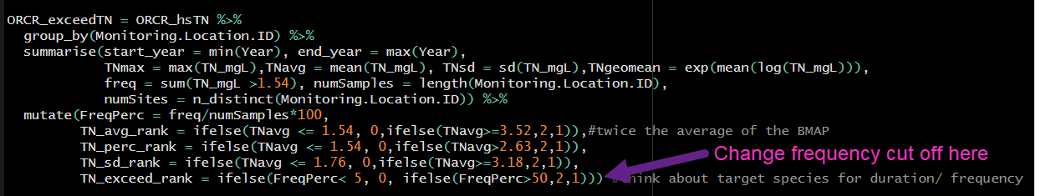
    - Add BMAP average to 0.5 SD and 1 SD to calculate SD ranking values.
  - Determine BMAP threshold for values of no concern (TMDL, NNC, etc.) (see above table).
    - If a BMAP has multiple TMDLs two options are:
      - Use the most stringent TMDL as threshold for values of no concern for BMAP as a whole.
      - Split areas by TMDL and run comparisons multiple times.
  - Rank the station against the above values and threshold.
    - Average Rank:
      - Rank 0: station average below BMAP threshold.
      - Rank 1: station average above threshold but below BMAP average.
      - Rank 2: station average 2x above average (depending on BMAP).
    - Percentiles Rank:
      - Rank 0: station average below BMAP threshold.
      - Rank 1: station average above threshold but below 90th percentile.
      - Rank 2: station average above 90th percentile.
    - Standard Deviation Rank:
      - Rank 0: station average below BMAP average + 0.5 SD.
      - Rank 1: station average at or above average + 0.5 SD but less than BMAP average + 1 SD.
      - Rank 2: station average at or above BMAP average + 1SD.
    - Frequency Rank:
      - Rank 0: station percent exceedance below 5%.
        - Exceedance thresholds are likely dependent on BMAP.
      - Rank 1: station exceedances between 5% and 49% of samples.
      - Rank 2: station exceedances over 50% of samples.
  - Add 4 ranks together to create Hot Spot Rank at each station. High rank value = high concern.

