Field Recon of Hudson Beach watershed, Pasco County, Oct. 24, 2023. Anita Stine joined Flatwoods Consulting (Michael Grzywacz and Brittany Banko) and Pasco County (Juanita Bernal Leon, Christine Lynch and Jonah Mick) and Legislative Assistant to Commissioner Jack Mariano, District #5 (Coleen Weaver).

Contacts:
Michael Grzywacz mgrzywacz@flatwoodsconsulting.com
Brittany Banko bbanko@flatwoodsconsulting.com
Juanita Bernal Leon jbernalleon@pascocountyfl.net
Christine L. Lynch clynch@pascocountyfl.net
Anita Stine Anita.Stine@FloridaDEP.gov
Jonah Mick jmick@pascocountyfl.net
Coleen A Weaver cweaver@pascocountyfl.net
Below are Anita’s photos and notes for follow up.
Observations:
- High tide to low tide at the beach makes a huge difference as during low tide, there is no water in the small roped off swimming area and birds congregate in the shade of the pavilion and deposit bird waste on the exposed moist rock and mud. There is a posted sign on the pavilion near the birds “do not feed the birds”.

- Sam’s Beach Bar appears to be dumping their mop water near the storm drain. There is staining on the asphalt, brooms hang on an exterior wall drying behind the dumpsters. Recommend the county reach out to code enforcement and/or DBPR to address future illicit dumping.

  - Juanita said the county will follow up on this.

- Storm pond at the NW end of the parking area for the boat launch had a strange light color dried scuzz on the grass in the base of the pond. It was said this has a sand filter. No one present could identify the scuzz. It sits along a sanitary sewer pipe. No problems identified but recommend continued recon of the pond on future trips.
  - Brittany and Michael will continue to recon this during sampling trips.

- For comparison, we checked the pond at the south east end of the ramp parking area, and it did not have the same scuzz.

- I interviewed county park clean up staff member who said the trailer park at Old Dixie Hwy. and Clark St. is said to dump sewage straight into the gulf. He also said the lift station near Sam’s flooded during hurricane.

  - The trailer part is Dixie Gulf Breeze R.V. Community, LLC, 13914 Old Dixie Hwy. We noticed at the corner of both driveways are sewer pipe accesses. They are next to the swale/small ditch that runs along Old Dixie Hwy. There was a scuzz in the ditch between the driveways. The caps come off easily by hand, it is possible that during rain events someone may be opening these to let them free-flow. The challenge with this theory is that it is not apparent how the sewage could flow to the gulf, there are no underground stormwater conveyances apparent in this area. It would need to cross a street and residences/business between the end of the drive and the canal to the Gulf.

- We watched as mowing crews blew cut grass into the dry swale.

- We visited the Apple Ave. site which has had a couple of hits for HF-183 and acetaminophen.

  - The Apple Ave. ditch was cloudier than any other area in the watershed. A white bacterial film was growing on submerged detritus on the north side of the ditch near a segment of the road that had been patched multiple times in multiple locations. Anita suspects there is sewer pipe crumbling underground and during high pressure may be leaking through the sand to the ditch. Recommend this stretch be investigated by CCTV.
    - Juanita said she will talk with the private utility to CCTV this segment.
    - Coleen heard water flowing just east of the ditch site, behind a segment of chain link fence. We walked in the woods/swamp to a thicket of cane to find the rushing water and found a 1” pvc pipe sticking out of the earth, shooting clear water out of it. It did not smell like sulfur and was cleaner in appearance than the tannic swamp water and a lot better than the cloudy ditch water. The top of the pipe had come apart and 2 spigots had originally been at the top of the pipe.
      - Coleen indicated she will talk with the RV business to see if they are aware of the pipe since it’s on their parcel. 14128 Plum Ln., part of RV World of Hudson. We drove through and saw no signs of concern in the RV parking areas.
      - Juanita will check the cameras in weeks to come to see if any indication of illicit dumping to the ditch is caught.
    - It is across the street from Hudson Water Works round white tank, north side of the road. East of the tank is the home of Todd Mattix of Mattix Brothers’ Seawalls whose work yard is west of Old Dixie Hwy on Apple St. He came out and talked with us about concerns he has about flooding at the west end of Apple because the ditch is filled in and floods everything in the area. He also said that the house on the north side of the pond/swamp adjacent to the Apple Ave ditch site dumps sewage into the pond (7024 Hudson Ave.). We visited the house and it was a sketchy situation. The man walked us behind the adjacent property to access the north end of the swamp, but not his own. He organically indicated neighbors call and make false reports of him dumping. No sewage smell could be identified adjacent the property. I think someone said that home is no longer hooked to the public water supply.
  - Coleen has said in the past that while flying over this swamp/pond it looked very different than the water in other areas of the watershed.
- Potholes and repeat patching can indicate crumbled stormwater or sanitary sewer conveyances causing erosion underground. Square or rectangular patches in asphalt can indicate a pipe (any kind, even drinking water or gas) was replaced. It would be good to ask the sanitary sewer utility about the condition of their system under areas with many patches. An indicator of infiltration is if the lift stations are overloaded/overflowing during rain events. Another indicator is when the lowest manhole for the stretch with patches overflows during rain. CCTV may be useful if the current condition is unknown.
  - The east end of Harbor Dr. between Old Dixie and Pine St. has many patches for potholes.
  - Sea Ranch Dr. also has areas with many patches.
- Boat contributions:
  - The area with commercial boats along Old Dixie between Sea Ranch Dr. and Clark St. were inaccessible from land due to fencing.
  - There are many boats large enough to have heads parked at homes and marinas all throughout the watershed.
  - Samplers said they are pretty sure there are liveaboard boats with residents at the west end of Shrimp Dock Dr. because air conditioners/generators on boats are running often.
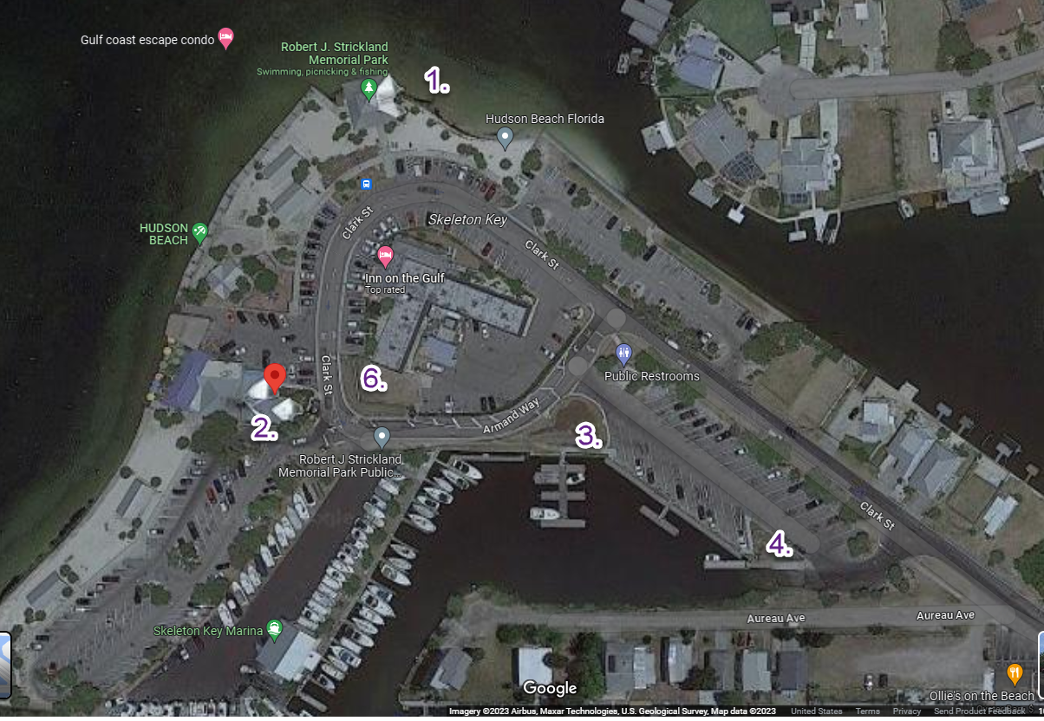
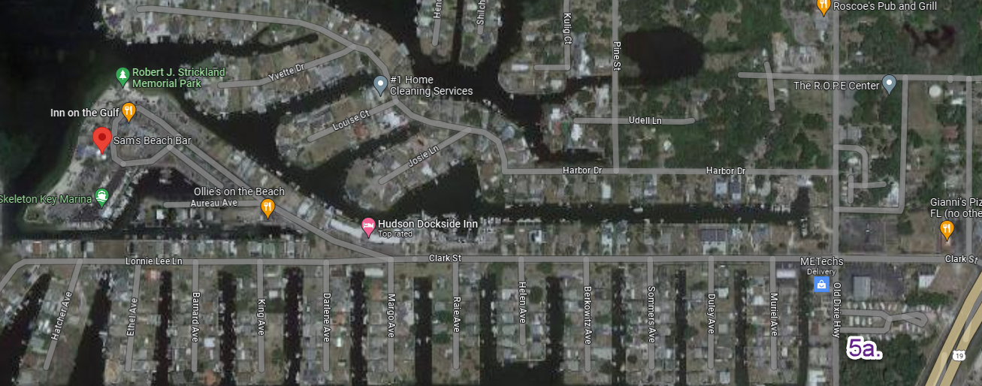

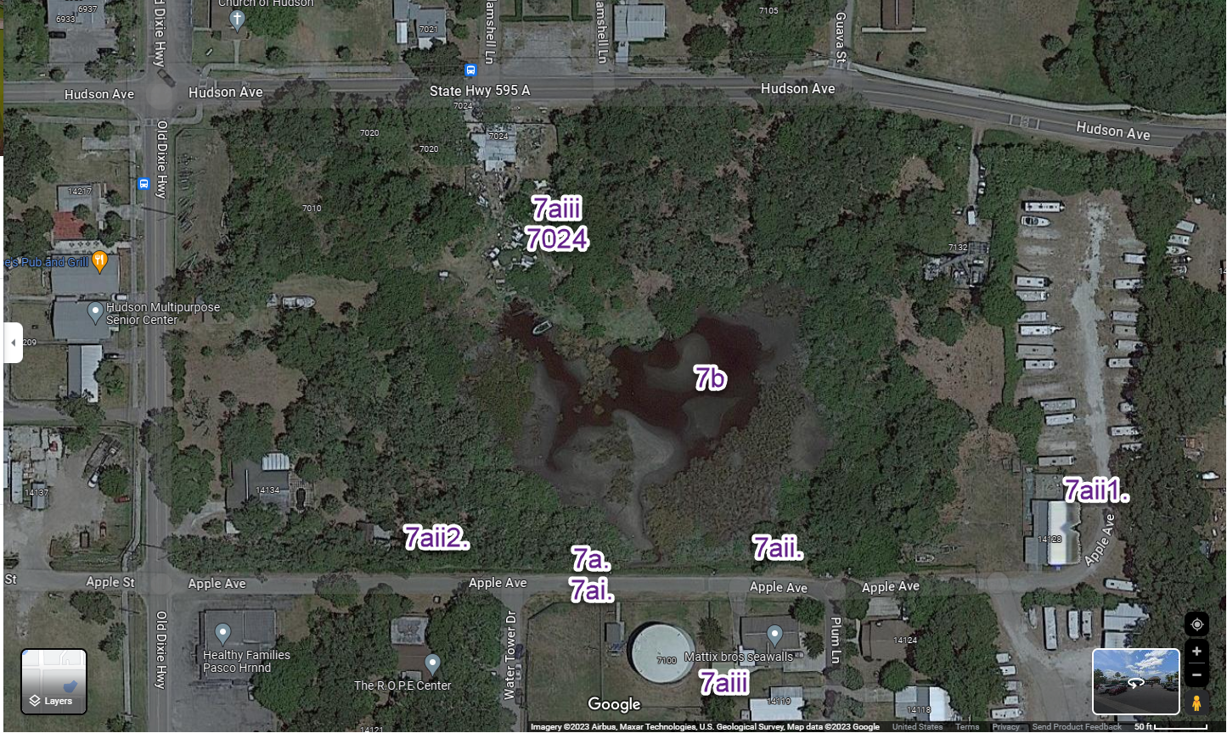

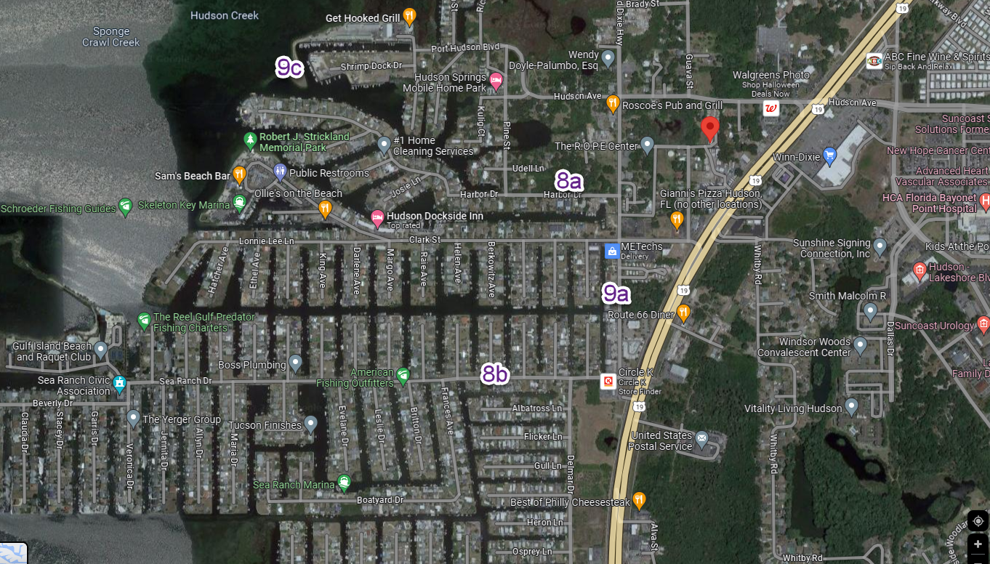

Photos to accompany this are not downloading as I had hoped. Meanwhile at least these things are noted.

