DRAFT
Indian River Lagoon Basin

North Indian River Lagoon
Basin Management Action Plan

Division of Environmental Assessment and Restoration
Water Quality Restoration Program
Florida Department of Environmental Protection

with participation from the
North Indian River Indian River Lagoon Stakeholders

November 2020



2600 Blair Stone Road
Tallahassee, FL 32399-2400
https://floridadep.gov/

Acknowledgments
The North Indian River Lagoon (NIRL) Basin Management Action Plan was prepared as part of a statewide watershed management approach to restore and protect Florida's water quality. It was prepared by the Florida Department of Environmental Protection with participation from the NIRL stakeholders identified below.
Type of Governmental or  Private Entity | Participant
Local Governments | Brevard County  Volusia County  City of Cocoa  City of Edgewater  City of Melbourne  City of Oak Hill  City of Rockledge  City of Titusville  Town of Indialantic  Town of Palm Shores
Federal Agencies | Kennedy Space Center
Regional and State Agencies | Florida Department of Agriculture and Consumer Services  Florida Department of Transportation District 5  Indian River Lagoon Estuary Program  St. Johns River Water Management District

Table of Contents
Acknowledgments 2
List of Acronyms and Abbreviations 9
Executive Summary 11
Chapter 1. Background Information 20
1.1 Water Quality Standards and Total Maximum Daily Loads (TMDLs) 20
1.1.1. NIRL TMDLs 21
1.2 NIRL Basin Management Action Plan (BMAP) 22
1.2.1. Pollutant Sources 25
1.2.1.1 Agricultural Nonpoint Sources 25
1.2.1.2 Municipal Separate Storm Sewer Systems (MS4s) 28
1.2.1.3 Septic Systems (Onsite Sewage Treatment and Disposal Systems (OSTDS ) 30
1.2.1.4 Urban Nonpoint Sources 33
1.2.1.5 Wastewater Treatment Facilities (WWTFs) 33
1.2.1.6 Milestones and Tracking Progress 35
1.2.2. Assumptions 38
1.2.3. Considerations 38
1.3 Economic Benefits of the IRL System 43
Chapter 2. Modeling, Load Estimates, and Restoration Approach 45
2.1 BMAP Modeling 45
2.1.1. SWIL Modeling 45
2.1.2. SWIL Calibration 46
2.1.3. Allocation Process 46
2.1.4. Project Credit Process 47
2.2 Calculation of Starting Loads and Allocations 47
2.2.1. Starting Loads and Allocation of Load Reductions 47
2.3 Basinwide Sources Approach 53
2.3.1. Agriculture 53
2.3.2. Septic Systems 54
2.3.3. Stormwater 55
2.3.4. Wastewater Treatment 56
2.4 Seagrass and Water Quality Monitoring Plan 59
2.4.1. Objectives 59
2.4.2. Monitoring Parameters, Frequency, and Network 59
2.4.3. Data Management and Assessment 64
2.4.4. Quality Assurance/Quality Control 64
2.5 Research Priorities 64
Chapter 3. Project Zones 66
3.1 Project Zone A 66
3.1.1. NIRL Project Zone A Existing and Planned Projects 67
3.2 Project Zone B 80
3.2.1. NIRL Project Zone B Existing and Planned Projects 81
Chapter 4. Compliance and Adaptive Management 117
4.1 Future Growth 117
4.2 Compliance 117
Chapter 5. References 120
Appendix A. BMAP Projects Supporting Information 121
Appendix B. Agricultural Enrollment and Reductions 123
Appendix C. Seagrass Analysis 140

List of Figures
Figure ES-1. NIRL BMAP area and project zones 17
Figure ES-2. Estimated progress towards meeting the TN TMDL allocated to the NIRL Project Zone A with projects completed through July 31, 2020 18
Figure ES-3. Estimated progress towards meeting the TP TMDL allocated to the NIRL Project Zone A with projects completed through July 31, 2020 19
Figure ES-4. Estimated progress towards meeting the TN TMDL allocated to the NIRL Project Zone B with projects completed through July 31, 2020 20
Figure ES-5. Estimated progress towards meeting the TP TMDL allocated to the NIRL Project Zone B with projects completed through July 31, 2020 21
Figure 1. NIRL BMAP area 26
Figure 2. Location of septic systems in the NIRL 34
Figure 3. Map of wastewater facilities in the NIRL 36
Figure 4. Estimated progress towards the NIRL BMAP TN milestones with projects completed through July 31, 2020 38
Figure 5. Estimated progress towards meeting the NIRL BMAP TP milestones with projects completed through July 31, 2020 39
Figure 6. 2013 BMAP area boundary and 2020 BMAP area boundary 45
Figure 7. IMPLAN Model calculation process 47
Figure 8. Total annual economic output by industry group in IRL region, 2014 48
Figure 9. Flowchart of the allocation steps, page 1 of 2 54
Figure 10. Flowchart of the allocation steps, page 2 of 2 55
Figure 11. Monitoring network in NIRL Project Zone A 68
Figure 12. Monitoring network in NIRL Project Zone B 69
Figure 13. NIRL Project Zone A seagrass evaluation results for compliance step 1 and step 2 128
Figure 14. NIRL Project Zone B seagrass evaluation results for compliance step 1 and step 2 128
Figure B-1. BMP enrollment in the North Indian River Lagoon BMAP area as of July 2020 135
Figure B-2. GIS example of a sliver 138
Figure B-3. Distribution of agricultural acreage on parcels with potential agricultural activity, NIRL BMAP area 140
Figure B-4. Agricultural land uses on parcels with 50 acres of agriculture and greater, NIRL BMAP area 140
Figure B-5. Agricultural land uses on parcels with less than 50 acres of agriculture, NIRL BMAP area 141
Figure B-6. Number of parcels with 50 acres of agriculture and greater, NIRL BMAP area 142
Figure B-7. Number of parcels with less than 50 acres of agriculture, NIRL BMAP area 142
Figure B-8. Distribution of agricultural acreage on parcels with potential agricultural activity, Project Zone A 143
Figure B-9. Land use type and distribution of agricultural acreage, Project Zone A 144
Figure B-10. Distribution of agricultural acreage on parcels with potential agricultural activity, Project Zone B 144
Figure B-11. Land use type and distribution of agricultural acreage by parcel size, Project Zone B 145
Figure C-1. Map of the seagrass transects in NIRL A 184
Figure C-2. Map of the seagrass transects in NIRL B 185

List of Tables
Table ES-1. Progress to date in the NIRL BMAP by Project Zone 15
Table 1. Designated use attainment categories for Florida surface waters 23
Table 2. Class II waters in the NIRL 23
Table 3. NIRL TMDLs 25
Table 4. NIRL Tributary TMDLs 25
Table 5. Agricultural land use acreage enrolled summary in the BMP Program in the NIRL BMAP area as of July 2020 29
Table 6. Agricultural land use acreage enrolled in the BMP Program in the NIRL BMAP area by project zone 29
Table 7. Summary of unenrolled agricultural land use acreage in the NIRL BMAP area 30
Table 8. Entities in the NIRL designated as Phase II MS4s as of September 2020 33
Table 9. Septic system counts by project zone 34
Table 10. Urban nonpoint sources in the NIRL 36
Table 11. Wastewater facilities in the NIRL as of September 2020 36
Table 12. SWIL Model starting loads (lbs/yr) 57
Table 13. Entity contributions to starting loads with low priority ranking cutoff 58
Table 14. TN load required reductions by entity (lbs/yr) 58
Table 15. TP load required reductions by entity (lbs/yr) 59
Table 16. TN effluent limits 65
Table 17. TP effluent limits 65
Table 18. Water quality monitoring stations in the NIRL BMAP 68
Table 19. Summary of land uses in Project Zone A 74
Table 20. Existing and planned projects in Project Zone A 75
Table 21. Summary of land uses in Project Zone B 88
Table 22. Existing and planned projects in Project Zone B 89
Table 23. Summary of seagrass compliance results, step 1 128
Table 24. Summary of seagrass compliance results, step 2 128
Table B-1. Agricultural land use acreage enrolled summary in the BMP program in the NIRL BMAP area as of July 2020 134
Table B-2. Agricultural land use acreage enrolled in the BMP program in the NIRL BMAP area by Project Zone 134
Table B-3. Agricultural land use acreage enrolled in the NIRL BMAP area by BMP program 134
Table B-4. Agricultural land use acreage enrolled in the BMP program in Project Zone A 134
Table B-5. Agricultural land use acreage enrolled in the BMP program in Project Zone B 134
Table B-6. Summary of unenrolled agricultural land use acreage in the NIRL BMAP area 141
Table B-7. Agricultural land use change by project zone 147
Table B-8. Cost-share project types and associated nutrient reductions recommended by OAWP 148

List of Acronyms and Abbreviations
BAM Biosorption Activated Media
BCC Brevard Community College
BCUD Brevard County Utility District
BMAP Basin Management Action Plan
BMP Best Management Practice
BOD Biochemical Oxygen Demand
CDD Community Development District
CERP Comprehensive Everglades Restoration Plan
CIRL Central Indian River Lagoon
CWA Clean Water Act
DEP Florida Department of Environmental Protection
DO Dissolved Oxygen
DOR Florida Department of Revenue
DWM Dispersed Water Management
EFDC Environmental Fluid Dynamics Code
EMC Event Mean Concentration
EPA U.S. Environmental Protection Agency
F.A.C. Florida Administrative Code
FCT Florida Communities Trust
FDACS Florida Department of Agriculture and Consumer Services
FDOH Florida Department of Health
FDOT Florida Department of Transportation
FIND Florida Inland Navigation District
FLWMI Florida Water Management Inventory
FPL Florida Power and Light
FRDAP Florida Recreation Development Assistance Program
F.S. Florida Statutes
FSAID Florida Statewide Agricultural Irrigation Demand (geodatabase)
FWRA Florida Watershed Restoration Act
GIS Geographic Information System
HSPF Hydrological Simulation Program–Fortran
IDDE Illicit Discharge Detection and Elimination
IRL Indian River Lagoon
IRL-S Indian River Lagoon-South
kg Kilogram
lbs Pounds
lbs/yr Pounds Per Year
LET Load Estimation Tool
m Meter
MAPS Managed Aquatic Plant System
mgd Million Gallons Per Day
mg/L Milligrams Per Liter
MS4 Municipal Separate Storm Sewer System
N/A Not Applicable
NELAC National Environmental Laboratory Accreditation Council
NELAP National Environmental Laboratory Accreditation Program
NEP National Estuary Program
NIRL North Indian River Lagoon
NOI Notice of Intent
NPDES National Pollutant Discharge Elimination System
NRCS Natural Resources Conservation Service
O&M Operations and Maintenance
OAWP Office of Agricultural Water Policy
OSTDS Onsite Sewage Treatment and Disposal System
PAR Photosynthetically Active Radiation
PLSM Pollutant Load Screening Model
PMC Parrish Medical Center
PSA Public Service Announcement
QA/QC Quality Assurance/Quality Control
RRLA Rapid Rate Land Application
RV Recreational Vehicle
SCTPO Space Coast Transportation Planning Organization
SJRWMD St. Johns River Water Management District
SOP Standard Operating Procedure
SR State Road
STORET STOrage and RETrieval (Database)
SWET Soil and Water Engineering Technology
SWIL Spatial Watershed Iterative Loading
SWMP Stormwater Mangement Plan
TBD To Be Determined
TMDL Total Maximum Daily Load
TN Total Nitrogen
TP Total Phosphorus
TSS Total Suspended Solids
USGS U.S. Geological Survey
VC Volusia County
WBID Waterbody Identification (number)
WCD Water Control District
WIN Watershed Information Network (Database)
WMD Water Management District
WWTF Wastewater Treatment Facility

Executive Summary
Background
The Indian River Lagoon (IRL) is a 156-mile-long estuary along Florida's east coast. The impaired portions of the IRL are directly adjacent to lands in only Volusia, Brevard, Indian River, and St. Lucie Counties. The northern portion of the watershed extends to near the Ponce De Leon Inlet in Volusia County and the southern portion to near the Fort Pierce Inlet at the Indian River County–St. Lucie County boundary line. Because of the large geographical extent of the IRL Basin and the hydrological differences throughout the basin, the Florida Department of Environmental Protection (DEP) determined the best way to address the total maximum daily loads (TMDLs) and impairments for the IRL Basin would be to divide the watershed into 3 subbasins: (1) Central IRL (CIRL), (2) North IRL (NIRL), and (3) Banana River Lagoon. Separate basin management action plans (BMAPs) were developed for each subbasin; this document focuses solely on the NIRL Subbasin. The main stem of the NIRL Subbasin extends from Turnbull Creek in Volusia County to the Melbourne Causeway in Brevard County (Figure ES-1).
TMDLs
A TMDL is a water quality restoration goal establishing the maximum amount of a pollutant that a waterbody can assimilate without causing exceedances of water quality standards. The nutrient TMDLs for the main stem of the IRL were adopted by DEP in March 2009. The TMDLs focus on the water quality conditions necessary for seagrass regrowth at water depth limits where seagrass historically grew in the lagoon, based on a multi-year composite of seagrass coverage. The median depth limits of seagrass coverage in the IRL decreased over the years because of changes in water quality conditions resulting from anthropogenic influences. As polluted runoff reaches the lagoon, it contributes to conditions that prevent the seagrass from growing in deeper water.
Additionally, TMDLs for two tributaries to the NIRL were adopted in 2013, which are now addressed in this BMAP. For Addison Creek (the segment with waterbody identification [WBID] number 3028), no further nutrient load reductions were requested beyond those already requested by the main stem seagrass nutrient TMDLs. For the Eau Gallie River (WBID 3082), the total nitrogen (TN) and total phosphorus (TP) target loads defined in the TMDL are different from the main stem. The tidal portion of the Eau Gallie River consistently showed high annual average chlorophyll a concentrations, so the loading targets for the Eau Gallie are the natural background nutrient condition which require a 51 % TN reduction and a 58 % TP reduction of nonpoint source loads based on the Hydrological Simulation Program–Fortran Model for the period from 1996 to 2005.
NIRL BMAP
Previously, in addition to dividing the overall IRL Watershed into subbasins, the NIRL was further divided into "project zones." The NIRL subbasin was split into two project zones as follows:
- North A – Turnbull Creek to NASA Causeway (State Road 405).
- North B – NASA Causeway to Melbourne Causeway (U.S. Highway 192).
DEP first adopted the NIRL BMAP in 2013 to implement TN and TP TMDLs. BMAPs are designed to be implemented in a phased approach. In 2018, DEP and the local stakeholders were developing several components of an updated BMAP including the local completion and DEP review of a new water quality model, the Spatial Watershed Iterative Loading (SWIL) Model. The SWIL Model was developed through cooperative funding provided by Brevard County and many of its cities in an effort to update the data being used to predict loading. In this BMAP update, the SWIL Model is used to estimate loading to the NIRL and the percent reductions adopted in the original TMDL rules are applied as the water quality targets.
This 2020 BMAP was developed based on several changes since the 2013 BMAP was adopted, including updates to the modeling,boundary adjustments, updated allocations of load reductions to the responsible stakeholders, management actions to achieve nutrient reductions, and a revised monitoring plan to continue to track trends in water quality. This update sets a deadline for achieving load reductions no later than 2035, which is 22 years after the initial BMAP adoption in 2013.
Summary of Load Reductions
DEP requested stakeholders to provide information on management actions, including projects, programs, and activities, that would reduce nutrient loads to the NIRL. Management actions are included in the BMAP to address nutrient loads to the lagoon and had to meet several criteria to be considered eligible for credit. The estimated reductions of activities completed to date are provided in Table ES-1. Figure ES-2 through Figure ES-5 show progress towards the TN and TP TMDL load reductions through July 31, 2020, by project zone.
To achieve the TMDL, stakeholders must identify and submit additional local projects as well as determine the significant funding that will be necessary. Enhancements to programs addressing basinwide sources will also be required.

Table ES-1. Progress to date in the NIRL BMAP by Project Zone
Project Zone | TN Reduction (lbs/yr) | % Achieved towards TN Target | TP Reduction (lbs/yr) | % Achieved Towards TP Target
A | 41,071 | 34.6 | 7,845 | 39.9
B | 65,340 | 48.8 | 14,709 | 57.6
Total | 106,411 | 42.1 | 22,554 | 49.9

Source Requirements
Florida law (Section 403.086, Florida Statutes [F.S.], and Chapter 2020-150, Laws of Florida) requires all domestic wastewater facilities directly discharging to surfaces waters of the state within or connected to the IRL to meet advanced waste treatment requirements no later than July 1, 2025. Additionally, this BMAP sets TN and TP effluent limits in the NIRL for individually permitted domestic wastewater facilities and their associated rapid rate land application (RRLA) effluent disposal systems and reuse activities, unless the owner or operator can demonstrate reasonable assurance that the discharge or associated RRLA or reuse activity would not cause or contribute to an exceedance of TMDLs or water quality standards. Local governments must also develop remediation plans to address loads from wastewater facilities and septic systems within the BMAP area.
Agricultural nonpoint sources are a contributor of TN and TP loading to the NIRL. The NIRL BMAP was originally adopted in 2013, and some agricultural producers have enrolled and are implementing best management practices (BMPs). However, enrollment still falls well short of the full participation requirement under law, and for those producers that have enrolled, onsite verification of BMP implementation is inconsistent and incomplete. To address TN and TP loading from agricultural nonpoint sources to the NIRL it is paramount that FDACS carries out its statutory authority and fulfills its statutory obligations to facilitate enrollment and implementation verification, pursuant to Paragraphs 403.067(7)(c) and 403.067(7)(d), F.S.
Within five years of the adoption of this BMAP, DEP will evaluate any entity located in the BMAP area that serves a minimum resident population of at least 1,000 individuals who are not currently covered by a municipal separate storm sewer system (MS4) permit and designate eligible entities as regulated MS4s, in accordance with Chapter 62-624, Florida Administrative Code (F.A.C.). In accordance with Subsection 373.4131(6), F.S., DEP and the water management districts are planning to update the stormwater design and operation requirements in Environmental Resource Permit rules and incorporate the most recent scientific information available to improve nutrient reduction benefits.
Water Quality Monitoring
The updated NIRL BMAP monitoring network consists of 7 stations sampled by the St. Johns River Water Management District. The monitoring plan also includes research priorities to better understand the lagoon, nutrient sources, and the responses of seagrass to nutrient loading, both internal and external to the lagoon.
BMAP Cost
The project costs provided for the BMAP may include capital costs as well as those associated with construction and routine operations and maintenance and monitoring. Many BMAP projects were built to achieve multiple objectives and not just nutrient reductions. Funds for some projects have already been spent, others have been obligated to ongoing projects, and the remainder are yet to be appropriated.
The funding sources for the projects range from local public and private contributions to state and federal legislative appropriations. DEP will continue to work with stakeholders to explore new opportunities for funding assistance to ensure that the activities listed in this BMAP can be maintained at the necessary level of effort and that additional projects can be constructed.

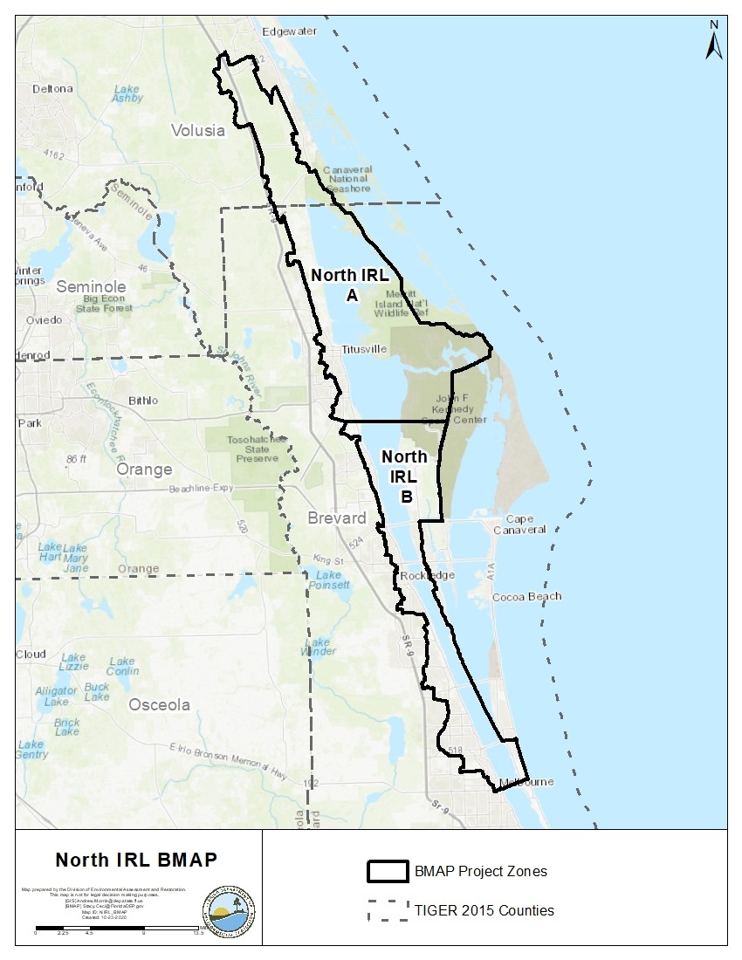
Figure ES-1. NIRL BMAP area and project zones

Figure ES-2. Estimated progress towards meeting the TN TMDL allocated to the NIRL Project Zone A with projects completed through July 31, 2020

Figure ES-3. Estimated progress towards meeting the TP TMDL allocated to the NIRL Project Zone A with projects completed through July 31, 2020

Figure ES-4. Estimated progress towards meeting the TN TMDL allocated to the NIRL Project Zone B with projects completed through July 31, 2020
57 %
100 %
30 %
65 %
Figure ES-5. Estimated progress towards meeting the TP TMDL allocated to the NIRL Project Zone B with projects completed through July 31, 2020

- Background Information

Water Quality Standards and Total Maximum Daily Loads (TMDLs)
Florida's water quality standards are designed to ensure that surface waters fully support their designated uses, such as drinking water, aquatic life, recreation, and agriculture. Currently, most surface waters in Florida, including many of those in the North Indian River Lagoon (NIRL), are categorized as Class III waters, meaning they must be suitable for recreation and must support fish consumption and the propagation and maintenance of a healthy, well-balanced population of fish and wildlife. In addition, many segments with waterbody identification (WBID) numbers are categorized as Class II waters, which have a designated use of shellfish propagation and maintenance of a health, well-blanaced population of fish and wildlife. Table 1 lists all designated use classifications for Florida surface waters.
Table 1. Designated use attainment categories for Florida surface waters
¹ Class I, I-Treated, and II waters additionally include all Class III uses.
Classification | Description
Class I¹ | Potable water supplies
Class I-Treated¹ | Treated potable water supplies
Class II¹ | Shellfish propagation or harvesting
Class III | Fish consumption; recreation, propagation and maintenance of a healthy,  well-balanced population of fish and wildlife
Class III-Limited | Fish consumption, recreation or limited recreation, and/or propagation and maintenance of a limited population of fish and wildlife
Class IV | Agricultural water supplies
Class V | Navigation, utility, and industrial use (no current Class V designations)

Class II waters in the NIRL include areas used for aquaculture. The WBIDs that are designated as Class II waters are listed in Table 2. If not listed, the remaining WBIDs are Class III waters.
Table 2. Class II waters in the NIRL
Classification | WBID Number | WBID Name
Class II | 2924 | Mosquito Lagoon
Class II | 2942A | Turnbull Creek (Marine Segment)
Class II | 2963A1 | Indian River Above Sebastian Inlet
Class II | 2963B1 | Indian River Above Melbourne Causeway
Class II | 2963C1 | Indian River Below 520 Causeway
Class II | 2963D1 | Indian River Above 520 Causeway
Class II | 2963EA | Indian River Above Nasa Causeway
Class II | 2963F2 | Big Flounder Creek
Class II | 2963F3 | Indian River Above Max Brewer Causeway
Class II | 3057A | Banana River Below 520 Causeway

Section 303(d) of the federal Clean Water Act (CWA) requires that each state must identify its "impaired" waters every two years, including estuaries, lakes, rivers, and streams, that do not meet their designated uses. Florida Department of Environmental Protection (DEP) staff in the Division of Environmental Assessment and Restoration are responsible for assessing Florida's waters for inclusion on the Verified List of Impaired Waters (when a causative pollutant for the impairment has been identified) and Study List (when a causative pollutant for the impairment has not been identified and additional study is needed). These lists are then provided to the U.S. Environmental Protection Agency (EPA) as an annual update to the state "303(d) list."

NIRL Total Maximum Daily Loads (TMDLs)
TMDLs are water quality restoration goals establishing the maximum amount of a pollutant that a waterbody can assimilate without causing exceedances of water quality standards. The TMDLs focus upon the water quality conditions necessary for seagrass re-growth at water depth limits where seagrass historically grew in the lagoon, based on a multi-year composite of seagrass coverage. The median depth limits of seagrass coverage in the IRL decreased over the years because of changes in water quality conditions resulting from anthropogenic influences.
As polluted runoff reaches the lagoon, it contributes to conditions that prevent the seagrass from growing in deeper water because of elevated light attenuation. The full restoration depth-limit target for seagrass was established for each segment based on a deep edge boundary delineating the composite of 7 years of historical seagrass data from the period of 1943 to 1999. It determined at what depths the deep edge of the seagrass beds previously grew and created a maximum depth limit for seagrass distribution. The TMDL targets allowed for a 10 % departure (shoreward) from the full restoration target seagrass depth. The 10 % departure in target depths was selected to be consistent with the water quality criteria in Chapter 62-302, Florida Administrative Code (F.A.C.), which allows for up to a 10 % reduction in the photo-compensation point.
To determine nutrient targets and reductions needed to improve lagoon water quality in each subbasin, regression relationships were used between 4 years of loading levels and the same years' seagrass depth limit (the percent departure from the full restoration). Nutrient targets were developed from the median concentrations observed where seagrass depth limits are within the 10 % departure (shoreward) from their full restoration levels. These targets should result in nutrient reductions that allow seagrass to grow almost to the depths previously seen in the area. Table 3 lists the TMDLs and pollutant load allocations adopted by rule for the NIRL.

Table 3. NIRL TMDLs
NPDES = National Pollutant Discharge Elimination System.
WBID | Waterbody | NPDES  Stormwater TN  (% Reduction) | NPDES  Stormwater TP  (% Reduction)
2963F | Indian River above Max Brewer | 21 | 41
2963E | Indian River above NASA Causeway | 23 | 44
2963D | Indian River above 520 Causeway | 21 | 43
2963B+2963C | Indian River above Melbourne Causeway | 25 | 47

Additionally, there are adopted TMDLs for two tributaries to the NIRL, which are also addressed in this basin management action plan (BMAP). For Addison Creek (WBID 3028), no further nutrient load reductions were requested beyond those already requested by the main stem seagrass nutrient TMDLs. For the Eau Gallie River (WBID 3082), the total nitrogen (TN) and total phosphorus (TP) target loads defined in the TMDL are different from the main stem; there is also a biochemical oxygen demand (BOD) TMDL for the Eau Gallie River. The tidal portion of the Eau Gallie River consistently showed high annual average chlorophyll a concentrations, and so the loading targets for the Eau Gallie are the natural background nutrient condition, which require a 51 % TN reduction and a 58 % TP reduction of nonpoint source loads based on the Hydrological Simulation Program–Fortran (HSPF) Model for the period from 1996 to 2005.
Table 4. NIRL Tributary TMDLs
WBID | Waterbody | NPDES  Stormwater TN  (% Reduction) | NPDES  Stormwater TP  (% Reduction)
3028 | Addison Creek | NIRL TN Target | NIRL TP Target
3082 | Eau Gallie River | 51 | 58

NIRL BMAP
A BMAP is a framework for water quality restoration that contains local and state commitments to reduce pollutant loading through current and future projects and strategies. BMAPs contain a comprehensive set of solutions, such as permit limits on wastewater facilities, urban and agricultural best management practices, and conservation programs designed to achieve pollutant reductions established by a total maximum daily load (TMDL). These broad-based plans are developed with local stakeholders and rely on local input and commitment for development and successful implementation. BMAPs are adopted by DEP Secretarial Order and are legally enforceable. The Florida Watershed Restoration Act (FWRA), Subparagraph 403.067(7)(a)1., Florida Statutes (F.S.) establishes an adaptive management process for BMAPs that continues until the TMDLs are met. This approach allows for incrementally reducing loadings through the implementation of projects and programs, while simultaneously monitoring and conducting studies to better understand water quality dynamics (sources and response variables) in each impaired waterbody. The NIRL BMAP was first adopted in February 2013. An adaptive management process which is statutorily required, such as the changes made in this updated BMAP, will continue until the TMDLs are met.
This document serves as an update to the 2013 BMAP. Figure 1 shows the updated NIRL BMAP area.
Figure 1. NIRL BMAP area

Pollutant Sources
There are various sources of pollution in the NIRL. Nonpoint (i.e., diffuse) sources in the subbasin contribute the majority of the TN and TP loads to the NIRL and include urban and agricultural runoff. The Mosquito Lagoon, to the north, is being addressed through a reasonable assurance plan.

Agricultural Nonpoint Sources
The primary agricultural land uses in the NIRL BMAP area are cow/calf operations (pasture) and citrus. Other agricultural land uses include nurseries, field/row crops, and horse farms/specialty farms. Most of the horse farms are small, noncommercial hobby farms. Because of urban encroachment, citrus health issues (freeze/disease), and the downturn in the economy, many citrus operations have been destroyed or abandoned, have significantly lowered their production acreage, or have transitioned to another commodity. In recent years, some of this acreage may have shifted to nonagricultural/urban uses.
Per Section 403.067, F.S., when DEP adopts a BMAP that includes agriculture, it is the agricultural landowner's responsibility either to implement best management practices (BMPs) adopted by the Florida Department of Agriculture and Consumer Services (FDACS) to help achieve load reductions, or to conduct water quality monitoring pursuant to Chapter 62-307, F.A.C. To date, FDACS' Office of Agricultural Water Policy (OAWP) has adopted BMP manuals by rule for cow/calf, citrus, vegetable and agronomic crops, nurseries, equine, sod, dairy, poultry, and specialty fruit and nut operations.
To enroll in the BMP Program, landowners first meet with OAWP to determine the BMPs that are applicable to that individual operation. The landowner must then submit to OAWP a Notice of Intent (NOI) to implement the BMPs on the checklist from the applicable BMP manual. Because many agricultural operations are diverse and are engaged in the production of multiple commodities, a landowner may be required to sign multiple NOIs for a single parcel.
OAWP is required to verify that landowners are implementing the BMPs identified in their NOIs. Rule 5M-1.008, F.A.C[ST1] ., outlines the procedures used to verify the implementation of agricultural BMPs. BMP implementation is verified through site visits conducted by OAWP staff at least every two years, as required by Subparagraph 403.067(7)(d)3, F.S. Producers not implementing BMPs according to the process outlined in Chapter 5M-1, F.A.C., are referred to DEP for enforcement action after attempts at corrective and remedial action are exhausted.
FDACS staff conduct site visits to verify that all BMPs are being implemented correctly and to review nutrient and irrigation management records. In addition, OAWP verifies that cost-share items are being implemented correctly. Site visits are prioritized based on the date the NOI was signed, the date of the last BMP verification site visit, and whether the operation has received cost-share funding. FDACS undertakes these onsite inspections at least every two years and provides information it obtains to DEP, subject to any confidentiality restrictions.
Where water quality problems are detected for agricultural nonpoint sources despite the appropriate implementation of adopted BMPs, a reevaluation of the BMPs shall be conducted pursuant to Subsection 403.067(7), F.S. If the reevaluation determines that the BMPs or other measures require modification, the applicable rule will be revised to require implementation of the modified practice. Continuing water quality problems may be detected through the monitoring component of the BMAP and other DEP and St. Johns River Water Management District (SJRWMD) activities. If a reevaluation of the BMPs is needed, FDACS will also include DEP, SJRWMD, and other partners in the process. Section 2.3.1 provides further details on the reevaluation of existing practices.
For the BMAP, the implementation of agricultural BMPs will be documented based on participation in FDACS' BMP Program. The program rules provide the presumption of compliance to those landowners.
Table 5 and Table 6 summarize the agricultural land use enrolled in BMP programs for the entire NIRL BMAP area and by project zone, respectively. Enrollment is as of July 2020, and the agricultural acreage in each basin is based on the Florida Statewide Agricultural Irrigation Demand (FSAID) VII geodatabase. Appendix B provides more information on agricultural activities in the NIRL BMAP area.
Table 5. Agricultural land use acreage enrolled summary in the BMP Program in the NIRL BMAP area as of July 2020
Category | Acres
FSAID VII agricultural acres in the BMAP area | 7,256
Total agricultural acres enrolled | 401
% of FSAID VII agricultural acres enrolled | 6

Table 6. Agricultural land use acreage enrolled in the BMP Program in the NIRL BMAP area by project zone
Project Zone | Total FSAID VII Agricultural Acres | Agricultural Acres Enrolled | % of Agricultural Acreage Enrolled
A | 5,683 | 327 | 6
B | 1,573 | 74 | 5
Total | 7,256 | 401 | 6

Unenrolled Agricultural Acreage
Agricultural land use designation is not always indicative of current agricultural activity and consequently presents challenges to estimating load allocations accurately as well as enrolling every agricultural acre in an appropriate BMP manual. To characterize unenrolled agricultural acres, OAWP identified FSAID VII features outside of the BMP enrollment areas using geographic information system (GIS) software (see Appendix B for details). Table 7 summarizes the results of that analysis.
Table 7. Summary of unenrolled agricultural land use acreage in the NIRL BMAP area
Note: Because of geometric variations between shapefiles used in the unenrolled agricultural lands analysis performed by OAWP, the unenrolled agricultural acres differ from subtraction of the FSAID VII Agricultural Acres in the BMAP and the Total Agricultural Acres Enrolled referenced in Table 5.
Category | Acres
Unenrolled agricultural acres | 6,855
Acres identified within slivers of unenrolled agricultural areas | 164
Lands without enrollable agricultural activity (e.g., tribal lands, residential development, and parcels with Florida Department of Revenue (DOR) use codes 70-98) | 1,515
Total lands with potentially enrollable agricultural activities | 5,176

As of July 2020, OAWP had enrolled 401 agricultural acres in BMPs. Considering the results of the analysis shown in Table 7, the total acreage with the potential to have agricultural activities that can be enrolled in FDACS' BMP Program in the subbasin is 5,577 acres. Using this adjusted agricultural acreage, 7 % of agricultural acres have been enrolled.
Analyzing land use data and parcel data is a valuable first step in identifying the agricultural areas that provide the greatest net benefits to water resources for enrollment in FDACS' BMP Program, as well as prioritizing implementation verification visits in a given basin. OAWP will continue to enroll agricultural lands in the BMP Program, focusing on intensive operations, including irrigated acreage, dairies and nurseries, parcels greater than 50 acres in size, and agricultural parcels adjacent to waterways.
The next step to help prioritize the enrollment efforts could use the parcel loading information derived from the Spatial Watershed Iterative Loading (SWIL) Model. This effort could help FDACS identify specific parcels with the highest modeled nutrient loading. These parcels could then be targeted for enrollment and implementation of BMPs, as well as the verification of BMP implementation.
Aquaculture
Under the CWA, aquaculture activities are defined as a point source. Since 1992, all aquaculture facilities have been regulated by DEP, the water management district, or both, through a general fish farm permit authorized by Section 403.814, F.S. In 1999, the Florida Legislature amended Chapter 597, F.S., Florida Aquaculture Policy Act, to create a program within FDACS requiring Floridians who commercially aquaculture aquatic species to annually acquire an Aquaculture Certificate of Registration and implement Chapter 5L-3, F.A.C., Aquaculture BMPs. Permit holders must reapply to be certified every year.
However, as with agricultural land use in Florida, aquaculture facilities are frequently in and out of production. The facilities for which acreages were provided may no longer be in operation and there may be new companies in different parts of the subbasin. In the NIRL subbasin, there are 85 acres of aquaculture estimated to be under certification with FDACS' Division of Aquaculture as of September 2020. For purposes of the BMAP, OAWP delineated the aquaculture facilities using parcel data. Since the acreages were not delineated to just the tank, pond, or pool areas, in most cases these calculations overestimate the acreages of aquaculture activity.

Municipal Separate Storm Sewer Systems (MS4s)
Many of the municipalities in the subbasin are regulated by the Florida NPDES Stormwater Program. An MS4 is a conveyance or system of conveyances, such as roads with stormwater systems, municipal streets, catch basins, curbs, gutters, ditches, constructed channels, or storm drains.
If an MS4 permittee is identified as a contributor in the BMAP, the permitted MS4 must undertake projects specified in the BMAP. The BMAP projects required to be undertaken by MS4s are detailed for each project zone in Chapter 3. Phase I and Phase II MS4s are required to implement stormwater management programs to reduce pollutants to the maximum extent practicable and address applicable TMDL allocations. Phase I MS4 permits include assessment practices to determine the effectiveness of stormwater management programs (SWMPs), which can include water quality monitoring. Both Phase I and Phase II MS4 permits include provisions for the modification of SWMP activities, at the time of permit renewal, for consistency with the assumptions and requirements of the adopted BMAP. There are no Phase I permittees in the NIRL as of September 2020.
Phase II MS4 Stormwater Permit Requirements
Table 8 lists the Phase II MS4s in the NIRL as of September 2020. Under a generic permit, the operators of regulated Phase II MS4s must develop an SWMP that includes BMPs with measurable goals and a schedule for implementation to meet the following six minimum control measures:
- Public Education and Outreach – Implement a public education program to distribute educational materials to the community or conduct equivalent outreach activities about the impacts of stormwater discharges on waterbodies and the steps that the public can take to reduce pollutants in stormwater runoff.
- Public Participation/Involvement – Implement a public participation/involvement program that complies with state and local public notice requirements.
- Illicit Discharge Detection and Elimination – Subsection 62-624.200(2), F.A.C., defines an illicit discharge as "…any discharge to an MS4 that is not composed entirely of stormwater…," except discharges under an NPDES permit, or those listed in rule that do not cause a violation of water quality standards. Illicit discharges can include septic/sanitary sewer discharge, car wash wastewater, laundry wastewater, the improper disposal of auto and household toxics, and spills from roadway accidents.
- Develop, if not already completed, a storm sewer system map showing the location of all outfalls, and the names and location of all surface waters of the state that receive discharges from those outfalls.
- To the extent allowable under state or local law, effectively prohibit, through ordinance or other regulatory mechanism, nonstormwater discharges into the storm sewer system and implement appropriate enforcement procedures and actions.
- Develop and implement a plan to detect and address nonstormwater discharges, including illegal dumping, to the storm sewer system.
- Inform public employees, businesses, and the general public of hazards associated with illegal discharges and improper waste disposal.
- Construction Site Runoff Control –
- Implement a regulatory mechanism to require erosion and sediment controls, as well as sanctions to ensure compliance, to reduce pollutants in any stormwater runoff to the Phase II MS4 from construction activity that results in a land disturbance greater than or equal to an acre. Construction activity disturbing less than one acre must also be included if that construction activity is part of a larger common plan of development or sale that would disturb one acre or more.
- Develop and implement requirements for construction site operators to implement appropriate erosion and sediment control BMPs.
- Implement requirements for construction site operators to control waste such as discarded building materials, concrete truck washout, chemicals, litter, and sanitary waste at the construction site that may cause adverse impacts to water quality.
- Develop and implement procedures for site plan review that incorporate the consideration of potential water quality impacts.
- Develop and implement procedures for receiving and considering information submitted by the public.
- Develop and implement procedures for site inspection and the enforcement of control measures.
- Postconstruction Runoff Control – Implement and enforce a program to address the discharges of postconstruction stormwater runoff from areas with new development and redevelopment. (Note: In Florida, Environmental Resource Permits issued by water management districts typically serve as a Qualifying Alternative Program for purposes of this minimum control measure.)
- Pollution Prevention/Good Housekeeping – Implement an operations and maintenance program that has the ultimate goal of preventing or reducing pollutant runoff from MS4 operator activities, such as park and open space maintenance, fleet and building maintenance, new construction and land disturbances, stormwater system maintenance, and staff training in pollution prevention.
The "NPDES Generic Permit for Discharge of Stormwater from Phase II MS4s," Paragraph 62-621.300(7)(a), F.A.C., also requires that if the permittee discharges stormwater to a waterbody with an adopted TMDL pursuant to Chapter 62-304, F.A.C., then the permittee must revise its SWMP to address the assigned wasteload in the TMDL. Additionally, in accordance with Section 403.067, F.S., if an MS4 permittee is identified in an area with an adopted BMAP or a BMAP in development, the permittee must comply with the adopted provisions of the BMAP that specify activities to be undertaken by the permittee.
DEP can designate an entity as a regulated Phase II MS4 if its discharges meet the requirements of the rule and are determined to be a significant contributor of pollutants to surface waters of the state in accordance with Rule 62-624.800, F.A.C. A Phase II MS4 can be designated for regulation when a TMDL has been adopted for a waterbody or segment into which the MS4 discharges the pollutant(s) of concern. If an MS4 is designated as a regulated Phase II MS4, it is subject to the conditions of the "NPDES Generic Permit for Stormwater Discharges from Phase II MS4s."
Table 8. Entities in the NIRL designated as Phase II MS4s as of September 2020
Permittee | Permit Number
Brevard County | FLR04E052
Volusia County | FLR04E033
City of Cocoa | FLR04E032
City of Edgewater | FLR04E016
City of Melbourne | FLR04E027
City of Oak Hill | FLR04E130
City of Rockledge | FLR04E047
City of Titusville | FLR04E079
Town of Indialantic | FLR04E030
FDOT District 5 | FLR04E024

Septic Systems (Onsite Sewage Treatment and Disposal Systems [OSTDS])
Based on data from the Florida Department of Health (FDOH) Florida Water Management Inventory (FLWMI), there are 12,192 known or likely septic systems located throughout the NIRL (Figure 2). Table 9 summarizes the number of septic systems by project zone.
Table 9. Septic system counts by project zone
NIRL Project Zone | Total Number of Septic Systems
A | 2,022
B | 10,170
Total | 12,192

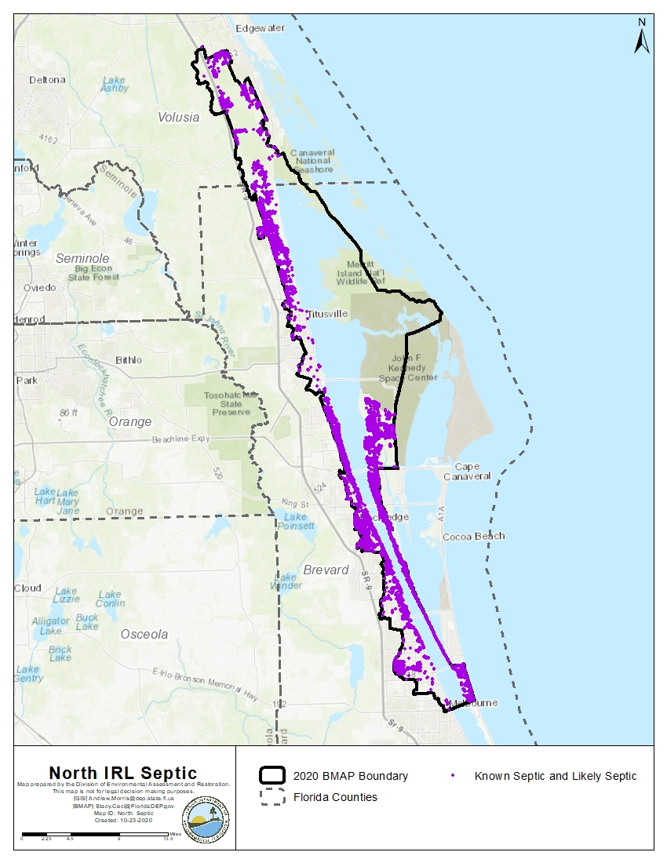
Figure 2. Location of septic systems in the NIRL

Urban Nonpoint Sources
Subsubparagraph 403.067(7)(b)2.f., F.S., prescribes the pollutant reduction actions required for nonagricultural pollutant sources that are not subject to NPDES permitting. "Non-MS4 sources" must also implement the pollutant reduction requirements detailed in a BMAP and are subject to enforcement action by DEP or a water management district if they fail to implement their responsibilities under the BMAP. Table 10 lists the nonpoint sources in the NIRL.
Table 10. Urban nonpoint sources in the NIRL
Type of Entity | Participant
Government Entities and Special Districts | Kennedy Space Center

Wastewater Treatment Facilities (WWTFs)
As of September 2020, DEP identified 18 individually permitted wastewater facilities or activities in the NIRL subbasin. A preliminary list of wastewater facilities in the NIRL as of September 2020 is provided below in Table 11 and a map of their locations is in Figure 3.
Table 11. Wastewater facilities in the NIRL as of September 2020
FPL = Flower Power and Light; RV = Recreational vehicle; VC = Volusia County; BCUD = Brevard County Utility District
Facility ID | Facility Name
FL0001473 | FPL - Cape Canaveral Power Plant
FL0021521 | Cocoa, City of - Cocoa Water Reclamation Facility
FL0021571 | Rockledge, City Of
FL0103268 | Titusville, City of - North - Osprey WWTF
FLA010264 | Housing Authority of Brevard County WWTF
FLA010323 | David B Lee Wastewater Treatment Plant
FLA010336 | Orlando Utilities Commission - Indian River Plant
FLA010354 | Canebreaker Condo
FLA010355 | Tropical Trail Village WWTF
FLA010358 | Willow Lakes RV Park WWTF
FLA010361 | River Forest Mobile Home Park WWTF
FLA010365 | Palm Harbor Mobile Home Park WWTF
FLA010375 | Oak Point Mobile Home Park WWTF
FLA010377 | Merritt Island Utility Company WWTF
FLA010383 | Riverview Mobile Home & RV Park
FLA011175 | Magnolia Village WWTF
FLA017413 | VC/Southeast WWTF-7
FLA102695 | BCUD/Sykes Creek Regional Wastewater Treatment Facility

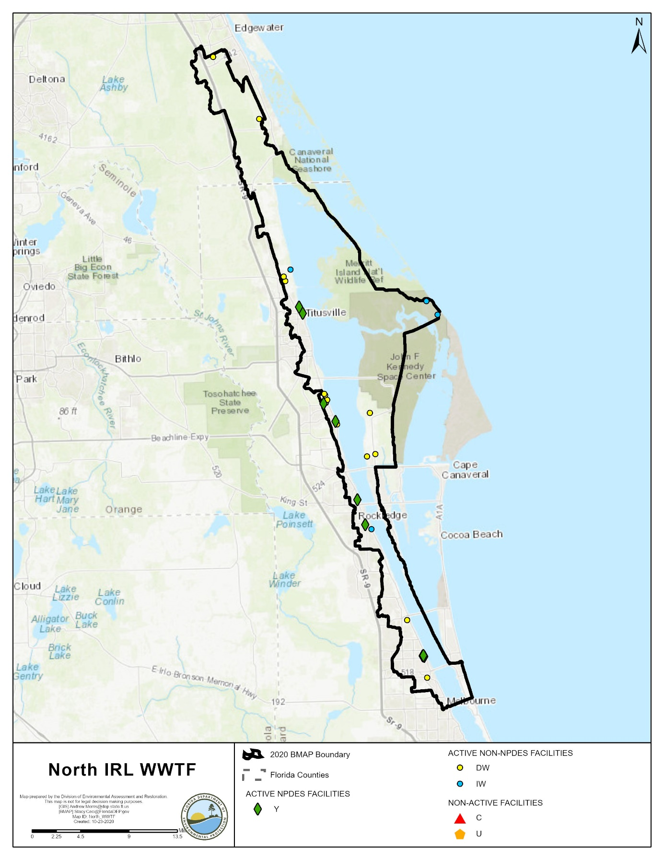
Figure 3. Map of wastewater facilities in the NIRL

Milestones and Tracking Progress
The projects and activities in the BMAP are key to the overall goal of recovering seagrass in the lagoon. The estimated benefits of these implemented activities are tracked to show stakeholder efforts by determining a percentage towards the total required reductions to be achieved at each milestone. Additionally, stakeholders provide DEP with reasonable assurance that they have a plan to achieve the individually assigned reductions required in Chapter 2. Section 403.067(7)(a)6, F.S., indicates that an assessment of progress towards the BMAP milestones shall be conducted very 5 years, and plan revisions made as appropriate. To meet these requirements, DEP has established milestones for the years 2025, 2030, and 2035.
The following percent reduction goals are proposed for each milestone and may be adjusted as the BMAP is adaptively managed through future phases:
- 5-year milestone in 2025: 30 % or 75,749 pounds per year (lbs/yr) of TN and 13,558 lbs/yr of TP. Based on model revisions, reset 10-year and 15-year milestones, as needed.
- 10-year milestone in 2030: 65 % or 164,122 lbs/yr of TN and 29,375 lbs/yr of TP.
- 15-year milestone in 2035: 100 % or 252,495 lbs/yr of TN and 45,193 lbs/yr of TP.
The next milestone is in 2025, by which at least 30 % of the TN and TP required reductions must be met. Figure 4 and Figure 5 show the milestones as well as the cumulative TN and TP reductions over time as projects are completed in each reporting period. The deadline established by this BMAP for achieving the full load reductions is 2035, which is 22 years after the initial adoption of the 2013 BMAP.

Figure 4. Estimated progress towards the NIRL BMAP TN milestones with projects completed through July 31, 2020

Figure 5. Estimated progress towards meeting the NIRL BMAP TP milestones with projects completed through July 31, 2020

Assumptions
The water quality impacts of BMAP implementation are based on several fundamental assumptions about the pollutants targeted by the TMDLs, modeling approaches, waterbody response, and natural processes. The following assumptions were used during the BMAP process:
- Certain BMPs were assigned provisional nutrient reduction benefits for load reductions in this BMAP iteration while additional monitoring and research are conducted to quantify their effectiveness. These estimated reductions may change in future BMAP iterations as additional information becomes available.
- Nutrient reduction benefits of the stakeholders' projects were calculated using the best available methodologies. Project-specific monitoring, where available, will be used to verify calculations, and reduction benefits may be adjusted as necessary.
- The TMDL requires TN and TP reductions from the watershed to improve water quality to allow seagrass to grow at greater water depths. High watershed nutrient loadings result in high chlorophyll a concentrations in the lagoon, which reduce light availability to the seagrass and limit the depth at which seagrass can grow. Therefore, reducing nutrient loading to the Central IRL is the most important factor to improving seagrass depth limits.
- The allocations do not require load reductions from areas identified as natural land use areas in the modeled land use/land cover information. These loads are considered uncontrollable, background sources, and the stakeholders are not required to make reductions on natural lands. The focus of the BMAP allocations is on urban and agricultural stormwater sources and septic systems in the watershed.
- Water is exchanged between the NIRL and other nearby waterbodies (the Banana IRL, Central IRL, and Mosquito Lagoon), and water quality conditions in the NIRL may be influenced by conditions in nearby waters. To help address these nearby conditions, separate BMAPs have been adopted for these watersheds and a reasonable assurance plan has been adopted for the Mosquito Lagoon.

Considerations
This BMAP requires stakeholders to implement their projects to achieve reductions within the specified period. However, the full implementation of this BMAP will be a long-term, adaptively managed process. While some of the BMAP projects and activities were recently completed or are currently ongoing, several projects require more time to design, secure funding, and construct. Regular followup and continued coordination and communication by the stakeholders will be essential to ensure the implementation of management strategies and assessment of incremental effects.
During the BMAP process, a number of items were identified that should be addressed in future watershed management cycles to ensure that future BMAPs use the most accurate information:
- Land Uses – The loading estimates in the BMAP are based on land uses at a point in time, allowing the model to be calibrated. The loading estimates for this BMAP iteration were based on land use/land cover data from approximately 2015 from the water management districts as well as property appraiser data.
- Basin Boundaries – Figure 6 shows the previous and updated BMAP boundary. Overall, 6,516 acres were added to the BMAP area and 904 acres removed, resulting in a net addition of 5,692 acres. When the 2013 basin boundary was developed, there was uncertainty about some areas and whether they drained to the IRL or to the Upper St. Johns River or other adjacent waterbodies. The boundaries were adjusted based on the best information available about the hydrology of the IRL but future adjustments may be made because of flow diversions or updated information.
- Jurisdictional Boundaries – Entities may experience shifts in their jurisdictional boundaries over time that require allocation adjustments. Changes to the boundaries and/or allocations for these stakeholders may be made as necessary and reflected in future BMAP iterations.
- SWIL Model – The SWIL Model was initially developed under a stakeholder partnership for purposes other than the BMAPs, and DEP will explore refinements that may help improve the future use of the SWIL for the IRL BMAPs. This effort could include updates to some of the SWIL Model input layers, verification of subbasin boundaries in some areas, revisions to the model period of record, and validation of predicted flows in selected calibration basins. There are also several optional tasks that could streamline efforts during the load allocation and project calculation processes. DEP expects the SWIL Model enhancements to change the loading estimates and the NIRL future allocations. Although it is unknown for certain the direction and magnitude of those changes, DEP anticipates that some may be higher, and some may be lower.
- CDD Responsibilities – DEP has had several communications with the community development districts (CDDs) located in the CIRL; there were no water quality-related CDDs found in the NIRL. In the CIRL, CDDs were assigned allocations only if three criteria were met: (1) there is development—i.e., roads and infrastructure—in the CDD area; (2) the CDD does not discharge to an MS4; and (3) the CDD pays a stormwater fee and receives a refund of this fee. CDDs that did not receive an allocation in this BMAP iteration may receive allocations in future BMAP iterations.
- Complexity of the Problem – DEP acknowledges the complexity of the dynamics that affect the water quality of the NIRL; therefore, this BMAP is designed to encompass a wide variety of projects and management strategies that will cumulatively act to significantly reduce nutrient loads. In estuarine-based systems, the interaction with ocean waters and freshwater inflows adds variabily to the water quality conditions. Other factors such as inconsistency in annual rainfall amounts, changing land uses and farming practices, and interal nutrient sources like muck deposits also complicate measuring the benefits of projects and understanding the relationship between nutrient loading and the biological response of the seagrass deep edge.
- Previous Restoration Efforts – DEP recognizes that stakeholders throughout the watershed have implemented stormwater management projects prior to the implementation of the TMDLs and that these efforts have benefited water quality. Projects completed in 2000 or later are considered for credits and inclusion in the BMAP.
- Atmospheric Deposition – The TMDL assumed that no reduction in atmospheric deposition would occur over time. The BMAP and all subsequent nutrient reduction requirements and allowable loads factor only those inputs directly from the watershed.
- Muck Deposition – Muck deposits contain nutrients that flux into the water column, increasing the abundance of phytoplankton, drift macroalgae, and epiphytes that attenuate light and constrain seagrass growth and propagation. Most IRL muck originates from upland soils and vegetation. For this reason, stringent watershed soil-erosion control and soil/vegetation containment measures are needed. Without such measures in place, muck removal will need to be frequently repeated, which is neither cost-effective nor time efficient. Ideally, muck removal projects should be performed in conjunction with soil and vegetation retention programs, including public awareness activities, which limit the amount of muck material deposited into the IRL. The SWIL Model does not automatically take this process into account; however, guidance documentation has been developed for crediting muck removal projects specifically from the lagoon.
- Tributary water quality impairments – DEP has identified nutrient and DO impairments in many of the NIRL tributaries, but has not yet set water quality targets with TMDLs. These waters include Turnbull Creek marine (WBID 2942A), Turnbull Creek freshwater (WBID 2942B), and Horse Creek (WBID 3081). The relation between the tributary loads and the targets set for the lagoon proper will be defined as tributary TMDLs are developed. As a general principle, when DEP establishes upstream TMDLs, downstream water quality targets are considered. In this case, when DEP establishes NIRL tributary TMDLs, meeting the lagoon's seagrass depth targets will be considered. Future tributary TMDLs may allow the targeting of specific watersheds for nutrient load reductions.

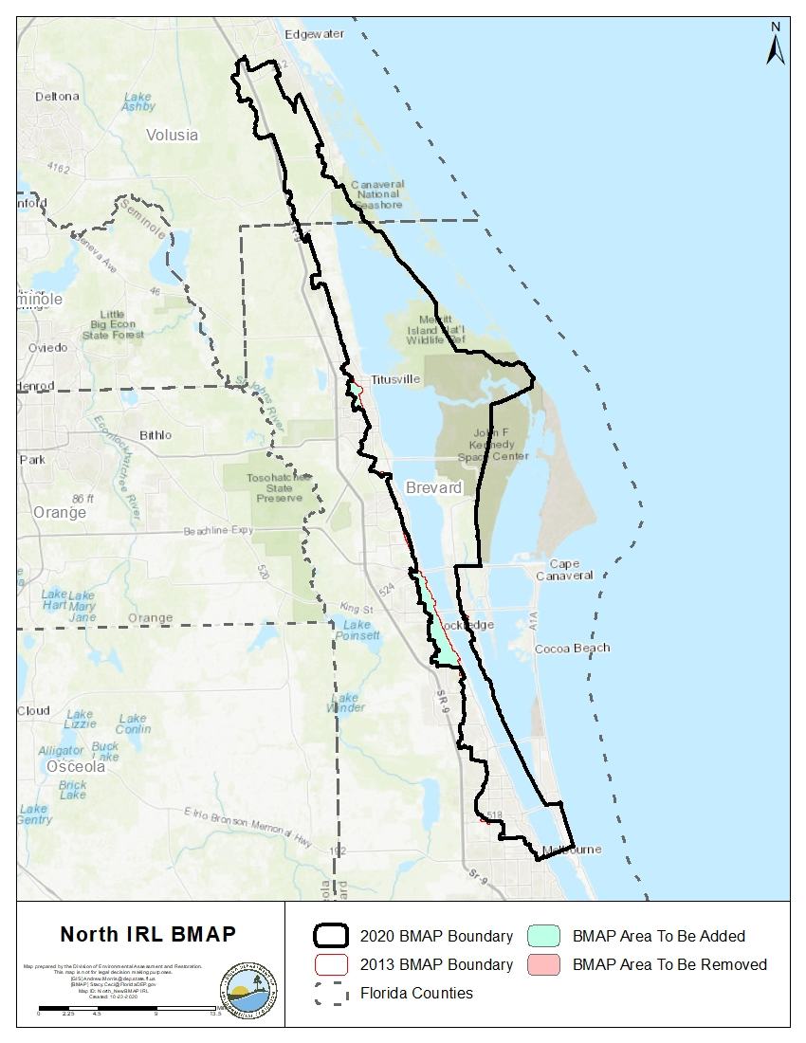
Figure 6. 2013 BMAP area boundary and 2020 BMAP area boundary

Economic Benefits of the IRL System
The IRL is a valuable ecological and economic asset for the state of Florida and the counties that border the lagoon and its tributaries. It is considered the most biologically diverse estuary in North America and was recognized as part of the National Estuary Program (NEP) in 1990. The lagoon directly and indirectly supports a large part of the region's and the state's economy. The basin supports the multimillion-dollar Indian River citrus industry and boat and marine sales industries. Finfish and shellfish harvesting from the lagoon contribute to local economies.
A 2016 economic study prepared by the East Coast Florida Regional Planning Council (ECFRPC) and Treasure Coast Regional Planning Council (TCRPC) (ECFRPC and TCRPC 2016) estimated the total value of the lagoon's benefits at $7.6 billion, measured in 2014 dollars. This does not include the estimated $934 million in annualized real estate value added for property located on or near the IRL (Hazen and Sawyer 2008). The study area spanned from Ponce de Leon Inlet in Volusia County to Jupiter Inlet in Palm Beach County, and included all of Brevard, Indian River, St. Lucie, and Martin Counties. The economic analysis was primarily conducted using the IMPLAN Regional Economic Input/Output Model. The model estimates direct, indirect, and induced economic effects as outlined in Figure 7.
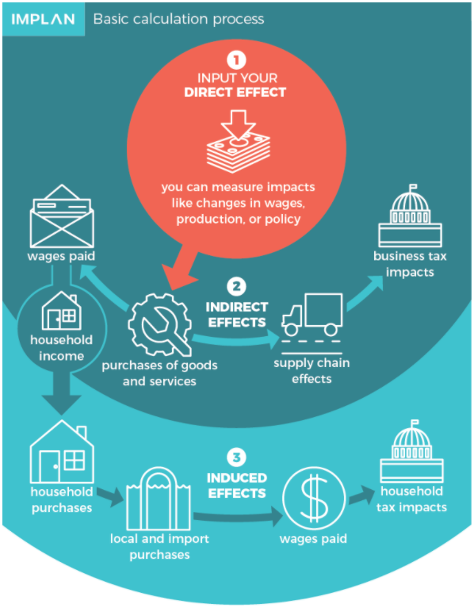
Figure 7. IMPLAN Model calculation process
The primary IRL-related industry groups identified in the study are Living Resources, Marine Industries, Recreation and Visitor-related, Resource Management, and Defense and Aerospace. The breakdown of the monetary contribution to the IRL regional economy is presented in Figure 8.
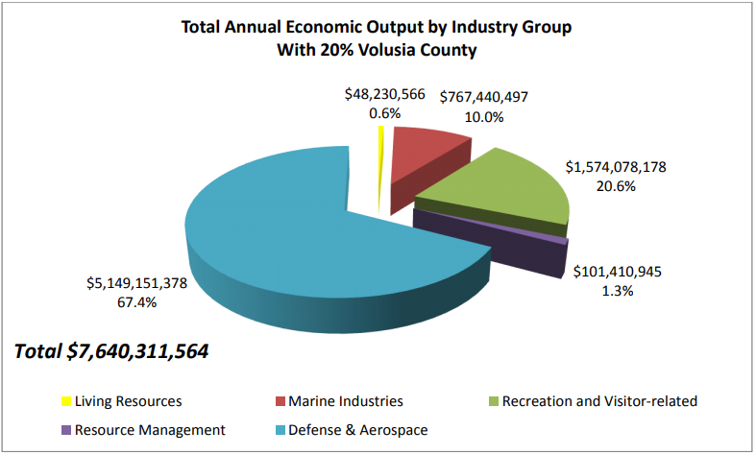
Figure 8. Total annual economic output by industry group in IRL region, 2014

$1.57 billion of economic benefit was generated from money spent on recreation and visitor-related activities. In 2014, over 7.4 million visitors traveled to the IRL region. From 2.3 to 3.5 million visitors to the IRL region participate in IRL-related recreation, and each visitor spends an average of about $162 a day. By 2025, the IRL region is anticipated to receive over 11 million visitors annually.
The study also estimated the cost of a sustainable IRL-based economy and return on investment of achieving water quality and seagrass restoration goals for the IRL. The annualized cost of achieving the nutrient load reductions required by the 4 BMAPs that span the study area was estimated at $230 million. When compared with the $7.6 billion valuation of the region's average annual economic output, the return on investment from achieving water quality and seagrass restoration goals is 33 to 1. Therefore, investing in projects and programs to improve the lagoon's water quality and seagrass beds is not only important for environmental considerations but also to improve the regional economy.

- Modeling, Load Estimates, and Restoration Approach

BMAP Modeling
Nutrient loading estimates were originally calculated for the BMAP using the Pollutant Load Screening Model (PLSM) which was expanded by SJRWMD to represent year 2000 loading (Adkins et al. 2004) in most of the IRL Watershed (excluding the Southern IRL area). The seagrass depth limits were developed by SJRWMD based on a series of photo-interpreted seagrass coverages beginning in 1943 through 2001. These models and the seagrass depth limits were reviewed by DEP and used to develop the IRL TMDLs that were adopted by rule (Gao 2009).
Through cooperative local effects, all the MS4 permittees within the Brevard County section of the IRL (17 entities) partnered to fund a Study Team to create a new watershed model that would update and refine the information that was used in the PLSM and associated TMDLs for the IRL. One outcome of this study was the development of the SWIL Model, which is intended to incorporate more available data, more recent conditions, and more temporally fine datasets. SWIL is a custom ESRI ArcGIS toolset, originally designed to provide a continuous monthly simulation of runoff over a 16-year period (Applied Ecology 2019).
During 2017 and 2018, while DEP prepared to calculate allocations for the Central IRL BMAP, the SWIL was proposed as an alternative to the previously used PLSM. Several options were presented for updating allocations during a public meeting in May 2017 and the options were discussed by DEP and stakeholders during and after the meeting. In November of 2017, a presentation was made to the IRL National Estuary Program STEM Committee to provide a technical overview of the SWIL. During the annual public meeting for the IRL BMAPs in December 2018, a proposed path forward was presented that included applying the SWIL to calculate allocations for the IRL BMAPs. A technical presentation was given by the model developer at a public webinar in January 2019 to provide stakeholders with an opportunity to discuss the model further. Finally, during the annual public meeting for the IRL BMAPs in December 2019, a summary of the allocation approach using SWIL was presented.

SWIL Modeling
The initial version of SWIL was developed for the IRL in 2012 (SWIL 1.0). To address several DEP comments and to improve execution and processing time, SWIL 2.0 was released in July 2014. SWIL 3.0 was released in April 2015 with improved model calibration to the measured available gauge data, including a revised method to derive baseflow volumes and loads. SWIL 3.0 also incorporated new evapotranspiration raster datasets. SWIL 4.0 was developed in support of the 3D numerical modeling effort led by the Florida Institute of Technology. Three major changes were performed for SWIL 4.0: (1) expansion of the model extent to provide nutrient loadings from Ponce Inlet to Fort Pierce; (2) temporal expansion from 2011 to 2015; and (3) converting the model from two to three land use/treatment time steps (Applied Ecology 2019).

SWIL Calibration
SWIL 3.0 was used for calibration, primarily in the Central IRL where volume data were available. Few data were available in NIRL and none in the Banana River Lagoon, and so the calibration is based primarly on the Central IRL conditions. Also during the calibration process, a change was made to the normalization process of the baseflow volumes by incorporating "groundwater storage depth," an area-weighted groundwter input variable (Applied Ecology 2015). The calibration was based on two model years—2000 and 2004. Since the calibration period was from a period early in the model time steps, the projects from 2000 forward are not thought to be well-represented in the SWIL Model and, therefore, are eligible for BMAP credit.

Allocation Process
To generate average annual TN and TP loads from the IRL watershed, SWIL was run using rainfall inputs that were thought to be from a representative period covering various conditions from high to low rainfall years. The outputs from this model run were used to generate a GIS-based Load Estimation Tool (LET) that included annual average loads from the watershed and was the basis of the allocation calculations.
The LET based on the SWIL Model can produce polygon outputs with loading data included. The determination of each entity's loading was performed using the LET and a GIS process. Through a series of GIS steps, polygons were generated for each stakeholder. GIS data were used to clip the area within the BMAP boundary associated with each entity's jurisdictional boundary or the codes from the model land cover data related to natural and agricultural lands. The clipping process was done sequentially, as follows:
- Dispersed Water Management (DWM) or Comprehensive Everglades Restoration Plan (CERP) projects.
- Roads (Florida Department of Transportation [FDOT] and Florida's Turnpike Enterprise).
- Water control districts (WCDs) and water improvement district canals and rights-of-way.
- Natural lands (land use codes 3000 [not including 3300], 4000, 5000, and 6000).
- Agriculture (land use codes 2000 and 3300).
- CDDs, if they meet the criteria.
- Municipalities.
- Remaining area assigned to each county.
Loads within DWM or CERP projects was not included in the total loads for the project zone, since these land uses are being converted to treatment projects. Loads from natural land uses were not assigned to any specific entity's starting load. FDOT, agriculture, municipalities, and counties were assigned starting loads based on this sequential process.

Project Credit Process
The LET was used to calculate updated TN and TP baseloads from all existing project treatment areas in the BMAP. The August 2020 DEP BMP Efficiencies Guidance document was used to determine the appropriate credit calculations for the various project types. Some project types that have credits based on measured data or weighed material, such as street sweeping, did not need to be updated using the LET.

Calculation of Starting Loads and Allocations
This section describes the process to calculate the load reductions needed to achieve the TMDL and to allocate the load reduction requirements to the responsible stakeholders.

Starting Loads and Allocation of Load Reductions
DEP requested to use the SWIL 4.0 Model to update the load allocations for the second cycle of the IRL BMAPs. To develop the loads that represent updated current conditions, the SWIL Model was customized for this use with the following parameters (Applied Ecology 2018):
- 50 x 50-meter (m) cell size, much higher spatial resolution than any previously developed watershed loading models for the IRL.
- Land use corresponds to 2015 conditions and is derived from water management districts land use, property appraiser data, and local government natural communities land cover, where available.
- Treatment layer (stormwater BMPs) correspond to development conditions in approximately 2015, excluding any retrofits implemented by the stakeholders in the IRL Watershed. Retrofit projects will need to be posteriorly calculated and provided as credits to the stakeholders.
- Period of record rainfall that includes 2004 to 2017 data, which allows for a wide range of rainfall conditions to represent the variability in loading to the IRL.
The outputs of this modeling effort can be described as static feature classes that include more than 1.2 million 50 x 50-m cells (as features) each. Each individual cell is associated with an estimated volume and both nitrogen and phosphorus estimated loading for the selected mean period of record conditions (Applied Ecology 2018). DEP refers to this output as the Load Estimation Tool, or LET.
For land use and land cover, 2015 conditions were represented that were derived (for nonurban land uses) from water management district land use and (for urban land uses) local property appraiser datasets. Natural community data from the local governments were also incorporated, where available (Brevard County). In addition, field-validated 2015 land use datasets for Patrick Air Force Base, Cape Canaveral Air Force Station, and the Malabar Annex were used in lieu of water management data. (Applied Ecology 2018) Land covers were grouped to reflect the available event mean concentrations (EMCs) and C values that would be applied in the model. (Listopad 2020)
DEP used the LET to develop the allocations (see Figure 9 and Figure 10). The percent reduction from the TMDL was applied to the applicable areas within the BMAP. The TMDL percent reductions are based on segmented areas of the lagoon defined by both DEP WBIDs along with breaks in the hydrology of the lagoon as defined by SJRWMD. Areas where segments share hydrologic similarity and similar reduction percentages, as noted by the TMDL, are defined as segment groups. Additionally, during the first phase of BMAP adoption, the hydrology defined by SJRWMD was used to define project zones in order to assess seagrass compliance. Both project zone and segment group assist in calculating the required reduction and the allocation of each entity within the BMAP. The total segment load from the LET was used and the percent reduction from the TMDL for that segment was applied to discern the total required reductions per segment. Natural lands had no reductions applied, and so the SWIL loads from natural land uses were held constant. The land cover codes considered to be "natural lands" include 3000 (upland nonforested; not including 3300), 4000 (upland forests), 5000 (water), and 6000 (wetlands). The allowable load in the segment was determined by subtracting the required reductions from the total segment load determined by the LET.
A test was performed to make sure that no reductions would be expected from natural land uses. The weighted average load per acre from natural lands for each segment was compared to the load per acre from the allowable load. If the allowable load per acre was less than the natural land load per acre, the allowable load was increased to equal the natural load per acre times the acres in the segment. This process was performed for both TN and TP loads in each segment.
Once the total required reductions for each segment were defined, the total anthropogenic load for the segment was examined. Each stakeholder's anthropogenic load was compared to the total anthropogenic load for the segment to determine their contribution to the total anthropogenic load. This percentage was considered to be representative of the stakeholder's loading contribution and that percentage of the segment's required reduction was applied to them. If an entity was located in more than one BMAP area, the required reductions are added together to determine their total required reductions for the project zone.

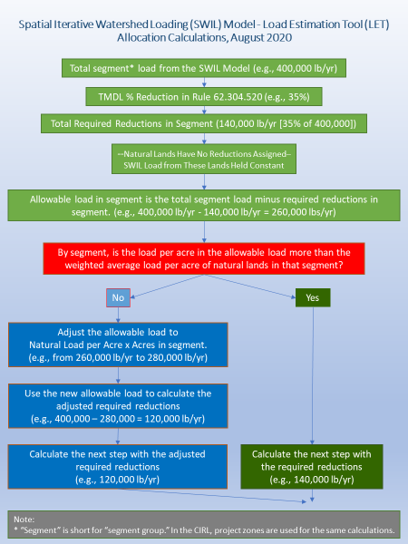
Figure 9. Flowchart of the allocation steps, page 1 of 2
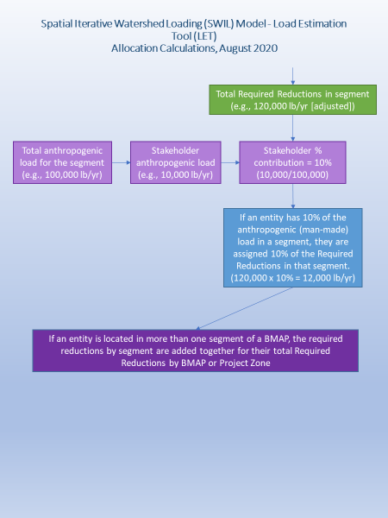
Figure 10. Flowchart of the allocation steps, page 2 of 2

The SWIL Model starting loads for each project zone are described in Table 12 below.
Table 12. SWIL Model starting loads (lbs/yr)
Project Zone | Starting TN Load | % Total Load TN | Starting TP Load | % Total Load TP
A | 399,161 | 53 | 46,021 | 48
B | 359,923 | 47 | 50,203 | 52
Totals | 759,084 | 100 | 96,224 | 100

Low Priority Ranking Determination
Several stakeholders contribute less than 0.30 % of both the TN and TP loading from the watershed to the NIRL. The contribution to the overall nutrient loading from these stakeholders is low enough that reductions from these areas would have essentially no impact on the required reductions for the BMAP during this phase of implementation; therefore, these entities are currently considered a low priority for implementing reductions. Low priority entities will be evaluated in future phases of BMAP implementation, as their contributions may change over time.
Table 13 summarizes the priority evaluation, and those stakeholders meeting the classification requirements for low priority are highlighted in grey. Stakeholders that met the low-priority classification include . These entities are not required to meet the reduction targets for TN and TP in this phase of the BMAP but must continue to adhere to all requirements of their MS4 permit or other permits.
BMAP progress will be reviewed over time, and reduction requirements, including for those stakeholders with this low-priority status, will be updated in a future BMAP update as needed. TN and TP reductions may be needed from the low-priority entities in the future. Therefore, although they do not currently have a reduction responsibility, this does not exempt these stakeholders from such requirements in future BMAP updates. Any actions taken by these entities that result in TN and TP reductions will be documented for credit against any reduction requirements allocated in subsequent BMAP updates.

Table 13. Entity contributions to starting loads with low priority ranking cutoff
Note: Grey highlighting and boldface type indicate jurisdictions meeting the classification requirements for low priority.
N/A = Not applicable
Entity | TN Starting Load (lbs/yr) | Anthropogenic % TN in BMAP | TP Starting Load (lbs/yr) | Anthropogenic % TP in BMAP
Brevard County | 178,194 | 38.86 | 26,588 | 39.70
City of Melbourne | 77,791 | 16.97 | 11,420 | 17.05
City of Titusville | 56,775 | 12.38 | 8,264 | 12.34
Agricultural Producers | 38,099 | 8.31 | 5,750 | 8.59
City of Rockledge | 27,669 | 6.03 | 3,982 | 5.95
Volusia County | 23,029 | 5.02 | 3,309 | 4.94
Kennedy Space Center | 18,271 | 3.98 | 2,251 | 3.36
City of Cocoa | 18,189 | 3.97 | 2,645 | 3.95
FDOT District 5 | 13,893 | 3.03 | 1,825 | 2.73
City of Edgewater | 2,704 | 0.59 | 361 | 0.54
Town of Palm Shores | 1,924 | 0.42 | 276 | 0.41
Town of Indialantic | 1,623 | 0.35 | 244 | 0.36
City of Oak Hill | 371 | 0.08 | 49 | 0.07
Total of Allocated Entities | 458,532 | 100.00 | 66,964 | 100.00
Natural Lands | 300,552 | N/A | 29,259 | N/A
Total | 759,084 | N/A | 96,224 | N/A

Required Reductions
The TN and TP reductions required by each entity are shown in Table 14 and Table 15, respectively.
Table 14. TN load required reductions by entity (lbs/yr)
Note: Grey highlighting and boldface type indicate jurisdictions meeting the classification requirements for low priority.
N/A = Not applicable
Entity | Project Zone A | Project Zone B | Total
City of Titusville | 37,334 | 2,619 | 39,953
Brevard County | 27,759 | 64,506 | 92,265
Agricultural Producers | 20,550 | 4,714 | 25,264
Kennedy Space Center | 4,325 | 2,423 | 6,748
FDOT District 5 | 9,730 | 3,640 | 13,370
Volusia County | 16,679 | N/A | 16,679
City of Edgewater | 1,959 | N/A | 1,959
City of Melbourne | N/A | 34,378 | 34,378
City of Rockledge | N/A | 11,322 | 11,322
City of Cocoa | N/A | 8,837 | 8,837
Town of Indialantic | N/A | 664 | 664
Town of Palm Shores | N/A | 787 | 787
City of Oak Hill | 269 | N/A | 0
Total | 118,604 | 133,891 | 252,226

Table 15. TP load required reductions by entity (lbs/yr)
Note: Grey highlighting and boldface type indicate jurisdictions meeting the classification requirements for low priority.
Entity | Project Zone A | Project Zone B | Total
City of Titusville | 6,224 | 474 | 6,698
Brevard County | 4,809 | 12,667 | 17,476
Agricultural Producers | 3,522 | 958 | 4,480
Kennedy Space Center | 1,422 | 353 | 1,775
FDOT District 5 | 631 | 641 | 1,272
Volusia County | 2,724 | N/A | 2,724
City of Edgewater | 297 | N/A | 297
City of Melbourne | N/A | 6,292 | 6,292
City of Rockledge | N/A | 2,135 | 2,135
City of Cocoa | N/A | 1,726 | 1,726
Town of Palm Shores | N/A | 148 | 148
Town of Indialantic | N/A | 131 | 131
City of Oak Hill | 40 | N/A | 0
Total | 19,669 | 25,524 | 45,154

Basinwide Sources Approach

Agriculture
When DEP adopts a BMAP that includes agriculture, it is the agricultural landowner's responsibility to implement BMPs adopted by FDACS to help achieve load reductions or demonstrate through monitoring that they are already meeting water quality standards. FDACS is responsible for verifying that all eligible landowners are enrolled in appropriate BMP programs. Subparagraph 403.067(7)(d)3, F.S., also requires FDACS to perform regular onsite inspections, at least every two years, of all agricultural operations enrolled under a BMP manual to ensure that these practices are being properly implemented. From these inspections, FDACS will provide DEP and SJRWMD an annual summary of aggregated fertilizer use in the BMAP area, quantifying total applications and providing information on applications by project zone.
Although it is anticipated that additional enrollment in agricultural BMPs along with more frequent implementation verification site visits by FDACS will increase nutrient reductions from agricultural nonpoint sources, further reductions, beyond the implementation of required owner-implemented BMPs, currently required by the FDACS manuals, will be necessary to achieve the TMDLs. FDACS has committed to updating its existing BMP manuals to incorporate updated BMPs based on the latest scientific and technical research. Section 403.067(7)(f)1, F.S., requires FDACS to annually develop research plans and legislative budget requests for the following:
- Evaluate and suggest enhancements to the existing adopted agricultural BMPs to reduce nutrient runoff.
- Develop new BMPs that, if proven effective, may be adopted by rule.
- Develop agricultural nutrient runoff reduction projects that willing participants could implement on a site-specific, cooperative basis, in addition to BMPs.
FDACS also provides funding to some agricultural operations to add other practices beyond owner-implemented BMPs. Examples include drainage improvements, fencing, water control structures, precision agriculture technology, and fertigation. Other reductions associated with the implementation and modification of BMPs may be realized through ongoing studies, data collection, and water management district initiatives. These additional projects and practices are to be implemented in conjunction with the BMP Program, which needs to achieve full enrollment with verification to ensure that the BMAP goals are achieved.
If owner-implemented BMPs fail to achieve water quality improvements, a cooperative agricultural regional water quality improvement element may be developed for this BMAP, subject to the conditions outlined in Subparagraph 403.067(7)(e)1, F.S. DEP, FDACS, and agricultural producers will cooperatively develop a regional water quality improvement element if:
- Agricultural measures have been adopted by FDACS pursuant to Subparagraph 403.067(7)(c)2, F.S., and have been implemented and the waterbody remains impaired.
- Agricultural nonpoint sources contribute to at least 20 percent of nonpoint source nutrient discharges.
- DEP determines that additional measures, in combination with state-sponsored regional projects and other management strategies included in the BMAP, are necessary to achieve the TMDL.
Further nutrient reductions can be achieved through the implementation of additional agricultural projects or activities. Other reductions associated with the implementation and modification of BMPs may be realized through ongoing studies, data collection, and water management district initiatives. These additional projects and practices are to be implemented in conjunction with the BMP Program, which needs to achieve full enrollment with verification to ensure that the BMAP goals are achieved.

Septic Systems
As required in Section 403.067(7) (a) 9.b., F.S., local governments must develop an OSTDS remediation plan to be adopted as part of the BMAP no later than July 1, 2025. The OSTDS remediation plans must be developed by each local government in cooperation with DEP, FDOH, water management districts, and public and private domestic wastewater facilities.
The OSTDS remediation plan requires entities to identify and address the following:
- Cost-effective and financially feasible projects necessary to achieve the nutrient load reductions required for OSTDS (e.g., sewering, advanced septic system retrofits, prohibiting the installation of new conventional septic systems).
- An inventory of OSTDS based on the best information available.
- OSTDS that would be eliminated through connection to existing or future central domestic wastewater infrastructure in the jurisdiction or domestic wastewater service area of the local government.
- OSTDS that would be replaced with or upgraded to enhanced nutrient-reducing onsite sewage treatment and disposal systems.
- Cost of improvements and sources of funding.
Based on data from FDOH, there are 8,182 known and likely septic systems located throughout the NIRL Subbasin. Of these, 7,149 are located in U.S. Census (2010)–designated urbanized areas or urban clusters. Table 9 summarizes the count of septic systems by project zone.
Stakeholders will submit projects describing how septic loads are addressed as part of BMAP reporting and estimate load reductions associated with each project. The estimated reductions to the lagoon from addressing these septic systems will be based on several factors. These may include factors such as how they are addressed (i.e., connecting to central sewer sends the wastewater to a treatment facility, which does not remove 100 % of the nutrient load) and the amount of attenuation that occurs as the effluent travels through the watershed to the lagoon.

Stormwater
Stormwater from urban areas is a considerable source of nutrient loading to the NIRL, and many of these areas are already regulated under the NPDES Stormwater Program. MS4 permittees are required to develop and implement a stormwater management program. Urban areas located in the BMAP area that are not currently covered by an MS4 permit also significantly contribute, individually or in aggregate, to nutrient loading. Therefore, the NPDES Stormwater Program will, within 5 years of BMAP adoption, evaluate any entity located in the BMAP area that serves a minimum resident population of at least 1,000 individuals that are not currently covered by an MS4 permit and designate eligible entities as regulated MS4s, in accordance with Chapter 62-624, F.A.C.
In accordance with Subsection 373.4131(6), F.S., DEP and the water management districts are planning to update the stormwater design and operation requirements in Environmental Resource Permit rules. These revisions will incorporate the most recent scientific information available to improve nutrient reduction benefits.

Wastewater Treatment
DEP issues permits for facilities and activities to discharge wastewater to surface waters and groundwaters of the state. DEP is authorized by the EPA to issue permits for discharges to surface waters under the NPDES Program. Permits for discharges to groundwaters are issued by DEP under state statutes and rules. These wastewater discharge permits establish specific limitations and requirements based on the location and type of facility or activity releasing industrial or domestic wastewaters from a point source. As of September 2020, there were 18 individually permitted wastewater facilities or activities in the NIRL Subbasin. All new and existing wastewater facilities that dispose of effluent or discharge in the BMAP area are subject to the BMAP provisions, regardless of whether the facility is listed in this BMAP. A preliminary list of wastewater facilities in the BRL as of September 2020 is provided in Table 11 and a map of their locations is presented in Figure 3.
In areas where there is anticipated growth in human population, adequate treatment capacity of domestic wastewater is essential. Domestic wastewater is treated through either WWTFs or OSTDS, commonly referred to as septic systems. Where sewer lines are available, Florida law (Section 381.00655, F.S.) requires a development or property owner to abandon the use of the OSTDS and connect to sanitary sewer lines.
Florida law (Section 403.086, F.S., and Chapter 2020-150, Laws of Florida) requires all domestic wastewater facilities directly discharging to surfaces waters of the state within or connected to the Indian River Lagoon must meet advanced waste treatment requirements, as defined in Section 403.086, no later than July 1, 2025. Additionally, this BMAP requires all individually permitted domestic wastewater facilities to meet the effluent limitation listed in Table 16 and Table 17, unless the owner or operator can demonstrate reasonable assurance that the effluent would not cause or contribute to an exceedance of the TMDLs or water quality standards in ground waters. To demonstrate reasonable assurance, the owner or operator must provide relevant water quality data, physical circumstances, or other site-specific credible information needed to show the facility would not cause or contribute to the nutrient loading in the BMAP area. This demonstration may include factors such as dilution; site-specific geological conditions; research/studies, including dye tracer tests; and modeling. If DEP concurs with the reasonable assurance demonstration, the effluent limitations established for discharges to ground water may be modified or waived for the facility. New effluent limitations will take effect no later than July 1, 2025.
New and existing domestic wastewater facilities must meet the stringent nutrient wastewater limitations set forth in this BMAP Any such new facilities (those commencing after the adoption of this BMAP) must be capable of meeting the requirements of this BMAP at the time of permit issuance. For existing domestic wastewater facilities, DEP shall modify the permit limitations and requirements to be consistent with this BMAP at the time of the next permit renewal. If the facility needs additional time to meet the new limits, the permit may include a compliance schedule with a completion date not to exceed four and half years after the effective date of the permit.
Table 16 and Table 17 list the TP and TN effluent limitations, respectively, adopted for this BMAP that apply to domestic wastewater facilities unless the owner or operator can demonstrate reasonable assurance as listed above. The effluent limitations for direct surface water discharges and reclaimed water pipelines apply to individually permitted NPDES facilities at the end-of-pipe. Because the limitations for direct surface water discharges are technical-based advanced waste treatment limitations, mixing zones are not authorized for TN and TP. The effluentlimitations for discharges to ground waterapply at the compliance well located at the edge of the zone of discharge. The owner or operator may elect to meet the ground water limitations prior to the edge of the zone of discharge. These effluent limitations are applied as an annual average. For direct surface water discharges, the limitations in Subparagraph 62-600.740(2)(b), F.A.C., will be applied in the permit.
Short-term or intermittent discharges are not significant sources of TN or TP in the NIRL Subbasin and are not subject to the limits in Table 16 and Table 17. Intermittent, rainfall-driven, diffuse overflow releases of wastewater from ponds or basins designed to hold precipitation from a 25-year, 24-hour rainfall event or less frequent rainfall event and that infrequently reaches surface waters are considered insignificant sources of TN and TP provided the ponds or basins are maintained under normal conditions at or below established water levels. The owners or operators of cooling pond reservoirs must operate each spillway gate either during regular operation or on a test basis to protect the structural integrity of the reservoir. Because of the short duration and low volume of wastewater released during spillway gate testing, releases either on an annual or semi-annual basis are considered insignificant sources of TN and TP.
Industrial wastewater facilities are not subject to the limits in Table 16 and Table 17. However, these facilities must hold the line. For industrial wastewater facilities that discharge to surface waters of the state must meet the numeric nutrient criteria in Rules 62-302.531 and 62-302.532, F.A.C.
Additionally, new or renewed wastewater permits in the BMAP area must require at least quarterly sampling of the effluent discharge at the point of discharge or edge of the zone of discharge for TN and TP and the reporting of sampling results in the discharge monitoring reports submitted to DEP.

Table 16. TN effluent limits
mg/L = milligrams per liter
mgd = million gallons per day
RRLA = rapid rate land application
Permitted Average Daily Flow  (mgd) | TN Concentration Limits for Direct Surface Discharge (mg/L) | TN Concentration Limits for RRLA Effluent Disposal System  (mg/L) | TN Concentration Limits for All Other Disposal Methods, Including Reuse (mg/L)
Greater than or equal to 0.5 | 3.0 | 3.0 | 10.0
Less than 0.5 and greater than or equal to 0.1 | 3.0 | 6.0 | 10.0
Less than 0.1 | 3.0 | 10.0 | 10.0

Table 17. TP effluent limits
Permitted Average Daily Flow  (mgd) | TP Concentration Limits for Direct Surface Discharge (mg/L) | TP Concentration Limits for RRLA Effluent Disposal System  (mg/L) | TP Concentration Limits for All Other Disposal Methods, Including Reuse (mg/L)
Greater than or equal to 0.5 | 1.0 | 1.0 | 6.0
Less than 0.5 and greater than or equal to 0.1 | 1.0 | 3.0 | 6.0
Less than 0.1 | 1.0 | 6.0 | 6.0

Pursuant to Subsubparagraph 403.067(7)(a)9., F.S., local governments in BMAPs where DEP determines remediation is necessary to achieve the TMDL must develop wastewater treatment plans to be adopted as part of the BMAP no later than July 1, 2025.
The wastewater treatment plans must be developed by each local government, in cooperation with the DEP, the water management district, and the public and private domestic wastewater treatment facilities within jurisdiction of the local government. A local government is not responsible for a private domestic wastewater facility's compliance with the BMAP unless such facility is operated through a public-private partnership to which the local government is a party.
The wastewater treatment plan requires entities to identify and address the following:
- Provide construction, expansion or necessary facility upgrades to achieve TMDL applicable to the domestic wastewater treatment facility.
- Include the permitted capacity in annual gallons per day for the domestic wastewater treatment facility.
- Include the average nutrient concentration and the estimated average nutrient load of the domestic wastewater.
- Project timeline of the dates by which the construction of any facility improvements will begin and be completed and the date by which operations of the improved facility will begin.
- Estimate cost of improvements.
- Identify the responsible parties.

Seagrass and Water Quality Monitoring Plan
This monitoring plan is designed to track seagrass distribution and identify long-term water quality trends. Sampling stations, parameters, frequency, and other elements of this strategy may be modified as appropriate to match changing environmental conditions, funding resources, and understanding of the IRL system.

Objectives
The primary and secondary monitoring objectives are described below:
Primary Monitoring Objective
- Track seagrass depth extent responses to BMAP implementation.
Secondary Monitoring Objective
- Track trends in ambient water quality in NIRL and its subbasin, including major tributaries.
- Determine if subbasin nutrient loading is decreasing resulting in improved lagoon water quality, which will allow seagrass to grow to target depths.
Additional information about the seagrass depth and compliance with the TMDL targets is discussed in Section 4.2, including the most recent results based on the 2019 aerial mapping data. To read more about the process for analyzing the seagrass data and depth analysis, see Appendix C.

Monitoring Parameters, Frequency, and Network
To achieve the primary monitoring objective, the main parameter that will be tracked is the seagrass depth by project zone, which are identified through flyover mapping and aerial photography interpretation. DEP, in conjunction with SJRWMD, are partnering to fund and conduct the flyovers and mapping. In the past, SJRWMD and partners typically have contracted for seagrass mapping every 2 to 3 years, and DEP will continue to work with the District to maintain this frequency for the BMAP monitoring plan as long as resources remain available. The aerial photography is taken in spring to early summer, which is during the seagrass growing season. Field sampling conducted around the time of the flights provides data for assessing accuracy of the maps, and additional field sampling is conducted to address uncertainty regarding areas mapped as seagrass. Using the aerial photography, a map is created showing seagrass extent in the lagoon. These maps are used in evaluations to assess progress towards the TMDL seagrass depth targets for the NIRL. Additional details are contained in Appendix C.
To achieve the secondary monitoring objective above, the existing SJRWMD monthly stations in the NIRL BMAP will be monitored. On average, seagrass transects are 1 kilometer (km) away from a long-term water quality station. The monitoring strategy for these stations focuses on the following parameters:

- Total Kjeldahl Nitrogen
- Nitrite/Nitrate
- Ammonia
- Total Phosphorus (TP)
- Orthophosphate
- Chlorophyll a (corrected)
- Photosynthetically Active Radiation (PAR)
- True Color
- Turbidity
- Total Suspended Solids (TSS)
- Dissolved Oxygen
- Specific Conductivity
- pH
- Salinity
- Secchi Depth
- Depth of Collection
- Total Depth of Sample Site
- Water Temperature
- Field Conditions
- Total Organic Carbon
- Dissolved Organic Carbon
- Silica
- Alkalinity
- Volatile Suspended Solids

In addition to the SJRWMD water quality monitoring stations, Volusia County collects water quality data at three stations, and the U.S. Geological Survey (USGS) collects flow data at two stations in the NIRL.
Table 18 lists the stations that SJRWMD, Volusia County, and USGS currently sample in the NIRL BMAP, and these stations are shown by project zone in Figure 11 and Figure 12. Generally data collection occurs from three types of stations: flow stations where volume is primarily determined; tributary water quality stations near the junction of tributaries where parameters are sampled as these waters mix with the lagoon; and lagoon water quality stations that measure parameters in the lagoon itself.
Table 18. Water quality monitoring stations in the NIRL BMAP
Entity | Station ID | Project Zone | Status | Latitude | Longitude | Station Type | Frequency
SJRWMD | IRLBFRR | NIRL-A | Active | 28.7553 | -80.8461 | Tributary Water Quality | Monthly
SJRWMD | IRLI02 | NIRL-A | Active | 28.7370 | -80.8007 | Lagoon Water Quality | Monthly
SJRWMD | IRLI06 | NIRL-A | Active | 28.6358 | -80.8020 | Lagoon Water Quality | Monthly
SJRWMD | IRLI07 | NIRL-A | Active | 28.6035 | -80.7984 | Lagoon Water Quality | Monthly
SJRWMD | IRLI09E | NIRL-A | Active | 28.5564 | -80.7416 | Lagoon Water Quality | Monthly
USGS | 02248380 | NIRL-A | Active | 28.7362 | -80.7546 | Flow | Continuous
Volusia County | ODIX | NIRL-A | Active | 28.8051 | -80.8604 | Tributary Water Quality | Bi-monthly
SJRWMD | IRLTBC | NIRL-A | Active | 28.8209 | -80.8601 | Tributary Water Quality | Monthly
Volusia County | TC2 | NIRL-A | Active | 28.8252 | -80.8572 | Tributary Water Quality | Bi-monthly
SJRWMD | IRLEGU | NIRL-B | Active | 28.1243 | -80.6308 | Tributary Water Quality | Monthly
SJRWMD | IRLI10 | NIRL-B | Active | 28.5012 | -80.7686 | Lagoon Water Quality | Monthly
SJRWMD | IRLI13 | NIRL-B | Active | 28.3931 | -80.7359 | Lagoon Water Quality | Monthly
SJRWMD | IRLI15 | NIRL-B | Active | 28.3353 | -80.7131 | Lagoon Water Quality | Monthly
SJRWMD | IRLI16 | NIRL-B | Active | 28.2778 | -80.6767 | Lagoon Water Quality | Monthly
SJRWMD | IRLI18 | NIRL-B | Active | 28.1949 | -80.6487 | Lagoon Water Quality | Monthly
SJRWMD | IRLI21 | NIRL-B | Active | 28.1253 | -80.6165 | Lagoon Water Quality | Monthly
SJRWMD | IRLUPEGWR | NIRL-B | Active | 28.1270 | -80.6454 | Tributary Water Quality | Monthly
SJRWMD | IRLUPHC | NIRL-B | Active | 28.1612 | -80.6554 | Tributary Water Quality | Monthly
USGS | 02249007 | NIRL-B | Active | 28.1270 | -80.6454 | Flow | Continuous

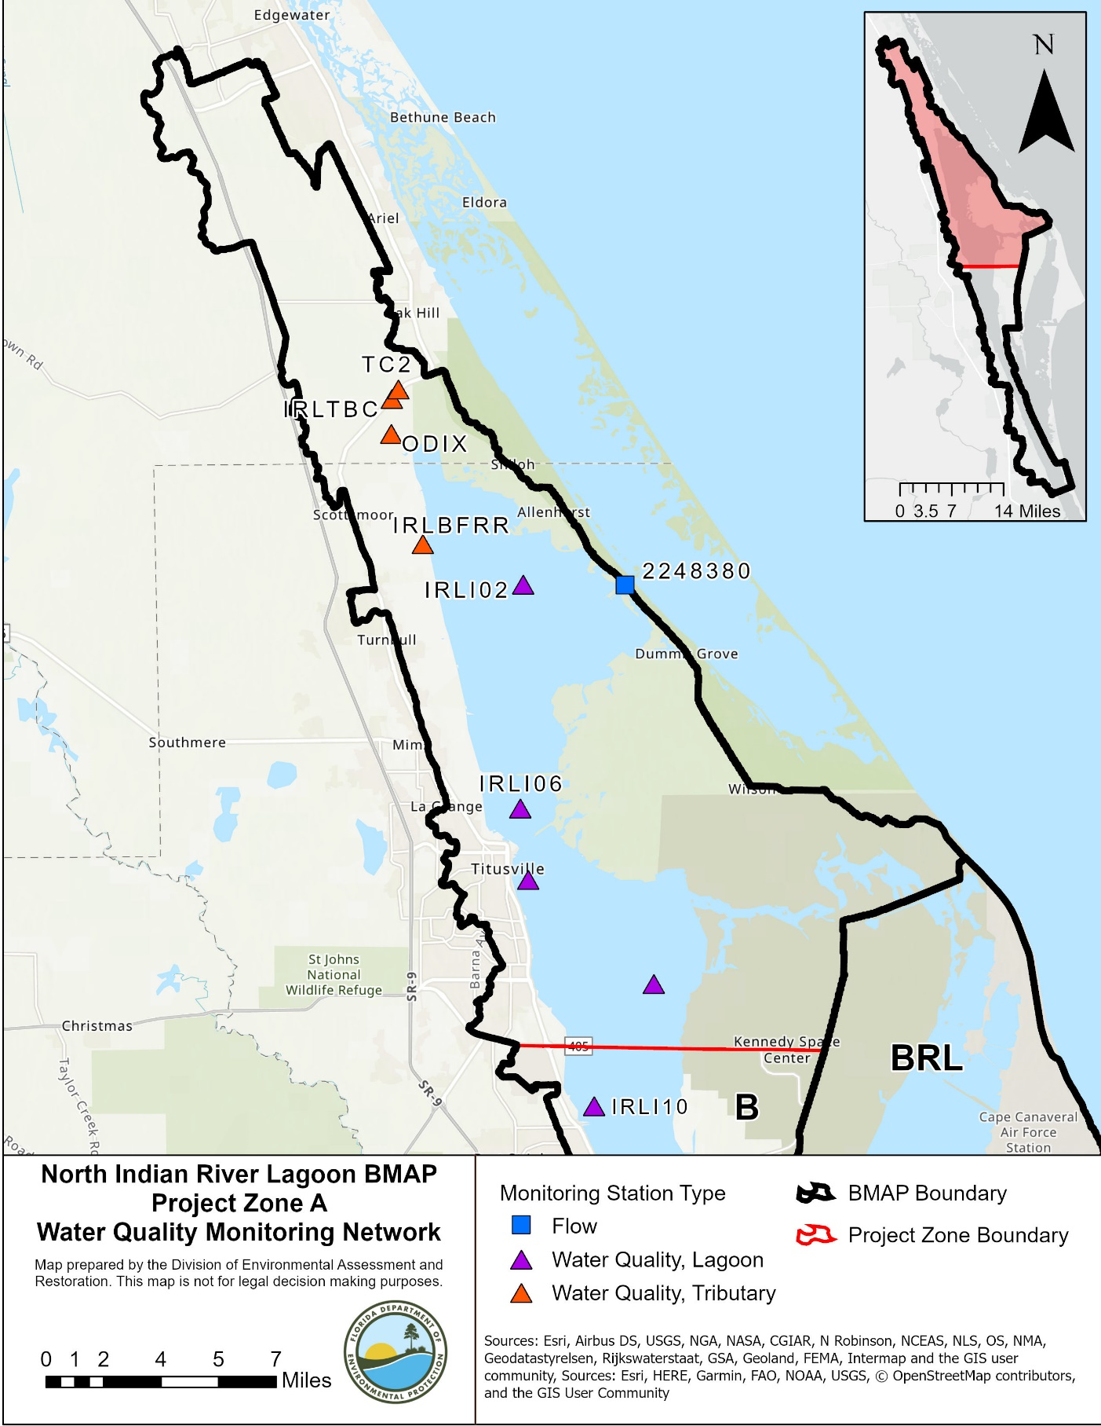
A
Figure 11. Monitoring network in NIRL Project Zone A

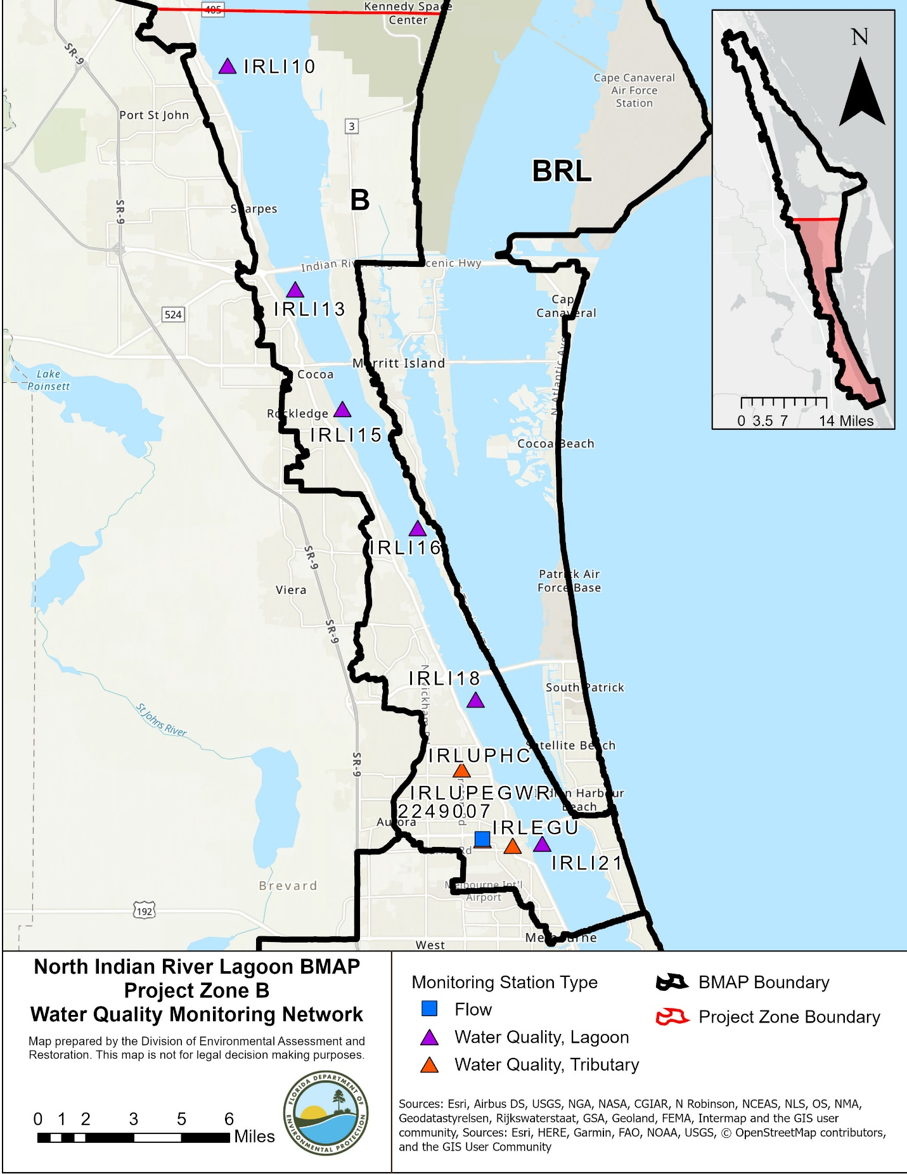
Figure 12. Monitoring network in NIRL Project Zone B

Data Management and Assessment
In 2017, the Florida Watershed Information Network (WIN) replaced the Florida Storage and Retrieval (STORET) database. WIN now serves as the primary repository of ambient water quality data for Florida. Water quality data from the WIN database are used for impaired waters rule assessments and TMDL development. Ambient water quality data collected as part of the BMAP will be uploaded into WIN for long-term storage and availability. All BMAP data providers have agreed to upload ambient water quality data to WIN at least quarterly, upon completion of the appropriate quality assurance/quality control (QA/QC) checks.
Other data relevant to monitoring restoration efforts, such as the extent and abundance of seagrass coverages, groundwater, and storm events, may be collected. Stakeholders agree to provide these data to other BMAP partners upon request, and when appropriate, for inclusion in BMAP data analyses and adaptive management evaluations. Other biological data used to assess the biological health of streams and lakes may be provided to department staff in the Watershed Assessment Section. For more information on submitting external biological data, please visit the DEP website.
The water quality data will be analyzed periodically to determine trends in water quality in the lagoon. Specific statistical analyses were not identified during BMAP development; however, commonly accepted methods of data analysis will be used.

Quality Assurance/Quality Control
Stakeholders participating in the monitoring plan must collect water quality data in a manner consistent with the DEP standard operating procedures (SOPs) for QA/QC. The most current version of these procedures can be downloaded from the DEP website. For BMAP-related data analyses, entities should use National Environmental Laboratory Accreditation Council (NELAC) National Environmental Laboratory Accreditation Program (NELAP) certified laboratories or other labs that meet the certification and other requirements outlined in the DEP SOPs. SJRWMD staff and contractors collect, process, and preserve samples according to SJRWMD's Field Standard Operating Procedures for Surface Water Sampling Fiscal Year 2020.

Research Priorities
During the BMAP process, the stakeholders identified several research priorities they would like to pursue, if funding becomes available. The investments prompted by the 2011 superbloom generated research topics that include the following:
- Collecting data to update the bathymetry for the IRL Basin, which would be used in evaluations of seagrass depth limits.
- Continuing coordinated monitoring of phytoplankton, periphyton, drift algae, and macroalgae in the basin to gain insights into cycling of nutrients.
- Data analysis of storm event monitoring at the major outfalls.
- Testing/verifying the TN, TP, and seagrass depth regression equations using data collected since 1999.
- Refining load estimates delivered by baseflows and modeling the contributions of baseflows.
- Synthesizing data on nutrient flux/internal recycling of legacy nutrient loads held within the IRL sediments and exchanged with the water column.
- Completing development, calibration, and validation of a water quality model that can be used to design, site and prioritize projects that reduce loads of nutrients (e.g., HSPF or SWIL Model coupled with Environmental Fluid Dynamics Code [EFDC] or another model that generates predictions of conditions that may be favorable for seagrass growth).
The stakeholders will continue to work with DEP and IRL NEP to identify other research needs, prioritize these needs, and develop scopes of work to address research priorities as appropriate. This information may be organized in a more detailed research plan that could be used to guide future efforts, as funding becomes available. These research projects are not BMAP requirements but would provide valuable information for future assessments of the health of NIRL. There are reports and peer-reviewed articles that have been completed to address several of these research priorities. References are provided in Chapter 5.

- Project Zones
Section 3.1 and Section 3.2 provide specific land use and project information on the two project zones in the NIRL. All projects identified as part of this BMAP are listed by project zone. For projects that treat lands in multiple project zones, the nutrient reductions provided in the table are only the estimated reductions for the project zone specified. To calculate the total benefits from these projects, credits from all project zones treated by the project should be summed. The table of existing and planned projects lists those projects submitted by stakeholders to help meet their obligations under the BMAP. Information in the tables was provided by the lead entity and is subject to change as the project develops and more information becomes available.
The projects and management strategies are ranked with a priority of high, medium, or low. Projects with a "completed" status were assigned a low priority. Projects classified as "underway" were assigned a medium priority because some resources have been allocated to these projects, but additional assistance may be needed for the projects to be completed. A high priority was assigned to projects listed as "planned," as well as certain "ongoing" projects (i.e., "street sweeping," "catch basin inserts/inlet filter clean out," "public education efforts," "fertilizer cessation," "fertilizer reduction," or "aquatic vegetation harvesting").

Project Zone A
Project Zone A covers more than 91,000 acres of the NIRL BMAP. As shown in Table 19, wetlands make up 47.9 % of the project zone, followed by urban areas with 15.0 %. Stakeholders in Project Zone A are Volusia County, Brevard County, FDOT District 5, City of Edgewater, City of Oak Hill, City of Titusville, and Kennedy Space Center.
Table 19. Summary of land uses in Project Zone A
Level 1  Land Use Code | Land Use Description | Acres | % Total
1000 | Urban | 13,707 | 15.0
2000 | Agricultural | 5,223 | 5.7
3000 | Upland Prairie and Shrublands | 12,752 | 13.9
4000 | Upland Forested Areas | 9,363 | 10.2
5000 | Water | 4,453 | 4.9
6000 | Wetlands | 43,880 | 47.9
7000 | Disturbed Lands | 715 | 0.8
8000 | Transportation | 1,464 | 1.6
Total |  | 91,557 | 100.0

NIRL Project Zone A Existing and Planned Projects
Table 20 summarizes the existing and planned projects provided by the stakeholders for Project Zone A.
Table 20. Existing and planned projects in Project Zone A
Lead Entity | Partners | Project Number | Project Name | Project Description | Project Type | Project Status | Estimated Completion Date | TN Reduction (lbs/yr) | TP Reduction (lbs/yr) | Project Zone | Acres Treated | Cost Estimate | Cost Annual O&M | Funding Source | Funding Amount | DEP Contract Agreement Number
FDACS | N/A | FDACS-01 | Credit for Changes in Land Use | Credit for changes in land use. Project canceled in 2020. Land use change occurred prior to land use date in the new model. | Land Use Change | Canceled | N/A | N/A | N/A | A | N/A | N/A | N/A | N/A | N/A | N/A
FDACS | Agricultural Producers | FDACS-03 | BMP Implementation and Verification | Enrollment and verification of BMPs by agricultural producers. Acres treated based on FDACS OAWP July 2020 Enrollment and FSAID VII. | Agricultural BMPs | Ongoing | N/A | 199.2484 | 28.57038 | A | 211.2176 | TBD | TBD | FDACS | TBD | N/A
FDACS | Not provided | FDACS-05 | FDACS Cost Share Projects | FDACS Cost Share Projects | Agricultural BMPs | Ongoing | N/A | 0 | 0 | A | TBD | TBD | TBD | FDACS | TBD | N/A
Brevard County | N/A | BC-001 | Old Dixie Highway 601 | Sediment trap. | BMP Cleanout | Ongoing | 2014 | Not provided | Not provided | A | Not provided | 2000 | 2000 | County | County - $2,000 | N/A
Brevard County | DEP/ Titusville | BC-002 | Chain of Lakes Pond | Wet detention Regional Pond. | Wet Detention Pond | Completed | 2010 | 3530.485 | 945.2629 | A | 1072.5 | 2051405 | Not provided | DEP | Not provided | WM804
Brevard County | West Melbourne/ Grant-Valkaria/ Malabar/ Melbourne/ Cocoa/ Indian Harbour Beach (IHB)/ Satellite Beach/ Cocoa Beach/ Cape Canaveral | BC-003 | Education Efforts | FYN; landscape, irrigation, fertilizer, and pet waste ordinances; PSAs; pamphlets; website, Illicit Discharge Program. | Education Efforts | Ongoing | N/A | 2299.68 | 350.52 | A | N/A | Not provided | Not provided | Not provided | Not provided | N/A
Brevard County | TBD | BC-004 | Scottsmoor I | Advanced denitrification and baffle box treatment train. | BMP Treatment Train | Underway | TBD | 1602.542 | 435.2317 | A | 530.9 | 601664 | 1000 | Legislative Funds | Legislative Funds - $286,648 | LP05118
Brevard County | DEP/ City of Titusville | BC-005 | Chain of Lakes Southern Expansion Phase 1 | Completion of additional detention. | Wet Detention Pond | Completed | 2014 | 284.4301 | 317.1718 | A | 575.2 | 3200000 | 1000 | DEP | Not provided | S0620
Brevard County | Not provided | BC-006 | Chain of Lakes Reuse | Installing reuse from the pond. | Stormwater Reuse | Completed | 2005 | TBD | TBD | A | Not provided | Not provided | Not provided | Not provided | Not provided | N/A
Brevard County | TBD | BC-007 | Scottsmoor C | Advanced denitrification and baffle box treatment train. | BMP Treatment Train | Underway | 2019 | 1008.8 | 265.2656 | A | 463 | TBD | 1000 | Legislative Funds | Legislative Funds - $33,7043 | LP05114
Brevard County | Not provided | BC-058 | Street Sweeping | Monthly street sweeping. | Street Sweeping | Ongoing | N/A | 110 | 71 | A | N/A | N/A | 21000 | County | N/A | N/A
Brevard County | N/A | BC-059 | Baffle Box/Sediment Trap Cleaning | Quarterly baffle box/sediment trap cleaning. | BMP Cleanout | Ongoing | 2015 | Not provided | Not provided | A | N/A | 250000 | 250000 | County | County - $250,000 | N/A
Brevard County | DEP | BC-060 | Huntington Road | Installation of vegetative floating island into an exiting detention pond. | Floating Islands/ Managed Aquatic Plant Systems (MAPS) | Completed | 2016 | 248.562 | 37.9331 | A | 354.6415 | 45788 | 9997.5 | DEP/County | Not provided | G0430
Brevard County | SOIRL | BC-074 | Flounder Creek Pond Denitrification Retrofit | Stormwater traditional BMP. | Biosorption Activated Media (BAM) | Planned | TBD | TBD | TBD | A | 320 | 157500 | 12307.5 | Not provided | Not provided | N/A
Brevard County | Not provided | BC-075 | Huntington Creek Pond Denitrification Retrofit | Not provided. | Biosorption Activated Media (BAM) | Planned | TBD | TBD | TBD | A | 355 | 180000 | 16662.5 | Not provided | Not provided | N/A
Brevard County | All Cities | BC-081 | Education Efforts | Fertilizer video, rain barrel workshops, Facebook page, bus wrap, and billboard. | Education Efforts | Ongoing | N/A | N/A | N/A | A | N/A | 50000 | TBD | SOIRL | SOIRL - $50,000 | N/A
Brevard County | N/A | BC-092 | Baffle Box/Sediment Trap Cleaning | Increasing cleanout frequency to quarterly. | BMP Cleanout | Ongoing | N/A | 1 | 1 | A | N/A | Not provided | 276303.3 | County | Not provided | N/A
Brevard County | SOIRL | BC-094 | Johns Rd Pond BAM - BB#62 (Actually located in 51) | Adding a media to remove nitrogen by denitrification. The media will be added to the side slope of the pond or the bottom of the swale. | Biosorption Activated Media (BAM) | Underway | 2020 | TBD | TBD | A | Not provided | 172000 | Not provided | LF/SOIRL | 58030 | N/A
Brevard County | SOIRL | BC-095 | Burkholm Rd BAM - BB#100 | Adding a media to remove nitrogen by denitrification. The media will be added to the side slope of the pond or the bottom of the swale. | Biosorption Activated Media (BAM) | Underway | 2020 | TBD | TBD | A | Not provided | 161000 | Not provided | LF/SOIRL | 99390 | N/A
Brevard County | SOIRL | BC-096 | Carter Rd BAM- BB#115 | Adding a media to remove nitrogen by denitrification. The media will be added to the side slope of the pond or the bottom of the swale. | Biosorption Activated Media (BAM) | Underway | 2020 | TBD | TBD | A | Not provided | 176000 | Not provided | LF/SOIRL | 97510 | N/A
Brevard County | SOIRL | BC-097 | Wiley Rd BAM - BB#193 | Adding a media to remove nitrogen by denitrification. The media will be added to the side slope of the pond or the bottom of the swale. | Biosorption Activated Media (BAM) | Underway | 2020 | TBD | TBD | A | Not provided | 179000 | Not provided | LF/SOIRL | 117735 | N/A
Brevard County | SOIRL | BC-098 | Broadway Pond BAM - BB#832 | Adding a media to remove nitrogen by denitrification. The media will be added to the side slope of the pond or the bottom of the swale. | Biosorption Activated Media (BAM) | Underway | 2020 | TBD | TBD | A | Not provided | 290000 | Not provided | LF/SOIRL | 77864 | N/A
Brevard County | SOIRL/ MRC | BC-101 | Grass Clippings Campaign Phase 1 | Not provided. | Enhanced Public Education | Ongoing | 2019 | N/A | N/A | A | N/A | 6667 | N/A | SOIRL | SOIRL - $20,000 | N/A
Brevard County | SOIRL | BC-102 | Education Efforts | Fertilizer, grass clippings, and septic system maintenance. | Enhanced Public Education | Ongoing | N/A | N/A | N/A | A | Not provided | 375000 | Not provided | SOIRL | SOIRL - $375,000 | N/A
Brevard County | SOIRL | BC-103 | Mims Muck Removal: Outflow Water Nutrient Removal | Not provided. | Muck Removal/Restoration Dredging | Underway | TBD | TBD | TBD | A | Not provided | Not provided | Not provided | Not provided | Not provided | N/A
Brevard County | LF/ SOIRL | BC-104 | Countyline Ditch Road - BB#10 | Adding a media to remove nitrogen by denitrification. The media will be added to the side slope of the pond or the bottom of the swale. | Biosorption Activated Media (BAM) | Underway | 2020 | TBD | TBD | A | Not provided | 200000 | Not provided | LF/SOIRL | 107773 | N/A
Brevard County | LF/ SOIRL | BC-105 | BB#141 | Adding a media to remove nitrogen by denitrification. The media will be added to the side slope of the pond or the bottom of the swale. | Biosorption Activated Media (BAM) | Underway | 2020 | TBD | TBD | A | Not provided | 164000 | Not provided | LF/SOIRL | 104174 | N/A
Brevard County | LF | BC-106 | Huntington Road BAM - BB#22 | Adding a media to remove nitrogen by denitrification. The media will be added to the side slope of the pond or the bottom of the swale. | Biosorption Activated Media (BAM) | Underway | 2020 | TBD | TBD | A | Not provided | TBD | Not provided | LF/SOIRL | 35000 | N/A
Brevard County | Not provided | BC-107 | Sunste Ave BAM - BB#26 | Adding a media to remove nitrogen by denitrification. The media will be added to the side slope of the pond or the bottom of the swale. | Biosorption Activated Media (BAM) | Underway | 2021 | TBD | TBD | A | Not provided | TBD | Not provided | Not provided | Not provided | N/A
City of Titusville | SOIRL | BC-83 | Stormwater Project - NIRL - Titusville - St. Teresa Basin | SOIRL-19. | Baffle Boxes- Second Generation | Completed | 2019 | TBD | TBD | A | 758.0605 | 375250 | Not provided | DEP TMDL | DEP TMDL - $272,800 | N/A
City of Titusville | SOIRL | BC-84 | Stormwater Project - NIRL - Titusville - South St Basin | SOIRL-20. | Baffle Boxes- Second Generation | Completed | 2019 | TBD | TBD | A | 202.25 | 475125 | Not provided | DEP TMDL | DEP TMDL - $86,856 | NF025
City of Titusville | SOIRL | BC-85 | Stormwater Project - NIRL - Titusville - La Paloma Basin | SOIRL-21. | Baffle Boxes- Second Generation | Completed | 2019 | TBD | TBD | A | 554.8 | 375250 | Not provided | DEP TMDL | DEP TMDL - $208,296 | N/A
City of Titusville | SOIRL | BC-89 | Wastewater Treatment Facility Upgrade-NIRL-Titusville | SOIRL-02. | WWTF Upgrade | Planned | 2022 | TBD | N/A | A | Not provided | 8000000 | Not provided | SOIRL/ City | 8000000 | N/A
City of Titusville | SOIRL | BC-99 | Coleman Pond MAPS | Installation of floating islands within a 1 acre City owned pond located within the Chain of Lakes basin. | Floating Islands/ Managed Aquatic Plant Systems (MAPS) | Completed | 2019 | TBD | TBD | A | 750 | 35000 | Not provided | SOIRL | SOIRL - $11,437.5 | N/A
City of Edgewater | Not provided | EW-1 | Education Efforts | FYN; landscape, irrigation, fertilizer, and pet waste ordinances; PSAs; pamphlets; website, Illicit Discharge Program. | Education Efforts | Ongoing | N/A | 162.2 | 21.7 | A | N/A | Not provided | 15000 | Not provided | Not provided | N/A
FDOT District 5 | N/A | FDOT-01 | Education Efforts | IDDE training, brochures, and NDPES flyer. | Education Efforts | Ongoing | N/A | 59.72 | 7.66 | A | N/A | Not provided | Not provided | Florida Legislature | Not provided | N/A
FDOT District 5 | N/A | FDOT-02 | Street Sweeping | Not provided. | Street Sweeping | Ongoing | N/A | 185 | 119 | A | N/A | Not provided | Not provided | Florida Legislature | Not provided | N/A
FDOT District 5 | N/A | FDOT-03 | Fertilizer Cessation | Elimination of fertilizer use along the rights-of-way. | Fertilizer Cessation | Completed | 2005 | 595 | 0 | A | N/A | Not provided | Not provided | Florida Legislature | Not provided | N/A
FDOT District 5 | N/A | FDOT-23 | FM 406869-4  79000-4068694-02 Pond 12B | Six lane Brevard C/L to SR44 | Wet Detention Pond | Completed | 2016 | 0.351767 | 0.082338 | A | TBD | N/A | N/A | Florida Legislature | N/A | N/A
FDOT District 5 | N/A | FDOT-24 | FM 406869-4  79000-4068694-04 Swales | Six lane Brevard C/L to SR44 | Grass swales without swale blocks or raised culverts | Completed | 2016 | 136.2083 | 17.02499 | A | TBD | N/A | N/A | Florida Legislature | N/A | N/A
FDOT District 5 | N/A | FDOT-25 | FM240812  79210-3505-01 WRA B | Add lanes/reconstruct from I-95 to Air Park Rd. | Wet Detention Pond | Completed | 2006 | 8.766934 | 2.479871 | A | TBD | N/A | N/A | Florida Legislature | N/A | N/A
FDOT District 5 | N/A | FDOT-26 | FM240812  79210-3505-02 Pond C | Add lanes/reconstruct from I-95 to Air Park Rd. | Dry Detention Pond | Completed | 2006 | 8.235103 | 0.96799 | A | TBD | N/A | N/A | Florida Legislature | N/A | N/A
FDOT District 5 | N/A | FDOT-27 | FM240812  79210-3505-03 Pond D | Add lanes/reconstruct from I-95 to Air Park Rd. | Dry Detention Pond | Completed | 2006 | 9.86142 | 1.197754 | A | TBD | N/A | N/A | Florida Legislature | N/A | N/A
FDOT District 5 | N/A | FDOT-28 | FM240811  79210-3504-01 Pond 1 | Add lanes/reconstruct from Air Park Rd to US 1. | Wet Detention Pond | Completed | 2006 | 4.535713 | 1.60398 | A | TBD | N/A | N/A | Florida Legislature | N/A | N/A
Kennedy Space Center | Not provided | KSC-01 | Landscape Fertilizer Reduction | Fertilizer use reduced from 60 tons/year in 2000 to 20 tons/year in 2010; formula changed from rapid nitrogen release 16-4-8 to slow nitrogen release, phosphate-free 15-0-15. | Fertilizer Reduction | Completed | 2009 | 312 | 44.2 | A | N/A | Not provided | Not provided | Not provided | Not provided | N/A
Kennedy Space Center | Not provided | KSC-02 | Citrus Grove Termination Roberts Road | Grove lease termination resulted in abandonment of previously fertilized areas. | Land Use Change | Completed | 2010 | TBD | TBD | A | Not provided | Not provided | Not provided | Not provided | Not provided | N/A
Kennedy Space Center | Not provided | KSC-03 | Citrus Grove Termination Schwartz Road | Grove lease termination resulted in abandonment of previously fertilized areas. Accounted for in 2020 BMAP update. | Land Use Change | Canceled | 2010 | N/A | N/A | A | Not provided | Not provided | Not provided | Not provided | Not provided | N/A
Kennedy Space Center | N/A | KSC-04 | Storage Building L5-0734 | Demolition of facility resulted in loss of impervious area and change of land use. | Land Use Change | Completed | 2010 | TBD | TBD | A | N/A | N/A | N/A | N/A | N/A | N/A
Kennedy Space Center | N/A | KSC-05 | Support Building L5-0683 | Demolition of facility resulted in loss of impervious area and change of land use. | Land Use Change | Completed | 2010 | TBD | TBD | A | 0.2 | N/A | N/A | N/A | N/A | N/A
Kennedy Space Center | Not provided | KSC-06 | Shuttle Landing Facility - missing from model | Runoff is captured and treated before discharging to the lagoon. | Wet Detention Pond | Completed | Prior to 2013 | 1598.265 | 341.0494 | A | 617.8 | Not provided | Not provided | Not provided | Not provided | N/A
Kennedy Space Center | Not provided | KSC-07 | Launch Pad 39A | This area is a closed basin. | Non-contributing Basin | Completed | 2014 | 1296.061 | 164.5454 | A | 456.5 | Not provided | Not provided | Not provided | Not provided | N/A
Kennedy Space Center | Not provided | KSC-08 | Launch Pad 39B | This area is a closed basin. | Non-contributing Basin | Completed | 2014 | 2587.278 | 287.3302 | A | 549 | Not provided | Not provided | Not provided | Not provided | N/A
Kennedy Space Center | Not provided | KSC-09 | Schwartz Road Drainage System - missing from model | Closed system that ultimately drains to the northwest before discharging to an impoundment area adjacent to the lagoon. | Impoundment | Completed | 2014 | 1714.045 | 228.7809 | A | 1614.1 | Not provided | Not provided | Not provided | Not provided | N/A
Kennedy Space Center | Not provided | KSC-10 | Warehouse/Processing Area - missing from model | Receives treatment from permitted stormwater treatment systems. | Wet Detention Pond | Completed | 2014 | 35.56989 | 7.777276 | A | 15.2 | Not provided | Not provided | Not provided | Not provided | N/A
Kennedy Space Center | Not provided | KSC-17a | NASA Parkway West | Missing from Model. Ditch along south side of NASA Parkway West, ends before the lagoon. | Grass Swales without Swale Blocks or Raised Culverts | Completed | 2014 | 48.71653 | 10.31643 | A | 23.87923 | Not provided | Not provided | Not provided | Not provided | N/A
Kennedy Space Center | N/A | KSC-18 | Demolition of Facility J6-2377 | Demolition of facility resulted in loss of impervious area and change of land use. | Land Use Change | Completed | 2014 | TBD | TBD | A | 0.1 | N/A | N/A | N/A | N/A | N/A
Town of Indialantic | DEP | TI-04 | Lily Park | Stormwater treatment. | Wet Detention Pond | Completed | 2016 | TBD | TBD | A | 1.93 | 173000 | 500 | DEP | DEP - $65,000 | LP05120
City of Titusville | Brevard County | TV-01 | Area 1 Stormwater Improvements | Upsize existing storm pipes and enclose the Florida Ditch; water directed to TV-02. | Wet Detention Pond | Completed | 2010 | 1334.346 | 365.1335 | A | 432.2 | 2151510 | 4797 | City/ Brevard County | City - $1,410,072/ County - $470,000 | N/A
City of Titusville | Brevard County/ Parrish Medical Center (PMC)/ Brevard Community College (BCC)/ SJRWMD | TV-02 | Chain of Lakes Regional Stormwater Pond | Construction of a regional park featuring wetlands, treatment ponds, and recreational features. | Wet Detention Pond | Completed | 2010 | 759.2001 | 191.2186 | A | 339.8 | 3521489 | 15620 | City/ Brevard County/ SJRWMD/ PMC/ BCC | City - $1,210,013/ County - $1,910,709/ SJRWMD - $577,145/ PMC - $350,000/ BCC - $217,500 | N/A
City of Titusville | DEP/ SJRWMD | TV-03 | Draa Field Stormwater Park | Water quality treatment for Area 2 drainage basin. | Wet Detention Pond | Completed | 2016 | 394.4124 | 103.4624 | A | 105.0747 | 1810000 | 15000 | DEP/ SJRWMD/ Florida Legislature/ City | DEP - $388,825/ SJRWMD - $366,000/ Florida Legislature - $800,000/ City - $255,000 | G0416
City of Titusville | DEP/ SJRWMD | TV-04 | St. Johns Basin Stormwater Improvements | Construction of a 3. 5-acre wet detention pond to treat runoff from mixed use lands prior to discharge to the lagoon. | Wet Detention Pond | Completed | 2014 | 81.53559 | 10.20378 | A | 882.1 | 2024000 | 8000 | DEP/ Brevard County/ City | DEP - $681,563/ County - $141,655/ City - $1,314,625 | S0338
City of Titusville | DEP/ SJRWMD | TV-05 | St. Johns Basin Stormwater Improvements | Installation of a baffle box downstream of the pond to treat runoff from mixed use lands prior to discharge to the lagoon. | Baffle Boxes- Second Generation | Completed | 2011 | 1553.253 | 175.7318 | A | 882.1 | 167343 | 8000 | DEP/ City | DEP - $100,000/ City - $67,343 | S0338
City of Titusville | DEP/ SJRWMD/ FCT/ Florida Recreation Development Assistance Program (FRDAP)/ FDOT | TV-06 | Spaceview Park | Alum treatment. | Stormwater - Alum Injection System | Completed | 2007 | 571.3578 | 142.9964 | A | 110.6 | 2727394 | 15000 | DEP/ SJRWMD/ FCT/ FRDAP/ FDOT/ City | DEP - $981,151/ SJRWMD - $83,600/ FCT - $228,375/ FRDAP - $103,956/ FDOT - $72,195/ City - $1,258,116 | G0053
City of Titusville | N/A | TV-07 | Education Efforts | Irrigation, fertilizer, pet waste management, and landscaping ordinances; pamphlets, presentations, website, Illicit Discharge Program. | Education Efforts | Ongoing | N/A | 3092.94 | 495.84 | A | N/A | N/A | 5000 | City | N/A | N/A
City of Titusville | N/A | TV-08 | Street Sweeping | Approximately 2,006,375 lbs. of debris were removed in North A during the reporting period. | Street Sweeping | Ongoing | N/A | 1130 | 724 | A | N/A | 188120 | 63106 | City | Not provided | N/A
City of Titusville | N/A | TV-11 | Senior Center Pond Floating Islands | Floating islands within a wet detention pond. | Floating Islands/ Managed Aquatic Plant Systems (MAPS) | Completed | 2015 | 447.3607 | 58.35909 | A | 624 | 52536 | 43720 | City | City - $52,536 | N/A
City of Titusville | DEP | TV-12 | Senior Center Ponds Littoral Zone Plantings | Littoral vegetation plantings around an already existing wet detention pond. | BMP Treatment Train | Completed | 2016 | N/A | N/A | A | 413.6 | 50000 | 2000 | DEP/ City | DEP - $21,144/ City - $14,721 | G0433
City of Titusville | DEP | TV-13 | Royal Oak Littoral Zone Plantings | Littoral vegetation plantings around an already existing wet detention pond. | BMP Treatment Train | Completed | 2016 | N/A | N/A | A | 123.1 | 50000 | 2000 | DEP/ City | DEP - $21,144/ City - $14,721 | G0433
City of Titusville | DEP | TV-14 | Main Street Baffle Box with BAM | 2nd generation baffle box with media. | Baffle Boxes- Second Generation with Media | Completed | 2018 | 2136.693 | 337.6215 | A | 295.96 | 393363 | 4000 | DEP/ City | DEP - $176,376/ City - $216,987 | G0442
City of Titusville | DEP | TV-15 | Sycamore Street Baffle Box with BAM | 2nd generation baffle box with media. | Baffle Boxes- Second Generation with Media | Completed | 2018 | 2051.967 | 329.0023 | A | 300.07 | 570517.7 | 4000 | DEP/ City | DEP - $176,376/ City - $394,142 | G0442
City of Titusville | N/A | TV-16 | Knox Mc Rae Baffle Box | 2nd generation baffle box with media. | Baffle Boxes- Second Generation with Media | Completed | 2018 | 308.4667 | 51.6468 | A | 37.9 | 225000 | 4000 | Florida Legislature/ City | Florida Legislature - $105,000/ City - $120,000 | LP05031
City of Titusville | Brevard County | TV-17 | Coleman Basin TMDL Improvements | Managed aquatic plant system within a one acre pond. | Floating Islands/ Managed Aquatic Plant Systems (MAPS) | Completed | 2019 | 636.7672 | 93.96413 | A | 107 | 11437.5 | 12000 | County | County - $11,438 | N/A
City of Titusville | SJRWMD/ Brevard County | TV-18 | South Street Basin TMDL Improvements | Three 2nd generation baffle boxes with media. | Baffle Boxes- Second Generation with Media | Completed | 2019 | 1482.313 | 234.8645 | A | 235 | 450000 | 12000 | City/ SJRWMD/ County | City - $254,144/ SJRWMD - $110,000/ County - $86,856 | N/A
City of Titusville | Brevard County | TV-19 | St. Theresa Basin TMDL Improvements | 2nd generation baffle box with media. | Baffle Boxes- Second Generation with Media | Completed | 2019 | 4728.512 | 761.7081 | A | 314 | 375000 | 4000 | City/ County | City - $102,200/ County - $272,800 | N/A
City of Titusville | Brevard County | TV-20 | La Paloma Basin TMDL Improvements | 2nd generation baffle box with media. | Baffle Boxes- Second Generation with Media | Completed | 2019 | 3533.862 | 562.5211 | A | 488 | 375000 | 4000 | City/ County | City - $166,704/ County - $208,296 | N/A
City of Titusville | TBD | TV-21 | THS Basin TMDL Improvements | Future project. | Baffle Boxes- Second Generation with Media | Planned | 2020 | 1498.178 | 235.5219 | A | 239.65 | TBD | TBD | TBD | TBD | N/A
City of Titusville | TBD | TV-22 | Brevard Street Basin TMDL Improvements | Future project. | BMP Treatment Train | Planned | TBD | TBD | TBD | A | 17.71 | TBD | TBD | TBD | TBD | N/A
City of Titusville | TBD | TV-23 | St. Johns 2nd Baffle Box TMDL Improvements | Future project. | BMP Treatment Train | Planned | TBD | TBD | TBD | A | 882.1 | TBD | TBD | TBD | TBD | N/A
City of Titusville | Brevard County/ SOIRL | TV-24 | Marina Basin TMDL Improvements - Osprey Pond MAPS | Osprey Pond MAPS | Floating Islands/ Managed Aquatic Plant Systems (MAPS) | Planned | 2021 | 259.7038 | 37.84802 | A | 271.17 | 60000 | 30000 | County | County - $60,000 | N/A
City of Titusville | TBD | TV-25 | Grace Basin TMDL Improvements | Future project. | BMP Treatment Train | Planned | TBD | TBD | TBD | A | 17.73 | TBD | TBD | TBD | TBD | N/A
City of Titusville | Private Development | TV-26 | Miracle City Basin TMDL Improvements | 2nd generation baffle box. | Baffle Boxes- Second Generation | Completed | 2018 | 10.91436 | 1.194394 | A | 2.448 | TBD | 4000 | Private Development | TBD | N/A
City of Titusville | TBD | TV-27 | South Marina Basin TMDL Improvements | Future project. | BMP Treatment Train | Planned | TBD | TBD | TBD | A | 322.88 | TBD | TBD | TBD | TBD | N/A
City of Titusville | TBD | TV-28 | S.R. 50 Basin TMDL Improvements | Future project. | BMP Treatment Train | Planned | TBD | TBD | TBD | A | 131.09 | TBD | TBD | TBD | TBD | N/A
City of Titusville | TBD | TV-29 | Commons Basin TMDL Improvements | Future project. | BMP Treatment Train | Planned | TBD | TBD | TBD | A | 4.37 | TBD | TBD | TBD | TBD | N/A
City of Titusville | TBD | TV-30 | Broad Street Basin TMDL Improvements | Future project. | BMP Treatment Train | Planned | TBD | TBD | TBD | A | 13.44 | TBD | TBD | TBD | TBD | N/A
City of Titusville | TBD | TV-31 | Riverview Street Basin TMDL Improvements | Future project. | BMP Treatment Train | Planned | TBD | TBD | TBD | A | 7.32 | TBD | TBD | TBD | TBD | N/A
City of Titusville | TBD | TV-32 | THS 2 Basin TMDL Improvements | Future project. | BMP Treatment Train | Planned | TBD | TBD | TBD | A | 26.54 | TBD | TBD | TBD | TBD | N/A
City of Titusville | Brevard County | TV-33 | Osprey Water Reclamation Nutrient Removal Upgrade | Nitrogen effluent reduction of reclaimed water from 17.9 mg/l to 6 mg/l. | WWTF Nutrient Reduction | Planned | 2022 | TBD | TBD | A | N/A | 8000000 | TBD | City/ County | TBD | N/A
City of Titusville | Brevard County | TV-34 | Draa Field Pond MAPS | Managed aquatic plant system within a 3 acre pond. | Floating Islands/ Managed Aquatic Plant Systems (MAPS) | Planned | 2020 | TBD | TBD | A | 105 | 60000 | 40000 | City/ Brevard County | City - $28,719 / County - $31,281 | N/A
City of Titusville | Brevard County | TV-35 | Draa Field Vegetation Harvesting | Aquatic vegetation harvesting of a 3 acre pond. | Aquatic Vegetation Harvesting | Planned | 2020 | TBD | TBD | A | 3 | 50000 | 0 | City/ Brevard County | TBD | N/A
Volusia County | Not provided | VC-01 | Education Efforts | Irrigation, fertilizer, pet waste management, and landscaping ordinances; pamphlets, presentations, website, illicit discharge program. | Education Efforts | Ongoing | N/A | 1381.74 | 198.54 | A | N/A | Not provided | Not provided | Not provided | Not provided | N/A
Volusia County | Not provided | VC-02 | Roadside Ditch Cleaning | Roadside ditch cleaning. | BMP Cleanout | Ongoing | 2016 | Not provided | Not provided | A | Not provided | Not provided | Not provided | Not provided | Not provided | N/A
Volusia County | Not provided | VC-03 | Open Channel Cleaning | Open channel cleaning; digging sediment out of open channels. | BMP Cleanout | Ongoing | 2016 | Not provided | Not provided | A | Not provided | Not provided | Not provided | Not provided | Not provided | N/A
Volusia County | N/A | VC-04 | Fertilizer Ordinance | Fertilizer restrictions including summer ban on nitrogen and phosphorus. Reductions included in VC-01. | Regulations, Ordinances, and Guidelines | Ongoing | N/A | N/A | N/A | A | N/A | Not provided | Not provided | Volusia County | N/A | N/A

Project Zone B
Project Zone B covers more than 49,000 acres of the NIRL BMAP. As shown in Table 21, urban areas make up the majority of the project zone with 59.3 % of the area, followed by wetlands with 16.5 %. Stakeholders in Project Zone B are Brevard County, FDOT District 5, City of Titusville, City of Cocoa, City of Rockledge, City of Melbourne, Town of Palm Shores, Town of Indialantic, and Kennedy Space Center.
Table 21. Summary of land uses in Project Zone B
Level 1  Land Use Code | Land Use Description | Acres | % Total
1000 | Urban | 29,544 | 59.3
2000 | Agricultural | 2,310 | 4.6
3000 | Upland Prairie and Shrublands | 2,159 | 4.3
4000 | Upland Forested Areas | 2,570 | 5.2
5000 | Water | 1,815 | 3.6
6000 | Wetlands | 8,198 | 16.5
7000 | Distrurbed Lands | 256 | 0.5
8000 | Transportation | 2,963 | 5.9
Total |  | 49,816 | 100.0

NIRL Project Zone B Existing and Planned Projects
Table 22 summarizes the existing and planned projects provided by the stakeholders for Project Zone B.
Table 22. Existing and planned projects in Project Zone B
Lead Entity | Partners | Project Number | Project Name | Project Description | Project Type | Project Status | Estimated Completion Date | TN Reduction (lbs/yr) | TP Reduction (lbs/yr) | Project Zone | Acres Treated | Cost Estimate | Cost Annual O&M | Funding Source | Funding Amount | DEP Contract Agreement Number
FDACS | N/A | FDACS-02 | Credit for Changes in Land Use | Credit for changes in land use. Project canceled in 2020. Land use change occurred prior to land use date in the new model. | Land Use Change | Canceled | N/A | N/A | N/A | B | N/A | N/A | N/A | N/A | N/A | N/A
FDACS | Agricultural Producers | FDACS-04 | BMP Implementation and Verification | Enrollment and verification of BMPs by agricultural producers. Acres treated based on FDACS OAWP July 2020 Enrollment and FSAID VII. | Agricultural BMPs | Ongoing | N/A | 33.24878 | 6.02843 | B | 35.47696 | TBD | TBD | FDACS | TBD | N/A
FDACS | Not provided | FDACS-06 | FDACS Cost Share Projects | FDACS Cost Share Projects | Agricultural BMPs | Ongoing | N/A | 0.084929 | 0.563334 | B | TBD | TBD | TBD | FDACS | TBD | N/A
SJRWMD | DEP/ FIND/ Brevard County/ City of Melbourne | SJRWMD-01 | Eau Gallie River Muck Dredging | Dredging commenced in January 2017 and was completed in 2019. Approximately 633,000 cubic yards of muck were removed, reducing nitrogen and phosphorus from the legacy loads in this tributary. | Muck Removal/ Restoration Dredging | Completed | 2019 | TBD | TBD | B | N/A | 23750000 | Not provided | Ad Valorem/ DEP/ FIND/ Brevard County/ City of Melbourne | Not provided | 27974
Brevard County | Not provided | BC-008 | Twin Lakes North | Construction of a bafffle box. | Baffle Boxes- First Generation | Completed | 2014 | 0.323739 | 0.209861 | B | 7.7 | Not provided | Not provided | Not provided | Not provided | N/A
Brevard County | Not provided | BC-009 | Twin Lakes South | Construction of a bafffle box. | Baffle Boxes- First Generation | Completed | 2014 | 0.36242 | 0.23567 | B | 8.5 | 20082 | Not provided | Not provided | Not provided | N/A
Brevard County | DEP | BC-010 | Lucas Place 640 Baffle Box | Construction of a bafffle box. Baffle box was replaced by a second generation baffle box and is credited in BC-33. | Baffle Boxes- First Generation | Canceled | 2003 | N/A | N/A | B | 5.2 | 36835 | 1000 | DEP/ County | Not provided | S0620
Brevard County | DEP | BC-011 | Rockledge Drive 2055 | Construction of a bafffle box. | Baffle Boxes- First Generation | Completed | 2008 | 0.109712 | 0.075499 | B | 2.4 | 61094 | 1000 | DEP | Not provided | S0620
Brevard County | Not provided | BC-012 | Rockledge and Riverwoods Baffle Box | Construction of a bafffle box. Baffle box was replaced by a second generation baffle box and is credited in BC-38. | Baffle Boxes- First Generation | Canceled | 2000 | N/A | N/A | B | 3.8 | 47686 | 1000 | Not provided | Not provided | N/A
Brevard County | DEP | BC-013 | Anchor Lane | Construction of a bafffle box. | Baffle Boxes- First Generation | Completed | 2000 | 1.358613 | 0.918662 | B | 29.4 | 49560 | 1000 | DEP | Not provided | S0620
Brevard County | Not provided | BC-014 | Kelmore Baffle Box | Construction of a bafffle box. | Baffle Boxes- First Generation | Completed | 2003 | 5.475097 | 3.771069 | B | 9.7 | 21817 | 1000 | Not provided | Not provided | N/A
Brevard County | DEP | BC-015 | Puesta Del Sol 735 Baffle Box | Construction of a bafffle box. | Baffle Boxes- First Generation | Completed | 2003 | 0.105045 | 0.07101 | B | 2.2 | 24953 | 1000 | DEP | Not provided | S0620
Brevard County | SJRWMD | BC-016 | Tequesta Harbor Baffle Box | Construction of a bafffle box. | Baffle Boxes- First Generation | Completed | 2009 | 0.639115 | 0.431646 | B | 13.1 | 27582 | 1000 | Not provided | Not provided | N/A
Brevard County | NRCS | BC-017 | Broadway Boulevard Pond | Constructon of a detention pond to treat runoff. | Wet Detention Pond | Completed | 2000 | 304.1263 | 95.3932 | B | 85.7 | 553169 | 14972.5 | Not provided | Not provided | N/A
Brevard County | Not provided | BC-018 | Fairglen Elementary School Pond | Constructon of a detention pond to treat runoff. | Wet Detention Pond | Completed | 2003 | 214.5747 | 56.9956 | B | 80.2 | 730869 | Not provided | Not provided | Not provided | N/A
Brevard County | DEP | BC-019 | Lake George | Constructon of a detention pond to treat runoff. | Wet Detention Pond | Completed | 2010 | 1409.133 | 441.5093 | B | 719 | 347255 | 17750 | DEP | Not provided | LP8952
Brevard County | Not provided | BC-020 | Merritt Island Courthouse Pond | Constructon of a detention pond to treat runoff. | Wet Detention Pond | Completed | 2003 | 4.69317 | 0.616847 | B | 7 | 95584 | Not provided | Not provided | Not provided | N/A
Brevard County | Not provided | BC-021 | Parkway Drive Phase 2 Pond | Constructon of a detention pond to treat runoff. | Wet Detention Pond | Completed | 2004 | 7148.169 | 1920.565 | B | 1796.9 | 1817720 | Not provided | Not provided | Not provided | N/A
Brevard County | Not provided | BC-022 | Street Sweeping | Monthly Street Sweeping 786 curb lane miles. | Street Sweeping | Ongoing | N/A | 636 | 408 | B | N/A | 106665 | Not provided | Not provided | Not provided | N/A
Brevard County | Not provided | BC-023 | Education Efforts | FYN; landscape, irrigation, fertilizer, and pet waste ordinances; PSAs; pamphlets; website, Illicit Discharge Program. | Education Efforts | Ongoing | N/A | 8391.96 | 1244.76 | B | N/A | Not provided | Not provided | Not provided | Not provided | N/A
Brevard County | DEP | BC-024 | Pine Island Phase I and II | Two Wet Detention Ponds (80-acres & 23 acres) with Gravity Flow and Pump Station. | Wet Detention Pond | Completed | 2015 | 13153.59 | 3504.234 | B | 6232.9 | 4131255 | 34705 | DEP TMDL/ EPA 319 | DEP TDML/ EPA 319 - $1,677,079 | G0288/ G0344
Brevard County | N/A | BC-025 | Merritt Island Airport | N/A | Wet Detention Pond | Canceled | N/A | 1.860414 | 0.422764 | B | N/A | N/A | N/A | N/A | N/A | N/A
Brevard County | DEP | BC-026 | Pines Industrial | Construction of a pond to treat runoff where no treatment was provided. | Wet Detention Pond | Underway | 2020 | TBD | TBD | B | 71 | 822000 | TBD | DEP | Not provided | NF003
Brevard County | DEP | BC-027 | Johnson Junior High | Discharge regulation, phosphorus reduction, and denitrification. Biosorption activated media added. | Floating Islands/ Managed Aquatic Plant Systems (MAPS) | Completed | 2017 | 1416.869 | 200.4724 | B | 133.4 | 499416.4 | Not provided | DEP | DEP - $489,200 | G0430
Brevard County | DEP | BC-028 | Florida Boulevard | Installation of floating vegetative islands for Nutrient uptake. | Floating Islands/ Managed Aquatic Plant Systems (MAPS) | Completed | 2014 | 57.20182 | 5.019217 | B | 88.4 | 40772 | 18295 | DEP | Not provided | G0430
Brevard County | DEP | BC-029 | Fairglen Elementary | Installation of floating vegetative islands for Nutrient uptake. | Floating Islands/ Managed Aquatic Plant Systems (MAPS) | Completed | 2017 | 37.81732 | 3.123288 | B | 80.2 | 34996 | 15703 | DEP | Not provided | G0430
Brevard County | DEP | BC-030 | Port St. John B | Installation of floating vegetative islands for Nutrient uptake. | Floating Islands/ Managed Aquatic Plant Systems (MAPS) | Completed | Prior to 2013 | 57.05205 | 8.353006 | B | 57.9 | 16308 | 7315 | DEP | Not provided | G0430
Brevard County | DEP | BC-031 | Wickham Park North | Installation of floating vegetative islands for Nutrient uptake. | Floating Islands/ Managed Aquatic Plant Systems (MAPS) | Completed | 2017 | TBD | TBD | B | 1796.9 | 75428 | 24175 | DEP | Not provided | G0430
Brevard County | DEP | BC-032 | West Avenue 6600 | Upgrading a 1st Generation to a 2nd generation baffle box by adding the nutrient separating screen. | Baffle Boxes- Second Generation | Completed | 2017 | 98.12982 | 11.50099 | B | 50.7 | 15000 | 2140 | DEP | DEP - $275,000 | S0648
Brevard County | DEP | BC-033 | Lucas Place | Upgrading a 1st Generation to a 2nd generation baffle box by adding the nutrient separating screen. | Baffle Boxes- Second Generation | Completed | Prior to 2013 | 9.394442 | 1.160118 | B | 2.7 | 12507 | 2140 | DEP | DEP - $275,000 | S0648
Brevard County | DEP | BC-034 | Indian River Isles | Upgrading a 1st Generation to a 2nd generation baffle box by adding the nutrient separating screen. | Baffle Boxes- Second Generation | Completed | Prior to 2013 | 68.21853 | 7.315461 | B | 7.3 | 30844 | 2140 | DEP | DEP - $275,000 | S0648
Brevard County | DEP | BC-035 | Granada Street 1030 East | Upgrading a 1st Generation to a 2nd generation baffle box by adding the nutrient separating screen. | Baffle Boxes- Second Generation | Completed | Prior to 2013 | 145.8459 | 17.21973 | B | 38.6 | 15000 | 2140 | DEP | DEP - $275,000 | S0648
Brevard County | DEP | BC-036 | Haverhill Avenue | Upgrading a 1st Generation to a 2nd generation baffle box by adding the nutrient separating screen. | Baffle Boxes- Second Generation | Completed | Prior to 2013 | 89.00115 | 10.50584 | B | 47.5 | 35857 | 2140 | DEP | DEP - $275,000 | S0648
Brevard County | DEP | BC-037 | Manth Avenue | Upgrading a 1st Generation to a 2nd generation baffle box by adding the nutrient separating screen. | Baffle Boxes- Second Generation | Completed | Prior to 2013 | 125.6019 | 15.11945 | B | 69.1 | 12507 | 2140 | DEP | DEP - $275,000 | S0648
Brevard County | Not provided | BC-038 | Rockledge and Riverwoods Boulevard Rockledge | Upgrading a 1st Generation to a 2nd generation baffle box by adding the nutrient separating screen. | Baffle Boxes- Second Generation | Completed | Prior to 2013 | 5.981847 | 0.702575 | B | 3.8 | 15000 | 2140 | Not provided | Not provided | N/A
Brevard County | DEP | BC-039 | Alamanda Indian Harbour Beach | Upgrading a 1st Generation to a 2nd generation baffle box by adding the nutrient separating screen. | Baffle Boxes- Second Generation | Completed | Prior to 2013 | 5.075029 | 0.606811 | B | 2.8 | 12507 | 2140 | DEP | DEP - $275,000 | S0648
Brevard County | DEP | BC-040 | River Shore 1848 Indialantic | Upgrading a 1st Generation to a 2nd generation baffle box by adding the nutrient separating screen. | Baffle Boxes- Second Generation | Completed | Prior to 2013 | 4.87445 | 0.582884 | B | 2.7 | 31751 | 2140 | DEP | DEP - $275,000 | S0648
Brevard County | DEP | BC-041 | River Shore 1925 Indialantic | Upgrading a 1st Generation to a 2nd generation baffle box by adding the nutrient separating screen. | Baffle Boxes- Second Generation | Completed | Prior to 2013 | 34.66021 | 4.452528 | B | 7.4 | 12507 | 2140 | DEP | DEP - $275,000 | S0648
Brevard County | DEP | BC-042 | Cedar Lane Indialantic | Upgrading a 1st Generation to a 2nd generation baffle box by adding the nutrient separating screen. | Baffle Boxes- Second Generation | Completed | Prior to 2013 | 6.65755 | 0.797401 | B | 3.8 | 12507 | 2140 | DEP | DEP - $275,000 | S0648
Brevard County | DEP | BC-043 | Riverview 9856 Indialantic | Upgrading a 1st Generation to a 2nd generation baffle box by adding the nutrient separating screen. | Baffle Boxes- Second Generation | Completed | Prior to 2013 | TBD | TBD | B | 5.7 | 15000 | 2140 | DEP | DEP - $275,000 | S0648
Brevard County | DEP | BC-044 | Riverview 9864 Indialantic | Upgrading a 1st Generation to a 2nd generation baffle box by adding the nutrient separating screen. | Baffle Boxes- Second Generation | Completed | Prior to 2013 | TBD | TBD | B | 98.5 | 15000 | 2140 | DEP | DEP - $275,000 | S0648
Brevard County | DEP | BC-045 | Oak Ridge Indialantic | Upgrading a 1st Generation to a 2nd generation baffle box by adding the nutrient separating screen. | Baffle Boxes- Second Generation | Completed | Prior to 2013 | 219.2554 | 25.80792 | B | 126.5 | 15000 | 2140 | DEP | DEP - $275,000 | S0648
Brevard County | SOIRL | BC-046 | Kingsmill-Aurora Phase 2 | Expansion of a Wet Detention Pond and adding Denitrifcation to pond slope. | Wet Detention Pond | Planned | 2022 | 3354.058 | 915.9812 | B | 1220.4 | 1600000 | 1000 | SOIRL | TBD | N/A
Brevard County | N/A | BC-047 | Sediment Trap, Grated Inlet Basket, Inlet Weir Cleaning | Annual maintenance, removing captured debris from structures. | BMP Cleanout | Ongoing | Prior to 2013 | TBD | TBD | B | N/A | 392105 | 250000 | N/A | N/A | N/A
Brevard County | DEP | BC-048 | Merritt Ridge 3A | Alum pond. | Floating Islands/ Managed Aquatic Plant Systems (MAPS) | Completed | Prior to 2013 | 3.81868 | 0.566291 | B | 32.1 | 100362 | 41817.5 | DEP/ County | Not provided | G0430
Brevard County | DEP | BC-049 | Lake George | Construction of a regional wet detention pond. Wet pond credited in BC-19. | Floating Islands/ Managed Aquatic Plant Systems (MAPS) | Completed | 2017 | 282.2497 | 27.2907 | B | 719 | 51200 | Not provided | DEP/ County | Not provided | LP852
Brevard County | Not provided | BC-050 | Wickham Park | The provided treatment volume is .17 ac-It. | Stormwater Reuse | Completed | 2010 | TBD | TBD | B | Not provided | Not provided | Not provided | Not provided | Not provided | N/A
Brevard County | Not provided | BC-051 | Ellington Park | Construction of a wet detention pond. | Stormwater Reuse | Completed | 2005 | 532.4965 | 76.27736 | B | Not provided | Not provided | Not provided | Not provided | Not provided | N/A
Brevard County | Not provided | BC-052 | Rockledge Barton Park Reuse | Barton Park Pond was constructed by Rockledge. Brevard Parks withdraws water for irrigation for Rockledge Park. | Stormwater Reuse | Completed | 2009 | 274.8434 | 38.51213 | B | Not provided | Not provided | Not provided | Not provided | Not provided | N/A
Brevard County | Not provided | BC-053 | Florida Boulevard Pond | Construction of a wet detention pond. | Wet Detention Pond | Completed | 2002 | 175.6096 | 29.96473 | B | 88.4 | 350384 | Not provided | Not provided | Not provided | N/A
Brevard County | DEP | BC-054 | McGiver South | Upgrading a 1st Generation to a 2nd generation baffle box by adding the nutrient separating screen. | Baffle Boxes- Second Generation | Completed | 2013 | 5.188995 | 0.5991 | B | 2.8 | 12507 | 2140 | DEP | DEP - $275,000 | S0648
Brevard County | DEP | BC-055 | 651 Franklyn | Upgrading a 1st Generation to a 2nd generation baffle box by adding the nutrient separating screen. | Baffle Boxes- Second Generation | Completed | 2013 | 24.96365 | 2.985472 | B | 13.7 | 12507 | 2140 | DEP | DEP - $275,000 | S0648
Brevard County | Not provided | BC-056 | Fountainhead | Removing vegetation from a wet detention pond. | Aquatic Vegetation Harvesting | Completed | 2014 | 401 | 64.7 | B | 125.458 | 39274 | Not provided | Not provided | Not provided | N/A
Brevard County | DEP | BC-057 | Fiske | Upgrading a 1st Generation to a 2nd generation baffle box by adding the nutrient separating screen. | Baffle Boxes- Second Generation | Completed | 2014 | 138.0553 | 16.15228 | B | 126.2 | 12507 | 2140 | DEP | DEP - $275,000 | S0648
Brevard County | DEP | BC-061 | Port St. John C | Installation of vegetative floating island into an exiting detention pond. | Floating Islands/ Managed Aquatic Plant Systems (MAPS) | Completed | 2016 | 18.56176 | 2.720649 | B | 19.98812 | 14062 | 3070.5 | DEP/County | Not provided | G0430
Brevard County | DEP | BC-062 | Shoreview Circle | Upgrading a 1st Generation to a 2nd generation baffle box by adding the nutrient separating screen. | Baffle Boxes- Second Generation | Completed | 2015 | 5.707652 | 0.682577 | B | Not provided | 11270 | 2140 | DEP | DEP - $275,000 | S0648
Brevard County | DEP | BC-063 | Granada West | Upgrading a 1st Generation to a 2nd generation baffle box by adding the nutrient separating screen. | Baffle Boxes- Second Generation | Completed | 2015 | 15.10811 | 1.809408 | B | Not provided | 11220 | 2140 | DEP | DEP - $275,000 | S0649
Brevard County | DEP | BC-064 | Shoreview Lane | Upgrading a 1st Generation to a 2nd generation baffle box by adding the nutrient separating screen. | Baffle Boxes- Second Generation | Completed | 2015 | 11.62614 | 1.389388 | B | Not provided | 24543.44 | 2140 | DEP | DEP - $275,000 | S0650
Brevard County | DEP | BC-065 | Sunset Park North | Upgrading a 1st Generation to a 2nd generation baffle box by adding the nutrient separating screen. | Baffle Boxes- Second Generation | Completed | 2015 | 42.15312 | 5.038728 | B | Not provided | 11170 | 2140 | DEP | DEP - $275,000 | S0651
Brevard County | DEP | BC-066 | Oak Street | Upgrading a 1st Generation to a 2nd generation baffle box by adding the nutrient separating screen. Project accounted for in CIRL-BC-02 and is outside the NIRL boundary. | Baffle Boxes- Second Generation | Canceled | 2015 | N/A | N/A | B | Not provided | 10895 | 2140 | DEP | DEP - $275,000 | S0652
Brevard County | DEP | BC-067 | Fountainhead Advanced Denitrification | Phosphorus reduction & denitrification. | Denitrification Walls | Underway | 2020 | TBD | TBD | B | 234.65 | 381000 | Not provided | DEP | Not provided | LP05115
Brevard County | DEP | BC-069 | Multiple Ditch Outfall Denitrification D4 (replace by individual Basin #s/names) | Providing base flow/grondwater treatment in open drainage basins. | Biosorption Activated Media (BAM) | Planned | 2019 | TBD | TBD | B | Not provided | 2140000 | Not provided | DEP | Not provided | LP0511A
Brevard County | Not provided | BC-070 | Otter Creek Basin D4 | Providing base flow/grondwater treatment in open drainage basins. | Biosorption Activated Media (BAM) | Planned | 2019 | TBD | TBD | B | Not provided | 130000 | Not provided | Not provided | Not provided | N/A
Brevard County | SJRWMD | BC-071 | Suntree In-Channel Denitrification D4 | Providing base flow/grondwater treatment in open drainage basins. | Biosorption Activated Media (BAM) | Planned | 2018 | TBD | TBD | B | Not provided | 71000 | Not provided | SJRWMD | Not provided | N/A
Brevard County | DEP | BC-072 | Multiple Ditch Outfall Denitrification D5 (replace by individual Basin#s/names) | Providing base flow/grondwater treatment in open drainage basins. | Biosorption Activated Media (BAM) | Underway | 2019 | TBD | TBD | B | Not provided | 100000 | Not provided | DEP | DEP - $100,000 | LP0511A
Brevard County | SOIRL | BC-073 | EauGallie Area Muck Dredging | Not provided. | Muck Removal/Restoration Dredging | Completed | 2017 | TBD | TBD | B | Not provided | 26250000 | N/A | SOIRL | SOIRL - $26,250,000 | N/A
Brevard County | Not provided | BC-077 | Merritt Ridge 2B D2 | Not provided. | Grass Swales without Swale Blocks or Raised Culverts | Completed | 2016 | 3.072829 | 0.452165 | B | 2 | 45000 | Not provided | Not provided | Not provided | N/A
Brevard County | Not provided | BC-078 | Merritt Ridge 2E D2 | Wet detention pond construction. | Wet Detention Pond | Planned | TBD | 289.5378 | 73.04627 | B | Not provided | 720000 | Not provided | Not provided | Not provided | N/A
Brevard County | N/A | BC-080 | Wickham Park Solar Bee | Installing a mixer to reduce the amount of algae and cyanobacteria on an existing pond. | BMP Treatment Train | Planned | TBD | TBD | TBD | B | TBD | TBD | TBD | TBD | TBD | N/A
Brevard County | All Cities | BC-081a | Education Efforts | Fertilizer video, rain barrel workshops, Facebook page, bus wrap, and billboard. | Education Efforts | Ongoing | N/A | N/A | N/A | B | N/A | Not provided | TBD | SOIRL | Not provided | N/A
Brevard County | N/A | BC-088 | Septic Removal - NIRL -MIRA | SOIRL-44. | OSTDS Phase Out | Underway | 2020 | TBD | N/A | B | Not provided | 2130852 | Not provided | SOIRL | SOIRL - $2,130,852 | N/A
Brevard County | N/A | BC-093 | N. Wickham Road Upflow Filter - BB#1298 | Upflow filter with Biosorption Activated Media installed within existing detention pond system to remove nitrogen from baseflow. | Biosorption Activated Media (BAM) | Underway | 2019 | TBD | TBD | B | 170 | 125000 | 2500 | Legislative Funding | Legislative Funding - $35,000 | LP0511A
Brevard County | SOIRL/ Brevard Zoo | BC-100 | Bomalaski Oyster Bar | Construct 100 linear foot oyster reef. | Creating/ Enhancing Oyster Reefs | Completed | 2018 | N/A | N/A | B | Not provided | 8900 | Not provided | SOIRL | SOIRL - $8,900 | N/A
Brevard County | SOIRL/ MRC | BC-101a | Grass Clippings Campaign Phase 1 | Not provided. | Enhanced Public Education | Ongoing | 2019 | N/A | N/A | B | N/A | N/A | N/A | N/A | N/A | N/A
Brevard County | SOIRL | BC-102a | Education Efforts | Fertilizer, grass clippings, and septic system maintenance. | Enhanced Public Education | Ongoing | N/A | N/A | N/A | B | Not provided | N/A | N/A | N/A | N/A | N/A
Brevard County | SOIRL/ SJRWMD | BC-108 | MIRA Phase 1 Septic to Sewer | Connect approximately 11 properties to a central sewer system. | OSTDS Phase Out | Completed | 2017 | TBD | N/A | B | N/A | 320000 | Not provided | SOIRL/ SJWMD | Not provided | N/A
Brevard County | N/A | BC-109 | Denitrifcation Basin - 1329 | Upflow filter through a BAM media to treat baseflow. | Biosorption Activated Media (BAM) | Underway | 2020 | TBD | TBD | B | Not provided | 155113 | Not provided | LF/ SOIRL | 70000 | LP0511A
City of Rockledge | SOIRL | BC-79 | Breeze Swept Septic to Sewer | Hood up to sewer - SOIRL-01. | Wastewater Service Area Expansion | Completed | 2017 | TBD | TBD | B | Not provided | 3400000 | Not provided | City/ SOIRL | 880530 | N/A
City of Cocoa | SOIRL | BC-82 | Stormwater Project - NIRL - Cocoa - Church St Type II Baffle Box | SOIRL-14. See CC-17. | Baffle Boxes- Second Generation | Completed | 2018 | TBD | TBD | B | 75.2033 | 233455 | Not provided | DEP TMDL | DEP TMDL - $20,856 | NF025
City of Melbourne | SOIRL | BC-86 | Stormwater Project - NIRL - Melbourne - Cliff Creek Baffle Box | SOIRL-34. | Baffle Boxes- Second Generation | Underway | 2019 | TBD | TBD | B | 515.41 | 347781 | Not provided | SOIRL/ City | 347781 | N/A
City of Melbourne | SOIRL | BC-87 | Stormwater Project - NIRL - Melbourne - Thrush Dr Baffle Box | SOIRL-35. | Baffle Boxes- Second Generation | Planned | 2019 | TBD | TBD | B | 422.9518 | 322200 | Not provided | SOIRL/ City | 322200 | N/A
City of Melbourne | SOIRL | BC-90 | Stewart Rd Dry Retrofit | Stormwater Project - CIRL - Melbourne, SOIRL-39. | Dry Detention Pond | Planned | 2020 | TBD | TBD | B | Not provided | 18344 | Not provided | SOIRL/ City | 18344 | N/A
City of Cocoa | SJRWMD | CC-01 | Bracco Pond B | SOIRL-01. | Wet Detention Pond | Completed | 2014 | 1608.641 | 491.0925 | B | 630.168 | 35000 | 12000 | City/ SJRWMD | City - $250,000/ SJRWMD - $250,000 | N/A
City of Cocoa | SJRWMD | CC-02 | Bracco Expansion Area | Provide the community with a park along the ponds. | Wet Detention Pond | Completed | 2014 | 103.7369 | 28.34129 | B | 880.6833 | 570762 | 5000 | City/ SJRWMD | City - $262,500/ SJRWMD - $262,500 | N/A
City of Cocoa | EPA/ SJRWMD | CC-03 | Cocoa Village Park | Subsurface detention storage that is part of a redevelopment project of the Cocoa Village Park and Riverwalk Esplanade areas. | Dry Detention Pond | Completed | 2018 | 13.81442 | 1.829297 | B | 13.5 | 330000 | 35000 | City/ SJRWMD | City - $1,250,000/ SJRWMD - $1,250,000 | WM736
City of Cocoa | Rockledge/ SOIRL | CC-04 | Morris Pond | Joint project with the City of Rockledge to accommodate previously untreated runoff. | Wet Detention Pond | Completed | 2014 | 59.60025 | 16.45238 | B | 16.2 | 247480 | N/A | City of Rockledge | N/A | N/A
City of Cocoa | N/A | CC-05 | North Brevard Avenue Stormwater Treatment Facility | Hydrodynamic separators that remove sediment, trap debris and separate floating oils from runoff. | Hydrodynamic Separators | Completed | 2014 | N/A | 1.82407 | B | 11.3 | N/A | N/A | City of Titusville | N/A | N/A
City of Cocoa | SJRWMD | CC-06 | North Fiske Stormwater Retention Facility | Wet detention pond to reduce the discharge of stormwater runoff into surface waters in the state by complete on-site storage. | 100% On-site Retention | Completed | 2014 | 16.28465 | 2.158203 | B | 33.9 | 330000 | 5000 | City | City - $250,000/ SJRWMD - $250,000 | N/A
City of Cocoa | N/A | CC-07 | Suntree Baffle Box #1 on 2116 IRD | Capture previously untreated runoff. | Baffle Boxes- Second Generation | Completed | 2014 | 10.96489 | 1.333427 | B | 5.9 | 80000 | 3500 | City | City - $40,000 | N/A
City of Cocoa | N/A | CC-08 | Street Sweeping | Pavement cleaning by sweeping, vacuum, or cleaning. | Street Sweeping | Ongoing | N/A | 405 | 260 | B | N/A | 80000 | 100000 | City | N/A | N/A
City of Cocoa | N/A | CC-09 | Bracco Supplemental Water Supply | Joint project with the WWTP to provide reclaimed water. | WWTF Diversion to Reuse | Completed | 2014 | 1102.896 | 107.7542 | B | N/A | 1200000 | N/A | City | City - $250,000 | N/A
City of Cocoa | Community Development Block Grant (CDBG) | CC-10 | Diamond Square Stormwater Improvements | Retrofit existing storm sewer in Dimond Square, including the construction of a wet detention pond. | Wet Detention Pond | Completed | 2011 | 41.03529 | 4.216735 | B | 98.69961 | 210000 | 2500 | City | City - $450,000 | N/A
City of Cocoa | N/A | CC-11 | Education Efforts | Fertilizer ordinance. | Education Efforts | Ongoing | N/A | 636.615 | 92.575 | B | N/A | N/A | N/A | City | N/A | N/A
City of Cocoa | Space Coast Transportation Planning Organization (SCTPO)/ FDOT | CC-12 | Peachtree St. Reconstruction | Roadway and stormwater improvements. | Stormwater System Rehabilitation | Completed | 2016 | N/A | N/A | B | 3 | 1700000 | N/A | City/ FDOT | City - $161,250/ FDOT - $1,387,500 | N/A
City of Cocoa | N/A | CC-13 | Cocoa Riverfront Park | Amphitheatre and stormwater improvements. Same as Project Number CC-03 where information is captured. Recommend removing from list. | Stormwater System Rehabilitation | Completed | 2016 | N/A | N/A | B | 12 | 162000 | N/A | City | N/A | N/A
City of Cocoa | N/A | CC-14 | Control Gate | Flood control gate installed at Bracco pond outfall. | Control Structure | Completed | 2016 | TBD | TBD | B | N/A | Not provided | N/A | City | City - $50,000 | N/A
City of Cocoa | SCTPO/ FDOT | CC-15 | Florida Avenue Improvements | Infiltration through pervious pavers and then ultimately to the AT&T pond. | BMP Treatment Train | Completed | 2017 | TBD | TBD | B | 6.9 | 3344222 | 1500 | City/ FDOT | City - $2,587,000/ FDOT - $913,000 | N/A
City of Cocoa | SJRWMD | CC-16 | AT&T Detention Pond Retrofit | Incoming inlets will have 2nd generation baffle boxes. | BMP Treatment Train | Completed | 2017 | 391.2669 | 53.90877 | B | 75.09657 | 297877 | 1500 | City/ SJRWMD | City - $199,578/ SJRWMD - $98,299 | N/A
City of Cocoa | SJRWMD/ SOIRL | CC-17 | Church Street Baffle Box | The goal of this project is to capture and treat stormwater that flows untreated and directly into the Indian River Lagoon. | Baffle Boxes- Second Generation with Media | Completed | 2018 | 323.0418 | 41.54147 | B | 75 | 173620 | 1500 | City/ SJRWMD/ SOIRL | City - $116,326/ SJRWMD - $50,000/ SOIRL - $20,000 | N/A
City of Cocoa | N/A | CC-18 | John Garren Street Realignment & Parking | Roadway and stormwater improvements. | BMP Treatment Train | Canceled | N/A | N/A | N/A | B | N/A | N/A | N/A | N/A | N/A | N/A
City of Cocoa | N/A | CC-19 | Brevard Ave. Bioretention and Tree Preservation | Roadway and stormwater improvements. | BMP Treatment Train | Canceled | N/A | N/A | N/A | B | N/A | N/A | N/A | N/A | N/A | N/A
City of Cocoa | TBD | CC-20 | U.S. 1 and Forrest Ave. Stormwater Treatment Facility | Develop a dry detention stormwater facility adjacent to U.S. 1. | Dry Detention Pond | Underway | 2021 | TBD | TBD | B | 16.39 | TBD | TBD | City | TBD | N/A
City of Cocoa | SJRWMD | CC-21 | Broadmoor Acres and Fiske Blvd. Drainage Improvements | Roadway and stormwater improvements. | Stormwater System Rehabilitation | Planned | 2020 | N/A | N/A | B | 7 | TBD | TBD | City/ SJRWMD | TBD | TBD
City of Cocoa | TBD | CC-22 | Cocoa Waterfront Stormwater Study | Stormwater Study for the Cocoa waterfront. | Study | Completed | 2019 | N/A | N/A | B | N/A | TBD | N/A | City | N/A | N/A
City of Cocoa | Brevard County | CC-23 | Septic to Sewer Indian River Drive | Design and Install new sewer along Indian River to provide sewer service and remove septic tank use. | OSTDS Phase Out | Underway | 2021 | TBD | TBD | B | N/A | 3000000 | N/A | City/SOIRL Tax | N/A | N/A
City of Cocoa | N/A | CC-24 | Annual Sewer Inspection | Annual sewer inspection and maintenance. | Sanitary Sewer Inspections | Ongoing | N/A | N/A | N/A | B | N/A | N/A | 335000 | City | N/A | N/A
City of Cocoa | N/A | CC-25 | Diamond Square Stormwater PS Feasibility Study | PS study for pumping stormwater across US 1 to Church Street baffle box. | Study | Underway | 2020 | N/A | N/A | B | N/A | 26620 | N/A | City | N/A | N/A
FDOT District 5 | N/A | FDOT-04 | 70010-3517-01 French Drains | Missing from Model. French Drain system along State Road 5 from University Boulevard to Aurora Road. Project canceled. Start date prior to 2000. BMP is accounted for in new model. | BMP Missing from Model | Canceled | Prior to 2013 | N/A | N/A | B | 21.3 | Not provided | Not provided | Florida Legislature | Not provided | N/A
FDOT District 5 | N/A | FDOT-05 | 70100-3544-01 French Drains | Missing from Model. Add lanes East of H. Humphrey Bridge to Sykes Creek Parkway. Project canceled. Start date prior to 2000. BMP is accounted for in new model. | BMP Missing from Model | Canceled | Prior to 2013 | N/A | N/A | B | 7 | Not provided | Not provided | Florida Legislature | Not provided | N/A
FDOT District 5 | N/A | FDOT-06 | 70020-3501-01 Pond 1 | Missing from Model. State Road 5 -Add lanes and reconstruct from Aurora Road to Post Road. | Wet Detention Pond | Completed | 2004 | 0.034169 | 0.005201 | B | 17.1 | Not provided | Not provided | Florida Legislature | Not provided | N/A
FDOT District 5 | N/A | FDOT-07 | 70020-3501-02A Pond 2A | Missing from Model. State Road 5 -Add lanes and reconstruct from Aurora Road to Post Road. | Wet Detention Pond | Completed | 2004 | 0 | 0 | B | 12.6 | Not provided | Not provided | Florida Legislature | Not provided | N/A
FDOT District 5 | N/A | FDOT-08 | 70020-3501-02B Pond 2B | Missing from Model. State Road 5 -Add lanes and reconstruct from Aurora Road to Post Road. | Wet Detention Pond | Completed | 2004 | 0 | 0 | B | 4.8 | Not provided | Not provided | Florida Legislature | Not provided | N/A
FDOT District 5 | N/A | FDOT-09 | 70020-3501-03 Pond 3 | Missing from Model. State Road 5 -Add lanes and reconstruct from Aurora Road to Post Road. | Wet Detention Pond | Completed | 2004 | 0.180339 | 0.030943 | B | 8.4 | Not provided | Not provided | Florida Legislature | Not provided | N/A
FDOT District 5 | N/A | FDOT-10 | 70020-3501-04 Pond 4 | Missing from Model. State Road 5 -Add lanes and reconstruct from Aurora Road to Post Road. | Dry Detention Pond | Completed | 2004 | 0.005296 | 0.000722 | B | 7.9 | Not provided | Not provided | Florida Legislature | Not provided | N/A
FDOT District 5 | N/A | FDOT-11 | 70020-3549-01 Pond 1 | Missing from Model. State Road 5 - Add lanes and reconstruct from Post Road to State Road 404. | Wet Detention Pond | Completed | 2005 | 0.206761 | 0.046868 | B | 9.9 | Not provided | Not provided | Florida Legislature | Not provided | N/A
FDOT District 5 | N/A | FDOT-12 | 70020-3549-02 Pond 2 | Missing from Model. State Road 5 - Add lanes and reconstruct from Post Road to State Road 404. | Wet Detention Pond | Completed | 2005 | 0.731734 | 0.217515 | B | 18.9 | Not provided | Not provided | Florida Legislature | Not provided | N/A
FDOT District 5 | N/A | FDOT-13 | 70020-3549-03 Pond 3 | Missing from Model. State Road 5 - Add lanes and reconstruct from Post Road to State Road 404. | Wet Detention Pond | Completed | 2005 | 0 | 0 | B | 11.2 | Not provided | Not provided | Florida Legislature | Not provided | N/A
FDOT District 5 | N/A | FDOT-14 | 70020-3549-04 Pond 4 | Missing from Model. State Road 5 - Add lanes and reconstruct from Post Road to State Road 404. | Wet Detention Pond | Completed | 2005 | 0.666256 | 0.268816 | B | 3.4 | Not provided | Not provided | Florida Legislature | Not provided | N/A
FDOT District 5 | N/A | FDOT-15 | 70020-3549-05 Pond 5 | Missing from Model. State Road 5 - Add lanes and reconstruct from Post Road to State Road 404. | Wet Detention Pond | Completed | 2005 | 0.064628 | 0.014893 | B | 3.4 | Not provided | Not provided | Florida Legislature | Not provided | N/A
FDOT District 5 | N/A | FDOT-16 | 70140-3514-01 Pond A | Missing from Model. State Road 3 - Replace Christa McAuliffe Bridge. | BMP Missing from Model | Completed | Prior to 2013 | 1.317169 | 0.298326 | B | 1.5 | Not provided | Not provided | Florida Legislature | Not provided | N/A
FDOT District 5 | N/A | FDOT-17 | 70140-3514-02 Pond B | Missing from Model. State Road 3 - Replace Christa McAuliffe Bridge. | BMP Missing from Model | Completed | Prior to 2013 | 0.045317 | 0.007279 | B | 5.9 | Not provided | Not provided | Florida Legislature | Not provided | N/A
FDOT District 5 | N/A | FDOT-18 | 70120-3518-01 Pond 7 | Missing from Model. State Road 518 at State Road 513. Project canceled. Start date prior to 2000. BMP is accounted for in new model. | BMP Missing from Model | Canceled | Prior to 2013 | N/A | N/A | B | 9.9 | Not provided | Not provided | Florida Legislature | Not provided | N/A
FDOT District 5 | N/A | FDOT-19 | 70008-3505-01 Pond 1 | Missing from Model. From south of State Road 518 (Eau Gallie Causeway) to Banana River Drive. Project canceled. Start date prior to 2000. BMP is accounted for in new model. | BMP Missing from Model | Canceled | Prior to 2013 | N/A | N/A | B | 2.3 | Not provided | Not provided | Florida Legislature | Not provided | N/A
FDOT District 5 | N/A | FDOT-20 | Education Efforts | IDDE training, stormwater brochures, NDPES flyer. | Education Efforts | Ongoing | N/A | 79.21 | 10.59 | B | N/A | Not provided | Not provided | Florida Legislature | Not provided | N/A
FDOT District 5 | N/A | FDOT-21 | Street Sweeping | Street sweeping. | Street Sweeping | Ongoing | N/A | 466 | 254 | B | N/A | Not provided | Not provided | Florida Legislature | Not provided | N/A
FDOT District 5 | N/A | FDOT-22 | Fertilizer Cessation | Elimination of fertilizer use along the rights-of-way. | Fertilizer Cessation | Completed | 2005 | 2785 | 426 | B | N/A | Not provided | Not provided | Florida Legislature | Not provided | N/A
Kennedy Space Center | Not provided | KSC-11 | Landscape Fertilizer Reduction | Fertilizer use reduced from 60 tons/year in 2000 to 20 tons/year in 2010; formula changed from rapid nitrogen release 16-4-8 to slow nitrogen release, phosphate-free 15-0-15. | Fertilizer Reduction | Completed | Prior to 2013 | 312 | 44.2 | B | N/A | Not provided | Not provided | Not provided | Not provided | N/A
Kennedy Space Center | Not provided | KSC-12 | Citrus Grove Termination Jerome Road West | Grove lease termination resulted in abandonment of previously fertilized areas. Accounted for in 2020 BMAP update. | Land Use Change | Canceled | 2010 | N/A | N/A | B | N/A | Not provided | Not provided | Not provided | Not provided | N/A
Kennedy Space Center | N/A | KSC-13 | KARS II Racquetball Court M6-0328A | Demolition of facility resulted in loss of impervious area and change of land use. | Land Use Change | Completed | 2010 | TBD | TBD | B | 0.1 | N/A | N/A | N/A | N/A | N/A
Kennedy Space Center | N/A | KSC-14 | Visitor Center Storage Building M6-0503 | Demolition of facility resulted in loss of impervious area and change of land use. | Land Use Change | Completed | 2010 | TBD | TBD | B | 0.1 | N/A | N/A | N/A | N/A | N/A
Kennedy Space Center | Not provided | KSC-15 | Causeway Wetland Mitigation | Missing from Model. Existing permitted stormwater treatment pond. | Wet Detention Pond | Completed | 2014 | 22.29577 | 4.904328 | B | 12.6 | Not provided | Not provided | Not provided | Not provided | N/A
Kennedy Space Center | Not provided | KSC-16 | Visitors Complex/ NASA Badging Center | Missing from Model. Existing permitted stormwater treatment pond. | Wet Detention Pond | Completed | 2014 | 228.457 | 47.51404 | B | 131.7 | Not provided | Not provided | Not provided | Not provided | N/A
Kennedy Space Center | Not provided | KSC-17 | NASA Parkway West | Missing from Model. Ditch along south side of NASA Parkway West, ends before the lagoon. | Grass Swales without Swale Blocks or Raised Culverts | Completed | 2014 | 175.3956 | 32.40774 | B | 109.4268 | Not provided | Not provided | Not provided | Not provided | N/A
Kennedy Space Center | N/A | KSC-19 | Demolition of Facility M5-1546 | Demolition of facility resulted in loss of impervious area and change of land use. | Land Use Change | Completed | 2014 | TBD | TBD | B | 5 | N/A | N/A | N/A | N/A | N/A
City of Melbourne | N/A | MEL-01 | Fee and Apollo Drainage Improvements | No treatment is provided within the existing development; complete a water quality addition. | Wet Detention Pond | Completed | 2010 | 17.05262 | 23.97905 | B | 43.6 | 525161 | Not provided | City | Not provided | N/A
City of Melbourne | N/A | MEL-02 | Dove Street Pond | No treatment is provided within the existing development; complete a water quality addition. | Wet Detention Pond | Completed | 2003 | 39.24446 | 10.43259 | B | 14.9 | 156164 | Not provided | City | Not provided | N/A
City of Melbourne | N/A | MEL-03 | Charles Drive Pipe Replacement | Replaced failing stormwater pipe and created wet detention pond; little to no treatment is provided within existing developments. | Wet Detention Pond | Completed | 2010 | 149.5285 | 89.87712 | B | 143.3 | 462644 | Not provided | City | Not provided | N/A
City of Melbourne | N/A | MEL-04 | Wickham Park Pond | Ponds along with piping upgrades help eliminate flooding within the area along with treatment. | Wet Detention Pond | Completed | 2004 | 4180.671 | 1111.084 | B | 1796.9 | 250000 | Not provided | City | City - $250,000 | N/A
City of Melbourne | N/A | MEL-05 | Babcock Street Realignment | Additional treatment was provided for the adjacent drainage basins. | On-line Retention BMPs | Completed | 2005 | 133.9586 | 18.87824 | B | 42.3 | 1757186 | Not provided | City | Not provided | N/A
City of Melbourne | N/A | MEL-06 | Garfield Street Ponds - Lot 12 (North) | Two small dry detention ponds within an existing subdivision (with MEL-7). | Dry Detention Pond | Canceled | N/A | N/A | N/A | B | N/A | N/A | N/A | N/A | N/A | N/A
City of Melbourne | N/A | MEL-07 | Garfield Street Ponds - Lot 24 (South) | Two small dry detention ponds within an existing subdivision (with MEL-6). | Dry Detention Pond | Canceled | N/A | N/A | N/A | B | N/A | N/A | N/A | N/A | N/A | N/A
City of Melbourne | N/A | MEL-08 | Education Efforts | FYN, Irrigation, fertilizer, pet waste management, and landscaping ordinances; pamphlets, presentations, website, Illicit Discharge Program. | Education Efforts | Ongoing | N/A | 4667.46 | 685.2 | B | N/A | Not provided | Not provided | City | Not provided | N/A
City of Melbourne | N/A | MEL-09 | Street Sweeping | Street sweeping in the basin and debris removal. | Street Sweeping | Ongoing | N/A | 701 | 378 | B | N/A | N/A | 162500 | City | Not provided | N/A
City of Melbourne | DEP | MEL-10 | Autumn Woods | Construction of a wet detention pond for water quality treatment. | Wet Detention Pond | Completed | 2016 | 0 | 0 | B | 56.90956 | 879220 | Not provided | City/ DEP | Not provided | LP05094
City of Melbourne | N/A | MEL-11 | Participation in FYN | Future participation in FYN Program. Credited in MEL-08. | Education Efforts | Canceled | N/A | N/A | N/A | B | N/A | Not provided | Not provided | City | Not provided | N/A
City of Melbourne | DEP | MEL-12 | South Croton Baffle Box | Dry retention and baffle box. | BMP Treatment Train | Completed | 2017 | TBD | TBD | B | 14.8 | 487296 | Not provided | City/ DEP | 191100 | LP05092
City of Melbourne | DEP | MEL-13 | Bell Street Baffle Box | Construction of a new baffle box. | Baffle Boxes- Second Generation with Media | Completed | 2017 | 994.6079 | 171.8716 | B | 127.2 | 300000 | Not provided | City/ DEP | 517050 | LP05093
City of Melbourne | N/A | MEL-14 | Paradise Baffle Box | Retrofit existing baffle box to upgrade to second generation. | Baffle Boxes- Second Generation with Media | Completed | 2016 | TBD | TBD | B | 125.6 | 19000 | Not provided | City | City - $19,000 | N/A
City of Melbourne | DEP | MEL-15 | Garfield North Baffle Box | Construction of a new baffle box. | Baffle Boxes- Second Generation with Media | Completed | 2017 | 501.2342 | 80.29042 | B | 67 | 350000 | Not provided | City/ DEP | Not provided | LP05093
City of Melbourne | DEP | MEL-16 | Garfield South Baffle Box | Construction of a new baffle box. | Baffle Boxes- Second Generation with Media | Completed | 2017 | 92.08779 | 14.67222 | B | 11.8 | 150000 | Not provided | City/ DEP | Not provided | LP05093
City of Melbourne | DEP | MEL-17 | Sherwood Stormwater Quality Project | Construction of a new wet detention pond for a subdivision without any treatment. | Wet Detention Pond | Underway | 2020 | TBD | TBD | B | 246.1714 | 2168800 | Not provided | City/ DEP | 400000 | NS013
City of Melbourne | SJRWMD | MEL-18 | Croton Road (Lime) Baffle Box | Installation of baffle box. | Baffle Boxes- Second Generation with Media | Completed | 2016 | 98.05499 | 16.87653 | B | 70 | 260660 | Not provided | City/ SJRWMD | 72752 | Not provided
City of Melbourne | N/A | MEL-19 | Young Street Existing Baffle Box Upgrade | Upgrade existing 1st generation baffle boxes to 2nd generation baffle boxes with BAM. | Baffle Boxes- Second Generation with Media | Completed | 2016 | TBD | TBD | B | 7.04 | 20000 | Not provided | City | City - $20,000 | N/A
City of Melbourne | SOIRL | MEL-20 | Thrush Drive Baffle Box | Baffle Box - 2nd generation with media filter. | Baffle Boxes- Second Generation with Media | Underway | TBD | TBD | TBD | B | 422 | 450000 | Not provided | City/ SOIRL | 322200 | N/A
City of Melbourne | SOIRL | MEL-21 | Cliff Creek Baffle Box | Baffle Box - 2nd generation with media filter. | Baffle Boxes- Second Generation with Media | Underway | TBD | TBD | TBD | B | 515 | 450000 | Not provided | City/ SOIRL | 347781 | N/A
City of Melbourne | SOIRL | MEL-22 | Riverside Drive Septic to Sewer Conversion | Providing for 12 lots to be converted to municipal sewer. | Wastewater Service Area Expansion | Underway | TBD | TBD | TBD | B | TBD | 215000 | Not provided | City/ SOIRL | 265960 | N/A
City of Melbourne | SOIRL | MEL-23 | Leewood Forest Wetland and Baffle Box | The proposed project consists of construction a wetland treatment area and baffle box to provide stormwater quality treatment. | Constructed Wetland Treatment | Planned | TBD | TBD | TBD | B | 149.5 | 2590000 | Not provided | City/ SOIRL | TBD | N/A
City of Melbourne | N/A | MEL-24 | South Sarno Drainage Improvements | Retrofit existing ditch system to include dry detention shelves. | Dry Detention Pond | Completed | 2015 | 1238.746 | 173.3101 | B | 1475 | 2227000 | Not provided | City | City - $2,227,000 | N/A
City of Melbourne | N/A | MEL-25 | Sarno Road Turn Lane | Dry detention above needs for turn lane construction. | Dry Detention Pond | Completed | 2018 | 7.201077 | 1.035737 | B | 6.79 | 560000 | Not provided | City | City - $560,000 | N/A
City of Melbourne | SOIRL | MEL-26 | Apollo/GA Baffle Box | 2nd generation baffle box with BAM. | Baffle Boxes- Second Generation with Media | Planned | 2019 | TBD | TBD | B | 854 | 825000 | Not provided | City/ SOIRL | 297522 | N/A
City of Melbourne | SOIRL | MEL-27 | Stewart Road WQ Project | Installation of BAM filter box on existing culvert. | Biosorption Activated Media (BAM) | Planned | 2020 | TBD | TBD | B | 36 | 435000 | Not provided | City/ SOIRL | 18344 | N/A
City of Melbourne | SOIRL | MEL-28 | Cherry Street Baffle Box | 2nd generation baffle box with BAM. | Baffle Boxes- Second Generation with Media | Underway | 2020 | 1017.391 | 161.0921 | B | 1307 | 550000 | Not provided | City/ SOIRL | 92120 | N/A
City of Melbourne | SOIRL | MEL-29 | Spring Creek Baffle Box | 2nd generation baffle box with BAM. | Baffle Boxes- Second Generation with Media | Underway | 2020 | 812.9534 | 123.1028 | B | 110 | 450000 | Not provided | City/ SOIRL | 99358 | N/A
City of Melbourne | SOIRL | MEL-30 | Brevard County Partnership Projects | Project approved by the SOIRL Project Plan not built by the City of Melbourne. | BMP Treatment Train | Underway | TBD | TBD | TBD | B | TBD | TBD | N/A | SOIRL | TBD | N/A
City of Melbourne | SOIRL/ SRF Loan | MEL-31 | Grant Street Water Reclamation Facility Improvements | Improvements include rehabilitation of major treatment elements and structures of facility. | WWTF Nutrient Reduction | Planned | TBD | TBD | TBD | B | TBD | 10038000 | Not provided | City/ SOIRL/ SRF | 5415600 | N/A
City of Melbourne | TBD | MEL-32 | Dove Street Pond Retrofit | Retrofting of existing pond to enhance treatment potential. | BMP Treatment Train | Planned | TBD | TBD | TBD | B | TBD | TBD | Not provided | TBD | TBD | N/A
City of Melbourne | TBD | MEL-33 | Melbourne Cemetery Baffle Box | 2nd generation baffle box with BAM. | Baffle Boxes- Second Generation with Media | Planned | TBD | TBD | TBD | B | TBD | TBD | Not provided | TBD | TBD | N/A
City of Melbourne | TBD | MEL-34 | Funeral Home Baffle Box | 2nd generation baffle box with BAM. | Baffle Boxes- Second Generation with Media | Planned | TBD | TBD | TBD | B | TBD | TBD | Not provided | TBD | TBD | N/A
City of Melbourne | TBD | MEL-35 | Melbourne High Baffle Box | 2nd generation baffle box with BAM. | Baffle Boxes- Second Generation with Media | Planned | TBD | TBD | TBD | B | TBD | TBD | Not provided | TBD | TBD | N/A
Town of Palm Shores | Not provided | PS-01 | Education Efforts | Fertilizer and landscaping ordinances, pamphlets, and presentations. | Education Efforts | Ongoing | N/A | 28.86 | 4.14 | B | N/A | Not provided | Not provided | Not provided | Not provided | N/A
City of Rockledge | SOIRL | ROCK-01 | Orange Avenue Baffle Box | The second generation (nutrient separating) baffle box includes a wire mesh box that captures vegetative debris, litter, and other materials from settling in the water in the bottom of the box, thereby preventing leaching of the nutrients. | Baffle Boxes- Second Generation | Completed | 2009 | 18.66393 | 2.32657 | B | 10.4 | 8600 | 2555 | Not provided | Not provided | N/A
City of Rockledge | SOIRL | ROCK-02 | Barton Avenue Baffle Box | The second generation (nutrient separating) baffle box includes a wire mesh box that captures vegetative debris, litter, and other materials from settling in the water in the bottom of the box, thereby preventing leaching of the nutrients. | Baffle Boxes- Second Generation | Completed | 2009 | 50.74786 | 6.624264 | B | 27.1 | 9350 | 2555 | Not provided | Not provided | N/A
City of Rockledge | Not provided | ROCK-03 | Hardee Circle Baffle Box | The second generation (nutrient separating) baffle box includes a wire mesh box that captures vegetative debris, litter, and other materials from settling in the water in the bottom of the box, thereby preventing leaching of the nutrients. | Baffle Boxes- Second Generation | Completed | 2009 | 26.37994 | 3.156715 | B | 14.59948 | 43420 | 2555 | Not provided | Not provided | N/A
City of Rockledge | Not provided | ROCK-04 | Rockledge Avenue Baffle Box | The second generation (nutrient separating) baffle box includes a wire mesh box that captures vegetative debris, litter, and other materials from settling in the water in the bottom of the box, thereby preventing leaching of the nutrients. | Baffle Boxes- Second Generation | Completed | 2004 | 69.96821 | 8.45365 | B | 40.97382 | 21448 | 3682 | Not provided | Not provided | N/A
City of Rockledge | Not provided | ROCK-05 | Bougainvillea Drive Baffle Box | The second generation (nutrient separating) baffle box includes a wire mesh box that captures vegetative debris, litter, and other materials from settling in the water in the bottom of the box, thereby preventing leaching of the nutrients. | Baffle Boxes- Second Generation | Completed | 2000 | 58.02128 | 6.704771 | B | 35.73918 | 29495 | 2566 | Not provided | Not provided | N/A
City of Rockledge | Not provided | ROCK-06 | Park Avenue Baffle Box | The second generation (nutrient separating) baffle box includes a wire mesh box that captures vegetative debris, litter, and other materials from settling in the water in the bottom of the box, thereby preventing leaching of the nutrients. | Baffle Boxes- Second Generation | Completed | 2007 | 23.47041 | 2.769965 | B | 13.18246 | 52529 | 2555 | Not provided | Not provided | N/A
City of Rockledge | Not provided | ROCK-07 | Little John Lane Baffle Box | The second generation (nutrient separating) baffle box includes a wire mesh box that captures vegetative debris, litter, and other materials from settling in the water in the bottom of the box, thereby preventing leaching of the nutrients. | Baffle Boxes- Second Generation | Completed | 2004 | 21.59321 | 2.562747 | B | 11.86976 | 60000 | 2555 | Not provided | Not provided | N/A
City of Rockledge | Not provided | ROCK-08 | Fernwood Drive Baffle Box | The second generation (nutrient separating) baffle box includes a wire mesh box that captures vegetative debris, litter, and other materials from settling in the water in the bottom of the box, thereby preventing leaching of the nutrients. | Baffle Boxes- Second Generation | Completed | Prior to 2013 | 23.37143 | 2.850717 | B | 12.8809 | 55750 | Not provided | Not provided | Not provided | N/A
City of Rockledge | Not provided | ROCK-09 | Valencia Drive Baffle Box | The second generation (nutrient separating) baffle box includes a wire mesh box that captures vegetative debris, litter, and other materials from settling in the water in the bottom of the box, thereby preventing leaching of the nutrients. | Baffle Boxes- Second Generation | Completed | 2008 | 41.62701 | 4.966122 | B | 22.8785 | 58960 | 2555 | Not provided | Not provided | N/A
City of Rockledge | Not provided | ROCK-10 | Knollwood Baffle Box | The second generation (nutrient separating) baffle box includes a wire mesh box that captures vegetative debris, litter, and other materials from settling in the water in the bottom of the box, thereby preventing leaching of the nutrients. | Baffle Boxes- Second Generation | Completed | 2002 | 44.15473 | 5.279585 | B | 24.3 | 68248 | 3682 | Not provided | Not provided | N/A
City of Rockledge | Not provided | ROCK-11 | Sutton Street Baffle Box | The second generation (nutrient separating) baffle box includes a wire mesh box that captures vegetative debris, litter, and other materials from settling in the water in the bottom of the box, thereby preventing leaching of the nutrients. | Baffle Boxes- Second Generation | Completed | 2011 | 14.99895 | 1.943021 | B | 8 | Not provided | Not provided | Not provided | Not provided | N/A
City of Rockledge | Not provided | ROCK-12 | River Groves Baffle Box | The second generation (nutrient separating) baffle box includes a wire mesh box that captures vegetative debris, litter, and other materials from settling in the water in the bottom of the box, thereby preventing leaching of the nutrients. | Baffle Boxes- Second Generation | Completed | 2011 | 13.12516 | 1.568483 | B | 7.4 | Not provided | Not provided | Not provided | Not provided | N/A
City of Rockledge | Not provided | ROCK-13 | Summer Place Baffle Box | The second generation (nutrient separating) baffle box includes a wire mesh box that captures vegetative debris, litter, and other materials from settling in the water in the bottom of the box, thereby preventing leaching of the nutrients. | Baffle Boxes- Second Generation | Completed | 2011 | 17.1487 | 2.021108 | B | 9.8 | 35000 | Not provided | Not provided | Not provided | N/A
City of Rockledge | Not provided | ROCK-14 | Sweet Street Swale | Swales are designed to infiltrate a defined quantity of runoff (the treatment volume) through the permeable soils of the swale floor and side slopes into the shallow ground water aquifer immediately following a storm event. | Grass Swales without Swale Blocks or Raised Culverts | Completed | 2011 | 27.78534 | 4.103821 | B | 8 | 10000 | Not provided | Not provided | Not provided | N/A
City of Rockledge | Not provided | ROCK-15 | Community Park of Rockledge Regional Facility Phase 1 | "Wet detention" means the collection and temporary storage of stormwater in a permanently wet impoundment in such a manner as to provide for treatment through physical, chemical, and biological processes with subsequent gradual release of the stormwater. | Wet Detention Pond | Completed | 2004 | 13.50891 | 1.689118 | B | 25.6 | 50000 | 23974 | Not provided | Not provided | N/A
City of Rockledge | Not provided | ROCK-16 | Pineland Park Unit Three | "Wet detention" means the collection and temporary storage of stormwater in a permanently wet impoundment in such a manner as to provide for treatment through physical, chemical, and biological processes with subsequent gradual release of the stormwater. | Wet Detention Pond | Completed | 2009 | 0.450827 | 0 | B | 54.3 | 100000 | 6234 | Not provided | Not provided | N/A
City of Rockledge | DEP | ROCK-17 | Barton Park Regional Detention System | "Wet detention" means the collection and temporary storage of stormwater in a permanently wet impoundment in such a manner as to provide for treatment through physical, chemical, and biological processes with subsequent gradual release of the stormwater. | Wet Detention Pond | Completed | 2010 | 2597.514 | 670.0999 | B | 757 | 2600000 | 40000 | DEP | Not provided | S0538
City of Rockledge | Not provided | ROCK-18 | Florida Avenue Stormwater Facility | "Wet detention" means the collection and temporary storage of stormwater in a permanently wet impoundment in such a manner as to provide for treatment through physical, chemical, and biological processes with subsequent gradual release of the stormwater. | Wet Detention Pond | Completed | 2010 | 37.69719 | 18.37597 | B | 25.2 | 435000 | 40950 | Not provided | Not provided | N/A
City of Rockledge | Not provided | ROCK-19 | Police Department Pond | "Wet detention" means the collection and temporary storage of stormwater in a permanently wet impoundment in such a manner as to provide for treatment through physical, chemical, and biological processes with subsequent gradual release of the stormwater. | Wet Detention Pond | Completed | 2010 | 12.72484 | 2.517782 | B | 39.1 | 350000 | 7035 | Not provided | Not provided | N/A
City of Rockledge | Not provided | ROCK-20 | Huntington Lakes I | "Wet detention" means the collection and temporary storage of stormwater in a permanently wet impoundment in such a manner as to provide for treatment through physical, chemical, and biological processes with subsequent gradual release of the stormwater. | Wet Detention Pond | Completed | 2014 | 15.40124 | 3.901349 | B | 36.9 | 950000 | Not provided | Not provided | Not provided | N/A
City of Rockledge | Not provided | ROCK-21 | Street Sweeping | Pavement cleaning by sweeping, vacuum, or washing. | Street Sweeping | Ongoing | N/A | 794 | 337 | B | N/A | Not provided | 54000 | Not provided | Not provided | N/A
City of Rockledge | Not provided | ROCK-22 | Treatment Missing from Model | Wet detention ponds – missing from model. Project canceled after model update. | BMP Missing from Model | Canceled | Prior to 2013 | N/A | N/A | B | 383.2 | Not provided | Not provided | Not provided | Not provided | N/A
City of Rockledge | Not provided | ROCK-23 | Education Efforts | Irrigation, fertilizer, pet waste management, and landscaping ordinances; pamphlets, presentations, website, illicit discharge program. Video "Know Your Waterways". | Education Efforts | Ongoing | N/A | 1660.14 | 238.92 | B | N/A | 7385 | 0 | Not provided | Not provided | N/A
City of Rockledge | Not provided | ROCK-24 | Huntington Lakes II | Project provides treatment to some of the basin that leads into ROCK-17. | Wet Detention Pond | Completed | 2016 | 298.4588 | 34.24327 | B | 133.5 | 900000 | 15000 | Not provided | Not provided | N/A
City of Rockledge | Not provided | ROCK-25 | Aquatic Harvesting | Data is collected by location in yards; determining method to convert to dry weight. | Aquatic Vegetation Harvesting | Completed | 2015 | TBD | TBD | B | N/A | Not provided | Not provided | Not provided | Not provided | N/A
City of Rockledge | Not provided | ROCK-26 | Breeze Swept Septic Phase-out | Estimates will be calculated using the latest version of ArcNLET for the septic tank phase out. | Wastewater Service Area Expansion | Completed | 2017 | TBD | TBD | B | 39.6 | 3700000 | 20000 | DEP, SJRWMD, 1/2 cent Lagoon Tax | 2580000 | N/A
City of Rockledge | Not provided | ROCK-27 | River Ridge Non Discharge | Nondisharge dry retention basin. | 100% On-site Retention | Completed | 2015 | 304.8869 | 44.00242 | B | 35.25983 | Not provided | Not provided | Not provided | Not provided | N/A
City of Rockledge | Not provided | ROCK-28 | Southwest Gus Hipp Conveyance | Add BAM for denitrification to major canal in the city. | BMP Treatment Train | Underway | 2019 | TBD | TBD | B | TBD | 17000 | Not provided | Not provided | Not provided | N/A
City of Rockledge | Not provided | ROCK-29 | Gus Hipp Pond | Conversion of borrow pit to a wet detention pond. | Wet Detention Pond | Planned | TBD | TBD | TBD | B | TBD | 335000 | Not provided | Not provided | Not provided | N/A
City of Rockledge | Not provided | ROCK-30 | Public Works Pond 1 | Enlarge current retention area. | Dry Detention Pond | Completed | 2017 | 5.042222 | 0.705844 | B | 5.687929 | 5000 | 600 | Not provided | Not provided | N/A
City of Rockledge | Not provided | ROCK-31 | Public Works Pond 2 | Enlarge current retention area. | Dry Detention Pond | Completed | 2017 | 6.510994 | 0.878181 | B | 6.96163 | 10000 | 600 | Not provided | Not provided | N/A
City of Rockledge | Not provided | ROCK-32 | School Triangle Pond | Create dry detention pond on city-owned land. | Dry Detention Pond | Completed | 2017 | 1.023658 | 0.144694 | B | 1.219959 | 20300 | 1000 | Not provided | Not provided | N/A
City of Rockledge | Not provided | ROCK-33 | Barton Park Irrigation | Use wet pond (Barton Lake) for irrigation. | Stormwater Reuse | Planned | TBD | TBD | TBD | B | TBD | TBD | TBD | TBD | TBD | N/A
City of Rockledge | Not provided | ROCK-34 | Winchester Cove Non Discharge | Nondisharge dry retention basin. | 100% On-site Retention | Completed | 2015 | 17.94158 | 2.638036 | B | 1.9 | Not provided | Not provided | Not provided | Not provided | N/A
City of Rockledge | Not provided | ROCK-35 | Florida Ave and Dixie Lane Swale | Grass swale with blocks or culverts. | Grass swales with swale blocks or raised culverts | Completed | 2018 | 94.89466 | 12.96 | B | 9.6 | 5000 | Not provided | Not provided | Not provided | N/A
City of Rockledge | Not provided | ROCK-36 | WWTP EQ Basin Nutrient Uptake | Modification of WWTP Process. | WWTF Upgrade | Planned | TBD | TBD | TBD | B | TBD | Not provided | Not provided | Not provided | Not provided | N/A
City of Rockledge | Not provided | ROCK-37 | WWTP Biosolids | Modification of WWTP Process. | WWTF Upgrade | Planned | TBD | TBD | TBD | B | TBD | Not provided | Not provided | Not provided | Not provided | N/A
City of Rockledge | Not provided | ROCK-38 | Rockled Indian River Dr | Septic to Sewer. | Wastewater Service Area Expansion | Planned | TBD | TBD | TBD | B | TBD | Not provided | Not provided | Not provided | Not provided | N/A
Town of Indialantic | Not provided | TI-01 | Swales North of U.S. 192 Causeway | Swales provide treatment as a part of TI-02 and all reductions are accounted for below. | Grass Swales without Swale Blocks or Raised Culverts | Completed | 2001 | N/A | N/A | B | 29.2 | Not provided | Not provided | Not provided | Not provided | N/A
Town of Indialantic | Not provided | TI-02 | 100% On-Site Retention | Not provided. | 100% On-site Retention | Completed | 2001 | 1280.45 | 190.0857 | B | 3.5 | Not provided | Not provided | Not provided | Not provided | N/A
Town of Indialantic | Not provided | TI-03 | Education Efforts | Pamphlet, website, and fertilizer ordinance. | Education Efforts | Ongoing | N/A | 64.92 | 9.76 | B | N/A | Not provided | Not provided | Not provided | Not provided | N/A
City of Titusville | N/A | TV-09 | Education Efforts | Irrigation, fertilizer, pet waste management, and landscaping ordinances; pamphlets, presentations, website, illicit discharge program. | Education Efforts | Ongoing | N/A | 313.56 | 42.18 | B | N/A | N/A | 5000 | City | N/A | N/A
City of Titusville | N/A | TV-10 | Street Sweeping | Approximately 205,725 lbs of debris removed from North B during the reporting period. | Street Sweeping | Ongoing | N/A | 116 | 74 | B | N/A | 188120 | 63106 | City | Not provided | N/A
Brevard County | DEP | BC-068 | Multiple Ditch Outfall Denitrification D1 | Providing base flow/grondwater treatment in open drainage basins. | Biosorption Activated Media (BAM) | Canceled | 2019 | N/A | N/A | N/A | N/A | 900000 | N/A | Florida Legislature/ Brevard County | 900600 | LP0511A
Brevard County | DEP | BC-068a | Multiple Ditch Outfall Denitrification D1 | Providing base flow/grondwater treatment in open drainage basins. | Biosorption Activated Media (BAM) | Canceled | 2019 | N/A | N/A | N/A | N/A | N/A | N/A | DEP | Not provided | LP0511A
Brevard County | SOIRL | BC-091 | Kingsmill Aurora Phase II | Construction of 5 ac pond with weirs, drop structures, etc. Duplicate with BC-46. | Wet Detention Pond | Canceled | N/A | N/A | N/A | N/A | N/A | N/A | N/A | N/A | N/A | N/A

- Compliance and Adaptive Management

Future Growth
To ensure that this BMAP effort can achieve and ultimately maintain the goal of meeting TMDL requirements, the overall restoration strategy must include actions and planning for future growth and development. New development primarily falls into two general source categories: (1) urban and (2) agriculture. Nutrient impacts from new development are addressed through a variety of mechanisms as well as other provisions of Florida law.
While the majority of the restoration projects and programs listed in this BMAP address current loading, the need to plan and implement sound management strategies to address additional population growth in the BMAP area must be considered. DEP has included in this BMAP specific elements to address all current and future WWTF effluent, septic systems, and stormwater sources. Broader laws—such as local land development regulations, comprehensive plans, ordinances, incentives, Environmental Resource Permit requirements, and consumptive use permit requirements—all provide additional mechanisms and avenues for protecting water resources and reducing the impact of new development and other land use changes as they occur. As more information becomes available, the modeling efforts used for determining loading to the lagoon will continue to be refined.
The recommendations presented in Chapter 2 should be considered by local governments during master planning and land use decision-making efforts. It should also be noted that any additional loading, such as from land use changes from low to high density, or any increase in intensity of use (that may include additional nutrient loadings), will be evaluated during future BMAP review efforts. If an increase in loading has occurred, additional restoration actions will be required to remediate impacts. DEP recommends that all local governments revise their planning and land use ordinance(s) to adequately address all future growth, and consider limitations on growth in sensitive areas, such as lands with a direct hydrologic connection to impaired waterbodies, wetland areas, or coastal areas.

Compliance
The intent of the TMDLs is to recover the deeper water seagrass habitats with the biological response of the seagrass being the most important factor in evaluating the success of achieving TMDL targets. To assess progress for the IRL Basin towards the median seagrass depth limit target, a 2-step process was used in the A and B Project Zones. For the 2013 BMAP, DEP conducted this 2-step evaluation using seagrass data from 2003, 2005, 2006, 2007, and 2009, which were the latest datasets available at the time of the analysis. For the NIRL, Project Zones A and B were not compliant and stakeholders in both zones were assigned detailed allocations in the first BMAP iteration.
Since the 2013 BMAP, further evaluations of the seagrass depth limits in the NRL have been conducted to reassess whether the NIRL project zones continued to be compliant. Table 23 and Table 24 list the results of both steps of these evaluations since 2013. In 2020, the evaluation was conducted using the 2013, 2015, 2017, and 2019 seagrass mapping data, which were the latest datasets available at that time. Figure 13 and Figure 14 show the results of both steps of the 2020 evaluation for Project Zones A and B, respectively. Neither of the project zones were compliant. As indicated in the 2013 BMAP, DEP assigns detailed allocations in project zones where compliance is not maintained.
Table 23. Summary of seagrass compliance results, step 1
Step 1 | North A | North B
2007 - 2013 | Fail | Fail
2009 - 2015 | Fail | Fail
2011 - 2017 | Fail | Fail
2013 - 2019 | Fail | Fail

Table 24. Summary of seagrass compliance results, step 2
Step 2 | North A | North B
2007 - 2013 | Fail | Fail
2009 - 2015 | Fail | Fail
2011 - 2017 | Fail | Fail
2013 - 2019 | Fail | Fail

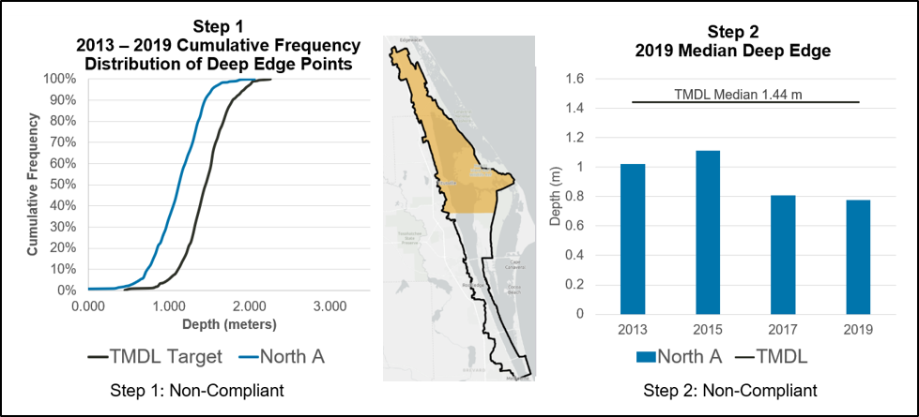
Figure 13. NIRL Project Zone A seagrass evaluation results for compliance step 1 and step 2

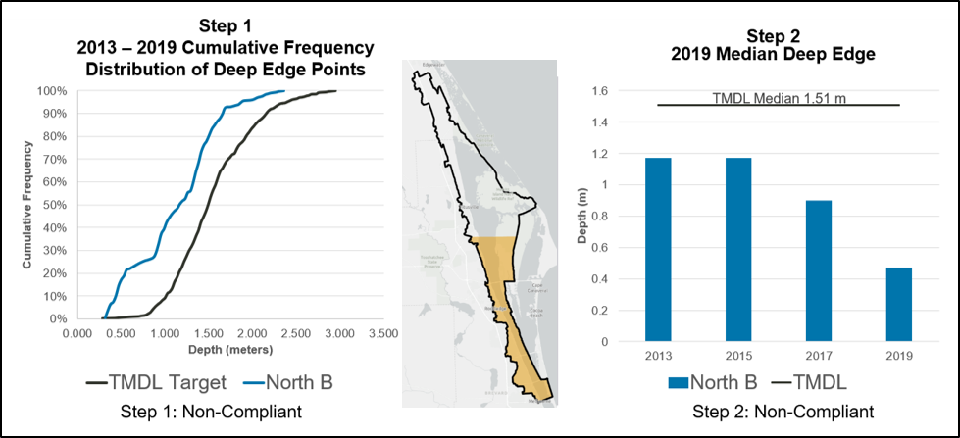
Figure 14. NIRL Project Zone B seagrass evaluation results for compliance step 1 and step 2

- References
Adkins, M., Mao, M., Taulor, M., Green, W., Basci, C., Bergman, M., and Smith, D. 2004. Watershed Model Development for the Indian River Lagoon Basin: Providing Simulated Runoff and Pollution Load to the Indian River Lagoon Pollution Load Reduction Model. Technical Memorandum 50. Palatka, FL: St. Johns River Water Management District.
Applied Ecology. October 15, 2015. Spatial Watershed Iterative Loading (SWIL) Model Methodology Report, Updated for SWIL 3.0. Page 18. Prepared for Brevard County Natural Resources Department.
Applied Ecology. March 20, 2019. Final Memorandum Report for the Development of Baseload Spatial Input Layers for the Indian River Lagoon Watershed. Prepared for Brevard County Natural Resources Department.
Florida Stormwater Association. 2012. Methodology for calculating nutrient load reductions using the FSA assessment tool.
Listopad, C., September 10, 2020. Personal communication with Tiffany Busby, DEP Contractor.
Gao, Xueqing. 2009. TMDL Report. Nutrient and Dissolved Oxygen TMDLs for the Indian River Lagoon and Banana River Lagoon. Florida Department of Environmental Protection.
St. Johns River Water Management District. January 2020. Indian River Lagoon Seagrass Monitoring Standard Operating Procedures.

Appendix A. BMAP Projects Supporting Information
The project tables in this BMAP (Table 20 and Table 22) list the implementation status of the BMAP projects as of July 31, 2020. The tables list the TN and TP reductions in lbs/yr attributable to each individual project. These projects were submitted to DEP by responsible entities with the understanding that the projects and activities would be included in the BMAP, thus setting the expectation for each entity to implement the proposed projects and activities to achieve the assigned load reduction estimates in the specified time.
However, the list of projects is meant to be flexible enough to allow for changes that may occur over time. During the annual review of BMAP implementation efforts, project-specific information may be revised and updated, resulting in changes to the estimated reductions for those projects. The revisions may increase or decrease estimated reductions, and DEP will work with stakeholders to address revisions as they are identified.
The project status column is standardized into the following five categories:
- Canceled: Project or activity that was planned but will no longer take place. This category includes the cessation of ongoing activities.
- Completed: Project, activity, or task that is finished. This category includes fully implemented activities (i.e., ongoing activities) that must continue to maintain assigned credits indefinitely (such as street sweeping, BMP cleanout, catch basin cleanout, public education, fertilizer cessation/reduction, and vegetation harvesting).
- Planned: Project or activity that is conceptual or proposed.
- Underway: Project or activity that has commenced or initiated but is not completed and is not yet reducing nutrient loads from the treated area.
- Ongoing: The lead entity is performing actions each year. This status is used when a project is typically non-structural and continuous. Ongoing projects are not a continuation of a reduction for a structural project.
Prior to reporting project information, DEP contacts each lead entity to gather new information on projects and confirm previously reported information. The terms used throughout the project tables are defined as follows:
- Not provided: Denotes that information was requested by DEP but was not provided by the lead entity.
- TBD: To be determined. Denotes that information is not currently available but will be provided by the stakeholder when it is available.
- N/A: Not applicable. Denotes that information for that category is not relevant to that project.
- 0: Zero. Denotes the numeric value for that category as zero.
The project tables are based on current information, and project details may be updated as further information becomes available.
This BMAP requires stakeholders to implement their projects to achieve reductions as soon as practicable. However, the full implementation of the BMAP will be a long-term process. While some of the projects and activities listed in the BMAP were recently completed or are currently ongoing, several projects require more time to design, secure funding, and construct. Unlike the existing and planned projects, these future projects are not yet considered commitments of the entities but rather are intended for future BMAP credit, pending the availability of funding and other resources.
Although BMAP implementation is a long-term process, the goal of this BMAP is to achieve the TMDLs by the 2035 milestone. It is understood that all waterbodies can respond differently to the implementation of reduced loadings to meet applicable water quality standards. Continued coordination and communication by the stakeholders will be essential to ensure that management strategies continue to meet the implementation milestones.

Appendix B. Agricultural Enrollment and Reductions
(Language in this appendix was provided by FDACS.)
All agricultural nonpoint sources in the North Indian River Lagoon BMAP area are statutorily required either to implement FDACS-adopted BMPs or to conduct water quality monitoring prescribed by DEP or the applicable water management district. Under Paragraph 403.067(7)(c), F.S., the implementation of FDACS-adopted, DEP-verified BMPs, in accordance with FDACS rules, provides a presumption of compliance with state water quality standards for the pollutants addressed by the BMPs.
FDACS Role in BMP Implementation and Follow-up
When DEP adopts a BMAP that includes agriculture, it is the agricultural landowner's responsibility to enroll in the FDACS BMP program and implement all applicable FDACS-adopted BMPs to help achieve load reductions. To date, FDACS OAWP has adopted BMP manuals by rule for cow/calf, citrus, vegetable and agronomic crops, nurseries, equine, sod, dairy, poultry, and specialty fruit and nut operations. All OAWP BMP manuals are periodically revised, updated, and subsequently reviewed and preliminarily verified by DEP before re-adoption. OAWP intends to update BMP manuals every five years.
To enroll in the FDACS BMP program, landowners must meet with an OAWP representative to determine the BMPs that are applicable to their operation. The landowner must submit an NOI to implement the BMPs on the checklist from the applicable BMP manual to an OAWP representative. Because many agricultural operations are diverse and are engaged in the production of multiple commodities, a landowner may sign multiple NOIs for a single parcel.
FDACS is required to conduct implementation verification site visits every two years to verify that landowners are implementing BMPs identified in their NOIs. BMP verification site visits are conducted to verify that all BMPs are being implemented properly, to review nutrient and irrigation management records, and to collect records FDACS is required to retain. In addition, FDACS verifies that cost-share items are being appropriately utilized. Procedures used to verify the implementation of agricultural BMPs are outlined in Rule 5M-1.008, F.A.C. Producers not implementing BMPs according to the process outlined in Title 5M-1, F.A.C., are referred to DEP for enforcement action after attempts at remedial action are exhausted.
Section 403.067, F.S., requires that, where water quality problems persist despite the proper implementation of adopted agricultural BMPs, FDACS must reevaluate the practices, in consultation with DEP, and modify them if necessary. Continuing water quality problems will be detected through the monitoring component of the BMAP and other DEP, and SJRWMD activities. If a reevaluation of the BMPs is needed, FDACS will also include SJRWMD and other partners in the process.
Adopted BMAP Agricultural Land Use and Enrollment
Land use data are helpful as a starting point for estimating agricultural acreage, determining agricultural nonpoint source loads, and developing strategies to reduce those loads in a BMAP area, but there are inherent limitations in the available data. The time of year when land use data are collected (through aerial photography) affects the accuracy of photo interpretation. Flights are often scheduled during the winter months because of better weather conditions and reduced leaf canopies. While these are favorable conditions for capturing aerial imagery, they make photo interpretation for determining agricultural land use more difficult. Agricultural lands are often fallow in the winter months and can lead to inappropriate analysis of the photo imagery.
There is also a significant variation in the frequency with which various sources of data are collected and compiled, and older data are less likely to capture the frequent changes that often typify agricultural land use. In addition, it is not always apparent that an agricultural activity is being conducted on the land. Consequently, DEP relies on local stakeholder knowledge and coordination with FDACS to verify agricultural acreage and BMP implementation.
FDACS uses the FSAID Geodatabase to estimate agricultural acreages statewide. FSAID is derived from water management district land use data, and is refined using county property appraiser data, OAWP BMP enrollment data, U.S. Department of Agriculture data for agriculture, such as the Cropland Data Layer and Census of Agriculture, FDACS Division of Plant Industry citrus data, water management district water use and permitting data, as well as field verification performed by USGS, the water management districts, and OAWP. Ongoing mapping and ground-truthing efforts of the FSAID dataset provide the best available data on the status of agricultural lands in Florida.
In terms of NOIs, enrolled acreage fluctuates when parcels are sold, when leases end or change hands, or when production areas downsize or production ceases, among other reasons. OAWP BMP enrollments are delineated in GIS using county property appraiser parcels. Nonproduction areas such as forest, roads, urban structures, and water features are often included within the parcel boundaries. Conversely, agricultural lands in the FSAID only include areas identified as agriculture. To estimate the agricultural acres enrolled in the BMP program, OAWP overlays FSAID and BMP enrollment data within GIS to calculate the acres of agricultural land in an enrolled parcel.
To address the greatest resource concerns, OAWP utilizes a phased approach based on commodity type and agricultural acreages, while ensuring that all entities identified as agriculture will be notified. Table B-1 lists the agricultural acreage based on FSAID VII that is enrolled in the North Indian River Lagoon BMAP area.
Table B-2 shows the agricultural acreage enrolled in the North Indian River Lagoon BMAP area by project zone. Table B-3 through Table B-5 show the agricultural land use acreage enrolled in the BMP program by commodity. Figure B-1 shows the parcels enrolled in the BMP program by commodity in the North Indian River Lagoon BMAP area; however, compliance with Section 403.067, F.S. is based on the NOIs and site visits described in Section 2.3.1.
Table B-1. Agricultural land use acreage enrolled summary in the BMP program in the NIRL BMAP area as of July 2020
Category | Acres
FSAID VII agricultural acres in the BMAP area | 7,256
Total agricultural acres enrolled | 401
% of FSAID VII agricultural acres enrolled | 6%

Table B-2. Agricultural land use acreage enrolled in the BMP program in the NIRL BMAP area by Project Zone
Project Zone | Total Agricultural Acres | Agricultural Acres Enrolled | % of Agricultural Acreage Enrolled
A | 5,683 | 327 | 6
B | 1,573 | 74 | 5
Total | 7,256 | 401 | 6

Table B-3. Agricultural land use acreage enrolled in the NIRL BMAP area by BMP program
Related OAWP BMP Programs | Agricultural Acres Enrolled
Citrus | 280
Cow/Calf | 114
Fruit/Nut | 6
Nursery | 1
Total | 401

Table B-4. Agricultural land use acreage enrolled in the BMP program in Project Zone A
Related OAWP BMP Programs | Agricultural Acres Enrolled
Citrus | 213
Cow/Calf | 114
Total | 327

Table B-5. Agricultural land use acreage enrolled in the BMP program in Project Zone B
Related OAWP BMP Programs | Agricultural Acres Enrolled
Citrus | 67
Fruit/Nut | 6
Nursery | 1
Total | 74

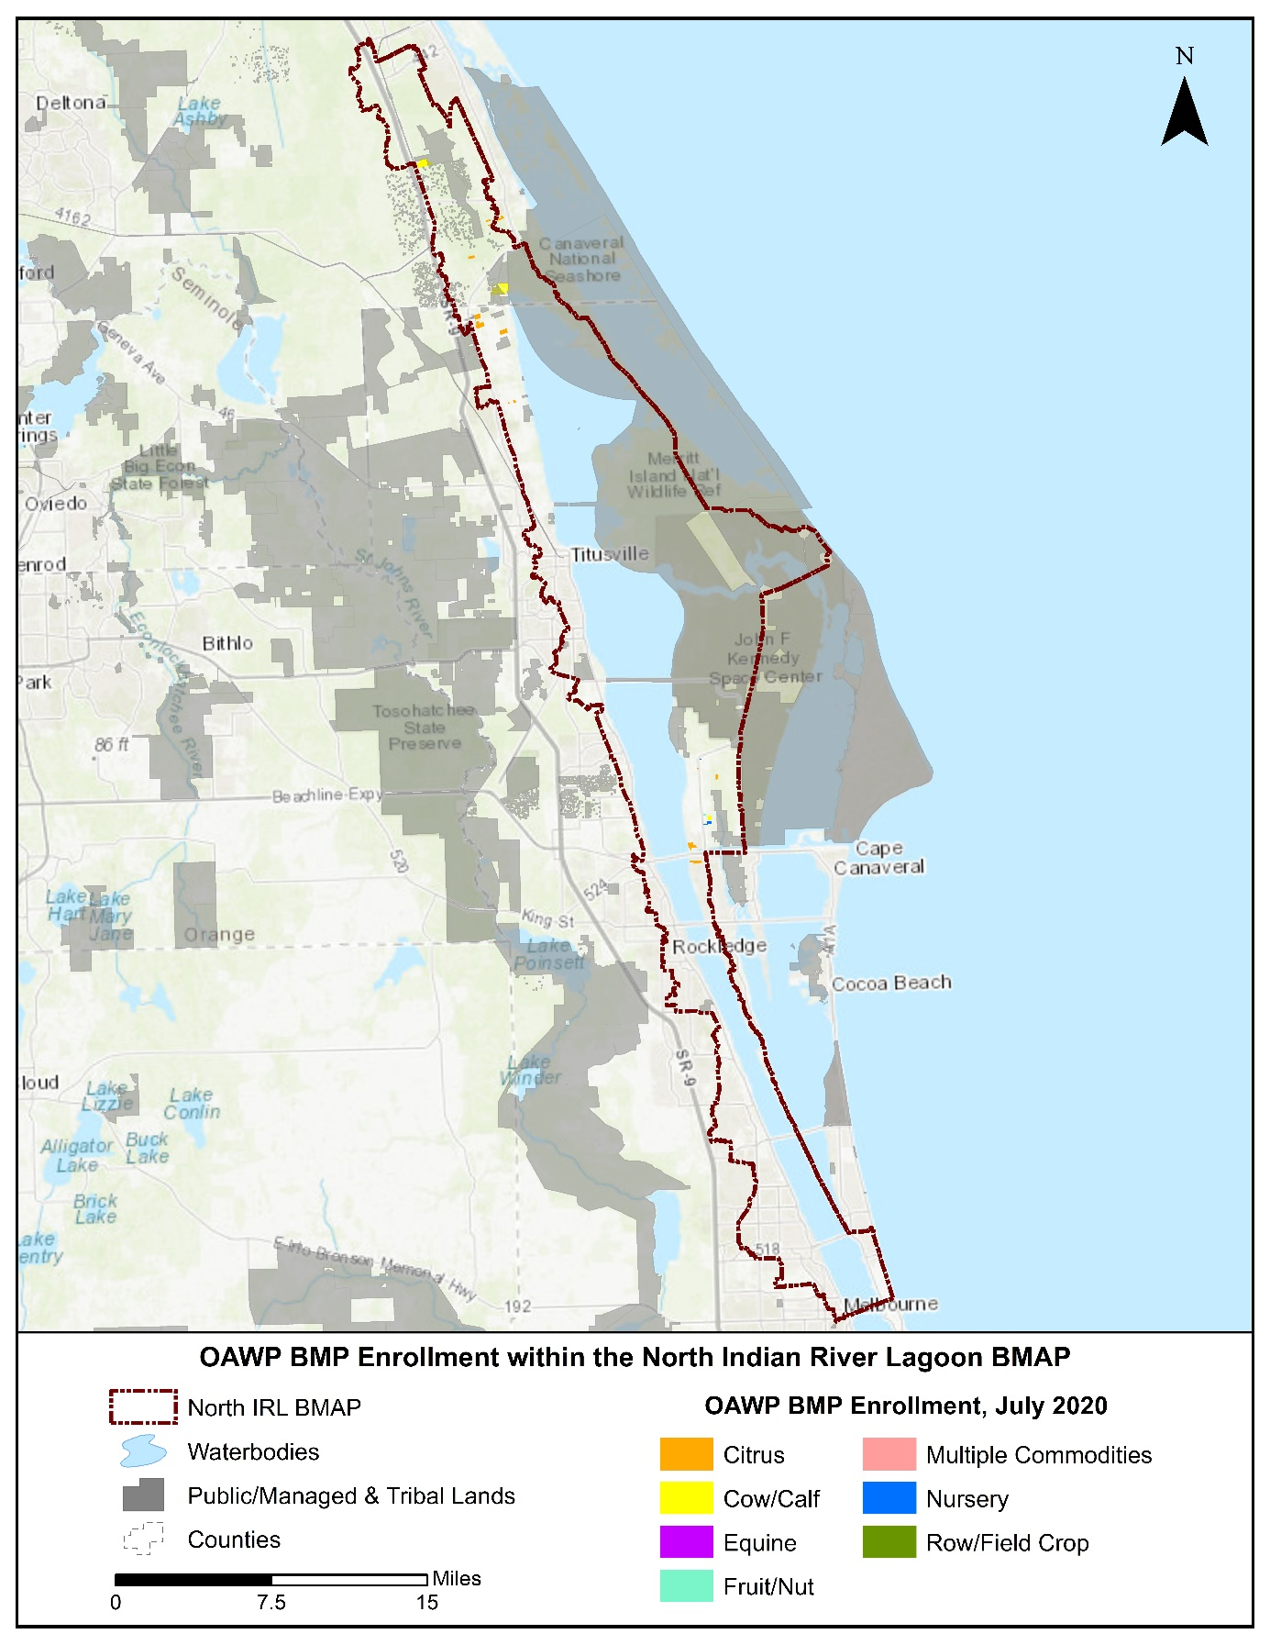
Figure B-1. BMP enrollment in the North Indian River Lagoon BMAP area as of July 2020
Unenrolled Agricultural Acreage
As of July 2020, 6 % of the agricultural acres in the North Indian River Lagoon BMAP area are enrolled in FDACS' BMP program and are implementing practices designed to improve water quality. FDACS continues to increase enrollment in all BMAPs to meet the BMAP goal of enrolling 100% of the enrollable agricultural acres in the BMP program. To achieve that goal, land use analyses are conducted to ensure that areas containing commercial agricultural land uses are prioritized. Lands classified as agriculture where the ability to implement agricultural BMPs under the BMP program is limited, such as smaller rural homesteads, receive lower priority for enrollment.
General Considerations
Although land use data have been used as the basis for prioritizing FDACS enrollment efforts, many land use issues not captured by these databases affect FDACS enrollment efforts. Many areas within the North Indian River Lagoon BMAP boundaries experience rapid land use changes, especially at the urban/rural boundary. Agricultural lands are regularly converted to residential, industrial, commercial, or multiuse properties, but still appear in various databases as pasture or other rural lands. While these lands are likely to be developed in the near future, the agricultural land use classifications require these properties to comply with the BMP enrollment requirements.
Additionally, the counties' methods of classifying small acreages as agricultural lands can affect the BMP enrollment process. Along with these changes, there are also large agricultural parcels being subdivided but remaining classified as "agriculture." These rural homesteads—also called residential agriculture, rural residential, rural estates, equine communities, ranchettes, and other descriptive names for homes with some acreage and agricultural zoning—present a particular challenge for FDACS The current BMP manuals and the measures they contain target commercial agricultural production practices and, in many cases, cannot be scaled down to appropriately enroll activities on these smaller, non-commercial agricultural properties. The increasing number of these smaller parcels with noncommercial agricultural activity represents a growing component of unenrolled acreage. It will be necessary to develop a suite of options to apply to these properties or develop a new classification that may subject these types of areas to other requirements to ensure their nutrient loading contribution is being appropriately identified and reduced.
Further, thousands of acres of open land, scrubland, unimproved pasture, and grazing land exist without a readily identifiable agricultural production activity that will fit within the framework of existing FDACS BMP manuals. Also, these types of parcels are usually controlled by many different individuals. It will be necessary to develop a suite of options to apply to these properties or develop a new classification that may subject these types of areas to alternative methods to ensure their nutrient loading contribution is being appropriately identified and reduced.
Another challenging area includes those agricultural lands that are inactive or fallow—i.e., lands that, on the day the FDACS representative visits, display no enrollable agricultural activity. These lands may be part of a rotation implemented by a landowner, scheduled for development, listed for sale, etc. The land use information FDACS receives is consistently improving the classification of these areas, but policy options remain limited in scope to ensure the implementation of practices aimed at reducing nutrient inputs from these areas.
Characterization of Unenrolled Agricultural Lands
To characterize unenrolled agricultural acres, OAWP identified FSAID VII features outside the BMP enrollment areas and overlaid these features with property appraiser parcels within GIS. OAWP then identified the number of parcels that encompass the unenrolled agricultural lands and the number of agricultural acres present within the parcels. The parcel owner information, other parcel details, and aerial imagery were used identify parcels that are unlikely to contain agricultural activity. As previously mentioned, OAWP BMP enrollments are initially delineated based on county property appraiser parcel data, even if the entire parcel is not agriculture, to allow BMPs to be tied to the specific parcels where agricultural activities are occurring. FSAID agricultural lands are delineated based on land use features identified as agriculture and represent a more refined analysis of those areas actually in agricultural production.
Because of differences in the spatial geometries between the OAWP BMP enrollment, FSAID, and property appraiser parcels, when they are combined or compared, the boundaries often do not align precisely, creating "slivers." Slivers are not enrollable because they are an artifact of the geospatial analysis and do not represent lands with active agricultural practices. For example, a sliver can represent the area between the boundary of a parcel and the beginning of a road, canal, easement, etc. A sliver can also represent a small portion of an FSAID feature outside the BMP enrollment areas that is slightly overlapped by a property appraiser parcel. Slivers are often associated with previously enrolled agricultural operations but because of the delineation differences, these slivers are not captured within the enrolled parcel during geoprocessing. When characterizing unenrolled agricultural lands, slivers are excluded. Figure B-2 shows an example of a sliver created when performing geospatial analysis.

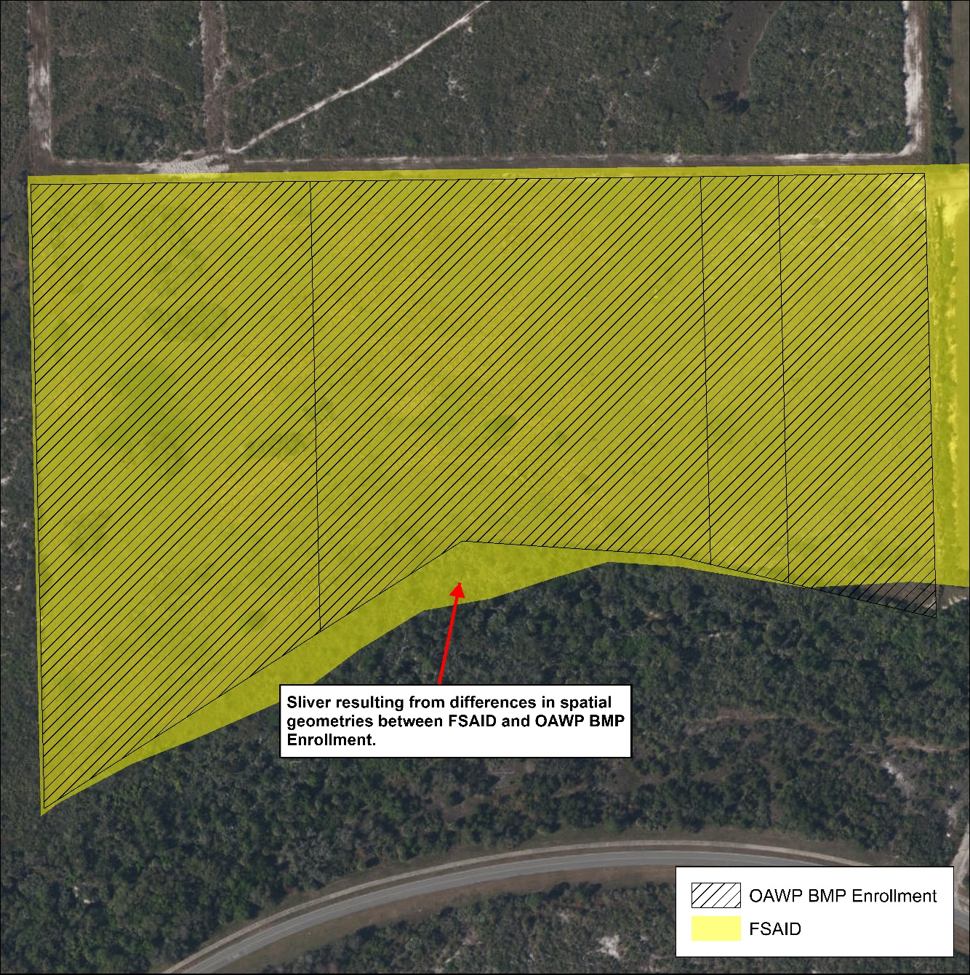
Figure B-2. GIS example of a sliver

Large areas that are identified as agricultural land use but are unlikely to have enrollable agricultural activities include lands owned by the state (Board of Trustees of the Internal Improvement Trust Fund) and water management districts (SJRWMD). It is possible that these lands, in whole or in part, may be leased to other entities that conduct agricultural activities, but such leasing is infrequent. If leasing occurs, the leasing entity will be required to enroll in the BMP program. Ongoing coordination between FDACS, DEP Division of State Lands, and SJRWMD is needed to ensure that any public lands that are leased for the purposes of agricultural activities are required to implement and enroll in FDACS BMP program as a condition of the lease.
Other smaller parcels that have been identified as nonagricultural but have features that cause them to be identified as agricultural lands in various databases, include those lands associated with utilities, telecommunication companies, churches, FDOT rights-of-way, and airports. DOR uses code numbers 70 through 98 to identify these types of lands.
Those agricultural lands that have been identified as "fallow," "former [ag]," and "abandoned," as well as brushland/scrubland/open land, comprise 49 % of the total unenrolled agricultural acres in the North Indian River Lagoon BMAP area. These acres are still classified as agricultural land for the purposes of the BMAP nutrient load assessment. There are a variety of potential options to account for these lands, such as enrollment as "temporarily inactive" operations—particularly those that were previously enrolled and are planned to resume production. Another option may be to note the inactive acres at the time of a field visit and perform periodic reassessment on a cyclical basis. The possibility for DEP and FDACS to calculate nutrient reduction credits or adjust nutrient loading rates may also provide opportunities to present more accurate estimates and establish priorities.
Another factor considered in the prioritization of BMP enrollment is the number of agricultural acres on the parcel. Analyzing the number of agricultural acreages on the parcel and commodity type can give an idea of the efforts that are needed to enroll these areas in FDACS' BMP program and also identify the areas most in need of enrollment. Figure B-3 summarizes the agricultural acres distributed by agricultural acreage found on each parcel.
Further analysis was done to characterize the parcels based on agricultural acreage and land use type. For graphing purposes, land use distribution is displayed in two charts, one showing the land use for parcels containing 50 acres of agriculture or greater (Figure B-4) and a second for parcels containing less than 50 acres of agriculture (Figure B-5). Of the 5,176 acres of land identified as having potential agricultural fallow land comprises 46 % of this acreage.

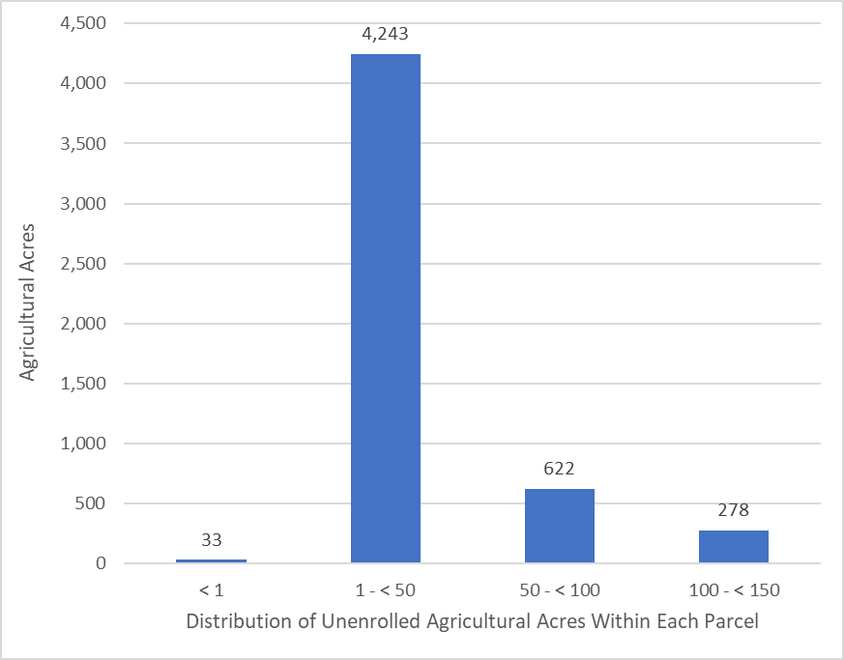
Figure B-3. Distribution of agricultural acreage on parcels with potential agricultural activity, NIRL BMAP area

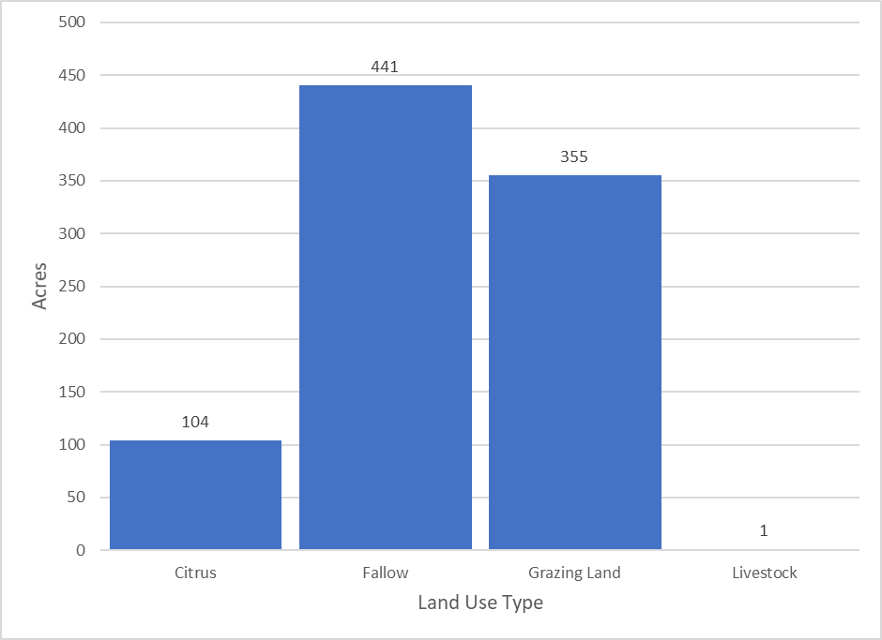
Figure B-4. Agricultural land uses on parcels with 50 acres of agriculture and greater, NIRL BMAP area
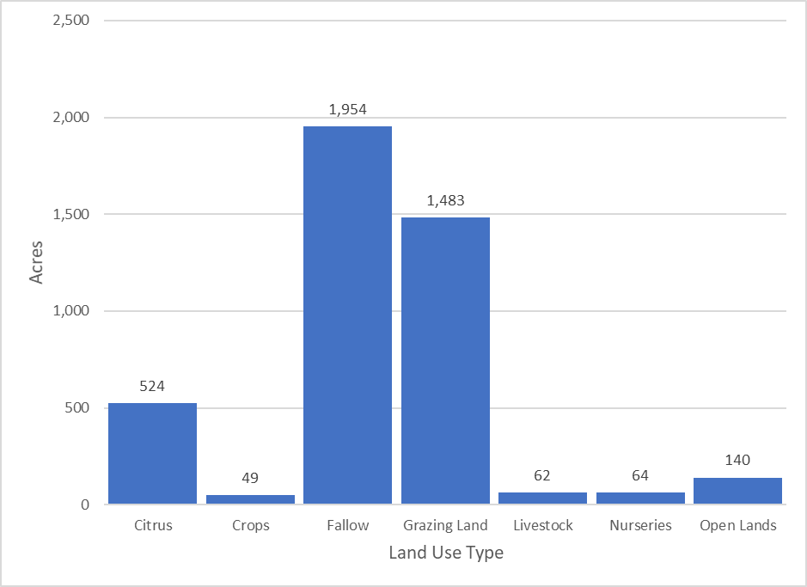
Figure B-5. Agricultural land uses on parcels with less than 50 acres of agriculture, NIRL BMAP area

Table B-6 lists the total acreage associated with the identified slivers and the lands that are not likely to have enrollable agricultural activities, along with the remaining total of unenrolled agricultural acres in the BMAP area. Figure B-6 and Figure B-7 summarize the unenrolled agricultural acres in the North Indian River Lagoon BMAP area by acres of agriculture within the parcels. However, they do not include acreages or parcels associated with slivers or lands that are not likely to have enrollable agricultural activities.
Table B-6. Summary of unenrolled agricultural land use acreage in the NIRL BMAP area
Note: Because of geometric variations between shapefiles used in the unenrolled agricultural lands analysis performed by OAWP, the unenrolled agricultural acres differ from subtraction of the FSAID VII Agricultural Acres in the BMAP and the Total Agricultural Acres Enrolled referenced in Table B-1.
Category | Acres
Unenrolled agricultural acres | 6,855
Acres identified within slivers of unenrolled agricultural areas | 164
Lands without enrollable agricultural activity (e.g., tribal lands, residential development, and parcels with DOR use codes 70-98) | 1,515
Total lands with potentially enrollable agricultural activities | 5,176

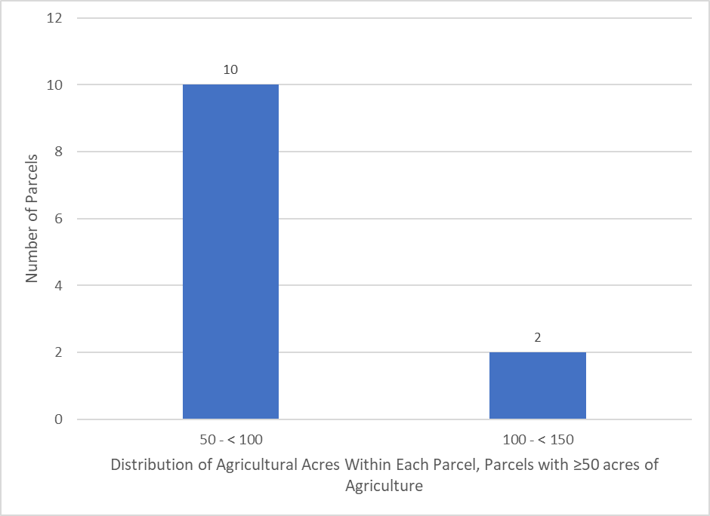
Figure B-6. Number of parcels with 50 acres of agriculture and greater, NIRL BMAP area

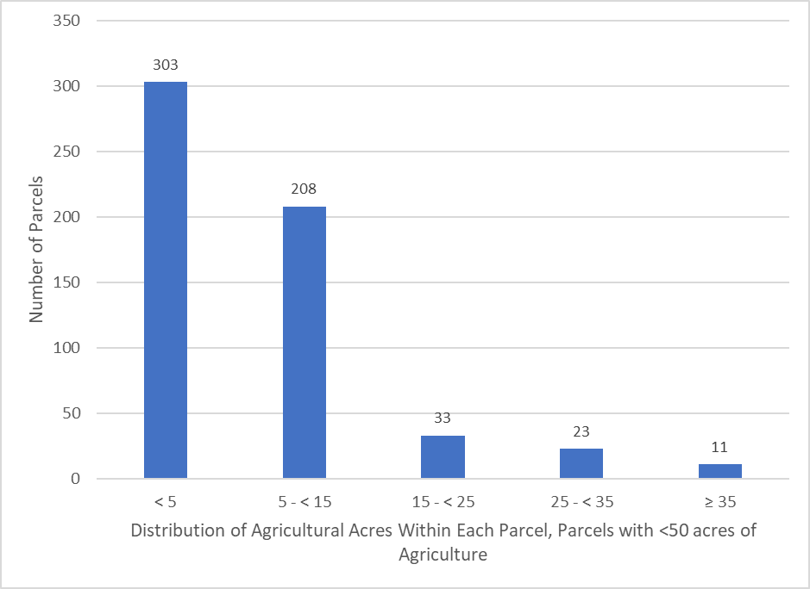

Figure B-7. Number of parcels with less than 50 acres of agriculture, NIRL BMAP area

Unenrolled agriculture characterization information for each individual project zone, including the distribution of agricultural acres within each parcel and land use type, is presented in Figure B-8 through Figure B-11.

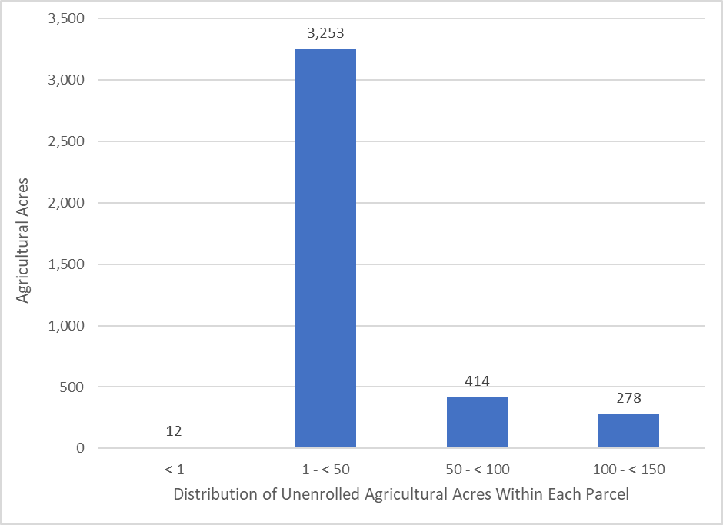
Figure B-8. Distribution of agricultural acreage on parcels with potential agricultural activity, Project Zone A
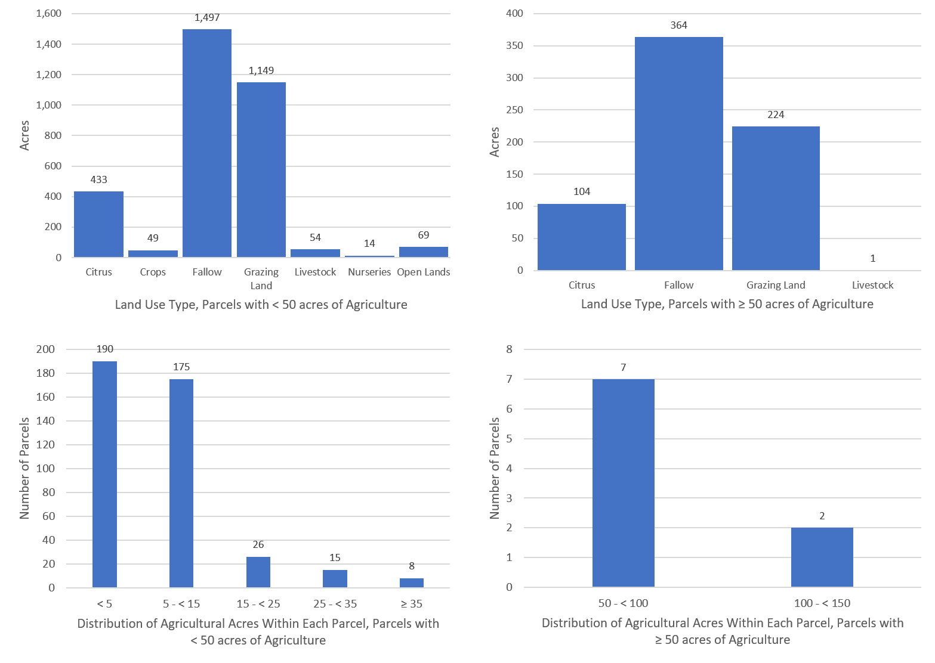
Figure B-9. Land use type and distribution of agricultural acreage, Project Zone A

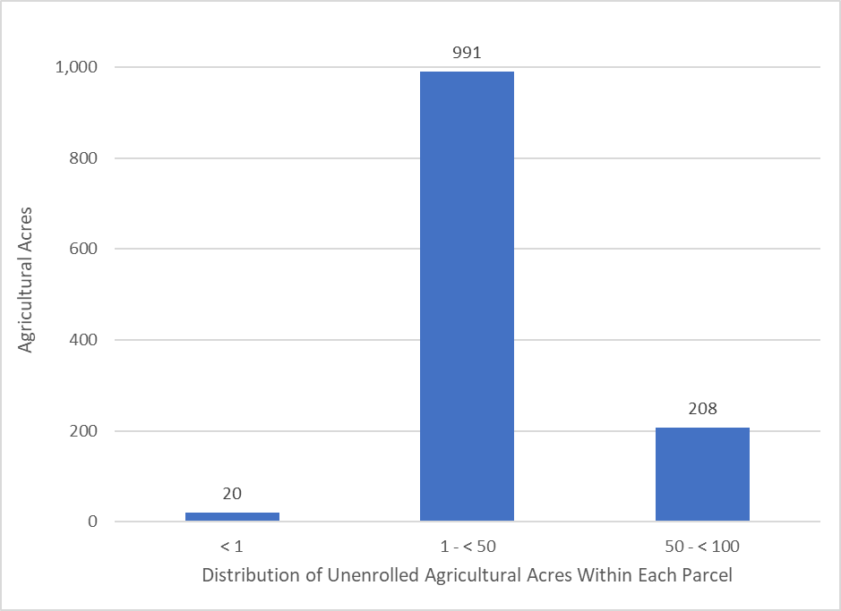
Figure B-10. Distribution of agricultural acreage on parcels with potential agricultural activity, Project Zone B
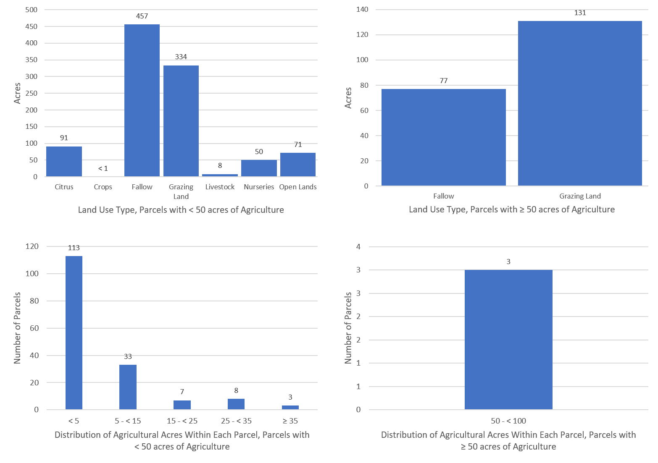
Figure B-11. Land use type and distribution of agricultural acreage by parcel size, Project Zone B

Future Efforts
To address resource concerns, FDACS continues enhancing coordination with producers, agencies and stakeholders to increase enrollment in the BMP program. OAWP is sending correspondence to agricultural land owners within BMAPs that are not currently enrolled in the BMP program to increase enrollment rates and verify land uses where additional focus may be required to achieve resource protection. This effort is utilizing a phased approach and targeting priority land uses and then using the amount of agricultural acreage for the remaining unenrolled lands, while ensuring that all entities identified as agriculture will be notified. Additionally, OAWP continues to coordinate with industry groups and outreach partners to educate and inform agricultural producers about the BMP program.
Additional Factors Related to Agricultural Lands and Measuring Progress
Legacy loading can present an additional challenge to measuring progress in many of areas of Florida with adopted BMAPs. Based on research, initial verification by DEP, and long-term trends in water quality in the BMAP area, it is expected that current efforts, such as BMP implementation, will continue to provide improvements in overall water quality despite the impacts from legacy loads.
While the implementation of BMPs will improve the water quality in the basin, it is not reasonable to assume that BMP implementation alone can overcome the issues of legacy loads, conversion to more urban environments, and the effects of intense weather events. BMP implementation is one of several complex and integrated components in managing the water resources of a watershed. Additional regional projects, precisely located and operated, may be needed to achieve the TMDLs for the North Indian River Lagoon basin.
Collaboration between DEP, the water management districts, and other state agencies, as well as local governments, federal partners, and agricultural producers, is critical in identifying projects and programs, as well as locating funding opportunities to achieve allocations provided for under this BMAP. To improve water quality while retaining the benefits agricultural production provides to local communities, wildlife enhancement, and the preservation of natural areas requires a commitment from all stakeholders to implementing protective measures in a way that maintain the viability of agricultural operations.
Recommended Updates to Land Use
BMAP loads and allocations, as well as water supply projections, are based primarily on land use data. Maintaining the most accurate agricultural land use dataset is critical to planning and policy decisions. Although crop changes, technology advances, and land ownership/lessee changes related to agricultural operations create dynamic environments and difficulties in estimating impacts from specific operations, FDACS and DEP continue to coordinate and develop ways to improve accuracy.
DEP and OAWP recognize that land use–related issues that consistently occur during BMAP development and/or updates. One of these issues is the differentiation between what is classified as an agricultural land use in the TMDL or BMAP model and that is no longer an agricultural land use by the time this BMAP is adopted or an update occurs.
OAWP has developed a methodology to identify agricultural land use changes to make adjustments in subsequent models and reports. Using GIS, OAWP compared the SWIL model land use with the latest FSAID land use and BMP enrollment data. OAWP identified areas classified as agriculture by the BMAP modeled land use that do not overlap with the latest FSAID or BMP enrollment data. OAWP reviewed the output of this overlay analysis by using county appraiser data and aerial imagery to determine if the nonoverlapping areas were still in production. OAWP identified 1,725 acres, classified as agriculture in the SWIL land use, that are now other land use types such as residential, industrial, or commercial (see Table B-7). DEP evaluated the land use changes identified by OAWP and apportioned the associated acres and loads to the appropriate entities after a discussion with each entity.
Often the analyses show changes that have occurred more rapidly than any land use data can capture, such as the transition to residential development. The land use changes are provided to DEP as a GIS shapefile with a description of the information in the county property appraiser database and aerial imagery reflected for the refinement of the acreage and loading allocated to agriculture in a BMAP area.
Table B-7. Agricultural land use change by project zone
Project Zone | Acres
A | 637
B | 1,088
Total | 1,725

In addition to identifying land use changes in the BMAP area modeled land use, OAWP regularly reviews FSAID data, at times daily or weekly, as it performs other job functions. Any edits or changes are reviewed and considered for inclusion in the next iteration of the FSAID.
Potential Site-Specific Nutrient Management Measures in Addition to BMPs
Beyond enrolling producers in the BMP program and verifying implementation, OAWP will also work with producers to identify a suite of agricultural projects and research agricultural technologies that could be implemented on properties where they are deemed technically feasible and if funding is made available. FDACS executes contracts with soil and water conservation districts and other partners to administer cost-share funds and provide technical and administrative support for these districts and other partners. Cost-share funding is being used to implement higher level BMPs, innovative technologies, and regional projects to provide the next added increment of improving and protecting water quality.
Table B-8 identifies the agricultural technologies that received cost-share assistance in the North Indian River Lagoon BMAP area and the associated nutrient reductions based on the 2016 Soil and Water Engineering Technology (SWET) report. Using the nutrient reductions from the report, OAWP developed a methodology to estimate nutrient reductions for NOIs that have received cost-share funding. The NOI boundary, based on property appraiser parcel data, was considered the area treated by the cost-shared agricultural technology or project. For parcels with more than one cost-share project, OAWP identified the order of treatment to determine the reductions for the multiple projects and created a workbook that provided the cost-share agricultural technologies and the formulas to estimate the nutrient reductions.

Table B-8. Cost-share project types and associated nutrient reductions recommended by OAWP
¹ Reductions for this measure are not incorporated as part of this exercise
² Reductions for this measure are from Table 5. Estimated Edge of Farm Nutrient Load Reductions for the FDACS Okeechobee BMP program in the 2016 SWET Report (Bottcher 2016) and is represented in pounds per year per unit (each project is 1 unit)
Project Types | TN Reductions  (%) | TP Reductions  (%)
Chemigation/fertigation | 20 | 20
Fence | 10 | 10
Irrigation improvements, automation | 20 | 20
Precision agriculture technology | 30 | 10
Weather station¹ | 20 | 5
Well, pipeline, trough, pond, heavy use protection² | 50 | 50

Appendix C. Seagrass Analysis
PROCESS TO CONDUCT THE SEAGRASS DEPTH LIMIT COMPLIANCE EVALUATION
The goal of the IRL Basin TMDLs is to recover the deeper seagrass habitats. The seagrass response is the most important factor in evaluating the success of the nutrient TMDLs. Even if the relationship among nutrient loads and seagrass recovery is not as predicted by the regression model, the load reduction requirements themselves will not determine TMDL success. The assessment of success is based on whether the seagrass grows at sufficient depths.
The TMDL seagrass depth limit targets are based on a union coverage of the seagrass mapping data from 1943, 1986, 1989, 1992, 1994, 1996, and 1999. The SJRWMD created this union coverage when it set PLRGs for the IRL Basin. The TMDL targets are not based on the full restoration of seagrass depths represented by this union coverage; instead, they were set at 90% of the full restoration estimate. These targets allow for seagrass growth almost to the depths previously seen in the lagoon, while accounting for the fact that changes have been made to the lagoon system that may limit seagrass growth in some areas, such as dredged areas similar to the Intracoastal Waterway.
Compliance with the TMDL seagrass depth limit targets is assessed on a project zone scale using the latest four consecutive data sets of seagrass mapping data. For the assessment years to be compliant with the TMDL seagrass depth limit targets, the data must meet the requirements of a two-step evaluation process.
The first step is a comparison of the TMDL union coverage cumulative frequency distribution curve with the assessment years' union cumulative frequency distribution curve. The cumulative distribution curves show what percentage of the seagrass deep edge is located at different depths. To be compliant, at least 50 % of the assessment years' curve, including the median, must be on or to the right of the TMDL curve.
The second step in the evaluation process is a comparison of the TMDL union coverage median value with each assessment year's median value. To be compliant in the second step, at least three of the four assessment year medians must be equal to or greater than the TMDL median. If the seagrass data from the four assessment years are compliant with both steps of the test, the project zone is achieving the TMDL depth limit target.
A series of GIS steps must be conducted to obtain the data necessary to complete the two-step evaluation process. These steps are as follows:
- Start with the seagrass GIS shapefiles for the four latest assessment years and edit these files to include only Categories 9113 and 9116, which represent seagrass. Other categories in the GIS shapefiles represent algae cover, which should not be included in this assessment. The seagrass shapefiles only represent the location of the seagrass beds.
- Use the dissolve function in GIS to create the union file of the assessment years. This union file results in a coverage of where seagrass beds were located during all four assessment years.
- Transform the polygons to a polyline in the assessment years' union file. This polyline represents the edges of the seagrass beds.
- Draw a 15.8-meter buffer around the seagrass polyline that is 7.9 meters inside and 7.9 meters outside the seagrass bed. The bathymetry layer was created by the SJRWMD in 1996, and the bathymetry was measured every 15.2 meters. The 15.8-meter buffer around the seagrass polyline ensures that 1 bathymetry point will be captured in the GIS analysis.
- Intersect the updated bathymetry shapefile with the seagrass coverage file that was transformed into a polyline. This intersection correlates the depth data with the seagrass locations so that depths along the seagrass bed edge can be determined.
- Intersect the deep edge file to each project zone (BRL A, BRL B, North A, North B, Central A, Central SEB, and Central B).
- Use the select by location function to identify and note points within dredged areas. The dredged areas are removed from this coverage because seagrass is not expected to grow in areas that have been dredged.
- Identify and note points that fall below 0.3 meters and above 3.5 meters from the coverage. This step is needed because seagrass growing at depths less than 0.3 meters are likely not light-limited, and seagrass are not expected to grow at depths greater than 3.5 meters.
- Identify and note points from the intersections of holes or bare areas, which do not represent the deep edge of the seagrass bed.
- These steps are also followed separately for each assessment year so that the median value can be calculated.
The final points that represent the seagrass deep edge boundary for the assessment years' union coverage are then exported from GIS into Excel to conduct the two-step evaluation. The depth points are sorted from highest to lowest, and the count of the number of points at each depth is determined. The cumulative count is determined by taking the count for the shallowest depth and adding it to the count for the next shallowest point until the counts for all the depths are added together to yield the total number of depth points. The cumulative count at each depth is divided by the total points to determine the percentage of the seagrass points at each depth. These points are then plotted as a curve on a graph for comparison with the TMDL cumulative distribution curve. For the Step 2 evaluation, the median depth point is calculated for each assessment year using Excel. These medians are then compared with the TMDL median to determine compliance.
The maps in Figure C-1 and Figure C-2 include the locations of ground truthing conducted before and during aerial surveys. Additionally, the transect locations where the SJRWMD conducts seasonal monitoring are shown. For more information on how SJRWMD and partners conduct in water seagrass surveys, the SJRWMD's SOP is referenced in Chapter 5.
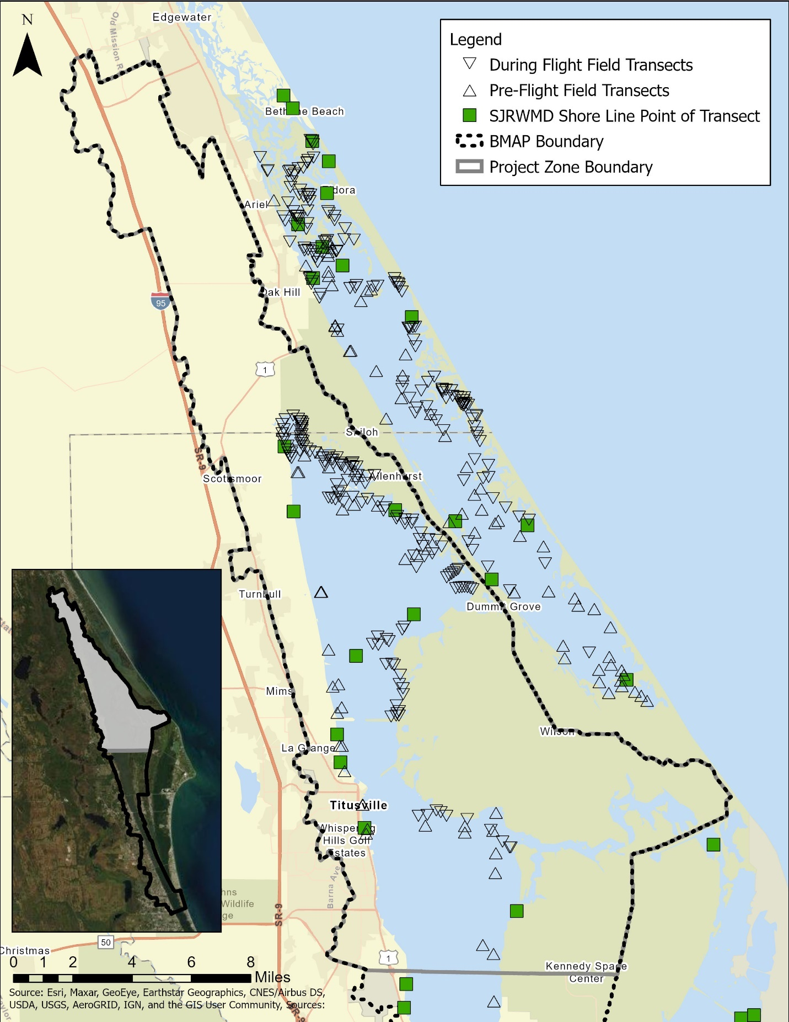
Figure C-1. Map of the seagrass transects in NIRL A
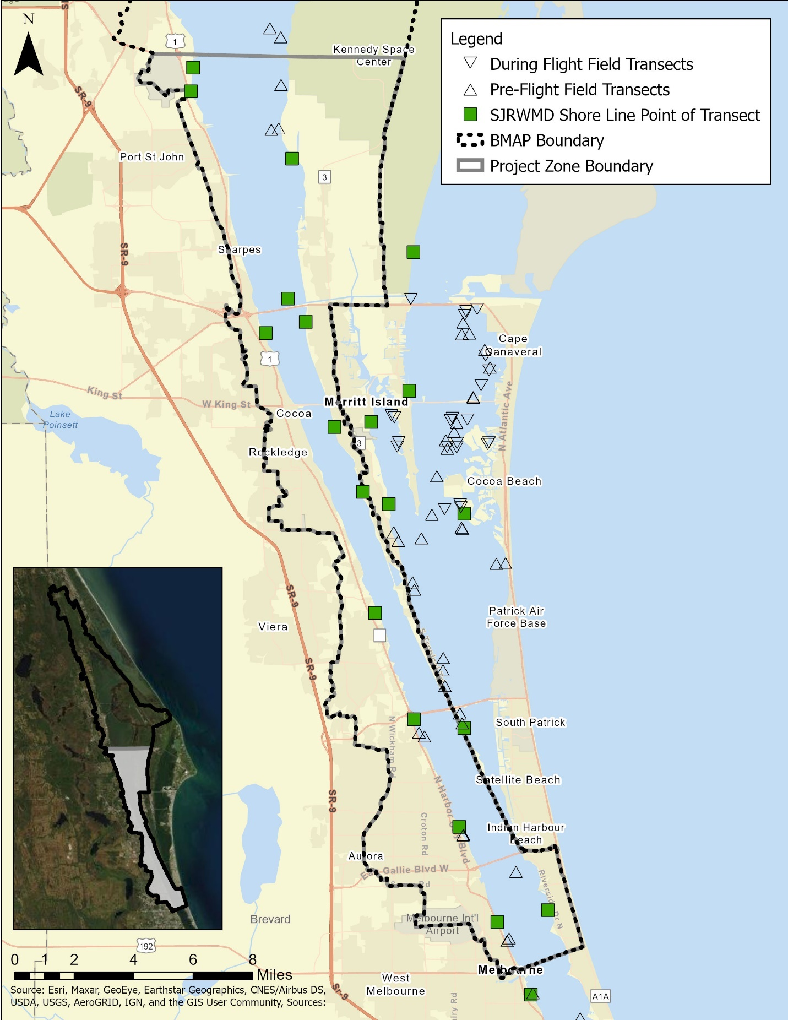
Figure C-2. Map of the seagrass transects in NIRL B

https://www.fdacs.gov/Agriculture-Industry/Water/Agricultural-Best-Management-Practices

