DRAFT
Indian River Lagoon Basin

Central Indian River Lagoon
Basin Management Action Plan

Division of Environmental Assessment and Restoration
Water Quality Restoration Program
Florida Department of Environmental Protection

with participation from the
Central Indian River Lagoon Stakeholders

December 2020



2600 Blair Stone Road
Tallahassee, FL 32399-2400
https://floridadep.gov/

Acknowledgments
The Central Indian River Lagoon Basin Management Action Plan was prepared as part of a statewide watershed management approach to restore and protect Florida's water quality. It was prepared by the Florida Department of Environmental Protection with participation from the Cenral Indian River Lagoon stakeholders identified below.
Type of Governmental or  Private Entity | Participant
Local Governments | Brevard County  Indian River County  St. Lucie County  City of Fellsmere  City of Fort Pierce  City of Melbourne  City of Palm Bay  City of Sebastian  City of Vero Beach  City of West Melbourne  Town of Grant-Valkaria  Town of Indialantic  Town of Indian River Shores  Town of Malabar  Town of Melbourne Beach  Town of Melbourne Village  Town of Orchid  Town of St. Lucie Village
Community Development Districts | Chaparral Community Development District  Emerald Lakes Community Development District  Mayfair Community Development District  PBR Community Development District  Veira East Community Development District
Special Districts | Fellsmere Water Control District  Fort Pierce Farms Water Control District  Indian River Farms Water Control District  Melbourne Tillman Water Control District  Sebastian River Improvement District  Vero Lakes Water Control District
Federal Agencies | Patrick Air Force Base
Regional and State Agencies | Florida Department of Agriculture and Consumer Services  Florida Department of Transportation District 4  Florida Department of Transportation District 5  Florida Turnpike Entreprise  Indian River Lagoon Estuary Program  South Florida Water Management District  St. Johns River Water Management District

Table of Contents
Acknowledgments 2
List of Acronyms and Abbreviations 10
Executive Summary 13
Chapter 1. Background Information 21
1.1 Water Quality Standards and Total Maximum Daily Loads (TMDLs) 21
1.1.1. CIRL TMDLs 22
1.2 CIRL Basin Management Action Plan (BMAP) 24
1.2.1. Pollutant Sources 27
1.2.1.1 Agricultural Nonpoint Sources 27
1.2.1.2 Municipal Separate Storm Sewer Systems (MS4s) 30
1.2.1.3 Septic Systems 33
1.2.1.4 Urban Nonpoint Sources 35
1.2.1.5 Wastewater Treatment Facilities (WWTFs) 35
1.2.2. Milestones and Tracking Progress 38
1.2.3. Assumptions 38
1.2.4. Considerations 39
1.3 Economic Benefits of the IRL System 44
Chapter 2. Modeling, Load Estimates, and Restoration Approach 47
2.1 BMAP Modeling 47
2.1.1. SWIL Modeling 47
2.1.2. SWIL Calibration 48
2.1.3. Allocation Process 48
2.1.4. Project Credit Process 49
2.2 Calculation of Starting Loads and Allocations 49
2.2.1. Starting Loads and Allocation of Load Reductions 49
2.2.1.1 Low-Priority Ranking Determination 54
2.2.1.2 Required Reductions 55
2.3 Basinwide Sources Approach 57
2.3.1. Agriculture 58
2.3.2. Septic Systems 59
2.3.3. Stormwater 60
2.3.4. Wastewater Treatment 60
2.4 Seagrass and Water Quality Monitoring Plan 63
2.4.1. Objectives 63
2.4.2. Monitoring Parameters, Frequency, and Network 64
2.4.3. Data Management and Assessment 71
2.4.4. Quality Assurance/Quality Control 72
2.5 Research Priorities 72
Chapter 3. Project Zones 74
3.1 CIRL A 75
3.1.1. Existing and Planned Projects 78
3.2 CIRL SEB 95
3.2.1. Existing and Planned Projects 98
3.3 CIRL B 110
3.3.1. Existing and Planned Projects 113
3.4 CIRL SIRL 122
3.4.1. Existing and Planned Projects 125
Chapter 4. Compliance and Adaptive Management 132
4.1 Future Growth 132
4.2 Compliance 132
4.2.1. TMDL Compliance 132
4.2.2. BMAP Compliance 135
Chapter 5. References 136
Appendices 137
Appendix A. BMAP Projects Supporting Information 137
Appendix B. Central IRL Allocation Calculations 139
Appendix C. Agricultural Enrollment and Reductions 154
Appendix D. Seagrass Analysis 177
Appendix E. WCDs and Other Special Districts 183

List of Figures
Figure ES-1. CIRL BMAP area and project zones 18
Figure ES-2. Estimated progress towards the CIRL BMAP TN milestones with projects completed through July 31, 2020 19
Figure ES-3. Estimated progress towards meeting the CIRL TP milestones with projects completed through July 31, 2020 20
Figure 1. CIRL BMAP area 26
Figure 2. Location of septic systems in the CIRL 34
Figure 3. Map of wastewater facilities in the CIRL 37
Figure 4. 2013 BMAP area boundary and 2020 BMAP area boundary 43
Figure 5: IMPLAN Model calculation process 45
Figure 6. Total annual economic output by industry group in the IRL region, 2014 46
Figure 7. Flow chart of the allocation steps, Part 1 of 2 52
Figure 8. Flow chart of the allocation steps, Part 2 of 2 53
Figure 9. Monitoring network in the Central A Project Zone 68
Figure 10. Monitoring network in the Central SEB Project Zone 69
Figure 11. Monitoring network in the Central B Project Zone 70
Figure 12. Monitoring network in the Central SIRL Project Zone 71
Figure 13. Estimated progress towards meeting the Required TN Reductions allocated to Project Zone A with projects completed through July 31, 2020 76
Figure 14. Estimated progress towards meeting the Required TP Reductions allocated to Project Zone A with projects completed through July 31, 2020 77
Figure 15. Estimated progress towards meeting the Required TN Reductions allocated to Project Zone SEB with projects completed through July 31, 2020 96
Figure 16. Estimated progress towards meeting the Required TP Reductions allocated to Project Zone SEB with projects completed through July 31, 2020 97
Figure 17. Estimated progress towards meeting the Required TN Reductions allocated to Project Zone B with projects completed through July 31, 2020 111
Figure 18. Estimated progress towards meeting the Required TP Reductions allocated to Project Zone B with projects completed through July 31, 2020 112
Figure 19. Estimated progress towards meeting the Required TN Reductions allocated to Project Zone SIRL with projects completed through July 31, 2020 123
Figure 20. Estimated progress towards meeting the Required TP Reductions allocated to Project Zone SIRL with projects completed through July 31, 2020 124
Figure 21. CIRL Project Zone A seagrass evaluation results for Compliance Step 1 and Step 2 133
Figure 22. CIRL Project Zone SEB seagrass evaluation results for Compliance Step 1 and Step 2 134
Figure 23. CIRL Project Zone B seagrass evaluation results for Compliance Step 1 and Step 2 134
Figure C-1. BMP enrollment in the CIRL BMAP area as of July 2020 158
Figure C-2. GIS example of a sliver 161
Figure C-3. Distribution of agricultural acreage on parcels with potential agricultural activity, CIRL BMAP area 163
Figure C-4. Agricultural land uses on parcels with 50 acres of agriculture and greater, CIRL BMAP area 163
Figure C-5. Agricultural land uses on parcels with less than 50 acres of agriculture, CIRL BMAP area 164
Figure C-6. Number of parcels with 50 acres of agriculture and greater, CIRL BMAP area 165
Figure C-7. Number of parcels with less than 50 acres of agriculture, CIRL BMAP area 165
Figure C-8. Distribution of agricultural acreage on parcels with potential agricultural activity, Project Zone A 166
Figure C-9. Land use type and distribution of agricultural acreage, Project Zone A 167
Figure C-10. Distribution of agricultural acreage on parcels with potential agricultural activity, Project Zone B 168
Figure C-11. Land use type and distribution of agricultural acreage by parcel size, Project Zone B 169
Figure C-12. Distribution of agricultural acreage on parcels with potential agricultural activity, Project Zone SEB 170
Figure C-13. Land use type and distribution of agricultural acreage by parcel size, Project Zone SEB 171
Figure C-14. Distribution of agricultural acreage on parcels with potential agricultural activity, Project Zone SIRL 172
Figure C-15. Land use type and distribution of agricultural acreage by parcel size, Project Zone SIRL 173
Figure D-1. Map of the seagrass transects in CIRL A 180
Figure D-2. Map of the seagrass transects in CIRL SEB 181
Figure D-3. Map of the seagrass transects in CIRL B 182
Figure E-1. Map of the Fellsmere WCD 184
Figure E-2. Map of the FPFWMD 187
Figure E-3. Map of the FPFWCD 190
Figure E-4. Map of the IRFWCD 192
Figure E-5. Map of the MTWCD 196
Figure E-6. Map of the SRID 199
Figure E-7. Map of the VLWCD 201

List of Tables
Table 1. Designated use attainment categories for Florida surface waters 21
Table 2. Class II waters in the CIRL 22
Table 3. CIRL TMDLs 23
Table 4. CIRL tributary TMDLs 24
Table 5. Agricultural land use acreage enrolled summary in the BMP Program in the CIRL BMAP area as of July 2020 28
Table 6. Agricultural land use acreage enrolled in the BMP Program in the CIRL BMAP area by project zone 28
Table 7. Summary of unenrolled agricultural land use acreage in the CIRL BMAP area 29
Table 8. Entities in the CIRL designated as Phase II MS4s as of September 2020 32
Table 9. Septic system counts by project zone 33
Table 10. Urban nonpoint sources in the CIRL 35
Table 11. Wastewater facilities in the CIRL as of September 2020 36
Table 12. SWIL Model starting loads 54
Table 13. Entity contributions to starting loads with low priority ranking cutoff 55
Table 14. TN load required reductions by entity (lbs/yr) 56
Table 15. TP load required reductions by entity (lbs/yr) 57
Table 16. TN effluent limits 62
Table 17. TP effluent limits 62
Table 18. Monitoring stations in the CIRL BMAP area 66
Table 19. Summary of land uses in Project Zone A 75
Table 20. Existing and planned projects in Project Zone A 78
Table 21. Summary of land uses in Project Zone SEB 95
Table 22. Existing and planned projects in Project Zone SEB 98
Table 23. Summary of land uses in Project Zone B 110
Table 24. Existing and planned projects in Project Zone B 113
Table 25. Summary of land uses in Project Zone SIRL 122
Table 26. Existing and planned projects in Project Zone SIRL 125
Table 27. Seagrass compliance results, Step 1 135
Table 28. Summary of seagrass compliance results, Step 2 135
Table B-1. Central IRL starting loads from model 139
Table B-2. Central IRL BMAP TMDL Required Reduction Percentage 139
Table B-3. Central IRL load reductions – starting load * TMDL Required Reduction Percentage 139
Table B-4. Central IRL allowable load per acre from natural loading 140
Table B-5. Central IRL allowable load per acre from total allocation 140
Table B-6. Central IRL adjusted load reductions 141
Table B-7. Central IRL Project Zone SEB entity starting loads from model, natural lands separated 141
Table B-8. Central IRL Project Zone SEB entity starting loads from model, natural lands separated 143
Table B-9. Central IRL Project Zone B entity starting loads from model, natural lands separated 143
Table B-10. Central IRL Project Zone SIRL entity starting loads from model, natural lands separated 144
Table B-11. Central IRL Project Zone A entity anthropogenic starting loads from model, natural lands separated 144
Table B-12. Central IRL Project Zone SEB entity anthropogenic starting loads from model, natural lands separated 145
Table B-13. Central IRL Project Zone B entity anthropogenic starting loads from model, natural lands separated 145
Table B-14. Central IRL Project Zone SIRL entity anthropogenic starting loads from model, natural lands separated 146
Table B-15. Central IRL Project Zone A entity reduction and allowable loading (allocation) 147
Table B-16. Central IRL Project Zone SEB entity reduction and allowable loading (allocation) 147
Table B-17. Central IRL Project Zone B entity reduction and allowable loading (allocation) 148
Table B-18. Central IRL Project Zone SIRL entity reduction and allowable loading (allocation) 148
Table B-19. Central IRL Project Zone A entity TN reduction and allowable TN loading at natural load per acre adjustment (allocation) 149
Table B-20. Central IRL Project Zone SEB entity TN reduction and allowable TN loading at natural load per acre adjustment (allocation) 149
Table B-21. Central IRL Project Zone B entity TN reduction and allowable TN loading at natural load per acre adjustment (allocation) 150
Table B-22. Central IRL Project Zone SIRL entity TN reduction and allowable TN loading at natural load per acre adjustment (allocation) 150
Table B-23. Central IRL BMAP entity starting load and % contribution from anthropogenic loads 151
Table B-24. Central IRL entity TN reductions by project zone 152
Table B-25. Central IRL entity TP reductions by project zone 153
Table C-1. Agricultural land use acreage enrolled summary in the BMP Program in the CIRL BMAP area as of July 2020 156
Table C-2. Agricultural land use acreage enrolled in the BMP Program in the CIRL BMAP area by project zone 156
Table C-3. Agricultural land use acreage enrolled in the CIRL BMAP area by BMP program 156
Table C-4. Agricultural land use acreage enrolled in the BMP Program in Project Zone A 156
Table C-5. Agricultural land use acreage enrolled in the BMP Program in Project Zone B 157
Table C-6. Agricultural land use acreage enrolled in the BMP Program in Project Zone SEB 157
Table C-7. Agricultural land use acreage enrolled in the BMP Program in Project Zone SIRL 157
Table C-8. Summary of unenrolled agricultural land use acreage in the CIRL BMAP area 164
Table C-9. Agricultural land use change by project zone 175
Table C-10. Cost-share project types and associated nutrient reductions recommended by OAWP 176

List of Acronyms and Abbreviations
BAM Biosorption Activated Media
BCWMA Blue Cypress Water Management Area
BMAP Basin Management Action Plan
BMP Best Management Practice
BOD Biochemical Oxygen Demand
CDD Community Development District
CDS Continuous Deflection Separation
CEPP Central Everglades Planning Project
CERP Comprehensive Everglades Restoration Plan
CIRL Central Indian River Lagoon
CR County Road
CWA Clean Water Act
DEM Division of Emergency Management
DEP Florida Department of Environmental Protection
DIW Deionized Water
DO Dissolved Oxygen
DOR Florida Department of Revenue
DWM Dispersed Water Management
EFDC Environmental Fluid Dynamics Code
EMC Event Mean Concentration
EPA U.S. Environmental Protection Agency
F.A.C. Florida Administrative Code
FCT Florida Communities Trust
FDACS Florida Department of Agriculture and Consumer Services
FDOH Florida Department of Health
FDOT Florida Department of Transportation
FIND Florida Inland Navigation District
FJV Fellsmere Joint Ventures
FLWMI Florida Water Management Inventory
FPFWCD Fort Pierce Farms Water Control District
FPL Florida Power and Light
F.S. Florida Statutes
FSAID Florida Statewide Agricultural Irrigation Demand (geodatabase)
ft Foot
FWRA Florida Watershed Restoration Act
GIS Geographic Information System
HMGP Hazard Mitigation Grant Program
HOA Homeowner Association
HSPF Hydrologic Simulation Program–Fortran
HWTT Hybrid Wetland Treatment Technology
IRFWCD Indian River Farms Water Control District
IRL Indian River Lagoon
IRLC Indian River Lake Conservancy
IWR Impaired Surface Waters Rule
kg Kilogram
km Kilometer
lbs Pounds
LET Load Estimation Tool
m Meter
MAPS Managed Aquatic Plant System
mgd Million Gallons Per Day
mg/L Milligrams Per Liter
MHP Mobile Home Park
MS4 Municipal Separate Storm Sewer System
mt Metric Tons
MTWCD Melbourne-Tillman Water Control District
N/A Not Applicable
NELAC National Environmental Laboratory Accreditation Council
NELAP National Environmental Laboratory Accreditation Program
NEP National Estuary Program
NGVD National Geodetic Vertical Datum
NIRL North Indian River Lagoon
NOI Notice of Intent
NPDES National Pollutant Discharge Elimination System
NRCS Natural Resources Conservation Service
NSLRWCD North St. Lucie River Water Control District
O&M Operations and Maintenance
OAWP Office of Agricultural Water Policy
OSTDS Onsite Sewage Treatment and Disposal System
PAM Polyacrylamide
PLSM Pollutant Load Screening Model
PSA Public Service Announcement
QA/QC Quality Assurance/Quality Control
RRLA Rapid Rate Land Application
RV Recreational Vehicle
SFWMD South Florida Water Management District
SJRWMD St. Johns River Water Management District
SIRL South Indian River Lagoon
SLC St. Lucie County
SOP Standard Operating Procedure
SR State Road
SRID Sebastian River Improvement District
STEM Science, Technology, Engineering and Mathematics
STEP Septic Tank Effluent Pumping
STORET STOrage and RETrieval (Database)
SWET Soil and Water Engineering Technology
SWIL Spatial Watershed Iterative Loading
SWMP Stormwater Management Program
TMDL Total Maximum Daily Load
TN Total Nitrogen
TP Total Phosphorus
TSS Total Suspended Solids
USACE U.S. Army Corps of Engineers
USGS U.S. Geological Survey
VLWCD Vero Lake Water Control District
WBID Waterbody Identification (number)
WCD Water Control District
WCS Water Control Structure
WIN Watershed Information Network (Database)
WMA Water Management Area
WMD Water Management District
WWTF Wastewater Treatment Facility

Executive Summary
Background
The Indian River Lagoon (IRL) is a 156-mile-long estuary along Florida's east coast. The impaired portions of the IRL are directly adjacent to lands in only Volusia, Brevard, Indian River, and St. Lucie counties. The northern portion of the watershed extends to near the Ponce De Leon Inlet in Volusia County and the southern portion to near the Fort Pierce Inlet at the Indian River County–St. Lucie County boundary line. Because of the large geographical extent of the IRL Basin and the hydrological differences throughout the basin, the Florida Department of Environmental Protection (DEP) determined the best way to address the total maximum daily loads (TMDLs) and impairments for the IRL Basin would be to divide the watershed into 3 subbasins: (1) Central IRL (CIRL), (2) North IRL (NIRL), and (3) Banana River Lagoon (BRL). Separate basin management action plans (BMAPs) were developed for each subbasin; this document focuses solely on the CIRL Subbasin. The main stem of the CIRL Subbasin extends from the Melbourne Causeway in Brevard County to Fort Pierce Inlet, and includes the areas drained by the Fort Pierce Farms Canal network and the C-25 Canal (Figure ES-1).
Intense and extensive algal blooms in the IRL began in 2011 and have returned periodically. Harmful algal blooms (HABs) cause shading that stresses seagrass in the IRL, adverse effects on wildlife, and in some cases, detrimental effects on human health. The St. Johns River Water Management District (SJRWMD) launched the Indian River Lagoon Protection Initiative in 2013, including a multiyear investigation that increased the understanding of these blooms. This and other research indicate it is important to persevere with projects that decrease nutrient loads to the IRL, because that approach will limit the severity of HABs and their impacts on the system.
TMDLs
A TMDL is a water quality restoration goal establishing the maximum amount of a pollutant that a waterbody can assimilate without causing exceedances of water quality standards. The nutrient TMDLs for the main stem of the IRL were adopted by DEP in March 2009. The TMDLs focus on the water quality conditions necessary for seagrass regrowth at water depth limits where seagrass historically grew in the lagoon, based on a multiyear composite of seagrass coverage. The median depth limits of seagrass coverage in the IRL decreased over the years because of changes in water quality conditions resulting from anthropogenic influences. As polluted runoff reaches the lagoon, it contributes to conditions that prevent the seagrass from growing in deeper water.
Additionally, TMDLs were adopted in 2013 for certain tributaries to the CIRL that are now addressed in this BMAP. For Crane Creek (waterbody identification [WBID] number 3085A), North Prong of the Sebastian River (WBID 3128), South Prong St. Sebastian River Estuary Segment (WBIDs 3129B1 and 3129B2), Sebastian River above Indian River (3129A), and the C-54 Canal (WBID 3135A), no further nutrient load reductions were requested beyond those already established for the main stem seagrass nutrient TMDLs. For Goat Creek (WBID 3107A), the targets were also set to control nutrient loads from the watershed of the creek to restore seagrass distribution in the IRL proper. No further nutrient reductions beyond those already being requested to protect the main stem seagrasses were included in the Goat Creek TMDLs.
CIRL BMAP
In addition to dividing the overall IRL Watershed into subbasins, the CIRL was further divided into "project zones." The project zone boundaries are based on the distinct hydrology in different areas of the basin and their corresponding annual residence times. These zones are important because the flushing times vary greatly among locations and consequently affect how nutrient reductions will impact these distinct areas of the basin. The project zones identify large areas where projects should be implemented to ensure that the load reductions achieve the desired response for each subbasin. The CIRL Subbasin was split into four project zones, as follows:
- Central A – Melbourne Causeway (U.S. 192) to the north tip of Grant Farm Island.
- Central SEB – Grant Farm Island to Wabasso Causeway (County Road 510).
- Central B – Wabasso Causeway to the boundary between Indian River County and St. Lucie County.
- South IRL (SIRL) – The St. Lucie/Indian River County line to Fort Pierce Inlet.
TMDLs have not yet been developed for the SIRL; however, because of the connectivity of the SIRL to the other three project zones, the reduction of loads here is critical for achieving the TMDLs for the main stem of the IRL. SIRL was therefore included in the CIRL BMAP adopted in 2013, and load reductions were developed for the SIRL project zone as part of this BMAP. Additionally, WBIDs 3163 and 3163B (C-25 canal) within the SIRL project zone are impaired for nutrients, as indicated by elevated phosphorus levels and the abundance of macrophytes.
DEP first adopted the CIRL BMAP in 2013 to implement total nitrogen (TN) and total phosphorus (TP) TMDLs in three of the four CIRL Project Zones. BMAPs are designed to be implemented in a phased approach. In 2018, DEP and several local stakeholders were developing several components of an updated BMAP, including the local completion and DEP review of a new water quality model, the Spatial Watershed Iterative Loading (SWIL) Model. The SWIL Model was developed through cooperative funding provided by Brevard County, all of its cities, and Florida Department of Transportation (FDOT) District 5, as well as support from the U.S. Air Force, in an effort to update the data being used to predict loading. In this BMAP update, the SWIL Model is used to estimate loading to the CIRL. The percent reductions adopted in the original TMDL rules are applied as the water quality targets.
This 2020 BMAP was developed based on several changes since the 2013 BMAP was adopted, including updated modeling efforts, boundary adjustments, updated allocations and load reductions to the responsible stakeholders, updated management actions to achieve nutrient reductions, and a revised monitoring plan to continue to track trends in water quality. This update sets a deadline for achieving load reductions no later than 2035, which is 22 years after the initial BMAP adoption in 2013.
As part of the adaptive management process for this BMAP, DEP will explore refinements to the SWIL Model used to develop BMAP allocations and estimate project credits. This effort could include updates to some of the SWIL Model input layers (e.g. land use, soils, etc.), the verification of watershed boundaries in some areas, revisions to the model period of record, and the validation of predicted flows in selected calibration basins. There are also several optional tasks that could streamline efforts during the load allocation and project calculation processes. The SWIL Model revisions may change the loading estimates presented in this BMAP, and may therefore result in changes to allocations in future iterations of the BMAP. Although the direction and magnitude of those changes is uncertain, DEP anticipates that some may be higher, and some may be lower.
Summary of Load Reductions
DEP requested stakeholders provide information on management actions, including projects, programs, and activities, that may reduce nutrient loads to the CIRL. Management actions are included in the BMAP to address nutrient loads to the lagoon and have to meet several criteria to be considered eligible for credit. The estimated reductions of activities completed to date are provided in Table ES-1. Figure ES-2 and Figure ES-3 show progress towards the TN and TP TMDL load reductions through July 31, 2020.
To achieve the TMDLs, stakeholders must identify and submit additional local projects as well as determine the significant funding that will be necessary. Enhancements to programs addressing basinwide sources will also be required.
Table ES-1. Progress to date in the CIRL BMAP area by project zone
lbs/yr = pounds per year
Project Zone | TN Reduction (lbs/yr) | % Achieved towards TN Target | TP Reduction (lbs/yr) | % Achieved towards TP Target
A | 76,866 | 29.2 | 9,267 | 22.7
SEB | 61,065 | 23.2 | 23,646 | 50.9
B | 92,410 | 31.4 | 14,169 | 37.4
SIRL | 16,718 | 17.5 | 3,826 | 4.0
Total | 247,059 | 27.0 | 50,909 | 23.1

Source Requirements
Florida law (Section 403.086, Florida Statutes [F.S.], and Chapter 2020-150, Laws of Florida) requires all domestic wastewater facilities directly discharging to surface waters of the state within or connected to the IRL to meet advanced wastewater treatment requirements no later than July 1, 2025. Additionally, this BMAP sets TN and TP effluent limits in the CIRL for individually permitted domestic wastewater facilities and their associated rapid rate land application (RRLA) effluent disposal systems and reuse activities, unless the owner or operator can demonstrate reasonable assurance that the discharge or associated RRLA or reuse activity would not cause or contribute to a failure to achieve the TMDLs or an exceedance of water quality standards. Local governments must also develop remediation plans to address loads from wastewater facilities and septic systems in the BMAP area.
Agricultural nonpoint sources are a significant contributor of TN and TP loading to the CIRL. Since the adoption of the CIRL BMAP in 2013, some agricultural producers have enrolled in the Florida Department of Agriculture and Consumer Services (FDACS) Best Management Practices (BMP) Program. However, enrollment still falls well short of the full participation requirement under law, and for those producers that have enrolled, the onsite verification of BMP implementation is inconsistent and incomplete. Sufficient agricultural BMP enrollment and implementation verification will be necessary to achieve the TMDLs. FDACS continues to work to improve enrollment percentages in the basin and will be undertaking implementation verification site visits on enrolled producers at least every two years to carry out its statutory authority and fulfill its statutory obligations to facilitate enrollment and implementation verification, pursuant to Paragraphs 403.067(7)(c) and 403.067(7)(d), F.S.
Within five years of the adoption of this BMAP, DEP will evaluate any entity located in the BMAP area that serves a minimum resident population of at least 1,000 individuals who are not currently covered by a municipal separate storm sewer system (MS4) permit and designate eligible entities as regulated MS4s, in accordance with Chapter 62-624, Florida Administrative Code (F.A.C.). In accordance with Subsection 373.4131(6), F.S., DEP and the water management districts are planning to update the stormwater design and operation requirements in Environmental Resource Permit rules and incorporate the most recent scientific information available to improve nutrient reduction benefits.
Water Quality Monitoring
The updated CIRL BMAP monitoring network consists of 44 stations sampled by the SJRWMD, South Florida Water Management District, U.S. Geological Survey, Indian River Farms Water Control District, Sebastian River Improvement District, Fort Pierce Farms Water Control District, and North St. Lucie River Water Control District. The monitoring plan also includes research priorities to better understand the lagoon, nutrient sources, and the responses of seagrass to nutrient loading, both internal and external, to the lagoon.
BMAP Cost
The project costs provided for the BMAP may include capital costs as well as those associated with construction, routine operations and maintenance, and monitoring. Many BMAP projects were built to achieve multiple objectives, not just nutrient reductions. Funds for some projects have already been spent, others have been obligated to ongoing projects, and the remainder are yet to be appropriated.
The funding sources for the projects range from local public and private contributions to state and federal legislative appropriations. DEP will continue to work with stakeholders to explore new opportunities for funding assistance to ensure that the activities listed in this BMAP can be maintained at the necessary level of effort and that additional projects can be constructed by 2035.

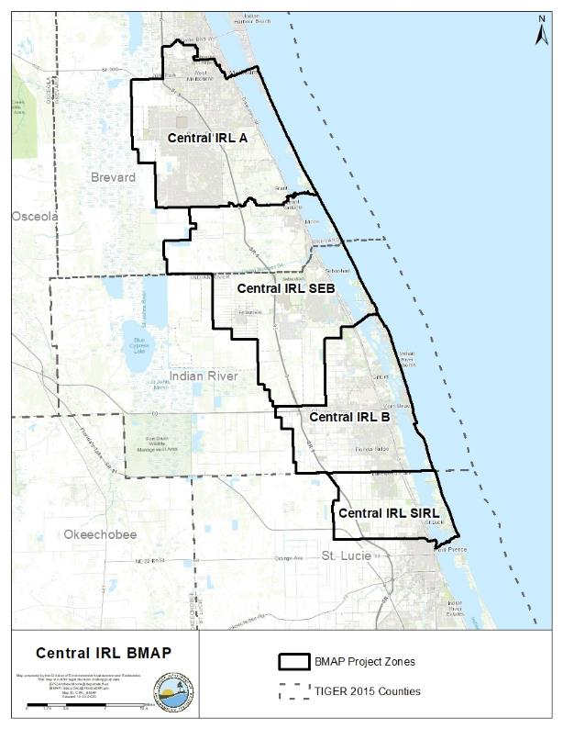
Figure ES-1. CIRL BMAP area and project zones

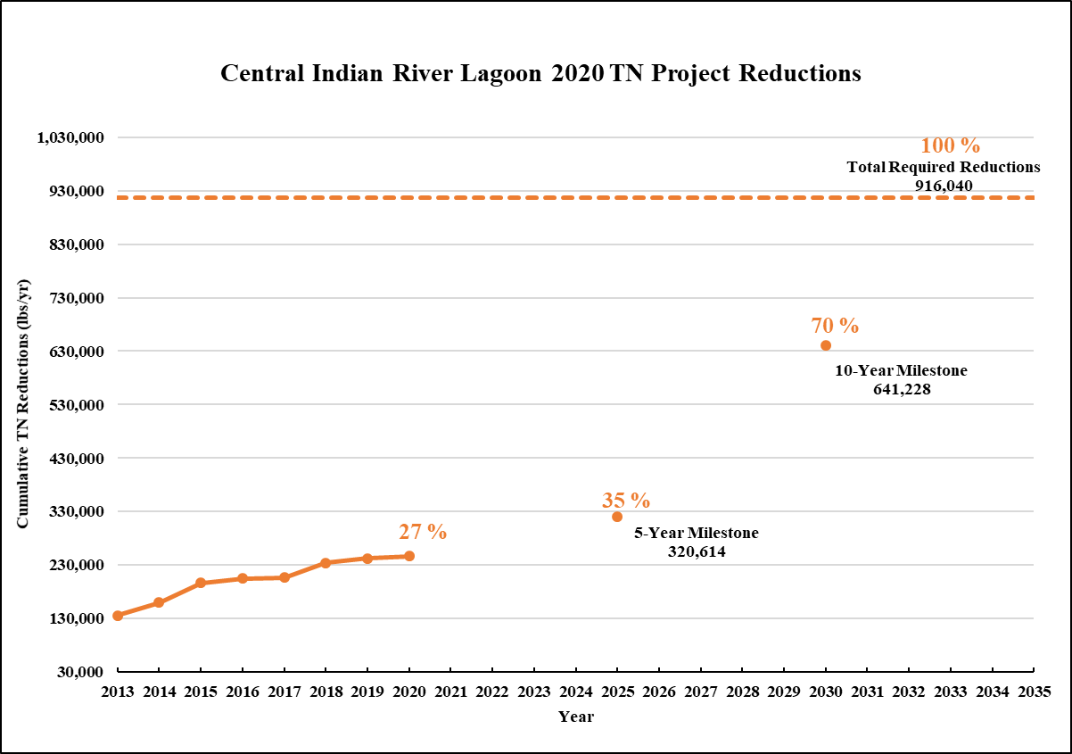
Figure ES-2. Estimated progress towards the CIRL BMAP TN milestones with projects completed through July 31, 2020

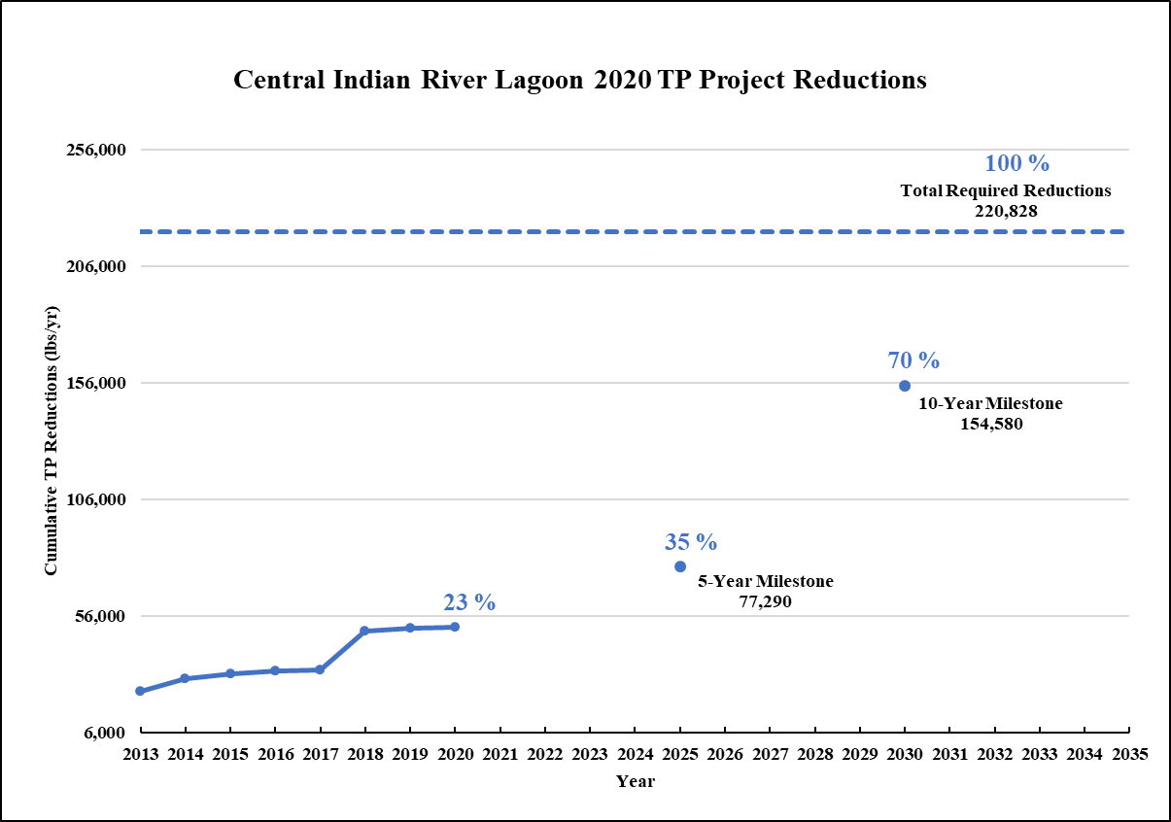
Figure ES-3. Estimated progress towards meeting the CIRL TP milestones with projects completed through July 31, 2020

- Background Information

Water Quality Standards and Total Maximum Daily Loads (TMDLs)
Florida's water quality standards are designed to ensure that surface waters fully support their designated uses, such as drinking water, aquatic life, recreation, and agriculture. Currently, most surface waters in Florida, including many of those in the Central Indian River Lagoon (CIRL), are categorized as Class III waters, meaning they must be suitable for recreation and must support fish consumption and the propagation and maintenance of a healthy, well-balanced population of fish and wildlife. In addition, many waterbody segments (also known as waterbody identification units, WBIDs) are categorized as Class II waters, which have a designated use of shellfish propagation or harvesting. Table 1 lists all designated use classifications for Florida surface waters.
Table 1. Designated use attainment categories for Florida surface waters
¹ Class I, I-Treated, and II waters additionally include all Class III uses.
Classification | Description
Class I¹ | Potable water supplies
Class I-Treated¹ | Treated potable water supplies
Class II¹ | Shellfish propagation or harvesting
Class III | Fish consumption; recreation, propagation and maintenance of a healthy,  well-balanced population of fish and wildlife
Class III-Limited | Fish consumption, recreation or limited recreation, and/or propagation and maintenance of a limited population of fish and wildlife
Class IV | Agricultural water supplies
Class V | Navigation, utility, and industrial use (no current Class V designations)

Class II waters in the CIRL may be used for aquaculture. The WBIDs that are designated as Class II waters are listed in Table 2. If not listed, the remaining WBIDs are Class III waters.
Section 303(d) of the federal Clean Water Act (CWA) requires that each state must identify its impaired waters every two years, including estuaries, lakes, rivers, and streams, that do not meet their designated uses. Florida Department of Environmental Protection (DEP) staff in the Division of Environmental Assessment and Restoration are responsible for assessing Florida's waters for inclusion on the Verified List of Impaired Waters (when a causative pollutant for the impairment has been identified) and Study List (when a causative pollutant for the impairment has not been identified and additional study is needed). These lists are then provided to the U.S. Environmental Protection Agency (EPA) as an update to the state’s 303(d) list. In 2009, DEP adopted, by Secretarial Order, revisions to the Verified List of Impaired Waters for the CIRL that identified several estuarine segments as impaired for dissolved oxygen (DO) and nutrients. The DO impairment was based on low DO concentrations measured in milligrams per liter (mg/L), and the nutrient impairment was based on an imbalance in flora and fauna because of decreases in seagrass distribution.
Table 2. Class II waters in the CIRL
Classification | WBID Number | Waterbody Name
Class II | 2963A1 | Indian River above Sebastian Outlet
Class II | 2963B1 | Indian River above Melbourne Causeway
Class II | 3107A | Goat Creek (marine segment)
Class II | 3107B | Goat Creek (freshwater segment)
Class II | 3115 | Kid Creek
Class II | 3119 | Trout Creek
Class II | 3147 | North Canal
Class II | 3190 | South Indian River (above Ft. Pierce Inlet)
Class II | 3190A | Little Jim Bridge
Class II | 5003B1 | South Indian River (below SR 60)
Class II | 5003B2 | South Indian River (below SR 60 – Shellfish Portion)
Class II | 5003C1 | South Indian River (above SR 60)
Class II | 5003D1 | South Indian River (near St. Sebastian River)
Class II | 5003DA | Coconut Point Sebastian Inlet

CIRL TMDLs
TMDLs are water quality restoration goals establishing the maximum amount of a pollutant that a waterbody can assimilate without causing exceedances of water quality standards. The IRL TMDLs focus on the water quality conditions necessary for seagrass regrowth at water depth limits where seagrass historically grew in the lagoon, based on a multiyear composite of seagrass coverage. The median depth limits of seagrass coverage in the IRL decreased over the years (see Section 4.2) due to changes in water quality conditions resulting from anthropogenic influences.
As polluted runoff reaches the lagoon, it contributes to conditions that prevent the seagrass from growing in deeper water because of elevated light attenuation. The full restoration depth-limit target for seagrass was established for each segment based on a deep edge boundary delineating the composite of 7 years of historical seagrass data for the period from 1943 to 1999. The restoration targets were set at depths where the deep edge of the seagrass beds previously grew and created a maximum depth limit for seagrass distribution. The TMDL targets allowed for a 10 % departure (shoreward) from the full restoration target seagrass depth. The 10 % departure in target depths was selected to be consistent with the water quality criteria in Chapter 62-302, Florida Administrative Code (F.A.C.), which allows for up to a 10 % reduction in the photo compensation point.
To determine nutrient targets and reductions needed to improve lagoon water quality in each subbasin, regression relationships were used between 4 years of loading levels and the same years' seagrass depth limit (the percent departure from the full restoration). Total nitrogen (TN) and total phosphorus (TP) targets were developed from the median concentrations observed where seagrass depth limits were within the 10 % departure (shoreward) from their full restoration levels. These targets should result in nutrient reductions that allow seagrass to grow almost to the depths previously seen in the area. Table 3 lists the TMDLs and pollutant load allocations adopted by rule for the CIRL.
Table 3. CIRL TMDLs
NPDES = National Pollutant Discharge Elimination System.
WBID | Waterbody | Parameter | NPDES  Stormwater  (% reduction)
5003D+2963A | South Indian River + Indian River Above Sebastian Inlet | TN | 56
5003D+2963A | South Indian River + Indian River Above Sebastian Inlet | TP | 48
5003B+5003C | South Indian River | TN | 56
5003B+5003C | South Indian River | TP | 48

Additionally, this BMAP addresses adopted TMDLs for certain tributaries to the CIRL. For all the CIRL tributaries, there are biochemical oxygen demand (BOD) TMDLs in rule. Also, for these tributaries—Crane Creek (WBID 3085A), North Prong of the Sebastian River (WBID 3128), South Prong St. Sebastian River Estuary Segment (WBIDs 3129B1 and 3129B2), Sebastian River above Indian River (WBID 3129A), and the C-54 Canal (WBID 3135A)—no further nutrient load reductions were requested beyond those already established for the main stem seagrass nutrient TMDLs. For Goat Creek (WBID 3107A), the targets were also set to control nutrient loads from the watershed of the creek to restore seagrass distribution in the IRL proper. No further nutrient reductions beyond those already being requested to protect the main stem seagrasses were included in the Goat Creek TMDLs.
Table 4 lists the tributary TMDLs in the CIRL.

Table 4. CIRL tributary TMDLs
WBID | Waterbody | Parameter | NPDES  Stormwater  (% Reduction) | Project Zone
3107A | Goat Creek | TN | 36 | A
3017A | Goat Greek | TP | 0 | A
3017A | Goat Greek | BOD | 72.3 | A
3085A | Crane Creek | TN | 56 | A
3085A | Crane Creek | TP | 48 | A
3085A | Crane Creek | BOD | 80.1 | A
3128 | North Prong of the Sebastian River | TN | 56 | SEB
3128 | North Prong of the Sebastian River | TP | 48 | SEB
3128 | North Prong of the Sebastian River | BOD | 69.7 | SEB
3129B1 | South Prong St. Sebastian River Estuary Segment | TN | 56 | SEB
3129B1 | South Prong St. Sebastian River Estuary Segment | TP | 48 | SEB
3129B1 | South Prong St. Sebastian River Estuary Segment | BOD | 78.2 | SEB
3129B2 | South Prong St. Sebastian River Estuary Segment | TN | 56 | SEB
3129B2 | South Prong St. Sebastian River Estuary Segment | TP | 48 | SEB
3129B2 | South Prong St. Sebastian River Estuary Segment | BOD | 78.2 | SEB
3129A | Sebastian River above Indian River | TN | 56 | SEB
3129A | Sebastian River above Indian River | TP | 48 | SEB
3129A | Sebastian River above Indian River | BOD | 74.2 | SEB
3135A | C-54 Canal | TN | 56 | SEB
3135A | C-54 Canal | TP | 48 | SEB
3135A | C-54 Canal | BOD | 72.3 | SEB

CIRL Basin Management Action Plan (BMAP)
A BMAP is a framework for water quality restoration that contains local and state commitments to reduce pollutant loading through current and future projects and strategies. BMAPs contain a comprehensive set of solutions, such as permit limits on wastewater facilities, urban and agricultural best management practices (BMPs), and conservation programs designed to achieve pollutant reductions established by a TMDL. These broad-based plans are developed with local stakeholders and rely on local input and commitment for development and successful implementation. BMAPs are adopted by DEP Secretarial Order and are legally enforceable.
The Florida Watershed Restoration Act (FWRA), Subparagraph 403.067(7)(a)1., Florida Statutes (F.S.), establishes an adaptive management process for BMAPs that continues until the TMDLs are met. This approach allows for incrementally reducing loadings through the implementation of projects and programs, while simultaneously monitoring and conducting studies to better understand water quality dynamics (sources and response variables) in each impaired waterbody. The CIRL BMAP was first adopted in February 2013. An adaptive management process that is statutorily required, such as the changes made in this updated BMAP, will continue until the TMDLs are met.
This document serves as an update to the 2013 BMAP. Figure 1 shows the CIRL BMAP area.

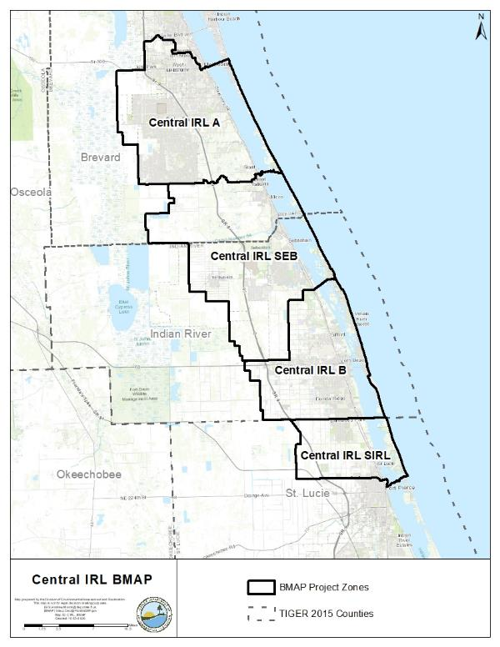
Figure 1. CIRL BMAP area

Pollutant Sources
There are various sources of pollution in the CIRL. Nonpoint (i.e., diffuse) sources in the watershed contribute the majority of the TN and TP loads to the CIRL and include urban and agricultural runoff. For additional information on other sources not directly addressable through anthropogenic activities, please refer to Section 1.2.4. The St. Lucie Estuary, to the south, is being addressed through the St. Lucie River and Estuary BMAP.

Agricultural Nonpoint Sources
The primary agricultural land uses in the CIRL BMAP area are grazing lands, fallow land, citrus, and open lands. Other agricultural land uses include nurseries and horse farms/specialty farms. Most of the horse farms are small, noncommercial hobby farms. Because of urban encroachment, citrus health issues (freeze/disease), and the downturn in the economy, a majority of previously existing citrus operations have been destroyed or abandoned, have significantly lowered their production acreage, or have transitioned to another commodity. In recent years, some of this acreage may have also shifted to nonagricultural/urban uses.
Per Section 403.067, F.S., when DEP adopts a BMAP that includes agriculture, it is the agricultural landowner's responsibility either to implement BMPs adopted by Florida Department of Agriculture and Consumer Services (FDACS) to help achieve load reductions, or to conduct water quality monitoring pursuant to Chapter 62-307, F.A.C. Landowners that do not enroll in the BMP program or conduct water quality monitoring are referred to DEP for enforcement action. To date, FDACS' Office of Agricultural Water Policy (OAWP) has adopted BMP manuals by rule for cow/calf, citrus, vegetable and agronomic crops, nurseries, equine, sod, dairy, poultry, and specialty fruit and nut operations.
To enroll in the BMP Program, landowners first meet with OAWP to determine the BMPs that are applicable to that individual operation. The landowner must then submit to OAWP a Notice of Intent (NOI) to implement the BMPs on the checklist from the applicable BMP manual. Because many agricultural operations are diverse and are engaged in the production of multiple commodities, a landowner may be required to sign multiple NOIs for a single parcel.
OAWP is required to verify that landowners are properly implementing the BMPs identified in their NOIs. Rule 5M-1.008, F.A.C., outlines the procedures used to verify the implementation of agricultural BMPs. BMP implementation is verified through site visits conducted by OAWP staff at least every two years, as required by Subparagraph 403.067(7)(d)3, F.S. Producers not properly implementing BMPs according to the process outlined in Chapter 5M-1, F.A.C., are referred to DEP for enforcement action after attempts at corrective and remedial action are exhausted.
FDACS staff conduct site visits to verify that all BMPs are being properly implemented and to review nutrient and irrigation management records. In addition, OAWP verifies that cost-share items are being implemented correctly. Site visits are prioritized based on the date the NOI was signed, the date of the last BMP verification site visit, and whether the operation has received cost-share funding. FDACS undertakes these onsite inspections at least every two years and provides DEP with aggregated information on nutrient amounts being applied.
Where water quality problems are detected for agricultural nonpoint sources despite the appropriate implementation of adopted BMPs, a reevaluation of the BMPs shall be conducted pursuant to Subparagraph 403.067(7)(c)4, F.S. If the reevaluation determines that the BMPs or other measures require modification, the applicable rule (BMP manual) will be revised to require implementation of the modified practice. Continuing water quality problems may be detected through the monitoring component of the BMAP and other DEP, St. Johns River Water Management District (SJRWMD), and South Florida Water Management District (SFWMD) activities. If a reevaluation of the BMPs is needed, FDACS will also include DEP, SJRWMD, SFWMD, and other partners in the process. Additional information on the evaluation of BMPs is provided in Section 2.3.1.
Under Paragraph 403.067(7)(c), F.S., the proper implementation of FDACS-adopted, DEP-verified BMPs, in accordance with FDACS rules, provides a presumption of compliance with state water quality standards for the pollutants addressed by the BMPs. For the BMAP, the implementation of agricultural BMPs will be documented based on participation in FDACS' BMP Program. Table 5 and Table 6 summarize the agricultural land use enrolled in BMP programs for the entire CIRL BMAP area and by project zone, respectively. Enrollment is as of July 2020, and the agricultural acreage in each basin is based on the Florida Statewide Agricultural Irrigation Demand (FSAID) VII Geodatabase. Appendix C provides more information on agricultural activities in the CIRL BMAP area.
Table 5. Agricultural land use acreage enrolled summary in the BMP Program in the CIRL BMAP area as of July 2020
Category | Acres
FSAID VII agricultural acres in the BMAP area | 72,898
Total agricultural acres enrolled | 18,277
% of FSAID VII agricultural acres enrolled | 25 %

Table 6. Agricultural land use acreage enrolled in the BMP Program in the CIRL BMAP area by project zone
Project Zone | Total FSAID VII Agricultural Acres | Agricultural Acres Enrolled | % of Agricultural Acreage Enrolled
A | 9,781 | 355 | 4
SEB | 33,776 | 12,737 | 38
B | 16,061 | 2,418 | 15
SIRL | 13,280 | 2,767 | 21
Total | 72,898 | 18,277 | 25

Unenrolled Agricultural Acreage
Agricultural land use designation is not always indicative of current agricultural activity and consequently presents challenges to estimating load allocations accurately as well as enrolling every agricultural acre in an appropriate BMP manual. To characterize unenrolled agricultural acres, OAWP identified FSAID VII features outside the BMP enrollment areas using geographic information system (GIS) software (see Appendix C for details). Table 7 summarizes the results of that analysis.
Table 7. Summary of unenrolled agricultural land use acreage in the CIRL BMAP area
Note: Because of geometric variations between shapefiles used in the unenrolled agricultural lands analysis performed by OAWP, the unenrolled agricultural acres differ from subtraction of the FSAID VII Agricultural Acres in the BMAP and the Total Agricultural Acres Enrolled referenced in Table 5.
Category | Acres
Unenrolled agricultural acres | 54,625
Acres identified within slivers of unenrolled agricultural areas | 443
Lands without enrollable agricultural activity (e.g., tribal lands, residential development, and parcels with Florida Department of Revenue (DOR) use codes 70-98) | 9,335
Total lands with potentially enrollable agricultural activities | 44,847

As of July 2020, OAWP had enrolled 18,277 agricultural acres in BMPs. Considering the results of the analysis shown in Table 7, the total acreage with the potential to have agricultural activities that can be enrolled in FDACS' BMP Program in the watershed is 63,124 acres. Using this adjusted agricultural acreage, 29 % of agricultural acres have been enrolled.
Analyzing land use data and parcel data is a valuable first step in identifying the agricultural areas that provide the greatest net benefits to water resources for enrollment in FDACS' BMP Program, as well as prioritizing implementation verification visits in a given basin. OAWP will continue to enroll agricultural lands in the BMP Program, focusing on intensive operations, including irrigated acreage, dairies and nurseries, parcels greater than 50 acres in size, and agricultural parcels adjacent to waterways.
The next step to help prioritize the enrollment efforts could use the parcel loading information derived from the Spatial Watershed Iterative Loading (SWIL) Model. This effort could help FDACS identify specific parcels with the highest modeled nutrient loading. These parcels could then be targeted for the enrollment and implementation of BMPs, as well as the verification of BMP implementation.
Aquaculture
Under the CWA, aquaculture activities are defined as a point source. Since 1992, all aquaculture facilities have been regulated by DEP, the water management district, or both, through a general fish farm permit authorized by Section 403.814, F.S. In 1999, the Florida Legislature amended Chapter 597, F.S., Florida Aquaculture Policy Act, to create a program within FDACS requiring Floridians who commercially culture aquatic species to annually acquire an Aquaculture Certificate of Registration and implement Chapter 5L-3, F.A.C., Aquaculture BMPs. Permit holders must reapply to be certified every year. However, as with agricultural land use in Florida, aquaculture facilities are frequently in and out of production. The facilities for which acreages were provided may no longer be in operation and there may be new companies in different parts of the watershed. In the CIRL Subbasin, 306 acres of aquaculture are estimated to be under certification with FDACS' Division of Aquaculture as of September 2020. For the purposes of the BMAP, OAWP delineated the aquaculture facilities using parcel data. Since the acreages were not delineated to just the tank, pond, or pool areas, in most cases these calculations overestimate the acreages of aquaculture activity.

Municipal Separate Storm Sewer Systems (MS4s)
Many of the municipalities in the watershed are regulated by the Florida National Pollutant Discharge Elimination System (NPDES) Stormwater Program. An MS4 is a conveyance or system of conveyances, such as roads with stormwater systems, municipal streets, catch basins, curbs, gutters, ditches, constructed channels, or storm drains.
If an MS4 permittee is identified as a contributor in the BMAP, the permitted MS4 must undertake projects specified in the BMAP. The BMAP projects required to be undertaken by MS4s are detailed for each project zone in Chapter 3. Phase I and Phase II MS4s are required to implement stormwater management programs (SWMPs) to reduce pollutants to the maximum extent practicable and address applicable TMDL allocations. Phase I MS4 permits include assessment practices to determine the effectiveness of SWMPs, which can include water quality monitoring. Both Phase I and Phase II MS4 permits include provisions for the modification of SWMP activities, at the time of permit renewal, for consistency with the assumptions and requirements of the adopted BMAP. There are no Phase I MS4 permittees in the CIRL as of September 2020.
Phase II MS4 Stormwater Permit Requirements
Table 8 lists the Phase II MS4s in the CIRL as of September 2020. Under a generic permit, the operators of regulated Phase II MS4s must develop a SWMP that includes BMPs with measurable goals and a schedule for implementation to meet the following six minimum control measures:
- Public Education and Outreach – Implement a public education program to distribute educational materials to the community or conduct equivalent outreach activities about the impacts of stormwater discharges on waterbodies and the steps that the public can take to reduce pollutants in stormwater runoff.
- Public Participation/Involvement – Implement a public participation/involvement program that complies with state and local public notice requirements.
- Illicit Discharge Detection and Elimination – Subsection 62-624.200(2), F.A.C., defines an illicit discharge as "…any discharge to an MS4 that is not composed entirely of stormwater…," except discharges under an NPDES permit, or those listed in rule that do not cause a violation of water quality standards. Illicit discharges can include septic/sanitary sewer discharge, car wash wastewater, laundry wastewater, the improper disposal of auto and household toxics, and spills from roadway accidents.
- Develop, if not already completed, a storm sewer system map showing the location of all outfalls, and the names and location of all surface waters of the state that receive discharges from those outfalls.
- To the extent allowable under state or local law, effectively prohibit, through ordinance or other regulatory mechanism, nonstormwater discharges into the storm sewer system and implement appropriate enforcement procedures and actions.
- Develop and implement a plan to detect and address nonstormwater discharges, including illegal dumping, to the storm sewer system.
- Inform public employees, businesses, and the general public of hazards associated with illegal discharges and improper waste disposal.
- Construction Site Runoff Control –
- Implement a regulatory mechanism to require erosion and sediment controls, as well as sanctions to ensure compliance, to reduce pollutants in any stormwater runoff to the Phase II MS4 from construction activity that results in a land disturbance greater than or equal to an acre. Construction activity disturbing less than one acre must also be included if that construction activity is part of a larger common plan of development or sale that would disturb one acre or more.
- Develop and implement requirements for construction site operators to implement appropriate erosion and sediment control BMPs.
- Implement requirements for construction site operators to control waste such as discarded building materials, concrete truck washout, chemicals, litter, and sanitary waste at the construction site that may cause adverse impacts to water quality.
- Develop and implement procedures for site plan review that incorporate the consideration of potential water quality impacts.
- Develop and implement procedures for receiving and considering information submitted by the public.
- Develop and implement procedures for site inspection and the enforcement of control measures.
- Postconstruction Runoff Control – Implement and enforce a program to address the discharges of postconstruction stormwater runoff from areas with new development and redevelopment. (Note: In Florida, Environmental Resource Permits issued by water management districts typically serve as a Qualifying Alternative Program for purposes of this minimum control measure.)
- Pollution Prevention/Good Housekeeping – Implement an operations and maintenance program that has the ultimate goal of preventing or reducing pollutant runoff from MS4 operator activities, such as park and open space maintenance, fleet and building maintenance, new construction and land disturbances, stormwater system maintenance, and staff training in pollution prevention.

The "NPDES Generic Permit for Discharge of Stormwater from Phase II MS4s," Paragraph 62-621.300(7)(a), F.A.C., also requires that if the permittee discharges stormwater to a waterbody with an adopted TMDL pursuant to Chapter 62-304, F.A.C., then the permittee must revise its SWMP to address the assigned wasteload in the TMDL. Additionally, in accordance with Section 403.067, F.S., if an MS4 permittee is identified in an area with an adopted BMAP or a BMAP in development, the permittee must comply with the adopted provisions of the BMAP that specify activities to be undertaken by the permittee.
DEP can designate an entity as a regulated Phase II MS4 if its discharges meet the requirements of the rule and are determined to be a significant contributor of pollutants to surface waters of the state in accordance with Rule 62-624.800, F.A.C. A Phase II MS4 can be designated for regulation when a TMDL has been adopted for a waterbody or segment into which the MS4 discharges the pollutant(s) of concern. If an MS4 is designated as a regulated Phase II MS4, it is subject to the conditions of the "NPDES Generic Permit for Stormwater Discharges from Phase II MS4s."
Table 8. Entities in the CIRL designated as Phase II MS4s as of September 2020
Permittee | Permit Number
Brevard County | FLR04E052
Indian River County | FLR04E068
St. Lucie County | FLR04E029
City of Fort Pierce | FLR04E065
City of Melbourne | FLR04E027
City of Palm Bay | FLR04E077
City of Sebastian | FLR04E124
City of Vero Beach | FLR04E010
City of West Melbourne | FLR04E028
FDOT District 4 | FLR04E083
FDOT District 5 | FLR04E024
Florida Turnpike Authority | FLR04E049
Patrick Air Force Base | FLR04E074
Town of Indialantic | FLR04E030
Town of Indian River Shores | FLR04E009
Town of Malabar | FLR04E050
Town of Melbourne Beach | FLR04E041

Septic Systems
Based on data from the Florida Department of Health (FDOH) Florida Water Management Inventory (FLWMI), there are 78,363known or likely septic systems (onsite sewage treatment and disposal systems [OSTDS]) located throughout the CIRL (Figure 2). Table 9 summarizes the number of septic systems by project zone.
Table 9. Septic system counts by project zone
Central Project Zone | Total Number of Septic Systems
A | 39,547
SEB | 17,369
B | 16,178
SIRL | 5,269
Total | 78,363

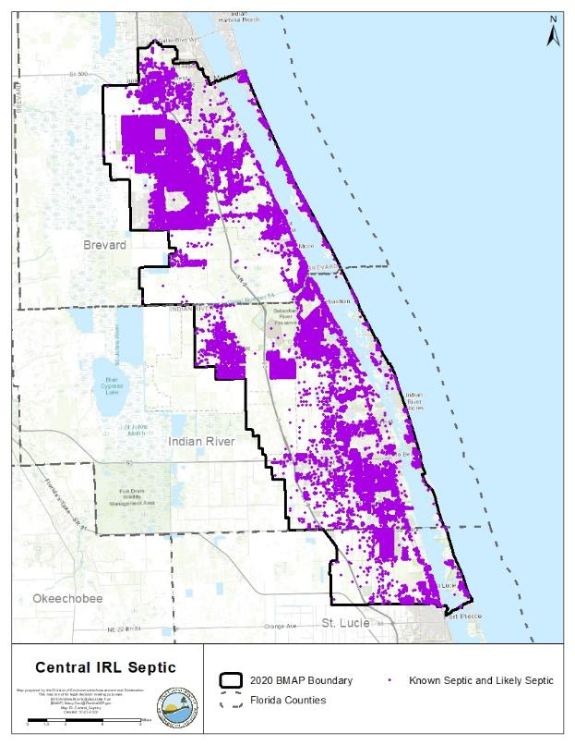
Figure 2. Location of septic systems in the CIRL

Urban Nonpoint Sources
Subsubparagraph 403.067(7)(b)2.f., F.S., prescribes the pollutant reduction actions required for nonagricultural pollutant sources that are not subject to NPDES permitting. Non-MS4 sources must also implement the pollutant reduction requirements detailed in a BMAP and are subject to enforcement action by DEP or a water management district if they fail to implement their responsibilities under the BMAP. Table 10 lists the urban nonpoint sources in the CIRL.
Table 10. Urban nonpoint sources in the CIRL
Type of Entity | Participant
Government Entities and Special Districts | Chaparral Community Development District  Emerald Lakes Community Development District  Mayfair Community Development District  PBR Community Development District  Viera East Community Development District  Fellsmere Water Control District  Fort Pierce Farms Water Control District  Indian River Farms Water Control District  Melbourne Tillman Water Control District  Sebastian River Improvement District  Vero Lakes Water Control District

Wastewater Treatment Facilities (WWTFs)
As of September 2020, DEP identified 41 individually permitted wastewater facilities or activities in the CIRL Subbasin. A list of wastewater facilities in the CIRL as of September 2020 is provided below in Table 11 and a map of their locations is shown in Figure 3.

Table 11. Wastewater facilities in the CIRL as of September 2020
BCUD = Brevard County Utilities Department; WWTF = Wastewater treatment facility; WWTP = Wastewater treatment plant; DIW = Deionized waterDeep Injection Well; RV = Recreational vehicle; MHP = Mobile home park; SLCU = St. Lucie County Utilities; IRCUD = Indian River County Utilities Department
Facility ID | Facility Name
FL0040622 | BCUD-South Beaches WWTF
FL0041122 | Melbourne Grant St WWTP & DIW
FL0041637 | Indian River County - West Regional WWTF
FL0042293 | Barefoot Bay Advanced
FLA010265 | Long Point Recreational Park
FLA010272 | Discovery Elementary School
FLA010332 | West Melbourne, City of - Ray Bullard WWTF
FLA010338 | Summit Cove Condominium
FLA010343 | Cove At South Beaches Condominium Association WWTF
FLA010346 | Pelican Bay MHC WWTF
FLA010347 | Southern Comfort Mobile Home Park WWTF
FLA010352 | Aquarina Beach Community WWTF
FLA010356 | Harris Malabar Facility
FLA010357 | South Shores Utility
FLA010359 | Treetop Village
FLA010363 | Camelot RV Park Inc
FLA010366 | Lighthouse Cove WWTF
FLA010374 | Indian River Shores Trailer Park WWTF
FLA010400 | River Grove Mobile Home Village WWTF
FLA010421 | Enchanted Lakes Estates
FLA010431 | Indian River County - Central - Gifford WWTF
FLA010434 | Indian River County – Residuals Dewatering Facility
FLA010435 | Indian River County – South Regional WWTF
FLA010472 | Royal Oaks Mobile Home Park WWTF
FLA010475 | Sun Ag Mobile Home Park Wastewater Treatment Facility
FLA010492 | Su - Rene MHP
FLA013945 | SLCU Fairwinds Golf Course WWTF
FLA013946 | North Hutchinson Island Regional WWTF
FLA013969 | St. Lucie County Utilities Holiday Pines WWTF
FLA013977 | Spanish Lakes Country Club Village WWTF
FLA013982 | Meadowood
FLA013998 | Spanish Lakes Country Club Village WWTF
FLA014025 | Cypress Mobile Home Park WWTF
FLA014028 | Country Cove MHP
FLA017104 | Harbor Branch Oceanographic Institution Post Doc Apartments
FLA021661 | Vero Beach, City of
FLA039586 | SLCU Lakewood Park WWTF
FLA103357 | Palm Bay, City of - WWTF
FLA104299 | Indian River County - Sea Oaks WWTF
FLA104388 | IRCUD/North Regional WWTF
FLA693782 | Palm Bay South Regional WRF

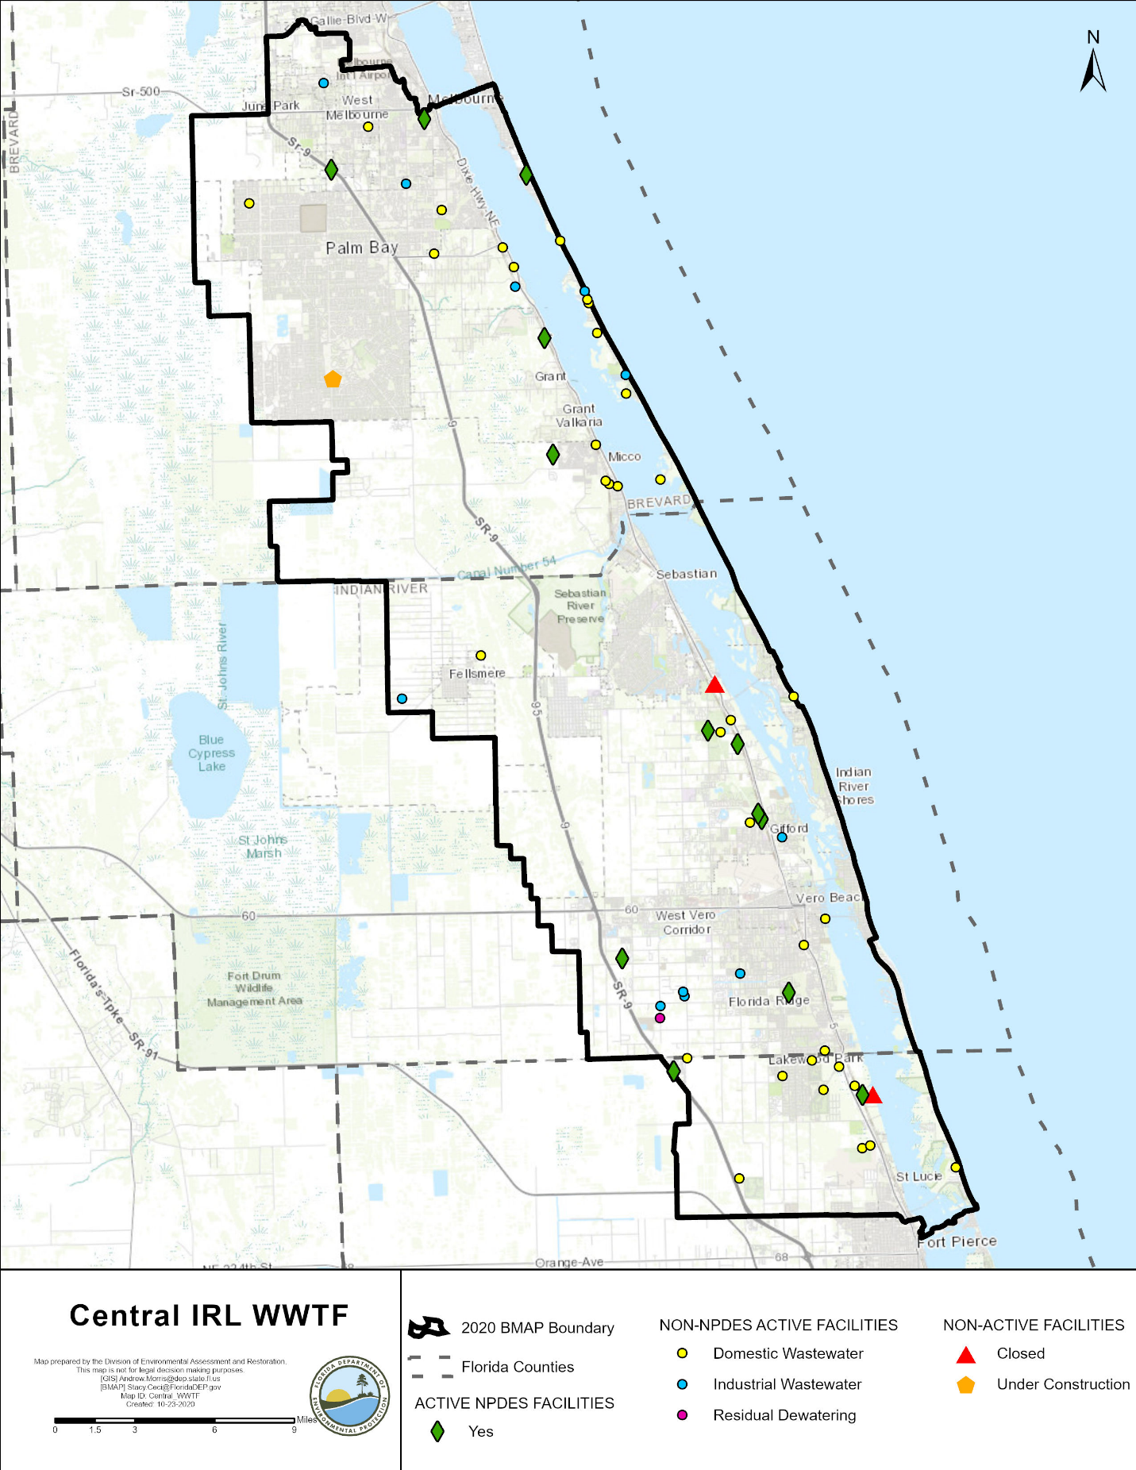
Figure 3. Map of wastewater facilities in the CIRL

Milestones and Tracking Progress
The projects and activities in the BMAP are key to the overall goal of recovering seagrass in the lagoon. The estimated benefits of these implemented activities are tracked to show stakeholder efforts by determining a percentage towards the total required reductions to be achieved at each milestone. Additionally, stakeholders provide DEP with reasonable assurance that they have a plan to achieve the individually assigned reductions required in Chapter 2. Section 403.067(7)(a)6, F.S., indicates that an assessment of progress towards the BMAP milestones shall be conducted every five years, and plan revisions made as appropriate. To meet these requirements, DEP has established milestones for the years 2025, 2030, and 2035. The percent reductions in the milestones apply to the total BMAP required reductions, so as various entities implement their projects, the overall milestones are also being met.
The following percent reduction goals are proposed for each milestone and may be adjusted as the BMAP is adaptively managed through future phases:
- 5-year milestone in 2025: 35 % or 320,614 lbs/yr of TN and 77,290 lbs/yr of TP. Based on model revisions, reset 10-year and 15-year milestones, as needed.
- 10-year milestone in 2030: 70 % or 641,228 lbs/yr of TN and 154,580 lbs/yr of TP.
- 15-year milestone in 2035: 100 % or 916,040 lbs/yr of TN and 220,828 lbs/yr of TP.

The next milestone is in 2025, by which at least 35 % of the TN and TP required reductions must be met. Figure ES- 2 and Figure ES- 3 show the milestones as well as the cumulative TN and TP reductions over time as projects are completed in each reporting period. The deadline established by this BMAP for achieving the full load reductions is 2035, which is 22 years after the initial adoption of the 2013 BMAP.

Assumptions
The water quality impacts of BMAP implementation are based on several fundamental assumptions about the pollutants targeted by the TMDLs, modeling approaches, waterbody response, and natural processes. The following assumptions were used during the BMAP process:
- Certain BMPs were assigned provisional nutrient reduction benefits for load reductions in this BMAP iteration while additional monitoring and research are conducted to quantify their effectiveness. These estimated reductions may change in future BMAP iterations as additional information becomes available.
- Nutrient reduction benefits of the stakeholders' projects were calculated using the best available methodologies. Project-specific monitoring, where available, will be used to verify calculations, and reduction benefits may be adjusted as necessary.
- The TMDLs require TN and TP reductions from the watershed to improve water quality in the CIRL to allow seagrass to grow at greater water depths High watershed nutrient loadings result in high chlorophyll-a concentrations in the lagoon, which may indicate algal growth and a reduction in light availability to the seagrass, thus limiting the depth at which seagrass can grow. Therefore, reducing nutrient loading to the CIRL is an important factor to improving seagrass depth limits.
- The allocations do not require load reductions from areas identified as natural land use areas in the modeled land use/land cover information. These loads are considered uncontrollable, background sources, and the stakeholders are not required to make reductions on natural lands. The BMAP allocations focus on urban and agricultural stormwater sources and septic systems in the watershed.
- Water is exchanged between the CIRL and other nearby waterbodies (the North Indian River Lagoon [NIRL], Banana River Lagoon [BRL], and St. Lucie River and Estuary), and water quality conditions in the CIRL may be influenced by conditions in nearby waters. To help address these nearby conditions, separate BMAPs have been adopted for these watersheds.

Considerations
This BMAP requires stakeholders to implement their projects to achieve reductions within the specified period. However, the full implementation of this BMAP will be a long-term, adaptively managed process. While some of the BMAP projects and activities were recently completed or are currently ongoing, several projects require more time to design, secure funding, and construct. Regular followup and continued coordination and communication by the stakeholders will be essential to ensure the implementation of management strategies and assessment of incremental effects.
During the BMAP process, a number of items were identified that should be addressed in future watershed management cycles to ensure that future BMAPs use the most accurate information:
- Harmful Algal Blooms (HABs) – HABs cause shading that stresses seagrass in the IRL, adverse effects on wildlife, and in some cases, has detrimental effects on human health. Intense and extensive algal blooms in the IRL began in 2011 and have returned periodically, with clear impacts on the extent, density, and depth where seagrasses grow; some fish kills; and, fortunately, little direct impact on human health. Compared with earlier blooms, the recent blooms have been dominated by smaller species of algae called nanoplankton and picoplankton. SJRWMD launched the Indian River Lagoon Protection Initiative in 2013, including a multiyear investigation that increased the understanding of the blooms. This and other research indicate it is important to persevere with projects that decrease TN and TP loads to the IRL, because that approach will limit the severity of HABs and their impacts on the system.
- Land Uses – The loading estimates in the BMAP are based on land uses at a point in time, allowing the model to be calibrated. The loading estimates for this BMAP iteration were based on land use/land cover data from approximately 2015 from the water management districts as well as property appraiser data. Land uses in the model will be updated during future model revisions based on the most recent and accurate data available; this may result in changes to loading estimates.
- Basin Boundaries – Figure 4 shows the previous and updated BMAP boundary. Overall, 1,214 acres were added to the BMAP area and 122,538 acres removed, resulting in a net reduction of 121,144 acres. When the 2013 basin boundary was developed, there was uncertainty about whether some areas drained to the IRL, to the Upper St. Johns River, or to other adjacent waterbodies. The boundaries were adjusted based on the best information available about the hydrology of the IRL, but future adjustments may be made because of flow diversions or updated information.
- Jurisdictional Boundaries – Entities may experience shifts in their jurisdictional boundaries over time that require allocation adjustments. Changes to the boundaries and/or allocations for these stakeholders may be made as necessary and reflected in future BMAP iterations.
- SWIL Model – The SWIL Model was initially developed through cooperative funding provided by Brevard County, all of its cities, and FDOT District 5, as well as support from the U.S. Air Force, for purposes other than the BMAPs, and DEP will explore refinements that may help improve the future use of the SWIL for the IRL BMAPs. This effort could include updates to some of the SWIL Model input layers, the verification of watershed boundaries in some areas, revisions to the model period of record, and the validation of predicted flows in selected calibration basins. There are also several optional tasks that could streamline efforts during the load allocation and project calculation processes. DEP expects the SWIL Model enhancements to change the loading estimates and the CIRL future allocations. Although the direction and magnitude of those changes are not certain, DEP anticipates that some may be higher, and some may be lower.
- Community Development District (CDD) Responsibilities –DEP has had several communications with the CDDs located in the CIRL. CDDs were assigned allocations only if three criteria were met: (1) there is development—i.e., roads and infrastructure—in the CDD area; (2) the CDD does not discharge to an MS4; and (3) the CDD pays a stormwater fee and receives a refund of this fee. CDDs that did not receive an allocation in this BMAP iteration may receive allocations in future BMAP iterations.
- Special Districts – Water control districts (WCDs) and similar types of special districts have been assigned qualitative allocations for the canals and rights-of-way to the special districts, as the districts have control over these portions of their jurisdictions. These districts are required to implement specific canal and right-of-way BMPs to be compliant with the BMAP. The BMPs for each special district are based on the activities and land uses within the district, and reporting on those BMPs is due annually. The specific approach for each special district is described in Appendix E, and will be reevaluated in each 5-year BMAP update. The evaluation will be based on the special district's operations, authorities, and utilization of those authorities.
- Complexity of the Problem – DEP acknowledges the complexity of the dynamics affecting the water quality of the CIRL; therefore, this BMAP is designed to encompass a wide variety of projects and management strategies that will cumulatively act to significantly reduce nutrient loads. In estuarine-based systems, the interaction with ocean waters and freshwater inflows adds variability to the water quality conditions—including those associated with climate change and sea level rise. Other factors such as inconsistency in annual rainfall amounts, changing land uses and farming practices, and internal nutrient sources such as muck deposits also complicate measuring the benefits of projects and management strategies and understanding the relationship between nutrient loading and the biological response of the seagrass deep edge.
- Sea Level Rise – Sea level rise and changes in lagoon water depth over time affect the depth at which seagrass growth is measured for TMDL compliance and for assessing seagrass restoration. Improved depth estimates and seagrass deep edge assessment techniques are needed.
- Previous Restoration Efforts – DEP recognizes that stakeholders throughout the watershed have implemented stormwater management projects prior to the implementation of the TMDLs and that these efforts have benefited water quality. Projects completed in 2000 or later are considered for credits and inclusion in the BMAP.
- Atmospheric Deposition – Reductions in atmospheric deposition have occurred over time and are expected to continue. This BMAP and all subsequent nutrient reduction requirements and allowable loads factor only those inputs directly from the watershed. DEP will continue to monitor atmospheric deposition and may address it in future BMAP iterations as part of the adapative management process.
- Muck Deposition – Muck deposits contain nutrients that flux into the water column, increasing the abundance of phytoplankton, drift macroalgae, and epiphytes that attenuate light and constrain seagrass growth and propagation. Most IRL muck originates from upland soils and vegetation. For this reason, stringent watershed soil-erosion control and soil/vegetation containment measures are needed. Without such measures in place, muck removal will need to be frequently repeated, which is neither cost-effective nor time efficient. Ideally, muck removal projects should be performed in conjunction with soil and vegetation retention programs, including public awareness activities, that limit the amount of muck material deposited into the IRL. The SWIL Model does not automatically take this process into account; however, guidance documentation has been developed for crediting muck removal projects specifically from the lagoon.
- Tributary Water Quality Impairments – DEP has identified tributary nutrient impairments within the SIRL project zone but has not yet set water quality targets with TMDLs. Specifically, WBIDs 3163 and 3163B (C-25 canal) are impaired for nutrients, as indicated by elevated phosphorus levels and the abundance of macrophytes.

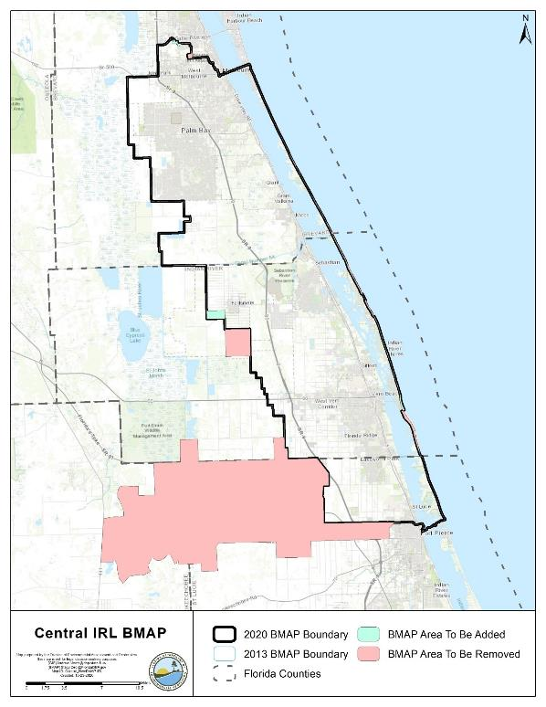
Figure 4. 2013 BMAP area boundary and 2020 BMAP area boundary

Economic Benefits of the IRL System
The IRL is a valuable ecological and economic asset for the state of Florida and the counties that border the lagoon and its tributaries. It is considered one of the most biologically diverse estuaries in North America and was recognized as part of the National Estuary Program (NEP) in 1990. The lagoon directly and indirectly supports a large part of the region's and the state's economy. The basin supports the multimillion-dollar Indian River citrus industry and boat and marine sales industries. Finfish and shellfish harvesting from the lagoon also contribute to local economies.
An economic study prepared by the East Coast Florida Regional Planning Council (ECFRPC) and Treasure Coast Regional Planning Council (TCRPC) (ECFRPC and TCRPC 2016) estimated the total annual value of the lagoon's benefits at $7.6 billion, measured in 2014 dollars. This does not include the estimated $934 million in annualized real estate value added for property located on or near the IRL (Hazen and Sawyer 2008). The study area spanned from Ponce de Leon Inlet in Volusia County to the Jupiter Inlet in Palm Beach County, and included all of Brevard, Indian River, St. Lucie, and Martin Counties. The economic analysis was primarily conducted using the Impact Analysis for Planning (IMPLAN) Regional Economic Input/Output Model, which estimates direct, indirect, and induced economic effects, as outlined in Figure 5.
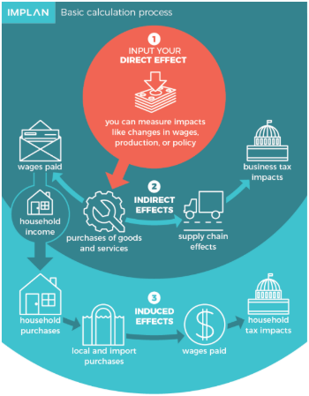
Figure 5: IMPLAN Model calculation process

The primary IRL-related industry groups identified in the study are Living Resources, Marine Industries, Recreation and Visitor-Related, Resource Management, and Defense and Aerospace. The breakdown of the monetary contribution to the IRL regional economy is shown in Figure 6.
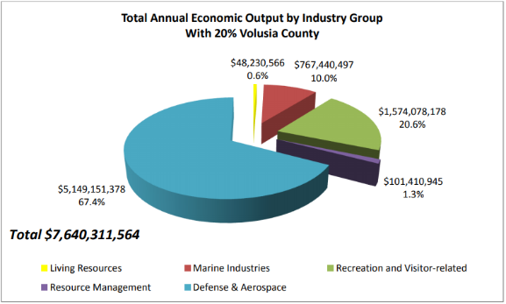
Figure 6. Total annual economic output by industry group in the IRL region, 2014

Money spent on recreation and visitor-related activities generated $1.57 billion of economic benefit. In 2014, over 7.4 million visitors traveled to the IRL region. Between 2.3 and 3.5 million visitors to the IRL region participate in IRL-related recreation, and each visitor spends an average of about $162 a day. By 2025, the IRL region is anticipated to receive over 11 million visitors annually.
The study also estimated the cost of a sustainable IRL-based economy and return on investment of achieving water quality and seagrass restoration goals for the IRL. The annualized cost of achieving the nutrient load reductions required by the four BMAPs that span the entire area was estimated at $230 million. When compared with the $7.6 billion valuation of the region's average annual economic output, the return on investment from achieving water quality and seagrass restoration goals is 33 to 1. Therefore, investing in projects and programs to improve the lagoon's water quality and seagrass beds is not only important for environmental considerations but also to improve the regional economy.

- Modeling, Load Estimates, and Restoration Approach

BMAP Modeling
Nutrient loading estimates were originally calculated for the BMAP using the Pollutant Load Screening Model (PLSM) which was expanded by SJRWMD to represent year 2000 loading (Adkins et al. 2004) in most of the IRL Watershed (excluding the IRL south of the Indian River and St. Lucie county boundary). The seagrass depth limits were developed by SJRWMD based on a series of photo-interpreted seagrass coverages from 1943 through 2001. DEP reviewed these models and the seagrass depth limits and used them to develop the IRL TMDLs that were adopted by rule (Gao 2009).
Through cooperative local effects, all the MS4 permittees within the Brevard County section of the IRL (17 entities) partnered to fund a Study Team to create a new watershed model that would update and refine the information that was used in the PLSM and associated TMDLs for the IRL. One outcome of this study was the development of the SWIL Model, which is intended to incorporate more available data, more recent conditions, and more temporally fine datasets. SWIL is a custom ESRI ArcGIS toolset, originally designed to provide a continuous monthly simulation of runoff over a 16-year period (Applied Ecology 2019).
During 2017 and 2018, while DEP prepared to calculate allocations for the CIRL BMAP, the SWIL Model was proposed as an alternative to the previously used PLSM. Several options were presented for updating allocations during a public meeting in May 2017, and the options were discussed by DEP and stakeholders during and after the meeting. In November 2017, a presentation was made to the IRL National Estuary Program (NEP) Science, Technology, Engineering and Mathematics
(STEM) Committee to provide a technical overview of the SWIL. During the annual public meeting for the IRL BMAPs in December 2018, a proposed path forward was presented that included applying the SWIL to calculate allocations for the IRL BMAPs. A technical presentation was given by the model developer at a public webinar in January 2019 to provide stakeholders with an opportunity to discuss the model further. Finally, during the annual public meeting for the IRL BMAPs in December 2019, a summary of the allocation approach using SWIL was presented.

SWIL Modeling
The initial version of SWIL was developed for the IRL in 2012 (SWIL 1.0). To address several DEP comments and to improve execution and processing time, SWIL 2.0 was released in July 2014. SWIL 3.0 was released in April 2015 with improved model calibration to the measured available gauge data, including a revised method to derive baseflow volumes and loads. SWIL 3.0 also incorporated new evapotranspiration raster datasets. SWIL 4.0 was developed in support of the 3D numerical modeling effort led by the Florida Institute of Technology. Three major changes were performed for SWIL 4.0: (1) Expansion of the model extent to provide nutrient loadings from Ponce Inlet to Fort Pierce; (2) temporal expansion to include 2011 to 2015, for a total model period of 20 years (1995 to 2015); and (3) the addition of a third land use/treatment time step using data from 2010 (Applied Ecology 2019).

SWIL Calibration
The SWIL 3.0 version was used for calibration using flow data primarily from the CIRL. The five gauge stations included in the calibration are located in the following basins: Crane Creek, Hickory Creek, North and South prongs of the Sebastian River, and Fellsmere Canal. Few data were available in the NIRL and none in the BRL, and so the calibration is based primarily on the CIRL conditions. Also, during the calibration process, a change was made to the normalization process of the baseflow volumes by incorporating "groundwater storage depth," an area-weighted groundwater input variable (Applied Ecology 2015). The calibration was based on simulated 1995-2010 flow volumes compared against measured data at the gauge stations. Since the treatment layer inputs to thwater ce model simulation did not incorporate BMPs beyond permit requirements after the year 2000, most projects installed from 2000 onward were not included in the calibration and are not well represented in the SWIL Model loading estimates. Therefore, projects completed from 2000 onward are eligible for BMAP credit.

Allocation Process
To generate average annual TN and TP loads from the IRL Watershed, SWIL was run using rainfall inputs that were thought to be from a representative period covering various conditions from high to low rainfall years. The outputs from this model run were used to generate a GIS-based Load Estimation Tool (LET) that included annual average loads from the watershed and was the basis of the allocation calculations.
The LET based on the SWIL Model can produce polygon outputs with loading data included. The determination of each entity's loading was performed using the LET and a GIS process. Through a series of GIS steps, polygons were generated for each stakeholder. GIS data were used to clip the area within the BMAP boundary associated with each entity's jurisdictional boundary or the codes from the model land cover data related to natural and agricultural lands. The clipping process was done sequentially, as follows:
- Dispersed Water Management (DWM) or Comprehensive Everglades Restoration Plan (CERP) projects.
- Roads (FDOT and Florida's Turnpike Enterprise).
- WCDs and improvement district canals and rights-of-way.
- Natural lands (land use codes 3000 [not including 3300], 4000, 5000, and 6000).
- Agriculture (land use codes 2000 and 3300).
- CDDs, if they meet the criteria.
- Municipalities.
- Remaining area assigned to each county.
Loads within DWM or CERP project areas were not included in the total loads for the project zone, since these land uses are being converted to treatment projects. Loads from natural land uses were not assigned to any specific entity's starting load. FDOT, agriculture, CDDs, municipalities, and counties were assigned starting loads based on this sequential process. The WCDs and Sebastian River Improvement District were assigned a qualitative allocation and are required to implement specific BMPs, as discussed in Appendix E.

Project Credit Process
The LET was used to calculate updated TN and TP baseloads from all existing project treatment areas in the BMAP. The August 2020 DEP BMP Efficiencies Guidance document was used to determine the appropriate credit calculations for the various project types. Some project types that have credits based on measured data or weighed material, such as street sweeping, did not need to be updated using the LET.

Calculation of Starting Loads and Allocations
This section describes the process used to calculate the load reductions needed to achieve the TMDLs and to allocate the load reduction requirements to the responsible stakeholders.

Starting Loads and Allocation of Load Reductions
DEP requested to use the SWIL 4.0 Model to update the load allocations for the second cycle of the IRL BMAPs. To develop the loads that represent updated current conditions, the SWIL Model was customized for this use with the following parameters (Applied Ecology 2018):
- A 50 x 50-meter (m) cell size was used, which is a much higher spatial resolution than any previously developed watershed loading models for the IRL.
- Land use corresponds to 2015 conditions and is derived from water management districts land use data, property appraiser data, and local government natural communities land cover, where available.
- Treatment layer (stormwater BMPs) corresponds to development conditions in approximately 2015, excluding any retrofits implemented by the stakeholders in the IRL Watershed. Retrofit projects will need to be retroactively calculated and provided as credits to the stakeholders.
- Period-of-record rainfall that includes 2004 to 2017 data, which allows for a wide range of rainfall conditions to represent the variability in loading to the IRL.
The outputs of this modeling effort can be described as static feature classes that include more than 1.2 million 50 x 50-m cells (as features) each. Each individual cell is associated with an estimated volume and both nitrogen and phosphorus estimated loading for the selected mean period-of-record conditions (Applied Ecology 2018).
For land use and land cover, 2015 conditions were represented as derived from water management district data for nonurban land uses and from local property appraiser datasets for urban land uses. Natural community data from local governments were also incorporated, where available (Brevard County). In addition, field-validated 2015 land use datasets for Patrick Air Force Base, Cape Canaveral Air Force Station, and the Malabar Annex were used in lieu of water management data (Applied Ecology 2018). Land covers were grouped to reflect the available event mean concentrations (EMCs) and C values that would be applied in the model. (Listopad 2020).
DEP used the LET to develop the allocations (see Figure 7 and Figure 8). The percent reduction from the TMDLs was applied to the applicable areas within the BMAP. The TMDL percent reductions are based on segmented areas of the lagoon defined by both DEP WBIDs, along with breaks in the hydrology of the lagoon as defined by the SJRWMD. Areas where segments share hydrologic similarity and similar reduction percentages, as noted by the TMDLs, are defined as segment groups. Additionally, during the first phase of BMAP adoption, the hydrology defined by SJRWMD was used to define project zones in order to assess seagrass compliance. Project zones were used to assist in calculating the required reduction and the allocation of each entity within the BMAP. In the CIRL, the total project zone load from the LET was used, and the percent reduction from the TMDL for that project zone was applied to determine the total required reductions per project zone. Natural lands had no reductions applied, and so the SWIL loads from natural land uses were held constant. The land cover codes considered to be "natural lands" include 3000 (upland nonforested; not including 3300), 4000 (upland forests), 5000 (water), and 6000 (wetlands). The allowable load in the project zone was determined by subtracting the required reductions from the total project zone load determined by the LET.
A test was performed to make sure that no reductions would be expected from natural land uses. The weighted average load per acre from natural lands for each project zone was compared with the load per acre from the allowable load. If the allowable load per acre was less than the natural land load per acre, the allowable load was increased to equal the natural load per acre times the acres in the project zone. This process was performed for both TN and TP loads in each project zone. The TN loads were adjusted using the natural load per acre for Project Zones A, B, and SEB. The TP loads were adjusted using the natural load per acre for Project Zone SIRL.
Once the total required reductions for each project zone were defined, the total anthropogenic load for the project zone was examined. Each stakeholder's anthropogenic load was compared with the total anthropogenic load for the project zone to determine its contribution to the total anthropogenic load. This percentage was considered to be representative of the stakeholder's loading contribution, and that percentage of the project zone's required reduction was applied to that stakeholder.

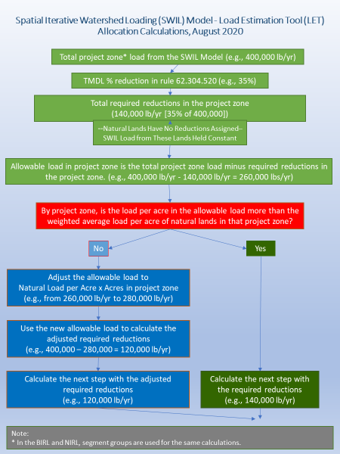
Figure 7. Flow chart of the allocation steps, Part 1 of 2
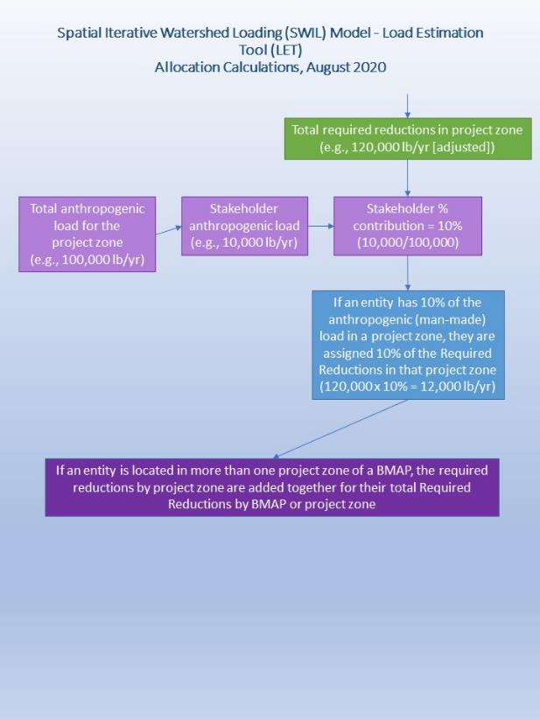
Figure 8. Flow chart of the allocation steps, Part 2 of 2

The SWIL Model starting loads for each project zone are described in Table 12.
Table 12. SWIL Model starting loads
BMAP Area | Project Zone | Starting TN Load (lbs/yr) | % Total Load TN | Starting TP Load (lbs/yr) | % Total Load TP
CIRL | A | 616,171 | 28 | 85,081 | 28
CIRL | B | 567,009 | 26 | 78,837 | 26
CIRL | SEB | 762,595 | 34 | 96,865 | 32
CIRL | SIRL | 266,181 | 12 | 38,975 | 13
CIRL Totals | N/A | 2,211,955 | 100 | 299,758 | 100

Low-Priority Ranking Determination
Several stakeholders contribute less than 0.30 % of both the TN and TP loading from the watershed to the CIRL. The contribution to the overall nutrient loading from these stakeholders is low enough that reductions from these areas would have essentially no impact on the required reductions for the BMAP during this phase of implementation; therefore, these entities are currently considered a low priority for implementing reductions. Low-priority entities will be evaluated in future phases of BMAP implementation, as their contributions may change over time.
Table 13 summarizes the priority evaluation, and those stakeholders meeting the classification requirements for low priority are highlighted in grey. Stakeholders that met the low-priority classification include the Town of St. Lucie Village, Town of Indialantic, Town of Melbourne Village, Town of Orchid, City of Fort Pierce, U.S. Air Force, and Florida Turnpike. These entities are not required to meet the reduction targets for TN and TP in this phase of BMAP implementation but must continue to adhere to all requirements of their MS4 permit or other permits.
BMAP progress will be reviewed over time, and reduction requirements, including for those stakeholders with this low-priority status, will be modified in a future BMAP update as needed. TN and TP reductions may be needed from the low-priority entities in the future. Therefore, although they do not currently have a reduction responsibility, this does not exempt these stakeholders from such requirements in future BMAP updates. Any actions taken by these entities that result in TN and TP reductions will be documented for credit against any reduction requirements allocated in subsequent BMAP updates.

Table 13. Entity contributions to starting loads with low priority ranking cutoff
Note: Grey highlighting and boldface type indicate jurisdictions meeting the classification requirements for low priority.
NA = Not applicable
Entity | TN Starting Load (lbs/yr) | Anthropogenic % of TN in BMAP | TP Starting Load (lbs/yr) | Anthropogenic % of TP in BMAP
Agricultural Producers | 477,619 | 29.82 | 67,398 | 29.05
Indian River County | 357,237 | 22.30 | 51,895 | 22.37
City of Palm Bay | 208,799 | 13.04 | 30,198 | 13.02
St. Lucie County | 104,021 | 6.49 | 16,773 | 7.23
Brevard County | 89,296 | 5.57 | 13,357 | 5.76
City of Melbourne | 63,245 | 3.95 | 9,057 | 3.90
City of Sebastian | 61,820 | 3.86 | 8,901 | 3.84
City of Vero Beach | 48,755 | 3.04 | 7,049 | 3.04
Town of Grant-Valkaria | 47,719 | 2.98 | 6,818 | 2.94
City of West Melbourne | 34,398 | 2.15 | 5,010 | 2.16
Town of Malabar | 23,093 | 1.44 | 3,338 | 1.44
FDOT District 4 | 22,731 | 1.42 | 2,978 | 1.28
Town of Indian River Shores | 17,525 | 1.09 | 2,639 | 1.14
FDOT District 5 | 13,058 | 0.82 | 1,718 | 0.74
City of Fellsmere | 10,603 | 0.66 | 1,544 | 0.67
Town Melbourne Beach | 5,252 | 0.33 | 779 | 0.34
Town of St. Lucie Village | 3,608 | 0.23 | 638 | 0.28
Town of Indialantic | 3,589 | 0.22 | 531 | 0.23
Town of Melbourne Village | 3,194 | 0.20 | 475 | 0.20
Town of Orchid | 2,547 | 0.16 | 367 | 0.16
City of Fort Pierce | 1,854 | 0.12 | 305 | 0.13
U.S. Air Force | 954 | 0.06 | 118 | 0.05
FL Turnpike | 818 | 0.05 | 100 | 0.04
Total for Allocated Entities | 1,601,735 | 100.00% | 231,986 | 100.00
Natural Lands | 564,616 | N/A | 61,538 | N/A
WCD Canals | 45,604 | N/A | 6,234 | N/A
Total | 2,211,955 | N/A | 299,758 | N/A

Required Reductions
The TN and TP reductions required by each entity are shown in Table 14 and Table 15, respectively.

Table 14. TN load required reductions by entity (lbs/yr)
Note: Grey highlighting and boldface type indicate jurisdictions meeting the classification requirements for low priority.
* = Adjusted using the natural load per acre
N/A = Not applicable
Entity | Project Zone A | Project Zone SEB | Project Zone B | Project Zone SIRL | Total
Agricultural Producers | 28,912 | 128,681 | 74,773 | 31,287 | 263,653
Indian River County | N/A | 47,223 | 169,639 | N/A | 216,862
City of Palm Bay | 110,334 | 1,657 | N/A | N/A | 111,991
St. Lucie County | N/A | N/A | N/A | 49,780 | 49,780
Brevard County | 19,940 | 27,987 | N/A | N/A | 47,927
City of Melbourne | 33,921 | N/A | N/A | N/A | 33,921
City of Sebastian | N/A | 33,196 | N/A | N/A | 33,196
City of Vero Beach | N/A | N/A | 30,713 | N/A | 30,713
Town of Grant-Valkaria | 20,519 | 5081 | N/A | N/A | 25,600
City of West Melbourne | 18,449 | N/A | N/A | N/A | 18,449
FDOT District 4 | N/A | 3,325 | 5,976 | 3,375 | 12,676
Town of Malabar | 12,386 | N/A | N/A | N/A | 12,386
Town of Indian River Shores | N/A | N/A | 11,040 | N/A | 11,040
FDOT District 5 | 5,226 | 1,780 | N/A | N/A | 7,006
City of Fellsmere | N/A | 5,694 | N/A | N/A | 5,694
Town Melbourne Beach | 2,817 | N/A | N/A | N/A | 2,817
Town of Indialantic | 1,925 | N/A | N/A | N/A | 0
Town of St. Lucie Village | N/A | N/A | N/A | 1,727 | 0
Town of Melbourne Village | 1,713 | N/A | N/A | N/A | 0
Town of Orchid | N/A | 1,368 | N/A | N/A | 0
City of Fort Pierce | N/A | N/A | N/A | 887 | 0
U.S. Air Force | 512 | N/A | N/A | N/A | 0
FL Turnpike | N/A | N/A | N/A | 391 | 0
Total | 256,654* | 255,992* | 292,141* | 87,447 | 883,711

Table 15. TP load required reductions by entity (lbs/yr)
Note: Grey highlighting and boldface type indicate jurisdictions meeting the classification requirements for low priority.
* = Adjusted using the natural load per acre
N/A = Not applicable
Entity | Project Zone A | Project Zone SEB | Project Zone B | Project Zone SIRL | Total
Agricultural Producers | 4,740 | 22,286 | 9,120 | 7,173 | 43,319
Indian River County | N/A | 8,580 | 22,231 | N/A | 30,811
City of Palm Bay | 17,041 | 279 | N/A | N/A | 17,320
St. Lucie County | N/A | N/A | N/A | 11,964 | 11,964
Brevard County | 3,197 | 5,251 | N/A | N/A | 8,448
City of Sebastian | N/A | 6015 | N/A | N/A | 6,015
City of Melbourne | 5,182 | N/A | N/A | N/A | 5,182
Town of Grant-Valkaria | 3,131 | 910 | N/A | N/A | 4,041
City of Vero Beach | N/A | N/A | 3,998 | N/A | 3,998
City of West Melbourne | 2,866 | N/A | N/A | N/A | 2,866
FDOT District 4 | N/A | 501 | 724 | 685 | 1,910
Town of Malabar | 1,910 | N/A | N/A | N/A | 1,910
Town of Indian River Shores | N/A | N/A | 1,497 | N/A | 1,497
City of Fellsmere | N/A | 1,043 | N/A | N/A | 1,043
FDOT District 5 | 744 | 282 | N/A | N/A | 1,026
Town Melbourne Beach | 446 | N/A | N/A | N/A | 446
Town of St. Lucie Village | N/A | N/A | N/A | 455 | 0
Town of Indialantic | 304 | N/A | N/A | N/A | 0
Town of Melbourne Village | 272 | N/A | N/A | N/A | 0
Town of Orchid | N/A | 248 | N/A | N/A | 0
City of Fort Pierce | N/A | N/A | N/A | 217 | 0
FL Turnpike | N/A | N/A | N/A | 72 | 0
U.S. Air Force | 67 | N/A | N/A | N/A | 0
Total | 39,900 | 45,395 | 37,570 | 20,566* | 141,796

Basinwide Sources Approach
The basinwide sources approach involves tailoring management strategies to the primary sources of anthropogenic nutrient loading throughout the CIRL Subbasin. The primary source categories included in this approach are agricultural runoff, septic systems, urban stormwater, and wastewater. For additional information on other sources not directly addressed through anthropogenic activities, please refer to Section 1.2.4.

Agriculture
When DEP adopts a BMAP that includes agriculture, it is the agricultural landowner's responsibility to properly implement BMPs adopted by FDACS to help achieve load reductions or demonstrate compliance through monitoring . FDACS is responsible for verifying that all eligible landowners are enrolled in appropriate BMP programs. Subparagraph 403.067(7)(d)3, F.S. requires FDACS to perform regular onsite inspections, at least every two years, of all agricultural operations enrolled under a BMP manual to ensure that these practices are being properly implemented. From these inspections, FDACS will provide DEP with an annual summary of aggregated fertilizer use in the BMAP area, quantifying total applications and providing information on applications by project zone.
It is anticipated that additional enrollment in agricultural BMPs, along with more frequent implementation verification site visits by FDACS, will increase nutrient reductions from agricultural nonpoint sources. However, further reductions beyond the implementation of required owner-implemented BMPs currently required by the FDACS manuals, may be necessary to achieve the TMDLs. FDACS has committed to updating its existing BMP manuals to incorporate updated BMPs based on the latest scientific and technical research. Subparagraph 403.067(7)(f)1, F.S., requires FDACS to annually develop research plans and legislative budget requests for the following:
- Evaluate and suggest enhancements to the existing adopted agricultural BMPs to reduce nutrient runoff.
- Develop new BMPs that, if proven effective, may be adopted by rule.
- Develop agricultural nutrient runoff reduction projects that willing participants could implement on a site-specific, cooperative basis, in addition to BMPs.
FDACS also provides funding to some agricultural operations to add other practices beyond owner-implemented BMPs. Examples include drainage improvements, fencing, water control structures, precision agriculture technology, and fertigation. SFWMD and SJRWMD are implementing and/or funding projects that encourage low-input agriculture and the use of water quality improvement technologies.
If owner-implemented BMPs fail to achieve water quality improvements, a cooperative agricultural regional water quality improvement element may be developed for this BMAP, subject to the conditions outlined in Subparagraph 403.067(7)(e)1, F.S. DEP, FDACS, and agricultural producers will cooperatively develop a regional water quality improvement element in the event of the following:
- Agricultural measures have been adopted by FDACS pursuant to Subparagraph 403.067(7)(c)2, F.S., and have been implemented and the waterbody remains impaired.
- Agricultural nonpoint sources contribute to at least 20 % of nonpoint source nutrient discharges.
- DEP determines that additional measures, in combination with state-sponsored regional projects and other management strategies included in the BMAP, are necessary to achieve the TMDLs.
Further nutrient reductions can be achieved through the implementation of additional agricultural projects or activities. Other reductions associated with the implementation and modification of BMPs may be realized through ongoing studies, data collection, and water management district initiatives. These additional projects and practices are to be implemented in conjunction with the BMP Program, which will aim to achieve full enrollment with verification to ensure that the BMAP goals are achieved.

Septic Systems
As required in Section 403.067(7) (a) 9.b., F.S., local governments must develop an onsite sewage treatment and disposal system (OSTDS) remediation plan to be adopted as part of the BMAP no later than July 1, 2025. The OSTDS remediation plans must be developed by each local government in cooperation with DEP, FDOH, water management districts, and public and private domestic wastewater facilities.
The OSTDS remediation plan requires entities to identify and address the following:
- Cost-effective and financially feasible projects necessary to achieve the nutrient load reductions required for OSTDS (e.g., sewering, advanced septic system retrofits, prohibiting the installation of new conventional septic systems).
- An inventory of OSTDS based on the best information available.
- OSTDS that would be eliminated through connection to existing or future central domestic wastewater infrastructure in the jurisdiction or domestic wastewater service area of the local government.
- OSTDS that would be replaced with or upgraded to enhanced nutrient-reducing systems.
- Cost of improvements and sources of funding.
Based on data from FDOH, there are 78,363 known and likely septic systems located throughout the CIRL Subbasin. Table 9 in Section 1.2.1.3 summarizes the count of septic systems by project zone.
Stakeholders will submit projects describing how septic loads are addressed as part of BMAP reporting and estimate the load reductions associated with each project. The estimated reductions to the lagoon from addressing these septic systems will be based on several factors, including how they are addressed (i.e., connecting to central sewer sends the wastewater to a treatment facility, which does not remove 100 % of the nutrient load) and the amount of attenuation that occurs as the effluent travels through the watershed to the lagoon.

Stormwater
Stormwater from urban areas is a considerable source of nutrient loading to the CIRL, and many of these areas are already regulated under the NPDES Stormwater Program. MS4 permittees are required to develop and implement a stormwater management program. Urban areas located in the BMAP area that are not currently covered by an MS4 permit also significantly contribute, individually or in aggregate, to nutrient loading. Therefore, the NPDES Stormwater Program will, within 5 years of BMAP adoption, evaluate any entity located in the BMAP area that serves a minimum resident population of at least 1,000 individuals that are not currently covered by an MS4 permit and designate eligible entities as regulated MS4s, in accordance with Chapter 62-624, F.A.C.
In accordance with Subsection 373.4131(6), F.S., DEP and the water management districts are planning to update the stormwater design and operation requirements in Environmental Resource Permit rules. These revisions will incorporate the most recent scientific information available to improve nutrient reduction benefits.

Wastewater Treatment
DEP issues permits for facilities and activities to discharge wastewater to surface waters and groundwaters of the state. DEP is authorized by the EPA to issue permits for discharges to surface waters under the NPDES Program. Permits for discharges to groundwater are issued by DEP under state statutes and rules. These wastewater discharge permits establish specific limitations and requirements based on the location and type of facility or activity releasing industrial or domestic wastewaters from a point source.
As of September 2020, there were 41 individually permitted wastewater facilities or activities in the CIRL Subbasin. All new or existing wastewater facilities that dispose of or discharge effluent in the BMAP area are subject to the BMAP provisions, regardless of whether the facility is listed in this BMAP. A preliminary list of wastewater facilities in the CIRL as of September 2020 is provided in Table 11 and a map of their locations is shown in Figure 3 in Section 1.2.1.5.
In areas where there is anticipated growth in human population, adequate treatment capacity of domestic wastewater is essential. Domestic wastewater is treated through either WWTFs or OSTDS (septic systems). Where sewer lines are available, Florida law (Section 381.00655, F.S.) requires a development or property owner to abandon the use of OSTDS and connect to sanitary sewer lines.
Florida law (Section 403.086, F.S., and Chapter 2020-150, Laws of Florida) requires all existing and new domestic wastewater facilities discharging to surface waters of the state within or connected to the IRL to meet advanced waste treatment requirements, as defined in Section 403.086, no later than July 1, 2025. Additionally, this BMAP requires all other individually permitted domestic wastewater facilities to meet the effluent limitations listed in Table 16 and Table 17, unless the owner or operator can demonstrate reasonable assurance that the effluent would not cause or contribute to an exceedance of the TMDLs or water quality standards in groundwater. To demonstrate reasonable assurance, the owner or operator must provide relevant water quality data, physical circumstances, or other site-specific credible information needed to show the facility would not cause or contribute to the nutrient loading in the BMAP area. This demonstration may include factors such as dilution; site-specific geological conditions; research/studies, including dye tracer tests; and modeling. If DEP concurs with the reasonable assurance demonstration, the effluent limitations established for discharges to ground water may be modified or waived for the facility. New effluent limitations will take effect no later than July 1, 2025.
New and existing domestic wastewater facilities must meet the stringent nutrient wastewater limitations set forth in this BMAP. Any such new facilities (those commencing after the adoption of this BMAP) must be capable of meeting the requirements of this BMAP at the time of permit issuance. For existing domestic wastewater facilities, DEP shall modify the permit limitations and requirements to be consistent with this BMAP at the time of the next permit renewal. If the facility needs additional time to meet the new limits, the permit may include a compliance schedule with a completion date not to exceed four and a half years after the effective date of the permit.
Table 16 and Table 17 list the TN and TP effluent limitations, respectively, adopted for this BMAP that apply to domestic wastewater facilities unless the owner or operator can demonstrate reasonable assurance as listed above. The effluent limitations for direct surface water discharges and reclaimed water pipelines apply to individually permitted NPDES facilities at the end-of-pipe. Because the limitations for direct surface water discharges are technically-based advanced waste treatment limitations, mixing zones are not authorized for TN and TP. The effluent limitations for discharges to groundwater apply at the compliance well located at the edge of the zone of discharge. The owner or operator may elect to meet the groundwater limitations prior to the edge of the zone of discharge. These effluent limitations are applied as an annual average. For direct surface water discharges, the limitations in Subparagraph 62-600.740(2)(b), F.A.C., will be applied in the permit.
Short-term or intermittent industrial discharges are not significant sources of TN or TP in the CIRL Subbasin and are not subject to the limits in Table 16 and Table 17. Intermittent, rainfall-driven, diffuse overflow releases of wastewater from ponds or basins designed to hold precipitation from a 25-year, 24-hour rainfall event or less frequent rainfall event and that infrequently reaches surface waters are considered insignificant sources of TN and TP, provided the ponds or basins are maintained under normal conditions at or below established water levels. The owners or operators of cooling pond reservoirs must operate each spillway gate either during regular operation or on a test basis to protect the structural integrity of the reservoir. Because of the short duration and low volume of wastewater released during spillway gate testing, releases either on an annual or semiannual basis are considered insignificant sources of TN and TP.
Existing industrial wastewater facilities are not subject to the limits in Table 16 or Table 17. However, these facilities must hold the line and shall not increase the nutrient load to receiving or downstream waters. New industrial wastewater facilities shall meet the limits in Tables 16 and 17. For industrial wastewater facilities that discharge to surface waters of the state must meet the numeric nutrient criteria in Rules 62-302.531 and 62-302.532, F.A.C.
Additionally, new or renewed wastewater permits in the BMAP area must require at least quarterly sampling of the effluent at the point of discharge or edge of the zone of discharge for TN and TP and the reporting of sampling results in the discharge monitoring reports submitted to DEP.
Table 16. TN effluent limits
mg/L = milligrams per liter
mgd = million gallons per day
RRLA = rapid rate land application
Permitted Average Daily Flow (mgd) | TN Concentration Limits for Direct Surface Discharge (mg/L) | TN Concentration Limits for RRLA Effluent Disposal System  (mg/L) | TN Concentration Limits for All Other Disposal Methods, Including Reuse  (mg/L)
Greater than or equal to 0.5 | 3.0 | 3.0 | 10.0
Less than 0.5 and greater than or equal to 0.1 | 3.0 | 6.0 | 10.0
Less than 0.1 | 3.0 | 10.0 | 10.0

Table 17. TP effluent limits
mg/L = milligrams per liter
mgd = million gallons per day
RRLA = rapid rate land application
Permitted Average Daily Flow (mgd) | TP Concentration Limits for Direct Surface Discharge (mg/L) | TP Concentration Limits for RRLA Effluent Disposal System  (mg/L) | TP Concentration Limits for All Other Disposal Methods, Including Reuse  (mg/L)
Greater than or equal to 0.5 | 1.0 | 1.0 | 6.0
Less than 0.5 and greater than or equal to 0.1 | 1.0 | 3.0 | 6.0
Less than 0.1 | 1.0 | 6.0 | 6.0

Pursuant to Subsubparagraph 403.067(7)(a)9., F.S., local governments in BMAPs where DEP determines remediation is necessary to achieve the TMDL must develop wastewater treatment plans to be adopted as part of the BMAP no later than July 1, 2025, when all effluent is required to meet the TN and TP concentrations for Direct Surface Discharge cited in Table 16 and Table 17.
The wastewater treatment plans must be developed by each local government, in cooperation with DEP, the water management district, and the public and private domestic wastewater treatment facilities within the jurisdiction of the local government. A local government is not responsible for a private domestic wastewater facility's compliance with the BMAP unless the facility is operated through a public-private partnership to which the local government is a party.
The wastewater treatment plan requires entities to identify and address the following:
- Provide construction, expansion or necessary facility upgrades to achieve the TMDLs applicable to the domestic WWTF.
- Include the permitted capacity in annual gallons per day for the domestic WWTF.
- Include the average nutrient concentration and the estimated average nutrient load of the domestic wastewater.
- Provide a project timeline of the date when the construction of any facility improvements will begin and be completed and the date when operations of the improved facility will begin.
- Estimate the cost of improvements.
- Identify the responsible parties.

Seagrass and Water Quality Monitoring Plan
This monitoring plan is designed to track seagrass distribution and to identify long-term water quality trends. Sampling stations, parameters, frequency, and other elements of this strategy may be modified as appropriate to match changing environmental conditions, funding resources, and understanding of the IRL system.

Objectives
The primary and secondary monitoring objectives for the CIRL monitoring plan are described as follows:
Primary Monitoring Objective
- Track seagrass depth extent responses to BMAP implementation.
Secondary Monitoring Objective
- Track trends in ambient water quality in the CIRL and its watershed, including major tributaries.
- Determine if watershed nutrient loading is decreasing and resulting in improved lagoon water quality, which will allow seagrass to grow to target depths.
Additional information about the seagrass depth and compliance with the TMDL targets is discussed in Section 4.2, including the most recent results based on the 2019 aerial mapping data. To read more about the process for analyzing the seagrass data and depth analysis, see Appendix D.

Monitoring Parameters, Frequency, and Network
To achieve the primary monitoring objective, the main parameter that will be tracked is the seagrass depth by project zone, which is identified through flyover mapping and aerial photography interpretation. DEP and SJRWMD are partnering to fund and conduct flyovers and mapping. In the past, SJRWMD and partners typically have contracted for seagrass mapping every two to three years, and DEP will continue to work with the District to maintain this frequency for the BMAP monitoring plan as long as resources remain available.
The aerial photography is taken in spring to early summer, during the seagrass growing season. Field sampling conducted around the time of the flights provides data for assessing the accuracy of the maps, and additional field sampling is conducted to address uncertainty regarding areas mapped as seagrass. Using the aerial photography, a map is created showing seagrass extent in the lagoon. These maps are used in evaluations to assess progress towards the TMDL seagrass depth targets for the CIRL. Additional details on the seagrass assessment methodology are contained in Appendix D.
To achieve the secondary monitoring objective above, the existing SJRWMD and SFWMD stations in the CIRL BMAP will be monitored. On average, seagrass transects are 1 kilometer (km) away from a long-term water quality station. The monitoring strategy for these stations focuses on the following parameters:

- Total Kjeldahl Nitrogen
- Nitrite/Nitrate
- Ammonia
- Total Nitrogen (TN)
- Total Phosphorus (TP)
- Orthophosphate
- Chlorophyll -a (corrected)
- Photosynthetically Active Radiation (PAR)
- True Color
- Turbidity
- Total Suspended Solids(TSS)
- Dissolved Oxygen
- Specific Conductivity
- pH
- Salinity
- Secchi Depth
- Depth of Collection
- Total Depth of Sample Site
- Water Temperature
- Field Conditions
- Total Organic Carbon
- Dissolved Organic Carbon
- Silica
- Alkalinity
- Volatile Suspended Solids

In addition to the SJRWMD and SFWMD water quality monitoring stations, long-term stations are monitored by the Indian River Farms Water Control District (IRF-WCD), North St. Lucie River WCD (NSLR-WCD) Fort Pierce Farms WCD (FPF-WCD), and Sebastian River Improvement District (SRID) for water quality, and U.S. Geological Survey (USGS) for flow. Table 18 lists the stations that SJRWMD, USGS, IRF-WCD, NSLR-WCD, FPF-WCD, and SRID currently sample in the CIRL BMAP area, and these stations are shown by project zone in Figure 9 through Figure 12. Data collection generally occurs from three types of stations: flow stations where volume is primarily determined; tributary water quality stations near the junction of tributaries where parameters are sampled as these waters mix with the lagoon; and lagoon water quality stations that measure parameters in the lagoon itself.

Table 18. Monitoring stations in the CIRL BMAP area
Entity | Station ID | Project Zone | Status | Latitude | Longitude | Station Type | Frequency
SJRWMD | CC03 | CIRL-A | Active | 28.0688 | -80.6212 | Tributary Water Quality | Monthly
SJRWMD | IRLI23 | CIRL-A | Active | 28.0699 | -80.5689 | Lagoon Water Quality | Monthly
SJRWMD | IRLI24 | CIRL-A | Active | 28.0447 | -80.5763 | Lagoon Water Quality | Monthly
SJRWMD | IRLI26 | CIRL-A | Active | 27.9885 | -80.5325 | Lagoon Water Quality | Monthly
SJRWMD | IRLI27 | CIRL-A | Active | 27.9469 | -80.5284 | Lagoon Water Quality | Monthly
SJRWMD | IRLIRJ01 | CIRL-A | Active | 27.7975 | -80.4496 | Lagoon Water Quality | Monthly
SJRWMD | IRLTPM | CIRL-A | Active | 28.0171 | -80.5959 | Tributary Water Quality | Monthly
SJRWMD | IRLTUS | CIRL-A | Active | 28.0334 | -80.5797 | Tributary Water Quality | Monthly
SJRWMD | IRLUPGC | CIRL-A | Active | 27.9650 | -80.5681 | Tributary Water Quality | Monthly
USGS | 02249500 | CIRL-A | Active | 28.0792 | -80.6297 | Flow | Continuous
USGS | 02250030 | CIRL-A | Active | 28.0170 | -80.5959 | Flow | Continuous
IRFWCD | IRF-1 | CIRL-B | Active | 27.6397 | -80.4294 | Tributary Water Quality | Quarterly
IRFWCD | IRF-2 | CIRL-B | Active | 27.6935 | -80.4453 | Tributary Water Quality | Quarterly
IRFWCD | IRF-3 | CIRL-B | Active | 27.5980 | -80.4132 | Tributary Water Quality | Quarterly
SJRWMD | IRLIRJ04 | CIRL-B | Active | 27.6921 | -80.3869 | Lagoon Water Quality | Monthly
SJRWMD | IRLIRJ05 | CIRL-B | Active | 27.6586 | -80.3763 | Lagoon Water Quality | Monthly
SJRWMD | IRLIRJ07 | CIRL-B | Active | 27.6197 | -80.3685 | Lagoon Water Quality | Monthly
SJRWMD | IRLIRJ08 | CIRL-B | Active | 27.5898 | -80.3561 | Lagoon Water Quality | Monthly
SJRWMD | IRLVMC | CIRL-B | Active | 27.6493 | -80.4003 | Tributary Water Quality | Monthly
SJRWMD | IRLVNCODH | CIRL-B | Active | 27.6924 | -80.4145 | Tributary Water Quality | Monthly
SJRWMD | IRLVSC | CIRL-B | Active | 27.6052 | -80.3826 | Tributary Water Quality | Monthly
USGS | 02252500 | CIRL-B | Active | 27.6934 | -80.4292 | Flow | Continuous
USGS | 02253000 | CIRL-B | Active | 27.6478 | -80.4056 | Flow | Continuous
USGS | 02253500 | CIRL-B | Active | 27.6034 | -80.3898 | Flow | Continuous
SJRWMD | IRLI28 | CIRL-SEB | Active | 27.8882 | -80.4851 | Lagoon Water Quality | Monthly
SJRWMD | IRLSEBNP | CIRL-SEB | Active | 27.8563 | -80.5242 | Tributary Water Quality | Monthly
SJRWMD | IRLSIR003 | CIRL-SEB | Active | 27.7695 | -80.5058 | Tributary Water Quality | Monthly
SJRWMD | IRLSUS | CIRL-SEB | Active | 27.8544 | -80.4913 | Tributary Water Quality | Monthly
SJRWMD | IRLUPSFW | CIRL-SEB | Active | 27.8303 | -80.5348 | Tributary Water Quality | Monthly
SRID | SRID-1 | CIRL-SEB | Active | 27.7486 | -80.4949 | Tributary Water Quality | Quarterly
USGS | 02251000 | CIRL-SEB | Active | 27.7692 | -80.5061 | Flow | Continuous
USGS | 02251500 | CIRL-SEB | Active | 27.8558 | -80.5244 | Flow | Continuous
USGS | 02251767 | CIRL-SEB | Active | 27.8303 | -80.5344 | Flow | Continuous
FPFWCD | 1 | CIRL-SIRL | Active | 27.4763 | -80.3451 | Tributary Water Quality | Quarterly
FPFWCD | 2 | CIRL-SIRL | Active | 27.5208 | -80.3903 | Tributary Water Quality | Quarterly
FPFWCD | 3 | CIRL-SIRL | Active | 27.5209 | -80.3985 | Tributary Water Quality | Quarterly
FPFWCD | 4 | CIRL-SIRL | Active | 27.5210 | -80.4068 | Tributary Water Quality | Quarterly
FPFWCD | 5 | CIRL-SIRL | Active | 27.5140 | -80.4299 | Tributary Water Quality | Quarterly
NSLRWCD | 5 | CIRL-SIRL | Active | 27.4688 | -80.3670 | Tributary Water Quality | Quarterly
SFWMD | C25S50 | CIRL-SIRL | Active | 27.4690 | -80.3383 | Tributary Water Quality | Weekly
SFWMD | IRL34B | CIRL-SIRL | Active | 27.4669 | -80.3226 | Lagoon Water Quality | 7x a year (Jan., Feb., Apr., Jun., Jul., Aug., Oct.)
SFWMD | IRL36B | CIRL-SIRL | Active | 27.4900 | -80.3306 | Lagoon Water Quality | 7x a year (Jan., Feb., Apr., Jun., Jul., Aug., Oct.)
SFWMD | IRL39B | CIRL-SIRL | Active | 27.5401 | -80.3451 | Lagoon Water Quality | 7x a year (Jan., Feb., Apr., Jun., Jul., Aug., Oct.)
SFWMD | IRL31C | CIRL-SIRL | Active | 27.4430 | -80.2983 | Lagoon Water Quality | 7x a year (Jan., Feb., Apr., Jun., Jul., Aug., Oct.)
SFWMD | S50_S | CIRL-SIRL | Active | 27.4686 | -80.3381 | Flow | Continuous

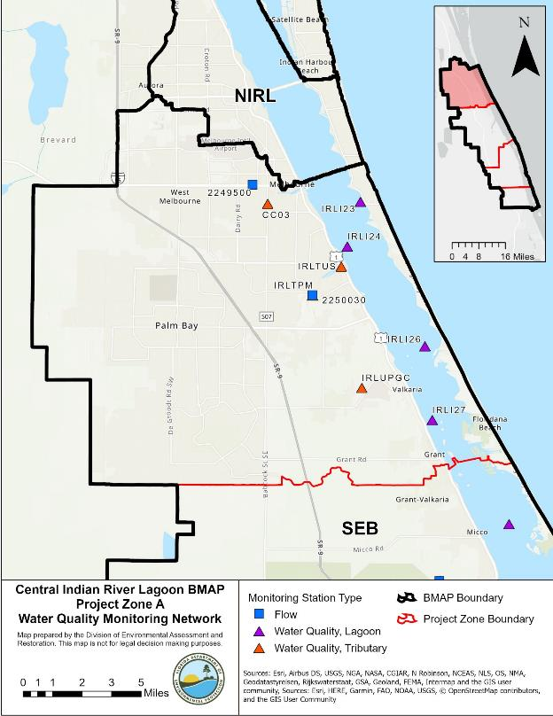
A
Figure 9. Monitoring network in the Central A Project Zone

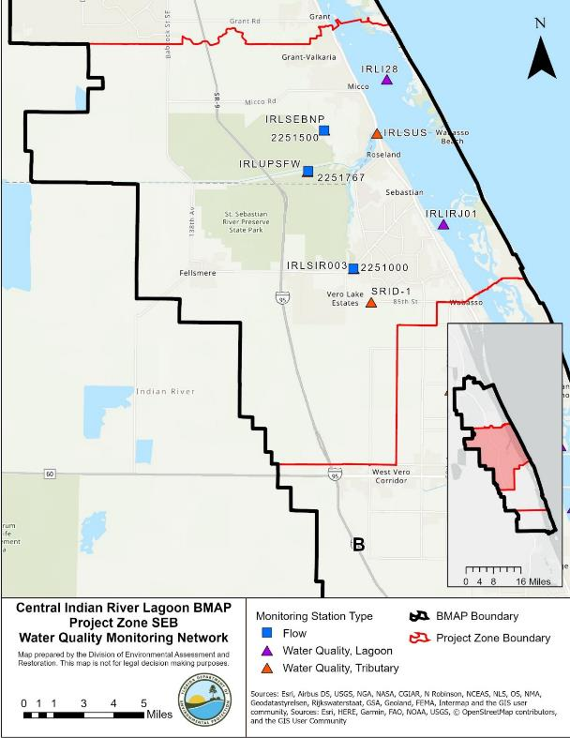
SEB
Figure 10. Monitoring network in the Central SEB Project Zone

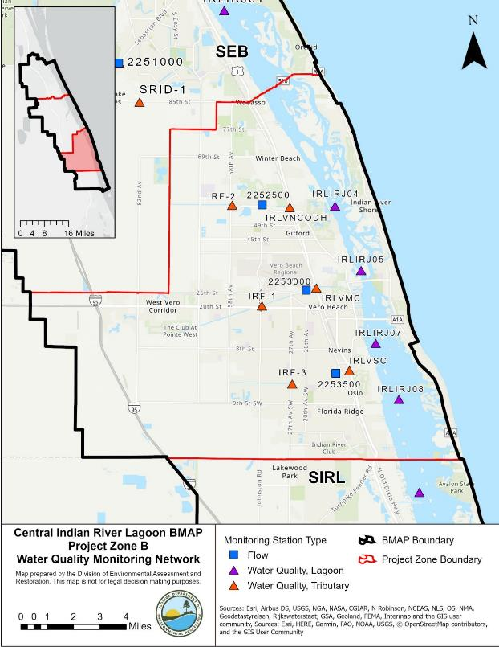
B
Figure 11. Monitoring network in the Central B Project Zone

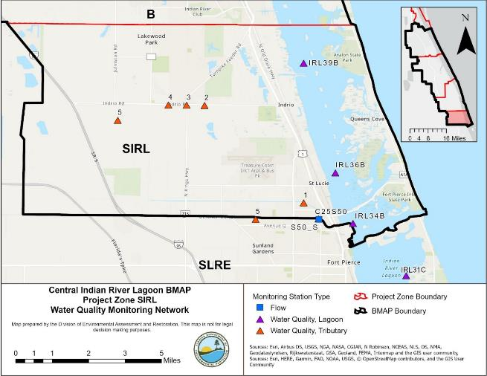
Figure 12. Monitoring network in the Central SIRL Project Zone

Data Management and Assessment
In 2017, the Florida Watershed Information Network (WIN) replaced the Florida Storage and Retrieval (STORET) Database. WIN now serves as the primary repository of ambient water quality data for the state of Florida. Water quality data from the WIN database are used for Impaired Surface Waters Rule (IWR) assessments and TMDL development. Ambient water quality data collected as part of the BMAP will be uploaded into WIN for long-term storage and availability. All BMAP data providers have agreed to upload ambient water quality data to WIN at least quarterly, upon the completion of the appropriate quality assurance/quality control (QA/QC) checks.
Other data relevant to monitoring restoration efforts, such as the extent and abundance of seagrass coverages, groundwater, and storm events, may be collected. Stakeholders agree to provide these data to other BMAP partners upon request, and when appropriate, for inclusion in BMAP data analyses and adaptive management evaluations. Other biological data used to assess the biological health of streams and lakes may be provided to DEP staff in the Watershed Assessment Section. For more information on submitting external biological data, visit the DEP website.
The water quality data will be analyzed periodically to determine trends in water quality in the lagoon. Specific statistical analyses were not identified during BMAP development; however, commonly accepted methods of data analysis will be used.

Quality Assurance/Quality Control
Stakeholders participating in the monitoring plan must collect water quality data in a manner consistent with the DEP standard operating procedures (SOPs) for QA/QC. The most current version of these procedures can be downloaded from the DEP website. For BMAP-related data analyses, entities should use National Environmental Laboratory Accreditation Council (NELAC) National Environmental Laboratory Accreditation Program (NELAP)–certified laboratories or other labs that meet the certification and other requirements outlined in the DEP SOPs. SJRWMD staff and contractors collect, process, and preserve samples according to SJRWMD's Field Standard Operating Procedures for Surface Water Sampling Fiscal Year 2020. SFWMD staff and contractors collect, process, and preserve samples according to SFWMD's Field Sampling Quality Manual.

Research Priorities
During the BMAP process, the stakeholders identified several research priorities they would like to pursue, if funding becomes available. The investments prompted by the 2011 superbloom generated research topics that include the following:
- Collecting data to update the bathymetry for the IRL Basin, which would be used in evaluations of seagrass depth limits.
- Continuing coordinated monitoring of phytoplankton, periphyton, drift algae, and macroalgae in the basin to gain insights into the cycling of nutrients as well as toxin production and release.
- Data analysis of storm event monitoring at the major outfalls.
- Collecting data on the nutrient load reduction that results from WCD staging/ retaining stormwater runoff.
- Refining load estimates delivered by baseflows and modeling the contributions of baseflows.
- Synthesizing data on nutrient flux/internal recycling of legacy nutrient loads held within IRL sediments and exchanged with the water column.
- Completing the development, calibration, and validation of a water quality model that can be used to design, site, and prioritize projects that reduce nutrient loads (e.g., Hydrologic Simulation Program FORTRAN [HSPF] or SWIL Model coupled with the Environmental Fluid Dynamics Code [EFDC] Model or another model that generates predictions of conditions that may be favorable for seagrass growth).

The stakeholders will continue to work with DEP and IRL NEP to identify other research needs, prioritize these needs, and develop scopes of work to address research priorities as appropriate. This information may be organized in a more detailed research plan that could be used to guide future efforts, as funding becomes available. These research projects are not BMAP requirements but would provide valuable information for future assessments of the health of the CIRL. There are reports and peer-reviewed articles that have been completed to address several of these research priorities. References are provided in Chapter 5.

- Project Zones
Section 3.1 through Section 3.4 provides specific land use and project information on the four project zones in the CIRL. All projects identified as part of this BMAP are listed by project zone. For projects that treat lands in multiple project zones, the nutrient reductions provided in the table are only the estimated reductions for the project zone specified. To calculate the total benefits from these projects, credits from all project zones treated by the project should be summed. The table of existing and planned projects lists those projects submitted by stakeholders to help meet their obligations under the BMAP. Information in the tables was provided by the lead entity and is subject to change as the project develops and more information becomes available.
It should be noted that only projects completed in 2000 and beyond are eligible for BMAP credit. Since the treatment input data for the hydrology calibration was from an earlier period in the model simulation, most projects beyond permit requirements installed from 2000 onward were not included in the calibration and are not well represented in the SWIL Model loading estimates. Therefore, projects completed from 2000 onward are eligible for BMAP credit. Projects completed prior to 2000 are accounted for in the period of record used for calibration of the SWIL Model.
The projects and management strategies are ranked with a priority of high, medium, or low. Projects with a "completed" status were assigned a low priority. Projects classified as "underway" were assigned a medium priority because some resources have been allocated to these projects, but additional assistance may be needed for the projects to be completed. A high priority was assigned to projects listed as "planned," as well as certain "ongoing" projects (i.e., "street sweeping," "catch basin inserts/inlet filter clean out," "public education efforts," "fertilizer cessation," "fertilizer reduction," or "aquatic vegetation harvesting").

CIRL A
Project Zone A covers more than 94,742 acres of the CIRL BMAP. As shown in Table 19, urban land uses makes up the majority of the project zone with 55.4 % of the area, followed by shrublands with 12.2%. Stakeholders in Project Zone A are agricultural producers, Brevard County, City of Melbourne, City of Palm Bay, City of Melbourne, FDOT District 5, Melbourne-Tillman WCD, Town of Melbourne Beach, Town of Grant-Valkaria, Town of Indialantic, Town of Malabar, Town of Melbourne Village, and U.S. Air Force (Malabar Annex).
Table 19. Summary of land uses in Project Zone A
Note: Land use code 5000 (water) acreage excludes lagoon water in this table.
Level 1  Land Use Code | Land Use Description | Acres | % Total
1000 | Urban | 52,496 | 55.4
2000 | Agricultural | 7,994 | 8.4
3000 | Upland Prairie and Shrublands | 11,573 | 12.2
4000 | Upland Forested Areas | 8,488 | 9.0
5000 | Water | 1,514 | 1.6
6000 | Wetlands | 8,283 | 8.7
7000 | Distrurbed Lands | 1,213 | 1.3
8000 | Transportation | 3,181 | 3.4
Total |  | 94,742 | 100.0

DEP asked stakeholders to provide information on management actions, including projects, programs, and activities, that may reduce nutrient loads to the CIRL. Management actions are included in the BMAP to address nutrient loads to the lagoon and have to meet several criteria to be considered eligible for credit. Figure 13 and Figure 14 show progress towards the required TN and TP load reductions allocated to Project Zone A from projects completed through July 31, 2020.

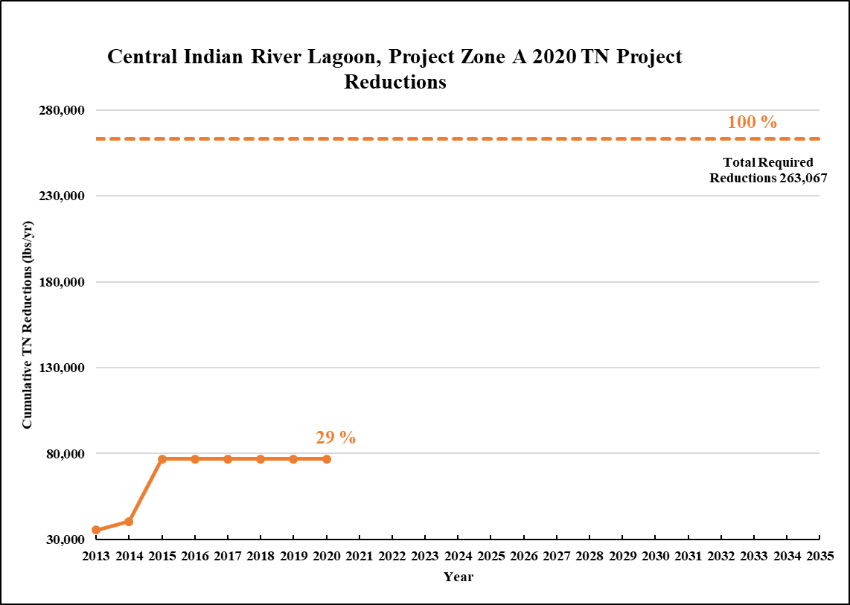
Figure 13. Estimated progress towards meeting the Required TN Reductions allocated to Project Zone A with projects completed through July 31, 2020

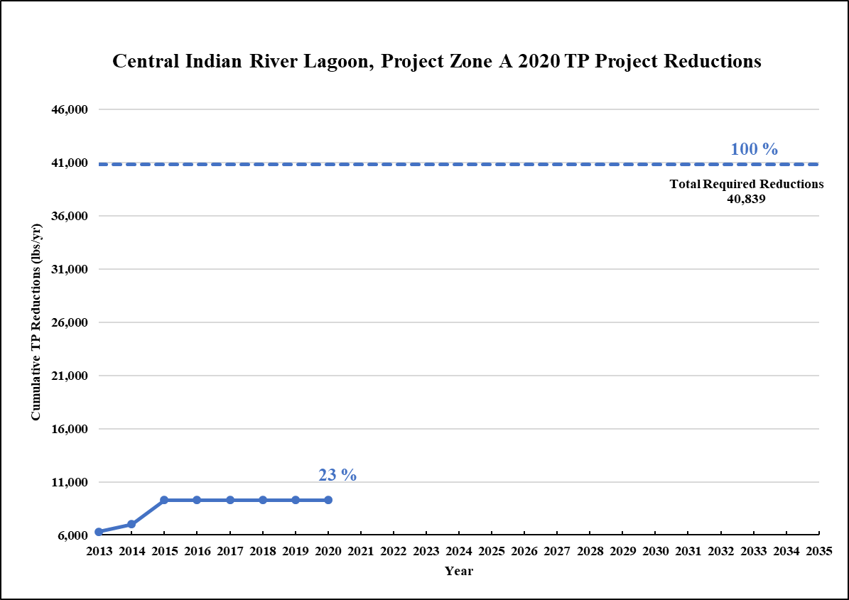
Figure 14. Estimated progress towards meeting the Required TP Reductions allocated to Project Zone A with projects completed through July 31, 2020

Existing and Planned Projects
Table 20 summarizes the existing and planned projects provided by the stakeholders for Project Zone A.
Table 20. Existing and planned projects in Project Zone A
Lead Entity | Partners | Project Number | Project Name | Project Description | Project Type | Project Status | Estimated Completion Date | TN Reduction (lbs/yr) | TP Reduction (lbs/yr) | Acres Treated | Cost Estimate | Cost Annual O&M | Funding Source | Funding Amount | DEP Contract Agreement Number
Brevard County | N/A | BC-01 | Tadlock and Goat Creek Baffle Box | Upgraded a 1st generation to a 2nd generation baffle box by adding the nutrient separating screen. | Baffle Boxes- Second Generation | Completed | 2000 | 40 | 6 | 22 | $43,811 | $1,000 | N/A | N/A | N/A
Brevard County | N/A | BC-02 | Oak Street Drainage Improvements | Swale and baffle box. | BMP Treatment Train | Completed | 2003 | 0 | 1 | 0 | $660,285 | Not provided | Not provided | Not provided | Not provided
Brevard County | N/A | BC-03 | Melbourne Shores Ponds | This pond helps alleviate flooding in the south beaches and cleans the stormwater runoff from a 135.9 acre drainage basin. | Wet Detention Pond | Completed | 2004 | 193 | 70 | 136 | $939,543 | Not provided | County | N/A | N/A
Brevard County | W. Melbourne/ Grant-Valkaria/ Malabar/ Melbourne/ Cocoa/ IHB/ Sat. Beach/ Cocoa Beach/ Cape Canaveral | BC-05 | Education Efforts | FYN, fertilizer and pet waste ordinances, public service announcements (PSAs), pamphlets, website, illicit discharge program. | Education Efforts | Ongoing | N/A | 2,231 | 335 | N/A | $90,000 | N/A | County | N/A | N/A
Brevard County | N/A | BC-06 | Street Sweeping | Remove debris from 786 linear feet of curb street throughout the county. | Street Sweeping | Ongoing | N/A | 55 | 35 | N/A | N/A | $147,076 | N/A | N/A | N/A
Brevard County | DEP | BC-07 | Valkaria Lakes | Converted borrow pits into detention ponds for stormwater treatment. | Wet Detention Pond | Completed | 2014 | 1,132 | 256 | 458 | $261,000 | Not provided | DEP/ County | $144,598 | G0249
Brevard County | City of Melbourne | BC-14 | Fountainhead | 982,300 lbs of vegetation removed using 113 dump trucks. | Aquatic Vegetation Harvesting | Completed | 2013 | 890 | 273 | Not provided | $39,274 | Not provided | Not provided | Not provided | N/A
Brevard County | DEP | BC-15 | Corey Road at Hall | Upgraded a 1st generation to a 2nd generation baffle box by adding the nutrient separating screen. | Baffle Boxes- Second Generation | Completed | 2015 | 83 | 9 | 52 | $12,507 | $2,140 | DEP | DEP - $275,000 | S0648
Brevard County | DEP | BC-16 | 430 Riverview | Upgraded a 1st generation to a 2nd generation baffle box by adding the nutrient separating screen. | Baffle Boxes- Second Generation | Completed | 2015 | 13 | 2 | 8 | $30,508 | $2,140 | DEP | DEP - $275,000 | S0648
Brevard County | SJRWMD | BC-17 | C-1 Rediversion | This project is designed to help restore the natural drainage flow from the west side of Palm Bay back to the St. Johns River. | Hydrologic Restoration | Completed | 2015 | 35,565 | 2,038 | Not provided | $531,051 | Not provided | SJRWMD | Not provided | S0652
Brevard County | N/A | BC-18 | Baffle Box/Sediment Trap Cleaning | Increasing cleanout frequency to quarterly. | BMP Cleanout | Ongoing | N/A | 1 | 1 | N/A | Not provided | Not provided | Not provided | Not provided | N/A
Brevard County | DEP | BC-19 | Turkey Creek Dredging | 230,000 cubic yards of material collected. | Muck Removal/Restoration Dredging | Completed | 2017 | TBD | TBD | N/A | $1,545,522 | Not provided | DEP | Not provided | S0714
Brevard County | DEP | BC-20 | Multiple Ditch Outfall Denitrification D3 | Providing base flow/groundwater treatment in 20 open drainage basins. Each Project will have its own number | Denitrification Walls | Underway | TBD | TBD | TBD | TBD | $1,182,858 | TBD | DEP | TBD | LP0511A
Brevard County | N/A | BC-21 | Kingsmill Aurora Phase II | Construction of a 5-acre pond with weirs, drop structures, etc. | Wet Detention Pond | Underway | 2018 | TBD | TBD | 1,213 | $990,000 | TBD | TBD | TBD | N/A
Brevard County | Cities within Brevard County | BC-23 | Education Efforts | Fertilizer video, rain barrel workshops, Facebook page, bus wrap, and billboard. | Enhanced Public Education | Ongoing | N/A | N/A | N/A | Not provided | TBD | TBD | Brevard County/ SOIRL | TBD | N/A
Brevard County | SOIRL/ Melbourne | BC-24 | Hoag Sewer Conversion | Septic Removal - CIRL - Melbourne, SOIRL-04. | OSTDS Phase Out | Underway | 2020 | 24 | N/A | Not provided | $100,000 | Not provided | SOIRL/ City | $86,031 | N/A
Brevard County | SOIRL | BC-25 | M1 Canal BAM - BB#1470 | Adding a media to remove nitrogen by denitrification. The media will be added to the side slope of the pond or the bottom of the swale. | Biosorption Activated Media (BAM) | Canceled | 2019 | N/A | N/A | TBD | $101,300 | Not provided | SOIRL | SOIRL - $66,300 | N/A
Brevard County | SJRWMD/ SOIRL | BC-27 | Crane Creek/M-1 Canal Rediversion Project | The project will treat and restore small storm events and baseflow from 5,300 acres of Lagoon-diverted water. | Hydrologic Restoration | Planned | 2020 | TBD | TBD | 5,300 | $9,186,500 | Not provided | SOIRL | SOIRL - $2,033,944 | N/A
Brevard County | Not provided | BC-29 | Riverview Senior Oyster Bar | Construct 320 linear foot oyster bar | Creating/ Enhancing Oyster Reefs | Completed | 2018 | TBD | TBD | TBD | $30,304 | Not provided | SOIRL | SOIRL - $30,304 | N/A
Brevard County | Not provided | BC-30 | Lagoon House Living Shoreline | Plant 300 mangroves and 1,000 spartina along the shoreline of the Lagoon House. | Creating/ Enhancing Living Shoreline | Completed | 2018 | TBD | TBD | TBD | $24,000 | Not provided | SOIRL | SOIRL - $24,000 | N/A
City of Melbourne | N/A | MEL-01 | Fee & Apollo Drainage Improvements | No treatment is provided within the existing development; completely a water quality addition. | Wet Detention Pond | Completed | 2011 | 28 | 40 | 77 | $525,161 | Not provided | City | City - $525,161 | N/A
City of Melbourne | N/A | MEL-02 | Education Efforts | Irrigation, fertilizer, pet waste management, and landscaping ordinances; pamphlets, presentations, website, illicit discharge program. | Education Efforts | Ongoing | N/A | 3,795 | 543 | N/A | Not provided | Not provided | City | Not provided | N/A
City of Melbourne | N/A | MEL-03 | Street Sweeping | Street sweeping in the basin and debris removal. | Street Sweeping | Ongoing | N/A | 378 | 187 | N/A | N/A | $87,500 | City | Not provided | N/A
City of Melbourne | N/A | MEL-04 | Participation in FYN | Participation in FYN Program. Credited in MEL-02. | Education Efforts | Canceled | N/A | N/A | N/A | N/A | N/A | N/A | N/A | N/A | N/A
City of Melbourne | N/A | MEL-05 | South Croton Baffle Box | Dry retention and baffle box. | BMP Treatment Train | Canceled | N/A | N/A | N/A | N/A | N/A | N/A | N/A | N/A | N/A
City of Melbourne | N/A | MEL-06 | Southwest Park Improvements near Florida Avenue | Installation of baffle box along with pipe replacement. | Baffle Boxes- Second Generation with Media | Completed | 2017 | TBD | TBD | 48 | $582,153 | Not provided | City | City - $582,153 | N/A
City of Melbourne | N/A | MEL-07 | Melbourne Avenue Existing Baffle Box Upgrade | Upgrade existing 1st generation baffle boxes to 2nd generation baffle boxes with BAM. | Baffle Boxes- Second Generation with Media | Completed | 2016 | TBD | TBD | 13 | $12,000 | Not provided | City | City - $12,000 | N/A
City of Melbourne | SOIRL | MEL-08 | Penwood Septic to Sewer Conversion | Providing for 12 lots (4 existing and 8 proposed) to be converted to municipal sewer. | Wastewater Service Area Expansion | Underway | 2020 | TBD | TBD | TBD | $60,000 | TBD | City/ SOIRL | $40,632 | N/A
City of Melbourne | SOIRL | MEL-09 | Riverview Park Living Shoreline | Construction of a living shoreline with an oyster breakwater. | Creating/ Enhancing Living Shoreline | Underway | 2021 | TBD | TBD | TBD | $440,000 | TBD | City/ SOIRL | $108,790 | N/A
City of Melbourne | SOIRL | MEL-10 | Hoag Septic to Sewer Conversion | Providing for 12 lots (7 existing and 5 proposed) to be converted to municipal sewer. | Wastewater Service Area Expansion | Underway | 2021 | TBD | TBD | TBD | $105,000 | TBD | City/ SOIRL | $86,031 | N/A
City of Melbourne | SOIRL | MEL-11 | Grant Place Baffle Box | 2nd Generation baffle box with BAM. | Baffle Boxes- Second Generation with Media | Underway | 2020 | TBD | TBD | 103 | $400,000 | TBD | City/ SOIRL | $82,481 | N/A
City of Melbourne | SOIRL | MEL-12 | Roxy Septic to Sewer Conversion | Five lots with septic systems to be converted to municipal sewer. | Wastewater Service Area Expansion | Planned | 2021 | TBD | TBD | TBD | $265,000 | TBD | City/ SOIRL | $88,944 | N/A
City of Melbourne | SOIRL | MEL-13 | Espanolia Baffle Box | Installation of baffle box along with pipe replacement. | Baffle Boxes- Second Generation with Media | Planned | 2022 | 458 | 73 | 61 | $550,000 | TBD | City/ SOIRL | $105,000 | N/A
City of Melbourne | SOIRL/SRF Loan | MEL-14 | Grant Street Water Reclamation Facility Improvements | Improvements include rehabilitation of major treatment elements and structures of facility. | WWTF Nutrient Reduction | Planned | TBD | TBD | TBD | TBD | ####### | Not provided | City of Melbourne/ SOIRL/ SRF | ####### | N/A
City of Palm Bay | N/A | PB-01 | Basin 11 | Not provided. | Muck Removal/Restoration Dredging | Completed | 2009 | Not provided | Not provided | Not provided | $1,866,695 | Not provided | Not provided | Not provided | N/A
City of Palm Bay | N/A | PB-02 | Chace Lane Pond Modifications | Not provided. | Dry Detention Pond | Completed | 2001 | 78 | 11 | 91 | $20,290 | Not provided | Not provided | Not provided | N/A
City of Palm Bay | N/A | PB-03 | Glenham Drive Sidewalks Improvements | Not provided. | Dry Detention Pond | Completed | 2014 | 11 | 2 | 12 | Not provided | Not provided | Not provided | Not provided | N/A
City of Palm Bay | N/A | PB-04 | Basin 7 Stormwater Improvements Phase II | Not provided. | Wet Detention Pond | Completed | 2009 | 352 | 101 | 147 | $79,109 | Not provided | Not provided | Not provided | N/A
City of Palm Bay | N/A | PB-05 | Boundary Canal Trail Phase 3 | Not provided. | Baffle Boxes- First Generation | Completed | 2014 | 17 | 12 | 366 | Not provided | Not provided | Not provided | Not provided | N/A
City of Palm Bay | N/A | PB-06 | Boundary Canal Phase II Stormwater Improvement | Not provided. | On-line Retention BMPs | Completed | 2014 | 3,276 | 383 | 633 | Not provided | Not provided | Not provided | Not provided | N/A
City of Palm Bay | N/A | PB-07 | Boundary Canal Phase I Baffle Box Installation | Not provided. | Baffle Boxes- First Generation | Completed | 2014 | 0 | 0 | 633 | Not provided | Not provided | Not provided | Not provided | N/A
City of Palm Bay | N/A | PB-08 | Norwood Street Baffle Box Installation | Not provided. | Baffle Boxes- First Generation | Completed | 2014 | 16 | 12 | 529 | Not provided | Not provided | Not provided | Not provided | N/A
City of Palm Bay | N/A | PB-09 | Basin 1 Drainage Improvements Phase 1 (East of US 1) | Not provided. | Wet Detention Pond | Completed | 2007 | 110 | 10 | 137 | $22,247 | Not provided | Not provided | Not provided | N/A
City of Palm Bay | N/A | PB-10 | Basin 13 Stormwater Improvements | Not provided. | Wet Detention Pond | Completed | 2006 | 143 | 37 | 42 | $200,419 | Not provided | Not provided | Not provided | N/A
City of Palm Bay | N/A | PB-11 | Powell's Subdivision Paving & Drainage Improvements | Not provided. | Wet Detention Pond | Completed | 2000 | 176 | 82 | 124 | $147,478 | Not provided | Not provided | Not provided | N/A
City of Palm Bay | N/A | PB-12 | Port Malabar Unit 40 Drainage Improvements North | Not provided. | Wet Detention Pond | Completed | 2015 | 737 | 182 | 224 | $23,778 | Not provided | Not provided | Not provided | N/A
City of Palm Bay | N/A | PB-13 | Mandarin Ditch (South) | Not provided. | Grass swales without swale blocks or raised culverts | Completed | 2006 | 213 | 30 | 73 | $308,797 | Not provided | Not provided | Not provided | N/A
City of Palm Bay | N/A | PB-14 | Basin 3 Main Street Parking Lot | Treatment train with PB-15. | Pervious Pavement Systems | Completed | 2008 | 1,428 | 206 | 346 | $4,845 | Not provided | Not provided | Not provided | N/A
City of Palm Bay | N/A | PB-15 | Basin 3 Main Street Improvements Channel Alignment | Treatment train with PB-14. | BMP Treatment Train | Completed | 2010 | 1,604 | 231 | 359 | $403,561 | Not provided | Not provided | Not provided | N/A
City of Palm Bay | N/A | PB-16 | Street Sweeping | Not provided. | Street Sweeping | Ongoing | N/A | 57 | 36 | N/A | $8,900 | Not provided | Not provided | Not provided | N/A
City of Palm Bay | N/A | PB-17 | Turkey Creek Maintenance Dredging | Not provided. | Muck Removal/Restoration Dredging | Completed | 2007 | Not provided | Not provided | Not provided | $255,241 | Not provided | Not provided | Not provided | N/A
City of Palm Bay | N/A | PB-18 | Turkey Creek Maintenance Dredging - Sump | Not provided. | Muck Removal/Restoration Dredging | Completed | 2014 | Not provided | Not provided | Not provided | Not provided | Not provided | Not provided | Not provided | N/A
City of Palm Bay | N/A | PB-19 | Anglers Drive | Not provided. | Baffle Boxes- First Generation | Completed | 2008 | 1 | 1 | 12 | $85,000 | Not provided | Not provided | Not provided | N/A
City of Palm Bay | N/A | PB-20 | Worth Court | Not provided. | Catch Basin Inserts/Inlet Filter Cleanout | Completed | 2014 | 0 | 0 | 5 | Not provided | Not provided | Not provided | Not provided | N/A
City of Palm Bay | SJRWMD/ DEP | PB-21 | Basin 9 (Harris Pond) | Not provided. | Wet Detention Pond | Completed | 2010 | TBD | TBD | 443 | $294,519 | Not provided | SJRWMD/ DEP | Not provided | Not provided
City of Palm Bay | N/A | PB-22 | Wild Rose BMP | Not provided. | Baffle Boxes- First Generation | Completed | 2014 | 0 | 0 | 5 | Not provided | Not provided | Not provided | Not provided | N/A
City of Palm Bay | N/A | PB-24 | Port Malabar Inlet Inserts | Not provided. | Catch Basin Inserts/Inlet Filter Cleanout | Completed | 2010 | Not provided | Not provided | 29 | $19,518 | Not provided | Not provided | Not provided | N/A
City of Palm Bay | N/A | PB-25 | Kent Street Baffle Box | Not provided. | Baffle Boxes- First Generation | Completed | 2009 | 1 | 1 | 21 | $50,000 | Not provided | Not provided | Not provided | N/A
City of Palm Bay | N/A | PB-26 | PMU1 North (Florin Pond) | Not provided. | Dry Detention Pond | Completed | 2000 | TBD | TBD | 26 | $150,000 | Not provided | Not provided | Not provided | N/A
City of Palm Bay | N/A | PB-27 | Education Efforts | FYN, ordinances, pamphlets, PSAs, website, illicit discharge program. | Education Efforts | Ongoing | N/A | 12,343 | 1,787 | N/A | $1,866,695 | N/A | N/A | N/A | N/A
City of Palm Bay | N/A | PB-28 | Vance Circle-Drainage Improvements | Not provided. | Catch Basin Inserts/Inlet Filter Cleanout | Canceled | N/A | N/A | N/A | N/A | N/A | N/A | N/A | N/A | N/A
City of Palm Bay | DEP | PB-29 | Basin 1 Drainage Improvements Phase 1 | Baffle box, modular wetlands, and upward filter. | BMP Treatment Train | Completed | 2017 | Not provided | Not provided | 175 | $250,000 | Not provided | DEP | DEP - $250,000 | S0876
City of Palm Bay | N/A | PB-30 | Troutman/ Clearmond Drainage Pond | Roadway widening from rural to urban section with underground drainage. | Dry Detention Pond | Completed | 2014 | 7 | 1 | 8 | $5,400,000 | Not provided | Not provided | Not provided | N/A
City of Palm Bay | N/A | PB-31 | Port Malabar Drainage Improvements Central | Modification of existing drainage system redesigned to promote infiltration of stormwater runoff. The system has perforated piping, baffles, and infiltration trenches to encourage percolation. | Exfiltration Trench | Completed | 2013 | 12 | 2 | 12 | Not provided | Not provided | Not provided | Not provided | N/A
City of Palm Bay | N/A | PB-32 | Kingswood Drainage Pond | Modification and expansion of existing drainage pond to provide additional stormwater capacity, attenuation, and treatment. | Dry Detention Pond | Completed | 2015 | 61 | 8 | 62 | Not provided | Not provided | Not provided | Not provided | N/A
City of Palm Bay | DEP | PB-33 | Basin 3 Bayfront Community SW Improvements (Koske Pond Phase 1) | Baffle box, modular wetlands, and upward filter. | BMP Treatment Train | Completed | 2017 | TBD | TBD | Not provided | $500,000 | Not provided | DEP | DEP - $500,000 | S0801
City of Palm Bay | SJRWMD/ DEP | PB-34 | Stormwater Treatment at City Marina | Baffle box, modular wetlands, and upward filter. | BMP Treatment Train | Planned | TBD | TBD | TBD | TBD | $890,050 | TBD | SJRWMD/ DEP | TBD | LP05073
City of Palm Bay | N/A | PB-37 | Norwood Baffle Box Retrofit | N/A | Baffle Boxes- First Generation | Canceled | N/A | N/A | N/A | N/A | N/A | N/A | N/A | N/A | N/A
City of Palm Bay | N/A | PB-38 | Victoria Pond | N/A | Baffle Boxes- First Generation | Canceled | N/A | N/A | N/A | N/A | N/A | N/A | N/A | N/A | N/A
City of Palm Bay | N/A | PB-39 | Goode Park | N/A | Baffle Boxes- First Generation | Canceled | N/A | N/A | N/A | N/A | N/A | N/A | N/A | N/A | N/A
City of Palm Bay | N/A | PB-40 | Florin Pond | N/A | Baffle Boxes- First Generation | Canceled | N/A | N/A | N/A | N/A | N/A | N/A | N/A | N/A | N/A
City of Palm Bay | N/A | PB-41 | Turkey Creek Shoreline Restoration | Bayfront shoreline restoration to place fill addressing hurricane erosion damage from 2016 and 2017. | Shoreline Stabilization | Completed | 2018 | TBD | TBD | TBD | $180,000 | TBD | DEO | DEO - $177,300/ City - $2,700 | N/A
City of Palm Bay | N/A | PB-42 | Unit 48 Drainage Improvements - Emerson | Expansion of wet detention system and adjustment of control structures. | Wet Detention Pond | Planned | 2019 | TBD | TBD | TBD | TBD | TBD | City | TBD | N/A
City of Palm Bay | Brevard County/ Brevard Zoo | PB-43 | Bayfront/Palm Bay Living Shoreline at Turkey Creek | Installation of oyster mats and plantings to uptake nutrients from sheet flow. | Creating/ Enhancing Living Shoreline | Canceled | 2019 | N/A | N/A | TBD | $113,000 | TBD | Brevard County | Brevard County - $113,000 | N/A
City of Palm Bay | N/A | PB-44 | Basin 3 Bayfront Community SW Improvements (Koske Pond Phases 2 and 3) | Expansion of wet pond. | Wet Detention Pond | Planned | 2019 | TBD | TBD | TBD | TBD | $200 | TBD | TBD | N/A
City of Palm Bay | N/A | PB-45 | Basin 1 Drainage Improvements Phase 2B Victoria Pond (West of U.S. 1) | Baffle box and upflow filter. | BMP Treatment Train | Planned | 2019 | TBD | TBD | 175 | TBD | TBD | TBD | TBD | N/A
City of West Melbourne | N/A | WM-01 | Westbrooke | Not provided. | Wet Detention Pond | Completed | 2004 | 23 | 4 | 169 | Not provided | Not provided | Not provided | Not provided | N/A
City of West Melbourne | N/A | WM-02 | Saddlebrook | Not provided. | Wet Detention Pond | Completed | 2004 | 0 | 0 | 40 | Not provided | Not provided | Not provided | Not provided | N/A
City of West Melbourne | N/A | WM-03 | Stratford Point | Not provided. | Wet Detention Pond | Completed | 2004 | 23 | 6 | 84 | Not provided | Not provided | Not provided | Not provided | N/A
City of West Melbourne | N/A | WM-04 | Oak Grove | Not provided. | Wet Detention Pond | Completed | 2010 | 20 | 5 | 91 | Not provided | Not provided | Not provided | Not provided | N/A
City of West Melbourne | N/A | WM-05 | Manchester Lakes | Not provided. | Wet Detention Pond | Completed | 2007 | 11 | 2 | 133 | Not provided | Not provided | Not provided | Not provided | N/A
City of West Melbourne | N/A | WM-06 | Havens at Riviera | Not provided. | Wet Detention Pond | Completed | 2009 | 5 | 4 | 23 | Not provided | Not provided | Not provided | Not provided | N/A
City of West Melbourne | N/A | WM-07 | Cypress/Creek Imagine Schools | Not provided. | Wet Detention Pond | Completed | 2009 | 32 | 4 | 72 | Not provided | Not provided | Not provided | Not provided | N/A
City of West Melbourne | N/A | WM-08 | Lynnwood | Not provided. | Wet Detention Pond | Completed | 2006 | 3 | 1 | 28 | Not provided | Not provided | Not provided | Not provided | N/A
City of West Melbourne | N/A | WM-09 | Coastal Commerce | Not provided. | Wet Detention Pond | Completed | 2009 | 12 | 5 | 60 | Not provided | Not provided | Not provided | Not provided | N/A
City of West Melbourne | N/A | WM-10 | Hammock Landing | Not provided. | Wet Detention Pond | Completed | 2009 | 5 | 2 | 76 | Not provided | Not provided | Not provided | Not provided | N/A
City of West Melbourne | N/A | WM-11 | Crystal Lakes | Not provided. | Wet Detention Pond | Completed | 2009 | 11 | 7 | 91 | Not provided | Not provided | Not provided | Not provided | N/A
City of West Melbourne | N/A | WM-12 | Orange View Drive | Not provided. | Baffle Boxes- Second Generation | Completed | 2014 | 90 | 11 | 49 | Not provided | Not provided | Not provided | Not provided | N/A
City of West Melbourne | N/A | WM-13 | Stephenson Drive | Not provided. | Baffle Boxes- Second Generation | Completed | 2014 | 28 | 3 | 14 | Not provided | Not provided | Not provided | Not provided | N/A
City of West Melbourne | N/A | WM-14 | Parker Road | Not provided. | Baffle Boxes- Second Generation | Completed | 2014 | 25 | 3 | 13 | Not provided | Not provided | Not provided | Not provided | N/A
City of West Melbourne | N/A | WM-15 | Laila Drive | Not provided. | Baffle Boxes- Second Generation | Completed | 2014 | 42 | 5 | 22 | Not provided | Not provided | Not provided | Not provided | N/A
City of West Melbourne | N/A | WM-16 | Doherty Drive | Not provided. | Baffle Boxes- Second Generation | Completed | 2014 | 120 | 16 | 66 | Not provided | Not provided | Not provided | Not provided | N/A
City of West Melbourne | N/A | WM-17 | Trend Road | Not provided. | Baffle Boxes- Second Generation | Completed | 2014 | 17 | 2 | 9 | Not provided | Not provided | Not provided | Not provided | N/A
City of West Melbourne | N/A | WM-18 | San Paolo | Not provided. | Baffle Boxes- Second Generation | Completed | 2014 | 6 | 1 | 3 | Not provided | Not provided | Not provided | Not provided | N/A
City of West Melbourne | N/A | WM-19 | San Paolo West | Not provided. | Baffle Boxes- Second Generation | Completed | 2014 | 17 | 2 | 8 | Not provided | Not provided | Not provided | Not provided | N/A
City of West Melbourne | N/A | WM-20 | John Carrol | Not provided. | Baffle Boxes- Second Generation | Completed | 2014 | 133 | 16 | 75 | Not provided | Not provided | Not provided | Not provided | N/A
City of West Melbourne | N/A | WM-21 | Street Sweeping | Not provided. | Street Sweeping | Ongoing | N/A | 316 | 216 | N/A | Not provided | Not provided | Not provided | Not provided | N/A
City of West Melbourne | N/A | WM-22 | Inlet Cleaning | Not provided. | BMP Cleanout | Ongoing | N/A | 20 | 2 | Not provided | Not provided | Not provided | Not provided | Not provided | N/A
City of West Melbourne | N/A | WM-23 | Sawgrass Lakes Ph. I | Not provided. | Wet Detention Pond | Completed | 2015 | Not provided | Not provided | 508 | Not provided | Not provided | Private | Not provided | N/A
City of West Melbourne | N/A | WM-24 | Manchester Lakes | Not provided. | Wet Detention Pond | Completed | 2016 | Not provided | Not provided | 133 | Not provided | Not provided | Private | Not provided | N/A
City of West Melbourne | Brevard County/St. Johns | WM-25 | Construction of Sylvan Drive Septic to Sewer Project | Connecting 59 properties to public sewer and abandoning 59 septic tanks | OSTDS Phase Out | Underway | 2021 | TBD | TBD | 60 | $2,322,551 | TBD | SOIRL/ St. Johns/ City of West Melbourne | ####### | N/A
FDACS | Agricultural Producers | FDACS-01 | BMP Implementation and Verification | Enrollment and verification of BMPs by agricultural producers. Acres treated based on FDACS OAWP July 2020 Enrollment and FSAID VII. Reductions based on SWIL Model-LET. | Agricultural BMPs | Ongoing | N/A | 208 | 27 | 234 | TBD | TBD | FDACS | TBD | N/A
FDACS | Agricultural Producers | FDACS-05 | FDACS Cost Share Projects | Cost-share projects paid for by FDACS. Acres treated based on FDACS OAWP July 2020 Enrollment. Reductions based on SWIL Model-LET. | Agricultural BMPs | Completed | 2020 | 0 | 0 | TBD | TBD | N/A | FDACS | TBD | N/A
SJRWMD | Not provided | SJRWMD-05 | C-10 Water Management Area Project | Construction of a 1,300 acre reservoir with pump station and outfall structure designed to increase the flow restoration to the St. Johns River of the C-1 Rediversion Project to a total of 50% of the average annual flow | Hydrologic Restoration | Planned | TBD | TBD | TBD | Not provided | TBD | Not provided | Ad Valorem | Not provided | Not provided
SJRWMD | DEP/ Brevard County | SJRWMD-06 | Crane Creek M-1 Canal Flow Restoration | This project would restore M-1 Canal baseflows and small stormflows west of Evans Road back to the USJRB by constructing an operable diversion structure in the M-1 Canal to divert and treat flows prior to discharging to the USJRB. | Hydrologic Restoration | Underway | 2022 | TBD | TBD | Not provided | ####### | Not provided | Ad Valorem/ DEP/ Brevard County | SJRWMD - $616000/ DEP - $2450000/ Brevard County - $2034000 | 33,591.00
FDOT District 5 | N/A | FDOTD5-01 | D5_70010-3528-01 | Pond A. | Wet Detention Pond | Completed | 2002 | 1 | 0 | 16 | Not provided | Not provided | Not provided | Not provided | N/A
FDOT District 5 | N/A | FDOTD5-02 | D5_70010-3528-02 | Pond B. | Wet Detention Pond | Completed | 2002 | 2 | 0 | 8 | Not provided | Not provided | Florida Legislature | Not provided | N/A
FDOT District 5 | N/A | FDOTD5-03 | D5_70012-3503-01 (Missing from model) | Pond WRA 1. | Wet Detention Pond | Completed | Prior to 2013 | 165 | 0 | 22 | Not provided | Not provided | Florida Legislature | Not provided | N/A
FDOT District 5 | N/A | FDOTD5-04 | D5_70012-3503-02 (Missing from model) | Pond WRA 2. | Wet Detention Pond | Completed | Prior to 2013 | 0 | 0 | 9 | Not provided | Not provided | Florida Legislature | Not provided | N/A
FDOT District 5 | N/A | FDOTD5-05 | D5_70012-3503-03 (Missing from model) | Pond WRA 3. | Dry Detention Pond | Completed | Prior to 2013 | 6 | 1 | 7 | Not provided | Not provided | Florida Legislature | Not provided | N/A
FDOT District 5 | N/A | FDOTD5-06 | D5_70050-3544-03 | Pond 7B. | Wet Detention Pond | Completed | 2004 | 2 | 0 | 5 | Not provided | Not provided | Florida Legislature | Not provided | N/A
FDOT District 5 | N/A | FDOTD5-07 | D5_70100-3517-01 (Missing from model) | French drains. Project canceled. Start date prior to 2000. BMP is accounted for in new model. | 100% On-site Retention | Canceled | Prior to 2013 | N/A | N/A | 3 | Not provided | Not provided | Florida Legislature | Not provided | N/A
FDOT District 5 | N/A | FDOTD5-08 | D5_70220-3433-01 | Pond C. | Wet Detention Pond | Completed | 2000 | 3 | 0 | 9 | Not provided | Not provided | Florida Legislature | Not provided | N/A
FDOT District 5 | N/A | FDOTD5-09 | D5_70220-3429-01 (Missing from model) | Pond A; Pond 1A under 242251-2 (10/09). Project canceled. Start date prior to 2000. BMP is accounted for in new model. | Wet Detention Pond | Canceled | Prior to 2013 | N/A | N/A | 20 | Not provided | Not provided | Florida Legislature | Not provided | N/A
FDOT District 5 | N/A | FDOTD5-10 | D5_70220-3429-02 (Missing from model) | Pond B is now Pond 1B under 241221-2 (10/09). Project canceled. Start date prior to 2000. BMP is accounted for in new model. | Wet Detention Pond | Canceled | Prior to 2013 | N/A | N/A | 26 | Not provided | Not provided | Florida Legislature | Not provided | N/A
FDOT District 5 | N/A | FDOTD5-11 | D5_70220-3429-03 (Missing from model) | Pond C is now Pond 2B under 241221-2 (10/09). Project canceled. Start date prior to 2000. BMP is accounted for in new model. | Wet Detention Pond | Canceled | Prior to 2013 | N/A | N/A | 26 | Not provided | Not provided | Florida Legislature | Not provided | N/A
FDOT District 5 | N/A | FDOTD5-12 | D5_70220-3429-04 (Missing from model) | Pond D is now Pond 2A under 241221-2 (10/09). Project canceled. Start date prior to 2000. BMP is accounted for in new model. | Wet Detention Pond | Canceled | Prior to 2013 | N/A | N/A | 22 | Not provided | Not provided | Florida Legislature | Not provided | N/A
FDOT District 5 | N/A | FDOTD5-13 | D5_409034-01 | French drains. | 100% On-site Retention | Completed | 2005 | 4 | 1 | 0 | Not provided | Not provided | Florida Legislature | Not provided | N/A
FDOT District 5 | N/A | FDOTD5-14 | Education Efforts | Pamphlets, Illicit Discharge Program. | Education Efforts | Ongoing | N/A | 97 | 13 | N/A | Not provided | Not provided | Florida Legislature | N/A | N/A
FDOT District 5 | N/A | FDOTD5-15 | Fertilizer Cessation | Elimination of fertilizer application in rights-of-way. | Fertilizer Cessation | Completed | 2005 | 1,586 | 0 | 101 | Not provided | Not provided | Florida Legislature | Not provided | N/A
FDOT District 5 | N/A | FDOTD5-16 | Street Sweeping | Street sweeping. | Street Sweeping | Ongoing | N/A | 215 | 117 | N/A | Not provided | Not provided | Florida Legislature | Not provided | N/A
Melbourne Tillman WCD | DEP | MT-01 | C-1 Re-Diversion Project | Not provided. | Hydrologic Restoration | Completed | 2014 | Not provided | Not provided | Not provided | Not provided | Not provided | DEP | Not provided | S0652
Melbourne Tillman WCD | N/A | MT-02 | Weir Construction C-69 @ C-1 | Not provided. | Control Structure | Completed | 2016 | Not provided | Not provided | 3,830 | Not provided | Not provided | Not provided | Not provided | N/A
Melbourne Tillman WCD | N/A | MT-03 | Weir Construction C-69 @ C-75 | Not provided. | Control Structure | Completed | 2016 | Not provided | Not provided | 2,940 | Not provided | Not provided | Not provided | Not provided | N/A
Melbourne Tillman WCD | N/A | MT-04 | Weir Construction C-74 @ C-69 | Not provided. | Control Structure | Completed | 2016 | Not provided | Not provided | 840 | Not provided | Not provided | Not provided | Not provided | N/A
Melbourne Tillman WCD | N/A | MT-05 | Windmill Aeration | Not provided. | Stormwater Aeration System | Completed | 2016 | N/A | N/A | 516 | Not provided | Not provided | Not provided | Not provided | N/A
Melbourne Tillman WCD | N/A | MT-06 | C-9R | Woodchip logs. | Turbidity Reducing Polymers (e.g., Floc logs ®) | Completed | 2016 | Not provided | Not provided | 205 | Not provided | Not provided | Not provided | Not provided | N/A
Melbourne Tillman WCD | N/A | MT-07 | C-49 Pond | Not provided. | Stormwater - Biological/ Bacteria Treatment | Completed | 2016 | Not provided | Not provided | 238 | Not provided | Not provided | Not provided | Not provided | N/A
Melbourne Tillman WCD | N/A | MT-08 | C-47 | Not provided. | Stormwater - Biological/ Bacteria Treatment | Completed | 2016 | Not provided | Not provided | 480 | Not provided | Not provided | Not provided | Not provided | N/A
Melbourne Tillman WCD | N/A | MT-09 | C-62 | Woodchip logs. | Turbidity Reducing Polymers (e.g., Floc logs ®) | Completed | 2016 | Not provided | Not provided | 120 | Not provided | Not provided | Not provided | Not provided | N/A
Melbourne Tillman WCD | N/A | MT-10 | C-84 | Not provided. | Stormwater - Biological/ Bacteria Treatment | Completed | 2016 | Not provided | Not provided | 152 | Not provided | Not provided | Not provided | Not provided | N/A
Melbourne Tillman WCD | N/A | MT-11 | Harvesting | Hydrilla harvesting. | Aquatic Vegetation Harvesting | Completed | 2016 | Not provided | Not provided | 80 | Not provided | Not provided | Not provided | Not provided | N/A
Melbourne Tillman WCD | Not provided | MT-12 | Harvesting | Hygrophilia and tape grass harvesting | Aquatic Vegetation Harvesting | Ongoing | N/A | 7,550 | 1,699 | 141 | $30,353 | Not provided | User Fees | User Fees - $30,352 | N/A
Melbourne Tillman WCD | N/A | MT-13 | Control Structure Maintenance | Maintain existing water control structures and any adjustable gates on water control structures. | Control Structure | Underway | TBD | N/A | N/A | N/A | Not provided | Not provided | Not provided | Not provided | Not provided
Melbourne Tillman WCD | N/A | MT-14 | Public Education and Outreach | Update website with links and literature related to clean waters and the Indian River Lagoon, and participate in education training to include FSESCI program. | Education Efforts | Ongoing | N/A | N/A | N/A | N/A | Not provided | Not provided | Not provided | Not provided | Not provided
Melbourne Tillman WCD | N/A | MT-15 | New Outfall Discharge Requirements | Implement discharge requirements for new outfalls from developments which are greater than required by other agencies to regulate the peak flow into the canals. | Regulations, Ordinances, and Guidelines | Ongoing | N/A | N/A | N/A | N/A | Not provided | Not provided | Not provided | Not provided | Not provided
Town of Indialantic | N/A | TI-01 | Education Efforts | Pamphlets, website, and fertilizer ordinance. | Education Efforts | Ongoing | N/A | 144 | 21 | N/A | N/A | N/A | N/A | N/A | N/A
Town of Indialantic | N/A | TI-02 | Swale Construction | Not provided. | Grass swales without swale blocks or raised culverts | Underway | TBD | 12 | 2 | Not provided | Not provided | Not provided | Not provided | Not provided | N/A
Town of Indialantic | N/A | TI-03 | Drainage Inlet Cleaning | Not provided. | BMP Cleanout | Ongoing | N/A | TBD | TBD | Not provided | Not provided | Not provided | Not provided | Not provided | N/A
Town of Indialantic | N/A | TI-04 | Street Sweeping | Not provided. | Street Sweeping | Ongoing | N/A | 28 | 18 | N/A | Not provided | Not provided | Not provided | Not provided | N/A
Town of Indialantic | N/A | TI-05 | Lily Park | Not provided. | On-line Retention BMPs | Planned | 2018 | TBD | TBD | TBD | TBD | TBD | TBD | TBD | N/A
Town of Melbourne Beach | N/A | MB-01 | Basin 9 - Oak Street Pedway | Not provided. | Exfiltration Trench | Completed | 2007 | 115 | 18 | 13 | $146,000 | Not provided | Not provided | Not provided | N/A
Town of Melbourne Beach | N/A | MB-02 | Basin 9 - Oak Street Pedway - Improvement Project | Not provided. | Baffle Boxes- Second Generation | Completed | 2007 | 152 | 19 | 86 | $146,000 | Not provided | Not provided | Not provided | N/A
Town of Melbourne Beach | N/A | MB-03 | Basin 8, 9, and 11 Oak Street Pedway - Improvement Project | Not provided. | Grass swales without swale blocks or raised culverts | Completed | 2007 | 199 | 30 | 45 | $146,000 | Not provided | Not provided | Not provided | N/A
Town of Melbourne Beach | N/A | MB-04 | Basin 1 - Hazard Mitigation Grant Program (HMGP) Flood Water Improvements Project | Not provided. | Baffle Boxes- Second Generation | Completed | 2010 | 150 | 18 | 84 | $500,000 | Not provided | Not provided | Not provided | N/A
Town of Melbourne Beach | N/A | MB-05 | Basin 1 - HMGP Flood Water Improvements Project | Not provided. | Grass swales without swale blocks or raised culverts | Completed | 2010 | 4 | 1 | 1 | $500,000 | Not provided | Not provided | Not provided | N/A
Town of Melbourne Beach | N/A | MB-06 | Basin 9 - HMGP Flood Water Improvements Project | Not provided. | Grass swales without swale blocks or raised culverts | Completed | 2010 | 4 | 1 | 1 | $500,000 | Not provided | Not provided | Not provided | N/A
Town of Melbourne Beach | N/A | MB-07 | Anchor Key Drainage Improvements - Basin 16 | Not provided. | Baffle Boxes- First Generation | Completed | 2002 | 0 | 0 | 3 | Not provided | Not provided | Not provided | Not provided | N/A
Town of Melbourne Beach | N/A | MB-08 | Pelican Key Drainage Improvements - Basin 14 | Not provided. | Baffle Boxes- First Generation | Completed | 2002 | 0 | 0 | 2 | Not provided | Not provided | Not provided | Not provided | N/A
Town of Melbourne Beach | DEP | MB-09 | Basin 5 - Ocean Ave Baffle Box | Not provided. | Baffle Boxes- First Generation | Completed | 2000 | 3 | 2 | 58 | Not provided | Not provided | DEP | Not provided | G0320
Town of Melbourne Beach | N/A | MB-10 | Basin 10 - Cherry Drive Baffle Box | Not provided. | Baffle Boxes- First Generation | Completed | 2000 | 4 | 3 | 87 | Not provided | Not provided | Not provided | Not provided | N/A
Town of Melbourne Beach | N/A | MB-11 | Basin 15 - Neptune Drive Baffle Box | Not provided. | Baffle Boxes- First Generation | Completed | 2000 | 0 | 0 | 6 | Not provided | Not provided | Not provided | Not provided | N/A
Town of Melbourne Beach | N/A | MB-12 | Basin 17 - Riverview Lane Baffle Box | Not provided. | Baffle Boxes- First Generation | Completed | 2000 | 0 | 0 | 1 | Not provided | Not provided | Not provided | Not provided | N/A
Town of Melbourne Beach | N/A | MB-13 | Basin 18 - Riverview Lane Baffle Box | Not provided. | Baffle Boxes- First Generation | Completed | 2000 | 0 | 0 | 6 | Not provided | Not provided | Not provided | Not provided | N/A
Town of Melbourne Beach | N/A | MB-14 | CIBs - Basins 4, 6, 10 & 15 | Not provided. | Catch Basin Inserts/Inlet Filter Cleanout | Completed | 2000 | 5 | 4 | Not provided | Not provided | Not provided | Not provided | Not provided | N/A
Town of Melbourne Beach | N/A | MB-15 | Melbourne Beach Chevron | Not provided. | 100% On-site Retention | Completed | 2010 | 6 | 1 | 1 | Not provided | Not provided | Not provided | Not provided | N/A
Town of Melbourne Beach | N/A | MB-16 | Melbourne Beach Library | Not provided. | Dry Detention Pond | Completed | 2001 | 1 | 0 | 2 | Not provided | Not provided | Not provided | Not provided | N/A
Town of Melbourne Beach | N/A | MB-17 | Melbourne Beach Town Hall | Not provided. | 100% On-site Retention | Completed | 2005 | 14 | 2 | 2 | Not provided | Not provided | Not provided | Not provided | N/A
Town of Melbourne Village | N/A | MV-01 | Platt Circle | Not provided. | Baffle Boxes- Second Generation | Completed | 2005 | 48 | 6 | 31 | $124,000 | Not provided | Not provided | Not provided | N/A
Town of Melbourne Village | N/A | MV-02 | Education Efforts | FYN, fertilizer ordinance, irrigation ordinance, PSAs, and informational pamphlets. | Education Efforts | Ongoing | N/A | 144 | 21 | N/A | Not provided | Not provided | Not provided | Not provided | N/A
Town of Melbourne Village | N/A | MV-02 | Dayton Culvert | Restoration of swale and installation of new culvert with baffle box. | Baffle Boxes- Second Generation | Underway | 2021 | TBD | TBD | TBD | $11,300 | Not provided | Not provided | Not provided | N/A

CIRL SEB
Project Zone SEB covers more than 117,881 acres of the CIRL BMAP. As listed in Table 21, urban land use makes up the largest portion of the project zone with 22.5 % of the area, followed by agriculture with 21.0 %. Stakeholders in Project Zone SEB are agricultural producers, Brevard County, City of Fellsmere, City of Palm Bay, City of Sebastian, FDOT District 4 and District 5, Fellsmere WCD, Indian River County, Sebastian River Improvement District, Town of Grant-Valkaria, Town of Orchid, and Vero Lakes WCD.
Table 21. Summary of land uses in Project Zone SEB
Note: Land use code 5000 (water) acreage excludes lagoon water in this table.
Level 1  Land Use Code | Land Use Description | Acres | % Total
1000 | Urban | 26,562 | 22.5
2000 | Agricultural | 24,726 | 21.0
3000 | Upland Prairie and Shrublands | 24,660 | 20.9
4000 | Upland Forested Areas | 17,250 | 14.6
5000 | Water | 2,256 | 1.9
6000 | Wetlands | 18,734 | 15.9
7000 | Disturbed Lands | 1,778 | 1.5
8000 | Transportation | 1,916 | 1.6
Total |  | 117,881 | 100.0

DEP asked stakeholders to provide information on management actions, including projects, programs, and activities, that may reduce nutrient loads to the CIRL. Management actions are included in the BMAP to address nutrient loads to the lagoon and have to meet several criteria to be considered eligible for credit. Figure 15 and Figure 16 show progress towards the required TN and TP load reductions allocated to Project Zone SEB from projects completed through July 31, 2020.

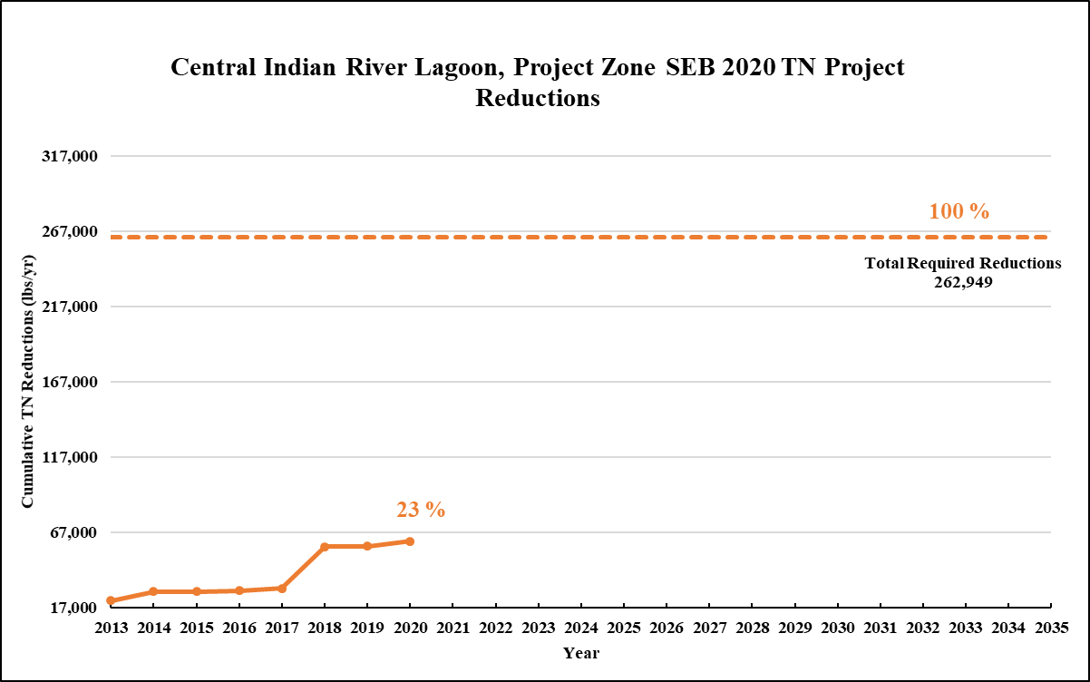
Figure 15. Estimated progress towards meeting the Required TN Reductions allocated to Project Zone SEB with projects completed through July 31, 2020
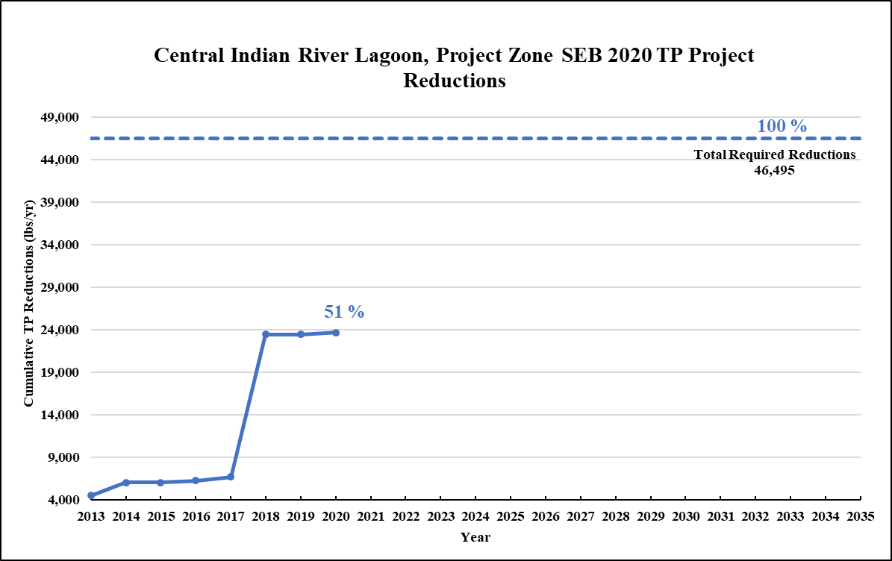
Figure 16. Estimated progress towards meeting the Required TP Reductions allocated to Project Zone SEB with projects completed through July 31, 2020

Existing and Planned Projects
Table 22 summarizes the existing and planned projects provided by the stakeholders for Project Zone SEB.
Table 22. Existing and planned projects in Project Zone SEB
Lead Entity | Partners | Project Number | Project Name | Project Description | Project Type | Project Status | Estimated Completion Date | TN Reduction (lbs/yr) | TP Reduction (lbs/yr) | Acres Treated | Cost Estimate | Cost Annual O&M | Funding Source | Funding Amount | DEP Contract Agreement Number
Brevard County | N/A | BC-04 | Church Street Pond Cleanout | Removed vegetation from pond. | BMP Cleanout | Completed | 2014 | 137 | 26 | 172 | Not provided | Not provided | County | Not provided | N/A
Brevard County | W. Melbourne/ Grant-Valkaria/ Malabar/ Melbourne/ Cocoa/ IHB/ Sat. Beach/ Cocoa Beach/ Cape Canaveral | BC-05a | Education Efforts | FYN, fertilizer and pet waste ordinances, public service announcements (PSAs), pamphlets, website, illicit discharge program. | Education Efforts | Ongoing | N/A | 3,127 | 466 | N/A | N/A | N/A | County | N/A | N/A
Brevard County | N/A | BC-06a | Street Sweeping | Remove debris from 786 linear feet of curb street throughout the county. | Street Sweeping | Ongoing | N/A | 58 | 37 | N/A | N/A | N/A | N/A | N/A | N/A
Brevard County | SJRWMD | BC-08 | Wheeler Properties (Sebastian River Improvements) | Wet detention pond and wetland enhancement. | Wet Detention Pond | Completed | 2012 | TBD | TBD | 16,404 | $3,500,000 | $2,000 | DEP | Not provided | S0436
Brevard County | N/A | BC-09 | Micco I | Exfiltration and denitrification. | BMP Treatment Train | Completed | 2016 | 40 | 6 | 52 | $175,599 | $1,000 | DEP | DEP - $355,304 | G0358
Brevard County | N/A | BC-10 | Micco B | Not provided. | Dry Detention Pond | Canceled | N/A | 41 | 6 | N/A | N/A | N/A | N/A | N/A | N/A
Brevard County | N/A | BC-11 | Mockingbird Pond | Installation of a floating vegetated island in an existing stormwater retention pond to provide additional nutrient removal. | Floating Islands/ Managed Aquatic Plant Systems (MAPS) | Completed | 2017 | 23 | 3 | 27 | $10,923 | $1,350 | DEP | Not provided | G0430
Brevard County | N/A | BC-12 | Church Street Pond MAPS | Installation of a floating vegetated island in an existing stormwater retention pond to provide additional nutrient removal. | Floating Islands/ Managed Aquatic Plant Systems (MAPS) | Completed | 2010 | 135 | 21 | 172 | $4,212 | $2,106 | N/A | N/A | N/A
Brevard County | DEP | BC-13 | Wheeler Flemming Grant | Construction of a wet detention pond that will help remove nitrogen and phosphorus from the stormwater adjacent to Fleming Grant Road in southeastern Brevard County. | Wet Detention Pond | Completed | 2016 | 553 | 182 | 134 | $645,073 | $2,000 | DEP | DEP - $591,081 | G0396
Brevard County | DEP | BC-20a | Multiple Ditch Outfall Denitrification D3 | Providing base flow/groundwater treatment in 20 open drainage basins. Each Project will have its own number | Denitrification Walls | Underway | TBD | TBD | TBD | TBD | N/A | TBD | DEP | TBD | LP0511A
Brevard County | SOIRL | BC-26 | Flemming Grant BAM - BB#2134 | Adding a media to remove nitrogen by denitrification. The media will be added to the side slope of the pond or the bottom of the swale. | Biosorption Activated Media (BAM) | Underway | 2020 | TBD | TBD | TBD | $181,000 | Not provided | LF/SOIRL | $91,588 | N/A
Brevard County | Not provided | BC-28 | Long Point Park Denitrification | Denitrification wall to remove nitrogen from the groundwater flowing from campground rapid infiltration wet pond into IRL | Denitrification Walls | Completed | 2017 | TBD | TBD | TBD | $101,854 | Not provided | SOIRL | SOIRL - $22,206.73 | N/A
Brevard County | Not provided | BC-31 | Education Efforts | Fertilizer, grass clippings, and septic system maintenance | Enhanced Public Education | Underway | 2017 | N/A | N/A | TBD | $375,000 | Not provided | SOIRL | SOIRL - $375,000 | N/A
Brevard County | Not provided | BC-32 | Babcock @C54 - BB#2258 | Adding a media to remove nitrogen by denitrification. The media will be added to the side slope of the pond or the bottom of the swale. | Biosorption Activated Media (BAM) | Underway | 2020 | TBD | TBD | TBD | $84,999 | TBD | LF | LF - $35,000 | Not provided
City of Fellsmere | Fellsmere WCD | F-01 | State Street Improvements and Stormwater Lake Project | Not provided. | Wet Detention Pond | Completed | Prior to 2013 | 79 | 22 | 50 | Not provided | Not provided | Not provided | Not provided | N/A
City of Fellsmere | N/A | F-02 | Senior League Field Park Improvements | Not provided. | Wet Detention Pond | Completed | 2008 | 4 | 1 | 12 | Not provided | Not provided | Not provided | Not provided | N/A
City of Fellsmere | N/A | F-03 | City Hall/Orange Street Project | Not provided. | Wet Detention Pond | Completed | 2018 | 4 | 1 | 8 | Not provided | Not provided | Not provided | Not provided | N/A
City of Fellsmere | N/A | F-04 | Sunrise Apartments Phase 1 & 2 | Not provided. | Wet Detention Pond | Completed | 2009 | 12 | 5 | 36 | Not provided | Not provided | Not provided | Not provided | N/A
City of Fellsmere | Fellsmere WCD | F-05 | Grace Meadows Subdivision | Not provided. | Wet Detention Pond | Completed | 2009 | 4 | 2 | 18 | Not provided | Not provided | Not provided | Not provided | N/A
City of Fellsmere | N/A | F-07 | Solid Waste Transfer Station | Not provided. | Wet Detention Pond | Completed | 2008 | 1 | 0 | 5 | Not provided | Not provided | Not provided | Not provided | N/A
City of Fellsmere | N/A | F-08 | Fertilizer Ordinance | Ordinance. | Regulations, Ordinances, and Guidelines | Ongoing | N/A | 53 | 8 | N/A | N/A | N/A | N/A | N/A | N/A
City of Fellsmere | SJRWMD/ Property Owner | F-09 | North Regional Lake | Not provided. | Wet Detention Pond | Completed | 2017 | 1,512 | 456 | 22 | $615,000 | $10,000 | SJRWMD | SJRWMD - $500,000 | N/A
City of Fellsmere | SJRWMD/ Property Owner | F-10 | South Regional Lake | Created wetland flow through system. | BMP Treatment Train | Planned | 2019 | 3,025 | 797 | 450 | $787,187 | $5,000 | SJRWMD | SJRWMD - $500,000 | N/A
City of Fellsmere | N/A | F-11 | Alleyway Grading | Convert alleyway system into stormwater treatment system. | Grass swales without swale blocks or raised culverts | Planned | TBD | TBD | TBD | 640 | $1,260,000 | $20,000 | City/ Grants | TBD | N/A
City of Fellsmere | N/A | F-12 | Stormwater Greenway | Convert unused rights-of-way into stormwater greenways. | Bioswales | Planned | TBD | TBD | TBD | 220 | $1,750,000 | $30,000 | City/ Grants | TBD | N/A
City of Fellsmere | N/A | F-13 | Additional Regional Treatment | Lake or treatment train system (additional 40 acres required). | Wet Detention Pond | Planned | TBD | TBD | TBD | 220 | $2,080,000 | $50,000 | City/ Grants | TBD | N/A
City of Fellsmere | N/A | F-14 | Road culverts, stormwater conveyance, paving | Reconstruct road culverts, stormwater conveyance, paving | Grass swales without swale blocks or raised culverts | Planned | TBD | TBD | TBD | TBD | ######## | TBD | City/ Grants | TBD | N/A
City of Fellsmere | N/A | F-15 | Micro system basins | Construct micro system basins for stormwater treatment | BMP Treatment Train | Planned | TBD | TBD | TBD | TBD | $1,000,000 | TBD | City/ Grants | TBD | N/A
City of Fellsmere | N/A | F-16 | Stormwater data inventory | Develop stormwater data inventory system | Study | Completed | 2018 | N/A | N/A | N/A | $15,000 | N/A | City Stormwater Fund | City Stormwater Fund - $15,000 | N/A
City of Fellsmere | IRL NEP | F-17 | 259 S. Pine Stormwater | Construct swale conveyances, dry retention and control structures for micro basin | Dry Detention Pond | Planned | 2019 | 37 | 5 | 7 | $130,000 | $5,000 | City/ Grants | $50,000 | N/A
City of Fellsmere | IRL NEP | F-18 | Stormwater Greenway | Convert unused rights-of-way into stormwater greenways. | Creating/ Enhancing Living Shoreline | Planned | 2019 | TBD | TBD | 22 | $5,000 | $2,500 | City/ Grants | $5,000 | N/A
City of Fellsmere | Not provided | F-18 | 97th Street Flood Control | Not provided. | BMP Treatment Train | Planned | TBD | TBD | TBD | 107 | Not provided | Not provided | Not provided | Not provided | Not provided
City of Palm Bay | N/A | PB-35 | Education Efforts | FYN, ordinances, pamphlets, PSAs, website, illicit discharge program. | Education Efforts | Ongoing | N/A | 185 | 25 | N/A | N/A | N/A | N/A | N/A | N/A
City of Sebastian | N/A | SEB-01 | Main Street/Indian River Drive Improvements | Not provided. | Dry Detention Pond | Completed | 2009 | 6 | 1 | 6 | Not provided | Not provided | Not provided | Not provided | N/A
City of Sebastian | N/A | SEB-02 | Main Street 4 | Not provided. | Dry Detention Pond | Canceled | N/A | N/A | N/A | N/A | N/A | N/A | N/A | N/A | N/A
City of Sebastian | N/A | SEB-03 | T-Hangar Development/Access Roads | Not provided. | Dry Detention Pond | Completed | 2004 | 2 | 0 | 2 | Not provided | Not provided | Not provided | Not provided | N/A
City of Sebastian | N/A | SEB-04 | Louisiana Avenue Improvements Projects | Not provided. | Dry Detention Pond | Completed | 2004 | 3 | 0 | 3 | Not provided | Not provided | Not provided | Not provided | N/A
City of Sebastian | N/A | SEB-05 | Twin Ditches Stormwater Retrofit | Not provided. | Wet Detention Pond | Completed | 2007 | 241 | 127 | 177 | Not provided | Not provided | Not provided | Not provided | N/A
City of Sebastian | N/A | SEB-06 | Indian River Drive & Davis Street Baffle Box | Not provided. | Baffle Boxes- First Generation | Completed | 2009 | 1 | 1 | 22 | Not provided | Not provided | Not provided | Not provided | N/A
City of Sebastian | DEP | SEB-07 | Periwinkle Drive Stormwater | Not provided. | Wet Detention Pond | Completed | 2008 | 5 | 1 | 48 | Not provided | Not provided | DEP | Not provided | G0200
City of Sebastian | DEP | SEB-08 | Collier Canal Stormwater Retrofit | Not provided. | Wet Detention Pond | Completed | 2010 | 1,655 | 444 | 532 | Not provided | Not provided | DEP | Not provided | G0235
City of Sebastian | N/A | SEB-09 | Schumann Park Improvements | Not provided. | Dry Detention Pond | Completed | 2009 | 4 | 1 | 4 | Not provided | Not provided | Not provided | Not provided | N/A
City of Sebastian | N/A | SEB-10 | Fertilizer Ordinance | Ordinance. | Regulations, Ordinances, and Guidelines | Ongoing | N/A | 309 | 45 | N/A | N/A | N/A | N/A | Not provided | N/A
City of Sebastian | N/A | SEB-11 | Airport Drive | Not provided. | Baffle Boxes- First Generation | Canceled | N/A | N/A | N/A | N/A | N/A | N/A | N/A | N/A | N/A
City of Sebastian | N/A | SEB-12 | Presidential Street | Not provided. | Baffle Boxes- First Generation | Completed | 2014 | TBD | TBD | 15 | Not provided | Not provided | Not provided | Not provided | N/A
City of Sebastian | N/A | SEB-13 | Powerline Road | Not provided. | Baffle Boxes- First Generation | Completed | 2014 | TBD | TBD | 2 | Not provided | Not provided | Not provided | Not provided | N/A
City of Sebastian | N/A | SEB-14 | STEP Septic System | Not provided. | Onsite Sewage Treatment and Disposal System (OSTDS) Enhancement | Canceled | N/A | N/A | N/A | N/A | N/A | N/A | N/A | N/A | N/A
City of Sebastian | N/A | SEB-15 | Collier Canal Dredge | Not provided. | Muck Removal/Restoration Dredging | Canceled | N/A | N/A | N/A | 22 | Not provided | Not provided | Not provided | Not provided | N/A
City of Sebastian | N/A | SEB-16 | Stormwater Park | Not provided. | Wet Detention Pond | Completed | 2010 | TBD | TBD | 162 | Not provided | Not provided | Not provided | Not provided | N/A
City of Sebastian | N/A | SEB-17 | Presidential Street | Not provided. | Baffle Boxes- First Generation | Completed | 2012 | TBD | TBD | 24 | Not provided | Not provided | Not provided | Not provided | N/A
City of Sebastian | N/A | SEB-18 | Water Quality Testing | Not provided. | Monitoring/Data Collection | Canceled | N/A | N/A | N/A | 24 | Not provided | Not provided | Not provided | Not provided | N/A
City of Sebastian | N/A | SEB-19 | Drainage Improvements | Not provided. | BMP Treatment Train | Completed | 2016 | TBD | TBD | 1 | Not provided | Not provided | Not provided | Not provided | N/A
City of Sebastian | N/A | SEB-20 | Tulip Drainage | Not provided. | On-line Retention BMPs | Completed | 2016 | TBD | TBD | 4 | Not provided | Not provided | Not provided | Not provided | N/A
City of Sebastian | N/A | SEB-21 | Septic to Sewer | 22 septic systems converted to central sewer. | OSTDS Phase Out | Underway | Not provided | TBD | TBD | TBD | Not provided | Not provided | Not provided | Not provided | N/A
City of Sebastian | N/A | SEB-22 | Oyster Point Exfiltration Trench | Exfiltration Trench. | Exfiltration Trench | Completed | 2018 | TBD | TBD | TBD | TBD | TBD | TBD | TBD | N/A
City of Sebastian | IRL Council | SEB-23 | Community Oyster Garden Project | Community Oyster Garden Outreach Education Project | Education Efforts | Underway | Not provided | N/A | N/A | TBD | TBD | TBD | IRL Council | TBD | N/A
FDACS | Agricultural Producers | FDACS-03 | BMP Implementation and Verification | Enrollment and verification of BMPs by agricultural producers. Acres treated based on FDACS OAWP July 2020 Enrollment and FSAID VII. Reductions based on SWIL Model-LET. | Agricultural BMPs | Ongoing | N/A | 10,233 | 1,338 | 2,196 | TBD | TBD | FDACS | TBD | N/A
FDACS | Agricultural Producers | FDACS-06 | FDACS Cost Share Projects | Cost-share projects paid for by FDACS. Acres treated based on FDACS OAWP July 2020 Enrollment. Reductions based on SWIL Model-LET. | Agricultural BMPs | Completed | 2020 | 3,324 | 187 | TBD | TBD | N/A | FDACS | TBD | N/A
SJRWMD | Banack Family Partnership | SJRWMD-02 | Banack Family Partnership | Upgrade irrigation system to better utilize surface water on approximately 80 acres of citrus. | Agricultural BMPs | Completed | 2019 | 167 | 14 | 80 | $277,388 | N/A | Banack Family Partnership/ SJRWMD | Banack Family Partnership - $69,347/ SJRWMD - $208,041 | N/A
SJRWMD | IMG Citrus | SJRWMD-03 | IMG Citrus Inc. | Purchase of compost and compost spreader for approximately 920 acres of citrus. | Agricultural BMPs | Underway | 2020 | 3,628 | 794 | 524 | $175,959 | N/A | IMG Citrus/ SJRWMD | IMG Citrus - $43,990/ SJRWMD - $131,969 | N/A
SJRWMD | Hammon Groves | SJRWMD-04 | Hammond Groves Inc. | Design and install a surface water pump station, design and complete a pond restoration project and purchase and install mesh bags for citrus trees on approximately 400 acres of citrus. | Agricultural BMPs | Underway | 2020 | 2,195 | 199 | 400 | $363,491 | N/A | Hammond Groves/ SJRWMD | Hammond Groves - $113,491/ SJRWMD - $250,000 | N/A
SJRWMD | Fellsmere Joint Venture | SJRWMD-07 | Dispersed Water Storage / Nutrient Reduction Pilot Project with Fellsmere Joint Venture | The District is evaluating benefits of using groves and private lands for retention to reduce excess nutrients. Project will create a ~2000 acre reservoir that should store about 18 mgd and reduce ~24 metric tons (mt) TN and 3 MT TP annually. | Dispersed Water Management | Underway | 2022 | TBD | TBD | Not provided | ######## | Not provided | Ad Valorem | Not provided | N/A
SJRWMD | Graves Brothers | SJRWMD-08 | Dispersed Water Storage / Nutrient Reduction Pilot Project with Graves Brothers | The District is evaluating benefits of using groves and private lands for retention to reduce excess nutrients. Project will create a ~200 acre reservoir that should store about 5 mgd and provide nutrient reductions of ~ 3 mt TN and 1 MT TP annually. | Dispersed Water Management | Underway | 2021 | TBD | TBD | Not provided | $5,655,000 | Not provided | Ad Valorem | Not provided | N/A
SJRWMD | FWC/ NRCS | SJRWMD-09 | Fellsmere Water Management Area | A component of the Upper St. Johns River Basin Project constructing a 10,000-acre reservoir to treat agricultural discharges and also benefits the IRL. Project will collectively restore more than 160,000 acres of the St. Johns River headwaters. | Stormwater Reuse/ Wet Detention Pond | Underway | 2021 | TBD | TBD | Not provided | ######## | Not provided | Ad Valorem/ FWC/ NRCS | Not provided | Not provided
SJRWMD | FDOT/ Brevard County | SJRWMD-10 | Micco Stormwater Park | Two wet‐detention ponds and wetland restoration areas, which improve the water quality to the Sebastian River and IRL. The stormwater system infrastructure was complete in 2016 and the park opened in 2018 with educational signs and other site amenities. | Regional Stormwater Treatment | Completed | 2018 | 27,200 | 16,750 | Not provided | $2,816,603 | Not provided | Ad Valorem/ FDOT/ Brevard County | Not provided | N/A
FDOT District 4 | N/A | FDOT4-03 | FM# 228615-1 | Resurfacing SR 5 between CR 510 to just south of Harrison Street. | Baffle Boxes- Second Generation | Completed | 2007 | 108 | 12 | 289 | Not provided | Not provided | Florida Legislature | Not provided | N/A
FDOT District 4 | N/A | FDOT4-04a | FDOT4 Street Sweeping | Materials from roadway and gutter sweeping. | Street Sweeping | Ongoing | N/A | 76 | 49 | N/A | Not provided | Not provided | Florida Legislature | Not provided | N/A
FDOT District 4 | N/A | FDOT4-09a | Education Efforts | Pamphlets and Illicit Discharge Program. | Education Efforts | Ongoing | N/A | 20 | 2 | N/A | N/A | N/A | Florida Legislature | N/A | N/A
FDOT District 4 | N/A | FDOT4-10a | Fertilizer Cessation | No longer applying routine fertilizer. | Fertilizer Cessation | Completed | 2014 | 6,045 | 1,511 | N/A | Not provided | Not provided | Florida Legislature | Not provided | N/A
FDOT District 4 | N/A | FDOT4-21a | FM#: 413048-1 (Interstate-95 from St. Lucie/ Indian River County Line to North of State Road 60) | Widening SR 9 from St. Lucie / IRC Line to North of State Rd 60. | 100% On-site Retention | Completed | 2016 | 36 | 4 | 33 | Not provided | Not provided | Florida Legislature | Not provided | N/A
FDOT District 4 | N/A | FDOT4-22 | FM# 411476-1 (Sebastian River Bridge Replacement Project) | SR A1A Sebastian River Bridge replacement. | Grass swales without swale blocks or raised culverts | Completed | 2014 | 0 | 0 | 2 | Not provided | Not provided | Florida Legislature | Not provided | N/A
FDOT District 4 | N/A | FDOT4-23 | FM# 413049-2 | Widening SR 9 from North of SR 60 to Indian River/ Brevard County line. | Grass swales without swale blocks or raised culverts | Completed | 2018 | 554 | 0 | 883 | Not provided | Not provided | Florida Legislature | Not provided | N/A
FDOT District 4 | N/A | FDOT4-35A | FM# 431152-1 | US-1 lateral ditch restoration. | On-line Retention BMPs | Completed | 2016 | TBD | TBD | TBD | Not provided | Not provided | Florida Legislature | Not provided | N/A
FDOT District 5 | N/A | FDOTD5-14a | Education Efforts | Pamphlets, Illicit Discharge Program. | Education Efforts | Ongoing | N/A | 33 | 4 | N/A | Not provided | Not provided | Florida Legislature | N/A | N/A
Fellsmere WCD | Sunrise Villas | FWCD-01 | Sunrise Villas | Pond designed per two-inch/day limitation rule. | Wet Detention Pond | Completed | 2003 | 5 | 2 | 14 | TBD | TBD | Private | TBD | N/A
Fellsmere WCD | SJRWMD/ Indian River County/ State | FWCD-02 | St. Johns Land Purchase | Conservation land. | Land Use Change | Completed | Prior to 2013 | N/A | N/A | 2,391 | TBD | TBD | SJRWMD | TBD | N/A
Fellsmere WCD | City of Fellsmere/ SJRWMD | FWCD-03 | Fellsmere Stormwater Lake and State Street Improvements | Stormwater retrofit improvements. Reduction split 50/50 with the City of Fellsmere. | Wet Detention Pond | Completed | 2003 | 76 | 21 | 50 | TBD | TBD | SJRWMD/ Fellsmere WCD | TBD | N/A
Fellsmere WCD | Indian River County Habitat for Humanity | FWCD-04 | Grace Meadows | Pond designed per two-inch/day limitation rule. Reductions split 50/50 with City of Fellsmere. | Wet Detention Pond | Completed | 2009 | 2 | 1 | 18 | TBD | TBD | Private | TBD | N/A
Fellsmere WCD | N/A | FWCD-05 | 2-Inch Limitation Discharges | Establishment of two-inch discharge rule. | Regulations, Ordinances, and Guidelines | Ongoing | N/A | TBD | TBD | N/A | N/A | N/A | N/A | N/A | N/A
Fellsmere WCD | N/A | FWCD-06 | Fellsmere WCD Mechanical Canal Maintenance | Canal cleaning/maintenance. | Stormwater System Rehabilitation | Ongoing | N/A | N/A | N/A | N/A | TBD | TBD | Fellsmere WCD | TBD | N/A
Fellsmere WCD | City of Fellsmere | FWCD-07 | Historic Fellsmere Master Drainage Plan | Stormwater retrofit improvements. Reductions will be split with the City of Fellsmere once determined. | Regional Stormwater Treatment | Planned | TBD | TBD | TBD | 1,661 | TBD | TBD | Fellsmere WCD/ City of Fellsmere | TBD | N/A
Fellsmere WCD | City of Fellsmere/ SJRWMD | FWCD-08 | South Regional Lake | Created wetland flow through system. Reductions to be split with the City of Fellsmere once determined. | BMP Treatment Train | Underway | TBD | TBD | TBD | 627 | TBD | TBD | SJRWMD/ City of Fellsmere | TBD | N/A
Fellsmere WCD | City of Fellsmere/ SJRWMD | FWCD-09 | North Regional Lake | Reductions to be split with the City of Fellsmere once determined. | Wet Detention Pond | Completed | 2018 | TBD | TBD | 367 | TBD | TBD | SJRWMD | TBD | N/A
Fellsmere WCD | Fellsmere Joint Venture (FJV)/ SJRWMD | FWCD-10 | Water Dispersion Project | Construction of berms and two pump stations to remove water from outfall canals and store on land. | Dispersed Water Management (DWM) | Planned | TBD | TBD | TBD | TBD | TBD | TBD | SJRWMD | TBD | N/A
Fellsmere WCD | N/A | FWCD-11 | Public Education and Outreach | Provide public education to residents of the District that fosters an understanding of the necessity to reduce  nutrient impacts to surface waters. | Education Efforts | Ongoing | N/A | N/A | N/A | N/A | Not provided | Not provided | Not provided | Not provided | Not provided
Fellsmere WCD | N/A | FWCD-12 | Assist FDACS with BMP Enrollment Outreach | Assist FDACS, where needed, with identifying and contacting landowners/ producers within the District boundaries for purposes of participating in the relevant FDACS BMP programs. | Agricultural BMPs | Ongoing | N/A | N/A | N/A | N/A | Not provided | Not provided | Not provided | Not provided | Not provided
Indian River County | DEP | IRC-01 | Vero Lake Estates Stormwater Improvements - Phase 1 | Series of swales and canals in a large development leading to large stormwater detention ponds. | Wet Detention Pond | Completed | 2002 | 7,655 | 1,993 | 2,407 | $1,572,829 | Not provided | DEP | Not provided | WM803
Indian River County | DEP | IRC-02 | East Roseland Stormwater Improvements | A stormwater detention pond receiving water from swale systems in a subdivision. | Wet Detention Pond | Completed | 2005 | 216 | 58 | 74 | $433,134 | $2,176 | DEP | Not provided | G0061
Indian River County | N/A | IRC-07a | Moorhen Marsh Low Energy Aquatic Plant System | This is a managed aquatic plant system that will remove sediment and suspended solids through settling and filtration by aquatic plant roots. The aquatic plants will be harvested on a regular basis. | Floating Islands/ Managed Aquatic Plant Systems (MAPS) | Underway | 2021 | 52 | 7 | 6,301 | $8,705,000 | $84,000 | County/ SJRWMD/Florida Legislature | Not provided | LPA0018
Indian River County | N/A | IRC-08a | Education Efforts | Fertilizer ordinance, PSAs, website, pamphlets, Illicit Discharge Program, and signs along Indian River Farms WCD canals. | Education Efforts | Ongoing | N/A | 5,277 | 762 | N/A | N/A | $52,000 | Not provided | Not provided | N/A
Indian River County | N/A | IRC-09a | Street Sweeping | Street sweeping. | Street Sweeping | Ongoing | N/A | 91 | 59 | N/A | Not provided | $22,050 | Not provided | Not provided | N/A
Indian River County | N/A | IRC-10a | Storm Drain Cleaning with Vacuum Trucks | Nutrient removal from measured data. | BMP Cleanout | Planned | TBD | TBD | TBD | TBD | TBD | $19,067 | TBD | TBD | N/A
Indian River County | N/A | IRC-11a | Floating Aquatic Plant Islands in County Stormwater Ponds and Lakes | Nutrient removal from measured data. | Floating Islands/ Managed Aquatic Plant Systems (MAPS) | Planned | TBD | TBD | TBD | TBD | TBD | TBD | TBD | TBD | N/A
Indian River County | N/A | IRC-13 | North Relief Canal Mechanical Vegetation/Debris Removal | Removal of aquatic vegetation containing nitrogen and phosphorus that otherwise, would enter IRL and die, releasing nutrients into the lagoon. | Aquatic Vegetation Harvesting | Planned | TBD | TBD | TBD | 6,301 | $1,000,000 | $50,000 | County/ Grants | TBD | N/A
Sebastian River Improvement District | N/A | SRID-01 | 2-Inch Rule | Establishment of two-inch discharge rule. | Regulations, Ordinances, and Guidelines | Ongoing | N/A | N/A | N/A | N/A | N/A | N/A | N/A | N/A | N/A
Sebastian River Improvement District | Not provided | SRID-02 | Control Gates | Radial arm control gates. | Control Structure | Planned | TBD | TBD | TBD | 9,000 | TBD | TBD | SRID | TBD | N/A
Sebastian River Improvement District | N/A | SRID-03 | Muck Removal | Vegetation and sediment/muck removal from canals. | Stormwater System Rehabilitation | Ongoing | N/A | Not provided | Not provided | Not provided | Not provided | Not provided | SRID | Not provided | N/A
Sebastian River Improvement District | N/A | SRID-04 | Education Efforts | Permit manual on website that encourages the use of BMPs. | Education Efforts | Ongoing | N/A | N/A | N/A | N/A | N/A | N/A | N/A | N/A | N/A
Sebastian River Improvement District | N/A | SRID-05 | Water Conservation | Large regional water conservation/ storage areas. | Off-line Retention BMPs | Planned | TBD | TBD | TBD | TBD | TBD | TBD | SRID | TBD | N/A
Sebastian River Improvement District | Groves Brothers/ SJRWMD | SRID-06 | 200-Acre Water Dispersion Project | Construction of berms and two pump stations to remove water from outfall canals and store on land. | Dispersed Water Management (DWM) | Underway | 2020 | TBD | TBD | 7,700 | $5,650,000 | TBD | SJRWMD | SJRWMD - $5,650,000 | N/A
Sebastian River Improvement District | N/A | SRID-07 | Lateral D System Stormwater Management | Lateral D system stormwater discharge limitation. | Regulations, Ordinances, and Guidelines | Planned | TBD | N/A | N/A | N/A | N/A | N/A | N/A | N/A | N/A
Sebastian River Improvement District | FDACS | SRID-08 | Assist FDACS with BMP Enrollment Outreach | Assist FDACS, where needed, with identifying and contacting producers within the district boundaries for purposes of participating in the relevant FDACS BMP programs. | Agricultural BMPs | Ongoing | N/A | N/A | N/A | N/A | Not provided | Not provided | Not provided | Not provided | Not provided
Vero Lakes WCD | N/A | VL-01 | Public Education and Outreach | Include annual meeting agenda item to alert the landowner of the existence of the BMAP and requirements for this landowner. | Education Efforts | Ongoing | N/A | N/A | N/A | N/A | Not provided | Not provided | Not provided | Not provided | Not provided
Vero Lakes WCD | FDACS | VL-02 | Assist FDACS with BMP Enrollment Outreach | Identify the current landowner and his contact information as shown on the VLWCD records, and encourage participation in the FDACS BMP program. | Agricultural BMPs | Ongoing | N/A | N/A | N/A | N/A | Not provided | Not provided | Not provided | Not provided | Not provided
Vero Lakes WCD | N/A | VL-03 | Canal/Ditch Bank Berms | Minimize sediment transport by constructing berms on top of canal/ditch banks and promoting vegetation to cover. | Vegetated Buffers | Underway | N/A | N/A | N/A | N/A | Not provided | Not provided | Not provided | Not provided | Not provided
Vero Lakes WCD | N/A | VL-04 | Culverts | Regular inspection is made to insure flow is maintained through culverts. | Stormwater System Rehabilitation | Ongoing | N/A | N/A | N/A | N/A | Not provided | Not provided | Not provided | Not provided | Not provided

CIRL B
Project Zone B covers more than 68,938 acres of the CIRL BMAP area. As listed in Table 23, urban land uses makes up the majority of the project zone with 55.6 % of the area, followed by agriculture with 19.3 %. Stakeholders in Project Zone B are agricultural producers, City of Vero Beach, FDOT District 4, Fort Pierce Farms WCD, Indian River County, Indian River Farms WCD, and Town of Indian River Shores.
Table 23. Summary of land uses in Project Zone B
Note: Land use code 5000 (water) acreage excludes lagoon water in this table.
Level 1  Land Use Code | Land Use Description | Acres | % Total
1000 | Urban | 38,344 | 55.6
2000 | Agricultural | 13,308 | 19.3
3000 | Upland Prairie and Shrublands | 5,984 | 8.7
4000 | Upland Forested Areas | 4,456 | 6.5
5000 | Water | 1,229 | 1.8
6000 | Wetlands | 2,383 | 3.5
7000 | Disturbed Lands | 929 | 1.3
8000 | Transportation | 2,301 | 3.3
9000 | Open Lands | 3 | 0.0
Total |  | 68,938 | 100.0

DEP asked stakeholders to provide information on management actions, including projects, programs, and activities, that may reduce nutrient loads to the CIRL. Management actions are included in the BMAP to address nutrient loads to the lagoon and have to meet several criteria to be considered eligible for credit. Figure 17 and Figure 18 show progress towards the required TN and TP load reductions allocated to Project Zone B from projects completed through July 31, 2020.
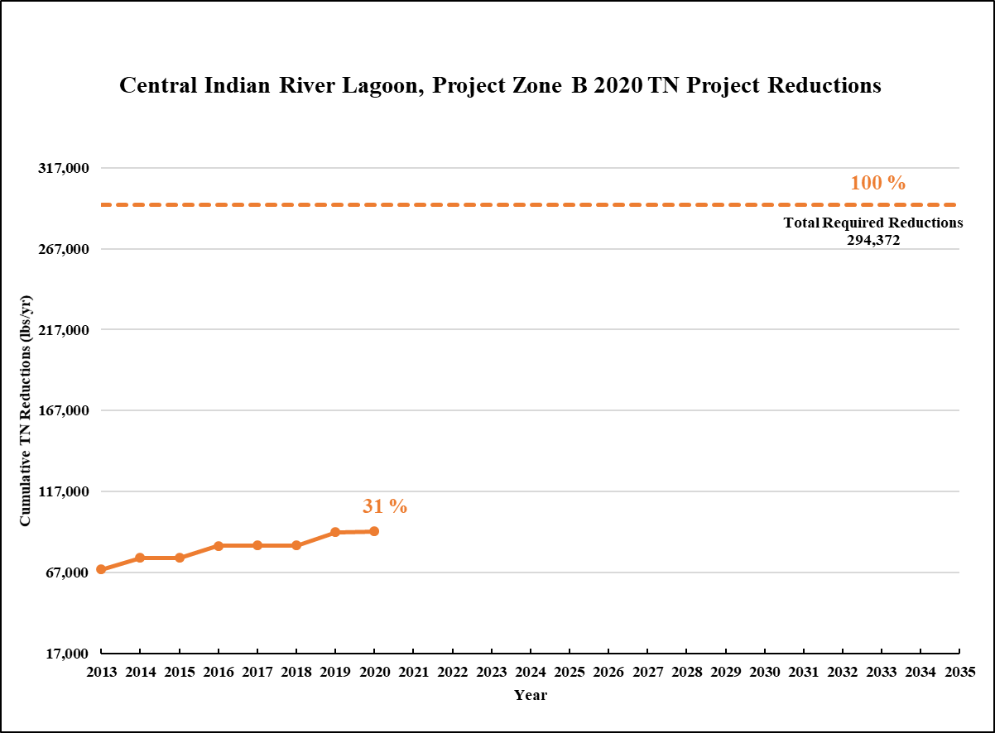
Figure 17. Estimated progress towards meeting the Required TN Reductions allocated to Project Zone B with projects completed through July 31, 2020
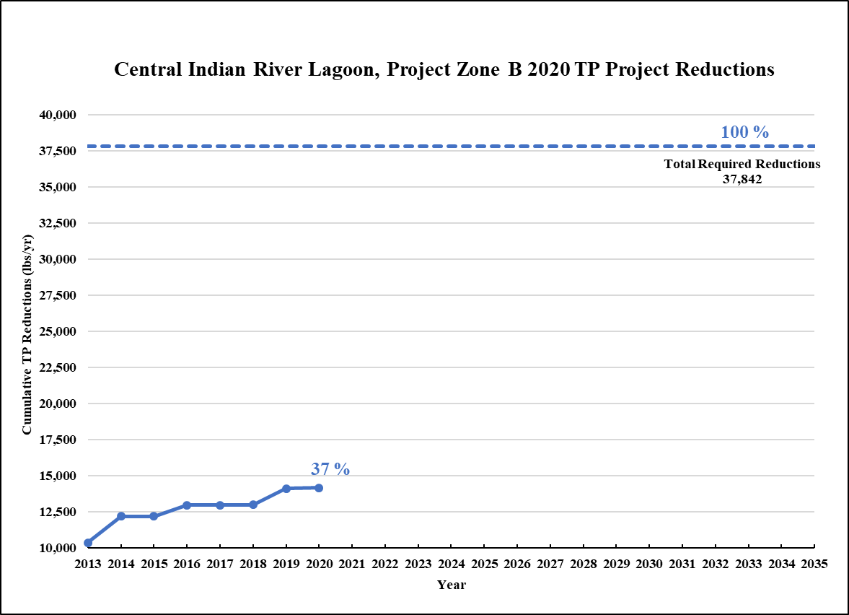
Figure 18. Estimated progress towards meeting the Required TP Reductions allocated to Project Zone B with projects completed through July 31, 2020

Existing and Planned Projects
Table 24 summarizes the existing and planned projects provided by the stakeholders for Project Zone B.
Table 24. Existing and planned projects in Project Zone B
Lead Entity | Partners | Project Number | Project Name | Project Description | Project Type | Project Status | Estimated Completion Date | TN Reduction (lbs/yr) | TP Reduction (lbs/yr) | Acres Treated | Cost Estimate | Cost Annual O&M | Funding Source | Funding Amount | DEP Contract Agreement Number
City of Vero Beach | DEP | VB-01 | Date Palm Baffle Box | Suntree baffle box with Bold and GoldTM media. | Baffle Boxes- Second Generation | Completed | 2017 | 109 | 13 | 7 | $200,232 | $1,000 | COVB/ DEP | COVB - $128,966.54/ DEP - $71,265.73 | G0242
City of Vero Beach | N/A | VB-02 | 10th and 12th Avenue Baffle Boxes | Includes ESI Ecovault® with a debris collection screen and baffle. | Baffle Boxes- Second Generation | Completed | 2011 | 135 | 16 | 70 | $97,800 | $1,000 | COVB | Not provided | N/A
City of Vero Beach | N/A | VB-03 | Greytwig Baffle Box | Includes ESI Ecovault® with a debris collection screen and baffle. | Baffle Boxes- Second Generation | Completed | 2011 | 51 | 6 | 10 | $75,000 | $1,000 | COVB | Not provided | N/A
City of Vero Beach | N/A | VB-04 | Education Efforts | FYN, landscape, fertilizer, irrigation, and pet waste ordinances, PSAs, informational pamphlets, website, and IDDE program. | Regulations, Ordinances, and Guidelines | Ongoing | N/A | 2,925 | 423 | N/A | N/A | N/A | N/A | N/A | N/A
City of Vero Beach | N/A | VB-05 | STEP Septic System | Conversion of existing septic systems to septic tank effluent pumping (STEP) systems. | Onsite Sewage Treatment and Disposal System (OSTDS) Enhancement | Underway | TBD | TBD | N/A | N/A | $500,000 | Not provided | COVB | Not provided | N/A
City of Vero Beach | DEP | VB-06 | 18th Street Outfall | Not provided. | Baffle Boxes- Second Generation | Completed | 2013 | 255 | 32 | 131 | $161,511 | Not provided | COVB/ DEP | COVB - $61,511.01/ DEP - $100,000.00 | G0356
City of Vero Beach | DEP | VB-07 | Humiston Park Outfall | Not provided. | Exfiltration Trench | Completed | 2010 | Not provided | Not provided | 40 | $577,313 | Not provided | COVB/ DEP | COVB - $241,312.77/ DEP - $336,000.00 | G0228
City of Vero Beach | N/A | VB-08 | Bahia Mar Road Outfall | Not provided. | Baffle Boxes- Second Generation | Completed | 2012 | 23 | 3 | 13 | Not provided | Not provided | COVB | Not provided | N/A
City of Vero Beach | N/A | VB-09 | Bay Drive Bridge | Not provided. | Baffle Boxes- Second Generation | Completed | 2010 | 3 | 0 | 2 | Not provided | Not provided | COVB | Not provided | N/A
City of Vero Beach | N/A | VB-10 | Indian Bay North and South | Not provided. | Baffle Boxes- Second Generation | Completed | 2012 | 21 | 3 | 20 | Not provided | Not provided | COVB | Not provided | N/A
City of Vero Beach | N/A | VB-11 | Live Oak Outfall | Not provided. | Baffle Boxes- Second Generation | Completed | 2011 | 113 | 14 | 12 | Not provided | Not provided | COVB | Not provided | N/A
City of Vero Beach | N/A | VB-12 | Indian River Drive E at Conn Way | Not provided. | Baffle Boxes- Second Generation | Completed | 2012 | 71 | 8 | 69 | Not provided | Not provided | COVB | Not provided | N/A
City of Vero Beach | N/A | VB-13 | River Drive Bridge | Not provided. | Baffle Boxes- Second Generation | Completed | 2010 | 12 | 1 | 61 | Not provided | Not provided | COVB | Not provided | N/A
City of Vero Beach | N/A | VB-14 | Lantana Lane | Not provided. | Pervious Pavement Systems | Canceled | 2014 | N/A | N/A | 38 | Not provided | Not provided | COVB | Not provided | N/A
City of Vero Beach | N/A | VB-15 | Royal Palm Pointe | Not provided. | Baffle Boxes- First Generation | Completed | 2001 | 1 | 1 | Not provided | Not provided | Not provided | COVB | Not provided | N/A
City of Vero Beach | N/A | VB-16 | Deep Injection Well | Not provided. | Wastewater - Deep Injection Well | Completed | 2010 | 15,158 | 1,403 | Not provided | Not provided | Not provided | COVB | Not provided | N/A
City of Vero Beach | N/A | VB-17 | Street Sweeping | Street sweeper operating 40 hours per week and sweeping approximately 9,600 miles annually. | Street Sweeping | Ongoing | N/A | 683 | 430 | N/A | $253,000 | $76,800 | COVB | COVB-$253,000.00 | N/A
City of Vero Beach | N/A | VB-18 | Country Club Drive Outfall | Not provided. | Baffle Boxes- First Generation | Completed | 2016 | 1 | 0 | 21 | Not provided | Not provided | COVB | Not provided | N/A
City of Vero Beach | N/A | VB-19 | Mockingbird Drive / Iris Lane | Not provided. | Baffle Boxes- First Generation | Completed | 2016 | 3 | 2 | 69 | Not provided | Not provided | COVB | Not provided | N/A
City of Vero Beach | Indian River Lagoon Council | VB-20 | Vero Isles Inlet Retrofits | Not provided. | Pervious Pavement Systems | Completed | 2017 | TBD | TBD | 51 | $339,868 | Not provided | COVB/ IRL Council | COVB - $235,314.77/ IRL Council - $104,553.50 | N/A
City of Vero Beach | N/A | VB-23 | BMP Maintenance | Not provided. | Catch Basin Inserts/Inlet Filter Cleanout | Ongoing | N/A | 190 | 114 | Not provided | Not provided | Not provided | COVB | Not provided | N/A
FDACS | Agricultural Producers | FDACS-02 | BMP Implementation and Verification | Enrollment and verification of BMPs by agricultural producers. Acres treated based on FDACS OAWP July 2020 Enrollment and FSAID VII. Reductions based on SWIL Model-LET. | Agricultural BMPs | Ongoing | N/A | 2,163 | 352 | 10,576 | TBD | TBD | FDACS | TBD | N/A
FDACS | Agricultural Producers | FDACS-07 | FDACS Cost Share Projects | Cost-share projects paid for by FDACS. Acres treated based on FDACS OAWP July 2020 Enrollment. Reductions based on SWIL Model-LET. | Agricultural BMPs | Completed | 2020 | 575 | 44 | TBD | TBD | N/A | FDACS | TBD | N/A
SJRWMD | Lambeth Citrus | SJRWMD-01 | Lambeth Citrus Micro Jet Irrigation Replacement | Replace micro-jet system with more efficient one and install soil moisture sensors on 116 acres of citrus. | Agricultural BMPs | Completed | 2018 | 767 | 168 | 116 | $213,070 | N/A | Lambeth Citrus/ SJRWMD | Lambeth Citrus - $53,268 / SJRWMD - $159,803 | N/A
FDOT District 4 | N/A | FDOT4-01 | FM# 228595-1 (Basin 4B) | Widening SR 60 between SR 9 and SR 91. | Wet Detention Pond | Completed | 2007 | 3 | 2 | 229 | Not provided | Not provided | Florida Legislature | Not provided | N/A
FDOT District 4 | N/A | FDOT4-02 | FM# 228620-1 | Resurfacing SR 60 and SR A1A intersection. | 100% On-site Retention | Completed | 2005 | 20 | 3 | 16 | Not provided | Not provided | Florida Legislature | Not provided | N/A
FDOT District 4 | N/A | FDOT4-04 | FDOT4 Street Sweeping | Materials from roadway and gutter sweeping. | Street Sweeping | Ongoing | N/A | 90 | 58 | N/A | Not provided | Not provided | Florida Legislature | Not provided | N/A
FDOT District 4 | N/A | FDOT4-05 | FM# 228583-5 (Pond 1) | Widening SR 5 from just south of Oslo Road to South Relief Canal. | Wet Detention Pond | Completed | 2010 | 0 | 0 | 118 | Not provided | Not provided | Florida Legislature | Not provided | N/A
FDOT District 4 | N/A | FDOT4-06 | FM# 228583-5 (Pond 2) | Widening SR 5 from just south of Oslo Road to South Relief Canal. | Wet Detention Pond | Completed | 2010 | 0 | 0 | 52 | Not provided | Not provided | Florida Legislature | Not provided | N/A
FDOT District 4 | N/A | FDOT4-07 | FM# 228627-1 (Pond 1) | Widening SR 60 between 82nd Ave to 66th Ave. | Wet Detention Pond | Completed | 2010 | 2 | 3 | 149 | Not provided | Not provided | Florida Legislature | Not provided | N/A
FDOT District 4 | N/A | FDOT4-08 | FM# 228627-1 (Pond 2) | Widening SR 60 between 82nd Ave to 66th Ave. | Wet Detention Pond | Completed | 2010 | 3 | 2 | 89 | Not provided | Not provided | Florida Legislature | Not provided | N/A
FDOT District 4 | N/A | FDOT4-09 | Education Efforts | Pamphlets and Illicit Discharge Program. | Education Efforts | Ongoing | N/A | 36 | 5 | N/A | N/A | N/A | Florida Legislature | N/A | N/A
FDOT District 4 | N/A | FDOT4-10 | Fertilizer Cessation | No longer applying routine fertilizer. | Fertilizer Cessation | Completed | 2014 | 7,179 | 1,795 | N/A | Not provided | Not provided | Florida Legislature | Not provided | N/A
FDOT District 4 | N/A | FDOT4-18 | FM# 228583-3 (State Road 5/US-1) | Widening SR 5 from South Relief Canal to north of 4th Street. | Wet Detention Pond | Completed | 2014 | 0 | 0 | 92 | Not provided | Not provided | Florida Legislature | Not provided | N/A
FDOT District 4 | N/A | FDOT4-19 | FM#: 230873-1 (27th Avenue Reconstruction) | 27th Avenue reconstruction. | 100% On-site Retention | Completed | 2014 | 61 | 9 | 49 | Not provided | Not provided | Florida Legislature | Not provided | N/A
FDOT District 4 | N/A | FDOT4-20 | FM#: 229966-1 (State Road A1A at the Moorings) | Drainage Improvements for SR A1A at the Moorings (from north of Periwinkle Drive to south of Harbour Drive). | Grass swales without swale blocks or raised culverts | Completed | 2014 | Not provided | Not provided | 2 | Not provided | Not provided | Florida Legislature | Not provided | N/A
FDOT District 4 | N/A | FDOT4-21 | FM#: 413048-1 (Interstate-95 from St. Lucie/ Indian River County Line to North of State Road 60) | Widening SR 9 from St. Lucie / IRC Line to North of State Rd 60. | 100% On-site Retention | Completed | 2016 | 1,298 | 166 | 754 | Not provided | Not provided | Florida Legislature | Not provided | N/A
FDOT District 4 | N/A | FDOT4-29 | FM# 228583-2 US 1 Widening (Pond 3) | Widening SR 5 from north of SR 713 to south of Oslo Road (Pond 3). | Wet Detention Pond | Completed | 2016 | 46 | 3 | 194 | Not provided | Not provided | Florida Legislature | Not provided | N/A
FDOT District 4 | City of Vero Beach | FDOT4-30 | FM# 403596-1: SR 60 Resurfacing (20th Street Outfall) | Resurfacing SR 60 from 21st Ave to Mockingbird Drive (20th Street outfall). | Baffle Boxes- Second Generation | Completed | 2008 | 155 | 24 | 443 | Not provided | Not provided | Florida Legislature | Not provided | N/A
FDOT District 4 | City of Vero Beach | FDOT4-31 | FM# 403596-1: SR 60 Resurfacing (21st Street Outfall) | Resurfacing SR 60 from 21st Ave to Mockingbird Drive (21st Street outfall). | Baffle Boxes- Second Generation | Completed | 2008 | 28 | 4 | 107 | Not provided | Not provided | Florida Legislature | Not provided | N/A
FDOT District 4 | City of Vero Beach | FDOT4-32 | FM# 403596-1: SR 60 Resurfacing (23rd Street Outfall) | Resurfacing SR 60 from 21st Ave to Mockingbird Drive (23rd Street outfall). | Baffle Boxes- Second Generation | Completed | 2008 | 217 | 34 | 598 | Not provided | Not provided | Florida Legislature | Not provided | N/A
FDOT District 4 | City of Vero Beach | FDOT4-33 | FM# 403596-1: SR 60 Resurfacing (25th and Royal Palm outfall) - Baffle Boxes # 1 and # 2. | Resurfacing SR 60 from 21st Ave to Mockingbird Drive (25th Street and Royal Palm outfall) - Baffle Boxes #1 and #2. | Baffle Boxes- Second Generation | Completed | 2008 | 80 | 12 | 265 | Not provided | Not provided | Florida Legislature | Not provided | N/A
FDOT District 4 | City of Vero Beach | FDOT4-34 | FM# 403596-1: SR 60 Resurfacing (25th and Royal Palm outfall) - Baffle Boxes # 1 and # 2. | Combined with FDOT4-33. | Baffle Boxes- Second Generation | Completed | 2008 | TBD | TBD | 51 | Not provided | Not provided | Florida Legislature | Not provided | N/A
FDOT District 4 | N/A | FDOT4-35 | FM# 431152-1 | US-1 lateral ditch restoration. | On-line Retention BMPs | Completed | 2016 | TBD | TBD | TBD | Not provided | Not provided | Florida Legislature | Not provided | N/A
Indian River County | DEP | IRC-03 | East Gifford Stormwater Improvements | A stormwater detention pond receiving water from swale systems in a subdivision. | Wet Detention Pond | Completed | 2004 | 129 | 39 | 44 | $686,136 | $2,471 | DEP | Not provided | WM836
Indian River County | DEP | IRC-04 | PC Main Screening System | Nutrient removal from measured data. | Regional Stormwater Treatment | Completed | 2009 | 1,739 | 476 | 22,801 | $5,331,908 | $63,260 | DEP | Not provided | G0182
Indian River County | DEP | IRC-05 | Egret Marsh Stormwater Park | Nutrient removal from measured data. | Regional Stormwater Treatment | Completed | 2010 | 13,406 | 3,005 | 10,104 | $7,563,274 | $200,189 | DEP | Not provided | G0143
Indian River County | DEP | IRC-06 | PC South (Osprey Marsh) Algal Nutrient Removal Facility | Nutrient removal from measured data. | Regional Stormwater Treatment | Completed | 2016 | 6,091 | 604 | 9,782 | $10,000,000 | $600,000 | DEP | Not provided | G0353
Indian River County | N/A | IRC-07 | Moorhen Marsh Low Energy Aquatic Plant System | This is a managed aquatic plant system that will remove sediment and suspended solids through settling and filtration by aquatic plant roots. The aquatic plants will be harvested on a regular basis. | Floating Islands/ Managed Aquatic Plant Systems (MAPS) | Underway | 2021 | 4,889 | 680 | 6,301 | $8,705,000 | $84,000 | County/ SJRWMD/Florida Legislature | Not provided | LPA0018
Indian River County | N/A | IRC-08 | Education Efforts | Fertilizer ordinance, PSAs, website, pamphlets, Illicit Discharge Program, and signs along Indian River Farms WCD canals. | Education Efforts | Ongoing | N/A | 16,158 | 2,352 | N/A | N/A | $52,000 | Not provided | Not provided | N/A
Indian River County | N/A | IRC-09 | Street Sweeping | Street sweeping. | Street Sweeping | Ongoing | N/A | 274 | 176 | N/A | Not provided | $22,050 | Not provided | Not provided | N/A
Indian River County | N/A | IRC-10 | Storm Drain Cleaning with Vacuum Trucks | Nutrient removal from measured data. | BMP Cleanout | Planned | TBD | TBD | TBD | TBD | TBD | $19,067 | TBD | TBD | N/A
Indian River County | N/A | IRC-11 | Floating Aquatic Plant Islands in County Stormwater Ponds and Lakes | Nutrient removal from measured data. | Floating Islands/ Managed Aquatic Plant Systems (MAPS) | Planned | TBD | TBD | TBD | TBD | TBD | TBD | TBD | TBD | N/A
Indian River County | N/A | IRC-12 | Spoonbill Marsh Project | Nutrient removal from measured data. | Constructed Wetland Treatment | Completed | 2010 | 5,700 | 247 | 359 | $4,200,000 | $329,143 | Not provided | Not provided | N/A
Indian River County | N/A | IRC-14 | South Relief Canal Mechanical Vegetation/Debris Removal | Removal of aquatic vegetation containing nitrogen and phosphorus that otherwise, would enter IRL and die, releasing nutrients into the lagoon. | Aquatic Vegetation Harvesting | Planned | TBD | TBD | TBD | 7,155 | $1,000,000 | $50,000 | County/ Grants | Not provided | N/A
Indian River County | SJRWMD/ DEP/ EPA | IRC-15 | Osprey Acres Floway and Nature Preserve | This is a managed aquatic plant system that will remove nutrients using aquatic vegetation that will be harvested on a regular basis. | Floating Islands/ Managed Aquatic Plant Systems (MAPS) | Completed | 2019 | 8,058 | 1,129 | 9,784 | $7,500,000 | $50,000 | DEP/ SJRWMD/ Florida Legislature | $3,634,536 | NS027
Indian River Farms WCD | N/A | IRF-01 | Tilting Weir Gates | Not provided. | Control Structure | Completed | Prior to 2013 | Not provided | Not provided | Not provided | Not provided | Not provided | Not provided | Not provided | N/A
Indian River Farms WCD | N/A | IRF-02 | Mechanical Removal of Floating Vegetation | Not provided. | Aquatic Vegetation Harvesting | Ongoing | N/A | Not provided | Not provided | Not provided | Not provided | Not provided | Not provided | Not provided | N/A
Indian River Farms WCD | N/A | IRF-03 | Establishment of 2-Inch Discharge Rule | Establishment of 2-Inch Discharge Rule. | Regulations, Ordinances, and Guidelines | Ongoing | N/A | Not provided | Not provided | Not provided | Not provided | Not provided | Not provided | Not provided | N/A
Indian River Farms WCD | N/A | IRF-04 | Public Education and Outreach | Provide public education to residents of the District that fosters an understanding of the necessity to reduce  nutrient impacts to surface waters. | Education Efforts | Ongoing | N/A | N/A | N/A | N/A | Not provided | Not provided | Not provided | Not provided | Not provided
Indian River Farms WCD | FDACS | IRF-05 | Assist FDACS with BMP Enrollment Outreach | Assist FDACS, where needed, with identifying and contacting landowners/ producers within the District  boundaries for purposes of participating in the relevant FDACS BMP programs. | Agricultural BMPs | Ongoing | N/A | N/A | N/A | N/A | Not provided | Not provided | Not provided | Not provided | Not provided
Town of Indian River Shores | DEP/ Indian River County | IRS-01 | Public Education | Implement FYN Program; adopted fertilizer, landscape, and irrigation ordinances; public website; and inspection of illicit discharges. | Education Efforts | Ongoing | N/A | 876 | 132 | N/A | $25,000 | $5,000 | IRL NEP/ Town | Not provided | N/A
Town of Indian River Shores | DEP | IRS-02 | Hurricane Evacuation Stormwater Improvements | Stormwater improvements including exfiltration, polyacrylamide (PAM) blocks, dry retention, swales, and stormwater reuse line. | BMP Treatment Train | Underway | 2019 | TBD | TBD | 36 | $1,470,000 | $25,000 | DEP/ Division of Emergency Management (DEM)/ Johns Island Water Management/ City of Palm Bay | DEP - $550,000/ DEM $637,500 | NS036
Town of Indian River Shores | DEP/ SJRWMD/ Indian River Lake Conservancy (IRLC) | IRS-03 | Dredging of Indian/Seminole Lane Stormwater Drainage Canal | Removal of accumulated muck that will reduce nutrient loading in the drainage canal. | Muck Removal/Restoration Dredging | Planned | 2020 | TBD | TBD | 54 | $350,000 | $25,000 | DEP/ SJRWMD/ Town | TBD | TBD
Town of Indian River Shores | DEP/ SJRWMD/ IRLC | IRS-04 | Pebble Bay Estates Inlet Basket Retrofit | Retrofit inlet baskets on four catch basins in Pebble Bay Estates. | Catch Basin Inserts/Inlet Filter Cleanout | Planned | 2021 | TBD | TBD | 31 | $150,000 | $15,000 | DEP/ SJRWMD/ Town | TBD | TBD
Town of Indian River Shores | IRL NEP | IRS-05 | Baffle Box | Installation of baffle box to reduce nutrient loading to lagoon. | Baffle Boxes- Second Generation | Completed | 2015 | TBD | TBD | 54 | $122,103 | $15,000 | IRL NEP/ Town | Not provided | N/A
Town of Indian River Shores | IRL NEP | IRS-06 | Oyster Reef | Construct an oyster bar reef waterside of Indian and Seminole Lanes. | Creating/ Enhancing Oyster Reefs | Planned | 2020 | N/A | N/A | 0 | $35,000 | $2,500 | IRL NEP/ Town | Not provided | N/A
Turnpike Enterprise | N/A | T-01 | Street Sweeping | Not provided. | Street Sweeping | Ongoing | N/A | 31 | 20 | N/A | $124,000 | Not provided | Not provided | Not provided | N/A
Turnpike Enterprise | N/A | T-02 | Public Education | No fertilizer on rights-of-way, educational signage, and illicit discharge training. | Education Efforts | Underway | Not provided | 8 | 1 | N/A | Not provided | Not provided | Not provided | Not provided | N/A

CIRL SIRL
Project Zone SIRL covers more than 34,653 acres of the CIRL BMAP area. As shown in Table 25, urban land uses makes up the largest portion of the project zone with 40.6 % of the area, followed by agriculture with 29.2 %. Stakeholders in Project Zone SIRL are agricultural producers, City of Fort Pierce, FDOT District 4, Florida Turnpike Enterprise, Fort Pierce Farms WCD, St. Lucie County, and Town of St. Lucie Village. TMDLs have not yet been developed by DEP for the impaired waterbodies in the SIRL, although there are some tributary TMDLs in this area, as outlined in Section 1.1.1.
Table 25. Summary of land uses in Project Zone SIRL
Note: Land use code 5000 (water) acreage excludes lagoon water in this table.
Level 1  Land Use Code | Land Use Description | Acres | % Total
1000 | Urban | 14,086 | 40.6
2000 | Agricultural | 10,130 | 29.2
3000 | Upland Prairie and Shrublands | 3,699 | 10.7
4000 | Upland Forested Areas | 2,910 | 8.4
5000 | Water | 570 | 1.6
6000 | Wetlands | 2,500 | 7.2
7000 | Disturbed Lands | 110 | 0.3
8000 | Transportation | 649 | 1.9
Total |  | 34,653 | 100.0

DEP asked stakeholders to provide information on management actions, including projects, programs, and activities, that may reduce nutrient loads to the CIRL. Management actions are included in the BMAP to address nutrient loads to the lagoon and have to meet several criteria to be considered eligible for credit. Figure 19 and Figure 20 show progress towards the required TN and TP load reductions allocated to Project Zone SIRL from projects completed through July 31, 2020.
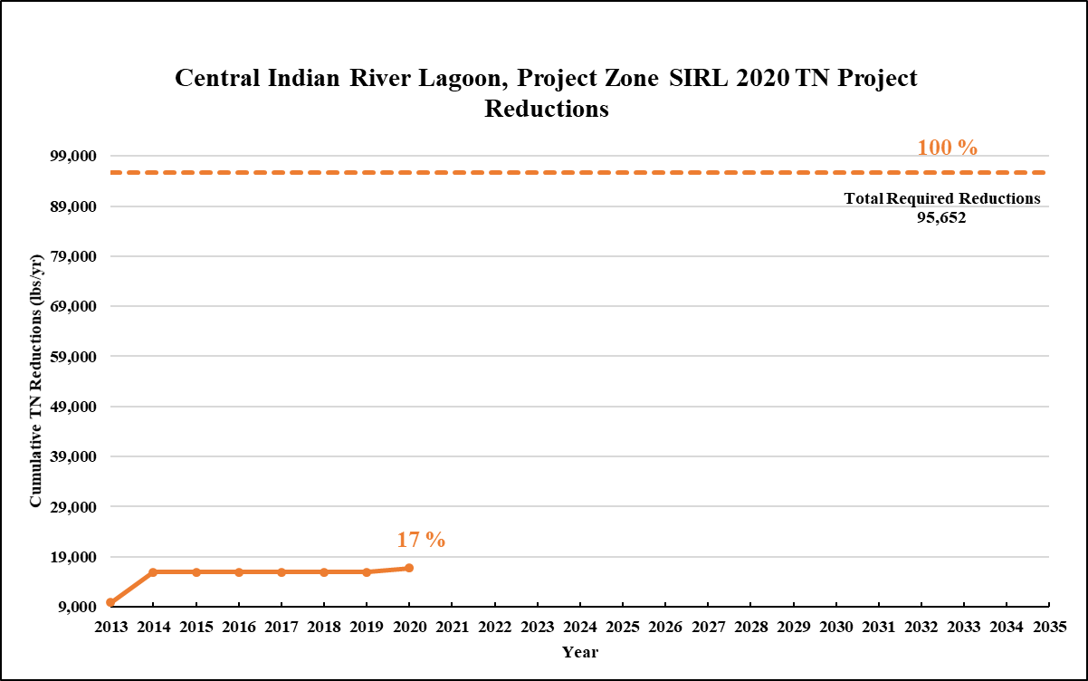
Figure 19. Estimated progress towards meeting the Required TN Reductions allocated to Project Zone SIRL with projects completed through July 31, 2020

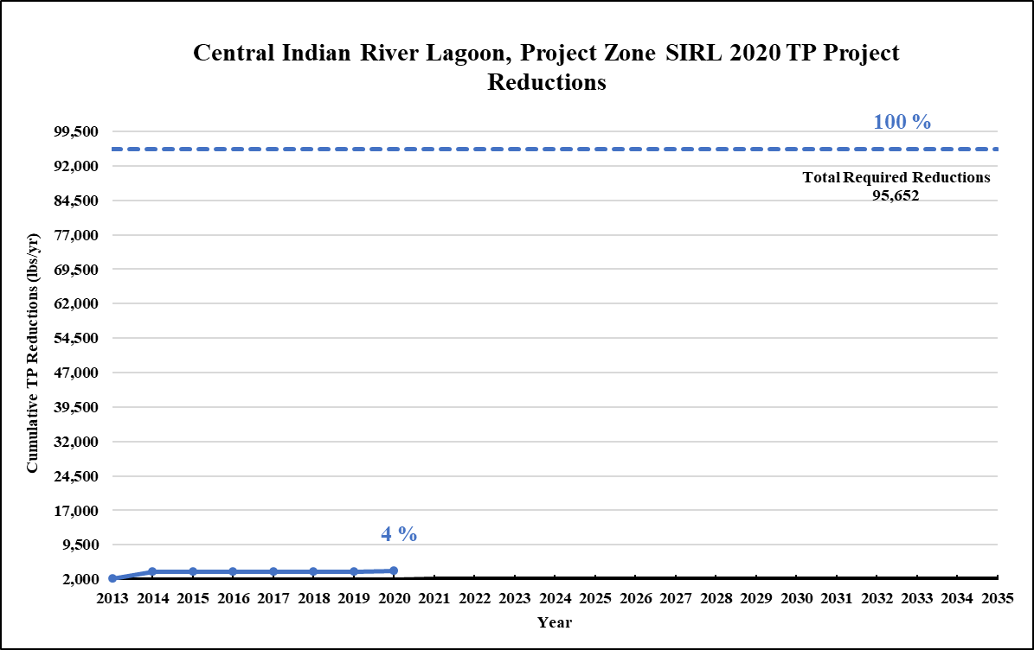
Figure 20. Estimated progress towards meeting the Required TP Reductions allocated to Project Zone SIRL with projects completed through July 31, 2020

Existing and Planned Projects
Table 26 summarizes the existing and planned projects provided by the stakeholders for Project Zone SIRL.
Table 26. Existing and planned projects in Project Zone SIRL
Lead Entity | Partners | Project Number | Project Name | Project Description | Project Type | Project Status | Estimated Completion Date | TN Reduction (lbs/yr) | TP Reduction (lbs/yr) | Acres Treated | Cost Estimate | Cost Annual O&M | Funding Source | Funding Amount | DEP Contract Agreement Number
City of Fort Pierce | N/A | FP-05 | Street Sweeping | 6,599 cubic yards of material. | Street Sweeping | Ongoing | N/A | 774 | 421 | N/A | Not provided | Not provided | Not provided | Not provided | N/A
City of Fort Pierce | N/A | FP-07 | Education Efforts | Stormwater education shows, pamphlets, presentations, storm drain stenciling, Illicit Discharge Program, and adopted fertilizer ordinance. | Education Efforts | Ongoing | N/A | 93 | 15 | N/A | N/A | N/A | N/A | N/A | N/A
FDACS | Agricultural Producers | FDACS-04 | BMP Implementation and Verification | Enrollment and verification of BMPs by agricultural producers. Acres treated based on FDACS OAWP July 2020 Enrollment and FSAID VII. Reductions based on SWIL Model-LET. | Agricultural BMPs | Ongoing | N/A | 1,745 | 344 | 2,378 | TBD | TBD | FDACS | TBD | N/A
FDACS | Agricultural Producers | FDACS-08 | FDACS Cost Share Projects | Cost-share projects paid for by FDACS. Acres treated based on FDACS OAWP July 2020 Enrollment. Reductions based on SWIL Model-LET. | Agricultural BMPs | Completed | 2020 | 760 | 120 | TBD | TBD | N/A | FDACS | TBD | N/A
FDOT District 4 | N/A | FDOT4-04b | FDOT4 Street Sweeping | Materials from roadway and gutter sweeping. | Street Sweeping | Ongoing | N/A | 71 | 46 | N/A | Not provided | Not provided | Florida Legislature | Not provided | N/A
FDOT District 4 | N/A | FDOT4-09b | Education Efforts | Pamphlets and Illicit Discharge Program. | Education Efforts | Ongoing | N/A | 21 | 3 | N/A | N/A | N/A | Florida Legislature | N/A | N/A
FDOT District 4 | N/A | FDOT4-10b | Fertilizer Cessation | No longer applying routine fertilizer. | Fertilizer Cessation | Completed | 2014 | 5,667 | 1,417 | N/A | Not provided | Not provided | Florida Legislature | Not provided | N/A
FDOT District 4 | N/A | FDOT4-11 | FM# 230132-1 (system 1) | Widening SR 615 between Avenue Q and Industrial Ave Three and constructing new roadway between Industrial Ave Three to SR 5 (system 1). | Dry Detention Pond | Completed | 2001 | TBD | TBD | TBD | Not provided | Not provided | Florida Legislature | Not provided | N/A
FDOT District 4 | N/A | FDOT4-12 | FM# 230132-1 (system 2) | Widening SR 615 between Avenue Q and Industrial Ave Three and constructing new roadway between Industrial Ave Three to SR 5 (system 2). | Dry Detention Pond | Completed | 2001 | 0 | 4 | 126 | Not provided | Not provided | Florida Legislature | Not provided | N/A
FDOT District 4 | N/A | FDOT4-13 | FM# 230132-1 (system 3) | Widening SR 615 between Avenue Q and Industrial Ave Three and constructing new roadway between Industrial Ave Three to SR 5 (system 3). | Dry Detention Pond | Completed | 2001 | 5 | 1 | 40 | Not provided | Not provided | Florida Legislature | Not provided | N/A
FDOT District 4 | N/A | FDOT4-14 | FM# 230132-1 (system 4) | Widening SR 615 between Avenue Q and Industrial Ave Three and constructing new roadway between Industrial Ave Three to SR 5 (system 4). | Dry Detention Pond | Completed | 2001 | 10 | 1 | 78 | Not provided | Not provided | Florida Legislature | Not provided | N/A
FDOT District 4 | N/A | FDOT4-15 | FM# 230132-1 (system 5) | Widening SR 615 between Avenue Q and Industrial Ave Three and constructing new roadway between Industrial Ave Three to SR 5 (system 5). | Wet Detention Pond | Completed | 2001 | 24 | 8 | 61 | Not provided | Not provided | Florida Legislature | Not provided | N/A
FDOT District 4 | N/A | FDOT4-16 | FM# 230132-1 (system 6) | Widening SR 615 between Avenue Q and Industrial Ave Three and constructing new roadway between Industrial Ave Three to SR 5 (system 6). | Wet Detention Pond | Completed | 2001 | 8 | 3 | 25 | Not provided | Not provided | Florida Legislature | Not provided | N/A
FDOT District 4 | N/A | FDOT4-17 | FM# 230132-1 (system 7) | Widening SR 615 between Avenue Q and Industrial Ave Three and constructing new roadway between Industrial Ave Three to SR 5 (system 7). | 100% On-site Retention | Completed | 2001 | 65 | 8 | 46 | Not provided | Not provided | Florida Legislature | Not provided | N/A
FDOT District 4 | N/A | FDOT4-24 | FM# 230279-1 (Kings Highway) | Constructing surface water management system for SR 713 (King's Highway). | Dry Detention Pond | Completed | 2003 | 1 | 0 | 6 | Not provided | Not provided | Florida Legislature | Not provided | N/A
FDOT District 4 | N/A | FDOT4-25 | FM# 413046-1 | Widening SR 9 from south of SR 70 to south of Indrio Rd. | Grass swales without swale blocks or raised culverts | Completed | 2014 | 226 | 58 | 454 | Not provided | Not provided | Florida Legislature | Not provided | N/A
FDOT District 4 | N/A | FDOT4-26 | FM# 413047-1 | Widening SR 9 from Indrio Rd to Indian River County. | Grass swales without swale blocks or raised culverts | Completed | 2013 | 151 | 40 | 285 | Not provided | Not provided | Florida Legislature | Not provided | N/A
FDOT District 4 | N/A | FDOT4-27 | FM# 230108-1 (Pond 1) | SR 68 from SR 9 to east of CR-607A: widening and new lane construction (60% credit, remaining 40% to SLE). | Wet Detention Pond | Completed | 2013 | Not provided | Not provided | 5 | Not provided | Not provided | Florida Legislature | Not provided | N/A
FDOT District 4 | N/A | FDOT4-28 | FM# 230108-1 (Pond 4) | SR 68 from SR 9 to east of CR-607A: widening and new lane construction (60% credit, remaining 40% to SLE). | Wet Detention Pond | Completed | 2013 | Not provided | Not provided | 5 | Not provided | Not provided | Florida Legislature | Not provided | N/A
FDOT District 4 | N/A | FDOT4-36 | FM# 230338-4 | Indrio Rd. widening - I-95 to SR-607. | BMP Treatment Train | Canceled | 2019 | N/A | N/A | N/A | N/A | N/A | N/A | N/A | N/A
Fort Pierce Farms WCD | N/A | FPF-01 | Swale Along Canal 1 Top of Bank (SLRIT Grant 2006-07) | Grassed swale constructed along Canal 1 top of bank, immediately upstream of IRL, to collect stormwater runoff and provide some water quality benefit. Project addressed previous area of bank erosion. | Grass swales without swale blocks or raised culverts | Completed | Prior to 2013 | Not provided | Not provided | 0 | Not provided | Not provided | Not provided | Not provided | N/A
Fort Pierce Farms WCD | N/A | FPF-02 | Dry Detention Area Along Canal 1 Top of Bank (SLRIT Grants 2006-07 and 2007-08) | Grassed dry detention area and control structure replacement to address stormwater runoff issues and canal bank erosion immediately upstream of the IRL. | Dry Detention Pond | Completed | Prior to 2013 | Not provided | Not provided | 3 | Not provided | Not provided | Not provided | Not provided | N/A
Fort Pierce Farms WCD | N/A | FPF-03 | Discharge Criteria Adopted as Part of Fort Pierce Farms WCD Permit Application Criteria | More stringent than standard pre vs. post; allows for approximately 11 % more volume per development to be detained by stormwater system. | Regulations, Ordinances, and Guidelines | Ongoing | N/A | N/A | N/A | N/A | N/A | N/A | N/A | Not provided | N/A
Fort Pierce Farms WCD | N/A | FPF-04 | Mechanical Removal of Aquatic Vegetation | Perform harvest aquatic vegetation within the canals using mechanical processes to the extent practicable  to reduce the need for herbicide treatment. | Aquatic Vegetation Harvesting | Ongoing | N/A | N/A | N/A | N/A | Not provided | Not provided | Not provided | Not provided | Not provided
Fort Pierce Farms WCD | N/A | FPF-05 | Canal Buffer | Create a canal buffer or filter strip to help reduce loading from stormwater runoff to the canals. | Vegetated Buffers | Underway | TBD | N/A | N/A | N/A | Not provided | Not provided | Not provided | Not provided | Not provided
Fort Pierce Farms WCD | FDACS | FPF-06 | Assist FDACS with BMP Enrollment Outreach | Assist FDACS, where needed, with identifying and contacting landowners/ producers within the District  boundaries for purposes of participating in the relevant FDACS BMP programs. | Agricultural BMPs | Ongoing | N/A | N/A | N/A | N/A | Not provided | Not provided | Not provided | Not provided | Not provided
Fort Pierce Farms WCD | N/A | FPF-07 | Public Education and Outreach | Provide public education to residents of the District that fosters an understanding of the necessity to reduce  nutrient impacts to surface waters. | Education Efforts | Ongoing | N/A | N/A | N/A | N/A | Not provided | Not provided | Not provided | Not provided | Not provided
Fort Pierce Farms WCD | N/A | FPF-08 | Control Structure Maintenance | Maintain existing water control structures and any adjustable gates on water control structures. | Control Structure | Underway | TBD | N/A | N/A | N/A | Not provided | Not provided | Not provided | Not provided | Not provided
North St. Lucie River WCD | N/A | NSLR-01 | C-25 Diversion Structure | Replace previous pump structure with gravity flow control structure. | Control Structure | Completed | Prior to 2013 | N/A | N/A | Not provided | Not provided | Not provided | Not provided | Not provided | N/A
North St. Lucie River WCD | N/A | NSLR-02 | Invasive Vegetation Removal at Canals 33 and 42 | Mechanical removal of invasive vegetation in canals and surrounding banks. | Aquatic Vegetation Harvesting | Completed | Prior to 2013 | N/A | N/A | Not provided | Not provided | Not provided | Not provided | Not provided | N/A
North St. Lucie River WCD | N/A | NSLR-03 | Canal Maintenance Program | Ongoing maintenance primarily by mechanical means to keep canals free of exotic and decaying vegetation. | Aquatic Vegetation Harvesting | Ongoing | N/A | N/A | N/A | Not provided | Not provided | $9,400 | Not provided | Not provided | N/A
North St. Lucie River WCD | N/A | NSLR-04 | Canal Buffer | Create a canal buffer or filter strip to help reduce loading from stormwater runoff to the canals. | Vegetated Buffers | Underway | TBD | N/A | N/A | N/A | Not provided | Not provided | Not provided | Not provided | Not provided
North St. Lucie River WCD | FDACS | NSLR-05 | Assist FDACS with BMP Enrollment Outreach | Assist FDACS, where needed, with identifying and contacting landowners/ producers within the District  boundaries for purposes of participating in the relevant FDACS BMP programs. | Agricultural BMPs | Ongoing | N/A | N/A | N/A | N/A | Not provided | Not provided | Not provided | Not provided | Not provided
North St. Lucie River WCD | N/A | NSLR-06 | Public Education and Outreach | Provide public education to residents of the District that fosters an understanding of the necessity to reduce  nutrient impacts to surface waters. | Education Efforts | Ongoing | N/A | N/A | N/A | N/A | Not provided | Not provided | Not provided | Not provided | Not provided
North St. Lucie River WCD | N/A | NSLR-07 | Control Structure Maintenance | Maintain existing water control structures and any adjustable gates on water control structures. | Control Structure | Underway | TBD | N/A | N/A | N/A | Not provided | Not provided | Not provided | Not provided | Not provided
St. Lucie County | N/A | SLC-01 | Education Efforts | FYN; landscaping, irrigation, fertilizer, and pet waste ordinances; PSAs, pamphlets, website, and illicit discharge program. | Education Efforts | Ongoing | N/A | 6,241 | 1,006 | N/A | N/A | N/A | N/A | N/A | N/A
St. Lucie County | N/A | SLC-02 | Street Sweeping | 470 tons/yr collected. | Street Sweeping | Ongoing | N/A | 664 | 299 | N/A | Not provided | Not provided | Not provided | Not provided | N/A
St. Lucie County | DEP/ SFWMD/ IRL National Estuary Program (NEP) | SLC-03 | Paradise Park Stormwater Improvement | Construction of drainage system providing 75 % treatment of first 1-inch runoff. | Dry Detention Pond | Completed | 2014 | 171 | 28 | 168 | ######## | Not provided | DEP/ SFWMD/ IRL NEP | DEP - $225,000/ SFWMD - $304,448/ IRL NEP - $125,000 | LP56020
St. Lucie County | N/A | SLC-04 | Harmony Heights Stormwater Improvement | Construction of drainage system providing 75 % treatment of first 1-inch runoff. | Dry Detention Pond | Underway | 2015 | 253 | 44 | 239 | ######## | TBD | TBD | $511,838 | N/A
St. Lucie County | N/A | SLC-05 | Taylor Creek Dredging | Three-phase sediment/muck removal project totaling approximately 200,000 cubic yards. | Muck Removal/Restoration Dredging | Completed | 2015 | Not provided | Not provided | Not provided | $7,500,000 | N/A | Not provided | Not provided | N/A
St. Lucie County | N/A | SLC-06 | Stan Blum Memorial Boat Launch | Not provided. | Wet Detention Pond | Completed | Prior to 2013 | Not provided | Not provided | 6 | Not provided | N/A | Not provided | Not provided | N/A
St. Lucie County | IRL NEP | SLC-07 | San Lucie Plaza Stormwater Master Plan | Construction of drainage system providing 75 % treatment of first 1-inch runoff. | On-line Retention BMPs | Underway | 2018 | 1,210 | 214 | 157 | ######## | TBD | TBD | $650,325 | N/A
St. Lucie County | N/A | SLC-09 | North Hutchinson Island Septic to Sewer Project | 538 Homes converted to Central Sewer | Wastewater Service Area Expansion | Underway | Not provided | TBD | TBD | N/A | N/A | N/A | N/A | N/A | N/A
St. Lucie County | N/A | SLC-10 | Port of Fort Pierce | Stormwater management system. | Stormwater System Rehabilitation | Completed | 2018 | N/A | N/A | Not provided | TBD | TBD | Not provided | Not provided | N/A
St. Lucie County | N/A | SLC-11 | Swales Material Collected | Roadside swale cleanout and reprofiling. | BMP Cleanout | Underway | TBD | TBD | TBD | N/A | TBD | TBD | TBD | TBD | N/A
St. Lucie County | N/A | SLC-12 | St. Lucie County Stormwater Needs Assessment Study | Report that will provide information on identified project opportunities to reduce nutrients, estimated benefits, and costs. | Study | Underway | TBD | N/A | N/A | TBD | $142,380 | TBD | TBD | TBD | N/A
St. Lucie Village | N/A | SLV-01 | Peninsula Drive | 0.75" detention storage for western half of Peninsula Drive where there was no previous treatment. | Wet Detention Pond | Completed | 2011 | Not provided | Not provided | Not provided | Not provided | Not provided | Not provided | Not provided | N/A
St. Lucie Village | N/A | SLV-02 | Education Efforts | Credit for fertilizer ordinance. | Education Efforts | Ongoing | N/A | 18 | 3 | N/A | N/A | N/A | N/A | N/A | N/A

- Compliance and Adaptive Management

Future Growth
To ensure that this BMAP effort can achieve and ultimately maintain the goal of meeting TMDL requirements, the overall restoration strategy must include actions and planning for future growth and development. Any new development would likely fall into two general source categories: (1) urban and (2) agricultural. Nutrient impacts from new development will be addressed through a variety of mechanisms as well as other provisions of Florida law.
While the majority of the restoration projects and programs listed in this BMAP address current loading, the need to plan and implement sound management strategies to address additional population growth in the BMAP area must be considered. DEP has included in this BMAP specific elements to address all current and future WWTF effluent, septic systems, and stormwater sources. Broader laws—such as local land development regulations, comprehensive plans, ordinances, incentives, Environmental Resource Permit requirements, and consumptive use permit requirements—all provide additional mechanisms and avenues for protecting water resources and reducing the impact of new development and other land use changes as they occur. As more information becomes available, the modeling efforts used for determining loading to the lagoon will continue to be refined.
The recommendations presented in Chapter 2 should be considered by local governments during master planning and land use decision-making efforts. It should also be noted that any additional loading, such as from land use changes from low to high density, or any increase in intensity of use (that may include additional nutrient loadings), will be evaluated during future BMAP review efforts. If an increase in loading has occurred, additional restoration actions will be required to remediate impacts. DEP recommends that all local governments revise their planning and land use ordinance(s) to adequately address all future growth, and consider limitations on growth in sensitive areas, such as lands with a direct hydrologic connection to impaired waterbodies, wetland areas, or coastal areas.

Compliance

TMDL Compliance
The intent of the TMDLs is to recover the deeper water seagrass habitats, with the biological response of the seagrass being the most important factor in evaluating the success of achieving TMDL targets. To assess progress for the IRL Basin towards the median seagrass depth limit target, a two-step process was used in the A, B, and SEB Project Zones. TMDL targets for Steps 1 and 2 were not established for the lagoon in the SIRL project zone, and so it is excluded from this analysis. For the 2013 BMAP, DEP conducted this two-step evaluation using seagrass data from 2003, 2005, 2006, 2007, and 2009, which were the latest datasets available at the time of the analysis. For the CIRL, all three project zones were determined to be both Step 1 and Step 2 compliant in 2013. Therefore, stakeholders in the CIRL were not required to make additional reductions at the time and were not assigned detailed allocations in the first iteration of the BMAP.
Since the 2013 BMAP, further evaluations of the seagrass depth limits in the CIRL have been conducted to reassess whether the CIRL project zones have continued to be compliant.
Table 27 and Table 28 list the results of both steps of these evaluations since 2013, including the number of years that passed Step 2 of the evaluation. In 2020, the evaluation was conducted using the 2013, 2015, 2017, and 2019 seagrass mapping data, which were the latest datasets available at that time. Figure 21 through Figure 23 show the results of both steps of the 2020 evaluation for Project Zones A, SEB, and B respectively. None of the 3 project zones with TMDLs was compliant. As indicated in the 2013 BMAP, DEP assigns detailed allocations in project zones where compliance is not maintained.
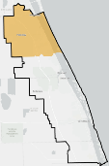
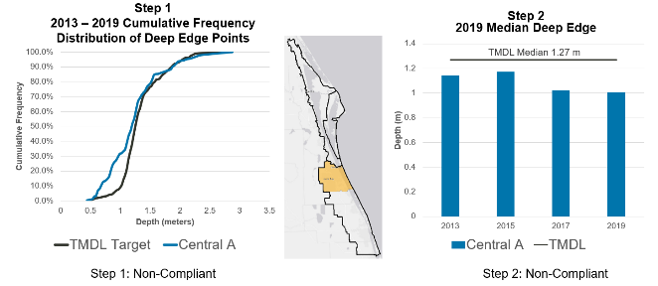
Figure 21. CIRL Project Zone A seagrass evaluation results for Compliance Step 1 and Step 2

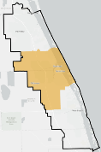
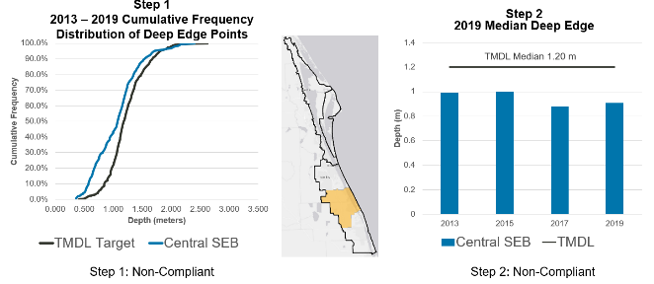
Figure 22. CIRL Project Zone SEB seagrass evaluation results for Compliance Step 1 and Step 2

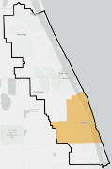
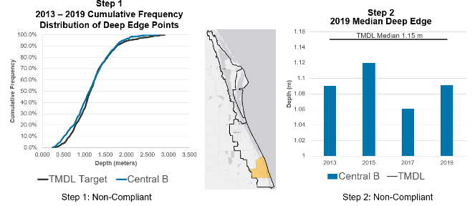
Figure 23. CIRL Project Zone B seagrass evaluation results for Compliance Step 1 and Step 2

Table 27. Seagrass compliance results, Step 1
Step 1 | CIRL A | CIRL SEB | CIRL B
2007 - 2013 | Pass | Pass | Pass
2009 - 2015 | Pass | Pass | Pass
2011 - 2017 | Fail | Fail | Fail
2013 - 2019 | Fail | Fail | Fail

Table 28. Summary of seagrass compliance results, Step 2
Note: Parentheses indicate number of years passing of those assessed for the compliance period of record.
Step 2 | CIRL A | CIRL SEB | CIRL B
2007 - 2013 | Fail (2 of 4) | Fail (2 of 4) | Fail (2 of 4)
2009 - 2015 | Fail (1 of 4) | Fail (1 of 4) | Fail (1 of 4)
2011 - 2017 | Fail (0 of 4) | Fail (0 of 4) | Fail (1 of 4)
2013 - 2019 | Fail (0 of 4) | Fail (0 of 4) | Fail (0 of 4)

BMAP Compliance
In addition to IRL TMDL compliance and the measurement of seagrass deep edge recovery, there are other compliance elements related to the BMAP. DEP has set BMAP TN and TP reduction milestones for the years 2025 and 2030 to ensure that significant progress will be made in each five-year increment prior to the 2035 total reduction deadline. The percent reductions in the milestones apply to the total BMAP required reductions; so as various entities implement their projects, the overall milestones are also being met. Individual entities must achieve compliance by meeting their own required reductions by the 2035 deadline, as well as show progress towards the BMAP milestones by planning and implementing projects.

- References
Adkins, M., M. Mao, M. Taulor, W. Green, C. Basci, M. Bergman, and D. Smith. 2004. Watershed model development for the Indian River Lagoon Basin: Providing simulated runoff and pollution load to the Indian River Lagoon Pollution Load Reduction Model. Technical Memorandum 50. Palatka, FL: St. Johns River Water Management District.
Applied Ecology. October 15, 2015. Spatial Watershed Iterative Loading (SWIL) Model methodology report, updated for SWIL 3.0. Page 18. Prepared for Brevard County Natural Resources Department.
Applied Ecology. March 20, 2019. Final memorandum report for the development of baseload spatial input layers for the Indian River Lagoon Watershed. Prepared for Brevard County Natural Resources Department.
East Coast Florida Regional Planning Council and Treasure Coast Regional Planning Council. August 2016. Indian River Lagoon economic valuation update.
Florida Stormwater Association. 2012. Methodology for calculating nutrient load reductions using the FSA assessment tool.
Gao, X. 2009. Nutrient and dissolved oxygen TMDLs for the Indian River Lagoon and Banana River Lagoon. TMDL report. Tallahassee, FL: Florida Department of Environmental Protection.
Hazen and Sawyer, P.C. 2008. Indian River Lagoon economic assessment and analysis update. Prepared for the Indian River Lagoon National Estuary Program in cooperation with the St. Johns River Water Management District and South Florida Water Management District.
Listopad, C. September 10, 2020. Personal communication with Tiffany Busby, DEP Contractor.
St. Johns River Water Management District. January 2020. Indian River Lagoon seagrass monitoring standard operating procedures.

Appendices

Appendix A. BMAP Projects Supporting Information
The project tables in this BMAP (Table 20, Table 22, Table 24, and Table 26) list the implementation status of the BMAP projects as of July 31, 2020. The tables list the TN and TP reductions in lbs/yr attributable to each individual project. These projects were submitted to DEP by responsible entities with the understanding that the projects and activities would be included in the BMAP, thus setting the expectation for each entity to implement the proposed projects and activities to achieve the assigned load reduction estimates in the specified time.
However, the list of projects is meant to be flexible enough to allow for changes that may occur over time. During the annual review of BMAP implementation efforts, project-specific information may be revised and updated, resulting in changes to the estimated reductions for those projects. The revisions may increase or decrease estimated reductions, and DEP will work with stakeholders to address revisions as they are identified.
The project status column is standardized into the following five categories:
- Canceled: Project or activity that was planned but will no longer take place. This category includes the cessation of ongoing activities.
- Completed: Project, activity, or task that is finished. This category includes fully implemented activities (i.e., ongoing activities) that must continue to maintain assigned credits indefinitely (such as street sweeping, BMP cleanout, catch basin cleanout, public education, fertilizer cessation/reduction, and vegetation harvesting).
- Planned: Project or activity that is conceptual or proposed.
- Underway: Project or activity that has commenced or initiated but is not completed and is not yet reducing nutrient loads from the treated area.
- Ongoing: The lead entity is performing actions each year. This status is used when a project is typically nonstructural and continuous. Ongoing projects are not a continuation of a reduction for a structural project.
Prior to reporting project information, DEP contacts each lead entity to gather new information on projects and confirm previously reported information. The terms used throughout the project tables are defined as follows:
- Not provided: Denotes that information was requested by DEP but was not provided by the lead entity.
- TBD: To be determined. Denotes that information is not currently available but will be provided by the stakeholder when it is available.
- N/A: Not applicable. Denotes that information for that category is not relevant to that project.
- 0: Zero. Denotes the numeric value for that category as zero.
The project tables are based on current information, and project details may be updated as further information becomes available.
This BMAP requires stakeholders to implement their projects to achieve reductions as soon as practicable. However, the full implementation of the BMAP will be a long-term process. While some of the projects and activities listed in the BMAP were recently completed or are currently ongoing, several projects require more time to design, secure funding, and construct. Unlike the existing and planned projects, these future projects are not yet considered commitments of the entities but rather are intended for future BMAP credit, pending the availability of funding and other resources.
Although BMAP implementation is a long-term process, the goal of this BMAP is to achieve the TMDLs by the 2035 milestone. It is understood that all waterbodies can respond differently to the implementation of reduced loadings to meet applicable water quality standards. Continued coordination and communication by the stakeholders will be essential to ensure that management strategies continue to meet the implementation milestones.

Appendix B. Central IRL Allocation Calculations
The first step in the allocation process was to establish the total TN and TP load, by project zone, from the SWIL Model. This is an important step because the watershed loads to each segment are based on the updated information and model refinements incorporated in the SWIL Model. Starting loads for Project Zone A were adjusted to account for the impact of the C-1 diversion project, which redirects flow to the St. John’s River and away from the IRL. Table B-1 below lists the TN and TP starting loads from the SWIL Model for each project zone and the associated acres of watershed in that segment.
Table B-1. Central IRL starting loads from model
Project Zone | Area (Acres) | TN Starting Load  (lbs/yr) | TP Starting load  (lbs/yr)
A | 106,926 | 616,171 | 85,081
SEB | 131,576 | 762,595 | 96,865
B | 77,252 | 567,009 | 78,837
SIRL | 39,672 | 267,636 | 39,232

The TMDLs for the IRL (in Rule 62.304.520, F.A.C.) include a percent reduction from the starting load for TN and TP. Table B-2 describes the TMDL rule percent reduction for each project zone and lists the WBIDs included in each project zone.
Table B-2. Central IRL BMAP TMDL Required Reduction Percentage
WBIDs | Project Zone | % TN Reduction | % TP Reduction
2936A | A | 56 | 48
5003D | SEB | 56 | 48
5003B & 5003C | B | 56 | 48
3190, 3190A, 3163A, & 3163 | SIRL | 36 | 58

The second step in the allocation calculations was to apply the TMDL percent reduction (Table B-2) for TN or TP to the starting load (Table B-1), respectively. Table B-3 lists the TN and TP reductions to meet the TMDL based on these calculations. The allowable load after the reductions are met is called the allocation. To calculate the TN allocation and the TP allocation in the table below, the TN reduction or TP reduction is subtracted from the TN or TP starting load in Table B-3.
Table B-3. Central IRL load reductions – starting load * TMDL Required Reduction Percentage
Project Zone | TN Reduction (lbs/yr) | TN Allocation (lbs/yr) | TP Reduction (lbs/yr) | TP Allocation (lbs/yr)
A | 345,056 | 271,115 | 40,839 | 44,242
SEB | 427,053 | 335,542 | 46,495 | 50,370
B | 317,525 | 249,484 | 37,842 | 40,995
SIRL | 96,349 | 171,287 | 22,755 | 16,477

Now that the total reductions are calculated with the TMDL percent reductions, a test is completed to ensure there are no requirements to make reductions from natural land uses. To test whether the calculated reductions would go beyond reductions for converted land uses (anthropogenic land uses), DEP calculated the weighted average load per acre of natural lands (natural load per acre) in each project zone. The natural load per acre values were calculated from loads associated with natural lands in the initial model output. Any land use adjustments that were later incorporated into the allocation process were not accounted for in the natural load per acre calculations. Table B-4 outlines the data that were used to calculate the natural load per acre for TN and TP. The acreage and the weighted average loading from only the natural lands were calculated from the SWIL Model, by project zone. The loading for TN and TP was divided by the acres of natural lands, respectively, to derive the natural load per acre and the values were rounded. These natural loads per acre were compared to the allowable loads per acre, as shown in Table B-5.
Table B-4. Central IRL allowable load per acre from natural loading
Project Zone | Natural | Area (Acres) | TN Natural Lands Load (lbs/yr) | TP Natural Lands Load (lbs/yr) | Natural TN Load (lbs/ac/yr) | Natural TP Load (lbs/ac/yr)
A | Natural Lands | 39,344 | 129,927 | 14,198 | 3.30 | 0.36
SEB | Natural Lands | 66,299 | 251,765 | 25,077 | 3.80 | 0.38
B | Natural Lands | 19,726 | 69,618 | 7,981 | 3.53 | 0.40
SIRL | Natural Lands | 14,444 | 54,669 | 6,083 | 3.78 | 0.42

DEP then calculated the allowable load per acre for each project zone. The allowable load per acre is the allocation load divided by the acres in the project zone. The allowable load is calculated for both TN and TP and compared with the weighted average load per acre of natural lands (natural load per acre) in that project zone. If the allowable load per acre is less than the natural load per acre, an adjustment is made. In Table B-5 below, the allowable load per acre for TN and TP are shown and "True" is entered if the allowable load per acre is less than the natural load per acre. When the test is "True," an adjustment is made for the TN reduction, TP reduction, or both.
Table B-5. Central IRL allowable load per acre from total allocation
Project Zone | Allowable TN Load Per Acre | Natural TN Load Per Acre (LPA) | Is Allowable TN LPA Less than Natural TN LPA? | Allowable TP LPA | Natural TP LPA | Is Allowable TP LPA Less than Natural TP LPA? | Result
A | 2.54 | 3.30 | TRUE | 0.41 | 0.36 | FALSE | Use adjustment for TN but no adjustment for TP
SEB | 2.55 | 3.80 | TRUE | 0.38 | 0.38 | FALSE | Use adjustment for TN but no adjustment for TP
B | 3.23 | 3.53 | TRUE | 0.53 | 0.40 | FALSE | Use adjustment for TN but no adjustment for TP
SIRL | 4.32 | 3.78 | FALSE | 0.42 | 0.42 | TRUE | No adjustment for TN but use adjustment for TP

When an adjustment was indicated, the reductions were then adjusted by taking the starting loads from Table B-1 and subtracting the adjusted allowable load and adjusting the reductions listed previously in Table B-3. Only those reductions noted as needing a adjustment (see Table B-5) were adjusted. A summary of the TN and TP reductions (adjusted, if applicable) and the TN and TP allocations are listed in Table B-6.
Table B-6. Central IRL adjusted load reductions
Project Zone | TN Reduction  (lbs/yr) | TN Allocation  (lbs/yr) | TP Reduction  (lbs/yr) | TP Allocation  (lbs/yr)
A | 263,315 | 352,856 | N/A | N/A
SEB | 262,606 | 499,989 | N/A | N/A
B | 294,309 | 272,700 | N/A | N/A
SIRL | N/A | N/A | 22,570 | 16,662

After the reductions are calculated for each project zone, the relative starting load in the project zone for each stakeholder is used to assign their entity reductions. The natural lands are separated from each entity's area to assess their relative anthropogenic contributions, so that stakeholders would not be asked to reduce loads from natural lands in their jurisdiction. In Table B-7, Table B-8, Table B-9, and Table B-10, natural lands are separated from the starting loads, and so only the anthropogenic loadings are included in the entity loads.
Table B-7. Central IRL Project Zone A entity starting loads from model, natural lands separated
Project Zone | Entity | TN Starting Load (lbs/yr) | TP Starting load  (lbs/yr)
A | Natural Lands | 272,914 | 28,068
A | Agricultural Producers | 239,638 | 32,975
A | Brevard County | 52,120 | 7,769
A | City of Fellsmere | 10,603 | 1,544
A | City of Palm Bay | 3,087 | 413
A | City of Sebastian | 61,820 | 8,901
A | FDOT District 4 | 6,191 | 741
A | FDOT District 5 | 3,314 | 418
A | FWCD | 6,122 | 806
A | Indian River County | 87,942 | 12,696
A | SRID ROW | 4,435 | 561
A | Town of Grant-Valkaria | 9,462 | 1,346
A | Town of Orchid | 2,547 | 367
A | VLWCD | 2,401 | 259
A | Totals | 762,595 | 96,865

Table B-8. Central IRL Project Zone SEB entity starting loads from model, natural lands separated
Project Zone | Entity | TN Starting Load (lbs/yr) | TP Starting load  (lbs/yr)
SEB | Natural Lands | 272,914 | 28,068
SEB | Agricultural Producers | 239,638 | 32,975
SEB | Brevard County | 52,120 | 7,769
SEB | City of Fellsmere | 10,603 | 1,544
SEB | City of Palm Bay | 3,087 | 413
SEB | City of Sebastian | 61,820 | 8,901
SEB | FDOT District 4 | 6,191 | 741
SEB | FDOT District 5 | 3,314 | 418
SEB | FWCD | 6,122 | 806
SEB | Indian River County | 87,942 | 12,696
SEB | SRID ROW | 4,435 | 561
SEB | Town of Grant-Valkaria | 9,462 | 1,346
SEB | Town of Orchid | 2,547 | 367
SEB | VLWCD | 2,401 | 259
SEB | Totals | 762,595 | 96,865

Table B-9. Central IRL Project Zone B entity starting loads from model, natural lands separated
Project Zone | Entity | TN Starting Load (lbs/yr) | TP Starting load (lbs/yr)
B | Natural Lands | 99,706 | 12,113
B | Agricultural Producers | 118,698 | 16,081
B | City of Vero Beach | 48,755 | 7,049
B | FDOT District 4 | 9,487 | 1,276
B | FPFWCD | 10 | 1
B | Indian River County | 269,295 | 39,199
B | IRFWCD | 3,532 | 478
B | Town of Indian River Shores | 17,525 | 2,639
B | Totals | 567,009 | 78,837

Table B-10. Central IRL Project Zone SIRL entity starting loads from model, natural lands separated
Project Zone | Entity | TN Starting Load (lbs/yr) | TP Starting Load  (lbs/yr)
SIRL | Natural Lands | 66,304 | 7,653
SIRL | Agricultural Producers | 65,378 | 10,057
SIRL | City of Fort Pierce | 1,854 | 305
SIRL | FDOT District 4 | 7,052 | 961
SIRL | FL Turnpike | 818 | 100
SIRL | FPFWCD | 17,145 | 2,487
SIRL | SFWMD CP | 1,456 | 257
SIRL | St. Lucie County | 104,021 | 16,773
SIRL | Town of St. Lucie Village | 3,608 | 638
SIRL | Totals | 267,636 | 39,232

After the natural lands were separated from the entity loading estimates based on the SWIL Model, the relative contribution of each entity to the total project zone anthropogenic load was calculated. Table B-11, Table B-12, Table B-13, and Table B-14 show the percent contribution within the project zone to anthropogenic TN and TP, respectively, by entity. The TN contribution percentage is calculated by dividing the entity anthropogenic TN load by the total anthropogenic TN segment load, and then a similar calculation is performed for each entity's TP load.
Table B-11. Central IRL Project Zone A entity anthropogenic starting loads from model, natural lands separated
Project Zone | Entity | Anthropogenic TN  (lbs/yr) | Anthropogenic TP  (lbs/yr) | % Contribution to Anthropogenic TN | % Contribution to Anthropogenic TP
A | Natural Lands | 0 | 0 | 0.00 | 0.00
A | Agricultural Producers | 53,905 | 8,285 | 10.99 | 11.61
A | Brevard County | 37,176 | 5,588 | 7.58 | 7.83
A | City of Melbourne | 63,245 | 9,057 | 12.89 | 12.69
A | City of Palm Bay | 205,713 | 29,785 | 41.94 | 41.73
A | City of West Melbourne | 34,398 | 5,010 | 7.01 | 7.02
A | FDOT District 5 | 9,744 | 1,300 | 1.99 | 1.82
A | MTWCD | 11,959 | 1,641 | 2.44 | 2.30
A | Town Melbourne Beach | 5,252 | 779 | 1.07 | 1.09
A | Town of Grant-Valkaria | 38,257 | 5,472 | 7.80 | 7.67
A | Town of Indialantic | 3,589 | 531 | 0.73 | 0.74
A | Town of Malabar | 23,093 | 3,338 | 4.71 | 4.68
A | Town of Melbourne Village | 3,194 | 475 | 0.65 | 0.67
A | U.S. Air Force | 954 | 118 | 0.19 | 0.16
A | Totals | 490,479 | 71,377 | 100.00 | 100.00

Table B-12. Central IRL Project Zone SEB entity anthropogenic starting loads from model, natural lands separated
Project Zone | Entity | Anthropogenic TN  (lbs/yr) | Anthropogenic TP  (lbs/yr) | % Contribution to Anthropogenic TN | % Contribution to Anthropogenic TP
SEB | Natural Lands | 0 | 0 | 0.00 | 0.00
SEB | Agricultural Producers | 239,638 | 32,975 | 48.94 | 47.93
SEB | Brevard County | 52,120 | 7,769 | 10.64 | 11.29
SEB | City of Fellsmere | 10,603 | 1,544 | 2.17 | 2.24
SEB | City of Palm Bay | 3,087 | 413 | 0.63 | 0.60
SEB | City of Sebastian | 61,820 | 8,901 | 12.62 | 12.94
SEB | FDOT District 4 | 6,191 | 741 | 1.26 | 1.08
SEB | FDOT District 5 | 3,314 | 418 | 0.68 | 0.61
SEB | FWCD | 6,122 | 806 | 1.25 | 1.17
SEB | Indian River County | 87,942 | 12,696 | 17.96 | 18.45
SEB | SRID ROW | 4,435 | 561 | 0.91 | 0.82
SEB | Town of Grant-Valkaria | 9,462 | 1,346 | 1.93 | 1.96
SEB | Town of Orchid | 2,547 | 367 | 0.52 | 0.53
SEB | VLWCD | 2,401 | 259 | 0.49 | 0.38
SEB | Totals | 489,681 | 68,797 | 100.00 | 100.00

Table B-13. Central IRL Project Zone B entity anthropogenic starting loads from model, natural lands separated
Project Zone | Entity | Anthropogenic TN  (lbs/yr) | Anthropogenic TP  (lbs/yr) | % Contribution to Anthropogenic TN | % Contribution to Anthropogenic TP
B | Natural Lands | 0 | 0 | 0.00 | 0.00
B | Agricultural Producers | 118,698 | 16,081 | 25.40 | 24.10
B | City of Vero Beach | 48,755 | 7,049 | 10.43 | 10.56
B | FDOT District 4 | 9,487 | 1,276 | 2.03 | 1.91
B | FPFWCD | 10 | 1 | 0.00 | 0.00
B | Indian River County | 269,295 | 39,199 | 57.63 | 58.75
B | IRFWCD | 3,532 | 478 | 0.76 | 0.72
B | Town of Indian River Shores | 17,525 | 2,639 | 3.75 | 3.96
B | Totals | 467,303 | 66,724 | 100.00 | 100.00

Table B-14. Central IRL Project Zone SIRL entity anthropogenic starting loads from model, natural lands separated
Project Zone | Entity | Anthropogenic TN  (lbs/yr) | Anthropogenic TP  (lbs/yr) | % Contribution to Anthropogenic TN | % Contribution to Anthropogenic TP
SIRL | Natural Lands | 0 | 0 | 0.00 | 0.00
SIRL | Agricultural Producers | 65,378 | 10,057 | 32.47 | 31.85
SIRL | City of Fort Pierce | 1,854 | 305 | 0.92 | 0.96
SIRL | FDOT District 4 | 7,052 | 961 | 3.50 | 3.04
SIRL | FL Turnpike | 818 | 100 | 0.41 | 0.32
SIRL | FPFWCD | 17,145 | 2,487 | 8.52 | 7.88
SIRL | SFWMD CP | 1,456 | 257 | 0.72 | 0.81
SIRL | St. Lucie County | 104,021 | 16,773 | 51.67 | 53.12
SIRL | Town of St. Lucie Village | 3,608 | 638 | 1.79 | 2.02
SIRL | Totals | 201,332 | 31,579 | 100.00 | 100.00

For the unadjusted project zones (for TN Project Zone SIRL is unadjusted and for TP Project Zone A, Project Zone SEB, and Project Zone B are unadjusted), each entity's reduction was calculated by multiplying the total project zone starting load (Table B-1) by the project zone required reduction (Table B-3) and by the entity's percent contribution to anthropogenic loading, as defined in Table B-11, Table B-12, Table B-13, and Table B-14. The calculations for the entity reductions were performed separately for TN and TP. Then, the entity TN and TP allowable loading (allocations) are computed by subtracting the entity required reductions in Table B-15, Table B-16, Table B-17, and Table B-18 from the entity anthropogenic starting loads (Table B-11, Table B-12, Table B-13, and Table B-14).

Table B-15. Central IRL Project Zone A entity reduction and allowable loading (allocation)
Project Zone | Entity | TN Reduction (lbs/yr) | TP Reduction (lbs/yr) | TN Allocation (lbs/yr) | TP Allocation (lbs/yr)
A | Natural Lands | 0 | 0 | 125,692 | 13,704
A | Agricultural Producers | 37,922 | 4,740 | 15,982 | 3,545
A | Brevard County | 26,154 | 3,197 | 11,023 | 2,391
A | City of Melbourne | 44,493 | 5,182 | 18,752 | 3,875
A | City of Palm Bay | 144,720 | 17,041 | 60,992 | 12,743
A | City of West Melbourne | 24,199 | 2,866 | 10,199 | 2,143
A | FDOT District 5 | 6,855 | 744 | 2,889 | 556
A | MTWCD | 8,413 | 939 | 3,546 | 702
A | Town Melbourne Beach | 3,695 | 446 | 1,557 | 333
A | Town of Grant-Valkaria | 26,914 | 3,131 | 11,343 | 2,341
A | Town of Indialantic | 2,525 | 304 | 1,064 | 227
A | Town of Malabar | 16,246 | 1,910 | 6,847 | 1,428
A | Town of Melbourne Village | 2,247 | 272 | 947 | 203
A | U.S. Air Force | 671 | 67 | 283 | 50
A | Totals | 345,056 | 40,839 | 271,115 | 44,242

Table B-16. Central IRL Project Zone SEB entity reduction and allowable loading (allocation)
Project Zone | Entity | TN Reduction (lbs/yr) | TP Reduction (lbs/yr) | TN Allocation (lbs/yr) | TP Allocation (lbs/yr)
SEB | Natural Lands | 0 | 0 | 272,914 | 28,068
SEB | Agricultural Producers | 208,990 | 22,286 | 30,649 | 10,689
SEB | Brevard County | 45,454 | 5,251 | 6,666 | 2,519
SEB | City of Fellsmere | 9,247 | 1,043 | 1,356 | 500
SEB | City of Palm Bay | 2,692 | 279 | 395 | 134
SEB | City of Sebastian | 53,913 | 6,015 | 7,906 | 2,885
SEB | FDOT District 4 | 5,399 | 501 | 792 | 240
SEB | FDOT District 5 | 2,890 | 282 | 424 | 135
SEB | FWCD | 5,339 | 545 | 783 | 261
SEB | Indian River County | 76,694 | 8,580 | 11,247 | 4,116
SEB | SRID ROW | 3,868 | 379 | 567 | 182
SEB | Town of Grant-Valkaria | 8,252 | 910 | 1,210 | 436
SEB | Town of Orchid | 2,221 | 248 | 326 | 119
SEB | VLWCD | 2,094 | 175 | 307 | 84
SEB | Totals | 427,053 | 46,495 | 335,542 | 50,370

Table B-17. Central IRL Project Zone B entity reduction and allowable loading (allocation)
Project Zone | Entity | TN Reduction (lbs/yr) | TP Reduction (lbs/yr) | TN Allocation (lbs/yr) | TP Allocation (lbs/yr)
B | Natural Lands | 0 | 0 | 99,706 | 12,113
B | Agricultural Producers | 80,654 | 9,120 | 38,045 | 6,961
B | City of Vero Beach | 33,128 | 3,998 | 15,627 | 3,051
B | FDOT District 4 | 6,446 | 724 | 3,041 | 552
B | FPFWCD | 6 | 1 | 3 | 1
B | Indian River County | 182,982 | 22,231 | 86,313 | 16,968
B | IRFWCD | 2,400 | 271 | 1,132 | 207
B | Town of Indian River Shores | 11,908 | 1,497 | 5,617 | 1,142
B | Totals | 317,525 | 37,842 | 249,484 | 40,995

Table B-18. Central IRL Project Zone SIRL entity reduction and allowable loading (allocation)
Project Zone | Entity | TN Reduction (lbs/yr) | TP Reduction (lbs/yr) | TN Allocation (lbs/yr) | TP Allocation (lbs/yr)
SIRL | Natural Lands | 0 | 0 | 66,304 | 7,653
SIRL | Agricultural Producers | 31,287 | 7,247 | 34,091 | 2,810
SIRL | City of Fort Pierce | 887 | 220 | 967 | 85
SIRL | FDOT District 4 | 3,375 | 692 | 3,677 | 268
SIRL | FL Turnpike | 391 | 72 | 426 | 28
SIRL | FPFWCD | 8,205 | 1,792 | 8,940 | 695
SIRL | SFWMD CP | 697 | 185 | 759 | 72
SIRL | St. Lucie County | 49,780 | 12,086 | 54,241 | 4,687
SIRL | Town of St. Lucie Village | 1,727 | 460 | 1,881 | 178
SIRL | Totals | 96,349 | 22,755 | 171,287 | 16,477

For some project zone calculations (for TN, Project Zones A, SEB, and B, and for TP, Project Zone SIRL), the entity reductions and allowable loads were calculated differently to incorporate the natural load per acre adjustment. Here, the project zone allocation was calculated by multiplying the acres in the project zone (Table B-4) by the project zone natural load per acre (Table B-4). Next, the entity allocation was computed by multiplying the adjusted project zone allocation (Table B-6) by the entity percent contribution to anthropogenic loading (Table B-11, Table B-12, Table B-13, and Table B-14). Once the entity allocation was known, then the entity reduction was calculated by subtracting the entity allocation from the entity starting load. The reductions and allocations are shown in Table B-19, Table B-20, Table B-21, and Table B-22.

Table B-19. Central IRL Project Zone A entity TN reduction and allowable TN loading at natural load per acre adjustment (allocation)
Project Zone | Entity | Adjusted TN Reduction (lbs/yr) | Adjusted TN Allocation (lbs/yr)
A | Natural Lands | 0 | 125,692
A | Agricultural Producers | 28,912 | 24,993
A | Brevard County | 19,940 | 17,237
A | City of Melbourne | 33,921 | 29,324
A | City of Palm Bay | 110,334 | 95,379
A | City of West Melbourne | 18,449 | 15,949
A | FDOT District 5 | 5,226 | 4,518
A | MTWCD | 6,414 | 5,545
A | Town Melbourne Beach | 2,817 | 2,435
A | Town of Grant-Valkaria | 20,519 | 17,738
A | Town of Indialantic | 1,925 | 1,664
A | Town of Malabar | 12,386 | 10,707
A | Town of Melbourne Village | 1,713 | 1,481
A | U.S. Air Force | 512 | 442
A | Totals | 263,067 | 353,104

Table B-20. Central IRL Project Zone SEB entity TN reduction and allowable TN loading at natural load per acre adjustment (allocation)
Project Zone | Entity | Adjusted TN Reduction (lbs/yr) | Adjusted TN Allocation (lbs/yr)
SEB | Natural Lands | 0 | 272,914
SEB | Agricultural Producers | 128,681 | 110,957
SEB | Brevard County | 27,987 | 24,133
SEB | City of Fellsmere | 5,694 | 4,910
SEB | City of Palm Bay | 1,657 | 1,429
SEB | City of Sebastian | 33,196 | 28,624
SEB | FDOT District 4 | 3,325 | 2,867
SEB | FDOT District 5 | 1,780 | 1,535
SEB | FWCD | 3,287 | 2,834
SEB | Indian River County | 47,223 | 40,719
SEB | SRID ROW | 2,381 | 2,053
SEB | Town of Grant-Valkaria | 5,081 | 4,381
SEB | Town of Orchid | 1,368 | 1,179
SEB | VLWCD | 1,289 | 1,112
SEB | Totals | 262,949 | 499,646

Table B-21. Central IRL Project Zone B entity TN reduction and allowable TN loading at natural load per acre adjustment (allocation)
Project Zone | Entity | Adjusted TN Reduction (lbs/yr) | Adjusted TN Allocation (lbs/yr)
B | Natural Lands | 0 | 99,706
B | Agricultural Producers | 74,773 | 43,926
B | City of Vero Beach | 30,713 | 18,042
B | FDOT District 4 | 5,976 | 3,511
B | FPFWCD | 6 | 4
B | Indian River County | 169,639 | 99,656
B | IRFWCD | 2,225 | 1,307
B | Town of Indian River Shores | 11,040 | 6,485
B | Totals | 294,372 | 272,637

Table B-22. Central IRL Project Zone SIRL entity TN reduction and allowable TN loading at natural load per acre adjustment (allocation)
Project Zone | Entity | Adjusted TP Reduction (lbs/yr) | Adjusted TP Allocation (lbs/yr)
SIRL | Natural Lands | 0 | 7,653
SIRL | Agricultural Producers | 7,173 | 2,884
SIRL | City of Fort Pierce | 217 | 87
SIRL | FDOT District 4 | 685 | 275
SIRL | FL Turnpike | 72 | 29
SIRL | FPFWCD | 1,774 | 713
SIRL | SFWMD CP | 184 | 74
SIRL | St. Lucie County | 11,964 | 4,809
SIRL | Town of St. Lucie Village | 455 | 183
SIRL | Totals | 22,524 | 16,708

As described above, the entity calculations were performed by project zone. Once these were complete, the information was summarized by entity. In Table B-23, the starting loads for each entity are totaled across all the project zones in which they have a land area. Also listed are their relative percentages of anthropogenic load for TN and TP, respectively, in the BMAP area.
Seven stakeholders contribute less than 0.30 % of both the TN and TP loading from the watershed to the NIRL. The contribution to the overall nutrient loading from these stakeholders is low enough that reductions from these areas would have essentially no impact on the required reductions for the BMAP during this phase of implementation; therefore, these entities are currently considered a low priority for implementing reductions. Low-priority entities will be evaluated in future phases of BMAP implementation, as their contributions may change over time. The stakeholders meeting the requirements for low priority are highlighted in grey.
Table B-23. Central IRL BMAP entity starting load and % contribution from anthropogenic loads
Entity | Starting TN Load (lbs/yr) | Anthropogenic % TN in BMAP | Starting TP Load (lbs/yr) | Anthropogenic % TP in BMAP
Agricultural Producers | 477,619 | 28.99 | 67,398 | 28.29
Brevard County | 89,296 | 5.42 | 13,357 | 5.61
City of Fellsmere | 10,603 | 0.64 | 1,544 | 0.65
City of Melbourne | 63,245 | 3.84 | 9,057 | 3.80
City of Palm Bay | 208,799 | 12.67 | 30,198 | 12.68
City of Sebastian | 61,820 | 3.75 | 8,901 | 3.74
City of Vero Beach | 48,755 | 2.96 | 7,049 | 2.96
City of West Melbourne | 34,398 | 2.09 | 5,010 | 2.10
FDOT District 4 | 22,731 | 1.38 | 2,978 | 1.25
FDOT District 5 | 13,058 | 0.79 | 1,718 | 0.72
St. Lucie County | 104,021 | 6.31 | 16,773 | 7.04
Indian River County | 357,237 | 21.69 | 51,895 | 21.78
Town Melbourne Beach | 5,252 | 0.32 | 779 | 0.33
Town of Grant-Valkaria | 47,719 | 2.90 | 6,818 | 2.86
Town of Indian River Shores | 17,525 | 1.06 | 2,639 | 1.11
Town of Malabar | 23,093 | 1.40 | 3,338 | 1.40
City of Fort Pierce | 1,854 | 0.11 | 305 | 0.13
FL Turnpike | 818 | 0.05 | 100 | 0.04
Town of Indialantic | 3,589 | 0.22 | 531 | 0.22
Town of Melbourne Village | 3,194 | 0.19 | 475 | 0.20
Town of Orchid | 2,547 | 0.15 | 367 | 0.15
Town of St. Lucie Village | 3,608 | 0.22 | 638 | 0.27
US Air Force | 954 | 0.06 | 118 | 0.05
SRID | 4,435 | 0.27 | 561 | 0.24
IRFWCD | 3,532 | 0.21 | 478 | 0.20
VLWCD | 2,401 | 0.15 | 259 | 0.11
FWCD | 6,122 | 0.37 | 806 | 0.34
FPFWCD | 17,154 | 1.04 | 2,489 | 1.04
MTWCD | 11,959 | 0.73 | 1,641 | 0.69
Totals | 1,647,339 | 100.00 | 238,219 | 100.00

Table B-24 and Table B-25 break down the TN and TP reductions for each entity by project zone and in total for the BMAP area.

Table B-24. Central IRL entity TN reductions by project zone
* = WCDs receive qualitative allocations in this BMAP as described in Appendix E; reductions shown have been calculated in the event of unsatisfactory implementation of qualitative allocation.
† = Adjusted using the natural load per acre
Entity | A | SEB | B | SIRL | Total
Agricultural Producers | 28,912 | 128,681 | 74,773 | 31,287 | 263,653
Brevard County | 19,940 | 27,987 | 0 | 0 | 47,927
City of Fellsmere | 0 | 5,694 | 0 | 0 | 5,694
City of Vero Beach | 0 | 0 | 30,713 | 0 | 30,713
FDOT District 4 | 0 | 3,325 | 5,976 | 3,375 | 12,676
St. Lucie County | 0 | 0 | 0 | 49,780 | 49,780
City of Melbourne | 33,921 | 0 | 0 | 0 | 33,921
City of Palm Bay | 110,334 | 1,657 | 0 | 0 | 111,991
City of Sebastian | 0 | 33,196 | 0 | 0 | 33,196
City of West Melbourne | 18,449 | 0 | 0 | 0 | 18,449
FDOT District 5 | 5,226 | 1,780 | 0 | 0 | 7,006
Indian River County | 0 | 47,223 | 169,639 | 0 | 216,862
Town Melbourne Beach | 2,817 | 0 | 0 | 0 | 2,817
Town of Grant-Valkaria | 20,519 | 5,081 | 0 | 0 | 25,600
Town of Indian River Shores | 0 | 0 | 11,040 | 0 | 11,040
Town of Malabar | 12,386 | 0 | 0 | 0 | 12,386
City of Fort Pierce | 0 | 0 | 0 | 887 | 0
FL Turnpike | 0 | 0 | 0 | 391 | 0
Town of Indialantic | 1,925 | 0 | 0 | 0 | 0
Town of Melbourne Village | 1,713 | 0 | 0 | 0 | 0
Town of Orchid | 0 | 1,368 | 0 | 0 | 0
Town of St. Lucie Village | 0 | 0 | 0 | 1,727 | 0
US Air Force | 512 | 0 | 0 | 0 | 0
SRID | 0 | 2,381* | 0 | 0 | 0
FWCD | 0 | 3,287* | 0 | 0 | 0
VLWCD | 0 | 1,289* | 0 | 0 | 0
MTWCD | 6,414* | 0 | 0 | 0 | 0
IRFWCD | 0 | 0 | 2,225* | 0 | 0
FPFWCD | 0 | 0 | 6 | 8,205* | 0
Totals | 263,067† | 262,949† | 294,372† | 95,652 | 883,711

Table B-25. Central IRL entity TP reductions by project zone
* = WCDs receive qualitative allocations in this BMAP as described in Appendix E; reductions shown have been calculated in the event of unsatisfactory implementation of qualitative allocation.
† = Adjusted using the natural load per acre
Entity | A | SEB | B | SIRL | Total
Agricultural Producers | 4,740 | 22,286 | 9,120 | 7,173 | 43,319
Brevard County | 3,197 | 5,251 | 0 | 0 | 8,448
City of Fellsmere | 0 | 1,043 | 0 | 0 | 1,043
City of Melbourne | 5,182 | 0 | 0 | 0 | 5,182
City of Palm Bay | 17,041 | 279 | 0 | 0 | 17,320
City of Sebastian | 0 | 6,015 | 0 | 0 | 6,015
City of Vero Beach | 0 | 0 | 3,998 | 0 | 3,998
City of West Melbourne | 2,866 | 0 | 0 | 0 | 2,866
FDOT District 4 | 0 | 501 | 724 | 685 | 1,910
FDOT District 5 | 744 | 282 | 0 | 0 | 1,026
St. Lucie County | 0 | 0 | 0 | 11,964 | 11,964
Indian River County | 0 | 8,580 | 22,231 | 0 | 30,811
Town of Grant-Valkaria | 3,131 | 910 | 0 | 0 | 4,041
Town of Malabar | 1,910 | 0 | 0 | 0 | 1,910
Town Melbourne Beach | 446 | 0 | 0 | 0 | 446
Town of St. Lucie Village | 0 | 0 | 0 | 455 | 0
City of Fort Pierce | 0 | 0 | 0 | 217 | 0
FL Turnpike | 0 | 0 | 0 | 72 | 0
Town of Indian River Shores | 0 | 0 | 1,497 | 0 | 0
US Air Force | 67 | 0 | 0 | 0 | 0
Town of Indialantic | 304 | 0 | 0 | 0 | 0
Town of Melbourne Village | 272 | 0 | 0 | 0 | 0
Town of Orchid | 0 | 248 | 0 | 0 | 0
FWCD | 0 | 545* | 0 | 0 | 0
SRID | 0 | 379* | 0 | 0 | 0
IRFWCD | 0 | 0 | 271* | 0 | 0
FPFWCD | 0 | 0 | 1 | 1,774* | 0
VLWCD | 0 | 175* | 0 | 0 | 0
MTWCD | 939* | 0 | 0 | 0 | 0
Totals | 40,839 | 46,495 | 37,842 | 22,341† | 140,299

Appendix C. Agricultural Enrollment and Reductions
(Language in this appendix was provided by FDACS.)
All agricultural nonpoint sources in the CIRL BMAP area are statutorily required either to implement FDACS-adopted BMPs or to conduct water quality monitoring prescribed by DEP or the applicable water management district. Under Paragraph 403.067(7)(c), F.S., the proper implementation of FDACS-adopted, DEP-verified BMPs, in accordance with FDACS rules, provides a presumption of compliance with state water quality standards for the pollutants addressed by the BMPs.
FDACS Role in BMP Implementation and Follow-up
When DEP adopts a BMAP that includes agriculture, it is the agricultural landowner's responsibility to enroll in the FDACS BMP Program and implement all applicable FDACS-adopted BMPs to help achieve load reductions. To date, FDACS OAWP has adopted BMP manuals by rule for cow/calf, citrus, vegetable and agronomic crops, nurseries, equine, sod, dairy, poultry, and specialty fruit and nut operations. All OAWP BMP manuals are periodically revised, updated, and subsequently reviewed and preliminarily verified by DEP before readoption. OAWP intends to update BMP manuals every five years.
To enroll in the FDACS BMP Program, landowners must meet with an OAWP representative to determine the BMPs that are applicable to their operation. The landowner must submit an NOI to an OAWP representative to implement the BMPs on the checklist from the applicable BMP manual. Because many agricultural operations are diverse and are engaged in the production of multiple commodities, a landowner may sign multiple NOIs for a single parcel.
FDACS is required to conduct implementation verification site visits every two years to verify that landowners are implementing BMPs identified in their NOIs. BMP verification site visits are conducted to verify that all BMPs are being implemented properly, to review nutrient and irrigation management records, and to collect records FDACS is required to retain. In addition, FDACS verifies that cost-share items are being appropriately utilized. Procedures used to verify the implementation of agricultural BMPs are outlined in Rule 5M-1.008, F.A.C. Producers not implementing BMPs according to the process outlined in Title 5M-1, F.A.C., are referred to DEP for enforcement action after attempts at corrective and remedial action are exhausted.
Section 403.067, F.S., requires that, where water quality problems persist despite the proper implementation of adopted agricultural BMPs, FDACS must reevaluate the practices, in consultation with DEP, and modify them if necessary. Continuing water quality problems will be detected through the monitoring component of the BMAP and other DEP, SJRWMD, and SFWMD activities. If a reevaluation of the BMPs is needed, FDACS will also include SJRWMD, SFWMD, and other partners in the process pursuant to Subsection 403.067(7), F.S.
Adopted BMAP Agricultural Land Use and Enrollment
Land use data are helpful as a starting point for estimating agricultural acreage, determining agricultural nonpoint source loads, and developing strategies to reduce those loads in a BMAP area, but there are inherent limitations in the available data. The time of year when land use data are collected (through aerial photography) affects the accuracy of photo interpretation. Flights are often scheduled during the winter months because of better weather conditions and reduced leaf canopies. While these are favorable conditions for capturing aerial imagery, they make photo interpretation for determining agricultural land use more difficult. Agricultural lands are often fallow in the winter months, and this can lead to the incorrect analysis of the photo imagery.
There is also a significant variation in the frequency with which various sources of data are collected and compiled, and older data are less likely to capture the frequent changes that often typify agricultural land use. In addition, it is not always apparent that an agricultural activity is being conducted on the land. Consequently, DEP relies on local stakeholder knowledge and coordination with FDACS to verify agricultural acreage and BMP implementation.
FDACS uses the FSAID Geodatabase to estimate agricultural acreages statewide. FSAID is derived from water management district land use data, and is refined using county property appraiser data, OAWP BMP enrollment data, U.S. Department of Agriculture data for agriculture, such as the Cropland Data Layer and Census of Agriculture, FDACS Division of Plant Industry citrus data, and water management district water use and permitting data, as well as field verification performed by USGS, the water management districts, and OAWP. Ongoing mapping and ground-truthing efforts of the FSAID dataset provide the best available data on the status of agricultural lands in Florida.
In terms of NOIs, enrolled acreage fluctuates when parcels are sold, when leases end or change hands, or when production areas downsize or production ceases, among other reasons. OAWP BMP enrollments are delineated in GIS using county property appraiser parcels. Nonproduction areas such as forest, roads, urban structures, and water features are often included within the parcel boundaries. Conversely, agricultural lands in the FSAID only include areas identified as agriculture. To estimate the agricultural acres enrolled in the BMP Program, OAWP overlays FSAID and BMP enrollment data within GIS to calculate the acres of agricultural land in an enrolled parcel.
To address the greatest resource concerns, OAWP utilizes a phased approach based on commodity type and agricultural acreages, while ensuring that all entities identified as agriculture will be notified. Table C-1 lists the agricultural acreage based on FSAID VII that is enrolled in the CIRL BMAP area.
Table C-2 lists the agricultural acreage enrolled in the CIRL BMAP area by project zone. Table C-3 through Table C-7 list the agricultural land use acreage enrolled in the BMP Program by commodity. Figure C-1 shows the parcels enrolled in the BMP program by commodity in the CIRL BMAP area; however, compliance with Section 403.067, F.S., is based on the NOIs and site visits described in Section 1.2.1.1.
Table C-1. Agricultural land use acreage enrolled summary in the BMP Program in the CIRL BMAP area as of July 2020
Category | Acres
FSAID VII agricultural acres in the BMAP area | 72,898
Total agricultural acres enrolled | 18,277
% of FSAID VII agricultural acres enrolled | 25%

Table C-2. Agricultural land use acreage enrolled in the BMP Program in the CIRL BMAP area by project zone
Project Zone | Total Agricultural Acres | Agricultural Acres Enrolled | % of Agricultural Acreage Enrolled
A | 9,781 | 355 | 4
B | 16,061 | 2,418 | 15
SEB | 33,776 | 12,737 | 38
SIRL | 13,280 | 2,767 | 21
Total | 72,898 | 18,277 | 25

Table C-3. Agricultural land use acreage enrolled in the CIRL BMAP area by BMP program
Related OAWP BMP Programs | Agricultural Acres Enrolled
Citrus | 4,803
Cow/Calf | 10,488
Equine | 22
Multiple Commodities | 160
Nursery | 130
Row/Field Crop | 2,675
Total | 18,277

Table C-4. Agricultural land use acreage enrolled in the BMP Program in Project Zone A
Related OAWP BMP Programs | Agricultural Acres Enrolled
Cow/Calf | 348
Nursery | 7
Total | 355

Table C-5. Agricultural land use acreage enrolled in the BMP Program in Project Zone B
Related OAWP BMP Programs | Agricultural Acres Enrolled
Citrus | 1,313
Cow/Calf | 978
Multiple Commodities | 64
Nursery | 11
Row/Field Crops | 53
Total | 2,418

Table C-6. Agricultural land use acreage enrolled in the BMP Program in Project Zone SEB
Related OAWP BMP Programs | Agricultural Acres Enrolled
Citrus | 2,087
Cow/Calf | 7,977
Equine | 22
Multiple Commodities | 18
Nursery | 11
Row/Field Crops | 2,622
Total | 12,737

Table C-7. Agricultural land use acreage enrolled in the BMP Program in Project Zone SIRL
Related OAWP BMP Programs | Agricultural Acres Enrolled
Citrus | 1,403
Cow/Calf | 1,185
Multiple Commodities | 78
Nursery | 101
Total | 2,767

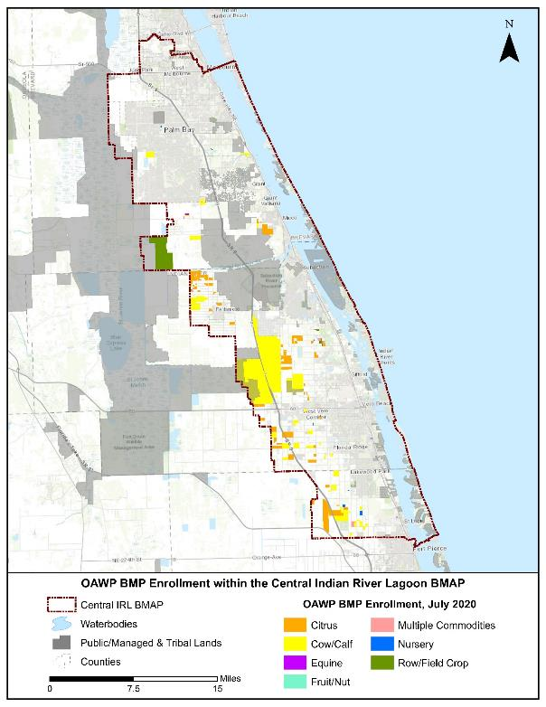
Figure C-1. BMP enrollment in the CIRL BMAP area as of July 2020

Unenrolled Agricultural Acreage
As of July 2020, 25 % of the agricultural acres in the CIRL BMAP area are enrolled in FDACS' BMP Program and are implementing practices designed to improve water quality. FDACS continues to increase enrollment in all BMAPs to meet the BMAP goal of enrolling 100% of the enrollable agricultural acres in the BMP program. To achieve that goal, land use analyses are conducted to ensure that areas containing commercial agricultural land uses are prioritized. Lands classified as agriculture where the ability to implement agricultural BMPs under the BMP program is limited, such as smaller rural homesteads, receive lower priority for enrollment.
General Considerations
Although land use data have been used as the basis for prioritizing FDACS enrollment efforts, many land use issues not captured by these databases affect FDACS enrollment efforts. Many areas within the CIRL BMAP boundaries experience rapid land use changes, especially at the urban/rural boundary. Agricultural lands are regularly converted to residential, industrial, commercial, or multiuse properties, but still appear in various databases as pasture or other rural lands. While these lands are likely to be developed in the near future, the agricultural land use classifications require these properties to comply with the BMP enrollment requirements.
Additionally, the counties' methods of classifying small acreages as agricultural lands can affect the BMP enrollment process. Along with these changes, there are also large agricultural parcels being subdivided but remaining classified as "agriculture." These rural homesteads—also called residential agriculture, rural residential, rural estates, equine communities, ranchettes, and other descriptive names for homes with some acreage and agricultural zoning—present a particular challenge for FDACS. The current BMP manuals and the measures they contain target commercial agricultural production practices and, in many cases, cannot be scaled down to appropriately enroll activities on these smaller, noncommercial agricultural properties. The increasing number of these smaller parcels with noncommercial agricultural activity represents a growing component of unenrolled acreage. It will be necessary to develop a suite of options to apply to these properties or develop a new classification that may subject these types of areas to other requirements to ensure their nutrient loading contribution is being appropriately identified and reduced.
Further, thousands of acres of open land, scrubland, unimproved pasture, and grazing land exist without a readily identifiable agricultural production activity that will fit within the framework of existing FDACS BMP manuals. Also, these types of parcels are usually controlled by many different individuals. It will be necessary to develop a suite of options to apply to these properties or develop a new classification that may subject these types of areas to other requirements to ensure their nutrient loading contribution is being appropriately identified and reduced.
Another challenging area includes those agricultural lands that are inactive or fallow—i.e., lands that, on the day the FDACS representative visits, display no enrollable agricultural activity. These lands may be part of a rotation implemented by a landowner, scheduled for development, listed for sale, etc. The land use information FDACS receives is used to consistently improve the classification of these areas, but policy options remain limited in scope to ensure the implementation of practices aimed at reducing nutrient inputs from these areas.
Characterization of Unenrolled Agricultural Lands
To characterize unenrolled agricultural acres, OAWP identified FSAID VII features outside the BMP enrollment areas and overlaid these features with property appraiser parcels within GIS. OAWP then identified the number of parcels that encompass the unenrolled agricultural lands and the number of agricultural acres present within the parcels. The parcel owner information, other parcel details, and aerial imagery were used identify parcels that are unlikely to contain agricultural activity. As previously mentioned, OAWP BMP enrollments are initially delineated based on county property appraiser parcel data, even if the entire parcel is not in agriculture, to allow BMPs to be tied to the specific parcels where agricultural activities are occurring. FSAID agricultural lands are delineated based on land use features identified as agriculture and represent a more refined analysis of those areas actually in agricultural production.
Because of differences in the spatial geometries between the OAWP BMP enrollment, FSAID, and property appraiser parcels, when they are combined or compared, the boundaries often do not align precisely, creating "slivers." Slivers are not enrollable because they are an artifact of the geospatial analysis and do not represent lands with active agricultural practices. For example, a sliver can represent the area between the boundary of a parcel and the beginning of a road, canal, easement, etc. A sliver can also represent a small portion of an FSAID feature outside the BMP enrollment areas that is slightly overlapped by a property appraiser parcel. Slivers are often associated with previously enrolled agricultural operations but because of the delineation differences, these slivers are not captured within the enrolled parcel during geoprocessing. When characterizing unenrolled agricultural lands, slivers are excluded. Figure C-2 shows an example of a sliver created when performing geospatial analysis.

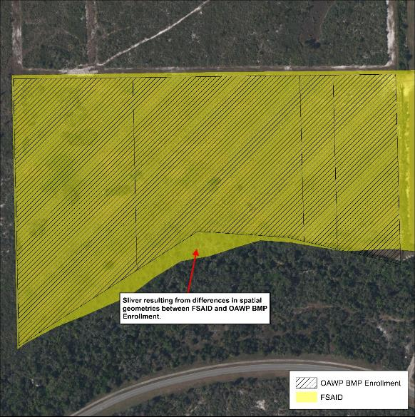
Figure C-2. GIS example of a sliver

Large areas that are identified as agricultural land use but are unlikely to have enrollable agricultural activities include lands owned by the state (Board of Trustees of the Internal Improvement Trust Fund) and water management districts (SJRWMD or SFWMD). It is possible that these lands, in whole or in part, may be leased to other entities that conduct agricultural activities, but such leasing is infrequent. If leasing occurs, the leasing entity will be required to enroll in the BMP Program. Ongoing coordination between FDACS, DEP Division of State Lands, SJRWMD, and SFWMD is needed to ensure that any public lands that are leased for the purposes of agricultural activities are required to implement and enroll in the FDACS BMP Program as a condition of the lease.
Other smaller parcels that have been identified as nonagricultural, but have features that cause them to be identified as agricultural lands in various databases, include those lands associated with utilities, telecommunication companies, churches, FDOT rights-of-way, and airports. The Florida Department of Revenue (DOR) uses code numbers 70 through 98 to identify these types of lands.
Those agricultural lands that have been identified as "fallow," "former [ag]," and "abandoned," as well as brushland/scrubland/open land, comprise 34 % of the total unenrolled agricultural acres in the CIRL BMAP area. These acres are still classified as agricultural land for the purposes of the BMAP nutrient load assessment. There are a variety of potential options to account for these lands, such as enrollment as "temporarily inactive" operations—particularly those that were previously enrolled and are planned to resume production. Another option may be to note the inactive acres at the time of a field visit and perform periodic reassessment on a cyclical basis. The possibility for DEP and FDACS to calculate nutrient reduction credits or adjust nutrient loading rates may also provide opportunities to present more accurate estimates and establish priorities.
Another factor considered in the prioritization of BMP enrollment is the number of agricultural acres on the parcel. Analyzing the number of agricultural acreages on the parcel and commodity type can give an idea of the efforts that are needed to enroll these areas in the FDACS BMP Program and also identify the areas most in need of enrollment. Figure C-3 summarizes the agricultural acres distributed by agricultural acreage found on each parcel.
Further analysis was done to characterize the parcels based on agricultural acreage and land use type. For graphing purposes, land use distribution is displayed in two charts, one showing the land use for parcels containing 50 acres of agriculture or greater (Figure C-4) and a second for parcels containing less than 50 acres of agriculture (Figure C-5). Of the 44,847 acres of land identified as having potential agricultural activity, grazing land comprises 48 % of this acreage.

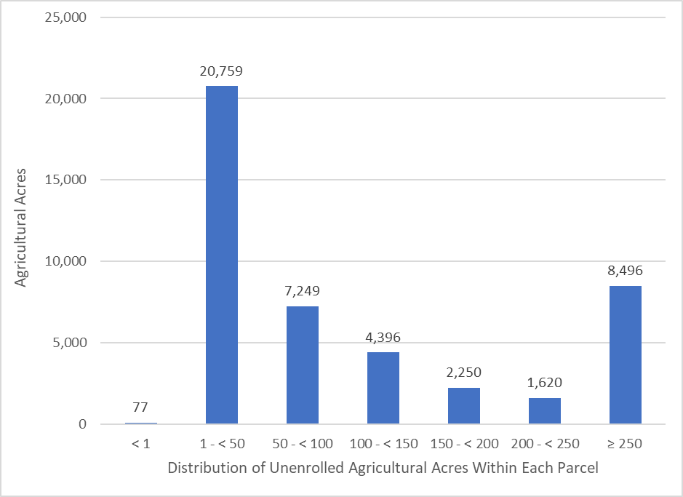
Figure C-3. Distribution of agricultural acreage on parcels with potential agricultural activity, CIRL BMAP area

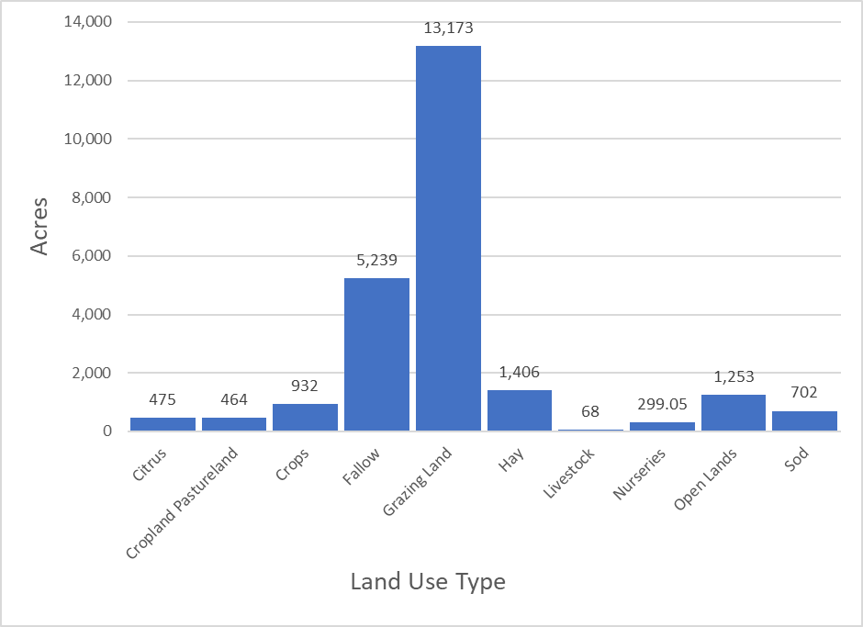
Figure C-4. Agricultural land uses on parcels with 50 acres of agriculture and greater, CIRL BMAP area

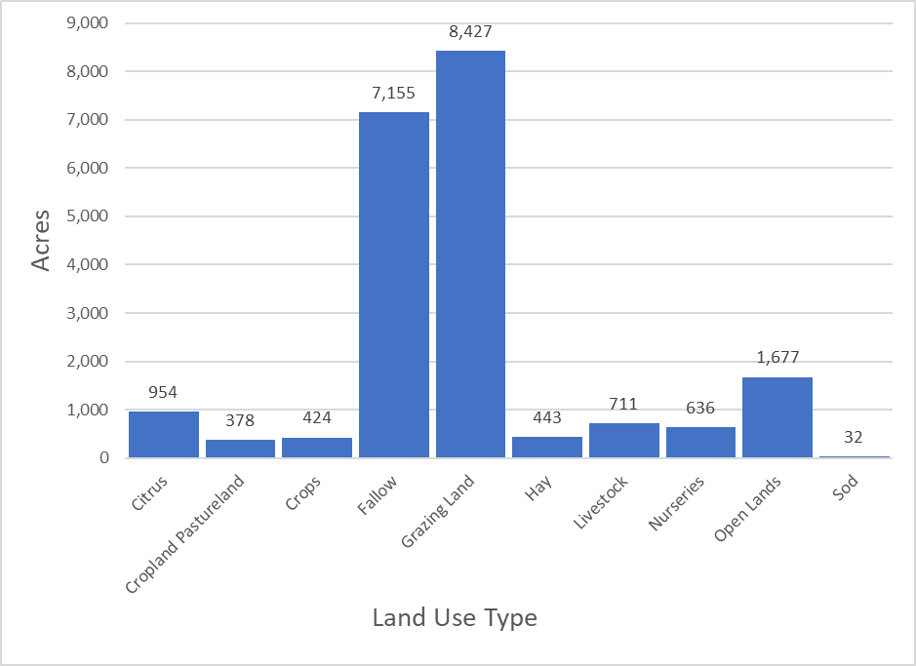
Figure C-5. Agricultural land uses on parcels with less than 50 acres of agriculture, CIRL BMAP area

Table C-8 lists the total acreage associated with the identified slivers and the lands that are not likely to have enrollable agricultural activities, along with the remaining total of unenrolled agricultural acres in the BMAP area. Figure C-6 and Figure C-7 summarize the unenrolled agricultural acres in the CIRL BMAP area by acres of agriculture within the parcels. However, they do not include acreages or parcels associated with slivers or lands that are not likely to have enrollable agricultural activities.
Table C-8. Summary of unenrolled agricultural land use acreage in the CIRL BMAP area
Note: Because of geometric variations between shapefiles used in the unenrolled agricultural lands analysis performed by OAWP, the unenrolled agricultural acres differ from subtraction of the FSAID VII Agricultural Acres in the BMAP and the Total Agricultural Acres Enrolled referenced in Table B-1.
Category | Acres
Unenrolled agricultural acres | 54,625
Acres identified within slivers of unenrolled agricultural areas | 443
Lands without enrollable agricultural activity (e.g., tribal lands, residential development, and parcels with DOR use codes 70-98) | 9,335
Total lands with potentially enrollable agricultural activities | 44,847

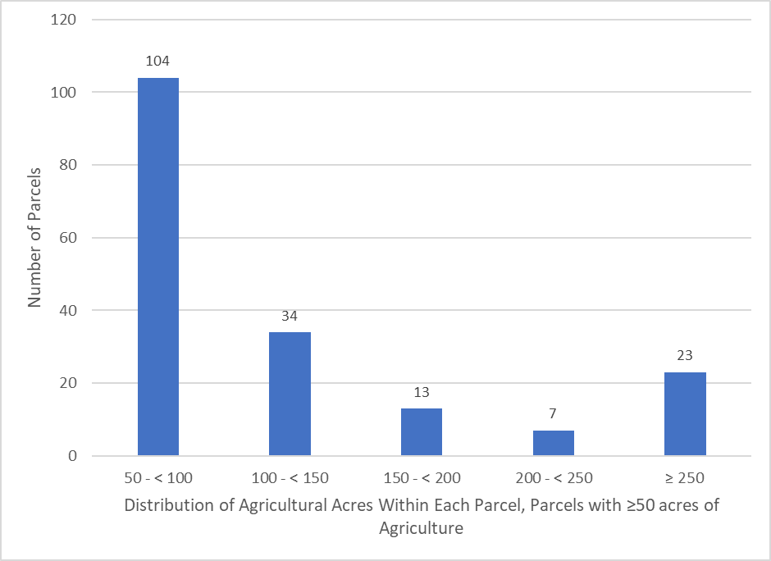
Figure C-6. Number of parcels with 50 acres of agriculture and greater, CIRL BMAP area

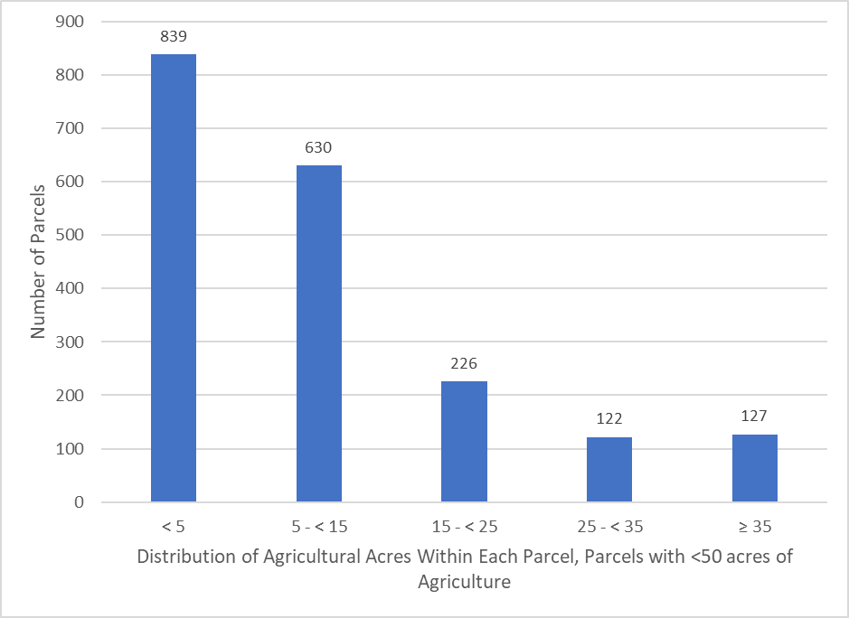
Figure C-7. Number of parcels with less than 50 acres of agriculture, CIRL BMAP area

Unenrolled agriculture characterization information for each individual project zone, including the distribution of agricultural acres within each parcel and land use type, is shown in Figure C-8 through Figure C-15.

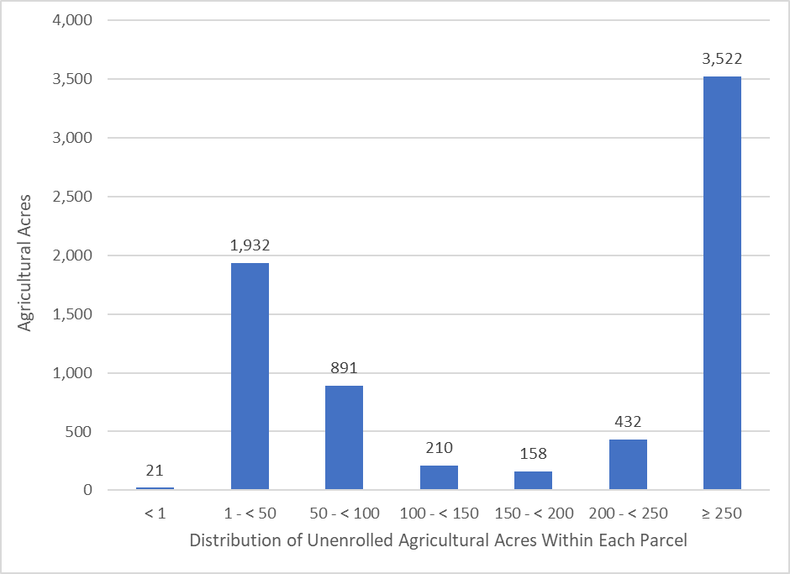
Figure C-8. Distribution of agricultural acreage on parcels with potential agricultural activity, Project Zone A

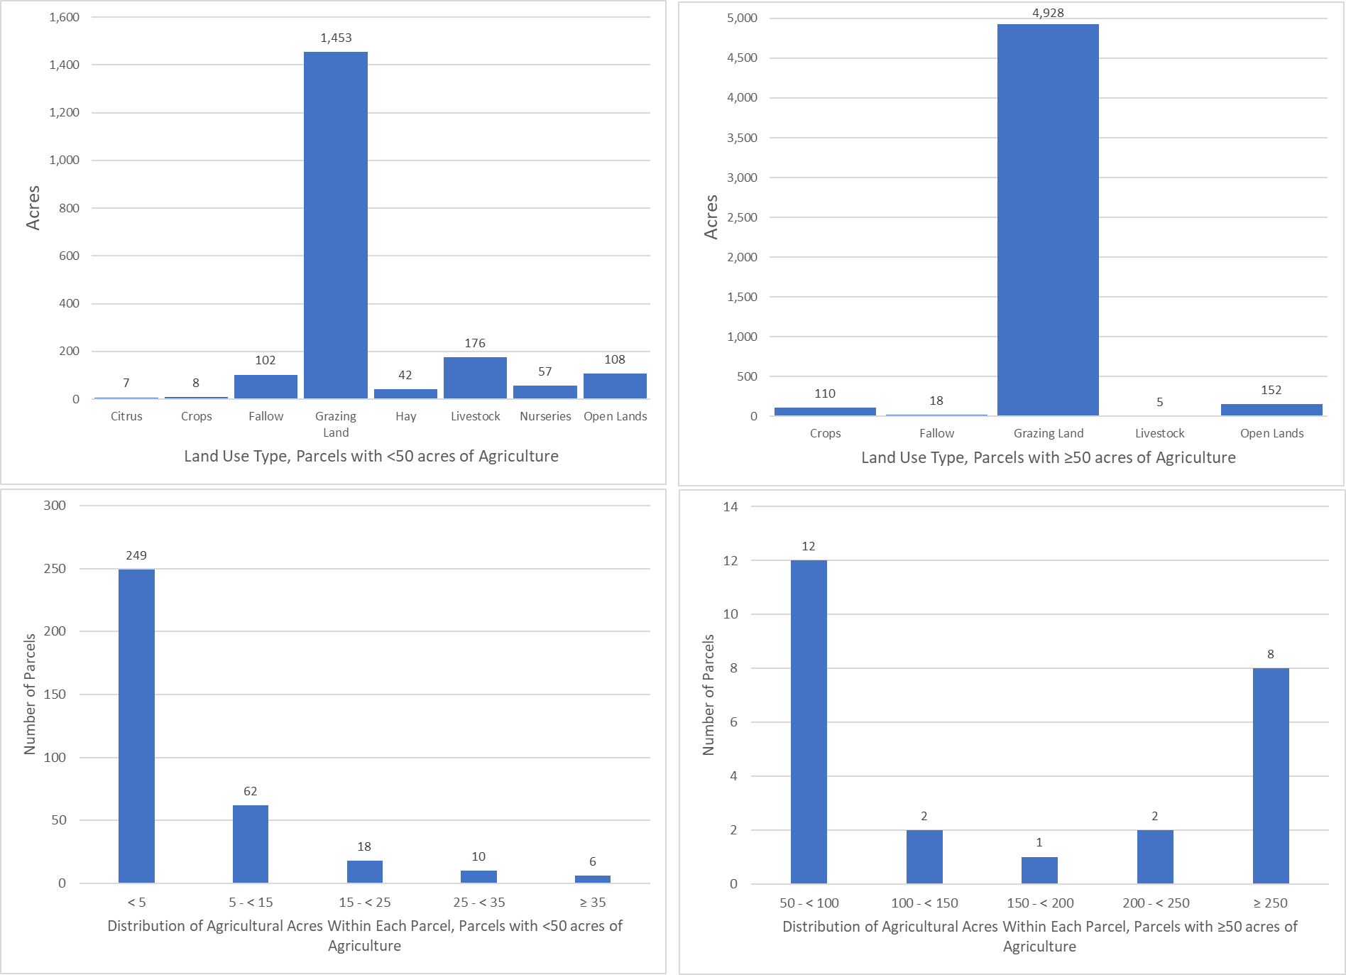
Figure C-9. Land use type and distribution of agricultural acreage, Project Zone A

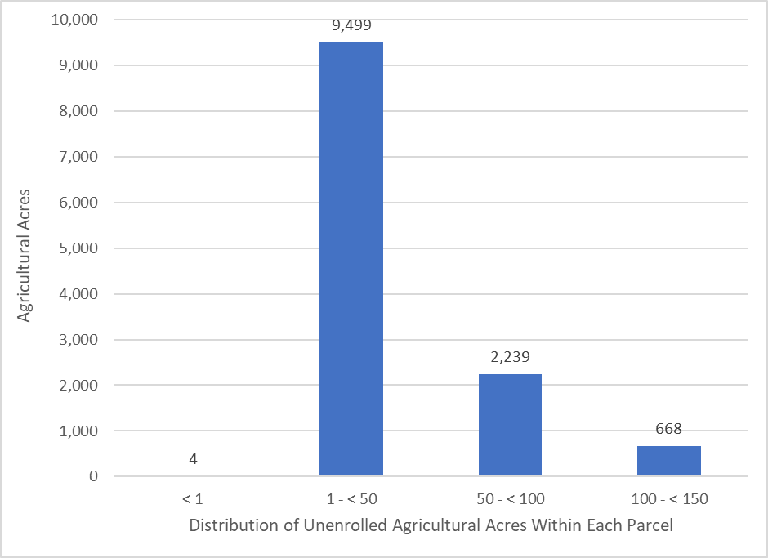
Figure C-10. Distribution of agricultural acreage on parcels with potential agricultural activity, Project Zone B

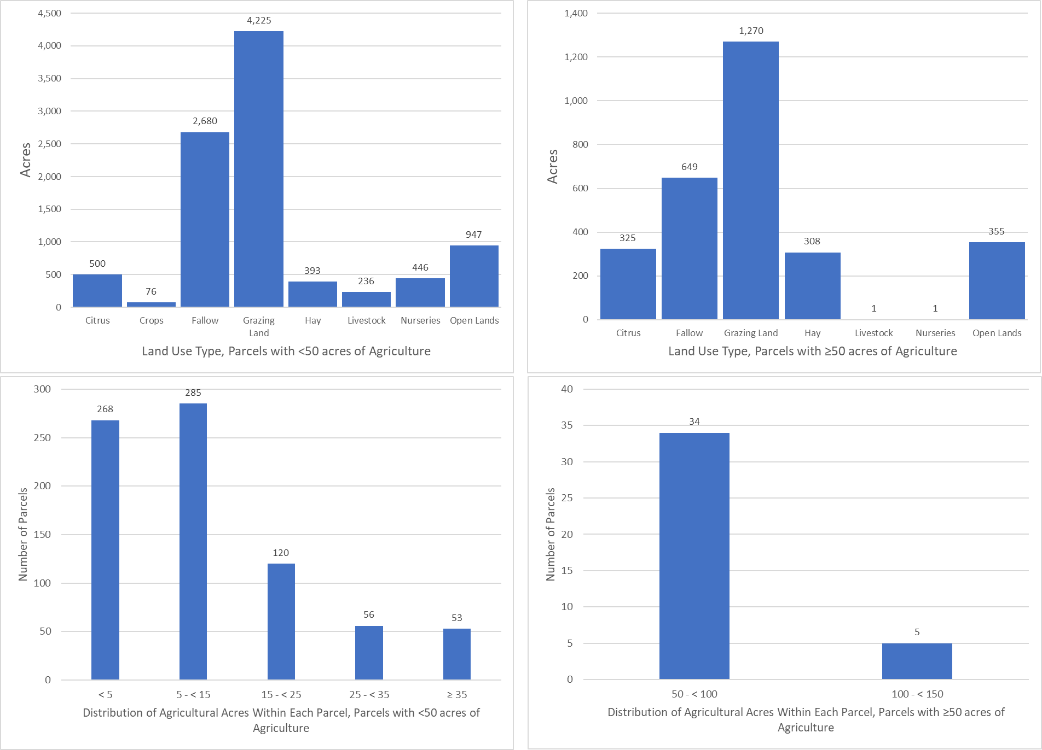
Figure C-11. Land use type and distribution of agricultural acreage by parcel size, Project Zone B

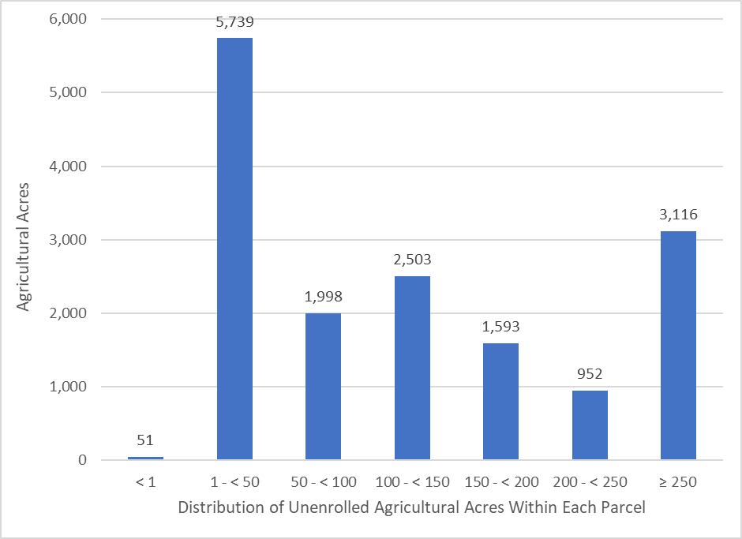
Figure C-12. Distribution of agricultural acreage on parcels with potential agricultural activity, Project Zone SEB

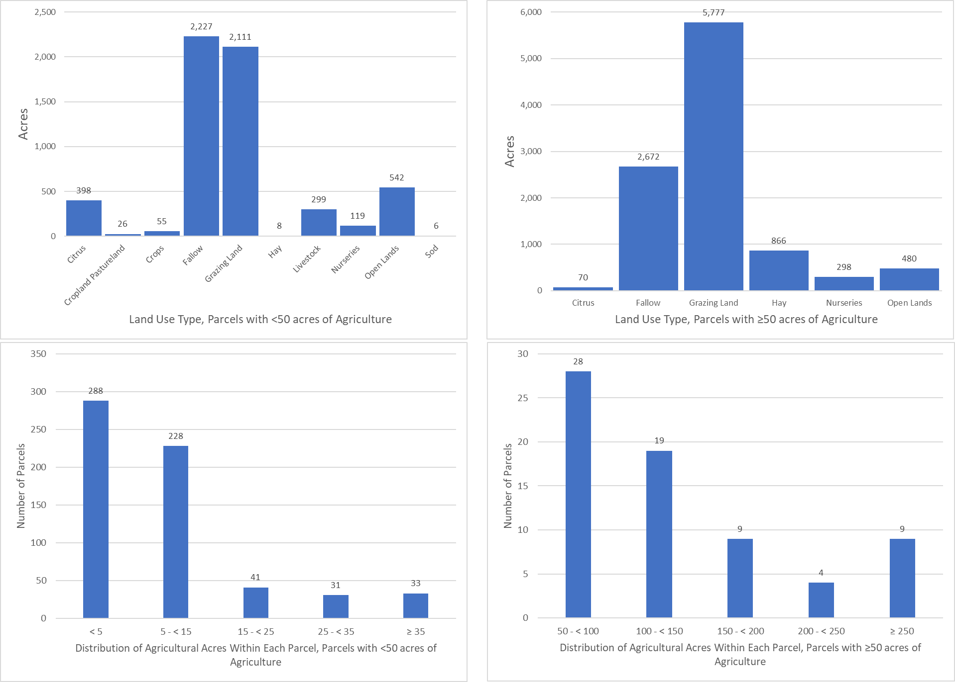
Figure C-13. Land use type and distribution of agricultural acreage by parcel size, Project Zone SEB

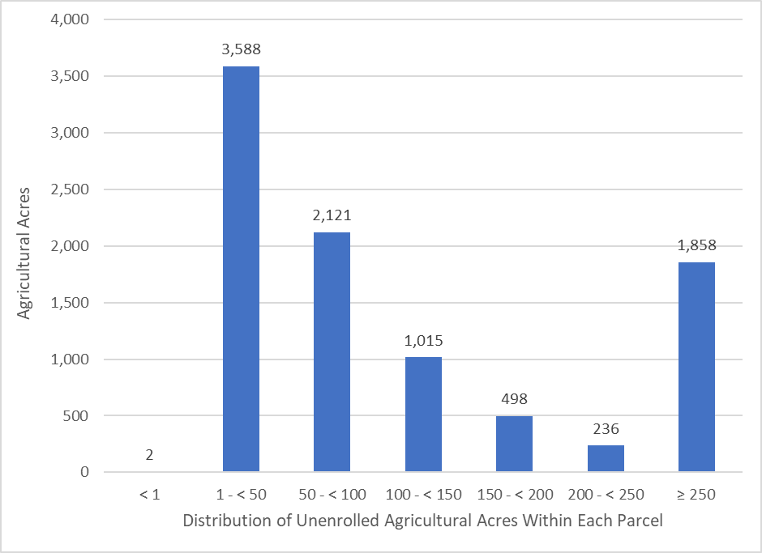
Figure C-14. Distribution of agricultural acreage on parcels with potential agricultural activity, Project Zone SIRL

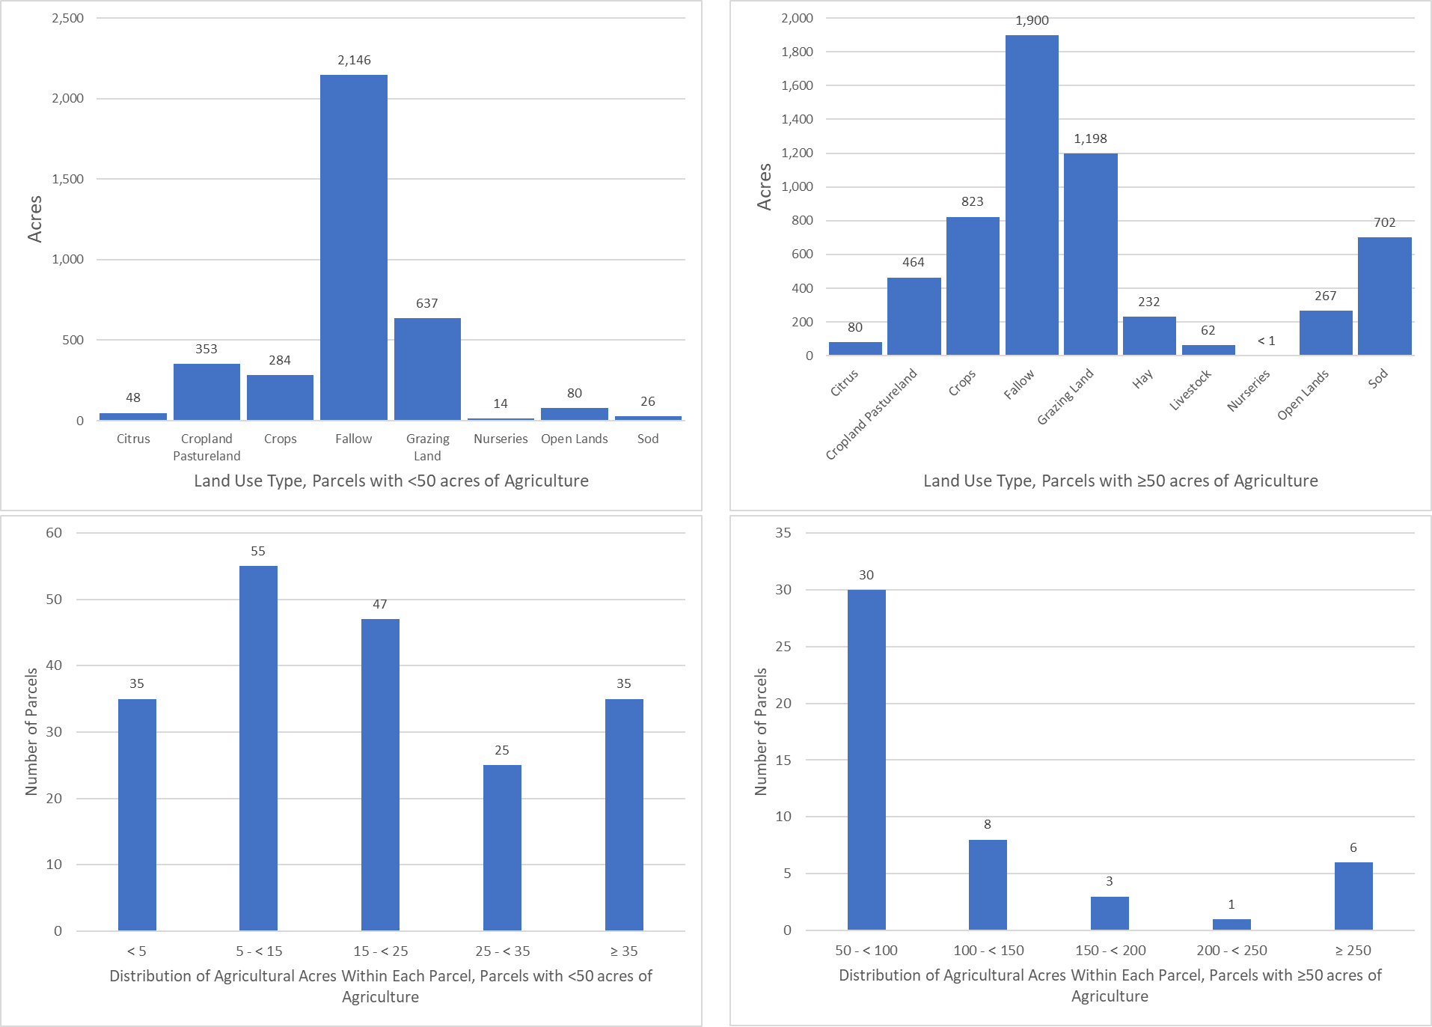
Figure C-15. Land use type and distribution of agricultural acreage by parcel size, Project Zone SIRL
Future Efforts
To address resource concerns, FDACS continues enhancing coordination with producers, agencies, and stakeholders to increase enrollment in the BMP Program. OAWP is sending correspondence to agricultural land owners within BMAP areas that are not currently enrolled in the BMP Program to increase enrollment rates and verify land uses where additional focus may be required to achieve resource protection. This effort is utilizing a phased approach and targeting priority land uses and then using the amount of agricultural acreage for the remaining unenrolled lands, while ensuring that all entities identified as agricultural will be notified. Additionally, OAWP continues to coordinate with industry groups and outreach partners to educate and inform agricultural producers about the BMP Program.
Additional Factors Related to Agricultural Lands and Measuring Progress
Legacy loading can present an additional challenge to measuring progress in many areas of Florida with adopted BMAPs. Based on research, initial verification by DEP, and long-term trends in water quality in the BMAP area, it is expected that current efforts, such as BMP implementation, will continue to provide improvements in overall water quality despite the impacts from legacy loads.
While the implementation of BMPs will improve the water quality in the basin, it is not reasonable to assume that BMP implementation alone can overcome the issues of legacy loads, conversion to more urban environments, and the effects of intense weather events. BMP implementation is one of several complex and integrated components in managing the water resources of a watershed. Additional regional projects, precisely located and operated, may be needed to achieve the TMDLs for the CIRL Subbasin.
Collaboration between DEP, the water management districts, and other state agencies, as well as local governments, federal partners, and agricultural producers, is critical in identifying projects and programs, as well as locating funding opportunities to achieve allocations provided for under this BMAP. To improve water quality while retaining the benefits that agricultural production provides to local communities, wildlife enhancement, and the preservation of natural areas requires a commitment from all stakeholders to implementing protective measures in a way that maintains the viability of agricultural operations.
Recommended Updates to Land Use
BMAP loads and allocations, as well as water supply projections, are based primarily on land use data. Maintaining the most accurate agricultural land use dataset is critical to planning and policy decisions. Although crop changes, technology advances, and land ownership/lessee changes related to agricultural operations create dynamic environments and difficulties in estimating impacts from specific operations, FDACS and DEP continue to coordinate and develop ways to improve accuracy.
DEP and OAWP recognize that land use–related issues consistently occur during BMAP development and/or updates. One of these issues is the differentiation between what is classified as an agricultural land use in the TMDL or BMAP model, and what is no longer an agricultural land use by the time the BMAP is adopted or an update occurs.
OAWP has developed a methodology to identify agricultural land use changes to make adjustments in subsequent models and reports. Using GIS, OAWP compared the SWIL model land use with the latest FSAID land use and BMP enrollment data. OAWP identified areas classified as agriculture by the BMAP modeled land use that do not overlap with the latest FSAID or BMP enrollment data
OAWP reviewed the output of this overlay analysis by using county appraiser data and aerial imagery to determine if the nonoverlapping areas were still in production. It identified 3,113 acres, classified as agriculture in the SWIL land use, that are now other land use types such as residential, industrial, or commercial (see Table C-9). DEP evaluated the land use changes identified by OAWP and apportioned the associated acres and loads to the appropriate entities after a discussion with each entity.
Often the analyses show changes that have occurred more rapidly than any land use data can capture, such as the transition to residential development. The land use changes are provided to DEP as a GIS shapefile with a description of the information in the county property appraiser database and aerial imagery reflected for the refinement of the acreage and loading allocated to agriculture in a BMAP area.
Table C-9. Agricultural land use change by project zone
Project Zone | Acres
A | 1,639
B | 543
SEB | 784
SIRL | 146
Total | 3,113

In addition to identifying land use changes in the BMAP area modeled land use, OAWP regularly reviews FSAID data, at times daily or weekly, as it performs other job functions. Any edits or changes are reviewed and considered for inclusion in the next iteration of the FSAID.
Potential Site-Specific Nutrient Management Measures in Addition to BMPs
Beyond enrolling producers in the FDACS BMP Program and verifying implementation, OAWP will also work with producers to identify a suite of agricultural projects and research agricultural technologies that could be implemented on properties where they are deemed technically feasible and if funding is made available. FDACS executes contracts with soil and water conservation districts and other partners to administer cost-share funds and provide technical and administrative support for these districts and other partners. Cost-share funding is being used to implement higher level BMPs, innovative technologies, and regional projects to provide the next added increment of improving and protecting water quality.
Table C-10 identifies the agricultural technologies that received cost-share assistance in the CIRL BMAP area and the associated nutrient reductions based on the 2016 Soil and Water Engineering Technology (SWET) report. Using the nutrient reductions from the report, OAWP developed a methodology to estimate nutrient reductions for NOIs that have received cost-share funding. The NOI boundary, based on property appraiser parcel data, was considered the area treated by the cost-shared agricultural technology or project. For parcels with more than one cost-share project, OAWP identified the order of treatment to determine the reductions for the multiple projects and created a workbook that provided the cost-share agricultural technologies and the formulas to estimate the nutrient reductions.
Table C-10. Cost-share project types and associated nutrient reductions recommended by OAWP
¹ Reductions for this measure not incorporated as part of this exercise.
² Reductions for this measure are from Table 5. Estimated Edge of Farm Nutrient Load Reductions for the FDACS Okeechobee BMP Program in the 2016 SWET Report (Bottcher 2016) and is represented in pounds per year per unit (each project is 1 unit).
Project Types | TN Reductions  (%) | TP Reductions  (%)
Chemigation/fertigation | 20 | 20
Fence | 10 | 10
Irrigation improvements, automation | 20 | 20
Precision agriculture technology | 30 | 10
Weather station¹ | 20 | 5
Well, pipeline, trough, pond, heavy use protection² | 50 | 50

Appendix D. Seagrass Analysis
PROCESS TO CONDUCT THE SEAGRASS DEPTH LIMIT COMPLIANCE EVALUATION
The goal of the IRL Basin TMDLs is to recover the deeper seagrass habitats. The seagrass response is the most important factor in evaluating the success of the nutrient TMDLs. Even if the relationship among nutrient loads and seagrass recovery is not as predicted by the regression model, the load reduction requirements themselves will not determine TMDL success. The assessment of success is based on whether the seagrass grows at sufficient depths.
The TMDL seagrass depth limit targets are based on a union coverage of the seagrass mapping data from 1943, 1986, 1989, 1992, 1994, 1996, and 1999. SJRWMD created this union coverage when it set pollutant load reduction goals for the IRL Basin. The TMDL targets are not based on the full restoration of seagrass depths represented by this union coverage; instead, they were set at 90 % of the full restoration estimate. These targets allow for seagrass growth almost to the depths previously seen in the lagoon, while accounting for the fact that changes have been made to the lagoon system that may limit seagrass growth in some areas, such as dredged areas similar to the Intracoastal Waterway.
Compliance with the TMDL seagrass depth limit targets is assessed on a project zone scale using the latest four consecutive data sets of seagrass mapping data. For the assessment years to be compliant with the TMDL seagrass depth limit targets, the data must meet the requirements of a two-step evaluation process.
The first step is a comparison of the TMDL union coverage cumulative frequency distribution curve with the assessment years' union cumulative frequency distribution curve. The cumulative distribution curves show what percentage of the seagrass deep edge is located at different depths. To be compliant, at least 50 % of the assessment years' curve, including the median, must be on or to the right of the TMDL curve.
The second step in the evaluation process is a comparison of the TMDL union coverage median value with each assessment year's median value. To be compliant in the second step, at least three of the four assessment year medians must be equal to or greater than the TMDL median. If the seagrass data from the four assessment years are compliant with both steps of the test, the project zone is achieving the TMDL depth limit target.
A series of GIS steps must be conducted to obtain the data necessary to complete the two-step evaluation process. These steps are as follows:
- Start with the seagrass GIS shapefiles for the four latest assessment years and edit these files to include only Categories 9113 and 9116, which represent seagrass. Other categories in the GIS shapefiles represent algae cover, which should not be included in this assessment. The seagrass shapefiles only represent the location of the seagrass beds.
- Use the dissolve function in GIS to create the union file of the assessment years. This union file results in a coverage of where seagrass beds were located during all four assessment years.
- Transform the polygons to a polyline in the assessment years' union file. This polyline represents the edges of the seagrass beds.
- Draw a 15.8-m buffer around the seagrass polyline that is 7.9 m inside and 7.9 m outside the seagrass bed. The bathymetry layer was created by SJRWMD in 1996, and the bathymetry was measured every 15.2 m. The 15.8 m buffer around the seagrass polyline ensures that 1 bathymetry point will be captured in the GIS analysis.
- Intersect the updated bathymetry shapefile with the seagrass coverage file that was transformed into a polyline. This intersection correlates the depth data with the seagrass locations so that depths along the seagrass bed edge can be determined.
- Intersect the deep edge file to each project zone (BRL A, BRL B, North A, North B, Central A, Central SEB, and Central B).
- Use the select by location function to identify and note points within dredged areas. The dredged areas are removed from this coverage because seagrass is not expected to grow in areas that have been dredged.
- Identify and note points that fall below 0.3 m and above 3.5 m from the coverage. This step is needed because seagrass growing at depths less than 0.3 m are likely not light-limited, and seagrass are not expected to grow at depths greater than 3.5 m.
- Identify and note points from the intersections of holes or bare areas, which do not represent the deep edge of the seagrass bed.
- These steps are also followed separately for each assessment year so that the median value can be calculated.
The final points that represent the seagrass deep edge boundary for the assessment years' union coverage are then exported from GIS into Excel to conduct the two-step evaluation. The depth points are sorted from highest to lowest, and the count of the number of points at each depth is determined. The cumulative count is determined by taking the count for the shallowest depth and adding it to the count for the next shallowest point until the counts for all the depths are added together to yield the total number of depth points. The cumulative count at each depth is divided by the total points to determine the percentage of the seagrass points at each depth. These points are then plotted as a curve on a graph for comparison with the TMDL cumulative distribution curve. For the Step 2 evaluation, the median depth point is calculated for each assessment year using Excel. These medians are then compared with the TMDL median to determine compliance.
The maps in Figure D-1 through Figure D-3 include the locations of ground truthing conducted before and during aerial surveys. Additionally, the transect locations where SJRWMD conducts seasonal monitoring are shown. For more information on how SJRWMD and partners conduct seagrass surveys, SJRWMD's SOP is referenced in Chapter 5.
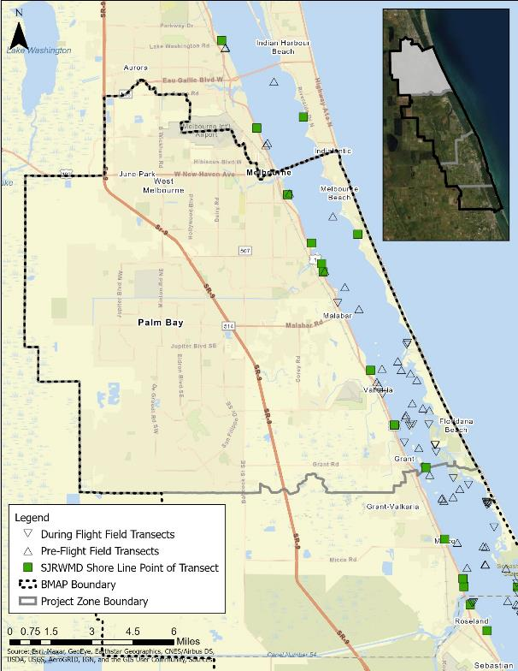
Figure D-1. Map of the seagrass transects in CIRL A

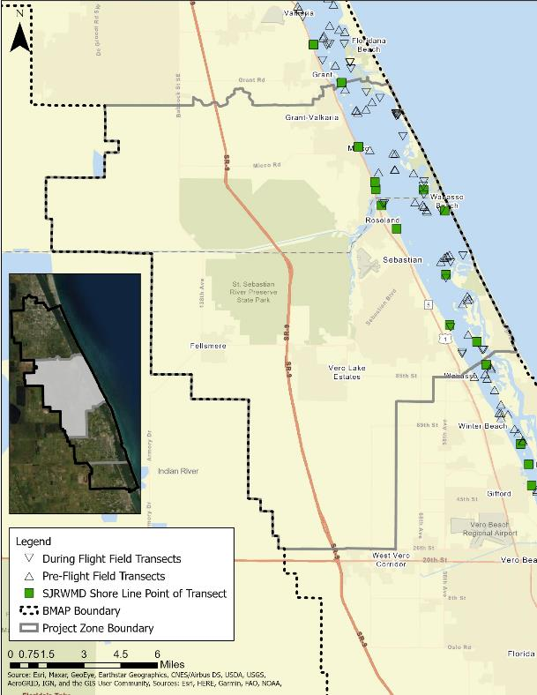
Figure D-2. Map of the seagrass transects in CIRL SEB

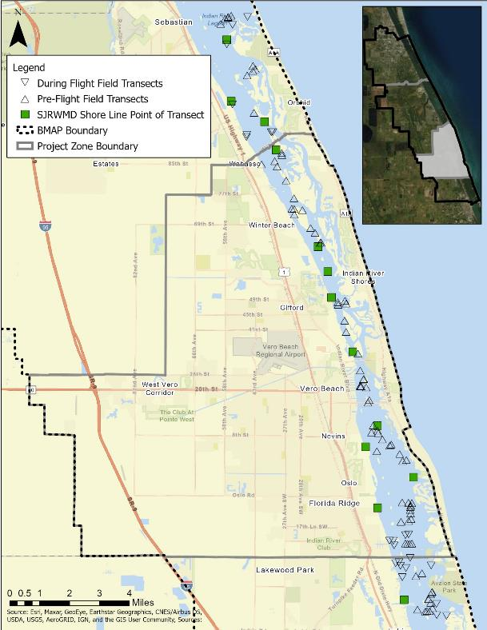
Figure D-3. Map of the seagrass transects in CIRL B

Appendix E. WCDs and Other Special Districts
In the 2013 BMAP, WCDs and other special districts were assigned quantitative (numeric) allocations, which included all agricultural and urban lands within their jurisdictional boundaries that were not part of an MS4. During the development of the 2013 BMAP, there were concerns with this approach, because FDACS is the only entity that can enroll agricultural producers in BMPs, but the WCDs were held responsible for reducing loading from the agricultural areas. In addition, the urban lands within the districts were permitted by the city or county and not under the district's control.
Therefore, this 2020 BMAP assigns qualitative (activity-based) allocations to the special districts for the canals and rights-of-way, as the districts have control over these portions of their jurisdictions. The districts are required to implement specific canal and right-of-way BMPs to be compliant with the BMAP. The BMPs for each special district are based on the activities and land uses in the district, and reporting on those BMPs is due annually. The included BMP plans were prepared and submitted by each individual WCD and reviewed by DEP.
Fellsmere Water Control District (FWCD)
The FWCD (formerly known as the Fellsmere Drainage District) was created April 8, 1919, under the General Drainage Laws of the State of Florida, by a Circuit Court proceeding (St. Lucie County, Case No. RED 533) and currently operates under Chapter 298 of the Florida Statutes, and amendments thereto, as an Independent Single Purpose Special District. The district was created and is responsible for the drainage, flood protection, and control with respect to drainage in times of excess water within its geographical boundaries. The FWCD does not generate any nutrient loading. The district receives the runoff from the lands within the gravity drainage portion of the overall district and conveys the flow to the Fellsmere Main Canal discharge point. The district map is shown in Figure E-1.
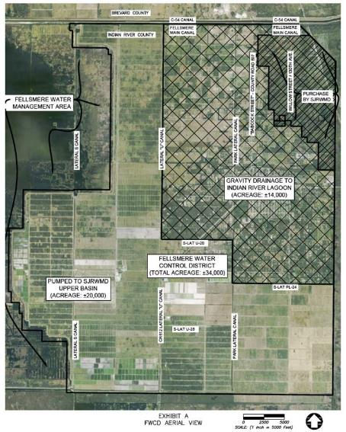
Figure E-1. Map of the Fellsmere WCD

The original overall district watershed included 50,000 acres of land primarily used for agriculture. The system includes east-west sublateral ditches approximately one-quarter mile on center. Due to the naturally occurring 10 mile ridge (Interstate 95) east of the district; the land generally slopes from east to west. The one-quarter mile ditches flow west into the lateral canals. The lateral canals flow north to the Fellsmere Main Canal.
The Fellsmere Main Canal is located along the north boundary of Indian River County and is graded to drain east through the 10-mile ridge and into the west prong of the St. Sebastian River. A plug in the Fellsmere Main Canal west of Lateral U, and internal control structures in Lateral U near Sublateral Ditch 20 and in Park Lateral near Sublateral Ditch 24, separates the gravity drained watershed and the pumped drained watershed.
With the acquisition of lands and development of the Upper St. Johns River Basin project by SJRWMD, the watershed basin of the original Fellsmere Water Control District has been reduced to 34,000 acres. A majority of the remaining area within the Fellsmere Water Control District is owned by Fellsmere Joint Ventures (FJV) and is pumped, or partially pumped, into portions of the Upper St. Johns River Basin.
The remaining gravity drained portion of the FWCD is drained by two lateral canals (Park Lateral and Lateral "U"). Generally, Park Lateral drains all the land within FWCD lying east of Park Lateral (including "The Original Town of Fellsmere”) and north of Sub-lateral PL-24, containing approximately 14.0 square miles. Park Lateral also partially drains the former "Berry Groves" parcel (now owned by FJV), containing approximately 6 square miles, that is pumped south into the Blue Cypress Water Management Area (BCWMA), during heavy rainfall events.
Lateral "U" Canal gravity drains all the land west of Park Lateral Canal and north of Sublateral U-20, containing approximately 8.4 square miles, and partially drains a portion of its southern basin (between Sublateral U-20 and U-28), containing approximately 2.5 square miles. This area is pumped south into BCWMA during heavy storm events.
The remaining nongravity-drained portions of the district are drained through pump stations, all owned and operated by FJV (SunAg, Inc.), into water management areas of the Upper St. Johns River Basin.
The FJV agricultural land that gravity drains to the CIRL is enrolled and is subject to the BMP Program managed by FDACS.
FWCD developed the Permit Information and Criteria Manual for Use of or Connection to Works of the District, the purpose of which is to provide information describing the criteria and permitting requirements relating to the utilization of, and connection to, the works of the FWCD. A copy of the manual and other information associated with FWCD can be found on the district's website: http://www.fellsmerewatercontroldistrict.com/permits.html.
FWCD proposes that the listed BMPs will be implemented and reported as active-based strategies. A specific allocation or nutrient reduction target will not be established. Rather, the FWCD's activities will serve to assist in the control of nutrients as part of the efforts described in the BMAP. Implementation of the BMPs shall provide compliance with the BMAP.
In selecting the BMPs, in coordination with DEP, the function, operation, and budget of FWCD has been considered. Each year, during the annual report information collection period, FWCD will confirm that these activities continue in its canals and rights-of-way. Each BMP includes a description and the required records.
Fellsmere Water Control District BMPs (For the Gravity Drainage Watershed Area Only)
- Assist FDACS, where needed, with identifying and contacting producers within the district boundaries for purposes of participating in the relevant FDACS BMP programs.
  - Report: Number of landowners contacted to assist FDACS, and the names of landowners.
- For all new change of land use development projects, exempting single family residences, a FWCD connection permit will require the compliance with the stormwater discharge limitation policy of 2 inches/24 hours for a 25-year-24-hour storm event. This limitation applies to any 24-hour period (hour 10–34, hour 14-38, etc.) during the 72 hours starting at time 0 of a 25-year, 24-hour storm event.
  - Report: The FWCD will provide the developer’s engineer with a boundary condition at the connection point to the FWCD system. The boundary condition will include a time stage summary for hours 0 – hour 72 of the 24-hour–25-year event. A list of projects permitted over the year will be provided.
- Routine maintainence of laterals and sublaterals for drainage and flood protection for land owners. Harvest aquatic vegetation in the canals using mechanical processes along with some necessary herbicide treatment. Vegetation removed from the canals must be disposed of in a location where the material will not be able to reenter the canal. Vegetation harvesting should consider the DEP guidelines in Removal of Aquatic Vegetation for Nutrient Credits in the Indian River Lagoon (IRL) Basin (September 2012).
  - Report: Dates when harvesting occurred and disposal location. Report any herbicide treatments and justification for nonmechanical removal of vegetation.
- Provide public education to residents of the FWCD that fosters an understanding of the necessity to reduce nutrient impacts to surface waters.
  - Report: Provide link or brief summary of the information regarding the encouraged use of BMPs throughout the district.

Fort Pierce Farms Water Control District (FPFWCD)
The FPFWCD was originally created in 1919 under the provisions of Chapter 298, F.S., commonly referred to as the General Drainage Law of Florida. The FPFWCD is located in St. Lucie County, and current FPFWCD boundaries encompass roughly 13,000 acres. The FPFWCD is responsible for drainage, flood control and protection, water managemen and the reclamation of lands within FPFWCD boundaries. The FPFWCD owns, operates, and maintains works for water management and regulates their use by others. The water management system generally includes a network of approximately 50 miles of canals, and associated pumps and water control structures. The Phillip C. Gates structure is the main water control structure located within Canal No. 1 that serves to regulate stormwater discharges into the Indian River Lagoon from FPFWCD. The original construction consisted of four 8 foot (ft) by 16 ft radial gates that opened from the bottom at elevation 6 ft National Geodetic Vertical Datum (NGVD). In 2018, FPFWCD completed a retrofit project in which the two outer gates were split at elevation 10 ft-NGVD and the two center gates were split at elevation 8 ft-NGVD. The retrofitted structure reduces sediment deposits downstream of the structure. An aerial map of the FPFWCD boundary (thick white line) and drainage canals is shown in Figure E-2. A more detailed map identifying the canal numbers and associated rights of way is shown in Figure E-3.
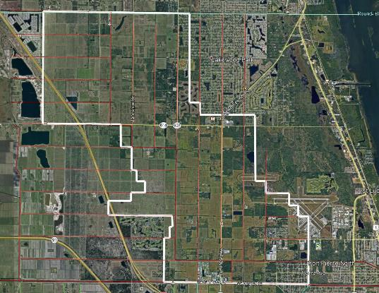
Figure E-2. Map of the FPFWMD
A map generally depicting the agricultural producers enrolled within the FPFWCD is on file with FDACS. Significant stormwater entering the FPFWCD canals is subject to the FDACS program. Additionally, stormwater entering the FPFWCD canals are subject to criteria imposed by other local, state, and federal agencies—including, but not limited to, the City of Fort Pierce, St. Lucie County, SFWMD, DEP, and U.S. Army Corps of Engineers (USACE).
The FPFWCD developed the Permit Information and Criteria Manual for Use of or Connection to Works of the District, the purpose of which is to provide information describing the criteria and permitting requirements relating to the utilization of, and connection to, the works of the FPFWCD. A copy of the manual and other information associated with FPFWCD can be found on the district's website: http://fpfwcd.org/.
The FPFWCD proposes that the listed BMPs will be implemented and reported as active-based strategies. A specific allocation or nutrient reduction target will not be established. Rather, the FPFWCD's activities will assist in the control of nutrients as part of the efforts described in the BMAP. The implementation of the BMPs shall provide compliance with the BMAP.
In selecting the BMPs, in coordination with DEP, the function, operation, and budget of the FPFWCD has been considered, and these listed BMPs should not be considered as cost-effective, technically practical, or applicable to any other water control district within the BMAP area. Each BMP includes a description and the required records.
- Aquatic Vegetation Control
Description: Perform harvest aquatic vegetation within the canals using mechanical processes to the extent practicable to reduce the need for herbicide treatment. Vegetation removal from the canals shall be placed in a manner as to limit the possibility of the material reentering the canal. Use of herbicide treatments shall be used at locations where canal bank stabilization measures, such as rock riprap, have been installed.
Report: Disposal of material outside of the district's rights-of-way is cost prohibitive at this time and will only be performed when deemed necessary by the district. The FPFWCD shall report herbicide treatment locations and provide a justification for each location.
- Canal Buffer
Description: Create a canal buffer or filter strip to help reduce loading from stormwater runoff to the canals. Maintenance activities consisting of mowing the canal banks shall be limited to the area outside a minimum distance of 10 feet from the canal top-of-bank. Mowing and maintenance activities shall be done in such a way to prevent grass clippings from entering the canals, where they can decompose and add nutrients.
Report: Width and locations (or percentage of canal banks that include a buffer strip) of vegetated buffer strip. Type and location of any alternative methods of canal buffer or filter strips.
- Assist FDACS
Description: Assist FDACS, where needed, with identifying and contacting landowners/ producers within the district boundaries for the purposes of participating in the relevant FDACS BMP programs.
Report: Number of landowners/ producers information requested by FDACS and response provided.
- Public Education and Outreach
Description: Provide public education to residents of the district that fosters an understanding of the necessity to reduce nutrient impacts to surface waters.
Report: Provide a link or brief summary of the information regarding the encouraged use of BMPs throughout the district.
- Control Structures
Description: Maintain existing water control structures and any adjustable gates on water control structures. The location of each water control structure can be found on the map in Figure E-3.
Report: Provide an update on any changes to existing water control structures including, but not limited to structure removal, modification or significant repairs.

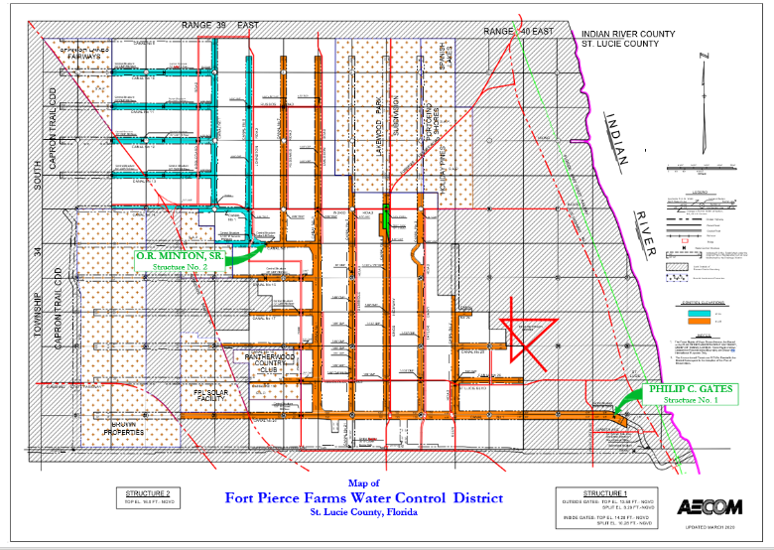
Figure E-3. Map of the FPFWCD

Indian River Farms Water Control District (IRFWCD)
The original Plan of Reclamation of the IRFWCD, formerly known as the Indian River Farms Drainage District, was initially adopted and approved by the Board of Supervisors of the Indian River Farms Drainage District on March 4, 1920.
At that point in time, the Indian River Farms Drainage District was located in St. Lucie County (Indian River County was created in June 1925), and the order approving the Report of Commissioners was approved by the Fifteenth Judicial Circuit in St. Lucie County on August 18, 1921, and recorded in Chancery Order Book 2, Page 493, Public Records of St. Lucie County.
The original Plan of Reclamation (now an integral part of the "Water Control Plan") has long been completed, and the IRFWCD now functions as an operations and maintenance entity of the Works of Improvements therein.
In the early to mid 1980s, the IRFWCD approved and undertook a project of evaluation and updating of the original Works of Improvements of the District. This study resulted in the creation of a computer model of the District's facilities and various revised recommendations in the operations of the district, including the two-inches-per-day volume discharge limitation.
The district map is shown in Figure E-4.
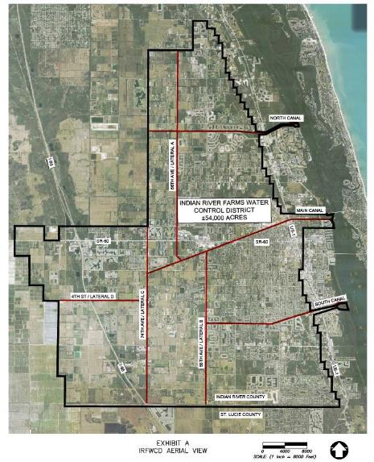
Figure E-4. Map of the IRFWCD
The IRFWCD contains approximately 50,000 gross acres lying within portions of Township 32 and 33 South, Range 39 East and Township 33 South, Range 38 East, and a small portion of Township 33 South, Range 40 East in Indian River County.
The IRFWCD contains the western portion of the City of Vero Beach (primarily west of the ancient coastal dune/ridge located along the Florida East Coast Railroad alignment) and the remainder of the district lies within the unincorporated area of Indian River County.
The 1913 Plat of Indian River Farms Subdivision was originally subdivided into primarily 40-acre, more or less, tracts and developed for agricultural use. With the growth of population and development in the IRFWCD, the gradual conversion of agricultural lands to urbanization has occurred concentrically around the City of Vero Beach (westward from the coast) and along major corridors such as State Road 60, 27th Avenue, 43rd Avenue, 58th Avenue, and Oslo Road (9th Street, S.W.)
The initial canal system was designed and constructed by the Indian River Farms Company in the 1912 to 1917 era, and contained only the Main Outfall Canal.
In early 1919, steps were taken to reorganize the former "district" under the General Drainage Laws of Florida. This new district was modified and reformed into the Indian River Farms Drainage District in May of 1919 and currently operates under Chapter 298, F.A.. This plan expanded the limits of the original project, adding the north and south relief canals and interconnecting lateral and sublateral canals.
This system was designed and constructed only as a gravity flow drainage district comprising many sublateral canals spaced one-half mile apart (generally along section and one-quarter section lines in an east-west alignment). These sublateral canals discharge into lateral canals (generally running in a north-south direction which, in turn, discharge into three major relief canals) that ultimately outfall into the IRL.
The initial design and construction of the system contained only one structure in the Main Canal. This structure is a drop spillway structure and provides a grade transition from 9.0 ft above sea level upstream to 0.00 ft downstream to prevent erosion and sloughing in the Main Relief Canal.
In the mid-1950s, radial gate water control structures were constructed in the three outfall canals to (1) reduce irrigation requirements, (2) conserve water, and (3) provide a limited source of supplemental irrigation water.
A salinity control weir structure was constructed in the Main Canal downstream of the drop spillway structure in 1962 to protect the City of Vero Beach wellfield from saltwater intrusion, and to provide irrigation water for the Vero Beach Country Club golf course.
In 1963, a fourth radial gate water control structure was added in Lateral "C" Canal (74th Avenue) south of 8th Street to reduce irrigation requirements and provide a limited source of irrigation for landowners in the southwest portion of the district.
The operation of the radial gate structures in the district relate directly to the duration and intensity of storm events and the antecedent rainfall conditions. The gates are kept closed a majority of the time, maintaining a minimum elevation of 15.5 ft, more or less, above sea level upstream of the 3 radial gates located in the 3 outfall canals, and 18.5 ft, more or less, above sea level upstream of the Lateral "C" structure.
These gates are opened, or partially opened, following storm events that create flooding conditions in the respective upstream pool elevations of the structures. The gates are opened only for a few hours to relieve flooding conditions in the affected areas. Following major storm events and complete ground saturation, the gates may be left open for a few days to provide groundwater draw down.
The IRFWCD is isolated from surrounding drainage by a levee (elevation 28.5 ft, more or less, above sea level, 6 ft to 8 ft top width and 1.5 ft to 1 ft side slope) along its north, west, and south boundary and by a coastal/dune ridge along its eastern boundary. It is further protected by adjoining water control districts along its north, west and southern boundaries, and serves no area outside its geographic area.
The IRFWCD proposes that the listed BMPs will be implemented and reported as active-based strategies. A specific allocation or nutrient reduction target will not be established. Rather, the IRFWCD's activities will assist in the control of nutrients as part of the efforts described in the BMAP. The implementation of the BMPs shall provide compliance with the BMAP.
In selecting the BMPs, in coordination with DEP, the function, operation and budget of the IRFWCD has been considered. Each year, during the annual report information collection period, the IRFWCD will confirm that these activities continue in their canals and rights-of-way. Each BMP includes a description and the required records.
Indian River Farms Water Control District BMPs
- Harvest aquatic vegetation in the canals using mechanical processes along with some necessary herbicide treatment. Vegetation removed from the canals must be disposed of in a location where the material will not be able to reenter the canal. Vegetation harvesting should consider the DEP guidelines in Removal of Aquatic Vegetation for Nutrient Credits in the Indian River Lagoon (IRL) Basin (September 2012).
  - Report: Dates when harvesting occurred and disposal location. Report any herbicide treatments and justification for nonmechanical removal of vegetation.
- For all new change of land use development projects, exempting single-family residences, an IRFWCD connection permit will require the compliance with the stormwater discharge limitation policy of 2 inches/24 hours for a 25-year-24-hour storm event. This limitation applies to any 24-hour period (hour 10–34, hour 14–38, etc.) during the 72-hours starting at time 0 of a 25-year, 24-hour storm event.
  - Report: The IRFWCD model results will provide the developer's engineer with a boundary condition at the connection point to the IRFWCD system. The boundary condition will include a time stage summary for hours 0 – hour 72 of the 24-hour–25-year event. A list of projects permitted over the year will be provided.
- Provide public education to residents of the district that fosters an understanding of the necessity to reduce nutrient impacts to surface waters.
  - Report: Provide a link or brief summary of the information regarding the encouraged use of BMPs throughout the district.
- Assist FDACS, where needed, with identifying and contacting producers within the district boundaries for purposes of participating in the relevant FDACS BMP programs.
  - Report: Number of landowners contacted to assist FDACS, and the names of landowners.

Melbourne-Tillman Water Control District (MTWCD)
The Melbourne-Tillman Water Control District (MTWCD) is a dependent special district authorized by the Florida Legislature under Chapter 2001-336, Laws of Florida, as amended by Chapters 2003-334 and 2010-253, respectively, for the purpose of constructing, reconstructing, and repairing, maintaining, and operating a surface water management system.
It was initially authorized as an independent district in 1922 for land reclamation for agricultural development and operating under Chapter 298, F.S.. It was reorganized as a dependent district in 1986 under Chapter 86-418, Laws of Florida, and codified in the 2001 legislation.
The Board of Directors has the power to establish a water management system to prevent damage from flooding, soil erosion, and excessive drainage; to promote the conservation, development, and proper utilization of surface and ground water; to preserve natural resources, fish, and wildlife; to maintain water quality; and to preserve and protect natural systems within and surrounding the district. The Board may authorize the cleaning, straightening, widening, or the change of course or flow, and alter or deepen any canal, ditch, drain, watercourse, or natural stream within the district boundaries. The building and construction of other works and improvements to preserve and maintain the works of the district are also authorized.
The MTWCD encompasses portions of unincorporated Brevard County, City of West Melbourne, City of Melbourne, City of Palm Bay, Town of Malabar, and Town of Grant-Valkaria. MTWCD is responsible for maintaining a primary network of canals within the district boundary. Various parcels have privately owned outfalls to the canals, with runoff from the remaining lands collected by the various governmental agencies delivering the runoff to the canals.
A map of the MTWCD canals and boundary is shown in Figure E-5. The district owns and maintains over 2,300 acres of canal rights-of-way in 163 miles of canals; 50 % has a right-of-way width greater than 100 ft, and 8 % has a right-of-way width greater than 250 feet. The district boundary covers 102 square miles.
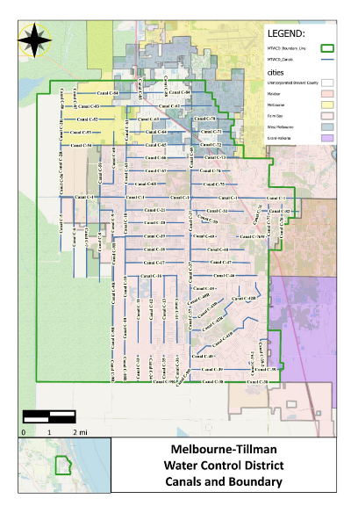
Figure E-5. Map of the MTWCD

The MTWCD proposes that the listed BMPs will be implemented and reported as activity-based strategies. A specific allocation or nutrient reduction target will not be established. The MTWCD's activities will assist in the control of nutrients as part of the efforts described in the IRL BMAP. Implementation of the BMPs shall provide compliance with the BMAP.
The BMPs, in coordination with DEP, are selected with the function, operation, and budget of the MTWCD in consideration, and the BMPs are not intended to be cost-effective, technically practical, or applicable to any other water control district within the BMAP area. Each BMP includes a description and the required record keeping.
It is recognized that the configuration of the canals and rights-of-way are limiting factors to the performance of certain BMP. An annual report confirming the activities identified are reported to DEP, with detailed records kept at the MTWCD office.
Melbourne-Tillman Water Control District BMPs
- Redirect flows to the St Johns River from the IRL during certain storm conditions. Replacement of the control structure gates (from underflow to over top) in the WCD's structure at the east end of Canal C-1 was completed in 2011.
- Report: Once completed, reports will be included with those defined in Point 5 below. Establish and maintain a stormwater aeration system at specified locations.
  - Report: Operation type, location (shapefile), and operation. Operation and any maintenance for the structure(s).
- Introduce turbidity-reducing polymers to canals such as woodchip logs.
  - Report: Operation type, location (shapefile), operation, and monitoring reports. Operation and any maintenance for the structure(s).
- Establish and maintain biological/bacteria treatment at specified locations.
  - Report: Operation type, location (shapefile), operation, and monitoring reports. Operation and any maintenance for the structure/facility(s)
- Harvest aquatic vegetation in the canals using mechanical processes instead of herbicide treatment. Vegetation removed from the canals must be disposed of in a location where the material will not be able to reenter the canal. Vegetation harvesting should consider the DEP guidelines in Removal of Aquatic Vegetation for Nutrient Credits in the Indian River Lagoon (IRL) Basin (September 2012).
  - Report: Dates when harvesting occurred and disposal location. Report any herbicide treatments and justification for nonmechanical removal of vegetation.
- Maintain existing water control structure(s).
  - Report: Structure type, location (shapefile), and operation. Operation and any maintenance for the structure(s).
- Provide education outreach and public involvement efforts as follows:
  - Update website with links and literature related to clean waters and the IRL.
  - Participate in educational training to include the Florida Erosion and Sedimentation Control Inspector program.

Sebastian River Improvement District (SRID)
The SRID is a "Chapter 189 – Improvement District" that was originally organized as a "Chapter 298 Drainage District." Reorganized under Chapter 189, the district is now known as SRID; however, the district still operates as a single-purpose drainage district.
The Sebastian River Water Control District was initially created by Decree of Incorporation entered by the Circuit Court in 1927 and included approximately 50,000 acres. Following the 1929 Depression, the Plan of Reclamation was scaled back in 1939 to the approximate 11,000 acres of the present day SRID.
The SRID system was designed and constructed as a gravity flow drainage district comprising sublateral canals spaced one-half mile apart in an east to west alignment. These sublateral canals discharge into Lateral Canals C and L which are constructed in a north-south alignment and drain to the north, and discharge into the south fork of the St. Sebastian River that ultimately outfalls into the IRL.
In the late 1950s, radial gate water control structures were constructed in the two outfall canals to (1) reduce irrigation requirements, (2) conserve water, and (3) provide a limited source of supplemental irrigation water.
In 2009, the district undertook a project to create a Survey Inventory of Existing Infrastructure and prepared a report called, "Stormwater Modeling to Evaluate the Works of Improvements of the District." This study resulted in the creation of a computer model of the district's facilities and various revised recommendations for the operations of the district, including the 2-inches-per-day volume discharge limitation.
The SRID contains a few residential areas, churches, a golf course, and schools but remains mostly in agricultural lands that lie within the unincorporated area of Indian River County.
The operation of the radial gate control structures within the district relate directly to the duration and intensity of storm events and the antecedent rainfall conditions. The gates are kept closed the majority of the time, maintaining a minimum elevation of 14.5 and 12.5 ft NAVD, more or less, upstream of the radial gates located in Lateral Canals C and L, respectively.
The district map is shown in Figure E-6.
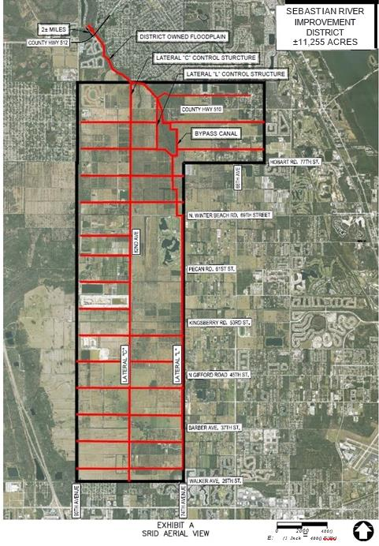
Figure E-6. Map of the SRID

These control gates are opened, or partially opened, following storm events that create flooding conditions in the respective upstream pool elevations of the structures. The gates are opened only for a few hours to relieve flooding conditions in the affected areas. Following major storm events and complete ground saturation, the gates may be left open for a few days to provide groundwater drawdown.
The SRID is isolated from surrounding drainage to the west by a levee. The south and east boundaries are common boundaries with IRFWCD, and each district has levees and boundary canals to manage water within their limits. The north boundary of SRID is isolated with smaller dikes, since the land slopes off the Sebastian River to the north.
The SRID proposes that the listed BMPs will be implemented and reported as active-based strategies. A specific allocation or nutrient reduction target will not be established. Rather, the SRID's activities will assist in the control of nutrients as part of the efforts described in the BMAP. The implementation of the BMPs shall provide compliance with the BMAP.
In selecting the BMPs, in coordination with DEP, the function, operation, and budget of the SRID has been considered. Each year, during the annual report information collection period, the SRID will confirm that these activities continue in its canals and rights-of-way. Each BMP includes a description and the required records.
Sebastian River Improvement District BMPs
- Harvest aquatic vegetation in the canals using mechanical processes along with some necessary herbicide treatment. Vegetation removed from the canals must be of disposed in a location where the material will not be able to reenter the canal. Vegetation harvesting should consider DEP guidelines in Removal of Aquatic Vegetation for Nutrient Credits in the Indian River Lagoon (IRL) Basin (September 2012).
  - Report: Dates when harvesting occurred and disposal location.
- For all new change of land use development projects, exempting single-family residences, a SRID connection permit will require compliance with the stormwater discharge limitation policy of 2 inches/24 hours for any 24-hour period (hour 10–34, hour 14–38, etc.) during a 25-year–24-hour storm event. The SRID will provide the developer's engineer with a boundary condition at the connection point to the SRID system. The boundary condition will include a time stage summary for hours 0–hour 72 of the 24-hour–25-year event.
  - Report: A list of projects permitted over the year will be provided.
- Assist FDACS, where needed, with identifying and contacting producers within the district boundaries for purposes of participating in the relevant FDACS BMP programs.
  - Report: Number of landowners contacted to assist FDACS, and the names of landowners.

Vero Lakes Water Control District
The Vero Lakes Water Control District (VLWCD) is a Chapter 298 District originally established as Vero Lakes Drainage by Decree of Incorporation of the Ninth Judicial Circuit in Indian River County, dated June 17, 1965. The VLWCD encompasses approximately 6,250 acres located entirely in north Indian River County, Florida. In general, the district is bisected by I-95, with portions of the district lying both east and west of I-95. The entire district is located south of SR 512. See Figure E-7 to better locate the boundaries of the district (shown in blue).
Figure E-7. Map of the VLWCD

The entire district is undeveloped, raw land with a single landowner. The entire district is in agriculture for the purpose of cattle raising. The stormwater runoff is collected in various low wetland areas. A primary ditch carries some stormwater from the southwest to the northeast section of the district that lies west of I-95. There are culverts under I-95 that allow some runoff that does not percolate back into the soil to flow east towards the eastern edge of the district.
Eventually, water that does not percolate back into the soil flows east to Lateral D. This does not increase the nutrient load in the runoff. The natural, undeveloped land acts as a filter for any runoff that makes its way east to Lateral D.
The VLWCD proposes that the listed BMPs will be implemented as activity-based strategies. A specific nutrient-based reduction target will not be established. Rather, the VLWCD's activities will assist in the control of nutrients as part of the efforts described in the BMAP. Implementation of the BMPs shall provide compliance with the BMAP.
In selecting the BMPs, in coordination with DEP, the function, operation, and budget of the VLWCD has been considered, and these listed BMPs should not be considered cost-effective, technically practical, or applicable to any other water control district within the BMAP. Each BMP includes a description and the required records.
The VLWCD will provide DEPwith an annual report confirming these activities are as identified below.
- Public Education and Outreach
Description: The VLWCD shall include as part of its annual meeting, an agenda item to alert the landowner of the existence of the BMAP and requirements for this landowner.
Report: Annual Landowner's Agenda. A copy of the agenda and material shall be kept on file.
- FDACS BMP Assistance
Description: The VLWCD will provide assistance to FDACS when requested. The VLWCD will identify the current landowner and his contact information as shown on the VLWCD records. The VLWCD will contact the landowner to encourage participation in the FDACS BMP program and encourage him to contact DEP if he have any questions.
Report: Landowner information requested by FDACS and the response provided.
- Nutrient Controls
Description: No nutrients imported via direct land application in the VLWCD rights of way.
Report: Annual verification by VLWCD.
- Canal/Ditch Bank Berms
Description: Minimize sediment transport by constructing berms on top of canal/ditch banks and promoting vegetation to cover. The agricultural pasturelands will continue to drain into the main ditch via smaller tributaries. On a regular basis, sediment is removed from the ditch and Lateral D canal. Vegetation is removed by mechanical methods, and not by herbicide treatment. Bank slopes are maintained at a slope that is flatter to prevent erosion.
Report: Visual observation and dates when sediment is removed.
- Control Structures and Culverts
Description: There are no control structures within the VLWCD. Regular inspection is made to ensure flow is maintained through culverts.
Report: Annual verification by VLWCD.
- Fertilizer Cessation
Description: No application of fertilizer within the VLWCD rights-of-way.
Report: Annual verification by VLWCD.

https://www.fdacs.gov/Agriculture-Industry/Water/Agricultural-Best-Management-Practices

