- Calculations first take place in the GIS feature class called IRL_LETv3_ParadisePark. It is best to use the provided model tool “Recalculate” in the LET Toolbox, however the following steps will achieve the same output:
  - Use calculate geometry to recalculate the acreages in the “Acres” field
  - Use the field calculator in the “TN Load (lbs/yr)” field to multiply the [Acres] by the [Annual_Tot_TN_Norm] aka “Total Nitrogen (lbs/yr/acre)”
  - Use the field calculator in the “TP Load (lbs/yr)” field to multiply the [Acres] by the [Annual_Tot_TP_Norm] aka “Total Phosphorus (lbs/yr/acre)”
  - Use the field calculator in the “Volume (m^3/yr)” field to multiply the [Acres] by the [Annual_Tot_Vol_Norm] aka “Total Volume (m^3/yr/acre)”
  - Use the field calculator in the “TN Load after C-1 Diversion (lbs/yr)” field to multiply the [TN_Load] aka “TN Load (lbs/yr)” by the [C1_Remains] aka “% Remaining after C-1 Project”
  - Use the field calculator in the “TP Load after C-1 Diversion (lbs/yr)” field to multiply the [TP_Load] aka “TP Load (lbs/yr)” by the [C1_Remains] aka “% Remaining after C-1 Project”
  - Use the field calculator in the “Volume after C-1 Diversion (m^3/yr)” field to multiply the [Volume] aka “Volume (m^3/yr)” by the [C1_Remains] aka “% Remaining after C-1 Project”
  - From Analysis Tools, select Summary Statistics
    - The LET will be your input
    - you can tell it where you would like to save the output table
    - In your statistics field include the following
      - TN_C1 statistic type SUM
      - TP_C1 statistic type SUM
      - Vol_C1 statistic type SUM
      - Acres statistic type SUM
    - In your case field include the following
      - BMAP
      - PZ
      - SegGroup
      - Segment
      - TN_Reduction
      - TP_Reduction
      - Entity
      - LC2015
      - LC2015_Description
      - LC2015_DEP
      - Overlaps
      - Stakeholder
      - Ag
      - Ag_toUrban
      - Duplicates
      - C1-Diverts
      - C1-Remains
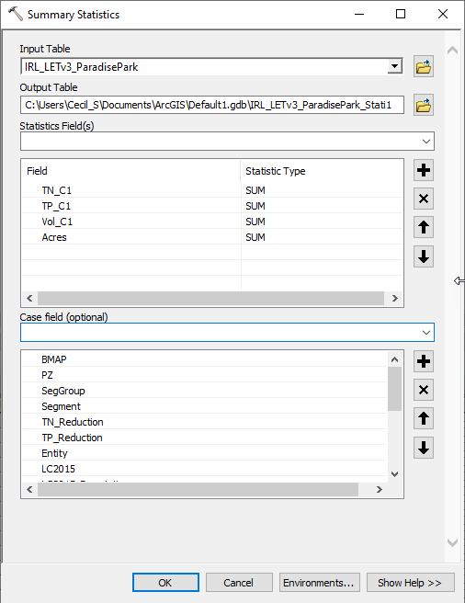
Figure 1. Summary Statistics Interface
  - From the Conversion Tools select the Table to Excel and export the summary output to an Excel workbook

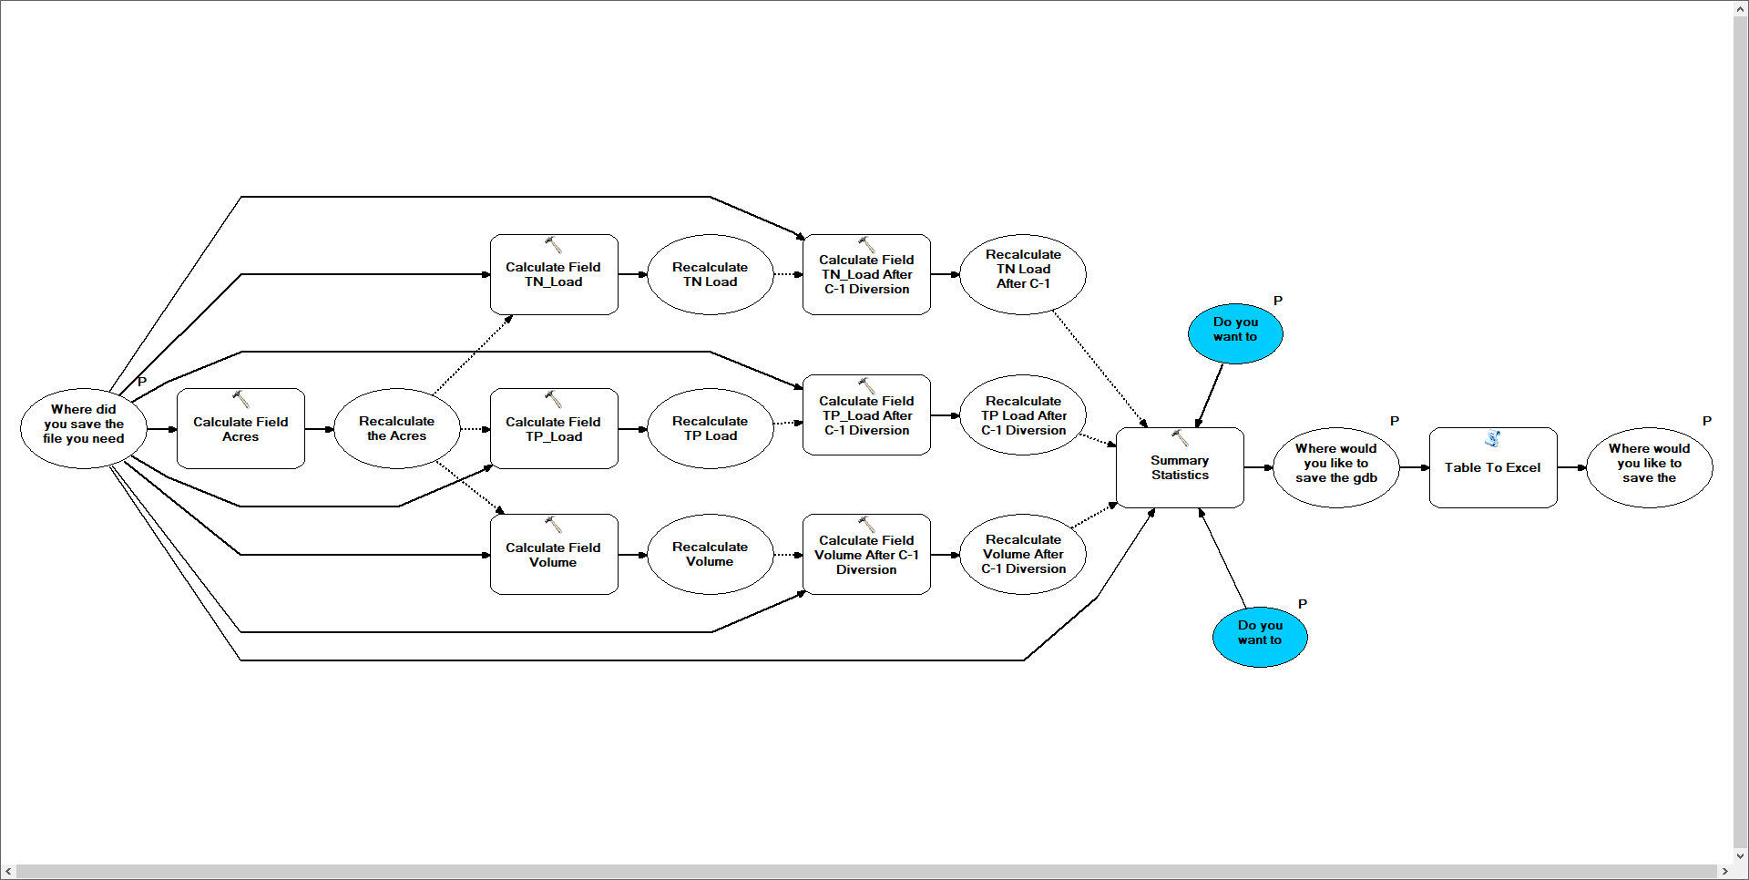
Figure 2. Recalculate Model Tool
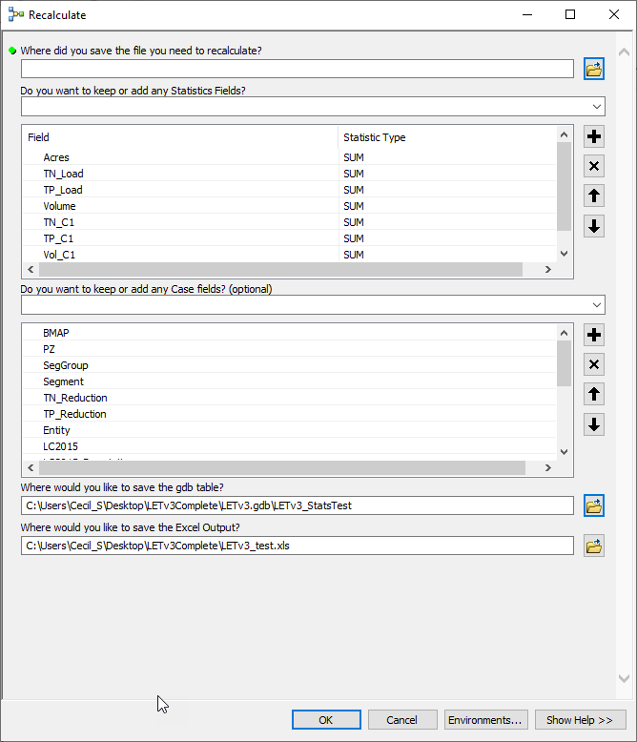
Figure 3. Recalculate Tool Interface

- Open the Excel workbook. Tab “LETv3_workbook” is the summary output of the SWIL LET attribute table. This comes from the GIS geodatabase of the LET. Because the shapefile/feature class is so large, summary statistics as described above were performed on loads based on the categories listed below. Further summary will be detailed through pivot tables in this workbook.
OBJECTID = the specific ID code used in the GIS database
BMAP = The BMAP
PZ = the Project Zone
SegGroup = the segment group based on TMDL segment proximity and reduction percentage
Segment = the segment as defined by the TMDL
TN_Reduction = the required total nitrogen reduction based on TMDL 62-304.520, F.A.C.
TP_Reduction = the required total phosphorus reduction based on TMDL 62-304.520, F.A.C.
Entity = The entity identified as responsible for loading
LC2015 = The land use codes used in the SWIL model
LC2015_Description = The description of the land use codes used in the SWIL model
LC2015_DEP = land use areas stakeholders identified as being erroneous – reflect generic 1000 codes if it was indicated as Urban; 2000 if indicated as Agricultural; 3000 if indicated as Natural
Natural = areas identified by the SWIL model landuse to be natural (3000 – 6999 not 3300) – these were used to assist in developing the correction factors
Overlaps = a record of where stakeholder jurisdictions were overlapping
Stakeholder = a record of which stakeholders were identified to be responsible for an area prior to all allocation steps being observed such as extraction of agricultural and natural lands
Ag = areas identified by the SWIL model landuse to be agricultural (2000 – 2999 & 3300)
Ag_toUrban = areas identified by FDACS to no longer be used for agricultural practices – as these areas may still exhibit legacy loading, they are granted to the entity and not to natural lands
Duplicates = areas where duplications and further overlaps occurred. These areas were not removed from the model as they left holes and slivers – this fields gives notes as to whom received the loading
C1_Diverts = the percentage of load the C1 project diverts away from the IRL
C1_Remains = the percentage of load the C1 project retains in the IRL
FREQUENCY = how many records were summarized in the summary for each category record
SUM_Acres = the total number of acres for each category record
SUM_TN_Load = the total nitrogen loading for each category record
SUM_TP_Load = the total phosphorus loading for each category record
SUM_Volume = the total volume for each category
SUM_TN_C1 = the total nitrogen loading for each category after the C1 diversion is applied
SUM_TP_C1 = the total phosphorus loading for each category after the C1 diversion is applied
SUM_Vol_C1 = the total volume for each category after the C1 diversion is applied
TN_Anthro = this field was created in Excel after export from the summary output –
Filter the LC2015_DEP for the Urban land use code (1000 – 2999, 3300 & 7000 – 9999) to obtain only Anthropogenic Source loadings of total nitrogen – each remaining cell should be set equal to Y2 (Sum_TN_C1)
TP_Anthro = this field was created in Excel after export from the summary output –
Filter the LC2015_DEP for the Urban land use code (1000 – 2999, 3300 & 7000 – 9999) to obtain only Anthropogenic Source loadings of total phosphorus – each remaining cell should be set equal to Z2 (Sum_TP_C1)
All subsequent worksheets are pivot tables of this table.
- Pivot table 1: Tab “Total Segment Reduction” is the total reduction required for each segment group, entities are not included and parsing between land uses are not made in this workbook.
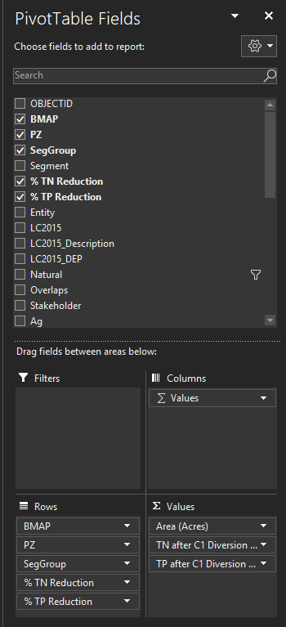
Figure 4. Pivot Table 1 Set Up
Columns A – C should be self-explanatory
Column D “% TN Reduction” = the required TMDL percent reduction of total nitrogen for this segment group
Column E “% TP Reduction” = the required TMDL percent reduction of total phosphorus for this segment group
Column F “Area (Acres)” = the total acres in this segment group
Column G “TN after C1 Diversion (lbs/yr)” = The starting total nitrogen loading from all land use sources
Column H “TP after C1 Diversion (lbs/yr)” = The starting total phosphorus loading from all land use sources
Column I “TN Reduction (lbs/yr)” = Column D * Column G
Column J “TP Reduction (lbs/yr)” = Column E * Column H
Column K “TN Allocation (lbs/yr)” = Column G – Column I
Column L “TP Allocation (lbs/yr)” = Column H – Column J
Column M “Allowable TN Load Per Acre” = Column K / Column F
Column N “Allowable TP Load Per Acre” = Column L / Column F
Come back to this step after creating the 2nd pivot table described in “2.”
We need to compare Column M and N to the Natural Load Per Acre to determine if a correction is required.
Column O = Column M < Column J in “Natural LPA”
Note that this field is conditionally formatted to fill in the cells that indicate this statement is “TRUE”
Column P = Column N < Column K in “Natural LPA”
Note that this field is conditionally formatted to fill in the cells that indicate this statement is “TRUE”
Column Q = indicates which workbook to pull final reductions and calculations

- Pivot Table 2: Tab “Natural LPA” shows the Natural Load Per Acre Calculations that were used in the correction to natural background for some entities
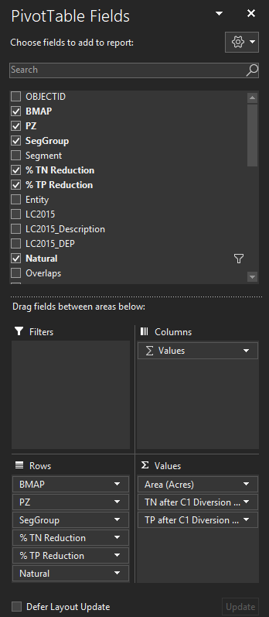
Figure 5. Pivot Table 2 Set Up
Columns A – F should be self-explanatory
Column G “Area (Acres)” = total acres in the segment group
Column H “TN after C1 Diversion (lbs/yr)” = The starting total nitrogen loading from modeled natural sources
Column I “TP after C1 Diversion (lbs/yr)” = The starting total phosphorus loading from modeled natural sources
Column J “TN LPA” = Column H / Column G
Column K “TP LPA” = Column I / Column G
- Note again: Where segment LPA in “Total Segment Reduction” is less than segment natural LPA in “Natural LPA”, the reductions from “Natural Comparison” will be used. Where segment LPA in “Total Segment Reduction” is greater than segment natural LPA in “Natural LPA”, the reductions from “% Contribution” will be used. The reductions in “TMDL % Reduction” are only for comparison.

- There are 3 reduction comparisons in this workbook:
  - % Contribution – this is the proposed method of reduction used in the BMAP update. This method removes natural loading from each entity’s responsibility, by calculating how much reduction is required from their anthropogenic loading by how much nutrient loading they contribute to the basin.
  - To Natural Comparison – this reduction method looks at the required load reduction for each entity if a stringent practice of taking all of the loads back to assumed natural or Natural Load Per Acre conditions were necessary. These calculations were used if a correction to the Natural Load Per Acre was deemed necessary.
  - TMDL % Reduction – this reduction method looks at the required load reductions for each entity if the straight TMDL reduction % were applied without taking contribution of loading into account. Because of this method is not concerned with how much load and type of load coming from an entity’s jurisdiction, natural land loading was not removed. This calculation was only produce for the sake of comparison.

- Pivot table 3: Tab “% Contribution” proposed load reductions by entity for each segment group. These numbers do not reflect any corrections to the loading.
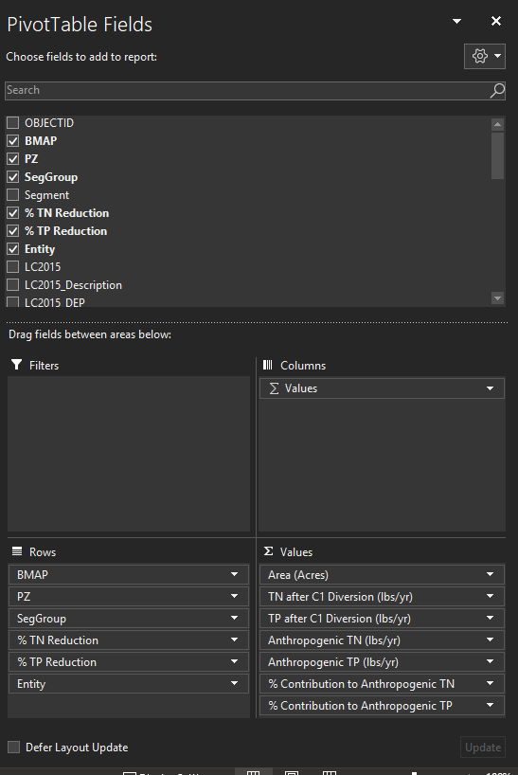
Figure 6. Pivot Table 3 & 4 Set Up
Column A – C should be self-explanatory
Column D “% TN Reduction” = the required TMDL percent reduction of total nitrogen for this segment group
Column E “% TP Reduction” = the required TMDL percent reduction of total phosphorus for this segment group
Column F “Entity” = Who is responsible for the load
Column G “Area (Acres)” = the total acres in this jurisdictional area
Column H “TN after C1 Diversion (lbs/yr)” = The starting total nitrogen loading from all land use sources
Column I “TP after C1 Diversion (lbs/yr)” = The starting total phosphorus loading from land use sources
Column J “Anthropogenic TN (lbs/yr)” = the starting total nitrogen from anthropogenic sources
Column K “Anthropogenic TP (lbs/yr)” = the starting total nitrogen from anthropogenic sources
Column L “% Contribution to Anthropogenic TN” = pivot calculation that shows the percent contribution of the TN anthropogenic loading to the total segment group starting load for each entity
Column M “% Contribution to Anthropogenic TP” = pivot calculation that shows the percent contribution of the TP anthropogenic loading to the total segment group starting load for each entity
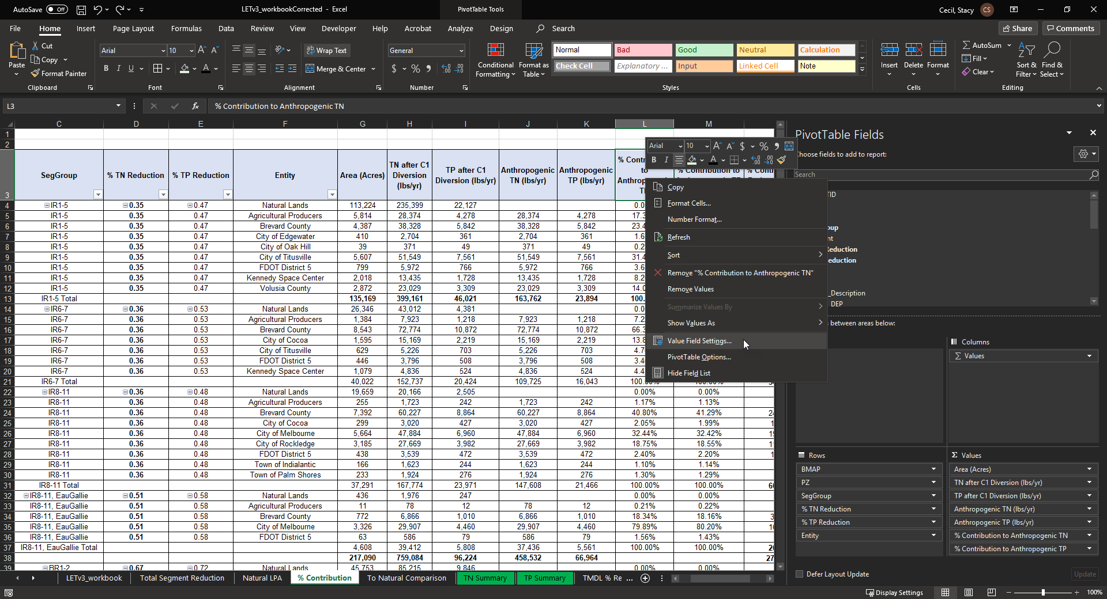
Figure 7. Instructions for Column L & M: left click on this pivot field and select the Value Field Settings
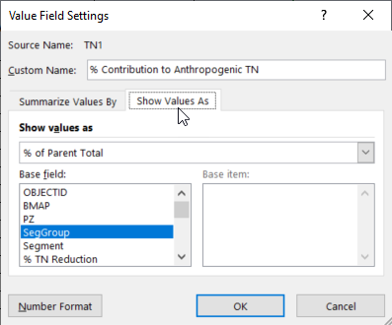
Figure 8. Instruction for Column L & M: Select the Tab Show Values As in the window that pops up, then select % of Parent Total from the drop down, then select SegGroup from the Base Field option.
Column N “% Contribution TN Reduction (lbs/yr)” = H$13* Column D * Column L
Note that the Totals deviate from this calculation as they are sums of all the entity contributions within the segment.
Column O “% Contribution TP Reduction (lbs/yr)” = I$13 * Column E * Column M
Note that the Totals deviate from this calculation as they are sums of all the entity contributions within the segment.
Column P “% Contribution TN Allocation (lbs/yr)” = Column H – Column N
Note that the Totals deviate from this calculation as they are sums of all the entity contributions within the segment.
Column Q “% Contribution TP Allocation (lbs/yr)” = Column I – Column O
Note that the Totals deviate from this calculation as they are sums of all the entity contributions within the segment.
- Pivot Table 4: Tab “To Natural Comparison”
Setup is the exact same as the “% Contribution” Pivot table.
Columns A – M are the same as “% Contribution”. The reduction and allocation calculation methodology differs in the following way:
First, set up your allocation totals for each segment group – Columns P & Q
e.g. calculation: P13 = G13 * “Natural LPA” J4
Column N “Natural LPA TN Reduction (lbs/yr)” = with the exception of the totals this is: Each total in Column P * Column L
e.g. calculation N4 = $P$13 * L4
Column O “Natural LPA TP Reduction (lbs/yr)” = with the exception of the totals this is: Each total in Column Q * Column M
e.g. calculation N4 = $Q$13 * M4
Column P “Natural LPA TN Allocation (lbs/yr)” = with the exception of the totals, the calculation is: Column H – Column N
Column Q “Natural LPA TP Allocation (lbs/yr)” = with the exception of the totals, the calculation is: Column I – Column O
- Tab “TN Summary” combination of the 2 reduction table calculations:
BMAP = The BMAP
PZ = the Project Zone
Note that the project zones for Banana River Lagoon are removed in this table
Segment Group = the segment group based on TMDL segment proximity and reduction percentage
Entity = Who is responsible for the load
Starting TN Load After C-1 Diversion (lbs/yr) = The starting total nitrogen loading from all land use sources
TN Reduction (lbs/yr) = based on the % contribution calculation, the amount of TN that an entity needs to reduce
TN Allocation (lbs/yr) = based on the % contribution calculation, the amount of TN that an entity does not need to reduce
Column H = Which workbook the reduction Numbers come from based on which LPA to use, as indicated by “Total Segment Reduction”
Pivot Table 5 = The pivot table sums columns A – G by Project Zone for each entity’s starting load, load reduction, and allocation
Note this pivot table is filtered to remove BMAP and Project Zone “Totals” from the source table, as well as entities with a 0 and the SFWMD CP project
- Tab “TP Summary” combination of the 2 reduction table calculations:
BMAP = The BMAP
PZ = the Project Zone
Note that the project zones for Banana River Lagoon are removed in this table
Segment Group = the segment group based on TMDL segment proximity and reduction percentage
Entity = Who is responsible for the load
Starting TP Load After C-1 Diversion (lbs/yr) = The starting total Phosphorus loading from all land use sources
TP Reduction (lbs/yr) = based on the % contribution calculation, the amount of TP that an entity needs to reduce
TP Allocation (lbs/yr) = based on the % contribution calculation, the amount of TP that an entity does not need to reduce
Column H = Which workbook the reduction Numbers come from based on which LPA to use, as indicated by “Total Segment Reduction”
Pivot Table 6 = The pivot table sums columns A – G by Project Zone for each entity’s starting load, load reduction, and allocation
Note this pivot table is filtered to remove BMAP and Project Zone “Totals” from the source table, as well as entities with a 0 and the SFWMD CP project
- Tab “TMDL % Reduction” proposed load reductions by entity for each segment group. These numbers do not reflect any corrections to the loading.
Column A – C should be self-explanatory
Column D “% TN Reduction” = the required TMDL percent reduction of total nitrogen for this segment group
Column E “% TP Reduction” = the required TMDL percent reduction of total phosphorus for this segment group
Column F “Ag2” = the areas where Agricultural land use are indicated by the model
Column G “Entity” = Who is responsible for the load
Column H “Area (Acres)” = the total acres in this jurisdictional area
Column I “TN after C1 Diversion (lbs/yr)” = The starting total nitrogen loading from all land use sources. Note that Natural Lands are not parsed from any entity’s total load.
Column J “TP after C1 Diversion (lbs/yr)” = The starting total phosphorus loading from land use sources. Note that Natural Lands are not parsed from any entity’s total load.
Column K “TMDL % TN Reduction (lbs/yr)” = Column D * Column I
Column L “TMDL % TP Reduction (lbs/yr)” = Column E * Column J
Column M “TMDL % TN Allocation (lbs/yr)” = Column I – Column K
Column N “TMDL % TP Allocation (lbs/yr)” = Column J – Column L
- Tab “for comparison summary” combination of the 2 reduction table calculations:
Columns A – G = a copy of the “TMDL % Reduction” table so that sums may be performed by Project Zone
Pivot Table 7 = The pivot table sums columns A – G by Project Zone for each entity’s starting load, load reduction, and allocation

