Process for Measuring Seagrass Deep Edge TMDL Compliance

Indian River Lagoon Basin Management Action Plans

June 2011

Biological Response Goal: Seagrass Depth Recovery (Independent of Nutrient Loads)
The intent of the total maximum daily loads (TMDLs) for total nitrogen (TN) and total phosphorus (TP) in the Indian River Lagoon (IRL) is to recover the deeper seagrass habitats. The biological response of the seagrasses is the most important factor to evaluate the success of the TMDLs. Even if the relationship among the nutrient loads and the seagrass recovery is not as predicted by the regression model, the load reduction requirements themselves will not determine TMDL success; assessment of success is based on whether the seagrasses can grow at sufficient depths, because that was the intent of the TMDLs and its associated load reductions.

As a point of clarification, complete seagrass recovery is considered to have seagrasses grow at 100% of the depth limit (DL) of the union coverage of the following mapping years: 1943, 1986, 1989, 1992, 1994, 1996 and 1999. The TMDL DL targets are 90% of that 1943-1999 union coverage DL. More specifically, the TMDL DL targets were set at 10% less than the cumulative frequency distribution of the 1943 – 1999 union coverage depth limits. The use of a cumulative frequency distribution of the deep edge of seagrass beds is a good way to summarize the depth of seagrass growth across an area without dictating the exact locations where seagrasses must recover because it helps to address the variability of conditions that may not be related to anthropogenic disturbances.

The Florida Department of Environmental Protection (FDEP) expects improvements in the seagrass DL resulting from reductions in TN and TP, which will also result in total suspended solid (TSS) reductions. While we will list projects in the BMAP that reduce TN and TP and compare those load reductions to individual nutrient allocations, FDEP will measure overall TMDL success based entirely on the seagrass response to changes in the watershed and water column. To assess the region’s achievement in meeting the TMDLs, FDEP is focused on measuring the maximum depth at which seagrasses currently grow in the IRL compared to the TMDL DL targets.

Scale for Measuring Success: Project Zones
Success in achieving the TMDL DL targets will be assessed based on a project zone scale. The IRL Basin is divided into three sub-lagoons: Banana River Lagoon (BRL), North IRL, and Central IRL. These sub-lagoons are important units but they are large areas that do not account for hydrological distinctions within these sub-lagoons based upon residence time. While FDEP desires to have all three sub-lagoons achieve seagrass recovery, it is possible to have success in smaller assessment areas, and for those areas within the sub-lagoons that have not fully recovered to continue to make nutrient reductions. For the purposes of the basin management action plans (BMAPs), the sub-lagoons were divided into project zones: one zone in BRL, two zones in North IRL, and three zones in Central IRL. Project zones are hydrologically connected areas and incoming loads would be expected to affect the entire area. The project zone, therefore, is a reasonable scale by which to judge success of the seagrass DL targets.

Still smaller units have also been created including segments – which are related to homogeneity in salinity and turbidity – by the St. Johns River Water Management District (SJRWMD), and waterbody identification numbers (WBIDs) – related to land surface that drains into the lagoon – by the FDEP TMDL program. These assessment units are useful but do not precisely reflect the effect of residence time because they interact liberally with their adjacent assessment units that exhibit the same flushing rates. It is difficult to use this scale to determine success because we cannot set aside the influence of their nutrient loads mixing in the other proximal units. FDEP has therefore recommended that the project zone scale is the best scale by which to judge seagrass recovery.

Two-Step Measurement of Success
FDEP defines success in meeting the TMDL seagrass DL targets using a two-step assessment approach. The two steps are used to address the following concerns:
- Determination of seagrass recovery should take into account inter-annual variability and allow for some years to have less seagrass depth than others.
- An evaluation of seagrass recovery should not allow one very good year to over-influence the evaluation of otherwise limited seagrass depths.

Step 1: Cumulative Frequency Distribution Analysis
To address the first concern, Step 1 is applied, which involves taking the four most recent mapped seagrass datasets and creating a union coverage in the Geographic Information System (GIS). Using this union coverage, a 15 meter buffer zone is applied to the perimeter of the coverage to create the deep edge of the seagrass beds. This buffer coverage shows the deepest edge that seagrass grew at any time during the data period, and is used to create a cumulative frequency distribution curve of the depth at which seagrasses exist within the project zone. This curve is then compared to the TMDL DL target curve.

Step 1 successful seagrass compliance is reached when 50% or more of the assessment years’ frequency distribution curve (including its 50th percentile value) for the project zone lies on or to the right of the TMDL DL target curve. This assessment method captures all four datasets of latest seagrass coverage, automatically accounting for inter-annual variability while emphasizing the better years out of the dataset.

If a project zone is compliant with Step 1, then the compliance evaluation continues. To ensure that any one year is not over biasing a compliance determination, Step 2 is performed.

Step 2: Median DL Comparison for Each Data Year
Step 2 calculates the median depth of seagrass growth for each year of the four most recent datasets, and then each year’s median is compared to the TMDL median DL target (90%). Three of the four medians of the assessment years’ seagrass coverages must meet or exceed the median TMDL DL target in order for a project zone to be Step 2 compliant.

If a project zone is compliant based on the Step 1 and Step 2 analysis, then the project zone is considered to be meeting the TMDL seagrass DL target. If a project zone fails to meet either Step 1 or Step 2, then it is not considered to be meeting the TMDL seagrass DL target for that set of assessment years.

2011 Seagrass Compliance Evaluation
Following the steps described above, FDEP evaluated the most recent data (mapping years 2003, 2005, 2006, and 2007) to determine if any of the project zones are achieving the seagrass DL targets.

Step 1: 2011 Cumulative Frequency Distribution Analysis
A union coverage of the assessment years’ 15 meter buffer established the deep edge and was created for each project zone. Based on this deep edge GIS coverage and the intersection of the bathymetric depths minus areas that were dredged, a cumulative frequency distribution curve was created for each project zone. A cumulative frequency distribution curve was also created for the TMDL union deep edge coverage in that project zone. Then, by project zone, the curve of the most recent data was plotted next to the TMDL union curve and the results were compared. Based on this analysis, four of the project zones were Step 1 compliant, as shown in the table below.

Project Zone | Step 1 Compliant?
BRL | Yes
North A | No
North B | No
Central A | Yes
Central SEB | Yes
Central B | Yes

The frequency distribution curve for each project zone is provided below. The blue line shows the TMDL target DL cumulative frequency distribution curve. The red line shows the union assessment years curve for the most recent data years.

Banana River Lagoon Frequency Distribution Curves
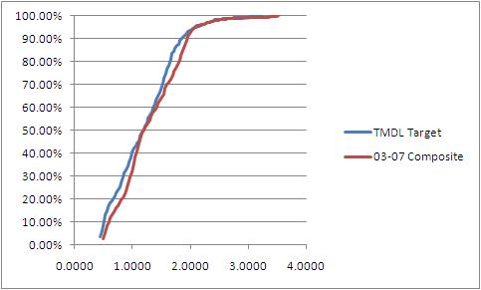

North A Frequency Distribution Curves
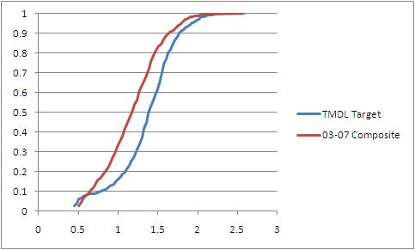

North B Frequency Distribution Curve
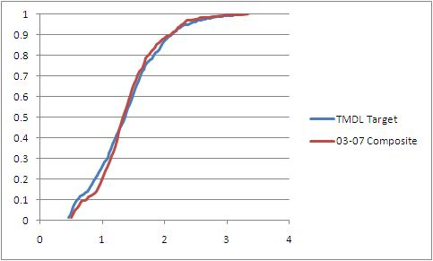

Central A Frequency Distribution Curves
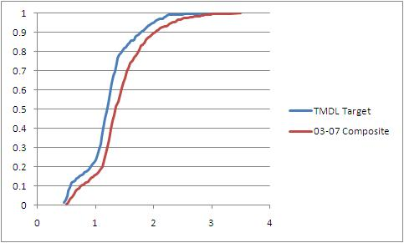

Central SEB Frequency Distribution Curves
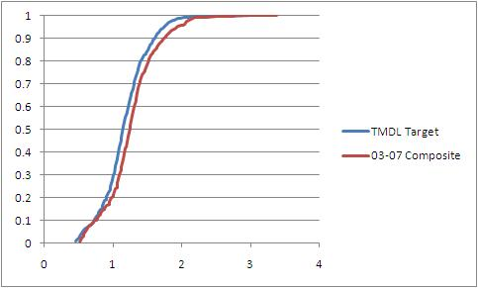

Central B Frequency Distribution Curves
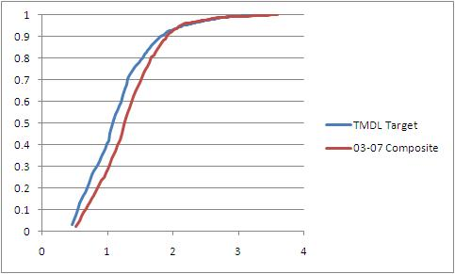

Step 2: 2011 Median Comparison for Each Depth Year
Although Step 1 compliance was not achieved for all areas, FDEP performed Step 2 for all project zones. If those project zones that met Step 1 also met Step 2, they would be considered to be TMDL compliant at this time. The Step 2 analyses performed were as follows:
- Ninety percent of the median depth for the TMDL dataset was calculated for each project zone.
- The medians were calculated for each of the recent data years by project zone.

The TMDL median deep edge seagrass depth and the medians for each year, by project zone, are presented below. The years where the median exceeds the TMDL median are highlighted and a determination of Step 2 compliance is included.

Year | BRL | North A | North B | Central A | Central SEB | Central B
TMDL Median | 1.192 | 1.411 | 1.370 | 1.219 | 1.147 | 1.092
2003 | 1.111 | 0.958 | 1.263 | 1.233 | 1.121 | 1.122
2005 | 1.111 | 1.080 | 1.263 | 1.202 | 1.152 | 1.122
2006 | 1.141 | 1.080 | 1.324 | 1.233 | 1.182 | 1.122
2007 | 1.172 | 1.080 | 1.294 | 1.324 | 1.213 | 1.244
Step 2 Compliant? | No | No | No | Yes | Yes | Yes

2011 Compliance Assessment Results
The results of both Step 1 and Step 2 are shown in the table below. Central A, Central SEB, and Central B are all fully compliant because these project zones all met both Step 1 and Step 2 for the most recent years of data. BRL is improving and showing Step 1 compliance, but is not yet showing Step 2 compliance. The areas furthest from compliance are in the North IRL.

Project Zone | Step 1 Compliant? | Step 2 Compliant? | TMDL Compliant?
BRL | Yes | No | No
North A | No | No | No
North B | No | No | No
Central A | Yes | Yes | Yes
Central SEB | Yes | Yes | Yes
Central B | Yes | Yes | Yes

Application of Assessment Results
Stakeholders in the Central A, Central SEB, and Central B project zones are meeting TMDL DL targets and will not be asked to make any reductions at this time; however, FDEP will continue to ask stakeholders to provide completed and any planned projects to characterize TN and TP reductions that have already occurred and will be achieved during the first BMAP cycle. Documenting known load reductions will further the understanding of how compliance was achieved and maintained. FDEP will then use the 2009 and 2011 seagrass mapping data, when available, to reassess whether these project zones continue to be compliant. If these project zones continue to meet the TMDL DL targets there will be six mapping years or nine calendar years (2003 – 2011) indicating a trend of success. If during this assessment the project zones no longer meet Step 1 and Step 2 compliance, FDEP would then ask for stakeholders to make nutrient reductions and a BMAP will be developed.

The stakeholders in Central A, Central SEB, and Central B include:

- Brevard County
- City of Fellsmere
- City of Fort Pierce
- City of Melbourne
- City of Palm Bay
- City of Sebastian
- City of Vero Beach
- City of West Melbourne
- Florida Department of Transportation (FDOT) District 4
- FDOT District 5
- Fellsmere Water Control District (WCD)
- Fort Pierce Farms WCD
- Indian River County
- Indian River Farms WCD
- Melbourne-Tillman WCD
- North St. Lucie River WCD
- Sebastian River Improvement District
- St. Lucie County
- Town of Grant-Valkaria
- Town of Indialantic
- Town of Indian River Shores
- Town of Malabar
- Town of Melbourne Beach
- Town of Melbourne Village
- Town of Orchid
- Turnpike Authority
- Vero Lakes WCD

Stakeholders in the BRL, North A, and North B project zones will be required to achieve TN and TP reductions in this first five-year BMAP period because these areas are not meeting the TMDL DL targets. In year four of the BMAP, TMDL DL targets will be reassessed using 2009, 2011, and 2013 mapping data for these project zones. As none of these project zones meet median DL targets for any of the most recent four mapping years (2003-2007), the earliest opportunity for achievement of the Step 2 requirement of three out of four mapping years that meet or exceed the TMDL median would be in this next data set. If these project zones are compliant using the 2007-2013 mapping years, FDEP will not ask stakeholders to make additional TN and TP reductions in the next iteration of the BMAP. Rather, FDEP will apply a methodology similar to what is being used in the Central project zones for reassessment. Data from the 2015 and 2017 seagrass mapping years will be evaluated to determine if the project zones continue to meet the TMDL target. If the project zones do not pass the Step 1 and Step 2 assessments for compliance, then FDEP will ask stakeholders to make further nutrient reductions.

