Seagrass and Water Quality Monitoring
This monitoring plan is designed to track seagrass distribution and identify long-term water quality trends in response to BMAP project implementation. Sampling stations, parameters, frequency, and other elements of this strategy may be modified as appropriate to match changing environmental conditions, funding resources, and understanding of the IRL system.

Objectives
Focused objectives are critical for a monitoring strategy to provide the information needed to evaluate implementation success. The primary and secondary monitoring objectives for the North IRL monitoring plan are described below. The purpose of the primary monitoring is to assess progress towards the TMDL seagrass depth limit targets through the seagrass flyover mapping and aerial photography interpretation. The purpose of the secondary monitoring is to assess water quality trends in the North IRL to determine if watershed nutrient loading is decreasing resulting in improved lagoon water quality, which will allow seagrass to grow to target depths.
Primary Monitoring Objective
- Track seagrass depth limit extent responses to BMAP implementation.
Secondary Monitoring Objective
- Track trends in ambient water quality in the North IRL watershed and major tributaries.

Monitoring Parameters, Frequency, and Network
To achieve the primary monitoring objective, the main parameter that will be tracked is the seagrass depth limits by project zone, which are identified through the flyover mapping and aerial photography interpretation. DEP, in conjunction with the SJRWMD, is taking the lead on funding and conducting the flyovers and mapping. In the past, SJRWMD typically has conducted seagrass mapping every 2 years, and DEP will try to maintain this frequency for the BMAP monitoring plan. The aerial photography is taken in spring to early summer, which is during the seagrass growing season. Field sampling conducted around the time of the flights provides data for assessing accuracy of the maps, and additional field sampling is conducted to address uncertainty regarding areas mapped as seagrass. Using the aerial photography, a map is created showing seagrass extent in the lagoon. These maps are used in evaluations to assess progress towards the TMDL seagrass depth limit targets for the North IRL.
To achieve the secondary monitoring objective above, the existing SJRWMD monthly stations in the North IRL BMAP will be monitored. At these stations, SJRWMD analyzes the following parameters:

- Total Kjeldahl Nitrogen
- Nitrite/Nitrate
- Ammonia
- TP
- Orthophosphate
- Chlorophyll-a (corrected)
- Photosynthetically Active Radiation
- True Color
- Turbidity
- TSS
- Dissolved Oxygen
- Specific Conductivity
- pH
- Salinity
- Secchi
- Depth of Collection
- Total Depth of Sample Site
- Water Temperature
- Field Conditions
- Total Organic Carbon
- Dissolved Organic Carbon
- Silica
- Alkalinity
- Volatile Suspended Solids

In addition to the SJRWMD water quality monitoring stations, Volusia County collects water quality data at 3 stations, and the U.S. Geological Survey (USGS) collects flow data at 2 stations in the North IRL. Table 40 lists the stations that SJRWMD, Volusia County, and USGS currently sample in the North IRL BMAP, and these stations are shown by project zone in Figure 13 and Figure 14.
Table 40: Monitoring Stations in the North IRL BMAP
Entity | Station ID | Project Zone | Status | Latitude | Longitude | Station Type | Frequency
SJRWMD | IRLBFRR | NIRL-A | Active | 28.7553 | -80.8461 | Water Quality | Monthly
SJRWMD | IRLI02 | NIRL-A | Active | 28.7370 | -80.8007 | Lagoon Water Quality | Monthly
SJRWMD | IRLI06 | NIRL-A | Active | 28.6358 | -80.8020 | Lagoon Water Quality | Monthly
SJRWMD | IRLI07 | NIRL-A | Active | 28.6035 | -80.7984 | Lagoon Water Quality | Monthly
SJRWMD | IRLI09E | NIRL-A | Active | 28.5564 | -80.7416 | Lagoon Water Quality | Monthly
USGS | 02248380 | NIRL-A | Active | 28.7362 | -80.7546 | Flow | Continuous
Volusia County | ODIX | NIRL-A | Active | 28.8051 | -80.8604 | Water Quality | Bi-monthly
Volusia County | TC1/IRLTBC | NIRL-A | Active | 28.8209 | -80.8601 | Water Quality | Monthly
Volusia County | TC2 | NIRL-A | Active | 28.8252 | -80.8572 | Water Quality | Bi-monthly
SJRWMD | IRLEGU | NIRL-B | Active | 28.1243 | -80.6308 | Water Quality | Monthly
SJRWMD | IRLI10 | NIRL-B | Active | 28.5012 | -80.7686 | Lagoon Water Quality | Monthly
SJRWMD | IRLI13 | NIRL-B | Active | 28.3931 | -80.7359 | Lagoon Water Quality | Monthly
SJRWMD | IRLI15 | NIRL-B | Active | 28.3353 | -80.7131 | Lagoon Water Quality | Monthly
SJRWMD | IRLI16 | NIRL-B | Active | 28.2778 | -80.6767 | Lagoon Water Quality | Monthly
SJRWMD | IRLI18 | NIRL-B | Active | 28.1949 | -80.6487 | Lagoon Water Quality | Monthly
SJRWMD | IRLI21 | NIRL-B | Active | 28.1253 | -80.6165 | Lagoon Water Quality | Monthly
SJRWMD | IRLUPEGWR | NIRL-B | Active | 28.1270 | -80.6454 | Water Quality | Monthly
SJRWMD | IRLUPHC | NIRL-B | Active | 28.1612 | -80.6554 | Water Quality | Monthly
USGS | 02249007 | NIRL-B | Active | 28.1270 | -80.6454 | Flow | Continuous

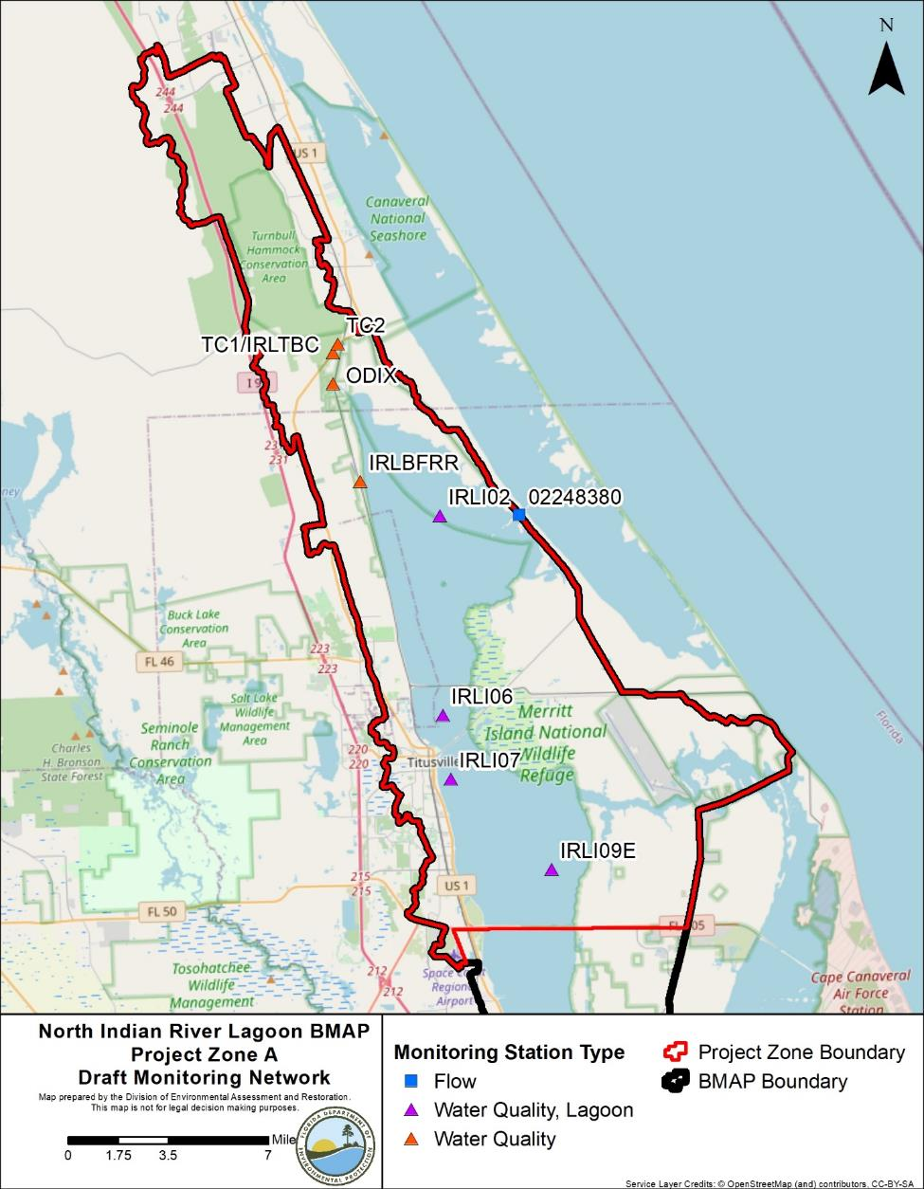
Figure 13: Monitoring Network in the North A Project Zone

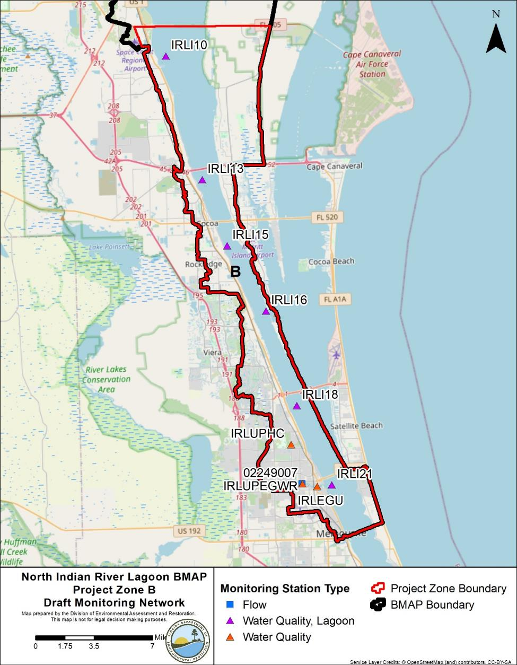
Figure 14: Monitoring Network in the Northern Part of the North B Project Zone

Data Management and Assessment
In 2017, the Florida Watershed Information Network (WIN) replaced the Florida Storage and Retrieval (STORET) database. WIN now serves as the primary repository of ambient water quality data for the state of Florida. Water quality data from the WIN database are used for impaired waters rule assessments and TMDL development. Ambient water quality data collected as part of the BMAP will be uploaded into WIN for long-term storage and availability. All BMAP data providers have agreed to upload ambient water quality data to WIN at least quarterly, upon completion of the appropriate quality assurance/quality control (QA/QC) checks.
Biological data used to assess the biological health of streams and lakes may be provided to department staff in the Watershed Assessment Section. For more information on submitting external biological data, please visit the DEP website. Other data, such as the extent and abundance of seagrass coverages, groundwater, and storm event, may also be collected. Stakeholders agree to provide these data to other BMAP partners upon request, and when appropriate, for inclusion in BMAP data analyses and adaptive management evaluations.
The water quality data will be analyzed periodically to determine trends in water quality in the lagoon. Specific statistical analyses were not identified during BMAP development; however, commonly accepted methods of data analysis will be used.

Quality Assurance/Quality Control
Stakeholders participating in the monitoring plan must collect water quality data in a manner consistent with the DEP standard operating procedures (SOPs) for QA/QC. The most current version of these procedures can be downloaded from the DEP website. For BMAP-related data analyses, entities should use National Environmental Laboratory Accreditation Council (NELAC) National Environmental Laboratory Accreditation Program (NELAP) certified laboratories or other labs that meet the certification and other requirements outlined in the DEP SOPs. SJRWMD staff and contractors collect, process, and preserve samples according to the SJRWMD’s Field Standard Operating Procedures for Surface Water Sampling Fiscal Year 2020. Where SJRWMD and DEP SOPs do not correspond to one another, SJRWMD staff and contractors defer to the DEP SOPs.

Research Priorities
During the BMAP process, the stakeholders identified several research priorities they would like to pursue, if funding becomes available. The investments prompted by the 2011 superbloom generated research topics that include:
- Collecting data to update the bathymetry for the IRL Basin, which would be used in evaluations of seagrass depth limits.
- Continuing coordinated monitoring of phytoplankton, drift algae, and macroalgae in the basin to gain insights into cycling of nutrients.
- Data analysis of storm event monitoring at the major outfalls.
- Testing/verifying the TN, TP, and seagrass depth regression equations using data collected since 1999.
- Refining load estimates delivered by baseflows and modeling the contributions of baseflows.
- Synthesizing data on nutrient flux/internal recycling of legacy nutrient loads held within the IRL sediments and exchanged with the water column.

- Completing development, calibration, and validation of a water quality model that can be used to design, site and prioritize projects that reduce loads of nutrients (e.g., Hydrologic Simulation Program FORTRAN [HSPF] or Spatial Watershed Iterative Loading Model [SWIL Model] coupled with Environmental Fluid Dynamics Code [EFDC] or another model that generates predictions of biological effects).
The stakeholders will continue to work with DEP and IRL NEP to identify other research needs, prioritize these needs, and develop scopes of work to address research priorities as appropriate. This information may be organized in a more detailed research plan that could be used to guide future efforts, as funding becomes available. These research projects are not BMAP requirements but would provide valuable information for future assessments of the health of the North IRL.

