Draft
Lake Okeechobee
Basin Management Action Plan

Division of Environmental Assessment and Restoration
Water Quality Restoration Program
Florida Department of Environmental Protection

with participation from the
Lake Okeechobee Stakeholders

January 2020



2600 Blair Stone Rd.
Tallahassee, FL 32399
https://www.floridadep.gov

Acknowledgments
The Lake Okeechobee Basin Management Action Plan was prepared as part of a statewide watershed management approach to restore and protect Florida's water quality. It was prepared by the Florida Department of Environmental Protection with participation from the Lake Okeechobee stakeholders identified below.
Type of Governmental or Private Entity | Participant
Counties | Glades  Hendry  Highlands  Martin  Okeechobee  Orange  Osceola  Palm Beach  Polk
Municipalities | City of Avon Park  City of Edgewood  City of Kissimmee  City of Okeechobee  City of Orlando  City of Sebring  Town of Windermere
Government entities and  special districts | Avon Park Air Force Range  Okeechobee Utility Authority  Istokpoga Marsh Watershed Improvement District  Reedy Creek Improvement District  Spring Lake Improvement District  South Florida Conservancy District  Valencia Water Control District
Agencies | Florida Department of Agriculture and Consumer Services  South Florida Water Management District  Florida Department of Transportation (FDOT) District 1  FDOT District 4  FDOT District 5

Table of Contents

Acknowledgments 2
List of Acronyms and Abbreviations 12
Executive Summary 14
Chapter 1. Background Information 20
1.1. Water Quality Standards and Total Maximum Daily Loads (TMDLs) 20
1.1.1. Lake Okeechobee TMDL 20
1.2. Lake Okeechobee Basin Management Action Plan (BMAP) 21
1.2.1. Pollutant Sources 24
1.2.1.1. Agricultural Nonpoint Sources 25
1.2.1.2. Municipal Separate Storm Sewer Systems (MS4s) 28
1.2.1.3. Septic Systems 32
1.2.1.4. Urban Nonpoint Sources 34
1.2.1.5. Wastewater Treatment Facilities (WWTFs) 34
1.2.2. Assumptions 35
1.2.3. Considerations 35
Chapter 2. 5-Year Review 38
2.1. Progress to Date 38
2.2. BMAP Modeling 40
2.2.1. Evaluation of Predrainage Conditions 41
2.2.2. Development of the LET 42
2.2.3. Subwatershed Attenuation Rates 42
2.3. LOW Construction Project 42
2.3.1. Coordinating Agencies' Projects and Initiatives 43
2.4. Water Quality Analysis 45
2.5. 5-Year Review Conclusions 53
2.5.1. Milestones 53
2.5.2. New Project Approach 54
Chapter 3. Restoration Approach 55
3.1. Basinwide Sources Approach 55
3.1.1. Agriculture 55
3.1.2. Septic Systems 56
3.1.3. Stormwater 57
3.1.4. Wastewater Treatment 57
3.2. TRA Approach 59
3.2.1. Overview 59
3.2.2. Evaluation 61
3.3. Water Quality Monitoring Plan 62
3.3.1. Objectives and Parameters 62
3.3.2. Monitoring Network 63
3.3.3. Data Management and Quality Assurance/Quality Control (QA/QC) 64
Chapter 4. Subwatersheds 66
4.1. Fisheating Creek Subwatershed 66
4.1.1. Water Quality Monitoring 67
4.1.2. Basin Evaluation Results 68
4.1.3. Projects 70
4.1.3.1. Existing and Planned Projects 70
4.1.3.2. Future Projects 71
4.2. Indian Prairie Subwatershed 72
4.2.1. Water Quality Monitoring 72
4.2.2. Basin Evaluation Results 74
4.2.3. Projects 75
4.2.3.1. Existing and Planned Projects 75
4.2.3.2. Future Projects 77
4.3. Lake Istokpoga Subwatershed 78
4.3.1. Water Quality Monitoring 78
4.3.2. Basin Evaluation Results 79
4.3.3. Projects 81
4.3.3.1. Existing and Planned Projects 81
4.3.3.2. Future Projects 83
4.4. Lower Kissimmee Subwatershed 85
4.4.1. Water Quality Monitoring 85
4.4.2. Basin Evaluation Results 87
4.4.3. Projects 88
4.4.3.1. Existing and Planned Projects 88
4.4.3.2. Future Projects 90
4.5. Taylor Creek/Nubbin Slough Subwatershed 91
4.5.1. Water Quality Monitoring 91
4.5.2. Basin Evaluation Results 93
4.5.3. Projects 95
4.5.3.1. Existing and Planned Projects 95
4.5.3.2. Future Projects 98
4.6. Upper Kissimmee Subwatershed 100
4.6.1. Water Quality Monitoring 100
4.6.2. Basin Evaluation Results 104
4.6.3. Projects 107
4.6.3.1. Existing and Planned Projects 107
4.6.3.2. Future Projects 130
4.6.4. Lake Tohopekaliga NRP 131
4.7. East Lake Okeechobee Subwatershed 132
4.7.1. Water Quality Monitoring 132
4.7.2. Basin Evaluation Results 133
4.7.3. Projects 135
4.7.3.1. Existing and Planned Projects 135
4.7.3.2. Future Projects 135
4.8. South Lake Okeechobee Subwatershed 136
4.8.1. Water Quality Monitoring 136
4.8.2. Basin Evaluation Results 138
4.8.3. Projects 139
4.8.3.1. Existing and Planned Projects 139
4.8.3.2. Future Projects 139
4.9. West Lake Okeechobee Subwatershed 140
4.9.1. Water Quality Monitoring 140
4.9.2. Basin Evaluation Results 141
4.9.3. Projects 143
4.9.3.1. Existing and Planned Projects 143
4.9.3.2. Future Projects 143
4.10. In-Lake Strategies 144
4.10.1. Water Quality Monitoring 144
4.10.2. Projects 144
4.10.2.1. Existing and Planned Projects 145
4.10.2.2. Future Projects 146
Chapter 5. Summary 147
5.1. Targeted Restoration Area Evaluation Results 147
5.2. RFI Responses 148
5.3. Future Growth 149
5.4. Compliance 149
Chapter 6. References 151
Appendices 152
Appendix A. BMAP Projects Supporting Information 152
Appendix B. Agricultural Enrollment and Reductions 154
Appendix C. Water Quality Data Processing and Analysis Methods 181
Appendix D. Stations Used in Five-Year Rolling Average TP Load Calculation 187
Appendix E. RFI Responses 192

List of Figures
Figure ES-1. Lake Okeechobee subwatersheds 18
Figure ES-2. Estimated progress towards meeting the TP TMDL allocated to the Lake Okeechobee Watershed with projects completed through June 30, 2019 19
Figure 1. LOW BMAP area 22
Figure 2. LOW subwatersheds and basins 23
Figure 3. Location of septic systems in the LOW 33
Figure 4. Tier 1 stations monthly TP load analysis 51
Figure 5. Tier 1 stations monthly TP FWM analysis 52
Figure 6. Tier 2 stations monthly TP concentration analysis 52
Figure 7. Estimated progress towards the Lake Okeechobee BMAP TP milestones with projects completed through June 30, 2019 54
Figure 8. Summary of the TRA prioritization process 62
Figure 9. Lake Okeechobee BMAP monitoring network 65
Figure 10. Locations of the water quality monitoring stations in the Fisheating Creek Subwatershed 68
Figure 11. Locations of the water quality monitoring stations in the Indian Prairie Subwatershed 73
Figure 12. Locations of the water quality monitoring stations in the Lake Istokpoga Subwatershed 79
Figure 13. Locations of the water quality monitoring stations in the Lower Kissimmee Subwatershed 86
Figure 14. Locations of the water quality monitoring stations in the Taylor Creek/ Nubbin Slough Subwatershed 93
Figure 15. Locations of the water quality monitoring stations in the Upper Kissimmee Subwatershed 104
Figure 16. Locations of the water quality monitoring stations in the East Lake Okeechobee Subwatershed 133
Figure 17. Locations of the water quality monitoring stations in the South Lake Okeechobee Subwatershed 137
Figure 18. Locations of the water quality monitoring stations in the West Lake Okeechobee Subwatershed 141
Figure 19. Locations of the water quality monitoring stations in Lake Okeechobee 144
Figure B-1. BMP enrollment in the Lake Okeechobee BMAP area as of June 2019 160
Figure B-2. GIS example of a sliver in the Lake Okeechobee BMAP area 163
Figure B-3. Distribution of agricultural acreage on parcels with potential agricultural activity 165
Figure B-4. Agricultural lands on parcels with 50 acres of agriculture and greater 166
Figure B-5. Agricultural land uses on parcels with less than 50 acres of agriculture 166
Figure B-6. Number of parcels with 50 acres of agriculture and greater 167
Figure B-7. Number of parcels with less than 50 acres of agriculture 168
Figure B-8. Distribution by agricultural acres within each parcel, Fisheating Creek Subwatershed 168
Figure B-9. Land use type and distribution of agricultural acreage, Fisheating Creek 169
Subwatershed 169
Figure B-10. Distribution by agricultural acres within each parcel, Indian Prairie Subwatershed 169
Figure B-11. Land use type and distribution of agricultural acreage, Indian Prairie Subwatershed 170
Figure B-12. Distribution by agricultural acres within each parcel, Lake Istokpoga Subwatershed 170
Figure B-13. Land use type and distribution of agricultural acreage, Lake Istokpoga Subwatershed 171
Figure B-14. Distribution by agricultural acres within each parcel, Lower Kissimmee Subwatershed 171
Figure B-15. Land use type and distribution of agricultural acreage, Lower Kissimmee 172
Subwatershed 172
Figure B-16. Distribution by agricultural acres within each parcel, Taylor Creek/Nubbin Slough Subwatershed 172
Figure B-17. Land use type and distribution of agricultural acreage, Taylor Creek/Nubbin Slough Subwatershed 173
Figure B-18. Distribution by agricultural acres within each parcel, Upper Kissimmee Subwatershed 173
Figure B-19. Land use type and distribution of agricultural acreage, Upper Kissimmee Subwatershed 174
Figure B-20. Distribution by agricultural acres within each parcel, East Lake Okeechobee Subwatershed 174
Figure B-21. Land use type and distribution of agricultural acreage, East Lake Okeechobee Subwatershed 175
Figure B-22. Distribution by agricultural acres within each parcel, South Lake Okeechobee Subwatershed 175
Figure B-23. Land use type and distribution of agricultural acreage, South Lake Okeechobee Subwatershed 176
Figure B-24. Distribution by agricultural acres within each parcel, West Lake Okeechobee Subwatershed 176
Figure B-25. Land use type and distribution of agricultural acreage, West Lake Okeechobee Subwatershed 177
Figure D-1. Stations used to determine the five-year rolling average TP load for the LOW 188
Figure D-2. Stations used to determine the five-year rolling average TP load for the LOW (zoomed in on north stations) 189
Figure D-3. Stations used to determine the five-year rolling average TP load for the LOW (zoomed in on west stations) 190
Figure D-4. Stations used to determine the five-year rolling average TP load for the LOW (zoomed in on east stations) 191

List of Tables
Table 1. Designated use attainment categories for Florida surface waters 20
Table 2. Load reductions and targets by subwatershed 24
Table 3. Summary of TP and TN loads by WAM land use category by subwatershed 24
Table 4. Summary of agricultural land use acreage enrolled in the BMP Program in the Lake Okeechobee BMAP area 26
Table 5. Agricultural land use acreage enrolled in the BMP Program in the Lake Okeechobee BMAP area by subwatershed 26
Table 6. Summary of unenrolled agricultural land use acreage in the Lake Okeechobee BMAP area 27
Table 7. Entities in the LOW designated as Phase I MS4s 29
Table 8. Entities in the LOW designated as Phase II MS4s as of October 2019 32
Table 9. Septic system counts by subwatershed 32
Table 10. Urban nonpoint sources in the LOW 34
Table 11. Projects to achieve the TMDL as of June 30, 2019 39
Table 12. Reductions towards the TMDL as of June 30, 2019 39
Table 13. Attenuation factors in the LOW by subwatershed 42
Table 14. Coordinating Agencies' initiatives 44
Table 15. Seasonal Kendall trend analysis results for TP FWMs at Tier 1 stations 46
Table 16. Seasonal Kendall trend analysis results for TP loads at Tier 1 stations 47
Table 17. Seasonal Kendall trend analysis results for TP concentrations at Tier 2 stations 48
Table 18. Septic system counts by subwatershed and estimated effluent loads 56
Table 19. TP effluent limits 59
Table 20. TN effluent limits 59
Table 21. Load reductions and targets by subwatershed 66
Table 22. Summary of land uses in the Fisheating Creek Subwatershed 67
Table 23. Water quality monitoring stations in the Fisheating Creek Subwatershed 67
Table 24. Basin evaluation results for the Fisheating Creek Subwatershed 69
Table 25. TRA evaluation results for the Fisheating Creek Subwatershed 69
Table 26. Existing and planned projects in the Fisheating Creek Subwatershed 70
Table 27. Future projects in the Fisheating Creek Subwatershed 71
Table 28. Summary of land uses in the Indian Prairie Subwatershed 72
Table 29. Water quality monitoring stations in the Indian Prairie Subwatershed 72
Table 30. Basin evaluation results for the Indian Prairie Subwatershed 74
Table 31. TRA evaluation results for the Indian Prairie Subwatershed 74
Table 32. Existing and planned projects in the Indian Prairie Subwatershed 75
Table 33. Future projects in the Indian Prairie Subwatershed 77
Table 34. Summary of land uses in the Lake Istokpoga Subwatershed 78
Table 35. Water quality monitoring stations in the Lake Istokpoga Subwatershed 78
Table 36. Basin evaluation results for the Lake Istokpoga Subwatershed 80
Table 37. TRA evaluation results for the Lake Istokpoga Subwatershed 80
Table 38. Existing and planned projects in the Lake Istokpoga Subwatershed 81
Table 39. Future projects in the Lake Istokpoga Subwatershed 84
Table 40. Summary of land uses in the Lower Kissimmee Subwatershed 85
Table 41. Water quality monitoring stations in the Lower Kissimmee Subwatershed 85
Table 42. Basin evaluation results for the Lower Kissimmee Subwatershed 87
Table 43. TRA evaluation results for the Lower Kissimmee Subwatershed 87
Table 44. Existing and planned projects in the Lower Kissimmee Subwatershed 88
Table 45. Future projects in the Lower Kissimmee Subwatershed 90
Table 46. Summary of land uses in the Taylor Creek/Nubbin Slough Subwatershed 91
Table 47. Water quality monitoring stations in the Taylor Creek/Nubbin Slough Subwatershed 92
Table 48. Basin evaluation results for the Taylor Creek/Nubbin Slough Subwatershed 94
Table 49. TRA evaluation results for the Taylor Creek/Nubbin Slough Subwatershed 94
Table 50. Existing and planned projects in the Taylor Creek/Nubbin Slough Subwatershed 95
Table 51. Future projects in the Taylor Creek/Nubbin Slough Subwatershed 98
Table 52. Summary of land uses in the Upper Kissimmee Subwatershed 100
Table 53. Water quality monitoring stations in the Upper Kissimmee Subwatershed 100
Table 54. Basin evaluation results for the Upper Kissimmee Subwatershed 105
Table 55. TRA evaluation results for the Upper Kissimmee Subwatershed 106
Table 56. Existing and planned projects in the Upper Kissimmee Subwatershed 107
Table 57. Future projects in the Upper Kissimmee Subwatershed 131
Table 58. Summary of land uses in the East Lake Okeechobee Subwatershed 132
Table 59. Water quality monitoring stations in the East Lake Okeechobee Subwatershed 132
Table 60. Basin evaluation results for the East Lake Okeechobee Subwatershed 134
Table 61. TRA evaluation results for the East Lake Okeechobee Subwatershed 134
Table 62. Existing and planned projects in the East Lake Okeechobee Subwatershed 135
Table 63. Summary of land uses in the South Lake Okeechobee Subwatershed 136
Table 64. Water quality monitoring stations in the South Lake Okeechobee Subwatershed 136
Table 65. Basin evaluation results for the South Lake Okeechobee Subwatershed 138
Table 66. TRA evaluation results for the South Lake Okeechobee Subwatershed 138
Table 67. Existing and planned projects in the South Lake Okeechobee Subwatershed 139
Table 68. Summary of land uses in the West Lake Okeechobee Subwatershed 140
Table 69. Water quality monitoring stations in the West Lake Okeechobee Subwatershed 140
Table 70. Basin evaluation results for the West Lake Okeechobee Subwatershed 142
Table 71. TRA evaluation results for the West Lake Okeechobee Subwatershed 142
Table 72. Existing and planned projects in the West Lake Okeechobee Subwatershed 143
Table 73. Future in-lake projects 146
Table 74. Summary of the TRA evaluation results 147
Table 75. Load reductions and targets by subwatershed 150
Table 76. Load reductions achieved through June 30, 2019, by subwatershed 150
Table B-1. Summary of agricultural land use acreage enrolled in the BMP Program in the Lake Okeechobee BMAP area 156
Table B-2. Agricultural land use acreage enrolled in the BMP Program in the Lake Okeechobee BMAP by subwatershed 156
Table B-3. Agricultural land use acreage enrolled in the Lake Okeechobee BMAP by BMP Program 157
Table B-4. Agricultural land use acreage enrolled in the BMP Program in the Fisheating Creek Subwatershed 157
Table B-5. Agricultural land use acreage enrolled in the BMP Program in the Indian Prairie Subwatershed 157
Table B-6. Agricultural land use acreage enrolled in the BMP Program in the Lake Istokpoga Subwatershed 158
Table B-7. Agricultural land use acreage enrolled in the BMP Program in the Lower Kissimmee Subwatershed 158
Table B-8. Agricultural land use acreage enrolled in the BMP Program in the Taylor Creek/Nubbin Slough Subwatershed 158
Table B-9. Agricultural land use acreage enrolled in the BMP Program in the Upper Kissimmee Subwatershed 159
Table B-10. Agricultural land use acreage enrolled in the BMP Program in the East Lake Okeechobee Subwatershed 159
Table B-11. Agricultural land use acreage enrolled in the BMP Program in the South Lake Okeechobee Subwatershed 159
Table B-12. Agricultural land use acreage enrolled in the BMP Program in the West Lake Okeechobee Subwatershed 159
Table B-13. Summary of unenrolled agricultural land use acreage in the Lake Okeechobee BMAP area 167
Table B-14. Agricultural land use change by subwatershed 179
Table B-15. Cost-share project types and associated nutrient reductions recommended by OAWP 180
Table C-1. POR for Tier 1 stations monthly TP FWM and load data series 184
Table C-2. POR for Tier 2 stations monthly TP concentration data series 185
Table E-1. Summary of responses received for RFI 2020012 193

List of Acronyms and Abbreviations
ACF Autocorrelation Function
ac-ft Acre-Feet
BMAP Basin Management Action Plan
BMP Best Management Practice
CDBG Community Development Block Grant
CDS Continuous Deflective Separation (Unit)
CIB Curb Inlet Basket
CR County Road
CWA Clean Water Act
DEO Florida Department of Economic Opportunity
DEP Florida Department of Environmental Protection
DO Dissolved Oxygen
DOR Florida Department of Revenue
DWM Dispersed Water Management
EPA U.S. Environmental Protection Agency
F.A.C. Florida Administrative Code
FDACS Florida Department of Agriculture and Consumer Services
FDOH Florida Department of Health
FDOT Florida Department of Transportation
FEMA Federal Emergency Management Agency
F.S. Florida Statutes
FSAID Florida Statewide Agricultural Irrigation Demand
FWM Flow Weighted Mean
FY Fiscal Year
FYN Florida Yards and Neighborhoods
GIS Geographic Information System
HOA Homeowners' Association
HWTT Hybrid Wetland Treatment Technology
IMWID Istokpoga Marsh Watershed Improvement District
lbs/yr Pounds Per Year
LET Load Estimation Tool
LOPP Lake Okeechobee Protection Plan
LOW Lake Okeechobee Watershed
LOWCP Lake Okeechobee Watershed Construction Project
LOWPP Lake Okeechobee Watershed Protection Plan
MAPS Managed Aquatic Plant System
mgd Million Gallons Per Day
mg/L Milligrams per Liter
MS4 Municipal Separate Storm Sewer System
MSTU Municipal Services Taxing Unit
mt/yr Metric Tons Per Year
N/A Not Applicable
NEEPP Northern Everglades and Estuaries Protection Program
NEPES Northern Everglades Payment for Environmental Services
NNC Numeric Nutrient Criteria
NOI Notice of Intent
NPDES National Pollutant Discharge Elimination System
NRCS Natural Resources Conservation Service
NRP Nutrient Reduction Plan
NSBB Nutrient-Separating Baffle Box
O&M Operations and Maintenance
OAWP Office of Agricultural Water Policy
OCHCD Orange County Housing and Community Development
OCUD Orange County Utilities Division
OSTDS Onsite Sewage Treatment and Disposal System
OUC Orlando Utilities Commission
POR Period of Record
PSA Public Service Announcement
QA/QC Quality Assurance/Quality Control
RCID Reedy Creek Improvement District
RFI Request for Information
ROC Regional Operations Center
SFER South Florida Environmental Report
SFWMD South Florida Water Management District
SLID Spring Lake Improvement District
SR State Road
STA Stormwater Treatment Area
STORET Storage and Retrieval (Database)
SWET Soil and Water Engineering Technology, Inc.
SWMP Stormwater Management Program
SWFWMD Southwest Florida Water Management District
TBD To Be Determined
TMDL Total Maximum Daily Load
TN Total Nitrogen
TP Total Phosphorus
TRA Targeted Restoration Area
UAL Unit Area Load
UF–IFAS University of Florida Institute of Food and Agricultural Sciences
USACE U.S. Army Corps of Engineers
USGS U.S. Geological Survey
WAM Watershed Assessment Model
WBID Waterbody Identification (Number)
WCD Water Control District
WIN Watershed Information Network
WPB West Palm Beach
WRF Water Reclamation Facility
WWTF Wastewater Treatment Facility
WY Water Year

Executive Summary
Background
Lake Okeechobee is the largest lake in the southeastern United States and is vital to the state of Florida and its residents. A shallow, eutrophic lake, it covers approximately 730 square miles, with an average depth of 9 feet (Florida Department of Environmental Protection [DEP] 2001). This multipurpose waterbody provides drinking water for urban areas, irrigation water and frost protection for agricultural lands, recharge for aquifers, fresh water for the Everglades, habitat for fish and wildlife, flood control, navigation, and many recreational activities (DEP 2001). Lake Okeechobee and the associated Lake Okeechobee Watershed (LOW) are primarily located in subtropical south-central Florida in Glades, Hendry, Highlands, Martin, Okeechobee, Orange, Osceola, Palm Beach, and Polk Counties. The LOW is divided into 9 subwatersheds (see Figure ES-1).
Lake Okeechobee and its watershed have been subjected to hydrologic, land use, and other anthropogenic, modifications over the past century that have degraded its water quality and affected the water quality of the connected Caloosahatchee and St. Lucie Rivers and Estuaries. To help address the nutrient impairment, DEP adopted a total maximum daily load (TMDL) to identify the target load for total phosphorus (TP) discharges to the lake. This basin management action plan (BMAP) represents the joint efforts of multiple stakeholders to identify where nutrients, both nitrogen and phosphorus, can be reduced through regulatory and nonregulatory programs, incentive-based programs, and the implementation of projects that will ultimately achieve the TP TMDL for Lake Okeechobee and help reduce nitrogen in the lake and connected estuaries.
Total Maximum Daily Loads
TMDLs are water quality targets designed to address verified impairments for specific pollutants, such as phosphorus. DEP identified Lake Okeechobee as impaired by TP in 1998. In August 2001, DEP adopted the TP TMDL in the LOW as a target for the lake's restoration. The TMDL proposed a load of 140 metric tons per year (mt/yr) of TP to Lake Okeechobee.
The attainment of the TMDL will be calculated using a 5-year rolling average of the monthly loads calculated from measured flow and concentration values. Of the 140 mt/yr, 35 mt/yr of TP are estimated to fall directly on the lake through atmospheric deposition; therefore, the remaining 105 mt/yr of TP is the load allocation for the LOW and its associated land uses to meet the Lake Okeechobee TMDL. As authorized by Subparagraph 403.067(7)(a)2., Florida Statutes (F.S.), the 105 mt/yr of TP is allocated to the entire LOW.
As part of the overall restoration strategy, DEP is prioritizing the development of TMDLs for local waterbodies in the LOW. This approach enhances the overall BMAP because, in most cases, the nutrient reductions needed to achieve local waterbody TMDLs are greater than what is needed for Lake Okeechobee from the same area.
Lake Okeechobee BMAP
DEP first adopted the Lake Okeechobee BMAP in December 2014 to implement the TP TMDL in the LOW. BMAPs are designed to be implemented in a phased approach and, at the end of each five-year phase, a review is completed and submitted to the Legislature and Governor. The 5-Year Review for the initial BMAP is included here as Chapter 2, and recommendations have been incorporated into this updated BMAP.
In addition, in January 2019, Executive Order 19-12 (Item C) included a requirement to update and secure all restoration plans, within one year, for waterbodies impacting south Florida communities, including the Lake Okeechobee BMAP. This 2020 BMAP provides information on changes since the 2014 BMAP was adopted, including updates to the modeling, subwatershed loading targets, and management actions to achieve nutrient reductions, as well as a revised monitoring plan to continue to track trends in water quality.
Summary of Load Reductions
DEP asked the local stakeholders to provide information on management actions, including projects, programs, and activities, that would reduce nutrient loads from the LOW. Management actions were required by the original BMAP to address nutrient loads and had to meet several criteria to be considered eligible for credit. Through June 30, 2019, 215 projects were completed, and an additional 51 projects were underway or planned. A Request for Information (RFI) was released in October 2019 to solicit additional projects from public and private entities in the LOW. Based on the load estimation tool (LET) developed from the Watershed Assessment Model (WAM), the completed activities are estimated to achieve total reductions of 95.54 mt/yr or 210,636 pounds per year (lbs/yr) of TP, which is 19.4 % of the reductions needed to meet the TMDL. Figure ES-2 shows progress towards the TP TMDL load reductions based on projects completed through June 30, 2019.
To achieve the TMDL in 20 years, stakeholders must submit additional local projects and the Coordinating Agencies (DEP, Florida Department of Agriculture and Consumer Services [FDACS], and South Florida Water Management District [SFWMD]) must identify additional regional projects as well as determine the significant funding that will be necessary. Enhancements to programs addressing basinwide sources will also be required. In addition, the legacy phosphorus contribution in the watershed must be addressed through further studies and projects targeted at this source. Once this additional information is provided, the Coordinating Agencies will address these constraints and estimate the time needed to achieve the TMDL in a future BMAP update. Based on the project information and the RFI responses received to date, it does not seem practicable to achieve reductions sufficient to meet the TMDL within 20 years.
Source Requirements
This BMAP sets TP and total nitrogen (TN) effluent limits for individually permitted wastewater facilities and associated activities in the LOW, unless the owner or operator can demonstrate reasonable assurance that the reuse or land application of effluent would not cause or contribute to an exceedance of the TP TMDL for Lake Okeechobee. In U.S. Census–designated urbanized areas and urban clusters, local governments and utilities are also directed to develop master wastewater treatment feasibility analyses to identify specific areas to be sewered within 20 years of BMAP adoption. In areas not targeted for sewering, local governments should identify alternative methods to address loads from septic systems. Sources of funding to address nutrient loading from septic systems should also be identified.
FDACS will verify that all eligible landowners are enrolled in appropriate best management practice (BMP) programs and are implementing BMPs as intended, and within one year of adoption of this BMAP will provide to DEP a list of all unenrolled landowners in the LOW. At least every two years, FDACS will perform an onsite inspection of each agricultural operation enrolled in a BMP program to ensure that such practices are being properly implemented. Further reductions beyond the implementation of required agricultural owner–implemented BMPs will be necessary to achieve the TMDL. As such, FDACS shall reevaluate existing owner-implemented BMPs and update existing BMP manuals and rules as necessary within five years of the adoption of this BMAP.
Further reductions can also be achieved through the implementation of additional agricultural projects or activities. The Coordinating Agencies will work together to identify cost-share practices and other projects that can be undertaken to achieve these nutrient reductions and identify and implement additional projects and activities in priority targeted restoration areas (TRAs). These additional projects and activities are to be implemented in conjunction with the BMP Program, which needs to achieve full enrollment with verification to ensure that the BMAP goals are achieved. FDACS will also collect fertilization and nutrient records during implementation verification visits from each agricultural producer enrolled in BMPs that address nutrients and provide an annual summary to DEP and SFWMD of fertilizer use in the BMAP area.
Within five years of BMAP adoption, DEP will evaluate any entity located in the BMAP area that serves a minimum resident population of at least 1,000 individuals who are not currently covered by a municipal separate storm sewer system (MS4) permit and designate eligible entities as regulated MS4s, in accordance with Chapter 62-624, F.A.C. DEP and the water management districts are planning to update the stormwater design and operation requirements in Environmental Resource Permit rules and incorporate the most recent scientific information available to improve nutrient reduction benefits.
Water Quality Monitoring
Of the original 121 BMAP monitoring stations, 89 remain in the updated BMAP monitoring network, which includes 272 stations sampled by local entities, DEP, SFWMD, and U.S. Geological Survey (USGS). Eleven of the monitoring stations are proposed as part of expanded SFWMD monitoring, and SFWMD will add TN monitoring at 13 stations as part of the expanded network. The monitoring network was revised into tiers as follows: (1) Tier 1 stations are the primary/priority stations used in periodic water quality analyses to track BMAP progress and water quality trends over the long term in the basin, (2) Tier 2 stations will provide secondary information that can be used to help focus and adaptively manage implementation efforts, and (3) Tier 3 stations are the gauges where flow and/or stage are monitored, generally by USGS. The monitoring stations are not specifically BMAP stations—i.e., they are designed for other purposes—but some of the data collected at these sites are used to monitor the effectiveness of BMAP implementation.
BMAP Cost
The project costs provided for the BMAP may include capital costs as well as those associated with construction and routine operations and maintenance and monitoring. Many BMAP projects were built to achieve multiple objectives and not just nutrient reductions. Funds for some projects have already been spent, others have been obligated to ongoing projects, and the remainder are yet to be appropriated.
The funding sources for the projects range from local public and private contributions to state and federal legislative appropriations. DEP will continue to work with stakeholders to explore new opportunities for funding assistance to ensure that the activities listed in this BMAP can be maintained at the necessary level of effort and that additional projects can be constructed.
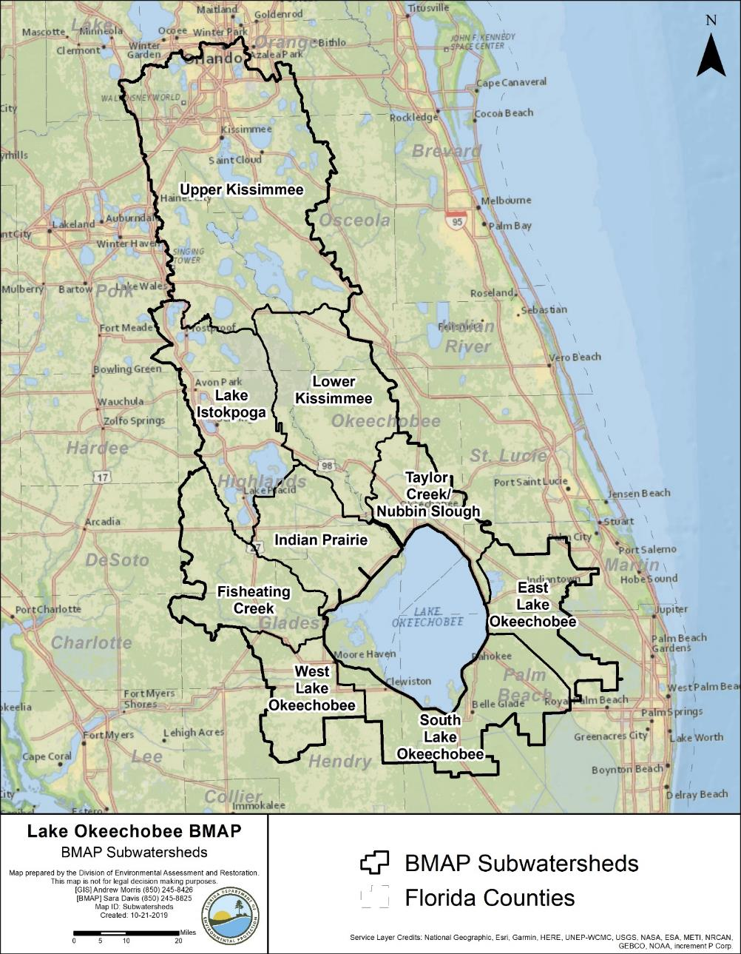
Figure ES-1. Lake Okeechobee subwatersheds

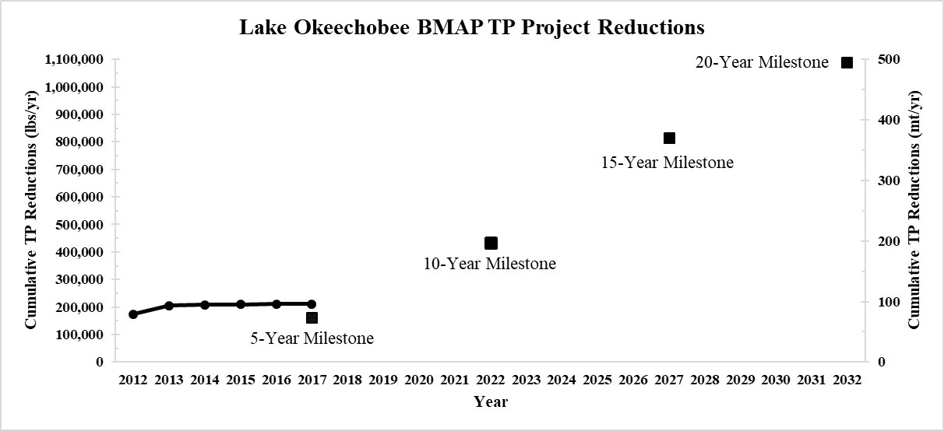
Figure ES-2. Estimated progress towards meeting the TP TMDL allocated to the Lake Okeechobee Watershed with projects completed through June 30, 2019

- Background Information

Water Quality Standards and Total Maximum Daily Loads (TMDLs)
Florida's water quality standards are designed to ensure that surface waters fully support their designated uses, such as drinking water, aquatic life, recreation, and agriculture. Lake Okeechobee is designated as a Class I water, with uses including public water supply, recreation, and propagation and maintenance of a healthy, well-balanced population of fish and wildlife. Most surface waters in Florida, including those in the Lake Okeechobee Watershed (LOW), which ultimately reach Lake Okeechobee, are categorized as Class III waters. Table 1 lists all designated use classifications for Florida surface waters.
Table 1. Designated use attainment categories for Florida surface waters
¹ Class I, I-Treated, and II waters additionally include all Class III uses.
Classification | Description
Class I¹ | Potable water supplies
Class I-Treated¹ | Treated potable water supplies
Class II¹ | Shellfish propagation or harvesting
Class III | Fish consumption, recreation, propagation and maintenance of a healthy,  well-balanced population of fish and wildlife
Class III-Limited | Fish consumption, recreation or limited recreation, and/or propagation and maintenance of a limited population of fish and wildlife
Class IV | Agricultural water supplies
Class V | Navigation, utility, and industrial use (no current Class V designations)

Section 303(d) of the federal Clean Water Act (CWA) requires that every two years each state must identify its "impaired" waters, including estuaries, lakes, rivers, and streams, that do not meet their designated uses. Florida Department of Environmental Protection (DEP) staff in the Division of Environmental Assessment and Restoration are responsible for assessing Florida's waters for inclusion on the Verified List of Impaired Waters (when a causative pollutant for the impairment has been identified) and Study List (when a causative pollutant has not been identified and additional study is needed). These lists are then provided to the U.S. Environmental Protection Agency (EPA) as an annual update to the state "303(d) list." In 1998, DEP identified Lake Okeechobee as impaired for total phosphorus (TP).

Lake Okeechobee TMDL
A TMDL is the maximum amount of a specific pollutant that a waterbody can assimilate while maintaining its designated uses, and in August 2001, DEP adopted the Lake Okeechobee TMDL for TP. The TMDL is an annual TP load to Lake Okeechobee of 140 metric tons per year (mt/yr) (308,647 pounds per year [lbs/yr]), of which 35 mt/yr (77,162 lbs/yr) is estimated to fall directly on the lake through atmospheric deposition. The remaining 105 mt/yr (231,485 lbs/yr) of TP are allocated to the 9 subwatersheds in the LOW, as authorized by Subparagraph 403.067(7)(a)2., Florida Statutes (F.S.). The attainment of the TMDL will be calculated using a 5-year rolling average based on the monthly loads calculated from measured flow and concentration values. Because there were no National Pollutant Discharge Elimination System (NPDES) facilities that directly discharged into the lake at that time, the adopted TMDL assigned all reductions to the permitted and unpermitted nonpoint source inflows to the lake.

Lake Okeechobee Basin Management Action Plan (BMAP)
DEP implements TMDLs through permits and BMAPs; the latter contain strategies to reduce and prevent pollutant discharges through various cost-effective means. During the watershed restoration process, DEP and the affected stakeholders jointly develop BMAPs or other implementation approaches. Stakeholder involvement is critical to the success of the watershed restoration program and varies with each phase of implementation to achieve different purposes. The BMAP development process is structured to achieve cooperation and consensus among a broad range of interested parties, including the South Florida Water Management District (SFWMD), Florida Department of Agriculture and Consumer Services (FDACS), and stakeholders representing other agencies, governments, and interested parties. The original Lake Okeechobee BMAP was adopted in December 2014. Figure 1 shows the LOW BMAP area which is divided into nine subwatersheds that are further divided into 64 “basins” (Figure 2).
The Florida Watershed Restoration Act, Subparagraph 403.067(7)(a)1., F.S., establishes an adaptive management process for BMAPs that continues until the TMDL is met. This approach allows for incrementally reducing loadings through the implementation of projects and programs, while simultaneously monitoring and conducting studies to better understand water quality dynamics (sources and response variables) in each impaired waterbody. This adaptive management process will continue until the TMDL is met.
The final 2019 South Florida Environmental Report (SFER) – Volume I, Chapter 8B prepared by SFWMD, reports the 5-year average (based on data from water year [WY] 2014 to WY2018 [May 1, 2013–April 30, 2018]) annual TP load from the watershed as 598 mt/yr (1,318,364 lbs/yr). Therefore, to achieve the allowable TMDL load of 105 mt/yr, the TP required reduction is 493 mt/yr (1,086,879 lbs/yr). The TP required reduction was assigned to each subwatershed based on the contribution of the total load from that subwatershed as listed in Table 2. The 5-year average annual TP load from the watershed is updated annually in the SFER.
Section 373.4595, F.S., calls for a review of the BMAP to be completed and submitted to the Legislature and Governor every five years. This document includes the initial 5-Year Review (Chapter 2) and updates the 2014 BMAP.

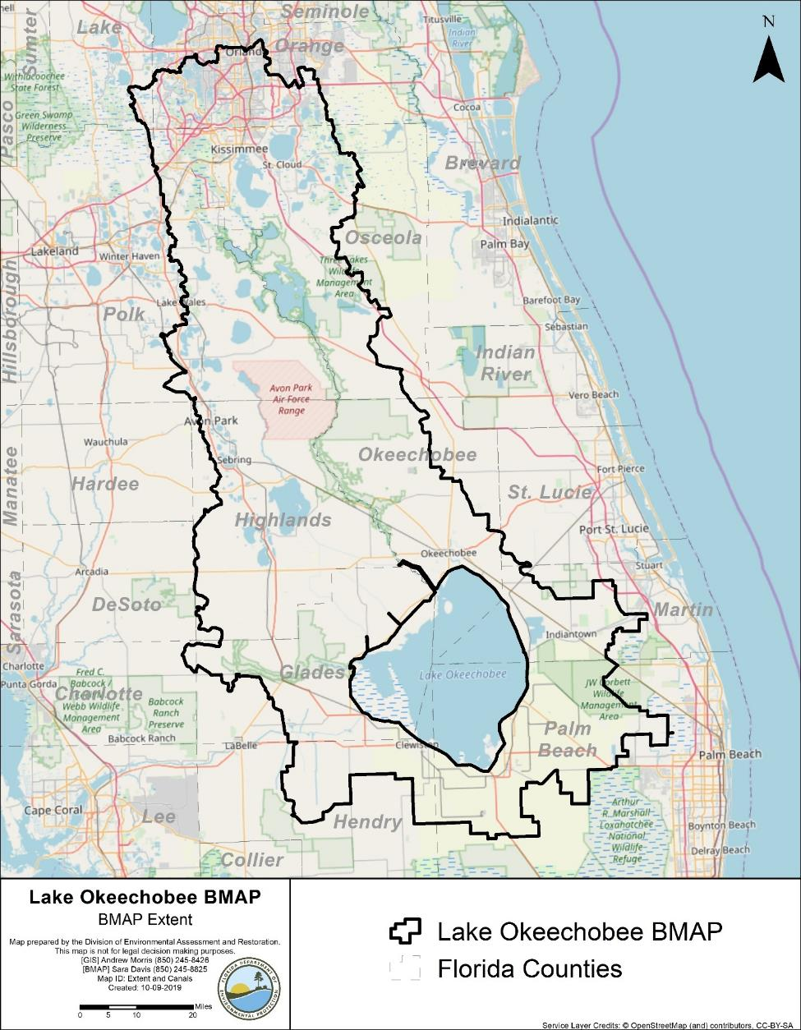
Figure 1. LOW BMAP area

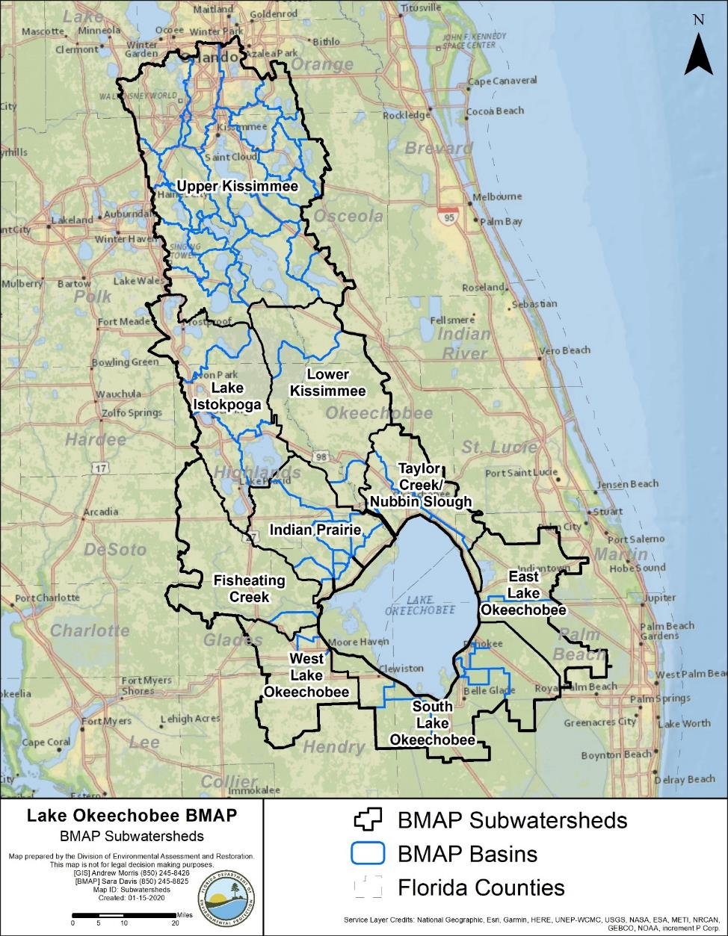
Figure 2. LOW subwatersheds and basins

Table 2. Load reductions and targets by subwatershed
Subwatershed | WY2014–WY2018  TP Load  (mt/yr) | % Contribution of Load | TP Load  Required Reduction  (mt/yr) | TP Target (mt/yr)
Fisheating Creek | 72.4 | 12 | 59.7 | 12.7
Indian Prairie | 102.5 | 17 | 84.5 | 18.0
Lake Istokpoga | 47.7 | 8 | 39.3 | 8.4
Lower Kissimmee | 125.9 | 21 | 103.8 | 22.1
Taylor Creek/Nubbin Slough | 113.6 | 19 | 93.7 | 19.9
Upper Kissimmee | 90.5 | 15 | 74.6 | 15.9
East Lake Okeechobee | 16.8 | 3 | 13.9 | 2.9
South Lake Okeechobee | 29.0 | 5 | 23.9 | 5.1
West Lake Okeechobee | <0.1 | <<1 | 0.0 | 0.0
Total | 598.4 | 100 | 493.4 | 105.0

Pollutant Sources
There are various sources of pollution in the LOW. Nonpoint (i.e., diffuse) sources in the watershed contribute the majority of the TP and total nitrogen (TN) loads to Lake Okeechobee and include agricultural and urban stormwater runoff. Several reports (SFWMD; DEP; FDACS; periodic Lake Okeechobee Protection Plan [LOPP] updates) document more detailed information regarding phosphorus and nitrogen inputs from the LOW. Table 3 summarizes the percent contribution of TP and TN loads to Lake Okeechobee from each land use category in each subwatershed as determined by the Watershed Assessment Model (WAM) load estimation tool (LET) discussed in Subsection 2.2.2. The subsections below discuss the sources included in this BMAP in more detail.
Table 3. Summary of TP and TN loads by WAM land use category by subwatershed
Subwatershed | Land Use Category | TP Load  (% contribution) | TN Load  (% contribution)
Fisheating Creek | Urban | 1.3 | 4.7
Fisheating Creek | Agriculture | 64.7 | 57.2
Fisheating Creek | Natural | 34.0 | 38.1
Indian Prairie | Urban | 2.5 | 9.9
Indian Prairie | Agriculture | 84.9 | 73.8
Indian Prairie | Natural | 12.6 | 16.3
Lake Istokpoga | Urban | 52.5 | 24.0
Lake Istokpoga | Agriculture | 20.7 | 57.4
Lake Istokpoga | Natural | 26.8 | 18.6
Lower Kissimmee | Urban | 3.0 | 7.4
Lower Kissimmee | Agriculture | 62.9 | 51.7
Lower Kissimmee | Natural | 34.2 | 40.9
Taylor Creek/Nubbin Slough | Urban | 13.2 | 18.3
Taylor Creek/Nubbin Slough | Agriculture | 82.6 | 75.1
Taylor Creek/Nubbin Slough | Natural | 4.2 | 6.7
Upper Kissimmee | Urban | 21.0 | 36.4
Upper Kissimmee | Agriculture | 37.3 | 43.9
Upper Kissimmee | Natural | 41.7 | 19.7
East Lake Okeechobee | Urban | 5.4 | 9.4
East Lake Okeechobee | Agriculture | 75.0 | 61.2
East Lake Okeechobee | Natural | 19.6 | 29.4
South Lake Okeechobee | Urban | 7.5 | 8.0
South Lake Okeechobee | Agriculture | 91.6 | 90.6
South Lake Okeechobee | Natural | 0.9 | 1.4
West Lake Okeechobee | Urban | 9.9 | 7.8
West Lake Okeechobee | Agriculture | 83.2 | 83.7
West Lake Okeechobee | Natural | 6.9 | 8.5

Agricultural Nonpoint Sources
The primary agricultural land uses in the LOW are improved pastures, unimproved pastures, citrus groves, and woodland pastures. Other agricultural land uses include field crops (e.g., sugar cane), dairies, croplands and pasture, row crops, tree nurseries, specialty farms, and ornamentals. Per Section 403.067, F.S., all agricultural nonpoint sources in the BMAP area are statutorily required either to implement appropriate best management practices (BMPs) or to conduct water quality monitoring that demonstrates compliance with state water quality standards.
Per Section 403.067, F.S., when DEP adopts a BMAP that includes agriculture, it is the agricultural landowner's responsibility to implement BMPs adopted by FDACS to help achieve load reductions or demonstrate through monitoring, per 62-307, F.A.C., that they are already meeting water quality standards. To date, FDACS' Office of Agricultural Water Policy (OAWP) has adopted BMP manuals by rule for cow/calf, citrus, vegetable and agronomic crops, nurseries, equine, sod, dairy, poultry, and specialty fruit and nut operations.
To enroll in the BMP Program, landowners must submit to OAWP a Notice of Intent (NOI) to implement the BMPs with the BMP checklist from the applicable BMP manual. The landowner may meet with OAWP to determine the BMPs that are applicable to that individual operation. Because many agricultural operations are diverse and are engaged in the production of multiple commodities, a landowner may be required to sign multiple NOIs for a single parcel.
OAWP is required to verify that landowners are implementing the BMPs identified in their NOIs. Rule 5M-1.008, Florida Administrative Code (F.A.C.), outlines the procedures used to verify the implementation of agricultural BMPs. BMP implementation is verified through annual surveys submitted by producers enrolled in the BMP Program and site visits by OAWP staff. Producers not implementing BMPs according to the process outlined in Chapter 5M-1, F.A.C., are referred to DEP for enforcement action after attempts at remedial action are exhausted.
FDACS staff conduct site visits to verify that all BMPs are being implemented correctly and to review nutrient and irrigation management records. In addition, OAWP verifies that cost-share items are being implemented correctly. Site visits are prioritized based on the date the NOI was signed, the date of the last BMP verification site visit, whether a survey was completed by the producer for the most recent year, and whether the operation has received cost-share funding.
Section 403.067, F.S., requires that, where water quality problems persist despite the proper implementation of adopted agricultural BMPs, FDACS must reevaluate the practices, in consultation with DEP, and modify them if necessary. Continuing water quality problems may be detected through the monitoring component of the BMAP and other DEP and SFWMD activities. If a reevaluation of the BMPs is needed, FDACS will also include SFWMD and other partners in the process. Subsection 3.1.1 provides further details on the reevaluation of existing practices.
For the BMAP, the implementation of agricultural BMPs will be documented based on participation in the FDACS BMP Program or SFWMD’s Chapter 40E-63, F.A.C., as applicable. Under the SFWMD program, all agricultural and nonagricultural lands are required to implement BMPs and monitor discharges to determine TP loading. The FDACS BMP Program rules provide the presumption of compliance to those agricultural landowners.
Table 4 and Table 5 summarize the agricultural land use enrolled in BMP programs for the entire LOW and by subwatershed, respectively. Enrollment is as of June 30, 2019, and the agricultural acreage in each subwatershed is based on the Florida Statewide Agricultural Irrigation Demand (FSAID) VI database. As new BMAPs are developed or existing BMAP areas are expanded, overlap among BMAPs is increasing. In the Lake Okeechobee BMAP area, 268,269 agricultural acres are also included in the BMAPs for Caloosahatchee (2020 update) or St. Lucie. While calculations, allocations, and projects are specific to each BMAP, the number of acres from the individual BMAP reports, if added, exceeds the total acres in the three BMAP areas. Appendix B provides more information on agricultural activities in the LOW.
Table 4. Summary of agricultural land use acreage enrolled in the BMP Program in the Lake Okeechobee BMAP area
Category | Acres
FSAID VI agricultural acres in the BMAP | 1,728,292
Total agricultural acres enrolled | 1,335,172
% of FSAID VI agricultural acres enrolled | 77 %

Table 5. Agricultural land use acreage enrolled in the BMP Program in the Lake Okeechobee BMAP area by subwatershed
Subwatershed | Total FSAID VI Agricultural Acres | Agricultural Acres  Enrolled | % Agricultural Acres Enrolled
Fisheating Creek | 189,488 | 171,662 | 91
Indian Prairie | 221,785 | 182,376 | 82
Lake Istokpoga | 118,901 | 93,115 | 78
Lower Kissimmee | 219,817 | 175,318 | 80
Taylor Creek/Nubbin Slough | 140,181 | 118,761 | 85
Upper Kissimmee | 260,175 | 126,633 | 49
East Lake Okeechobee | 101,510 | 56,644 | 56
South Lake Okeechobee | 333,231 | 292,512 | 88
West Lake Okeechobee | 143,204 | 118,151 | 83
Total | 1,728,292 | 1,335,172 | 77

Unenrolled Agricultural Acreage
Agricultural land use designation is not always indicative of current agricultural activity and consequently presents challenges to estimating load allocations accurately as well as enrolling every agricultural acre in an appropriate BMP manual. To characterize unenrolled agricultural acres, OAWP identified FSAID VI features outside of the BMP enrollment areas using geographic information system (GIS) software (see Appendix B for details). Table 6 summarizes the results of that analysis.
Table 6. Summary of unenrolled agricultural land use acreage in the Lake Okeechobee BMAP area
Note: Due to geometric variations between shapefiles used in the unenrolled agricultural lands analysis performed by OAWP, the unenrolled agricultural acres differ from subtraction of the FSAID VI Agricultural Acres in the BMAP and the Total Agricultural Acres Enrolled referenced in Table 5.
Category | Acres
Unenrolled agricultural acres | 393,571
Acres identified within slivers of unenrolled agricultural areas | 15,889
Lands without enrollable agricultural activity (e.g., tribal lands, residential development, and parcels with Florida Department of Revenue [DOR] use codes 70-98) | 117,299
Total lands with potentially enrollable agricultural activities | 260,384

As of June 30, 2019, OAWP had enrolled 1,335,172 agricultural acres in BMPs. Considering the results of the analysis shown in Table 6, the total acreage with the potential to have agricultural activities that can be enrolled in FDACS' BMP Program in the basin is 1,595,104 acres. Using this adjusted agricultural acreage, 84 % of agricultural acres have been enrolled.
Analyzing land use data and parcel data is a valuable first step in identifying the agricultural areas that provide the greatest net benefits to water resources for enrollment in the FDACS BMP Program, as well as the prioritization of implementation verification visits in a given basin. OAWP will continue to enroll agricultural lands in the BMP Program, focusing on intensive operations, including irrigated acreage, dairies and nurseries, parcels greater than 50 acres in size, and agricultural parcels adjacent to waterways.
The next step to help prioritize the enrollment efforts could use the parcel loading information derived from the WAM. This effort could help FDACS identify specific parcels with the highest modeled nutrient loading. These parcels could then be targeted for enrollment and implementation of BMPs, as well as the verification of BMP implementation.

Aquaculture
Under the CWA, aquaculture activities are defined as a point source. Starting in 1992, DEP and/or the water management districts regulated all aquaculture facilities through a general fish farm permit authorized by Section 403.814, F.S. In 1999, the Florida Legislature amended Chapter 597, F.S., Florida Aquaculture Policy Act, to create a program within FDACS requiring Floridians who sell aquatic species to annually acquire an Aquaculture Certificate of Registration and implement Chapter 5L-3, F.A.C., Aquaculture BMPs. Permit holders must be certified every year.
However, as with agricultural land use in Florida, aquaculture facilities are frequently in and out of production. The facilities for which acreages were provided in the original BMAP may no longer be in operation and there may be new companies in different parts of the basin. In the LOW, 663 acres of aquaculture are under certification with FDACS' Division of Aquaculture as of September 2019. For purposes of the BMAP, OAWP delineated the aquaculture facilities using parcel data. Since the acreages were not delineated to just the tank, pond, or pool areas, in most cases these calculations overestimate the acreages of aquaculture activity.

Municipal Separate Storm Sewer Systems (MS4s)
Many of the municipalities in the basin are regulated by the Florida NPDES Stormwater Program. An MS4 is a conveyance or system of conveyances, such as roads with stormwater systems, municipal streets, catch basins, curbs, gutters, ditches, constructed channels, or storm drains.
If an MS4 permittee is identified as a contributor in the BMAP, the permitted MS4 must undertake projects specified in the BMAP. The BMAP projects required to be undertaken by MS4s are detailed for each subwatershed in Chapter 4. Phase I and Phase II MS4s are required to implement stormwater management programs to reduce pollutants to the maximum extent practicable and address applicable TMDL allocations. Phase I MS4 permits include assessment practices to determine the effectiveness of stormwater management programs (SWMP), which can include water quality monitoring. Both Phase I and Phase II MS4 permits include provisions for the modification of SWMP activities, at the time of permit renewal, for consistency with the assumptions and requirements of the adopted BMAP.

Phase I MS4 Stormwater Permit Requirements
Table 7 lists the local governments in the LOW designated as Phase I MS4s. Phase I MS4 permittees were subject to a two-part application process requiring (1) the development of a proposed SWMP that would meet the standard of reducing discharged pollutants to the maximum extent practicable, and (2) the incorporation of the SWMP into an individual permit issued to the MS4 operator. The stormwater management programs for Phase I MS4s include, but are not limited to, the following measures:
- Identify major outfalls and pollutant loadings.
- Detect and eliminate nonstormwater discharges (illicit discharges) to the system.
- Reduce pollutants in runoff from industrial, commercial, and residential areas.
- Control stormwater discharges from new development and redevelopment areas.
- Ensure flood control projects assess the impacts to water quality of receiving waters.
- Implement a program to reduce the stormwater discharge of pollutants related to the storage and application of pesticides, herbicides, and fertilizers.
- Implement an assessment program to determine program effectiveness.
Additionally, in accordance with Section 403.067, F.S., if an MS4 permittee is identified in an area with an adopted BMAP or BMAP in development, the permittee must comply with the adopted provisions of the BMAP that specify activities to be undertaken by the permittee. If the permittee discharges stormwater to a waterbody with an adopted TMDL pursuant to Chapter 62-304, F.A.C., then the permittee must revise its stormwater master plan to address the assigned wasteload in the TMDL.
Table 7. Entities in the LOW designated as Phase I MS4s
Permittee | Permit Number
Orange County and copermittees: | FLS000011
City of Belle Isle | FLS266795
City of Edgewood | FLS266817
Florida Department of Transportation (FDOT) District 5 | FLS266876
Valencia Water Control District (WCD) | FLS266868
City of Orlando | FLS000014
Palm Beach County and copermittees: | FLS000018
City of Belle Glade | FLS643459
FDOT District 4 | FLS266493
City of South Bay | FLS645281
Indian Trail Improvement District | FLS606723
Polk County and copermittees: | FLS000015
City of Davenport | FLS266621
Town of Dundee | FLS266639
City of Frostproof | FLS266663
City of Haines City | FLS266671
Town of Hillcrest Heights | FLS266698
City of Lake Wales | FLS266736
FDOT District 1 | FLS266779
Reedy Creek Improvement District (RCID) | FLS000010

Phase II MS4 Stormwater Permit Requirements
DEP can designate an entity as a regulated Phase II MS4 if its discharges meet the requirements of the rule and are determined to be a significant contributor of pollutants to surface waters of the state in accordance with Rule 62-624.800, F.A.C. A Phase II MS4 can be designated for regulation when a TMDL has been adopted for a waterbody or segment into which the MS4 discharges the pollutant(s) of concern. If an MS4 is designated as a regulated Phase II MS4, it is subject to the conditions of the "NPDES Generic Permit for Stormwater Discharges from Phase II MS4s."
DEP can designate an entity as a regulated Phase II MS4 if its discharges meet the requirements of the rule and are determined to be a significant contributor of pollutants to surface waters of the state in accordance with Rule 62-624.800, F.A.C. A Phase II MS4 can be designated for regulation when a TMDL has been adopted for a waterbody or segment into which the MS4 discharges the pollutant(s) of concern. If an MS4 is designated as a regulated Phase II MS4, it is subject to the conditions of the "NPDES Generic Permit for Stormwater Discharges from Phase II MS4s."
Table 8 lists the Phase II MS4s in the LOW as of October 2019. Under a generic permit, the operators of regulated Phase II MS4s must develop a SWMP that includes BMPs with measurable goals and a schedule for implementation to meet the following six minimum control measures:
- Public Education and Outreach – Implement a public education program to distribute educational materials to the community or conduct equivalent outreach activities about the impacts of stormwater discharges on water bodies and the steps that the public can take to reduce pollutants in stormwater runoff.
- Public Participation/Involvement – Implement a public participation/involvement program that complies with state and local public notice requirements.
- Illicit Discharge Detection and Elimination – Subsection 62-624.200(2), F.A.C., defines an illicit discharge as "…any discharge to an MS4 that is not composed entirely of stormwater…," except discharges under an NPDES permit, or those listed in rule that do not cause a violation of water quality standards. Illicit discharges can include septic/sanitary sewer discharge, car wash wastewater, laundry wastewater, the improper disposal of auto and household toxics, and spills from roadway accidents.
  - Develop, if not already completed, a storm sewer system map showing the location of all outfalls, and the names and location of all surface waters of the state that receive discharges from those outfalls.
  - To the extent allowable under state or local law, effectively prohibit, through an ordinance or other regulatory mechanism, nonstormwater discharges into the storm sewer system and implement appropriate enforcement procedures and actions.
  - Develop and implement a plan to detect and address nonstormwater discharges, including illegal dumping, to the storm sewer system.
  - Inform public employees, businesses, and the general public of hazards associated with illegal discharges and the improper disposal of waste.
- Construction Site Runoff Control –
  - Implement a regulatory mechanism to require erosion and sediment controls, as well as sanctions to ensure compliance, to reduce pollutants in any stormwater runoff to the Phase II MS4 from construction activity that results in a land disturbance greater than or equal to an acre. Construction activity disturbing less than one acre must also be included if that construction activity is part of a larger common plan of development or sale that would disturb one acre or more.
  - Develop and implement requirements for construction site operators to implement appropriate erosion and sediment control BMPs.
  - Implement requirements for construction site operators to control waste such as discarded building materials, concrete truck washout, chemicals, litter, and sanitary waste at the construction site that may cause adverse impacts to water quality.
  - Develop and implement procedures for site plan review that incorporate the consideration of potential water quality impacts.
  - Develop and implement procedures for receiving and considering information submitted by the public.
  - Develop and implement procedures for site inspection and the enforcement of control measures.
  - Postconstruction Runoff Control – Implement and enforce a program to address the discharges of postconstruction stormwater runoff from areas with new development and redevelopment. (Note: In Florida, Environmental Resource Permits issued by the water management districts typically serve as a Qualifying Alternative Program for purposes of this minimum control measure.)
  - Pollution Prevention/Good Housekeeping – Implement an operations and maintenance program that has the ultimate goal of preventing or reducing pollutant runoff from MS4 operator activities, such as park and open space maintenance, fleet and building maintenance, new construction and land disturbances, stormwater system maintenance, and staff training in pollution prevention.
The "NPDES Generic Permit for Discharge of Stormwater from Phase II MS4s," Paragraph 62-621.300(7)(a), F.A.C., also requires that if the permittee discharges stormwater to a waterbody with an adopted TMDL pursuant to Chapter 62-304, F.A.C., then the permittee must revise its SWMP to address the assigned wasteload in the TMDL. Additionally, in accordance with Section 403.067, F.S., if an MS4 permittee is identified in an area with an adopted BMAP or BMAP in development, the permittee must comply with the adopted provisions of the BMAP that specify activities to be undertaken by the permittee.
DEP can designate an entity as a regulated Phase II MS4 if its discharges meet the requirements of the rule and are determined to be a significant contributor of pollutants to surface waters of the state in accordance with Rule 62-624.800, F.A.C. A Phase II MS4 can be designated for regulation when a TMDL has been adopted for a waterbody or segment into which the MS4 discharges the pollutant(s) of concern. If an MS4 is designated as a regulated Phase II MS4, it is subject to the conditions of the "NPDES Generic Permit for Stormwater Discharges from Phase II MS4s."
Table 8. Entities in the LOW designated as Phase II MS4s as of October 2019
Permittee | Permit Number
Glades County | FLR04E137
Hendry County | FLR04E138
Highlands County | FLR04E148
Martin County | FLR04E013
Okeechobee County | FLR04E140
Osceola County | FLR04E012
City of Avon Park | FLR04E150
City of Clewiston | FLR04E134
City of Kissimmee | FLR04E064
City of Sebring | FLR04E149
City of St. Cloud | FLR04E112
FDOT District 1 – Highlands County | FLR04E147
FDOT Florida's Turnpike Enterprise | FLR04E049
Town of Windermere | FLR04E063

Septic Systems
Based on 2019 data from the Florida Department of Health (FDOH), there are 124,176 known or likely septic systems located throughout the LOW (Figure 3). Table 9 summarizes the number of septic systems by subwatershed.
Table 9. Septic system counts by subwatershed
Subwatershed | Number of  Septic Systems
Fisheating Creek | 467
Indian Prairie | 2,095
Lake Istokpoga | 30,787
Lower Kissimmee | 924
Taylor Creek/Nubbin Slough | 11,085
Upper Kissimmee | 61,264
East Lake Okeechobee | 12,562
South Lake Okeechobee | 2,699
West Lake Okeechobee | 2,293
Total | 124,176

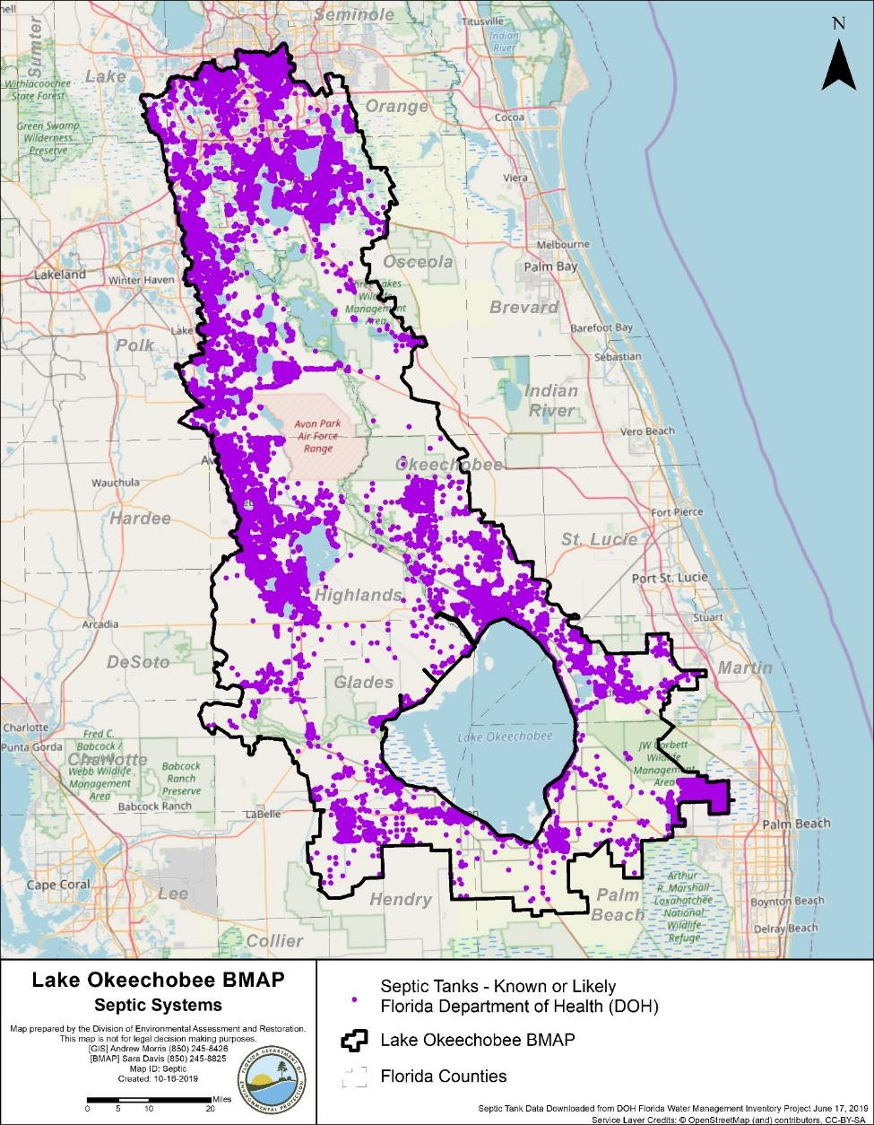
Figure 3. Location of septic systems in the LOW

Urban Nonpoint Sources
Subsubparagraph 403.067(7)(b)2.f., F.S., prescribes the pollutant reduction actions required for nonagricultural pollutant sources that are not subject to NPDES permitting. "Non-MS4 sources" must also implement the pollutant reduction requirements detailed in a BMAP and are subject to enforcement action by DEP or a water management district if they fail to implement their responsibilities under the BMAP. Table 10 lists the nonpoint sources in the LOW.
Table 10. Urban nonpoint sources in the LOW
Type of Entity | Participant
Municipalities | City of Moore Haven  City of Okeechobee  City of Pahokee  Town of Lake Placid  Village of Highland Park  Village of Indiantown
Government entities and special districts | Avon Park Air Force Range  Barron WCD  Clewiston Drainage District  Collins Slough WCD  Coquina Water Management District  Devils Garden WCD  Disston Island Conservancy District  East Beach WCD  East Hendry County Drainage District  East Shore WCD  Flaghole Drainage District  Henry Hillard WCD  Highlands Glades Drainage District  Istokpoga Marsh Watershed Improvement District (IMWID)  Northern Palm Beach County Improvement District  Pahokee Drainage District  Pelican Lake WCD  Ritta Drainage District  South Florida Conservancy District  South Shore Drainage District  Spring Lake Improvement District (SLID)  Sugarland Drainage District

Wastewater Treatment Facilities (WWTFs)
The TMDL identified 190 domestic and industrial WWTFs in the LOW, none of which directly discharged to the lake. Many of the discharges were through wells to groundwater. Therefore, these facilities were not assigned a wasteload allocation. As of December 2019, there were 254 individually permitted wastewater facilities or activities in the LOW. Of these, 26 hold NPDES permits and therefore are authorized, within the limitations of their permits, to discharge directly to surface waters within the LOW. The remaining 228 do not have authorization to discharge directly to surface waters.

Assumptions
The water quality impacts of BMAP implementation are based on several fundamental assumptions about the pollutants targeted by the TMDLs, modeling approaches, waterbody response, and natural processes. The following assumptions were used during the BMAP process:
- Certain BMPs were assigned provisional nutrient reduction benefits for load reductions in this BMAP iteration while additional monitoring and research are conducted to quantify their effectiveness. These estimated reductions may change in future BMAP iterations, as additional information becomes available.
- Nutrient reduction benefits of the stakeholders' projects were calculated using the best available methodologies. Project-specific monitoring, where available, will be used to verify the calculations, and reduction benefits may be adjusted as necessary.

Considerations
This BMAP requires stakeholders to implement projects to achieve reductions within the specified period. However, the full implementation of the BMAP will be a long-term, adaptively managed process. While some of the BMAP projects and activities were recently completed or are currently ongoing, several projects require more time to design, secure funding, and construct. Regular follow-up and continued coordination and communication by the stakeholders will be essential to ensure the implementation of management strategies and assessment of incremental effects.
During the BMAP process, several items were identified that should be addressed in future watershed management cycles to ensure that future BMAPs use the most accurate information:
- Land Uses – The loading estimates in the BMAP are based on land uses at a particular point in time, allowing the model to be validated and calibrated. The loading estimates for this BMAP iteration were based on the WAM, which used 2009 land use data updated by SFWMD during 2013 to refine the land use categories. This dataset is referred to in this document as the 2009 land use. WAM updates in this BMAP will allow for the differentiation of phosphorus loading from various land use types.
- Watershed Boundaries – The 2014 BMAP focused on the six subwatersheds north of the lake because the WAM at that time did not include the full watershed. This BMAP update includes all nine subwatersheds and uses information from the 2017 WAM to help with load estimation.
- Chapter 40E-61, F.A.C. – SFWMD has initiated rulemaking to revise Chapter 40E-61, F.A.C., to ensure its objectives are consistent with Sections 373.4595 and 403.067, F.S.
- Complexity of Problem – DEP acknowledges the complexity of the dynamics that affect the water quality of Lake Okeechobee and its watershed; therefore, this BMAP is designed to encompass a wide variety of projects that will cumulatively act to significantly reduce nutrient loads. In September 2019, DEP released a Request for Information (RFI) to obtain new proposals for restoration projects and technologies to be implemented in the LOW. Appendix E lists the projects and technologies submitted through this RFI for each of the nine subwatersheds and the lake itself. Resources will be needed to implement these projects throughout the watershed.
- Legacy Phosphorus – DEP recognizes that legacy phosphorus is present in Lake Okeechobee and in the LOW as a result of past anthropogenic activities, and this watershed load has the potential to be transported to Lake Okeechobee. The Coordinating Agencies (DEP, FDACS, and SFWMD) and stakeholders will identify projects and management strategies that will address the legacy load.
- Attenuation Factors – Attenuation factors were calculated for each of the LOW subwatersheds using the 2017 WAM outputs. These factors were applied during the project credit calculation process to determine the nutrient reduction benefits to Lake Okeechobee.
- Other TMDLs in the LOW – As part of the overall restoration strategy, DEP is prioritizing waterbody TMDLs in the LOW. DEP has adopted nutrient TMDLs for Lake Kissimmee (waterbody identification [WBID] number 3183B), Lake Cypress (WBID 3180A), Lake Holden (WBID 3168H), Lake Jackson (WBID 3183G), and Lake Marian (WBID 3184) that became effective in December 2013. The dissolved oxygen (DO) TMDL for C-44 Canal (WBID 3218) and C-23 Canal (WBID 3200) became effective in March 2009. The nutrient TMDL for Lake Persimmon (WBID 1938E) became effective in November 2018. The DO TMDLs for the S-4 Basin (WBID 3246), C-19 Canal (WBID 3237E), Lake Hicpochee (WBID 3237C), Townsend Canal (WBID 3235L), and Long Hammock Creek (WBID 3237B) became effective in August 2019 and will be addressed as part of the Caloosahatchee River and Estuary BMAP.
DEP also has nutrient TMDLs in development for Lake Glenada (WBID 1813L), Red Water Lake (WBID 1938F), Lake Placid (WBID 1938C), and Lake Istokpoga (WBID 1856B). For Reedy Lake (WBID 1685D), Lake Ida (WBID 1685E), Hickory Lake (WBID 1730), Lake Clinch (WBID 1706), and Lake Adelaide (WBID 1730D), DEP held a public rule development workshop in August 2019, with anticipated adoption by 2020.
In addition, DEP will perform site-specific studies of 28 waterbodies in the Kissimmee, Taylor Creek, and Istokpoga Basins. The statewide priority list is posted on the DEP website.
- TN – Although the Lake Okeechobee TMDL only addresses TP, TN is of particular importance to the Northern Everglades and Estuaries system, including the Caloosahatchee and St. Lucie Estuaries, which receive flows directly from Lake Okeechobee. Each of these estuaries has a TMDL and a BMAP in place to address TN; therefore, DEP has calculated project reduction benefits for TN to track TN management efforts in the LOW that will directly or indirectly benefit the lake and downstream waters. In addition, DEP is evaluating TN concentrations compared with benchmark concentrations to help prioritize basins for restoration activities.
- Previous Restoration Efforts – DEP recognizes that stakeholders throughout the watershed have implemented stormwater management projects as well as statutorily mandated diversions away from Lake Okeechobee prior to 2009 and that these efforts have benefited water quality.
- Estuary BMAP Overlap – Portions of the LOW overlap with the watersheds for the Caloosahatchee River and Estuary and St. Lucie River and Estuary. The projects in these overlap areas are included in both this BMAP and the applicable estuary BMAP. The benefits of these projects will vary by BMAP as the reductions are calculated for the waterbody that is the focus of the BMAP.

- 5-Year Review
The BMAP, which is adopted by Secretarial Order, implements phased TP reductions according to Subparagraph 403.067(7)(a)1., F.S., for the loading generated in the LOW. This first 5-Year Review was prepared to update the status of implementation and provide recommendations for the updated BMAP. The sections below summarize the progress made to date, updates to the BMAP model, the targeted restoration area (TRA) approach for the BMAP update, water quality monitoring revisions, and established milestones. The updates and recommendations identified during the 5-Year Review are incorporated into this BMAP update.

Progress to Date
During the development of the BMAP update, DEP asked the stakeholders to provide information on activities and projects that would reduce nutrient loading to achieve the BMAP milestones and ultimately attain the TMDL. The outputs from the 2017 WAM were used to develop an LET for the calculation of existing loads and nutrient reduction benefits associated with stakeholder projects (see Section 2.2 for details). Management strategies and projects are being implemented by the local stakeholders and Coordinating Agencies.
Chapter 4 includes projects and other management strategies that were completed, planned, or ongoing since January 1, 2009, as well as those currently under development by the Coordinating Agencies (DEP, SFWMD, and FDACS) and other initiatives. Public-private partnerships and regional projects represent a number of management strategies in the LOW. Municipal, regional, state, and federal agencies, as well as agricultural producers, have responsibilities under the BMAP to implement structural and nonstructural activities to reduce TP loads to Lake Okeechobee.
Responsible entities submitted these projects and activities to DEP with the understanding that these would be included in the BMAP, thus setting the expectation for each entity to implement the proposed projects and activities to achieve the assigned project load reduction estimates in the period specified for each project. This list of projects is meant to be flexible enough to allow for changes that may occur over time, provided that the reduction is still met within the specified period. DEP must first approve any change in listed projects and activities, or the deadline to complete these actions. Substituted projects must result in equivalent or greater nutrient reductions than expected from the original projects.
Projects had to meet several criteria to be considered eligible for nutrient reduction benefits under the BMAP. All projects, programs, and activities were required to address TP loads. Only projects completed, planned, or ongoing since January 1, 2009, were eligible for BMAP nutrient reduction benefits. While DEP recognizes that significant stakeholder actions were implemented in the LOW prior to 2009, the intent of this BMAP is to focus on current, planned, and future projects to reduce TP loads. Projects were only given nutrient reduction benefits for the portion of the load reduction over and above any permit requirements.
DEP annually reviews each entity's progress towards completing projects listed in the BMAP to achieve the TMDL. Table 11 lists the number of projects that each entity committed to in the BMAP and annual progress reports, along with the project status projects as of June 30, 2019. Through June 30, 2019, 215 projects were completed, and an additional 51 projects were underway or planned. Based on the LET, the completed activities are estimated to achieve total reductions of 95.54 mt/yr or 210,636 pounds per year (lbs/yr) of TP, which is 19.4 % of the reductions needed to meet the TMDL. Table 12 summarizes the reductions achieved by each entity based on modeled estimates of projects completed as of June 30, 2019.
Table 11. Projects to achieve the TMDL as of June 30, 2019
Entity | Completed | Underway | Planned | Canceled | Total
Avon Park Air Force Range | 1 | 0 | 0 | 0 | 1
City of Avon Park | 1 | 0 | 0 | 2 | 3
City of Edgewood | 3 | 0 | 0 | 0 | 3
City of Kissimmee | 6 | 2 | 1 | 0 | 9
City of Okeechobee | 2 | 0 | 2 | 0 | 4
City of Orlando | 15 | 0 | 1 | 1 | 17
City of Sebring | 2 | 0 | 0 | 0 | 2
Coordinating Agencies | 8 | 9 | 2 | 1 | 20
FDACS/Agriculture | 24 | 0 | 0 | 0 | 24
FDOT District 1 | 3 | 0 | 0 | 0 | 3
FDOT District 4 | 5 | 1 | 0 | 0 | 6
FDOT District 5 | 25 | 11 | 0 | 0 | 36
Glades County | 2 | 0 | 2 | 0 | 4
Highlands County | 7 | 0 | 0 | 0 | 7
IMWID | 0 | 2 | 0 | 0 | 2
Okeechobee County | 7 | 0 | 0 | 0 | 7
Orange County | 44 | 10 | 2 | 3 | 59
Osceola County | 31 | 2 | 0 | 0 | 33
Polk County | 4 | 0 | 0 | 0 | 4
RCID | 2 | 0 | 0 | 0 | 2
SFWMD | 20 | 2 | 1 | 0 | 23
SLID | 1 | 0 | 0 | 1 | 2
Town of Windermere | 1 | 0 | 0 | 0 | 1
Valencia WCD | 1 | 0 | 1 | 0 | 2
Total | 215 | 39 | 12 | 8 | 274

Table 12. Reductions towards the TMDL as of June 30, 2019
Subwatershed | TP Reduction to Date (lbs/yr) | TP Reduction to Date (mt/yr)
Fisheating Creek | 31,652 | 14.36
Indian Prairie | 45,077 | 20.45
Lake Istokpoga | 5,595 | 2.54
Lower Kissimmee | 12,245 | 5.55
Taylor Creek/Nubbin Slough | 51,437 | 23.33
Upper Kissimmee | 36,234 | 16.44
East Lake Okeechobee | 8,911 | 4.04
South Lake Okeechobee | 18,309 | 8.30
West Lake Okeechobee | 1,176 | 0.53
Total | 210,636 | 95.54
Total Required Reductions | 1,086,879 | 493.00
Total Reductions Achieved (%) | 19.4 % | 19.4 %

BMAP Modeling
Since the BMAP was adopted in 2014, the Lake Okeechobee WAM has been updated and revised. WAM was developed to evaluate the impact of alternative land uses and management practices associated with the implementation of BMPs and nutrient load reduction projects for the LOW. It is a process-based model that can be used to perform hydrologic and water quality analysis to carry out the following (Soil and Water Engineering Technology, Inc. [SWET] 2017a):
- Simulate flows and nutrient loads for existing land uses, soils, and land management practices.
- Analyze the hydrologic and water quality impacts on streams and lakes for management scenarios, such as land use changes, the implementation of BMPs, or the addition of regional stormwater treatment areas (STAs).
- View and analyze the simulated flow and concentrations for every source cell and stream reach in the LOW under the ArcGIS platform.
- Prioritize geographic areas to focus BMP efforts.
To enhance the WAM tool for this BMAP update and other uses, the Coordinating Agencies contracted with SWET to update and recalibrate WAM to existing conditions using the latest land use, soils, hydrography, control projects, and weather databases for the six northern subwatersheds and to extend the model to include the three southern subwatersheds (SWET 2017a).
Since the previous WAM for the subwatersheds north of the lake was developed, several of the model datasets have received significant updates, including land use, hydrography, topography, drainage boundary, rainfall, flow, hydraulic structure, and TN and TP concentration data. The WAM period of record (POR) was also extended through 2013 using the latest available rainfall, temperature, and other meteorological data. In addition, the model domains were modified to be consistent with the most current subwatershed boundaries provided by the Coordinating Agencies. Finally, shoreline reaches for all major lakes to separate flow and loads from source cells that directly discharge to the lake and other reaches draining to the lake were added to the model, as this information is useful for budget analyses (SWET 2017a).
For the LOW, the updated model used the 2009 SFWMD land use coverage, as updated in 2013 by SFWMD to refine the land use classifications. Simulation data were reported and analyzed on a daily, monthly, and annual basis to determine flows, TP and TN concentrations, and TN and TP loads from each of the six subwatersheds north of Lake Okeechobee. SWET also recalibrated the model. The model was run from 1975 through 2013; however, the validation period was limited to 2003 through 2013 because the existing land use conditions were the most representative for this period. The calibration period was split to cover the first three years (2003–05) and the last three years (2011–13) with the middle five years (2006–10) serving as the verification period (SWET 2017a).
In addition to the updates completed for the northern six subwatersheds, the WAM domain was extended to include the East, South, and West Lake Okeechobee Subwatersheds. The model domain was expanded and then the calibration, verification, and goodness-of-fit processes were completed for the three southern subwatersheds. These updates provide information for the entire LOW, used in this BMAP to estimate project load reductions. The updated WAM also provides a tool for assessing various abatement strategies that can be implemented throughout the LOW (SWET 2017b).

Evaluation of Predrainage Conditions
During the development of the initial BMAP, stakeholders requested that the Coordinating Agencies evaluate loads to Lake Okeechobee under predrainage conditions, i.e., conditions that existed prior to agricultural and urban development. Therefore, in 2018, SWET used the updated WAM to develop estimates of water and nutrient loadings to the lake under predrainage conditions. To simulate the predrainage conditions, a variety of sources, including descriptions of the area from the 1800s and aerial photography from the mid-1900s, were consulted, and existing land use, hydrography, and soils datasets were modified based on these sources.
All nonnative land uses were converted to the best available estimates of native land cover, man-made hydrologic features were removed, and sloughs and streams were added to reflect estimated natural conditions. The original natural topography has been altered in many places, particularly in the southern part of the watershed; therefore, a topographic dataset reflecting predrainage conditions that was developed for the Natural System Regional Simulation Model was obtained from SFWMD to use in the model setup. The literature was reviewed to develop estimates of nutrient concentrations in runoff and recharge to groundwater from native land covers that were not impacted by human development.
Simulations of the pristine conditions in all 9 subwatersheds were run with WAM over calendar years 1994 through 2013, and the overall discharge volume of water, nutrient loads, and flow-weighted concentrations to Lake Okeechobee were calculated. The estimates from the WAM simulations based on rainfall over the period from WY1995–WY2013 are that, on average, 1.8 million acre-feet (ac-ft) of water were discharged into Lake Okeechobee each year, carrying nutrient loads into the lake of almost 2,400 mt/yr of TN and 80 mt/yr of TP. Flow-weighted concentrations of TN and TP in water entering the lake were 1.05 and 0.036 milligrams per liter (mg/L), respectively (SWET 2018).

Development of the LET
DEP developed the LET for the northern Lake Okeechobee BMAP subwatersheds in 2014. It provided the spatial TN and TP source loads and determined how much of those loads ultimately reach Lake Okeechobee. The purpose of the LET is to provide the stakeholders with the ability to evaluate the relative benefits of projects based on their location in the LOW. The LET was originally developed for the northern six subwatersheds based on the 2012 WAM. This version of the LET did not have the ability to separate surface versus groundwater flows through the watershed stream network to their associated outlet locations into Lake Okeechobee.
Therefore, as part of the contract to update the WAM in 2017, SWET was tasked with updating the LET using the 2017 WAM that included all nine subwatersheds. This updated LET was to provide separate estimates of TN and TP loads for surface and groundwater at the source cells, after attenuation to the nearest stream/reach, and loads from the source cells that ultimately reach Lake Okeechobee. The updated version was used in this BMAP to update the estimated load reduction benefits from the BMAP projects.

Subwatershed Attenuation Rates
Based on a comparison of the source loads and loads that reach the lake from each subwatershed within the LET, attenuation factors were calculated for each of the LOW subwatersheds. These factors were applied during the project credit calculation process (where project base loads were not already attenuated) to determine the nutrient reduction benefits to Lake Okeechobee. Table 13 lists the attenuation rates used for each subwatershed in the LOW.
Table 13. Attenuation factors in the LOW by subwatershed
Subwatershed | TP Attenuation Rate | TN Attenuation Rate
Fisheating Creek | 0.38 | 0.70
Indian Prairie | 0.03 | 0.37
Lake Istokpoga | 0.69 | 0.64
Lower Kissimmee | 0.38 | 0.68
Taylor Creek/Nubbin Slough | 0.21 | 0.40
Upper Kissimmee | 0.47 | 0.67
East Lake Okeechobee | 0.66 | 0.70
South Lake Okeechobee | 0.90 | 0.53
West Lake Okeechobee | 0.93 | 0.90

LOW Construction Project
The Coordinating Agencies (DEP, SFWMD, and FDACS) have been working together to identify restoration measures for the LOW to meet the intent of the Northern Everglades and Estuaries Protection Program (NEEPP). In accordance with Paragraph 373.4595(3)(a), F.S., the Coordinating Agencies, led by SFWMD, developed the Lake Okeechobee Watershed Protection Plan (LOWPP) (SFWMD et al. 2007), which includes the Lake Okeechobee Research and Water Quality Monitoring Plan and the Lake Okeechobee Watershed Construction Project (LOWCP). The LOWPP contains an integrated management strategy based on watershed and in-lake remediation activities.
The purpose of the LOWCP is to provide an overall strategy to protect and restore surface water resources by improving hydrology and water quality for the Northern Everglades ecosystem to support the BMAP in achieving the TP TMDL for Lake Okeechobee. To date, the LOWCP has evolved through two phases. Phase I (outlined in the 2007 LOWPP Update) was intended to bring immediate TP load reductions to the lake with a subset of specific projects. Phase II (also known as the Phase II Technical Plan; SFWMD et al. 2008) identified regional construction projects and onsite measures, practices, and regulations intended to prevent or reduce pollution at the source and to increase storage north of the lake to attenuate and reduce flows to Lake Okeechobee.
In early 2019, SFWMD worked closely with the Coordinating Agencies to prepare the proposed initiatives and projects (known as management measures) in the LOWCP and establish the recommended modifications and updates to the LOWCP. The draft LOWCP 2020 Update was also provided to LOW stakeholders to review and comment on the proposed projects via a public workshop as well as an interactive, dedicated website for the update. In accordance with Subparagraph 373.4595(3)(a)(1)c, F.S., SFWMD provided the LOWCP 2020 Update to DEP in August 2019. Chapter 4 includes the measures from the LOWCP for Lake Okeechobee and each of the subwatersheds of the LOW. Additional details about the update can be found on the SFWMD LOWPP website. The complete LOWPP 2020 Update will be published by SFWMD in the final 2020 SFER – Volume I, Appendix 8A-1.

Coordinating Agencies' Projects and Initiatives
During the first five years of BMAP implementation, a host of restoration activities in the LOW progressed. Pursuant to Paragraph 373.4595(3)(b), F.S., the Coordinating Agencies developed an interagency agreement in March 2017 that outlines each agency's role and responsibilities in the implementation of the LOWPP and BMAP as set forth in Sections 373.4595 and 403.0678, F.S. Subsequently, the Coordinating Agencies have prepared Annual Work Plans to further define and update as needed the specific tasks of the agencies outlined in the interagency agreement. In addition to site-specific projects, the Coordinating Agencies continued work on other initiatives to achieve nutrient reductions in the LOW. Table 14 provides an update on the status of those initiatives listed in the Lake Okeechobee BMAP.
Table 14. Coordinating Agencies' initiatives
Initiative | Explanation | Start Date | Update
Lake Okeechobee Watershed Restoration Project (LOWRP) | SFWMD reinitiated formulation of storage components of LOWRP, with U.S. Army Corps of Engineers (USACE) as federal partner. | Summer 2016 | LOWRP contains 3 components of Comprehensive Everglades Restoration Plan that will identify regional-scale features north of Lake Okeechobee to improve quantity, timing, and distribution of flows to better manage lake water levels, reduce freshwater discharges to Caloosahatchee and St. Lucie Estuaries, increase spatial extent and functionality of wetland habitat, and increase availability of water supply to existing legal water users of Lake Okeechobee. These objectives will be achieved through storage of water in a wetland attenuation feature and aquifer storage and recovery wells, and restoration of approximately 4,800 acres of wetlands in the LOW. Work by USACE and SFWMD on the LOWRP planning effort commenced in June 2016. Tentatively selected plan was identified in May 2018, and tentatively selected plan was subsequently optimized to become Recommended Plan. Planning process is anticipated to take 46 months to complete. After planning process, future work is contingent on congressional authorization and appropriations.
Implemented BMP Verification | FDACS and DEP are developing plan for BMP verification. | Spring 2015 | FDACS is currently working with DEP to identify possible sites with owner-implemented and cost-share BMPs.
Cost-Share BMP Effectiveness Review | FDACS and DEP are developing approach to evaluate effectiveness of various types of cost-share projects. | Fall 2015 | In late 2015, FDACS contracted with SWET to assess treatment efficiencies (TP and TN reductions in concentration and loads) as well as storage capacities of various common cost-share BMPs in LOW. TP and TN reductions for evaluated cost-share BMPs were provided to DEP, so revised nutrient-reduction benefits can be attributed to cost-share BMPs in this BMAP. FDACS will also use TP and TN reductions and storage capacities to review future cost-share applications and maximize nutrient reduction potential that can be achieved with available cost-share dollars. Report was finalized in summer 2016 and includes expected nutrient reductions and cost ranges.
SFWMD Regulatory Nutrient Source Control Program | Chapter 40E-61, F.A.C. | Fall 2019 | SFWMD has initiated rulemaking to revise Chapter 40E-61, F.A.C., to ensure objectives are consistent with Sections 373.4595 and 403.067, F.S..
Water Quality Monitoring | As DEP develops monitoring plan for BMAP, consideration is being given to areas with on-the-ground projects/ BMPs to evaluate water quality improvements. | Fall 2018 | BMAP monitoring plan stations have been verified, with data providers and locations confirmed, and appropriate updates made to revised monitoring network. DEP is working with additional potential data providers to evaluate possible inclusion of new monitoring sites. Based on mapped locations of projects and BMPs, Coordinating Agencies are working to optimize monitoring efforts. As a result of these efforts, SFWMD is expanding monitoring efforts in the LOW to include more locations, greater frequency, and more parameters.
In-Lake Strategies: Muck Scraping and Tilling | In Lake Okeechobee | Fall 2014 | Initiative has potential for inclusion as BMAP project(s) during low lake levels if drought conditions occur and if project logistics (e.g., planning, permitting, contracting) can be implemented in timely fashion for work to be conducted. SFWMD Low Water Level Habitat Enhancement Plan drafted for lake in November 2015 may inform this initiative. SFWMD draft plan (November 2015) was submitted to DEP in March 2016.

Water Quality Analysis
DEP completed a water quality analysis to assist in tracking TP trends in the LOW. This analysis, five years into BMAP implementation, was used to identify the locations where trends exist. The results provide an initial look at the status of water quality in waterbodies in the BMAP area. Future analyses will investigate the drivers of these trends to help focus activities and projects and will include a longer period with more available data.
The majority of data for the analysis was received from SFWMD, and any additional station data were retrieved from the DEP Watershed Information Network (WIN) Database. Monitoring stations in the BMAP area were grouped into tiers based on data provider and station type. Only Tier 1 and Tier 2 stations (described in Subsection 3.3.2) with adequate data availability and sampling frequencies were used in the analysis, and some refinements to the monitoring network have been made since this analysis was completed. Furthermore, Tier 1 data are based on grab samples in combination with autosampler data (time or flow composited) and generally have associated flow monitoring, while Tier 2 data are often from grab samples.
Datasets from stations with less than 50 % of available data for the POR were not included in the analysis. This data availability requirement is based on a review of the literature regarding the data requirements necessary for trend analysis. The station datasets were divided into 2 groups based on the number of sampled data points (on a monthly basis) relative to the total potential number of months in the POR. The first group contained stations with greater than 50 % of available data points, and the second group contained stations with less than 50 % of available data points. Only the stations with more than 50 % of available data were assessed for this analysis. Stations with less data may be used in future analyses, provided more data become available and they can meet data quality requirements.
The POR selected for this analysis was May 1, 2008, to April 30, 2018 (WY2009–WY2018). The 10-year POR includes a period prior to BMAP adoption in December 2014 that could be used to track progress from the implementation of a number of load reduction projects. Analyzing data based on water year is a standard practice among the Coordinating Agencies and allows for consistent reporting and analysis. In future reviews at the 10- and 15-year milestones, additional data will be available that will allow for the further analysis of long-term trends.
Trends in TP flow weighted mean (FWM) concentrations and load data provided by SFWMD were assessed for Tier 1 structure stations. Trends in TP concentrations were assessed for Tier 2 stations. The results of the trend analysis are summarized below, and Appendix C describes in more detail the methods used to retrieve, process, and perform the analysis.
The nonparametric Seasonal Kendall test was used to identify monotonic trends in the nutrient data for each station. The effects of seasonal patterns and serial correlation in the data series were taken into account in the analysis to avoid false positive or false negative indications of trend significance. It should be noted that while the trends may be statistically significant, they may not be ecologically significant. A statistically significant trend in a dataset with slope closer to zero will likely not show a measurable impact within a reasonable period (i.e., years to decades).
Trends for Tier 1 structure stations were assessed in terms of FWM and loads. The results for the Seasonal Kendall trend analysis for Tier 1 station FWM and loads are summarized in Table 15 and Table 16, respectively, and shown in Figure 4 and Figure 5, respectively. Out of the 23 Tier 1 stations analyzed, 11 showed significant trends for FWM, while 14 stations showed significant trends for loads. Differences in trend results across the type of parameter measured (FWM versus load) were found when analyzing nutrient loads for each structure station. Eight stations showed a significant trend for TP load, varying between positive and negative, but no significant trend for FWM. Conversely, 5 stations showed a significant trend for FWM, but no significant trend for load. Five stations (S-135, S-4, S-65, S-65E, and S-72) showed significantly increasing trends for both FWM and TP load.
The results of the Seasonal Kendall trend analysis of TP concentrations for Tier 2 stations are summarized in Table 17 and shown in Figure 6. Of the 58 Tier 2 stations analyzed, 19 showed significant trends for TP concentrations, 9 of which were significantly increasing and 10 of which were significantly decreasing.
Table 15. Seasonal Kendall trend analysis results for TP FWMs at Tier 1 stations
Notes: P-values listed in bold indicate statistical significance (p<0.05).
TP measured in mg/L.
¹ Even if the p-value is statistically significant, the result may not be ecologically significant. For example, if a trend is statistically significantly declining (negative trend) but the slope is near zero, then it may not be realistic to assume that an improvement in water quality by reductions in TP may positively impact the ecological system in a measurable way.
² Series with serial correlation (as per autocorrelation analysis results) used the adjusted P-value for serial correlation.
³ A decreasing trend may suggest an improvement in water quality. An increasing trend may suggest a decline in water quality.
Station | Subwatershed | Tau | P-Value | Adjusted P-Value | Slope¹ | Selected P-value² | Serial Correlation | Trend³
C10A | East Lake Okeechobee | 0.253 | 0.0150 | 0.1683 | 0.0043 | 0.015 | No | Significantly Increasing
FECSR78 | Fisheating Creek | 0.085 | 0.2453 | 0.4692 | 0.0025 | 0.245 | No | No Significant Trend
INDUSCAN | South Lake Okeechobee | -0.010 | 0.9277 | 0.9518 | -0.0002 | 0.928 | No | No Significant Trend
L59W | Indian Prairie | -0.241 | 0.0039 | 0.1456 | -0.0156 | 0.004 | No | Significantly Decreasing
L60E | Indian Prairie | -0.052 | 0.5612 | 0.7368 | -0.0021 | 0.561 | No | No Significant Trend
L60W | Indian Prairie | 0.019 | 0.8204 | 0.8585 | 0.0004 | 0.859 | Yes | No Significant Trend
L61E | Indian Prairie | -0.167 | 0.0936 | 0.3040 | -0.0030 | 0.094 | No | No Significant Trend
S127 | Indian Prairie | -0.161 | 0.0907 | 0.3922 | -0.0081 | 0.091 | No | No Significant Trend
S129 | Indian Prairie | -0.407 | 0.0000 | 0.0476 | -0.0048 | 0.048 | Yes | Significantly Decreasing
S131 | Indian Prairie | -0.070 | 0.4372 | 0.6523 | -0.0008 | 0.652 | Yes | No Significant Trend
S133 | Taylor Creek/Nubbin Slough | -0.137 | 0.1789 | 0.4760 | -0.0047 | 0.179 | No | No Significant Trend
S135 | Taylor Creek/Nubbin Slough | 0.346 | 0.0002 | 0.0817 | 0.0093 | 0.000 | No | Significantly Increasing
S154 | Taylor Creek/Nubbin Slough | 0.137 | 0.1366 | 0.3377 | 0.0107 | 0.137 | No | No Significant Trend
S154C | Taylor Creek/Nubbin Slough | -0.124 | 0.1175 | 0.3789 | -0.0114 | 0.118 | No | No Significant Trend
S191 | Taylor Creek/Nubbin Slough | 0.391 | 0.0000 | 0.0086 | 0.0243 | 0.009 | Yes | Significantly Increasing
S308C | East Lake Okeechobee | 0.233 | 0.0036 | 0.1338 | 0.0071 | 0.004 | No | Significantly Increasing
S4 | South Lake Okeechobee | 0.303 | 0.0001 | 0.0856 | 0.0177 | 0.000 | No | Significantly Increasing
S65 | Upper Kissimmee | 0.237 | 0.0010 | 0.0544 | 0.0021 | 0.001 | No | Significantly Increasing
S65E | Lower Kissimmee | 0.293 | 0.0001 | 0.0139 | 0.0074 | 0.000 | No | Significantly Increasing
S68 | Lake Istokpoga | 0.266 | 0.0003 | 0.0785 | 0.0040 | 0.079 | Yes | No Significant Trend
S71 | Lake Istokpoga | 0.107 | 0.1464 | 0.2646 | 0.0051 | 0.146 | No | No Significant Trend
S72 | Indian Prairie | 0.202 | 0.0056 | 0.0560 | 0.0105 | 0.006 | No | Significantly Increasing
S84 | Indian Prairie | 0.190 | 0.0090 | 0.1120 | 0.0067 | 0.009 | No | Significantly Increasing

Table 16. Seasonal Kendall trend analysis results for TP loads at Tier 1 stations
Notes: P-values listed in bold indicate statistical significance (p<0.05).
TP loads measured in kilograms.
¹ Even if the p-value is determined to be statistically significant, the result may not be ecologically significant. For example, if a trend is statistically significantly declining (negative trend) but the slope is near zero, then it may not be realistic to assume that an improvement in water quality by reductions in TP may positively impact the ecological system in a measurable way.
² Series with serial correlation (as per autocorrelation analysis results) used the P-value adjusted for serial correlation.
³ A decreasing trend may suggest an improvement in water quality. An increasing trend may suggest a decline in water quality.
Station | Subwatershed | Tau | P-Value | Adjusted P-Value | Slope¹ | Selected P-value² | Serial Correlation | Trend³
C10A | East Lake Okeechobee | 0.009 | 0.9109 | 0.9458 | 0.0000 | 0.911 | No | No Significant Trend
FECSR78 | Fisheating Creek | 0.248 | 0.0006 | 0.0708 | 44.2000 | 0.001 | No | Significantly Increasing
INDUSCAN | South Lake Okeechobee | -0.169 | 0.0192 | 0.0086 | -1.3920 | 0.019 | No | Significantly Decreasing
L59W | Indian Prairie | 0.091 | 0.2117 | 0.4382 | 3.8870 | 0.438 | Yes | No Significant Trend
L60E | Indian Prairie | 0.176 | 0.0131 | 0.1134 | 0.4175 | 0.013 | No | Significantly Increasing
L60W | Indian Prairie | 0.231 | 0.0014 | 0.0065 | 1.4160 | 0.001 | No | Significantly Increasing
L61E | Indian Prairie | 0.001 | 0.9556 | 0.9685 | 0.0000 | 0.956 | No | No Significant Trend
S127 | Indian Prairie | 0.133 | 0.0575 | 0.2777 | 0.4762 | 0.058 | No | No Significant Trend
S129 | Indian Prairie | 0.002 | 1.0000 | 1.0000 | 0.0000 | 1.000 | No | No Significant Trend
S131 | Indian Prairie | 0.165 | 0.0204 | 0.2017 | 0.8327 | 0.020 | No | Significantly Increasing
S133 | Taylor Creek/Nubbin Slough | 0.291 | 0.0000 | 0.0554 | 15.2800 | 0.000 | No | Significantly Increasing
S135 | Taylor Creek/Nubbin Slough | 0.380 | 0.0000 | 0.0137 | 20.7900 | 0.014 | Yes | Significantly Increasing
S154 | Taylor Creek/Nubbin Slough | 0.187 | 0.0072 | 0.1408 | 0.0270 | 0.007 | No | Significantly Increasing
S154C | Taylor Creek/Nubbin Slough | 0.017 | 0.8353 | 0.8972 | 0.0000 | 0.835 | No | No Significant Trend
S191 | Taylor Creek/Nubbin Slough | 0.083 | 0.2465 | 0.4680 | 0.0427 | 0.468 | Yes | No Significant Trend
S308C | East Lake Okeechobee | -0.033 | 0.6597 | 0.7983 | -3.1330 | 0.660 | No | No Significant Trend
S4 | South Lake Okeechobee | 0.178 | 0.0139 | 0.0470 | 6.3680 | 0.014 | No | Significantly Increasing
S65 | Upper Kissimmee | 0.244 | 0.0007 | 0.0345 | 197.8000 | 0.001 | No | Significantly Increasing
S65E | Lower Kissimmee | 0.293 | 0.0001 | 0.0192 | 595.2000 | 0.000 | No | Significantly Increasing
S68 | Lake Istokpoga | 0.183 | 0.0114 | 0.2363 | 174.7000 | 0.011 | No | Significant Increasing
S71 | Lake Istokpoga | 0.115 | 0.1153 | 0.4178 | 89.2500 | 0.418 | Yes | No Significant Trend
S72 | Indian Prairie | 0.163 | 0.0247 | 0.2663 | 138.3000 | 0.025 | No | Significantly Increasing
S84 | Indian Prairie | 0.170 | 0.0188 | 0.2255 | 160.8000 | 0.019 | No | Significantly Increasing

Table 17. Seasonal Kendall trend analysis results for TP concentrations at Tier 2 stations
Notes: P-values listed in bold indicate statistical significance (p<0.05).
TP measured in mg/L.

¹ Even if the p-value is determined to be statistically significant, the result may not be ecologically significant. For example, if a trend is statistically significantly declining (negative trend) but the slope is near zero, then it may not be realistic to assume that an improvement in water quality by reductions in TP may positively impact the ecological system in a measurable way.
² Series with serial correlation (as per autocorrelation analysis results) used the P-value adjusted for serial correlation.
³ A decreasing trend may suggest an improvement in water quality. An increasing trend may suggest a decline in water quality.
Station | Subwatershed | Tau | P-Value | Adjusted  P-Value | Slope¹ | Selected  P-value² | Serial Correlation | Trend³
AB27343014 | Lake Istokpoga | 0.096 | 0.2168 | 0.3458 | 0.0030 | 0.346 | Yes | No Significant Trend
ABOGGN | Upper Kissimmee | 0.251 | 0.0064 | 0.0302 | 0.0007 | 0.006 | No | Significantly Increasing
AR06333013 | Lake Istokpoga | -0.058 | 0.4380 | 0.7287 | -0.0005 | 0.729 | Yes | No Significant Trend
AR18343012 | Lake Istokpoga | 0.114 | 0.1583 | 0.2549 | 0.0021 | 0.255 | Yes | No Significant Trend
BH04392912 | Fisheating Creek | -0.413 | 0.0000 | 0.0118 | -0.0285 | 0.012 | Yes | Significantly Decreasing
BN03332911 | Lake Istokpoga | -0.291 | 0.0001 | 0.0226 | -0.0392 | 0.023 | Yes | Significantly Decreasing
BN08332912 | Lake Istokpoga | -0.226 | 0.0037 | 0.1545 | -0.0798 | 0.004 | No | Significantly Decreasing
BNSHINGLE | Upper Kissimmee | -0.157 | 0.0556 | 0.2949 | -0.0013 | 0.295 | Yes | No Significant Trend
BS-59 | Upper Kissimmee | -0.098 | 0.4080 | 0.6328 | -0.0002 | 0.408 | No | No Significant Trend
CL18273011 | Upper Kissimmee | -0.255 | 0.0321 | 0.1305 | -0.0015 | 0.032 | No | Significantly Decreasing
CREEDYBR | Upper Kissimmee | -0.196 | 0.0670 | 0.2630 | -0.0030 | 0.263 | Yes | No Significant Trend
CY05353444 | Lower Kissimmee | -0.026 | 0.7678 | 0.7829 | -0.0022 | 0.783 | Yes | No Significant Trend
DLMARNCR | Upper Kissimmee | -0.050 | 0.6841 | 0.7923 | -0.0005 | 0.684 | No | No Significant Trend
ET05253114 | Upper Kissimmee | -0.262 | 0.0133 | 0.1262 | -0.0009 | 0.126 | Yes | No Significant Trend
ET06253113 | Upper Kissimmee | -0.196 | 0.0113 | 0.0617 | -0.0028 | 0.011 | No | Significantly Decreasing
FE20393013 | Fisheating Creek | 0.144 | 0.1781 | 0.3790 | 0.0146 | 0.178 | No | No Significant Trend
FE21392913 | Fisheating Creek | -0.311 | 0.0050 | 0.0616 | -0.0124 | 0.062 | Yes | No Significant Trend
FE26362812 | Fisheating Creek | -0.069 | 0.4703 | 0.6584 | -0.0013 | 0.470 | No | No Significant Trend
GA09393011 | Fisheating Creek | -0.398 | 0.0000 | 0.0251 | -0.0326 | 0.025 | Yes | Significantly Decreasing
HP06393242 | Indian Prairie | 0.155 | 0.1928 | 0.1979 | 0.0086 | 0.198 | Yes | No Significant Trend
HP11373132 | Indian Prairie | 0.424 | 0.0004 | 0.0451 | 0.0053 | 0.045 | Yes | Significantly Increasing
HP15373112 | Indian Prairie | 0.224 | 0.0350 | 0.1408 | 0.0194 | 0.141 | Yes | No Significant Trend
HP22373112 | Indian Prairie | -0.321 | 0.0015 | 0.0076 | -0.0218 | 0.008 | Yes | Significantly Decreasing
HP25373013 | Indian Prairie | -0.037 | 0.6375 | 0.7282 | -0.0011 | 0.728 | Yes | No Significant Trend
IP09383232 | Indian Prairie | 0.180 | 0.1339 | 0.0894 | 0.0095 | 0.134 | No | No Significant Trend
KR05373311 | Lower Kissimmee | 0.168 | 0.1534 | 0.1248 | 0.0193 | 0.153 | No | No Significant Trend
KR16373414 | Taylor Creek/Nubbin Slough | 0.294 | 0.0019 | 0.0361 | 0.0200 | 0.036 | Yes | Significantly Increasing
KR17373513 | Taylor Creek/Nubbin Slough | 0.203 | 0.0255 | 0.1766 | 0.0095 | 0.177 | Yes | No Significant Trend
KR24353114 | Lower Kissimmee | -0.326 | 0.0012 | 0.0475 | -0.0139 | 0.048 | Yes | Significantly Decreasing
KREA 01 | Lower Kissimmee | -0.037 | 0.7771 | 0.7797 | -0.0030 | 0.780 | Yes | No Significant Trend
KREA 04 | Lower Kissimmee | -0.061 | 0.6129 | 0.7429 | -0.0019 | 0.743 | Yes | No Significant Trend
KREA 14 | Lower Kissimmee | 0.026 | 0.8684 | 0.8953 | 0.0024 | 0.868 | No | No Significant Trend
KREA 17A | Lower Kissimmee | 0.232 | 0.0139 | 0.1324 | 0.0163 | 0.014 | No | Significantly Increasing
KREA 22 | Lower Kissimmee | -0.043 | 0.6448 | 0.7214 | -0.0003 | 0.645 | No | No Significant Trend
KREA 23 | Lower Kissimmee | -0.276 | 0.0038 | 0.0511 | -0.0050 | 0.004 | No | Significantly Decreasing
KREA91 | Lower Kissimmee | -0.224 | 0.0024 | 0.0874 | -0.0035 | 0.002 | No | Significantly Decreasing
KREA92 | Lower Kissimmee | 0.248 | 0.0010 | 0.0423 | 0.0020 | 0.001 | No | Significantly Increasing
KREA93 | Lower Kissimmee | 0.066 | 0.3902 | 0.5585 | 0.0008 | 0.559 | Yes | No Significant Trend
KREA94 | Lower Kissimmee | 0.086 | 0.2574 | 0.4369 | 0.0010 | 0.437 | Yes | No Significant Trend
KREA97 | Lower Kissimmee | -0.206 | 0.0060 | 0.1370 | -0.0022 | 0.137 | Yes | No Significant Trend
KREA98 | Lower Kissimmee | 0.084 | 0.2555 | 0.5383 | 0.0005 | 0.538 | Yes | No Significant Trend
LB29353513 | Taylor Creek/Nubbin Slough | 0.079 | 0.3974 | 0.5749 | 0.0131 | 0.397 | No | No Significant Trend
LI02362923 | Lake Istokpoga | 0.094 | 0.3378 | 0.3580 | 0.0005 | 0.338 | No | No Significant Trend
LV14322813 | Lake Istokpoga | -0.043 | 0.7122 | 0.7604 | -0.0033 | 0.760 | Yes | No Significant Trend
MS08373611 | Taylor Creek/Nubbin Slough | 0.257 | 0.0156 | 0.1978 | 0.0660 | 0.198 | Yes | No Significant Trend
OK09353212 | Lower Kissimmee | -0.167 | 0.0830 | 0.2218 | -0.0067 | 0.083 | No | No Significant Trend
OT34353513 | Taylor Creek/Nubbin Slough | 0.167 | 0.1309 | 0.2019 | 0.0218 | 0.202 | Yes | No Significant Trend
PA10313112 | Upper Kissimmee | 0.137 | 0.1338 | 0.3620 | 0.0026 | 0.362 | No | No Significant Trend
PB24392912 | Fisheating Creek | 0.113 | 0.1467 | 0.2500 | 0.0062 | 0.250 | No | No Significant Trend
PL01382911 | Lake Istokpoga | 0.346 | 0.0000 | 0.0058 | 0.0336 | 0.006 | Yes | Significantly Increasing
RD08322913 | Lake Istokpoga | 0.454 | 0.0000 | 0.0026 | 0.0050 | 0.003 | Yes | Significantly Increasing
TCNS 204 | Taylor Creek/Nubbin Slough | 0.016 | 0.9010 | 0.9236 | 0.0032 | 0.901 | No | No Significant Trend
TCNS 207 | Taylor Creek/Nubbin Slough | 0.060 | 0.6268 | 0.6732 | 0.0025 | 0.673 | Yes | No Significant Trend
TCNS 213 | Taylor Creek/Nubbin Slough | 0.047 | 0.6155 | 0.6843 | 0.0018 | 0.616 | No | No Significant Trend
TCNS 214 | Taylor Creek/Nubbin Slough | 0.500 | 0.0000 | 0.0015 | 0.0426 | 0.000 | No | Significantly Increasing
TCNS 217 | Taylor Creek/Nubbin Slough | 0.116 | 0.1418 | 0.3598 | 0.0060 | 0.142 | No | No Significant Trend
TCNS 220 | Taylor Creek/Nubbin Slough | 0.239 | 0.0275 | 0.1118 | 0.0331 | 0.028 | No | Significantly Increasing
TCNS 222 | Taylor Creek/Nubbin Slough | 0.109 | 0.2146 | 0.3497 | 0.0073 | 0.350 | Yes | No Significant Trend

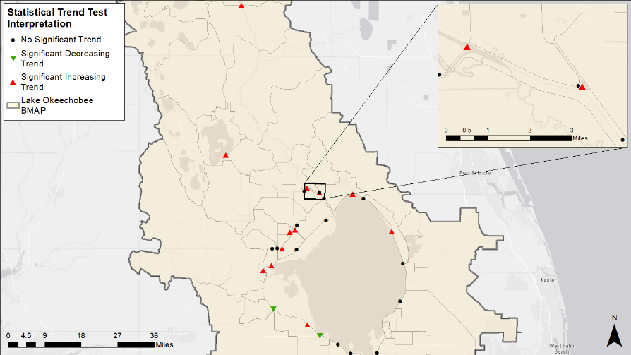
Figure 4. Tier 1 stations monthly TP load analysis

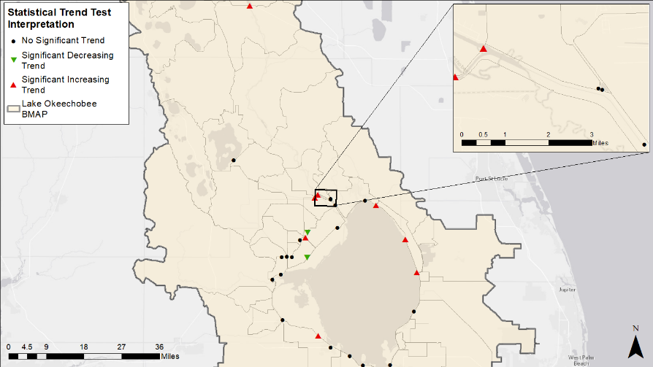
Figure 5. Tier 1 stations monthly TP FWM analysis

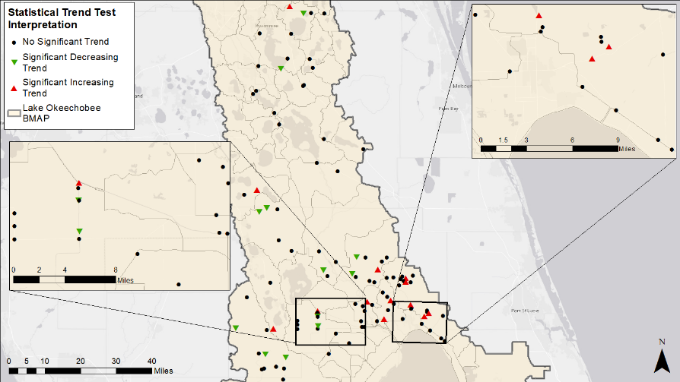
Figure 6. Tier 2 stations monthly TP concentration analysis

5-Year Review Conclusions

Milestones
The 5-Year Review documents progress and allows for stakeholder involvement in the methods of assessing progress and revising the BMAP as appropriate. The projects and activities in the BMAP are key to reducing TP in the watershed and lake. The estimated benefits of these implemented activities should be tracked to show stakeholder efforts by determining a percentage towards the total required reductions to be achieved at each milestone.
To reach the TMDL in 20 years, stakeholders must submit additional local projects and the Coordinating Agencies (DEP, FDACS, and SFWMD) must identify additional regional projects as well as determine the significant funding that will be necessary. Constraints to having this information available at this time include the need to determine appropriate locations, identify funding sources, design the projects, obtain funding, secure permits, and construct the projects.
Enhancements to programs addressing basinwide sources will also be required, as discussed in Section 3.1. In addition, the legacy phosphorus contribution in the watershed must be addressed through further studies and projects targeted at this source. The Coordinating Agencies will evaluate studies and assist with identifying projects targeted at reducing this source. Once this additional information is provided, the Coordinating Agencies will address these constraints and estimate the time needed to achieve the TMDL in a future BMAP update. Based on the current project information and the RFI responses received, it does not seem practicable to achieve reductions sufficient to meet the TMDL within 20 years.
The following percent reduction goals are proposed for each milestone and may be adjusted as more information is obtained:
- 5-year milestone (Years 1 to 5, including projects completed after January 1, 2009): 15 % or 163,032 lbs/yr (74.0 mt/yr) TP.
- 10-year milestone (Years 6 to 10): 40 % or 434,752 lbs/yr (197.2 mt/yr) TP. Based on study results, reset 15-year, 20-year, and future 5-year milestones, as needed.
- 15-year milestone (Years 11 to 15): 75 % or 815,159 lbs/yr (369.7 mt/yr) TP.
- 20-year milestone (Years 16 to 20): 100 % or 1,086,879 lbs/yr (493.0 mt/yr) TP.
Figure 7 shows the 5-, 10-, 15-, and 20-year milestones as well as the cumulative TP reductions over time as projects are completed in each reporting period.
Figure 7. Estimated progress towards the Lake Okeechobee BMAP TP milestones with projects completed through June 30, 2019

New Project Approach
Land uses in the LOW are predominately agricultural, and a new approach is needed to solicit projects and ideas to achieve nutrient reductions throughout the watershed. Chapter 3 includes proposed measures to address the sources in the LOW, as well as the new approach used to carry out some of the projects included in this BMAP.

- Restoration Approach

Basinwide Sources Approach

Agriculture
When DEP adopts a BMAP that includes agriculture, it is the agricultural landowner's responsibility to implement BMPs adopted by FDACS to help achieve load reductions or demonstrate through monitoring that they are already meeting water quality standards. FDACS shall verify that all eligible landowners are enrolled in appropriate BMP programs and are implementing BMPs as intended to achieve maximum environmental benefit, and within one year will provide a list of all unenrolled landowners in the LOW to DEP. At least every two years, FDACS will perform onsite inspections of each agricultural producer that enrolls in a BMP program to ensure that such practice is being properly implemented.
Although it is anticipated that additional enrollment in agricultural BMPs along with more frequent implementation verification site visits by FDACS will increase nutrient reductions from agricultural nonpoint sources, it is also recognized that further reductions, beyond the implementation of required owner-implemented BMPs, will be necessary to achieve the TMDL. As such, FDACS shall reevaluate existing owner-implemented BMPs and update existing BMP manuals and rules as necessary within five years of the adoption of this BMAP.
Nutrient reductions can also be achieved through implementation of additional agricultural projects or activities. The Coordinating Agencies shall continue to collaborate to identify cost-share practices and other projects that can be undertaken to achieve these nutrient reductions. In addition, the Coordinating Agencies will work together to identify and implement additional projects and practices in priority TRAs.
SFWMD is implementing projects that encourage low-input agriculture and water quality improvement technologies. FDACS also provides funding to some agricultural operations to add other practices beyond owner-implemented BMPs. Examples include drainage improvements, fencing, water control structures, precision agriculture technology, and fertigation. The Coordinating Agencies will also investigate the possibility of implementing other incentive-based programs—such as providing incentives for producers to transition to less-intensive crops, changing land use to fallow or native landscape, or changing the type of cropping system–that would reduce nutrient loading in the BMAP area. Other reductions associated with the implementation and modification of BMPs may be realized through ongoing studies, data collection, and water management district initiatives. These additional projects and activities are to be implemented in conjunction with the BMP Program, which needs to achieve full enrollment with verification to ensure that the BMAP goals are achieved.
During the implementation verification visits, FDACS will also collect fertilization and nutrient records from each agricultural producer enrolled in BMPs that address nutrients. FDACS will provide DEP and SFWMD an annual summary of aggregated fertilizer use in the BMAP area, quantifying total applications and providing information on application reductions by subwatershed.

Septic Systems
In U.S. Census–designated urbanized areas and urban clusters, local governments and utilities shall develop master wastewater treatment feasibility analyses that include provisions to address loads from existing and new septic systems (e.g., sewering, advanced septic system retrofits, prohibiting the installation of new conventional septic systems). The analyses shall identify specific areas to be sewered within 20 years of BMAP adoption. Sources of funding to address nutrient loading from septic systems will also be identified in the analyses. The feasibility analyses will be completed and submitted to DEP within 3 years of BMAP adoption, so that the analyses can inform the selection of management strategies and projects as part of the next 5-year review of the BMAP.
Based on data from FDOH, there are 124,176 known and likely septic systems located throughout the LOW. Of these, 93,827 are located within U.S. Census–designated urbanized areas or urban clusters. The TN and TP estimated loads from septic systems in urbanized areas are summarized in Table 18. These loads were calculated based on 2018 U.S. Census Bureau data for the average number of people per household for each county in the LOW with an estimated wastewater flow of 70 gallons per day per person and TN and TP nutrient concentrations in the effluent from the EPA Onsite Wastewater Treatment Systems Manual (2002). This resulted in an average effluent load leaving the septic system of 15 lbs/yr of TN and 1.5 lbs/yr of TP per septic system. The reductions from addressing these septic systems will be less than the estimated load depending on how they are addressed (i.e., connecting to central sewer sends the wastewater to a treatment facility, which does not remove 100 % of the nutrient load). This effluent load will also attenuate as it travels through the watershed to Lake Okeechobee, so the benefits at the lake will be lower than these effluent loads. Furthermore, stakeholders will submit projects describing how septic loads are addressed as part of BMAP reporting.
Table 18. Septic system counts by subwatershed and estimated effluent loads
Subwatershed | Total Number of  Septic Systems | Number of Septic Systems in the Urbanized Areas and Urban Clusters | Estimated TN Load from Urbanized Septic Systems  (lbs/yr) | Estimated TP Load from Urbanized Septic Systems  (lbs/yr)
Fisheating Creek | 467 | 3 | 20,574 | 1,990
Indian Prairie | 2,095 | 129 | 39 | 4
Lake Istokpoga | 30,787 | 23,132 | 278,139 | 26,899
Lower Kissimmee | 924 | 0 | 0 | 0
Taylor Creek/Nubbin Slough | 11,085 | 7,577 | 377,387 | 36,498
Upper Kissimmee | 61,264 | 48,746 | 469,866 | 45,442
East Lake Okeechobee | 12,562 | 11,339 | 13,330 | 1,289
South Lake Okeechobee | 2,293 | 869 | 177,199 | 17,137
West Lake Okeechobee | 2,699 | 2,032 | 125,086 | 12,097
Total | 124,176 | 93,827 | 1,461,619 | 141,356

Stormwater
Stormwater from urban areas is a considerable source of nutrient loading to Lake Okeechobee, and many of these areas are already regulated under the NPDES Stormwater Program. MS4 permittees are required to develop and implement a stormwater management program. Urban areas located in the BMAP area that are not currently covered by an MS4 permit also significantly contribute, individually or in aggregate, to nutrient loading. Therefore, the NPDES Stormwater Program shall, within five years of BMAP adoption, evaluate any entity located in the BMAP area that serves a minimum resident population of at least 1,000 individuals that are not currently covered by an MS4 permit and designate eligible entities as regulated MS4s, in accordance with Chapter 62-624, F.A.C.
DEP and the water management districts are planning to update stormwater design and operation requirements in Environmental Resource Permit rules. These revisions will incorporate the most recent scientific information available to improve nutrient reduction benefits.

Wastewater Treatment
DEP issues permits for facilities and activities to discharge wastewater to surface waters and ground waters of the state. DEP is authorized by the U.S. Environmental Protection Agency to issue permits for discharges to surface waters under the NPDES Program. Permits for discharges to ground waters are issued by DEP under state statutes and rules. These wastewater discharge permits establish specific limitations and requirements based on the location and type of facility or activity releasing industrial or domestic wastewaters from a point source. Historically, the term point source has meant discharges to surface waters that typically have a continuous flow via a discernable, confined, and discrete conveyance, such as a pipe, ditch, channel or conduit. This term does not include agricultural stormwater discharges and return flows from irrigated agriculture.
New and existing facilities or activities must meet the stringent nutrient wastewater limitations set forth in this BMAP. New facilities or activities (those commencing after the adoption of this BMAP) must be capable of meeting the requirements of this BMAP at the time of permit issuance. For existing facilities or activities, DEP shall modify the permit limitations and requirements to be consistent with this BMAP at the time of the next permit renewal. In some cases, the owner or operator of an existing facility or activity may require additional time to meet the modified limitations in the renewed permit, in which case, the permit shall also establish a compliance schedule not to exceed four and half years after the effective date of the permit.
In areas where there is anticipated growth in human population, adequate treatment capacity of domestic wastewater is essential. Domestic wastewater is treated through either WWTFs or onsite sewage treatment and disposal systems (OSTDS), commonly referred to as septic systems. Where sewer lines are available, Florida law (Section 381.00655, F.S.) requires a development or property owner to abandon the use of OSTDS and connect to sanitary sewer lines.
This BMAP requires all individually permitted domestic facilities to meet the effluent limits listed in Table 19 and Table 20, unless the owner or operator can demonstrate reasonable assurance that the effluent would not cause or contribute to an exceedance of the TP TMDL for Lake Okeechobee. To demonstrate reasonable assurance, the owner or operator must provide relevant water quality data, physical circumstances, or other site-specific credible information needed to show the facility would not cause or contribute to the phosphorus loading to the BMAP area. This demonstration may include factors such as dilution; site-specific geological conditions; research/studies, including dye tracer tests; and modeling. Should DEP concur with the reasonable assurance demonstration request, the TP effluent requirements established here may be modified for the owner or operator or waived. New effluent standards will take effect at the time of permit issuance.
Table 19 and Table 20 list the TP and TN effluent limits, respectively, adopted for this BMAP that apply to wastewater facilities and activities, unless the owner or operator can demonstrate reasonable assurance as listed above. The limits for direct surface discharges apply to individually NPDES-permitted facilities. The limits for Rapid-Rate Land Application (RRLA) effluent disposal systems apply at the edge of the zone of discharge for facilities or activities having sites such as rapid infiltration basins (RIBs) and absorption fields. These limits are applied as an annual average.
Short-term or intermittent discharges are not significant sources of TN or TP in the LOW, and are not subject to the limits in Table 19 and Table 20. Intermittent, rainfall-driven, diffuse overflow releases of wastewater from ponds or basins designed to hold precipitation from a 25-year, 24-hour rainfall event or less frequent rainfall event and that infrequently reaches surface waters are considered insignificant sources of TN and TP. The owners or operators of cooling pond reservoirs must operate each spillway gate either during regular operation or on a test basis to protect the structural integrity of the reservoir. Because of the short duration and low volume of wastewater released during spillway gate testing, releases either on an annual or semi-annual basis are considered insignificant sources of TN and TP.
As of December 2019, there were 254 individually permitted wastewater facilities or activities in the BMAP area. Of these, 26 hold NPDES permits and therefore are authorized, within the limitations of their permits, to discharge directly to surface waters within the LOW. The remaining 228 do not have authorization to directly discharge to surface waters.
Additionally, new or revised wastewater permits in the BMAP area must require at least quarterly sampling of the effluent discharge and compliance wells for TP and TN and the reporting of sampling results in the discharge monitoring reports submitted to DEP.
Table 19. TP effluent limits
mgd = Million gallons per day
Permitted Average Daily Flow  (mgd) | TP Concentration Limits for Direct Surface Discharge (mg/L) | TP Concentration Limits for RRLA Effluent Disposal System  (mg/L) | TP Concentration Limits for All Other Land Disposal Methods, Including Reuse (mg/L)
Greater than or equal to 0.5 | 1 | 1 | 6
Less than 0.5 and greater than or equal to 0.1 | 1 | 3 | 6
Less than 0.1 | 6 | 6 | 6

Table 20. TN effluent limits
mgd = Million gallons per day
Permitted Average Daily Flow  (mgd) | TN Concentration Limits for Direct Surface Discharge (mg/L) | TN Concentration Limits for RRLA Effluent Disposal System  (mg/L) | TN Concentration Limits for All Other Land Disposal Methods, Including Reuse (mg/L)
Greater than or equal to 0.5 | 3 | 3 | 10
Less than 0.5 and greater than or equal to 0.1 | 3 | 6 | 10
Less than 0.1 | 10 | 10 | 10

TRA Approach

Overview
To better prioritize and focus resources to most efficiently achieve restoration in the LOW, DEP developed the TRA approach. This approach used measured data collected throughout the watershed to evaluate TP and TN concentrations, as well as flow, in the basins in each of the LOW subwatersheds. The measured nutrient concentrations were compared with selected benchmarks to identify those basins that should be the highest priority for restoration. This advisory process is not intended to be a management strategy under Chapter 403.067, F.S. The benchmarks are not intended to measure progress towards restoration; they were only used to prioritize resources. The overall approach implemented the following steps:
- Identify smaller areas (e.g., basins) for focused restoration.
- Delineate each area and locate relevant water quality stations:
  - Obtain existing data for TN, TP, and flow.
  - Recommend additional monitoring where data are lacking.
  - Supplement with information from water quality models where appropriate.

- Determine benchmarks for evaluating water quality and water storage:
  - Consider the applicable numeric nutrient criteria (NNC) (e.g., peninsular for streams) and consult the LOWCP for indications of water quality and/or flow issues.
  - Rely on existing SFWMD information for water storage needs.
- Review measured data:
  - Calculate most recent 5-year average TN and TP concentrations (WY2014–WY2018).
  - Compare concentrations with established benchmarks.
  - Consult FWM concentrations and unit area loads, where available, to better understand conditions.
- Identify criteria for implementation and funding, and describe restoration types (e.g., water quality, flow) recommended for each TRA:
  - Calculate expected reductions from existing and recommended projects using measured data wherever possible.
  - Identify where additional projects are necessary.
- Prioritize areas where new projects would have the most impact on overall restoration:
  - Use water quality (TN and TP) and flow data.
  - Compare with benchmarks for each basin,
- Publish an RFI to solicit additional projects and evaluate responses based on benchmarks established for each TRA.
Chapter 4 includes the results of the TRA approach for each of the subwatersheds and the lake itself. Table E-1 in Appendix E lists the projects received from the RFI.
Future steps in this approach include the following:
- Evaluate progress in TRAs annually by comparing measured data with benchmarks and TMDL targets for the subwatersheds.
- Use responses from RFIs and existing project lists, combined with the prioritized areas and recommended restoration needs, to inform future budget requests for DEP.
- Update existing water quality models based on expanded monitoring efforts.

Evaluation
Chapter 4 summarizes the results of the TRA evaluation process for the basins in each subwatershed of the LOW. For each basin, a priority was assigned based on the TP concentration, TN concentrations, and flows. These priorities were set to help focus resources and projects in the basins that are in most need of improvement. Basins were assessed and prioritized as follows (see Figure 8):
- Assess the five-year average concentration at representative stations and compare with the NNC benchmark:
  - Priority 1: Concentration is two times greater than the NNC.
  - Priority 2: Concentration is greater than the NNC but less than two times the NNC.
  - Priority 3: Concentration is less than or equal to the NNC.
- Assess the five-year average FWM concentration and compare with the NNC benchmark. This step is weighted above Step 1; therefore, the results for the FWM concentrations would supersede the priorities from Step 1:
  - Priority 1: FWM concentration is two times greater than the NNC.
  - Priority 2: FWM concentration is greater than the NNC but less than two times the NNC.
  - Priority 3: FWM concentration is less than or equal to the NNC.
- Assess the attenuated unit area load (UAL), which is the average load per acre in each subwatershed from the LET, and compare it with the subwatershed UAL calculated target (derived from the loading in the final 2019 SFER – Volume I, Chapter 8B. and the subwatershed targets described in Section 5.4). This step is weighted above Step 2 where data are available; therefore, results would increase or decrease the priority accordingly:
  - Priority increases: UAL is greater than 50 % above the subwatershed target UAL.
  - Priority decreases: UAL is less than the subwatershed target UAL.
  - Priority remains unchanged: UAL is above the subwatershed target UAL, but less than 50 %.
- Assess the water quality trends from the water quality analysis (Section 2.4) for statistical significance. This step is weighted above Step 3 where data are available; therefore, the results would increase or decrease the priority accordingly:
  - Priority increases: Trend is significantly increasing.
  - Priority decreases: Trend is significantly decreasing.
  - Priority remains unchanged: No significant trend is detected.

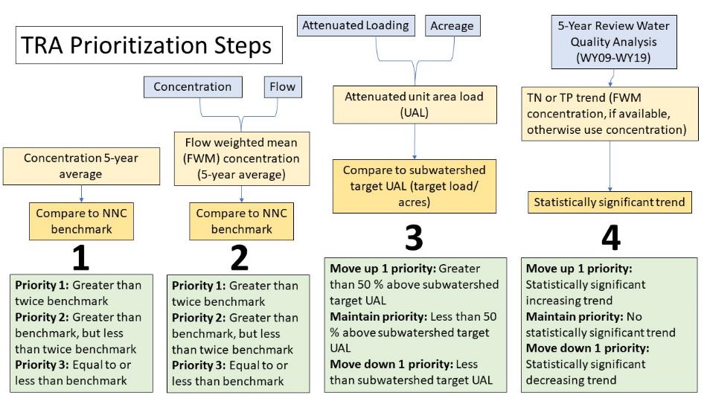

Figure 8. Summary of the TRA prioritization process

Water Quality Monitoring Plan
To help prioritize monitoring and track BMAP progress, the BMAP monitoring network is being revised, as discussed below, to implement a new tiered system for the sampling stations, remove some stations from the network, and add new monitoring locations.

Objectives and Parameters
The Lake Okeechobee BMAP monitoring plan was designed to enhance the understanding of basin loads, identify areas with high nutrient concentrations, and track water quality trends. The information gathered through the monitoring plan measures progress toward achieving the TMDLs and provides a better understanding of watershed loading. The BMAP monitoring plan consists of ambient water quality sampling, sampling at discharge structures, and flow monitoring.
Focused objectives are critical for a monitoring strategy to provide the information needed to evaluate implementation success. The primary and secondary objectives of the monitoring strategy for the LOW, described below, are used to evaluate the success of the BMAP, help interpret the data collected, and provide information for potential future refinements of the BMAP.
Primary Objective
- To continue to track trends in TP loads and concentrations by subwatershed and basin.
Secondary Objectives
- To continue to track trends in TN loads and concentrations by subwatershed and basin.
- To continue to identify areas in the watershed with elevated TP and TN loading to better focus management efforts.
- To continue to measure the effectiveness of individual or collective projects in reaching TMDL target-pollutant loadings.
To achieve the objectives above, the monitoring strategy focuses on the following suggested parameters:

- Alkalinity.
- Ammonia (N).
- BOD.
- Carbon – organic.
- Carbon – Total.
- Chlorophyll a.
- Color.
- DO.
- DO Saturation.
- Flow.
- Nitrate-Nitrite (N).
- Nitrogen – Total Kjeldahl.
- Nitrogen – Total.
- Orthophosphate (P)
- pH.
- Phosphorus – Total.
- Specific conductance/salinity.
- Temperature, Water.
- Total suspended solids.
- Turbidity.

Monitoring Network
The monitoring network comprises a tiered system for the sampling stations, as follows:
- Tier 1 stations are the primary/priority stations used in periodic water quality analyses to track BMAP progress and water quality trends over the long term in the basin. Tier 1 stations consist of only SFWMD water control structure stations that measure water quality and flow at each station. These stations will be used to calculate annual TP and TN loads for each subwatershed or basin.
- Tier 2 stations will provide secondary information that can be used to help focus and adaptively manage implementation efforts. These include SFWMD ambient stations, which are mostly open-water stations, and do not record flow data. Tier 2 also includes the monitoring associated with the Lake Tohopekaliga Nutrient Reduction Plan (NRP) (CDM 2011).
- Tier 3 consists of U.S. Geological Survey (USGS) gauges where flow and/or stage are monitored.
Figure 9 shows the stations included in each of these tiers. In addition to monitoring throughout the LOW, various agencies also sample stations in Lake Okeechobee. Chapter 4 includes additional information about the BMAP monitoring network and stations used in the TRA process.

Data Management and Quality Assurance/Quality Control (QA/QC)
The STOrage and RETrieval (STORET) Database served as the primary repository of ambient water quality data for the state until DEP transitioned to WIN in 2017. BMAP data providers have agreed to upload ambient water quality data at least once every six months on the completion of the appropriate QA/QC checks and have begun uploading data to WIN instead of STORET. Data must be collected following DEP standard operating procedures, and the results must be analyzed by a National Environmental Laboratory Accreditation Program–certified laboratory.
In addition to ambient water quality data, flow data are used to track loading trends for the BMAP. Data collected by the USGS are available through its website, and some flow data are also available through the SFWMD corporate environmental database, DBHYDRO.

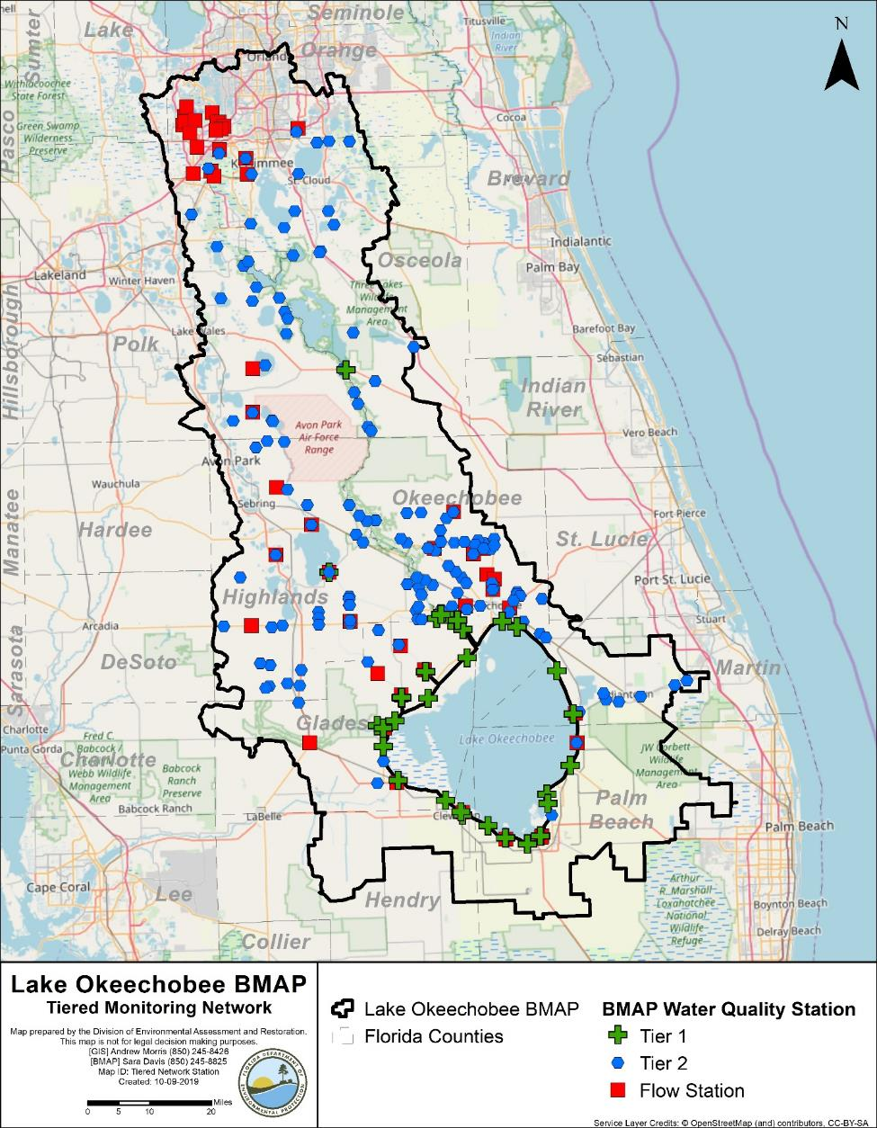
Figure 9. Lake Okeechobee BMAP monitoring network

- Subwatersheds
Section 4.1 through Section 4.10 provide specific information on the nine subwatersheds and within Lake Okeechobee. The land use summaries are based on the 2009 land use in WAM, and Appendix B provides additional details on agricultural land uses. Monitoring network stations in the subwatershed or the lake are provided along with designations for the basin where the station is located, monitoring entity, BMAP monitoring network tier, whether the station is a representative site for the TRA approach discussed in Section 3.2, and whether additional data are needed for the TRA approach in that basin or at that station. The TN, TP, and flow priority results of the TRA evaluation are provided for basins in each subwatershed. Finally, all projects identified as part of this BMAP update are provided by subwatershed. The table of existing and planned projects lists those projects submitted by stakeholders to help meet their obligations under the BMAP. Future projects have been identified by stakeholders to help meet the remaining reductions needed; however, many of these projects are conceptual, in early design stages, or have not been fully funded. Information in the tables was provided by the lead entity and is subject to change as the project develops and more information becomes available. Appendix E lists projects and technologies submitted as part of the RFI.
DEP will also be monitoring and working to achieve the subwatershed targets identified in Table 21. DEP will use this information to identify problem areas and sources that are not meeting the target, acknowledge them through annual reporting and public engagement, and focus resources accordingly (i.e., regulatory programs through permitting decisions, compliance and enforcement, and nutrient reduction projects).
Table 21. Load reductions and targets by subwatershed
Subwatershed | WY2014–WY2018 TP Load (mt/yr) | % Contribution of Load | TP Load Required Reduction  (mt/yr) | TP Target (mt/yr)
Fisheating Creek | 72.4 | 12 | 59.7 | 12.7
Indian Prairie | 102.5 | 17 | 84.5 | 18.0
Lake Istokpoga | 47.7 | 8 | 39.3 | 8.4
Lower Kissimmee | 125.9 | 21 | 103.8 | 22.1
Taylor Creek/Nubbin Slough | 113.6 | 19 | 93.7 | 19.9
Upper Kissimmee | 90.5 | 15 | 74.6 | 15.9
East Lake Okeechobee | 16.8 | 3 | 13.9 | 2.9
South Lake Okeechobee | 29.0 | 5 | 23.9 | 5.1
West Lake Okeechobee | 0.0 | 0 | 0.0 | 0.0
Total | 598.4 | 100 | 493.4 | 105.0

Fisheating Creek Subwatershed
The Fisheating Creek Subwatershed covers more than 318,000 acres of the LOW and comprises 2 basins. As shown in Table 22, agriculture makes up the majority of the subwatershed with 54.7 % of the area, followed by wetlands with 23.8 %. Stakeholders in the Fisheating Creek Subwatershed are Glades County and Highlands County.
Table 22. Summary of land uses in the Fisheating Creek Subwatershed
Level 1  Land Use Code | Land Use Description | Acres | % Total
1000 | Urban and Built-Up | 5,581 | 1.8
2000 | Agriculture | 174,019 | 54.7
3000 | Upland Nonforested | 14,163 | 4.5
4000 | Upland Forests | 45,809 | 14.4
5000 | Water | 1,050 | 0.3
6000 | Wetlands | 75,623 | 23.8
7000 | Barren Land | 1,025 | 0.3
8000 | Transportation, Communication, and Utilities | 774 | 0.2
 | Total | 318,044 | 100.0

Water Quality Monitoring
In the Fisheating Creek Subwatershed, the BMAP monitoring network includes water quality stations in both of the basins. Table 23 summarizes the water quality monitoring stations in the subwatershed, and Figure 10 shows the station locations. Table 23 also includes recommendations to change the location, frequency, or parameters sampled for the station to better align with the BMAP.
Table 23. Water quality monitoring stations in the Fisheating Creek Subwatershed
Basin | Representative Site? | Entity | Station ID | Tier | Data Needs
Fisheating Creek/L-61 | No | SFWMD | L61W | 1 | Not applicable (N/A)
Nicodemus Slough North | Yes | SFWMD | CULV5 | 1 | Sufficient TN and TP data
Fisheating Creek/L-61 | Yes | SFWMD | FECSR78 | 1 | Sufficient TN and TP data
Fisheating Creek/L-61 | No | SFWMD | PB24392912 | 2 | N/A
Fisheating Creek/L-61 | No | SFWMD | FE03382911 | 2 | N/A
Fisheating Creek/L-61 | No | SFWMD | FE20393013 | 2 | N/A
Fisheating Creek/L-61 | No | SFWMD | BH04392912 | 2 | N/A
Fisheating Creek/L-61 | No | SFWMD | BH32382914 | 2 | N/A
Fisheating Creek/L-61 | No | SFWMD | FE21392914 | 2 | N/A
Fisheating Creek/L-61 | No | SFWMD | FE21392913 | 2 | N/A
Fisheating Creek/L-61 | No | SFWMD | FE26362812 | 2 | N/A
Fisheating Creek/L-61 | No | SFWMD | FE32372814 | 2 | N/A
Fisheating Creek/L-61 | No | SFWMD | GA09393011 | 2 | N/A
Fisheating Creek/L-61 | No | SFWMD | GG05403011 | 2 | N/A
Fisheating Creek/L-61 |  | SFWMD/USGS | 02255600 | 2
Fisheating Creek/L-61 |  | SFWMD/USGS | 02256500 | 2
Fisheating Creek/L-61 |  | SFWMD/USGS | 02257000 | 2
Nicodemus Slough North | No | USACE | CULV5 | 3 | N/A
Fisheating Creek/L-61 | No | USGS | 02255600 | 3 | N/A
Fisheating Creek/L-61 | No | USGS | 02256500 | 3 | N/A
Fisheating Creek/L-61 | No | USGS | 02257000 | 3 | N/A

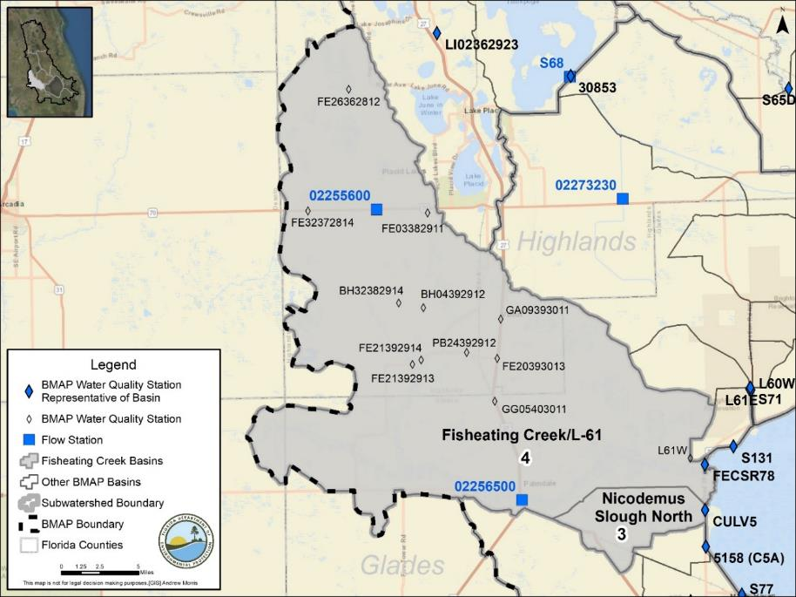
Figure 10. Locations of the water quality monitoring stations in the Fisheating Creek Subwatershed

Basin Evaluation Results
The current TP load based on data from WY2014–WY2018 for the Fisheating Creek Subwatershed is 72.4 mt/yr. A reduction of 59.7 mt/yr is required to help achieve the TMDL and meet the subwatershed target of 12.7 mt/yr.
Table 24 summarizes the basin evaluation results for the Fisheating Creek Subwatershed. Both basins in the subwatershed have TN concentrations greater than the benchmark. The Fisheating Creek/L-61 Basin also has TP concentrations above the benchmark. Based on evaluations made by SFWMD in the LOWCP update, flow was determined not to be an issue in the Nicodemus Slough North Basin but may be an issue in the Fisheating Creek/L-61 Basin. Table 25 lists the TRA prioritization results for the Fisheating Creek Subwatershed, with 1 the highest priority, 2 the next highest priority, and 3 a priority as resources allow.

Table 24. Basin evaluation results for the Fisheating Creek Subwatershed
TRA ID | Basin Name | TN (mg/L)  (Benchmark – 1.54) | TP (mg/L)  (Benchmark – 0.12) | Flow
3 | Nicodeumus Slough North | 1.61 | 0.073 | No
4 | Fisheating Creek/L-61 | 1.79 | 0.166 | Maybe

Table 25. TRA evaluation results for the Fisheating Creek Subwatershed
Basin | Station | TP Priority | TN Priority | Flow Priority
Fisheating Creek/L-61 | FECSR78 | 1 | 1 | 2
Nicodemus Slough North | CULV5 | 3 | 1 | 3

Projects
The sections below summarize the existing and planned and future projects for the Fisheating Creek Subwatershed that were provided for the BMAP. The existing and planned projects are a BMAP requirement, while future projects will be implemented as funding becomes available for project implementation. Appendix A provides additional details about the projects and the terms used in these tables.

Existing and Planned Projects
Table 26 summarizes the existing and planned projects provided by the stakeholders for the Fisheating Creek Subwatershed.
Table 26. Existing and planned projects in the Fisheating Creek Subwatershed

Lead Entity | Partners | Project Number | Project Name | Project Description | Project Type | Project Status | Estimated Completion Date | TN Reduction (lbs/yr) | TN Reduction (mt/yr) | TP Reduction (lbs/yr) | TP Reduction (mt/yr) | Basin | Acres Treated | Cost Estimate | Cost Annual Operations and Maintenance (O&M) | Funding Source | Funding Amount | DEP Contract Agreement Number
Coordinating Agency | N/A | CA-06 | Legislative  Cost-Share Appropriation Program (Dairy Projects) | FDACS conducted 3 rounds of solicitations for dairy project proposals. First solicitation was in fall 2014; 7 projects were funded, of which 1 is still under construction. Second solicitation for dairy projects occurred in fall 2015. | Dairy Remediation | Underway | To be determined (TBD) | TBD | TBD | TBD | TBD | Fisheating Creek/L-61 | TBD | Not provided | Not provided | FDACS | Not provided | N/A
Coordinating Agency | Natural Resources Conservation Service (NRCS) | CA-12 | PL-566 Funded/Fisheating Creek Structure | NRCS began wetland restoration work on Phase I (~10,000 acres) of Fisheating Creek project in 2019; this phase is expected to be completed in 2020. NRCS received SFWMD permit to initiate work on remaining acres (~24,000) in 2020. NRCS has committed $14 million to restoration project and by mid-2020 should have idea whether that will be enough to also address water control structure. | Control Structure | Planned | TBD | TBD | TBD | 1,888.6 | 0.86 | Fisheating Creek/L-61 | TBD | $14,000,000 | TBD | NRCS | $14,000,000 | N/A
FDACS | Private Landowner | FDACS-04 | Fisheating Creek | Floating aquatic vegetation treatment. | Floating Islands/ Managed Aquatic Plant System (MAPS) | Completed | 2016 | 10,242.6 | 4.65 | 1,981.5 | 0.90 | Fisheating Creek/L-61 | 45,000 | $3,311,070 | $1,435,790 | FDACS | TBD | N/A
FDACS | Agricultural Producers | FDACS-07 | BMP Implementation and Verification | Enrollment and verification of BMPs by agricultural producers – Fisheating Creek. Acres treated based on FDACS OAWP June 2019 Enrollment and FSAID VI. Reductions were estimated using 2019 BMAP LET. | Agricultural BMPs | Completed | N/A | 59,236.0 | 26.87 | 6,096.8 | 2.77 | Fisheating Creek | 171,662 | TBD | TBD | FDACS | TBD | N/A
FDACS | Agricultural Producers | FDACS-16 | Cost-Share Projects | Cost-share projects paid for by FDACS. Acres treated based on FDACS OAWP June 2019 Enrollment. Reductions estimated by DEP using 2019 BMAP LET. | Agricultural BMPs | Completed | N/A | 9,125.6 | 4.14 | 1,688.3 | 0.77 | Fisheating Creek | 37,797 | TBD | TBD | FDACS | TBD | N/A
Glades County | N/A | GC-01 | Education and Outreach | Florida Yards and Neighborhoods (FYN); landscaping, irrigation, and fertilizer ordinances; public service announcements (PSAs), pamphlets, website, and illicit discharge program. | Education Efforts | Completed | N/A | 361.7 | 0.16 | 15.9 | 0.01 | Fisheating Creek/L-61, Nicodemus Slough North | 2,241.2 | Not provided | $5,500 | Glades County | Not provided | N/A
Highlands County | University of Florida Institute of Food and Agricultural Sciences (UF–IFAS) | HC-01 | Education and Outreach | FYN, landscaping and irrigation ordinances, PSAs, and pamphlets. | Education Efforts | Completed | N/A | 2,056.2 | 0.93 | 49.6 | 0.02 | Fisheating Creek/L-61 | 5,171.9 | Not provided | Not provided | Highlands County | Not provided | N/A
SFWMD | N/A | SFWMD-18 | XL Ranch (Lightsey) | Storage of 887 ac-ft of water through above-ground impoundment and pasture. | DWM (dispersed water management) | Completed | 2012 | TBD | TBD | 278.0 | 0.13 | Fisheating Creek/L-61 | 3,227.0 | $61,396 | $137,000 | Florida Legislature | Florida Legislature – $137,000 | N/A
SFWMD | N/A | SFWMD-20 | La Hamaca (Blue Head Ranch) | Storage of 3,462 ac-ft of water through pasture. | DWM | Completed | 2017 | TBD | TBD | 1,867.8 | 0.85 | Fisheating Creek/L-61 | 5,020.0 | $193,750 | $361,200 | Florida Legislature | Florida Legislature – $361,200 | N/A
SFWMD | N/A | SFWMD-21 | Nicodemus Slough | Storage of 33,860 ac-ft of water through above-ground impoundment and pasture. | DWM | Completed | 2015 | TBD | TBD | 19,674.1 | 8.92 | Nicodemus Slough North | 15,906.0 | $4,900,000 | $2,500,000 | Florida Legislature | Florida Legislature – $2,500,000 | N/A

Future Projects
Table 27 lists the future projects provided by the stakeholders for the Fisheating Creek Subwatershed.
Table 27. Future projects in the Fisheating Creek Subwatershed
Lead Entity | Partners | Project Number | Project Name | Project Description | Project Type | Project Status | Acres Treated | TN Reduction (lbs/yr) | TN Reduction (mt/yr) | TP Reduction (lbs/yr) | TP Reduction (mt/yr) | Basin | Cost Estimate | Cost Annual O&M
Highlands County | Coordinating Agencies | F-01 | Smart Fertilizer | Watershedwide ban on fertilizer use during certain portion of year for residential use. | Enhanced Public Education | Planned | TBD | TBD | TBD | TBD | TBD | Fisheating Creek/L-61 | TBD | TBD
Highlands County | Coordinating Agencies | F-02 | Happy Planters | Replanting grant for vegetation loss on waterbodies. | Creating/Enhancing Living Shoreline | Planned | TBD | TBD | TBD | TBD | TBD | Fisheating Creek/L-61 | TBD | TBD
Coordinating Agency | N/A | F-03 | Fisheating Creek Marsh Watershed Project | DWM. | DWM | Conceptual | TBD | TBD | TBD | 6,287.6 | 2.85 | Fisheating Creek/L-61 | TBD | TBD
Coordinating Agency | N/A | F-04 | Fisheating Creek | Alternative water storage and disposal interim project. | Stormwater Reuse | Conceptual | TBD | TBD | TBD | 330.8 | 0.15 | Fisheating Creek/L-61 | TBD | TBD

Indian Prairie Subwatershed
The Indian Prairie Subwatershed covers more than 276,500 acres of the LOW and is made up of 11 basins. As shown in Table 28, agriculture makes up the largest portion of the subwatershed, with 79.9 % of the area, followed by wetlands with 12.1 %. Stakeholders in the Indian Prairie Subwatershed are Glades County, Highlands County, and IMWID.
Table 28. Summary of land uses in the Indian Prairie Subwatershed
Level 1 Land Use Code | Land Use Description | Acres | % Total
1000 | Urban and Built-Up | 5,201 | 1.9
2000 | Agriculture | 220,921 | 79.9
3000 | Upland Nonforested | 5,677 | 2.1
4000 | Upland Forests | 3,776 | 1.4
5000 | Water | 3,588 | 1.3
6000 | Wetlands | 33,602 | 12.1
7000 | Barren Land | 3,663 | 1.3
8000 | Transportation, Communication, and Utilities | 150 | 0.1
 | Total | 276,578 | 100.0

Water Quality Monitoring
In the Indian Prairie Subwatershed, the BMAP monitoring network includes water quality stations in all 11 of the basins. Table 29 summarizes the water quality monitoring stations in the subwatershed, and Figure 11 shows the station locations. Table 29 also includes recommendations to change the location, frequency, or parameters sampled for the station to better align with the BMAP.
Table 29. Water quality monitoring stations in the Indian Prairie Subwatershed
Basin | Representative Site? | Entity | Station ID | Tier | Data Needs
L-59E | No | SFWMD | C38W | 1 | N/A
In canal to lake | No | SFWMD | G207 | 1 | N/A
L-59W | No | SFWMD | G208 | 1 | N/A
S-131 | Yes | SFWMD | S131 | 1 | Sufficient TN and TP data
L-49 | Yes | SFWMD | S129 | 1 | Sufficient TN and TP data
L-60W | Yes | SFWMD | L60W | 1 | Sufficient TN and TP data
L-61E | Yes | SFWMD | L61E | 1 | Sufficient TN and TP data
C-41 | Yes | SFWMD | S71 | 1 | Sufficient TN and TP data
L-60E | Yes | SFWMD | L60E | 1 | Sufficient TN and TP data
L-59W | Yes | SFWMD | L59W | 1 | Sufficient TN and TP data
C-40 | Yes | SFWMD | S72 | 1 | Sufficient TN and TP data
L-48 | Yes | SFWMD | S127 | 1 | Sufficient TN and TP data
L-59E | Yes | SFWMD | L59E | 1 | Sufficient TN and TP data
C-41A | Yes | SFWMD | S84 | 1 | Sufficient TN and TP data
C-41A | No | SFWMD | SD28373312 | 2 | N/A
C-41A | No | SFWMD | SD33373314 | 2 | N/A
C-41A | No | SFWMD | SD34373313 | 2 | N/A
C-41 | No | SFWMD | HP06393242 | 2 | N/A
C-41 | No | SFWMD | HP11373132 | 2 | N/A
C-41 | No | SFWMD | HP15373112 | 2 | N/A
C-41 | No | SFWMD | HP22373112 | 2 | N/A
C-41 | No | SFWMD | HP23373111 | 2 | N/A
C-41 | No | SFWMD | HP24373013 | 2 | N/A
C-41 | No | SFWMD | HP25373013 | 2 | N/A
C-41 | No | SFWMD | HP34373124 | 2 | N/A
C-41 | No | SFWMD | HP35373113 | 2 | N/A
C-41 | No | SFWMD | HP36373013 | 2 | N/A
C-40 | No | SFWMD | IP09383232 | 2 | N/A
C-40 | No | SFWMD | IP24383214 | 2 | N/A
C-40 | No | USGS | 02258800 | 3 | N/A
C-40 | No | USGS | 02259100 | 3 | N/A
C-41 | No | USGS | 02257750 | 3 | N/A
C-41 | No | USGS | 02257790 | 3 | N/A
C-41 | No | USGS | 02273230 | 3 | N/A

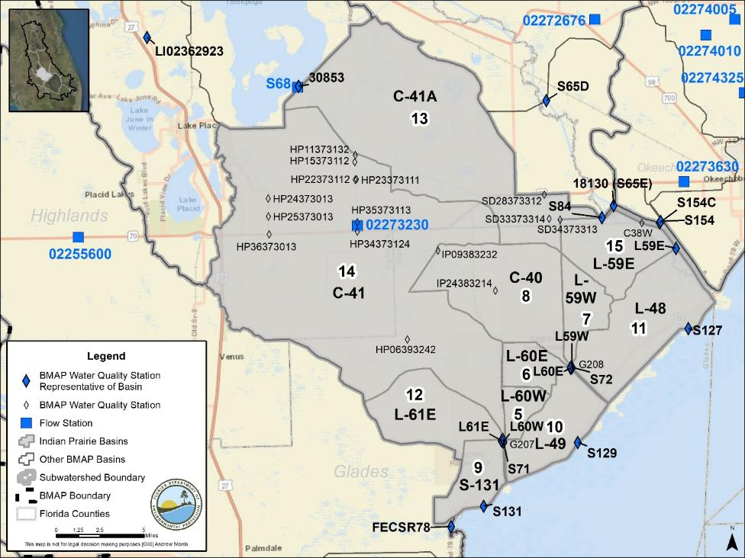
Figure 11. Locations of the water quality monitoring stations in the Indian Prairie Subwatershed

Basin Evaluation Results
The current TP load based on data from WY2014–WY2018 for the Indian Prairie Subwatershed is 102.5 mt/yr. A reduction of 84.5 mt/yr is required to help achieve the TMDL and meet the subwatershed target of 18.0 mt/yr.
Table 30 summarizes the basin evaluation results for the subwatershed. The TN concentrations in Basins C-41, L-59E, L-61E, C-40, L-48, L-59W, L-60E, and L-60W are greater than the benchmark, as are the TP concentrations in Basins C-40, L-59W, C-41, L-59E, L-60E, L-48, and L-61E. In addition, based on evaluations made by SFWMD in the LOWCP update, flow may be an issue in Basins C-40, L-59W, C-41, L-59E, L-60E, L-61E, L-60W, and C-41A but is not an issue in the other basins. Table 31 lists the TRA prioritization results for the Indian Prairie Subwatershed, with 1 the highest priority, 2 the next highest priority, and 3 a priority as resources allow.
Table 30. Basin evaluation results for the Indian Prairie Subwatershed
TRA ID | Basin Name | TN (mg/L)  (Benchmark – 1.54) | TP (mg/L)  (Benchmark – 0.12) | Flow
5 | L-60W | 1.64 | 0.117 | Maybe
6 | L-60E | 1.65 | 0.178 | Maybe
7 | L-59W | 1.74 | 0.225 | Maybe
8 | C-40 | 2.07 | 0.232 | No
9 | S-131 | 1.39 | 0.095 | No
10 | L-49 | 1.46 | 0.046 | No
11 | L-48 | 1.95 | 0.130 | No
12 | L-61E | 2.36 | 0.127 | Maybe
13 | C-41A | 1.42 | 0.072 | Yes
14 | C-41 | 2.82 | 0.210 | No
15 | L-59E | 2.82 | 0.199 | Maybe

Table 31. TRA evaluation results for the Indian Prairie Subwatershed
Basin | Station | TP Priority | TN Priority | Flow Priority
C-40 | S72 | 1 | 1 | 3
C-41 | S71 | 1 | 1 | 3
C-41A | S84 | 1 | 1 | 1
L-48 | S127 | 1 | 2 | 3
L-49 | S129 | 3 | 3 | 3
L-59E | L59E | 2 | 1 | 2
L-59W | L59W | 2 | 2 | 2
L-60E | L60E | 1 | 2 | 2
L-60W | L60W | 1 | 1 | 2
L-61E | L61E | 1 | 1 | 2
S-131 | S131 | 2 | 3 | 3

Projects
The sections below summarize the existing and planned and future projects for the Indian Prairie Subwatershed that were provided for the BMAP. The existing and planned projects are a BMAP requirement, while future projects will be implemented as funding becomes available for project implementation. Appendix A provides additional details about the projects and the terms used in these tables.

Existing and Planned Projects
Table 32 summarizes the existing and planned projects provided by the stakeholders for the Indian Prairie Subwatershed.
Table 32. Existing and planned projects in the Indian Prairie Subwatershed
Lead Entity | Partners | Project Number | Project Name | Project Description | Project Type | Project Status | Estimated Completion Date | TN Reduction (lbs/yr) | TN Reduction (mt/yr) | TP Reduction (lbs/yr) | TP Reduction (mt/yr) | Basin | Acres Treated | Cost Estimate | Cost Annual O&M | Funding Source | Funding Amount | DEP Contract Agreement Number
Coordinating Agency | N/A | CA-01 | Brighton Valley DWM | Estimated to provide net annual average benefit of 39,765 ac-ft of treated water via passthrough system. | DWM | Underway | 2019 | 37,917.2 | 17.20 | 6,843.4 | 3.10 | C-41 | 8,200.0 | $42,642,088 | $3,125,000 (years 1-4)  $3,000,000 (years 5-10) | FDACS/ Florida Legislature | $11,500,000 | N/A
Coordinating Agency | N/A | CA-03 | Inactive Dairies – Lagoon Remediation | See CA-02. | Dairy Remediation | Completed | Not provided | Not provided | Not provided | Not provided | Not provided | Indian Prairie | Not provided | Not provided | Not provided | FDACS | Not provided | N/A
Coordinating Agency | N/A | CA-07 | Legislative Cost-Share Appropriation Program (Dairy Projects) | See CA-06. | Dairy Remediation | Underway | TBD | TBD | TBD | TBD | TBD | Indian Prairie | TBD | Not provided | Not provided | FDACS | Not provided | N/A
Coordinating Agency | FDOT | CA-15 | State Road (SR) 710 Regional Project | See FDOT4-01. | Stormwater System Rehabilitation | Canceled | Canceled | Canceled | Canceled | Canceled | Canceled | Canceled | TBD | TBD | TBD | FDOT | TBD | N/A
FDACS | Agricultural Producers | FDACS-08 | BMP Implementation and Verification | Enrollment and verification of BMPs by agricultural producers – Indian Prairie. Acres treated based on FDACS OAWP June 2019 Enrollment and FSAID VI. Reductions were estimated using 2019 BMAP LET. | Agricultural BMPs | Completed | N/A | 114,031.0 | 51.72 | 23,104.1 | 10.48 | Indian Prairie | 182,376 | TBD | TBD | FDACS | TBD | N/A
FDACS | Agricultural Producers | FDACS-17 | Cost-Share BMP Projects | Cost-share projects paid for by FDACS. Acres treated based on FDACS OAWP June 2019 Enrollment. Reductions estimated by DEP using 2019 BMAP LET. | Agricultural BMPs | Completed | N/A | 7,600.5 | 3.45 | 1,993.2 | 0.90 | Indian Prairie | 28,429 | TBD | TBD | FDACS | TBD | N/A
Glades County | N/A | GC-02 | Education and Outreach | FYN; landscaping, irrigation, and fertilizer ordinances; PSAs, pamphlets, website, and illicit discharge program. | Education Efforts | Completed | N/A | 4,301.2 | 1.95 | 40.7 | 0.02 | L-60W,  L-60E,  L-59W,  C-40,  S-131,  L-49, L-48, L-61E,  C-41A.  C-41,  L-59E | 3,649.7 | Not provided | $5,500 | Glades County | Not provided | N/A
Highlands County | UF-IFAS | HC-02 | Education and Outreach | FYN, landscaping and irrigation ordinances, PSAs, and pamphlets. | Education Efforts | Completed | N/A | 1,979.5 | 0.90 | 68.1 | 0.03 | C-41A, C-41, L-59E | 4,771.6 | Not provided | Not provided | Highlands County | Not provided | N/A
IMWID | DEP/ SFWMD/ FDACS/ IMWID | IMWID-01 | IMWID Phase I (DWM Project in Two Phases) | Construct above-ground impoundment with storage capacity of 950 ac-ft/yr. | DWM | Underway | 2020 | N/A | N/A | 1,817.7 | 0.82 | C-41 | 308.0 | $15,437,146 | TBD | DEP/ SFWMD/ FDACS | DEP funding – $4,600,000/ FDACS funding – $2,414,000/ SFWMD funding – $8,423,146 | S0650
IMWID | DEP/ SFWMD/ FDACS/ IMWID | IMWID-02 | IMWID Phase II (DWM Project in Two Phases) | Construct above-ground impoundment with storage capacity of 1,200 ac-ft/yr. | DWM | Underway | 2023 | N/A | N/A | 2,459.3 | 1.12 | C-41 | 400.0 | $4,450,000 | TBD | DEP/ FDACS | DEP funding – $450,000/ FDACS funding – $4,000,000 | NF023
SFWMD | N/A | SFWMD-10 | Lykes West Waterhole Marsh | Project pumps excess water from C-40 Canal for phosphorus removal via uptake in wetlands and associated marshes before it enters Lake Okeechobee. | DWM | Completed | 2006 | 31,945.0 | 14.49 | 12,403.2 | 5.63 | C-41 | 2,370.0 | $50,000 | $470,238 | Florida Legislature | Florida Ranchlands Environmental Services Project – $470,238 | N/A
SFWMD | N/A | SFWMD-12 | Buck Island Ranch (Northern Everglades Payment for Environmental Services [NEPES]-1) | Storage of 1,573 ac-ft of water through pasture. | DWM | Completed | 2012 | TBD | TBD | 3,336.0 | 1.51 | C-41 | 1,048.0 | $1,725 | $173,600 | Florida Legislature | Florida Legislature – $173,600 | N/A
SFWMD | N/A | SFWMD-23 | Buck Island Ranch Wildlife Management Area NEPES-2 | Component 1 – Storage of 620 ac-ft of water through pasture. Component 2 – Nutrient removal of 1,567 lbs of phosphorus on forage lands | DWM | Completed | 2015 | TBD | TBD | 1,565.0 | 0.71 | C-41 | 1,048.0 | $2,259,600 | $163,500 | Florida Legislature | Florida Legislature – $163,500 | N/A

Future Projects
Table 33 lists the future projects provided by the stakeholders for the Indian Prairie Subwatershed.
Table 33. Future projects in the Indian Prairie Subwatershed
Lead Entity | Partners | Project Number | Project Name | Project Description | Project Type | Project Status | Acres Treated | TN Reduction (lbs/yr) | TN Reduction (mt/yr) | TP Reduction (lbs/yr) | TP Reduction (mt/yr) | Basin | Cost Estimate | Cost Annual O&M
Highlands County | Coordinating Agencies | F-05 | Smart Fertilizer | Watershedwide ban on fertilizer use during certain portion of year for residential use. | Enhanced Public Education | Planned | TBD | TBD | TBD | TBD | TBD | C-41A, C-41, L-59E | TBD | TBD
Highlands County | Coordinating Agencies | F-06 | Happy Planters | Replanting grant for vegetation loss on waterbodies. | Creating/ Enhancing Living Shoreline | Planned | TBD | TBD | TBD | TBD | TBD | C-41A, C-41, L-59E | TBD | TBD
Highlands County | Coordinating Agencies | F-07 | IMWID Phase III | Continue purchasing property for current water quality project. Still need 500 acres to get estimated 90 % reduction. | DWM | Conceptual | 500 | TBD | TBD | TBD | TBD | C-41 | TBD | TBD
Coordinating Agency | N/A | F-08 | Pearce/Hartman Property | Alternative water storage and disposal interim project. | Stormwater Reuse | Conceptual | TBD | TBD | TBD | 1,582.5 | 0.72 | L-48, L-59E | TBD | TBD
Coordinating Agency | N/A | F-09 | Buckhead Ridge Property | Alternative water storage and disposal interim project. | Stormwater Reuse | Conceptual | TBD | TBD | TBD | 23.5 | 0.00 | L-48 | TBD | TBD
Coordinating Agency | N/A | F-10 | Harney Pond | Alternative water storage and disposal interim project. | Stormwater Reuse | Conceptual | TBD | TBD | TBD | 27.8 | 0.01 | C-41 | TBD | TBD
Coordinating Agency | N/A | F-11 | Indian Prairie | Alternative water storage and disposal interim project. | Stormwater Reuse | Conceptual | TBD | TBD | TBD | 47.0 | 0.02 | TBD | TBD | TBD
Coordinating Agency | N/A | F-12 | S-68 STA | STA. | STA | Conceptual | TBD | TBD | TBD | 17,107.9 | 7.76 | C-41 | TBD | TBD
Coordinating Agency | N/A | F-13 | Istokpoga/ Kissimmee Reservoir and STA | Reservoir and STA.. | STAs | Conceptual | TBD | TBD | TBD | 19,246.4 | 8.73 | C-41 | TBD | TBD
Coordinating Agency | N/A | F-14 | West Water Hole Expansion | Public-private partnership project will treat and remove phosphorus and nitrogen from regional system by adding 500 acres to existing project. | DWM | Conceptual | TBD | TBD | TBD | 2,138.5 | 0.97 | C-40 | TBD | TBD

Lake Istokpoga Subwatershed
The Lake Istokpoga Subwatershed covers more than 394,000 acres of the LOW and is made up of 4 basins. As shown in Table 34, agriculture covers 33.1 % of the area, followed by urban and built-up with 16.5 %. Stakeholders in the subwatershed are the City of Avon Park, City of Frostproof, City of Sebring, Highlands County, Polk County, SLID, Town of Hillcrest Heights, Town of Lake Placid, and Village of Highland Park.
Table 34. Summary of land uses in the Lake Istokpoga Subwatershed
Level 1 Land Use Code | Land Use Description | Acres | % Total
1000 | Urban and Built-Up | 64,880 | 16.5
2000 | Agriculture | 130,399 | 33.1
3000 | Upland Nonforested | 27,597 | 7.0
4000 | Upland Forests | 44,330 | 11.2
5000 | Water | 58,141 | 14.7
6000 | Wetlands | 63,824 | 16.2
7000 | Barren Land | 563 | 0.1
8000 | Transportation, Communication, and Utilities | 4,472 | 1.1
 | Total | 394,206 | 100.0

Water Quality Monitoring
In the Lake Istokpoga Subwatershed, the BMAP monitoring network includes water quality stations in all four of the basins. Table 35 summarizes the water quality monitoring stations in the subwatershed, and Figure 12 shows the station locations. Table 35 also includes recommendations to change the location, frequency, or parameters sampled for the station to better align with the BMAP.
Table 35. Water quality monitoring stations in the Lake Istokpoga Subwatershed
Basin | Representative Site? | Entity | Station ID | Tier | Data Needs
Lake Istokpoga | No | SFWMD | S68 | 1 | N/A
Lake Arbuckle | No | SFWMD | LV14322813 | 2 | N/A
Josephine Creek | No | SFWMD | PL01382911 | 2 | N/A
Lake Arbuckle | No | SFWMD | RD08322913 | 2 | N/A
Arbuckle Creek | No | SFWMD | BN03332911 | 2 | N/A
Arbuckle Creek | No | SFWMD | BN08332912 | 2 | N/A
Arbuckle Creek | No | SFWMD | AB27343014 | 2 | N/A
Arbuckle Creek | No | SFWMD | AR06333013 | 2 | N/A
Arbuckle Creek | No | SFWMD | AR18343012 | 2 | N/A
Josephine Creek | Yes | SFWMD | LI02362923 | 2 | Sufficient TP data; SFWMD will include TN in expanded monitoring
Lake Istokpoga | Yes | SFWMD | 30853 | 2 | Sufficient TN and TP data
Arbuckle Creek | Yes | SFWMD | 30854 | 2 | Sufficient TN and TP data
Lake Arbuckle | Yes | DEP Southwest Regional Operations Center (ROC) | 274119812344 (ARBUCKLE1-274119812344) | 2 | Sufficient TN and TP data
Lake Arbuckle | Yes | Polk County Natural Resources Division | Arbuckle1 (ARBUCKLE1-274119812344) | 2 | Sufficient TN and TP data
Arbuckle Creek | No | USGS | 02270000 | 3 | N/A
Arbuckle Creek | No | USGS | 02270500 | 3 | N/A
Arbuckle Creek | No | USGS | ARBUCK | 3 | N/A
Josephine Creek | No | USGS | 02271500 | 3 | N/A
Lake Arbuckle | No | USGS | 02269520 | 3 | N/A
Lake Istokpoga | No | USGS | S68 | 3 | N/A

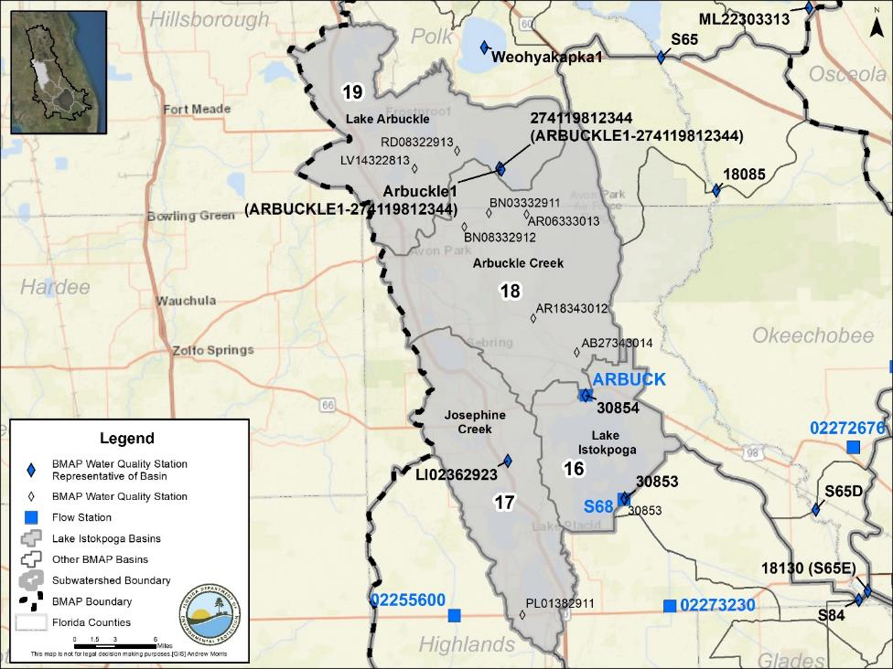

Figure 12. Locations of the water quality monitoring stations in the Lake Istokpoga Subwatershed

Basin Evaluation Results
The current TP load based on data from WY2014–WY2018 for the Lake Istokpoga Subwatershed is 47.7 mt/yr. A reduction of 39.3 mt/yr is required to help achieve the TMDL and meet the subwatershed target of 8.4 mt/yr.
Table 36 summarizes the basin evaluation results for the subwatershed. The Lake Istokpoga Basin TN concentrations are greater than the benchmark, and the Arbuckle Creek TP concentrations are higher than the benchmark. Based on evaluations of the subwatershed made by SFWMD in the LOWCP update, additional investigations are needed to determine whether flow is an issue. Table 37 lists the TRA prioritization results for the Lake Istokpoga Subwatershed, with 1 the highest priority, 2 the next highest priority, and 3 a priority as resources allow.
Table 36. Basin evaluation results for the Lake Istokpoga Subwatershed
Insufficient data = Available data were not at the frequency needed for evaluation.
TRA ID | Basin Name | TN (mg/L)  (Benchmark – 1.54) | TP (mg/L)  (Benchmark – 0.12) | Flow
16 | Lake Istokpoga | 1.61 | 0.095 | Maybe
17 | Josephine Creek | Insufficient Data | 0.058 | Maybe
18 | Arbuckle Creek | 1.31 | 0.121 | Maybe
19 | Lake Arbuckle | 1.02 | 0.084 | Maybe

Table 37. TRA evaluation results for the Lake Istokpoga Subwatershed
*SFWMD determined that additional investigations are needed regarding whether water quantity is an issue in this subwatershed.
Insufficient data = Available data were not at the frequency needed for evaluation.
Basin | Station | TP Priority | TN Priority | Flow Priority
Arbuckle Creek | 30854 | 3 | 3 | *
Josephine Creek | LI02362923 | 3 | Insufficient Data | *
Lake Arbuckle | ARBUCKLE1-274119812344 | 3 | 3 | *
Lake Istokpoga | 30853 | 2 | 1 | *

Projects
The sections below summarize the existing and planned and future projects for the Lake Istokpoga Subwatershed that were provided for the BMAP. The existing and planned projects are a BMAP requirement, while future projects will be implemented as funding becomes available for project implementation. Appendix A provides additional details about the projects and the terms used in these tables.

Existing and Planned Projects
Table 38 summarizes the existing and planned projects provided by the stakeholders for the Lake Istokpoga Subwatershed.
Table 38. Existing and planned projects in the Lake Istokpoga Subwatershed
Lead Entity | Partners | Project Number | Project Name | Project Description | Project Type | Project Status | Estimated Completion Date | TN Reduction (lbs/yr) | TN Reduction (mt/yr) | TP Reduction (lbs/yr) | TP Reduction (mt/yr) | Basin | Acres Treated | Cost Estimate | Cost Annual O&M | Funding Source | Funding Amount | DEP Contract Agreement Number
City of Avon Park | N/A | AP-01 | Avon Park Street Sweeping | Street sweeping. | Street Sweeping | Canceled | Canceled | Canceled | Canceled | Canceled | Canceled | Canceled | N/A | Not provided | Not provided | City of Avon Park | Not provided | N/A
City of Avon Park | N/A | AP-02 | Lake Tulane Stormwater Improvement Project | Runoff will be captured in series of swales that will allow runoff to percolate into sandy soils, preventing further degradation of Lake Tulane. | Grass Swales Without Swale Blocks or Raised Culverts | Canceled | Canceled | Canceled | Canceled | Canceled | Canceled | Canceled | 32.1 | Not provided | Not provided | City of Avon Park/ Southwest Florida Water Management District (SWFWMD) | Not provided | N/A
City of Avon Park | N/A | AP-03 | Lake Isis Stormwater Improvement Project | Runoff will be captured in lakeside swale and redesigned pond that will allow runoff to percolate into sandy soils, preventing further degradation of Lake Isis. | Wet Detention Pond | Completed | Completed | 0.2 | 0.0 | 0.2 | 0.00 | Lake Arbuckle | 37.1 | Not provided | Not provided | City of Avon Park/ SWFWMD | Not provided | N/A
Coordinating Agency | N/A | CA-08 | Legislative Cost-Share Appropriation Program (Dairy Projects) | See CA-05. | Dairy Remediation | Underway | TBD | TBD | TBD | TBD | TBD | Lake Istokpoga | TBD | Not provided | Not provided | FDACS | Not provided | N/A
FDACS | Agricultural Producers | FDACS-09 | BMP Implementation and Verification | Enrollment and verification of BMPs by agricultural producers – Lake Istokpoga. Acres treated based on FDACS OAWP June 2019 Enrollment and FSAID VI. Reductions were estimated using 2019 BMAP LET. | Agricultural BMPs | Completed | N/A | 72,156.8 | 32.73 | 1,652.6 | 0.75 | Lake Istokpoga | 93,115 | TBD | TBD | FDACS | TBD | N/A
FDACS | Agricultural Producers | FDACS-18 | Cost-Share BMP Projects | Cost-share projects paid for by FDACS. Acres treated based on FDACS OAWP June 2019 Enrollment. Reductions estimated by DEP using 2019 BMAP LET. | Agricultural BMPs | Completed | N/A | 7,987.3 | 3.62 | 286.2 | 0.13 | Lake Istokpoga | 13,644 | TBD | TBD | FDACS | TBD | N/A
Highlands County | UF-IFAS | HC-03 | Education and Outreach | FYN, landscaping and irrigation ordinances, PSAs, and pamphlets. | Education Efforts | Completed | N/A | 11,712.3 | 5.31 | 2,368.7 | 1.07 | Lake Istokpoga, Josephine Creek, Arbuckle Creek, Lake Arbuckle | 57,004.5 | Not provided | Not provided | Highlands County | Not provided | N/A
Highlands County | FDOT/ SWFWMD | HC-05 | Lake June Stormwater Project | Install 450 feet of 24-inch French drain in 4 contributing basins. | Online Retention BMPs | Completed | 2018 | 127.4 | 0.06 | 92.7 | 0.04 | Josephine Creek | 42.0 | $530,000 | Not provided | SWFWMD/ Highlands County | SWFWMD – $440,000/ County – $90,000 | N/A
Highlands County | SWFWMD | HC-06 | Lake Clay Stormwater Project | 600 feet of 24-inch online French drain for parking lot subbasin; 300 feet of 24-inch online French drain will treat street subbasin. | On-line Retention BMPs | Completed | 2013 | 259.4 | 0.12 | 20.2 | 0.01 | Josephine Creek | 24.7 | $330,000 | $1,973 | SWFWMD/ Highlands County | SWFWMD – $330,000/ County – $1,973 | N/A
Highlands County | Highlands Soil and Water Conservation District/ FDOT/ SWFWMD | HC-07 | Lake McCoy Stormwater Project | Replace 420 feet of concrete sluiceway with grassy swales, ditch blocks and drop box. | Online Retention BMPs | Completed | 2018 | 29.9 | 0.01 | 9.8 | 0.00 | Josephine Creek | 9.9 | $134,479 | TBD | Highlands Soil and Water Conservation District/ FDOT/ SWFWMD | SWFMWD – $100,859/ Soil and Water Conservation District – $33,620 | N/A
Polk County | Extension Office/ County Utilities/ Lakes Education Action Drive/ Municipal Agencies | PC-01 | Education and Outreach | FYN, fertilizer ordinance, PSAs, pamphlets, website, and Illicit Discharge Program. | Education Efforts | Completed | N/A | 824.2 | 0.37 | 186.2 | 0.08 | Lake Arbuckle, Arbuckle Creek | 12,720.9 | N/A | $2,000 | Polk County | $2,000 | N/A
City of Sebring | DEP/ SWFWMD/ Highlands County | SEB-01 | Little Lake Jackson Offline Alum Injection Stormwater Treatment | Stormwater is diverted through underground culvert, alum is injected, and water settles for 7 days in detention pond. Treated water is released to Little Lake Jackson. | Alum Injection Systems | Completed | 2011 | TBD | TBD | TBD | TBD | Josephine Creek | Not provided | $231,494 | $18,500 | DEP/ SWFWMD/ City of Sebring/ Highlands County | Not provided | N/A
City of Sebring | Not provided | SEB-02 | Street Sweeping | Street sweeping to collect 602,940 lbs/yr of material. In 2018, 992,000 lbs of material were collected. | Street Sweeping | Completed | N/A | 122.2 | 0.06 | 67.5 | 0.03 | Arbuckle Creek, Josephine Creek | N/A | Not provided | $35,000 | City of Sebring | Not provided | N/A
SFWMD | N/A | SFWMD-11 | Rafter T Ranch | Storage of 1,298 ac-ft of water through above-ground impoundment and pasture. | DWM | Completed | 2014 | TBD | TBD | 769.9 | 0.35 | Arbuckle Creek | 2,602.0 | $1,627,360 | $162,736 | Florida Legislature | Florida Legislature – $743,477 | N/A
SLID | DEP | SLID-01 | SLID Improvements Phases 1–3 | Treatment of runoff through STA. | STAs | Completed | 2016 | 426.7 | 0.19 | 140.5 | 0.06 | Josephine Creek | 2,327.7 | $3,671,712 | $60,000 | SLID/ DEP/ Florida Legislature | SLID – $69,267/ DEP – $3,186,445/ Legislature – $416,000 | G0377
SLID | N/A | SLID-02 | SLID Improvements Phase 4 | Modification of existing STA (Project SLID-1) to include bypass weir to direct more water to STA. | STAs | Canceled | Canceled | Canceled | Canceled | Canceled | Canceled | Canceled | Canceled | N/A | N/A | N/A | N/A | N/A

Future Projects
Table 39 lists the future projects provided by the stakeholders for the Lake Istokpoga Subwatershed.
Table 39. Future projects in the Lake Istokpoga Subwatershed
Lead Entity | Partners | Project Number | Project Name | Project Description | Project Type | Project Status | Acres Treated | TN Reduction (lbs/yr) | TN Reduction (mt/yr) | TP Reduction (lbs/yr) | TP Reduction (mt/yr) | Basin | Cost Estimate | Cost Annual O&M
Highlands County | Coordinating Agencies | F-15 | Smart Fertilizer | Watershedwide ban on fertilizer use during certain portion of year for residential use. | Enhanced Public Education | Planned | TBD | TBD | TBD | TBD | TBD | Lake Istokpoga, Josephine Creek, Arbuckle Creek, Lake Arbuckle | TBD | TBD
Highlands County | Coordinating Agencies | F-16 | Happy Planters | Replanting grant for vegetation loss on waterbodies. | Creating/ Enhancing Living Shoreline | Planned | TBD | TBD | TBD | TBD | TBD | Lake Istokpoga, Josephine Creek, Arbuckle Creek, Lake Arbuckle | TBD | TBD
Highlands County | Coordinating Agencies | F-17 | Arbuckle Creek Supports Istokpoga | Property for sale at mouth of Arbuckle Creek not only contains creek itself but decent-sized piece of land on east side of the creek. Maybe purchase this land and run portion of Arbuckle Creek through series of filtering ponds before release into Istokpoga. These areas are often turned into parks as well. | DWM | Conceptual | TBD | TBD | TBD | TBD | TBD | Arbuckle Creek | TBD | TBD
City of Sebring | N/A | F-18 | Lakeview Dr. Roadway and Drainage Improvements | Repair/replace/rehab drainage infrastructure and roadway. | Stormwater System Rehabilitation | Planned | TBD | TBD | TBD | TBD | TBD | Josephine Creek | TBD | TBD

Lower Kissimmee Subwatershed
The Lower Kissimmee Subwatershed covers more than 429,000 acres of the LOW and is made up of 3 basins. As shown in Table 40, agriculture is the largest portion of the subwatershed with 51.3 % of the area, followed by wetlands with 21.0 %. Stakeholders in the subwatershed are Highlands County, Osceola County, and Polk County.
Table 40. Summary of land uses in the Lower Kissimmee Subwatershed
Level 1 Land Use Code | Land Use Description | Acres | % Total
1000 | Urban and Built-Up | 11,061 | 2.6
2000 | Agriculture | 220,226 | 51.3
3000 | Upland Nonforested | 77,511 | 18.1
4000 | Upland Forests | 25,065 | 5.8
5000 | Water | 3,432 | 0.8
6000 | Wetlands | 90,035 | 21.0
7000 | Barren Land | 1,583 | 0.4
8000 | Transportation, Communication, and Utilities | 277 | 0.1
 | Total | 429,190 | 100.0

Water Quality Monitoring
In the Lower Kissimmee Subwatershed, the BMAP monitoring network includes water quality stations in all three of the basins. Table 41 summarizes the water quality monitoring stations in the subwatershed, and Figure 13 shows the station locations. Table 41 also includes recommendations to change the location, frequency, or parameters sampled for the station to better align with the BMAP.
Table 41. Water quality monitoring stations in the Lower Kissimmee Subwatershed
Basin | Representative Site? | Entity | Station ID | Tier | Data Needs
S-65E | Yes | SFWMD | 18130 (S65E) | 1 | Sufficient TN and TP data
Kissimmee River | No | SFWMD | OK09353212 | 2 | N/A
Kissimmee River | No | SFWMD | CY05353444 | 2 | N/A
Kissimmee River | No | SFWMD | CY06363411 | 2 | N/A
Kissimmee River | No | SFWMD | CY17353413 | 2 | N/A
S-65A | No | SFWMD | BB16313214 | 2 | N/A
S-65E | No | SFWMD | KR05373311 | 2 | N/A
Kissimmee River | No | SFWMD | KR24353114 | 2 | N/A
Kissimmee River | No | SFWMD | KR29353334 | 2 | N/A
Kissimmee River | No | SFWMD | KR30353214 | 2 | N/A
Kissimmee River | No | SFWMD | KR30353312 | 2 | N/A
S-65E | No | SFWMD | KR36363312 | 2 | N/A
Kissimmee River | No | SFWMD | KREA 01 | 2 | N/A
Kissimmee River | No | SFWMD | KREA 04 | 2 | N/A
Kissimmee River | No | SFWMD | KREA 06A | 2 | N/A
Kissimmee River | No | SFWMD | KREA 22 | 2 | N/A
Kissimmee River | No | SFWMD | KREA 23 | 2 | N/A
S-65E | No | SFWMD | KREA 41A | 2 | N/A
S-65E | No | SFWMD | KREA 14 | 2 | N/A
S-65E | No | SFWMD | KREA 19 | 2 | N/A
S-65E | No | SFWMD | KREA 17A | 2 | N/A
S-65A | No | SFWMD | KREA 91 | 2 | N/A
S-65A | No | SFWMD | KREA 92 | 2 | N/A
Kissimmee River | No | SFWMD | KREA 98 | 2 | N/A
Kissimmee River | No | SFWMD | KREA 94 | 2 | N/A
S-65A | No | SFWMD | KREA 97 | 2 | N/A
Kissimmee River | No | SFWMD | KREA 93 | 2 | N/A
Kissimmee River | Yes | SFWMD | S65D | 2 | Sufficient TP data; SFWMD will add TN in expanded monitoring
S-65A | Yes | SFWMD | 18085 | 2 | Sufficient TN and TP data
Kissimmee River | No | USGS | 02272676 |  | N/A
Kissimmee River | No | SFWMD | S65_S | 3 | N/A
S-65A | No | SFWMD | S65A-S | 3 | N/A
Kissimmee River | No | SFWMD | S-65D | 3 | N/A
Kissimmee River | No | USGS | 02272650 | 3 | N/A
Kissimmee River | No | USGS | 02272676 | 3 | N/A

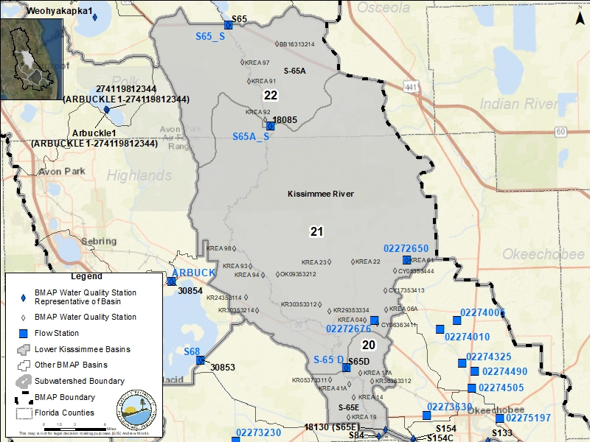
Figure 13. Locations of the water quality monitoring stations in the Lower Kissimmee Subwatershed

Basin Evaluation Results
The current TP load based on data from WY2014–WY2018 for the Lower Kissimmee Subwatershed is 125.9 mt/yr. A reduction of 103.8 mt/yr is required to help achieve the TMDL and meet the subwatershed target of 22.1 mt/yr.
Table 42 summarizes the basin evaluation results for the subwatershed. Both basins in the subwatershed have TN concentrations greater than the benchmark. None of the three basins has TN or TP concentrations above the benchmarks. Based on evaluations made by SFWMD in the LOWCP update, flow was determined not to be an issue in any of the basins. Table 43 lists the TRA prioritization results for the Lower Kissimmee Subwatershed, with 1 the highest priority, 2 the next highest priority, and 3 a priority as resources allow.
Table 42. Basin evaluation results for the Lower Kissimmee Subwatershed
Insufficient data = Available data were not at the frequency needed for evaluation.
TRA ID | Basin Name | TN (mg/L)  (Benchmark – 1.54) | TP (mg/L)  (Benchmark – 0.12) | Flow
20 | S-65E | 1.34 | 0.101 | No
21 | Kissimmee River | Insufficient Data | 0.096 | No
22 | S-65A | 1.22 | 0.079 | No

Table 43. TRA evaluation results for the Lower Kissimmee Subwatershed
Insufficient data = Available data were not at the frequency needed for evaluation.
Basin | Station | TP Priority | TN Priority | Flow Priority
Kissimmee River | S65D | 3 | Insufficient Data | 3
S-65A | 18085 | 3 | 3 | 3
S-65E | S65E | 1 | 3 | 3

Projects
The sections below summarize the existing and planned and future projects for the Lower Kissimmee Subwatershed that were provided for the BMAP. The existing and planned projects are a BMAP requirement, while future projects will be implemented as funding becomes available for project implementation. Appendix A provides additional details about the projects and the terms used in these tables.

Existing and Planned Projects
Table 44 summarizes the existing and planned projects provided by the stakeholders for Lower Kissimmee Subwatershed.
Table 44. Existing and planned projects in the Lower Kissimmee Subwatershed
Lead Entity | Partners | Project Number | Project Name | Project Description | Project Type | Project Status | Estimated Completion Date | TN Reduction (lbs/yr) | TN Reduction (mt/yr) | TP Reduction (lbs/yr) | TP Reduction (mt/yr) | Basin | Acres Treated | Cost Estimate | Cost Annual O&M | Funding Source | Funding Amount | DEP Contract Agreement Number
Coordinating Agency | N/A | CA-05 | El Maximo Ranch DWM (formerly Latt Maxcy DWM) | Estimated to provide net annual average benefit of 32,675 ac-ft of treated water via pass-through system. | DWM | Underway | 2020 | TBD | TBD | 2,733.6 | 1.24 | S-65A | 7,030.0 | Not provided | $3,863,204 | FDACS | Not provided | N/A
Coordinating Agency | N/A | CA-09 | Legislative Cost-Share Appropriation Program (Dairy Projects) | See CA-05. | Dairy Remediation | Underway | TBD | TBD | TBD | TBD | TBD | Lower Kissimmee | TBD | Not provided | Not provided | FDACS | Not provided | N/A
Coordinating Agency | N/A | CA-17 | Alternative Water Supply Projects – Joe Hall, Raulerson and Sons Ranch | Stormwater recycling project. | Stormwater Reuse | Completed | 2010 | TBD | TBD | 45.1 | 0.02 | S-65D | Not provided | Not provided | Not provided | Not provided | Not provided | N/A
Coordinating Agency | N/A | CA-18 | Alternative Water Supply Projects – David H. Williams Sod & Cattle | Stormwater irrigation project. | Stormwater Reuse | Completed | 2010 | TBD | TBD | 20.5 | 0.01 | S-65D | Not provided | Not provided | Not provided | Not provided | Not provided | N/A
Coordinating Agency | N/A | CA-19 | Alternative Water Supply Projects – Four K Ranch, Inc., Lippincott Farm | Stormwater recycling project. | Stormwater Reuse | Completed | 2010 | TBD | TBD | 4.1 | 0.00 | S-65D | Not provided | Not provided | Not provided | Not provided | Not provided | N/A
Coordinating Agency | N/A | CA-20 | Alternative Water Supply Projects – Haynes and Susan Williams, 101 Ranch | 17.2-acre reservoir and 44-acre reservoir. | Stormwater Reuse | Completed | 2010 | TBD | TBD | 4.1 | 0.00 | S-65D | Not provided | Not provided | Not provided | Not provided | Not provided | N/A
FDACS | Agricultural Producers | FDACS-10 | BMP Implementation and Verification | Enrollment and verification of BMPs by agricultural producers – Lower Kissimmee. Acres treated based on FDACS OAWP June 2019 Enrollment and FSAID VI. Reductions were estimated using 2019 BMAP LET. | Agricultural BMPs | Completed | N/A | 75,818.4 | 34.39 | 9,366.6 | 4.25 | Lower Kissimmee | 175,318 | TBD | TBD | FDACS | TBD | N/A
FDACS | Agricultural Producers | FDACS-19 | Cost-Share BMP Projects | Cost-share projects paid for by FDACS. Acres treated based on FDACS OAWP June 2019 Enrollment. Reductions estimated by DEP using 2019 BMAP LET. | Agricultural BMPs | Completed | N/A | 16,070.1 | 7.29 | 1,842.2 | 0.84 | Lower Kissimmee | 27,257 | TBD | TBD | FDACS | TBD | N/A
Highlands County | UF–IFAS | HC-04 | Education and Outreach | FYN, landscaping and irrigation ordinances, PSAs, and pamphlets. | Education Efforts | Completed | N/A | 771.3 | 0.35 | 85.8 | 0.04 | Kissimmee River,  S-65E | 2,436.4 | Not provided | Not provided | Highlands County | Not provided | N/A
Osceola County | N/A | OSC-11 | Education and Outreach | FYN; landscaping, irrigation, fertilizer, and pet waste management ordinances; PSAs; pamphlets; website; and illicit discharge program. | Education Efforts | Completed | N/A | 12.7 | 0.01 | 4.2 | 0.00 | S-65A, Kissimmee River | 165.6 | Not provided | $5,000 | Osceola County | $5,000 | N/A
Polk County | Extension Office/ County Utilities/ Lakes Education Action Drive/ Municipal Agencies | PC-02 | Education and Outreach | FYN, fertilizer ordinance, PSAs, pamphlets, website, and Illicit Discharge Program. | Education Efforts | Completed | N/A | 917.6 | 0.42 | 31.9 | 0.01 | Kissimmee River,  S-65A | 5,616.7 | N/A | $3,000 | Polk County | $3,000 | N/A
SFWMD | N/A | SFWMD-04 | Otter Slough Restoration | Completed project included 5 ditch plugs and removal of 2 berms to help attenuate regional stormwater runoff, as well as provide nutrient reductions because of plant uptake from overland flows. | Hydrologic Restoration | Completed | 2009 | TBD | TBD | 10.9 | 0.00 | Lake Kissimmee | 500.0 | N/A | $0 | N/A | N/A | N/A
SFWMD | USACE | SFWMD-05 | Kissimmee River Restoration | Restore  ecological integrity by restoring 40 miles of meandering river and more than 12,000 acres of wetlands  through the design and construction of physical project features coupled with application of optimized  hydrologic conditions. | Hydrologic Restoration | Underway | 2020 | 9,934.8 | 4.5 | 1,369.9 | 0.6 | S-65A, S-65BC, S-65D | 25,000.0 | $780,000,000 | N/A | USACE | USACE – $780,000,000 | N/A
SFWMD | N/A | SFWMD-13 | Dixie West | Storage of 315 ac-ft of water through pasture. | DWM | Completed | 2012 | TBD | TBD | 451.4 | 0.20 | S-65E | 495.0 | $548,000 | $51,500 | Florida Legislature | Florida Legislature – $51,500 | N/A
TBDTBD223.90.10SFWMD | N/A | SFWMD-17 | Willaway Cattle and Sod | Storage of 229 ac-ft of water through above-ground impoundment. | DWM | Completed | 2013 | TBD | TBD | 153.9 | 0.07 | Kissimmee River | 69.0 | $344,279 | $1,878 | Florida Legislature | Florida Legislature – $1,878 | N/A
SFWMD | N/A | SFWMD-19 | Triple A Ranch | Storage of 397 ac-ft of water through above-ground impoundment. | DWM | Completed | 2015 | TBD | TBD | 2,733.6 | 1.24 | Kissimmee River | 106.0 | $607,186 | $30,000 | Florida Legislature | Florida Legislature – $30,000 | N/A

Future Projects
Table 45 lists the future projects provided by the stakeholders for the Lower Kissimmee Subwatershed.
Table 45. Future projects in the Lower Kissimmee Subwatershed
Lead Entity | Partners | Project Number | Project Name | Project Description | Project Type | Project Status | Acres Treated | TN Reduction (lbs/yr) | TN Reduction (mt/yr) | TP Reduction (lbs/yr) | TP Reduction (mt/yr) | Basin | Cost Estimate | Cost Annual O&M
Highlands County | Coordinating Agencies | F-19 | Smart Fertilizer | Watershedwide ban on fertilizer use during certain portion of year for residential use. | Enhanced Public Education | Planned | TBD | TBD | TBD | TBD | TBD | Kissimmee River, S-65E | TBD | TBD
Highlands County | Coordinating Agencies | F-20 | Happy Planters | Replanting grant for vegetation loss on waterbodies. | Creating/ Enhancing Living Shoreline | Planned | TBD | TBD | TBD | TBD | TBD | Kissimmee River, S-65E | TBD | TBD

Taylor Creek/Nubbin Slough Subwatershed
The Taylor Creek/Nubbin Slough Subwatershed covers almost 198,000 acres of the LOW and is made up of 5 basins. As shown in Table 46, agriculture is the predominate land use with 71.6 % of the area, followed by urban and built-up with 9.2 %. Stakeholders in the subwatershed are the City of Okeechobee, Coquina Water Management District, FDOT District 1, FDOT District 4, Martin County, and Okeechobee County.
Table 46. Summary of land uses in the Taylor Creek/Nubbin Slough Subwatershed
Level 1 Land Use Code | Land Use Description | Acres | % Total
1000 | Urban and Built-Up | 18,126 | 9.2
2000 | Agriculture | 141,605 | 71.6
3000 | Upland Nonforested | 2,699 | 1.4
4000 | Upland Forests | 4,519 | 2.3
5000 | Water | 2,401 | 1.2
6000 | Wetlands | 17,486 | 8.8
7000 | Barren Land | 1,545 | 0.8
8000 | Transportation, Communication, and Utilities | 813 | 0.4
9000 | Inactive Dairy | 8,602 | 4.3
 | Total | 197,796 | 100.0

Water Quality Monitoring
In the Taylor Creek/Nubbin Slough Subwatershed, the BMAP monitoring network includes water quality stations in all five of the basins. Table 47 summarizes the water quality monitoring stations in the subwatershed, and Figure 14 shows the station locations. Table 47 also includes recommendations to change the location, frequency, or parameters sampled for the station to better align with the BMAP.

Table 47. Water quality monitoring stations in the Taylor Creek/Nubbin Slough Subwatershed
Basin | Representative Site? | Entity | Station ID | Tier | Data Needs
S-135 | Yes | SFWMD | S135 | 1 | Sufficient TN and TP data
S191 | Yes | SFWMD | S191 | 1 | Sufficient TN and TP data
S-133 | Yes | SFWMD | S133 | 1 | Sufficient TN and TP data
S-154C | Yes | SFWMD | S154C | 1 | Sufficient TN and TP data
S-154 | Yes | SFWMD | S154 | 1 | Sufficient TN and TP data
S191 | No | SFWMD | MS05373613 | 2 | N/A
S191 | No | SFWMD | MS08373611 | 2 | N/A
S191 | No | SFWMD | MS08373614 | 2 | N/A
S191 | No | SFWMD | OT29353514 | 2 | N/A
S191 | No | SFWMD | OT32353511 | 2 | N/A
S191 | No | SFWMD | OT34353513 | 2 | N/A
S191 | No | SFWMD | TC03373511 | 2 | N/A
S-154 | No | SFWMD | KR17373513 | 2 | N/A
S191 | No | SFWMD | TC27353413 | 2 | N/A
S-154 | No | SFWMD | TS26363411 | 2 | N/A
S-154 | No | SFWMD | TS36363411 | 2 | N/A
S-154 | No | SFWMD | KR16373414 | 2 | N/A
S-154C | No | SFWMD | KR20373413 | 2 | N/A
S191 | No | SFWMD | LB29353513 | 2 | N/A
S191 | No | SFWMD | TCNS 201 | 2 | N/A
S191 | No | SFWMD | TCNS 204 | 2 | N/A
S191 | No | SFWMD | TCNS 207 | 2 | N/A
S191 | No | SFWMD | TCNS 209 | 2 | N/A
S191 | No | SFWMD | TCNS 212 | 2 | N/A
S191 | No | SFWMD | TCNS 213 | 2 | N/A
S191 | No | SFWMD | TCNS 214 | 2 | N/A
S191 | No | SFWMD | TCNS 217 | 2 | N/A
S191 | No | SFWMD | TCNS 230 | 2 | N/A
S191 | No | SFWMD | TCNS 220 | 2 | N/A
S-154 | No | SFWMD | KREA 28 | 2 | N/A
S191 | No | SFWMD | TCNS 233 | 2 | N/A
S191 | No | SFWMD | TCNS 249 | 2 | N/A
S-154 | No | SFWMD | KREA 25 | 2 | N/A
S-154 | No | SFWMD | KREA 20 | 2 | N/A
S191 | No | SFWMD | TCNS 228 | 2 | N/A
S191 | No | SFWMD | TCNS 222 | 2 | N/A
S-154 | No | SFWMD | KREA 30 A | 2 | N/A
S191 | No | USGS | 02275197 | 2 | N/A
S-154 | No | USGS | 02273630 | 3 | N/A
S191 | No | USGS | 02274005 | 3 | N/A
S191 | No | USGS | 02274010 | 3 | N/A
S191 | No | USGS | 02274325 | 3 | N/A
S191 | No | USGS | 02274490 | 3 | N/A
S191 | No | USGS | 02274505 | 3 | N/A
S191 | No | USGS | 02275197 | 3 | N/A

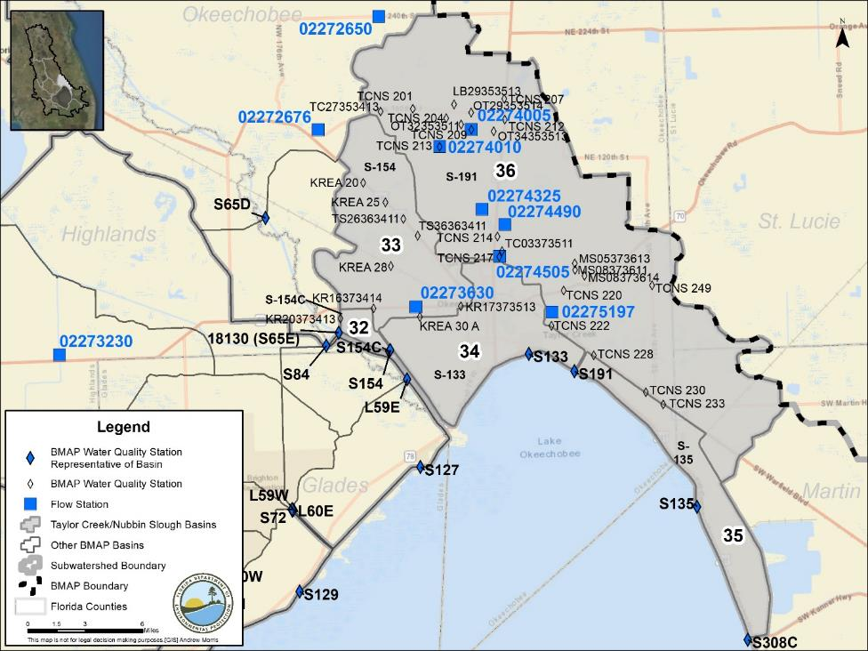
Figure 14. Locations of the water quality monitoring stations in the Taylor Creek/
Nubbin Slough Subwatershed

Basin Evaluation Results
The current TP load based on data from WY2014–WY2018 for the Taylor Creek/Nubbin Slough Subwatershed is 113.6 mt/yr. A reduction of 93.7 mt/yr is required to help achieve the TMDL and meet the subwatershed target of 19.9 mt/yr.
Table 48 summarizes the basin evaluation results for the Taylor Creek/Nubbin Slough Subwatershed. All five basins have TN concentrations higher than the benchmark. The S-154C, S-154, S-133, and S191 Basins also have TP concentrations higher than the benchmark. Based on evaluations made by SFWMD in the LOWCP update, flow was determined not to be an issue in the S-135 basin. Table 49 lists the TRA prioritization results for the Taylor Creek/Nubbin Slough Subwatershed, with 1 the highest priority, 2 the next highest priority, and 3 a priority as resources allow.

Table 48. Basin evaluation results for the Taylor Creek/Nubbin Slough Subwatershed
TRA ID | Basin Name | TN (mg/L)  (Benchmark – 1.54) | TP (mg/L)  (Benchmark – 0.12) | Flow
32 | S-154C | 2.18 | 0.492 | Maybe
33 | S-154 | 1.70 | 0.274 | Maybe
34 | S-133 | 1.88 | 0.197 | Maybe
35 | S-135 | 1.55 | 0.113 | No
36 | S191 | 1.81 | 0.493 | Maybe

Table 49. TRA evaluation results for the Taylor Creek/Nubbin Slough Subwatershed
Basin | Station | TP Priority | TN Priority | Flow Priority
S-133 | S133 | 1 | 1 | 2
S-135 | S135 | 1 | 1 | 3
S-154 | S154 | 1 | 1 | 2
S-154C | S154C | 1 | 1 | 2
S191 | S191 | 1 | 1 | 2

Projects
The sections below summarize the existing and planned and future projects for the Taylor Creek/Nubbin Slough Subwatershed that were provided for the BMAP. The existing and planned projects are a BMAP requirement, while future projects will be implemented as funding becomes available for project implementation. Appendix A provides additional details about the projects and the terms used in these tables.

Existing and Planned Projects
Table 50 summarizes the existing and planned projects provided by the stakeholders for the Taylor Creek/Nubbin Slough Subwatershed.
Table 50. Existing and planned projects in the Taylor Creek/Nubbin Slough Subwatershed
Lead Entity | Partners | Project Number | Project Name | Project Description | Project Type | Project Status | Estimated Completion Date | TN Reduction (lbs/yr) | TN Reduction (mt/yr) | TP Reduction (lbs/yr) | TP Reduction (mt/yr) | Basin | Acres Treated | Cost Estimate | Cost Annual O&M | Funding Source | Funding Amount | DEP Contract Agreement Number
Coordinating Agency | N/A | CA-02 | Inactive Dairies – Lagoon Remediation | FDACS worked with dairy in LOW to partially remediate its lagoon. Soil was spread on field for crops to use nutrients, and stormwater was routed to remediated pond and reused to minimize discharges and groundwater withdrawals. | Dairy Remediation | Completed | Not provided | Not provided | Not provided | Not provided | Not provided | S-133 | 79.1 | $643,593 | Not provided | FDACS | Not provided | N/A
Coordinating Agency | N/A | CA-04 | Lakeside Ranch Phase II | Phase II Includes southern STA and pump station (S-191), also known as Phase III in 2018 Ops Plan, to manage rim canal levels during high flow and potentially recirculate lake water back to STA for further TP removal. | STAs | Underway | 2021 | TBD | TBD | 13,236.5 | 6.00 | S-133 | 66.7 | $1,112,005 | Not provided | Federal Emergency Management Agency (FEMA)/ DEO | Not provided | N/A
Coordinating Agency | N/A | CA-10 | Legislative Cost-Share Appropriation Program (Dairy Projects) | See CA-06. | Dairy Remediation | Underway | TBD | TBD | TBD | TBD | TBD | S-133 | TBD | Not Provided | Not provided | FDACS | Not provided | N/A
Coordinating Agency | FDOT | CA-14 | SR 710 Regional Project | Feasibility study was completed. FDOT is reviewing several conceptual designs. Coordinating Agencies are also reviewing study to determine whether multiple program initiatives can be aligned for greater project impact. | Study | Completed | N/A | N/A | N/A | N/A | N/A | S-133 | 39.5 | $1,485,917 | Not provided | FEMA | Not provided | N/A
City of Okeechobee | SFWMD/ DEP | CO-01 | Centennial Park Stormwater Drainage Construction | Upgrade stormwater infrastructure by constructing nutrient-separating baffle box (NSBB), bioswale, and removing and replacing pipe. | Baffle Boxes – First Generation (hydrodynamic separator) | Completed | 2018 | 2.2 | 0.00 | 0.0 | 0.00 | S-154 | 17.3 | $786,665 | Not provided | DEO | Not provided | N/A
City of Okeechobee | N/A | CO-02 | South 4th St. Stormwater Drainage Construction | Upgrade stormwater infrastructure by constructing NSBB, bioswale, and removing and replacing pipe. | Baffle Boxes – First Generation (hydrodynamic separator) | Planned | TBD | 275.3 | 0.12 | 10.0 | 0.00 | S-133 | 20.0 | $749,410 | Not provided | Florida Legislature | Not provided | N/A
City of Okeechobee | DEP | CO-03 | SE 8th Stormwater Drainage Construction | Upgrade stormwater infrastructure by constructing NSBB, bioswale, and removing and replacing pipe. | Baffle Boxes – First Generation (hydrodynamic separator) | Planned | 2020 | 18.2 | 0.01 | 0.6 | 0.00 | S-133 | 0.0 | $157,143 | Not provided | Florida Legislature | Not provided | N/A
City of Okeechobee | N/A | CO-04 | Citywide Street Sweeping | Remove turbidity and excess nutrients from runoff. | Street Sweeping | Completed | N/A | TBD | TBD | TBD | TBD | S-191 | 118.0 | $26,900,000 | $141,882 | USACE/ SFWMD | USACE – $26,900,000/ SFWMD – $141,882 | N/A
FDACS | SFWMD | FDACS-01 | Lemkin Creek | Hybrid wetland treatment technology (HWTT) is combination of wetland and chemical treatment technologies designed mainly to remove phosphorus at subbasin and parcel scales. | HWTT | Completed | 2009 | 806.4 | 0.37 | 489.8 | 0.22 | S-191 | 1,522 | $635,970 | $253,910 | FDACS | TBD | N/A
FDACS | SFWMD | FDACS-02 | Wolff Ditch | HWTT is combination of wetland and chemical treatment technologies designed mainly to remove phosphorus at subbasin and parcel scales. | HWTT | Completed | 2009 | 1,420.8 | 0.64 | 1,043.6 | 0.47 | S-135 | 1,930 | $1,036,070 | $412,380 | FDACS | TBD | N/A
FDACS | SFWMD | FDACS-03 | Grassy Island | HWTT is combination of wetland and chemical treatment technologies designed mainly to remove phosphorus at subbasin and parcel scales. | HWTT | Completed | 2010 | 9,891.0 | 4.49 | 4,171.2 | 1.89 | S-154 | 37,802 | $5,041,338 | $1,252,580 | FDACS | TBD | N/A
FDACS | Private Landowner | FDACS-05 | Nubbin Slough | HWTT is combination of wetland and chemical treatment technologies designed mainly to remove phosphorus at subbasin and parcel scales. | HWTT | Completed | 2008 | 1,128.6 | 0.51 | 1,160.5 | 0.53 | S-133 | 2,000 | $900,260 | $216,500 | FDACS | TBD | N/A
FDACS | Private Landowner | FDACS-06 | Mosquito Creek | HWTT is combination of wetland and chemical treatment technologies designed mainly to remove phosphorus at subbasin and parcel scales. | HWTT | Completed | 2008 | 2,638.8 | 1.20 | 1,318.5 | 0.60 | S-133 | 5,000 | $1,263,920 | $275,110 | FDACS | TBD | N/A
FDACS | Agricultural Producers | FDACS-11 | BMP Implementation and Verification | Enrollment and verification of BMPs by agricultural producers – Taylor Creek/Nubbin Slough. Acres treated based on FDACS OAWP June 2019 Enrollment and FSAID VI. Reductions were estimated using 2019 BMAP LET. | Agricultural BMPs | Completed | N/A | 73,699.4 | 33.43 | 12,995.2 | 5.89 | S-133 | 118,761 | TBD | TBD | FDACS | TBD | N/A
FDACS | Agricultural Producers | FDACS-20 | Cost-Share Projects | Cost-share projects paid for by FDACS. Acres treated based on FDACS OAWP June 2019 Enrollment. Reductions estimated by DEP using 2019 BMAP LET. | Agricultural BMPs | Completed | N/A | 12,290.6 | 5.57 | 4,397.2 | 1.99 | S-133 | 35,026 | TBD | TBD | FDACS | TBD | N/A
FDOT District 1 | N/A | FDOT1-01 | SR 70 from 34th Avenue to 80th Avenue | 6 wet detention ponds. | Wet Detention Pond | Completed | 2018 | 35.5 | 0.02 | 37.4 | 0.02 | S-154 | 17.3 | $786,665 | Not provided | DEO | Not provided | N/A
FDOT District 1 | N/A | FDOT1-02 | SR 70 from 80th Ave. to St. Lucie County Line | 3 wet detention ponds and 3 dry retention swales. | Wet Detention Pond | Completed | 2018 | 24.4 | 0.01 | 9.6 | 0.00 | S-133 | 20.0 | $749,410 | Not provided | Florida Legislature | Not provided | N/A
FDOT District 1 | N/A | FDOT1-03 | Street Sweeping | Street sweeping. | Street Sweeping | Completed | N/A | 144.1 | 0.07 | 120.2 | 0.05 | S-133 | 0.0 | $157,143 | Not provided | Florida Legislature | Not provided | N/A
FDOT District 4 | N/A | FDOT4-04 | Public Education | Pamphlets. | Education Efforts | Completed | N/A | 0.7 | 0.00 | 0.1 | 0.00 | S-191 | 118.0 | $26,900,000 | $141,882 | USACE/ SFWMD | USACE – $26,900,000/ SFWMD – $141,882 | N/A
Okeechobee County | DEO | OK-01B | Douglas Park South | Addition of dry detention area to serve 73.5 acres of original 150-acre drainage area. | Dry Detention Pond | Completed | 2009 | 38.0 | 0.02 | 5.4 | 0.00 | S-191 | 773.0 | N/A | $196,548 | USACE/ SFWMD | N/A | N/A
Okeechobee County | FEMA/ DEO | OK-02 | Oak Park | Roadside swales with raised inlets and 2 hydrodynamic separators. | Grass Swales with Swale Blocks or Raised Culverts | Completed | 2016 | 47.0 | 0.02 | 5.9 | 0.00 | S-135 | 919.0 | $22,800,000 | $132,704 | Florida Legislature | USACE – $22,800,000/ SFWMD – $132,704 | N/A
Okeechobee County | FEMA/ City of Okeechobee | OK-03 | Southwest 21st St.+ | Dry detention roadside swales with raised inlets and 1 hydrodynamic separator. | Grass Swales with Swale Blocks or Raised Culverts | Completed | 2013 | 0.6 | 0.00 | 0.1 | 0.00 | S-154 | See SFWMD-14. | See SFWMD-14. | See SFWMD-14. | See SFWMD-14. | Included in SFWMD-14. | N/A
Okeechobee County | FEMA | OK-04 | Southwest Drainage Area Improvements | Dry detention roadside swales with raised inlets and 2 hydrodynamic separators. | Grass Swales with Swale Blocks or Raised Culverts | Completed | 2011 | 1.0 | 0.00 | 0.2 | 0.00 | S-133 | 79.1 | $643,593 | Not provided | DEO | Not provided | N/A
Okeechobee County | DEO | OK-05 | Okeechobee County 2008 Disaster Recovery Community Development Block Grant (CDBG) | Culvert upgrades and dry detention area to improve water quality and alleviate need for funding. | Stormwater System Rehabilitation | Completed | 2014 | 5.6 | 0.00 | 0.8 | 0.00 | S-133 | 66.7 | $1,112,005 | Not provided | FEMA/ DEO | Not provided | N/A
Okeechobee County | Not provided | OK-06 | Southwest Drainage Area Improvements Whidden Ditch (Phase III) | Ditch and culvert upgrades to improve stormwater conveyance to Rim Canal. | Stormwater System Rehabilitation | Completed | 2017 | TBD | TBD | TBD | TBD | S-133 | 2.5 | $483,893 | Not provided | FEMA/ City of Okeechobee/ County | Not provided | N/A
Okeechobee County | Not provided | OK-07 | Lock 7 Bypass Culvert System | Installation of parallel culvert system along Rim Canal to improve conveyance. | Stormwater System Rehabilitation | Completed | 2016 | 0.0 | 0.00 | 0.0 | 0.00 | S-133 | 39.5 | $1,485,917 | Not provided | FEMA | Not provided | N/A
SFWMD | USACE | SFWMD-01 | Taylor Creek | Taylor Creek STA is 2-celled STA. | STA | Completed | 2008 | TBD | TBD | 3,483.3 | 1.6 | S-154 | 17.3 | $786,665 | Not provided | DEO | Not provided | N/A
SFWMD | USACE | SFWMD-02 | Nubbin Slough | Nubbin Slough STA is larger of 2 pilot STAs constructed north of lake; 2-celled enclosure. | STA | Completed | 2015 | TBD | TBD | 9,230.8 | 4.2 | S-133 | 20.0 | $749,410 | Not provided | Florida Legislature | Not provided | N/A
SFWMD | USACE | SFWMD-03 | Lakeside Ranch Phase I | Phase I included northern STA and inflow pump station (S-650), which began operating in 2012. | STA | Completed | 2012 | TBD | TBD | 12,191.6 | 5.5 | S-133 | 0.0 | $157,143 | Not provided | Florida Legislature | Not provided | N/A
SFWMD | N/A | SFWMD-14 | Dixie Ranch | Storage of 856 ac-ft of water through pasture. | DWM | Completed | 2012 | TBD | TBD | 261.9 | 0.12 | S-65E | 3,771.0 | $507,500 | $146,500 | Florida Legislature | Florida Legislature – $146,500 | N/A
SFWMD | N/A | SFWMD-15 | Dixie Ranch | See SFWMD-14. | DWM | Completed | 2012 | TBD | TBD | 513.7 | 0.23 | S-191 | 118.0 | $26,900,000 | $141,882 | USACE/ SFWMD | USACE – $26,900,000/ SFWMD – $141,882 | N/A

Future Projects
Table 51 lists the future projects provided by the stakeholders for the Taylor Creek/Nubbin Slough Subwatershed.
Table 51. Future projects in the Taylor Creek/Nubbin Slough Subwatershed
Lead Entity | Partners | Project Number | Project Name | Project Description | Project Type | Project Status | Acres Treated | TN Reduction (lbs/yr) | TN Reduction (mt/yr) | TP Reduction (lbs/yr) | TP Reduction (mt/yr) | Basin | Cost Estimate | Cost Annual O&M
Coordinating Agency | N/A | F-21 | Grassy Island Flow Equalization Basin | Flow equalization basin to provide inflows needed to maintain wetland vegetation at Taylor Creek STA. | Regional Stormwater Treatment | Conceptual | TBD | TBD | TBD | 1,741.7 | 0.79 | S-191 | TBD | TBD
Coordinating Agency | N/A | F-22 | Lemkin Creek Urban Stormwater Facility | Alternatives consist of shallow impoundment and shallow wetland treatment system. | Regional Stormwater Treatment | Conceptual | TBD | TBD | TBD | 1,915.8 | 0.87 | S-133 | TBD | TBD
Coordinating Agency | N/A | F-23 | Okeechobee County East/West Stormwater Conveyance Project | DWM. | DWM | Conceptual | TBD | TBD | TBD | 557.3 | 0.25 |  | TBD | TBD
Coordinating Agency | N/A | F-24 | Brady Ranch STA | STA. | STA | Conceptual | TBD | TBD | TBD | 8,708.3 | 3.95 | S-191 | TBD | TBD
Coordinating Agency | N/A | F-25 | C-38 Reservoir Assisted STA | Treat water from 3 priority basins. | STA | Conceptual | TBD | TBD | TBD | TBD | TBD | S-154,  S-154C, S-133 | TBD | TBD
Landowner | TBD | F-26 | Urban Regional Basin STA in Southwest Okeechobee County | Provide additional water quality and stormwater detention area for urbanized area. Regional drainage system fed from Highway 70 and urbanized residential area. Regional onsite drainage canal and expansion for additional water quality are available. | BMP Treatment Train | Conceptual | 500 | TBD | TBD | TBD | TBD | S-191 | $350,000 | $7,500
FDOT D1 | N/A | F-27 | 443172-1 | SR 15 (US 98) from SE 36th Ave. to SE 38th Ave. | Stormwater System Rehabilitation | Planned | TBD | TBD | TBD | TBD | TBD | S-133 | TBD | TBD
FDOT D1 | N/A | F-28 | 439032-1 | US 98/US 441 from SW 23rd St. to SW 14th St.. | Wet Detention Pond | Planned | TBD | TBD | TBD | TBD | TBD | S-133 | TBD | TBD
Okeechobee Utility Authority | TBD | F-29 | Treasure Island Septic to Sewer | Elimination of up to 2,430 connections. | OSTDS Phase Out | Conceptual | TBD | 18,396.0 | 8.34 | 0.0 | 0.00 | S-133 | $24,300,000 | TBD
Okeechobee Utility Authority | TBD | F-30 | Southwest Wastewater Service Area | Elimination of up to 738 connections. | OSTDS Phase Out | Conceptual | TBD | 5,628.0 | 2.55 | 0.0 | 0.00 | S-133 | $13,950,000 | TBD
Okeechobee Utility Authority | TBD | F-31 | Pine Ridge Park Septic to Sewer | Elimination of up to 80 connections. | OSTDS Phase Out | Conceptual | TBD | 630.0 | 0.29 | 0.0 | 0.00 | S-133 | $1,500,000 | TBD
Okeechobee Utility Authority | TBD | F-32 | Okee-Tantie Wastewater Improvements | Elimination of up to 633 connections. | OSTDS Phase Out | Conceptual | TBD | 4,788.0 | 2.17 | 0.0 | 0.00 | S-133 | $10,500,000 | TBD

Upper Kissimmee Subwatershed
The Upper Kissimmee Subwatershed covers more than 1,000,000 acres of the LOW and is made up of 25 basins. As shown in Table 52, wetlands cover 34.6 % of the subwatershed, followed by agriculture at 26.1 %. Stakeholders in the subwatershed are Avon Park Air Force Range, City of Belle Isle, City of Davenport, City of Edgewood, City of Haines City, City of Kissimmee, City of Lake Wales, City of Orlando, City of St. Cloud, FDOT District 5, Turnpike Enterprise, Orange County, Osceola County, Polk County, RCID, Town of Dundee, Town of Windermere, and Valencia WCD.
Table 52. Summary of land uses in the Upper Kissimmee Subwatershed
Level 1 Land Use Code | Land Use Description | Acres | % Total
1000 | Urban and Built-Up | 216,916 | 21.1
2000 | Agriculture | 268,628 | 26.1
3000 | Upland Nonforested | 59,930 | 5.8
4000 | Upland Forests | 71,457 | 6.9
5000 | Water | 25,743 | 2.5
6000 | Wetlands | 355,682 | 34.6
7000 | Barren Land | 5,235 | 0.5
8000 | Transportation, Communication, and Utilities | 24,834 | 2.4
 | Total | 1,028,425 | 100.0

Water Quality Monitoring
In the Upper Kissimmee Subwatershed, the BMAP monitoring network includes water quality stations in 23 of the 25 basins. Table 53 summarizes the water quality monitoring stations in the subwatershed, and Figure 15 shows the station locations. Table 53 also includes recommendations to change the location, frequency, or parameters sampled for the stations to better align with the BMAP. New monitoring stations have been recommended in two basins where no representative site exists.
Table 53. Water quality monitoring stations in the Upper Kissimmee Subwatershed
Basin | Representative Site? | Entity | Station ID | Tier | Data Needs
Lake Kissimmee | Yes | SFWMD | S65 | 1 | Sufficient TN and TP data
Lake Tohopekaliga | No | SFWMD | LT32263013 | 2 | N/A
Lake Kissimmee | No | SFWMD | PA10313112 | 2 | N/A
S63A | No | SFWMD | CL06283112 | 2 | N/A
East Lake Tohopekaliga | No | SFWMD | ET05253114 | 2 | N/A
East Lake Tohopekaliga | No | SFWMD | ET06253113 | 2 | N/A
Lake Tohopekaliga | No | SFWMD | BNSHINGLE | 2 | N/A
Catfish Creek | No | SFWMD | ROMIN | 2 | N/A
Lake Marian | Yes | SFWMD | ML22303313 | 2 | Sufficient TP data; SFWMD will add TN in expanded monitoring
Lake Jackson | Yes | SFWMD | LJACKDSCH | 2 | Sufficient TP data; SFWMD will add TN in expanded monitoring
Lake Rosalie | Yes | SFWMD | KUB009 | 2 | Sufficient TP data; SFWMD will add TN in expanded monitoring
Lake Hatchinea | Yes | SFWMD | EC-37 | 2 | Sufficient TP data; SFWMD will add TN in expanded monitoring
Lake Gentry | Yes | SFWMD | GENTRYDTCH | 2 | Sufficient TP data; SFWMD will add TN in expanded monitoring
Lower Reedy Creek | Yes | SFWMD | CREEDYBR | 2 | Sufficient TN and TP data
East Lake Tohopekaliga | Yes | SFWMD | BS-59 | 2 | Sufficient TN and TP data
Lake Hart | Yes | SFWMD | MJ01253123 | 2 | Sufficient TP data; SFWMD will add TN in expanded monitoring
Boggy Creek | Yes | SFWMD | ABOGGN | 2 | Sufficient TN and TP data
S63A | Yes | SFWMD | CL06283111 | 2 | Sufficient TP data; SFWMD will add TN in expanded monitoring
Lake Tohopekaliga | Yes | SFWMD | CL18273011 | 2 | Sufficient TP data; SFWMD will add TN in expanded monitoring
Lake Pierce | Yes | Polk County Natural Resources Division | Pierce1 | 2 | Increase collection frequency for TN and TP
Catfish Creek | Yes | SFWMD | 34008 | 2 | Sufficient TN and TP data
Lake Marion | Yes | DEP Watershed Monitoring Section | 51242 | 2 | Increase collection frequency for TN and TP
Shingle Creek | Yes | Orange County Environmental Protection Division | SCD | 2 | Sufficient TN and TP data
Lake Cypress | Yes | SFWMD | 4002 | 2 | Sufficient TN and TP data
Horse Creek | Yes | Polk County Natural Resources Division | Horse Crk2 | 2 | Increase collection frequency for TN and TP
Lake Weohyakapka | Yes | Polk County Natural Resources Division | Weohyakapka1 | 2 | Increase collection frequency for TN and TP
Upper Reedy Creek | No | RCID | RC-13H (C-12E-RC-13H) | 2 | N/A
Tiger Lake | Yes | DEP Central ROC | G4CE0070 (Tiger1-G4CE0070) | 2 | Sufficient TN and TP data
Alligator Lake | Yes | SFWMD | LG32263124 | 2 | Sufficient TP data; SFWMD will add TN in expanded monitoring
Upper Reedy Creek | No | RCID | C-12E (C-12E-RC-13H) | 2 | N/A
Upper Reedy Creek | Yes | RCID | RC-13L | 2 | Proposed station (RCID)
Marion Creek | Yes | SFWMD | DLMARNCR | 2 | Sufficient TP data; SFWMD will add TN in expanded monitoring
Marion Creek | Yes | SFWMD | DLONDNCR | 2 | Sufficient TP data; SFWMD will add TN in expanded monitoring
Tiger Lake | Yes | Polk County Natural Resources Division | Tiger1 (Tiger1-G4CE0070) | 2 | Sufficient TN and TP data
Lake Conlin | N/A | N/A | N/A | 2 | No site available
Lake Myrtle | N/A | N/A | N/A | 2 | No site available
Boggy Creek | No | Orange County | Boggy Creek A (Tradeport) | 2 | N/A
Shingle Creek | No | Orange County | Shingle Creek (Central FL Pkwy.) | 2 | N/A
Lake Hart | No | Orange County | HART: Lake Hart Outflow at S-62 (Clap Sims Duda) | 2 | N/A
Lake Hart | No | City of Orlando | Buck Lake | 2 | Lake Tohopekaliga  NRP station
Boggy Creek | No | City of Orlando | Lake Fran | 2 | Lake Tohopekaliga  NRP station
Boggy Creek | No | City of Orlando | Lake Mare Prairie | 2 | Lake Tohopekaliga  NRP station
Boggy Creek | No | City of Orlando | Mud Lake | 2 | Lake Tohopekaliga  NRP station
Shingle Creek | No | City of Orlando | Turkey Lake (North) | 2 | Lake Tohopekaliga  NRP station
Shingle Creek | No | City of Orlando | Turkey Lake (South) | 2 | Lake Tohopekaliga  NRP station
Lake Tohopekaliga | No | City of Kissimmee | East City Ditch Outfall | 2 | Lake Tohopekaliga  NRP station
Lake Tohopekaliga | No | City of Kissimmee | Mill Slough Outfall | 2 | Lake Tohopekaliga  NRP station
Lake Tohopekaliga | No | City of Kissimmee | Bass Slough at Boggy Creek | 2 | Lake Tohopekaliga  NRP station
Lake Tohopekaliga | No | City of Kissimmee | Bass Slough at Timothy Lane | 2 | Lake Tohopekaliga  NRP station
Lake Tohopekaliga | No | City of Kissimmee | Mill Slough at Mill Run Blvd.. | 2 | Lake Tohopekaliga  NRP station
Lake Tohopekaliga | No | City of Kissimmee | West City Ditch at Hacienda Circle | 2 | Lake Tohopekaliga  NRP station
Lake Tohopekaliga | No | City of Kissimmee | Shingle Creek at John Young Pkwy. | 2 | Lake Tohopekaliga  NRP station
Shingle Creek | No | City of Kissimmee | Shingle Creek at Town Center Blvd.. | 2 | Lake Tohopekaliga  NRP station
Shingle Creek | No | City of Kissimmee | Shingle Creek at Yates Rd. | 2 | Lake Tohopekaliga  NRP station
Boggy Creek | No | Orlando/Orange County | Boggy Creek B  (SR 527A) | 2 | Lake Tohopekaliga  NRP station
Boggy Creek | No | Orlando/Orange County | Boggy Creek @ 527A City of Orlando Site (bcb) | 2 | Lake Tohopekaliga  NRP station
Shingle Creek | No | Orlando/Orange County | Shingle Creek City of Orlando | 2 | Lake Tohopekaliga  NRP station
Lake Tohopekaliga | No | Osceola County | ETO5253114 | 2 | Lake Tohopekaliga  NRP station
Lake Tohopekaliga | No | Osceola County | JUDGES_DCH | 2 | Lake Tohopekaliga  NRP station
Lake Tohopekaliga | No | Osceola County | PARTIN_CNL | 2 | Lake Tohopekaliga  NRP station
Lake Tohopekaliga | No | Osceola County | RUNNYMEDE | 2 | Lake Tohopekaliga  NRP station
Lake Tohopekaliga | No | SFWMD | S61-S | 3 | N/A
Lake Kissimmee | No | SFWMD | S65_S | 3 | N/A
Boggy Creek | No | USGS | 02262900 | 3 | N/A
Lake Weohyakapka | No | USGS | 02268390 | 3 | N/A
Shingle Creek | No | USGS | 02263800 | 3 | N/A
Shingle Creek | No | USGS | 02264495 | 3 | N/A
Upper Reedy Creek | No | USGS | 02263869 | 3 | N/A
Upper Reedy Creek | No | USGS | 02264000 | 3 | N/A
Upper Reedy Creek | No | USGS | 02264003 | 3 | N/A
Upper Reedy Creek | No | USGS | 02264030 | 3 | N/A
Upper Reedy Creek | No | USGS | 02264051 | 3 | N/A
Upper Reedy Creek | No | USGS | 02264060 | 3 | N/A
Upper Reedy Creek | No | USGS | 02264100 | 3 | N/A
Upper Reedy Creek | No | USGS | 02266025 | 3 | N/A
Upper Reedy Creek | No | USGS | 02266200 | 3 | N/A
Upper Reedy Creek | No | USGS | 02266205 | 3 | N/A
Upper Reedy Creek | No | USGS | 02266291 | 3 | N/A
Upper Reedy Creek | No | USGS | 02266293 | 3 | N/A
Upper Reedy Creek | No | USGS | 02266295 | 3 | N/A
Upper Reedy Creek | No | USGS | 02266300 | 3 | N/A
Upper Reedy Creek | No | USGS | 02266480 | 3 | N/A
Upper Reedy Creek | No | USGS | 02266496 | 3 | N/A
Upper Reedy Creek | No | USGS | 02266500 | 3 | N/A

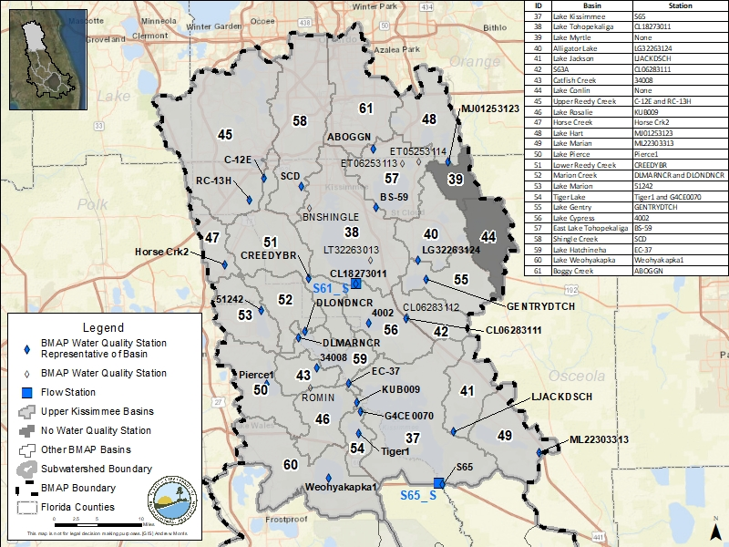
Figure 15. Locations of the water quality monitoring stations in the Upper Kissimmee Subwatershed

Basin Evaluation Results
The current TP load, based on data from WY2014–WY2018 for the Upper Kissimmee Subwatershed, is 90.5 mt/yr. A reduction of 74.6 mt/yr is required to help achieve the TMDL and meet the subwatershed target of 15.9 mt/yr.
Table 54 summarizes the basin evaluation results for the Upper Kissimmee Subwatershed. For the basins with sufficient data, Catfish Creek and Lake Pierce have TN concentrations greater than the benchmark, and Lake Marian and Tiger Lake have TP concentrations greater than the benchmark. Based on evaluations made by SFWMD in the LOWCP update, flow was determined not to be an issue in this subwatershed. The TRA prioritization results for the Upper Kissimmee Subwatershed are listed in Table 55, with 1 the highest priority, 2 the next highest priority, and 3 a priority as resources allow.

Table 54. Basin evaluation results for the Upper Kissimmee Subwatershed
Insufficient data = Available data were not at the frequency needed for evaluation.
TRA ID | Basin Name | TN (mg/L)  (Benchmark – 1.54) | TP (mg/L)  (Benchmark – 0.12) | Flow
37 | Lake Kissimmee | 1.37 | 0.084 | No
38 | Lake Tohopekaliga | Insufficient Data | 0.042 | No
39 | Lake Myrtle | Insufficient Data | Insufficient Data | No
40 | Alligator Lake | Insufficient Data | 0.025 | No
41 | Lake Jackson | Insufficient Data | 0.077 | No
42 | S63A | Insufficient Data | 0.081 | No
43 | Catfish Creek | 1.78 | 0.071 | No
44 | Lake Conlin (closed basin) | Insufficient Data | Insufficient Data | No
45 | Upper Reedy Creek | 0.50 | 0.045 | No
46 | Lake Rosalie | Insufficient Data | 0.079 | No
47 | Horse Creek (closed basin) | 1.32 | 0.067 | No
48 | Lake Hart | Insufficient Data | 0.021 | No
49 | Lake Marian | Insufficient Data | 1.281 | No
50 | Lake Pierce | 1.97 | 0.052 | No
51 | Lower Reedy Creek | 1.21 | 0.086 | No
52 | Marion Creek | Insufficient Data | 0.067 | No
53 | Lake Marion | 1.25 | 0.100 | No
54 | Tiger Lake | 0.87 | 0.139 | No
55 | Lake Gentry | Insufficient Data | 0.074 | No
56 | Lake Cypress | 1.17 | 0.045 | No
57 | East Lake Tohopekaliga | 0.71 | 0.023 | No
58 | Shingle Creek | 0.61 | 0.048 | No
59 | Lake Hatchineha | Insufficient Data | 0.065 | No
60 | Lake Weohyakapka | 0.87 | 0.034 | No
61 | Boggy Creek | 0.63 | 0.036 | No

Table 55. TRA evaluation results for the Upper Kissimmee Subwatershed
Insufficient data = Available data were not at the frequency needed for evaluation.
Basin | Station | TP Priority | TN Priority | Flow Priority
Alligator Lake | S60 | Insufficient Data | Insufficient Data | 3
Boggy Creek | ABOGGN | 2 | 3 | 3
Catfish Creek | 34008 | 3 | 3 | 3
East Lake Tohopekaliga | BS-59 | 3 | 3 | 3
Horse Creek (closed basin) | Horse Crk2 | 3 | 3 | 3
Lake Conlin (closed basin) |  | Insufficient Data | Insufficient Data | 3
Lake Cypress | 4002 | 3 | 3 | 3
Lake Gentry | GENTRYDTCH | 3 | Insufficient Data | 3
Lake Hart | MJ01253123 | 3 | Insufficient Data | 3
Lake Hatchineha | EC-37 | 3 | Insufficient Data | 3
Lake Jackson | LJACKDSCH | 3 | Insufficient Data | 3
Lake Kissimmee | S65 | 1 | 2 | 3
Lake Marian | ML22303313 | 2 | Insufficient Data | 3
Lake Marion | 51242 | 3 | Insufficient Data | 3
Lake Myrtle |  | Insufficient Data | Insufficient Data | 3
Lake Pierce | Pierce1 | 3 | 3 | 3
Lake Rosalie | KUB009 | 3 | Insufficient Data | 3
Lake Tohopekaliga | CL18273011 | 3 | Insufficient Data | 3
Lake Weohyakapka | Weohyakapka1 | 3 | 3 | 3
Lower Reedy Creek | CREEDYBR | 3 | 3 | 3
Marion Creek | DLMARNCR-DLONDNCR | 3 | Insufficient Data | 3
S63A | S63A | Insufficient Data | Insufficient Data | 3
Shingle Creek | SCD | 3 | 3 | 3
Tiger Lake | Tiger1-G4CE0070 | 3 | 3 | 3
Upper Reedy Creek | C-12E-RC-13H | 3 | Insufficient Data | 3

Projects
The sections below summarize the existing and planned and future projects for the Upper Kissimmee Subwatershed that were provided for the BMAP. The existing and planned projects are a BMAP requirement, while future projects will be implemented as funding becomes available for project implementation. Appendix A provides additional details about the projects and the terms used in these tables.

Existing and Planned Projects
Table 56 summarizes the existing and planned projects provided by the stakeholders for the Upper Kissimmee Subwatershed.
Table 56. Existing and planned projects in the Upper Kissimmee Subwatershed
Lead Entity | Partners | Project Number | Project Name | Project Description | Project Type | Project Status | Estimated Completion Date | TN Reduction (lbs/yr) | TN Reduction (mt/yr) | TP Reduction (lbs/yr) | TP Reduction (mt/yr) | Basin | Acres Treated | Cost Estimate | Cost Annual O&M | Funding Source | Funding Amount | DEP Contract Agreement Number
Orange County | N/A | OC-31 | Jewell-Gatlin NSBB | Construct NSBB containing media. | Baffle Boxes – Second Generation with Media | Canceled | N/A | 1,902.8 | 0.86 | 606.5 | 0.28 | Canceled | Canceled | N/A | N/A | N/A | N/A | N/A
Avon Park Air Force Range | N/A | AFR-01 | Cancellation of Cattle Lease | Land use change from agriculture to natural. | Land Use Change | Completed | 2018 | TBD | TBD | TBD | TBD | Arbuckle Creek | 23,996.3 | N/A | N/A | N/A | N/A | N/A
Coordinating Agency | N/A | CA-11 | Legislative Cost-Share Appropriation Program (Dairy Projects) | See CA-05. | Dairy Remediation | Underway | TBD | TBD | TBD | 10.6 | 0.00 | Upper Kissimmee | TBD | Not provided | Not provided | FDACS | Not provided | N/A
Coordinating Agency | N/A | CA-13 | Rolling Meadows Wetland Restoration Phase II | Land has been acquired and conceptual plan recommended. Implementation of Phase II is contingent on success of Phase I and future legislative funding. Schedule: If approved and funded, project completion is anticipated in 2 to 3 years. | Wetland Restoration | Planned | TBD | TBD | TBD | 37.4 | 0.02 | Catfish Creek | 580.0 | TBD | TBD | TBD | TBD | N/A
Coordinating Agency | N/A | CA-16 | Sumica DWM | DWM. | DWM | Completed | Not provided | 32.0 | 0.01 | 18.2 | 0.01 | Tiger Lake | Not provided | Not provided | Not provided | Not provided | Not provided | N/A
City of Edgewood | N/A | EW-01 | Water Quality Awareness Program | Water quality education and awareness articles in city quarterly newsletter. Water quality–related informational brochures, fliers, and other publications displayed at city hall for the public. | Education Efforts | Completed | N/A | 18.2 | 0.01 | 18.7 | 0.01 | Boggy Creek | N/A | N/A | $1,000 | City of Edgewood | $1,000 | N/A
City of Edgewood | Orange County | EW-02 | Street Sweeping | Orange County performs weekly sweeping of 15.6 miles of streets within city limits | Street Sweeping | Completed | N/A | 2.4 | 0.00 | 2.4 | 0.00 | Boggy Creek | N/A | N/A | N/A | Orange County | N/A | N/A
City of Edgewood | Orange County | EW-03 | Catch Basin Inlet Cleaning | Orange County performs monthly cleaning of storm inlet baskets for debris removal | Catch Basin Inserts | Completed | N/A | 77,891.3 | 35.33 | 4,654.4 | 2.11 | Boggy Creek | N/A | N/A | N/A | Orange County | N/A | N/A
FDACS | Agricultural Producers | FDACS-12 | BMP Implementation and Verification | Enrollment and verification of BMPs by agricultural producers – Upper Kissimmee. Acres treated based on FDACS OAWP June 2019 Enrollment and FSAID VI. Reductions were estimated using 2019 BMAP LET. | Agricultural BMPs | Completed | N/A | 8,305.5 | 3.77 | 731.9 | 0.33 | Upper Kissimmee | 126,633 | TBD | TBD | FDACS | TBD | N/A
FDACS | Agricultural Producers | FDACS-21 | Cost-Share Projects | Cost-share projects paid for by FDACS. Acres treated based on FDACS OAWP June 2019 Enrollment. Reductions estimated by DEP using 2019 BMAP LET. | Agricultural BMPs | Completed | N/A | 0.1 | 0.00 | 0.0 | 0.00 | Upper Kissimmee | 12,178 | TBD | TBD | FDACS | TBD | N/A
FDOT District 5 | N/A | FDOT5-01 | 239266-B SR 15 (Hoffner Rd.) from north of Lee Vista Blvd. to west of SR 436 (Pond 2) | Add lanes and reconstruct. | Wet Detention Pond | Completed | 2019 | 0.9 | 0.00 | 0.0 | 0.00 | Boggy Creek | 4.9 | Not provided | Not provided | Florida Legislature | Not provided | N/A
FDOT District 5 | N/A | FDOT5-02 | 239266-A SR 15 Hoffner Ave. from east of SR 436 to Conway Rd. (Pond 1) | Add lanes and reconstruct. | Wet Detention Pond | Completed | 2019 | 5.9 | 0.00 | 0.8 | 0.00 | Boggy Creek | 7.4 | Not provided | Not provided | Florida Legislature | Not provided | N/A
FDOT District 5 | N/A | FDOT5-03 | 239266-C SR 15 Hoffner Ave. from west of SR 436 to Conway Rd. (Pond 3) | Add lanes and reconstruct. | Wet Detention Pond | Completed | 2019 | 11.8 | 0.01 | 1.5 | 0.00 | Boggy Creek | 4.9 | Not provided | Not provided | Florida Legislature | Not provided | N/A
FDOT District 5 | N/A | FDOT5-04 | 239266-D SR 15 Hoffner Ave. from west of SR 436 to Conway Rd. (Pond 4) | Add lanes and reconstruct. | Wet Detention Pond | Completed | 2019 | 40.4 | 0.02 | 14.8 | 0.01 | Boggy Creek | 23.9 | Not provided | Not provided | Florida Legislature | Not provided | N/A
FDOT District 5 | N/A | FDOT5-05 | 239535-F SR 50 from Good Homes Rd. to Pine Hills Rd. (Pond 4) | Add lanes and reconstruct. | Dry Detention Pond | Completed | 2014 | 6.0 | 0.00 | 0.9 | 0.00 | Shingle Creek | 207.6 | Not provided | Not provided | Florida Legislature | Not provided | N/A
FDOT District 5 | N/A | FDOT5-06 | 416518-A Interstate (I) 4 Braided Ramp from US 192 Interchange to Osceola Pkwy. Interchange (Pond SE-1) | New road construction. | Wet Detention Pond | Completed | 2014 | 1.7 | 0.00 | 0.3 | 0.00 | Upper Reedy Creek | 14.8 | Not provided | Not provided | Florida Legislature | Not provided | N/A
FDOT District 5 | N/A | FDOT5-07 | 416518-B Interstate-4 Braided Ramp from US 192 Interchange to Osceola Pkwy. Interchange (Pond SE-2) | New road construction. | Wet Detention Pond | Completed | 2014 | 11.2 | 0.01 | 2.2 | 0.00 | Upper Reedy Creek | 4.9 | Not provided | Not provided | Florida Legislature | Not provided | N/A
FDOT District 5 | N/A | FDOT5-08 | 239682-A SR 500 (US 17-92) from Aeronautical Dr. to Budinger Ave. (Pond 1) | Add lanes and rehabilitate pavement. | Wet Detention Pond | Underway | 2020 | 20.8 | 0.01 | 1.7 | 0.00 | Lake Tohopekaliga | 12.4 | Not provided | Not provided | Florida Legislature | Not provided | N/A
FDOT District 5 | N/A | FDOT5-09 | 239682-B SR 500 (US 17-92) from Aeronautical Dr. to Budinger Ave. (Pond 2) | Add lanes and rehabilitate pavement. | Wet Detention Pond | Underway | 2020 | 9.6 | 0.00 | 2.1 | 0.00 | Lake Tohopekaliga | 9.9 | Not provided | Not provided | Florida Legislature | Not provided | N/A
FDOT District 5 | N/A | FDOT5-10 | 239682-C SR 500 (US 17-92) from Aeronautical Dr. to Budinger Ave. (Pond 3) | Add lanes and rehabilitate pavement. | Wet Detention Pond | Underway | 2020 | 12.6 | 0.01 | 5.3 | 0.00 | Lake Tohopekaliga | 9.9 | Not provided | Not provided | Florida Legislature | Not provided | N/A
FDOT District 5 | N/A | FDOT5-11 | 239682-D SR 500 (US 17-92) from Aeronautical Dr. to Budinger Ave. (Pond 4) | Add lanes and rehabilitate pavement. | Wet Detention Pond | Underway | 2020 | 2.8 | 0.00 | 0.8 | 0.00 | Lake Tohopekaliga | 34.6 | Not provided | Not provided | Florida Legislature | Not provided | N/A
FDOT District 5 | N/A | FDOT5-12 | 418403-A, B SR 600 (US 17-92) John Young Pkwy. (JYP) from south of Portage St. to north of Vine St. (US 192) (Ponds East and West) | Add lanes and reconstruct. | Wet Detention Pond | Completed | 2019 | 1.6 | 0.00 | 0.9 | 0.00 | Lake Tohopekaliga | 2.5 | Not provided | Not provided | Florida Legislature | Not provided | N/A
FDOT District 5 | N/A | FDOT5-13 | 239454-A widening of SR 436 from SR 528 to SR 552 (Pond A) | Add lanes and reconstruct. | Wet Detention Pond | Completed | 2010 | 0.7 | 0.00 | 0.1 | 0.00 | Boggy Creek | 59.3 | Not provided | Not provided | Florida Legislature | Not provided | N/A
FDOT District 5 | N/A | FDOT5-14 | 239635-A New Bridge SR 500 at Reedy Creek  (Pond 1) | New bridge. | Dry Detention Pond | Completed | 2010 | 3.0 | 0.00 | 0.3 | 0.00 | Lower Reedy Creek | 2.5 | Not provided | Not provided | Florida Legislature | Not provided | N/A
FDOT District 5 | N/A | FDOT5-15 | 239635-B New Bridge SR 500 at Reedy Creek  (Pond 2) | New bridge. | Wet Detention Pond | Completed | 2010 | 2.7 | 0.00 | 0.5 | 0.00 | Lower Reedy Creek | 4.9 | Not provided | Not provided | Florida Legislature | Not provided | N/A
FDOT District 5 | N/A | FDOT5-16 | 239663-A Widening of SR 530 from SR 535 to Hoagland Blvd. (Pond 1) | Add lanes and reconstruct. | Wet Detention Pond | Completed | 2010 | 6.7 | 0.00 | 1.0 | 0.00 | Shingle Creek | 19.8 | Not provided | Not provided | Florida Legislature | Not provided | N/A
FDOT District 5 | N/A | FDOT5-17 | 239663-B Widening of SR 530 from SR 535 to Hoagland Blvd. (Pond 2) | Add lanes and reconstruct. | Wet Detention Pond | Completed | 2010 | 16.9 | 0.01 | 3.6 | 0.00 | Shingle Creek | 17.3 | Not provided | Not provided | Florida Legislature | Not provided | N/A
FDOT District 5 | N/A | FDOT5-18 | 239663-C Widening of SR 530 from SR 535 to Hoagland Blvd. (Pond 3) | Add lanes and reconstruct. | Wet Detention Pond | Completed | 2010 | 4.5 | 0.00 | 2.1 | 0.00 | Shingle Creek | 14.8 | Not provided | Not provided | Florida Legislature | Not provided | N/A
FDOT District 5 | N/A | FDOT5-19 | 239663-D Widening of SR 530 from SR 535 to Hoagland Blvd. (Pond 4) | Add lanes and reconstruct. | Wet Detention Pond | Completed | 2010 | 3.1 | 0.00 | 0.4 | 0.00 | Shingle Creek | 12.4 | Not provided | Not provided | Florida Legislature | Not provided | N/A
FDOT District 5 | N/A | FDOT5-20 | 242436-A SR 400 Ramps at Gore Ave. Retention Pits (Ponds 1 and 2) | Ramps. | Dry Detention Pond | Completed | 2011 | 3.2 | 0.00 | 0.8 | 0.00 | Boggy Creek | 4.9 | Not provided | Not provided | Florida Legislature | Not provided | N/A
FDOT District 5 | N/A | FDOT5-21 | 242484-A Widening of SR 400 from Universal Blvd. to South St. (Pond 4) | Add lanes and reconstruct. | Wet Detention Pond | Completed | 2011 | 0.5 | 0.00 | 0.6 | 0.00 | Boggy Creek | 19.8 | Not provided | Not provided | Florida Legislature | Not provided | N/A
FDOT District 5 | N/A | FDOT5-22 | 405515-A and B SR 400 Wet Detention Pond (Ponds 1 and 2) | Add lanes and reconstruct. | Wet Detention Pond | Completed | 2011 | 0.7 | 0.00 | 0.3 | 0.00 | Shingle Creek | 9.9 | Not provided | Not provided | Florida Legislature | Not provided | N/A
FDOT District 5 | N/A | FDOT5-23 | 410732-B SR 400 Swales | Add lanes and reconstruct. | Grass Swales Without Swale Blocks or Raised Culverts | Completed | 2010 | 280.2 | 0.13 | 288.3 | 0.13 | Shingle Creek | 32.1 | Not provided | Not provided | Florida Legislature | Not provided | N/A
FDOT District 5 | N/A | FDOT5-24 | Street Sweeping | Street sweeping to collect 1,507,453 lbs/yr of material. | Street Sweeping | Completed | N/A | 67.8 | 0.03 | 19.5 | 0.01 | Lake Tohopekaliga, Upper Reedy Creek, Lower Reedy Creek, Shingle Creek, Boggy Creek, Alligator Lake | N/A | Not provided | Not provided | Florida Legislature | Not provided | N/A
FDOT District 5 | N/A | FDOT5-25 | Education and Outreach | Funding for Orange County Water Atlas website, and illicit discharge inspection and training program. | Education Efforts | Completed | N/A | 65.5 | 0.03 | 11.7 | 0.01 | Lake Kissimmee, Lake Tohopekaliga, Alligator Lake, Lake Jackson, S63A, Lake Conlin (closed basin), Upper Reedy Creek, Lake Rosalie, Horse Creek (closed basin), Lake Hart, Lake Marian, Lake Pierce, Lower Reedy Creek, Lake Marion, Tiger Lake, Lake Gentry, Lake Cypress, East Lake Tohopekaliga, Shingle Creek, Lake Weohyakapka, Boggy Creek | 12,414.5 | Not provided | Not provided | Florida Legislature | Not provided | N/A
FDOT District 5 | N/A | FDOT5-26 | 2396831 Pond 6 (SR 500 widening from Eastern Ave. to Nova Rd.) | Add lanes and reconstruct. | Wet Detention Pond | Completed | 2017 | 79.3 | 0.04 | 6.9 | 0.00 | Alligator Lake | 19.1 | Not provided | Not provided | Florida Legislature | Not provided | N/A
FDOT District 5 | N/A | FDOT5-27 | 2396831 Pond 7 (SR 500 widening from Eastern Ave. to Nova Rd.) | Add lanes and reconstruct. | Wet Detention Pond | Completed | 2017 | 16.0 | 0.01 | 3.6 | 0.00 | Alligator Lake | 23.2 | Not provided | Not provided | Florida Legislature | Not provided | N/A
FDOT District 5 | N/A | FDOT5-28 | 407143-4 Ponds WDA 2A and 2B (SR 482 widening from west of Turkey Lake Rd. to east of Universal Blvd.) | Add lanes and reconstruct. | Wet Detention Pond | Underway | 2019 | 7.7 | 0.00 | 2.4 | 0.00 | Shingle Creek | 42.0 | Not provided | Not provided | Florida Legislature | Not provided | N/A
FDOT District 5 | N/A | FDOT5-29 | 407143-4 Pond WDA 3 (SR 482 widening from west of Turkey Lake Rd. to east of Universal Blvd.) | Add lanes and reconstruct. | Wet Detention Pond | Underway | 2019 | 17.9 | 0.01 | 7.1 | 0.00 | Shingle Creek | 27.2 | Not provided | Not provided | Florida Legislature | Not provided | N/A
FDOT District 5 | N/A | FDOT5-30 | 407143-4 Pond WDA 4 (SR 482 widening from west of Turkey Lake Rd. to east of Universal Blvd.) | Add lanes and reconstruct. | Wet Detention Pond | Underway | 2019 | 4.3 | 0.00 | 2.4 | 0.00 | Shingle Creek | 39.5 | Not provided | Not provided | Florida Legislature | Not provided | N/A
FDOT District 5 | N/A | FDOT5-31 | 407143-6 SR 482 (Sand Lake Rd.) at John Young Pkwy. – Overpass over Sand Lake | Overpass over Sand Lake at John Young Pkwy. (2 wet detention ponds for FM 407143-1). | Wet Detention Pond | Underway | 2019 | 1.7 | 0.00 | 1.1 | 0.00 | Shingle Creek | 32.1 | Not provided | Not provided | Florida Legislature | Not provided | N/A
FDOT District 5 | N/A | FDOT5-32 | 239714-SR 600 from west of Poinciana to County Road (CR) 535 (Pond 1) | Add lanes and reconstruct. | Wet Detention Pond | Underway | 2021 | 1.4 | 0.00 | 0.8 | 0.00 | Shingle Creek | 13.0 | Not provided | Not provided | Florida Legislature | Not provided | N/A
FDOT District 5 | N/A | FDOT5-33 | 239714-SR 600 from west of Poinciana to CR 535 (Pond 2) | Add lanes and reconstruct. | Wet Detention Pond | Underway | 2021 | 0.4 | 0.00 | 0.2 | 0.00 | Shingle Creek | 13.3 | Not provided | Not provided | Florida Legislature | Not provided | N/A
FDOT District 5 | N/A | FDOT5-34 | 239714-SR 600 from west of Poinciana to CR 535 (Pond 3) | Add lanes and reconstruct. | Wet Detention Pond | Underway | 2021 | 1.1 | 0.00 | 0.4 | 0.00 | Shingle Creek | 4.0 | Not provided | Not provided | Florida Legislature | Not provided | N/A
FDOT District 5 | N/A | FDOT5-35 | 239304-SR 530 from Lake C/L to east of Secret Lake Dr. (Pond 1) | Add lanes and reconstruct. | Wet Detention Pond | Completed | 2014 | 1.1 | 0.00 | 0.4 | 0.00 | Upper Reedy Creek | 11.0 | Not provided | Not provided | Florida Legislature | Not provided | N/A
FDOT District 5 | N/A | FDOT5-36 | 239304-SR 530 from Lake C/L to east of Secret Lake Dr. (Pond 5) | Add lanes and reconstruct. | Wet Detention Pond | Completed | 2014 | 253.0 | 0.11 | 92.8 | 0.04 | Upper Reedy Creek | 11.9 | Not provided | Not provided | Florida Legislature | Not provided | N/A
City of Kissimmee | N/A | KS-01 | Education and Outreach | PSAs, pamphlets, website, and Illicit Discharge Program. | Education Efforts | Completed | N/A | 1,320.5 | 0.60 | 1,359.9 | 0.62 | Shingle Creek, Lake Tohopekaliga, East Lake Tohopekaliga | 9,197.2 | $65,000 | $45,000 | City of Kissimmee | $110,000 | N/A
City of Kissimmee | N/A | KS-02 | Street Sweeping | Complete 6,573 miles of street sweeping and collect 3,100 cubic yards of debris. | Street Sweeping | Completed | N/A | TBD | TBD | TBD | TBD | Shingle Creek, Lake Tohopekaliga, East Lake Tohopekaliga | N/A | $50,000 | $50,000 | City of Kissimmee | $100,000 | N/A
City of Kissimmee | TBD | KS-03 | Lake Tivoli | Treatment for older existing development as well as future online development; treatment provides 2.5 times proposed percent impervious area. | Online Retention BMPs | Underway | TBD | 2.3 | 0.00 | 0.1 | 0.00 | Lake Tohopekaliga | 135.9 | $300,000 | TBD | TBD | TBD | N/A
City of Kissimmee | N/A | KS-04 | Lakefront Park Redevelopment - Swales/ Rain Gardens | Swale/rain garden system with 2.07 acres of dry detention. | Grass Swales Without Swale Blocks or Raised Culverts | Completed | 2015 | 4.0 | 0.00 | 0.2 | 0.00 | Lake Tohopekaliga | 12.4 | $500,000 | Not provided | City of Kissimmee | $500,000 | N/A
City of Kissimmee | N/A | KS-05 | Lakefront Park Redevelopment Baffle Boxes | 3 NSBBs and 3 filter boxes in lakefront park area. Will install up to additional 2 baffle boxes in next 5 years. | Baffle Boxes – Second Generation | Completed | 2015 | 1.0 | 0.0 | 0.1 | 0.0 | Lake Tohopekaliga | 12.4 | $394,267 | Not provided | City of Kissimmee | $394,267 | N/A
City of Kissimmee | N/A | KS-06 | Martin Luther King Blvd. Phase III from Thacker Ave. to Dyer Blvd. | Construction of dry detention with specific standards (side slopes, littoral zones) per Federal Aviation Administration for reduction of bird strikes. | Grass Swales Without Swale Blocks or Raised Culverts | Completed | 2015 | 0.1 | 0.0 | 0.0 | 0.0 | Lake Tohopekaliga | 5.5 | $1,500,000 | $1,500 | City of Kissimmee | $1,501,500 | N/A
City of Kissimmee | DEP | KS-07 | Emory Ave. Stormwater Management Pond | Offline stormwater pond to provide extra storage to alleviate flooding. Pond will also catch first flush during rain events to help provide water quality treatment to West City Ditch. | Wet Detention Pond | Completed | 2017 | TBD | TBD | TBD | TBD | Lake Tohopekaliga | TBD | $500,000 | $1,000 | DEP | $500,000 | S0725
City of Kissimmee | NRCS | KS-08 | Mill Slough Restoration | Restored eroded banks and removed excess silt that was washed from bank along with removal of downed trees. | Shoreline Stabilization | Underway | 2019 | TBD | TBD | TBD | TBD | Lake Tohopekaliga | TBD | $1,857,026 | TBD | NRCS/ City of Kissimmee | $1,434,974 | N/A
City of Kissimmee | DEP | KS-09 | Woodside Drainage Improvement | Project would reduce flooding and improve water quality entering Shingle Creek Basin. | Wet Detention Pond | Planned | 2021 | 14,785.3 | 6.71 | 9,192.1 | 4.17 | Lake Tohopekaliga | TBD | TBD | TBD | DEP/ City of Kissimmee | TBD | TBD
Orange County | N/A | OC-01 | Education and Outreach | FYN; landscaping, irrigation, fertilizer, and pet waste management ordinances; PSAs; pamphlets; Water Atlas website; and illicit discharge program. | Education Efforts | Completed | N/A | 212.9 | 0.10 | 157.9 | 0.07 | Upper Reedy Creek, Shingle Creek, Boggy Creek, Lake Tohopekaliga, East Lake Tohopekaliga, Lake Hart, Lower Reedy Creek | 66,065.8 | $225,000 | $6,988 | Orange County | $225,000 and $6,988 annually | N/A
Orange County | N/A | OC-02 | Lake Conway Street Sweeping | Street sweeping of 5,011 curb miles annually. | Street Sweeping | Completed | N/A | 35.3 | 0.02 | 26.0 | 0.01 | Boggy Creek | N/A | $94,217 | $94,217 | Lake Conway Taxing District (Municipal Services Taxing Unit [MSTU]) | $94,217 annually | N/A
Orange County | N/A | OC-03 | Lake Holden Street Sweeping | Street sweeping of 829 curb miles annually. | Street Sweeping | Completed | N/A | 31.0 | 0.01 | 23.3 | 0.01 | Boggy Creek | N/A | $15,587 | $15,587 | Lake Holden Taxing District (MSTU) | $15,587 annually | N/A
Orange County | N/A | OC-04 | Lake Jessamine Street Sweeping | Street sweeping of 734 curb miles annually. | Street Sweeping | Completed | N/A | 176.2 | 0.08 | 130.4 | 0.06 | Boggy Creek | N/A | $13,801 | $13,801 | Lake Jessamine Taxing District (MSTU) | $13,801 annually | N/A
Orange County | N/A | OC-05 | Shingle/Boggy/Hart Basin Street Sweeping | Countywide street sweeping (about 13,000 curb miles). | Street Sweeping | Completed | N/A | 3.6 | 0.00 | 3.7 | 0.00 | Shingle Creek, Boggy Creek, Lake Hart | N/A | $404,000 | $404,000 | Orange County | $404,000  Annually | N/A
Orange County | N/A | OC-07 | Lake Conway Curb Inlet Basket (CIB) Existing | Curb or grate inlet filter baskets (116) to collect 16,169 lbs/yr of material. | Catch Basin Inserts/Inlet Filter Cleanout | Completed | 2015 | 0.9 | 0.00 | 0.9 | 0.00 | Boggy Creek | 71.0 | $112,000 | $13,269 | Lake Conway Taxing District (MSTU) | Not provided | N/A
Orange County | N/A | OC-09 | Lake Pineloch CIB | Curb or grate inlet filter baskets (23) to collect 4,158 lbs/yr of material. | Catch Basin Inserts/Inlet Filter Cleanout | Completed | 2008 | Canceled | Canceled | Canceled | Canceled | Boggy Creek | 14.0 | $18,000 | $2,677 | Orange County | Not provided | N/A
Orange County | N/A | OC-10 | Lake Anderson CIB | Curb or grate inlet filter baskets (11) to collect 3,364 lbs/yr of material. | Catch Basin Inserts/Inlet Filter Cleanout | Canceled | Canceled | 6.2 | 0.00 | 6.1 | 0.00 | Canceled | Canceled | $10,000 | $1,280 | Lake Anderson MSTU | Not provided | N/A
Orange County | N/A | OC-11 | Lake Holden CIB | Curb or grate inlet filter baskets (115) to collect 27,602 lbs/yr of material. | Catch Basin Inserts/Inlet Filter Cleanout | Completed | 2008 | 2.9 | 0.00 | 2.9 | 0.00 | Shingle Creek | 72.0 | $41,000 | $13,386 | Lake Holden Taxing District (MSTU) | Not provided | N/A
Orange County | N/A | OC-12 | Lake Jessamine CIB | Curb or grate inlet filter baskets (92) to collect 13,025 lbs/yr of material. | Catch Basin Inserts/Inlet Filter Cleanout | Completed | 2008 | 1.1 | 0.00 | 1.1 | 0.00 | Boggy Creek | 63.0 | $110,000 | $10,708 | Lake Jessamine Taxing District (MSTU) | Not provided | N/A
Orange County | N/A | OC-13 | Lake Floy CIB | Curb or grate inlet filter baskets (10) to collect 4,835 lbs/yr of material. | Catch Basin Inserts/Inlet Filter Cleanout | Completed | 2008 | 0.9 | 0.00 | 0.8 | 0.00 | Shingle Creek | 6.0 | $10,000 | $1,164 | Lake Floy MSTU | Not provided | N/A
Orange County | N/A | OC-14 | Lake Cane CIB | Curb or grate inlet filter baskets (14) to collect 3,845 lbs/yr of material. | Catch Basin Inserts/Inlet Filter Cleanout | Completed | 2008 | 0.2 | 0.00 | 0.2 | 0.00 | Shingle Creek | 11.0 | $14,000 | $1,629 | Orange County | Not provided | N/A
Orange County | N/A | OC-15 | Lake Odell CIB | Curb or grate inlet filter baskets (3) to collect 904 lbs/yr of material. | Catch Basin Inserts/Inlet Filter Cleanout | Completed | 2008 | 1.1 | 0.00 | 1.1 | 0.00 | Shingle Creek | 2.0 | $3,000 | $349 | Orange County | Not provided | N/A
Orange County | Not provided | OC-16 | Lake Tyler CIB | Curb or grate inlet filter baskets (10). | Catch Basin Inserts/Inlet Filter Cleanout | Completed | 2008 | 3.8 | 0.00 | 3.8 | 0.00 | Shingle Creek | 7.0 | $11,000 | $1,164 | Not provided | Not provided | Not provided
Orange County | N/A | OC-17 | Lake Down/Windermere CIB | Curb or grate inlet filter baskets (51) to collect 16,934 lbs/yr of material. | Catch Basin Inserts/Inlet Filter Cleanout | Completed | 2014 | 3.1 | 0.00 | 3.0 | 0.00 | Shingle Creek | 34.0 | $56,000 | $16,063 | Windermere Water and Navigation Control District (MSTU) | Not provided | N/A
Orange County | N/A | OC-18 | Lake Tibet CIB | Curb or grate inlet filter baskets (92) to collect 13,494 lbs/yr of material. | Catch Basin Inserts/Inlet Filter Cleanout | Completed | 2008 | 2.6 | 0.00 | 1.7 | 0.00 | Upper Reedy Creek | 58.0 | $31,000 | Not provided | Windermere Water and Navigation Control District (MSTU) | Not provided | N/A
Orange County | N/A | OC-19 | Lisa Waterway Continuous Deflective Separation (CDS) Unit | Treats runoff from Orange Ave. | Hydrodynamic Separators | Completed | 2008 | 0.0 | 0.0 | 0.0 | 0.0 | Boggy Creek | Not provided | $225,000 | $6,988 | Lake Conway Taxing District (MSTU) | Not provided | N/A
Orange County | Not provided | OC-20 | Randolph Ave. CDS Unit | Treats runoff from Randolph Ave. | Hydrodynamic Separators | Completed | Not provided | 0.0 | 0.0 | 0.0 | 0.0 | Boggy Creek | Not provided | Not provided | Not provided | Not provided | Not provided | Not provided
Orange County | Not provided | OC-21 | Randolph Ave. Stormceptor™ | Stormceptor™. | Hydrodynamic Separators | Completed | Prior to 2014 | 0.1 | 0.0 | 0.0 | 0.0 | Boggy Creek | Not provided | Not provided | Not provided | Not provided | Not provided | Not provided
Orange County | Not provided | OC-22 | Randolph (Hansel) Ave. Pond | Retrofit of wet detention pond – increased residence time, pond depth. | Wet Detention Pond | Completed | 2019 | 9.3 | 0.00 | 10.7 | 0.00 | Boggy Creek | Not provided | Not provided | Not provided | Orange County Public Works/ Lake Conway Taxing District (MSTU) | Not provided | Not provided
Orange County | FDOT District 5/ City of Edgewood | OC-23 | Lake Mary Jess Pond | Wet retention pond created from canal. | Wet Detention Pond | Completed | 2013 | 2.1 | 0.00 | 2.2 | 0.00 | Boggy Creek | 27.2 | $534,795 | $6,000 | FDOT District 5/ City of Edgewood | Not provided | N/A
Orange County | N/A | OC-24 | Lake Odell Sediment Sump | Small sump collects sediment from roadway, with estimated 12,000 lbs/yr of material. | Control Structure | Completed | 2014 | 103.7 | 0.05 | 0.6 | 0.00 | Shingle Creek | N/A | $33,300 | $1,500 | Orange County | Not provided | N/A
Orange County | SJRWMD | OC-25 | Lake Jennie Jewell NSBB | Construct second-generation NSBB containing media. Improve headwall and forebay prior to discharge to lake. | Baffle Boxes – Second Generation with Media | Completed | 2018 | 782.5 | 0.35 | 13.3 | 0.01 | Boggy Creek | 24.7 | $312,511 | $2,500 | SJRWMD/ Orange County | SJRWMD – $119,600/ County – $192,911 | N/A
Orange County | N/A | OC-26 | Lake Anderson Alum Treatment System | Storm pond enhancement with alum. | Alum Injection Systems | Completed | 2017 | 108.1 | 0.05 | 14.0 | 0.01 | Boggy Creek | 170.5 | $345,166 | $16,900 | Orange County/ Lake Anderson MSBU | Not provided | N/A
Orange County | N/A | OC-27 | Lake Jessamine Surface Alum | Whole-lake alum treatment. | Alum Injection Systems | Completed | 2013 | 317.8 | 0.14 | 35.6 | 0.02 | Boggy Creek | 294.1 | $246,000 | Not provided | Lake Jessamine Taxing District (MSTU) | Not provided | N/A
Orange County | DEP | OC-28 | Lake Down Alum Treatment Facility | Installation of offline alum injection facility on upstream portion of Butler Chain of Lakes to address phosphorus loading to chain and downstream. | Alum Injection Systems | Completed | 2016 | N/A | N/A | N/A | N/A | Upper Reedy Creek | 378.1 | $2,000,000 | $15,000 | Windermere Water and Navigation Control District (MSTU)/ DEP | MSTU – $1,053,000/  DEP 319 – $790,000 | G0335
Orange County | N/A | OC-29 | Lake Conway Hydrologic and Nutrient Study | Identify nutrient sources. | Study | Underway | 2019 | 2.0 | 0.00 | 2.0 | 0.00 | Boggy Creek | N/A | $172,000 | N/A | Lake Conway Taxing District (MSTU) | $224,097 | N/A
Orange County | N/A | OC-30 | Lake Jennie Jewel CIB Installation | Install baskets in stormwater inlets. | Catch Basin Inserts/Inlet Filter Cleanout | Completed | 2015 | Canceled | Canceled | Canceled | Canceled | Boggy Creek | N/A | $9,360 | $1,200 | Orange County | $93,600 and $1,200 annually | N/A
Orange County | N/A | OC-32 | Lake Gem Mary Loading Assessment | Identify impairment sources and recommend BMPs. | Study | Underway | 2019 | N/A | N/A | N/A | N/A | Boggy Creek | N/A | $162,517 | N/A | Orange County | $162,517 | N/A
Orange County | DEP | OC-33 | Lake Conway Old Dominion Rd. NSBB | Treat stormwater from Lake Conway Woods. | Baffle Boxes – Second Generation with Media | Completed | 2015 | TBD | TBD | TBD | TBD | Boggy Creek | 39.5 | $173,513 | $4,258 | Lake Conway Taxing District (MSTU) | DEP – $141,679/ MSTU – $31,834 | LP4803F
Orange County | N/A | OC-34 | Lake Conway Pershing CDS | Treat stormwater from Pershing Ave. | Hydrodynamic Separators | Completed | Not provided | TBD | TBD | TBD | TBD | Boggy Creek | Not provided | Not provided | $5,072 | Lake Conway Taxing District (MSTU) | MSTU – $5,072 annually | N/A
Orange County | N/A | OC-35 | Lake Conway Cullen Lakeshore CDS | Treat stormwater from Cullen Lake shore. | Hydrodynamic Separators | Completed | Prior to 2007 | TBD | TBD | TBD | TBD | Boggy Creek | Not provided | Not provided | $5,677 | Lake Conway Taxing District (MSTU) | MSTU – $5,677 annually | N/A
Orange County | N/A | OC-36 | Lake Jessamine 608 Viscaya NSB1 | Treat stormwater from Viscaya Ave. | Baffle Boxes – Second Generation with Media | Completed | 2015 | TBD | TBD | TBD | TBD | Boggy Creek | Not provided | Not provided | $1,175 | Lake Jessamine Taxing District (MSTU) | MSTU – $1,175 annually | N/A
Orange County | N/A | OC-37 | Lake Jessamine 616 Viscaya NSB1 | Treat stormwater from Viscaya Ave. | Baffle Boxes – Second Generation with Media | Completed | 2015 | TBD | TBD | TBD | TBD | Boggy Creek | Not provided | Not provided | $1,404 | Lake Jessamine Taxing District (MSTU) | MSTU – $1,404 annually | N/A
Orange County | N/A | OC-38 | Lake Jessamine Silvera Ave. NSB1 | Treat stormwater from Silvera Ave. | Baffle Boxes – Second Generation with Media | Completed | 2015 | TBD | TBD | TBD | TBD | Boggy Creek | Not provided | Not provided | $2,076 | Lake Jessamine Taxing District (MSTU) | MSTU – $2,076 annually | N/A
Orange County | N/A | OC-39 | Lake Tyler Apts. 8 CDS | Treat stormwater from Lake Tyler Apts. | Hydrodynamic Separators | Completed | 2008 | TBD | TBD | TBD | TBD | Boggy Creek | Not provided | Not provided | $2,952 | Orange County | County – $2,952 annually | N/A
Orange County | N/A | OC-40 | Lake Tyler Apts. 9 CDS | Treat stormwater from Lake Tyler Apts. | Hydrodynamic Separators | Completed | 2008 | TBD | TBD | TBD | TBD | Boggy Creek | Not provided | Not provided | $5,445 | Orange County | County – $5,445 annually | N/A
Orange County | N/A | OC-41 | Hidden Cove Apts. 7 CDS | Treat stormwater from Hidden Cove Apts. | Hydrodynamic Separators | Completed | 2008 | TBD | TBD | TBD | TBD | Boggy Creek | Not provided | Not provided | $3,333 | Orange County | County – $3,333 annually | N/A
Orange County | N/A | OC-42 | Lake Tibet Houston Pl. NSBB | Treat stormwater from Houston Place. | Baffle Boxes – Second Generation with Media | Completed | 2017 | TBD | TBD | TBD | TBD | Upper Reedy Creek | Not provided | Not provided | $2,329 | Butler MSTU | MSTU – $2,329 annually | N/A
Orange County | N/A | OC-43 | Lake Down Subbasin 9 NSBB | Treat stormwater from Subbasin 9 in Lake Down. | Baffle Boxes – Second Generation | Completed | 2017 | TBD | TBD | TBD | TBD | Upper Reedy Creek | 411.0 | $390,000 | $8,125 | Butler MSTU/ SFWMD | Not provided | N/A
Orange County | N/A | OC-44 | Lake Jessamine Hydrologic Nutrient Budget Study | Hydrologic and nutrient budget study. | Study | Completed | 2012 | N/A | N/A | N/A | N/A | Boggy Creek | N/A | $105,886 | N/A | Lake Jessamine Taxing District (MSTU) | Not provided | N/A
Orange County | N/A | OC-45 | Anderson St. Sweeping | Sweeping of 31.8 curb miles annually. | Street Sweeping | Canceled | Canceled | Canceled | Canceled | Canceled | Canceled | Canceled | N/A | Not provided | $770 | Lake Anderson Taxing District (MSTU) | MSTU – $770 annually | N/A
Orange County | N/A | OC-46 | Bass Lake CIB | Collect 1,572 lbs/yr of material in 6 CIBs. | Catch Basin Inserts/Inlet Filter Cleanout | Completed | 2008 | 1.0 | 0.00 | 1.0 | 0.00 | Bogg Creek | 4.0 | $5,430 | $470 | Bass Lake Taxing District (MSTU) | MSTU – $5,430 plus $470 annually | N/A
Orange County | N/A | OC-47 | Jennie Jewel Alum | In-lake application of alum and buffer. | Alum Injection Systems | Completed | 2019 | 35.6 | 0.02 | 1.1 | 0.00 | Boggy Creek | 69.2 | $138,605 | N/A | Orange County Board of County Commissioners/ SJRWMD | $119,600.00 (Bundled with OC-25) | N/A
Orange County | N/A | OC-48 | LaGrange CIB | Collect 2,290 lbs/yr of material. | Catch Basin Inserts/Inlet Filter Cleanout | Completed | 2014 | 2.0 | 0.00 | 1.0 | 0.00 | Boggy Creek | 5.0 | $7,200 | $940 | LaGrange Taxing District (MSTU) | MSTU – $7,200 plus $940 annually | N/A
Orange County | N/A | OC-49 | Lake Christie NSBB | Install NSBB fitted with bioactivated media. | Baffle Boxes – Second Generation with Media | Completed | 2018 | TBD | TBD | TBD | TBD | Shingle Creek | 81.5 | $150,000 | $1,500 | Orange County | $151,500.00 | N/A
Orange County | N/A | OC-50 | Lake Pineloch NSBB | Construct treatment train consisting of online NSBB and offline upflow filter | Baffle Boxes – Second Generation with Media | Planned | 2020 | TBD | TBD | TBD | TBD | Boggy Creek | 109.0 | $841,992 | $1,500 | TBD | TBD | N/A
Orange County | N/A | OC-51 | Shingle Creek Hydro/ Nutrient Assessment | Conduct nutrient/hydro assessment and produce ranked list of BMPs. | Study | Underway | 2019 | N/A | N/A | N/A | N/A | Shingle Creek | N/A | $134,958 | N/A | Orange County | $134,958 | N/A
Orange County | N/A | OC-52 | Boggy Creek B-14 Pipeline (Segment B) | Replace structures and failing 60-inch corrugated metal pipe. | Stormwater System Rehabilitation | Completed | 2016 | TBD | TBD | TBD | TBD | Boggy Creek | N/A | $172,840 | N/A | Orange County | $172,840 | N/A
Orange County | N/A | OC-53 | Bonnie Brook Erosion Control | Remove failing fabriform revetment and install new reinforced concrete channel lining and riprap in segments of Lake Ellenor Outfall Canal and Westridge Outfall Canal. | Shoreline Stabilization | Completed | 2017 | TBD | TBD | TBD | TBD | Shingle Creek | Not provided | $387,412 | N/A | Orange County | $387,412 | N/A
Orange County | N/A | OC-54 | B-14 Wheatberry Court | Repair existing slope failure areas and install turf reinforcement mat to stabilize slope. | Shoreline Stabilization | Underway | 2019 | TBD | TBD | TBD | TBD | Boggy Creek | TBD | $60,000 | N/A | Orange County | $113,710 | N/A
Orange County | N/A | OC-55 | Boggy Creek B-14 Pipeline (Segments A, C, and D) | Replace 4,500 linear feet of failing 60-inch corrugated metal pipe. | Stormwater System Rehabilitation | Underway | 2021 | TBD | TBD | TBD | TBD | Boggy Creek | TBD | $3,100,000 | N/A | Orange County | $3,100,000 | N/A
Orange County | N/A | OC-56 | Lake Hickorynut Hydro/Nutrient Source Assessment | Assess hydrological and nutrient pollutant sources, allocate source loading, produce ranked list of BMPs for consideration. | Study | Underway | 43983 | N/A | N/A | N/A | N/A | Upper Reedy Creek | 800.0 | $199,179 | $0 | Orange County Board of County Commissioners | $199,179 | N/A
Orange County | N/A | OC-57 | Lake Gem Mary Alum Treatment Design | Size alum application of Lake Gem Mary. | Alum Injection Systems | Underway | 43800 | TBD | TBD | TBD | TBD | Boggy Creek | 14.0 | $63,672 | $0 | Orange County Board of County Commissioners | $63,672 | N/A
Orange County | N/A | OC-58 | Lake Gem Mary Alum Treatment | In-lake alum surface water treatment. | Alum Injection Systems | Planned | TBD | 543.0 | 0.25 | 12.1 | 0.01 | Boggy Creek | 61.8 | TBD | $0 | Orange County Board of County Commissioners | TBD | N/A
Orange County | N/A | OC-59 | Shingle Creek Feasibility Study | Determine constructability of BMPs intended to improve water quality and/or impound water. | Study | Underway | TBD | N/A | N/A | N/A | N/A | Shingle Creek | TBD | $197,354 | $0 | Orange County Board of County Commissioners | $197,354 | N/A
Orange County | N/A | OC-60 | Holden Heights Community Improvements Phase IV | Project includes new gravity sewer to replace aging septic tank systems. This is joint Orange County Utilities (OCUD), Orange County Public Works, Orange County Housing and Community Development (OCHCD), and Orlando Utilities Commission (OUC) project with CDBG funding provided through OCHCD. | OSTDS Phase Out | Underway | 2019 | 494.8 | 0.22 | 0.0 | 0.00 | Shingle Creek | N/A | Not provided | N/A | CDBG funding provided through OCHCD | Not provided | N/A
Orange County | N/A | OC-61 | Hamlin Water Reclamation Facility (WRF) | Hamlin WRF project consists of design and construction of new physical, biological, and chemical treatment facilities for raw sewage with annual average daily flow capacity of 5 mgd. WRF will be designed to meet effluent goals of advanced WRF. | WWTF Nutrient Reduction | Underway | 2023 | TBD | TBD | TBD | TBD | Shingle Creek | N/A | Not provided | N/A | OCUD Capital Improvements Program Budget | Not provided | N/A
City of Orlando | SFWMD | ORL-01 | 18th St./ Parramore Ave. Baffle Box | Baffle box installed to remove gross pollutants, including organic debris, sediment and litter. 1.5 cubic yards per year of material collected. | Baffle Boxes – Second Generation | Completed | 2009 | 2.6 | 0.00 | 0.1 | 0.00 | Boggy Creek | 2.5 | $578,138 | Not provided | SFWMD/ City of Orlando Streets and Stormwater Division | City – $289,069/ SFWMD – $289,069 | N/A
City of Orlando | SFWMD | ORL-02 | 19th St./ Parramore Ave. Baffle Box | Baffle box installed to remove gross pollutants, including organic debris, sediment and litter.  1 cubic yd/yr of material collected. | Baffle Boxes – Second Generation | Completed | 2009 | 7.6 | 0.00 | 0.1 | 0.00 | Boggy Creek | 12.4 | N/A | Not provided | SFWMD/ City of Orlando Streets and Stormwater Division | N/A | N/A
City of Orlando | DEP | ORL-03 | Pine St./ Orange Blossom Trail Corridor Stormwater Improvements | Installation of 1,800 linear feet of stormwater pipe from Pine St. to Lake Lorna Doone, including baffle box. | Baffle Boxes – Second Generation | Completed | 2010 | 1.8 | 0.00 | 1.0 | 0.00 | Boggy Creek | 9.9 | $942,710 | Not provided | DEP/ City of Orlando Streets and Stormwater Division | City – $471,355/ DEP – $471,355 | Not provided
City of Orlando | OUC | ORL-04 | Lake Holden Terrace/Albert Shores Sanitary Components | Sanitary infrastructure installed for septic tank conversions. 11 of 77 homes converted. | Wastewater Service Area Expansion | Completed | 2012 | 320.2 | 0.15 | 0.0 | 0.00 | Boggy Creek | N/A | $3,522,911 | Not provided | City of Orlando/ OUC | Not provided | N/A
City of Orlando | OUC | ORL-05 | Lake Holden Terrace/Albert Shores Stormwater Components | 2 baffle boxes and 1 Storm Flo unit installed in stormwater infrastructure for capturing organic debris, sediment, and litter; stormwater infrastructure added to alleviate flooding. 20.5 cubic yds/yr of material collected. | Baffle Boxes – Second Generation | Completed | 2012 | 1,587.2 | 0.72 | 98.4 | 0.04 | Boggy Creek | 69.2 | N/A | Not provided | City of Orlando/ OUC | Not provided | N/A
City of Orlando | DEP | ORL-06 | Lake Angel Drainage Improvements | Expand permanent pool volume of Lake Angel and install 3 baffle boxes in main inflow pipes. | Wet Detention Pond | Completed | 2015 | 22.0 | 0.01 | 0.6 | 0.00 | Boggy Creek | 101.3 | $1,239,249 | Not provided | DEP/ City of Orlando Streets and Stormwater Division | City – $948,249/ DEP – $291,000 | Not provided
City of Orlando | N/A | ORL-07 | Cemex – South Division Ave. Roadway and Drainage Improvements | Pave unimproved access road to industrial park and install baffle box to capture sediment; install curbing along additional areas of Division Ave. to allow street sweepers to effectively capture more sediment in Lake Holden Basin. | Baffle Boxes – Second Generation | Canceled | N/A | Canceled | Canceled | Canceled | Canceled | Canceled | Canceled | N/A | N/A | N/A | N/A | N/A
City of Orlando | N/A | ORL-08 | Lake Pineloch Basin Inlet Baskets | 32 inlet baskets installed to remove gross pollutants, including organic debris, sediment, and litter. 44 cubic yds/yr of material collected. | Catch Basin Inserts/Inlet Filter Cleanout | Completed | Not provided | 14.2 | 0.01 | 14.0 | 0.01 | Boggy Creek | Not provided | $40,480 | $11,735 | City of Orlando Streets and Stormwater Division | Not provided | N/A
City of Orlando | N/A | ORL-09 | Clear Lake Basin Inlet Baskets | 29 inlet baskets installed to remove gross pollutants, including organic debris, sediment and litter. 25.25 cubic yds/yr of material collected. | Catch Basin Inserts/Inlet Filter Cleanout | Completed | Not provided | 16.6 | 0.01 | 16.4 | 0.01 | Shingle Creek | Not provided | $8,550 | $8,332 | City of Orlando Streets and Stormwater Division | Not provided | N/A
City of Orlando | N/A | ORL-10 | Lake Lorna Doone Basin Inlet Baskets | 16 inlet baskets installed to remove gross pollutants, including organic debris, sediment and litter. 32.6 cubic yds/yr of material collected. | Catch Basin Inserts/Inlet Filter Cleanout | Completed | Not provided | 16.2 | 0.01 | 16.0 | 0.01 | Shingle Creek | Not provided | $17,755 | $8,673 | City of Orlando Streets and Stormwater Division | Not provided | N/A
City of Orlando | N/A | ORL-11 | Lake Mann Basin Inlet Baskets | 44 inlet baskets installed to remove gross pollutants, including organic debris, sediment and litter. 23 cubic yds/yr of material collected. | Catch Basin Inserts/Inlet Filter Cleanout | Completed | Not provided | 27.4 | 0.01 | 27.0 | 0.01 | Shingle Creek | Not provided | $48,826 | $3,566 | City of Orlando Streets and Stormwater Division | Not provided | N/A
City of Orlando | N/A | ORL-13 | Rock Lake Basin Inlet Baskets | 10 inlet baskets installed to remove gross pollutants, including organic debris, sediment and litter. 21 cubic yds/yr of material collected. | Catch Basin Inserts/Inlet Filter Cleanout | Completed | Not provided | 10.3 | 0.00 | 10.2 | 0.00 | Shingle Creek | Not provided | $8,550 | $9,706 | City of Orlando Streets and Stormwater Division | Not provided | N/A
City of Orlando | N/A | ORL-14 | Lake Sunset Basin Inlet Baskets | 8 inlet baskets installed to remove gross pollutants, including organic debris, sediment and litter. 15 cubic yds/yr of material collected. | Catch Basin Inserts/Inlet Filter Cleanout | Completed | Not provided | 18.7 | 0.01 | 18.4 | 0.01 | Shingle Creek | Not provided | $8,550 | $11,451 | City of Orlando Streets and Stormwater Division | Not provided | N/A
City of Orlando | N/A | ORL-15 | Walker Lagoon Basin Inlet Baskets | 16 inlet baskets installed to remove gross pollutants, including organic debris, sediment and litter. 35.1 cubic yds/yr of material collected. | Catch Basin Inserts/Inlet Filter Cleanout | Completed | Not provided | 16.4 | 0.01 | 16.2 | 0.01 | Shingle Creek | Not provided | $17,755 | $7,049 | City of Orlando Streets and Stormwater Division | Not provided | N/A
City of Orlando | N/A | ORL-16 | Street Sweeping | Street sweeping within all public roads within city limits. 22,325.2 cubic yds/yr of material collected. | Street Sweeping | Completed | N/A | 212.5 | 0.10 | 218.9 | 0.10 | Shingle Creek, Boggy Creek | N/A | Not provided | $850,000 | City of Orlando Streets and Stormwater Division | $850,000 | N/A
City of Orlando | N/A | ORL-17 | Education and Outreach | FYN; landscaping, irrigation, fertilizer, and pet waste management ordinances; PSAs; pamphlets; website; and illicit discharge program. | Education Efforts | Completed | N/A | 2,852.2 | 1.29 | 1,311.6 | 0.59 | Shingle Creek, Boggy Creek | 32,625.2 | $51,500 | Not provided | City of Orlando Streets and Stormwater Division | Not provided | N/A
City of Orlando | N/A | ORL-18 | Lizzie Rogers Park Baffle Box | Relocation of drainage outfall into Lake Sunset with addition of baffle box. | Baffle Boxes – Second Generation | Planned | 2020 | 5.2 | 0.00 | 0.2 | 0.00 | Shingle Creek | 7.4 | TBD | TBD | City of Orlando Streets and Stormwater Division | Not provided | N/A
Osceola County | N/A | OSC-01 | Narcoossee Rd. IB Ponds 2 and 3 | Roadway widening. | Wet Detention Pond | Completed | 2011 | 9.4 | 0.00 | 0.9 | 0.00 | East Lake Tohopekaliga | 126.0 | Not provided | $4,195 | Osceola County | Not provided | N/A
Osceola County | N/A | OSC-02 | Narcoossee Rd. III Ponds C3A and C3B | Roadway widening. | Wet Detention Pond | Completed | 2012 | 2.8 | 0.00 | 0.6 | 0.00 | East Lake Tohopekaliga | 29.7 | Not provided | $4,195 | Osceola County | Not provided | N/A
Osceola County | N/A | OSC-03 | Narcoossee Rd. III Pond D3 | Roadway widening. | Wet Detention Pond | Completed | 2012 | 8.9 | 0.00 | 0.6 | 0.00 | East Lake Tohopekaliga | 22.2 | Not provided | $4,195 | Osceola County | Not provided | N/A
Osceola County | N/A | OSC-04 | Narcoossee Rd. III Pond E1 | Roadway widening. | Wet Detention Pond | Completed | 2012 | 5.1 | 0.00 | 0.7 | 0.00 | East Lake Tohopekaliga | 12.4 | Not provided | $4,195 | Osceola County | Not provided | N/A
Osceola County | N/A | OSC-05 | Neptune Rd. I – Ponds 100, 200, and 300 | Road improvement. | Wet Detention Pond | Completed | 2010 | 1,334.0 | 0.61 | 59.3 | 0.03 | Lake Tohopekaliga | 229.8 | Not provided | $4,195 | Osceola County | Not provided | N/A
Osceola County | N/A | OSC-06 | Old Wilson Rd. Pond D002-P | Road improvement. | Online Retention BMPs | Completed | 2012 | 17.1 | 0.01 | 0.0 | 0.00 | Upper Reedy Creek | 64.2 | Not provided | Not provided | Osceola County | Not provided | N/A
Osceola County | N/A | OSC-07 | Old Wilson Rd. Pond D004-P | Road improvement. | Online Retention BMPs | Completed | 2012 | 18.7 | 0.01 | 0.4 | 0.00 | Upper Reedy Creek | 32.1 | Not provided | Not provided | Osceola County | Not provided | N/A
Osceola County | N/A | OSC-08 | Old Wilson Rd. Pond E002-P | Road improvement. | Online Retention BMPs | Completed | 2012 | 16.0 | 0.01 | 0.6 | 0.00 | Upper Reedy Creek | 27.2 | Not provided | Not provided | Osceola County | Not provided | N/A
Osceola County | N/A | OSC-09 | Stewart St. Regional Pond Retrofit | Regional pond retrofit. | Wet Detention Pond | Completed | 2009 | 2,835.3 | 1.29 | 336.6 | 0.15 | Lake Tohopekaliga | 2,241.2 | Not provided | Not provided | Osceola County | Not provided | N/A
Osceola County | N/A | OSC-10 | Education and Outreach | FYN; landscaping, irrigation, fertilizer, and pet waste management ordinances; PSAs; pamphlets; website; and illicit discharge program. | Education Efforts | Completed | N/A | 18,018.4 | 8.17 | 8,940.3 | 4.06 | Lake Kissimmee, Lake Tohopekaliga, Lake Myrtle, Alligator Lake, Lake Jackson, S63A, Lake Conlin, Upper Reedy Creek, Horse Creek, Lake Marian, Lower Reedy Creek, Marion Creek, Lake Gentry, Lake Cypress, East Lake Tohopekaliga, Shingle Creek, Lake Hatchineha | 73,437.0 | Not provided | $60,000 | Osceola County | $60,000 | N/A
Osceola County | Homeowners' Association (HOA) | OSC-12 | East Lake Reserve Stormwater Reuse | Stormwater reuse for landscape irrigation from Pond A1 (9.1A). | Stormwater Reuse | Completed | Not provided | 439.0 | 0.20 | 18.5 | 0.01 | East Lake Tohopekaliga | 126.0 | Not provided | Not provided | HOA | Not provided | N/A
Osceola County | N/A | OSC-13 | Neptune Rd. Stormwater Reuse | Stormwater reuse for landscape irrigation from Ponds 100/101 and 300. | Stormwater Reuse | Completed | Not provided | 124.7 | 0.06 | 5.9 | 0.00 | Lake Tohopekaliga | 34.6 | $640,690 | $26,000 | Osceola County | Not provided | N/A
Osceola County | HOA | OSC-14 | Bellalago and Isles of Bellalago Stormwater Reuse | Stormwater reuse for landscape irrigation (197A). | Stormwater Reuse | Completed | Not provided | 2,221.5 | 1.01 | 118.2 | 0.05 | Lake Tohopekaliga | 1,354.1 | Not provided | Not provided | HOA | Not provided | N/A
Osceola County | Private | OSC-15 | Poinciana Commerce Center Reuse | Stormwater reuse for landscape irrigation from Pond 1. | Stormwater Reuse | Completed | Not provided | 7.5 | 0.00 | 0.4 | 0.00 | Lower Reedy Creek | 7.4 | Not provided | Not provided | Private | Not provided | N/A
Osceola County | Private | OSC-16 | Kissimmee Bay Reuse | Stormwater reuse; 20-year duration for 84.5 acres of golf course and 5-year duration for 45.5 acres of landscape irrigation. | Stormwater Reuse | Completed | Not provided | 441.9 | 0.20 | 31.0 | 0.01 | East Lake Tohopekaliga | 266.9 | Not provided | Not provided | Private | Not provided | N/A
Osceola County | Private | OSC-17 | Remington Reuse | Stormwater reuse for golf course irrigation from Ponds 12, 13, 14A, and 14B. | Stormwater Reuse | Completed | Not provided | 205.0 | 0.09 | 11.4 | 0.01 | East Lake Tohopekaliga | 170.5 | Not provided | Not provided | Private | Not provided | N/A
Osceola County | Private | OSC-18 | Eagle Lake Reuse | Stormwater reuse for turf irrigation. | Stormwater Reuse | Completed | Not provided | 892.2 | 0.40 | 48.9 | 0.02 | Lake Tohopekaliga, Upper Reedy Creek | 427.5 | Not provided | Not provided | Private | Not provided | N/A
Osceola County | Private | OSC-19 | La Quinta Inn Reuse | Stormwater reuse for turf irrigation. | Stormwater Reuse | Completed | Not provided | 49.4 | 0.02 | 2.4 | 0.00 | Shingle Creek | 17.3 | Not provided | Not provided | Private | Not provided | N/A
Osceola County | DEP/ SFWMD | OSC-20 | Lake Toho Regional Water Storage Facility (Judge Farms) | Construction of regional stormwater pond and alternative water supply reservoir. | STA | Underway | 2020 | 20,415.0 | 9.26 | 747.7 | 0.34 | Lake Tohopekaliga | 5,888.5 | TBD | TBD | County/ DEP/ SFWMD/ Toho Water Authority | County – $32,850,000/ DEP – $1,750,000 SFWMD – $400,000 | LP49021 and S0806
Osceola County | N/A | OSC-21 | Street Sweeping | Monthly street sweeping. | Street Sweeping | Completed | N/A | 38.1 | 0.02 | 39.3 | 0.02 | Lake Kissimmee, Arbuckle Creek, Lake Tohopekaliga, Lake Myrtle, Alligator Lake, Lake Arbuckle, Lake Jackson, S-63A, Catfish Creek, Lake Conlin, Upper Reedy Creek, Lake Rosalie, Horse Creek, Lake Hart, Lake Pierce, Lower Reedy Creek, Marion Creek, Lake Marion, Tiger Lake, Lake Gentry, Lake Cypress, East Lake Tohopekaliga, Shingle Creek, Lake Hatchineha, Lake Weohyakapka | N/A | Not provided | $60,000 | Osceola County | $60,000 | N/A
Osceola County | N/A | OSC-22 | Buenaventura Lakes Golf Course Ponds | 2 new lakes at golf course. | Wet Detention Pond | Completed | Not provided | 5.4 | 0.00 | 3.8 | 0.00 | Lake Tohopekaliga | 518.9 | Not provided | Not provided | Osceola County | Not provided | N/A
Osceola County | N/A | OSC-23 | Slaman | Conservation areas. | Land Preservation | Completed | 2008 | 18.5 | 0.01 | 3.0 | 0.00 | Alligator Lake | 29.7 | Not provided | $1,500 | Osceola County | $1,500 | N/A
Osceola County | N/A | OSC-24 | Jim Yates | Conservation areas. | Land Preservation | Completed | 2009 | 487.8 | 0.22 | 45.3 | 0.02 | East Lake Tohopekaliga | 126.0 | Not provided | $3,750 | Osceola County | $3,750 | N/A
Osceola County | N/A | OSC-25 | Udstad | Conservation areas. | Land Preservation | Completed | 2008 | 12.2 | 0.01 | 2.3 | 0.00 | Shingle Creek | 4.9 | Not provided | $3,500 | Osceola County | $3,500 | N/A
Osceola County | N/A | OSC-26 | Proctor | Conservation areas. | Land Preservation | Completed | 2009 | 138.5 | 0.06 | 14.5 | 0.01 | Lake Tohopekaliga | 34.6 | Not provided | $1,750 | Osceola County | $1,750 | N/A
Osceola County | N/A | OSC-27 | Twin Oaks | Conservation areas. | Land Preservation | Completed | 2009 | 4.0 | 0.00 | 0.5 | 0.00 | East Lake Tohopekaliga | 2.5 | Not provided | $16,500 | Osceola County | $16,500 | N/A
Osceola County | N/A | OSC-28 | Cherokee Point | Conservation areas. | Land Preservation | Completed | 2005 | 2,468.3 | 1.12 | 289.6 | 0.13 | Lake Tohopekaliga, Upper Reedy Creek | 1,354.1 | Not provided | $21,800 | Osceola County | $21,800 | N/A
Osceola County | HOA | OSC-29 | Encantada Resort | Stormwater reuse for landscape irrigation from pond. | Stormwater Reuse | Completed | Not provided | 55.6 | 0.03 | 1.7 | 0.00 | Upper Reedy Creek | 56.8 | Not provided | Not provided | HOA | Not provided | N/A
Osceola County | HOA | OSC-30 | Cypress Palms Condos | Stormwater reuse for landscape irrigation from pond. | Stormwater Reuse | Completed | Not provided | 13.0 | 0.01 | 1.1 | 0.00 | Shingle Creek | 12.4 | Not provided | Not provided | HOA | Not provided | N/A
Osceola County | HOA | OSC-31 | Lake Pointe | Stormwater reuse for landscape irrigation from pond. | Stormwater Reuse | Completed | Not provided | 280.8 | 0.13 | 41.4 | 0.02 | East Lake Tohopekaliga | 12.4 | Not provided | Not provided | HOA | Not provided | N/A
Osceola County | HOA | OSC-32 | Traditions at Westside | Stormwater reuse for landscape irrigation from pond. | Stormwater Reuse | Completed | Not provided | 10.1 | 0.00 | 1.1 | 0.00 | Upper Reedy Creek | 27.2 | Not provided | Not provided | HOA | Not provided | N/A
Osceola County | N/A | OSC-33 | Hoagland Blvd. Phase III | Road widening | Hydrodynamic Separators | Underway | 2020 | 0.0 | 0.00 | 0.4 | 0.00 | Shingle Creek, Upper Kissimmee | 7.4 | $16,000 | $2,400 | Osceola County | $16,000 | N/A
Polk County | Extension Office/ County Utilities/ Lakes Education Action Drive/ Municipal Agencies | PC-03 | Education and Outreach | FYN, fertilizer ordinance, PSAs, pamphlets, website, and Illicit Discharge Program. | Education Efforts | Completed | N/A | 7,601.3 | 3.45 | 4,769.7 | 2.16 | Lake Kissimmee, Catfish Creek, Upper Reedy Creek, Lake Rosalie, Horse Creek, Lake Pierce, Lower Reedy Creek, Marion Creek, Lake Marion, Tiger Lake, Lake Hatchineha, Lake Wohyakapka | 50,849.1 | N/A | $2,000 | Polk County | $2,000 | N/A
Polk County | SFWMD | PC-04 | Sumica Preserve Water Storage/ Hydrologic Restoration | Construction of gravel berm to store water onsite for wetland restoration. | Wetland Restoration | Completed | 2010 | 464.6 | 0.21 | 31.8 | 0.01 | Tiger Lake | 4,240.3 | $42,850 | $13,000 | Polk County/ SFWMD | County – $21,425/ SFWMD – $21,245 | N/A
Reedy Creek Improvement District | Walt Disney World | RCID-01 | Education and Outreach | Landscaping, irrigation, and fertilizer ordinances; PSAs, pamphlets, website, Illicit Discharge Program, inspection program; equivalent FYN program to address needs of visitors, Walt Disney World employees, and neighboring property owners. | Education Efforts | Completed | N/A | 883.8 | 0.40 | 164.3 | 0.07 | Upper Reedy Creek | 7,769.0 | Not provided | Not provided | RCID | Not provided | N/A
Reedy Creek Improvement District | Walt Disney World | RCID-02 | Propertywide Street Sweeping | Street sweeping of more than 220,000 lane miles annually. | Street Sweeping | Completed | N/A | 405.2 | 0.18 | 417.1 | 0.19 | Upper Reedy Creek | N/A | Not provided | Not provided | RCID | Not provided | N/A
SFWMD | DEP | SFWMD-06 | Phase I Rolling Meadows | Restore historical Lake Hatchineha floodplain wetlands and habitat in Rolling Meadows property, which was purchased jointly with DEP. | Wetland Restoration | Completed | 2016 | TBD | TBD | 350.5 | 0.16 | Catfish Creek | 1,900.0 | $43,200,000 | $150,000 | DEP | DEP – $150,000 | N/A
SFWMD | N/A | SFWMD-07 | Gardner-Cobb Marsh | Project includes various activities (ditch plugs, berm removal, exotic vegetation treatment, and culvert replacement) to help attenuate regional stormwater runoff. May provide ancillary water quality benefits because of nutrient plant uptake from overland flows in marsh. | Hydrologic Restoration | Planned | TBD | TBD | TBD | 330.7 | 0.15 | Lake Kissimmee | 1,832.0 | $79,073 | $55,000 | Florida Legislature | Florida Legislature – $55,000 | N/A
SFWMD | N/A | SFWMD-08 | Rough Island | Completed project included various activities (e.g., ditch plugs, ditch filling, exotic removal) to help attenuate regional stormwater runoff and provide incidental nutrient reductions because of plant uptake from overland flows. | Hydrologic Restoration | Completed | 2009 | TBD | TBD | 2.8 | 0.00 | Lake Kissimmee | 7,200.0 | Included in SFWMD-05. | Included in SFWMD-05. | Included in SFWMD-05. | Included in SFWMD-05. | N/A
SFWMD | N/A | SFWMD-09 | Oasis Marsh Restoration | Completed project included filling 4 ditches, totaling 2.4 acres in size, with 3,144 cubic yds of sediments from an adjacent levee to restore floodplain function of 77 acres of wetlands and reconnect them to the littoral zone of Lake Kissimmee. | Wetland Restoration | Completed | 2010 | TBD | TBD | 1,051.6 | 0.48 | Upper Reedy Creek | 23.5 | $566,889 | Not provided | Windermere/ SFWMD | Windermere – $391,889/ SFWMD – $175,000 | N/A
SFWMD | N/A | SFWMD-16 | Lost Oak Ranch | Storage of 374 ac-ft of water through pasture. | DWM | Completed | 2013 | TBD | TBD | 150.9 | 0.07 | Shingle Creek | 3,417.5 | N/A | $1,000 | Valencia WCD | $1,000 | N/A
SFWMD | USACE | SFWMD-22 | Kissimmee River Headwaters Revitalization | Increase stages and change operating schedule of 3 headwaters lakes to provide appropriate flow patterns to restored Kissimmee River and floodplain. This is also expected to improve quantity and quality of littoral habitat in headwater lakes. | Hydrologic Restoration | Underway | 2020 | TBD | TBD | 3,049.7 | 1.38 | Shingle Creek | 107.1 | $62,750 | $328,214 | Valencia WCD | $62,750 | N/A
Town of Windermere | SFWMD | TW-01 | First Ave. and Forest St. Drainage Improvements | Construct vegetated swales, exfiltration trench systems, and oil/grit separation units to treat stormwater runoff into Wauseon Bay, which is directly connected to Lake Butler, Outstanding Florida Water. | BMP Treatment Train | Completed | 2018 | TBD | TBD | TBD | TBD | Lake Kissimmee | 1,832.0 | $79,073 | $55,000 | Florida Legislature | Florida Legislature – $55,000 | N/A
Valencia WCD | N/A | VWCD-01 | Water Quality Awareness Program | Water quality education and awareness articles posted on Orange County website. | Education Efforts | Completed | N/A | 24.3 | 0.01 | 10.2 | 0.00 | Lake Kissimmee | 7,200.0 | Included in SFWMD-05. | Included in SFWMD-05. | Included in SFWMD-05. | Included in SFWMD-05. | N/A
Valencia WCD | N/A | VWCD-02 | C-4 Outfall | Replace existing outfall structure draining to C-4 Canal. Reline existing storm pipes at outfall. Provide flow-calming weir in C-4 Canal | Control Structure | Planned | 2020 | 0.0 | 0.00 | 0.0 | 0.00 | Upper Reedy Creek | 23.5 | $566,889 | Not provided | Windermere/ SFWMD | Windermere – $391,889/ SFWMD – $175,000 | N/A

Future Projects
Table 57 lists the future projects provided by the stakeholders for the Upper Kissimmee Subwatershed.
Table 57. Future projects in the Upper Kissimmee Subwatershed
Lead Entity | Partners | Project Number | Project Name | Project Description | Project Type | Project Status | Acres Treated | TN Reduction (lbs/yr) | TN Reduction (mt/yr) | TP Reduction (lbs/yr) | TP Reduction (mt/yr) | Basin | Cost Estimate | Cost Annual O&M
Polk County | SWFWMD/ NRCS/ FDOT | F-33 | Crooked Lake Surface Water Restoration | Block old agricultural ditches through wetland for rehydration. | Hydrologic Restoration | Planned | 4,660 | 1,241 | 0.56 | 2,020 | 0.92 | Lake Arbuckle | $804,150 | $4,000
Polk County | SWFWMD | F-34 | Sunset Trail Water Quality Improvements (Crooked Lake Basin) | Divert roadway runoff to treatment area. | BMP Treatment Train | Planned | 75 | 36 | 0.02 | 20 | 0.01 | Lake Arbuckle | TBD | TBD
Polk County | DEP | F-35 | Lake Rosalie Canal Restoration (Lake Kissimmee State Park) | Restore historical flow patterns to adjacent wetlands. | Hydrologic Restoration | Conceptual | 600 | 8 | 0.00 | 8 | 0.00 | Lake Rosalie | TBD | TBD
Polk County | City Davenport | F-36 | Restoration of Lake Play and Nearby Wetlands | Water quality treatment, habitat enhancement. | Hydrologic Restoration | Conceptual | TBD | 18 | 0.01 | 16 | 0.01 | Horse Creek | TBD | TBD

Lake Tohopekaliga NRP
Within the Lake Okeechobee BMAP boundary, restoration efforts have been ongoing under the Lake Tohopekaliga NRP. This plan, accepted by DEP in December 2011, includes many efforts that parallel those in the Lake Okeechobee BMAP, and some that benefit Lake Okeechobee in addition to benefiting Lake Tohopekaliga. Stakeholders are providing updates on NRP project efforts as part of the Lake Okeechobee BMAP progress reports. Section 4.6.1 lists the NRP monitoring stations, and the projects are included in the tables in Section 4.6.3. Additional details on the Lake Tohopekaliga NRP can be obtained by contacting DEP's Division of Environmental Assessment and Restoration, Watershed Assessment Section.

East Lake Okeechobee Subwatershed
The East Lake Okeechobee Subwatershed covers more than 239,000 acres of the LOW and is made up of 2 basins. As shown in Table 58, agriculture is the largest portion of the subwatershed with 42.9 % of the area, followed by wetlands with 23.6 %. Stakeholders in the subwatershed are FDOT District 4, Hendry County, Indian Trail Improvement District, Martin County, Palm Beach County, and Village of Indiantown.
Table 58. Summary of land uses in the East Lake Okeechobee Subwatershed
Level 1  Land Use Code | Land Use Description | Acres | % Total
1000 | Urban and Built-Up | 23,846 | 10.0
2000 | Agriculture | 102,425 | 42.9
3000 | Upland Nonforested | 8,978 | 3.8
4000 | Upland Forests | 32,277 | 13.5
5000 | Water | 9,560 | 4.0
6000 | Wetlands | 56,481 | 23.6
7000 | Barren Land | 1,978 | 0.8
8000 | Transportation, Communication, and Utilities | 3,468 | 1.5
 | Total | 239,013 | 100.0

Water Quality Monitoring
In the East Lake Okeechobee Subwatershed, the BMAP monitoring network includes water quality stations in both of the basins. Table 59 summarizes the water quality monitoring stations in the subwatershed, and Figure 16 shows the station locations. Table 59 also includes recommendations to change the location, frequency, or parameters sampled for the station to better align with the BMAP.
Table 59. Water quality monitoring stations in the East Lake Okeechobee Subwatershed
Basin | Representative Site? | Entity | Station ID | Tier | Data Needs
C-44/Basin 8/S-153 | Yes | SFWMD | S308C | 1 | Sufficient TN and TP data; only consider when flowing to lake
L-8 | Yes | SFWMD | 5147 (C10A) | 2 | Increase collection frequency for TN and TP; biweekly sampling only if flowing; otherwise monthly
C-44/Basin 8/S-153 | Proposed | SFWMD | C44SC2 | 2 | Proposed station as part of SFWMD expanded monitoring
C-44/Basin 8/S-153 | Proposed | SFWMD | C44SC5 | 2 | Proposed station as part of SFWMD expanded monitoring
C-44/Basin 8/S-153 | Proposed | SFWMD | C44SC14 | 2 | Proposed station as part of SFWMD expanded monitoring
C-44/Basin 8/S-153 | Proposed | SFWMD | C44SC19 | 2 | Proposed station as part of SFWMD expanded monitoring
C-44/Basin 8/S-153 | Proposed | SFWMD | C44SC23 | 2 | Proposed station as part of SFWMD expanded monitoring
C-44/Basin 8/S-153 | Proposed | SFWMD | C44SC24 | 2 | Proposed station as part of SFWMD expanded monitoring
C-44/Basin 8/S-153 | No | USGS | 02276877 | 3 | N/A
L-8 | No | USGS | 265501080364900 | 3 | N/A

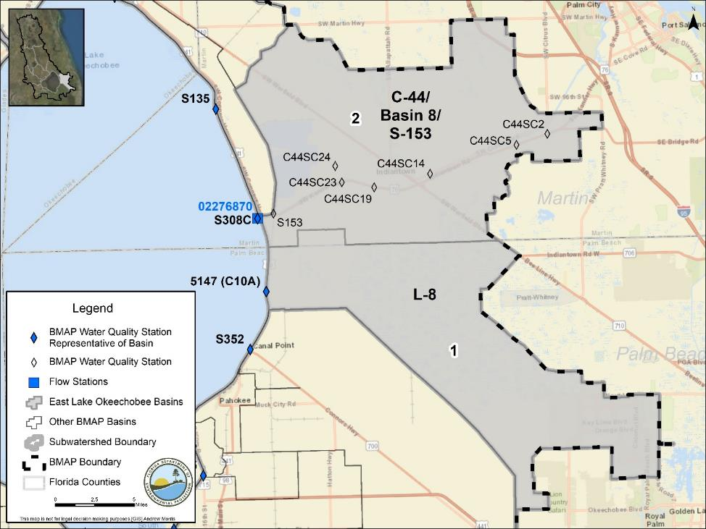
Figure 16. Locations of the water quality monitoring stations in the East Lake Okeechobee Subwatershed

Basin Evaluation Results
The current TP load based on data from WY2014–WY2018 for the East Lake Okeechobee Subwatershed is 16.8 mt/yr. A reduction of 13.9 mt/yr is required to help achieve the TMDL and meet the subwatershed target of 2.9 mt/yr.
Table 60 summarizes the basin evaluation results for the East Lake Okeechobee Subwatershed. The concentrations in the two basins are variable, depending on the flow to the lake from the subwatershed. Based on evaluations made by SFWMD in the LOWCP update, flow was determined not to be an issue in the subwatershed. Table 61 lists the TRA prioritization results for the subwatershed, with 1 the highest priority, 2 the next highest priority, and 3 a priority as resources allow.
Table 60. Basin evaluation results for the East Lake Okeechobee Subwatershed
Variable = Flows to the lake in this area are inconsistent and the concentrations are variable.
TRA ID | Basin Name | TN (mg/L)  (Benchmark – 1.54) | TP (mg/L)  (Benchmark – 0.12) | Flow
1 | L-8 | Variable | Variable | No
2 | C-44/Basin 8/S-153 | Variable | Variable | No

Table 61. TRA evaluation results for the East Lake Okeechobee Subwatershed
Basin | Station | TP Priority | TN Priority | Flow Priority
C-44/Basin 8/S-153 | S308C | 1 | 1 | 3
L-8 | 5147 | 1 | 1 | 3

Projects
The sections below summarize the existing and planned and future projects for the East Lake Okeechobee Subwatershed that were provided for the BMAP. The existing and planned projects are a BMAP requirement, while future projects will be implemented as funding becomes available for project implementation. Appendix A provides additional details about the projects and the terms used in these tables.

Existing and Planned Projects
Table 62 summarizes the existing and planned projects provided by the stakeholders for the East Lake Okeechobee Subwatershed.
Table 62. Existing and planned projects in the East Lake Okeechobee Subwatershed
Lead Entity | Partners | Project Number | Project Name | Project Description | Project Type | Project Status | Estimated Completion Date | TN Reduction (lbs/yr) | TN Reduction (mt/yr) | TP Reduction (lbs/yr) | TP Reduction (mt/yr) | Basin | Acres Treated | Cost Estimate | Cost Annual O&M | Funding Source | Funding Amount | DEP Contract Agreement Number
Coordinating Agency | FDOT | CA-15 | State Road (SR) 710 Regional Project | See FDOT4-01. | Stormwater System Rehabilitation | Canceled | Canceled | Canceled | Canceled | Canceled | Canceled | Canceled | TBD | TBD | TBD | FDOT | TBD | N/A
FDACS | Agricultural Producers | FDACS-13 | BMP Implementation and Verification | Enrollment and verification of BMPs by agricultural producers – East Lake Okeechobee. Acres treated based on FDACS OAWP June 2019 Enrollment and FSAID VI. Reductions were estimated using 2019 BMAP LET. | Agricultural BMPs | Completed | N/A | 81,011.0 | 36.75 | 8,554.6 | 3.88 | All East Lake Okeechobee | 56,644 | TBD | TBD | FDACS | TBD | N/A
FDACS | Agricultural Producers | FDACS-22 | Cost-share Projects | Cost-share projects paid for by FDACS. Acres treated based on FDACS OAWP June 2019 Enrollment. Reductions estimated by DEP using 2019 BMAP LET. | Agricultural BMPs | Completed | N/A | 1,326.0 | 0.60 | 82.5 | 0.04 | All East Lake Okeechobee | 2,798 | TBD | TBD | FDACS | TBD | N/A
FDOT District 4 | N/A | FDOT4-01 | FM# 432705-1 / SR 710 | SR-710/Beeline Highway widening from 2 to 4 lanes. | Grass swales without swale blocks or raised culverts | Underway | 2019 | 23.9 | 0.01 | 1.6 | 0.00 | C-44/  Basin 8/  S-153 | 145.8 | Not provided | Not provided | Not provided | Not provided | N/A
FDOT District 4 | N/A | FDOT4-02 | Public Education | Pamphlets. | Education Efforts | Completed | N/A | 3.3 | 0.00 | 0.3 | 0.00 | C-44/  Basin 8/  S-153, L-8 | 711.7 | Not provided | Not provided | Not provided | Not provided | N/A
FDOT District 4 | N/A | FDOT4-05 | Street Sweeping | Continued sweeping. | Street Sweeping | Completed | N/A | 541.8 | 0.25 | 283.3 | 0.13 | C-44/  Basin 8/  S-153 | N/A | Not provided | Not provided | Not provided | Not provided | N/A
FDOT District 4 | N/A | FDOT4-06 | Catch Basin Clean-Out | Continued cleanout. | BMP Cleanout | Completed | N/A | TBD | TBD | TBD | TBD | C-44/  Basin 8/  S-153 | N/A | Not provided | Not provided | Not provided | Not provided | N/A

Future Projects
No future projects were provided by the stakeholders for the East Lake Okeechobee Subwatershed.

South Lake Okeechobee Subwatershed
The South Lake Okeechobee Subwatershed covers more than 363,000 acres of the LOW and is made up of 9 basins. As shown in Table 63, the predominate land use is agriculture with 92.5 % of the subwatershed, followed by urban and built-up with 3.7 %. Stakeholders in the subwatershed are the City of Belle Glade, City of Clewiston, City of Pahokee, City of South Bay, FDOT District 4, Hendry County, Palm Beach County, East Beach WCD, East Hendry County Drainage District, East Shore WCD, Highlands Glades Drainage District, Northern Palm Beach County Improvement District, Pahokee Drainage District, Pelican Lake WCD, Ritta Drainage District, South Shore Drainage District, and South Florida Conservancy District.
Table 63. Summary of land uses in the South Lake Okeechobee Subwatershed
Level 1 Land Use Code | Land Use Description | Acres | % Total
1000 | Urban and Built-Up | 13,432 | 3.7
2000 | Agriculture | 335,878 | 92.5
3000 | Upland Nonforested | 1,369 | 0.4
4000 | Upland Forests | 150 | 0.0
5000 | Water | 3,645 | 1.0
6000 | Wetlands | 2,331 | 0.6
7000 | Barren Land | 3,346 | 0.9
8000 | Transportation, Communication, and Utilities | 2,992 | 0.8
 | Total | 363,143 | 100.0

Water Quality Monitoring
In the South Lake Okeechobee Subwatershed, the BMAP monitoring network includes water quality stations in all nine of the basins. Table 64 summarizes the water quality monitoring stations in the subwatershed, and Figure 17 shows the station locations. Table 64 also includes recommendations to change the location, frequency, or parameters sampled for the stations to better align with the BMAP.
Table 64. Water quality monitoring stations in the South Lake Okeechobee Subwatershed
Basin | Representative Site? | Entity | Station ID | Tier | Data Needs
S-4 | No | SFWMD | INDUSCAN | 1 | N/A
S-4 | No | SFWMD | S169 | 1 | N/A
S2 | No | SFWMD | S351 | 1 | N/A
S-3 | No | SFWMD | S354 | 1 | N/A
South Shore Drainage District  (Culv 4A) | Yes | South Shore Drainage District | C-4A | 1 | Increase collection frequency for TN and TP – only TP collected when flowing to lake
S-3 | Yes | SFWMD | S3 | 1 | Sufficient TN and TP data
S2 | Yes | SFWMD | S2 | 1 | Needs further investigation – only TP collected when flowing to lake
South Florida Conservancy District  (S-236) | Yes | South Florida Conservancy District/SFWMD | S-236 | 1 | Sufficient TN and TP data
S-4 | Yes | SFWMD | S4 | 1 | Sufficient TN and TP data
East Beach WCD (Culv 10) | Yes | East Beach WCD | S273 (C-10) | 1 | Increase collection frequency for TN and TP – only TP collected when flowing to lake
S-5A Basin (S-352-West Palm Beach [WPB] Canal) | Yes | SFWMD | S352 | 1 | Sufficient TN and TP data
715 Farms  (Culv 12A) | Yes | Sugar Farms Co-Op | S274 (C12A) | 1 | Increase collection frequency for TN and TP – only TP collected when flowing to lake
East Shore WCD (Culv 12) | Yes | East Shore WCD | S275 (C-12) | 2 | Increase collection frequency for TN and TP – only TP collected when flowing to lake
S2 | No | USGS | 02280500 | 3 | N/A
S2 | No | USGS | 02283500 | 3 | N/A
S-3 | No | USGS | 02286400 | 3 | N/A
S-4 | No | USGS | 264514080550700 | 3 | N/A

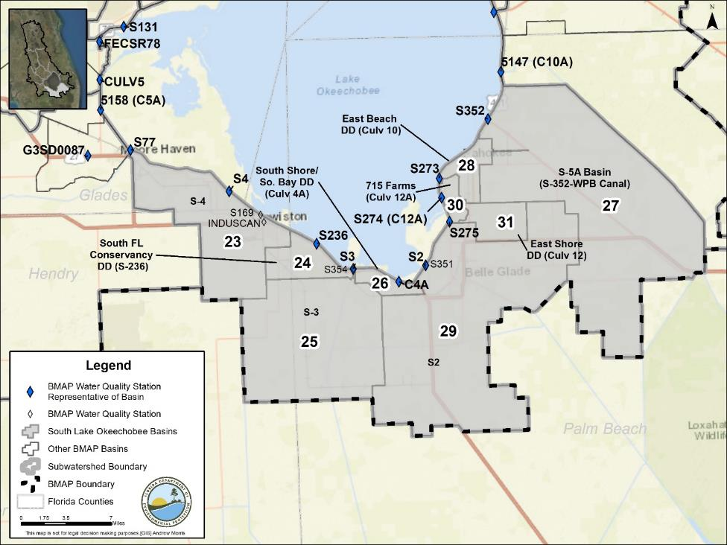
Figure 17. Locations of the water quality monitoring stations in the South Lake Okeechobee Subwatershed

Basin Evaluation Results
The current TP load based on data from WY2014–WY2018 for the South Lake Okeechobee Subwatershed is 29.0 mt/yr. A reduction of 23.9 mt/yr is required to help achieve the TMDL and meet the subwatershed target of 5.1 mt/yr.
Table 65 summarizes the basin evaluation results for the South Lake Okeechobee Subwatershed. The concentrations in the nine basins are variable depending on the flow to the lake from the subwatershed. Based on evaluations made by SFWMD in the LOWCP update, flow was determined not to be an issue in the subwatershed. Table 66 lists the TRA prioritization results for the South Lake Okeechobee Subwatershed, with 1 the highest priority, 2 the next highest priority, and 3 a priority as resources allow.
Table 65. Basin evaluation results for the South Lake Okeechobee Subwatershed
Variable = Flows to the lake in this area are inconsistent and the concentrations are variable.
TRA ID | Basin Name | TN (mg/L)  (Benchmark – 1.54) | TP (mg/L)  (Benchmark – 0.12) | Flow
23 | S-4 | Variable | Variable | No
24 | South FL Conservancy Drainage District (S-236) | Variable | Variable | No
25 | S-3 | Variable | Variable | No
26 | South Shore/ So. Bay Drainage District (Culv 4A) | Variable | Variable | No
27 | S-5A Basin (S-352-WPB Canal) | Variable | Variable | No
28 | East Beach Drainage District (Culv 10) | Variable | Variable | No
29 | S2 | Variable | Variable | No
30 | 715 Farms (Culv 12A) | Variable | Variable | No
31 | East Shore Drainage District (Culv 12) | Variable | Variable | No

Table 66. TRA evaluation results for the South Lake Okeechobee Subwatershed
Insufficient data = Available data were not at the frequency needed for evaluation.
Basin | Station | TP Priority | TN Priority | Flow Priority
715 Farms (Culv 12A) | S274 (C12A) | Insufficient Data | Insufficient Data | 3
East Beach Drainage District (Culv 10) | S273 | 2 | 1 | 3
East Shore Drainage District (Culv 12) | S275 | Insufficient Data | Insufficient Data | 3
S2 | S2 | 2 | 1 | 3
S-3 | S3 | 3 | 1 | 3
S-4 | S4 | 1 | 1 | 3
S-5A Basin (S-352-WPB Canal) | S352 | 2 | 2 | 3
South Florida Conservancy Drainage District (S-236) | S236 | 3 | 1 | 3
South Shore/ So. Bay Drainage District (Culv 4A) | C4A | 2 | 2 | 3

Projects
The sections below summarize the existing and planned and future projects for the South Lake Okeechobee Subwatershed that were provided for the BMAP. The existing and planned projects are a BMAP requirement, while future projects will be implemented as funding becomes available for project implementation. Appendix A provides additional details about the projects and the terms used in these tables.

Existing and Planned Projects
Table 67 summarizes the existing and planned projects provided by the stakeholders for the South Lake Okeechobee Subwatershed.
Table 67. Existing and planned projects in the South Lake Okeechobee Subwatershed
Lead Entity | Partners | Project Number | Project Name | Project Description | Project Type | Project Status | Estimated Completion Date | TN Reduction (lbs/yr) | TN Reduction (mt/yr) | TP Reduction (lbs/yr) | TP Reduction (mt/yr) | Basin | Acres Treated | Cost Estimate | Cost Annual O&M | Funding Source | Funding Amount | DEP Contract Agreement Number
FDACS | Agricultural Producers | FDACS-14 | BMP Implementation and Verification | Enrollment and verification of BMPs by agricultural producers – South Lake Okeechobee. Acres treated based on FDACS OAWP June 2019 Enrollment and FSAID VI. Reductions estimated using 2019 BMAP LET. | Agricultural BMPs | Completed | N/A | 311,617.0 | 141.35 | 18,273.7 | 8.29 | All South Lake Okeechobee | 292,512 | TBD | TBD | FDACS | TBD | N/A
FDACS | Agricultural Producers | FDACS-23 | Cost-share Projects | Cost-share projects paid for by FDACS. Acres treated based on FDACS OAWP June 2019 Enrollment. Reductions estimated by DEP using 2019 BMAP LET. | Agricultural BMPs | Completed | N/A | 376.3 | 0.17 | 48.2 | 0.02 | All South Lake Okeechobee | 752 | TBD | TBD | FDACS | TBD | N/A
FDOT District 4 | N/A | FDOT4-03 | Public Education | Pamphlets. | Education Efforts | Completed | N/A | 32.5 | 0.01 | 1.4 | 0.00 | South Florida Conservancy Drainage District (S-236), S-3, South Shore/ So. Bay Drainage District (Culv 4A), S-5A Basin (S-352-WPB Canal), East Beach Drainage District (Culv 10), S2, 715 Farms (Culv 12A), East Shore Drainage District (Culv 12) | 1,954.6 | Not provided | Not provided | Not provided | Not provided | N/A

Future Projects
No future projects were provided by the stakeholders for the South Lake Okeechobee Subwatershed.

West Lake Okeechobee Subwatershed
The West Lake Okeechobee Subwatershed covers more than 204,000 acres of the LOW and is made up of 3 basins. As shown in Table 68, the predominate land use is agriculture with 66.2 % of the subwatershed, followed by wetlands with 14.4 %. Stakeholders in the subwatershed are the City of Moore Haven, Glades County, Barron WCD, Clewiston Drainage District, Collins Slough WCD, Devils Garden WCD, Disston Island Conservancy District, Flaghole Drainage District, Henry Hillard WCD, and Sugarland Drainage District.
Table 68. Summary of land uses in the West Lake Okeechobee Subwatershed
Level 1 Land Use Code | Land Use Description | Acres | % Total
1000 | Urban and Built-Up | 7,457 | 3.7
2000 | Agriculture | 135,032 | 66.2
3000 | Upland Nonforested | 5,894 | 2.9
4000 | Upland Forests | 20,659 | 10.1
5000 | Water | 2,166 | 1.1
6000 | Wetlands | 29,317 | 14.4
7000 | Barren Land | 2,084 | 1.0
8000 | Transportation, Communication, and Utilities | 1,485 | 0.7
 | Total | 204,094 | 100.0

Water Quality Monitoring
In the West Lake Okeechobee Subwatershed, the BMAP monitoring network includes water quality stations in all three of the basins. Table 69 summarizes the water quality monitoring stations in the subwatershed, and Figure 18 shows the station locations. Table 69 also includes recommendations to change the location, frequency, or parameters sampled for the station to better align with the BMAP.
Table 69. Water quality monitoring stations in the West Lake Okeechobee Subwatershed
Basin | Representative Site? | Entity | Station ID | Tier | Data Needs
East Caloosahatchee | Yes | SFWMD | S77 | 1 | Sufficient TN and TP data
Nicodemus Slough North | Yes | SFWMD | 5158 (C5A) | 2 | Increase collection frequency for TN and TP – biweekly sampling when flowing
East Caloosahatchee | Proposed | SFWMD | CRFW01 | 2 | Proposed station as part of SFWMD expanded monitoring
East Caloosahatchee | Proposed | SFWMD | CRFW02 | 2 | Proposed station as part of SFWMD expanded monitoring
East Caloosahatchee | Proposed | SFWMD | CRFW03 | 2 | Proposed station as part of SFWMD expanded monitoring
East Caloosahatchee | Proposed | SFWMD | CRFW04 | 2 | Proposed station as part of SFWMD expanded monitoring
East Caloosahatchee | Proposed | SFWMD | CRFW05 | 2 | Proposed station as part of SFWMD expanded monitoring
Hicpochee North | Yes | DEP South ROC | G3SD0087 | 2 | Increase collection frequency for TN and TP
Hicpochee North | No | SFWMD | CRFW33 | 2 | Proposed station as part of SFWMD expanded monitoring
East Caloosahatchee | No | USGS | 02292010 | 3 | N/A

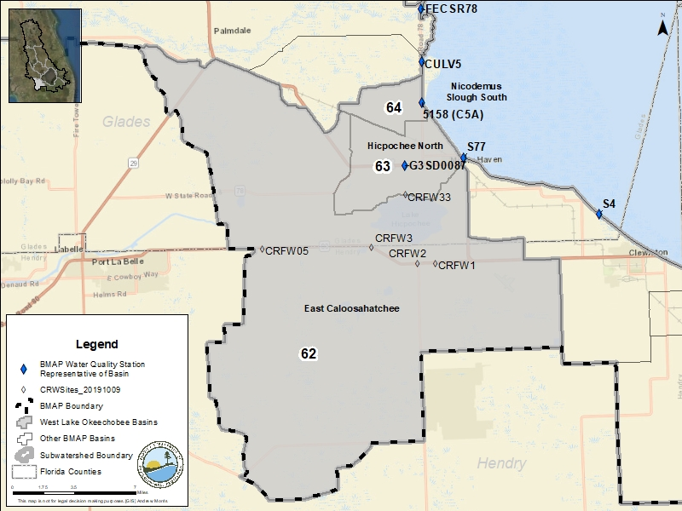
Figure 18. Locations of the water quality monitoring stations in the West Lake Okeechobee Subwatershed

Basin Evaluation Results
The current TP load based on data from WY2014–WY2018 for the West Lake Okeechobee Subwatershed is 0 mt/yr. Therefore, reductions are not required to help achieve the TMDL.
Table 70 summarizes the basin evaluation results for the subwatershed. The concentrations in the three basins are variable depending on the flow to the lake from the subwatershed. Based on evaluations made by SFWMD in the LOWCP update, flow was determined not to be an issue in the basins. Table 71 lists the TRA prioritization results for the subwatershed, with 1 the highest priority, 2 the next highest priority, and 3 a priority as resources allow.
Table 70. Basin evaluation results for the West Lake Okeechobee Subwatershed
Variable = Flows to the lake in this area are inconsistent and the concentrations are variable.
TRA ID | Basin Name | TN (mg/L)  (Benchmark – 1.54) | TP (mg/L)  (Benchmark – 0.12) | Flow
62 | East Caloosahatchee | Variable | Variable | No
63 | Hicpochee North | Variable | Variable | No
64 | Nicodemus Slough South | Variable | Variable | No

Table 71. TRA evaluation results for the West Lake Okeechobee Subwatershed
Insufficient data = Available data were not at the frequency needed for evaluation.
Basin | Station | TP Priority | TN Priority | Flow Priority
East Caloosahatchee | S77 | 3 | 3 | 3
Hicpochee North | G3SD0087 | 3 | Insufficient Data | 3
Nicodemus Slough South | C5A | 2 | 1 | 3

Projects
The sections below summarize the existing and planned and future projects for the West Lake Okeechobee Subwatershed that were provided for the BMAP. The existing and planned projects are a BMAP requirement, while future projects will be implemented as funding becomes available for project implementation. Appendix A provides additional details about the projects and the terms used in these tables.

Existing and Planned Projects
Table 72 summarizes the existing and planned projects provided by the stakeholders for the West Lake Okeechobee Subwatershed.
Table 72. Existing and planned projects in the West Lake Okeechobee Subwatershed
Lead Entity | Partners | Project Number | Project Name | Project Description | Project Type | Project Status | Estimated Completion Date | TN Reduction (lbs/yr) | TN Reduction (mt/yr) | TP Reduction (lbs/yr) | TP Reduction (mt/yr) | Basin | Acres Treated | Cost Estimate | Cost Annual O&M | Funding Source | Funding Amount | DEP Contract Agreement Number
FDACS | Agricultural Producers | FDACS-15 | BMP Implementation and Verification | Enrollment and verification of BMPs by agricultural producers – West Lake Okeechobee. Acres treated based on FDACS OAWP June 2019 Enrollment and FSAID VI. Reductions were estimated using 2019 BMAP LET. | Agricultural BMPs | Completed | N/A | 17,069.1 | 7.74 | 1,135.0 | 0.51 | All West Lake Okeechobee | 118,151 | TBD | TBD | FDACS | TBD | N/A
FDACS | Agricultural Producers | FDACS-24 | Cost-share Projects | Cost-share projects paid for by FDACS. Acres treated based on FDACS OAWP June 2019 Enrollment. Reductions estimated by DEP using 2019 BMAP LET. | Agricultural BMPs | Completed | N/A | 908.4 | 0.41 | 50.1 | 0.02 | All West Lake Okeechobee | 5,595 | TBD | TBD | FDACS | TBD | N/A
Glades County | N/A | GC-03 | Glades County Caloosahatchee River and Estuary Area Wastewater Grant | Elimination of aging and/or failing existing septic systems in City of Moore Haven. Project also provides for increased conveyance capacity for additional homes and businesses. | OSTDS Phase Out | Planned | 2021 | 252.0 | 0.11 | 0.0 | 0.00 | Hicpochee North | 86.5 | $891,848 | $12,240 | GAA | $891,848.00 | LP22023
Glades County | N/A | GC-04 | Glades County Business Park Wetlands | Wetland maintenance and planting agreement | Wetland Restoration | Planned | 2021 | 0.0 | 0.00 | 0.0 | 0.00 | Hicpochee North | 8.8 | $42,395 | Not provided | Glades County | $42,395 | N/A

Future Projects
No future projects were provided by the stakeholders for the West Lake Okeechobee Subwatershed.

In-Lake Strategies
The Lake Okeechobee BMAP is established to address loads from the LOW; however, the treatment of legacy loads in the lake is also important for restoration. This section documents in-lake treatment strategies and water quality monitoring. These are not management strategies within the meaning of Section 403.067, F.S., and are provided for informational purposes. Additional information on water quality in Lake Okeechobee can be found in the latest SFER, published annually on the SFWMD website.

Water Quality Monitoring
Figure 19 shows the locations of the in-lake monitoring stations. These stations are not part of the BMAP monitoring network but are monitored to evaluate in-lake water quality. Additional information on in-lake monitoring is reported annually in the SFER.
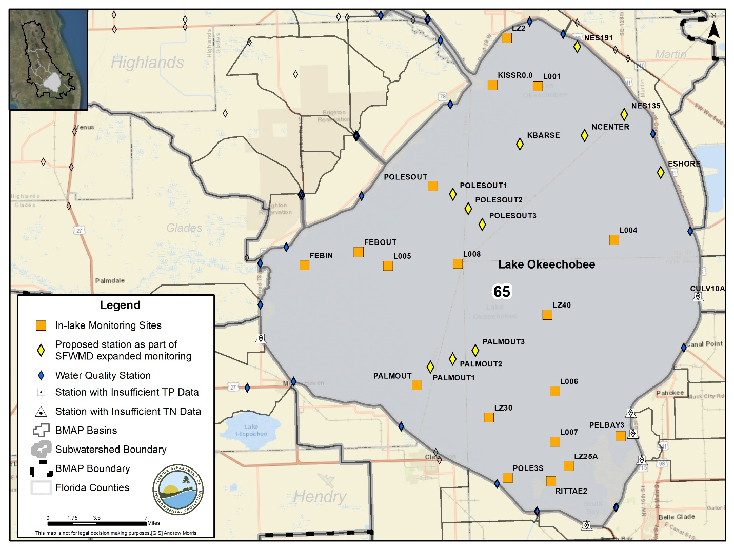
Figure 19. Locations of the water quality monitoring stations in Lake Okeechobee

Projects
The 2014 Lake Okeechobee BMAP lists the in-lake strategies of muck scraping and tilling as a BMAP initiative. Additional projects that were added as part of this BMAP are included in the sections below.

Existing and Planned Projects
Pursuant to the NEEPP (Section 373.4595, F.S.), the Lake Okeechobee Internal Phosphorus Management Program is a component of the LOWPP. In accordance with Paragraph 373.4595(3)(d), F.S., this legislation requires SFWMD, in cooperation with the Coordinating Agencies and interested parties, to evaluate the feasibility of Lake Okeechobee internal phosphorus load removal projects. The evaluation must be based on technical feasibility, as well as economic considerations, and consider all reasonable methods of phosphorus removal. Relevant information resulting from the Lake Okeechobee Internal Phosphorus Management Program is covered in the LOWPP 2020 Update (to be published by March 1, 2020, as Appendix 8A-1 of the final 2020 SFER – Volume I), with a brief overview provided below.
Internal phosphorus loading from sediments in Lake Okeechobee is primarily affected by two factors: (1) the depth of resuspendable sediment, and (2) the distribution of that sediment once entrained in the water column. Prior studies have focused on the plausibility of reducing resuspension, both through the capping and removal of sediment (SFWMD 2003). However, to date there has been little focus on evaluating options for reducing distribution. Consequently, a modeling effort by SFWMD is planned in fiscal year (FY) 2020 to assess the effects of increasing the height of natural rock barriers in the southern portions of the lake to isolate turbid pelagic water from nearshore areas. Using a hydrocirculation model, several alternative heights and locations of rock formation are being evaluated for their effects on circulation patterns and turbidity in the lake's southern portion at various stages and wind directions.
The properties of in-lake sediments (e.g., depth, nutrient content, exchange rates, uptake capacity, and distribution of easily resuspended mud) have been historically monitored, but these have not been studied for more than a decade (SFWMD 2007). To address this need, a proposed effort is planned in FY 2020–21 to reassess the sediment properties and distribution in the lake to determine how Hurricane Irma (which made landfall in Florida on September 10, 2017) affected the location and depths of resuspendable sediments, as well as nutrient content, exchange rates, and uptake capacity.
Long-term water quality monitoring in the lake suggests the depth of resuspendable sediments―and subsequently, water column turbidity―has increased since the 2004–05 hurricanes, possibly affecting the burial rates of phosphorus, soil/water interface properties, light penetration, and other factors. Updating sediment maps will also help improve lake circulation models by further reducing uncertainties and allowing better predictions of the effects of any mitigation strategies, such as future dredging or mud isolation projects.

Future Projects
Table 73 lists the future in-lake projects included in the LOWCP.
Table 73. Future in-lake projects
Lead Entity | Partners | Project Number | Project Name | Project Description | Project Type | Project Status | Acres Treated | TN Reduction (lbs/yr) | TN Reduction (mt/yr) | TP Reduction (lbs/yr) | TP Reduction (mt/yr) | Basin | Cost Estimate | Cost Annual O&M
Coordinating Agency | N/A | F-37 | In-Lake Strategies | Low stage muck scraping, and tilling | Muck Removal/  Restoration Dredging | Conceptual | TBD | TBD | TBD | TBD | TBD | In-lake | TBD | TBD
Coordinating Agency | N/A | F-38 | In-Lake Strategies | New concepts and technologies for in-lake phosphorus treatment. | Muck Removal/  Restoration Dredging | Conceptual | TBD | TBD | TBD | TBD | TBD | In-lake | TBD | TBD

- Summary

Targeted Restoration Area Evaluation Results
Table 74 summarizes the results of the TRA evaluation process that were presented by subwatershed in Chapter 4 for the basins in the LOW. For each basin, a priority was assigned based on the TP and TN concentrations and flows. These priorities were set to help focus resources and projects in the basins that are in most need of improvement. Priorities were set with 1 the highest priority, 2 the next highest priority, and 3 a priority as resources allow.
Table 74. Summary of the TRA evaluation results
*SFWMD determined that additional investigations are needed regarding whether water quantity is an issue in this subwatershed.
Insufficient data = Available data were not at the frequency needed for evaluation.
Subwatershed | Basin | Station | TP Priority | TN Priority | Flow Priority
Fisheating Creek | Fisheating Creek/L-61 | FECSR78 | 1 | 1 | 2
Fisheating Creek | Nicodemus Slough North | CULV5 | 3 | 1 | 3
Indian Prairie | C-40 | S72 | 1 | 1 | 3
Indian Prairie | C-41 | S71 | 1 | 1 | 3
Indian Prairie | C-41A | S84 | 1 | 1 | 1
Indian Prairie | L-48 | S127 | 1 | 2 | 3
Indian Prairie | L-49 | S129 | 3 | 3 | 3
Indian Prairie | L-59E | L59E | 2 | 1 | 2
Indian Prairie | L-59W | L59W | 2 | 2 | 2
Indian Prairie | L-60E | L60E | 1 | 2 | 2
Indian Prairie | L-60W | L60W | 1 | 1 | 2
Indian Prairie | L-61E | L61E | 1 | 1 | 2
Indian Prairie | S-131 | S131 | 2 | 3 | 3
Lake Istokpoga | Arbuckle Creek | 30854 | 3 | 3 | *
Lake Istokpoga | Josephine Creek | LI02362923 | 3 | Insufficient Data | *
Lake Istokpoga | Lake Arbuckle | ARBUCKLE1-274119812344 | 3 | 3 | *
Lake Istokpoga | Lake Istokpoga | 30853 | 2 | 1 | *
Lower Kissimmee | Kissimmee River | S65D | 3 | Insufficient Data | 3
Lower Kissimmee | S-65A | 18085 | 3 | 3 | 3
Lower Kissimmee | S-65E | 18130 (S65E) | 1 | 3 | 3
Taylor Creek/  Nubbin Slough | S-133 | S133 | 1 | 1 | 2
Taylor Creek/  Nubbin Slough | S-135 | S135 | 1 | 1 | 3
Taylor Creek/  Nubbin Slough | S-154 | S154 | 1 | 1 | 2
Taylor Creek/  Nubbin Slough | S-154C | S154C | 1 | 1 | 2
Taylor Creek/  Nubbin Slough | S191 | S191 | 1 | 1 | 2
Upper Kissimmee | Alligator Lake | S60 | Insufficient Data | Insufficient Data | 3
Upper Kissimmee | Boggy Creek | ABOGGN | 2 | 3 | 3
Upper Kissimmee | Catfish Creek | 34008 | 3 | 3 | 3
Upper Kissimmee | East Lake Tohopekaliga | BS-59 | 3 | 3 | 3
Upper Kissimmee | Horse Creek (closed basin) | Horse Crk2 | 3 | 3 | 3
Upper Kissimmee | Lake Conlin (closed basin) | None | Insufficient Data | Insufficient Data | 3
Upper Kissimmee | Lake Cypress | 4002 | 3 | 3 | 3
Upper Kissimmee | Lake Gentry | GENTRYDTCH | 3 | Insufficient Data | 3
Upper Kissimmee | Lake Hart | MJ01253123 | 3 | Insufficient Data | 3
Upper Kissimmee | Lake Hatchineha | EC-37 | 3 | Insufficient Data | 3
Upper Kissimmee | Lake Jackson | LJACKDSCH | 3 | Insufficient Data | 3
Upper Kissimmee | Lake Kissimmee | S65 | 1 | 2 | 3
Upper Kissimmee | Lake Marian | ML22303313 | 2 | Insufficient Data | 3
Upper Kissimmee | Lake Marion | 51242 | 3 | Insufficient Data | 3
Upper Kissimmee | Lake Myrtle | None | Insufficient Data | Insufficient Data | 3
Upper Kissimmee | Lake Pierce | Pierce1 | 3 | 3 | 3
Upper Kissimmee | Lake Rosalie | KUB009 | 3 | Insufficient Data | 3
Upper Kissimmee | Lake Tohopekaliga | CL18273011 | 3 | Insufficient Data | 3
Upper Kissimmee | Lake Weohyakapka | Weohyakapka1 | 3 | 3 | 3
Upper Kissimmee | Lower Reedy Creek | CREEDYBR | 3 | 3 | 3
Upper Kissimmee | Marion Creek | DLMARNCR-DLONDNCR | 3 | Insufficient Data | 3
Upper Kissimmee | S63A | S63A | Insufficient Data | Insufficient Data | 3
Upper Kissimmee | Shingle Creek | SCD | 3 | 3 | 3
Upper Kissimmee | Tiger Lake | Tiger1 (Tiger1-G4CE0070) | 3 | 3 | 3
Upper Kissimmee | Upper Reedy Creek | C-12E (C-12E-RC-13H) | 3 | Insufficient Data | 3
East Lake Okeechobee | C-44/Basin 8/S-153 | S308C | 1 | 1 | 3
East Lake Okeechobee | L-8 | 5147 (C10A) | 1 | 1 | 3
West Lake Okeechobee | East Caloosahatchee | S77 | 3 | 3 | 3
West Lake Okeechobee | Hicpochee North | G3SD0087 | 3 | Insufficient Data | 3
West Lake Okeechobee | Nicodemus Slough South | 5158 (C5A) | 2 | 1 | 3
South Lake Okeechobee | 715 Farms (Culv 12A) | S274 (C12A) | Insufficient Data | Insufficient Data | 3
South Lake Okeechobee | East Beach Drainage District (Culv 10) | S273 (C10) | 2 | 1 | 3
South Lake Okeechobee | East Shore Drainage District (Culv 12) | S275 | Insufficient Data | Insufficient Data | 3
South Lake Okeechobee | S2 | S2 | 2 | 1 | 3
South Lake Okeechobee | S-3 | S3 | 3 | 1 | 3
South Lake Okeechobee | S-4 | S4 | 1 | 1 | 3
South Lake Okeechobee | S-5A Basin (S-352-WPB Canal) | S352 | 2 | 2 | 3
South Lake Okeechobee | South Florida Conservancy Drainage District (S-236) | S236 | 3 | 1 | 3
South Lake Okeechobee | South Shore/ So. Bay Drainage District (Culv 4A) | C4A | 2 | 2 | 3

RFI Responses
To further identify restoration projects for this BMAP, DEP implemented an RFI in October 2019 to generate additional restoration projects or activities from both the public and private sectors. The effort was open to any interested parties who could propose a viable project for restoration and could be considered for inclusion in the final Lake Okeechobee BMAP for funding consideration.
Overall, the RFI process generated 34 responses, mainly from the private sector. Submittals ranged from on-the-ground projects, such as STAs, to technologies that could be implemented in both aquatic and terrestrial environments. All submittals were reviewed, and Appendix E provides a summary of the submittals. Resources will be needed to implement any of these projects throughout the watershed, and they are being considered for DEP funding. Additional details on all responses are on file with DEP and may be considered as opportunities arise in the future.

Future Growth
To ensure that this BMAP effort can achieve and ultimately maintain the goal of meeting TMDL requirements, the overall restoration strategy must include actions and planning for future growth and development. New development primarily falls into two general source categories: (1) urban and (2) agriculture. Nutrient impacts from new development are addressed through a variety of mechanisms as well as other provisions of Florida law.
While the majority of the restoration projects and programs listed in this BMAP address current loading, the need to plan and implement sound management strategies to address additional population growth in the BMAP area must be considered. DEP has included in this BMAP specific elements to address all current and future WWTF effluent, septic systems, and stormwater sources. Broader laws—such as local land development regulations, comprehensive plans, ordinances, incentives, Environmental Resource Permit requirements, and consumptive use permit requirements—all provide additional mechanisms and avenues for protecting water resources and reducing the impact of new development and other land use changes as they occur.
The recommendations presented in Chapter 3 should be considered by local governments during master planning and land use decision-making efforts. At the time of BMAP development and adoption, many of these recommendations are not required by statute, but it is anticipated that some, if not all, of them may be a part of future legislative mandates and future BMAP iterations.
It should also be noted that any additional loading, such as from land use changes from low to high density, or any increase in intensity of use (that may include additional nutrient loadings), will be evaluated during future BMAP review efforts. If an increase in loading has occurred, additional restoration actions will be required to remediate impacts. DEP recommends that all local governments revise their planning and land use ordinance(s) to adequately address all future growth, and consider limitations on growth in sensitive areas, such as lands with a direct hydrologic connection to impaired waterbodies, wetland areas, or coastal areas.

Compliance
The TMDL sets an annual TP load to Lake Okeechobee of 140 mt/yr (308,647 lbs/yr), of which 35 mt/yr (77,162 lbs/yr) is estimated to fall directly on the lake through atmospheric deposition. The remaining 105 mt/yr (231,485 lbs/yr) of TP are allocated to the entire LOW. The attainment of the TMDL is calculated based on a 5-year rolling average using the monthly loads calculated from measured flow and concentration values.
In addition to overall compliance with the TMDL (i.e., 140 and 105 mt/yr of TP for the lake and entire watershed, respectively), DEP will be monitoring and working to achieve the subwatershed targets identified in Table 75. DEP will use this information to identify problem areas and sources that are not meeting the target, acknowledge them through annual reporting and public engagement, and focus resources (regulatory programs through permitting decisions, compliance and enforcement, and nutrient reduction projects) accordingly. This is a key component to the ultimate strategy for restoring the lake.
The final 2019 SFER – Volume I, Chapter 8B prepared by SFWMD, reports the 5-year average (based on data from WY2014–WY2018 [May 1, 2013–April 30, 2018]) annual TP load from the watershed as 598 mt/yr (1,318,364 lbs/yr). Therefore, to achieve the allowable TMDL load of 105 mt/yr, the TP required reductions are 493 mt/yr (1,086,879 lbs/yr). The TP required reductions were assigned to each subwatershed based on the contribution of the total load from that subwatershed (Table 75), and Table 76 lists the progress towards those reductions with projects completed through June 30, 2019. DEP will refer to the 5-year average TP load reported annually in the SFER to update the estimated load reductions needed to achieve the TMDL and to track progress towards the TMDL.
Table 75. Load reductions and targets by subwatershed
Subwatershed | WY2014–WY2018 TP Load (mt/yr) | % Contribution of Load | TP Load Required Reduction (mt/yr) | TP Target (mt/yr)
Fisheating Creek | 72.4 | 12 | 59.7 | 12.7
Indian Prairie | 102.5 | 17 | 84.5 | 18.0
Lake Istokpoga | 47.7 | 8 | 39.3 | 8.4
Lower Kissimmee | 125.9 | 21 | 103.8 | 22.1
Taylor Creek/Nubbin Slough | 113.6 | 19 | 93.7 | 19.9
Upper Kissimmee | 90.5 | 15 | 74.6 | 15.9
East Lake Okeechobee | 16.8 | 3 | 13.9 | 2.9
South Lake Okeechobee | 29.0 | 5 | 23.9 | 5.1
West Lake Okeechobee | 0.0 | 0 | 0.0 | 0.0
Total | 598.4 | 100 | 493.4 | 105.0

Table 76. Load reductions achieved through June 30, 2019, by subwatershed
Subwatershed | TP Load Required Reduction  (mt/yr) | TP Reduction Through June 30, 2019  (mt/yr) | TP Reductions Achieved Through June 30, 2019  (%)
Fisheating Creek | 59.7 | 14.4 | 24.1
Indian Prairie | 84.5 | 20.5 | 24.3
Lake Istokpoga | 39.3 | 2.5 | 6.4
Lower Kissimmee | 103.8 | 5.6 | 5.4
Taylor Creek/Nubbin Slough | 93.7 | 23.3 | 24.9
Upper Kissimmee | 74.6 | 16.4 | 22.0
East Lake Okeechobee | 13.9 | 4.0 | 28.8
South Lake Okeechobee | 23.9 | 8.3 | 34.7
West Lake Okeechobee | 0.0 | 0.5 | N/A
Total | 493.4 | 95.5 | 19.4

- References
CDM. 2011. Lake Tohopekaliga Nutrient Reduction Plan.
Florida Department of Environmental Protection. 2001. Total maximum daily load for total phosphorus in Lake Okeechobee. Tallahassee, FL.
Soil and Water Engineering Technology, Inc. 2016. Estimation of total phosphorus and nitrogen load reductions associated with FDACS Lake Okeechobee cost-share BMP Program. Tasks 1 and 2. --
———. 2017a. Watershed Assessment Model (WAM): Recalibration of the northern Lake Okeechobee basins. Deliverable 1 WAM recalibration report. Florida Department of Agriculture and Consumer Services Contract No. 24010.
———. 2017b. WAM calibration for the Lake Okeechobee Watershed. Deliverable #2: Southern subwatersheds calibration, Deliverable #3: Southern subwatersheds verification, Deliverable #4: Southern subwatersheds goodness of fit. Florida Department of Agriculture and Consumer Services Contract No.: 024010.
———. 2018. Evaluation of effectiveness of abatement strategies compared against predrainage and existing conditions in the Lake Okeechobee Watershed. Deliverable 2.2: Final predrainage characterization report. Delivered to South Florida Water Management District on November 13, 2018.
South Florida Water Management District. 2003. Evaluation of alternatives – Lake Okeechobee sediment management feasibility study. Final report, C-11650. Blasland, Bouck and Lee Inc.
———. 2007. Lake Okeechobee sediment quality mapping project. Final report, ST060576-WO01. BEM Systems Inc. and University of Florida.
———. 2019. 2019 South Florida Environmental Report.
South Florida Water Management District, Florida Department of Environmental Protection, Florida Department of Agriculture and Consumer Services. 2007. Lake Okeechobee Protection Program, Lake Okeechobee Protection Plan. West Palm Beach and Tallahassee, FL.
———. 2008. Lake Okeechobee Watershed Construction Project Phase II Technical Plan. West Palm Beach and Tallahassee, FL.
U.S Environmental Protection Agency. 2002. Onsite Wastewater Treatment Systems Manual. EPA/625/R-00/008.

Appendices

Appendix A. BMAP Projects Supporting Information
The project tables in this BMAP list the implementation status of the BMAP projects as of June 30, 2019. The tables list the attenuated TP and TN reductions (in lbs/yr and mt/yr) attributable to each individual project. These projects were submitted to DEP by responsible entities with the understanding that the projects and activities would be included in the BMAP, thus setting the expectation for each entity to implement the proposed projects and activities to achieve the assigned load reduction estimates in the specified time.
However, the list of projects is meant to be flexible enough to allow for changes that may occur over time. During the annual review of BMAP implementation efforts, project-specific information may be revised and updated, resulting in changes to the estimated reductions for those projects. The revisions may increase or decrease estimated reductions, and DEP will work with stakeholders to address revisions as they are identified.
The project status column is standardized into the following four categories:
- Canceled: Project or activity that was planned but will no longer take place. This category includes the cessation of ongoing activities.
- Completed: Project, activity, or task that is finished. This category includes fully implemented activities (i.e., ongoing activities) that must continue to maintain assigned credits indefinitely (such as street sweeping, BMP clean-out, catch basin cleanout, public education, fertilizer cessation/reduction, and vegetation harvesting).
- Planned: Project or activity that is conceptual or proposed.
- Underway: Project or activity that has commenced or initiated but is not completed and is not yet reducing nutrient loads from the treated area.
Prior to reporting project information, DEP contacts each lead entity to gather new information on projects and confirm previously reported information. The terms used throughout the project tables are defined as follows:
- Not provided: Denotes that information was requested by DEP but was not provided by the lead entity.
- TBD: To be determined. Denotes that information is not currently available but will be provided by the stakeholder when it is available.
- N/A: Not applicable. Denotes that information for that category is not relevant to that project.
- 0: Zero. Denotes the numeric value for that category as zero.
The project tables are based on current information, and project details may be updated as further information becomes available.
This BMAP requires stakeholders to implement their projects to achieve reductions as soon as practicable. However, the full implementation of the BMAP will be a long-term process. While some of the projects and activities listed in the BMAP were recently completed or are currently ongoing, several projects require more time to design, secure funding, and construct. Unlike the existing and planned projects, these future projects are not yet considered commitments of the entities but rather are intended for future BMAP credit, pending the availability of funding and other resources.
Although BMAP implementation is a long-term process, the goal of this BMAP is to achieve the TMDL within 20 years from BMAP adoption. It is understood that all waterbodies can respond differently to the implementation of reduced loadings to meet applicable water quality standards. Continued coordination and communication by the stakeholders will be essential to ensure that management strategies continue to meet the implementation milestones.
DEP requested information from stakeholders on future projects and also released an RFI to obtain proposals for restoration projects and technologies with the potential for additional load reductions in the basin. Funding has not yet been identified for many of these future and RFI projects, and the additional funding of projects is a key part of making the reductions required to achieve the TMDL. The future project tables in Chapter 4 will be updated as project details are refined and funding is obtained.

Appendix B. Agricultural Enrollment and Reductions
(Language in this appendix was provided by FDACS.)
All agricultural nonpoint sources in the Lake Okeechobee BMAP area are statutorily required either to implement FDACS-adopted BMPs or to conduct water quality monitoring prescribed by DEP or the applicable water management district. Under Paragraph 403.067(7)(c), F.S., the implementation of FDACS-adopted, DEP-verified BMPs, in accordance with FDACS rules, provides a presumption of compliance with state water quality standards for the pollutants addressed by the BMPs.
FDACS Role in BMP Implementation and Followup
When DEP adopts a BMAP that includes agriculture, it is the agricultural landowner's responsibility to implement BMPs adopted by FDACS to help achieve load reductions. To date, FDACS OAWP has adopted BMP manuals by rule for cow/calf, citrus, vegetable and agronomic crops, nurseries, equine, sod, dairy, poultry, and specialty fruit and nut operations. All OAWP BMP manuals are periodically revised, updated, and subsequently reviewed and preliminarily verified by DEP before readoption. OAWP intends to update BMP manuals every five years.
To enroll in the BMP Program, landowners must meet with OAWP to determine the BMPs that are applicable to their operation. The landowner must submit a NOI to implement the BMPs on the BMP checklist from the applicable BMP manual to OAWP. Because many agricultural operations are diverse and are engaged in the production of multiple commodities, a landowner may sign multiple NOIs for a single parcel.
OAWP is required to verify that landowners are implementing BMPs identified in their NOIs. Procedures used to verify the implementation of agricultural BMPs are outlined in Rule 5M-1.008, F.A.C. BMP implementation is verified using annual surveys submitted by producers enrolled in the BMP Program and site visits by OAWP. Producers not implementing BMPs according to the process outlined in Title 5M-1, F.A.C., are referred to DEP for enforcement action after attempts at remedial action are exhausted.
BMP verification site visits are conducted to verify that all BMPs are being implemented correctly and to review nutrient and irrigation management records. In addition, OAWP verifies that cost-share items are being implemented correctly. Site visits are prioritized based on the date the NOI was signed, the date of the last BMP verification site visit, whether a survey was completed by the producer for the most recent year, and whether the operation has received cost-share funding.
Section 403.067, F.S. requires that, where water quality problems persist despite the proper implementation of adopted agricultural BMPs, FDACS must reevaluate the practices, in consultation with DEP, and modify them if necessary. Continuing water quality problems will be detected through the monitoring component of the BMAP and other DEP and SFWMD activities. If a reevaluation of the BMPs is needed, FDACS will also include SFWMD and other partners in the process.
Adopted BMAP Agricultural Land Use and Enrollment
Land use data are helpful as a starting point for estimating agricultural acreage, determining agricultural nonpoint source loads, and developing strategies to reduce those loads in a BMAP area, but there are inherent limitations in the available data. The time of year when land use data are collected (through aerial photography) affects the accuracy of photo interpretation. Flights are often scheduled during the winter months because of better weather and reduced leaf canopies. While these are favorable conditions for capturing aerial imagery, they make photo interpretation for determining agricultural land use more difficult because agricultural lands are often fallow in the winter months and can result in inappropriate analysis of the photo imagery.
There is also a significant variation in the frequency with which various sources of data are collected and compiled, and older data are less likely to capture the frequent changes that often typify agricultural land use. In addition, it is not always apparent that an agricultural activity is being conducted on the land. Consequently, DEP relies on local stakeholder knowledge and coordination with FDACS to verify agricultural acreage and BMP implementation.
FDACS uses the FSAID geodatabase to estimate agricultural acreages statewide. FSAID is derived from water management district land use data and is refined using county property appraiser data, OAWP BMP enrollment data, U.S. Department of Agriculture data for agriculture such as the Cropland Data Layer and Census of Agriculture, FDACS Department of Plant Industry citrus data, and water management district water use and permitting data, as well as field verification performed by USGS, the water management districts, and OAWP. Ongoing mapping and ground-truthing efforts of the FSAID dataset provide the best available data on the status of irrigated and nonirrigated agricultural lands in Florida.
In terms of NOIs, enrolled acreage fluctuates when parcels are sold, when leases end or change hands, or when production areas downsize or production ceases, among other reasons. When crop types on a specific parcel change, additional NOIs may be required for any new commodities being produced on the parcel, and this could result in a reduction in enrolled acreage. OAWP BMP enrollments are delineated in GIS using county property appraiser parcels. Nonproduction areas such as forest, roads, urban structures, and water features are often included within the parcel boundaries. Conversely, agricultural lands in the FSAID only include areas identified as agriculture. To estimate the agricultural acres enrolled in the BMP Program, OAWP overlays FSAID and BMP enrollment data within GIS to calculate the acres of agricultural land in an enrolled parcel.
To address the greatest resource concerns, OAWP prioritizes the enrollment of agricultural land uses. The highest priority parcels comprise all intensive operations, including dairies and nurseries, parcels greater than 50 acres in size, and agricultural parcels adjacent to waterways.
When considering agricultural land uses and associated nonpoint source loads, it is important to note that the Lake Okeechobee BMAP boundary overlaps portions of both the Caloosahatchee and St. Lucie River and Estuary BMAP areas. The total agricultural acreage represented by the overlap between watersheds is 268,269, which comprises 16 % of the agricultural acreage in the Lake Okeechobee BMAP. Table B-1 through Table B-12 list the agricultural acreage in each subwatershed, based on FSAID VI, that is enrolled in each OAWP BMP Program commodity or in LOPP enrollments. LOPP enrollments were made before OAWP adopted commodity-specific BMP manuals and are being reincorporated over time under the appropriate manuals, mostly cow/calf. The acreages in these tables may differ from the WAM 2009 land use acreages provided for each subwatershed in Chapter 4. Figure B-1 shows the parcels enrolled in the OAWP BMP Program by commodity in the Lake Okeechobee BMAP area.
Table B-1. Summary of agricultural land use acreage enrolled in the BMP Program in the Lake Okeechobee BMAP area
Category | Acres
FSAID VI agricultural acres in the BMAP area | 1,728,292
Total agricultural acres enrolled | 1,335,172
% of FSAID VI agricultural acres enrolled | 77 %

Table B-2. Agricultural land use acreage enrolled in the BMP Program in the Lake Okeechobee BMAP by subwatershed
Subwatershed | Total FSAID VI Agricultural Acres | Agricultural Acres Enrolled | % of Agricultural Acres Enrolled
Fisheating Creek | 189,488 | 171,662 | 91
Indian Prairie | 221,785 | 182,376 | 82
Lake Istokpoga | 118,901 | 93,115 | 78
Lower Kissimmee | 219,817 | 175,318 | 80
Taylor Creek/Nubbin Slough | 140,181 | 118,761 | 85
Upper Kissimmee | 260,175 | 126,633 | 49
East Lake Okeechobee | 101,510 | 56,644 | 56
South Lake Okeechobee | 333,231 | 292,512 | 88
West Lake Okeechobee | 143,204 | 118,151 | 83
Total | 1,728,292 | 1,335,172 | 77

Table B-3. Agricultural land use acreage enrolled in the Lake Okeechobee BMAP by BMP Program
Related OAWP BMP Programs | Agricultural Acres Enrolled
Citrus | 124,646
Conservation Plan | 148,941
Cow/Calf | 495,742
Dairy | 17,764
Equine | 456
LOPP | 63,937
Multiple Commodities | 78,089
Nursery | 3,579
Poultry | 38
Row/Field Crops | 385,931
Specialty Fruit and Nut | 815
Sod | 15,234
Total | 1,335,172

Enrollment Information by Subwatershed
Table B-4 through Table B-12 provide additional details about enrollment in the nine subwatersheds.
Table B-4. Agricultural land use acreage enrolled in the BMP Program in the Fisheating Creek Subwatershed
Related OAWP BMP Programs | Agricultural Acres Enrolled
Citrus | 9,266
Conservation Plan | 54,432
Cow/Calf | 99,517
Dairy | 874
LOPP | 956
Multiple Commodities | 5,709
Nursery | 290
Row/Field Crops | 597
Total | 171,662

Table B-5. Agricultural land use acreage enrolled in the BMP Program in the Indian Prairie Subwatershed
Related OAWP BMP Programs | Agricultural Acres Enrolled
Citrus | 14,155
Conservation Plan | 72,866
Cow/Calf | 66,389
Dairy | 93
LOPP | 5,609
Multiple Commodities | 16,900
Nursery | 122
Row/Field Crops | 2,639
Sod | 3,603
Total | 182,376

Table B-6. Agricultural land use acreage enrolled in the BMP Program in the Lake Istokpoga Subwatershed
Related OAWP BMP Programs | Agricultural Acres Enrolled
Citrus | 45,231
Conservation Plan | 1,629
Cow/Calf | 34,070
Dairy | 2,231
LOPP | 843
Multiple Commodities | 5,880
Nursery | 169
Row/Field Crops | 606
Specialty Fruit and Nut | 107
Sod | 2,349
Total | 93,115

Table B-7. Agricultural land use acreage enrolled in the BMP Program in the Lower Kissimmee Subwatershed
Related OAWP BMP Programs | Agricultural Acres Enrolled
Citrus | 7,104
Conservation Plan | 8,754
Cow/Calf | 110,922
Dairy | 2,969
LOPP | 20,131
Multiple Commodities | 17,661
Nursery | 196
Row/Field Crops | 7,581
Total | 175,318

Table B-8. Agricultural land use acreage enrolled in the BMP Program in the Taylor Creek/Nubbin Slough Subwatershed
Related OAWP BMP Programs | Agricultural Acres Enrolled
Citrus | 3
Conservation Plan | 2
Cow/Calf | 65,441
Dairy | 11,459
Equine | 339
LOPP | 28,273
Multiple Commodities | 6,206
Nursery | 1,903
Poultry | 38
Row/Field Crops | 4,564
Sod | 533
Total | 118,761

Table B-9. Agricultural land use acreage enrolled in the BMP Program in the Upper Kissimmee Subwatershed
Related OAWP BMP Programs | Agricultural Acres Enrolled
Citrus | 32,056
Cow/Calf | 68,539
LOPP | 2,644
Multiple Commodities | 12,633
Nursery | 181
Row/Field Crops | 3,779
Specialty Fruit and Nut | 687
Sod | 6,114
Total | 126,633

Table B-10. Agricultural land use acreage enrolled in the BMP Program in the East Lake Okeechobee Subwatershed
Related OAWP BMP Programs | Agricultural Acres Enrolled
Citrus | 1,022
Cow/Calf | 20,359
Equine | 117
LOPP | 2,209
Multiple Commodities | 3,263
Nursery | 587
Row/Field Crops | 27,802
Sod | 1,284
Total | 56,644

Table B-11. Agricultural land use acreage enrolled in the BMP Program in the South Lake Okeechobee Subwatershed
Related OAWP BMP Programs | Agricultural Acres Enrolled
Cow/Calf | 499
LOPP | 2,099
Multiple Commodities | 1,488
Nursery | 123
Row/Field Crops | 288,303
Total | 292,512

Table B-12. Agricultural land use acreage enrolled in the BMP Program in the West Lake Okeechobee Subwatershed
Related OAWP BMP Programs | Agricultural Acres Enrolled
Citrus | 15,811
Conservation Plan Rule | 11,256
Cow/Calf | 30,005
Dairy | 138
LOPP | 1,174
Multiple Commodities | 8,348
Nursery | 9
Row/Field Crops | 50,060
Sod | 1,351
Total | 118,151

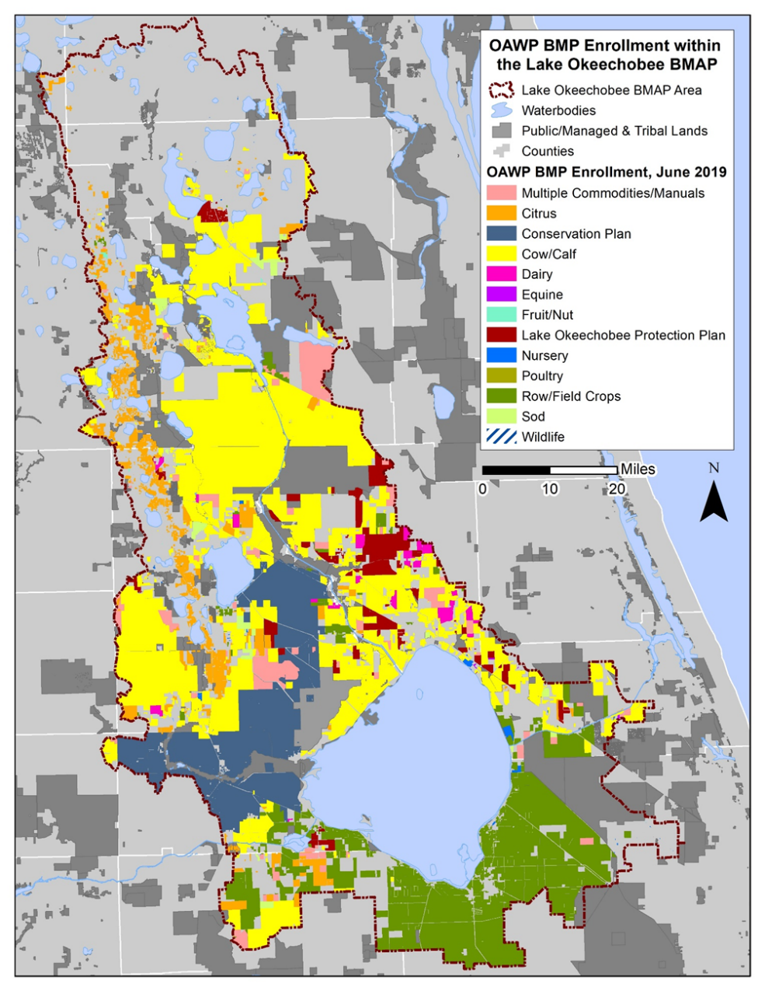
Figure B-1. BMP enrollment in the Lake Okeechobee BMAP area as of June 2019

Unenrolled Agricultural Acreage
Since the adoption of the NEEPP, FDACS’ goal has been to enroll 100 % of the agricultural acres in the BMP Program. As of June 2019, 77 % of the agricultural acres in the Lake Okeechobee BMAP area are enrolled in FDACS BMP Program and are implementing practices designed to improve water quality. While achieving 100 % enrollment is a laudable goal, the analysis of various land use databases has identified land uses classified as agriculture that are difficult to enroll or where there is a limit to the BMPs that can effectively be implemented onsite. This has required the prioritization and specific identification of agricultural lands that can be enrolled in FDACS' BMP Program.
To address the greatest resource concerns, OAWP has prioritized BMP enrollment by focusing on more intensive operations, including irrigated acreage, dairies and nurseries, parcels greater than 50 acres in size, and agricultural parcels adjacent to waterways. As of June 2019, 87 % of irrigated agricultural acres in the Lake Okeechobee BMAP area were enrolled in FDACS' BMP programs.
As these priorities are met, OAWP has identified additional enrollment priorities, typically comprising smaller irrigated agricultural operations ranging from 30 to 50 acres and other targeted areas. Those larger, more intensive operations that have not enrolled are being referred to DEP to either develop individual monitoring plans pursuant to Chapter 62-307, F.A.C., or be subject to enforcement actions under DEP's regulatory authority.
General Considerations
As new BMAPs are developed or existing BMAP areas are expanded, overlap among BMAPs is increasing. In the Lake Okeechobee BMAP area, 16 % of the agricultural acres are also included in the BMAPs for the Caloosahatchee River and Estuary (2020 update) or St. Lucie River and Estuary. While calculations, allocations, and projects are specific to each BMAP, it should be noted that the number of acres from the individual BMAP reports, if added, exceeds the total acres in the three BMAP areas. The Lake Okeechobee BMAP boundary encompasses 169,184 acres of unenrolled agricultural land use, and 55,258 acres of the unenrolled agriculture in this BMAP are also identified in other BMAPs.
Although land use data have been used as the basis for prioritizing FDACS enrollment efforts, many land use issues not captured by these databases affect FDACS enrollment efforts. Many areas within the Lake Okeechobee BMAP area experience rapid land use changes, especially at the urban/rural boundary. Agricultural lands are regularly converted to residential, industrial, commercial, or multiuse properties, but still appear in various databases as pasture or other rural lands. While these lands are likely to be developed in the near future, the agricultural land use classifications require these properties to comply with the BMP enrollment requirements.
Additionally, the counties’ methods of classifying small acreages as agricultural lands can affect the BMP enrollment process. Along with these changes, there are also large agricultural parcels being subdivided but remaining classified as "agriculture." This "urban agriculture"—also called residential agriculture, rural residential, rural estates, equine communities, ranchettes, rural homesteads, and other descriptive names for homes with some acreage and agricultural zoning—present a particular challenge for FDACS, since the BMP manuals are not designed for the enrollment of these properties in BMPs targeted for bona fide agricultural production areas.
Further, thousands of acres of open land, scrub land, unimproved pasture, and grazing land exist without a readily identifiable agricultural production activity that will fit within the framework of existing FDACS BMP manuals. Also, these types of parcels are usually controlled by many different individuals (for example, an initial analysis indicates approximately 16,000 different entities control the parcels whose size is less than 50 acres). The increasing number of these smaller parcels with nontraditional agricultural production represents a growing component of unenrolled acreage. It will be necessary to develop a suite of options to apply to these properties or develop a new classification that may subject these types of areas to alternative methods to ensure their nutrient loading contribution is being appropriately identified and reduced.
Another challenging area includes those agricultural lands that are inactive or fallow—i.e., lands that, on the day the FDACS representative visits, display no enrollable agricultural activity. These lands may be part of a rotation implemented by a landowner, scheduled for development, listed for sale, etc. The land use information FDACS receives is consistently improving the classification of these areas, but policy options remain limited in scope to ensure the implementation of practices aimed at reducing nutrient inputs from these areas.
Characterization of Unenrolled Agricultural Lands
To characterize unenrolled agricultural acres, OAWP identified FSAID VI features outside of the BMP enrollment areas within GIS. As previously mentioned, OAWP BMP enrollments are initially delineated based on county property appraiser parcel data, even if the entire parcel is not agriculture, to allow BMPs to be tied to the specific parcels where agricultural activities are occurring. FSAID agricultural lands are delineated based on land use features identified as agriculture and represent a more refined analysis of those areas actually in agricultural production.
Because of differences in their spatial geometries when they are combined or compared, the boundaries often do not align precisely, creating "slivers." Slivers are not enrollable because they are an artifact of the geospatial analysis and do not represent lands with active agricultural practices. For example, a sliver can represent the area between the boundary of a parcel and the beginning of a road, canal, easement, etc. Slivers are often associated with previously enrolled agricultural operations but because of the delineation differences, these slivers are not captured within the enrolled parcel during geoprocessing. When characterizing unenrolled agricultural lands, slivers are excluded. Figure B-2 shows an example of a sliver created when performing geospatial analysis.
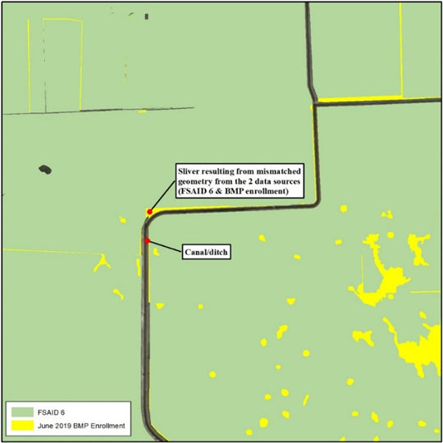
Figure B-2. GIS example of a sliver in the Lake Okeechobee BMAP area

OAWP used property appraiser data and manually reviewed aerial imagery to characterize unenrolled lands in the BMAP area. Lands under tribal ownership are not subject to the requirements of Section 403.067, F.S.; yet areas within the sovereign lands of the Seminole Tribe of Florida are identified as unenrolled agricultural lands. Other large areas that are identified as agricultural land use but are unlikely to have enrollable agricultural activities include lands owned by the state (Board of Trustees of the Internal Improvement Trust Fund), and SFWMD. It is possible that these lands, in whole or in part, may be leased to other entities that conduct agricultural activities, but such leasing is infrequent. If leasing occurs, the leasing entity will be required to enroll in the BMP Program. Ongoing coordination between FDACS, DEP’s Division of State Lands, and SFWMD is needed to ensure that any public lands that are leased for the purposes of agricultural activities are required to implement and enroll in FDACS BMP program as a condition of the lease. Other lands that may be classified as agriculture but are unlikely to have enrollable agricultural activities include lands that may be part of a restoration project or water storage project. Future analysis and coordination with SFWMD will be needed to identify which areas may have enrollable agriculture in the areas identified for restoration and water storage projects.

Other smaller parcels that have been identified as nonagricultural but have features that cause them to be identified as agricultural lands in various databases, include those lands associated with utilities, telecommunication companies, churches, FDOT rights-of-way, and airports. DOR uses code numbers 70 through 98 to identify these types of lands.
Those agricultural lands that have been identified as "fallow," "former [ag]," and "abandoned," as well as brush land/scrub land/open land, comprise 16 % of the total unenrolled agricultural acres in the Lake Okeechobee BMAP area. These acres are still classified as agricultural land for the purposes of the BMAP nutrient load assessment. There are a variety of potential options to account for these lands, such as enrollment as "temporarily inactive" operations to capture some of these lands—particularly those that were previously enrolled and are planned to resume production. Another option may be to note the inactive acres at the time of a field visit and perform periodic reassessment on a cyclical basis. The possibility for DEP and FDACS to calculate nutrient reduction credits or adjust nutrient loading rates may also provide opportunities to present more accurate estimates and establish priorities.
Another factor considered in the prioritization of BMP enrollment is the number of agricultural acres on the parcel. Analyzing the number of agricultural acreages on the parcel and commodity type can give an idea of the efforts that are needed to enroll these areas in the FDACS’ BMP Program and also identify the areas most in need of enrollment. Figure B-3 summarizes the agricultural acres distributed by agricultural acreage found on each parcel.
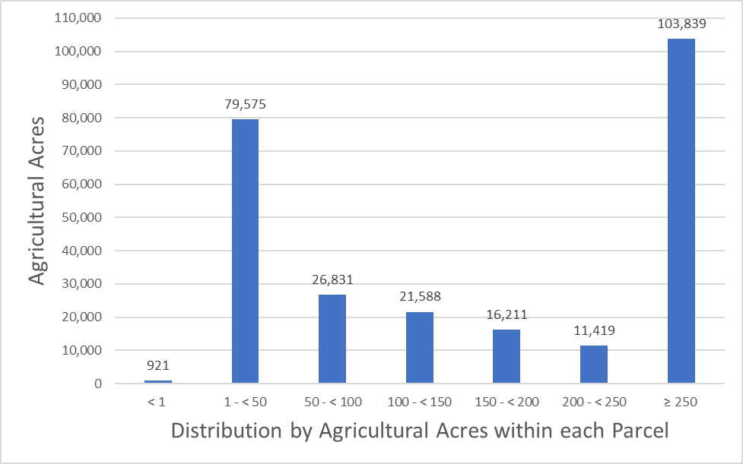
Figure B-3. Distribution of agricultural acreage on parcels with potential agricultural activity

Further analysis was done to characterize the parcels that contain 50 acres of agriculture or greater and those parcels with less than 50 acres of agriculture; 179,888 acres of the 260,384 acres of land identified as having potential agricultural activity are found on parcels that contain 50 acres of agriculture or greater. Figure B-4 shows the types of agricultural land use based on FSAID VI found on parcels that contain 50 acres of agriculture or greater. Grazing land comprises 56 % of this acreage.
Of the land identified as agriculture, 80,496 acres are found on parcels with less than 50 acres of agriculture. Figure B-5 shows the types of agricultural land use found on parcels with less than 50 acres of agriculture. Grazing land comprises 55 % of this acreage. For these parcels, OAWP will prioritize the more intensive agricultural operations, such as sugarcane, citrus, and other row crops, for enrollment.
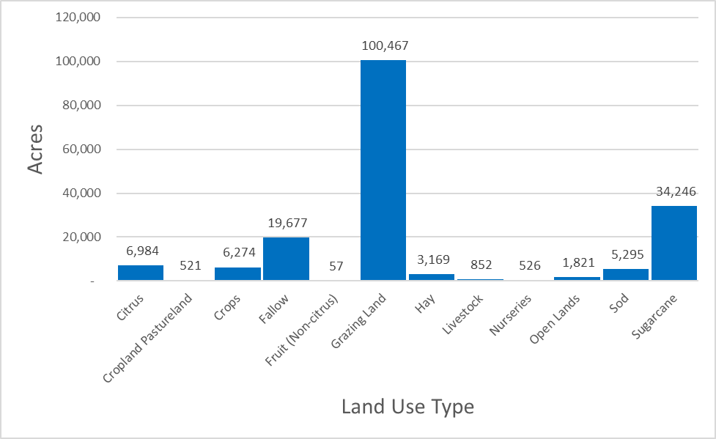
Figure B-4. Agricultural lands on parcels with 50 acres of agriculture and greater

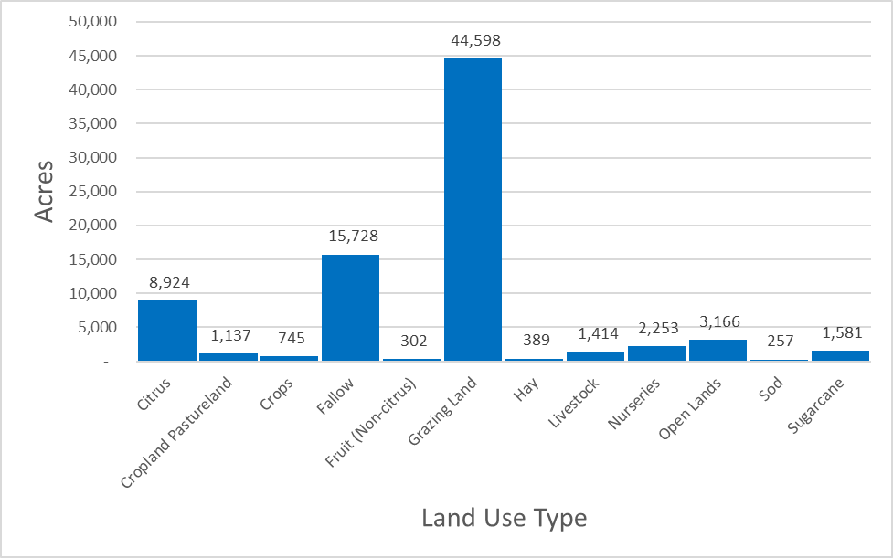
Figure B-5. Agricultural land uses on parcels with less than 50 acres of agriculture

Table B-13 lists the total acreage associated with the identified slivers and the lands that are not likely to have enrollable agricultural activities, along with a remaining total of unenrolled agricultural acres in the BMAP area. Figure B-6 through Figure B-7 summarize the unenrolled agricultural acres in the Lake Okeechobee BMAP area by acres of agriculture within the parcels. However, they do not include acreages or parcels associated with slivers or lands that are not likely to have enrollable agricultural activities.
Table B-13. Summary of unenrolled agricultural land use acreage in the Lake Okeechobee BMAP area
Note: Due to geometric variations between shapefiles used in the unenrolled agricultural lands analysis performed by OAWP, the unenrolled agricultural acres differ from subtraction of the FSAID VI Agricultural Acres in the BMAP and the Total Agricultural Acres Enrolled referenced in Table B-2.
Category | Acres
Unenrolled agricultural acres | 393,571
Acres identified within slivers of unenrolled agricultural areas | 15,889
Lands without enrollable agricultural activity (e.g., tribal lands, residential development, and parcels with DOR use codes 70-98) | 117,299
Total lands with potentially enrollable agricultural activities | 260,384

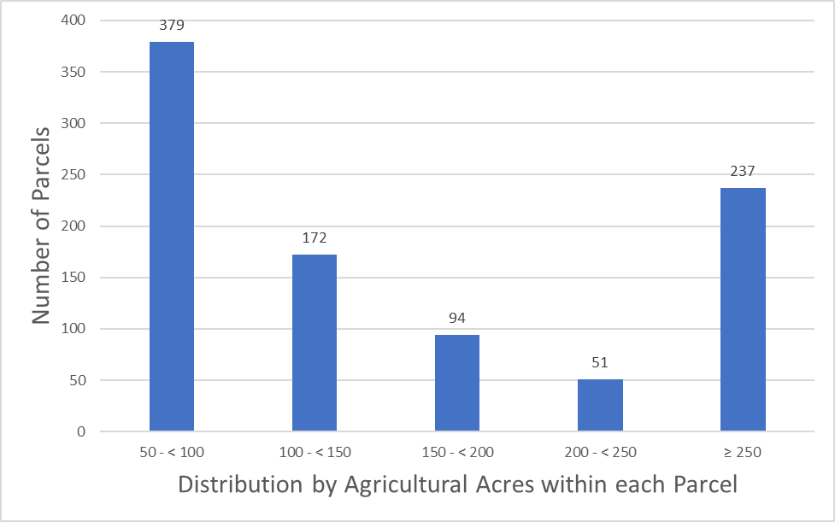
Figure B-6. Number of parcels with 50 acres of agriculture and greater

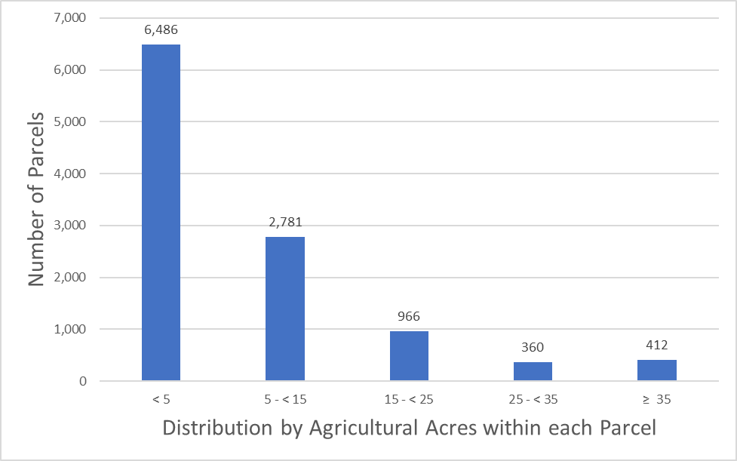
Figure B-7. Number of parcels with less than 50 acres of agriculture

Unenrolled agriculture characterization information for each individual subwatershed, including the distribution of agricultural acres within each parcel and land use type, is presented in Figure B-8 through Figure B-25.
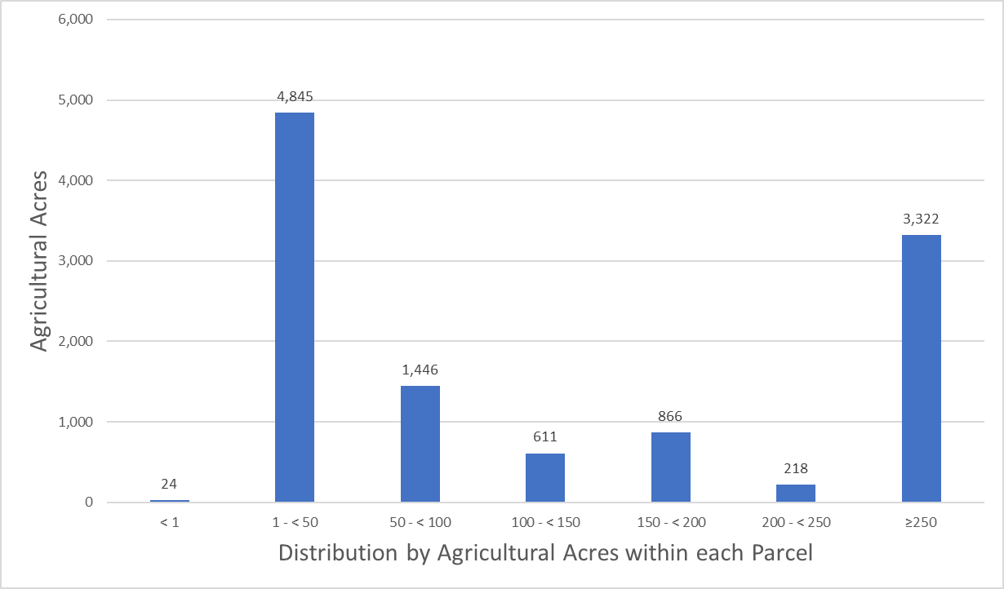
Figure B-8. Distribution by agricultural acres within each parcel, Fisheating Creek Subwatershed

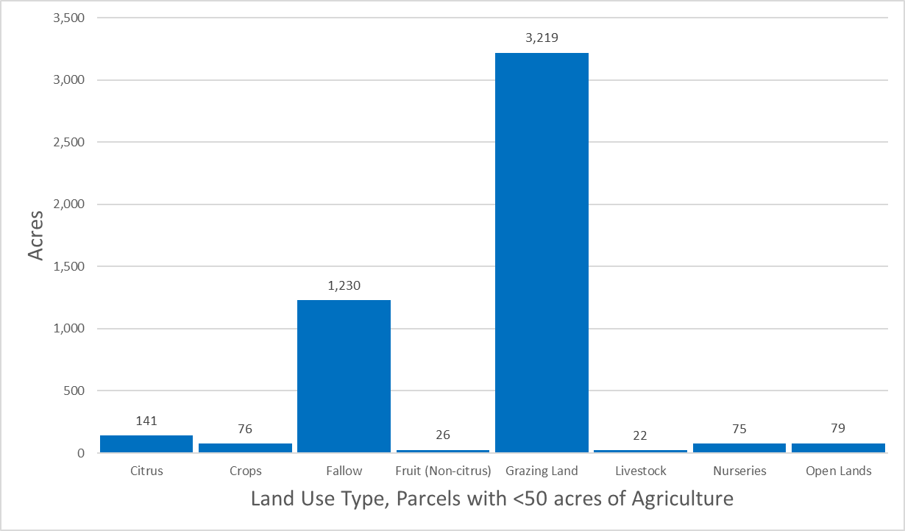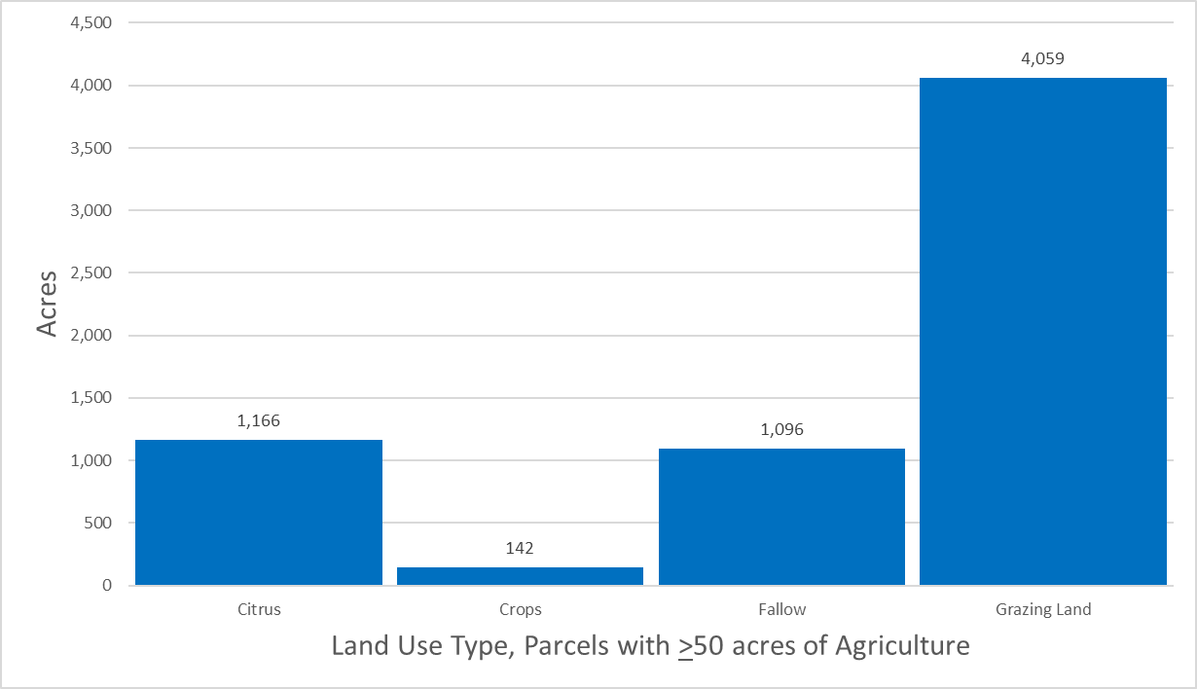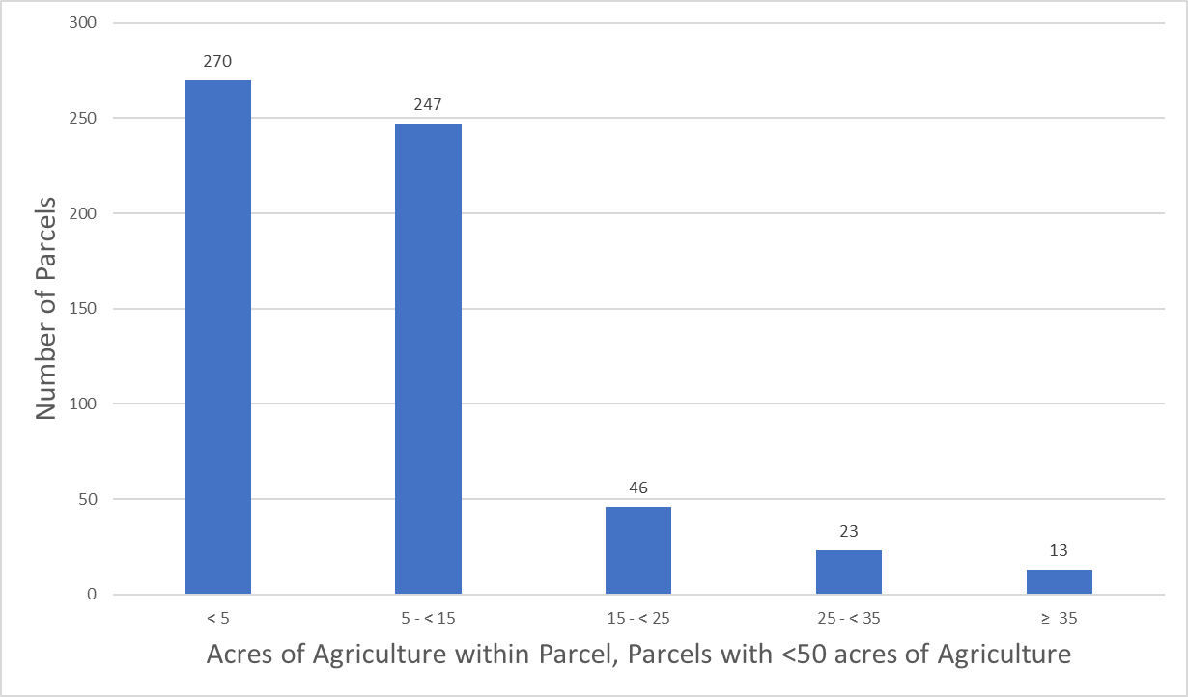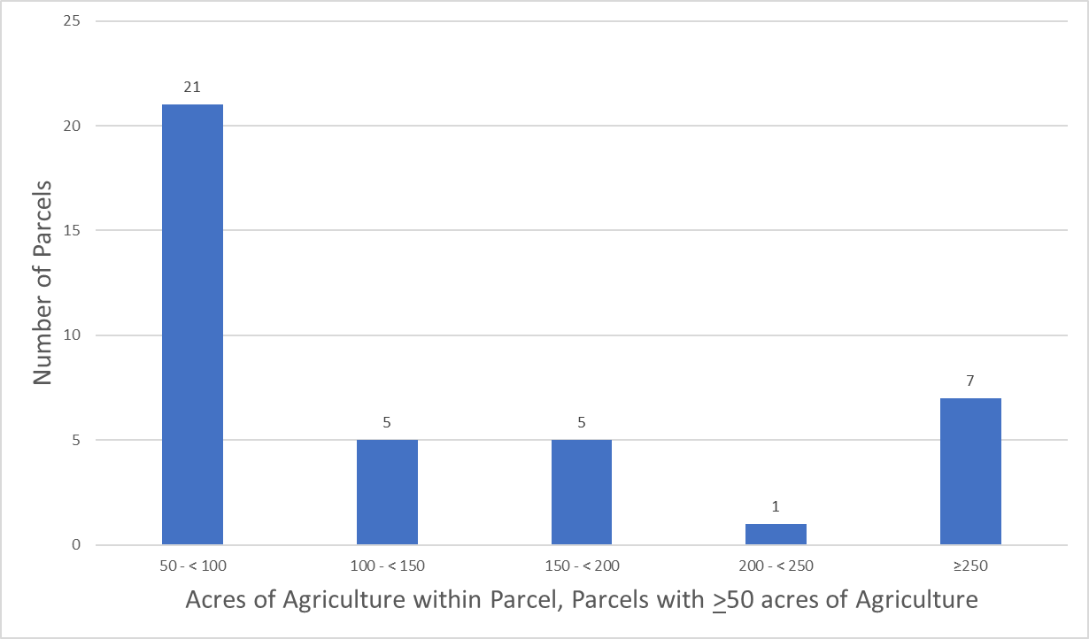
Figure B-9. Land use type and distribution of agricultural acreage, Fisheating Creek
Subwatershed

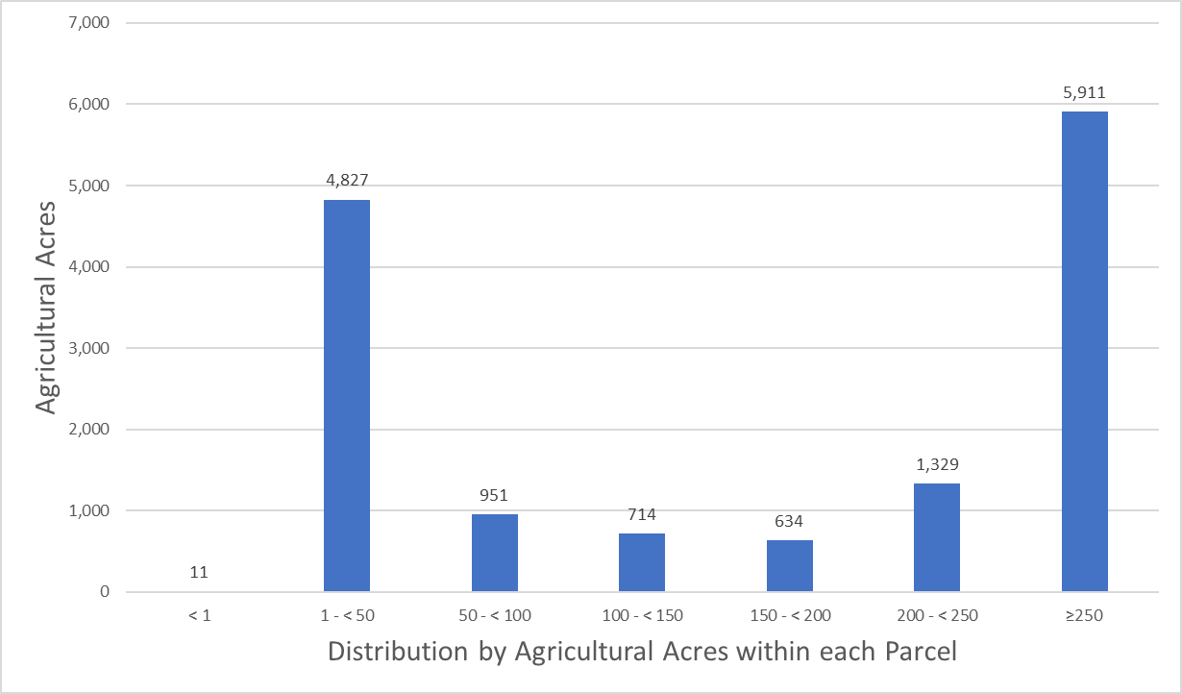
Figure B-10. Distribution by agricultural acres within each parcel, Indian Prairie Subwatershed

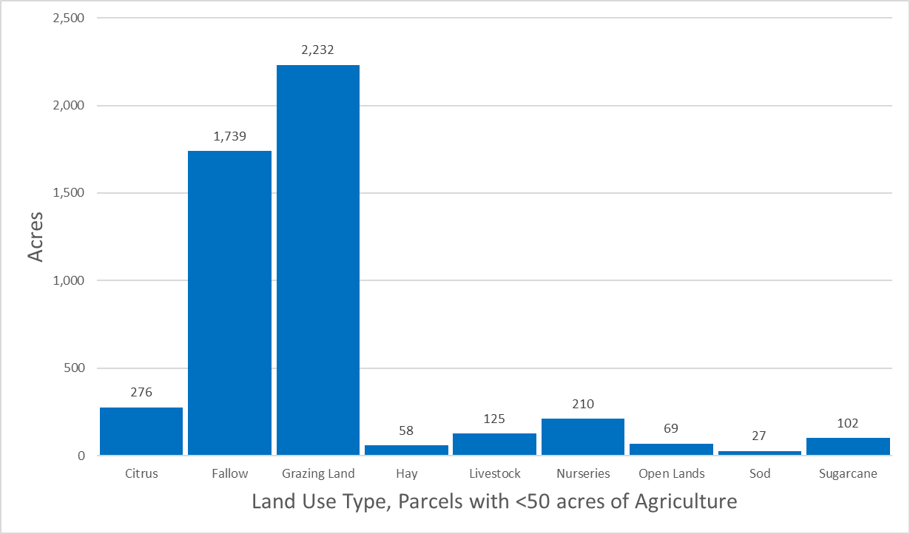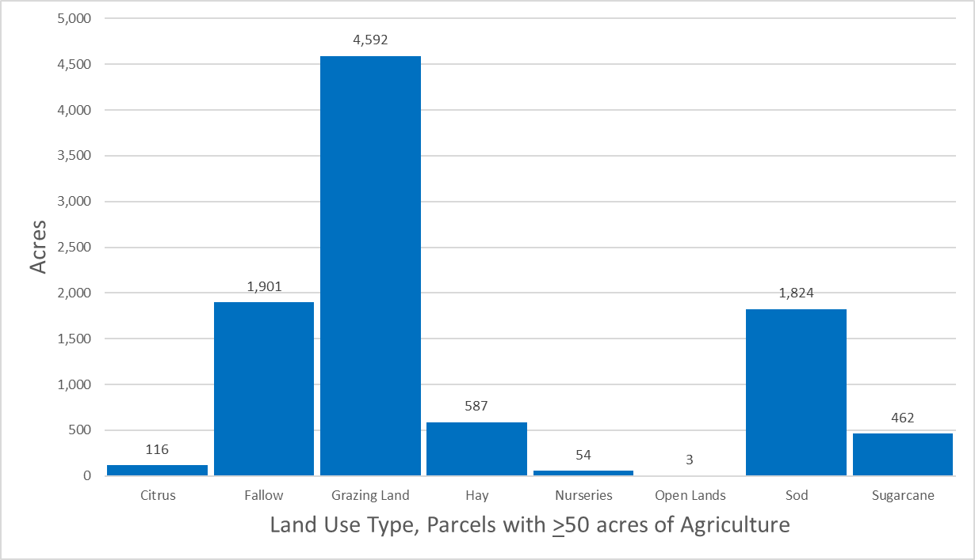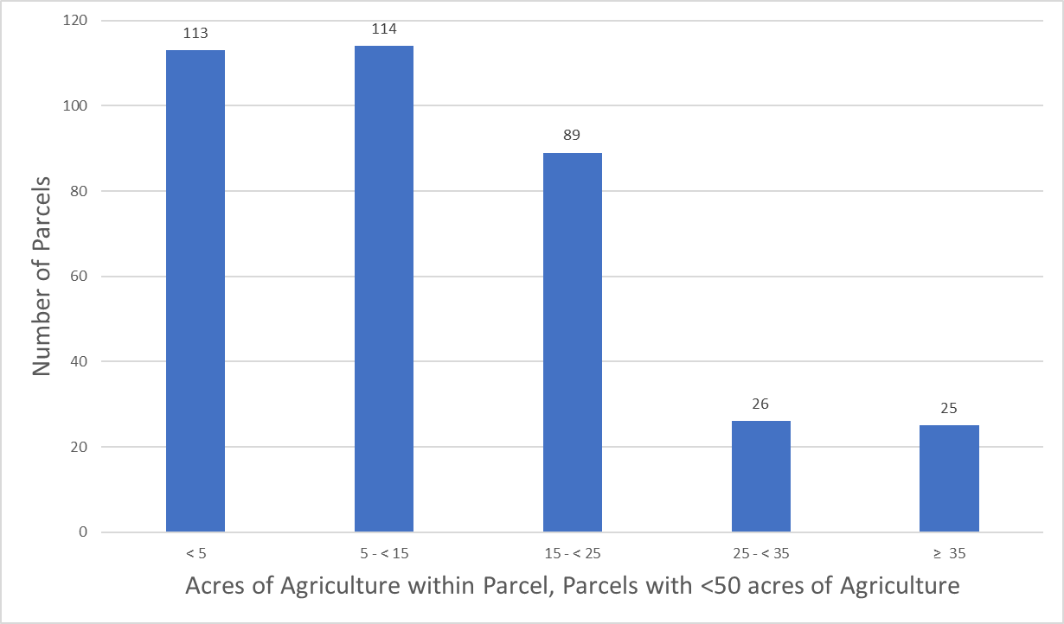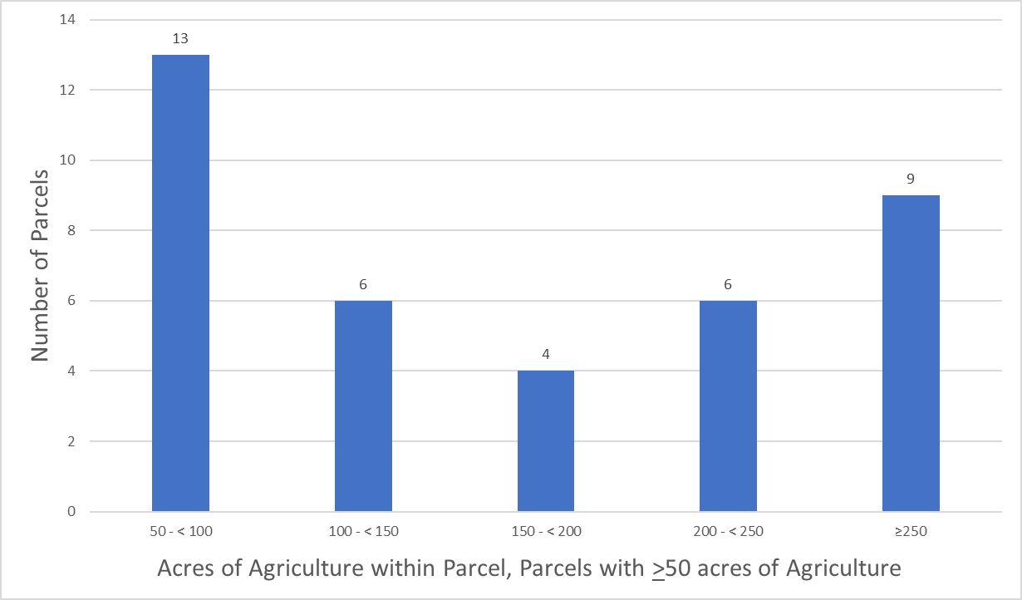
Figure B-11. Land use type and distribution of agricultural acreage, Indian Prairie Subwatershed

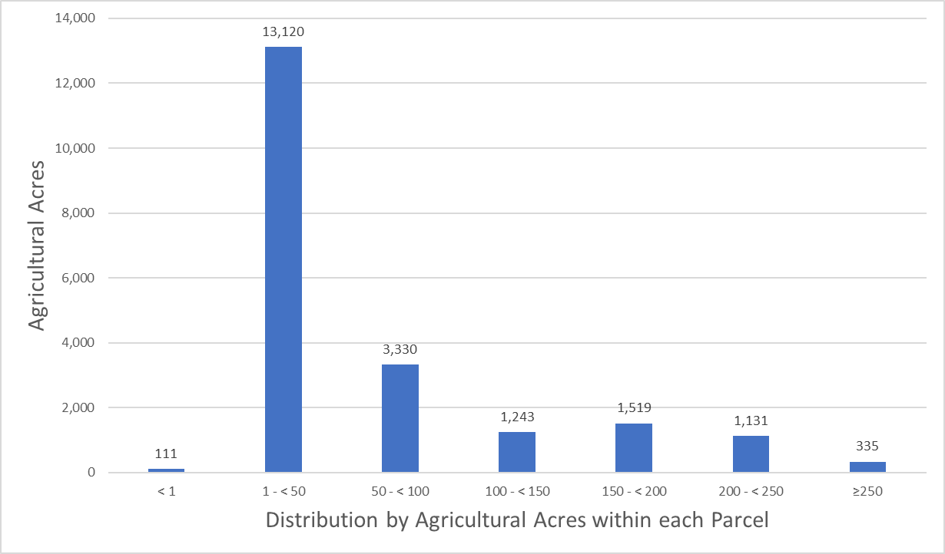
Figure B-12. Distribution by agricultural acres within each parcel, Lake Istokpoga Subwatershed

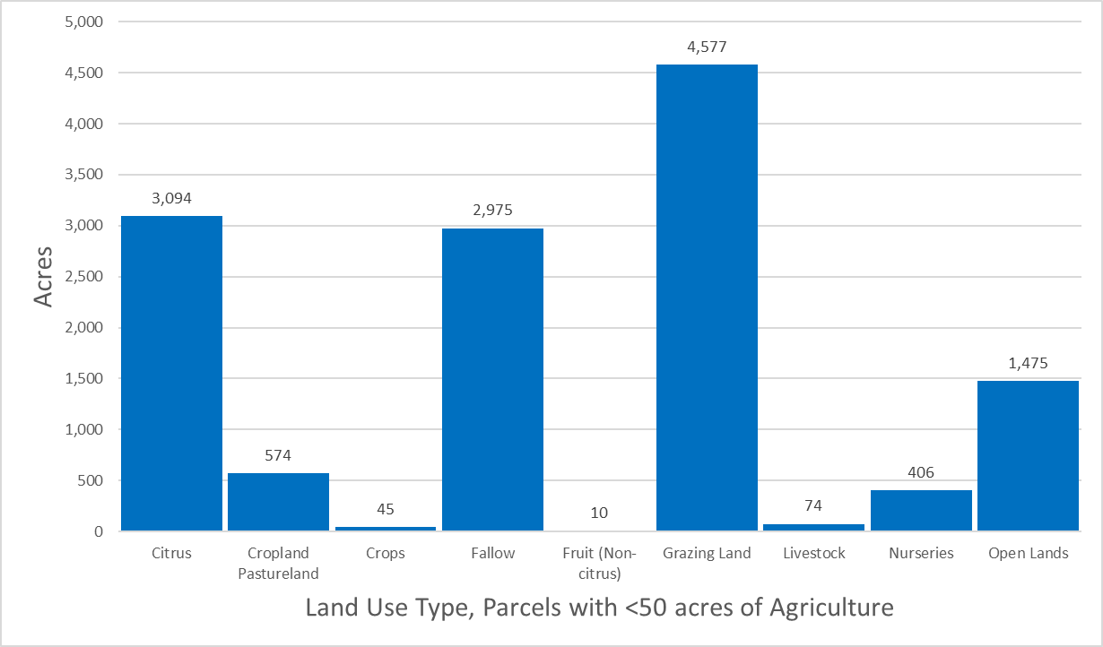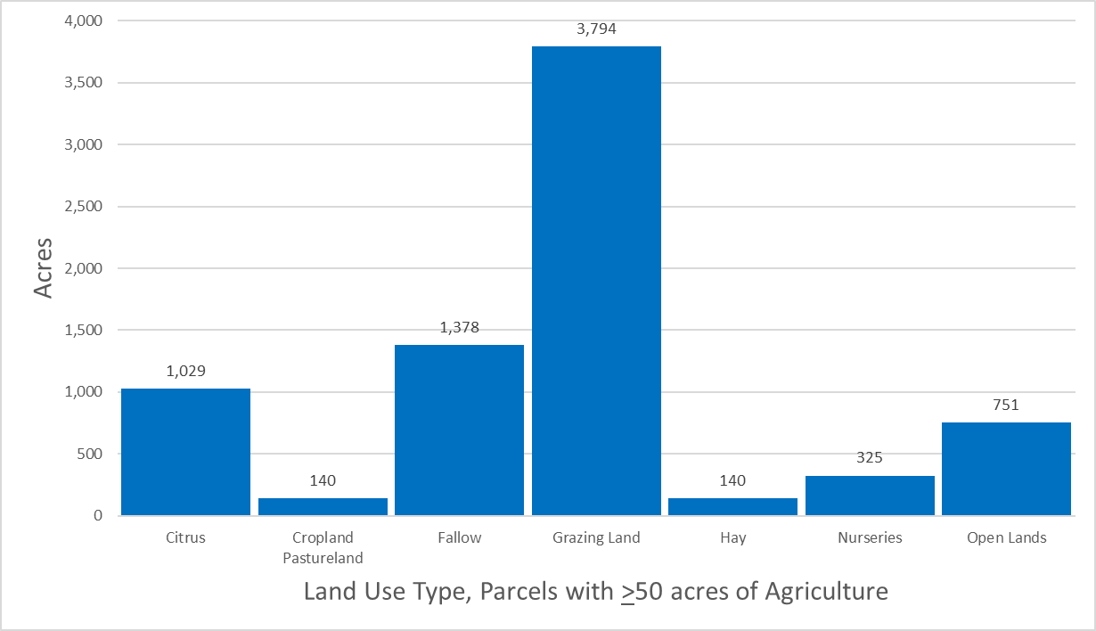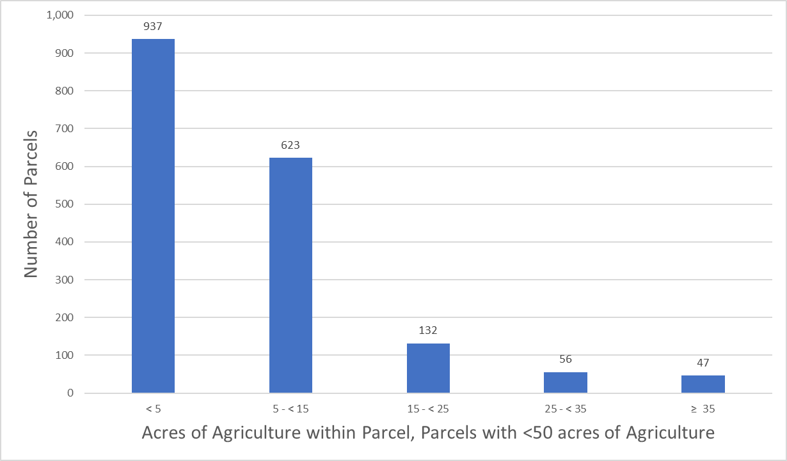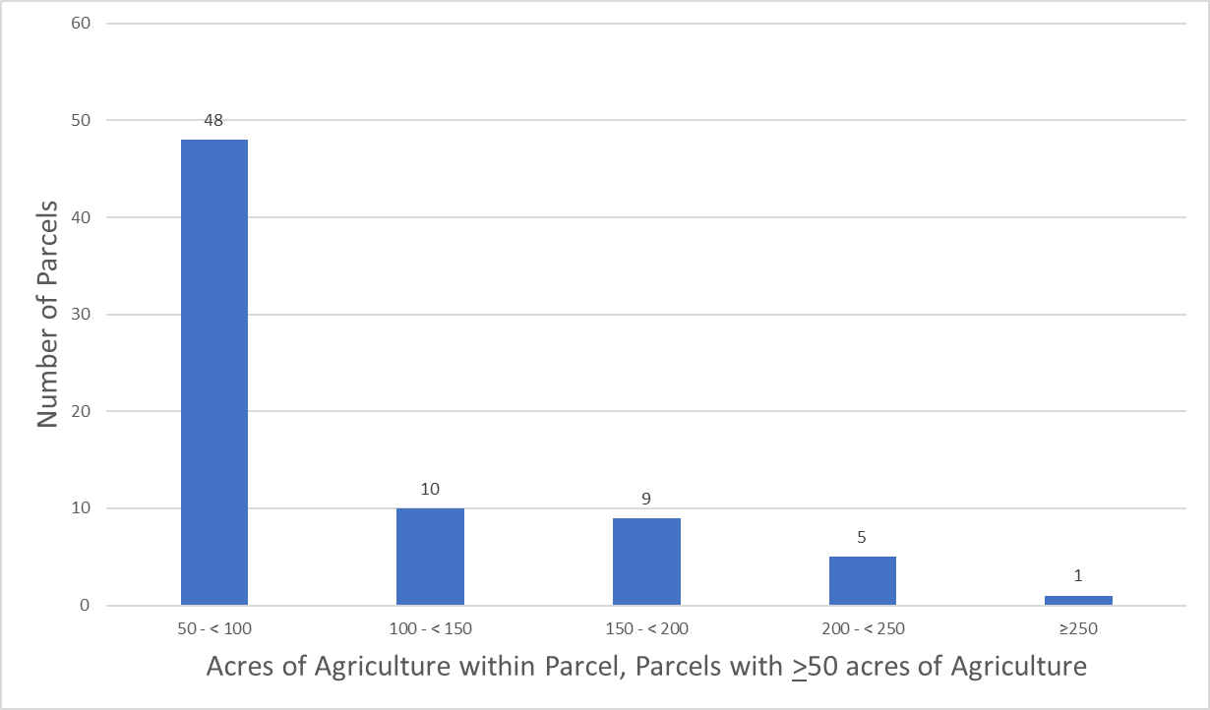
Figure B-13. Land use type and distribution of agricultural acreage, Lake Istokpoga Subwatershed

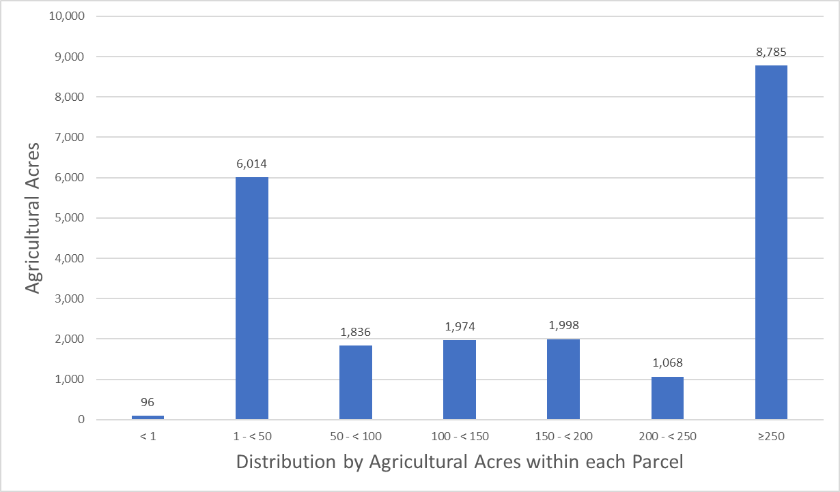
Figure B-14. Distribution by agricultural acres within each parcel, Lower Kissimmee Subwatershed

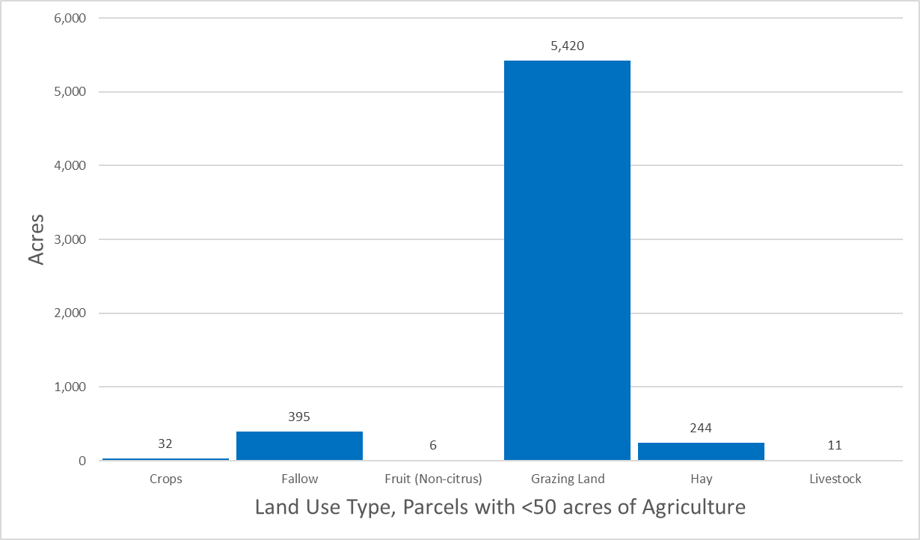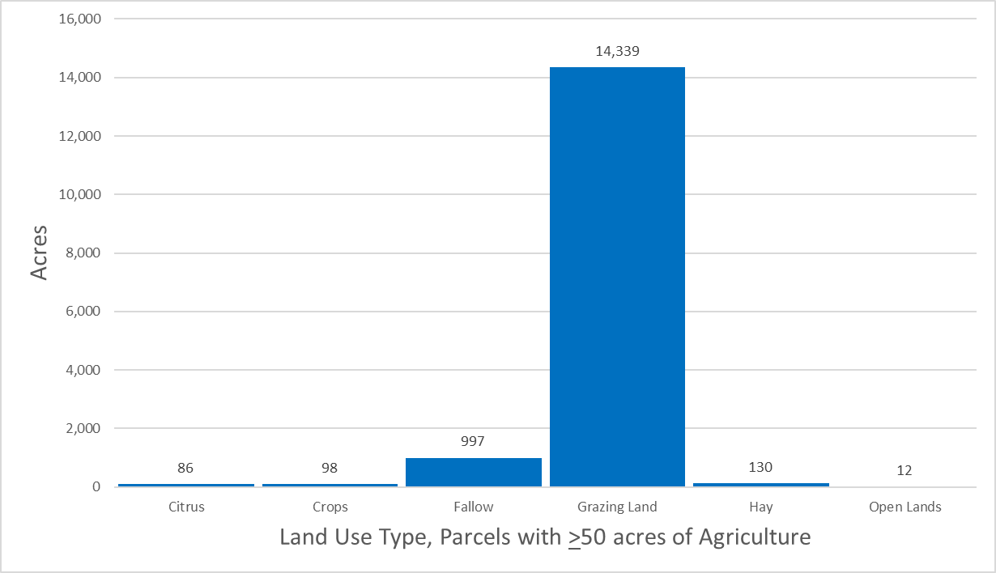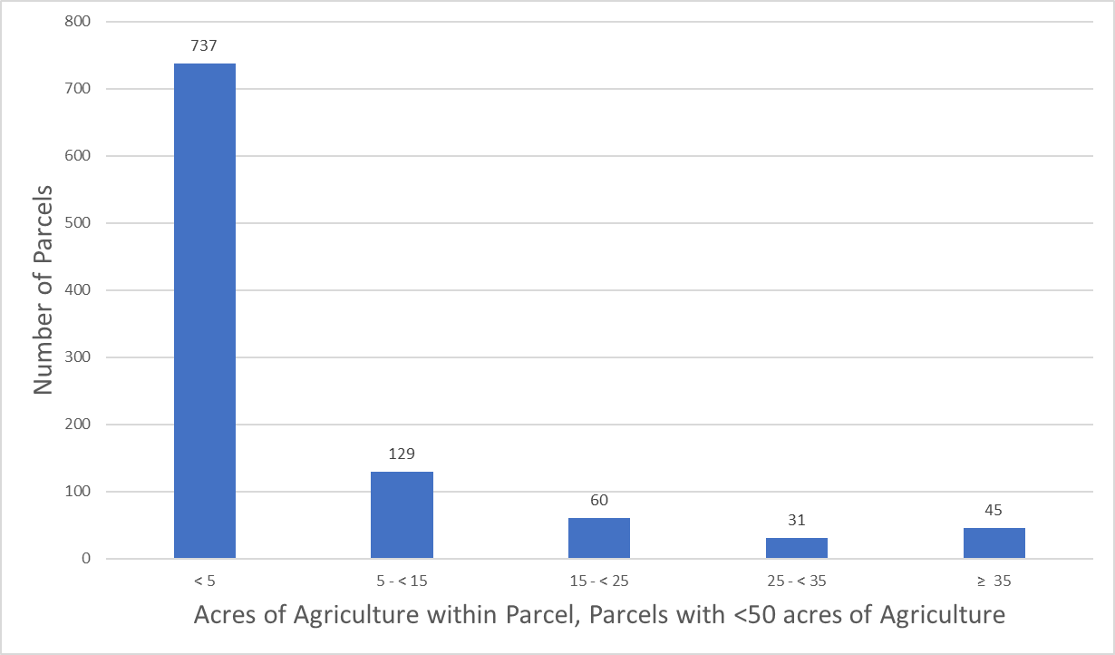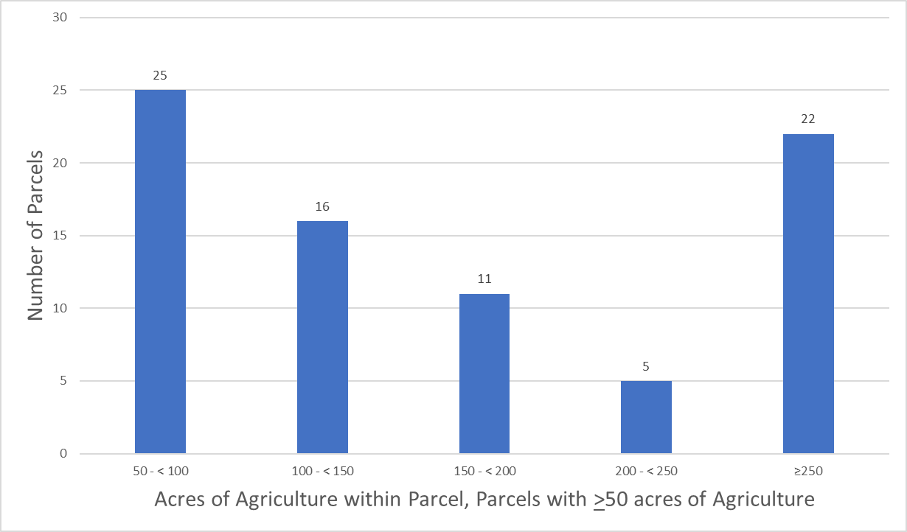
Figure B-15. Land use type and distribution of agricultural acreage, Lower Kissimmee
Subwatershed

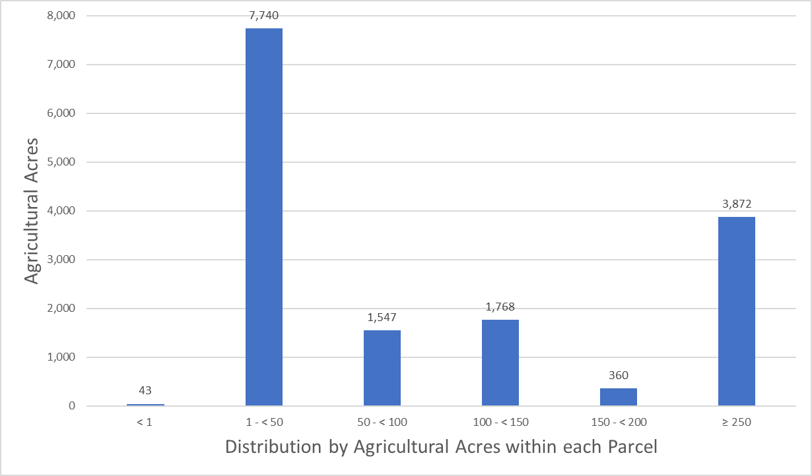
Figure B-16. Distribution by agricultural acres within each parcel, Taylor Creek/Nubbin Slough Subwatershed

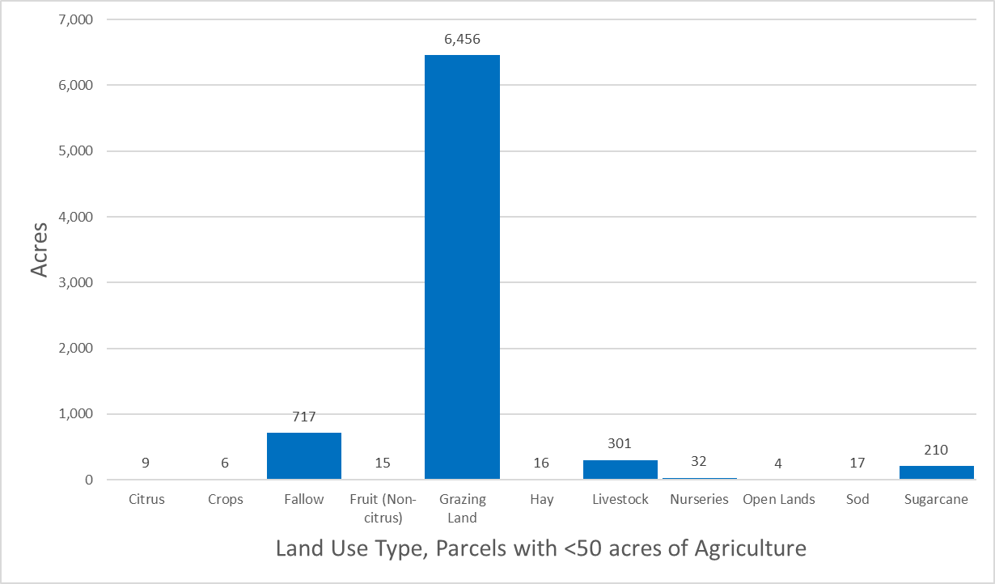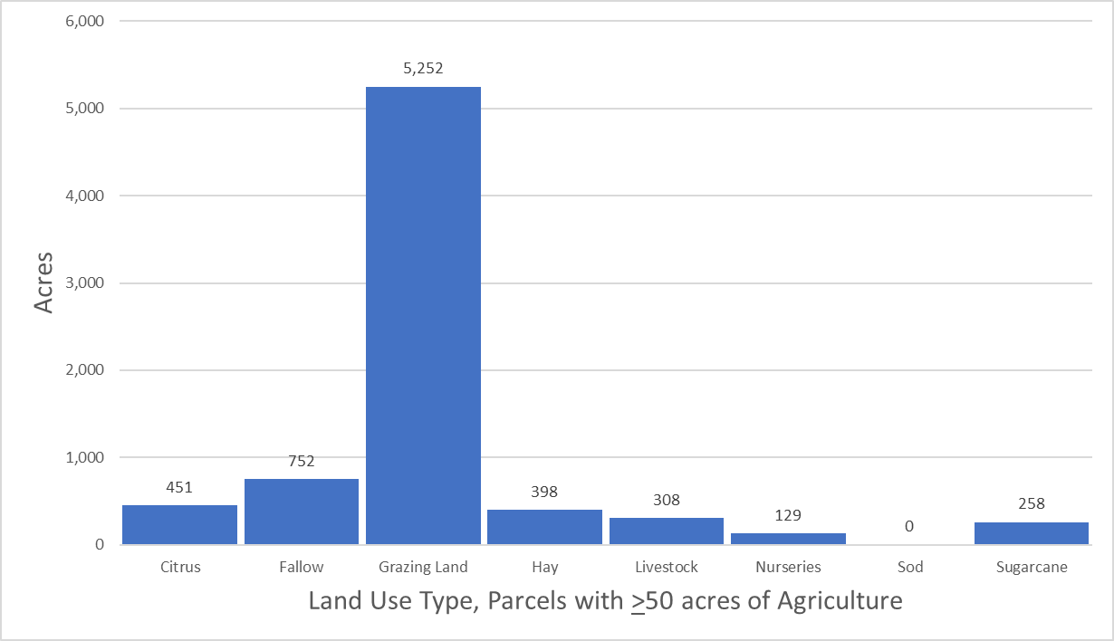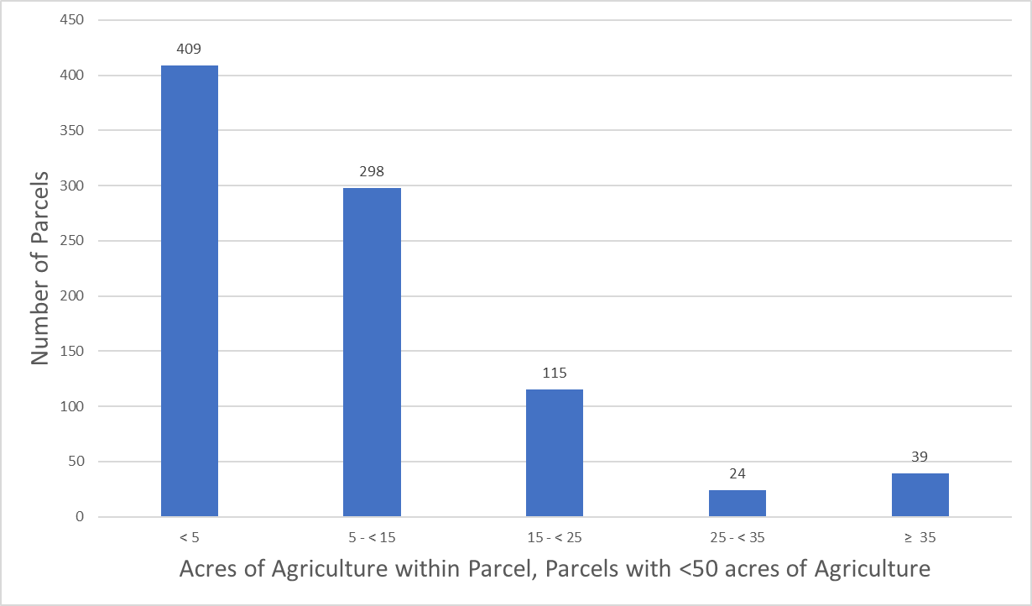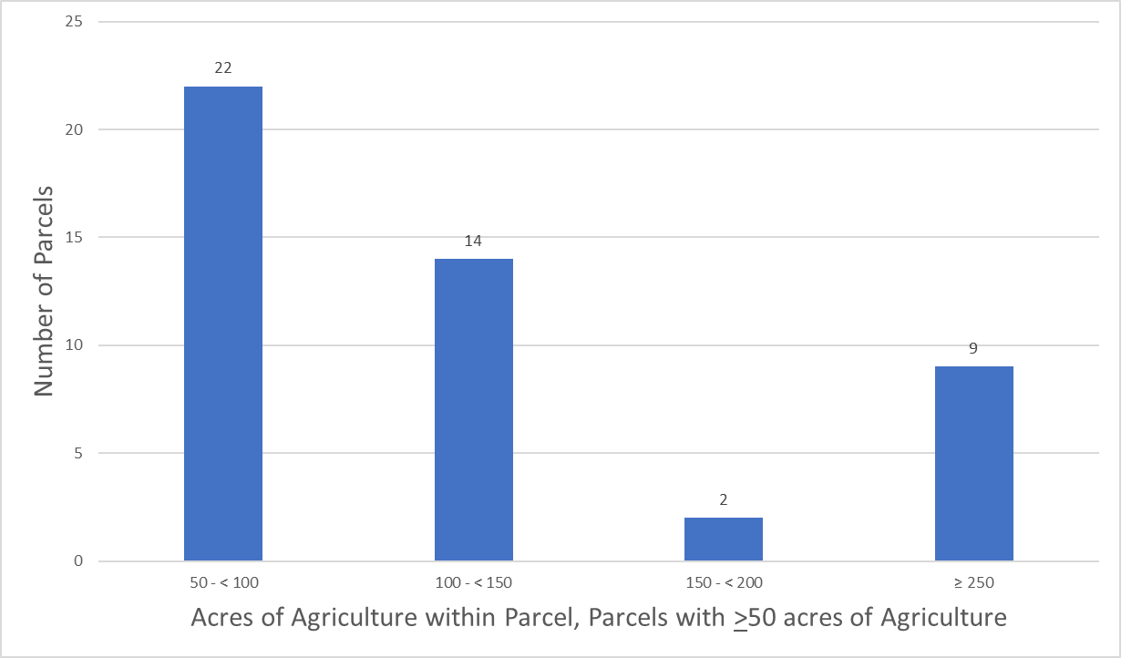
Figure B-17. Land use type and distribution of agricultural acreage, Taylor Creek/Nubbin Slough Subwatershed

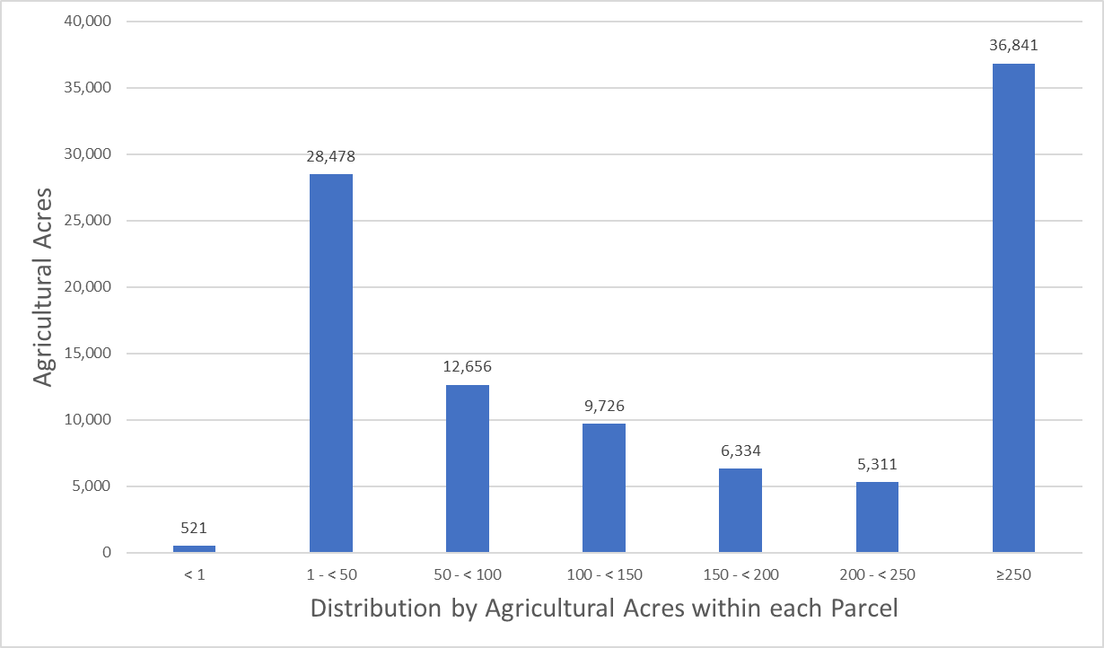
Figure B-18. Distribution by agricultural acres within each parcel, Upper Kissimmee Subwatershed

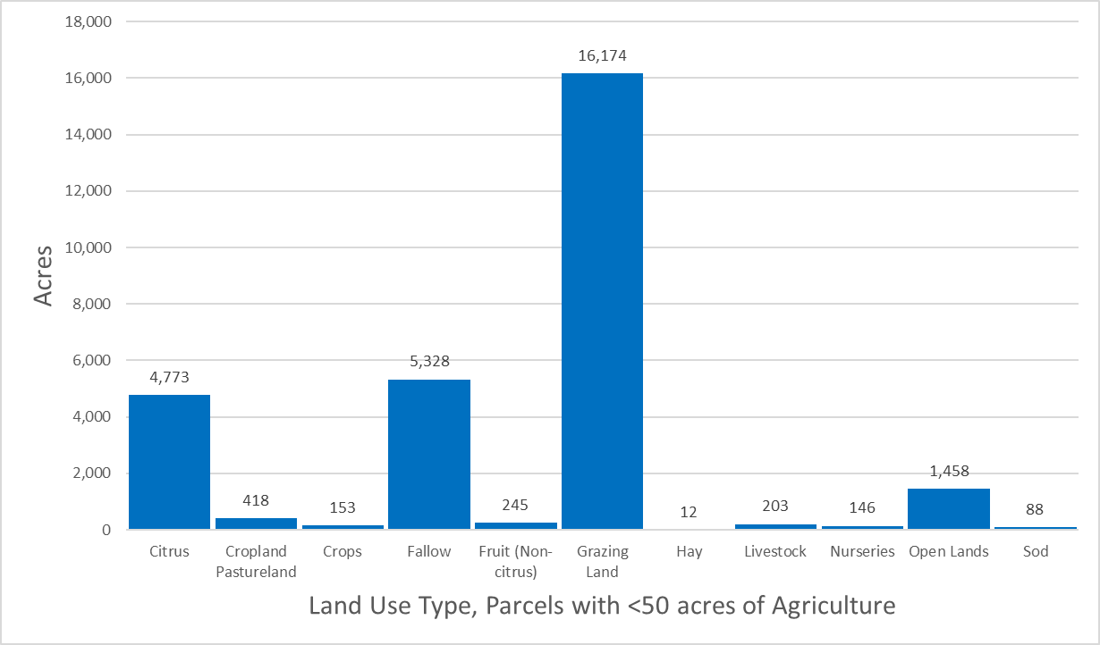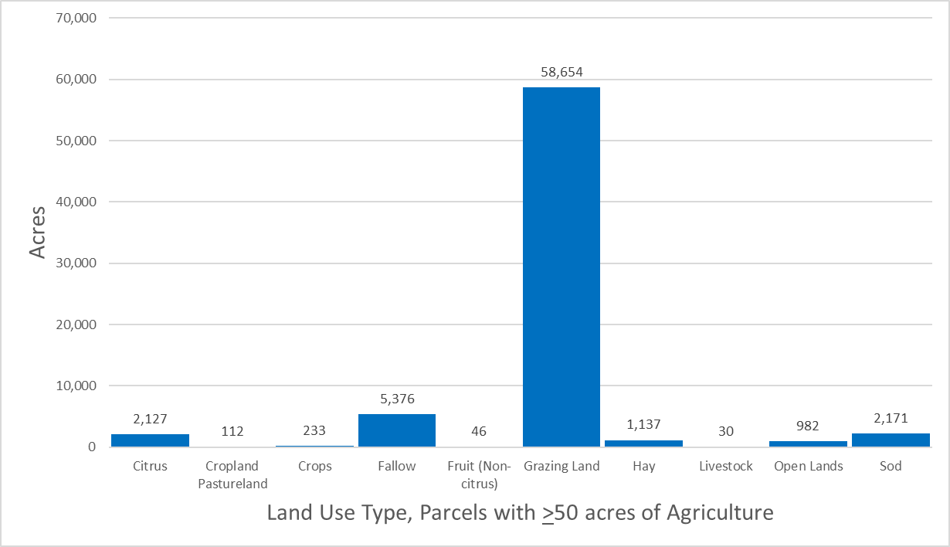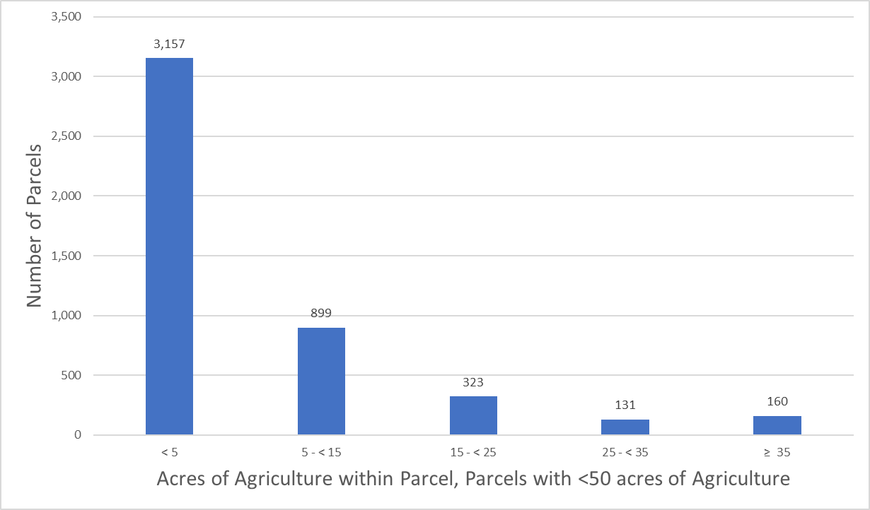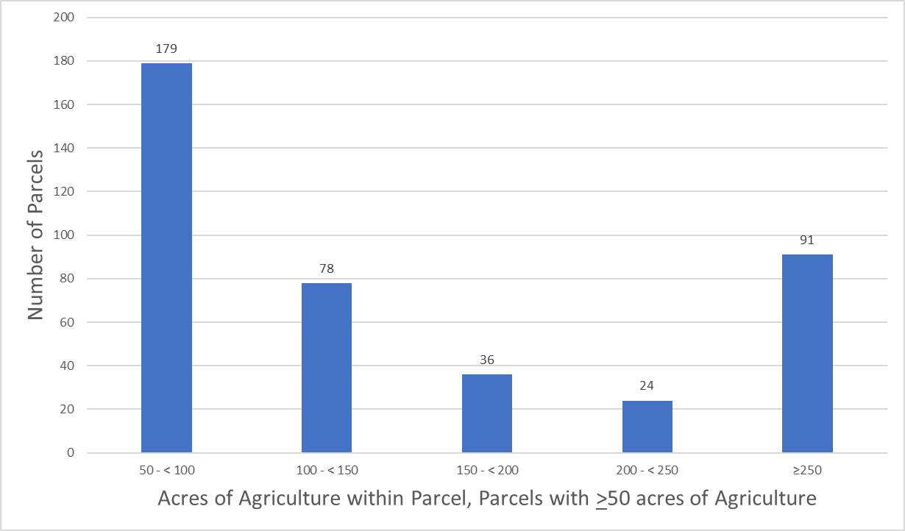
Figure B-19. Land use type and distribution of agricultural acreage, Upper Kissimmee Subwatershed

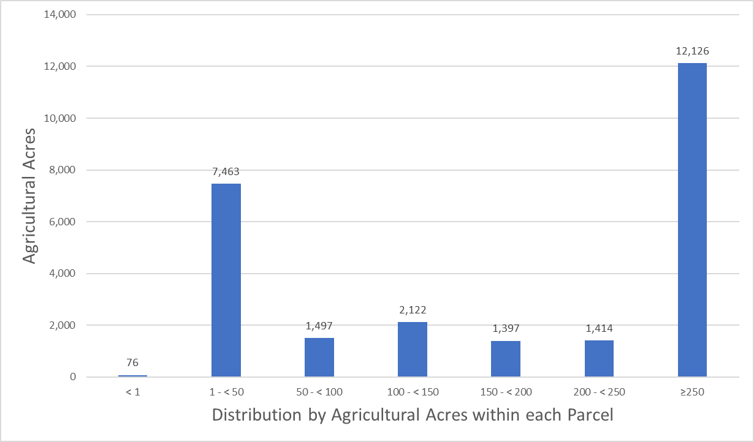
Figure B-20. Distribution by agricultural acres within each parcel, East Lake Okeechobee Subwatershed

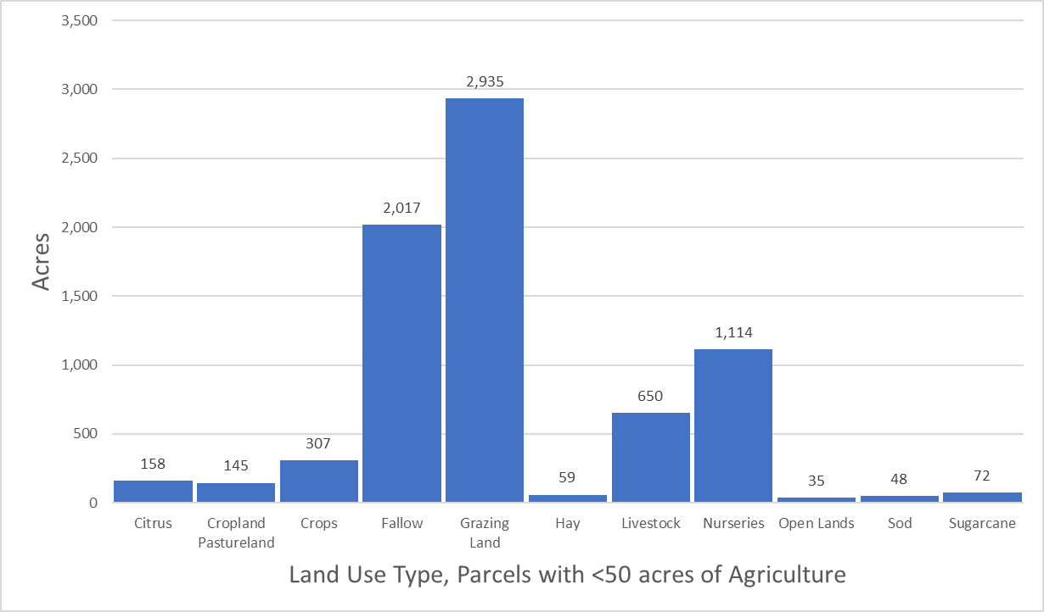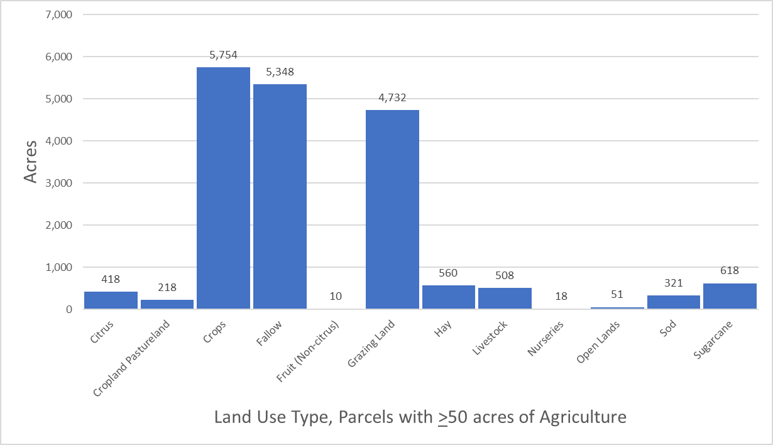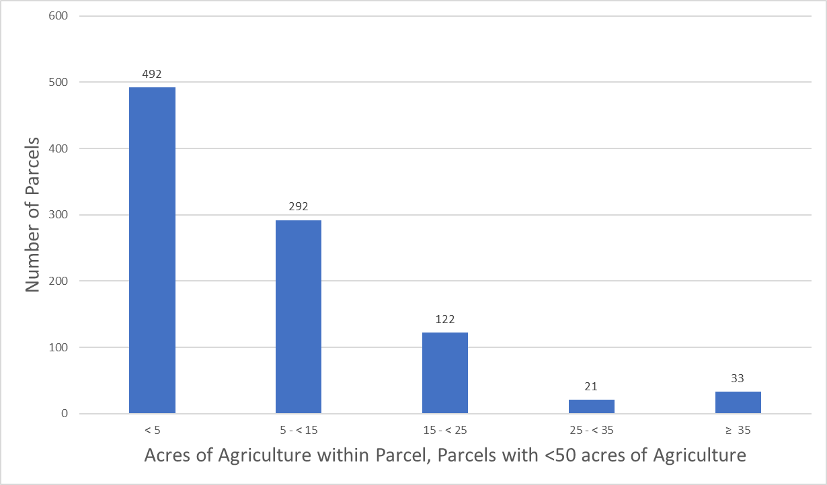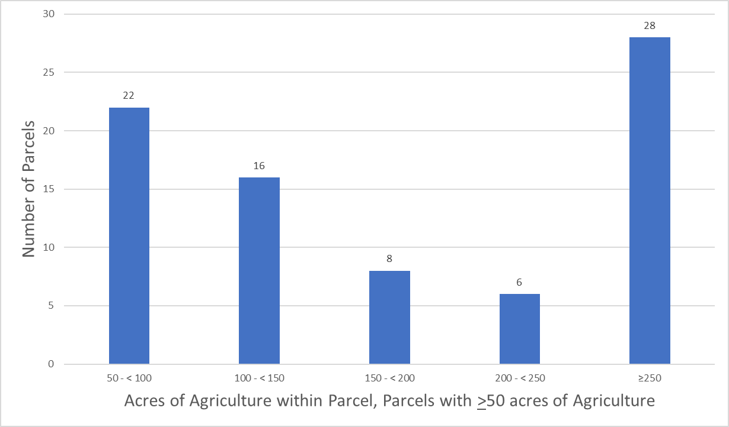
Figure B-21. Land use type and distribution of agricultural acreage, East Lake Okeechobee Subwatershed

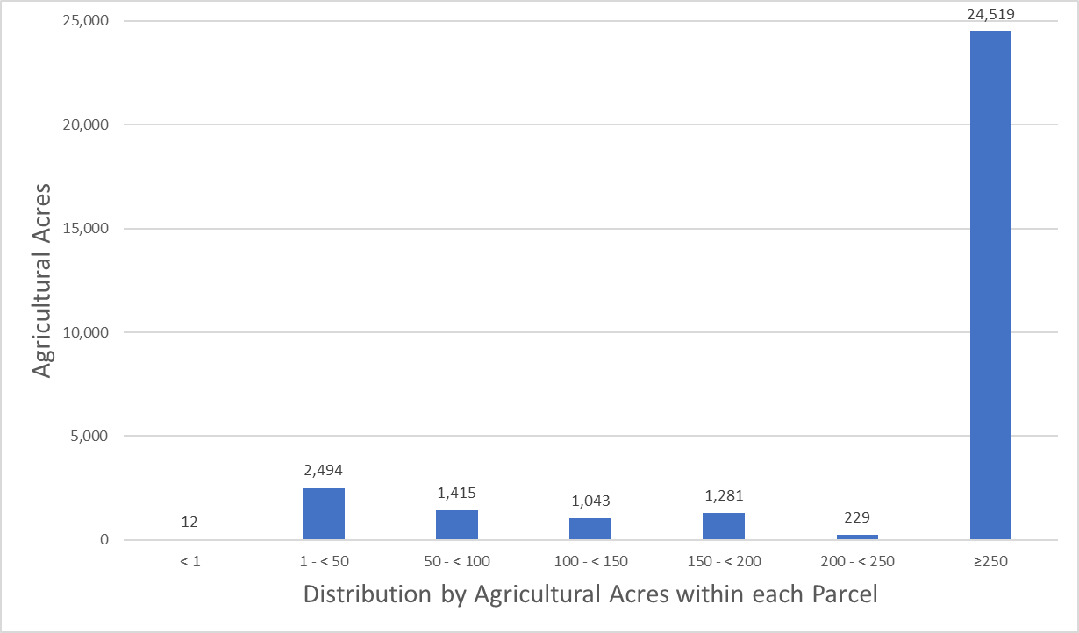
Figure B-22. Distribution by agricultural acres within each parcel, South Lake Okeechobee Subwatershed

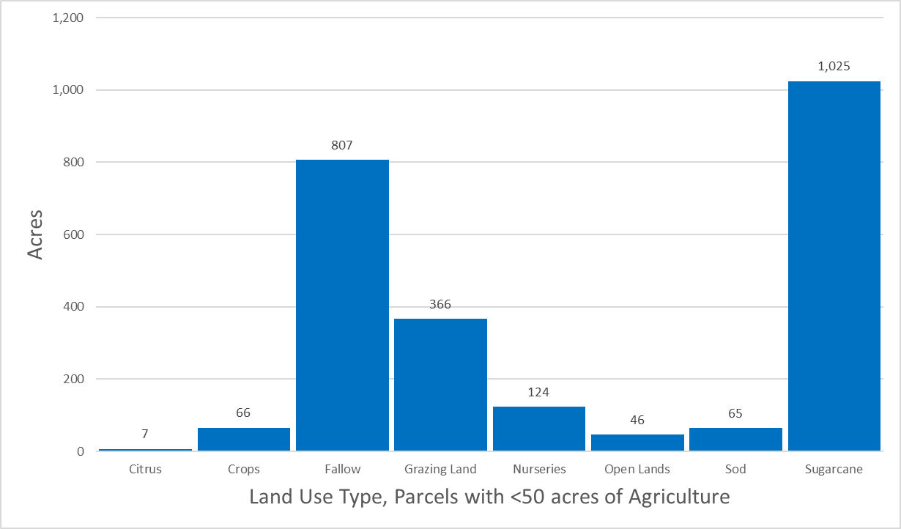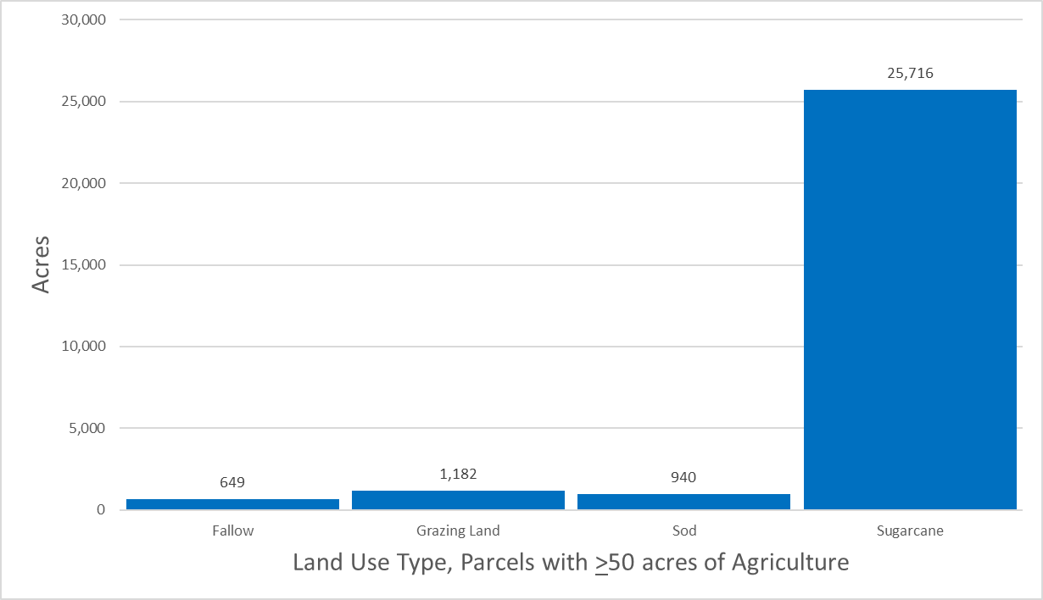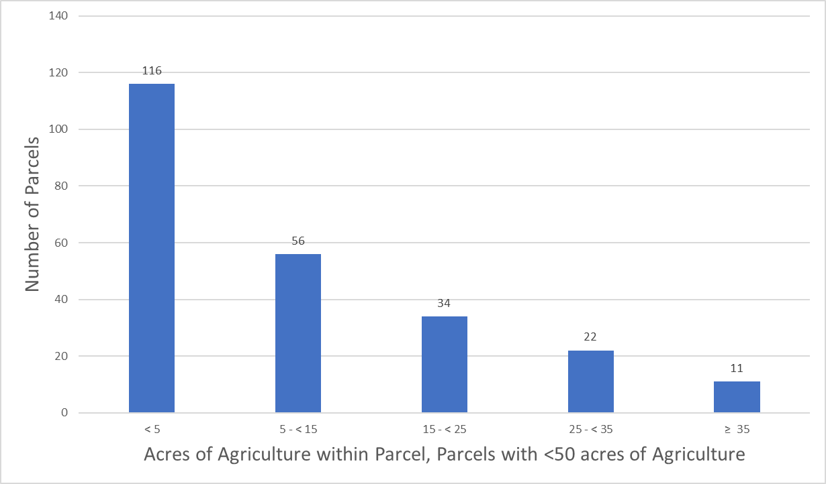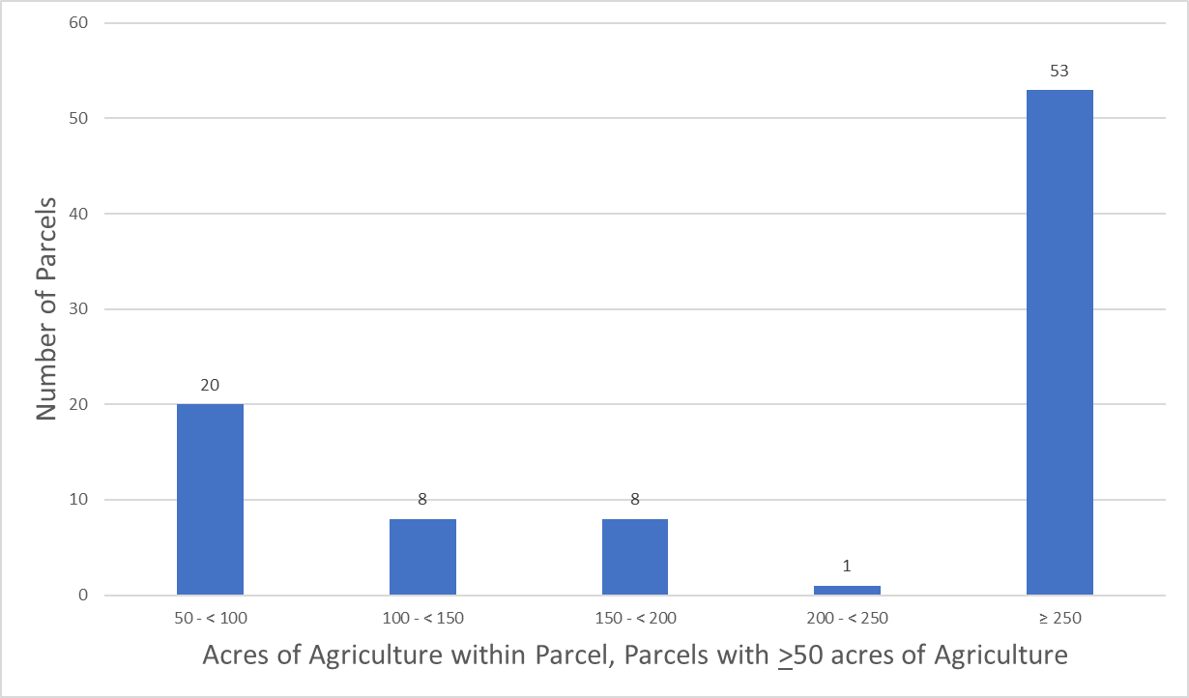
Figure B-23. Land use type and distribution of agricultural acreage, South Lake Okeechobee Subwatershed

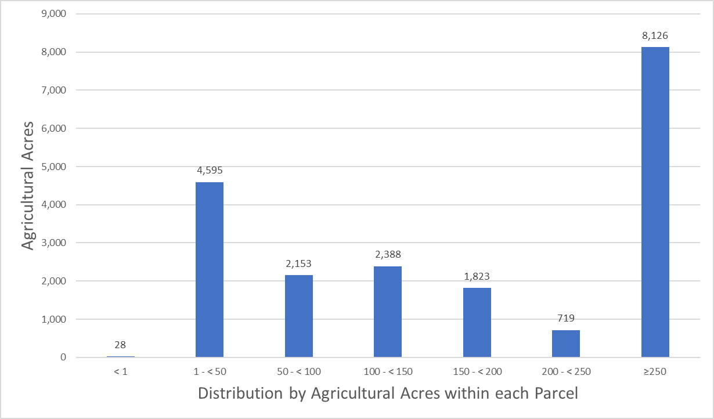
Figure B-24. Distribution by agricultural acres within each parcel, West Lake Okeechobee Subwatershed

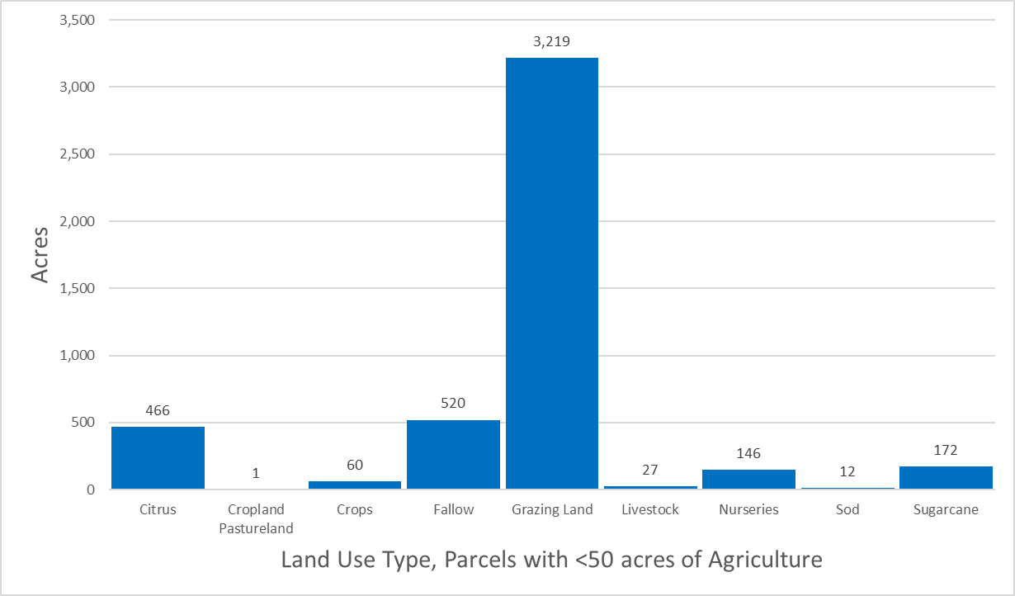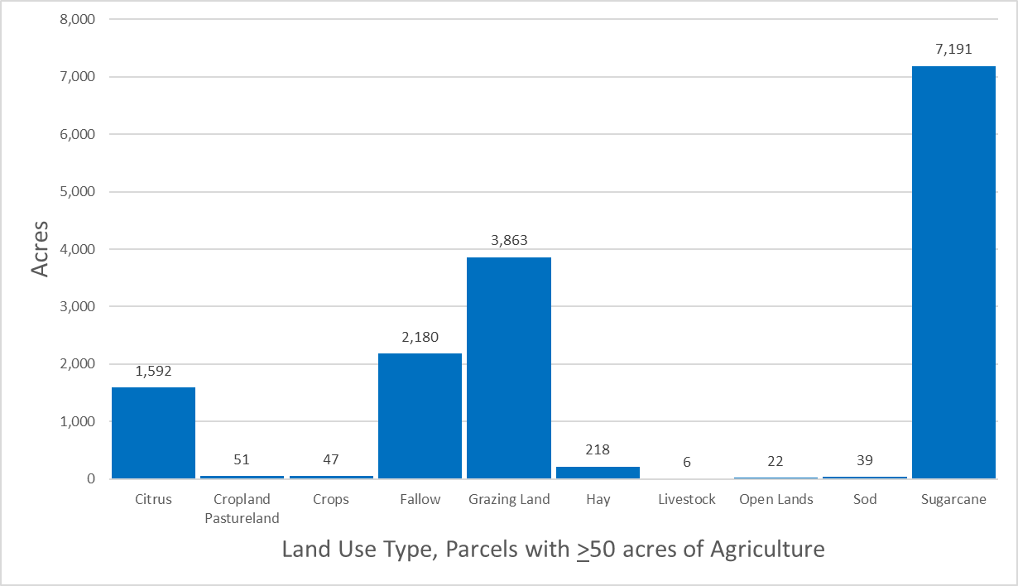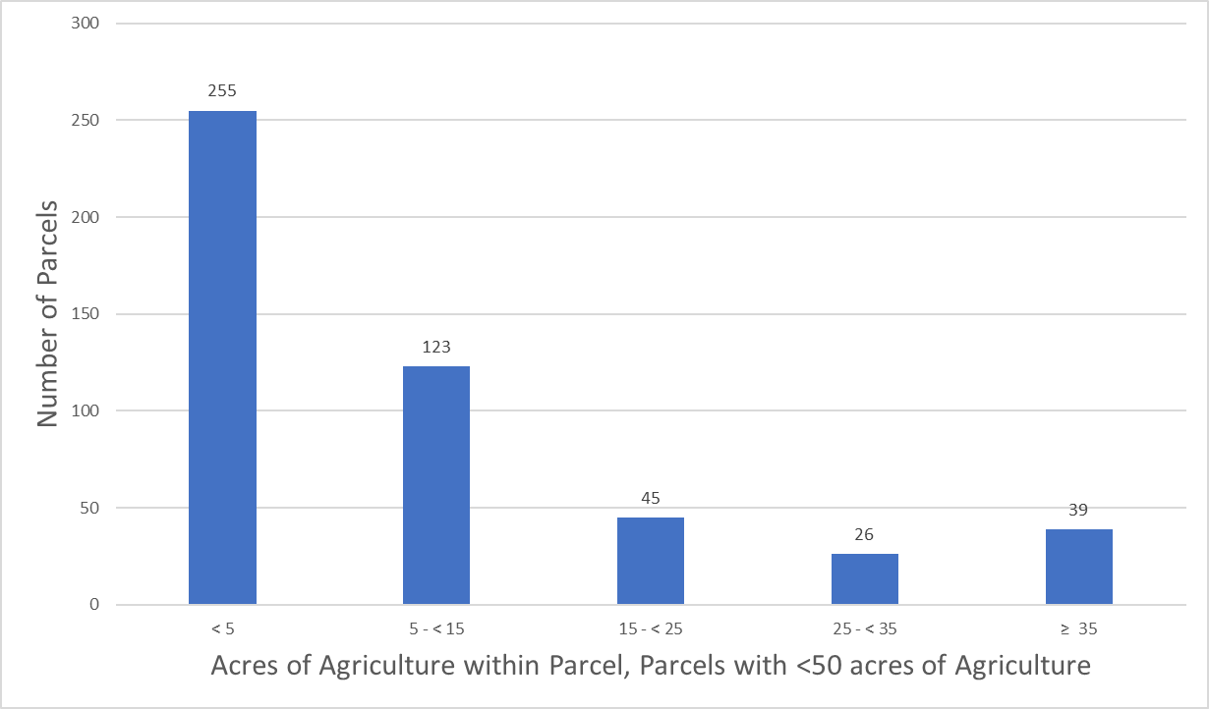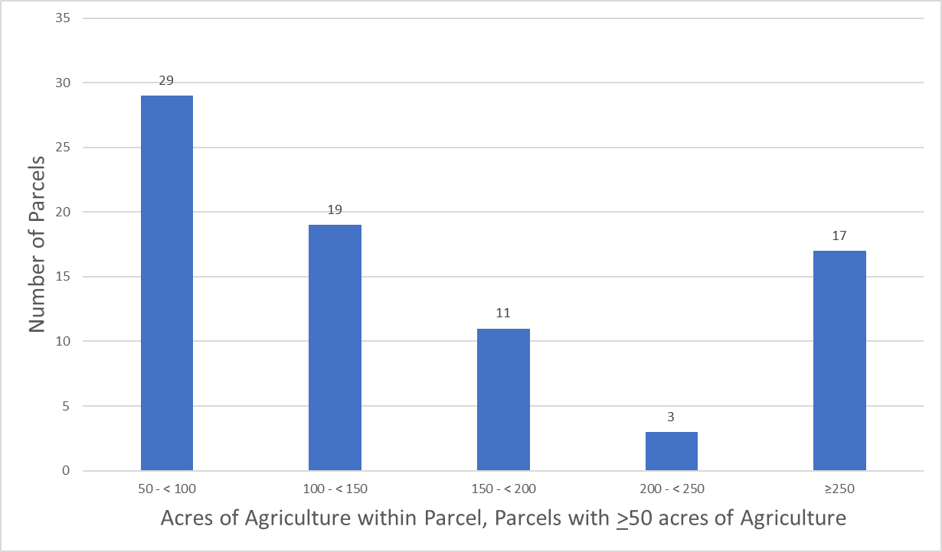
Figure B-25. Land use type and distribution of agricultural acreage, West Lake Okeechobee Subwatershed

Future Efforts
BMAP loads and allocations, as well as water supply projections, are based primarily on land use data. Maintaining the most accurate agricultural land use dataset is critical to planning and policy decisions. Although crop changes, technology advances, and land ownership/lessee changes related to agricultural operations create dynamic environments and difficulties in estimating impacts from specific operations, FDACS and DEP continue to coordinate and develop ways to improve accuracy.
Additional characterizations of the agricultural land uses need to be conducted for each of the subwatersheds in the Lake Okeechobee BMAP area. As the DEP analysis identifies the nutrient loading estimates for each associated subwatershed, FDACS will be able to better focus enrollment and cost-share efforts on those subwatersheds with the highest estimated loads and characterize the land uses with agricultural production that is consistent with FDACS’ BMP Program.
Analyzing land use data and parcel data is a valuable first step in identifying the agricultural areas that provide the greatest net benefits to water resources for enrollment in FDACS’ BMP Program, as well as to prioritize implementation verification visits in a given subwatershed. The next step to refine the enrollment efforts will have the parcel loading information derived from WAM converted to a format that can easily be analyzed with the land use and parcel geodatabases. This effort will help FDACS identify those specific parcels with the highest modeled nutrient loading. These parcels would then be prioritized for enrollment and implementation of BMPs, as well as site visits for the verification of BMP implementation.
Additional Factors Related to Agricultural Lands and Measuring Progress
Legacy loading, including loading as a result of the operation of the regional water management system and associated infrastructure, can present an additional challenge to measuring progress in many of areas of Florida with adopted BMAPs. Based on research, initial verification by DEP, and long-term trends in water quality in the BMAP area, it is expected that current efforts, such as BMP implementation, will continue to provide improvements in overall water quality despite the impacts from legacy loads. Recognition that there is naturally occurring phosphorus in the system is important when evaluating solutions, as the ubiquity of the source, limitations for treatment, and uncertainty of proportion compared with anthropogenic sources may mask or overwhelm gains achieved through BMP implementation and other site-specific efforts.
While the implementation of BMPs will improve the water quality in the basin, it is not reasonable to assume that BMP implementation alone can overcome the issues of legacy loads, conversion to more urban environments, and the effects of intense weather events. BMP implementation is one of several complex and integrated components in managing the water resources of a watershed. Additional regional projects, precisely located and operated, will be needed to achieve the TMDL for the LOW.
Collaboration between DEP, the water management districts, and other state agencies, as well as local governments, federal partners, and agricultural producers, is critical in identifying projects and programs, as well as locating funding opportunities to achieve allocations provided for under this BMAP. To improve water quality while retaining the benefits agricultural production provides to local communities, wildlife enhancement, and preservation of natural areas requires a commitment from all stakeholders to implementing protective measures in a way that maintain the viability of agricultural operations.
Recommended Updates to Land Use
DEP and OAWP have identified land use–related issues that consistently occur during BMAP development and/or updates. One of these issues is the differentiation between what is classified as agricultural land use in the TMDL or BMAP model and what is no longer agricultural land use.
OAWP has developed a methodology to identify agricultural land use changes. Using GIS, OAWP compared the 2009 SFWMD BMAP modeled land use with the latest FSAID land use and OAWP BMP enrollment data. OAWP identified areas classified as agriculture by the BMAP modeled land use that do not overlap with the latest FSAID or OWAP BMP enrollment data. OAWP reviewed the output of this overlay analysis by using county property appraiser data and aerial imagery to determine if the nonoverlapping areas were still in production. OAWP identified 13,407 acres, classified as agriculture in the 2009 SFWMD land use used in WAM, that are now other land use types such as residential, industrial, or commercial (see Table B-14). Often the analyses show changes that have occurred more rapidly than any land use data can capture, such as the transition to residential development. The land use changes are provided to DEP as a GIS shapefile with a description of the information in the county property appraiser database and aerial imagery reflected for refinement of the acreage and loading allocated to agriculture in a BMAP area.
In addition to identifying land use changes in BMAP modeled land use, OAWP regularly reviews FSAID data, at times daily or weekly, as it performs other job functions. Any edits or changes are reviewed and considered for inclusion in the next iteration of the FSAID.
Table B-14. Agricultural land use change by subwatershed
Subwatershed | Acres
Fisheating Creek | 1,448
Indian Prairie | 5,605
Lake Istokpoga | 2,181
Lower Kissimmee | 2,411
Taylor Creek/Nubbin Slough | N/A
Upper Kissimmee | N/A
East Lake Okeechobee | 855
West Lake Okeechobee | 907
South Lake Okeechobee | N/A

Potential Site-Specific Nutrient Management Measures in Addition to BMPs
Beyond enrolling producers in the OAWP BMP Program and verifying implementation, OAWP will also work with producers to identify a suite of agricultural projects and research agricultural technologies that could be implemented on properties where they are deemed technically feasible and if funding is made available. FDACS executes contracts with soil and water conservation districts and other partners to administer cost-share funds and provide technical and administrative support for these districts and other partners. Cost-share funding is being used to implement higher level BMPs, innovative technologies, and regional projects to provide the next added increment of improving and protecting water quality.
Table B-15 identifies the agricultural technologies that received cost-share assistance in the Lake Okeechobee BMAP area and the associated nutrient reductions based on the 2016 SWET report. Using the nutrient reductions from the report, OAWP developed a methodology to estimate nutrient reductions for NOIs that have received cost-share funding. The NOI boundary, based on county property appraiser parcel data, was considered the area treated by the cost-share agricultural technology or project. For parcels with more than one cost-share project, OAWP identified the order of treatment to determine the reductions for the multiple projects and created a workbook that provided the cost-share agricultural technologies and the formulas to estimate the nutrient reductions.

Table B-15. Cost-share project types and associated nutrient reductions recommended by OAWP
¹ Reductions for this measure were not incorporated as part of this exercise.
² Reductions for this measure are from Table 5 in the 2016 SWET Report (Bottcher 2016). Each project is 1 unit..
Project Types | TN Reductions  (%) | TP Reductions  (%)
Chemigation/fertigation | 20 | 20
Composting and/or storage project | N/A | N/A
Crop implements | N/A | N/A
Dairy work | 50 | 50
Drainage improvements, mole drain, ditch cleaning | 10 | 15
Engineering, surveying, planning, modeling | N/A | N/A
Fence | 10 | 10
Irrigation improvements, automation | 20 | 20
Precision agriculture technology | 30 | 10
Retention, detention, tailwater recovery, berms (vegetable and agronomic crops, citrus) | 64 | 70
Retention, detention, tailwater recovery, berms (cow/calf) | 25 | 18
Structure for water control/culvert | 17 | 29
Weather station¹ | 20 | 5
Well, pipeline, trough, pond, heavy use protection² | 186 lbs/yr/unit | 50 lbs/yr/unit

Appendix C. Water Quality Data Processing and Analysis Methods
For the 5-Year Review of the Lake Okeechobee BMAP, trend analyses were conducted on available data from Tier 1 and Tier 2 stations for the period from May 1, 2008, to April 30, 2018. Data were provided by SFWMD and retrieved from WIN and processed according to the procedure outlined in the next section.
The nonparametric Seasonal Kendall test was used to identify monotonic trends in the data. This statistical technique was chosen because data are not required to conform to a particular distribution and the results are robust against outliers and gaps in the data record. Section 3.3.3 summarizes the results of the Seasonal Kendall analysis, and details of the techniques are provided below.
Data Management and Processing
The POR for this analysis was May 1, 2008, to April 30, 2018, to allow a sufficient data record for trend analysis including periods before and after BMAP adoption in December 2014, and to remain consistent with the established water year in the region (May 1–April 30).
TP was the only parameter used in this analysis, and SFWMD provided TP data for the Tier 1 and Tier 2 stations. Data from the last four months of WY2018 for Station KREA98 were appended from data retrieved from WIN. Table C-1 and Table C-2 list the POR and data availability for the monthly series of TP data for each station. The data provided by SFWMD were already preprocessed per standard SFWMD quality control protocols.
Data retrieved from WIN were further processed with standard quality control checks and statistical diagnostics, including removing data with fatal qualifier codes, the assessment of temporal independence, and serial correlation. After quality control processing was completed, monthly aggregated values were calculated for each month with more than one sampling event. The monthly series was the final dataset used in statistical and trend analysis. Specific data processing and steps and methodology are provided in the following sections.
Statistical Analyses
The Seasonal Kendall test was used to identify monotonic trends in the TP load (Tier 1), FWM (Tier 1), or concentration (Tier 2) data, which were dependent on station type. The USGS Fortran code for the Seasonal Kendall test was used to compute a tau, raw p-value, and slope for each parameter series using months as "seasons." The program also provides a p-value adjusted for covariance caused by serial correlation.
Autocorrelation function (ACF) analysis was conducted on the monthly TP series for each station to identify the presence of seasonality and serial correlation. If a series showed significant autocorrelation at the 12-month lag, it was considered to exhibit serial correlation, and the adjusted p-value was selected as the representative p-value for the series. If no serial correlation was detected, then the raw p-value was reported. Trends in the data series were considered statistically significant if the appropriate p-value was less than 0.05, with a positive Sen slope indicating an increasing trend and a negative Sen slope indicating a decreasing trend.
Data Download
Station data were provided by SFWMD to assess TP concentrations for Tier 2 stations and TP FWMs and loads at Tier I structure stations for the designated POR of May 1, 2008, through April 30, 2018.
Data Processing (in order of operation)
- The majority of data processing was conducted by SFWMD for the final 2019 SFER – Volume I, Chapter 8B prepared by SFWMD. Data processing conducted by SFWMD included the calculations of monthly surface water flows and nutrient (TP and TN) loads for the major drainage basins into Lake Okeechobee, as well as discharges from Lakes Istokpoga and Kissimmee. Data were based on stations where flows are continuously monitored and TP and TN samples are collected weekly, if flowing; otherwise monthly at a minimum. Basin load and flow data were used to estimate nutrient FWM concentrations. The SFER lists annual flows and nutrient loads to Lake Okeechobee for each water year.
- Few data points downloaded for WY2018 for KREA98 were subject to the following data processing:
  - Data Qualifiers:
    - Data with result qualifiers of "G," "H," "K," "L," "N," "O," "Q," "V," "Y," or "?" were not used in the analysis, as per Table 1, Data Qualifier Codes, in Rule 62-160.700, F.A.C., Quality Assurance, and recent DEP decisions.
    - Only grab samples were used in the analysis of concentration data.
    - Both grab and automatic composite samples were used in the analysis of FWM and load data (as calculated and provided by SFWMD from flow and concentration data).
    - Data with a result qualifier of "J" were reviewed.
    - Data with a result qualifier of "U" were reviewed:
      - If not already present, a result qualifier of "U" was assigned to any data with a result value of "*Non-Detect."
      - Data with a result value of "*Not Reported" were deleted unless they also had a value qualifier of "U."
      - Data with a result qualifier of "U" were processed in accordance with Subsection 62-303.320(12), F.A.C., Aquatic Life-Based Water Quality Criteria Assessment. Results with the "U" data qualifier code reported by a laboratory were assessed as half the reported result or half the criterion (whichever was lower).
  - Sample Depth:
    - Samples were not filtered by sample depth.
  - Nutrient Characteristic Selection:
    - TP: "Phosphorus as P," "Phosphorus-Total."
  - Accounting for Duplicate Samples:
    - If samples were found to share the same station, characteristic, date, and time, they were flagged and reviewed.
    - The median of the duplicate samples was used as the reported value.
- Temporal Processing:
  - Monthly Time Series: If multiple data points existed within a month, the monthly median was calculated for each month.
- Processing for Statistical Tests:
  - Data were processed according to the needs of each statistical test (ACF or trend) and formatted for use in the R statistical program or USGS Fortran code.
  - Sampling Frequency:
    - Monthly data series were used for analysis.
    - Stations were separated into 2 analysis groups based on whether they had more or less than 50 % of available points.
    - Only station datasets with greater than 50 % of available data points were used for analysis.
Trend Analysis
- ACF:
  - Conducted to analyze seasonal patterns or serial correlation (using monthly seasons).
  - For the purposes of Seasonal Kendall analysis, statistically significant correlation on the 12th month lag was considered to be representative of serial correlation.
- Seasonal Kendall Tau Test:
  - Statistical Test Description: A nonparametric statistical test that does not require data to conform to a specific distribution and is not sensitive to outliers or data gaps.
    - Identifies monotonic trends in the datasets.
    - Yields statistical significance value and direction of trend (increasing or decreasing).
    - Accounts for seasonal data patterns (using months as seasons).
  - Use in Trend Analysis:
    - Serial correlation was identified with ACFs prior to trend analysis.
    - USGS Fortran code for Seasonal Kendall Tau Test was used to produce tau, p-value, adjusted p-value, and Sen slope:
      - Raw p-value was used for series with no serial correlation detected.
      - Adjusted p-value was used if serial correlation was identified.
    - Tau, p-value, and slope were used to interpret the significance and direction of a monotonic trend.

Table C-1. POR for Tier 1 stations monthly TP FWM and load data series
Station | FWM Start Date | FWM End Date | FWM Count | Load Start Date | Load End Date | Load Count
C10A | 5/1/2008 | 4/1/2018 | 72 | 5/1/2018 | 4/1/2018 | 120
FECSR78 | 5/1/2018 | 4/1/2018 | 120 | 5/1/2018 | 4/1/2018 | 120
INDUSCAN | 5/1/2008 | 4/1/2018 | 105 | 5/1/2018 | 4/1/2018 | 120
L59W | 5/1/2008 | 4/1/2018 | 98 | 5/1/2018 | 4/1/2018 | 120
L60E | 7/1/2008 | 3/1/2018 | 94 | 5/1/2018 | 4/1/2018 | 120
L60W | 5/1/2008 | 4/1/2018 | 112 | 5/1/2018 | 4/1/2018 | 120
L61E | 5/1/2008 | 4/1/2018 | 77 | 5/1/2018 | 4/1/2018 | 120
S127 | 8/1/2008 | 1/1/2018 | 83 | 5/1/2018 | 4/1/2018 | 120
S129 | 8/1/2008 | 2/1/2018 | 98 | 5/1/2018 | 4/1/2018 | 120
S131 | 7/1/2008 | 3/1/2018 | 92 | 5/1/2018 | 4/1/2018 | 120
S133 | 8/1/2008 | 2/1/2018 | 77 | 5/1/2018 | 4/1/2018 | 120
S135 | 7/1/2008 | 2/1/2018 | 84 | 5/1/2018 | 4/1/2018 | 120
S154 | 7/1/2008 | 3/1/2018 | 87 | 5/1/2018 | 4/1/2018 | 120
S154C | 7/1/2008 | 4/1/2018 | 107 | 5/1/2018 | 4/1/2018 | 120
S191 | 6/1/2018 | 1/1/2018 | 97 | 5/1/2018 | 4/1/2018 | 120
S308C | 5/1/2008 | 4/1/2018 | 104 | 5/1/2018 | 4/1/2018 | 120
S4 | 7/1/2008 | 4/1/2018 | 105 | 5/1/2018 | 4/1/2018 | 120
S65 | 5/1/2018 | 4/1/2018 | 120 | 5/1/2018 | 4/1/2018 | 120
S65E | 5/1/2018 | 4/1/2018 | 118 | 5/1/2018 | 4/1/2018 | 120
S68 | 5/1/2018 | 4/1/2018 | 115 | 5/1/2018 | 4/1/2018 | 120
S71 | 5/1/2018 | 4/1/2018 | 118 | 5/1/2018 | 4/1/2018 | 120
S72 | 5/1/2018 | 4/1/2018 | 119 | 5/1/2018 | 4/1/2018 | 120
S84 | 5/1/2018 | 4/1/2018 | 119 | 5/1/2018 | 4/1/2018 | 120

Table C-2. POR for Tier 2 stations monthly TP concentration data series
Notes: Stations KREA91, KREA92, KREA93, KREA94, KREA97, and KREA98 are in-river sites.
SFWMD water quality stations KREA01, TCNS 213, TCNS 214, and TCNS 217 are colocated with USGS flow monitoring stations.
Station | Start Date | End Date | Count | % Available Data
AB27343014 | 5/9/2008 | 4/12/2018 | 110 | 91.67
ABOGGN | 12/8/2009 | 1/9/2018 | 83 | 69.17
AR06333013 | 5/9/2008 | 4/12/2018 | 117 | 97.50
AR18343012 | 5/9/2008 | 4/12/2018 | 104 | 86.67
BH04392912 | 5/13/2008 | 12/21/2017 | 84 | 70.00
BN03332911 | 5/9/2008 | 4/12/2018 | 118 | 98.33
BN08332912 | 5/9/2008 | 4/12/2018 | 108 | 90.00
BNSHINGLE | 5/19/2008 | 4/24/2018 | 100 | 83.33
BS-59 | 5/19/2008 | 4/24/2018 | 62 | 51.67
CL18273011 | 7/21/2011 | 4/17/2018 | 61 | 50.83
CREEDYBR | 5/19/2008 | 4/24/2018 | 71 | 59.17
CY05353444 | 5/12/2008 | 4/17/2018 | 101 | 84.17
DLMARNCR | 6/19/2012 | 4/30/2018 | 68 | 56.67
ET05253114 | 7/9/2008 | 2/14/2018 | 71 | 59.17
ET06253113 | 5/14/2008 | 1/22/2018 | 109 | 90.83
FE20393013 | 5/13/2008 | 12/21/2017 | 72 | 60.00
FE21392913 | 5/13/2008 | 9/22/2017 | 68 | 56.67
FE26362812 | 7/8/2008 | 3/6/2018 | 86 | 71.67
GA09393011 | 5/13/2008 | 3/6/2018 | 103 | 85.83
HP06393242 | 5/9/2011 | 3/16/2018 | 63 | 52.50
HP11373132 | 6/18/2008 | 9/22/2017 | 61 | 50.83
HP15373112 | 6/27/2008 | 11/16/2017 | 72 | 60.00
HP22373112 | 5/5/2008 | 12/21/2017 | 76 | 63.33
HP25373013 | 5/5/2008 | 4/5/2018 | 114 | 95.00
IP09383232 | 5/9/2011 | 10/5/2017 | 62 | 51.67
KR05373311 | 5/7/2008 | 2/2/2018 | 64 | 53.33
KR16373414 | 5/27/2008 | 4/24/2018 | 83 | 69.17
KR17373513 | 5/12/2008 | 4/24/2018 | 88 | 73.33
KR24353114 | 6/19/2008 | 4/12/2018 | 76 | 63.33
KREA 01 | 5/5/2008 | 11/22/2017 | 65 | 54.17
KREA 04 | 7/7/2008 | 4/12/2018 | 67 | 55.83
KREA 14 | 7/8/2008 | 1/19/2018 | 61 | 50.83
KREA 17A | 7/8/2008 | 2/2/2018 | 83 | 69.17
KREA 22 | 5/5/2008 | 2/14/2018 | 91 | 75.83
KREA 23 | 7/7/2008 | 12/28/2017 | 82 | 68.33
KREA91 | 5/5/2008 | 12/13/17 | 116 | 96.67
KREA92 | 5/5/2008 | 12/13/17 | 112 | 93.33
KREA93 | 5/6/2008 | 12/12/17 | 114 | 95.00
KREA94 | 5/6/2008 | 12/12/17 | 114 | 95.00
KREA97 | 5/5/2008 | 12/13/17 | 114 | 95.00
KREA98 | 5/6/2018 | 4/10/18 | 118 | 98.33
LB29353513 | 6/30/2008 | 4/17/2018 | 87 | 72.50
LI02362923 | 6/1/2011 | 4/5/2018 | 81 | 67.50
LV14322813 | 9/2/2008 | 2/1/2018 | 70 | 58.33
MS08373611 | 6/30/2008 | 2/22/2018 | 70 | 58.33
OK09353212 | 5/12/2008 | 2/14/2018 | 82 | 68.33
OT34353513 | 5/20/2008 | 1/5/2018 | 68 | 56.67
PA10313112 | 7/24/2008 | 3/13/2018 | 88 | 73.33
PB24392912 | 5/13/2008 | 2/21/2018 | 110 | 91.67
PL01382911 | 6/25/2008 | 3/6/2018 | 105 | 87.50
RD08322913 | 5/9/2008 | 4/12/2018 | 119 | 99.17
TCNS 204 | 6/2/2008 | 2/14/2018 | 77 | 64.17
TCNS 207 | 7/7/2008 | 2/14/2018 | 65 | 54.17
TCNS 213 | 7/7/2008 | 12/28/2017 | 91 | 75.83
TCNS 214 | 5/5/2008 | 4/24/2018 | 69 | 57.50
TCNS 217 | 5/5/2008 | 4/24/2018 | 108 | 90.00
TCNS 220 | 6/3/2008 | 4/24/2018 | 67 | 55.83
TCNS 222 | 5/6/2008 | 4/24/2018 | 93 | 77.50

Appendix D. Stations Used in Five-Year Rolling Average TP Load Calculation
The SFER, prepared by SFWMD, reports annually on the TP load to Lake Okeechobee by water year and for the latest five-year average. The reported load is based on the locations shown in Figure D-1 through Figure D-4, and further analysis is available in the final 2019 SFER – Volume I, Chapter 8B (which documents water flow, TP load, and TP FWM concentrations in each subwatershed of the LOW) and in the final 2019 SFER – Volume III, Appendix 4-1.

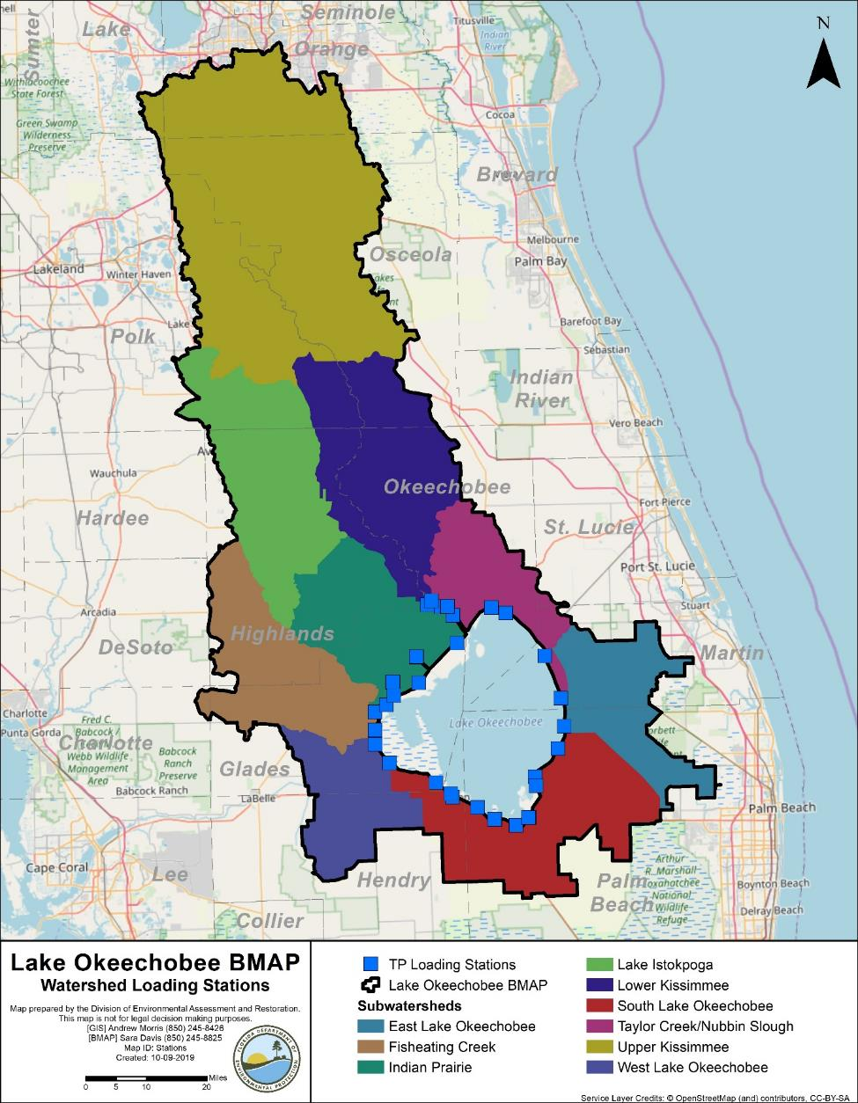
Figure D-1. Stations used to determine the five-year rolling average TP load for the LOW

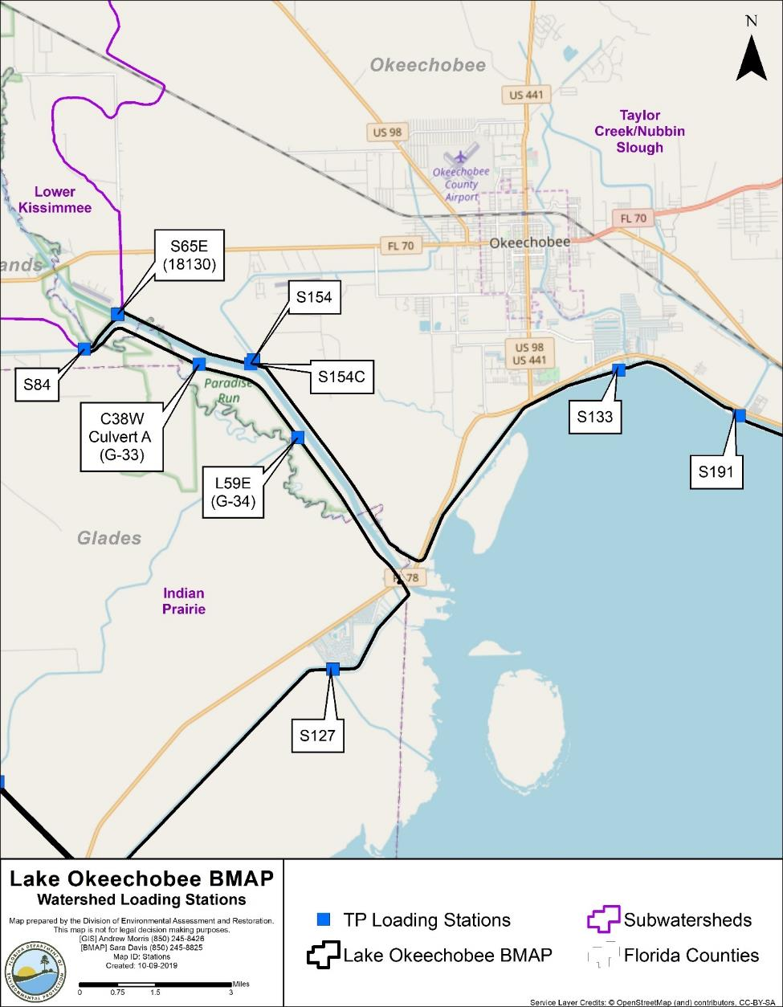
Figure D-2. Stations used to determine the five-year rolling average TP load for the LOW (zoomed in on north stations)

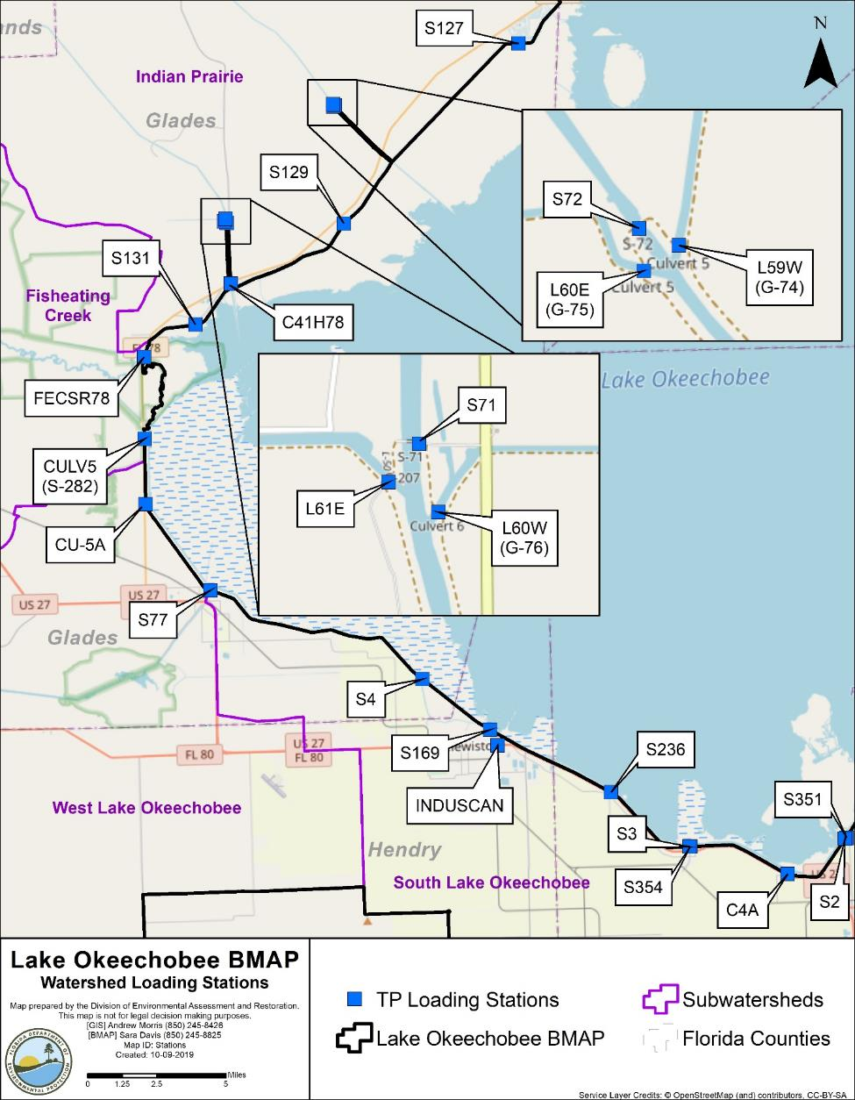
Figure D-3. Stations used to determine the five-year rolling average TP load for the LOW (zoomed in on west stations)

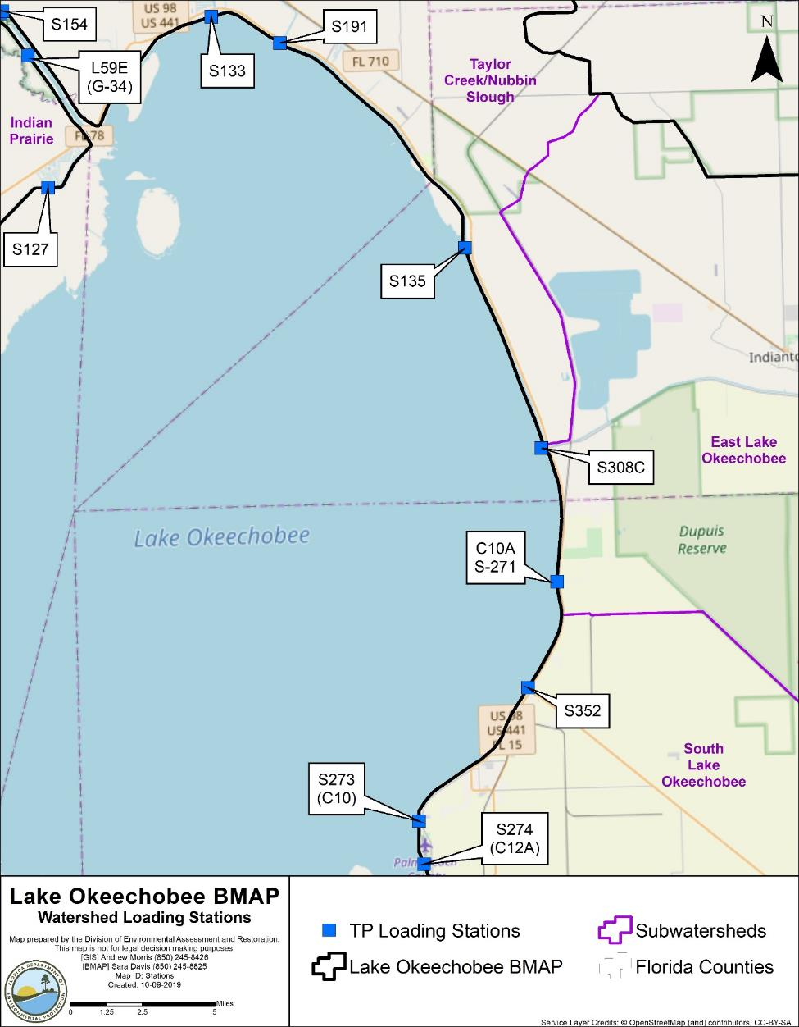
Figure D-4. Stations used to determine the five-year rolling average TP load for the LOW (zoomed in on east stations)

Appendix E. RFI Responses
To further identify restoration projects for this BMAP, DEP released an RFI in October 2019 to generate additional restoration projects or activities from both the public and private sectors. The effort was open to any interested parties who could propose a viable project for restoration and could be considered for inclusion in the final Lake Okeechobee BMAP for funding consideration.
Overall, the RFI process generated 34 responses from the private sector. Submittals ranged from on-the-ground projects, such as STAs, to technologies that could be implemented in both aquatic and terrestrial environments. All submittals were reviewed; Table E-1 summarizes the submittals. The TRA IDs and basin names reference the maps for each subwatershed and the lake in Chapter 4. Resources will be needed to implement any of these projects throughout the watershed, and they are being considered for DEP funding. Additional details on all responses are on file with DEP.

Table E-1. Summary of responses received for RFI 2020012
Location Information | Submitted by | Project Name | Project Type
TRA 1 (L-8) | The Colinas Group | Mayaca Materials STA | Storage/STA
TRA ID 2 (C 44/Basin 8/S 153) | The MilCor Group, Inc. | Caulkins-Troup Water Farm | Storage/STA
TRA ID 2 (C 44/Basin 8/S 153) | The MilCor Group, Inc. | Caulkins-Greenridge Water Farm | Storage/STA
TRA ID 14 (C-41) | EHS Support | Two Bar G Farms STA | Storage/STA
TRA IDs: 14 (C-41) and 36 (S-191)  Can also treat TRA IDs 13, 21, 33, and 65 | AquaFiber Technologies Corporation | AquaFiber Algae Harvesting | Algae-harvesting technology
TRA IDs: 32 (S-154C) and 34 (S-133)  Can also treat TRA IDs 13, 21, 33, and 65 | Ecosystem Investment Partners | Dual-cell STAs | Storage/STA
TRA ID 33 (S-154) | Family Tree Enterprises Limited Partnership, LLLP | The Dixie Ranch Stormwater Pond and Ditches | Storage/STA
TRA ID 33 (S-154) | HydroMentia Technologies | Algal Turf Scrubber | Algae filtration technology
TRA ID 36 (S-191) | Sustainable Water Investment Group, LLC | Phosphorus Elimination System Upgrade of Taylor Creek STA | Storage/STA
TRA ID 54 (Tiger Lake) | ECO2 | Super Oxygenation | In-lake treatment
TRA ID 62 (East Caloosahatchee) | Lykes Bros. Inc. | Turkey Branch Above-Ground Impoundments | Storage/STA
TRA ID 65 (in-lake) | Atkins | Quantification of Sediment Nutrient Recycling to Guide Implementation of In Situ Nutrient Sequestration | Monitoring
TRA ID 65 (in-lake) | Ensynox | Ensynox Enzyme | Bioremediation treatment technology
TRA ID 65 (in-lake) | Green Wave Innovative Solutions, LLC | Chara filter | Algae filtration technology
TRA IDs: 1,2,9,23,24,26,27,28,30,34,35,65 | Beta Analytic | Dissolved Nitrate Isotopic Monitoring | Monitoring
TRA IDs: 3,4,16,17,18,19,21,37,38,39,40,41,43,44,45,46,47,48,49,50,51,52,53,54,55,56,57,58,59,60,61,62,63,64 | Eco Librium | Water Cleanser | Technology
TRA IDs: 32,33,34,35,36 | AECOM Technical Services, Inc. | Nutrient Inceptor Removal System (NIRS) | Algae-harvesting technology
TRA IDs: 3-8, 11-16, 32-36, 43,49,50,54, 65 | Equilibrium Sciences, LLC | ExtraGroTM | Bioremediation/  land application technology
TRA IDs: 3-8,11,12,14,15,16,18,32-36,43,49,50,54 | UltraTech International | Ultra-Archaea and Ultra-PhosFilter | Bioremediation treatment technology
TRA IDs: 4,6,7,8,11,12,14,15,18,32,33,34,36,49,54 | ESSRE | Nano-Enhanced Adsorbent Media (NEAM) | Technology
TRA IDs: 6,7,8,32,33,36,65 | Nclear, Inc | TPX™ Phosphorus Removal Media | Technology
TRA IDs: 7,8,14,15,32,33,34,36,49 | Water Warriors | PoseidonTM Carbonate Pellets | Technology
TRA IDs: 8,14,32,33,36,65 | Phosphorus Free | Phosphorus Free Water Solutions | Technology
TRA IDs: 1-64  Also visited two dairy farms and found acceptable sites. | ECS | Bold & Gold Filtration Media | Biosorption activated media
TRA IDs: 1-64 | Higgins Env | A-Pod | Technology
TRA IDs: 1-64 | LatAm Services | LatAm Services Technology | Bioremediation/  land application technology
TRA IDs: 1-64 | PDS Health, Inc | PDS Health Technology | Algae-harvesting technology
TRA IDs: 1-65 | Peace USA | Nualgi | Algae-harvesting technology
TRA IDs: 1-65 | Universal Engineering Sciences, Inc. | Universal Engineering Sciences Bioremediation | Bioremediation treatment technology
TRAs with tillable land | HSC Organics | HSC Organics Soil Treatment | Bioremediation/  land application technology
Not Provided | Freytech | Environmental Balance Device | Technology
Not Provided | OxSolve, LLC | OxSolve Aeration System | Technology
Not Provided | SFS SOS | Salvation Farming Solutions  Salvation Ocean Solutions | Technology

https://www.fdacs.gov/Agriculture-Industry/Water/Agricultural-Best-Management-Practices

