Watershed Assessment Model (WAM): Recalibration of the Northern Lake Okeechobee Basins
Deliverable 1: WAM Recalibration Report
Soil and Water Engineering Technology, Inc. | July 18, 2017
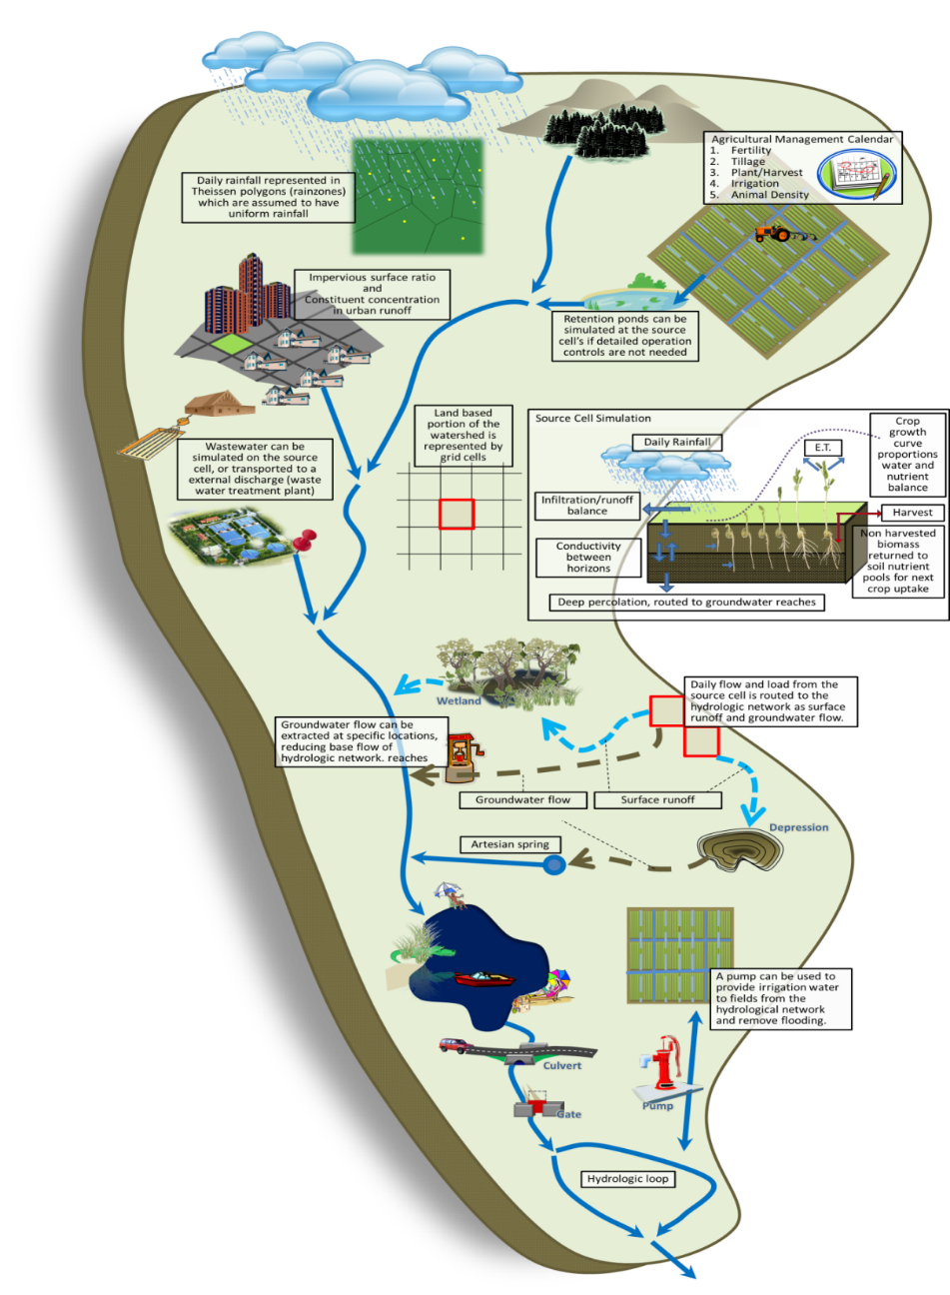
FDACS Contract No. 24010
Table of Contents
1 Introduction and Background 13
1.1 Introduction 13
1.2 Background 13
1.3 Objectives 14
2 The Watershed Assessment Model 17
2.1 Model Approach 17
2.2 Source Cell Modeling 17
2.2.1 GLEAMS 18
2.2.2 EAAMOD 19
2.3 Hydrodynamic Routing 21
3 Data Acquisition and Formatting 23
3.1 Input Spatial (GIS) Datasets 23
3.1.1 Model Domain Boundaries 24
3.1.2 Subbasin Boundaries 26
3.1.3 Topography 26
3.1.4 Hydrography 28
3.1.5 Land Use 28
3.1.6 Soils 32
3.1.7 Rainfall Stations 32
3.1.8 Major Hydrologic Control Structures 32
3.1.9 Utility (Wastewater) Zones 36
3.1.10 Location of Water and Nutrient Point Sources/Sinks 36
3.1.11 Irrigation source specification 36
3.2 Measured Data 36
3.2.1 Flow Data 37
3.2.2 Rainfall 39
3.2.3 Evapotranspiration 40
3.2.4 Temperature 40
3.2.5 Water Quality 41
3.2.6 Lake Okeechobee Seepage Estimates 43
3.3 System Operations 43
3.4 Data Preparation 45
3.4.1 Reach Delineation 45
3.4.2 GIS Dataset Reconciliation 47
3.4.3 Time Series Dataset Preparation 50
4 Calibration, Verification, and Goodness of Fit Methodology 53
4.1 The Impact of Uncertainty in Input Data on WAM 54
4.2 Calibration 54
4.2.1 Hydrologic and Hydraulic (H&H) Calibration 56
4.2.2 Nitrogen and Phosphorus Load Calibration 57
4.3 Verification 58
4.4 Calibration/Verification Period and Calibration Targets 58
4.5 Goodness of Fit 60
5 Model Results 61
5.1 Fisheating Creek 63
5.1.1 Flows and Water Quality Data at SR-78 64
5.2 Indian Prairie 67
5.2.1 Flow and Water Quality Data at S-84 70
5.2.2 Flow and Water Quality Data at S-71 72
5.2.3 Flow and Water Quality Data at S-72 75
5.2.4 Combined Estimates from S-84, S-71, and S-72 78
5.2.5 Flow and Water Quality Data at S-127 79
5.2.6 Flow and Water Quality Data at S-129 81
5.2.7 Flow and Water Quality Data at S-131 84
5.3 Lake Istokpoga 89
5.3.1 Flow and Water Quality Data at S-68 90
5.4 Lower Kissimmee 94
5.4.1 Flow and Water Quality Data at S-65E 95
5.5 Taylor Creek/Nubbin Slough 99
5.5.1 Flow and Water Quality Data at S-133 101
5.5.2 Flow and Water Quality Data at S-135 103
5.5.3 Flow and Water Quality Data at S-154 106
5.5.4 Flow and Water Quality Data at S-191 109
5.6 Upper Kissimmee 113
5.6.1 Flow and Water Quality Data at S-65 114
5.7 Summary and Conclusions 117
5.7.1 GOF Results 117
5.7.2 Conclusions 117
6 Appendices 119
6.1 Charts of Flow and Nutrient Loads 1975-2013 119
6.1.1 Fisheating Creek 119
6.1.2 Indian Prairie 122
6.1.3 Lake Istokpoga 131
6.1.4 Lower Kissimmee 133
6.1.5 Taylor Creek/Nubbin Slough 134
6.1.6 Upper Kissimmee 140
6.2 Volume and Nutrient Load Tables 1975-2013 142
6.2.1 Fisheating Creek 142
6.2.2 Volume over the period 1975-2013 at SR-78 on Fisheating Creek 142
6.2.3 Total Nitrogen Loads over the period 1998-2013 at SR-78 on Fisheating Creek 142
6.2.4 Total Phosphorus Loads over the period 1998-2013 at SR-78 on Fisheating Creek 143
6.2.5 Volume over the period 1998-2013 at Palmdale on Fisheating Creek 144
6.2.6 Total Nitrogen Loads over the period 1975-2011 at Palmdale on Fisheating Creek 145
6.2.7 Total Phosphorus Loads over the period 1975-2011 at Palmdale on Fisheating Creek 146
6.2.8 Indian Prairie 147
6.2.9 Total Nitrogen Loads over the period 1975-2013 at S-84 149
6.2.10 Total Phosphorus Loads over the period 1975-2013 at S-84 150
6.2.11 Volume over the period 1975-2013 at S-71 151
6.2.12 Total Nitrogen Loads over the period 1975-2013 at S-71 152
6.2.13 Total Phosphorus Loads over the period 1975-2013 at S-71 154
6.2.14 Volume over the period 1975-2013 at S-72 155
6.2.15 Total Nitrogen Loads over the period 1975-2013 at S-72 156
6.2.16 Total Phosphorus Loads over the period 1975-2013 at S-72 157
6.2.17 Volume over the period 1975-2013 at S-127 159
6.2.18 Total Nitrogen Loads over the period 1975-2013 at S-127 160
6.2.19 Total Phosphorus Loads over the period 1975-2013 at S-127 161
6.2.20 Volume over the period 1975-2013 at S-129 162
6.2.21 Total Nitrogen Loads over the period 1975-2013 at S-129 164
6.2.22 Total Phosphorus Loads over the period 1975-2013 at S-129 165
6.2.23 Volume over the period 1975-2013 at S-131 166
6.2.24 Total Nitrogen Loads over the period 1975-2013 at S-131 167
6.2.25 Total Phosphorus Loads over the period 1975-2013 at S-131 169
6.2.26 Lake Istokpoga 170
6.2.27 Total Nitrogen Loads over the period 1975-2013 at S-68 171
6.2.28 Total Phosphorus Loads over the period 1975-2013 at S-68 172
6.2.29 Lower Kissimmee 174
6.2.30 Total Nitrogen Loads over the period 1975-2013 at S-65E 175
6.2.31 Total Phosphorus Loads over the period 1975-2013 at S-65E 176
6.2.32 Taylor Creek/Nubbin Slough 177
6.2.33 Volume over the period 1975-2013 at S-133 177
6.2.34 Total Nitrogen Loads over the period 1975-2013 at S-133 179
6.2.35 Total Phosphorus Loads over the period 1975-2013 at S-133 180
6.2.36 Volume over the period 1975-2013 at S-135 181
6.2.37 Total Nitrogen Loads over the period 1975-2013 at S-135 182
6.2.38 Total Phosphorus Loads over the period 1975-2013 at S-135 184
6.2.39 Volume over the period 1975-2013 at S-154 185
6.2.40 Total Nitrogen Loads over the period 1975-2013 at S-154 186
6.2.41 Total Phosphorus Loads over the period 1975-2013 at S-154 187
6.2.42 Volume over the period 1975-2013 at S-191 189
6.2.43 Total Nitrogen Loads over the period 1975-2013 at S-191 190
6.2.44 Total Phosphorus Loads over the period 1975-2013 at S-191 191
6.2.45 Upper Kissimmee 193
6.2.46 Volume over the period 1975-2013 at S-65 193
6.2.47 Total Nitrogen Loads over the period 1975-2013 at S-65 194
6.2.48 Total Phosphorus Loads over the period 1975-2013 at S-65 195
6.3 WAM Structure Parameters 197
6.4 FLUCCS/WAM Land Use ID Correspondence 206
7 References 216

Table of Figures
Figure 1. Location of the six northern Lake Okeechobee sub-watersheds that were modeled for the project. The three southern sub-watersheds that were modeled for Deliverables 2, 3, and 4 are also shown. 16
Figure 2. Unique cell generation. 17
Figure 3. Source model selection. 18
Figure 4. EAAMOD digitization scheme for a general soil profile. 20
Figure 5. Flow path routing for determination of attenuation distance. 22
Figure 6. Model domain boundaries for the WAM simulations in the six northern sub-watersheds, based on the sub-watershed boundaries defined by the Coordinating Agencies. 25
Figure 7. Representation of the topography data used for the WAM simulations. 27
Figure 8. The reach network developed for WAM. 29
Figure 9. Land use feature class for the LOW currently incorporated into WAM. 30
Figure 10. Soil distribution in the LOW. 33
Figure 11. Rainfall stations within the Lake Okeechobee Watershed used in WAM simulations. 34
Figure 12. SFWMD hydraulic control structures used in the WAM simulations. 35
Figure 13. Box plot of rainfall over the simulation period. Rainfall data from all stations used in the model are included. 52
Figure 14. Box plot of rainfall over the combined calibration/verification period. Rainfall data from all stations used in the model are included. 59
Figure 15. The Fisheating Creek model domain. Rain stations, flow station, and water quality stations are shown. 63
Figure 16. Measured and simulated accumulated water volumes in acre-feet (upper chart) and accumulated volume residuals (lower chart) at SR-78. 65
Figure 17. Comparison of measured and simulated TN (upper chart) and TP (lower chart) concentrations at SR-78. 66
Figure 18. Measured and simulated accumulated TN loads in metric tons (upper chart) and accumulated residuals (lower chart) at SR-78. 66
Figure 19. Measured and simulated accumulated TP loads in metric tons (upper chart) and accumulated residuals (lower chart) at SR-78. 67
Figure 20. The Indian Prairie model domain. Rainfall, flow, and water quality stations are shown. 68
Figure 21. Measured and simulated accumulated water volumes in acre-feet (upper chart) and accumulated volume residuals (lower chart) at structure S-84. 70
Figure 22. Comparison of measured and simulated TN (upper chart) and TP (lower chart) concentrations at structure S-84 on C-41A. 71
Figure 23. Measured and simulated accumulated TN loads in metric tons (upper chart) and accumulated residuals (lower chart) at structure S-84 on C-41A. 72
Figure 24. Measured and simulated accumulated TP loads in metric tons (upper chart) and accumulated residuals (lower chart) at structure S-84 on C-41A. 72
Figure 25. Measured and simulated accumulated water volumes in acre-feet (upper chart) and accumulated volume residuals (lower chart) at structure S-71. 73
Figure 26. Comparison of measured and simulated TN (upper chart) and TP (lower chart) concentrations at structure S-71. 74
Figure 27. Measured and simulated accumulated TN loads in metric tons (upper chart) and accumulated residuals (lower chart) at structure S-71. 74
Figure 28. Measured and simulated accumulated TP loads in metric tons (upper chart) and accumulated residuals (lower chart) at structure S-71. 75
Figure 29. Measured and simulated accumulated water volumes in acre-feet (upper chart) and accumulated volume residuals (lower chart) at structure S-72. 76
Figure 30. Comparison of measured and simulated TN (upper chart) and TP (lower chart) concentrations at structure S-72 on C-40. 77
Figure 31. Measured and simulated accumulated TN loads in metric tons (upper chart) and accumulated residuals (lower chart) at structure S-72 on C-40. 77
Figure 32. Measured and simulated accumulated TP loads in metric tons (upper chart) and accumulated residuals (lower chart) at structure S-72 on C-40. 78
Figure 33. Measured and simulated accumulated water volumes in acre-feet (upper chart) and accumulated volume residuals (lower chart) at structure S-127. 79
Figure 34. Comparison of measured and simulated TN (upper chart) and TP (lower chart) concentrations at structure S-127. 80
Figure 35. Measured and simulated accumulated TN loads in metric tons (upper chart) and accumulated residuals (lower chart) at structure S-127. 80
Figure 36. Measured and simulated accumulated TP loads in metric tons (upper chart) and accumulated residuals (lower chart) at structure S-127. 81
Figure 37. Measured and simulated accumulated water volumes in acre-feet (upper chart) and accumulated volume residuals (lower chart) at structure S-129. 82
Figure 38. Comparison of measured and simulated TN (upper chart) and TP (lower chart) concentrations at structure S-129. 83
Figure 39. Measured and simulated accumulated TN loads in metric tons (upper chart) and accumulated residuals (lower chart) at structure S-129. 83
Figure 40. Measured and simulated accumulated TP loads in metric tons (upper chart) and accumulated residuals (lower chart) at structure S-129. 84
Figure 41. Measured and simulated accumulated water volumes in acre-feet (upper chart) and accumulated volume residuals (lower chart) at structure S-131. 85
Figure 42. Comparison of measured and simulated TN (upper chart) and TP (lower chart) concentrations at structure S-131. 86
Figure 43. Measured and simulated accumulated TN loads in metric tons (upper chart) and accumulated residuals (lower chart) at structure S-131. 86
Figure 44. Measured and simulated accumulated TP loads in metric tons (upper chart) and accumulated residuals (lower chart) at structure S-131. 87
Figure 45. The Lake Istokpoga model domain. Rain stations, flow station, and water quality stations are shown. 89
Figure 46. Measured and simulated accumulated water volumes in acre-feet (upper chart) and accumulated volume residuals (lower chart) at the outflow to Lake Istokpoga at structure S-68. 91
Figure 47. Comparison of measured and simulated TN (upper chart) and TP (lower chart) concentrations at structure S-68. 92
Figure 48. Measured and simulated accumulated TN loads in metric tons (upper chart) and accumulated residuals (lower chart) at structure S-68. 92
Figure 49. Measured and simulated accumulated TP loads in metric tons (upper chart) and accumulated residuals (lower chart) at structure S-68. 93
Figure 50. The Lower Kissimmee model domain. Rain stations, flow station, and water quality stations are shown. 94
Figure 51. Measured and simulated accumulated water volumes in acre-feet (upper chart) and accumulated volume residuals (lower chart) at structure S-65E. 96
Figure 52. Comparison of measured and simulated TN (upper chart) and TP (lower chart) concentrations at structure S-65E. 97
Figure 53. Measured and simulated accumulated TN loads in metric tons (upper chart) and accumulated residuals (lower chart) at S-65E. 97
Figure 54. Measured and simulated accumulated TP loads in metric tons (upper chart) and accumulated residuals (lower chart) at S-65E. 98
Figure 55. The Taylor Creek/Nubbin Slough model domain. Rain stations, flow station, and water quality stations are shown. 99
Figure 56. Measured and simulated accumulated water volumes in acre-feet (upper chart) and accumulated volume residuals (lower chart) at structure S-133. 101
Figure 57. Comparison of measured and simulated TN (upper chart) and TP (lower chart) concentrations at structure S-133. 102
Figure 58. Measured and simulated accumulated TN loads in metric tons (upper chart) and accumulated residuals (lower chart) at structure S-133. 102
Figure 59. Measured and simulated accumulated TP loads in metric tons (upper chart) and accumulated residuals (lower chart) at structure S-133. 103
Figure 60. Measured and simulated accumulated water volumes in acre-feet (upper chart) and accumulated volume residuals (lower chart) at structure S-135. 104
Figure 61. Comparison of measured and simulated TN (upper chart) and TP (lower chart) concentrations at structure S-135. 105
Figure 62. Measured and simulated accumulated TN loads in metric tons (upper chart) and accumulated residuals (lower chart) at structure S-135. 105
Figure 63. Measured and simulated accumulated TP loads in metric tons (upper chart) and accumulated residuals (lower chart) at structure S-135. 106
Figure 64. Measured and simulated accumulated water volumes in acre-feet (upper chart) and accumulated volume residuals (lower chart) at structure S-154. 107
Figure 65. Comparison of measured and simulated TN (upper chart) and TP (lower chart) concentrations at structure S-154. 108
Figure 66. Measured and simulated accumulated TN loads in metric tons (upper chart) and accumulated residuals (lower chart) at structure S-154. 108
Figure 67. Measured and simulated accumulated TP loads in metric tons (upper chart) and accumulated residuals (lower chart) at structure S-154. 109
Figure 68. Measured and simulated accumulated water volumes in acre-feet (upper chart) and accumulated volume residuals (lower chart) at structure S-191. 110
Figure 69. Comparison of measured and simulated TN (upper chart) and TP (lower chart) concentrations at structure S-191. 111
Figure 70. Measured and simulated accumulated TN loads in metric tons (upper chart) and accumulated residuals (lower chart) at structure S-191. 111
Figure 71. Measured and simulated accumulated TP loads in metric tons (upper chart) and accumulated residuals (lower chart) at structure S-191. 112
Figure 72. The Upper Kissimmee model domain. Rainfall, flow, and water quality stations are shown. 113
Figure 73. Measured and simulated accumulated water volumes in acre-feet (upper chart) and accumulated volume residuals (lower chart) at structure S-65. 114
Figure 74. Comparison of measured and simulated TN (upper chart) and TP (lower chart) concentrations at structure S-65. 115
Figure 75. Measured and simulated accumulated TN loads in metric tons (upper chart) and accumulated residuals (lower chart) at structure S-65. 116
Figure 76. Measured and simulated accumulated TP loads in metric tons (upper chart) and accumulated residuals (lower chart) at structure S-65. 116
Figure 77. Total accumulated volume (millions of acre-feet) and residuals (thousands of acre feet) at SR-78. Note that measurements were not taken until 1998. 119
Figure 78. Total accumulated TN loads in metric tons (upper chart) and residual (lower chart) at SR-78. Note that measurements were not taken until 1998. 120
Figure 79. Total accumulated TP loads in metric tons (upper chart) and residual (lower chart) at SR-78. Note that measurements were not taken until 1998. 120
Figure 80. Total accumulated volume (millions of acre-feet) and residuals (thousands of acre feet) at Palmdale on Fisheating Creek. Note that measurements were not taken after May 2012. 121
Figure 81. Total accumulated TN loads in metric tons (upper chart) and residual (lower chart) at Palmdale on Fisheating Creek. Note that measurements were not taken after May 2012. 121
Figure 82. Total accumulated TP loads in metric tons (upper chart) and residual (lower chart) at Palmdale on Fisheating Creek. Note that measurements were not taken after May 2012. 122
Figure 83. Total accumulated volume (millions of acre-feet) and residuals (thousands of acre feet) at S-84. 122
Figure 84. Total accumulated TN loads in metric tons (upper chart) and residual (lower chart) at S-84. 123
Figure 85. Total accumulated TP loads in metric tons (upper chart) and residual (lower chart) at S-84. 123
Figure 86. Total accumulated volume (millions of acre-feet) and residuals (thousands of acre feet) at S-71. 124
Figure 87. Total accumulated TN loads in metric tons (upper chart) and residual (lower chart) at S-71. 124
Figure 88. Total accumulated TP loads in metric tons (upper chart) and residual (lower chart) at S-71. 125
Figure 89. Total accumulated volume (millions of acre-feet) and residuals (thousands of acre feet) at S-72. 125
Figure 90. Total accumulated TN loads in metric tons (upper chart) and residual (lower chart) at S-72. 126
Figure 91. Total accumulated TP loads in metric tons (upper chart) and residual (lower chart) at S-72. 126
Figure 92. Total accumulated volume (millions of acre-feet) and residuals (thousands of acre feet) at S-127. 127
Figure 93. Total accumulated TN loads in metric tons (upper chart) and residual (lower chart) at S-127. 127
Figure 94. Total accumulated TP loads in metric tons (upper chart) and residual (lower chart) at S-127. 128
Figure 95. Total accumulated volume (millions of acre-feet) and residuals (thousands of acre feet) at S-129. 128
Figure 96. Total accumulated TN loads in metric tons (upper chart) and residual (lower chart) at S-129. 129
Figure 97. Total accumulated TP loads in metric tons (upper chart) and residual (lower chart) at S-129. 129
Figure 98. Total accumulated volume (millions of acre-feet) and residuals (thousands of acre feet) at S-131. 130
Figure 99. Total accumulated TN loads in metric tons (upper chart) and residual (lower chart) at S-131. 130
Figure 100. Total accumulated TP loads in metric tons (upper chart) and residual (lower chart) at S-131. 131
Figure 101. Total accumulated volume (millions of acre-feet) and residuals (thousands of acre feet) at S-68. 131
Figure 102. Total accumulated TN loads in metric tons (upper chart) and residual (lower chart) at S-68. 132
Figure 103. Total accumulated TP loads in metric tons (upper chart) and residual (lower chart) at S-68. 132
Figure 104. Total accumulated volume (millions of acre-feet) and residuals (thousands of acre feet) at S-65E. 133
Figure 105. Total accumulated TN loads in metric tons (upper chart) and residual (lower chart) at S-65E. 133
Figure 106. Total accumulated TP loads in metric tons (upper chart) and residual (lower chart) at S-65E. 134
Figure 107. Total accumulated volume (millions of acre-feet) and residuals (thousands of acre feet) at S-133. 134
Figure 108. Total accumulated TN loads in metric tons (upper chart) and residual (lower chart) at S-133. 135
Figure 109. Total accumulated TP loads in metric tons (upper chart) and residual (lower chart) at S-133. 135
Figure 110. Total accumulated volume (millions of acre-feet) and residuals (thousands of acre feet) at S-135. 136
Figure 111. Total accumulated TN loads in metric tons (upper chart) and residual (lower chart) at S-135. 136
Figure 112. Total accumulated TP loads in metric tons (upper chart) and residual (lower chart) at S-135. 137
Figure 113. Total accumulated volume (millions of acre-feet) and residuals (thousands of acre feet) at S-154. 137
Figure 114. Total accumulated TN loads in metric tons (upper chart) and residual (lower chart) at S-154. 138
Figure 115. Total accumulated TP loads in metric tons (upper chart) and residual (lower chart) at S-154. 138
Figure 116. Total accumulated volume (millions of acre-feet) and residuals (thousands of acre feet) at S-191. 139
Figure 117. Total accumulated TN loads in metric tons (upper chart) and residual (lower chart) at S-191. 139
Figure 118. Total accumulated TP loads in metric tons (upper chart) and residual (lower chart) at S-191. 140
Figure 119. Total accumulated volume (millions of acre-feet) and residuals (thousands of acre feet) at S-65. 140
Figure 120. Total accumulated TN loads in metric tons (upper chart) and residual (lower chart) at S-65. 141
Figure 121. Total accumulated TP loads in metric tons (upper chart) and residual (lower chart) at S-65. 141

Table of Tables
Table 1. Coordinate system selected for the model project. 23
Table 2. The top 30 land use acreages in the northern six Lake Okeechobee sub-watersheds. 31
Table 3. Stations used for flow data listed by sub-watershed. 37
Table 4. Monthly averages of weather data inputs for WAM. Temperature values are in units of °C, solar radiation in units of Langleys (MJ/cm²), and wind speed is an average in km/day. 40
Table 5. Water quality stations used during the calibration. 41
Table 6. Structures used in the WAM simulations. 43
Table 7. Land uses that may be run using EAAMOD (if the soil type allows). 47
Table 8. List of BMP factors applied. The last three rows are combinations of two of the other BMPs listed. 49
Table 9. Listing of soils datasets obtained from NRCS by county. 50
Table 10. Rain stations used in the WAM model setup. Some stations have multiple records, indicated by more than one DB key. 51
Table 11. Standard calibration, verification, and goodness of fit procedures for WAM. 55
Table 12. Fisheating Creek water volume (in acre-feet) and TN and TP loads (in metric tons) at SR-78. 64
Table 13. Fisheating Creek GOF statistics at station FISHCR (LakePort). Note that RMSE has units of acre-feet for volume and metric tons for nutrient loads. The columns marked (C) refer to the calibration period while those marked (V) refer to the verification period. 67
Table 14. Indian Prairie Total Water Volume (acre-feet). 69
Table 15. Indian Prairie Total Nitrogen Load (metric tons). 69
Table 16. Indian Prairie Total Phosphorus Load (metric tons) 69
Table 17. Combined water volume (in acre-feet) and TN and TP loads (in metric tons) to Lake Okeechobee from S-84, S-71, and S-72. 78
Table 18. Indian Prairie GOF Statistics. Note that RMSE has units of acre-feet for volume and metric tons for nutrient loads. 87
Table 19. Lake Istokpoga water volume (in acre-feet) and TN and TP loads (in metric tons) leaving S-68. 90
Table 20. Lake Istokpoga GOF Statistics At Structure S68. Note that RMSE has units of acre-feet for volume and metric tons for nutrient loads. 91
Table 21. Lower Kissimmee water volume (in acre-feet) and TN and TP loads (in metric tons) at S-65E. 95
Table 22. Lower Kissimmee GOF Statistics At Structure S65E. Note that RMSE has units of acre-feet for volume and metric tons for nutrient loads. 98
Table 23. Taylor Creek/Nubbin Slough Total Water Volume (acre-feet). 100
Table 24. Taylor Creek/Nubbin Slough Total Nitrogen (metric tons). 100
Table 25. Taylor Creek/Nubbin Slough Total Phosphorus (metric tons). 100
Table 26. Taylor Creek/Nubbin Slough GOF Statistics. Note that RMSE has units of acre-feet for volume and metric tons for nutrient loads. 112
Table 27. Lake Kissimmee water volume (ac-ft) and TN and TP loads (in metric tons) leaving S-68. 114
Table 28. Upper Kissimmee GOF Statistics At Structure S-65. Note that RMSE has units of acre-feet for volume and metric tons for nutrient loads. 116
Table 29. NSE statistics for all of the outflow structures simulated. Note that (C) in a column indicates the calibration period, (V) indicates the verification period. 117
Table 30. Comparison of measured and simulated water volume over the period 1998-2013 at SR-78 on Fisheating Creek (acre-feet). 142
Table 31. Comparison of measured and simulated total nitrogen loads over the period 1998-2013 at SR-78 on Fisheating Creek (metric tons). 142
Table 32. Comparison of measured and simulated total phosphorus loads over the period 1998-2013 at SR-78 on Fisheating Creek (metric tons). 143
Table 33. Comparison of measured and simulated water volume over the period 1975-2013 at Palmdale on Fisheating Creek (acre-feet). 144
Table 34. Comparison of measured and simulated total nitrogen loads over the period 1975-2013 at Palmdale on Fisheating Creek (metric tons). 145
Table 35. Comparison of measured and simulated total phosphorus loads over the period 1975-2011 at Palmdale on Fisheating Creek (metric tons). 146
Table 36. Comparison of measured and simulated water volume over the period 1975-2013 at S-84 (acre-feet). 147
Table 37. Comparison of measured and simulated total nitrogen loads over the period 1975-2013 at S-84 (metric tons). 149
Table 38. Comparison of measured and simulated total phosphorus loads over the period 1975-2013 at S-84 (metric tons). 150
Table 39. Comparison of measured and simulated water volume over the period 1975-2013 at S-71 (acre-feet). 151
Table 40. Comparison of measured and simulated total nitrogen loads over the period 1975-2013 at S-71 (metric tons). 152
Table 41. Comparison of measured and simulated total phosphorus loads over the period 1975-2013 at S-71 (metric tons). 154
Table 42. Comparison of measured and simulated water volume over the period 1975-2013 at S-72 (acre-feet). 155
Table 43. Comparison of measured and simulated total nitrogen loads over the period 1975-2013 at S-72 (metric tons). 156
Table 44. Comparison of measured and simulated total phosphorus loads over the period 1975-2013 at S-72 (metric tons). 157
Table 45. Comparison of measured and simulated water volume over the period 1975-2013 at S-127 (acre-feet). 159
Table 46. Comparison of measured and simulated total nitrogen loads over the period 1975-2013 at S-127 (metric tons). 160
Table 47. Comparison of measured and simulated total phosphorus loads over the period 1975-2013 at S-127 (metric tons). 161
Table 48. Comparison of measured and simulated water volume over the period 1975-2013 at S-129 (acre-feet). 162
Table 49. Comparison of measured and simulated total nitrogen loads over the period 1975-2013 at S-129 (metric tons). 164
Table 50. Comparison of measured and simulated total phosphorus loads over the period 1975-2013 at S-129 (metric tons). 165
Table 51. Comparison of measured and simulated water volume over the period 1975-2013 at S-131 (acre-feet). 166
Table 52. Comparison of measured and simulated total nitrogen loads over the period 1975-2013 at S-131 (metric tons). 167
Table 53. Comparison of measured and simulated total phosphorus loads over the period 1975-2013 at S-131 (metric tons). 169
Table 54. Comparison of measured and simulated water volume over the period 1975-2013 at S-68 (acre-feet). 170
Table 55. Comparison of measured and simulated total nitrogen loads over the period 1975-2013 at S-68 (metric tons). 171
Table 56. Comparison of measured and simulated total phosphorus loads over the period 1975-2013 at S-68 (metric tons). 172
Table 57. Comparison of measured and simulated water volume over the period 1975-2013 at S-65E (acre-feet). 174
Table 58. Comparison of measured and simulated total nitrogen loads over the period 1975-2013 at S-65E (metric tons). 175
Table 59. Comparison of measured and simulated total phosphorus loads over the period 1975-2013 at S-65E (metric tons). 176
Table 60. Comparison of measured and simulated water volume over the period 1975-2013 at S-133 (acre-feet). 177
Table 61. Comparison of measured and simulated total nitrogen loads over the period 1975-2013 at S-133 (metric tons). 179
Table 62. Comparison of measured and simulated total phosphorus loads over the period 1975-2013 at S-133 (metric tons). 180
Table 63. Comparison of measured and simulated water volume over the period 1975-2013 at S-135 (acre-feet). 181
Table 64. Comparison of measured and simulated total nitrogen loads over the period 1975-2013 at S-135 (metric tons). 182
Table 65. Comparison of measured and simulated total phosphorus loads over the period 1975-2013 at S-135 (metric tons). 184
Table 66. Comparison of measured and simulated water volume over the period 1975-2013 at S-154 (acre-feet). 185
Table 67. Comparison of measured and simulated total nitrogen loads over the period 1975-2013 at S-154 (metric tons). 186
Table 68. Comparison of measured and simulated total phosphorus loads over the period 1975-2013 at S-154 (metric tons). 187
Table 69. Comparison of measured and simulated water volume over the period 1975-2013 at S-191 (acre-feet). 189
Table 70. Comparison of measured and simulated total nitrogen loads over the period 1975-2013 at S-191 (metric tons). 190
Table 71. Comparison of measured and simulated total phosphorus loads over the period 1975-2013 at S-191 (metric tons). 191
Table 72. Comparison of measured and simulated water volume over the period 1975-2013 at S-65 (acre-feet). 193
Table 73. Comparison of measured and simulated total nitrogen loads over the period 1975-2013 at S-65 (metric tons). 194
Table 74. Comparison of measured and simulated total phosphorus loads over the period 1975-2013 at S-65 (metric tons). 195
Table 75. Hydraulic structures simulated in WAM in the Fisheating Creek sub-watershed. 197
Table 76. Hydraulic structures simulated in WAM in the Indian Prairie sub-watershed. 197
Table 77. Hydraulic structures simulated in WAM in the Lake Istokpoga sub-watershed. 199
Table 78. Hydraulic structures simulated in WAM in the Lower Kissimmee sub-watershed. 200
Table 79. Hydraulic structures simulated in WAM in the Taylor Creek/Nubbin Slough sub-watershed. 201
Table 80. Hydraulic structures simulated in WAM in the Upper Kissimmee sub-watershed. 204
Table 81. FLUCCS codes and descriptions and associated WAM land use IDs. 206

Introduction and Background

Introduction

The ecological health of Lake Okeechobee and its associated influence on downstream waterbodies, such as coastal estuaries and the Everglades, has been the focus of much research and management activities for decades. Phosphorus loads to the lake are a primary concern because they have been identified as the dominant cause of increased eutrophication within the lake. However, total nutrient loads and excessive freshwater releases from the lake to coastal estuaries are also a concern. The phosphorus sources and potential abatement strategies to meet phosphorus reduction targets for Lake Okeechobee are summarized in the December 2014 adopted Basin Management Action Plan (BMAP) (FDEP, 2014). The Watershed Assessment Model (WAM) was an integral tool used for the development of the load estimations described in the BMAP, and moving forward WAM will be used to help assess the cost benefits of alternative abatement strategies and to update sub-watershed loads and nutrient reduction benefits associated with various management strategies.
To enhance the WAM tool for future use, Soil and Water Engineering Technology, Inc. (SWET) was contracted by the Florida Department of Agriculture and Consumer Services (FDACS) (Contract #24010) to address the following objectives: 1) to update and recalibrate WAM to existing conditions using the latest land use, soils, hydrography, control projects, and weather databases; and 2) complete a goodness of fit assessment for a representative sub-watershed to validate its utility. This report describes the work completed under Deliverable 1 of the above referenced contract, entitled WAM Recalibration of Six (Northern) Sub-watersheds.

Background

WAM was developed to evaluate the effect of alternative land uses and management practices associated with the implementation of best management practices (BMPs) and nutrient load reduction projects for the Lake Okeechobee Watershed (LOW). It is a process-based hydrologic and water quality model that can be used to:
- Simulate flows and nutrient loads for existing land uses, soils, and land management practices.
- Analyze the hydrological and water quality effects on streams and lakes for management scenarios, such as land use changes, implementation of BMPs, or the addition of regional stormwater treatment areas (STAs).
- View and analyze the simulated flow and concentrations for every source cell and stream reach within the LOW under the ArcGIS platform.
- Prioritize geographical areas where BMP efforts are to be focused.
The South Florida Water Management District (SFWMD), the Florida Department of Environmental Protection (FDEP), and FDACS, hereinafter collectively referred to as the Coordinating Agencies, have identified WAM as the best tool for performing such analyses in the LOW.
Some examples of WAM applications include:
- Evaluation of various nitrogen (N) and phosphorus (P) control programs within the LOW.
- Evaluation of total nitrogen (TN) and total phosphorus (TP) load reductions under agricultural BMPs, which were included in the 2011 Lake Okeechobee Watershed Protection Plan (LOWPP) (SFWMD, 2011).
- Simulation of existing and pre-drainage flows, concentrations, and loads for the Lake Okeechobee Pre-drainage Characterization Project, which was contracted by the SFWMD to SWET (HDR, 2015; 2012).
- Refinement of existing loads, project load reductions, and monitoring locations, associated with the Lake Okeechobee BMAP, which was developed by the Coordinating Agencies in collaboration with the local stakeholders (FDEP, 2014).
- Assessment of temporal and spatial loading patterns for inclusion in the BMAP refinement process (HDR, 2009).
The Coordinating Agencies invested in improving the tool through the WAM Enhancement and Application in the Lake Okeechobee Watershed Project (HDR, 2009). This current report for Deliverable #1, entitled Northern Sub-watersheds WAM Recalibration of Six Sub-watersheds, is an extension of this previous work to update WAM to more current conditions.

Objectives

The primary objective of Deliverable 1 is to update and recalibrate the earlier application of WAM to the Lake Okeechobee sub-watersheds north of Lake Okeechobee. The earlier application, titled WAM Enhancement and Application in the Lake Okeechobee Watershed Project (HDR, 2009) used a rainfall period of record (POR) between 1998 and 2007 for model calibration. Subsequently, this model was rerun without calibration for the extended period of record of 1978 through 2010 (HDR, 2015).
Since that work, several datasets have received significant updates, including land use, hydrography, topography, drainage boundary, rainfall, flow, hydraulic structures, and measured TN and TP concentration data. Notable among the updates are the ArcHydro Enhanced Database (AHED) developed by the SFWMD and topography incorporating LIDAR data (Light Detection and Ranging). These updates were obtained from the SFWMD and incorporated into WAM and the POR was extended through the end of 2013 using the latest available rainfall, temperature data, and other meteorological data. In addition, the model domains were modified to be consistent with the most current sub-watershed boundaries provided by the Coordinating Agencies. Finally, shoreline reaches have been added around all major lakes to identify direct loading rates from source cells to lakes. This was done to improve the applicability of the model for budget analyses.
Using these updates, the application of WAM to the northern six sub-watersheds with the extended POR from 1975 through 2013 was completed in 2015 under FDACS contract number 21905. During that work, simulations using WAM were conducted on the updated existing conditions for the basins north of Lake Okeechobee located in the following sub-watersheds:
- Fisheating Creek
- Lake Istokpoga
- Indian Prairie
- Lower Kissimmee
- Taylor Creek/Nubbin Slough
- Upper Kissimmee
The updated model used the 2009 SFWMD land use coverage, as updated in 2013, for the LOW. The model was also updated to the latest version of ArcGIS being used by the Coordinating Agencies (ArcGIS 10.3.1). Simulation data were reported and analyzed on a daily, monthly, and annual basis to determine flows and nutrient (TN and TP) concentrations and loads from each of the six (6) sub-watersheds north of Lake Okeechobee (see Figure 1). This model was run without recalibration, with the results being summarized in the report Watershed Assessment Model (WAM): Calibration and Uncertainty and Sensitivity Analyses. Task 1.2a: WAM Simulated Existing Conditions Characterization Report and Model Validation Report (September 4, 2015) (SWET, 2015). Application of goodness-of-fit statistics that compare measured flow and nutrient concentration data against model output indicated that a recalibration of the model would be required before application of the model for planning purposes.
This current report gives the results of the recalibration process. The model was run from 1975 through 2013; however, since WAM is limited to a land use dataset that does not change over time the calibration/verification period was limited to 2003 through 2013 because the existing land use conditions are most representative for this period. The results of the WAM simulations are summarized on a monthly and annual basis for flow and TN and TP concentrations and loads. In addition, a quantitative evaluation of the goodness-of-fit standard error analysis was completed.
This document is structured as follows: Section 2 includes a general overview of how WAM works, both from a conceptual viewpoint and a discussion of the specific sub-models that comprise WAM. Section 3 includes a discussion of the various datasets, both spatial and tabular, that are used to set up a WAM application. This section provides details about how the datasets were acquired, prepared, and assembled for use in WAM. Section 4 discusses the calibration and verification process for the model application and a description of the goodness-of-fit statistics used. Section 5 discusses the results of the modeling effort and provides goodness-of-fit statistics for the simulated results. The Appendix in Section 6 provides additional data and extended results.

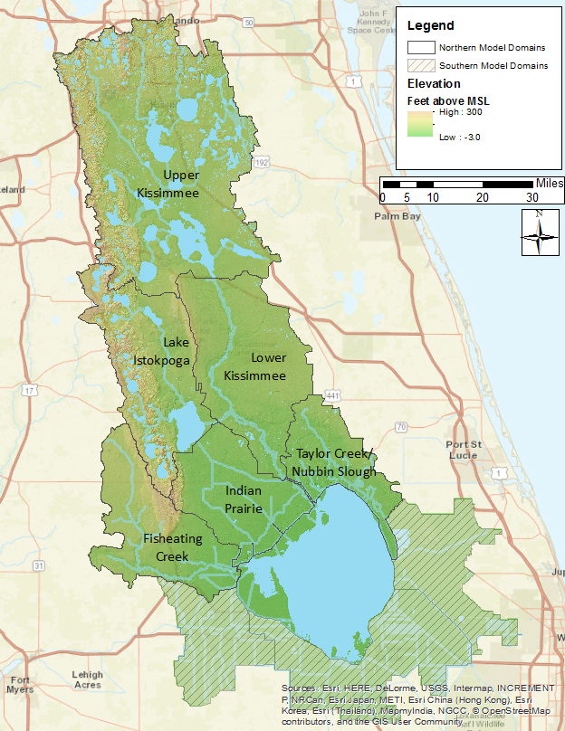
Figure 1. Location of the six northern Lake Okeechobee sub-watersheds that were modeled for the project. The three southern sub-watersheds that were modeled for Deliverables 2, 3, and 4 are also shown.

The Watershed Assessment Model

Model Approach

The WAM was chosen to simulate the water quantity and quality discharged from the project area because of its ability to simulate a wide variety of land uses and land use practices while taking into account the geographic and geologic features of the land. WAM uses a GIS grid-based representation to model the physical characteristics of the watershed. One of the first steps is the determination of the specific combination of land use, soil, rainfall, and wastewater service area for each cell in the watershed (see Figure 2). These four datasets are overlain as part of the modeling process to identify the unique combinations of these inputs. These unique cell combinations characterize the specific conditions that occur on each cell within the watershed.
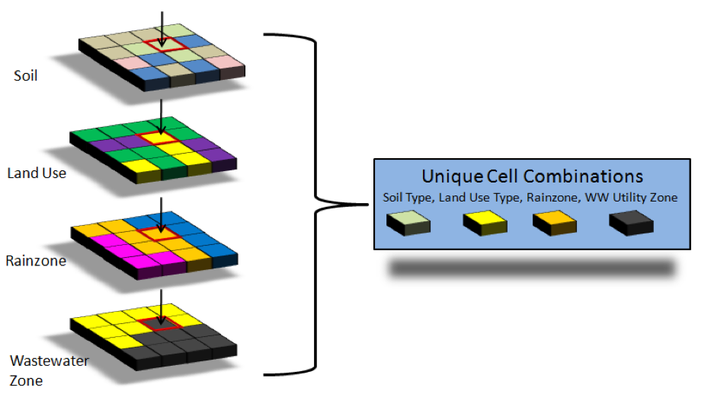
Figure 2. Unique cell generation.
WAM then creates a spatial map and tabular list of every unique combination of the inputs. The concept of identifying unique cell groupings is critical because it greatly reduces the number of cell level simulations that are needed while still providing the detail of cell level simulated flow and constituent transport for every cell within the watershed.

Source Cell Modeling

The creation of unique cell groupings is also critical because it allows for the most appropriate field-scale sub-model to be used for each unique cell condition, more accurately simulating the daily runoff in terms of both water quality and quantity. Based on the soil and land use combination of the cell, the most appropriate field scale sub-model is selected to simulate that cell (Figure 3).
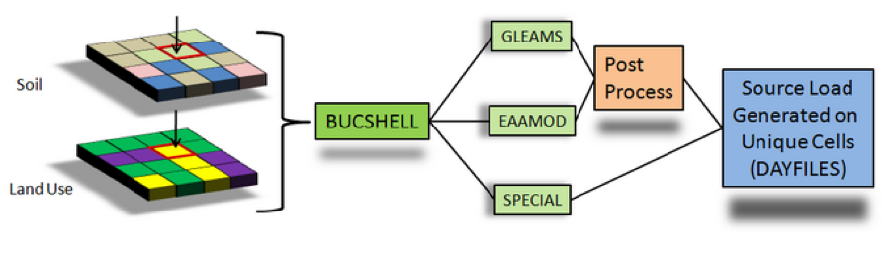
Figure 3. Source model selection.
The sub-models include Groundwater Loading Effects of Agricultural Management Systems (GLEAMS) (Knisel, 1993; Knisel and Davis, 1999), the Everglades Agricultural Area Model (EAAMOD) (Bottcher et al., 2012, 1998; SWET, 2008a), and a special-case model written specifically for WAM. GLEAMS is used to simulate processes in areas that have well-drained soils while EAAMOD is used to simulate processes on high water table soils. The special case sub-model is used to simulate source cells that are not handled well by these other two sub-models, e.g. wetlands, mining, aquaculture, and open water (SWET, 2011a, 2011b). These sub-models are bundled into one Fortran program called BUCShell (BUC stands for Basin Unique Cell).
The individual field scale sub-models used are specifically designed to deal with the particular natural processes that exist between those land use and soils combinations. The daily flows and loads produced by BUCShell are stored in CSV files (comma separated values) that are termed “dayfiles”. These dayfiles contain the amount of nutrients and water leaving each source cell on a daily basis.

GLEAMS
GLEAMS (Knisel, 1993; Leonard et al., 1987) is a physically based model used to simulate processes affecting water quality on an agricultural field scale. It has been used extensively and is well documented. GLEAMS is divided into four separate models. These models include:
- Hydrology
- Erosion/sediment yield
- Chemical (pesticide) transport (not currently available within WAM)
- Nutrient transport
The hydrology component of GLEAMS simulates runoff due to daily rainfall using a modification of the NRCS curve number method, where ground recharge is calculated as a function of rainfall minus ET/interception and the change in soil storage. Hydrologic computations for evapotranspiration, percolation, infiltration, and runoff are determined using a daily time step (Knisel, 1993). Two options are provided in the hydrology component to estimate potential evapotranspiration:
- The Priestly-Taylor evapotranspiration estimation method (Priestley and Taylor, 1972) using daily temperature and radiation data computed from mean monthly data is currently used by WAM.
- The Penman-Monteith method (Jensen et al., 1990) may be used, however, it requires additional data that are more difficult to obtain. Water routing through the soil profile is based on the storage routing concept which allows the downward movement of water from one layer to the next when water content is in excess of field capacity. Comprehensive detail is provided in Knisel (1993).
The erosion component in GLEAMS uses the universal soil loss equation (USLE) and the concept of continuity of mass to predict erosion and sediment transport under different topographic and cultural conditions. The erosion component considers overland, channel, impoundment, or any combination of these routes. Computation begins at the upper end of the overland slope. The overland flow may be selected from several possible overland flow paths. Its shape may be uniform, convex, concave, or a combination of these slopes. The processes of detachment and deposition are both considered, and each condition occurs based on the relationship between transport capacity of runoff water and sediment load.
The plant-nutrient component of the GLEAMS model considers both nitrogen (N) and phosphorus (P) cycles. For a detailed description of the GLEAMS input parameters see Knisel (1993). The N component includes: mineralization, immobilization, denitrification, ammonia volatilization, nitrogen fixation by legumes, crop N uptake, and losses of N in runoff, sediment, and percolation below the root zone. It also considers fertilizer and animal waste application. The P component includes: mineralization, immobilization, crop uptake, losses to surface runoff, sediment and leaching, and it also includes fertilizer and animal waste application. Tillage algorithms are included in the model to account for the incorporation of crop residue, fertilizer, and animal waste. Soil temperature and soil moisture algorithms are also included in the model to provide proper adjustments for ammonification, nitrification, denitrification, volatilization, and mineralization rates. Rainfall N and P are model inputs and may vary depending upon the study region. Initial soil TP, as an input in the land use parameter file, is a sensitive parameter in the model and is used to represent legacy P, which makes it an important calibration parameter. Initial soil TN is not as sensitive as TP because N will not accumulate within the soil.
The GLEAMS model predicts soluble inorganic nitrogen (ammonium-N and nitrate-N) and phosphorus (soluble P) in runoff and leachate and sediment-attached organic and inorganic N and P in surface runoff. The GLEAMS model does not predict biological oxygen demand (BOD) or soluble organic N and P. Outputs of these constituents are derived within WAM as a function of total suspended solids (TSS) and from total nitrogen loads in runoff and leachate, respectively.

EAAMOD
The EAAMOD is a field-scale model developed by Soil and Water Engineering Technology, Inc. (SWET, 2008b) for multi-layered soils with high water tables (Figure 4). Created in the early 1990s, the model grew out of a need to evaluate agricultural BMPs within the Everglades Agricultural Area (EAA) and other high water table soils in Florida. The model initially focused on water using a hydrography sub-model (WP) and P movement from histosols (flat organic soils) using the P sub-model (PMOVE), but was then expanded to all high water table soils and to handle N with the inclusion of the nitrogen sub-model (NUTMOD). Histosols require special consideration because of the aerobic mineralization releases of both P and N from organic matter due to drainage and the resulting nutrient impacts downstream. To adequately address this problem, EAAMOD simulates water control practices and the effects of various agricultural management scenarios on nutrient transport.
Percolation and runoff in EAAMOD is calculated using a vertical two-dimensional hydrologic model (WP). The flow model within EAAMOD uses the Dupuit-Forcheimer assumption (zero vertical hydraulic gradient) for two separate flow regimes in the field profile, specifically, above and below an impeding layer such as the spodic horizon in flatwoods soils and the marl cap rock in histosols. The impeding layer is generally highly localized, and while water locally perches above the layer it does not act as a confining layer.
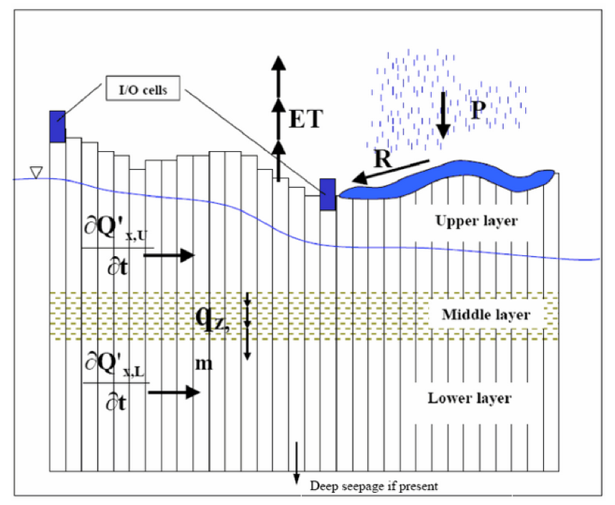
Figure 4. EAAMOD digitization scheme for a general soil profile.
The one-dimensional horizontal flow model provides the water table depth and horizontal flow for each cell across the field between drainage ditches. Flow through the spodic horizon is determined by solving the piezometric head distribution below the horizon and then using Darcy’s Law across the impeding layer with the gradient across the horizon being the difference between the water table above it and the piezometric head below it. Water flow is simulated by using finite difference techniques with forcing functions representing pumped drainage/irrigation, culvert flow, rainfall and ET. Saturated horizontal flow above the mid- horizon is calculated by a fourth-order Runge-Kutta method that solves the continuity equation for each cell using Darcy’s Law within the saturated zone.
The water budget is calculated in the top zone of cell $i$ by the following equation:
$$ΔS\left(i\right)=Q\left(i+1\right)-Q\left(i\right)+R\left(i\right)-ET\left(i\right)-QS\left(i\right)+P\left(i\right)$$
Where:
$ΔS$ is the change in water storage in the top zone (inches of air void/hr),
$Q$ is horizontal saturated flow (in/hr),
R is rainfall (in/hr),
$ET$ is evapotranspiration (in/hr),
$QS$ is deep percolation through the middle restricting zone (in/hr), and
$P$ is the forced input or output (irrigation/drainage) (in/hr) for up to two cells, typically ditches.
The calculated flow is always for the left side of the cell indicated. Rather than using total water storage in a cell, the water profile algorithm keeps track of air void volume (S). Therefore, a zero value for S would represent a saturated soil condition with no surface ponding. Surface ponding results in a value of S less than zero and typically would indicate that surface runoff is occurring, but could be a stagnant surface storage condition.
The air void volume, S, is calculated for each time step, $t$, by the following equation:
$$S\left(i,t\right)=S\left(i,t-1\right)+ΔS\left(i,t\right)⋅ΔT$$
Where: $ΔT$ is equal to $t$ (current time in hours) minus $t$-1 (previous time step in hours).
To represent actual water management in a field, a series of utility features within the model allow for controlled drainage through a pump, gravity flow through a culvert (bi-directional), flow over a weir, subsurface or surface irrigation, and variable crop ET parameters. Automatic scheduling of irrigation and drainage pump operation is available based upon desired ditch water levels or soil moisture deficit. The flow properties of the pump(s), culvert(s), or weir(s) for specific land use types can be specified by the user in the management section for High Water Table Soils (see SWET, 2011b).
Surface water is only allowed to flow to or from the first defined ditch/drainage outlet cell, but this cell may be located anywhere. For flooding, the water profile algorithm allows flows from the ditch to fill each successive cell to the level of the ditch until the time step’s flow volume is depleted. The flow volume is limited by the flow rate to the ditch cell and conservation of mass within the ditch. This procedure continues until complete flooding occurs, at which time any subsequent flow due to a rise in ditch levels will be artificially applied to all cells. For surface runoff the procedure is reversed except that artificial ET is used to move the water from the field to the ditch.

Hydrodynamic Routing

The daily outputs from each cell, which includes surface and groundwater flows and constituent concentrations, are routed to the streams by the Basin Land Area to Stream Routing model (BLASRoute) (Jacobson et al., 1998). BLASRoute is a Fortran program that routes the flows and loads based on the distance grids previously calculated and delayed using separate unit hydrographs and delay factors for surface and groundwater. The constituent loads are attenuated based on the landscape features encountered en route to the reach network. The routing process is a complex combination of transport, dispersion, and assimilation that, in most cases, will result in an attenuation, or decrease, in the constituent concentration. The source loads are transported to the reach network via surface and/or ground water.
The transportation path is based on the distance to the closest downhill hydrogeologic feature (reach, wetland or depression) which is identified from the distance grids that are calculated by WAM. The transportation path influences both the time it takes for daily flows to be delivered to the reach network and the attenuation rates applied to the constituent concentrations en route to the reach network. The degree of nutrient attenuation also depends on the hydrogeologic features encountered. Figure 5 shows the conceptual routing schemes and flow distances that are calculated for each cell.
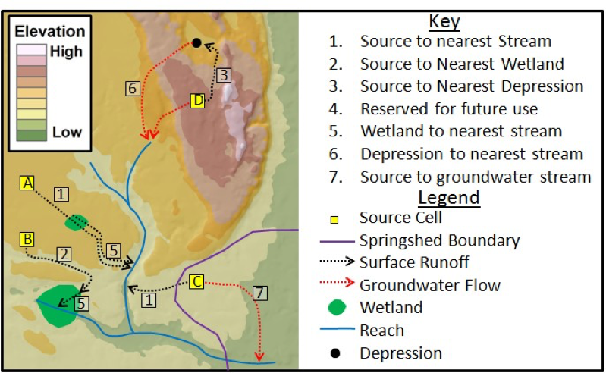
Figure 5. Flow path routing for determination of attenuation distance.
WAM includes overland and in-stream attenuation algorithms that function on a daily time step starting at the source cell. From this starting point nutrients are attenuated during overland flow, when passing through wetlands, and within streams and canals before finally discharging to the lake.
Each numbered path shown in Figure 5 is represented by a GIS grid, which includes the distance of the paths. These distances are related back to the original source cell so that the model can extract the needed distance through a downstream geographic feature for all grid cells. Destination information is stored in a similar manner. When extracting the distance through a downstream wetland, for example, the type of wetland can also be extracted, which has an associated set of assimilation coefficients.

Data Acquisition and Formatting

Input Spatial (GIS) Datasets

The spatial datasets required to set up projects in WAM are:
- Basin boundary
- Sub-basin boundaries
- Topography
- Hydrologic network
- Land use
- Soils
- Rain gage locations
- Hydrologic structures
- Utility (wastewater) zones.
- Location of water and nutrient point sources (or sinks)
- Irrigation source specification
The specifics of each of these spatial datasets with respect to the entire Lake Okeechobee model domain are discussed below. In addition to these spatial datasets, a time series of recorded rainfall values at each rain station, daily temperatures, and other climate data required to run WAM is also discussed below. Prior to building a WAM scenario, a projection for the spatial data must be chosen. For this project, the Florida State Plane East (in feet) was used. Other relevant coordinate system details are shown in Table 1.
Table 1. Coordinate system selected for the model project.
NAD 1983 HARN State Plane Florida East (FIPS 0901) Feet
Projection | Transverse Mercator
False Easting | 656166.67
False Northing | 0
Central Meridian | -81
Scale Factor | 0.99994118
Latitude of Origin | 24.33333
Linear Unit | Foot
Many of the spatial datasets used in the 2009 WAM effort dated from the mid-2000s and have been superseded by newer datasets. In some cases, such as with land use, this reflects actual changes in the underlying data as development occurs or as some agricultural land uses are taken out of production. Some datasets, such as soils, have been updated as studies have been used to refine and further delineate specific soils types. Thus, while the general dataset types outlined in the 2009 report are still applicable, the actual datasets have changed. In many cases the available information is more consistent across the watershed and a single feature class may suffice where before several disparate coverages had to be merged to provide an accurate representation. For example, for the current project a single topography dataset was provided by the SFWMD whereas for the 2009 project several datasets had to be merged to create a comprehensive dataset. Similarly, the hydrography used in 2009 was created from several sources; for this project, a single hydrography dataset (a subset of AHED) covers the entire study area. In many cases, data from the 2009 study could easily be adapted with only minor modifications (such as basin and subbasin coverages, rainfall stations, and hydrologic structures). However, in other cases, such as soils, land use, hydrography, and the actual model domains, entirely new datasets needed to be incorporated.
The following listing of the spatial datasets indicates the provenance of the various feature classes. Details about the specific preparation, adjustments, and modifications to these input datasets for use within WAM are discussed in Section 3.4. Of the spatial datasets discussed below, it is the soils, land use, rainfall stations, and utility zones that are used to define the unique combinations of cells (see Figure 2) that are simulated by the land source model to produce daily contributions of runoff, percolation, and nutrient loads.

Model Domain Boundaries
Each model domain boundary serves as the domain for all the input spatial datasets, with each GIS dataset (with two exceptions, discussed below) clipped to this boundary (Figure 6). Each of the six model domains in the northern LOW requires a basin boundary, which were defined to be the sub-watersheds provided by the Coordinating Agencies. The sub-watershed boundary dataset used was obtained from FDEP in January of 2015 and is named “LOW_Subwatersheds”. Note that this same dataset was also provided to SWET by the SFWMD in November 2016 along with the latest land use spatial dataset. Three other model domains are located around the eastern, southern, and western boundaries of the lake known as the southern sub-watersheds in the Lake Okeechobee BMAP. These domains were not modeled for this task, instead they were modeled as part of a separate task for Deliverables #2-#4.
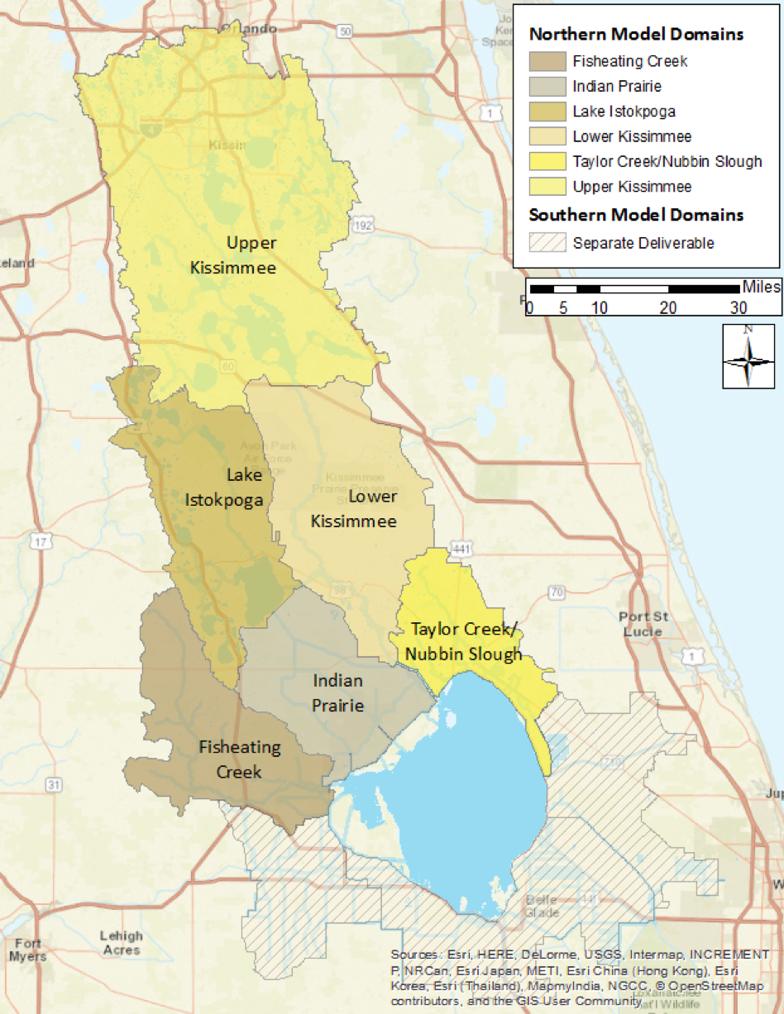
Figure 6. Model domain boundaries for the WAM simulations in the six northern sub-watersheds, based on the sub-watershed boundaries defined by the Coordinating Agencies.
The LOW includes four major tributary systems: Kissimmee River, Lake Istokpoga–Indian Prairie/Harney Pond, Fisheating Creek, and Taylor Creek/Nubbin Slough. These tributary systems and drainage networks are generally bounded by the drainage divides of the major water bodies. The dataset represents the external boundaries of the LOW, the nine sub-watersheds which comprise the LOW, and the 69 basins which comprise the sub-watersheds as per the 2014 LOWPP Update and the Northern Everglades and Estuaries Protection Program (NEEPP) (Bertolotti et al., 2014). The basis for the boundaries was the technical work associated with the document Draft – Technical Support Document: Lake Okeechobee Watershed Performance Measure Methodologies (Gary Goforth Inc., et al., 2013) developed for revisions to the 40E-61 Works of the District Program, with minor modifications.
As mentioned above, the model domain boundaries are used to clip the input datasets such as land use or soils. Note that two datasets may contain data that lie outside of the boundary, which are the hydrologic network and the location of rain gages. These are discussed below. Additionally, during the modeling process the WAM interface uses the model boundary as a mask while creating grids (rasters) from the various input datasets.

Subbasin Boundaries
Subbasins are used by WAM to further subdivide the modeling domains discussed above in Section 3.1.1. The motivation for this is to separate surface water flow based on either natural or man-made flow paths on a finer scale than is possible at the sub-watershed level. Note that the terminology used by WAM is different from that used by the Coordinating Agencies; the “Subbasin” dataset input to WAM contains smaller-scale features than the “Subbasin” feature class included with the AHED.
For modeling purposes, the subbasin boundaries are those that reflect hydrologic divides or boundaries within the model domain/sub-watershed. In many parts of Florida, subbasin boundaries can be created by artificial levees or berms, but are more typically due to natural topographic features, such as ridges. The subbasin data from the 2009 modeling effort was developed using the ArcHydro toolset, but it was considered too small-scale for the current purposes. Consequently, a dataset named “LOW_Subwatersheds_Basins” that was included with the sub-watershed boundary dataset discussed in the previous section was used as the WAM subbasin boundaries. Note that the “LOW_Subwatersheds_Basins” dataset has only minor differences when compared to the AHED “Watershed” feature class.

Topography
Topography datasets in the previous 2009 WAM modeling efforts were created by merging Digital Elevation Model (DEM) data and LIDAR data, which became available in 2006 from the Kissimmee Basin Modeling and Operations Study (KBMOS). The datasets were derived from various sources of information including USGS 5-foot contours, SFWMD bathymetry and LIDAR (EarthTech, 2006).
For the current modeling effort, a continuous elevation raster that covers the entire study area was obtained from the SFWMD (Figure 7). This raster has 50-feet by 50-feet grid cells. The topography data are resampled to one-hectare grid cells during calculation of grid cell to stream distances. The topographic data is used by WAM to determine the directions of flow and distances to (and through) hydrologic features such as lakes, streams, canals, sloughs, riparian wetlands and depressions (Figure 5).
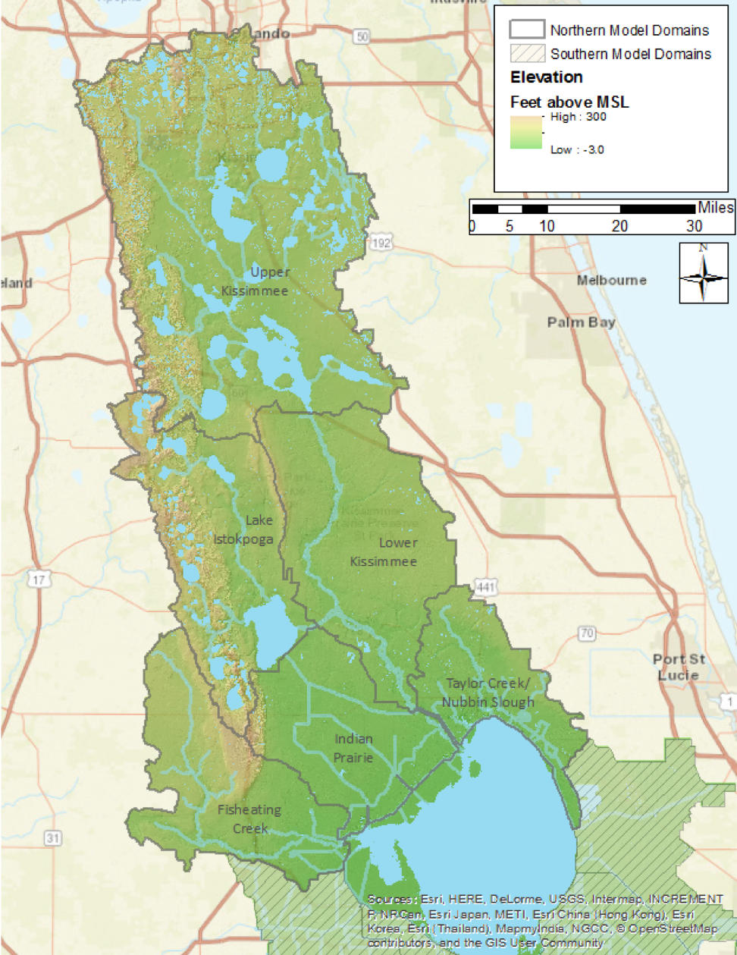
Figure 7. Representation of the topography data used for the WAM simulations.

Hydrography
The hydrography used to create the reach network in WAM was based on modification of the latest hydrographic dataset obtained from the SFWMD together with the hydrography used in the 2009 WAM modeling effort and the 2012 update (Figure 8). The SFWMD maintains all hydrologic data in AHED. This dataset was originally obtained in February of 2015, while an updated dataset was obtained in February of 2016. In addition to linear (e.g., stream) features (the “hydroedge” feature class), the AHED dataset includes water bodies, hydrologic structure locations, monitoring points, etc. In many locations, the AHED hydroedge feature class contains somewhat more detail than is necessary for developing a reach network for WAM. For example, disconnected hydrologic features such as isolated wetlands and lakes are included in the hydroedge network. WAM has a separate algorithm for routing water into these types of features and then into groundwater (or lost via evaporation), so hydroedge features of this type were not included in the WAM network.

Land Use
The land use feature class used was obtained from the SFWMD in November of 2016 and is named “Neepp_LOW_LU”. This feature class was modified to include an integer field for the WAM land use IDs (LUIDs) which were filled using a lookup table (“fluccs_main_tab”) provided by the SFWMD (see Table 2 and Table 81 in the Appendix, Section 6.4). Figure 9 shows the breakdown of land uses within all six sub-watersheds by acreage. The metadata included with the dataset summarizes the feature class as follows (SFWMD, 2016):
Land Use for the Lake Okeechobee Watershed, composite of best-available data as of November 2016. The composite was created from “current” land-use datasets from the SFWMD, SJRWMD, and SWFWMD in order to provide complete coverage of the watershed, plus a buffer zone around it. In general, the land-use (LU) code was used in preference to the land-cover (LC) code, and newer data was used in preference to older. Coordinates are referenced to the state plane system, Florida east zone, NAD83 (HARN), US feet. Much of the metadata below is vestigial from the 2014 and 2008 SFWMD land-use metadata. *** This data set serves as documentation of land cover and land use (LCLU) within the South Florida Water Management District as it existed in 2008-09. Land Cover Land Use data was updated from 2004-05 LCLU by photo-interpretation from 2008-09 aerial photography and classified using the SFWMD modified FLUCCS classification system. Features were interpreted from the county-based aerial photography (4 in - 2 ft pixel) and updated on screen from the 2004-05 vector data. Horizontal accuracy of the data corresponds to the positional accuracy of the county aerial photography. The minimum mapping unit for classification was 2 acres for wetlands and 5 acres for uplands. The update was completed on 07/11/2011. The “wet prairie” (6430) category was added back into the database on 01/18/2012, for areas that were classified as wet prairie in the 2004-5 LCLU and had been converted to freshwater marsh (6410) for the 2008-9 LCLU. In order to provide a single dataset that covers the entire area of the SFWMD, on 02/02/2012 the 2004-5 LCLU was added to the 2008-9 LCLU, for areas were not included in the 2008-9.
The prior phase of this project used an earlier version of the feature class (“LOW_LU_LOPP_09”) (LOPP is the “Lake Okeechobee Protection Plan”) that contained 2009 land use data with modifications in 2012. Those data were obtained from the SFWMD in February of 2015. SWET made modifications to this earlier land use dataset in the Taylor Creek/Nubbin Slough model domain by combining it with a dataset obtained from the SFWMD in July of 2016. This second dataset contained detailed refinement to dairy land uses, such as breaking out specific pasture land uses, spray fields, and cooling ponds. Consequently, the Taylor Creek/Nubbin Slough model domain uses the modified earlier dataset while the other five model domains use the updated 2016 land use dataset.
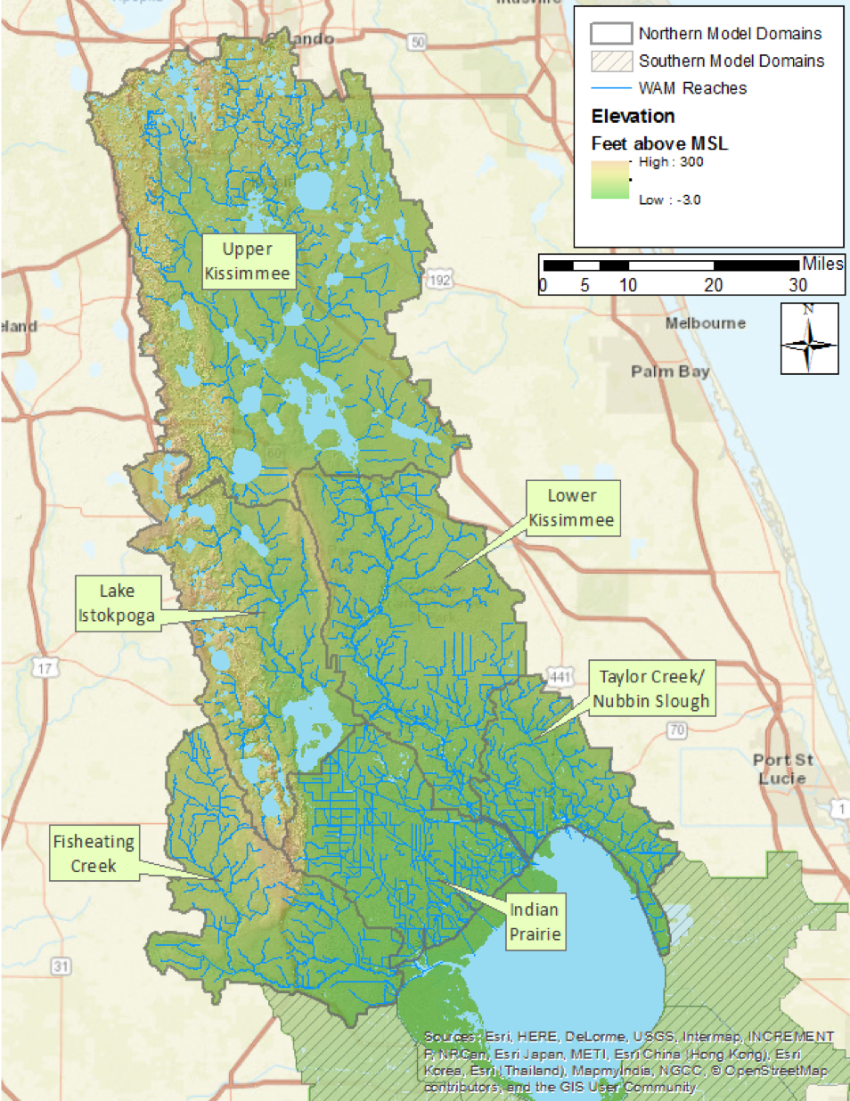
Figure 8. The reach network developed for WAM.
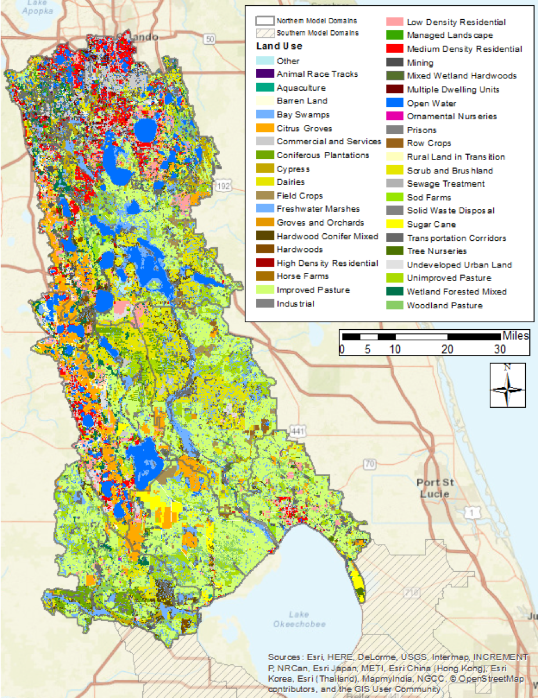
Figure 9. Land use feature class for the LOW currently incorporated into WAM.

Table 2. The top 30 land use acreages in the northern six Lake Okeechobee sub-watersheds.
Land Use | LUID | Fisheating Creek | Indian Prairie | Lake Istokpoga | Lower Kissimmee | Taylor Creek/ Nubbin Slough | Upper Kissimmee | Total Acres
Improved Pasture | 26 | 102,502 | 119,149 | 41,675 | 132,534 | 91,331 | 126,083 | 613,273
Scrub and Brushland | 5 | 22,884 | 7,813 | 56,093 | 90,312 | 4,407 | 98,737 | 280,246
Freshwater Marshes | 16 | 50,697 | 27,277 | 28,726 | 69,140 | 10,309 | 107,937 | 294,086
Open Water | 9 | 1,050 | 3,579 | 58,140 | 3,432 | 3,055 | 139,908 | 209,163
Unimproved Pasture | 27 | 36,040 | 23,705 | 13,552 | 45,593 | 10,041 | 33,004 | 161,935
Citrus Groves | 84 | 7,722 | 30,079 | 51,786 | 9,910 | 3,481 | 46,070 | 149,047
Woodland Pasture | 28 | 23,967 | 21,188 | 3,667 | 11,408 | 13,507 | 36,717 | 110,454
Mixed Wetland Hardwoods | 12 | 12,582 | 4,989 | 9,760 | 17,196 | 5,523 | 49,381 | 99,432
Medium Density Residential | 19 | 130 | 829 | 17,020 | 193 | 4,306 | 71,861 | 94,339
Cypress | 14 | 5,000 | 13 | 3,109 | 1,387 | 119 | 40,883 | 50,511
Low Density Residential | 2 | 3,593 | 2,154 | 19,418 | 6,571 | 8,376 | 49,488 | 89,600
Wetland Forested Mixed | 15 | 6,209 | 1,137 | 18,833 | 1,877 | 1,229 | 37,604 | 66,890
Commercial and Services | 3 | 298 | 319 | 7,965 | 1,944 | 2,328 | 47,796 | 60,650
Hardwood Conifer Mixed | 7 | 15,092 | 2,285 | 7,394 | 7,620 | 3,123 | 26,398 | 61,913
Coniferous Plantations | 8 | 20,403 | 404 | 10,848 | 7,832 | 55 | 6,112 | 45,655
Undeveloped Urban Land | 70 | 1,068 | 1,766 | 16,138 | 2,204 | 1,594 | 16,344 | 39,114
Sugar Cane | 68 | 20 | 13,078 | 2,382 | 0 | 5,217 |  | 20,697
Dairies | 39 | 37 | 21 | 558 | 1,796 | 2,062 | 39 | 4,513
Hardwoods | 6 | 2,443 | 118 | 2,627 | 440 | 19 | 5,191 | 10,838
Field Crops | 62 | 302 | 4,704 | 411 | 8,764 | 3,507 | 7,645 | 25,331
Transportation Corridors | 18 | 704 | 106 | 1,561 | 189 | 313 | 14,095 | 16,968
Barren Land | 17 | 1,065 | 3,546 | 1,998 | 1,594 | 1,490 | 5,413 | 15,106
Managed Landscape | 23 |  |  | 1,616 | 65 | 519 | 11,647 | 13,847
Rural Land in Transition | 4 |  |  | 8,446 |  |  | 4,809 | 13,254
High Density Residential | 20 | 21 | 123 | 2,870 | 112 | 368 | 9,884 | 13,378
Abandoned Dairies | 89 |  |  |  |  | 8,602 |  | 8,602
Multiple Dwelling Units | 21 |  |  | 104 | 8 | 41 | 10,995 | 11,148
Bay Swamps | 10 | 1,119 | 185 | 1,960 | 434 | 303 | 5,492 | 9,493
Row Crops | 25 | 29 | 1,188 | 555 | 4,581 | 315 | 1,444 | 8,112
Sod Farms | 36 | 737 | 3,029 | 180 |  | 1,521 | 3,161 | 8,629
Other |  | 1,782 | 3,625 | 4,766 | 2,036 | 10,657 | 14,282 | 37,148
Total Acres |  | 317,497 | 276,409 | 394,156 | 429,173 | 197,719 | 1,028,419 | 2,643,373

Soils
The spatial distribution of soils is a required input to WAM. The database of soil parameters within WAM has been developed from previous modeling efforts in Florida and contains data for 429 soil categories common to the state. This existing database was used with a newly updated and compiled feature class of Soil Survey Geographic (SSURGO) data (Figure 10). The final soils information used in the project came from the U.S. Department of Agriculture, Natural Resource Conservation Service (NRCS) published SSURGO data for 2013 - 2015. These data were derived from each of the county soils feature classes downloaded from NRCS. The county-wide datasets were merged and then the final product was clipped to cover the entire study area. Section 3.4.2.2 discusses how the soils data from NRCS were imported into WAM.

Rainfall Stations
WAM uses a point feature class for rainfall stations to generate a Thiessen polygon raster that is in turn used to assign rainfall time series to each unique cell. Location of rainfall stations were included in the AHED dataset (Figure 11). For consistency, the same stations that were included in the 2009 WAM application and the 2012 update were used for the current work. With the exception of one station, all data were available from the DBHYDRO database, which is the SFWMD’s hydrologic, water quality, and hydrogeologic data storage and retrieval system. The lone exception was a station (Frostproof) that lies within the South West Florida Water Management District (SWFWMD) boundary. All data were updated to include data through the end of 2013. This is discussed in more detail below in Section 3.4.3.

Major Hydrologic Control Structures
There are many control structures in the modeled domains that are operated by the SFWMD (Figure 12). These include gates, pumps, and weirs. Many of these were present in the earlier 2009 WAM applications, while additional ones were taken from other WAM applications in the LOW. In addition to controlling flow within the modeled area, many of the control structures serve as measurement locations for flow, stage, and nutrient concentrations. Further control information and listings of the control structures are given in Section 3.3 and in the Appendix, Section 6.3.

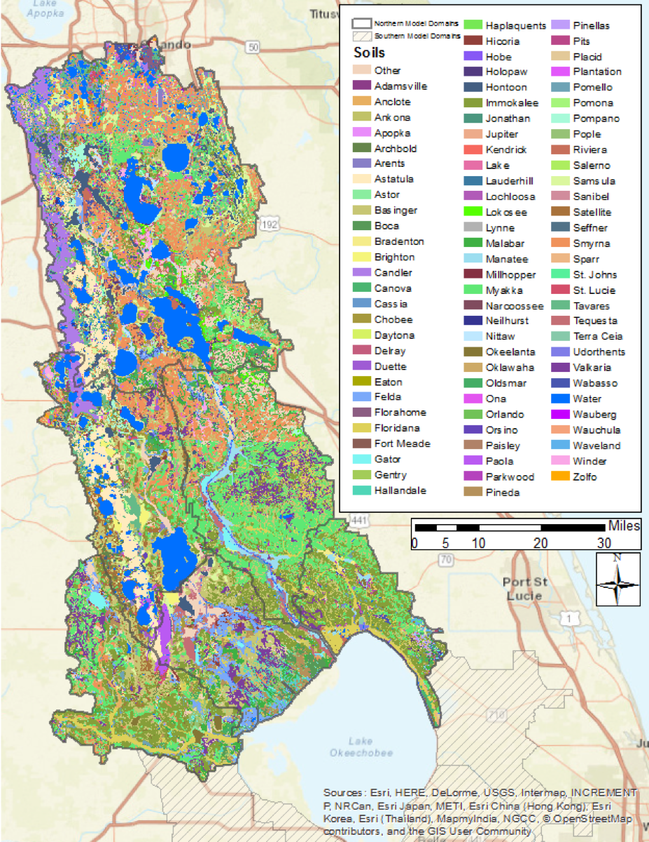
Figure 10. Soil distribution in the LOW.
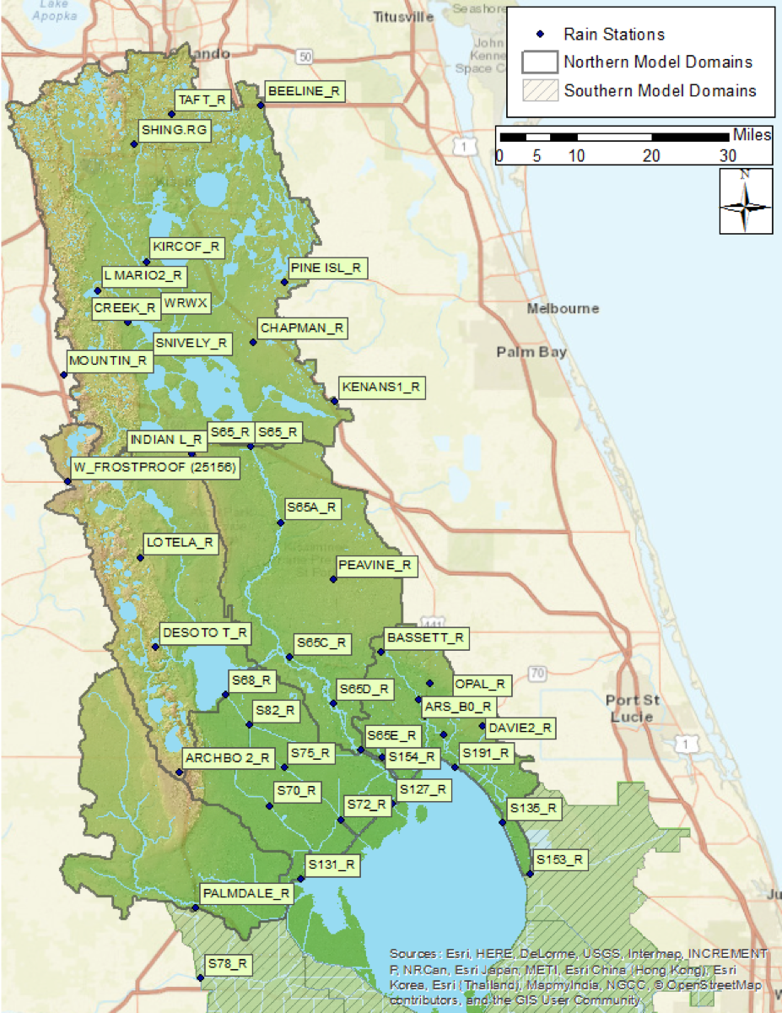
Figure 11. Rainfall stations within the Lake Okeechobee Watershed used in WAM simulations.
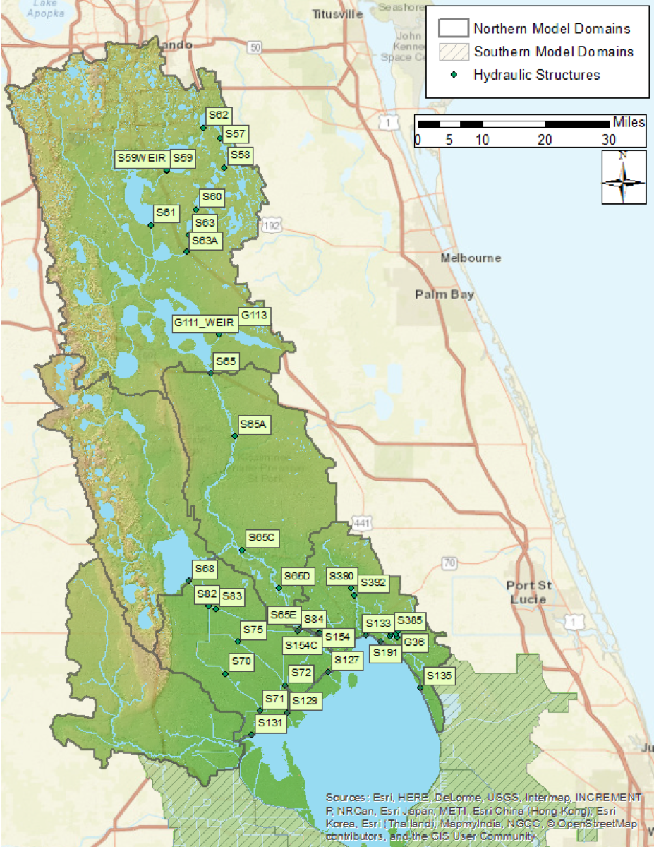
Figure 12. SFWMD hydraulic control structures used in the WAM simulations.

Utility (Wastewater) Zones
This is a polygonal feature class that delineates areas that are served by wastewater utility services. Within the feature class, areas that are served by a utility service are designated by a simple integer attribute of 1, otherwise the attribute is set to 0. For this project, wastewater utility zones were incorporated into the model in only one sub-watershed, Taylor Creek/Nubbin Slough. Note that using a wastewater zone is equivalent to placing a given land use (e.g., high density residential) on external treatment. In either case wastewater is not returned to the same source cell, rather, wastewater is either removed from the system or is added back as a stream point source at another location in the basin. The first case may occur when wastewater is removed via a sewer system, piped to a treatment plant, and subsequently applied to a sprayfield outside the model domain. The second may occur when the treated water is applied to a sprayfield that is within the model domain. Alternatively, if the wastewater service area is not known, urban land uses that are typically served by treatment systems (such as high/medium residential or commercial and services) undergo treatment that is equivalent to that provided by a treatment plant (such as a sprayfield). The treated water is then assumed by the model to have been released on-site rather than routed to a treatment plant and released there. In this case, the utility zone feature class is simply a mirror of the watershed boundary with the attribute set to 0 everywhere.

Location of Water and Nutrient Point Sources/Sinks
WAM has the ability to include point sources of water and/or nutrients, such as discharges from treatment plants, various types of industrial plants, or mining areas. Typically, if an area is served by a wastewater zone (as described above) and the treated water is reintroduced into the same sub-watershed, WAM simulates these point sources by adding the water and nutrient loads directly to reaches. Conversely, point sources can also be used to simulate withdrawals of water directly from reaches. For the base scenarios simulated, only Taylor Creek/Nubbin Slough incorporated a point source to accommodate the waste water discussed is the previous section. Note that either point sources or sinks may be added in the future to any model for the purposes of testing alternative potential modifications to an area.

Irrigation source specification
This dataset is used to specify the origin of water used for irrigation purposes. There are three choices available:
- Irrigation water is taken from deep groundwater (e.g., the Floridan aquifer).
- Irrigation water is taken from the shallow, surficial aquifer.
- Irrigation water is taken from surface water, i.e., the stream network.
For most areas in this project, irrigation water is assumed to be taken from the deep aquifer (option 1). However, option 3 is used in parts of the Indian Prairie and Taylor Creek/Nubbin Slough sub-watersheds, including those areas within the Lake Okeechobee Service Area (LOSA).

Measured Data

Measurements of flow, stage, rainfall, and water quality data were downloaded from the SFWMD DBHYDRO database, except for some rainfall data that were downloaded from SWFWMD (i.e., data for the Frostproof station). Each data type (flow, rain, etc.) are described in more detail in the following sections. Flow and nutrient loading data used for calibration/verification were provided by the SFWMD as discussed in Section 4 below, but much of the data obtained from DBHYDRO were used to assist the calibration/verification process. Other data (e.g., rainfall, boundary stages) were used for input data to the model.

Flow Data
Monthly summaries of flow data at all structures that discharge to Lake Okeechobee (and S-65 and S-68 at the outlets to Lake Kissimmee and Lake Istokpoga, respectively) were obtained from the SFWMD. In addition, time series of flow data, recording the mean daily flow in cubic feet per second (CFS), were obtained from the DBHYDRO database for any required stations. These data are identified by DBKeys (the alphanumeric database key for a specific time series; see Table 3). Generally, the downloaded time series data covers the POR from the beginning of calendar year 1972 through the end of 2013. Where available, the time series in DBHYDRO that were marked as “PREF” were downloaded. This annotation indicates that the recorded value is the preferred value. For many stations data for the entire period was not available under same DBKey; in these cases, multiple times series from the same station were combined with values from the later time series taking precedence over earlier entries when both were present. Since the flow data used to calibrate/verify WAM were provided directly by the SFWMD, it was not critical to have data of the entire POR at every flow station.
Table 3. Stations used for flow data listed by sub-watershed.
Station | DBKey | Recorder | POR Start | POR End
Fisheating Creek
FISHP | 15627 | PREF | 1/1/72 | Current
FISHCR | WH036 | ???? | 5/9/97 | Current
2255600 | 88210 | NA | 8/20/03 | Current
Indian Prairie
S127_P | 15641 | PREF | 1/1/72 | Current
S127_C | 15819 | TELE | 9/14/94 | Current
S129_PMP_P | 15642 | PREF | 1/1/72 | Current
S129_C | 15823 | NA | 8/21/94 | Current
S129_C | 4024 | NA | 1/1/84 | Current
S131_C | 4042 | NA | 1/1/84 | Current
 | M2931 | TELE | 9/24/92 | Current
S131_PMP_P | 15643 | PREF | 1/1/72 | Current
S70_S | AM230 | MOD1 | 5/17/86 | Current
S71_S | 15633 | PREF | 1/1/72 | Current
S71W_W | W4354 | TELE | 9/4/08 | Current
S72_S | 15634 | PREF | 1/1/72 | Current
S72W_W | W4355 | TELE | 2/20/12 | Current
S82_S | 15960 | NA | 11/5/93 | Current
S83_S | 15965 | NA | 11/30/93 | Current
S83X_S | VM845 | TELE | 2/5/08 | Current
S84_S | 15636 | PREF | 1/1/72 | Current
S84X_S | VM846 | TELE | 2/5/08 | Current
Lake Istokpoga
ARBUCK | 210 | NA | 7/1/39 | Current
CARTER C | 206 | NA | 10/1/54 | Current
JOSEPHIN | 224 | NA | 10/1/46 | Current
LIVINFROST | TA461 | ???? | 3/1/91 | Current
S68_S | 15632 | PREF | 1/1/72 | Current
S68X_S | AM652 | MOD1 | 4/22/09 | 4/30/16
Lower Kissimmee
S65A_S | J9202 | PREF | 5/12/86 | Current
S65AX_C | 12570 | CR10 | 7/12/88 | Current
S65C_S | 15338 | NA | 3/2/87 | Current
 | 4458 | NA | 4/29/66 | 7/10/92
 | 6959 | NA | 3/2/87 | Current
S65CX_C | 15332 | NA | 3/2/87 | Current
 | 4464 | NA | 2/1/83 | 9/30/93
S65D_S | 91655 | NA | 8/7/70 | Current
 | 6962 | SP01 | 3/10/87 | 31-Jul-09
 | WN344 | TELE | 7/31/09 | Current
S65DX1_C | 88300 | TELE | 6/12/09 | Current
S65DX2_S | AI354 | TELE | 7/31/09 | Current
S65E_S | 91656 | NA | 1/1/86 | Current
 | P1020 | MOD1 | 1/1/65 | 12/31/12
 | KO585 | TELE | 1/26/00 | Current
Taylor Creek/Nubbin Slough
NUBBC_C | 5222 | NA | 6/23/83 | Current
 | 12442 | SP01 | 9/28/88 | Current
S133_P | 15637 | PREF | 1/1/72 | Current
S135_PMP_P | 15638 | PREF | 1/1/72 | Current
S135_C | 16548 | NA | 9/13/94 | Current
 | TA288 | MOD1 | 6/3/87 | 12/31/12
 | 4072 | NA | 1/15/79 | 6-Nov-98
S154_C | 15629 | PREF | 1/1/72 | Current
S154C_C | VB265 | DWR | 7/12/74 | Current
 | VW893 | CR10 | 5/12/08 | Current
S191_S | 15639 | PREF | 1/1/72 | Current
2274325 | 88225 | NA | 8/12/04 | Current
2273630 | 88218 | NA | 10/10/03 | Current
2275197 | 88231 | NA | 10/1/03 | Current
2274490 | 88227 | NA | 9/4/03 | Current
2274505 | 88229 | NA | 10/1/03 | Current
2274010 | 88223 | NA | 8/7/03 | Current
2274005 | 88220 | NA | 7/10/03 | Current
Upper Kissimmee
S65_S | H0289 | PREF | 10/1/33 | Current
S63A_S | WN231 | TELE | 5/14/09 | Current
 | 15798 | SP01 | 11/14/91 | 7/28/10
 | 4796 | NA | 12/24/68 | 8/24/93
S63S | WN333 | TELE | 6/18/09 | Current
 | 15542 | CR10 | 1/8/93 | 7/28/10
 | 4424 | NA | 6/1/67 | 8/18/93
S60_S | AI222 | TELE | 6/11/09 | Current
 | 15536 | CR10 | 1/8/93 | 2/4/10
 | 4608 | NA | 6/1/67 | 11/2/94
S58_C | 15528 | CR10 | 1/8/93 | Current
 | 4400 | NA | 5/18/69 | 7/20/94
S61_S | WN288 | TELE | 6/12/09 | Current
 | 15560 | CR10 | 1/15/93 | 7/27/10
S59_S | WN290 | TELE | 6/11/09 | Current
 | 15533 | CR10 | 1/1/93 | 7/27/10
 | 4406 | NA | 12/19/63 | 2/22/94
S62_S | WN247 | TELE | 5/21/09 | Current
 | 15539 | CR10 | 1/8/93 | 8/30/10
 | 4418 | NA | 5/20/69 | 5/31/93
SHING.CA | 134 | NA | 10/1/68 | Current
REEDYLOU | 165 | NA | 10/1/39 | Current
 | J6175 | PREF | 1/1/67 | 1/31/96
REEDYC | 156 | NA | 12/1/22 | 2/17/17
 | J6173 | PREF | 5/3/66 | 6/20/95
BOGGY.TA | 113 | NA | 9/1/59 | 2/17/17

Rainfall
There were 35 rainfall stations where rainfall data were collected and input to the WAM setups of the sub-watersheds (Figure 11). Time series rainfall data for most of the 35 stations were collected from the SFWMD’s DBHYDRO database. Note that there are considerably more than 35 stations located within (or near to) the six sub-watersheds with data contained in DBHYDRO. However, many of these stations have short PORs, and many stations may have a longer POR but still not cover the entire simulation POR. In several cases, the rainfall station was relocated or re-instrumented, necessitating a new station key (DBKey) in DBHYDRO (Table 10). To account for this, all rainfall data in the study area were downloaded into a Microsoft Access database. Data from each rainfall station that were used for the 2009 study and the 2012 update was extracted from the database. Where data were missing (due to the station being moved or decommissioned) data from the nearest rain station were used to fill in those missing values. In addition, data for Frostproof Tower, a rainfall station outside the SFWMD boundary (and consequently with no rainfall data in DBHYDRO), were collected from the SWFWMD website. When the input files for WAM are generated, Theissen polygons of the rain gage network are generated. Each Thiessen polygon defines an area around a rain gage where every location inside the polygon is closer to that gage than any other gages. Each source cell is then assigned the rainfall time series associated with that polygon.

Evapotranspiration
To calculate potential evapotranspiration (PET), WAM uses average monthly high and low temperatures, as well as average monthly values for solar radiation, wind, and dewpoint. These data were obtained from the Florida Automated Weather Network (FAWN) station in Okeechobee. These values are presented in Table 4.
Table 4. Monthly averages of weather data inputs for WAM. Temperature values are in units of °C, solar radiation in units of Langleys (MJ/cm²), and wind speed is an average in km/day.
Month | Max Temp | Min Temp | Solar Rad | Wind Speed | Dew Point
Jan | 24.7 | 11.1 | 16.4 | 98 | 11.1
Feb | 23.5 | 9.4 | 17 | 114 | 9.4
Mar | 26.9 | 12.2 | 16.1 | 123 | 12.2
Apr | 29.3 | 15.4 | 21 | 118 | 15.4
May | 30.3 | 17.9 | 27.7 | 99 | 17.9
Jun | 31.1 | 20.5 | 21.6 | 89 | 20.5
Jul | 32.8 | 20.7 | 19.7 | 82 | 20.7
Aug | 33.7 | 20.8 | 27.2 | 79 | 20.8
Sep | 32.8 | 20.2 | 26.7 | 92 | 20.2
Oct | 31.2 | 18.5 | 21.7 | 104 | 18.5
Nov | 26.1 | 13.6 | 15.9 | 100 | 13.6
Dec | 26 | 12.8 | 18.9 | 96 | 12.8

Temperature
One of the land source models (EAAMod) requires average daily air temperature to predict phosphorus soil mineralization rate. While the output from EAAMod is not particularly sensitive to these values, they must be provided. These data were obtained from the SFWMD at the S-65CW and S-65DWX stations, and were supplemented with values obtained from NOAA at the Kissimmee and Avon Park weather stations.

Water Quality
Surface water nitrogen and phosphorus concentrations were downloaded from DBHYDRO for the major water control structures and other sampling locations (see Table 5). These stations included those used for the previous 2009 study, with several additions. Note that this list is not an exhaustive list of all sampling stations in the six northern sub-watersheds. Several of the stations listed in Table 5 provide data from only limited areas (i.e., the contributing areas are relatively small in size), while others have only limited temporal data. However, during the recalibration it was found helpful to use this extra data when calibrating source areas that show either higher or lower nutrient concentrations when compared with the overall basin averages. Both data from grab samples and autosamplers were downloaded. Most of the data downloaded was, however, collected from grab samples. Concentrations of TP were directly recorded at most stations. If TN was not directly recorded it was calculated by summing nitrate (or nitrate + nitrite) and TKN.
Table 5. Water quality stations used during the calibration.
Station | POR Start | POR End | Remark
Fisheating Creek
2255600 | 12/8/03 | Current
2256500 | 12/9/03 | Current
FE21392913 | 10/27/04 | Current
FECSR78 | 4/8/73 | Current
Indian Prairie
2273230 | 12/9/03 | Current | C-41 south of S-82
C41H78 | 1/2/08 | Current
HP06393242 | 1/3/06 | Current | S-70
HP06393232 | 10/9/04 | 4/25/11 | S-70
HP10373114 | 10/29/04 | 4/25/11 | S-82
HP11373132 | 1/4/06 | Current | S-82
HP23373111 | 11/2/04 | Current | Downstream from S-82
IP09383232 | 1/3/06 | Current | S-75
IP29383313 | 10/19/04 | Current
L59W | 4/15/87 | Current
L60E | 4/15/87 | Current
L60W | 4/15/87 | Current
L61E | 4/15/87 | Current
S127 | 4/8/73 | Current
S129 | 4/8/73 | Current
S131 | 4/8/73 | Current
S71 | 4/8/73 | Current
S72 | 4/8/73 | Current
S84 | 4/8/73 | Current
Lake Istokpoga
02270500 | 12/8/03 | Current | Arbuckle Creek at Lake I inlet
2273198 | 12/9/03 | Current | S-68
AR06333013 | 4/8/05 | Current
AR18343012 | 4/8/05 | Current
ARBKSR98 | 2/10/88 | 1/3/05
CA11342914 | 4/8/05 | 4/27/11
ISTK3W | 3/21/05 | 11/16/15
JOSNCR17 | 2/10/88 | 1/3/05
LI02362923 | 6/1/11 | Current
LI02362913 | 10/12/05 | 10/3/11
RD08322913 | 4/8/05 | Current
RD01322813 | 4/8/05 | Current
S68 | 2/10/88 | 1/2/07
Lower Kissimmee
S65A | 6/13/73 | Current
S65C | 6/13/73 | Current
S65D | 6/13/73 | Current
S65E | 4/8/73 | Current
Taylor Creek/Nubbin Slough
2274325 | 8/17/04 | 8/24/10 | Taylor Creek at Grassy Island
2274490 | 12/9/03 | 9/13/10 | Williamson Ditch
2275197 | 12/8/03 | Current
KREA 30A | 11/4/88 | Current
OT29353514 | 10/18/04 | Current
S133 | 4/8/73 | Current
S135 | 4/8/73 | Current
S154 | 10/2/73 | Current
S154C | 4/15/87 | Current
S191 | 4/8/73 | Current
TCNS 201 | 8/10/88 | Current
TCNS 213 | 8/10/88 | Current
TCNS 214 | 8/10/88 | Current
TCNS 220 | 8/10/88 | Current
TCNS 228 | 8/10/88 | Current
TCNS 230 | 8/10/88 | Current
TCNS 233 | 8/10/88 | Current
TCNS 249 | 8/10/88 | Current
Upper Kissimmee
CL06283111 | 5/25/11 | Current | Upstream of S-63A
CL06283121 | 9/12/06 | 4/27/11 | S-63A
CL18273011 | 5/25/11 | Current
CL18273021 | 9/12/06 | 4/27/11 | S-61
CL19273113 | 9/12/06 | 6/20/11 | S-63
CL19273123 | 7/7/11 | Current | S-63
CREEDYBR | 4/10/85 | Current
DLMARNCR | 4/6/82 | Current
DLONDNCR | 4/6/82 | Current
EC-37 | 4/6/82 | Current | Canal C-37
HL08283014 | 7/2/12 | Current | Canal C-36
HL17283022 | 9/12/06 | 6/18/12 | Canal C-36
LG32263114 | 9/12/06 | 4/27/11 | S-60
LG32263124 | 5/25/11 | Current | S-60
S65 | 6/13/72 | Current

Lake Okeechobee Seepage Estimates
Estimates of seepage across the Herbert Hoover dike are needed during the calibration process when “seepage” reaches are added to the model (see Section 3.4.1 below). Estimates of between 0.0028 to 0.025 CMS (0.1 to 0.9 CFS) per linear mile of dike per foot of head difference across the dike were found by McKenzie (1973).

System Operations

Descriptions of major control structures from the 2009 study and the 2012 update were used to parameterize the structures in this work and were subsequently validated against the “Redbook” documents available from the SFWMD that provide the physical attributes and operational parameters of structures operated by the SFWMD. The hydraulic structures included spillways, culverts, gates and pumps (Table 6). Detailed information about how operational information was implemented in WAM (invert elevations, trigger elevations, gate openings, etc.) is given for each structure incorporated into the WAM simulations in the Appendix in Section 6.3 in Tables 75 – 80. Note that a few structures, designated as “farm weirs” are structures that are not part of the SFWMD control network, but have been located by field work done by SWET.
Table 6. Structures used in the WAM simulations.
Structure Name | Structure Type | WAM Type | Sub-watershed | Stream/Canal
C-6 | Spillway? | Gate | Taylor Creek/Nubbin Slough
C-8 | Spillway? | Gate | Taylor Creek/Nubbin Slough
Farm Weir | Spillway-Unknown | Weir | Fisheating Creek | Fisheating Creek
Farm Weir | Spillway? | Weir | Taylor Creek/Nubbin Slough
G-111 | Culvert | Weir | Upper Kissimmee | Jackson Canal
G-113 | Culvert | Weir | Upper Kissimmee | Outlet of Lake Marian
G-36 | Spillway? | Gate | Taylor Creek/ Nubbin Slough
S-127 | Spillway | Gate | Indian Prairie | L-48
S-127 | Pump | Pump | Indian Prairie | L-48
S-129 | Spillway | Gate | Indian Prairie | L-49
S-129 | Pump | Pump | Indian Prairie | L-49
S-131 | Gate | Gate | Indian Prairie | L-50
S-131 | Pump | Pump | Indian Prairie | L-50
S-133 | Pump | Pump | Taylor Creek/ Nubbin Slough | L-47
S-135 | Pump | Pump | Taylor Creek/ Nubbin Slough | L-47
S-135 | Spillway | Gate | Taylor Creek/ Nubbin Slough | L-47
S-154 | Culvert-Box | Gate | Taylor Creek/ Nubbin Slough | LD-4
S-154C | Culvert-Box | Gate | Taylor Creek/ Nubbin Slough | LD-4
S-191 | Spillway-Concrete | Gate | Taylor Creek/ Nubbin Slough | Nubbin Slough
S-385 | Pump | Pump | Taylor Creek/ Nubbin Slough
S-386A-B | Spillway? | Weir | Taylor Creek/ Nubbin Slough
S-387A-C | Spillway? | Weir | Taylor Creek/ Nubbin Slough
S-390 | Pump | Pump | Taylor Creek/ Nubbin Slough
S-392 | Spillway? | Weir | Taylor Creek/ Nubbin Slough
S-57 | Culvert | Weir | Upper Kissimmee | C-30
S-58 | Culvert | Weir | Upper Kissimmee | C-32
S-59 | Culvert | Gate | Upper Kissimmee | C-31
S-60 | Spillway-Concrete | Gate | Upper Kissimmee | C-33
S-61 | Spillway-Concrete | Gate | Upper Kissimmee | C-35
S-62 | Spillway-Concrete | Gate | Upper Kissimmee | C-29
S-63 | Spillway-Concrete | Gate | Upper Kissimmee | C-34
S-63A | Spillway-Concrete | Gate | Upper Kissimmee | C-34
S-65 | Spillway - Concrete | Gate | Upper Kissimmee | C-38
S-65A | Spillway-Concrete | Gate | Lower Kissimmee | C-38
S-65C | Spillway-Concrete | Gate | Lower Kissimmee | C-38
S-65D | Spillway-Concrete | Gate | Lower Kissimmee | C-38
S-65E | Spillway-Concrete | Gate | Lower Kissimmee | C-38
S-65G | Spillway-Concrete | Weir | Upper Kissimmee | C-38
S-68 | Spillway-Concrete | Gate | Lake Istokpoga | To C-41 from Lake Istokpoga
S-70 | Spillway-Concrete | Gate | Indian Prairie | C-41
S-71 | Spillway-Concrete | Gate | Indian Prairie | C-41
S-72 | Spillway-Concrete | Gate | Indian Prairie | C-40
S-75 | Spillway-Concrete | Gate | Indian Prairie | C-40
S-82 | Spillway-Concrete | Gate | Indian Prairie | C-41A to C-41
S-83 | Spillway-Concrete | Gate | Indian Prairie | C-41A
S-84 | Spillway-Concrete | Gate | Indian Prairie | C-41A

Data Preparation

The measured data used for WAM inputs must undergo various amounts of preparation before they are incorporated into the model. This ranged from simple formatting of time series data (such as rainfall and boundary data) to more detailed efforts to import and reconcile datasets such as land use or stream networks.

Reach Delineation
The current version of WAM (compiled to run on ArcMap 10.3.1) used the current version of the SFWMD-wide AHED. WAM includes tools that are integrated with ArcMap (the “WAM Toolbar”) that allow users to import and modify hydrography, create a reach network, index the reaches, and assign reach types (stream, canal, etc.). In order to do this, each segment in the network must be connected to the rest of the network, and any loops present within the network must be accounted for. Small or disconnected reaches must be deleted or modified to attach correctly to the rest of the network. In addition, tools are available for the user to create and modify the cross-sectional profiles of each reach and modify bottom elevations. The connectivity of the network is then generated, i.e., determining which reach can flow into which other reach(s).
As was discussed briefly in Section 3.1.4, the “hydroedge” feature class contained in AHED served as the basis for developing the hydrologic network, together with the WAM reach dataset from 2009. Extensive processing of the hydroedge feature class was required to get it into a form usable by WAM. This included merging many of the smaller segments in the hydroedge feature class, ensuring that small features (e.g., segments on the order of a few meters) had been included, and that any segments that had been detached during the modification had been re-attached. Also, features in the hydroedge class that were originally disconnected from the network (e.g., isolated wetlands or lakes) were either deleted or attached to an appropriate reach.
After this work was completed, classification of the reaches was initiated. Reaches in the study area fall into one of seven main categories used by WAM:
- Streams
- Canals
- Sloughs
- Groundwater
- Lakes
- Shorelines
- Seepage
These classifications are used by WAM to assign specific nutrient attenuation coefficients to each type of reach, e.g., attenuation coefficients in streams can be set independently of lakes. Aerial imagery was used to assist in the classification process. Some assignments were straightforward (many canals are obvious), but distinguishing between streams and sloughs took greater effort. The last three reach types listed serve specialized purposes. Lake reaches are incorporated into the models where the hydrography intersects a sufficiently large water body (typically more than a few acres). Cross sections for lake reaches are generated so that the reach length times its width matches the lake area. This ensures that the volume of water in the simulated reach represents the amount in the lake. A special case land use category (land use ID 92) is assigned to lakes simulated in this manner. This land use passes rainfall directly into the reach without any attenuation process applied.
Shoreline reaches can be added around such lakes if desired; these reaches primarily serve to intercept water and nutrients flowing into a lake via overland flow and route the water and nutrients into the lake. This reach type was assigned to the boundaries of larger lakes in the Upper Kissimmee and Lake Istokpoga sub-watersheds. Shoreline reaches act as an accounting mechanism so that the amount of water and nutrients flowing into a lake via overland flow can be easily determined. No in-stream attenuation is applied in shoreline reaches since it assumed that all applicable attenuation processes occur during overland flow.
Lastly, seepage reaches are added where seepage may occur between a large lake and a canal. For example, seepage reaches were added connecting Lake Okeechobee and each modeled segment of the perimeter canal in the Indian Prairie and Taylor Creek/Nubbin Slough model domains. In each case a narrow weir or culvert is used to control the amount of seepage to fall within the range of measured values given above in Section 3.2.6. In addition to the main categories listed above, new subcategories of reach types may be created during the modeling processes to apply specialized attenuation coefficients to individual reaches or subsets of reaches. For example, specific attenuation coefficients were applied to Lake Kissimmee and Lake Istokpoga, so a new subcategory was created for each lake.
After the sub-watershed reach network was set up, model runs were required to ensure that simulation run times were sufficiently short. One of the primary methods for optimization of a reach network is to ensure that the bottom elevations, cross-sectional profiles, and structure information are appropriate. During the model setup process, the first two sets of parameters (bottom elevations and cross-sectional profiles) are estimated using algorithms incorporated into WAM. The reach cross-sectional profiles are estimated by determining the upstream contributing area for each reach. Bottom elevations are estimated by averaging elevations within 100 meters of the reach to obtain a top-of-bank elevation and then subtracting the depth of the associated cross sections. For the major reaches, particularly canals, the cross-sections were adjusted by hand by using aerial imagery and/or measured data if available. For all of the simulated sub-watersheds this process used only limited information from the 2009 study due to changes in the configuration of the boundary and changes to the hydrography. In particular, the changes in the Kissimmee River in the Lower Kissimmee Sub-watershed, due to restoration efforts, were significant. It is anticipated that modifications to the reach network will continue as feedback is obtained from the Coordinating Agencies.

GIS Dataset Reconciliation

Land Use
The current version of WAM uses the same land use database format as in previous versions, although it is important to note that the land use features have changed due to updates of the land use feature class. All the land use codes present in the feature class provided by the SFWMD (FLUCCS code) are listed in the WAM land use database as land use IDs (LUID, Table 74 Section 6.4 of the Appendix).
Since the 2009 study and the 2012 update, the input files for EAAMod (one of the land source models; see Section 2.2.2) have been updated to include data for urban and natural area land use types. This was done in conjunction with the update to the latest land use dataset discussed in Section 3.1.5 above (see Table 7). With these modifications, the land uses were run using EAAMod if the soil type is appropriate, i.e., where the soil indicates high water table conditions are present. Otherwise, GLEAMS was used for the simulation. This change adds a significant amount of data to the WAM scenario database and increased simulation run times since EAAMod simulations take longer than GLEAMS simulations for equivalent simulation periods. This change altered simulation outputs significantly and was partly responsible for the need to recalibrate the models.
Table 7. Land uses that may be run using EAAMOD (if the soil type allows).
Land Use Name | LUID | New
Low Density Residential | 2 | Yes
Commercial and Services | 3 | Yes
Pastureland and Rural Land in Transition | 4 | Yes
Scrub and Brushland | 5 | Yes
Hardwoods | 6 | Yes
Hardwood Conifer Mixed | 7 | Yes
Coniferous Plantations | 8 | Yes
Transportation Corridors | 18 | Yes
Medium Density Residential | 19 | Yes
High Density Residential | 20 | Yes
Multiple Dwelling Units | 21 | Yes
Industrial | 22 | Yes
Managed Landscape | 23 | Yes
Row Crops | 25 | No
Improved Pasture | 26 | No
Unimproved Pasture | 27 | No
Woodland Pasture | 28 | No
Tree Nurseries | 35 | No
Sod Farms | 36 | No
Ornamental Nurseries | 37 | No
Horse Farms | 38 | Yes
Dairies | 39 | Yes
Field Crops | 62 | No
Sugar cane | 68 | No
Citrus | 84 | No
Intensive Dairy Pasture | 85 | No
Field Crops - Dairy Sprayfield | 86 | No
Abandoned Dairies | 89 | No
Dairy Outer Pasture | 90 | No

Land Use Changes
The only modification that SWET made to the land use feature class was in the Indian Prairie sub-watershed, in the Istokpoga Marsh Drainage District (IMDD) area immediately south of Lake Istokpoga. The current land use indicates a mix of sugar cane, improved pasture, and a small amount of citrus. A report done by SWET for the SFWMD (SWET, 2008b) indicated that much of the area has ornamental and row crops, as well as sod, in addition to the currently mapped land uses. Since sod and ornamental/row crops have much higher fertilization rates, modifications were made based on data obtained by SWET for the 2008 report to better represent known conditions in the IMDD.

BMP Projects in the Northern Okeechobee Sub-Watersheds
A number of projects with BMPs have been implemented in the Northern Okeechobee sub-watersheds as part of the FDACS BMP program. A shapefile of point locations for these projects, along with a listing of the BMP classes were obtained in spring of 2016 from FDACS. The classes listed in the dataset are:
- Dairy Improvements
- Drainage Improvements
- Fencing
- Irrigation Improvements/Fertigation
- Water Control Structures
- Well, pipeline, trough, pond, heavy use
In addition to the six classes, combinations of classes may be applied to a particular land use; e.g., a dairy may have both dairy and drainage improvements. For each class listed and combination of classes encountered, an appropriate set of BMP factors was developed (Table 8) (Bottcher, 2006; SWET, 2008c). These BMP factors are applied to the affected land use within the WAM input files. Note that separate factors are applied to TN and TP in runoff and groundwater.

Table 8. List of BMP factors applied. The last three rows are combinations of two of the other BMPs listed.
BMP Class | TSS | Runoff TN | Runoff TP | BOD | GW TN | GW TP
Dairy Improvements | 0.7 | 0.7 | 0.7 | 0.7 | 0.7 | 0.9
Drainage Improvements | 0.9 | 0.9 | 0.9 | 0.9 | 0.9 | 0.9
Fencing | 0.7 | 0.7 | 0.7 | 0.7 | 0.7 | 0.7
Irrigation Improvements/Fertigation | 0.9 | 0.9 | 0.9 | 0.9 | 0.9 | 0.9
Water Control Structures | 0.9 | 0.9 | 0.9 | 0.9 | 0.9 | 0.9
Well, Pipeline, Trough, Pond | 0.9 | 0.9 | 0.9 | 0.9 | 0.9 | 0.9
Dairy and Drainage Improvements | 0.63 | 0.63 | 0.63 | 0.63 | 0.63 | 0.81
Drainage Improvements and Water Control Structures | 0.81 | 0.81 | 0.81 | 0.81 | 0.81 | 0.81
Fencing and Well, Pipeline, etc. | 0.63 | 0.63 | 0.63 | 0.63 | 0.63 | 0.63
These BMP factors were incorporated into the land use dataset by selecting land use features that intersected the points given in the BMP shapefile. These selected land use features where then modified to apply appropriate BMP factors to the land use.

Soils
As discussed in Section 3.1.6, soils data were obtained from the NRCS. Each dataset covers at most a single county (some counties have multiple associated datasets) and consequently 12 datasets needed to be downloaded for the 11 counties (Table 9). Some counties (Charlotte, Desoto) only covered small portions of the study area. The datasets were downloaded from the USDA NRCS web site at https://gdg.sc.egov.usda.gov/GDGOrder.aspx. After downloading, the feature classes were extracted, re-projected, and imported into a geodatabase feature set with the appropriate spatial projection. The features from each dataset were then merged into a single dataset that covered all of the counties for which data were obtained. The data were then clipped to the LOW boundary (see Figure 10). To import the data for use in WAM, the “compname” field was used to associate the soil features and the WAM soil ID for each soil type. This was done using a lookup table for soils that contains the compname and associated soil ID. Note that since the join between the feature class table and the lookup table is done on a text field, the spelling, capitalization, and blanks had to be identical. For example, extra blanks or missing periods (“Ft” vs. “Ft.” for “Fort”) will cause joins to fail.
Table 9. Listing of soils datasets obtained from NRCS by county.
County | Associated Datasets
Charlotte | FL015
Desoto | FL027
Glades | FL043
Highlands | FL055
Lake | FL607, FL609
Martin | FL085
Okeechobee | FL093
Orange | FL095
Osceola | FL097
Polk | FL105
St. Lucie | FL111
To obtain the “compname” for each map unit, the soil map unit feature class (typically named “soilmu_a_flXXX” where “XXX” is the numeric designation for each county) is joined with the “mapunit” data table obtained with the feature class. This is then joined with the “component” table, which contains the “compname” field. Since each map unit may contain several components, the component with “majcompflag” equal to “Yes” is used to select the primary component. If multiple components have “majcompflag” set to “Yes”, the component with the highest percentage is used and the map unit is assigned the chosen value of “compname”. Using this methodology, each map unit in the study area was assigned a soil type corresponding to a soil contained in the WAM database.

Time Series Dataset Preparation
Time series datasets for flow, stage, and water quality were used for comparison with WAM output. No processing of the collected datasets for flow, stage, and water quality was performed other than QA/QC.

Rainfall
Rainfall is a primary input to WAM and as such, missing portions of the time series were patched with the best available rainfall data. A detailed review of the rainfall data collected initially from DBHYDRO was conducted for this report as described below. It was apparent from the initial effort to collect rainfall data that at some rainfall monitoring stations separate time series were available which, when combined, covered the entire POR.
Each collected time series is identified by DBKEY (Table 10). Each DBKEY was summarized on a yearly basis and inspected to determine if the data were a viable input to WAM. This quality check was important because the routing module of WAM will simulate zero flow in a reach if there is insufficient rainfall to generate runoff. Naturally, this may be valid if no rainfall actually occurs, however, since a rainfall gage can only represent rainfall measured at a discrete point, applying that rainfall over a large area may not be accurate. A general guideline for assessing how accurate and/or representative rainfall is over a given period (such as a year) is to examine cases where observed flow is different from simulated flow by some threshold value, e.g., 10%. In areas above this threshold the accuracy of the contributing rain stations was re-examined. In practice, however, all stations used were examined by comparing annual totals with surrounding stations. If gaps were found, missing portions of the time series were filled with the data of the closest station that contained original data during that time period.

Table 10. Rain stations used in the WAM model setup. Some stations have multiple records, indicated by more than one DB key.
Rain Station | DBKey |  | Rain Station | DBKey
ARCHBO 2_R | 16604 |  | S135_R | 5849
BASSETT_R | 6047 |  |  | 16580
BASSETT_R | 15577 |  | S153_R | 16582
BEELINE_R | 5963 |  | S61_R | 5868
BEELINE_R | TY244 |  | S65_R | 5940
CHAPMAN_R | 5902 |  | S65A_R | 5981
DESOTO T_R | 6096 |  | S65C_R | 6024
INDIAN L_R | 5946 |  | S65D_R | 6068
 | P6922 |  |  | 16658
KENANS1_R | 6867 |  | S65E_R | 6071
 | T0958 |  |  | F9542
KISS.FS2_R | 5859 |  | S68_R | 6066
 | 16617 |  | S70_R | F9543
L MARIO2_R | 5884 |  | S72_R | 16666
LOTELA_R | 5853 |  |  | K8691
 | TA345 |  | S75_R | 16663
MOUNTIN_R | 6134 |  |  | 16663
OKEE F 2_R | 6070 |  |  | K8692
 | 16697 |  | S75WX | RQ467
 | 16285 |  | S78_R | 6243
OPAL_R | 6052 |  |  | 16625
 | 15580 |  | S82_R | 16655
PALMDALE_R | 6093 |  |  | K8694
 | 15786 |  | SNIVELY_R | 5912
PEAVINE_R | 5858 |  |  | T0933
 | T0919 |  | TAFT_R | 6042
PINE ISL_R | 5876 |  |  | T0964
 | T0929 |  | W FROSTPROOF | N/A
S131_R | 6120
 | 16286
Finally, it is worthwhile to examine the annual variation in rainfall over the simulation period. A box-and-whisker plot of data from all of the rain stations used in the model is shown in Figure 13. This aggregates annual rainfall totals from all stations and uses a box plot to show the range of values observed in that year. The line in the center of each box shows the median value for that year, and the upper and lower ends of each box are the third and first quartiles, respectively. The “whiskers” represent the maximum and minimum values for that year. The horizontal red line superimposed across all boxes is the median rainfall value across all years (46.6 inches) while the light green band represents the span between the first and third quartiles of data from all years (39.5 and 53.5 inches, respectively). Overall, 1983, 1984, and 2005 were the wettest years, while 2000 and 2006 were the driest.
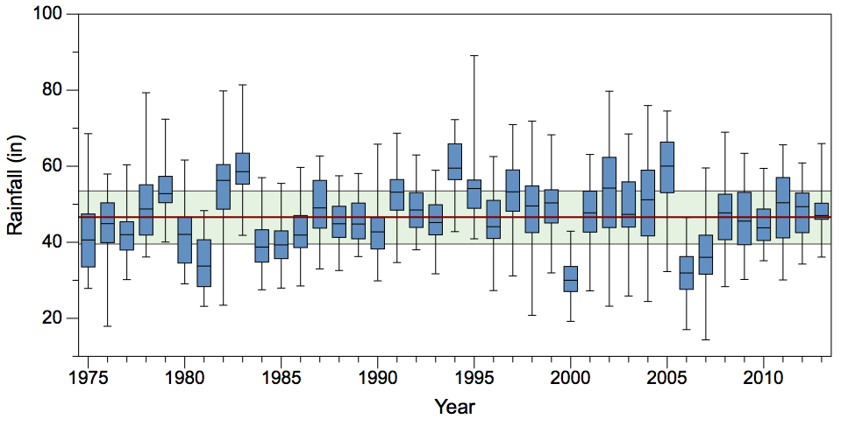
Figure 13. Box plot of rainfall over the simulation period. Rainfall data from all stations used in the model are included.

Calibration, Verification, and Goodness of Fit Methodology
Once the data requirements have been satisfied and the model is able to run successfully (i.e., error-free) and provide output, the next step is the calibration phase, followed by model verification. The classical definition of the calibration process is the adjustment of the input parameters of a mathematical or numerical model to optimize the agreement between observed data and the simulated output. Calibration and verification of watershed models require special considerations because of the temporal and spatial variation that occur in the measured data sets used for these processes. However, when the model parameters represent actual physical quantities, (e.g. fertilization rates, reach network parameters, land slope, irrigation rates, etc.) the adjustment of these parameters must be constrained within known bounds. Consequently, an additional step — a parameter validation process — is done to ensure the accuracy of the physical parameters that characterize the watershed and land use activities. This step is done before the adjustment of statistical or empirical model parameters. This is accomplished simply by examining physical parameters such as irrigation or fertilization rates to ensure that they are within reasonable bounds. This parameter validation step should not be confused with the later verification process where the accuracy of the simulated data is evaluated using measured data.
Before starting the calibration process, it is important to decide which measured data are to be used for the calibration process versus the data to be used for the verification process. Ideally, the calibration/verification datasets should either be spatially or temporally separated. However, since it is very difficult to find two spatially separated watersheds with similar physical properties, sufficient sampling points, that are also independent (i.e. are not upstream or downstream of one another), temporally separated observation datasets are typically used. Donigian (2002) points out that a split-sample calibration/verification procedure is recommended where only a portion of the observed dataset is used for calibration so that a separate portion of the dataset can be used to verify the model’s performance for non-calibrated periods. There is no consensus in the literature on the appropriate ratio of the time periods for calibration versus verification because it is highly dependent on the actual modeling goals. SWET has successfully used a ratio of 1:1 for previous modeling efforts and therefore a similar target was set for this project. The constraint here is that the time period for calibration must be long enough to contain a range of conditions to be expected in the watershed, e.g. wet and dry extremes over multiple years. As with the ratio of time periods for calibration/verification, there is no consensus on the minimum length of data that should be used for either calibration or verification. However, to the extent possible, recommendations have been made that calibration periods should be of at least 3-5 years in length and should include both above, below, and average years (Yew Gan et al., 1997). However, the optimal length of calibration periods is likely project-specific (Engel et al., 2007).
The criteria for determining the goodness of fit, i.e., how well the simulated data fits the measured data, are important for both the calibration and verification processes. Goodness of fit should be evaluated using a combined statistical and visual approach. The visual approach (e.g., simply comparing charts of time series) is useful for the initial assessments because it can quickly reveal deviations from the general trend between the simulation results and the observed data. The visual approaches should then be followed by commonly used statistical approaches, including relative error measures (such as Nash-Sutcliffe coefficient of efficiency) and absolute error measures (RMSE) to better quantify the goodness of fit.
However, no single goodness of fit measure is adequate for fully judging model performance. For example, the Nash-Sutcliffe coefficient is sensitive to extreme values (Legates and McCabe, 1999). Jain and Sudheer (2008) demonstrated cases where relatively poor models yielded a high value of the Nash-Sutcliffe coefficient and vice versa. Willmott (1981) and others have recommended that at least one absolute error measure (such as RMSE) and one relative error measure (such as the Nash-Sutcliffe coefficient of efficiency) should be used together with graphical comparisons of observed and simulated results. For this report, we have used the percent bias, the RMSE, the Nash-Sutcliffe coefficient, and a recently developed measure, the Kling-Gupta efficiency (Gupta et al., 2009). The Kling-Gupta efficiency utilizes a multi-objective approach that focuses on a combination of criteria to be optimized against. These are the correlation $r$, the ratio of the simulated and observed standard deviations, and the bias. Since it has only been recently developed, the Kling-Gupta efficiency has not seen widespread usage but it appears to be robust and not as sensitive to outliers as the NSE. It is included here to provide comparisons with other measures and provide a basis for future applications. Finally, while qualitative in nature, graphical comparisons such as simple box-and-whisker plots can yield additional information beyond that provided by a single error statistic. In short, goodness of fit statistics are but a single tool in evaluating model performance (Legates and McCabe, 1999; Loague and Green, 1991).

The Impact of Uncertainty in Input Data on WAM

Before conducting the calibration process, it is important to understand the influence of the variability and error associated with the model input data as they relate to model predictive error. The quality of numerical model output will always be limited by the quality of the input data. Because hydrologic models are, obviously, water-focused, the dominant controlling inputs are the addition and removal of water from the system, i.e., rainfall and evapotranspiration. Rainfall is both temporally and spatially more variable than evapotranspiration, consequently rainfall is the most influential input parameter for WAM. Soil and land use parameters are also important but have less of a temporal effect than the weather inputs and vary little spatially over time. To illustrate this, the Section 3 of the SWET report for Deliverables #2-#4 contains a discussion on how rainfall impacts output from simulations. That analysis indicates that water discharges from a source cell with identical land use and soil type can vary depending on the rainfall conditions by as much as 1000% introducing a predictive error of 20% to 30% for annual flows. Note that for future applications of WAM within the LOW it is likely that rainfall estimates will utilize either NEXRAD data, or the gridded rain estimates generated by the SFWMD. It was not utilized for this current project since the POR extends back much further than the period for which NEXRAD data are available, and for consistency with the earlier modeling efforts. In addition, the computational demand would be greatly increased since the number of zones with unique rainfall will be dramatically increased. However, for simulations requiring a shorter POR it should be feasible to use these data.

Calibration

WAM is primarily a physically based model, consequently, if the input physical parameters (land use, soils, hydrography, boundary conditions, weather, etc.) are correct then the resulting simulation results should be reasonable. The standard calibration procedure is designed to validate that the parameters that characterize the physical processes of the model are accurately represented at each major step in the simulation process. These simulation processes are loosely broken into 3 sections;
- Source cell nutrient load and flow generation,
- Cell to stream routing, and
- In-stream routing.
For each of these processes there are specific calibration techniques that have been developed. Furthermore, it is essential to first calibrate the Hydrologic and Hydraulic (H&H) processes to ensure that flows and stages are being correctly simulated in the reaches. Once these simulated hydrologic values reasonably match observed data, calibration for the nutrient concentrations is then conducted. The calibration procedure is thus broken into two sections: 1) H&H and then 2) nutrient concentrations and loads (Table 11).
Table 11. Standard calibration, verification, and goodness of fit procedures for WAM.
Step | Task
Setup.1 | Complete initial watershed setup using the WAM interface. This includes a preliminary validation of the watershed’s physical parameters as well as defaulted land use parameters to ensure that these parameters represent the local features found in the watershed.
Setup.2 | Obtain measured data for the watershed over the simulation time period and assess these data to identify periods to be used for calibration and verification.
Setup.3 | Run WAM
A | Hydrologic and Hydraulic (H&H)
A.1 | For the calibration period, calibrate runoff and percolation from the Source Cells by visually comparing the predicted flows in the dayfiles to observed values or literature values for each unique cell group to identify possible additional physical parameter errors.
A.2 | Correct/adjust source cell parameters to better characterize the watershed and rerun WAM until reasonable visual agreement for source cell flows are obtained for the calibration period.
A.3 | Assess that the surface and groundwater flow paths are accurate in each of the reaches and that the delay and shape of the hydrographs of the reaches following rainfall events are being represented correctly.
A.4 | Adjust delay and unit hydrographs and rerun WAM until reasonable visual agreement for hydrograph shapes are obtained for the calibration period.
A.5 | Verify that the flows and stages of the reaches have a reasonable visual agreement. Those reaches for which observed data exist should be reviewed objectively to ensure that hydraulic processes are represented correctly in the model parameter setup.
A.6 | Correct/adjust stream parameters and rerun WAM until reasonable visual agreement is obtained for the calibration period.
B | Constituent Concentrations
B.1 | Calibrate constituents (nutrients, sediment, and BOD) in the runoff and percolation from the Source Cells by visually comparing predicted concentrations in the Dayfiles to observed or literature values for each unique cell to identify possible additional physical parameter errors.
B.2 | Correct/adjust source cell parameters and rerun WAM until reasonable agreement for source cell constituent concentrations are obtained for the calibration period.
B.3 | Assess whether the overland and groundwater attenuation statistical model parameters are accurate.
B.4 | Adjust attenuation coefficients and rerun WAM until reasonable agreement for constituent concentrations are obtained for the calibration period.
B.5 | Compare the constituent concentrations in those reaches identified for calibration to observed datasets.
B.6 | Once physical parameters have been validated, adjust the empirical attenuation coefficients and rerun WAM until reasonable agreement is obtained for the calibration period.
C | Goodness of fit (GOF) for Calibration Period
C.1 | Run a GOF statistical method(s) for calibration period.
C.2 | Repeat steps A1-B6 until the best Goodness of fit is obtained for calibration period.
D | Goodness of fit (GOF) for Verification Period
D.1 | Visually compare WAM results to the verification period of measured dataset.
D.2 | Run a Goodness of fit statistical method(s) for verification period.
D.3 | Report results of the calibration and verification processes.

Hydrologic and Hydraulic (H&H) Calibration
The first step in calibrating a watershed model is to ensure that the overall volume of water and temporal distribution (i.e., flow) of water is simulated correctly. This involves calibrating the land use and soil parameters so that runoff and percolation produced by each source cell is reasonable and is delivered properly to the reach network. Secondly, it must be determined that the source cell water is being properly routed through the stream/canal network.

Source Cell Runoff and Percolation Parameter Validation and Calibration
The BUCShell module in WAM calculates the source flows and loads of each simulated constituent that is generated within the unique source cells on a daily basis. The source load that is generated within each cell is a product of the relationship between the rainfall, land use, and soil types, or more specifically, the parameterization of each of these input types. Because the source cell sub-models are mostly physically based, the process of calibrating and verifying runoff and percolation from the source cells is preceded by a parameter validation step. This is done by examining model output for each unique cell to identify predicted results that are inconsistent with known flow and water quality conditions (SWET, 2008a). Such inconsistencies are normally the result of inaccurate data entry associated with physical properties such as pump controls, fertilizer rates, soil data, etc. A utility program for WAM (called “DayFileToYear”), is used to complete this evaluation efficiently. This utility creates model output (a CSV file) that contains the annual averages (in units of cm for runoff/percolation or kg/ha for nutrients) for the flow and nutrient loads for all the unique source cell types. Anomalies may be identified through a visual inspection of the data, such as the annual average discharge data for various land uses.

Stream/Canal Network Flow Calibration
Once the source cell runoff and percolation estimates are within the range of observed values, the BLASRoute module in WAM is run to route the source cell flows overland to a destination reach, and subsequently through the stream/canal network to the sub-watershed outlets. Known flow or stage boundary conditions must be applied at all inlets and outlets to the sub-watersheds. For discharges into Lake Okeechobee, the nearest available recorded stage data were used for the lake side stage boundary condition for each structure located on the lake. For other discharge locations, such as from Lake Kissimmee at S-65 or Lake Istokpoga at S-68, tailwater stages at those structures were used as the boundary conditions. As with the source cell calibration, the first BLASRoute calibration process was to validate that the hydrography was properly represented, which includes validating the stream/canal network connectivity, structure locations and operational protocols, and that boundary conditions have the correct flows and stages.
The hydrography validation was done by running the preliminary setup, and comparing the flows and stages at all simulated structures. Once the hydrography and boundary conditions were verified and (if needed) corrected, the simulated accumulative flows through the sub-watershed outflow structures were compared to measured flows to determine if the net evapotranspiration (ET) within the sub-watersheds was correct, i.e., source cell irrigation demand and net runoff estimates were reasonable. In sub-watersheds dominated by high water table flatwoods and muck soils, the EAAMod parameter controlling evapotranspiration (PETFACEAAMOD) was used to globally adjust the crop ET coefficient for all land uses, which requires re-running of BUCShell. In areas dominated by well-drained soils (less common) the GLEAMS parameter PETFAC was adjusted to accomplish the same result. For lake-dominated systems (Lake Istokpoga, Upper Kissimmee), the ET coefficients for the lake reaches were adjusted. When the accumulative flow curves (i.e., total volume) over the calibration period for the major sub-watershed outflow structures were found to be within 10% of the observed values the model was deemed to be calibrated for flows. Detailed results are given for each sub-watershed in Section 5. Note that some accumulated flow volume for some years may deviate considerably more than 10% from the observed values. Investigation of these years determined that such differences usually arise primarily due to 1) non-representative rainfall and 2) possible temporal changes in structure operation protocols, particularly those associated with unique climatic events, such as hurricanes. For example, lake discharge structures have been operated to lower water levels in anticipation of major rain events, although the expected rainfall did not always materialize. Since WAM cannot incorporate such temporal operational changes, simulated results can diverge from actual measured values in these cases.

Nitrogen and Phosphorus Load Calibration
Once the model was calibrated for H&H output the next step was to calibrate the model to match nitrogen and phosphorus concentrations and loads. As with the procedure for H&H calibration, the first step is to verify that the input data are properly representing the land use conditions that exist in the sub-watersheds to ensure source cell loads are reasonable. This involves reviewing the assumed fertilization rates, crop rotations, waste treatment types, etc., for each source cell for accuracy, which requires the constituent nitrogen and phosphorus loads for each land use to be evaluated.

Source Cell Nitrogen and Phosphorus Load Calibration
As with the water leaving source cells, the BUCShell module in WAM calculates daily loads of each simulated constituent generated within the unique source cells and outputs these time-series data in CSV format. The source cell’s nitrogen and phosphorus loads generated for each cell are a product of the simulated runoff and/or percolation and the associated nitrogen and phosphorus concentrations.
As with the flow calibration, since the source cell sub-models are mostly physically based, the process of calibrating and verification of the nutrient loads from the source cells is an exercise of reviewing the output data for each unique cell to identify any physical parameterization errors. As before, the utility program, “DayFileToYear”, was used to help complete this evaluation efficiently. Anomalies were identified through a visual inspection of the simulated data compared to observed data (SWET, 2008a), such as charting the TN and TP concentration data for the land uses present in any given sub-watershed.

Stream/Canal Network Nitrogen and Phosphorus Calibration
Once the source cell nitrogen and phosphorus concentrations and loads were determined to be reasonable, the BLASRoute module in WAM was run to route the source cell flows and nutrients overland to the nearest reaches and subsequently through the stream/canal network to the sub-watershed outlets. Nutrient assimilation processes are simulated throughout the water conveyance system. Like the source cell calibration, the first BLASRoute calibration process was to verify that the hydrography and associated nutrient assimilation parameters were being properly represented for the overland, stream, slough, and canals hydrologic conveyance features.
The parameters used to calibrate the nitrogen and phosphorus within overland flow or within the stream network were the attenuation coefficients $a$ and $C_{b}$ for the overland, streams, sloughs, and canal conveyance features. Note that the $b$ coefficient was not modified during the calibration process because of its relatively low sensitivity. Separate attenuation equations are used for overland and stream flow since it has been shown in earlier reports that attenuation during overland flow (source cell to the target conveyance reach) is more influenced by flow rate/velocity and distance of travel, whereas assimilation in streams is better correlated with the wetted perimeter of a reach and residence time within that reach. The equation used for overland attenuation processes is:
$$C=\left(C_{0}-C_{b}\right)e^{-a⋅x⋅q-b⋅x⋅d}+C_{0}$$
While the equation for in-stream attenuation is
$$\frac{dL}{dt}=a_{s}A\left(C_{0}-C_{b}\right)$$
where $C$ (mg/l) is the final concentration in stream reach at end of time step or the concentration of overland flow when it enters the nearest stream; $C_{0}$ (mg/l) is the concentration in stream reach at the start of a time step or the concentration of the overland flow as it is leaving the source cell; $C_{b}$ (mg/l) is the user specified background concentration; $a$ and $b$ (both dimensionless) are user specified attenuation exponents; $q$ ($m^{3}$/s/ha) is the flow rate leaving the source cell during that day; $d$ (m) is the flow distance; $a_{s}$ (m/s) is the rate of load transfer (m/s); $L$ (g) is the load; and $A$ (m²) is the stream wetted surface area.

Verification

Verification of model outputs is done after the calibration process is complete. The purpose of this step is to determine how the model performs against measured values that were not used in the calibration process; in this case a time interval that was not part of the calibration process was the source of the measured data. Basically, simulated data is compared against measured data without making further adjustments to the model inputs to assess how the model performs against “new” data.

Calibration/Verification Period and Calibration Targets

After consultation with staff from the Coordinating Agencies, it was decided that to best reflect the land uses present in the sub-watersheds the calibration/verification periods were limited to the 2003-2013 time frame (11 years). The calibration period was split to cover the first three years (2003-2005) and the last three years (2011-2013) with the middle five years (2006-2010) serving as the verification period. The target set for calibration was to match the accumulated flows over the combined six-year period within ± 10%. Choosing the target for nutrients is more difficult since water quality data is not gathered daily, at best, auto-samplers can provide flow-weighted concentrations over intervals up to about two weeks, but there may be gaps between the intervals where no data is available. If loads are used for calibration then interpolation must be done to fill gaps, and the method of interpolation then has an influence on the evaluation of the goodness of fit. However, proper assessment of water volumes and nutrient loads into Lake Okeechobee is the primary objective of this modeling effort. Monthly summaries of measured water volumes and nutrient loads that have undergone an extensive QA/QC process were provided by the SFWMD, consequently, these summaries were used for the calibration and verification process.
Examination of rainfall data over the selected calibration/verification period shows some of the input variability discussed above in Section 4.1. A box-and-whisker plot of data from all of the rain stations used in the model is shown in Figure 14. This is the same as Figure 13 shown in Section 3.4.3.1 except that the range of years shown corresponds only with the calibration/verification period, not the entire simulation. As before the bottom and top of the green band shows the first and third quartiles, respectively, over the entire simulation period, and the red line indicates the median rainfall over the simulation period. This shows that the calibration period was considerably wetter than the than the verification period. The calibration period had one of the wettest years in the entire simulation period in 2005, followed by one of the driest in 2006, which falls in the verification period. In addition, the spread of rainfall amounts across all of the sub-watersheds within each year can be large, as shown by the top and bottom “whiskers” for each box. Even the interquartile range (which excludes the maximum and minimum values) can be greater than 15 inches.
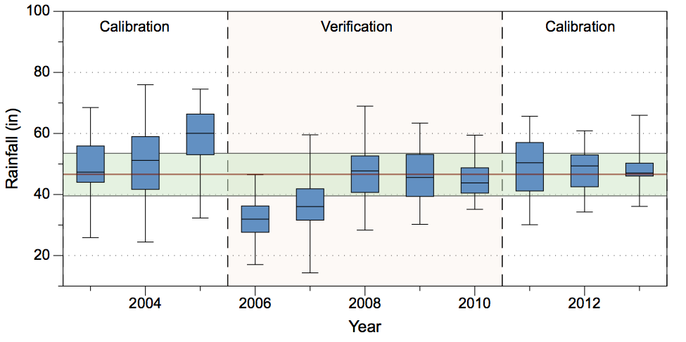
Figure 14. Box plot of rainfall over the combined calibration/verification period. Rainfall data from all stations used in the model are included.
The results of the calibration and verification process, as well as an evaluation of the goodness of fit of the simulated data is provided in the next section, where each sub-watershed is discussed separately.

Goodness of Fit

To determine goodness of fit, the freely available statistical program “R” was used (see The R Project for Statistical Computing at https://www.r-project.org (R Development Core Team, 2015)) in combination with the package “hydroGOF” (Zambrano-Bigiarini, 2014). The program “R” is widely supported, has been incorporated into the latest version of ArcGIS, and has many add-on packages. The hydroGOF package produces a comprehensive set of statistical outputs to describe how well the simulated data represents measured values, however only four statistics were used here. Results from hydroGOF are presented in Section 5 as tables with the following entries:
- PBIAS %: Percent Bias (dimensionless).
- RMSE: Root Mean Square Error (acre-feet for volume, MT for loads).
- NSE: Nash-Sutcliffe Efficiency (dimensionless) ($-∞≤NSE≤1$).
- KGE: Kling-Gupta efficiency (dimensionless) ($-∞≤KGE≤1$).
At each outflow point, goodness of fit statistics are presented for water volume and nutrient (TN and TP) loads. Statistics are applied to determine how well the simulated values fit the measured values on a monthly basis. Comparison with measured concentration data was used as a qualitative assessment, but the final calibration targets were based on the water volumes and nutrient loads.

Model Results
Comparisons of model results with measured data are presented below for each of the six sub-watersheds. The simulation period for the BUCShell submodel was 1972-2013; however, the first three years are done as a spin-up period and are not used in BLASRoute. Consequently, results from BLASRoute starts in 1975 and runs through the end of 2013.
As described in the SOW, even though the model was run from 1975-2013, the combined calibration/verification period was from 2003 through the end of 2013. The charts cover this time frame; however charts of accumulated flow and nutrient loads for the entire simulation period are provided in the Appendix (Section 6.1). Charts provided in the following sub-watershed specific sections show accumulated water volume (in millions of acre-feet) since January 1, 2003. Each volume accumulation chart is split into two parts, with the upper chart showing the accumulated volume and the lower part showing the accumulated residuals (in thousands of acre-feet) over the same time frame. The accumulated residuals are the total accumulated simulated volume at a given point in time minus the total accumulated measured volume at the same point in time. A negative value of the residual indicates that the model underestimates the volume up to that time while a positive value shows the model overestimating the accumulated volume. In addition, an upward-pointing spike in the residual indicates that the simulated values lead the measured values in time while a downward-pointing spike indicates the opposite, i.e., the simulated values lag the measured values. Tables comparing simulated values against measured values of water volumes and nutrient loads are presented for each outflow structure. Charts showing accumulated TN and TP loads are shown as well. These are analogous to the charts showing water volume, with the accumulated load in the upper chart (in metric tons) and the accumulated residual in the lower chart.
Additionally, time series charts of TN and TP concentrations are presented at each structure as two parts of a single figure with TN in the upper half and TP in the lower. These are provided to give a qualitative assessment of how WAM is performing. The calibration and verification periods are indicated on both flow and nutrient charts. For completeness, charts of accumulated volume and nutrient loads (in metric tons) over the entire 1975-2013 simulation period are shown in the Appendix in Section 6.1 in Figures 77 – 121. As discussed in the previous section, statistics for load calculations were generated by summing the simulated values over a month and comparing these against the corresponding monthly values provided by the SFWMD.
As was discussed in the previous sections, this modeling effort involved significant updates to the basin areas, land use, soils, and hydrography datasets. The initial phase of this project ran the model “as-is” and no parameters were recalibrated. The input land use and soils parameters for GLEAMS, EAAMOD, and special case land uses for the initial phase were identical to those used for the earlier 2009 study. However, the feature classes associated with both land use and soils have been updated so not all areas simulated fall under the same categories as in the previous study. Additionally, changes to the model domains have resulted in some domains that were simulated as independent areas in 2009 are now being incorporated into a larger sub-watershed. These changes required this extensive recalibration effort.
As discussed in the previous section, the general approach for WAM calibration is to calibrate the simulated flow values to measured values of flow first. Only after a satisfactory fit has been obtained will the model be calibrated for nutrient data. The reasoning for this is that while concentrations can be affected by a large extent by flow, it is rare that a change in calibration for water quality has an influence on flow. That will typically only happen when, for example, changes in fertilization practices affect crop growth, which in turn can affect runoff and percolation to some extent. Such effects are typically not large.
The technique for calibration when there are external flows entering a model domain (generally referred to as “pass through” water) is to use either the measured flow and concentration data for the inlet structure or the simulated flow and concentration data from the upstream model domain as inflow boundary conditions. Pass through water only exists for the Indian Prairie and Lower Kissimmee sub-watersheds, where flows through S-68 from the Lake Istokpoga sub-watershed enter the Indian Prairie sub-watershed and flows through S-65 from the Upper Kissimmee sub-watershed enter the Lower Kissimmee sub-watershed. For these sub-watersheds, the upstream inflow boundaries use the measured flow and nutrient concentrations since it was determined that it was best to calibrate hydrologic processes occurring within each sub-watershed to the best available measured data. When the model is used to simulate impacts of alternative scenarios across the entire watershed, simulated flows and nutrient loads at the basin inflows can be substituted into the model if desired. Alternatively, when assessing the impacts of projects that are limited to a single watershed, the measured inflow data should be used.
In each of the subsections below a given sub-watershed is discussed. A map showing the model domain is presented showing the sub-boundaries, rain stations, and various flow and water quality sampling locations. Due to space limitations, results from the flow and water quality sampling locations are only presented at outflow structures and not all locations shown on the map. The “internal” sampling points were used during the calibration process to better determine processes within specific portions of the model domains.

Fisheating Creek

The Fisheating Creek sub-watershed is located on the southwestern side of the six northern sub-watersheds. The sub-watershed is approximately 317,500 acres in area, with the southern end of the Lake Wales Ridge occupying the northeastern part of the sub-watershed. Fisheating Creek drains the sub-watershed, running from north to south along the northern part and then turning to the east before discharging into Lake Okeechobee. The sub-watershed is unique in that the discharge to Lake Okeechobee is uncontrolled, i.e., no gates or pumps exist at the mouth. The WAM model setup for Fisheating Creek is shown in Figure 15. Data at the discharge point into Lake Okeechobee is at the station “FISHCR” at SR-78. Summaries of water volumes and TN and TP loads at the basin outfall structures are shown in Table 12.
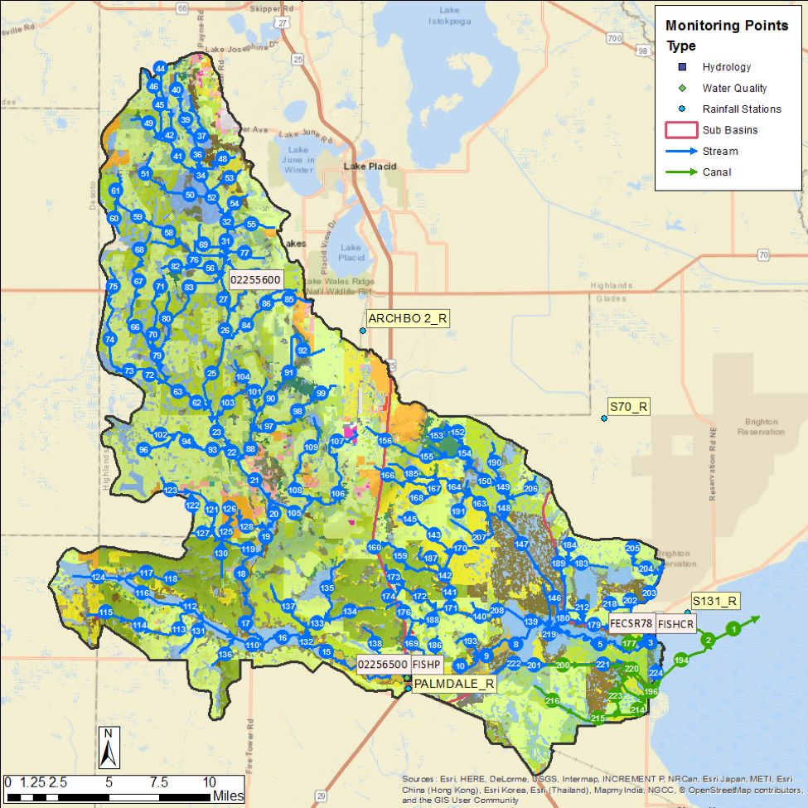
Figure 15. The Fisheating Creek model domain. Rain stations, flow station, and water quality stations are shown.

Table 12. Fisheating Creek water volume (in acre-feet) and TN and TP loads (in metric tons) at SR-78.
Location | Simulated | Measured | Difference | Percentage
Volume (ac-ft)
SR-78 Cal. | 1,744,683 | 1,853,223 | -108,540 | -5.86%
SR-78 Ver. | 861,573 | 729,872 | 131,701 | 18.04%
TN (MT)
SR-78 Cal. | 3,695 | 3,566 | 130 | 3.63%
SR-78 Ver. | 1,834 | 1,638 | 196 | 11.93%
TP (MT)
SR-78 Cal. | 443 | 459 | -16 | -3.42%
SR-78 Ver. | 220 | 247 | -27 | -10.92%

Flows and Water Quality Data at SR-78
Accumulated flow at SR-78 (SFWMD Station FISHCR) over the 2003-2013 period shows reasonable agreement (Figure 16). Note that measurements was not collected at this location prior to 1997. A second station on Fisheating Creek (at Palmdale) has flow and load data collected back to 1975, but not after May 2012, which is during the calibration period. However, data from that station is included for reference in the long-term flow and load calculations in the Appendix (Section 6.1).
As can be seen, over the entire calibration/verification period the simulation results and measured values are close. The simulated values underestimated the measured values in the calibration period by approximately 6% and overestimated the measured volume by 18% during the verification period. The greatest deviation between simulated and measured values occurred during relatively high flow years of the first calibration period (2003-2005) and again during the low-flow year of 2010. Over the combined calibration/verification period the simulated results are about 1% higher than observed flow. The NSE statistics for the volume estimates are 0.73 and 0.76 for the calibration and verification periods, respectively, indicating a good fit (Table 13).
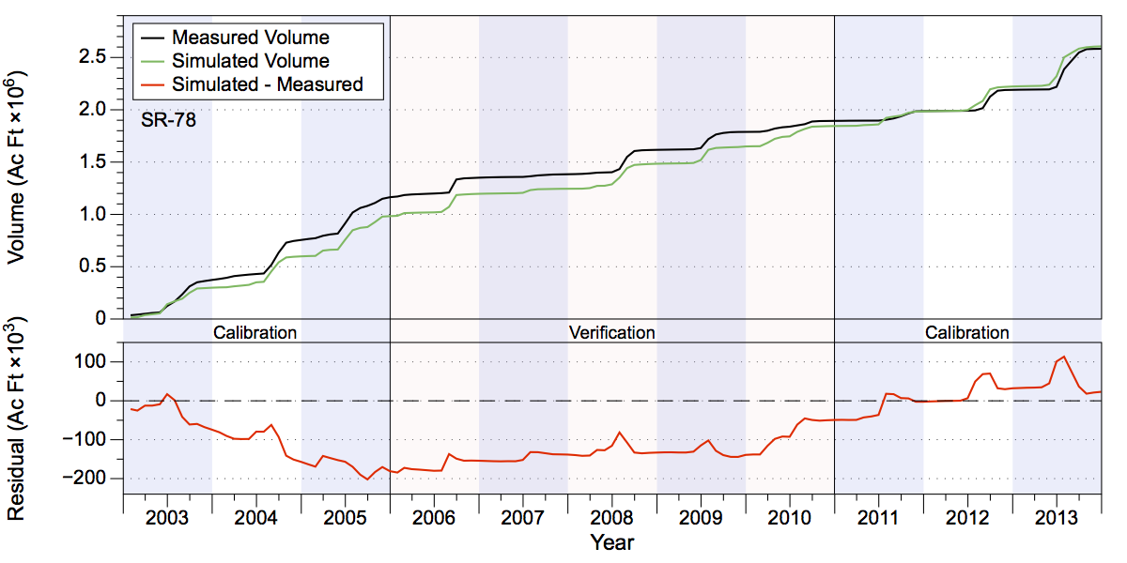
Figure 16. Measured and simulated accumulated water volumes in acre-feet (upper chart) and accumulated volume residuals (lower chart) at SR-78.
Qualitative comparisons between measured and simulated nutrient concentrations are reasonable. Overall the simulated TN concentrations have about the same degree of variability as the measured values, as do the TP concentrations (Figure 17). In both cases, however, several extreme values are missed, e.g., relatively high TN concentrations in 2007 and 2012, and high TP concentrations in mid-2004, 2008, and 2013. Simulated TN load values overestimated the measured amounts by just under 4% during the calibration period and overestimated the measured values by about 12% in the verification period (Table 12 and Figure 18). Most of the deviation from the measured loads occurs during 2010 in the verification period and from 2011-2013 in the second calibration period. Some of the times where TN concentrations are underestimated (e.g., 2007) occurred during low flow periods and consequently had little effect on load estimates. Simulated TP loads underestimated measured loads by slightly over 3% during the calibration period and also underestimated measured loads by about 11% in the verification period (Table 12 and Figure 19). Much of the separation between estimated and measured loads came during 2004 and again in 2008 and 2009, when high flow periods were combined with underestimates of TP by WAM.
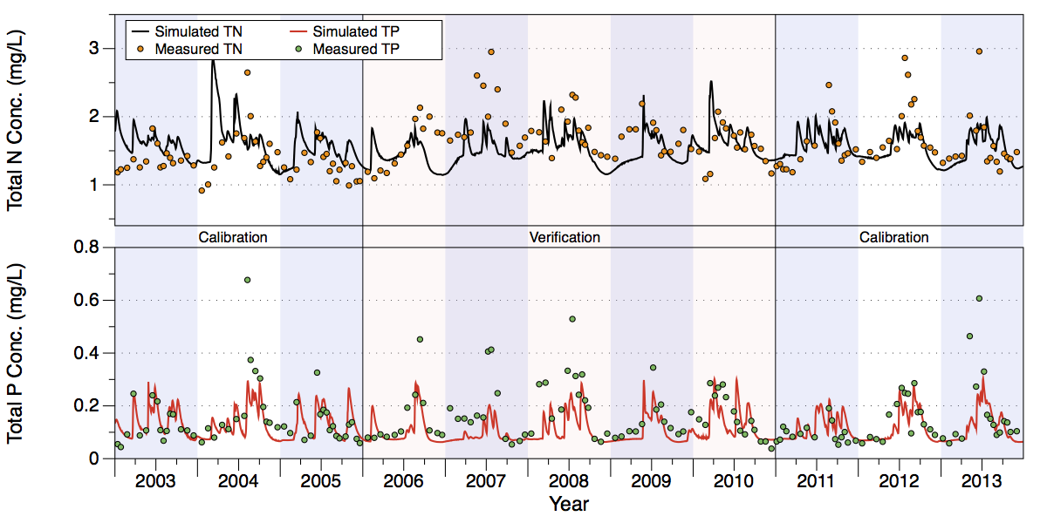
Figure 17. Comparison of measured and simulated TN (upper chart) and TP (lower chart) concentrations at SR-78.
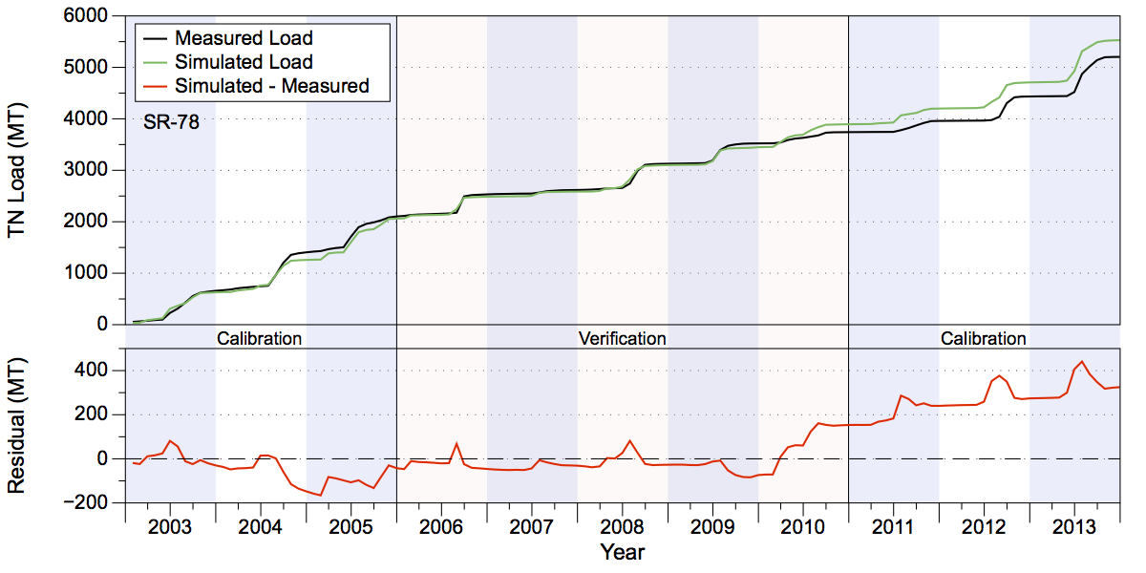
Figure 18. Measured and simulated accumulated TN loads in metric tons (upper chart) and accumulated residuals (lower chart) at SR-78.
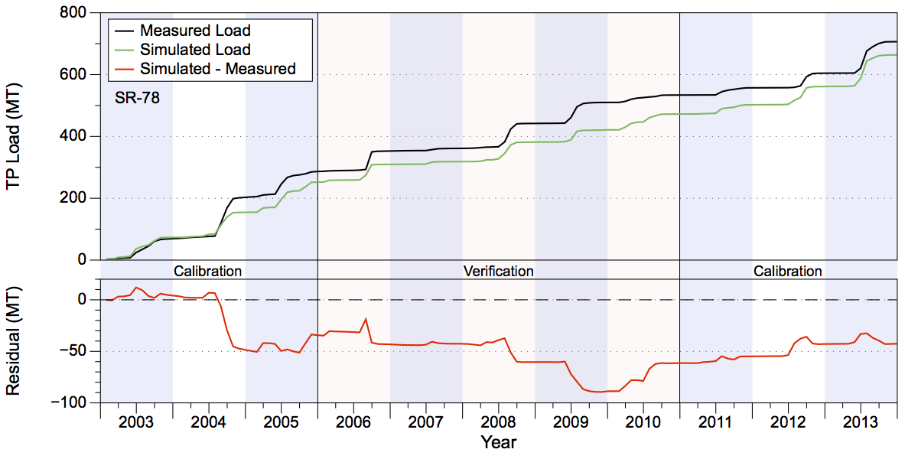
Figure 19. Measured and simulated accumulated TP loads in metric tons (upper chart) and accumulated residuals (lower chart) at SR-78.
The NSE statistics for both TN and TP loads are quite good, with values in both the calibration and verification period being over 0.75, with the value for TP being 0.82 during the calibration period (Table 13).

Table 13. Fisheating Creek GOF statistics at station FISHCR (LakePort). Note that RMSE has units of acre-feet for volume and metric tons for nutrient loads. The columns marked (C) refer to the calibration period while those marked (V) refer to the verification period.
Statistic | Volume (C) | Volume (V) | TN Load (C) | TN Load (V) | TP Load (C) | TP Load (C)
PBIAS % | -5.90 | 18.00 | 3.60 | 11.90 | -3.40 | -10.90
RMSE | 18,270.28 | 12,133.16 | 33.66 | 27.89 | 4.91 | 4.96
NSE | 0.73 | 0.76 | 0.78 | 0.77 | 0.82 | 0.77
KGE | 0.85 | 0.78 | 0.88 | 0.80 | 0.84 | 0.67

Indian Prairie

The Indian Prairie sub-watershed is located in the south-central portion of the six sub-watersheds, lying south of the Lake Istokpoga and Lower Kissimmee model domains and immediately north of Lake Okeechobee (Figure 20). The sub-watershed is approximately 276,400 acres in area. The Indian Prairie sub-watershed includes several areas that were studied as separate basins in the 2009 WAM study. In that study, the L-48 and L-49 basins were simulated independently of the rest of the lower C-38 basin. In the current study these basins, along with the S-131 basin, have been incorporated into the full model domain, which has significantly altered the WAM setup for the hydrography. The S-68 structure serves as the inflow point into the model domain from Lake Istokpoga. Water exits the lake and flows southeast down the C-41A canal until reaching the point where the C-41 canal splits off to the south from C-41A. Water continues flowing east-southeast in the C-41A canal until it reaches the S-84 structure, which controls part of the discharge from the basin. In the C-41 canal, water flows south to the point where the C-39A splits off and runs to the east and in turn flows into the C-40 canal. Water in C-40 flows southeast through the S-75 structure and S-72 structure before discharging into Lake Okeechobee. Water in the C-41 Canal continues flowing south through the S-70 structure and the S-71 structure before discharging into Lake Okeechobee. Thus, the inflow into the model domain from Lake Istokpoga via S-68 may take one of three routes before discharging into Lake Okeechobee.
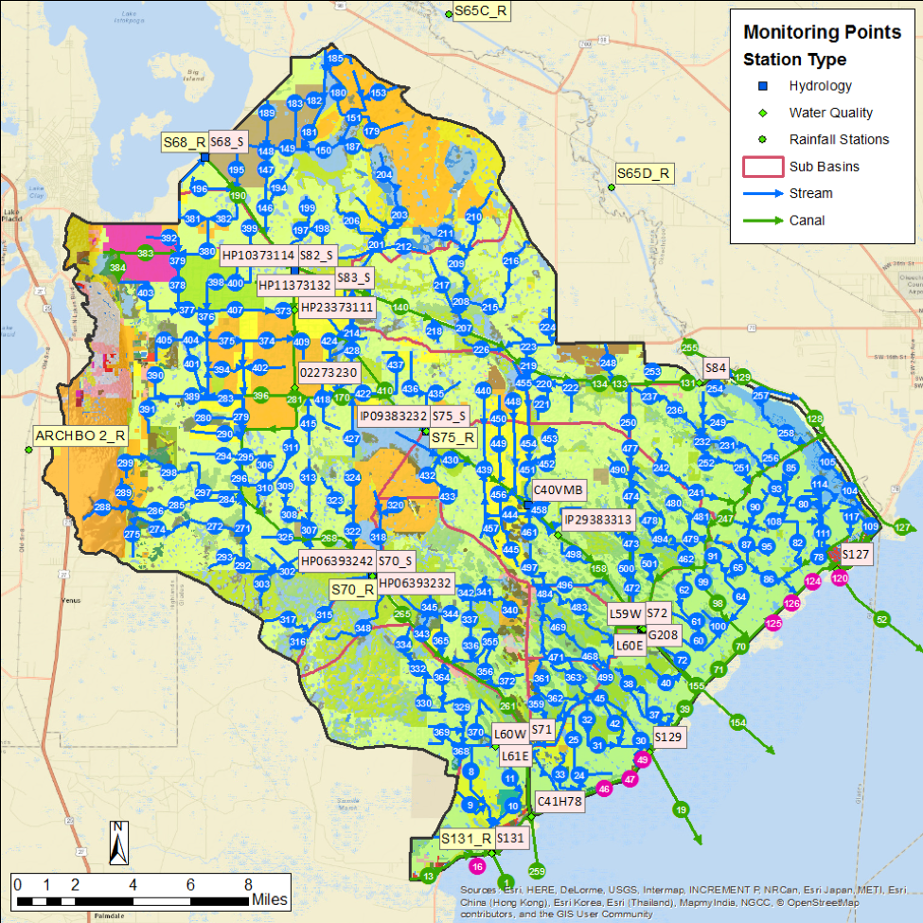
Figure 20. The Indian Prairie model domain. Rainfall, flow, and water quality stations are shown.
Summaries of water volumes and TN and TP loads at the basin outfall structures are shown in Tables 14-16, respectively. These results are discussed individually for each structure below.

Table 14. Indian Prairie Total Water Volume (acre-feet).
Structure | Simulated | Measured | Difference | Percentage
S-84 Cal. | 1,468,113 | 1,541,972 | -73,859 | -4.79%
S-84 Ver. | 501,657 | 585,617 | -83,960 | -14.34%
S-71 Cal. | 1,361,070 | 1,419,506 | -58,436 | -4.12%
S-71 Ver. | 658,247 | 608,433 | 49,815 | 8.19%
S-72 Cal. | 406,228 | 401,332 | 4,896 | 1.22%
S-72 Ver. | 183,433 | 131,835 | 51,598 | 39.14%
S-127 Cal. | 90,054 | 87,432 | 2,621 | 3.00%
S-127 Ver. | 46,820 | 41,012 | 5,808 | 14.16%
S-129 Cal. | 89,625 | 87,831 | 1,794 | 2.04%
S-129 Ver. | 34,868 | 40,343 | -5,475 | -13.57%
S-131 Cal. | 70,934 | 68,026 | 2,908 | 4.27%
S-131 Ver. | 25,505 | 28,576 | -3,071 | -10.75%

Table 15. Indian Prairie Total Nitrogen Load (metric tons).
Structure | Simulated | Measured | Difference | Percentage
S-84 Cal. | 2,528 | 2,743 | -215 | -7.83%
S-84 Ver. | 1,068 | 1,125 | -57 | -5.04%
S-71 Cal. | 3,494 | 4,058 | -563 | -13.88%
S-71 Ver. | 2,116 | 1,944 | 172 | 8.85%
S-72 Cal. | 1,162 | 1,146 | 15 | 1.34%
S-72 Ver. | 644 | 427 | 217 | 50.93%
S-127 Cal. | 230 | 225 | 4 | 1.94%
S-127 Ver. | 129 | 112 | 17 | 15.31%
S-129 Cal. | 176 | 165 | 11 | 6.63%
S-129 Ver. | 72 | 90 | -18 | -20.08%
S-131 Cal. | 144 | 133 | 11 | 8.20%
S-131 Ver. | 54 | 65 | -11 | -17.22%

Table 16. Indian Prairie Total Phosphorus Load (metric tons)
Structure | Simulated | Measured | Difference | Percentage
S-84 Cal. | 178 | 179 | -1 | -0.48%
S-84 Ver. | 66 | 84 | -18 | -21.49%
S-71 Cal. | 398 | 439 | -41 | -9.24%
S-71 Ver. | 294 | 227 | 67 | 29.51%
S-72 Cal. | 136 | 139 | -3 | -2.49%
S-72 Ver. | 84 | 53 | 31 | 57.69%
S-127 Cal. | 27 | 29 | -2 | -6.89%
S-127 Ver. | 19 | 19 | 0 | 1.07%
S-129 Cal. | 9 | 9 | 0 | 3.45%
S-129 Ver. | 5 | 6 | -1 | -18.95%
S-131 Cal. | 11 | 10 | 1 | 5.44%
S-131 Ver. | 4 | 6 | -2 | -33.33%

Flow and Water Quality Data at S-84
Accumulated simulated volume at the S-84 structure on C-41A over the 2003-2013 period was slightly lower than observed (Figure 21). Over the entire calibration/verification period the simulation results are close, where the simulated values underestimated the measured values in the calibration period by 5% and underestimated the measured values during the verification period by 14% (Table 14). Most of the separation between simulated and observed measurements occurs in mid-2009 and mid-2010 during the verification period, followed by a rather larger separation in mid-2013. Over the combined calibration/verification period the simulated is about 7% too low. Much of the shortfall occurs at the midpoint of 2013. The NSE statistics of 0.8 and 0.82 for the calibration and verification periods, respectively, indicate a good fit (Table 18).
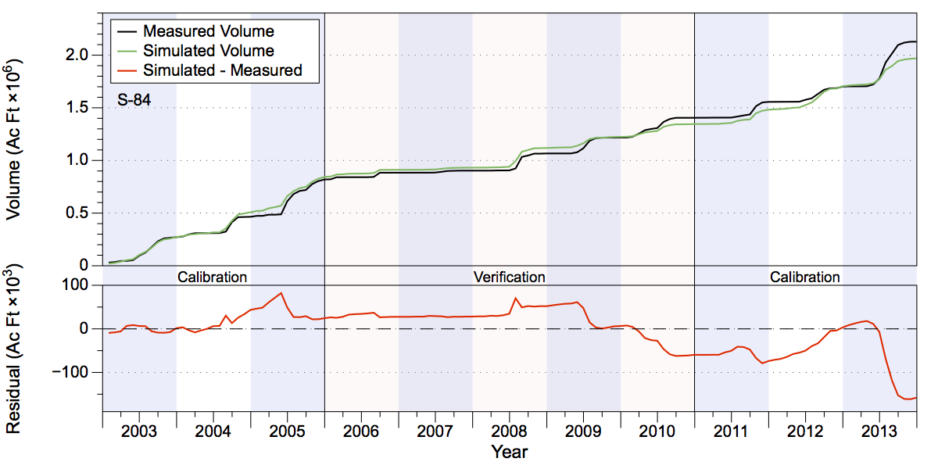
Figure 21. Measured and simulated accumulated water volumes in acre-feet (upper chart) and accumulated volume residuals (lower chart) at structure S-84.
Comparison of the simulated TN and TP concentrations show that that the simulated concentrations demonstrate a similar degree of variability as the measured values (Figure 22). However, simulated TN concentrations tended to overestimate measured values during the verification period, while simulated TP concentrations miss a few peaks during 2004 and 2007-2008, but subsequently tend to show a number of spikes above the measured values from 2009 onward.
Simulated TN loads underestimated measured values by almost 8% in the calibration period and by 5% in the verification period (Table 15 and Figure 23). Most of the underestimate in TN loads occurred during 2013 at the same point where the simulated flow separated from observed values. Simulated TP loads underestimated measured loads by less than 1% during the calibration period, but underestimated observed values by almost 22% during the verification period (Table 16 and Figure 24). A large fraction of the TP load underestimate occurred during the verification period in mid-2008 when higher observed TP concentrations coincided with a flow event. The NSE statistics for TN are 0.72 and 0.82 for the calibration and verification periods, respectively while the statistics for TP are 0.76 and 0.64 (Table 18). All of these values demonstrate good fits.
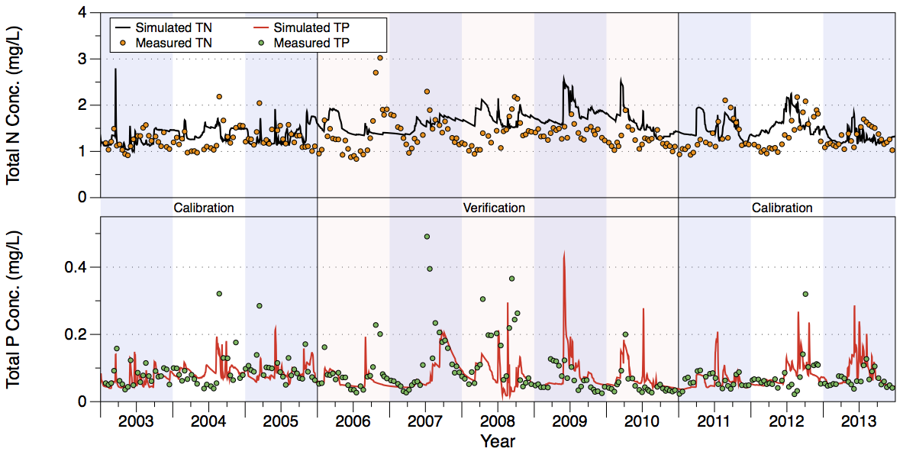
Figure 22. Comparison of measured and simulated TN (upper chart) and TP (lower chart) concentrations at structure S-84 on C-41A.
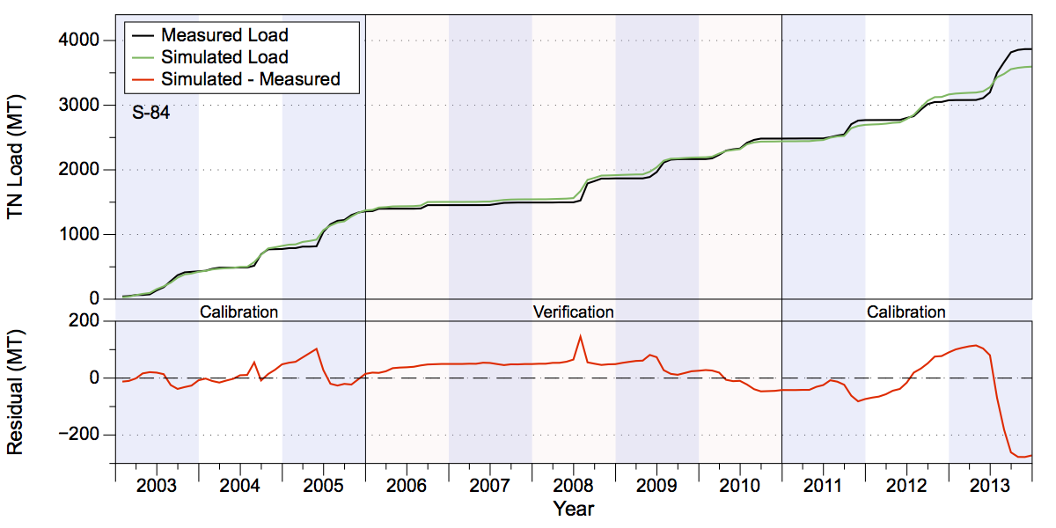
Figure 23. Measured and simulated accumulated TN loads in metric tons (upper chart) and accumulated residuals (lower chart) at structure S-84 on C-41A.
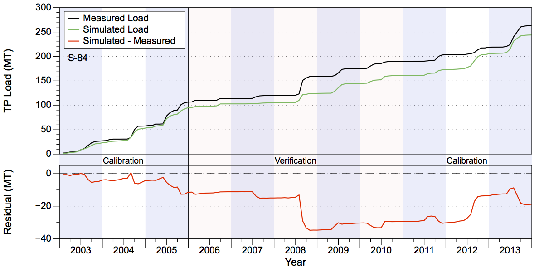
Figure 24. Measured and simulated accumulated TP loads in metric tons (upper chart) and accumulated residuals (lower chart) at structure S-84 on C-41A.

Flow and Water Quality Data at S-71
The accumulated simulated volumes at the S-71 structure on C-41 over the 2003-2013 period are close to the measured values (Figure 25). The simulated values underestimated the measured values in the calibration period by about 4% and overestimated the measured values by about 8% during the verification period (Table 14). The largest deviations occur during mid-2004 and mid-2008 when simulated flows underestimated observed values. After this time, however, simulated values steadily overestimated the measured flow. Over the combined calibration/verification period the simulated volume is within 1% of the observed volume. The NSE statistics are 0.64 and 0.7 for the calibration and verification periods, respectively (Table 18).
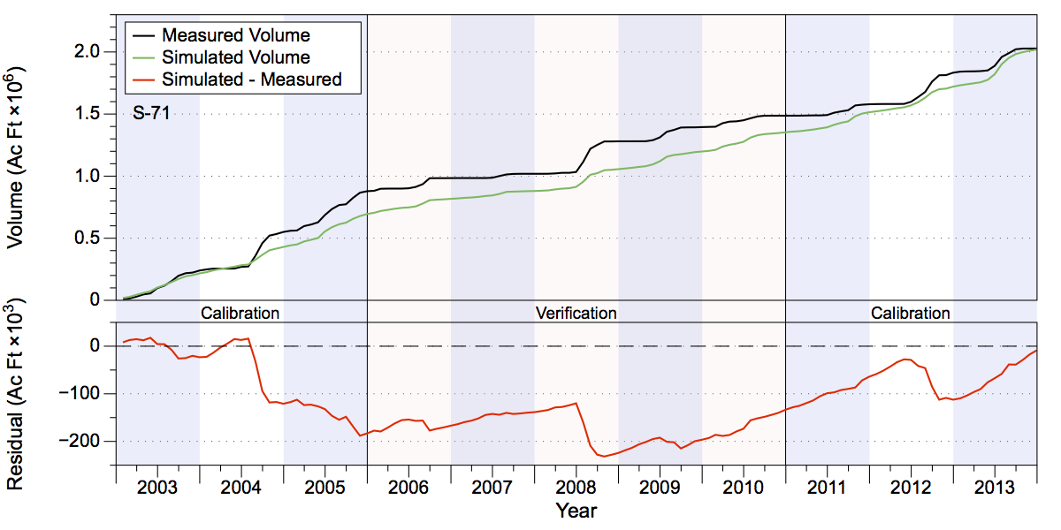
Figure 25. Measured and simulated accumulated water volumes in acre-feet (upper chart) and accumulated volume residuals (lower chart) at structure S-71.
The simulated TN concentrations capture much of the variability present in the measured data with the exception of overestimation from mid-2007 through mid-2008. Simulated TP concentrations show a reasonable degree of similarity with the measured values, but do have higher peak values, particularly after mid-2007 (Figure 26). Simulated TN loads underestimated measured values by nearly 14% during the calibration period and overestimated measured values by 9% in the verification period (Table 15 and Figure 27). Underestimates in mid-2004 and mid-2008 reflect flow underestimates during the same periods. Simulated TP loads underestimated measured load values by about 9% and overestimated measured values by almost 30% in the verification period (Table 16 and Figure 28). The largest underestimates of TP loading occurred from 2004-2005, while overestimates occurred during the period from 2010 through 2013. The NSE statistics for TN are 0.59 and 0.69 in the calibration and verification periods, respectively, while the equivalent measurements for TP are 0.55 and 0.69, all of which demonstrate satisfactory fits (Table 18).
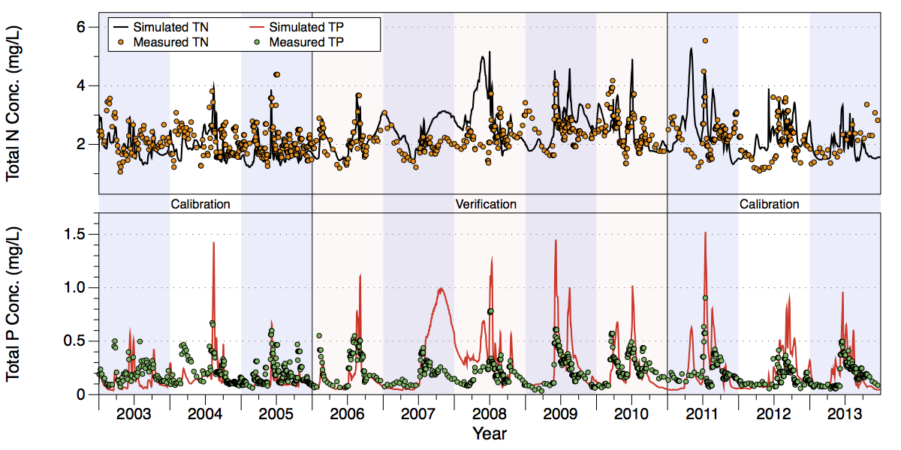
Figure 26. Comparison of measured and simulated TN (upper chart) and TP (lower chart) concentrations at structure S-71.
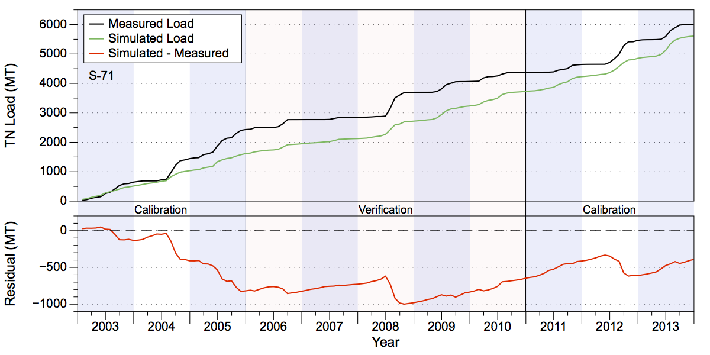
Figure 27. Measured and simulated accumulated TN loads in metric tons (upper chart) and accumulated residuals (lower chart) at structure S-71.
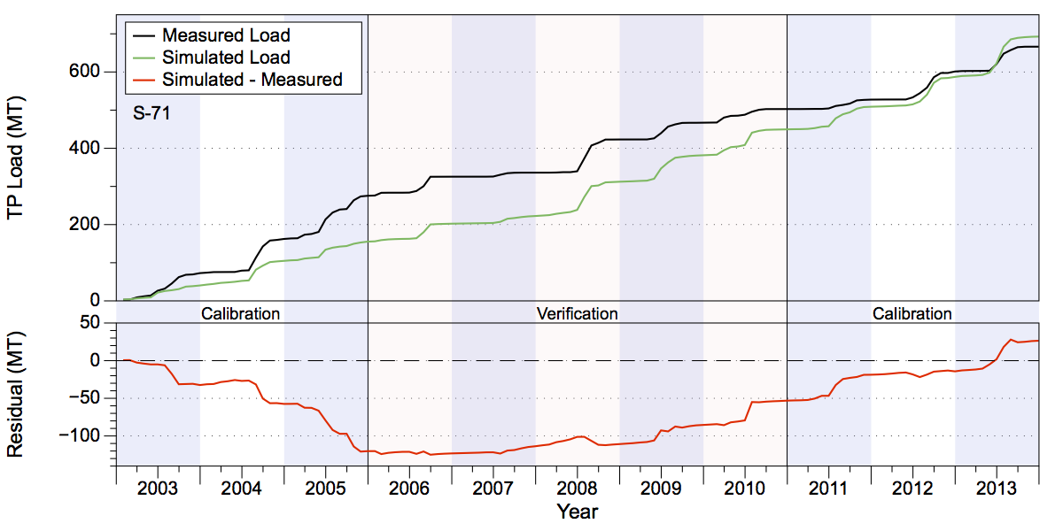
Figure 28. Measured and simulated accumulated TP loads in metric tons (upper chart) and accumulated residuals (lower chart) at structure S-71.

Flow and Water Quality Data at S-72
Simulated accumulated flow volumes at the S-72 structure on C-40 over the 2003-2013 period are close to measured values (Figure 29). The simulated values overestimated the measured values in the calibration period by just over 1% and overestimated the measured values during the verification period by almost 40% (Table 14). A large underestimation of the measured values occurred in mid-2004, while overestimation was steady during the verification period. Note that a large overestimate occurred in mid-2013; this within the same time frame that a large underestimate occurred at the S-84 structure. Over the combined calibration/verification period the simulated volume is about 10% higher than the observed volume. The NSE statistics are 0.54 and 0.8 for the calibration and verification periods, respectively (Table 18).
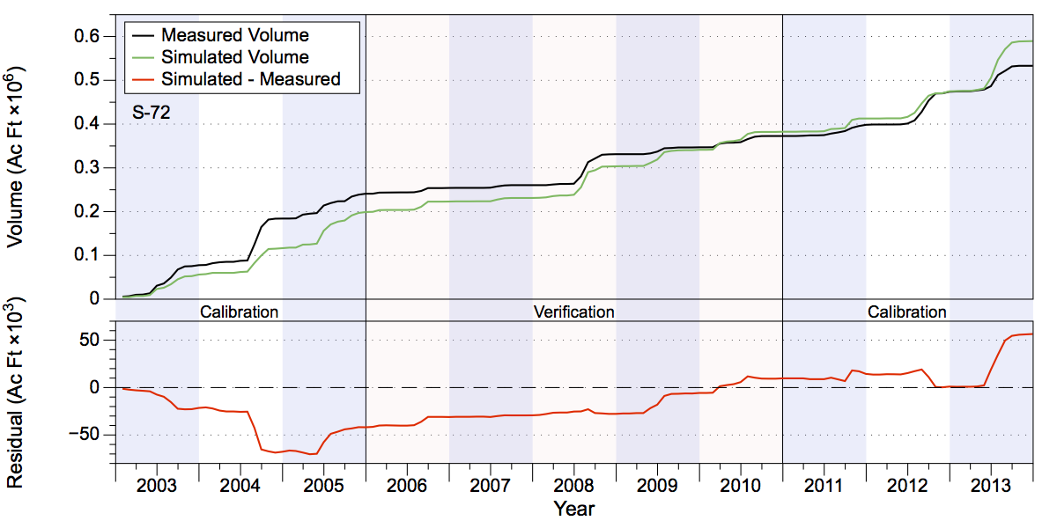
Figure 29. Measured and simulated accumulated water volumes in acre-feet (upper chart) and accumulated volume residuals (lower chart) at structure S-72.
Visual inspection of the water quality results indicate that the simulated TN concentrations overestimated measured concentration during low-flow periods (particularly during the verification period), but are more representative during high-flow periods. Simulated TP concentrations capture the variability of the measured values well, although some spikes in simulated concentrations overestimated measured values, particularly in mid-2009 and mid-2010 (Figure 30). The simulated TN loads overestimated observed loads by slightly more than 1% during the calibration period, but overestimated loads by 50% during the verification period (Table 15 and Figure 31). A large underestimate occurred during 2004 which corresponds to the flow underestimate at that time, while a large overestimate occurred in mid-2013, as well as during the verification period in 2009-2010. Simulated TP loads underestimated measured values by about 2.5% during the calibration period but overestimated loads during the verification period by almost 60% (Table 16 and Figure 32). As with TN, a large underestimate occurred in mid-2004 with an overestimate by a similar magnitude occurred in mid-2013. Overestimates in TP loads also occurred during the verification period in 2009-2010. The NSE statistics for TN are 0.49 and 0.68 in the calibration and verification periods, respectively, while the equivalent measurements for TP are 0.33 and 0.57, all of which demonstrate satisfactory fits (Table 18).
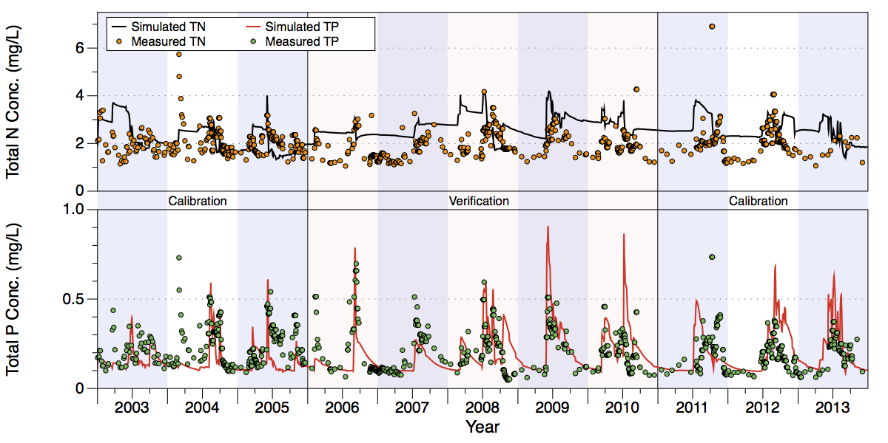
Figure 30. Comparison of measured and simulated TN (upper chart) and TP (lower chart) concentrations at structure S-72 on C-40.
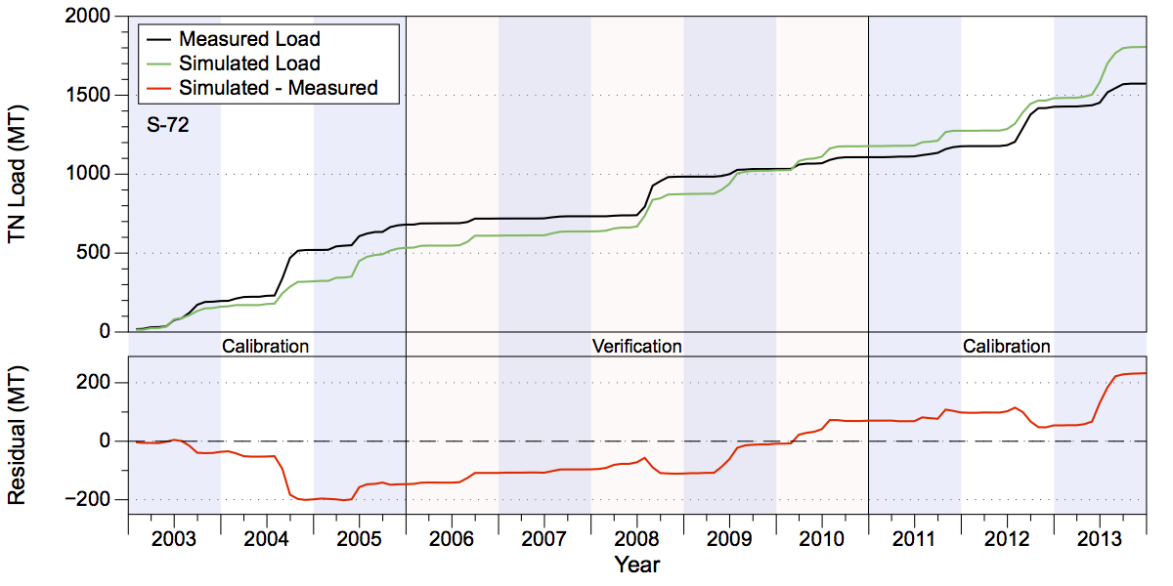
Figure 31. Measured and simulated accumulated TN loads in metric tons (upper chart) and accumulated residuals (lower chart) at structure S-72 on C-40.
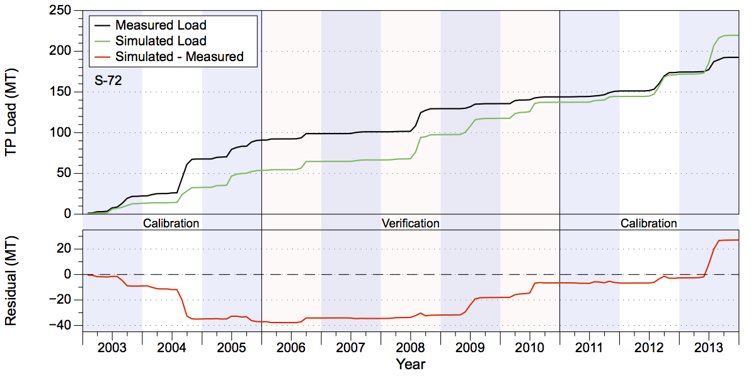
Figure 32. Measured and simulated accumulated TP loads in metric tons (upper chart) and accumulated residuals (lower chart) at structure S-72 on C-40.

Combined Estimates from S-84, S-71, and S-72
Because the inflow to the Indian Prairie sub-watershed via the S-68 structure splits into three canals that discharge to Lake Okeechobee (i.e., C-41A, C-41, and C-40) it is useful to summarize the overall discharge to the lake by summing outflow from all three canals (Table 17). These combined results show that the overall simulated flow to the Lake Okeechobee is about 4% low over the calibration period and about 1% too high over the verification period. The total flow over both periods is about 2% low. Simulated TN loads over the calibration period are about 10% too low but over the verification period TN loads are about 10% too high. Over both periods simulated TN loading is about 4% low. Simulated TP loads over the verification period are 6% too low, but are about 22% too high over the verification period. Over both periods the simulated TP loading is 3% too high.

Table 17. Combined water volume (in acre-feet) and TN and TP loads (in metric tons) to Lake Okeechobee from S-84, S-71, and S-72.
 | Simulated | Measured | Difference | Percentage
Volume (ac-ft)
Calibration | 3,235,411 | 3,362,810 | -127,399 | -3.79%
Verification | 1,343,337 | 1,325,885 | 17,452 | 1.32%
Total | 4,578,748 | 4,688,695 | -109,947 | -2.34%
TN Load (MT)
Calibration | 7,184 | 7,947 | -763 | -9.60%
Verification | 3,828 | 3,496 | 332 | 9.50%
Total | 11,012 | 11,443 | -431 | -3.77%
TP Load (MT)
Calibration | 712 | 757 | -45 | -5.94%
Verification | 444 | 364 | 80 | 21.98%
Total | 1,156 | 1,121 | 35 | 3.12%

Flow and Water Quality Data at S-127
The accumulated simulated volumes at the S-127 structure over the 2003-2013 period are moderately close to the measured values (Figure 33). The simulated values overestimated measured values in the calibration period by 3% and overestimated the measured values by 14% during the verification period (Table 14). Over the combined calibration/verification period the simulated values are 6.5% higher than observed. Note that the time interval from 2003 through late 2004 and again from late 2006 until mid-2008 had little or no measured flow; much of the divergence in the simulated and measured volumes occur during these periods. The NSE statistics for the volumes are 0.46 and 0.69 for the calibration and verification periods, respectively (Table 18).
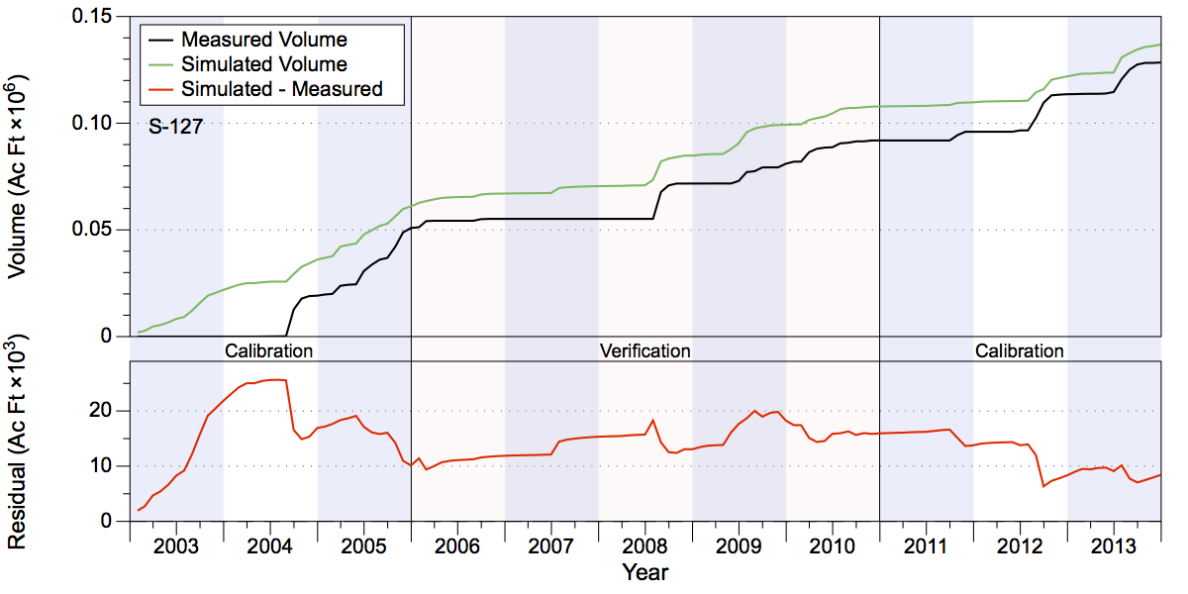
Figure 33. Measured and simulated accumulated water volumes in acre-feet (upper chart) and accumulated volume residuals (lower chart) at structure S-127.
The simulated TN and TP concentrations capture some of the dynamics of the measured data during higher flow periods, but both diverged from the measured values and overestimated concentrations during low-flow periods such as from mid-2006 through mid-2008 and again from mid-2010 through late-2011 (Figure 34). Simulated TN loads overestimated measured loads by about 2% during the calibration period, but overestimated loads by 15% during the verification period (Table 15 and Figure 35). Simulated TP loads underestimated measured values by about 7% during the calibration period but overestimated loads during the verification period by only about 1% (Table 16 and Figure 36). The NSE statistics for TN are 0.5 and 0.68 in the calibration and verification periods, respectively, while the measurements for TP are 0.36 and 0.67, all of which demonstrate satisfactory fits (Table 18).
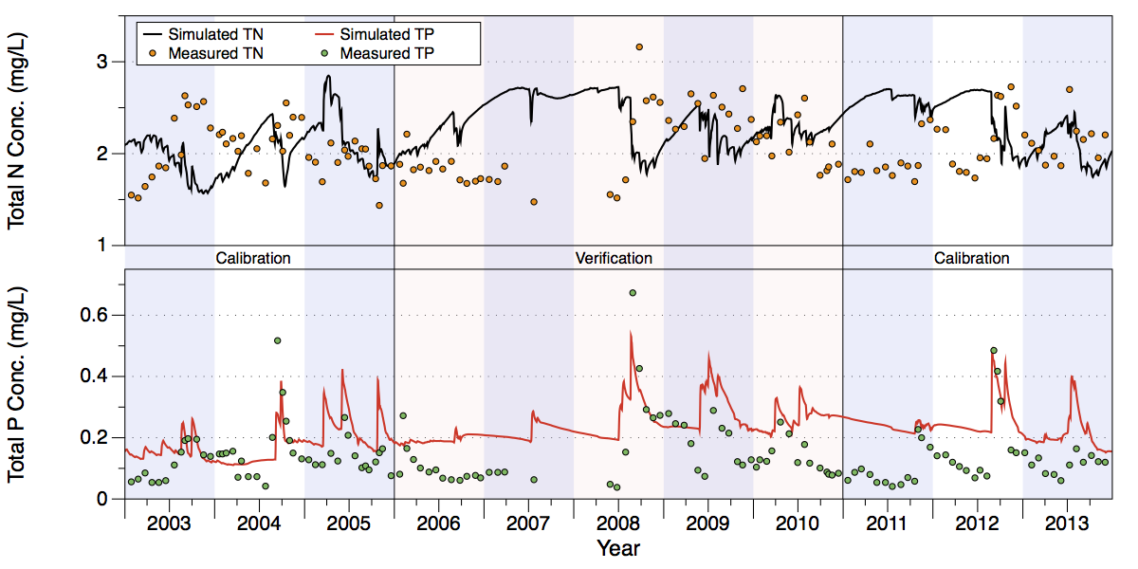
Figure 34. Comparison of measured and simulated TN (upper chart) and TP (lower chart) concentrations at structure S-127.
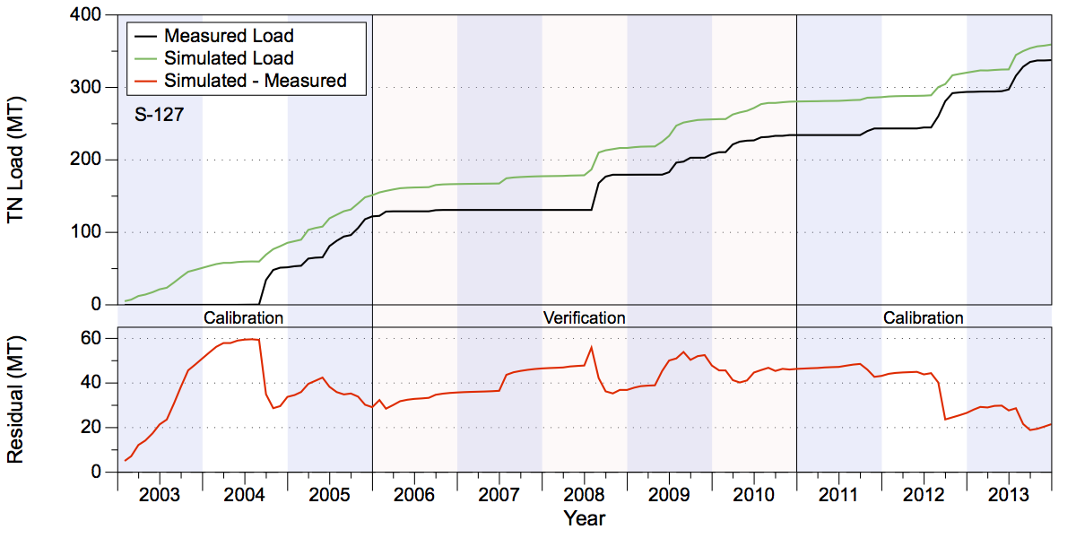
Figure 35. Measured and simulated accumulated TN loads in metric tons (upper chart) and accumulated residuals (lower chart) at structure S-127.
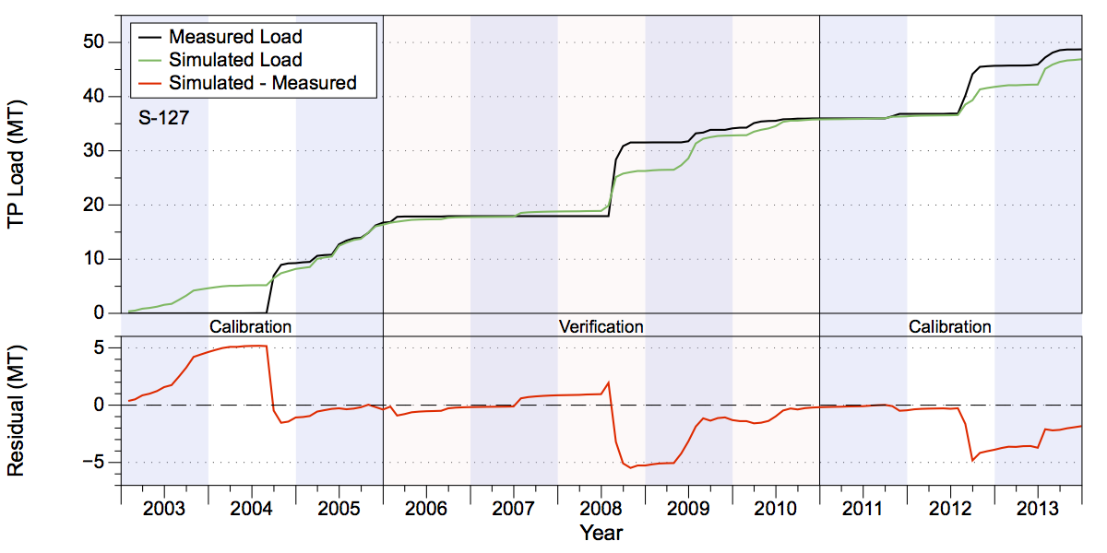
Figure 36. Measured and simulated accumulated TP loads in metric tons (upper chart) and accumulated residuals (lower chart) at structure S-127.

Flow and Water Quality Data at S-129
The simulated accumulated volume at the S-129 structure over the 2003-2013 period is close to the measured volume (Figure 37). Simulated values overestimated the measured values in the calibration period by 2% and underestimated the measured volume by about 14% during the verification period (Table 14). Over the entire calibration/verification period the simulated values are 3% too low. Note that an interval from late 2006 until mid-2008 had little measured flow; consequently, even the slight overestimation of the flow in this time period resulted in a large percentage difference. The NSE statistics for the volumes are 0.63 and 0.72 for the calibration and verification periods, respectively (Table 18).
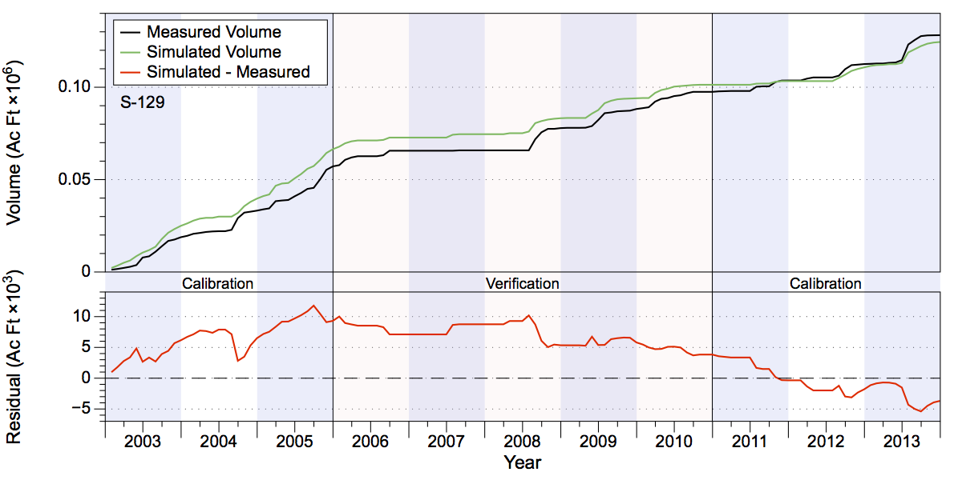
Figure 37. Measured and simulated accumulated water volumes in acre-feet (upper chart) and accumulated volume residuals (lower chart) at structure S-129.
The simulated nutrient concentrations capture the variability present in the measured data at S-129 better than at S-127, although TP values show higher spikes than the measured values, and the simulated values taper from the peak values more rapidly than the measured values (compare Figure 38 with Figure 34). The simulated TN loads overestimated the measured loads by about 6% during the calibration period, but underestimated measured loads by about 20% during the verification period (Table 15 and Figure 39). The divergence of simulated from measured loads was most pronounced during calendar year 2005. Simulated TP values overestimated measured values by 3% during the calibration period, but underestimated measured values by about 19% during the verification period, with a particularly large underestimate occurring during mid-2008 (Table 16 and Figure 40). The NSE statistics for TN are 0.72 and 0.52 in the calibration and verification periods, respectively, while the NSE statistics for TP are 0.1 and 0.58 (Table 18).
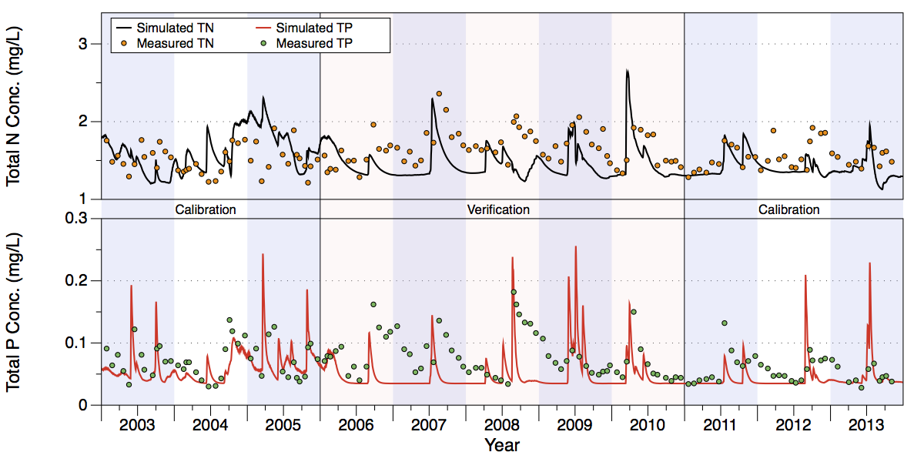
Figure 38. Comparison of measured and simulated TN (upper chart) and TP (lower chart) concentrations at structure S-129.
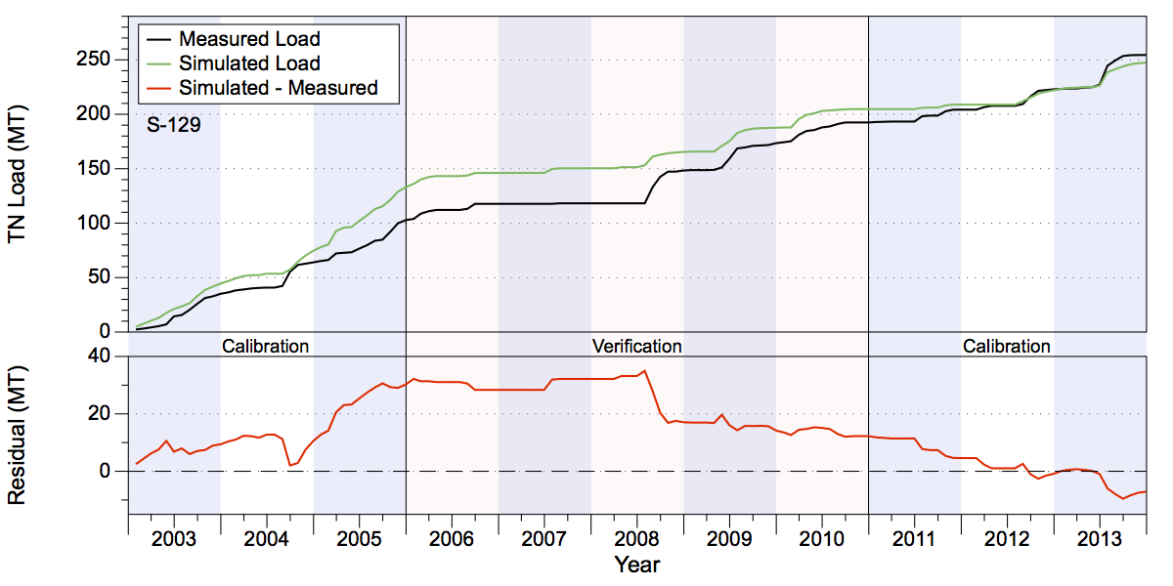
Figure 39. Measured and simulated accumulated TN loads in metric tons (upper chart) and accumulated residuals (lower chart) at structure S-129.
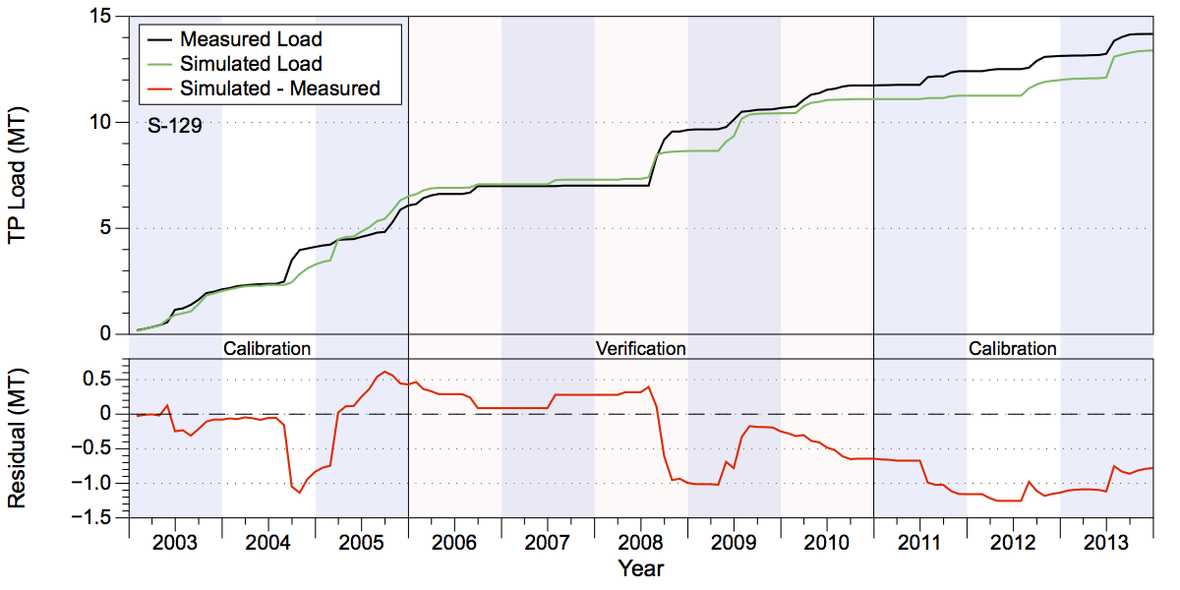
Figure 40. Measured and simulated accumulated TP loads in metric tons (upper chart) and accumulated residuals (lower chart) at structure S-129.

Flow and Water Quality Data at S-131
The accumulated simulated volume estimates at the S-131 structure over the 2003-2013 period are close to the measured values (Figure 41). The simulated values overestimated the measured values in the calibration period by 4% and underestimated the measured values by 11% during the verification period (Table 14). The largest divergence of simulated from measured values occurred during 2003-2004, although the accumulated volumes then converge over calendar year 2005. Over the combined calibration/verification period the simulated volume is within 1% of the observed volume. As with the S-129 structure, an interval from late 2006 until mid-2008 had little measured flow; consequently, even a slight overestimation of the flow in this time period results in a large percentage difference. The NSE statistics for the volumes are 0.6 and 0.23 for the calibration and verification periods, respectively (Table 18).
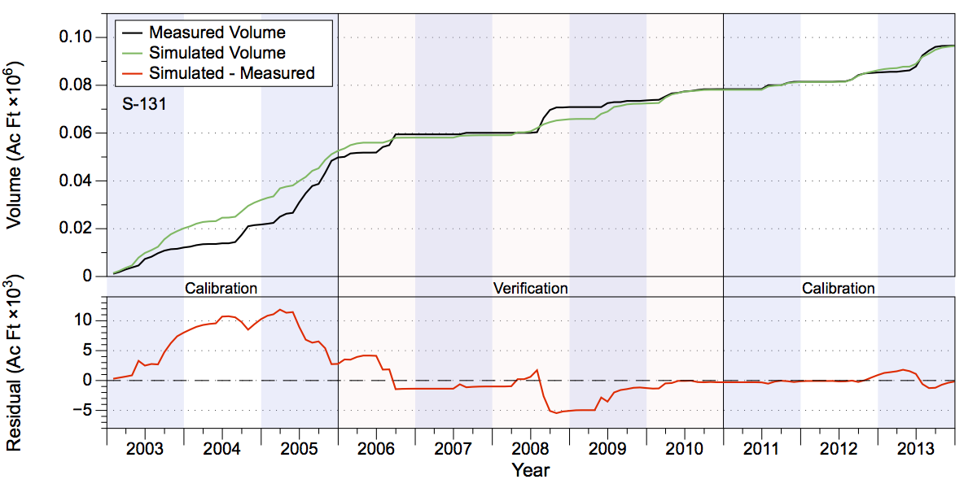
Figure 41. Measured and simulated accumulated water volumes in acre-feet (upper chart) and accumulated volume residuals (lower chart) at structure S-131.
Visual inspection of the results indicate that the simulated values for both TN and TP capture the variability present in the measured data better than at S-127 and about as well as at S-129 (compare Figure 42 to Figures 34 and 38), although as at S-129 the TP values show higher spikes than the measured values and the simulated values decrease from the peak values over a shorter time than the measured values. The simulated TN loads overestimated the measured loads by about 8% during the calibration period, but underestimated measured loads by about 17% during the verification period (Table 15 and Figure 43). A large fraction of the underestimation during the verification period occurred in mid-2008. Simulated TP values overestimated measured values by slightly more than 5% during the calibration period and underestimated measured values by about 33% during the verification period (Table 16 and Figure 44). As with the TN loads, a significant portion of the underestimation during the verification period occurred in mid-2008. The NSE statistics for TN are 0.57 and 0.13 in the calibration and verification periods, respectively, while the NSE statistics for TP are 0.33 and 0.1 (Table 18).
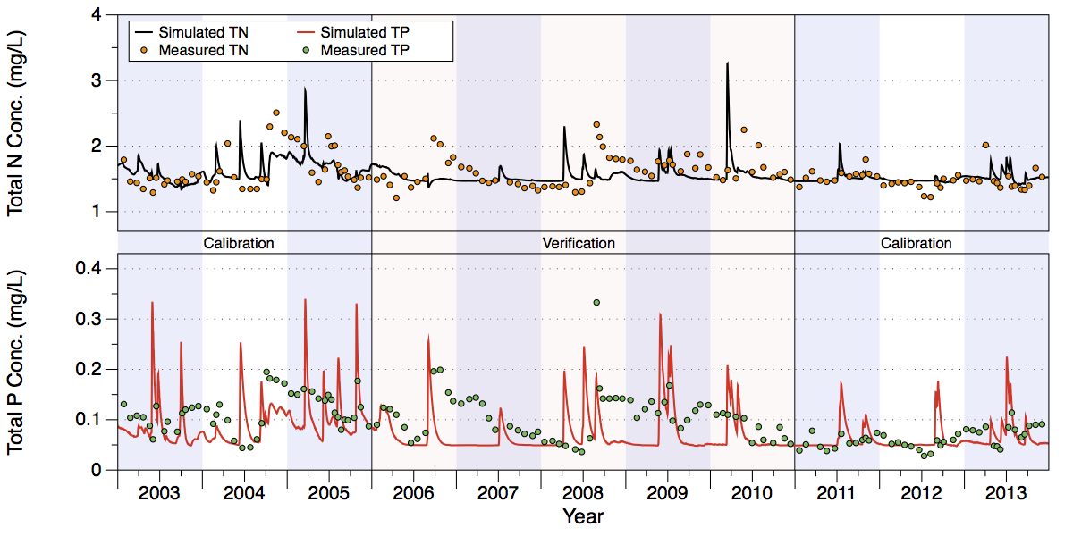
Figure 42. Comparison of measured and simulated TN (upper chart) and TP (lower chart) concentrations at structure S-131.
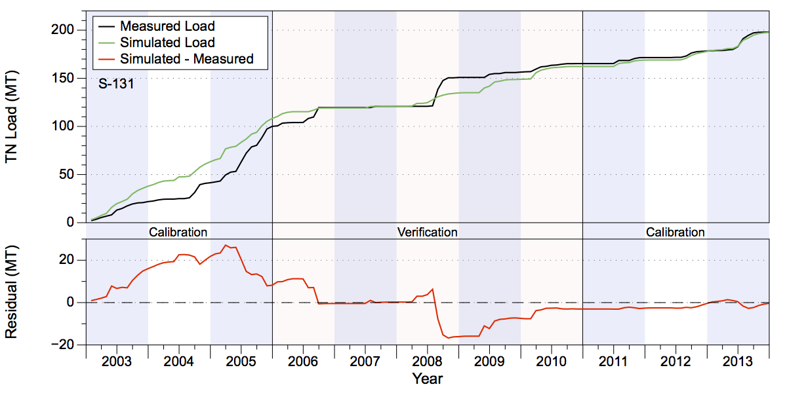
Figure 43. Measured and simulated accumulated TN loads in metric tons (upper chart) and accumulated residuals (lower chart) at structure S-131.
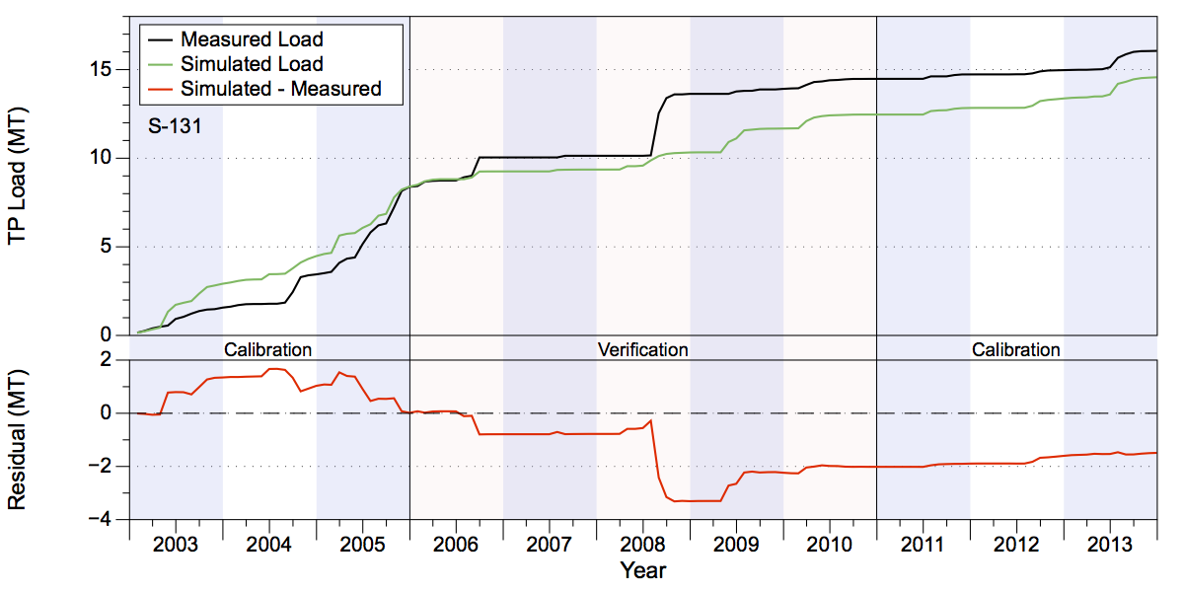
Figure 44. Measured and simulated accumulated TP loads in metric tons (upper chart) and accumulated residuals (lower chart) at structure S-131.

Table 18. Indian Prairie GOF Statistics. Note that RMSE has units of acre-feet for volume and metric tons for nutrient loads.
Statistic | Volume (C) | Volume (V) | TN Load (C) | TN Load (V) | TP Load (C) | TP Load (C)
S-84
PBIAS % | -4.80 | -14.30 | -7.80 | -5.00 | -0.50 | -21.50
RMSE | 13,541.46 | 8,401.40 | 30.68 | 17.83 | 1.90 | 2.29
NSE | 0.80 | 0.82 | 0.72 | 0.82 | 0.76 | 0.64
KGE | 0.68 | 0.72 | 0.60 | 0.73 | 0.79 | 0.50
S-71
PBIAS % | -4.10 | 8.20 | -13.90 | 8.80 | -9.20 | 29.50
RMSE | 13,819.78 | 10,383.70 | 43.54 | 35.33 | 5.65 | 4.13
NSE | 0.64 | 0.70 | 0.59 | 0.69 | 0.55 | 0.69
KGE | 0.57 | 0.54 | 0.53 | 0.56 | 0.75 | 0.67
S-72
PBIAS % | 1.20 | 39.10 | 1.30 | 50.90 | -2.50 | 57.70
RMSE | 5,622.15 | 2,213.94 | 18.40 | 10.86 | 2.84 | 1.56
NSE | 0.54 | 0.80 | 0.49 | 0.68 | 0.33 | 0.57
KGE | 0.77 | 0.56 | 0.73 | 0.47 | 0.68 | 0.31
S-127
PBIAS % | 3.00 | 14.20 | 1.90 | 15.30 | -6.90 | 1.10
RMSE | 1,718.69 | 1,019.29 | 4.38 | 2.98 | 0.84 | 0.79
NSE | 0.46 | 0.69 | 0.50 | 0.68 | 0.36 | 0.67
KGE | 0.50 | 0.67 | 0.52 | 0.64 | 0.38 | 0.55
S-129
PBIAS % | 2.00 | -13.60 | 6.60 | -20.10 | 3.50 | -18.90
RMSE | 976.63 | 631.88 | 2.12 | 1.76 | 0.17 | 0.14
NSE | 0.63 | 0.72 | 0.52 | 0.61 | 0.10 | 0.58
KGE | 0.70 | 0.70 | 0.70 | 0.58 | 0.57 | 0.67
S-131
PBIAS % | 4.30 | -10.70 | 8.20 | -17.20 | 5.40 | -33.30
RMSE | 802.79 | 951.63 | 1.67 | 2.61 | 0.18 | 0.33
NSE | 0.60 | 0.23 | 0.57 | 0.13 | 0.38 | 0.10
KGE | 0.64 | 0.30 | 0.66 | 0.17 | 0.66 | 0.02

Lake Istokpoga

The Lake Istokpoga sub-watershed lies on the west-central portion of the area covered by the six sub-watersheds, between Upper Kissimmee and Fisheating Creek, and contains a sizeable portion of the Lake Wales Ridge along its western edge (Figure 45). The sub-watershed is nearly 394,160 acres in area. It is bordered by the Indian Prairie model domain on its southern end. The main outflow from the sub-watershed is at the S-68 structure on the southeastern site of Lake Istokpoga. This discharge point is an inflow boundary to Indian Prairie. Summaries of water volumes and TN and TP loads at the basin outfall structure at S-68 are shown in Table 19.
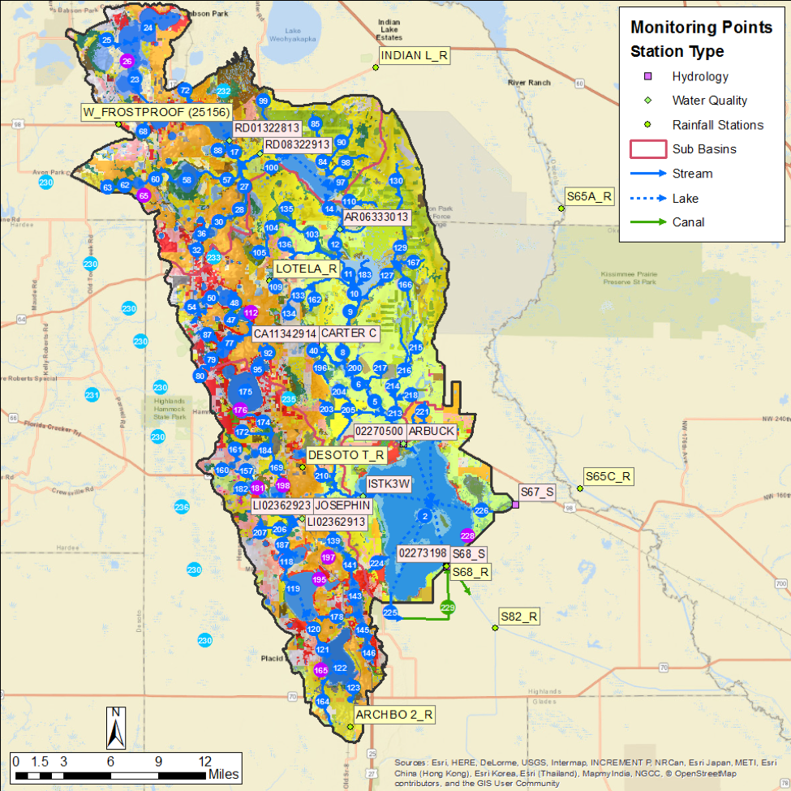
Figure 45. The Lake Istokpoga model domain. Rain stations, flow station, and water quality stations are shown.

Table 19. Lake Istokpoga water volume (in acre-feet) and TN and TP loads (in metric tons) leaving S-68.
Structure | Simulated | Measured | Difference | Percentage
Volume (ac-ft)
S-68 Cal. | 2,337,397 | 2,187,221 | 150,175 | 6.87%
S-68 Ver. | 764,963 | 741,860 | 23,103 | 3.11%
TN Load (MT)
S-68 Cal. | 4,283 | 3,924 | 359 | 9.14%
S-68 Ver. | 1,500 | 1,507 | -7 | -0.44%
TP Load (MT)
S-68 Cal. | 295 | 319 | -24 | -7.50%
S-68 Ver. | 112 | 74 | 38 | 51.16%

Flow and Water Quality Data at S-68
Over the calibration/verification period the simulation results are close to the measured values (Figure 46). The simulated volume overestimated the total measured volume in the calibration period by almost 7% and overestimated the measured value during the verification period by 3% (Table 19). The simulated volumes underestimated observed values during the second half of 2005, and then steadily overestimated measured values during the second half of the calibration period from 2011-2013. Over the combined calibration/verification period the simulated volume is about 6% over the observed value. The NSE statistics for the volume estimates are 0.7 and 0.55 for the calibration and verification periods, respectively, indicating a satisfactory fit for both periods. (Table 20).
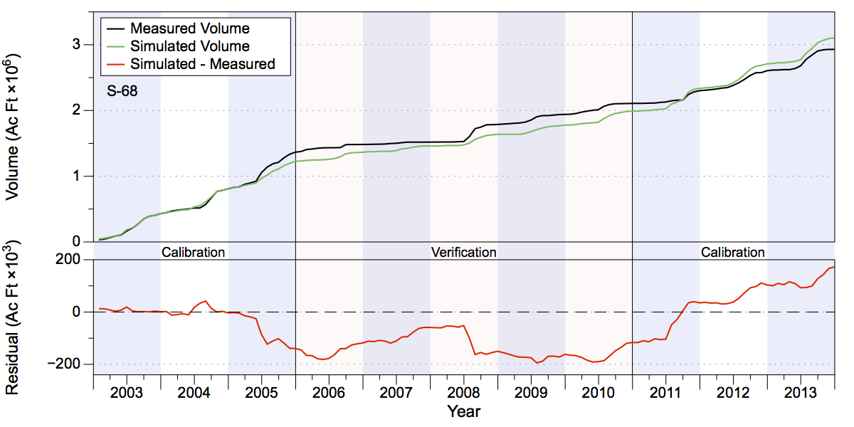
Figure 46. Measured and simulated accumulated water volumes in acre-feet (upper chart) and accumulated volume residuals (lower chart) at the outflow to Lake Istokpoga at structure S-68.
Visual inspection of the simulated TN and TP concentrations indicate that the model does not capture the variability present in the measured data, particularly the variability in measured P concentrations. Simulated TP values overestimated observed values during the mid-2006 to mid-2008 time frame, and again during much of 2010 and 2011. The simulated values do not predict the multi-year trends present in the observed data (Figure 47). Much of this error is attributable to the inability of WAM to simulate complex in-lake processes, such as algal blooms and wind-driven mixing. Furthermore, WAM averages N and P concentrations over the large volume of the lake at each time step, which may damp out much of the dynamic behavior of the nutrients.
Overall, the simulated TN load values overestimated the measured values by 9% during the calibration period but underestimated the measured loads by less than 1% during the verification period (Table 19 and Figure 48). Simulated TP load values underestimated measured values by 7% during the calibration period, where a large fraction of the underestimation occurred during a mid-2005 event that combined relatively high TP concentrations with moderately high flows. The simulated TP loads overestimated measured values by over 50% during the verification period (Table 19 and Figure 49). The NSE statistics for TN load have satisfactory values of 0.7 and 0.51 over the calibration and verification periods, respectively while for TP loads the NSE statistic is 0.11 for the calibration period and 0.38 for the verification period (Table 20).
Table 20. Lake Istokpoga GOF Statistics At Structure S68. Note that RMSE has units of acre-feet for volume and metric tons for nutrient loads.
Statistic | Volume (C) | Volume (V) | TN Load (C) | TN Load (V) | TP Load (C) | TP Load (C)
PBIAS % | 6.90 | 3.10 | 9.10 | -0.40 | -7.50 | 51.20
RMSE | 15,920.56 | 13,784.06 | 29.38 | 28.88 | 9.94 | 2.11
NSE | 0.70 | 0.55 | 0.70 | 0.51 | 0.11 | 0.38
KGE | 0.82 | 0.58 | 0.80 | 0.53 | 0.07 | 0.35
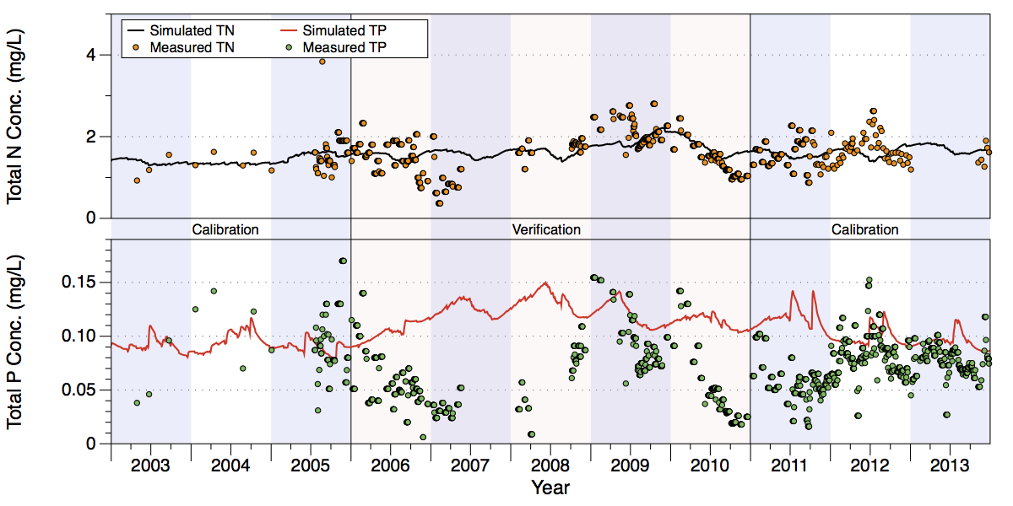
Figure 47. Comparison of measured and simulated TN (upper chart) and TP (lower chart) concentrations at structure S-68.
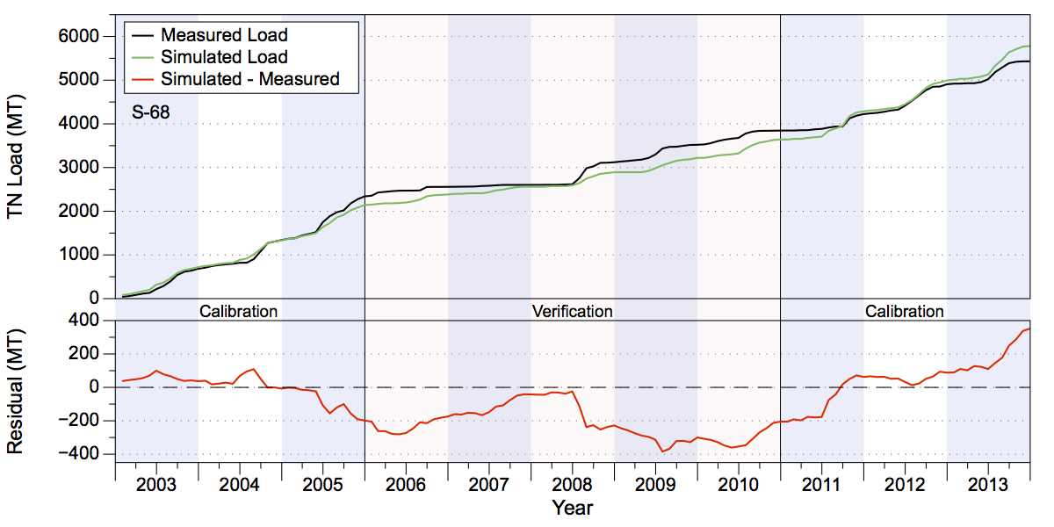
Figure 48. Measured and simulated accumulated TN loads in metric tons (upper chart) and accumulated residuals (lower chart) at structure S-68.
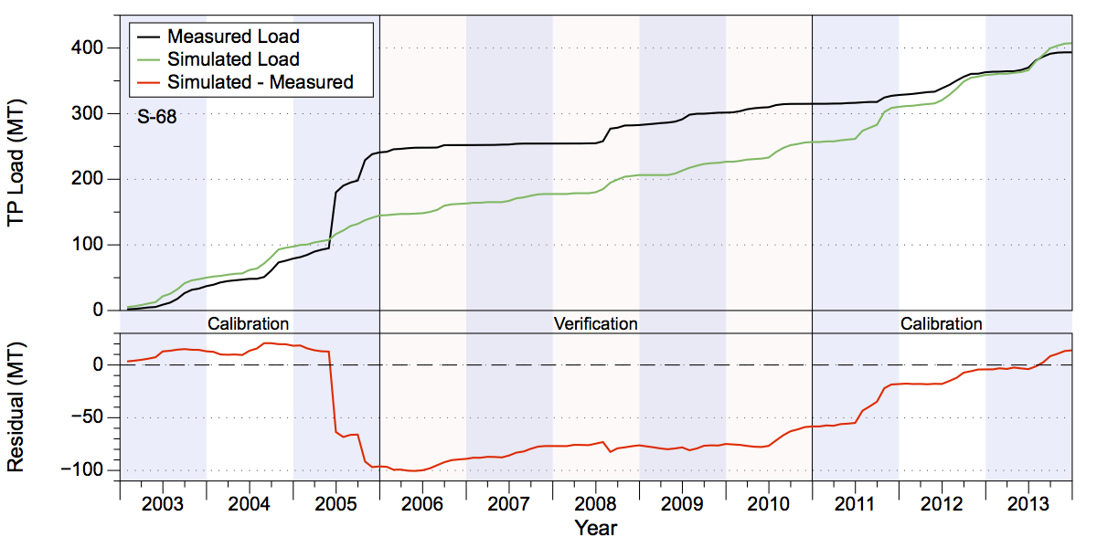
Figure 49. Measured and simulated accumulated TP loads in metric tons (upper chart) and accumulated residuals (lower chart) at structure S-68.

Lower Kissimmee

The Lower Kissimmee sub-watershed lies along the east-central portion of the six sub-watersheds, comprising the area between the Upper Kissimmee and Taylor Creek/Nubbin Slough model domains. It is approximately 429,170 acres in size (Figure 50). The dominant feature through the domain is the Kissimmee River that runs from the northern end at the S-65 gate, which controls inflow to the sub-watershed from Lake Kissimmee, to the S-65E gates at the southern end of the domain.
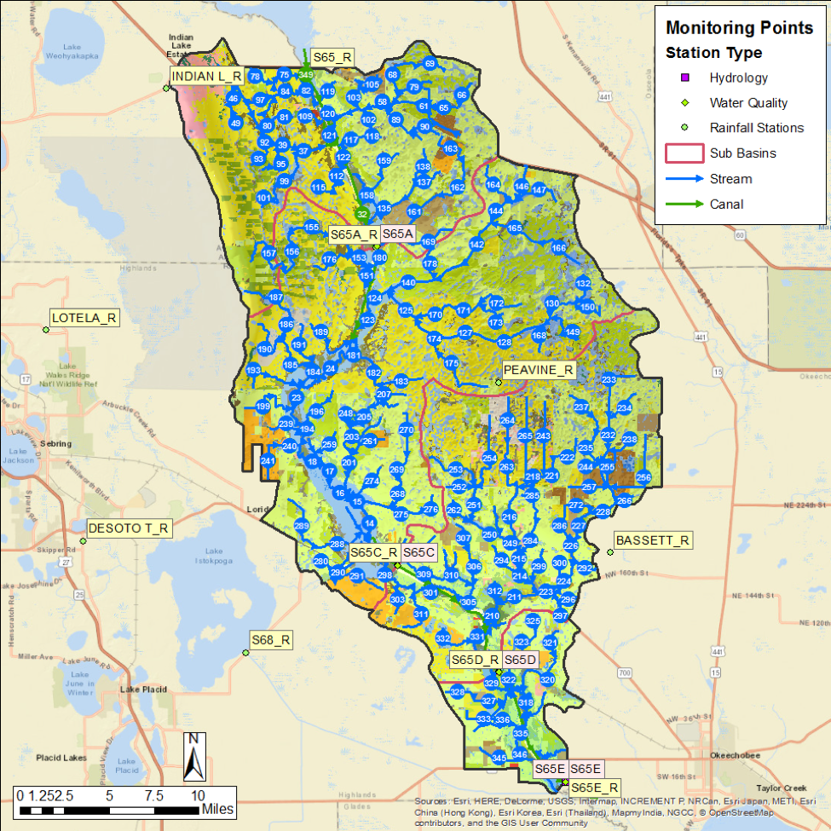
Figure 50. The Lower Kissimmee model domain. Rain stations, flow station, and water quality stations are shown.

Table 21. Lower Kissimmee water volume (in acre-feet) and TN and TP loads (in metric tons) at S-65E.
Structure | Simulated | Measured | Difference | Percentage
Volume (ac-ft)
S-65E Cal. | 8,692,287 | 9,491,700 | -799,413 | -8.42%
S-65E Ver. | 4,021,005 | 3,377,161 | 643,844 | 19.06%
TN Load (MT)
S-65E Cal. | 13,131 | 13,683 | -552 | -4.03%
S-65E Ver. | 6,333 | 5,470 | 863 | 15.78%
TP Load (MT)
S-65E Cal. | 1,244 | 1,250 | -6 | -0.48%
S-65E Ver. | 556 | 446 | 109 | 24.53%

Flow and Water Quality Data at S-65E
Summaries of water volumes and TN and TP loads at the single basin outfall structure S-65E are shown in Table 21. Simulated accumulated volume at the S-65E structure over the 2003-2013 period is close to the observed measurements (Figure 51). The simulated values underestimated the measured values in the calibration period by 8% and overestimated the measured values during the verification period by 19% (Table 21). Much of the underestimation during the calibration period occurred during the first half from 2003-2005 where the simulated values were consistently below measurements. Conversely, simulated values consistently overestimated measured values during the verification period. Over the combined calibration/verification period the simulated values are about 1% lower than observed. The NSE statistics of the volume estimates are greater than 0.9 for both the calibration and verification periods (Table 22). Note that these values are high since the inflow to the sub-watershed at S-65 accounts for much of the flow at S-65E (i.e., pass-through water).
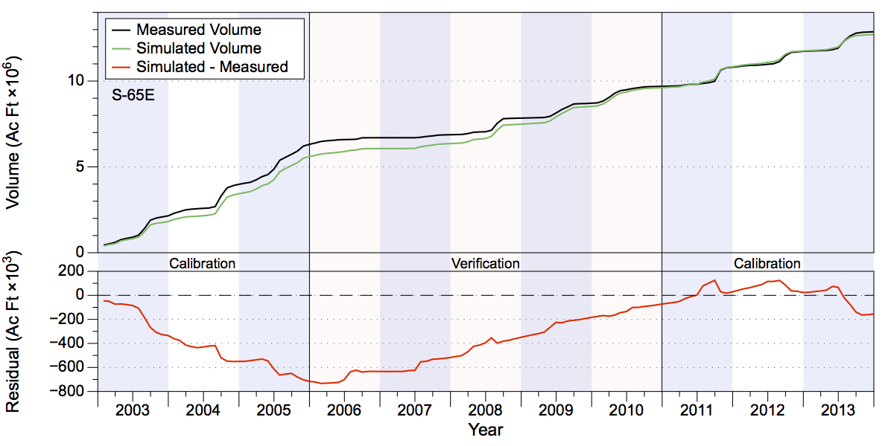
Figure 51. Measured and simulated accumulated water volumes in acre-feet (upper chart) and accumulated volume residuals (lower chart) at structure S-65E.
Visual comparison of the simulated TN and TP concentrations indicate that the model captures the variability present in the measured data reasonably well, although some dynamics are missed, including a significant spike in measured values of both nutrients during a low-flow period in mid-2006 that tapered off through mid-2007 (Figure 52). Overall, the simulated TN loads underestimated the measured values by 4% during the calibration period and overestimated the measured values by about 16% during the verification period (Table 21 and Figure 53). Simulated TP loads underestimated measured values by less than 1% during the calibration period, but overestimated measured values by nearly 25% during the verification period (Table 21 and Figure 54). The overestimates of both TN and TP loads during the verification period reflect the overestimate of water volume during the same time frame. As with the volume estimates, the NSE statistics for TN loads are over 0.9 for both the calibration and verification periods, while for TP the NSE statistics are also quite high, with values of 0.89 and 0.9 for both the calibration and verification periods.
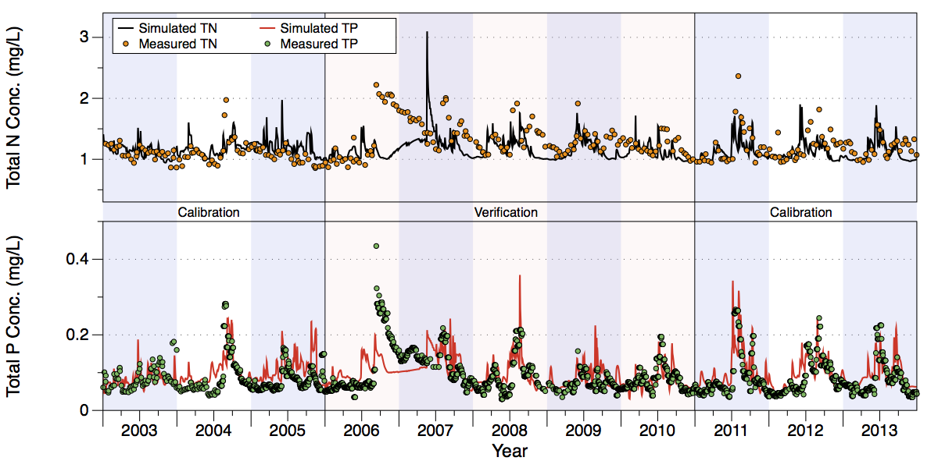
Figure 52. Comparison of measured and simulated TN (upper chart) and TP (lower chart) concentrations at structure S-65E.
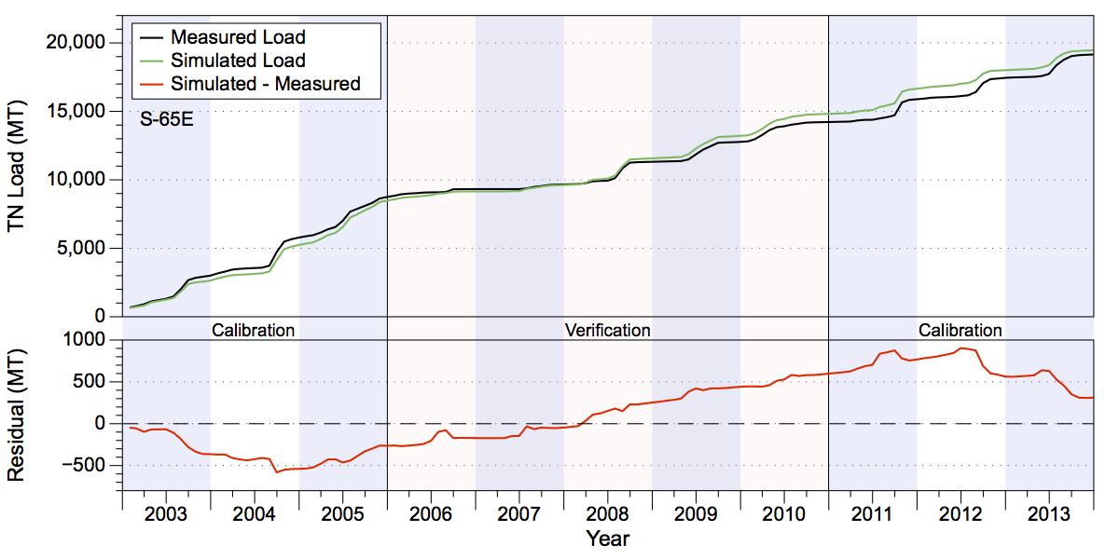
Figure 53. Measured and simulated accumulated TN loads in metric tons (upper chart) and accumulated residuals (lower chart) at S-65E.
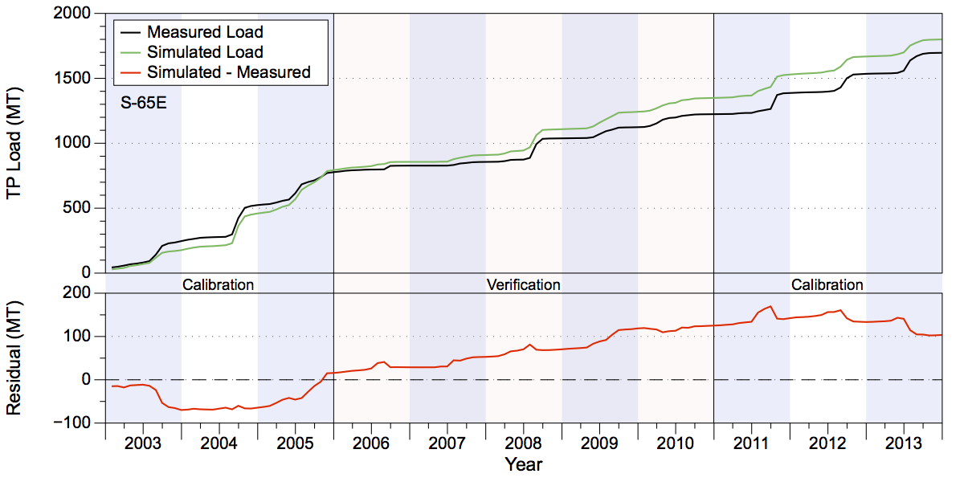
Figure 54. Measured and simulated accumulated TP loads in metric tons (upper chart) and accumulated residuals (lower chart) at S-65E.

Table 22. Lower Kissimmee GOF Statistics At Structure S65E. Note that RMSE has units of acre-feet for volume and metric tons for nutrient loads.
Statistic | Volume (C) | Volume (V) | TN Load (C) | TN Load (V) | TP Load (C) | TP Load (C)
PBIAS % | -8.40 | 19.10 | -4.00 | 15.80 | -0.50 | 24.50
RMSE | 33,455.02 | 20,503.01 | 50.07 | 34.84 | 8.51 | 4.87
NSE | 0.95 | 0.93 | 0.95 | 0.93 | 0.89 | 0.90
KGE | 0.82 | 0.81 | 0.88 | 0.84 | 0.87 | 0.74

Taylor Creek/Nubbin Slough

The Taylor Creek/Nubbin Slough sub-watershed is the south-easternmost of the six sub-watersheds modeled, and is approximately 197,720 acres in area (Figure 55). The sub-watershed is made up of four smaller domains: the S-133, S-135, S-191, and S-154 basins. In the 2009/2012 modeling effort these were modeled independently, but for this effort they were aggregated into a single sub-watershed. The discharges at S-133 and S-135 are pump-controlled, while the discharge at S-191 is controlled by gates. The discharge through S-191 consists of the combined flow from Taylor Creek, which drains the north-central part of the model domain, and Nubbin Slough, which drains the eastern portion.
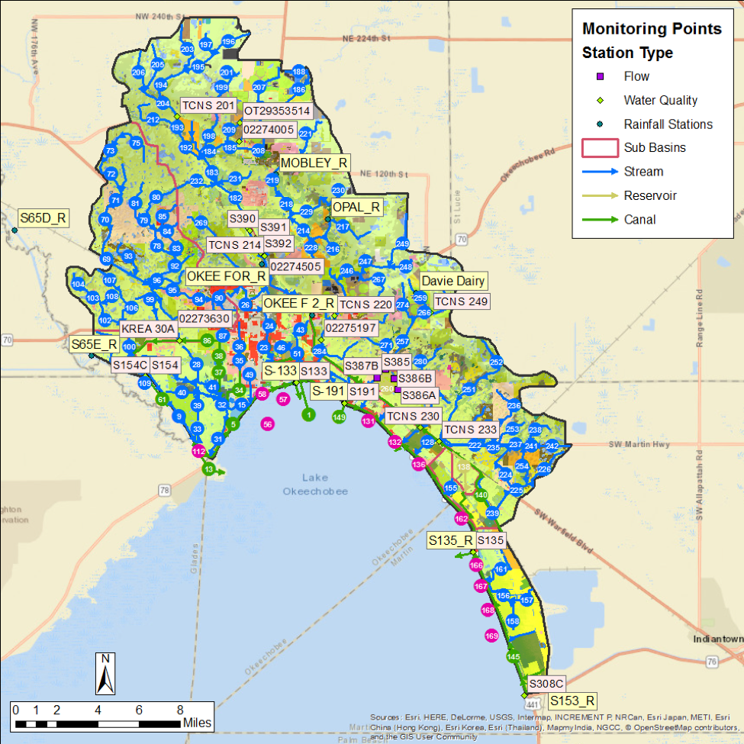
Figure 55. The Taylor Creek/Nubbin Slough model domain. Rain stations, flow station, and water quality stations are shown.
Summaries of water volumes and TN and TP loads at the basin outfall structures are shown in Tables 23-25, respectively. These results are discussed individually for each structure below.

Table 23. Taylor Creek/Nubbin Slough Total Water Volume (acre-feet).
Structure | Simulated | Measured | Difference | Percentage
S-133 Cal. | 151,936 | 152,648 | -712 | -0.47%
S-133 Ver. | 88,052 | 31,981 | 56,071 | 175.33%
S-135 Cal. | 157,915 | 153,194 | 4,721 | 3.08%
S-135 Ver. | 21,409 | 28,335 | -6,926 | -24.44%
S-154 Cal. | 179,409 | 205,364 | -25,955 | -12.64%
S-154 Ver. | 107,724 | 64,593 | 43,131 | 66.77%
S-191 Cal. | 660,697 | 717,996 | -57,299 | -7.98%
S-191 Ver. | 355,449 | 235,134 | 120,314 | 51.17%

Table 24. Taylor Creek/Nubbin Slough Total Nitrogen (metric tons).
Structure | Simulated | Measured | Difference | Percentage
S-133 Cal. | 335 | 338 | -3 | -0.89%
S-133 Ver. | 196 | 74 | 122 | 166.07%
S-135 Cal. | 313 | 296 | 16 | 5.49%
S-135 Ver. | 46 | 60 | -14 | -22.84%
S-154 Cal. | 443 | 587 | -144 | -24.53%
S-154 Ver. | 308 | 186 | 122 | 65.45%
S-191 Cal. | 1,688 | 1,815 | -127 | -7.00%
S-191 Ver. | 956 | 628 | 328 | 52.17%

Table 25. Taylor Creek/Nubbin Slough Total Phosphorus (metric tons).
Structure | Simulated | Measured | Difference | Percentage
S-133 Cal. | 54 | 59 | -6 | -9.69%
S-133 Ver. | 36 | 16 | 20 | 122.04%
S-135 Cal. | 27 | 26 | 1 | 3.59%
S-135 Ver. | 3 | 5 | -2 | -33.95%
S-154 Cal. | 124 | 172 | -47 | -27.49%
S-154 Ver. | 80 | 59 | 21 | 35.71%
S-191 Cal. | 524 | 552 | -28 | -5.10%
S-191 Ver. | 286 | 161 | 126 | 78.31%

Flow and Water Quality Data at S-133
Accumulated water volume through the S-133 pump over the 2003-2013 period shows that the simulated and observed results are reasonably close over the calibration period (Figure 56). The simulated values are within 1% of the measured values in the calibration period but overestimated the measured values by a large amount (175%) during the verification period (Table 23). Note that during this time there was only a small amount of water pumped from the S-133 basin into Lake Okeechobee, however, the measured values do not appear to reflect flow into the lake via the S-193 lock (station “TAYLCRHGS6”). During the calibration period, approximately 7,500 acre-feet of water flowed from the lake into the rim canal (a negative flow), while during the verification period approximately 20,800 acre-feet of water flowed from the rim canal into Lake Okeechobee. If accurate, adding these volumes to the volumes pumped via S-133 indicate that the simulated values overestimated measured values by 4.7% and 67% during the calibration and verification periods, respectively. The GoF statistics for water volume show an NSE value for the calibration period of 0.75, indicating a good fit, but shows a suboptimal value for the verification period (Table 26).
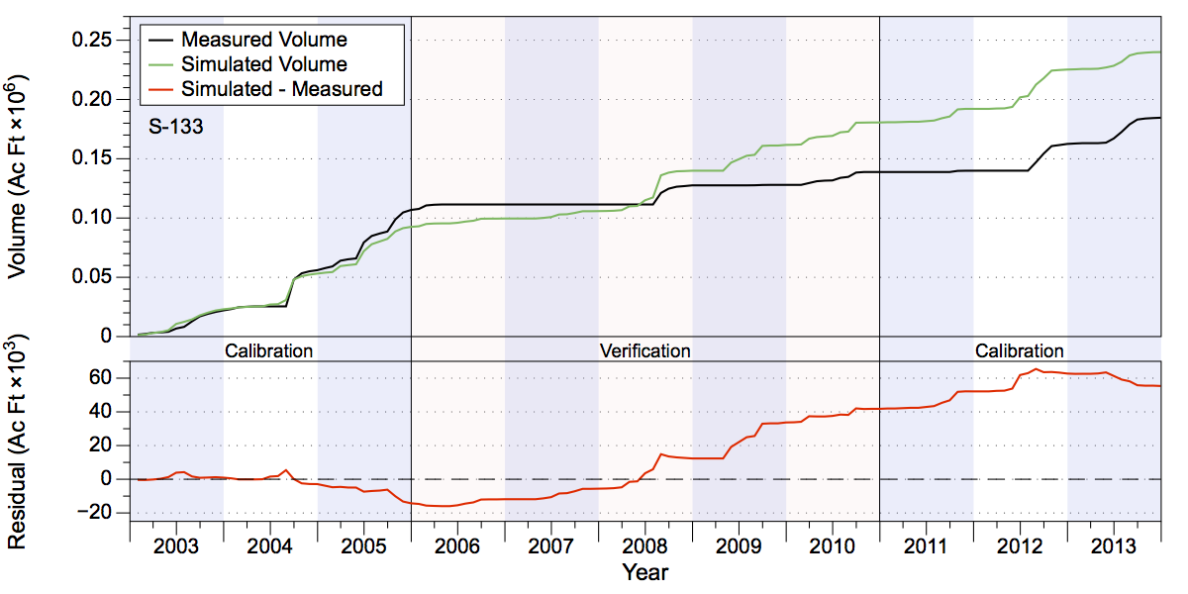
Figure 56. Measured and simulated accumulated water volumes in acre-feet (upper chart) and accumulated volume residuals (lower chart) at structure S-133.
Visual inspection of the water quality results indicate that the simulated TN and TP concentrations capture the variability present in the measured data reasonably well over most of the period. A few notable exceptions are in early-to-mid 2005 where the simulated concentrations are over twice the measured values, and again in mid 2009 and early 2010 where the simulated values show a spike not observed in the measured values. Simulated values of TP concentrations show a reasonable range of values, although the simulated values underestimated a brief peak in measured values in late 2007 and subsequently overestimated measured values during the low-flow period from 2009-2011 (Figure 57).
Overall, the simulated TN load values underestimated the measured values by less than 1% during the calibration period but overestimated observed values by 166% during the verification period (Table 24 and Figure 58). Simulated TP load values underestimated measured values by slightly less than 10% during the calibration period, but overestimated by 122% during the verification period ([Table 25 and Figure 59). The large overestimates for both TN and TP loads during the verification period result from the overestimation of water volume during the same time period. The NSE statistic for TN load during the calibration period shows a reasonable fit of 0.57, although the negative NSE statistic of -0.27 for the verification period indicates a suboptimal fit (Table 26). For TP loads, the NSE statistic of 0.67 for the calibration period indicates a good fit, while the NSE value of 0.19 for the verification period indicates a reasonable fit (Table 26).
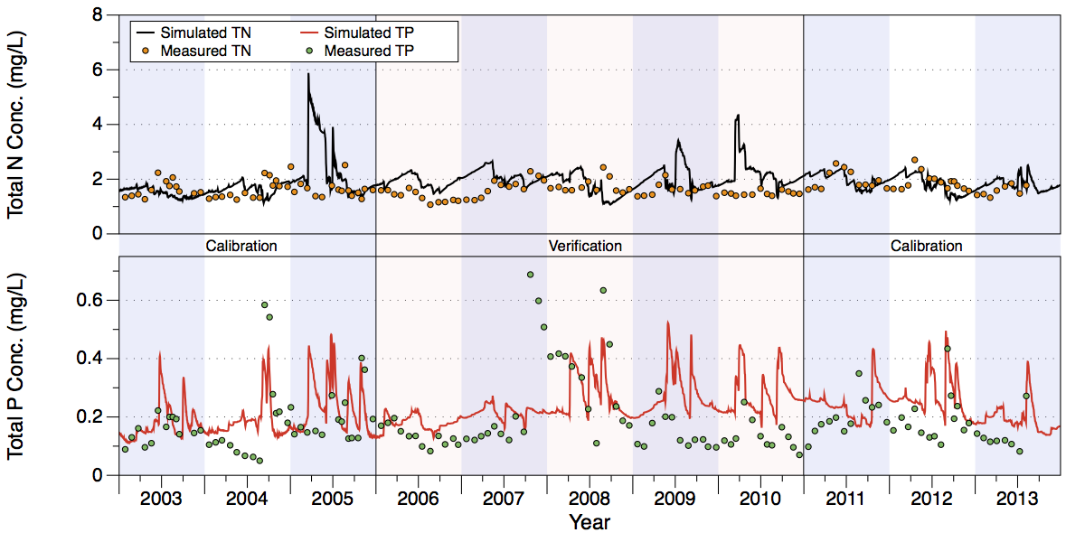
Figure 57. Comparison of measured and simulated TN (upper chart) and TP (lower chart) concentrations at structure S-133.
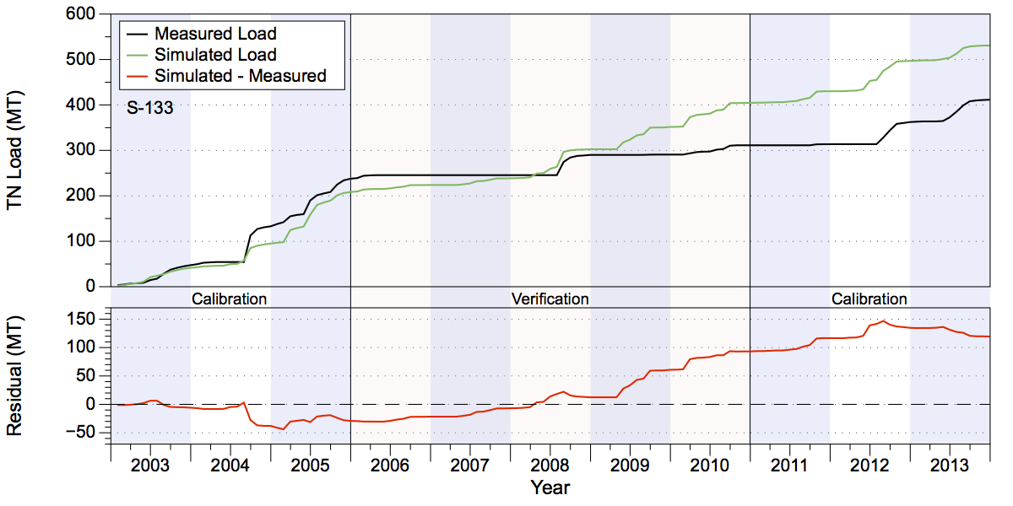
Figure 58. Measured and simulated accumulated TN loads in metric tons (upper chart) and accumulated residuals (lower chart) at structure S-133.
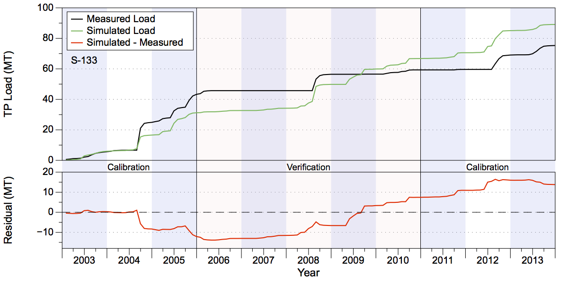
Figure 59. Measured and simulated accumulated TP loads in metric tons (upper chart) and accumulated residuals (lower chart) at structure S-133.

Flow and Water Quality Data at S-135
Accumulated simulated volume results at the S-135 structure over the 2003-2013 period are close to the observed measurements (Figure 60). The simulated values overestimated the measured values in the calibration period by 3% but underestimated the measured values by 34% during the verification period (Table 23). Much of the overestimated values during the calibration period occur over calendar year 2005, while the underestimation during the verification period occurred during 2010. Over the combined calibration/verification period the simulated volume is about 1% lower than the observed volume. The NSE statistics are 0.69 and 0.62 for the calibration and verification periods, respectively (Table 26).
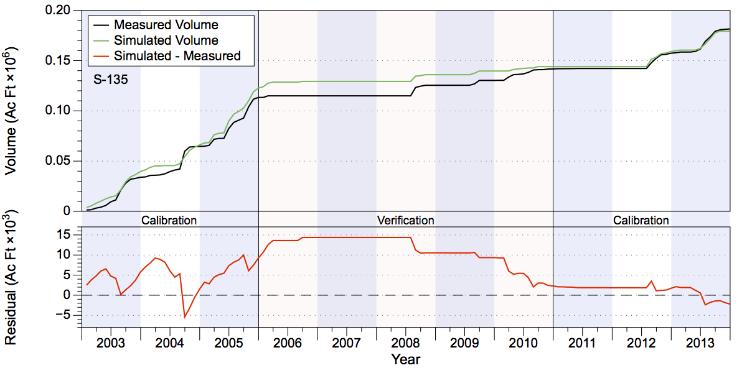
Figure 60. Measured and simulated accumulated water volumes in acre-feet (upper chart) and accumulated volume residuals (lower chart) at structure S-135.
Visual inspection of the nutrient concentrations indicate that the simulated values for TN captures the variability present in the measured data reasonably well, while the TP simulated values look reasonable over the 2003-2008 time frame, but fail to match the consistently low values from 2009 onward (Figure 61).
Overall, the simulated TN load values overestimated the measured values by about 5% during the calibration period and underestimated the measured values by 23% during the verification period (Table 24 and Figure 62). The divergence of simulated TN loads mirrors the mismatch in the simulated vs. observed flow with much of the overestimate during the calibration period occurring during calendar year 2005 and the underestimate occurring from mid-2008 through the end of 2010. Simulated TP values overestimated measured values by about 4% during the calibration period, but underestimated measured values by 34% during the verification period (Table 25 and Figure 63). The simulated TP loads show a significant underestimate in mid-2004 followed by a recovery in 2005. There is also an underestimate in mid-2008 that reflects the flow and TN load distribution, but an overestimate occurs in mid-2012 that is not observed in either the flow or TN estimates. For TN loads, the NSE statistic shows good fits of 0.6 for both the calibration and verification periods (Table 26). For TP loads, the NSE statistics are 0.16 and 0.72, respectively, for the calibration period and verification periods (Table 26).
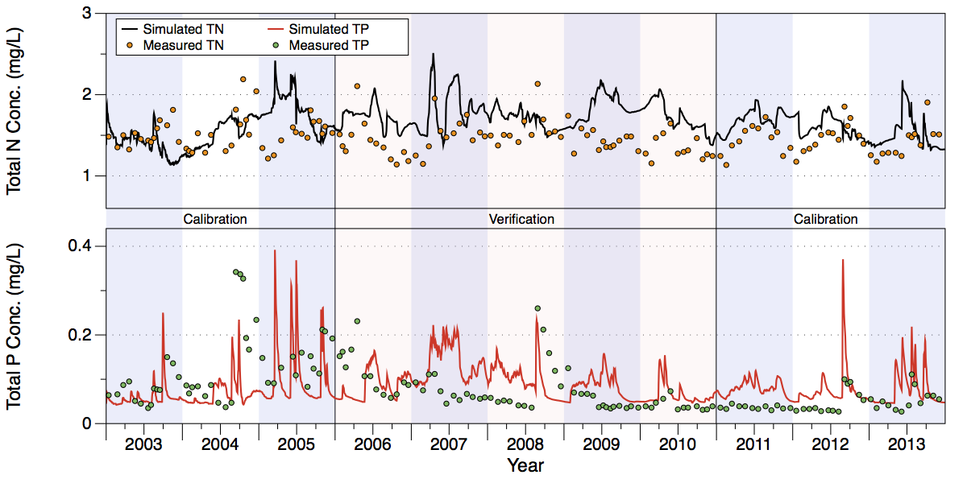
Figure 61. Comparison of measured and simulated TN (upper chart) and TP (lower chart) concentrations at structure S-135.
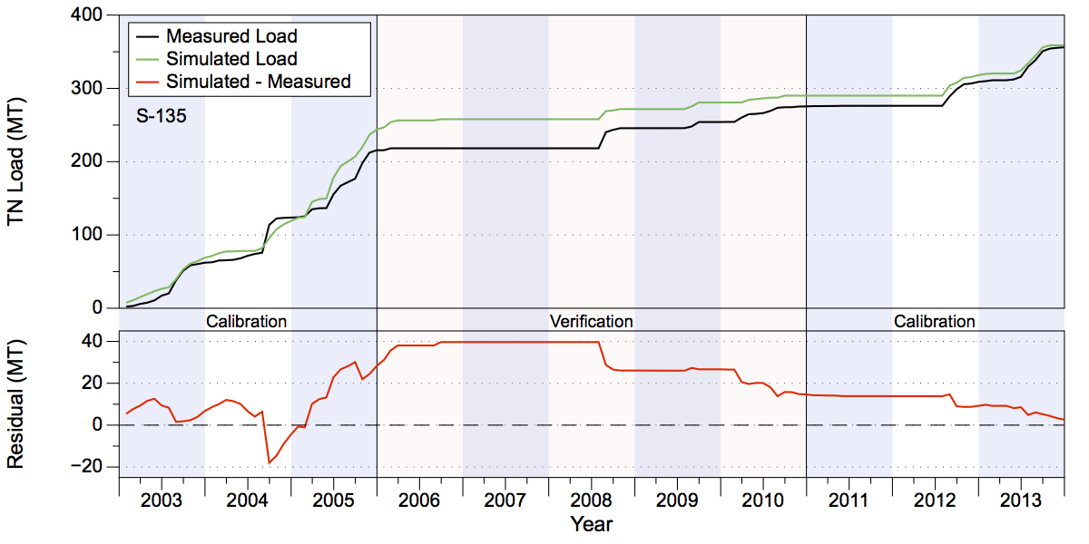
Figure 62. Measured and simulated accumulated TN loads in metric tons (upper chart) and accumulated residuals (lower chart) at structure S-135.
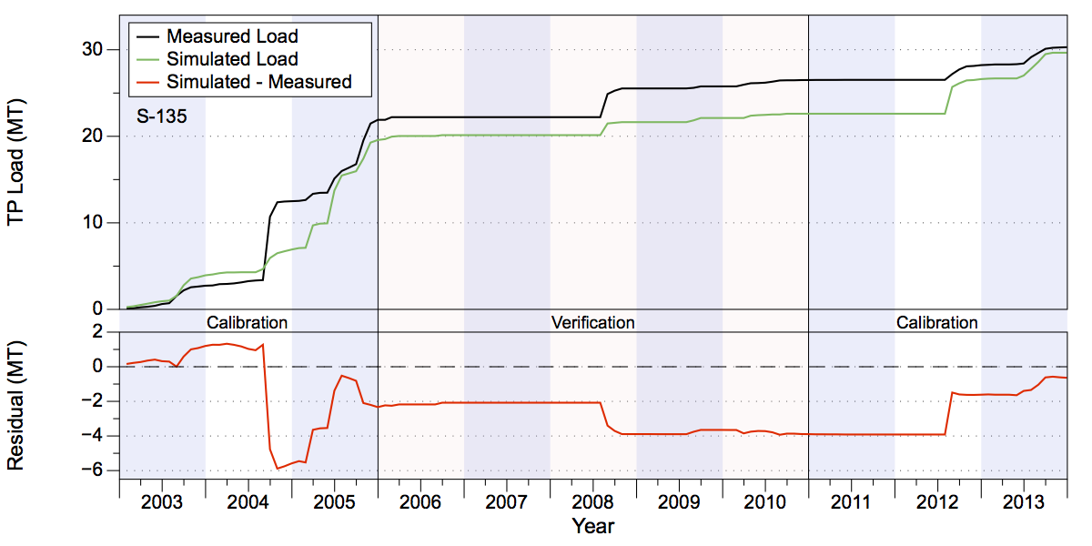
Figure 63. Measured and simulated accumulated TP loads in metric tons (upper chart) and accumulated residuals (lower chart) at structure S-135.

Flow and Water Quality Data at S-154
Accumulated simulated volume at the S-154 structure over the 2003-2013 period shows that the simulated results overestimated the measured values (Figure 64). The simulated volume underestimated the measured values in the calibration period by 12%, with much of the underestimation occurring during the first three years of the calibration period. The simulated values overestimated measured values by 67% during the verification period (Table 23). Over the entire calibration/verification period the simulated is 6% higher than observed measurements. Note that the low flow years of 2006-2007 and 2009 have high percentage errors, but account for a relatively low fraction of the total volume. The NSE statistics are 0.51 and 0.59 for the calibration and verification periods, respectively (Table 26).
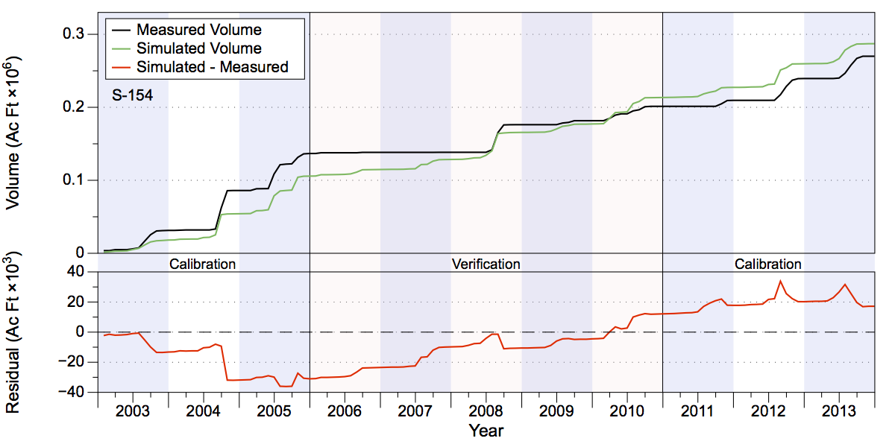
Figure 64. Measured and simulated accumulated water volumes in acre-feet (upper chart) and accumulated volume residuals (lower chart) at structure S-154.
Visual inspection of the results for simulated TN concentrations show that the values capture a reasonable amount of the variability present, although peaks in the simulated values in 2004, early-to-mid 2005, and early 2010 do not accurately reflect measured values. Simulated TP concentrations do not capture the overall variability present in the measured data, although the temporal distribution of high/low values is partially replicated, i.e., peaks and lows in the simulated values occur at roughly the same times as the measured values, but the overall high-to-low spread is lower than measured (Figure 65).
The simulated TN load values underestimated the measured values by over 24% during the calibration period and overestimated by 65% during the verification period (Table 24 and Figure 66). Over the combined calibration/verification period the simulated TN load is within 3% of the measured value. Simulated TP load values underestimated measured values by about 27% during the calibration period with a significant underestimate in mid-2004. The simulated loads overestimated measured load values by about 35% during the verification period (Table 25 and Figure 67). The NSE statistics for TN loads are 0.34 and 0.55 for the calibration and verification periods, respectively, while for TP loads the NSE statistics show reasonable values of 0.38 and 0.67 for the for the calibration and verification periods, respectively (Table 26).
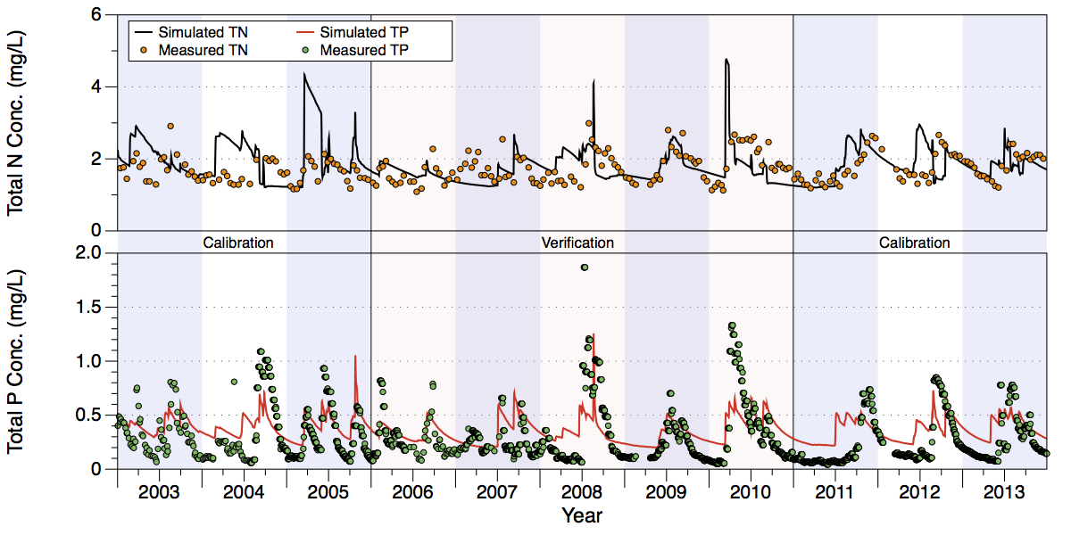
Figure 65. Comparison of measured and simulated TN (upper chart) and TP (lower chart) concentrations at structure S-154.
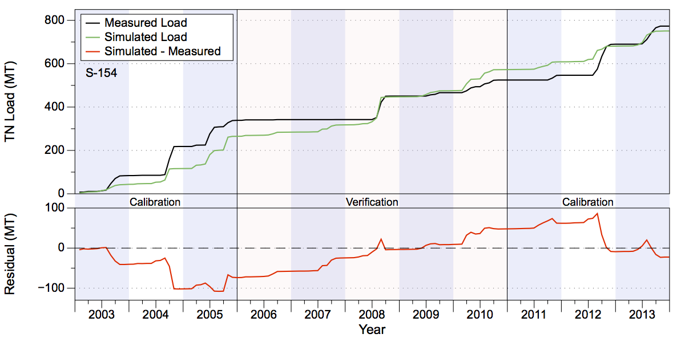
Figure 66. Measured and simulated accumulated TN loads in metric tons (upper chart) and accumulated residuals (lower chart) at structure S-154.
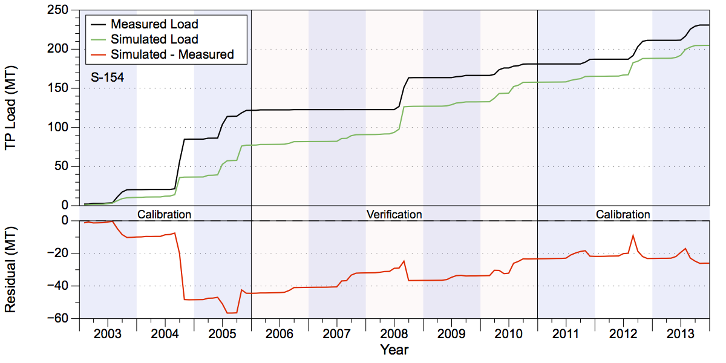
Figure 67. Measured and simulated accumulated TP loads in metric tons (upper chart) and accumulated residuals (lower chart) at structure S-154.

Flow and Water Quality Data at S-191
The simulated and observed accumulated volumes at the S-191 structure over the 2003-2013 period are reasonably close (Figure 68). The simulated volumes underestimated the measured values in the calibration period by 8% but overestimated the measured values by 51% during the verification period (Table 23). Much of the overestimation of the measured values occurred during early- to mid-2010. Over the entire calibration/verification period the simulated volume is 6.6% higher than observed. The NSE statistics for the calibration and verification periods are 0.87 and 0.64, respectively, which demonstrates good fits for both periods (Table 26).
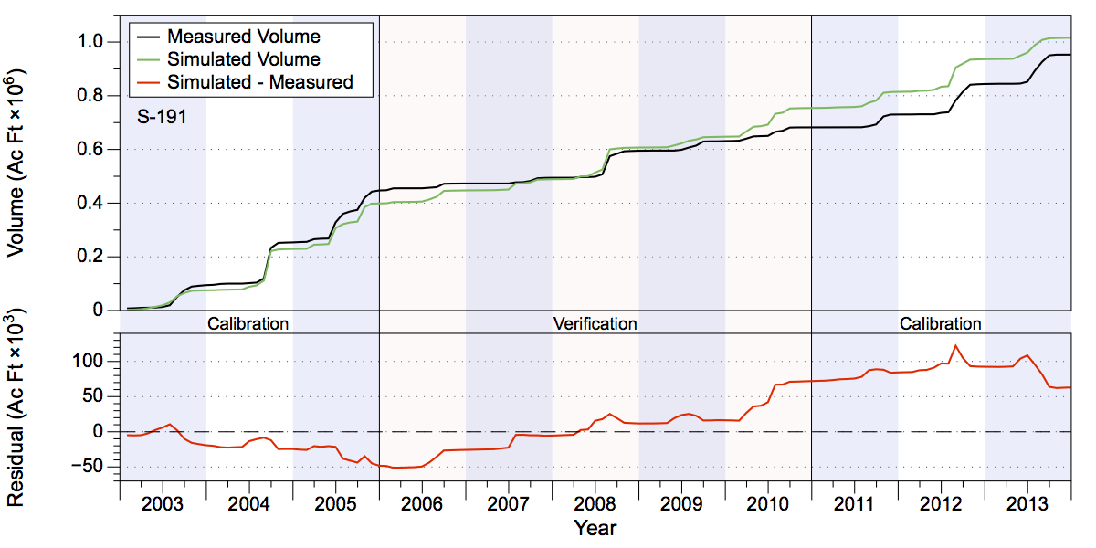
Figure 68. Measured and simulated accumulated water volumes in acre-feet (upper chart) and accumulated volume residuals (lower chart) at structure S-191.
Visual inspection of results for simulated TN concentrations show that the values represent the variability in the measured values reasonable well, although some peaks in the simulated data overestimated measurements. The results for TP concentrations capture the variability present in the measured data well (Figure 69). The simulated TN load values are about 7% lower than the measured loads during the calibration period but are 50% too high over the verification period (Table 24 and Figure 70). A significant fraction of the overestimated values in the verification period occurred in 2010 and reflects the overestimate in measured flow. Simulated TP values underestimated measured values by about 5% during the calibration period but overestimated the measured load values by 78% during the verification period (Table 25 and Figure 71). The NSE statistics for TN loads are 0.8 and 0.72 for the calibration and verification periods, respectively, while for TP loads, the NSE statistics are 0.76 for the calibration period and 0.22 for the verification period (Table 26).
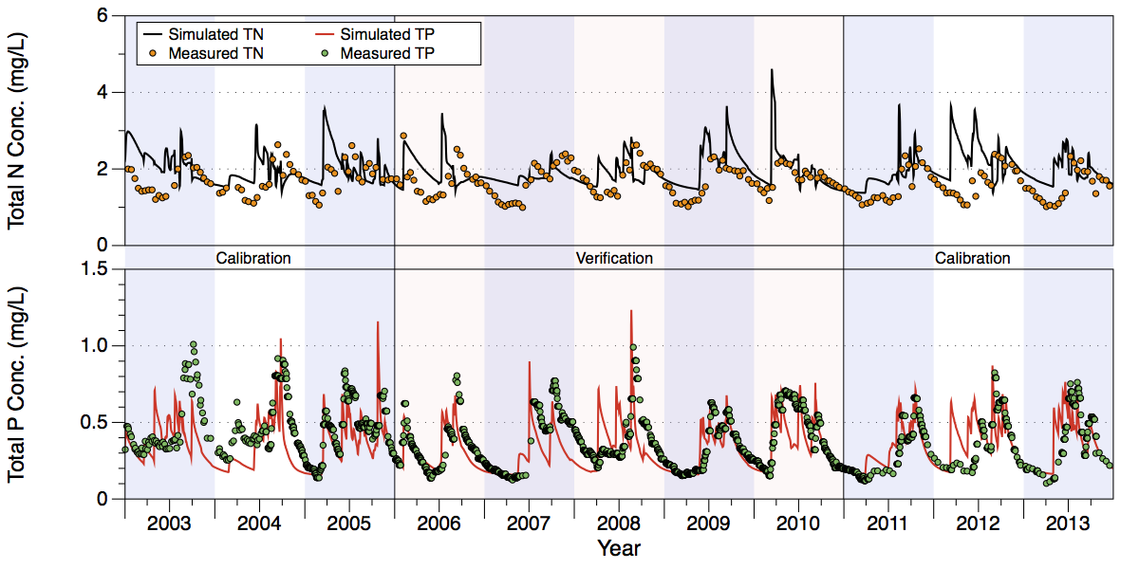
Figure 69. Comparison of measured and simulated TN (upper chart) and TP (lower chart) concentrations at structure S-191.
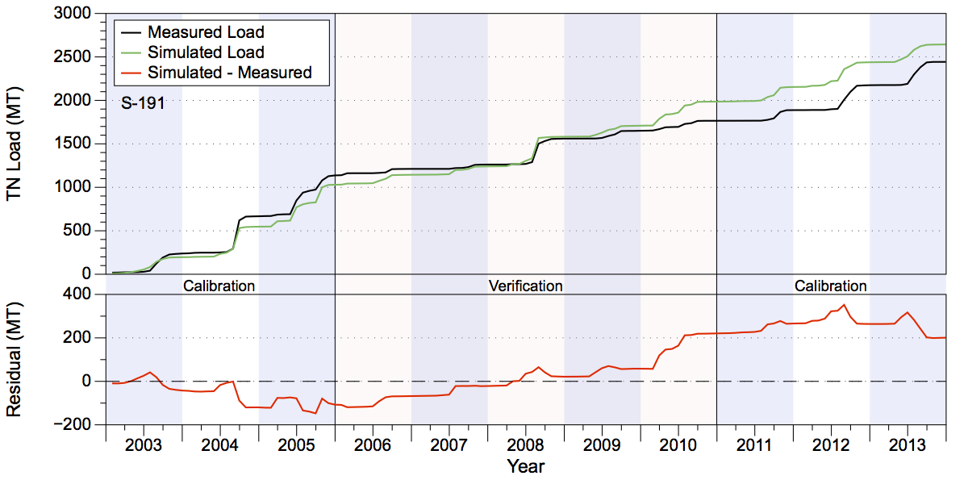
Figure 70. Measured and simulated accumulated TN loads in metric tons (upper chart) and accumulated residuals (lower chart) at structure S-191.
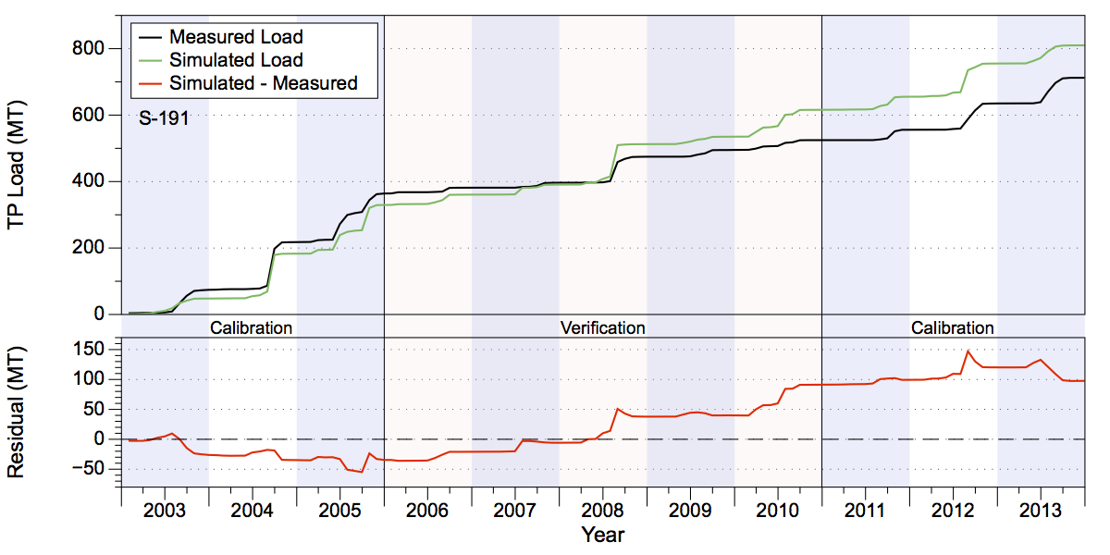
Figure 71. Measured and simulated accumulated TP loads in metric tons (upper chart) and accumulated residuals (lower chart) at structure S-191.
Table 26. Taylor Creek/Nubbin Slough GOF Statistics. Note that RMSE has units of acre-feet for volume and metric tons for nutrient loads.
Statistic | Volume (C) | Volume (V) | TN Load (C) | TN Load (V) | TP Load (C) | TP Load (C)
S-133
PBIAS % | -0.50 | 175.30 | -0.90 | 166.10 | -9.70 | 122.00
RMSE | 1,774.54 | 2,161.29 | 5.55 | 4.56 | 1.10 | 0.90
NSE | 0.75 | -1.20 | 0.57 | -0.27 | 0.67 | 0.22
KGE | 0.78 | -1.02 | 0.66 | -0.74 | 0.63 | -0.30
S-135
PBIAS % | 3.10 | -24.40 | 5.50 | -22.80 | 3.60 | -34.00
RMSE | 1,806.51 | 800.20 | 4.10 | 1.95 | 0.88 | 0.18
NSE | 0.69 | 0.62 | 0.60 | 0.60 | 0.16 | 0.72
KGE | 0.76 | 0.56 | 0.74 | 0.52 | 0.42 | 0.41
S-154
PBIAS % | -12.60 | 66.80 | -24.50 | 65.50 | -27.50 | 35.70
RMSE | 3,906.77 | 2,177.21 | 12.80 | 6.69 | 4.63 | 2.05
NSE | 0.51 | 0.59 | 0.34 | 0.55 | 0.38 | 0.67
KGE | 0.69 | 0.31 | 0.48 | 0.26 | 0.44 | 0.60
S-191
PBIAS % | -8.00 | 51.20 | -7.00 | 52.20 | -5.10 | 78.30
RMSE | 6,670.08 | 5,554.89 | 22.35 | 15.00 | 7.96 | 6.80
NSE | 0.87 | 0.64 | 0.80 | 0.72 | 0.76 | 0.22
KGE | 0.89 | 0.42 | 0.80 | 0.44 | 0.86 | -0.05

Upper Kissimmee

The Upper Kissimmee sub-watershed is the northernmost of the six sub-watersheds simulated for this project, as well as the largest in area, measuring approximately 1,028,400 acres (Figure 72). The Upper Kissimmee sub-watershed encompasses the area from just south of Orlando to the bottom edge of Lake Kissimmee. It contains the largest area of urban land uses of the six sub-watersheds simulated while also including large amounts of improved pasture and citrus as well as a significant amount of lakes. The basin outlet is the southern end of Lake Kissimmee, with discharge to the Kissimmee River controlled by a set of gates at S-65.
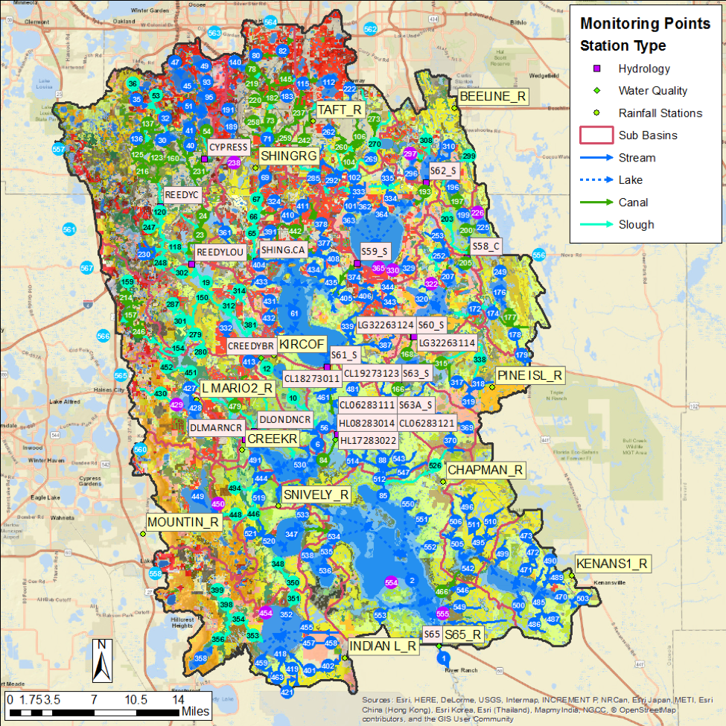
Figure 72. The Upper Kissimmee model domain. Rainfall, flow, and water quality stations are shown.

Table 27. Lake Kissimmee water volume (ac-ft) and TN and TP loads (in metric tons) leaving S-68.
Structure | Simulated | Measured | Difference | Percentage
Volume (ac-ft)
S-65 Cal. | 6,144,384 | 6,418,693 | -274,309 | -4.27%
S-65 Ver. | 2,881,955 | 2,764,104 | 117,851 | 4.26%
TN Load (MT)
S-65 Cal. | 9,507 | 9,966 | -458 | -4.60%
S-65 Ver. | 5,053 | 4,610 | 443 | 9.62%
TP Load (MT)
S-65 Cal. | 707 | 763 | -56 | -7.28%
S-65 Ver. | 326 | 255 | 71 | 27.77%

Flow and Water Quality Data at S-65
Accumulated flow at the outlet of Lake Kissimmee at the S-65 structure over the 2003-2013 period shows that the simulation results are reasonably close (Figure 73). The simulated values underestimated the measured values in the calibration period by 4% but overestimated the measured values by 4% during the verification period (Table 27). Over the combined calibration/verification period the simulated is about 2% lower than observed. The NSE statistics show values at or near 0.5 in the calibration and verification periods (Table 28).
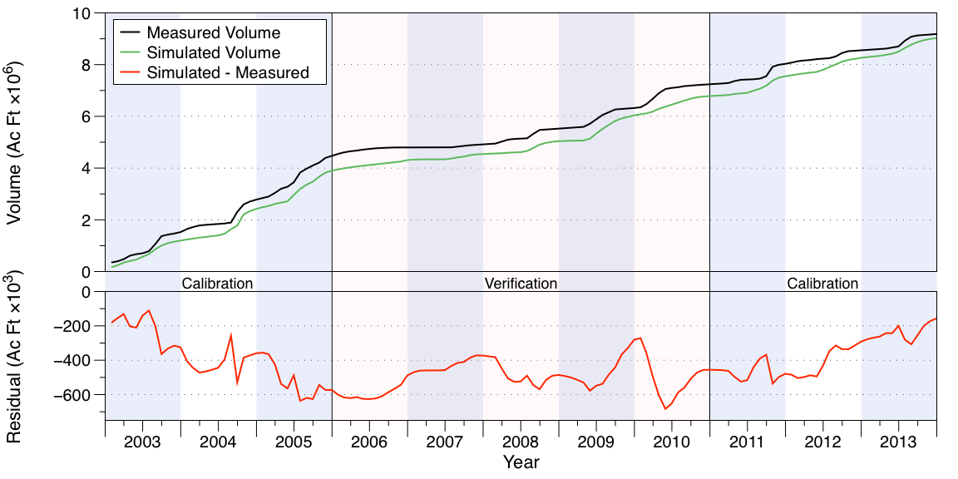
Figure 73. Measured and simulated accumulated water volumes in acre-feet (upper chart) and accumulated volume residuals (lower chart) at structure S-65.
Visual inspection of the results indicate that the simulated values for both TN and TP concentrations do not capture the variability present in the measured data (Figure 74). As with Lake Istokpoga, much of this error is attributable to the inability of WAM to simulate complex in-lake processes such as algal blooms and wind-driven mixing. In addition, WAM averages N and P concentrations at each time step over the large volume of the reach used to simulate Lake Kissimmee, which damps out much of the observed dynamics.
Overall, the simulated TN load values underestimated the measured values by 4.6% during the calibration period and overestimated measured values by 9.6% during the verification period, while simulated TP loads underestimated measured values by about 7% during the calibration period, but overestimated measured values by about 28% during the verification period (Table 27). The differences between the simulated and observed TN loads reflect mismatches in the flow estimates, with underestimates during the first calibration period and overestimates during the second. The simulated TP loads show a sharp deviation from the observed values during mid-2004, and significantly underestimated loads at that time. From mid-2009 through the end of 2013 the simulated TP loads consistently overestimated the measured values. For TN loads the NSE statistics show reasonable fit values of 0.46 and 0.51 for the calibration and verification periods, respectively (Table 28). For TP loads, the NSE statistics show reasonable fits of 0.26 and 0.35 for the calibration and verification periods, respectively (Table 28).
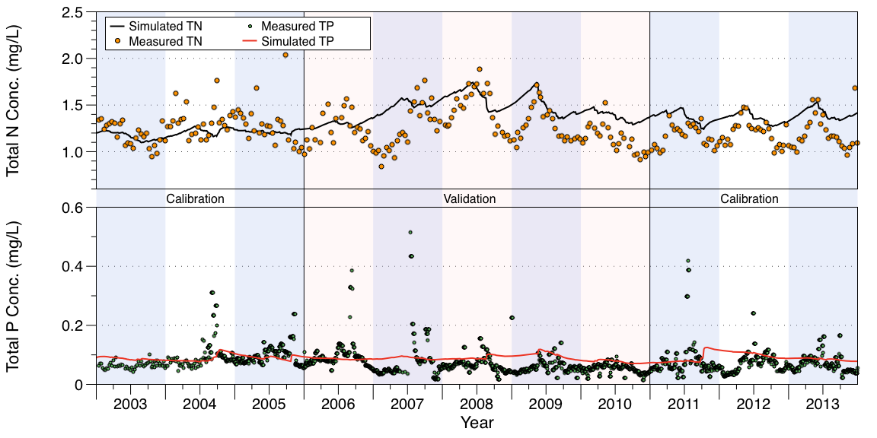
Figure 74. Comparison of measured and simulated TN (upper chart) and TP (lower chart) concentrations at structure S-65.
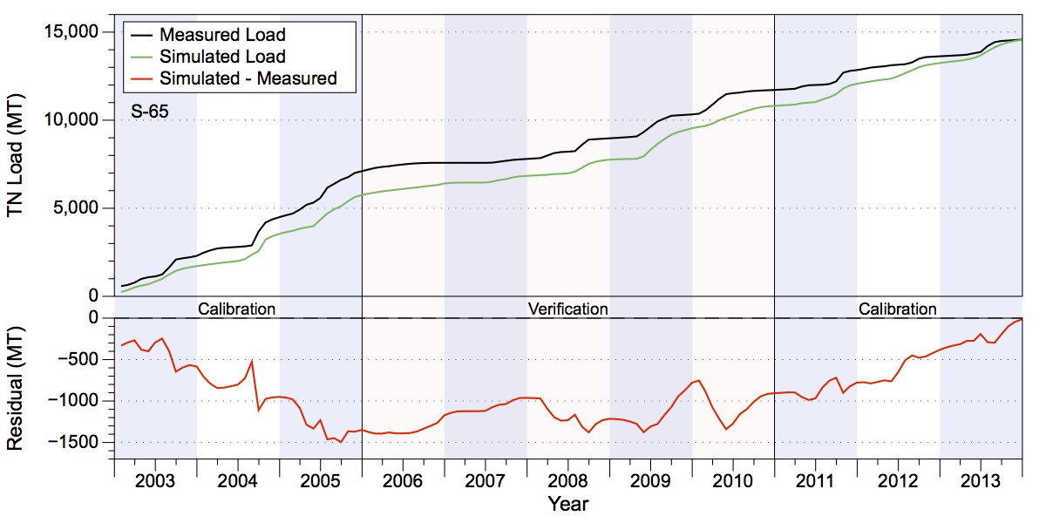
Figure 75. Measured and simulated accumulated TN loads in metric tons (upper chart) and accumulated residuals (lower chart) at structure S-65.
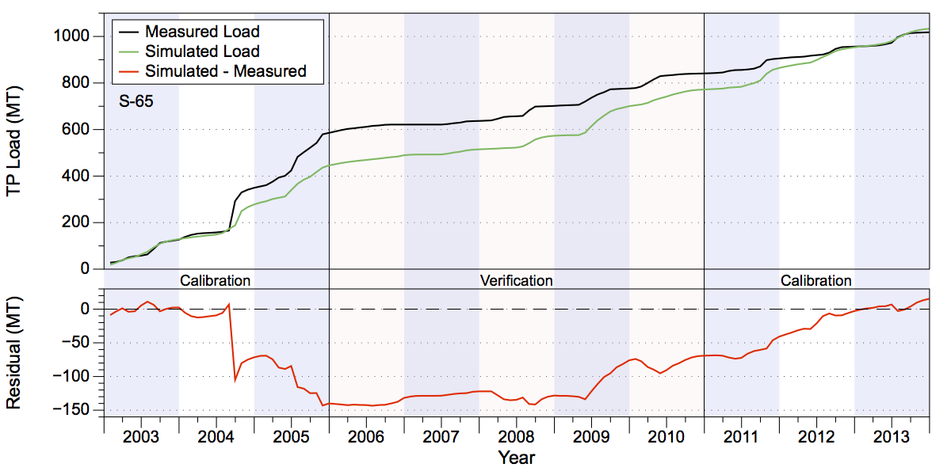
Figure 76. Measured and simulated accumulated TP loads in metric tons (upper chart) and accumulated residuals (lower chart) at structure S-65.

Table 28. Upper Kissimmee GOF Statistics At Structure S-65. Note that RMSE has units of acre-feet for volume and metric tons for nutrient loads.
Statistic | Volume (C) | Volume (V) | TN Load (C) | TN Load (V) | TP Load (C) | TP Load (C)
PBIAS % | -4.30 | 4.30 | -4.60 | 9.60 | -7.30 | 27.80
RMSE | 67,871.25 | 40,167.86 | 114.82 | 68.70 | 14.95 | 4.31
NSE | 0.50 | 0.49 | 0.46 | 0.51 | 0.26 | 0.35
KGE | 0.59 | 0.64 | 0.53 | 0.66 | 0.30 | 0.60

Summary and Conclusions

GOF Results
A summary of the NSE statistics for outfall structures is shown in Table 29. All values are positive, except for the S-133 pump structure, where the flow and TN load fits were less than zero for the verification period.
Table 29. NSE statistics for all of the outflow structures simulated. Note that (C) in a column indicates the calibration period, (V) indicates the verification period.
Location | Volume (C) | Volume (V) | TN Load (C) | TN Load (V) | TP Load (C) | TP Load (C)
FISHCR | 0.73 | 0.76 | 0.78 | 0.77 | 0.82 | 0.77
S-68 | 0.70 | 0.55 | 0.70 | 0.51 | 0.11 | 0.38
S-65 | 0.50 | 0.49 | 0.46 | 0.51 | 0.26 | 0.35
S-65E | 0.95 | 0.93 | 0.95 | 0.93 | 0.89 | 0.90
S-84 | 0.80 | 0.82 | 0.72 | 0.82 | 0.76 | 0.64
S-71 | 0.64 | 0.70 | 0.59 | 0.69 | 0.55 | 0.69
S-72 | 0.54 | 0.80 | 0.49 | 0.68 | 0.33 | 0.57
S-127 | 0.46 | 0.69 | 0.50 | 0.68 | 0.36 | 0.67
S-129 | 0.63 | 0.72 | 0.52 | 0.61 | 0.10 | 0.58
S-131 | 0.60 | 0.23 | 0.57 | 0.13 | 0.38 | 0.10
S-133 | 0.75 | -1.20 | 0.57 | -0.27 | 0.67 | 0.22
S-135 | 0.69 | 0.62 | 0.60 | 0.60 | 0.16 | 0.72
S-154 | 0.51 | 0.59 | 0.34 | 0.55 | 0.38 | 0.67
S-191 | 0.87 | 0.64 | 0.80 | 0.72 | 0.76 | 0.22

Conclusions
A model covering the six northern sub-watersheds of the LOW was developed in WAM and has been successfully applied over the 1975-2013 time period. The results indicate that WAM is doing a satisfactory job simulating flows and nutrient loads into Lake Okeechobee from these sub-watersheds. However, as with any model there are issues that should be addressed moving forward. As with any simulation on this scale, input data such as rainfall, evapotranspiration estimates, and land use characterization can always be refined and improved. As part of this process every effort should be taken to keep the model up to date as much as possible by extending the POR as newer data becomes available.
The overall results for flow show that WAM was within ±10% of the calibration target at 13 of the 14 locations, and was within ±10% at 4 of the locations for the validation period. For the entire 11-year combined calibration/verification period, flow volumes at 13 of the 14 locations were at or within ±10%. With respect to nutrients, WAM is also doing a reasonable job simulating load data. TN loads are within ±10% of the calibration target at 12 of the 14 locations and was within ±10% at 4 of the locations for the validation period. Over the combined period TN loads are within ±10% of the calibration target at 12 of the 14 locations. TP loads are within ±10% of the calibration target at 13 of the 14 locations but only within that range for one of the locations in the verification period. Over the combined period TP loads are within ±10% of the calibration target at 10 of the 14 locations.
The slightly poorer performance for the estimated nutrient loading is due to a variety of factors. These include a combination of model variability, measurement/characterization errors, insufficient land use representation within the basins, and limited information for historic nutrient build up in soils, particularly legacy P. Land use characterization data are always difficult to verify spatially because land management variations (such as dates of fertilizer application) across the watershed are not available, and because WAM is unable to account for changes in land use over the simulation period. The spatial variability of legacy P for given land uses is poorly defined because historical practices determine legacy P, not current land use practices. However, when land uses, soil types, and rainfall are well-characterized, WAM provides reasonable values for nutrient concentrations at the source cell level. We reiterate here that the primary purpose of a model such as WAM is to characterize differences between alternative management scenarios, such as when evaluating the influence of BMPs on water/nutrient loading. This goal is not adversely impacted by the simulated nutrient concentration estimates generated by this study, and, given the overall performance of WAM demonstrated here we have confidence that WAM can be successfully used to provide meaningful comparative scenario assessments.

Appendices

Charts of Flow and Nutrient Loads 1975-2013

Fisheating Creek
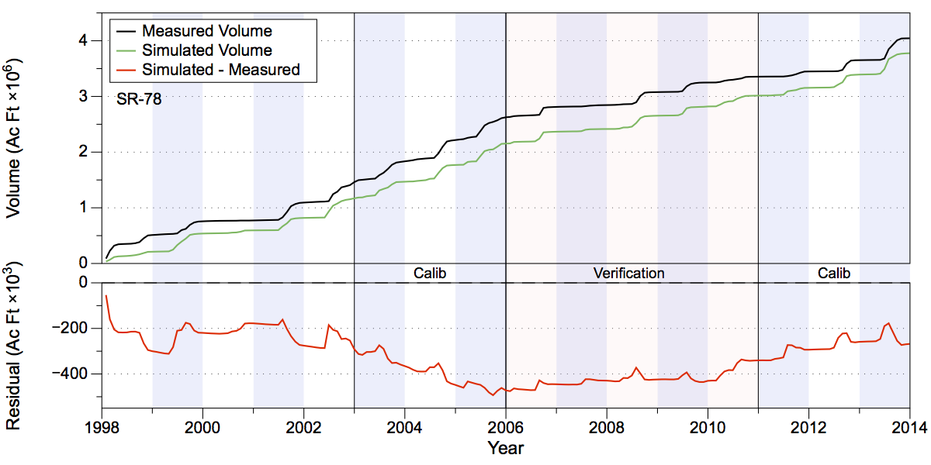
Figure 77. Total accumulated volume (millions of acre-feet) and residuals (thousands of acre feet) at SR-78. Note that measurements were not taken until 1998.
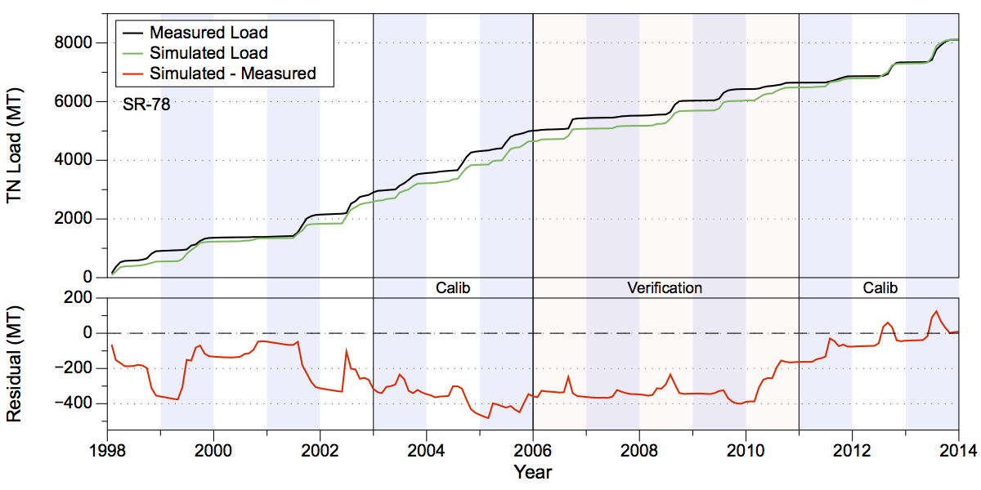
Figure 78. Total accumulated TN loads in metric tons (upper chart) and residual (lower chart) at SR-78. Note that measurements were not taken until 1998.
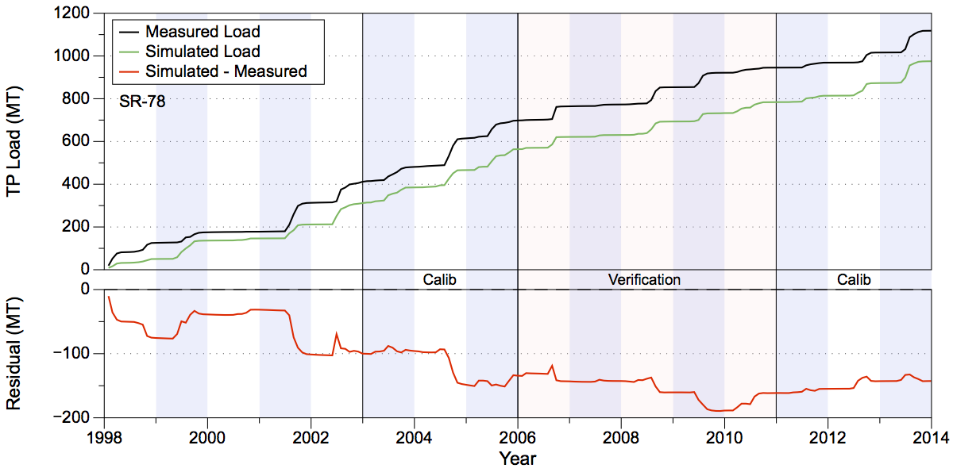
Figure 79. Total accumulated TP loads in metric tons (upper chart) and residual (lower chart) at SR-78. Note that measurements were not taken until 1998.
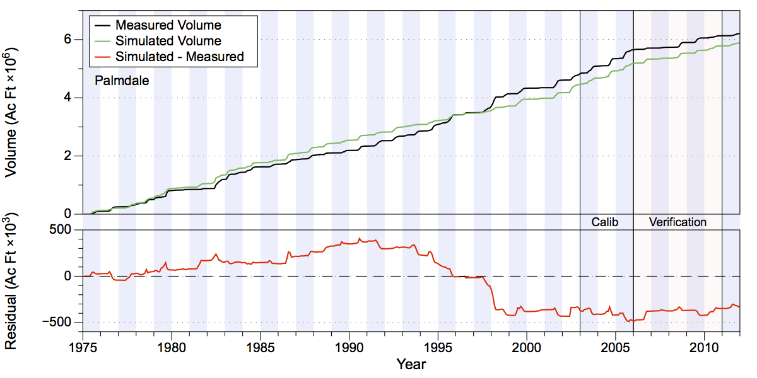
Figure 80. Total accumulated volume (millions of acre-feet) and residuals (thousands of acre feet) at Palmdale on Fisheating Creek. Note that measurements were not taken after May 2012.
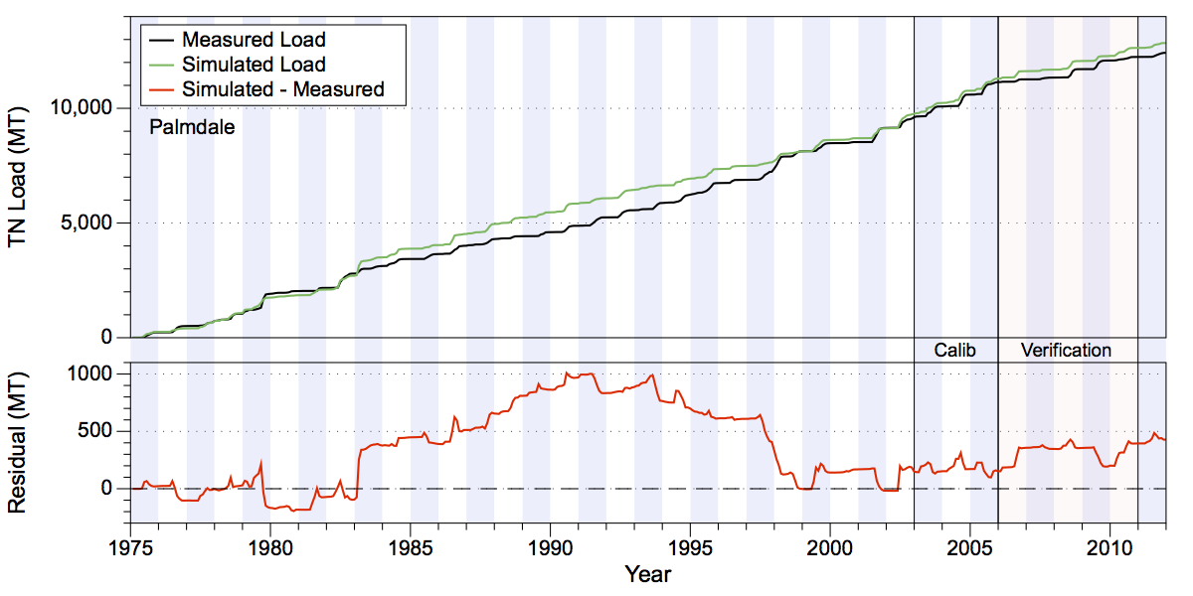
Figure 81. Total accumulated TN loads in metric tons (upper chart) and residual (lower chart) at Palmdale on Fisheating Creek. Note that measurements were not taken after May 2012.
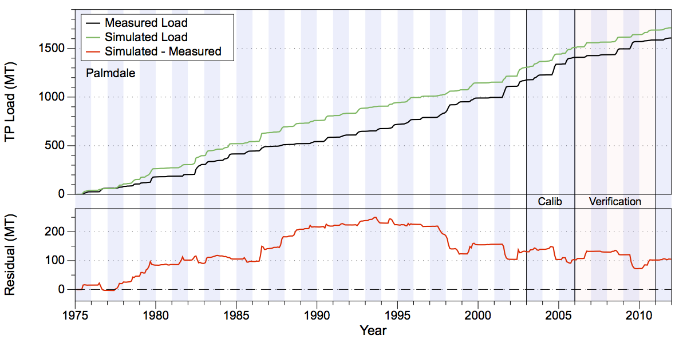
Figure 82. Total accumulated TP loads in metric tons (upper chart) and residual (lower chart) at Palmdale on Fisheating Creek. Note that measurements were not taken after May 2012.

Indian Prairie
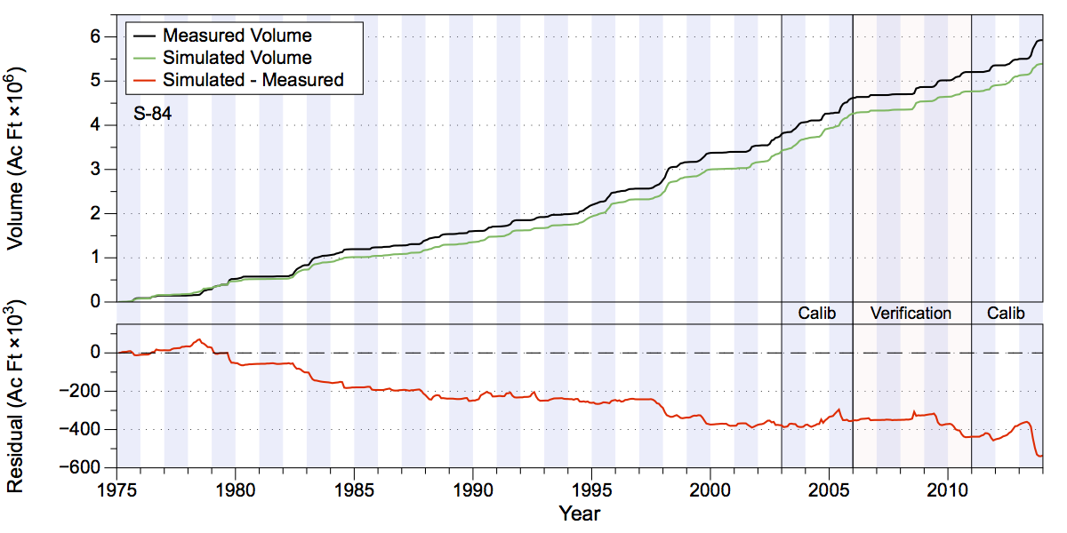
Figure 83. Total accumulated volume (millions of acre-feet) and residuals (thousands of acre feet) at S-84.
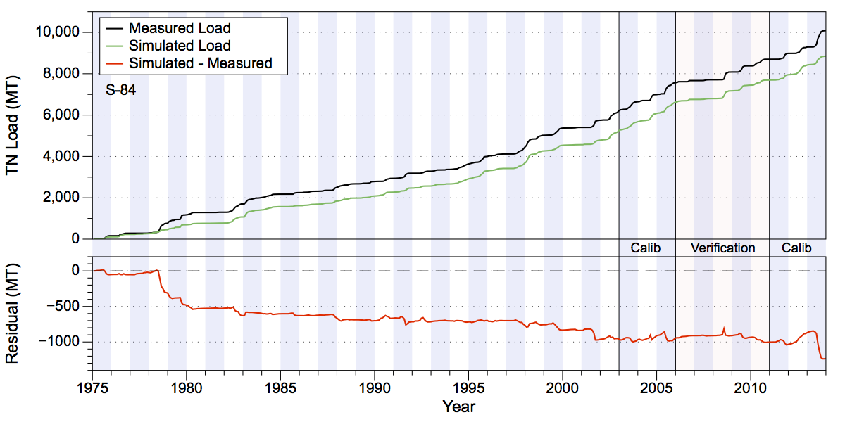
Figure 84. Total accumulated TN loads in metric tons (upper chart) and residual (lower chart) at S-84.
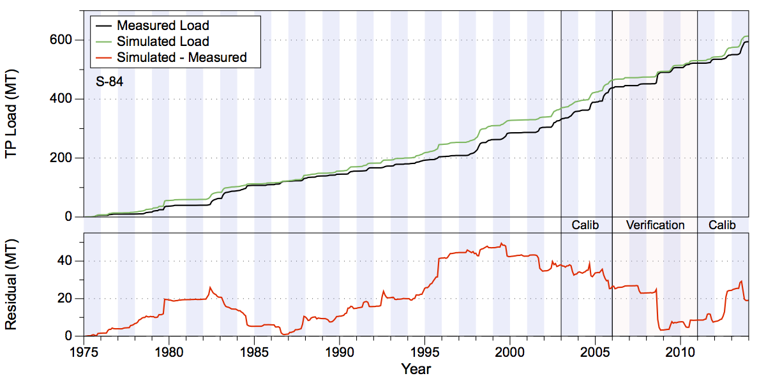
Figure 85. Total accumulated TP loads in metric tons (upper chart) and residual (lower chart) at S-84.
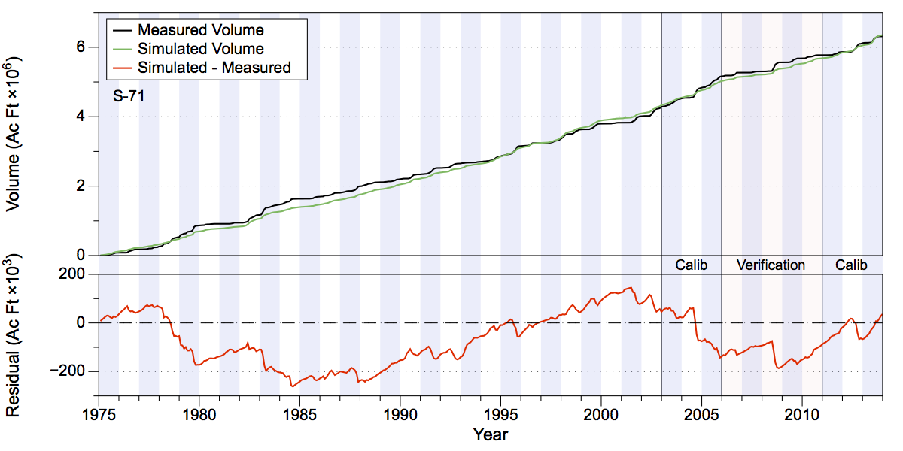
Figure 86. Total accumulated volume (millions of acre-feet) and residuals (thousands of acre feet) at S-71.
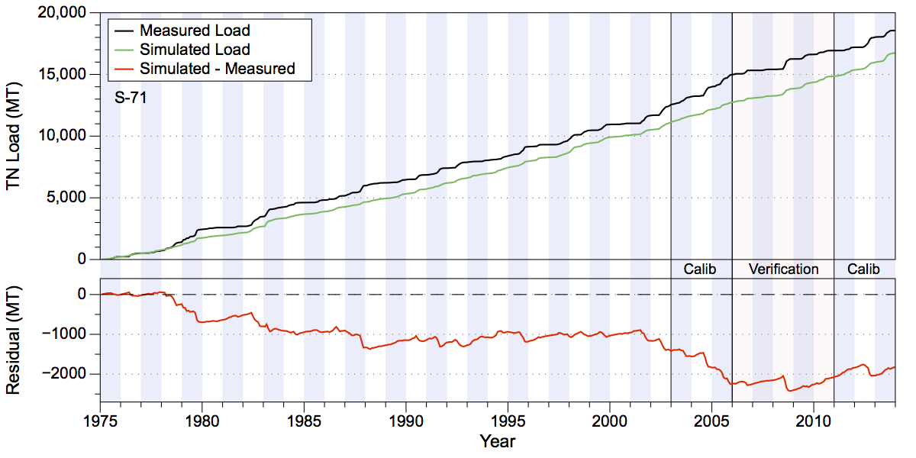
Figure 87. Total accumulated TN loads in metric tons (upper chart) and residual (lower chart) at S-71.
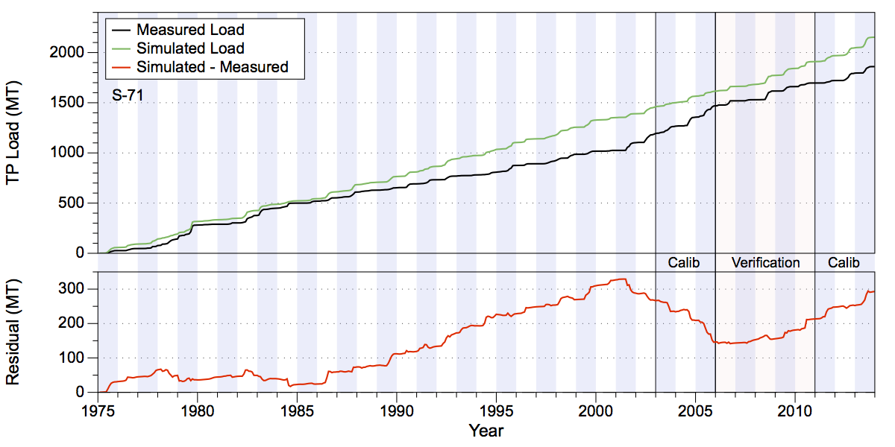
Figure 88. Total accumulated TP loads in metric tons (upper chart) and residual (lower chart) at S-71.
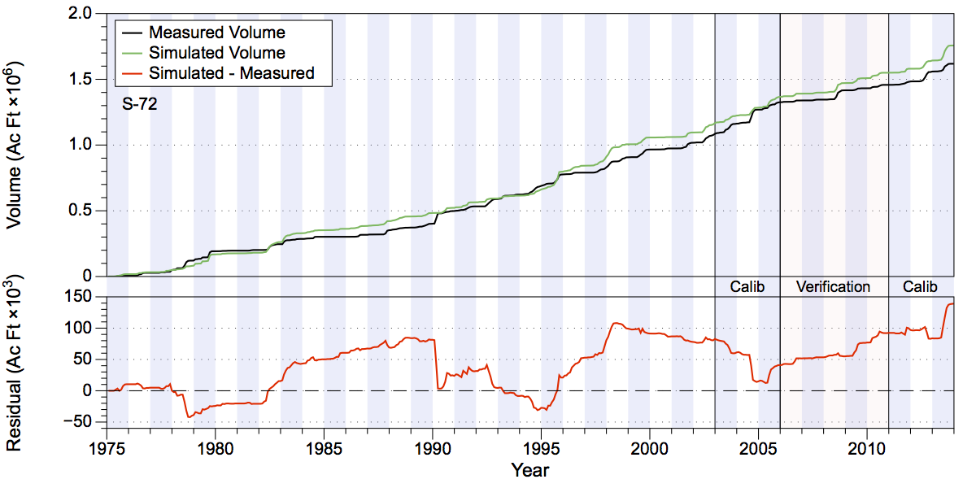
Figure 89. Total accumulated volume (millions of acre-feet) and residuals (thousands of acre feet) at S-72.
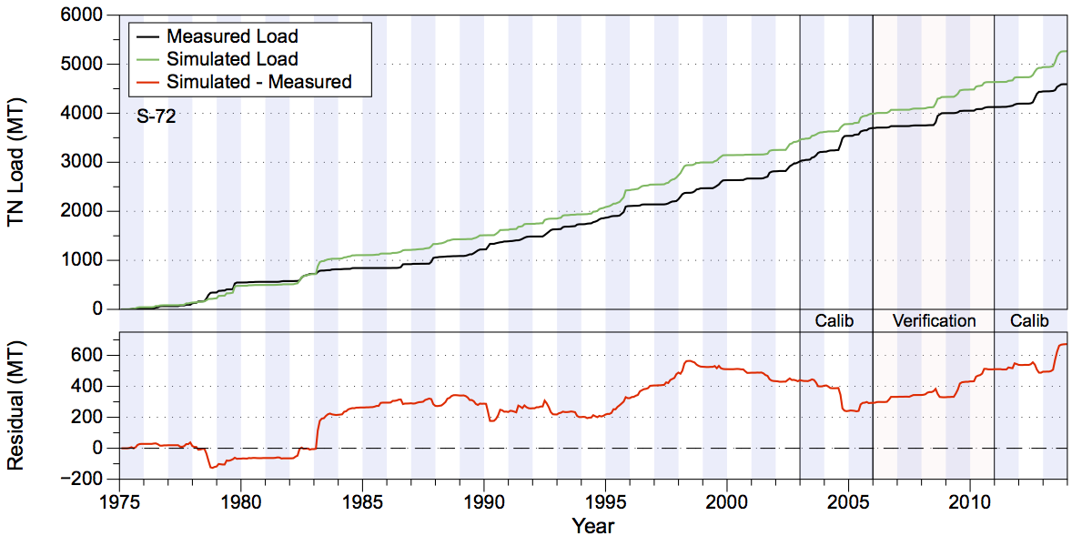
Figure 90. Total accumulated TN loads in metric tons (upper chart) and residual (lower chart) at S-72.
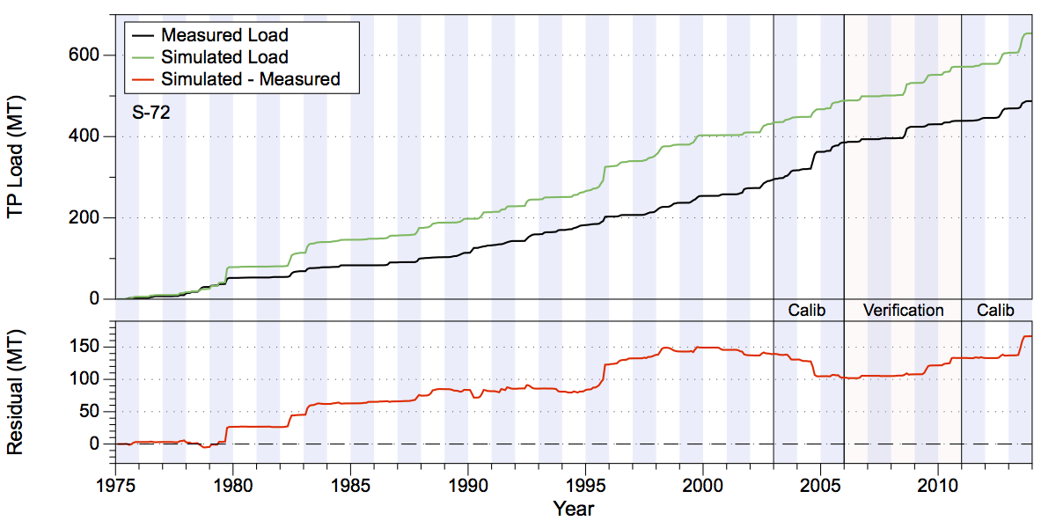
Figure 91. Total accumulated TP loads in metric tons (upper chart) and residual (lower chart) at S-72.
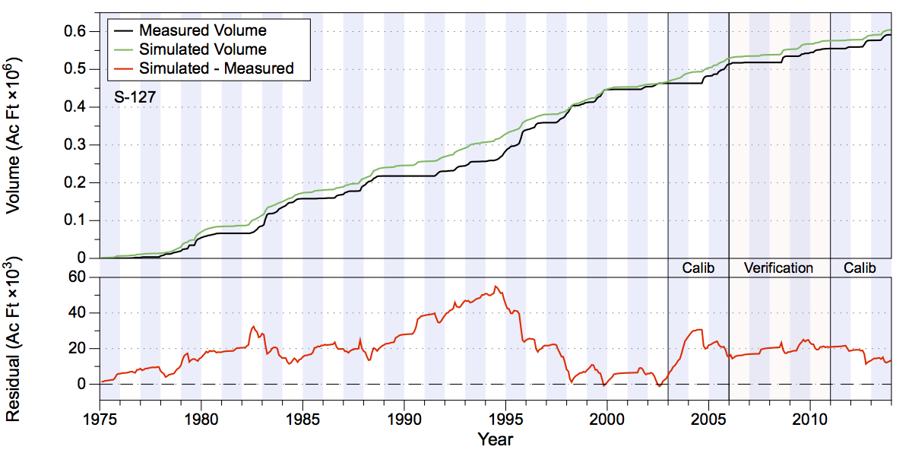
Figure 92. Total accumulated volume (millions of acre-feet) and residuals (thousands of acre feet) at S-127.
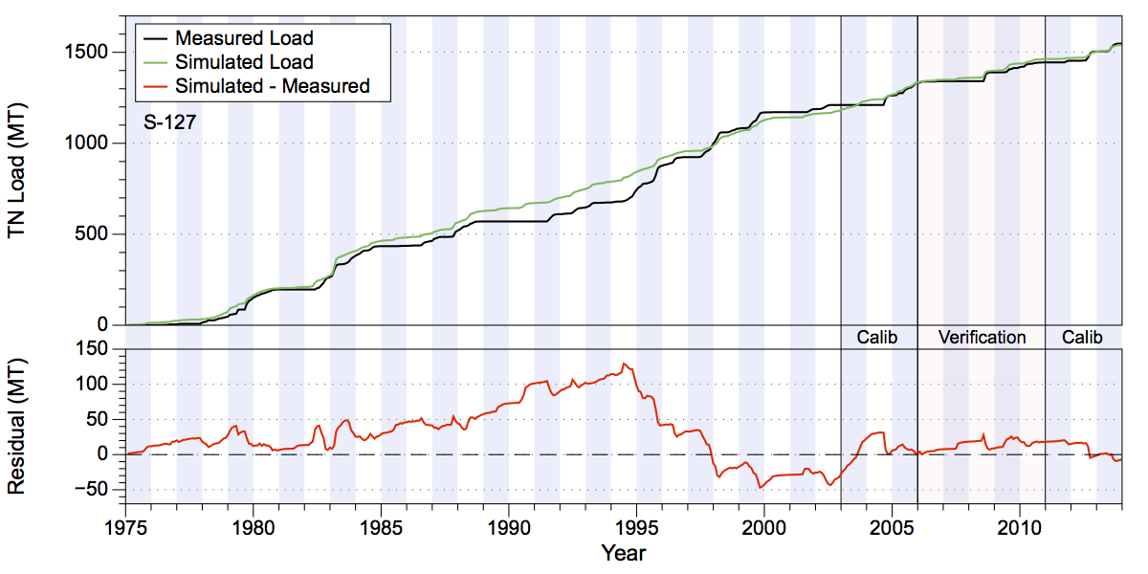
Figure 93. Total accumulated TN loads in metric tons (upper chart) and residual (lower chart) at S-127.
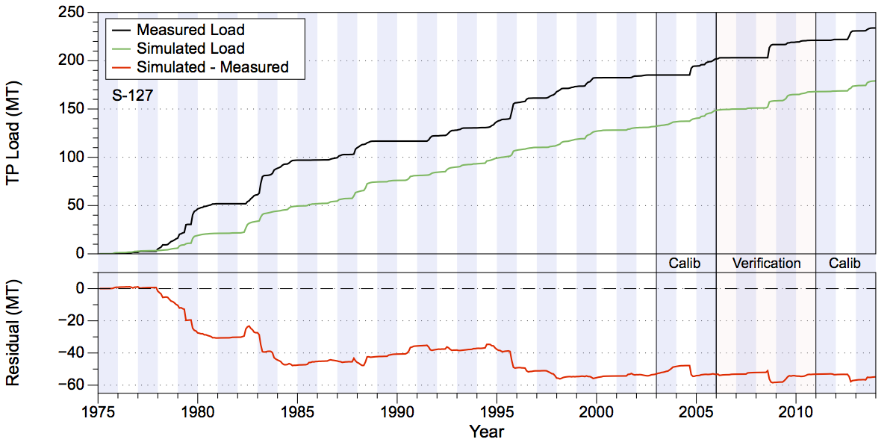
Figure 94. Total accumulated TP loads in metric tons (upper chart) and residual (lower chart) at S-127.
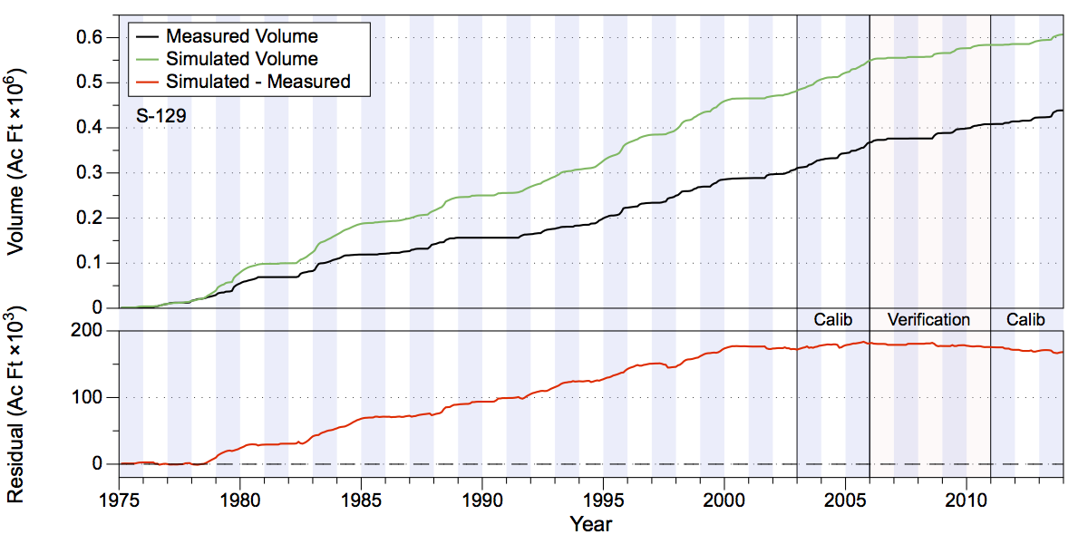
Figure 95. Total accumulated volume (millions of acre-feet) and residuals (thousands of acre feet) at S-129.
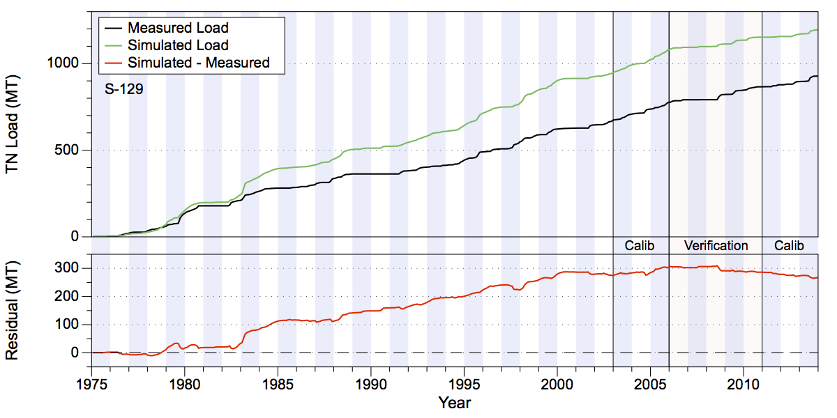
Figure 96. Total accumulated TN loads in metric tons (upper chart) and residual (lower chart) at S-129.
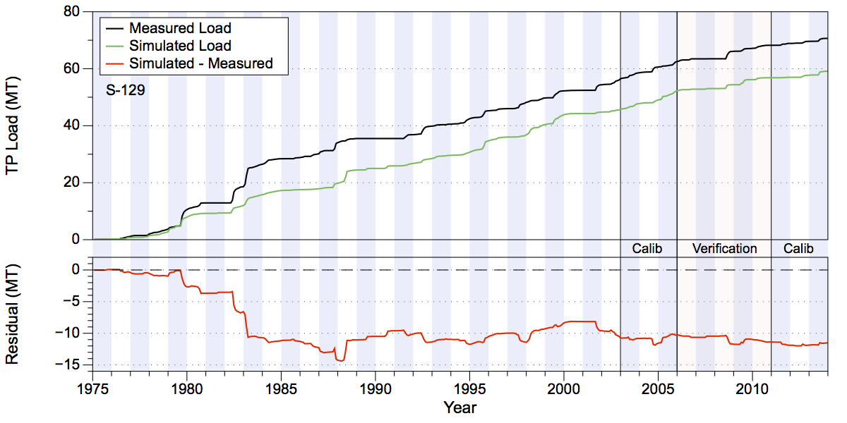
Figure 97. Total accumulated TP loads in metric tons (upper chart) and residual (lower chart) at S-129.
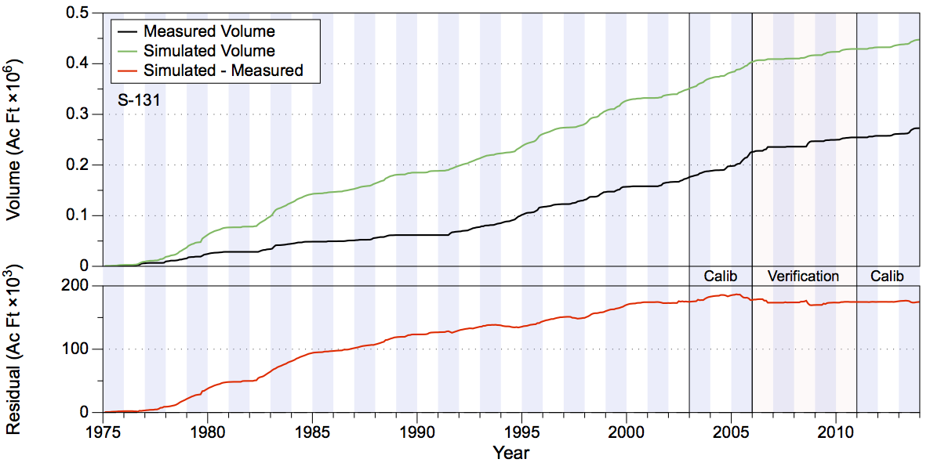
Figure 98. Total accumulated volume (millions of acre-feet) and residuals (thousands of acre feet) at S-131.
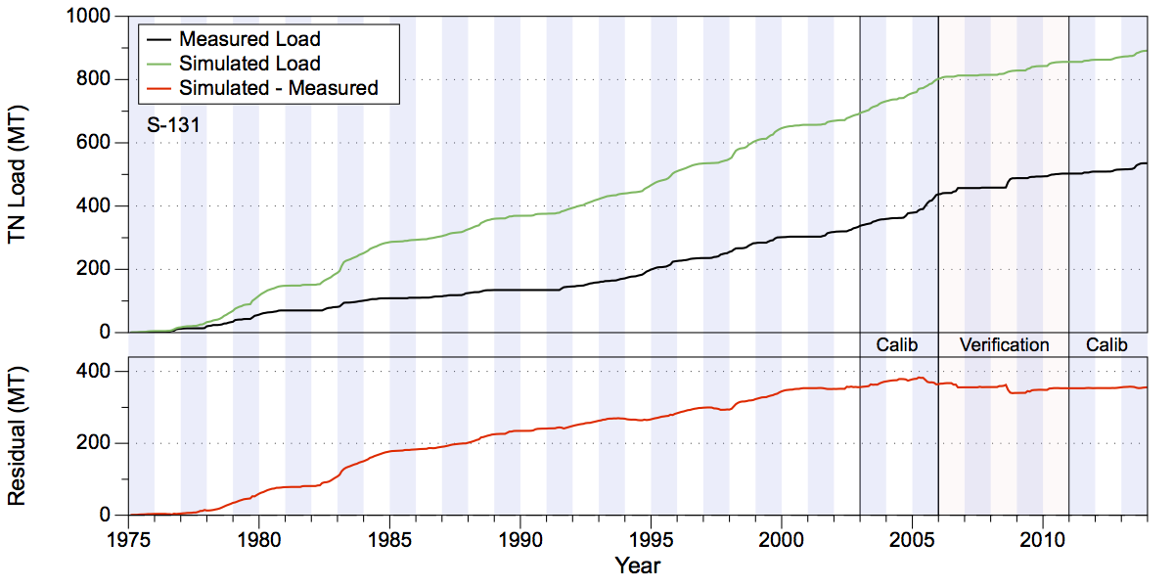
Figure 99. Total accumulated TN loads in metric tons (upper chart) and residual (lower chart) at S-131.
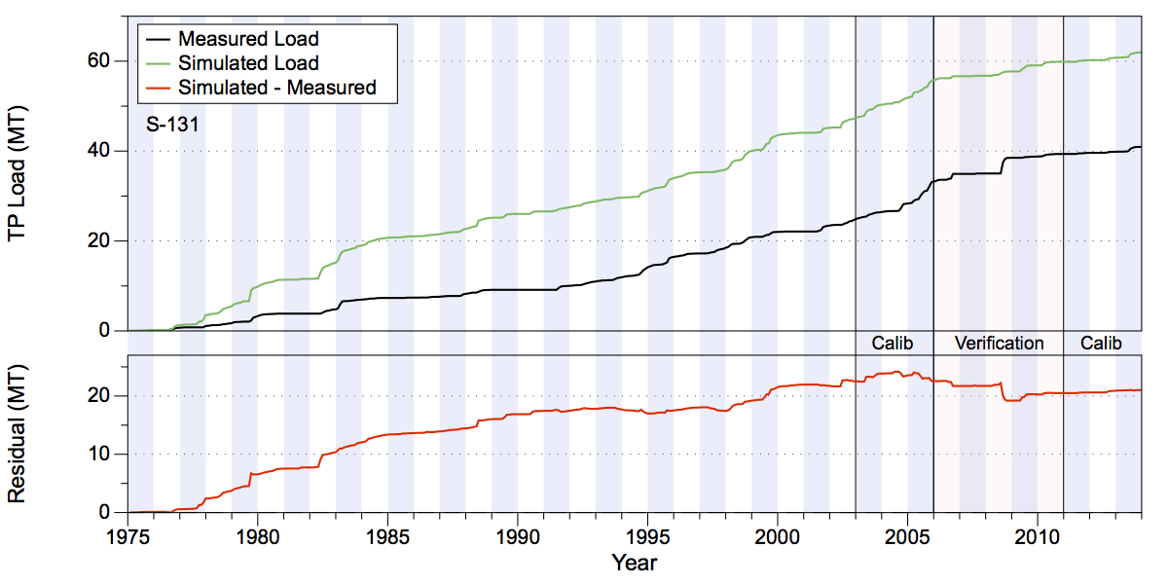
Figure 100. Total accumulated TP loads in metric tons (upper chart) and residual (lower chart) at S-131.

Lake Istokpoga
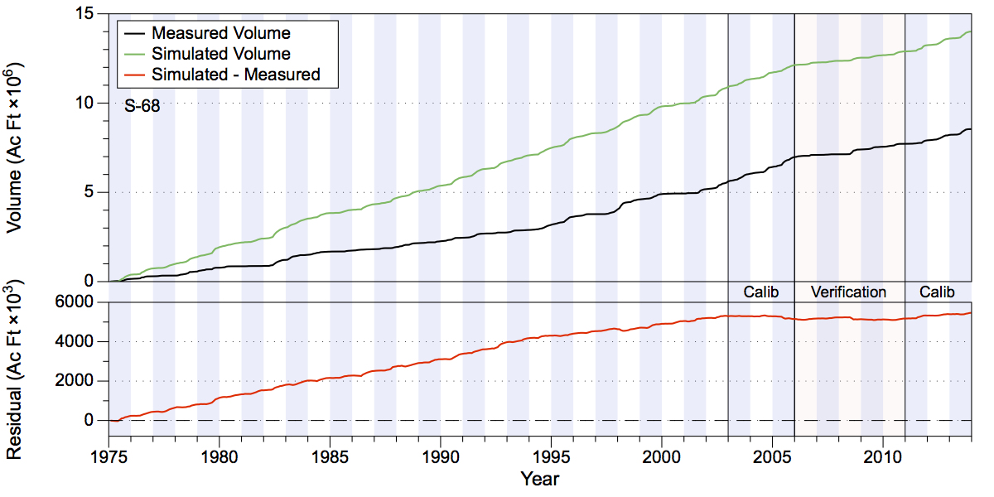
Figure 101. Total accumulated volume (millions of acre-feet) and residuals (thousands of acre feet) at S-68.
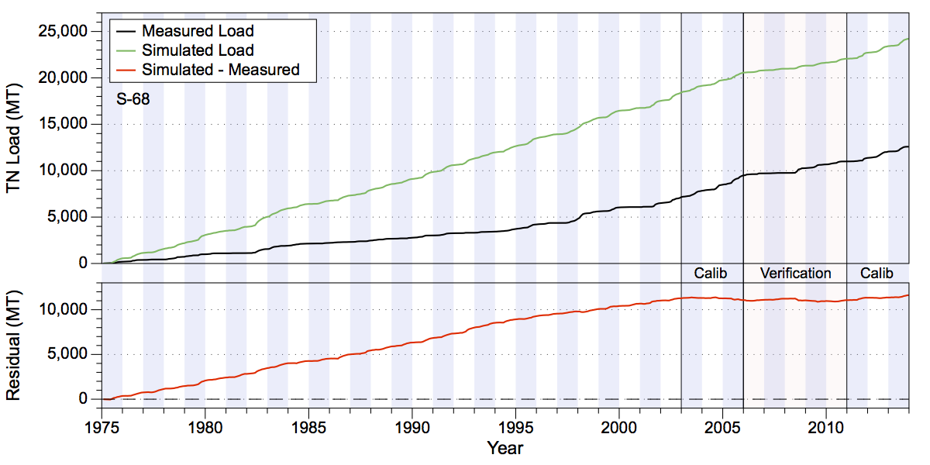
Figure 102. Total accumulated TN loads in metric tons (upper chart) and residual (lower chart) at S-68.
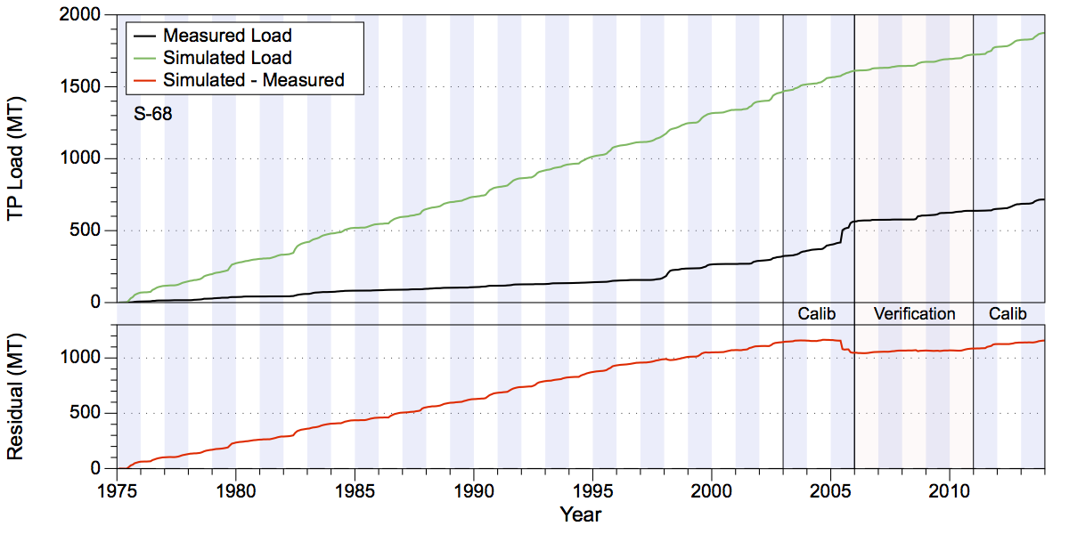
Figure 103. Total accumulated TP loads in metric tons (upper chart) and residual (lower chart) at S-68.

Lower Kissimmee
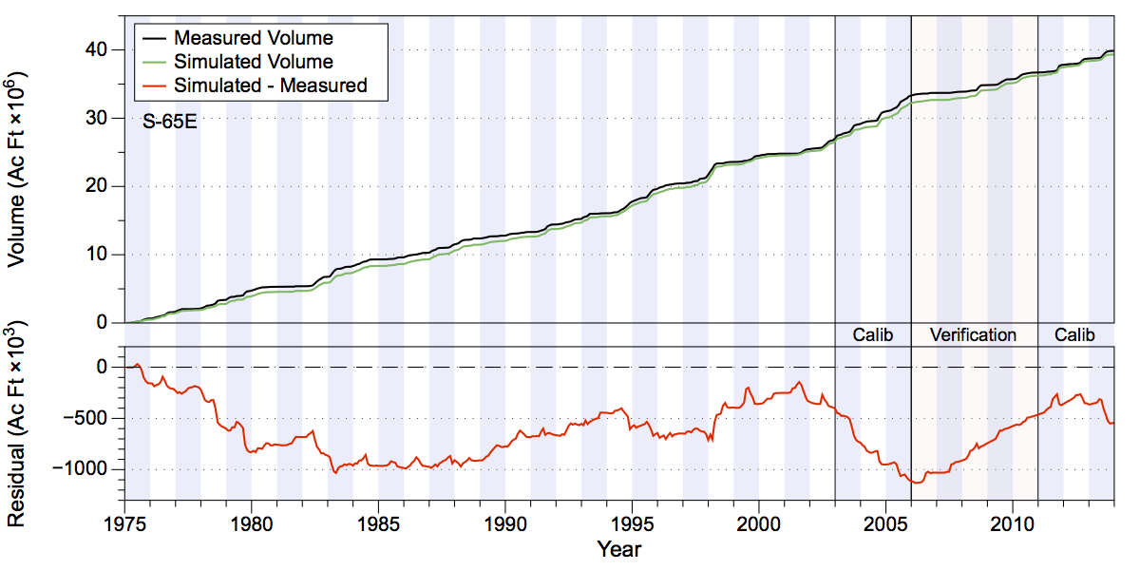
Figure 104. Total accumulated volume (millions of acre-feet) and residuals (thousands of acre feet) at S-65E.
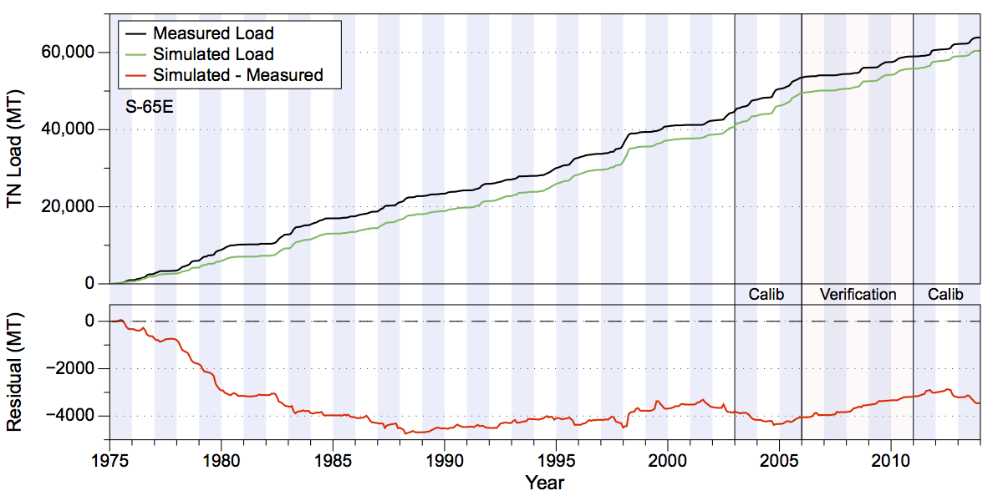
Figure 105. Total accumulated TN loads in metric tons (upper chart) and residual (lower chart) at S-65E.
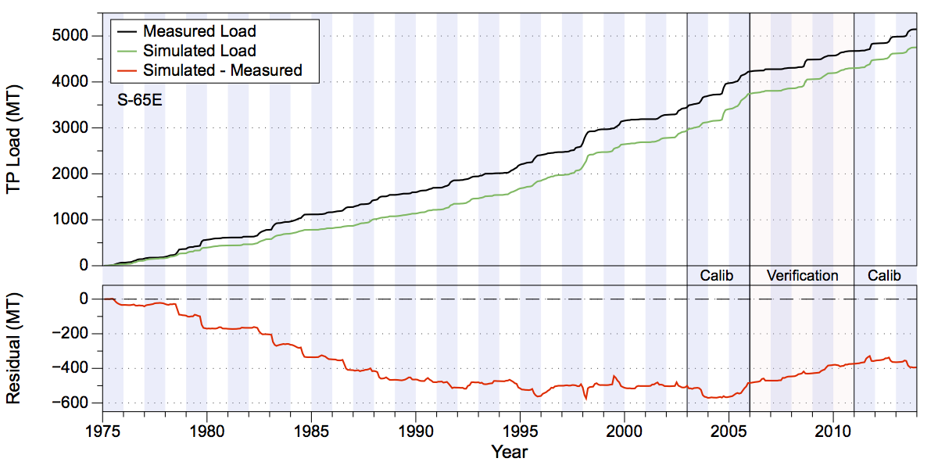
Figure 106. Total accumulated TP loads in metric tons (upper chart) and residual (lower chart) at S-65E.

Taylor Creek/Nubbin Slough
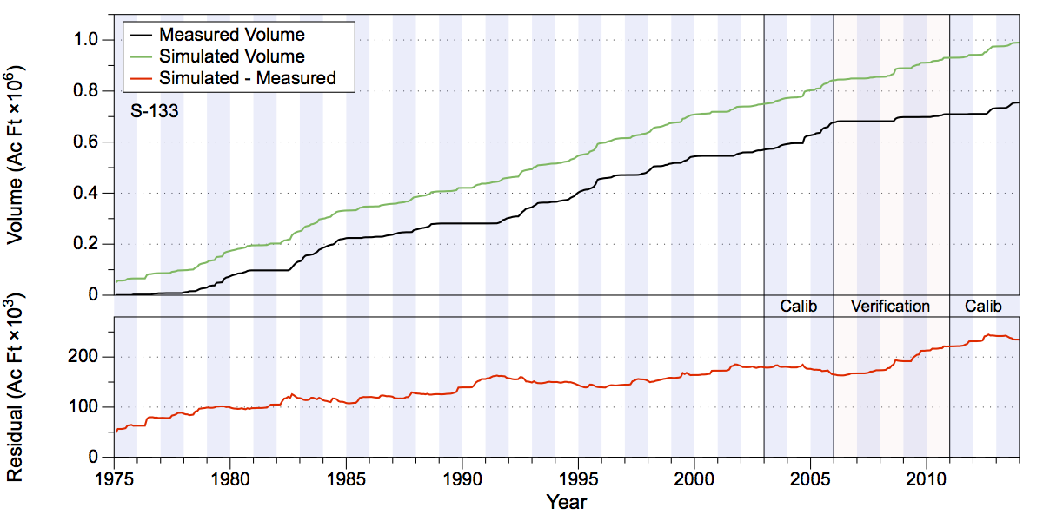
Figure 107. Total accumulated volume (millions of acre-feet) and residuals (thousands of acre feet) at S-133.
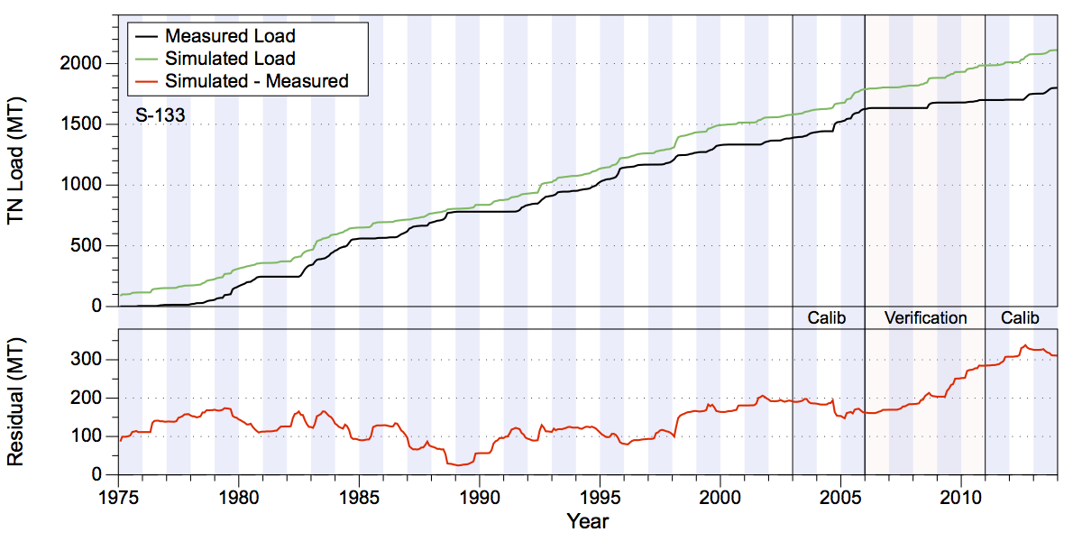
Figure 108. Total accumulated TN loads in metric tons (upper chart) and residual (lower chart) at S-133.
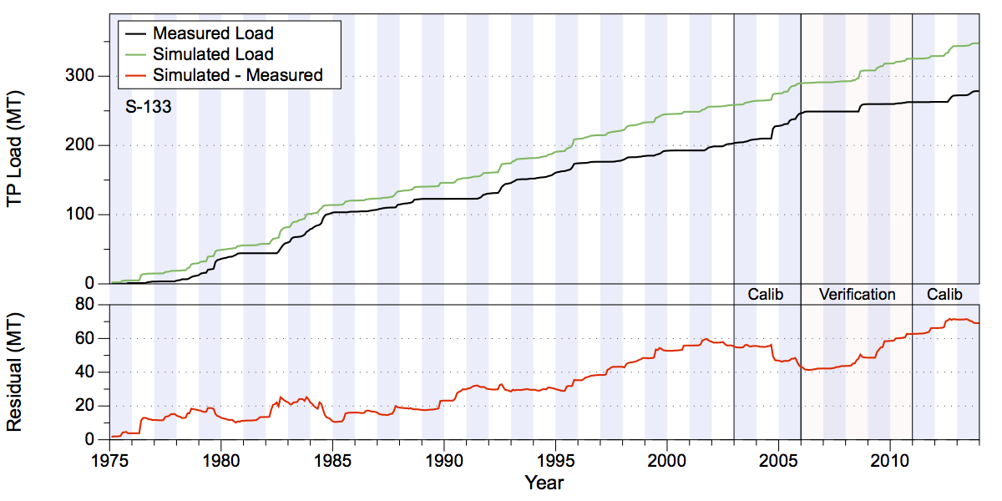
Figure 109. Total accumulated TP loads in metric tons (upper chart) and residual (lower chart) at S-133.
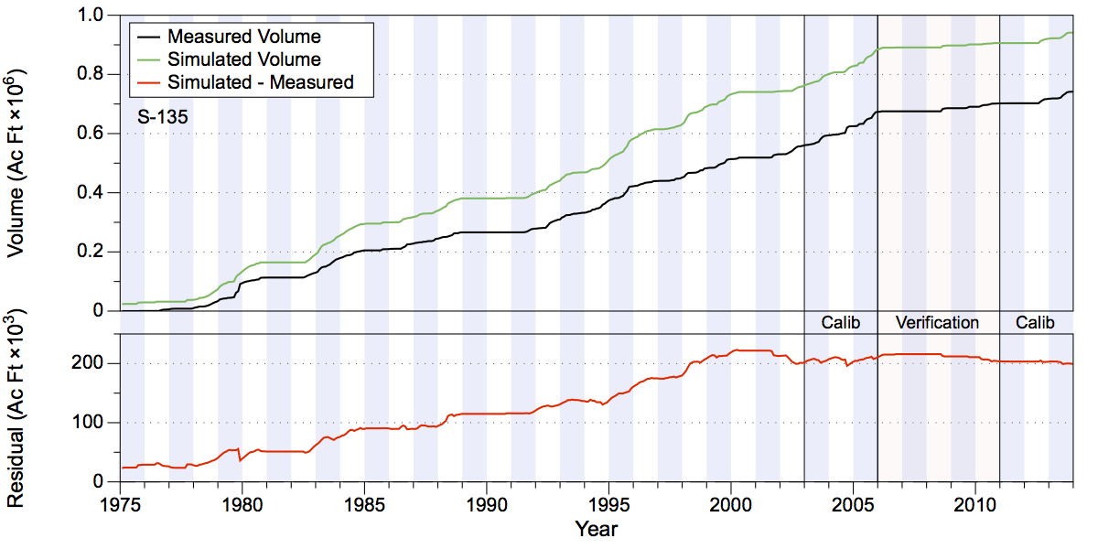
Figure 110. Total accumulated volume (millions of acre-feet) and residuals (thousands of acre feet) at S-135.
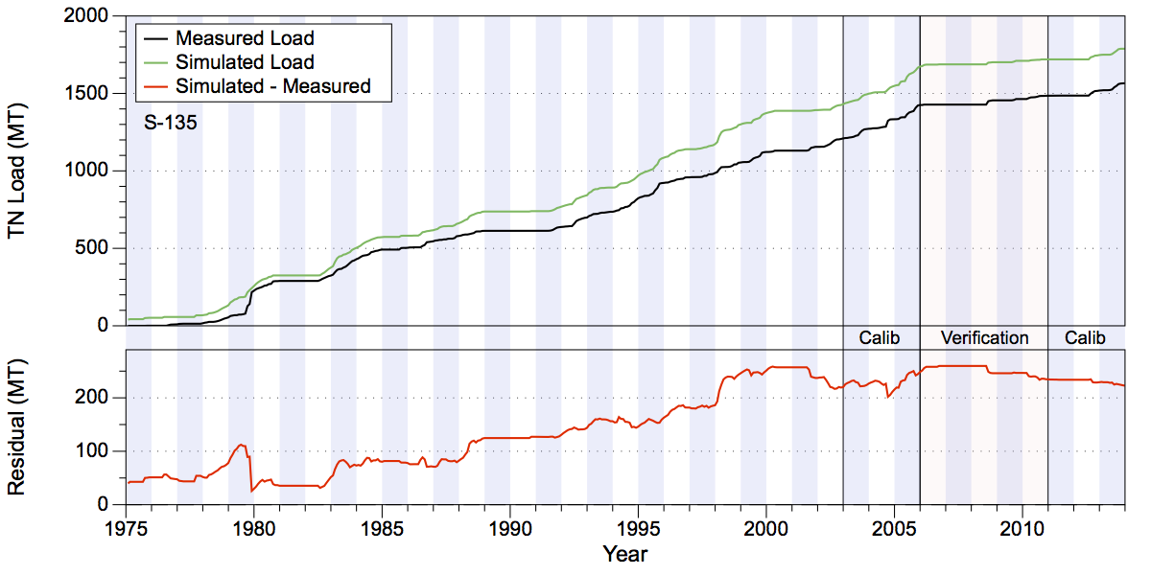
Figure 111. Total accumulated TN loads in metric tons (upper chart) and residual (lower chart) at S-135.
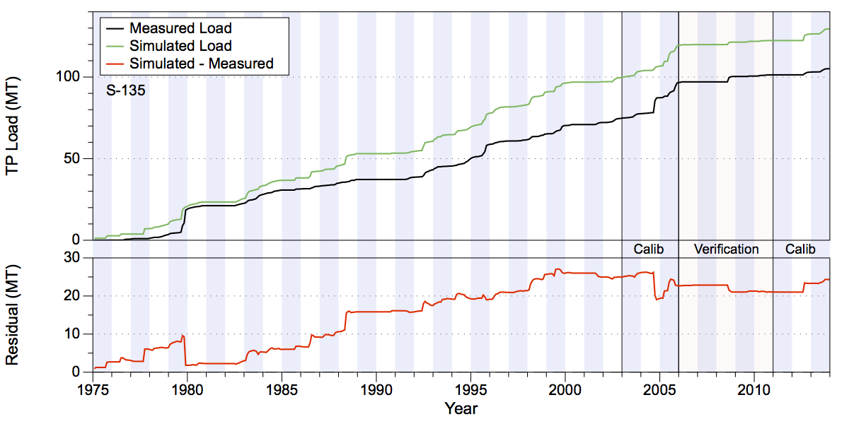
Figure 112. Total accumulated TP loads in metric tons (upper chart) and residual (lower chart) at S-135.
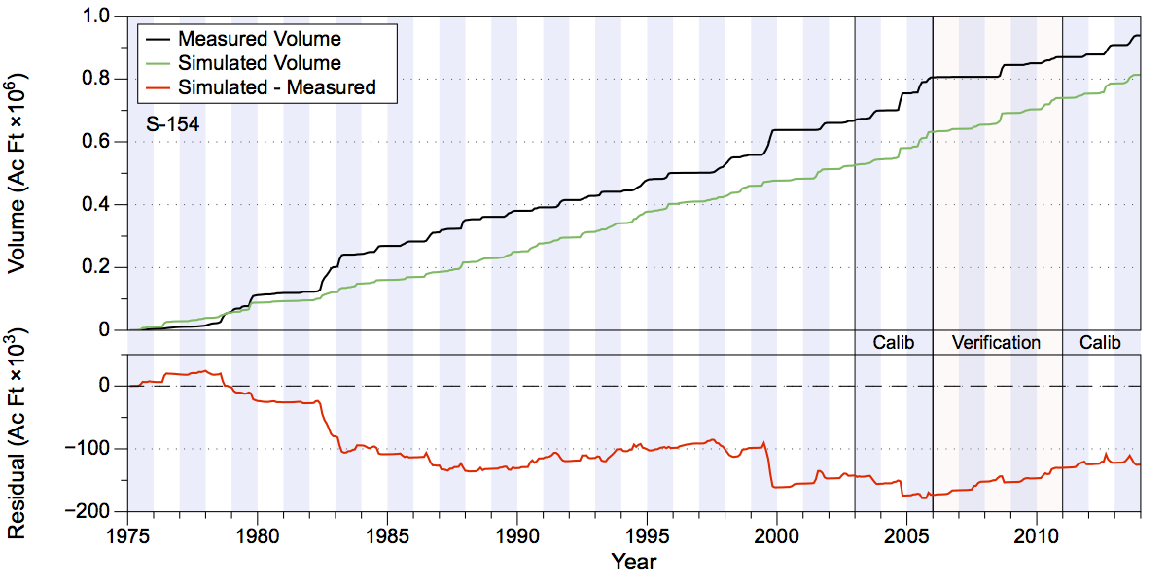
Figure 113. Total accumulated volume (millions of acre-feet) and residuals (thousands of acre feet) at S-154.
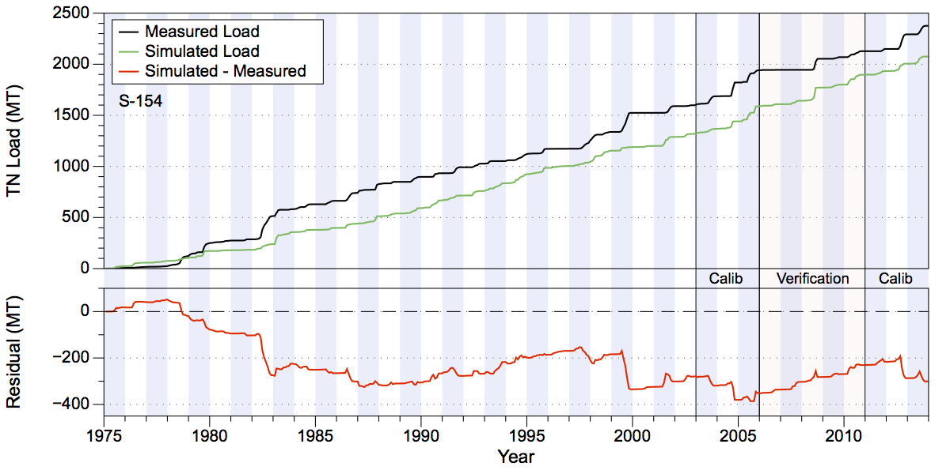
Figure 114. Total accumulated TN loads in metric tons (upper chart) and residual (lower chart) at S-154.
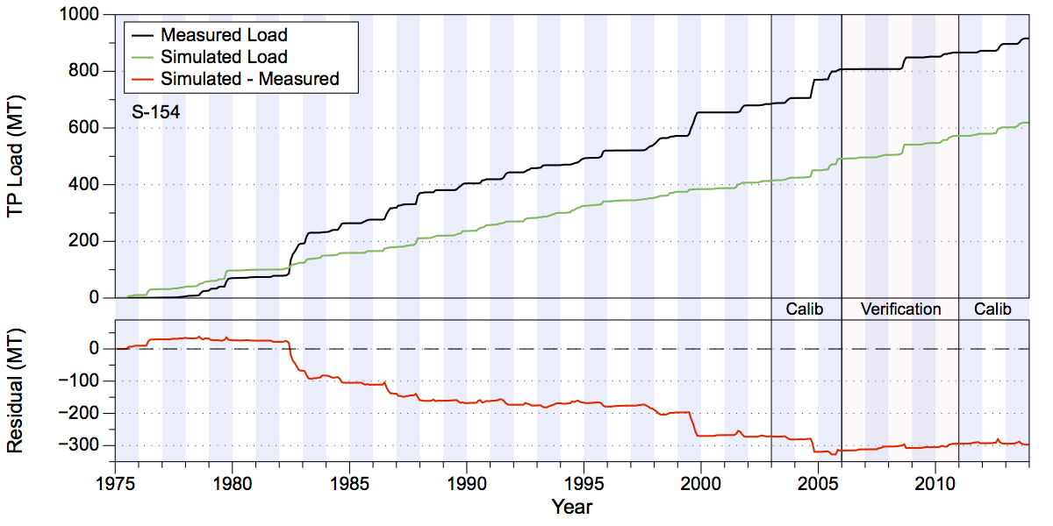
Figure 115. Total accumulated TP loads in metric tons (upper chart) and residual (lower chart) at S-154.
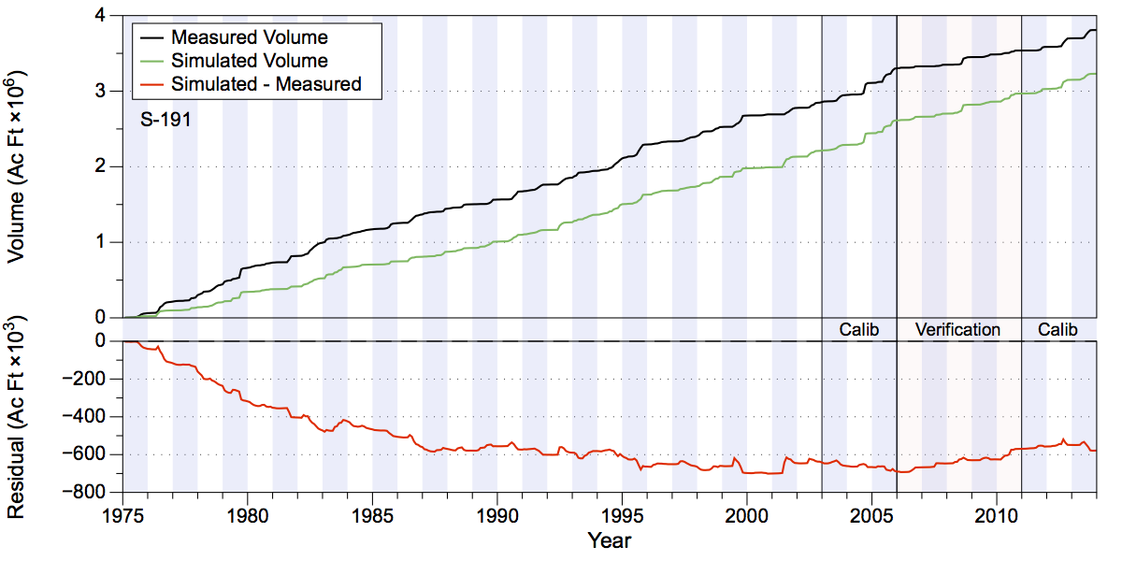
Figure 116. Total accumulated volume (millions of acre-feet) and residuals (thousands of acre feet) at S-191.
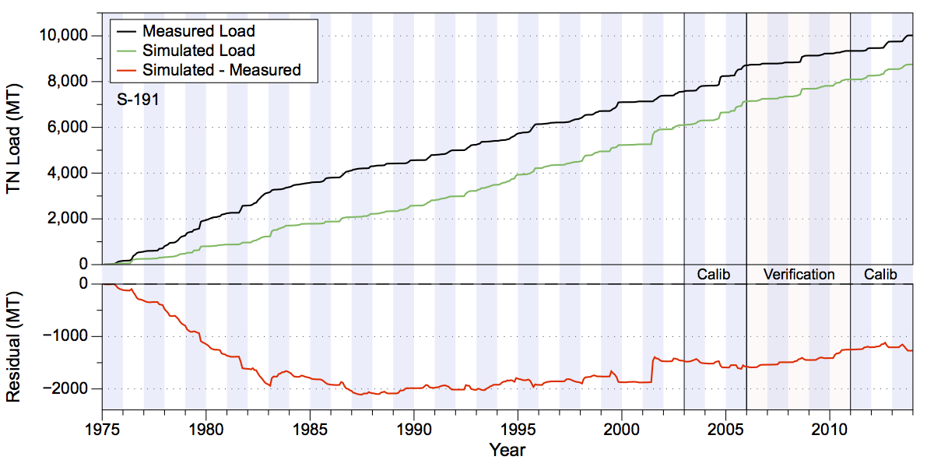
Figure 117. Total accumulated TN loads in metric tons (upper chart) and residual (lower chart) at S-191.
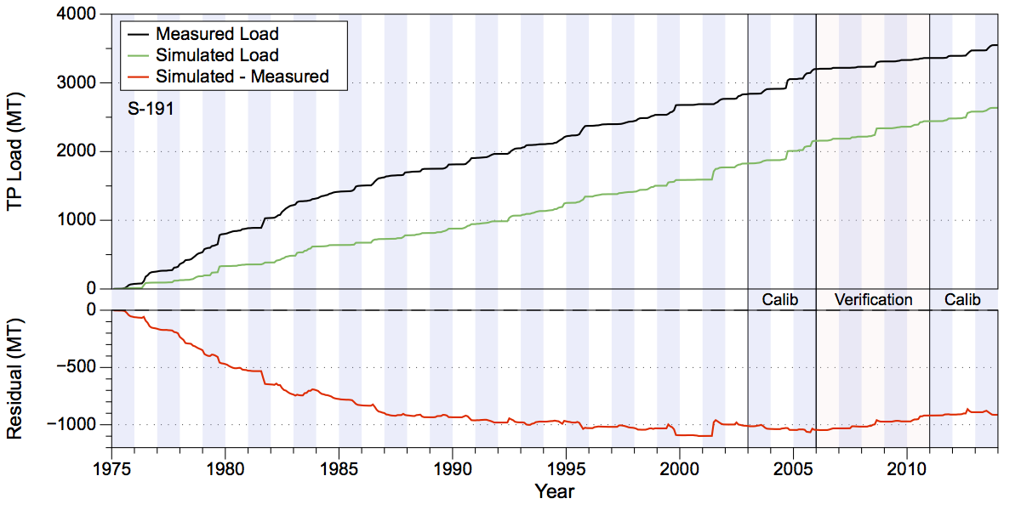
Figure 118. Total accumulated TP loads in metric tons (upper chart) and residual (lower chart) at S-191.

Upper Kissimmee
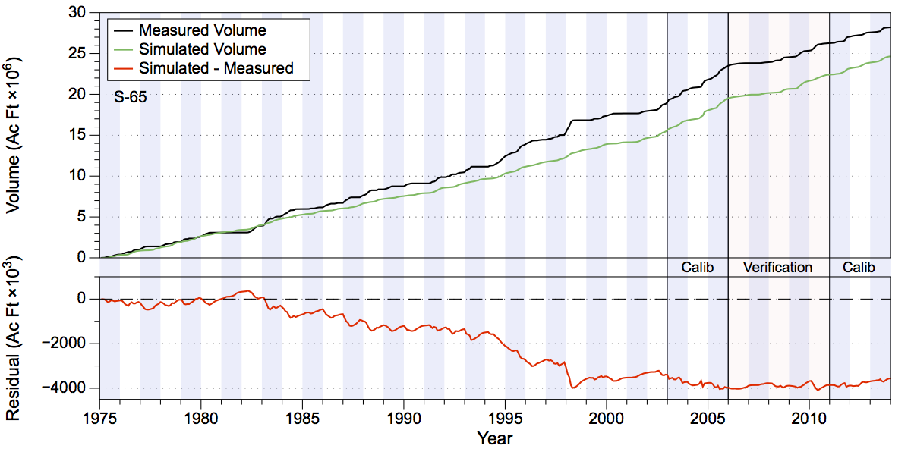
Figure 119. Total accumulated volume (millions of acre-feet) and residuals (thousands of acre feet) at S-65.
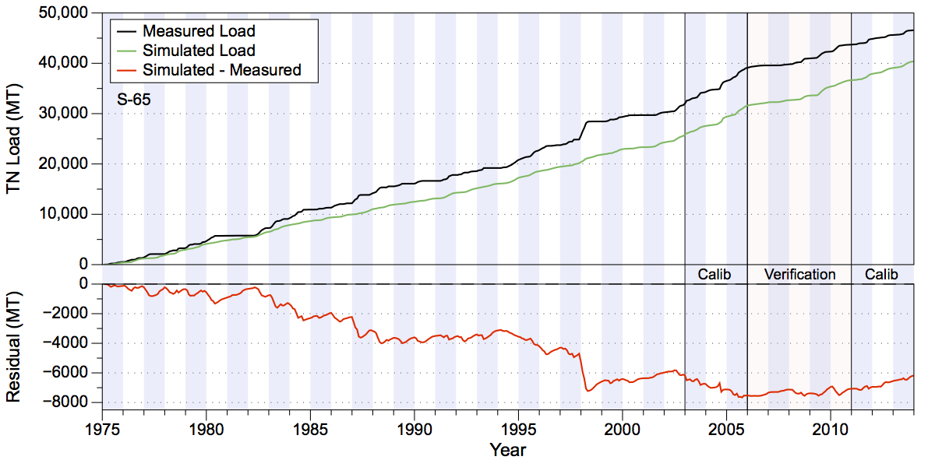
Figure 120. Total accumulated TN loads in metric tons (upper chart) and residual (lower chart) at S-65.
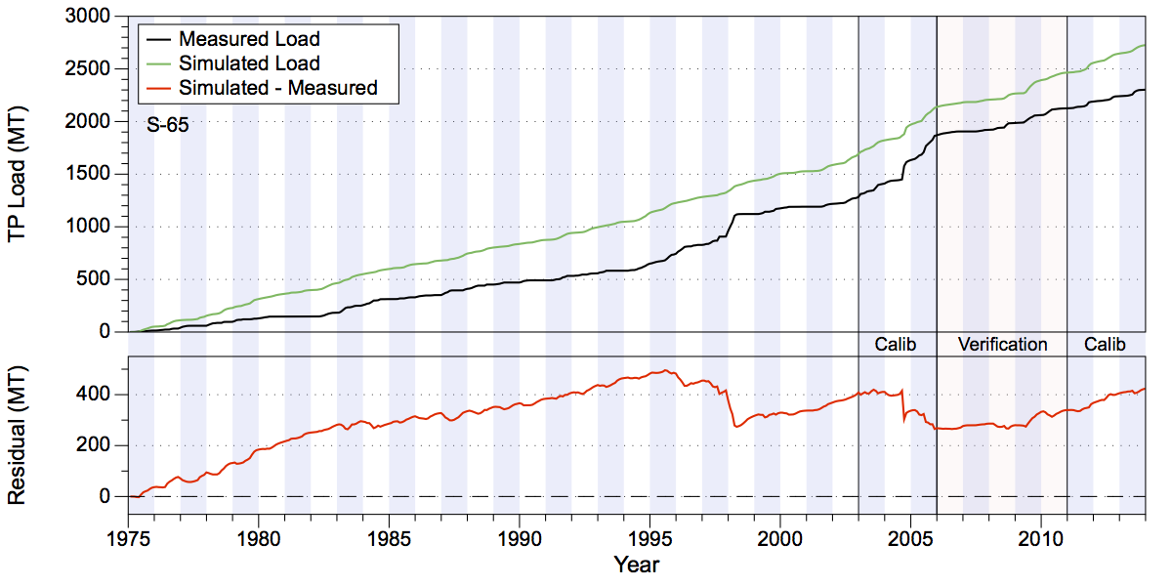
Figure 121. Total accumulated TP loads in metric tons (upper chart) and residual (lower chart) at S-65.

Volume and Nutrient Load Tables 1975-2013

Fisheating Creek

Volume over the period 1975-2013 at SR-78 on Fisheating Creek

Table 30. Comparison of measured and simulated water volume over the period 1998-2013 at SR-78 on Fisheating Creek (acre-feet).
Year | Simulated | Measured | Difference | Percentage
1998 | 211,166 | 511,144 | -299,978 | -58.69%
1999 | 326,498 | 246,040 | 80,459 | 32.70%
2000 | 57,110 | 15,206 | 41,904 | 275.58%
2001 | 223,510 | 321,447 | -97,937 | -30.47%
2002 | 351,692 | 367,197 | -15,505 | -4.22%
2003 | 299,220 | 373,353 | -74,133 | -19.86%
2004 | 299,730 | 382,493 | -82,762 | -21.64%
2005 | 384,374 | 408,393 | -24,019 | -5.88%
2006 | 213,520 | 186,635 | 26,885 | 14.41%
2007 | 48,463 | 32,653 | 15,810 | 48.42%
2008 | 238,852 | 233,674 | 5,178 | 2.22%
2009 | 165,509 | 171,495 | -5,986 | -3.49%
2010 | 195,230 | 105,416 | 89,814 | 85.20%
2011 | 140,099 | 93,297 | 46,802 | 50.16%
2012 | 237,736 | 203,132 | 34,605 | 17.04%
2013 | 383,524 | 392,557 | -9,033 | -2.30%
Total | 3,776,233 | 4,044,130 | -267,896 | -6.62%

Total Nitrogen Loads over the period 1998-2013 at SR-78 on Fisheating Creek

Table 31. Comparison of measured and simulated total nitrogen loads over the period 1998-2013 at SR-78 on Fisheating Creek (metric tons).
Year | Simulated | Measured | Difference | Percentage
1998 | 550.77 | 910.30 | -359.52 | -39.50%
1999 | 676.21 | 449.38 | 226.83 | 50.48%
2000 | 116.38 | 30.90 | 85.48 | 276.60%
2001 | 492.40 | 757.77 | -265.37 | -35.02%
2002 | 753.79 | 757.31 | -3.53 | -0.47%
2003 | 628.07 | 657.76 | -29.69 | -4.51%
2004 | 630.29 | 747.86 | -117.58 | -15.72%
2005 | 802.92 | 697.82 | 105.10 | 15.06%
2006 | 424.83 | 428.48 | -3.65 | -0.85%
2007 | 100.07 | 85.28 | 14.79 | 17.34%
2008 | 514.68 | 510.58 | 4.11 | 0.80%
2009 | 348.32 | 395.03 | -46.71 | -11.82%
2010 | 445.81 | 218.83 | 226.98 | 103.72%
2011 | 304.88 | 218.09 | 86.80 | 39.80%
2012 | 508.31 | 474.41 | 33.90 | 7.14%
2013 | 820.67 | 769.64 | 51.03 | 6.63%
Total | 8,118.38 | 8,109.43 | 8.95 | 0.11%

Total Phosphorus Loads over the period 1998-2013 at SR-78 on Fisheating Creek

Table 32. Comparison of measured and simulated total phosphorus loads over the period 1998-2013 at SR-78 on Fisheating Creek (metric tons).
Year | Simulated | Measured | Difference | Percentage
1998 | 50.25 | 125.77 | -75.52 | -60.05%
1999 | 86.05 | 49.35 | 36.70 | 74.37%
2000 | 10.22 | 2.81 | 7.41 | 263.57%
2001 | 65.25 | 135.08 | -69.83 | -51.69%
2002 | 99.94 | 98.66 | 1.28 | 1.30%
2003 | 73.40 | 69.30 | 4.10 | 5.91%
2004 | 81.05 | 133.66 | -52.60 | -39.36%
2005 | 97.70 | 83.59 | 14.11 | 16.88%
2006 | 57.44 | 66.24 | -8.80 | -13.29%
2007 | 9.04 | 8.52 | 0.52 | 6.14%
2008 | 63.06 | 80.77 | -17.71 | -21.93%
2009 | 39.43 | 67.79 | -28.36 | -41.83%
2010 | 51.28 | 23.92 | 27.35 | 114.34%
2011 | 29.93 | 23.40 | 6.53 | 27.91%
2012 | 59.25 | 47.27 | 11.98 | 25.35%
2013 | 102.12 | 101.92 | 0.20 | 0.19%
Total | 975.39 | 1,118.03 | -142.65 | -12.76%

Volume over the period 1998-2013 at Palmdale on Fisheating Creek

Table 33. Comparison of measured and simulated water volume over the period 1975-2013 at Palmdale on Fisheating Creek (acre-feet).
Year | Simulated | Measured | Difference | Percentage
1975 | 132,142 | 104,840 | 27,302 | 26.04%
1976 | 76,731 | 146,289 | -69,558 | -47.55%
1977 | 168,531 | 93,800 | 74,731 | 79.67%
1978 | 176,881 | 158,416 | 18,465 | 11.66%
1979 | 326,559 | 309,378 | 17,181 | 5.55%
1980 | 47,977 | 37,065 | 10,912 | 29.44%
1981 | 122,002 | 31,234 | 90,768 | 290.61%
1982 | 297,812 | 314,426 | -16,614 | -5.28%
1983 | 237,457 | 244,721 | -7,264 | -2.97%
1984 | 186,804 | 185,274 | 1,530 | 0.83%
1985 | 79,576 | 92,095 | -12,518 | -13.59%
1986 | 233,841 | 153,257 | 80,584 | 52.58%
1987 | 202,690 | 154,959 | 47,731 | 30.80%
1988 | 141,658 | 79,377 | 62,282 | 78.46%
1989 | 109,355 | 85,083 | 24,272 | 28.53%
1990 | 169,994 | 149,181 | 20,813 | 13.95%
1991 | 112,479 | 186,260 | -73,781 | -39.61%
1992 | 174,097 | 156,572 | 17,525 | 11.19%
1993 | 86,521 | 170,318 | -83,797 | -49.20%
1994 | 136,294 | 231,081 | -94,787 | -41.02%
1995 | 190,548 | 331,278 | -140,730 | -42.48%
1996 | 62,892 | 72,979 | -10,087 | -13.82%
1997 | 92,125 | 221,695 | -129,570 | -58.45%
1998 | 150,071 | 426,816 | -276,746 | -64.84%
1999 | 234,585 | 194,166 | 40,419 | 20.82%
2000 | 35,681 | 16,565 | 19,117 | 115.41%
2001 | 190,848 | 260,026 | -69,178 | -26.60%
2002 | 287,463 | 224,076 | 63,386 | 28.29%
2003 | 216,914 | 258,514 | -41,600 | -16.09%
2004 | 246,139 | 254,841 | -8,702 | -3.41%
2005 | 246,092 | 309,987 | -63,896 | -20.61%
2006 | 158,130 | 52,515 | 105,614 | 201.11%
2007 | 30,024 | 28,172 | 1,852 | 6.57%
2008 | 171,220 | 165,864 | 5,356 | 3.23%
2009 | 102,649 | 153,898 | -51,249 | -33.30%
2010 | 148,562 | 76,785 | 71,777 | 93.48%
2011 | 94,540 | 73,702 | 20,838 | 28.27%
Total | 5,877,883 | 6,205,503 | -327,620 | -5.28%

Total Nitrogen Loads over the period 1975-2011 at Palmdale on Fisheating Creek

Table 34. Comparison of measured and simulated total nitrogen loads over the period 1975-2013 at Palmdale on Fisheating Creek (metric tons).
Year | Simulated | Measured | Difference | Percentage
1975 | 252.99 | 230.50 | 22.48 | 9.75%
1976 | 151.14 | 276.72 | -125.59 | -45.38%
1977 | 324.97 | 224.03 | 100.94 | 45.06%
1978 | 344.26 | 313.00 | 31.26 | 9.99%
1979 | 673.77 | 870.24 | -196.47 | -22.58%
1980 | 104.44 | 119.79 | -15.35 | -12.81%
1981 | 247.50 | 136.59 | 110.91 | 81.20%
1982 | 602.52 | 625.14 | -22.62 | -3.62%
1983 | 800.12 | 329.68 | 470.44 | 142.70%
1984 | 378.48 | 306.58 | 71.91 | 23.45%
1985 | 157.30 | 215.28 | -57.98 | -26.93%
1986 | 483.50 | 361.37 | 122.12 | 33.79%
1987 | 434.71 | 291.47 | 143.24 | 49.14%
1988 | 279.19 | 124.97 | 154.22 | 123.41%
1989 | 230.03 | 175.95 | 54.09 | 30.74%
1990 | 383.02 | 277.31 | 105.72 | 38.12%
1991 | 230.53 | 366.18 | -135.66 | -37.05%
1992 | 366.55 | 313.27 | 53.27 | 17.01%
1993 | 192.52 | 314.83 | -122.31 | -38.85%
1994 | 297.73 | 363.19 | -65.46 | -18.02%
1995 | 417.45 | 503.54 | -86.09 | -17.10%
1996 | 138.40 | 142.14 | -3.74 | -2.63%
1997 | 210.60 | 486.89 | -276.29 | -56.75%
1998 | 423.72 | 758.78 | -335.07 | -44.16%
1999 | 495.71 | 352.74 | 142.97 | 40.53%
2000 | 76.63 | 48.34 | 28.29 | 58.53%
2001 | 430.12 | 616.42 | -186.30 | -30.22%
2002 | 636.33 | 469.96 | 166.37 | 35.40%
2003 | 469.26 | 465.96 | 3.30 | 0.71%
2004 | 534.59 | 515.66 | 18.93 | 3.67%
2005 | 526.71 | 546.48 | -19.77 | -3.62%
2006 | 324.76 | 119.76 | 204.99 | 171.16%
2007 | 66.97 | 76.99 | -10.02 | -13.02%
2008 | 377.46 | 368.62 | 8.84 | 2.40%
2009 | 221.51 | 375.95 | -154.44 | -41.08%
2010 | 349.09 | 155.31 | 193.78 | 124.77%
2011 | 212.65 | 180.16 | 32.49 | 18.03%
Total | 12,847.22 | 12,419.81 | 427.41 | 3.44%

Total Phosphorus Loads over the period 1975-2011 at Palmdale on Fisheating Creek

Table 35. Comparison of measured and simulated total phosphorus loads over the period 1975-2011 at Palmdale on Fisheating Creek (metric tons).
Year | Simulated | Measured | Difference | Percentage
1975 | 41.51 | 26.20 | 15.31 | 58.44%
1976 | 17.48 | 35.88 | -18.40 | -51.27%
1977 | 48.04 | 18.97 | 29.07 | 153.24%
1978 | 46.55 | 25.96 | 20.59 | 79.34%
1979 | 109.88 | 72.15 | 37.74 | 52.31%
1980 | 9.65 | 7.47 | 2.18 | 29.17%
1981 | 32.56 | 17.35 | 15.21 | 87.65%
1982 | 91.96 | 103.13 | -11.17 | -10.83%
1983 | 67.32 | 41.73 | 25.59 | 61.31%
1984 | 56.27 | 66.91 | -10.65 | -15.91%
1985 | 21.22 | 29.56 | -8.34 | -28.21%
1986 | 90.66 | 46.32 | 44.34 | 95.74%
1987 | 60.56 | 19.52 | 41.04 | 210.20%
1988 | 36.50 | 10.39 | 26.11 | 251.17%
1989 | 29.09 | 20.89 | 8.20 | 39.27%
1990 | 47.25 | 44.39 | 2.86 | 6.44%
1991 | 27.11 | 23.21 | 3.90 | 16.81%
1992 | 53.16 | 38.15 | 15.01 | 39.35%
1993 | 19.40 | 27.73 | -8.33 | -30.05%
1994 | 37.28 | 43.46 | -6.18 | -14.22%
1995 | 51.31 | 49.51 | 1.81 | 3.65%
1996 | 14.54 | 21.77 | -7.22 | -33.18%
1997 | 23.14 | 55.57 | -32.43 | -58.36%
1998 | 42.34 | 105.05 | -62.71 | -59.70%
1999 | 70.40 | 38.97 | 31.43 | 80.67%
2000 | 7.93 | 6.31 | 1.62 | 25.60%
2001 | 61.96 | 114.05 | -52.09 | -45.67%
2002 | 91.57 | 65.63 | 25.95 | 39.54%
2003 | 59.82 | 50.92 | 8.90 | 17.48%
2004 | 75.31 | 110.63 | -35.32 | -31.93%
2005 | 68.85 | 69.93 | -1.08 | -1.54%
2006 | 47.92 | 18.79 | 29.13 | 155.05%
2007 | 6.55 | 8.95 | -2.39 | -26.75%
2008 | 50.97 | 60.28 | -9.32 | -15.45%
2009 | 27.12 | 74.70 | -47.58 | -63.70%
2010 | 45.84 | 16.52 | 29.32 | 177.54%
2011 | 23.06 | 20.15 | 2.91 | 14.45%
Total | 1,712.08 | 1,607.06 | 105.02 | 6.53%

Indian Prairie

Table 36. Comparison of measured and simulated water volume over the period 1975-2013 at S-84 (acre-feet).
Year | Simulated | Measured | Difference | Percentage
1975 | 77,538 | 87,261 | -9,722 | -11.14%
1976 | 80,925 | 57,027 | 23,898 | 41.91%
1977 | 24,010 | 3,979 | 20,032 | 503.45%
1978 | 133,771 | 140,864 | -7,093 | -5.04%
1979 | 154,055 | 234,456 | -80,402 | -34.29%
1980 | 48,373 | 52,257 | -3,884 | -7.43%
1981 | 7,548 | 6,175 | 1,374 | 22.25%
1982 | 206,389 | 252,111 | -45,722 | -18.14%
1983 | 175,023 | 228,879 | -53,856 | -23.53%
1984 | 107,896 | 132,762 | -24,865 | -18.73%
1985 | 29,205 | 42,284 | -13,079 | -30.93%
1986 | 40,308 | 40,865 | -557 | -1.36%
1987 | 91,257 | 117,352 | -26,095 | -22.24%
1988 | 122,816 | 141,316 | -18,500 | -13.09%
1989 | 55,879 | 65,492 | -9,613 | -14.68%
1990 | 125,614 | 103,983 | 21,630 | 20.80%
1991 | 139,283 | 144,805 | -5,522 | -3.81%
1992 | 53,549 | 70,527 | -16,978 | -24.07%
1993 | 74,076 | 65,631 | 8,445 | 12.87%
1994 | 185,726 | 205,817 | -20,091 | -9.76%
1995 | 302,082 | 287,135 | 14,947 | 5.21%
1996 | 88,719 | 85,253 | 3,466 | 4.07%
1997 | 149,623 | 194,332 | -44,709 | -23.01%
1998 | 353,103 | 403,719 | -50,616 | -12.54%
1999 | 172,915 | 209,411 | -36,496 | -17.43%
2000 | 18,108 | 24,364 | -6,256 | -25.68%
2001 | 145,655 | 140,707 | 4,948 | 3.52%
2002 | 258,156 | 260,737 | -2,581 | -0.99%
2003 | 273,362 | 271,803 | 1,559 | 0.57%
2004 | 235,232 | 193,115 | 42,117 | 21.81%
2005 | 335,251 | 354,418 | -19,166 | -5.41%
2006 | 67,268 | 64,145 | 3,123 | 4.87%
2007 | 20,246 | 19,673 | 572 | 2.91%
2008 | 187,139 | 163,327 | 23,812 | 14.58%
2009 | 105,592 | 151,069 | -45,477 | -30.10%
2010 | 121,412 | 187,403 | -65,990 | -35.21%
2011 | 136,772 | 151,241 | -14,469 | -9.57%
2012 | 222,075 | 144,910 | 77,166 | 53.25%
2013 | 265,420 | 426,485 | -161,065 | -37.77%
Total | 5,391,373 | 5,927,090 | -535,717 | -9.04%

Total Nitrogen Loads over the period 1975-2013 at S-84

Table 37. Comparison of measured and simulated total nitrogen loads over the period 1975-2013 at S-84 (metric tons).
Year | Simulated | Measured | Difference | Percentage
1975 | 110.81 | 161.45 | -50.64 | -31.37%
1976 | 119.70 | 121.11 | -1.42 | -1.17%
1977 | 39.77 | 10.00 | 29.78 | 297.84%
1978 | 185.46 | 473.85 | -288.40 | -60.86%
1979 | 237.78 | 409.82 | -172.04 | -41.98%
1980 | 68.81 | 114.03 | -45.22 | -39.66%
1981 | 13.95 | 10.50 | 3.45 | 32.89%
1982 | 294.82 | 399.94 | -105.12 | -26.28%
1983 | 341.32 | 309.85 | 31.46 | 10.15%
1984 | 157.14 | 163.10 | -5.97 | -3.66%
1985 | 49.43 | 75.40 | -25.96 | -34.44%
1986 | 71.60 | 66.09 | 5.51 | 8.34%
1987 | 150.11 | 190.11 | -40.00 | -21.04%
1988 | 145.70 | 169.03 | -23.33 | -13.80%
1989 | 98.48 | 111.35 | -12.87 | -11.56%
1990 | 186.02 | 151.04 | 34.98 | 23.16%
1991 | 199.05 | 248.85 | -49.80 | -20.01%
1992 | 98.33 | 99.05 | -0.73 | -0.73%
1993 | 100.30 | 86.83 | 13.47 | 15.52%
1994 | 246.52 | 262.08 | -15.57 | -5.94%
1995 | 385.67 | 365.63 | 20.04 | 5.48%
1996 | 118.88 | 121.02 | -2.14 | -1.77%
1997 | 267.01 | 333.17 | -66.16 | -19.86%
1998 | 579.03 | 569.21 | 9.83 | 1.73%
1999 | 271.19 | 348.29 | -77.09 | -22.14%
2000 | 30.38 | 34.55 | -4.17 | -12.07%
2001 | 219.36 | 344.55 | -125.19 | -36.33%
2002 | 468.53 | 465.43 | 3.10 | 0.67%
2003 | 424.31 | 431.99 | -7.68 | -1.78%
2004 | 399.85 | 343.81 | 56.04 | 16.30%
2005 | 549.09 | 582.69 | -33.60 | -5.77%
2006 | 130.57 | 95.70 | 34.86 | 36.43%
2007 | 40.40 | 40.70 | -0.30 | -0.74%
2008 | 373.16 | 373.47 | -0.31 | -0.08%
2009 | 275.01 | 298.21 | -23.21 | -7.78%
2010 | 249.26 | 317.07 | -67.80 | -21.38%
2011 | 254.49 | 286.12 | -31.63 | -11.05%
2012 | 469.78 | 306.01 | 163.77 | 53.52%
2013 | 430.29 | 792.03 | -361.74 | -45.67%
Total | 8,851.35 | 10,083.15 | -1,231.79 | -12.22%

Total Phosphorus Loads over the period 1975-2013 at S-84

Table 38. Comparison of measured and simulated total phosphorus loads over the period 1975-2013 at S-84 (metric tons).
Year | Simulated | Measured | Difference | Percentage
1975 | 7.35 | 5.76 | 1.59 | 27.58%
1976 | 6.57 | 4.21 | 2.36 | 56.20%
1977 | 3.01 | 0.23 | 2.78 | 1219.73%
1978 | 10.15 | 6.53 | 3.62 | 55.42%
1979 | 28.99 | 20.12 | 8.88 | 44.13%
1980 | 3.09 | 2.87 | 0.21 | 7.47%
1981 | 0.63 | 0.37 | 0.26 | 71.33%
1982 | 24.02 | 22.97 | 1.05 | 4.57%
1983 | 19.27 | 26.05 | -6.78 | -26.02%
1984 | 9.49 | 18.21 | -8.72 | -47.88%
1985 | 3.30 | 2.50 | 0.80 | 32.09%
1986 | 6.42 | 11.38 | -4.95 | -43.55%
1987 | 19.27 | 10.15 | 9.13 | 89.94%
1988 | 7.09 | 7.94 | -0.85 | -10.71%
1989 | 7.25 | 5.96 | 1.29 | 21.65%
1990 | 14.52 | 10.33 | 4.19 | 40.55%
1991 | 12.23 | 11.28 | 0.94 | 8.34%
1992 | 10.68 | 5.98 | 4.70 | 78.68%
1993 | 6.93 | 7.46 | -0.53 | -7.08%
1994 | 17.84 | 12.29 | 5.55 | 45.15%
1995 | 28.11 | 11.98 | 16.13 | 134.70%
1996 | 7.04 | 4.12 | 2.92 | 71.02%
1997 | 14.53 | 14.90 | -0.37 | -2.50%
1998 | 41.88 | 38.92 | 2.96 | 7.59%
1999 | 17.95 | 22.69 | -4.74 | -20.90%
2000 | 1.95 | 1.70 | 0.24 | 14.19%
2001 | 9.32 | 17.19 | -7.87 | -45.78%
2002 | 30.85 | 27.65 | 3.20 | 11.58%
2003 | 23.20 | 27.14 | -3.94 | -14.52%
2004 | 30.07 | 30.41 | -0.33 | -1.10%
2005 | 41.80 | 48.97 | -7.17 | -14.65%
2006 | 7.74 | 7.46 | 0.28 | 3.81%
2007 | 2.11 | 5.92 | -3.81 | -64.33%
2008 | 19.40 | 39.14 | -19.74 | -50.43%
2009 | 20.39 | 16.05 | 4.35 | 27.09%
2010 | 15.97 | 15.01 | 0.96 | 6.40%
2011 | 12.40 | 13.25 | -0.85 | -6.41%
2012 | 32.25 | 15.56 | 16.69 | 107.31%
2013 | 38.57 | 43.82 | -5.25 | -11.98%
Total | 613.63 | 594.45 | 19.18 | 3.23%

Volume over the period 1975-2013 at S-71

Table 39. Comparison of measured and simulated water volume over the period 1975-2013 at S-71 (acre-feet).
Year | Simulated | Measured | Difference | Percentage
1975 | 118,070 | 82,169 | 35,901 | 43.69%
1976 | 107,194 | 95,970 | 11,224 | 11.70%
1977 | 101,417 | 82,885 | 18,531 | 22.36%
1978 | 149,847 | 269,548 | -119,701 | -44.41%
1979 | 217,477 | 335,730 | -118,254 | -35.22%
1980 | 82,729 | 48,008 | 34,721 | 72.32%
1981 | 59,546 | 31,392 | 28,154 | 89.68%
1982 | 222,264 | 221,685 | 580 | 0.26%
1983 | 206,915 | 301,642 | -94,728 | -31.40%
1984 | 129,019 | 166,885 | -37,866 | -22.69%
1985 | 73,359 | 60,208 | 13,151 | 21.84%
1986 | 138,899 | 110,069 | 28,830 | 26.19%
1987 | 151,983 | 189,923 | -37,940 | -19.98%
1988 | 149,153 | 116,644 | 32,509 | 27.87%
1989 | 140,267 | 88,483 | 51,784 | 58.52%
1990 | 167,585 | 136,512 | 31,073 | 22.76%
1991 | 178,119 | 185,855 | -7,736 | -4.16%
1992 | 117,374 | 128,306 | -10,932 | -8.52%
1993 | 136,684 | 50,641 | 86,044 | 169.91%
1994 | 203,246 | 157,616 | 45,630 | 28.95%
1995 | 253,492 | 293,604 | -40,112 | -13.66%
1996 | 142,019 | 88,423 | 53,596 | 60.61%
1997 | 152,889 | 124,750 | 28,139 | 22.56%
1998 | 279,483 | 265,350 | 14,133 | 5.33%
1999 | 210,617 | 165,708 | 44,910 | 27.10%
2000 | 62,592 | 28,947 | 33,646 | 116.23%
2001 | 142,744 | 187,274 | -44,530 | -23.78%
2002 | 235,895 | 271,240 | -35,345 | -13.03%
2003 | 216,486 | 239,687 | -23,201 | -9.68%
2004 | 213,243 | 310,937 | -97,693 | -31.42%
2005 | 265,653 | 327,995 | -62,342 | -19.01%
2006 | 121,927 | 105,733 | 16,194 | 15.32%
2007 | 63,072 | 34,537 | 28,535 | 82.62%
2008 | 175,830 | 261,652 | -85,822 | -32.80%
2009 | 142,331 | 114,482 | 27,849 | 24.33%
2010 | 155,088 | 92,029 | 63,058 | 68.52%
2011 | 161,311 | 91,926 | 69,385 | 75.48%
2012 | 205,940 | 254,247 | -48,307 | -19.00%
2013 | 298,436 | 194,714 | 103,723 | 53.27%
Total | 6,350,196 | 6,313,407 | 36,789 | 0.58%

Total Nitrogen Loads over the period 1975-2013 at S-71

Table 40. Comparison of measured and simulated total nitrogen loads over the period 1975-2013 at S-71 (metric tons).
Year | Simulated | Measured | Difference | Percentage
1975 | 237.18 | 236.67 | 0.51 | 0.22%
1976 | 245.04 | 264.91 | -19.87 | -7.50%
1977 | 297.05 | 221.97 | 75.07 | 33.82%
1978 | 388.44 | 683.59 | -295.15 | -43.18%
1979 | 578.12 | 1,036.58 | -458.46 | -44.23%
1980 | 203.93 | 143.82 | 60.11 | 41.80%
1981 | 225.22 | 103.02 | 122.19 | 118.61%
1982 | 507.37 | 789.33 | -281.96 | -35.72%
1983 | 660.98 | 774.52 | -113.54 | -14.66%
1984 | 324.65 | 361.15 | -36.50 | -10.11%
1985 | 214.54 | 204.98 | 9.56 | 4.66%
1986 | 378.56 | 342.69 | 35.86 | 10.46%
1987 | 397.69 | 825.76 | -428.07 | -51.84%
1988 | 286.25 | 229.78 | 56.48 | 24.58%
1989 | 378.41 | 250.03 | 128.38 | 51.35%
1990 | 387.39 | 387.04 | 0.35 | 0.09%
1991 | 490.67 | 550.70 | -60.03 | -10.90%
1992 | 406.01 | 472.86 | -66.85 | -14.14%
1993 | 360.55 | 161.56 | 198.99 | 123.17%
1994 | 483.49 | 344.51 | 138.98 | 40.34%
1995 | 508.27 | 754.85 | -246.58 | -32.67%
1996 | 318.68 | 170.80 | 147.88 | 86.58%
1997 | 405.92 | 421.34 | -15.42 | -3.66%
1998 | 735.77 | 730.15 | 5.62 | 0.77%
1999 | 488.52 | 482.44 | 6.08 | 1.26%
2000 | 166.40 | 86.29 | 80.11 | 92.83%
2001 | 428.97 | 634.71 | -205.74 | -32.42%
2002 | 624.85 | 888.21 | -263.37 | -29.65%
2003 | 514.23 | 646.90 | -132.67 | -20.51%
2004 | 520.85 | 798.01 | -277.16 | -34.73%
2005 | 580.31 | 988.47 | -408.16 | -41.29%
2006 | 334.25 | 339.56 | -5.31 | -1.56%
2007 | 176.58 | 80.60 | 95.98 | 119.08%
2008 | 593.24 | 844.87 | -251.63 | -29.78%
2009 | 514.02 | 369.40 | 144.62 | 39.15%
2010 | 497.80 | 309.47 | 188.33 | 60.86%
2011 | 500.76 | 267.40 | 233.36 | 87.27%
2012 | 620.46 | 819.26 | -198.80 | -24.27%
2013 | 757.85 | 537.61 | 220.25 | 40.97%
Total | 16,739.26 | 18,555.82 | -1,816.55 | -9.79%

Total Phosphorus Loads over the period 1975-2013 at S-71

Table 41. Comparison of measured and simulated total phosphorus loads over the period 1975-2013 at S-71 (metric tons).
Year | Simulated | Measured | Difference | Percentage
1975 | 57.88 | 26.64 | 31.25 | 117.33%
1976 | 34.17 | 20.45 | 13.71 | 67.04%
1977 | 50.44 | 29.89 | 20.55 | 68.77%
1978 | 49.31 | 65.64 | -16.33 | -24.88%
1979 | 125.51 | 138.55 | -13.04 | -9.41%
1980 | 16.42 | 8.06 | 8.36 | 103.64%
1981 | 15.53 | 13.48 | 2.06 | 15.25%
1982 | 76.72 | 74.03 | 2.69 | 3.64%
1983 | 63.04 | 72.85 | -9.81 | -13.47%
1984 | 33.67 | 50.26 | -16.59 | -33.01%
1985 | 21.11 | 19.74 | 1.37 | 6.94%
1986 | 68.28 | 33.01 | 35.27 | 106.84%
1987 | 71.62 | 57.34 | 14.28 | 24.91%
1988 | 23.68 | 19.11 | 4.56 | 23.88%
1989 | 57.54 | 23.85 | 33.69 | 141.24%
1990 | 45.51 | 38.72 | 6.79 | 17.55%
1991 | 55.70 | 40.80 | 14.90 | 36.51%
1992 | 75.85 | 36.77 | 39.08 | 106.26%
1993 | 32.28 | 11.63 | 20.65 | 177.50%
1994 | 60.53 | 27.23 | 33.30 | 122.29%
1995 | 68.85 | 67.24 | 1.61 | 2.40%
1996 | 36.84 | 16.65 | 20.19 | 121.23%
1997 | 38.28 | 32.90 | 5.38 | 16.36%
1998 | 77.13 | 61.47 | 15.66 | 25.48%
1999 | 71.43 | 31.19 | 40.24 | 129.01%
2000 | 24.77 | 7.66 | 17.12 | 223.61%
2001 | 38.24 | 77.01 | -38.77 | -50.34%
2002 | 69.86 | 91.53 | -21.67 | -23.68%
2003 | 40.38 | 72.76 | -32.38 | -44.50%
2004 | 64.50 | 89.56 | -25.07 | -27.99%
2005 | 50.47 | 113.19 | -62.72 | -55.41%
2006 | 46.98 | 50.00 | -3.03 | -6.05%
2007 | 20.14 | 10.61 | 9.53 | 89.80%
2008 | 89.84 | 86.97 | 2.87 | 3.30%
2009 | 69.40 | 43.96 | 25.44 | 57.87%
2010 | 68.01 | 35.76 | 32.25 | 90.18%
2011 | 59.14 | 24.75 | 34.40 | 139.00%
2012 | 78.20 | 73.71 | 4.48 | 6.08%
2013 | 105.71 | 65.01 | 40.70 | 62.61%
Total | 2,153.00 | 1,860.01 | 292.99 | 15.75%

Volume over the period 1975-2013 at S-72

Table 42. Comparison of measured and simulated water volume over the period 1975-2013 at S-72 (acre-feet).
Year | Simulated | Measured | Difference | Percentage
1975 | 17,929 | 7,505 | 10,424 | 138.89%
1976 | 14,973 | 20,485 | -5,512 | -26.91%
1977 | 16,563 | 21,251 | -4,688 | -22.06%
1978 | 32,846 | 71,845 | -39,000 | -54.28%
1979 | 85,770 | 71,254 | 14,515 | 20.37%
1980 | 8,292 | 4,344 | 3,948 | 90.88%
1981 | 4,618 | 5,098 | -479 | -9.40%
1982 | 80,447 | 44,237 | 36,209 | 81.85%
1983 | 67,964 | 40,052 | 27,912 | 69.69%
1984 | 22,949 | 16,050 | 6,899 | 42.98%
1985 | 10,528 | 147 | 10,381 | 7072.52%
1986 | 21,926 | 15,059 | 6,867 | 45.60%
1987 | 36,465 | 34,810 | 1,655 | 4.75%
1988 | 35,137 | 20,239 | 14,898 | 73.61%
1989 | 26,867 | 29,443 | -2,576 | -8.75%
1990 | 38,990 | 96,639 | -57,649 | -59.65%
1991 | 42,527 | 34,828 | 7,699 | 22.11%
1992 | 28,854 | 55,883 | -27,028 | -48.37%
1993 | 21,445 | 34,289 | -12,843 | -37.46%
1994 | 46,825 | 65,735 | -18,910 | -28.77%
1995 | 135,590 | 87,201 | 48,389 | 55.49%
1996 | 45,437 | 13,679 | 31,758 | 232.17%
1997 | 68,015 | 40,191 | 27,824 | 69.23%
1998 | 94,808 | 76,321 | 18,487 | 24.22%
1999 | 51,643 | 59,416 | -7,773 | -13.08%
2000 | 3,588 | 8,131 | -4,543 | -55.87%
2001 | 34,324 | 43,238 | -8,914 | -20.62%
2002 | 72,383 | 67,619 | 4,764 | 7.05%
2003 | 56,210 | 77,686 | -21,476 | -27.64%
2004 | 60,295 | 106,514 | -46,219 | -43.39%
2005 | 82,610 | 56,767 | 25,842 | 45.52%
2006 | 23,948 | 13,168 | 10,780 | 81.86%
2007 | 8,168 | 6,368 | 1,800 | 28.27%
2008 | 72,325 | 70,780 | 1,545 | 2.18%
2009 | 37,768 | 15,720 | 22,048 | 140.25%
2010 | 41,224 | 25,798 | 15,426 | 59.79%
2011 | 30,212 | 25,578 | 4,634 | 18.12%
2012 | 62,220 | 75,553 | -13,333 | -17.65%
2013 | 114,681 | 59,233 | 55,448 | 93.61%
Total | 1,757,364 | 1,618,156 | 139,208 | 8.60%

Total Nitrogen Loads over the period 1975-2013 at S-72

Table 43. Comparison of measured and simulated total nitrogen loads over the period 1975-2013 at S-72 (metric tons).
Year | Simulated | Measured | Difference | Percentage
1975 | 44.71 | 16.53 | 28.18 | 170.45%
1976 | 41.32 | 49.87 | -8.55 | -17.15%
1977 | 53.08 | 58.31 | -5.23 | -8.96%
1978 | 87.67 | 219.67 | -132.00 | -60.09%
1979 | 253.81 | 203.39 | 50.42 | 24.79%
1980 | 17.82 | 13.54 | 4.29 | 31.66%
1981 | 13.43 | 15.53 | -2.10 | -13.53%
1982 | 206.73 | 147.05 | 59.67 | 40.58%
1983 | 315.40 | 93.86 | 221.54 | 236.02%
1984 | 72.37 | 25.23 | 47.14 | 186.83%
1985 | 31.90 | 0.61 | 31.30 | 5154.61%
1986 | 74.55 | 78.63 | -4.08 | -5.19%
1987 | 120.14 | 137.05 | -16.90 | -12.33%
1988 | 96.42 | 29.46 | 66.96 | 227.31%
1989 | 82.28 | 134.79 | -52.51 | -38.96%
1990 | 110.55 | 164.32 | -53.77 | -32.72%
1991 | 122.24 | 98.26 | 23.98 | 24.41%
1992 | 107.02 | 147.07 | -40.05 | -27.23%
1993 | 86.27 | 103.06 | -16.79 | -16.29%
1994 | 148.53 | 132.19 | 16.34 | 12.36%
1995 | 345.10 | 239.19 | 105.91 | 44.28%
1996 | 115.01 | 33.19 | 81.82 | 246.56%
1997 | 187.87 | 104.69 | 83.18 | 79.46%
1998 | 261.69 | 223.90 | 37.78 | 16.87%
1999 | 149.65 | 165.45 | -15.80 | -9.55%
2000 | 10.58 | 33.41 | -22.82 | -68.32%
2001 | 93.43 | 147.84 | -54.41 | -36.80%
2002 | 209.07 | 202.36 | 6.71 | 3.32%
2003 | 160.58 | 196.72 | -36.14 | -18.37%
2004 | 160.56 | 323.17 | -162.61 | -50.32%
2005 | 212.54 | 160.66 | 51.88 | 32.29%
2006 | 76.95 | 38.42 | 38.53 | 100.30%
2007 | 26.49 | 14.27 | 12.22 | 85.59%
2008 | 236.65 | 251.00 | -14.35 | -5.72%
2009 | 151.14 | 48.95 | 102.19 | 208.76%
2010 | 153.03 | 74.22 | 78.81 | 106.17%
2011 | 97.00 | 69.17 | 27.83 | 40.22%
2012 | 206.12 | 250.14 | -44.02 | -17.60%
2013 | 325.03 | 146.62 | 178.41 | 121.68%
Total | 5,264.73 | 4,591.81 | 672.93 | 14.65%

Total Phosphorus Loads over the period 1975-2013 at S-72

Table 44. Comparison of measured and simulated total phosphorus loads over the period 1975-2013 at S-72 (metric tons).
Year | Simulated | Measured | Difference | Percentage
1975 | 6.03 | 2.89 | 3.14 | 108.53%
1976 | 4.38 | 4.35 | 0.03 | 0.75%
1977 | 6.82 | 7.08 | -0.26 | -3.74%
1978 | 8.33 | 15.75 | -7.43 | -47.15%
1979 | 53.32 | 22.22 | 31.10 | 139.99%
1980 | 1.19 | 0.98 | 0.21 | 21.24%
1981 | 0.81 | 1.31 | -0.50 | -38.01%
1982 | 33.25 | 14.32 | 18.93 | 132.22%
1983 | 26.49 | 9.71 | 16.78 | 172.89%
1984 | 5.61 | 4.72 | 0.89 | 18.75%
1985 | 2.41 | 0.06 | 2.35 | 3856.74%
1986 | 7.82 | 7.05 | 0.77 | 10.88%
1987 | 18.75 | 9.88 | 8.88 | 89.84%
1988 | 13.08 | 3.13 | 9.95 | 318.45%
1989 | 9.58 | 10.70 | -1.12 | -10.47%
1990 | 16.18 | 18.28 | -2.10 | -11.51%
1991 | 14.61 | 10.68 | 3.92 | 36.72%
1992 | 16.55 | 16.42 | 0.14 | 0.83%
1993 | 6.01 | 10.72 | -4.71 | -43.90%
1994 | 14.59 | 12.08 | 2.51 | 20.77%
1995 | 60.44 | 20.90 | 39.53 | 189.14%
1996 | 13.44 | 3.97 | 9.47 | 238.17%
1997 | 15.81 | 10.29 | 5.52 | 53.60%
1998 | 24.73 | 19.57 | 5.16 | 26.39%
1999 | 22.95 | 17.00 | 5.94 | 34.95%
2000 | 0.48 | 3.90 | -3.42 | -87.65%
2001 | 6.66 | 15.12 | -8.46 | -55.95%
2002 | 24.13 | 21.67 | 2.46 | 11.35%
2003 | 13.42 | 22.41 | -8.99 | -40.13%
2004 | 19.42 | 45.35 | -25.93 | -57.18%
2005 | 20.97 | 23.19 | -2.22 | -9.56%
2006 | 10.91 | 7.94 | 2.97 | 37.45%
2007 | 1.86 | 2.24 | -0.38 | -16.95%
2008 | 31.06 | 28.38 | 2.68 | 9.44%
2009 | 20.04 | 6.17 | 13.87 | 224.78%
2010 | 19.72 | 8.28 | 11.44 | 138.08%
2011 | 7.10 | 7.23 | -0.13 | -1.83%
2012 | 27.31 | 23.28 | 4.04 | 17.34%
2013 | 47.79 | 18.02 | 29.77 | 165.16%
Total | 654.05 | 487.25 | 166.80 | 34.23%

Volume over the period 1975-2013 at S-127

Table 45. Comparison of measured and simulated water volume over the period 1975-2013 at S-127 (acre-feet).
Year | Simulated | Measured | Difference | Percentage
1975 | 6,331 | 466 | 5,865 | 1258.20%
1976 | 4,676 | 1,745 | 2,931 | 167.91%
1977 | 2,834 | 4,227 | -1,393 | -32.96%
1978 | 16,194 | 12,928 | 3,266 | 25.26%
1979 | 39,682 | 35,431 | 4,251 | 12.00%
1980 | 14,558 | 11,482 | 3,075 | 26.78%
1981 | 2,485 | 0 | 2,485 | N/A
1982 | 27,471 | 19,498 | 7,973 | 40.89%
1983 | 35,759 | 49,571 | -13,812 | -27.86%
1984 | 23,310 | 22,679 | 631 | 2.78%
1985 | 7,214 | 702 | 6,512 | 927.38%
1986 | 8,503 | 10,467 | -1,963 | -18.76%
1987 | 21,786 | 23,002 | -1,216 | -5.29%
1988 | 29,118 | 25,696 | 3,422 | 13.32%
1989 | 5,897 | 0 | 5,897 | N/A
1990 | 10,703 | 0 | 10,703 | N/A
1991 | 12,581 | 12,653 | -72 | -0.57%
1992 | 22,628 | 14,213 | 8,416 | 59.21%
1993 | 15,669 | 11,808 | 3,861 | 32.69%
1994 | 21,657 | 27,664 | -6,008 | -21.72%
1995 | 35,119 | 55,200 | -20,081 | -36.38%
1996 | 16,566 | 19,582 | -3,016 | -15.40%
1997 | 10,331 | 23,783 | -13,452 | -56.56%
1998 | 28,744 | 29,217 | -473 | -1.62%
1999 | 27,751 | 34,537 | -6,787 | -19.65%
2000 | 5,972 | 629 | 5,343 | 849.50%
2001 | 6,702 | 7,006 | -304 | -4.35%
2002 | 7,898 | 8,939 | -1,041 | -11.64%
2003 | 21,862 | 0 | 21,862 | N/A
2004 | 14,232 | 19,177 | -4,945 | -25.78%
2005 | 24,934 | 31,713 | -6,780 | -21.38%
2006 | 6,022 | 4,273 | 1,749 | 40.92%
2007 | 3,451 | 0 | 3,451 | N/A
2008 | 14,288 | 16,554 | -2,266 | -13.69%
2009 | 14,481 | 9,305 | 5,176 | 55.63%
2010 | 8,579 | 10,880 | -2,301 | -21.15%
2011 | 1,930 | 4,093 | -2,162 | -52.84%
2012 | 12,142 | 17,586 | -5,445 | -30.96%
2013 | 14,953 | 14,863 | 90 | 0.61%
Total | 605,010 | 591,569 | 13,441 | 2.27%

Total Nitrogen Loads over the period 1975-2013 at S-127

Table 46. Comparison of measured and simulated total nitrogen loads over the period 1975-2013 at S-127 (metric tons).
Year | Simulated | Measured | Difference | Percentage
1975 | 12.73 | 0.98 | 11.75 | 1197.16%
1976 | 12.36 | 3.87 | 8.49 | 219.54%
1977 | 8.14 | 9.95 | -1.81 | -18.15%
1978 | 40.47 | 31.77 | 8.70 | 27.38%
1979 | 89.86 | 104.95 | -15.09 | -14.38%
1980 | 39.36 | 45.04 | -5.68 | -12.61%
1981 | 7.17 | 0.00 | 7.17 | N/A
1982 | 64.25 | 67.88 | -3.63 | -5.34%
1983 | 133.29 | 117.51 | 15.78 | 13.43%
1984 | 56.08 | 52.78 | 3.31 | 6.26%
1985 | 18.47 | 1.55 | 16.92 | 1094.08%
1986 | 23.02 | 27.44 | -4.42 | -16.10%
1987 | 59.34 | 56.43 | 2.92 | 5.17%
1988 | 63.21 | 50.34 | 12.87 | 25.56%
1989 | 15.58 | 0.00 | 15.58 | N/A
1990 | 28.32 | 0.00 | 28.32 | N/A
1991 | 28.91 | 40.04 | -11.13 | -27.81%
1992 | 48.30 | 36.16 | 12.14 | 33.57%
1993 | 40.36 | 28.10 | 12.26 | 43.63%
1994 | 53.51 | 69.99 | -16.48 | -23.55%
1995 | 76.10 | 132.13 | -56.03 | -42.41%
1996 | 37.94 | 46.99 | -9.05 | -19.25%
1997 | 29.44 | 74.67 | -45.22 | -60.57%
1998 | 76.86 | 81.87 | -5.01 | -6.12%
1999 | 64.02 | 89.43 | -25.41 | -28.41%
2000 | 15.39 | 1.37 | 14.01 | 1021.52%
2001 | 19.82 | 16.47 | 3.35 | 20.33%
2002 | 20.05 | 22.80 | -2.75 | -12.05%
2003 | 51.02 | 0.00 | 51.02 | N/A
2004 | 34.54 | 51.79 | -17.25 | -33.30%
2005 | 65.66 | 70.28 | -4.62 | -6.57%
2006 | 15.47 | 8.87 | 6.60 | 74.40%
2007 | 10.78 | 0.00 | 10.78 | N/A
2008 | 38.96 | 48.61 | -9.65 | -19.84%
2009 | 39.48 | 28.53 | 10.94 | 38.36%
2010 | 24.67 | 26.17 | -1.50 | -5.73%
2011 | 5.99 | 9.13 | -3.14 | -34.39%
2012 | 33.78 | 50.39 | -16.61 | -32.96%
2013 | 38.87 | 43.90 | -5.03 | -11.45%
Total | 1,541.59 | 1,548.15 | -6.57 | -0.42%

Total Phosphorus Loads over the period 1975-2013 at S-127

Table 47. Comparison of measured and simulated total phosphorus loads over the period 1975-2013 at S-127 (metric tons).
Year | Simulated | Measured | Difference | Percentage
1975 | 1.15 | 0.32 | 0.83 | 262.62%
1976 | 1.58 | 1.29 | 0.29 | 22.62%
1977 | 0.73 | 3.44 | -2.70 | -78.65%
1978 | 2.44 | 11.24 | -8.80 | -78.33%
1979 | 13.12 | 30.26 | -17.14 | -56.64%
1980 | 2.19 | 5.35 | -3.16 | -59.04%
1981 | 0.49 | 0.00 | 0.49 | N/A
1982 | 12.12 | 9.33 | 2.79 | 29.92%
1983 | 10.45 | 27.39 | -16.94 | -61.84%
1984 | 5.23 | 8.42 | -3.19 | -37.90%
1985 | 2.39 | 0.15 | 2.24 | 1462.55%
1986 | 2.72 | 2.40 | 0.33 | 13.61%
1987 | 9.43 | 10.36 | -0.93 | -8.95%
1988 | 10.42 | 6.80 | 3.62 | 53.28%
1989 | 1.58 | 0.00 | 1.58 | N/A
1990 | 5.05 | 0.00 | 5.05 | N/A
1991 | 3.37 | 5.51 | -2.14 | -38.87%
1992 | 5.48 | 5.89 | -0.41 | -6.97%
1993 | 3.38 | 2.32 | 1.06 | 45.85%
1994 | 5.79 | 6.42 | -0.63 | -9.75%
1995 | 8.20 | 19.65 | -11.45 | -58.28%
1996 | 2.91 | 4.83 | -1.92 | -39.84%
1997 | 2.11 | 6.57 | -4.47 | -67.94%
1998 | 6.36 | 5.41 | 0.95 | 17.59%
1999 | 8.33 | 9.05 | -0.72 | -7.94%
2000 | 1.14 | 0.09 | 1.06 | 1236.11%
2001 | 2.47 | 1.65 | 0.82 | 49.55%
2002 | 1.58 | 1.09 | 0.49 | 45.00%
2003 | 4.63 | 0.00 | 4.63 | N/A
2004 | 3.56 | 9.27 | -5.71 | -61.56%
2005 | 8.17 | 7.47 | 0.69 | 9.29%
2006 | 1.41 | 1.19 | 0.21 | 17.78%
2007 | 1.03 | 0.00 | 1.03 | N/A
2008 | 7.47 | 13.60 | -6.13 | -45.06%
2009 | 6.56 | 2.60 | 3.96 | 152.58%
2010 | 2.97 | 1.84 | 1.13 | 61.08%
2011 | 0.56 | 0.84 | -0.27 | -32.57%
2012 | 5.43 | 8.87 | -3.44 | -38.79%
2013 | 5.10 | 3.04 | 2.06 | 67.94%
Total | 179.09 | 233.91 | -54.82 | -23.44%

Volume over the period 1975-2013 at S-129

Table 48. Comparison of measured and simulated water volume over the period 1975-2013 at S-129 (acre-feet).
Year | Simulated | Measured | Difference | Percentage
1975 | 4,190 | 1,517 | 2,673 | 176.17%
1976 | 5,483 | 8,015 | -2,532 | -31.59%
1977 | 6,828 | 6,938 | -110 | -1.58%
1978 | 22,520 | 12,811 | 9,709 | 75.78%
1979 | 40,021 | 25,779 | 14,242 | 55.25%
1980 | 19,345 | 14,023 | 5,322 | 37.95%
1981 | 1,403 | 0 | 1,403 | N/A
1982 | 24,402 | 13,458 | 10,944 | 81.32%
1983 | 38,930 | 26,832 | 12,098 | 45.09%
1984 | 24,139 | 9,679 | 14,460 | 149.39%
1985 | 4,879 | 1,884 | 2,995 | 158.95%
1986 | 7,136 | 5,702 | 1,434 | 25.15%
1987 | 16,879 | 15,207 | 1,672 | 10.99%
1988 | 29,739 | 14,547 | 15,192 | 104.44%
1989 | 4,269 | 0 | 4,269 | N/A
1990 | 5,387 | 0 | 5,387 | N/A
1991 | 13,822 | 7,811 | 6,011 | 76.95%
1992 | 22,473 | 12,078 | 10,395 | 86.07%
1993 | 15,896 | 6,973 | 8,923 | 127.96%
1994 | 19,121 | 16,114 | 3,007 | 18.66%
1995 | 39,046 | 23,760 | 15,286 | 64.34%
1996 | 18,744 | 10,726 | 8,018 | 74.76%
1997 | 11,141 | 15,870 | -4,729 | -29.80%
1998 | 34,917 | 18,987 | 15,930 | 83.90%
1999 | 28,482 | 16,827 | 11,655 | 69.26%
2000 | 6,111 | 3,051 | 3,061 | 100.32%
2001 | 5,180 | 8,330 | -3,150 | -37.82%
2002 | 12,068 | 13,682 | -1,615 | -11.80%
2003 | 24,987 | 18,825 | 6,163 | 32.74%
2004 | 14,723 | 14,385 | 338 | 2.35%
2005 | 26,755 | 23,945 | 2,810 | 11.74%
2006 | 6,284 | 8,485 | -2,200 | -25.93%
2007 | 1,832 | 186 | 1,646 | 886.87%
2008 | 8,642 | 12,051 | -3,409 | -28.29%
2009 | 10,804 | 10,344 | 460 | 4.44%
2010 | 7,307 | 9,277 | -1,971 | -21.24%
2011 | 1,979 | 6,159 | -4,181 | -67.88%
2012 | 7,435 | 8,886 | -1,451 | -16.33%
2013 | 13,746 | 15,632 | -1,886 | -12.06%
Total | 607,046 | 438,778 | 168,268 | 38.35%

Total Nitrogen Loads over the period 1975-2013 at S-129

Table 49. Comparison of measured and simulated total nitrogen loads over the period 1975-2013 at S-129 (metric tons).
Year | Simulated | Measured | Difference | Percentage
1975 | 5.86 | 3.48 | 2.38 | 68.20%
1976 | 9.54 | 17.48 | -7.94 | -45.43%
1977 | 12.21 | 14.49 | -2.28 | -15.76%
1978 | 44.46 | 25.60 | 18.86 | 73.66%
1979 | 79.74 | 74.18 | 5.56 | 7.50%
1980 | 45.82 | 43.83 | 1.98 | 4.52%
1981 | 2.38 | 0.00 | 2.38 | N/A
1982 | 44.08 | 31.36 | 12.72 | 40.55%
1983 | 102.47 | 52.75 | 49.72 | 94.27%
1984 | 47.04 | 17.88 | 29.16 | 163.09%
1985 | 8.40 | 4.37 | 4.03 | 92.31%
1986 | 12.77 | 15.15 | -2.38 | -15.74%
1987 | 33.86 | 35.88 | -2.02 | -5.63%
1988 | 55.90 | 26.58 | 29.31 | 110.27%
1989 | 7.46 | 0.00 | 7.46 | N/A
1990 | 10.76 | 0.00 | 10.76 | N/A
1991 | 22.27 | 18.05 | 4.22 | 23.38%
1992 | 36.40 | 21.42 | 14.98 | 69.92%
1993 | 27.57 | 10.17 | 17.40 | 171.13%
1994 | 33.49 | 29.33 | 4.15 | 14.16%
1995 | 70.59 | 48.24 | 22.35 | 46.34%
1996 | 35.49 | 17.74 | 17.75 | 100.09%
1997 | 23.30 | 40.77 | -17.46 | -42.84%
1998 | 75.97 | 39.90 | 36.07 | 90.40%
1999 | 53.83 | 33.40 | 20.43 | 61.16%
2000 | 12.55 | 5.44 | 7.11 | 130.69%
2001 | 11.09 | 18.07 | -6.97 | -38.60%
2002 | 22.34 | 27.90 | -5.56 | -19.94%
2003 | 44.53 | 35.14 | 9.39 | 26.73%
2004 | 30.05 | 28.86 | 1.19 | 4.13%
2005 | 58.48 | 38.81 | 19.67 | 50.69%
2006 | 13.04 | 14.94 | -1.90 | -12.72%
2007 | 4.29 | 0.47 | 3.82 | 805.07%
2008 | 15.06 | 30.14 | -15.09 | -50.05%
2009 | 22.21 | 25.10 | -2.88 | -11.49%
2010 | 17.06 | 19.02 | -1.96 | -10.28%
2011 | 4.11 | 11.77 | -7.65 | -65.04%
2012 | 13.22 | 18.69 | -5.47 | -29.26%
2013 | 25.36 | 31.57 | -6.21 | -19.68%
Total | 1,195.03 | 927.96 | 267.06 | 28.78%

Total Phosphorus Loads over the period 1975-2013 at S-129

Table 50. Comparison of measured and simulated total phosphorus loads over the period 1975-2013 at S-129 (metric tons).
Year | Simulated | Measured | Difference | Percentage
1975 | 0.25 | 0.17 | 0.08 | 46.73%
1976 | 0.49 | 0.96 | -0.47 | -49.08%
1977 | 0.73 | 0.88 | -0.15 | -16.90%
1978 | 1.28 | 1.70 | -0.42 | -24.61%
1979 | 5.14 | 6.83 | -1.69 | -24.75%
1980 | 1.34 | 2.36 | -1.02 | -43.27%
1981 | 0.14 | 0.00 | 0.14 | N/A
1982 | 2.64 | 5.71 | -3.07 | -53.75%
1983 | 3.76 | 7.88 | -4.12 | -52.29%
1984 | 1.48 | 1.92 | -0.45 | -23.27%
1985 | 0.29 | 0.41 | -0.12 | -28.61%
1986 | 0.32 | 1.32 | -1.00 | -75.66%
1987 | 1.95 | 3.93 | -1.98 | -50.33%
1988 | 4.64 | 1.43 | 3.21 | 223.83%
1989 | 0.56 | 0.00 | 0.56 | N/A
1990 | 0.89 | 0.00 | 0.89 | N/A
1991 | 0.85 | 1.36 | -0.51 | -37.36%
1992 | 1.73 | 2.98 | -1.25 | -41.96%
1993 | 1.12 | 0.70 | 0.42 | 59.47%
1994 | 1.11 | 1.92 | -0.81 | -42.16%
1995 | 4.00 | 2.77 | 1.22 | 44.13%
1996 | 1.31 | 0.77 | 0.54 | 71.15%
1997 | 0.77 | 2.22 | -1.45 | -65.18%
1998 | 3.63 | 1.49 | 2.14 | 143.93%
1999 | 3.44 | 2.52 | 0.92 | 36.51%
2000 | 0.41 | 0.20 | 0.22 | 110.14%
2001 | 0.50 | 1.92 | -1.42 | -73.85%
2002 | 0.97 | 2.13 | -1.17 | -54.72%
2003 | 2.04 | 2.12 | -0.08 | -3.72%
2004 | 1.25 | 2.00 | -0.75 | -37.59%
2005 | 3.21 | 1.95 | 1.26 | 64.67%
2006 | 0.57 | 0.91 | -0.34 | -37.42%
2007 | 0.22 | 0.02 | 0.19 | 797.15%
2008 | 1.35 | 2.63 | -1.27 | -48.48%
2009 | 1.78 | 1.04 | 0.74 | 71.74%
2010 | 0.67 | 1.06 | -0.39 | -37.13%
2011 | 0.16 | 0.67 | -0.51 | -76.19%
2012 | 0.74 | 0.72 | 0.02 | 2.95%
2013 | 1.40 | 1.04 | 0.36 | 34.32%
Total | 59.14 | 70.65 | -11.51 | -16.30%

Volume over the period 1975-2013 at S-131

Table 51. Comparison of measured and simulated water volume over the period 1975-2013 at S-131 (acre-feet).
Year | Simulated | Measured | Difference | Percentage
1975 | 2,868 | 684 | 2,184 | 319.09%
1976 | 6,329 | 5,254 | 1,075 | 20.45%
1977 | 9,444 | 3,570 | 5,873 | 164.51%
1978 | 18,307 | 6,032 | 12,276 | 203.52%
1979 | 25,025 | 8,799 | 16,227 | 184.42%
1980 | 14,747 | 4,185 | 10,562 | 252.37%
1981 | 1,691 | 0 | 1,691 | N/A
1982 | 20,157 | 5,460 | 14,696 | 269.14%
1983 | 27,036 | 10,584 | 16,452 | 155.45%
1984 | 17,212 | 4,100 | 13,112 | 319.81%
1985 | 3,847 | 793 | 3,054 | 384.87%
1986 | 6,096 | 1,668 | 4,428 | 265.45%
1987 | 10,795 | 4,907 | 5,888 | 119.98%
1988 | 17,060 | 5,643 | 11,417 | 202.32%
1989 | 4,432 | 0 | 4,432 | N/A
1990 | 3,315 | 0 | 3,315 | N/A
1991 | 10,132 | 7,105 | 3,027 | 42.60%
1992 | 14,691 | 8,873 | 5,818 | 65.57%
1993 | 9,761 | 7,581 | 2,180 | 28.75%
1994 | 14,030 | 16,266 | -2,236 | -13.75%
1995 | 24,135 | 15,651 | 8,485 | 54.21%
1996 | 12,550 | 5,641 | 6,909 | 122.46%
1997 | 7,193 | 8,558 | -1,366 | -15.96%
1998 | 25,869 | 15,292 | 10,577 | 69.17%
1999 | 20,336 | 10,383 | 9,953 | 95.87%
2000 | 5,265 | 1,002 | 4,263 | 425.53%
2001 | 6,284 | 7,575 | -1,291 | -17.04%
2002 | 12,423 | 10,520 | 1,903 | 18.09%
2003 | 20,153 | 12,140 | 8,013 | 66.01%
2004 | 11,849 | 9,601 | 2,248 | 23.42%
2005 | 20,590 | 28,068 | -7,478 | -26.64%
2006 | 5,513 | 9,665 | -4,152 | -42.96%
2007 | 1,008 | 634 | 374 | 59.06%
2008 | 6,692 | 10,774 | -4,082 | -37.89%
2009 | 6,609 | 2,795 | 3,814 | 136.45%
2010 | 5,683 | 4,708 | 976 | 20.73%
2011 | 3,246 | 3,090 | 156 | 5.05%
2012 | 4,920 | 3,884 | 1,036 | 26.66%
2013 | 10,175 | 11,243 | -1,067 | -9.49%
Total | 447,469 | 272,728 | 174,740 | 64.07%

Total Nitrogen Loads over the period 1975-2013 at S-131

Table 52. Comparison of measured and simulated total nitrogen loads over the period 1975-2013 at S-131 (metric tons).
Year | Simulated | Measured | Difference | Percentage
1975 | 4.99 | 1.28 | 3.70 | 288.35%
1976 | 11.64 | 10.76 | 0.88 | 8.17%
1977 | 16.48 | 7.96 | 8.53 | 107.18%
1978 | 35.59 | 14.28 | 21.31 | 149.19%
1979 | 47.72 | 22.37 | 25.35 | 113.31%
1980 | 31.71 | 13.39 | 18.32 | 136.88%
1981 | 3.10 | 0.00 | 3.10 | N/A
1982 | 37.72 | 11.13 | 26.59 | 238.83%
1983 | 62.17 | 19.82 | 42.36 | 213.76%
1984 | 34.95 | 7.64 | 27.32 | 357.78%
1985 | 7.21 | 1.61 | 5.61 | 349.13%
1986 | 11.64 | 4.38 | 7.27 | 166.03%
1987 | 21.52 | 10.30 | 11.22 | 108.98%
1988 | 33.31 | 9.74 | 23.58 | 242.18%
1989 | 9.52 | 0.00 | 9.52 | N/A
1990 | 6.40 | 0.00 | 6.40 | N/A
1991 | 18.55 | 11.34 | 7.21 | 63.60%
1992 | 27.80 | 13.12 | 14.68 | 111.91%
1993 | 17.92 | 12.38 | 5.55 | 44.81%
1994 | 26.10 | 27.85 | -1.75 | -6.27%
1995 | 44.06 | 26.97 | 17.09 | 63.35%
1996 | 24.67 | 9.36 | 15.32 | 163.72%
1997 | 14.19 | 19.47 | -5.29 | -27.15%
1998 | 56.88 | 27.83 | 29.06 | 104.41%
1999 | 40.32 | 18.69 | 21.64 | 115.76%
2000 | 10.68 | 1.73 | 8.95 | 518.83%
2001 | 12.57 | 14.67 | -2.10 | -14.31%
2002 | 24.27 | 19.41 | 4.86 | 25.04%
2003 | 37.90 | 21.88 | 16.02 | 73.20%
2004 | 25.37 | 19.60 | 5.77 | 29.42%
2005 | 45.01 | 58.60 | -13.60 | -23.20%
2006 | 10.89 | 19.51 | -8.62 | -44.18%
2007 | 1.97 | 1.30 | 0.68 | 52.34%
2008 | 13.66 | 29.99 | -16.32 | -54.43%
2009 | 14.17 | 5.55 | 8.62 | 155.45%
2010 | 13.27 | 8.86 | 4.42 | 49.85%
2011 | 6.67 | 6.24 | 0.43 | 6.93%
2012 | 9.02 | 6.81 | 2.21 | 32.50%
2013 | 19.82 | 19.76 | 0.06 | 0.28%
Total | 891.49 | 535.55 | 355.93 | 66.46%

Total Phosphorus Loads over the period 1975-2013 at S-131

Table 53. Comparison of measured and simulated total phosphorus loads over the period 1975-2013 at S-131 (metric tons).
Year | Simulated | Measured | Difference | Percentage
1975 | 0.20 | 0.09 | 0.12 | 136.23%
1976 | 1.07 | 0.62 | 0.45 | 72.65%
1977 | 2.24 | 0.39 | 1.85 | 475.42%
1978 | 1.95 | 0.62 | 1.33 | 213.74%
1979 | 4.38 | 1.56 | 2.82 | 179.99%
1980 | 1.53 | 0.56 | 0.97 | 172.31%
1981 | 0.21 | 0.00 | 0.21 | N/A
1982 | 3.58 | 0.96 | 2.62 | 272.94%
1983 | 3.84 | 2.16 | 1.68 | 77.74%
1984 | 1.71 | 0.37 | 1.33 | 356.45%
1985 | 0.33 | 0.07 | 0.26 | 387.62%
1986 | 0.47 | 0.19 | 0.27 | 141.01%
1987 | 1.18 | 0.63 | 0.55 | 86.74%
1988 | 2.46 | 0.91 | 1.56 | 171.46%
1989 | 0.86 | 0.00 | 0.86 | N/A
1990 | 0.56 | 0.00 | 0.56 | N/A
1991 | 0.94 | 0.90 | 0.04 | 4.34%
1992 | 1.29 | 0.94 | 0.35 | 37.01%
1993 | 0.83 | 0.95 | -0.12 | -12.40%
1994 | 1.51 | 2.22 | -0.71 | -32.04%
1995 | 2.82 | 2.31 | 0.51 | 22.26%
1996 | 1.31 | 0.77 | 0.54 | 70.11%
1997 | 0.64 | 1.27 | -0.63 | -49.70%
1998 | 4.12 | 2.33 | 1.79 | 76.79%
1999 | 3.50 | 1.19 | 2.31 | 192.91%
2000 | 0.53 | 0.09 | 0.44 | 516.62%
2001 | 1.12 | 1.32 | -0.21 | -15.59%
2002 | 2.22 | 1.45 | 0.77 | 52.72%
2003 | 2.92 | 1.57 | 1.35 | 85.77%
2004 | 1.56 | 1.87 | -0.31 | -16.77%
2005 | 3.92 | 4.94 | -1.02 | -20.57%
2006 | 0.85 | 1.66 | -0.80 | -48.50%
2007 | 0.10 | 0.09 | 0.01 | 11.95%
2008 | 0.96 | 3.49 | -2.53 | -72.39%
2009 | 1.35 | 0.28 | 1.07 | 379.63%
2010 | 0.79 | 0.56 | 0.22 | 39.36%
2011 | 0.37 | 0.25 | 0.12 | 48.36%
2012 | 0.53 | 0.24 | 0.29 | 119.49%
2013 | 1.20 | 1.08 | 0.11 | 10.42%
Total | 61.96 | 40.94 | 21.02 | 51.36%

Lake Istokpoga

Table 54. Comparison of measured and simulated water volume over the period 1975-2013 at S-68 (acre-feet).
Year | Simulated | Measured | Difference | Percentage
1975 | 388,257 | 150,609 | 237,648 | 157.79%
1976 | 349,213 | 147,475 | 201,738 | 136.79%
1977 | 252,635 | 38,852 | 213,783 | 550.25%
1978 | 389,416 | 227,944 | 161,472 | 70.84%
1979 | 548,282 | 212,886 | 335,397 | 157.55%
1980 | 261,607 | 82,241 | 179,366 | 218.10%
1981 | 219,089 | 17,790 | 201,299 | 1131.54%
1982 | 618,607 | 338,577 | 280,030 | 82.71%
1983 | 501,324 | 286,493 | 214,832 | 74.99%
1984 | 312,508 | 176,073 | 136,436 | 77.49%
1985 | 178,661 | 59,843 | 118,817 | 198.55%
1986 | 312,157 | 77,754 | 234,403 | 301.47%
1987 | 349,579 | 120,879 | 228,700 | 189.20%
1988 | 389,974 | 217,468 | 172,507 | 79.33%
1989 | 299,879 | 105,435 | 194,444 | 184.42%
1990 | 471,763 | 196,895 | 274,868 | 139.60%
1991 | 465,616 | 237,306 | 228,309 | 96.21%
1992 | 420,528 | 58,784 | 361,743 | 615.37%
1993 | 345,602 | 139,969 | 205,633 | 146.91%
1994 | 412,719 | 286,441 | 126,277 | 44.08%
1995 | 553,647 | 452,589 | 101,058 | 22.33%
1996 | 275,904 | 148,013 | 127,891 | 86.41%
1997 | 362,337 | 262,164 | 100,173 | 38.21%
1998 | 635,468 | 561,916 | 73,552 | 13.09%
1999 | 497,348 | 297,912 | 199,437 | 66.94%
2000 | 171,883 | 32,175 | 139,709 | 434.22%
2001 | 393,452 | 243,294 | 150,159 | 61.72%
2002 | 527,973 | 434,318 | 93,655 | 21.56%
2003 | 431,435 | 430,590 | 845 | 0.20%
2004 | 373,424 | 377,521 | -4,097 | -1.09%
2005 | 421,475 | 557,840 | -136,365 | -24.45%
2006 | 138,314 | 117,052 | 21,262 | 18.16%
2007 | 95,106 | 35,581 | 59,525 | 167.29%
2008 | 177,831 | 268,961 | -91,130 | -33.88%
2009 | 140,587 | 152,237 | -11,650 | -7.65%
2010 | 213,124 | 168,028 | 45,097 | 26.84%
2011 | 344,436 | 192,845 | 151,591 | 78.61%
2012 | 373,112 | 304,933 | 68,179 | 22.36%
2013 | 393,514 | 323,492 | 70,022 | 21.65%
Total | 14,007,788 | 8,541,175 | 5,466,612 | 64.00%

Total Nitrogen Loads over the period 1975-2013 at S-68

Table 55. Comparison of measured and simulated total nitrogen loads over the period 1975-2013 at S-68 (metric tons).
Year | Simulated | Measured | Difference | Percentage
1975 | 556.69 | 192.28 | 364.41 | 189.53%
1976 | 579.60 | 188.27 | 391.33 | 207.85%
1977 | 433.89 | 49.60 | 384.29 | 774.77%
1978 | 619.64 | 291.01 | 328.63 | 112.93%
1979 | 879.29 | 271.78 | 607.51 | 223.53%
1980 | 449.47 | 104.99 | 344.47 | 328.09%
1981 | 428.88 | 22.71 | 406.17 | 1788.44%
1982 | 1,078.19 | 432.24 | 645.94 | 149.44%
1983 | 912.30 | 365.75 | 546.55 | 149.43%
1984 | 474.62 | 224.78 | 249.83 | 111.14%
1985 | 343.56 | 76.40 | 267.16 | 349.69%
1986 | 568.66 | 99.26 | 469.39 | 472.87%
1987 | 594.63 | 154.32 | 440.31 | 285.32%
1988 | 640.49 | 191.57 | 448.92 | 234.34%
1989 | 545.93 | 111.41 | 434.52 | 390.01%
1990 | 750.69 | 244.10 | 506.59 | 207.54%
1991 | 742.22 | 243.44 | 498.78 | 204.89%
1992 | 714.77 | 47.82 | 666.94 | 1394.62%
1993 | 656.19 | 122.99 | 533.20 | 433.52%
1994 | 669.21 | 282.81 | 386.40 | 136.63%
1995 | 845.97 | 488.39 | 357.58 | 73.22%
1996 | 442.12 | 161.40 | 280.72 | 173.93%
1997 | 675.63 | 440.06 | 235.57 | 53.53%
1998 | 1,090.24 | 803.43 | 286.81 | 35.70%
1999 | 766.33 | 430.83 | 335.50 | 77.87%
2000 | 301.21 | 39.17 | 262.04 | 669.07%
2001 | 764.51 | 423.44 | 341.07 | 80.55%
2002 | 899.90 | 648.30 | 251.60 | 38.81%
2003 | 720.30 | 683.06 | 37.25 | 5.45%
2004 | 612.36 | 656.99 | -44.62 | -6.79%
2005 | 808.87 | 999.78 | -190.92 | -19.10%
2006 | 242.12 | 218.51 | 23.61 | 10.80%
2007 | 177.33 | 44.61 | 132.72 | 297.51%
2008 | 332.27 | 518.12 | -185.86 | -35.87%
2009 | 328.36 | 400.37 | -72.01 | -17.99%
2010 | 420.24 | 325.38 | 94.86 | 29.15%
2011 | 643.79 | 376.16 | 267.63 | 71.15%
2012 | 709.16 | 683.45 | 25.71 | 3.76%
2013 | 788.43 | 524.87 | 263.57 | 50.22%
Total | 24,208.06 | 12,583.85 | 11,624.21 | 92.37%

Total Phosphorus Loads over the period 1975-2013 at S-68

Table 56. Comparison of measured and simulated total phosphorus loads over the period 1975-2013 at S-68 (metric tons).
Year | Simulated | Measured | Difference | Percentage
1975 | 69.49 | 7.43 | 62.06 | 835.12%
1976 | 46.81 | 7.28 | 39.53 | 543.23%
1977 | 31.46 | 1.92 | 29.54 | 1540.95%
1978 | 49.80 | 11.25 | 38.55 | 342.81%
1979 | 75.64 | 10.50 | 65.13 | 620.06%
1980 | 30.67 | 4.06 | 26.62 | 655.88%
1981 | 28.79 | 0.88 | 27.92 | 3187.05%
1982 | 87.56 | 16.71 | 70.85 | 424.10%
1983 | 59.82 | 14.13 | 45.68 | 323.18%
1984 | 39.55 | 8.69 | 30.86 | 355.31%
1985 | 26.56 | 2.95 | 23.61 | 799.50%
1986 | 49.24 | 3.84 | 45.41 | 1183.68%
1987 | 53.97 | 5.96 | 48.01 | 804.99%
1988 | 48.48 | 7.52 | 40.96 | 544.84%
1989 | 37.37 | 4.10 | 33.27 | 811.51%
1990 | 66.94 | 9.99 | 56.95 | 570.11%
1991 | 61.75 | 9.51 | 52.24 | 549.26%
1992 | 55.52 | 2.04 | 53.49 | 2626.68%
1993 | 41.23 | 6.64 | 34.60 | 521.32%
1994 | 53.99 | 5.97 | 48.03 | 804.68%
1995 | 70.64 | 10.89 | 59.75 | 548.61%
1996 | 30.10 | 4.82 | 25.28 | 524.42%
1997 | 50.45 | 19.71 | 30.74 | 155.92%
1998 | 80.97 | 59.98 | 20.99 | 34.99%
1999 | 69.41 | 28.38 | 41.03 | 144.57%
2000 | 23.82 | 3.18 | 20.64 | 649.72%
2001 | 57.62 | 21.94 | 35.68 | 162.58%
2002 | 69.13 | 32.59 | 36.55 | 112.16%
2003 | 50.07 | 37.08 | 12.99 | 35.03%
2004 | 47.30 | 42.03 | 5.27 | 12.54%
2005 | 47.43 | 161.85 | -114.42 | -70.70%
2006 | 18.25 | 11.12 | 7.14 | 64.21%
2007 | 14.51 | 2.32 | 12.19 | 524.62%
2008 | 28.87 | 28.22 | 0.65 | 2.29%
2009 | 20.30 | 18.99 | 1.30 | 6.85%
2010 | 30.02 | 13.40 | 16.62 | 124.02%
2011 | 53.62 | 13.42 | 40.20 | 299.60%
2012 | 48.55 | 34.66 | 13.89 | 40.08%
2013 | 48.49 | 30.39 | 18.11 | 59.60%
Total | 1,874.21 | 716.33 | 1,157.89 | 161.64%

Lower Kissimmee

Table 57. Comparison of measured and simulated water volume over the period 1975-2013 at S-65E (acre-feet).
Year | Simulated | Measured | Difference | Percentage
1975 | 496,548 | 654,115 | -157,567 | -24.09%
1976 | 936,439 | 1,008,722 | -72,283 | -7.17%
1977 | 476,504 | 465,215 | 11,288 | 2.43%
1978 | 882,704 | 1,264,721 | -382,017 | -30.21%
1979 | 1,119,831 | 1,347,947 | -228,116 | -16.92%
1980 | 636,762 | 564,551 | 72,211 | 12.79%
1981 | 153,252 | 78,670 | 74,581 | 94.80%
1982 | 1,198,572 | 1,379,643 | -181,071 | -13.12%
1983 | 1,480,569 | 1,578,841 | -98,272 | -6.22%
1984 | 974,724 | 977,042 | -2,318 | -0.24%
1985 | 276,029 | 296,936 | -20,907 | -7.04%
1986 | 682,013 | 669,802 | 12,211 | 1.82%
1987 | 1,297,461 | 1,233,802 | 63,659 | 5.16%
1988 | 856,676 | 857,687 | -1,011 | -0.12%
1989 | 557,220 | 419,536 | 137,684 | 32.82%
1990 | 617,736 | 528,355 | 89,381 | 16.92%
1991 | 1,126,950 | 1,108,467 | 18,483 | 1.67%
1992 | 922,161 | 810,593 | 111,568 | 13.76%
1993 | 936,077 | 828,867 | 107,210 | 12.93%
1994 | 1,583,190 | 1,717,382 | -134,192 | -7.81%
1995 | 1,806,860 | 1,871,032 | -64,172 | -3.43%
1996 | 780,777 | 784,816 | -4,039 | -0.51%
1997 | 1,212,417 | 1,276,225 | -63,808 | -5.00%
1998 | 2,187,820 | 1,871,453 | 316,368 | 16.90%
1999 | 944,065 | 907,769 | 36,296 | 4.00%
2000 | 411,590 | 303,705 | 107,884 | 35.52%
2001 | 596,150 | 683,500 | -87,350 | -12.78%
2002 | 1,455,939 | 1,521,064 | -65,125 | -4.28%
2003 | 1,815,613 | 2,148,459 | -332,846 | -15.49%
2004 | 1,622,631 | 1,836,318 | -213,687 | -11.64%
2005 | 2,162,075 | 2,326,662 | -164,588 | -7.07%
2006 | 471,865 | 387,693 | 84,171 | 21.71%
2007 | 292,369 | 174,205 | 118,164 | 67.83%
2008 | 1,138,092 | 968,304 | 169,788 | 17.53%
2009 | 1,034,594 | 867,232 | 167,362 | 19.30%
2010 | 1,092,412 | 979,726 | 112,686 | 11.50%
2011 | 1,220,861 | 1,118,085 | 102,775 | 9.19%
2012 | 919,874 | 924,023 | -4,149 | -0.45%
2013 | 960,411 | 1,138,152 | -177,740 | -15.62%
Total | 39,337,833 | 39,879,320 | -541,487 | -1.36%

Total Nitrogen Loads over the period 1975-2013 at S-65E

Table 58. Comparison of measured and simulated total nitrogen loads over the period 1975-2013 at S-65E (metric tons).
Year | Simulated | Measured | Difference | Percentage
1975 | 649.99 | 979.19 | -329.20 | -33.62%
1976 | 1,301.21 | 1,697.83 | -396.63 | -23.36%
1977 | 729.60 | 796.35 | -66.75 | -8.38%
1978 | 1,538.48 | 2,554.08 | -1,015.60 | -39.76%
1979 | 1,707.05 | 2,815.64 | -1,108.59 | -39.37%
1980 | 1,130.71 | 1,363.33 | -232.62 | -17.06%
1981 | 227.82 | 191.96 | 35.86 | 18.68%
1982 | 1,935.64 | 2,414.09 | -478.44 | -19.82%
1983 | 2,317.09 | 2,595.00 | -277.91 | -10.71%
1984 | 1,490.40 | 1,591.04 | -100.65 | -6.33%
1985 | 437.90 | 521.31 | -83.41 | -16.00%
1986 | 993.04 | 1,236.11 | -243.07 | -19.66%
1987 | 2,216.19 | 2,412.60 | -196.41 | -8.14%
1988 | 1,399.77 | 1,589.12 | -189.35 | -11.92%
1989 | 799.74 | 630.99 | 168.75 | 26.74%
1990 | 910.19 | 861.23 | 48.95 | 5.68%
1991 | 1,673.03 | 1,704.92 | -31.89 | -1.87%
1992 | 1,314.16 | 1,099.37 | 214.79 | 19.54%
1993 | 1,090.01 | 937.47 | 152.53 | 16.27%
1994 | 2,403.42 | 2,031.34 | 372.08 | 18.32%
1995 | 7,826.10 | 2,675.14 | 5,150.96 | 192.55%
1996 | 1,215.53 | 1,011.95 | 203.59 | 20.12%
1997 | 2,082.57 | 2,412.11 | -329.54 | -13.66%
1998 | 3,969.64 | 3,257.17 | 712.47 | 21.87%
1999 | 1,569.32 | 1,479.85 | 89.47 | 6.05%
2000 | 525.23 | 352.08 | 173.15 | 49.18%
2001 | 1,007.16 | 1,110.64 | -103.48 | -9.32%
2002 | 2,253.45 | 2,433.42 | -179.97 | -7.40%
2003 | 2,642.85 | 3,003.44 | -360.59 | -12.01%
2004 | 2,607.26 | 2,780.67 | -173.41 | -6.24%
2005 | 3,243.33 | 2,964.22 | 279.11 | 9.42%
2006 | 669.41 | 574.57 | 94.85 | 16.51%
2007 | 472.40 | 343.92 | 128.47 | 37.36%
2008 | 1,953.83 | 1,651.98 | 301.85 | 18.27%
2009 | 1,646.80 | 1,455.29 | 191.51 | 13.16%
2010 | 1,603.57 | 1,443.91 | 159.66 | 11.06%
2011 | 1,837.08 | 1,666.56 | 170.53 | 10.23%
2012 | 1,362.75 | 1,564.13 | -201.38 | -12.87%
2013 | 1,454.14 | 1,703.90 | -249.76 | -14.66%
Total | 66,207.84 | 63,907.92 | 2,299.92 | 3.60%

Total Phosphorus Loads over the period 1975-2013 at S-65E

Table 59. Comparison of measured and simulated total phosphorus loads over the period 1975-2013 at S-65E (metric tons).
Year | Simulated | Measured | Difference | Percentage
1975 | 34.32 | 67.91 | -33.58 | -49.46%
1976 | 79.82 | 88.05 | -8.24 | -9.35%
1977 | 50.93 | 37.51 | 13.42 | 35.76%
1978 | 106.43 | 173.20 | -66.76 | -38.55%
1979 | 123.41 | 198.75 | -75.33 | -37.90%
1980 | 46.41 | 47.27 | -0.85 | -1.81%
1981 | 25.88 | 20.39 | 5.49 | 26.92%
1982 | 111.14 | 149.24 | -38.09 | -25.53%
1983 | 121.09 | 180.55 | -59.47 | -32.94%
1984 | 82.62 | 154.80 | -72.18 | -46.63%
1985 | 34.93 | 47.28 | -12.34 | -26.10%
1986 | 50.91 | 113.28 | -62.37 | -55.06%
1987 | 145.14 | 149.93 | -4.79 | -3.19%
1988 | 63.41 | 114.29 | -50.88 | -44.52%
1989 | 59.49 | 57.50 | 1.99 | 3.46%
1990 | 81.40 | 97.16 | -15.77 | -16.23%
1991 | 131.47 | 163.05 | -31.58 | -19.37%
1992 | 116.23 | 85.29 | 30.94 | 36.28%
1993 | 74.67 | 67.88 | 6.79 | 10.01%
1994 | 143.32 | 185.42 | -42.10 | -22.71%
1995 | 166.58 | 210.05 | -43.47 | -20.69%
1996 | 123.18 | 64.22 | 58.96 | 91.81%
1997 | 184.26 | 194.55 | -10.29 | -5.29%
1998 | 316.25 | 302.24 | 14.02 | 4.64%
1999 | 170.89 | 186.35 | -15.47 | -8.30%
2000 | 44.52 | 34.52 | 9.99 | 28.95%
2001 | 92.85 | 93.42 | -0.57 | -0.61%
2002 | 167.53 | 165.82 | 1.71 | 1.03%
2003 | 176.96 | 246.53 | -69.57 | -28.22%
2004 | 282.99 | 277.26 | 5.73 | 2.07%
2005 | 334.15 | 253.70 | 80.45 | 31.71%
2006 | 63.51 | 50.13 | 13.38 | 26.70%
2007 | 53.10 | 28.79 | 24.31 | 84.45%
2008 | 199.44 | 181.42 | 18.02 | 9.94%
2009 | 134.55 | 85.93 | 48.62 | 56.58%
2010 | 106.60 | 99.98 | 6.63 | 6.63%
2011 | 180.53 | 163.12 | 17.41 | 10.67%
2012 | 139.33 | 147.85 | -8.52 | -5.76%
2013 | 132.02 | 161.69 | -29.67 | -18.35%
Total | 4,752.27 | 5,146.31 | -394.04 | -7.66%

Taylor Creek/Nubbin Slough

Volume over the period 1975-2013 at S-133

Table 60. Comparison of measured and simulated water volume over the period 1975-2013 at S-133 (acre-feet).
Year | Simulated | Measured | Difference | Percentage
1975 | 65,640 | 2,721 | 62,918 | 2312.04%
1976 | 20,654 | 5,086 | 15,569 | 306.13%
1977 | 11,545 | 3,076 | 8,469 | 275.29%
1978 | 31,182 | 19,045 | 12,137 | 63.73%
1979 | 44,408 | 44,235 | 173 | 0.39%
1980 | 21,958 | 23,258 | -1,300 | -5.59%
1981 | 7,124 | 0 | 7,124 | N/A
1982 | 48,454 | 35,427 | 13,027 | 36.77%
1983 | 48,918 | 53,002 | -4,084 | -7.71%
1984 | 31,926 | 37,686 | -5,760 | -15.29%
1985 | 15,670 | 3,642 | 12,028 | 330.29%
1986 | 10,615 | 10,100 | 516 | 5.10%
1987 | 26,398 | 19,642 | 6,755 | 34.39%
1988 | 22,186 | 23,816 | -1,630 | -6.84%
1989 | 13,953 | 411 | 13,542 | 3298.28%
1990 | 16,564 | 0 | 16,564 | N/A
1991 | 23,218 | 21,638 | 1,581 | 7.31%
1992 | 33,333 | 41,788 | -8,455 | -20.23%
1993 | 22,043 | 21,122 | 921 | 4.36%
1994 | 30,601 | 36,696 | -6,095 | -16.61%
1995 | 49,875 | 54,217 | -4,341 | -8.01%
1996 | 19,330 | 14,173 | 5,157 | 36.39%
1997 | 21,877 | 14,405 | 7,472 | 51.88%
1998 | 36,918 | 30,535 | 6,383 | 20.90%
1999 | 33,574 | 28,187 | 5,387 | 19.11%
2000 | 10,728 | 2,035 | 8,693 | 427.06%
2001 | 20,308 | 10,774 | 9,534 | 88.49%
2002 | 10,689 | 13,660 | -2,971 | -21.75%
2003 | 23,037 | 22,078 | 960 | 4.35%
2004 | 30,092 | 33,928 | -3,836 | -11.31%
2005 | 39,426 | 50,822 | -11,395 | -22.42%
2006 | 7,039 | 4,614 | 2,425 | 52.56%
2007 | 6,253 | 0 | 6,253 | N/A
2008 | 34,059 | 16,128 | 17,931 | 111.18%
2009 | 21,776 | 394 | 21,382 | 5433.87%
2010 | 18,925 | 10,845 | 8,080 | 74.50%
2011 | 11,474 | 1,122 | 10,353 | 922.89%
2012 | 33,164 | 22,578 | 10,586 | 46.89%
2013 | 14,742 | 22,122 | -7,379 | -33.36%
Total | 989,675 | 755,005 | 234,671 | 31.08%

Total Nitrogen Loads over the period 1975-2013 at S-133

Table 61. Comparison of measured and simulated total nitrogen loads over the period 1975-2013 at S-133 (metric tons).
Year | Simulated | Measured | Difference | Percentage
1975 | 116.05 | 4.49 | 111.56 | 2483.78%
1976 | 36.03 | 8.91 | 27.12 | 304.23%
1977 | 21.77 | 5.69 | 16.08 | 282.64%
1978 | 51.58 | 36.52 | 15.06 | 41.23%
1979 | 86.79 | 112.04 | -25.26 | -22.54%
1980 | 46.20 | 78.11 | -31.91 | -40.85%
1981 | 13.52 | 0.00 | 13.52 | N/A
1982 | 93.83 | 95.31 | -1.49 | -1.56%
1983 | 127.76 | 118.51 | 9.25 | 7.81%
1984 | 56.69 | 99.75 | -43.06 | -43.17%
1985 | 44.48 | 6.16 | 38.32 | 622.17%
1986 | 21.07 | 53.50 | -32.43 | -60.61%
1987 | 49.92 | 72.50 | -22.58 | -31.14%
1988 | 39.40 | 87.64 | -48.24 | -55.04%
1989 | 32.23 | 1.64 | 30.59 | 1866.91%
1990 | 39.44 | 0.00 | 39.44 | N/A
1991 | 52.99 | 54.73 | -1.74 | -3.18%
1992 | 93.75 | 76.09 | 17.65 | 23.20%
1993 | 52.05 | 40.74 | 11.31 | 27.77%
1994 | 60.04 | 72.89 | -12.85 | -17.62%
1995 | 88.74 | 118.11 | -29.37 | -24.87%
1996 | 37.53 | 24.82 | 12.71 | 51.20%
1997 | 43.24 | 30.79 | 12.44 | 40.41%
1998 | 128.24 | 67.95 | 60.29 | 88.72%
1999 | 59.60 | 61.94 | -2.34 | -3.77%
2000 | 21.59 | 4.80 | 16.79 | 349.81%
2001 | 42.64 | 26.86 | 15.77 | 58.72%
2002 | 23.22 | 28.51 | -5.30 | -18.58%
2003 | 41.55 | 47.41 | -5.85 | -12.35%
2004 | 53.41 | 85.46 | -32.05 | -37.51%
2005 | 113.50 | 104.71 | 8.79 | 8.39%
2006 | 15.42 | 7.92 | 7.50 | 94.81%
2007 | 14.75 | 0.00 | 14.75 | N/A
2008 | 63.83 | 44.52 | 19.31 | 43.36%
2009 | 49.16 | 0.74 | 48.42 | 6567.44%
2010 | 52.82 | 20.48 | 32.35 | 157.95%
2011 | 25.78 | 2.44 | 23.34 | 956.87%
2012 | 66.86 | 48.68 | 18.18 | 37.35%
2013 | 33.79 | 49.18 | -15.39 | -31.30%
Total | 2,111.25 | 1,800.55 | 310.70 | 17.26%

Total Phosphorus Loads over the period 1975-2013 at S-133

Table 62. Comparison of measured and simulated total phosphorus loads over the period 1975-2013 at S-133 (metric tons).
Year | Simulated | Measured | Difference | Percentage
1975 | 5.01 | 1.17 | 3.84 | 328.95%
1976 | 10.00 | 2.16 | 7.84 | 362.25%
1977 | 3.99 | 1.30 | 2.70 | 207.78%
1978 | 11.05 | 7.99 | 3.06 | 38.27%
1979 | 19.11 | 23.53 | -4.42 | -18.77%
1980 | 6.38 | 8.13 | -1.75 | -21.50%
1981 | 2.20 | 0.00 | 2.20 | N/A
1982 | 24.25 | 15.50 | 8.74 | 56.41%
1983 | 19.12 | 19.20 | -0.08 | -0.42%
1984 | 12.81 | 24.02 | -11.20 | -46.65%
1985 | 6.52 | 1.33 | 5.18 | 389.25%
1986 | 2.88 | 2.84 | 0.04 | 1.30%
1987 | 10.42 | 7.52 | 2.91 | 38.70%
1988 | 6.61 | 7.97 | -1.35 | -16.98%
1989 | 5.67 | 0.19 | 5.48 | 2929.96%
1990 | 6.70 | 0.00 | 6.70 | N/A
1991 | 7.74 | 7.61 | 0.13 | 1.64%
1992 | 13.84 | 15.30 | -1.46 | -9.54%
1993 | 7.38 | 6.32 | 1.06 | 16.74%
1994 | 8.85 | 8.45 | 0.40 | 4.79%
1995 | 18.87 | 13.61 | 5.26 | 38.63%
1996 | 5.37 | 2.25 | 3.12 | 139.02%
1997 | 7.22 | 2.43 | 4.79 | 197.11%
1998 | 11.14 | 5.86 | 5.27 | 89.95%
1999 | 11.92 | 7.65 | 4.27 | 55.73%
2000 | 3.53 | 0.42 | 3.11 | 738.20%
2001 | 7.43 | 5.19 | 2.24 | 43.04%
2002 | 2.49 | 5.32 | -2.83 | -53.16%
2003 | 5.96 | 5.66 | 0.30 | 5.35%
2004 | 10.62 | 19.25 | -8.63 | -44.84%
2005 | 14.62 | 18.38 | -3.77 | -20.48%
2006 | 1.49 | 2.42 | -0.93 | -38.47%
2007 | 1.49 | 0.00 | 1.49 | N/A
2008 | 15.64 | 10.73 | 4.91 | 45.80%
2009 | 10.08 | 0.11 | 9.97 | 9489.00%
2010 | 6.86 | 2.76 | 4.10 | 148.26%
2011 | 3.82 | 0.33 | 3.49 | 1063.52%
2012 | 14.48 | 9.43 | 5.05 | 53.61%
2013 | 4.04 | 6.24 | -2.20 | -35.28%
Total | 347.62 | 278.58 | 69.05 | 24.79%

Volume over the period 1975-2013 at S-135

Table 63. Comparison of measured and simulated water volume over the period 1975-2013 at S-135 (acre-feet).
Year | Simulated | Measured | Difference | Percentage
1975 | 29,364 | 369 | 28,995 | 7859.36%
1976 | 2,424 | 5,308 | -2,884 | -54.33%
1977 | 6,231 | 4,183 | 2,048 | 48.95%
1978 | 35,805 | 23,643 | 12,162 | 51.44%
1979 | 59,737 | 60,924 | -1,188 | -1.95%
1980 | 30,994 | 18,904 | 12,090 | 63.95%
1981 | 0 | 0 | 0 | N/AN
1982 | 26,997 | 16,280 | 10,717 | 65.83%
1983 | 63,644 | 49,642 | 14,002 | 28.21%
1984 | 39,532 | 25,916 | 13,616 | 52.54%
1985 | 5,165 | 4,381 | 783 | 17.87%
1986 | 17,622 | 18,413 | -791 | -4.29%
1987 | 21,582 | 16,871 | 4,711 | 27.92%
1988 | 41,891 | 21,249 | 20,642 | 97.14%
1989 | 0 | 0 | 0 | N/AN
1990 | 1,059 | 42 | 1,018 | 2443.19%
1991 | 17,170 | 12,660 | 4,511 | 35.63%
1992 | 41,530 | 30,955 | 10,575 | 34.16%
1993 | 28,102 | 22,487 | 5,615 | 24.97%
1994 | 42,219 | 41,649 | 570 | 1.37%
1995 | 71,684 | 48,041 | 23,643 | 49.21%
1996 | 31,833 | 17,715 | 14,119 | 79.70%
1997 | 16,711 | 11,764 | 4,947 | 42.05%
1998 | 59,974 | 31,412 | 28,562 | 90.93%
1999 | 41,426 | 31,044 | 10,382 | 33.44%
2000 | 7,933 | 4,954 | 2,979 | 60.14%
2001 | 2,248 | 11,303 | -9,054 | -80.11%
2002 | 18,931 | 30,213 | -11,282 | -37.34%
2003 | 39,710 | 33,924 | 5,786 | 17.06%
2004 | 26,380 | 30,675 | -4,295 | -14.00%
2005 | 56,543 | 48,780 | 7,763 | 15.91%
2006 | 6,688 | 1,573 | 5,116 | 325.26%
2007 | 0 | 0 | 0 | -100.00%
2008 | 6,675 | 10,493 | -3,818 | -36.39%
2009 | 3,648 | 4,844 | -1,197 | -24.71%
2010 | 4,398 | 11,425 | -7,026 | -61.50%
2011 | 0 | 470 | -470 | -100.00%
2012 | 15,072 | 15,193 | -121 | -0.80%
2013 | 20,211 | 24,152 | -3,941 | -16.32%
Total | 941,134 | 741,851 | 199,283 | 26.86%

Total Nitrogen Loads over the period 1975-2013 at S-135

Table 64. Comparison of measured and simulated total nitrogen loads over the period 1975-2013 at S-135 (metric tons).
Year | Simulated | Measured | Difference | Percentage
1975 | 51.83 | 0.63 | 51.19 | 8071.68%
1976 | 5.28 | 8.91 | -3.63 | -40.71%
1977 | 11.26 | 6.89 | 4.37 | 63.38%
1978 | 63.90 | 37.80 | 26.10 | 69.04%
1979 | 123.78 | 172.11 | -48.34 | -28.08%
1980 | 69.08 | 63.31 | 5.76 | 9.10%
1981 | 0.00 | 0.00 | 0.00 | N/AN
1982 | 50.50 | 34.43 | 16.06 | 46.65%
1983 | 127.67 | 105.90 | 21.77 | 20.56%
1984 | 69.18 | 62.08 | 7.10 | 11.44%
1985 | 9.16 | 11.61 | -2.46 | -21.15%
1986 | 35.36 | 42.11 | -6.75 | -16.03%
1987 | 45.27 | 34.13 | 11.15 | 32.66%
1988 | 75.46 | 33.06 | 42.39 | 128.21%
1989 | 0.00 | 0.00 | 0.00 | N/AN
1990 | 2.46 | 0.07 | 2.39 | 3421.24%
1991 | 28.60 | 24.97 | 3.63 | 14.53%
1992 | 74.12 | 60.96 | 13.16 | 21.59%
1993 | 49.52 | 37.14 | 12.38 | 33.32%
1994 | 76.92 | 87.15 | -10.23 | -11.74%
1995 | 115.93 | 99.16 | 16.77 | 16.91%
1996 | 54.82 | 35.81 | 19.00 | 53.06%
1997 | 32.71 | 28.39 | 4.32 | 15.23%
1998 | 127.45 | 67.58 | 59.87 | 88.60%
1999 | 72.81 | 67.88 | 4.93 | 7.26%
2000 | 14.78 | 8.57 | 6.20 | 72.36%
2001 | 4.61 | 24.52 | -19.91 | -81.20%
2002 | 37.27 | 54.48 | -17.21 | -31.58%
2003 | 68.89 | 62.16 | 6.73 | 10.82%
2004 | 50.29 | 61.51 | -11.22 | -18.24%
2005 | 124.76 | 91.95 | 32.81 | 35.68%
2006 | 14.01 | 2.64 | 11.37 | 430.17%
2007 | 0.00 | 0.00 | 0.00 | -100.00%
2008 | 13.83 | 27.43 | -13.60 | -49.57%
2009 | 9.00 | 8.42 | 0.58 | 6.87%
2010 | 9.31 | 21.32 | -12.01 | -56.32%
2011 | 0.00 | 0.84 | -0.84 | -100.00%
2012 | 27.99 | 32.59 | -4.60 | -14.11%
2013 | 40.61 | 47.22 | -6.60 | -13.98%
Total | 1,788.40 | 1,565.75 | 222.65 | 14.22%

Total Phosphorus Loads over the period 1975-2013 at S-135

Table 65. Comparison of measured and simulated total phosphorus loads over the period 1975-2013 at S-135 (metric tons).
Year | Simulated | Measured | Difference | Percentage
1975 | 2.75 | 0.05 | 2.70 | 5392.03%
1976 | 1.07 | 0.66 | 0.41 | 62.14%
1977 | 3.33 | 0.48 | 2.85 | 597.89%
1978 | 2.85 | 2.34 | 0.51 | 21.70%
1979 | 10.87 | 15.53 | -4.66 | -30.01%
1980 | 2.57 | 2.12 | 0.45 | 20.97%
1981 | 0.00 | 0.00 | 0.00 | N/AN
1982 | 2.18 | 1.45 | 0.73 | 50.37%
1983 | 7.75 | 5.45 | 2.29 | 42.06%
1984 | 3.36 | 2.67 | 0.69 | 25.70%
1985 | 1.48 | 0.67 | 0.81 | 120.84%
1986 | 4.13 | 1.71 | 2.42 | 141.43%
1987 | 3.28 | 1.87 | 1.42 | 75.78%
1988 | 7.45 | 2.23 | 5.23 | 234.97%
1989 | 0.00 | 0.00 | 0.00 | N/AN
1990 | 0.30 | 0.00 | 0.30 | 5998.23%
1991 | 1.07 | 1.38 | -0.31 | -22.75%
1992 | 6.21 | 4.55 | 1.66 | 36.60%
1993 | 4.05 | 2.31 | 1.74 | 75.13%
1994 | 4.69 | 4.63 | 0.06 | 1.26%
1995 | 8.45 | 8.60 | -0.15 | -1.70%
1996 | 3.91 | 2.09 | 1.82 | 86.84%
1997 | 1.34 | 0.89 | 0.45 | 50.23%
1998 | 7.71 | 3.43 | 4.28 | 124.72%
1999 | 5.49 | 5.20 | 0.29 | 5.59%
2000 | 0.62 | 0.58 | 0.04 | 6.66%
2001 | 0.20 | 1.25 | -1.06 | -84.25%
2002 | 2.66 | 2.68 | -0.02 | -0.59%
2003 | 3.94 | 2.74 | 1.20 | 43.90%
2004 | 2.98 | 9.76 | -6.79 | -69.49%
2005 | 12.66 | 9.41 | 3.25 | 34.57%
2006 | 0.56 | 0.31 | 0.25 | 82.78%
2007 | 0.00 | 0.00 | 0.00 | N/AN
2008 | 1.50 | 3.32 | -1.81 | -54.67%
2009 | 0.48 | 0.24 | 0.24 | 101.51%
2010 | 0.49 | 0.74 | -0.24 | -32.98%
2011 | 0.00 | 0.02 | -0.02 | -100.00%
2012 | 4.00 | 1.70 | 2.30 | 135.23%
2013 | 3.05 | 2.07 | 0.98 | 47.13%
Total | 129.43 | 105.13 | 24.30 | 23.11%

Volume over the period 1975-2013 at S-154

Table 66. Comparison of measured and simulated water volume over the period 1975-2013 at S-154 (acre-feet).
Year | Simulated | Measured | Difference | Percentage
1975 | 11,294 | 4,625 | 6,669 | 144.17%
1976 | 17,801 | 6,052 | 11,749 | 194.15%
1977 | 10,339 | 4,528 | 5,810 | 128.31%
1978 | 17,133 | 43,230 | -26,097 | -60.37%
1979 | 31,698 | 53,700 | -22,002 | -40.97%
1980 | 4,606 | 6,853 | -2,247 | -32.79%
1981 | 2,740 | 3,838 | -1,098 | -28.61%
1982 | 25,788 | 78,559 | -52,771 | -67.17%
1983 | 27,537 | 42,012 | -14,475 | -34.46%
1984 | 11,346 | 25,379 | -14,032 | -55.29%
1985 | 9,235 | 14,142 | -4,908 | -34.70%
1986 | 16,112 | 29,123 | -13,012 | -44.68%
1987 | 30,599 | 39,045 | -8,446 | -21.63%
1988 | 13,281 | 10,278 | 3,003 | 29.22%
1989 | 20,390 | 19,144 | 1,245 | 6.51%
1990 | 26,640 | 11,056 | 15,584 | 140.96%
1991 | 18,949 | 23,280 | -4,331 | -18.60%
1992 | 18,087 | 13,143 | 4,945 | 37.62%
1993 | 27,217 | 13,257 | 13,960 | 105.30%
1994 | 36,846 | 37,014 | -168 | -0.45%
1995 | 24,878 | 22,673 | 2,205 | 9.73%
1996 | 7,726 | 768 | 6,958 | 906.41%
1997 | 16,550 | 25,836 | -9,286 | -35.94%
1998 | 33,067 | 30,855 | 2,212 | 7.17%
1999 | 16,648 | 79,299 | -62,651 | -79.01%
2000 | 6,171 | 189 | 5,982 | 3165.28%
2001 | 30,579 | 22,411 | 8,168 | 36.45%
2002 | 12,978 | 8,236 | 4,743 | 57.59%
2003 | 18,117 | 31,349 | -13,233 | -42.21%
2004 | 36,047 | 54,662 | -18,615 | -34.05%
2005 | 51,561 | 50,720 | 841 | 1.66%
2006 | 9,061 | 1,529 | 7,532 | 492.45%
2007 | 13,759 | 90 | 13,669 | 15126.14%
2008 | 37,087 | 37,837 | -750 | -1.98%
2009 | 11,556 | 5,478 | 6,078 | 110.96%
2010 | 36,261 | 19,659 | 16,602 | 84.45%
2011 | 13,866 | 8,206 | 5,660 | 68.97%
2012 | 32,333 | 29,902 | 2,431 | 8.13%
2013 | 27,485 | 30,524 | -3,039 | -9.96%
Total | 813,367 | 938,482 | -125,115 | -13.33%

Total Nitrogen Loads over the period 1975-2013 at S-154

Table 67. Comparison of measured and simulated total nitrogen loads over the period 1975-2013 at S-154 (metric tons).
Year | Simulated | Measured | Difference | Percentage
1975 | 24.13 | 6.45 | 17.68 | 274.27%
1976 | 33.45 | 10.51 | 22.93 | 218.11%
1977 | 18.28 | 7.10 | 11.19 | 157.67%
1978 | 27.76 | 98.61 | -70.85 | -71.85%
1979 | 68.28 | 127.04 | -58.76 | -46.25%
1980 | 7.84 | 24.71 | -16.87 | -68.28%
1981 | 4.36 | 12.33 | -7.97 | -64.63%
1982 | 54.92 | 226.87 | -171.95 | -75.79%
1983 | 117.93 | 69.09 | 48.85 | 70.70%
1984 | 22.16 | 46.96 | -24.80 | -52.81%
1985 | 18.77 | 33.67 | -14.90 | -44.26%
1986 | 41.85 | 77.67 | -35.82 | -46.12%
1987 | 72.48 | 86.79 | -14.31 | -16.49%
1988 | 27.12 | 21.32 | 5.80 | 27.22%
1989 | 52.82 | 48.56 | 4.26 | 8.77%
1990 | 74.97 | 35.66 | 39.31 | 110.25%
1991 | 47.57 | 58.41 | -10.84 | -18.56%
1992 | 45.12 | 35.39 | 9.72 | 27.47%
1993 | 75.11 | 24.88 | 50.23 | 201.88%
1994 | 88.73 | 68.72 | 20.00 | 29.11%
1995 | 62.16 | 51.04 | 11.12 | 21.78%
1996 | 18.01 | 1.31 | 16.70 | 1277.07%
1997 | 41.24 | 80.41 | -39.17 | -48.71%
1998 | 108.49 | 84.00 | 24.50 | 29.16%
1999 | 35.92 | 186.74 | -150.82 | -80.76%
2000 | 10.62 | 0.26 | 10.36 | 3989.26%
2001 | 88.84 | 65.68 | 23.17 | 35.27%
2002 | 35.75 | 12.80 | 22.96 | 179.40%
2003 | 43.60 | 83.99 | -40.40 | -48.09%
2004 | 72.81 | 134.23 | -61.43 | -45.76%
2005 | 148.74 | 120.58 | 28.15 | 23.35%
2006 | 19.22 | 3.29 | 15.93 | 483.46%
2007 | 33.52 | 0.20 | 33.32 | 16496.11%
2008 | 129.45 | 108.39 | 21.06 | 19.43%
2009 | 28.36 | 15.78 | 12.58 | 79.67%
2010 | 97.09 | 58.27 | 38.82 | 66.62%
2011 | 35.91 | 21.94 | 13.97 | 63.67%
2012 | 72.31 | 143.25 | -70.94 | -49.52%
2013 | 69.92 | 83.39 | -13.47 | -16.16%
Total | 2,075.58 | 2,376.29 | -300.71 | -12.65%

Total Phosphorus Loads over the period 1975-2013 at S-154

Table 68. Comparison of measured and simulated total phosphorus loads over the period 1975-2013 at S-154 (metric tons).
Year | Simulated | Measured | Difference | Percentage
1975 | 10.70 | 0.71 | 9.99 | 1403.24%
1976 | 20.69 | 0.81 | 19.88 | 2457.40%
1977 | 9.04 | 4.19 | 4.85 | 115.85%
1978 | 17.95 | 20.70 | -2.75 | -13.28%
1979 | 38.77 | 43.97 | -5.21 | -11.84%
1980 | 2.70 | 3.77 | -1.07 | -28.27%
1981 | 0.97 | 4.52 | -3.55 | -78.56%
1982 | 23.74 | 113.38 | -89.64 | -79.06%
1983 | 25.51 | 40.87 | -15.36 | -37.58%
1984 | 8.92 | 31.07 | -22.15 | -71.28%
1985 | 6.71 | 12.70 | -5.99 | -47.20%
1986 | 13.98 | 41.85 | -27.87 | -66.60%
1987 | 31.11 | 51.38 | -20.27 | -39.45%
1988 | 9.33 | 10.84 | -1.51 | -13.91%
1989 | 16.28 | 23.73 | -7.45 | -31.39%
1990 | 20.89 | 14.59 | 6.31 | 43.23%
1991 | 12.76 | 24.31 | -11.55 | -47.50%
1992 | 12.74 | 15.05 | -2.31 | -15.35%
1993 | 17.50 | 10.31 | 7.19 | 69.71%
1994 | 25.04 | 23.60 | 1.44 | 6.12%
1995 | 15.79 | 27.85 | -12.06 | -43.31%
1996 | 3.75 | 0.79 | 2.96 | 373.59%
1997 | 8.89 | 21.69 | -12.80 | -59.02%
1998 | 20.97 | 29.28 | -8.31 | -28.39%
1999 | 9.85 | 82.91 | -73.06 | -88.12%
2000 | 2.93 | 0.12 | 2.81 | 2354.49%
2001 | 19.60 | 24.81 | -5.21 | -21.00%
2002 | 7.02 | 5.33 | 1.69 | 31.66%
2003 | 10.60 | 20.53 | -9.93 | -48.37%
2004 | 26.03 | 64.50 | -38.47 | -59.65%
2005 | 40.77 | 36.84 | 3.94 | 10.69%
2006 | 4.59 | 0.93 | 3.66 | 395.51%
2007 | 8.89 | 0.03 | 8.87 | 35049.10%
2008 | 36.23 | 40.84 | -4.62 | -11.31%
2009 | 5.66 | 2.82 | 2.84 | 100.59%
2010 | 25.06 | 14.65 | 10.41 | 71.07%
2011 | 7.54 | 6.06 | 1.48 | 24.44%
2012 | 22.88 | 24.16 | -1.28 | -5.30%
2013 | 16.60 | 19.50 | -2.90 | -14.89%
Total | 619.00 | 916.00 | -297.01 | -32.42%

Volume over the period 1975-2013 at S-191

Table 69. Comparison of measured and simulated water volume over the period 1975-2013 at S-191 (acre-feet).
Year | Simulated | Measured | Difference | Percentage
1975 | 22,582 | 62,926 | -40,344 | -64.11%
1976 | 76,157 | 151,916 | -75,759 | -49.87%
1977 | 41,928 | 85,944 | -44,016 | -51.21%
1978 | 66,933 | 143,074 | -76,141 | -53.22%
1979 | 136,284 | 218,104 | -81,821 | -37.51%
1980 | 35,569 | 69,338 | -33,769 | -48.70%
1981 | 36,350 | 87,896 | -51,546 | -58.64%
1982 | 106,929 | 175,496 | -68,567 | -39.07%
1983 | 148,692 | 100,380 | 48,313 | 48.13%
1984 | 34,075 | 76,927 | -42,852 | -55.70%
1985 | 41,818 | 81,239 | -39,421 | -48.52%
1986 | 61,147 | 115,246 | -54,099 | -46.94%
1987 | 66,359 | 76,364 | -10,005 | -13.10%
1988 | 49,682 | 58,592 | -8,910 | -15.21%
1989 | 85,292 | 62,206 | 23,086 | 37.11%
1990 | 89,831 | 107,597 | -17,766 | -16.51%
1991 | 63,255 | 90,561 | -27,306 | -30.15%
1992 | 102,042 | 90,597 | 11,445 | 12.63%
1993 | 99,951 | 91,539 | 8,412 | 9.19%
1994 | 138,660 | 163,850 | -25,190 | -15.37%
1995 | 127,182 | 184,338 | -57,156 | -31.01%
1996 | 53,959 | 41,168 | 12,791 | 31.07%
1997 | 56,715 | 70,400 | -13,685 | -19.44%
1998 | 124,528 | 120,373 | 4,155 | 3.45%
1999 | 113,656 | 151,078 | -37,422 | -24.77%
2000 | 13,067 | 15,591 | -2,524 | -16.19%
2001 | 140,566 | 85,681 | 54,885 | 64.06%
2002 | 80,798 | 77,048 | 3,750 | 4.87%
2003 | 75,248 | 94,437 | -19,189 | -20.32%
2004 | 153,975 | 159,297 | -5,322 | -3.34%
2005 | 169,675 | 193,412 | -23,737 | -12.27%
2006 | 48,473 | 25,949 | 22,524 | 86.80%
2007 | 41,624 | 21,339 | 20,285 | 95.06%
2008 | 118,008 | 100,785 | 17,223 | 17.09%
2009 | 40,424 | 35,901 | 4,523 | 12.60%
2010 | 106,920 | 51,160 | 55,760 | 108.99%
2011 | 60,296 | 47,917 | 12,379 | 25.83%
2012 | 121,604 | 113,583 | 8,021 | 7.06%
2013 | 79,899 | 109,350 | -29,451 | -26.93%
Total | 3,230,150 | 3,808,596 | -578,445 | -15.19%

Total Nitrogen Loads over the period 1975-2013 at S-191

Table 70. Comparison of measured and simulated total nitrogen loads over the period 1975-2013 at S-191 (metric tons).
Year | Simulated | Measured | Difference | Percentage
1975 | 51.90 | 165.96 | -114.06 | -68.73%
1976 | 199.79 | 401.95 | -202.16 | -50.30%
1977 | 75.11 | 235.47 | -160.35 | -68.10%
1978 | 150.73 | 468.06 | -317.33 | -67.80%
1979 | 324.12 | 676.23 | -352.10 | -52.07%
1980 | 75.48 | 296.51 | -221.03 | -74.54%
1981 | 89.20 | 338.80 | -249.60 | -73.67%
1982 | 264.50 | 563.49 | -298.99 | -53.06%
1983 | 474.81 | 244.17 | 230.63 | 94.46%
1984 | 80.88 | 186.52 | -105.65 | -56.64%
1985 | 94.16 | 221.77 | -127.61 | -57.54%
1986 | 193.92 | 313.42 | -119.51 | -38.13%
1987 | 143.61 | 187.82 | -44.21 | -23.54%
1988 | 117.13 | 121.21 | -4.08 | -3.37%
1989 | 241.59 | 142.11 | 99.47 | 69.99%
1990 | 236.82 | 229.65 | 7.17 | 3.12%
1991 | 172.07 | 205.85 | -33.78 | -16.41%
1992 | 237.61 | 242.41 | -4.80 | -1.98%
1993 | 267.08 | 168.41 | 98.67 | 58.59%
1994 | 436.77 | 321.79 | 114.98 | 35.73%
1995 | 291.25 | 408.96 | -117.71 | -28.78%
1996 | 140.38 | 74.23 | 66.16 | 89.13%
1997 | 156.68 | 180.23 | -23.55 | -13.07%
1998 | 432.97 | 315.64 | 117.33 | 37.17%
1999 | 279.23 | 389.81 | -110.58 | -28.37%
2000 | 30.79 | 34.17 | -3.38 | -9.89%
2001 | 654.16 | 249.70 | 404.46 | 161.97%
2002 | 193.41 | 191.99 | 1.43 | 0.74%
2003 | 196.34 | 238.56 | -42.22 | -17.70%
2004 | 350.88 | 428.34 | -77.46 | -18.08%
2005 | 482.67 | 470.19 | 12.49 | 2.66%
2006 | 114.39 | 75.00 | 39.38 | 52.51%
2007 | 96.27 | 49.97 | 46.30 | 92.65%
2008 | 341.47 | 298.55 | 42.92 | 14.38%
2009 | 126.99 | 90.16 | 36.83 | 40.84%
2010 | 276.99 | 114.62 | 162.37 | 141.66%
2011 | 168.05 | 122.56 | 45.49 | 37.12%
2012 | 284.41 | 286.53 | -2.12 | -0.74%
2013 | 205.20 | 268.38 | -63.18 | -23.54%
Total | 8,749.82 | 10,019.20 | -1,269.38 | -12.67%

Total Phosphorus Loads over the period 1975-2013 at S-191

Table 71. Comparison of measured and simulated total phosphorus loads over the period 1975-2013 at S-191 (metric tons).
Year | Simulated | Measured | Difference | Percentage
1975 | 13.57 | 74.39 | -60.82 | -81.76%
1976 | 79.52 | 180.44 | -100.92 | -55.93%
1977 | 35.33 | 106.36 | -71.04 | -66.79%
1978 | 58.33 | 174.95 | -116.62 | -66.66%
1979 | 146.43 | 267.30 | -120.87 | -45.22%
1980 | 23.92 | 81.36 | -57.44 | -70.60%
1981 | 28.65 | 148.81 | -120.16 | -80.75%
1982 | 98.15 | 186.89 | -88.75 | -47.49%
1983 | 134.83 | 96.79 | 38.04 | 39.31%
1984 | 21.09 | 97.98 | -76.89 | -78.48%
1985 | 33.92 | 89.14 | -55.22 | -61.95%
1986 | 53.70 | 120.86 | -67.16 | -55.57%
1987 | 53.40 | 73.47 | -20.08 | -27.33%
1988 | 34.00 | 50.80 | -16.80 | -33.08%
1989 | 63.33 | 63.37 | -0.04 | -0.06%
1990 | 66.03 | 93.15 | -27.13 | -29.12%
1991 | 41.47 | 60.22 | -18.75 | -31.14%
1992 | 82.97 | 81.82 | 1.16 | 1.41%
1993 | 66.08 | 59.07 | 7.01 | 11.86%
1994 | 117.26 | 114.75 | 2.51 | 2.19%
1995 | 93.13 | 152.59 | -59.45 | -38.96%
1996 | 35.48 | 24.60 | 10.88 | 44.22%
1997 | 35.59 | 45.76 | -10.17 | -22.22%
1998 | 86.63 | 89.42 | -2.78 | -3.11%
1999 | 83.41 | 143.88 | -60.47 | -42.03%
2000 | 5.59 | 11.91 | -6.32 | -53.05%
2001 | 177.89 | 77.29 | 100.59 | 130.15%
2002 | 56.85 | 69.94 | -13.09 | -18.72%
2003 | 48.04 | 74.22 | -26.18 | -35.27%
2004 | 135.01 | 143.59 | -8.58 | -5.97%
2005 | 146.52 | 146.23 | 0.29 | 0.20%
2006 | 31.12 | 17.55 | 13.57 | 77.33%
2007 | 30.05 | 14.96 | 15.09 | 100.84%
2008 | 121.86 | 78.24 | 43.62 | 55.75%
2009 | 22.49 | 20.38 | 2.10 | 10.32%
2010 | 80.88 | 29.49 | 51.39 | 174.29%
2011 | 39.37 | 31.25 | 8.12 | 25.98%
2012 | 99.95 | 79.18 | 20.76 | 26.22%
2013 | 54.73 | 77.27 | -22.53 | -29.16%
Total | 2,636.56 | 3,549.67 | -913.11 | -25.72%

Upper Kissimmee

Volume over the period 1975-2013 at S-65

Table 72. Comparison of measured and simulated water volume over the period 1975-2013 at S-65 (acre-feet).
Year | Simulated | Measured | Difference | Percentage
1975 | 341,830 | 406,487 | -64,657 | -15.91%
1976 | 533,887 | 640,554 | -106,667 | -16.65%
1977 | 385,213 | 347,349 | 37,864 | 10.90%
1978 | 653,532 | 550,840 | 102,692 | 18.64%
1979 | 727,658 | 668,775 | 58,883 | 8.80%
1980 | 451,724 | 472,443 | -20,719 | -4.39%
1981 | 327,092 | 7,940 | 319,152 | 4019.63%
1982 | 585,609 | 834,397 | -248,787 | -29.82%
1983 | 785,611 | 1,225,777 | -440,166 | -35.91%
1984 | 492,228 | 817,619 | -325,390 | -39.80%
1985 | 433,483 | 198,914 | 234,569 | 117.92%
1986 | 324,106 | 546,728 | -222,622 | -40.72%
1987 | 615,229 | 932,618 | -317,389 | -34.03%
1988 | 551,261 | 728,521 | -177,260 | -24.33%
1989 | 343,887 | 376,262 | -32,375 | -8.60%
1990 | 359,938 | 350,777 | 9,162 | 2.61%
1991 | 671,519 | 763,480 | -91,960 | -12.04%
1992 | 543,808 | 606,424 | -62,617 | -10.33%
1993 | 527,043 | 678,986 | -151,943 | -22.38%
1994 | 662,153 | 1,267,989 | -605,836 | -47.78%
1995 | 829,138 | 1,459,726 | -630,587 | -43.20%
1996 | 591,179 | 570,444 | 20,735 | 3.63%
1997 | 586,116 | 931,668 | -345,552 | -37.09%
1998 | 929,232 | 1,451,177 | -521,945 | -35.97%
1999 | 654,052 | 539,937 | 114,116 | 21.14%
2000 | 235,219 | 291,931 | -56,713 | -19.43%
2001 | 517,192 | 296,908 | 220,284 | 74.19%
2002 | 966,790 | 1,062,008 | -95,218 | -8.97%
2003 | 1,198,093 | 1,523,254 | -325,161 | -21.35%
2004 | 1,222,016 | 1,256,368 | -34,352 | -2.73%
2005 | 1,480,646 | 1,694,487 | -213,841 | -12.62%
2006 | 407,218 | 322,306 | 84,912 | 26.35%
2007 | 235,098 | 119,784 | 115,314 | 96.27%
2008 | 496,198 | 608,811 | -112,613 | -18.50%
2009 | 1,001,525 | 796,260 | 205,265 | 25.78%
2010 | 741,916 | 916,943 | -175,026 | -19.09%
2011 | 767,749 | 790,877 | -23,128 | -2.92%
2012 | 710,673 | 524,166 | 186,507 | 35.58%
2013 | 765,206 | 629,540 | 135,667 | 21.55%
Total | 24,652,071 | 28,209,475 | -3,557,404 | -12.61%

Total Nitrogen Loads over the period 1975-2013 at S-65

Table 73. Comparison of measured and simulated total nitrogen loads over the period 1975-2013 at S-65 (metric tons).
Year | Simulated | Measured | Difference | Percentage
1975 | 408.50 | 528.09 | -119.59 | -22.65%
1976 | 801.25 | 897.46 | -96.21 | -10.72%
1977 | 676.98 | 676.44 | 0.54 | 0.08%
1978 | 1,054.52 | 1,183.01 | -128.49 | -10.86%
1979 | 1,166.45 | 1,373.92 | -207.47 | -15.10%
1980 | 722.23 | 1,075.76 | -353.53 | -32.86%
1981 | 605.33 | 25.10 | 580.23 | 2311.90%
1982 | 1,077.22 | 1,508.93 | -431.71 | -28.61%
1983 | 1,345.25 | 1,947.54 | -602.29 | -30.93%
1984 | 785.54 | 1,718.54 | -933.00 | -54.29%
1985 | 725.46 | 376.98 | 348.49 | 92.44%
1986 | 590.49 | 872.70 | -282.20 | -32.34%
1987 | 1,064.06 | 2,009.02 | -944.96 | -47.04%
1988 | 889.25 | 1,352.79 | -463.54 | -34.27%
1989 | 572.67 | 536.31 | 36.35 | 6.78%
1990 | 646.50 | 555.26 | 91.24 | 16.43%
1991 | 1,143.99 | 1,178.00 | -34.01 | -2.89%
1992 | 890.57 | 752.78 | 137.79 | 18.30%
1993 | 891.67 | 625.64 | 266.03 | 42.52%
1994 | 1,187.97 | 1,611.07 | -423.09 | -26.26%
1995 | 1,304.69 | 1,947.02 | -642.33 | -32.99%
1996 | 889.88 | 985.89 | -96.00 | -9.74%
1997 | 925.23 | 1,871.82 | -946.59 | -50.57%
1998 | 1,490.56 | 2,835.36 | -1,344.80 | -47.43%
1999 | 1,076.86 | 899.86 | 177.00 | 19.67%
2000 | 405.17 | 357.27 | 47.90 | 13.41%
2001 | 938.38 | 553.46 | 384.92 | 69.55%
2002 | 1,553.81 | 1,741.11 | -187.30 | -10.76%
2003 | 1,714.21 | 2,298.10 | -583.90 | -25.41%
2004 | 1,834.34 | 2,200.55 | -366.20 | -16.64%
2005 | 2,211.14 | 2,610.14 | -399.00 | -15.29%
2006 | 648.43 | 471.84 | 176.59 | 37.42%
2007 | 431.37 | 220.36 | 211.01 | 95.76%
2008 | 919.15 | 1,172.23 | -253.07 | -21.59%
2009 | 1,789.46 | 1,354.29 | 435.17 | 32.13%
2010 | 1,264.54 | 1,390.84 | -126.30 | -9.08%
2011 | 1,256.81 | 1,128.52 | 128.28 | 11.37%
2012 | 1,176.04 | 780.91 | 395.13 | 50.60%
2013 | 1,314.88 | 947.51 | 367.37 | 38.77%
Total | 40,390.86 | 46,572.39 | -6,181.53 | -13.27%

Total Phosphorus Loads over the period 1975-2013 at S-65

Table 74. Comparison of measured and simulated total phosphorus loads over the period 1975-2013 at S-65 (metric tons).
Year | Simulated | Measured | Difference | Percentage
1975 | 51.14 | 14.35 | 36.78 | 256.29%
1976 | 60.98 | 26.64 | 34.34 | 128.89%
1977 | 42.21 | 18.68 | 23.53 | 125.97%
1978 | 74.47 | 37.55 | 36.92 | 98.31%
1979 | 85.07 | 32.45 | 52.62 | 162.18%
1980 | 49.84 | 17.31 | 32.53 | 187.94%
1981 | 34.86 | 0.46 | 34.40 | 7561.50%
1982 | 65.92 | 35.67 | 30.25 | 84.79%
1983 | 85.30 | 72.28 | 13.02 | 18.01%
1984 | 49.41 | 57.50 | -8.10 | -14.08%
1985 | 45.70 | 16.94 | 28.77 | 169.86%
1986 | 34.14 | 21.51 | 12.63 | 58.74%
1987 | 66.37 | 59.01 | 7.36 | 12.48%
1988 | 57.26 | 40.86 | 16.41 | 40.16%
1989 | 34.22 | 19.24 | 14.98 | 77.83%
1990 | 38.23 | 20.72 | 17.51 | 84.52%
1991 | 65.83 | 42.27 | 23.57 | 55.76%
1992 | 54.76 | 24.54 | 30.22 | 123.12%
1993 | 51.94 | 24.72 | 27.22 | 110.10%
1994 | 84.98 | 67.24 | 17.74 | 26.38%
1995 | 93.98 | 93.91 | 0.07 | 0.08%
1996 | 56.25 | 83.83 | -27.58 | -32.90%
1997 | 54.49 | 131.63 | -77.14 | -58.60%
1998 | 100.54 | 161.98 | -61.44 | -37.93%
1999 | 66.12 | 53.55 | 12.57 | 23.46%
2000 | 23.94 | 15.81 | 8.13 | 51.39%
2001 | 58.79 | 27.18 | 31.61 | 116.32%
2002 | 105.95 | 66.45 | 39.50 | 59.43%
2003 | 129.14 | 126.68 | 2.46 | 1.94%
2004 | 148.72 | 222.72 | -74.00 | -33.23%
2005 | 167.88 | 236.35 | -68.47 | -28.97%
2006 | 43.87 | 35.63 | 8.24 | 23.11%
2007 | 25.26 | 15.53 | 9.73 | 62.66%
2008 | 58.37 | 64.62 | -6.25 | -9.67%
2009 | 127.26 | 74.92 | 52.34 | 69.87%
2010 | 71.51 | 64.65 | 6.86 | 10.61%
2011 | 92.64 | 64.40 | 28.24 | 43.85%
2012 | 88.75 | 50.73 | 38.03 | 74.96%
2013 | 80.04 | 61.80 | 18.24 | 29.52%
Total | 2,726.13 | 2,302.31 | 423.82 | 18.41%

WAM Structure Parameters

Table 75. Hydraulic structures simulated in WAM in the Fisheating Creek sub-watershed.
Fisheating Creek
Weirs
WAM Reach | Location on Reach | Width (m) | A | B | Crest Elevation (m)
Farm Weir 1.7 miles N. of SR 70
29 | Bottom | 15 | 1.78 | 1.5 | 24

Table 76. Hydraulic structures simulated in WAM in the Indian Prairie sub-watershed.
Indian Prairie
Gates
WAM Reach | Location on Reach | Width (m) | A | B | Elevation (m)
Action | Trigger Reach | Trigger Elevation (m) | Stop Elevation (m) | Rate (m/s) | Opening (m) | Opens From | Starting Elevation (m)
S-70
267 | Bottom | 16.46 | 1.9 | 0.5 | 4.57
Open | 267 | 7.9 | 7.84 | 0.00254 | 3.57 | Bottom | 7.84
Close | 267 | 7.62 | 7.84 | 0.00254
S-71
261 | Bottom | 22.86 | 1.9 | 0.5 | 3.11
Open | 261 | 6.1 | 6.04 | 0.00254 | 3.41 | Bottom | 6.04
Close | 189 | 5.98 | 6.04 | 0.00254
S-72
156 | Bottom | 16.46 | 1.9 | 0.5 | 3.02
Open | 156 | 6.46 | 6.1 | 0.00254 | 3.63 | Bottom | 6.31
Close | 156 | 6.31 | 6.1 | 0.00254
S-75
167 | Bottom | 8.53 | 1.9 | 0.5 | 5.18
Open | 167 | 7.99 | 7.83 | 0.00254 | 2.96 | Bottom | 7.83
Close | 167 | 7.71 | 7.83 | 0.00254
S-82
177 | Top | 7 | 1.9 | 0.5 | 8.14
Open | 144 | 9.81 | 9.75 | 0.00017 | 2.56 | Bottom | 9.75
Close | 144 | 9.69 | 9.75 | 0.00017
S-82 Gate 2
177 | Top | 7 | 1.9 | 0.5 | 8.14
Open | 144 | 9.85 | 9.79 | 0.0002 | 2.56 | Bottom | 9.77
Close | 144 | 9.65 | 9.79 | 0.0002
S-83
143 | Bottom | 7.62 | 1.9 | 0.5 | 5.61
Open | 144 | 9.81 | 9.75 | 0.00017 | 4.48 | Bottom | 9.75
Close | 144 | 9.69 | 9.75 | 0.00017
S-84
131 | Bottom | 12.8 | 1.9 | 0.5 | 4.02
Open | 131 | 7.68 | 7.53 | 0.00017 | 3.81 | Bottom | 7.53
Close | 131 | 7.4 | 7.53 | 0.00017
S-127 Gate
53 | Bottom | 100 | 0.09 | 0.5 | 4
Open | 52 | 4.18 | 4.19 | 0.0254 | 1.5 | Bottom | 4.19
Close | 52 | 4.2 | 4.19 | 0.0254
S-129 Gate
20 | Bottom | 100 | 0.9 | 0.5 | 4
Open | 19 | 3.92 | 3.93 | 0.0254 | 1.5 | Bottom | 3.93
Close | 19 | 3.94 | 3.93 | 0.0254
S-131 Gate
2 | Bottom | 100 | 0.9 | 0.5 | 4
Open | 1 | 3.92 | 3.93 | 0.0254 | 1.5 | Bottom | 3.93
Close | 1 | 3.94 | 3.93 | 0.0254
Pumps
WAM Reach | Location on Reach | Elevation (m) | Trigger Reach | Trigger On (m) | Trigger Off (m) | Pump Rate (CMS)
S127 Pump 1
53 | Bottom | 4 | 53 | 4.25 | 4.07 | 2
S-127 Pump 2
53 | Bottom | 4 | 53 | 4.27 | 4.25 | 16
S-129 Pump 1
20 | Bottom | 4 | 20 | 4.05 | 3.96 | 2
S-129 Pump 2
20 | Bottom | 4 | 20 | 4.15 | 4.1 | 11
S-131 Pump 1
2 | Bottom | 4 | 2 | 4.05 | 3.96 | 2
S-131 Pump 2
2 | Bottom | 1 | 2 | 4.15 | 4.1 | 2
S-131 Pump 3
2 | Bottom | 4 | 2 | 4.16 | 4.15 | 6

Table 77. Hydraulic structures simulated in WAM in the Lake Istokpoga sub-watershed.
Indian Prairie
Gates
WAM Reach | Location on Reach | Width (m) | A | B | Elevation (m)
Action | Trigger Reach | Trigger Elevation (m) | Stop Elevation (m) | Rate (m/s) | Opening (m) | Opens From | Starting Elevation (m)
S-70
267 | Bottom | 16.46 | 1.9 | 0.5 | 4.57
Open | 267 | 7.9 | 7.84 | 0.00254 | 3.57 | Bottom | 7.84
Close | 267 | 7.62 | 7.84 | 0.00254
S-71
261 | Bottom | 22.86 | 1.9 | 0.5 | 3.11
Open | 261 | 6.1 | 6.04 | 0.00254 | 3.41 | Bottom | 6.04
Close | 189 | 5.98 | 6.04 | 0.00254
S-72
156 | Bottom | 16.46 | 1.9 | 0.5 | 3.02
Open | 156 | 6.46 | 6.1 | 0.00254 | 3.63 | Bottom | 6.31
Close | 156 | 6.31 | 6.1 | 0.00254
S-75
167 | Bottom | 8.53 | 1.9 | 0.5 | 5.18
Open | 167 | 7.99 | 7.83 | 0.00254 | 2.96 | Bottom | 7.83
Close | 167 | 7.71 | 7.83 | 0.00254
S-82
177 | Top | 7 | 1.9 | 0.5 | 8.14
Open | 144 | 9.81 | 9.75 | 0.00017 | 2.56 | Bottom | 9.75
Close | 144 | 9.69 | 9.75 | 0.00017
S-82 Gate 2
177 | Top | 7 | 1.9 | 0.5 | 8.14
Open | 144 | 9.85 | 9.79 | 0.0002 | 2.56 | Bottom | 9.77
Close | 144 | 9.65 | 9.79 | 0.0002
S-83
143 | Bottom | 7.62 | 1.9 | 0.5 | 5.61
Open | 144 | 9.81 | 9.75 | 0.00017 | 4.48 | Bottom | 9.75
Close | 144 | 9.69 | 9.75 | 0.00017
S-84
131 | Bottom | 12.8 | 1.9 | 0.5 | 4.02
Open | 131 | 7.68 | 7.53 | 0.00017 | 3.81 | Bottom | 7.53
Close | 131 | 7.4 | 7.53 | 0.00017
S-127 Gate
53 | Bottom | 100 | 0.09 | 0.5 | 4
Open | 52 | 4.18 | 4.19 | 0.0254 | 1.5 | Bottom | 4.19
Close | 52 | 4.2 | 4.19 | 0.0254
S-129 Gate
20 | Bottom | 100 | 0.9 | 0.5 | 4
Open | 19 | 3.92 | 3.93 | 0.0254 | 1.5 | Bottom | 3.93
Close | 19 | 3.94 | 3.93 | 0.0254
S-131 Gate
2 | Bottom | 100 | 0.9 | 0.5 | 4
Open | 1 | 3.92 | 3.93 | 0.0254 | 1.5 | Bottom | 3.93
Close | 1 | 3.94 | 3.93 | 0.0254
Pumps
WAM Reach | Location on Reach | Elevation (m) | Trigger Reach | Trigger On (m) | Trigger Off (m) | Pump Rate (CMS)
S127 Pump 1
53 | Bottom | 4 | 53 | 4.25 | 4.07 | 2
S-127 Pump 2
53 | Bottom | 4 | 53 | 4.27 | 4.25 | 16
S-129 Pump 1
20 | Bottom | 4 | 20 | 4.05 | 3.96 | 2
S-129 Pump 2
20 | Bottom | 4 | 20 | 4.15 | 4.1 | 11
S-131 Pump 1
2 | Bottom | 4 | 2 | 4.05 | 3.96 | 2
S-131 Pump 2
2 | Bottom | 1 | 2 | 4.15 | 4.1 | 2
S-131 Pump 3
2 | Bottom | 4 | 2 | 4.16 | 4.15 | 6

Table 78. Hydraulic structures simulated in WAM in the Lower Kissimmee sub-watershed.
Lower Kissimmee
Gates
WAM Reach | Location on Reach | Width (m) | A | B | Elevation (m)
Action | Trigger Reach | Trigger Elevation (m) | Stop Elevation (m) | Rate (m/s) | Opening (m) | Opens From | Starting Elevation (m)
S-65A Gate
30 | Bottom | 24.68 | 1.9 | 0.5 | 10.51
Open | 30 | 14.2 | 14.1 | 0.00254 | 4.39 | Bottom | 14.1
Close | 30 | 14 | 14.1 | 0.00254
S-65C Gate
12 | Bottom | 16.5 | 1.9 | 0.5 | 8.5
Open | 12 | 10.5 | 10.4 | 0.00254 | 4.39 | Bottom | 10.4
Close | 12 | 10.3 | 10.4 | 0.00254
S-65C Gate 2
12 | Bottom | 16.4 | 1.9 | 0.5 | 8.5
Open | 12 | 10.55 | 10.45 | 0.0025 | 4.39 | Bottom | 10.45
Close | 12 | 10.35 | 10.45 | 0.0025
S-65D Gate
8 | Bottom | 115 | 1.9 | 0.5 | 3.99
Open | 8 | 8.3 | 8.17 | 0.00254 | 4.14 | Bottom | 8.17
Close | 8 | 8.05 | 8.17 | 0.00254
S-65E Gate
2 | Bottom | 175 | 1.9 | 0.5 | 2.3
Open | 2 | 6.6 | 6.4 | 0.00254 | 4.14 | Bottom | 6.4
Close | 2 | 6.2 | 6.4 | 0.00254

Table 79. Hydraulic structures simulated in WAM in the Taylor Creek/Nubbin Slough sub-watershed.
Taylor Creek/Nubbin Slough
Gates
WAM Reach | Location on Reach | Width (m) | A | B | Elevation (m)
Action | Trigger Reach | Trigger Elevation (m) | Stop Elevation (m) | Rate (m/s) | Opening (m) | Opens From |  | Starting Elevation (m)
C-6 Gate
14 | Bottom | 0 | 1 | 0.5 | 4
Open | 13 | 20 | 19.5 | 0.00254 | 2 | Bottom |  | 19.5
Close | 13 | 19 | 19.5 | 0.00254
C-8 Gate
54 | Bottom | 0 | 1 | 0.5 | 4
Open | 53 | 20 | 19.5 | 0.00254 | 2 | Top |  | 19.5
Close | 53 | 19 | 19.5 | 0.00254
G-36 Gate
114 | Bottom | 0 | 1 | 0.5 | 1
Open | 113 | 20 | 19.5 | 0.0254 | 2 | Top |  | 19.5
Close | 113 | 19 | 19.5 | 0.0254
S-133 Gate
2 | Bottom | 20 | 1 | 0.5 | 0.5
Open | 1 | 3.95 | 4.025 | 0.025 | 2 | Bottom |  | 4.025
Close | 1 | 4.1 | 4.025 | 0.025
Override | Close if reach | 2 | 4.05 | Above
Override | Close if reach | 2 | 3.8 | Below
S-135 Gate
288 | Bottom | 10 | 0.9 | 0.5 | 0.5
Open | 122 | 3.95 | 3.99 | 0.0254 | 2 | Bottom |  | 3.99
Close | 122 | 4.03 | 3.99 | 0.0254
Override | Close if reach | 288 | 4.1 | Above
S-154 Gate
62 | Bottom | 6.1 | 1.9 | 0.5 | 1.37
Open | 62 | 7.25 | 7.1 | 0.00254 | 2.44 | Bottom |  | 7.1
Close | 62 | 6.95 | 7.1 | 0.00254
S-154C Gate
109 | Bottom | 2 | 1.9 | 0.5 | 2
Open | 109 | 5.03 | 4.88 | 0.00254 | 2.44 | Bottom |  | 4.88
Close | 109 | 4.73 | 4.88 | 0.00254
S-191 Gate 1
150 | Bottom | 50 | 1 | 0.5 | 4
Open | 150 | 5.8 | 5.73 | 0.0254 | 2.5 | Bottom |  | 5.73
Close | 150 | 5.66 | 5.73 | 0.0254
S-191 Gate 2
150 | Bottom | 50 | 1 | 0.5 | 4
Open | 150 | 5.98 | 5.92 | 0.0254 | 3 | Bottom |  | 5.92
Close | 150 | 5.86 | 5.92 | 0.0254
Pumps
WAM Reach | Location on Reach | Elevation (m) | Trigger Reach | Trigger On (m) | Trigger Off (m) | Pump Rate (CMS)
S-133 Pump 1
286 | Bottom | 4 | 286 | 4.24 | 4.04 | 6
S-133 Pump 2
286 | Bottom | 4 | 286 | 4.15 | 4.04 | 17
S-135 Pump 1
123 | Bottom | 1 | 123 | 4.18 | 4.04 | 4
S-135 Pump 2
123 | Bottom | 1 | 123 | 4.24 | 4.04 | 20
S-385 Nubbin Slough STA Inflow Pump 1
262 | Top | 5.2 | 256 | 5.4 | 5.2 | 0
S-385 Nubbin Slough STA Inflow Pump 2
262 | Top | 5.2 | 256 | 5.6 | 5.4 | 0
S-385 Nubbin Slough STA Inflow Pump 3
262 | Top | 5.2 | 256 | 5.8 | 5.6 | 0
S-385 Nubbin Slough STA Inflow Pump 4
262 | Top | 5.2 | 256 | 6 | 5.8 | 0
S-390 Taylor Creek STA Inflow Pump 1
190 | Top | 5.2 | 182 | 5.5 | 5.18 | 0.16
S-390 Taylor Creek STA Inflow Pump 2
190 | Top | 5.2 | 182 | 5.7 | 5.19 | 0.16
S-390 Taylor Creek STA Inflow Pump 3
190 | Top | 5.2 | 182 | 5.85 | 5.2 | 0.14
S-390 Taylor Creek STA Inflow Pump 4
190 | Top | 5.2 | 182 | 6 | 5.21 | 0.14
TCNS STA Reverse 1
190 | Top | 1 | 190 | 8.075 | 7.9 | -0.16
TCNS STA Reverse 2
190 | Top | 1 | 190 | 8.1 | 7.925 | -0.16
TCNS STA Reverse 3
190 | Top | 1 | 190 | 8.125 | 7.95 | -0.14
TCNS STA Reverse 4
190 | Top | 1 | 190 | 8.15 | 8 | -0.14
Weirs
WAM Reach | Location on Reach | Width (m) | A | B | Crest Elevation (m)
S-191 Spillway Weir
150 | Bottom | 300 | 1.78 | 1.5 | 7
S-386A-B Nubbin Slough STA Cell 1 Outflow
264 | Top | 1.8 | 1.78 | 1.5 | 6.4
Nubbin Slough STA Cell 1 Seepage Weir
260 | Bottom | 0.21 | 1.78 | 1.5 | 6
Nubbin Slough STA Cell 2 Seepage Weir
263 | Bottom | 0.3 | 1.78 | 1.5 | 6
S-387A-C Nubbin Slough STA Cell 2 Outflow
265 | Top | 2.7 | 1.78 | 1.5 | 6.4
Taylor Creek STA Seepage Weir
189 | Bottom | 0.83 | 1.78 | 1.5 | 6.858
TCNS STA Mid Cell Weir
190 | Bottom | 1.66 | 1 | 0.5 | 7.239
S-392 Taylor Creek STA Outflow
191 | Bottom | 0.83 | 1.78 | 1.5 | 6.858
Farm Weir (WAM 2009: Reach 65)
185 | Bottom | 39.6 | 1.78 | 1.5 | 9.21

Table 80. Hydraulic structures simulated in WAM in the Upper Kissimmee sub-watershed.
Upper Kissimmee
Gates
WAM Reach | Location on Reach | Width (m) | A | B | Elevation (m)
Action | Trigger Reach | Trigger Elevation (m) | Stop Elevation (m) | Rate (m/s) | Opening (m) | Opens From | Starting Elevation (m)
S-59 Gate
98 | Top | 5.48 | 1.9 | 0.5 | 14.97
Open | 99 | 17.1 | 16.9 | 0.0029 | 4.27 | Bottom | 16.9
Close | 99 | 16.7 | 16.9 | 0.0029
S-60 Spillway on Canal C-33
169 | Bottom | 3.66 | 1.9 | 0.5 | 16.76
Open | 169 | 19.1 | 18.9 | 0.0029 | 3.05 | Bottom | 18.9
Close | 169 | 18.7 | 18.9 | 0.0029
S-61 Gate
60 | Top | 8.23 | 1.9 | 0.5 | 11.25
Open | 61 | 16.2 | 16 | 0.0029 | 5.48 | Bottom | 16
Close | 61 | 15.8 | 16 | 0.0029
S-62 Spillway on Canal C-29 at Lake Hart
193 | Top | 4.27 | 1.9 | 0.5 | 16.86
Open | 194 | 18.5 | 18.3 | 0.0029 | 1.46 | Bottom | 18.3
Close | 194 | 18.1 | 18.3 | 0.0029
S-63 Gate on Canal C-34
166 | Top | 4.57 | 1.9 | 0.5 | 16.46
Open | 167 | 18.8 | 18.65 | 0.0029 | 3.05 | Bottom | 18.65
Close | 167 | 18.5 | 18.65 | 0.0029
S-63A Spillway on C-34
163 | Top | 9.14 | 1.9 | 0.5 | 15.06
Open | 164 | 17.45 | 17.22 | 0.0029 | 3.05 | Bottom | 17.22
Close | 164 | 17.13 | 17.22 | 0.0029
S-65 Gate 1
2 | Bottom | 24.68 | 1.9 | 0.5 | 12
Open | 2 | 15.7 | 15.65 | 0.00254 | 4.14 | Bottom | 14.8
Close | 2 | 15.6 | 15.65 | 0.00254
S-65 Gate 2
2 | Bottom | 24.68 | 1.9 | 0.5 | 12
Open | 2 | 15.9 | 15.85 | 0.00254 | 4.14 | Bottom | 14.8
Close | 2 | 15.8 | 15.85 | 0.00254
S-65 Gate 3
2 | Bottom | 6.68 | 1.9 | 0.5 | 12
Open | 2 | 15.5 | 15.45 | 0.00254 | 4.14 | Bottom | 14.8
Close | 2 | 15.4 | 15.45 | 0.00254
Weirs
WAM Reach | Location on Reach | Width (m) | A | B | Crest Elevation (m)
G-111 Weir on Jackson Canal
467 | Top | 2.74 | 1.78 | 1.5 | 10
G-113 Lake Marian Control
469 | Top | 7.32 | 1.78 | 1.5 | 18
S-57 Weir on Canal C-30
198 | Bottom | 2.74 | 1.78 | 1.5 | 18.6
S-58 Weir on Canal C-32 at Highway 532
205 | Bottom | 2.74 | 1.78 | 1.5 | 19.2
S-65G Spillway on Lake Kissimmee at Canal C-38
2 | Bottom | 141 | 1.78 | 1.5 | 14.9

FLUCCS/WAM Land Use ID Correspondence

Table 81 below gives the mapping between FLUCCS codes and the WAM land use ID (LUID). This table is used when importing land use datasets with an associated FLUCCS code. To prepare a land use feature class for use in WAM, a user will add an integer field to the dataset for the WAM LUID. The feature class will then be joined to Table 60 based on the FLUCCS code, and the field calculator will be used in ArcMap to fill in values for the newly added LUID field. The joined table should then be removed before use in WAM.

Table 81. FLUCCS codes and descriptions and associated WAM land use IDs.
FLUCCS | FLUCCS Description | LUID
1000 | Residential | 2
1009 | RV Parks | 2
1100 | Low Density Residential, Fixed Single Family Units | 2
1110 | Low Density Residential, Fixed Single Family Units | 2
1120 | Low Density Residential, Mobile Home Units | 2
1130 | Low Density Residential, Mixed Units (Fixed and Mobile) | 2
1140 | Ranchettes - Fixed Single Units | 71
1150 | Ranchettes - Mobile Units | 71
1160 | Ranchettes - Mixed Units | 71
1180 | Low Density Residential, Under Construction | 2
1190 | Low Density Residential, Under Construction | 2
1200 | Medium Density Residential, Fixed Single Family Units | 19
1210 | Medium Density Residential, Fixed Single Family Units | 19
1220 | Medium Density Residential, Mobile Home Units | 19
1230 | Medium Density Residential, Mixed Units (Fixed and Mobile) | 19
1290 | Medium Density Residential, Under Construction | 19
1300 | High Density Residential | 20
1310 | High Density Residential, Fixed Single Family Units | 20
1320 | High Density Residential, Mobile Home Units | 20
1330 | High Density Residential, Multiple Dwelling Units (Low Rise) | 21
1340 | High Density Residential, Multiple Dwelling Units (High Rise) | 21
1350 | High Density Residential, Mixed Units (Fixed and Mobile | 20
1370 | High Density Residential, Mixed Units (Fixed and Mobile | 20
1390 | Medium Density Residential, Under Construction | 20
1400 | Commercial and Services | 3
1410 | Retail Sales and Services | 3
1411 | Shopping Centers (Plazas, Malls) | 3
1420 | Wholesale Sales and Services | 3
1423 | Junk Yards | 3
1424 | Farmers Markets | 3
1430 | Professional Services | 3
1440 | Cultural and Entertainment | 3
1443 | Open Air Theaters | 3
1450 | Tourist Services | 3
1452 | Motels | 21
1453 | Travel Trailer Parks | 21
1454 | Campgrounds | 7
1460 | Oil and Gas Storage | 3
1470 | Mixed Commercial and Services | 3
1480 | Cemeteries | 23
1490 | Commercial and Services Under Construction | 3
1500 | Industrial | 22
1510 | Industrial | 22
1513 | Seafood Processing | 22
1514 | Meat Packaging Facilities | 22
1515 | Poultry and Egg Processing | 22
1516 | Grains and Legumes Processing | 22
1520 | Timber Processing | 22
1521 | Sawmills | 22
1522 | Plywood and Veneer Mills | 22
1523 | Pulp and Paper Mills | 22
1524 | Pole Peeler and Treatment Plants | 22
1526 | Log Home Prefabrication | 22
1527 | Woodyards | 22
1530 | Mineral Processing | 22
1532 | Phosphate Processing | 75
1533 | Limerock Processing | 22
1535 | Heavy Minerals Processing | 22
1540 | Oil and Gas Processing | 22
1542 | Jet Fuel Processing | 22
1544 | Liquefied Gases Processing | 22
1545 | Asphalt Processing | 22
1550 | Other Light Industrial | 22
1551 | Boat Building and Repair | 22
1552 | Electronics Industry | 22
1554 | Aircraft Building and Repair | 22
1555 | Container Manufacturer | 22
1556 | Mobile Home Manufacturers | 22
1560 | Other Heavy Industrial | 22
1561 | Ship Building and Repair | 22
1562 | Pre-stressed Concrete Plants | 22
1563 | Metal Fabrication Plants | 22
1564 | Cement Plants | 22
1565 | Other Heavy Industrial | 22
1570 | Other Heavy Industrial | 22
1590 | Industrial, Under Construction | 22
1600 | Extractive | 73
1610 | Strip Mines | 73
1611 | Clay Mines | 73
1612 | Peat Mine | 17
1613 | Heavy Minerals Mine | 73
1614 | Phosphate Mines | 74
1620 | Sand and Gravel Pits | 73
1630 | Rock Quarries | 73
1631 | Limerock Quarries | 73
1632 | Dolomite Quarries | 73
1633 | Phosphate Quarries | 74
1634 | Heavy Mineral Mines | 73
1640 | Oil and gas fields | 73
1650 | Reclaimed Land (Extractives) | 5
1660 | Holding Ponds (Extractives) | 73
1670 | Inactive Strip Mines | 73
1700 | Educational Facilities | 3
1710 | Educational Facilities | 3
1720 | Religious Facilities | 3
1730 | Military | 3
1736 | National Guard Installations | 3
1740 | Medical and Health Care | 3
1741 | Hospitals | 3
1742 | Nursing Homes and/or Convalescent Centers | 21
1750 | Governmental | 3
1751 | Governmental - Wastewater Treatment Plant | 3
1756 | Maintenance Yards | 3
1758 | SRWMD Conservation Lands | 5
1759 | Other Public Conservation Lands | 5
1760 | Correctional Facilities | 72
1761 | State Prisons | 72
1763 | Correctional Facilities | 72
1765 | Municipal Prisons | 72
1770 | Other Institutional Facilities | 3
1771 | Private Conservation Lands | 5
1800 | Recreation | 3
1810 | Swimming Beach | 3
1820 | Golf Courses | 23
1830 | Race Tracks | 24
1831 | Automobile Race Tracks | 3
1832 | Horse Race Tracks | 24
1833 | Dog Race Tracks | 24
1840 | Marinas and Fish Camps | 3
1841 | Marinas and Fish Camps - Wild Game | 5
1850 | Golf Courses | 23
1851 | City Parks | 23
1852 | Zoos | 29
1860 | Community Recreational Facilities | 3
1870 | Stadiums | 3
1880 | Historical Sites | 3
1890 | Other Recreational Facilities | 3
1900 | Undeveloped Land | 70
1910 | Undeveloped Land Within Urban Areas | 70
1920 | Inactive Land With Street Pattern but Without Structure | 70
1923 | Inactive Development Land - Nonforested | 70
1924 | Inactive Development Land - Forested | 70
1930 | Urban Land in Transition | 70
1940 | Other Open Land | 70
2100 | Pastures and Fields | 4
2110 | Improved Pasture | 26
2111 | Intensive Pasture | 85
2120 | Unimproved Pasture | 27
2130 | Woodland Pasture | 28
2140 | Row Crops | 25
2141 | Field Corn | 69
2142 | Tomatoes | 63
2143 | Potatoes | 60
2144 | Carrots, Greens & Mixed Vegetables | 50
2149 | Cabbage | 61
2150 | Field Crops | 62
2151 | Field Crops Spray Field | 86
2156 | Sugar Cane | 68
2160 | Mixed Crops | 60
2200 | Tree Crops | 84
2210 | Citrus Grove | 84
2220 | Fruit Orchards | 30
2221 | Peach Orchards | 30
2224 | Blueberries | 31
2230 | Other Groves | 30
2231 | Pecan Groves | 30
2240 | Abandoned Tree Crops | 30
2300 | Feeding Operations | 32
2310 | Cattle Feeding Operations | 32
2320 | Poultry Feeding Operations | 33
2330 | Swine Feeding Operations | 34
2400 | Nurseries and Vineyards | 35
2410 | Tree Nurseries | 35
2420 | Sod Farms | 36
2430 | Ornamentals | 37
2450 | Floriculture | 35
2500 | Specialty Farms | 39
2510 | Horse Farms | 38
2520 | Dairies | 39
2521 | Dairy Waste Pond | 9
2522 | Dairy High Intensity Area - Untreated | 87
2523 | Dairy High Intensity Area - Treated | 88
2524 | Dairy Boundary Pastures | 90
2525 | Abandoned Dairies | 89
2530 | Kennels | 40
2540 | Aquaculture | 41
2549 | Aquaculture | 41
2550 | Tropical Fish Farms | 41
2590 | Other Specialty Farms | 25
2600 | Old Field | 5
2610 | Old Field | 5
2620 | Old Field | 5
3100 | Herbaceous | 5
3200 | Prairies | 5
3210 | Palmetto Prairies | 5
3220 | Coastal Scrub | 5
3230 | Other Shrubs and Brush | 5
3290 | Other Shrubs and Brush | 5
3300 | Other Shrubs and Brush | 5
3430 | Other Shrubs | 5
4100 | Upland Coniferous Forests | 5
4110 | Pine Flatwoods | 5
4119 | Pine Flatwoods - Melaleuca Infested | 7
4120 | Longleaf Pine - Xeric Oak | 7
4130 | Sand Pine | 5
4140 | Pine - Mesic Oak | 7
4190 | Other Pines | 8
4200 | Upland Hardwood Forest | 7
4210 | Xeric Oak | 6
4220 | Brazilian Pepper | 7
4230 | Oak - Pine - Hickory | 7
4240 | Melaleuca | 7
4250 | Temperate Hardwoods | 6
4270 | Live Oak | 6
4271 | Live Oak | 6
4280 | Cabbage Palm | 7
4290 | Cabbage Palm - Melaleuca Infested | 7
4310 | Beech - Magnolia | 6
4320 | Sand Live Oak | 5
4330 | Western Everglades Hardwoods | 7
4340 | Hardwood - Conifer Mixed | 7
4350 | Dead trees | 7
4370 | Australian Pine | 8
4380 | Other Hardwoods | 7
4390 | Other Hardwoods | 7
4400 | Coniferous Plantations | 8
4410 | Coniferous Plantations | 8
4411 | Sand Pine Plantations | 8
4412 | Christmas Tree Plantations | 8
4420 | Tree Plantations | 8
4430 | Forest Regeneration Areas | 8
5100 | Streams and Waterways | 9
5110 | Natural River, Stream, Waterway | 9
5120 | Streams and Waterways | 9
5200 | Lakes | 9
5210 | Lakes larger than 500 acres | 9
5220 | Lakes larger than 100 acres but less than 500 acres | 9
5230 | Lakes larger than 10 acres but less than 100 acres | 9
5240 | Lakes less than 10 acres | 9
5250 | Marshy Lakes | 9
5300 | Reservoirs | 9
5310 | Reservoirs larger than 500 acres | 9
5320 | Reservoirs larger than 100 acres but less than 500 acre | 9
5330 | Reservoirs larger than 10 acres but less than 100 acres | 9
5340 | Reservoirs less than 100 acres | 9
5400 | Bays and Swamps | 9
5410 | Embayments Opening Directly into the Gulf or the Atlantic | 9
5420 | Embayments Not Opening Directly into the Gulf or the Atlantic | 9
5430 | Enclosed salt water ponds within salt marsh | 9
5500 | Major Springs | 9
5600 | Slough Waters | 9
5710 | Atlantic Ocean | 9
6000 | Wetlands | 16
6100 | Mixed Wetland Hardwoods | 12
6110 | Bay Swamps | 10
6111 | Bay Swamps - Bayhead | 10
6120 | Mangrove Swamps | 10
6121 | Black Mangrove | 10
6130 | Gum Swamps | 10
6140 | Shrub Swamps | 10
6150 | Stream and Lake Swamps (Bottomland) | 15
6160 | Inland Ponds and Sloughs | 15
6170 | Mixed Wetland Hardwoods | 12
6171 | Mixed Wetland Hardwoods - Willows | 12
6172 | Mixed Wetland Hardwoods - Mixed Shrubs | 12
6180 | Cabbage Palm Savannah | 12
6181 | Cabbage Palm Hammock | 12
6191 | Wet Melaleuca | 12
6200 | Wetland Coniferous Forest | 15
6210 | Cypress | 14
6215 | Cypress | 14
6216 | Cypress | 14
6218 | Cypress - melaleuca infested | 14
6219 | Cypress - with wet prairies | 14
6220 | Wet Flatwoods | 15
6230 | Atlantic White Cedar | 15
6240 | Cypress - Pine - Cabbage Palm | 15
6250 | Wetland Coniferous Forest | 15
6300 | Wetland Forested Mixed | 15
6310 | Hydric Hammock | 15
6320 | Tidal Swamp | 15
6400 | Vegetated Non-Forested Wetlands | 16
6410 | Freshwater Marshes | 16
6411 | Freshwater Marshes - Sawgrass | 16
6412 | Freshwater Marshes - Cattail | 16
6420 | Saltwater Marshes | 10
6430 | Wet Prairies | 16
6439 | Wet Prairies - with Pine | 16
6440 | Emergent Aquatic Vegetation | 16
6450 | Submergent Aquatic Vegetation | 16
6460 | Emergent Aquatic Vegetation | 16
6500 | Non Vegetated Wetlands | 42
6510 | Salt Barrens | 42
6520 | Intertidal Areas | 17
6530 | Inland Shores/Ephemeral Ponds | 17
6540 | Oyster Bars | 42
6600 | Cut-over Wetlands | 15
7100 | Beaches | 17
7200 | Sand Other Than Beaches | 17
7340 | Exposed Rocks | 17
7400 | Barren Land | 17
7410 | Rural Land in Transition | 4
7420 | Borrow Areas | 17
7430 | Spoil Areas | 17
7440 | Fill Areas | 17
7450 | Burned Areas | 17
7470 | Dikes and Levees | 17
8000 | Transportation, Communications and Utilities | 3
8100 | Transportation | 18
8110 | Airports | 3
8111 | Commercial Airports | 3
8112 | General Aviation Airports | 3
8113 | Private Airports | 3
8115 | Airports | 3
8120 | Railroads | 3
8130 | Bus and Truck Terminals | 3
8132 | Bus (Government, School, City Service) | 3
8133 | Truck Terminals | 3
8140 | Limited Access Roads (Interstate System) | 18
8141 | Limited Access Roads (Interstate System) | 18
8142 | Divided Highways (Federal - State) | 18
8143 | Two-Lane Highways (State) | 18
8147 | Transportation Corridors | 18
8150 | Port Facilities | 3
8160 | Canals and Locks | 3
8170 | Oil, Water or Gas Long Distance Transmission Lines | 5
8180 | Auto Parking Facilities | 3
8200 | Communications | 3
8213 | Transmission Towers | 5
8220 | Communication Facilities | 22
8300 | Utilities | 22
8310 | Electrical Power Facilities | 22
8311 | Thermal Electrical Power Facilities | 22
8312 | Gas Turbine Electrical Power Plants | 22
8315 | Sub-station Electrical Power Facilities | 3
8320 | Electrical Power Transmission Lines | 5
8330 | Water Supply Plants | 22
8340 | Sewage Treatment | 43
8341 | Sewage Treatment Plants | 43
8349 | Sewage Treatment | 43
8350 | Solid Waste Disposal Facilities | 44
8370 | Surface Water Collection Basin | 9
9520 | Inactive Dairies | 89

References

Bertolotti, L., Sharfstein, B., Zhang, J., Raulerson, H., Olson, S., 2014. Lake Okeechobee watershed protection program annual and three-year update, in: South Florida Environmental Report. South Florida Water Management District, West Palm Beach, FL.
Bottcher, A.B., 2006. Phosphorus reduction performance and implementation costs under BMPs and technologies in the Lake Okeechobee protection plan area. Letter report to the South Florida Water Management District. South Florida Water Management District, West Palm Beach, FL.
Bottcher, A.B., Whiteley, B.J., James, A.I., Hiscock, J.G., 2012. Watershed assessment model (WAM): model use, calibration, and validation. Transactions of the ASABE 55, 1367–1383.
Bottcher, D., Pickering, N., Cooper, A.B., 1998. EAAMOD-FIELD: A flow and phosphorus model for high water tables, in: 7th Annual International Drainage Symposium. ASAE, St. Joseph, Mich., pp. 599–606.
Donigian, A.S., 2002. Watershed model calibration and validation: The HSPF experience. Proceedings of the Water Environment Federation 2002, 44–73. doi:10.2175/193864702785071796
EarthTech, 2006. Kissimmee basin hydrologic assessment, modeling, and operations planning study alternative formulation/evaluation tool development technical design document. Prepared for the South Florida Water Management District (SFWMD).
Engel, B., Storm, D., White, M., Arnold, J., Arabi, M., 2007. A hydrologic/water quality model application. Journal of the American Water Resources Association 43, 1223–1236. doi:10.1111/j.1752-1688.2007.00105.x
Florida Department of Environmental Protection, 2014. Basin Management Action Plan for the implementation of Total Maximum Daily Loads for total phosphorus by the Florida Department of Environmental Protection in Lake Okeechobee.
Gary Goforth, Inc., L. Hornung Consulting, Inc., and Soil and Water Engineering Technology Inc., 2013. Draft - technical support document: Lake Okeechobee watershed performance measure methodologies. Prepared for the South Florida Water Management District (SFWMD), West Palm Beach, FL.
Gupta, H.V., Kling, H., Yilmaz, K.K., Martinez, G.F., 2009. Decomposition of the mean squared error and NSE performance criteria: Implications for improving hydrological modelling. Journal of Hydrology 377, 80–91. doi:10.1016/j.jhydrol.2009.08.003
HDR, 2015. Lake Okeechobee watershed pre-drainage characterization study. Prepared for the South Florida Water Management District (SFWMD).
HDR, 2009. WAM enhancement and application in the Lake Okeechobee watershed. Prepared for the South Florida Water Management District (SFWMD), West Palm Beach, FL.
HDR, SWET, 2012. LOW_PDC project study area pre-drainage hydrology and land cover (memorandum). Prepared for the South Florida Water Management District (SFWMD), West Palm Beach, FL.
Jacobson, B.M., Bottcher, A.B., Pickering, N.B., Hiscock., J.G., 1998. Unique routing algorithm for the Watershed Assessment Model. American Society of Agricultural Engineers Paper 98-2237.
Jain, S.K., Sudheer, K.P., 2008. Fitting of hydrologic models: A close look at the Nash–Sutcliffe index. Journal of Hydrologic Engineering 13, 981–986. doi:10.1061/(ASCE)1084-0699(2008)13:10(981)
Jensen, M.E., Burman, R.D., Allen, R.G., 1990. Evapotranspiration and irrigation water requirements. ASCE Manuals and Reports on Engineering Practice No. 70.
Knisel, W.G., 1993. GLEAMS: Groundwater Loading Effects of Agricultural Management Systems, Version 2.10, in:. University of Georgia-Coastal Plain Experiment Station, Biological; Agricultural Engineering Department, Tifton.
Knisel, W.G., Davis, F., 1999. Groundwater loading effects of agricultural management systems.
Legates, D.R., McCabe, G.J., 1999. Evaluating the use of “goodness-of-fit” measures in hydrologic and hydroclimatic model validation. Water Resources Research 35, 233–241. doi:10.1029/1998WR900018
Leonard, R.A., W. G. Knisel, Still, D.A., 1987. GLEAMS - Groundwater Loading Effects of Agricultural Management Systems. Transactions of the ASAE 30, 1403–1418. doi:10.13031/2013.30578
Loague, K., Green, R.E., 1991. Statistical and graphical methods for evaluating solute transport models: Overview and application. Journal of Contaminant Hydrology 7, 51–73.
McKenzie, D.J., 1973. Lake Okeechobee seepage monitoring network. United States Geological Survey.
Priestley, C.H.B., Taylor, R.J., 1972. On the assessment of surface heat flux and evaporation using large-scale parameters. Monthly Weather Review 100, 81–92. doi:10.1175/1520-0493(1972)100<0081:OTAOSH>2.3.CO;2
R Development Core Team, 2015. R: A language and environment for statistical computing. R Foundation for Statistical Computing, Vienna, Austria. URL http://www.R-project.org/.
Soil and Water Engineering Technology Inc, 2015. Watershed Assessment Model (WAM): Calibration and uncertainty and sensitivity analyses. Task 1.2a: WAM simulated existing conditions characterization report and model validation report - draft. Prepared for the Florida Department of Agriculture; Consumer Services (FDACS), Tallahassee, FL.
Soil and Water Engineering Technology Inc, 2011a. Watershed assessment model documentation and validation: Model calibration and validation. Prepared for the South Florida Water Management District (SFWMD), West Palm Beach, FL.
Soil and Water Engineering Technology Inc, 2011b. Watershed Assessment Model technical and user manuals (www.swet.com). Gainesville, FL.
Soil and Water Engineering Technology Inc, 2008a. Literature review for nutrient loading rates, reduction factors, and implementation costs associated with BMPs and technologies. Final Task 4 report. Prepared for the South Florida Water Management District (SFWMD), West Palm Beach, FL.
Soil and Water Engineering Technology Inc, 2008b. EAAMOD technical and user manuals. Final reports to the Everglades Research and Education Center, University of Florida, Belle Glade, FL.
Soil and Water Engineering Technology Inc, 2008c. Nutrient loading rates, reduction factors and implementation costs associated with BMPs and technologies. Prepared for the South Florida Water Management District (SFWMD), West Palm Beach, FL.
South Florida Water Management District Geospatial Services, 2016. Metadata for the feature class “Neepp_LOW_LU”.
South Florida Water Management District, Florida Department of Environmental Protection, Florida Department of Agricultural and Consumer Services, 2011. 2011 Lake Okeechobee protection plan update. South Florida Water Management District, West Palm Beach, FL.
Willmott, C.J., 1981. On the validation of models. Physical Geography 2, 184–194.
Yew Gan, T., Dlamini, E.M., Biftu, G.F., 1997. Effects of model complexity and structure, data quality, and objective functions on hydrologic modeling. Journal of Hydrology 192, 81–103. doi:10.1016/S0022-1694(96)03114-9
Zambrano-Bigiarini, M., 2014. hydroGOF: Goodness-of-fit functions for comparison of simulated and observed hydrological time series.

