Deliverable 1 WAM Recalibration Report - Draft
March 15, 2017
Soil and Water Engineering
Technology, Inc.
Watershed Assessment Model (WAM) :
Recalibration of the Northern Lake Okeechobee Basins
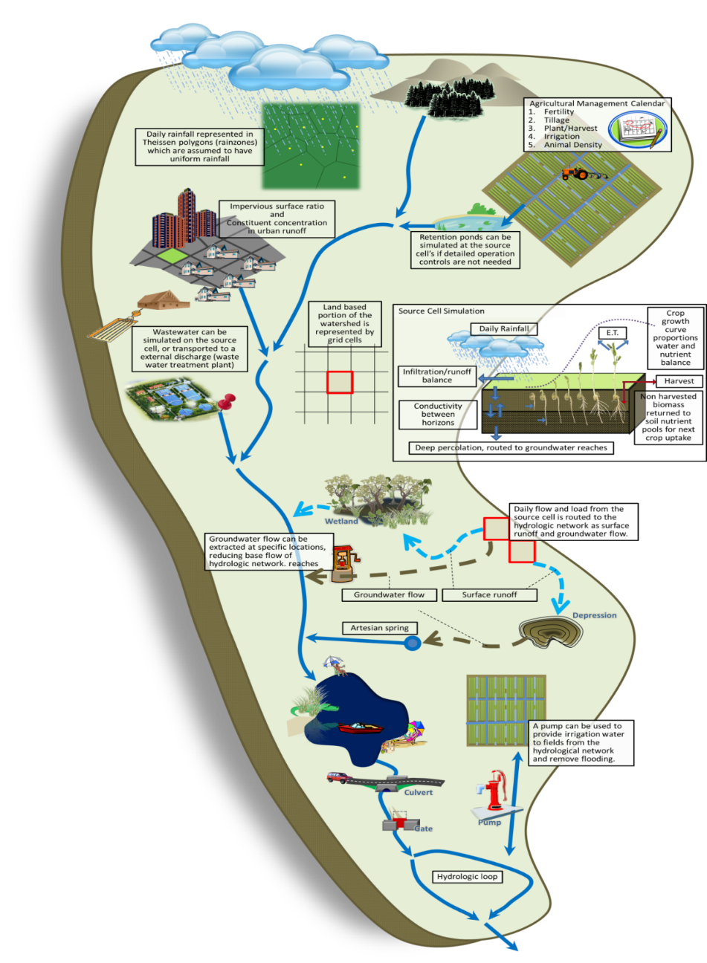
FDACS Contract No. 24010

Table of Contents
1 Introduction and Background 8
1.1 Introduction 8
1.2 Background 8
1.3 Objectives 9
2 The Watershed Assessment Model 11
2.1 Model Approach 11
2.2 Source Cell Modeling 12
2.2.1 GLEAMS 12
2.2.2 EAAMOD 13
2.3 Hydrodynamic Routing 15
3 Data Gathering and Formatting 17
3.1 Required Input Spatial (GIS) Datasets 17
3.2 Data Acquisition 17
3.2.1 GIS Datasets 17
3.3 Measured Data 32
3.3.2 System Operations 38
3.4 Data preparation 39
3.4.1 Reach Delineation 39
3.4.2 GIS Dataset Reconciliation 41
3.4.3 Time Series Dataset Preparation 44
4 Calibration, Verification, and Goodness of Fit Methodology 46
4.1 The Impact of Uncertainty in Input Data on WAM 47
4.2 Calibration 47
4.2.1 Hydrologic and Hydraulic (H&H) Calibration 49
4.2.2 Nitrogen and Phosphorus Load Calibration 50
4.3 Verification 51
4.4 Calibration/Verification Period and Calibration Targets 51
4.5 Goodness of Fit 52
5 Model Results 53
5.1 Fisheating Creek 54
5.1.1 Flows and Water Quality Data at SR-78 55
5.2 Indian Prairie 58
5.2.1 Flow and Water Quality Data at S-84 60
5.2.2 Flow and Water Quality Data at S-71 63
5.2.3 Flow and Water Quality Data at S-72 66
5.2.4 Flow and Water Quality Data at S-127 69
5.2.5 Flow and Water Quality Data at S-129 72
5.2.6 Flow and Water Quality Data at S-131 75
5.3 Lake Istokpoga 78
5.3.1 Flow and Water Quality Data at S-68 79
5.4 Lower Kissimmee 82
5.4.1 Flow and Water Quality Data at S-65E 85
5.5 Taylor Creek/Nubbin Slough 88
5.5.1 Flow and Water Quality Data at S-133 89
5.5.2 Flow and Water Quality Data at S-135 92
5.5.3 Flow and Water Quality Data at S-154 95
5.5.4 Flow and Water Quality Data at S-191 99
5.6 Upper Kissimmee 102
5.6.1 Flow and Water Quality Data at S-65 103
5.7 Summary and Conclusions 106
6 Appendices 108
6.1 Charts of Flow and Nutrient Loads 1975-2013 108
6.1.1 Fisheating Creek 108
6.1.2 Indian Prairie 109
6.1.3 Lake Istokpoga 115
6.1.4 Lower Kissimmee 116
6.1.5 Taylor Creek/Nubbin Slough 117
6.1.6 Upper Kissimmee 121
6.2 WAM Structure Parameters 122
FLUCCS/WAM Land Use ID Correspondence 130
7 References 139

Table of Tables
Table 1. Coordinate system selected for the model project. 17
Table 2. The top 30 land use acreages in the northern six Lake Okeechobee sub-watersheds. 26
Table 3. Stations used for flow data listed by sub-watershed. 32
Table 4. Monthly averages of weather data inputs for WAM. Temperature values are in units of °C, solar radiation in units of Langleys (MJ/cm²), and wind speed is an average in km/day. 35
Table 5. Water quality stations used during the calibration. 36
Table 6. Structures used in the WAM simulations. 38
Table 7. Land uses that may be run using EAAMOD (if the soil type allows). 42
Table 8. List of BMP factors applied. The last three rows are combinations of two of the other BMPs listed. 43
Table 9. Listing of soils datasets obtained from NRCS by county. 44
Table 10. Rain station used in the WAM model setup. Some stations have multiple records, indicated by more than one DB key. 45
Table 11. Standard calibration, verification, and goodness of fit procedures for WAM. 48
Table 12. Comparison of measured and simulated water volumes (in acre-feet) on Fisheating Creek at SR-78. 56
Table 13. Statistics of daily, monthly, and annual flow values for the calibration and verification periods on Fisheating Creek at SR-78. 57
Table 14. Statistics of daily, monthly, and annual total N and P concentrations and loads for the calibration and verification periods on Fisheating Creek at SR-78. 58
Table 15. Comparison of measured and simulated water volumes (in acre-feet) at structure S-84 on C-41A. 61
Table 16. Statistics of daily, monthly, and annual flow values for the calibration and verification periods at structure S-84 on C-41A. 62
Table 17. Statistics of daily, monthly, and annual total N and P concentrations and loads for the calibration and verification periods at structure S-84 on C-41A. 63
Table 18. Comparison of measured and simulated water volumes (in acre-feet) at structure S-71 on C-41. 64
Table 19. Statistics of daily, monthly, and annual flow values for the calibration and verification periods at structure S-71 on C-41. 65
Table 20. Statistics of daily, monthly, and annual total N and P concentrations and loads for the calibration and verification periods at structure S-71 on C-41. 66
Table 21. Comparison of measured and simulated water volumes (in acre-feet) at structure S-72 on C-40. 67
Table 22. Statistics of daily, monthly, and annual flow values for the calibration and verification periods at structure S-72 on C-40. 68
Table 23. Statistics of daily, monthly, and annual total N and concentrations and loads for the calibration and verification periods at structure S-72 on C-40. 69
Table 24. Comparison of measured and simulated water volumes (in acre-feet) at structure S-127. 70
Table 25. Statistics of daily, monthly, and annual flow values for the calibration and verification periods at structure S-127. 71
Table 26. Statistics of daily, monthly, and annual total N and P concentrations and loads for the calibration and verification periods at structure S-127. 72
Table 27. Comparison of measured and simulated water volumes (in acre-feet) at structure S-129. 73
Table 28. Statistics of daily, monthly, and annual flow values for the calibration and verification periods at structure S-129. 74
Table 29. Statistics of daily, monthly, and annual total N and P concentrations and loads for the calibration and verification periods at structure S-129. 75
Table 30. Comparison of measured and simulated water volumes (in acre-feet) at structure S-131. 76
Table 31. Statistics of daily, monthly, and annual flow values for the calibration and verification periods at structure S-131. 77
Table 32. Statistics of daily, monthly, and annual total N and P concentrations and loads for the calibration and verification periods at structure S-131. 78
Table 33. Comparison of measured and simulated water volumes (in acre-feet) at structure S-68. 80
Table 34. Statistics of daily, monthly, and annual flow values for the calibration and verification periods at structure S-68. 81
Table 35. Statistics of daily, monthly, and annual total N and P concentrations and loads for the calibration and verification periods at structure S-68. 82
Table 36. Comparison of measured and simulated water volumes (in acre-feet) at structure S-65E. 85
Table 37. Statistics of daily, monthly, and annual flow values for the calibration and verification periods at structure S-65E. 86
Table 38. Statistics of daily, monthly, and annual total N and P concentrations and loads for the calibration and verification periods at structure S-65E. 87
Table 39. Comparison of measured and simulated water volumes (in acre-feet) at structure S-133. 90
Table 40. Statistics of daily, monthly, and annual flow values for the calibration and verification periods at structure S-133. 91
Table 41. Statistics of daily, monthly, and annual total N and P concentrations and loads for the calibration and verification periods at structure S-133. 92
Table 42. Comparison of measured and simulated water volumes (in acre-feet) at structure S-135. 93
Table 43. Statistics of daily, monthly, and annual flow values for the calibration and verification periods at structure S-135. 94
Table 44. Statistics of daily, monthly, and annual total N and P concentrations and loads for the calibration and verification periods at structure S-135. 95
Table 45. Comparison of measured and simulated water volumes (in acre-feet) at structure S-154. 96
Table 46. Statistics of daily, monthly, and annual flow values for the calibration and verification periods at structure S-154. 97
Table 47. Statistics of daily, monthly, and annual total N and P concentrations and loads for the calibration and verification periods at structure S-154. 98
Table 48. Comparison of measured and simulated water volumes (in acre-feet) at structure S-191. 99
Table 49. Statistics of daily, monthly, and annual flow values for the calibration and verification periods at structure S-191. 100
Table 50. Statistics of daily, monthly, and annual total N and P concentrations and loads for the calibration and verification periods at structure S-191. 101
Table 51. Comparison of measured and simulated water volumes (in acre-feet) at structure S-65. 104
Table 52. Statistics of daily, monthly, and annual flow values for the calibration and verification periods at structure S-65. 105
Table 53. Statistics of daily, monthly, and annual total N and P concentrations and loads for the calibration and verification periods at structure S-65. 106
Table 55. Hydraulic structures simulated in WAM in the Fisheating Creek sub-watershed. 122
Table 56. Hydraulic structures simulated in WAM in the Indian Prairie sub-watershed. 122
Table 57. Hydraulic structures simulated in WAM in the Lake Istokpoga sub-watershed. 123
Table 58. Hydraulic structures simulated in WAM in the Lower Kissimmee sub-watershed. 124
Table 59. Hydraulic structures simulated in WAM in the Taylor Creek/Nubbin Slough sub-watershed. 125
Table 60. Hydraulic structures simulated in WAM in the Upper Kissimmee sub-watershed. 127
Table 61. FLUCCS codes and descriptions and associated WAM land use IDs. 130

Table of Figures
Figure 1. Location of the six northern Lake Okeechobee sub-watersheds that were modeled for the project. The three southern sub-watersheds that were modeled for Deliverables 2, 3, and 4 are also shown. 10
Figure 2. Unique cell generation. 11
Figure 3. Field scale model selection process 12
Figure 4. EAAMOD digitization scheme for a general soil profile. 14
Figure 5. Flow path routing for attenuation distance determination. 16
Figure 6. Model domain boundaries for the WAM simulations in the six northern sub-watersheds, based on the sub-watershed boundaries defined by the Coordinating Agencies. 19
Figure 7. Representation of the topography data used for the WAM simulations. 22
Figure 8. The reach network developed for WAM. 23
Figure 9. Land use feature class for the LOW currently incorporated into WAM. 25
Figure 10. Soil distribution in the LOW. 28
Figure 11. Rainfall stations within the Lake Okeechobee watershed used in WAM simulations. 29
Figure 12. SFWMD hydraulic control structures used in the WAM simulations. 30
Figure 13. The Fisheating Creek model domain. Rain stations, flow station, and water quality stations are shown. 55
Figure 14. Measured and simulated accumulated water volumes in acre-feet (upper chart) and accumulated volume residuals (lower chart) at SR-78. 56
Figure 15. Comparison of measured and simulated total N (upper chart) and total P (lower chart) concentrations on Fisheating Creek at SR-78. 57
Figure 16. The Indian Prairie model domain. Rain stations, flow station, and water quality stations are shown. 60
Figure 17. Measured and simulated accumulated water volumes in acre-feet (upper chart) and accumulated volume residuals (lower chart) at structure S-84. 61
Figure 18. Comparison of measured and simulated total N (upper chart) and total P (lower chart) concentrations at structure S-84 on C-41A. 62
Figure 19. Measured and simulated accumulated water volumes in acre-feet (upper chart) and accumulated volume residuals (lower chart) at structure S-71. 64
Figure 20. Comparison of measured and simulated total N (upper chart) and total P (lower chart) concentrations at structure S-71 on C-41. 65
Figure 21. Measured and simulated accumulated water volumes in acre-feet (upper chart) and accumulated volume residuals (lower chart) at structure S-72. 67
Figure 22. Comparison of measured and simulated total N (upper chart) and total P (lower chart) concentrations at structure S-72 on C-40. 68
Figure 23. Measured and simulated accumulated water volumes in acre-feet (upper chart) and accumulated volume residuals (lower chart) at structure S-127. 70
Figure 24. Comparison of measured and simulated total N (upper chart) and total P (lower chart) concentrations at structure S-127. 71
Figure 25. Measured and simulated accumulated water volumes in acre-feet (upper chart) and accumulated volume residuals (lower chart) at structure S-129. 73
Figure 26. Comparison of measured and simulated total N (upper chart) and total P (lower chart) concentrations at structure S-129. 74
Figure 27. Measured and simulated accumulated water volumes in acre-feet (upper chart) and accumulated volume residuals (lower chart) at structure S-131. 76
Figure 28. Comparison of measured and simulated total N (upper chart) and total P (lower chart) concentrations at structure S-131. 77
Figure 29. The Lake Istokpoga model domain. Rain stations, flow station, and water quality stations are shown. 79
Figure 30. Measured and simulated accumulated water volumes in acre-feet (upper chart) and accumulated volume residuals (lower chart) at the outflow to Lake Istokpoga at structure S-68. 80
Figure 31. Comparison of measured and simulated total N (upper chart) and total P (lower chart) concentrations at structure S-68. 81
Figure 32. The Lower Kissimmee model domain. Rain stations, flow station, and water quality stations are shown. 84
Figure 33. Measured and simulated accumulated water volumes in acre-feet (upper chart) and accumulated volume residuals (lower chart) at structure S-65E. 85
Figure 34. Comparison of measured and simulated total N (upper chart) and total P (lower chart) concentrations at structure S-65E. 87
Figure 35. The Taylor Creek/Nubbin Slough model domain. Rain stations, flow station, and water quality stations are shown. 89
Figure 36. Measured and simulated accumulated water volumes in acre-feet (upper chart) and accumulated volume residuals (lower chart) at structure S-133. 90
Figure 37. Comparison of measured and simulated total N (upper chart) and total P (lower chart) concentrations at structure S-133. 91
Figure 38. Measured and simulated accumulated water volumes in acre-feet (upper chart) and accumulated volume residuals (lower chart) at structure S-135. 93
Figure 39. Comparison of measured and simulated total N (upper chart) and total P (lower chart) concentrations at structure S-135. 94
Figure 40. Measured and simulated accumulated water volumes in acre-feet (upper chart) and accumulated volume residuals (lower chart) at structure S-154. 96
Figure 41. Comparison of measured and simulated total N (upper chart) and total P (lower chart) concentrations at structure S-154. 97
Figure 42. Measured and simulated accumulated water volumes in acre-feet (upper chart) and accumulated volume residuals (lower chart) at structure S-191. 99
Figure 43. Comparison of measured and simulated total N (upper chart) and total P (lower chart) concentrations at structure S-191. 101
Figure 44. The Upper Kissimmee model domain. Rain stations, flow station, and water quality stations are shown. 103
Figure 45. Measured and simulated accumulated water volumes in acre-feet (upper chart) and accumulated volume residuals (lower chart) at structure S-65. 104
Figure 46. Comparison of measured and simulated total N (upper chart) and total P (lower chart) concentrations at structure S-65. 105
Figure 47. Total accumulated volume (millions of acre-feet) and residuals (thousands of acre feet) at SR78. Note that measurements were not taken until 1998. 108
Figure 48. Total accumulated total N loads (upper chart) and total P loads (lower chart), both in metric tons, at SR78. Note that measurements were not taken until 1998. 108
Figure 49. Total accumulated volume (millions of acre-feet) and residuals (thousands of acre feet) at S-84. 109
Figure 50. Total accumulated total N loads (upper chart) and total P loads (lower chart), both in metric tons, at S-84. 109
Figure 51. Total accumulated volume (millions of acre-feet) and residuals (thousands of acre feet) at S-71. 110
Figure 52. Total accumulated total N loads (upper chart) and total P loads (lower chart), both in metric tons, at S-71. 110
Figure 53. Total accumulated volume (millions of acre-feet) and residuals (thousands of acre feet) at S-72. 111
Figure 54. Total accumulated total N loads (upper chart) and total P loads (lower chart), both in metric tons, at S-72. 111
Figure 55. Total accumulated volume (millions of acre-feet) and residuals (thousands of acre feet) at S-127. 112
Figure 56. Total accumulated total N loads (upper chart) and total P loads (lower chart), both in metric tons, at S-127. 112
Figure 57. Total accumulated volume (millions of acre-feet) and residuals (thousands of acre feet) at S-129. 113
Figure 58. Total accumulated total N loads (upper chart) and total P loads (lower chart), both in metric tons, at S-129. 113
Figure 59. Total accumulated volume (millions of acre-feet) and residuals (thousands of acre feet) at S-131. 114
Figure 60. Total accumulated total N loads (upper chart) and total P loads (lower chart), both in metric tons, at S-131. 114
Figure 61. Total accumulated volume (millions of acre-feet) and residuals (thousands of acre feet) at S-68. 115
Figure 62. Total accumulated total N loads (upper chart) and total P loads (lower chart), both in metric tons, at S-68. 115
Figure 63. Total accumulated volume (millions of acre-feet) and residuals (thousands of acre feet) at S-65E. 116
Figure 64. Total accumulated total N loads (upper chart) and total P loads (lower chart), both in metric tons, at S-65E. The large jump in the total N load in the simulated data is due to a (possibly erroneous?) nitrate concentration in the S-65 inflow data registering 95.1 ppm on December 27, 1994. 116
Figure 65. Total accumulated volume (millions of acre-feet) and residuals (thousands of acre feet) at S-133. 117
Figure 66. Total accumulated total N loads (upper chart) and total P loads (lower chart), both in metric tons, at S-133. 117
Figure 67. Total accumulated volume (millions of acre-feet) and residuals (thousands of acre feet) at S-135. 118
Figure 68. Total accumulated total N loads (upper chart) and total P loads (lower chart), both in metric tons, at S-135. 118
Figure 69. Total accumulated volume (millions of acre-feet) and residuals (thousands of acre feet) at S-154. 119
Figure 70. Total accumulated total N loads (upper chart) and total P loads (lower chart), both in metric tons, at S-154. 119
Figure 71. Total accumulated volume (millions of acre-feet) and residuals (thousands of acre feet) at S-191. 120
Figure 72. Total accumulated total N loads (upper chart) and total P loads (lower chart), both in metric tons, at S-191. 120
Figure 73. Total accumulated volume (millions of acre-feet) and residuals (thousands of acre feet) at S-65. 121
Figure 74. Total accumulated total N loads (upper chart) and total P loads (lower chart), both in metric tons, at S-65. The large jump in the measured total N load in late 1994 is due to a (possibly erroneous?) nitrate concentration of 95.1 ppm on December 27, 1994. 121

Introduction and Background

Introduction
The ecological health of Lake Okeechobee and its associated influence on downstream waterbodies, such as coastal estuaries and the Everglades, has been the focus of much research and management activities for decades. Phosphorus loads to the lake are the primary concern because they have been identified as the dominant cause of increased eutrophication within the lake. However, total nutrient loads and excessive freshwater releases from the lake to coastal estuaries are also a concern. The phosphorus sources and potential abatement strategies to meet phosphorus reduction targets for Lake Okeechobee are summarized in the December 2014 adopted Basin Management Action Plan (BMAP). The Watershed Assessment Model (WAM) was an integral tool used for the development of the load estimations described in the BMAP, and moving forward will be used to help assess the cost benefits of alternative abatement strategies as well as to update sub-watershed loads and nutrient reduction benefits associated with various management strategies.
To enhance the WAM tool for future use, Soil and Water Engineering Technology, Inc. (SWET) was contracted by the Florida Department of Agriculture and Consumer Services (FDACS) (Contract #24010) to address the following objectives: 1) to update and recalibrate WAM to existing conditions using the latest land use, soils, hydrography, control projects, and weather databases; and 2) and to complete a goodness of fit assessment for a representative sub-watershed to validate its utility. This report describes the work completed under Deliverable 1, entitled “WAM Recalibration of Six (Northern) Sub-watersheds”, of the above referenced contract, which includes a brief background of the WAM.

Background
WAM was developed to evaluate the impact of alternative land uses and management practices associated with the implementation of best management practices (BMPs) and nutrient load reduction projects for the Lake Okeechobee Watershed (LOW). It is a process-based model that can be used to perform hydrological and water quality analysis to:
- Simulate flows and nutrient loads for existing land uses, soils, and land management practices.
- Analyze the hydrological and water quality impacts on streams and lakes for management scenarios, such as land use changes, implementation of BMPs or the addition of regional stormwater treatment areas (STAs).
- View and analyze the simulated flow and concentrations for every source cell and stream reach within the LOW under the ArcGIS platform.
- Prioritize geographical areas where BMP efforts are to be focused.
The South Florida Water Management District (SFWMD), the Florida Department of Environmental Protection (FDEP), and the FDACS, hereinafter collectively referred to as the Coordinating Agencies, have identified WAM as the best tool for performing such analyses in the LOW.
Some examples of WAM applications include:
- Evaluation of various nitrogen (N) and phosphorus (P) control programs within the LOW.
- Evaluation of total nitrogen (TN) and total phosphorus (TP) load reductions under agricultural BMPs, which were included in the 2011 Lake Okeechobee Watershed Protection Plan (LOWPP).
- Simulation of existing and pre-drainage flows, concentrations, and loads for the Lake Okeechobee Pre-drainage Characterization Project, which was contracted by the SFWMD to SWET.
- Refinement of existing loads, project load reductions, and monitoring locations, associated with the Lake Okeechobee BMAP, which was developed by the Coordinating Agencies in collaboration with the local stakeholders.
- Assessment of temporal and spatial loading patterns for inclusion in the BMAP refinement process.
The Coordinating Agencies invested in improving the tool through the WAM Enhancement and Application in the Lake Okeechobee Watershed Project (2009). This current report for Deliverable #1, entitled Northern Sub-watersheds WAM Recalibration of Six Sub-watersheds is an extension of this previous work to update WAM to more current conditions.

Objectives
The primary objective of Deliverable 1 is to update and recalibrate the earlier application of WAM to the Lake Okeechobee sub-watersheds north of Lake Okeechobee. The earlier application, titled WAM Enhancement and Application in the Lake Okeechobee Watershed Project (2009) used a rainfall period of record (POR) between 1998 and 2007 for model calibration. Subsequently, this model was rerun without calibration for the extended period of record of 1975 through 2010 (HDR, 2012).
Since that work, several datasets have received significant updates, including land use, hydrography (Arc Hydro Enhanced Database (AHED)), topography from LIDAR (Light Detection and Ranging), drainage boundary, rainfall, flow, hydraulic structure, and TN and TP concentration data. These updates were obtained from the SFWMD and incorporated into WAM as well as extending the POR through the end of 2013 using the latest available rainfall, temperature data, and other meteorological data. In addition, the model domains were modified to be consistent with the most current sub-watershed boundaries provided by the Coordinating Agencies. Finally, shoreline reaches for all major lakes to separate flow and loads from source cells that directly discharge to the lake and other reaches draining to the lake have been added to the model as this information is useful for budget analyses.
Using these updates, the application of WAM to the northern six sub-watersheds with the extended POR from 1975 through 2013 was completed in 2015 under FDACS contract number 21905. During that work, simulations using WAM were conducted on the updated existing conditions for the basins north of Lake Okeechobee located in the following sub-watersheds:
- Fisheating Creek
- Lake Istokpoga
- Indian Prairie
- Lower Kissimmee
- Taylor Creek/Nubbin Slough
- Upper Kissimmee
The updated model used the 2009 SFWMD land use coverage, as updated in 2013, for the LOW. The model was also updated to the latest version of ArcGIS being used by the Coordinating Agencies (ArcGIS 10.3.1). Simulation data were reported and analyzed on a daily, monthly, and annual basis to determine flows, TP and TN concentrations, and TN and TP loads from each of the six (6) sub-watersheds north of Lake Okeechobee (see Figure 1). This model was run without recalibration, with the results being summarized in the report Watershed Assessment Model (WAM): Calibration and Uncertainty and Sensitivity Analyses. Task 1.2a: WAM Simulated Existing Conditions Characterization Report and Model Validation Report (September 4, 2015). Application of goodness-of-fit statistics that compare measured flow and nutrient concentration data against model output indicated that a recalibration of the model would be required before application of the model for planning purposes.
This current report gives the results of the recalibration process. The model was run from 1975 through 2013; however, the validation period was limited to 2003 through 2013 because the existing land use conditions are most representative for this period. The results of the WAM simulations are summarized on a daily, monthly, and annual basis for flow, TN and TP concentrations, and TN and TP loads. In addition, a quantitative evaluation of the goodness-of-fit standard error analysis was completed.
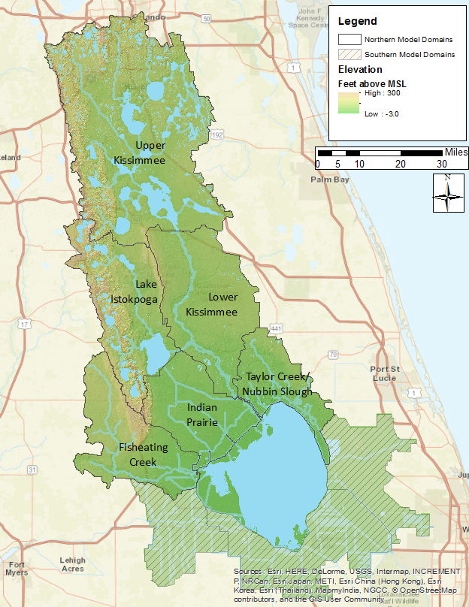
Figure 1. Location of the six northern Lake Okeechobee sub-watersheds that were modeled for the project. The three southern sub-watersheds that were modeled for Deliverables 2, 3, and 4 are also shown.
This document is structured as follows: Section 2 includes a general overview of how WAM works, both from a conceptual viewpoint and a discussion of the specific sub-models that comprise WAM. Section 3 includes a discussion of the various datasets, both spatial and tabular, that are used to set up a WAM application. This section provides details about how the datasets were acquired, prepared, and assembled for use in WAM. Finally, Section 4 discusses the results of the modeling effort and provides goodness-of-fit statistics for the simulated results.

The Watershed Assessment Model

Model Approach
The WAM was chosen to simulate the water quantity and quality discharged from the project area because of its ability to simulate a wide variety of land uses and land use practices while taking into account the geographic and geologic features of the land. WAM uses a GIS grid-based representation to model the physical characteristics of the watershed. One of the first steps is the determination of the specific combination of land use, soil, rainfall, and wastewater service area for each cell in the watershed (Figure 2). These four datasets are overlain as part of the modeling process to identify the unique combinations of these inputs. These unique cell combinations characterize the specific conditions that occur on each cell within the watershed.
WAM then creates a spatial map and tabular list of every unique combination of the inputs. The concept of identifying unique cell groupings is critical because it greatly reduces the number of cell level simulations that are needed while still providing the detail of cell level simulated flow and constituent transport for every cell within the watershed.
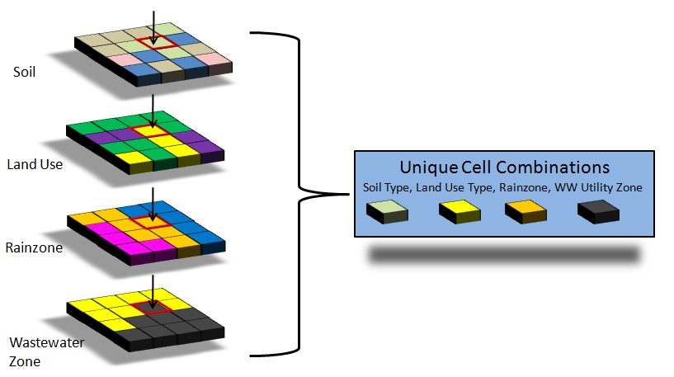
Figure 2. Unique cell generation.

Source Cell Modeling
The creation of unique cell groupings is also critical because it allows for the most appropriate field-scale sub-model to be used for each unique cell condition, more accurately simulating the daily runoff in terms of both water quality and quantity. Based on the soil and land use combination of the cell, the most appropriate field scale sub-model is selected to simulate that cell as shown in Figure 3.
The sub-models include Groundwater Loading Effects of Agricultural Management Systems (GLEAMS) (Knisel, 1993), the Everglades Agricultural Area Model (EAAMOD) (Bottcher et al., 1998; SWET, 2008a; Bottcher et al., 2012), and a special-case model written specifically for WAM. GLEAMS is used to simulate processes in areas that have well-drained soils, while EAAMOD is used to simulate processes on high water table soils. The special case sub-model is used to simulate source cells that are not handled well by these other two sub-models, e.g. wetlands, mining, aquaculture, and open water. These sub-models are bundled into one Fortran program called BUCShell (BUC stands for Basin Unique Cell).
The individual field scale sub-models used are specifically designed to deal with the particular natural processes that exist between those land use and soils combinations. The daily flows and loads produced by BUCShell are stored in what are referred to as dayfiles and contain the amount of nutrients and water that are leaving each source cell on a daily basis.

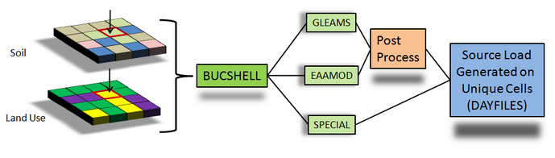
Figure 3. Field scale model selection process

GLEAMS
GLEAMS (Leonard et al., 1987 and Knisel, 1993) is a physically based model used to simulate processes affecting water quality on an agricultural field scale. It has been used extensively and is well documented. GLEAMS is divided into four separate models. These models include:
  - Hydrology
  - Erosion/sediment yield
  - Chemical (pesticide) transport (not currently available within WAM)
  - Nutrient transport
The hydrology component of GLEAMS simulates runoff due to daily rainfall using a modification of the NRCS curve number method, where ground recharge is calculated as rainfall minus ET/interception and the change in soil storage. Hydrologic computations for evapotranspiration, percolation, infiltration, and runoff are determined using a daily time step (Knisel, 1993). Two options are provided in the hydrology component to estimate potential evapotranspiration.
The Priestly-Taylor evapotranspiration estimation method (1972) using daily temperature and radiation data computed from mean monthly data is currently used by WAM. The other available option in WAM is the Penman-Monteith method (Jensen et al., 1990), however it requires additional data that are more difficult to obtain. Water routing through the soil profile is based on the storage routing concept which allows the downward movement of water more than field capacity water content from one layer to the next. Comprehensive detail is provided in Knisel (1993).
The erosion component in GLEAMS uses the universal soil loss equation (USLE) and the concept of continuity of mass to predict erosion and sediment transport under different topographic and cultural conditions. The erosion component considers overland, channel, impoundment, or any combination of these routes. Computation begins at the upper end of the overland slope. The overland flow may be selected from several possible overland flow paths. Its shape may be uniform, convex, concave, or a combination of these slopes. The processes of detachment and deposition are both considered, and each condition occurs based on the relationship between transport capacity of runoff water and sediment load.
The plant-nutrient component of the GLEAMS model considers both nitrogen (N) and phosphorus (P) cycles. For a detailed description of the GLEAMS input parameters see Knisel (1993). The N component includes: mineralization, immobilization, denitrification, ammonia volatilization, nitrogen fixation by legumes, crop N uptake, and losses of N in runoff, sediment, and percolation below the root zone. It also considers fertilizer and animal waste application. The P component includes: mineralization, immobilization, crop uptake, losses to surface runoff, sediment and leaching, and it also includes fertilizer and animal waste application. Tillage algorithms are included in the model to account for the incorporation of crop residue, fertilizer, and animal waste. Soil temperature and soil moisture algorithms are also included in the model to provide proper adjustments for ammonification, nitrification, denitrification, volatilization, and mineralization rates. Rainfall N and P are inputs for the model and may vary depending upon the study region. Initial soil TP, as an input in the land use parameter file, is a sensitive parameter in the model and is used to represent legacy P, which makes it an important calibration parameter. Initial soil TN is not as sensitive as TP because N will not accumulate within the soil.
The GLEAMS model provides outputs of soluble inorganic nitrogen (ammonium-N and nitrate-N) and phosphorus (soluble P) in runoff and leachate and sediment-attached organic and inorganic N and P in surface runoff. The GLEAMS model does not produce outputs of biological oxygen demand (BOD) or soluble organic N and P. Outputs of these constituents are derived within WAM as a function of total suspended solids (TSS) and from total nitrogen loads in runoff and leachate, respectively.

EAAMOD
The EAAMOD is a field-scale model developed by Soil and Water Engineering Technology, Inc. (SWET) for multi-layered soils with high water tables. Created in the early 1990s, the model grew out of a need to evaluate agricultural BMPs within the Everglades Agricultural Area (EAA) and other high water table soils in Florida. The model initially focused on water using a hydrography sub-model (WP) and P movement from histosols (flat organic soils) using the P sub-model (PMOVE), but was then expanded to all high water table soils and to handle N with the inclusion of the nitrogen sub-model (NUTMOD). Histosols require special consideration because of the aerobic mineralization releases of both P and N from organic matter due to drainage and the resulting nutrient impacts downstream. To adequately address this problem, EAAMOD simulates water control practices and the impacts of various cultural management scenarios on nutrient transport.
Percolation and runoff in EAAMOD is calculated using a vertical two-dimensional hydrologic model (WP). The flow model within EAAMOD uses the Dupuit-Forcheimer assumption (zero vertical hydraulic gradient) for two separate flow regimes in the field profile, specifically, above and below an impeding layer such as the spodic horizon in flatwoods soils and the marl cap rock in histosols. The impeding layer is generally highly localized, and while water locally perches above the layer it does not act as a confining layer. The model is conceptually represented in Figure 4.
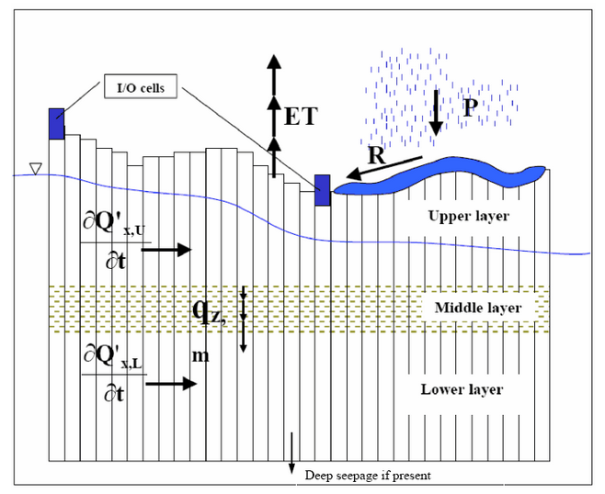
Figure 4. EAAMOD digitization scheme for a general soil profile.
The one-dimensional horizontal flow model provides the water table depth and horizontal flow for each cell across the field between drainage ditches. Flow through the spodic horizon is determined by solving the piezometric head distribution below the horizon and then using Darcy's Law across the impeding layer with the gradient across the horizon being the difference between the water table above it and the piezometric head below it. Water flow is simulated by using finite difference techniques with forcing functions representing pumped drainage/irrigation, culvert flow, rainfall and ET. Saturated horizontal flow above the mid- horizon is calculated by a fourth order Runge-Kutta method that solves the continuity equation for each cell using Darcy's Law within the saturated zone.
The water budget is calculated in the top zone of cell i by the following equation:
$$ΔS\left(i\right)=Q\left(i+1\right)-Q\left(i\right)+R\left(i\right)-ET\left(i\right)-QS\left(i\right)+P\left(i\right)$$
Where:
$ΔS$ is the change in water storage in the top zone (inches of air void/hr),
$Q$ is horizontal saturated flow (in/hr),
R is rainfall (in/hr),
$ET$ is evapotranspiration (in/hr),
$QS$ is deep percolation through the middle restricting zone (in/hr), and
$P$ is the forced input or output (irrigation/drainage) (in/hr) for up to two cells, typically ditches.
The calculated flow is always for the left side of the cell indicated. Rather than using total water storage in a cell, the water profile algorithm keeps track of air void volume (S). Therefore, a zero value for S would represent a saturated soil condition with no surface ponding. Surface ponding results in a value of S less than zero and typically would indicate that surface runoff is occurring, but could be a stagnant surface storage condition.
The air void volume, S, is calculated for each time step, t, by the following equation:
$$S\left(i,t\right)=S\left(i,t-1\right)+ΔS\left(i,t\right)⋅ΔT$$
Where: ΔT is equal to t (current time in hours) minus t-1 (previous time step in hours).
To represent actual water management in a field, a series of utility features within the model allow for controlled drainage through a pump, gravity flow through a culvert (bi-directional), flow over a weir, subsurface or surface irrigation, and variable crop ET parameters. Automatic scheduling of irrigation and drainage pump operation is available based upon desired ditch water levels or soil moisture deficit. The flow properties of the pump(s), culvert(s), or weir(s) for specific land use types can be specified by the user in the management section for High Water Table Soils.
Surface water is only allowed to flow to or from the first defined ditch/drainage outlet cell, but this cell may be located anywhere. For flooding, the water profile algorithm allows flows from the ditch to fill each successive cell to the level of the ditch until the time step's flow volume is depleted. The flow volume is limited by the flow rate to the ditch cell and conservation of mass within the ditch. This procedure continues until complete flooding occurs, at which time any subsequent flow due to a rise in ditch levels will be artificially applied to all cells. For surface runoff the procedure is reversed except that artificial ET is used to move the water from the field and move it to the ditch.

Hydrodynamic Routing
The daily outputs from each cell, which includes surface and groundwater flows and constituent concentrations, are simulated they are routed to the streams by the Basin Land Area to Stream Routing model (BLASRoute). BLASRoute is a Fortran program that routes the flows and loads based on the distance grids previously calculated and delayed using separate unit hydrographs and delay factors for surface and groundwater. The constituent loads are attenuated based on the landscape features encountered en route to the reach network. The routing process is a complex combination of transport, dispersion, and assimilation that, in most cases, will result in an attenuation, or decrease, in the constituent concentration. The source loads are transported to the reach network via surface and/or ground water.
The transportation path is based on the distance to the closest downhill hydrogeologic feature, (reach, wetland, or depression) which is identified from the Distance Grids that are calculated by WAM. The transportation path will influence both the time it takes for daily flows to be delivered to the reach network, as well as the attenuation rates that are applied to the constituent concentrations en route to the reach network, depending on the hydrogeologic features encountered. Figure 5 shows the conceptual routing schemes and flow distances that are calculated for each cell.

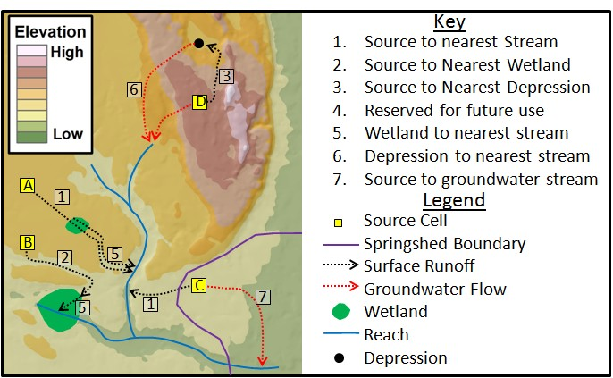
Figure 5. Flow path routing for attenuation distance determination.

WAM includes overland and in-stream attenuation algorithms that function on a daily time step starting at the source cell. From this starting point, nutrients are attenuated during both overland flow, when passing through wetlands, and within streams and canals before finally discharging to the lake.
Each numbered path shown in Figure 5 is represented by a GIS grid, which includes the distance of the paths. These distances are related back to the original source cell so that the model can extract the needed distance through a downstream geographic feature for all grid cells. Destination information is stored in a similar manner. When extracting the distance through a downstream wetland, for example, the type of wetland can also be extracted, which has an associated set of assimilation coefficients.

Data Gathering and Formatting

Required Input Spatial (GIS) Datasets
The required spatial datasets are:
- Basin boundary
- Sub-basin boundaries
- Topography
- Hydrologic network
- Land use
- Soils
- Rain gage locations
- Hydrologic structures
- Utility (wastewater) zones.
- Location of water and nutrient point sources (or sinks)
- Irrigation source specification
The specifics of each of these spatial datasets with respect to the entire Lake Okeechobee model domain are discussed below. In addition to these spatial datasets, a time series of recorded rainfall values at each rain station, daily temperatures, and other climate data required to run WAM is also discussed below. Prior to building a WAM scenario, a projection for the spatial data must be chosen. For this project the Florida State Plane East (in feet) was used. Other relevant coordinate system details are shown in Table 1.
Table 1. Coordinate system selected for the model project.
NAD 1983 HARN State Plane Florida East (FIPS 0901) Feet
Projection | Transverse Mercator
False Easting | 656166.67
False Northing | 0
Central Meridian | -81
Scale Factor | 0.99994118
Latitude of Origin | 24.33333
Linear Unit | Foot

Data Acquisition

GIS Datasets
Many of the spatial datasets used in the 2009 WAM effort dated from the mid-2000s and have been superseded by newer datasets. In some cases, such as with land use, this reflects actual changes in the underlying data as development occurs or as some agricultural land uses are taken out of production. Some datasets, such as soils, have been updated as studies have been used to refine and further delineate specific soil types. Thus, while the general dataset types outlined in the 2009 report are still applicable, the actual datasets have changed. In many cases the available information is more consistent across the watershed and a single feature class may suffice where before several disparate coverages had to be merged to provide an accurate representation. For example, a single topography dataset was provided by the SFWMD whereas for the 2009 project several datasets had to be merged to create a comprehensive dataset. Similarly, the hydrography used in 2009 was created from several sources; for this project a single hydrography dataset (part of SFWMD’s ArcHydro Enhanced Database) covers the entire study area. In many cases, data from the 2009 study could easily be adapted with only minor modifications (such as basin and sub-basin coverages, rainfall stations, and hydrologic structures). However, in other cases, such as soils, land use, hydrography, and the actual model domains, entirely new datasets needed to be incorporated.
The following listing of the spatial datasets indicate the provenance of the various feature classes. Details about the specific preparation, adjustments, and modifications to these input datasets for use within WAM are discussed in Section 3.4.

Model Domain Boundaries
Each model domain boundary serves as the domain for all the input spatial datasets, with each GIS dataset (with two exceptions, discussed below) clipped to this boundary. The model domains are shown in Figure 6. Each of the six model domains in the northern LOW requires a basin boundary, which were defined to be the sub-watersheds by the Coordinating Agencies. The sub-watershed boundary dataset used was obtained from FDEP in January of 2015 and is named “LOW_Subwatersheds”. Note that this same dataset was also provided to SWET by the SFWMD in November 2016 along with the latest land use spatial dataset. Figure 6 also shows the three model domains around eastern, southern, and western boundaries of the lake known as the southern sub-watersheds in the Lake Okeechobee BMAP. These domains were not modeled for this task, instead they were modeled as part of Deliverables #2-#4.
The LOW includes four major tributary systems: Kissimmee River, Lake Istokpoga–Indian Prairie/Harney Pond, Fisheating Creek, and Taylor Creek/Nubbin Slough. These tributary systems and drainage networks are generally bound by the drainage divides of the major water bodies. The dataset represents the external boundaries of the LOW, the nine sub-watersheds, which comprise the LOW, and the 69 basins, which comprise the sub-watersheds as per the 2014 LOWPP Update and the Northern Everglades and Estuaries Protection Program (NEEPP). The three sub-watersheds located on the eastern, southern, and western boundaries of Lake Okeechobee were simulated in a separate task in this current modeling effort. The basis for the boundaries was the technical work associated with the “Draft – Technical Support Document: Lake Okeechobee Watershed Performance Measure Methodologies” document dated February 2013 developed for revisions to the 40E-61 Works of the District Program, with minor modifications.
As mentioned above, the model domain boundaries are used to clip the input datasets such as land use or soils. Note that two datasets may contain data that lie outside of the boundary, which are the hydrologic network and the location of rain gages. These are discussed below. Additionally, during the modeling process the WAM interface uses the model boundary as a mask while creating grids (rasters) from the various input datasets.

Subbasin Boundaries
Subbasins are used by WAM to further subdivide the modeling domains discussed above in Section 3.2.1.1. The motivation for this is to separate surface water flow based on either natural or man-made flow paths on a finer scale than is possible at the sub-watershed level. Note that the terminology used by WAM is different from that used by the Coordinating Agencies; the “Sub-basin” dataset input to WAM contains smaller-scale features than the “Sub-basin” feature class included with the AHED.
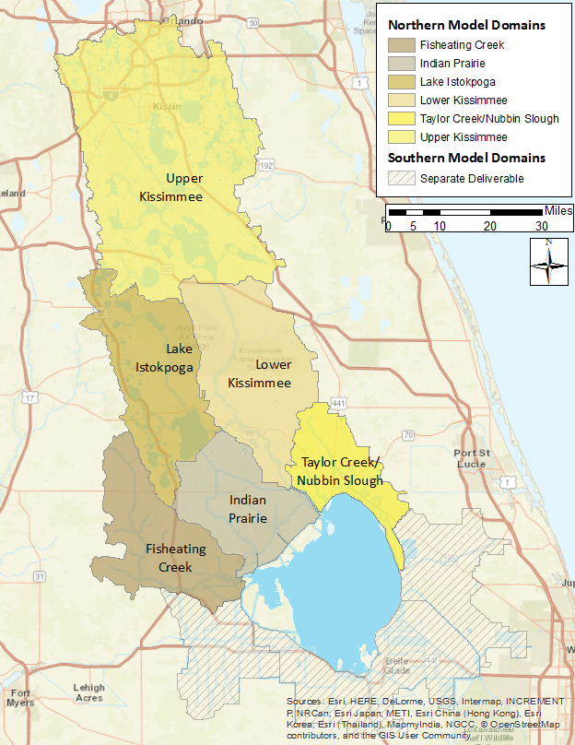
Figure 6. Model domain boundaries for the WAM simulations in the six northern sub-watersheds, based on the sub-watershed boundaries defined by the Coordinating Agencies.
For modeling purposes, the sub-basin boundaries are those that reflect hydrologic divides or boundaries within the model domain/sub-watershed. In many parts of Florida sub-basin boundaries can be created by artificial levees or berms, but are more typically due to natural topographic features, such as ridges. The sub-basin data from the 2009 modeling effort was developed using the ArcHydro toolset, but it was considered too small-scale for the current purposes. Consequently, a dataset named “LOW_Subwatersheds_Basins” that was included with the sub-watershed boundary dataset discussed in the previous section was used as the WAM sub-basin boundaries. Note that the “LOW_Subwatersheds_Basins” dataset has only minor differences when compared to the AHED “Watershed” feature class.

Topography
Topography datasets in the previous 2009 WAM modeling efforts were created by obtaining and merging Digital Elevation Model (DEM) data, LIDAR data, which became available in 2006 from the Kissimmee Basin Modeling and Operations Study (KBMOS). The datasets were derived from various sources of information including USGS 5-foot contours, SFWMD bathymetry and LIDAR (Earth-Tech, 2006).
For the current modeling effort, a continuous elevation raster that covers the entire study area was obtained from the SFWMD. This raster has 50-feet by 50-feet grid cells. The topography data are resampled to grid cells that are a hectare in size during the WAM set up process. The topographic data is used by WAM to determine the directions of flow and distances to (and through) hydrologic features such as lakes, streams, canals, sloughs, riparian wetlands and depressions (see Figure 5). The topography dataset used for the study is shown in Figure 7.

Hydrography
The hydrography used for the current effort was based on modification of the latest hydrographic dataset obtained from the SFWMD together with the hydrography used in the 2009 WAM modeling effort and the 2012 update. The SFWMD maintains all hydrologic data in an AHED. This data was originally obtained in February of 2015, while an updated dataset was obtained in February of 2016. In addition to linear (e.g., stream) features (the “hydroedge” feature class), the AHED dataset includes water bodies, hydrologic structure locations, monitoring points, etc. In many locations, the AHED hydroedge feature class contains somewhat more detail than is necessary for developing a reach network for WAM. For example, disconnected hydrologic features such as isolated wetlands and lakes are included in the hydroedge network. WAM has a separate algorithm for routing water into these types of features and then into groundwater (or lost via evaporation), so hydroedge features of this type were not included in the WAM network. The reach network used in WAM is shown in Figure 8.

Land Use
The land use feature class used was obtained from the SFWMD in November of 2016 and is named “Neepp_LOW_LU”. This feature class was modified to include an integer field for the WAM land use ID (LUID) which was filled using a lookup table (“fluccs_main_tab”) provided by the SFWMD. The metadata included with the dataset summarizes the feature class as follows:
Land Use for the Lake Okeechobee Watershed, composite of best-available data as of November 2016. The composite was created from "current" land-use datasets from the SFWMD, SJRWMD, and SWFWMD in order to provide complete coverage of the watershed, plus a buffer zone around it. In general, the land-use (LU) code was used in preference to the land-cover (LC) code, and newer data was used in preference to older. Coordinates are referenced to the state plane system, Florida east zone, NAD83 (HARN), US feet. Much of the metadata below is vestigial from the 2014 and 2008 SFWMD land-use metadata. *** This data set serves as documentation of land cover and land use (LCLU) within the South Florida Water Management District as it existed in 2008-09. Land Cover Land Use data was updated from 2004-05 LCLU by photo-interpretation from 2008-09 aerial photography and classified using the SFWMD modified FLUCCS classification system. Features were interpreted from the county-based aerial photography (4 in - 2 ft pixel) and updated on screen from the 2004-05 vector data. Horizontal accuracy of the data corresponds to the positional accuracy of the county aerial photography. The minimum mapping unit for classification was 2 acres for wetlands and 5 acres for uplands. The update was completed on 07/11/2011. The "wet prairie" (6430) category was added back into the database on 01/18/2012, for areas that were classified as wet prairie in the 2004-5 LCLU and had been converted to freshwater marsh (6410) for the 2008-9 LCLU. In order to provide a single dataset that covers the entire area of the SFWMD, on 02/02/2012 the 2004-5 LCLU was added to the 2008-9 LCLU, for areas were not included in the 2008-9.
The prior phase of this project used an earlier version of the feature class (“LOW_LU_LOPP_09”) (LOPP is the “Lake Okeechobee Protection Plan”) that contained 2009 land use data with modifications in 2012. That data were obtained from the SFWMD in February of 2015. SWET made modifications to this earlier land use dataset in the Taylor Creek/Nubbin Slough model domain by combining it with a dataset obtained from the SFWMD in July of 2016. This second dataset contained detailed refinement to dairy land uses, such as breaking out specific pasture land uses, spray fields, and cooling ponds. Consequently, the Taylor Creek/Nubbin Slough model domain uses the modified earlier dataset while the other five model domains use the updated 2016 land use dataset.
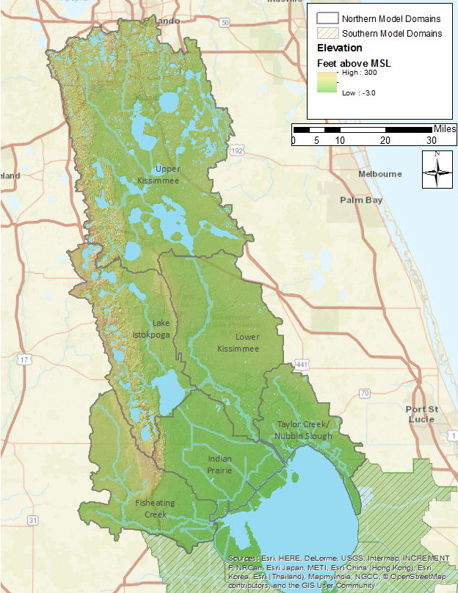
Figure 7. Representation of the topography data used for the WAM simulations.
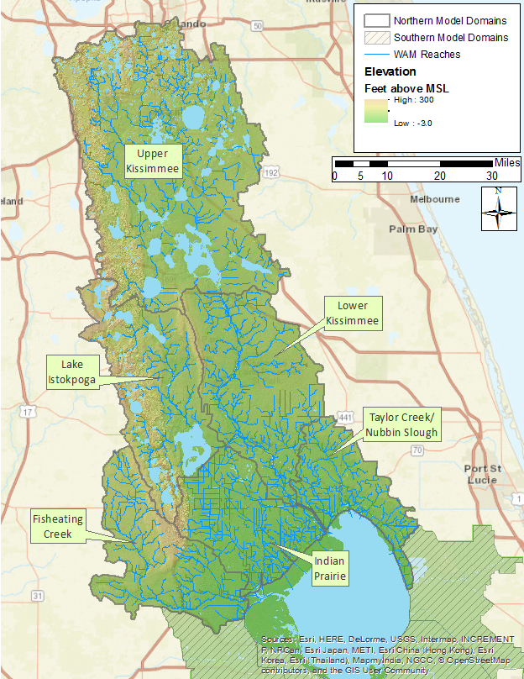
Figure 8. The reach network developed for WAM.

The land use data currently incorporated into WAM is shown in Figure 9. Acreages for the predominant land use categories used by WAM is broken down by sub-watershed and summarized in Table 2.

Soils
The spatial distribution of soils is a required input to WAM and because of previous modeling efforts with WAM, the WAM database of soil parameters already contained data for 429 soil categories common to Florida. The existing database was used with a newly updated and compiled feature class of Soil Survey Geographic (SSURGO) data. The final soils information used in the project came from the U.S. Department of Agriculture, Natural Resource Conservation Service (NRCS) published SSURGO data for 2013 - 2015. These data were derived from each of the county soils feature classes downloaded from NRCS. The county-wide datasets were merged and then the final product was clipped to cover the entire study area. Section 3.4.2.2 discusses how the soils data from NRCS were imported into WAM. The soils dataset is shown in Figure 10.

Rainfall Stations
WAM uses a point feature class for rainfall stations that is used to generate a Theissen polygon raster that is used within the program to assign rainfall time series to each unique cell. Location of rainfall stations were included in the AHED dataset. For consistency, the same stations that were included in the 2009 WAM application and the 2012 update were used for the current work and are shown in Figure 11. With the exception of one station, all data were available from the DBHYDRO database, which is the SFWMD’s hydrologic, water quality, and hydrogeologic data storage and retrieval system. The lone exception was a station (Frostproof) that lies within the Southwest Florida Water Management District (SWFWMD) boundary. All data were updated to include data through the end of 2013. This is discussed in more detail below in Section 3.4.3.1.

Major Hydrologic Control Structures
There are many control structures in the modeled domains that are operated by the SFWMD, such as gates, pumps, and weirs. Many of these were present in the earlier 2009 WAM applications, while additional ones were taken from other WAM applications in the LOW. In addition to controlling flow within the modeled area, many of the control structures serve as measurement locations for flow, stage, and nutrient concentrations. These control structures are shown in Figure 12 as provided in the AHED dataset. Further control information and listings of the control structures are given in Section 3.3.2 and in the Appendix, Section 1.1.

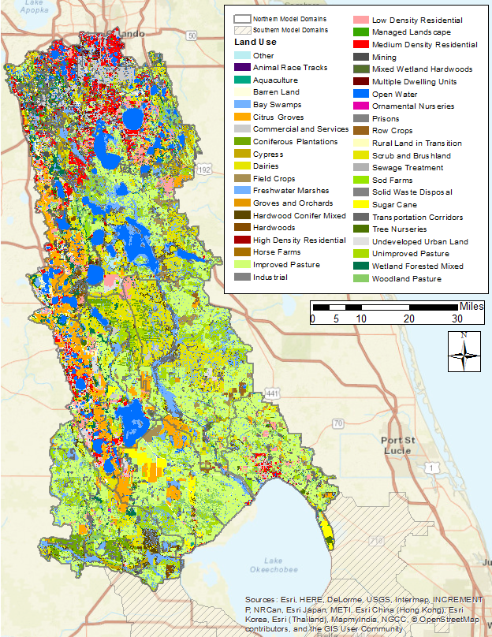
Figure 9. Land use feature class for the LOW currently incorporated into WAM.
Table 2. The top 30 land use acreages in the northern six Lake Okeechobee sub-watersheds.
Land Use | Fisheating Creek | Indian Prairie | Lake Istokpoga | Lower Kissimmee | Taylor Creek/ Nubbin Slough | Upper Kissimmee | Total Acres
Improved Pasture | 102,502 | 119,149 | 41,675 | 132,534 | 91,331 | 126,083 | 613,273
Scrub and Brushland | 22,884 | 7,813 | 56,093 | 90,312 | 4,407 | 98,737 | 280,246
Freshwater Marshes | 50,697 | 27,277 | 28,726 | 69,140 | 10,309 | 107,937 | 294,086
Open Water | 1,050 | 3,579 | 58,140 | 3,432 | 3,055 | 139,908 | 209,163
Unimproved Pasture | 36,040 | 23,705 | 13,552 | 45,593 | 10,041 | 33,004 | 161,935
Citrus Groves | 7,722 | 30,079 | 51,786 | 9,910 | 3,481 | 46,070 | 149,047
Woodland Pasture | 23,967 | 21,188 | 3,667 | 11,408 | 13,507 | 36,717 | 110,454
Mixed Wetland Hardwoods | 12,582 | 4,989 | 9,760 | 17,196 | 5,523 | 49,381 | 99,432
Medium Density Residential | 130 | 829 | 17,020 | 193 | 4,306 | 71,861 | 94,339
Cypress | 5,000 | 13 | 3,109 | 1,387 | 119 | 40,883 | 50,511
Low Density Residential | 3,593 | 2,154 | 19,418 | 6,571 | 8,376 | 49,488 | 89,600
Wetland Forested Mixed | 6,209 | 1,137 | 18,833 | 1,877 | 1,229 | 37,604 | 66,890
Commercial and Services | 298 | 319 | 7,965 | 1,944 | 2,328 | 47,796 | 60,650
Hardwood Conifer Mixed | 15,092 | 2,285 | 7,394 | 7,620 | 3,123 | 26,398 | 61,913
Coniferous Plantations | 20,403 | 404 | 10,848 | 7,832 | 55 | 6,112 | 45,655
Undeveloped Urban Land | 1,068 | 1,766 | 16,138 | 2,204 | 1,594 | 16,344 | 39,114
Sugar Cane | 20 | 13,078 | 2,382 |  | 5,217 |  | 20,697
Dairies | 37 | 21 | 558 | 1,796 | 2,062 | 39 | 4,513
Hardwoods | 2,443 | 118 | 2,627 | 440 | 19 | 5,191 | 10,838
Field Crops | 302 | 4,704 | 411 | 8,764 | 3,507 | 7,645 | 25,331
Transportation Corridors | 704 | 106 | 1,561 | 189 | 313 | 14,095 | 16,968
Barren Land | 1,065 | 3,546 | 1,998 | 1,594 | 1,490 | 5,413 | 15,106
Managed Landscape |  |  | 1,616 | 65 | 519 | 11,647 | 13,847
Rural Land in Transition |  |  | 8,446 |  |  | 4,809 | 13,254
High Density Residential | 21 | 123 | 2,870 | 112 | 368 | 9,884 | 13,378
Abandoned Dairies |  |  |  |  | 8,602 |  | 8,602
Multiple Dwelling Units |  |  | 104 | 8 | 41 | 10,995 | 11,148
Bay Swamps | 1,119 | 185 | 1,960 | 434 | 303 | 5,492 | 9,493
Row Crops | 29 | 1,188 | 555 | 4,581 | 315 | 1,444 | 8,112
Sod Farms | 737 | 3,029 | 180 |  | 1,521 | 3,161 | 8,629
Other | 1,782 | 3,625 | 4,766 | 2,036 | 10,657 | 14,282 | 37,148
Total Acres | 317,497 | 276,409 | 394,156 | 429,173 | 197,719 | 1,028,419 | 2,643,373

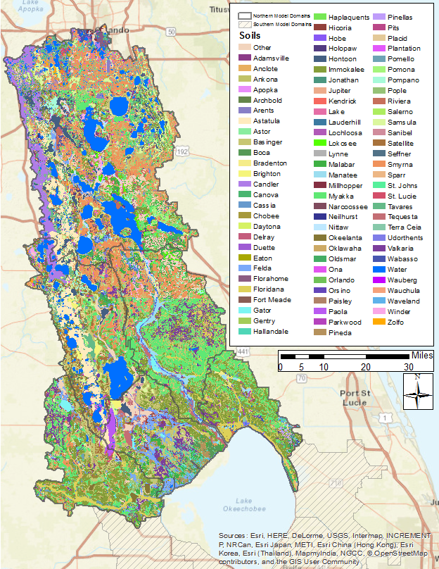
Figure 10. Soil distribution in the LOW.
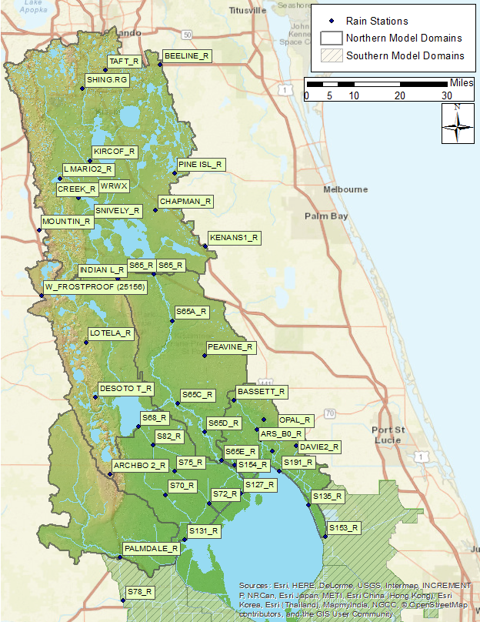
Figure 11. Rainfall stations within the Lake Okeechobee Watershed used in WAM simulations.

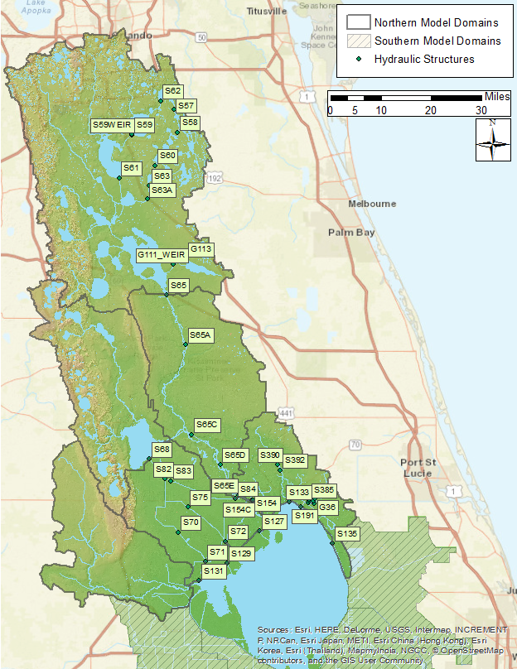
Figure 12. SFWMD hydraulic control structures used in the WAM simulations.

Utility (wastewater) zones.
This is a polygonal feature class that delineates areas that are served by a wastewater utility services. Within the feature class, areas that are served by a utility service are designated by a simple integer attribute of 1, otherwise the attribute is set to 0. For this project, wastewater utility zones were incorporated into the model in only one sub-watershed, Taylor Creek/Nubbin Slough. Note that using a wastewater zone is equivalent to placing a given land use (e.g., high density residential) on external treatment; in both cases no wastewater is returned at the same source cell as the land use, rather, the wastewater is either removed from the system or is added back as a stream point source at another location in the basin. The first case may occur when wastewater is removed via a sewer system and piped to a treatment plant and subsequently applied to a sprayfield outside the model domain. The second may occur when the treated water is applied to a sprayfield that is within the model domain. Alternatively, if the wastewater service area is not known, urban land uses that are typically served by treatment systems (such as high/medium residential or commercial and services) undergo treatment that is equivalent to that provided by a treatment plant (such as a sprayfield). The treated water is then assumed by the model to have been released on-site rather than routed to a treatment plant and released there. In this case, the utility zone feature class is simply a mirror of the watershed boundary with the attribute set to 0 everywhere.

Location of water and nutrient point sources (or sinks)
WAM has the ability to include point sources of water and/or nutrients, such as discharges from treatment plants, various types of industrial plants, or mining areas. Typically, if an area is served by a wastewater zone (as described above) and the treated water is reintroduced into the same sub-watershed, WAM simulates these point sources by adding the water and nutrient loads directly to reaches. Conversely, point sources can also be used to simulate withdrawals of water directly from reaches. For the base scenarios simulated, only Taylor Creek/Nubbin Slough incorporated a point source to accommodate the waste water discussed is the previous section. Note that either point sources or sinks may be added in the future to any model for the purposes of testing alternative potential modifications to an area.

Irrigation source specification
This dataset is used to specify the origin of water used for irrigation purposes. There are three choices available:
- Irrigation water is taken from deep groundwater (e.g., the Floridan aquifer).
- Irrigation water is taken from the shallow, surficial aquifer.
- Irrigation water is taken from surface water, i.e., the stream network.
For most areas in this project, irrigation water is assumed to be taken from the deep aquifer (option 1).
Of the spatial datasets discussed above, it is the soils, land use, rainfall stations, and utility zones that are used to define the unique combinations of cells (see Figure 2 that are simulated by the land source model to produce daily contributions of runoff, percolation, and nutrient loads.

Measured Data
Measurements of flow, stage, rainfall, and water quality data were downloaded from the SFWMD DBHYDRO database, except for some rainfall data that were downloaded from the SWFWMD. Each data type (flow, rain, etc.) is described in more detail in the following sections.

Flow Data
Time series of flow data, recording the mean daily flow in cubic feet per second (CFS), was collected at the stations and DBKeys (the alphanumeric database key for a specific time series) listed in Table 3. Generally, the time series data covers the period of record (POR) from the beginning of calendar year 1972 through the end of 2013. Where available, the time series in DBHYDRO that were marked as “PREF” were downloaded. This annotation indicates that the recorded value is the preferred value. For many stations data for the entire period was not available under same DBKey; in these cases multiple times series from the same station were combined with values from the later time series taking precedence over earlier entries when both were present. Since the flow data were primarily used to calibrate the model developed with WAM, it was not critical to have data of the entire POR at every flow station.
Table 3. Stations used for flow data listed by sub-watershed.
Station | DBKey | Recorder | POR Start | POR End
Fisheating Creek
FISHP | 15627 | PREF | 1/1/1972 | Current
FISHCR | WH036 | ???? | 5/9/1997 | Current
2255600 | 88210 | NA | 8/20/2003 | Current
Indian Prairie
S127_P | 15641 | PREF | 1/1/1972 | Current
S127_C | 15819 | TELE | 9/14/1994 | Current
S129_PMP_P | 15642 | PREF | 1/1/1972 | Current
S129_C | 15823 | NA | 8/21/1994 | Current
S129_C | 04024 | NA | 1/1/1984 | Current
S131_C | 04042 | NA | 1/1/1984 | Current
 | M2931 | TELE | 9/24/1992 | Current
S131_PMP_P | 15643 | PREF | 1/1/1972 | Current
S70_S | AM230 | MOD1 | 5/17/1986 | Current
S71_S | 15633 | PREF | 1/1/1972 | Current
S71W_W | W4354 | TELE | 9/4/2008 | Current
S72_S | 15634 | PREF | 1/1/1972 | Current
S72W_W | W4355 | TELE | 2/20/2012 | Current
S82_S | 15960 | NA | 11/5/1993 | Current
S83_S | 15965 | NA | 11/30/1993 | Current
S83X_S | VM845 | TELE | 2/5/2008 | Current
S84_S | 15636 | PREF | 1/1/1972 | Current
S84X_S | VM846 | TELE | 2/5/2008 | Current
Lake Istokpoga
ARBUCK | 00210 | NA | 7/1/1939 | Current
CARTER C | 00206 | NA | 10/1/1954 | Current
JOSEPHIN | 00224 | NA | 10/1/1946 | Current
LIVINFROST | TA461 | ???? | 3/1/1991 | Current
S68_S | 15632 | PREF | 1/1/1972 | Current
S68X_S | AM652 | MOD1 | 4/22/2009 | 4/30/2016
Lower Kissimmee
S65A_S | J9202 | PREF | 5/12/1986 | Current
S65AX_C | 12570 | CR10 | 7/12/1988 | Current
S65C_S | 15338 | NA | 3/2/1987 | Current
 | 04458 | NA | 4/29/1966 | 7/10/1992
 | 06959 | NA | 3/2/1987 | Current
S65CX_C | 15332 | NA | 3/2/1987 | Current
 | 04464 | NA | 2/1/1983 | 9/30/1993
S65D_S | 91655 | NA | 8/7/1970 | Current
 | 06962 | SP01 | 3/10/1987 | 31-Jul-09
 | WN344 | TELE | 7/31/2009 | Current
S65DX1_C | 88300 | TELE | 6/12/2009 | Current
S65DX2_S | AI354 | TELE | 7/31/2009 | Current
S65E_S | 91656 | NA | 1/1/1986 | Current
 | P1020 | MOD1 | 1/1/1965 | 12/31/2012
 | KO585 | TELE | 1/26/2000 | Current
Taylor Creek/Nubbin Slough
NUBBC_C | 05222 | NA | 6/23/1983 | Current
 | 12442 | SP01 | 9/28/1988 | Current
S133_P | 15637 | PREF | 1/1/1972 | Current
S135_PMP_P | 15638 | PREF | 1/1/1972 | Current
S135_C | 16548 | NA | 9/13/1994 | Current
 | TA288 | MOD1 | 6/3/1987 | 12/31/2012
 | 04072 | NA | 1/15/1979 | 6-Nov-98
S154_C | 15629 | PREF | 1/1/1972 | Current
S154C_C | VB265 | DWR | 7/12/1974 | Current
 | VW893 | CR10 | 5/12/2008 | Current
S191_S | 15639 | PREF | 1/1/1972 | Current
02274325 | 88225 | NA | 8/12/2004 | Current
02273630 | 88218 | NA | 10/10/2003 | Current
02275197 | 88231 | NA | 10/1/2003 | Current
02274490 | 88227 | NA | 9/4/2003 | Current
02274505 | 88229 | NA | 10/1/2003 | Current
02274010 | 88223 | NA | 8/7/2003 | Current
02274005 | 88220 | NA | 7/10/2003 | Current
Upper Kissimmee
S65_S | H0289 | PREF | 10/1/1933 | Current
S63A_S | WN231 | TELE | 5/14/2009 | Current
 | 15798 | SP01 | 11/14/1991 | 7/28/2010
 | 04796 | NA | 12/24/1968 | 8/24/1993
S63S | WN333 | TELE | 6/18/2009 | Current
 | 15542 | CR10 | 1/8/1993 | 7/28/2010
 | 04424 | NA | 6/1/1967 | 8/18/1993
S60_S | AI222 | TELE | 6/11/2009 | Current
 | 15536 | CR10 | 1/8/1993 | 2/4/2010
 | 04608 | NA | 6/1/1967 | 11/2/1994
S58_C | 15528 | CR10 | 1/8/1993 | Current
 | 04400 | NA | 5/18/1969 | 7/20/1994
S61_S | WN288 | TELE | 6/12/2009 | Current
 | 15560 | CR10 | 1/15/1993 | 7/27/2010
S59_S | WN290 | TELE | 6/11/2009 | Current
 | 15533 | CR10 | 1/1/1993 | 7/27/2010
 | 04406 | NA | 12/19/1963 | 2/22/1994
S62_S | WN247 | TELE | 5/21/2009 | Current
 | 15539 | CR10 | 1/8/1993 | 8/30/2010
 | 04418 | NA | 5/20/1969 | 5/31/1993
SHING.CA | 00134 | NA | 10/1/1968 | Current
REEDYLOU | 00165 | NA | 10/1/1939 | Current
 | J6175 | PREF | 1/1/1967 | 1/31/1996
REEDYC | 00156 | NA | 12/1/1922 | 2/17/2017
 | J6173 | PREF | 5/3/1966 | 6/20/1995
BOGGY.TA | 00113 | NA | 9/1/1959 | 2/17/2017

Rainfall
There were 35 rainfall stations where rainfall data were collected and input to the WAM of the sub-watersheds (Figure 11). Time series rainfall data for most of the 35 stations were collected from the SFWMD’s DBHYDRO database. Note that there are considerably more than 35 stations located within (or near to) the six sub-watersheds with data contained in DBHYDRO. However, many of these stations have short PORs, and many stations may have a longer POR but still not cover the entire simulation POR. In several cases, the rainfall station was relocated or re-instrumented, necessitating a new station key (DBKey) in DBHYDRO. To account for this, all rainfall data in the study area were downloaded into a Microsoft Access database. Data from each rainfall station that were used for the 2009 study and the 2012 update was extracted from the database. Where data were missing (due to the station being moved or decommissioned) data from the nearest rain station were used to fill in those missing values. In addition, data for Frostproof Tower, a rainfall station with no rainfall data in DBHYDRO, was collected from the SWFWMD website. When the input files for WAM are generated, a Theissen polygonalization of the rain gage network is generated. Each Thiessen polygon defines an area around a rain gage so that any location inside the polygon is closer to that gage than any of the other rain gages. Each source cell is then assigned the rainfall time series associated with that polygon.

Evapotranspiration
To calculate potential evapotranspiration (PET), WAM uses average monthly high and low temperatures, solar radiation, wind, and dewpoint values. These data were obtained from the Florida Automated Weather Network (FAWN) station in Okeechobee. These values are presented in Table 4.
Table 4. Monthly averages of weather data inputs for WAM. Temperature values are in units of °C, solar radiation in units of Langleys (MJ/cm²), and wind speed is an average in km/day.
Month | Max Temp | Min Temp | Solar Rad | Wind Speed | Dew Point
Jan | 24.7 | 11.1 | 16.4 | 98 | 11.1
Feb | 23.5 | 9.4 | 17.0 | 114 | 9.4
Mar | 26.9 | 12.2 | 16.1 | 123 | 12.2
Apr | 29.3 | 15.4 | 21.0 | 118 | 15.4
May | 30.3 | 17.9 | 27.7 | 99 | 17.9
Jun | 31.1 | 20.5 | 21.6 | 89 | 20.5
Jul | 32.8 | 20.7 | 19.7 | 82 | 20.7
Aug | 33.7 | 20.8 | 27.2 | 79 | 20.8
Sep | 32.8 | 20.2 | 26.7 | 92 | 20.2
Oct | 31.2 | 18.5 | 21.7 | 104 | 18.5
Nov | 26.1 | 13.6 | 15.9 | 100 | 13.6
Dec | 26.0 | 12.8 | 18.9 | 96 | 12.8

Temperature
One of the land source models (EAAMod) requires average daily air temperature data for use in determining the phosphorus soil mineralization rate. While the output from EAAMod is not particularly sensitive to these values, they must be provided. These data were obtained from the SFWMD at the S-65CW and S-65DWX stations, and was supplemented with values obtained from NOAA at the Kissimmee and Avon Park weather stations.

Water Quality
Water quality data of surface water phosphorus and nitrogen concentrations were collected from DBHYDRO for the major water control structures and other sampling locations listed in Table 5. These stations included those used for the previous 2009 study, with several additions. Note that this list is not an exhaustive list of all sampling stations in the six northern sub-watersheds. Several the stations listed in Table 5 provide data from only limited areas (i.e., the contributing areas are relatively small in size), while others have only limited temporal data. However, during the recalibration it was found helpful to use this extra data when calibrating source areas that show either higher or lower nutrient concentrations when compared with the overall basin averages. Both data from grab samples and autosamplers were downloaded. Most of the data downloaded was, however, collected from grab samples. Concentrations of total P were directly recorded at most stations. If total N was not directly recorded it was calculated by summing nitrate (or nitrate + nitrite) and TKN.
Table 5. Water quality stations used during the calibration.
Station | POR Start | POR End | Remark
Fisheating Creek
02255600 | 12/8/2003 | Current
02256500 | 12/9/2003 | Current
FE21392913 | 10/27/2004 | Current
FECSR78 | 4/8/1973 | Current
Indian Prairie
02273230 | 12/9/2003 | Current | C-41 south of S-82
C41H78 | 1/2/2008 | Current
HP06393242 | 1/3/2006 | Current | S-70
HP06393232 | 10/9/2004 | 4/25/2011 | S-70
HP10373114 | 10/29/2004 | 4/25/2011 | S-82
HP11373132 | 1/4/2006 | Current | S-82
HP23373111 | 11/2/2004 | Current | Downstream from S-82
IP09383232 | 1/3/2006 | Current | S-75
IP29383313 | 10/19/2004 | Current
L59W | 4/15/1987 | Current
L60E | 4/15/1987 | Current
L60W | 4/15/1987 | Current
L61E | 4/15/1987 | Current
S127 | 4/8/1973 | Current
S129 | 4/8/1973 | Current
S131 | 4/8/1973 | Current
S71 | 4/8/1973 | Current
S72 | 4/8/1973 | Current
S84 | 4/8/1973 | Current
Lake Istokpoga
02270500 | 12/8/2003 | Current | Arbuckle Creek at Lake I inlet
02273198 | 12/9/2003 | Current | S-68
AR06333013 | 4/8/2005 | Current
AR18343012 | 4/8/2005 | Current
ARBKSR98 | 2/10/1988 | 1/3/2005
CA11342914 | 4/8/2005 | 4/27/2011
ISTK3W | 3/21/2005 | 11/16/2015
JOSNCR17 | 2/10/1988 | 1/3/2005
LI02362923 | 6/1/2011 | Current
LI02362913 | 10/12/2005 | 10/3/2011
RD08322913 | 4/8/2005 | Current
RD01322813 | 4/8/2005 | Current
S68 | 2/10/1988 | 1/2/2007
Lower Kissimmee
S65A | 6/13/1973 | Current
S65C | 6/13/1973 | Current
S65D | 6/13/1973 | Current
S65E | 4/8/1973 | Current
Taylor Creek/Nubbin Slough
02274325 | 8/17/2004 | 8/24/2010 | Taylor Creek at Grassy Island
02274490 | 12/9/2003 | 9/13/2010 | Williamson Ditch
02275197 | 12/8/2003 | Current
KREA 30A | 11/4/1988 | Current
OT29353514 | 10/18/2004 | Current
S133 | 4/8/1973 | Current
S135 | 4/8/1973 | Current
S154 | 10/2/1973 | Current
S154C | 4/15/1987 | Current
S191 | 4/8/1973 | Current
TCNS 201 | 8/10/1988 | Current
TCNS 213 | 8/10/1988 | Current
TCNS 214 | 8/10/1988 | Current
TCNS 220 | 8/10/1988 | Current
TCNS 228 | 8/10/1988 | Current
TCNS 230 | 8/10/1988 | Current
TCNS 233 | 8/10/1988 | Current
TCNS 249 | 8/10/1988 | Current
Upper Kissimmee
CL06283111 | 5/25/2011 | Current | Upstream of S-63A
CL06283121 | 9/12/2006 | 4/27/2011 | S-63A
CL18273011 | 5/25/2011 | Current
CL18273021 | 9/12/2006 | 4/27/2011 | S-61
CL19273113 | 9/12/2006 | 6/20/2011 | S-63
CL19273123 | 7/7/2011 | Current | S-63
CREEDYBR | 4/10/1985 | Current
DLMARNCR | 4/6/1982 | Current
DLONDNCR | 4/6/1982 | Current
EC-37 | 4/6/1982 | Current | Canal C-37
HL08283014 | 7/2/2012 | Current | Canal C-36
HL17283022 | 9/12/2006 | 6/18/2012 | Canal C-36
LG32263114 | 9/12/2006 | 4/27/2011 | S-60
LG32263124 | 5/25/2011 | Current | S-60
S65 | 6/13/1972 | Current

Lake Okeechobee Seepage Estimates
Estimates of seepage across the Herbert Hoover dike are needed during the calibration process when “seepage” reaches are added to the model (see Section 3.4.1 below). Estimates of between 0.0028 to 0.025 CMS (0.1 to 0.9 CFS) per linear mile of dike per foot of head difference across the dike were found by McKenzie (1973).

System Operations
Descriptions of major control structures from the 2009 study and the 2012 update were used for parameterizing the structures in this work and were subsequently validated against the “Redbook” documents available from the SFWMD that provide the physical attributes and operational parameters of structures operated by the SFWMD. The hydraulic structures used are shown in Table 6, and detailed information about how operational information was implemented in WAM (invert elevations, trigger elevations, gate openings, etc.) is given for each structure incorporated into the WAM simulations in the Appendix in Section 1.1. Note that a few structures, designated as “farm weirs” are structures that are not part of the SFWMD control network, but have been located by field work done by SWET.
Table 6. Structures used in the WAM simulations.
Structure Name | Structure Type | WAM Type | Sub-watershed | Stream/Canal
C-6 | Spillway? | Gate | Taylor Creek/Nubbin Slough
C-8 | Spillway? | Gate | Taylor Creek/Nubbin Slough
Farm Weir | Spillway-Unknown | Weir | Fisheating Creek | Fisheating Creek
Farm Weir | Spillway? | Weir | Taylor Creek/Nubbin Slough
G-111 | Culvert | Weir | Upper Kissimmee | Jackson Canal
G-113 | Culvert | Weir | Upper Kissimmee | Outlet of Lake Marian
G-36 | Spillway? | Gate | Taylor Creek/ Nubbin Slough
S-127 | Spillway | Gate | Indian Prairie | L-48
S-127 | Pump | Pump | Indian Prairie | L-48
S-129 | Spillway | Gate | Indian Prairie | L-49
S-129 | Pump | Pump | Indian Prairie | L-49
S-131 | Gate | Gate | Indian Prairie | L-50
S-131 | Pump | Pump | Indian Prairie | L-50
S-133 | Pump | Pump | Taylor Creek/ Nubbin Slough | L-47
S-135 | Pump | Pump | Taylor Creek/ Nubbin Slough | L-47
S-135 | Spillway | Gate | Taylor Creek/ Nubbin Slough | L-47
S-154 | Culvert-Box | Gate | Taylor Creek/ Nubbin Slough | LD-4
S-154C | Culvert-Box | Gate | Taylor Creek/ Nubbin Slough | LD-4
S-191 | Spillway-Concrete | Gate | Taylor Creek/ Nubbin Slough | Nubbin Slough
S-385 | Pump | Pump | Taylor Creek/ Nubbin Slough
S-386A-B | Spillway? | Weir | Taylor Creek/ Nubbin Slough
S-387A-C | Spillway? | Weir | Taylor Creek/ Nubbin Slough
S-390 | Pump | Pump | Taylor Creek/ Nubbin Slough
S-392 | Spillway? | Weir | Taylor Creek/ Nubbin Slough
S-57 | Culvert | Weir | Upper Kissimmee | C-30
S-58 | Culvert | Weir | Upper Kissimmee | C-32
S-59 | Culvert | Gate | Upper Kissimmee | C-31
S-60 | Spillway-Concrete | Gate | Upper Kissimmee | C-33
S-61 | Spillway-Concrete | Gate | Upper Kissimmee | C-35
S-62 | Spillway-Concrete | Gate | Upper Kissimmee | C-29
S-63 | Spillway-Concrete | Gate | Upper Kissimmee | C-34
S-63A | Spillway-Concrete | Gate | Upper Kissimmee | C-34
S-65 | Spillway - Concrete | Gate | Upper Kissimmee | C-38
S-65A | Spillway-Concrete | Gate | Lower Kissimmee | C-38
S-65C | Spillway-Concrete | Gate | Lower Kissimmee | C-38
S-65D | Spillway-Concrete | Gate | Lower Kissimmee | C-38
S-65E | Spillway-Concrete | Gate | Lower Kissimmee | C-38
S-65G | Spillway-Concrete | Weir | Upper Kissimmee | C-38
S-68 | Spillway-Concrete | Gate | Lake Istokpoga | To C-41 from Lake Istokpoga
S-70 | Spillway-Concrete | Gate | Indian Prairie | C-41
S-71 | Spillway-Concrete | Gate | Indian Prairie | C-41
S-72 | Spillway-Concrete | Gate | Indian Prairie | C-40
S-75 | Spillway-Concrete | Gate | Indian Prairie | C-40
S-82 | Spillway-Concrete | Gate | Indian Prairie | C-41A to C-41
S-83 | Spillway-Concrete | Gate | Indian Prairie | C-41A
S-84 | Spillway-Concrete | Gate | Indian Prairie | C-41A

Data preparation
The measured data used for WAM inputs must undergo various amounts of preparation before they are incorporated into the model. The preparation required ranges from simple formatting of time series data (such as rainfall) to more detailed efforts to import and reconcile datasets such as land use or stream networks.

Reach Delineation
The current version of WAM (compiled to run on ArcMap 10.3.1) could use the current version of the SFWMD-wide AHED. WAM includes tools that are integrated with ArcMap (the “WAM Toolbar”) that allow users to import and modify hydrography, and then create a reach network, index the reaches, and assign reach types (stream, canal, etc.) In order to do this, each segment in the network must be connected, and looping within the network must be accounted for. Small or disconnected reaches must be deleted or modified to attach correctly to the rest of the network. In addition, tools are available for the user to create and modify the cross-sectional profiles of each reach and modify bottom elevations. The connectivity of the network is then generated, meaning the relation between reaches, i.e., which reach flows into which other reach, must be determined.
As was discussed briefly in Section 3.2.1.4, the “hydroedge” feature class contained in AHED served as the basis for developing the hydrologic network, together with the WAM reach dataset from 2009. Extensive processing of the hydroedge feature class was required to get it into a form usable by WAM. This included merging many of the smaller segments in the hydroedge feature class, ensuring that small features (e.g., segments on the order of a few meters) had been accounted for, and that any segments that had been detached during the modification had been re-attached. Also, features in the hydroedge class that were originally disconnected from the network (e.g., isolated wetlands or lakes) had to either be deleted or attached to an appropriate reach.
After that work was finished, classification of the reaches needed to begin. Reaches in the study area fall into one of seven main categories used by WAM:
- Streams
- Canals
- Sloughs
- Groundwater
- Lakes
- Shorelines
- Seepage
These classifications are used by WAM to assign specific nutrient attenuation coefficients to each type of reach. The last three reach types listed serve specialized purposes. Lake reaches are incorporated into the models where the hydrography intersects a sufficiently large water body (typically more than a few acres). Cross sections for lake reaches are generated so that the reach length times its width match the lake area. This ensures that the volume of water in the simulated reach represents the amount in the lake. A special case land use category (land use ID 92) is assigned to lakes simulated in this manner. This land use passes rainfall directly into the reach without any attenuation process applied. Shoreline reaches can be added around such lakes if desired; these reaches primarily serve to intercept water and nutrients flowing into a lake via overland flow and then allow the water and nutrients to flow into the lake. As such, they act as an accounting mechanism so that the amount of water and nutrients flowing into a lake via overland flow can be easily determined. No in-stream attenuation is applied in shoreline reaches since it assumed that all applicable attenuation processes occur during overland flow. Lastly, seepage reaches are added where seepage may occur between a large lake and a canal. For example, seepage reaches were added connecting Lake Okeechobee and each modeled segment of the perimeter canal in the Indian Prairie and Taylor Creek/Nubbin Slough model domains. In each case a narrow weir or culvert is used to control the amount of seepage to be in line with measured values given above in Section 3.3.1.6.
In addition to the main categories listed above, new subcategories of reach types may be created during the modeling processes to apply specialized attenuation coefficients to individual reaches or subsets of reaches. For example, specific attenuation coefficients were applied to Lake Kissimmee and Lake Istokpoga, so a new subcategory was created for each lake.
During the classification process, since there was rarely an indication in the AHED as to which category a particular reach fell into, this was a somewhat laborious process that necessitated examination of the reach in aerial imagery. Some assignments were straightforward (many canals are obvious), but distinguishing between streams and sloughs took greater effort. In addition, as requested in the Statement of Work (SOW), shoreline reaches were assigned to the boundaries of the larger lakes that are found in the Upper Kissimmee and Lake Istokpoga sub-watersheds.
After the sub-watershed reach network was set up, model runs were required to ensure that simulation run times were sufficiently short. One of the primary methods for optimization of a reach network is to ensure that the bottom elevations, cross-sectional profiles, and structure information are appropriate. During the model setup process, the first two sets of parameters (bottom elevations and cross-sectional profiles) are estimated using algorithms incorporated into WAM. The reach cross-sectional profiles are estimated by determining the upstream contributing area for each reach while the bottom elevations are estimated from averaging the near-reach elevations (i.e., elevations obtained from the topography dataset that are within 100 meters of the reach) combined with the estimated cross sections. For the major reaches, particularly canals, the cross-sections were adjusted by hand by using aerial imagery and/or measured data if available. For all of the simulated sub-watersheds this was an extended process that could only use limited information from the 2009 study due to changes in the configuration of the boundary and changes to the hydrography. In particular, the changes in the Kissimmee River in the Lower Kissimmee Sub-watershed due to restoration efforts required a significant time investment. It is anticipated that modifications to the reach network will continue as feedback is obtained from the Coordinating Agencies.

GIS Dataset Reconciliation

Land Use
The current version of WAM uses the same land use database format as in previous versions, although it is important to note that the land use features have changed due to updates of the land use feature class. All the land use codes present in the feature class provided by the SFWMD are listed in the WAM land use database. A correspondence between the land use FLUCCS code and the WAM land use IDs (LUID) assigned to those areas is shown in Table 60 in the Appendix (Section 6).
Since the 2009 study and the 2012 update, the input files for EAAMod (one of the land source models; see Section 2.2.2) have been updated to include data for urban and natural area land use types. This was done in conjunction with the update to the latest land use dataset discussed in Section 3.2.1.5 above. With these modifications, the land uses listed in Table 7 were run using EAAMod if the soil type is appropriate, i.e., where the soil indicates high water table conditions are present. Otherwise, GLEAMS was used for the simulation. This change necessitated adding a significant amount of data to the WAM scenario database and increases simulation run times since EAAMod simulations take longer than GLEAMS simulations for equivalent time periods. This change altered simulation outputs significantly and was partly responsible for the need to recalibrate the models.
Table 7. Land uses that may be run using EAAMOD (if the soil type allows).
Land Use Name | LUID | New
Low Density Residential | 2 | Yes
Commercial and Services | 3 | Yes
Pastureland and Rural Land in Transition | 4 | Yes
Scrub and Brushland | 5 | Yes
Hardwoods | 6 | Yes
Hardwood Conifer Mixed | 7 | Yes
Coniferous Plantations | 8 | Yes
Transportation Corridors | 18 | Yes
Medium Density Residential | 19 | Yes
High Density Residential | 20 | Yes
Multiple Dwelling Units | 21 | Yes
Industrial | 22 | Yes
Managed Landscape | 23 | Yes
Row Crops | 25 | No
Improved Pasture | 26 | No
Unimproved Pasture | 27 | No
Woodland Pasture | 28 | No
Tree Nurseries | 35 | No
Sod Farms | 36 | No
Ornamental Nurseries | 37 | No
Horse Farms | 38 | Yes
Dairies | 39 | Yes
Field Crops | 62 | No
Sugar cane | 68 | No
Citrus | 84 | No
Intensive Dairy Pasture | 85 | No
Field Crops - Dairy Sprayfield | 86 | No
Abandoned Dairies | 89 | No
Dairy Outer Pasture | 90 | No

Land Use Changes
The only modification that SWET made to the land use feature class was in the Indian Prairie sub-watershed, in the Istokpoga Marsh Drainage District (IMDD) area immediately south of Lake Istokpoga. The current land use indicates a mix of sugar cane, improved pasture, and a small amount of citrus. A report done by SWET for the SFWMD (SWET, 2008b) indicated that much of the area has ornamental and row crops, as well as sod, in addition to the currently mapped land uses. Since sod and ornamental/row crops have much higher fertilizer loads, modifications were made based on data obtained by SWET for the 2008 report to better represent known conditions in the IMDD.

BMP Projects in the Northern Okeechobee Sub-Watersheds.
A number of projects implementing BMPs have been carried out in the Northern Okeechobee sub-watersheds as part of the FDACS BMP program. A shapefile of point locations for these projects, along with a listing of the BMP classes were obtained in spring of 2016 from FDACS. The classes listed in the dataset are:
- Dairy Improvements
- Drainage Improvements
- Fencing
- Irrigation Improvements/Fertigation
- Water Control Structures
- Well, pipeline, trough, pond, heavy use
In addition to the six classes, combinations of classes may be applied to a particular land use; e.g., a dairy may have dairy and drainage improvements. For each class listed and combination of classes encountered, an appropriate set of BMP factors was developed. These BMP factors are applied to the affected land use within the WAM input files and are shown in Table 8. Note that separate factors are applied to TN and TP runoff and groundwater.
Table 8. List of BMP factors applied. The last three rows are combinations of two of the other BMPs listed.
BMP Class | TSS | Runoff TN | Runoff TP | BOD | GW TN | GW TP
Dairy Improvements | 0.7 | 0.7 | 0.7 | 0.7 | 0.7 | 0.9
Drainage Improvements | 0.9 | 0.9 | 0.9 | 0.9 | 0.9 | 0.9
Fencing | 0.7 | 0.7 | 0.7 | 0.7 | 0.7 | 0.7
Irrigation Improvements/Fertigation | 0.9 | 0.9 | 0.9 | 0.9 | 0.9 | 0.9
Water Control Structures | 0.9 | 0.9 | 0.9 | 0.9 | 0.9 | 0.9
Well, Pipeline, Trough, Pond | 0.9 | 0.9 | 0.9 | 0.9 | 0.9 | 0.9
Dairy and Drainage Improvements | 0.63 | 0.63 | 0.63 | 0.63 | 0.63 | 0.81
Drainage Improvements and Water Control Structures | 0.81 | 0.81 | 0.81 | 0.81 | 0.81 | 0.81
Fencing and Well, Pipeline, etc. | 0.63 | 0.63 | 0.63 | 0.63 | 0.63 | 0.63

These BMP factors were incorporated into the land use dataset by selecting land use features that intersected the points given in the BMP shapefile. These selected land use features where then modified to apply appropriate BMP factors listed in Table 8 to the land use.

Soils
As discussed in Section 3.2.1.6, soils data was obtained from the NRCS. Each dataset covers at most a single county (some counties have multiple associated datasets) and consequently 12 datasets needed to be downloaded for the 11 counties shown in Table 9. Some counties (Charlotte, Desoto) only covered small portions of the study area. The datasets were downloaded from the USDA NRCS web site at https://gdg.sc.egov.usda.gov/GDGOrder.aspx. After downloading, the feature classes were extracted, re-projected, and imported into a geodatabase feature set with the appropriate spatial projection. At this point, the features from each dataset were merged into a single dataset that covered all of the counties for which data was obtained. The data was then clipped to the LOW
Table 9. Listing of soils datasets obtained from NRCS by county.
County | Associated Datasets
Charlotte | FL015
Desoto | FL027
Glades | FL043
Highlands | FL055
Lake | FL607, FL609
Martin | FL085
Okeechobee | FL093
Orange | FL095
Osceola | FL097
Polk | FL105
St. Lucie | FL111

boundary (see Figure 10). To import the data for use in WAM, the “compname” field was used to associate the soil features and the WAM LUID for each soil type. This was done using a lookup table for soils similar to that used for land use discussed in the previous section. Note that since the join between the feature class table and the lookup table is done on a text field, many small, but significant differences had to be accounted for. For example, extra blanks or missing periods (“Ft” vs. “Ft.” for “Fort”) will cause joins to fail.
To obtain the “compname” for each map unit, the soil map unit feature class (typically named “soilmu_a_flXXX” where “XXX” is the numeric designation for each county) is joined with the “mapunit” data table obtained with the feature class. This is then joined with the “component” table, which contains the “compname” field. Since each map unit may contain several components, the component with “majcompflag” equal to “Yes” is used to select the primary component. If multiple components have “majcompflag” set to “Yes”, the component with the highest percentage is used and the map unit is assigned the chosen value of “compname”. Using this methodology, each map unit in the study area was able to be assigned a soil type corresponding to a soil contained in the WAM database.

Time Series Dataset Preparation
Time series datasets for flow, stage, and water quality was used for comparison with WAM output. No processing of the collected datasets for flow, stage, and water quality was performed. Rainfall and ET time series were input to WAM and had the ability to be applied to sub-regions of the model domain or uniformly over the entire model domain.

Rainfall
Rainfall is a primary input to WAM and as such, missing portions of the time series must be patched with the best available rainfall data. A detailed review of the rainfall data collected initially from DBHYDRO was conducted for this report as described below. It was apparent from the initial effort to collect rainfall data that at some rainfall monitoring stations separate time series were available which, when combined, covered the entire POR.
Each collected time series was summarized on a yearly basis and inspected to determine if the data was a viable input to WAM. This quality check was important because WAM generates a time series of flow and concentration for unique combinations of soils, land use, and rainfall values in the model domain on a one hectare scale. The routing module of WAM will simulate zero flow in a reach if there is insufficient rainfall to generate runoff. This may be a valid occurrence, or, because a rainfall gage only represents rainfall measured at a discrete point, applying that rainfall over a large area may not be accurate. In cases where observed flow is different from simulated flow by roughly 10%, the accuracy of the contributing rain stations may be re-examined. Missing portions of the time series were filled with the data of the closest station that contained original data during that time. The time series, identified by DBHYDRO code, that were used for each rain station in WAM are listed in Table 10.
Table 10. Rain station used in the WAM model setup. Some stations have multiple records, indicated by more than one DB key.
Rain Station | DBKey |  | Rain Station | DBKey
ARCHBO 2_R | 16604 |  | S135_R | 05849
BASSETT_R | 06047 |  | S135_R | 16580
BASSETT_R | 15577 |  | S153_R | 16582
BEELINE_R | 05963 |  | S61_R | 05868
BEELINE_R | TY244 |  | S65_R | 05940
CHAPMAN_R | 05902 |  | S65A_R | 05981
DESOTO T_R | 06096 |  | S65C_R | 06024
INDIAN L_R | 05946 |  | S65D_R | 06068
INDIAN L_R | P6922 |  | S65D_R | 16658
KENANS1_R | 06867 |  | S65E_R | 06071
KENANS1_R | T0958 |  | S65E_R | F9542
KISS.FS2_R | 05859 |  | S68_R | 06066
KISS.FS2_R | 16617 |  | S70_R | F9543
L MARIO2_R | 05884 |  | S72_R | 16666
LOTELA_R | 05853 |  | S72_R | K8691
LOTELA_R | TA345 |  | S75_R | 16663
MOUNTIN_R | 06134 |  | S75_R | 16663
OKEE F 2_R | 06070 |  | S75_R | K8692
OKEE F 2_R | 16697 |  | S75WX | RQ467
OKEE F 2_R | 16285 |  | S78_R | 06243
OPAL_R | 06052 |  | S78_R | 16625
OPAL_R | 15580 |  | S82_R | 16655
PALMDALE_R | 06093 |  | S82_R | K8694
PALMDALE_R | 15786 |  | SNIVELY_R | 05912
PEAVINE_R | 05858 |  | SNIVELY_R | T0933
PEAVINE_R | T0919 |  | TAFT_R | 06042
PINE ISL_R | 05876 |  | TAFT_R | T0964
PINE ISL_R | T0929 |  | W FROSTPROOF | N/A
S131_R | 06120
S131_R | 16286

Calibration, Verification, and Goodness of Fit Methodology
Once the data requirements have been satisfied and the model is able to run successfully error-free and provide output, the next step is the calibration phase, followed by model verification. The classical definition of the calibration process is the adjustment of the input parameters of a mathematical or numerical model to optimize the agreement between observed data and the simulated output. Calibration and verification of watershed models require special considerations because of the temporal and spatial variation that occur in the measured data sets that are used for these processes. However, when the model parameters represent actual physical quantities, (e.g. fertilization rates, reach network parameters, land slope, irrigation rates, etc.) the adjustment of such parameters must be limited by the physical knowledge of the catchment area. Consequently, the calibration and verification process used for physically based watershed models has an additional step not typically included in classical calibration procedures for statistically based models. This extra step is a validation of the accuracy of the physical parameters that characterize land use activities and the watershed before the adjustment of the statistical or empirical model parameters can be performed to obtain a good fit. This means that a parameter validation process is the initial step during the calibration process. This parameter validation step should not be confused with the later verification process where the accuracy of the simulated data is evaluated using measured data.
It is also important to decide before starting the calibration process what measured data are to be used for the calibration process versus the data to be used for the verification process. Ideally, the calibration/verification datasets should either be spatially and temporally separated. However, since it is very difficult to find two spatially separated watersheds with similar physical properties, sufficient sampling points, and are independent, i.e. are not upstream or downstream of one another, temporally separated observation datasets are typically used. Donigian (2002) points out that a split-sample calibration/verification procedure is recommended where only a portion of the observed dataset is used for calibration so that a portion of the dataset can be used to verify the model’s performance for non-calibrated periods. There is no consensus in the literature on the appropriate ratio of the time periods for calibrated versus verification because it would be highly dependent on the actual modeling goals. SWET has successfully used a ratio of 1:1 for previous modeling efforts and therefore a similar target was set for this project. The constraint here is that the time period for calibration must be long enough to contain a range of conditions to be expected in the watershed, e.g. wet and dry extremes over multiple years. As with the ratio of time periods for calibration/verification, there is not a consensus on the minimum length of data that should be used for either calibration or verification. However, to the extent possible, recommendations have been made that calibration periods should be of at least 3-5 years in length and should include both above, below, and average years (Gan et al., 1997). However, the optimal length of calibration periods is likely project-specific (Engel et al., 2007).
The criteria for determining the goodness of fit, i.e., how well the simulated data fits the measured data, are important for both the calibration and verification processes. Goodness of fit should be evaluated using a combined statistical and visual approach. The visual approach (e.g., simply comparing charts of time series) is useful for the initial assessments because it can quickly reveal deviations from the general trend between the simulation results and the observed data. The visual approaches should then be followed by commonly used statistical approaches, including relative error measures (such as Nash-Sutcliff coefficient of efficiency) and absolute error measures (RMSE) to better quantify the goodness of fit.
However, no single goodness of fit measure is adequate for fully judging model performance. For example, the Nash-Sutcliffe coefficient is sensitive to extreme values (Legates and McCabe, 1999). Jain and Sudheer (2008) demonstrated cases where relatively poor models yielded a high value of the Nash-Sutcliffe coefficient and vice versa. Willmott (1981) and others have recommended that at least one absolute error measure (such as RMSE) and one relative error measure (such as the Nash-Sutcliffe coefficient of efficiency) should be used together with graphical comparisons of observed and simulated results. For this report, we have used the percent bias, the RMSE, the Nash-Sutcliffe coefficient, and a more recent measure, the Kling-Gupta efficiency (Gupta et. al, 2009). The Kling-Gupta efficiency utilizes a multi-objective approach that focuses on a combination of the correlation r, the ratio of the simulated and observed standard deviations, and the bias, as the criteria to be optimized against. While qualitative in nature, graphical comparisons such as simple box-and-whisker plots can yield additional information beyond that provided by a single error statistic. In short, goodness of fit statistics are but a single tool in evaluating model performance (Legates and McCabe, 1999; Loague and Green, 1991).

The Impact of Uncertainty in Input Data on WAM
Before conducting the calibration process, it is important to understand the influence of the variability and error associated with the model input data as they relate to model predictive error. The quality of numerical model output will always be limited by the quality of the input data. Because hydrologic models are, obviously, water-focused, the dominant controlling inputs are the addition and removal of water from the system, i.e., rainfall and evapotranspiration. Rainfall is both temporally and spatially more variable than evapotranspiration, consequently rainfall is the most influential input parameter for WAM. Soil and land use parameters are also important but have less of a temporal effect than the weather inputs and vary little spatially over time. To illustrate this, the Section 3 of the SWET report for Deliverables #2-#4 contains a discussion on how rainfall impacts output from simulations. That analysis indicates that water discharges from a source cell with identical land use and soil type can vary depending on the rainfall conditions by as much as 1000% introducing a predictive error of 20% to 30% for annual flows.

Calibration
WAM is primarily a physically based model, consequently, if the input physical parameters (land use, soils, hydrography, boundary conditions, weather, etc.) are correct then the resulting simulation results should be reasonable. The standard calibration procedure is designed to validate that the parameters that characterize the physical processes of the model are accurately represented at each major step in the simulation process. These simulation processes are loosely broken into 3 sections;
- Source cell nutrient load and flow generation,
- Cell to stream routing, and
- In-stream routing.
For each of these processes there are specific calibration techniques that have been developed. Furthermore, it is essential to calibrate the Hydrologic and Hydraulic (H&H) processes first to ensure that the correct flows and stages are being simulated in the reaches. Once these simulated hydrologic values reasonably match observed data, calibration for the nutrient concentrations can be conducted. The calibration procedure is thus broken into two sections: 1) H&H and then 2) nutrient concentrations and loads. The calibration and verification processes presented in this section are summarized in Table 11 and as a series of procedural steps.
Table 11. Standard calibration, verification, and goodness of fit procedures for WAM.
Step | Task
Setup.1 | Complete initial watershed setup using the WAM interface. This includes a preliminary validation of the watershed’s physical parameters as well as defaulted land use parameters to ensure that these parameters represent the local features found in the watershed.
Setup.2 | Obtain measured data for the watershed over the simulation time period and assess these data to identify periods to be used for calibration and verification.
Setup.3 | Run WAM
A | Hydrologic and Hydraulic (H&H)
A.1 | For the calibration period, calibrate runoff and percolation from the Source Cells by visually comparing the predicted flows in the dayfiles to observed values or literature values for each unique cell group to identify possible additional physical parameter errors.
A.2 | Correct/adjust source cell parameters to better characterize the watershed and rerun WAM until reasonable visual agreement for source cell flows are obtained for the calibration period.
A.3 | Assess that the surface and groundwater flow paths are accurate in each of the reaches and that the delay and shape of the hydrographs of the reaches following rainfall events are being represented correctly.
A.4 | Adjust delay and unit hydrographs and rerun WAM until reasonable visual agreement for hydrograph shapes are obtained for the calibration period.
A.5 | Verify that the flows and stages of the reaches have a reasonable visual agreement. Those reaches for which observed data exist should be reviewed objectively to ensure that hydraulic processes are represented correctly in the model parameter setup.
A.6 | Correct/adjust stream parameters and rerun WAM until reasonable visual agreement is obtained for the calibration period.
B | Constituent Concentrations
B.1 | Calibrate constituents (nutrients, sediment, and BOD) in the runoff and percolation from the Source Cells by visually comparing predicted concentrations in the Dayfiles to observed or literature values for each unique cell to identify possible additional physical parameter errors.
B.2 | Correct/adjust source cell parameters and rerun WAM until reasonable agreement for source cell constituent concentrations are obtained for the calibration period.
B.3 | Assess whether the overland and groundwater attenuation statistical model parameters are accurate.
B.4 | Adjust attenuation coefficients and rerun WAM until reasonable agreement for constituent concentrations are obtained for the calibration period.
B.5 | Compare the constituent concentrations in those reaches identified for calibration to observed datasets.
B.6 | Once physical parameters have been validated, adjust the empirical attenuation coefficients and rerun WAM until reasonable agreement is obtained for the calibration period.
C | Goodness of fit (GOF) for Calibration Period
C.1 | Run a GOF statistical method(s) for calibration period.
C.2 | Repeat steps A1-B6 until the best Goodness of fit is obtained for calibration period.
D | Goodness of fit (GOF) for Verification Period
D.1 | Visually compare WAM results to the verification period of measured dataset.
D.2 | Run a Goodness of fit statistical method(s) for verification period.
D.3 | Report results of the calibration and verification processes.

Hydrologic and Hydraulic (H&H) Calibration
The first step in calibrating a watershed model is to ensure that the overall volume of water and temporal distribution of water is simulated correctly. This involves calibrating the land use and soil parameters so that runoff and percolation produced by each source cell is correct and is delivered properly to the reach network. Secondly, it must be determined that the source cell water is being properly routed through the hydrography conveyance system or the stream/canal network.

Source Cell Runoff and Percolation Parameter Validation and Calibration
The BUCShell module in WAM calculates the source flows and loads of each simulated constituent that is generated within the unique source cells on a daily basis. The source load that is generated within each cell is a product of the relationship between the rainfall, land use, and soil types, or more specifically, the parameterization of each of these input types. Because the source cell sub-models are mostly physically based, the process of calibrating and verifying runoff and percolation from the source cells is preceded by a parameter validation step. This is done by examining model output for each unique cell to identify predicted results that are not consistent with known flow and water quality conditions (SWET, 2008c). Such inconsistencies are normally the result of inaccurate data entry associated with physical properties such as pump controls, fertilizer rates, soil data, etc. A utility program for WAM (called “DayFileToYear”), is used to complete this evaluation efficiently. This utility creates model output (a CSV file) that contains the annual averages (in units of cm for runoff/percolation or kg/ha for nutrients) for the flow and nutrient for all the unique source cell types. Anomalies may be identified through a visual inspection of the data, such as the annual average discharge data for various land uses.

Stream/Canal Network Flow Calibration
Once the source cell runoff and percolation estimates are found to be within the range of observed values, the BLASRoute module in WAM is run to route the source cell flows overland to a destination reach, and subsequently through the stream/canal network to the sub-watershed outlets. Known flow or stage boundary conditions must be applied at all inlets and outlets to the sub-watersheds. For discharges into Lake Okeechobee, the nearest available recorded stage data were used for the lake side stage boundary condition of all structures located on the lake. For other discharge locations, such as from Lake Kissimmee at S-65 or Lake Istokpoga at S-68, tailwater stages at those structures were used as the boundary conditions. As with the source cell calibration, the first BLASRoute calibration process was to validate that the hydrography was properly represented, which includes validating the stream/canal network connectivity, structure locations and operational protocols, and that boundary conditions have the correct flows and stages.
The hydrography validation was done by running the preliminary setup, and comparing the flows and stages at all simulated structures. Once the hydrography and boundary conditions were verified and (if needed) corrected, the simulated accumulative flows through the sub-watershed outflow structures were compared to measured flows to determine if the net evapotranspiration (ET) within the sub-watersheds were correct, i.e., source cell irrigation demand and net runoff estimates were reasonable. In sub-watersheds dominated by high water table flatwoods and muck soils, the EAAMod parameter controlling evapotranspiration (PETFACEAAMOD) was used to globally adjust the crop ET coefficient for all land uses, which requires re-running of BUCShell. In areas dominated by well-drained soils (less common) the GLEAMS parameter PETFAC was adjusted to accomplish the same result. For lake-dominated systems (Lake Istokpoga, Upper Kissimmee), the ET coefficients for the lake reaches were adjusted. When the accumulative flow curves (i.e., total volume) over the calibration period for the major sub-watershed outflow structures were found to be within 10% of the observed values the model was deemed to be calibrated for flows. Detailed results are given for each sub-watershed in Section 5. Note that some accumulated flow volume for some years may deviate considerably more than 10% from the observed values. Investigation of these years determined that such differences usually arise primarily due to 1) non-representative rainfall and 2) possible temporal changes in structure operation protocols, particularly those associated with unique climatic events, such as hurricanes. For example, lake discharge structures may be operated to lower water levels in anticipation of major rain events, although the expected rainfall did not always materialize. Since WAM cannot incorporate such temporal operational changes, simulate results may diverge from actual measured values in these cases.

Nitrogen and Phosphorus Load Calibration
Once the model was calibrated for H&H output the next step is to calibrate the model to match nitrogen and phosphorus concentrations and associated loads. As with the procedure for H&H calibration, the first step is to verify that the input data are properly representing the land use conditions that exist in the sub-watersheds to ensure source cell loads are reasonable. This involves reviewing the assumed fertilization rates, crop rotations, waste treatment types, etc., for each source cell for correctness, which requires the nitrogen and phosphorus loads for each land use to evaluated.

Source Cell Nitrogen and Phosphorus Load Calibration
As with the water leaving source cells, the BUCShell module in WAM calculates daily loads of each simulated constituent generated within the unique source cells and outputs these time-series data in CSV format. The source cell’s nitrogen and phosphorus loads generated for each cell are a product of the simulated runoff and/or percolation and the associated nitrogen and phosphorus concentrations.
As with the flow calibration, since the source cell sub-models are mostly physically based, the process of calibrating and verification of the nutrient loads from the source cells is an exercise of reviewing the output data for each unique cell to identify any physical parameterization errors. As before, the utility program, “DayFileToYear”, was used to help complete this evaluation efficiently. Anomalies were identified through a visual inspection of the simulated data compared to observed data (SWET, 2008c), such as charting the total nitrogen and total phosphorus concentration data for the land uses present in any given sub-watershed.

Stream/Canal Network Nitrogen and Phosphorus Calibration
Once the source cell nitrogen and phosphorus concentrations and loads were determined to be reasonable, the BLASRoute module in WAM was run to route the source cell flows and nutrients overland to the nearest reaches and subsequently through the stream/canal network to the sub-watershed outlets. Nutrient assimilation processes are simulated throughout the water conveyance system. Like the source cell calibration, the first BLASRoute calibration process was to verify that the hydrography and associated nutrient assimilation parameters were being properly represented for the overland, stream, slough, and canals hydrologic conveyance features.
The parameters used to calibrate the nitrogen and phosphorus within overland flow or within the stream network were the attenuation coefficients a and C_{b} for the overland, streams, sloughs, and canal conveyance features. Note that the b coefficient was not modified during the calibration process because of its relatively low sensitivity. Separate attenuation equations are used for overland and stream flow since it has been shown in earlier reports that attenuation during overland flow (source cell to the target conveyance reach) is more influenced by flow rate/velocity and distance of travel, whereas assimilation in streams is better correlated with the wetted perimeter of a reach and residence time within that reach. The equation used for overland attenuation processes is:
$$C=\left(C{}_{0}-C_{b}\right)e^{-a∙x∙q-b∙x∙d}+C_{0}$$
While the equation for in-stream attenuation is
$$\frac{dL}{dt}=a_{s}A\left(C{}_{0}-C_{b}\right)$$
where C (mg/l) is the final concentration in stream reach at end of time step or the concentration of overland flow when it enters the nearest stream; C_{o} (mg/l) is the concentration in stream reach at the start of a time step or the concentration of the overland flow as it is leaving the source cell; C_{b} (mg/l) is the user specified background concentration; a and b (both dimensionless) are user specified attenuation exponents; q (m³/s/ha) is the flow rate leaving the source cell during that day; d (m) is the flow distance; a_{s} (m/s) is the rate of load transfer (m/s); L (g) is the load; and A (m²) is the stream wetted surface area.

Verification
Verification of model outputs is done after the calibration process is complete. The purpose of this step is to determine how the model performs against measured values that were not used in the calibration process; in this case a time interval that was not part of the calibration process was the source of the measured data. Basically, simulated data is compared against measured data without making further adjustments to the model inputs to assess how the model performs against “new” data.

Calibration/Verification Period and Calibration Targets
After consultation with staff from the Coordinating Agencies, it was decided that to best reflect the land uses present in the sub-watersheds the calibration/verification periods were limited to the 2003-2013 time frame (11 years). The calibration period was split to cover the first three years (2003-2005) and the last three years (2011-2013) with the middle five years (2006-2010) serving as the verification period. The target set for calibration was to match the accumulated flows over the combined six-year period within ± 10%. Choosing the target for nutrients is more difficult since water quality data is not gathered daily, at best, auto-samplers can provide flow-weighted concentrations over intervals up to about two weeks, but there may be gaps between the intervals where no data is available. If loads are used for calibration then interpolation must be done to fill gaps, and the method of interpolation then has an influence on the evaluation of the goodness of fit.
The results of the calibration and verification process, as well as an evaluation of the goodness of fit of the simulated data is provided in the next section, where each sub-watershed is discussed separately.

Goodness of Fit
To determine goodness of fit, the freely available statistical program “R” was used (see The R Project for Statistical Computing at https://www.r-project.org) in combination with the package “hydroGOF". The program “R” is widely supported, has been incorporated into the latest version of ArcGIS, and has many add-on packages. The hydroGOF package produces a comprehensive set of statistical outputs to describe how well the simulated data represents measured values, however only four statistics were used here. Results from hydroGOF are presented in the result section as tables with the following entries:
- PBIAS %: Percent Bias (dimensionless).
- RMSE: Root Mean Square Error (acre-feet/d for volume, MT for loads).
- NSE: Nash-Sutcliffe Efficiency (dimensionless) (-∞ ≤ NSE ≤ 1).
- KGE: Kling-Gupta efficiency (dimensionless) (-∞ ≤ KGE ≤ 1).
At each outflow point, goodness of fit statistics are presented for flow, concentrations, and loads. Statistics are applied to daily values, and monthly and annual averages. Note that for concentration data, which may only be sampled a few times a month, that only simulated values on those days for which there are measured values are used to calculate averages. In other words, even though WAM produces output on a daily basis, the only simulated values used are those days with corresponding measured values. For example, if grab samples were taken on 4/5/2005 and 4/18/2005, only simulated values on those two days were used to calculate the corresponding monthly average. Note that this same methodology is used to calculate statistics for loads, so that only measured values are used to calculate the fit statistics. This is to ensure comparison of the simulated WAM data against measured values, instead of comparing simulated values to interpolated data. If interpolated values were used for the measured data, the interpolation method would have an influence, possibly large, on the fit statistics. However, the charts in the Appendix (Section 6.1) that show accumulated loads use linearly interpolated measured concentration values to construct the curves for measured load data. In some cases annual values show high error statistics since only six values are calculated for the calibration period and five are used for the verification period.

Model Results
Comparisons of model results with measured data are presented below for each of the six sub-watersheds. The simulation period for the BUCShell submodel was 1972-2013; however, the first three years are done as a spin-up period and are not used in BLASRoute. Consequently, results from BLASRoute starts in 1975 and runs through the end of 2013.
As described in the SOW, even though the model was run from 1975-2013, the combined calibration/verification period was from 2003 through the end of 2013. The charts shown are over this time frame, however charts of accumulated flow and nutrient loads for the entire simulation period are provided in the Appendix (Section 6.1). Charts provided in the following sub-watershed specific sections show accumulated water volume (in millions of acre-feet) since January 1, 2003. Each volume accumulation chart is split into two parts with the upper chart showing the accumulated volume and the lower part showing the accumulated residuals (in thousands of acre-feet) over the same time frame. The accumulated residuals are the total accumulated simulated volume at a given point in time, minus the total accumulated measured volume at the same point in time. Thus, a negative value indicates that the model underestimates the volume up to that time while a positive value shows the model overestimating the accumulated volume. In addition, an upward-pointing spike in the residual indicates that the simulated values are leading the measured values while a downward-pointing spike indicates the opposite, i.e., the simulated values lag the measured values. Time series charts of total N and total P are also presented as two parts of a single figure with total N in the upper half and total P in the lower. The calibration and verification periods are indicated on both flow and nutrient charts. For completeness, charts of accumulated volume and nutrient loads (in metric tons) over the entire 1975-2013 simulation period are shown in the Appendix in Section 6.1 in Figures 47-74. As discussed in the previous section, statistics for load calculations were generated using only measured, not interpolated values. For this reason, the statistics are not directly comparable to the charts comparing measured vs. simulated loads presented in the Appendix, which do, by necessity, use interpolated values.
As was discussed in the previous sections, this modeling effort involved significant updates to the basin areas, land use, soils, and hydrography datasets. The initial phase of this project ran the model “as-is” and no parameters were recalibrated. The input land use and soils parameters for GLEAMS, EAAMOD, and special case land uses for the initial phase were identical to those used for the earlier 2009 study. However, the feature classes associated with both land use and soils have been updated so not all areas simulated fall under the same categories as in the previous study. Additionally, changes to the model domains have resulted in some domains that were simulated as independent areas in 2009 are now being incorporated into a larger sub-watershed. These changes required this extensive recalibration effort.
As discussed in the previous section, the general approach for WAM calibration is to calibrate the simulated flow values to measured values of flow first. Only after a satisfactory fit has been obtained will the model be calibrated for nutrient data. The reasoning for this is that while concentrations can be affected by a large extent by flow, it is rare that a change in calibration for water quality has an influence on flow. That will typically only happen when, for example, changes in fertilization practices affect crop growth, which in turn can affect runoff and percolation to some extent. Such effects are typically not large.
The technique for calibration when there are external flows entering a model domain (generally referred to as “pass through” water) is to use either the measured flow and concentration data for the inlet structure or the simulated flow and concentration data from the upstream model domain as inflow boundary conditions. Pass through water only exists for the Indian Prairie and Lower Kissimmee sub-watersheds, where flows through S-68 from the Lake Istokpoga sub-watershed enter the Indiana Prairie sub-watershed and flows through S-65 from the Upper Kissimmee sub-watershed enter the Lower Kissimmee sub-watershed. For these sub-watersheds, the upstream inflow boundaries use the measured flow and nutrient concentrations since it was determined that it was best to calibrate hydrologic processes occurring within each sub-watershed to the best available measured data. When the model is used to simulate impacts of alternative scenarios across the entire watershed, simulated flows and nutrient loads at the basin inflows can be substituted into the model if desired. Alternatively, when assessing the impacts of projects that are limited to a single watershed, the measured inflow data should be used.
In each of the subsections below a given sub-watershed is discussed. A map showing the modeldomain is presented showing the sub-boundaries, rain stations, and various flow and water quality sampling locations. Due to space limitations, results from the flow and water quality sampling locations are not presented for all the locations, only for the outflow points. The “internal” sampling points were used during the calibration process, to better determine processes within specific portions of the model domains.

Fisheating Creek
The Fisheating Creek sub-watershed is located on the southwestern side of the six northern sub-watersheds. The sub-watershed is approximately 317,500 acres in area, with the southern end of the Lake Wales Ridge occupying the northeastern part of the sub-watershed. Fisheating Creek drains the sub-watershed, running from north to south along the northern part and then turning to the east before discharging into Lake Okeechobee. The sub-watershed is unique in that the discharge to Lake Okeechobee is uncontrolled, i.e., no gates or pumps exist at the mouth. The WAM model setup for Fisheating Creek is shown in Figure 13. Data at the discharge point into Lake Okeechobee is at the station “FISHCR” at SR-78.
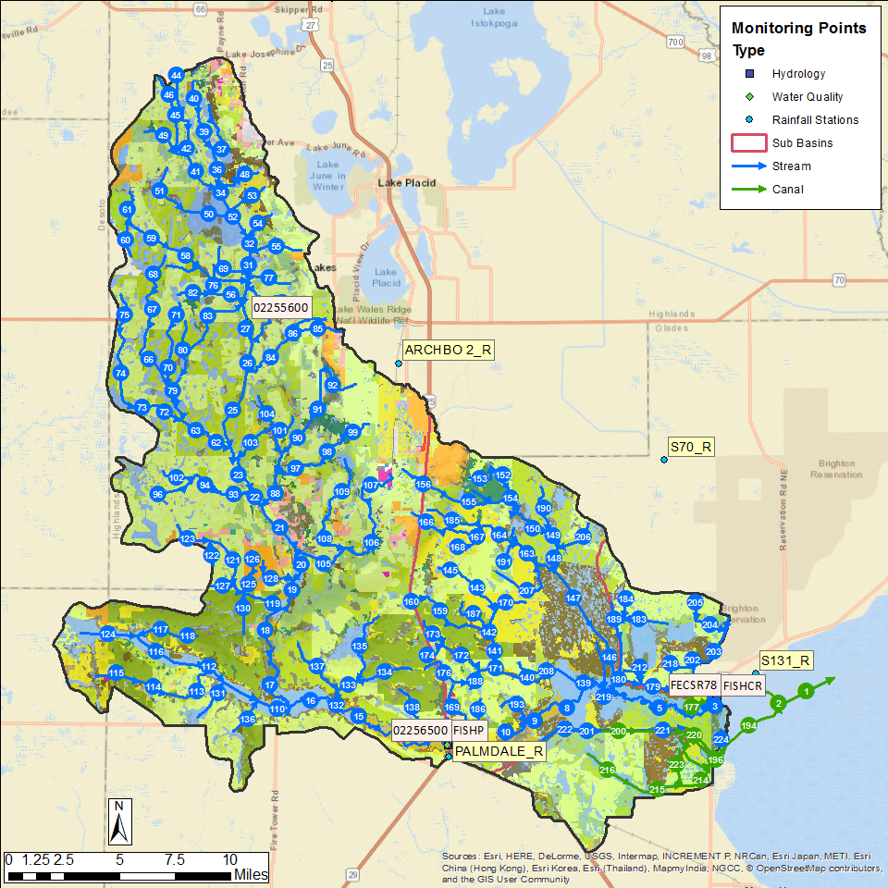
Figure 13. The Fisheating Creek model domain. Rain stations, flow station, and water quality stations are shown.

Flows and Water Quality Data at SR-78

Flow Results
Accumulated flow at SR-78 (SFWMD Station FISHCR) over the 2003-2013 period is shown in Figure 14, with tabulated values over the calibration and verification period shown in Table 12. Note that measured data was not collected prior to 1997. As can be seen, over the entire calibration/verification period the simulation results and measured values are close, with the simulated values underestimating the measured values in the calibration period by 6% and overestimating by 19% the measured values during the verification period. Over the combined calibration/verification period the simulated results are about 1% too high.
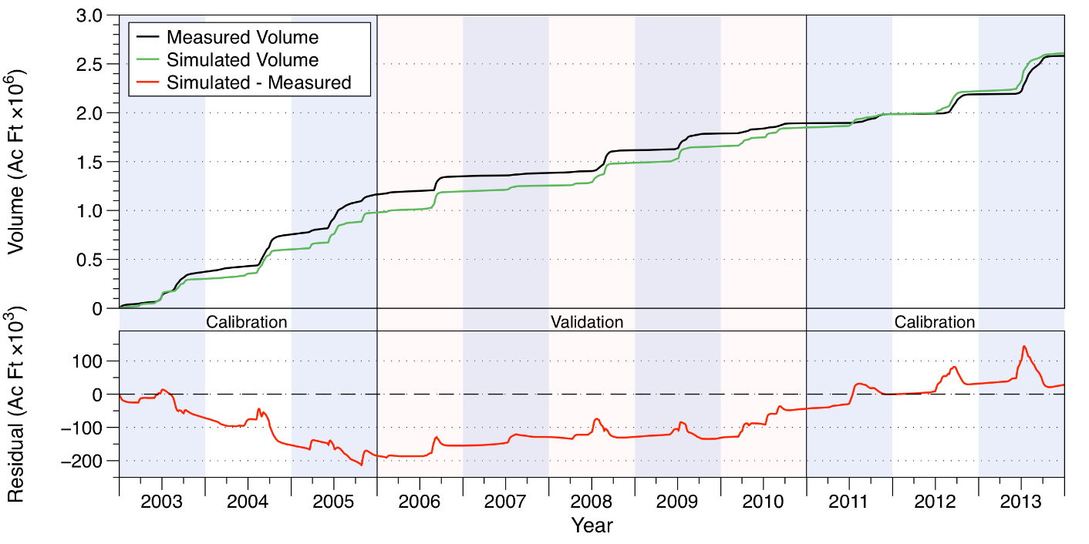
Figure 14. Measured and simulated accumulated water volumes in acre-feet (upper chart) and accumulated volume residuals (lower chart) at SR-78.
Table 12. Comparison of measured and simulated water volumes (in acre-feet) on Fisheating Creek at SR-78.
Year | Simulated | Measured | Residual | Percent
Calibration
2003 | 301,751 | 373,353 | -71,602 | -19%
2004 | 301,031 | 382,493 | -81,462 | -21%
2005 | 376,267 | 408,393 | -32,126 | -8%
2011 | 135,485 | 92,379 | 43,106 | 47%
2012 | 235,429 | 203,101 | 32,328 | 16%
2013 | 388,837 | 392,485 | -3,648 | -1%
Subtotal | 1,738,800 | 1,852,205 | -113,405 | -6%
Verification
2006 | 217,070 | 186,635 | 30,435 | 16%
2007 | 58,513 | 32,533 | 25,980 | 80%
2008 | 233,963 | 233,656 | 306 | 0%
2009 | 168,822 | 171,137 | (2,315) | -1%
2010 | 192,004 | 104,877 | 87,127 | 83%
Subtotal | 870,372 | 728,839 | 141,533 | 19%
Total | 2,609,172 | 2,581,043 | 28,128 | 1%

Relevant statistics for daily, monthly, and annual flow values from the calibration/verification periods are shown in Table 13. The statistics show satisfactory values over 0.5 for the NSE for both the calibration and verification periods.
Table 13. Statistics of daily, monthly, and annual flow values for the calibration and verification periods on Fisheating Creek at SR-78.
 | Calibration |  |  | Verification
 | Daily | Monthly | Annual | Daily | Monthly | Annual
PBIAS % | -6.1 | -6.1 | -6.1 | 19.4 | 19.3 | 19.4
RMSE | 938 | 578 | 140 | 674 | 385 | 118
NSE | 0.51 | 0.75 | 0.81 | 0.55 | 0.77 | 0.62
KGE | 0.75 | 0.85 | 0.71 | 0.67 | 0.78 | 0.75

Water Quality Results
Comparisons between measured and simulated nutrient concentrations are shown in Figure 15 for total N (upper chart) and total P (lower chart). Overall the simulated total N concentrations show about the same degree of variability as the measured values, while the total P concentrations do not show the full variability of the higher measured values.
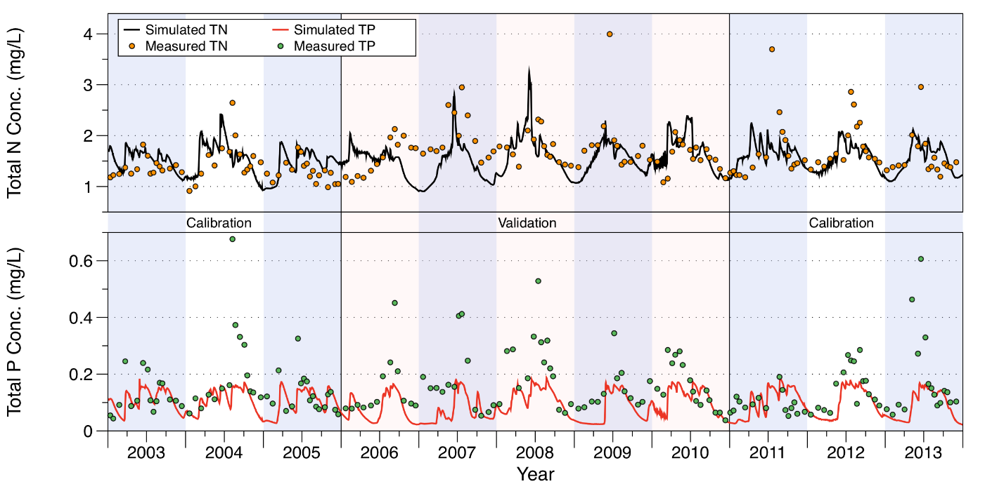
Figure 15. Comparison of measured and simulated total N (upper chart) and total P (lower chart) concentrations on Fisheating Creek at SR-78.
Relevant statistics for daily, monthly, and annual total N and P concentrations and loads from the calibration/verification periods are shown in Table 14. For total N concentrations, the statistics show fits that are better than using mean values (i.e., NSE > 0) for the calibration period, while the fits are somewhat worse for the verification period with negative NSE values calculated. Note that simulated values underestimate the measured values by approximately 10% during the verification period. The values for total N loads are better than those for concentrations, with NSE values over 0.5 for all categories.
For total P concentrations, the statistics show fits that are slightly better than using mean values (i.e., NSE > 0) for daily and monthly values during the calibration period, while the fits are somewhat worse for the verification period. Note that simulated values underestimate the measured values by over 30% for the calibration period and nearly 50% during the verification period. For total P loads, the fits are better than for concentrations, with daily and monthly calculated values over 0.5 for both calibration and verification periods.
Table 14. Statistics of daily, monthly, and annual total N and P concentrations and loads for the calibration and verification periods on Fisheating Creek at SR-78.
 | Calibration |  |  | Verification
 | Daily | Monthly | Annual | Daily | Monthly | Annual
Total Nitrogen Concentrations
PBIAS % | 1.6 | 1 | 1.5 | -10 | -10.1 | -10.6
RMSE | 0.43 | 0.4 | 0.14 | 0.51 | 0.52 | 0.28
NSE | 0.05 | 0.07 | 0.35 | -0.33 | -0.36 | -1.97
KGE | 0.21 | 0.3 | 0.23 | 0.23 | 0.24 | -0.58
Total Nitrogen Loads
PBIAS % | 1.1 | 5.1 | 0.6 | 19.3 | 26 | 17.7
RMSE | 2 | 1.4 | 0.23 | 1.6 | 1.1 | 0.43
NSE | 0.59 | 0.71 | 0.91 | 0.66 | 0.67 | 0.66
KGE | 0.8 | 0.85 | 0.94 | 0.67 | 0.67 | 0.77
Total Phosphorus Concentrations
PBIAS % | -31.3 | -35.2 | -31.6 | -48.8 | -50.9 | -49.4
RMSE | 0.14 | 0.15 | 0.06 | 0.2 | 0.2 | 0.1
NSE | 0.03 | 0.02 | -3.22 | -0.07 | -0.06 | -6.4
KGE | 0.03 | 0.01 | -0.24 | -0.04 | -0.08 | -0.14
Total Phosphorus Loads
PBIAS % | -31.9 | -31.5 | -32.7 | -31.4 | -30.5 | -32.6
RMSE | 0.34 | 0.26 | 0.14 | 0.29 | 0.20 | 0.11
NSE | 0.61 | 0.68 | 0.25 | 0.72 | 0.65 | 0.35
KGE | 0.47 | 0.47 | 0.34 | 0.53 | 0.49 | 0.38

Indian Prairie
The Indian Prairie sub-watershed is located along the south-central portion of the six sub-watersheds, lying south of the Lake Istokpoga and Lower Kissimmee model domains and immediately north of Lake Okeechobee. The sub-watershed is approximately 276,400 acres in area. The Indian Prairie sub-watershed includes several areas that were studied as separate basins in the 2009 WAM study. In that study, the L-48 and L-49 basins were simulated independently of the rest of the lower C-38 basin. The changes to the model domain have in turn significantly altered the WAM setup for the hydrography. The S-68 structure serves as the inflow point from Lake Istokpoga into the domain, flowing southeast down the C-41A canal until the C-41 canal splits from C-41A. The C-41A canal continues flowing east-southeast until it reaches the S-84 structure which controls part of the discharge from the basin. The C-41 canal flows south where the C-39A splits off to the east and then flows into the C-40 canal which flows southeast through the S-75 structure, the S-72 structure, and then into Lake Okeechobee. The C-41 Canal continues flowing south through the S-70 structure, the S-71 structure, and then discharging into Lake Okeechobee. Thus, the inflow leaving Lake Istokpoga via S-68 may take one of three routes before discharging into Lake Okeechobee.
As discussed earlier, measured flow and nutrient loads are used for the inflow boundary condition at S-68, since when WAM is used as a tool to evaluate either nutrient loadings to Lake Okeechobee exclusively due to land use practices within the Indian Prairie sub-watershed or to investigate alternative land use scenarios, it would be most efficient to use the measured inflow data. However, if alternative land use scenarios involving changes everywhere in the northern LOW, it is best to use simulated data as the boundary conditions. Thus, two model setups will be provided, one with the measured data as the inflow boundary condition, and a second with the simulated inflow data.
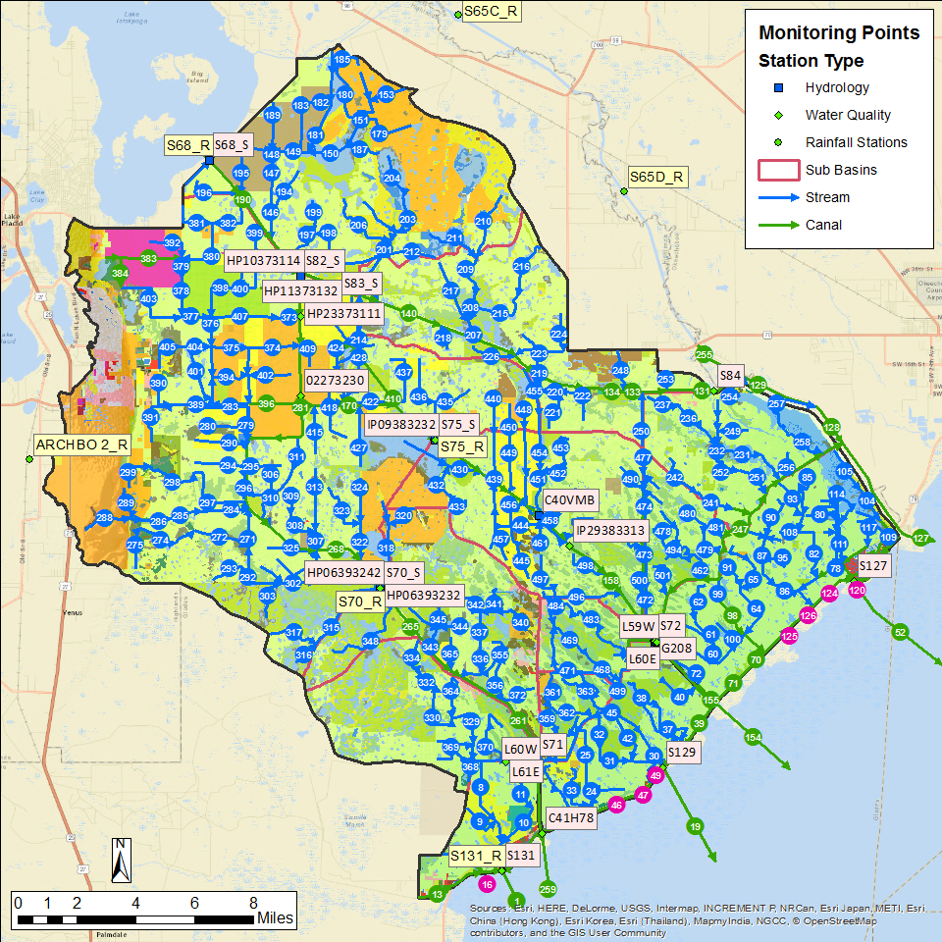
Figure 16. The Indian Prairie model domain. Rain stations, flow station, and water quality stations are shown.

Flow and Water Quality Data at S-84

Flow Results
Accumulated flow at the S-84 structure on C-41A over the 2003-2013 period is shown in Figure 17, with tabulated values over the calibration and verification period shown in Table 15. As can be seen, over the entire calibration/verification period the simulation results are close, with the simulated values underestimating the measured values in the calibration period by 3% and overestimating by 2% the measured values during the verification period. Over the combined calibration/verification entire period the simulated is about 2% too low.
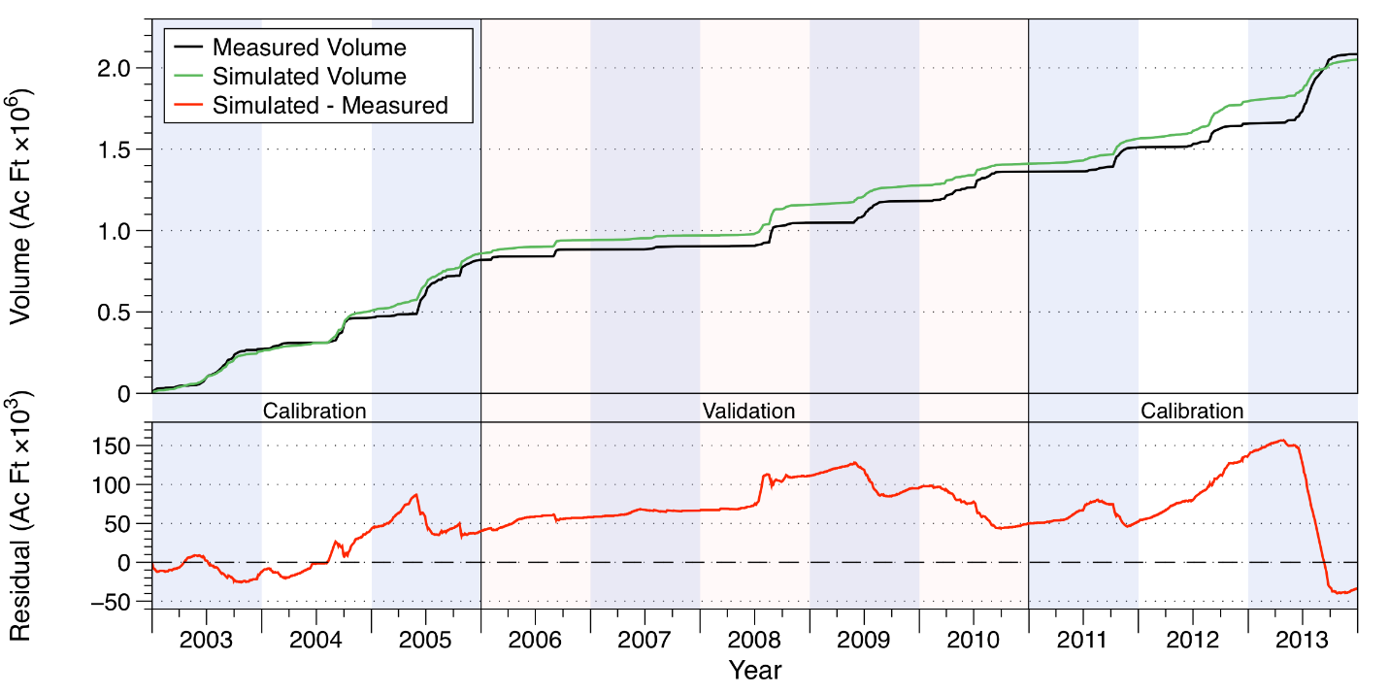
Figure 17. Measured and simulated accumulated water volumes in acre-feet (upper chart) and accumulated volume residuals (lower chart) at structure S-84.
Table 15. Comparison of measured and simulated water volumes (in acre-feet) at structure S-84 on C-41A.
Year | Simulated | Measured | Residual | Percent
Calibration
2003 | 259,417 | 271,803 | -12,386 | -5%
2004 | 248,801 | 193,116 | 55,685 | 29%
2005 | 351,353 | 354,418 | -3,065 | -1%
2011 | 153,336 | 151,241 | 2,095 | 1%
2012 | 229,549 | 144,910 | 84,639 | 58%
2013 | 256,197 | 426,486 | -170,289 | -40%
Subtotal | 1,498,653 | 1,541,974 | -43,321 | -3%
Verification
2006 | 81,958 | 64,145 | 17,813 | 28%
2007 | 27,959 | 19,673 | 8,286 | 42%
2008 | 189,396 | 144,358 | 45,038 | 31%
2009 | 117,862 | 133,660 | -15,798 | -12%
2010 | 134,622 | 180,303 | -45,681 | -25%
Subtotal | 551,797 | 542,139 | 9,658 | 2%
Total | 2,050,450 | 2,084,113 | -33,663 | -2%

Relevant statistics for daily, monthly, and annual flow values from the calibration/verification periods are shown in Table 16. The statistics show satisfactory values over 0.5 for the NSE for both the calibration and verification except for the calibration value for annualized data.
Table 16. Statistics of daily, monthly, and annual flow values for the calibration and verification periods at structure S-84 on C-41A.
 | Calibration |  |  | Verification
 | Daily | Monthly | Annual | Daily | Monthly | Annual
PBIAS % | -2.8 | -2.8 | -2.8 | 1.8 | 1.8 | 1.8
RMSE | 653 | 469 | 222 | 412 | 236 | 84
NSE | 0.77 | 0.78 | 0.41 | 0.79 | 0.82 | 0.72
KGE | 0.72 | 0.67 | 0.43 | 0.81 | 0.81 | 0.83

Water Quality Results
Comparisons between measured and simulated nutrient concentrations are shown in Figure 18 for total N (upper chart) and total P (lower chart). Overall, both the simulated total N and P concentrations somewhat overestimate the measured values.
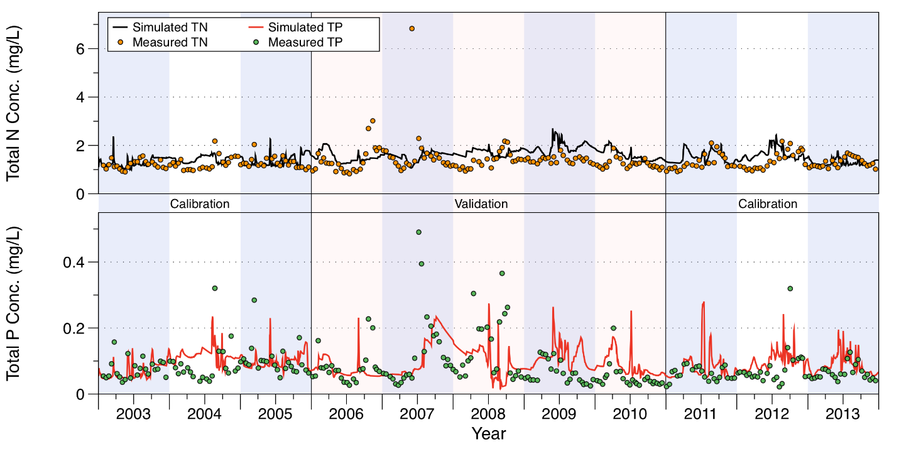
Figure 18. Comparison of measured and simulated total N (upper chart) and total P (lower chart) concentrations at structure S-84 on C-41A.
Relevant statistics for daily, monthly, and annual total N and P concentrations and loads from the calibration/verification periods are shown in Table 17. For total N concentrations the statistics bear out the overestimation by the simulation, by nearly 10% in the calibration period and 16% in the verification period, as well as showing suboptimal fits as indicated by the negative NSE statistics. For total N loads, the bias statistic shows that loads are slightly underestimated (2%-3%) while the NSE statistic shows values > 0.5 for all calculations except for the annual average during the calibration period, at 0.28.
For total P concentrations, the statistics show an overestimation of approximately 16% during the calibration period, but only 4% during the verification period. The NSE statistic indicates suboptimal fits for both calibration and verification period. For total P loads, the simulated values only overestimate the measured values by about 5% during the calibration period, and the NSE statistic is above 0.5 for all calculations during the calibration period. During the verification period, the simulated total P loads underestimate the measured values by 22%-23%, and the NSE statistics, while still greater than zero, are less than 0.5.
Table 17. Statistics of daily, monthly, and annual total N and P concentrations and loads for the calibration and verification periods at structure S-84 on C-41A.
 | Calibration |  |  | Verification
 | Daily | Monthly | Annual | Daily | Monthly | Annual
Total Nitrogen Concentrations
PBIAS % | 9.5 | 8.9 | 9.7 | 16 | 16.1 | 16.1
RMSE | 0.34 | 0.31 | 0.16 | 0.72 | 0.59 | 0.31
NSE | -0.56 | -0.62 | -7.22 | -0.41 | -0.62 | -3.99
KGE | 0.21 | 0.23 | -0.51 | -0.27 | -0.22 | -0.15
Total Nitrogen Loads
PBIAS % | -3.4 | -2.3 | -2.6 | 19.6 | 19.6 | 19.7
RMSE | 1.25 | 1.1 | 0.52 | 0.76 | 0.57 | 0.12
NSE | 0.67 | 0.64 | 0.28 | 0.6 | 0.58 | 0.51
KGE | 0.65 | 0.61 | 0.2 | 0.66 | 0.7 | 0.56
Total Phosphorus Concentrations
PBIAS % | 15.9 | 13.6 | 16.1 | 4.7 | 3.7 | 4.3
RMSE | 0.05 | 0.04 | 0.02 | 0.08 | 0.08 | 0.03
NSE | -0.27 | -0.21 | -0.91 | -0.12 | -0.13 | 0.09
KGE | 0.17 | 0.2 | 0.49 | 0.05 | 0.07 | 0.15
Total Phosphorus Loads
PBIAS % | 5.1 | 4.8 | 5.1 | -22.7 | -22.7 | -23.4
RMSE | 0.08 | 0.06 | 0.02 | 0.1 | 0.07 | 0.02
NSE | 0.72 | 0.74 | 0.68 | 0.4 | 0.42 | 0.2
KGE | 0.71 | 0.69 | 0.56 | 0.31 | 0.34 | 0.24

Flow and Water Quality Data at S-71

Flow Results
Accumulated flow at the S-71 structure on C-41 over the 2003-2013 period is shown in Figure 19, with tabulated values over the calibration and verification period shown in Table 18. As can be seen, over the entire calibration/verification period the simulation results are close, with the simulated values underestimating the measured values in the calibration period by 6% and overestimating by 1% the measured values during the verification period. Over the combined calibration/verification entire period the simulated is 4% too low.
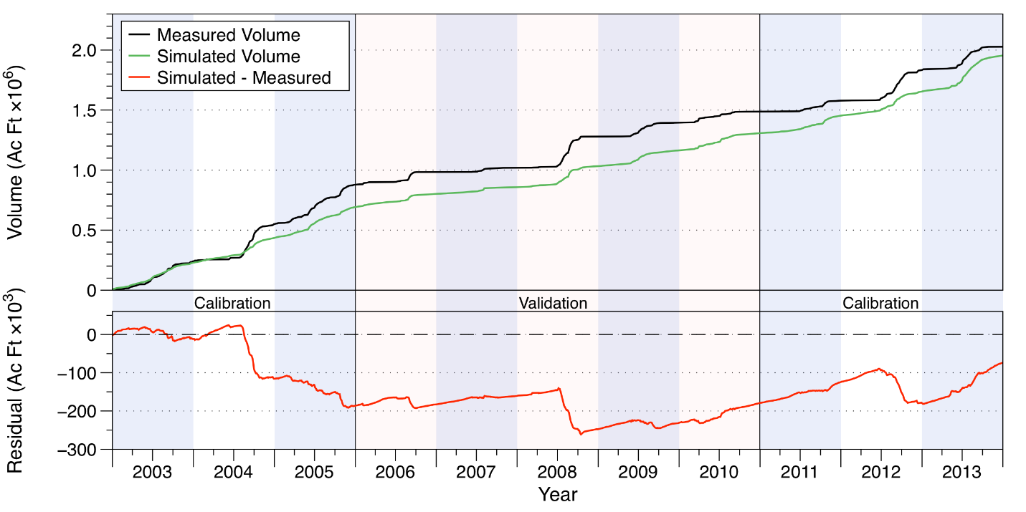
Figure 19. Measured and simulated accumulated water volumes in acre-feet (upper chart) and accumulated volume residuals (lower chart) at structure S-71.
Table 18. Comparison of measured and simulated water volumes (in acre-feet) at structure S-71 on C-41.
Year | Simulated | Measured | Residual | Percent
Calibration
2003 | 228,238 | 239,687 | -11,450 | -5%
2004 | 206,709 | 310,937 | -104,228 | -34%
2005 | 257,545 | 327,995 | -70,450 | -21%
2011 | 146,286 | 91,926 | 54,360 | 59%
2012 | 199,630 | 254,247 | -54,617 | -21%
2013 | 299,984 | 194,714 | 105,270 | 54%
Subtotal | 1,338,393 | 1,419,507 | -81,115 | -6%
Verification
2006 | 109,188 | 105,733 | 3,456 | 3%
2007 | 56,568 | 34,537 | 22,031 | 64%
2008 | 174,932 | 261,652 | -86,721 | -33%
2009 | 130,730 | 114,482 | 16,248 | 14%
2010 | 144,255 | 92,029 | 52,225 | 57%
Subtotal | 615,673 | 608,434 | 7,240 | 1%
Total | 1,954,066 | 2,027,941 | -73,875 | -4%

Relevant statistics for daily, monthly, and annual flow values from the calibration/verification periods are shown in Table 19. The statistics show satisfactory values over 0.5 for the NSE for both the calibration and verification except for the calibration value for annualized data. The simulated volume underestimates the measured volume by approximately 6% over the calibration period, while during the verification period the simulated values are approximately 1% too high.
Table 19. Statistics of daily, monthly, and annual flow values for the calibration and verification periods at structure S-71 on C-41.
 | Calibration |  |  | Verification
 | Daily | Monthly | Annual | Daily | Monthly | Annual
PBIAS % | -5.7 | -5.6 | -5.7 | 1.2 | 1.3 | 1.2
RMSE | 669 | 452 | 203 | 505 | 318 | 128
NSE | 0.59 | 0.64 | 0.1 | 0.65 | 0.73 | 0.61
KGE | 0.56 | 0.57 | 0.3 | 0.63 | 0.58 | 0.5

Water Quality Results
Comparisons between measured and simulated nutrient concentrations are shown in Figure 20 for total N (upper chart) and total P (lower chart). Overall, both the simulated total N and P concentrations underestimate the measured values, with simulated total P underestimating the measured values by over 30%.
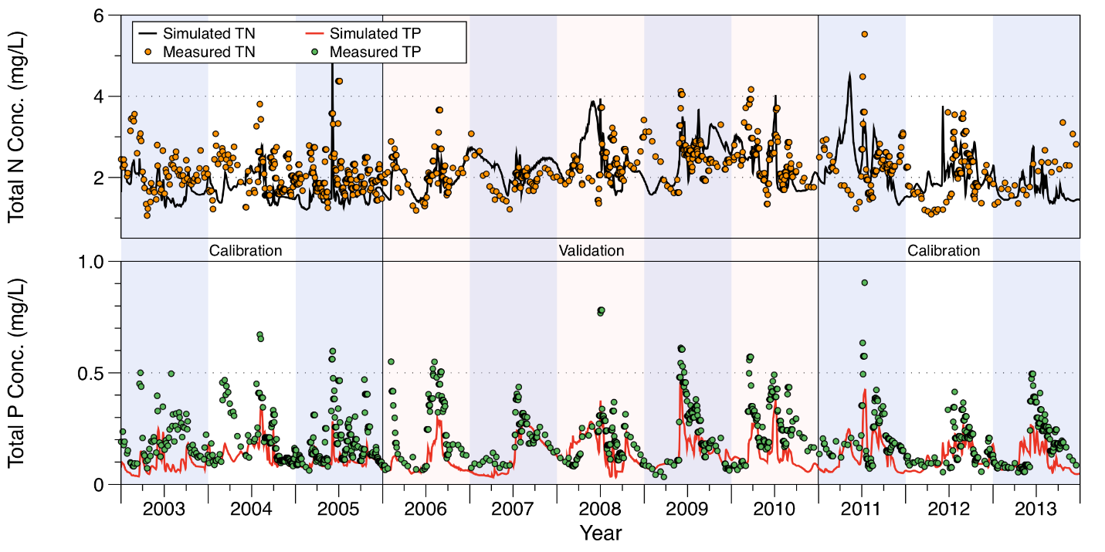
Figure 20. Comparison of measured and simulated total N (upper chart) and total P (lower chart) concentrations at structure S-71 on C-41.
Relevant statistics for daily, monthly, and annual total N and P concentrations and loads from the calibration/verification periods are shown in Table 20. For simulated total N concentrations, the statistics bear out the underestimation by the simulation, by nearly 12%-15% in the calibration period, but only 3% (with a slight overestimation in the monthly statistics) in the verification period, as well as showing suboptimal fits as indicated by the negative NSE statistics. For simulated total N loads the NSE statistic is negative only for the annual calculation for the calibration period, although the simulated loads underestimate the measured loads by a greater margin than the concentration data, between 25% and 42%.
For simulated total P concentrations, the statistics show an underestimation of approximately 36% over both the calibration and verification periods. The NSE statistic indicates suboptimal fits for both calibration and verification period, except for the monthly NSE statistic during the verification period. The simulated total P loads underestimate the measured values by around 50%, while the NSE statistic is greater than zero for both daily and monthly calculations for the calibration and verification periods.
Table 20. Statistics of daily, monthly, and annual total N and P concentrations and loads for the calibration and verification periods at structure S-71 on C-41.
 | Calibration |  |  | Verification
 | Daily | Monthly | Annual | Daily | Monthly | Annual
Total Nitrogen Concentrations
PBIAS % | -14.8 | -11.8 | -14.1 | -3 | 1.7 | -2.3
RMSE | 0.73 | 0.68 | 0.36 | 0.62 | 0.53 | 0.22
NSE | -0.72 | -1.51 | -8.69 | -0.32 | -0.35 | 0.04
KGE | 0.24 | -0.01 | -0.52 | 0.3 | 0.33 | 0.59
Total Nitrogen Loads
PBIAS % | -42.3 | -25.9 | -35.6 | -30.2 | -14.9 | -30.7
RMSE | 3.33 | 1.57 | 1.46 | 3.01 | 1.4 | 1.35
NSE | 0.35 | 0.5 | -0.21 | 0.5 | 0.61 | 0.24
KGE | 0.26 | 0.4 | 0.17 | 0.4 | 0.48 | 0.3
Total Phosphorus Concentrations
PBIAS % | -35.3 | -37.2 | -36.2 | -36.8 | -31.4 | -36
RMSE | 0.12 | 0.1 | 0.08 | 0.14 | 0.1 | 0.1
NSE | -0.08 | -0.35 | -32.63 | -0.14 | 0.17 | -16.49
KGE | 0.28 | 0.29 | -0.1 | 0.33 | 0.44 | -0.01
Total Phosphorus Loads
PBIAS % | -52.6 | -49 | -51.4 | -50.6 | -42.8 | -51.1
RMSE | 0.42 | 0.22 | 0.19 | 0.4 | 0.19 | 0.2
NSE | 0.31 | 0.37 | -1.9 | 0.39 | 0.49 | -0.74
KGE | 0.16 | 0.21 | 0.09 | 0.24 | 0.28 | 0.04

Flow and Water Quality Data at S-72

Flow Results
Accumulated flow at the S-72 structure on C-40 over the 2003-2013 period is shown in Figure 21, with tabulated values over the calibration and verification period shown in Table 21. As can be seen, over the entire calibration/verification period the simulation results are close, with the simulated values underestimating the measured values in the calibration period by 5% and overestimating by 27% the measured values during the verification period. Over the combined calibration/verification entire period the simulated is 3% too high.
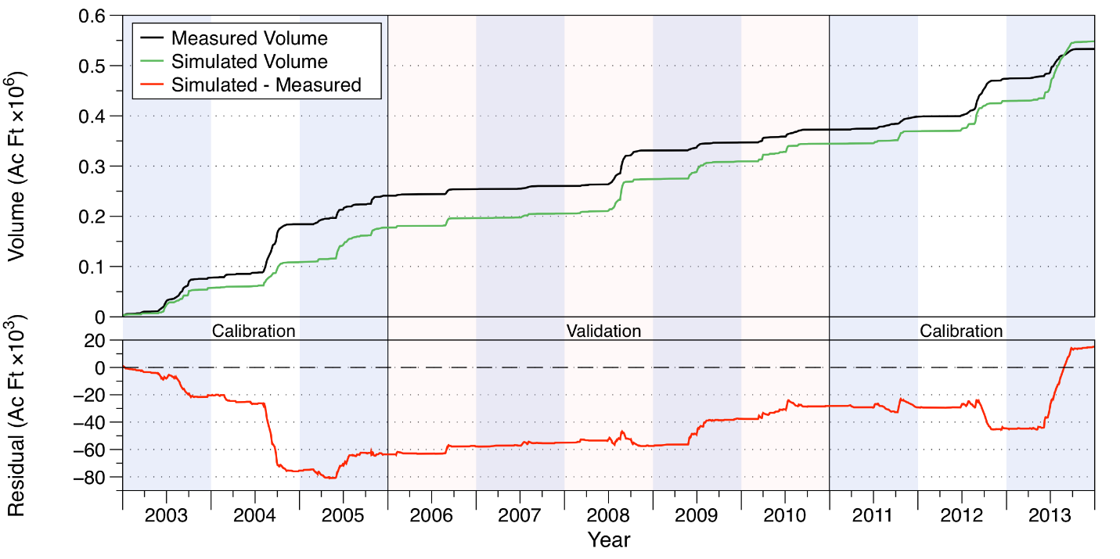
Figure 21. Measured and simulated accumulated water volumes in acre-feet (upper chart) and accumulated volume residuals (lower chart) at structure S-72.
Table 21. Comparison of measured and simulated water volumes (in acre-feet) at structure S-72 on C-40.
Year | Simulated | Measured | Residual | Percent
Calibration
2003 | 57,187 | 77,686 | -20,499 | -26%
2004 | 51,587 | 106,514 | -54,927 | -52%
2005 | 68,658 | 56,768 | 11,890 | 21%
2011 | 24,551 | 25,578 | -1,028 | -4%
2012 | 60,130 | 75,553 | -15,423 | -20%
2013 | 118,918 | 59,233 | 59,684 | 101%
Subtotal | 381,029 | 401,333 | -20,304 | -5%
Verification
2006 | 18,968 | 13,168 | 5,800 | 44%
2007 | 9,065 | 6,368 | 2,697 | 42%
2008 | 68,395 | 70,780 | -2,385 | -3%
2009 | 35,499 | 15,720 | 19,779 | 126%
2010 | 35,276 | 25,798 | 9,478 | 37%
Subtotal | 167,203 | 131,835 | 35,368 | 27%
Total | 548,232 | 533,168 | 15,065 | 3%

Relevant statistics for daily, monthly, and annual flow values from the calibration/verification periods are shown in Table 22. The statistics show satisfactory values around 0.5 for the NSE for the daily and monthly calibration, but show a poor value (-1.04) for the annualized values. The NSE statistics for verification show reasonable daily values of 0.47, but show high values for monthly and annualized values over the verification period. The simulated volume underestimates the measured volume by approximately 5% over the calibration period, while during the verification period the simulated values are approximately 27% too high.
Table 22. Statistics of daily, monthly, and annual flow values for the calibration and verification periods at structure S-72 on C-40.
 | Calibration |  |  | Verification
 | Daily | Monthly | Annual | Daily | Monthly | Annual
PBIAS % | -5.1 | -5.2 | -5 | 26.8 | 26.8 | 26.9
RMSE | 289 | 191 | 96 | 180 | 67 | 28
NSE | 0.43 | 0.5 | -1.04 | 0.47 | 0.83 | 0.8
KGE | 0.72 | 0.74 | 0.12 | 0.54 | 0.67 | 0.7

Water Quality Results
Comparisons between measured and simulated nutrient concentrations are shown in Figure 22 for total N (upper chart) and total P (lower chart). Overall, both the simulated total N and P concentrations underestimate the measured values during the calibration period, while total N values are overestimated during the verification period. Simulated total P values slightly underestimate measured values during the verification period on both a daily and annual basis, but overestimate the measure values on a monthly basis.
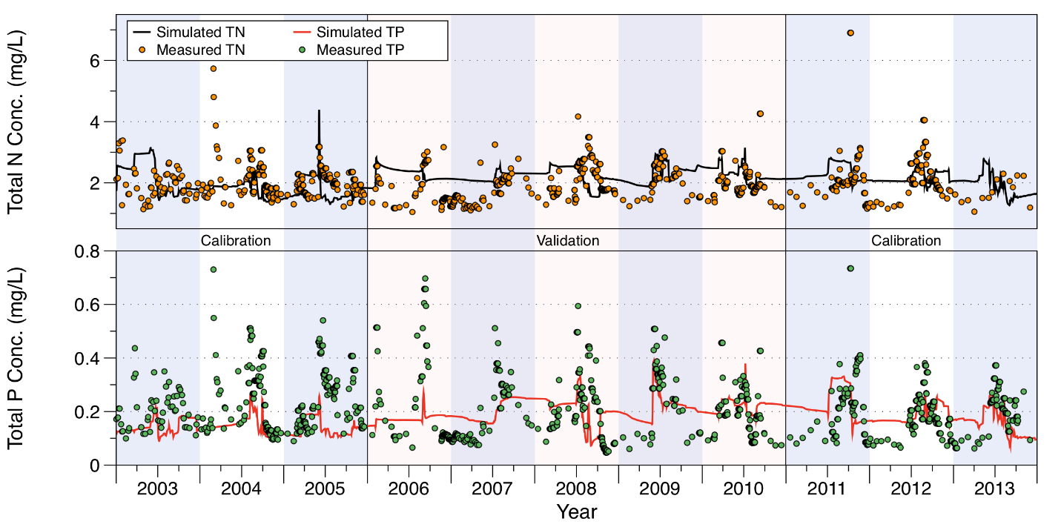
Figure 22. Comparison of measured and simulated total N (upper chart) and total P (lower chart) concentrations at structure S-72 on C-40.
Relevant statistics for daily, monthly, and annual total N and P concentrations and loads from the calibration/verification periods are shown in Table 23. For total N concentrations, the statistics show the slight underestimation on the daily and annual values, but show a slight overestimation on the monthly values. During the verification period, the simulated total N values overestimate the simulated values by 13%-25%. The NSE statistics show suboptimal fits as indicated by the negative NSE statistics for both the calibration and verification periods. Simulated total N loads have NSE values near or greater than 0.5 except for the annual calculation for the calibration period.
For simulated total P concentrations, the statistics show an underestimation of 12% - 14% over the calibration period, but shows between an 8% underestimation to 10% overestimation for the verification period. The NSE statistic indicates suboptimal fits for both the calibration and verification periods, except for a slight positive value for the daily NSE statistic during the verification period. Simulated total P loads underestimate measured values by 43%-46%, however NSE statistics are greater than zero for all categories except the annual calibration calculation.
Table 23. Statistics of daily, monthly, and annual total N and concentrations and loads for the calibration and verification periods at structure S-72 on C-40.
 | Calibration |  |  | Verification
 | Daily | Monthly | Annual | Daily | Monthly | Annual
Total Nitrogen Concentrations
PBIAS % | -6.1 | 7.2 | -1.9 | 13.5 | 25.6 | 14.8
RMSE | 0.76 | 0.65 | 0.24 | 0.68 | 0.7 | 0.35
NSE | -0.37 | -0.73 | -0.74 | -0.52 | -1.02 | -1.62
KGE | 0.08 | -0.04 | 0.32 | -0.09 | -0.08 | 0.29
Total Nitrogen Loads
PBIAS % | -38 | -26.2 | -32.5 | 5 | 8.7 | 14.7
RMSE | 1.46 | 0.61 | 0.61 | 0.98 | 0.46 | 0.3
NSE | 0.42 | 0.55 | -0.02 | 0.52 | 0.65 | 0.49
KGE | 0.47 | 0.6 | 0.16 | 0.74 | 0.79 | 0.63
Total Phosphorus Concentrations
PBIAS % | -24.7 | -12.2 | -23.9 | -6.9 | 10.1 | -8.2
RMSE | 0.13 | 0.11 | 0.07 | 0.13 | 0.11 | 0.03
NSE | -0.45 | -0.39 | -6.66 | 0.09 | -0.01 | -0.13
KGE | -0.05 | -0.14 | -0.38 | 0.09 | -0.03 | 0.49
Total Phosphorus Loads
PBIAS % | -45.9 | -44.5 | -43.4 | -16.5 | -16.8 | -10.1
RMSE | 0.2 | 0.09 | 0.1 | 0.12 | 0.06 | 0.04
NSE | 0.38 | 0.42 | -0.54 | 0.56 | 0.68 | 0.38
KGE | 0.3 | 0.31 | 0 | 0.63 | 0.64 | 0.58

Flow and Water Quality Data at S-127

Flow Results
Accumulated flow at the S-127 structure over the 2003-2013 period is shown in Figure 23, with tabulated values over the calibration and verification period shown in Table 24. As can be seen, over the entire calibration/verification period the simulation results are moderately close, with the simulated values underestimating the measured values in the calibration period by 19% and overestimating by 38% the measured values during the verification period. Over the combined calibration/verification entire period the simulated is 3% too low. Note that the time interval from 2003 through late 2004 and again from late 2006 until mid-2008 had little measured flow; consequently, even a slight overestimation of the flow in this time period results in a large percentage difference.
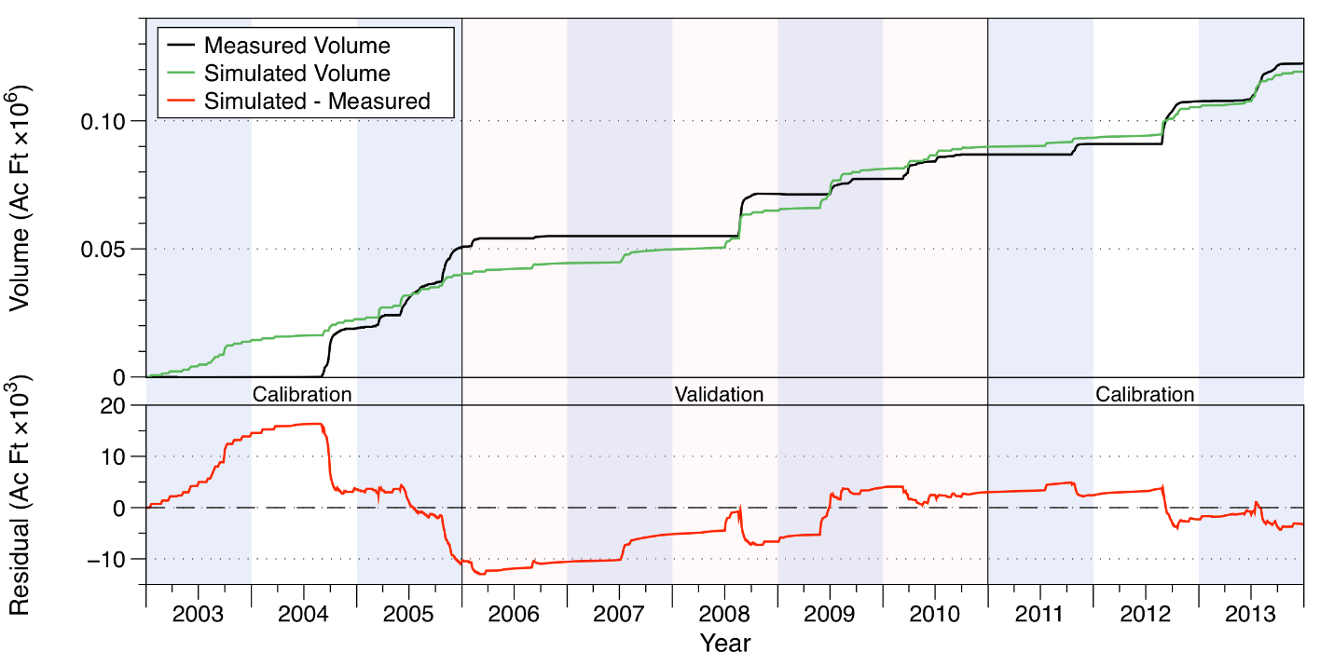
Figure 23. Measured and simulated accumulated water volumes in acre-feet (upper chart) and accumulated volume residuals (lower chart) at structure S-127.
Table 24. Comparison of measured and simulated water volumes (in acre-feet) at structure S-127.
Year | Simulated | Measured | Residual | Percent
Calibration
2003 | 14,224 | -157 | 14,381 | -9159%
2004 | 8,354 | 19,177 | -10,823 | -56%
2005 | 17,627 | 31,713 | -14,087 | -44%
2011 | 3,488 | 4,093 | -605 | -15%
2012 | 11,971 | 16,681 | -4,710 | -28%
2013 | 13,849 | 14,820 | -971 | -7%
Subtotal | 69,513 | 86,327 | -16,814 | -19%
Verification
2006 | 4,233 | 4,273 | -40 | -1%
2007 | 5,392 | 0 | 5,392 | N/A
2008 | 15,094 | 16,554 | -1,460 | -9%
2009 | 16,314 | 5,759 | 10,555 | 183%
2010 | 8,621 | 9,523 | -902 | -9%
Subtotal | 49,654 | 36,109 | 13,544 | 38%
Total | 119,167 | 122,436 | -3,270 | -3%

Relevant statistics for daily, monthly, and annual flow values from the calibration/verification periods are shown in Table 25. The statistics show values above zero but less than 0.5 except for the monthly NSE in the verification phase.
Table 25. Statistics of daily, monthly, and annual flow values for the calibration and verification periods at structure S-127.
 | Calibration |  |  | Verification
 | Daily | Monthly | Annual | Daily | Monthly | Annual
PBIAS % | -19.5 | -19.7 | -19.4 | 37.5 | 36.6 | 37.6
RMSE | 104 | 58 | 26 | 89 | 38 | 15
NSE | 0.22 | 0.44 | 0.16 | 0.2 | 0.58 | 0.07
KGE | 0.48 | 0.41 | 0.21 | 0.47 | 0.53 | 0.45

Water Quality Results
Comparisons between measured and simulated nutrient concentrations are shown in Figure 24 for total N (upper chart) and total P (lower chart). Overall, the simulated total N values slightly underestimate the measured values by 6%-8% during both the calibration and verification periods. Simulated total P values underestimate measured values by a larger amount, between 20% to 30% during the calibration and verification period. Visual inspection of the results shown in Figure 24 indicate that the simulated values do not capture the variability present in the measured data, particularly with the total P values.
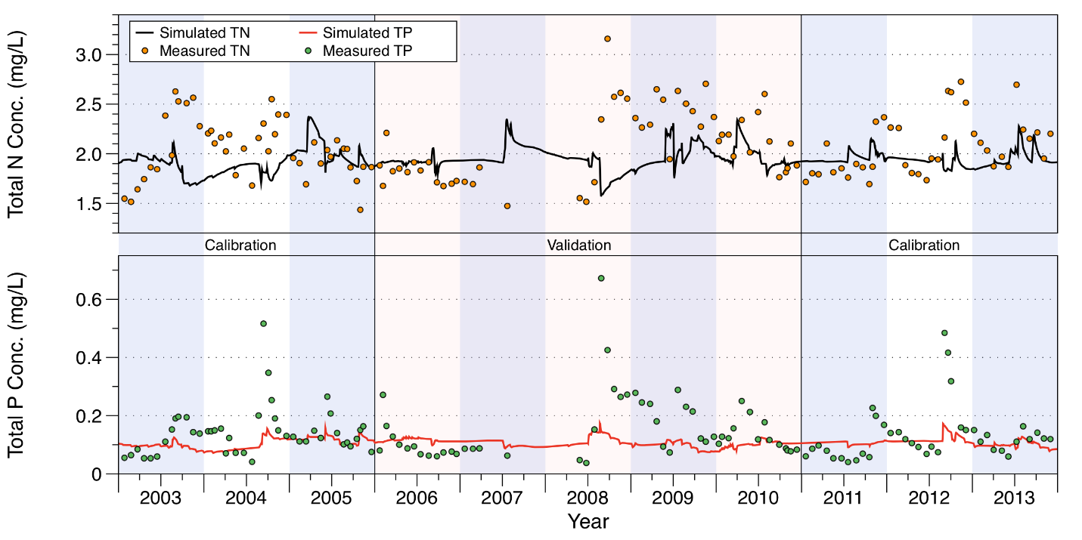
Figure 24. Comparison of measured and simulated total N (upper chart) and total P (lower chart) concentrations at structure S-127.
Relevant statistics for daily, monthly, and annual total N and P concentrations and loads from the calibration/verification periods are shown in Table 26. The statistics show the slight underestimation of the measured total N concentrations by 6%-8% during the calibration and verification periods. The NSE statistics show suboptimal fits as indicated by the negative NSE statistics for both the calibration and verification periods. The NSE statistics for simulated total N loads are also less than zero, indicating a suboptimal fit. Note that the simulated total N loads underestimate the measure values by 48%-58%.
For simulated total P concentrations, the statistics show an underestimation of 18% - 22% over the calibration period, and show an underestimation of around 30% during the verification period. The NSE statistic indicates slightly positive values during the calibration period, but show suboptimal fits for the verification period. The simulated total P loads underestimate the measured loads by nearly 80%, while the NSE statistic is negative or just slightly positive.
Table 26. Statistics of daily, monthly, and annual total N and P concentrations and loads for the calibration and verification periods at structure S-127.
 | Calibration |  |  | Verification
 | Daily | Monthly | Annual | Daily | Monthly | Annual
Total Nitrogen Concentrations
PBIAS % | -7 | -6.1 | -6.9 | -7.7 | -7.9 | -5.8
RMSE | 0.36 | 0.35 | 0.21 | 0.45 | 0.46 | 0.33
NSE | -0.57 | -0.52 | -2.64 | -0.45 | -0.46 | -0.47
KGE | -0.49 | -0.47 | -0.87 | -0.42 | -0.43 | -0.51
Total Nitrogen Loads
PBIAS % | -57.9 | -48.3 | -57.4 | -60.4 | -62.6 | -66.6
RMSE | 0.28 | 0.26 | 0.1 | 0.31 | 0.31 | 0.12
NSE | -0.1 | -0.2 | -1.76 | 0.22 | 0.19 | -0.1
KGE | -0.16 | -0.19 | -0.8 | -0.05 | -0.08 | -0.16
Total Phosphorus Concentrations
PBIAS % | -22.7 | -18 | -21.9 | -30.4 | -30.5 | -29.5
RMSE | 0.08 | 0.08 | 0.04 | 0.12 | 0.12 | 0.08
NSE | 0.08 | 0.1 | -0.71 | -0.11 | -0.11 | -0.38
KGE | 0.09 | 0.07 | 0.11 | -0.14 | -0.15 | -0.13
Total Phosphorus Loads
PBIAS % | -78.8 | -73 | -78.6 | -89.7 | -90.5 | -91.6
RMSE | 0.04 | 0.03 | 0.01 | 0.09 | 0.1 | 0.04
NSE | 0.01 | -0.04 | -1.36 | 0.05 | 0.05 | -0.24
KGE | -0.3 | -0.35 | -0.84 | -0.32 | -0.33 | -0.34

Flow and Water Quality Data at S-129

Flow Results
Accumulated flow at the S-129 structure over the 2003-2013 period is shown in Figure 27, with tabulated values over the calibration and verification period shown in Table 27. As can be seen, over the entire calibration/verification period the simulation results are close, with the simulated values underestimating the measured values in the calibration period by 3% and underestimating by 7% the measured values during the verification period. Over the combined calibration/verification entire period the simulated is 5% too low. Note that an interval from late 2006 until mid-2008 had little measured flow; consequently, even a slight overestimation of the flow in this time period results in a large percentage difference.
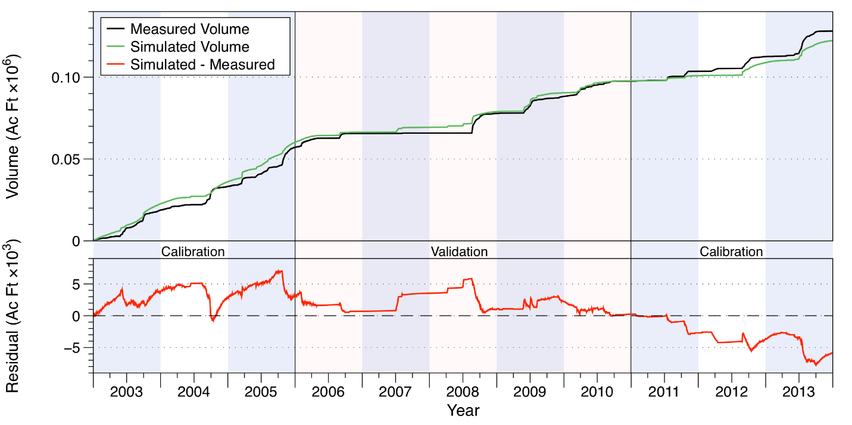
Figure 25. Measured and simulated accumulated water volumes in acre-feet (upper chart) and accumulated volume residuals (lower chart) at structure S-129.
Table 27. Comparison of measured and simulated water volumes (in acre-feet) at structure S-129.
Year | Simulated | Measured | Residual | Percent
Calibration
2003 | 22,558 | 18,825 | 3,733 | 20%
2004 | 13,502 | 14,385 | -883 | -6%
2005 | 24,155 | 23,945 | 210 | 1%
2011 | 3,194 | 6,138 | -2,944 | -48%
2012 | 7,899 | 8,886 | -986 | -11%
2013 | 13,451 | 15,632 | -2,181 | -14%
Subtotal | 84,759 | 87,810 | -3,051 | -3%
Verification
2006 | 6,113 | 8,485 | -2,372 | -28%
2007 | 3,048 | 186 | 2,862 | 1542%
2008 | 9,474 | 12,051 | -2,577 | -21%
2009 | 11,609 | 10,344 | 1,265 | 12%
2010 | 7,275 | 9,277 | -2,003 | -22%
Subtotal | 37,519 | 40,343 | -2,825 | -7%
Total | 122,278 | 128,153 | -5,876 | -5%

Relevant statistics for daily, monthly, and annual flow values from the calibration/verification periods are shown in Table 28. The statistics show values above zero but less than 0.5 for the daily NSE in the daily calculation in both the calibration and verification phase, but much higher (> 0.5) for the monthly and annual calculations for the calibration and verification periods.
Table 28. Statistics of daily, monthly, and annual flow values for the calibration and verification periods at structure S-129.
 | Calibration |  |  | Verification
 | Daily | Monthly | Annual | Daily | Monthly | Annual
PBIAS % | -3.5 | -3.5 | -3.5 | -7 | -7.6 | -7
RMSE | 81 | 31 | 6.0 | 62 | 23 | 6.3
NSE | 0.16 | 0.64 | 0.86 | 0.25 | 0.66 | 0.69
KGE | 0.52 | 0.65 | 0.74 | 0.61 | 0.69 | 0.67

Water Quality Results
Comparisons between measured and simulated nutrient concentrations are shown in Figure 28 for total N (upper chart) and total P (lower chart). Overall, the simulated total N values slightly overestimate the measured values by 4%-5% during the calibration period, but underestimate by about 4% during the verification period. Simulated total P values overestimate measured values by 22% to 24% during the calibration period, but underestimate measured values by about 10% during the verification period. Visual inspection of the results shown in Figure 24 indicate that the simulated values capture the variability present in the measured data better than at S-127, although total P values miss some large peaks during the verification period.
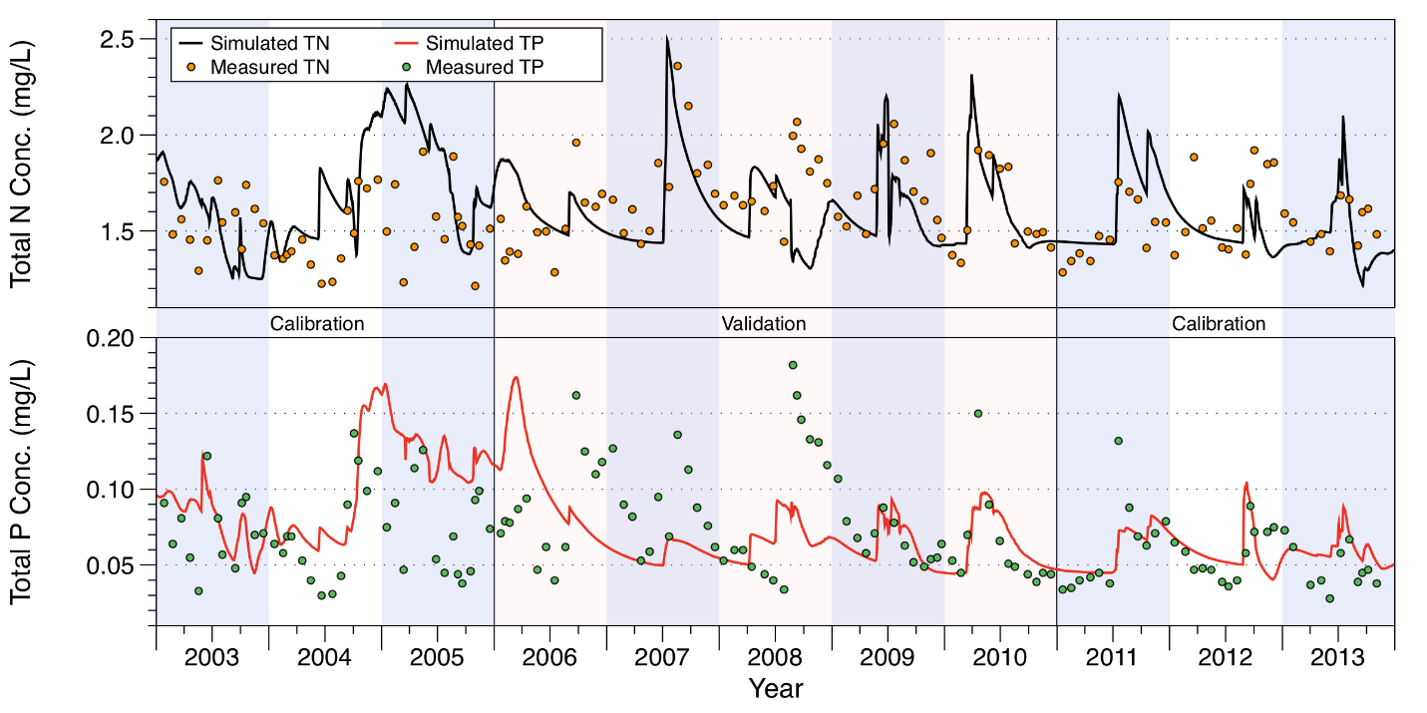
Figure 26. Comparison of measured and simulated total N (upper chart) and total P (lower chart) concentrations at structure S-129.
Relevant statistics for daily, monthly, and annual total N and P concentrations and loads from the calibration/verification periods are shown in Table 29. The NSE statistics for total N concentrations show suboptimal fits as indicated by the negative NSE statistics for both the calibration and verification periods. For total N loads, the NSE statistics are greater than zero, but less than 0.5 for all calculations except for the annual calibration value, at -0.04.
For total P concentrations, as with total N values, the NSE statistics show suboptimal fits for both the calibration and verification periods. However, for total P loads, the NSE values are greater than zero for all calculations for both the calibration and verification periods. Note that during the calibration period that the simulated total P loads underestimate the measured values by 5% to 10%, while in the verification period that the total P loads are underestimated by around 50%.
Table 29. Statistics of daily, monthly, and annual total N and P concentrations and loads for the calibration and verification periods at structure S-129.
 | Calibration |  |  | Verification
 | Daily | Monthly | Annual | Daily | Monthly | Annual
Total Nitrogen Concentrations
PBIAS % | 4.7 | 5.2 | 4.2 | -4 | -4 | -3.9
RMSE | 0.29 | 0.29 | 0.16 | 0.27 | 0.25 | 0.13
NSE | -1.76 | -1.88 | -11.43 | -0.5 | -0.4 | -1.06
KGE | 0.05 | 0.04 | -1.21 | 0.24 | 0.31 | -0.31
Total Nitrogen Loads
PBIAS % | -17.1 | -14.7 | -18.3 | -44 | -30.7 | -43.4
RMSE | 0.15 | 0.14 | 0.03 | 0.09 | 0.06 | 0.02
NSE | 0.15 | 0.21 | -0.04 | 0.33 | 0.43 | 0.28
KGE | 0.41 | 0.45 | 0.45 | 0.26 | 0.43 | 0.4
Total Phosphorus Concentrations
PBIAS % | 23.3 | 24 | 22.3 | -10.2 | -10.4 | -10.4
RMSE | 0.03 | 0.03 | 0.02 | 0.04 | 0.04 | 0.02
NSE | -0.52 | -0.57 | -4.97 | -0.34 | -0.3 | -1.58
KGE | 0.43 | 0.42 | -0.53 | 0.13 | 0.12 | 0.2
Total Phosphorus Loads
PBIAS % | -8.8 | -5.3 | -10.3 | -53.4 | -46.5 | -53.3
RMSE | 0.01 | 0.01 | 0 | 0.01 | 0 | 0
NSE | 0.13 | 0.2 | 0.62 | 0.39 | 0.49 | 0.24
KGE | 0.43 | 0.49 | 0.65 | 0.17 | 0.24 | 0.26

Flow and Water Quality Data at S-131

Flow Results
Accumulated flow at the S-131 structure over the 2003-2013 period is shown in Figure 27, with tabulated values over the calibration and verification period shown in Table 30. As can be seen, over the entire calibration/verification period the simulation results are close, with the simulated values underestimating the measured values in the calibration period by 2% and underestimating by 9% the measured values during the verification period. Over the combined calibration/verification entire period the simulated is 4% too low. As with the S-129 structure, an interval from late 2006 until mid-2008 had little measured flow; consequently, even a slight overestimation of the flow in this time period results in a large percentage difference.
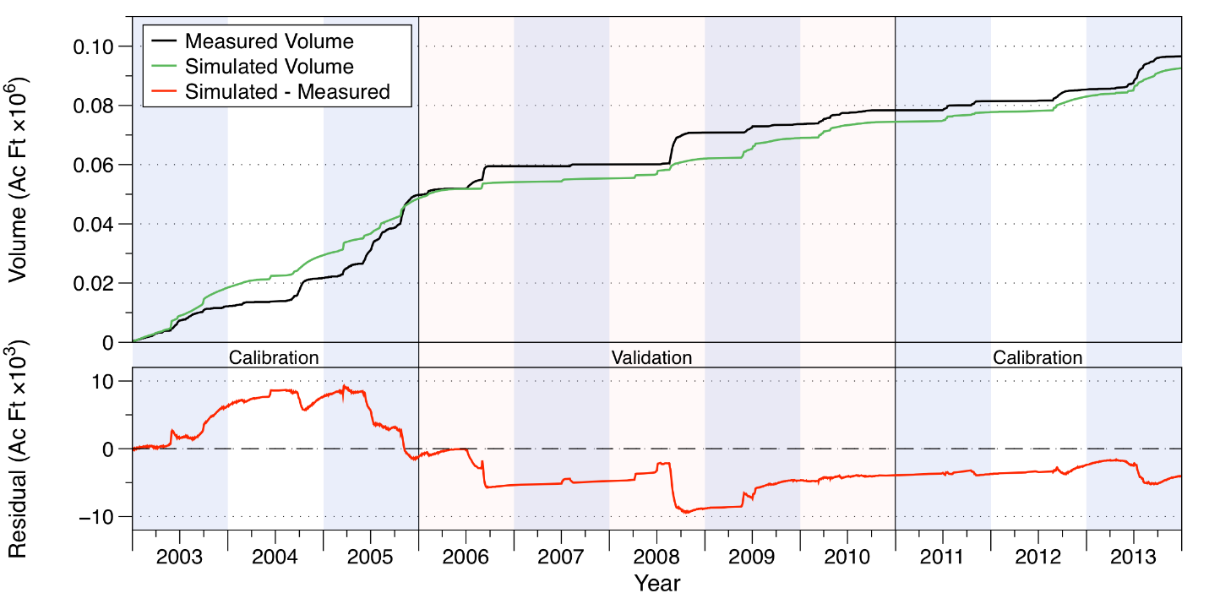
Figure 27. Measured and simulated accumulated water volumes in acre-feet (upper chart) and accumulated volume residuals (lower chart) at structure S-131.
Table 30. Comparison of measured and simulated water volumes (in acre-feet) at structure S-131.
Year | Simulated | Measured | Residual | Percent
Calibration
2003 | 18,465 | 12,140 | 6,325 | 52%
2004 | 10,965 | 9,601 | 1,364 | 14%
2005 | 19,151 | 28,068 | -8,918 | -32%
2011 | 3,291 | 3,090 | 201 | 6%
2012 | 5,243 | 3,884 | 1,359 | 35%
2013 | 9,578 | 11,243 | -1,664 | -15%
Subtotal | 66,692 | 68,026 | -1,333 | -2%
Verification
2006 | 5,533 | 9,665 | -4,132 | -43%
2007 | 1,236 | 634 | 603 | 95%
2008 | 6,680 | 10,774 | -4,094 | -38%
2009 | 6,944 | 2,795 | 4,149 | 148%
2010 | 5,483 | 4,708 | 775 | 16%
Subtotal | 25,877 | 28,576 | -2,699 | -9%
Total | 92,570 | 96,602 | -4,032 | -4%

Relevant statistics for daily, monthly, and annual flow values from the calibration/verification periods are shown in Table 31. The statistics show values above zero but less than 0.5 for the daily NSE in the calibration period and even slightly negative for the verification period, but much higher (> 0.5) for the monthly and annual calculations for the calibration period while being 0.27 and 0.32 for the monthly and annual calculations for the verification period.
Table 31. Statistics of daily, monthly, and annual flow values for the calibration and verification periods at structure S-131.
 | Calibration |  |  | Verification
 | Daily | Monthly | Annual | Daily | Monthly | Annual
PBIAS % | -2 | -2 | -2 | -9.4 | -9.8 | -9.4
RMSE | 61 | 27 | 13 | 59 | 30 | 8.8
NSE | 0.16 | 0.58 | 0.69 | -0.03 | 0.27 | 0.32
KGE | 0.53 | 0.59 | 0.68 | 0.25 | 0.29 | 0.36

Water Quality Results
Comparisons between measured and simulated nutrient concentrations are shown in Figure 28 for total N (upper chart) and total P (lower chart). Overall, the simulated total N values slightly overestimate the measured values by 4%-5% during the calibration period and by about 2% during the verification period. Simulated total P values overestimate measured values by 4% to 6% during the calibration period, but underestimate measured values by about 15% during the verification period. Visual inspection of the results shown in Figure 24 indicate that the simulated values for both total N and P capture the variability present in the measured data better than at S-127 and about as well as at S-129.
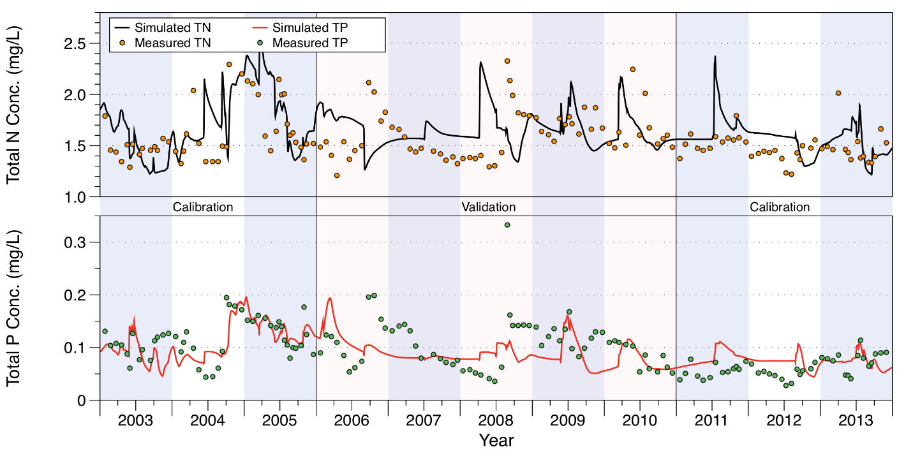
Figure 28. Comparison of measured and simulated total N (upper chart) and total P (lower chart) concentrations at structure S-131.
Relevant statistics for daily, monthly, and annual total N and P concentrations and loads from the calibration/verification periods are shown in Table 32. For total N concentrations, the NSE statistics show suboptimal fits as indicated by the negative NSE statistics for both the calibration and verification periods for the daily and monthly calculations, but show better fits for the annualized values during both the calibration and verification periods. Total N loads show better NSE fits, with positive values for all calculations, although all are less than 0.5.
For total P concentrations, the NSE statistics show fits greater than zero and approaching 0.5 for the calibration period, but are suboptimal for the verification period. Total P loading NSE statistics also show positive values, although they are lower than the equivalent P concentration statistics. Note that the simulated total P loads underestimate measured values by 40%-45% during the calibration period, and by over 70% during the verification period.
Table 32. Statistics of daily, monthly, and annual total N and P concentrations and loads for the calibration and verification periods at structure S-131.
 | Calibration |  |  | Verification
 | Daily | Monthly | Annual | Daily | Monthly | Annual
Total Nitrogen Concentrations
PBIAS % | 4.5 | 5.7 | 4.6 | 2 | 2.5 | 2.2
RMSE | 0.26 | 0.27 | 0.09 | 0.34 | 0.34 | 0.06
NSE | -0.12 | -0.29 | 0.41 | -1.05 | -1.06 | 0.34
KGE | 0.51 | 0.48 | 0.83 | -0.34 | -0.35 | 0.43
Total Nitrogen Loads
PBIAS % | -38 | -30.2 | -37.2 | -52.9 | -51.3 | -51.7
RMSE | 0.14 | 0.12 | 0.04 | 0.15 | 0.14 | 0.04
NSE | 0.18 | 0.13 | 0.45 | 0.18 | 0.18 | 0.23
KGE | 0.21 | 0.21 | 0.43 | -0.05 | -0.04 | 0.05
Total Phosphorus Concentrations
PBIAS % | 4.6 | 5.6 | 5.3 | -15.8 | -15.8 | -15.6
RMSE | 0.03 | 0.03 | 0.02 | 0.05 | 0.05 | 0.02
NSE | 0.42 | 0.46 | 0.72 | -0.21 | -0.22 | -1.18
KGE | 0.58 | 0.63 | 0.67 | 0.07 | 0.05 | 0.65
Total Phosphorus Loads
PBIAS % | -46.2 | -38.6 | -45.5 | -73.2 | -73.9 | -72.3
RMSE | 0.01 | 0.01 | 0 | 0.02 | 0.02 | 0.01
NSE | 0.12 | 0.16 | 0.4 | 0.08 | 0.08 | 0.02
KGE | 0.04 | 0.12 | 0.3 | -0.25 | -0.26 | -0.15

Lake Istokpoga
The Lake Istokpoga sub-watershed lies on the west-central portion of the area covered by the six sub-watersheds, between Upper Kissimmee and Fisheating Creek, and contains a sizeable portion of the Lake Wales Ridge along its western edge. The sub-watershed is nearly 394,160 acres in area. It is bordered by the Indian Prairie model domain on its southern end. The main outflow from the sub-watershed is at the S-68 structure on the southeastern site of Lake Istokpoga. This discharge point is an inflow boundary to Indian Prairie.
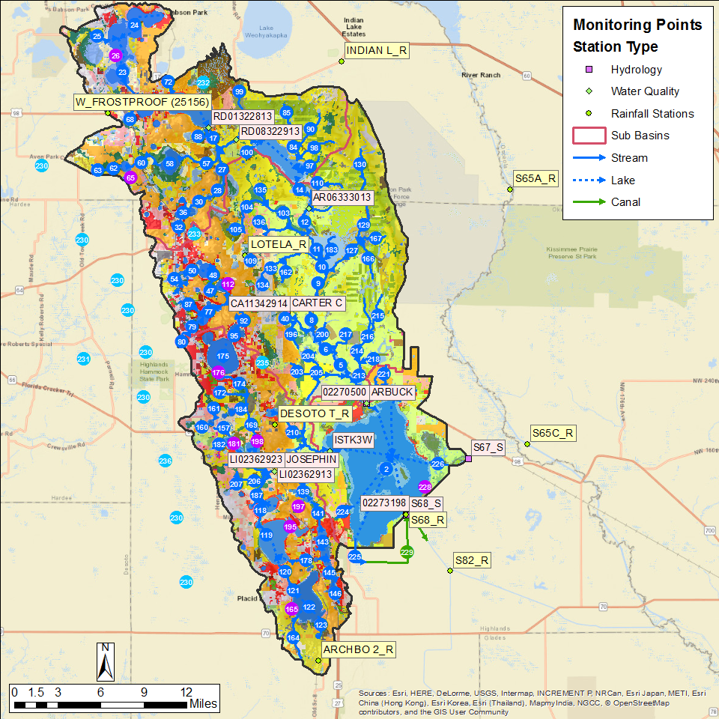
Figure 29. The Lake Istokpoga model domain. Rain stations, flow station, and water quality stations are shown.

Flow and Water Quality Data at S-68

Flow Results
Accumulated flow at the outflow of Lake Istokpoga at the S-68 structure over the 2003-2013 period is shown in Figure 30, with tabulated values over the calibration and verification period shown in Table 33. As can be seen, over the entire calibration/verification period the simulation results are close, with the simulated values underestimating the measured values in the calibration period by 3% and underestimating by 4% the measured values during the verification period. Over the combined calibration/verification entire period the simulated is 3% too low.
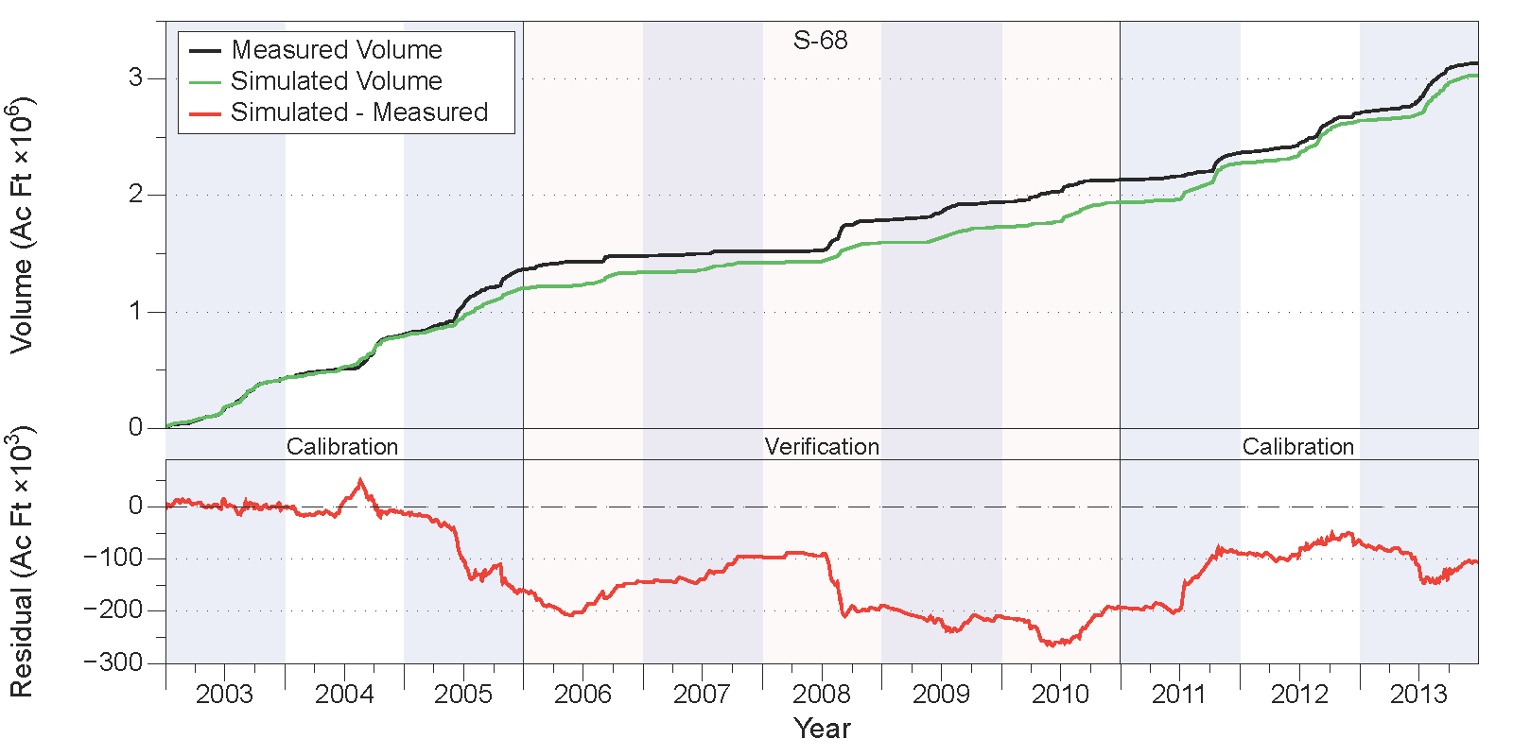
Figure 30. Measured and simulated accumulated water volumes in acre-feet (upper chart) and accumulated volume residuals (lower chart) at the outflow to Lake Istokpoga at structure S-68.
Table 33. Comparison of measured and simulated water volumes (in acre-feet) at structure S-68.
Year | Simulated | Measured | Residual | Percent
Calibration
2003 | 429,590 | 430,590 | -1,000 | 0%
2004 | 364,103 | 377,521 | -13,418 | -4%
2005 | 412,293 | 557,841 | -145,548 | -26%
2011 | 334,107 | 231,768 | 102,339 | 44%
2012 | 367,265 | 340,934 | 26,331 | 8%
2013 | 389,482 | 432,001 | -42,518 | -10%
Subtotal | 2,296,841 | 2,370,655 | -73,814 | -3%
Verification
2006 | 133,676 | 117,052 | 16,623 | 14%
2007 | 83,251 | 35,581 | 47,670 | 134%
2008 | 175,553 | 268,962 | -93,408 | -35%
2009 | 134,825 | 155,828 | -21,003 | -13%
2010 | 209,907 | 192,282 | 17,625 | 9%
Subtotal | 737,212 | 769,705 | -32,493 | -4%
Total | 3,034,053 | 3,140,360 | -106,307 | -3%

Relevant statistics for daily, monthly, and annual flow values from the calibration/verification periods are shown in Table 34. The statistics show values above zero but less than 0.5 for the daily and annual NSE in the calibration period and in the daily NSE for the verification period, but higher (> 0.5) for the monthly calculations for the calibration period and for the monthly and annual calculations for the verification period.
Table 34. Statistics of daily, monthly, and annual flow values for the calibration and verification periods at structure S-68.
 | Calibration |  |  | Verification
 | Daily | Monthly | Annual | Daily | Monthly | Annual
PBIAS % | -3.1 | -3.1 | -3.1 | -4.2 | -4.3 | -4.2
RMSE | 1176 | 493 | 207 | 801 | 445 | 134
NSE | 0.34 | 0.76 | 0.42 | 0.36 | 0.56 | 0.6
KGE | 0.64 | 0.83 | 0.3 | 0.48 | 0.6 | 0.52

Water Quality Results
Comparisons between measured and simulated nutrient concentrations are shown in Figure 31 for total N (upper chart) and total P (lower chart). Overall, the simulated total N values overestimate the measured values by 7%-12% during the calibration period and by about 20% - 25% during the verification period. Simulated total P values overestimate measured values by 5% to 10% during the calibration period, but overestimate measured values by over 40% during the verification period. Visual inspection of the results shown in Figure 31 indicate that the simulated values for both total N and P do not capture the variability present in the measured data, nor do they capture the multi-year trends present in the observed data. Much of this error is attributable to the inability of WAM to simulate complex in-lake processes, such as algal blooms, wind-driven mixing, and temperature-driven lake turnovers.
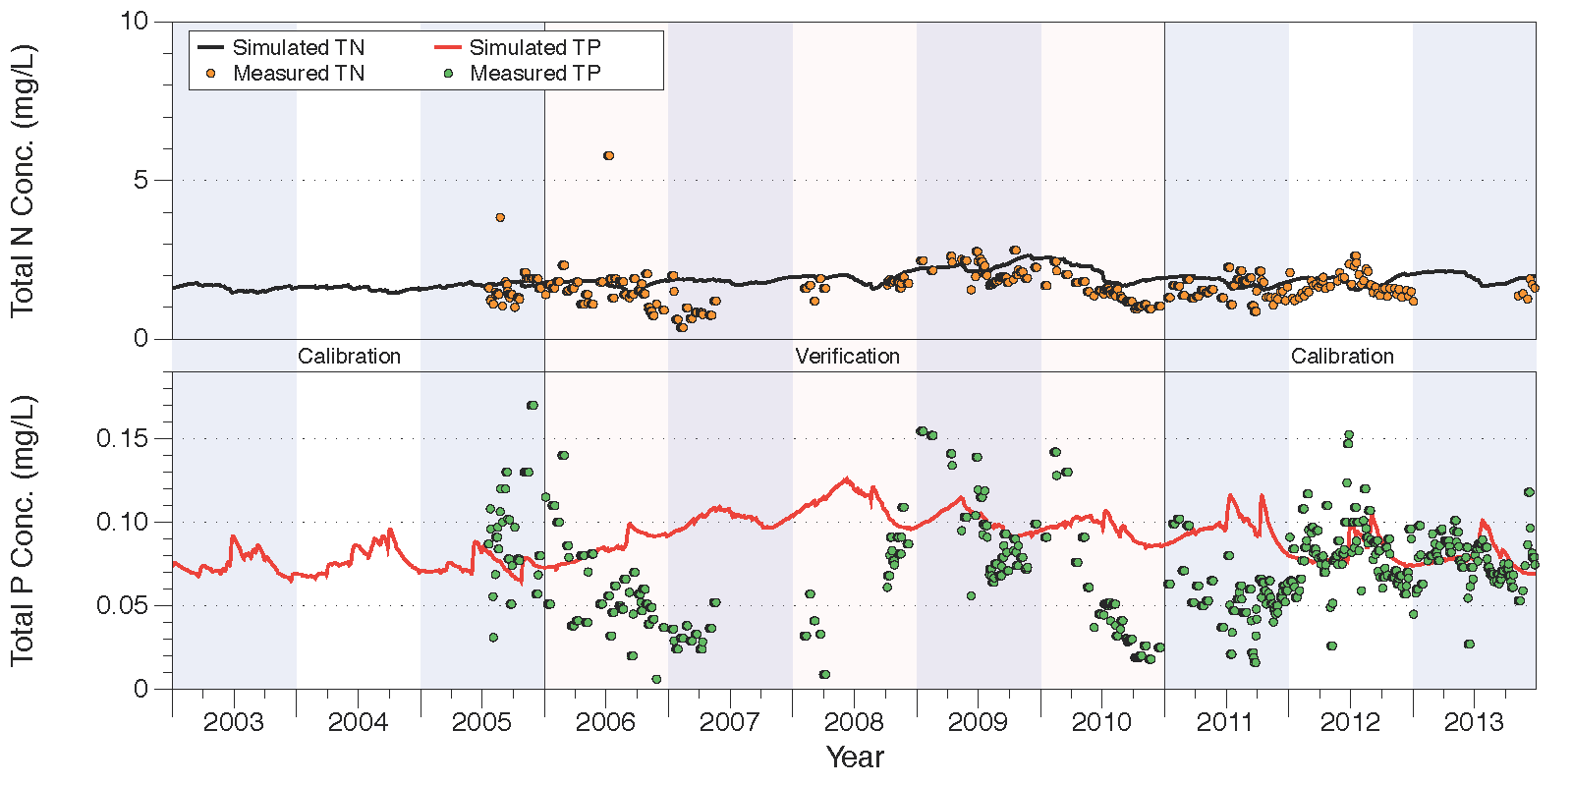
Figure 31. Comparison of measured and simulated total N (upper chart) and total P (lower chart) concentrations at structure S-68.
Relevant statistics for daily, monthly, and annual total N and P concentrations and loads from the calibration/verification periods are shown in Table 35. The NSE statistics for total N concentrations show suboptimal fits as indicated by the negative NSE statistics for both the calibration and verification periods for the daily and monthly calculations. NSE values to total N load estimates show better values, with all values greater than zero, and monthly and annual values during the calibration period over 0.5.
For total P, as with total N, the NSE statistics show suboptimal fits for the calibration and verification periods. The NSE statistics for total N loads are suboptimal for all calculations except for the monthly estimate during the calibration period. Note that the simulated total P loads overestimate measured values by 7% to 18% during the calibration period, and by 30% to 55% during the verification period.
Table 35. Statistics of daily, monthly, and annual total N and P concentrations and loads for the calibration and verification periods at structure S-68.
 | Calibration |  |  | Verification
 | Daily | Monthly | Annual | Daily | Monthly | Annual
Total Nitrogen Concentrations
PBIAS % | 7.4 | 12 | 10.2 | 19.4 | 20.7 | 25.1
RMSE | 0.6 | 0.41 | 0.26 | 0.68 | 0.57 | 0.52
NSE | -0.24 | -1.23 | -3.52 | -0.14 | -0.16 | -0.58
KGE | -0.45 | -0.54 | -0.75 | 0.12 | 0.3 | 0.3
Total Nitrogen Loads
PBIAS % | 8.2 | -4.5 | -7.8 | 27.6 | 15 | 22.1
RMSE | 3.93 | 1.47 | 0.66 | 1.55 | 0.94 | 0.34
NSE | 0.06 | 0.57 | 0.56 | 0.17 | 0.31 | 0.29
KGE | 0.27 | 0.73 | 0.55 | 0.5 | 0.63 | 0.41
Total Phosphorus Concentrations
PBIAS % | 10.8 | 10.4 | 4.7 | 46.1 | 39.6 | 56.3
RMSE | 0.03 | 0.03 | 0.02 | 0.05 | 0.05 | 0.04
NSE | -0.6 | -0.9 | -1.47 | -0.79 | -0.55 | -2.93
KGE | -0.44 | -0.48 | -0.99 | -0.27 | -0.24 | -0.31
Total Phosphorus Loads
PBIAS % | 18.1 | 16.9 | 7.3 | 55.1 | 32.9 | 48.9
RMSE | 0.16 | 0.1 | 0.06 | 0.09 | 0.06 | 0.03
NSE | -0.12 | 0.17 | -1.2 | -0.43 | -0.26 | -1.69
KGE | 0.48 | 0.57 | -0.77 | 0.2 | 0.38 | -0.06

Lower Kissimmee
The Lower Kissimmee sub-watershed lies along the east-central portion of the six sub-watersheds, containing the area between the Upper Kissimmee and Taylor Creek/Nubbin Slough model domains. It is approximately 429,170 acres in size. The dominant feature through the domain is the Kissimmee River running from the northern end at the S-65 gate which controls inflow to the sub-watershed from Lake Kissimmee, to the S-65E gates at the southern end of the domain.
During the initial set up of WAM for the Lower Kissimmee sub-watershed, the decision was made to use the measured outflow at S-65 for the inflow at the upper boundary of the model. The original intention for the project was to use the simulated outflow from the Upper Kissimmee sub-watershed as the inflow boundary condition. However, as with the Indian Prairie sub-watershed, it was decided to include two WAM setups, one with the measured inflow data and one with inflow data simulated by WAM. The rationale for using the measured flow data for model input was to avoid making decisions about the hydrographic network as well as any initial calibration decisions based on the use of un-calibrated inflow data.
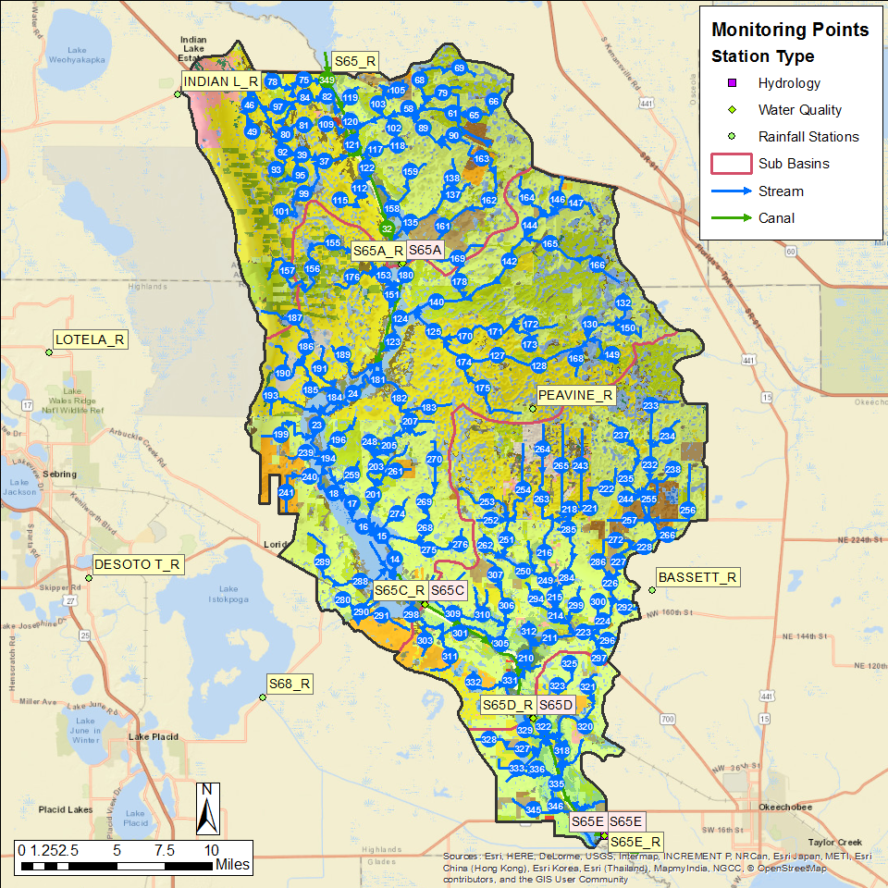
Figure 32. The Lower Kissimmee model domain. Rain stations, flow station, and water quality stations are shown.
To show an appropriate comparison for this report, the flow data presented for S-65A, S-65C, S-65D, and S-65E all represent the differences in flow by subtracting the daily inflows from both the measured and simulated values. The “flow differences” (both measured and simulated) are then compared at each structure. While not providing an exact comparison between measured and simulated values, it does give a good indication of how well the model is simulating the contributing area to the structure, without the identical flow values contributed at the inflow dominating the comparisons.
Note that the same issue exists for the nutrient concentration data, however there is no meaningful way to subtract concentration values to arrive at a useful comparison, since the in-stream attenuation processes dominate the simulated concentration values. The comparisons between total N and total P are simply of the “raw” measured and simulated values.

Flow and Water Quality Data at S-65E

Flow Results
Accumulated flow at the S-65E structure over the 2003-2013 period is shown in Figure 33, with tabulated values over the calibration and verification period shown in Table 36. As can be seen, over the entire calibration/verification period the simulation results are close, with the simulated values underestimating the measured values in the calibration period by 8% and overestimating by 12% the measured values during the verification period. Over the combined calibration/verification entire period the simulated is 2% too low.
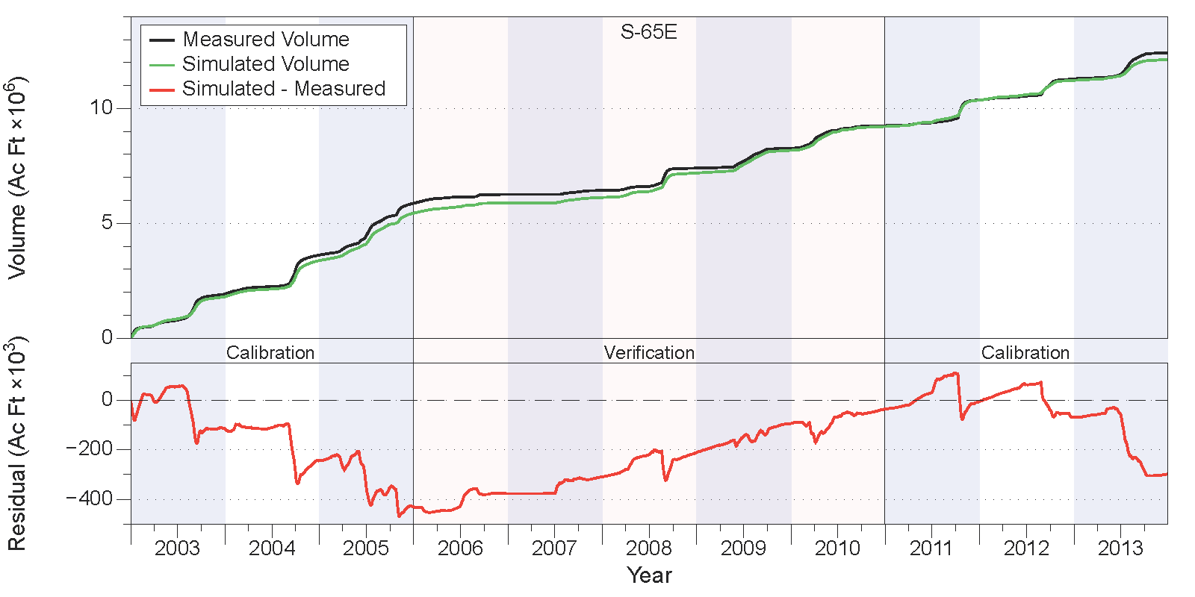
Figure 33. Measured and simulated accumulated water volumes in acre-feet (upper chart) and accumulated volume residuals (lower chart) at structure S-65E.
Table 36. Comparison of measured and simulated water volumes (in acre-feet) at structure S-65E.
Year | Simulated | Measured | Residual | Percent
Calibration
2003 | 1,808,214 | 1,921,973 | -113,759 | -6%
2004 | 1,570,504 | 1,700,964 | -130,460 | -8%
2005 | 2,065,638 | 2,251,845 | -186,207 | -8%
2011 | 1,148,599 | 1,118,459 | 30,140 | 3%
2012 | 859,178 | 922,686 | -63,508 | -7%
2013 | 908,767 | 1,138,156 | -229,388 | -20%
Subtotal | 8,360,900 | 9,054,083 | -693,183 | -8%
Verification
2006 | 437,355 | 384,146 | 53,208 | 14%
2007 | 243,359 | 175,364 | 67,994 | 39%
2008 | 1,068,699 | 970,417 | 98,282 | 10%
2009 | 984,044 | 867,262 | 116,781 | 13%
2010 | 1,038,047 | 979,324 | 58,723 | 6%
Subtotal | 3,771,502 | 3,376,513 | 394,989 | 12%
Total | 12,132,402 | 12,430,596 | -298,194 | -2%

Relevant statistics for daily, monthly, and annual flow values from the calibration/verification periods are shown in Table 37. The statistics show values much greater than 0.5 for all NSE values in both the calibration and verification periods. Note that these values are high since the inflow to the sub-watershed at S-65 accounts for much of the flow at S-65E (i.e., pass-through water).
Table 37. Statistics of daily, monthly, and annual flow values for the calibration and verification periods at structure S-65E.
 | Calibration |  |  | Verification
 | Daily | Monthly | Annual | Daily | Monthly | Annual
PBIAS % | -7.7 | -7.5 | -7.7 | 11.7 | 11.7 | 11.7
RMSE | 2427 | 1603 | 391 | 1314 | 805 | 226
NSE | 0.84 | 0.9 | 0.91 | 0.85 | 0.91 | 0.94
KGE | 0.73 | 0.78 | 0.9 | 0.81 | 0.87 | 0.88

Water Quality Results
Comparisons between measured and simulated nutrient concentrations are shown in Figure 34 for total N (upper chart) and total P (lower chart). Overall, the simulated total N values underestimate the measured values by 1%-2% during the calibration period and by about 10% during the verification period. Simulated total P values overestimate measured values by 10% to 14% during the calibration period, but slightly underestimate measured values by 2%-3% during the verification period. Visual inspection of the results shown in Figure 31 indicate that the simulated values for both total N and P capture the variability present in the measured data reasonably well, although some dynamics during 2006 and 2007 are missed.
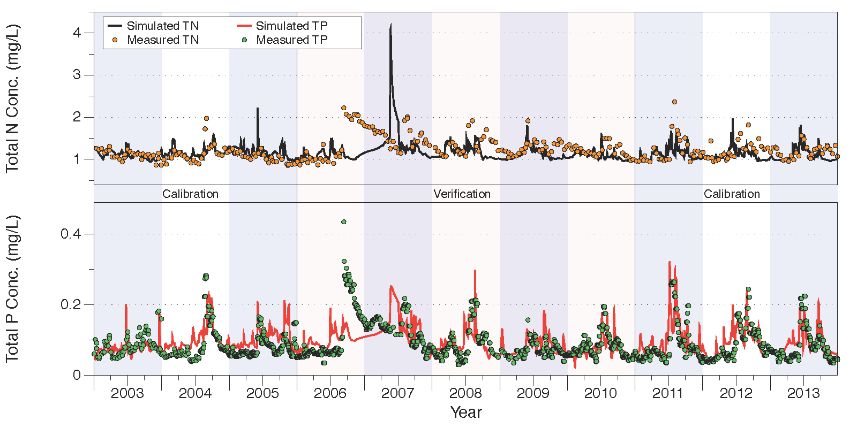
Figure 34. Comparison of measured and simulated total N (upper chart) and total P (lower chart) concentrations at structure S-65E.
Relevant statistics for daily, monthly, and annual total N and P concentrations and loads from the calibration/verification periods are shown in Table 38. For total N concentrations, the NSE statistics show suboptimal fits as indicated by the negative NSE statistics for both the calibration and verification periods for the daily and monthly calculations. However, the NSE statistics for total N loads are above 0.8 for all calculations in both the calibration and verification period. Note that the simulated total N loads underestimate the measure values by 3% to almost 6%.
For total P, the NSE statistics show positive values for the calibration and verification periods, except for the annualized values during the calibration period when the value is negative. Total P loads show NSE statistics that are greater than 0.7 for all calculations during both the calibration and verification periods. Note that the simulated total P loads underestimate measured values by 8% to 11% during the calibration period, but overestimate measured values by 2% to 3% during the verification period.
Table 38. Statistics of daily, monthly, and annual total N and P concentrations and loads for the calibration and verification periods at structure S-65E.
 | Calibration |  |  | Verification
 | Daily | Monthly | Annual | Daily | Monthly | Annual
Total Nitrogen Concentrations
PBIAS % | -1.4 | -0.9 | -1.8 | -10.2 | -10.6 | -10.3
RMSE | 0.21 | 0.17 | 0.08 | 0.5 | 0.43 | 0.15
NSE | -0.09 | -0.09 | -1.62 | -1.81 | -1.4 | -0.71
KGE | 0.15 | 0.22 | -0.58 | 0 | 0.06 | 0.61
Total Nitrogen Loads
PBIAS % | -4.5 | -5.6 | -5.1 | -2.9 | -2.8 | -2.9
RMSE | 3.4 | 3.03 | 0.6 | 2.2 | 1.92 | 0.17
NSE | 0.87 | 0.89 | 0.82 | 0.89 | 0.88 | 0.99
KGE | 0.78 | 0.78 | 0.8 | 0.86 | 0.85 | 0.97
Total Phosphorus Concentrations
PBIAS % | 14.3 | 13.5 | 10.4 | -2.9 | -1.1 | -2.3
RMSE | 0.04 | 0.03 | 0.01 | 0.05 | 0.04 | 0.01
NSE | 0.22 | 0.45 | -1.67 | 0.23 | 0.31 | 0.76
KGE | 0.53 | 0.68 | 0.33 | 0.34 | 0.44 | 0.67
Total Phosphorus Loads
PBIAS % | -8.2 | -9.6 | -10.5 | 1.9 | 2.6 | 2.6
RMSE | 0.59 | 0.36 | 0.12 | 0.37 | 0.23 | 0.06
NSE | 0.73 | 0.81 | 0.82 | 0.74 | 0.78 | 0.87
KGE | 0.68 | 0.72 | 0.85 | 0.62 | 0.69 | 0.8

Taylor Creek/Nubbin Slough
The Taylor Creek/Nubbin Slough sub-watershed is the south-easternmost of the six sub-watersheds modeled, and is approximately 197,720 acres in area. The sub-watershed is made up of four smaller domains: the S-133, S-135, S-191, and S-154 basins. In the 2009/2012 modeling effort these were modeled independently, but for this effort they were aggregated into the single sub-watershed. The discharges at S-133 and S-135 are pump-controlled, while the discharge at S-191 is controlled by gates. The discharge through S-191 consists of the combined flow from Taylor Creek, which drains the north-central part of the model domain, and Nubbin Slough, which drains the eastern portion.
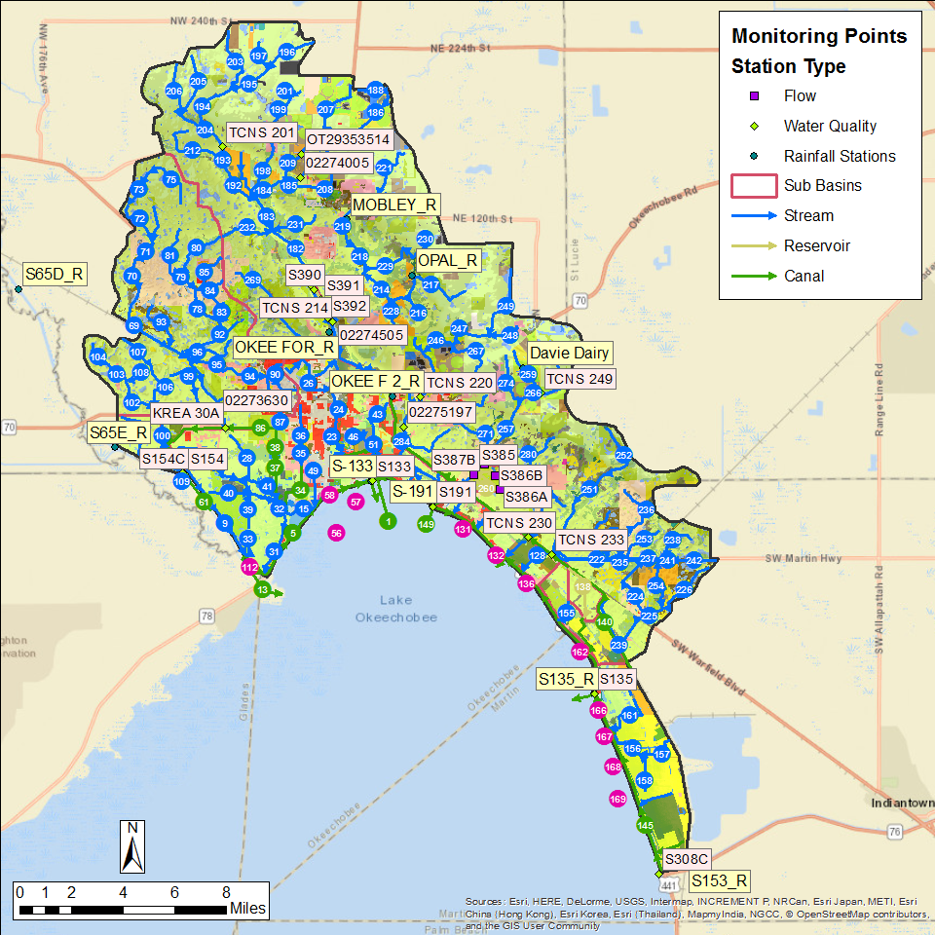
Figure 35. The Taylor Creek/Nubbin Slough model domain. Rain stations, flow station, and water quality stations are shown.

Flow and Water Quality Data at S-133

Flow Results
Accumulated flow at the S-133 structure over the 2003-2013 period is shown in Figure 36, with tabulated values over the calibration and verification period shown in Table 39. As can be seen, over the entire calibration/verification period the simulation results are reasonable close, with the simulated values underestimating the measured values in the calibration period by 12% but overestimating the measured values by 35% during the verification period. Over the combined calibration/verification entire period the simulated is 4% too low.
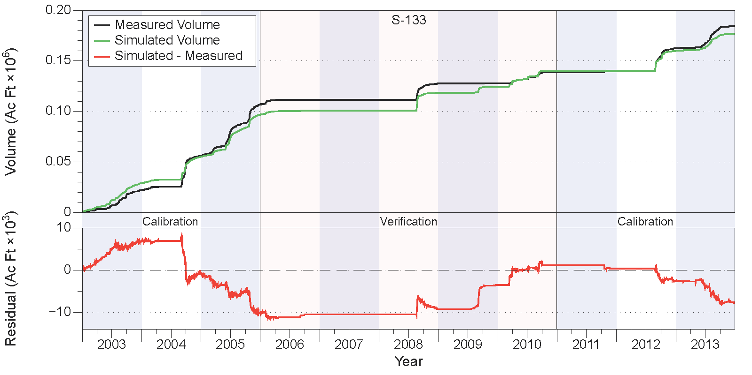
Figure 36. Measured and simulated accumulated water volumes in acre-feet (upper chart) and accumulated volume residuals (lower chart) at structure S-133.
Table 39. Comparison of measured and simulated water volumes (in acre-feet) at structure S-133.
Year | Simulated | Measured | Residual | Percent
Calibration
2003 | 28,971 | 22,078 | 6,893 | 31%
2004 | 26,233 | 33,928 | -7,695 | -23%
2005 | 41,544 | 50,822 | -9,278 | -18%
2011 | 309 | 1,122 | -813 | -72%
2012 | 19,694 | 22,578 | -2,884 | -13%
2013 | 16,911 | 22,122 | -5,211 | -24%
Subtotal | 133,660 | 152,648 | -18,988 | -12%
Verification
2006 | 4,212 | 4,614 | -402 | -9%
2007 | 0 | 0 | 0 | N/A
2008 | 17,369 | 16,128 | 1,241 | 8%
2009 | 6,151 | 394 | 5,757 | 1463%
2010 | 15,498 | 10,845 | 4,653 | 43%
Subtotal | 43,230 | 31,981 | 11,250 | 35%
Total | 176,890 | 184,629 | -7,738 | -4%

Relevant statistics for daily, monthly, and annual flow values from the calibration/verification periods are shown in Table 40. The statistics show values greater than 0.5 for all NSE values in the calibration period as well as in the monthly and annual calculations, while the daily calculated value for the verification period is greater than zero, but less than 0.5.
Table 40. Statistics of daily, monthly, and annual flow values for the calibration and verification periods at structure S-133.
 | Calibration |  |  | Verification
 | Daily | Monthly | Annual | Daily | Monthly | Annual
PBIAS % | -12.4 | -12.6 | -12.4 | 35.2 | 34.5 | 35.2
RMSE | 126 | 44 | 17 | 83 | 33 | 9.2
NSE | 0.56 | 0.86 | 0.83 | 0.14 | 0.53 | 0.71
KGE | 0.68 | 0.69 | 0.79 | 0.41 | 0.46 | 0.63

Water Quality Results
Comparisons between measured and simulated nutrient concentrations are shown in Figure 37 for total N (upper chart) and total P (lower chart). Overall, the simulated total N values underestimate the measured values by about 10% during the calibration period but only by 3% during the verification period. Simulated total P values underestimate measured values by about 35% during the calibration period, and by 45%. Visual inspection of the results shown in Figure 37 indicate that the simulated values for both total N and P capture the variability present in the measured data reasonably well, although the total P simulated values do not reach the peak values of the measurements.
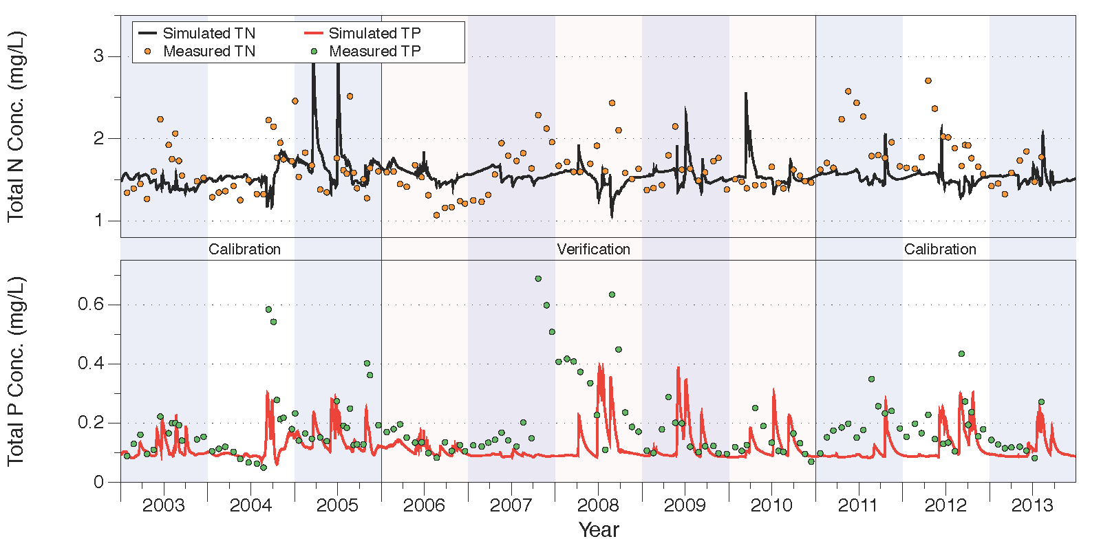
Figure 37. Comparison of measured and simulated total N (upper chart) and total P (lower chart) concentrations at structure S-133.
Relevant statistics for daily, monthly, and annual total N and P concentrations and loads from the calibration/verification periods are shown in Table 41. The NSE statistics for total N concentrations show suboptimal fits as indicated by the negative NSE statistics for both the calibration and verification periods for the daily and monthly calculations. For total N loads, the NSE statistics are positive for all calculations except for the annual calculation during the calibration period. Note that the values are greater than 0.5 for the daily and monthly calculations during the verification period, although the simulated total N loads underestimate the measured values by 36% to nearly 50%.
For total P concentrations, the NSE statistics show suboptimal fits as indicated by the negative NSE statistics for both the calibration and verification periods for the daily and monthly calculations. The NSE statistics for total P loads, however, are greater than zero except for the annual calculation during the calibration period. The simulated total P loads underestimate the measured values by over 50% during both the calibration and verification periods.
Table 41. Statistics of daily, monthly, and annual total N and P concentrations and loads for the calibration and verification periods at structure S-133.
 | Calibration |  |  | Verification
 | Daily | Monthly | Annual | Daily | Monthly | Annual
Total Nitrogen Concentrations
PBIAS % | -10.9 | -10.4 | -10.9 | -2.3 | -2.3 | -2.3
RMSE | 0.4 | 0.39 | 0.25 | 0.34 | 0.34 | 0.17
NSE | -0.42 | -0.42 | -1.78 | -0.55 | -0.55 | -0.43
KGE | -0.21 | -0.26 | -0.26 | -0.36 | -0.36 | -0.89
Total Nitrogen Loads
PBIAS % | -39.7 | -36.4 | -37 | -49.3 | -49.3 | -49.3
RMSE | 0.27 | 0.23 | 0.07 | 0.2 | 0.2 | 0.08
NSE | 0.15 | 0.25 | -1.5 | 0.62 | 0.62 | 0.41
KGE | 0.19 | 0.3 | 0.44 | 0.28 | 0.28 | 0.19
Total Phosphorus Concentrations
PBIAS % | -35.2 | -33.5 | -35.2 | -44.5 | -44.5 | -44.5
RMSE | 0.1 | 0.09 | 0.07 | 0.16 | 0.16 | 0.12
NSE | -0.12 | -0.14 | -6.02 | -0.37 | -0.37 | -1.17
KGE | 0.23 | 0.23 | 0.34 | -0.18 | -0.18 | -0.18
Total Phosphorus Loads
PBIAS % | -59.9 | -56.5 | -57.2 | -55.5 | -55.5 | -55.5
RMSE | 0.04 | 0.03 | 0.01 | 0.04 | 0.04 | 0.02
NSE | 0.21 | 0.31 | -7.8 | 0.69 | 0.69 | 0.51
KGE | 0.06 | 0.16 | 0.22 | 0.24 | 0.24 | 0.19

Flow and Water Quality Data at S-135

Flow Results
Accumulated flow at the S-135 structure over the 2003-2013 period is shown in Figure 38, with tabulated values over the calibration and verification period shown in Table 42. As can be seen, over the entire calibration/verification period the simulation results are reasonable close, with the simulated values overestimating the measured values in the calibration period by 2% but underestimating the measured values by 19% during the verification period. Over the combined calibration/verification entire period the simulated is 2% too low.
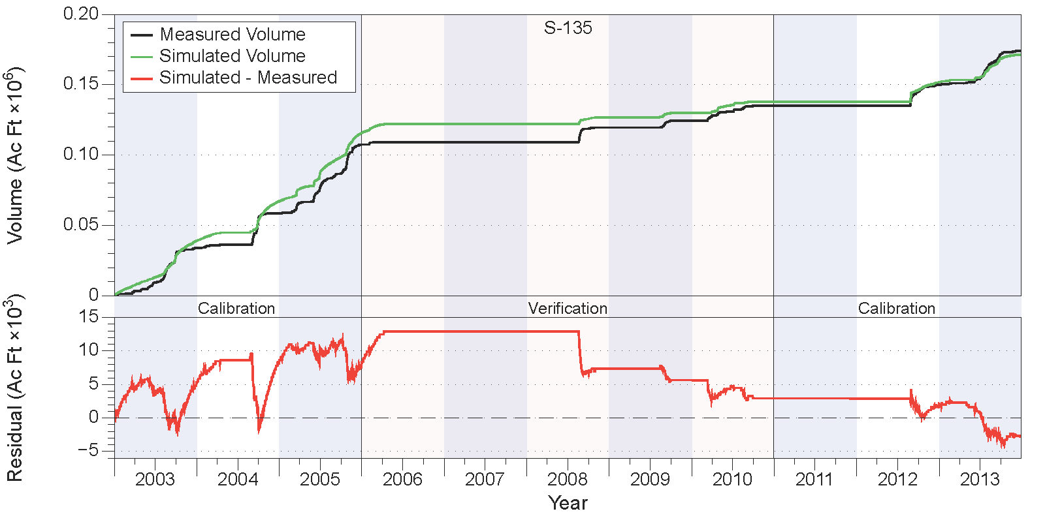
Figure 38. Measured and simulated accumulated water volumes in acre-feet (upper chart) and accumulated volume residuals (lower chart) at structure S-135.
Table 42. Comparison of measured and simulated water volumes (in acre-feet) at structure S-135.
Year | Simulated | Measured | Residual | Percent
Calibration
2003 | 39,192 | 33,924 | 5,269 | 16%
2004 | 27,940 | 24,842 | 3,098 | 12%
2005 | 48,496 | 48,780 | -284 | -1%
2011 | 0 | 22 | -22 | -100%
2012 | 13,766 | 14,924 | -1,158 | -8%
2013 | 19,585 | 24,130 | -4,545 | -19%
Subtotal | 148,980 | 146,622 | 2,358 | 2%
Verification
2006 | 6,399 | 1,572 | 4,827 | 307%
2007 | 0 | 0 | 0 | N/A
2008 | 4,942 | 10,492 | -5,551 | -53%
2009 | 3,131 | 4,838 | -1,707 | -35%
2010 | 7,902 | 10,631 | -2,729 | -26%
Subtotal | 22,374 | 27,534 | -5,160 | -19%
Total | 171,354 | 174,156 | -2,802 | -2%

Relevant statistics for daily, monthly, and annual flow values from the calibration/verification periods are shown in Table 43. The statistics show values greater than 0.5 for monthly and annual NSE values in the calibration period, but show lower values (but still positive) for the daily calibration period and all values in the verification period.
Table 43. Statistics of daily, monthly, and annual flow values for the calibration and verification periods at structure S-135.
 | Calibration |  |  | Verification
 | Daily | Monthly | Annual | Daily | Monthly | Annual
PBIAS % | 1.6 | 1.6 | 1.6 | -18.7 | -18 | -18.7
RMSE | 158 | 58 | 8.6 | 75 | 30 | 9.8
NSE | 0.22 | 0.71 | 0.96 | 0.2 | 0.48 | 0.34
KGE | 0.56 | 0.68 | 0.93 | 0.37 | 0.46 | 0.44

Water Quality Results
Comparisons between measured and simulated nutrient concentrations are shown in Figure 39 for total N (upper chart) and total P (lower chart). Overall, the simulated total N values underestimate the measured values by about 10% during the calibration period but only by 3% during the verification period. Simulated total P values underestimate measured values by about 13% to 17% during the calibration period, but overestimate measured values by 1% to 2% during the verification period. Visual inspection of the results shown in Figure 39 indicate that the simulated values for total N captures the variability present in the measured data reasonably well, while the total P simulated values look reasonable over the 2003-2008 time period, but don’t match the consistently low values from 2009 onward.
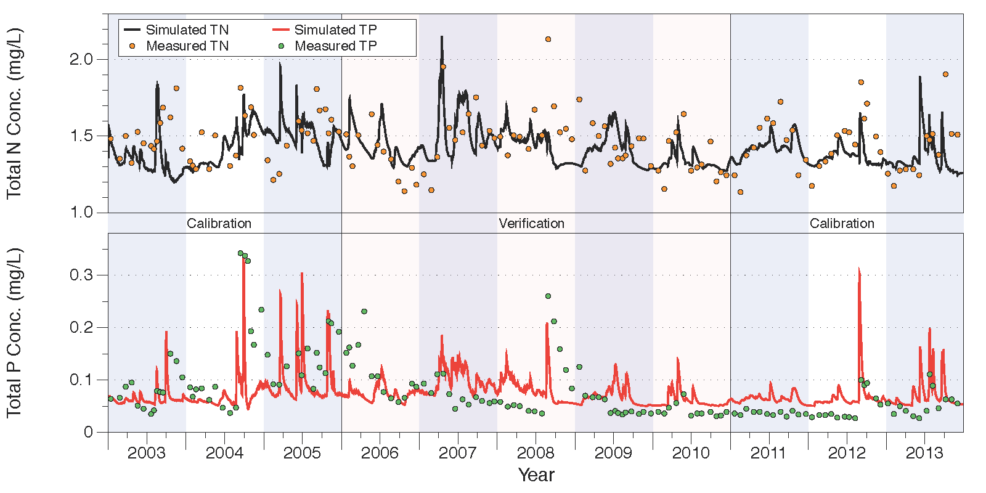
Figure 39. Comparison of measured and simulated total N (upper chart) and total P (lower chart) concentrations at structure S-135.
Relevant statistics for daily, monthly, and annual total N and P concentrations and loads from the calibration/verification periods are shown in Table 44. For total N concentrations, the NSE statistics show suboptimal fits as indicated by the negative NSE statistics for both the calibration and verification periods for the daily and monthly calculations, except for the annual calculation over the verification period. The NSE statistics for total N loads are greater than zero during the calibration period, but are less than zero during the verification period. The simulated total N loads underestimate measured values by 16% to 26% during the calibration period, but underestimate over the verification period by over 50%.
For total P, the NSE statistics show positive values (but less than 0.5) for the calibration period, but the daily and monthly calculations for the verification period shows suboptimal fits for the daily and monthly calculations. Total P loading shows positive NSE statistics for all calculations during the calibration period, but are negative (or zero) during the verification period. Note that simulated total P loads underestimate measured values by 30% to 40% in the calibration period, and by over 65% during verification.
Table 44. Statistics of daily, monthly, and annual total N and P concentrations and loads for the calibration and verification periods at structure S-135.
 | Calibration |  |  | Verification
 | Daily | Monthly | Annual | Daily | Monthly | Annual
Total Nitrogen Concentrations
PBIAS % | -5.4 | -5.1 | -5.3 | -1.8 | -2.6 | -1.9
RMSE | 0.21 | 0.2 | 0.09 | 0.2 | 0.2 | 0.06
NSE | -0.22 | -0.21 | -2.65 | -0.05 | -0.01 | 0.3
KGE | 0.15 | 0.1 | 0.48 | 0.19 | 0.21 | 0.66
Total Nitrogen Loads
PBIAS % | -25.8 | -15.6 | -25.9 | -53.9 | -66.2 | -56.7
RMSE | 0.26 | 0.2 | 0.05 | 0.22 | 0.22 | 0.09
NSE | 0.01 | 0.13 | 0.57 | -0.07 | -0.14 | -1.85
KGE | 0.34 | 0.52 | 0.64 | -0.04 | -0.24 | -0.43
Total Phosphorus Concentrations
PBIAS % | -17.1 | -13.4 | -14.5 | 1.7 | 0.8 | 1.9
RMSE | 0.06 | 0.06 | 0.04 | 0.05 | 0.05 | 0.02
NSE | 0.13 | 0.19 | 0.08 | -0.04 | -0.02 | 0.17
KGE | 0.15 | 0.13 | 0.05 | 0.04 | 0.06 | 0.24
Total Phosphorus Loads
PBIAS % | -39.9 | -31 | -39 | -66.5 | -75.7 | -68.8
RMSE | 0.02 | 0.01 | 0.01 | 0.02 | 0.02 | 0.01
NSE | 0.03 | 0.12 | 0.07 | 0 | -0.03 | -0.84
KGE | 0.2 | 0.41 | 0.31 | -0.27 | -0.41 | -0.4

Flow and Water Quality Data at S-154

Flow Results
Accumulated flow at the S-154 structure over the 2003-2013 period is shown in Figure 40, with tabulated values over the calibration and verification period shown in Table 45. As can be seen, over the entire calibration/verification period the simulation results underestimate the measured values, particularly in 2004. The simulated values underestimate the measured values in the calibration period by 23% but overestimate the measured values by 34% during the verification period. Over the combined calibration/verification entire period the simulated is 10% too low. Note that the low flow years of 2006-2007 and 2009 have high percentage errors, but account for a relatively low fraction of the total volume.
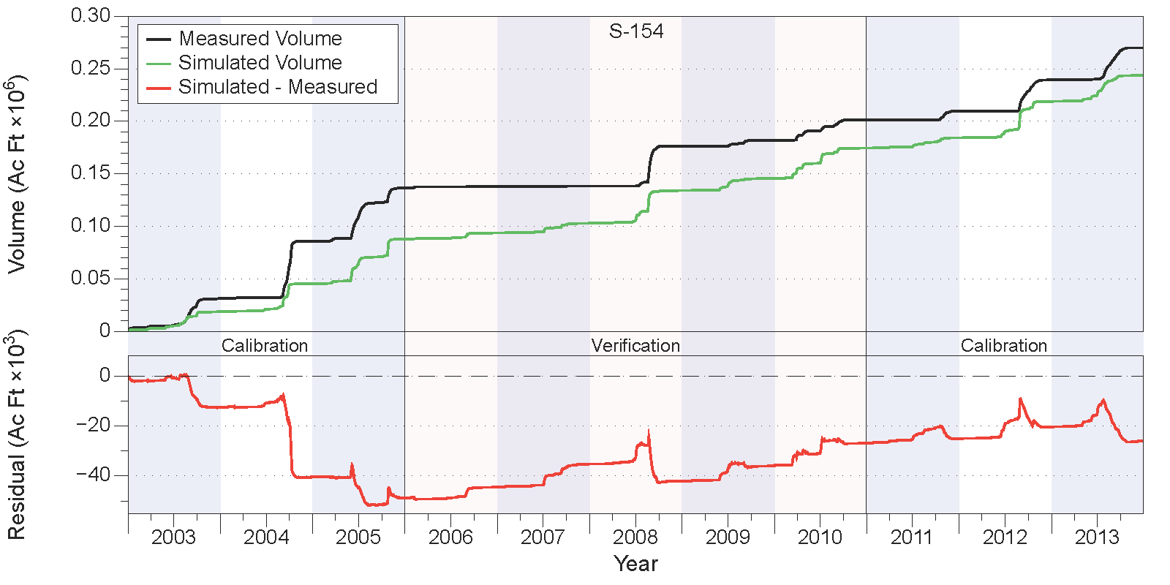
Figure 40. Measured and simulated accumulated water volumes in acre-feet (upper chart) and accumulated volume residuals (lower chart) at structure S-154.
Table 45. Comparison of measured and simulated water volumes (in acre-feet) at structure S-154.
Year | Simulated | Measured | Residual | Percent
Calibration
2003 | 18,787 | 31,349 | -12,563 | -40%
2004 | 26,786 | 54,662 | -27,876 | -51%
2005 | 42,365 | 50,720 | -8,355 | -16%
2011 | 9,841 | 8,206 | 1,635 | 20%
2012 | 34,569 | 29,902 | 4,667 | 16%
2013 | 24,936 | 30,524 | -5,588 | -18%
Subtotal | 157,284 | 205,364 | -48,080 | -23%
Verification
2006 | 5,916 | 1,529 | 4,386 | 287%
2007 | 9,266 | 90 | 9,176 | 10154%
2008 | 31,048 | 37,837 | -6,789 | -18%
2009 | 11,570 | 5,478 | 6,092 | 111%
2010 | 28,763 | 19,659 | 9,104 | 46%
Subtotal | 86,563 | 64,593 | 21,970 | 34%
Total | 243,847 | 269,958 | -26,111 | -10%

Relevant statistics for daily, monthly, and annual flow values from the calibration/verification periods are shown in Table 46. The statistics show values greater than 0.5 for monthly NSE values in the calibration and verification periods as well as in the annual calculations for the verification period, while the daily calculated values for the calibration and verification periods are greater than zero, but less than 0.5.
Table 46. Statistics of daily, monthly, and annual flow values for the calibration and verification periods at structure S-154.
 | Calibration |  |  | Verification
 | Daily | Monthly | Annual | Daily | Monthly | Annual
PBIAS % | -23.4 | -23.5 | -23.4 | 34 | 33.6 | 34.1
RMSE | 229 | 125 | 36 | 150 | 68 | 20
NSE | 0.19 | 0.53 | 0.25 | 0.29 | 0.62 | 0.73
KGE | 0.54 | 0.55 | 0.52 | 0.53 | 0.59 | 0.56

Water Quality Results
Comparisons between measured and simulated nutrient concentrations are shown in Figure 41 for total N (upper chart) and total P (lower chart). Overall, the simulated total N values underestimate the measured values by about 10% during the calibration period but only by 3% during the verification period. Simulated total P values underestimate measured values by about 10% to 15% during the calibration period, and by about 20% during the verification period. Visual inspection of the results shown in Figure 37 indicate that the simulated values for both total N and P don’t capture the variability present in the peak values of the measured data very, although the temporal distribution of high/low values is partially replicated.
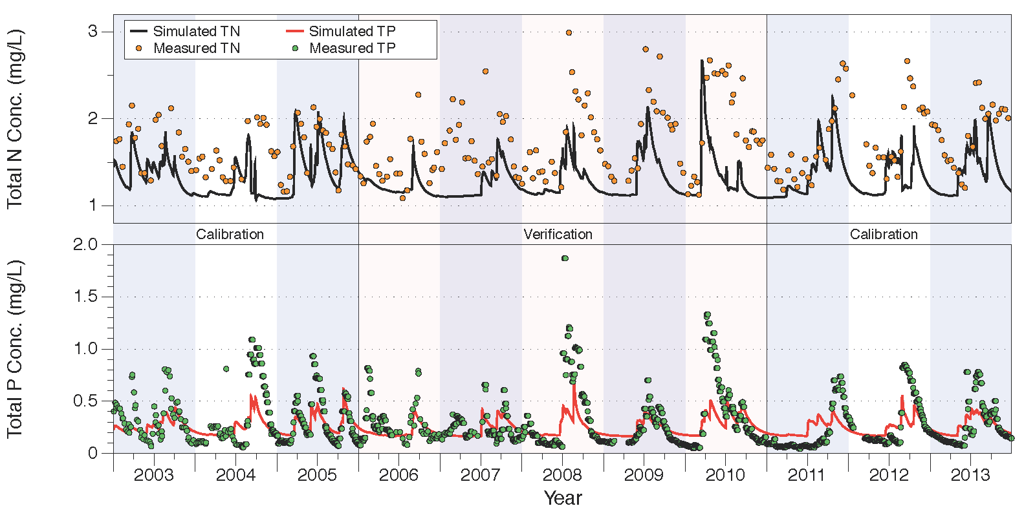
Figure 41. Comparison of measured and simulated total N (upper chart) and total P (lower chart) concentrations at structure S-154.
Relevant statistics for daily, monthly, and annual total N and P concentrations and loads from the calibration/verification periods are shown in Table 47. For total N concentrations, the NSE statistics show suboptimal fits as indicated by the negative NSE statistics for both the calibration and verification periods for the daily and monthly calculations. Total N load NSE statistics are slightly positive except for the annual calculation during the verification period at -0.54. The simulated N loads underestimate the measured values by over 50% during the calibration and verification periods.
For total P, the NSE statistics show reasonable values for the fits for the daily and monthly calculations for both the calibration and verification periods, but a negative value for the annualized verification value. The NSE statistics for total P loads show positive values except for a slightly negative value for the annual calculation during the calibration period. The simulated total P loads underestimate measured values by over 50% during the calibration period and by around 30% during the verification period.
Table 47. Statistics of daily, monthly, and annual total N and P concentrations and loads for the calibration and verification periods at structure S-154.
 | Calibration |  |  | Verification
 | Daily | Monthly | Annual | Daily | Monthly | Annual
Total Nitrogen Concentrations
PBIAS % | -21.8 | -21.8 | -22.2 | -27.2 | -26.9 | -27
RMSE | 0.51 | 0.49 | 0.4 | 0.61 | 0.58 | 0.49
NSE | -0.95 | -1.11 | -12.53 | -1 | -1.15 | -10.34
KGE | 0.28 | 0.27 | 0.24 | 0.24 | 0.24 | 0.25
Total Nitrogen Loads
PBIAS % | -63.1 | -63.7 | -64.3 | -50.1 | -50.1 | -50.8
RMSE | 0.5 | 0.39 | 0.14 | 0.4 | 0.28 | 0.11
NSE | 0.09 | 0.08 | -3.8 | 0.08 | 0.11 | 0.02
KGE | -0.14 | -0.14 | -0.54 | -0.01 | -0.01 | -0.04
Total Phosphorus Concentrations
PBIAS % | -9.5 | -10 | -14.9 | -20.7 | -17.8 | -20.4
RMSE | 0.2 | 0.17 | 0.09 | 0.25 | 0.21 | 0.09
NSE | 0.37 | 0.39 | 0.05 | 0.27 | 0.33 | -0.42
KGE | 0.29 | 0.3 | 0.17 | 0.21 | 0.25 | 0.29
Total Phosphorus Loads
PBIAS % | -53.9 | -53.5 | -59.6 | -33 | -28.5 | -31.7
RMSE | 0.28 | 0.16 | 0.11 | 0.15 | 0.07 | 0.03
NSE | 0.15 | 0.32 | -0.05 | 0.44 | 0.62 | 0.6
KGE | 0.14 | 0.13 | 0 | 0.47 | 0.44 | 0.36

Flow and Water Quality Data at S-191

Flow Results
Accumulated flow at the S-191 structure over the 2003-2013 period is shown in Figure 42, with tabulated values over the calibration and verification period shown in Table 48. As can be seen, over the entire calibration/verification period the simulation results are reasonable close, with the simulated values underestimating the measured values in the calibration period by 16% but overestimating the measured values by 34% during the verification period. Over the combined calibration/verification entire period the simulated is 3% too low.
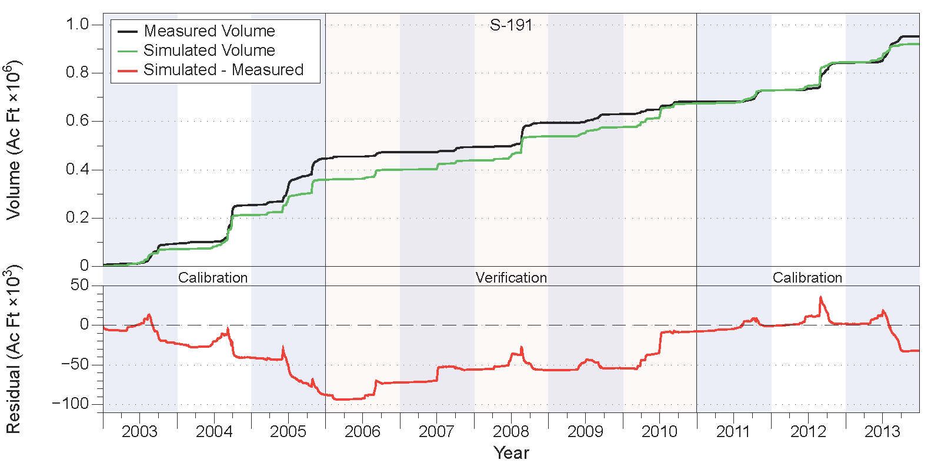
Figure 42. Measured and simulated accumulated water volumes in acre-feet (upper chart) and accumulated volume residuals (lower chart) at structure S-191.
Table 48. Comparison of measured and simulated water volumes (in acre-feet) at structure S-191.
Year | Simulated | Measured | Residual | Percent
Calibration
2003 | 71,203 | 94,437 | -23,234 | -25%
2004 | 141,907 | 159,297 | -17,390 | -11%
2005 | 146,320 | 193,413 | -47,093 | -24%
2011 | 55,003 | 47,918 | 7,086 | 15%
2012 | 116,037 | 113,583 | 2,454 | 2%
2013 | 75,697 | 109,350 | -33,653 | -31%
Subtotal | 606,167 | 717,997 | -111,830 | -16%
Verification
2006 | 41,598 | 25,949 | 15,649 | 60%
2007 | 37,595 | 21,339 | 16,256 | 76%
2008 | 100,006 | 100,785 | -779 | -1%
2009 | 38,457 | 35,901 | 2,555 | 7%
2010 | 97,628 | 51,160 | 46,468 | 91%
Subtotal | 315,283 | 235,135 | 80,149 | 34%
Total | 921,450 | 953,131 | -31,681 | -3%

Relevant statistics for daily, monthly, and annual flow values from the calibration/verification periods are shown in Table 49. The statistics show values at or greater than 0.5 for all NSE values in the calibration and verification periods except for the annualized calculation in the verification period.
Table 49. Statistics of daily, monthly, and annual flow values for the calibration and verification periods at structure S-191.
 | Calibration |  |  | Verification
 | Daily | Monthly | Annual | Daily | Monthly | Annual
PBIAS % | -15.6 | -15.7 | -15.6 | 34.1 | 33.7 | 34.1
RMSE | 490 | 227 | 73 | 400 | 166 | 63
NSE | 0.72 | 0.86 | 0.67 | 0.49 | 0.69 | 0.35
KGE | 0.78 | 0.8 | 0.71 | 0.55 | 0.63 | 0.62

Water Quality Results
Comparisons between measured and simulated nutrient concentrations are shown in Figure 43 for total N (upper chart) and total P (lower chart). Overall, the simulated total N values underestimate the measured values by about 11% during the calibration period and by 17% during the verification period. Simulated total P values underestimate measured values by about 23% during the calibration period, and by 24% during the verification period. Visual inspection of the results shown in Figure 37 indicate that the simulated values for both total N and P capture the variability present in the measured data reasonably well, although the simulated total N concentrations show higher peaks than the measurements.
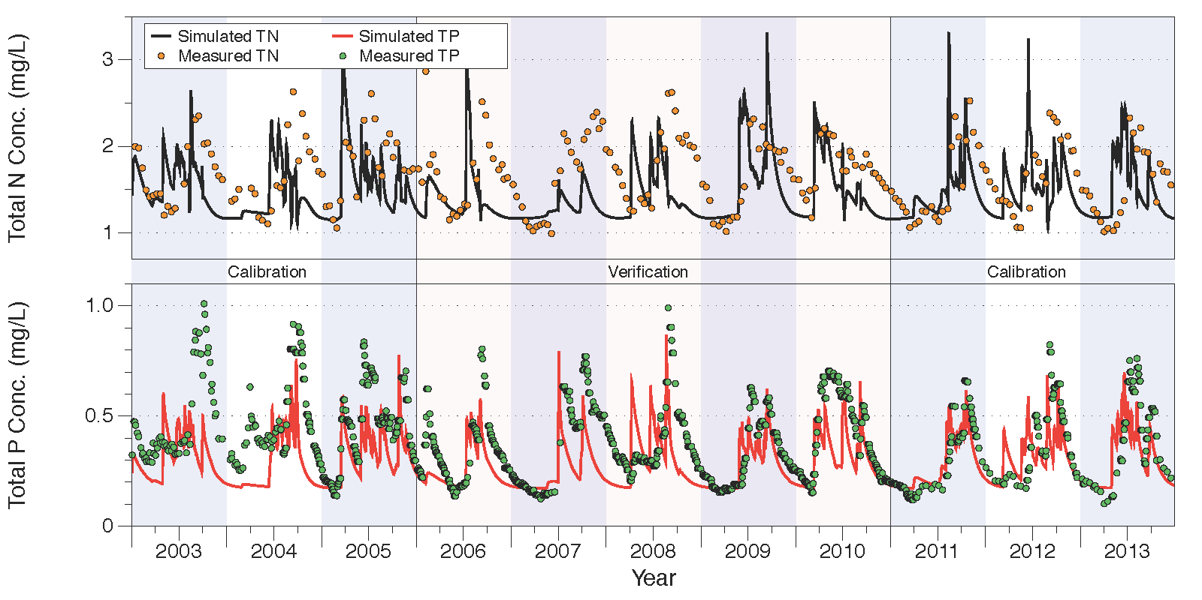
Figure 43. Comparison of measured and simulated total N (upper chart) and total P (lower chart) concentrations at structure S-191.
Relevant statistics for daily, monthly, and annual total N and P concentrations and loads from the calibration/verification periods are shown in Table 50. For total N concentrations, the NSE statistics show suboptimal fits as indicated by the negative NSE statistics for both the calibration and verification periods for the daily and monthly calculations. Total N load NSE statistics show positive values except for the annual calculations during both the calibration and verification periods. The simulated total N loads underestimate the measured values by approximately 33% to 38%.
For total P concentrations, the NSE statistics show greater than zero values for the daily and monthly calculations for both the calibration and verification periods, but less than zero for the corresponding annual calculations. For total P loads, the NSE statistics are greater than 0.5 for both the calibration and verification periods, while the simulated total P loads underestimate the measured loads by 20% to 26% during the calibration period, but overestimate by 12% to 15% during the verification period.
Table 50. Statistics of daily, monthly, and annual total N and P concentrations and loads for the calibration and verification periods at structure S-191.
 | Calibration |  |  | Verification
 | Daily | Monthly | Annual | Daily | Monthly | Annual
Total Nitrogen Concentrations
PBIAS % | -11.2 | -11.5 | -11.4 | -17.3 | -17.3 | -17.3
RMSE | 0.46 | 0.44 | 0.2 | 0.56 | 0.52 | 0.32
NSE | -0.33 | -0.31 | -4.71 | -0.89 | -0.77 | -16.32
KGE | 0.24 | 0.22 | 0.44 | 0.14 | 0.17 | 0.02
Total Nitrogen Loads
PBIAS % | -36.6 | -37.9 | -37 | -33.7 | -33.7 | -33.7
RMSE | 0.97 | 0.94 | 0.29 | 0.84 | 0.62 | 0.24
NSE | 0.51 | 0.38 | -1.74 | 0.23 | 0.17 | -1.43
KGE | 0.54 | 0.43 | 0.21 | 0.3 | 0.28 | -0.08
Total Phosphorus Concentrations
PBIAS % | -23.1 | -21.5 | -23.9 | -24.4 | -24.8 | -24.7
RMSE | 0.19 | 0.17 | 0.12 | 0.16 | 0.16 | 0.09
NSE | 0.01 | 0.11 | -2.93 | 0.05 | 0.13 | -5.44
KGE | 0.38 | 0.36 | -0.08 | 0.41 | 0.39 | 0.49
Total Phosphorus Loads
PBIAS % | -25.5 | -20.6 | -26.4 | 14.5 | 11.9 | 13.5
RMSE | 0.7 | 0.31 | 0.14 | 0.33 | 0.09 | 0.03
NSE | 0.53 | 0.72 | 0.55 | 0.55 | 0.89 | 0.82
KGE | 0.66 | 0.71 | 0.62 | 0.65 | 0.83 | 0.78

Upper Kissimmee
The Upper Kissimmee sub-watershed is the northernmost of the six sub-watersheds simulated for this domain, as well as the largest in area, measuring approximately 1,028,400 acres. The Upper Kissimmee sub-watershed encompasses the area from just south of Orlando to the bottom edge of Lake Kissimmee. It contains the largest area of urban land uses of the six sub-watersheds simulated while also including large amounts of improved pasture and citrus as well as a significant amount of lakes. The basin outlet is the southern end of Lake Kissimmee, with discharge to the Kissimmee River controlled by a set of gates at S-65.
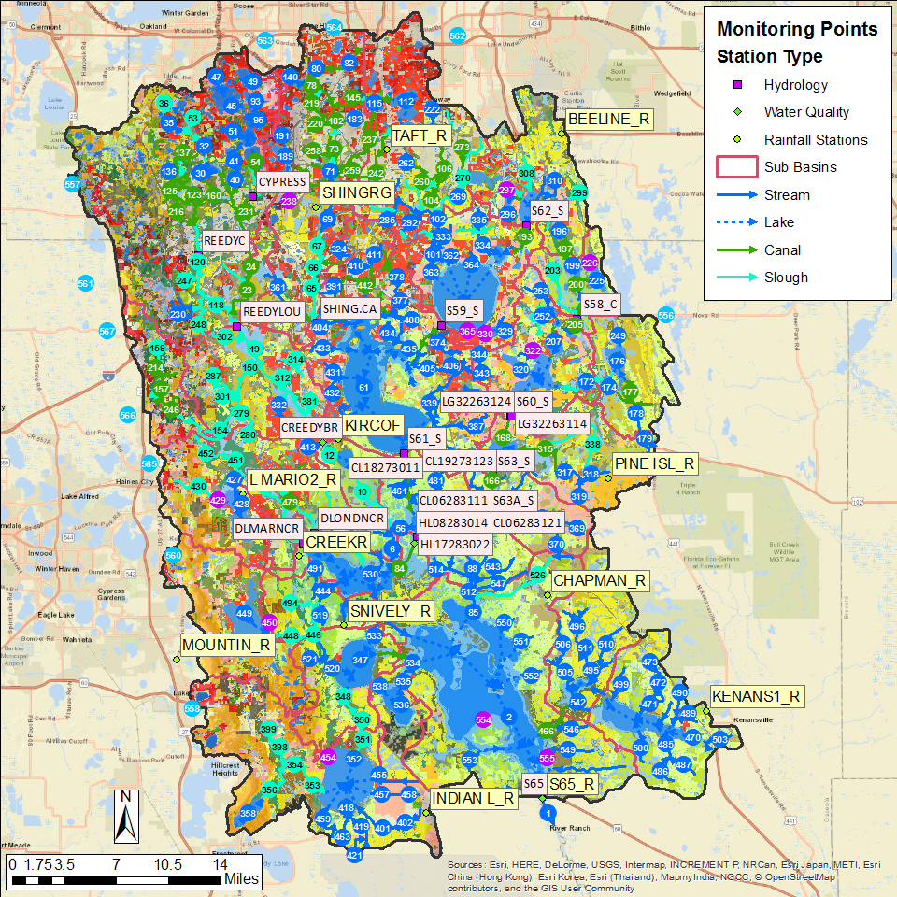
Figure 44. The Upper Kissimmee model domain. Rain stations, flow station, and water quality stations are shown.

Flow and Water Quality Data at S-65

Flow Results
Accumulated flow at outlet of Lake Kissimmee at the S-65 structure over the 2003-2013 period is shown in Figure 45, with tabulated values over the calibration and verification period shown in Table 51. As can be seen, over the entire calibration/verification period the simulation results are reasonable close, although they underestimate the measured values. The simulated values underestimate the measured values in the calibration period by 6% but overestimate the measured values by 1% during the verification period. Over the combined calibration/verification entire period the simulated is 3% too low.
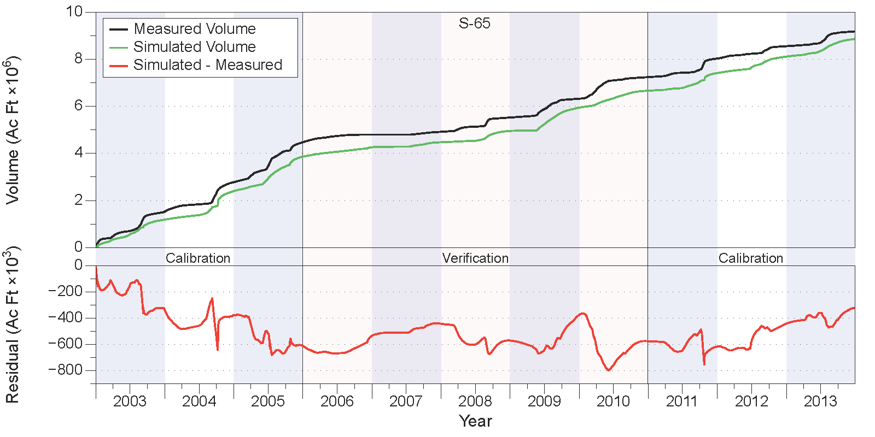
Figure 45. Measured and simulated accumulated water volumes in acre-feet (upper chart) and accumulated volume residuals (lower chart) at structure S-65.
Table 51. Comparison of measured and simulated water volumes (in acre-feet) at structure S-65.
Year | Simulated | Measured | Residual | Percent
Calibration
2003 | 1,189,399 | 1,523,254 | -333,855 | -22%
2004 | 1,212,775 | 1,256,372 | -43,598 | -3%
2005 | 1,460,827 | 1,694,490 | -233,664 | -14%
2011 | 749,231 | 790,879 | -41,648 | -5%
2012 | 699,646 | 524,166 | 175,479 | 33%
2013 | 750,439 | 629,542 | 120,897 | 19%
Subtotal | 6,062,315 | 6,418,704 | -356,388 | -6%
Verification
2006 | 397,984 | 322,309 | 75,674 | 23%
2007 | 213,134 | 119,783 | 93,351 | 78%
2008 | 479,848 | 608,816 | -128,968 | -21%
2009 | 991,267 | 796,264 | 195,003 | 24%
2010 | 717,258 | 916,943 | -199,685 | -22%
Subtotal | 2,799,490 | 2,764,116 | 35,375 | 1%
Total | 8,861,806 | 9,182,819 | -321,013 | -3%

Relevant statistics for daily, monthly, and annual flow values from the calibration/verification periods are shown in Table 52. The statistics show values near or greater than 0.5 for all NSE values in the calibration and verification periods except for the daily calculation during the calibration period where the negative value indicates a suboptimal fit.
Table 52. Statistics of daily, monthly, and annual flow values for the calibration and verification periods at structure S-65.
 | Calibration |  |  | Verification
 | Daily | Monthly | Annual | Daily | Monthly | Annual
PBIAS % | -5.6 | -5.6 | -5.6 | 1.3 | 0.9 | 1.3
RMSE | 4929 | 2223 | 519 | 1652 | 1328 | 404
NSE | -0.68 | 0.5 | 0.82 | 0.48 | 0.49 | 0.75
KGE | 0.29 | 0.59 | 0.64 | 0.57 | 0.64 | 0.84

Water Quality Results
Comparisons between measured and simulated nutrient concentrations are shown in Figure 46 for total N (upper chart) and total P (lower chart). Overall, the simulated total N values exhibit only a slight overestimation during the calibration period and overestimate the measured values by 4% during the verification period. Simulated total P values underestimate measured values by about 15% to 17% during the calibration period, and by 2% to 4% during the verification period. Visual inspection of the results shown in Figure 37 indicate that the simulated values for both total N and P do not capture the variability present in the measured data. As with Lake Istokpoga, much of this error is attributable to the inability of WAM to simulate complex in-lake processes, such as algal blooms, wind-driven mixing, and temperature-driven lake turnovers. In addition, the large dimensions of the reach that is used to simulate Lake Kissimmee causes the simulated results to be averaged over the entire lake volume at each time step.
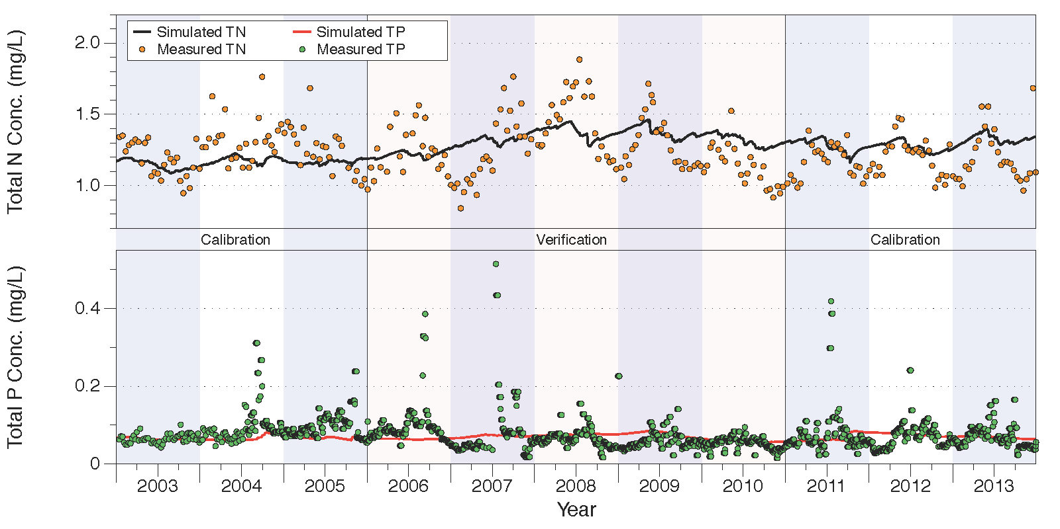
Figure 46. Comparison of measured and simulated total N (upper chart) and total P (lower chart) concentrations at structure S-65.
Relevant statistics for daily, monthly, and annual total N and P concentrations and loads from the calibration/verification periods are shown in Table 53. For total N concentrations the NSE statistics show suboptimal fits as indicated by the negative NSE statistics for the calibration period but show zero to slightly positive values during the and verification period. Total N load NSE values are greater than zero during the calibration period, and are at 0.5 or above during the verification period. The simulated total N loads underestimate measured values by around 18% during the calibration period and by around 8% during the verification period.
For total P concentrations, the NSE statistics show suboptimal fits as indicated by the negative NSE statistics for both the calibration and verification periods for the daily and monthly calculations. NSE statistics for total P loads are greater than zero except for the daily calculation during the calibration period. Note that simulated total P loads underestimate measured values by about 30% during the calibration period, but only by about 3% during the verification period.
Table 53. Statistics of daily, monthly, and annual total N and P concentrations and loads for the calibration and verification periods at structure S-65.
 | Calibration |  |  | Verification
 | Daily | Monthly | Annual | Daily | Monthly | Annual
Total Nitrogen Concentrations
PBIAS % | 0.2 | 0 | 0.1 | 4 | 3.7 | 3.8
RMSE | 0.19 | 0.17 | 0.11 | 0.21 | 0.2 | 0.1
NSE | -0.26 | -0.35 | -2.61 | 0.07 | 0.08 | 0
KGE | -0.19 | -0.17 | -0.51 | 0.06 | 0.08 | 0.32
Total Nitrogen Loads
PBIAS % | -16.8 | -18.1 | -17.2 | -7.9 | -7.7 | -8.3
RMSE | 5.42 | 5.12 | 1.36 | 3.24 | 2.67 | 0.75
NSE | 0.19 | 0.2 | 0.55 | 0.5 | 0.52 | 0.73
KGE | 0.26 | 0.25 | 0.47 | 0.5 | 0.56 | 0.8
Total Phosphorus Concentrations
PBIAS % | -16.7 | -15.3 | -17.2 | -2.1 | -4.1 | -2.3
RMSE | 0.05 | 0.04 | 0.02 | 0.05 | 0.04 | 0.02
NSE | -0.15 | -0.19 | -0.71 | -0.01 | -0.02 | -0.23
KGE | -0.41 | -0.36 | -0.23 | -0.28 | -0.27 | -0.17
Total Phosphorus Loads
PBIAS % | -28.8 | -30.4 | -30.5 | -2.7 | -2.8 | -2.4
RMSE | 0.7 | 0.48 | 0.2 | 0.18 | 0.12 | 0.04
NSE | -0.17 | 0.24 | 0.45 | 0.46 | 0.52 | 0.6
KGE | 0.16 | 0.17 | 0.33 | 0.52 | 0.68 | 0.75

Summary and Conclusions
A model covering the six northern sub-watersheds of the LOW was developed in WAM and has been successfully applied over the 1975-2013 time period. The results indicate that WAM is doing a satisfactory job simulating flows and nutrient loads into Lake Okeechobee from these sub-watersheds. However, as with any model there are issues that should be addressed moving forward. As with any simulation on this scale, input data such as rainfall, evapotranspiration estimates, and land use characterization can always be refined and improved upon. As part of this process every effort should be taken to keep the model up to date as much as possible by extending the POR as newer data becomes available.
The overall results for flow show that WAM was within ±10% of the calibration target at 10 of the 14 locations, and was within ±10% at 5 of the locations. For the entire 11-year combined calibration/verification period, flow volumes at all the locations were at or within ±10%. Note that all but one of the locations underestimates the flow volume during the calibration period, while all but 4 of the locations overestimates the flow volume during the verification period. This is not surprising since the verification time frame was over a much drier period than the calibration period and that several basins had extended periods with no flow.
With respect to nutrients, WAM is also doing a reasonable job simulating concentration data, although total N and P concentrations and loads show more scatter than flow data. Simulated total N and P concentrations and loads tend to, on average, underestimate measured values over most sampling locations, although some locations were overestimated. This variability is suspected to be caused by a combination of model variability, measurement/characterization errors, insufficient land use representation within the basins, and limited information for historic nutrient build up in soils, particularly legacy P. Land use characterization data are always difficult to spatially verify because land management variations (such as dates of fertilizer application) across the watershed are not available, and because WAM is unable to account for changes in land use over the simulation period. The spatial variability of legacy P for given land uses is poorly defined because historical practices determine legacy P, not current land use practices. However, when land uses, soil types, and rainfall are well-characterized, WAM provides reasonable values for nutrient concentrations at the source cell level. We reiterate here that the primary purpose of a model such as WAM is to characterize differences between alternative management scenarios, such as when evaluating the influence of BMPs on water/nutrient loading. This goal is not adversely impacted by the simulated nutrient concentration estimates generated by this study, and, given the overall performance of WAM demonstrated here we have confidence that WAM can be successfully used to provide meaningful comparative scenario assessments.

Appendices

Charts of Flow and Nutrient Loads 1975-2013

Fisheating Creek
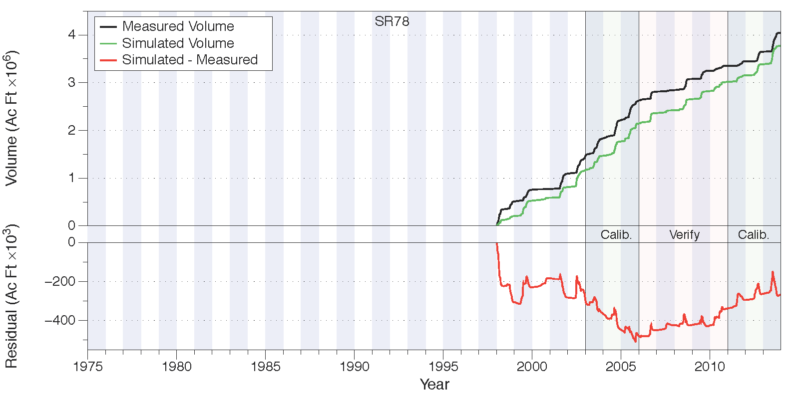
Figure 47. Total accumulated volume (millions of acre-feet) and residuals (thousands of acre feet) at SR78. Note that measurements were not taken until 1998.
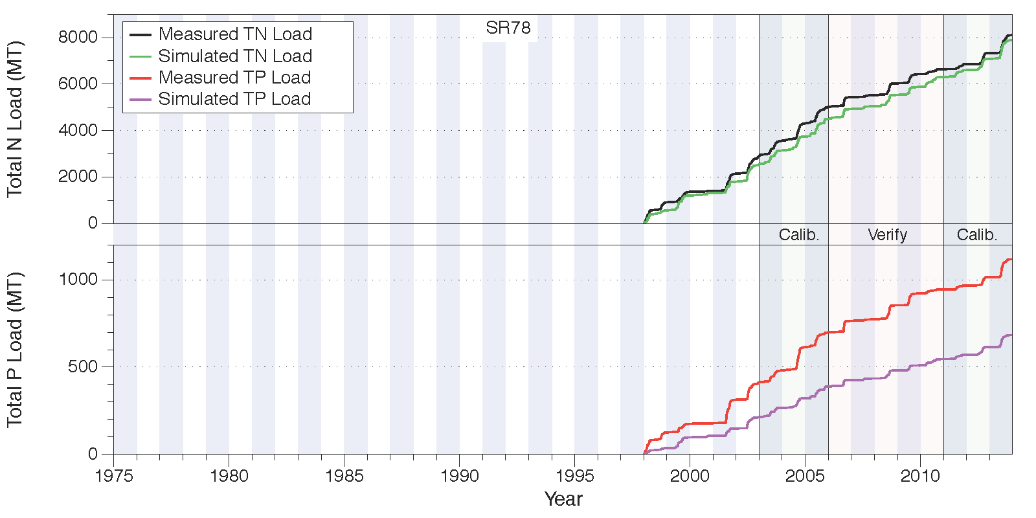
Figure 48. Total accumulated total N loads (upper chart) and total P loads (lower chart), both in metric tons, at SR78. Note that measurements were not taken until 1998.

Indian Prairie
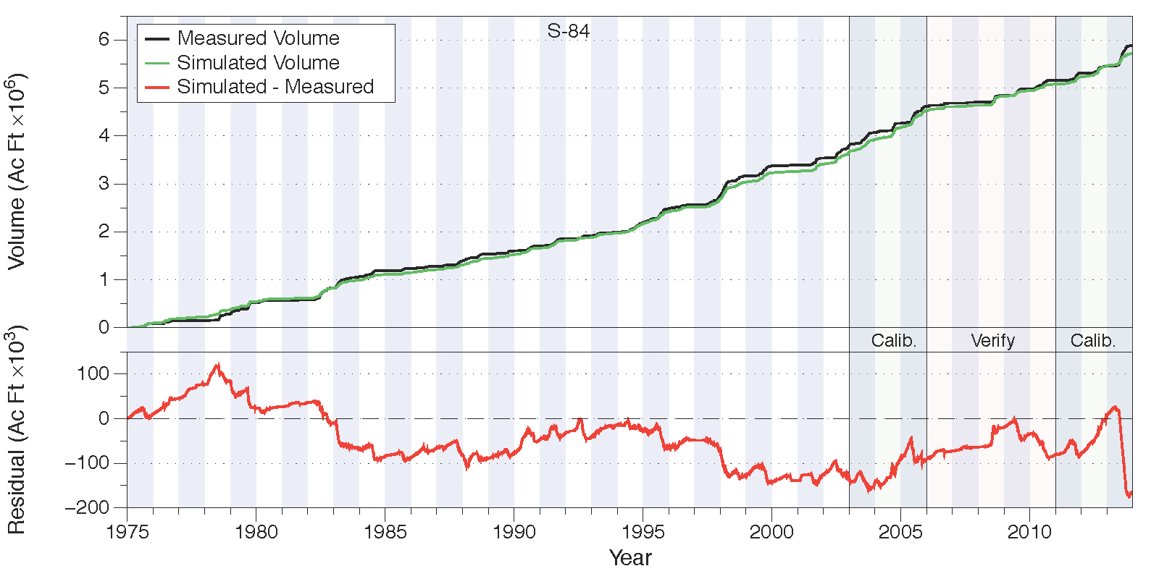
Figure 49. Total accumulated volume (millions of acre-feet) and residuals (thousands of acre feet) at S-84.
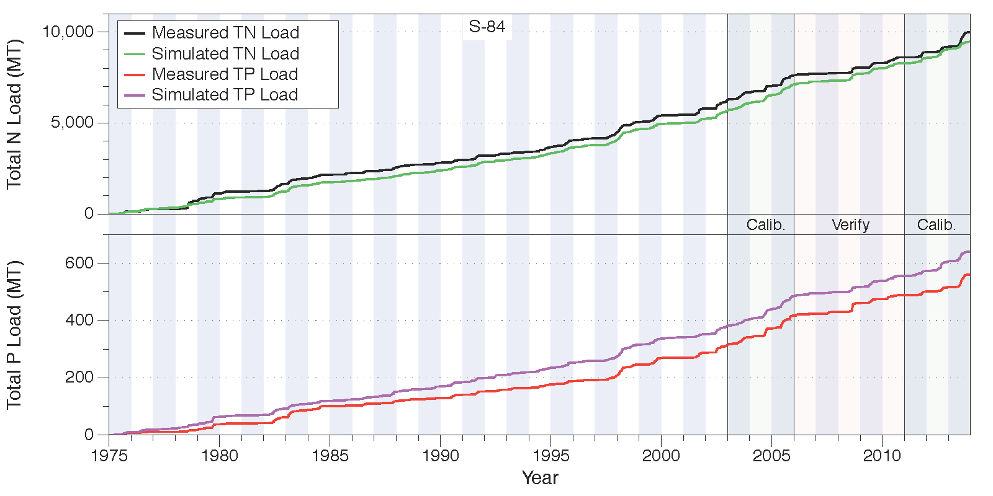
Figure 50. Total accumulated total N loads (upper chart) and total P loads (lower chart), both in metric tons, at S-84.

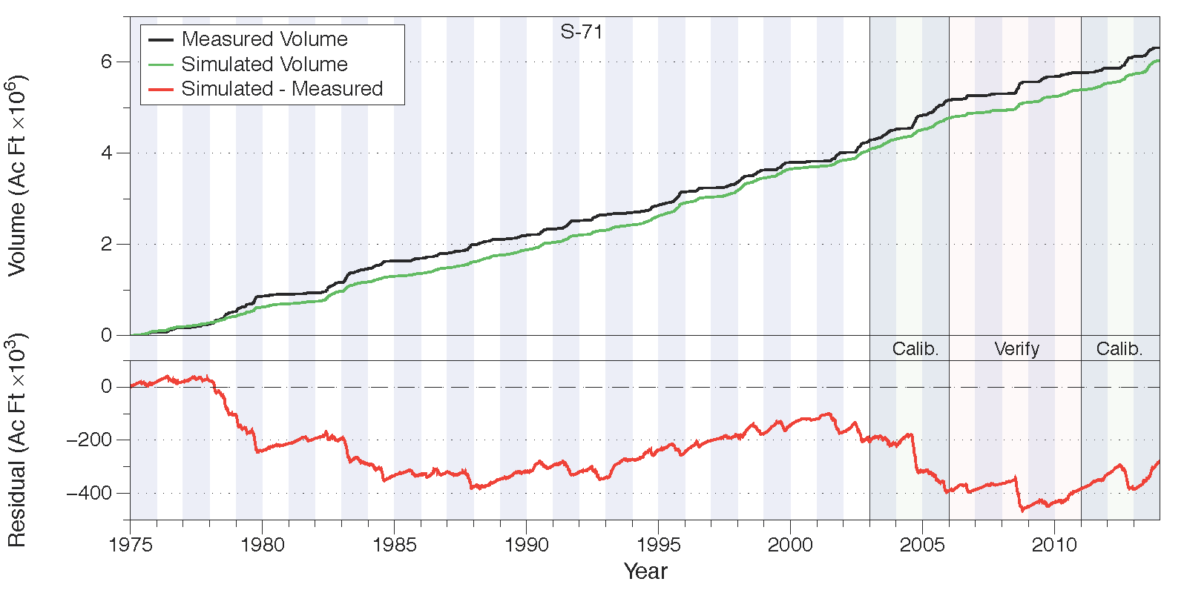
Figure 51. Total accumulated volume (millions of acre-feet) and residuals (thousands of acre feet) at S-71.
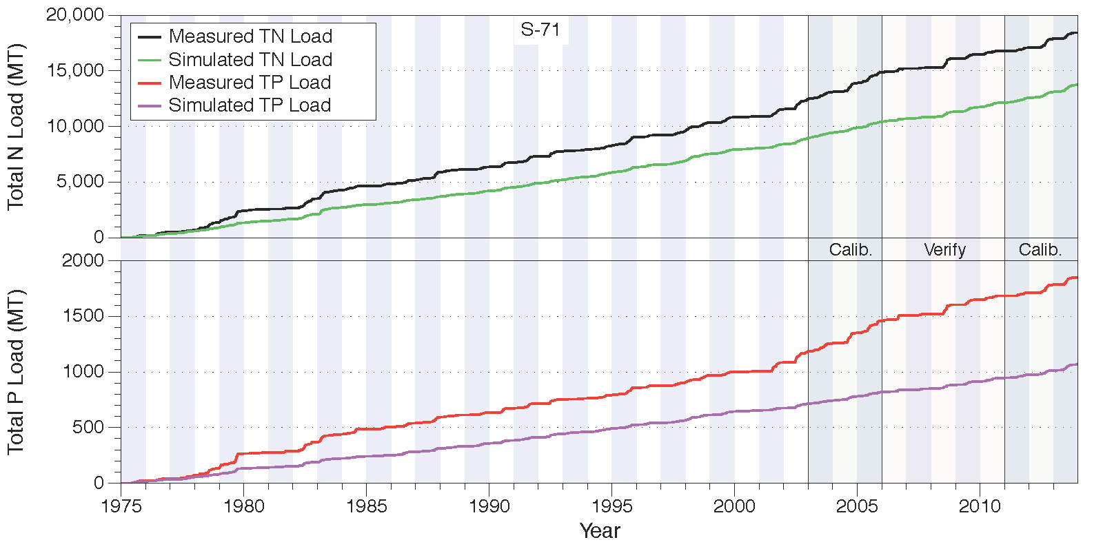
Figure 52. Total accumulated total N loads (upper chart) and total P loads (lower chart), both in metric tons, at S-71.

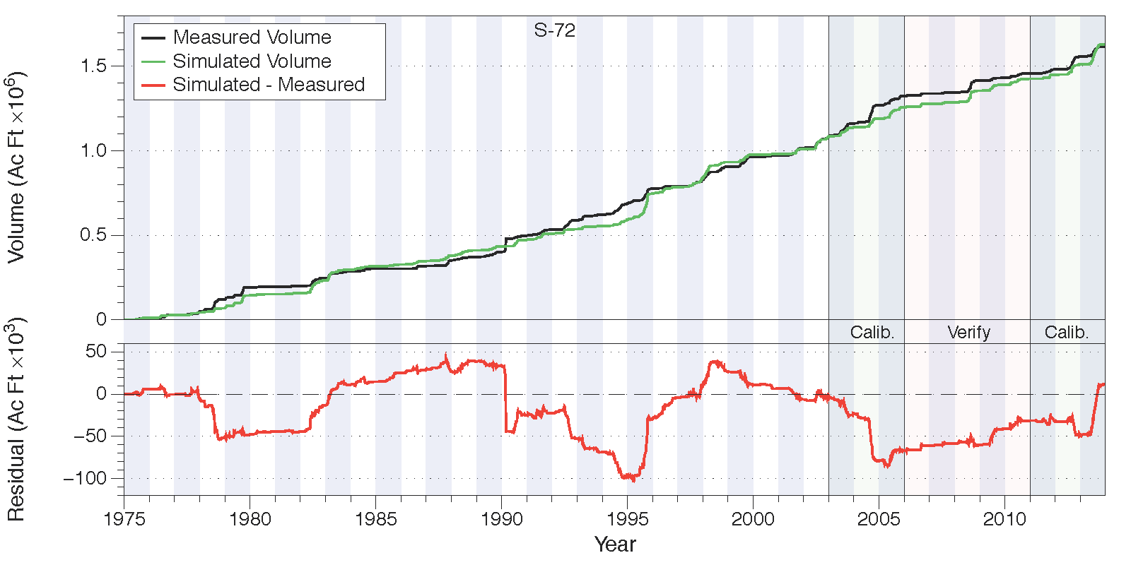
Figure 53. Total accumulated volume (millions of acre-feet) and residuals (thousands of acre feet) at S-72.
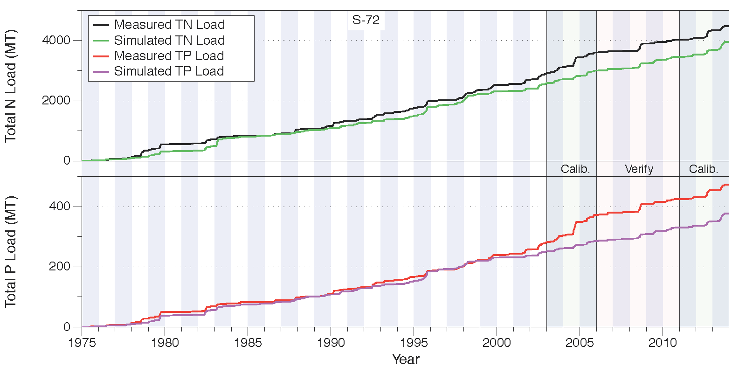
Figure 54. Total accumulated total N loads (upper chart) and total P loads (lower chart), both in metric tons, at S-72.
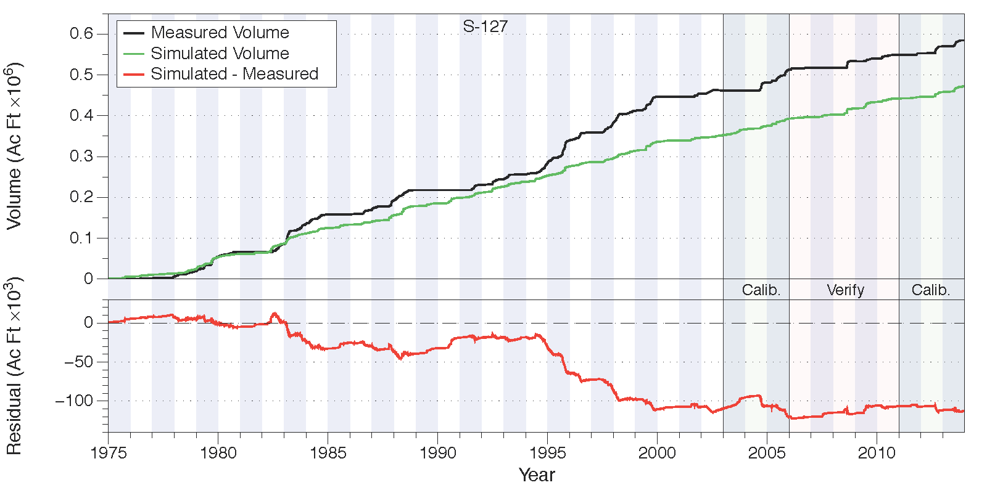
Figure 55. Total accumulated volume (millions of acre-feet) and residuals (thousands of acre feet) at S-127.
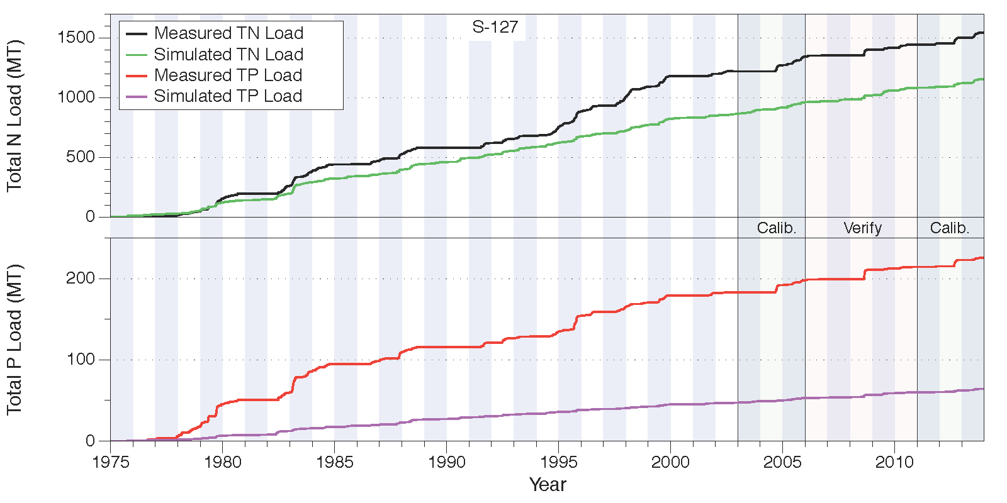
Figure 56. Total accumulated total N loads (upper chart) and total P loads (lower chart), both in metric tons, at S-127.

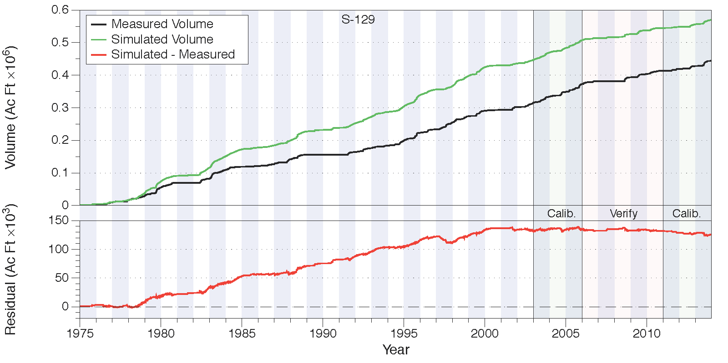
Figure 57. Total accumulated volume (millions of acre-feet) and residuals (thousands of acre feet) at S-129.
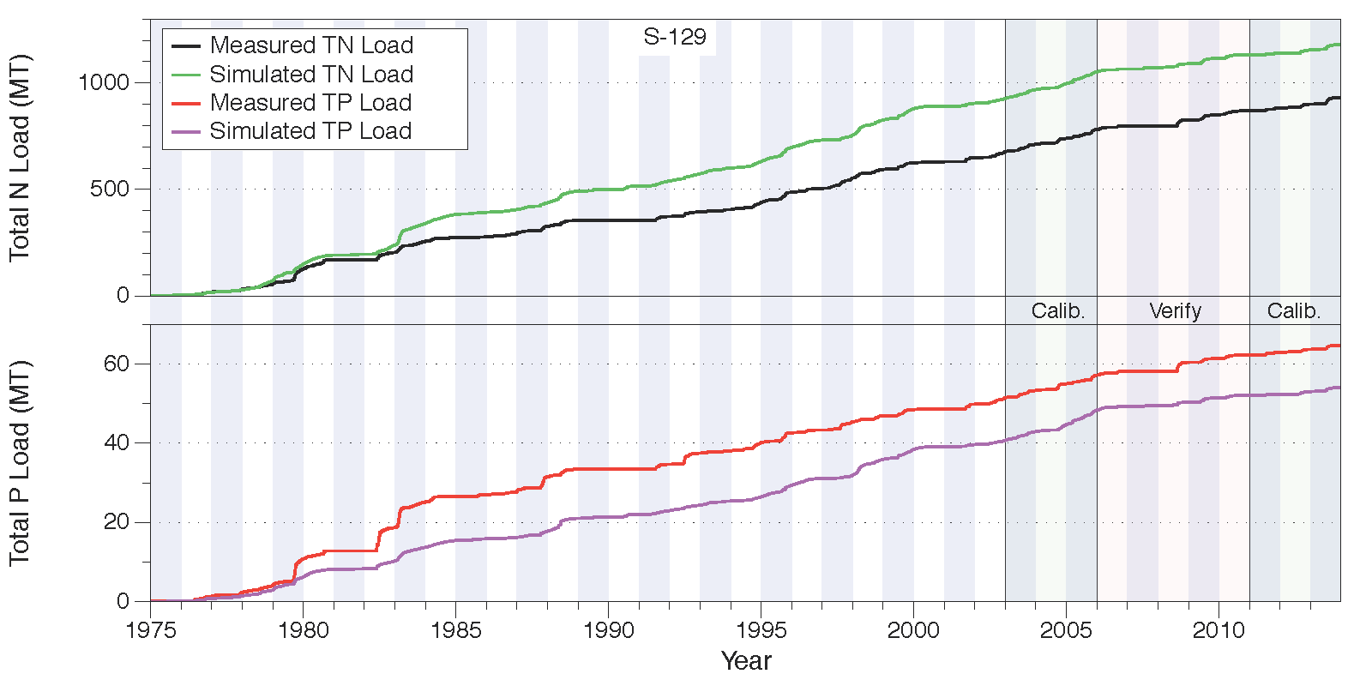
Figure 58. Total accumulated total N loads (upper chart) and total P loads (lower chart), both in metric tons, at S-129.

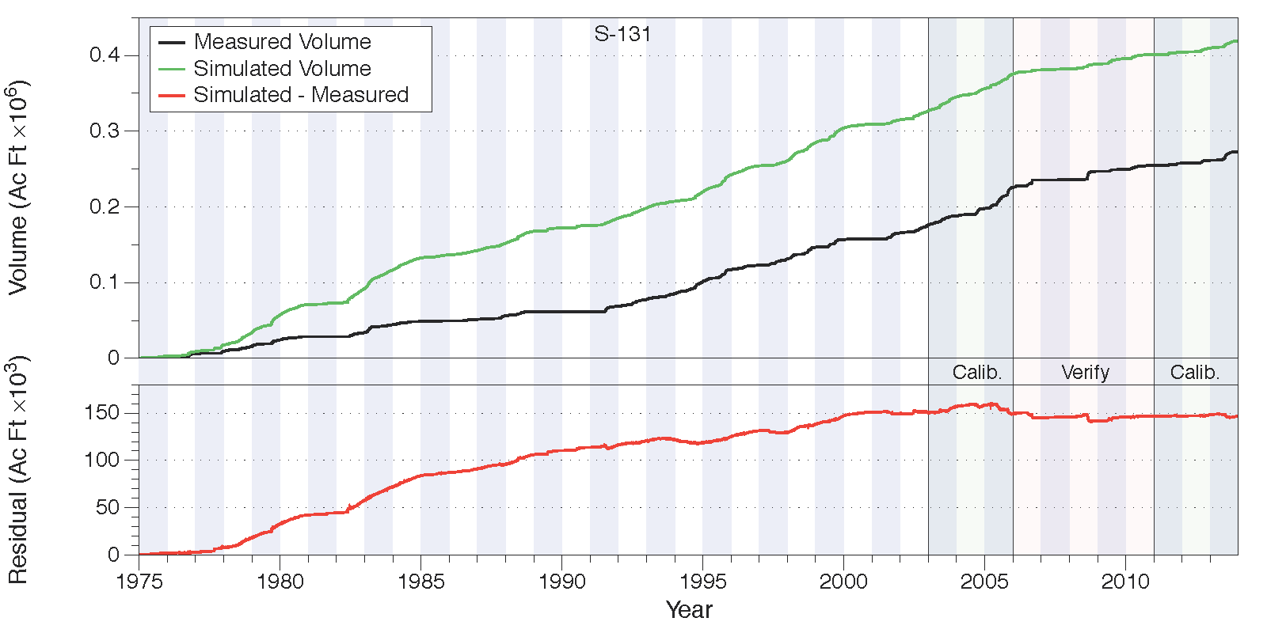
Figure 59. Total accumulated volume (millions of acre-feet) and residuals (thousands of acre feet) at S-131.
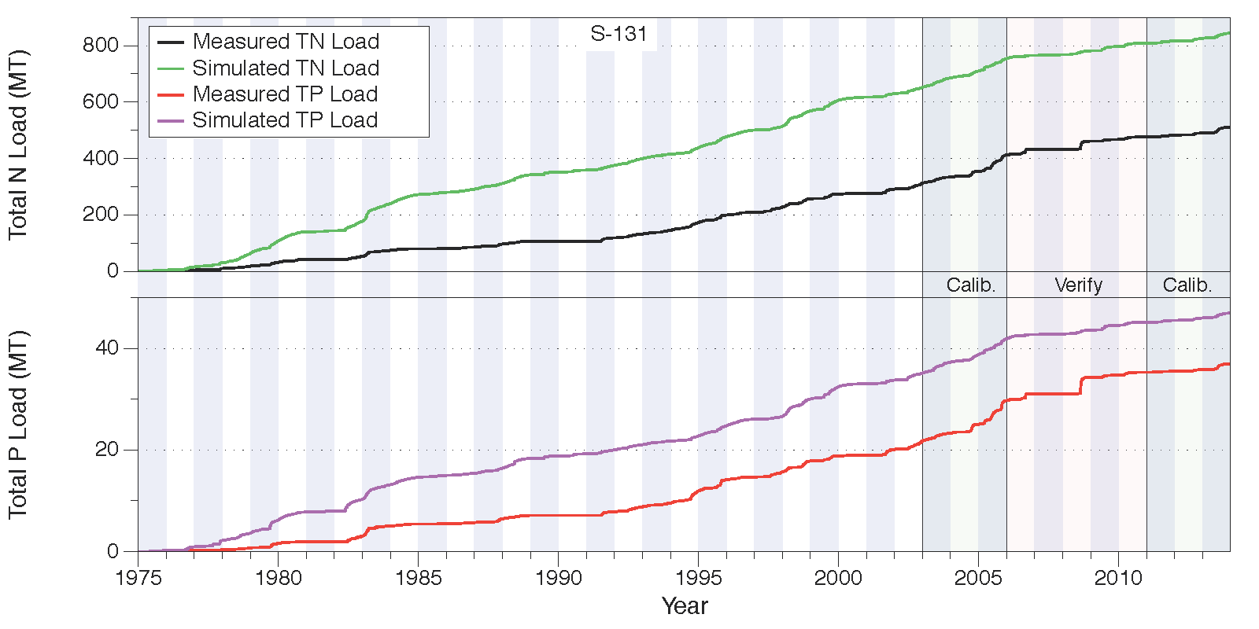
Figure 60. Total accumulated total N loads (upper chart) and total P loads (lower chart), both in metric tons, at S-131.

Lake Istokpoga
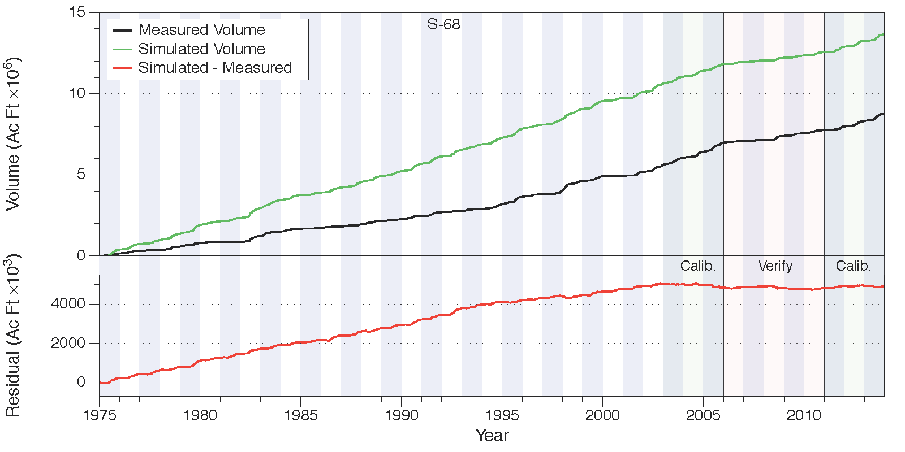
Figure 61. Total accumulated volume (millions of acre-feet) and residuals (thousands of acre feet) at S-68.
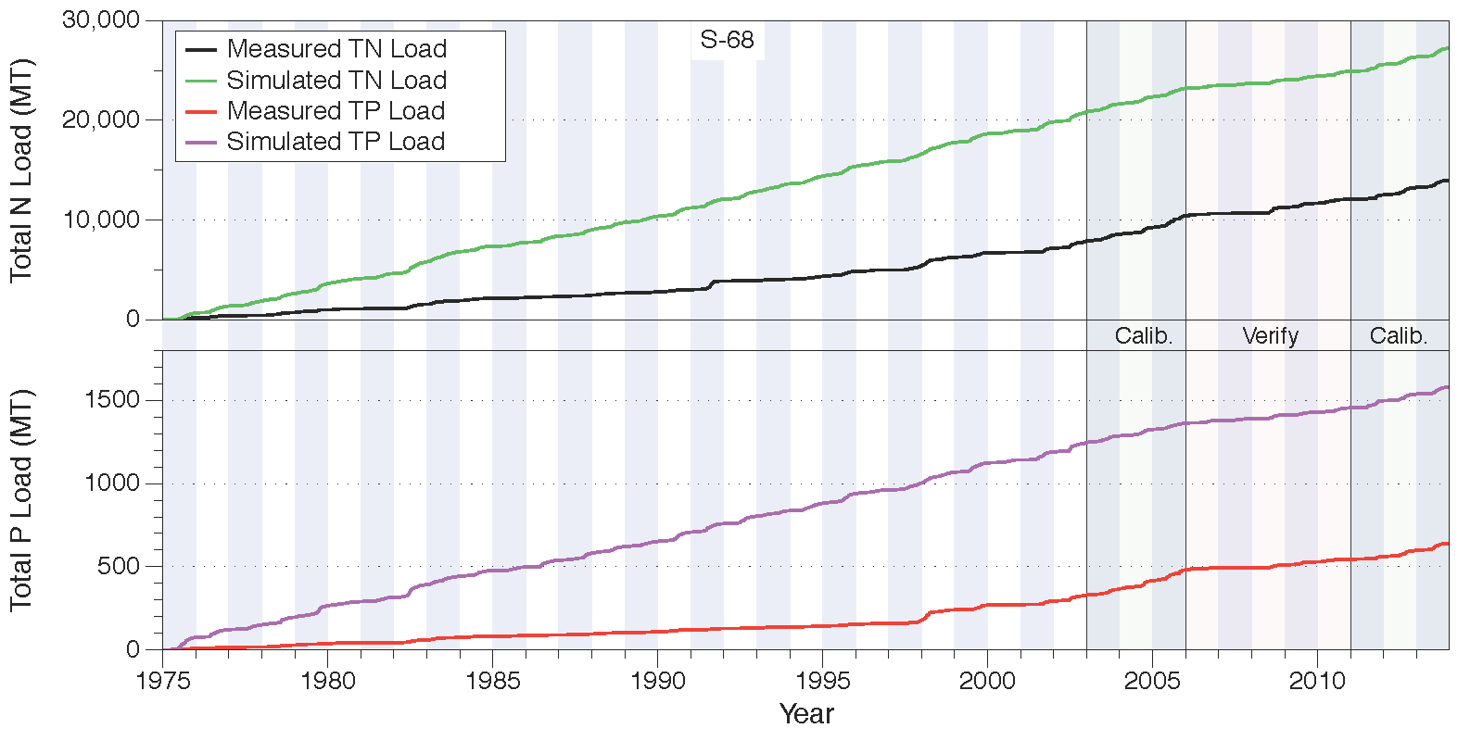
Figure 62. Total accumulated total N loads (upper chart) and total P loads (lower chart), both in metric tons, at S-68.

Lower Kissimmee
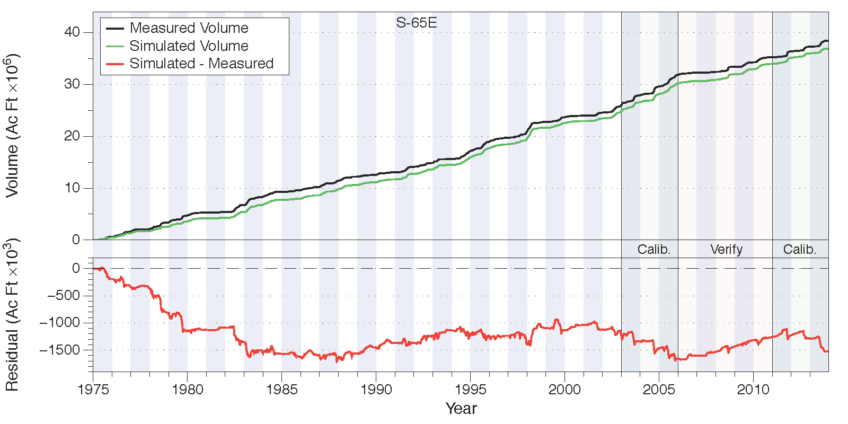
Figure 63. Total accumulated volume (millions of acre-feet) and residuals (thousands of acre feet) at S-65E.
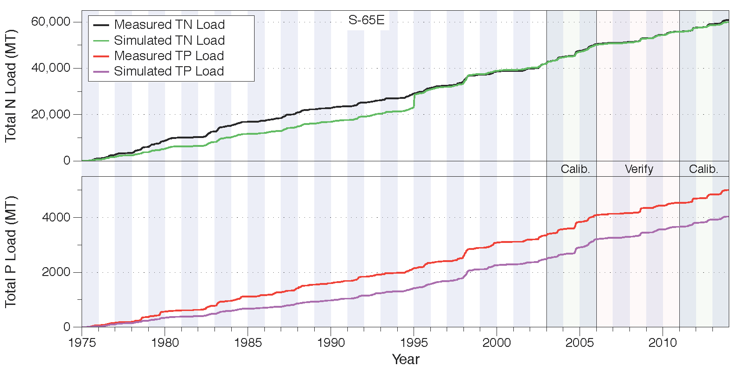
Figure 64. Total accumulated total N loads (upper chart) and total P loads (lower chart), both in metric tons, at S-65E. The large jump in the total N load in the simulated data is due to a (possibly erroneous?) nitrate concentration in the S-65 inflow data registering 95.1 ppm on December 27, 1994.

Taylor Creek/Nubbin Slough
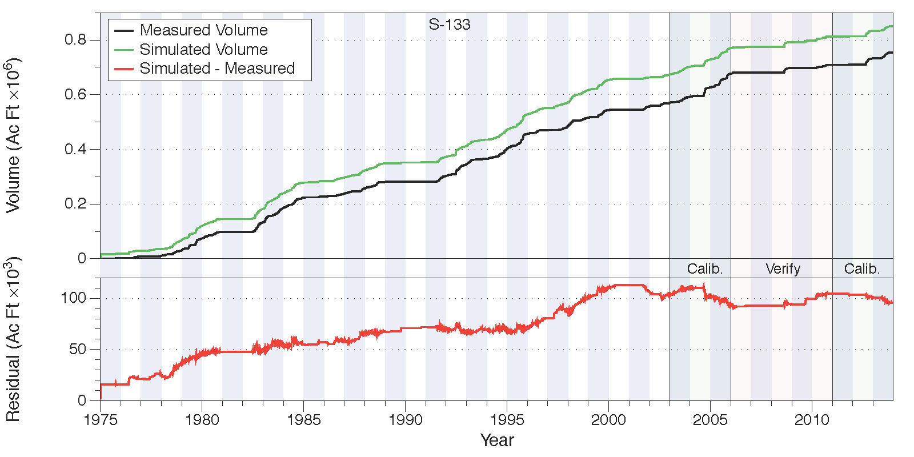
Figure 65. Total accumulated volume (millions of acre-feet) and residuals (thousands of acre feet) at S-133.
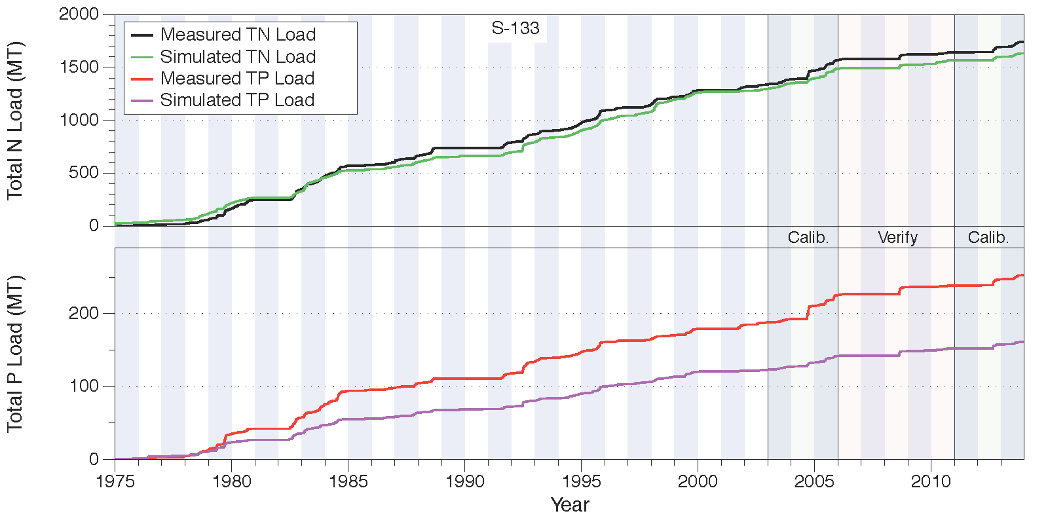
Figure 66. Total accumulated total N loads (upper chart) and total P loads (lower chart), both in metric tons, at S-133.

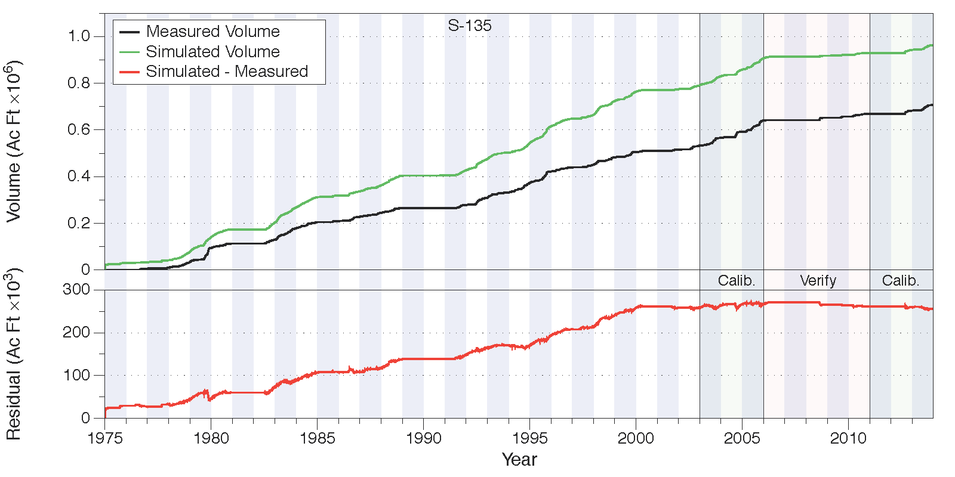
Figure 67. Total accumulated volume (millions of acre-feet) and residuals (thousands of acre feet) at S-135.
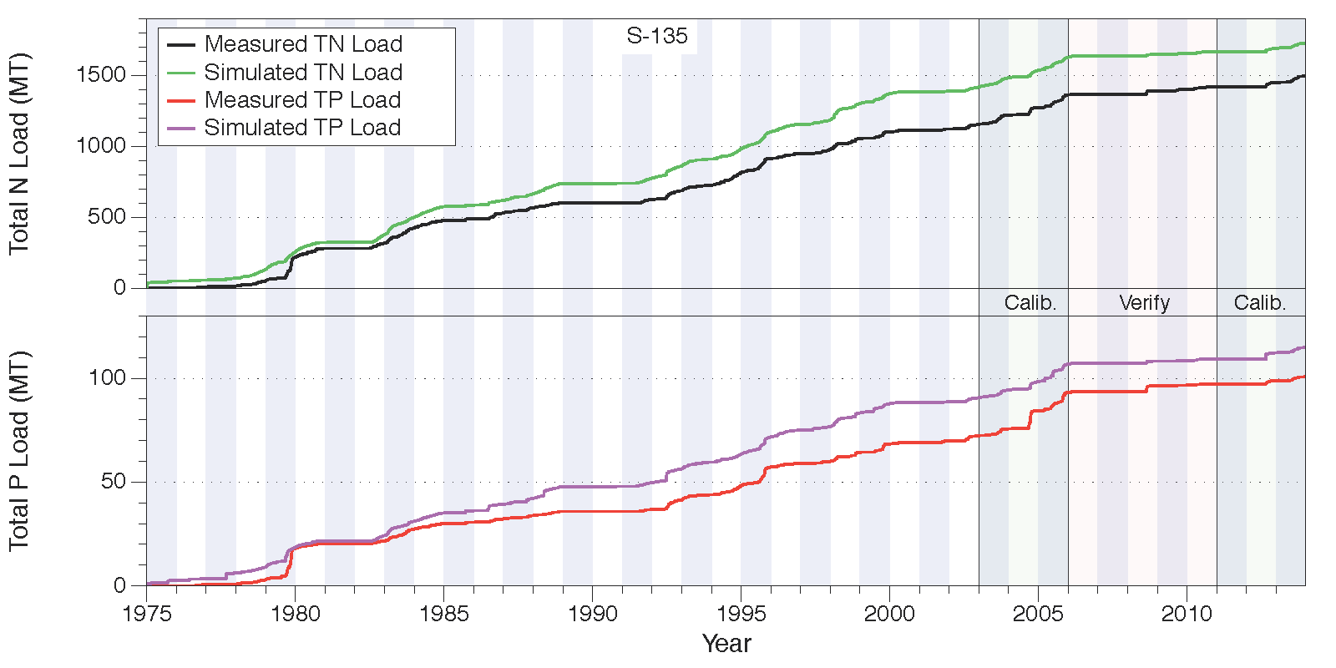
Figure 68. Total accumulated total N loads (upper chart) and total P loads (lower chart), both in metric tons, at S-135.

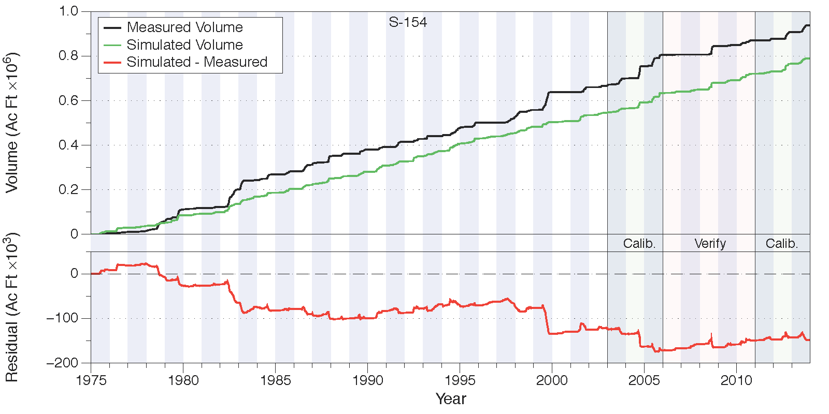
Figure 69. Total accumulated volume (millions of acre-feet) and residuals (thousands of acre feet) at S-154.
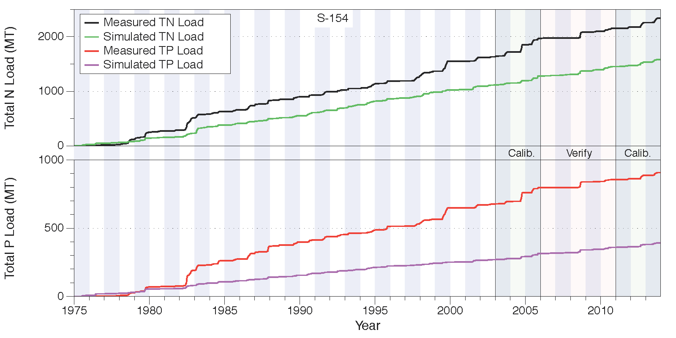
Figure 70. Total accumulated total N loads (upper chart) and total P loads (lower chart), both in metric tons, at S-154.
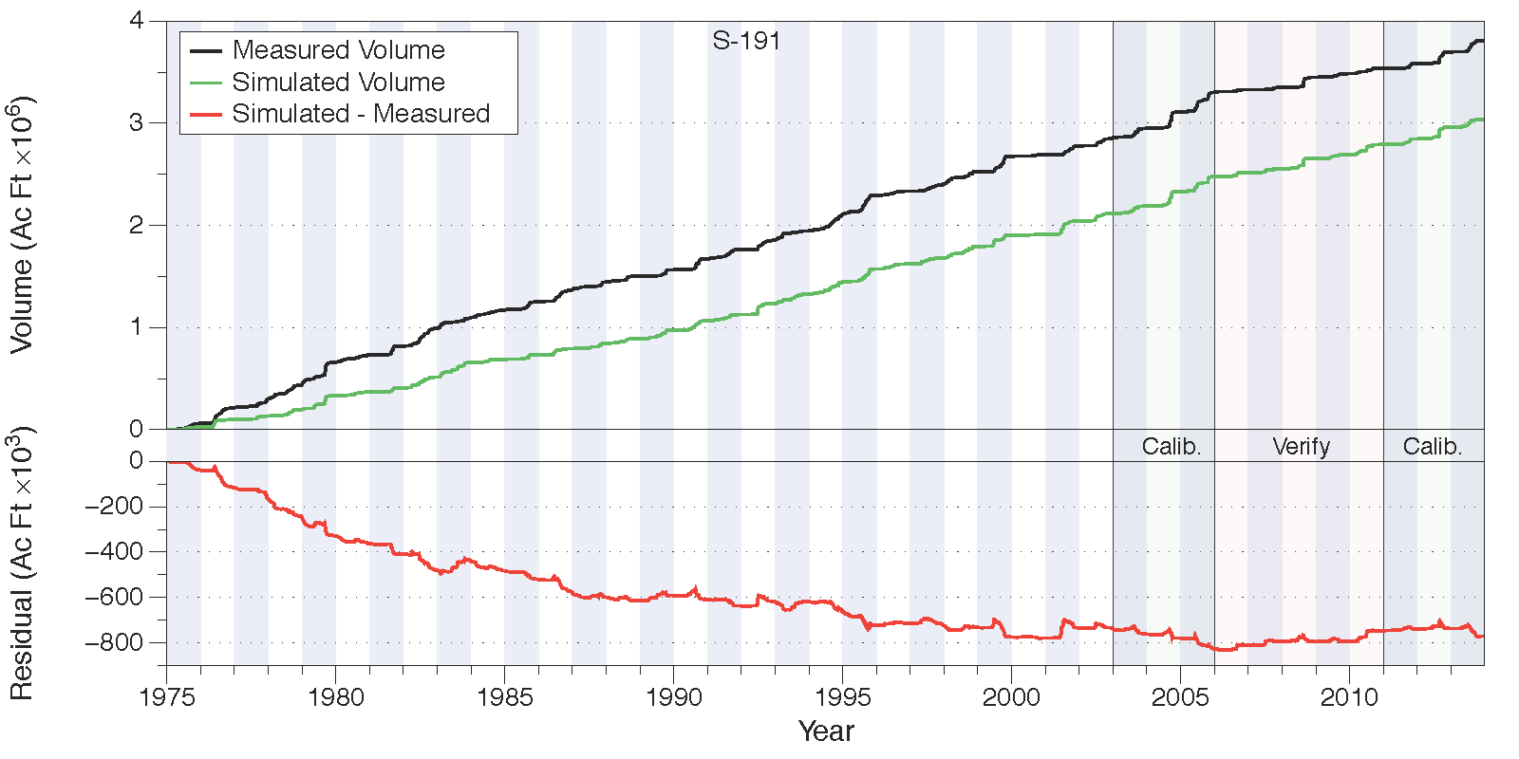
Figure 71. Total accumulated volume (millions of acre-feet) and residuals (thousands of acre feet) at S-191.
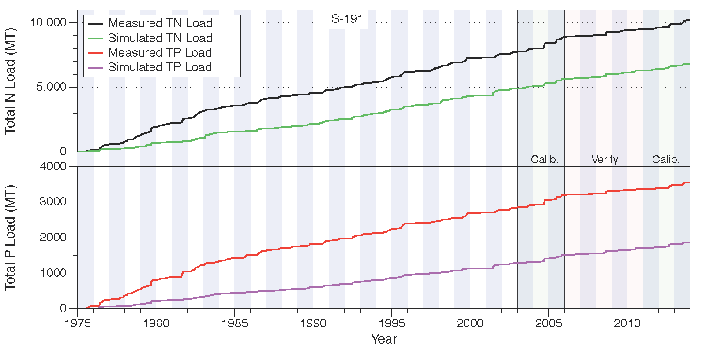
Figure 72. Total accumulated total N loads (upper chart) and total P loads (lower chart), both in metric tons, at S-191.

Upper Kissimmee
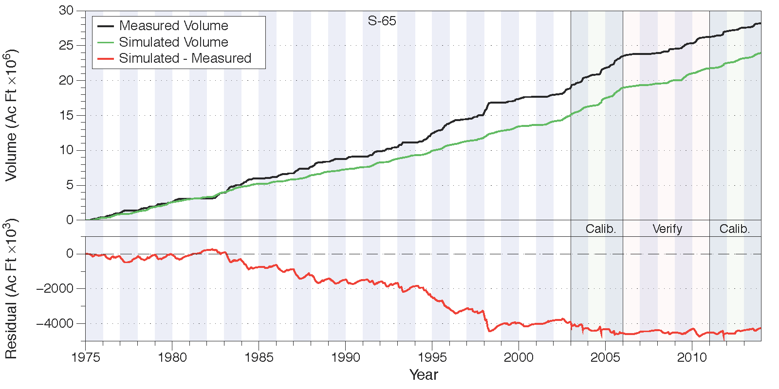
Figure 73. Total accumulated volume (millions of acre-feet) and residuals (thousands of acre feet) at S-65.
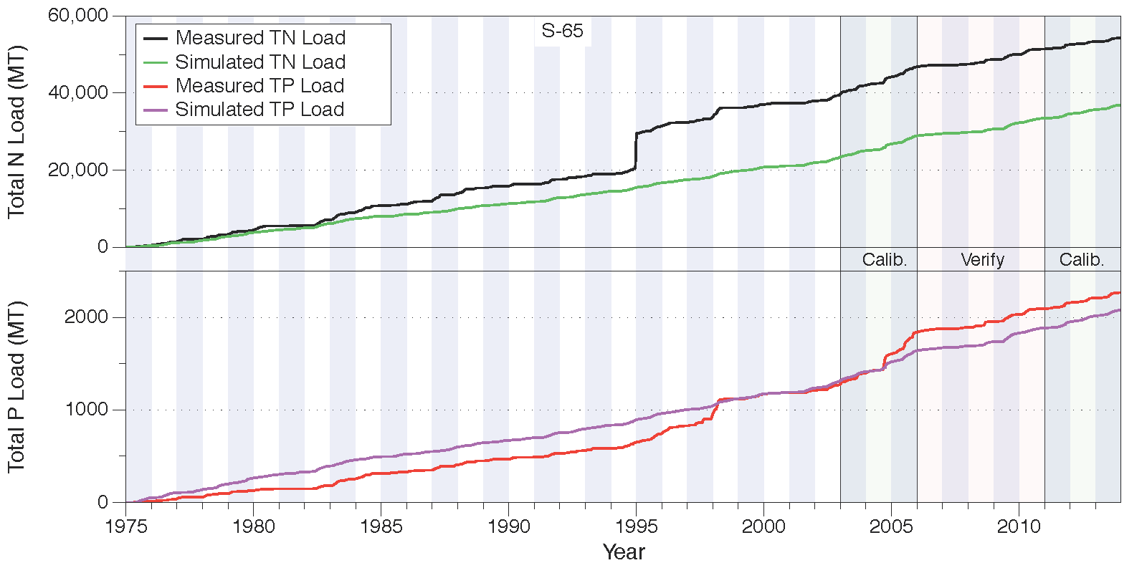
Figure 74. Total accumulated total N loads (upper chart) and total P loads (lower chart), both in metric tons, at S-65. The large jump in the measured total N load in late 1994 is due to a (possibly erroneous?) nitrate concentration of 95.1 ppm on December 27, 1994.

WAM Structure Parameters
Table 54. Hydraulic structures simulated in WAM in the Fisheating Creek sub-watershed.
Fisheating Creek
Weirs
WAM Reach | Location on Reach | Width (m) | A | B | Crest Elevation (m)
Farm Weir 1.7 miles N. of SR 70
29 | Bottom | 15 | 1.78 | 1.5 | 24

Table 55. Hydraulic structures simulated in WAM in the Indian Prairie sub-watershed.
Indian Prairie
Gates
WAM Reach | Location on Reach | Width (m) | A | B | Elevation (m)
Action | Trigger Reach | Trigger Elevation (m) | Stop Elevation (m) | Rate (m/s) | Opening (m) | Opens From | Starting Elevation (m)
S-70
267 | Bottom | 16.46 | 1.9 | 0.5 | 4.57
Open | 267 | 7.9 | 7.84 | 0.00254 | 3.57 | Bottom | 7.84
Close | 267 | 7.62 | 7.84 | 0.00254
S-71
261 | Bottom | 22.86 | 1.9 | 0.5 | 3.11
Open | 261 | 6.1 | 6.04 | 0.00254 | 3.41 | Bottom | 6.04
Close | 189 | 5.98 | 6.04 | 0.00254
S-72
156 | Bottom | 16.46 | 1.9 | 0.5 | 3.02
Open | 156 | 6.46 | 6.1 | 0.00254 | 3.63 | Bottom | 6.31
Close | 156 | 6.31 | 6.1 | 0.00254
S-75
167 | Bottom | 8.53 | 1.9 | 0.5 | 5.18
Open | 167 | 7.99 | 7.83 | 0.00254 | 2.96 | Bottom | 7.83
Close | 167 | 7.71 | 7.83 | 0.00254
S-82
177 | Top | 7 | 1.9 | 0.5 | 8.14
Open | 144 | 9.81 | 9.75 | 0.00017 | 2.56 | Bottom | 9.75
Close | 144 | 9.69 | 9.75 | 0.00017
S-82 Gate 2
177 | Top | 7 | 1.9 | 0.5 | 8.14
Open | 144 | 9.85 | 9.79 | 0.0002 | 2.56 | Bottom | 9.77
Close | 144 | 9.65 | 9.79 | 0.0002
S-83
143 | Bottom | 7.62 | 1.9 | 0.5 | 5.61
Open | 144 | 9.81 | 9.75 | 0.00017 | 4.48 | Bottom | 9.75
Close | 144 | 9.69 | 9.75 | 0.00017
S-84
131 | Bottom | 12.8 | 1.9 | 0.5 | 4.02
Open | 131 | 7.68 | 7.53 | 0.00017 | 3.81 | Bottom | 7.53
Close | 131 | 7.4 | 7.53 | 0.00017
S-127 Gate
53 | Bottom | 100 | 0.09 | 0.5 | 4
Open | 52 | 4.18 | 4.19 | 0.0254 | 1.5 | Bottom | 4.19
Close | 52 | 4.2 | 4.19 | 0.0254
S-129 Gate
20 | Bottom | 100 | 0.9 | 0.5 | 4
Open | 19 | 3.92 | 3.93 | 0.0254 | 1.5 | Bottom | 3.93
Close | 19 | 3.94 | 3.93 | 0.0254
S-131 Gate
2 | Bottom | 100 | 0.9 | 0.5 | 4
Open | 1 | 3.92 | 3.93 | 0.0254 | 1.5 | Bottom | 3.93
Close | 1 | 3.94 | 3.93 | 0.0254
Pumps
WAM Reach | Location on Reach | Elevation (m) | Trigger Reach | Trigger On (m) | Trigger Off (m) | Pump Rate (CMS)
S127 Pump 1
53 | Bottom | 4 | 53 | 4.25 | 4.07 | 2
S-127 Pump 2
53 | Bottom | 4 | 53 | 4.27 | 4.25 | 16
S-129 Pump 1
20 | Bottom | 4 | 20 | 4.05 | 3.96 | 2
S-129 Pump 2
20 | Bottom | 4 | 20 | 4.15 | 4.1 | 11
S-131 Pump 1
2 | Bottom | 4 | 2 | 4.05 | 3.96 | 2
S-131 Pump 2
2 | Bottom | 1 | 2 | 4.15 | 4.1 | 2
S-131 Pump 3
2 | Bottom | 4 | 2 | 4.16 | 4.15 | 6

Table 56. Hydraulic structures simulated in WAM in the Lake Istokpoga sub-watershed.
Lake Istokpoga
Gates
WAM Reach | Location on Reach | Width (m) | A | B | Elevation (m)
Action | Trigger Reach | Trigger Elevation (m) | Stop Elevation (m) | Rate (m/s) | Opening (m) | Opens From | Starting Elevation (m)
S-68 Gate 1
2 | Bottom | 14 | 1.5 | 0.5 | 9.5
Open | 2 | 12.04 | 11.96 | 0.00254 | 4.14 | Bottom | 11.96
Close | 2 | 11.9 | 11.96 | 0.00254
S-68 Gate 2
2 | Bottom | 4 | 1.5 | 0.5 | 9.5
Open | 2 | 11.8 | 11.75 | 0.00254 | 4.14 | Bottom | 11.7
Close | 2 | 11.7 | 11.75 | 0.00254
Istokpoga Marsh Gate
225 | Bottom | 2.5 | 1 | 0.5 | 7
Open | 225 | 50 | 10 | 0.00254 | 1 | Top | 10
Close | 225 | 45 | 10 | 0.00254
Override | Close | 2 | 11.575 | Above
Lake Istokpoga Gate 3
2 | Bottom | 2 | 1 | 0.5 | 9.5
Open | 2 | 12.1 | 12.075 | 0.00254 | 4.14 | Top | 11.55
Close | 2 | 12.05 | 12.075 | 0.00254
Pumps
WAM Reach | Location on Reach | Data
Istokpoga Marsh Irrigation Pump
225 | Bottom | Time series of flows to marsh

Table 57. Hydraulic structures simulated in WAM in the Lower Kissimmee sub-watershed.
Lower Kissimmee
Gates
WAM Reach | Location on Reach | Width (m) | A | B | Elevation (m)
Action | Trigger Reach | Trigger Elevation (m) | Stop Elevation (m) | Rate (m/s) | Opening (m) | Opens From | Starting Elevation (m)
S-65A Gate
30 | Bottom | 24.68 | 1.9 | 0.5 | 10.51
Open | 30 | 14.2 | 14.1 | 0.00254 | 4.39 | Bottom | 14.1
Close | 30 | 14 | 14.1 | 0.00254
S-65C Gate
12 | Bottom | 16.5 | 1.9 | 0.5 | 8.5
Open | 12 | 10.5 | 10.4 | 0.00254 | 4.39 | Bottom | 10.4
Close | 12 | 10.3 | 10.4 | 0.00254
S-65C Gate 2
12 | Bottom | 16.4 | 1.9 | 0.5 | 8.5
Open | 12 | 10.55 | 10.45 | 0.0025 | 4.39 | Bottom | 10.45
Close | 12 | 10.35 | 10.45 | 0.0025
S-65D Gate
8 | Bottom | 115 | 1.9 | 0.5 | 3.99
Open | 8 | 8.3 | 8.17 | 0.00254 | 4.14 | Bottom | 8.17
Close | 8 | 8.05 | 8.17 | 0.00254
S-65E Gate
2 | Bottom | 175 | 1.9 | 0.5 | 2.3
Open | 2 | 6.6 | 6.4 | 0.00254 | 4.14 | Bottom | 6.4
Close | 2 | 6.2 | 6.4 | 0.00254

Table 58. Hydraulic structures simulated in WAM in the Taylor Creek/Nubbin Slough sub-watershed.
Taylor Creek/Nubbin Slough
Gates
WAM Reach | Location on Reach | Width (m) | A | B | Elevation (m)
Action | Trigger Reach | Trigger Elevation (m) | Stop Elevation (m) | Rate (m/s) | Opening (m) | Opens From |  | Starting Elevation (m)
C-6 Gate
14 | Bottom | 0 | 1 | 0.5 | 4
Open | 13 | 20 | 19.5 | 0.00254 | 2 | Bottom |  | 19.5
Close | 13 | 19 | 19.5 | 0.00254
C-8 Gate
54 | Bottom | 0 | 1 | 0.5 | 4
Open | 53 | 20 | 19.5 | 0.00254 | 2 | Top |  | 19.5
Close | 53 | 19 | 19.5 | 0.00254
G-36 Gate
114 | Bottom | 0 | 1 | 0.5 | 1
Open | 113 | 20 | 19.5 | 0.0254 | 2 | Top |  | 19.5
Close | 113 | 19 | 19.5 | 0.0254
S-133 Gate
2 | Bottom | 20 | 1 | 0.5 | 0.5
Open | 1 | 3.95 | 4.025 | 0.025 | 2 | Bottom |  | 4.025
Close | 1 | 4.1 | 4.025 | 0.025
Override | Close if reach | 2 | 4.05 | Above
Override | Close if reach | 2 | 3.8 | Below
S-135 Gate
288 | Bottom | 10 | 0.9 | 0.5 | 0.5
Open | 122 | 3.95 | 3.99 | 0.0254 | 2 | Bottom |  | 3.99
Close | 122 | 4.03 | 3.99 | 0.0254
Override | Close if reach | 288 | 4.1 | Above
S-154 Gate
62 | Bottom | 6.1 | 1.9 | 0.5 | 1.37
Open | 62 | 7.25 | 7.1 | 0.00254 | 2.44 | Bottom |  | 7.1
Close | 62 | 6.95 | 7.1 | 0.00254
S-154C Gate
109 | Bottom | 2 | 1.9 | 0.5 | 2
Open | 109 | 5.03 | 4.88 | 0.00254 | 2.44 | Bottom |  | 4.88
Close | 109 | 4.73 | 4.88 | 0.00254
S-191 Gate 1
150 | Bottom | 50 | 1 | 0.5 | 4
Open | 150 | 5.8 | 5.73 | 0.0254 | 2.5 | Bottom |  | 5.73
Close | 150 | 5.66 | 5.73 | 0.0254
S-191 Gate 2
150 | Bottom | 50 | 1 | 0.5 | 4
Open | 150 | 5.98 | 5.92 | 0.0254 | 3 | Bottom |  | 5.92
Close | 150 | 5.86 | 5.92 | 0.0254
Pumps
WAM Reach | Location on Reach | Elevation (m) | Trigger Reach | Trigger On (m) | Trigger Off (m) | Pump Rate (CMS)
S-133 Pump 1
286 | Bottom | 4 | 286 | 4.24 | 4.04 | 6
S-133 Pump 2
286 | Bottom | 4 | 286 | 4.15 | 4.04 | 17
S-135 Pump 1
123 | Bottom | 1 | 123 | 4.18 | 4.04 | 4
S-135 Pump 2
123 | Bottom | 1 | 123 | 4.24 | 4.04 | 20
S-385 Nubbin Slough STA Inflow Pump 1
262 | Top | 5.2 | 256 | 5.4 | 5.2 | 0
S-385 Nubbin Slough STA Inflow Pump 2
262 | Top | 5.2 | 256 | 5.6 | 5.4 | 0
S-385 Nubbin Slough STA Inflow Pump 3
262 | Top | 5.2 | 256 | 5.8 | 5.6 | 0
S-385 Nubbin Slough STA Inflow Pump 4
262 | Top | 5.2 | 256 | 6 | 5.8 | 0
S-390 Taylor Creek STA Inflow Pump 1
190 | Top | 5.2 | 182 | 5.5 | 5.18 | 0.16
S-390 Taylor Creek STA Inflow Pump 2
190 | Top | 5.2 | 182 | 5.7 | 5.19 | 0.16
S-390 Taylor Creek STA Inflow Pump 3
190 | Top | 5.2 | 182 | 5.85 | 5.2 | 0.14
S-390 Taylor Creek STA Inflow Pump 4
190 | Top | 5.2 | 182 | 6 | 5.21 | 0.14
TCNS STA Reverse 1
190 | Top | 1 | 190 | 8.075 | 7.9 | -0.16
TCNS STA Reverse 2
190 | Top | 1 | 190 | 8.1 | 7.925 | -0.16
TCNS STA Reverse 3
190 | Top | 1 | 190 | 8.125 | 7.95 | -0.14
TCNS STA Reverse 4
190 | Top | 1 | 190 | 8.15 | 8 | -0.14
Weirs
WAM Reach | Location on Reach | Width (m) | A | B | Crest Elevation (m)
S-191 Spillway Weir
150 | Bottom | 300 | 1.78 | 1.5 | 7
S-386A-B Nubbin Slough STA Cell 1 Outflow
264 | Top | 1.8 | 1.78 | 1.5 | 6.4
Nubbin Slough STA Cell 1 Seepage Weir
260 | Bottom | 0.21 | 1.78 | 1.5 | 6
Nubbin Slough STA Cell 2 Seepage Weir
263 | Bottom | 0.3 | 1.78 | 1.5 | 6
S-387A-C Nubbin Slough STA Cell 2 Outflow
265 | Top | 2.7 | 1.78 | 1.5 | 6.4
Taylor Creek STA Seepage Weir
189 | Bottom | 0.83 | 1.78 | 1.5 | 6.858
TCNS STA Mid Cell Weir
190 | Bottom | 1.66 | 1 | 0.5 | 7.239
S-392 Taylor Creek STA Outflow
191 | Bottom | 0.83 | 1.78 | 1.5 | 6.858
Farm Weir (WAM 2009: Reach 65)
185 | Bottom | 39.6 | 1.78 | 1.5 | 9.21

Table 59. Hydraulic structures simulated in WAM in the Upper Kissimmee sub-watershed.
Upper Kissimmee
Gates
WAM Reach | Location on Reach | Width (m) | A | B | Elevation (m)
Action | Trigger Reach | Trigger Elevation (m) | Stop Elevation (m) | Rate (m/s) | Opening (m) | Opens From | Starting Elevation (m)
S-59 Gate
98 | Top | 5.48 | 1.9 | 0.5 | 14.97
Open | 99 | 17.1 | 16.9 | 0.0029 | 4.27 | Bottom | 16.9
Close | 99 | 16.7 | 16.9 | 0.0029
S-60 Spillway on Canal C-33
169 | Bottom | 3.66 | 1.9 | 0.5 | 16.76
Open | 169 | 19.1 | 18.9 | 0.0029 | 3.05 | Bottom | 18.9
Close | 169 | 18.7 | 18.9 | 0.0029
S-61 Gate
60 | Top | 8.23 | 1.9 | 0.5 | 11.25
Open | 61 | 16.2 | 16 | 0.0029 | 5.48 | Bottom | 16
Close | 61 | 15.8 | 16 | 0.0029
S-62 Spillway on Canal C-29 at Lake Hart
193 | Top | 4.27 | 1.9 | 0.5 | 16.86
Open | 194 | 18.5 | 18.3 | 0.0029 | 1.46 | Bottom | 18.3
Close | 194 | 18.1 | 18.3 | 0.0029
S-63 Gate on Canal C-34
166 | Top | 4.57 | 1.9 | 0.5 | 16.46
Open | 167 | 18.8 | 18.65 | 0.0029 | 3.05 | Bottom | 18.65
Close | 167 | 18.5 | 18.65 | 0.0029
S-63A Spillway on C-34
163 | Top | 9.14 | 1.9 | 0.5 | 15.06
Open | 164 | 17.45 | 17.22 | 0.0029 | 3.05 | Bottom | 17.22
Close | 164 | 17.13 | 17.22 | 0.0029
S-65 Gate 1
2 | Bottom | 24.68 | 1.9 | 0.5 | 12
Open | 2 | 15.7 | 15.65 | 0.00254 | 4.14 | Bottom | 14.8
Close | 2 | 15.6 | 15.65 | 0.00254
S-65 Gate 2
2 | Bottom | 24.68 | 1.9 | 0.5 | 12
Open | 2 | 15.9 | 15.85 | 0.00254 | 4.14 | Bottom | 14.8
Close | 2 | 15.8 | 15.85 | 0.00254
S-65 Gate 3
2 | Bottom | 6.68 | 1.9 | 0.5 | 12
Open | 2 | 15.5 | 15.45 | 0.00254 | 4.14 | Bottom | 14.8
Close | 2 | 15.4 | 15.45 | 0.00254
Weirs
WAM Reach | Location on Reach | Width (m) | A | B | Crest Elevation (m)
G-111 Weir on Jackson Canal
467 | Top | 2.74 | 1.78 | 1.5 | 10
G-113 Lake Marian Control
469 | Top | 7.32 | 1.78 | 1.5 | 18
S-57 Weir on Canal C-30
198 | Bottom | 2.74 | 1.78 | 1.5 | 18.6
S-58 Weir on Canal C-32 at Highway 532
205 | Bottom | 2.74 | 1.78 | 1.5 | 19.2
S-65G Spillway on Lake Kissimmee at Canal C-38
2 | Bottom | 141 | 1.78 | 1.5 | 14.9

FLUCCS/WAM Land Use ID Correspondence
Table 60 below gives the mapping between FLUCCS codes and the WAM land use ID (LUID). This table is used when importing land use datasets with an associated FLUCCS code. To prepare a land use feature class for use in WAM, a user will add an integer field to the dataset for the WAM LUID. The feature class will then be joined to Table 60 based on the FLUCCS code, and the field calculator will be used in ArcMap to fill in values for the newly added LUID field. The joined table should then be removed before use in WAM.
Table 60. FLUCCS codes and descriptions and associated WAM land use IDs.
FLUCCS | FLUCCS Description | LUID
1000 | Residential | 2
1009 | RV Parks | 2
1100 | Low Density Residential, Fixed Single Family Units | 2
1110 | Low Density Residential, Fixed Single Family Units | 2
1120 | Low Density Residential, Mobile Home Units | 2
1130 | Low Density Residential, Mixed Units (Fixed and Mobile) | 2
1140 | Ranchettes - Fixed Single Units | 71
1150 | Ranchettes - Mobile Units | 71
1160 | Ranchettes - Mixed Units | 71
1180 | Low Density Residential, Under Construction | 2
1190 | Low Density Residential, Under Construction | 2
1200 | Medium Density Residential, Fixed Single Family Units | 19
1210 | Medium Density Residential, Fixed Single Family Units | 19
1220 | Medium Density Residential, Mobile Home Units | 19
1230 | Medium Density Residential, Mixed Units (Fixed and Mobile) | 19
1290 | Medium Density Residential, Under Construction | 19
1300 | High Density Residential | 20
1310 | High Density Residential, Fixed Single Family Units | 20
1320 | High Density Residential, Mobile Home Units | 20
1330 | High Density Residential, Multiple Dwelling Units (Low Rise) | 21
1340 | High Density Residential, Multiple Dwelling Units (High Rise) | 21
1350 | High Density Residential, Mixed Units (Fixed and Mobile | 20
1370 | High Density Residential, Mixed Units (Fixed and Mobile | 20
1390 | Medium Density Residential, Under Construction | 20
1400 | Commercial and Services | 3
1410 | Retail Sales and Services | 3
1411 | Shopping Centers (Plazas, Malls) | 3
1420 | Wholesale Sales and Services | 3
1423 | Junk Yards | 3
1424 | Farmers Markets | 3
1430 | Professional Services | 3
1440 | Cultural and Entertainment | 3
1443 | Open Air Theaters | 3
1450 | Tourist Services | 3
1452 | Motels | 21
1453 | Travel Trailer Parks | 21
1454 | Campgrounds | 7
1460 | Oil and Gas Storage | 3
1470 | Mixed Commercial and Services | 3
1480 | Cemeteries | 23
1490 | Commercial and Services Under Construction | 3
1500 | Industrial | 22
1510 | Industrial | 22
1513 | Seafood Processing | 22
1514 | Meat Packaging Facilities | 22
1515 | Poultry and Egg Processing | 22
1516 | Grains and Legumes Processing | 22
1520 | Timber Processing | 22
1521 | Sawmills | 22
1522 | Plywood and Veneer Mills | 22
1523 | Pulp and Paper Mills | 22
1524 | Pole Peeler and Treatment Plants | 22
1526 | Log Home Prefabrication | 22
1527 | Woodyards | 22
1530 | Mineral Processing | 22
1532 | Phosphate Processing | 75
1533 | Limerock Processing | 22
1535 | Heavy Minerals Processing | 22
1540 | Oil and Gas Processing | 22
1542 | Jet Fuel Processing | 22
1544 | Liquefied Gases Processing | 22
1545 | Asphalt Processing | 22
1550 | Other Light Industrial | 22
1551 | Boat Building and Repair | 22
1552 | Electronics Industry | 22
1554 | Aircraft Building and Repair | 22
1555 | Container Manufacturer | 22
1556 | Mobile Home Manufacturers | 22
1560 | Other Heavy Industrial | 22
1561 | Ship Building and Repair | 22
1562 | Pre-stressed Concrete Plants | 22
1563 | Metal Fabrication Plants | 22
1564 | Cement Plants | 22
1565 | Other Heavy Industrial | 22
1570 | Other Heavy Industrial | 22
1590 | Industrial, Under Construction | 22
1600 | Extractive | 73
1610 | Strip Mines | 73
1611 | Clay Mines | 73
1612 | Peat Mine | 17
1613 | Heavy Minerals Mine | 73
1614 | Phosphate Mines | 74
1620 | Sand and Gravel Pits | 73
1630 | Rock Quarries | 73
1631 | Limerock Quarries | 73
1632 | Dolomite Quarries | 73
1633 | Phosphate Quarries | 74
1634 | Heavy Mineral Mines | 73
1640 | Oil and gas fields | 73
1650 | Reclaimed Land (Extractives) | 5
1660 | Holding Ponds (Extractives) | 73
1670 | Inactive Strip Mines | 73
1700 | Educational Facilities | 3
1710 | Educational Facilities | 3
1720 | Religious Facilities | 3
1730 | Military | 3
1736 | National Guard Installations | 3
1740 | Medical and Health Care | 3
1741 | Hospitals | 3
1742 | Nursing Homes and/or Convalescent Centers | 21
1750 | Governmental | 3
1751 | Governmental - Wastewater Treatment Plant | 3
1756 | Maintenance Yards | 3
1758 | SRWMD Conservation Lands | 5
1759 | Other Public Conservation Lands | 5
1760 | Correctional Facilities | 72
1761 | State Prisons | 72
1763 | Correctional Facilities | 72
1765 | Municipal Prisons | 72
1770 | Other Institutional Facilities | 3
1771 | Private Conservation Lands | 5
1800 | Recreation | 3
1810 | Swimming Beach | 3
1820 | Golf Courses | 23
1830 | Race Tracks | 24
1831 | Automobile Race Tracks | 3
1832 | Horse Race Tracks | 24
1833 | Dog Race Tracks | 24
1840 | Marinas and Fish Camps | 3
1841 | Marinas and Fish Camps - Wild Game | 5
1850 | Golf Courses | 23
1851 | City Parks | 23
1852 | Zoos | 29
1860 | Community Recreational Facilities | 3
1870 | Stadiums | 3
1880 | Historical Sites | 3
1890 | Other Recreational Facilities | 3
1900 | Undeveloped Land | 70
1910 | Undeveloped Land Within Urban Areas | 70
1920 | Inactive Land With Street Pattern but Without Structure | 70
1923 | Inactive Development Land - Nonforested | 70
1924 | Inactive Development Land - Forested | 70
1930 | Urban Land in Transition | 70
1940 | Other Open Land | 70
2100 | Pastures and Fields | 4
2110 | Improved Pasture | 26
2111 | Intensive Pasture | 85
2120 | Unimproved Pasture | 27
2130 | Woodland Pasture | 28
2140 | Row Crops | 25
2141 | Field Corn | 69
2142 | Tomatoes | 63
2143 | Potatoes | 60
2144 | Carrots, Greens & Mixed Vegetables | 50
2149 | Cabbage | 61
2150 | Field Crops | 62
2151 | Field Crops Spray Field | 86
2156 | Sugar Cane | 68
2160 | Mixed Crops | 60
2200 | Tree Crops | 84
2210 | Citrus Grove | 84
2220 | Fruit Orchards | 30
2221 | Peach Orchards | 30
2224 | Blueberries | 31
2230 | Other Groves | 30
2231 | Pecan Groves | 30
2240 | Abandoned Tree Crops | 30
2300 | Feeding Operations | 32
2310 | Cattle Feeding Operations | 32
2320 | Poultry Feeding Operations | 33
2330 | Swine Feeding Operations | 34
2400 | Nurseries and Vineyards | 35
2410 | Tree Nurseries | 35
2420 | Sod Farms | 36
2430 | Ornamentals | 37
2450 | Floriculture | 35
2500 | Specialty Farms | 39
2510 | Horse Farms | 38
2520 | Dairies | 39
2521 | Dairy Waste Pond | 9
2522 | Dairy High Intensity Area - Untreated | 87
2523 | Dairy High Intensity Area - Treated | 88
2524 | Dairy Boundary Pastures | 90
2525 | Abandoned Dairies | 89
2530 | Kennels | 40
2540 | Aquaculture | 41
2549 | Aquaculture | 41
2550 | Tropical Fish Farms | 41
2590 | Other Specialty Farms | 25
2600 | Old Field | 5
2610 | Old Field | 5
2620 | Old Field | 5
3100 | Herbaceous | 5
3200 | Prairies | 5
3210 | Palmetto Prairies | 5
3220 | Coastal Scrub | 5
3230 | Other Shrubs and Brush | 5
3290 | Other Shrubs and Brush | 5
3300 | Other Shrubs and Brush | 5
3430 | Other Shrubs | 5
4100 | Upland Coniferous Forests | 5
4110 | Pine Flatwoods | 5
4119 | Pine Flatwoods - Melaleuca Infested | 7
4120 | Longleaf Pine - Xeric Oak | 7
4130 | Sand Pine | 5
4140 | Pine - Mesic Oak | 7
4190 | Other Pines | 8
4200 | Upland Hardwood Forest | 7
4210 | Xeric Oak | 6
4220 | Brazilian Pepper | 7
4230 | Oak - Pine - Hickory | 7
4240 | Melaleuca | 7
4250 | Temperate Hardwoods | 6
4270 | Live Oak | 6
4271 | Live Oak | 6
4280 | Cabbage Palm | 7
4290 | Cabbage Palm - Melaleuca Infested | 7
4310 | Beech - Magnolia | 6
4320 | Sand Live Oak | 5
4330 | Western Everglades Hardwoods | 7
4340 | Hardwood - Conifer Mixed | 7
4350 | Dead trees | 7
4370 | Australian Pine | 8
4380 | Other Hardwoods | 7
4390 | Other Hardwoods | 7
4400 | Coniferous Plantations | 8
4410 | Coniferous Plantations | 8
4411 | Sand Pine Plantations | 8
4412 | Christmas Tree Plantations | 8
4420 | Tree Plantations | 8
4430 | Forest Regeneration Areas | 8
5100 | Streams and Waterways | 9
5110 | Natural River, Stream, Waterway | 9
5120 | Streams and Waterways | 9
5200 | Lakes | 9
5210 | Lakes larger than 500 acres | 9
5220 | Lakes larger than 100 acres but less than 500 acres | 9
5230 | Lakes larger than 10 acres but less than 100 acres | 9
5240 | Lakes less than 10 acres | 9
5250 | Marshy Lakes | 9
5300 | Reservoirs | 9
5310 | Reservoirs larger than 500 acres | 9
5320 | Reservoirs larger than 100 acres but less than 500 acre | 9
5330 | Reservoirs larger than 10 acres but less than 100 acres | 9
5340 | Reservoirs less than 100 acres | 9
5400 | Bays and Swamps | 9
5410 | Embayments Opening Directly into the Gulf or the Atlantic | 9
5420 | Embayments Not Opening Directly into the Gulf or the Atlantic | 9
5430 | Enclosed salt water ponds within salt marsh | 9
5500 | Major Springs | 9
5600 | Slough Waters | 9
5710 | Atlantic Ocean | 9
6000 | Wetlands | 16
6100 | Mixed Wetland Hardwoods | 12
6110 | Bay Swamps | 10
6111 | Bay Swamps - Bayhead | 10
6120 | Mangrove Swamps | 10
6121 | Black Mangrove | 10
6130 | Gum Swamps | 10
6140 | Shrub Swamps | 10
6150 | Stream and Lake Swamps (Bottomland) | 15
6160 | Inland Ponds and Sloughs | 15
6170 | Mixed Wetland Hardwoods | 12
6171 | Mixed Wetland Hardwoods - Willows | 12
6172 | Mixed Wetland Hardwoods - Mixed Shrubs | 12
6180 | Cabbage Palm Savannah | 12
6181 | Cabbage Palm Hammock | 12
6191 | Wet Melaleuca | 12
6200 | Wetland Coniferous Forest | 15
6210 | Cypress | 14
6215 | Cypress | 14
6216 | Cypress | 14
6218 | Cypress - melaleuca infested | 14
6219 | Cypress - with wet prairies | 14
6220 | Wet Flatwoods | 15
6230 | Atlantic White Cedar | 15
6240 | Cypress - Pine - Cabbage Palm | 15
6250 | Wetland Coniferous Forest | 15
6300 | Wetland Forested Mixed | 15
6310 | Hydric Hammock | 15
6320 | Tidal Swamp | 15
6400 | Vegetated Non-Forested Wetlands | 16
6410 | Freshwater Marshes | 16
6411 | Freshwater Marshes - Sawgrass | 16
6412 | Freshwater Marshes - Cattail | 16
6420 | Saltwater Marshes | 10
6430 | Wet Prairies | 16
6439 | Wet Prairies - with Pine | 16
6440 | Emergent Aquatic Vegetation | 16
6450 | Submergent Aquatic Vegetation | 16
6460 | Emergent Aquatic Vegetation | 16
6500 | Non Vegetated Wetlands | 42
6510 | Salt Barrens | 42
6520 | Intertidal Areas | 17
6530 | Inland Shores/Ephemeral Ponds | 17
6540 | Oyster Bars | 42
6600 | Cut-over Wetlands | 15
7100 | Beaches | 17
7200 | Sand Other Than Beaches | 17
7340 | Exposed Rocks | 17
7400 | Barren Land | 17
7410 | Rural Land in Transition | 4
7420 | Borrow Areas | 17
7430 | Spoil Areas | 17
7440 | Fill Areas | 17
7450 | Burned Areas | 17
7470 | Dikes and Levees | 17
8000 | Transportation, Communications and Utilities | 3
8100 | Transportation | 18
8110 | Airports | 3
8111 | Commercial Airports | 3
8112 | General Aviation Airports | 3
8113 | Private Airports | 3
8115 | Airports | 3
8120 | Railroads | 3
8130 | Bus and Truck Terminals | 3
8132 | Bus (Government, School, City Service) | 3
8133 | Truck Terminals | 3
8140 | Limited Access Roads (Interstate System) | 18
8141 | Limited Access Roads (Interstate System) | 18
8142 | Divided Highways (Federal - State) | 18
8143 | Two-Lane Highways (State) | 18
8147 | Transportation Corridors | 18
8150 | Port Facilities | 3
8160 | Canals and Locks | 3
8170 | Oil, Water or Gas Long Distance Transmission Lines | 5
8180 | Auto Parking Facilities | 3
8200 | Communications | 3
8213 | Transmission Towers | 5
8220 | Communication Facilities | 22
8300 | Utilities | 22
8310 | Electrical Power Facilities | 22
8311 | Thermal Electrical Power Facilities | 22
8312 | Gas Turbine Electrical Power Plants | 22
8315 | Sub-station Electrical Power Facilities | 3
8320 | Electrical Power Transmission Lines | 5
8330 | Water Supply Plants | 22
8340 | Sewage Treatment | 43
8341 | Sewage Treatment Plants | 43
8349 | Sewage Treatment | 43
8350 | Solid Waste Disposal Facilities | 44
8370 | Surface Water Collection Basin | 9
9520 | Inactive Dairies | 89

References

Bottcher, A.B., N.B. Pickering, and A.B. Cooper, 1998. EAAMOD‐FIELD: A flow and phosphorus model for high water tables. In Proc. 7th Annual Drainage Symposium, 599‐606. St. Joseph, Mich.: ASAE.
Bottcher, A.B., B.J. Whiteley, James, A.I., and J.G. Hiscock, 2012. Watershed Assessment Model (WAM): Model use, calibration and validation. Transactions of ASABE 55(4): 1367-1383.
Christiansen, Daniel E. 2012. Simulation of Daily Streamflows at Gaged and Ungaged Locations within the Cedar River Basin, Iowa, Using a Precipitation-Runoff Modeling System Model. Scientific Investigations Report 2012-5213. USGS.
Donigian, A. S. 2002. Watershed Model Calibration and Validation: The HSPF Experience. Proceedings of the Water Environment Federation, National TMDL Science and Policy. Published by Water Environment Federation, pp. 44-73(30)
Earth Tech, 2006, Kissimmee Basin Hydrologic Assessment, Modeling, and Operations Planning Study Alternative Formulation/Evaluation Tool Development Technical Design Document, prepared for SFWMD.
Engel, B., Storm, D., While, M., Arnold, J. and M. Arabi. 2007. A Hydrologic/Water Quality Model Application Protocol. Journal of the American Water Resources Association 43(5): 1223-1266.
Gan, T.Y., Dlamini, E.M. and G.F. Biftu. 1997. Effects of Model Complexity and Structure, Data Quality, And Objective Functions On Hydrologic Modeling. Journal of Hydrology 192: 81-103.
Gupta, H.V., Kling, H., Yilmaz, K.K., and Martinez, G.F., 2009. Decomposition of the mean squared error and NSE performance criteria: Implications for improving hydrological modelling. Journal of Hydrology 377: 80-91
Jain, S.K. and K.P. Sudheer. 2008. Fitting of Hydrologic Models: A Close Look at the Nash-Sutcliffe Index. Journal of Hydrologic Engineering 13(10): 981-986
Jensen, M.E., R.D. Burman, and R.G. Allen, 1990. Evapotranspiration and Irrigation Water Requirements. ASCE Manuals and Reports on Engineering Practice No. 70, Am. Soc. Civil Engr., New York, NY. 332 p.
Knisel, W.G. (Ed), 1993. GLEAMS: Groundwater Loading Effects of Agricultural Management Systems. Univ. of Georgia, Coastal Plain Expt. Sta, Bio. and Agri. Engr. Dept., Publ. No. 5.
Legates, D.R. and G.L. McCabe. 1999. Evaluating the Use of “Goodness-Of-Fit” Measures in Hydrologic and Hydroclimatic Model Validation. Water Resources Research 35(1): 233-241.
Leonard, R. A., W.G. Knisel, and D. A. Still, 1987. GLEAMS: Groundwater Loading Effects of Agricultural Management Systems. Transactions of the ASAE, 30(5).
Loague, Keith. 1994. Impact of Overland Flow Plane Characterization on Event Simulations with a Quasi-Physically Based Rainfall-Runoff Model. Water Resources Research. Vol.28. No.9.2541-2545
McKenzie, D.J. 1973. Lake Okeechobee Seepage Monitoring Network Progress Report 1970-1972. Open-File Report 73018, U.S. Geological Survey.
SFWMD, FDEP and FDACS, 2014. Chapter 8: Lake Okeechobee Watershed Protection Program Annual and Three-Year Update. 126p.
Soil and Water Engineering Technology, Inc., 2008a. EAAMOD Technical and User Manuals. Final Reports to the Everglades Research and Education Center, University of Florida, Belle Glade, FL. Also available from www.swet.com.
Soil and Water Engineering Technology, Inc., 2008b. Final Report on the Evaluation of P Reduction Scenarios for Istokpoga Marsh Drainage District. SFWMD Contract No. C-10047358.
Soil and Water Engineering Technology, Inc., 2008c. Nutrient Loading Rates, Reduction Factors and Implementation Costs Associated with BMPs and Technologies.
Zambrano-Bigiarini, Mauricio, 2014. hydroGOF: Goodness-of-fit functions for comparison of simulated and observed hydrological time series. R package version 0.3-8. https://CRAN.R-project.org/package=hydroGOF.

