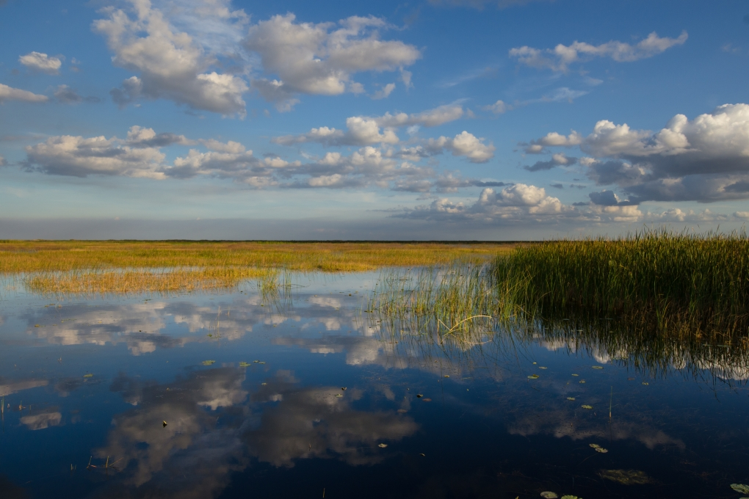

Evaluation of Effectiveness of Abatement Strategies

Compared Against Pre-Drainage and Existing Conditions in the Lake Okeechobee Watershed

Deliverable 2.1: Pre-Drainage Characterization Report

October 1, 2018

Soil and Water Engineering Technology, Inc.


Table of Contents
Executive Summary 1
1 Introduction 2
1.1 Objectives and Goals 3
1.1.1 Tasks and Deliverables 3
1.2 A Brief Description of WAM 5
1.2.1 Required Datasets 5
1.3 Pre-Drainage Characterization 6
1.3.1 Previous Work 6
2 WAM Model Setup 9
2.1 Modification of Spatial Datasets 9
2.1.1 Modification of Soils Dataset 9
2.1.2 Creation of Pre-drainage Land Cover 13
2.1.3 Pre-drainage Hydrologic Reach Delineation 21
2.1.4 Modification of Topography 26
2.1.5 Estimates of Nitrogen and Phosphorus Concentrations in Runoff from Pristine Land Cover 26
2.1.6 WAM Nutrient Settings 36
3 Results 39
3.1 Upper Kissimmee 46
3.1.1 Water and Nutrient Loads from Source Cells 47
3.1.2 Water and Nutrient Loads Discharging from the Sub-Watershed 49
3.2 Lower Kissimmee 51
3.2.1 Water and Nutrient Loads from Source Cells 53
3.2.2 Water and Nutrient Loads Discharging from the Sub-Watershed 55
3.3 Lake Istokpoga 58
3.3.1 Water and Nutrient Loads from Source Cells 60
3.3.2 Water and Nutrient Loads Discharging from the Sub-Watershed 61
3.4 Indian Prairie 63
3.4.1 Water and Nutrient Loads from Source Cells 64
3.4.2 Water and Nutrient Loads Discharging from the Sub-Watershed 67
3.5 Fisheating Creek 69
3.5.1 Water and Nutrient Loads from Source Cells 71
3.5.2 Water and Nutrient Loads Discharging from the Sub-Watershed 73
3.6 Taylor Creek/Nubbin Slough 75
3.6.1 Water and Nutrient Loads from Source Cells 77
3.6.2 Water and Nutrient Loads Discharging from the Sub-Watershed 79
3.7 East Lake Okeechobee Sub-Watershed 82
3.7.1 Water and Nutrient Loads from Source Cells 83
3.7.2 Water and Nutrient Loads Discharging from the Sub-Watershed 85
3.8 West Lake Okeechobee Sub-Watershed 88
3.8.1 Water and Nutrient Loads from Source Cells 89
3.8.2 Water and Nutrient Loads Discharging from the Sub-Watershed 91
3.9 South Lake Okeechobee Sub-Watershed 93
3.9.1 Water and Nutrient Loads from Source Cells 94
3.9.2 Water and Nutrient Loads Discharging from the Sub-Watershed 96
3.10 Conclusions 98
4 References 99
5 Appendix A: A Brief Description of the Watershed Assessment Model 103
5.1 Model Approach 103
5.1.1 Source Cell Modeling 103
5.1.2 Hydrodynamic Routing 107
6 Appendix B: Summary of the 2015 Literature Review 109
6.1 LOW Pre-Drainage Vegetation Communities 109
7 Appendix C: Lake Okeechobee Stage Model 129

List of Figures
Figure 1. The Lake Okeechobee Watershed depicting current major hydrologic features and the nine sub-watersheds (six northern, three southern) simulated for this project. 4
Figure 2. The areas with completed pre-drainage (i.e., PD) land cover and hydrology datasets (FEC, northern LOW) are enclosed by the purple and green boundaries, respectively. The red boundary encloses the area where pre-drainage land cover and hydrology datasets were created. For clarity, some small areas lacking pre-drainage data around the northern sub-watersheds are not highlighted. 7
Figure 3. Comparison of soils feature class for current conditions (left) and pre-drainage (right) for a portion of the South sub-watershed. 10
Figure 4. Soils used for the pre-drainage simulations in the six northern sub-watersheds. 11
Figure 5. Soils used for the pre-drainage simulations in the three southern sub-watersheds. 12
Figure 6. The hatching pattern indicates the area covered by PDLD data created by Zahina et al. (2007). The red line denotes the boundary of the sub-watersheds that require the creation of a land cover dataset. 15
Figure 7. Comparison between Upper Kissimmee current conditions (left) and the modified pre-drainage land use (right). 18
Figure 8. Estimated pre-drainage land cover in the six northern sub-watersheds. 19
Figure 9. Estimated pre-drainage land cover in the three southern sub-watersheds. 20
Figure 10. Hydrology of the Everglades: Pre-drainage surface water flows, ca. 1850s. Arrow size and color reflects flow magnitude. Selected post-drainage levees and roads shown for orientation. Red lines mark the pre-drainage boundary of the Everglades. Source: NSRSM v3.3 (Said and Brown 2010). From McVoy et al. 2011 (Plate 3a). 22
Figure 11. Pre-drainage reach network in the northern sub-watersheds. 24
Figure 12. Pre-drainage reach network in the southern sub-watersheds. 25
Figure 13. Pre-drainage Topography used in the WAM simulations. 27
Figure 14. Distribution of percentages of Ortho-P in measured TP from W-IN-EX 32
Figure 15. Distribution of percentages of Dissolved P in measured TP from W-IN-EX. 33
Figure 16. Distribution of percentages of nitrate in measured TN from FEC. 33
Figure 17. Distribution of percentages of ammonia in measured TN from FEC. 34
Figure 18. Distribution of percentages of TKN in measured TN from FEC. 34
Figure 19. Distribution of percentages of ortho-P in measured TP from FEC. 35
Figure 20. Annual water volumes and nutrient loads discharging into Lake Okeechobee. The top pane shows water volume (acre-feet), the middle pane shows TN loads (mt), and the bottom pane shows TP loads (mt). 45
Figure 21. The Upper Kissimmee sub-watershed, showing pre-drainage land cover and hydrography with reach numbers labeled. 47
Figure 22. Source cell runoff per year and broken down by land cover in the Upper Kissimmee sub-watershed. 48
Figure 23. Source cell percolation per year in the Upper Kissimmee sub-watershed. 48
Figure 24. Source cell TN loadings per year in the Upper Kissimmee sub-watershed. 49
Figure 25. Source cell TP loadings per year in the Upper Kissimmee sub-watershed 49
Figure 26. Simulated daily discharge from Lake Kissimmee. 50
Figure 27. Simulated daily TN concentrations leaving Lake Kissimmee. 51
Figure 28. Simulated daily TP concentrations leaving Lake Kissimmee. 51
Figure 29. Land cover and hydrography (reach numbers labeled) for the Lower Kissimmee sub-watershed. 53
Figure 30. Source cell runoff per year in the Lower Kissimmee sub-watershed. 54
Figure 31. Source cell percolation per year in the Lower Kissimmee sub-watershed. 54
Figure 32. Source cell TN loadings per year in the Lower Kissimmee sub-watershed. 55
Figure 33. Source cell TP loadings per year in the Lower Kissimmee sub-watershed. 55
Figure 34. Simulated daily discharge from the Kissimmee River to Lake Okeechobee. 56
Figure 35. Simulated daily TN concentrations entering Lake Okeechobee from the Kissimmee River. 57
Figure 36. Simulated daily TP concentrations entering Lake Okeechobee from the Kissimmee River. 57
Figure 37. The Lake Istokpoga sub-watershed, showing pre-drainage land cover and hydrography with reach numbers labeled. 59
Figure 38. Source cell runoff per year in the Lake Istokpoga sub-watershed. 60
Figure 39. Source cell percolation per year in the Lake Istokpoga sub-watershed. 60
Figure 40. Source cell TN loadings per year in the Lake Istokpoga sub-watershed. 61
Figure 41. Source cell TP loadings per year in the Lake Istokpoga sub-watershed. 61
Figure 42. Simulated daily discharge from Lake Istokpoga. 62
Figure 43. Simulated daily TN concentrations leaving Lake Istokpoga. 62
Figure 44. Simulated daily TP concentrations leaving Lake Istokpoga. 63
Figure 45. The Indian Prairie sub-watershed, showing pre-drainage land cover and hydrography with reach numbers labeled. 64
Figure 46. Source cell runoff per year in the Indian Prairie sub-watershed 65
Figure 47. Source cell percolation per year in the Indian Prairie sub-watershed. 66
Figure 48. Source cell TN loadings per year in the Indian Prairie sub-watershed. 66
Figure 49. Source cell TP loadings per year in the Indian Prairie sub-watershed. 67
Figure 50. Simulated daily discharge from Indian Prairie to Lake Okeechobee. 68
Figure 51. Simulated daily TN concentrations entering Lake Okeechobee from Indian Prairie. 69
Figure 52. Simulated daily TP concentrations entering Lake Okeechobee from Indian Prairie. 69
Figure 53. The FEC sub-watershed, showing pre-drainage land cover and hydrography with reach numbers labeled. 71
Figure 54. Source cell runoff per year in the FEC sub-watershed 72
Figure 55. Source cell percolation per year in the FEC sub-watershed. 72
Figure 56. Source cell TN loadings per year in the FEC sub-watershed. 73
Figure 57. Source cell TP loadings per year in the FEC sub-watershed. 73
Figure 58. Simulated daily discharge from Fisheating Creek to Lake Okeechobee. 74
Figure 59. Simulated daily TN concentrations entering Lake Okeechobee from Fisheating Creek. 75
Figure 60. Simulated daily TP concentrations entering Lake Okeechobee from Fisheating Creek. 75
Figure 61. The Taylor Creek/Nubbin Slough sub-watershed, showing pre-drainage land cover and hydrography with reach numbers labeled. 77
Figure 62. Source cell runoff per year in the Taylor Creek/Nubbin Slough sub-watershed. 78
Figure 63. Source cell percolation per year in the Taylor Creek/Nubbin Slough sub-watershed. 78
Figure 64. Source cell TN loadings per year in the Taylor Creek/Nubbin Slough sub-watershed. 79
Figure 65. Source cell TP loadings per year in the Taylor Creek/Nubbin Slough sub-watershed. 79
Figure 66. Simulated daily discharge from Taylor Creek/Nubbin Slough sub-watershed to Lake Okeechobee. 80
Figure 67. Simulated daily TN concentrations entering Lake Okeechobee from Taylor Creek/Nubbin Slough sub-watershed. 81
Figure 68. Simulated daily TP concentrations entering Lake Okeechobee from Taylor Creek/Nubbin Slough sub-watershed. 81
Figure 69. The East sub-watershed, showing pre-drainage land cover and hydrography with reach numbers labeled. 83
Figure 70. Source cell runoff per year in the East sub-watershed. 84
Figure 71. Source cell percolation per year in the East sub-watershed. 84
Figure 72. Source cell TN loadings per year in the East sub-watershed. 85
Figure 73. Source cell TP loadings per year in the East sub-watershed. 85
Figure 74. Simulated daily discharge from the East sub-watershed to Lake Okeechobee. 86
Figure 75. Simulated daily TN concentrations entering Lake Okeechobee from the East sub-watershed. 87
Figure 76. Simulated daily TP concentrations entering Lake Okeechobee from the East sub-watershed. 87
Figure 77. The West sub-watershed, showing pre-drainage land cover and hydrography with reach numbers labeled. 89
Figure 78. Source cell runoff per year in the West sub-watershed. 90
Figure 79. Source cell TN loadings per year in the West sub-watershed. 90
Figure 80. Source cell TP loadings per year in the West sub-watershed. 91
Figure 81. Simulated daily discharge from the West sub-watershed to Lake Okeechobee. 91
Figure 82. Simulated daily TN concentrations entering Lake Okeechobee from the West sub-watershed. 92
Figure 83. Simulated daily TP concentrations entering Lake Okeechobee from the West sub-watershed. 93
Figure 84. The South sub-watershed (including the expanded area), showing pre-drainage land cover and hydrography with reach numbers labeled. 94
Figure 85. Source cell runoff per year in the South sub-watershed. 95
Figure 86. Source cell TN loadings per year in the South sub-watershed. 96
Figure 87. Source cell TP loadings per year in the South sub-watershed. 96
Figure 88. Simulated daily discharge from the South sub-watershed out of the domain. 97
Figure 89. Simulated daily TN concentrations at the south boundary of the South sub-watershed. 97
Figure 90. Simulated daily TP concentrations at the south boundary of the South sub-watershed. 98
Figure 91. Generation of unique cell combinations. 103
Figure 92. Selection of source cell sub-model and post processing 104
Figure 93. EAAMOD digitization scheme for soil profile. 106
Figure 94. Flow path routing for attenuation distance determination. 108
Figure 95. Relationship of Lake Okeechobee stage to storage volume. 130

List of Tables
Table 1. List of spatial datasets required by WAM, and source of information for updates. Rows highlighted in blue are datasets requiring significant modification, those in gray are used unchanged, and those in yellow have all anthropomorphic features removed. 8
Table 2. Pre-drainage land cover acreages for the nine sub-watersheds. 16
Table 3. Nitrogen concentrations for non-impacted wetlands (after Reiss et al. 2009). 28
Table 4. Phosphorus concentrations for non-impacted wetlands (after Reiss et al. 2009). 29
Table 5. Quartiles of nutrient concentrations from non-impacted wetlands. 29
Table 6. Summary of nutrient loads and concentrations for various land covers. 30
Table 7. Mean N and P concentrations for WAM land uses. 36
Table 8. Maximum N and P concentrations for WAM land uses. 37
Table 9. Minimum N and P concentrations for WAM land uses. 37
Table 10. Annual average runoff and percolation (in acre-feet), and nutrient loadings (in metric tons) produced at the source cell level for the nine sub-watersheds. 40
Table 11. Water volumes, nutrient loads, and flow-weighted concentrations for each sub-watershed for the simulation period WY 1995-2013. 44
Table 12. Average rainfall per sub-watershed, and discharge, TN, and TP normalized by sub-watershed area. East and West sub-watersheds are excluded since only a portion of their areas do not contribute to the lake. 44
Table 13. Breakdown of land cover acreages as run by source cell model in the Upper Kissimmee sub-watershed. Note no source cell model is run on the "Lakes" land cover, since rainfall is passed directly through to the stream network. 46
Table 14. Breakdown of land cover acreages as run by source cell model in the Lower Kissimmee sub-watershed. 52
Table 15. Breakdown of land cover acreages as run by source cell model in the Lake Istokpoga sub-watershed. Note no source cell model is run on the "Lakes" land cover, since rainfall is passed directly through to the stream network. 58
Table 16. Breakdown of land cover acreages as run by source cell model in the Indian Prairie sub-watershed. 65
Table 17. Breakdown of land cover acreages as run by source cell model in the FEC sub-watershed. 70
Table 18. Breakdown of land cover acreages as run by source cell model in the Taylor Creek/Nubbin Slough. 76
Table 19. Breakdown of land cover acreages as run by source cell model in the East Lake Okeechobee sub-watershed. 82
Table 20. Breakdown of land cover acreages as run by source cell model in the West Lake Okeechobee sub-watershed. 88
Table 21. Breakdown of land cover acreages as run by source cell model in the South Lake Okeechobee sub-watershed. 95
Table 22. NRCS native vegetation descriptions by soil series. Shaded rows represent the soil series that were added during the extension of the work to the five northern sub-watersheds and were not previously assigned as part of the earlier Fisheating Creek study. 111
Table 23. The lookup table created to assign FLUCCS codes to soil mapunit names. 118
Table 24. PDLD vegetation descriptions. 127

List of Abbreviations
BLASRoute Basin Land Area to Stream Routing
BMAP Basin Management Action Plan
BMP Best Management Practice
BUCShell Basin Unique Cell Shell (command line shell program)
CERP Comprehensive Everglades Restoration Plan
COMPNAME Component Name (in NRCS soil maps)
DEM Digital Elevation Model
EAA Everglades Agricultural Area
EAAMod Everglades Agricultural Area Model
ESW East Sub-Watershed (of the LOW)
FDACS Florida Department of Agriculture and Consumer Services
FDEP Florida Department of Environmental Protection
FEC Fisheating Creek
FIPS Federal Information Processing Standard
FLUCCS Florida Land Use, Cover (and Forms) Classification System
GIS Geographic Information System
GLEAMS Groundwater Loading Effects of Agricultural Management Systems
HARN High Accuracy Reference Network
HSPF Hydrological Simulation Program - FORTRAN
HUC Hydrologic Unit Code
LOW Lake Okeechobee Watershed
LOWPP Lake Okeechobee Watershed Protection Plan
MUKEY Mapunit Key (in NRCS soil maps)
MUNAME Mapunit Name (in NRCS soil maps)
N Nitrogen
NAD North American Datum
NSRSM Natural System Regional Simulation Model
NRCS Natural Resources Conservation Service
Ortho-P Ortho-phosphate
P Phosphorus
PDLD Pre-drainage Landscape Database
SFWMD South Florida Water Management District
SRP Soluble Reactive Phosphorus
SSW South Sub-Watershed (of the LOW)
SWET Soil and Water Engineering Technology, Inc.
TKN Total Kjeldahl Nitrogen
TN Total Nitrogen
TP Total Phosphorus
USLE Universal Soil Loss Equation
WAM Watershed Assessment Model
WSW West Sub-Watershed (of the LOW)
WY Water Year

Executive Summary
The Watershed Assessment Model (WAM) was used to develop estimates of water and nutrient loadings to Lake Okeechobee under pre-drainage conditions, i.e., conditions that existed prior to agricultural and urban development. This project provides a reference point for an ultimate mitigation target for the Lake Okeechobee Watershed (LOW) (Figure 1) and is part of a larger effort to determine the effectiveness of future abatement strategies.
The LOW consists of nine sub-watersheds with six located north of Lake Okeechobee and three located immediately east, south, and west of the lake. Agricultural and urban development has resulted in extensive alteration of land cover and hydrography throughout the LOW. To simulate these changes, a variety of sources including descriptions of the area from the 1800s and aerial photography from the mid-1900s were consulted, and existing land use, hydrography, and soils datasets were modified based on these sources. All non-native land uses were converted to the best available estimates of native land cover, manmade hydrologic features were removed, and sloughs and streams added to reflect estimated natural conditions. The original natural topography has been altered in many places, particularly in the southern part of the watershed where extensive subsidence has occurred due to drainage and soil oxidation. A topographic dataset reflecting pre-drainage conditions that was developed for the Natural System Regional Simulation Model (NSRSM) was obtained from the South Florida Water Management District (SFWMD) to use in the model setup.
Literature was reviewed to develop estimates of nutrient concentrations in runoff and recharge to groundwater from native land covers that have not been impacted by human development. These estimates were developed for each type of native land use, and the literature data were also used to determine appropriate nutrient attenuation coefficients for overland and in-stream flow.
Simulations of the pristine conditions in all nine sub-watersheds were run with WAM over calendar years 1994-2013 and the overall discharge volume of water, nutrient loads and flow-weighted concentrations to Lake Okeechobee were calculated. The estimates from the WAM simulations are that on average, over the period from water year (WY) 1995 – WY 2013 about 1.8 million acre-feet of water were discharged into Lake Okeechobee each year, carrying nutrient loads into the lake of almost 2,400 metric tons (mt) of total nitrogen (TN) and about 80 mt of total phosphorus (TP) each year. Flow-weighted concentrations of TN and TP in water entering the lake were 1.05 mg/L and 0.036 mg/L, respectively.
In comparison, a measured annual average value of approximately 2.3 million acre-feet of water were discharged into Lake Okeechobee over the time frame from WY 1995-WY 2013

Introduction
The Watershed Assessment Model (WAM) was used to evaluate the impact of alternative land uses, implementation of best management practices (BMPs), and nutrient load reduction projects for the Lake Okeechobee Watershed (LOW) (Bottcher et al. 2012; SWET 2017a, 2017b). In addition to these applications, WAM can simulate pre-drainage conditions to provide base targets for abatement programs, such as the Lake Okeechobee Watershed Protection Plan (LOWPP) and the Lake Okeechobee Basin Management Action Plan (BMAP), and in the federal planning process for the Comprehensive Everglades Restoration Plan (CERP). The term “pre-drainage” (used interchangeably with “pre-development”) conditions are defined as environmental conditions that existed in the sub-watersheds prior to the timeframe from roughly 1850 to 1900. It is meant to reflect conditions before the replacement of native vegetation and hydrography due to agriculture and urbanization.
WAM is a process-based model that can be used to perform hydrological and water quality analyses to:
- Simulate flows and nutrient loads for existing and pre-drainage land uses, soils, and land management practices.
- Analyze the hydrological and water quality impacts on streams and lakes for management scenarios, such as land use changes, implementation of BMPs, or the addition of regional reservoirs and stormwater treatment areas.
- View and analyze the simulated flow and concentrations for every stream reach in the sub-watershed using the ArcMap™ platform.
- Prioritize geographical areas where BMP efforts are to be focused.
- Provide quantitative comparisons of flows and nutrient loads between pre-drainage (i.e., prior to development), existing, and future conditions.
The South Florida Water Management District (SFWMD), the Florida Department of Environmental Protection (FDEP), and the Florida Department of Agriculture and Consumer Services (FDACS), hereinafter collectively referred to as the Coordinating Agencies, have identified WAM as the best tool for performing such analyses in the LOW.
For this deliverable, Soil and Water Engineering Technology, Inc. (SWET) used WAM to evaluate pre-drainage conditions in the LOW. Later deliverables will use WAM to determine the effectiveness of future abatement strategies for reducing nutrient loads to Lake Okeechobee and the impact of those strategies on the drainage system in the LOW (Figure 1) and ultimately Lake Okeechobee. The simulation of pre-drainage conditions was defined as a need in the adopted Lake Okeechobee BMAP (FDEP 2014) since it will provide a reference point for an ultimate mitigation target for the watershed.
The LOW consists of nine sub-watersheds. Six of these are north and upstream of Lake Okeechobee, while the remaining three are located immediately east, south, and west of the lake and are generally downstream of the lake but in certain cases may discharge to the lake. In what follows, the three southern-most sub-watersheds will be referred to as the East sub-watershed (ESW), South sub-watershed (SSW), and West sub-watershed (WSW). A calibrated WAM simulation was developed to estimate water flows and nutrient loads across all the nine sub-watersheds in the LOW (SWET 2017a, 2017b), including the hydrologically connected southern part of the Everglades Agricultural Area (EAA) that does not lie within the Lake Okeechobee BMAP area. The simulation period of record (POR) was from 1975 through the end of 2013. The simulations for the northern six sub-watersheds were built upon earlier work (Bottcher et al. 2012), while the simulations of the three southern sub-watersheds were a new application. These simulations will serve as the reference estimates for existing conditions for the current project.

Objectives and Goals
The primary objective of this project is to assess the effectiveness of the most promising hydrological and nutrient abatement programs and associated BMPs/technologies for meeting LOWPP/BMAP targets across the entire LOW. The effectiveness will be assessed on a relative basis by comparing simulation results against the current state of the watershed. In this context, the estimated results from the pre-drainage simulation can serve as a bound for what may possibly be achieved. As mentioned in the preceding section the calibrated WAM application to the LOW (SWET 2017a, 2017b), which was shown to adequately model the situations concerned, will serve as the current conditions basis for this assessment. It is subsequently referred to as the “existing conditions scenario.” The goal of the current deliverable is to use WAM to simulate all nine sub-watersheds for the pre-drainage scenario (Tasks 2.1 and 2.1). These tasks are detailed below.

Tasks and Deliverables
The list of tasks and deliverables for this project as given in the scope of work are listed below, with the due dates indicated. The following section discusses the approach for the current tasks, 2.1 and 2.2.
Task 1: Work Plan (Completed)
- Deliverable 1.1: Draft Work Plan.
- Deliverable 1.2: Final Work Plan.
Task 2: Pre-Drainage Characterization (This Report)
- Deliverable 2.1: Pre-drainage Characterization Report including GIS datasets (see Table 1) (9/10/2018)
- Deliverable 2.2: Final Pre-drainage Characterization Report including GIS datasets (see Table 1) (10/1/2018)
Task 3: Abatement Scenarios (Future Report)
- Deliverable 3.1: Draft Abatement Scenarios Report including Cost-Benefit Analysis Results and a Draft Power Point Presentation (12/31/2018)
- Deliverable 3.2: Final Abatement Scenarios Report (1/22/2019)
Task 4: Comprehensive Report and Final Stakeholders Presentation
- Deliverable 4.1: Draft Comprehensive Report (2/25/2019)
- Deliverable 4.2: Final Comprehensive Report and a PowerPoint Presentation (4/8/2019)

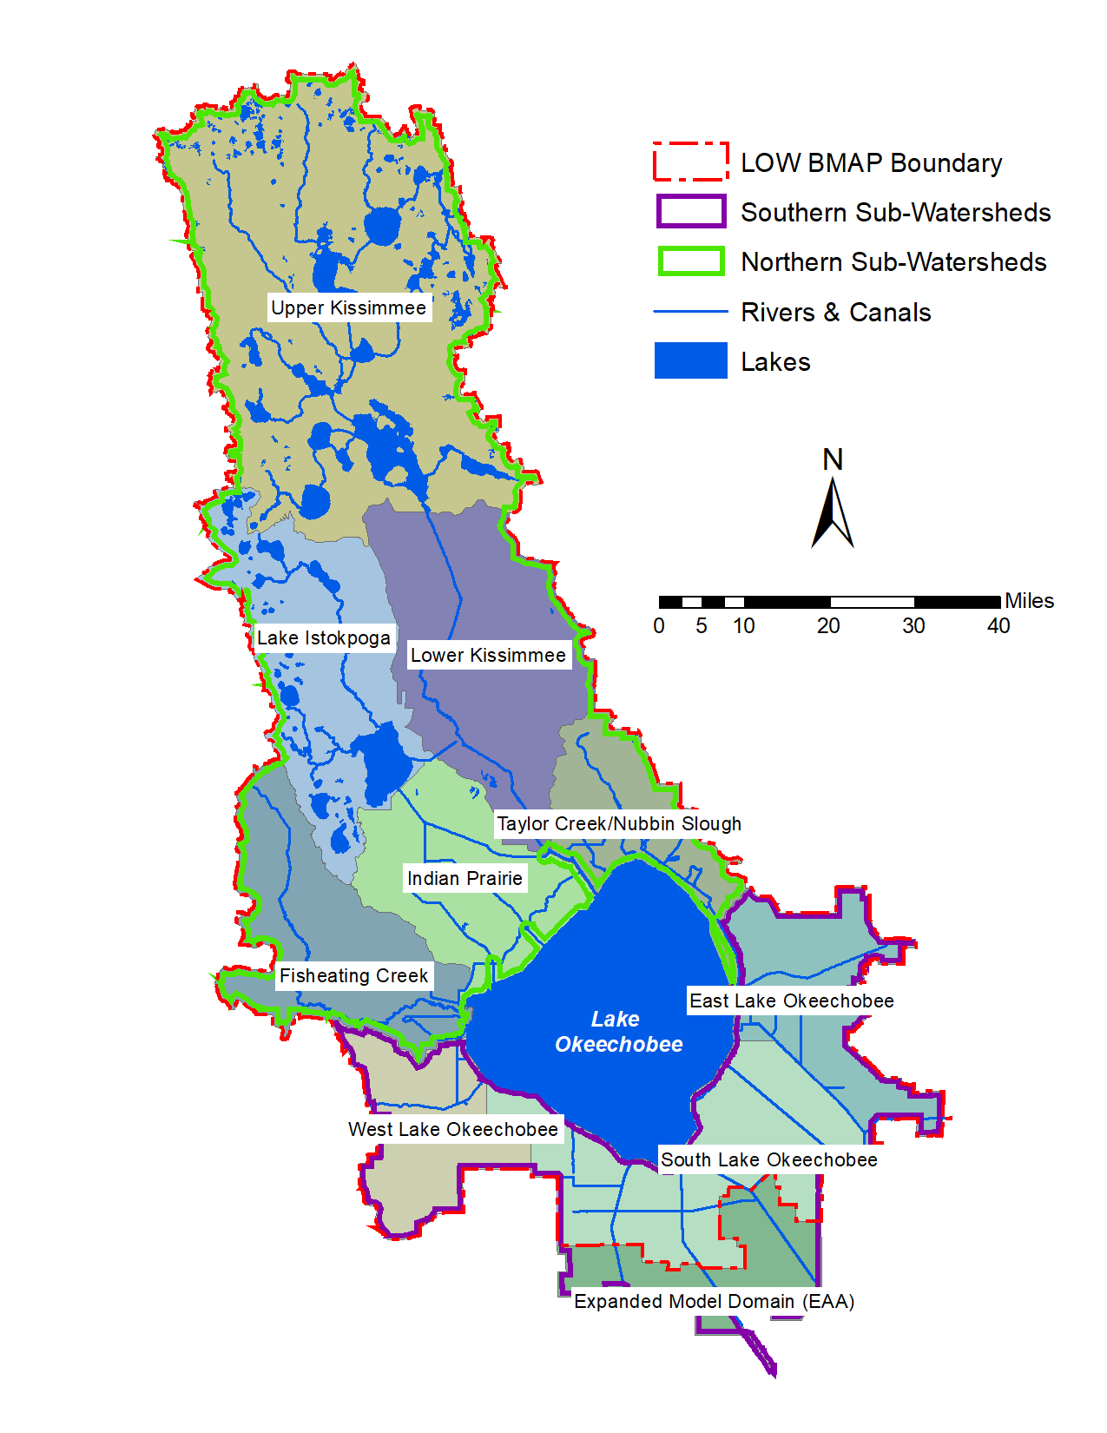
Figure 1. The Lake Okeechobee Watershed depicting current major hydrologic features and the nine sub-watersheds (six northern, three southern) simulated for this project.

A Brief Description of WAM
WAM simulates water and nutrient loading from a wide variety of land covers and land use practices while incorporating geographic and geologic features. WAM has been successfully used to simulate many different scenarios representing a wide range of conditions across Florida. WAM uses a geographic information system (GIS) grid-based representation to simulate the physical characteristics of the watershed. One of the first steps in the simulation process is the determination of the specific combination of land use/land cover, soil, wastewater service area, and rainfall for each cell in the watershed. These four datasets are overlain to identify the unique combinations of these inputs. These unique cell combinations characterize the specific conditions that occur on each cell within the watershed.
Estimates of runoff, percolation, and nutrient loads are generated at the source cell level as a daily time series. Depending on the unique cell combination, one of three sub-models is used to simulate hydrologic and chemical processes within the cell. The sub-model Groundwater Loading Effects of Agricultural Management Systems (GLEAMS) (Knisel, 1993) is used on well drained soils with deep water tables. On poorly drained soils with high water tables, the Everglades Agricultural Model (EAAMod) (Bottcher et al., 1998; SWET, 2008) is used. For wetlands and open water, the Special Case sub-model (SWET, 2008) is used, which determines water and nutrient loads using a water balance based on the rainfall, potential ET, plant ET coefficient, percolation rate, and water storage depth. Typically, the source cells are specified to be one hectare (ha) in size. These estimates are then routed via overland and subsurface flow to the stream network and are in turn routed through the network to the basin or sub-watershed outlet. Water flow and nutrient concentrations are typically output on a daily basis, although the internal time step used by the routing algorithm does not exceed 10 minutes (an adaptive time stepping algorithm is used). Nutrients simulated by WAM include soluble and particulate ammonia (NH3) and organic nitrogen, nitrate (NO3), as well as soluble and particulate phosphorus. See Section 5 (Appendix A) for a more detailed discussion of WAM.

Required Datasets
To develop a WAM simulation for a specific area the following spatial datasets are required:
- Basin and sub-basin boundaries
- Topography
- Hydrologic network
- Land use/cover
- Soils
- Rain gage locations
- Hydraulic structures
- Utility (wastewater) service area
- Location of water and nutrient point sources (or sinks)
- Irrigation source specification
These datasets were used for the calibrated WAM application to the LOW (SWET 2017a, 2017b). In addition to these spatial datasets, a time series of recorded rainfall values at each rain station, daily temperatures, and other climate data are required to run WAM.

Pre-Drainage Characterization
The task to evaluate water and nutrient loading under pre-drainage conditions is the subject of this report. This includes discussion of the preparation of inputs for WAM using pre-drainage datasets for the nine sub-watersheds, and the subsequent application of WAM to estimate water flow and nutrient loads under pre-drainage conditions. As discussed above, the simulation of pre-drainage conditions was defined as a need in the adopted Lake Okeechobee BMAP. The primary use of the pre-drainage simulation results will be to serve as one end point representing an idealized set of water and nutrient loadings (although unlikely to be achieved in practice) with the other end point being established current conditions. With these two end points it is possible to evaluate where specific abatement strategies implemented as part of future tasks fall on the spectrum between these points and determine how closely a particular scenario can approach these ideal loading conditions.

Previous Work
A number of studies on pre-drainage/pre-development conditions have been conducted in the LOW that are directly related to the work for this study. Zahina et al. (2007) created a geospatial database of pre-drainage vegetation within the SFWMD boundary to provide a comprehensive data source for pre-drainage ecological conditions of the region. McVoy et al. (2011) developed characterizations of the pre-drainage vegetation, soils, regional topography, and hydrology of the Everglades. This work focused on the area south of the lake, with some limited data for the East and West sub-watersheds.
A study to assess pre-drainage conditions in the Fisheating Creek (FEC) sub-watershed (HDR 2011) produced an estimated land cover dataset based on soils data that was used in a WAM simulation for pre-drainage conditions in the sub-watershed. A later project titled “Lake Okeechobee Watershed Pre-Drainage Characterization Study” (HDR 2015) developed pre-drainage vegetative cover and hydrography datasets for a majority of the area in the five northern sub-watersheds (excluding FEC) for use with a WAM simulation. No simulations using WAM were conducted for that study, but the feature class datasets were directly usable in the WAM setup for this study.
The areas that had pre-drainage datasets completed for the 2011 (FEC) and 2015 (the rest of the northern LOW) reports lie within the purple and green boundaries, respectively, shown in Figure 2. Pre-drainage land cover and hydrology datasets for use in WAM had not been developed for most of the three remaining sub-watersheds, indicated by the red boundary. Note that a portion of the East Lake Okeechobee sub-watershed had pre-drainage data, while some small areas around the periphery of the northern sub-watersheds do not, due to minor changes in the delineation of the boundary. Any area without existing land cover and/or hydrography datasets usable in WAM had the appropriate datasets developed as part of this task.
A summary of the spatial datasets required by WAM, broken down by task, is shown in Table 1. Each spatial dataset is listed with associated columns indicating if it was altered from the existing datasets for the task, and the source of the dataset. For example, the watershed/sub-watershed boundaries were not altered, and conform to the 2017 WAM simulation setup.

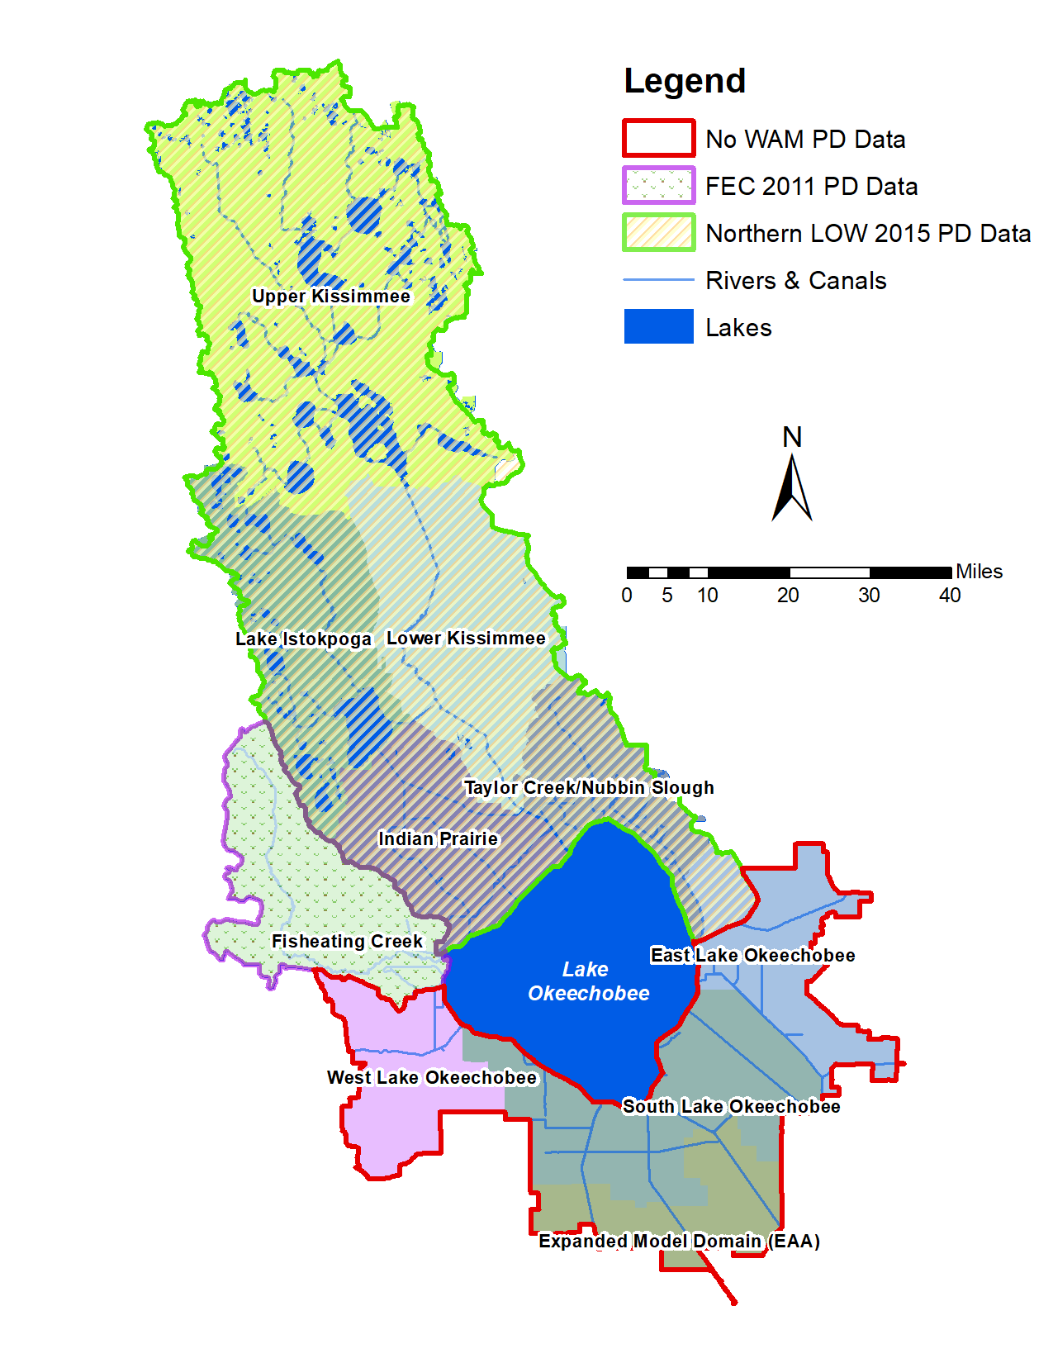
Figure 2. The areas with completed pre-drainage (i.e., PD) land cover and hydrology datasets (FEC, northern LOW) are enclosed by the purple and green boundaries, respectively. The red boundary encloses the area where pre-drainage land cover and hydrology datasets were created. For clarity, some small areas lacking pre-drainage data around the northern sub-watersheds are not highlighted.
The map projection used for all datasets was North American Datum (NAD) 1983 High Accuracy Reference Network (HARN) Florida State Plane East (Federal Information Processing Standard [FIPS] 0901), with feet as the linear unit. Of the datasets listed, it was critical to obtain the topographic dataset from the SFWMD (used for NSRSM simulations) since SWET had only limited spatial information about subsidence south of Lake Okeechobee.

Table 1. List of spatial datasets required by WAM, and source of information for updates. Rows highlighted in blue are datasets requiring significant modification, those in gray are used unchanged, and those in yellow have all anthropomorphic features removed.
Pre-Drainage Scenario (Task 2 Due 9/10/2018)
Dataset | Altered | Source
Land use/cover | Yes | Have for northern sub-watersheds, developed from SFWMD
Hydrologic network | Yes | Taken from prior work for the northern sub-watersheds, developed for the East, South, and West Lake Okeechobee sub-watersheds
Soils | Yes | Required modifications where native soil type not present in Natural Resources Conservation Service (NRCS) soils data
Topography | Yes | Obtained from SFWMD (NSRSM)
Watershed and sub-watershed boundaries | No | Used model domain and sub-watershed boundaries from 2017 WAM simulations
Rain gage locations | No | Reused from 2017 WAM simulations
Hydraulic structures | Yes | Removed structures
Utility zones | Yes | Current zones were removed; no utility zones present in the datasets
Point sources/sinks | Yes | Current sources/sinks were removed; no sources/sinks present in the resulting datasets
Irrigation sources | Yes | Current sources will be removed; no sources present in the datasets

Of the spatial datasets listed in Table 1, the land use/cover, hydrography network, soils, and topography (datasets shown in light blue) required significant modification to develop the inputs for most or all of the model domains. All non-native land uses were converted to the best available estimates of native land cover. The current hydrography of the region has been significantly altered through canals being dug for flood control and agricultural irrigation, so manmade hydrologic features were removed from the dataset and sloughs and streams added to reflect estimated natural conditions. The soils dataset required less modification although some soils have been so extensively altered that the original soil type was no longer obvious. These were removed from the dataset and replaced by the nearest adjacent soil type(s). The original natural topography has also been altered in many places, particularly in the southern part of the watershed where extensive subsidence has occurred due to drainage and subsequent oxidation and consequently the current topography is several feet below the pre-drainage land surface. Details of how the land cover, hydrography, soils, and topography datasets were modified are discussed in Section 2 below.
The datasets for hydraulic structures, point source locations, utility service areas, and irrigation specifications (shown in light yellow in Table 1) represent manmade features, and were only altered by removing features to represent natural conditions. The utility service area and irrigation sources datasets need to be present for WAM to run but were modified so that no service areas or irrigation sources are present.
Because there are no available daily rainfall or other climatology records from the pre-drainage time frame, the model was run using the same recent rainfall and climatology data that were used in prior WAM modeling efforts. The period of record (POR) is from 1991-2013, with the first three years used as a spin-up period for the WAM land source models run via BUCShell. The full model was run over the 20-year period from January 1, 1994 through the end of 2013. Annual average results are calculated over WY 1995 – WY 2013 (19 years). This model period was chosen to be long enough to cover both wet and dry periods as well as covering the 11-year calibration/verification period used in the 2017 modeling efforts (2003-2013) (SWET 2017a, 2017b) while avoiding excessive simulation run times.

WAM Model Setup

Modification of Spatial Datasets

Modification of Soils Dataset
The soils dataset is discussed first since it was subsequently used as the foundation of the pre-drainage land use/cover feature class. The soils dataset was originally created for the 2017 modeling effort by downloading feature classes from NRCS on a county-by-county basis and merging them into a single dataset. To ensure that the most recent dataset was used for the current project, the soils data were re-downloaded from the NRCS website. This was done by Hydrologic Unit Code (HUC) using the online NRCS Map Viewer application. Each HUC feature class was dissolved on a set of fields including Mapunit Key (MUKEY) and Mapunit Name (MUNAME) and then clipped to the LOW boundary. The features were merged and dissolved again to remove multiple overlapping polygons. A lookup table was created by exporting the table of features to Excel and the MUKEY and MUNAME fields were copied to a new worksheet. Rows with duplicate MUKEYs were deleted (note that MUKEY entries are unique across the U.S.) To facilitate the development of the pre-drainage land use/cover dataset (see steps 1 and 2 in the itemized list in Section 2.1.2, below) a field (“NRCS_FLUCCS”) was added in the soils feature class to hold the Florida Land Use Land Cover Classification System (FLUCCS) code for the associated soil type taken from the 2015 work. Entries in the newly created feature class that did not have FLUCCS entries were assigned a FLUCCS value of -99. These missing entries were then manually filled in by finding a related soil type, e.g., matching “Adamsville fine sand, 0 to 2 percent slopes” to “Adamsville sand, 0 to 2 percent slopes” and using the FLUCCS code for that soil, or by finding an entry for native vegetation in the NRCS soil series description.
After FLUCCS codes were assigned to all native soil types, the feature class was edited to change non-native soil types (e.g., “Arents,” “Pits,” “Urban Land,” etc.) to the nearest native type. Some types that have combined native/non-native MUNAMEs (e.g., “Myakka-Urban land complex”) were changed to the dominant native type (e.g., “Myakka”). Obvious anthropomorphic features such as canals or retention ponds were edited by clipping out the feature and merging it with the native type. Many of these consisted of canals constructed between the lakes in the Upper Kissimmee sub-watershed or the numerous canals in the Indian Prairie, East, and South sub-watersheds. There were also several reservoirs and retention ponds mapped as water in the soils dataset that were edited to reflect the surrounding soil types.
Figure 3 shows one example of how the soils feature class was edited in the South sub-watershed. The current conditions are shown in the left pane and the estimated pre-drainage in the right. The polygons were edited in ArcMap by cutting and merging the water and Udorthents soils types representing the L-21, L-24, L-25, and L-26 canals to reflect the surrounding Pahokee and Terra Ceia soils. This type of editing was required in many places throughout the LOW, although the overall percentage of map area that had to be altered was less than 1% or 2%.

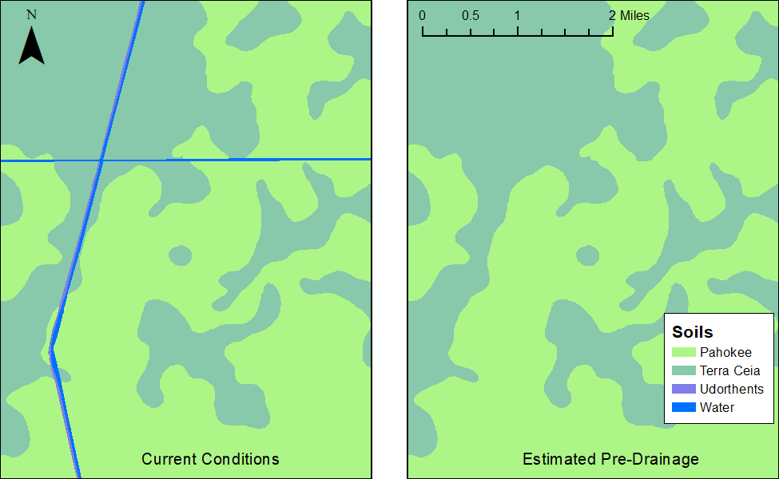
Figure 3. Comparison of soils feature class for current conditions (left) and pre-drainage (right) for a portion of the South sub-watershed.
The Florida Power & Light reservoir in the East sub-watershed was edited by examining the NRCS soil survey for Martin County (NRCS, 1981) which had aerial imagery of the county prior to construction of the reservoir. However, the soils map included in the report had the boundary of the reservoir delimited with no soils information provided within the reservoir. The imagery was loaded into ArcMap and the soils feature class was modified based on comparison of the imagery and the soil types surrounding the reservoir.
The final modified soils feature class used in the pre-drainage simulations is shown in Figures 4 and 5. The soils dataset was then clipped to each model domain and used as the WAM soils feature class as well as forming the basis for determining the pre-drainage land cover, discussed next.
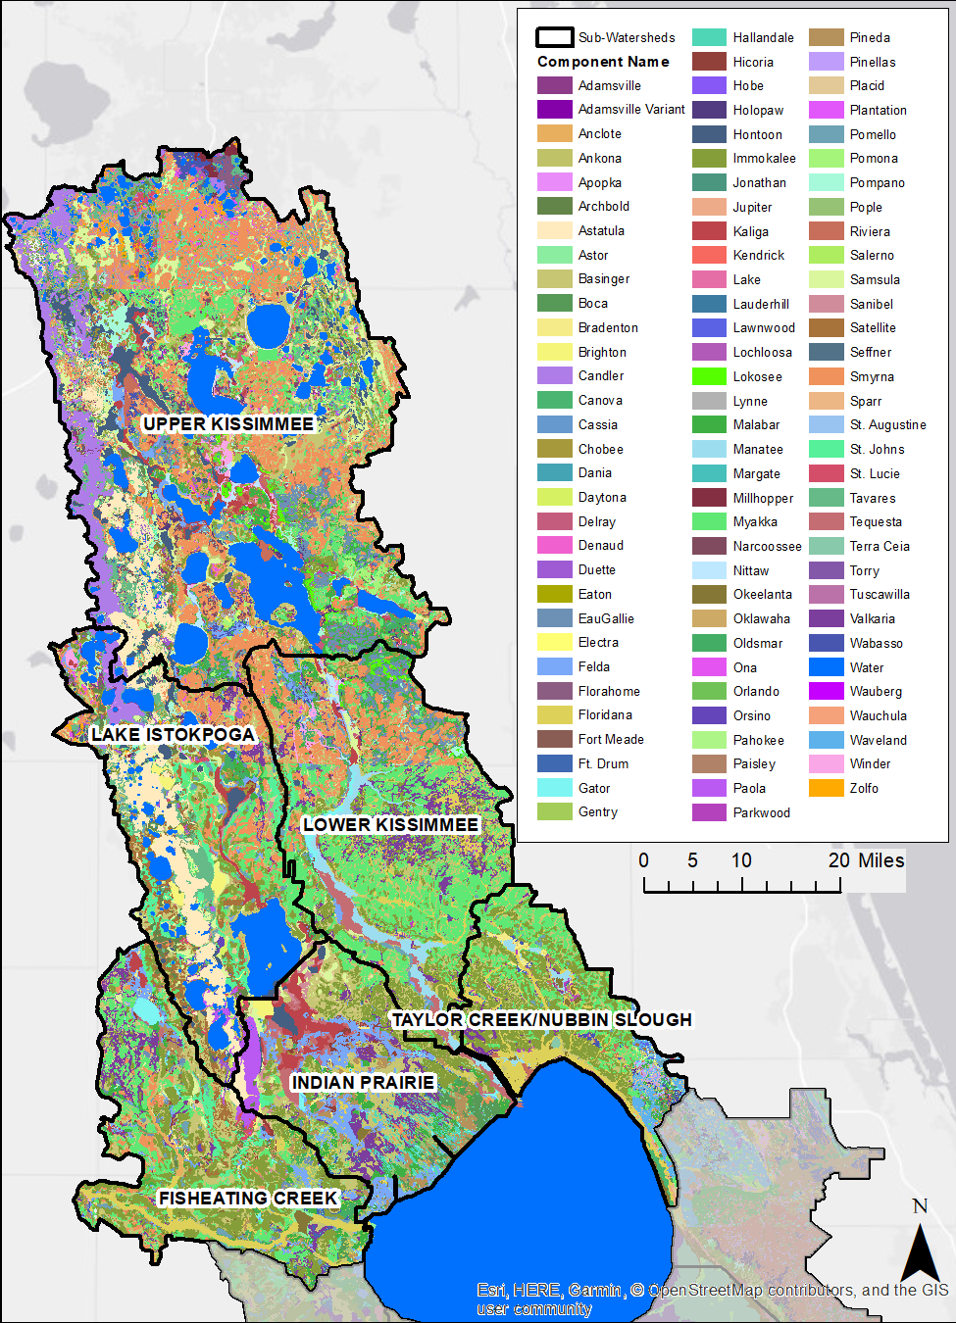
Figure 4. Soils used for the pre-drainage simulations in the six northern sub-watersheds.
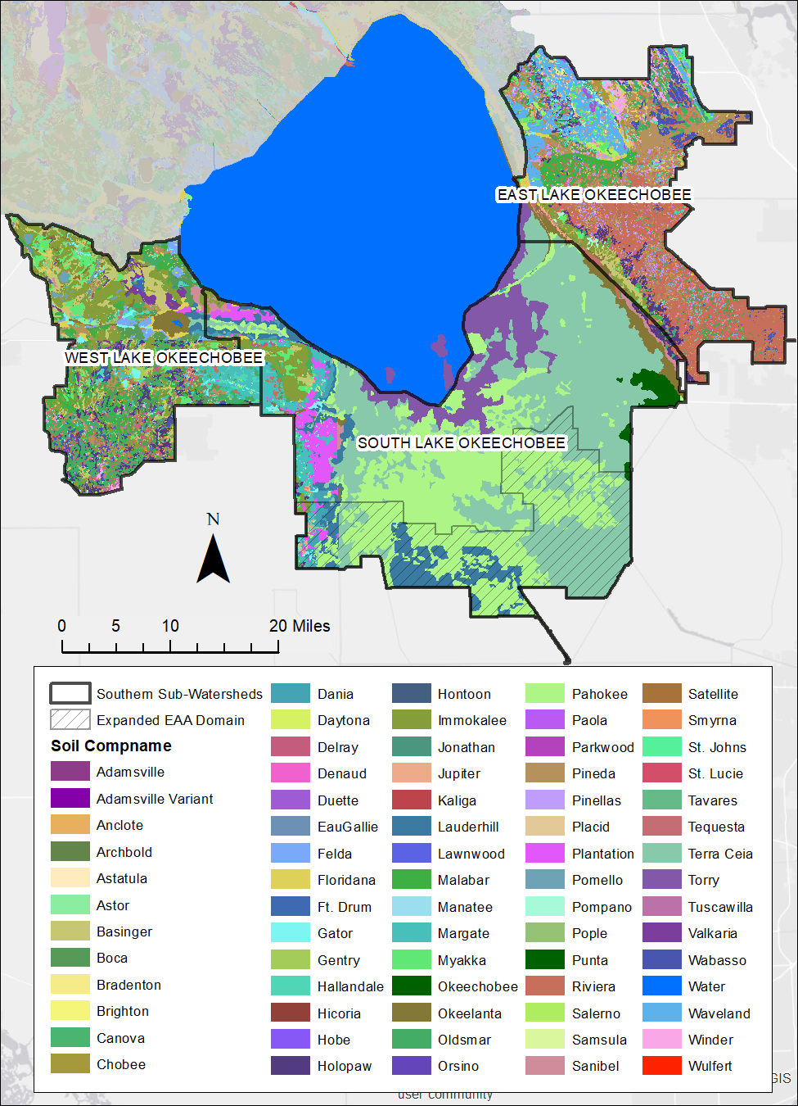
Figure 5. Soils used for the pre-drainage simulations in the three southern sub-watersheds.

Creation of Pre-drainage Land Cover
WAM requires a land use dataset to spatially assign land use and land cover properties in combination with soil properties and rainfall zones. The land cover of over 1,458,000 acres of the study area has been extensively altered due to anthropogenic activities. Excluding lakes, this accounts for approximately two-thirds of the watershed. To develop an appropriate land use/cover dataset to simulate pre-drainage conditions, it was necessary to estimate the native land cover based on available information. The 2011 study to assess pre-drainage conditions in the FEC sub-watershed (HDR 2011) produced an estimated land cover dataset based on soils data and used descriptions of soils series (maintained by the NRCS) that also include native vegetation. Those descriptions were converted to codes using FLUCCS codes. Starting in 2012 this approach was extended by SWET to assess pre-drainage conditions throughout the remaining five northern sub-watersheds of the LOW. The methodology describing this approach was compiled into the HDR (2015) study. The 2015 study also contains an extensive literature review pertaining to the development of the pre-drainage land cover for the northern basin (a summary of that literature review is provided in Section 6 (Appendix B).
Zahina et al. (2007) produced a pre-drainage landscape database (PDLD) for the LOW sub-watersheds. They started with the creation of a geospatial database of pre-development vegetation within the boundaries of the SFWMD, which includes the LOW. A vegetation classification scheme was developed to define major natural community types that would also meet anticipated data requirements of hydrological models and restoration projects. The project area was divided into sub-regions having unique or similar vegetation patterns and a map of historic vegetation was created for each sub-region based on available pre-development vegetation map sources. Vegetation communities and descriptions in the map were converted to the vegetation community classes. Not all the SFWMD jurisdictional area was mapped using this approach, but where PDLD data were available, they were factored into the 2015 assessment. For the current task, data from the PDLD were used to guide the setup of the pre-drainage soil and land cover layer in WAM. The spatial coverage of the PDLD includes the three sub-watersheds not covered by the 2015 work (Figure 6). Lastly, McVoy et al. (2011) produced a detailed study that examines many aspects of the pre-drainage state of the Everglades, from Lake Okeechobee south to Florida Bay. Much of the data used to examine pre-drainage vegetation relied on the work of Zahina et al. (2007), but it contained significant information pertaining to vegetation in the southern sub-watershed and data from that report are incorporated here.
The pre-drainage land use/cover dataset created for the current project is based on the modified soils dataset discussed above in Section 2.1.1 (steps 1 and 2 below) but also drew on the data sources outlined above for additional details. The detailed methodology used to produce the native land cover for the nine sub-watersheds is presented below.
- Research and assign native FLUCCS codes to NRCS soil series as part of developing the soils dataset. Develop a NRCS-FLUCCS lookup table from this.
- Create base native land use/cover coverage by joining the NRCS-FLUCCS lookup table (Table 23) to NRCS coverage using MUNAME field.
- Assign FLUCCS codes to any vegetation codes used in the PDLD coverage (Zahina et al. 2007) that were not previously assigned as part of the 2015 work (Table 24).
- Perform a spatial union of the modified soils dataset with the PDLD feature class to obtain a feature class with both NRCS-based FLUCCS codes and PDLD-based codes.
- Replace all NRCS-based FLUCCS codes for water (5100) with PDLD-based codes if the PDLD code was not also water, and if it was available. This served to change any remaining anthropogenic water features to native land covers.
- Replace all non-native soils that remained in the modified soils feature class with PDLD-based FLUCCS codes where available. This included "Arents," "Pits," "Quartzipsamments," "Udifluvents," and "Udorthents."
- Replace NRCS-based FLUCCS codes that correspond to anthropogenic features underlain with native soils with PDLD-based codes. This corresponded to much of the Lower Kissimmee River floodplain.
- Examine and remove any remaining anthropogenically created water or other features such as levees.
The overall approach was to first determine if a FLUCCS code could be assigned to the features in the modified soil feature class based on NRCS information, otherwise the PDLD-based FLUCCS codes was used based on the spatial location of the feature within the PDLD dataset. This approach gave a greater amount of detail in the estimated land cover assigned, in contrast with simply using the PDLD feature class where available. Use of the PDLD data exclusively in the areas it covered led to a very pronounced change in estimated land cover types across the transition where the PDLD data did not exist, such as the upper part of the LOW.
The pre-drainage feature class was then carefully examined, and a number of features were manually edited with several anthropogenic features identified and revised. For example, around the southern perimeter of Lake Okeechobee, any polygon that has PDLD-based FLUCCS of 5100 (water) had the FLUCCS code set to 5100, irrespective of the NRCS-based value. The area of Lake Hicpochee to the southwest of Lake Okeechobee shown by Zahina et al. (2007) was also changed to 5100 based on PDLD data. Several small features where no code could be determined were merged with an adjacent polygon. Around the southern end of Lake Okeechobee, "Urban Land" (NRCS-based FLUCCS 4110) had the FLUCCS code changed to 6173 ("Misc. Wetland Hardwoods," note that 6173a is "Pond Apple"). Other land covers that had NRCS-based codes of 6110 (“Bay Swamps”) with soil types of either "Udorthents, 2 to 35 percent slopes" or "Arents-Urban land complex, organic substratum" were changed to use the FLUCCS code 6172 (“Mixed wetland hardwoods”). Some small linear features extending into the sawgrass plain south of Lake Okeechobee that had NRCS-based codes of either 6110 or 6173 were changed to 6411 (“Freshwater marshes - sawgrass”). Some small features on the southeast side of Lake Okeechobee were reclassified to FLUCCS codes of 6173 if they were water or otherwise incorrect. Lastly, some small features in the sawgrass plain (6411) that were on "Urban" land were changed to 6411.
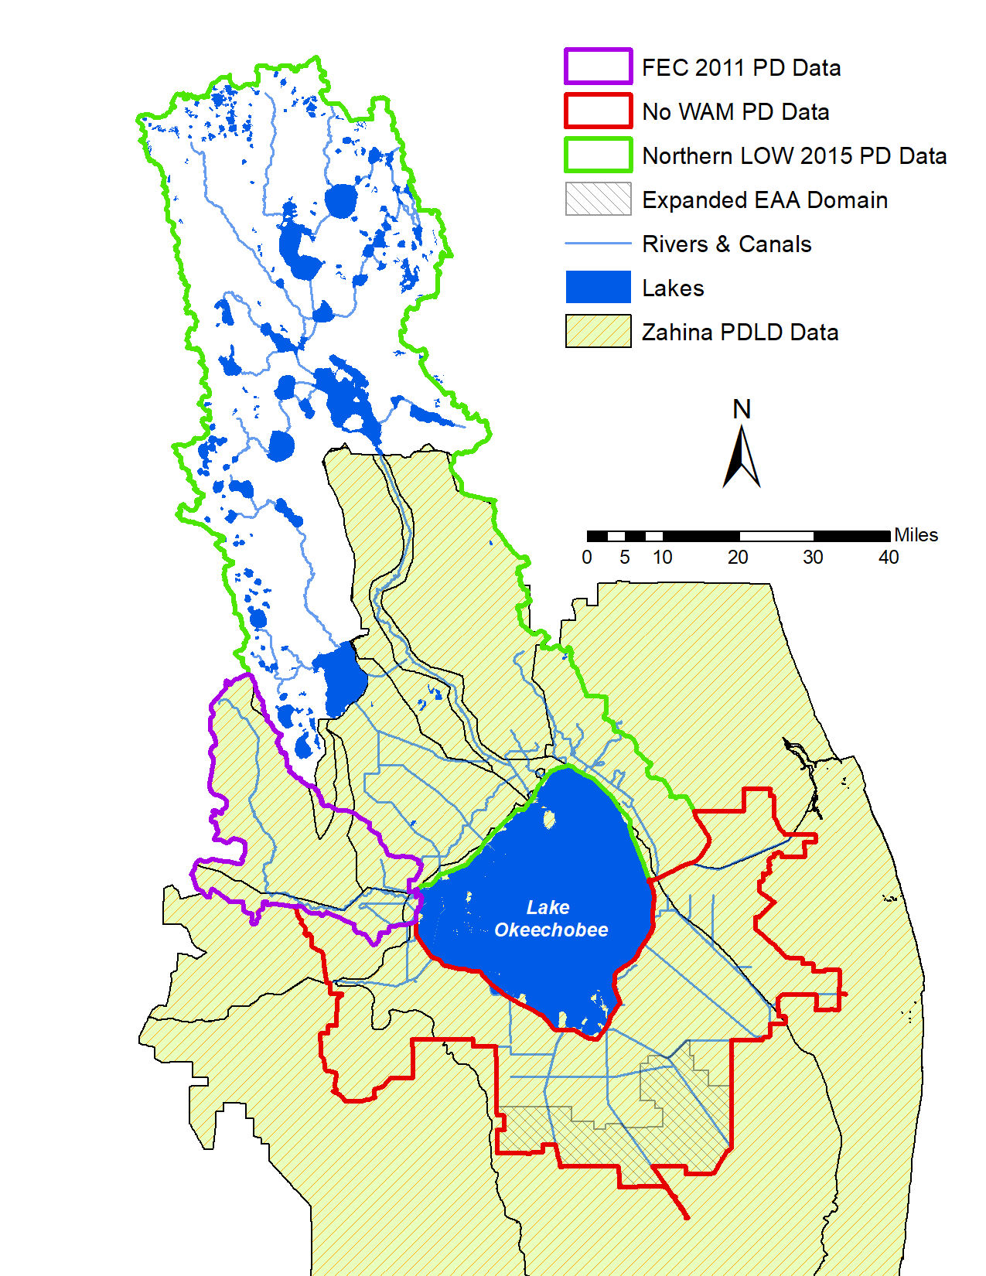
Figure 6. The hatching pattern indicates the area covered by PDLD data created by Zahina et al. (2007). The red line denotes the boundary of the sub-watersheds that require the creation of a land cover dataset.
Soil descriptions and the lookup table created to assign FLUCCS codes to soil mapunit can be found from Appendix B, Section 6, which were originally developed for the 2011 and 2015 pre-drainage studies and have been modified using the steps outlined above. These include native land cover descriptions of the NRCS soil series and the PDLD vegetation codes, respectively, for all the sub-watersheds. The soil series in Appendix B is represented by the column name COMPNAME (Component Name), which may contain several actual soil types. Both tables include the FLUCCS codes that were assigned based on the vegetation descriptions and a “best match” obtained from the “Florida Land Use, Cover and Forms Classification System” handbook (Florida Department of Transportation 1999).
The lookup table between the NRCS MUNAME and the best estimated FLUCCS code for that soil unit is also included in Appendix B. This table was joined in ArcMap to the modified soils feature class and the FLUCCS code was copied to a new field. The resulting feature class was saved as a new feature class that became the basis for the pre-drainage land use/cover feature class (Step 2, above). This lookup table includes a spatial compilation of the NRCS and PDLD FLUCCS code assignments in the northern sub-watersheds where both datasets overlapped. The PDLD information was spatially distributed using the NRCS soils polygons. However, there is not a one-to-one relationship of vegetation codes to soil types. For comparison purposes, the majority vegetation code was determined for each soil type (MUNAME).
Application of the methodology for determining pre-drainage land cover resulted in the acreages shown in Table 2. The first four land uses shown in the table are run either under GLEAMS or EAAMod, depending on the soil type. GLEAMS is used to simulate water and nutrient loading on well-drained soils such as Astatula and Paola series, while EAAMod is used for source cells underlain with soils that are relatively poorly drained such as Immokalee and Myakka series. The remaining six are run under the Special Case land source model. The estimated land cover acreages for the six northern sub-watersheds can be compared with Table 2 in the 2017 recalibration report (SWET 2017a). Note that the FEC sub-watershed is 547 acres larger than in the 2017 report, due to a change of the sub-watershed boundary. The updated total reflects this.
Table 2. Pre-drainage land cover acreages for the nine sub-watersheds.
WAM Land Cover | UK | LK | LI | IP | FEC | TC/NS | East SW | West SW | South SW
Pine Palmetto  Flatwoods | 421,914  (41%) | 244,546  (57%) | 142,640  (36%) | 72,538  (26%) | 156,296  (49%) | 106,446  (54%) | 41,585  (17%) | 95,655  (47%) | 14,929  (3%)
Hardwoods | 63,852  (6%) | 231  (0%) | 10,309  (3%) | 7,107  (3%) | 7,635  (2%) | 2,320  (1%) |  | 1,235  (1%)
Hardwoods/Conifer mixed | 98,901  (10%) | 4,165  (1%) | 67,374  (17%) | 2,510  (1%) | 1,301  (0%) | 16,733  (8%) | 43,464  (18%) | 13,925  (7%) | 1,256  (0%)
Barren Land (shorelines) | 25  (0%) |  | 1,028  (0%)
Open Water | 129,716  (13%) | 3,876  (1%) | 55,803  (14%) | 427  (0%) | 37  (0%) | 2,743  (1%) | 575  (0%) | 6,941  (3%) | 13,875  (3%)
Bay Swamps | 14  (0%) |  | 3  (0%) |  | 2  (0%) | 11  (0%) |  |  | 30  (0%)
Mixed Wetland Hardwoods | 94,893  (9%) | 90,935  (21%) | 59,052  (15%) | 113,147  (41%) | 85,187  (27%) | 27,548  (14%) | 32,786  (14%) | 28,247  (14%) | 1,371  (0%)
Cypress | 2,705  (0%) | 373  (0%) | 33  (0%) |  |  | 2  (0%) | 2,536  (1%) | 684  (0%) | 46  (0%)
Wetland Forested Mixed | 61,510  (6%) | 2,636  (1%) | 17,682  (4%) | 6,677  (2%) | 2,590  (1%) | 2,804  (1%) | 79,192  (33%) | 3,422  (2%) | 40,639  (8%)
Freshwater Marshes | 154,896  (15%) | 82,412  (19%) | 40,234  (10%) | 74,004  (27%) | 64,996  (20%) | 39,113  (20%) | 38,876  (16%) | 53,986  (26%) | 468,308  (87%)
Total | 1,028,426 | 429,174 | 394,158 | 276,410 | 318,044 | 197,720 | 239,014 | 204,095 | 540,454

An example of the application of the methodology for determining pre-drainage land cover to a part of the Upper Kissimmee sub-watershed is shown in Figure 7. This figure is a portion of the sub-watershed immediately south-east of Kissimmee with the left pane showing the current conditions land use and the right pane showing the pre-drainage land use/cover after following the steps listed above to create the estimated land cover. In the left pane, the Florida Turnpike is the gray line running diagonally from the upper left to the lower right. Lakes Tohopekaliga and Gentry are labeled. The urban (symbolized by various red and gray shades) and agricultural land uses (greens) were modified based on the underlaying soil types. Note that the PDLD did not extend to this part of the LOW. The features that typically required hand editing are the narrow canals between lakes (two of which are indicated with red arrows) and the removal of myriad small water features associated with urban and agricultural land uses, e.g., retention ponds. Many of these can be seen in the areas labeled “Medium Density Residential” (bright red) east of the turnpike. Removal of the canal features from the dataset required using ArcMap editor tools to cut the water (and associated spoil pile features) and assign the FLUCCS code based on the closest adjacent feature. Small water features were also assigned the FLUCCS code of the nearest adjacent feature as well. In any areas where roads were underlain by soils categorized as non-native were treated the same. At the completion of the editing a geoprocessing dissolve operation was run on the feature class to merge features that had the same FLUCCS attribute. This substantially reduced the number of features to make working with the feature class in ArcMap more efficient.
The land cover distributions for the six northern and three southern sub-watersheds are shown in Figures 8 and 9, respectively. Note that the area designated as “custard apple” on the southern shore of Lake Okeechobee is included under the “wetland forested mixed” land use category for modeling purposes.
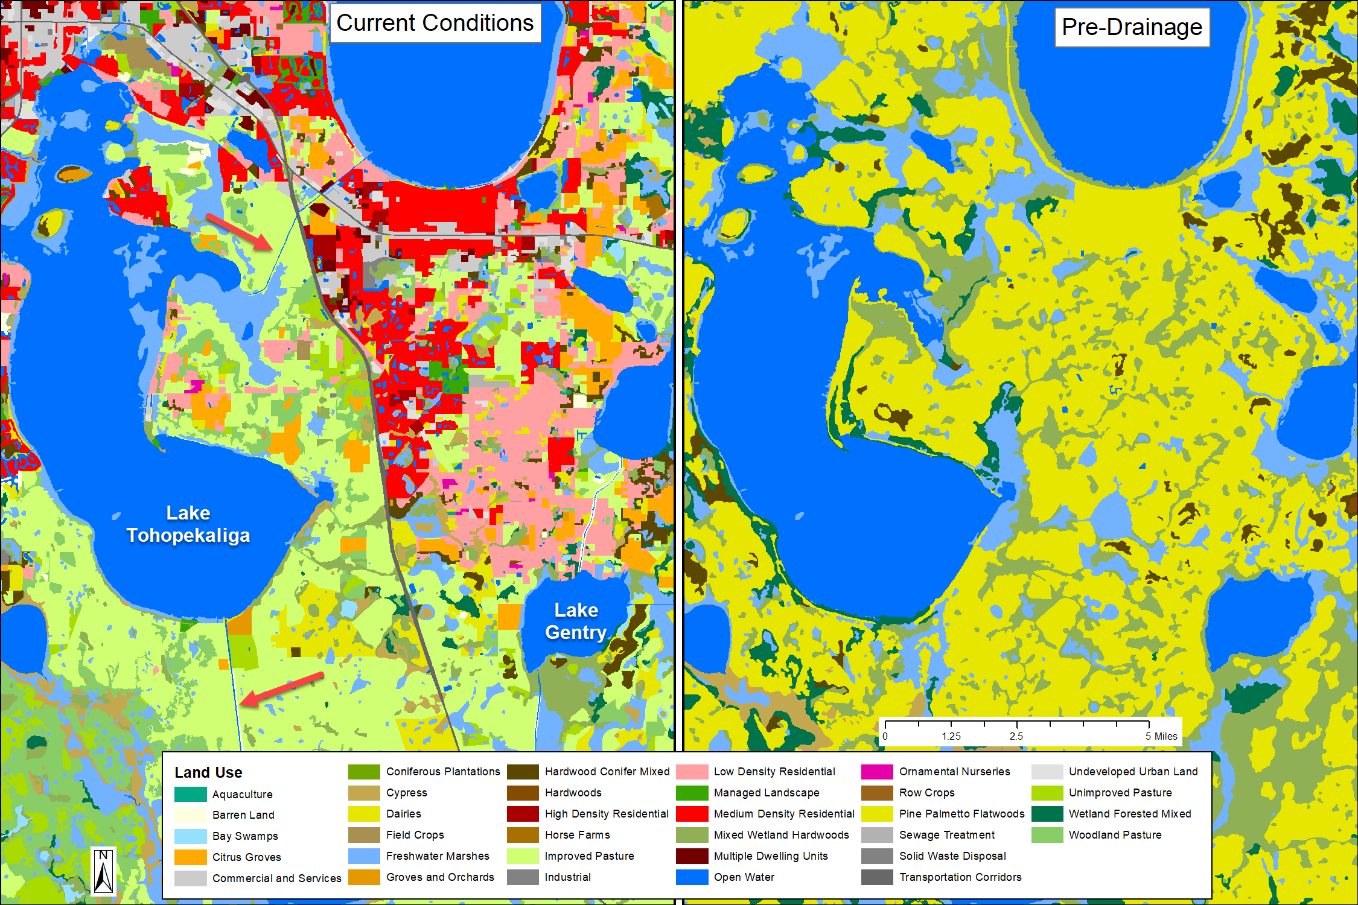
Figure 7. Comparison between Upper Kissimmee current conditions (left) and the modified pre-drainage land use (right).

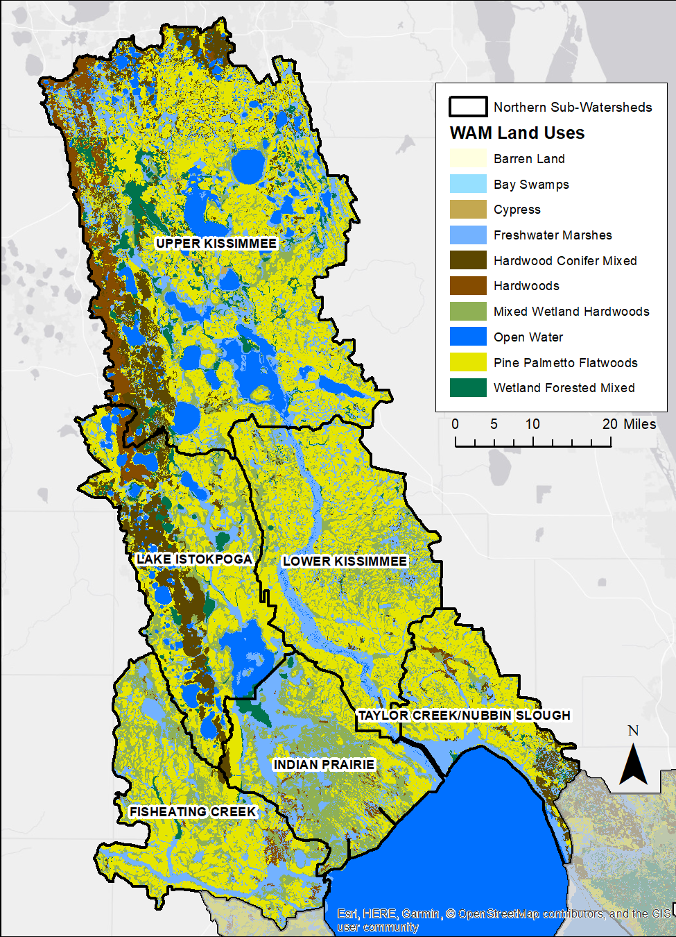
Figure 8. Estimated pre-drainage land cover in the six northern sub-watersheds.
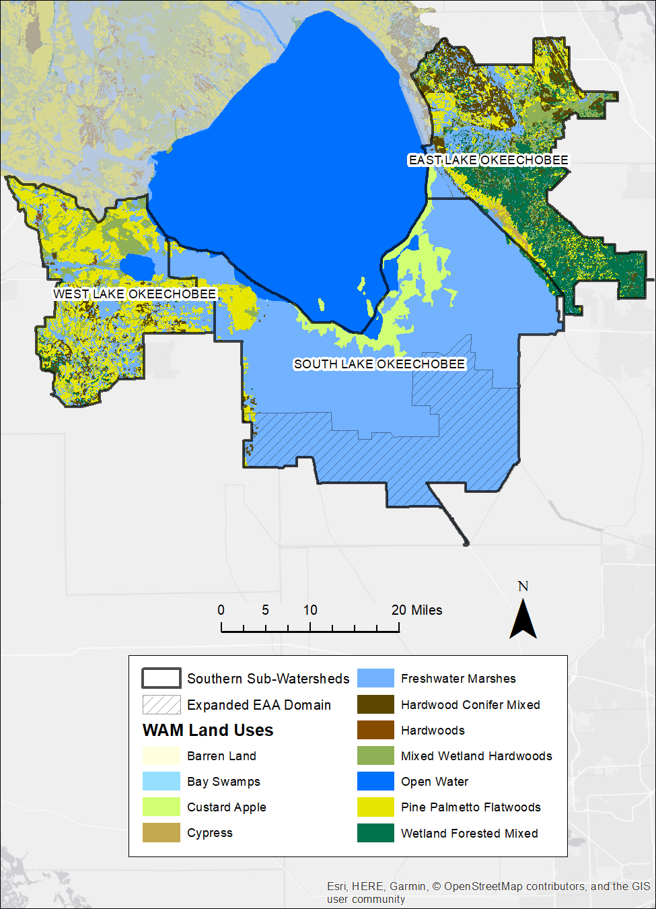
Figure 9. Estimated pre-drainage land cover in the three southern sub-watersheds.

Pre-drainage Hydrologic Reach Delineation
Development of a hydrologic reach network was begun during the 2015 study (HDR 2015) to represent historical, pre-anthropogenic flow conditions within the northern sub-watersheds in the LOW. The primary resources for delineating pre-drainage reaches for that work were high resolution aerial imagery from the 1940s, topography, soils dataset, and information from the literature review conducted for that study. The methodology used is described in detail in the 2015 report (HDR 2015). However, the reach network developed during the 2015 work required extensive editing to incorporate it in WAM.
The majority of reaches in the sub-watersheds were categorized as either sloughs or streams. For the most part, the designation “stream” was assigned to those reaches that could be identified as having a well-defined continuous channel in early imagery, while the “slough” designation was assigned to drainages most other places. While the distinction between these types within WAM is largely arbitrary, attenuation coefficients are assigned based on the reach type, and streams typically have lower attenuation rate coefficients (the parameter “a”) but not necessarily different background coefficients (“C_{b}”). Note that attenuation coefficients can vary between different scenarios, and a new reach subtype can be created with different sets of attenuation coefficients if needed. The reach types also vary in the initial value of the Manning’s roughness coefficient assigned to each reach, as well as the general shape of the cross-sectional profile. In all cases the initial cross-sectional profile assigned to a reach is a function of the upstream drainage area. Both the roughness coefficient and the profile can be altered on a reach-by-reach basis. For the pre-drainage hydrology, the profiles assigned to sloughs are flatter and wider than streams, unless manually altered afterwards. In some cases where a channel was not apparent in the imagery, individual slough segments were assigned very broad profiles up to several hundred meters wide.
Other reach types present in the pre-drainage scenarios are those used to represent lakes and shorelines. Lake reaches are used where a large water feature in the land cover clearly lies within the reach network. The lake reaches are parametrized to ensure that the length and width of the reach matches the area represented by the lake. Shoreline reaches are added around lake features and are used as an accounting mechanism to determine the water and nutrient loading to the lake from the surrounding land. Shoreline reaches do not attenuate nutrients and have the evaporation coefficients set to zero. Lake and shoreline reaches are only used in the Lake Istokpoga and Upper Kissimmee sub-watersheds.
In each sub-watershed, additional work editing the network was required to ensure that all reaches were connected to an outflow point, and that reaches did not overlap; instead, each reach segment had to attach to other segments at an end point. Bottom elevations had to be established and verified, and cross-sectional profiles had to be created. The top of bank elevations were calculated by determining the average elevation within a 100-meter buffer along each reach using the topographic dataset (see Section 2.1.4 below). Bottom elevations were determined subtracting the depth of the estimated profile from the top of bank elevations; these were verified by checking against the topographic dataset and neighboring reaches to ensure consistent values. Most of these steps could be done in ArcMap using the tools developed for setting up WAM scenarios, but additional manual editing was also required.
None of the earlier work by SWET included the development of pre-drainage hydrology in the East, South, or West sub-watersheds. In the East and West sub-watersheds, the steps outlined above were replicated to develop reasonable reach networks. In contrast, the pre-drainage South sub-watershed was a broad drainage area that had little to no discrete drainage features (e.g., streams). The works of McVoy et al. (2011) and Said and Brown (2013) were very useful in developing the reach network for the three southern sub-watersheds.
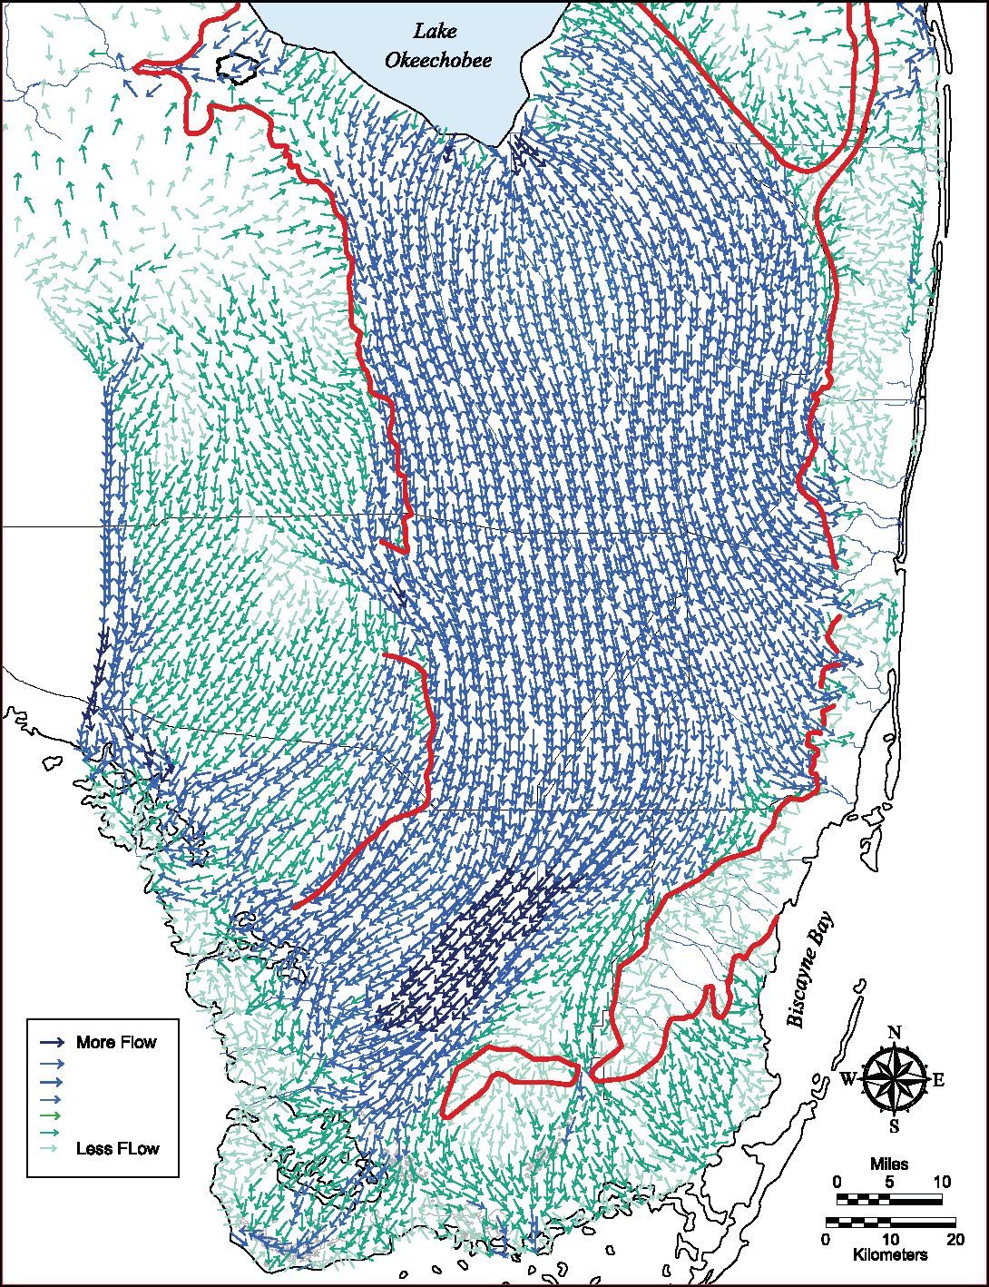
Figure 10. Hydrology of the Everglades: Pre-drainage surface water flows, ca. 1850s. Arrow size and color reflects flow magnitude. Selected post-drainage levees and roads shown for orientation. Red lines mark the pre-drainage boundary of the Everglades. Source: NSRSM v3.3 (Said and Brown 2010). From McVoy et al. 2011 (Plate 3a).
Plate 3a in McVoy et al. (2011) (Figure 10; see also Figure 95 in Said and Brown 2013) presents simulated long-term average of monthly flow vectors for dry and wet seasons. These show the widespread parallel shallow flow across the sawgrass plains immediately south of Lake Okeechobee, which corresponds to the current South sub-watershed. Additionally, the vector directions were used to guide the placement of sloughs in the three sub-watersheds. Said and Brown (2013) also include a number of figures that show the pre-drainage Caloosahatchee River and some of its tributaries which assisted in the placement of these reaches. Additionally, Said and Brown (2013) include (their Figure 19) the military map of Ives from 1856 which also shows some small tributaries of the Caloosahatchee River. McVoy et al. (2011) describe the drainage south from Lake Okeechobee and west to the Okeechobee Marsh in great detail. A composite map of the Okeechobee Marsh west of Lake Okeechobee also assisted in developing the reach network in the West sub-watershed.
The reaches in the West sub-watershed WAM setup were added as sloughs, with Lake Hicpochee simulated as a lake reach. The reaches forming the eastern end of the Caloosahatchee River drainage are modeled as very wide channels, with little variation in the elevations of the segments from Lake Okeechobee westward until about the middle of the model domain.
The reaches in the East sub-watershed were also added as very broad sloughs. Except for a few areas along the eastern boundary, these drain either back into Lake Okeechobee or into the eastern edge of the sawgrass plain, i.e., into the South sub-watershed.
The South sub-watershed is simulated as a set of very wide, shallow sloughs to mimic the wide swath of drainage across the sawgrass plains. Note that the southern boundary of the sub-watershed is considerably north of where the ridge-and-slough landscape characteristic of the Everglades begin.
The pre-drainage reach networks used in the WAM simulations are shown for the northern and southern sub-watersheds in Figures 11 and 12, respectively. In Section 3, the drainage network for each sub-watershed is shown with reach numbers indicated. The numbering system for reaches is generated during the construction of the stream network using the WAM toolbar with the reaches numbered consecutively from each outfall point up through the drainage network. Numbering can be altered by the user if desired.

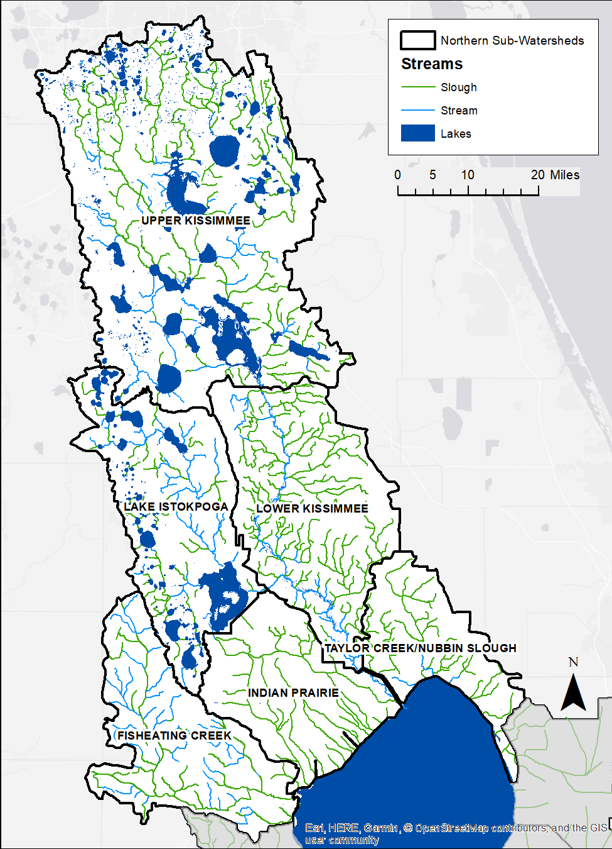
Figure 11. Pre-drainage reach network in the northern sub-watersheds.
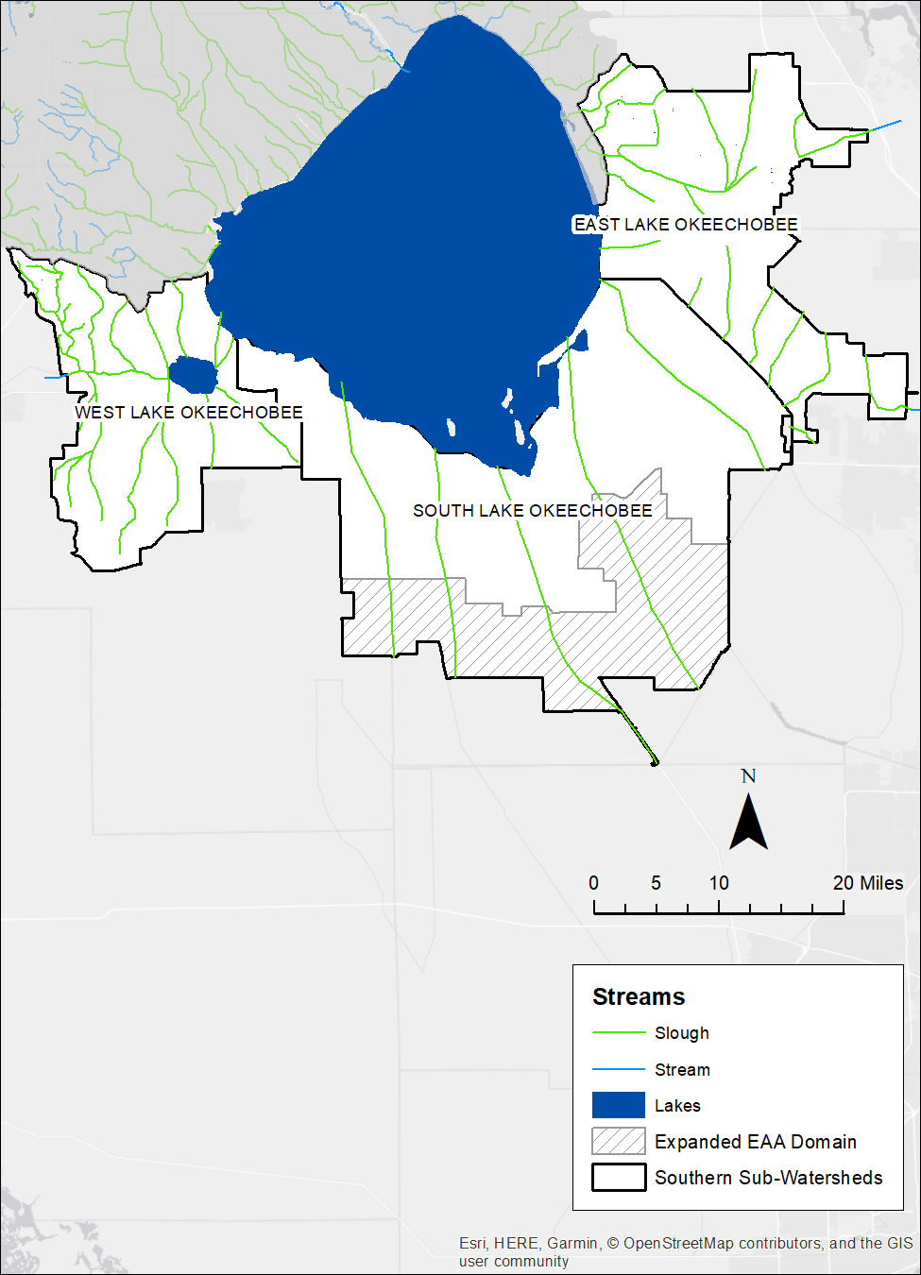
Figure 12. Pre-drainage reach network in the southern sub-watersheds.

Modification of Topography
The changes to the LOW from agriculture and urbanization have significantly changed the topography of the area. One major alteration to the topography has been subsidence within the EAA, which results in surface elevations several feet below pre-drainage conditions. Said and Brown (2013) present raster maps of topographic elevations used by the NSRSM (their Figure 13). The topographic dataset used in that study was obtained from the SFWMD and used in this current modeling effort. Because it did not cover the northern portions of the LOW, data from the existing topographic dataset were used to fill in elevation values for those areas not covered by the NSRSM raster (Figure 13). The existing topographic dataset used for the 2017 WAM simulations was provided by the SFWMD (2014). The primary use of the topographic data set in WAM is to determine overland flow directions, which are calculated on a one-hectare grid size, which is considerably coarser than the grid size of the provided datasets (which have 100 × 100-foot cells). During the WAM setup, the raster is resampled and then aggregated up to a one-hectare cell size. Consequently, the elevation used for each cell in the WAM simulations is an average of over 10 cells, which serves to smooth out any anthropogenic features that cannot otherwise be edited out.

Estimates of Nitrogen and Phosphorus Concentrations in Runoff from Pristine Land Cover
Studies pertaining to nitrogen (N) and phosphorus (P) concentrations in Florida under pristine conditions are somewhat limited. There are two general categories of data that were useful for the current study: 1) nutrient concentrations in runoff from various types of land cover and vegetation, and 2) concentrations in receiving waterbodies i.e., lakes and streams. When simulating pre-drainage conditions using WAM, data from the first category are used to set bounds of nutrient concentrations generated at the source cell level by the BUCShell sub-model, but before overland and in-stream attenuation occurs in the WAM sub-model BLASRoute. See Appendix A (Section 5.1) for a detailed description of this process. Data from the second category are used to guide the estimation of overland and in-stream attenuation parameters.

Nutrient Concentrations in Source Cell Runoff
Studies estimating nutrient concentrations in runoff at the source cell level typically give data for very general land cover and vegetation types, e.g., “wetlands,” “woods,” etc. For the 2011 and 2015 studies, N and P concentrations and associated nutrient loads were developed for more specific pristine land cover and vegetative types, such as upland forest and wetlands. To accomplish this, SWET staff met with wetland experts (Mark Brown, University of Florida and Bob Knight, Florida Springs Institute) to develop nutrient concentration estimates for all native vegetative conditions based on their professional judgement. These estimates represent mean concentrations because there was no way to fully represent the temporal variability that can exist seasonally and during different flow events. The final calibrated pre-development N and P concentrations and loads for FEC were reviewed by environmental stakeholders, including Paul Grey (Audubon Society) and Hilary Swain (Archbold Biological Station), who agreed the predicted values were reasonable, but possibly a little high, based on their knowledges of native systems in South Florida.
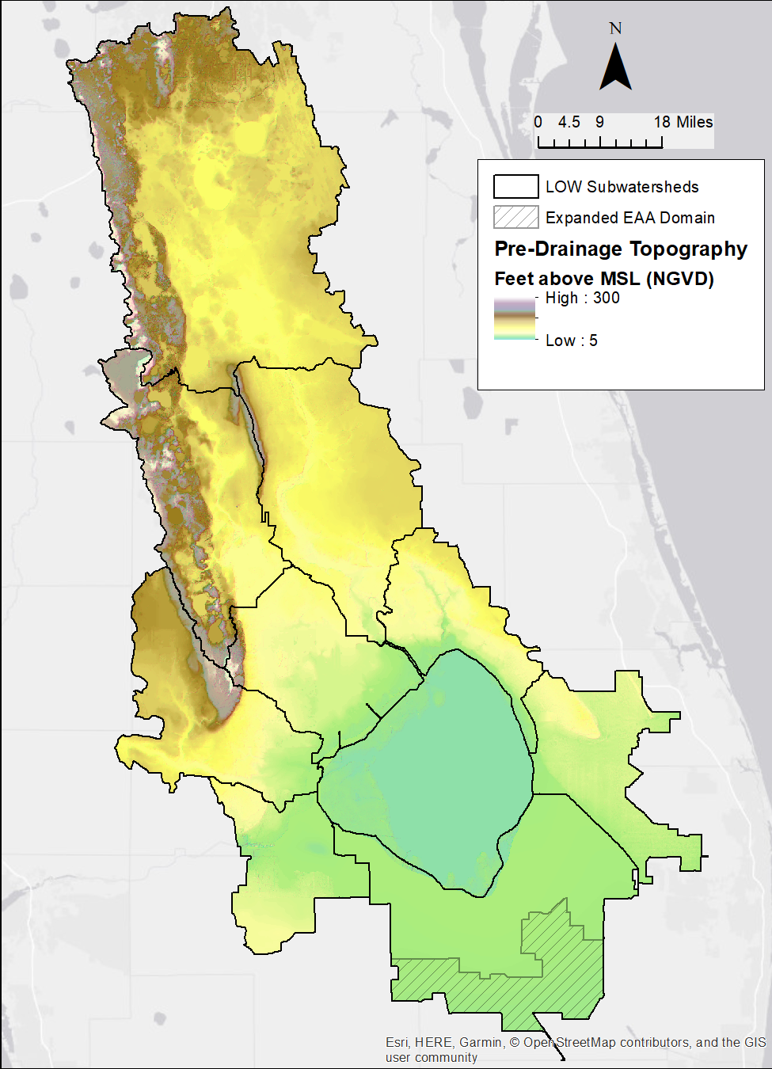
Figure 13. Pre-drainage Topography used in the WAM simulations.
Reiss et al. (2009) summarized a database of environmental parameters for isolated wetlands in Florida. This included a comprehensive literature review of the hydrology and nutrient chemistry of wetlands in Florida. Specific attention was given to a literature review of measured N and P concentrations in wetlands, both in the water column and in the soils. Most relevant to this modeling effort, Reiss et al. classified the data collected as from “non-impacted wetlands,” which have had minimal impact from human disturbance, or from wetlands that had been impacted by human activity, e.g., wetlands that have been completely surrounded by urban and/or agricultural land uses. The literature review included data from throughout Florida, with about 50% pertaining to south and central Florida.
Reiss et al. (2009) grouped wetlands into four broad types by two categories, vegetation and hydrogeomorphology. The two vegetation types are forested and emergent, with forested wetlands characterized by woody species that are at least 20 feet (6 meters) tall or taller (FLUCCS codes 610, 620, and 630). Emergent wetlands (marshes) are comprised of rooted herbaceous aquatic vegetation (FLUCCS codes 641). The hydrogeomorphic categories used by Reiss et al. are divided into depressional and basin wetlands. Depressional wetlands often occur in relatively small watersheds and are dependent on precipitation. Basin wetlands were characterized in the study as larger wetland systems often with a seasonal or semi-permanent surface hydrologic connection to other wetlands or aquatic bodies.
Tables 3 and 4 (Tables 2, 3, and 6 in Reiss et al. 2009) show ranges of N and P concentrations for the four categories listed above. The forms of nitrogen listed are nitrate (NO₃), ammonia (NH₃), total Kjeldahl nitrogen (TKN), and TN. The forms of P listed are orthophosphate (Ortho-P), soluble reactive P (SRP), Organic P and TP. The columns headed by “#” indicate the number of entries used to calculate the maximum and minimum values, i.e., there were 79 measurements found for nitrate concentrations in depressional forested wetlands. Table 5 gives the quartiles of concentrations for three of the categories, disregarding “basin forested” because of the lack of data points. Most of the cited measurements originated from the two types of depressional wetlands (although very few report TN), with relatively few from basin wetlands. In many cases the minimum values tend to be close to the detection limit, particularly for nitrate. Note that these include concentration data taken from across Florida since the data were not categorized by location.
Overall, these data suggest that the middle range (i.e., 50%) of TN concentrations is between 1.1 and 2.0 mg/L, with slightly higher values in depressional emergent environments relative to depressional forested environments. Reasonable maximum and minimum values (excluding outliers) are from about 3.2 mg/L down to 0.5 mg/L. The middle range of TP concentrations is between 0.016 mg/L and 0.08 mg/L, with reasonable maximum and minimum values from 0.14 mg/L down to about 0.006 mg/L.

Table 3. Nitrogen concentrations for non-impacted wetlands (after Reiss et al. 2009).
Land Cover |  | NO₃  (mg N/L) | # | NH₃  (mg N/L) | # | TKN  (mg N/L) | # | TN  (mg N/L) | #
Depressional forested | Min | 0.002 | 79 | 0.002 | 66 | 0.002 | 82 | 1.6 | 2
 | Max | 1.9 |  | 1.7 |  | 5.6 |  | 1.67
Basin forested | Min | 0.004 | 3 | 0.01 | 3 | 0.62 | 3 | 0.94 | 1
 | Max | 0.09 |  | 0.095 |  | 0.98
Depressional emergent | Min | 0.002 | 49 | 0.005 | 29 | 0.41 | 49 | N.A. | 0
 | Max | 0.047 |  | 2.6 |  | 6
Basin emergent | Min | 0.007 | 9 | 0.06 | 9 | 0.92 | 4 | N.A. | 0
 | Max | 0.117 |  | 1.2 |  | 1.77

Table 4. Phosphorus concentrations for non-impacted wetlands (after Reiss et al. 2009).
Land Cover |  | Ortho-P  (mg P/L) | # | SRP  (mg P/L) | # | Organic P  (mg P/L) | # | TP  (mg P/L) | #
Depressional forested | Min | 0.0008 | 7 | Non-detect | 1 | 0.02 | 2 | 0.002 | 82
 | Max | 0.48 |  |  |  | 0.12 |  | 0.64
Basin forested | Min | 0.003 | 2 | N.A. | 0 | 0.01 | 1 | 0.009 | 3
 | Max | 0.006 |  |  |  |  |  | 0.01
Depressional emergent | Min | N.A. | 0 | N.A. | 0 | N.A. | 0 | 0.0069 | 49
 | Max |  |  |  |  |  |  | 0.12
Basin emergent | Min | 0.002 | 8 | N.A. | 0 | N.A. | 0 | 0.007 | 5
 | Max | 0.035 |  |  |  |  |  | 0.08

Table 5. Quartiles of nutrient concentrations from non-impacted wetlands.
 | Depressional  Forested | Depressional  Emergent | Basin  Emergent
Nitrate-N (mg N/L)
25th Percentile | 0.002 | 0.002 | 0.011
Median | 0.005 | 0.006 | 0.024
75th Percentile | 0.02 | 0.01 | 0.038
Ammonia -N (mg N/L)
25th Percentile | 0.018 | 0.016 | 0.111
Median | 0.024 | 0.02 | 0.16
75th Percentile | 0.05 | 0.033 | 0.23
TKN (mg N/L)
25th Percentile | 1.085 | 1.123 | 0.96
Median | 1.45 | 1.694 | 1.1
75th Percentile | 2 | 2.2 | 1.608
TP (mg P/L)
25th Percentile | 0.027 | 0.016 | 0.009
Median | 0.044 | 0.026 | 0.012
75th Percentile | 0.085 | 0.041 | 0.047

Several other literature sources were examined as well and are summarized in Table 6. Frink (1991) reviewed estimates of nutrient exports from a variety of land use categories in the northeast United States and compared those estimates to calculated nutrient exports to 33 lakes in Connecticut. Overall, Frink (1991) found a wide range of loads from woodlands across the northeast, with TN loads ranging from about 0.2 to 10 lbs/ac/y and TP loads ranging from 0.01 to 0.8 lbs/ac/y. With typical runoff of about 7 in/y these would result in concentrations of TN from 0.1 to 6.3 mg/L and TP from 0.006 to 0.5 mg/L. Note that these estimates do not distinguish between pristine and impacted land uses.
Donigian (2002) presented results from the application of the HSPF model in the state of Connecticut to determine nutrient loadings to Long Island Sound (the Connecticut Watershed Model, or CTWM). The loadings were broken down by land use, with “Forest” and “Wetland” being the two natural land uses studied (in addition to non-native urban and agricultural). As with Frink (1991), Donigian (2002) did not distinguish between pristine and impacted natural land uses. Donigian (2002) used Frink’s export coefficients in calculating nutrient loads. Calculated TN loads ranged between 1.4 and 3.5 lbs/ac/y for wetlands and 1.4 and 4.3 lbs/ac/y for forests, with wetlands and forests producing 5 and 10 in/y runoff, respectively. The corresponding concentrations range from 1.2 to 3.1 mg/L for wetlands and 0.62 to 1.9 mg/L for forests. Calculated TP loads were between 0.02 and 0.05 lbs/ac/y for wetlands, corresponding to concentrations of 0.018-0.044 mg/L, and 0.03 and 0.08 lbs/ac/y for forests, corresponding to 0.013 and 0.035 mg/L TP concentrations.
Gray (2002) gives values of nutrient loading and concentrations from pristine wetlands in the LOW of 0.63-2.7 lbs/ac/y (corresponding to 0.4-1.7 mg/L) for TN and 0.01-0.1 lbs/ac/y (0.005-0.066 mg/L) TP.
Table 6. Summary of nutrient loads and concentrations for various land covers.
Land Cover |  | Flow | TP |  | TN
 |  | in/y | Load  lbs/ac/y | Conc  mg/L | Load  lbs/ac/y | Conc  mg/L
Frink (1991)
Woods | Min | 7 | 0.01 | 0.006 | 0.2 | 0.1
Woods | Max | 7 | 0.8 | 0.5 | 10 | 6.3
Donigian (2002)
Wetlands | Min | 5 | 0.02 | 0.018 | 1.4 | 1.2
Wetlands | Max | 5 | 0.05 | 0.044 | 3.5 | 3.1
Forests | Min | 10 | 0.03 | 0.013 | 1.4 | 0.62
Forests | Max | 10 | 0.08 | 0.035 | 4.3 | 1.90
Gray (2002)
Pristine Wetlands | Min | 7 | 0.01 | 0.005 | 0.63 | 0.4
Pristine Wetlands | Max | 7 | 0.10 | 0.066 | 2.70 | 1.7

Nutrient Speciation
Data for the speciation of TN and TP, i.e., concentrations of ammonia, nitrate/nitrite, soluble organic N, and particulate N for TN, and soluble/dissolved and particulate P for phosphorus are very limited for pristine conditions. As shown in Tables 3 and 4 Reiss et al. (2009) found the speciation of TN and TP was highly variable and the way these data were presented does not lend itself to establishing average percentages of the N and P species. Kadlec and Knight (1996) indicated that for two Florida wetlands the speciation of TN was nitrate-N ~7%, ammonia-N ~10%, and TKN ~75%, and for TP dissolved P ~55% and particulate 45%. Unfortunately, these data were based on only a few samples and lacked information on soluble organic forms of N and P.
Therefore, it was felt that a more reasonable approach for defining the relative speciation of the nutrients would be to look at representative data within the Okeechobee watershed that has speciation data. It was found that a few reference sites suggested by FDEP that are located in fairly pristine wetlands along the Kissimmee River did have N and P speciation data collected back in the 1970s and 1980s. It was decided to use these sites along with Fisheating Creek (FEC), which is one of the lesser developed sub-watersheds, to develop reasonable estimates of the N and P species for native conditions. Figures 14 and 15 show the total dissolved P and ortho-P for site W-IN-EX, which is a structure on the west side of the Boney Marsh just west of the S65-B structure (now removed) on the C-38 canal. Other sites reviewed, including E-IN in Boney Marsh about ten miles north of the old S65-B structure and E02 in Lake Kissimmee, showed similar speciation for N and P, with the exception of ammonia N in Lake Kissimmee which was slightly lower, about 1.7% of TN versus about 3% to 4% for the wetlands. The N speciation histograms for the reference sites look very similar to the FEC N histograms (Figures 16 – 18) below and are not shown.
The FEC TN concentrations are closer to observed native levels than other sub-watersheds; therefore, using FEC for speciation of TN was also assumed appropriate. However, the FEC TP concentrations are higher than reported native TP levels, which means their speciation data may not be representative and therefore the reference wetland sites were considered to be more appropriate for TP speciation. The SFWMD data for FEC did provide a significant amount of nitrate-nitrite N, ammonia N, TKN, and ortho-P concentrations along with the TN and TP concentrations as shown in Figures 16 – 19. Unfortunately, there were only a limited number of samples that had dissolved TKN, which allows particulate TKN to be estimated. However, the reference sites did have substantially more dissolved TKN data. The limited FEC data indicated that about 85% of the TKN is in the dissolved form, which is close to the W-IN-EX and E-IN reference sites that were at 84% and 81% of TKN, respectively.
Because WAM simulates dissolved (soluble P) and TP, dissolved P is the critical parameter for comparison to the WAM results. Analysis of the mean concentrations of dissolved P and TP for the reference sites W-IN-EX and E-IN, and FEC indicates that the percentages of dissolved P in TP are 56%, 67%, and 63%, respectively. If ortho-P is of interest, then the WAM predicted dissolved P can be further speciated into soluble ortho-P and soluble organic P. Analyzing the reference sites, it was found that ortho-P concentrations at sites W-IN-EX and E-IN were 31% and 24% of TP, respectively. It was interesting to observe that FEC had an ortho-P percentage of TP of 63%, which likely implies that the anthropogenic activities causing the TP concentration increases are primarily only influencing ortho-P concentrations. It is possible that that the soluble organic P, which is the difference between dissolved P and ortho-P, is being generated by natural background processes that are not influenced significantly by anthropogenic activities, such as fertilization.
Based on the above analyses of existing data, the following native condition TN and TP speciation targets are:
- Nitrate-nitrite N ≅ 3% of TN
- Ammonia N ≅ 4% of TN
- Dissolved TKN ≅ 83% of TN
- Particulate TKN ≅ 14% of TN
- Dissolved P ≅ 63% of TP
- Ortho-P ≅ 28% of TP
Since WAM simulates total dissolved P, not ortho-P, it will be up to the user to understand that if ortho-P concentrations are desired, then it can be estimated reasonably by multiplying the above estimated ortho-P percentage times TP.
Figure 14. Distribution of percentages of Ortho-P in measured TP from W-IN-EX
Figure 15. Distribution of percentages of Dissolved P in measured TP from W-IN-EX.
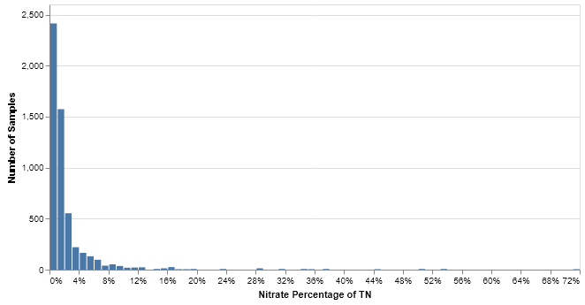
Figure 16. Distribution of percentages of nitrate in measured TN from FEC.
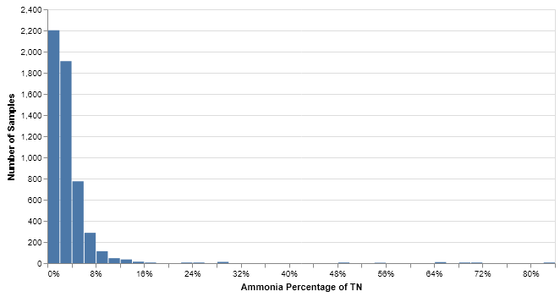
Figure 17. Distribution of percentages of ammonia in measured TN from FEC.
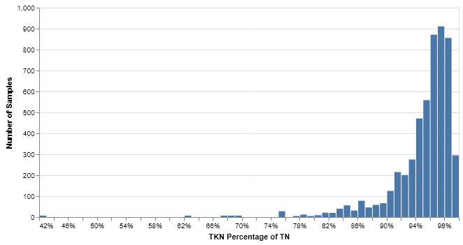
Figure 18. Distribution of percentages of TKN in measured TN from FEC.
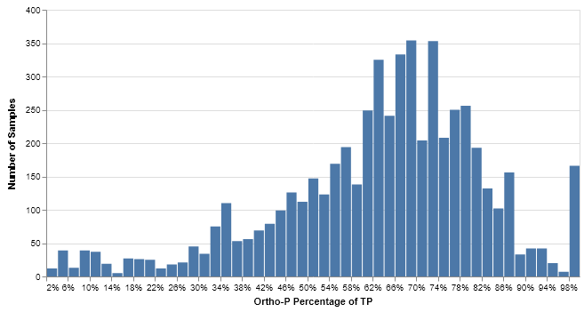
Figure 19. Distribution of percentages of ortho-P in measured TP from FEC.

Waterbody Nutrient Concentrations
Estimates of nutrient concentrations in lakes and streams under pristine conditions are important for determining attenuation coefficients for the pre-drainage WAM simulations.

In-Stream
Smith et al. (2003) summarize estimated natural background concentrations of nutrients throughout the United States. For the Southern Coastal Plain (which extends well beyond Florida but includes all the northern sub-watersheds as well as the East and West sub-watersheds) they report ranges for TN of 0.4-0.9 mg/L and 0.02-0.04 mg/L for TP.
Hand (2004) summarizes concentrations of N and P for a variety of environments throughout Florida, including values for the 10th through 90th percentiles. These include data from both impacted and non-impacted sources. The median in-stream concentration of TN is 1.05 mg/L (range from 0.31-2.28 mg/L from the 10th to the 90th percentile). The median TP concentration in streams is 0.08 mg/L (range from 0.01-0.49 mg/L), in blackwater streams (i.e., streams with high tannin content) the median TP value is 0.11 mg/L (range from 0.02-0.38 mg/L).
Jones (2005) documented TN and TP concentrations of 1.12 – 1.33 mg/L and 0.034 – 0.071 mg/L, respectively, in the channelized Kissimmee, remnant river run, and C-38 stations in Pools A and C. These concentrations were measured over a three-year period prior to the initiation of phase I construction in 1999. Jones (2005) also cites measured concentrations of TP (Odum 1953) in the Kissimmee River of 0.06, 0.002, and 0.012 mg/L, although a footnote indicates that the lower values may have been below detection limits at the time. Mean discharge-weighted concentration of TP in the Kissimmee River over the time period from 1974-1995 range from a low of 0.043 mg/L at S-65 (the outflow structure from Lake Kissimmee) to a high of 0.105 mg/L at S-65 E (Jones 2005).
In developing the TMDL report for Lake Kissimmee (Kang and Gilbert 2013) used the HSPF model to evaluate TN and TP concentrations under what they termed the “natural land use background condition.” This was accomplished by reassigning land uses representing current conditions to a mixture of forest and wetland during HSPF model simulations. They estimated that the TN and TP concentrations in Lake Kissimmee should have had long-term averages of 1.09 and 0.032 mg/L, respectively.

In-Lake
Hand (2004) indicates that the median in-stream concentration of TN is 0.75 mg/L in lakes (range from 0.33-1.8 mg/L), while the median concentration of TP in lakes is 0.03 mg/L (range from 0.01-0.15 mg/L).
Paleolimnological studies have used diatom assemblages in sediment cores to estimate pre-development P concentrations in several Florida lakes (Brenner et al 1993; Whitmore and Brenner 2002; Whitmore 2003; Riedinger-Whitmore et al. 2005). Two of the lakes studied for these reports are within the LOW: Lake Francis (Brenner et al. 1993) and Lake Persimmon (Riedinger-Whitmore et al. 2005), which are immediately west of Lake Istokpoga. Most of the other lakes studied are near Winter Haven and Lakeland, immediately west of the LOW.
Brenner et al. (1993) report that Lake Francis was historically eutrophic with TP levels between 0.05 and 0.07 mg/L inferred from diatom assemblages in the lower parts of sediment cores. Although Riedinger-Whitmore et al. (2005) studied Lake Persimmon, they did not infer any historic TP concentrations. The other lakes studied in the reports include Bonny, Conine, Haines, Lulu, May, and Parker, which are in Polk County. Historic (pre-development) inferred TP concentrations are in the range of 0.024-0.044 mg/L.

WAM Nutrient Settings

Source Cell Nutrient Concentrations
Using these data points as guidance, the mean, minimum, and maximum concentrations for nutrients leaving source cells with the land cover categories used in WAM are presented in Tables 7–9. The values shown in Table 7 are used to set runoff concentrations in the wetland land uses that are run under the Special Case sub-model in BUCShell, i.e., WAM Land Use IDs 9, 10, 12, 14, 15, and 16. The remaining land uses, “Pine Palmetto Flatwoods” (ID 5), “Hardwoods” (ID 6), and “Hardwood Conifer Mixed” (ID 7) are run either under GLEAMS (for cells on well drained soils) or EAAMod (for cells on high water table soils). For these remaining land uses, the values in Tables 7–9 are used as a target for long-term averages and general upper and lower bounds of concentrations leaving source cells. The values for the wetland land uses are also used to set background nutrient concentration coefficients for attenuation processes if constituents pass through wetlands during the overland routing process.
Table 7. Mean N and P concentrations for WAM land uses.
Land Use | WAM  LUID | NO3-N  (mg/l) | Ammonia-N  (mg/l) | TN  (mg/l) | Dissolved P  (mg/l) | TP  (mg/l)
Bay Swamps | 10 | 0.08 | 0.140 | 1.6 | 0.018 | 0.03
Cypress | 14 | 0.08 | 0.140 | 1.6 | 0.024 | 0.04
Freshwater Marshes | 16 | 0.055 | 0.096 | 1.1 | 0.022 | 0.035
Hardwood Conifer Mixed | 7 | 0.05 | 0.100 | 1.45 | 0.042 | 0.055
Hardwoods | 6 | 0.05 | 0.100 | 1.5 | 0.03 | 0.04
Mixed Wetland Hardwoods | 12 | 0.055 | 0.096 | 1.1 | 0.031 | 0.05
Open Water | 9 | 0.19 | 0.010 | 0.9 | 0.016 | 0.02
Pine Palmetto Flatwoods | 5 | 0.05 | 0.100 | 1.4 | 0.035 | 0.045
Wetland Forested Mixed | 15 | 0.055 | 0.096 | 1.1 | 0.03 | 0.05

Table 8. Maximum N and P concentrations for WAM land uses.
Land Use | WAM  LUID | NO3-N  (mg/l) | Ammonia-N  (mg/l) | TN  (mg/l) | Dissolved P  (mg/l) | TP  (mg/l)
Bay Swamps | 10 | 0.16 | 0.28 | 3.2 | 0.054 | 0.09
Cypress | 14 | 0.16 | 0.28 | 3.2 | 0.072 | 0.12
Freshwater Marshes | 16 | 0.11 | 0.1925 | 2.2 | 0.066 | 0.105
Hardwood Conifer Mixed | 7 | 0.1 | 0.2 | 2.9 | 0.126 | 0.165
Hardwoods | 6 | 0.1 | 0.2 | 3 | 0.09 | 0.12
Mixed Wetland Hardwoods | 12 | 0.11 | 0.1925 | 2.2 | 0.093 | 0.15
Open Water | 9 | 0.19 | 0.010 | 0.9 | 0.016 | 0.02
Pine Palmetto Flatwoods | 5 | 0.1 | 0.2 | 2.8 | 0.105 | 0.135
Wetland Forested Mixed' | 15 | 0.11 | 0.1925 | 2.2 | 0.09 | 0.15

Table 9. Minimum N and P concentrations for WAM land uses.
Land Use | WAM  LUID | NO3-N  (mg/l) | Ammonia-N  (mg/l) | TN  (mg/l) | Dissolved P  (mg/l) | TP  (mg/l)
Bay Swamps | 10 | 0.04 | 0.07 | 0.8 | 0.0036 | 0.006
Cypress | 14 | 0.04 | 0.07 | 0.8 | 0.0048 | 0.008
Freshwater Marshes | 16 | 0.0275 | 0.048125 | 0.55 | 0.0044 | 0.007
Hardwood Conifer Mixed | 7 | 0.025 | 0.05 | 0.725 | 0.0084 | 0.011
Hardwoods | 6 | 0.025 | 0.05 | 0.75 | 0.006 | 0.008
Mixed Wetland Hardwoods | 12 | 0.0275 | 0.048125 | 0.55 | 0.0062 | 0.01
Open Water | 9 | 0.19 | 0.010 | 0.9 | 0.016 | 0.02
Pine Palmetto Flatwoods | 5 | 0.025 | 0.05 | 0.7 | 0.007 | 0.009
Wetland Forested Mixed | 15 | 0.0275 | 0.048125 | 0.55 | 0.006 | 0.01

Rainfall Nutrient Concentrations
Nitrogen concentrations in rainfall are set to 0.2 mg/L (assigned to the nitrate fraction) and 0.007 mg/L assigned to dissolved phosphorus. These are the same values used for the current conditions simulations (SWET 2017a, 2017b).

Results
Results from the pre-drainage WAM simulations are presented here. Table 10 shows annual average (calculated by water year) runoff, percolation, TN, and TP loadings from source cells broken down by land cover in each of the sub-watersheds. Nutrient loadings are given in metric tons (mt), while runoff and percolation are given as acre-feet (ac-ft). If a sub-watershed does not have a particular land cover within its domain, the cell entry is left blank, for example, only Upper Kissimmee and Lake Istokpoga have the land cover “Barren Land.” The source cell loadings are what leave the source cell before overland and in-stream routing is simulated and do not reflect any attenuation processes.
Table 11 shows annual average water volumes and nutrient loads leaving each sub-watershed. This is the primary product of this study, as it gives the estimates of water volume and nutrient loads and average concentrations discharging into Lake Okeechobee. As described in the footnotes, the values for the Lower Kissimmee and Indian Prairie sub-watersheds are the values generated by WAM minus the inflow contributions from the Upper Kissimmee and Lake Istokpoga sub-watersheds, respectively. For the WAM simulations, the outflow from the Upper Kissimmee is used as an inflow boundary condition for the Lower Kissimmee model, and the outflow from Lake Istokpoga is used as an inflow for the Indian Prairie model. This was done to generate contributions on a per-watershed basis. Figure 20 shows annual (water-year) contributions of water volume and nutrient loads to Lake Okeechobee broken down by sub-watershed.
Discharge from the East sub-watershed is split into four parts: the first two are to the east (towards the Atlantic Ocean) and into the South sub-watershed; neither of these contribute to Lake Okeechobee. The remainder either flows directly into Lake Okeechobee, or across the southern part of the Taylor Creek/Nubbin Slough sub-watershed, across what is now the S-135 Basin. As with the other basins that receive flow from upstream basins, the values reported are the totals from the East sub-watershed that reach the lake and the contributions from the East sub-watershed to Taylor Creek/Nubbin Slough are subtracted from the totals given for Taylor Creek/Nubbin Slough.
Discharge from the West sub-watershed is split between flow down the Caloosahatchee River to the west and a direct contribution to Lake Okeechobee that occurs when the lake stage is low. Note that some of this is water that flowed from the lake into the West sub-watershed when the lake stage was high. None of the South sub-watershed discharges to the lake.
Detailed breakdowns by sub-watershed are provided in the following sections. A map is shown for each sub-watershed with land cover and the reach network, with the reach numbers labeled. Charts of annual (by water year) runoff and percolation volume and loads of TN and TP produced at the source cell level categorized by land cover are shown for each sub-watershed. In each of these charts the average over the simulation period is indicated by a dashed red line. In charts showing runoff and percolation, the total annual rainfall volume over the basin (second y-axis, ac-ft) are indicated by squares with green fill. Daily time series charts of flow and nutrient concentrations leaving each sub-watershed covering the entire simulation period from 1994-2013 are presented as well.
Table 10. Annual average runoff and percolation (in acre-feet), and nutrient loadings (in metric tons) produced at the source cell level for the nine sub-watersheds.
 | Barren Land | Bay Swamps | Cypress | Freshwater Marshes | Hardwood Conifer Mixed | Hardwoods | Mixed Wetland Hardwoods | Open Water | Pine Palmetto Flatwoods | Wetland Forested Mixed
UK Runoff | 16 | 6 | 627 | 76,133 | 39,301 | 29 | 46,233 | 10,419 | 271,976 | 19,778
UK Perc | 2 |  |  |  | 69,751 | 110,666 |  |  | 50,393
UK TN Load | 0 | 0 | 1 | 103 | 93 | 1 | 63 | 12 | 463 | 27
UK TP Load | 0.0 | 0.0 | 0.0 | 3.3 | 5.2 | 0.6 | 2.9 | 0.3 | 17.9 | 1.2
UK TN Conc | 0.65 | 1.60 | 1.60 | 1.10 | 0.69 | 0.01 | 1.11 | 0.90 | 1.17 | 1.10
UK TN Conc Max | 1.34 | 1.60 | 1.60 | 1.10 | 9.49 | 2.98 | 1.11 | 0.90 | 12.34 | 1.10
UK TN Conc Min | 0.52 | 1.60 | 1.60 | 1.10 | 0.00 | 0.00 | 1.11 | 0.90 | 0.00 | 1.10
UK TP Conc | 0.065 | 0.030 | 0.040 | 0.035 | 0.039 | 0.005 | 0.050 | 0.020 | 0.045 | 0.050
UK TP Conc Max | 0.387 | 0.030 | 0.040 | 0.035 | 0.565 | 0.131 | 0.050 | 0.020 | 0.680 | 0.050
UK TP Conc Min | 0.040 | 0.030 | 0.040 | 0.035 | 0.000 | 0.004 | 0.050 | 0.020 | 0.000 | 0.050
LK Runoff |  |  | 131 | 44,561 | 2,737 | 151 | 50,602 | 2,674 | 198,876 | 1,137
LK Perc |  |  |  |  | 33 |  |  |  | 5,018
LK TN Load |  |  | 0 | 60 | 6 | 0 | 69 | 3 | 302 | 2
LK TP Load |  |  | 0.0 | 1.9 | 0.3 | 0.0 | 3.1 | 0.1 | 10.4 | 0.1
LK TN Conc |  |  | 1.60 | 1.10 | 1.77 | 1.12 | 1.11 | 0.90 | 1.20 | 1.10
LK TN Conc Max |  |  | 1.60 | 1.10 | 6.73 | 3.73 | 1.11 | 0.90 | 11.62 | 1.10
LK TN Conc Min |  |  | 1.60 | 1.10 | 0.00 | 0.51 | 1.11 | 0.90 | 0.00 | 1.10
LK TP Conc |  |  | 0.040 | 0.035 | 0.097 | 0.052 | 0.050 | 0.020 | 0.041 | 0.050
LK TP Conc Max |  |  | 0.040 | 0.035 | 0.558 | 0.108 | 0.050 | 0.020 | 0.722 | 0.050
LK TP Conc Min |  |  | 0.040 | 0.035 | 0.004 | 0.033 | 0.050 | 0.020 | 0.002 | 0.050
LI Runoff | 766 | 1 | 8 | 20,012 | 11,673 | 426 | 29,104 | 1,457 | 62,875 | 6,189
LI Perc | 52 |  |  |  | 99,907 | 17,048 |  |  | 98,189
LI TN Load | 1 | 0 | 0 | 27 | 33 | 1 | 40 | 2 | 106 | 8
LI TP Load | 0.0 | 0.0 | 0.0 | 0.9 | 2.8 | 0.1 | 1.8 | 0.0 | 4.4 | 0.4
LI TN Conc | 0.51 | 1.60 | 1.60 | 1.10 | 0.24 | 0.03 | 1.11 | 0.90 | 0.53 | 1.10
LI TN Conc Max | 4.44 | 1.60 | 1.60 | 1.10 | 7.68 | 2.47 | 1.11 | 0.90 | 7.83 | 1.10
LI TN Conc Min | 0.00 | 1.60 | 1.60 | 1.10 | 0.00 | 0.00 | 1.11 | 0.90 | 0.00 | 1.10
LI TP Conc | 0.044 | 0.030 | 0.040 | 0.035 | 0.021 | 0.006 | 0.050 | 0.020 | 0.022 | 0.050
LI TP Conc Max | 0.942 | 0.030 | 0.040 | 0.035 | 0.584 | 0.089 | 0.050 | 0.020 | 0.632 | 0.050
LI TP Conc Min | 0.009 | 0.030 | 0.040 | 0.035 | 0.002 | 0.004 | 0.050 | 0.020 | 0.000 | 0.050
IP Runoff |  |  |  | 20,139 | 3 | 2,231 | 33,973 | 255 | 31,821 | 892
IP Perc |  |  |  |  | 5,581 |  |  |  | 19,834
IP TN Load |  |  |  | 27 | 0 | 3 | 47 | 0 | 50 | 1
IP TP Load |  |  |  | 0.9 | 0.1 | 0.1 | 2.1 | 0.0 | 1.7 | 0.1
IP TN Conc |  |  |  | 1.10 | 0.00 | 1.10 | 1.11 | 0.90 | 0.79 | 1.10
IP TN Conc Max |  |  |  | 1.10 | 2.36 | 3.42 | 1.11 | 0.90 | 8.25 | 1.10
IP TN Conc Min |  |  |  | 1.10 | 0.00 | 0.34 | 1.11 | 0.90 | 0.00 | 1.10
IP TP Conc |  |  |  | 0.035 | 0.009 | 0.053 | 0.050 | 0.020 | 0.027 | 0.050
IP TP Conc Max |  |  |  | 0.035 | 0.059 | 0.093 | 0.050 | 0.020 | 0.725 | 0.050
IP TP Conc Min |  |  |  | 0.035 | 0.009 | 0.036 | 0.050 | 0.020 | 0.003 | 0.050
FEC Runoff |  | 2 |  | 45,500 | 139 | 3,621 | 65,112 | 30 | 117,902 | 2,142
FEC Perc |  |  |  |  | 2,401 |  |  |  | 24,091
FEC TN Load |  | 0 |  | 62 | 0 | 5 | 89 | 0 | 178 | 3
FEC TP Load |  | 0.0 |  | 2.0 | 0.0 | 0.2 | 4.0 | 0.0 | 6.3 | 0.1
FEC TN Conc |  | 1.60 |  | 1.10 | 0.10 | 1.01 | 1.11 | 0.90 | 1.01 | 1.10
FEC TN Conc Max |  | 1.60 |  | 1.10 | 4.10 | 4.08 | 1.11 | 0.90 | 7.13 | 1.10
FEC TN Conc Min |  | 1.60 |  | 1.10 | 0.00 | 0.43 | 1.11 | 0.90 | 0.00 | 1.10
FEC TP Conc |  | 0.030 |  | 0.035 | 0.014 | 0.051 | 0.050 | 0.020 | 0.036 | 0.050
FEC TP Conc Max |  | 0.030 |  | 0.035 | 0.307 | 0.337 | 0.050 | 0.020 | 0.369 | 0.050
FEC TP Conc Min |  | 0.030 |  | 0.035 | 0.009 | 0.014 | 0.050 | 0.020 | 0.002 | 0.050
TCNS Runoff |  | 1 | 1 | 11,558 | 7,193 | 1,268 | 10,277 | 1,173 | 73,743 | 536
TCNS Perc |  |  |  |  | 227 |  |  |  | 643
TCNS TN Load |  | 0 | 0 | 16 | 22 | 2 | 14 | 1 | 113 | 1
TCNS TP Load |  | 0.0 | 0.0 | 0.5 | 0.9 | 0.1 | 0.6 | 0.0 | 4.3 | 0.0
TCNS TN Conc |  | 1.60 | 1.60 | 1.10 | 2.39 | 1.17 | 1.11 | 0.90 | 1.23 | 1.10
TCNS TN Conc Max |  | 1.60 | 1.60 | 1.10 | 11.44 | 3.48 | 1.11 | 0.90 | 11.39 | 1.10
TCNS TN Conc Min |  | 1.60 | 1.60 | 1.10 | 0.00 | 0.48 | 1.11 | 0.90 | 0.00 | 1.10
TCNS TP Conc |  | 0.030 | 0.040 | 0.035 | 0.104 | 0.058 | 0.050 | 0.020 | 0.047 | 0.050
TCNS TP Conc Max |  | 0.030 | 0.040 | 0.035 | 0.778 | 0.113 | 0.050 | 0.020 | 0.754 | 0.050
TCNS TP Conc Min |  | 0.030 | 0.040 | 0.035 | 0.000 | 0.043 | 0.050 | 0.020 | 0.004 | 0.050
ESW Runoff |  |  | 544 | 14,371 | 33,824 |  | 20,175 | 264 | 33,548 | 28,298
ESW Perc |  |  |  |  | 816
ESW TN Load |  |  | 1 | 19 | 91 |  | 28 | 0 | 61 | 38
ESW TP Load |  |  | 0.0 | 0.6 | 3.9 |  | 1.2 | 0.0 | 2.3 | 1.7
ESW TN Conc |  |  | 1.60 | 1.10 | 2.14 |  | 1.11 | 0.90 | 1.47 | 1.10
ESW TN Conc Max |  |  | 1.60 | 1.10 | 16.19 |  | 1.11 | 0.90 | 16.22 | 1.10
ESW TN Conc Min |  |  | 1.60 | 1.10 | 0.00 |  | 1.11 | 0.90 | 0.34 | 1.10
ESW TP Conc |  |  | 0.040 | 0.035 | 0.092 |  | 0.050 | 0.020 | 0.055 | 0.050
ESW TP Conc Max |  |  | 0.040 | 0.035 | 0.873 |  | 0.050 | 0.020 | 0.869 | 0.050
ESW TP Conc Min |  |  | 0.040 | 0.035 | 0.000 |  | 0.050 | 0.020 | 0.011 | 0.050
WSW Runoff |  |  | 232 | 26,582 | 9,322 | 712 | 14,369 | 4,429 | 66,958 | 1,739
WSW Perc
WSW TN Load |  |  | 0 | 36 | 24 | 1 | 20 | 5 | 94 | 2
WSW TP Load |  |  | 0.0 | 1.1 | 1.5 | 0.0 | 0.9 | 0.1 | 3.5 | 0.1
WSW TN Conc |  |  | 1.60 | 1.10 | 2.05 | 0.89 | 1.11 | 0.90 | 1.14 | 1.10
WSW TN Conc Max |  |  | 1.60 | 1.10 | 14.36 | 2.57 | 1.11 | 0.90 | 13.16 | 1.10
WSW TN Conc Min |  |  | 1.60 | 1.10 | 0.50 | 0.37 | 1.11 | 0.90 | 0.33 | 1.10
WSW TP Conc |  |  | 0.040 | 0.035 | 0.132 | 0.046 | 0.050 | 0.020 | 0.043 | 0.050
WSW TP Conc Max |  |  | 0.040 | 0.035 | 1.054 | 0.123 | 0.050 | 0.020 | 0.985 | 0.050
WSW TP Conc Min |  |  | 0.040 | 0.035 | 0.012 | 0.030 | 0.050 | 0.020 | 0.005 | 0.050
SSW Runoff |  | 11 | 6 | 195,360 | 1,036 |  | 417 | 8,383 | 14,213 | 11,212
SSW Perc
SSW TN Load |  | 0 | 0 | 265 | 2 |  | 1 | 9 | 21 | 15
SSW TP Load |  | 0.0 | 0.0 | 8.4 | 0.1 |  | 0.0 | 0.2 | 0.6 | 0.7
SSW TN Conc |  | 1.60 | 1.60 | 1.10 | 1.45 |  | 1.11 | 0.90 | 1.18 | 1.10
SSW TN Conc Max |  | 1.60 | 1.60 | 1.10 | 8.89 |  | 1.11 | 0.90 | 3.35 | 1.10
SSW TN Conc Min |  | 1.60 | 1.60 | 1.10 | 0.51 |  | 1.11 | 0.90 | 0.38 | 1.10
SSW TP Conc |  | 0.030 | 0.040 | 0.035 | 0.062 |  | 0.050 | 0.020 | 0.037 | 0.050
SSW TP Conc Max |  | 0.030 | 0.040 | 0.035 | 0.606 |  | 0.050 | 0.020 | 0.134 | 0.050
SSW TP Conc Min |  | 0.030 | 0.040 | 0.035 | 0.014 |  | 0.050 | 0.020 | 0.006 | 0.050

Table 11. Water volumes, nutrient loads, and flow-weighted concentrations for each sub-watershed for the simulation period WY 1995-2013.
Sub-Watershed | Discharge (ac-ft) | TN Load (mt) | TP Load (mt) | TN Conc (mg/L) | TP Conc (mg/L)
Upper Kissimmee | 632,924 | 839 | 25 | 1.07 | 0.033
Lower Kissimmee | 304,351 | 396 | 15 | 1.06 | 0.041
Lake Istokpoga | 314,531 | 376 | 12 | 0.97 | 0.030
Indian Prairie | 106,803 | 152 | 5.1 | 1.16 | 0.038
Fisheating Creek | 249,524 | 316 | 12 | 1.03 | 0.037
Taylor Creek/Nubbin Slough | 106,391 | 142 | 6 | 1.08 | 0.042
East sub-watershed | 75,179 | 111 | 4 | 1.14 | 0.037
West sub-watershed | 29,145 | 42 | 1.5 | 1.16 | 0.042
Total into Lake Okeechobee | 1,818,847 | 2,374 | 80 | 1.06 | 0.036

Table 12. Average rainfall per sub-watershed, and discharge, TN, and TP normalized by sub-watershed area. East and West sub-watersheds are excluded since only a portion of their areas do not contribute to the lake.
Sub-Watershed | Avg Rain (in) | Area Avg Discharge (in) | TN (lb/acre) | TP (lb/ac)
Upper Kissimmee | 49 | 7.4 | 1.8 | 0.054
Lower Kissimmee | 50 | 8.5 | 2.0 | 0.079
Lake Istokpoga | 50 | 9.6 | 2.1 | 0.065
Indian Prairie | 42 | 4.6 | 1.2 | 0.040
Fisheating Creek | 49 | 9.4 | 2.2 | 0.080
Taylor Creek/Nubbin Slough | 46 | 6.5 | 1.6 | 0.062
Average | 49 | 7.8 | 1.8 | 0.062

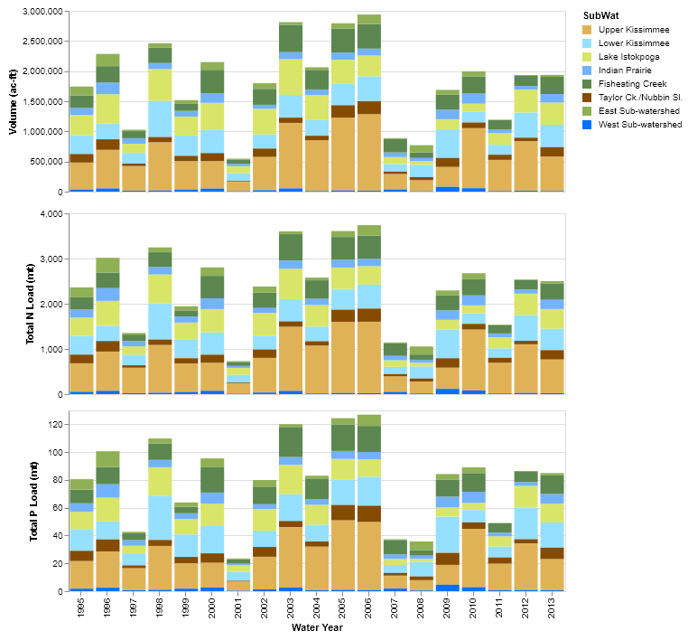
Figure 20. Annual water volumes and nutrient loads discharging into Lake Okeechobee. The top pane shows water volume (acre-feet), the middle pane shows TN loads (mt), and the bottom pane shows TP loads (mt).

Upper Kissimmee
The Upper Kissimmee sub-watershed is the northernmost of the six sub-watersheds simulated for this project, as well as the largest in area, measuring approximately 1,028,400 acres (Figure 21). The Upper Kissimmee sub-watershed encompasses the area from just south of Orlando to the bottom edge of Lake Kissimmee. The basin outlet is the southern end of Lake Kissimmee, with discharge to the Kissimmee River, which under current conditions is controlled by a set of gates at S-65. For the pre-drainage simulations, a set of four weirs of increasing crest elevations was used to mimic a broad area of outflow from Lake Kissimmee (WAM reach 3). The weir elevations are 49, 49.2, 50, and 50.5 feet (14.95, 15, 15.25, and 15.4 meters) (NGVD), while the corresponding widths are 66, 197, 197, and 657 feet (20, 60, 60, 200 meters), respectively. The flow between the lake and WAM reach 2 was used as an inflow boundary condition for the Lower Kissimmee sub-watershed.
The dominant pre-drainage land cover is Pine Palmetto Flatwoods (Table 2), followed by Freshwater Marshes and Open Water. As was discussed in Section 2.1.6, the Pine Palmetto Flatwoods, Hardwood, Hardwood/Conifer Mixed, and Barren Land cover types (57% of the land cover in the sub-watershed) are run using either the EAAMod or GLEAMS land-source models (depending on the soil type), while 32% are run using the Special Case model, and the remaining 11% is accounted for by direct rainfall to lakes within the stream network (Table 13). For the last case, no runoff or percolation is generated, and all attenuation processes occur within the reach network. Note that the “Open Water” acreage in Table 2 includes the “Lakes” acreage.
Table 13. Breakdown of land cover acreages as run by source cell model in the Upper Kissimmee sub-watershed. Note no source cell model is run on the "Lakes" land cover, since rainfall is passed directly through to the stream network.
Land Cover | GLEAMS | EAAMod | Special Case | None
Pine Palmetto Flatwoods | 27,516 | 394,398
Hardwoods | 63,795 | 57
Hardwood Conifer Mixed | 73,246 | 25,655
Open Water |  |  | 14,220
Bay Swamps |  |  | 14
Mixed Wetland Hardwoods |  |  | 94,893
Cypress |  |  | 2,705
Wetland Forested Mixed |  |  | 61,510
Freshwater Marshes |  |  | 154,896
Barren Land | 25
Lakes |  |  |  | 115,496
Percent of Total | 16% | 41% | 32% | 11%

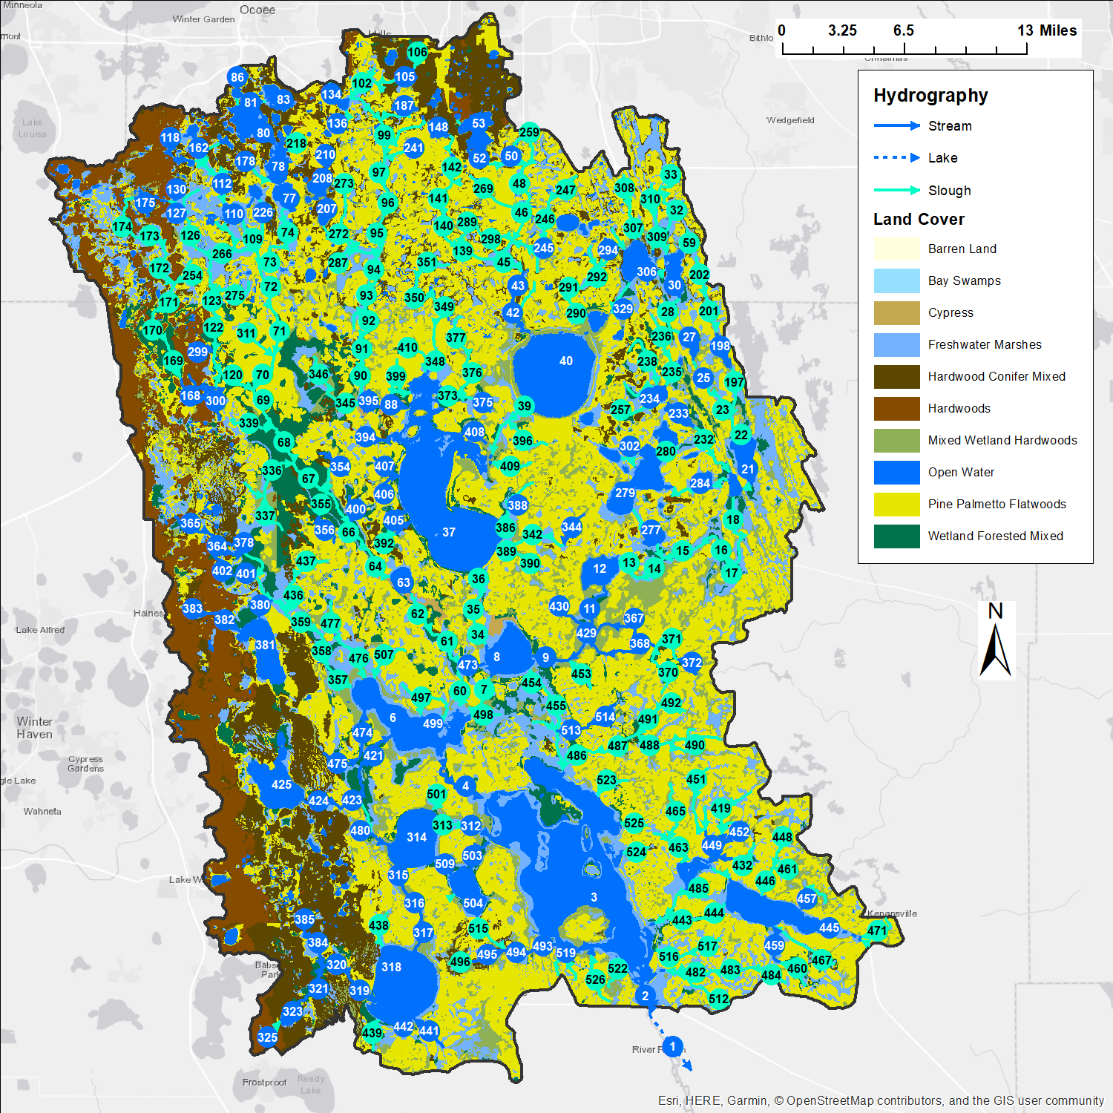
Figure 21. The Upper Kissimmee sub-watershed, showing pre-drainage land cover and hydrography with reach numbers labeled.

Water and Nutrient Loads from Source Cells
Annual totals of simulated annual water volumes and nutrient loads leaving source cells are shown in Figures 22 – 25. Overall, percolation to groundwater directly from source cells is about 33% of the total cell discharge (i.e., 67% runoff). Because of subsurface attenuation, the fractions of TN and TP loadings tend to be small, consequently, the sum of runoff and percolation TN and TP loads are shown rather than separately. The source cell percolation to groundwater does not include the contribution that originated from runoff and was routed via overland flow to depressions where it subsequently percolated to groundwater. These amounts are included in the runoff values.

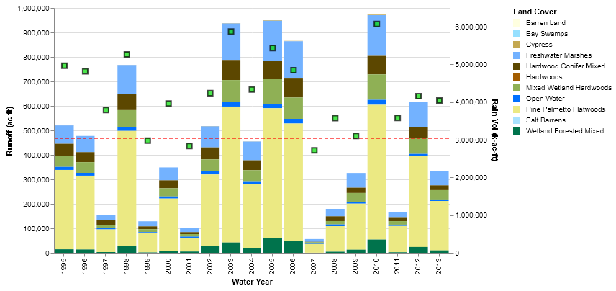
Figure 22. Source cell runoff per year and broken down by land cover in the Upper Kissimmee sub-watershed.
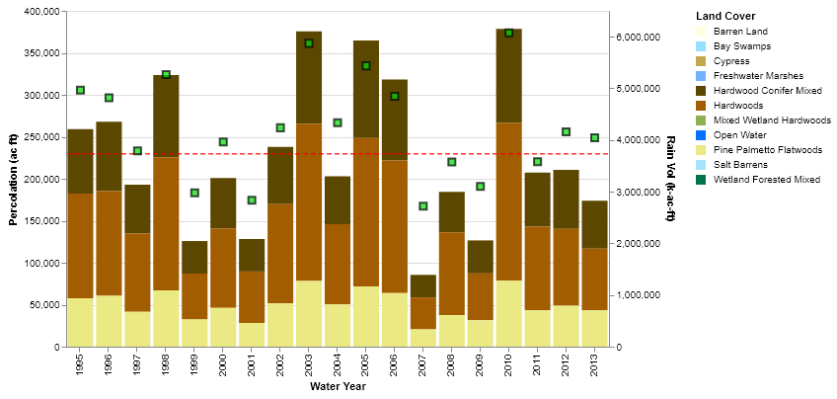
Figure 23. Source cell percolation per year in the Upper Kissimmee sub-watershed.
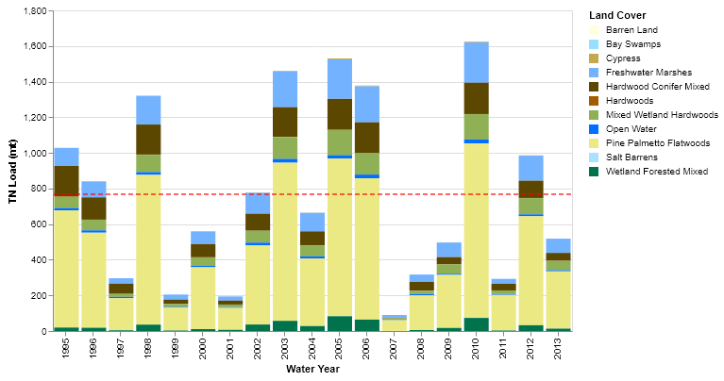
Figure 24. Source cell TN loadings per year in the Upper Kissimmee sub-watershed.

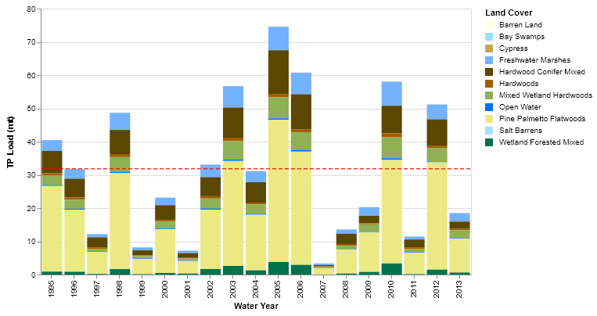
Figure 25. Source cell TP loadings per year in the Upper Kissimmee sub-watershed

Water and Nutrient Loads Discharging from the Sub-Watershed
The simulated discharge (in m³/s) leaving the sub-watershed at the southern end of Lake Kissimmee is shown in Figure 26. The annual average discharge was slightly over 24 m³/s, corresponding to the annual average volume of over 624,000 acre-feet per year. Peak discharge occurred during the wet years of 2004 and 2005.
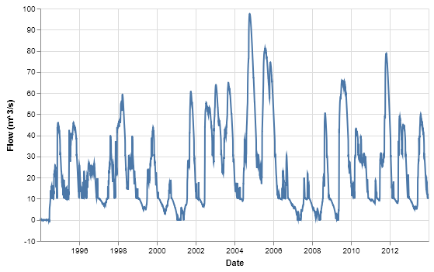
Figure 26. Simulated daily discharge from Lake Kissimmee.
Simulated concentrations of TN and TP over the modeling period are shown in Figures 27 and 28, respectively. The flow-weighted average TN concentration over the entire period was 1.075 mg/L (Table 11) with most of the concentrations in the range of 1.0 – 1.3 mg/L, with peaks approaching 1.4 mg/L during low-flow periods. The flow-weighted TP concentration over the entire period was 0.032 mg/L with the bulk of the concentrations in the range of 0.03 – 0.04 mg/L.
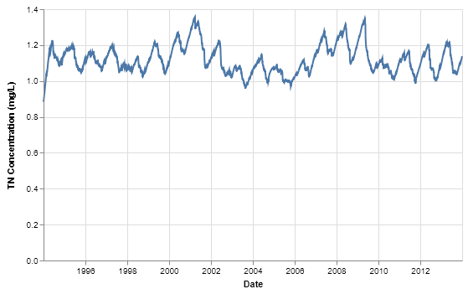
Figure 27. Simulated daily TN concentrations leaving Lake Kissimmee.
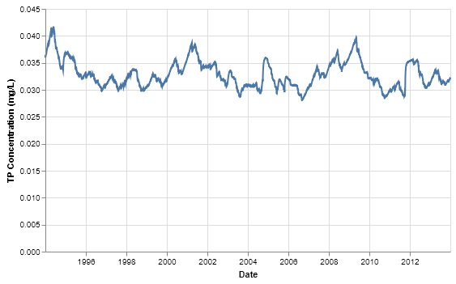
Figure 28. Simulated daily TP concentrations leaving Lake Kissimmee.

Lower Kissimmee
The Lower Kissimmee sub-watershed lies along the east-central portion of the six sub-watersheds, comprising the area between the Upper Kissimmee and Taylor Creek/Nubbin Slough model domains. It is approximately 429,170 acres in size (Figure 29). The dominant feature through the domain is the Kissimmee River, which runs from the discharge point of Lake Kissimmee at the northern end of the model domain and meanders southward to the current location of the S-65E gates at the southern end of the domain. The northern end of the Kissimmee River receives inflow from Lake Kissimmee. This is simulated in WAM by using the discharge from the lake as the inflow into WAM reach 107, which is modeled as an inflow boundary condition. The outflow at the southern end of the Kissimmee is simulated as a stage boundary condition, but since there is not a time series of stages for pre-drainage conditions the boundary is simulated as a constant stage. Because the goal of this project is to estimate nutrient loading into Lake Okeechobee, the stage was set low enough to capture all of the flow from the river without complications arising from back-water effects. This same methodology was used at all points where discharge from the hydrography network to the lake occurred.
The dominant pre-drainage land cover is Pine Palmetto Flatwoods, followed by Mixed Wetland Hardwoods and Freshwater Marshes (Table 2). The Kissimmee River floodplain land cover is dominated by Freshwater Marshes, while Pine Palmetto Flatwoods and Mixed Wetland Hardwoods are evenly distributed across the rest of the area. About 58% of the area is run using either EAAMod or GLEAMS, although since high water table soils are predominant, EAAMod is used to simulate the majority (57%) of the area. The remaining area is simulated using the Special Case model (Table 14).
Table 14. Breakdown of land cover acreages as run by source cell model in the Lower Kissimmee sub-watershed.
Land Cover | GLEAMS | EAAMod | Special Case
Pine Palmetto Flatwoods | 2,727 | 241,729
Hardwoods |  | 231
Hardwood Conifer Mixed | 50 | 4,115
Open Water |  |  | 3,876
Mixed Wetland Hardwoods |  |  | 90,935
Cypress |  |  | 373
Wetland Forested Mixed |  |  | 2,636
Freshwater Marshes |  |  | 82,412
Percent of Total | 1% | 57% | 42%

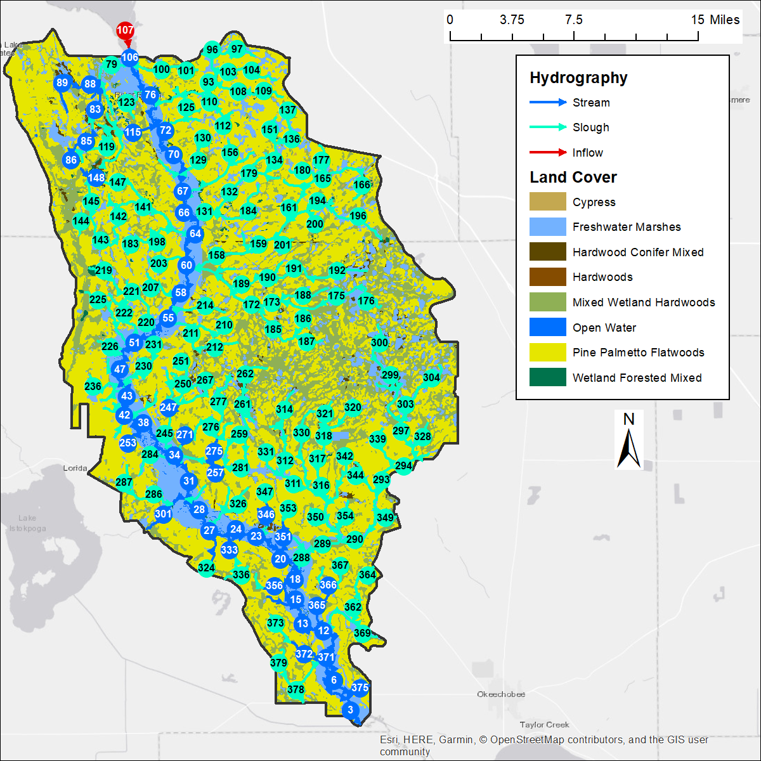
Figure 29. Land cover and hydrography (reach numbers labeled) for the Lower Kissimmee sub-watershed.

Water and Nutrient Loads from Source Cells
Annual totals of simulated annual water volumes and nutrient loads leaving source cells are shown in Figures 30 – 33. Because of the large amounts of high water table soils, direct percolation to groundwater accounts for about 2% of water leaving source cells. However as before, some runoff water is routed to landscape depressions where it will infiltrate to groundwater. Nutrient loads are dominated by contributions from Pine Palmetto Flatwoods, followed by Mixed Wetland Hardwoods and Freshwater Marshes.
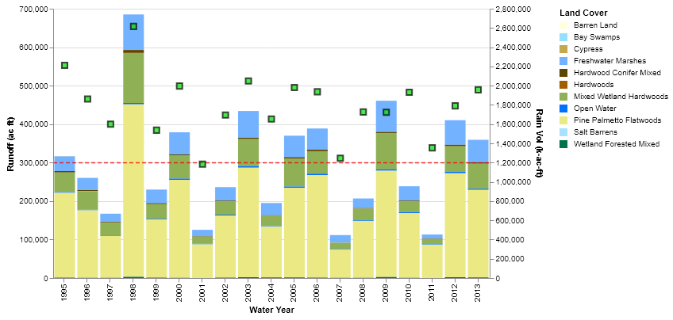
Figure 30. Source cell runoff per year in the Lower Kissimmee sub-watershed.
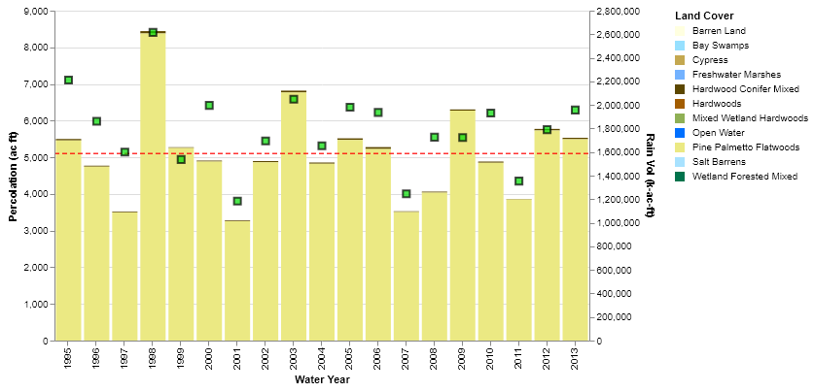
Figure 31. Source cell percolation per year in the Lower Kissimmee sub-watershed.
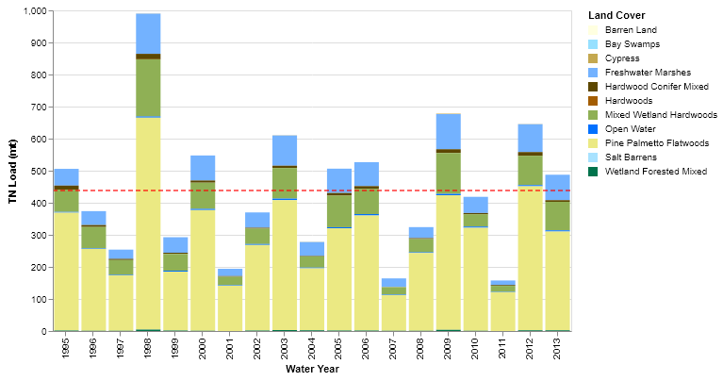
Figure 32. Source cell TN loadings per year in the Lower Kissimmee sub-watershed.
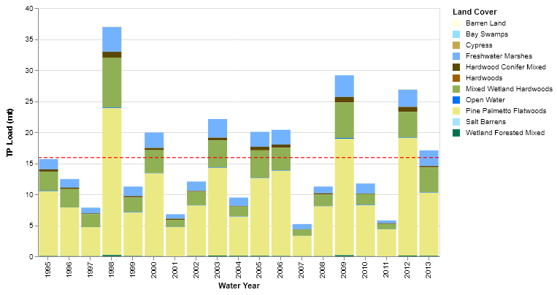
Figure 33. Source cell TP loadings per year in the Lower Kissimmee sub-watershed.

Water and Nutrient Loads Discharging from the Sub-Watershed
The simulated discharge from the Kissimmee River into Lake Okeechobee reflects the inflow of water and nutrients from the Upper Kissimmee sub-watershed as well as the contributions from land within the Lower Kissimmee sub-watershed. The simulated discharge (in m³/s) leaving the sub-watershed at the southern end of the Kissimmee River is shown in Figure 34. The annual average discharge was slightly over 36 m³/s, corresponding to the annual average volume of over 929,000 acre-feet per year. Peak discharge occurred during 2004, 2008, and 2011.
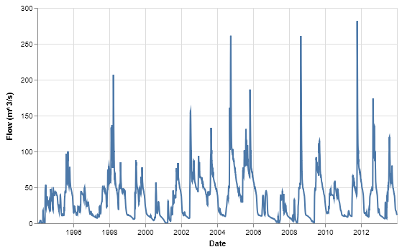
Figure 34. Simulated daily discharge from the Kissimmee River to Lake Okeechobee.
Simulated concentrations of TN and TP over the modeling period are shown in Figures 35 and 36, respectively. The flow-weighted average TN concentration over the entire period was 1.069 mg/L (Table 11) with most of the concentrations in the range of 1.0 – 1.2 mg/L, with peaks slightly over 1.2 mg/L and strong dips down to around 0.4 mg/L in 2001 and 2009. The flow-weighted TP concentration over the entire period was 0.035 mg/L with the bulk of the concentrations in the range of 0.03 – 0.05 mg/L, but also showing dips below 0.01 mg/L in 2001 and 0.015 mg/L in 2009. The dips in both TN and TP occur during low-flow periods, when most of the water entering the river is from groundwater with strongly attenuated TN and TP concentrations. This is due to a combination of direct contribution from source cells to groundwater as well as from overland flow into depressions that in turn contribute to groundwater. Since these transient spikes occur during low-flow periods, there is little change to the overall loading to Lake Okeechobee.
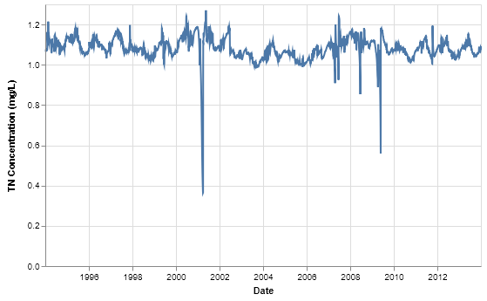
Figure 35. Simulated daily TN concentrations entering Lake Okeechobee from the Kissimmee River.
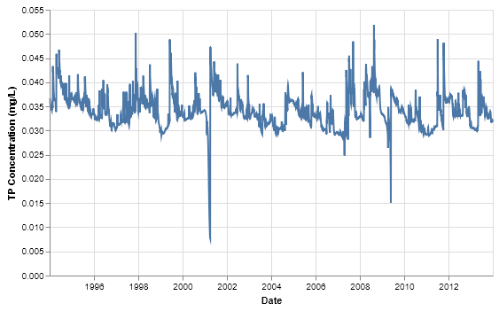
Figure 36. Simulated daily TP concentrations entering Lake Okeechobee from the Kissimmee River.

Lake Istokpoga
The Lake Istokpoga sub-watershed lies on the west-central portion of the area covered by the six sub-watersheds, between Upper Kissimmee and Fisheating Creek, and contains a sizeable portion of the Lake Wales Ridge along its western edge (Figure 37). The sub-watershed is nearly 394,160 acres in area. It is bordered by the Indian Prairie model domain on its southern end. The main outflow from the sub-watershed is at the southern end of Lake Istokpoga (now the S-68 structure). The discharge point is an inflow boundary to the Indian Prairie sub-watershed. The discharge is simulated as a broad-crested weir at the boundary between WAM reaches 2 (Lake Istokpoga) and reach 1 which is meant to represent overflow from the lake into a broad slough. The weir crest elevation is set to 38.4 feet (11.7 meters) (NGVD) and the width is set to 197 feet (60 meters).
The dominant pre-drainage land cover is Pine Palmetto Flatwoods, followed by Hardwood/Conifer Mixed, Mixed Wetland Hardwoods and Open Water (Table 2). A small amount of Barren Land is present around some lake shorelines. About 56% of the area is run using either EAAMod or GLEAMS, with the higher, well-drained terrain along the Lake Wales Ridge simulated using GLEAMS, and the eastern part of the sub-watershed with high water table soils simulated with EAAMod. About 30% of the area is run using the Special Case model, while the remaining 14% is direct contribution of rainfall to lakes within the reach network (Table 15).
Table 15. Breakdown of land cover acreages as run by source cell model in the Lake Istokpoga sub-watershed. Note no source cell model is run on the "Lakes" land cover, since rainfall is passed directly through to the stream network.
Land Cover | GLEAMS | EAAMod | Special Case | None
Pine Palmetto Flatwoods | 48,492 | 94,148
Hardwoods | 9,597 | 712
Hardwood Conifer Mixed | 64,272 | 3,102
Open Water |  |  | 1,870
Bay Swamps |  |  | 3
Mixed Wetland Hardwoods |  |  | 59,052
Cypress |  |  | 33
Wetland Forested Mixed |  |  | 17,682
Freshwater Marshes |  |  | 40,234
Barren Land | 1,028
Lakes |  |  |  | 53,933
Percent of Total | 31% | 25% | 30% | 14%

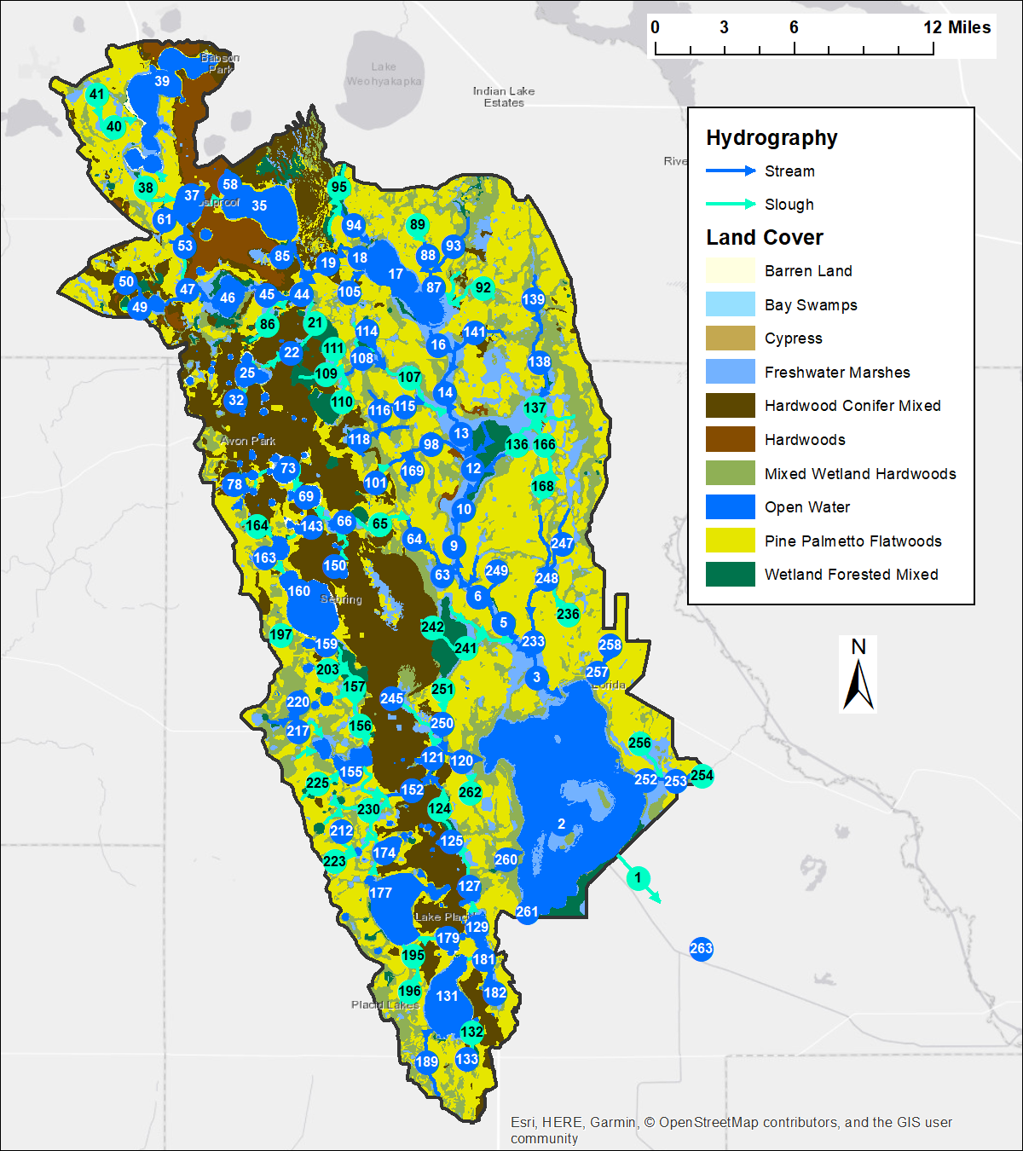
Figure 37. The Lake Istokpoga sub-watershed, showing pre-drainage land cover and hydrography with reach numbers labeled.

Water and Nutrient Loads from Source Cells
Annual totals of simulated annual water volumes and nutrient loads leaving source cells are shown in Figures 38 – 41. Overall, percolation to groundwater directly from source cells is about 60% of the total discharge from the cells.

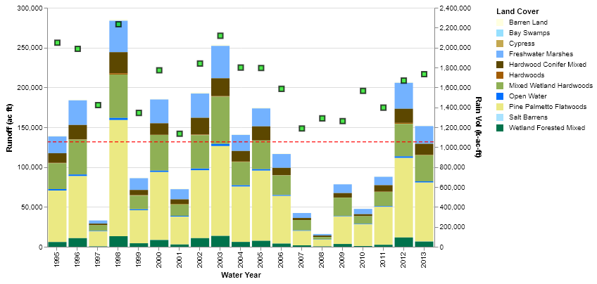
Figure 38. Source cell runoff per year in the Lake Istokpoga sub-watershed.

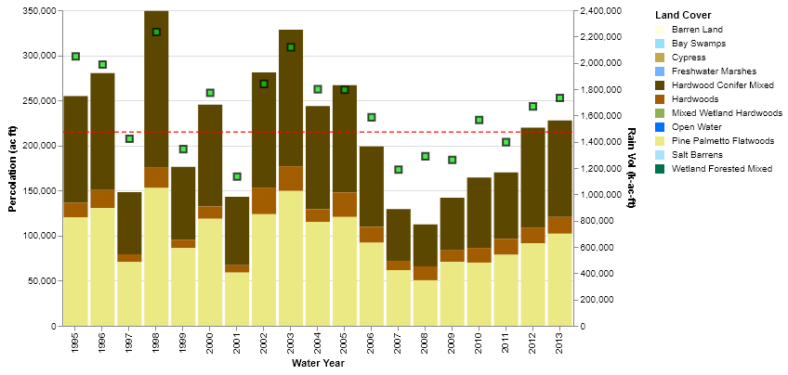
Figure 39. Source cell percolation per year in the Lake Istokpoga sub-watershed.
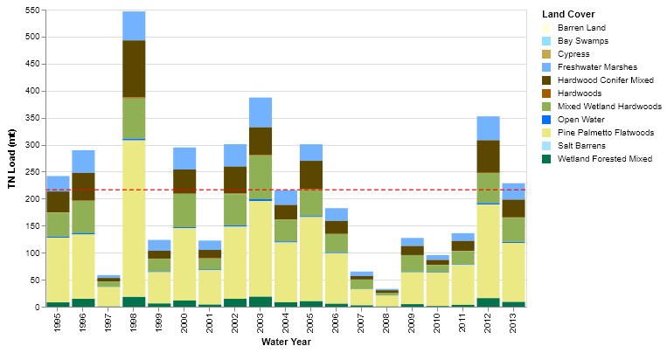
Figure 40. Source cell TN loadings per year in the Lake Istokpoga sub-watershed.
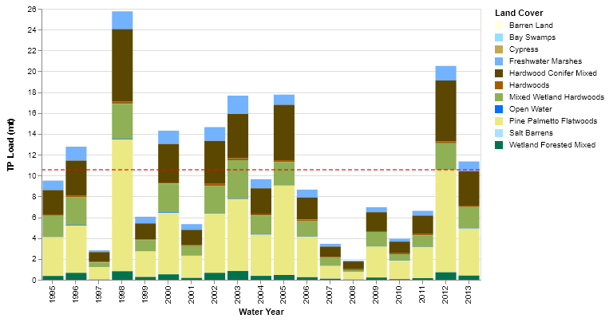
Figure 41. Source cell TP loadings per year in the Lake Istokpoga sub-watershed.

Water and Nutrient Loads Discharging from the Sub-Watershed
The simulated discharge (in m³/s) leaving the sub-watershed at the southern end of Lake Istokpoga is shown in Figure 42. The annual average discharge was slightly over 12 m³/s, corresponding to the annual average volume of nearly 316,000 acre-feet per year. Peak discharge occurred during 2002, with other peak periods in late 1995, 1999, and 2011-2013.
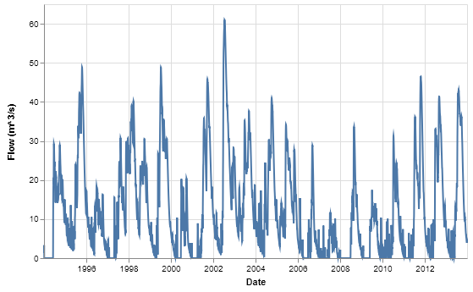
Figure 42. Simulated daily discharge from Lake Istokpoga.
Simulated concentrations of TN and TP over the modeling period are shown in Figures 43 and 44, respectively. The flow-weighted average TN concentration over the entire period was 0.97 mg/L (Table 11) with most of the concentrations in the range of 0.9 – 1.2 mg/L, with peaks slightly over 1.2 mg/L during low-flow periods. The flow-weighted TP concentration over the entire period was 0.03 mg/L with the bulk of the concentrations in the range of 0.027 – 0.035 mg/L.
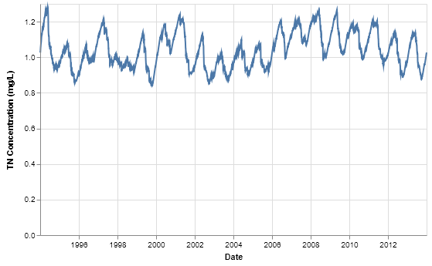
Figure 43. Simulated daily TN concentrations leaving Lake Istokpoga.
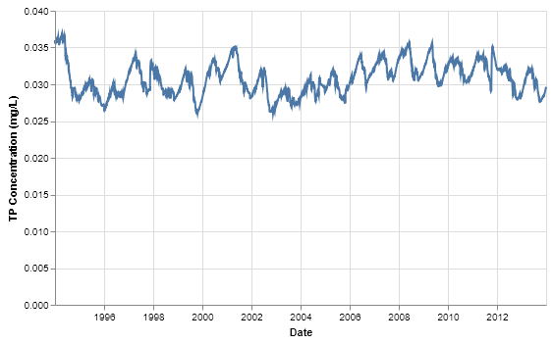
Figure 44. Simulated daily TP concentrations leaving Lake Istokpoga.

Indian Prairie
The Indian Prairie sub-watershed is located in the south-central portion of the six northern sub-watersheds, lying south of the Lake Istokpoga and Lower Kissimmee model domains and immediately north of Lake Okeechobee (Figure 45). The sub-watershed is approximately 276,400 acres in area. In the current state, the Indian Prairie sub-watershed has undergone extensive channelization, with the primary canals running from the discharge point at Lake Istokpoga south-eastward and splitting at several points before discharging into Lake Okeechobee and the Kissimmee river.
For the pre-drainage simulations, the inflow to the Indian Prairie sub-watershed from Lake Istokpoga is modeled as occurring across a broad slough at WAM reach 155. The flow across the landscape is similarly modeled as occurring across a set of broad sloughs that split and recombine at several points. The discharge into Lake Okeechobee is distributed across 14 reaches (3, 23, 38, 83, 109, 120, 127, 143, 146, 150, 151, 152, 153, 154) that are routed into a single collection reach (not shown in Figure 45) which subsequently flows into Lake Okeechobee. This step is done for accounting purposes and enables a single discharge to be calculated from the sub-watershed into the lake. No attenuation processes occur within the collection reach.
The dominant land cover is Mixed Wetland Hardwoods, followed by Freshwater Marshes and Pine Palmetto Flatwoods. In contrast to the sub-watersheds discussed above, only about 30% of the domain is simulated by EAAMod (25%) or GLEAMS (5%), with the remaining 70% simulated using the Special Case sub-model (Table 16).
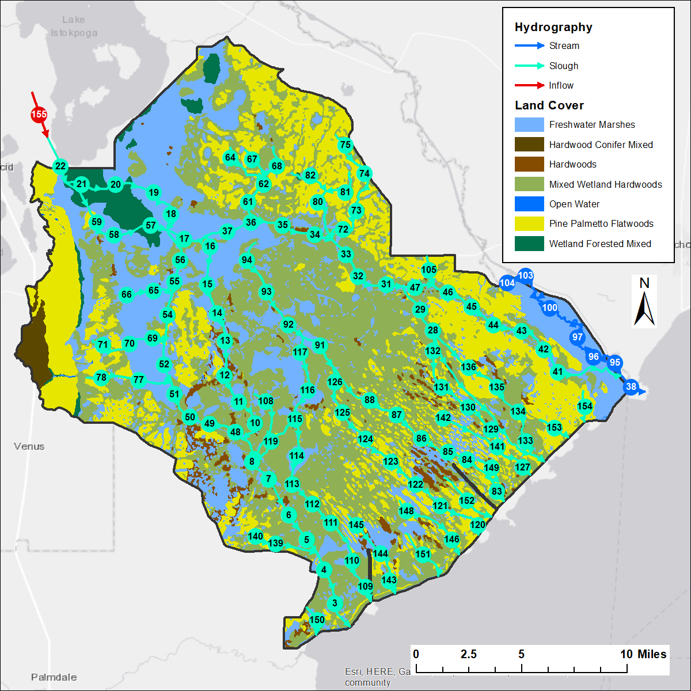
Figure 45. The Indian Prairie sub-watershed, showing pre-drainage land cover and hydrography with reach numbers labeled.

Water and Nutrient Loads from Source Cells
Annual totals of simulated annual water volumes and nutrient loads leaving source cells are shown in Figures 46 - 49. Direct percolation to groundwater accounts for about 24% of water leaving source cells. However as with other sub-watersheds dominated by high water table soils, some runoff water is routed to landscape depressions where it infiltrates to groundwater. Nutrient loads are dominated by contributions from Mixed Wetland Hardwoods, followed by Freshwater Marshes and Pine Palmetto Flatwoods.
Table 16. Breakdown of land cover acreages as run by source cell model in the Indian Prairie sub-watershed.
Land Cover | GLEAMS | EAAMod | Special Case
Pine Palmetto Flatwoods | 9,937 | 62,601
Hardwoods |  | 7,107
Hardwood Conifer Mixed | 2,501 | 9
Open Water |  |  | 427
Mixed Wetland Hardwoods |  |  | 113,147
Wetland Forested Mixed |  |  | 6,677
Freshwater Marshes |  |  | 74,004
Percent of Total | 5% | 25% | 70%

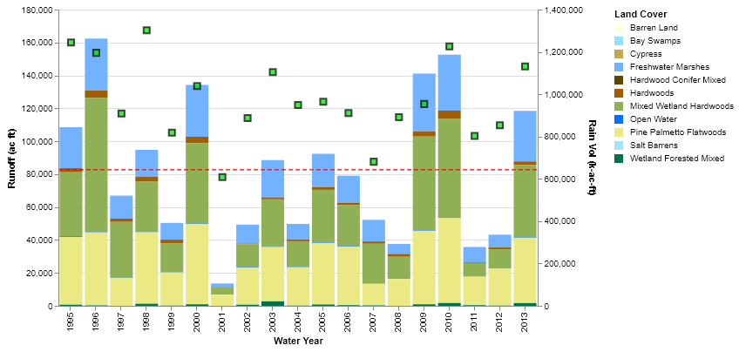
Figure 46. Source cell runoff per year in the Indian Prairie sub-watershed
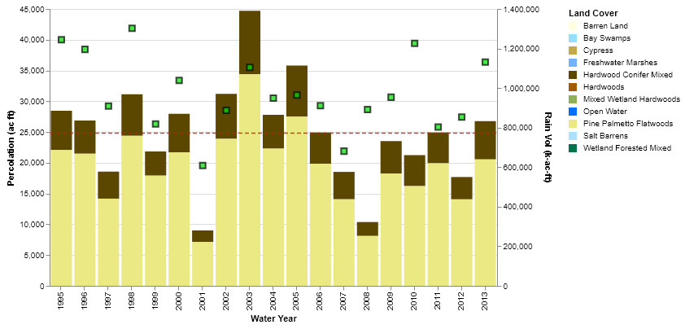
Figure 47. Source cell percolation per year in the Indian Prairie sub-watershed.
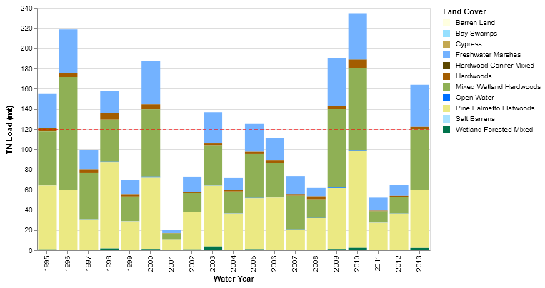
Figure 48. Source cell TN loadings per year in the Indian Prairie sub-watershed.
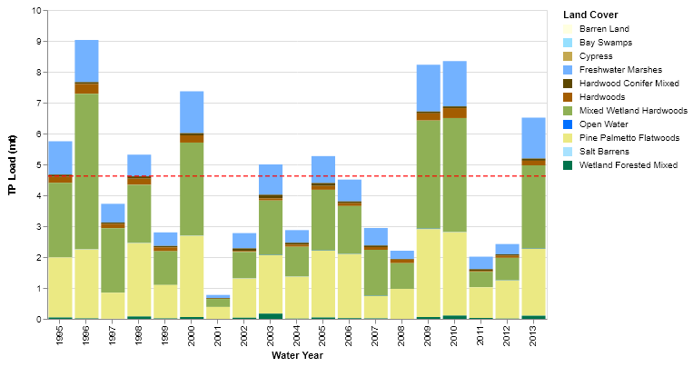
Figure 49. Source cell TP loadings per year in the Indian Prairie sub-watershed.

Water and Nutrient Loads Discharging from the Sub-Watershed
The simulated discharge from Indian Prairie into Lake Okeechobee reflects the inflow of water and nutrients from the Lake Istokpoga sub-watershed as well as the contributions from land within the Indian Prairie sub-watershed. The simulated discharge (in m³/s) leaving the sub-watershed at the boundary with Lake Okeechobee is shown in Figure 50. The annual average discharge was slightly over 16 m³/s, corresponding to the annual average volume of over 428,000 acre-feet per year. Peak discharge occurred in late 1995, 1999, and 2008.

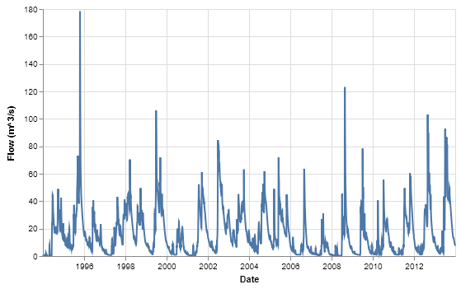
Figure 50. Simulated daily discharge from Indian Prairie to Lake Okeechobee.
Simulated concentrations of TN and TP over the modeling period are shown in Figures 51 and 52, respectively. The flow-weighted average TN concentration over the entire period was 1.016 mg/L (Table 11) with most of the concentrations in the range of 0.8 – 1.2 mg/L, with a few dips below 0.8 mg/L in early 1999 and late 2006. The flow-weighted TP concentration over the entire period was 0.032 mg/L with the concentrations oscillating in the range of 0.02 – 0.04 mg/L. As with the nutrient concentration discharging from the Lower Kissimmee sub-watershed, the dips in both TN and TP occur during low-flow periods, indicating a significant contribution from groundwater with attenuated TN and TP concentrations during those periods.

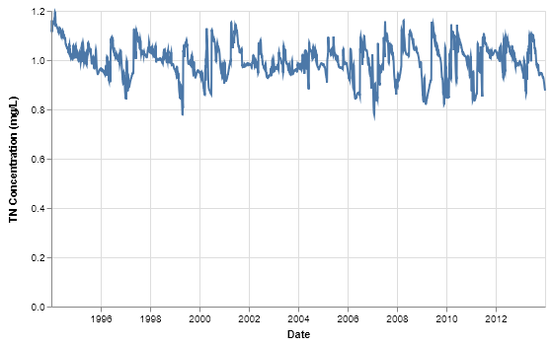
Figure 51. Simulated daily TN concentrations entering Lake Okeechobee from Indian Prairie.
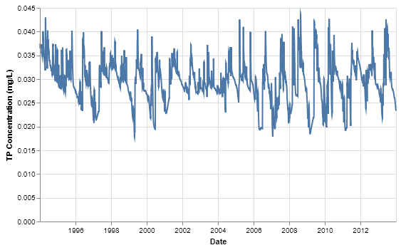
Figure 52. Simulated daily TP concentrations entering Lake Okeechobee from Indian Prairie.

Fisheating Creek
The FEC sub-watershed is located on the southwestern side of the six northern sub-watersheds. The sub-watershed is approximately 317,500 acres in area, with the southern end of the Lake Wales Ridge occupying the northeastern part of the sub-watershed. Fisheating Creek drains the sub-watershed, running from north to south along the northern part and making an easterly bend before discharging into Lake Okeechobee. In the current conditions, the sub-watershed is unique in that the discharge to Lake Okeechobee is uncontrolled, i.e., no gates or pumps exist at the mouth. The pre-drainage configuration of the sub-watershed has most of the water and nutrient contribution to Lake Okeechobee occurring via FEC, with two additional sloughs draining areas near the lake. Contributions from these three reaches are combined to determine simulated water and nutrient loads to the lake. The WAM model setup for FEC is shown in Figure 53.
The dominant pre-drainage land cover is Pine Palmetto Flatwoods, followed by Mixed Wetland Hardwoods and Freshwater Marshes (Table 2). The lower FEC floodplain is dominated by Freshwater Marshes, with Mixed Wetland Hardwoods predominating in the northern part of the sub-watershed, and Pine Palmetto Flatwoods distributed across the area. About 52% of the area is run using either EAAMod (48%) or GLEAMS (4%), with GLEAMS applied along the southern end of the Lake Wales Ridge, and EAAMod elsewhere (Table 17). The remaining 48% is run using the Special Case model.
Table 17. Breakdown of land cover acreages as run by source cell model in the FEC sub-watershed.
Land Cover | GLEAMS | EAAMod | Special Case
Pine Palmetto Flatwoods | 11,436 | 144,860
Hardwoods |  | 7,635
Hardwoods/Conifer mixed | 1,128 | 173
Open Water |  |  | 37
Bay Swamps |  |  | 2
Mixed Wetland Hardwoods |  |  | 85,187
Wetland Forested Mixed |  |  | 2,590
Freshwater Marshes |  |  | 64,996
Percent of Total | 4% | 48% | 48%

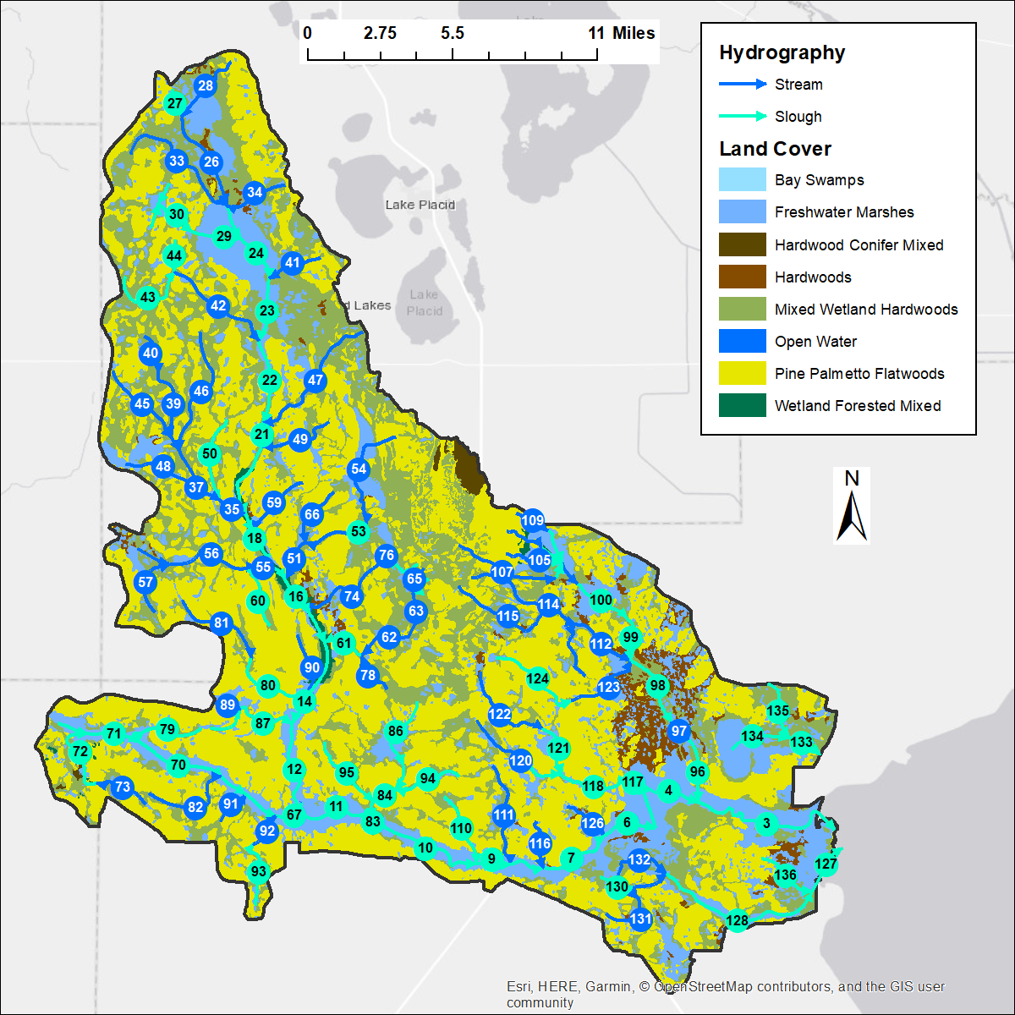
Figure 53. The FEC sub-watershed, showing pre-drainage land cover and hydrography with reach numbers labeled.

Water and Nutrient Loads from Source Cells
Annual totals of simulated annual water volumes and nutrient loads leaving source cells are shown in Figures 54 – 57. Direct percolation to groundwater accounts for about 10% of water leaving source cells. Nutrient loads are dominated by contributions from Pine Palmetto Flatwoods, followed by Mixed Wetland Hardwoods and Freshwater Marshes.

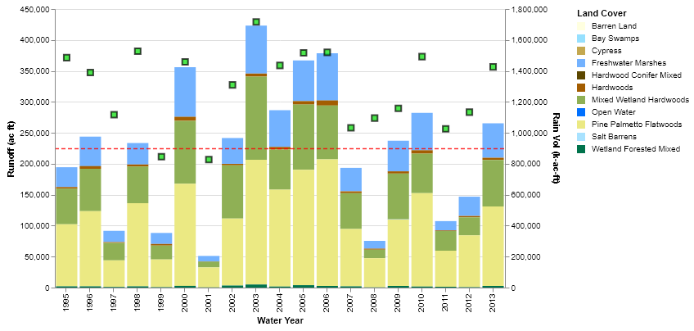
Figure 54. Source cell runoff per year in the FEC sub-watershed
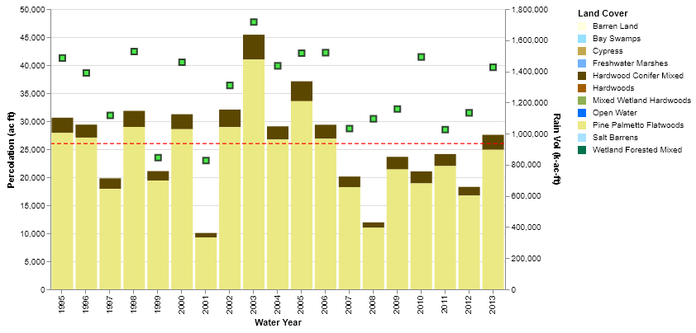
Figure 55. Source cell percolation per year in the FEC sub-watershed.
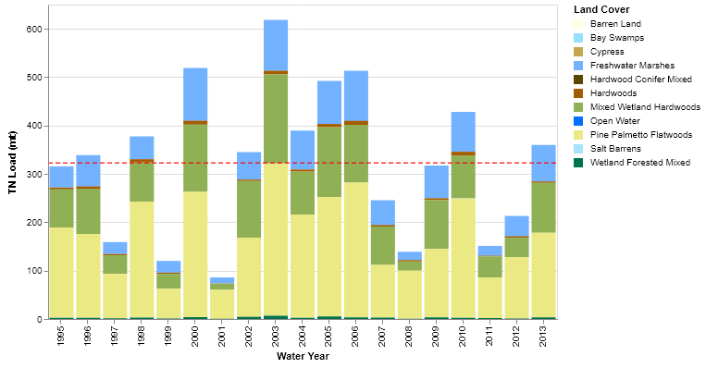
Figure 56. Source cell TN loadings per year in the FEC sub-watershed.
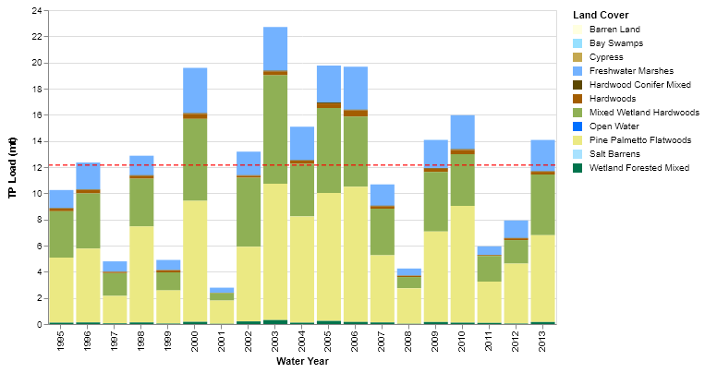
Figure 57. Source cell TP loadings per year in the FEC sub-watershed.

Water and Nutrient Loads Discharging from the Sub-Watershed
The simulated discharge (in m³/s) from FEC into Lake Okeechobee is shown in Figure 58. The annual average discharge was slightly over 10 m³/s, corresponding to the annual average volume of nearly 260,000 acre-feet per year. Peak discharges tended to occur after 2001.

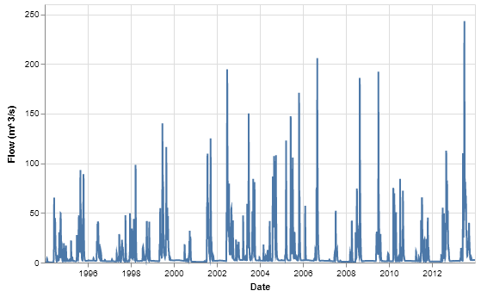
Figure 58. Simulated daily discharge from Fisheating Creek to Lake Okeechobee.
Simulated concentrations of TN and TP over the modeling period are shown in Figures 59 and 60, respectively. The flow-weighted average TN concentration over the entire period was 1.028 mg/L (Table 11) with most of the concentrations in the range of 0.7 – 1.1 mg/L. The flow-weighted TP concentration over the entire period was 0.038 mg/L with the bulk of the concentrations in the range of 0.02 – 0.04 mg/L. As was observed in the simulations in the other sub-watersheds, the lowest TN and TP occur during low-flow periods, when most of the water entering the river is from groundwater with attenuated TN and TP concentrations. Since these low concentrations occur during low-flow periods, there is little contribution to the overall loading to Lake Okeechobee.
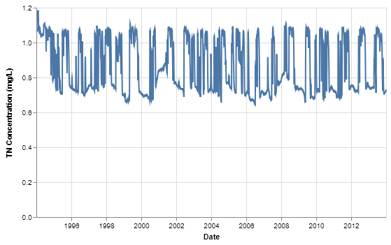
Figure 59. Simulated daily TN concentrations entering Lake Okeechobee from Fisheating Creek.
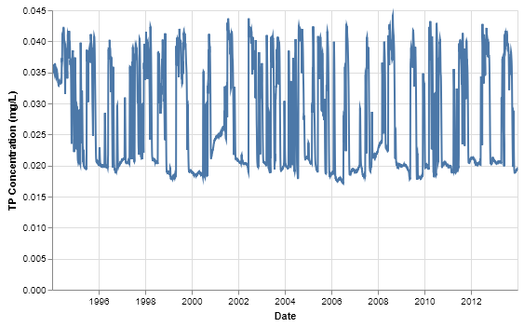
Figure 60. Simulated daily TP concentrations entering Lake Okeechobee from Fisheating Creek.

Taylor Creek/Nubbin Slough
The Taylor Creek/Nubbin Slough sub-watershed is located along the northern and north-eastern portion of Lake Okeechobee. It is approximately 197,720 acres in area (Figure 61). Under current conditions, discharges to the lake are pump and gate controlled. Taylor Creek drains the north-central part of the model domain, while Nubbin Slough drains the eastern portion. The southern part of the sub-watershed has simulated inflows from the East sub-watershed at WAM reaches 91, 92, 93, and 94. As with the Indian Prairie sub-watershed, discharge into Lake Okeechobee occurs at several reaches (3, 29, 50, 59, 71, 76, 79, 85, 88, 89, 90). Contributions from these reaches are routed into a single collection reach (reach # 2 in the WAM output files, but not shown here) to calculate the total discharge from the sub-watershed into the lake. No attenuation processes occur within the collection reach. Inflow from the East Sub-watershed occurs at what is now the eastern boundary of the S-135 basin. These inflows have been subtracted from the TCNS outflows for the results presented in Table 11, similar to how the contribution from the Upper Kissimmee Sub-watershed was subtracted from the Lower Kissimmee results. Note that the daily flows and loads contributing to Lake Okeechobee shown in Figures 66 - 68 include the contributions from the East Sub-watershed.
The dominant land cover is Pine Palmetto Flatwoods, followed by Freshwater Marshes, Mixed Wetland Hardwoods, and Hardwood/Conifer Mixed. Freshwater Marshes dominate the landscape adjacent to the lake, with Pine Palmetto Flatwoods covering the majority of land away from the lake to the north and east. Mixed Wetland Hardwoods is scattered throughout the area, with Hardwood/Conifer Mixed covering the south-east part of the domain away from the lake. About 63% of the area is simulated using the EAAMod sub-model, with only 1% simulated using GLEAMS sub-models, and the remaining 37% simulated using the Special Case sub-model (Table 18).
Table 18. Breakdown of land cover acreages as run by source cell model in the Taylor Creek/Nubbin Slough.
Land Cover | GLEAMS | EAAMod | Special Case
Pine Palmetto Flatwoods | 655 | 105,791
Hardwoods |  | 2,320
Hardwoods/Conifer mixed | 1,100 | 15,633
Open Water |  |  | 2,743
Bay Swamps |  |  | 11
Mixed Wetland Hardwoods |  |  | 27,548
Cypress |  |  | 2
Wetland Forested Mixed |  |  | 2,804
Freshwater Marshes |  |  | 39,113
Percent of Total | 1% | 63% | 37%

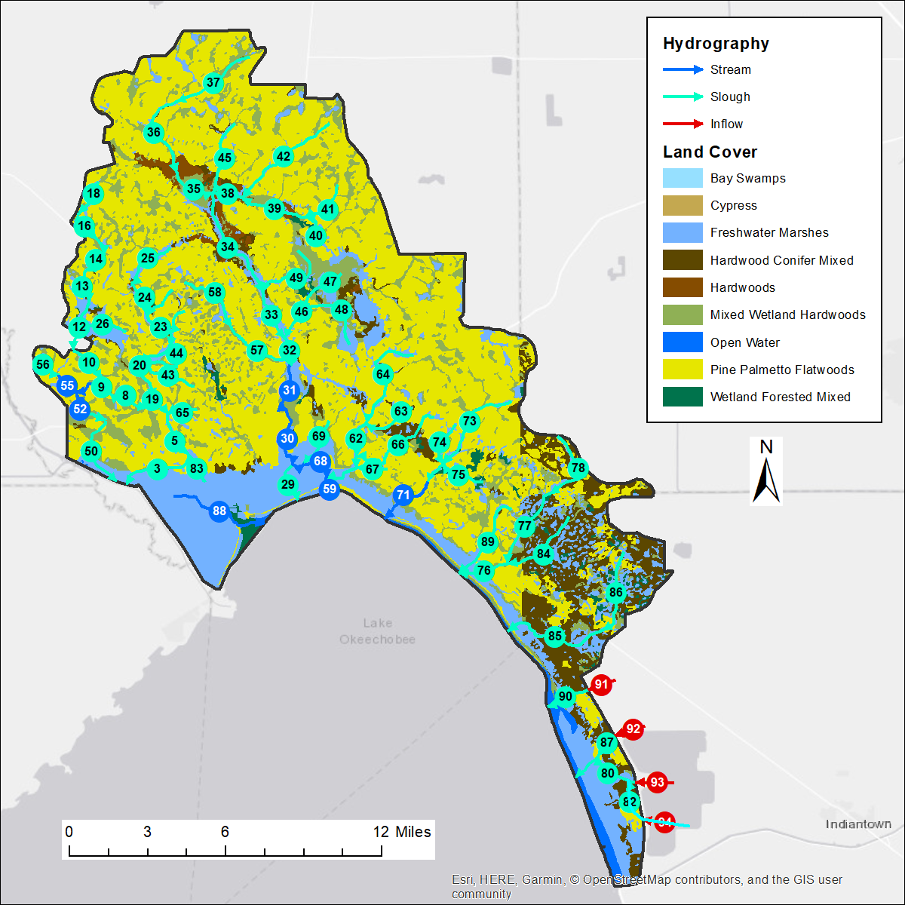
Figure 61. The Taylor Creek/Nubbin Slough sub-watershed, showing pre-drainage land cover and hydrography with reach numbers labeled.

Water and Nutrient Loads from Source Cells
Annual totals of simulated annual water volumes and nutrient loads leaving source cells are shown in Figures 62 – 65. Because of the large amounts of high water table soils, direct percolation to groundwater accounts for about 0.1% of water leaving source cells. However as before, some runoff water is routed to landscape depressions where it infiltrates to groundwater. Nutrient loads are dominated by contributions Pine Palmetto Flatwoods and Hardwood/Conifer Mixed.

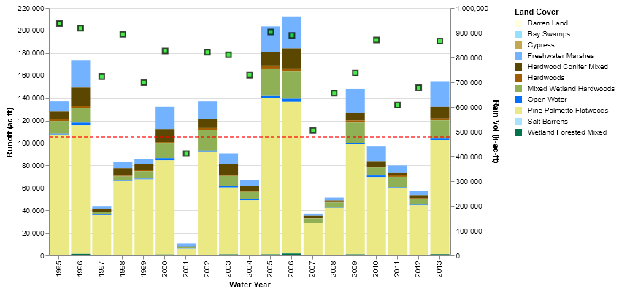
Figure 62. Source cell runoff per year in the Taylor Creek/Nubbin Slough sub-watershed.
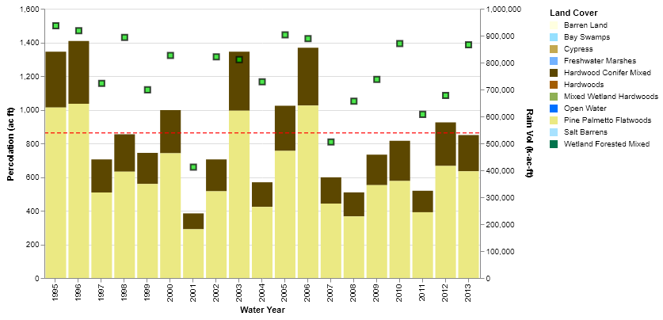
Figure 63. Source cell percolation per year in the Taylor Creek/Nubbin Slough sub-watershed.
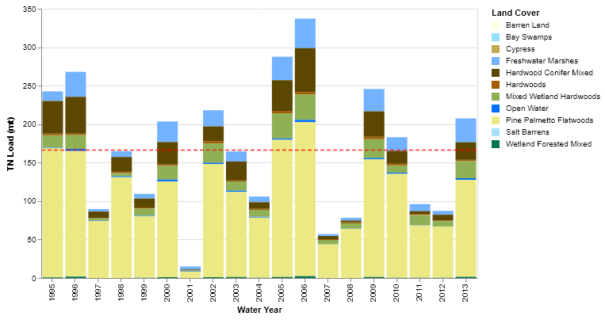
Figure 64. Source cell TN loadings per year in the Taylor Creek/Nubbin Slough sub-watershed.
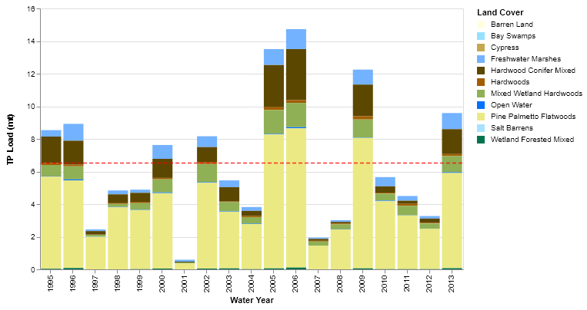
Figure 65. Source cell TP loadings per year in the Taylor Creek/Nubbin Slough sub-watershed.

Water and Nutrient Loads Discharging from the Sub-Watershed
The simulated discharge (in m³/s) from Taylor Creek/Nubbin Slough into Lake Okeechobee along the sub-watershed is shown in Figure 66. This discharge reflects inflows from the East sub-watershed as well. The annual average discharge was nearly 7 m³/s, corresponding to the annual average volume of about 173,000 acre-feet per year. Peak discharge occurred in 2008 and 2012, with other peaks in 2004 and late 2005.
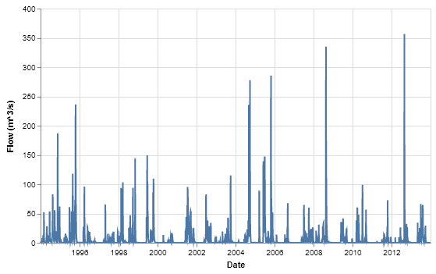
Figure 66. Simulated daily discharge from Taylor Creek/Nubbin Slough sub-watershed to Lake Okeechobee.
Simulated concentrations of TN and TP over the modeling period are shown in Figures 67 and 68, respectively, with both nutrients having a greater degree of variability than other sub-watersheds. The flow-weighted average TN concentration over the entire period was 1.13 mg/L (Table 11) with the concentrations oscillating in the range of 0.6 – 1.2 mg/L, with a few dips below 0.6 mg/L in early 1996 and late 2008/early 2009. The flow-weighted TP concentration over the entire period was 0.042 mg/L with the concentrations oscillating in the range of 0.02 – 0.045 mg/L, with peaks up to nearly 0.06 mg/L and dips down to almost 0.01 mg/L.

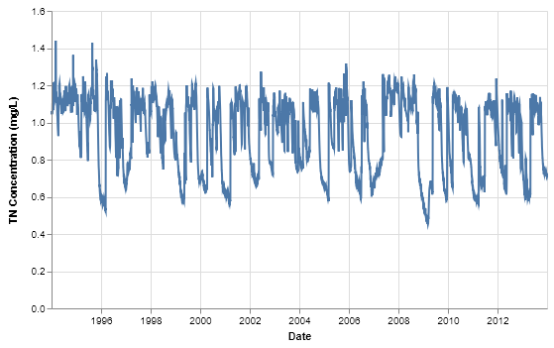
Figure 67. Simulated daily TN concentrations entering Lake Okeechobee from Taylor Creek/Nubbin Slough sub-watershed.
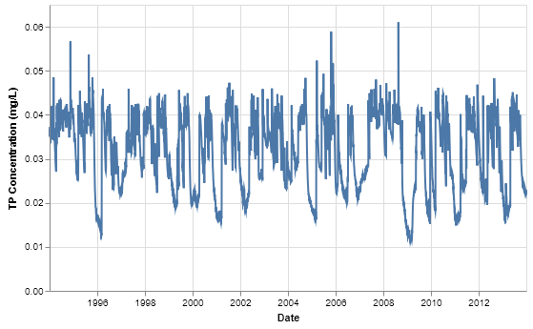
Figure 68. Simulated daily TP concentrations entering Lake Okeechobee from Taylor Creek/Nubbin Slough sub-watershed.

East Lake Okeechobee Sub-Watershed
The East sub-watershed is located along the eastern and south-eastern portion of Lake Okeechobee. It is approximately 239,014 acres in area (Figure 69). Under current conditions, most of the discharge is out of Lake Okeechobee at structure S308, east down the C-44 Canal, and discharging to the east at structure S-80. However, discharge back to the lake occurs as well. In the pre-drainage configuration, Said and Brown (2013) indicate a significant portion of water flows to the west into Lake Okeechobee, across the south-eastern part of the Taylor Creek/Nubbin Slough sub-watershed, to the southwest into the sawgrass plain south of the lake, as well as some discharge east.
Using the topographic coverage provided by the SFWMD, it was determined that most of the overland flow direction was either to Lake Okeechobee or the Southern sub-watershed. To simulate this, a series of broad sloughs were incorporated into the hydrography. The northeastern-most part of the domain discharges to WAM reach 68 while the southeastern part discharges to WAM reach 63. Both reach 63 and 68 are simulated as fixed-head boundary conditions. The rest of the southern half of the domain discharges to the sawgrass plain in the Southern sub-watershed. A small part along the western edge discharges directly to the lake at WAM reaches 58 and 62. The remaining part of the northern half discharges into the Taylor Creek/Nubbin Slough sub-watershed and is included with that sub-watershed’s contribution to Lake Okeechobee (see Figures 66 – 68).
The dominant land cover is Mixed Wetland Hardwoods, followed by Hardwood/Conifer Mixed, Pine Palmetto Flatwoods, and Freshwater Marshes (Table 2). About 35% of the area is simulated using the EAAMod sub-model, while only about 1% uses GLEAMS (14%) (Table 19). The remaining 64% is simulated using the Special Case sub-model.
Table 19. Breakdown of land cover acreages as run by source cell model in the East Lake Okeechobee sub-watershed.
Land Cover | GLEAMS | EAAMod | Special Case
Pine Palmetto Flatwoods | 52 | 41,533
Hardwoods/Conifer mixed | 2,084 | 41,380
Open Water |  |  | 575
Mixed Wetland Hardwoods |  |  | 32,786
Cypress |  |  | 2,536
Wetland Forested Mixed |  |  | 79,192
Freshwater Marshes |  |  | 38,876
Percent of Total | 1% | 35% | 64%

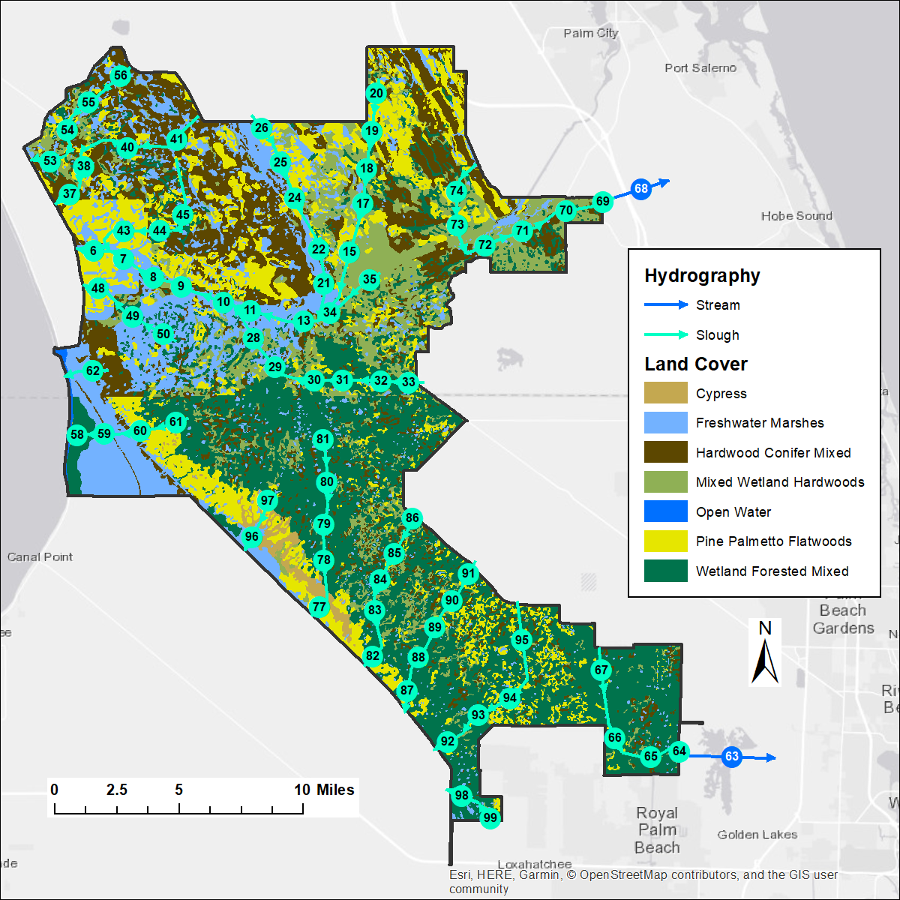
Figure 69. The East sub-watershed, showing pre-drainage land cover and hydrography with reach numbers labeled.

Water and Nutrient Loads from Source Cells
Annual totals of simulated annual water volumes and nutrient loads leaving source cells are shown in Figures 70 – 73. Direct percolation to groundwater accounts for less than 0.1% of water leaving source cells. Nutrient loads are dominated by contributions from Hardwood/Conifer Mixed, followed by Pine Palmetto Flatwoods.

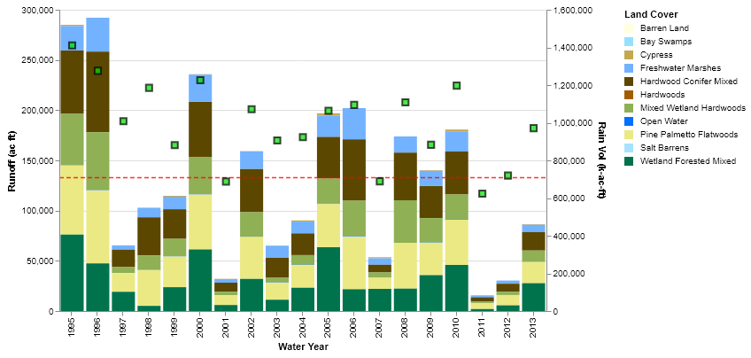
Figure 70. Source cell runoff per year in the East sub-watershed.

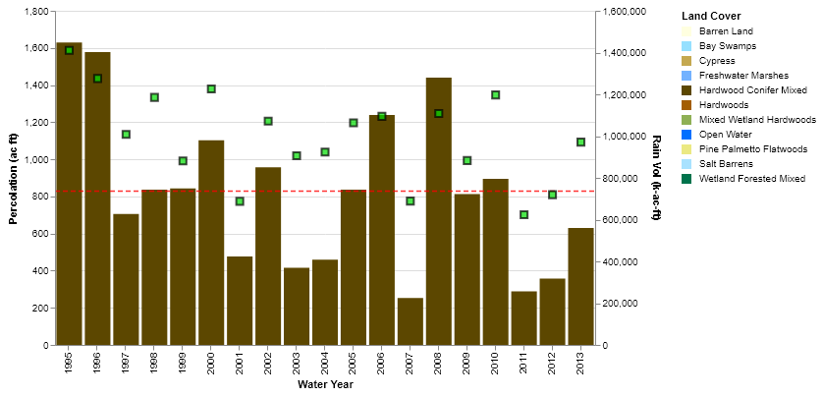
Figure 71. Source cell percolation per year in the East sub-watershed.
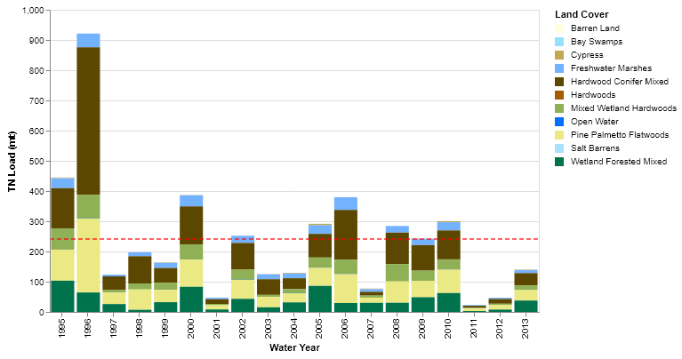
Figure 72. Source cell TN loadings per year in the East sub-watershed.
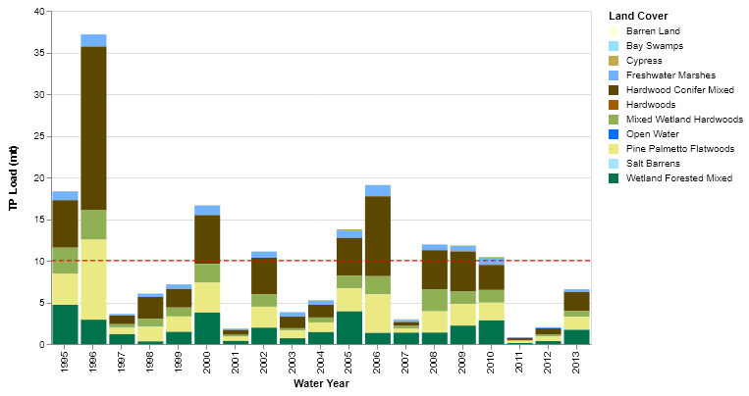
Figure 73. Source cell TP loadings per year in the East sub-watershed.

Water and Nutrient Loads Discharging from the Sub-Watershed
The simulated discharge (in m³/s) from the East sub-watershed directly into Lake Okeechobee is shown in Figure 74. The annual average discharge was barely over 0.3 m³/s, corresponding to the annual average volume of slightly over 8,000 acre-feet per year. Again, this represents only a fraction of the total water discharging from the sub-watershed, with most of the rest of the contribution accounted for in the discharge from Taylor Creek/Nubbin Slough or not entering the lake at all, i.e., discharging into the South sub-watershed or to the east.
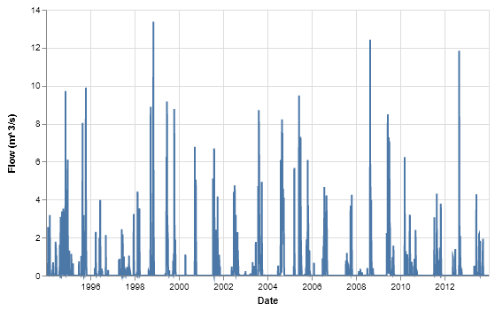
Figure 74. Simulated daily discharge from the East sub-watershed to Lake Okeechobee.
Simulated concentrations of TN and TP over the modeling period are shown in Figures 75 and 76, respectively. The flow-weighted average TN concentration over the entire period was 1.137 mg/L (Table 11) with most of the concentrations in the range of 1.0 – 1.2 mg/L, but with frequent downward spikes to 0.4 mg/L. The flow-weighted TP concentration over the entire period was 0.037 mg/L with the bulk of the concentrations in the range of 0.03 – 0.04 mg/L, with a few spikes upward to over 0.05 mg/L. As was observed in the simulations in the other sub-watersheds, the lowest TN and TP concentrations occur during low-flow periods due to groundwater inflow and contribute little to the overall loading to Lake Okeechobee.

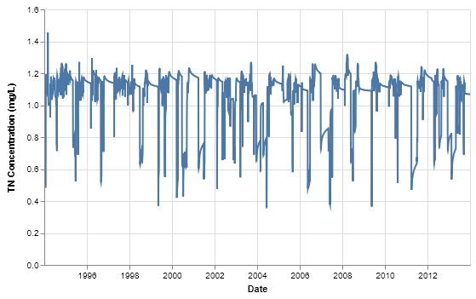
Figure 75. Simulated daily TN concentrations entering Lake Okeechobee from the East sub-watershed.
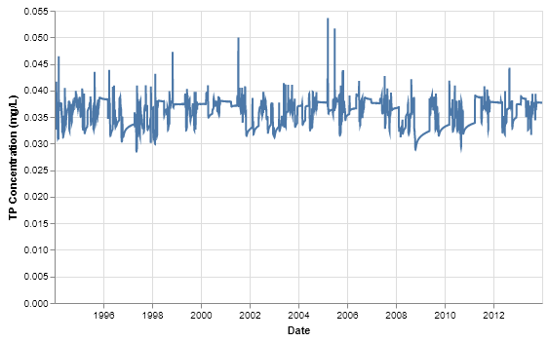
Figure 76. Simulated daily TP concentrations entering Lake Okeechobee from the East sub-watershed.

West Lake Okeechobee Sub-Watershed
The West sub-watershed is located along the western and south-western portion of Lake Okeechobee. It is approximately 204,095 acres in area (Figure 77). Under current conditions, much of the discharge (both to and out of Lake Okeechobee) is from structures C-5A and S-77. In the pre-drainage configuration, Said and Brown (2013) indicate a significant portion of water flow to the west to the headwaters of the Caloosahatchee River, which McVoy et al. (2011) indicated was originally a wide marshy area. This was simulated as a swath of wide sloughs (WAM reaches 53-55 and 74-72) that connect Lake Okeechobee to Lake Hicpochee (WAM reach 37) which is in turn connected to the Caloosahatchee River (from west to east, WAM reaches 2-10). The inflow reach representing Lake Okeechobee is WAM reach 56. The sloughs surrounding Lake Hicpochee form a very flat area that is only slightly elevated relative to the terrain to the east and west of Lake Hicpochee. Only when the water level in Lake Okeechobee is high enough will water discharge from Lake Okeechobee down the Caloosahatchee River. To simulate the stage of Lake Okeechobee, a simple model (Appendix C, Section 7) was developed that takes the inflow from the FEC, Indian Prairie, Kissimmee River, and Taylor Creek/Nubbin Slough sub-watersheds and determines a time series of stage elevations. This lake model assumes that discharge from the lake will only occur if the stage is at 20 feet (NGVD, 6.096 m). This same model was used as a stage boundary condition for the Southern sub-watershed, described in the following section.
The dominant land cover is Pine Palmetto Flatwoods, followed by Freshwater Marshes and Mixed Wetland Hardwoods (Table 2). About 54% of the area is simulated using the EAAMod sub-model, less than 1% is run using GLEAMS, 43% is simulated using the Special Case sub-model (Table 20), with the remaining 3% is direct contribution of rainfall to lakes.
Table 20. Breakdown of land cover acreages as run by source cell model in the West Lake Okeechobee sub-watershed.
Land Cover | GLEAMS | EAAMod | Special Case | None
Pine Palmetto Flatwoods |  | 95,655
Hardwoods |  | 1,235
Hardwoods/Conifer mixed | 405 | 13,520
Open Water |  |  | 1,001
Mixed Wetland Hardwoods |  |  | 28,247
Cypress |  |  | 684
Wetland Forested Mixed |  |  | 3,422
Freshwater Marshes |  |  | 53,986
Lakes |  |  |  | 5,940
Percent of Total | 0% | 54% | 43% | 3

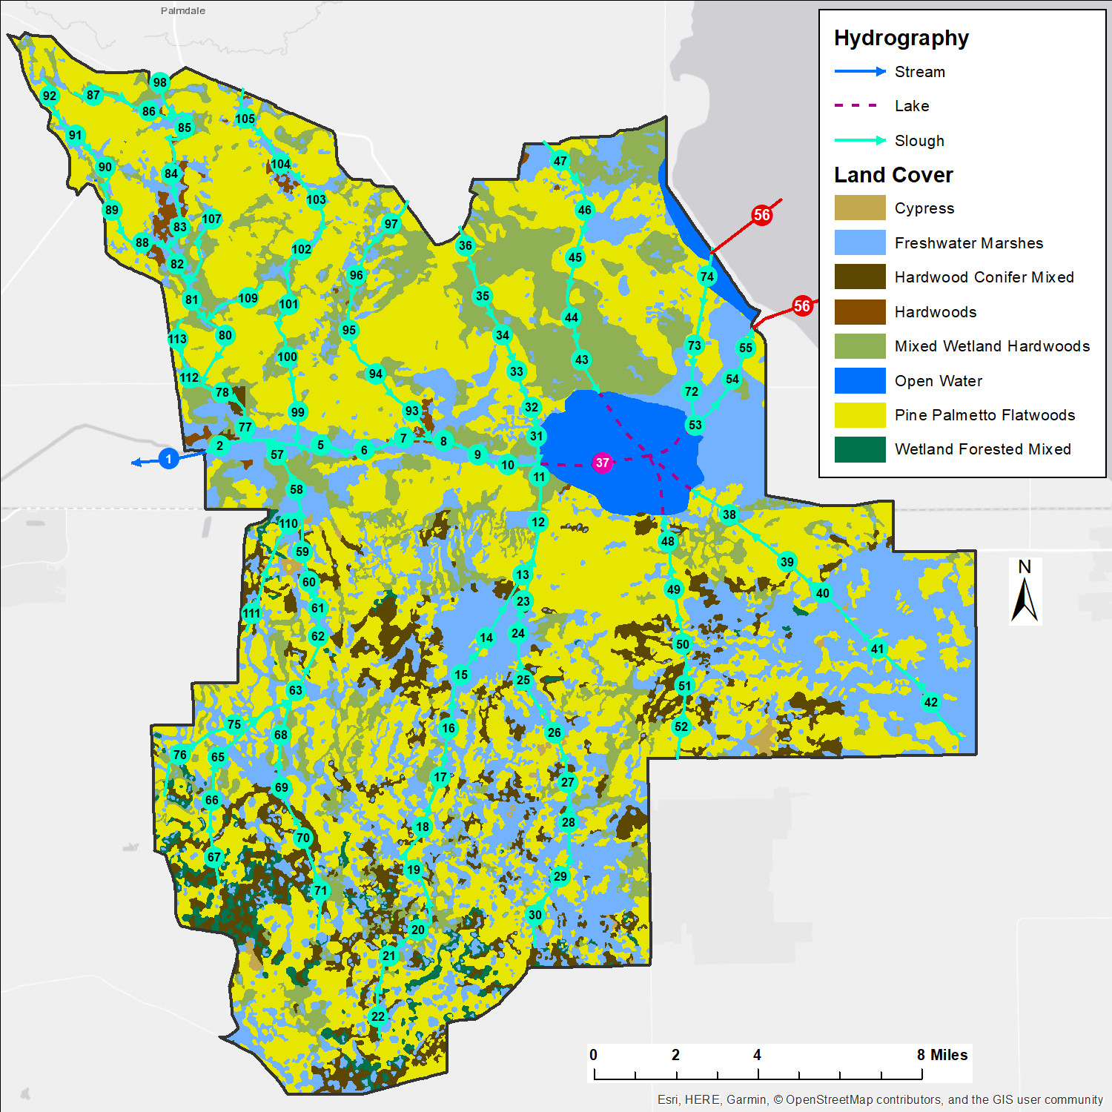
Figure 77. The West sub-watershed, showing pre-drainage land cover and hydrography with reach numbers labeled.

Water and Nutrient Loads from Source Cells
Annual totals of simulated annual water volumes and nutrient loads leaving source cells are shown in Figures 78 – 80. There is no direct percolation to groundwater in the sub-watershed, but since there are numerous depressions, overland flow to depression areas results in percolation to groundwater. Nutrient loads are dominated by contributions from Pine Palmetto Flatwoods, followed by Freshwater Marshes and Hardwood/Conifer Mixed.
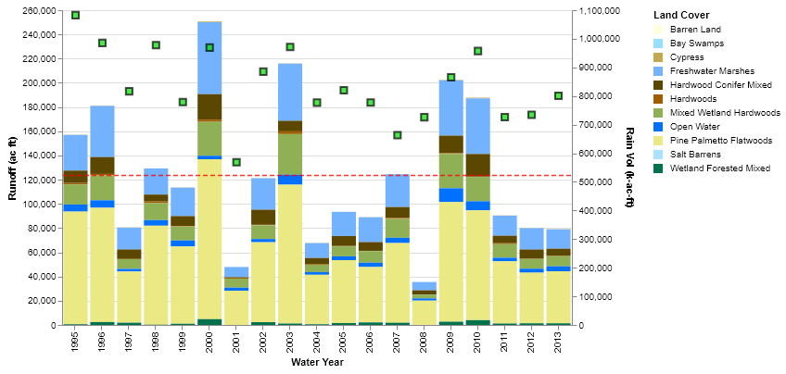
Figure 78. Source cell runoff per year in the West sub-watershed.
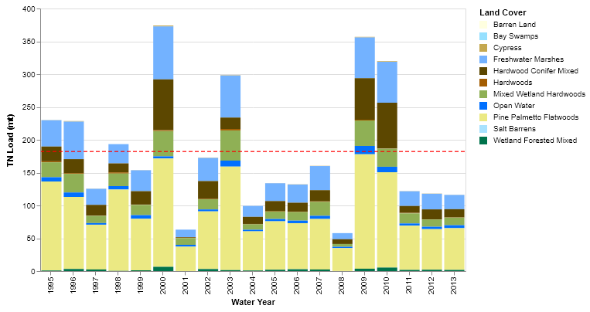
Figure 79. Source cell TN loadings per year in the West sub-watershed.
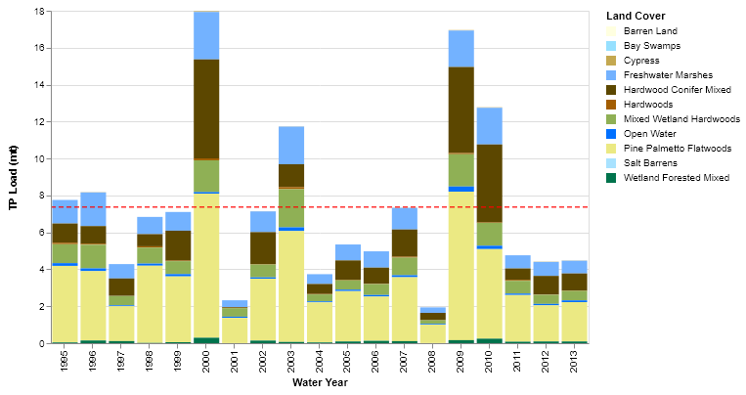
Figure 80. Source cell TP loadings per year in the West sub-watershed.

Water and Nutrient Loads Discharging from the Sub-Watershed
The simulated discharge (in m³/s) entering Lake Okeechobee from the West sub-watershed is shown in Figure 81. The annual average discharge was slightly over 1 m³/s, corresponding to the annual average volume of over 28,000 acre-feet per year. Note that there is some discharge from Lake Okeechobee into the West sub-watershed as indicated by the negative flow values.
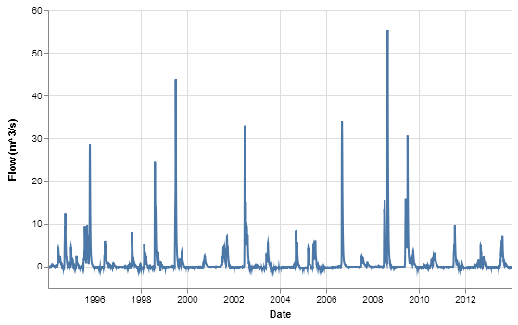
Figure 81. Simulated daily discharge from the West sub-watershed to Lake Okeechobee.
Simulated concentrations of TN and TP over the modeling period are shown in Figures 82 and 83, respectively, with both nutrients showing some degree of variability. The flow-weighted average TN concentration over the entire period was 1.16 mg/L (Table 11) with the concentrations oscillating in the range of 0.4 – 1.4 mg/L. The flow-weighted TP concentration over the entire period was 0.042 mg/L with the concentrations oscillating in the range of 0.04 – 0.06 mg/L, with peaks up to nearly 0.07 mg/L.

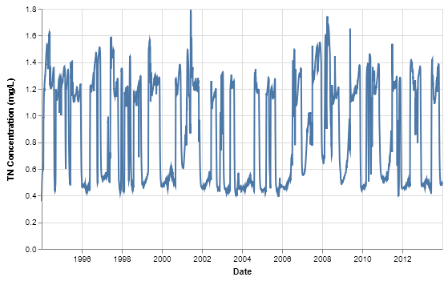
Figure 82. Simulated daily TN concentrations entering Lake Okeechobee from the West sub-watershed.
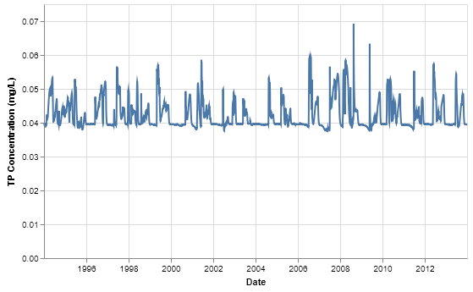
Figure 83. Simulated daily TP concentrations entering Lake Okeechobee from the West sub-watershed.

South Lake Okeechobee Sub-Watershed
The Southern sub-watershed is dominated by the wide expanse of the sawgrass plain to the south of Lake Okeechobee, which is simulated in WAM as the land cover Freshwater Marshes. Immediately south of the lake is an area of Custard Apple, shown in Figure 84 (and simulated) as Wetland Forested Mixed. The Southern sub-watershed is approximately 540,450 acres in area. A minor amount of the area along the western edge is simulated as Pine Palmetto Flatwoods (about 3%). The majority of the area (97%) is simulated using the Special Case sub-model, while the 3% is simulated using EAAMod and less than 1% is simulated using GLEAMS (Table 21).
The hydrography is simulated as a series of five very broad sloughs, each divided into sets of reaches, with each reach multiple kilometers wide. The sloughs slope very gradually from north to south. Inflow from Lake Okeechobee is determined by using the time series of stages discussed in the previous section. Water flows into the sloughs when the stage exceeds 20 feet (NGVD). A minor amount of inflow from the East sub-watershed occurs via a set of reaches along the eastern part of the domain (WAM reaches 66-71). Note that no flow occurs from the sub-watershed back into Lake Okeechobee, therefore, there are no nutrient contributions from the sub-watershed to the lake.

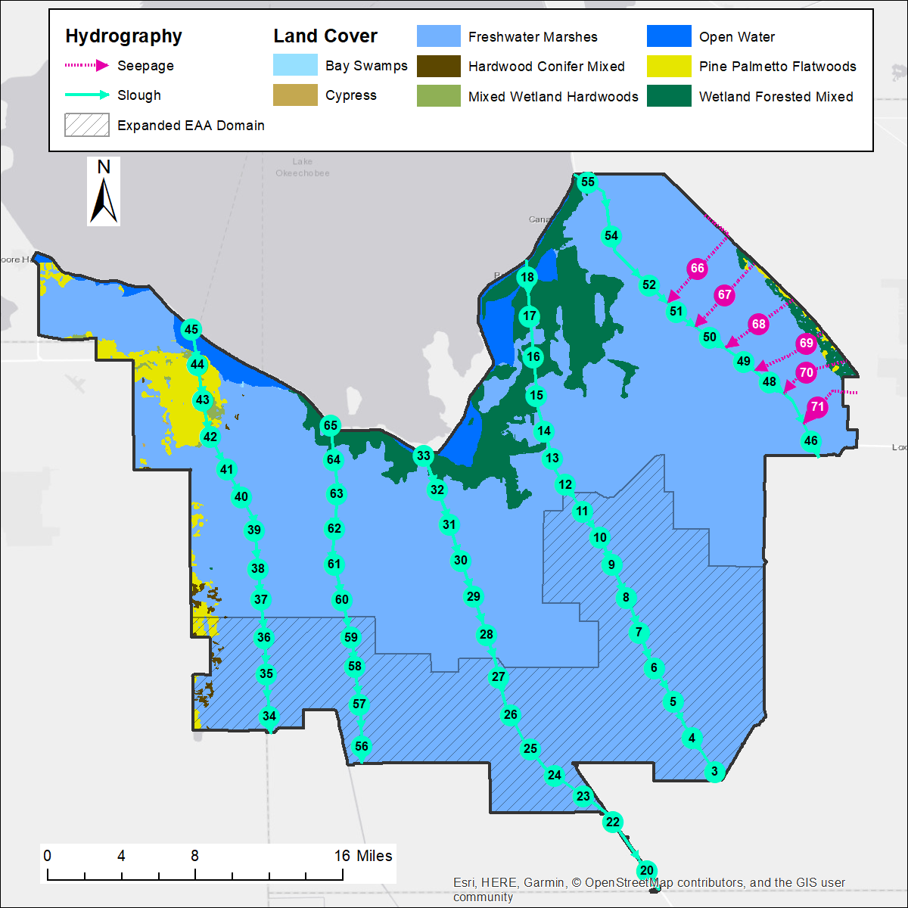
Figure 84. The South sub-watershed (including the expanded area), showing pre-drainage land cover and hydrography with reach numbers labeled.

Water and Nutrient Loads from Source Cells
Annual totals of simulated annual water volumes and nutrient loads leaving source cells are shown in Figures 85 - 87. As with the West sub-watershed, there is no direct percolation to groundwater in the sub-watershed. Note that there are no simulated depressions within the sub-watershed, so neither are there contributions to groundwater from that mechanism. Nutrient loads are dominated by contributions from the wide expanse of Freshwater Marshes.

Table 21. Breakdown of land cover acreages as run by source cell model in the South Lake Okeechobee sub-watershed.
Land Cover | GLEAMS | EAAMod | Special Case
Pine Palmetto Flatwoods |  | 14,929
Hardwoods/Conifer mixed | 794 | 462
Open Water |  |  | 13,875
Bay Swamps |  |  | 30
Mixed Wetland Hardwoods |  |  | 1,371
Cypress |  |  | 46
Wetland Forested Mixed |  |  | 40,639
Freshwater Marshes |  |  | 468,308
Percent of Total | 0% | 3% | 97%

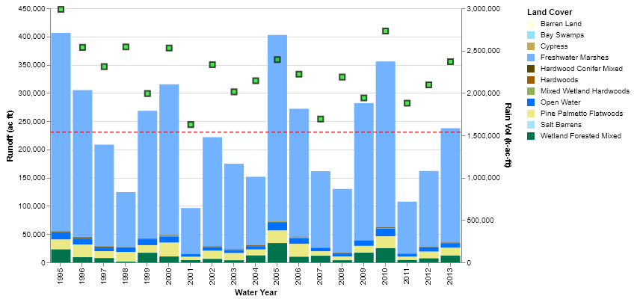
Figure 85. Source cell runoff per year in the South sub-watershed.

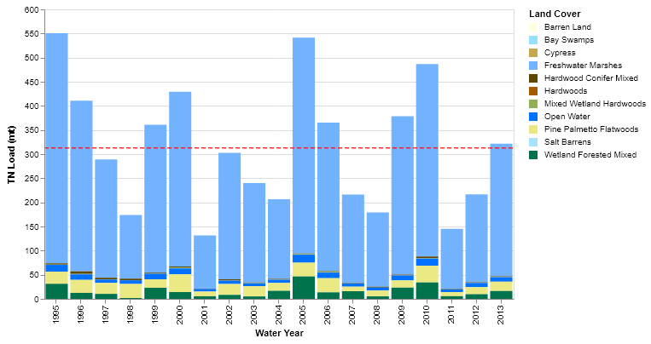
Figure 86. Source cell TN loadings per year in the South sub-watershed.
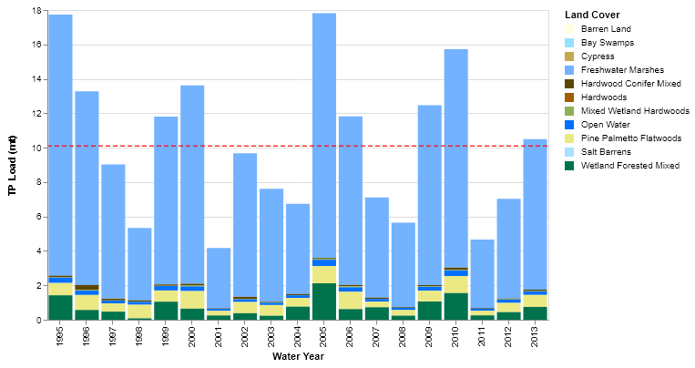
Figure 87. Source cell TP loadings per year in the South sub-watershed.

Water and Nutrient Loads Discharging from the Sub-Watershed
The simulated discharge (in m³/s) from the southern end of the South sub-watershed directly into the Everglades is shown in Figure 88. The annual average discharge was about 70 m³/s, corresponding to the annual average volume of over 1.8 million acre-feet per year. Peak discharges are near 250 m³/s.
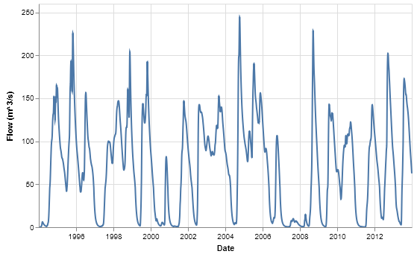
Figure 88. Simulated daily discharge from the South sub-watershed out of the domain.
Simulated concentrations of TN and TP over the modeling period are shown in Figures 89 and 90, respectively. The flow-weighted average TN concentration over the entire period was 0.74 mg/L (Table 11) with the concentrations oscillating in the range of 0.6 – 1.1 mg/L. The flow-weighted TP concentration over the entire period was 0.013 mg/L with the concentrations in the range of 0.008 – 0.02 mg/L, with peaks slightly over 0.02 mg/L.
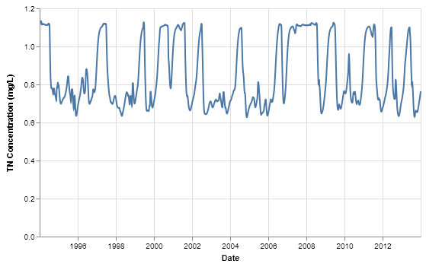
Figure 89. Simulated daily TN concentrations at the south boundary of the South sub-watershed.
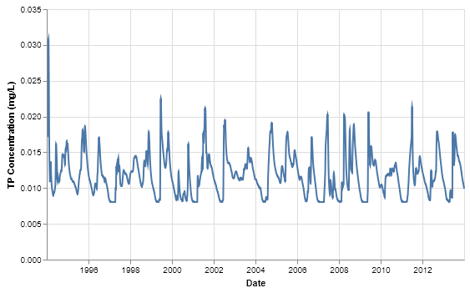
Figure 90. Simulated daily TP concentrations at the south boundary of the South sub-watershed.

Conclusions
WAM was successfully set up and run to simulate the pre-drainage conditions for the nine sub-watersheds associated with the Lake Okeechobee BMAP. The flows and TN and TP loads to Lake Okeechobee were predicted from these sub-watersheds over a twenty-year simulation period on a daily time scale. The simulated TP concentrations of the water discharging into Lake Okeechobee are similar to the Lake Okeechobee TMDL of 0.04 mg/L. The upland source cell TP concentrations are in the order of 0.045-0.055 mg/L but are attenuated down to less than 0.04 mg/L before reaching the lake. The TN concentrations entering Lake Okeechobee are a little over 1 mg/L, which is only slightly less than existing conditions since most anthropogenic nitrogen inputs are quickly assimilated in the flatwoods and sloughs characteristic of the watershed.
The predicted pre-drainage TP concentrations in water discharging into the Everglades are about 0.013 mg/L, which is slightly higher than the current TP target of 0.01 mg/L for EAA discharges to the conservation areas. These estimates can be improved by mapping a more oligotrophic sawgrass wetland type in the southern part of the EAA to better represent the assimilative capacity and background TP concentrations there.

References
Bottcher, A.B. and F.T. Izuno, 1994. Everglades Agricultural Area (EAA) – Water, Soil, Crops, and Environmental Management. University Press of Florida. Gainesville, FL
Bottcher, A.B., B.J. Whiteley, A.I. James, and J.G. Hiscock, 2012. Watershed assessment model (WAM): model use, calibration, and validation. Transactions of the ASABE 55, 1367–1383.
Bousquin, S. G., D. H. Anderson, G. E. Williams, and D. J. Colangelo, 2005. Establishing a Baseline: Pre-restoration Studies of the Channelized Kissimmee River. SFWMD Technical Publication ERA 432. South Florida Water Management District, West Palm Beach, FL.
Brenner, M., T. J. Whitmore, M. S. Flannery, and M. W. Binford, 1993. Paleolimnological methods for defining target conditions in lake restoration: Florida case studies. Lake and Reservoir Management 7(2), 209-217.
Bridges, E.L., 2006. Historical Accounts of Vegetation in the Kissimmee River Dry Prairie Landscape. Pages 43-63 in R.G. Noss, ed.: Land of Fire and Water: The Florida Dry Prairie Ecosystem. Proceedings of the Florida Dry Prairie Conference. Painter, DeLeon Springs, FL.
Brown, M.T., 1995. Water Quality and Wildlife Values of Wetlands. White Paper for Soil and Water Engineering Technology, Inc. Gainesville, FL.
Donigian, A.S., 2002. Watershed model calibration and validation: The HSPF experience. WEF National TMDL Science and Policy 2002, November 13-16, 2002. Phoenix, AZ.
Federico, A. C., 1977. Investigations of the relationship between land use, rainfall, and runoff quality in the Taylor Creek Watershed. SFWMD Technical Publication No. 77-3. South Florida Water Management District, West Palm Beach, FL.
Federico, A. C., 1982. Water quality characteristics of the lower Kissimmee River basin, Florida. SFWMD Technical Publication No 82-3. South Florida Water Management District, West Palm Beach, FL.
Federico, A., K. Dickson, C., Kratzer, and F. Davis. 1981. Lake Okeechobee water quality studies and eutrophication assessment. SFWMD Technical Publication No 81-2. South Florida Water Management District, West Palm Beach, FL.
Florida Department of Environmental Protection, 2001. Total Maximum Daily Load for Total Phosphorus in Lake Okeechobee, Florida. Florida Department of Environmental Protection, Tallahassee, Florida. August.
FDEP. 2014. Final Basin Management Action Plan for the Implementation of Total Maximum Daily Loads for Total Phosphorus by the Florida Department of Environmental Protection in Lake Okeechobee. Prepared by the Florida Department of Environmental Protection, Tallahassee, FL. December 2014.

Florida Department of Transportation, 1999. Florida Land Use, Cover and Forms Classification System. Handbook, Third Edition. http://www.fdot.gov/geospatial/documentsandpubs/fluccmanual1999.pdf
Frink, C.R., 1991. Estimating nutrient exports to estuaries. J. Environ. Qual. v. 20 (4), 717–724.
Gray, S.G., 2002. Correspondence to Nathaniel Pryor Reed on 1980’s dairy buyout program and present-day dairy herd sizes. Director, Lake Okeechobee Division, South Florida Water Management District.
Hand, J., 2004. Typical Water Quality Values for Florida’s Lakes, Streams, and Estuaries. Watershed Assessment Section, Bureau of Watershed Management, FDEP. Tallahassee, FL.
HDR Engineering, Inc., 2011. Fisheating Creek Sub-watershed Feasibility Study Project Features Site Characterization Report. Prepared for the South Florida Water Management District, West Palm Beach, FL.
HDR Engineering, Inc., 2015. Lake Okeechobee Watershed Pre-drainage Characterization Study. Draft Closure Report (Deliverable 2.1 under PO No. 9500006452). Prepared for the South Florida Water Management District, West Palm Beach, FL.
Jones, B.L., 2005. Water Quality in the Channelized Kissimmee River. Chapter 5 in Bousquin et al., Establishing a Baseline: Pre-restoration Studies of the Channelized Kissimmee River. SFWMD Technical Publication ERA 432. South Florida Water Management District, West Palm Beach, FL.
Joyner, B. F. 1974. Appraisal of chemical and biological conditions of Lake Okeechobee, Florida, 1969-70. Rep. Invest. No. 71. Bul. Geology, Fla. Dep. Nat. Resources. Tallahassee, FL.
Kadlec, R. H. and R. L. Knight. 1996. Constructed Wetlands. Lewis Publishers. New York.
Kang, W.-J. and D. Gilbert, 2013. FINAL TMDL Report. Nutrient TMDL for Lake Kissimmee (WBID 3183B). Water Quality Evaluation and TMDL Program, Division of Environmental Assessment and Restoration. Florida Department of Environmental Protection.
Koebel, J.W. and S.G. Bousquin, 2014. The Kissimmee River Restoration Project and Evaluation Program, Florida, U.S.A. Restoration Ecology – The Journal of the Society for Ecological Restoration.
Kozusko, T. J. 1999. Limnology of ponds in the Kissimmee Prairie. MS Thesis. Univ. of Central Florida. Orlando. 178pp.
Livingston, E, J. Hand, M. Paulic, T. Seal, T. Swihart, G. Maddox, J. Silvanima, C. Coultas, K. Study, M. Scheinkman, T. McClenahan, B. Fisher, D. McClaugherty, S. Partney, and R. Deuerling. 1998. Water quality. Pages 136-154 In Water Resources Atlas of Florida. E. A. Fernald and E. D. Purdum, eds. Institute of Science and Public Affairs, Florida State Univ.
Mackay, J. and J. F. Blake, 1839. Map of the Seat of War in Florida. Lithographed map, Head Quarters, Army of the South, Tampa Bay, FL.
Macomb, A, 1837. Theatre of Military Operations in Florida during 1835, 36 & 37. Lithographed map, Head Quarters of the Army, Washington, DC.
McVoy, Christopher W., W. P. Said, J. T. Obeysekera, J. VanArman, and T. W. Dreschel, 2011. Landscape and Hydrology of the Predrainage Everglades, University Press, Gainesville, FL.
Milleson, J. F. 1978. Limnological investigations of seven lakes in the Istokpoga drainage basin. SFWMD Technical Publication No 78-1. South Florida Water Management District, West Palm Beach, FL.
Odum, H. T. 1953. Dissolved phosphorus in Florida waters. Pages 1-40 in Report of investigations, No. 9: miscellaneous studies. Florida Geological Survey, Tallahassee, Florida, USA.
Reiss, K. C., J. Evans, and M.T. Brown, 2009, Summary of the Available Literature on Nutrient Concentrations and Hydrology for Florida Isolated Wetlands. Howard T. Odum Center for Wetlands. Dept. of Environmental Engineering Sciences, University of FL. Prepared under DEP Contract WM942 and submitted to the Bureau of Watershed Restoration, FDEP, Tallahassee, Florida
Riedinger-Whitmore, M.A., T.J. Whitmore, J.M. Smoak, M. Brenner, A. Moore, J. Curtis and C.L. Schelske. 2005. Cyanobacterial proliferation is a recent response to eutrophication in many Florida lakes: A paleolimnological assessment. Lake and Reservoir Management, 21(4), 423-435.
Said, W. P. and M. C. Brown, 2010. Natural System Regional Simulation Model v3.3. Implementation, results, and evaluation report, September 2010 (draft). South Florida Water Management District.
Said, W. P. and M. C. Brown, 2013. Hydrologic Simulation of the Predrainage Greater Everglades Using the Natural System Regional Simulation Model v3.5.2. South Florida Water Management District.
SFWMD, 2005. Establishing a Baseline: Pre-Restoration Studies Of The Channelized Kissimmee River. Edited by Stephen G. Bousquin, David H. Anderson, Gary E. Williams, and David J. Colangelo. SFWMD Technical Publication ERA #432. South Florida Water Management District, West Palm Beach, FL.
SFWMD, FDEP, and FDACS, 2007. Lake Okeechobee Protection Program. Lake Okeechobee Protection Plan Evaluation Report. South Florida Water Management District, West Palm Beach, FL; Florida Department of Environmental Protection, Tallahassee, FL; and Florida Department of Agriculture and Consumer Services, Tallahassee, FL.
SFWMD, 2014. Topography DEM. Downloadable from: http://sfwmd.maps.arcgis.com
Smith, R. A., R. B. Alexander, and G. E. Schwarz, 2003. Natural Background Concentrations of Nutrients in Streams and Rivers of the Conterminous United States. Environmental Science and Technology 37(14).
SWET, 2006. Letter report entitled: Phosphorus reduction performance and implementation costs under BMPs and technologies in the Lake Okeechobee protection plan area, Soil and Water Engineering Technology, Inc., Gainesville, FL
SWET, 2008. Final report: Nutrient loading rates, reduction factors and implementation costs associated with BMPs and technologies, Soil and Water Engineering Technology, Inc., Gainesville, FL.
SWET, 2016. Estimation of Total Phosphorus and Nitrogen Loads Reductions Associated with FDACS Lake Okeechobee Cost-Share BMP Program. Tasks 1 and 2. Prepared for the Florida Department of Agriculture and Consumer Services, Tallahassee, FL.
SWET 2017a. Watershed Assessment Model (WAM): Recalibration of the Northern Lake Okeechobee Basins. Deliverable 1: WAM Recalibration Report. Prepared for the Florida Department of Agriculture and Consumer Services, Tallahassee, FL. Contract No. 024010.
SWET 2017b. WAM Calibration for the Lake Okeechobee Watershed. Deliverable #2: Southern Sub-watersheds Calibration; Deliverable #3: Southern Sub-watersheds Verification; Deliverable #4: Southern Sub-watersheds Goodness of Fit. Prepared for the Florida Department of Agriculture and Consumer Services, Tallahassee, FL. Contract No. 024010.
USDA Soil Conservation Service 1981. Soil Survey of Martin County Area, Florida.
Whitmore, T. J., 2003. Water-Quality Trends Associated with Algal Community Changes in Florida Lakes: Historic Evidence for Defining Nutrient Criteria. Final Report for the Florida Department of Environmental Protection.
Whitmore, T. J. and Brenner, M., 2002. Paleolimnological Characterization of Pre-disturbance Water Quality Conditions in EPA-Defined Florida Lake Regions. Final Report for the Florida Department of Environmental Protection.
Williams, G., J.W. Koebel, D.H. Anderson, and J. Jorge. 2005. Kissimmee River Restoration and Upper Basin Initiatives. Chapter 11 in South Florida Environmental Report Volume I: The South Florida Environment - Water Year 2004. South Florida Water Management District, West Palm Beach, FL.
Zahina, J.G., W. P. Said, R. Grein, and M. Duever. June 2007. Pre-drainage Vegetation Communities of Southern Florida, SFWMD Technical Publication HESM-02. South Florida Water Management District, West Palm Beach, FL.
Zahina, J., K. Liudahl, T. Liebermann, K. Saari, J. Krenz, and V. Mullen, 2001. Soil classification database: categorization of county soil survey data within the SFWMD including natural soils landscape position. SFWMD Technical Publication WS-06. South Florida Water Management District, West Palm Beach, FL.

Appendix A: A Brief Description of the Watershed Assessment Model

Model Approach
The Watershed Assessment Model (WAM) was chosen to simulate the water quantity and quality discharged from the project area because of its ability to simulate a wide variety of land uses and land use practices while taking into account the geographic and geologic features of the land. WAM uses a GIS grid-based representation to model the physical characteristics of the watershed. One of the first steps is the determination of the specific combination of land use, soil, wastewater service area, and rainfall for each cell in the watershed (Figure 91). These four datasets are overlain as part of the modeling process to identify the unique combinations of these inputs. These unique cell combinations characterize the specific conditions that occur on each cell within the watershed.
WAM then creates a spatial map and tabular list of every unique combination of the inputs. The concept of identifying unique cell groupings is critical because it greatly reduces the number of cell level simulations that are needed while still providing the detail of cell level simulated flow and constituent transport for every cell within the watershed.
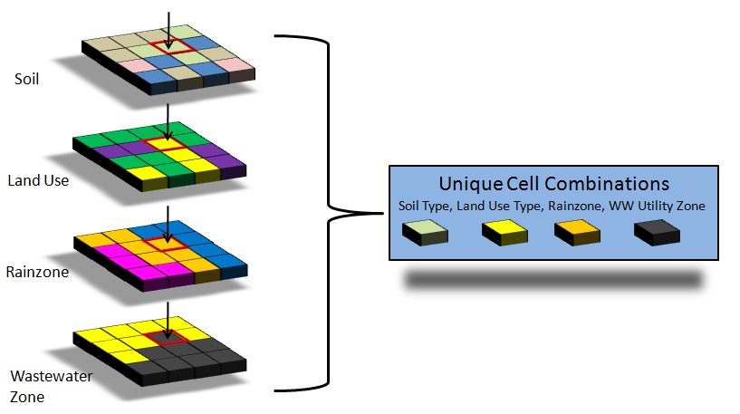
Figure 91. Generation of unique cell combinations.

Source Cell Modeling
The creation of unique cell groupings is also critical because it allows for the most appropriate field-scale sub-model to be used for each unique cell condition, more accurately simulating the daily runoff in terms of both water quality and quantity. Based on the Soil and Land Use combination of the cell, the most appropriate field scale sub-model is selected to simulate that cell as shown in Figure 92. The sub-models include Groundwater Loading Effects of Agricultural Management Systems (GLEAMS) (Knisel, 1993), the Everglades Agricultural Area Model (EAAMod) (Bottcher et al., 1998; SWET, 2008), and a special-case model written specifically for WAM to handle wetland and urban landscapes. These sub-models are bundled into one FORTRAN program called BUCShell (BUC stands for Basin Unique Cell).
The individual field scale sub-models used are specifically designed to deal with the particular natural processes that exist between those land use and soils combinations. The daily flows and loads produced by BUCShell are stored in what are referred to as “dayfiles” and contain a daily time series of the amount of nutrients and water leaving each source cell.
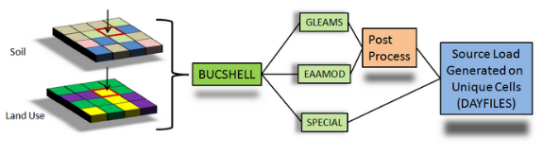
Figure 92. Selection of source cell sub-model and post processing

GLEAMS
GLEAMS (Leonard et al., 1987 and Knisel, 1993) is a physically based model used to simulate processes affecting water quality on an agricultural field scale. It has been used extensively and is well documented. GLEAMS is divided into four separate models. These models include:
- Hydrology
- Erosion/sediment yield
- Chemical (pesticide) transport (not currently available within WAM)
- Nutrient transport
The hydrology component of GLEAMS simulates runoff due to daily rainfall using a modification of the NRCS curve number method. Hydrologic computations for evapotranspiration, percolation, and runoff are determined using a daily time step (Knisel, 1993). Two options are provided in the hydrology component to estimate potential evapotranspiration.
The Priestly-Taylor method (1972) using daily temperature and radiation data computed from mean monthly data is one option. The other option is the Penman-Monteith method (Jensen et al., 1990) and it requires additional data such as wind speed and dew point temperature. Water routing through the soil profile is based on the storage routing concept which allows the downward movement of water in excess of field capacity water content from one layer to the next. Comprehensive detail is provided in Knisel (1993).
The erosion component in GLEAMS uses the universal soil loss equation (USLE) and the concept of continuity of mass to predict erosion and sediment transport under different topographic and cultural conditions. The erosion component considers overland, channel, impoundment, or any combination of these routes. Computation begins at the upper end of the overland slope. The overland flow may be selected from several possible overland flow paths. Its shape may be uniform, convex, concave, or a combination of these slopes. The processes of detachment and deposition are both considered, and each condition occurs based on the relationship between transport capacity of runoff water and sediment load.
The plant-nutrient component of the GLEAMS model considers both nitrogen and phosphorus cycles. The nitrogen component includes: mineralization, immobilization, denitrification, ammonia volatilization, nitrogen fixation by legumes, crop N uptake, and losses of N in runoff, sediment, and percolation below the root zone. It also considers fertilizer and animal waste application. The phosphorus component includes: mineralization, immobilization, crop uptake, losses to surface runoff, sediment and leaching, and it also includes fertilizer and animal waste application. Tillage algorithms are included in the model to account for the incorporation of crop residue, fertilizer and animal waste. Soil temperature and soil moisture algorithms are also included in the model to provide proper adjustments for ammonification, nitrification, denitrification, volatilization, and mineralization rates. Rainfall nitrogen is an input for the model and may vary depending upon the study region. Initial soil total N and total P are sensitive parameters in the model. For a detailed description of the nutrient component see (Knisel, 1993).
The GLEAMS model provides outputs of soluble inorganic nitrogen (ammonium-N and nitrate-N) and phosphorus (soluble P) in runoff and leachate and sediment-attached N and P in surface runoff. The GLEAMS model does not produce outputs of biological oxygen demand (BOD) or soluble organic N and P. Outputs of these constituents are derived within WAM as a function of total suspended solids (TSS) and from total nitrogen loads in runoff and leachate, respectively.

EAAMod
The EAAMod is a field-scale model developed by Soil and Water Engineering Technology, Inc. (SWET) for multi-layered soils with high water tables. Created in the early 1990s, the model grew out of a need to evaluate agricultural BMPs within the Everglades Agricultural Area (EAA) and other high-water table soils in Florida. The model initially focused on water using a hydrography sub-model (WP) and phosphorus (P) movement from histosols (flat organic soils) using the P sub-model PMOVE but was then expanded to all high-water table soils and to handle nitrogen (N) with the inclusion of the nitrogen sub-model (NUTMOD). Histosols require special consideration because of the aerobic mineralization releases of both P and N from organic matter due to drainage and the resulting nutrient impacts downstream. To adequately address this problem, EAAMod simulates water control practices and the impacts of various cultural management scenarios on nutrient transport.
Percolation and runoff in EAAMod is calculated using a vertical two-dimensional hydrologic model (WP). The flow model within EAAMod uses the Dupuit-Forcheimer assumption (zero vertical hydraulic gradient) for two separate flow regimes in the field profile, specifically, above and below an impeding layer such as the spodic horizon in flatwoods soils and the marl cap rock in histosols. The impeding layer is generally highly localized, and while water locally perches above the layer it does not act as a confining layer. The model is conceptually represented in Figure 93.
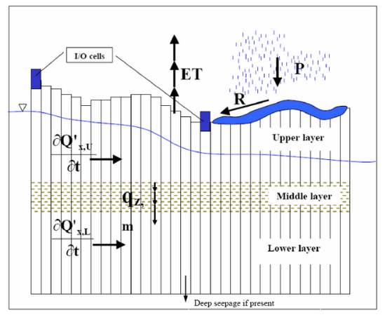
Figure 93. EAAMOD digitization scheme for soil profile.
The one-dimensional horizontal flow model provides the water table depth and horizontal flow for each cell across the field between drainage ditches. Flow through the spodic horizon is determined by solving the piezometric head distribution below the horizon and then using Darcy's Law across the impeding layer with the gradient across the horizon being the difference between the water table above it and the piezometric head below it. Water flow is simulated by using finite difference techniques with forcing functions representing pumped drainage/irrigation, culvert flow, rainfall and ET. Saturated horizontal flow above the mid- horizon is calculated by a fourth order Runge-Kutta method that solves the continuity equation for each cell using Darcy's Law within the saturated zone.
The water budget is calculated in the top zone of cell i by the following equation:
$$ΔS\left(i\right)=Q\left(i+1\right)-Q\left(i\right)+R\left(i\right)-ET\left(i\right)-QS\left(i\right)+P\left(i\right)$$
Where:
$ΔS$ is the change in water storage in the top zone (inches of air void/hr),
$Q$ is horizontal saturated flow (in/hr), R is rainfall (in/hr),
$ET$ is evapotranspiration (in/hr),
$QS$ is deep percolation through the middle restricting zone (in/hr), and
$P$ is the forced input or output (irrigation/drainage) (in/hr) for up to two cells, typically ditches.
The calculated flow is always for the left side of the cell indicated. Rather than using total water storage in a cell, the water profile algorithm keeps track of air void volume (S). Therefore, a zero value for S would represent a saturated soil condition with no surface ponding. Surface ponding results in a value of S less than zero and typically would indicate that surface runoff is occurring but could be a stagnant surface storage condition.
The air void volume, S, is calculated for each time step t by the following equation:
$$S\left(i,t\right)=S\left(i,t-1\right)+ΔS\left(i,t\right)⋅ΔT$$
Where:
$ΔT$ is equal to t (current time in hours) minus t-1 (previous time step in hours)
To represent actual water management in a field, a series of utility features within the model allow for controlled drainage through a pump, gravity flow through a culvert (bi-directional), flow over a weir, subsurface or surface irrigation, and variable crop ET parameters. Automatic scheduling of irrigation and drainage pump operation is available based upon desired ditch water levels or soil moisture deficit. The flow properties of the pump(s), culvert(s), or weir(s) for specific land use types can be specified by the user in the management section for High Water Table Soils.
Surface water is only allowed to flow to or from the first defined ditch/drainage outlet cell, but this cell may be located anywhere. For flooding, the water profile algorithm allows flows from the ditch to fill each successive cell to the level of the ditch until the time step's flow volume is depleted. The flow volume is limited by the flow rate to the ditch cell and conservation of mass within the ditch. This procedure continues until complete flooding occurs, at which time any subsequent flow due to a rise in ditch levels will be artificially applied to all cells. For surface runoff the procedure is reversed except that artificial ET is used to move the water from the field and move it to the ditch.

Hydrodynamic Routing
The daily outputs from each cell, which includes surface and groundwater flows and constituent concentrations, are simulated they are routed to the streams by the Basin Land Area to Stream Routing model (BLASRoute). BLASRoute is a FORTRAN program that routes the flows and loads based on the distance grids previously calculated and delayed using separate unit hydrographs and delay factors for surface and groundwater. The constituent loads are attenuated based on the landscape features encountered en route to the reach network. The routing process is a complex combination of transport, dispersion, and assimilation that, in most cases, will result in an attenuation, or decrease, in the constituent concentration. The source loads are transported to the reach network via surface and/or ground water.
The transportation path is based on the distance to the closest downhill hydrogeologic feature (reach, wetland or depression) which is identified from the Distance Grids that are calculated by WAM. The transportation path will influence both the time it takes for daily flows to be delivered to the reach network, as well as the attenuation rates that are applied to the constituent concentrations en route to the reach network, depending on the hydrogeologic features encountered. Figure 94 shows the conceptual routing schemes and flow distances that are calculated for each cell.
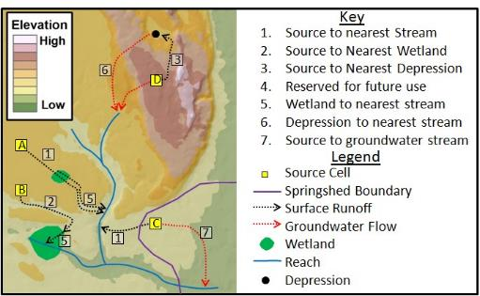
Figure 94. Flow path routing for attenuation distance determination.
WAM includes overland and in-stream attenuation algorithms that function on a daily time step starting at the source cell. From this starting point, nutrients are attenuated during both overland flow, when passing through wetlands, and within streams and canals before finally discharging to the lake.
Each numbered path shown is represented by a GIS grid which includes the distance of the paths. These distances are related back to the original source cell so that the model can extract the needed distance through a downstream geographic feature for each and every grid cell. Destination information is stored in a similar manner. When extracting the distance through a downstream wetland, for example, the type of wetland can also be extracted, which has an associated set of assimilation coefficients.

Appendix B: Summary of the 2015 Literature Review
As part of the earlier pre-drainage study (HDR 2015), a comprehensive literature review was conducted to identify, acquire, and assess historic written accounts of the environmental conditions (mainly related to surface hydrology, soils, and vegetation) that most likely characterized the sub-watersheds that make up the LOW Pre-Drainage Characterization study area prior to the construction and operation of the extensive drainage system. This literature review was an important part in the development of the methodology used to create the land cover and hydrography feature classes. Where possible, the same methodology was used to develop the necessary feature classes for the current work; therefore, a brief overview of the literature review is presented here. The interested reader is referred to the report by HDR (2015) for a more detailed assessment of existing literature if desired.
Generally, the term pre-drainage (sometimes also referred to as pre-development) conditions are defined as environmental conditions that existed in the sub-watersheds earlier than the 1850s to 1900s, depending on location. Narrative historic accounts and maps that would facilitate understanding of the pre-drainage hydrology (e.g., water levels, inundation periods, flow magnitudes) in the sub-watersheds were also examined. In addition, available data on the P-loading associated with un-impacted wetlands and native uplands in the LOW were researched. Based upon the literature review feature classes reflecting pre-drainage land cover and hydrography were created for the northern six sub-watersheds in the LOW. The same methodology will be used to generate equivalent feature classes for the southern sub-watersheds in the LOW as part of the deliverables for the current project.
The literature search was primarily intended to support the WAM setup that was used to simulate pre-drainage conditions in the LOW. Accordingly, the search was focused on identifying data that would help characterize “pristine” vegetative and hydrologic conditions. The search was not intended to be a comprehensive evaluation of pre-drainage conditions in the LOW. It was strictly intended to be a compilation of previously reported relevant information and conclusions and should not be considered a validation of the facts reported in the referenced documents or sources. A brief review follows.

LOW Pre-Drainage Vegetation Communities
A critical part of simulating pre-drainage conditions is determining to the greatest extent possible the vegetative communities that were present since these have perhaps the largest influence on both the hydrology and nutrients that eventually end up in Lake Okeechobee. The literature review was used to determine these vegetative communities by examining historical maps from the 1800s, which were developed both for exploration and military purposes.
The earliest documented records describing conditions in the Kissimmee River Basin are from the period of the Seminole Wars (1830s). The first map to show the Kissimmee River is the map of the “Theatre of Military Operations in Florida during 1835, 36, & 37” (Macomb 1837). A portion of this map shows the “Kissimmee Creek” flowing south from Lake Tohopekaliga, and entering “Okeechobee.” This map was subsequently updated with additional observations and it formed the basis for the “Map of the Seat of War in Florida” (Mackay and Blake 1839).
Mackay and Blake’s 1839 map included relatively accurate positions of features such as Lake Kissimmee, Lake Istokpoga, Lake Okeechobee, Kissimmee River, Peace River, Fisheating Creek, and Caloosahatchee River. More important for the purposes of the current study is that this map also included some information on vegetation cover. No legends were provided for the symbols used in the map, but most signs are easily interpreted: pines, cabbage palms, oaks, swamps (trees overlain by marsh symbols), marshes, and grasslands. The 1856 map produced by the Lt. Joseph C. Ives showed almost the entire central Florida region depicted as being covered by one of several general vegetation types, delineated in the legend as “SawGrass, Swamp, Marsh, Scrub, Wet Prairie, Dry Prairie, Wet Hammock, and Dry Hammock.”
Bridges (2006) reported on the historic vegetation associated with the Florida dry prairie in the Kissimmee River region. Dry prairie is a rare natural community that is restricted to southcentral peninsular Florida and is a well-defined community distinguished and delineated on many of the pre-settlement land surveys of the region. Vegetation data used by Bridges were obtained from surveys conducted before any extensive alteration of the landscape from logging and drainage, and, therefore, represent a good approximation of natural conditions that occurred within the historic dry prairies.
Bridges (2006) reported that the Kissimmee River dry prairie region was defined as the extent of relatively contiguous prairie on predominantly upland soils, extending to the relatively continuous pinelands on its northern, western, and eastern borders. The pre-settlement extent of the Kissimmee River dry prairie region was determined to be about 2,037 square kilometers (787 square miles or 503,354 acres). This study also distinguishes between two types of “prairies” and classifies different types of marshes as follows:
- Dry Prairies are defined as areas of the pre-settlement extent of “prairie” which were relatively contiguous north of the Kissimmee River marshes on one or both sides of the river. These occurred on poorly drained but rarely flooded soils, mostly spodosols such as the Immokalee, Myakka, Smyrna, Ona, Eau Gallie, and Oldsmar soil series. In some cases, they were also associated with alfisols such as Malabar.
- Wet Prairies are defined as areas with sufficient ponding to lack a well-distributed layer of low shrubs interspersed with grasses and sedges. Shallow inundation occurs for several months during a normal wet season.
- Shallow River Floodplain Marshes are located at the outer zones of the Kissimmee River floodplain marsh. These marshes were dominated by grass and would have been only subjected to infrequent flooding.
- Shallow Lakeshore Floodplain Marshes occurred mostly in the northern part of the region, extending for up to a mile from the permanent water zone of Lake Kissimmee; Lake Tohopekaliga; and, to a lesser extent, from Lake Marian, Lake Jackson, Tiger Lake, Lake Rosalie, Lake Hatchineha, and Cypress Lake.
- Shallow Basin Marshes are mapped as “ponds” or “grass ponds.”
- Community Mosaic Complexes consist of prairie, savanna, and sawgrass areas interspersed within a mosaic of shallower and deeper lakeshore floodplain marshes and mixed in with scattered “islands” of cabbage palm or other trees that are generally located on higher ground.
- Savanna represents areas that had significantly lower pine density than the nearby pinelands over a fairly broad area.
Zahina et al. (2007) created a geospatial database of pre-drainage vegetation within the SFWMD boundary to provide a reliable and comprehensive data source for pre-drainage ecological conditions of the region. The authors conducted a literature search to identify previous studies that provided maps of historical vegetation within the central and south Florida region. A vegetation classification scheme was then developed to define major natural community types that would also meet anticipated data requirements of hydrological models and restoration projects. The authors divided the project area into sub-regions with unique or similar vegetation patterns. A map of historic vegetation was then created for each sub-region based on available predevelopment vegetation map sources acquired during the literature review. A base map was compiled by using a default historic map (usually, the earliest source with the highest resolution) and filling data gaps or areas of questionable accuracy with other historic information. Vegetation communities and descriptions in the base map were converted to the vegetation community classes.
The resulting map and geospatial database were compared to vegetation descriptions in the base map with U.S. General Land Office Survey field note descriptions and maps from the mid- to late-1800s. Data obtained from the Natural Soils Landscape Position/Soils Database (Zahina et al. 2001) and other available sources of historic vegetation data were used to map and “field verify” pre-drainage vegetation communities across southern Florida.
Information from this study was used to assist in development of the land use/land cover feature classes for sections of the northern sub-watersheds. In a similar fashion, it was used to corroborate the relationship between soil types and historic vegetation communities during development of the pre-drainage land use/land cover feature class for the three southern sub-watersheds.
Table 22. NRCS native vegetation descriptions by soil series. Shaded rows represent the soil series that were added during the extension of the work to the five northern sub-watersheds and were not previously assigned as part of the earlier Fisheating Creek study.
COMPNAME | ASSOCIATED VEGETATION | FLUCCS
ADAMSVILLE | Natural vegetation consists of pines, laurel, and water oaks with a ground cover of saw palmetto, pineland threeawn, indiangrass, bluestem grasses, and several low panicums. | 4110
ADAMSVILLE VARIANT | Natural vegetation consists of pines, laurel, and water oaks with a ground cover of saw palmetto, pineland threeawn, indiangrass, bluestem grasses, and several low panicums. | 4110
ANCLOTE | Native vegetation consists of cypress, bay, popash, pond pine, cabbage palm, red maple, and juncus species. | 6220
ANKONA | longleaf pine, slash pine, sawpalmetto, waxmyrtle, gallberry, fetterbush, creeping bluestem, chalky bluestem, lopsided Indiangrass, low panicums and pineland threeawn | 4110
APOPKA | bluejack oak, turkey oak, post oak, live oak, and longleaf pine | 4270
ARCHBOLD | Most of this soil is in native scrub forest of sand pine, bluejack oak, sawpalmetto, pricklypear cactus and scattered stands of pineland threeawn. | 3200
ARENTS | Community Undetermined | N/A
ASTATULA | Natural vegetation consists of bluejack, blackjack, turkey oaks, longleaf pine, sand pine, and an understory of rosemary, pineland threeawn, bluestem, paspalum, lopsided indiangrass, and panicum. | 4340
ASTOR | Natural vegetation in swamps consists of sweetgum, red maple, water oak, laurel oak, and a few slash pine or loblolly pine | 6410
BASINGER | The natural vegetation consists of waxmyrtle, St. Johnswort, maidencane, pineland threeawn, cypress, slash pine, longleaf pine, pond pine, and other water tolerant plants. | 6172
BOCA | Native vegetation consists of gallberry, sawpalmetto, cabbage palmettos, slash pine, and an understory of pineland threeawn. | 4110
BRADENTON | Natural vegetation consists of slash pine, laurel oak, live oak, cabbage palm, southern bayberry, sweetbay magnolia, American holly, water oak, sweetgum, bluestems, longleaf uniola, and panicums. | 4250
BRIGHTON | Natural vegetation consists mostly of Jamaica sawgrass, prairie iris, ferns, bull-tongue, greenbriar, buttonbush, maidencane, sedges, and arrow arums in some areas, with other areas being dominated by baldcypress, red bay, white bay, and red maple. | 6220
CANDLER | Native vegetation consists of bluejack oak, turkey oak, post oak, live oak, and longleaf pine with a sparse understory of indiangrass, chalky bluestem, pineland threeawn, hairy panicum, and other annual forbs. | 4270
CANOVA | The vegetation is dominated by reeds, sedges, sawgrass, lilies, scattered cypress, maple, gum, bay, and myrtle. | 6430
CASSIA | The native vegetation consists of scattered slash pine, longleaf pine, and saw palmetto. | 4110
CHOBEE | Most of the soils remain in their natural state and have vegetation consisting of pickerelweed, lilies, sawgrass, and scattered swamp maples in treeless areas. | 6410
DAYTONA | The native vegetation consists of sand pine with an understory of creeping bluestem, broomsedge bluestem, splitbeard bluestem, lopsided indiangrass, pineland threeawn, switchgrass, panicum, and paspalums. | 3200
DELRAY | Natural vegetation includes southern bayberry, pickerelweed, sedges, reeds, water tolerant grasses, and cypress, bay, tupelo and other water tolerant trees. | 6410
DUETTE | The natural vegetation is chiefly sand pine, sand live oak, rosemary, sawpalmetto, running oak, pricklypear cactus, fetterbush, and pineland threeawn. | 3200
EATON | The native vegetation is chiefly loblolly pine, longleaf pine, and slash pine, but includes magnolia, water oak, sweetgum, and bay. | 4140
EAUGALLIE | Natural vegetation consists of longleaf pine, South Florida slash pine, and sawpalmetto. | 4110
ELECTRA | Most areas remain in native vegetation consisting of dwarf live oak, a few longleaf and sand pine, running oak, sawpalmetto, and blueberry. | 4340
FELDA | Natural vegetation consists of cypress, waxmyrtle, pond pine, slash pine, cabbage palm, pineland threeawn, and various grasses, vines, and shrubs. | 6172
FLORAHOME | Natural vegetation includes laurel oak, live oak, hickory, sweetgum, slash pine, and longleaf pine. | 4140
FLORIDANA | Natural vegetation consists of sand cordgrass, cabbage palmetto, myrtle, and pineland threeawn. | 6410
FORT MEADE | Native vegetation is longleaf pine or slash and loblolly pine, laurel, live, post, and turkey oaks, and some dogwood, hickory, cabbage palm, and magnolia, | 4340
FT. DRUM | The natural vegetation consists of slash pine, south Florida slash pine, and cabbage palm. | 4110
GATOR | Native vegetation is mostly cordgrass or Jamaica sawgrass, maidencane, Coastal Plain willow, redosier dogwood, or swamp vegetation including baldcypress, sweetgum, red maple, and American hornbeam. | 6410
GENTRY | Most areas remain in native vegetation of pond cypress, red maple, sweetgum, wax myrtle, pickerelweed, and maidencane. | 6210
HALLANDALE | Native vegetation consists of pineland threeawn, paspalum spp., bluejoint panicum, blue maidencane, bluestem, scattered cypress, saw palmettos, and slash pine. | 4110
HAPLAQUENTS | Community Undetermined | N/A
HICORIA | Natural vegetation consists of cypress, willow, sweetbay, red bay, pickerel weed, arrowhead, maidencane, sawgrass, chalky bluestem, bushybeard bluestem, sand cordgrass, waxmyrtle, and other water tolerant plants. | 6410
HOBE | The vegetations primarily consists of sandpine, scattered slash pine, sand live oak, running oak, sand heath, sawpalmetto, fetterbush, and a few widely spaced pineland threeawn and panicum grasses. | 4140
HOLOPAW | Native vegetation is scattered slash and pond pine, cabbage and sawpalmettos, scattered cypress, myrtle, sand cordgrass, and pineland threeawn. | 6220
HONTOON | Native vegetation is loblolly, bay, maple, gum, and scattered cypress trees with a ground cover of greenbriers, ferns, and other aquatic plants. | 6220
IMMOKALEE | Principal vegetation is longleaf and slash pines and undergrowth of sawpalmetto, gallberry, waxmyrtle, and pineland threeawn. | 4110
JONATHAN | The native vegetation consists of slash pine, sawpalmetto, sand live oak, running oak, gallberry, fetterbush, pricklypear, and pineland threeawn. | 4140
JUPITER | Natural vegetation on the low hammocks consists of cabbage palm, laurel oak, water oak, scattered south Florida slash pine, red mulberry, and redbay with an understory of marlberry, waxmyrtle, wild coffee, greenbriars, ferns, longleaf uniola, Eastern gamagrass, chalky bluestem, maidencane, and switchgrass. | 4140
KALIGA | A large part of this soil is in natural vegetation of sawgrass, pickerelweed, maidencane, cattails, flags and scattered thickets of woody button bush. | 6410
KENDRICK | Natural vegetation is longleaf, loblolly, and slash pines; hickory, magnolia, dogwood; and laurel, live, and water oaks. | 4140
LAKE | Natural vegetation consists of bluejack, blackjack, turkey and live oaks, scattered longleaf pine, and an understory of scattered palmetto, pineland threeawn, bluestem, and paspalum. | 4210
LAUDERHILL | Most areas are in natural vegetation of sawgrass, sedges, lilies, spikerush, willow, elderberry and cypress. | 6410
LAWNWOOD | The principal vegetation is longleaf pine and slash pine with an understory of sawpalmetto, waxmyrtle, inkberry, fetterbush, creeping bluestem, chalky bluestem, Florida threeawn and pineland threeawn. | 4110
LOCHLOOSA | Native vegetation consists of slash and loblolly pine, dogwood, hickory, live, laurel and water oak, sweetgum, red maple, and magnolia. | 4230
LOKOSEE | Native vegetation consists of slash pine, waxmyrtle, cabbage palm, sawpalmetto, pineland threeawn wiregrass, chalky bluestem, and carpet grass. | 4110
LYNNE | The native vegetation consists of slash pine, longleaf pine, creeping bluestem, chalky bluestem, indiangrass, panicum, pineland threeawn, saw palmetto, fetterbush, gallberry, and wax myrtle. | 4110
MALABAR | Native vegetation consists of scattered slash pine, cypress wax myrtle, cabbage palm, pineland threeawn, and maidencane. | 6410
MANATEE | Natural vegetation consists of red maple, gum, cabbage palm and widely spaced cypress. | 6170
MILLHOPPER | Native vegetation consists of live oak, laurel oak, post oak, water oak, sweetgum, cherry laurel, few hickory, and slash and longleaf pine. | 4340
MINERAL SOIL | Soil that is mainly mineral material and low in organic material. Its bulk density is more than that of organic soil. Used Placid | 6410
MYAKKA | Native vegetation includes longleaf and slash pines with an undergrowth of sawpalmetto | 4110
NARCOOSSEE | Native vegetation is dominantly water oak, willow oak, live oak, laurel oak, longleaf pine, slash pine, greenbrier, sawpalmetto, pineland threeawn, creeping bluestem, panicum, purple lovegrass, and lopsided Indiangrass. | 4110
NEILHURST | Natural vegetation is very sparse and consists of scattered slash pines, pineland threeawn, and broomsedge. | 4110
NITTAW | Native vegetation is mixed hardwoods of bald cypress, red maple, sweetgum, and hickory with an understory of wax myrtle, greenbrier, wild grape, cabbage palm, and few shade and water tolerant forbes and grasses. | 6170
OKEELANTA | Native vegetation consists of sawgrass, lilies, sedges, and other water tolerant plants. | 6410
OKLAWAHA | Most areas are in natural vegetation of sawgrass, lilies, sedges, cypress, bay, maple, and blackgum and used for range, wildlife habitat, or water storage areas. | 6410
OLDSMAR | Native vegetation consists of cabbage palmetto, sawpalmetto, live oak, slash pine, with an undergrowth of laurel, wax myrtle, and pineland threeawn. | 4110
ONA | Natural vegetation is slash pine and longleaf pine, gallberry, widely spaced sawpalmettos, huckleberry, and pineland threeawn. | 4110
ORLANDO | Natural vegetation is longleaf pine, laurel, live and turkey oaks, dogwood, hickory, and sweetbay | 4120
ORSINO | Native vegetation consists primarily of scrub vegetation with sand live oak, Chapman oak, myrtle oak, and scrub hickory. | 3200
PAISLEY | Native vegetation consists of slash, longleaf, and loblolly pine, swamp white oak, swamp maple, and sweetgum with an understory of wax myrtle, cabbage palmetto, bluestem, and native grasses. | 4110
PAOLA | Native vegetation consists of sand pine, slash pine, longleaf pine, scrub live oak, scattered turkey oak, and bluejack oak. | 3200
PARKWOOD | The dominant vegetation consists of cabbage palm, live oak, water oak, red cedar, magnolia | 4280
PENDARVIS | The vegetation consists of scattered longleaf pine and sand pine with a dense understory of myrtle oak, chapman oak, sand live oak, sawpalmetto, and running oak. | 4110
PINEDA | Natural vegetation consists of slash pine, cypress, myrtle, cabbage palm, blue maidencane, chalky bluestem, bluepoint panicum, sedges, pineland threeawn, and sand cordgrass. | 6172
PINELLAS | The natural vegetation consists of cabbage palm, sawpalmetto, scattered slash pine, inkberry, maidencane, and pineland threeawn. | 4280
PITS | Community Undetermined | 4110
PLACID | Natural vegetation consists of pond pine, bay, cypress, gum, pickerel weed, and coarse grasses. | 6410
PLACID VARIANT | Natural vegetation consists of pond pine, bay, cypress, gum, pickerel weed, and coarse grasses. | 6220
PLANTATION | The native vegetation consists of sawgrass, paspalum, maidencane, and cutthroat grass. | 6410
POMELLO | Native vegetation is dominated by scrub oak, dwarf live oak, sawpalmetto, longleaf pine, slash pine, and pine land threeawn. | 3200
POMONA | The native vegetation consists of slash pine (Pinus Elliottii), longleaf pine (Pinus Palustris), and south Florida slash pine | 4110
POMPANO | Natural vegetation consists of palmetto, widely spaced cypress, gum, and slash pine, and native grasses. | 3200
POPLE | Natural vegetation is principally cabbage palms, liveoaks, longleaf pine, and slash pine with an understory of sawpalmetto, running oak, waxmyrtle, various bluestems, and in places gallberry. | 4250
RIVIERA | Native vegetation consists of slash pine, cabbage, and sawpalmetto, scattered cypress, maidencane, and pineland threeawn. | 6240
SALERNO | The native vegetation consists of slash pine | 4110
SAMSULA | Natural vegetation is loblolly bay with scattered cypress, maple, gum, and pine trees with a ground cover of greenbriers, ferns, and other aquatic plants. | 6410
SANIBEL | Most areas are in natural vegetation which consists mostly of sawgrass, melaleuca, and waxmyrtle. | 6410
SATELLITE | Native vegetation consists of south Florida slash pine, saw palmetto, pineland threeawn, and other native grasses. | 3200
SEFFNER | The natural vegetation consists of longleaf pine, laurel oak, and water oak | 4140
SMYRNA | Natural vegetation consists of longleaf and slash pines with an undergrowth of sawpalmetto, running oak, gallberry, waxmyrtle, and pineland threeawn. | 4110
SPARR | Native vegetation consists of longleaf pine, slash pine, loblolly pine, magnolia, dogwood, hickory, and live oak, laurel oak, and water oak. | 4140
ST. AUGUSTINE | Some areas have natural vegetation of southern red cedar and cabbage palm with an understory or waxmyrtle, blackberry, greenbrier, and panicums. | 4300
ST. JOHNS | Principal vegetation of the forested areas is longleaf pine, slash pine, and pond pine with an undergrowth of sawpalmetto, gallberry, waxmyrtle, huckleberry, and pineland threeawn. | 4140
ST. LUCIE | Vegetation is dominated by sand live oak, sand pine, dwarf willow, sawpalmetto, rosemary, pricklypear cactus, and lichens. | 3200
TAVARES | In most places the natural vegetation consists of slash pine, longleaf pine, a few scattered blackjack oak, turkey oak, and post oak with an undercover of pineland threeawn. | 4340
TEQUESTA | The natural vegetation consists of needlegrass, pickerelweed, maidencane, ferns, waxmyrtle, and scattered cypress. | 6410
TERRA CEIA | The natural vegetation consists of sawgrass, lilies, sedges, reeds, maidencane, spikerush, and other aquatic plants. | 6430
UDORTHENTS | Community Undetermined | N/A
URBAN LAND | Community Undetermined. Assume upland pine lands | 4110
VALKARIA | Natural vegetation is palms, cabbage palmettos, St. Johnswort, waxmyrtle, blue maidencane, chalky bluestem, pineland threeawn, and widely spaced pine and cypress. | 6172
VERO | Most areas are in native vegetation of longleaf and slash pines, scattered cabbage palms, sawpalmetto, waxmyrtle, gallberry, fetterbush, creeping bluestem, chalky bluestem, and pineland threeawn. | 4110
WABASSO | The natural vegetation consists of longleaf pine, slash pine, cabbage palm, live oak | 4140
WATER | Community Undetermined | 5100
WAUBERG | Most areas of these soils remain in native vegetation consisting of low panicums, bushybeard, creeping and chalky bluestems, bulrush, cutgrass, maidencane, carpetgrass, dogfennel, briars, thistle, and waxmyrtle. | 3200
WAUCHULA | The natural vegetation consists of longleaf pine, slash pine, sawpalmetto | 4110
WAVELAND | The principal vegetation is longleaf pine and slash pine | 4140
WINDER | Natural vegetation consists of cordgrass, maidencane, cabbage palmetto, saw palmetto, and pineland threeawn. | 4110
ZOLFO | Native vegetation consists of scattered turkey, laurel, or water oaks; long leaf or slash pine | 4140

Table 23 was created using FLUCCS codes estimated from NRCS and PDLD codes. Where the entry in the NRCS FLUCCS code is “PDLD”, the FLUCCS code from PDLD dataset was assigned to the polygon based on its location. If the entry is, for example, “PDLD/4100” the PDLD code was used unless it was not present, in which case 4100 was assigned.

Table 23. The lookup table created to assign FLUCCS codes to soil mapunit names.
Mapunit Name (MUNAME) | COMPNAME | NRCS FLUCCS
Adamsville fine sand, 0 to 2 percent slopes | Adamsville | 4110
Adamsville fine sand, organic substratum | Adamsville | 4110
Adamsville sand, 0 to 2 percent slopes | Adamsville | 4110
Adamsville variant fine sand, 0 to 5 percent slopes | Adamsville variant | 4110
Adamsville variant sand | Adamsville Variant | 4110
Adamsville-Urban land complex | Adamsville | 4110
Anclote and Myakka soils | Anclote | 6220
Anclote fine sand | Anclote | 6220
Anclote mucky fine sand, frequently ponded, 0 to 1 percent slopes | Anclote | 6220
Anclote sand, depressional, 0 to 1 percent slopes | Anclote | 6220
Anclote sand, frequently ponded, 0 to 1 percent slopes | Anclote | 6220
Anclote-Basinger fine sand, frequently flooded | Anclote | 6220
Ankona fine sand | Ankona | 4110
Ankona-Urban land complex | Ankona | 4110
Apopka fine sand, 0 to 5 percent slopes | Apopka | 4270
Apopka sand, 0 to 5 percent slopes | Apopka | 4270
Apopka sand, 5 to 12 percent slopes | Apopka | 4270
Aquents, organic substratum | Aquents | PDLD
Archbold fine sand, 0 to 5 percent slopes | Archbold | 3200
Archbold sand, 0 to 5 percent slopes | Archbold | 3200
Arents | Arents | PDLD/4110
Arents, 0 to 2 percent slopes | Arents | PDLD/4110
Arents, 0 to 5 percent slopes | Arents | PDLD/4110
Arents, 45 to 65 percent slopes | Arents | PDLD/4110
Arents, clayey substratum | Arents | PDLD/4110
Arents, nearly level | Arents | PDLD/4110
Arents, organic substratum | Arents | PDLD/4110
Arents, organic substratum, 0 to 5 percent slopes | Arents | PDLD/4110
Arents, organic substratum-Urban land complex | Arents | PDLD/4110
Arents, sandy | Arents | PDLD/4110
Arents, very steep | Arents | PDLD/4110
Arents-Urban land complex, 0 to 5 percent slopes | Arents | PDLD/4110
Arents-Urban land complex, organic substratum | Arents | PDLD/4110
Arents-Water complex | Arents | PDLD/4110
Astatula sand, 0 to 5 percent slopes | Astatula | 4340
Astatula sand, 12 to 20 percent slopes | Astatula | 4340
Astatula sand, 5 to 12 percent slopes | Astatula | 4340
Astatula-Urban land complex, 0 to 8 percent slopes | Astatula | 4340
Astor fine sand, depressional | Astor | 6410
Basinger and Myakka sands, depressional | Basinger | 6210
Basinger and Placid soils, depressional | Basinger | 6172
Basinger fine sand | Basinger | 6172
Basinger fine sand, 0 to 2 percent slopes | Basinger | 6172
Basinger fine sand, depressional, 0 to 1 percent slopes | Basinger | 6172
Basinger fine sand, frequently ponded, 0 to 1 percent slopes | Basinger | 6172
Basinger mucky fine sand, depressional | Basinger | 6172
Basinger sand, 0 to 2 percent slopes | Basinger | 6172
Basinger, St. Johns, and Placid soils | St. Johns | 6172
Boca fine sand | Boca | 4110
Boca fine sand, 0 to 2 percent slopes | Boca | 4110
Boca sand | Boca | 4110
Boca sand, depressional | Boca | 6210
Borrow Pits | Borrow pits | 4270
Bradenton fine sand | Bradenton | 4250
Bradenton fine sand, 0 to 2 percent slopes | Bradenton | 4250
Brighton muck | Brighton | 6220
Candler fine sand, 0 to 5 percent slopes | Candler | 4270
Candler fine sand, 5 to 12 percent slopes | Candler | 4270
Candler sand, 0 to 5 percent slopes | Candler | 4270
Candler sand, 12 to 40 percent slopes | Candler | 4270
Candler sand, 5 to 12 percent slopes | Candler | 4270
Candler sand, 5 to 8 percent slopes | Candler | 4270
Candler-Apopka fine sands, 5 to 12 percent slopes | Candler | 4270
Candler-Urban land complex, 0 to 5 percent slopes | Candler | 4270
Candler-Urban land complex, 5 to 12 percent slopes | Candler | 4270
Canova muck, moderately deep, drained | Canova | 6430
Cassia fine sand, 0 to 2 percent slopes | Cassia | 4110
Cassia sand | Cassia | 4110
Chobee fine sandy loam | Chobee | 6410
Chobee fine sandy loam, frequently flooded | Chobee | 6410
Chobee fine sandy loam, frequently ponded, 0 to 1 percent slopes | Chobee | 6410
Chobee fine sandy loam, limestone substratum, depressional | Chobee | 6410
Chobee loamy fine sand, frequently ponded, 0 to 1 percent slopes | Chobee | 6410
Chobee muck, frequently ponded, 0 to 1 percent slopes | Chobee | 6410
Dania muck, drained, frequently ponded, 0 to 1 percent slopes | Dania | 6411
Daytona sand | Daytona | 3200
Daytona sand, 0 to 5 percent slopes | Daytona | 3200
Delray loamy fine sand, depressional | Delray | 6410
Delray sand, depressional | Delray | 6410
Denaud muck | Denaud | 6410
Denaud-Gator mucks | Denaud | 6400
Duette fine sand | Duette | 3200
Duette sand, 0 to 5 percent slopes | Duette | 3200
Eaton mucky fine sand, depressional | Eaton | 4140
EauGallie fine sand | EauGallie | 4110
EauGallie fine sand, 0 to 2 percent slopes | EauGallie | 4110
EauGallie sand, 0 to 2 percent slopes | EauGallie | 4110
Electra fine sand | Electra | 4340
Felda fine sand | Felda | 6172
Felda fine sand, 0 to 2 percent slopes | Felda | 6172
Felda fine sand, 0 to 2 percent slopes, frequently flooded | Felda | 6172
Felda fine sand, frequently ponded, 0 to 1 percent slopes | Felda | 6172
Florahome fine sand, 0 to 5 percent slopes | Florahome | 4140
Florahome-Urban land complex, 0 to 5 percent slopes | Florahome | 4140
Floridana fine sand, 0 to 1 percent slopes, frequently flooded | Floridana | 6410
Floridana fine sand, frequently ponded, 0 to 1 percent slopes | Floridana | 6410
Floridana mucky fine sand, frequently ponded, 0 to 1 percent slopes | Floridana | 6410
Floridana sand, frequently ponded, 0 to 1 percent slopes | Floridana | 6410
Floridana, Astor, and Felda soils, frequently flooded | Floridana | 6410
Floridana, Placid, and Okeelanta soils, frequently flooded | Floridana | 6410
Floridana, Riviera, and Placid soils, depressional | Floridana | 6410
Fort Meade sand, 0 to 5 percent slopes | Fort Meade | 4340
Ft. Drum fine sand | Ft. Drum | 4110
Gator and Tequesta mucks | Gator | 6410
Gator muck, frequently ponded, 0 to 1 percent slopes | Gator | 6410
Gentry fine sand | Gentry | 6210
Gentry fine sand, depressional | Gentry | 6410
Hallandale fine sand, 0 to 2 percent slopes | Hallandale | 4110
Hallandale fine sand, slough | Hallandale | 4110
Hallandale sand | Hallandale | 4110
Hallandale sand, 0 to 2 percent slopes | Hallandale | 4110
Hallandale sand, depressional | Hallandale | 4110
Hallandale-Pople complex | Hallandale | 4110
Haplaquents clayey | Haplaquents | 4110
Hicoria mucky sand, depressional | Hicoria | 6410
Hobe fine sand, 0 to 5 percent slopes | Hobe | 4140
Hobe sand, 0 to 5 percent slopes | Hobe | 4140
Holopaw fine sand, 0 to 2 percent slopes | Holopaw | 6220
Holopaw fine sand, frequently ponded, 0 to 1 percent slopes | Holopaw | 6220
Holopaw sand, 0 to 2 percent slopes | Holopaw | 4200
Holopaw sand, frequently ponded, 0 to 1 percent slopes | Holopaw | 6400
Holopaw sand, limestone substratum | Holopaw | 6430
Hontoon muck, frequently ponded, 0 to 1 percent slopes | Hontoon | 6220
Hydraquents, clayey | Hydraquents, clayey | PDLD
Immokalee fine sand | Immokalee | 4110
Immokalee fine sand, 0 to 2 percent slopes | Immokalee | 4110
Immokalee sand | Immokalee | 4110
Immokalee sand, 0 to 2 percent slopes | Immokalee | 4110
Jonathan sand, 0 to 5 percent slopes | Jonathan | 4140
Jupiter fine sand, 0 to 2 percent slopes | Jupiter | 4140
Jupiter sand | Jupiter | 4140
Kaliga muck, frequently flooded | Kaliga | 6410
Kaliga muck, frequently ponded, 0 to 1 percent slopes | Kaliga | 6410
Kendrick fine sand, 0 to 5 percent slopes | Kendrick | 4140
Kendrick sand, 0 to 5 percent slopes | Kendrick | 4140
Kendrick sand, 5 to 8 percent slopes | Kendrick | 4140
Lake sand, 0 to 5 percent slopes | Lake | 4210
Lake sand, 5 to 12 percent slopes | Lake | 4210
Lauderhill muck, drained, frequently ponded, 0 to 1 percent slopes | Lauderhill | 6411
Lawnwood and Myakka fine sands | Myakka | 4110
Lawnwood and Myakka sands | Lawnwood | 4110
Lochloosa fine sand | Lochloosa | 4230
Lochloosa sand | Lochloosa | 4230
Lokosee fine sand | Lokosee | 4110
Lynne sand | Lynne | 4110
Malabar fine sand | Malabar | 6410
Malabar fine sand, 0 to 2 percent slopes | Malabar | 6410
Malabar fine sand, depressional | Malabar | 6410
Malabar fine sand, depressional, 0 to 1 percent slopes | Malabar | 6410
Malabar fine sand, frequently ponded, 0 to 1 percent slopes | Malabar | 6410
Malabar fine sand, high, 0 to 2 percent slopes | Malabar | 6410
Malabar sand, 0 to 2 percent slopes | Malabar | 6410
Malabar sand, frequently ponded, 0 to 1 percent slopes | Malabar | 6410
Manatee loamy fine sand, frequently ponded, 0 to 1 percent slopes | Manatee | 6170
Manatee, Floridana, and Tequesta soils, frequently flooded | Manatee | 6170
Margate mucky sand, prairie | Margate | 6411
Margate sand | Margate | 6411
Millhopper fine sand, 0 to 5 percent slopes | Millhopper | 4340
Millhopper-Urban land complex, 0 to 5 percent slopes | Millhopper | 4340
Myakka fine sand, 0 to 2 percent slopes | Myakka | 4110
Myakka fine sand, frequently ponded, 0 to 1 percent slopes | Myakka | 4110
Myakka sand, 0 to 2 percent slopes | Myakka | 4110
Myakka sand, depressional | Myakka | 4110
Myakka-Immokolee-Urban land complex | Myakka | 4110
Myakka-Myakka, wet, sands, 0 to 2 percent slopes | Myakka | 4110
Myakka-Urban land complex | Myakka | 4110
Narcoossee fine sand, 0 to 2 percent slopes | Narcoossee | 4110
Narcoossee sand | Narcoossee | 4110
Neilhurst sand, 1 to 5 percent slopes | Neilhurst | 4110
Nittaw muck | Nittaw | 6170
Nittaw sandy clay loam, frequently flooded | Nittaw | 6170
Okeechobee muck | Okeechobee | 6411
Okeelanta and Dania soils, depressional | Okeelanta | 6410
Okeelanta muck | Okeelanta | 6410
Okeelanta muck, drained, frequently ponded, 0 to 1 percent slopes | Okeelanta | 6410
Okeelanta muck, frequently ponded, 0 to 1 percent slopes | Okeelanta | 6410
Oklawaha muck | Oklawaha | 6410
Oldsmar fine sand | Oldsmar | 4110
Oldsmar fine sand, 0 to 2 percent slopes | Oldsmar | 4110
Oldsmar sand, 0 to 2 percent slopes | Oldsmar | 4110
Oldsmar sand, depressional | Oldsmar | 4110
Oldsmar sand, limestone substratum | Oldsmar | 4110
Ona fine sand, 0 to 2 percent slopes | Ona | 4110
Ona-Ona, wet, fine sand, 0 to 2 percent slopes | Ona | 4110
Ona-Urban land complex | Ona | 4110
Orlando fine sand, 0 to 5 percent slopes | Orlando | 4120
Orsino fine sand | Orsino | 3200
Orsino sand, 0 to 5 percent slopes | Orsino | 3200
Pahokee muck, drained, 0 to 1 percent slopes | Pahokee | 6411
Pahokee muck, drained, frequently ponded, 0 to 1 percent slopes | Pahokee | 6411
Paisley fine sand, 0 to 1 percent slopes | Paisley | 4110
Paola and St. Lucie sands, 0 to 8 percent slopes | Paola | 3200
Paola sand, 0 to 5 percent slopes | Paola | 3200
Paola sand, 0 to 8 percent slopes | Paola | 3200
Paola-Basinger sands, rolling | Paola | 3200
Parkwood fine sand | Parkwood | 4280
Parkwood loamy fine sand, occasionally flooded | Parkwood | 4280
Pendarvis and Pomello sands, 0 to 5 percent slopes | Pomello | 4110
Pineda and Riviera fine sands | Pineda | 6172
Pineda fine sand, 0 to 2 percent slopes | Pineda | 6172
Pineda fine sand, frequently ponded, 0 to 1 percent slopes | Pineda | 6172
Pineda sand, 0 to 2 percent slopes | Pineda | 6172
Pineda sand, depressional | Pineda | 6172
Pineda sand, limestone substratum | Pineda | 4200
Pinellas fine sand | Pinellas | 4280
Pits | Pits | 4110
Pits, 0 to 5 percent slopes | Pits | 4110
Placid and Basinger fine sands, depressional | Placid | 6410
Placid and Myakka fine sands, depressional | Placid | 6410
Placid and Myakka sands, depressional | Placid | 6410
Placid fine sand, frequently flooded | Placid | 6410
Placid fine sand, frequently ponded, 0 to 1 percent slopes | Placid | 6410
Placid sand, frequently ponded, 0 to 2 percent slopes | Placid | 6410
Placid variant fine sand | Placid variant | 6220
Plantation muck | Plantation | 6410
Plantation muck, depressional | Plantation | 6410
Plantation muck, drained | Plantation | 6410
Pomello fine sand | Pomello | 3200
Pomello fine sand, 0 to 2 percent slopes | Pomello | 3200
Pomello fine sand, 0 to 5 percent slopes | Pomello | 3200
Pomello sand, 0 to 5 percent slopes | Pomello | 3200
Pomello-Urban land complex | Pomello | 3200
Pomello-Urban land complex, 0 to 5 percent slopes | Pomello | 3200
Pomona fine sand | Pomona | 4110
Pomona fine sand, 0 to 2 percent slopes | Pomona | 4110
Pompano fine sand | Pompano | 3200
Pompano fine sand, 0 to 2 percent slopes | Pompano | 3200
Pompano fine sand, frequently ponded, 0 to 1 percent slopes | Pompano | 3200
Pompano sand | Pompano | 3200
Pompano sand, 0 to 2 percent slopes | Pompano | 3200
Pople fine sand | Pople | 4250
Punta fine sand | Punta | 4110
Quartzipsamments, shaped, 0 to 5 percent slopes | Quartzipsamments | PDLD
Riviera fine sand, 0 to 2 percent slopes | Riviera | 6240
Riviera fine sand, frequently ponded, 0 to 1 percent slopes | Riviera | 6240
Riviera sand, frequently ponded, 0 to 1 percent slopes | Riviera | 6240
Riviera sand, limestone substratum | Riviera | 6430
Riviera sand, limestone substratum, depressional | Riviera | 6400
Salerno and Punta sands | Punta | 4110
Salerno sand | Salerno | 4110
Samsula muck, frequently ponded, 0 to 1 percent slopes | Samsula | 6410
Samsula-Hontoon-Basinger association, depressional | Samsula | 6410
Sanibel muck | Sanibel | 6410
Sanibel muck, depressional | Sanibel | 6410
Sanibel muck, drained | Sanibel | 6410
Satellite fine sand, 0 to 2 percent slopes | Satellite | 3200
Satellite sand, 0 to 2 percent slopes | Satellite | 3200
Satellite-Basinger-Urban land complex | Satellite | 3200
Seffner fine sand, 0 to 2 percent slopes | Seffner | 4140
Seffner sand | Seffner | 4140
Smyrna and Myakka fine sands | Smyrna | 4110
Smyrna fine sand, 0 to 2 percent slopes | Smyrna | 4110
Smyrna sand, 0 to 2 percent slopes | Smyrna | 4110
Smyrna-Smyrna, wet, fine sand, 0 to 2 percent slopes | Smyrna | 4110
Smyrna-Urban land complex | Smyrna | 4110
Sparr sand, 0 to 5 percent slopes | Sparr | 4140
St. Augustine sand | St. Augustine | 4300
St. Johns fine sand | St. Johns | 4140
St. Johns sand | St. Johns | 4140
St. Lucie fine sand, 0 to 5 percent slopes | St. Lucie | 3200
St. Lucie sand, 0 to 5 percent slopes | St. Lucie | 3200
St. Lucie sand, 0 to 8 percent slopes | St. Lucie | 3200
St. Lucie-Urban land complex, 0 to 5 percent slopes | St. Lucie | 3200
Swamp | Organic soil | 6410
Tavares fine sand, 0 to 5 percent slopes | Tavares | 4340
Tavares sand, 0 to 5 percent slopes | Tavares | 4340
Tavares-Basinger-Sanibel complex, rolling | Tavares | 4340
Tavares-Millhopper complex, 0 to 5 percent slopes | Tavares | 4340
Tavares-Urban land complex | Tavares | 4340
Tavares-Urban land complex, 0 to 5 percent slopes | Tavares | 4340
Tequesta muck, drained | Tequesta | 6410
Tequesta muck, frequently ponded, 0 to 1 percent slopes | Tequesta | 6410
Terra Ceia muck, drained | Terra Ceia | 6411
Terra Ceia muck, drained, frequently ponded, 0 to 1 percent slopes | Terra Ceia | 6411
Terra Ceia muck, frequently ponded, 0 to 1 percent slopes | Terra Ceia | 6411
Torry muck | Torry | 6173
Tuscawilla fine sand | Tuscawilla | 4200
Udifluvents | Udifluvents | 4110
Udorthents | Udorthents | PDLD/6410
Udorthents, 0 to 35 percent slopes | Udorthents | PDLD/6410
Udorthents, 2 to 35 percent slopes | Udorthents | PDLD/6410
Udorthents, excavated | Udorthents | PDLD/6410
Urban land | Urban land | PDLD/4110
Valkaria fine sand, 0 to 2 percent slopes | Valkaria | 6172
Valkaria fine sand, depressional | Valkaria | 6172
Valkaria sand | Valkaria | 6172
Wabasso and Oldsmar fine sands, depressional | Wabasso | 4140
Wabasso fine sand | Wabasso | 4140
Wabasso fine sand, 0 to 2 percent slopes | Wabasso | 4140
Wabasso sand, 0 to 2 percent slopes | Wabasso | 4140
Wabasso sand, limestone substratum, 0 to 2 percent slopes | Wabasso | 4140
Wabasso-Urban land complex | Wabasso | 4140
Water | Water | 5100
Water-Udorthents complex, 0 to 35 percent slopes | Water | 6411
Wauberg fine sand | Wauberg | 3200
Wauchula fine sand | Wauchula | 4110
Waveland and Immokalee fine sands | Waveland | 4140
Waveland and Lawnwood fine sands, depressional | Waveland | 4140
Waveland-Lawnwood complex, depressional | Waveland | 4140
Winder fine sand, frequently ponded, 0 to 1 percent slopes | Winder | 4110
Winder loamy fine sand | Winder | 4110
Winder sand, depressional | Winder | 4110
Wulfert and Durbin mucks, tidal | Wulfert | 4110
Zolfo fine sand, 0 to 2 percent slopes | Zolfo | 4140
Zolfo-Urban land complex | Zolfo | 4140

Table 24. PDLD vegetation descriptions.
VEG CODE | DESCRIPTION | FLUCCS
100 | Water Permanently inundated site; includes freshwater, estuary and marine systems. | 5100
400 | Forested Freshwater Wetland: Forested freshwater wetlands (swamps). | 6220
410 | Cypress Swamp: Freshwater swamp dominated by cypress with few large hardwood trees. | 6210
420 | Hardwood Swamp: Freshwater swamp dominated by broadleaf trees; may also contain some cypress. | 6110
500 | Non-Forested Freshwater Wetland: Freshwater wetland dominated by herbaceous vegetation; non-forested. | 6410
510 | Long-hydroperiod Marsh: Freshwater marsh with hydroperiods extending from 11 to 12 months on average. | 6400
511 | Ridge and Slough Marsh: Everglades-specific community mosaic of alternating open water sloughs and sawgrass ridges interspersed with tree islands. | 6411
512 | Sawgrass Plain: Northern Everglades-specific community consisting of a generally unbroken expanse of sawgrass across a large spatial extent. | 6411
520 | Medium-hydroperiod Marsh: Freshwater marsh with hydroperiods extending from 6 to 10 months on average. | 6400
521 | Marsh with Scattered Cypress: Freshwater marsh that contains scattered  stunted cypress. | 6400
522 | Everglades Marl Marsh: Historical Everglades community consisting of a medium-hydroperiod marsh with marl soils derived from calcareous algae; most extensive in the southern Everglades. | 6430
530 | Wet Prairie: Short-hydroperiod treeless wetlands that have hydric soils, hydroperiods extending from 2 to 6 months, and inundation to 1 foot on average. | 6430
531 | Wet prairie with scattered trees and shrubs, including pine, cypress and bay. | 6439
532 | Wet prairie with scattered cypress. | 6431
600 | Hydric Upland: Moist woodlands on non-hydric soils in level, low landscapes than may have some short-duration flooding each year. Fire frequency is the primary factor in shaping dominant vegetation type. | 4200
610 | Hydric Flatwood: Hydric flatwoods typically are dominated by open pine forest with a herbaceous ground cover. | 6250
620 | Hydric Hammock: Hydric hammocks typically are dense forests dominated by hardwood species. | 6170
700 | Mesic Upland: Mesic communities are found on upland (non-hydric) soils; short-duration flooding may occur only during high-rainfall events. Fire frequency is the primary factor shaping dominant vegetation type. | 4110
710 | Dry Prairie: Non-forested upland community composed primarily of grasses and palms; high fire frequency. | 3100
720 | Mesic Pine Flatwood: Forested upland community composed primarily of pines; moderate fire frequency. | 4110
730 | Mesic Hammock: Forested upland community composed primarily of broadleaf trees; low fire frequency. | 4200

Appendix C: Lake Okeechobee Stage Model
A model was developed to provide a time series of stage in Lake Okeechobee because such a time series is needed as a boundary condition for the three southern sub-watersheds. Under pre-drainage conditions it is assumed that the southern shore of the lake acts as a very wide broad-crested weir, i.e., water will discharge into these basins only water levels go above 20 feet (NGVD) and in accordance with the weir equation. Therefore, the model for estimating the daily stage in the lake was developed based on maintaining a complete water balance within the lake on a daily basis. The following processes are represented in the model:
- WAM simulated inflows to Lake Okeechobee
- Rainfall onto Lake Okeechobee and its upland vegetated floodplain
- ET off the open water with Lake Okeechobee
- Runoff from the upland vegetated floodplain
- Discharges from Lake Okeechobee based on lake stage and weir equation.
The above processes can be represented in the following equations:
$$ΔS=I+A_{o}\left(R_{o}-{Et}_{o}\right)+ A_{v}\left(R_{v}-{Et}_{v}\right)-Q$$
Were ∆S is the change in lake storage volume S (m³/d), I is the total simulated WAM inflow to the lake (m³/d), A_{o} is the open water area (m²), A_{v} is the vegetated area within the lake boundary (m²), R_{o} and R_{v} are the rainfall onto open water and vegetated areas (cm/d), respectively, Et_{o} and Et_{o} are the estimated evapotranspiration from open water and vegetates areas (cm/d), respectively, and Q is the calculated discharge (m³/d) based on a weir equation (below).
At time t (d), the storage is then given by:
$$S_{t}= S_{t-1}+∆S$$
The daily lake stage D is calculated based on the stage versus S relationship provided in Figure 95. The previous day S_{t-1} is used to calculate the current discharge rate from the lake using the following equation:
$$Q=1000⋅{\left(D-6.096\right)}^{1.5}⋅86,400$$
Where 1000 is the weir crest length (m), 6.096 is weir crest elevation (m), and 1.5 is the weir coefficient.
The model used an average rainfall from seven rainfall stations located around the lake as net rainfall onto the lake. The model also assumes 100% of this rain enters the lake when falling on its open water, but only 20% of the rain falling on the upland vegetated areas within the lake boundary will runoff into the lake.
The above equations and referenced data are programed into an Excel spreadsheet named “LakeO-Model.xlsx” that was used to calculate the daily lake stage, which was then used to generate the required Lake Okeechobee stage boundary file for the southern three sub-watersheds.

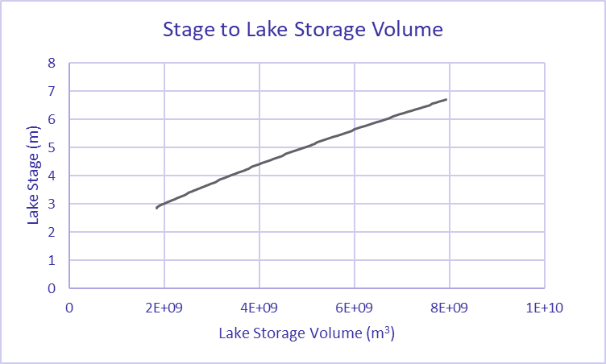
Figure 95. Relationship of Lake Okeechobee stage to storage volume.

Volume and loads at the mouth of the Kissimmee River minus the contribution from the Upper Kissimmee Sub-watershed.
Volume and loads entering Lake Okeechobee from Indian Prairie minus the contribution from the Lake Istokpoga Sub-watershed.
Volume and loads entering Lake Okeechobee from Taylor Creek/Nubbin Slough minus the contribution from the East Sub-watershed.
The Natural Soils Landscape Position/Soils Database essentially used the NRCS Soil Survey Geographic database county soil survey information to determine the historic vegetation communities that resided on soil types. This is available for 19 counties in southern Florida and was completed in 2000.

