Final Report

Developing a water and nutrient budget for Lake Trafford, Florida, U.S.A

Contract S0778

Final Report submitted to:
Division of Environmental Assessment and Restoration
Florida Department of Environmental Protection
2600 Blair Stone Rd., MS 3500
Tallahassee, FL 32399

Submitted on 03/31/2017 by:
Serge Thomas (PI*), Jong-Yeop Kim (co-PI) and Mark Lucius (MS student)

*Southwest Florida Aquatic Ecology Group/Inland Ecology Research Group
Florida Gulf Coast University
10501 FGCU Blvd. S.
Fort Myers, FL 33965-6565

Ph. 239‐590‐7148, Cell. 239-204-0920
sethomas@fgcu.edu

Table of Contents
Table of Contents i
List of Tables iii
List of Figures iv
List of Appendices vi
Executive Summary 7
Introduction 10
Research Objective 17
Methodology 18
Study Site 18
Water fluxes and Nutrient loading 24
Groundwater 28
Surface water inflow 33
Dry and Wet deposition 36
Meteorological data and evaporation modeling 38
Change in Storage 41
Water and Nutrient Budget Modeling 42
Results 45
Groundwater 45
Surface Water Inflow 53
Dry and Wet Deposition 62
Lake water quality 65
Meteorological Data, Evaporation Modeling, and Change in Storage 66
Water Budget 72
Nutrient Budget 77
Discussion 83
Areas of Future Study 96
Conclusions 97
Literature Cited 99
Appendix A 104
Appendix B 105
Appendix C 106
Appendix D 107
Appendix E 108
Appendix F 110

List of Tables
Table 1: Sampling type and nutrient species analyzed for each budget component.. 25
Table 2: Summary table of event number, date range, and number of days in the event. 27
Table 3: Summary table of seepage meter locations in Universal Transverse Mercator (UTM).. 30
Table 4: RMSE values for each pair of duplicates, grouped by sampling site. 46
Table 5: Daily rates of groundwater (GW) discharge (in), recharge (out), and nutrient loading in and out categorized by sampling event. 52
Table 6: Mean values for TP and TN concentrations in canal samples, as well as mean daily discharge values for each canal. 59
Table 7: Mean, standard deviation, and min/max values for each facet of the water budget. 73
Table 8: Summary statistics for all facets of the nitrogen and phosphorus budgets including in-lake processes. “GW in” is groundwater discharge, and “GW out” is groundwater recharge. 78

List of Figures
Figure 1: Plot depicting the typical pattern of ecological regime shift 12
Figure 2: Diagram depicting typical hydrological inputs and outputs for aquatic system 15
Figure 3: Median specific conductance of Lake Trafford for the various dredging periods 17
Figure 4: Lake Trafford watershed boundary delineated for the 2008 TMDL report 19
Figure 5: Lake Trafford watershed boundary with categorized land use 20
Figure 6: Numbering and location of the five dead end drainage canals feeding into Lake Trafford 21
Figure 7: Satellite image of Lake Trafford and the Immokalee Slough 22
Figure 8: Bathymetric map of Lake Trafford 24
Figure 9: Approximate location of the 20 groundwater seepage meters and sampling wells 28
Figure 10: Diagram of groundwater seepage meter and pore water wells 32
Figure 11: Autonomous sampling station for canal water and flow sampling and Sontek IQ 34
Figure 12: Automatic dry/wet deposition sampler 39
Figure 13: Surfer map of the average groundwater flow rate 45
Figure 14: Box and whisker plots of well sample concentrations for TN and TP 47
Figure 15: Spatial variation in average nutrient concentrations of collected groundwater samples 48
Figure 16: Interpolated Surfer maps of the average groundwater loading of TN and TP 49
Figure 17: Total Groundwater discharge and recharge for each sampling event 49
Figure 18: Groundwater discharge and recharge interpolated between biweekly sampling events using a Bessel Spline function 50
Figure 19: Time series of cumulative groundwater discharge in both total cubic meters and percent of average lake volume 50
Figure 20: TP and TN groundwater discharge and recharge loading for each sampling event. 51
Figure 21: Hydrographs of canal discharge 54
Figure 22: Canal discharge plotted over rainfall for all five canals 55
Figure 23: Scatterplots comparing groundwater level or lake stage to canal discharge 56
Figure 24: Satellite Image of Lake Trafford and surrounding area depicting the approximate location of USGS Groundwater level monitoring well 262554081283801 C- 687 57
Figure 25: Scatterplots of discharge from Canal 3 before correction and after correction 58
Figure 26: SRP/TP ratios for Lake Trafford’s five drainage canals and center-lake grab samples 59
Figure 27: Composite sample concentrations for TN and TP for canal discharge 60
Figure 28: Bi-week canal discharge loading totals from composite samples analyzed for TN and TP 61
Figure 29: Daily loading rates of TN and TP for dry and wet deposition 63
Figure 30: Relative percentage of mean daily atmospheric deposition accounted for by wet and dry deposition of nitrogen and phosphorus 64
Figure 31: Time series plots of pH and TOC, conductivity and temperature, and TN and TP for samples taken from the center of Lake Trafford during the study period. 65
Figure 32: Two-week cumulative rainfall at the Lake Trafford weather station and at the IFAS extension in Immokalee 66
Figure 33: Air temperature and water temperature plotted with rainfall 67
Figure 34: Scatterplot of daily averages of gross solar radiation from the Davis weather station and net solar radiation from the Kern NR2 Lite 68
Figure 35: Changes in gross solar radiation, net solar radiation, and reflected solar radiation over time 69
Figure 36: Results of the four evaporation models applied to Lake Trafford 69
Figure 37: Changes in hourly-averaged water levels as measured by the USGS staff gauge located at Ann Oleski Park and at the weather station by the SOLINST levellogger. 70
Figure 38: Time series of lake stage over the past nine years. Time series graph of lake stage during the period of data collection. Stage-volume curve and a stage-planar surface area curve 71
Figure 39: The final daily water budget of all fluxes for Lake Trafford 72
Figure 40: Stacked bar graphs showing daily volume of the hydrological inputs and outputs into and out of Lake Trafford by month 74
Figure 41: Time series plot of both the true volume and the budgeted volume of Lake Trafford 76
Figure 42: The final daily nutrient budget of all of measured loading for Lake Trafford over the course of the study period 77
Figure 43: Relative percentages of each source of nutrient loading into Lake Trafford for total nitrogen and total phosphorus 78
Figure 44: Stacked bar graphs for loading of TP and TN by month for each source of nutrients 79
Figure 45: Modeled TN and TP lake concentrations compared to true concentrations. 81
Figure 46: Total net in-lake processing for each bi-week 82
Figure 47: Changes in groundwater and lake level elevation over the course of the study, along with measured groundwater discharge (black dots). Increased groundwater discharge should be expected when groundwater elevation (dashed line) is higher than lake water elevation (black line). 83
Figure 48: Maps of sediment+floc (i.e. muck) accumulation in Lake Trafford pre-dredging (Art Engineering, 2004) and post dredging (Dettmar, 2012) 85
Figure 49: Monthly historic averages (1959 – 2007) for rainfall plotted against recorded rainfall during 2015-16 recorded at the installed Davis station and IFAS Immokalee 88
Figure 50: Changes in net sheet flow, precipitation,, and stage over time. 92

List of Appendices
Appendix A: Terms and abreviations.........................................................................................104
Appendix B: Code for flow weighted sampling of canal discharge............................................105
Appendix C: Code for movement of automatic dry/wet deposition sampler..............................106
Appendix D: Interpolated maps of groundwater flow for each sampling event..........................107
Appendix E: Interpolated maps of groundwater loading for each sampling event......................108
Appendix F: Time series graphs for stage and flow velocity for each canal.................................110

Executive Summary
Eutrophication is a widespread problem plaguing water bodies throughout the world. The need to control nutrient loading into lakes has become paramount in lake management. Failing to do so can lead to numerous undesired effects, including algae blooms, fish kills, and even complete ecological regime shifts. Water and nutrient budgets are useful for quantifying nutrient loading into a hydrosystem while also revealing problematic areas or times of excessive nutrient deliveries. Lake Trafford is a shallow 600 ha natural hydrosystem of circular shape with ambiguous boundaries, surrounded mostly by wetlands (e.g. Corkscrew swamp) and located near the city of Immokalee, Collier County, FL, USA. The lake has been subjected to decades of cultural eutrophication and still exhibits the turbid water state of eutrophic shallow lakes dominated by phytoplankton, despite the completion of sediment dredging in 2011. To determine the current sources of nutrient loading and to calculate the total daily loads for nitrogen and phosphorus, a water and nutrient budget was developed. Unlike most budgets which rely on modeling and numerous assumptions or estimates, direct measurements of atmospheric (dry and wet), surface water (canals), and groundwater nutrient loading made at a high spatio-temporal definition were used to develop this budget. Using the measured components of the water and nutrient budget, estimates of diffuse runoffs from the surrounding watershed and out to the adjacent wetlands were made, along with estimates of internal loading of nutrients and biological uptake.
Groundwater seepage measurements, grab samples, and composite samples were collected during biweekly sampling events between October 2015 and May of 2016. Groundwater seepage meters were used to assess groundwater discharge and recharge paired with pore water wells for groundwater sampling. Surface water nutrient loading from five drainage canals was monitored with Sontek IQ units and ISCO 3700 automatic water samplers. Meteorological data were collected at a weather station built on the lake, and were used to determine direct precipitation and evaporation rates. A constructed wet/dry deposition sampler was also employed to collect composite samples of atmospheric deposition on the lake.
Results showed that the vast majority of water entering Lake Trafford was through the five drainage canals which delivered 61% (41,963 m³ d⁻¹) of the daily water influx, while direct precipitation (27%; 18,887 m³ d⁻¹) and groundwater discharge (12%; 7,975 m³ d⁻¹) contributed less water overall. Outflow was dominated by sheet flow moving out to Corkscrew Swamp which accounted for 69% (-49,389 m³ d⁻¹) of all effluxes, while evaporation (30%; -21,644 m³ d⁻¹) and groundwater recharge (1%; -345 m³ d⁻¹) accounted for less. Sheet flow was calculated as a net value and was negative on average (-48,768 m³ d⁻¹), indicating that more sheet flow was leaving Lake Trafford than entering. Nitrogen loading into Lake Trafford was highest from groundwater discharge (49%; 117.46 kg TN d⁻¹), while loading of phosphorus was dominated by surface water discharge from the five drainage canals (48%; 10.32 kg TP d⁻¹). The residual component of the budget was assumed to be controlled by processes within in the lake (e.g. internal loading, sedimentation, biological uptake), and was found to be a negative value on average (-61.3 kg TN d⁻¹; -7.6 kg TP d⁻¹) indicating that in-lake nutrient dynamics were dominated by sequestration processes, such as biological uptake. The total daily load was found to be 274.3 kg d⁻ ¹ and 24.2 kg d⁻¹ for TN and TP, respectively. These values are higher than those found in the lake’s adopted TMDL report of 190.5 kg d⁻¹ for TN and 18.6 kg d⁻¹ for TP, which was estimated during a seven year modeling period using land-use based runoff modeling. Dry season rainfall was higher than average (563 mm for October 2015 – May 2016; 330 mm for historic average October –May) and influenced the results. The final water and nutrient budgets provided insight into the hydrological dynamics of Lake Trafford, although future work should be conducted to better understand its hydrogeology as well as the nutrient loading into its drainage canals; particularly the eastern most canal which is an ideal area for remediation.

Introduction
Lake Trafford is a shallow, subtropical lake located near the city of Immokalee in Collier County, Florida. Lake Trafford is the center low spot of a 70-mile² basin and is considered a discharge basin for the local surficial aquifer (Gibson, 2002). While the lake has no defined tributaries, it is the headwaters to the Corkscrew Swamp and the Imperial and Cocohatchee River watersheds. It contributes shallow seepage to these areas during the dry season and overflows its banks when water levels reach an elevation of 21 ft. NGVD. When water levels are above this 21-ft threshold, water discharges to Corkscrew Swamp as well as south through Camp Keais Strand and Stumpy Strands, thus impacting the Fakahatchee Strand and Golden Gate Estates Critical Project Area and eventually makes its way to the coast through the 10,000 Islands (Gibson, 2002; Ceilley et al. 2013; Ferlita, 2014).
Lake Trafford was historically known as the premier freshwater boating and fishing destination in Southwest Florida after the first public boat ramp opened in the early 1960’s (Ceilley et al. 2013). The lake was known for its clear water, sandy bottom, and diverse and expansive coverage of submerged and emergent aquatic vegetation. Over the years, local development and the establishment of many farms caused anthropogenic nutrient loading to Lake Trafford to increase. This was coupled with extensive proliferations of the macrophyte Hydrilla verticillata.
Hydrilla is an invasive exotic from the warmer regions of Asia which was accidently introduced in the lake in 1969. With optimal conditions of light, temperature and nutrients, this plant can grow up to 2.5cm a day and a single tuber can grow more than 6000 new tubers per m² (Sutton et al. 1992). Further extended hydrilla beds can smother native vegetation (e.g. Vallisneria americana and Potamogeton illinoensis) and reduce habitat suitability of fish at elevated densities (Haller and Sutton, 1975). Hydrilla can grow in dark, turbid waters, requiring only 0.75% of incoming solar radiation to grow (Canfield et al. 1985). It can grow in a wide variety of conditions and has been known to double its water body coverage in as little as six weeks (Haller and Sutton, 1975). Visitors to the lake complained of boat propeller fouling and decreased fishing area after Hydrilla had covered the entire lake from its bottom to its water’s surface.
The lake was thus treated with herbicides from the 1970’s to the 90’s. The subsequent death and decay of Hydrilla caused increased organic sediment to accumulate on the lake bottom. This increased internal nutrient loading and allowed for the perpetual disturbance of the bottom sediment due to the lack of anchored vegetation, which led to decreasing water clarity (Søndergaard et al. 2003). Consequently, Lake Trafford experienced an ecological regime shift from a clear water state to a turbid, phytoplankton dominated state with no submerged aquatic vegetation to compete for nutrients or stabilize organic sediment once the Hydrilla was eradicated (i.e. the turbid state of the alternative stable states as described in Scheffer et al. 1993 and summarized in Scheffer et al. 2001). The large amounts of organic sediment that had accumulated from the decaying Hydrilla created an average 0.74 m thick organic sediment layer with up to 2 m in some areas (Art Engineering, 2004) thus i) reducing lake water volume, ii) increasing BOD, iii) yielding recurrent (harmful at times) algae blooms which iv) led to massive fish kills (e.g. 50,000 fishes in 1996; Ceilley et al. 2013) and v) quickly drew public attention. Lake Trafford was then added to the State of Florida 303(d) list of impaired waterbodies in 2002 due to chronic hypoxia and elevated concentrations of unionized ammonia typical of dystrophic lakes (Kang and Gilbert, 2008). The decline of recreation in and around Lake Trafford as well as increasing public outcry from residents spurred the start of a restoration effort beginning in 1996.
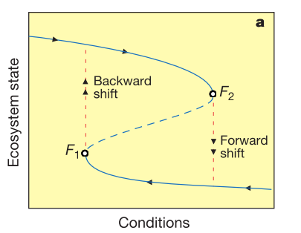
Reversing the nutrient rich turbid state of a lake dominated by phytoplankton to its previous clear state dominated by native plants poses a great challenge since the effort involved for such a shift is greater than what it took to initially make the hydrosystem shift to the turbid state (a phenomenon called hysteresis, Scheffer et al. 2001, Figure 1). Despite this obvious challenge, the Army Corps of Engineers sharing costs with the Big Cypress Basin ad valorem funds, the Florida Fish and Wildlife Conservation Commission and Collier County Tourist Development Council signed in 2000 a $21,359,619 Project Cooperation Agreement with the SFWMD to i) dredge Lake Trafford organic sediment, ii) deposit the sediment in a spoil area 1 mile north of the lake, iii) restore native fisheries and the lake ecosystem and iv) develop a watershed protection plan to reduce cultural eutrophication. Sediment dredging can induce a switch towards the initial clear state, although this strategy may have negative impacts (Zhong and Fan, 2007; Ferlita, 2014).

Figure 1: Plot depicting the typical pattern of ecological regime shift, where different ecological states can be present under the same ecological conditions. Backward shifts in ecological state (e.g. from turbid water state to clear water state) typically require lower nutrient and turbidity levels (“conditions”) to occur when compared to forward state shifts (e.g. clear water state to turbid water state). This effect is known as hysteresis (Scheffer et al. 2001).

Per the muck measurement performed in January 2004 (Art Engineering, 2004), all the estimated 4.8 10⁶ m³ of accumulated organic muck was removed by dredging from 2006 to November 2010. The muck was disposed in the spoil area north of the lake. Additionally, the restoration effort included plantings of native vegetation to limit sediment resuspension, control the growth of Hydrilla, and improve fish habitat (Ceilley et al. 2013). Watershed alterations were made as well; the most notable of which rerouted reclaimed water from a nearby wastewater treatment plant out of Lake Trafford (SFWMD, 2011). Fisheries management plans and aquatic plant management plans were established post-dredging by the Florida Fish and Wildlife Commission (FWC). The assembly of the Lake Trafford Management Action Team also allowed for cooperative action by a variety of State and local agencies (Ceilley et al. 2013). Water quality monitoring projects and SAV mapping strategies were implemented by Florida Gulf Coast University (FGCU) in conjunction with the South Florida Water Management District (SFWMD). The SAV mapping, which utilized sonar and various ground truthing techniques, determined that approximately 10% of the lakes benthic surface area was covered by macrophytes, with most of that coverage coming from Hydrilla (Thomas et al. 2015). A study by Ferlita (2014) which analyzed changes to zooplankton communities as indicators of lake change has also been conducted.
While the restoration effort for Lake Trafford has been an important curative step in the lake’s recovery with e.g. an encouraging growth of bass population (including notably some large specimens), the lake continues to exhibit cyanobacterial algae blooms and Hydrilla spread over the native vegetation (Thomas et al. 2015).
Contemporarily to the restoration efforts started in 2000, a legally mandated TMDL was created in 2008 due to the lake’s impaired status, with the goal of determining the sources of loading into Lake Trafford and identifying nutrient load targets for the lake. The TMDL modeled water and nutrient loading into Lake Trafford using Hydrologic Simulation Program - Fortran (HSPF) which applied local land use data, topography, and local groundwater well data to model surface flow, baseflow, interflow, and direct precipitation (Kang and Gilbert, 2008). The model estimated that the lake received an average of 32% of its incoming water from baseflow, 24% from interflow, 23% from direct precipitation and 21% from runoff during the modeling period between 1998-2007 (Kang and Gilbert, 2008). Estimation of nutrient concentrations were also applied based on land use data to estimate the annual load of nitrogen and phosphorus to the lake. Overall, the model estimated loading at 190 kg d⁻¹ of TN and 18.6 kg d⁻¹ of TP during the models simulation period. Runoff was estimated to be the largest contributor of TN at 92 kg d⁻¹ while subsurface deliveries (baseflow and interflow) contributed 83.5 kg d⁻¹. Conversely, TP loading was estimated to be higher among subsurface deliveries (12.2 kg d⁻¹) and lower from surface runoff (5.6 kg d⁻¹). Per the TMDL report, final load limits were set at a daily allowable load of 70.4 kg d⁻¹ for TN and 4.15 kg d⁻¹ for TP.
Because the TMDL study conducted in 2008 was solely based upon modeling, most of the lake’s water and nutrient budget have never been measured directly. Budgets and mass balance models are typically implemented in lentic systems such as lakes and wetlands (e.g. Mitsch et al. 1979; Grubbs, 1995; Swancar et al. 2000; Kirk et al. 2004) and can help identify sources contributing significant nutrients to the system, potentially allowing for their targeted reduction (Smeltzer and Quinn, 1996). To develop an accurate water or nutrient budget for a lake, one must quantify all inputs and outputs of water and nutrients. Typical inputs include precipitation, surface runoff or direct (point source) inflow, groundwater discharge, dry deposition, and direct anthropogenic inputs (e.g. publicly owned treatment works – POTW’s, municipal separate storm sewer systems- MS4’s). Typical outputs include evapotranspiration, surface outflow, groundwater recharge, and direct withdrawals for human use (Scheider, 1979; Kirk et al. 2004; Figure 2).

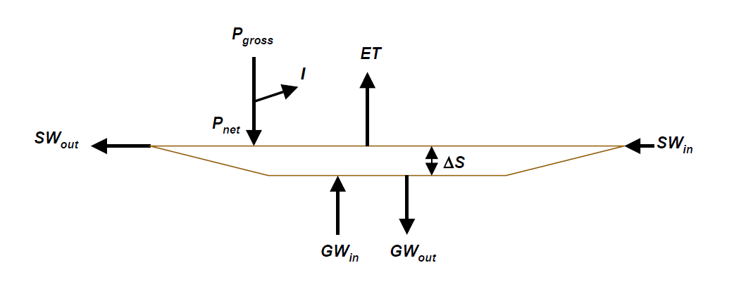
Figure 2: Diagram depicting typical inputs and outputs for aquatic systems. SW_{out} is surface water outflow; SW_{in} is surface water inflow; GW_{in} is groundwater discharge; GW_{out} is groundwater recharge; ET is evapotranspiration; P is precipitation; I is interception of precipitation; ∆S is change in storage (Kirk et al. 2004).

Groundwater/surface water interactions have never been measured in Lake Trafford. Groundwater can have an unseen influence on lake ecology, delivering water and nutrients in the subsurface, but it is often overlooked or assumed to be a non-factor (e.g. Kebde et al. 2006) in limnological research (Kang et al. 2005, Rosenberry et al. 2015). Lakes, especially in Florida, often have an intimate connection with groundwater as the water tables are shallow and movement between the lake and water table is common (Schiffer, 1998; Lee et al. 2014). Nearly seventy percent of lakes in Florida are seepage lakes, which are lakes with no true surface water tributaries flowing in or out (Schiffer, 1998). These lakes receive most of their water from groundwater and precipitation, and can also act as recharge areas for local aquifers.
Input from groundwater could be carrying higher concentrations of inorganic nutrients than estimated and may also be interacting with the surface water of Lake Trafford in unexpected ways. Groundwater nutrient pollution is becoming increasingly problematic and its delivery to lakes and coastal systems can be significant across large temporal and spatial scales (Spalding and Exner, 1993; Ouyang, 2011). Many studies have shown that nutrient concentrations in groundwater (specifically phosphorus) can be high enough to cause lake eutrophication (e.g. Burkart et al. 2004; Tomer et al. 2010). Nitrogen and phosphorus concentrations in groundwater typically become elevated due to anthropogenic activity, including fertilizer applications for agriculture (e.g. Sekhon, 1995; de Wit et al. 2002) and the use and poor maintenance of subterranean septic tanks. Both septic tanks and agricultural activity are thought to elevate nutrient concentrations in the surficial aquifer surrounding Lake Trafford in SW Florida (Kang and Gilbert, 2008).
Additionally, current groundwater seepage may be higher than pre-dredging seepage, as Lake Trafford’s average conductivity has increased post-dredging, potentially indicating increased groundwater discharge (Everham et al. 2015, Figure 3). Genereux and Bandopadhyay (2001) found that increased sediment thickness and density with lower hydraulic conductivities were very influential on spatial seepage patterns, and often caused increased groundwater discharge farther from shore, even with uniform sediment coverage.
Finally, discharge from Lake Trafford’s five primary dead-end collection canals has also never been measured, and may indicate a greater than expected level of nutrient loading via surface water runoff. Directly measuring point-source surface water inflow and outflow for nutrient budgets is more common than for groundwater (e.g. Kebede et al. 2006).
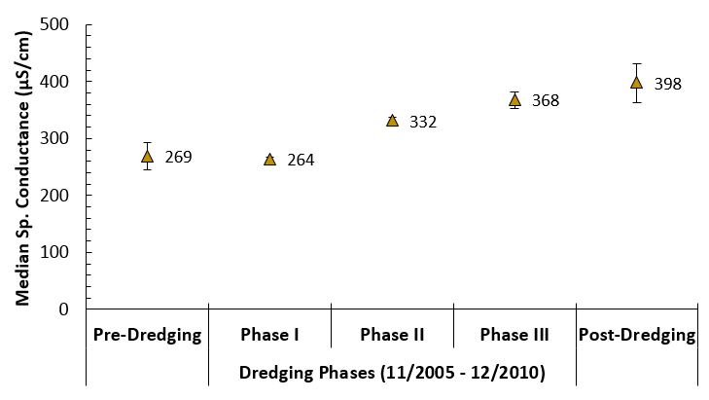
Figure 3: Median specific conductance of Lake Trafford for the various dredging periods: Pre-dredging from 1/1/2004, Phase I dredging operations from 11/4/2005 to 4/25/2006, Phase II dredging operations from 12/1/2006 to 4/25/2006, Phase III dredging operations from 6/1/2009 to 12/28/2010 and Post-dredging from 1/1/2010 to 12/31/2012. Post-dredging median specific conductance is significantly higher than pre-dredging (p-value<0.001). Error bars represent the interquartile range (25th-75th percentiles).

Research Objective
This study sought to directly measure water and nutrient loading into and out of Lake Trafford to develop water and nutrient budgets for this hydrosystem. The majority of water fluxes were measured in situ, including groundwater seepage, and numerous water samples were used to calculate loads. Other fluxes, such as sheet flow in and out of the lake and internal nutrient loading, were estimated by deduction using the measured water and nutrient budgets. The purpose of the final budgets was to determine the most significant sources of nutrients to the lake, the most problematic areas or times for nutrient loading, and to help identify potential areas for remediation. Additionally, the water and nutrient budgets will be ideal for comparison to Lake Trafford’s adopted TMDL which estimated water and nutrient loading into Lake Trafford via land-use based runoff modeling. Increasing the knowledge of Lake Trafford’s hydrology and nutrient dynamics is important to guiding its restoration and its hopeful return to a clear water state.

Methodology

Study Site
Lake Trafford is a shallow, subtropical, dissolution lake located at latitude 26° 25’38.25” North, longitude 81° 29’22.4” West near the city of Immokalee in northern Collier County, Florida (Kang and Gilbert, 2008). The lake is mostly round with a surface area of approximately 600-ha and an average depth of 2 m when the lake level is at 19.5 ft. NGVD (Kang and Gilbert, 2008). Due to its circular shape and long multi-directional fetch (2.5 - 3.15 kilometers depending on wind direction), Lake Trafford is polymictic and prone to high wave activity in times of high winds (Ceilley et al. 2013; Ferlita, 2014).
Lake Trafford’s current official drainage basin mapped in the lake’s 2008 TMDL report expands to the north and east of the lake (Figure 4), encompassing many urban and agricultural areas around the City of Immokalee, FL (Kang and Gilbert, 2008). However, the drainage basin is currently being re-evaluated using LIDAR, water level sensors, and velocimeters to track water movement over relatively flat terrain. Many assumptions regarding water movement around the lake and in its surrounding wetlands may soon be revised (Sanjay Shukla, UF IFAS, unpublished data.). While Lake Trafford is a seepage lake with no defined tributaries in or out, it is bordered by low lying wetlands to the south and west that have been known to receive lake water overflow when water levels approach 21 ft. NGVD (Flaig, 2000; Gibson, 2002). The City of Immokalee lies directly to the east of Lake Trafford, with abundant agricultural land to the north and south (Figure 5).

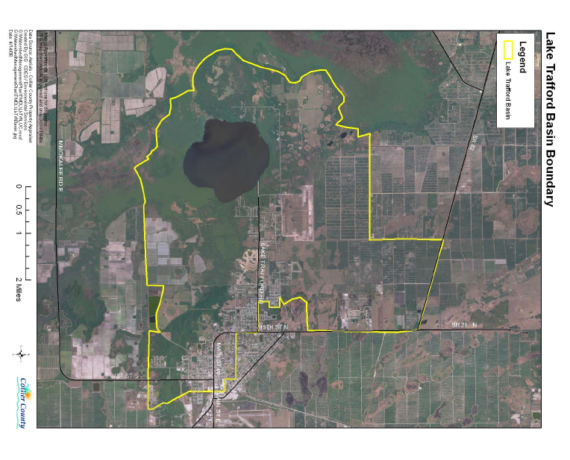
Figure 4: Lake Trafford watershed boundary delineated for the 2008 TMDL report (Kang and Gilbert, 2008). The watershed boundary is currently being revaluated using LIDAR and other methodology and the watershed shown may be updated in the near future.

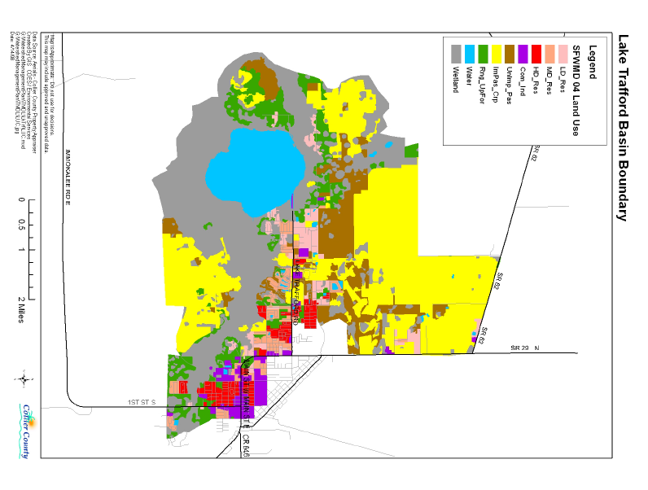
Figure 5: Lake Trafford watershed boundary with categorized land use (right). These land use categories were used by DEP to estimate nutrient loads into Lake Trafford for its adopted TMDL. Lake Trafford’s watershed is dominated by agricultural land.
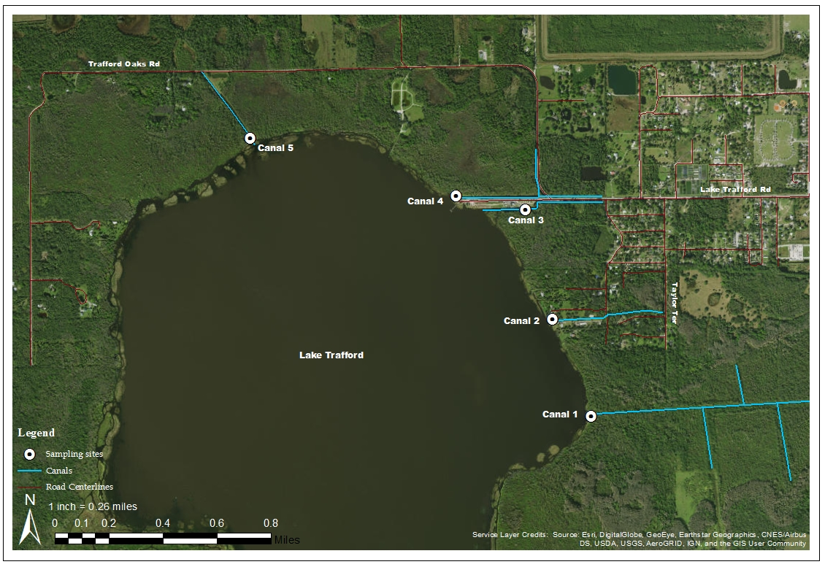
Figure 6: Numbering and location of the five dead end drainage canals feeding into Lake Trafford. The white circles indicate the approximate location of the flow and nutrient sampling equipment at each canal.

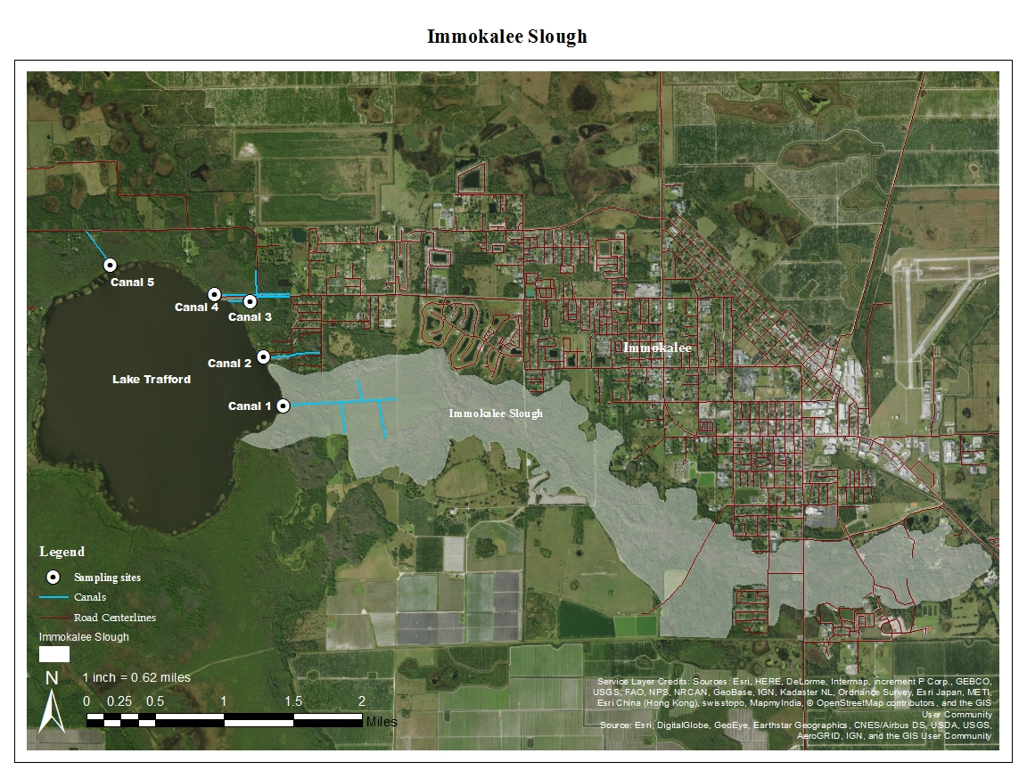
Lake Trafford has five dead-end drainage canals (numbered 1-5 for this study) that are assumed to channel surrounding rainwater and runoff from the watershed towards the lake (Figure 6). Canal 1 is located on the east side of the lake and has poorly defined banks during periods of high water (over 20 ft. NGVD 1929). It is hypothesized that this canal may drain much of the so called “Immokalee Slough” into Lake Trafford (Figure 7). Canal 2 is also situated on the eastern side of the lake, north of Canal 1. This canal has well defined banks on both sides at any water level. Following this canal upstream eventually leads to Taylor Terrace (off of Lake Trafford Road) but the canal is connected via culverts to drainage ditches and wetlands between Lake Trafford and the city of Immokalee. Canals 3 and 4 were dug as borrow pits in order to elevate and develop land where Ann Olesky Park is currently located. They are found on either side of the recreational and parking areas. These canals have well defined banks on one side (park side) and very poorly defined banks on the opposite side where vast wetland flood plains become inundated when lake levels increase during the wet season. Both canals are connected to drainage ditches that run along either side of Lake Trafford Road. Canal 5 is the northern most canal, located on Lake Trafford’s northern bank. This canal has well defined banks on one side, but poorly defined banks on the opposite side when water levels are high. This canal is connected to the road side drainage system running alongside Trafford Oaks Road.
Figure 7: Satellite image of Lake Trafford and the adjacent land to its East. The Immokalee Slough is highlighted in opaque white (digitized from aerial imagery). The location of each canal is marked with a blue line and the sampling stations are marked with white circles. Canal 1 can be seen in the terminating area of the slough.

The hydrogeology of Lake Trafford is of importance for understanding potential groundwater movement into and out of Lake Trafford. The lake sits atop the Surficial Aquifer (also called the Water Table Aquifer), Lower Tamiami Aquifer, Sandstone Aquifer, and the Mid and Lower Hawthorn Aquifers (Geddes et al. 2015). Of these, the Surficial Aquifer is most relevant to this study as it is the only aquifer to come in contact with Lake Trafford. The unconfined Surficial Aquifer supplies much of the water to residential and commercial users in Southwest Florida (Bennett, 1992). It is comprised of fine to medium grain quartz sands, as well as areas with biogenic limestone and Pleistocene and Holocene shell deposits (Bennett, 1992), the latter of which has been observed to be very abundant beneath Lake Trafford’s organic sediment layer. Hydraulic conductivity ranges from 30 m d⁻¹ to greater than 1000 m d⁻¹ through this unconfined aquifer. The aquifer is separated from the Lower Tamiami Aquifer by the Lower Tamiami confining unit over most of Collier County, but, in the vicinity of Lake Trafford, the Tamiami confining unit is absent or insignificant (Geddes et al. 2015). This could potentially allow for interactions from the deeper Lower Tamiami aquifer due to the lack of confinement, albeit it is unknown if this occurs. Bennett’s (1992) applied model of horizontal flow through the Surficial Aquifer using MODFLOW depicts an area of strong lateral subsurface water movement beneath the Lake Trafford watershed due to strong hydraulic gradients caused by elevation changes east of Lake Trafford. Using this modeling, groundwater influx is expected to occur on the Northern and Eastern banks of Lake Trafford.

Figure 8: Bathymetric map of Lake Trafford. The scale shown is in meters using the 0 m isobath as 19.5 ft. NGVD. Bathymetry data were collected by FGCU (Thomas et al. 2015) and were used to determined volumes and planar surface areas at various lake levels using Surfer 12. Seepage meter locations are depicted as black dots.

Water fluxes and Nutrient loading
A water budget for natural lakes can be created using a basic relationship which quantifies the hydrological inputs and outputs of the system. The relationship can be written as:
∆S= (P_{gross}+ GW_{in}+ SW_{in}) – (ET+ GW_{out} + SW_{out})
where ∆S is the change in storage of the lake, P_{gross} is the precipitation into the lake, GW_{in} is the inflow of groundwater, SW_{in} is surface water runoff/inflow, ET is evapotranspiration, GW_{out} is the outflow water into the ground, and SW_{out} is surface water outflow (Kirk et al. 2004). Figure 2 illustrates this relationship visually. Each facet of the water budget was measured for Lake Trafford either experimentally, by modeling, or through subtraction and deduction. Water budgeting for lakes requires that the bathymetry and total volume of the lake be known to determine the change in water storage. Post-dredging bathymetry for Lake Trafford was determined in 2015 (Thomas at al. 2015; Figure 8).
In addition to determining the volumetric flow of water, water samples were taken from each component of the water budget to determine mass nutrient loads and to create a corresponding nutrient budget. Samples were analyzed by the DEP Laboratory in Tallahassee (DEP Lab) for total phosphorus (TP), soluble reactive phosphorus (SRP), total Kjeldahl nitrogen (TKN), ammonia nitrogen (NH₄⁺), and nitrate-nitrite nitrogen (NO_{x}). All samples were handled and preserved according to applicable DEP standard operating procedures (SOPs) before being shipped overnight to the DEP Lab for analysis. Temperature and pH were measured for all samples in order to determine the ratio of ionized (NH₄⁺) and unionized (NH₃) forms of ammonia (Trussell, 1972), the latter of which is partly responsible for Lake Trafford’s official impairment designation (Kang and Gilbert, 2008). Samples were taken every fourteen days (i.e. biweekly; twice a month) or composited over these two-week periods (Table 1). Quality control blanks were taken for all sampling equipment and field duplicates were taken for approximately 20% of all groundwater and surface water samples.
Table 1: Sampling type and nutrient species analyzed for each budget component. While six nutrient species were analyzed, only TP and TN (TKN + NO_{x}) were used for this budget. X’s in the table indicate analyte was sampled.

To create the nutrient budget, nutrient mass loading was determined for each component of the water budget. Average mass loads over two-week periods were determined as:
$$L=\frac{\sum_{j=1}^{14}{{A_{j}C}_{j}Q_{j}}}{\sum_{j=1}^{14}{A_{j}}}$$

where L is the mean load, A is either 1 or 0 depending on whether data is available on day j, C_{j} is the concentration on day j, and Q_{j} is the flow rate on day j (Dolan et al. 1981). Loads were expressed as kg per unit time for each budget component. The structure of the nutrient budget model mirrors that of the water budget model with two exceptions: i) direct surface water runoff was determined through deduction and no water samples were taken to determine nutrient concentration and ii) dry deposition of particulate nutrients has no corresponding water flux. Data collection occurred from October 2015 to October 2016 and was performed as biweekly “events” where data could be easily qualified based on event number. Additionally, several composite sampling systems were used that collected samples for extended periods of time. Nutrient data from these systems were applied as the average for each biweekly event. The dates for these events can be found in Table 2. The methodologies for quantifying each facet of the water and nutrient budgets are detailed below.

Table 2: Table of sampling event number, dates ranges, and number of days per sampling event. Some days had more or less than 14 days.

Groundwater
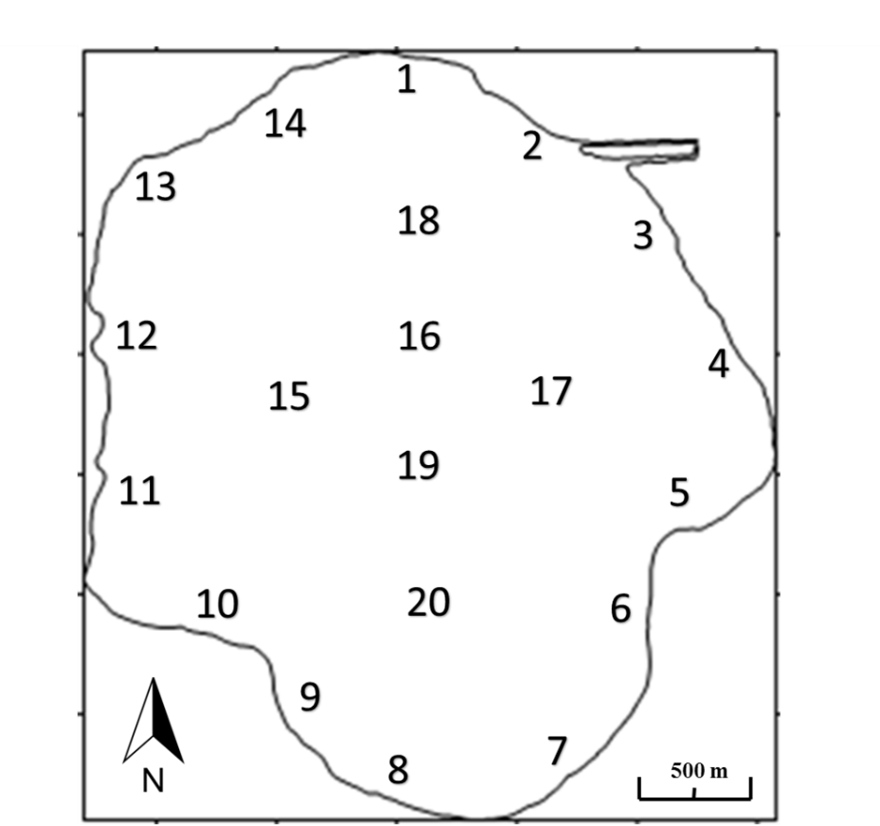
Upward and downward fluxes of groundwater were quantified with groundwater seepage meters. Groundwater fluxes were measured every other week (i.e. twice a month) with a total of 25 seepage meters placed at 20 locations throughout the lake (fourteen littoral sites, six open water sites; Figure 9; Table 3). More meters were used in the littoral zone of the lake where the majority of groundwater exchanges typically occur (e.g. Belanger et al. 1985; Rosenberry et al. 2014). Five sites received duplicate seepage meters which were placed directly adjacent to one another. These duplicate meters were used to assess the precision of the duplicate groundwater flux measurements in close proximity using Root-Mean-Square Error (RMSE). A total of four duplicate meters were used to assess the shallow water meters’ accuracy (Sites 3, 5, 10, and 13) and one was used to assess the deep water meters’ accuracy (Site 15).
Figure 9: Approximate location of the 20 groundwater seepage meters and sampling wells. Meters 1-14 are situated in the littoral zone, while meters 15-20 are situated in open, deeper water.

Littoral seepage meters were spaced evenly around the lake’s perimeter. The meters were placed in June of 2015 when water levels were lowest, and were placed as shallow as possible. Depth and spacing around the lake were the primary drivers of meter placement, but other factors influenced positioning as well. For example, large stands of emergent vegetation often forced meters to be placed further from shore or further down the bank. Additionally, an airboat tour company operating in Lake Trafford has created many “airboat trails” where their boats frequently travel. These areas were avoided to avoid collisions with meters and erroneous fluxes from boat pressure waves. Each seepage meter was placed deep into the sediment and confirmed to have a complete seal around the bottom with the lake bed. The deep meters were installed with the use of SCUBA while the shallow meters were installed on foot. The shallow meters were marked with PVC pipes extending above the water’s surface in the shape of a “tipi” and each pipe was marked with red/white Department of Transportation (DOT) reflective tape. The shape of these markers helped to prevent boaters from approaching the meters too closely and causing erroneous measurements or unintended collisions. Deep water meter sites were marked with a single 2” PVC pipe marked with reflective tape. These markers were driven into the ground until refusal, roughly two meters away from the seepage meter location. All meters were allowed to settle for three months before official sampling began; long enough for adequate settling and accurate flow results (Erickson, 1981; Shaw and Prepas, 1989; Rosenberry et al. 2008).

Table 3: Summary table of seepage meter locations in Universal Transverse Mercator (UTM). Seepage locations that have duplicate meters are marked with an “X”.
Seepage rates were measured every other week for a period of 24-hours each time. For each sampling event, an eight liter 1.5-mm polypropylene bag was placed on each seepage meter. The bags were pre-filled with 1000 ml of lake water, except for two randomly chosen sites per sampling event which received deionized (DI) water. The bags were placed and collected using SCUBA or snorkel to prevent artificially high flow caused by disturbing the sediment around the meter (Rosenberry et al. 2008). After being deployed for approximately twenty-four hours, each bag was removed and measured volumetrically. Bags that were filled with DI water were also measured for specific conductance to determine the conductivity of the groundwater flux.
The volumetric flow rate (Q) for each site was then determined as:
$$Q= \frac{∆V}{∆t}= \frac{V_{start }+V_{final}}{elasped time}$$
where V_{final} is the volume final in the bag, V_{start} is the initial volume in the bag and dt is the elapsed time. Flux velocity was also calculated by dividing Q by the cross-sectional area of the seepage meter (2,600 cm²) which is useful for comparing flux rates between systems with varying meter designs. A correction coefficient of x1.10 was applied to all flow rates (Rosenberry et al. 2008).
Groundwater was sampled using pore water wells placed directly adjacent to each seepage meter. Each well was constructed from ¾” Schedule 40 PVC connected to a Solinst™ standpoint piezometer. These piezometers have 40 cm section of 297 µm filter screen (50 mesh) and were placed with the tip of the well 80 cm below the sediment water interface (Figure 10).
Wells were dug using one of two methods. First, in areas of softer sediment, a 6” PVC well casing was hammered into the sediment. This casing was then cleared of sediment using a soil auger and peristaltic pump before placing the piezometer inside the casing. The casing was then backfilled with fine grain well sand and then capped with bentonite. The well casing was finally removed. The second method was used in areas where tougher sediment or limestone were present. The initial hole was dug free-hand using posthole diggers and a wrecking bar to break through areas of limestone rock. The piezometers were then placed and back filled by hand congruent with the previous method. All wells were placed within 1 meter of their associated seepage meters, with the exception of Site 9, where shallow limestone forced well placement approximately 30 meters to the west of its seepage meter. Wells located at shallow water sites extended above the surface and were capped with a vented PVC cap to allow for gas exchange. Wells at deeper seepage sites extended approximately one meter above the sediment and were topped with a nozzle and ball-valve where a vinyl hose could be attached for sampling.

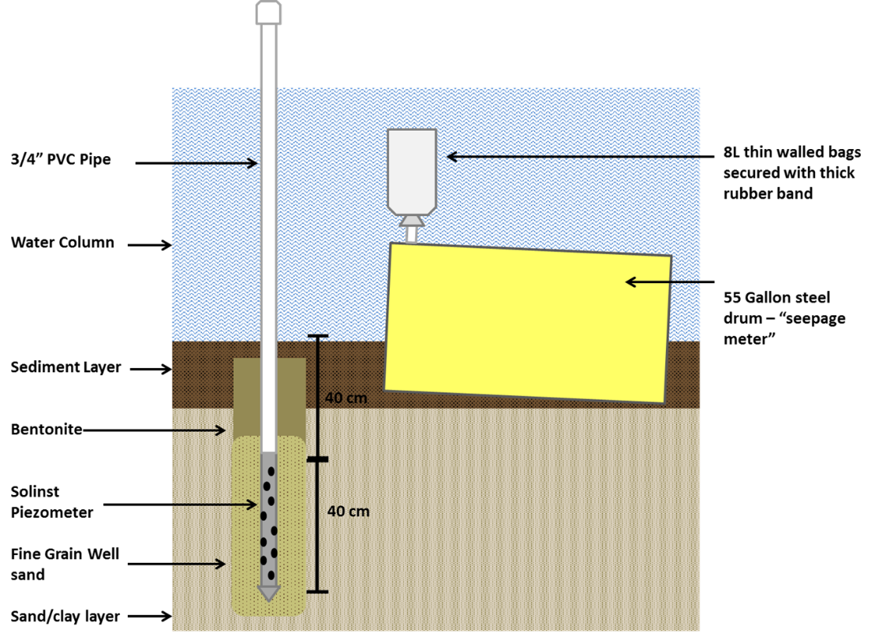
Figure 10: Diagram of groundwater seepage meter and pore water wells located at each groundwater sampling site. Porewater wells were sampled using a peristaltic pump if groundwater discharge was measured through the seepage meter.
In the event that a seepage meter site measured positive groundwater flux (>50 ml increase in bag volume), groundwater was pulled from the adjacent well using a peristaltic pump at a low flow rate. The well was first purged of two times its standing volume (determined by the current water depth, known depth of the piezometer in the sediment, and diameter of the piping used) before samples were taken. Once collected, samples were preserved with sulfuric acid (pH<2) and chilled <6°C, with the exception of one 120-ml sample intended for orthophosphate (SRP) analysis which received no acid. Samples were sent to the DEP Lab in Tallahassee via overnight shipping for next day analysis. Turbidity, pH, temperature, and conductivity were all recorded using a Hach HQ40d, with conductivity being of particular interest. When conductivity or turbidity levels were found to be abnormally high (turbidity) or low (conductivity), a well evaluation was performed and replaced if needed. Wells 3, 5, 8, 10, and 16 were all replaced during the study. It is believed that loss in performance in these wells was caused by incidental contact with the standpipe. Well 16 was broken by the researchers’ boat anchor during a windy day.
The sampled water was used to determine mass loading via groundwater. For positive groundwater discharge, groundwater mass loading was calculated using the flow rate and the concentration results of the sampled water. Conversely, in the event of groundwater recharge, the ambient water column concentration was used to calculate the negative mass load of nutrients.
Data was logged and stored in Excel and statistical analysis performed using IBM SPSS Statistics. Spatial and temporal variability of the flow rates and nutrient loading were analyzed and extrapolated for the entire lake using Surfer 12 contour mapping software (Goldensoftware.com). Surfer 12 was also used to determine the total volume of water discharged as well as the total mass groundwater nutrient loading.

Surface water inflow
Each of Lake Trafford’s five dead-end, runoff collection canals was equipped with a Sontek IQ (Canals 1, 4, and 5) or Sontek IQ+ (Canals 2 and 3). Additionally, each canal was fitted with an ISCO 3700 automatic water sampler and a WaterLOG Storm3 data logger. This equipment was programmed to create an autonomous sampling system that sampled canal water when a certain flow threshold had been reached, allowing for continuous monitoring of discharge and nutrient loading into Lake Trafford.
The IQ and IQ+ models are ideal for measuring water velocity and discharge in shallow canals and culverts. The cross sectional bathymetry of each canal was measured manually using a surveyor’s level and stadia rod and entered into the IQ software. This allowed the software to calculate Q through each canal by monitoring stage and water velocity. IQ units were placed in areas where the canal was straight with well-defined banks (when possible). The IQ units were mounted on platforms constructed of angle and sheet aluminum attached to four mounting legs made of galvanized piping (Figure 11). The platforms were adjusted so that their height was approximately 10 cm from the top of the sediment. The true height off of the bottom for each IQ unit was input into the IQ Software, allowing the software to adjust to the true stage of the canal. Noise in the flow data was elevated originally, with high up and down readings within the span of 10 minutes. Subsequent to months of troubleshooting with the IQ’s manufacturers, this was remedied by disabling the two side-mounted acoustic beams and using only the two center line beams for velocity measurements beginning in April 2016.Data collected before April was used for all Canals with the exception of Canal 3 which had much higher noise due to an incidental change in tilt unknown causality. Data for Canal 3 was transfromed to reduce noise during that period due to high noise within the daily averages (Figure 25). Daily averages for the other four canals were deemed representative despite noise in the raw data.
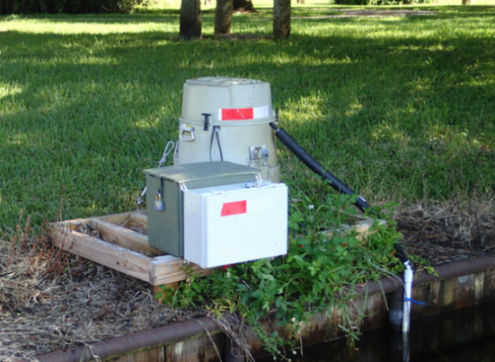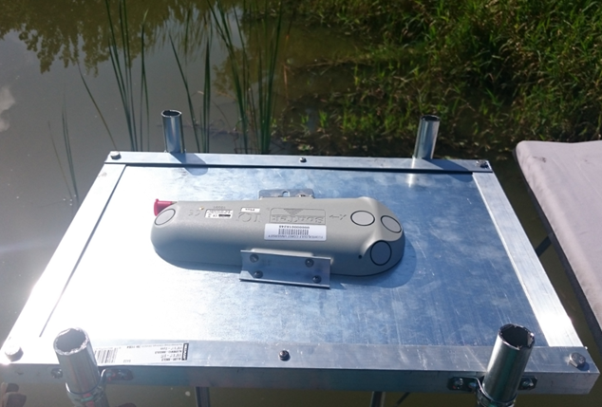
Figure 11: Autonomous sampling station for canal water and flow sampling (left). The ISCO sampler was triggered by the flow measured by the Sontek IQ unit (right) to create a flow weighed sampling pattern.

The ISCO samplers were mounted to wooden platforms placed in the shallows along the side of each canal. ISCO samplers have the capability of utilizing up to 24 discrete sampling bottles and filling them using a motorized distributor arm. However, this option was not used for this study. Instead, the individual bottles and distributor arm were removed and replaced with a single 5-gallon polyethylene camping bladder. Each sample taken was placed in this bladder to create composite samples over each two-week sampling period.
Each IQ unit was connected via SDI-12 to a WaterLOG Storm3 data logger to record canal discharge every ten minutes with a five-minute scanning duration. Flow rate (Q; m³ s⁻¹), mean velocity (m s⁻¹), water level (m), and water temperature (ºC) were all recorded (Appendix F). Storm3 data loggers and the IQ power adapters were housed in weather proof electrical NEMA boxes mounted to each ISCO platform. All equipment was powered with a 12V 105-ah deep cycle marine battery housed in a lockable box which was replaced with a fully charged battery every two weeks.
A simple program written in Basic language was used within the Storm3 software to allow flow rates to dictate sampling pace by the ISCO samplers (Appendix B). A positive flow counter logged and summed all positive flow (ignoring any negative readings). A flow threshold was then assigned for each canal that, when surpassed, signaled the ISCO samplers to take a 100 ml sample. ISCO samplers were programmed to purge> rinse> purge>sample to clean the sampling apparatus before the final sample was taken. The sampling apparatus consisted of a slotted PVC pipe extending out one meter into the canal.
Because flow rates through Lake Trafford’s canals had never been determined, initial flow thresholds were approximated using rainfall data and local watershed analysis. ISCO sampling flow thresholds were then adjusted after the first three months of data were collected in order to maximize the resolution of each composite sample. Flow thresholds were changed monthly for each canal to correspond with anticipated rainfall and water flow.
Sampling trips to Lake Trafford occurred every fourteen days unless weather or other factors altered scheduled dates. Flow data was downloaded from the Storm3 data loggers over Wi-Fi and 12V batteries were swapped with fully charged replacements. The composite samples collected by the ISCO sampler were homogenized and subsampled. Composite samples remained in place between each sampling event and were collected after fourteen days. Because of this, an acid preservative was placed in the composite bladder before each sampling event (750 ml of 0.5 N sulfuric acid). The acid preservative prevented the determination of orthophosphate due to acid hydrolysis (Gales et al. 1966). Thus, a grab sample from each canal was taken during each sampling trip to estimate loading of soluble reactive phosphorus by determining the typical TP:SRP ratio for each canal.

Dry and Wet deposition
Dry and wet deposition were measured experimentally at the study site using a homemade dry and wet deposition sampler (Figure 12). The unit is composed of a wooden platform with two 5 gallon HDPE buckets, with the top of the buckets reaching the standard 1.5-meter height for dry deposition collection (Amodio et al. 2014). A railing system was created with a sliding lid, connected to an IP67 rated 12” linear actuator powered by a deep cycle 12V battery. The actuator can either push or retract to slide the lid along the tracks to cover one bucket of the other. During deployment at Lake Trafford, the two buckets would each collect a form of deposition: one bucket for wet and one bucket for dry. The lid was used to cover the dry deposition bucket during rain events (thus exposing the wet deposition bucket) and to cover the wet deposition bucket during dry periods (thus exposing the dry deposition bucket). This was accomplished by wiring the linear actuator to an Arduino Uno open source coding board, a bread board, a 4 channel 5V relay board, and a rain drop sensor mounted on top of the unit. A simple code was written using Arduino language that would move the linear actuator one way while precipitation was detected and move the other way when the rain stopped (Appendix C). The program allowed the sensitivity of the rain drop sensor to be adjusted and was always kept at a high sensitivity to prevent light precipitation from entering the dry deposition bucket.
Each bucket was prefilled with an acid solution. The dry deposition collection bucket received 3.78 l of DI water with 150 ml of 0.5 N sulfuric acid and the wet deposition collection bucket received 150 ml of 0.5 N sulfuric acid only. One gallon is the standard volume for dry deposition measurements and is preferred over using empty buckets because it is known to underestimate nitrogen loading (Anderson and Downing, 2006). Both buckets received acid as a sample preservative and enough acid was used to maintain pH<2, even in the event of large amounts of rainfall. Additionally, beginning in February 2016, the buckets received a 6 mesh stainless steel screen (3.35 mm x 3.35 mm opening size) to prevent the accumulation of insects and occasionally small reptiles (i.e. anoles, tree frogs) from tainting the samples.
The sampler operated continuously for fourteen day periods after which the buckets were removed and measured volumetrically. The screens were rinsed with sample water to clean off any dust that had adhered to the screen itself. The samples were then homogenized and subsampled. The buckets were cleaned with a mild sulfuric acid solution and replaced with new water and acid solutions. The 12V battery was also swapped with a fully charged battery. Similar to the ISCO composite samples, orthophosphate could not be analyzed because the samples remained in the field for two weeks and were acidified during this time (Gales et al. 1966)

Meteorological data and evaporation modeling
Ambient weather data was collected in situ using three devices, all mounted to a permanent platform located in the southern portion of the lake (Figure 12). The first device, a Davis Vantage Pro2, was used to collect the bulk of the meteorological data. Second, a Kipp & ZonenTM NR Lite 2 Net Radiometer was used to monitor both incoming and reflected solar radiation, producing a net radiation value. Third, an ISCO 674 rain gauge was used to cross-check rainfall rates.
The Davis Vantage Pro2 weather station was used to measure rainfall, wind speed and direction, temperature, humidity, solar radiation, and surface water temperature. Standard anemometer placement is at a height of 10 meters with a distance of at least four times the height of the obstruction away from any potential wind breaks (Fryberger and Dean, 1979). However, infrastructure and budgetary limitations limited placement height of the anemometer to 1/3 of standard height (3.3 meters) from the water surface at the high water level. Rainfall rates were measured using the standard tipping bucket found on the Davis Vantage Pro2 (1 tip = 0.2 mm rainfall). Bird activity was problematic during very early data collection, but the addition of bird spikes around the edge of the rain bucket helped prevent it from clogging with bird droppings. A soil temperature probe was also connected to the Davis Vantage Pro2 to monitor surface water temperature. The probe was affixed to the platform’s leg, approximately 1 meter below the water’s surface.

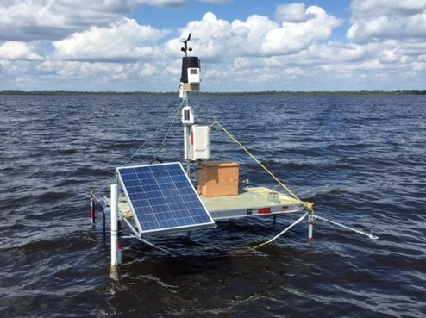
Figure 12: Automatic dry/wet deposition sampler. The linear actuator slides a wooden lid from one bucket to the other when the rain drop sensor detects rain (left). Lake Trafford weather station located in the southern open water portion of the lake (right).
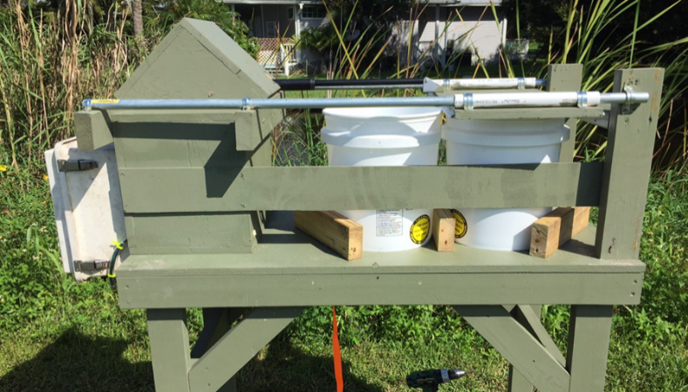
The Kipp & ZonenTM NR Lite 2 net radiometer was connected via analog connection to a Strom3 data logger. The unit has two thermopile sensors facing opposite directions (one facing the sky and one facing the water’s surface below). The unit produces a reading in volts that was then converted to watts of net radiation per square meter. The measurement of the net radiation is valuable for determining evaporation rates using more advanced evaporation models such as the Penman-Monteith model (Ponce, 1989).
An ISCO 674 rain gauge (1 tip = 0.1 mm) was used as a backup and also used to cross-check the rainfall data of the Davis Vantage Pro2. Bird spikes were also added to the collection bucket in January 2016 due to frequently being fouled by bird droppings. Rainfall samples were collected at the dry deposition station, approximately 1 mile away from the weather station.
The entire weather station was powered using a 12V deep cycle battery with a south facing 100-watt solar panel. Data from the weather station were collected every fifteen minutes. The weather station console was used in conjunction with a LIVATM minicomputer tethered to a Verizon 4G LTE hotspot. The small computer was controlled remotely using TeamViewer 10, allowing the researchers to view the data in real time as well as download the data remotely. Further, a small USB webcam was mounted to the weather station and connected to the mini PC, which took pictures of the weather conditions every three minutes. All weather station data was hosted live online (lakesrus.com/Trafford) and made viewable to the public.
Using the data collected from the weather station, three evaporation models could then be applied to the surface of the lake. Although evaporation from lakes and reservoirs is often estimated from pan evaporation, such measurements are subject to many potential errors including pan environment bias, operator’s bias, estimation of rainfall on the pan, reading error, data recording errors, and others (Gunderson, 1989; Abtew et al. 2011). Thus, evaporation from water surfaces is rarely measured experimentally (Jones, 1992). Therefore, evaporation rates were determined via modeling.
To estimate evaporation from Lake Trafford, three models were used: Modified Turc Model (Turc, 1961), Simple Method (Abtew, 2001), the Abtew Marsh Model (Abtew, 2001), and the Penman-Monteith model (Ponce, 1989). These three evaporation estimation models are considered the most appropriate tools to estimate evaporation of open water bodies located in subtropical South Florida (Abtew, 2001) and they are written as:
Modified Turc model
$$E= \frac{K_{2}(23.89R_{s}+50)T_{max}}{(T_{max}+15)}$$

Radiation-temperature based model
$$E= K_{1}\frac{R_{s}}{λ}$$
Abtew Marsh model
$$E= \frac{1}{K_{3}}\frac{R_{s}T_{max}}{λ}$$
Penman-Monteith Model
$$E=\frac{∆ E_{n}+86400 ρ_{a}c_{p}\left(e_{s}- e_{a}\right)r_{a}^{-1} ρ^{-1}λ^{-1}}{∆+γ}$$
where, E = lake evaporation (mm d⁻¹); K₁ = a coefficient dependent on surface type (0.53 for open water); R_{S} = solar radiation (MJ m⁻² day⁻¹); T_{max} = maximum daily air temperature at 2 m height (°C); K₂ = a coefficient, 0.0123; K₃ = a coefficient (°C), 52.6 °C was selected for a shallow lake in the south Florida region; and λ = latent heat of vaporization of water (MJ kg⁻¹); ∆ = saturation vapor pressure gradient (mbar °C⁻¹); ρ_{a} = density of moist air (g cm⁻³); c_{p} = specific heat of moist air (g⁻¹ °C⁻¹); e_{s} – e_{a} = vapor pressure deficit (mbar); r_{a} = external resistance (s cm⁻¹); ρ = water density (g cm⁻³); and γ = psychrometric constant (mbar °C⁻¹). Evaporation rates (mm d⁻¹) were then applied to the planar surface area of the lake at the time of weather data collection. This was done using Surfer 12 to determine the lake’s stage-surface area curve.

Change in Storage
Lake Trafford’s bathymetry was determined post dredging in 2015. Thus, the volume of the lake can be determined when the water level of the lake is known. The USGS has been monitoring lake elevation above mean sea level (NGVD) since 2007 (Gauge 02291200). However, an additional monitoring device, a Solinst Levelogger 3001, was deployed at the weather station in order to cross check USGS measurements, as well as act as a failsafe in the case of USGS equipment failure. The unit was mounted within a 2” PVC pipe in which holes were drilled. The pipe extended above the surface of the water to create a consistent water surface elevation, where wave activity could not create erroneous measurements. The water level data was downloaded every two weeks. Using the bathymetry data and measured water level, the total water volume of Lake Trafford was determined using Surfer 12 at various stages, allowing for the creation of both stage-volume and stage-surface area curves.

Water and Nutrient Budget Modeling
All water and nutrient budget variables were compiled into a meta-database. When possible, daily averages for each water flux or loading were used in order to create a daily time step for the budget model. Because groundwater fluxes were only measured biweekly, fluxes between these dates were interpolated using a Bessel spline function (Figure 15). The water budget model is represented as:
$${TruVol}_{t+1}={TruVol}_{t}+{GWin}_{t}- {GWout}_{t}+ C_{t}+ P_{t}- E_{t}+{Snet}_{t}$$
where TruVol_{t +1} is the true lake volume at time step t + 1; GWin is groundwater discharge at time step t; GWout is groundwater recharge; C is canal discharge; P_{t} is direct precipitation; E_{t} is evaporation; Snet_{t} is the net sheet flow moving in or out of Lake Trafford. Incoming and outgoing sheet flow was not measured directly for Lake Trafford. Instead, the summation of the measured water fluxes was subtracted from the true volume of the lake to calculate net sheet flow (TruVol; determined by lake stage and bathymetry). This can be represented as:
$${Snet}_{t}=({TruVol}_{t+1}-{ModVol}_{t})$$
Where ModVol is equal to:
ModVol = ${GWin}_{t}- {GWout}_{t}+ C_{t}+ P_{t}- E_{t}$
This value is assumed to be the volume of net sheet flow or runoff entering or leaving Lake Trafford. To create the final water budget model, the net sheet flow is added to the modeled volume which then becomes equal to the true volume of the lake.
The nutrient budget model utilized sheet flow values determined from the water budget model to complete the nutrient budget. The nutrient concentrations for sheet flow entering Lake Trafford were estimated using the average composite sample concentration for the five canal locations during each event, with the assumption that the water in the canals has similar chemistry to the direct incoming sheet flow. The final nutrient budget model is represented as:
$${TruTN}_{t+1}={TruTN}_{t}+{GWLin}_{t}-{GWLout}_{t}+{CL}_{t}+{ADL}_{t}+{SFLnet}_{t}+{ILnet}_{t}$$
where TruTN_{t+1} is the total kilograms of nutrient (nitrogen or phosphorus) in the lake water; GWL_{in} is nutrient loading via groundwater discharge; GWLout_{t} is nutrient loss via groundwater recharge; CL_{t} is nutrient loading via canal discharge; ADL_{t} is nutrient loading via atmospheric deposition; SFLnet_{t} is net nutrient loading via sheet flow; ILnet_{t} is the net internal nutrient loading or nutrient retention (via biological uptake or sedimentation) which will be henceforth be referred to as “In-lake Processes”.
ILnet_{t} was determined much like sheet flow. Using the nutrient concentrations in the lake and the calculated lake volume, the total kilograms of nitrogen and phosphorus could be calculated. This was then used to determine the difference between the model nutrient mass and the true nutrient mass. This can be represented as:
$${ILnet}_{t}={truTN}_{t}- {ModTN}_{t}$$
where ModTN is equal to:
${ModTN= GWLin}_{t}-{GWLout}_{t}+{CL}_{t}+{ADL}_{t}+{SFLnet}_{t}$
Many water samples collected for nutrient analysis were composited over two-week time periods. Thus, the nutrient mass budget could only be run with a biweekly time step, versus a daily time step for the water budget model.

Results

Groundwater
Groundwater/surface water interactions were found to occur in all areas of Lake Trafford, including at sampling locations in deeper portions of the lake (Figure 13). Groundwater discharge rates were recorded as high as 28.24 l m⁻² day⁻¹, and recharge rates were recorded as low as -7.64 l m⁻² day⁻¹, although the average volumetric flow (Q) was a much more modest 1.16 l m⁻² day⁻¹. Groundwater flow patterns throughout Lake Trafford changed over time. Appendix D highlights these changes using “flow maps” created with Surfer 12 for each of the 28 sampling events.
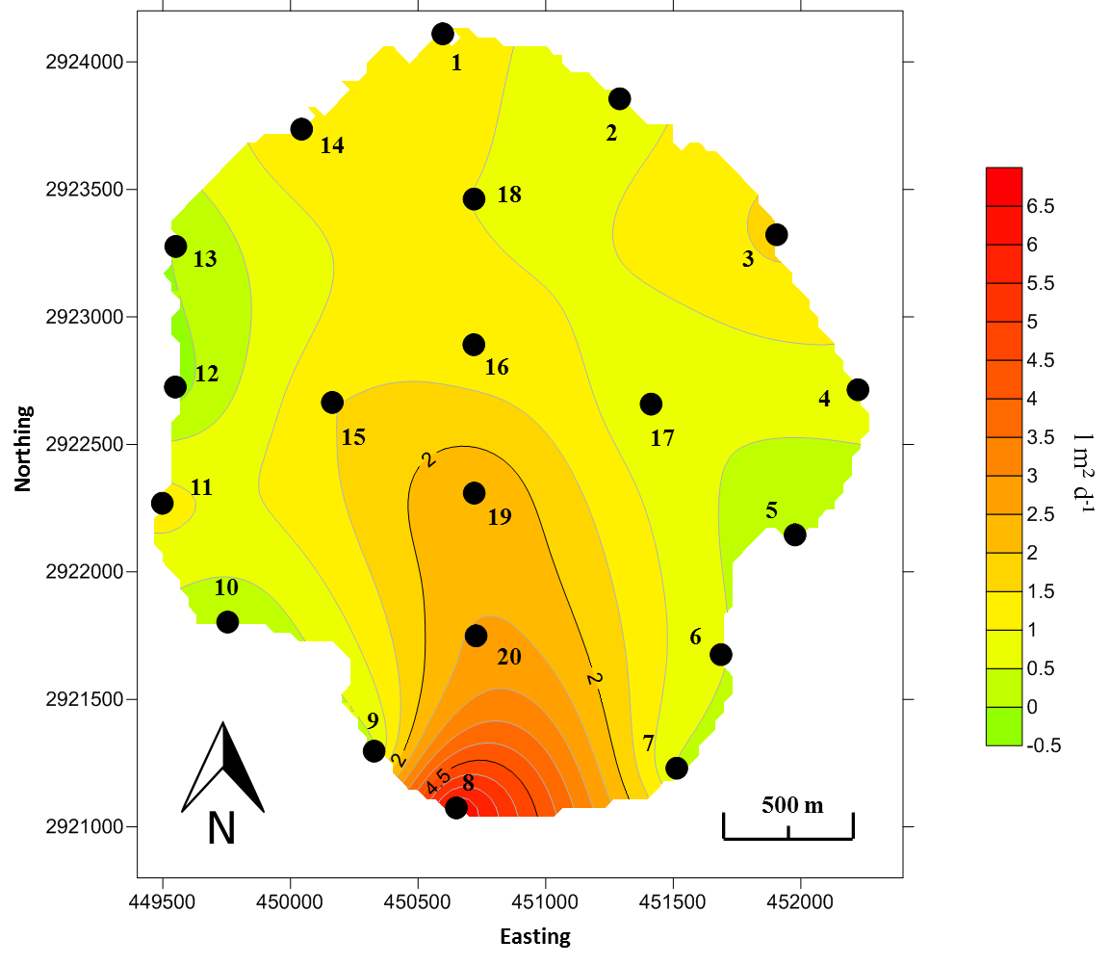
Figure 13: Surfer map of the average groundwater flow rate (l m⁻² d⁻¹) using all flow data from the 28 sampling events. Note meters 3, 8, 19, and 20 which had high positive flow averages, while meters 2, 5, 6, 10, 12, and 13 had low or negative averages. Meter numbers are shown on the map next to their locations (closed black dots).

Table 4 shows the comparison of flow rates between duplicate meters at five of the sites in the lake using root mean square error (RMSE) which is the standard deviation of the residuals between the expected and recorded values. The high values for RMSE indicate that there was high spatial variation in groundwater flux, even over the distance of one meter. Only events that had data from both duplicate seepage meters (i.e. successful bag placement and retrieval from both meters) were used in the RMSE comparisons for each groundwater site.
Table 4: RMSE values for each pair of duplicates, grouped by sampling site. Lower RMSE values indicate better replication between the two meters.
The box and whisker plots in Figure 14 depict the distribution of the concentrations found for each sampling event while the Surfer maps in Figure 15 depict the average TN and TP concentrations of the groundwater samples taken at each of the sampling locations, while. Noteworthy are the elevated levels of TN in the central sampling stations of the lake, with concentrations over 30 mg/l; much higher than the surrounding sampling locations in the littoral zone. The average TN concentration of the groundwater was 12.68±9.79mg l⁻¹ and the majority of the nitrogen in the groundwater samples was comprised of ammonia-N species (84.6%). Also noteworthy is the relatively high average TP concentration of 0.89±0.63mg l⁻¹ amongst all groundwater sites, with the majority of the phosphorus being orthophosphate-P (83.2%). The concentration of the groundwater is substantially higher than Lake Trafford average surface water TP concentration over this time period of 0.13± 0.04 mg l⁻¹ (Figure 31).

Figure 14: Box and whisker plots of well sample concentrations for TN (top) and TP (bottom) from October 2015 to October 2016. It is important to note that not all wells were sampled during each event.
Figure 15: Spatial variation in average nutrient concentrations (mg l⁻¹) of groundwater samples taken at the twenty groundwater seepage locations. Higher concentrations are found in the center samplings stations of the lake. Meters are shown on the map (closed black dots).
Figure 16 shows the average TN and TP mass loading rates over the twenty-eight sampling events. Individual event loading maps can be found in Appendix E. Because nutrient loading is the product of both Q and nutrient concentration in the water, loading maps closely mirror the patterns of flow and nutrient concentrations. This is especially obvious with TN loading in the lake center, which is much higher than the surrounding areas due to the elevated nutrient concentrations found there.
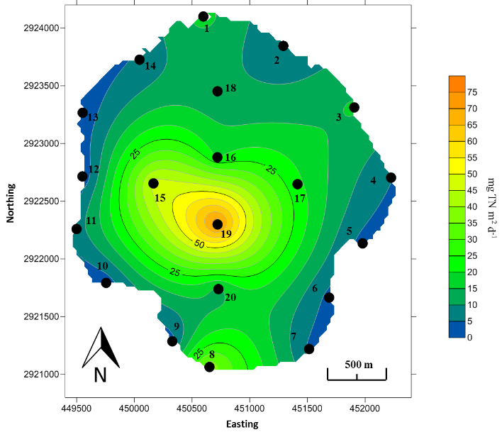
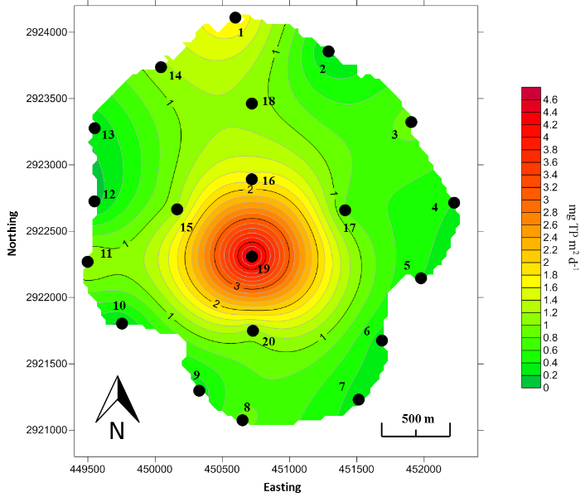
Using Surfer 12, the total groundwater discharge and recharge were calculated (m³) as well as the total mass of TN and TP influx and efflux (kg). Figure 17 and Table 5 shows the result of this analysis for each of the twenty-eight sampling events, as well as the overall average. The mean groundwater discharge into Lake Trafford of 8,075±4,775 m³ d⁻¹ represents roughly 0.07% of the mean lake volume, while the mean recharge of -347±509 m³ d⁻¹ represents 0.003%. Overall, there was greater groundwater discharge than groundwater recharge in all sampling events, with the exception of sampling event 7 (4th and 5th of January, 2016; 1,487 l m⁻² d⁻¹ discharge, -2,649 l m⁻ ² d⁻ ¹ recharge). Groundwater dischrage and recharge was interpolated between sampling dates using a Bessel Spline model (Figure 18). The interpolated values were then used in the daily water budget model. Over the course of data collection, net groundwater flow exchanged 26.3% of the overall lake volume (3,110,558 m³; Figure 19).
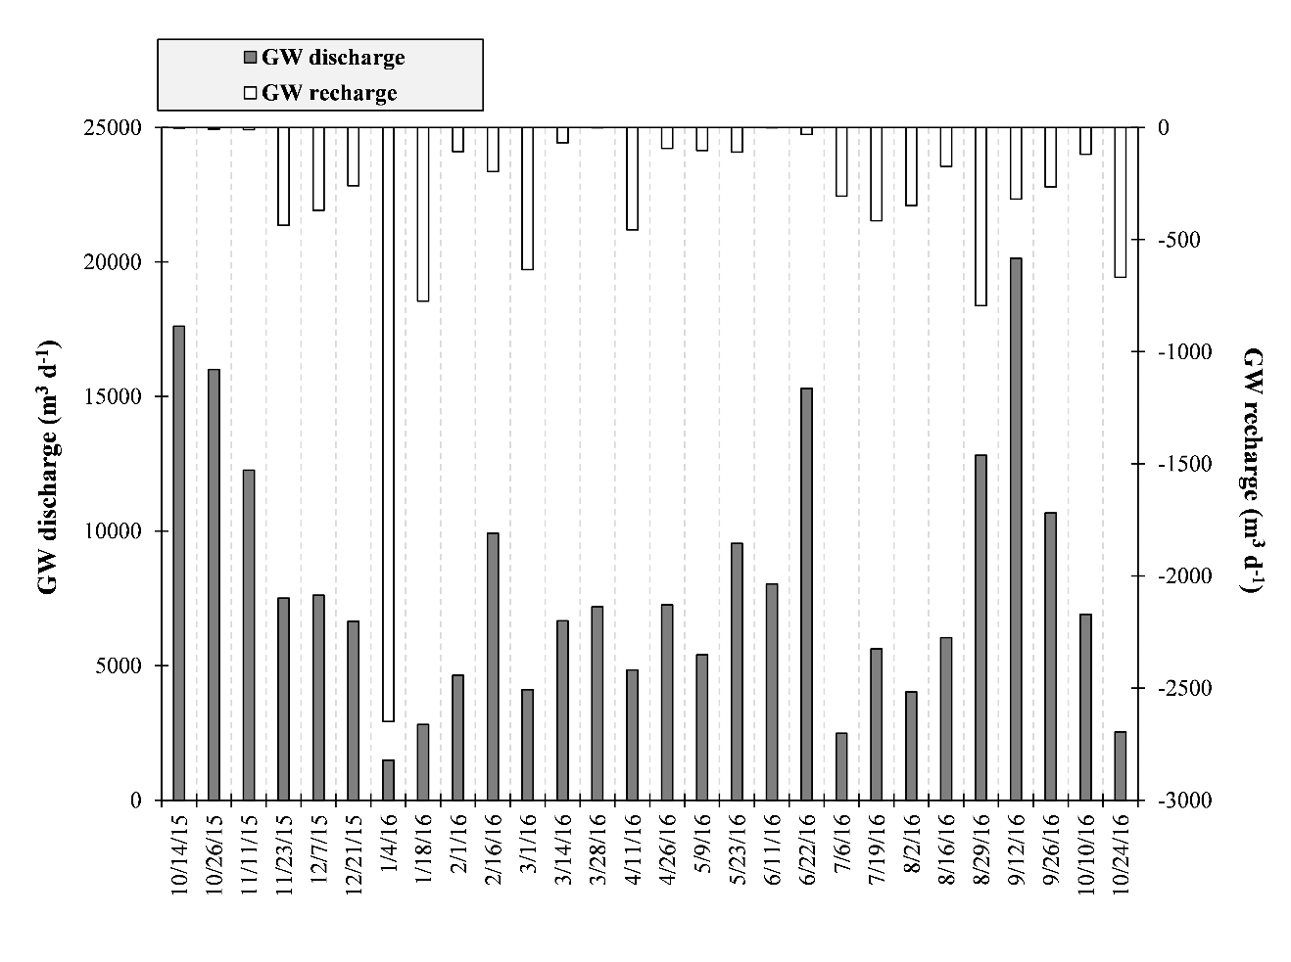
Figure 16: Interpolated Surfer maps of the average loading of TN (left) and TP (right) in mg l⁻² d⁻¹ for the 28 sampling events. Elevated flow and nutrient concentrations in the center locations is particularly evident, especially for Meter 19. Meter numbers are shown on the map next to their location (closed black dots).
Figure 17: Total Groundwater discharge (gray bars) and recharge (white bars) in m³ d⁻¹ for each sampling event. Discharge volume was determined using Surfer 12 to interpolate flow rates between sampling locations.
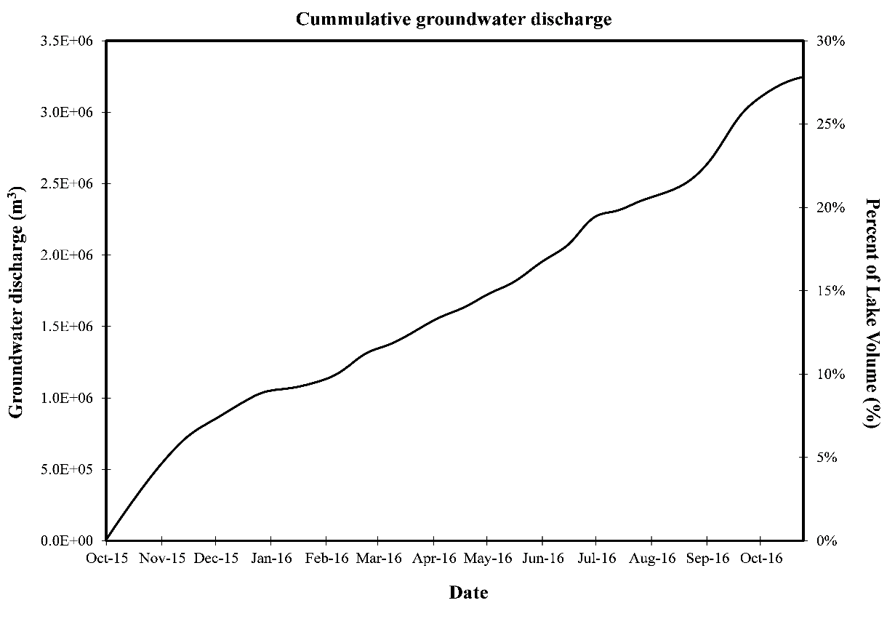
Figure 18: Groundwater discharge (closed black circles) and recharge (open circles) interpolated between biweekly sampling events using a Bessel Spline function
Figure 19: Time series of cumulative groundwater discharge in both total cubic meters (m³) and percent (%) of average lake volume. A total of 26.27% of the average lake volume entered the lake via groundwater discharge over the course of data collection
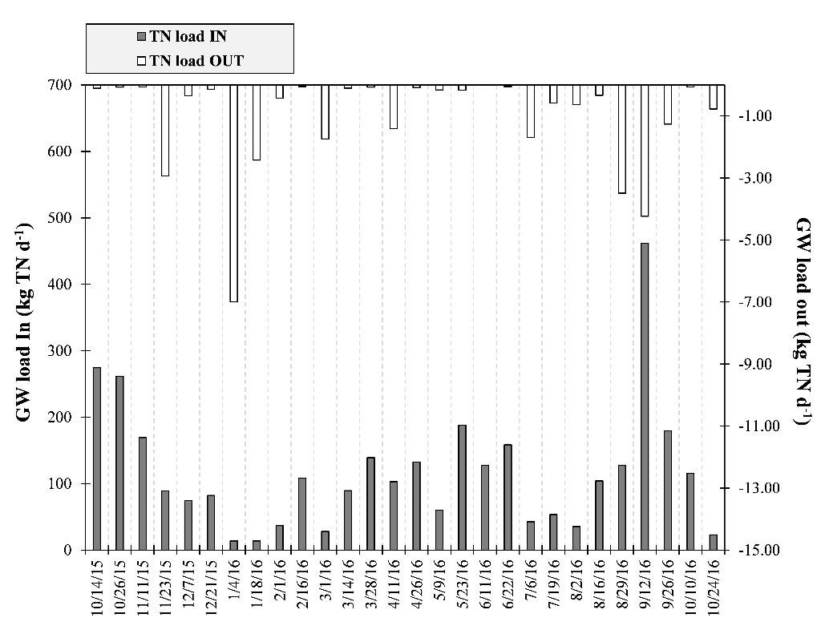
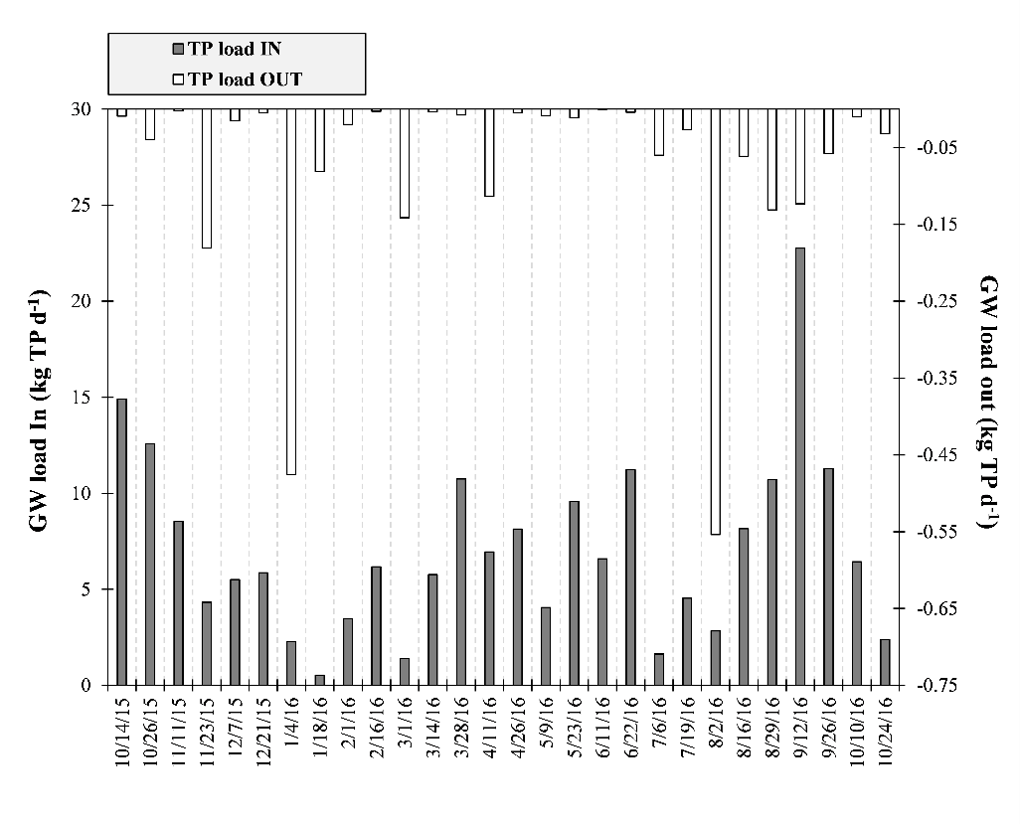
Mean daily nitrogen and phosphorus additions via groundwater discharge averaged 117.63±95.75 kg TN d⁻¹ and 7.12±4.80 kg TP d⁻¹, representing 0.007% and 0.0002% of the average total nutrient mass in the lake, respectively. The mean N:P mass ratio of the groundwater discharge was 14.1±2.97:1 The lowest ratio observed was 9.4:1, which occurred during sampling Event 28 (24th and 25th of October, 2016).
Figure 20: TP (top) and TN (bottom) groundwater (GW) discharge (gray bars) and recharge (white bars) loading for each sampling event in kg d⁻¹ determined using Surfer 12.
Table 5: Daily rates of groundwater (GW) discharge (in), recharge (out), and nutrient loading in and out categorized by sampling event. Mean daily values and standard deviations are also reported

Surface Water Inflow
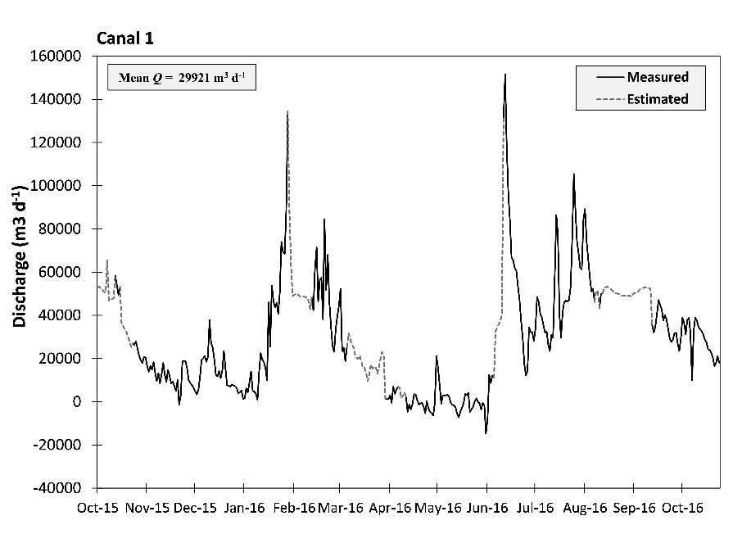
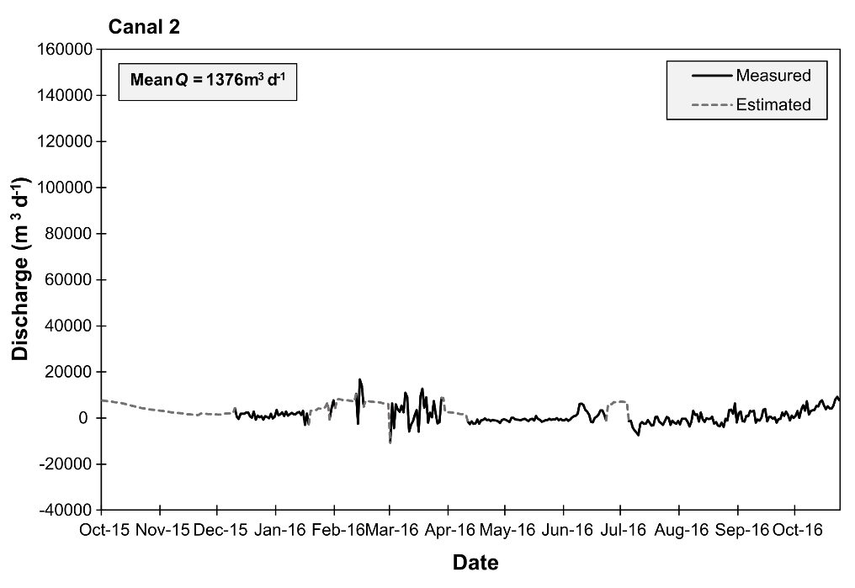
Canal discharge was highly variable both between canals and temporally within each canal (Figure 21; Appendix F). Discharge from Canal 1 was significantly higher than the other four canals. The mean Q of Canal 1 was 29,921±25,055 m³ d⁻¹ which is 248% higher than the combined average discharge from Canals 2, 3, 4, and 5 of 12,041±6455 m³ d⁻¹. Canal 1 represented 71.3% of all the canal discharge into Lake Trafford during the study period and was the most responsive to rain events.
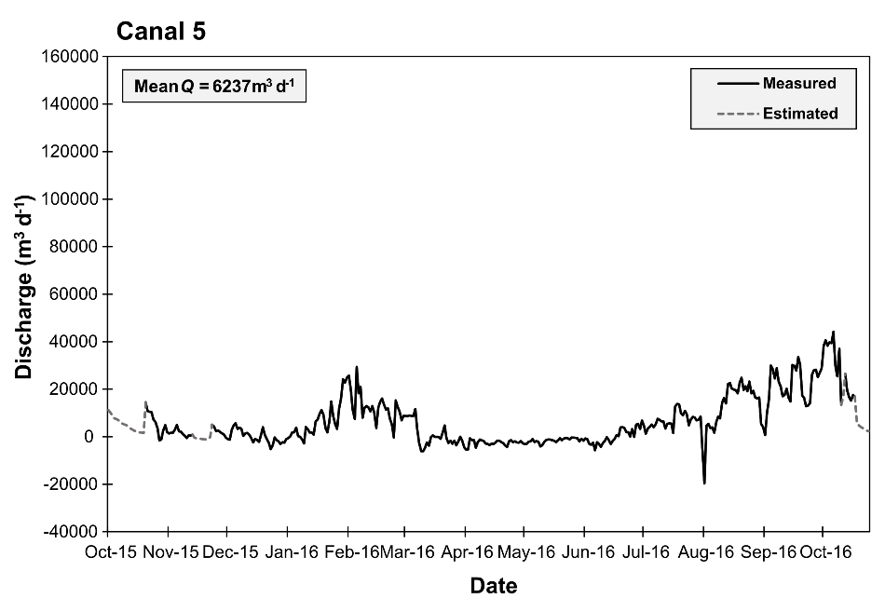
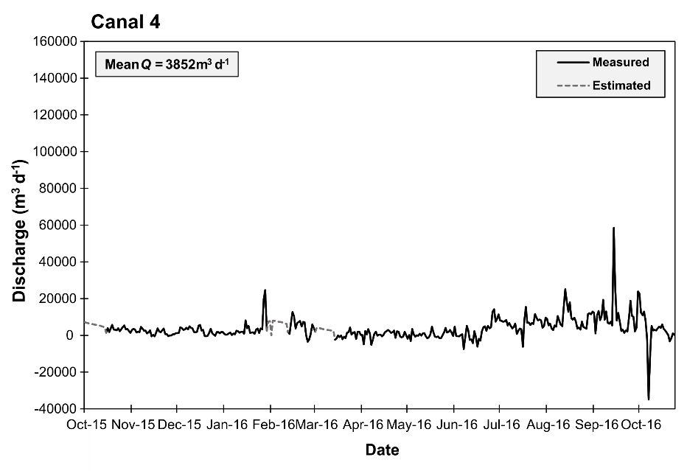
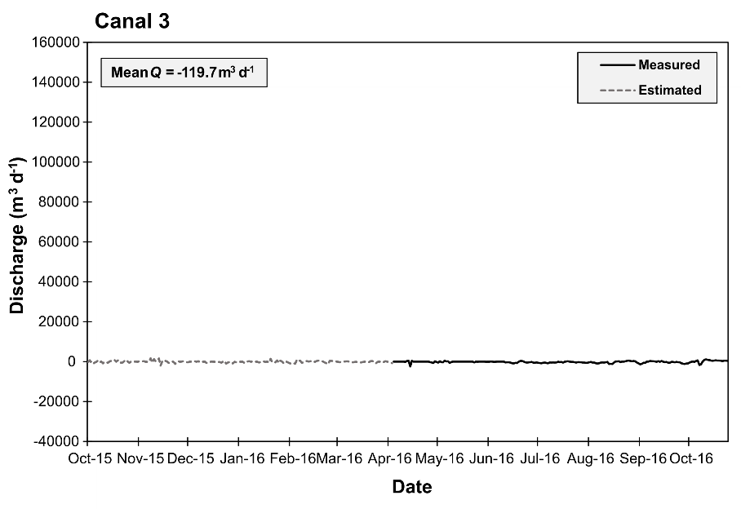
Figure 21: Hydrographs of each of the canals discharge (m³ d⁻¹) from 10/1/2015 to 10/24/2016. All scales are standardized to demonstrate the difference in flow rate between each canal. Mean daily Q is also reported for comparison. Estimated portions of the hydrographs appear as dashed lines.
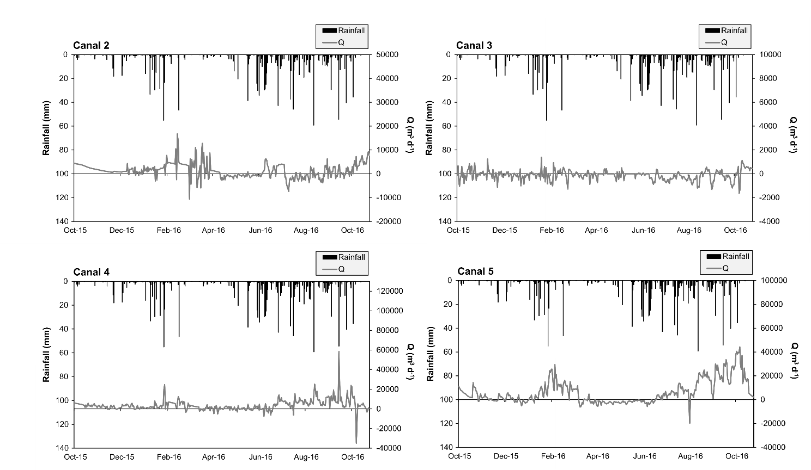
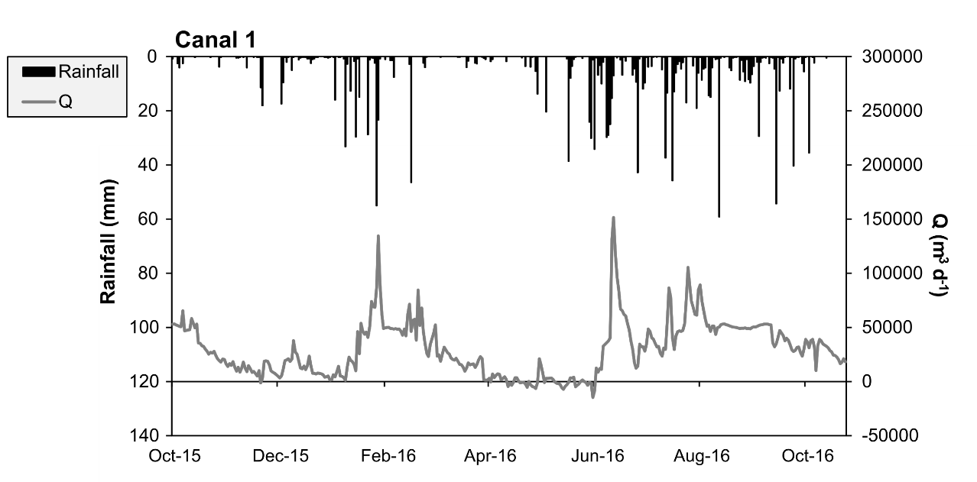
Q from each canal was influenced by rainfall (Figure 22), with the exception of Canal 2 and Canal 3 which did not show a significant response to rainfall events. The discharge from the canals was also correlated with the local groundwater level - particularly canal 1 (Figure 23).

Figure 22: Canal discharge plotted over rainfall for all five canals. Note that the scales for Q are not standardized to best show response of discharge to rainfall. Canals 1, 4, and 5 appear to be most responsive to rain events.
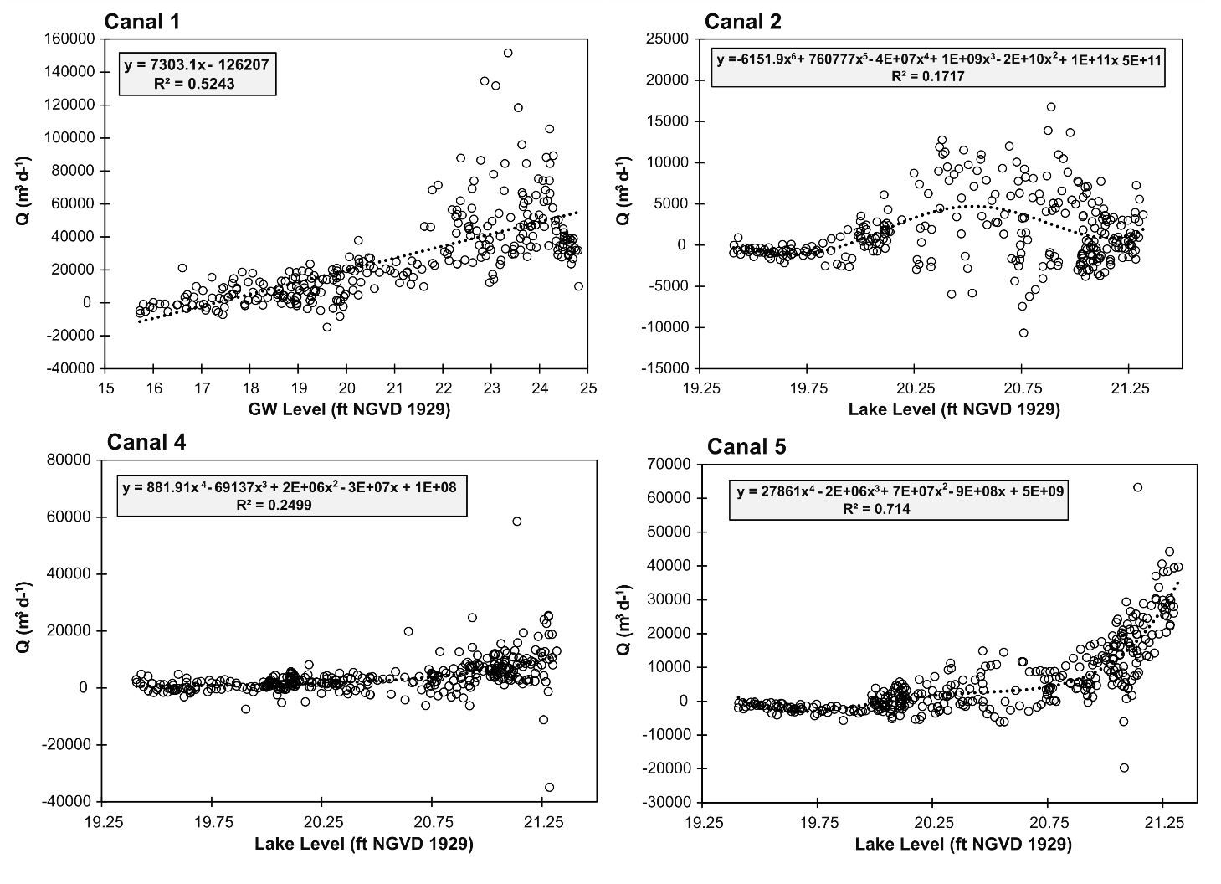
Figure 23: Scatterplots comparing groundwater level at a nearby USGS well (Station 262554081283801 C-687) or lake stage to canal discharge (Q). Dashed line indicates a best fit linear or polynomial function. Canal 2 had very low discharge throughout the study period and thus a strong predictive relationship was not found.

Local groundwater data elevation was taken from a nearby USGS groundwater monitoring station (262554081283801 C – 687; Figure 24) located off of Lake Trafford Road. Several of the Sontek IQ flow meters experienced malfunctions during data collection (unrelated to the previously described noise issue) leading to periods of missing discharge data for several canals. The relationship between discharge and groundwater elevation allowed for the estimation of this missing Q data for Canals 1 and 2. Canals 4 and 5 were better correlated with lake stage. The short periods of estimation can be seen as the dashed line portion of the hydrograph time series in Figure 21. Other canals (namely Canals 4 and 5) were more strongly correlated with lake stage.
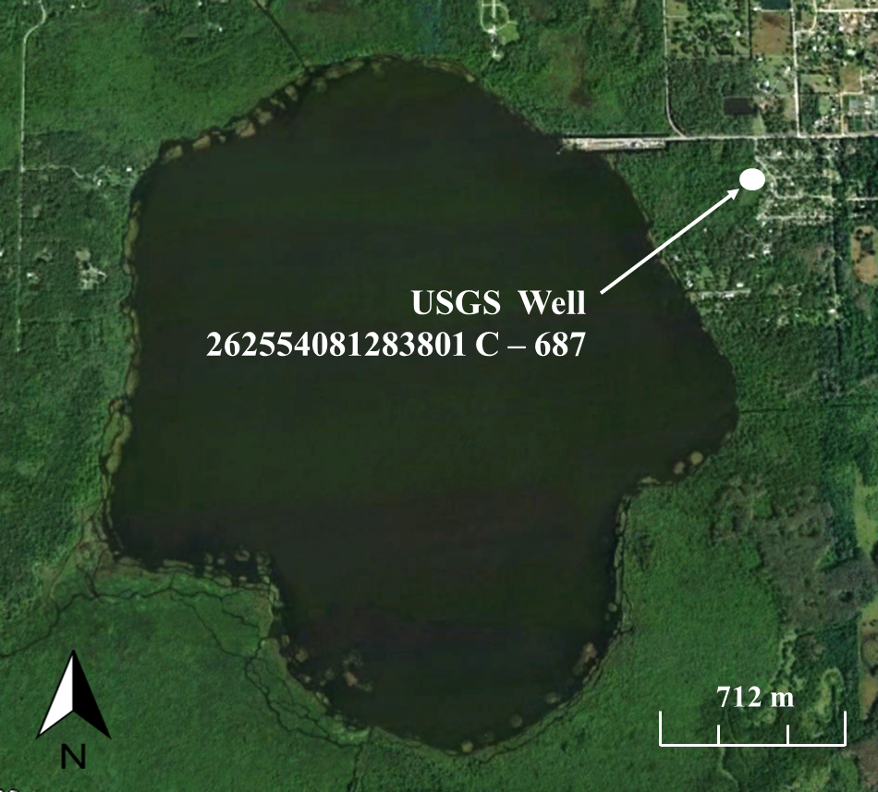
Canal 3 also experienced periods of missing flow data due to Sontek malfunction, but also recorded high levels of noise during the first half of the study (10/1/15 – 4/3/16) due to an incidental change in pitch (tilt) after installation. After the issue was corrected, flow measurements were much more consistent. In order to reduce the noise of the earlier data to comparable levels, the standard deviations of each data set (pre 4/3/16 and post 4/3/16) was compared. The ratio (determined to be 11.72:1) was used as a divisor to reduce the values of the pre 4/3/16 dataset to values with similar noise to post 4/3/16 levels (Figure 25). While this method does include inherent uncertainty, it should be noted that Canal 3 had the lowest discharge of the five canals surveyed and is essentially a minute factor for both the nutrient and water budgets for Lake Trafford.
Figure 24: Satellite Image of Lake Trafford and surrounding area depicting the approximate location of USGS Groundwater level monitoring well 262554081283801 C- 687. The level from this well was found to correlate well with the discharge from Canal 1 and 2.
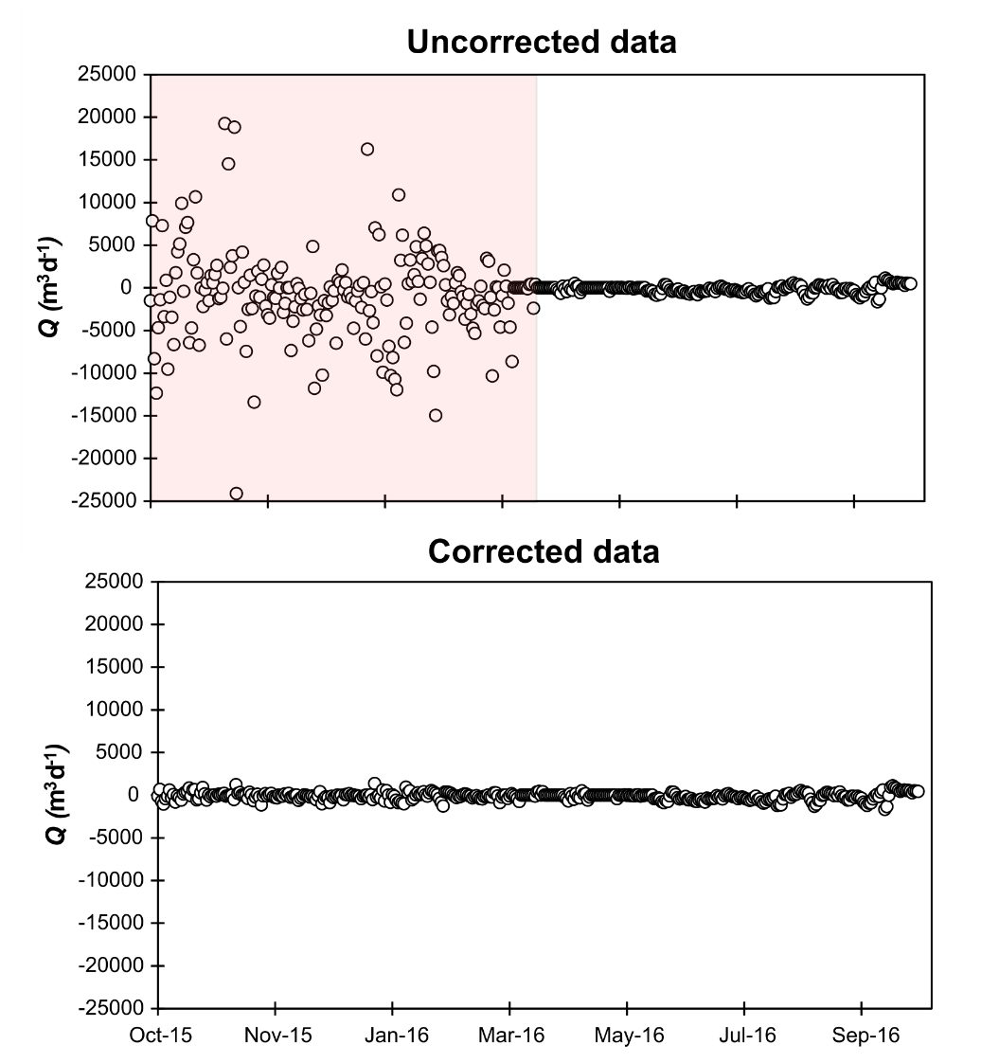
Nutrient concentrations from canal discharge varied both in magnitude and relative abundance between nutrient species (Table 6, Figure 27). Canal 1 had both the highest average TP concentration (0.28 mg l⁻¹) and the lowest nitrogen to phosphorus mass ratio (7.28:1). This is significant because phosphorus is the limiting nutrient in Lake Trafford. Because composite samples could not be analyzed for SRP, grab samples were taken during each event and were then analyzed for SRP and TP. The ratio in the grab samples was then used to estimate the TP:SRP ratio within the composite samples. This allowed for the estimation of SRP concentrations within the composite samples (Figure 23).
Figure 25: Scatterplots of discharge from Canal 3 before correction (pink area; top) and after correction (bottom). Standard deviation of high noise data was compared to low noise data (post-Sontek error correction) and the ratio was used has a devisor for the high noise data set.

Figure 28 depict the TN and TP loading from each canal for each of the 28 biweekly events. Because mass loading is a product of Q, the loading is much higher during periods of rainfall and higher groundwater level when Q was also higher. The loading from all of the canals averaged 81.3±75.1 kg d⁻¹ and 10.3±13.9 kg d⁻¹ for TN and TP, respectively. The total TN load from the collective canal discharge was 31,709 kg TN d⁻¹ over the course of the study, equating to 108% of the average kilograms of TN in the entire lake volume during that time.
The total TP load from the collective canal discharge was 4,026 kg TP d⁻¹ over the course of the study, equating to 259% of the average mass of TP in the entire lake volume during that time. This discrepancy between TN and TP is caused by the much lower N:P mass ratio of the discharge from Canal 1, which accounted for most of the canal discharge (Table 6).
Table 6: Mean values for TP and TN concentrations in canal samples, as well as mean daily discharge values for each canal. Mean daily loads from all canals were 10.32 and 81.31 kg d⁻¹ for TP and TN, respectively. Mass N:P ratio are also presented.
Figure 26: SRP/TP ratios for Lake Trafford’s five drainage canals and center-lake grab samples. Grab samples in the canals were used to estimate SRP concentrations in composite samples. SRP/TP ratios appear to increase for all canals during event 8 and then begin to taper off for the rest of the dry season. Canal 1 consistently had the highest ratio.
Figure 27: Composite sample concentrations for TN (top) and TP (bottom) for each canal during the study period. A time period is highlighted in gray for TP that may be evidence of a first flush for Canal 1 after the first heavy rains of the wet season occurred.

Figure 28: Bi-week loading totals from composite samples analyzed for TN and TP for the five dead end canals from 10/01/2015 to 10/24/16. Loading via these canals is lower post-Event 12 (03/02/15 – 03/14/15), when rainfall mostly ceased for the remainder of the spring season. Higher loading can be seen after rains resumed in June. Some negative values can be seen, indicating the average flow through the canal was negative during that time period.

Dry and Wet Deposition
Dry deposition rates in the composite sampling buckets were applied to the entire lake surface area. The size of the bucket opening was extrapolated over the planar surface area of Lake Trafford in order to calculate loads. Dry deposition was typically higher than wet deposition, with the exception of events with large rain events (e.g. Event 21; Figure 29). The stainless steel mesh was placed over the buckets beginning Event 9 after fouling from small animals (e.g. reptiles, amphibians, and insects) caused elevated nutrient concentrations within the sample buckets during Events 1, 4, and 7. The data from these events were substituted with the mean value from the rest of the sampling data. The mean daily load over the course of the study (with erroneous data excluded) was 24.40±18.06 kg d⁻¹ and 2.47±1.86 kg d⁻¹ for TN and TP, respectively.
Loading from wet deposition was also only applied to direct precipitation falling on the planar surface area of the lake. The mean daily load over the course of the study (with erroneous data excluded) was 17.45±21.16 kg d⁻¹and 1.40±1.65 kg d⁻¹ for TN and TP, respectively. High standard deviations are the result of some events having no rainfall, and thus zero mass loading via wet deposition.
Total atmospheric deposition for Lake Trafford averaged 41.85±34.10 kg TN d⁻¹ and 4.07±2.82 kg TP d⁻¹. These values represent 0.14% and 0.26% of the mean total nutrient mass within Lake Trafford for TN and TP, respectively. Dry deposition accounted for an average of 69.4% of the total atmospheric deposition over the course of data collection, with wet deposition accounting for an average of 30.6% (Figure 30).
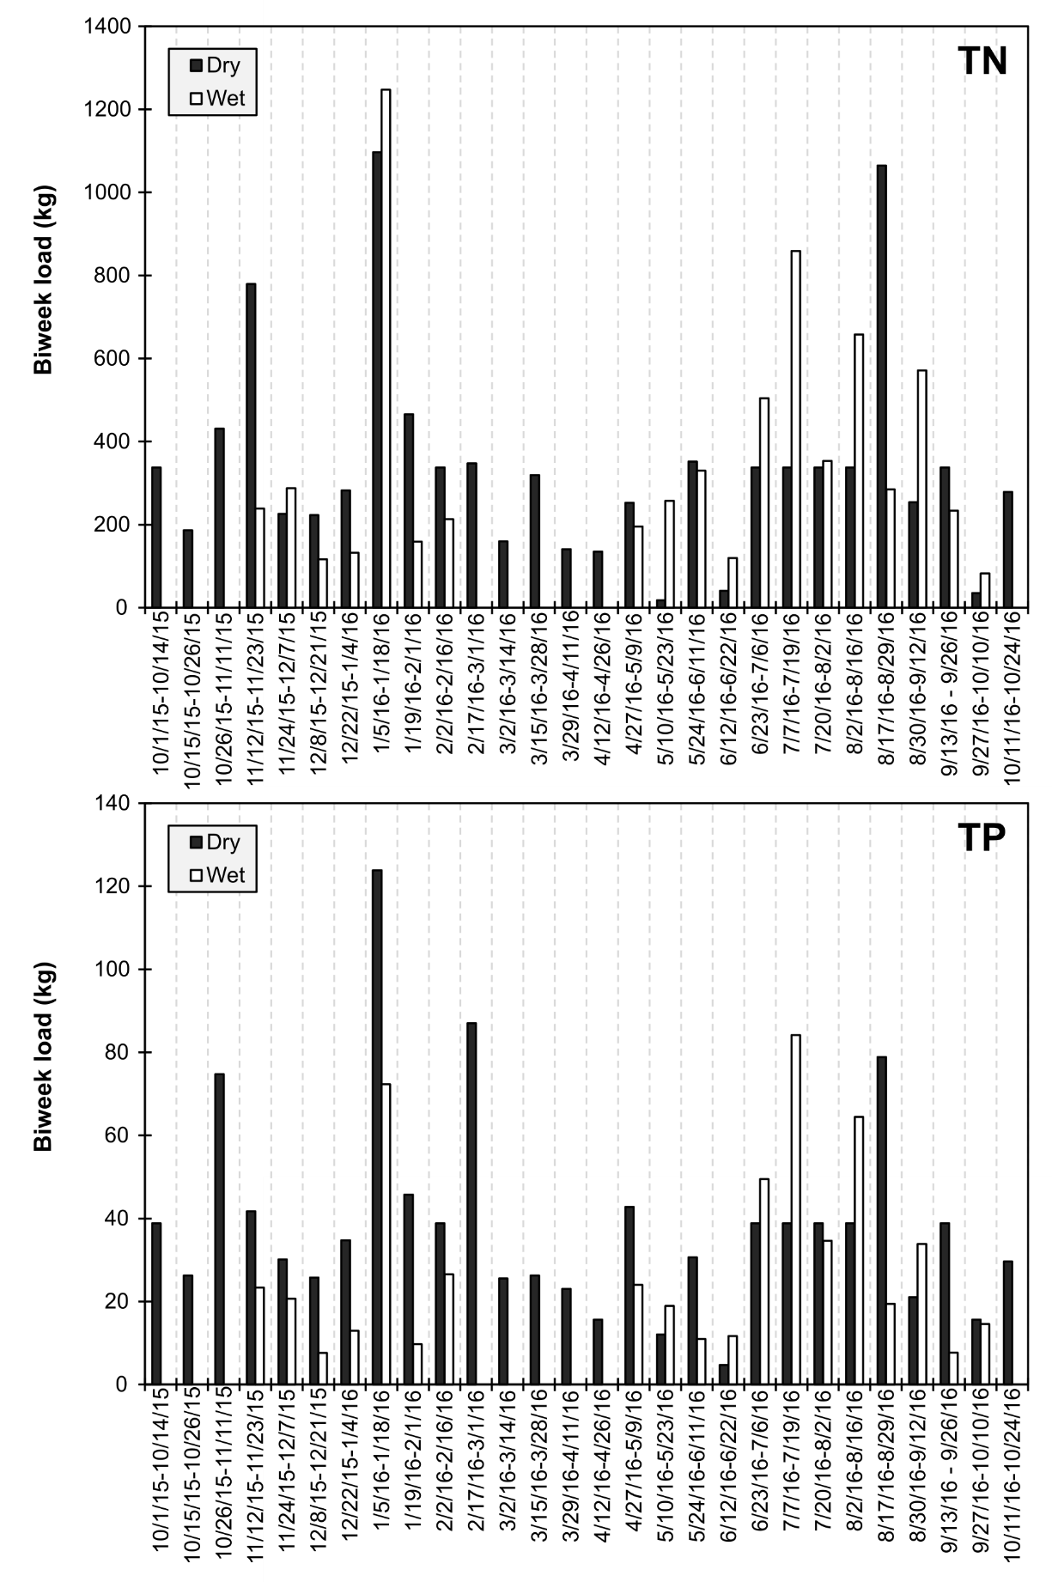
Figure 29: Daily loading rates of TN (top) and TP (bottom) for dry (black bars) and wet (white bars) deposition. Bars are absent for wet deposition loading when rainfall did not occur during a given sampling event
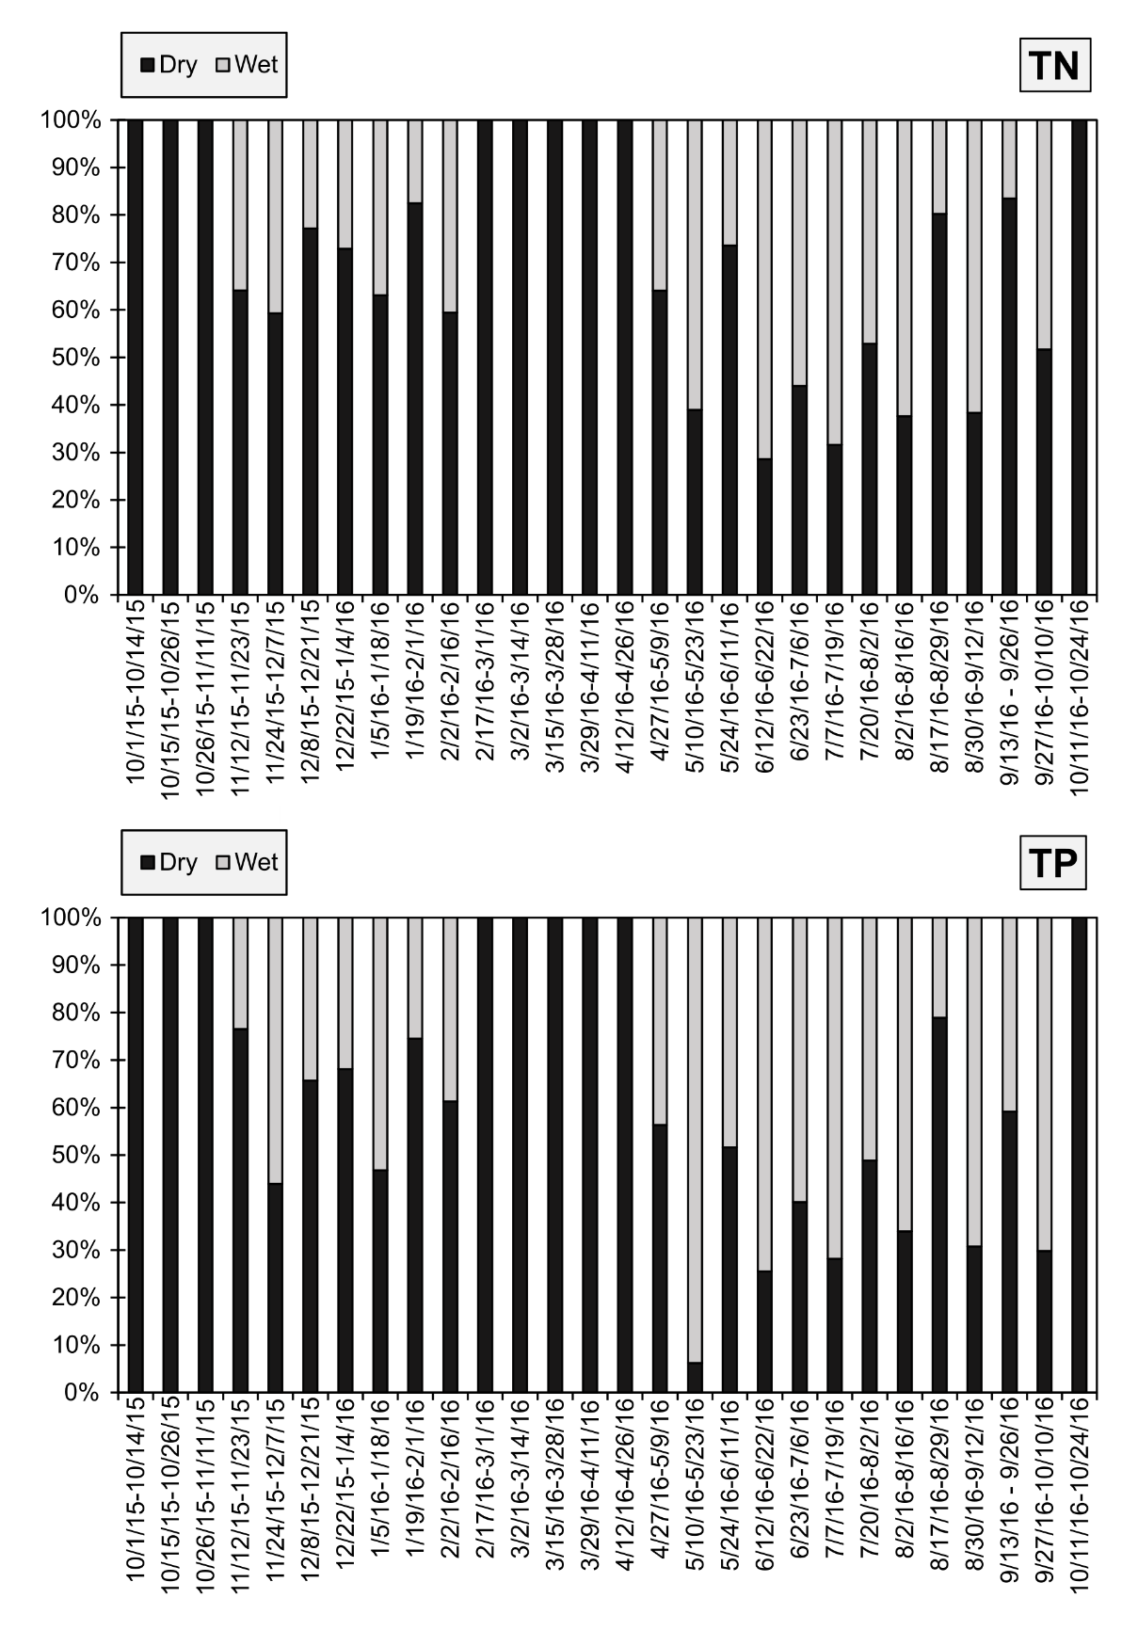
Figure 30: Relative percentage of mean daily atmospheric deposition accounted for by wet (stacked gray bar) and dry (stacked black bar) deposition for nitrogen (top graph) and phosphorus (bottom graph).

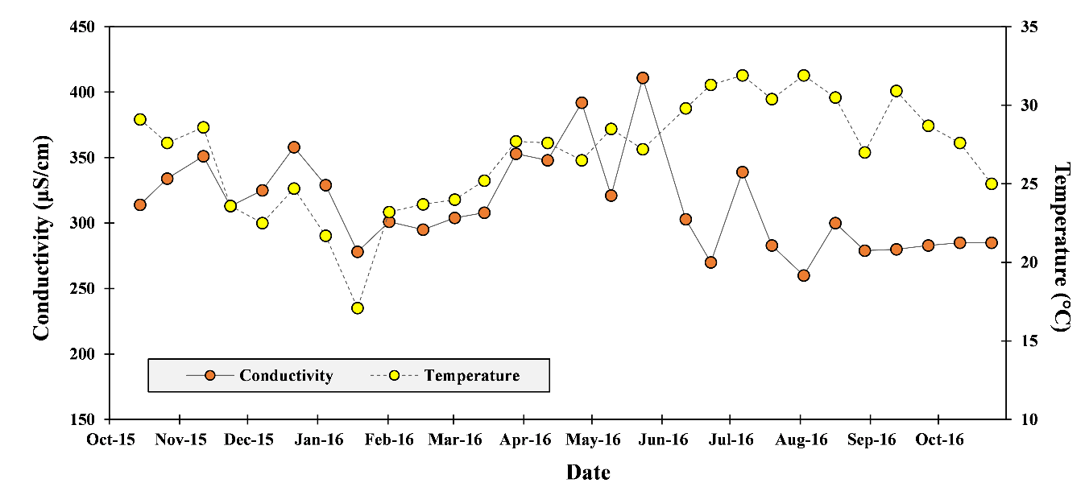
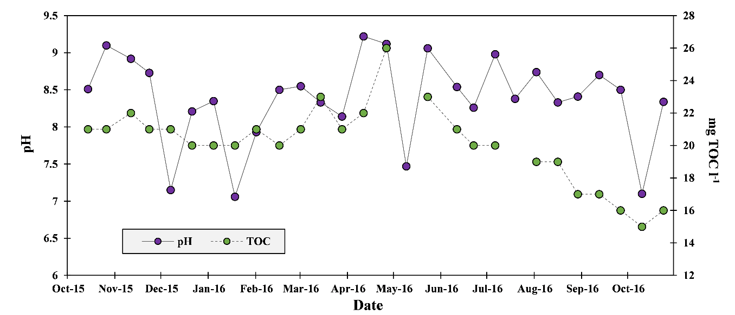
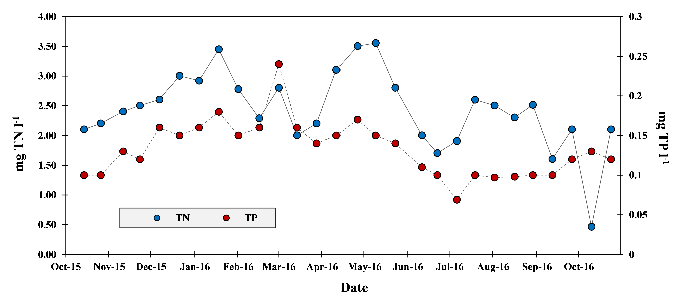
Lake water quality

Figure 31: Time series plots of pH and TOC (top left), conductivity and temperature (top rights), and TN and TP (bottom) for samples taken from the center of Lake Trafford during the study period (Oct 2015-October 2016).

Meteorological Data, Evaporation Modeling, and Change in Storage
Expected seasonal trends can be seen in the data recorded at the center lake weather station. A period of missing temperature and humidity data was caused by a malfunction of the temperature and humidity sensors on the Davis Vantage Pro2 from 12/29/15 to 01/12/16. Temperature and humidity data from a nearby weather station located 9 km northeast at the IFAS extension in Immokalee (Weather Station 450, Latitude North 26.46, Longitude West 81.44, https://fawn.ifas.ufl.edu/tour/fawn_info) was used to fill in this time period. Rainfall totals from the Davis Vantage Pro2 rain bucket were used for water budgeting, unless it was found to be clogged during an event. In these cases, the backup (and inter calibrating) rain gauge (ISCO brand) data was used for that period. The weather station attracted over time larger and larger flocs of mainly cormorant which were not deterred by any commercial devices to prevent them from perching on the platform and instruments, especially both rain gauges. For the sake of comparison with a station which was not left unattended for a couple of weeks and visited by birds, precipitation data were plotted alongside precipitation data from the aforementioned IFAS station 450 (Figure 32).
Figure 32: Two-week cumulative rainfall at the Lake Trafford weather station and at the IFAS extension in Immokalee. Despite the distance (9 km), the rain patterns are similar but the rain gauge from the IFAS weather station most often measured more rain. Bird droppings and other factors linked to the intrinsic tipping bucket mechanism as well as local weather differences can all be potential reasons for such discrepancies.
Total rainfall from October 1st, 2015 to October 31st, 2016 was 1222 mm which delivered an average of 18,887 m³ d⁻¹ of water via direct precipitation. Solar radiation and net radiation showed similar trends throughout the study period. These two variables were strongly correlated (R² = 0.847), but some daily averages with larger discrepancies occurred, and were likely caused by the aforementioned perching birds shading one sensor or the other (Figure 34).
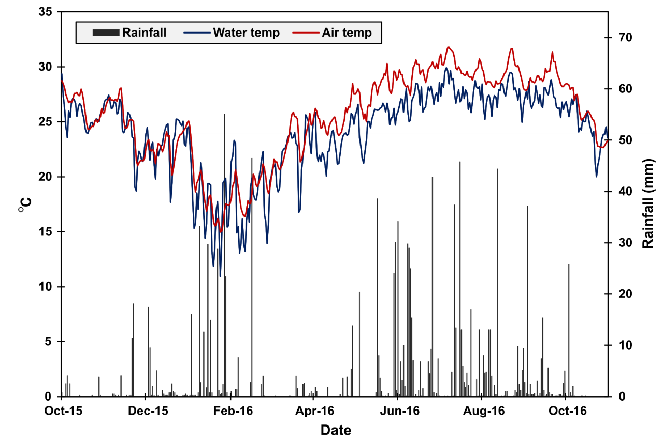
Measuring both gross radiation and net radiation allowed for the calculation of reflected radiation by taking the difference between the two. However, the discrepancies caused by bird activity resulted in some days having a negative reflected radiation (cf. negative values in Figure 35). Additionally, gross solar radiation was not measured at the Lake Trafford weather station until 01/18/2016. These missing data were substituted with data from the aforementioned IFAS weather station for the final water budgeting.
Figure 33: Air temperature (red line) and water temperature (blue line) plotted with rainfall (gray bars). Water temperature and air temperature reached their lowest points in January, which also unexpected1ly saw the highest amounts of rainfall.
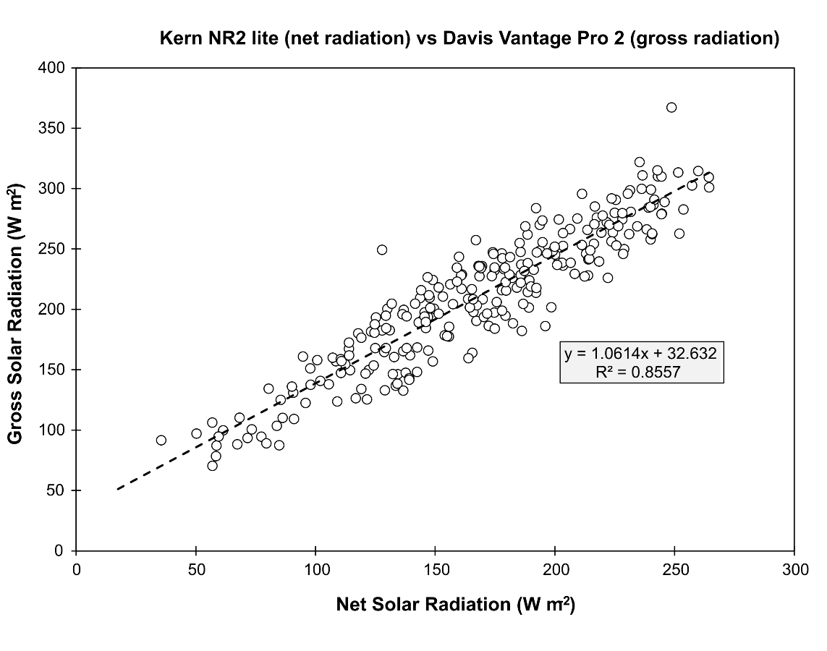
Combining the data from this study with IFAS data, the mean solar radiation during the period of data collection was 189.3±64.6 W m⁻² while the mean net radiation was an average of 19% lower, at 153.5±53.8 W m⁻². It follows from these values that the average reflected radiation during the study period was 35.9 W m⁻².
Figure 34: Scatterplot of daily averages of gross solar radiation from the Davis weather station and net solar radiation from the Kern NR2 Lite.

Figure 36 shows the results of the four evaporation models applied to the data in time series. The models correlate well and produced a higher evaporation curve during the warmer months with lower overall evaporation levels in the winter time. Using the average of the four models, mean daily lake evaporation was 3.58±1.36 mm d⁻¹ and had a daily evaporative volume of 21,644±8177 m³ d⁻¹.

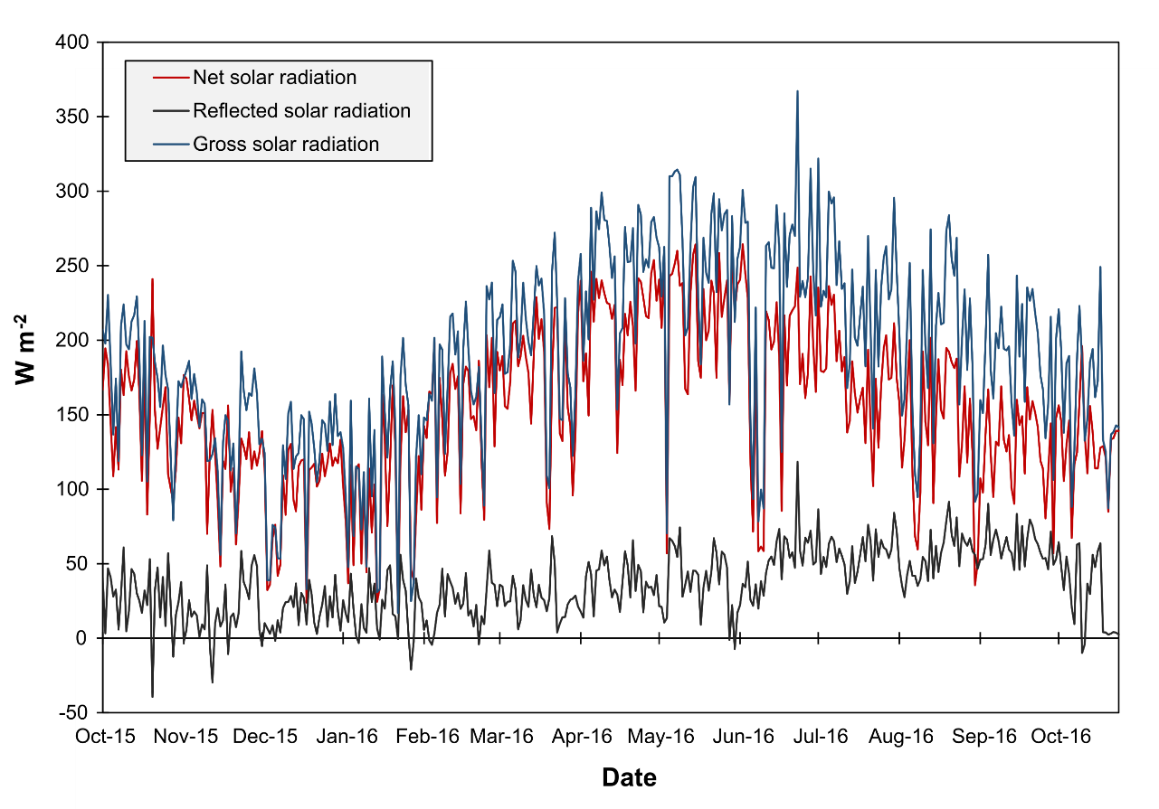
Figure 35: Changes in gross solar radiation, net solar radiation, and reflected solar radiation over time. Note the points of negative reflected solar radiation where perching birds likely shaded the gross solar radiation sensor.
Figure 36: Results of the four evaporation models (“E”) applied to Lake Trafford. An expected seasonal trend is present, with decreased evaporation rates in the winter months, increasing throughout the spring. Heavy rains and cloud cover caused several days of minimal evaporation in late June.

Figure 37: Changes in hourly-averaged water levels as measured by the USGS staff gauge located at Ann Olesky Park and at the weather station by the SOLINST levellogger.

Levellogger data show lake stage reaching maximum levels during January and February and again during June through September (Figure 37). Levellogger data for the center lake weather station correlated well with the USGS station located at Ann Olesky Park.
The nine year (2007 – 2016) average stage for Lake Trafford is 19.21 ft NGVD 1929 (Figure 38). The stage during the study period (October 2015 – October 2016) was continuously above average, with the minimum stage falling to 19.48 in early June 2016. The stage volume curve and stage planar surface area curve are also presented in Figure 38 and show increasing volume and planar surface area as stage increases, with surface area maxing out at the 19.5 ft. NGVD 1929 boundary.

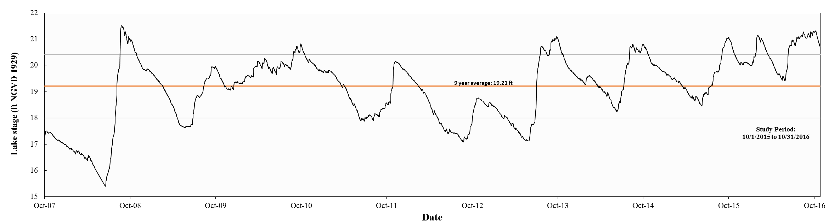
Figure 38: (Top graph) Time series of lake stage (USGS 02291200) over the past nine years (top) with the orange line representing the average stage over that period and the gray lines indicating z-sores of +1 and -1. (Bottom left graph) Time series graph of lake stage during the period of data collection. Lake stage was highest (approx. 21 ft. NGVD) at the start of the project, in February after El Nino rains, and throughout the rainy season (June-October 2016). Lake stage was higher than average throughout the entire study period. A stage-volume curve and a stage-planar surface area curve were established for Lake Trafford to calculate lake volumes and surface areas based on lake stage (bottom right graph).

Water Budget
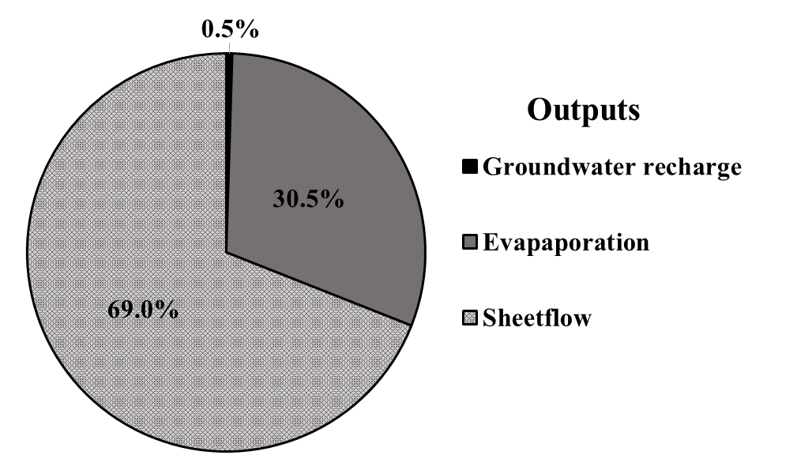
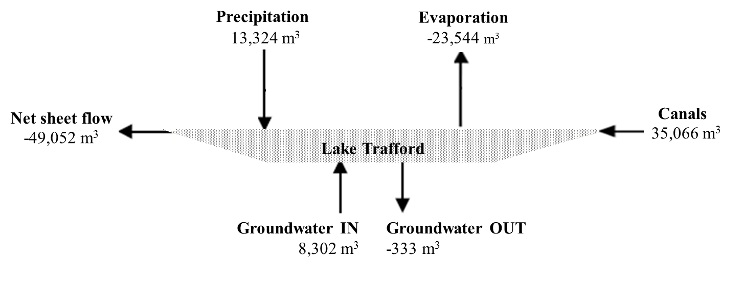
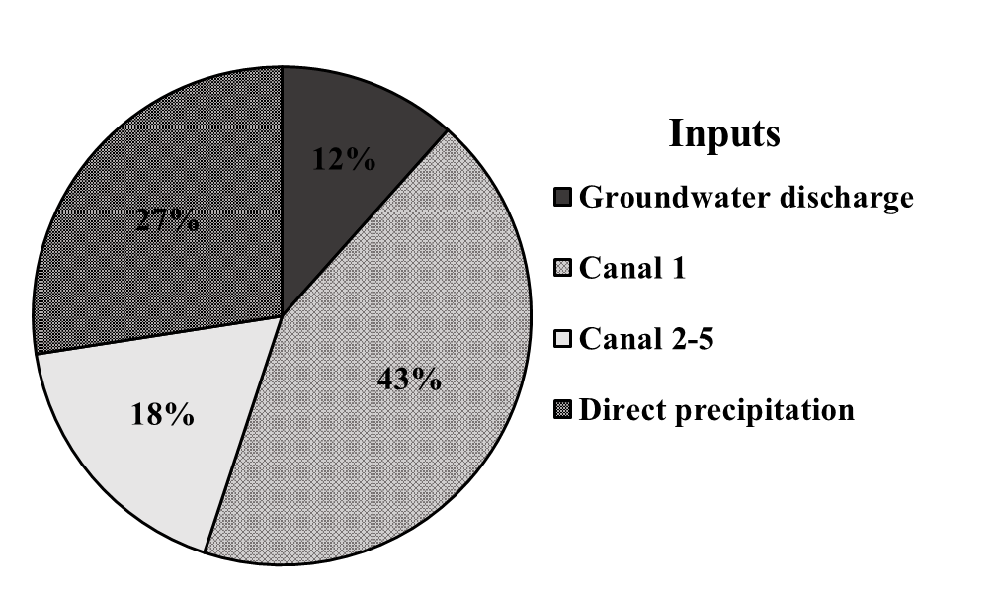
Influxes into Lake Trafford were dominated by Canal 1, which delivered an average of 43% (29,921 m³ d⁻¹) of all water into the lake during the study period (Figure 39 and Table 7). All the canals combined delivered 61% (41,963 m³ d⁻¹) of the total volume. Effluxes were similarly dominated by sheet flow which accounted for 69% (-49,052 m³ d⁻¹) of the water leaving the lake during the study period. Groundwater discharge was a smaller hydrological contributor, delivering 12% (8,320 m³ d⁻¹) of the water into the lake, while groundwater recharge accounted for only 0.5% (-333 m³ d⁻¹) of all effluxes.
Figure 39: The final daily water budget of all fluxes for Lake Trafford over the course of the study period (top diagram). Mean net sheet flow was negative, and was thus depicted as an efflux. Relative Percentage of inputs and outputs for the water budget (bottom pie charts). Sheet flow is only represented in the outputs chart due to the inability to separate positive and negative flows from the calculated net sheet flow. Discharge from Canal 1 is separated from Canals 2 thru 5 to show its magnitude compared to the other incoming water fluxes.
Table 7: Mean, standard deviation, and min/max values for each facet of the water budget. Q from all five canals was pooled. Values were rounded to the nearest cubic meter.

The final water budget for Lake Trafford used the known water fluxes to determine the unknown flux volume of surface runoff as sheet flow. Sheet flow for this study is considered diffuse runoff directly into the lake (not into the five canals) and surface water outflow to the surrounding wetlands during high water levels. Sheet flow was calculated as the difference between the measured net water flux and the true change in storage. Using this method, only net sheet flow could be calculated. Thus, it is unknown what the true percentage of the total water influx entering Lake Trafford is runoff and what percentage of the true water efflux is sheet flow. However, during the study period, the mean net sheet flow was negative, -49,052 ±80,441 m³ d⁻¹, indicating there was more water moving out of the lake via sheet flow than into the lake. Additionally, the high standard deviation indicates that the value is also highly variable. Monthly comparisons for each flux of the water budget can be found in Figure 40.
Figure 40: Stacked bar graphs showing daily volume of the hydrological inputs (top) and outputs (bottoms) into and out of Lake Trafford by month, beginning with October 2015 and ending October 2016.
Figure 41 depicts the change in net sheet flow over time by comparing the true lake volume to the budgeted lake volume. The two lines represent the modeled change in volume from the previous time step and the true change in storage using the known stage-volume relationship. The difference between these two lines is the volume of net sheet flow moving in or out of Lake Trafford. As the lines diverge, there is a larger volume of sheet flow entering or leaving the lake. It is evident that more sheet flow moves out of the lake than in, and it is mostly occurring during high water levels (20.5 ft. NVGD and higher). As water levels decreased in the spring, positive sheet flow was more commonly seen, but at a lesser magnitude than the negative fluxes at higher water levels. It is likely that higher positive sheet flow volumes would have been observed under a more typical hydrological pattern for this area (i.e. for a non El-Niño year), with a lower stage during the winter and spring months. The minimum net sheet flow value calculated was -245,067 m³ d⁻¹ on August 12th, 2016 while the maximum net sheet flow calculated was 342,524 m³ d⁻¹ on January 28th, 2016 after the largest rain event during the study period (55.1 mm). Using the final water budget, residence time or turnover rate for Lake Trafford was determined to be 167 days. In other words, Lake Trafford water is renewed 2.16 times per year.

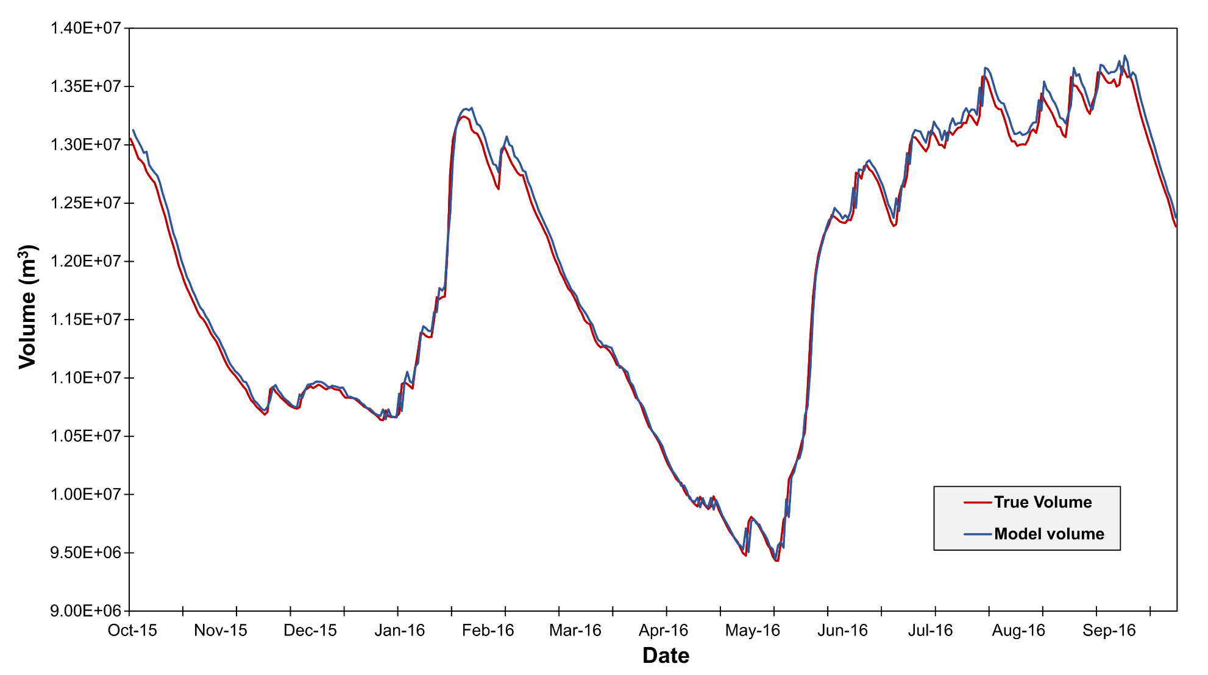
Figure 41: Time series plot of both the true volume (TruVol – depth based volume estimate) and the budgeted volume (ModVol – sum of water budget components). The difference between the modeled volume and the true volume are used to calculate sheet flow. Time periods where the modeled volume is higher than the true volume, indicate a net negative sheet flow moving out of the lake. Time periods where the modeled volume is lower than the true volume indicate net positive sheet flow.

Nutrient Budget
The finalized nutrient budget used the water fluxes measured in situ or derived from the water budget (i.e. sheet flow) and calculated loads by multiplying the measured or estimated nutrient concentrations by each flow rate (Figure 42 and Table 8).
The final daily load for Lake Trafford was determined to be 274.3±187.2 kg for TN and 24.2±21.7 kg for TP. The high standard deviations are expected due to some days having no rainfall, and thus no delivery mechanism for the nutrients (e.g. canal flow, runoff, wet deposition). Of the TN load, groundwater was found to be the largest source, contributing 43% of the TN to the lake. For TP, the largest contributor was the discharge from the five canals, which delivered 42% of the total TP load to the system (Figure 43).
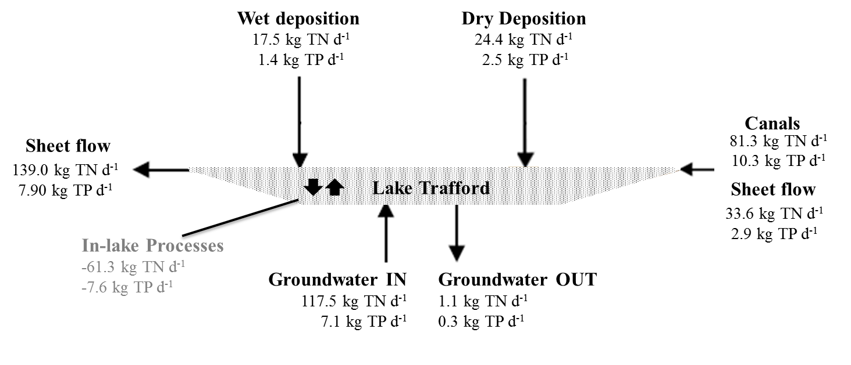
Figure 42: The final daily nutrient budget of all of measured loading for Lake Trafford over the course of the study period. Because sheet flow could only be determined as a net value, volume in and out could only be estimated. This was done by averaging all net positive flows, and all net negative flows and using the results to calculate loads. Thus, the loading results for sheet flow should not be considered as reliable as the loads calculated for the other fluxes. “In-lake processes” (grey font) are shown as a net value and are not used in the final total nutrient load for Lake Trafford.

Table 8: Summary statistics for all facets of the nitrogen and phosphorus budgets including in-lake processes. “GW in” is groundwater discharge, and “GW out” is groundwater recharge. Lake concentration determined from samples taken at lake center.

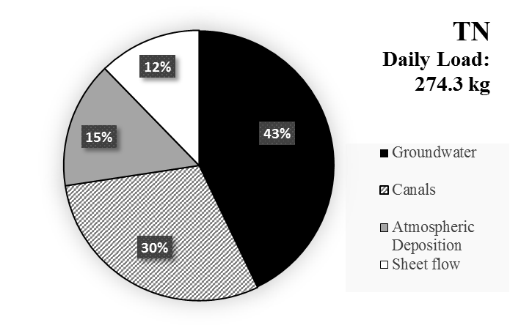
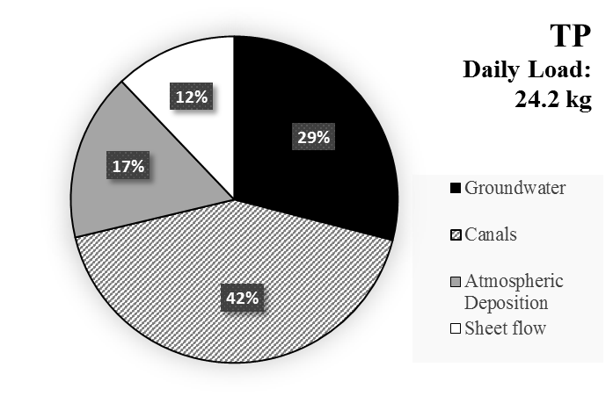
Figure 43: Relative percentages of each source of nutrient loading into Lake Trafford for total nitrogen and total phosphorus. Sheet flow was estimated by averaging all positive net sheet flow, and all negative net sheet flow.
Figure 44: Stacked bar graphs for loading of TP (top) and TN (bottom) by month for each source of nutrients into Lake Trafford from October 2015 to October 2016.

Running a daily nutrient concentration model was attempted (Figure 45), but without accounting for in-lake processes (e.g. internal loading, nitrogen fixation, or sedimentation/biological assimilation), modeled values consistently increased over the true values without a means for reduction. The model signal appeared to mirror the true concentrations found in the lake, but climbed more rapidly. Thus, using the nutrient budget, the estimation of nutrient loading or nutrient uptake by in-lake nutrient processes was attempted. Similar to sheet flow calculations, net “in lake processes” were estimated by taking the difference between the true nutrient mass in the water column and the measured nutrient loading inputs and outputs to obtain a net value. However, because ambient water column nutrient concentrations were only measured biweekly, a daily step model could not be performed adequately. Thus, a model using biweekly averages was used (Figure 46). For most of the study period, sedimentation and biological uptake were higher than internal loading, creating negative net values with averages of -131.8±83.6 kg d⁻¹ and -12.2±9.1 kg d⁻¹ for TN and TP, respectively. Only Events 9 (TP) and 10 (TP and TN), have a net positive nutrient load, indicating internal loading may have been occurring during these bi-weeks.
Nutrient retention was determined by subtracting nutrient loading out of the system from nutrient loading into the system. TN retention rates averaged 29.2% and TP retention rates averaged 54.7%. This indicates that phosphorus is likely being utilized by phytoplankton and macrophytes at a higher proportion of its mass when compared to nitrogen, allowing less phosphorus to be discharged via sheet flow or groundwater recharge.
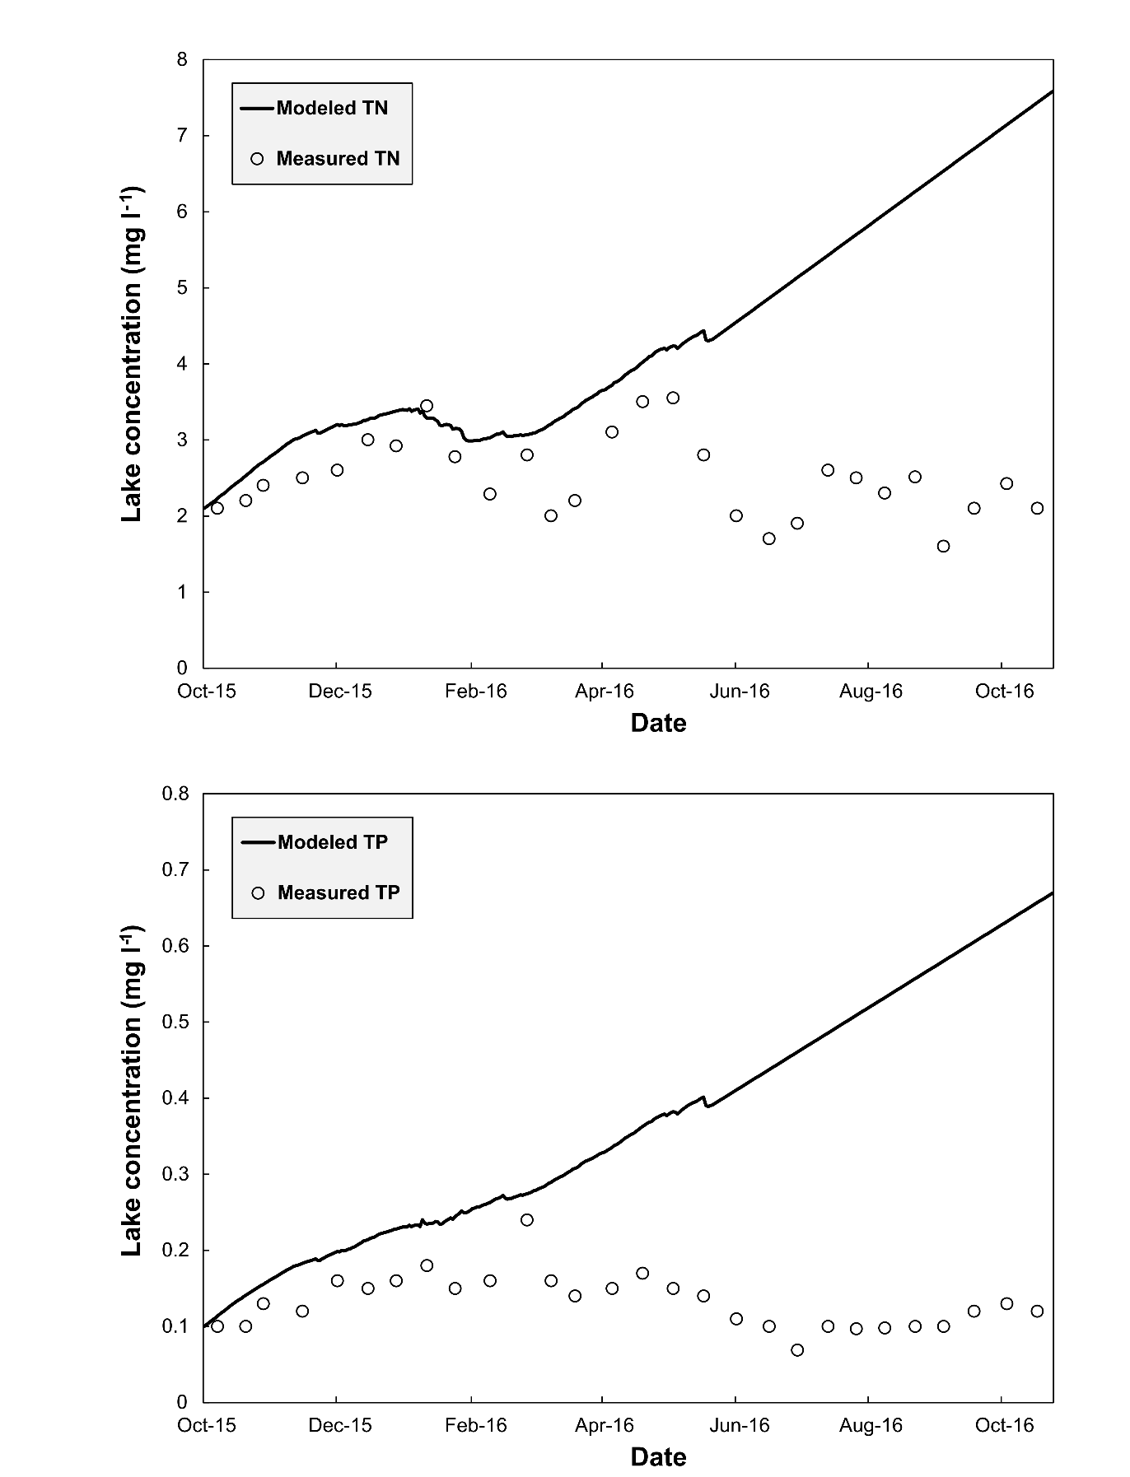
Figure 45: Modeled TN and TP concentrations (gray line) compared to biweekly samples taken in the lake center (black dots). The modeled line does not account for internal nutrient cycling or “net in-lake processes” (e.g. biological uptake, internal loading, and sedimentation) and consequently rises above the true concentrations observed. Note the similar signal between the modeled values and the true concentrations, especially for TN.
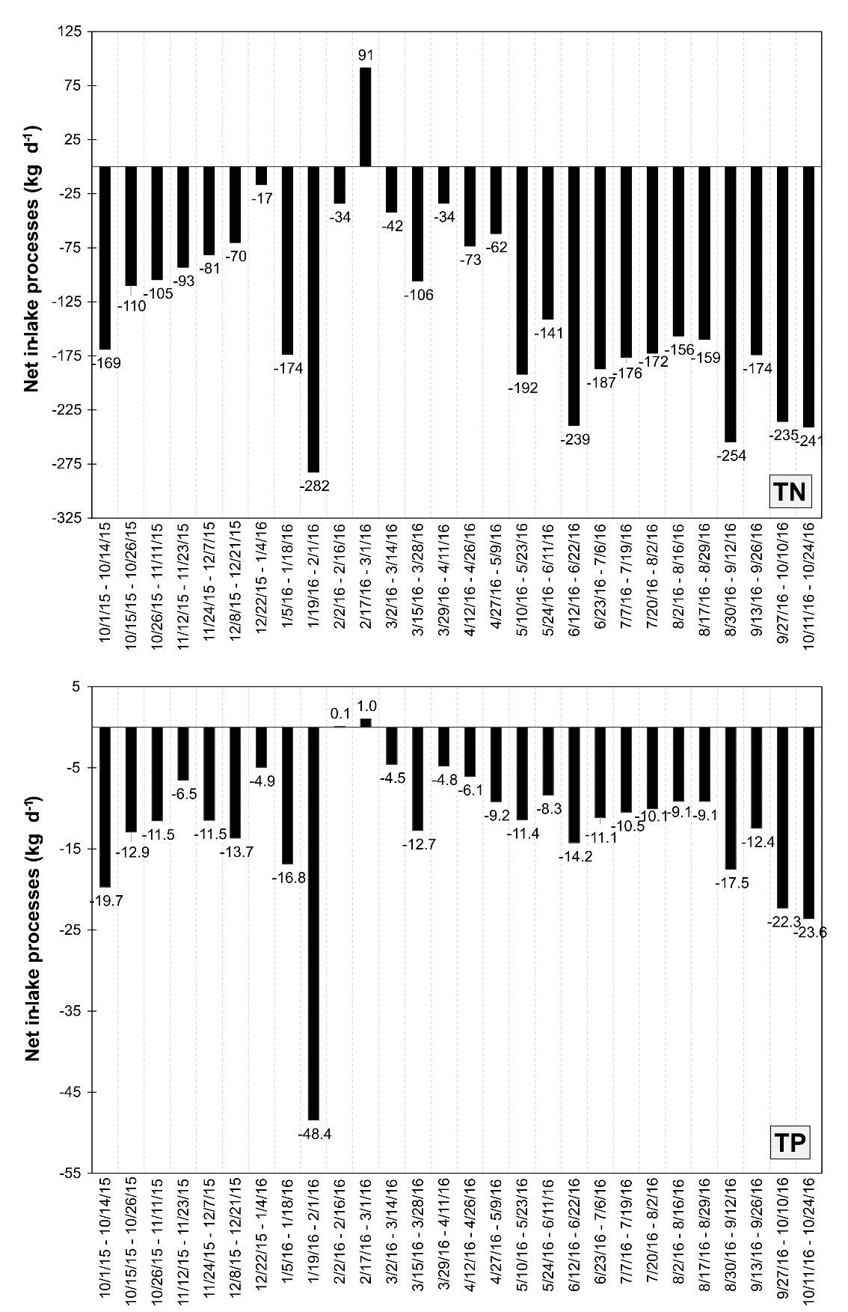

Figure 46: Total net in-lake processing (i.e. internal loading, sedimentation) for each bi-week. For the most part, in lake processes accounted for a net sink of nutrients, with only Events 10 (TP only) and 11 having a net positive load to the system (TN only), assumed to be caused by internal nitrogen loading.

Discussion
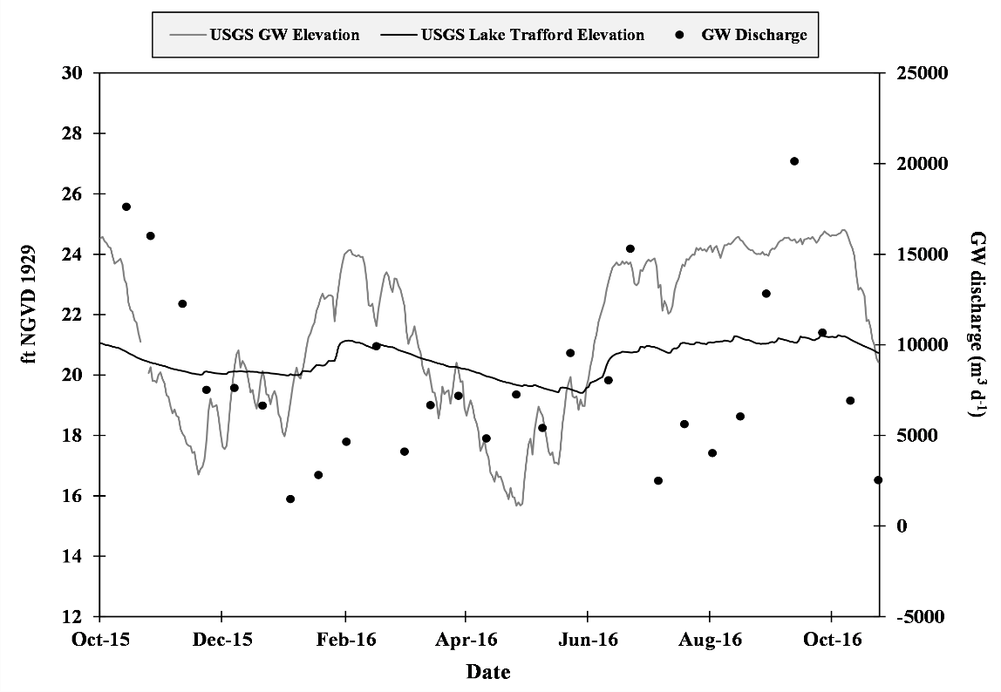
Groundwater discharge and recharge values for Lake Trafford are within the normal range of values typical of Florida lakes (Belanger, 1985; Harper, 2011). Groundwater flow measurements throughout the course of the study indicated that groundwater flow was occurring in all areas of Lake Trafford at some point throughout data collection, including deep water sites. In most cases, groundwater discharge occurs in the shallow areas of lakes, where lake level and groundwater level discrepancies are most pronounced. Figure 47 shows the difference in water level and groundwater level from a nearby USGS monitoring well (USGS 262554081283801 C- 687; Figure 24) during the study. Water level elevation discrepancies were as high as one meter, and groundwater elevation was found to be both above and below lake level elevation at various points during the study period. Groundwater discharge closely mirrored the groundwater elevation at the beginning of the study, but became less correlated as El-Niño related rains began in January. This may be due to rainfall and sampling time biases.
Figure 47: Changes in groundwater and lake level elevation over the course of the study, along with measured groundwater discharge (black dots). Increased groundwater discharge should be expected when groundwater elevation (dashed line) is higher than lake water elevation (black line).
Time of sampling relative to rainfall was a driver in measured groundwater seepage, with flow rates taken days after rainfall being low or mostly negative compared to sampling events with no rainfall. This paradigm is expected as Schiffer (1998) points out that rainfall can increase lake water elevation faster than groundwater elevation, thus creating a negative or balanced hydraulic head, limiting groundwater discharge into a waterbody. It is unknown if groundwater discharge would have increased to higher levels in the days after sampling. This single day of sampling was used as the average flow rate for each biweekly event. Because of this, groundwater inflow may be much higher than indicated during each bi-week event and in reality may correlate better with local groundwater elevations.
Deep seepage meters were the most predictable of all the sampling locations, with seepage bag volumes increasing in almost every event. This is an atypical occurrence in most lakes (Asbury, 1990; Schiffer, 1998). Groundwater discharge in the center of lakes is typically indicative of a high potentiometric head moving water upward from deeper in the aquifer. This condition is less common and it is unclear if Lake Trafford falls into this category. Furthermore, with all five (plus the duplicate) seepage meters showing groundwater discharge in these areas, it is unlikely that this measured flow is erroneous. The latest hydrogeological report for Collier County indicates that the base of the surficial aquifer is deep in this area, and the Lower Tamiami confining unit is absent or insignificant (Geddes et al. 2015). This may allow for water from deeper aquifers to have influence on the potentiometric head of the pore water beneath Lake Trafford. Further study is needed to confirm this hypothesis.
Another possible reason for the atypical spatial patterns of groundwater discharge is the influence of sediment dredging. Genereux and Bandopadhyay (2001) found that increased discharge further offshore in inflow lakes typically occurs when the lake bed is covered with dense organic sediment with a low hydraulic conductivity. A mapping of the sediment thickness was conducted in Lake Trafford (Dettmar, 2012) and compared with the sediment thickness prior to dredging (ART Engineering, 2004) and showed the expected reduction in sediment accumulation in especially the central portion of the lake (Figure 48). As such, the hydraulic conductivity of Lake Trafford’s bed – especially within its central section – should therefore be investigated.
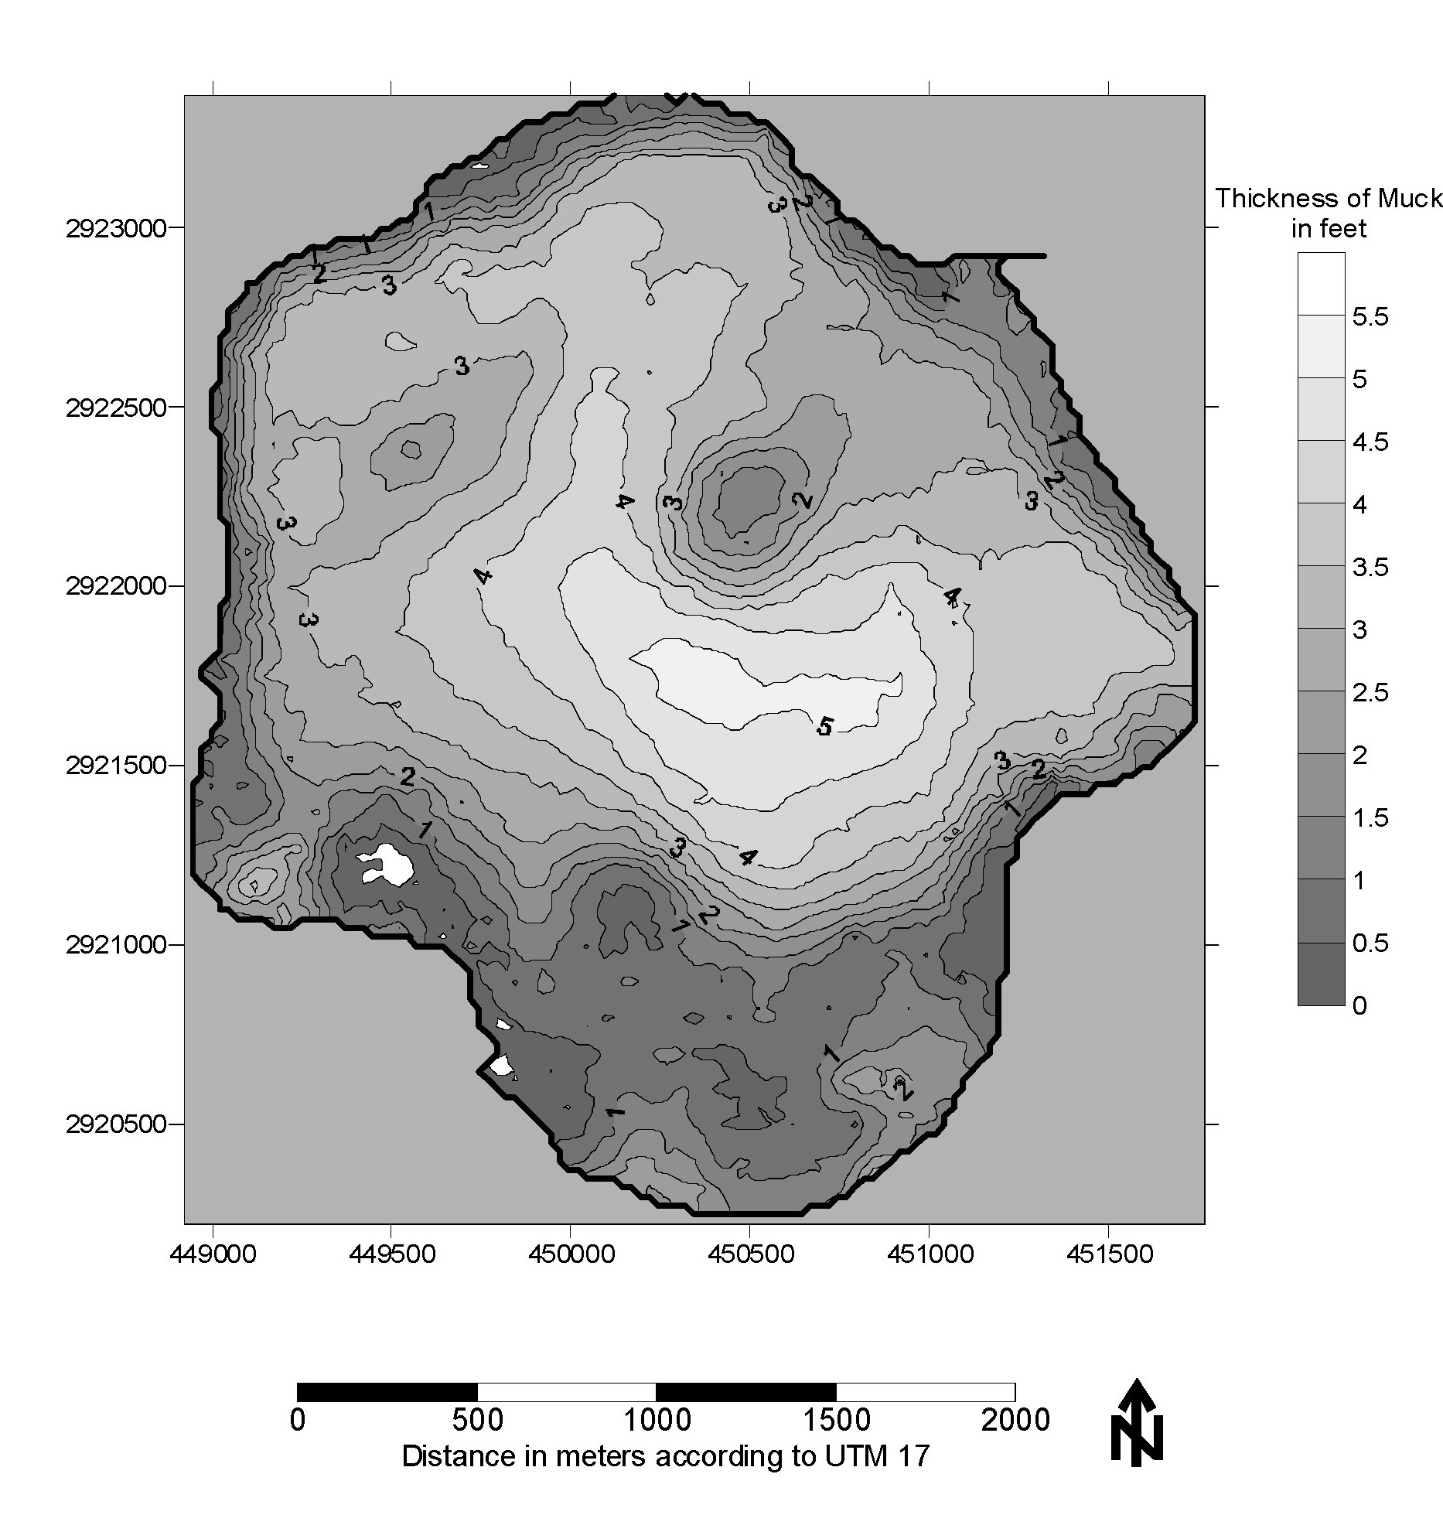
Figure 48: Maps of sediment+floc (i.e. muck) accumulation in Lake Trafford pre-dredging (Art Engineering, 2004) and post dredging (Dettmar, 2012). Note the 5x scale change between the two maps. A gray scale was chosen for the 2012 muck accumulation map to match the one made in 2004 (for which FGCU does not have the raw data).

The use of groundwater seepage meters is often accompanied by a plethora of problems, such as bag breakage or loss (Belanger, 1992). However, in this study, seepage measurements were mostly successful with only 23 lost/detached or broken bags out of 685 possible total bag deployments (96.6% successful bag deployments). Only eight meters needed to be reseated due to “blowout,” and 3 meters lost their marker buoy. This is a much lower unsuccessful bag deployment ratio than other studies using groundwater seepage meters (e.g. Harper, 2011; 55% of bags lost). The relative success likely stems from the short sampling period of groundwater flow limited to 24-hours. This short duration, while ideal for bag preservation, introduces other issues. For example, shorter sampling durations lack temporal resolution compared to extended bag placement times and may be more influenced by temporary conditions such as hydraulic head loss post rainfall.
Flow through the seepage meters may also have been lower due to the relatively high water levels experienced during the study period. Seepage meters were placed in June of 2015 when water levels were approximately 18 ft. NGVD. Lake stage never fell below 19.48 ft. NGVD during sample collection, leaving meters deeper and further from the true boundary of the lake than would have been ideal (Asbury, 1990). Having several groups of seepage meters to be used at various levels of lake stage would have solved this issue (e.g. Thomas and Lucius, 2016), but would have been costly and especially difficult to implement since the lake boundary is very undefined as it extends to a densely-vegetated flood plain/wetland when lake water level is high.
Nutrient concentrations in groundwater proved to be somewhat dichotomous, with deeper sites having consistently higher concentrations than shallower sites, especially for total nitrogen, which was found to be over 30 mg l⁻¹ in some samples. The mean TN concentration for all groundwater samples from Lake Trafford of 12.68±9.80 mg l⁻¹ is almost three times higher than results from Lake Tohopekaliga (4.6 mg l⁻¹; Belanger et al. 1985), three times higher than results from Lake Jesup (4.2 mg l⁻¹; Harper, 2011), and almost five times higher than samples from a wet detention pond on the Fort Myers campus of FGCU (2.7 mg l⁻¹; Thomas and Lucius, 2016).
It is unknown what is driving the elevated nutrient levels at the central seepage sites and further study should be conducted to ascertain the cause. Furthermore, coupled with the regular groundwater discharge in these areas, nitrogen loading from groundwater discharge is much higher than anticipated because of the high nitrogen concentrations in the pore water from the center lake sites.
Average phosphorus concentrations (0.90±0.62 mg l⁻¹) were also elevated above surface water concentrations and concentrations from groundwater seepage from other Florida lakes. TP concentrations in Lake Trafford were approximately 3.5 times the concentrations of seepage into Lake Tohopekaliga (0.25 mg l⁻¹; Belanger et al. 1985), 2.5 times the concentrations for Lake Jesup (0.33 mg l⁻¹; Harper, 2011) and over 3.5 times the concentrations for the FGCU pond (0.27 mg l⁻¹; Thomas and Lucius, 2016). This makes phosphorus loading via groundwater discharge higher into Lake Trafford than other studied systems, even with its normal rates of seepage.
Canal discharge was, as expected, dependent on rainfall, with flows mostly stagnant during extended dry periods. Data quality was good, but the Sontek IQ units were often unreliable and lead to many gaps in Q data when they needed to be removed for repair. The vast majority of discharge occurred from Canal 1, which also had the highest concentrations of nitrogen and phosphorus, making it a substantial source of water and nutrients into Lake Trafford.
It is hypothesized that Canal 1 may experience much more flow due to its connection with the Immokalee Slough (Figure 7), a wetland area that extends east from Lake Trafford, meandering its way between farm land to the south and the City of Immokalee to the north. This area is clearly within the Lake Trafford drainage basin and is likely the reason for the higher Q and nutrient concentrations in Canal 1. Increased impervious surface area from the City of Immokalee and agricultural runoff from the lands to the south are potentially the source of the excessive nutrients, especially stormwater runoff which is likely channeled into the slough.
Rainfall totals in the Corkscrew area (SFWMD station name “CORK.HQ_R”, Latitude North 262301.294, Longitude West 813459.278) averaged 1,484 mm per year from 1959 to 2007 (DBHYDRO, 2007; Figure 49). The rainfall total during the 2015-16 study period was found to be 1,222 mm measured at the installed weather station on Lake Trafford and 1,582 mm at IFAS Immokalee FAWN station. Rainfall during the wet season followed the typical historical patterns while the dry season was much wetter than average. Using statistical modeling methods from South Florida Water Management District (1995), the amount of rainfall measured between November 2015 and May of 2016 is considered a “1 in 10 event” or an event that only occurs in 10% of years. Rain gauges equipped with a tipping bucket underestimate rainfall a fortiori when the rainfall rate is high over a short period of time. This could partially explain the lower than average rainfall during summer 2016 recorded at the installed weather stations. Algorithms are often used to estimate the correct rainfall during said high precipitation events.

Figure 49: Monthly historic averages (1959 – 2007) for rainfall (gold bar) plotted against recorded rainfall during 2015-16 recorded at the installed Davis station (blue bars) and IFAS Immokalee (red bars). Exceptionally high rainfall totals were observed in January 2016.
Canal flow was measured directly in this study and the data may be useful for modeling flow from these canals in the future. The canals correlated well with groundwater level and rainfall. Using Automated Neural Networks (ANN), an accurate estimation of canal discharge would likely be possible using known groundwater levels and rainfall totals. A simpler model using a polynomial relationship between groundwater level and Q could also be used, but would miss peaks in Q post rainfall. The model could aid in policy decisions and the easier estimation of nutrient loading into the lake through the five drainage canals.
Dry and wet deposition collection and analysis were successful with the use of the homemade collection sampler. Only one missed sample occurred due to an incorrectly placed bucket as well as corrosion occurring on the rainfall sensor that precluded the collection of data for two events. Data quality was good with two exceptions: i) insects and small reptiles and amphibians tainted several samples ii) the land based location was not ideal due to nearby trees likely influencing deposition patterns. The small stainless steel screen added to the buckets eliminated most of the insect and reptile fouling, but it also may have impacted deposition rates. The screen size chosen was a compromise between fouling prevention and deposition blockage.
The average dry deposition rates recorded in this study were somewhat elevated, matching rates found in both the Ohio Valley and the Northeastern US for total nitrogen deposition (Lawrence et al. 2000). Values calculated for Tampa Bay were 50% lower than those found in this study (Poor, 2001). It is unknown whether the elevated values found for Lake Trafford are erroneous, but the fairly remote location of the lake, far from any large industrial areas, leads one to believe that the values recorded may be inflated, perhaps due to the extended period of composite sample collection. Other possibilities may include higher deposition rates caused from pre-harvest sugar cane burning at the nearby Everglades Agricultural Area (EAA; 35 miles west-northwest). Further study is needed to clear up this issue.
The final calculated water budget showed groundwater to be a relatively small contributor, and was measured at only 30% of the rate estimated in the TMDL HSPF model (Kang and Gilbert, 2008). However, true groundwater discharge may be higher than recorded as previously discussed. Evaporation and sheet flow are the primary hydrological outputs from Lake Trafford, with groundwater recharge only accounting for 0.5% of the outflow. Evaporation estimates are in agreeance with the TMDL report estimates, differing by only 2.3%. The average evaporation rate observed was very similar to other lakes in Florida (Lake Trafford: 3.59 mm d⁻¹, Lake Okeechobee, 3.61 mm d⁻¹; Abtew et al. 2003).
There is a very clear relationship between lake stage, sheet flow, and rainfall (Figure 50). As stage increases, net sheet flow becomes increasingly negative. As stage decreases, net sheet flow becomes more positive. This fits logically with the assertion that Lake Trafford feeds the wetlands to its South and West with overflowing water when water levels approach 21 ft. NGVD. Net sheet flow values became increasingly negative as lake stage increased above 20 ft., reaching its highest values around 21 ft. Rainfall also appears to drive positive sheet flow with diffuse runoffs entering the lake after rain events. This can be seen as an upward spike in net sheet flow following larger rain events. These spikes can also be found in the stage elevation, as runoff and direct precipitation increased lake levels.
Negative net sheet flow was the norm during the study period, again related to the much wetter than average winter of 2015-16. Due to the methodology used in this study, it is unknown how much of the net sheet flow calculated was incoming and outgoing sheet flow. It is possible that the higher water levels not only increased outgoing sheet flow, but the increased rainfall also increased incoming sheet flow, but to a lesser degree. The lack of resolution in this regard is a limitation of this project. Moreover, it is unclear how much runoff is channeled by the five canals before entering the lake. It is possible that the amount of direct surface runoff outside of the canals is small, and somewhat insignificant. This hypothesis may be backed up by Lake Trafford’s adopted TMDL. Using a wet year from the TMDL sampling period to better compare with the conditions of this study (2005 – 1,650 mm rainfall), the daily runoff average was estimated to be 38,358 m³ d⁻¹ (Kang and Gilbert, 2008). Discharge from the canals in this study has averaged 41,963 m³ d⁻¹. More data would be needed to confirm, but this makes a plausible argument that the majority of runoff entering Lake Trafford enters through the canals. If true, it would also make remediation and load reduction projects easier to accomplish.

Figure 50: Changes in net sheet flow (left Y axis), precipitation (no scale), and stage (right Y axis) over time. Note that there is no scale on this plot for rainfall, as it is rather used to show the timing and magnitude of rain events and the responses of stage and net sheet flow. There is an evident inverse relationship between stage and net sheet flow, as well as the spike in the value of said parameters after rain events.
Loading from sheet flow calculations was difficult to estimate due to the way sheet flow volume was calculated. To estimate loading, concentrations from the composite samples taken from the five collection canals were used which are assumed to have similar source water as direct runoff. Determining the Q to use was less intuitive. Average values from all positive net sheet flow calculations were used to estimate the daily Q from diffuse runoff for the study period. The same process was repeated for negative flow volumes. This process is unlikely to accurately estimate positive and negative runoff volumes, but will serve its purpose to provide loose estimates of relative percentages for each influx and efflux. Net loading from sheet flow should be considered the most accurate value.
Nutrient concentrations have proven to be higher than expected when compared to the TMDL report. TMDL model estimates for surface runoff are approximately 0.040 mg TP l⁻¹ depending on the year, while surface discharge from the canals averaged 0.166 TP l⁻¹ in this study. Groundwater concentrations were also much higher. TN concentrations were estimated to be between 0.04 and 0.78 mg l⁻¹ in the TMDL report, but average TN concentrations were found to be over 12 mg l⁻¹ from data collected in situ in this study, representing a substantial difference between the two projects.
The average total daily load estimated in Lake Trafford’s TMDL over the course of their modeling period was 190.5 kg d⁻¹ for total nitrogen and 18.6 kg d⁻¹ for total phosphorus. The final results of this study were 274.3 kg d⁻¹ and 24.2 kg d⁻¹, equating to differences of 31% and 23% for TN and TP, respectively. Wetter years, such as 2005, had modeled total loads of 335 kg d⁻¹ and 37.6 kg d⁻¹ for TN and TP respectively.
Using the nutrient budget, net values for “in-lake processes” including positive loads such as internal loading, and negative loads such as biological uptake and sedimentation could be estimated. Historically, Lake Trafford was known to have problems with legacy loading from a very thick organic sediment layer that was very easily re-suspended in windy conditions. Sediment dredging was the cure for this legacy load. The data from this study suggest that the sediment dredging accomplished its goal. Net in-lake processes were found to have negative values on average (-61.26 kg TN d⁻¹ and -7.63 kg TP d⁻¹), meaning biological uptake or sedimentation was a more dominating factor than internal loading. Values for in-lake processes became less negative throughout the fall moving into the winter months and then increased negatively as warmer conditions returned in the spring. This is likely caused by decreased primary production of both macrophytes and phytoplankton during the colder conditions and lower light levels of winter, indicating that biological uptake may be the most significant driver of the lakes internal nutrient dynamics. It is quite possible that internal loading still persists, particularly in areas that were not dredged. However, internal loading does not appear to be the problematic factor it once was.
The TMDL report from 2008 indicated that the total maximum daily loads for Lake Trafford should be limited to 70.4 kg d⁻¹ and 4.2 kg d⁻¹ for TN and TP, respectively. This equates to reductions of 60% for TN and 77% for TP. The results of this study are indicative of how far from these targets we are in terms of reducing nutrient loading into Lake Trafford. Load reductions will be necessary to prevent Lake Trafford from getting more eutrophied. The DEP has not adopted a Basin Management Action Plan (BMAP) for Lake Trafford. Data from multiple studies, including this one, should likely influence future policy decisions.
Data from this study indicates several areas where load reductions could be targeted, but there is one area that would be the most effective from a policy or project standpoint. Elevated concentrations of nitrogen and phosphorus in the groundwater are problematic, but the source of these nutrients is likely derived from the entire watershed, and perhaps even outside of it. Spot targeting reductions for groundwater nutrient leaching would be difficult, but fertilizer and perhaps septic tank policy changes may have a positive impact. The most effective place for nutrient reduction is likely Canal 1 which delivers most of the phosphorus from the five canals and a significant portion of the overall phosphorus load to Lake Trafford. This makes it a prime candidate for a remediation project. The fact that it is also a surface water delivery with sources that are probably evident upon inspection also make it ideal.

Areas of Future Study
Further areas of study that could prove to be valuable have been highlighted by this project. Because Lake Trafford’s boundary is often ambiguous and highly vegetated, a piezometer study with sites that extend beyond Lake Trafford’s boundary into the surrounding wetlands may be better suited for monitoring groundwater discharge and recharge around the lake than seepage meters alone. Ion and radio isotope research on the groundwater entering Lake Trafford could also be valuable for determining the sources of inflowing groundwater and potentially point to sources of groundwater pollution. Additionally, studying the hydrogeology beneath Lake Trafford may explain the unusual flow patterns. Further study is also needed involving the Immokalee Slough, particularly where and when nutrient loads are moving into it. It is unknown whether MS4 outfall drainage is present or if it is being used as drainage for crop land. However, its large deliveries of water and nutrients to Lake Trafford make it worth further investigation. Finally, this was the first attempt at direct measurement of dry deposition falling on to Lake Trafford. Continual measurements would be useful for determining the average value and whether it is truly elevated over background values for one reason or another.

Conclusions
Experimentally measuring the water and nutrient fluxes in Lake Trafford proved to be a valuable undertaking. El Niño was an influential factor on lake hydrology during the study period, as was the lack of a full hydrological year of data. However, several pre-existing assertions regarding Lake Trafford’s hydrology were confirmed, such as its delivery to downstream wetlands when stage elevation approached 21 ft. NGVD. Novel information was also gleaned from the study. Water influxes were shown to be dominated by surface water channeled by the five collector canals (especially through Canal 1), and rainfall and base flow into these canals were the most predictive drivers of discharge. Groundwater discharge had a smaller influence than expected, but did show an inverse relationship with rain flow, although this relationship may have been an artifact of sampling duration. Furthermore, groundwater seepage measurements may have been underestimated due to the continuously high water levels during the study period. Evaporation models were similar to both nearby Lake Okeechobee and to previously estimated values for Lake Trafford.
Through nutrient budgeting, the data suggest that nutrient loads are still elevated and do not meet the target loads determined by the TMDL for Lake Trafford. Groundwater loading was particularly high due to elevated nutrient concentrations sampled from pore water beneath the lake, the cause of which is unknown. Surface water inflow was also more nutrient rich than expected. Dry deposition loading was higher than expected, comparable to more industrialized areas, and more research should be conducted to substantiate these findings or to determine if these values were overestimated.
Overall, daily nutrient loading was comparable to upper TMDL estimates (from previous rainy years), but higher than the average daily load values calculated in the TMDL likely due to higher than average rainfall during the study period. The measured budget also indicated that internal loading is likely lower than pre-dredging conditions and that sedimentation and biological uptake were, at the very least, canceling out any ongoing internal loading. This is one positive aspect -out of many- of the sediment dredging which recently took place.
It is hoped that further work will be conducted to reduce the overall nutrient load entering Lake Trafford, and will help return the lake back to its original state nutrients and water clarity wise. The continuation of this project could be beneficial for a better understanding of Lake Trafford’s hydrology and nutrient loading under varying hydrological regimes (wet years vs dry years, etc.). However, reducing the sampling effort to once a month may be more ideal from a monetary perspective and would still be sufficient from a temporal resolution standpoint, especially considering that most sampling is continuous or automated. Furthermore, increasing the time for bag deployments on the seepage meters to 48, 72, or even 96 hours may serve as a nice balance between increased temporal resolution, and preservation of the delicate seepage bags.
Load reductions for Lake Trafford should be the primary goal from a lake management standpoint, but other activities should be encouraged as well, such as native SAV plantings. Both decreased loading and increased SAV coverage will be needed to return Lake Trafford to a clear water state. Because of its prolific growth, Hydrilla could be used as a management tool to control sediment re-suspension and uptake nutrients out of the water column until the lake switches to a clearer water state which would allow the rapid return of rooted submerged aquatic vegetation (SAV). The use of the adequate amount of grass carps could then selectively graze upon Hydrilla, thus allowing the native SAV to proliferate.

Literature Cited
Abtew W, Obeysekera J, Iricanin, N. 2011. Pan evaporation and potential evapotranspiration trends in South Florida. Hydrological Processes 25(6):958–969.
Abtew W, Obeysekera J, Irizzary-Ortiz M, Lyons D, Reardon A. 2003. Evapotranspiration estimation for south Florida. Environmental Monitoring & Assessment Department, South Florida Water Management District.
Abtew W. 2001. Evaporation estimation for Lake Okeechobee in south Florida. Journal of Irrigation and Drainage Engineering 127(3):140-147.
Amodio M, Catino S, Dambruoso PR, De Gennaro G, Di Gilio A, Giungato P, Tutino M. 2014. Atmospheric deposition: sampling procedures, analytical methods, and main recent findings from the scientific literature. Advances in Meteorology 2014: 1-27.
Anderson KA, Downing JA. 2006. Dry and wet atmospheric deposition of nitrogen, phosphorus and silicon in an agricultural region. Water, Air, and Soil Pollution 176(1-4):351-374.
ART Engineering. 2004. Lake Trafford critical restoration project – aquascan radar survey report. Tampa, Florida.
Art HW. 1993. A dictionary of ecology and environmental science (1st ed.): New York, New York, Henry Holt and Company: 196.
Asbury CE. 1990. The role of groundwater seepage in sediment chemistry and nutrient budgets in Mirror Lake, New Hampshire. Ph.D. dissertation. Cornell University.
Ashley J. 2004. Lake Trafford Restoration. Central and Southern Florida Ecosystem Restoration Critical Project Letter Report. US Army Corps of Engineers. Jacksonville District. http://www.saj.usace.army.mil/projects/laketraf.htm.
Bennett MW. 1992. A three-dimensional finite difference ground water flow model of western Collier County, Florida. Hydrogeology Division, Department of Research and Evaluation, South Florida Water Management District. Technical Publication 92-04.
Burkart MR, Simpkins WW, Morrow AJ, Gannon JM. 2004. Occurrence of total dissolved phosphorous in unconsolidated aquifers and aquitards in Iowa. Journal of the American Water Resources Association 40(3):827–834.
Canfield DE, Langeland KA, Linda SB, Haller WT. 1985. Relations between water transparency and maximum depth of macrophyte colonization in lakes. Journal of Aquatic Plant Management 23(1):25-28.
.
Ceilley DW, Thomas S, Everham III EM. 2013. Lake Trafford Management Action Plan. Lake Trafford Management Action Team. SFWMD contract E, Naples FL, USA.
DBHYDRO. 2007. Station CORK.HQ_R, Rainfall data 1959-2007. South Florida Water Management District. http://my.sfwmd.gov/dbhydroplsql/show_dbkey_info.show _station_info?v_station=CORK.HQ_R
de Wit M, Behrendt H, Bendoricchio G, Bleuten W, van Gaans P. 2002. The contribution of agriculture to nutrient pollution in three European rivers, with reference to the European Nitrates Directive. European Water Management Online, 19. Hennef, Germany.
Dettmar D. 2012. Assessment of lake bed sediment content in sediment cores of Lake Trafford. Limnology report, PCB5307C Class, Florida Gulf Coast University, Fort Myers, Florida.
Dolan DM, Yui AK, Geist RD. 1981. Evaluation of river load estimation methods for total phosphorus. Journal of Great Lakes Research 7(3):207–14.
Erickson DR. 1981. A study of littoral groundwater seepage at Williams Lake, Minnesota, using seepage meters and wells. Master’s thesis, University of Minnesota.
Everham III EM, Thomas S., Ceilley DW. 2015. Lake Trafford Limnological and Biological Assessment and Lake Management Coordination. Final Report. South Florida Water Management District, Technical Report.
Ferlita II JA. 2014. Ecological Indicators of Restoration Success: Zooplankton as Indicators of Lake Change in a Dredged Southwest Florida Lake. Master’s Thesis, Florida Gulf Coast University.
Flaig E. 2000. Lake Trafford. http://naples.net/presents/trafford/
Fryberger SG, Dean G. 1979. Dune forms and wind regime. In A study of global sand seas, McKee E. (Ed). U.S. Geological Survey. Professional Paper 1052 pp 137-170.
Gales ME, Julian EC, Kroner RC. 1966. Method for quantitative determination of total phosphorus in water. American Water Works Association 58(10):1363-1368.
Geddes E, Richardson E, Dodd A. 2015. Hydrogeological unit mapping update for the Lower West Coast Water Supply Planning Area. South Florida Water Management District. Technical Publication WS-35.
Genereux D, Bandopadhyay I. 2001. Numerical investigation of lake bed seepage patterns: effects of porous medium and lake properties. Journal of Hydrology 241(3):286-303.
Gibson GG. 2002. The restoration of Lake Trafford, Collier County, Florida: A work in progress. INSTEP proceedings.
Grubbs JW. 1995. Evaluation of ground-water flow and hydrologic budget of Lake Five-O, A seepage lake in northwestern Florida. U.S. Geological Survey, Tallahassee.Water-Resources Investigations Report 94-4145.
Gunderson LH. 1989. Accounting for discrepancies in pan evaporation calculations. Water Resources Bulletin 25(3):573–579.
Harper HH. 2011. Evaluation of hydrologic and nutrient loadings from groundwater seepage to Lake Jesup. Final report. Environmental Research & Design, Inc., Orlando.
Kang WJ, Gilbert D. 2008. TMDL Report: Nutrient, Un-ionized Ammonia, and DO TMDLs for Lake Trafford (WBID 3259W). Florida Department of Environmental Protection.
Kang WJ, Kolasa KV, Rials MW. 2005. Groundwater inflow and associated transport of phosphorus to a hypereutrophic lake. Environmental Geology 47(4):565–575.
Kebede S, Travi Y, Alemayehu T, Marc V. 2006. Water balance of Lake Tana and its sensitivity to fluctuations in rainfall, Blue Nile basin, Ethiopia. Journal of hydrology 316(1):233-247.
Kirk JA, Wise WR, Delfino JJ. 2004. Water budget and cost-effectiveness analysis of wetland restoration alternatives: a case study of Levy Prairie, Alachua County, Florida. Ecological Engineering 22(1):43-60.
Kröger R, Holland MM, Moore MT, Cooper CM. 2008. Agricultural drainage ditches mitigate phosphorus loads as a function of hydrological variability. Journal of Environmental Quality 37(1):107-113.
Lawrence GB, Lovett GM, Baevsky YH. 2000. Atmospheric deposition and watershed nitrogen export along an elevational gradient in the Catskill Mountains, NewYork. Biogeochemistry 50(1):21-43.
Lee TM, Sacks LA, Swancar A. 2014. Exploring the long-term balance between net precipitation and net groundwater exchange in Florida seepage lakes: Journal of Hydrology 519:3054-3068.
Mitsch WJ, Dorage CL, Wiemhoff JR. 1979. Ecosystem dynamics and a phosphorus budget of an alluvial cypress swamp in southern Illinois. Ecology 60(6):1116-1124.
Ponce VM. 1989. Engineering Hydrology: Principles and Practices. Prentice Hall, Englewood Cliffs, New Jersey.
Poor N, Pribble R, Greening H. 2001. Direct wet and dry deposition of ammonia, nitric acid, ammonium and nitrate to the Tampa Bay Estuary, FL, USA. Atmospheric Environment 35(23): 3947-3955.
Rosenberry DO, LaBaugh JW, Hunt RJ. 2008. Use of monitoring wells, portable piezometers, and seepage meters to quantify flow between surface water and ground water. Field techniques for estimating water fluxes between surface water and ground water. US Geological Survey Techniques and Methods, 4-D2.
Rosenberry DO, Lewandowski J, Meinikmann K, Nützmann, G. 2015. Groundwater‐the disregarded component in lake water and nutrient budgets. Part 1: effects of groundwater on hydrology. Hydrological Processes 29(13): 2895-2921.
Scheffer M, Hosper SH, Meijer ML, Moss B, Jeppesen E. 1993. Alternative equilibria in shallow lakes. Trends in Ecology and Evolution 8(8):275-279.
Scheider WA, Moss JJ, Dillon PJ. 1979. Measurement and uses of hydraulic and nutrient budgets. Lake Restoration: proceedings of a national conference. EPA=440/5-79-001. August 22-24.
Schiffer DM. 1998. Hydrology of Central Florida Lakes – A Primer. – United States Geological Survey Circular. Technical Publication 1137.
SFWMD. 2011. Quick Facts on Lake Trafford Restoration. http://www.sfwmd.gov/portal/page/ portal/xrepository/sfwmd_repository_pdf/spl_lake_trafford.pdf
Shaw RD, Prepas EE. 1989. Anomalous, short-term influx of water into seepage meters: Limnology and Oceanography 34(7):1343–1351.
Smeltzer E, Quinn S. 1996. A phosphorus budget, model, and load reduction strategy for Lake Champlain. Lake and Reservoir Management 12(3):381-393.
Søndergaard M, Jensen JP, Jeppesen E. (2003). Role of sediment and internal loading of phosphorus in shallow lakes. Hydrobiologia 506(1): 135-145.
Spalding RF, Exner ME. 1993. Occurrence of nitrate in groundwater - a review. Journal of Environmental Quality 22(3):392-402.
Sutton DL, Portier KM. 1992. Density of tubers and turions of Hydrilla in South Florida. Journal of Aquatic Plant Management 23:64-67.
Swancar A, Lee TM, O'Hare TM. 2000. Hydrogeologic setting, water budget, and preliminary analysis of ground-water exchange at Lake Starr, a seepage lake in Polk County, Florida (No. 2000-4030). US Department of the Interior, US Geological Survey.
Thomas S, Everham III EM, Ceilley DW, Lucius M. 2015. Lake Trafford aquatic vegetation monitoring and mapping Final Report. South Florida Water Management District, Technical Report.
Thomas S, Lucius MA. 2016. Groundwater seepage nutrient loading in a recently dug wet detention stormwater pond. Florida Scientist 79(2-3):132-146.
Tomer MD, Schilling KE, Cambardella CA, Jacobsen P, Drobney P. 2010. Groundwater nutrient concentrations during prairie reconstruction on an Iowa landscape. Agriculture Ecosystem Environment 139(1):206–213.
Trussell RP. 1972. The percent un-ionized ammonia in aqueous ammonia solutions at different ph levels and temperatures. Journal of the Fisheries Board of Canada 29(10):1505-1507.
Winter JG, Dillon PJ, Futter MN, Nicholls KH, Scheider WA, Scott LD. 2002. Total phosphorus budgets and nitrogen loads: Lake Simcoe, Ontario (1990 to 1998). Journal of Great Lakes Research 28(3):301-314.
Zhong J, Fan C. 2007. Advance in the study on the effectiveness and environmental impact of sediment dredging. Journal of Lake Science 19(1):1-10.

Appendix A
Terms and abbreviations

ADL – atmospheric deposition load
ADV – acoustic Doppler velocimetry
BMAP – Basin Management Action Plan
BMP – Best Management Practices
C – concentration
cp - specific heat of moist air (g⁻¹ °C⁻¹)
CFS – cubic feet per second
CL – canal discharge load
DI – deionized
E - evaporation (mm d⁻¹)
es – ea - vapor pressure deficit (mbar)
ET – evapotranspiration (mm d⁻¹)
GW – groundwater
GWL – groundwater load
HSPF - Hydrologic Simulation Program Fortran
IL – internal loading
K₁ – evaporation coefficient 1 (0.53)
K₂ – evaporation coefficient 2 (0.0123)
K₃ – evaporation coefficient 3 (52.6 °C)
L – load
MJ – megajoules
ModTN ­– modeled or budgeted nutrient mass
ModVol – modeled or budgeted lake volume
MS4 – municipal separate storm sewer system
N – normality
NGVD – National Geodetic Vertical Datum
NPDES – National Pollutant Discharge Elimination System

POTW – publicly owned treatment works
Q – volumetric flow rate
ra - external resistance (s cm⁻¹)
RMSE – root mean square error
R_{s} - solar radiation
s = standard deviation
SAV – submerged aquatic vegetation
SEM – standard error of the mean
SFL – sheet flow load
Snet – Net sheet flow
SOP – standard operating procedure
SRP – soluble reactive phosphorus
SW – surface water
t – time
TKN – total Kjeldal nitrogen
T_{max} – maximum daily temperature (°C)
TMDL – Total Maximum Daily Load
TN – total Nitrogen
TP – total Phosphorus
TruTn - true nutrient mass in lake
TruVol – true lake volume
V – volume
λ - latent heat of vaporization of water (MJ kg⁻¹)
∆ - saturation vapor pressure gradient (mbar °C⁻¹)
ρ - water density (g cm⁻³)
ρa - density of moist air (g cm⁻³)
γ - psychrometric constant (mbar °C⁻¹)

Appendix B
Code for Storm3 data loggers
Coding Language: Basic

GETVALUE SENSOR "IQ(TotalVolume)", varReading

GETVALUE COUNTER3, varVolumeChk

IF (varReading > varVolumeChk) THEN
GETVALUE COUNTER4, varPosVolume
SETVALUE COUNTER4 (varPosVolume + (varReading - varVolumeChk))
SETVALUE COUNTER3, (varReading)
GOTO TriggerChk
ELSE
SETVALUE COUNTER3, (varReading)
GOTO Exit
ENDIF

LABEL TriggerChk
varSetting = (Threshold value; e.g. 55000)
GETVALUE COUNTER2, varCount
varTotal = varSetting * varCount
IF (varPosVolume > varTotal) THEN
SETVALUE DIGITAL1,0
DELAY 2
SETVALUE DIGITAL1,1
SETVALUE COUNTER2, (varCount + 1)
ELSE
SETVALUE DIGITAL1,1
ENDIF

LABEL Exit
END

Appendix C
Arduino Software
Coding Language: Arduino (C/C++)

//pin 8 = direction
//pin 9 = enable

const int sensorValue = A0;
const int PIN_PULSE = 8;
const int PIN_PULSE2 = 9;
const int PIN_PULSE3 = 10;
const int PIN_PULSE4 = 11;
int pulseCount = 0;

int bucketOPEN = true;

void setup() {

pinMode(PIN_PULSE, OUTPUT);
pinMode(PIN_PULSE2, OUTPUT);
pinMode(PIN_PULSE3, OUTPUT);
pinMode(PIN_PULSE4, OUTPUT);
pinMode(sensorValue, INPUT);
}
void loop()
{
analogRead(A0);

if (bucketOPEN == true && analogRead(A0) < 900)
{
closeBucket();
}
else if (bucketOPEN == false && analogRead(A0) > 900)
{
openBucket();
}
}
void closeBucket()
{
//if (rainSensorState == HIGH)
{
digitalWrite(PIN_PULSE4, LOW);
digitalWrite(PIN_PULSE3, LOW);
delay(100);
digitalWrite(PIN_PULSE, HIGH);
digitalWrite(PIN_PULSE2, HIGH);

bucketOPEN = false;
}
}
void openBucket()
{
//if(rainSensorState == LOW)
{
digitalWrite(PIN_PULSE4, HIGH);
digitalWrite(PIN_PULSE3, HIGH);
delay(100);
digitalWrite(PIN_PULSE, HIGH);
digitalWrite(PIN_PULSE2, HIGH);

bucketOPEN = true;
}
}

Appendix D
Surfer 12 maps of groundwater discharge and recharge for each sampling event

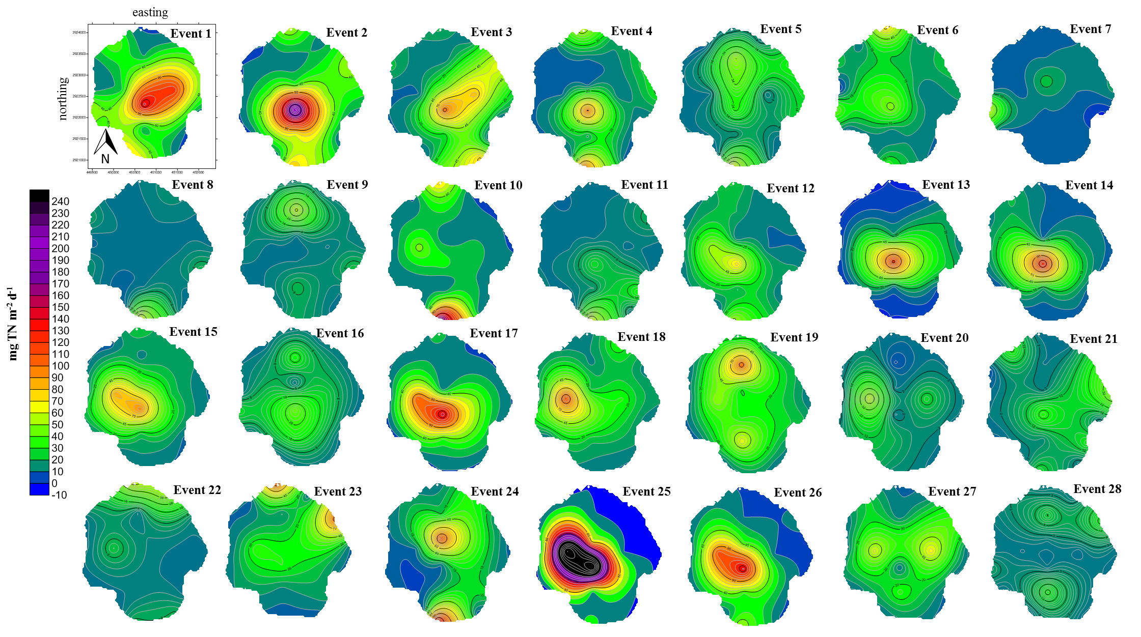
Appendix E
Surfer 12 maps of nutrient loading for TN and TP for each sampling event
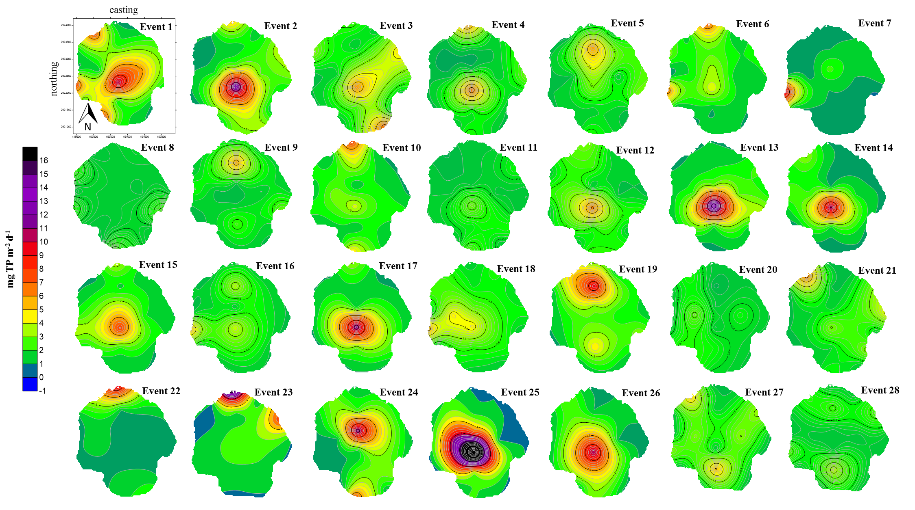

Appendix F
Time series graphs for stage and flow velocity for each of the five canals surveyed

