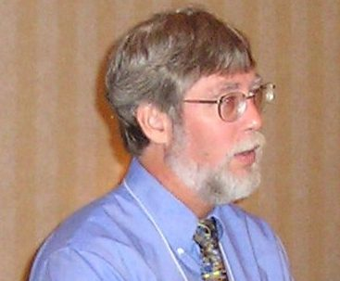
FDEP Bios for EPA Webinar

ERIC H. LIVINGSTON

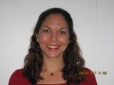
Eric H. Livingston is a public servant who has dedicated his life to the protection, management, and enhancement of our planet’s water resources. He began his career at the Florida Department of Environmental Protection in Tallahassee in 1977 as a scientist in the stormwater/nonpoint source management program which he later administered from 1984 through 1999. From 1999 through 2009, he served as chief of the Bureau of Watershed Restoration and Management which is responsible for the implementation of the state’s watershed management and restoration program. In 2009, he stepped down to become Program Administrator of the NPDES Stormwater Section so he could focus on once again making Florida’s stormwater program the nation’s best. Eric received his B.S. degree in biology from Florida State University in 1973 and his M.S. degree in biology from University of Alabama in 1980.
AMY TRACY
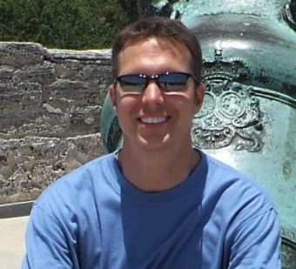
Amy Tracy graduated from Florida Atlantic University with her Master’s and Bachelor’s degrees in Geography with an emphasis in Geographic Information Systems. She came to work for the Department in 2005 to work in the Source Water Assessment and Protection Program then moved into the Watershed Planning and Coordination Section in 2007. Amy was a part of the Lower St. Johns Tributary team that received the National Coastal America Spirit Award for their work in Walking the Waterbody in 2009.
EDWARD SMITH
Edward Smith is the former MS4 coordinator for the Florida Department of Environmental Protection, having spent three years in that post. He has a B.S. degree in Biology and his M.S. degree in Science Education from the University of South Alabama. He joined DEP in 2006 and recently accepted a position as the Environmental Manager of the Wastewater Compliance Evaluation Section.

