2015 Draft Progress Report

for the
Lower St. Johns River Main Stem
Basin Management Action Plan

prepared by the

Division of Environmental Assessment and Restoration
Water Quality Restoration Program
Florida Department of Environmental Protection
Tallahassee, FL 32399

with participation from the
Lower St. Johns River TMDL
Executive Committee

February 2016
Acknowledgments
This 2015 Lower St. Johns River Main Stem BMAP Progress Report was prepared as part of a statewide watershed management approach to restore and protect Florida’s water quality. It was prepared by the Florida Department of Environmental Protection with participation from the following Lower St. Johns River Main Stem stakeholders:
- Agriculture.
- Anheuser Busch.
- Camp Blanding.
- City of Atlantic Beach.
- City of Green Cove Springs.
- City of Jacksonville.
- City of Jacksonville Beach.
- City of Neptune Beach.
- City of Palatka.
- Clay County.
- Clay County Utility Authority.
- Florida Department of Agriculture and Consumer Services.
- Florida Department of Transportation.
- Georgia-Pacific.
- JEA.
- Naval Air Station Jacksonville.
- Naval Station Mayport.
- Putnam County.
- Seminole Electric.
- Smurfit-Stone Container.
- St. Johns County.
- St. Johns River Water Management District.
- Town of Hastings.
- Town of Orange Park.
- Town of Welaka.

For additional information on the watershed management approach in the Lower St. Johns River Main Stem Basin, contact:
Kevin Coyne, Environmental Administrator
Florida Department of Environmental Protection
Water Quality Restoration Program
2600 Blair Stone Road, Mail Station 3565
Tallahassee, FL 32399-2400
Email: kevin.coyne@dep.state.fl.us
Phone: (850) 245–8555
TABLE OF CONTENTS
List of Acronyms and Abbreviations vii
Summary ix
1.1 Purpose of the Report 1
1.2 Total Maximum Daily Loads for the LSJR Basin 1
1.3 LSJR Basin 1
2.1 Precipitation and Hydrologic Conditions for 2015 4
2.1.1 River Patterns in Nutrient Concentrations and Algal Productivity 5
2.1.2 Long-Term and Annual Patterns in Nutrients and Algal Growth within the Worst-Case WBIDs. 7
2.2 Evaluation of the Dames Point Sonde Data for 2015 11
2.2.1 Introduction 11
2.3 Evaluation of the Buckman Bridge DO Sonde Data 2015 15
2.3.1 Introduction 15
2.4 Analysis of Clapboard Creek (CBC) and Channel Marker (CM) 36 Sonde Data for 2015 20
2.4.1 Location of CBC and CM 36 Data Sondes 20
2.4.2 Summary of Data Sonde Deployments at Clapboard Creek and CM 36 over the 2010 Through 2015 Period 27
3.1 Accomplishments by Source Type 29
3.1.1 WWTFs 29
3.1.2 Municipal Separate Storm Sewer Systems (MS4s) 31
3.1.3 Urban Stormwater 35
3.1.4 Agriculture 38
3.2 Improving Scientific Understanding 48
3.2.1 Water Quality Monitoring 48
3.2.2 Algal Initiative and Upstream Projects 49
3.2.3 SJRWMD Funding for Additional Nutrient Reductions 50
3.3 Funding 50
3.4 Summary of Accomplishments 50
3.5 Water Quality Monitoring 54
4.1 Upcoming Efforts by Source Type 55
4.1.1 MS4s 55
4.1.2 Urban Stormwater 55
4.1.3 Agriculture 55
Appendix A: BMAP Projects 57

LIST OF FIGURES
Figure ES- 1: Progress Towards the TP TMDL in the Freshwater Reach xi
Figure ES- 2: Progress Towards the TN TMDL in the Freshwater Reach xii
Figure ES- 3: Progress Towards the TN TMDL in the Marine Reach xiii
Figure 1: Location of the LSJR Basin 2
Figure 2: Marine and Freshwater Reaches in the LSJR Basin 3
Figure 3. Precipitation and Discharge Conditions in the LSJR Basin for 2015 5
Figure 4. Longitudinal Patterns in Total Nitrogen, Total Phosphorus, and Chlorophyll-a Concentrations for the St. Johns River Estuary 6
Figure 5: Temporal Trend in TN and TP Concentrations for the Long-Term Monitoring Station in WBID K Near Racy Point 8
Figure 6: Chlorophyll-a and Dissolved Oxygen in 2015 at Monitoring Sites in the LSJR Freshwater Reach WBIDs K and L 9
Figure 7: Long-Term Trend in Chlorophyll-a Maximum (Green Bars) and Total Bloom Duration (Tan Bars) for the Benchmark LSJR Freshwater Reach Monitoring Site at Racy Point, 1995 – 2015 10
Figure 8: Temporal Trends in Surface TN and TP at the Long-Term Monitoring Site Near Talleyrand in Jacksonville, 1995 – 2015 10
Figure 9: Daily Average DO Concentrations at Dames Point in 2015 11
Figure 10: Daily Average DOSAT at Dames Point in 2015 12
Figure 11: Daily Average Salinity at Dames Point in 2015 13
Figure 12: Daily Average Specific Conductance at Dames Point in 2015 14
Figure 13: Daily Average Water Temperature at Dames Point in 2015 14
Figure 14: Daily Average DO Concentrations at Buckman in 2015 16
Figure 15: Daily Average DOSAT at Buckman in 2015 16
Figure 16: Daily Average Salinity at Buckman in 2015 18
Figure 17: Daily Average Specific Conductance at Buckman in 2015 19
Figure 18: Daily Average Water Temperature at Buckman in 2015 19
Figure 19: Location of Clapboard Creek and CM 50 Data Sondes 21
Figure 20: Daily Average Dissolved Oxygen Concentration at the CM Top Sonde Site 22
Figure 21: Daily Average Dissolved Oxygen Saturation at the CM Top Sonde Site 22
Figure 22: Daily Average Water Temperature at the CM Top Sonde Site 23
Figure 23: Daily Average Salinity at the CM Top Sonde Site 23
Figure 24: Daily Average Dissolved Oxygen Concentration at the CM Bottom Sonde Site 24
Figure 25: Daily Average Dissolved Oxygen Saturation at the CM Bottom Sonde Site 25
Figure 26: Daily Average Water Temperature at the CM Bottom Sonde Site 25
Figure 27: Daily Average Salinity at the CM Bottom Sonde Site 26
Figure 28: WWTF Progress Towards the TP Freshwater TMDL 29
Figure 29: WWTF Progress Towards the TN Freshwater TMDL 29
Figure 30: MS4 Progress Towards the TP Freshwater TMDL 31
Figure 31: MS4 Progress Towards the TN Freshwater TMDL 32
Figure 32: MS4 Progress Towards the TN Marine TMDL 34
Figure 33: Non-MS4 Progress Towards the TP Freshwater TMDL 35
Figure 34: Non-MS4 Progress Towards the TN Freshwater TMDL 36
Figure 35: Non-MS4 Progress Towards the TN Marine TMDL 37
Figure 36: Map of Agricultural BMP Enrollment in the LSJR Basin 39
Figure 37: Progress Towards the TP TMDL in the Freshwater Reach 49
Figure 38: Progress Towards the TN TMDL in the Freshwater Reach 50
Figure 39: Progress Towards the TN TMDL in the Marine Reach 51

LIST OF TABLES
Table ES- 1: Progress Towards the TP TMDL in the Freshwater Reach ix
Table ES- 2: Progress Towards the TN TMDL in the Freshwater Reach x
Table ES- 3: Progress Towards the TN TMDL in the Marine Reach xi
Table 1: Summary of Daily Average DO and DOSAT for 2015 12
Table 2: Total Fractional Exposure Calculation for 2014 13
Table 3: Total Fractional Exposure Calculation at Dames Point Over the 2008 – 2015 Period 15
Table 4: Summary Statistics of Daily Average DO and DOSAT for 2015 17
Table 5: Summary Statistics of Daily Average Specific Conductance at Buckman in 2015 18
Table 6: Clapboard Creek Data Sonde Records for the 2010 – 2015 Period 27
Table 7: CM 36 Top Data Sonde Records for the 2010 – 2015 Period 28
Table 8: CM 36 Bottom Data Sonde Records for the 2010 – 2015 Period 28
Table 9: WWTF Projects Completed in the Marine Reach for TN in 2015 31
Table 10: MS4 Projects Completed in the Marine Reach in 2015 35
Table 11: Non-MS4 Projects Completed in the Freshwater Reach in 2015 37
Table 12: Agricultural Acres Enrolled in BMPs as of September 30, 2015 39
Table 13: Agricultural TN and TP Load Reduction Allocation and Estimated Reductions in Loads from BMPs and RSTs 39
Table 14: Progress Towards the TP TMDL in the Freshwater Reach 51
Table 15: Progress Towards the TN TMDL in the Freshwater Reach 52
Table 16: Progress Towards the TN TMDL in the Marine Reach 53

List of Acronyms and Abbreviations

µg/L Micrograms Per Liter
µmhos/cm Micromhos Per Centimeter
APRICOT A Prototype Realistic Innovative Community of Today
BMAP Basin Management Action Plan
BMP Best Management Practice
BNR Bionutrient Removal
CBC Clapboard Creek
CCUA Clay County Utility Authority
cfs Cubic Feet Per Second
CM Channel Marker
COJ City of Jacksonville
DO Dissolved Oxygen
DOSAT Dissolved Oxygen Saturation
FDACS Florida Department of Agriculture and Consumer Services
FDOT Florida Department of Transportation
HWTT Hybrid Wetlands Treatment Technology
kg Kilograms
kg/yr Kilograms Per Year
lbs/yr Pounds per Year
LSJR Lower St. Johns River
mg/L Milligrams Per Liter
MS4 Municipal Separate Storm Sewer System
N Nitrogen
NAS Naval Air Station
NOI Notice of Intent
NRCS Natural Resources Conservation Service
O&M Operation and Maintenance
OAWP Office of Agricultural Water Policy
ppt Parts Per Thousand
RST Regional Stormwater Treatment
RWLARS Reclaimed Water Land Application and Recovery System
SCR Selective Catalytic Reduction
SJRWMD St. Johns River Water Management District
SSAC Site-Specific Alternative Criteria
STORET Storage and Retrieval (Database)
TCAA Tri-County Agricultural Area
TMDL Total Maximum Daily Load
TN Total Nitrogen
TP Total Phosphorus
UF–IFAS University of Florida–Institute of Food and Agricultural Sciences
USGS United States Geological Survey
WBID Waterbody Identification
WWTP Wastewater Treatment Plant
WWTF Wastewater Treatment Facility

Summary
Progress Towards Total Maximum Daily Loads
During 2015, the city of Jacksonville continued work on septic tank phase-outs by connecting some properties where sewer lines were available. Jacksonville also completed two water quality credit trades with both JEA and the Florida Department of Transportation (FDOT) for a total of 40,910 kilograms per year of nitrogen reductions. Camp Blanding regraded over 38 miles of roads to achieve water quality improvements. The United States (U.S.) Naval Air Station Jacksonville completed the second phase of their reuse project that redirects wastewater discharges away from the river. St. Johns County completed Phase I of the Masters Tract Regional Stormwater Treatment (RST) system and substantially completed improvements to the Deep Creek West RST. Putnam County completed the Hiawatha Wastewater Treatment Facility (WWTF) phase-out and brought the new East Palatka WWTF on-line. JEA completed new reclaimed water transmission lines to Nocatee Oaks Phase 4 and increased the reclaimed water service capacity at their Arlington East facility by two million gallons per day. In addition, the Florida Department of Agriculture and Consumer Services (FDACS) continued to enroll producers in best management practices (BMPs) in the freshwater reach, increasing BMP enrollment by 16,790 acres in 2015.
U.S. Naval Station Mayport started the design of their new wastewater facility in 2015. The reductions associated with these efforts will be reported when the facility upgrade is completed.
The tables and figures below (Table ES- 1 and Figure ES- 1, Table ES- 2 and Figure ES- 2, and Table 15Table ES- 3 and Figure ES- 3) illustrate the overall load reductions made by the stakeholders in the Lower St. Johns River (LSJR) Basin and the remaining reductions in nutrient loading needed to achieve the TMDLs in each segment of the river. Although some source categories have exceeded their reductions, there are individual stakeholders that still need to make reductions to meet their Basin Management Action Plan allocations.

Table ES- 1: Progress Towards the Total Phosphorus (TP) TMDL in the Freshwater Reach
*Exceeded the total required reductions for the source category.
Source | % of Controllable Load | Starting Load in Kilograms per Year  (kg/yr) | 2015 Load (kg/yr) | Allocation (kg/yr) | Remaining Reductions (kg/yr) | % Complete
WWTF* | 45% | 81,015 | 37,881 | 44,386 | 0 | 100%
MS4* | 1% | 1,500 | 1,256 | 1,256 | 0 | 100%
Non-MS4 | 7% | 12,358 | 10,157 | 9,408 | 749 | 75%
Agriculture | 47% | 83,455 | 75,626 | 70,974 | 4,652 | 63%
Total | 100% | 178,329 | 124,920 | 126,025 | 5,401 | 90%

As indicated in Table ES-1, the reductions achieved by the wastewater facilities and the Municipal Separate Storm Sewer Systems (MS4) have met and exceeded the allocations to these sources. There are still reductions remaining that have been assigned to non-MS4 areas and to agricultural land uses, for an overall percent complete of 90 percent.
In Figure ES-1, the charts show the progress made since the TMDL data period in reducing loads. As the wastewater facilities and MS4s have exceeded their requirements, the estimated 2015 TP load is less than the TP allocation for the river. Additional TP reductions are still expected from those entities that have not met their individual TP reduction requirements.

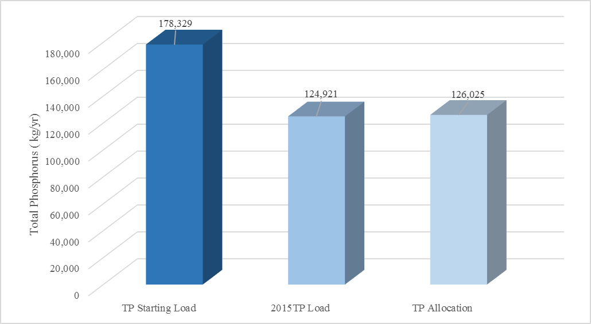
Figure ES- 1: Progress Towards the TP TMDL in the Freshwater Reach

Table ES- 2: Progress Towards the Total Nitrogen (TN) TMDL in the Freshwater Reach
*Exceeded the total required reductions for the source category.
Source | % of Controllable Load | Starting Load  (kg/yr) | 2015 Load (kg/yr) | Allocation (kg/yr) | Remaining Reductions (kg/yr) | % Complete
WWTF* | 47% | 364,650 | 195,560 | 237,200 | 0 | 100%
MS4* | 1% | 9,731 | 8,685 | 8,685 | 0 | 100%
Non-MS4 | 11% | 88,705 | 75,828 | 74,119 | 1,709 | 88%
Agriculture | 40% | 310,700 | 232,709 | 194,336 | 38,373 | 67%
Total | 100% | 773,786 | 512,782 | 514,340 | 40,232 | 84%

As indicated in Table ES-2, the freshwater TN reductions achieved by the wastewater facilities and the MS4s have met and exceeded the allocations to these sources, similarly to the TP reductions. There are still reductions remaining that have been assigned to non-MS4 areas and to agricultural land uses, for an overall percent complete of 84 percent.
In Figure ES-2, the charts show the progress made since the TMDL data period in reducing TN loads in the freshwater section. As the wastewater facilities and MS4s have exceeded their requirements, the estimated 2015 TN load is less than the TN allocation for the river. Additional TN reductions are still expected from those entities that have not met their individual TN reduction requirements.

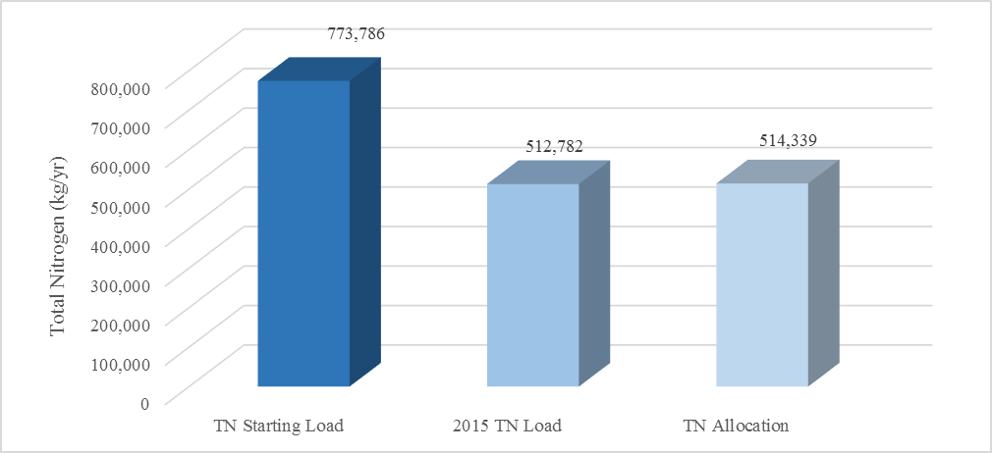
Figure ES- 2: Progress Towards the TN TMDL in the Freshwater Reach

Table ES- 3: Progress Towards the TN TMDL in the Marine Reach
* Exceeded the total required reductions for the source category.
** Reductions have not occurred for the agricultural sources; however, based on an evaluation of recent land uses, there does not appear to be agriculture remaining in the marine reach.
Source | % of Control-lable Load | Starting Load  (kg/yr) | 2015 Load (kg/yr) | Allocation (kg/yr) | Remaining Reductions (kg/yr) | % Complete
WWTF* | 84% | 1,786,542 | 838,561 | 878,326 | 0 | 100%
MS4 | 14% | 291,657 | 222,526 | 136,422 | 86,104 | 45%
Non-MS4 | 1% | 24,767 | 21,785 | 17,192 | 4,593 | 39%
Agriculture** | 1% | 12,800 | 12,800 | 4,170 | 8,630 | 0%
Total | 100% | 2,115,766 | 1,095,672 | 1,036,110 | 99,327 | 94%

As described in Table ES-3, the TN reductions achieved by the marine section wastewater facilities have met and exceeded the allocations to these sources. There are still reductions remaining that have been assigned to MS4 areas, non-MS4 areas, and to agricultural land uses, for an overall percent complete of 94 percent.
In Figure ES-3, the charts show the progress made in the marine section since the TMDL data period in reducing TN loads. As the wastewater facilities have exceeded their requirements, the estimated 2015 TN load is more than the TN allocation for the marine section, but has less difference because of the reductions beyond their requirements. Additional TN reductions are still expected from those entities that have not met their individual TN reduction requirements.

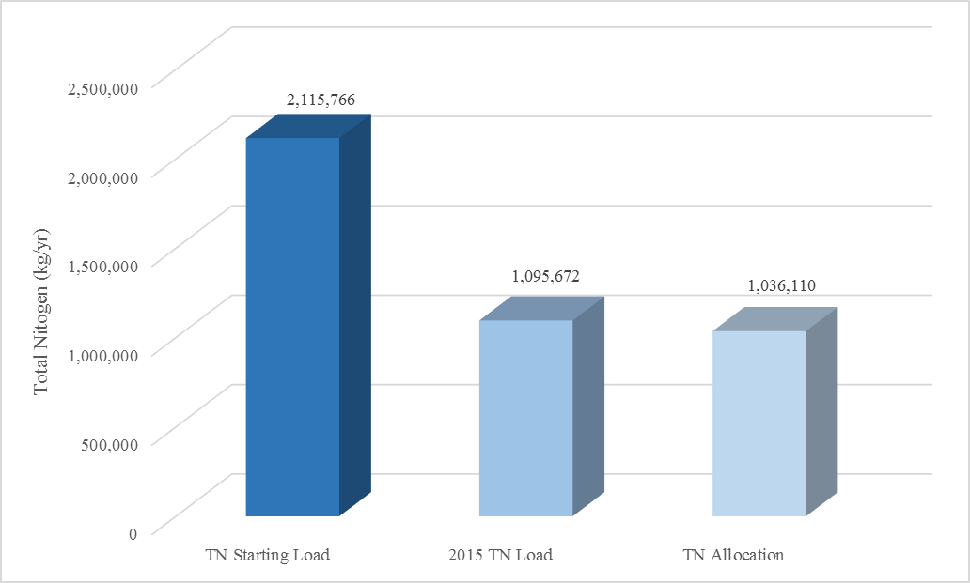
Figure ES- 3: Progress Towards the TN TMDL in the Marine Reach

Water Quality Evaluation
The annual report examined trends in both river and tributary nutrient concentrations, as well as the achievement of river water quality targets established during TMDL development. For 2015, the annual rainfall pattern in the Lower St. Johns Basin was similar to the long-term average both in terms of total accumulation and timing. For most river monitoring locations, TN and TP concentrations exhibit significant downward trends. TN concentrations are declining for all sites within the LSJR, while TP concentrations are declining significantly from Green Cove Springs northward. The trends in mean annual chlorophyll-a concentration appear to contradict the nutrient trends, with increasing trends in river segments from Green Cove Springs through Orange Park to south Jacksonville.
For the long-term monitoring station near Racy Point within waterbody identification (WBID) K, TN concentrations have declined consistently and significantly since 1999. Similar declines have not occurred in TP concentrations. Elevated TP concentrations at Racy Point appear to be the result of loads entering within the LSJR at the long-term river monitoring station located near Racy Point. At RM 64, chlorophyll-a peaked at 60.3 µg/L on June 8th. Phytoplankton samples indicated a freshwater blue-green algal bloom occurring the second week in June. This bloom was the largest occurring in the freshwater LSJR since the extreme Aphanizomenon flos-aquae bloom in 2010.
In the marine reach, the DO monitoring station at the Dames Point Bridge continued to meet the DO site-specific alternative criteria (SSAC) in 2015. During 2015, data were not available for the Clapboard Creek site due to equipment failure and minimal data were available for the Channel Marker 36 site.

: Introduction

Purpose of the Report
This is the seventh annual report for the Lower St. Johns River (LSJR) Main Stem Basin Management Action Plan. Section 2 provides an overview of water quality trends during the first seven years of BMAP implementation. Section 3 describes the major accomplishments during the period from January 1, 2015, through December 31, 2015. Section 4 includes a summary of efforts for the upcoming year (January 1, 2016, through December 31, 2016).

Total Maximum Daily Loads for the LSJR Basin
The department adopted the TMDLs for the main stem of the LSJR Basin in June 2008. The TMDLs include total phosphorus (TP) and total nitrogen (TN) in the freshwater reach to achieve reductions in chlorophyll-a levels in this portion of the river. A TN TMDL was also established in the marine reach to meet dissolved oxygen (DO) levels that would be protective of aquatic life uses. TMDLs and pollutant load allocations adopted by rule for the watershed can be found here, at the department final TMDL page.

LSJR Basin
The area addressed by the LSJR BMAP is that portion of the St. Johns River which flows between the mouth of the Ocklawaha River, its largest tributary, and the Atlantic Ocean, encompassing a 2,750-square-mile drainage area (see Figure 1). Within this reach, the St. Johns River is 101 miles long and has a water surface area of approximately 115 square miles. Major centers of population in the LSJR Basin include Palatka, a city of 10,700 at the southern entrance to the basin; Green Cove Springs, a city of 4,700 at the midpoint; and the Orange Park, Middleburg, and Jacksonville metropolitan area, with a population of over 1 million, in the northern portion of the basin. For assessment purposes, the Florida Department of Environmental Protection has divided the LSJR Basin into water assessment polygons with a unique waterbody identification (WBID) number for each watershed or stream reach. The main stem of the LSJR is divided into 15 WBID segments (see Figure 1). The LSJR is also divided into two reaches based on salinity: marine and fresh water (Figure 2).

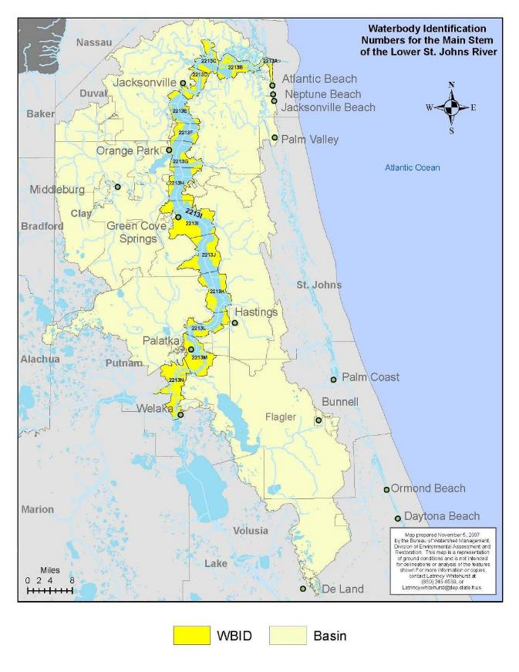
Figure 1: Location of the LSJR Basin
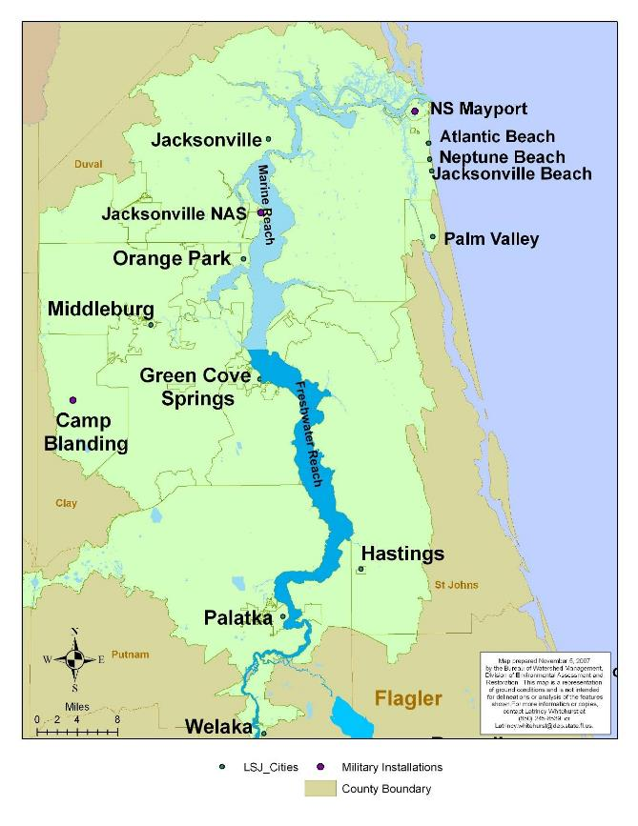
Figure 2: Marine and Freshwater Reaches in the LSJR Basin

: Water Quality Evaluation

Precipitation and Hydrologic Conditions for 2015
Because the nonpoint source nutrient load to the lower St. Johns, as well as the location and severity of algal blooms, is dependent upon runoff and river flow, it is worthwhile to review the annual precipitation pattern. For 2015, the annual rainfall pattern in the Lower St. Johns Basin was similar to the long-term average both in terms of total accumulation and timing as shown in Figure 3.
In the figures, blue lines and symbols identify the 1995-2014 mean, while red lines represent 2015. Figure 3a compares the 2015 rainfall accumulation to the 20-year mean for stations at Elkton, Penny Farms, and the Jacksonville Airport. The cumulative rainfall plot shows both the total accumulation, with instantaneous slope for any specific duration indicating the rate of accumulation. The typical pattern exhibits moderate rate of accumulation from January through May, and from October through December, with a higher rate of accumulation from June through September. Deviations from the long-term pattern are apparent in May and June, when the precipitation rate lagged the long-term average, and in August and September, when the long-term rate is exceeded.
Upstream St. Johns River discharge entering the LSJR matched the long-term pattern, with the exception of lower than average inflow in July (Figure 3b). Discharge at Palatka was calculated as the sum of measured discharge at the St. Johns at Buffalo Bluff and Dunns Creek stations. Tributary flows within the basin for Black Creek (Figure 3c) and Deep Creek (Figure 3d) appeared to respond to the rainfall pattern, with lower than average flow (for Black Creek) in June, but higher than average flow in September. For 2015, the maximum upstream encroachment of the statutory marine salinity condition of 1,500 milligrams per liter (mg/L) chloride reached river mile 43, very close to the long-term average location and the line of demarcation used to separate fresh and marine reaches for the TMDL.
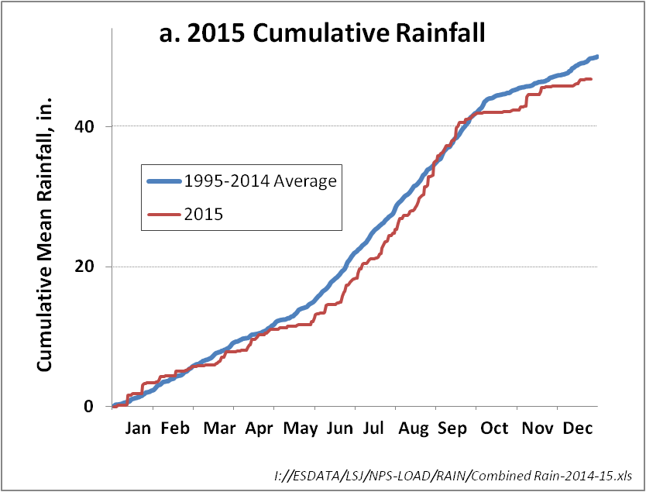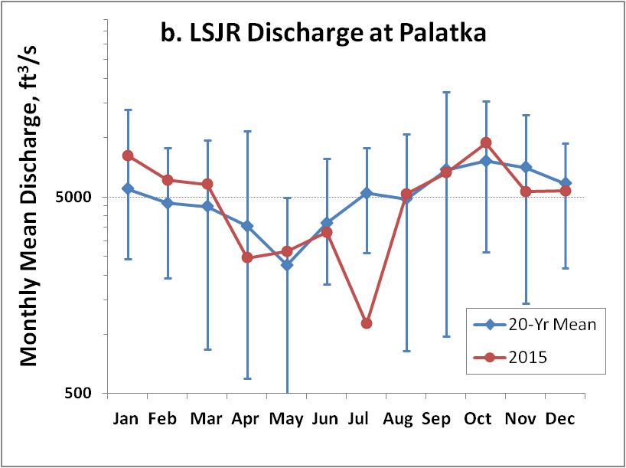
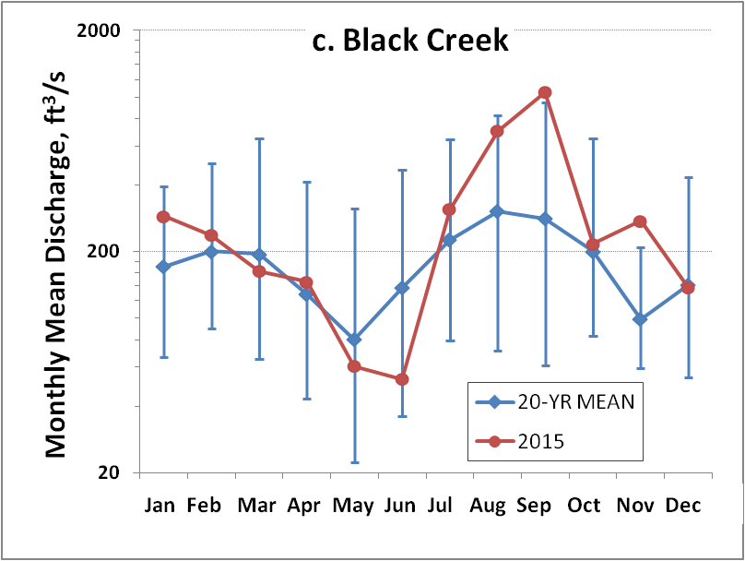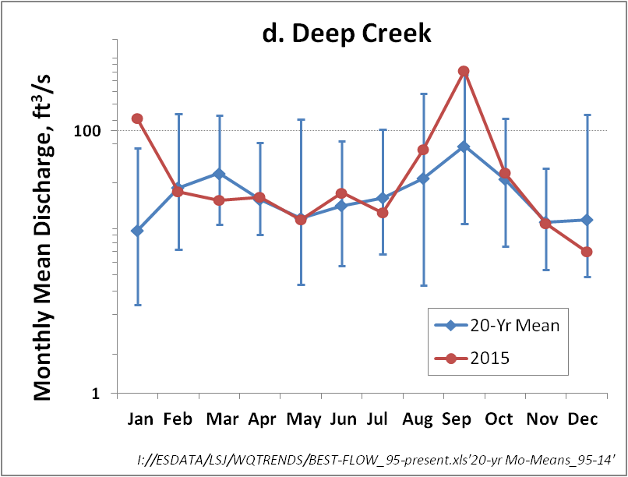
Figure 3. Precipitation and Discharge Conditions in the LSJR Basin for 2015

River Patterns in Nutrient Concentrations and Algal Productivity
The Lower St. Johns River exhibits distinct longitudinal trends in TN, TP and chlorophyll-a, from Lake George to the mouth (Figure 4). Horizontal bars represent the 15-year annual geometric mean concentrations, with blue error bars bracketing the 95 percent confidence intervals for the mean. Red circles represent the 2015 mean concentrations for the corresponding locations. Green bars indicate that the location exhibits a significant decreasing trend in concentration for the 15-year record; yellow indicates no significant trend; and red indicates a significant increasing trend. Trends are taken from the St. Johns River Water Management District (SJRWMD) annual Status and Trends Assessment.
The outlet of Lake George exhibits the highest average TN concentrations in the estuary, originating in part from the incorporation of atmospheric nitrogen from the productivity of Nitrogen (N)-fixing blue-green algae (Figure 4, Panel a). A second longitudinal peak is discernible from river mile (RM) 64 through 50, again in part due to external inputs and to the fixation of atmospheric N by blue-green algae that thrive in the lacustrine freshwater reach of the estuary. In the last 20 miles of river, TN concentrations decline sharply in response to the dilution with lower concentration Atlantic shelf water through tidal mixing. The longitudinal pattern is reversed for TP (Figure 4, Panel b), with the lowest concentrations just downstream of the inflow of the Ocklawaha River and at Palatka, and from there increasing to a peak near downtown Jacksonville, before declining due to tidal mixing. Chlorophyll-a, the standard measure of algal biomass, follows a pattern similar to TN, with the highest levels at Lake George, and within the LSJR freshwater reach (Figure 4, Panel c). This pattern exists because the shallower upstream freshwater portions of the estuary have a larger proportion of the water column illuminated and hence suitable for algal productivity. Though the chlorophyll-a pattern is correlated with the longitudinal TN pattern, TN is most likely not the cause of higher algal biomass, but more likely a result of it through algal N-fixation.

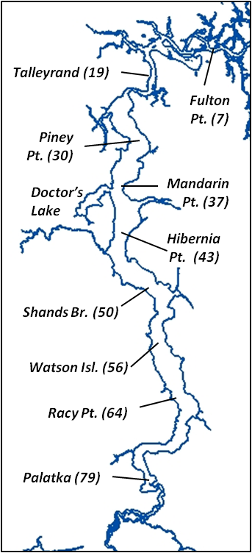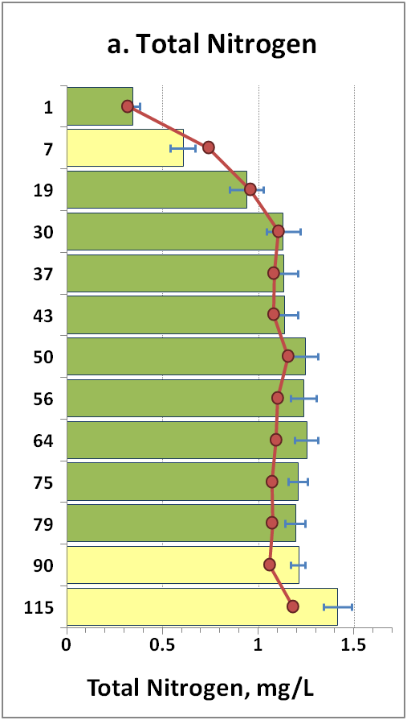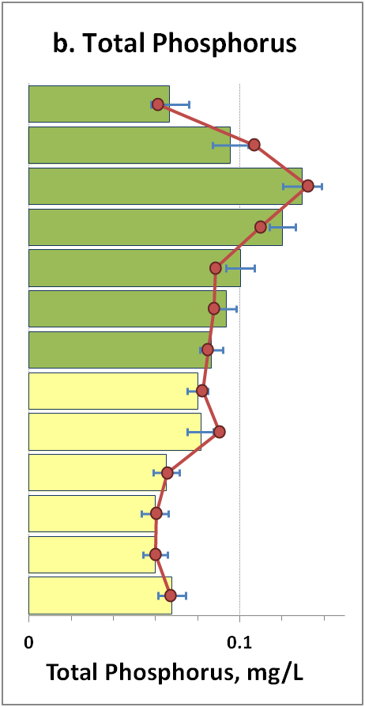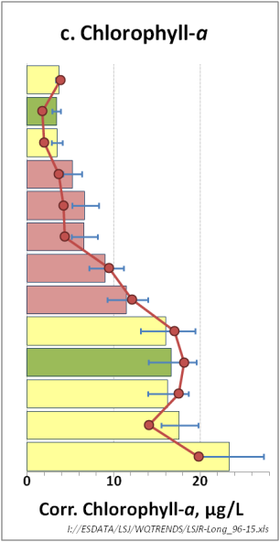
Figure 4. Longitudinal Patterns in Total Nitrogen, Total Phosphorus, and Chlorophyll-a Concentrations for the St. Johns River Estuary

The bars of Figure 4 are color-coded based on the 15-year trends in annual mean concentrations for river monitoring locations. Green bars identify significantly decreasing trends, yellow bars indicate no significant trend, while red bars indicate a significant upward trend. For most river monitoring locations, TN and TP concentrations exhibit significant downward trends. TN concentrations are declining for all sites within the LSJR, while TP concentrations are declining significantly from Green Cove Springs northward. The trends in mean annual chlorophyll-a concentration appear to contradict the nutrient trends, with increasing trends in river segments from Green Cove Springs through Orange Park to south Jacksonville. This anomaly is believed due to a recent increased occurrence of high discharge in the spring bloom season at the end of the trend assessment record. High river discharge in spring leads to freshwater conditions down-estuary, creating conditions that are conducive for the growth of blue-green algae. Though TN and TP concentrations have been declining in this reach, concentrations are still sufficiently high for algae to reach high biomass levels if the satisfactory hydrodynamic conditions occur.
The red circles of Figure 4 chart the 2015 annual mean concentrations. At most locations, TN concentrations fall below the long-term average, and should positively influence the prevailing downward TN trend. TP concentrations in 2015 also appear consistent with current trends, with freshwater reach mean concentrations matching the long-term means, perpetuating the stable trend for this reach, and oligohaline reach means below the long term means in the reach, which should favor their continued downward trend. Throughout the freshwater reach, 2015 chlorophyll-a concentrations were slightly above the log-term mean, but were below the long-term mean for stations within the oligohaline reach. These lower 2015 annual means may be sufficient to curtail the upward trends in chlorophyll-a within this reach.

Long-Term and Annual Patterns in Nutrients and Algal Growth within the Worst-Case WBIDs.
During the development of the LSJR TMDL, agency technical staff proposed the concept of the “worst-case WBID” to refer to the water-body identification system locations where the major symptoms of eutrophication in the LSJR, algal blooms and low dissolved oxygen, were manifested most severely. The basic tenet of the concept was that if nutrient reductions were proposed that led to the attainment of designated use in these segments, then the remainder of the river would also be protected. Within the freshwater reach, these worst-case WBIDs are situated between Rice Creek and Tocoi Creek (WBIDs K and L), while in the marine reach, where the river exhibited its lowest dissolved oxygen levels, the worst-case WBID is between Fulton Point and Dames Point (WBID B).
For the long-term monitoring station near Racy Point within WBID K, TN concentrations have declined consistently and significantly since 1999, and the 2015 annual mean TN concentration, at 1.1 mg/L, is 32 percent lower than the peak of 1.6 mg/L observed in 1999 (Figure 5). Similar declines have not occurred in TP concentrations, and the 2015 annual mean of 0.09 mg/L is equivalent to the 78th percentile for the normalized distribution of annual means from 1995 – 2015. Elevated TP concentrations at Racy Point appear to be the result of loads entering within the LSJR, as TP concentrations upstream at Palatka are trending downward, and the difference between Racy and Palatka paired annual means and individual sample date values have increased significantly over time.
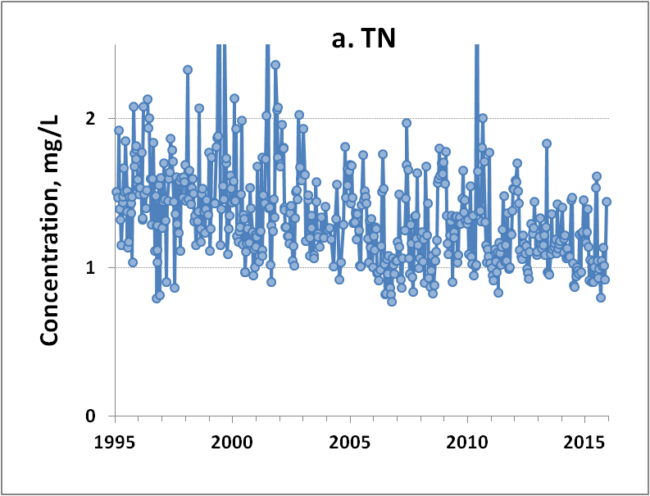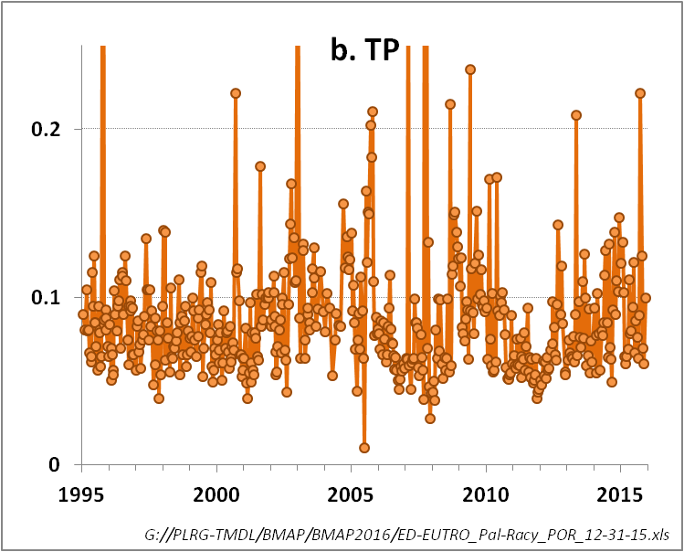
Figure 5: Temporal Trend in TN and TP Concentrations for the Long-Term Monitoring Station in WBID K Near Racy Point

Figure 6 charts the concentrations of chlorophyll-a and dissolved oxygen in the freshwater WBIDs K and L for 2015. Green and purple circles represent the concentrations measured for instantaneous grab samples collected at Racy Point in WBID K, while smooth lines are the data collected at the United States Geological Survey (USGS) continuous sensor site at Dancy Point in WBID L. Green lines are daily average chlorophyll-a converted from YSI phycocyanin sensor readings, while purple lines are the 15-minute DO measurements. At the long-term river monitoring station located near Racy Pt. at RM 64, chlorophyll-a peaked at 60.3 µg/L on June 8th. The highest concentrations in 2015 in the LSJR were observed just downstream of these “worst-case” WBIDs, between Tocoi Creek and the Shands Bridge, where chlorophyll-a peaked at 82 micrograms per liter (µg/L). Phytoplankton samples indicated that this freshwater reach bloom was dominated by the filamentous, non-nitrogen-fixing blue-green Limnothrix spp. During this bloom, several sites recorded slightly elevated levels of the algal toxins cylindrospermopsin and saxitoxin, though at levels well below proposed recreational guidelines (adopted standards do not presently exist for these toxins). As is typical of LSJR freshwater blue-green blooms, they disappear quickly in a rapid senescence with an associated low dissolved oxygen episode, which can be observed in Figure 6 occurring the second week in June. During this senescence, DO dropped briefly below the 38 percent saturation minimum, though with insufficient duration to constitute an exceedance of this standard. This bloom was the largest occurring in the freshwater LSJR since the extreme Aphanizomenon flos-aquae bloom in 2010, though still remained below the TMDL target, which seeks to limit the duration algal blooms (with a bloom defined as a concentration of chlorophyll-a greater than 40 µg/L) to a duration of less than 40 days. The total duration above the bloom level of 40 µg/L at Racy Point was 30 days (Figure 7). Downstream at the site of the chlorophyll-a maximum, the duration was 32 days.

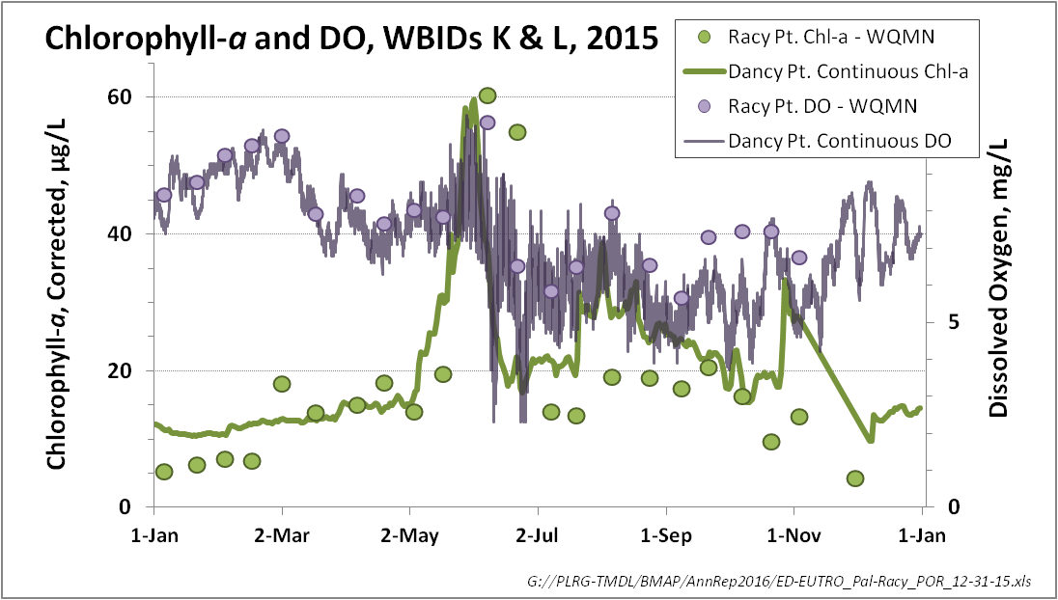
Figure 6: Chlorophyll-a and Dissolved Oxygen in 2015 at Monitoring Sites in the LSJR Freshwater Reach WBIDs K and L

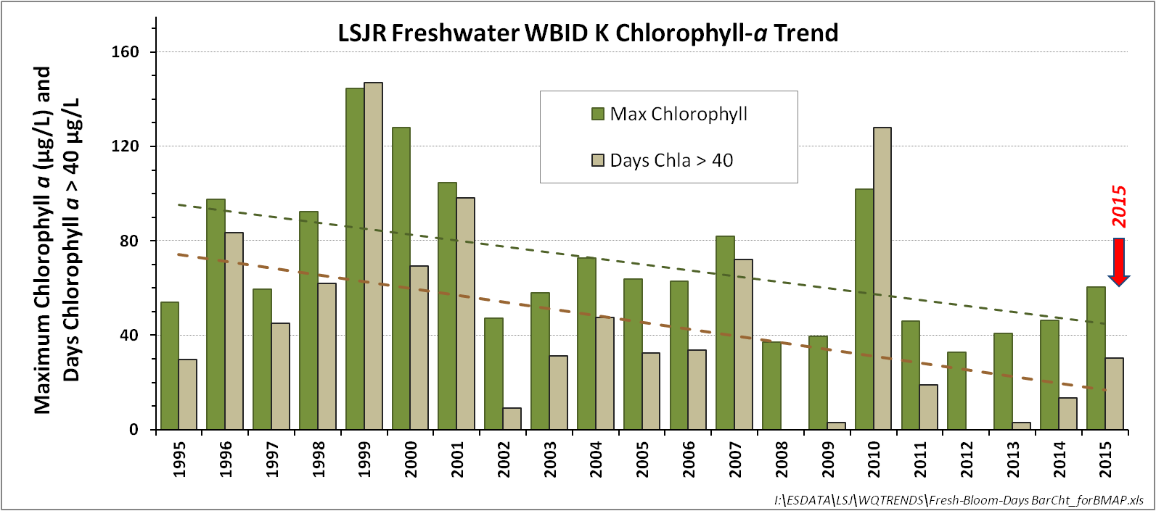
Figure 7: Long-Term Trend in Chlorophyll-a Maximum (Green Bars) and Total Bloom Duration (Tan Bars) for the Benchmark LSJR Freshwater Reach Monitoring Site at Racy Point, 1995 – 2015

Within the marine reach of the river, concentrations of TN and TP continue to trend downward. To assess marine reach trends for the BMAP annual report, we have examined nutrient concentrations at the long-term monitoring site near the Talleyrand section of Jacksonville. Though this station is located in WBID D, ten miles upstream of the worst-case WBID B, it possesses a longer-term data record, and is less influenced by tidal mixing, so provides a stronger signal of river water quality trends.
TN concentrations have significantly decreased at this location, with the mean concentration observed in 2015 (0.95 mg/L, SJRWMD data for surface, ebb tide) roughly 20 percent lower that then average annual mean that occurred from 1995 – 1999 (Figure 8a). Concentrations of TP at this location peaked around 2005 (Figure 8b), and since have declined significantly. Data collected by SJRWMD are shown in blue diamonds, while data collected by the city of Jacksonville (COJ) are shown in red circles. Daily data collected by SJRWMD are the mean of flood and ebb slack collections from 2003 – 2010, and from this time are just the ebb slack condition. COJ data are collected irrespective of tide.

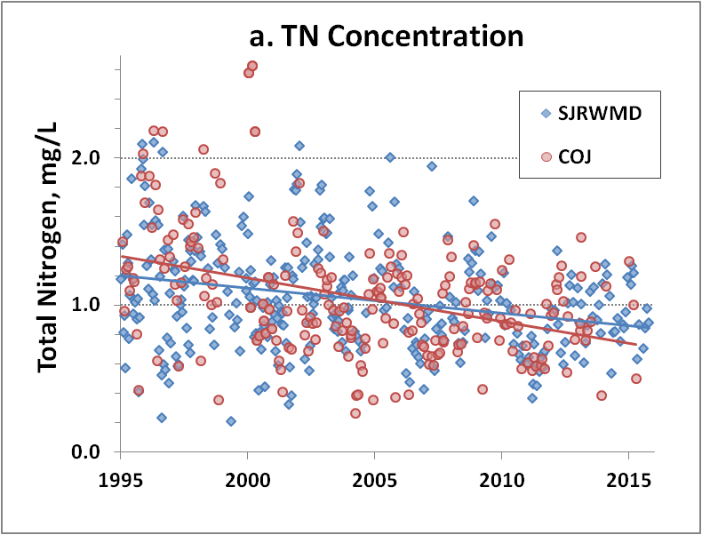
Figure 8: Temporal Trends in Surface TN and TP at the Long-Term Monitoring Site Near Talleyrand in Jacksonville, 1995 – 2015

Evaluation of the Dames Point Sonde Data for 2015

Introduction
Hourly DO, specific conductance, and water temperature measurements reported from two depths (approximately 8 feet and 15 feet below the average water surface level) by the USGS at the Dames Point Bridge (USGS 302309081333001) over the 2015 period were processed to obtain daily average DO concentrations and dissolved oxygen saturation (DOSAT). Note that the data set is marked as provisional at this time. Specific conductance measurements were converted to salinity for the calculation of DOSAT. Dates with less than 16 observations were excluded from further analysis. Daily average DO concentrations were then ranked from low to high to assign observations in the respective bins to determine whether the DO site-specific alternative criteria (SSAC) was attained. The DO SSAC was expressed as:
The total fractional exposure must be at or below 1.0 for the annual evaluation period for attainment. Annual graphs are presented of daily average DO (Figure 9) and DOSAT (Figure 10) at the two depths along with summary statistics (Table 1). The total fractional exposure for 2015 was calculated to be 0.53 and 0.61 for the Dames Point top and bottom measurements, respectively (Table 8Table 8).

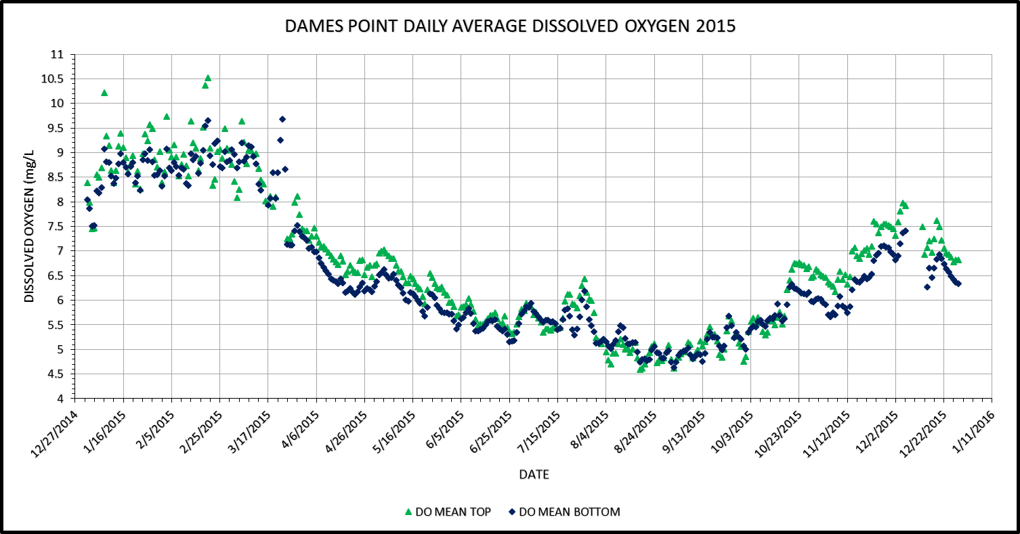
Figure 9: Daily Average DO Concentrations at Dames Point in 2015

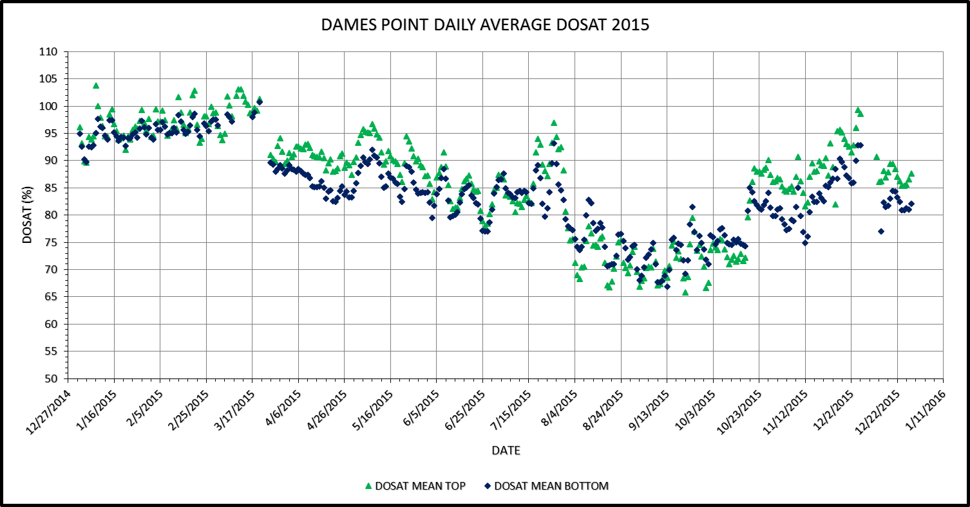
Figure 10: Daily Average DOSAT at Dames Point in 2015

Table 1: Summary of Daily Average DO and DOSAT for 2015
Statistic | Bottom DO (mg/L) | Bottom DOSAT (%) | Top DO (mg/L) | Top DOSAT (%)
N of Cases | 352 | 337 | 352 | 351
Minimum | 4.64 | 66.89 | 4.60 | 65.84
Maximum | 9.69 | 100.68 | 10.53 | 103.76
Mean | 6.51 | 84.25 | 6.72 | 86.70
Standard Deviation | 1.34 | 7.70 | 1.39 | 9.40
Pct1 | 4.75 | 67.94 | 4.70 | 66.82
Pct5 | 4.92 | 71.28 | 4.85 | 69.38
Pct10 | 5.08 | 74.25 | 5.04 | 71.45
Pct20 | 5.41 | 77.00 | 5.42 | 75.62
Pct25 | 5.50 | 78.66 | 5.56 | 81.38
Pct30 | 5.60 | 80.73 | 5.68 | 83.48
Pct40 | 5.81 | 82.48 | 6.16 | 86.59
Pct50 | 6.14 | 84.18 | 6.52 | 88.53
Pct60 | 6.40 | 85.33 | 6.85 | 90.38
Pct70 | 6.92 | 88.05 | 7.29 | 92.70
Pct75 | 7.24 | 89.23 | 7.55 | 94.03
Pct80 | 8.24 | 91.98 | 8.13 | 94.86
Pct90 | 8.80 | 95.56 | 8.92 | 97.49
Pct95 | 8.97 | 97.15 | 9.15 | 99.39
Pct99 | 9.25 | 98.46 | 9.74 | 102.84

Table 8: Total Fractional Exposure Calculation for 2014
Sonde | DO 4.0-<4.2 | DO 4.2-<4.4 | DO 4.4-<4.6 | DO 4.6-<4.8 | DO 4.8-<5.0 | Exposure
Top | 0 | 0 | 0 | 8 | 20 | 0.53
Bottom | 0 | 0 | 1 | 11 | 19 | 0.61

The corresponding daily average salinity and specific conductance at Dames Point during 2015 is illustrated in Figure 11 and Figure 12. Salinities at Dames Point ranged between 6.2 and 32.42 parts per thousand (ppt). Based on Rule 62-302.200 (30), Florida Administrative Code, predominantly marine waters means specific conductance ≥ 4,580 micromhos per centimeter (µmhos/cm) measured within the bottom half of the water column. The minimum daily average specific conductance during 2015 was 10,708 µmhos/cm.

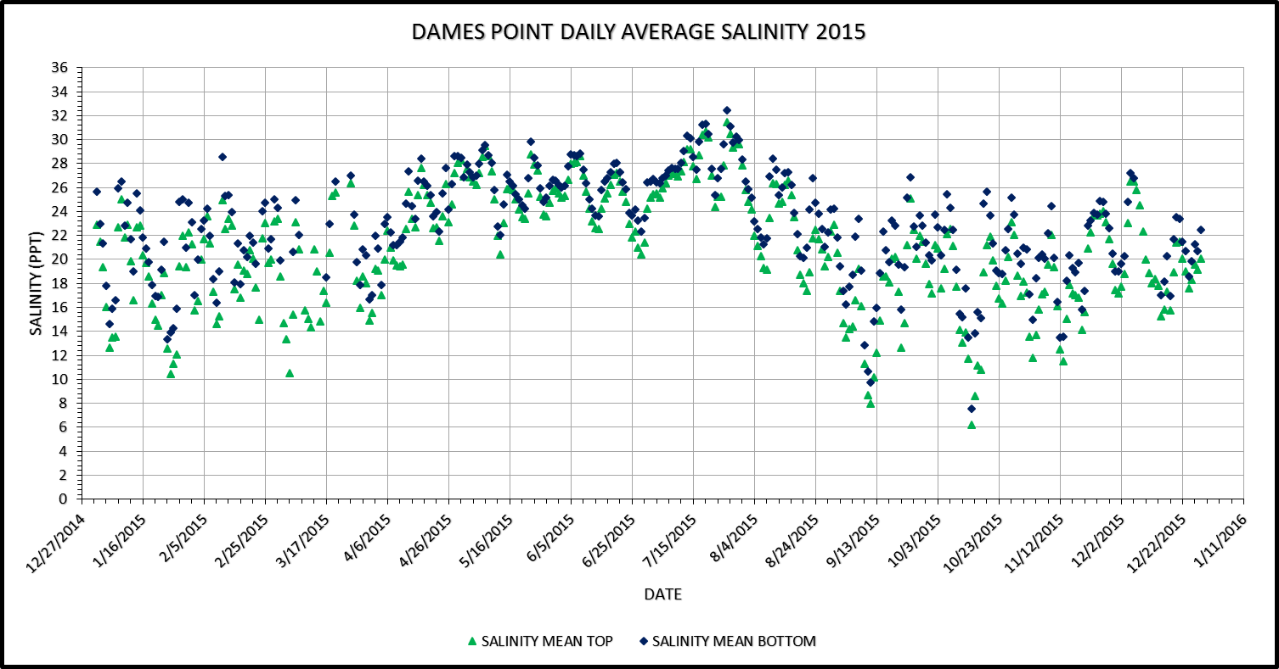
Figure 11: Daily Average Salinity at Dames Point in 2015

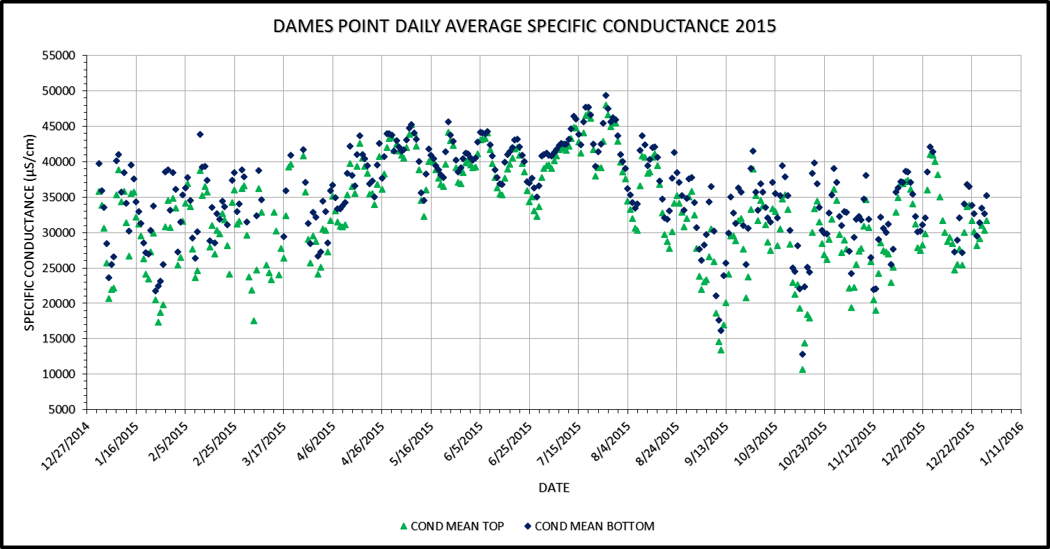
Figure 12: Daily Average Specific Conductance at Dames Point in 2015

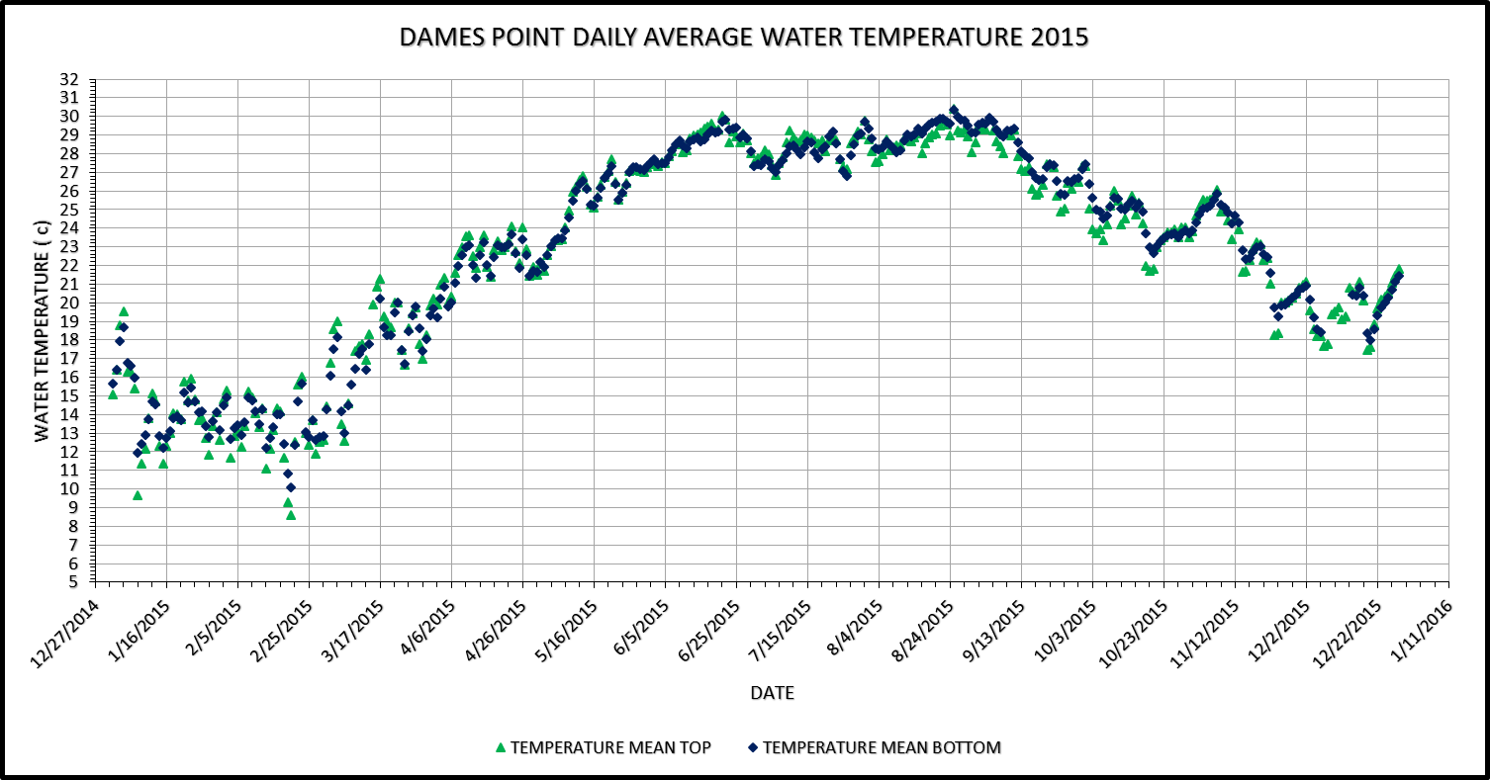
Figure 13: Daily Average Water Temperature at Dames Point in 2015

Table 3 summarizes the total fractional exposure calculated based on the USGS measurements at the Dames Point Bridge over the 2008 to 2015 period.

Table 2: Total Fractional Exposure Calculation at Dames Point Over the 2008 – 2015 Period

Year | Top | Bottom
2008 | 0.07 | 0.00
2009 | 0.24 | 0.56
2010 | 0.00 | 0.00
2011 | 0.04 | 0.25
2012 | 0.09 | 0.05
2013 | 0.05 | 0.13
2014 | 0.00 | 0.13
2015 | 0.53 | 0.61

Evaluation of the Buckman Bridge DO Sonde Data 2015

Introduction
Thirty minute dissolved oxygen, specific conductance, and water temperature measurements reported from two depths by the UGSS at the Buckman Bridge (USGS 301124081395901) over the 2015 period were processed to obtain daily average DO concentrations and DOSAT. Specific conductance measurements were converted to salinity for the calculation of DOSAT. Dates with less than 24 observations were excluded from further analysis.
Annual graphs are presented of daily average DO (Figure 14) and DOSAT (Figure 15) at the two depths along with summary statistics (Table 3). The minimum daily DO at both depths was greater than 6 mg/L. Note that this DO station was not operational for a period of time in May and June 2015 and, therefore, data from that time period are unavailable.
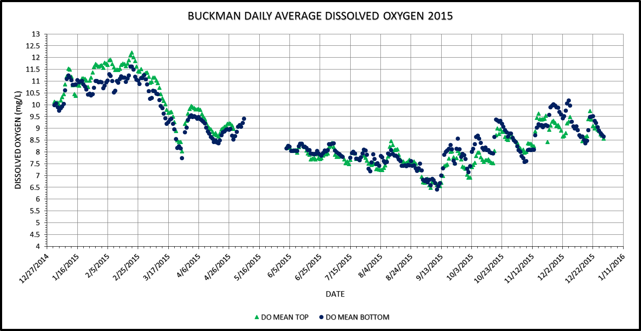
Figure 14: Daily Average DO Concentrations at Buckman in 2015

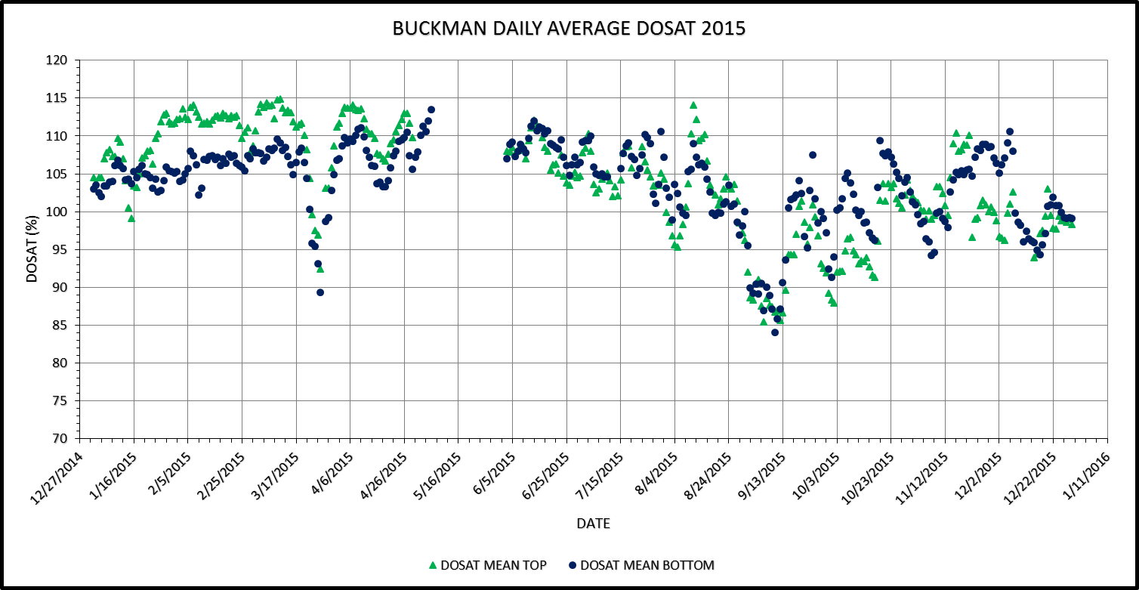
Figure 15: Daily Average DOSAT at Buckman in 2015

Table 3: Summary Statistics of Daily Average DO and DOSAT for 2015
Statistic | Bottom DO (mg/L) | Bottom DOSAT (%) | Top DOSAT (mg/L) | Top DOSAT (%)
N of Cases | 331 | 331 | 318 | 318
Minimum | 6.42 | 84.09 | 6.48 | 85.45
Maximum | 11.61 | 113.48 | 12.20 | 114.91
Mean | 8.88 | 103.74 | 8.93 | 104.12
Standard Deviation | 1.24 | 5.34 | 1.47 | 7.13
Pct1 | 6.66 | 87.07 | 6.61 | 86.73
Pct5 | 7.23 | 93.13 | 6.97 | 90.74
Pct10 | 7.50 | 96.34 | 7.41 | 93.91
Pct20 | 7.88 | 99.75 | 7.66 | 98.30
Pct25 | 7.94 | 100.67 | 7.75 | 99.44
Pct30 | 8.05 | 101.94 | 7.89 | 100.60
Pct40 | 8.24 | 103.86 | 8.18 | 103.07
Pct50 | 8.65 | 104.98 | 8.59 | 104.52
Pct60 | 9.05 | 106.12 | 9.00 | 107.52
Pct70 | 9.41 | 107.17 | 9.41 | 109.01
Pct75 | 9.68 | 107.43 | 9.81 | 110.25
Pct80 | 10.04 | 108.04 | 10.44 | 111.38
Pct90 | 10.96 | 109.30 | 11.45 | 112.68
Pct95 | 11.10 | 110.19 | 11.69 | 113.56
Pct99 | 11.33 | 111.41 | 11.95 | 114.22

As seen in Figure 16, daily average salinities at the Buckman Bridge in 2015 ranged between 0.26 and 11.79 ppt. Daily average specific conductance is graphed in Figure 17. Summary statistics of the daily average specific conductance at the two depths is presented in Table 4. Based on Rule 62-302.200 (30), Florida Administrative Code, predominantly marine waters means specific conductance greater than or equal to 4,580 µmhos/cm measured within the bottom half of the water column. Based on observations from the bottom sample depth, approximately 77 percent of the daily average specific conductance values were below the predominantly marine threshold. Daily average temperatures are graphed in Figure 18.

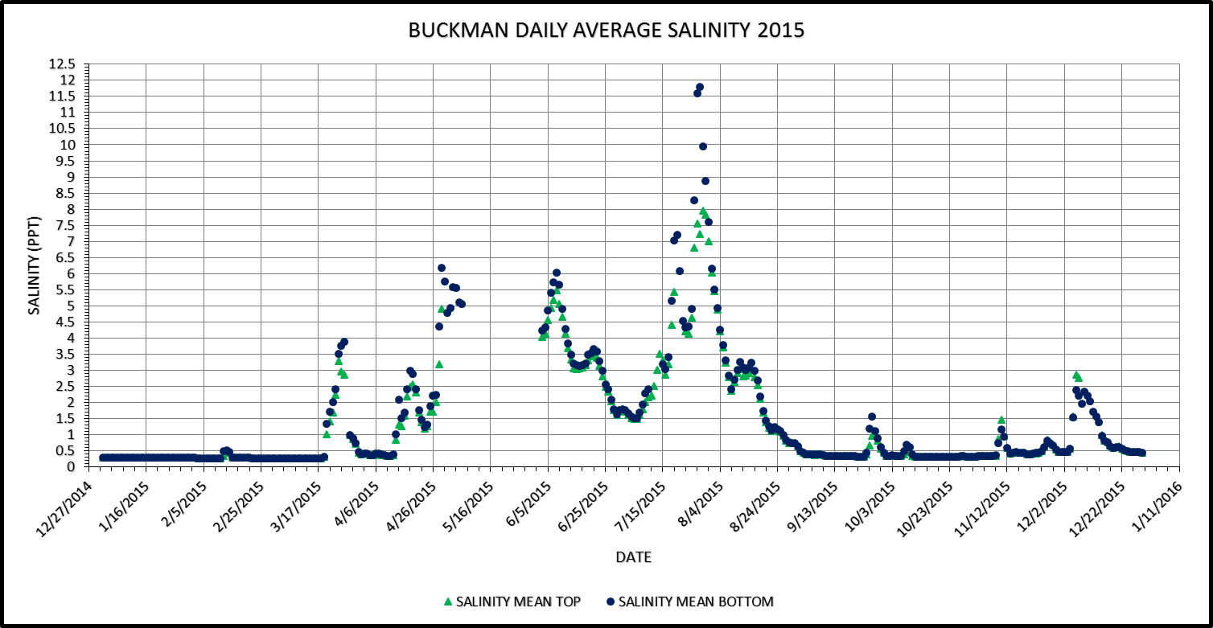
Figure 16: Daily Average Salinity at Buckman in 2015

Table 4: Summary Statistics of Daily Average Specific Conductance at Buckman in 2015
Statistic | Bottom Conductance (µS/cm) | Top Conductance (µS/cm)
N of Cases | 331 | 318
Minimum | 590 | 589
Maximum | 19440 | 13553
Mean | 2832 | 2449
Standard Deviation | 3292 | 2701
Pct1 | 593 | 593
Pct5 | 610 | 609
Pct10 | 627 | 626
Pct20 | 660 | 659
Pct25 | 715 | 704
Pct30 | 738 | 731
Pct40 | 837 | 783
Pct50 | 1003 | 975
Pct60 | 1671 | 1434
Pct70 | 3250 | 2756
Pct75 | 4150 | 3355
Pct80 | 5271 | 4660
Pct90 | 7708 | 6076
Pct95 | 9721 | 8271
Pct99 | 15289 | 12525

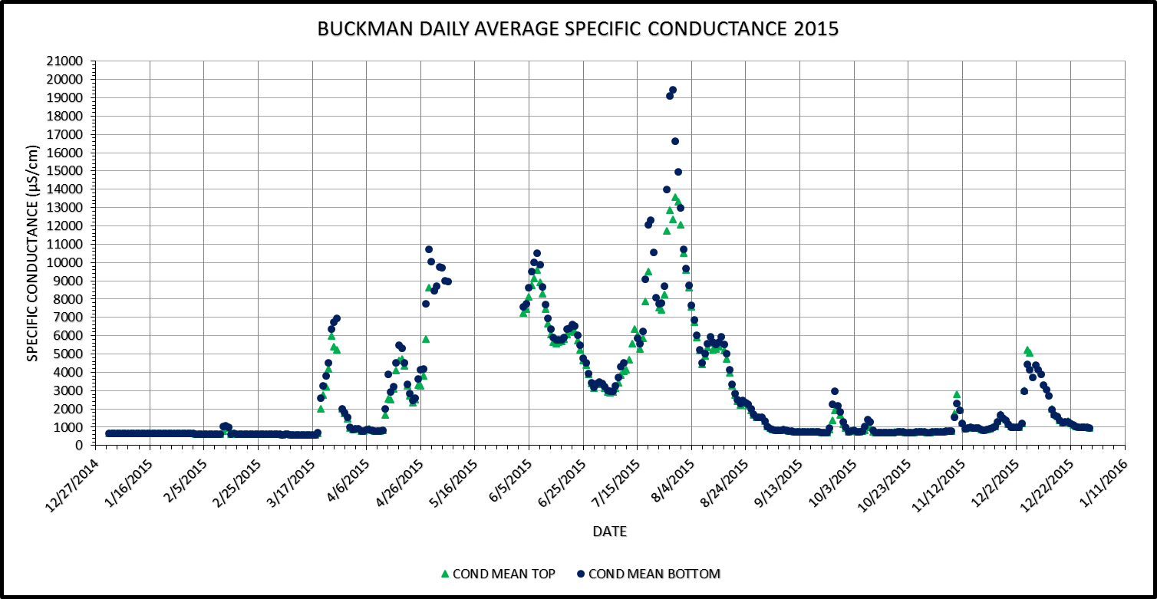
Figure 17: Daily Average Specific Conductance at Buckman in 2015

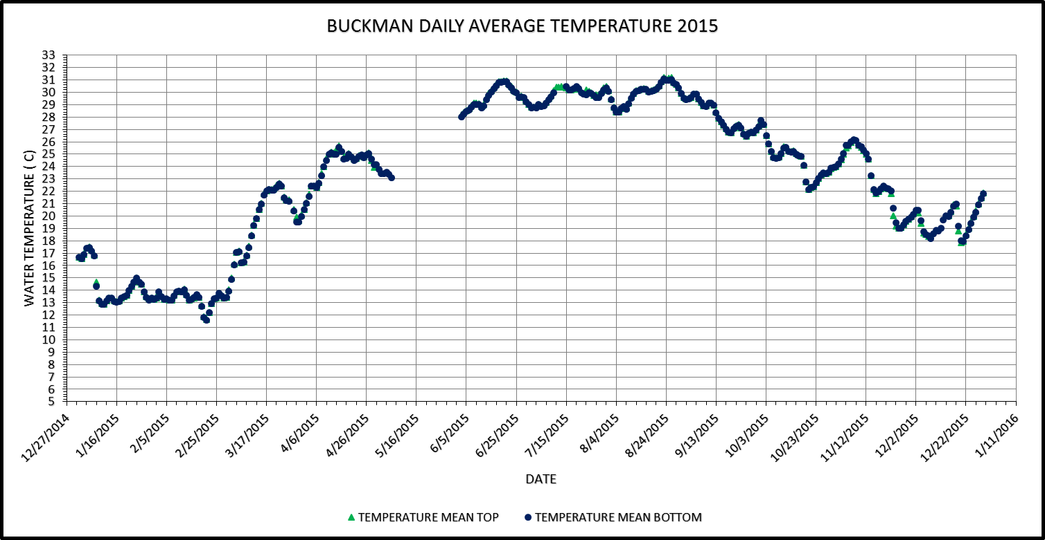
Figure 18: Daily Average Water Temperature at Buckman in 2015

Analysis of Clapboard Creek (CBC) and Channel Marker (CM) 36 Sonde Data for 2015

Location of CBC and CM 36 Data Sondes
Figure 19 illustrates the locations of the CBC and CM 36 data sondes. A single data sonde is deployed at the CBC site and two sondes are deployed at the CM site. Due to ship traffic that has “taken out” the channel marker several times over the past six years, it has been difficult to obtain a long-term record of dissolved oxygen conditions at that location. The current location shown in Figure 19 is approximately 200 meters east of the historic location of the channel marker.

CBC DO Station Site
There were no data sonde records available for 2015 at the Clapboard Creek site due to equipment failure.

CM 36 DO Station Site

CM Top Sonde
Observations were available from February 12, 2015 through April 27, 2015. Daily minimum, average, and maximum concentrations for DO, DOSAT, water temperature, salinity, and specific conductance were calculated for 75 days. The lowest daily average DO concentration was 6.26 mg/L and the lowest daily average DOSAT was 84.5 percent. If there were less than 50 observations in a day, the date was excluded from further analysis.
Over the February 12, 2015 through April 27, 2015 period, a total of 75 days were considered in the analysis. Figure 20, Figure 21, Figure 22, and Figure 23 illustrate daily average concentrations of DO, DOSAT, water temperature, and salinity, respectively. The average depth of measurements was 1.75 m (range 1.46 to 2.08 m). Daily average salinities ranged between 13.38 and 29.19 ppt, with an average of 22.31 ppt.
Due to the limited data set, a fractional exposure for the year was not calculated.
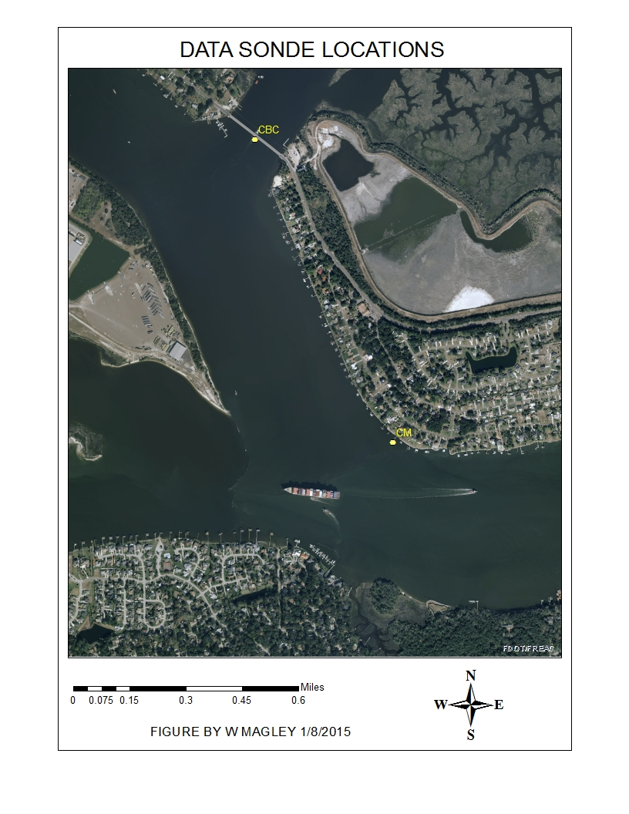
Figure 19: Location of Clapboard Creek and CM 50 Data Sondes

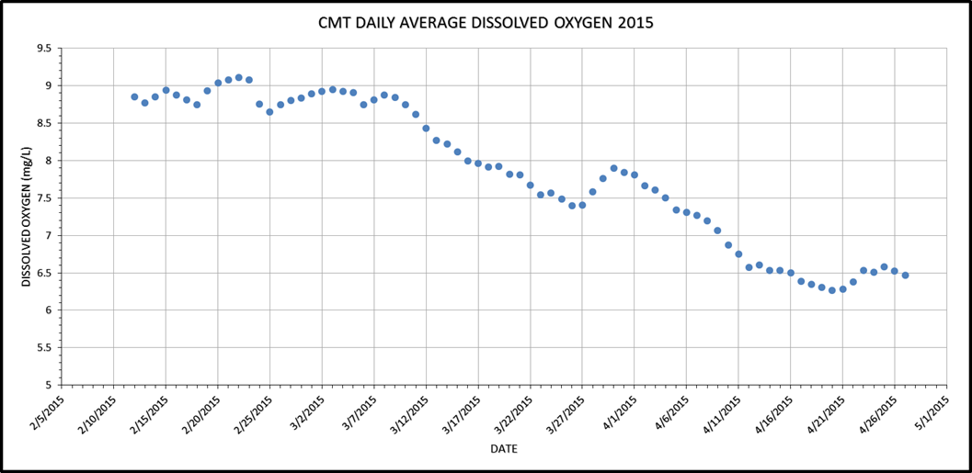
Figure 20: Daily Average Dissolved Oxygen Concentration at the CM Top Sonde Site

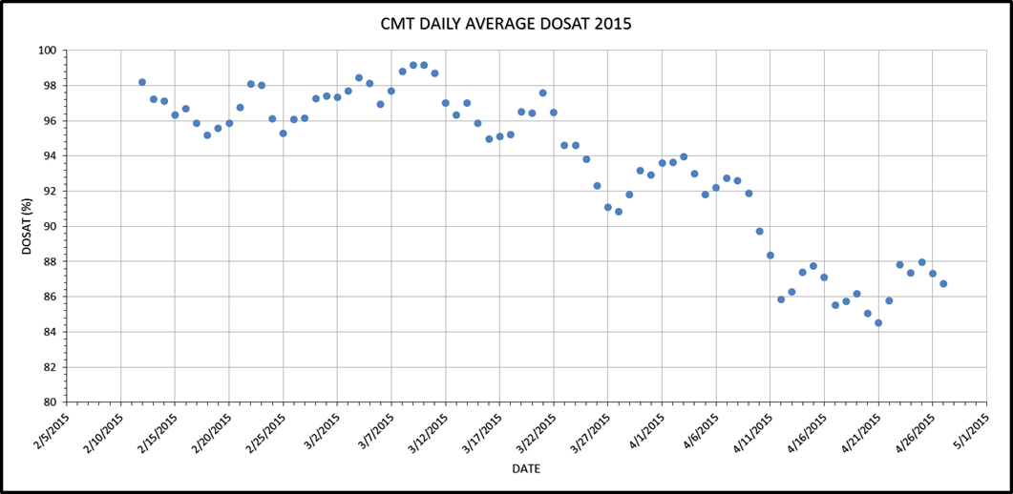
Figure 21: Daily Average Dissolved Oxygen Saturation at the CM Top Sonde Site

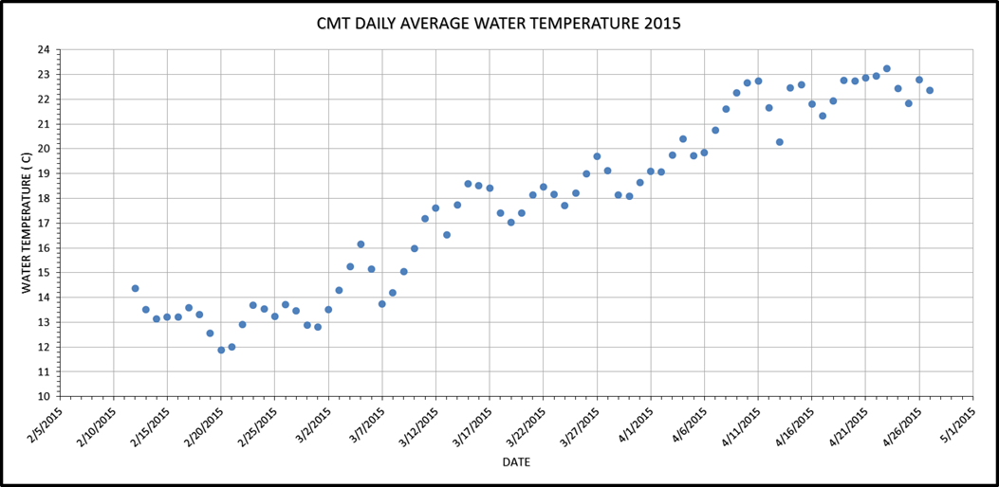
Figure 22: Daily Average Water Temperature at the CM Top Sonde Site

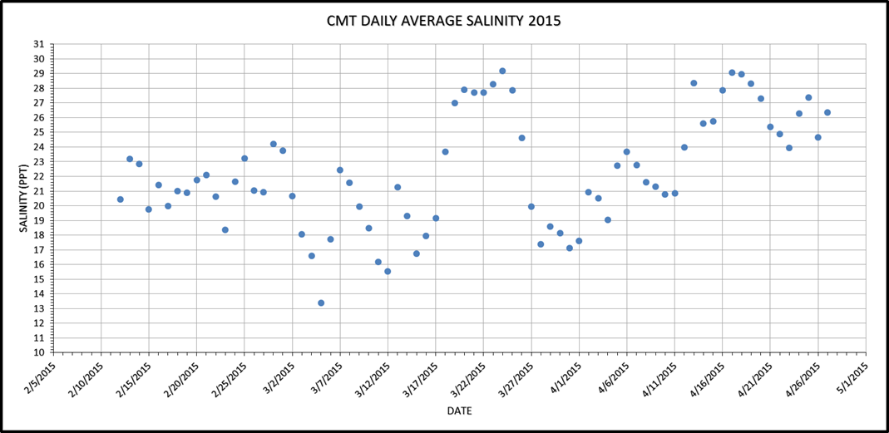
Figure 23: Daily Average Salinity at the CM Top Sonde Site

CM Bottom Sonde
Observations were available from February 12, 2015 through April 27, 2015. Daily minimum, average, and maximum concentrations for DO, DOSAT, water temperature, salinity, and specific conductance were calculated for 75 days. The lowest daily average DO concentration was 6.43 mg/L and the lowest daily average DOSAT was 86.5 percent. If there were less than 50 observations in a day, the date was excluded from further analysis.
Over the February 12, 2015 through April 27, 2015 period, a total of 75 days were considered in the analysis. Figure 24, Figure 25, Figure 26, and Figure 27 illustrate daily average concentrations of DO, DOSAT, water temperature, and salinity. The average depth of measurements was 2.34 m (range 2.14 to 2.72 m). Daily average salinities ranged between 13.76 and 29.179 ppt, with an average of 22.54 ppt.
Due to the limited data set, a fractional exposure for the year was not calculated.
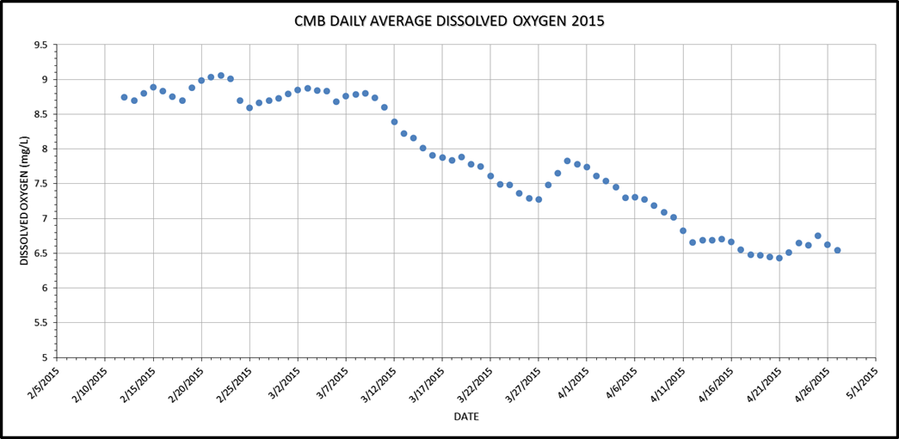
Figure 24: Daily Average Dissolved Oxygen Concentration at the CM Bottom Sonde Site
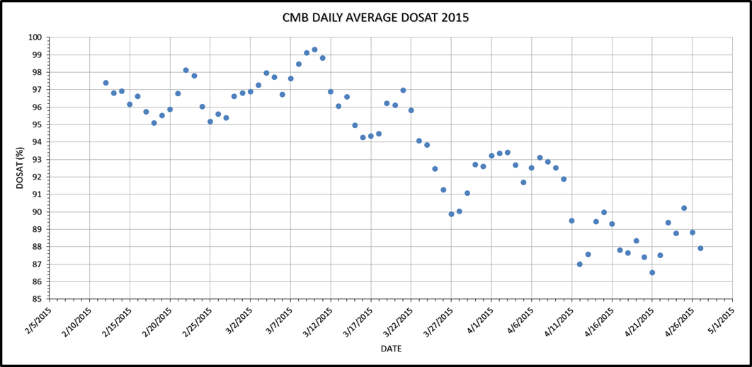
Figure 25: Daily Average Dissolved Oxygen Saturation at the CM Bottom Sonde Site

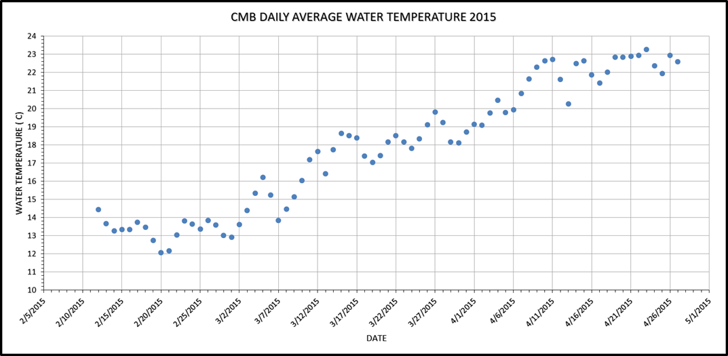
Figure 26: Daily Average Water Temperature at the CM Bottom Sonde Site

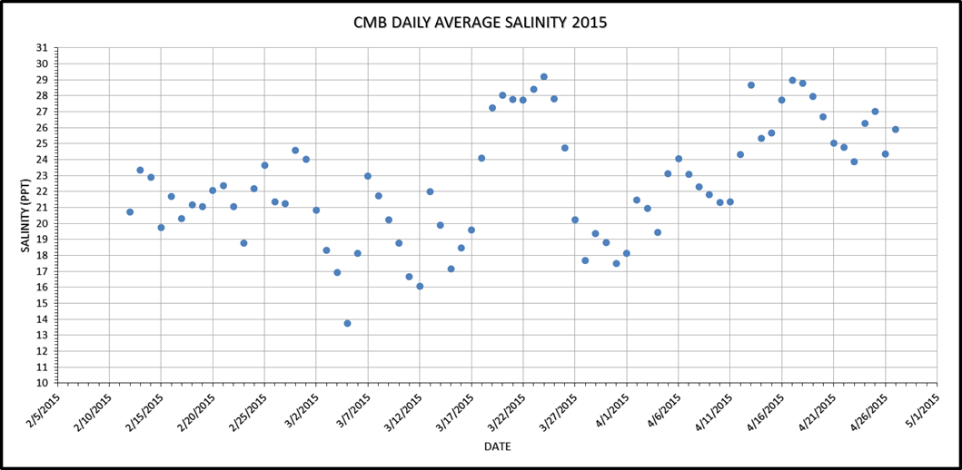
Figure 27: Daily Average Salinity at the CM Bottom Sonde Site

Summary of Data Sonde Deployments at Clapboard Creek and CM 36 over the 2010 Through 2015 Period
As described in previous reports and meetings, operation and maintenance of data sondes at these locations has been problematic. Due to ship traffic that has “taken out” Channel Marker 36 several times over the past five years, it has been difficult to obtain a long-term record of dissolved oxygen conditions at that location and the sonde was relocated to the current position shown in Figure 19. These stations have had frequent issues with boat strikes which disables and/or causes permanent loss of the equipment. Table 5, Table 6, and Table 7 summarize the extent of records that were analyzed over the 2009 through 2015 period at the Clapboard Creek and CM 36 locations for evaluation of the total fractional exposure.
Table 5: Clapboard Creek Data Sonde Records for the 2010 – 2015 Period
N/A: Not applicable.
- Empty cell.
Year | Deployment Period | # Days Analyzed | Total Fractional Exposure | Deployment Issues
2009 | 7/21 – 10/04 | 49 | N/A | -
2010 | 7/15 – 12/31 | 50 | N/A | -
2011 | 1/1 – 11/20 | 124 | 1.31 | -
2012 | 1/9 – 11/9 | 264 | 0.20 | -
2013 | No Data | - | - | Equipment failure
2014 | 9/2 – 12/1 | 103 | 0.04 | -
2015 | No Data | - | - | Equipment failure

Table 6: CM 36 Top Data Sonde Records for the 2010 – 2015 Period
N/A: Not applicable.
- Empty cell.
Year | Deployment Period | # Days Analyzed | Total Fractional Exposure | Deployment Issues
2009 | 7/21 – 10/04 | 64 | N/A | Equipment failure
2010 | 8/12 – 11/29 | 105 | 0.09 | -
2011 | 1/1 – 11/20 | 321 | 0.00 | -
2012 | 1/5 – 2/26 | 53 | N/A | Channel Marker taken out by barge
2013 | No Data | - | - | Channel Marker taken out by barge
2014 | 3/18 – 12/1 | 156 | 0.07 | -
2015 | 2/12 – 4/27 | 75 | N/A | Equipment failure

Table 7: CM 36 Bottom Data Sonde Records for the 2010 – 2015 Period
- Empty cell.
Year | Deployment Period | # Days Analyzed | Total Fractional Exposure | Deployment Issues
2009 | 7/21 – 10/04 | 76 | NA | Equipment failure
2010 | 8/12 – 12/31 | 26 | NA | -
2011 | 1/1 – 11/20 | 324 | 0.44 | -
2012 | 1/5 – 3/7 | 63 | NA | Channel Marker taken out by barge
2013 | No Data | - | - | Channel Marker taken out by barge
2014 | 9/2 – 12/1 | 56 | NA | -
2015 | 2/12 – 4/27 | 75 | NA | Equipment failure

: Accomplishments During the Reporting Period
During the reporting period, the city of Jacksonville completed several stormwater treatment projects and executed two water quality credit trading agreements of which provide a total of 40.91 metric tons per year TN reduction. Putnam County completed the Hiawatha wastewater treatment facility trade. St. Johns County completed phase one of the Masters Tract project and improvements to the Deep Creek RST facility. The Naval Air Station (NAS) Jacksonville Wastewater Reuse Construction Phase II was completed on December 1, 2015. In addition, the Florida Department of Agriculture and Consumer Services (FDACS) continued to enroll producers in BMPs in the freshwater reach. Details of the major accomplishments over the past year are described in Section 3.1 and Appendix A contains the individual project tables.

Accomplishments by Source Type

WWTFs

Freshwater Reach

WWTF Progress Towards the Freshwater TMDLs
The WWTFs in the freshwater reach (city of Green Cove Springs, city of Palatka WWTF, Georgia-Pacific, and Seminole Electric WWTF) have already achieved and exceeded (more than 100% of the TN and TP required reductions) their portion of the TP and TN TMDLs, as shown in Figure 28 and Figure 29. These facilities exceeded the TP required reductions by 6,505 kilograms per year (kg/yr) and the TN required reductions by 41,640 kg/yr. The first bar in the figures shows the starting load for the freshwater WWTFs, as calculated in the BMAP. The second bar shows the estimated 2015 load based on all completed freshwater WWTF projects. The third bar indicates the total allocation allowed for the WWTFs in the freshwater reach of the river.
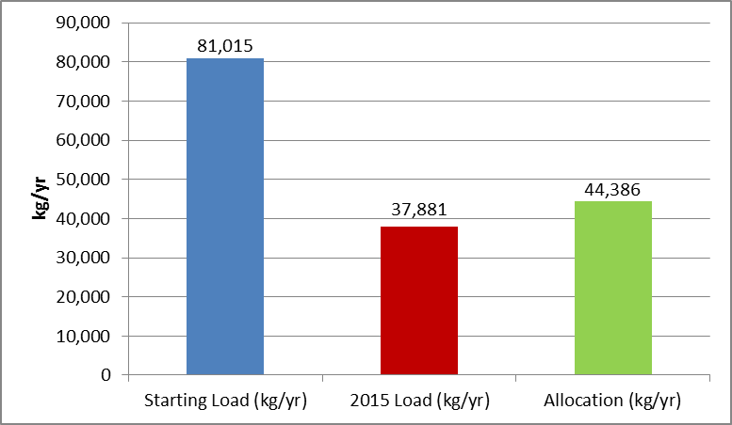
Figure 28: WWTF Progress Towards the TP Freshwater TMDL

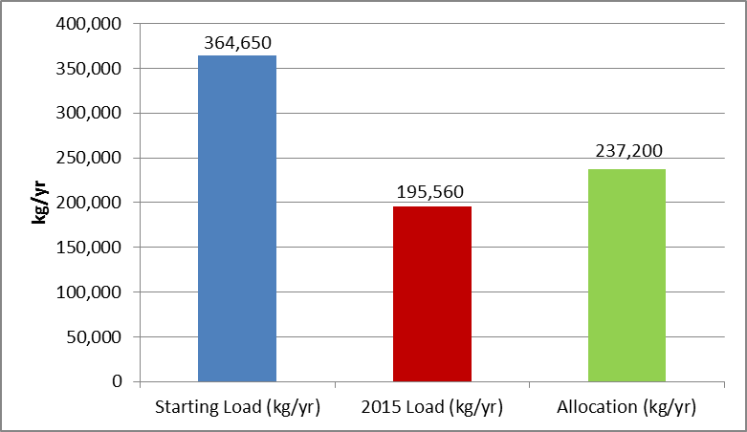
Figure 29: WWTF Progress Towards the TN Freshwater TMDL

Marine Reach

JEA
JEA’s obligations under the terms of the BMAP were fulfilled in the 2013 calendar year. However, JEA continues to optimize the operations of its wastewater treatment plants and expand its reclaimed water system. FDEP recognized JEA’s ongoing reuse expansion by awarding the 2015 David W. York award to JEA’s South Grid reuse system. JEA added 1,700 new South Grid reuse customers in 2015 in the utility’s area of greatest growth.

United States (U.S.) Navy
The NAS Jacksonville Wastewater Reuse Construction Phase II was completed on December 1, 2015. The project expanded the wastewater reuse system at NAS Jacksonville. This expansion was achieved by constructing an 8-inch diameter wastewater reuse pipeline approximately 10,000 feet to further land-apply treated wastewater treatment plant (WWTP) effluent at a 60-acre sprayfield area. This area of the installation is known as the Antenna Farm.

WWTF Progress Towards the Marine Reach TMDL

Project Implementation Status
The section above described all the efforts in the past year related to project implementation, including design and construction. These are important milestones that lead to project completion and actual load reductions. The WWTF projects that were completed during the last year and their associated load reductions are shown in Table 8 for the marine reach. The freshwater reach WWTFs have already achieved their reductions.
Table 8: WWTF Projects Completed in the Marine Reach for TN in 2015
N/A = Not applicable
Entity | Project Number | Description | TN Project Reduction (kg/yr)
U.S. Navy Aggregate | USN-2 | NAS Jax WWTF FL0000957 | 2,790
Total | N/A | N/A | 2,790

Municipal Separate Storm Sewer Systems (MS4s)

Freshwater Reach

Clay County
The continued efforts of the Riverkeeper in Clay County have now branched out.. The Riverkeeper made contact with Ridgeview High School and their Leadership Academy. The Leadership Academy produced a plan to provide rain barrels to all of the Clay County Schools. Through their own partnership with Chik-Fil-A, and the added help from Coca Cola to provide the barrels, the students painted, assembled three hundred rain barrels. They delivered these barrels to all of the Clay County Schools. Chik-Fil-A recognized the efforts by the students early on in the project and hired a film crew to follow the students over a two event. The first day was filming the students assembling the barrels. The next day, the crew rented boats and asked the Riverkeeper to follow along into Black Creek. There they filmed the students interacting with the Riverkeeper and learning about turbidity and the reason why the creek’s water is dark. The efforts from the film crew were spotlighted in June on the show “Small Town Big Deal” that aired on a cable network RFD TV. Following this, additional spotlight moments came on national aired college football games that were sponsored by Chik-Fil-A. To continue the excitement and the effort from the students, Chik-Fil-A and provided the Leadership Academy with $12,000 over the next three years to produce more impact projects.

MS4 Progress Towards Meeting the Freshwater TMDLs
Figure 30 and Figure 31 show the progress made towards meeting the MS4 portion of the freshwater TP and TN TMDLs, respectively. Through completed projects from the BMAP and 2009 and 2010 Progress Reports, as well as the ongoing efforts listed above, the MS4s in the freshwater reach have met 100% of the TP and TN reductions required under the BMAP.
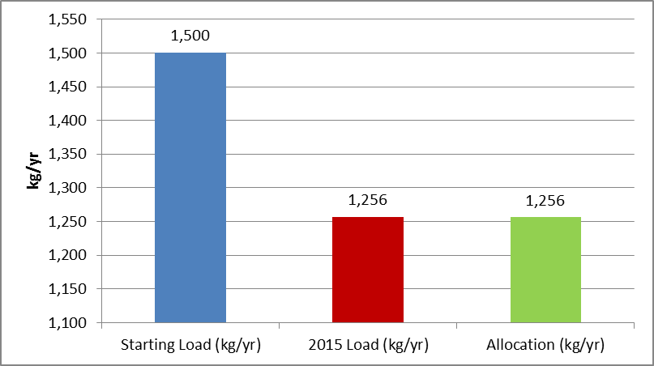
Figure 30: MS4 Progress Towards the TP Freshwater TMDL

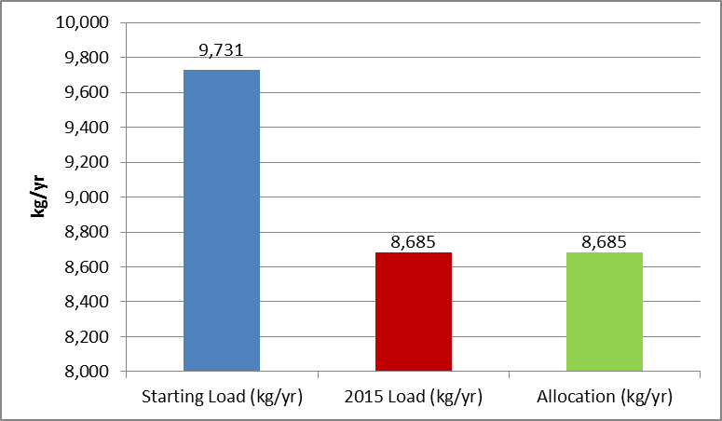
Figure 31: MS4 Progress Towards the TN Freshwater TMDL

Marine Reach

City of Jacksonville
The city of Jacksonville outlined a toolbox approach in the BMAP to reduce TN discharged to the LSJR. Stormwater projects completed include the following:
- Avenue B & Zinnia Avenue Drainage Improvement - Box culvert installation completed which addressed erosion and safety issues.
- Country Creek – Completed removal of sedimentation at three roadway bridge and culvert crossings and installed rip rap to reduce erosions at three locations.
- Hamilton Jersey Drainage Improvements - Installed two, 2nd generation baffle boxes, neighborhood drainage collection system with raised inlets and perforated pipe.
- Leonid Road Drainage Basin Reconstruction - Completed the redesign and construction of Leonid Road Pond.
The Mandarin Area Drainage project is ongoing and will reduce flooding in the area by replacing several roadway culvert crossings and improving the outfall.

The first phase of Masters Tract consisting of a pump station, pond and outfall was completed in August of 2015 by St. Johns County. The second phase comprised of treatment wetlands and Canal 4 improvements is currently under construction and is scheduled for completion by August 2016. St. Johns County also substantially completed improvements to the Deep Creek West RST facility. The facility is currently operational.

Clay County
Clay County constructed a 0.60 acre pond to alleviate flooding in the Bear Run Subdivision. Much on the basin that will drain to this pond did not have any form of treatment prior to this effort. Clay County paved two dirt roads for a total of two miles. In addition, the established water quality trading mechanism with Clay County Utility Authority (CCUA) has continued for 2015 (an Interlocal Agreement executed in September 2009).

St. Johns County
St. Johns County had success in completing construction of large regional stormwater treatment (RST) projects. The county continued collaborating with the SJRWMD to identify regional projects, evaluate their effectiveness, and assist with grant funding. These regional projects have helped the county work towards meeting their Algal Initiative load reduction requirements.

MS4 Progress Towards Meeting the Marine TMDLs
Figure 32 shows the progress made towards meeting the MS4 portion of the marine TN TMDL. The first bar in the figure shows the starting load for the marine MS4s from the BMAP. The second bar shows the estimated 2015 load based on all completed marine MS4 projects (from the BMAP; 2009, 2010, 2011, 2012, 2013, and 2014 Progress Reports; and those listed above). The third bar indicates the total allocation allowed for the MS4s in the marine reach of the river. Based on completed projects, 45% of the TN required reductions have been achieved.

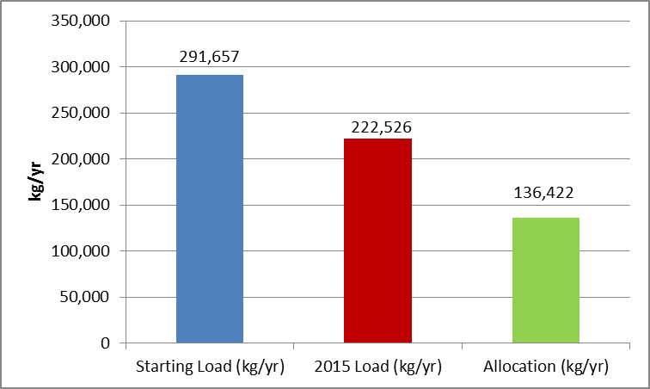
Figure 32: MS4 Progress Towards the TN Marine TMDL

Project Implementation Status
The section above described all the activities that were under way during the past year, including efforts that are not yet complete or are ongoing, such as public education. The MS4 projects that were completed during the last year and their associated load reductions are shown in Table 9 for the marine reach. The MS4s in the freshwater reach have met the required TN and TP reductions; therefore, no additional projects were completed during the reporting period.
Table 9: MS4 Projects Completed in the Marine Reach in 2015
N/A = Not applicable
Entity | Project Number | Description | TN Project Reduction  (kg/yr)
St. Johns County | SJC-17 | Algal Initiative – Masters Tract RST Facility* | 1,868
St. Johns County | SJC-29 | Deep Creek West RST Improvements** | 2,052
Total | N/A | N/A | 4920

Urban Stormwater

Freshwater Reach

Clay County
Clay County continued with the established water quality trading mechanism with CCUA (an interlocal agreement was executed in September 2009) (Project CC-6).

Putnam County
Putnam County continued its public education and outreach efforts (Project PUT-8). The East Putnam County Regional WWTF went online in May 2015.

St. Johns County
St. Johns County made its annual payment of $30,000 to the town of Hastings for the 198.2 kg/yr of TP reduction per the 2009 agreement. The county also continued its education and outreach efforts (Project SJC-3). Putnam County completed the Hiawatha WWTF trade during the reporting period.

Non-MS4 Progress Towards Meeting the Freshwater TMDLs
Figure 33 and Figure 34 show the progress made towards meeting the non-MS4 portion of the freshwater TP and TN TMDLs. The first bar in the figures shows the starting load for the freshwater non-MS4s from the BMAP. The second bar shows the estimated 2015 load based on all completed freshwater non-MS4 projects (from the BMAP; 2009, 2010, 2011, 2012, 2013, and 2014 Progress Reports; and those listed above). The third bar indicates the total allocation allowed for the non-MS4s in the freshwater reach of the river. Based on projects completed to date, the non-MS4s in the freshwater reach have achieved 75% of the TP reductions and 88% of the TN reductions.
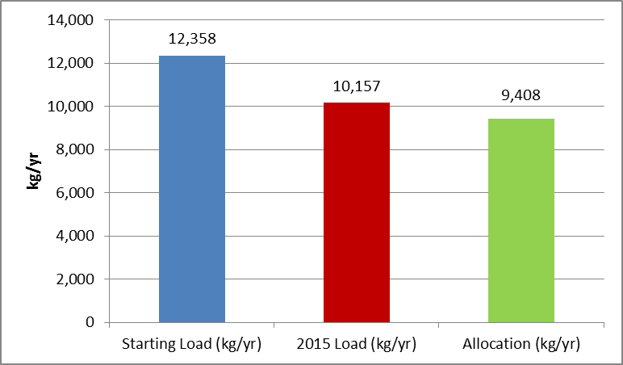
Figure 33: Non-MS4 Progress Towards the TP Freshwater TMDL

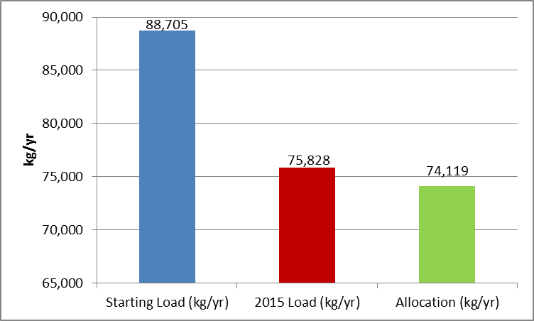
Figure 34: Non-MS4 Progress Towards the TN Freshwater TMDL

Project Implementation Status
The section above described all of the activities that were under way during the past year, including efforts that are not yet complete or are continuous, such as public education. The non-MS4 projects completed during the last year and their associated load reductions are shown in Table 10 for the freshwater reach.
Table 10: Non-MS4 Projects Completed in the Freshwater Reach in 2015
N/A = Not applicable
Entity | Project Number | Description | TP Project Reduction  (kg/yr) | TN Project Reduction  (kg/yr)
Putnam County | PUT-2 | Hiawatha WWTF trade | 49.8 | 150
Total | N/A | N/A | 49.8 | 150

Marine Reach

Non-MS4 Progress Towards Meeting the Marine TMDL
Figure 35 shows the progress made towards meeting the non-MS4 portion of the marine TN TMDL. The first bar in the figure shows the starting load for the marine non-MS4s from the BMAP. The second bar shows the estimated 2015 load based on all completed marine non-MS4 projects (from the BMAP; 2009, 2010, 2011, 2012, 2013 and 2014 Progress Reports; and those listed above). The third bar indicates the total allocation allowed for the non-MS4s in the marine reach of the river. Based on projects completed to date, the non-MS4s in the marine reach have achieved 39% of the TN reductions.

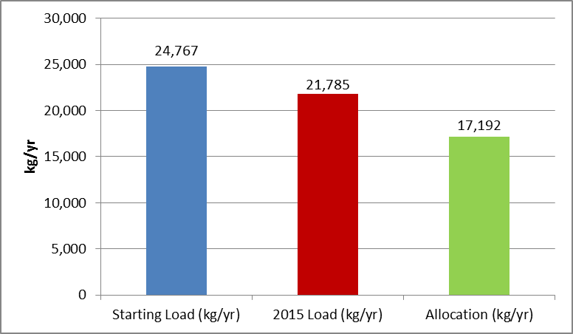
Figure 35: Non-MS4 Progress Towards the TN Marine TMDL

Agriculture

BMP Implementation Status
In 2015, the Office of Agricultural Water Policy (OAWP) - FDACS staff signed up growers under the vegetable and agronomic crop, citrus, cow/calf, and nursery BMP manuals, enrolling an additional 16,790 acres. Because of limited staff, the enrollment goals for FDACS outreach have not yet been met, but progress is continuing. In September 2013, FDACS undertook a significant effort to help producers comply with the statutory requirement for agricultural operations within BMAP areas to implement BMPs or monitor their water quality. Further discussion of the outreach effort and its results is included in Section 3.1.4.3..
The cumulative enrollment numbers are contained in Table 11: Agricultural Acres Enrolled in BMPs as of September 30, 2015Table 11. Enrolled parcels are depicted in Figure 36. To date, no producers have opted to monitor water quality instead of implementing BMPs. Enrollment of agricultural acreage in FDACS BMPs in the LSJR Basin has not reached the 100% target contained in the BMAP. As shown in Table 12 enrollment in the LSJR BMAP area as of September 30, 2015 is 101,345, or 91% of the target enrollment. Of the remaining 23,143 acres of unenrolled land, FDACS has determined through the compliance assistance efforts that approximately 8,438 acres classified as agricultural land uses are not commercial agriculture and are therefore ineligible for enrollment in the FDACS BMP Program. Within the Tri-County Agricultural Area (TCAA), an area of specific concern, the enrollment is 53,525.2 acres, or 79% of the TCAA agricultural acreage. However, FDACS believes that the actual enrollment in the TCAA is higher than reported because of recent changes in leased land that has yet to be reflected in the Notices of Intent (NOIs), but FDACS expect for the change in acreage to be reflected through the Implementation Assurance Program process where FDACS staff conducts site visits to review submitted NOIs. An estimate of load reductions due to BMP implementation and SJRWMD RST facilities is shown in Table 13.
Table 11: Agricultural Acres Enrolled in BMPs as of September 30, 2015
N/A = Not applicable.
¹ Due to improved mapping, reported acres are all within the LSJR Basin; previous reports were based on county boundaries.
² Enrollment numbers will depend on the ability of field staff to identify and locate producers, changes in land uses, and actual number of acres in production on an operation. Even with 100% enrollment, the acres will not match the 2004 land use numbers.
2004 SJRWMD Land Use | 2004 Acres | FDACS-Adjusted Acres for Enrollment | Related FDACS  BMP Programs | Acreage Enrolled1 | Related Notices of Intent | Remaining Acreage2
Pasture | 55,457 | 55,547 | Cow/Calf, Forage (Hay) | 68,754 | 76 | N/A
Row/Field/Mixed Crops | 42,546 | 42,546 | Vegetable/Agronomic Crops | 27,294 | 58 | 15,252
Fallow Cropland (out of production) | 1,446 | N/A | N/A | N/A | N/A | N/A
Horse Farm | 3,145 | 3,145 | Equine | 259 | 9 | 2,886
Citrus | 375 | 375 | Ridge Citrus, Statewide Citrus | 139 | 5 | 236
Abandoned Citrus | 30 | N/A | No enrollment needed | N/A | N/A | N/A
Tree Crops | 298 | 298 | Specialty Fruit and Nut | 75 | 5 | 223
Nurseries and Vineyards | 56 | 56 | Specialty Fruit and Nut, Statewide Nurseries | 0 | N/A | 56
Tree Nurseries, Ornamentals, Shade Ferns, Hammock Ferns | 2,869 | 2,869 | Statewide Nurseries, Container Nursery | 1,864 | 29 | 1,005
Sod Farms | 4,678 | 4,678 | Statewide Sod | 2,960 | 7 | 1,718
Specialty Farms | 26 | 26 | Conservation Plan Rule | 0 | N/A | 26
Dairies | 1,070 | 1,070 | Future Dairy Manual | 0 | N/A | 1,070
Cattle Feeding | 475 | 475 | Conservation Plan Rule | 0 | N/A | 475
Poultry Feeding | 196 | 196 | Conservation Plan Rule | 0 | N/A | 196
Other Open Lands – Rural | 854 | N/A | No enrollment needed | N/A | N/A | N/A
Totals | 113,521 | 111,281 | N/A | 101,345 | 189 | 23,143

Table 12: Agricultural TN and TP Load Reduction Allocation and Estimated Reductions in Loads from BMPs and RSTs
¹ Estimated reductions are based on BMPs for all enrolled commodities. FDACS and the Department will work to identify areas that are no longer in agricultural production and reduction credits will be assigned.
² RSTs were constructed by SJRWMD. The reduction is associated with the Deep Creek West RST and Dog Branch RST minus credits for operations and maintenance (O&M) given to St. Johns County and Putnam County, respectively. Both RSTs were offline in 2015; therefore, no TN and TP reductions were achieved.
³ The Department, FDACS, and SJRWMD will determine how to calculate reductions associated with BMPs in the marine portion of the LSJR Basin.
Reduction Category | TN Freshwater (kg/yr) | TP Freshwater (kg/yr) | TN Marine (kg/yr)³
Load Reduction Allocation | 116,364 | 12,481 | 8,630
Estimated Load Reductions via BMPs¹ | 105,701 | 5,024 | N/A
Estimated Load Reduction via completed RSTs² | 0 | 0 | N/A
Remaining Load Reductions Needed | 10,663 | 7,457 | 8,630

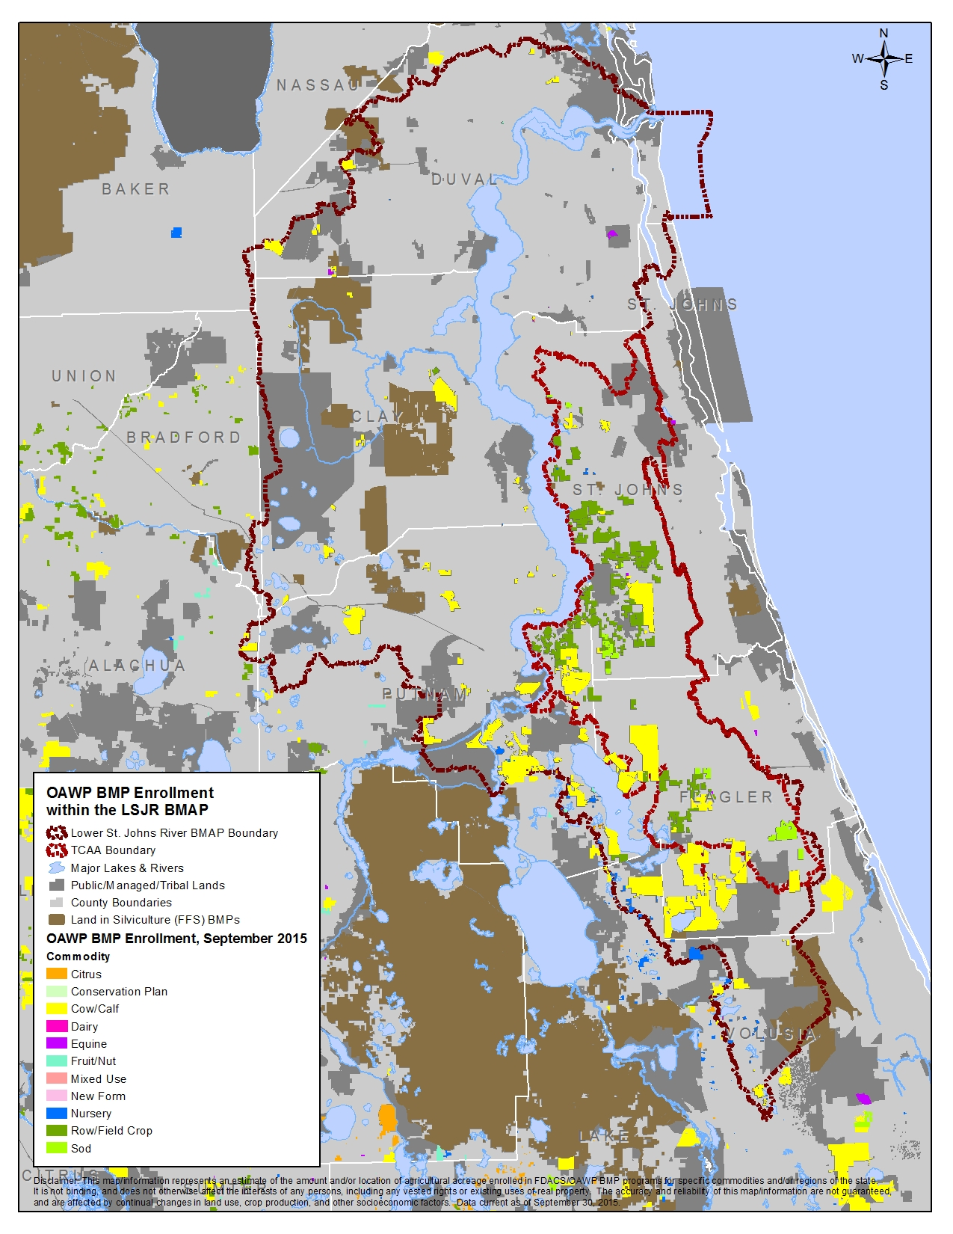
Figure 36: Map of Agricultural BMP Enrollment in the LSJR Basin
The statewide nursery manual revision was adopted in June 2014 and now includes practices related to in-ground and cut foliage production methods, in addition to container operations. In 2015, the vegetable and agronomic crop BMP manual was adopted by rule in Chapter 5M-8, Florida Administrative Code and became effective October 7, 2015. The manual includes specific nutrient- and irrigation-management BMPs for plastic mulch, bare ground, sugarcane, hay/silage, and greenhouse production systems. In 2015, FDACS published the Notice of Proposed Rule in the Florida Administrative Register adopting the new manual by reference. In 2016, FDACS will begin development of the poultry BMP manual.

Agricultural Load Reduction Allocation and BMP Load Reduction Estimates
Table 12 lists the reductions required of agricultural land uses in the LSJR Basin and the estimated load reductions achieved through the implementation of BMPs by all enrolled operations. In prior reports, FDACS only received credit for enrollment on vegetable and row crop lands. However, during 2015, FDACS met with the department and SJRWMD to discuss how credits for reductions associated with BMP implementation in other commodities could be calculated. It was determined that the same commodity-specific BMP reductions should be applied in the LSJR Basin as were applied in the Lakes Harney and Monroe, St. Lucie River and Estuary, and Lake Okeechobee BMAPs. Due to the inaccuracies in 2004 land use information and changes in land use since 2004, the estimated total load for agriculture may be greater than the actual loading.

Agricultural Land Use Data
Agricultural acreage in the LSJR Basin has declined since the 2004 land use data were collected. In addition, some categories of agricultural land use may include acreage that is not in production or that is not actually agriculture. As discussed above, FDACS has determined that 8,438 acres classified as agriculture in the 2004 land use are noncommercial agriculture. This is because aerial photos of land use are not always clear enough to interpret accurately. The potential for misinterpretation is generally greatest in the pasture categories. FDACS staff are working with the Department and SJRWMD to determine more accurately the agricultural acreage in the basin.

TCAA Water Management Partnership
The objective of the TCAA Water Management Partnership is to contribute to the improved health of the LSJR through on-farm and regional water management projects and practices that reduce the movement of nutrients to the river, improve water conservation, and result in more efficient farm management while maintaining the long-term viability of agriculture in the TCAA. The primary resource concern is the movement of phosphorus from farmlands into the LSJR and its tributaries; however, nitrogen movement is also a concern.
To address these concerns, the TCAA Water Management Partnership is providing funding for water management projects and other practices to better manage and/or treat stormwater runoff and better target or reduce nutrient applications. Technical support and education/outreach to promote enhanced farm practices is also a key component. TCAA Water Management Partnership partners include the following:
- TCAA growers.
- FDACS.
- Department.
- SJRWMD.
- U.S. Department of Agriculture Natural Resources Conservation Service (NRCS).
- University of Florida–Institute of Food and Agricultural Sciences (UF–IFAS).
- St. Johns County.
- Floridan Resource Conservation and Development Council.
- Florida Farm Bureau.
- Florida Fruit and Vegetable Association.

Project types and cost-share items that currently are considered for funding by the TCAA Water Management Partnership include the following; however, other ideas for projects that would further the program objective may be proposed:
- Projects:
  - Surface and subsurface drip irrigation.
  - Overhead irrigation.
  - Tailwater recovery.
  - Irrigation drain tile.
  - Regional water reuse.
  - Regional wet detention.
- Practices/Equipment:
  - Fertilizer application equipment, e.g., banding equipment, nurse tank and injection pumps for fertigation, and automated fertigation and irrigation controllers for drip systems.
  - Observation wells.
  - Pump upgrades with soil moisture sensors.
  - Soil moisture sensors.

The growers and agencies (FDACS, Department, SJRWMD, NRCS, and UF–IFAS) are working together to install and demonstrate these projects and practices on TCAA farms through cost-share funding, education, and technical assistance. To date (projects funded in fiscal years 2012-2013 and 2014-2015, the TCAA Water Management Partnership projects treat approximately 1,508 acres. Estimated TN and TP reductions associated with these projects are 14,886.00 pounds per year (lbs/yr) and 2,919.00 lbs/yr. Additionally, it is estimated that these projects result in 128 million gallons per year in water savings. Since 2012, the purchase of 16 fertilizer banding machines also has been approved and completed. Fertilizer banding has been implemented on 16 farms and applied to approximately 11,768 acres. Banding applications have resulted in estimated TN and TP reductions of 26,929.00 lbs/yr and 10,823.00 lbs/yr, respectively. Acreage and reduction figures for projects funded from the June 2015 application period were not available at the time of this report but will be included in future updates. Approved irrigation projects include the following:
- Enhanced seepage irrigation on potatoes and other vegetables.
- Surface drip irrigation on potatoes.
- Irridrain on potatoes and sod.
- Overhead irrigation on sod, cabbage, and potatoes.

To be eligible for cost-share funding, TCAA growers must be enrolled in and implementing applicable FDACS BMPs. This is one of eight eligibility requirements, including the willingness to undergo monitoring to determine the benefits of the projects, and to host and participate in educational/demonstration activities on the project site.
FDACS staff are coordinating the partnership’s efforts. SJRWMD provided $ 2.25 million in fiscal years 2013-2014, with $750,000 dedicated to fertilizer banding equipment, and $849,630 in fiscal year 2015-2016 for water management projects. FDACS provided a total of $1 million in fiscal years 2013–2014 and 2014-2015 and has budgeted $990,000 in fiscal year 2015–2016. The Department contributed $1.9 million in fiscal year 2013–2014 and 2014–2015 and budgeted $800,000 in fiscal year 2015–2016 for water management projects and banding equipment, which is being administered through SJRWMD. The Department and FDACS are providing the funds to monitor the water quality and conservation benefits of four of the approved projects.
Through the National Water Quality Incentives Program, the NRCS provided increased targeted cost share in two specified subbasins within the TCAA for farms that enrolled in the Environmental Quality Incentives Program. Total program funds obligated for the TCAA since 2012 through grower contracts are more than $1,179,831. NRCS plans to continue to set aside funds for the TCAA.
UF-IFAS held several workshops and demonstrations days regarding more efficient irrigation and nutrient management practices. While the current focus for projects is on more efficient irrigation systems to reduce nutrient runoff and leaching, irrigation/stormwater recovery and reuse projects are under discussion for future funding. These may be on individual farms or may be joint projects between two or more farms. Members of the TCAA Water Management Partnership technical support team are developing information on tailwater recovery specific to the TCAA, to help inform farmers about associated design requirements, benefits, and costs.
The partnership is intended to be perpetual, to foster ongoing collaboration among agencies and growers. While funding amounts for projects and practices may vary from year to year, there will be continued support for farmers to enhance their farming practices and reduce their nutrient inputs while maintaining or increasing yields.

BMP Compliance Process
To ensure that agricultural landowners know of their statutory responsibility to implement BMPs within the BMAP area, in 2013 FDACS did a broad mail-out (about 2,400 letters) to landowners with property of ten acres or more with a county agricultural tax classification, and to nurseries of all sizes. A great number of these properties have turned out to be noncommercial agriculture of smaller acreages (10 to 30 acres), largely planted pines with no fertilization or other active management. However, a significant number of commercial operations responded to the letter and have been enrolled in FDACS BMPs or are scheduled for enrollment. FDACS staff and contractors are conducting follow up with those who responded to the department compliance assistance letter. The Florida Forest Service indicates that approximately 90,084 acres were enrolled in forestry BMPs from September 2013 through December 2015 as a result of the mail-out. Of this number, 16,790 acres were enrolled from January 1, 2015 through September 30, 2015. The FDACS OAWP reports that approximately 45,405 acres were enrolled in fruit/nut, cow/calf, equine, vegetable and agronomic crop, and nursery BMP programs during that time as a result of the mail-out. Follow-up activities will continue.

RST Facilities/Hybrid Wetland Treatment Technology (HWTT) Project

RST Facilities
SJRWMD has completed two RST facilities, Deep Creek West (also known as Yarborough) and Dog Branch (also known as Edgefield) located in St. Johns and Putnam Counties respectively, in the TCAA. Modeling assessments conducted prior to the construction of the Deep Creek RST estimated reductions of 998 kg/yr of TN and 816 kg/yr of TP. The Edgefield RST was estimated to achieve reductions of 2,404 kg/yr of TN and 1,089 kg/yr of TP. Both RST facilities are designed as a BMP treatment train with a wet detention pond at the forefront followed by a constructed treatment wetland. Through an agreement with SJRWMD and DEP, both St. Johns and Putnam Counties operate and maintain the facilities in exchange for a pro-rated share of nutrient reduction credits in the LSJR Main Stem BMAP.
Differences in nutrient loads entering and exiting (inflow canal load versus wetland outflow load) both the Deep Creek West facility and the Dog Branch facility were calculated to generate the actual annual total load reductions and overall RST treatment efficiency for the 2009 through 2014 period of record. Both facilities have exceeded the estimated TN and TP reductions outlined in the LSJR Main Stem BMAP. The Deep Creek West annual average nitrogen and phosphorus reductions for 2009 through 2014 were 2,875 kg/yr and 1,336 kg/yr respectively, which exceed the estimated TN load reductions (1,000 kg/yr) and estimated TP load reductions (818 kg/yr) outlined in the LSJR Main Stem BMAP. The Dog Branch facility annual average nitrogen and phosphorus reductions for 2009 through 2014 were 7,676 kg/yr and 3,143 kg/yr respectively, which exceed the estimated TN load reductions (2,409 kg/yr) and TP load reductions (1,091 kg/yr) outlined in the LSJR Main Stem BMAP for the Dog Branch RST. Both facilities have reduced nutrient loading from their respective agricultural watershed.
Based on the findings of a wetland dye-tracer study conducted in June 2010 at the Deep Creek West RST facility, only 5.1 acres of the 38-acre wetland were functioning under baseflow condition due to hydraulic short circuiting and dead zones throughout the wetland. Additionally, St. Johns County identified other potential improvements that could optimize the nutrient removal achieved at Deep Creek West. SJRWMD and the county collaborated on the design improvements and estimated the new design features would improve water quality by treating an additional 635 kg of TP and 907 kg of TN annually. Phase I construction began in July 2014 to increase flow volumes and storage volumes in the pond, while phase II construction includes wetland ditch blocks designed to increase the wetted area of the wetland, thus increasing residence time and treatment. Construction is scheduled for completion in 2016. Subsequently, since the Deep Creek West project has been offline, performance monitoring has not occurred and therefore 2015 nutrient reductions cannot be reported.
The Dog Branch RST facility also underwent design improvements during 2015 to improve water quality treatment; therefore, 2015 nutrient reductions cannot be reported. The SJRWMD began work in January 2015 to replace the failing pumps at the Dog Branch RST. The old pump system was designed to capture 80% of peak discharge utilizing two pumps capable of pumping 15 cubic feet per second (cfs) each. However, base flow (average of 2.81 cfs) is estimated to be 69% of the total flow into the system (CDM 2003 Technical Memorandum). Because of the pump design, which resulted in short pump cycles, a large volume of base flow bypassed the inflow to the RST, flowing untreated to the river. New variable rate pumps were installed in September 2015 that are designed to efficiently capture both low and high flows from Dog Branch improving pumping capacity during base flow, as well as pump efficiency and treatment performance during both low and high flow conditions. Dog Branch RST is scheduled to be online in February 2016.
St. Johns County continued construction of an additional RST on property obtained from SJRWMD, known as the Masters Tract, adjacent to Deep Creek near Hastings. Estimated reduction values for this facility are 2,370 kg/yr of TN and 1,190 kg/yr of TP. The total estimated cost of this project is $6,432,000.
HWTT Project
FDACS has submitted a permit application for the construction of the Deep Creek HWTT system. The Deep Creek HWTT facility will be located on the east side of Deep Creek. Water will be pumped from Deep Creek into the HWTT system, and the treated water will be discharged back into the creek. The facility has expected TN and TP reductions of 10,140.10 kg/yr TN and 2,815.90 kg/yr TP.

Improving Scientific Understanding

Water Quality Monitoring

Freshwater Reach for the Chlorophyll-a Target
The SJRWMD long-term river ambient monitoring network includes now includes five stations. The sixth station at Federal Point was dropped in 2012 when the station locations were optimized. The stations monitor the WBIDs between Palatka and Green Cove Springs, which are assessed annually for compliance with the TMDL chlorophyll-a target, and these data are regularly uploaded to the Florida Storage and Retrieval (STORET) database. In addition, two continuous in-situ sensor stations are supported within this reach, which are used to interpolate between monitoring dates to assure conformity with the duration component of the criteria. Finally, it is expected that satellite remote sensing capability for bloom monitoring will be restored in 2016 with the launch of the Sentinel-3 Ocean and Land Color Instrument, allowing for a detailed two dimensional estimate of the extent of bloom density.

Marine Reach for the DO Target
Compliance with the DO target in the marine reach of the river is determined through data from collected by the USGS continuous DO station at Dames Point. The data from this station can be accessed through the USGS website.
The two BMAP DO stations at Fulton Point and Clapboard Creek were not operational in 2015. At the Fulton Point station, damage from two separate boat strikes in 2012 meant that few data were collected in 2012 and all of 2013. Equipment was redeployed in March 2014 at a slightly different location (648 meters east of the previous location). Data were collected in 2014 from March 18 through December 1, 2014. After repairs, data were collected in 2015 from February 12 through April 27, 2015 when another equipment failure occurred. The dataset from this station is therefore very limited for 2015.
At the Clapboard Creek station, the DO sondes went missing in early 2013. DEP installed new sondes in September 2014. However, there were no data sonde records available for 2015 at the Clapboard Creek site due to another equipment failure.

River and Tributary Inflow Monitoring
The tributaries monitoring includes ambient sampling to determine the loads entering the main stem of the river from its tributaries and to estimate the reductions associated with the implementation of stormwater projects. The SJRWMD collects regular ambient surface water samples at 16 stations, most of which are sampled monthly. In addition to surface water chemistry, the SJRWMD monitoring program collects samples for identification of phytoplankton and algal toxins at a limited number of sites, and in 2015 resumed submerged aquatic vegetation monitoring. This sampling occurred on schedule over the last year. JEA is responsible for sampling five stations bimonthly, and this sampling occurred on schedule throughout the year. In addition, the city of Jacksonville maintains a long-term network, which provides supporting data for the BMAP monitoring plan. All of the ambient monitoring data are uploaded to Florida STORET regularly.

Algal Initiative and Upstream Projects
As reported previously, SJRWMD has completed two RST facilities and St. Johns County continued construction of an additional RST on property obtained from SJRWMD, known as the Masters Tract, adjacent to Deep Creek near Hastings. Estimated reduction values for this facility are 2,370 kg/yr of TN and 1,190 kg/yr of TP. The total estimated cost of this project is $6,432,000. St. Johns County and SJRWMD are collaborating on the design and construction of improvements to the Deep Creek West RST facility that will result in improved water quality treatment from that facility began. These improvements are estimated to provide 1,400 lbs/yr of TP and 2,000 lbs/yr of TN removal.
Numerous upstream project opportunities are being examined by SJRWMD. SJRWMD executed its second year of rough fish harvesting from Lake George, which is just upstream of the LSJR Basin. The 2015 summer harvest of rough fish from Lake George began on May 4, 2015 and ended in early September 2015. The 1,325,978 pounds (601,453 kilograms) of rough fish removed equates to the direct removal of 10,926 pounds of phosphorus and 27,845 pounds of nitrogen. As in previous years, the 2016 harvest is planned from May through September. In addition, projects in the Deep Creek Basin in Volusia County, the Wekiva River and Econlockhatchee River Basins, as well as the acquisition of agricultural lands on the shores of Lake Jesup with associated improvements to provide water quality treatment of stormwater entering the lake continue to be evaluated.
At this time it appears that nutrient loads emanating from Deep Creek have declined significantly and to the point that a regional nutrient reduction project there would not be cost effective. Evaluation of potential projects within the Econlockhatchee and Lake Jesup basins continues. Additionally, the district has increased funding to its general local government, Regional Equitable Development Initiative (REDI), innovative projects and agricultural BMP cost share programs. All of these programs support water quality improvement projects.

SJRWMD Funding for Additional Nutrient Reductions
Several cost-share agreements for the expansion of reclaimed water service have been executed, including those with Palatka, JEA, CCUA, Neptune Beach, and NAS Jacksonville. All these agreements have been completed. As indicated by the BMAP, water quality credits are being held for the river to provide reductions over and above what is required to achieve the TMDL. The credits based on the SJRWMD ad valorem funding contribution, prorated in relation to the total project cost. Held credits do not accrue to the recipient and are not available for TMDL compliance or for sale as water quality credits to other entities. Credit reductions will be documented in the recipient’s domestic wastewater facilities permit. The estimated amount of credit reservations by SJRWMD is 45,503 kg/yr of TN. These reductions will be finally calculated for adoption within permit at the time projects are completed and based on final construction costs and actual nutrient reduction data.
In addition to the above projects, CCUA and SJRWMD also entered into an agreement for construction of a reclaimed water storage project that takes water from the Miller Street Plant that would otherwise be discharged into the St. Johns River, and stores it in a series of infiltration cells. This approach has been termed the Reclaimed Water Land Application and Recovery System (RWLARS) consisting of a series of surficial aquifer rapid infiltration basins. The goal of the project is to provide wet weather storage of reclaimed water during periods of low demand and to re-utilize this water during periods of high demand. The project has two primary objectives: (1) reduce discharge of reclaimed water to the LSJR, and (2) reduce CCUA’s pumping of Floridan aquifer ground water to augment its reclaimed water system during high demand periods. The project was completed in 2015 at a total project cost of approximately $2.5 million and, once the full capacity of the project is reached, is estimated to reduce nitrogen discharges by approximately 9,850 kg/yr.

Funding
The stakeholders did not receive any additional grant funding from the DEP during the annual reporting period.

Summary of Accomplishments
The tables and figures below (Table 13 and Figure 37, Table 14 and Figure 38, and Table 15 and Figure 39) illustrate the load reductions made by the stakeholders in the LSJR Basin and the remaining reductions in nutrient loading needed to achieve the TMDLs in each segment of the river. Although some source categories have exceeded their reductions, there are individual stakeholders that still need to make reductions to meet their BMAP allocations.
Table 13: Progress Towards the TP TMDL in the Freshwater Reach
*Exceeded the total required reductions for the source category.
Source | % of Controllable Load | Starting Load  (kg/yr) | 2015 Load (kg/yr) | Allocation (kg/yr) | Remaining Reductions (kg/yr) | % Complete
WWTF* | 45% | 81,015 | 37,881 | 44,386 | 0 | 100%
MS4* | 1% | 1,500 | 1,256 | 1,256 | 0 | 100%
Non-MS4 | 7% | 12,358 | 10,157 | 9,408 | 749 | 75%
Agriculture | 47% | 83,455 | 75,626 | 70,974 | 4,652 | 63%
Total | 100% | 178,329 | 124,920 | 126,025 | 5,401 | 90%

As indicated in Table 13, the reductions achieved by the wastewater facilities and the MS4s have met and exceeded the allocations to these sources. There are still reductions remaining that have been assigned to non-MS4 areas and to agricultural land uses, for an overall percent complete of 90 percent.
In Figure 37, the charts show the progress made since the TMDL data period in reducing loads. As the wastewater facilities and MS4s have exceeded their requirements, the estimated 2015 TP load is less than the TP allocation for the river. Additional TP reductions are still expected from those entities that have not met their individual TP reduction requirements.

Figure 37: Progress Towards the TP TMDL in the Freshwater Reach

As indicated in Table 14, the freshwater TN reductions achieved by the wastewater facilities and the MS4s have met and exceeded the allocations to these sources, similarly to the TP reductions. There are still reductions remaining that have been assigned to non-MS4 areas and to agricultural land uses, for an overall percent complete of 84 percent.
Table 14: Progress Towards the TN TMDL in the Freshwater Reach
*Exceeded the total required reductions for the source category.
Source | % of Controllable Load | Starting Load  (kg/yr) | 2015 Load (kg/yr) | Allocation (kg/yr) | Remaining Reductions (kg/yr) | % Complete
WWTF* | 47% | 364,650 | 195,560 | 237,200 | 0 | 100%
MS4* | 1% | 9,731 | 8,685 | 8,685 | 0 | 100%
Non-MS4 | 11% | 88,705 | 75,828 | 74,119 | 1,709 | 88%
Agriculture | 40% | 310,700 | 232,709 | 194,336 | 38,373 | 67%
Total | 100% | 773,786 | 512,782 | 514,340 | 40,232 | 84%

In Figure 38, the charts show the progress made since the TMDL data period in reducing TN loads in the freshwater section. As the wastewater facilities and MS4s have exceeded their requirements, the estimated 2015 TN load is less than the TN allocation for the river. Additional TN reductions are still expected from those entities that have not met their individual TN reduction requirements.
Figure 38: Progress Towards the TN TMDL in the Freshwater Reach

Table 15: Progress Towards the TN TMDL in the Marine Reach
* Exceeded the total required reductions for the source category.
** Reductions have not occurred for the agricultural sources; however, based on an evaluation of recent land uses, there does not appear to be agriculture remaining in the marine reach.
Source | % of Control-lable Load | Starting Load  (kg/yr) | 2015 Load (kg/yr) | Allocation (kg/yr) | Remaining Reductions (kg/yr) | % Complete
WWTF* | 84% | 1,786,542 | 838,561 | 878,326 | 0 | 100%
MS4 | 14% | 291,657 | 222,526 | 136,422 | 86,104 | 45%
Non-MS4 | 1% | 24,767 | 21,785 | 17,192 | 4,593 | 39%
Agriculture** | 1% | 12,800 | 12,800 | 4,170 | 8,630 | 0%
Total | 100% | 2,115,766 | 1,095,672 | 1,036,110 | 99,327 | 94%

Figure 39: Progress Towards the TN TMDL in the Marine Reach

Water Quality Monitoring
For the freshwater sampling, the SJRWMD will continue to monitor at its ambient stations. In the river’s marine reach, both the city of Jacksonville and SJRWMD will continue to operate their long-term water quality monitoring programs. The department will continue the DO monitoring stations at Fulton Point and Clapboard Creek. The SJRWMD and JEA will continue ambient water quality sampling in the tributaries.

: Upcoming Activities
The eighth annual BMAP Progress Report will encompass the period from January 1 to December 31, 2016. Section 4.1 summarizes the activities that will occur during this time.

Upcoming Efforts by Source Type

MS4s

Marine Reach

United States Navy
Design of the new and improved wastewater treatment facility (WWTF) at NS Mayport was awarded by the Government on May 26, 2015. The design will implement bionutrient removal (BNR) technologies that were shown to be successful in pilot plant testing conducted in 2013. Completion of design will position the installation to be ready to proceed with construction upon approval of military construction funding.

Urban Stormwater

Freshwater Reach

Putnam County
Putnam County will complete septic tank phase out by the end of 2016.

Marine Reach

Camp Blanding
Camp Blanding will continue to regrade the swales per the consent letter (Project CB-4), for a total of 27 miles in 2016.

Agriculture
FDACS will focus on continuing to increase enrollment in all commodities and on supporting and expanding the TCAA Water Management Partnership. Extension agents and researchers with UF–IFAS will continue to assist growers in nutrient application and irrigation efficiencies, and in applying for cost-share funds for water management projects and BMPs. FDACS staff will continue to provide coordination and technical support for the partnership. SJRWMD, the Department, and NRCS will continue to assist growers with developing project concepts and monitoring plans, along with providing cost-share funds as available.
It is important to remember that even if all commercial agricultural operations participate in FDACS BMPs, the enrolled acreage will not add up to the target acreage for several reasons:
- Only the acres that are in production and need BMPs will be recorded on the notices of intent and tracked in the FDACS BMP Tracking System.
- The land use data upon which target enrollment is based are from 2004; since that time, agricultural acreage has declined in the basin.
- The land use data contain inaccuracies that inflate the amount of agricultural acreage in the basin.
- There is a significant amount of noncommercial open land, pasture, and forestry acreage that is not appropriate for enrollment in FDACS BMP programs. Many landowners who receive the agricultural tax classification, and whose property may show up under agricultural land use on SJRWMD land use data, do not engage in production agriculture. They may have small gardens, a few animals, or just passive tree growth.

Appendix A: BMAP Projects
The BMAP project tables below show the status of the projects as of December 31, 2015. These tables provide information on the nutrient reduction attributed to each individual project and the remaining nutrient load after each project is implemented, shown in both kg/yr and lbs/yr. The expected load reductions are subtracted from the entity’s starting point load. The remaining nutrient balance once all projects have been implemented by an entity should be equal to or exceed the allocation for that entity’s facility or facilities. The schedule to implement each of the projects is also included in the tables.
Notes to tables:
N/A = Not applicable
- = Empty cell/no data

Freshwater Phosphorus Allocation

Name of Facility Wasteload Allocation (kg/yr)

Clay County MS4 FLR04E045 212.6
Lead Entity | Project Number | Project Description | Project Type | Acres Treated | Deadline | Project TP Reduction (kg/yr) | Project TP Reduction (lbs/yr)
CC MS4 FLR04E045 | N/A | Total Reduction Required | N/A | N/A | N/A | 191.9 | 422.2
CC MS4 FLR04E045 | CC-1 | Education Program | N/A | N/A | Ongoing | 16.2 | 35.6
CC MS4 FLR04E045 | CC-2 | Florida Department of Transportation (FDOT) SR 21 Widening from SR 215 to CR 220 | Dry retention (1”) | 12 | Completed | 2.3 | 5.1
CC MS4 FLR04E045 | CC-3 | Trade with CCUA | N/A | N/A | Completed | 173.4 | 381.5
CC MS4 FLR04E045 | N/A | Total Project Reductions | N/A | N/A | N/A | 191.9 | 442.2
CC MS4 FLR04E045 | N/A | Credit/(Deficit) | N/A | N/A | N/A | 0 | 0

City of Green Cove Springs Aggregate FL0635618 1,929.2
Lead Entity | Project Number | Project Description | Deadline | Project TP Reduction (kg/yr) | Project TP Reduction (lbs/yr)
Green Cove Total (Aggregate) | N/A | Total Reduction Required | N/A | 1,935.8 | 4,258.8
GCS – Harbor Rd FL0020915, South FL0030210 | GCS-3 | Operational Changes | Completed | 2,486 | 5,469.2
Green Cove Total (Aggregate) | N/A | Total Project Reductions | N/A | 2,486 | 5,469.2
Green Cove Total (Aggregate) | N/A | Credit/(Deficit) | N/A | 550.2 | 1,210.4

City of Green Cove Springs MS4 FLR04E103 1,043.7
Lead Entity | Project Number | Project Description | Project Type | Acres Treated | Deadline | Project TP Reduction (kg/yr) | Project TP Reduction (lbs/yr)
Green Cove MS4 | N/A | Total Reduction Required | N/A | N/A | N/A | 52 | 114
GCS MS4 FLR04E103 | GCS-3 | SW Drainage System Improvements | Wet Detention (1”, 21 day) | 54.6 | Completed | 15 | 33
GCS MS4 FLR04E103 | GCS-4 | Cypress Baffle Box | Baffle Box | 125 | Completed | 6 | 13
GCS MS4 FLR04E103 | GCS-5 | Green Cove Springs Industrial Park | Wet Detention (2.5”, 21 day) | 91.6 | Completed | 31 | 68
GCS MS4 FLR04E103 | GCS-6 | Vystar Credit Union | Dry Detention | 1.8 | Completed | 0 | 0
Green Cove MS4 | N/A | Total Project Reductions | N/A | N/A | N/A | 52 | 114
Green Cove MS4 | N/A | Credit/(Deficit) | N/A | N/A | N/A | 0 | 0

Name of Facility Wasteload Allocation (kg/yr)

City of Palatka WWTF FL0040061 5,954.7
Lead Entity | Project Number | Project Description | Deadline | Project TP Reduction (kg/yr) | Project TP Reduction (lbs/yr)
Palatka WWTF | N/A | Total Reduction Required | N/A | 4,000.3 | 8,800.7
Palatka WWTF FL0040061 | PAL-1 | Reuse to Golf Course | Completed | 1,730 | 3,806
Palatka WWTF FL0040061 | PAL-2 | Reuse to Ball Fields | Completed | 691 | 1,520
Palatka WWTF FL0040061 | PAL-3 | Reuse to Cemeteries | Completed | 1,205 | 2,651
Palatka WWTF FL0040061 | PAL-4 | Reuse at WTP | Completed | 1,555 | 3,421
Palatka WWTF FL0040061 | PAL-5 | Zero Discharge | Completed | 4,774 | 10,503
Palatka WWTF | N/A | Total Project Reductions | N/A | 9,955 | 21,901
Palatka WWTF | N/A | Credit/(Deficit) | N/A | 5,954.7 | 13,100.3

Georgia-Pacific FL0002763 33,182
Lead Entity | Project Number | Project Description | Deadline | Project TP Reduction (kg/yr) | Project TP Reduction (lbs/yr)
Georgia-Pacific | N/A | Total Reduction Required | N/A | 30,693 | 67,525
Georgia-Pacific | GP-1 | Complete Process Improvements | Completed | 30,693 | 67,525
Georgia-Pacific | N/A | Total Project Reductions | N/A | 30,693 | 67,525
Georgia-Pacific | N/A | Credit/(Deficit) | N/A | 0 | 0

Name of Facility Load Allocation (kg/yr)

City of Palatka Non-MS4 1,507.8
Lead Entity | Project Number | Project Description | Project Type | Deadline | Project TP Reduction (kg/yr) | Project TP Reduction (lbs/yr)
Palatka Non-MS4 | N/A | Total Reduction Required | N/A | N/A | 0.0 | 0.0
Palatka Non-MS4 | PAL-7 | Downtown Watershed First-Flush Treatment | Stormwater Treatment System | Completed | 0.3 | 0.7
Palatka Non-MS4 | N/A | Total Project Reductions | N/A | N/A | 0.3 | 0.7
Palatka Non-MS4 | N/A | Credit/(Deficit) | N/A | N/A | 0.3 | 0.7

Clay County Non-MS4 499.4
Lead Entity | Project Number | Project Description | Project Type | Acres Treated | Deadline | Project TP Reduction (kg/yr) | Project TP Reduction (lbs/yr)
CC Non-MS4 | N/A | Total Reduction Required | N/A | N/A | N/A | 267.9 | 589.4
CC Non-MS4 | CC-4 | Education Program | N/A | N/A | Ongoing | 30.7 | 67.5
CC Non-MS4 | CC-5 | FDOT Construction of 7 New Wet Ponds on SR 15 from Putnam County Line to SR 16 | Wet Pond  (1”, 14 days) | 281 | Completed | 89.5 | 196.9
CC Non-MS4 | CC-6 | Trade with CCUA | N/A | N/A | Completed | 147.7 | 324.9
CC Non-MS4 | N/A | Total Project Reductions | N/A | N/A | N/A | 267.9 | 589.4
CC Non-MS4 | N/A | Credit/(Deficit) | N/A | N/A | N/A | 0 | 0

Name of Facility Wasteload Allocation (kg/yr)

Hastings Non-MS4 49.3
Lead Entity | Project Number | Project Description | Project Type | Acres Treated | Deadline | Project TP Reduction (kg/yr) | Project TP Reduction (lbs/yr)
Hastings Non-MS4 | N/A | Total Reduction Required | N/A | N/A | N/A | 43.6 | 95.9
Hastings Non-MS4 | HAS-1 | WWTP Chemical Feed Systems | N/A | N/A | Completed | 249.1 | 548.0
Hastings Non-MS4 | HAS-2 | FDOT 4 Laning of SR 207 | Wet Pond  (1”, 14 days) | 12 | Completed | 3.6 | 7.9
Hastings Non-MS4 | HAS-3 | FDOT 4 Laning of SR 207 from CR 305 to Cypress Link Blvd | Wet Pond  (1”, 14 days) | 106 | Completed | 33.6 | 73.9
Hastings Non-MS4 | N/A | Total Project Reductions | N/A | N/A | N/A | 286.3 | 629.9
Hastings Non-MS4 | N/A | Credit/(Deficit) | N/A | N/A | N/A | 242.7 | 533.9
Name of Facility Wasteload Allocation (kg/yr)

Putnam County Non-MS4 3,964.9
Lead Entity | Project Number | Project Description | Project Type | Acres Treated | Deadline | Project TP Reduction (kg/yr) | Project TP Reduction (lbs/yr)
Putnam Non-MS4 | N/A | Total Reduction Required | N/A | N/A | N/A | 2,025.5 | 4,456.1
Putnam Non-MS4 | PUT-1 | Trade with Putnam Lanes WWTF | N/A | N/A | Completed | 12.5 | 27.5
Putnam Non-MS4 | PUT-2 | Trade with Hiawatha WWTF | N/A | N/A | Completed | 49.8 | 109.6
Putnam Non-MS4 | PUT-3 | Septic Tank Phase-Out | N/A | N/A | 05/31/2015 | 298.0 | 656.0
Putnam Non-MS4 | PUT-4 | Edgefield RST O&M Value | N/A | N/A | Completed | 269.1 | 592.0
Putnam Non-MS4 | PUT-5 | FDOT Construction of 7 New Wet Ponds on SR15 from Clay County Line to South of Gordon Wilkins Rd | Wet Pond  (1”, 14 days) | 1,181 | Completed | 376.8 | 829.0
Putnam Non-MS4 | PUT-6 | Algal Initiative | N/A | N/A | 10/31/2017 | 824.6 | 1,814.0
Putnam Non-MS4 | PUT-8 | Education and Outreach | Education | N/A | Ongoing | 194.7 | 428.0
Putnam Non-MS4 | N/A | Total Project Reductions | N/A | N/A | N/A | 2,025.5 | 4,456.1
Putnam Non-MS4 | N/A | Credit/(Deficit) | N/A | N/A | N/A | 0 | 0
Name of Facility Wasteload Allocation (kg/yr)

Putnam County Non-MS4 Project Schedule

Septic Tank Phase-Out
Activity | Schedule
a. Start Date | Completed
b. Completion Date - Design | Completed
c. Completion Date - Construction | 05/31/2015
d. Completion Date – Completion of Project | 05/31/2015

Algal Initiative
Activity | Schedule
a. Start Date | Completed
b. Completion Date – Project Assessment | Completed
c. Completion Date – Project Fundraising | 10/31/2012
d. Completion Date – Construction | 10/31/2017

Name of Facility Load Allocation (kg/yr)

St. Johns County Non-MS4 3,296.6
Lead Entity | Project Number | Project Description | Deadline | Project TP Reduction (kg/yr) | Project TP Reduction (lbs/yr)
SJC Non-MS4 | N/A | Total Reduction Required | N/A | 430.8 | 947.8
SJC Non-MS4 | SJC-3 | Stormwater Education | Ongoing | 186.4 | 410.1
SJC Non-MS4 | SJC-4 | Low-Impact Development | Ongoing | Not quantified | Not quantified
SJC Non-MS4 | SJC-5 | Slow Release Fertilizer Ordinance | Completed | Not quantified | Not quantified
SJC Non-MS4 | SJC-6 | Deep Creek RST O&M value | Completed | 255.9 | 563.0
SJC Non-MS4 | SJC-7 | Purchase Hastings WWTF Reduction Credits | Completed | 198.2 | 436.0
SJC Non-MS4 | N/A | Total Project Reductions | N/A | 640.5 | 1,409.1
SJC Non-MS4 | N/A | Credit/(Deficit) | N/A | 209.7 | 461.3

Name of Facility Load Allocation (kg/yr)

Welaka Non-MS4 90.4
Lead Entity | Project Number | Project Description | Deadline | Project TP Reduction (kg/yr) | Project TP Reduction (lbs/yr)
Welaka Non-MS4 | N/A | Total Reduction Required | N/A | 81.6 | 179.5
Welaka Non-MS4 | WEL-1 | Septic Tank Phase-Out | Completed | 153.0 | 336.6
Welaka Non-MS4 | N/A | Total Project Reductions | N/A | 153.0 | 336.6
Welaka Non-MS4 | N/A | Credit/(Deficit) | N/A | 71.4 | 157.1

Point Source – Freshwater Nitrogen Allocation

Name of Facility Wasteload Allocation (kg/yr)

Clay County MS4 FLR04E045 2,418
Lead Entity | Project Number | Project Description | Project Type | Acres Treated | Deadline | Project TN Reduction (kg/yr) | Project TN Reduction (lbs/yr)
CC MS4 FLR04E045 | N/A | Total Reduction Required | N/A | N/A | N/A | 352 | 774
CC MS4 FLR04E045 | CC-1 | Education Program | N/A | N/A | Ongoing | 111 | 244
CC MS4 FLR04E045 | CC-2 | FDOT SR 21 Widening from SR 215 to CR 220 | Dry retention (1”) | 12 | Completed | 5 | 11
CC MS4 FLR04E045 | CC-7 | Atmospheric Deposition Load Reduction – Seminole Electric Selective Catalytic Reduction (SCR) Upgrade | N/A | N/A | Completed | 236 | 519
CC MS4 FLR04E045 | N/A | Total Project Reductions | N/A | N/A | N/A | 352 | 774
CC MS4 FLR04E045 | N/A | Credit/(Deficit) | N/A | N/A | N/A | 0 | 0

Name of Facility Wasteload Allocation (kg/yr)

City of Green Cove Springs Aggregate FL0635618 7,752.5
Lead Entity | Project Number | Project Description | Deadline | Project TN Reduction (kg/yr) | Project TN Reduction (lbs/yr)
Green Cove Total (Aggregate) | N/A | Total Reduction Required | N/A | 6,847.5 | 15,064.5
GCS – Harbor Rd FL0020915, South FL0030210 | GCS-3 | Operational Changes | Completed | 9,641 | 21,210.2
Green Cove Total (Aggregate) | N/A | Total Project Reductions | N/A | 9,641 | 21,210.2
Green Cove Total (Aggregate) | N/A | Credit/(Deficit) | N/A | 2,793.5 | 6,145.7

City of Green Cove Springs MS4 FLR04E103 6,266.5
Lead Entity | Project Number | Project Description | Project Type | Acres Treated | Deadline | Project TN Reduction (kg/yr) | Project TN Reduction (lbs/yr)
Green Cove MS4 | N/A | Total Reduction Required | N/A | N/A | N/A | 694.5 | 1,528
GCS MS4 FLR04E103 | GCS-3 | SW Drainage System Improvements | Wet Detention (1”, 21 day) | 54.6 | Completed | 28 | 62
GCS MS4 FLR04E103 | GCS-4 | Cypress Baffle Box | Baffle Box | 125 | Completed | 15 | 33
GCS MS4 FLR04E103 | GCS-5 | Green Cove Springs Industrial Park | Wet Detention (2.5”, 21 day) | 91.6 | Completed | 58 | 128
GCS MS4 FLR04E103 | GCS-6 | Vystar Credit Union | Dry Detention | 1.8 | Completed | 0.5 | 1
GCS MS4 FLR04E103 | GCS-7 | Atmospheric Deposition Load Reduction – Seminole Electric Selective Catalytic Reduction (SCR) Upgrade | N/A | N/A | Completed | 593 | 1,305
Green Cove MS4 | N/A | Total Project Reductions | N/A | N/A | N/A | 694.5 | 1,528
Green Cove MS4 | N/A | Credit/(Deficit) | N/A | N/A | N/A | 0 | 0

Name of Facility Wasteload Allocation (kg/yr)

City of Palatka WWTF FL0040061 38,845
Lead Entity | Project Number | Project Description | Deadline | Project TN Reduction (kg/yr) | Project TN Reduction (lbs/yr)
Palatka WWTF | N/A | Total Reduction Required | N/A | 22,044 | 48,497
Palatka WWTF  FL0040061 | PAL-1 | Reuse to Golf Course | Completed | 13,000 | 28,600
Palatka WWTF  FL0040061 | PAL-2 | Reuse to Ball Fields | Completed | 5,227 | 11,499
Palatka WWTF  FL0040061 | PAL-3 | Reuse to Cemeteries | Completed | 9,091 | 20,000
Palatka WWTF  FL0040061 | PAL-4 | Reuse at WTP | Completed | 11,727 | 25,799
Palatka WWTF  FL0040061 | PAL-5 | Zero Discharge | Completed | 21,844 | 48,057
Palatka WWTF | N/A | Total Project Reductions | N/A | 60,889 | 133,956
Palatka WWTF | N/A | Credit/(Deficit) | N/A | 38,845 | 85,459

Georgia-Pacific WWTF FL0002763 165,909
Lead Entity | Project Number | Project Description | Deadline | Project TN Reduction (kg/yr) | Project TN Reduction (lbs/yr)
Georgia-Pacific | N/A | Total Reduction Required | N/A | 92,246 | 202,941
Georgia-Pacific | GP-1 | Complete Process Improvements | Completed | 92,246 | 202,941
Georgia-Pacific | N/A | Total Project Reductions | N/A | 92,246 | 202,941
Georgia-Pacific | N/A | Credit/(Deficit) | N/A | 0 | 0

Name of Facility Wasteload Allocation (kg/yr)

Seminole Electric FL0036498 14,732
Lead Entity | Project Number | Project Description | Deadline | Project TN Reduction (kg/yr) | Project TN Reduction (lbs/yr)
Seminole Electric Total | N/A | Total Reduction Required | N/A | 6,314 | 13,891
Seminole Electric FL0036498 | SE-1 | SCR Upgrade | Completed | 6,314 | 13,891
Seminole Electric Total | N/A | Total Project Reductions | N/A | 6,314 | 13,891
Seminole Electric Total | N/A | Credit/(Deficit) | N/A | 0 | 0

Name of Facility Load Allocation (kg/yr)

City of Palatka Non-MS4 8,858
Lead Entity | Project Number | Project Description | Project Type | Deadline | Project TN Reduction (kg/yr) | Project TN Reduction (lbs/yr)
Palatka Non-MS4 | N/A | Total Reduction Required | N/A | N/A | 825 | 1,815
Palatka Non-MS4 | PAL-6 | Atmospheric Deposition Load Reduction – Seminole Electric SCR Upgrade | N/A | Completed | 825 | 1,815
Palatka Non-MS4 | PAL-7 | Downtown Watershed First-Flush Treatment | Stormwater Treatment System | Completed | 2 | 4
Palatka Non-MS4 | N/A | Total Project Reductions | N/A | N/A | 827 | 1,819
Palatka Non-MS4 | N/A | Credit/(Deficit) | N/A | N/A | 2 | 4

Clay County Non-MS4 4,659
Lead Entity | Project Number | Project Description | Project Type | Acres Treated | Deadline | Project TN Reduction (kg/yr) | Project TN Reduction (lbs/yr)
CC Non-MS4 | N/A | Total Reduction Required | N/A | N/A | N/A | 920 | 2,024
CC Non-MS4 | CC-3 | Education Program | N/A | N/A | Ongoing | 223 | 491
CC Non-MS4 | CC-4 | FDOT Construction of 7 New Wet Ponds on SR 15 from Putnam County Line to SR 16 | Wet Pond  (1”, 14 days) | 281 | Completed | 172 | 378
CC Non-MS4 | CC-8 | Atmospheric Deposition Load Reduction – Seminole Electric SCR Upgrade | N/A | N/A | Completed | 525 | 1,155
CC Non-MS4 | N/A | Total Project Reductions | N/A | N/A | N/A | 920 | 2,024
CC Non-MS4 | N/A | Credit/(Deficit) | N/A | N/A | N/A | 0 | 0

Name of Facility Load Allocation (kg/yr)

Hastings Non-MS4 448
Lead Entity | Project Number | Project Description | Project Type | Acres Treated | Deadline | Project TN Reduction (kg/yr) | Project TN Reduction (lbs/yr)
Hastings Non-MS4 | N/A | Total Reduction Required | N/A | N/A | N/A | 177 | 389
Hastings Non-MS4 | HAS-1 | WWTP Chemical Feed Systems | N/A | N/A | Completed | 176 | 388
Hastings Non-MS4 | HAS-2 | FDOT 4 Laning of SR 207 | Wet Pond  (1”, 14 days) | 12 | Completed | 7 | 15
Hastings Non-MS4 | HAS-3 | FDOT 4 Laning of SR 207 from CR 305 to Cypress Link Blvd | Wet Pond  (1”, 14 days) | 106 | Completed | 65 | 143
Hastings Non-MS4 | HAS-4 | Atmospheric Deposition Load Reduction – Seminole Electric SCR Upgrade | N/A | N/A | Completed | 54 | 119
Hastings Non-MS4 | N/A | Total Project Reductions | N/A | N/A | N/A | 302 | 664
Hastings Non-MS4 | N/A | Credit/(Deficit) | N/A | N/A | N/A | 125 | 275

Name of Facility Load Allocation (kg/yr)

Putnam County Non-MS4 33,976
Lead Entity | Project Number | Project Description | Project Type | Acres Treated | Deadline | Project TN Reduction (kg/yr) | Project TN Reduction (lbs/yr)
Putnam Non-MS4 | N/A | Total Reduction Required | N/A | N/A | N/A | 9,639 | 21,206
Putnam Non-MS4 | PUT-1 | Trade with Putnam Lanes WWTF | N/A | N/A | Completed | 50 | 110
Putnam Non-MS4 | PUT-2 | Trade with Hiawatha WWTF | N/A | N/A | Completed | 150 | 330
Putnam Non-MS4 | PUT-3 | Septic Tank Phase-Out | N/A | N/A | 05/31/2015 | 705 | 1,551
Putnam Non-MS4 | PUT-4 | Edgefield RST O&M Value | N/A | N/A | Completed | 594 | 1,307
Putnam Non-MS4 | PUT-5 | FDOT Construction of 7 New Wet Ponds on SR15 from Clay County Line to South of Gordon Wilkins Rd | Wet pond  (1”, 14 days) | 1,181 | Completed | 723 | 1,591
Putnam Non-MS4 | PUT-6 | Algal Initiative | N/A | N/A | 10/31/2017 | 1,943 | 4,275
Putnam Non-MS4 | PUT-7 | Atmospheric Deposition Load Reduction –  Seminole Electric SCR Upgrade | N/A | N/A | Completed | 4,056 | 8,923
Putnam Non-MS4 | PUT-8 | Education and Outreach | Education | N/A | Ongoing | 1,418 | 3,119
Putnam Non-MS4 | N/A | Total Project Reductions | N/A | N/A | N/A | 9,639 | 21,206
Putnam Non-MS4 | N/A | Credit/(Deficit) | N/A | N/A | N/A | 0 | 0

Putnam County Non-MS4 Project Schedule

Septic Tank Phase-Out
Activity | Schedule
a. Start Date | Completed
b. Completion Date - Design | Completed
c. Completion Date - Construction | 05/31/2015
d. Completion Date – Completion of Project | 05/31/2015

Algal Initiative
Activity | Schedule
a. Start Date | Completed
b. Completion Date – Project Assessment | Completed
c. Completion Date – Project Fundraising | 10/31/2012
d. Completion Date – Construction | 10/31/2017

Name of Facility Load Allocation (kg/yr)

St. Johns County Non-MS4 25,340
Lead Entity | Project Number | Project Description | Deadline | Project TN Reduction (kg/yr) | Project TN Reduction (lbs/yr)
SJC Non-MS4 | N/A | Total Required Reduction | N/A | 1,850 | 4,070
SJC Non-MS4 | SJC-3 | Stormwater Education | Ongoing | 1,078 | 2,372
SJC Non-MS4 | SJC-4 | Low-Impact Development | Ongoing | Not quantified | Not quantified
SJC Non-MS4 | SJC-5 | Slow Release Fertilizer Ordinance | Completed | Not quantified | Not quantified
SJC Non-MS4 | SJC-6 | Deep Creek RST O&M Value | Completed | 313 | 689
SJC Non-MS4 | SJC-8 | Atmospheric Deposition Load Reduction –  Seminole Electric SCR Upgrade | Completed | 1,937 | 4,261
SJC Non-MS4 | SJC-27 | Application of Freshwater Non-MS4 TN Credits to Marine Non-MS4 Section | Completed | -1,391 | -3,060
SJC Non-MS4 | N/A | Total Project Reductions | N/A | 1,937 | 4,261
SJC Non-MS4 | N/A | Credit/(Deficit) | N/A | 87 | 191

Welaka Non-MS4 838
Lead Entity | Project Number | Project Description | Deadline | Project TN Reduction (kg/yr) | Project TN Reduction (lbs/yr)
Welaka Non-MS4 | N/A | Total Reduction Required | N/A | 337.0 | 741.4
Welaka Non-MS4 | WEL-1 | Septic Tank Phase-Out | Completed | 409.5 | 901.0
Welaka Non-MS4 | WEL-2 | Atmospheric Deposition Load Reduction –  Seminole Electric SCR Upgrade | Completed | 100.0 | 220.0
Welaka Non-MS4 | N/A | Total Project Reductions | N/A | 509.5 | 1,121.0
Welaka Non-MS4 | N/A | Credit/(Deficit) | N/A | 172.5 | 379.6

Point Source – Marine Nitrogen Allocation

Name of Facility Wasteload Allocation (kg/yr)

Anheuser Busch – Main Street FL0041530 12,418
Lead Entity | Project Number | Project Description | Deadline | Project TN Reduction (kg/yr) | Project TN Reduction (lbs/yr)
Anheuser Busch – Main Street | N/A | Total Reduction Required | N/A | 11,981 | 26,358
Anheuser Busch – Main Street | ANB-1 | Complete Process Improvements | Completed | 11,981 | 26,358
Anheuser Busch – Main Street | N/A | Total Project Reductions | N/A | 11,981 | 26,358
Anheuser Busch – Main Street | N/A | Credit/(Deficit) | N/A | 0 | 0

Name of Facility Wasteload Allocation (kg/yr)

City of Atlantic Beach Aggregate FL0626881 21,188
Lead Entity | Project Number | Project Description | Deadline | Project TN Reduction (kg/yr) | Project TN Reduction (lbs/yr)
Atlantic Bch Total (Aggregate) | N/A | Total Reduction Required | N/A | 28,087 | 61,791
Buccaneer WWTP FL0023248 | AB-1 | Complete Upgrade to Sequencing Batch Reactor | Completed | 9,985 | 21,967
Main WWTP FL0038776 | AB-2 | Upgrade to Biological Nutrient Removal and Flow Transfer from Buccaneer WWTF | Completed | 22,119 | 48,661
Main WWTP FL0038776 | AB-3 | Atlantic Beach Country Club Reclaimed Facilities | Completed | 2,075 | 4,566
Atlantic Bch Total (Aggregate) | N/A | Total Project Reductions | N/A | 34,179 | 75,194
Atlantic Bch Total (Aggregate) | N/A | Credit/(Deficit) | N/A | 6,092 | 13,403

City of Atlantic Beach MS4 FLS000012 1,651
Lead Entity | Project Number | Project Description | Project Type | Acres Treated | Deadline | Project TN Reduction (kg/yr) | Project TN Reduction (lbs/yr)
Atlantic Bch MS4 | N/A | Total Reduction Required | N/A | N/A | N/A | 823 | 1,811
Atlantic Bch MS4 FLS000012 | AB-4 | Core City Capital Improvement Project: Stormwater, Sanitary Sewer, and Water Systems Upgrades | 2nd Generation Baffle Box | 180 | Completed | 659 | 1,450
Atlantic Bch MS4 FLS000012 | AB-5 | Hopkins Creek Stormwater Treatment System | Wet Detention | 53 | Completed | 12 | 26
Atlantic Bch MS4 FLS000012 | AB-6 | FDOT Widening of SR 10 (Atlantic Blvd) Roadway & Bridge Upgrade | Wet Pond  (1”, 14 days) | 152 | Completed | 50 | 110
Atlantic Bch MS4 FLS000012 | AB-7 | FDOT Atlantic Blvd and Mayport Rd Interchange | Wet Pond  (1”, 14 days) | 50 | Completed | 18 | 40
Atlantic Bch MS4 FLS000012 | AB-8 | FDOT Wonderwood Connector Segment 1 – Girvin to Sandcastle | Wet Pond  (1”, 14 days) | 70 | Completed | 6 | 13
Atlantic Bch MS4 FLS000012 | AB-9 | Atmospheric Deposition Load Reduction –  Seminole Electric SCR Upgrade | N/A | N/A | Completed | 78 | 172
Atlantic Bch MS4 | N/A | Total Project Reductions | N/A | N/A | N/A | 823 | 1,811
Atlantic Bch MS4 | N/A | Credit/(Deficit) | N/A | N/A | N/A | 0 | 0

Name of Facility Wasteload Allocation (kg/yr)

City of Jacksonville/FDOT MS4 FLS000012 96,016
¹ The load reductions associated with septic tank phase-out have been revised based on the Florida State University septic tank model. While the estimates may be further refined based on acceptable site-specific information, new estimates have been established and the septic tank study is complete.
² Additional projects and/or water quality credit trades must be completed by the due date for the septic tank phase-out project, which is December 31, 2023.
Lead Entity | Project Number | Project Description | Project Type | Acres Treated | Deadline | Project TN Reduction (kg/yr) | Project TN Reduction (lbs/yr)
COJ MS4 FLS000012 | N/A | Total Reduction Required | N/A | N/A | N/A | 147,422 | 324,328
COJ MS4 FLS000012 | COJ-1 | Big Fishweir Creek-Murray Hill Phase I –Drainage Improvements | 2nd Generation Baffle Box | 219 | Completed | 80 | 176
COJ MS4 FLS000012 | COJ-2 | Sixmile Creek-West 1st Street/Melson Avenue – Drainage Improvements | Wet Detention | 254 | Completed | 470 | 1,034
COJ MS4 FLS000012 | COJ-3 | McCoys Creek Pond A & B | Wet Detention | 680 | Completed | 750 | 1,650
COJ MS4 FLS000012 | COJ-4 | McCoys Creek Pond F | Wet Detention | 11 | Completed | 10 | 22
COJ MS4 FLS000012 | COJ-5 | Riverside Ave – Baffle Boxes | 2nd Generation Baffle Box | 70 | Completed | 40 | 88
COJ MS4 FLS000012 | COJ-6 | St Augustine Rd (Emerson to US 1) – Regional Pond Facilities | Wet Detention | 167 | Completed | 200 | 440
COJ MS4 FLS000012 | COJ-7 | Powers Ave/Old Kings Rd –  Regional Pond Facilities | Wet Detention | 520 | Completed | 620 | 1,364
COJ MS4 FLS000012 | COJ-8 | Fouraker Rd – from Old Middleburg Rd to Normandy Blvd Regional Pond Facilities | Wet Detention | 32 | Completed | 40 | 88
COJ MS4 FLS000012 | COJ-9 | Greenland Rd – from St. Augustine Rd to Coastal Lane – Detention Pond Facilities | Wet Detention | 33 | Completed | 30 | 66
COJ MS4 FLS000012 | COJ-10 | Barnes Rd – from University Blvd to Parental Home Rd –  Detention Pond Facilities | Wet Detention | 97 | Completed | 20 | 44
COJ MS4 FLS000012 | COJ-11 | Emerson St – from Emerson St Expwy to Spring Glenn Rd – Detention Pond Facility | Wet Detention | 17 | Completed | 20 | 44
COJ MS4 FLS000012 | COJ-12 | Bowden Rd – from US 1 to Salisbury Rd – Detention Pond Facilities | Wet Detention | 98 | Completed | 130 | 286
COJ MS4 FLS000012 | COJ-13 | Parental Home Rd Phase I (Bowden Rd from Salisbury Rd to Dean Rd) –  Detention Pond Facility | Wet Detention | 28 | Completed | 20 | 44
COJ MS4 FLS000012 | COJ-14 | Parental Home Rd Phase II (Beach Blvd to Ibach Rd) Detention Pond Facility | Wet Detention | 82 | Completed | 10 | 22
COJ MS4 FLS000012 | COJ-15 | Lorretto Rd from S.R. 13 to Old St. Augustine Rd – Detention Pond Facilities | Wet Detention | 55 | Completed | 50 | 110
COJ MS4 FLS000012 | COJ-16 | Belford Rd-Pottsburg Ck. to Touchton Rd. Detention Pond Facilities | Wet Detention | 20 | Completed | 10 | 22
COJ MS4 FLS000012 | COJ-17 | Royal Terrace Phases A+B+C+D+E+1+2+3+4 – Master Pond Facility | Wet Detention | 332 | Completed | 410 | 902
COJ MS4 FLS000012 | COJ-18 | University Pointe Regional Pond Facility | Wet Detention | 102 | Completed | 150 | 330
COJ MS4 FLS000012 | COJ-19 | Cleveland Rd –  Phase I-B Wet Detention Pond | Wet Detention | 269 | Completed | 150 | 330
COJ MS4 FLS000012 | COJ-20 | Hogan Creek | Wet Detention | 48 | Completed | 50 | 110
COJ MS4 FLS000012 | COJ-21 | McCoy Creek Pond D | Wet Detention | 27 | Completed | 30 | 66
COJ MS4 FLS000012 | COJ-22 | Upper Deer Creek  Regional Stormwater Facility | Wet Detention | 537 | Completed | 840 | 1,848
COJ MS4 FLS000012 | COJ-23 | Hugh Edwards Canal | Wet Detention | 329 | Completed | 760 | 1,672
COJ MS4 FLS000012 | COJ-24 | Cedar River Outfall Improvements | Wet Detention | 1,452 | Completed | 530 | 1,166
COJ MS4 FLS000012 | COJ-25 | Sandalwood Canal | Wet Detention | 3,118 | Completed | 880 | 1,936
COJ MS4 FLS000012 | COJ-26 | Moncrief Creek | Wet Detention | 619 | Completed | 650 | 1,430
COJ MS4 FLS000012 | COJ-27 | Lincoln Villas-East Side –  Regional Pond Facility | Wet Detention | 185 | Completed | 100 | 220
COJ MS4 FLS000012 | COJ-28 | Old Middleburg Rd from Wilson Blvd to 103rd St – Regional Pond Facilities | Wet Detention | 192 | Completed | 210 | 462
COJ MS4 FLS000012 | COJ-29 | Lakeshore Woodcrest Drainage Improvement | Wet Detention | 296 | Completed | 440 | 968
COJ MS4 FLS000012 | COJ-30 | Townsend Rd Drainage improvements | Wet Detention | 151 | Completed | 60 | 132
COJ MS4 FLS000012 | COJ-31 | Lenox Ave (Highway to McDuff) | Wet Detention | 108 | Completed | 180 | 396
COJ MS4 FLS000012 | COJ-32 | Wesconnett Blvd (Blanding to Blanding) | Wet Detention | 396 | Completed | 40 | 88
COJ MS4 FLS000012 | COJ-33 | Durkeeville West | Wet Detention | 106 | Completed | 160 | 352
COJ MS4 FLS000012 | COJ-34 | Huffman Blvd | Wet Detention | 16 | Completed | 20 | 44
COJ MS4 FLS000012 | COJ-35 | Spring Park Rd/Emerson to University | Wet Detention | 36 | Completed | 50 | 110
COJ MS4 FLS000012 | COJ-36 | Barnes Rd/Kennerly to University | Wet Detention | 418 | Completed | 720 | 1,584
COJ MS4 FLS000012 | COJ-37 | Pritchard Rd (Jones to Interstate (I) 295) | Wet Detention | 116 | Completed | 0 | 0
COJ MS4 FLS000012 | COJ-38 | Lenox, Lane to Normandy | Wet Detention | 47 | Completed | 30 | 66
COJ MS4 FLS000012 | COJ-39 | Cahoon Rd, Phase I | Wet Detention | 23 | Completed | 20 | 44
COJ MS4 FLS000012 | COJ-40 | Pulaski Rd (Eastport Dr to New Berlin Rd) | Wet Detention | 19 | Completed | 20 | 44
COJ MS4 FLS000012 | COJ-41 | Lamoya Roadway Project | Wet Detention | 17 | Completed | 0 | 0
COJ MS4 FLS000012 | COJ-42 | LSJR Upstream of Trout River | Wet Detention | 3,141 | 12/31/2023 | 1,292 | 2,842
COJ MS4 FLS000012 | COJ-43 | Ortega River | Wet Detention | 7,169 | 12/31/2023 | 15 | 33
COJ MS4 FLS000012 | COJ-44 | Arlington River | Wet Detention | 3,352 | 12/31/2023 | 1,137 | 2,501
COJ MS4 FLS000012 | COJ-45 | LSJR Downstream of Trout River | Wet Detention | 514 | 12/31/2023 | 579 | 1,274
COJ MS4 FLS000012 | COJ-46 | Intracoastal Waterway | Wet Detention | 7,646 | 12/31/2023 | 0 | 0
COJ MS4 FLS000012 | COJ-47 | Julington Creek | Wet Detention | 4,404 | 12/31/2023 | 128 | 282
COJ MS4 FLS000012 | COJ-48 | Trout River | Wet Detention | 5,329 | 12/31/2023 | 1,065 | 2,343
COJ MS4 FLS000012 | COJ-49 | Broward River | Wet Detention | 837 | 12/31/2023 | 0 | 0
COJ MS4 FLS000012 | COJ-50 | Dunn Creek | Wet Detention | 1,300 | 12/31/2023 | 631 | 1,388
COJ MS4 FLS000012 | COJ-51 | Public Education Activities | N/A | N/A | Ongoing | 13,146 | 28,920
COJ MS4 FLS000012 | COJ-121 | Street Sweeping | Street Sweeping | N/A | Ongoing | 5,553 | 12,217
COJ MS4 FLS000012 | COJ-52 | Septic Tank Phase-Out Projects¹ | Septic Tank  Phase-Out | N/A | 12/31/2023 | 6,200 | 13,640
COJ MS4 FLS000012 | COJ-123 | Lateral Only Connection (LOC) Septic Tank Phase-Out Projects | Septic Tank  Phase-Out | N/A | 07/31/2015 | 1,660 | 3,652
COJ MS4 FLS000012 | COJ-124 | Better Jacksonville Plan Septic Tank  Phase-Out Projects | Septic Tank  Phase-Out | N/A | Completed | 2,936 | 6,459
COJ MS4 FLS000012 | COJ-122 | Future Projects and/or Trades² | To Be Determined | N/A | 06/30/2023 | 82,423 | 181,331
COJ MS4 FLS000012 | COJ-53 | Atmospheric Deposition Load Reduction –  Seminole Electric SCR Upgrade | N/A | N/A | Completed | 6,926 | 15,237
COJ MS4 FLS000012 | N/A | City of Jacksonville Projects Subtotal | N/A | N/A | N/A | 132,691 | 291,919
COJ MS4 FLS000012 | COJ-54 | FDOT Urban Office Reconstruction | Dry Retention w/ Underdrain | 7 | Completed | 9 | 20
COJ MS4 FLS000012 | COJ-55 | FDOT Fort George Inlet Bridge | Wet Pond  (1”, 14 days) | 18 | Completed | 6 | 13
COJ MS4 FLS000012 | COJ-56 | FDOT Widening of Riverside Area | Wet Pond  (1”, 14 days) | 14 | Completed | 5 | 11
COJ MS4 FLS000012 | COJ-57 | FDOT Widening of Merrill Rd between Wompi Dr and Milcoe Rd | Wet Pond  (1”, 14 days) | 58 | Completed | 21 | 46
COJ MS4 FLS000012 | COJ-58 | FDOT Widening of Merrill Rd between 9A and Wompi Dr | Wet Pond  (1”, 14 days) | 69 | Completed | 25 | 55
COJ MS4 FLS000012 | COJ-59 | FDOT Widening of SR 13 to 6 Lane Divided Highway | Wet Pond  (1”, 14 days) | 174 | Completed | 63 | 139
COJ MS4 FLS000012 | COJ-60 | FDOT Bch Blvd Widening from Intracoastal Waterway to E. of Penman | Wet Pond  (1”, 14 days) | 25 | Completed | 9 | 20
COJ MS4 FLS000012 | COJ-61 | FDOT I-295 and SR 21 (Blanding) Interchange Upgrade | Wet Pond  (1”, 14 days) | 42 | Completed | 15 | 33
COJ MS4 FLS000012 | COJ-62 | FDOT I-295 and SR 17 (Blanding) Interchange Expansion | Wet Pond  (1”, 14 days) | 96 | Completed | 35 | 77
COJ MS4 FLS000012 | COJ-63 | FDOT JTB/Belfort Rd Interchange | Wet Pond  (1”, 14 days) | 155 | Completed | 56 | 123
COJ MS4 FLS000012 | COJ-64 | FDOT Pine Avenue Sidewalk | Dry Retention (1”) | 7 | Completed | 9 | 20
COJ MS4 FLS000012 | COJ-65 | FDOT 9A from Baymeadows Rd to I-95 | Wet Pond  (1”, 14 days) | 550 | Completed | 200 | 440
COJ MS4 FLS000012 | COJ-66 | FDOT Widening of I-95 from St. Johns County Line to 9A/I-295 | Wet Pond  (1”, 14 days) | 175 | Completed | 64 | 141
COJ MS4 FLS000012 | COJ-67 | FDOT Widening of I-95 from I-295 to South of JTB | Wet Pond  (1”, 14 days) | 441 | Completed | 160 | 352
COJ MS4 FLS000012 | COJ-68 | FDOT Widening of SR 10 (Atlantic Blvd from St. Johns Bluff to San Pablo) | Wet Pond  (1”, 14 days) | 1096 | Completed | 397 | 873
COJ MS4 FLS000012 | COJ-69 | FDOT Widening of Southside Blvd | Dry Retention | 146 | Completed | 53 | 117
COJ MS4 FLS000012 | COJ-70 | FDOT New JTB/9A Interchange | Detention/  Retention (1”) | 339 | Completed | 442 | 972
COJ MS4 FLS000012 | COJ-71 | FDOT Southside (SR 115) Frontage Rd | Wet Pond  (1”, 14 days) | 8 | Completed | 3 | 7
COJ MS4 FLS000012 | COJ-72 | FDOT I-95 Improvement - from I-295 to Nassau County Line South Project | Wet Pond  (1”, 14 days) | 291 | Completed | 105 | 231
COJ MS4 FLS000012 | COJ-73 | FDOT I-95 Improvement –  S. of Clarke Rd to I-295 | Wet Pond  (1”, 14 days) | 94 | Completed | 34 | 75
COJ MS4 FLS000012 | COJ-74 | FDOT 9A Improvement - South Project | Wet Pond  (1”, 14 days) | 176 | Completed | 64 | 141
COJ MS4 FLS000012 | COJ-75 | FDOT 9A from South of Atlantic to  Beach Blvd | Wet Pond  (1”, 14 days) | 124 | Completed | 45 | 99
COJ MS4 FLS000012 | COJ-76 | FDOT I-295/I-95/9A Interchange | Wet Pond  (1”, 14 days) | 580 | Completed | 200 | 440
COJ MS4 FLS000012 | COJ-77 | FDOT Branan Field Chafee Roadway Project | Wet Pond  (1”, 14 days) | 187 | Completed | 115 | 253
COJ MS4 FLS000012 | COJ-78 | FDOT Wonderwood Connector Segment 1 Project Girvin to Sandcastle | Wet Pond  (1”, 14 days) | 70 | Completed | 19 | 42
COJ MS4 FLS000012 | COJ-79 | FDOT JIA South Access Connector Project | Dry Detention | 63 | Completed | 82 | 180
COJ MS4 FLS000012 | COJ-80 | FDOT I-95 Widening from Lem Turner to  I-295 Project | Wet Pond  (1”, 14 days) | 117 | Completed | 42 | 92
COJ MS4 FLS000012 | COJ-81 | FDOT 4 Laning of SR 13 | Wet Pond  (1”, 14 days) | 105 | Completed | 38 | 84
COJ MS4 FLS000012 | COJ-82 | FDOT SR 21 Widening from S. of Cedar River to E. of Cassat | Wet Pond  (1”, 14 days) | 19 | Completed | 7 | 15
COJ MS4 FLS000012 | COJ-83 | FDOT Arlington Expressway Project | Unknown | 27 | Completed | 10 | 22
COJ MS4 FLS000012 | COJ-84 | FDOT Merrill Rd Southside Blvd Interchange Project | Wet Pond  (1”, 14 days) | 15 | Completed | 5 | 11
COJ MS4 FLS000012 | COJ-85 | FDOT Baymeadows Project from East of  US 1 to SR 13 | Wet Pond  (1”, 14 days) | 35 | Completed | 9 | 20
COJ MS4 FLS000012 | COJ-86 | FDOT SR 115/8th St Project | Wet Pond  (1”, 14 days) | 31 | Completed | 11 | 24
COJ MS4 FLS000012 | COJ-87 | FDOT SR 115/8th St Project | Wet Pond  (1”, 14 days) | 4 | Completed | 1 | 2
COJ MS4 FLS000012 | COJ-88 | FDOT JTB from I-95 to Gate Parkway Project | Wet Pond  (1”, 14 days) | 58 | Completed | 21 | 46
COJ MS4 FLS000012 | COJ-89 | FDOT I-295 from West of Duval to Biscayne Blvd | Wet Pond  (1”, 14 days) | 20 | Completed | 7 | 15
COJ MS4 FLS000012 | COJ-90 | FDOT Beaver Street (US 90) Project from Stockton to Tyler | Wet Pond  (1”, 14 days) | 7 | Completed | 3 | 7
COJ MS4 FLS000012 | COJ-91 | FDOT 9A from Baymeadows to JTB Project | Wet Pond  (1”, 14 days) | 195 | Completed | 71 | 156
COJ MS4 FLS000012 | COJ-92 | FDOT JTB/A1A Interchange Project | Wet Pond  (1”, 14 days) | 20 | Completed | 3 | 7
COJ MS4 FLS000012 | COJ-93 | FDOT Southside Blvd/I-95 Connector | Dry Retention (1”) | 76 | Completed | 99 | 218
COJ MS4 FLS000012 | COJ-94 | FDOT Beach Blvd Improvement from West of FCCJ to East of San Pablo | Wet Pond  (1”, 14 days) | 165 | Completed | 60 | 132
COJ MS4 FLS000012 | COJ-95 | FDOT widening of SR 13 | Unknown | 227 | Completed | 82 | 180
COJ MS4 FLS000012 | COJ-96 | FDOT Branan Field Chafee Roadway Project (Argyle Forrest to 103rd) | Wet Pond  (1”, 14 days) | 112 | Completed | 40 | 88
COJ MS4 FLS000012 | COJ-97 | FDOT Branan Field Chafee Roadway Project (103rd to I-10) | Wet Pond  (1”, 14 days) | 150 | Completed | 55 | 121
COJ MS4 FLS000012 | COJ-98 | FDOT Southside (SR 115) & Beach Blvd (SR 202) Interchange & Road Widening | Wet Pond  (1”, 14 days) | 33 | Completed | 12 | 26
COJ MS4 FLS000012 | COJ-99 | FDOT Wonderwood Connector Segment 2 | Wet Pond  (1”, 14 days) | 58 | Completed | 21 | 46
COJ MS4 FLS000012 | COJ-100 | FDOT JTB/Kernan Project | Wet Pond  (1”, 14 days) | 65 | Completed | 24 | 53
COJ MS4 FLS000012 | COJ-101 | FDOT I-95 from JTB to Emerson | Dry Retention (1”) | 105 | Completed | 137 | 301
COJ MS4 FLS000012 | COJ-102 | FDOT Heckscher Dr /  9a Interchange-1 DRS | Dry Retention (1") | 103 | Completed | 89 | 196
COJ MS4 FLS000012 | COJ-103 | FDOT Heckscher Dr /  9a Interchange-2 WDS | Wet Pond  (1”, 14 days) | 68 | Completed | 25 | 55
COJ MS4 FLS000012 | COJ-104 | FDOT Wonderwood Segment 3 Project | Wet Pond  (1”, 14 days) | 69 | Completed | 25 | 55
COJ MS4 FLS000012 | COJ-105 | FDOT Collins Rd Collector Distributor | Wet Pond  (1”, 14 days) | 142 | Completed | 51 | 112
COJ MS4 FLS000012 | COJ-106 | FDOT JTB / I-95 Ramp Project  (40-031-18233-6) | Wet Pond  (1”, 14 days) | 54 | Completed | 20 | 44
COJ MS4 FLS000012 | COJ-107 | FDOT SR 5 US 1 Project (209516-3-52-01) | Wet Pond  (1”, 14 days) | 27 | Completed | 10 | 22
COJ MS4 FLS000012 | COJ-108 | FDOT 4 Laning of SR 207 | Wet Pond  (1”, 14 days) | 12 | Completed | 7 | 15
COJ MS4 FLS000012 | COJ-109 | FDOT 4 Laning of SR 207 from CR 305 to Cypress Link Blvd | Wet Pond  (1”, 14 days) | 106 | Completed | 65 | 143
COJ MS4 FLS000012 | COJ-110 | FDOT 4 Laning of SR207 from SR 15  (US 17) to CR 207 | Wet Pond  (1”, 14 days) | 538 | Completed | 330 | 726
COJ MS4 FLS000012 | COJ-111 | FDOT 6 Laning of I-95 from Flagler County Line to SR 16 | Wet Pond  (1”, 14 days) | 800 | Completed | 255 | 561
COJ MS4 FLS000012 | COJ-112 | FDOT I-95 Rest Area Reconstruction | Wet Pond  (1”, 14 days) | 52 | Completed | 17 | 37
COJ MS4 FLS000012 | COJ-113 | FDOT 6 Laning of I-95 from World Golf Village to Duval CountyLline | Wet Pond  (1”, 14 days) | 537 | Completed | 237 | 521
COJ MS4 FLS000012 | COJ-114 | FDOT Widening of SR 16 | Swale Treatment System | 68 | Completed | 22 | 48
COJ MS4 FLS000012 | COJ-115 | FDOT SR 207 from I-95 to SR 312 | Wet Pond  (1”, 14 days) | 102 | Completed | 33 | 73
COJ MS4 FLS000012 | COJ-116 | FDOT SR 207 from SR 312 to US 1 | Wet Pond  (1”, 14 days) | 536 | Completed | 171 | 376
COJ MS4 FLS000012 | COJ-117 | FDOT Stormwater Education Efforts in  St. Johns County | N/A | N/A | Ongoing | 286 | 629
COJ MS4 FLS000012 | COJ-118 | FDOT Education Efforts in  City of Jacksonville | N/A | N/A | Ongoing | 1,461 | 3,214
COJ MS4 FLS000012 | COJ-119 | Atmospheric Deposition Load Reduction – Seminole Electric SCR Upgrade | N/A | N/A | Completed | 769 | 1,692
COJ MS4 FLS000012 | COJ-120 | FDOT Future Projects and/or Trade (Fertilizer Cessation) | N/A | N/A | Completed | 18,445 | 40,663
COJ MS4 FLS000012 | N/A | FDOT Projects Subtotal | N/A | N/A | N/A | 25,312 | 55,768
COJ MS4 FLS000012 | N/A | Total Project Reductions | N/A | N/A | N/A | 158,003 | 347,687
COJ MS4 FLS000012 | N/A | Credit/(Deficit) | N/A | N/A | N/A | 10,581 | 23,359

City of Jacksonville Schedule

Future City of Jacksonville Stormwater Projects
Project | Schedule
a. Start Date | Completed
b. Completion Date – Attain 50% of Required Reduction | 07/31/2015
c. Completion Date – Completion of Project | 12/31/2023

Septic Tank Phase-Out Projects
Project | Schedule
a. Start Date | Completed
b. Completion Date - Phase Out 50% of Septic Tanks | 07/31/2015
c. Completion Date – Completion of Project | 12/31/2023

Name of Facility Wasteload Allocation (kg/yr)

City of Jacksonville Beach WWTF FL002031 21,015
Lead Entity | Project Number | Project Description | Deadline | Project TN Reduction (kg/yr) | Project TN Reduction (lbs/yr)
Jax Bch WWTF | N/A | Total Reduction Required | N/A | 19,135 | 42,097
Jax Bch WWTF FL0020231 | JB-1 | Upgrade WWTF to Advanced Wastewater Treatment for TN removal | Completed | 21,555 | 47,421
Jax Bch WWTF | N/A | Total Project Reductions | N/A | 21,555 | 47,421
Jax Bch WWTF | N/A | Credit/(Deficit) | N/A | 2,420 | 5,324

City of Jacksonville Beach MS4 FLS000013 4,804
Lead Entity | Project Number | Project Description | Acres Treated | Deadline | Project TN Reduction (kg/yr) | Project TN Reduction (lbs/yr)
Jax Bch MS4 | N/A | Total Reduction Required | N/A | N/A | 170 | 374
Jax Bch MS4 FLS000013 | JB-2 | FDOT Beach Blvd Widening (Pond 2) | 38.87 | Completed | 14 | 31
Jax Bch MS4 FLS000013 | JB-3 | Atmospheric Deposition Load Reduction –  Seminole Electric SCR Upgrade | N/A | Completed | 156 | 343
Jax Bch MS4 | N/A | Total Project Reductions | N/A | N/A | 170 | 374
Jax Bch MS4 | N/A | Credit/(Deficit) | N/A | N/A | 0 | 0
Name of Facility Wasteload Allocation (kg/yr)

City of Neptune Beach WWTF FL0020427 6,162
Lead Entity | Project Number | Project Description | Deadline | Project TN Reduction (kg/yr) | Project TN Reduction (lbs/yr)
Neptune Beach WWTF FL0020427 | N/A | Total Reduction Required | N/A | 5,286 | 11,629
Neptune Beach WWTF FL0020427 | NB-1 | Complete Process Improvements | Completed | 7,322 | 16,108
Neptune Beach WWTF FL0020427 | N/A | Total Project Reductions | N/A | 7,322 | 16,108
Neptune Beach WWTF FL0020427 | N/A | Credit/(Deficit) | N/A | 2,036 | 4,479

City of Neptune Beach MS4 FLS000012 1,437
Lead Entity | Project Number | Project Description | Deadline | Project TN Reduction (kg/yr) | Project TN Reduction (lbs/yr)
Neptune Beach MS4 | N/A | Total Reduction Required | N/A | 47 | 103
Neptune Beach MS4 | NB-2 | Atmospheric Deposition Load Reduction –  Seminole Electric SCR Upgrade | Completed | 47 | 103
Neptune MS4 | N/A | Total Project Reductions | N/A | 47 | 103
Neptune MS4 | N/A | Credit/(Deficit) | N/A | 0 | 0

Name of Facility Wasteload Allocation (kg/yr)

Clay County MS4 FLR04E045 21,188

Lead Entity | Project Number | Project Description | Project Type | Acres Treated | Deadline | Project TN Reduction (kg/yr) | Project TN Reduction (lbs/yr)
CC MS4 FLR04E045 | N/A | Total Reduction Required | N/A | N/A | N/A | 4,061 | 8,934
CC MS4 FLR04E045 | CC-9 | Wells Rd Improvements | Wet Detention Pond | 120 | Completed | 9 | 20
CC MS4 FLR04E045 | CC-10 | CR 224 Phase I | Wet Detention Pond | 70 | Completed | 38 | 84
CC MS4 FLR04E045 | CC-11 | CR 224 Phase II | Wet Detention Pond | 140 | Completed | 68 | 150
CC MS4 FLR04E045 | CC-12 | Education Program | N/A | N/A | Ongoing | 1,010 | 2,222
CC MS4 FLR04E045 | CC-13 | FDOT Construction of Stormwater Management Systems for Clay County Recreational Trail on  SR 15 | Retention/ Detention (1") | 69 | Completed | 90 | 198
CC MS4 FLR04E045 | CC-14 | FDOT SR 15 Widening @ Fleming Island | Retention/ Detention (1") | 606 | Completed | 1,336 | 2,939
CC MS4 FLR04E045 | CC-15 | FDOT SR 15 Widening @ Fleming Island from Village Sq Park Rd to South of Margarets Walk Rd | Retention/ Detention (1") | 301 | Completed | 664 | 1,461
CC MS4 FLR04E045 | CC-16 | Atmospheric Deposition Load Reduction –  Seminole Electric SCR Upgrade | N/A | N/A | Completed | 846 | 1,861
CC MS4 FLR04E045 | CC-20 | CR 729 Widening from CR 218 to Black Creek Bridge | Wet Detention Pond | 23 | Completed | 45 | 99
CC MS4 FLR04E045 | CC-21 | Old Jennings Rd Widening from Blanding Blvd to Branan Field Rd | Wet Detention Pond | N/A | Completed | 17 | 37
CC MS4 FLR04E045 | CC-22 | College Drive Ponds A and B | Wet Detention Pond | N/A | Completed | Not quantified | Not quantified
CC MS4 FLR04E045 | N/A | Total Project Reductions | N/A | N/A | N/A | 4,123 | 9,070
CC MS4 FLR04E045 | N/A | Credit/(Deficit) | N/A | N/A | N/A | 62 | 136

Name of Facility Wasteload Allocation (kg/yr)

Clay County Utility Authority Aggregate FL0629006 63,963
Lead Entity | Project Number | Project Description | Deadline | Project TN Reduction (kg/yr) | Project TN Reduction (lbs/yr)
CCUA Total Facilities | N/A | Total Reduction Required | N/A | -2,394 | -5,267
Fleming Island WWTF FL0043834 | CCUA-1 | Upgrade to A Prototype Realistic Innovative Community of Today (APRICOT) and Reuse | Completed | 18,195 | 40,029
Miller Street WWTF FL0025151 | CCUA-2 | Reuse Water Upgrades Including Spencer WWTP | Completed | 16,209 | 35,670
Miller Street WWTF FL0025151 | CCUA-3 | WWTF Improvements To Meet APRICOT Standards | Completed | 10,335 | 22,737
CCUA Total Facilities | N/A | Total Project Reductions | N/A | 44,739 | 98,426
CCUA Total Facilities | N/A | Credit/(Deficit) | N/A | 47,133 | 103,693

Name of Facility Wasteload Allocation (kg/yr)

JEA Aggregate FL0620564 654,672
Lead Entity | Project Number | Project Description | Construction Complete | Achieve Operational Effectiveness | Project TN Reduction (kg/yr) | Project TN Reduction (lbs/yr)
JEA Total Facilities | N/A | Total Reduction Required | N/A | N/A | 741,951 | 1,632,292
JEA Julington Creek FL0043591 | JEA-1 | Complete Process Improvements | Completed | N/A | 5,909 | 13,000
JEA Arlington East FL0026441 | JEA-2 | Complete Process Improvements | Completed | N/A | 92,727 | 204,000
JEA District II FL0026450 | JEA-3 | Complete Process Improvements | Completed | N/A | 140,000 | 308,000
JEA Southwest FL0026468 | JEA-4 | Complete Process Improvements | Completed | N/A | 45,909 | 101,000
JEA Buckman FL0026000 | JEA-5 | Complete Process Improvements | Completed | N/A | 50,455 | 111,000
JEA Monterey FL00230604 | JEA-6 | Complete Process Improvements | Completed | N/A | 35,455 | 78,001
JEA Mandarin FL0023493 | JEA-7 | Complete Process Improvements | Completed | N/A | 12,726 | 27,997
JEA San Pablo FL0024767 | JEA-8 | Complete Phase-Out | Completed | N/A | 6,364 | 14,001
JEA Woodmere FL0026786 | JEA-9 | Complete Phase-Out | Completed | N/A | 10,000 | 22,000
JEA Beacon Hills FL0026778 | JEA-10 | Complete Phase-Out | Completed | Completed | 5,700 | 12,540
JEA Royal Lakes FL0026751 | JEA-11 | Complete Phase-Out | Completed | Completed | 0 | 0
JEA Jax Heights FL0023671 | JEA-12 | Complete Phase-Out | Completed | Completed | 0 | 0
JEA Arlington East FL0026441 | JEA-13 | Complete Process Improvements | Completed | Completed | 118,172 | 259,978
JEA District II FL0026450 | JEA-14 | Complete Process Improvements | 7/31/2015 | 7/31/2015 | 39,700 | 87,340
JEA San Jose FL0023663 | JEA-15 | Complete Phase-Out | Completed | Completed | 0 | 0
JEA Buckman FL0026000 | JEA-16 | Complete Process Improvements | Completed | Completed | 191,183 | 420,603
JEA Facilities | JEA-17 | Reuse Expansion (approximately 10 million gallons per day) at Arlington East, Mandarin, and District II | Completed | Completed | 59,090 | 129,998
JEA Total Facilities | N/A | Total Project Reductions | N/A | N/A | 813,390 | 1,789,458
JEA Total Facilities | N/A | Credit/(Deficit) | N/A | N/A | 71,439 | 157,166

Name of Facility Wasteload Allocation (kg/yr)

Smurfit-Stone Container FL0000400 74,305
Lead Entity | Project Number | Project Description | Deadline | Project TN Reduction (kg/yr) | Project TN Reduction (lbs/yr)
Smurfit-Stone | N/A | Total Reduction Required | N/A | 71,684 | 157,705
Smurfit-Stone | SS-1 | Complete Process Improvements | Completed | 71,684 | 157,705
Smurfit-Stone | N/A | Total Project Reductions | N/A | 71,684 | 157,705
Smurfit-Stone | N/A | Credit/(Deficit) | N/A | 0 | 0

St. Johns County MS4 FLR04E025 746
* This project is located in the freshwater reach. The trading ratio from the freshwater reach to marine reach is 1:1. This project is currently under construction.
Lead Entity | Project Number | Project Description | Project Type | Acres Treated | Deadline | Project TN Reduction (kg/yr) | Project TN Reduction (lbs/yr)
SJC MS4 FLR04E025 | N/A | Starting Load | N/A | N/A | N/A | 2,311 | 5,084
SJC MS4 FLR04E025 | SJC-11 | Stormwater Education | Education | N/A | Ongoing | 153 | 337
SJC MS4 FLR04E025 | SJC-12 | Low-Impact Development | N/A | N/A | Ongoing | Not quantified | Not quantified
SJC MS4 FLR04E025 | SJC-13 | Slow Release Fertilizer Ordinance | N/A | N/A | Completed | Not quantified | Not quantified
SJC MS4 FLR04E025 | SJC-14 | FDOT 4 Laning of SR 312 | Wet Pond  (1”, 14 days) | 38 | Completed | 14 | 31
SJC MS4 FLR04E025 | SJC-15 | FDOT A1A Stormwater Retrofit from Duval County Line to Thousand Oaks Lane | Dry Detention | 98 | Completed | 216 | 475
SJC MS4 FLR04E025 | SJC-16 | Atmospheric Deposition Load Reduction –  Seminole Electric SCR Upgrade | N/A | N/A | Completed | 60 | 132
SJC MS4 FLR04E025 | SJC-17 | Algal Initiative –  Masters Tract RST Facility* | Wet Pond, Treatment Wetland | N/A | 10/31/2017 | 1,868 | 4,109
SJC MS4 FLR04E025 | N/A | Total Project Reductions | N/A | N/A | N/A | 2,311 | 5,084
SJC MS4 FLR04E025 | N/A | Credit/(Deficit) | N/A | N/A | N/A | 0 | 0

St. Johns County MS4 Schedule
Algal Initiative | Schedule
a. Start Date of Project | Completed
b. Completion Date – Project Assessment | Completed
c. Completion Date – Project Fundraising | 10/31/2012
d. Completion Date – Construction | 10/31/2017

Name of Facility Wasteload Allocation (kg/yr)

Town of Orange Park WWTF FL0023922 7,940
Lead Entity | Project Number | Project Description | Deadline | Project TN Reduction (kg/yr) | Project TN Reduction (lbs/yr)
Orange Park WWTF | N/A | Total Reduction Required | N/A | 16,946 | 37,281
Ash Street WWTF FL0023922 | OP-1 | Phase 1 Improvements | Completed | 15,953 | 35,097
Ash Street WWTF FL0023922 | OP-2 | Phase 2 Improvements | Completed | 6,942 | 15,272
Orange Park WWTF | N/A | Total Project Reductions | N/A | 22,885 | 50,369
Orange Park WWTF | N/A | Credit/(Deficit) | N/A | 5,939 | 13,088

Town of Orange Park MS4 FLR04E075 3,348
Lead Entity | Project Number | Project Description | Deadline | Project TN Reduction (kg/yr) | Project TN Reduction (lbs/yr)
Orange Park MS4 | N/A | Total Reduction Required | N/A | 103 | 227
Orange Park MS4 | OP-4 | Atmospheric Deposition Load Reduction –  Seminole Electric SCR Upgrade | Completed | 103 | 227
Orange Park MS4 | N/A | Total Project Reductions | N/A | 103 | 227
Orange Park MS4 | N/A | Credit/(Deficit) | N/A | 0 | 0

Name of Facility Wasteload Allocation (kg/yr)

United States Navy Aggregate FL0639451 11,684
Lead Entity | Project Number | Project Description | Deadline | Project TN Reduction (kg/yr) | Project TN Reduction (lbs/yr)
USN Total (Aggregate) | N/A | Total Reduction Required | N/A | 30,345 | 66,759
NAS Jax WWTF FL0000957 | USN-1 | Reuse to Timuquana Country Club | Completed | 7,693 | 16,925
NAS Jax WWTF FL0000957 | USN-2 | Expand Reuse System | Completed | 2,790 | 6,138
NAS Jax WWTF FL0000957 | USN-3 | Inflow/Infiltration Repair Projects | Completed | 2,790 | 6,138
NS Mayport WWTF  FL0000922 | USN-4 | Inflow/Infiltration Repair Projects | Completed | 5,753 | 12,657
NS Mayport WWTF  FL0000922 | USN-5 | Modifications to Mayport WWTF | 10/01/2015 | 11,319 | 24,901
USN Total (Aggregate) | N/A | Total Project Reductions | N/A | 30,345 | 66,759
USN Total (Aggregate) | N/A | Credit/(Deficit) | N/A | 0 | 0

United States Navy Aggregate Schedule

Modifications to Mayport WWTF
Projects | Schedule
a. Start Date | Completed
b. Completion Date – Design | 02/01/2017
c. Begin Construction | 08/01/2017
d. End Construction | 11/01/2019
e. Operational Level Attained | 02/01/2020

Name of Facility Wasteload Allocation (kg/yr)

United States Navy MS4s FLR04E091 and FLR04E056 7,232
Lead Entity | Project Number | Project Description | Deadline | Project TN Reduction (kg/yr) | Project TN Reduction (lbs/yr)
USN MS4s | N/A | Total Reduction Required | N/A | 298 | 656
USN MS4 | USN-6 | Atmospheric Deposition Load Reduction –  Seminole Electric SCR Upgrade | Completed | 298 | 656
USN MS4 | N/A | Total Project Reductions | N/A | 298 | 656
USN MS4 | N/A | Credit/(Deficit) | N/A | 0 | 0
Name of Facility Load Allocation (kg/yr)

Camp Blanding Non-MS4 1,220
Lead Entity | Project Number | Project Description | Project Type | Acres Treated | Deadline | Project TN Reduction (kg/yr) | Project TN Reduction (lbs/yr)
Camp Blanding | N/A | Total Reduction Required | N/A | N/A | N/A | 1,650 | 3,630
Camp Blanding | CB-1 | Regrade Existing Swale System(completed through 2013) | Swales | N/A | Completed | 706 | 1,552
Camp Blanding | CB-2 | Atmospheric Deposition Load Reduction –  Seminole Electric SCR Upgrade | N/A | N/A | Completed | 98 | 216
Camp Blanding | CB-3 | Completed stormwater projects | Retention | 32.5 | Completed | 48 | 105
Camp Blanding | CB-4 | Re-grade existing swale system (80 miles) | Swales | N/A | 09/30/2017 | 800 | 1,760
Camp Blanding | N/A | Total Project Reductions | N/A | N/A | N/A | 1,652 | 3,633
Camp Blanding | N/A | Credit/(Deficit) | N/A | N/A | N/A | 2 | 3

Camp Blanding Non-MS4 Schedule
Regrade Existing Swale System | Schedule
a. Start Date of Project | October 1, 2014
b. Completion – 19 miles of swales plus 2 additional miles per consent letter | September 30, 2015
c. Completion – 27 miles of swales plus 3 additional miles per consent letter | September 30, 2016
d. Completion – 42 miles of swales plus 3 additional miles per consent letter | September 30, 2017
f. Completion– Completion of Project | September 30, 2017

Name of Facility Load Allocation (kg/yr)

Clay County Non-MS4 11,107
Lead Entity | Project Number | Project Description | Project Type | Acres Treated | Deadline | Project TN Reduction (kg/yr) | Project TN Reduction (lbs/yr)
CC Non-MS4 | N/A | Total Reduction Required | N/A | N/A | N/A | 944 | 2,077
CC Non-MS4 | CC-17 | Education Program | N/A | N/A | Ongoing | 482 | 1,060
CC Non-MS4 | CC-18 | FDOT SR 23 Improvement from Kindlewood Rd to Duval County Line – 5 Systems | Wet Pond  (1”, 14 days) | 112 | Completed | 69 | 152
CC Non-MS4 | CC-19 | Atmospheric Deposition Load Reduction –  Seminole Electric SCR Upgrade | N/A | N/A | Completed | 393 | 865
CC Non-MS4 | N/A | Total Project Reductions | N/A | N/A | N/A | 944 | 2,077
CC Non-MS4 | N/A | Credit/(Deficit) | N/A | N/A | N/A | 0 | 0

Name of Facility Load Allocation (kg/yr)

St. Johns County Non-MS4 4,865 kg/yr
* This project is located in the freshwater reach. The trading ratio from the freshwater reach to marine reach is 1:1. This project is currently under construction.
** Reductions are estimates pending design finalization.
Lead Entity | Project Number | Project Description | Project Type | Acres Treated | Deadline | Project TN Reduction (kg/yr) | Project TN Reduction (lbs/yr)
SJC Non-MS4 | N/A | Total Reduction Required | N/A | N/A | N/A | 4,981 | 10,958
SJC Non-MS4 | SJC-17 | Algal Initiative –  Masters Tract RST Facility* | Wet Pond,  Treatment Wetland | N/A | 10/31/2017 | 277 | 609
SJC Non-MS4 | SJC-18 | Greenbriar Rd Paving/Improvements | Wet Ponds | 40 | Completed | 33 | 73
SJC Non-MS4 | SJC-21 | Stormwater Education | Education | N/A | Ongoing | 492 | 1,082
SJC Non-MS4 | SJC-22 | Low-Impact Development | N/A | N/A | Ongoing | Not quantified | Not quantified
SJC Non-MS4 | SJC-23 | Slow Release Fertilizer Ordinance | N/A | N/A | Completed | Not quantified | Not quantified
SJC Non-MS4 | SJC-24 | FDOT SR 312 from US 1 to SR 3 | N/A | 38 | Completed | 84 | 185
SJC Non-MS4 | SJC-25 | Atmospheric Deposition Load Reduction –  Seminole Electric SCR Upgrade | N/A | N/A | Completed | 390 | 858
SJC Non-MS4 | SJC-26 | Algal Initiative – Masters Tract RST Facility* | Stormwater Harvesting | N/A | 10/31/2017 | 611 | 1,347
SJC Non-MS4 | SJC-27 | Application of Freshwater Non-MS4 Credits | N/A | N/A | Completed | 1,391 | 3,060
SJC Non-MS4 | SJC-28 | Bishop Estates Baffles Boxes | 2nd Generation Baffle Boxes | N/A | 10/31/2017 | 119 | 262
SJC Non-MS4 | SJC-29 | Deep Creek West RST Improvements** | Wet Pond,  Treatment Wetland | N/A | 10/31/2017 | 2,052 | 4,515
SJC Non-MS4 | SJC-30 | Fruit Cove Secret Oaks Place Baffle Box | 2nd Generation Baffle Boxes | N/A | 10/31/2017 | 42 | 92
SJC Non-MS4 | SJC-31 | Fruit Cove Lemon Wood Rd Baffle Box | 2nd Generation Baffle Boxes | N/A | 10/31/2017 | 104 | 229
SJC Non-MS4 | SJC-32 | Fruit Cove Degrove Rd Baffle Box | 2nd Generation Baffle Boxes | N/A | 10/31/2017 | 36 | 79
SJC Non-MS4 | SJC-33 | CR 13 & Joe Ashton Rd Baffle Box | 2nd Generation Baffle Boxes | N/A | 10/31/2017 | 75 | 165
SJC Non-MS4 | SJC-34 | Colee Cove Rd Baffle Box | 2nd Generation Baffle Boxes | N/A | 10/31/2017 | 350 | 770
SJC Non-MS4 | SJC-35 | CR 13 Culvert Box #8 | 2nd Generation Baffle Boxes | N/A | Completed | 68 | 150
SJC Non-MS4 | N/A | Total Project Reductions | N/A | N/A | N/A | 6,124 | 13,476
SJC Non-MS4 | N/A | Credit/(Deficit) | N/A | N/A | N/A | 1,143 | 2,518
St. Johns County Non-MS4 Schedule
Algal Initiative | Schedule
a. Start Date of Project | Completed
b. Completion Date – Project Assessment | Completed
c. Completion Date – Project Fundraising | 10/31/2012
d. Completion Date – Construction | 10/31/2017

