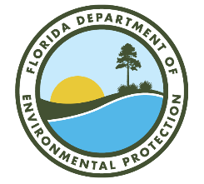

Lower St. Johns River Main Stem

Basin Management Action Plan (BMAP)

Annual Meeting

Via Webinar
November 2, 2023
2:00 P.M.

Webinar Registration Link: https://attendee.gotowebinar.com/register/6112264737973855072

Agenda

- BMAP Updates

- St. Johns River Water Management District (SJRWMD) Update

- Florida Department of Agriculture and Consumer Services (FDACS) Update

- Agriculture Enforcement Update

Please note the FTP site for documents pertaining to the various BMAPs: http://publicfiles.dep.state.fl.us/DEAR/BMAP/
For more information on the Lower St. Johns River Main Stem, contact: Tiffany Busby, 904-797/2721, TLBusby@wildwoodconsulting.net.
Note: The contact for the Lower St. Johns River Tributaries BMAP is Anita Stine at Anita.Stine@FloridaDEP.gov.

