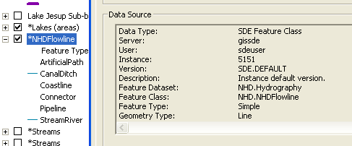
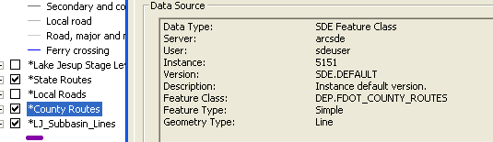

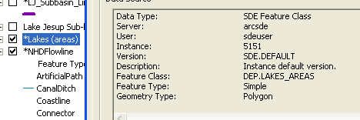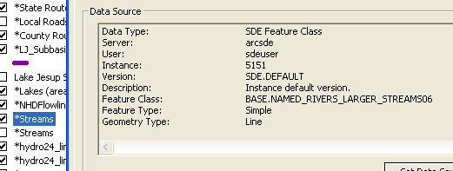

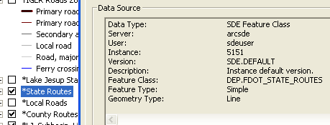

NHD Flowline

County Routes

Lakes (areas)

Streams

State Routes
  - Each of the above was used in the figures. These shapefiles are stored in the DEP SDE database. Access to these files is as follows:
Anita Nash will add to this when she gets the instructions. 1-15-10 (850) 245-8545

