Summary of the Lakes Harney and Monroe Total Maximum Daily Loads
November 2011

Basin Information
The Lakes Harney and Monroe total maximum daily loads (TMDLs) were adopted by the Florida Department of Environmental Protection (FDEP) in December 2009. The impaired waterbodies included in the TMDLs are Lake Harney, Lake Monroe, and the Middle St. Johns River between the inlet of Lake Harney and the confluence with the Wekiva River. The total watershed area that drains to these impaired waterbodies is 216,486 acres (see Figure 1). FDEP has divided the basin into waterbody identification (WBID) numbers. The TMDLs encompass six WBIDs that are impaired for dissolved oxygen (DO) and/or nutrients.

Sources in the TMDLs
The TMDLs identified nutrient loading from wastewater treatment facilities (WWTFs), municipal separate storm sewer systems (MS4s), other urban stormwater sources, agriculture, failing septic tanks, groundwater, atmospheric deposition, the Upper St. Johns River, Econlockhatchee River, and Lake Jesup. The BMAP focuses on the reductions assigned to the MS4s, other urban stormwater sources, failing septic tanks, and agriculture. The WWTF allocations were assigned in the TMDLs. Groundwater and atmospheric deposition are considered natural background and the TMDLs do not require reductions from these sources. The upstream river sources and Lake Jesup sources will be addressed through other plans. The following entities are located within the watershed and are considered stakeholders in the basin management action plan (BMAP):

- Sanford North WWTF
- Seminole County
- Volusia County
- City of DeBary
- City of DeLand
- City of Deltona
- City of Lake Helen
- City of Lake Mary
- City of Orange City
- City of Sanford
- Florida Department of Transportation (FDOT)
- Turnpike Authority
- Agriculture

Total Maximum Daily Load
The TMDL reductions are divided into a wasteload allocation (WLA) for point sources and a load allocation (LA) for nonpoint sources. Each WLA is further divided into wastewater (ww) and MS4 stormwater (sw) allocations. The reductions needed to achieve the TMDLs are summarized in Table 2.

Table 2: TMDLs for the Lakes Harney and Monroe Basin
WBID | Parameter | TMDL  (lbs/yr) | WLA ww  (lbs/yr) | WLA sw | LA  (lbs/yr)
2964A | TN | 3,355,570 | 0 | 39% | 3,355,570
2964A | TP | 241,026 | 0 | 33% | 241,026
2964 + 2893F | TN | 3,741,990 | 0 | 37% | 3,741,990
2964 + 2893F | TP | 276,141 | 0 | 32% | 276,141
2893D + 2893E | TN | 4,171,255 | 0 | 38% | 4,171,255
2893D + 2893E | TP | 315,512 | 0 | 31% | 315,512
2893C | TN | 4,202,340 | 19,342 | 37% | 4,182,998
2893C | TP | 318,236 | 2,345 | 31% | 315,891
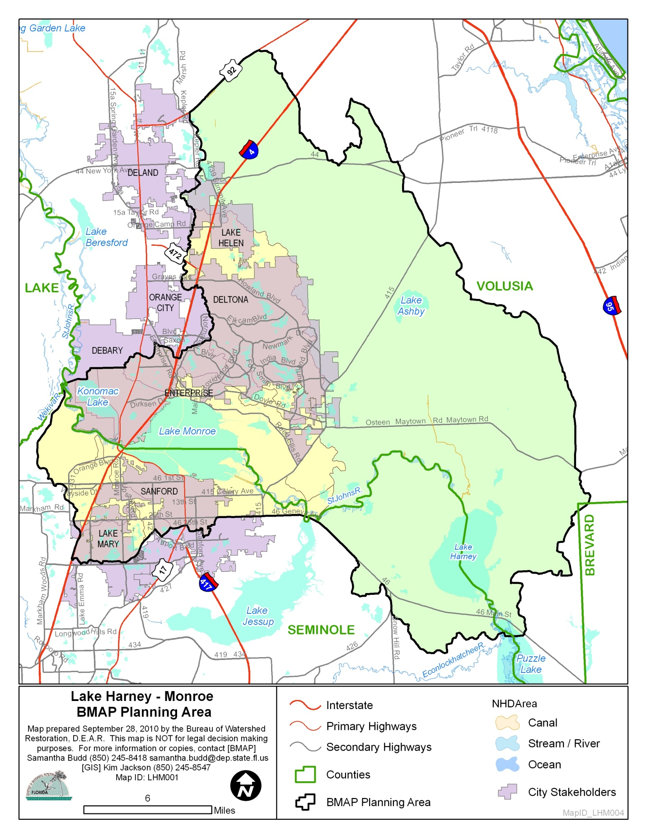Figure 1: Lakes Harney and Monroe BMAP Basin

