CHAPTER 6: ASSESSING PROGRESS AND MAKING CHANGES
Successful BMAP implementation requires commitment and follow-up. In the Commitment to Plan Implementation (see Chapter 7), stakeholders have expressed their intention to carry out the plan, monitor its effect, and continue to coordinate within and across jurisdictions to achieve water quality targets. The FWRA requires that an assessment be conducted every 5 years to determine whether there is reasonable progress in implementing the BMAP and achieving pollutant load reductions. This chapter contains the water quality monitoring component sufficient to make this evaluation.

WATER QUALITY MONITORING
The Lakes Harney and Monroe and MSJR BMAP monitoring plan is designed to enhance the understanding of basin loads, identify areas with high nutrient concentrations, and track water quality trends. This information will measure progress toward achieving the TMDLs and provide a better understanding of the watershed loading. Sampling stations, parameters, frequency, and other elements of this strategy may be modified as appropriate to match changing environmental conditions and funding resources. However, any modifications made shall not affect the ability of the monitoring network to fulfill the objectives noted below.

    - OBJECTIVES
Focused objectives are critical for a monitoring plan to provide the information needed to evaluate implementation success. The primary and secondary objectives of the monitoring plan for the Lakes Harney and Monroe and MSJR Basin are described below. Primary objectives are necessary to evaluate success of the BMAP. Secondary objectives contribute to this evaluation, can help interpret data collected, and provide information for potential future refinements of the TMDL and/or BMAP.
      - Primary Objective – Track inputs and trends in TN and TP loads in the major tributaries and Smith Canal.
      - Secondary Objective – Identify areas within the watershed with high loadings of nutrients to better focus management efforts.

    - WATER QUALITY INDICATORS AND RESOURCE RESPONSES
To achieve the objectives above, the monitoring plan focuses on two types of indicators to track water quality trends: core and supplemental (Table 26). The core indicators are directly related to the parameters causing impairment in the Lakes Harney and Monroe and MSJR Basin. Supplemental indicators are monitored primarily to support the interpretation of core water quality parameters. At a minimum, the core parameters will be tracked to determine progress towards meeting the TMDL. The water quality parameters for the tributaries are shown in Table 26 and the water quality parameters for the lakes are shown in Table 27.
TABLE 26: CORE AND SUPPLEMENTAL PARAMETERS FOR TRIBUTARIES MONITORING
CORE PARAMETERS | SUPPLEMENTAL PARAMETERS
Total phosphorus (as P) | Total suspended solids
Orthophosphate as P | Biochemical oxygen demand
Nitrate/nitrite as N | Chlorophyll-a
Total Kjeldahl nitrogen (TKN) | Ammonium

CORE PARAMETERS | SUPPLEMENTAL PARAMETERS
Dissolved oxygen | Color
Temperature | -
Specific conductance | -
pH – field | -

TABLE 27: CORE AND SUPPLEMENTAL PARAMETERS FOR LAKES MONITORING
CORE PARAMETERS | SUPPLEMENTAL PARAMETERS
Total phosphorus (as P) | Total suspended solids
Orthophosphate as P | Biochemical oxygen demand
Nitrate/nitrite as N | -
Total Kjeldahl nitrogen (TKN) | -
Dissolved oxygen | -
Temperature | -
Specific conductance | -
pH – field | -
Chlorophyll-a | -

In addition to the water quality parameters, resource responses to BMAP implementation will be monitored (see Section 6.1.4). The resource responses represent improvements in the overall ecological health of the waterbodies. As noted earlier, although nutrient reductions in the watershed are expected to occur over a relatively short period of time, the water quality of the impaired waterbodies will not improve until reductions are made in the upstream sources.

    - MONITORING NETWORK
The monitoring network for this plan builds upon existing efforts in the basin by:
      - City of Deltona;
      - Seminole County;
      - SJRWMD;
      - Volusia County; and
      - U.S. Geological Survey (USGS).
Table 28 lists the stations that are included in the BMAP monitoring network. The water quality monitoring will be conducted on a monthly basis to assess the conditions in the watershed and within the lakes and tributaries to determine changes in water quality from the actions implemented as part of the BMAP. The stations in the monitoring network are also shown in Figure 6 through Figure 8.
TABLE 28: BMAP MONITORING NETWORK
ENTITY | STATION ID | STATION DESCRIPTION | YEAR SITE ESTABLISHED | STATION TYPE
Deltona | Gleason1 | Gleason Basin Outfall | 2011 | Water Quality
Deltona | Providence1 | Providence Basin Outfall | 2011 | Water Quality
Deltona | McGarity1 | McGarity Basin Outfall | 2011 | Water Quality
Seminole County | 1014 | Smith Canal (SMI) | 2000 | Water Quality

ENTITY | STATION ID | STATION DESCRIPTION | YEAR SITE ESTABLISHED | STATION TYPE
Sanford/Seminole County | Mill1 | Mills Creek Outfall to Monroe | 2012 | Water Quality
SJRWMD | LA-OW-S | Lake Ashby open water | 2003 | Water Quality
SJRWMD | SJR-415 | St. Johns River at 415 Bridge at Sanford | 2002 | Water Quality
SJRWMD | SJR-DPP | St. Johns River downstream of Power Plant | 2002 | Water Quality
SJRWMD | SJR-OLH | Lake Harney Outfall - St. Johns River | 2002 | Water Quality
SJRWMD | SRN | Lake Harney inflow - St. Johns River at SR46 Bridge | 1982 | Water Quality
SJRWMD* | DCD-MRD | Deep Creek Diversion at Maytown Road | 2011 | Water Quality
SJRWMD | OW-SJR-1 | Mid SJR east of Barge Canal and east of JJ Fish Camp | 1996 | Water Quality
SJRWMD | CLH | Center of Lake Harney | 2001 | Water Quality
SJRWMD | DMR | Deep Creek at Maytown Road | 1985 | Water Quality
SJRWMD | LMAC | Lake Monroe at Center | 1991 | Water Quality
Volusia County | VC-044 | St. Johns River, at Lemon Bluff | 2005 | Water Quality
Volusia County | VC-047A | St. Johns River, S. end of Lake Monroe | 2012 | Water Quality
Volusia County* | VC-092 | DC3 Lake Ashby Canal at Maytown Rd | 2003 | Water Quality
Volusia County | VC-DC04 | DC4 Deep Creek | 2005 | Water Quality
Volusia County | VC-DC05 | DC5 Deep Creek | 2005 | Water Quality
Volusia County | VC-COW | Cow Creek | 2012 | Water Quality
Volusia County | VC-082 | Gemini North (west boil) | 2000 | Water Quality
Volusia County | VC-083 | Gemini Springs outfall | 2000 | Water Quality
Volusia County | VC-084 | Volusia Green Springs | 2000 | Water Quality
USGS | 2234000 | St. Johns River Above Lake Harney near Geneva, FL | 1981 | Flow
USGS | 2234500 | St. Johns River Near Sanford, FL | 1995 | Flow
* Note: These stations are located in the same location and will each be sampled bi-monthly.

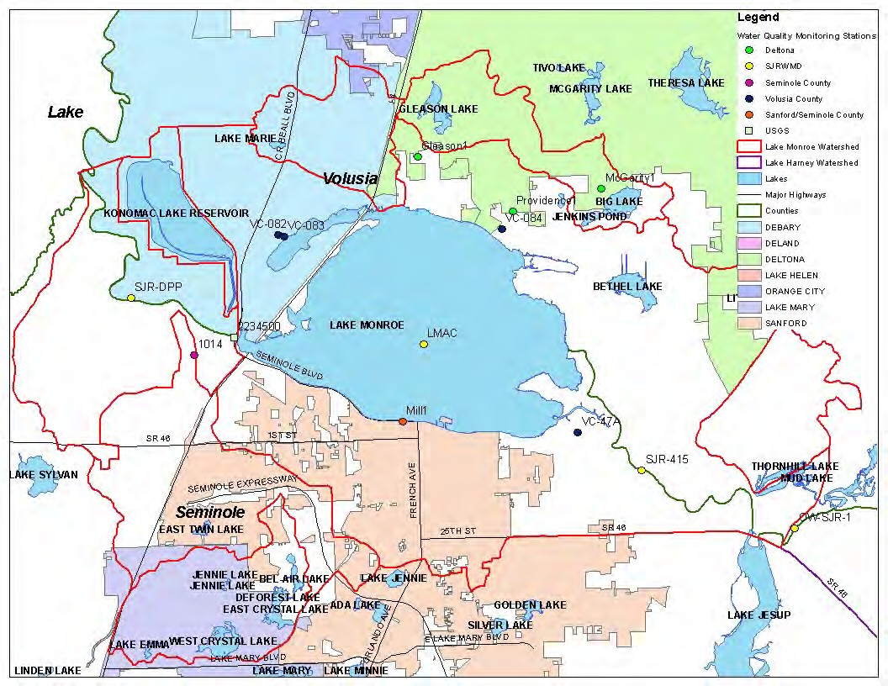
FIGURE 6: WATER QUALITY MONITORING STATIONS IN THE LAKE MONROE BASIN

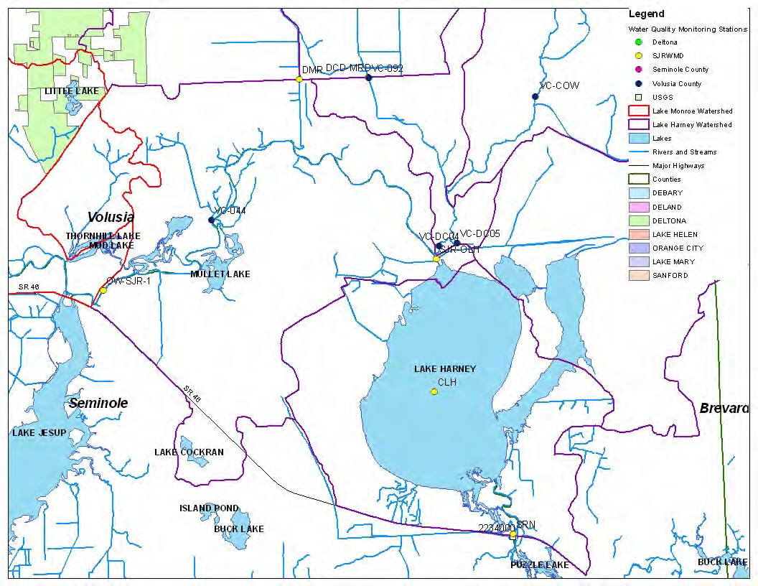
FIGURE 7: WATER QUALITY MONITORING STATIONS IN THE SOUTHERN LAKE HARNEY BASIN

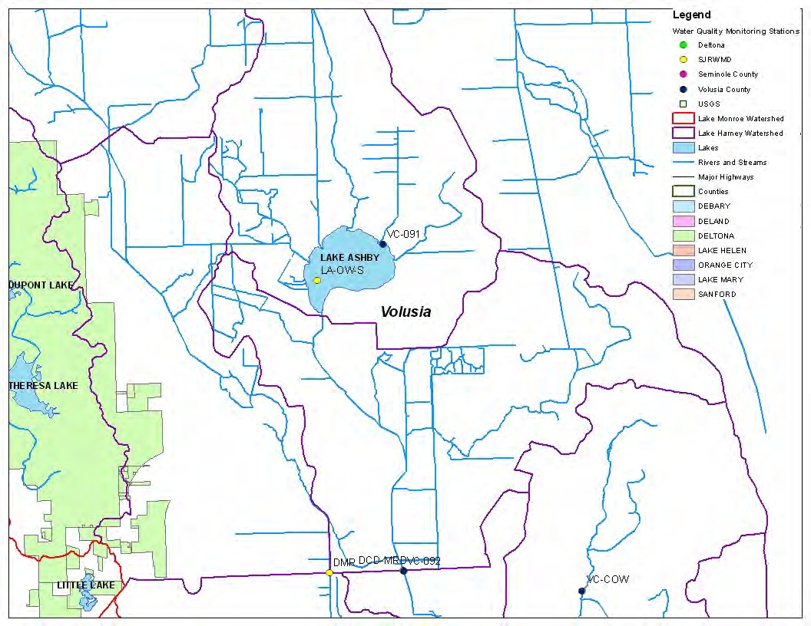
FIGURE 8: WATER QUALITY MONITORING STATIONS IN THE NORTHERN LAKE HARNEY BASIN

    - BIOLOGICAL AND VEGETATION MONITORING
Bioassessments are desirable tools for detecting the severity of impairments affecting the flora and/or fauna of a waterbody. As water chemistry results provide detailed information regarding the health of a waterbody at a specific time, bioassessment results reflect the health of the biological communities within the waterbody over a longer period of time. Seminole County employs various FDEP designed bioassessment tools to detect changes in these biological communities, as described below.
The Lake Vegetation Index (LVI) is a multi-metric index that evaluates how closely a lake’s plant community resembles one that has very little human disturbance. Lake Harney has been monitored annually using the LVI in 2005, and 2007-2011. Lake Monroe is likewise monitored annually for the period of 2008-2011.
The Lake Condition Index (LCI) is also a multi-metric index that is based on the macroinvertebrate assemblage within a lake with “best available” conditions upon which comparisons can be made to assess the health of the lake being monitored. LCIs have been performed on Lake Harney in 2003-2008 and 2010. Lake Monroe was monitored using this tool in 2008 and 2010. After collecting years of LCI data, recent research led FDEP to come to the conclusion that this tool was not exposing human disturbance as well as had been expected. Seminole County continues to use the LCI for establishing health trends in lakes. However, collecting and assessing benthic macroinvertebrates in lakes using the conventional methods, such as the basic Shannon-Weaver Index, have been added to the monitoring program. Lake Harney and Lake Monroe were both sampled once during 2011 using the Shannon-Weaver Index.
The Stream Condition Index (SCI) is another multi-metric tool that assesses the macroinvertebrate communities and compares the results to “minimally disturbed” reference sites. Seminole County’s monitoring site on Smith Canal was assessed annually for the period of 2007-2009, and will be monitored again in 2012.
Seminole County also conducts lake assessments on a routine basis, usually quarterly, for Lakes Harney and Monroe to assess and document the condition of the waterbody and aquatic plant management activities. In addition to specific lake management strategies, long and short term trends are developed using these assessments, which includes tracking aquatic vegetation types, growth rate, diversity of species (flora and fauna), native and non-native species, clarity, and overall health. Lake assessments are performed in compliance with state and federal standards and methodologies by certified professional Seminole County Lake Management Program staff and results are provided in a narrative report distributed to the regulatory agencies within the MSJR Basin.
SJRWMD also conducts monthly sampling and analysis of phytoplankton at 7 stations in the watershed. This sampling started in 2002 for most stations and in 2003 for the Lake Monroe and Lake Ashby stations and will continue as long as budget for this effort is available.
The biological and vegetation monitoring conducted by Seminole County and SJRWMD is listed in Table 29 and shown in Figure 9.
TABLE 29: BIOLOGICAL AND VEGETATION MONITORING
ENTITY | STATION NAME | YEAR SITE ESTABLISHED | END DATE | STATION TYPE | SAMPLING PARAMETERS
Seminole County | Lake Harney North (HRN-N) | 2003 | 2010 | LCI | Macroinvertebrates
Seminole County | Lake Harney South (HRN-S) | 2003 | 2010 | LCI | Macroinvertebrates

ENTITY | STATION NAME | YEAR SITE ESTABLISHED | END DATE | STATION TYPE | SAMPLING PARAMETERS
Seminole County | Lake Monroe North (MONN) | 2008 | 2010 | LCI | Macroinvertebrates
Seminole County | Lake Monroe South (MONS) | 2008 | 2010 | LCI | Macroinvertebrates
Seminole County | Lake Harney North (HRN-N) | 2011 | Ongoing | Shannon- Weaver | Macroinvertebrates
Seminole County | Lake Harney South (HRN-S) | 2011 | Ongoing | Shannon-  Weaver | Macroinvertebrates
Seminole County | Lake Monroe North (MONN) | 2011 | Ongoing | Shannon- Weaver | Macroinvertebrates
Seminole County | Lake Monroe South (MONS) | 2011 | Ongoing | Shannon- Weaver | Macroinvertebrates
Seminole County | Lake Harney (HRN) | 2005 | Ongoing | LVI | Vegetation index, submersed, and shoreline
Seminole County | Lake Monroe (MON) | 2008 | Ongoing | LVI | Vegetation index, submersed, and shoreline
Seminole County | Lake Harney (HRN) | 2007 | Ongoing | Lake  Assessment | Whole lake vegetation data;  secchi
Seminole County | Lake Monroe (MON) | 2007 | Ongoing | Lake Assessment | Whole lake vegetation data; secchi
Seminole County | Smith Canal (SMI) | 2007 | Ongoing | SCI | Macroinvertebrates
SJRWMD | Lake Monroe at Center (LMAC) | 2003 | Ongoing | Biological | Phytoplankton
SJRWMD | St. Johns River at 415  Bridge at Sanford (SJR-415) | 2002 | Ongoing | Biological | Phytoplankton
SJRWMD | Mid SJR east of Barge Canal and east of JJ Fish Camp  (OW-SJR-1) | 2002 | Ongoing | Biological | Phytoplankton
SJRWMD | Center of Lake Harney (CLH) | 2002 | Ongoing | Biological | Phytoplankton
SJRWMD | Lake Ashby open water (LA- OW-S) | 2003 | Ongoing | Biological | Phytoplankton
SJRWMD | Lake Harney inflow – St. Johns River at SR46 Bridge (SRN) | 2002 | Ongoing | Biological | Phytoplankton

FINAL Lakes Harney and Monroe and MSJR Basin Management Action Plan – August 2012

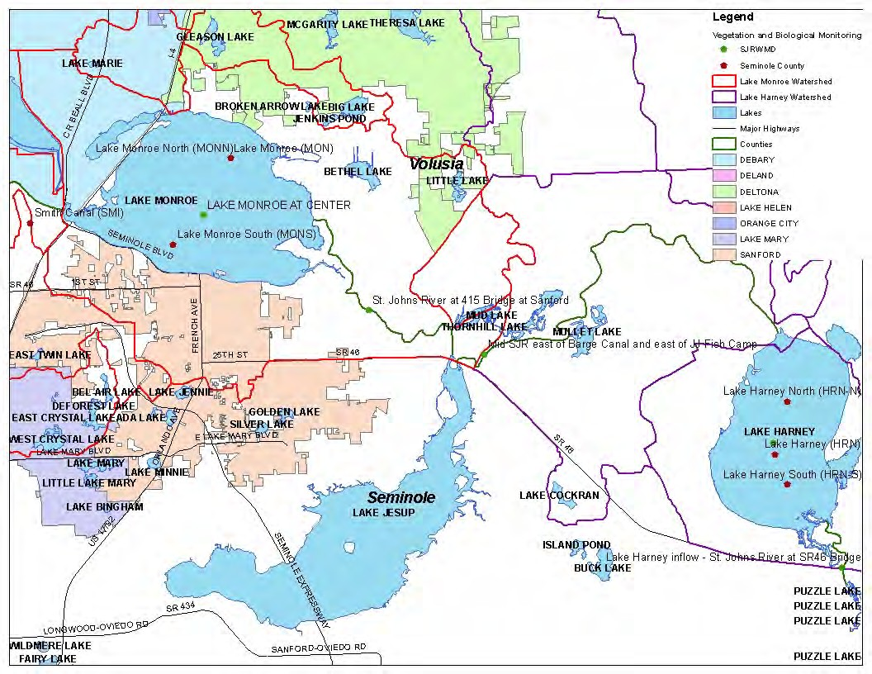
FIGURE 9: BIOLOGICAL AND VEGETATION MONITORING STATIONS IN THE LAKES HARNEY AND MONROE AND MSJR BMAP

    - DATA MANAGEMENT AND ASSESSMENT
The Florida STORET database serves as the primary repository of ambient water quality data for the state of Florida. FDEP pulls water quality data used for impaired water evaluations and TMDL development directly from the STORET database. Ambient water quality data collected as part of the BMAP will be uploaded into STORET for long-term storage and availability. SJRWMD, FDEP, and some local stakeholders currently upload water quality data into STORET. All BMAP data providers have agreed to upload ambient water quality data to STORET at least once every six months, upon completion of the appropriate quality assurance/quality control (QA/QC) checks.
Other data, such as biological and storm event, may also be collected and the STORET database is not equipped to store these types of data. Stakeholders agree to provide these data to other BMAP partners upon request and when appropriate for inclusion in BMAP data analyses and adaptive management evaluations.
The water quality data will be analyzed after four years of BMAP implementation to determine trends in water quality in the lakes and their tributaries. A wide variety of statistical methods are available for trend analyses. The selection of an appropriate data analysis method depends on the frequency, spatial distribution, and period of record available from existing data. Specific statistical analyses were not identified during BMAP development; however, commonly accepted methods of data analysis will be used that are consistent with the TMDL model.

    - QUALITY ASSURANCE/QUALITY CONTROL
Stakeholders participating in the monitoring plan must collect water quality data in a manner consistent with FDEP’s SOPs for QA/QC. The most current version of these procedures can be downloaded from http://www.dep.state.fl.us/water/sas/sop/sops.htm. For BMAP-related data analyses, entities should use National Environmental Laboratory Accreditation Council (NELAC) National Environmental Laboratory Accreditation Program (NELAP) certified laboratories (http://www.dep.state.fl.us/labs/cgi-bin/aams/index.asp) or other labs that meet the certification and other requirements outlined in the SOPs. SJRWMD staff and contractors collect, process, and preserve samples according to the SJRWMD’s Standard Operating Procedures for the Collection of Surface Water Quality Samples and Field Data–Feb. 13, 2004. Where SJRWMD and FDEP SOP’s do not correspond to one another, SJRWMD staff and contractors defer to FDEP’s SOPs.

TRACKING IMPLEMENTATION
FDEP will work with the stakeholders to organize the monitoring data and track project implementation. This information will be presented in an annual report. The technical stakeholders will meet at least every 12 months after the adoption of the BMAP to follow up on plan implementation, share new information, and continue to coordinate on TMDL-related issues. The following types of activities may occur at annual meetings:
- Implementation Data and Reporting
  - Collect project implementation information from the stakeholders and MS4 permit reporting and compare with the BMAP schedule.
  - Discuss the data collection process, including any concerns and possible improvements to the process.
  - Review the monitoring plan implementation, as detailed in Section 6.1.

- Sharing New Information
  - Report on results from water quality monitoring and trend information.
  - Provide updates on new projects and programs in the basin that will help reduce nutrient loading.
  - Identify and review new scientific developments on addressing nutrient loading and incorporate any new information into annual progress reports.
  - Discuss new sampling technologies that will improve source identification.
  - Provide updates to the stakeholders on HSPF model modifications to validate assumptions.

- Coordinating TMDL-Related Issues
  - Provide updates from FDEP on the basin cycle and activities related to any impairments, TMDLs, and BMAP.
  - Obtain reports from other basins where tools or other information may be applicable to the Lakes Harney and Monroe and MSJR TMDLs.

Covering all of these topics is not required for the annual meetings, but they provide examples of the types of information that should be considered for the agenda to assist with BMAP implementation and improve coordination among the agencies and stakeholders.

