2014 Progress Report

For the Lake Jesup
Basin Management Action Plan

prepared by the
Division of Environmental Assessment and Restoration
Water Quality Restoration Program
Florida Department of Environmental Protection
Tallahassee, Florida 32399

in cooperation with the
Lake Jesup Basin Working Group

August 2014
Acknowledgements
This 2014 Lake Jesup BMAP Progress Report was prepared as part of a statewide watershed management approach to restore and protect Florida’s water quality. It was prepared by the Florida Department of Environmental Protection in cooperation with the Lake Jesup stakeholders.

 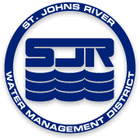                 Orlando-Orange County Expressway Authority

For additional information on the watershed management approach in the Lake Jesup Basin, contact:

Moira Rojas, Basin Coordinator
Florida Department of Environmental Protection
Water Quality Restoration Program, Watershed Planning and Coordination Section
2600 Blair Stone Road, Mail Station 3565
Tallahassee, FL 32399-2400
Email: Moira.Rojas@dep.state.fl.us
Phone: (850) 245–8460

Table of Contents
List of Acronyms and Abbreviations vi
Summary vii
Section 1 : Introduction 1
1.1 Purpose of the Report 1
1.2 TMDLs for the Lake Jesup Basin 1
1.3 Responsible Parties and Key Stakeholders 3
1.4 BMAP Allocations 4
Section 2 : Accomplishments 5
2.1 Summary of Efforts 5
2.2 Accomplishments by Entity 5
2.2.1 City of Altamonte Springs 5
2.2.2 City of Casselberry 5
2.2.3 City of Lake Mary 9
2.2.4 City of Longwood 9
2.2.5 City of Maitland 9
2.2.6 City of Orlando 9
2.2.7 City of Oviedo 10
2.2.8 City of Sanford 10
2.2.9 City of Winter Park 10
2.2.10 City of Winter Springs 11
2.2.11 FDOT District 5 12
2.2.12 Orange County 12
2.2.13 Seminole County 13
2.2.14 Town of Eatonville 14
2.2.15 Turnpike Authority 14
2.2.16 Agriculture 15
2.3 Summary of Accomplishments 17
2.4 Improving Scientific Understanding 18
2.4.1 Water Quality Monitoring 18
2.4.2 Research Priorities 25
2.5 TMDL Model Update 25
Section 3 : Upcoming Year Activities 27
3.1 Summary of Efforts for the Upcoming Year 27
3.2 Upcoming Efforts by Entity 27
3.2.1 City of Casselberry 27
3.2.2 City of Longwood 27
3.2.3 City of Maitland 27
3.2.4 City of Orlando 27
3.2.5 City of Oviedo 27
3.2.6 City of Winter Park 27
3.2.7 FDOT District 5 28
3.2.8 Orange County 28
3.2.9 Seminole County 28
3.2.10 Agriculture 28
3.3 Water Quality Monitoring 28
Appendix A: BMAP Projects 30
Appendix B: Water Quality Data 53
List of Figures
Figure ES-1: Progress Towards the Lake Jesup TP TMDL Through May 31, 2014 viii
Figure 1: Lake Jesup and Local Government Jurisdictions in the Basin 2
Figure 2: City of Casselberry Cleanout Sequence for the Lake Hodge Baffle Box 7
Figure 3: City of Casselberry Bioswale/Bioretention Area (Foreground) for North Lake Triplet (Background) Shoreline Revegetation Project 8
Figure 4: City of Casselberry Earthfest in April 2014 8
Figure 5: City of Maitland Street Sweeper 9
Figure 6: City of Winter Park Canton Baffle Box 11
Figure 7: City of Winter Park North Exfiltration Treatment Project 11
Figure 8: City of Winter Springs Solary Canal Regional Stormwater Treatment Facility 12
Figure 9: Orange County Clean Inlet Basket Inside Curb Inlet (Left) and Inlet Basket Full of Debris Ready for Processing (Right) 13
Figure 10: Seminole County Lake Restoration Event with Volunteers 14
Figure 11: Seminole County Repair of the Submerged Aquatic Vegetation Exclusion Area 14
Figure 12: Agricultural Operations Enrolled in FDACS BMP Programs in the Lake Jesup BMAP Area as of March 31, 2014 16
Figure 13: Progress Towards the Lake Jesup TP TMDL Through May 31, 2014 18
Figure 14: City of Sanford Site 10 Improvements 21
Figure 15: Site 10 Storm Event Samples for TN 22
Figure 16: Site 10 Storm Event Samples for TP 22
Figure 17: Site 10 Grab Samples for TN 23
Figure 18: Site 10 Grab Samples for TP 23
Figure 19: Site 10 Grab Sample Collection Locations 24

List of Tables
Table 1: TMDLs in the Lake Jesup Basin 1
Table 2: TP Wasteload Allocations for 2010-2015 4
Table 3: Agricultural Acres Enrolled in FDACS BMPs in the Lake Jesup BMAP Area 15
Table 4: Agricultural TP Load Reduction Allocation and Estimated Reductions in TP Loads 17
Table 5: Summary of Projects Completed in the Reporting Period (June 1, 2013 Through May 31, 2014) 18
Table A-1: City of Altamonte Springs Projects 31
Table A-2: City of Casselberry Projects 32
Table A-3: City of Lake Mary Projects 36
Table A-4: City of Longwood Projects 36
Table A-5: City of Maitland Projects 37
Table A-6: City of Orlando Projects 39
Table A-7: City of Oviedo Projects 42
Table A-8: City of Sanford Projects 42
Table A-9: City of Winter Park Projects 43
Table A-10: City of Winter Springs Projects 46
Table A-11: Florida Department of Transportation Projects 47
Table A-12: Orange County Projects 48
Table A-13: Orlando Orange County Expressway Authority Projects 48
Table A-14: Seminole County Projects 49
Table A-15: Town of Eatonville Projects 52
Table A-16: Turnpike Authority Projects 52
Table B-1: City of Winter Park Sampling Results 53
Table B-2: City of Altamonte Springs Sampling Results 54
Table B-3: City of Maitland Sampling Results 54
Table B-4: City of Orlando Sampling Results 55

List of Acronyms and Abbreviations
BMAP Basin Management Action Plan
BMP Best Management Practice
BOD Biological Oxygen Demand
CDS Continuous Deflective Separation (Unit)
Department Florida Department of Environmental Protection
FDACS Florida Department of Agriculture and Consumer Services
FDOT Florida Department of Transportation
FWC Florida Fish and Wildlife Conservation Commission
FYN Florida Yards and Neighborhood (Program)
HSPF Hydrologic Simulation Program – FORTRAN (model)
I/I Inflow and Infiltration
lbs/yr Pounds per Year
mg/L Milligrams per Liter
MS4 Municipal Separate Storm Sewer System
O&M Operations and Maintenance
OOCEA Orlando Orange County Expressway Authority
PSA Public Service Announcement
RSF Regional Stormwater Facility
SJRWMD St. Johns River Water Management District
STORET STOrage and RETrieval (Database)
TKN Total Kjeldahl Nitrogen
TMDL Total Maximum Daily Load
TN Total Nitrogen
TP Total Phosphorus
TSI Trophic State Index
UF–IFAS University of Florida–Institute of Food and Agricultural Sciences
WASP Water Quality Analysis Simulation Program
WBID Waterbody identification

Summary
Total Maximum Daily Loads
Lake Jesup is one of the largest lakes in Central Florida and is part of the St. Johns River system. Lake Jesup has a surface area of about 10,660 acres and drains a watershed of about 86,382 acres, including a large portion of Seminole County, a small portion of Orange County, the entire City of Winter Springs, and portions of the following municipalities: Altamonte Springs, Casselberry, Eatonville, Lake Mary, Longwood, Maitland, Orlando, Oviedo, Sanford, and Winter Park. The Florida Department of Environmental Protection identified Lake Jesup to be impaired for nutrients, and, in 2006, adopted total maximum daily loads (TMDLs) for total phosphorus (TP) and total nitrogen (TN) for the lake. The TMDLs required a 34% reduction in TP to achieve the target concentration of 0.096 milligrams per liter (mg/L) and a 50% reduction in TN to achieve the target concentration of 1.27 mg/L.
The Lake Jesup Basin Management Action Plan (BMAP) was adopted in May 2010 to implement the TP TMDL. The focus on the TP loads was driven by the significant role of nitrogen fixation in Lake Jesup and several unknowns regarding internal nutrient cycling in the lake, including mineralization and resuspension from the sediments to the water column, mass deposition from the water column to the sediments, and diffusion. However, the stakeholders have been conducting studies to evaluate the unknowns and plan to include TN load reductions in the second iteration of the BMAP. The BMAP allocated the required surface runoff and septic tank reductions to the responsible entities. To allow time for additional monitoring and research studies to address the unknowns identified, the required reductions were split into three, five-year time periods. The adopted BMAP addresses the first one-third of the required reductions.
This 2014 Progress Report is the fourth annual progress report for the Lake Jesup BMAP, and it describes the accomplishments and issues identified during the reporting period from June 1, 2013 through May 31, 2014.
Accomplishments
The fourth year of BMAP implementation has been successful. The total estimated project reductions during the reporting period were 337.2 pounds per year (lbs/yr) of TP. The total BMAP project reductions, including those shown as completed in the BMAP and the projects completed during the first four years of implementation are 12,987.1 lbs/yr of TP, which are greater than the required reduction in the first BMAP iteration of 6,249.5 lbs/yr of TP. The total reductions, including those from completed projects to date and the load within noncontributing areas to the lake, are 14,022.1 lbs/yr of TP, which is a 71.5% reduction from the starting load. The goal of the first BMAP iteration was a 33% reduction in TP.
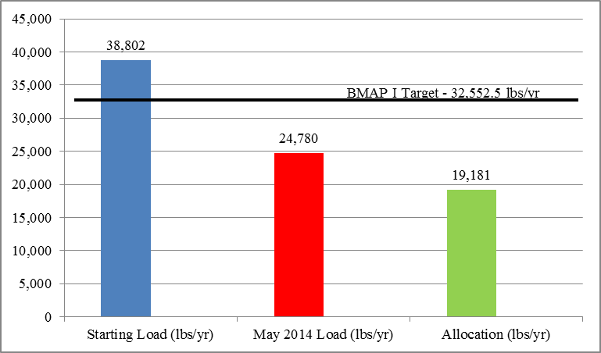
Figure ES-1: Progress Towards the Lake Jesup TP TMDL Through May 31, 2014

During the reporting period (June 1, 2013 through May 31, 2014), the City of Winter Park completed two projects, an exfiltration trench project and a baffle box project, with reductions of 9.7 lbs/yr of TP and 6.6 lbs/yr of TP, respectively. The City of Oviedo adopted a pet waste ordinance for a reduction of 5.8 lbs/yr of TP, and completed a stormwater treatment project for a reduction of 1.9 lbs/yr. Orange County installed 40 curb inlet baskets in the Lake Burkett sub-basin resulting in a reduction of 11.5 lbs/yr of TP. Seminole County completed a wet detention pond project for a reduction of 156.8 lbs/yr of TP. The Florida Department of Agriculture and Consumer Services (FDACS), through field staff and contracted staff with the East Central Florida Resource Conservation and Development Council, has been working on enrolling growers in the container nursery, citrus, and cow/calf best management practice (BMP) programs. Most of the efforts so far have concentrated on the container nurseries and cow/calf operations.
Several of the research studies to gather additional data for the next iteration of the TMDL and BMAP have been completed or are ongoing. In addition, the responsible stakeholders implemented the BMAP monitoring plan to gather water quality data for Lake Jesup and its tributaries.
Activities for the Upcoming Year
The five-year BMAP assessment report will encompass the period of June 1, 2014 through May 31, 2015. Seminole County will complete two wet detention ponds, one of which will achieve a reduction of 229 lbs/yr of TP and other which has an estimated reduction range between 82 lbs/yr and 238 lbs/yr of TP. The City of Maitland will complete a baffle box project for a reduction of 7.7 lbs/yr of TP, and an infiltration trench project for a reduction of 0.9 lbs/yr. The City of Casselberry will complete two shoreline vegetation projects for a reduction of 1.1 lbs/yr, and an alum treatment project for a reduction of 510.4 lbs/yr. The City of Orlando will complete a stormwater retrofit and alum treatment project for a reduction of 3.8 lbs/yr. Orange County will complete installation of the second phase of curb inlet baskets in the Lake Martha and Burkett drainage basin for an estimated reduction of 12.7 lbs/yr of TP. The Florida Department of Transportation (FDOT), City of Winter Park, and Seminole County will each begin construction on projects. FDACS will continue to sign up growers for BMPs under the container nursery, citrus, and cow/calf manuals, and FDACS will also explore opportunities for more one-on-one work and/or workshops with growers in the basin to ensure the proper implementation of BMPs. In addition, BMAP monitoring will continue.
In addition, the St. Johns River Water Management District (SJRWMD) engineering staff are developing both a watershed loading model, Hydrologic Simulation Program – FORTRAN (HSPF), and an in-lake water quality model, Water Quality Analysis Simulation Program (WASP) for the Lake Jesup Basin. Results from this modeling will facilitate the recalculation of the TMDLs for TP and TN, as needed.

: Introduction

Purpose of the Report
This is the fourth annual progress report for the Lake Jesup Basin Management Action Plan (BMAP). Section 2 describes the accomplishments and the progress toward meeting the total maximum daily load (TMDL) during the period from June 1, 2013 through May 31, 2014. A summary of efforts scheduled for the upcoming year (June 1, 2014 through May 31, 2015) is included in Section 3.

TMDLs for the Lake Jesup Basin
Lake Jesup is one of the largest lakes in Central Florida and is part of the St. Johns River system. Lake Jesup has a surface area of about 10,660 acres (16.7 square miles) and drains a watershed of about 87,322 acres (136.4 square miles), including a large portion of Seminole County, a small portion of Orange County, the entire City of Winter Springs, and portions of the following municipalities: Altamonte Springs, Casselberry, Eatonville, Lake Mary, Longwood, Maitland, Orlando, Oviedo, Sanford, and Winter Park. At high stage levels, Lake Jesup has surface area up to 16,000 acres. Lake Jesup includes waterbody identification numbers (WBIDs) 2981 and 2981A. The subbasins and local governments located in the Lake Jesup Basin are shown in Figure 1.
The TMDLs for the Lake Jesup Basin were adopted by the Florida Department of Environmental Protection in April 2006 for total phosphorus (TP) and total nitrogen (TN). The focus of the BMAP is to achieve reductions in external TP loads to the lake. The focus on external TP loads was driven by the significant role of nitrogen fixation in Lake Jesup and several unknowns regarding internal nutrient cycling in the lake. The stakeholders have been conducting studies to evaluate TN loading and in-lake processes and plan to include TN load reductions in the second iteration of the BMAP.
Table 1 lists the TMDLs and pollutant load allocations adopted by rule for the Lake Jesup Basin.
Table 1: TMDLs in the Lake Jesup Basin
WBID(s) | TMDL  (pounds per year [lbs/yr]) | Target Concentration  (milligrams per liter [mg/L]) | Wasteload Allocation  Stormwater | Load Allocation  (nonpoint)
2981 (Including 2981A) | 41,888 TP | 0.096 | 34% | 34%
2981 (Including 2981A) | 545,203 TN | 1.27 | 50% | 50%

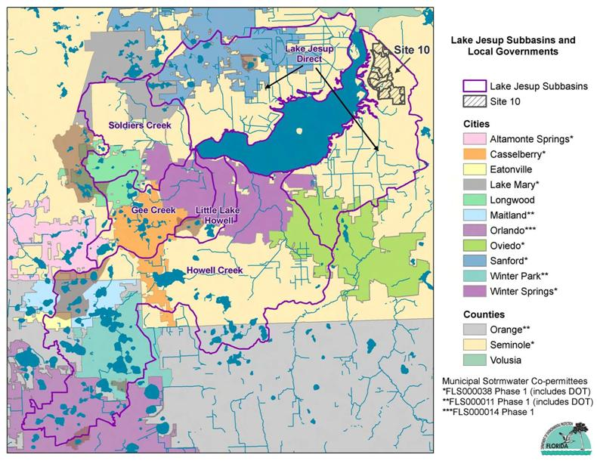
Figure 1: Lake Jesup and Local Government Jurisdictions in the Basin

Responsible Parties and Key Stakeholders
The Lake Jesup BMAP identified municipal separate storm sewer systems (MS4s), septic tanks, and agricultural sources of TN and TP in the basin. Those entities that are responsible for achieving the load reductions are:
- Agriculture
- City of Altamonte Springs
- City of Casselberry
- City of Lake Mary
- City of Longwood
- City of Maitland
- City of Orlando
- City of Oviedo
- City of Sanford
- City of Winter Park
- City of Winter Springs
- Florida Department of Transportation (FDOT) District 5
- Orange County
- Orlando Orange County Expressway Authority (OOCEA)
- Seminole County
- Town of Eatonville
- Turnpike Authority
In addition to the these entities, the Florida Department of Agriculture and Consumer Services (FDACS), the Department, and St. Johns River Water Management District (SJRWMD) are essential to the implementation of the BMAP activities.

BMAP Allocations
Stakeholders in the Lake Jesup Basin agreed that a fair approach for allocations would be to determine the relative contribution of each entity to the surface runoff and septic tank (if applicable) loadings and use this relative contribution to apportion the required reductions. This percentage was separately calculated for each entity for the surface runoff load and septic tank load. To allow time for additional monitoring and research studies (see Section 2.4) to address the unknowns identified in the BMAP, the required reductions were split into three, five-year time periods. The adopted BMAP addresses the first one-third of the required reductions over the period from BMAP adoption (May 2010) through May 31, 2015, as shown in Table 2.
Table 2: TP Wasteload Allocations for 2010-2015
Allocation Entity | 2010-2015 Total Required Reduction (lbs/yr)
Agriculture | 254.7
City of Altamonte Springs | 19.0
City of Casselberry | 342.7
City of Lake Mary | 264.3
City of Longwood | 205.3
City of Maitland | 124.8
City of Orlando | 326.3
City of Oviedo | 258.7
City of Sanford | 602.2
City of Winter Park | 370.5
City of Winter Springs | 513.0
FDOT District 5 | 132.3
OOCEA | 5.2
Orange County | 569.0
Seminole County | 2,137.0
Town of Eatonville | 23.4
Turnpike Authority | 101.1
Total | 6,249.5

: Accomplishments

Summary of Efforts
The fourth year of BMAP implementation has been successful. During the reporting period, the City of Winter Park completed two projects, an exfiltration trench project and a baffle box project, with reductions of 9.7 lbs/yr of TP and 6.6 lbs/yr of TP, respectively. The City of Oviedo adopted a pet waste ordinance for a reduction of 5.8 lbs/yr of TP, and completed a stormwater treatment project for a reduction of 1.9 lbs/yr. Orange County installed 40 curb inlet baskets in the Lake Burkett sub-basin resulting in a reduction of 11.5 lbs/yr of TP. Seminole County completed a wet detention pond project for a reduction of 156.8 lbs/yr of TP. The Florida Department of Agriculture and Consumer Services (FDACS), through field staff and contracted staff with the East Central Florida Resource Conservation and Development Council, has been working on enrolling growers in the container nursery, citrus, and cow/calf best management practice (BMP) programs. Most of the efforts so far have concentrated on the container nurseries and cow/calf operations.
Several research studies to gather additional data for the next iteration of the TMDL and BMAP have been completed or are ongoing. In addition, the responsible stakeholders implemented the BMAP monitoring plan to gather water quality data for Lake Jesup and its tributaries.
Additional details about the accomplishments over the past year are described in Section 2.2 through Section 2.4. The individual project tables are included in Appendix A, and photographs of project implementation efforts are included in Section 2.2.

Accomplishments by Entity

City of Altamonte Springs
The City of Altamonte Springs continues to fund and participate in the Florida Yards and Neighborhoods (FYN) program through Seminole County and University of Florida–Institute of Food and Agricultural Sciences (UF-IFAS) Extension office (Project A-3). In addition, the city’s street sweeping program continues to operate year-round and citywide (Project A-2).

City of Casselberry
As reported previously, a series of whole lake alum treatments were proposed for two lakes to cost effectively bind phosphorus in the sediments, reducing loads and water quality impacts through internal nutrient recycling and groundwater seepage. In 2013, this project was expanded to include a total of four lakes (Middle, North, and South Lake Triplet, and Queen’s Mirror Lake) (Project C-21). The city also completed a total of eight whole lake alum treatments over the past year and has two more planned in the coming year. These projects are anticipated to bind a total of over 5,100 pounds of phosphorus over a ten year period, and it is hoped that significant water quality improvements in these lakes, as well as positive downstream effects, will be evidenced by the city’s long-term monitoring data. At a total cost of about $282/lbs of TP removed, this project is more cost effective than most conventional stormwater treatment projects. Altogether 14 treatments have been completed so far, with two more planned for completion in fall 2014 to conclude the project. The total cost of the project is anticipated to be approximately $297,016 and is fully funded.
The city concluded field work on the effectiveness evaluation of multiple baffle boxes, inlet filter baskets, and a continuous deflective separation (CDS) unit (see Figure 2). A draft report was completed in early 2014 and is anticipated to be finalized by fall 2014. Design differences between the various baffle boxes studied in the project amplify the importance of the study (e.g., some feature media filters, while others feature additives to prevent anoxic conditions). It is hoped the results of this study will provide information statewide in helping agencies choose the most cost effective forms of pollutant reduction for particular applications. This study will also help guide the city in modifying its future proposed projects for the BMAP, as necessary, to improve their cost effectiveness. Based on the draft report (subject to change), TP removal by the various baffle boxes ranged from 10% to 57%, with a removal cost estimate ranging from $4.48/lb of TP to $24,658/lb of TP. Those baffle boxes with media filtration and special additives to prevent anoxic conditions performed best. It should be noted that these numbers are preliminary and subject to change pending the final report for the study.
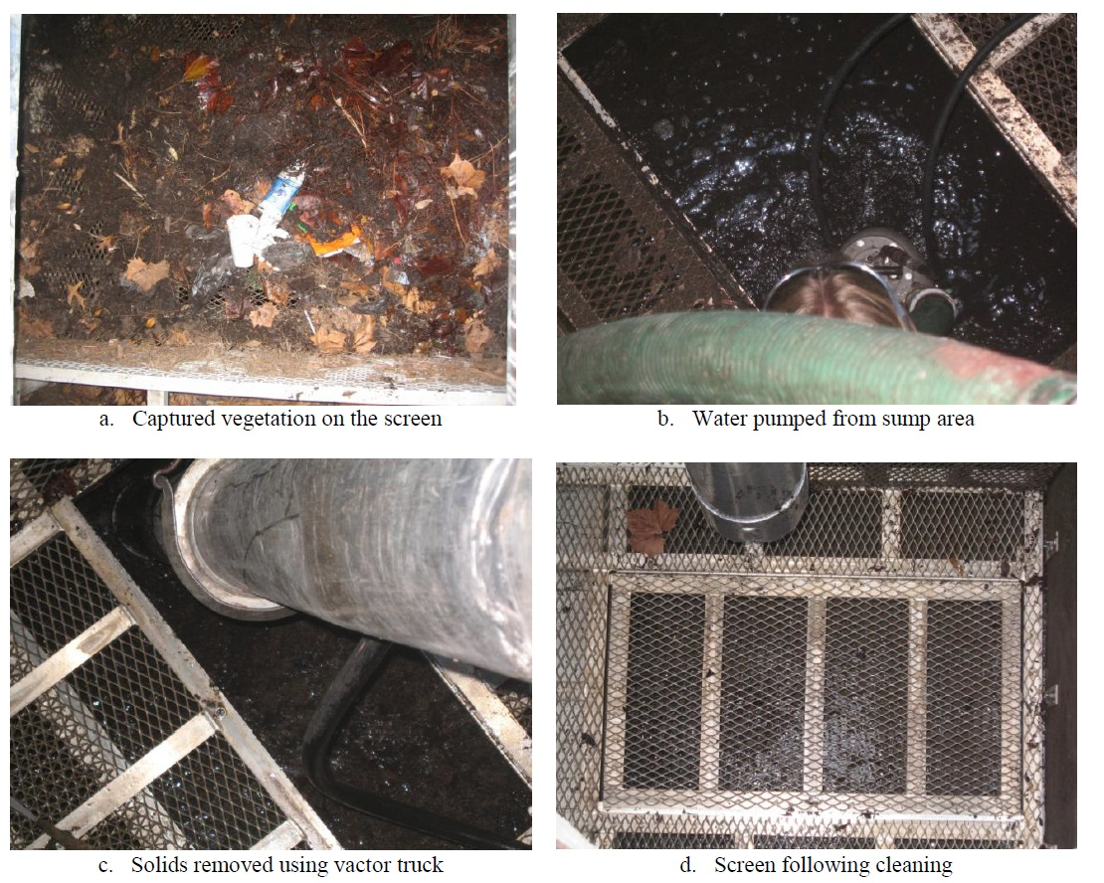
Note: Photographs taken from the draft project report prepared by Environmental Research & Design, Inc.
Figure 2: City of Casselberry Cleanout Sequence for the Lake Hodge Baffle Box

Substantial progress was made on the North and Middle Lake Triplet Shoreline Revegetation (Projects C-7 and C-22), resulting in enhanced shorelines for both lakes that now provide improved erosion protection, improved vegetative buffer, and improved native habitat. The city completed a design and began installation of this revegetation project using in-house resources. The project consists of removal of invasive vegetation, installation of a shallow bioretention area (North Lake Triplet only, Figure 3), and restoration with native shoreline and emergent plants. Final plantings, a volunteer planting event, and installation of an educational sign are planned for completion by September 2014.
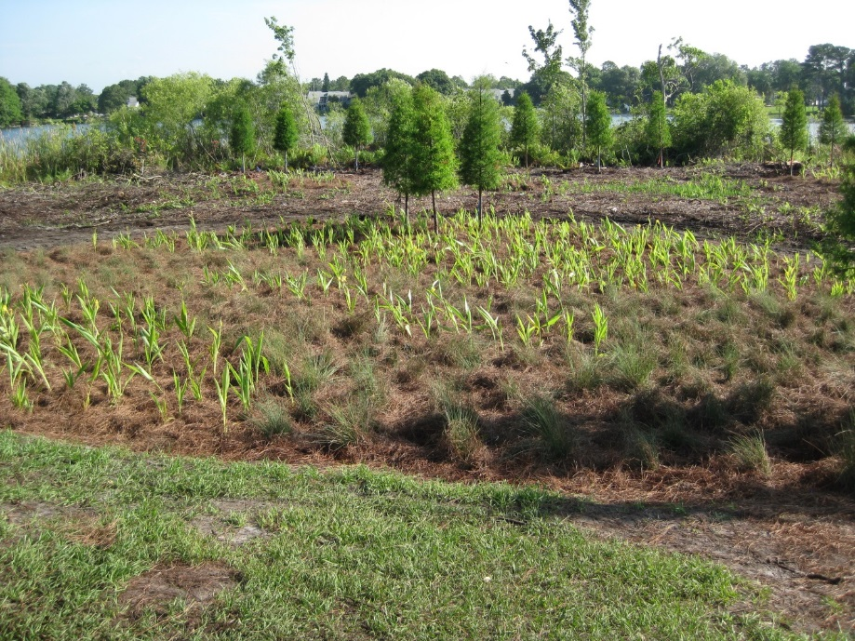
Figure 3: City of Casselberry Bioswale/Bioretention Area (Foreground) for North Lake Triplet (Background) Shoreline Revegetation Project

The City of Casselberry continued its public education programs related to water quality (Project C-28). The city continues to partner in the FYN program and continues to grow its conservation/environmental branding program called “Green Up Casselberry.” In April, the city once again hosted an Earth Day event called Earth Fest at Lake Concord Park (Figure 4). The event included several educational workshops, which covered Florida-friendly landscaping, shoreline plants, rain gardens, rain barrels, and more. The event highlighted Lake Concord Park’s permanent stormwater educational features.
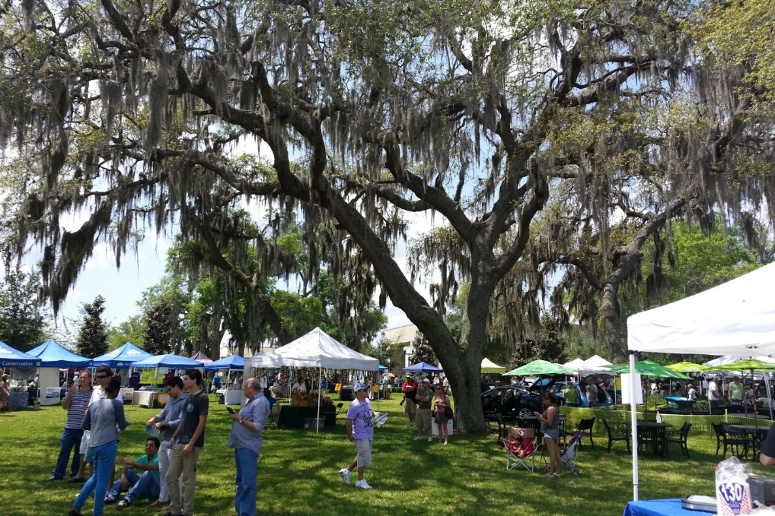
Figure 4: City of Casselberry Earthfest in April 2014

City of Lake Mary
The City of Lake Mary continued its street sweeping, education and outreach efforts, and catch basin clean out over the last year (Projects LM-3, LM-4, and LM-5).

City of Longwood
The City of Longwood continued its BMP clean out (Project L-3), street sweeping (Project L-4), and education and outreach efforts (Project L-5) during the reporting year.

City of Maitland
The City of Maitland found that street sweeping (see Figure 5) and education continue to be very successful components in the city’s nutrient reduction goals. Street sweeping continued once every two weeks throughout the reporting period (Project M-16). Educational events included but are not limited to cooperative public service announcements (PSAs) with Seminole County, stormwater education talks to classes at Maitland Middle School, presentations to lakefront property owners regarding stewardship, educational booths and community events, and bi-monthly newsletter with tips and regulations regarding stormwater BMPs.
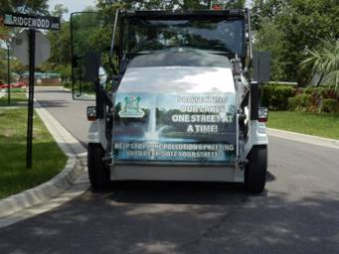
Figure 5: City of Maitland Street Sweeper

City of Orlando
The City of Orlando continues to maintain all of its stormwater retrofit BMPs with clean out performed on the inlet baskets. The city is continually implementing ways to increase maintenance frequency. The City of Orlando has developed a complete inventory of all structures and pipes within the Howell Branch basin.

City of Oviedo
The City of Oviedo adopted a Pet Waste Ordinance (Ordinance #1583), to enable enforcement and strengthen education delivered to pet owners regarding harmful nutrients entering the city’s storm systems and non-source point pollutant reduction (project OV-6). The city conducted revisions to the Land Development Code - Environmental Preservation Chapter to include inlet marking by developers and installation of pet waste stations. As part of the Water Quality Report regarding the fecal coliform impairment in the Little Econlockhatchee, the city conducted a Geographic Information Systems septic tank assessment inventory. This information will be included in the revised land development code, which will prohibit septic tanks along the Econlockhatchee Corridor. In addition, the Aulin Avenue Stormwater/Roadway Improvement Project is substantially complete (Projects OV-9 and OV-10). Final completion and project closeout documents are currently being coordinated by the city's public works operations manager. The improvements have addressed flooding and pavement deterioration on Aulin Avenue South and its contributing streets.

City of Sanford
The City of Sanford continued with the street sweeping program, which includes sweeping 37.7 miles of roadways weekly in the Lake Jesup Basin (Project S-1). The city has also continued to participate in the FYN program, which provides ongoing public education that takes place in the city (Project S-2).

City of Winter Park
The City of Winter Park continued its street sweeping twice a month, education and outreach efforts, and implementation of the stormwater and lake management program (Projects WP-34 and WP-35). The city completed the Canton Avenue retrofit project (Figure 6), in which a baffle box was installed to improve conditions by removing larger organic debris (primarily oak leaves) and sediment (project WP-41). The Park North exfiltration treatment project (project WP-40) was also completed during the reporting period (see Figure 7).
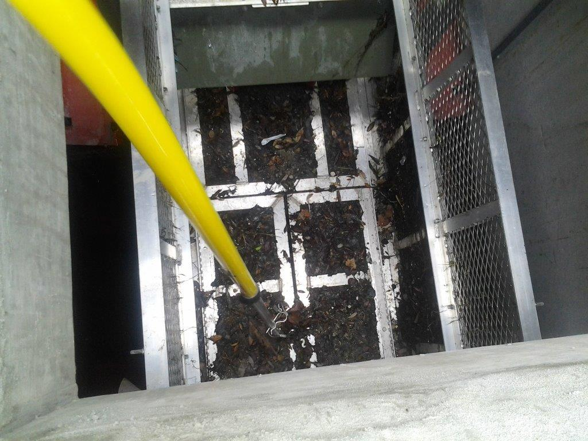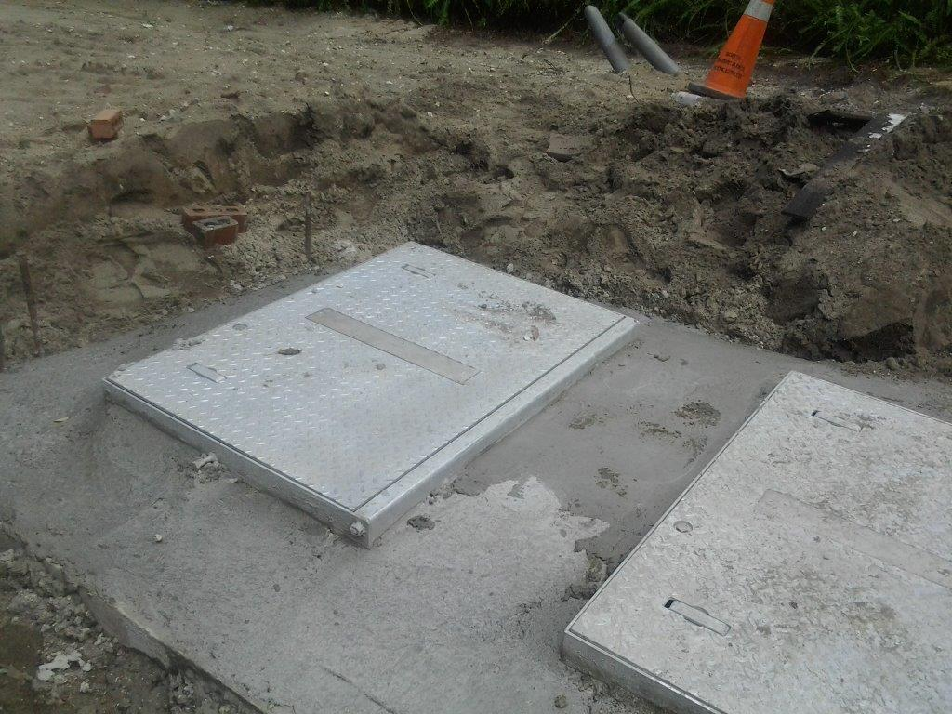
Figure 6: City of Winter Park Canton Baffle Box

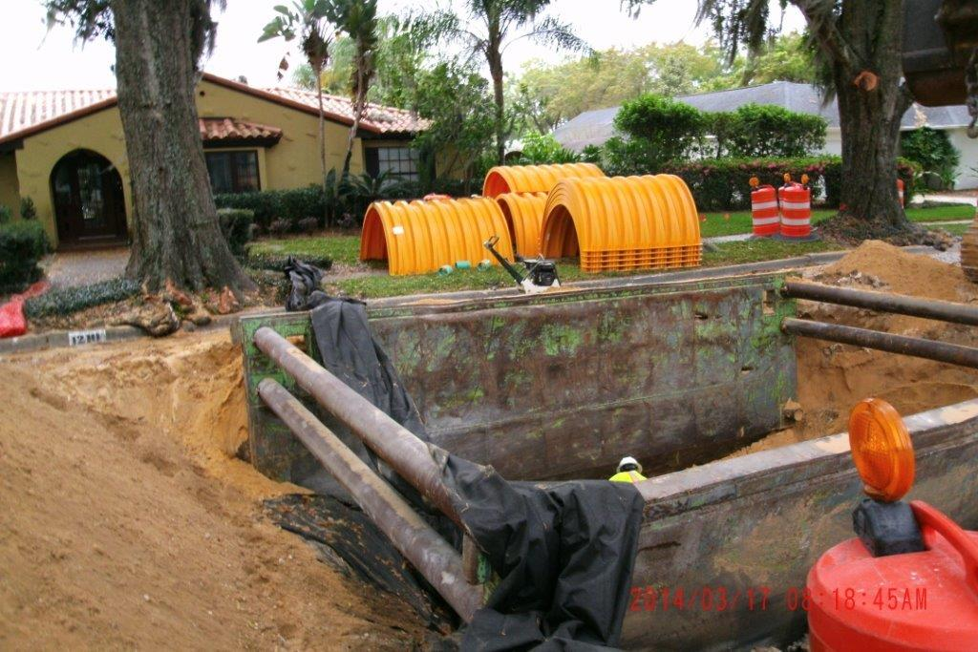
Figure 7: City of Winter Park North Exfiltration Treatment Project

In addition, the city has several projects underway including a study and design project for the Howell Branch retention pond; alum station rehabilitation projects, which will involve upgrading the electronics in all four of the active stations and switching to more modern pumps in two of them; and several other retrofit projects. Results for these projects will be reported on the next cycle.

City of Winter Springs
The City of Winter Springs continued its education and outreach activities and quarterly street sweeping of roads within the city. During the reporting period, the city improved the performance of its street sweeping operation (Project WS-7). In addition, the Solary Canal Regional Stormwater Treatment Facility (Project WS-1) has been complete for about two years, and has performed successfully with minimal maintenance required (see Figure 8).
Figure 8: City of Winter Springs Solary Canal Regional Stormwater Treatment Facility

FDOT District 5
FDOT District 5 has continued its public education efforts (Project FDOT-6). In addition, the Soldiers Creek Alum Treatment Facility (project FDOT-2) was approved by the Seminole County Board of County Commissioners on June 11, 2013. The facility was permitted by SJRWMD. The design for FDOT’s US 17/92 road widening project was completed and the Environmental Resource Permit applications were submitted (Project FDOT-3). Construction for both projects is anticipated to begin in spring 2015. FDOT recently revised the requirements for new street sweeping contracts in Seminole County. The new contracts, which begin in July 2014, will provide specific sweeping frequencies and estimates of material collected. FDOT’s reporting of nutrient removal credits from street sweeping activities will likely resume in 2014 and 2015 (Project FDOT-5).

Orange County
Orange County continued its street sweeping and educational outreach efforts (Projects OC-4 and OC-5). The pressure transducer installed at Lake Burkett continues to transmit data real-time to the Water Atlas (www.orange.wateratlas.org). Debris and sediment continues to be removed from stormwater using curb inlet baskets which were installed around Lake Sue (Project OC-3) and Lake Killarney (Project OC-10). In addition, during the reporting period, Orange County installed 40 curb inlet baskets (Project OC-8) in the Lake Burkett sub-basin (see Figure 9), and removed debris and sediment in this sub-basin.
Figure 9: Orange County Clean Inlet Basket Inside Curb Inlet (Left) and Inlet Basket Full of Debris Ready for Processing (Right)

Seminole County
Seminole County continued to conduct the ongoing educational efforts, PSAs, and ambient monitoring cooperatively funded by Seminole County and other local governments (Project SC-10). The county continued to conduct lake restoration events using volunteers (Figure 10), as well as AquaScaping Classes through the FYN program. The county continued biological and vegetative monitoring, mapping and restoration both in-lake and in-basin; as well as conducting research studies, such as the Crow Creek Nutrient Study and Red Bug Regional Stormwater Facility (RSF) vegetative efficiency study. The in-lake submerged aquatic vegetation plantings of Suwannee narrow leaf biotype eelgrass in two, one-acre plots continue to show success. The exclusion area protecting the one-acre plots were breached, which allowed predation of the plants (Figure 11). An additional revegetation event was conducted during the past year, which included repair of the exclusion area and replanting of the plots. Work continues on the construction and efficiency monitoring at the Cassel Creek RSF (Project SC-1), and the project design, construction, and monitoring the Black Hammock Creek reclamation and floodplain treatment system (Project SC-17).
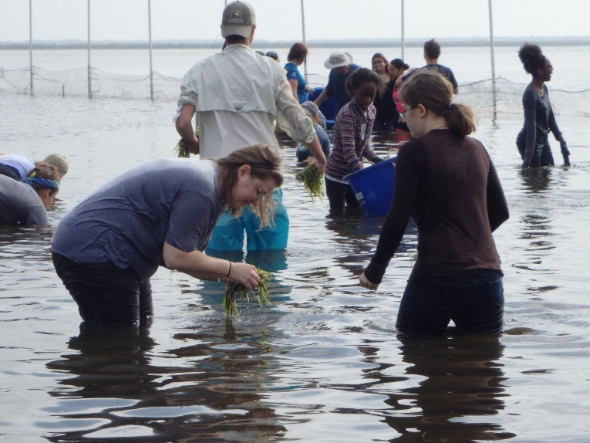
Figure 10: Seminole County Lake Restoration Event with Volunteers

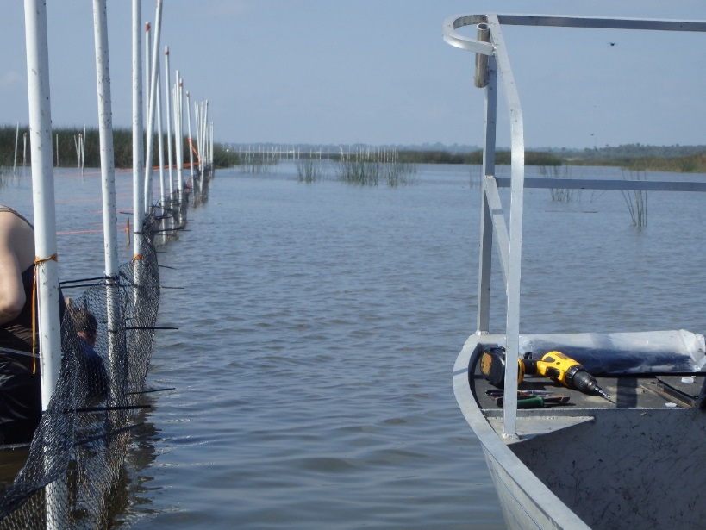
Figure 11: Seminole County Repair of the Submerged Aquatic Vegetation Exclusion Area

Town of Eatonville
The Town of Eatonville continued with its street sweeping of all town roads and its public education and outreach activities (Projects E-1 and E-4).

Turnpike Authority
The Turnpike Authority continued its monthly street sweeping in the basin (Project T-2). In addition, the Turnpike continued its education and outreach efforts of presentations and an illicit discharge program (Project T-3).

Agriculture
FDACS, through field staff and contracted staff with the East Central Florida Resource Conservation and Development Council, has been working on enrolling growers in the container nursery, citrus, and cow/calf BMP programs. Most of the efforts so far have concentrated on the container nurseries and cow/calf operations.
The land use table in the BMAP shows significant acreage in the nurseries and vineyards category that still needs to be enrolled. As discussed in the agriculture section of the BMAP, most of the remainder of this acreage is an in-ground palm nursery in the Black Hammock area. This operation will be contacted in the near future as the existing nursery manual was just revised in June 2014 and now includes in-ground operations. A large citrus operation in the same area will be enrolled under the new statewide citrus manual. As reported last year, the table also shows just over 200 acres of row/field crops, but field verification of the basin shows only one small row crop operation, which was enrolled prior to BMAP adoption. The majority of the remaining acres designated as row/field crops are now a sod farm, which was enrolled in the sod BMP program in 2009. Current enrollment figures are contained in Table 3 and depicted in Figure 12.
The basin also has several small equine operations that may or may not be eligible to enroll in the equine manual, depending on whether they are commercial agriculture or residential/hobby operations. With limited staff, FDACS’ equine BMP enrollments have been focused on heavily commercial equine regions in the state, and no assessments have yet taken place in the Lake Jesup Basin.
Table 3: Agricultural Acres Enrolled in FDACS BMPs in the Lake Jesup BMAP Area
*Note: 2,197.6 of the cow/calf acres were categorized as wetlands in the 2004 SJRWMD land use coverage.
Land Use Description | Land Use Acres (2004 SJRWMD) | BMP Program | Acres Enrolled as of July 2009 | Acres Enrolled as of March 2014
Citrus | 1,340.8 | Citrus | 100.0 | 376.0
Unimproved, improved, and woodland pasture | 2,425.3 | Cow/Calf | Not applicable | 2,558.0*
Row crops, field crops, and mixed crops | 212.1 | Vegetable and Agronomic Crops | 15.0 | 7.5
Nurseries and vineyards, ornamentals | 475.0 | Container Nurseries; Specialty Fruit and Nut | 93.5 | 75.1
Floriculture | 2.3 | Not applicable – Comprehensive nursery manual under development | Not applicable | Not applicable
Sod farm | 278.0 | Sod | 0.0 | 609.0
Horse farm | 88.2 | Equine | Not applicable | 0.0
Poultry feeding | 2.5 | Conservation Plan Rule | Not applicable | 0.0
Total Acres | 4,824.2 | BMP Implementation Total | 208.5 | 3,625.6

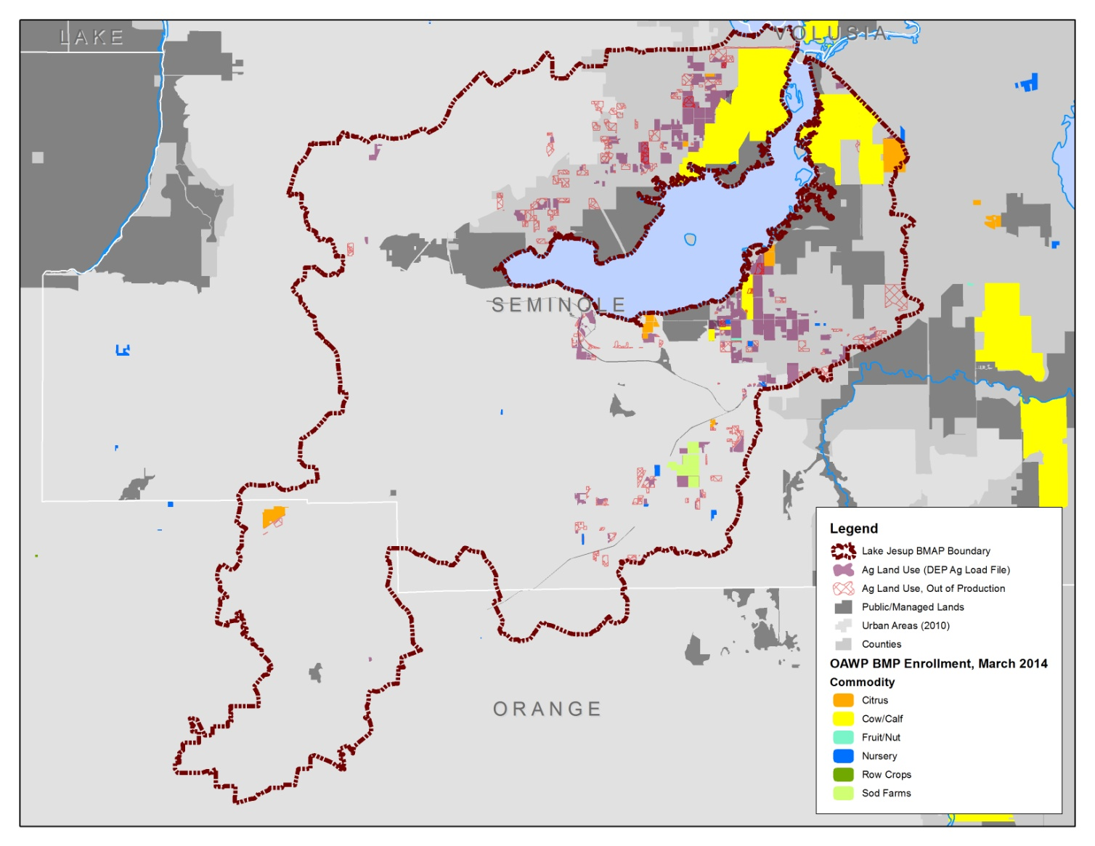
Figure 12: Agricultural Operations Enrolled in FDACS BMP Programs in the Lake Jesup BMAP Area as of March 31, 2014

For the BMAP, FDACS and the Department used a spreadsheet model tool to estimate the total potential load reduction from BMP implementation to be 277.9 lbs/yr of TP, based on agricultural land use acreage. Estimated load reductions to date, based on FDACS enrollment of about 3,626 acres within the BMAP basin (excluding silviculture and aquaculture) comes to 72.5 lbs/yr of TP. This estimate does not include the majority of the acres enrolled in cow/calf BMPs, as those acres were not initially included in the 2004 SJRWMD agricultural acres used to calculate the starting loads and associated load reduction estimates. Those acres were identified as wetlands. The more recent land use/land cover identifies most of the acreage as unimproved pasture, but no loadings have been assigned to that acreage.
FDACS worked with the Department to calculate an estimated load reduction credit based on loss of agricultural production acreage. During the development of this BMAP, FDACS identified approximately 2,650 acres classified as agricultural land in the 2004 land use/land cover that appeared to be no longer in production. However, no agricultural credit was calculated due to the limitations listed in the BMAP document, including the absence of commodity-specific load estimates. During the 2013-2014 reporting year, FDACS compared the 2004 land use with the most recent land use available in the basin, and worked with the Department to refine the agricultural loading information in order to calculate an estimated load reduction associated with the loss of production acreage. The total reductions from changes in agricultural land uses was 144.9 lbs/yr of TP (see Table 4).
Table 4: Agricultural TP Load Reduction Allocation and Estimated Reductions in TP Loads
Estimated Loads | TP (lbs/yr)
Agricultural Load Reduction Allocation | 764.0
Agricultural Reduction Needed per BMAP Allocation Scenario, 2010-2015 | 254.7
Estimated Load Reductions via BMPs, 100% Target Enrollment, 2010-2015 | 235.9
Reductions from Land Use Changes | 144.9
Total Estimated Load Reductions | 380.8
Estimated Load Reductions Needed for BMAP, 2010-2015 | (credit) -126.1

Summary of Accomplishments
The projects completed during the fourth annual BMAP reporting period are summarized in Table 5. These projects resulted in an estimated 337.2 lbs/yr of TP reductions. These reductions are in addition to those projects given credit before BMAP adoption and the projects that were completed during the first, second, and third annual progress report periods. Therefore, the total project reductions to date are 12,987.1 lbs/yr of TP, which is greater than the required reduction in the first BMAP iteration of 6,249.5 lbs/yr of TP. The total reductions, including those from completed projects to date and the load within noncontributing areas to the lake, are 14,022.1 lbs/yr of TP, which is a 71.5% reduction from the starting load. The goal of the first BMAP iteration was a 33% reduction in TP.
The progress towards the total TMDL load reductions are shown in Figure 13. The first bar in this figure shows the starting load for stormwater runoff and septic tanks from the TMDL. The second bar shows the current estimated loading with the implementation of projects and the removal of non-contributing areas. The third bar shows the total allocation for stormwater runoff and septic tanks to meet the TMDL. The line shows the target for the first BMAP, which is a reduction of 6,249.5 lbs/yr of TP.
Table 5: Summary of Projects Completed in the Reporting Period (June 1, 2013 Through May 31, 2014)
Entity | Project Number | Project Name | TP Reduction (lbs/yr)
Agriculture | N/A | Agricultural Land Use Changes | 144.9
City of Oviedo | OV-6 | Additional Education – Pet Waste Ordinance | 5.8
City of Oviedo | OV-10 | Aulin Avenue South | 1.9
City of Winter Park | WP-40 | Park North Exfiltration | 9.7
City of Winter Park | WP-41 | Canton Avenue Outfall Retrofit | 6.6
Orange County | OC-8 | Lake Burkett Curb Inlet Baskets | 11.5
Seminole County | SC-1 | Cassel Creek RSF | 156.8
Total | Not applicable | Total Reductions in Reporting Period | 337.2

Figure 13: Progress Towards the Lake Jesup TP TMDL Through May 31, 2014

Improving Scientific Understanding

Water Quality Monitoring
The Lake Jesup BMAP monitoring plan was designed to enhance the understanding of basin loads, track project implementation, and identify long-term water quality trends. The information gathered through the monitoring plan will measure progress toward achieving the TP TMDL and provide a foundation for continued improvement in cost-effective project implementation. The BMAP monitoring plan consists of ambient water quality sampling, storm event sampling, and biological monitoring. All responsible stakeholders participated in the monitoring plan in the fourth year of BMAP implementation. A few highlights of the monitoring efforts are described below.
The Department’s Central District office has been sampling at Cameron Avenue and Kentucky Street, near the Sanford wastewater treatment facility, as part of the BMAP monitoring plan. However, although staff has tried to collect monthly samples, this site rarely has flows so very few water quality samples have been collected since BMAP adoption. Therefore, this station has been removed from the BMAP monitoring plan. In addition, the Central District office collects samples at Sweetwater Creek at Howard Avenue and Kansas Street in conjunction with Seminole County. During the reporting period, Sweetwater Creek in this area was choked with vegetation and had minimal flows. Therefore, samples are now collected slightly south of the original location at the corner of Florida Avenue and Kansas Street.
The City of Altamonte Springs continued to fulfill its commitment to perform surface water sampling in Prairie Lake. Although the city has contracted with the University of South Florida to upload the sampling data to STORET, there may be a lag in the reported results between sampling and upload; therefore, the sampling results for the reporting period are included in Appendix B.
The City of Casselberry continued to conduct quarterly ambient water quality sampling of 12 of its lakes. In addition, the city continued to partner with Seminole County by funding monthly sampling at the Gee Creek weir and partially funding ambient sampling for Lake Howell. The city uploads its quarterly ambient water quality data twice annually to the Seminole County Watershed Atlas, which is then uploaded to STORET.
The City of Longwood and Seminole County signed a Letter of Understanding for Lake Jesup BMAP sampling at the Fairy Lake outfall. Samples have been collected monthly at this site.
The City of Lake Mary has a contract with Seminole County for ambient environmental monitoring, and data upload to STORET.
The City of Maitland has collected monthly water quality data at the Lake Waumpi site. The city has not yet uploaded the data into STORET but the data are included in Appendix B.
The City of Orlando collected monthly water quality data at the Lake Rowena Canal site. The city is in the process of uploading their data into STORET, and the data are included in Appendix B. During this reporting period, the parameter biological oxygen demand (BOD) was omitted for a portion of the sampling year, but will be added again during next year’s monitoring efforts.
The City of Sanford has continued with the Letter of Understanding with Seminole County for ambient environmental monitoring, which allows the Seminole County Watershed Management Division to pull samples for the Chub Creek and Navy Creek sites. The county uploads the data to STORET.
The City of Winter Park was able to collect monthly water quality samples from its station at the Howell Branch weir. The data have not yet been uploaded to STORET but are included in Appendix B.
Orange County collected water quality and flow data from the Burkett Canal site. The data will be added to STORET in the next upload (summer 2014).
Seminole County continued its ambient monitoring, which is cooperatively funded by several other local governments. The county has two sites that will be removed from the BMAP monitoring plan because of low or no flow conditions. The first station, CHUBB, is located on Chub Creek at East Lake Mary Boulevard, where the creek flows from the Sanford airport property to Lake Jesup. The airport constructed additional stormwater ponds on their property, which affected the amount of flow that the creek is receiving. The county visited the site monthly since June 22, 2010, and has only been able to collect samples on nine separate occasions. No samples have been collected since June 25, 2012 due to low water levels, which are less than inches. Seminole County sampled this location for the City of Sanford. The second site, BLMOUT-LM, is located at the Big Lake Mary Outfall. The county has visited this site monthly since June 30, 2010, and has never been able to collect a sample due to either no water present or very low water level with no flow conditions. Seminole County sampled this location for the City of Lake Mary. The county also continued the biological and vegetative monitoring, mapping, and restoration both in-lake and in-basin. Monitoring data is uploaded twice a year via the Seminole Watershed Atlas.

Site 10 Monitoring
As part of the City of Sanford’s Domestic Wastewater Facility Permit Number FL002014, the city was required to identify an additional sampling point for storm event sampling that could be alternated with the initial sampling location (Pond B-2). The city conducted a site visit in late 2012 with the Department and SJRWMD staff to identify potential locations to re-locate the auto-sampler from its current location at Pond B-2. Pond C-2B, which is located in the southern portion of the site, was selected based on accessibility and observed flow conditions. During the site visit, it was also observed that the pond inflow structures would require rehabilitation prior to the re-location of the auto-sampler. Based on the field inspection, city staff and the regulatory agencies agreed to re-locate the auto-sampler to the new location at Pond C-2B pending the completion of the pond rehabilitation activities. Plans for the Pond C-2B were subsequently prepared and the rehabilitation was completed in December 2013 (Figure 14). City staff initiated the re-location of the auto-sampler from Pond B-2 to Pond C-2B earlier this year but have been working on resolving some equipment issues until sample collection can be initiated at the new location.
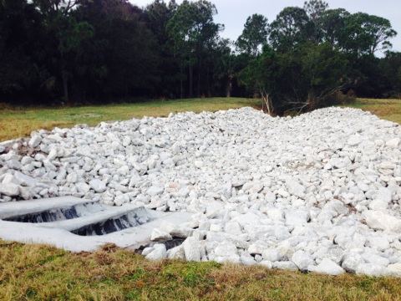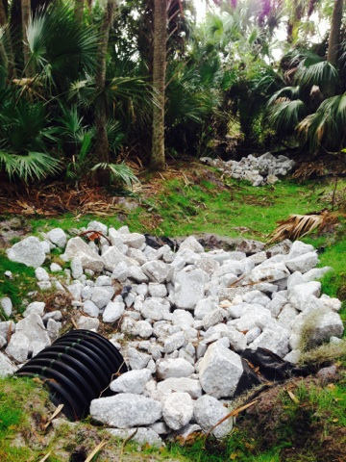
Figure 14: City of Sanford Site 10 Improvements

Sampling in 2013 continued at Pond B-2 while the rehabilitation of Pond C-2B was underway. Updated results for storm event sampling for TN and TP are shown in Figure 15 and Figure 16. Storm events that met thresholds resulted in sample collection during the second, third, and fourth quarters of 2013. However, it should be noted for the October 7, 2013 sample date, the city observed the concentrations were elevated compared to previous collected samples. Inspection of the area after the sampling event indicated that cattle broke through the fence and disturbed the ditch reinforcements on the upstream side resulting in sediment buildup in the pipe. There was also observed cattle waste which most likely contributed to high organic concentrations. The auto-sampler was in the process of being re-located during the first quarter of 2014, and city staff has recently been working on resolving equipment issues so samples have not been collected during the first quarter.

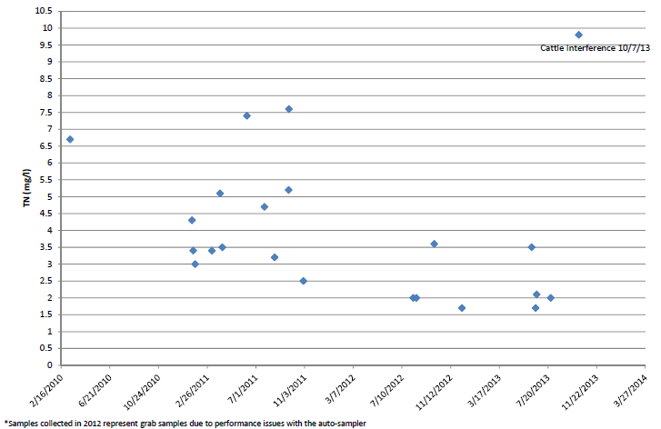
Figure 15: Site 10 Storm Event Samples for TN

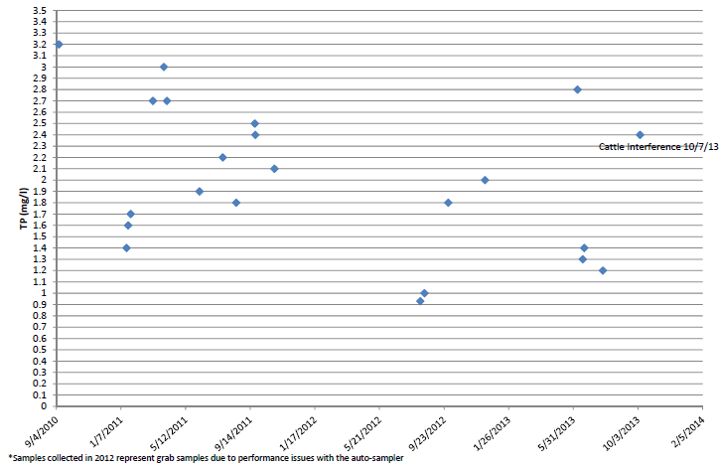
Figure 16: Site 10 Storm Event Samples for TP

The city also continued to collect quarterly surface water grab samples for Site 10. The grab sample data that were collected since 2010 and through the reporting period are shown graphically in Figure 17 and Figure 18. Figure 19 shows the locations where the grab samples are collected.
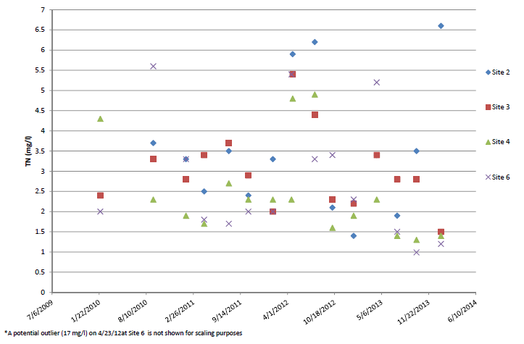
Figure 17: Site 10 Grab Samples for TN

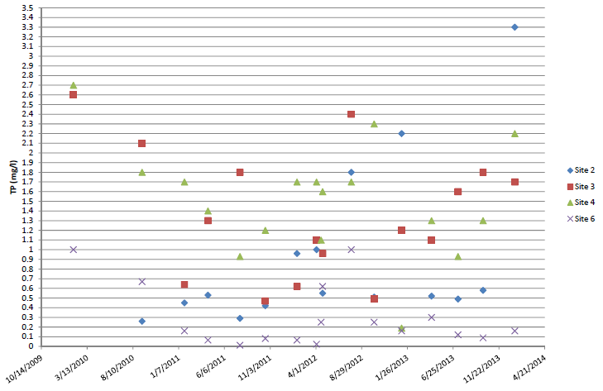
Figure 18: Site 10 Grab Samples for TP

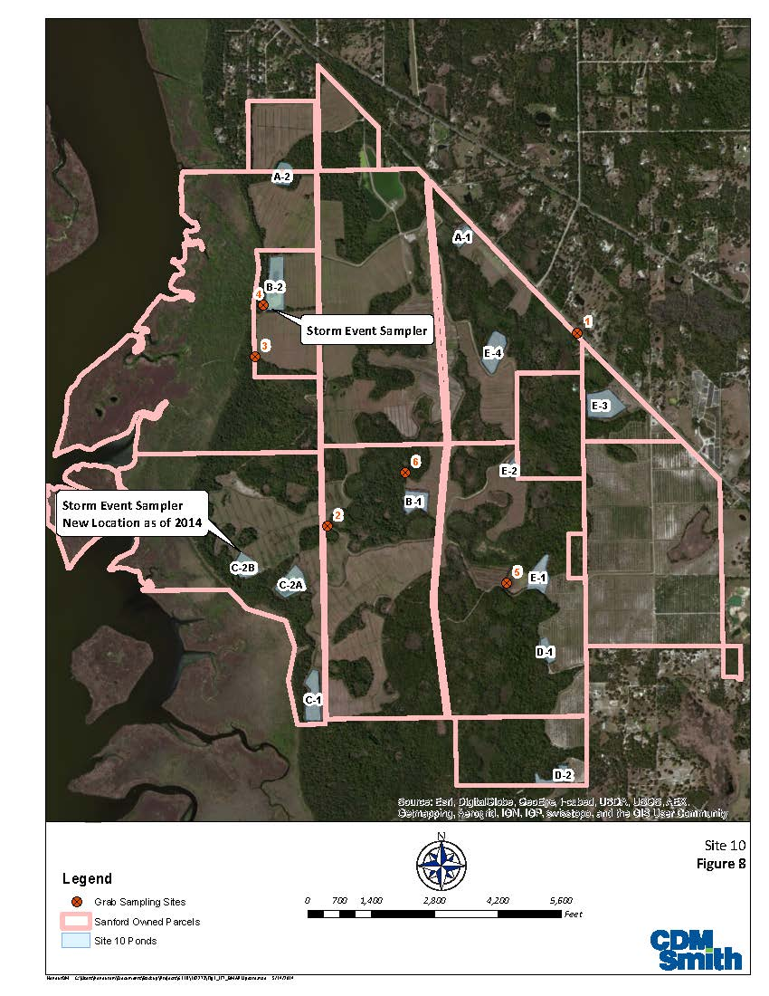
Figure 19: Site 10 Grab Sample Collection Locations

Research Priorities
Several entities in the basin have completed research projects or are currently implementing studies that will provide information to address the unknowns in the basin that were identified in the BMAP. The applicable data from these studies will be used by the Department in future re-evaluation of the TMDLs (see Section 2.5).

Orange County
Orange County continued with its efforts to determine the pollutant loads being discharged through Lake Burkett. Sampling is ongoing and data are submitted to the Department and SJRWMD.

Seminole County
Seminole County will update the QUAL2K model to reflect the additional research and ongoing monitoring results. The Red Bug RSF vegetative efficiency study will be extended for an additional year, as it was determined that one of the outfall structures was not functioning properly, which caused the conditions (water elevation) within the pond to be irregular. The county initiated efficiency monitoring on the Cassel Creek RSF. In addition, the county began several monitoring projects for in-lake vegetation and biological bioassessments.

SJRWMD
The pilot project treating lake water on the southern shore of Jesup ended in April 2014. AquaFiber Technologies completed this project having successfully met all project objectives.
No new studies on Lake Jesup nutrient dynamics were completed this past year by SJRWMD. One study is beginning in July that will measure changes in the unconsolidated sediment layer since the first SJRWMD study evaluated cores in 1996 (Cable et al 1997). Results quantifying overall changes in volume and exploring potential shifts in deposition should be available by September 2014.
Preliminary assessments of developing a marsh to treat lake water on the northwest shore of Lake Jesup began in March 2014, and a potential conceptual design will be presented to the SJRWMD Governing Board in early fall 2014 for discussion.

TMDL Model Update
The Lake Jesup BMAP identified “technical uncertainties,” and stakeholders committed to address these uncertainties within the first BMAP iteration to allow for possible recalculation of the TMDLs and requisite adjustments to the allocations required by the BMAP. With the completion of the fourth year of BMAP implementation, the Department in collaboration with stakeholders, including SJRWMD, Seminole County, Orange County, and others, is coordinating new modeling efforts to better quantify many of the uncertainties originally expressed in the BMAP.
SJRWMD engineering staff are developing both a watershed loading model, Hydrologic Simulation Program – FORTRAN (HSPF), and an in-lake water quality model, Water Quality Analysis Simulation Program 7 (WASP7) for the Lake Jesup Basin. The HSPF model will include data collected by the stakeholders from the research studies and BMAP monitoring to revise the estimates of loading to the lake. In-lake modeling will include new ground water information, sediment dynamics, and updated watershed loads from the HSPF model. This collaborative process allows the agencies, local municipalities, and counties to achieve the most efficient and effective use of their resources necessary for data collection, data analysis, and modeling activities and to answer many of the questions related to baseline TP and TN loadings. The watershed loading model will be complete by end of July 2014, and the in-lake model is scheduled for completion in September 2014. Recommendations for target TP concentrations and pollutant load reduction goals will be completed sometime between July and September by SJRWMD environmental science staff. SJRWMD is working with the Department to share results and information, as available. Results from this modeling will facilitate the recalculation of the TMDLs for TP and TN, as needed.

: Upcoming Year Activities

Summary of Efforts for the Upcoming Year
The five-year BMAP assessment report will encompass the period of June 1, 2014 through May 31, 2015. In addition the projects detailed in Section 3.2 and Section 3.3., BMAP monitoring will continue.

Upcoming Efforts by Entity

City of Casselberry
The City of Casselberry will complete two shoreline vegetation projects for a reduction of 1.1 lbs/yr, and an alum treatment project for a reduction of 510.4 lbs/yr.

City of Longwood
The City of Longwood will complete the Raven Avenue stormwater pipe replacement (Project L-2) for an estimated reduction of 1.4 lbs/yr of TP.

City of Maitland
The City of Maitland will complete a baffle box project for a reduction of 7.7 lbs/yr of TP, and an infiltration trench project for a reduction of 0.9 lbs/yr.

City of Orlando
The City of Orlando will complete a stormwater retrofit and alum treatment project for a reduction of 3.8 lbs/yr.

City of Oviedo
The City of Oviedo will begin work on the Aulin Avenue North stormwater retrofit and water quality treatment project.

City of Winter Park
The City of Winter Park will continue with the Howell Branch Retention Pond upgrades study and design. In addition, the city has the alum station rehabilitation projects underway, and will report on this project on the next progress report.

FDOT District 5
The Soldiers Creek Alum Treatment project with Seminole County continues to move forward. In addition, FDOT recently revised the requirements for new street sweeping contracts in Seminole County. The new contracts, which will begin in July 2014, will provide specific sweeping frequencies and estimates of material collected. FDOT’s reporting of nutrient removal credits from street sweeping activities will likely resume in 2014 and 2015.

Orange County
Orange County intends to install an additional 44 curb inlet baskets in the Lake Burkett Sub-basin, which has an estimated TP reduction of 12.7 lbs/yr. The installation of these baskets will bring the total number of baskets in this sub-basin to 84, which have a total estimated TP load reduction of 24 lbs/yr.

Seminole County
Seminole County will complete two wet detention ponds, one with an estimated reduction of 229 lbs/yr of TP and the other with an estimated reduction range between 82 lbs/yr and 238 lbs/yr of TP. In addition, the county is in the process of adopting a fertilizer ordinance and potentially adopting a shoreline protection ordinance by the end 2014.

Agriculture
FDACS will continue to sign up growers for BMPs under the citrus and cow/calf manuals. FDACS will also explore opportunities for more one-on-one work and/or workshops with growers in the basin to ensure the proper implementation of BMPs.
As per the BMAP, the target date for enrolling all operations for which an adopted manual exists is June 2015. The target date for enrolling all other commodities is within five years of manual adoption. During the coming year, FDACS will work to enroll the remaining citrus and cow/calf acreage. In addition, FDACS will explore opportunities for more one-on-one work and/or workshops with growers in the basin to ensure the proper implementation of BMPs.

Water Quality Monitoring
All responsible stakeholders in the BMAP monitoring plan will continue to sample their stations at the frequency noted in the BMAP. The stakeholders will continue to upload their data to STORET on a regular basis. Any stakeholder that is not currently loading their data into STORET will work with the Department to set up the capability to do so.

Appendix A: BMAP Projects
The BMAP project tables below show the status of the projects as of May 31, 2014. The tables provide information on the nutrient reduction attributed to each individual project, shown in lbs/yr. These projects were submitted to provide reasonable assurance to the Department that each entity has a plan on how they will meet their allocation; however, this list of projects is meant to be flexible enough to allow for changes that may occur over time, provided that the reduction is still met within the specified timeframe.

Table A-1: City of Altamonte Springs Projects
N/A = Not applicable
Entity | Project Number | Project Name | Project Detail | TP Reduction (lbs/yr) | Status
Altamonte Springs | A-1 | Existing BMPs | BMPs in place at the time of the TMDL | 35.0 | Completed
Altamonte Springs | A-2 | Street Sweeping | Street sweeping of 4.4 miles, two times per month | 220.0 | Ongoing
Altamonte Springs | A-3 | Education Efforts | FYN, irrigation ordinance, PSAs, pamphlets, presentations, website, illicit discharge program | 4.6 | Ongoing
Altamonte Springs | N/A | N/A | Total Projects Reduction | 259.6 | N/A
Altamonte Springs | N/A | N/A | Total Required Reduction 2010-2015 | 19.0 | N/A
Altamonte Springs | N/A | N/A | Credit for Future BMAPs | 240.6 | N/A
Table A-2: City of Casselberry Projects
N/A = Not applicable
Entity | Project Number | Project Name | Project Detail | Start Date | End Date | TP Reduction (lbs/yr) | Project Cost | Treatment Acres | Project Type | Status
Casselberry | C-1 | Lake Concord Stormwater Park/Anniversary Park - Plumosa Baffle Box | Redevelopment and retrofit of city-owned property into an educational stormwater park; 2nd generation baffle box | 10/2007 | 09/2009 | 0.5 | $43,250 | 8.5 | Stormwater retrofit | Completed
Casselberry | C-2 | Lake Concord Stormwater Park/Anniversary Park - Exfiltration Trench | Redevelopment and retrofit of city-owned property into an educational stormwater park; an exfiltration trench | 10/2007 | 09/2009 | 0.4 | $143,200 | 1.7 | Exfiltration | Completed
Casselberry | C-3 | Lake Concord Stormwater Park/Anniversary Park - Dry Detention | Redevelopment and retrofit of city-owned property into an educational stormwater park; dry detention | 10/2007 | 09/2009 | 0.0 | $75,000 | 1.0 | Dry detention pond | Completed
Casselberry | C-4 | Lake Concord Stormwater Park/Anniversary Park - Swale, Wetland Revegetation, & Boardwalk | Redevelopment and retrofit of city-owned property into an educational stormwater park; swale, lakeshore revegetation, educational boardwalk | 10/2007 | 09/2009 | 0.1 | $742,000 | 1.7 | Swales | Completed
Casselberry | C-5 | Lake Concord Stormwater Park/Anniversary Park | Redevelopment and retrofit of city-owned property into an educational stormwater park; baffle box, pervious pavement, bioretention/ parking lot | 10/2007 | 09/2009 | 0.1 | $226,500 | 1.2 | Stormwater retrofit | Completed
Casselberry | C-6 | Anchor Road Reconstruction | Reconstruction of Anchor Road with drainage improvements including upgraded detention/retention ponds | 10/2007 | 10/2009 | 2.9 | $2,000,000 | 60.7 | Wet detention pond | Completed
Casselberry | C-7 | North Lake Triplet Shoreline Revegetation | Remove existing nuisance vegetation from the north and west shores of North Lake Triplet and replace with beneficial species; install reverse berm and swale | 12/2007 | 09/2014 | 0.8 | $80,000 | 16.2 | Swales | Substantially complete; shallow bioretention installed; anticipated to come in well under budget
Casselberry | C-8 | Secret Lake Shoreline Revegetation | Remove existing nuisance vegetation from the east and southwest shores of Secret Lake and replace with beneficial species; install 2 reverse berms and swales | 01/2008 | 05/2008 | 0.2 | N/A | 3.7 | Swales | Completed
Casselberry | C-9 | Fountain/Aeration and Revegetation for Grassy Lake | Installation of aeration  for high BOD loading to this waterbody; includes shoreline revegetation for aesthetics and nutrient removal with swale construction as practicable | 03/2009 | 07/2009 | 0.0 | $150,000 | 1.7 | Aeration system | Completed
Casselberry | C-10 | 672 & 676 San Pablo Avenue 2nd generation Baffle Boxes | Replace existing storm manholes with two inlet filters and one 2nd generation baffle box for removal of pollutants | 03/2009 | 01/2012 | 1.3 | $300,000 | 28.0 | Stormwater retrofit | Completed
Casselberry | C-11 | Madrid Drive at Desoto Drive 2nd Generation Baffle Box | Replace existing storm manholes with 2nd generation baffle boxes for removal of pollutants | 03/2009 | 01/2012 | 0.4 | $150,000 | 5.0 | Stormwater retrofit | Completed
Casselberry | C-12 | Sonora Drive at Desoto Drive 2nd Generation Baffle box | Replace existing storm manholes with 2nd generation baffle boxes for removal of pollutants | 03/2009 | 01/2012 | 2.4 | $170,000 | 42.7 | Stormwater retrofit | Completed
Casselberry | C-13 | Live Oaks Center 2nd Generation Baffle Box | Replace existing storm manholes with baffle boxes for removal of pollutant | Unknown | Unknown | 1.9 | $100,000 | 11.6 | Stormwater retrofit | Deferred
Casselberry | C-15 | Lake Hodge Park 2nd Generation Baffle Box | Replace existing storm manholes with baffle boxes for removal of pollutants | 03/2011 | 04/2012 | 3.3 | $170,000 | 53.2 | Stormwater retrofit | Completed
Casselberry | C-16 | 161 South Lake Triplet Drive 2nd Generation Baffle Box | Replace existing storm manholes with baffle boxes for removal of pollutants | Unknown | Unknown | 5.5 | $170,000 | 89.9 | Stormwater retrofit | Planned & Funded, Delayed
Casselberry | C-17 | 530 South Lake Triplet Drive 2nd Generation Baffle Box | Replace existing storm manholes with baffle boxes for removal of pollutants; it is anticipated this project will be cancelled with bioswales and other drainage improvements instead (anticipated construction in fall 2014) | Unknown | Unknown | 1.3 | $140,000 | 20.7 | Stormwater retrofit | Planned & Funded, Delayed
Casselberry | C-19 | 808 Osceola Trail 2nd Generation Baffle Box | Replace existing storm manholes with baffle boxes for removal of pollutants | Unknown | 2012 | 1.2 | $140,000 | 25.2 | Stormwater retrofit | Completed
Casselberry | C-20 | Park Drive Drainage/Wetland Improvements | Construction of stormwater  retention area on Lots 10A & 11 on north side of Park Drive | 10/2013 | Unknown | 4.2 | $36,000 | 46.4 | Wet retention pond | Planned & Funded, Delayed. Feasibility study planned to commence June 2014.
Casselberry | C-21 | Whole Lake Alum Treatment | Modified project: Execution of whole lake alum treatments to directly treat Queens Mirror Lake and the Triplet Lake chain to address loads due to groundwater seepage and internal recycling | 09/2012 | 09/2014 | 510.4 (equivalent per year for 10 years) | $297,016 | 101.9 (lake acreage only) | Alum treatment | Underway, approximately 88% completed
Casselberry | C-22 | Middle Lake Triplet Shoreline Revegetation | Remove existing nuisance vegetation from the north shore of Middle Lake Triplet and replace with beneficial species | 12/2013 | 09/2014 | 0.3 | $33,000 | 3.4 | Swales | In Progress
Casselberry | C-23 | Secret Way at Canal 2nd generation Baffle Box | Replace existing storm manholes with baffle boxes for removal of pollutants | Unknown | Unknown | 0.7 | $170,000 | 16.4 | Stormwater retrofit | Planned & Funded, Delayed
Casselberry | C-24 | 51 North Lake Triplet Drive 2nd Generation Baffle Box | Replace existing storm manholes with baffle boxes for removal of pollutants | Unknown | Unknown | 1.2 | $140,000 | 27.4 | Stormwater retrofit | Planned & Funded, Delayed
Casselberry | C-25 | South Lake Triplet Swales | Installation of water quality swales along northwestern shore of South Lake Triplet to provide golf course runoff treatment | Unknown | Unknown | 1.0 | $80,000 | 6.3 | Swales | Planned & Funded, Delayed
Casselberry | C-26 | South Lake Triplet 2nd Generation Baffle Box | Replace existing storm manholes with baffle boxes for removal of pollutants (sediment and detritus) (4.l) | Unknown | Unknown | 0.8 | $140,000 | 18.3 | Stormwater retrofit (baffle box) | Envisioned but Not Funded, Delayed
Casselberry | C-27 | Street Sweeping | Monthly street sweeping of 72.5 miles, 29,876 cubic feet of material collected annually | N/A | N/A | 916.0 | N/A | N/A | Street sweeping | Ongoing
Casselberry | C-28 | Education Efforts | FYN, landscape and irrigation ordinances, PSAs, pamphlets/presentations, website, illicit discharge program | N/A | N/A | 85.6 | N/A | N/A | Education | Ongoing
Casselberry | C-29 | Existing BMPs | BMPs that were in place at the time of the TMDL | N/A | N/A | 319.9 | N/A | N/A | N/A | Completed
Casselberry | C-30 | Structures Cleaning | 729 cubic feet of solids collected from catch basins, baffle boxes, and other structures per year | N/A | N/A | 26.0 | N/A | N/A | Clean out | Ongoing
Casselberry | N/A | N/A | Total Projects Reduction | N/A | N/A | 1,888.4 | N/A | N/A | N/A | N/A
Casselberry | N/A | N/A | Total Required Reduction 2010-2015 | N/A | N/A | 342.7 | N/A | N/A | N/A | N/A
Casselberry | N/A | N/A | Credit for Future BMAPs | N/A | N/A | 1,545.7 | N/A | N/A | N/A | N/A

Table A-3: City of Lake Mary Projects
N/A = Not applicable
O&M = Operations and maintenance
Entity | Project Number | Project Name | Project Detail | Start Date | End Date | TP Reduction (lbs/yr) | Project Cost | Annual O&M Cost | Footprint (Acres) | Project Type | Status
Lake Mary | LM-1 | Lake Mary Woods | Eliminate 18 septic tanks 75 feet from surface water, some of them were failing | 5/2005 | 4/2006 | 44.5 | $3,700,000 | $2,056 | 6,260 | Extend sewer line | Completed
Lake Mary | LM-2 | Street Sweeping | Annual street sweeping of 31.5 miles | N/A | N/A | 17.0 | N/A | N/A | N/A | Street sweeping | Ongoing
Lake Mary | LM-3 | Education Efforts | FYN, ordinances, PSAs, pamphlets, presentations, website, illicit discharge program | N/A | N/A | 67.6 | N/A | N/A | N/A | Education | Ongoing
Lake Mary | LM-4 | Existing BMPs | BMPs that were in place at the time of the TMDL | N/A | N/A | 264.3 | N/A | N/A | N/A | N/A | Completed
Lake Mary | LM-5 | Catch Basin Clean Out | Removal of 1,620 cubic feet of material per year | N/A | N/A | 57.0 | N/A | N/A | N/A | Clean out | Ongoing
Lake Mary | N/A | N/A | Total Projects Reduction | N/A | N/A | 450.4 | N/A | N/A | N/A | N/A | N/A
Lake Mary | N/A | N/A | Total Required Reduction 2010-2015 | N/A | N/A | 264.3 | N/A | N/A | N/A | N/A | N/A
Lake Mary | N/A | N/A | Credit for Future BMAPs | N/A | N/A | 186.1 | N/A | N/A | N/A | N/A | N/A

Table A-4: City of Longwood Projects
N/A = Not applicable
Entity | Project Number | Project Name | Project Detail | Start Date | End Date | TP Reduction (lbs/yr) | Project Cost | Project Type | Status
Longwood | L-1 | Stormwater Master Plan Project | Fairy Lake outfall | 2011 | 2013 | 0.7 | $300,000 | Stormwater retrofit | Completed
Longwood | L-2 | Stormwater Master Plan Project | Raven Avenue replacement of stormwater pipe | 2014 | 2015 | 1.4 | $300,000 | Stormwater retrofit | Planned
Longwood | L-3 | BMP Clean Out | Clean out of BMPs, 176 cubic feet of material per year | N/A | Ongoing | 5.0 | N/A | BMP clean out | Ongoing
Longwood | L-4 | Street Sweeping | Quarterly street sweeping of 11.1 miles | N/A | N/A | 4.0 | N/A | Street sweeping | Ongoing
Longwood | L-5 | Education Efforts | FYN, pamphlets, presentations, website, illicit discharge program | N/A | N/A | 44.9 | N/A | Education | Ongoing
Longwood | L-6 | Existing BMPs | BMPs that were in place at the time of the TMDL | N/A | N/A | 58.9 | N/A | N/A | Completed
Longwood | L-7 | Regional Project | Participate in a regional project | 2009 | 2014 | 90.4 | N/A | N/A | Planned
Longwood | N/A | N/A | Total Projects Reduction | N/A | N/A | 205.3 | N/A | N/A | N/A
Longwood | N/A | N/A | Total Required Reduction 2010-2015 | N/A | N/A | 205.3 | N/A | N/A | N/A
Longwood | N/A | N/A | Credit for Future BMAPs | N/A | N/A | 0.0 | N/A | N/A | N/A
Table A-5: City of Maitland Projects
N/A = Not applicable
O&M = Operations and maintenance
Entity | Project Number | Project Name | Project Detail | Start Date | End Date | TP Reduction (lbs/yr) | Project Cost | Annual O&M Cost | Treatment Acres | Project Type | Status
Maitland | M-1 | Sybelia Parkway Regional Pond | Construct wet pond | 2005 | 2007 | 33.7 | $4,400,000 | $3,000 | 125.2 | Wet detention pond | Completed
Maitland | M-2 | Lake Gem/Park Lake COOP BMP | Construct second generation baffle box | 2010 | Unknown | 0.3 | $30,000 | $3,000 | 3.4 | Stormwater retrofit | Delayed indefinitely
Maitland | M-3 | Lake Gem/Park Lake COOP BMP | Construct second generation baffle box | 2010 | Unknown | 3.1 | $30,000 | $3,000 | 20.0 | Stormwater retrofit | Delayed indefinitely
Maitland | M-4 | Lake Gem/Park Lake COOP BMP | Construct second generation baffle box | 2010 | Unknown | 0.2 | $60,000 | $6,000 | 3.1 | Stormwater retrofit | Delayed indefinitely
Maitland | M-5 | Lake Gem/Park Lake COOP BMP | Construct second generation baffle box | 2010 | Unknown | 18.9 | $60,000 | $6,000 | 178.9 | Stormwater retrofit | Delayed indefinitely
Maitland | M-6 | Lake Gem/Park Lake COOP BMP | Construct second generation baffle box | 2010 | Unknown | 9.1 | $60,000 | $6,000 | 58.1 | Stormwater retrofit | Delayed indefinitely
Maitland | M-7 | Lake Maitland Basin - Ridgewood Area Quality Neighborhood Program City Street Improvement Plan | Construct infiltration trenches | 2009 | 2010 | 0.5 | $60,000 | $2,500 | 3.9 | Infiltration trench | Completed
Maitland | M-8 | Lake Maitland Basin - Ridgewood Area Quality Neighborhood Program City Street Improvement Plan | Construct infiltration trenches | 2009 | 2010 | 1.7 | $170,000 | $8,500 | 15.0 | Infiltration trench | Completed
Maitland | M-9 | Lake Maitland Basin - Ridgewood Area Quality Neighborhood Program City Street Improvement Plan | Construct infiltration trenches | 2009 | 2010 | 0.6 | $100,000 | $5,000 | 9.2 | Infiltration trench | Completed
Maitland | M-10 | North Lake Maitland Leaf Trap Project | Install curb inlet leaf trap | 2009 | 2010 | 0.1 | $3,000 | $6,000 | 16.8 | Inlet | Completed
Maitland | M-11 | Lake Maitland Basin - Ridgewood Area Quality Neighborhood Program City Street Improvement Plan | Construct infiltration trenches | 2009 | 2010 | 0.9 | $100,000 | $8,500 | 14.8 | Infiltration trench | Completed
Maitland | M-12 | Dommerich Lot Baffle Box | Construct second generation baffle box | 2010 | 2014 | 1.1 | $60,000 | $5,000 | 24.7 | Stormwater retrofit | Planned and Funded
Maitland | M-13 | Chipewa Trail Baffle Box | Construct second generation baffle box | 2007 | 2007 | 1.1 | $60,000 | $5,000 | 25.3 | Stormwater retrofit | Completed
Maitland | M-14 | Horatio Avenue Infiltration Trench | Construct infiltration trenches | 2014 | 2015 | 0.9 | $150,000 | $5,000 | 5.0 | Infiltration trench | Planned and Funded
Maitland | M-15 | Minnehaha Park Stormwater Improvements Dry Stormwater Pond | Construct wet pond | 2007 | 2008 | 1.3 | $65,000 | $2,000 | 9.9 | Dry detention pond | Completed
Maitland | M-16 | Street Sweeping | Street sweeping once every 2 weeks of 71 miles | 2005 | Ongoing | 398.0 | N/A | $100,000 | 2,898 | Street sweeping | Ongoing
Maitland | M-17 | Education Efforts | Landscaping ordinance, PSAs, presentations/ pamphlets, website, illicit discharge program | N/A | N/A | 40.8 | N/A | N/A | N/A | Education | Ongoing
Maitland | M-18 | Existing BMPs | BMPs in place at the time of the TMDL | N/A | N/A | 0.7 | N/A | N/A | N/A | N/A | Completed
Maitland | M-19 | Packwood Avenue Baffle Box | Construct second generation baffle box | N/A | 2012 | 9.9 | N/A | N/A | 13 | Stormwater retrofit | Completed
Maitland | M-19 | Minnehaha Circle Baffle Box | Construction second generation baffle box | 2012 | 2014 | 7.7 | N/A | N/A | 23 | Stormwater retrofit | Under Design
Maitland | M-20 | Park Lake Baffle Boxes | Construction second generation baffle boxes | 2012 | Unknown | 23.2 | N/A | N/A | 58 | Stormwater retrofit | Planned and Funded
Maitland | N/A | N/A | Total Projects Reduction | N/A | N/A | 553.8 | N/A | N/A | N/A | N/A | N/A
Maitland | N/A | N/A | Total Required Reduction 2010-2015 | N/A | N/A | 124.8 | N/A | N/A | N/A | N/A | N/A
Maitland | N/A | N/A | Credit for Future BMAPs | N/A | N/A | 429.0 | N/A | N/A | N/A | N/A | N/A

Table A-6: City of Orlando Projects
N/A = Not applicable
O&M = Operations and maintenance
Entity | Project Number | Project Name | Project Detail | Start Date | End Date | TP Reduction (lbs/yr) | Project Cost | Annual O&M Cost | Treatment Acres | Project Type | Status
Orlando | ORL-1 | Lake Dot Water Quality Restoration | Installation of Alum Treatment System, where aluminum sulfate (alum) is injected into stormline on a flow-proportioned basis | 1988 | 07/1990 | 70.4 | $569,207 | N/A | 276 | Alum | Completed
Orlando | ORL-2 | Hazel Street Outfall Improvements | Installation of CDS Unit at Lake Winyah from 96" pipe | 07/2000 | 07/2003 | 8.3 | $410,992 | N/A | 505 | Stormwater retrofit | Completed
Orlando | ORL-3 | Lake Rowena Screening Facility & Alum Stormwater Treatment | Installation of underground, flow-actuated rotating bar screen on 108" outfall pipe to capture debris with additional treatment via alum system | 1994 | 1996 | 55.0 | $596,512 | N/A | 470 | Screening and alum | Completed
Orlando | ORL-4 | Lake Highland CDS Unit | Installation of CDS Unit at Lake Highland | 1998 | 1999 | 1.0 | $60,000 | N/A | 45 | Stormwater retrofit | Completed
Orlando | ORL-5 | Mills Avenue Retrofit | Construction of Storm Flo Litter Collection Screen on Mills Ave., adjacent to Lake Rowena to treat runoff from 36" and 24" stormlines | 01/2009 | 04/2009 | 8.4 | $250,000 | N/A | 89 | Stormwater retrofit | Completed
Orlando | ORL-6 | Overbrook Stormwater Improvements | Construct 2nd generation baffle box upstream of Lake Adair; Implement pollution prevention methods, including gravel bottom and check dams to settle out pollutants | 10/2007 | 07/2008 | 1.8 | $400,000 | N/A | 236 | Stormwater retrofit | Completed
Orlando | ORL-7 | Guernsey Park - Expansion of Wet Detention Pond | Expansion of wet detention pond to treat 61% of sub-basin drainage | 11/2011 | 03/2012 | 0.1 | $425,000 | N/A | 80 | Wet detention pond | Completed
Orlando | ORL-8 | Ivanhoe Plaza Park Exfiltration | Installation of exfiltration galleries to treat 100% of sub-basin drainage | 05/2012 | 12/2012 | 1.3 | $1,100,000 | N/A | 49 | 100% on-site retention | Completed
Orlando | ORL-9 | Lake Concord 2nd Generation Baffle Boxes | Construct two 2nd Generation Baffle Boxes upstream of Lake Concord and reroute flow to treat 30" and 24" outfalls from nearly 100% of two sub-basins | 7/2011 | 09/2011 | 0.8 | $250,000 | N/A | 66 | Stormwater retrofit | Completed
Orlando | ORL-10 | Winyah (Westchester Ave/Wilkinson St) 2nd Generation Baffle Box | Construct 2nd Generation Baffle Box upstream of Lake Winyah to treat 71% of sub-basin | 9/2009 | 10/2009 | 1.6 | $72,000 | N/A | 30 | Stormwater retrofit | Completed
Orlando | ORL-11 | Westmoreland 2nd Generation Baffle Box | Construct 2nd Generation Baffle Box upstream of Lake Adair | N/A | 2006 | 0.1 | $35,000 | N/A | 5.3 | Stormwater retrofit | Completed
Orlando | ORL-12 | Stormwater Filtration Systems / Inlet Baskets | Installation of 6 inlet baskets around perimeter of Lake Adair | N/A | 2007 | 0.0 | $5,400 | N/A | 25 | Inlet basket | Completed
Orlando | ORL-13 | Stormwater Filtration Systems / Inlet Baskets | Installation of 11 inlet baskets in Spring Lake basin | N/A | 2007 | 0.0 | $9,900 | N/A | 25 | Inlet basket | Completed
Orlando | ORL-14 | Stormwater Filtration Systems / Inlet Baskets | Installation of 13 inlet baskets in Lake Formosa basin | N/A | 2007 | 0.1 | $11,700 | N/A | 14 | Inlet basket | Completed
Orlando | ORL-15 | Stormwater Filtration Systems / Inlet Baskets | Installation of 29 inlet baskets in Lake Highland basin | N/A | 2007 | 3.5 | $26,100 | N/A | 223 | Inlet basket | Completed
Orlando | ORL-16 | Stormwater Filtration Systems / Inlet Baskets | Installation of 2 inlet baskets in Lake Rowena basin | N/A | 2007 | 0.5 | $1,800 | N/A | 39 | Inlet basket | Completed
Orlando | ORL-17 | Stormwater Filtration Systems / Inlet Baskets | Installation of 49 inlet baskets in Lake Ivanhoe basin | N/A | 2008 | 0.6 | $44,100 | N/A | 242 | Inlet basket | Completed
Orlando | ORL-18 | Stormwater Filtration Systems / Inlet Baskets | Installation of 4 inlet baskets in Lake Druid basin | N/A | 2007 | 0.4 | $1,800 | N/A | 39 | Inlet basket | Completed
Orlando | ORL-19 | Street Sweeping | 2 times per week of 6.4 miles, weekly of 9.3 miles, and 2 times per month of 113 miles | N/A | Ongoing | 428.0 | N/A | $1,800,000 | N/A | Street sweeping | Ongoing
Orlando | ORL-20 | Reading Drive (24" line) - 2nd Generation Baffle Box at Lake Adair | Construct 2nd Generation Baffle Box upstream of Lake Adair to treat approximately 13% of subbasin | 9/2009 | 10/2009 | 0.5 | N/A | N/A | 26 | Stormwater retrofit | Completed
Orlando | ORL-21 | Spring Lake -2nd Generation Baffle Box at Rio Grande | Construct 2nd Generation Baffle Box upstream of Spring Lake to treat 100% of subbasin | 9/2009 | 10/2009 | 0.6 | $128,000 | N/A | 39 | Stormwater retrofit | Completed
Orlando | ORL-22 | Spring Lake- 2nd Generation Baffle Box at Springdale Rd | Construct 2nd Generation Baffle Box upstream of Spring Lake to treat 100% of subbasin | N/A | N/A | 0.1 | N/A | N/A | 21 | Stormwater retrofit | Completed
Orlando | ORL-23 | DOT Pond Maintenance, west of Spring Lake | Removal of muck/sediment and expansion of wet detention pond to treat 95% and 5% of two sub-basins, respectively. | 2/2010 | 11/2010 | 6.1 | N/A | N/A | 141 | Wet detention pond | Completed
Orlando | ORL-24 | Weber Dr - 2nd Generation Baffle Box at Lake Druid | Construct 2nd Generation Baffle Box upstream of Lake Druid to treat approximately 7% of subbasin | N/A | 2006 | 0.3 | N/A | N/A | 6 | Stormwater retrofit | Completed
Orlando | ORL-25 | Educational Component | FYN, ordinances (landscape, irrigation, pet waste), PSAs, pamphlets, presentations, website, illicit discharge program | N/A | Ongoing | 94.2 | N/A | N/A | N/A | Education | Ongoing
Orlando | ORL-26 | Lake Concord Alum Injection Retrofit | Divert stormwater from Lake Concord basin to Lake Dot Alum Treatment before discharging into chain of lakes; installation of injection line in Lake Dot and new baffle box on Concord Ave | 06/2013 | N/A | 3.8 | $500,000 | N/A | 90.8 | Stormwater retrofit and alum | In Progress
Orlando | ORL-27 | Existing BMPs | BMPs that were in place at the time of the TMDL | N/A | N/A | 684.4 | N/A | N/A | N/A | N/A | Completed
Orlando | ORL-28 | FDOT Pond Sandbar Removal from Spring Lake | Removal of sandbar from FDOT pond outfall that enters Spring Lake | 11/2010 | 2/2011 | N/A | N/A | N/A | N/A | Wet detention pond | Completed
Orlando | ORL-29 | Catch Basin Clean Out | Clean out of catch basins, removal of 524 cubic feet of material per year | N/A | Ongoing | 19.0 | N/A | N/A | N/A | Catch basin clean out | Ongoing
Orlando | ORL-30 | BMP Clean Out | Clean out of BMPs, removal of 133 cubic feet of material per year | N/A | Ongoing | 4.0 | N/A | N/A | N/A | BMP clean out | Ongoing
Orlando | N/A | N/A | Total Projects Reduction | N/A | N/A | 1,394.9 | N/A | N/A | N/A | N/A | N/A
Orlando | N/A | N/A | Total Required Reduction 2010-2015 | N/A | N/A | 326.3 | N/A | N/A | N/A | N/A | N/A
Orlando | N/A | N/A | Credit for Future BMAPs | N/A | N/A | 1,068.6 | N/A | N/A | N/A | N/A | N/A
Table A-7: City of Oviedo Projects
N/A = Not applicable
Entity | Project Number | Project Name | Project Detail | Start Date | End Date | TP Reduction (lbs/yr) | Project Cost | Treatment Acres | Project Type | Status
Oviedo | OV-1 | Aulin Regional Stormwater Pond | Aulin Regional Stormwater Pond | 2009 | 12/2012 | 13.5 | N/A | N/A | Wet detention pond | Completed
Oviedo | OV-2 | Lightwood Knox Canal Project | Lightwood Knox Canal Project | 2009 | 2014 | 84.5 | N/A | N/A | Dry detention pond, swales | Envisioned, but Not Funded
Oviedo | OV-3 | Sweetwater Creek Project | Sweetwater Creek Project | 2009 | 2014 | 30.4 | N/A | N/A | Dry detention pond, wet detention pond | Envisioned, but Not Funded
Oviedo | OV-4 | Solary Canal Stormwater Treatment Area | Regional Stormwater Treatment Facility consisting of an 8.0-acre wet pond and 4.8-acre wetland | 4/2010 | 12/2011 | 188.3 | $1,700,000 | 1,471 | Wet detention pond, wetland treatment | Completed
Oviedo | OV-5 | Street Sweeping | Monthly street sweeping of 315 lane miles | N/A | N/A | 601.0 | N/A | N/A | Street sweeping | Ongoing
Oviedo | OV-6 | Education Efforts | FYN, pet waste ordinance, illicit discharge program, Adopt A Pond Program | N/A | N/A | 52.0 | N/A | N/A | Education | Ongoing
Oviedo | OV-7 | Existing BMPs | BMPs that were in place at the time of the TMDL | N/A | N/A | 386.5 | N/A | N/A | N/A | Completed
Oviedo | OV-8 | Jet-Vac Program | Routine cleaning of inlets and pipes | 2011 | N/A | 220.0 | N/A | N/A | Inlet and pipe cleaning | Ongoing
Oviedo | OV-9 | Aulin Avenue North | Construction of stormwater conveyance system and treatment area | 2014 | 2015 | Not quantified | $50,000 | Unknown | Stormwater Retrofitting and Water Quality Treatment | Under Design
Oviedo | OV-10 | Aulin Avenue South | Improvement of stormwater treatment and road flooding | 2008 | 2013 | 1.9 | $899,860 | Unknown | Installation of Storm Inlets and Stormwater Treatment Area | Completed
Oviedo | N/A | N/A | Total Projects Reduction | N/A | N/A | 1,576.1 | N/A | N/A | N/A | N/A
Oviedo | N/A | N/A | Total Required Reduction 2010-2015 | N/A | N/A | 258.7 | N/A | N/A | N/A | N/A
Oviedo | N/A | N/A | Credit for Future BMAPs | N/A | N/A | 1,317.4 | N/A | N/A | N/A | N/A

Table A-8: City of Sanford Projects
N/A = Not applicable
Entity | Project Number | Project Name | Project Detail | TP Reduction (lbs/yr) | Status
Sanford | S-1 | Street Sweeping | Weekly street sweeping of 37.7 miles | 427.0 | Ongoing
Sanford | S-2 | Public Education | Public Education | 108.9 | Ongoing
Sanford | S-3 | Existing BMPs | BMPs that were in place at the time of the TMDL | 521.2 | Completed
Sanford | N/A | N/A | Total Projects Reduction | 1,057.1 | N/A
Sanford | N/A | N/A | Total Required Reduction 2010-2015 | 602.2 | N/A
Sanford | N/A | N/A | Credit for Future BMAPs | 454.9 | N/A
Table A-9: City of Winter Park Projects
N/A = Not applicable
O&M = Operations and maintenance
Entity | Project Number | Project Name | Project Detail | Start Date | End Date | TP Reduction (lbs/yr) | Project Cost | Annual O&M Cost | Treatment Acres | Project Type | Status
Winter Park | WP-1 | Lake Island Interconnect | First Flush bypass to Wet Retention Ponds | 06/2002 | 09/2003 | 4.7 | $408,009 | N/A | 74.5 | Wet detention pond | Completed
Winter Park | WP-2 | Via Lugano Exfiltration | Off Line Exfiltration | 10/1996 | 11/1997 | 1.3 | $200,000 | N/A | 25.3 | Dry detention pond | Completed
Winter Park | WP-3 | N. Park Ave. Exfiltration | Off Line Exfiltration | 06/2004 | 10/2004 | 6.6 | $250,000 | N/A | 21.44 | Dry detention pond | Completed
Winter Park | WP-4 | Fairway 3 Exfiltration | Off Line Exfiltration | 11/2006 | 10/2007 | 5.5 | $1,000,000 | N/A | 57.39 | Dry detention pond | Completed
Winter Park | WP-5 | McKean Road CDS | CDS Unit on 24" outfall | 05/2004 | 06/2005 | 0.0 | N/A | N/A | 5.58 | Stormwater retrofit | Completed
Winter Park | WP-6 | Pinetree Rd Outfall CDS | CDS unit on 42" outfall | 05/2004 | 06/2005 | 0.6 | N/A | N/A | 64.78 | Stormwater retrofit | Completed
Winter Park | WP-7 | 1190 Park Ave CDS | CDS unit on 30" outfall | 08/1998 | 11/1999 | 0.2 | N/A | N/A | 22.82 | Stormwater retrofit | Completed
Winter Park | WP-8 | Moss/ Venetian Dry Capture 1st Generation Baffle Box | Baffle screen on 15" outfall | 02/2000 | 03/2007 | 0.1 | N/A | N/A | 3.02 | Stormwater retrofit | Completed
Winter Park | WP-9 | Green Cove Road 2 CDS Units | 2 CDS units on two 24" outfalls | 05/2004 | 06/2006 | 0.1 | N/A | N/A | 11.35 | Stormwater retrofit | Completed
Winter Park | WP-10 | Courtland Alum Injection Treatment | Alum injection at Lake Mizell outfall | N/A | N/A | 21.2 | N/A | N/A | 88.08 | Alum | Completed
Winter Park | WP-11 | Partnership/ Wet Detention/ Windsong | Developer's agreement to treat Palmer Ditch basin run off within site MSSW | N/A | N/A | 5.8 | N/A | N/A | 84.55 | Wet detention pond | Completed
Winter Park | WP-12 | Lincoln Ave Alum Injection Treatment | Alum injection at Lake Osceola outfall | N/A | N/A | 37.7 | N/A | N/A | 17.59 | Alum | Completed
Winter Park | WP-13 | Alexander Place Alum Injection Treatment with Baffle Box | Alum injection at Lake Osceola outfall | N/A | N/A | 22.6 | N/A | N/A | 24.61 | Alum | Completed
Winter Park | WP-14 | Morse /Alum Injection Treatment | Alum injection at Lake Osceola outfall | N/A | N/A | 6.9 | N/A | N/A | 57.13 | Alum | Completed
Winter Park | WP-15 | Trismen and Lakewood Drive Exfiltration | Off-Line Exfiltration | N/A | N/A | 0.4 | N/A | N/A | 7.35 | Dry detention pond | Completed
Winter Park | WP-16 | Trismen CDS Unit | CDS Unit on 24" outfall | N/A | N/A | 0.0 | N/A | N/A | 0.39 | Stormwater retrofit (CDS) | Completed
Winter Park | WP-17 | Trismen Dry 1st Generation Baffle Box | Baffle screen on 15" outfall | N/A | N/A | 0.0 | N/A | N/A | 1.84 | Stormwater retrofit | Completed
Winter Park | WP-18 | Elizabeth CDS Treating Inlet at Bonita and Dale | CDS on 15" Pipe | 05/2004 | 06/2006 | 0.0 | N/A | N/A | 2.35 | Stormwater retrofit | Completed
Winter Park | WP-19 | Lake Chelton Outfall Improvement | 4 dry-capture baffle inlets and boxes | 09/2003 | 01/2004 | 0.0 | N/A | N/A | 28.65 | Stormwater retrofit | Completed
Winter Park | WP-20 | Lakeview Road Bricking | CDS Installation on 24" outfall | 03/2006 | 03/2006 | 0.1 | N/A | N/A | 9.53 | Stormwater retrofit | Completed
Winter Park | WP-21 | Mead Gardens Borrow Pit Pond Retrofit | Retrofit screening devices (two baffle boxes) to existing MSSW | 05/2006 | 09/2006 | 15.4 | N/A | $560,000 | 62.06 | Stormwater retrofit | Completed
Winter Park | WP-22 | Glencoe Road Bricking | Stormwater capture and screening system (baffle box) | 03/2007 | 06/2007 | 0.1 | N/A | N/A | 3.39 | Stormwater retrofit | Completed
Winter Park | WP-23 | Laurel Road Dry Retention Pond | On-line dry retention pond | 05/1999 | 03/2001 | 1.7 | N/A | N/A | 17.15 | Dry detention pond | Completed
Winter Park | WP-24 | Alum Injection Treatment/ Rollins | Alum injection at outfalls to Lake Virginia | 01/1995 | 1996 | 26.8 | N/A | N/A | 72.99 | Alum | Completed
Winter Park | WP-25 | 9th Grade Center Pond Wet Detention | Wet detention pond retrofit | Pre 1995 | Pre 1995 | 7.6 | N/A | N/A | 110.8 | Wet detention pond | Completed
Winter Park | WP-26 | Lakeview Bricking | Stormwater capture and screening system (baffle box) | 02/2005 | 11/2006 | 0.1 | N/A | N/A | 6.97 | Stormwater retrofit | Completed
Winter Park | WP-27 | Oxford Road Bricking | Stormwater capture and screening system (baffle box) | 08/2006 | 11/2006 | 0.1 | N/A | N/A | 5.28 | Stormwater retrofit | Completed
Winter Park | WP-28 | Lake Island Park | Created treatment volume in Lake Mendsen, construct control structures for wet detention treatment | 06/1905 | 03/1996 | 83.8 | N/A | N/A | 256.00 | Wet detention pond | Completed
Winter Park | WP-29 | 950 Palmer Ave Retrofit | Stormwater capture and screening system (baffle box) | 07/2007 | 07/2007 | 0.3 | N/A | N/A | 18.33 | Stormwater retrofit | Completed
Winter Park | WP-30 | Banchory Exfiltration | On-line retention 0.25 treatment volume | 2008 | 2008 | 0.4 | N/A | N/A | N/A | On-line retention | Completed
Winter Park | WP-31 | Bryan CDS | CDS | 2008 | 2008 | 0.2 | N/A | N/A | N/A | Stormwater retrofit | Completed
Winter Park | WP-32 | E. Lake Sue CDS | CDS | 2008 | 2008 | 0.1 | N/A | N/A | N/A | Stormwater retrofit | Completed
Winter Park | WP-33 | Elizabeth Drive Baffle Box | Baffle box | N/A | N/A | 1.1 | N/A | N/A | N/A | Stormwater retrofit | Completed
Winter Park | WP-34 | Street Sweeping | Street sweeping two times per month of 130 miles | N/A | Ongoing | 13.6 | N/A | N/A | N/A | Street sweeping | Ongoing
Winter Park | WP-35 | Education Efforts | FYN, landscape and fertilizer ordinances, pamphlets, presentations, website, illicit discharge program | N/A | Ongoing | 106.3 | N/A | N/A | N/A | Education | Ongoing
Winter Park | WP-36 | Existing BMPs | BMPs that were in place at the time of the TMDL | N/A | N/A | 151.5 | N/A | N/A | N/A | N/A | Completed
Winter Park | WP-37 | Courtland Avenue Alum System Retrofit | 2 Suntree baffle boxes (Osceola Ave and Mizell Ave outfalls) | 06/2011 | 08/2011 | 40.7 | $350,000 | $4,000 | 88 | Stormwater retrofit | Completed
Winter Park | WP-38 | Alabama Drive Improvements | 2 dry retention swales and 1 baffle box | 08/2011 | 10/2011 | 1.7 | $50,000 | <$1,000 | 5 | Stormwater retrofit | Completed
Winter Park | WP-39 | Morse Boulevard Outfalls Retrofit | 2- Suntree baffle boxes | 04/2012 | 05/2012 | 194.7 | $180,000 | $2,500 | 30 | Stormwater retrofit | Completed
Winter Park | WP-40 | Park North  Exfiltration | Exfiltration trench | 02/2014 | 5/29/14 | 9.7 | $703,000 | $2,500 | 8.8 | Retrofit | Completed
Winter Park | WP-41 | Canton Avenue Outfall Retrofit | Suntree baffle box | 05/2013 | 9/18/13 | 6.6 | $129,000 | $1,000 | 23 | Retrofit | Completed
Winter Park | N/A | N/A | Total Projects Reduction | N/A | N/A | 776.3 | N/A | N/A | N/A | N/A | N/A
Winter Park | N/A | N/A | Total Required Reduction 2010-2015 | N/A | N/A | 370.5 | N/A | N/A | N/A | N/A | N/A
Winter Park | N/A | N/A | Credit for Future BMAPs | N/A | N/A | 405.8 | N/A | N/A | N/A | N/A | N/A

Table A-10: City of Winter Springs Projects
N/A = Not applicable
O&M = Operations and maintenance
Entity | Project Number | Project Name | Project Detail | Start Date | End Date | TP Reduction (lbs/yr) | Project Cost | Annual O&M Cost | Status
Winter Springs | WS-1 | Solary Canal Stormwater Treatment Area | Regional Stormwater Treatment Facility consisting of an 8.0-acre wet pond and 4.8-acre wetland | 4/2010 | 12/2011 | 188.3 | $1,700,000 | N/A | Completed
Winter Springs | WS-2 | Winding Hollow Wetland Treatment Area | Divert No Name Creek flow into wetland treatment system | 2020 | 2020 | 210.1 | $357,000 | N/A | Envisioned but Not Funded
Winter Springs | WS-3 | Winter Springs and Wedgewood Filtration Devices | Retrofit stormwater outfalls with flow-through filtration devices | 2020 | 2020 | 24.7 | $132,000 | N/A | Envisioned but Not Funded
Winter Springs | WS-4 | North Orlando Townsite Filtration Devices | Retrofit eastern and western outfalls with flow-through filtration devices | 2020 | 2020 | 5.2 | $80,000 | N/A | Envisioned but Not Funded
Winter Springs | WS-5 | Highlands Regional Pond Enhancements | Expansion of existing wet pond and redirection of untreated stormwater runoff to the pond | 2020 | 2020 | 64.5 | $1,385,000 | N/A | Envisioned but Not Funded
Winter Springs | WS-6 | Education Efforts - Update Local Codes and Ordinances (Fertilizer Rule, etc.), FYN | Continue FYN, PSAs, distribution of pamphlets, presentations to various groups, and inspection program on illicit discharges. | N/A | N/A | 92.0 | N/A | $4,000 | Ongoing
Winter Springs | WS-7 | Street Sweeping | Quarterly street sweeping; total swept in reporting year is 671 miles. | N/A | N/A | 58.0 | N/A | $23,381 | Ongoing
Winter Springs | WS-8 | Existing BMPs | BMPs that were in place at the time of the TMDL | N/A | N/A | 765.2 | N/A | N/A | Completed
Winter Springs | N/A | N/A | Total Projects Reduction | N/A | N/A | 1,408.0 | N/A | N/A | N/A
Winter Springs | N/A | N/A | Total Required Reduction 2010-2015 | N/A | N/A | 513.0 | N/A | N/A | N/A
Winter Springs | N/A | N/A | Credit for Future BMAPs | N/A | N/A | 895.0 | N/A | N/A | N/A
Table A-11: Florida Department of Transportation Projects
N/A = Not applicable
* The street sweeping frequency and approach that was being implemented within the basin has changed. Credits for street sweeping for the reporting period cannot be calculated at this time.
Entity | Project Number | Project Name | Project Description | Start Date | End Date | TP Reduction (lbs/yr) | Treatment Acres | Project Type | Status
FDOT | FDOT -1 | FM: 240167-1 SR434 | Widen from 2 to 6 lanes from McCulloch Road to Mitchell Hammock; drainage improvements and treatment of existing impervious area | 2002 | 2007 | 3.6 | 83.47 | Wet detention | Completed
FDOT | FDOT -2 | Soldiers Creek Alum Treatment Facility | Flow-through alum system along CR 427 in Seminole County to reduce nutrient loads within Soldiers Creek | 2015 | 2016 | 80.0 | N/A | Alum treatment | Designed and Permitted
FDOT | FDOT -3 | FM: 240196-1 SR17-92 Basin C&D | Proposed widening of SR 15/600 (US 17/92) from Shepard Road to Lake Mary Blvd; drainage improvements and treatment of existing impervious area | 2015 | 2016 | 3.7 | 47.97 | Dry retention | Designed, Permits Pending
FDOT | FDOT -4 | FM: 240163-1 SR 46 | SR 46 Bridge Replacement over Lake Jesup; drainage improvements and treatment of existing impervious area | 2008 | 2010 | 5.4 | 50.50 | Wet detention | Completed
FDOT | FDOT -5 | Street Sweeping | Monthly street sweeping of 1,232.6 miles | N/A | N/A | 0.0* | N/A | Street sweeping | Ongoing
FDOT | FDOT -6 | Education Efforts | Public Education efforts | N/A | N/A | 6.5 | N/A | Education | Ongoing
FDOT | FDOT -7 | Existing BMPs | Varies | N/A | N/A | 207.7 | N/A | N/A | Completed
FDOT | N/A | N/A | Total Projects Reduction | N/A | N/A | 306.9 | N/A | N/A | N/A
FDOT | N/A | N/A | Total Required Reduction 2010-2015 | N/A | N/A | 132.3 | N/A | N/A | N/A
FDOT | N/A | N/A | Credit for Future BMAPs | N/A | N/A | 174.6 | N/A | N/A | N/A

Table A-12: Orange County Projects
N/A = Not applicable
Entity | Project Number | Project Name | Project Detail | Start Date | End Date | TP Reduction (lbs/yr) | Project Type | Status
Orange County | OC-1 | Hall Road Improvements | OC CIP Hall Road Improvements | 2003 | 2009 | 0.1 | Stormwater retrofit | Completed
Orange County | OC-2 | OC CIP Lake Waunatta | OC CIP Lake Waunatta | 2005 | 2009 | 3.5 | Stormwater retrofit | Completed
Orange County | OC-3 | Lake Sue Inlet Baskets | Lake Sue inlet baskets | 2011 | N/A | 1.0 | Curb inlet baskets | Completed
Orange County | OC-4 | Street Sweeping | Street sweeping for a total of 971.93 curb miles per year | N/A | N/A | 29.1 | Street sweeping | Ongoing
Orange County | OC-5 | Education Efforts | FYN, ordinances, PSAs, pamphlets, presentations, website, illicit discharge program | N/A | N/A | 151 | Educational outreach | Ongoing
Orange County | OC-6 | Existing BMPs | BMPs that were in place at the time of the TMDL | N/A | N/A | 197.3 | N/A | Completed
Orange County | OC-7 | Regional Project | Participate in a regional project | 2009 | 2014 | 157.0 | Regional project | Planned
Orange County | OC-8 | Lake Burkett Inlet Baskets Phase I | Lake Burkett sub-basin | 2013 | N/A | 11.5 | Curb inlet baskets | Completed
Orange County | OC-9 | Lake Burkett Inlet Baskets Phase II | Lake Burkett sub-basin | To be determined | N/A | 12.7 | Curb inlet baskets | Planned
Orange County | OC-10 | Lake Killarney Inlet Baskets | Lake Killarney | 2011 | N/A | 5.8 | Curb inlet baskets | Ongoing
Orange County | N/A | N/A | Total Projects Reduction | N/A | N/A | 569.0 | N/A | N/A
Orange County | N/A | N/A | Total Required Reduction 2010-2015 | N/A | N/A | 569.0 | N/A | N/A
Orange County | N/A | N/A | Credit for Future BMAPs | N/A | N/A | 0.0 | N/A | N/A

Table A-13: Orlando Orange County Expressway Authority Projects
N/A = Not applicable
Entity | Project Number | Project Name | Project Detail | TP Reduction (lbs/yr) | Project Type | Status
OOCEA | OOCEA-1 | Existing BMPs | BMPs that were in place at the time of the TMDL | 12.8 | N/A | Completed
OOCEA | N/A | N/A | Total Projects Reduction | 12.8 | N/A | N/A
OOCEA | N/A | N/A | Total Required Reduction 2010-2015 | 5.2 | N/A | N/A
OOCEA | N/A | N/A | Credit for Future BMAPs | 7.6 | N/A | N/A

Table A-14: Seminole County Projects
N/A = Not applicable
Entity | Project Number | Project Name | Project Detail | Start Date | End Date | TP Reduction (lbs/yr) | Project Cost | Footprint (Acres) | Treatment Acres | Project Type | Status
Seminole County | SC-1 | Cassel Creek RSF | RSF to treat water in the sub basin upstream | 09/2012 | 07/2013 | 156.8 | $927,531 | 10 | 830 | Wet detention pond | Completed
Seminole County | SC-2 | Lake Ann Outfall | Baffle box and pipe replacement | 04/2001 | 10/2001 | 10.8 | $148,000 | 0.1 | 322 | Stormwater Retrofit | Completed
Seminole County | SC-3 | Red Bug Lake Road RSF | RSF to treat water in the sub basin upstream | 01/2010 | 07/2010 | 93.0 | $1,400,000 | 9 | 1050 | Wet detention pond | Completed
Seminole County | SC-4 | Navy Canal RSF | RSF to treat water in the sub basin upstream | 03/01/2005 | 10/14/2006 | 285.0 | $2,112,336 | 7 | 889 | Wet detention pond | Completed
Seminole County | SC-5 | Cameron Ditch RSF | RSF to treat water in the sub basin upstream | 04/17/2006 | 10/14/2006 | 71.9 | $3,735,374 | 32 | 376 | Wet detention pond, Wetland treatment | Completed
Seminole County | SC-6 | Lake Howell Road Pond Retrofit | Retrofit of an old FDOT pond now under county jurisdiction that drains Howell Branch Road | 05/2007 | 11/01/2007 | 7.1 | N/A | 4.0 | 23 | Wet detention pond | Completed
Seminole County | SC-7 | Solary Canal Stormwater Treatment Area | RST facility consisting of an 8.0-acre wet pond and 4.8-acre wetland | 04/2010 | 12/2011 | 188.3 | $1,700,000 | 12.7 | 1471 | Wet detention pond, Wetland treatment | Completed
Seminole County | SC-8 | Anchor Road Reconstruction | Reconstruction of Anchor Road with drainage improvements including upgraded detention/retention ponds | 11/2008 | 04/2010 | 5.1 | $2,000,000 | 13 | 60.7 | Wet detention pond | Completed
Seminole County | SC-9 | Street Sweeping | Street sweeping monthly of 66.8 miles and quarterly of 160.2 miles | N/A | Ongoing | 124.0 | N/A | N/A | N/A | Street sweeping | Ongoing
Seminole County | SC-10 | Education Efforts | FYN, ordinances, PSAs, pamphlets, presentations, website, illicit discharge program | N/A | Ongoing | 558.3 | N/A | N/A | N/A | Education | Ongoing
Seminole County | SC-11 | Existing BMPs | BMPs that were in place at the time of the TMDL | N/A | N/A | 1,753.8 | N/A | N/A | N/A | N/A | Completed
Seminole County | SC-12 | Soldiers Creek at County Road 427 RSF | RSF with alum to treat water in the sub basin upstream | 04/2014 | 07/2015 | 2,137.0 | $6,500,000 | 11 | 5,692 | Alum treatment system | Final design
Seminole County | SC-13 | Bear Gully RSF at Chapman Road | Preliminary design for RSF to treat water from Bear Gully Canal subbasin | 02/2013 | 08/2014 | 82.0-238.0 (estimated) | $88,000 | 20 | 1,098 | Wet detention pond | Preliminary design underway, in sampling phase
Seminole County | SC-14 | Eagle Lake RSF at Six Mile Creek | Preliminary design for RSF to treat water from Six Mile Creek | 08/2013 | 02/2015 | 229.0 (estimated) | $95,000 | 24 | 1,085 | Wet detention pond | Preliminary design, in sampling phase, underway
Seminole County | SC-15 | Lake Jesup In-Lake Restoration/Re-Vegetation | 2,400 linear feet of shoreline planting at Jesup Park | 10/2012 | 12/2012 | Unknown | $25,000 | 2,400 linear feet | N/A | Shoreline planting | Completed
Seminole County | SC-16 | Lake Jesup SAV Restoration | Planting two acres of eel grass near the Marlbed Flats | 04/2012 | 03/2013 | Unknown | $10,000 | 2 | N/A | In-lake restoration, native SAV | Completed
Seminole County | SC-17 | Black Hammock Creek Reclamation and Floodplain Treatment System | Preliminary and final design, construction, and monitoring to treat water from the Black Hammock area | 04/2013 | 11/2016 | In development | $2,000,000 | 160 | 5,619 | Creek restoration/ reclamation | Preliminary design underway
Seminole County | SC-18 | Lake Howell Restoration Events | In-lake re-vegetation of submersed and emergent plants by residents and volunteers, six events held to date | 2011 | Ongoing | Unknown | $10,000 | N/A | N/A | In-lake restoration | Ongoing
Seminole County | SC-19 | Lake Burkett/ Martha Restoration Events | In-lake re-vegetation of submersed and emergent plants by residents and volunteers; one event held to date | 2013 | Ongoing | Unknown | $1,000 | N/A | N/A | In-lake restoration | Ongoing
Seminole County | SC-20 | BMP Clean Out | Clean out of BMPs, 6,936 cubic feet of material per year | N/A | Ongoing | 141.0 | N/A | N/A | N/A | BMP clean out | Ongoing
Seminole County | SC-21 | Bear Gully Lake Restoration Events | In-lake re-vegetation of submersed and emergent plants by residents and volunteers, two events held to date | 2011 | Ongoing | Unknown | $10,000 | N/A | N/A | In-lake restoration | Ongoing
Seminole County | SC-22 | Lake Jesup SAV Restoration | Planting of 2 acres of eel grass within containment, to reestablish SAV in the Lake. Completed by staff & volunteers. Three events have been completed to date | 2011 | Ongoing | Unknown | $5,000 | N/A | N/A | In-lake Restoration | Ongoing
Seminole County | SC-23 | Lake Jesup Shoreline Restoration at 2 County parks; Jesup and Overlook | In-lake re-vegetation of shoreline emergent plants by contractors that is monitored by County staff and maintained with herbicides for invasive plant management | 2011 | Ongoing | Unknown | $50,000 | N/A | N/A | In-lake restoration | Ongoing- 2 County park lands completed to date
Seminole County | SC-24 | Lake Jesup Shoreline Restoration | In-lake re-vegetation of shoreline emergent plants by contractors | 2011 | Ongoing | Unknown | $90,000 | N/A | N/A | In-lake restoration | Ongoing- 17,000 linear feet of shoreline completed to date
Seminole County | N/A | N/A | Total Projects Reduction | N/A | N/A | 5,844.1 | N/A | N/A | N/A | N/A | N/A
Seminole County | N/A | N/A | Total Required Reduction 2010-2015 | N/A | N/A | 2,137.0 | N/A | N/A | N/A | N/A | N/A
Seminole County | N/A | N/A | Credit for Future BMAPs | N/A | N/A | 3,707.1 | N/A | N/A | N/A | N/A | N/A

Table A-15: Town of Eatonville Projects
N/A = Not applicable
Entity | Project Number | Project Name | Project Detail | Start Date | End Date | TP Reduction (lbs/yr) | Project Type | Status
Eatonville | E-1 | Street Sweeping | Monthly street sweeping of 3.7 miles | N/A | N/A | 0.3 | Street sweeping | Ongoing
Eatonville | E-2 | Existing BMPs | BMPs that were in place at the time of the TMDL | N/A | N/A | 9.6 | N/A | Completed
Eatonville | E-3 | Regional Project | Participate in a regional project | 2009 | 2014 | 11.6 | Regional project | Planned
Eatonville | E-4 | Public Education | Brochures, newsletters, public displays, workshops, illicit discharge program | N/A | Ongoing | 1.9 | Education | Ongoing
Eatonville | N/A | N/A | Total Projects Reduction | N/A | N/A | 23.4 | N/A | N/A
Eatonville | N/A | N/A | Total Required Reduction 2010-2015 | N/A | N/A | 23.4 | N/A | N/A
Eatonville | N/A | N/A | Credit for Future BMAPs | N/A | N/A | 0.0 | N/A | N/A

Table A-16: Turnpike Authority Projects
N/A = Not applicable
Entity | Project Number | Project Name | Project Detail | TP Reduction (lbs/yr) | Status
Turnpike Authority | T-1 | Existing BMPs | BMPs that were in place at the time of the TMDL | 252.3 | Completed
Turnpike Authority | T-2 | Monthly street sweeping of 48 miles | Monthly street sweeping | 3.2 | Ongoing
Turnpike Authority | T-3 | Education efforts | Presentations, illicit discharge program | 9 | Ongoing
Turnpike Authority | N/A | N/A | Total Projects Reduction | 264.5 | N/A
Turnpike Authority | N/A | N/A | Total Required Reduction 2010-2015 | 101.1 | N/A
Turnpike Authority | N/A | N/A | Credit for Future BMAPs | 163.4 | N/A

Appendix B: Water Quality Data
The Lake Jesup BMAP monitoring plan was designed to enhance the understanding of basin loads, track project implementation, and identify long-term water quality trends. The information gathered through the monitoring plan will measure progress toward achieving the TP TMDL and provide a foundation for continued improvement in cost-effective project implementation. The following summarizes the data collected during the reporting period that have not been uploaded to STORET.
The City of Winter Park is in the process of uploading their data to STORET. The following table shows the results of their sampling at the outfall weir from Lake Maitland (at Howell Branch Road).
Table B-1: City of Winter Park Sampling Results
Date | Ammonia (mg/L) | NOx (mg/L) | TN (mg/L) | SRP (mg/L) | TP (mg/L) | Chlorophyll-a  (mg/m³) | BOD5 (mg/L)
6/12/13 | 0.003 | 0.009 | 0.432 | 0.001 | 0.008 | 0.018 | 2.8
7/17/13 | 0.052 | 0.008 | 0.376 | 0.005 | 0.016 | 0.011 | 2.4
8/15/13 | 0.003 | 0.009 | 0.357 | 0.002 | 0.014 | 0.009 | 1.9
9/18/13 | 0.023 | 0.005 | 0.492 | 0.005 | 0.011 | 0.006 | 2.2
10/23/13 | 0.003 | 0.008 | 0.653 | 0.013 | 0.014 | 0.009 | 2.8
11/20/13 | 0.003 | 0.003 | 0.478 | 0.005 | 0.019 | 0.012 | 3.8
12/18/13 | 0.003 | 0.006 | 0.537 | 0.007 | 0.015 | 0.009 | 1.2
1/15/2014 | 0.043 | 0.007 | 0.503 | 0.010 | 0.022 | 0.008 | 1.8
2/12/2014 | 0.029 | 0.005 | 0.326 | 0.001 | 0.019 | 0.005 | 1.8
3/12/2014 | 0.021 | 0.007 | 0.328 | 0.001 | 0.013 | 0.003 | 2.4
4/15/2014 | 0.038 | 0.156 | 0.386 | 0.013 | 0.014 | 0.005 | 1.1
5/14/2014 | 0.008 | 0.079 | 0.444 | 0.001 | 0.013 | 0.005 | 1.7

The City of Altamonte Springs collected data from its monitoring station in Prairie Lake, and is working with the University of South Florida to upload the data into STORET. The following table shows the sampling results for the reporting period.
Table B-2: City of Altamonte Springs Sampling Results
Date | Specific Conductance (uS/cm) | pH | DO (mg/L) | Temp (°C) | TSS (mg/L) | Alkalinity (mg/L) | Chlorophyll-a (corrected) (mg/L) | BOD (mg/L) | TP (mg/L) | Ortho-P (mg/L) | Ammonia (mg/L) | Nitrite (mg/L) | Nitrate (mg/L) | TKN (mg/L) | TN (mg/L)
Jun-13 | 204 | 8.31 | 8.21 | 26.6 | 124 | 48 | 2.57 | 2 | 0.02 | 0.01 | 0.03 | 0.003 | 0.004 | 0.32 | 0.32
Jul-13 | 182 | 8.09 | 6.02 | 27 | 94 | 46 | 1.37 | 2 | 0.04 | 0.01 | 0.02 | 0.003 | 0.005 | 0.18 | 0.18
Sep-13 | 112 | 6.84 | 7.02 | 26.3 | 92 | 48 | 2.05 | 2 | 0.05 | 0.05 | 0.02 | 0.003 | 0.014 | 0.12 | 0.12
Oct-13 | 203 | 7.61 | 5.95 | 24.7 | 88 | 46 | 2.05 | 2 | 0.07 | 0.01 | 0.02 | 0.003 | 0.012 | 0.36 | 0.36
Dec-13 | 213 | 8.96 | 6.87 | 21.6 | 130 | 48 | 1.37 | 2 | 0.05 | 0.02 | 0.02 | 0.006 | 0.004 | 0.24 | 0.24
Jan-14 | 197 | 10.7 | 10 | 10.6 | 96 | 50 | 3.42 | 2 | 0.03 | 0.02 | 0.02 | 0.003 | 0.013 | 0.23 | 0.23
Mar-14 | 185 | 9.77 | 8.47 | 188 | 124 | 50 | 2.74 | 2 | 0.02 | 0.01 | 0.02 | 0.008 | 0.004 | 0.24 | 0.24
Apr-14 | 190 | 8.29 | 7.57 | 21.6 | 122 | 48 | 2.05 | 2 | 0.05 | 0.01 | 0.02 | 0.003 | 0.004 | 0.46 | 0.46

The City of Maitland is currently working with the Department to upload its data to STORET. The following table shows the results of the sampling at the Lake Waumpi site during the reporting period.
Table B-3: City of Maitland Sampling Results
Date | Ammonia (mg/L) | Chlorophyll-a (mg/L) | Conductivity (uS/cm) | DO (mg/L) | pH | Temperature (°C) | Nitrate (mg/L) | Nitrite (mg/L) | Ortho-P (mg/L) | TKN (mg/L) | TP (mg/L) | TSS (mg/L)
June 2013 | 0.0100 | 3.46 | 214 | 5.13 | 8.29 | 30.4 | 0.0500 | 0.05 | 0.100 | 1.070 | 0.0376 | 2.50
July 2013 | 0.0100 | 25.70 | 200 | 4.39 | 7.56 | 28.9 | 0.0844 | 0.05 | 0.100 | 1.880 | 0.0247 | 1.63
August 2013 | 0.0100 | 7.69 | 196 | 3.44 | 7.49 | 29.5 | 0.0649 | 0.05 | 0.100 | 0.925 | 0.0243 | 2.25
September 2013 | 0.0100 | 14.20 | 193 | 4.56 | 7.29 | 30.1 | 0.0708 | 0.02 | 0.002 | 0.728 | 0.0336 | 3.13
October 2013 | 0.0207 | 39.90 | 190 | 4.25 | 7.20 | 27.1 | 0.0500 | 0.05 | 0.100 | 0.883 | 0.0328 | 5.00
November 2013 | 0.0100 | 1.00 | 241 | 4.10 | 6.72 | 22.2 | 0.5310 | 0.05 | 0.100 | 0.473 | 0.0178 | 1.00
December 2013 | 0.0100 | 1.15 | 211 | 4.20 | 7.08 | 17.9 | 0.3480 | 0.05 | 0.100 | 0.712 | 0.0369 | 1.00
January 2014 | 0.0100 | 4.12 | 224 | 4.67 | 7.06 | 17.8 | 0.2350 | 0.05 | 0.100 | 0.623 | 0.0677 | 1.00
February 2014 | 0.0229 | 1.69 | 225 | 5.93 | 7.32 | 18.9 | 0.2560 | 0.05 | 0.100 | 0.746 | 0.0387 | 2.00
March 2014 | 0.0100 | 4.45 | 202 | 5.19 | 7.13 | 18.3 | 0.0500 | 0.05 | 0.100 | 0.721 | 0.0393 | 1.25
April 2014 | N/A | N/A | N/A | N/A | N/A | N/A | N/A | N/A | N/A | N/A | N/A | N/A
May 2014 | 0.0100 | 1.69 | 261 | 4.67 | 7.18 | 25.2 | 0.0500 | 0.05 | 0.100 | 0.587 | 0.0211 | 1.50
June 2014 | 0.0100 | 1.53 | 188 | 4.05 | 7.59 | 28.7 | 0.0500 | 0.05 | 0.100 | 0.870 | 0.0371 | 2.50
The City of Orlando is in the process of uploading their data to STORET. The following table shows the results of their sampling at the Lake Rowena Canal site during the reporting period.
Table B-4: City of Orlando Sampling Results
Date | BOD (mg/L) | Alkalinity (mg/L) | pH | DO (mg/L) | Temp (°C) | TP (mg/L) | Ortho-phosphate (mg/L) | TN (mg/L) | Ammonia (mg/L) | NO3 (mg/L) | NO2 (mg/L) | TKN (mg/L) | TSS (mg/L) | Chlorophyll-a  (mg/m³)
6/27/2012 | 3 | 49.2 | 7.33 | 7.21 | 27.2 | 0.033 | 0.002 | 1.12 | <0.01 | 0.02 | <0.005 | 1.1 | 5.8 | 18
7/19/2012 | 3.8 | 45.2 | 7.58 | 7.28 | 29.9 | 0.032 | 0.002 | 0.91 | 0.02 | <0.01 | <0.005 | 0.91 | 7 | 20.9
8/16/2012 | 3 | 46.8 | 8.21 | 8.08 | 31.75 | 0.022 | <0.002 | 0.82 | <0.01 | <0.01 | <0.005 | 0.82 | 5.4 | 8.94
9/12/2012 | 2.5 | 50.1 | 6.77 | - | 28.4 | 0.022 | <0.002 | 0.79 | 0.01 | <0.01 | <0.005 | 0.79 | 5 | 13.1
10/16/2012 | 2.6 | 48.9 | 7.1 | - | 26.9 | 0.027 | <0.002 | 0.77 | 0.02 | <0.01 | <0.005 | 0.77 | 6.8 | 9.77
11/15/2012 | 2.8 | 52.5 | 6.73 | 7.91 | 21 | 0.032 | 0.003 | 0.86 | <0.01 | <0.01 | <0.005 | 0.86 | 5.4 | 15.6
12/13/2012 | 2.5 | 54.7 | 6.59 | 7.39 | 21.3 | 0.027 | <0.002 | 0.77 | 0.01 | 0.02 | <0.005 | 0.75 | 4.6 | 15.8
1/16/2013 | 1.6 | 54.3 | 6.49 | 7.47 | 20.5 | 0.021 | 0.002 | 0.67 | 0.05 | 0.01 | <0.005 | 0.66 | 4 | 8.52
2/13/2013 | 1.4 | 57.1 | 6.67 | 5.67 | 21.4 | 0.022 | 0.005 | 0.6 | 0.02 | 0.01 | <0.005 | 0.59 | 2.8 | 1.09
3/13/2013 | 1.6 | 56.8 | 6.41 | 5.2 | 17.3 | 0.023 | 0.005 | 0.6 | 0.02 | <0.01 | <0.005 | 0.6 | <2.0 | <0.8
4/16/2013 | 1.7 | 50.8 | 6.8 | 6.54 | 24.9 | 0.023 | 0.003 | 0.43 | 0.02 | <0.01 | <0.005 | 0.43 | 2.4 | 4.09
5/16/2013 | 2.4 | 54.4 | 7.82 | 7.97 | 27.9 | 0.017 | <0.002 | 0.64 | <0.01 | <0.01 | <0.005 | 0.64 | 3.2 | <0.8

