MONITORING SUBMERGED AQUATIC VEGETATION AND MACROALGAE IN THE WEKIVA RIVER AND ROCK SPRINGS RUN
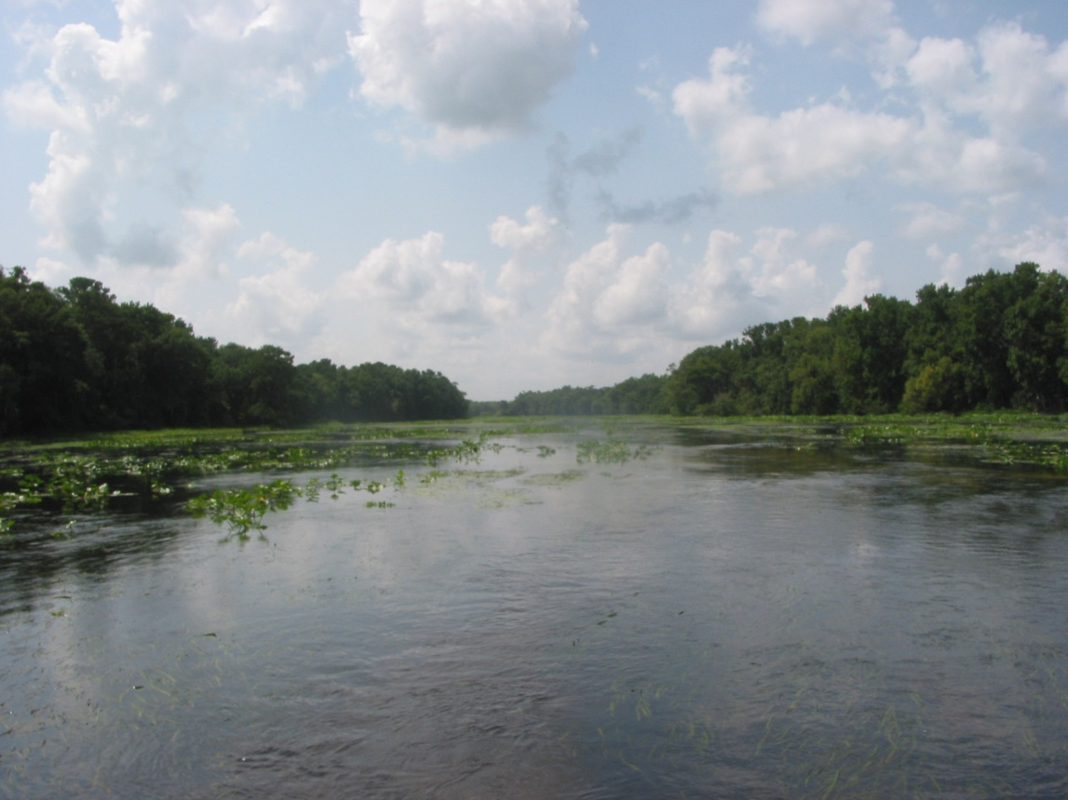
ANNUAL REPORT 2011

Prepared by Robert A. Mattson, CEP, CSE
St. Johns River Water Management District

SUBMITTED TO SATISFY REQUIREMENTS OF PERMIT NO. 02161113
FLORIDA DEPT. OF ENVIRONMENTAL PROTECTION
DIVISION OF RECREATION AND PARKS

Page Intentionally left blank

INTRODUCTION

The communities of submerged aquatic vegetation (SAV) and benthic algae in Florida springs and spring-run streams are important sources of autochthonous production (Odum 1957). SAV and algae also provide habitat for invertebrates and other aquatic animals (Power 1990). Excessive algal growth, however, may be detrimental to spring-run stream ecosystems, altering habitat and degrading water quality (Stevenson 1997, Stevenson et al. 2004).

SAV and algae have been monitored as indicators of water quality for many years and have been shown to be excellent for this purpose (Patrick 1973; Rosen 1995). Monitoring of SAV and algae in selected spring-run streams in the St. Johns River Water Management District (SJRWMD) provides a number of important benefits:

- Better assess water quality and ecological conditions in the spring runs;

- Assess the impacts/effects of elevated nutrient concentrations and other water quality changes;

- Contribute to refinement of Pollution Load Reduction Goals (PLRGs)

METHODS

The purpose of this project is to quantitatively describe the distribution and spatial coverage of SAV and filamentous macroalgae selected spring-run streams along the St. Johns River, including the headsprings. For purposes of this study, “macroalgae” are defined as those algae with a macroscopic or plant-like thallus visible to the naked eye. In the spring-run streams sampled in this project, these shall primarily be filamentous algae in the Chlorophyta (green algae), Cyanobacteria (blue-green algae), Bacillariophyceae (diatoms), and/or Xanthophyceae (yellow-green algae). SAV is defined as vascular plants which grow submersed on the stream bottom with no aerial or emergent portions. SAV includes the green alga Chara sp.

Once each year District staff conduct systematic surveys of the distribution and coverage of SAV and macroalgae in two headsprings and their spring-run streams located within the Wekiwa Springs State Park/Rock Springs Run State Reserve/Lower Wekiva State Preserve complex:

Rock Springs Run (Kelly Park/Rock Springs Run [RSR] State Reserve)
Wekiva River (Wekiwa Springs State Park/RSR State Reserve/Lower Wekiva River Preserve)

The timing of this annual sampling is in the late spring/early summer (April-June), which generally coincides with the period of maximal algal and SAV coverage. Sampling in the two spring run streams was conducted 26 April, 19 May, 02 June, 07 June and 15 June 2011. Sampling is conducted using transects established in 2007/08, which run along the length of each spring-run stream from (and including) the headspring to a downstream point; either the confluence with a larger stream or a convenient take-out point. During each annual survey, SAV and algal distribution and coverage is measured at each transect or grid by:

- measuring SAV (by species) and algal cover with the Braun-Blanquet scale using 0.25 m² quadrats which shall be randomly located along each transect (or systematically located if the stream channel is < 12 m in width). The Braun-Blanquet scale is an ordinal scale system which estimates percent cover in the following categories:

5 - 75-100% cover
4 - 50-75% cover
3 - 25-50% cover
2 - 5-25% cover
1 - < 5% cover

- if possible in the field, identify dominant algae in the mats to Division (Cyanobacteria, Chlorophyta, etc.);

Transect locations are illustrated in Figures 1 (Rock Springs Run) and 2 (Wekiva River).

Concurrent with vegetation surveys, field water quality (water temperature, pH, conductivity and dissolved oxygen) is collected using a calibrated meter (YSI or equivalent).

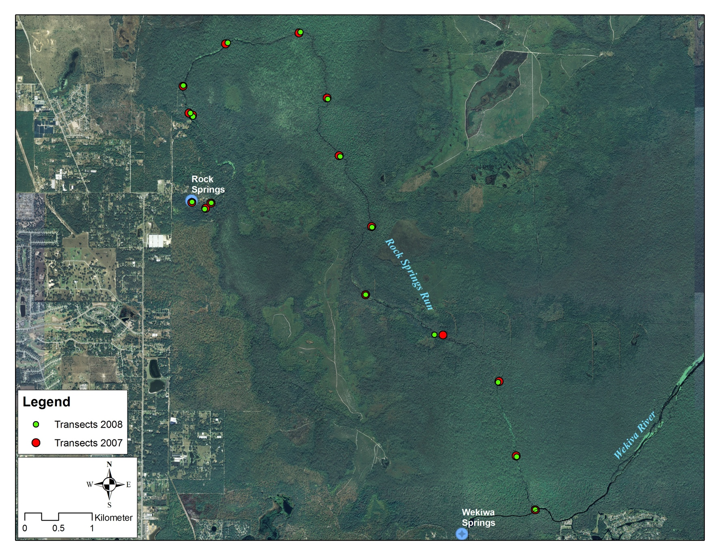
Figure 1. Transect locations in Rock Springs Run. 2008 locations were used in 2011 Survey.
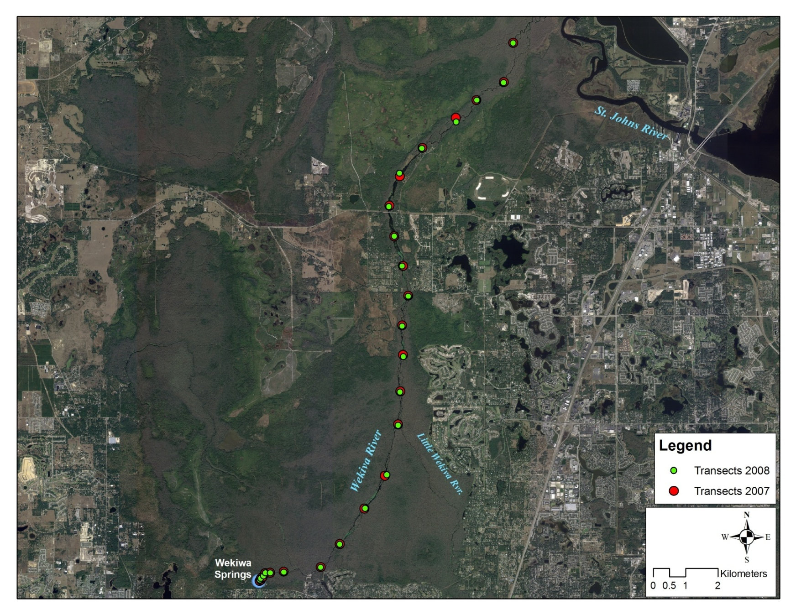
Figure 2. Transect locations in the Wekiva River. 2008 locations were used in 2011 Survey.
RESULTS

Water Quality

Profiles of the field water quality variables measured at the transects is shown in Figure 3 (Rock Springs Run) and Figure 4 (Wekiva River). As seen in prior years, conductivity in the Wekiva River increases dramatically downstream of Transect 19 (at the SR 46 bridge crossing), due to the inflow of more saline groundwater. Conductivity in Rock Springs Run is generally constant down the entire length of the stream. Dissolved oxygen (DO) is low at the headsprings of both systems and increases downstream. Water temperature and pH are also generally similar throughout the length of each stream, although temperature increases slightly in a downstream direction (part of which could be due to sampling downstream later in the spring).

Vegetation

Three species of macrophyte were identified. Vallisneria americana (freshwater eelgrass or wild celery) was found in both Wekiva River and Rock Springs Run and was the dominant (in terms of occurrence at transects and mean cover). Southern naiad (Najas guadalupensis) and the exotic hydrilla (Hydrilla verticillata) were observed in the upper Wekiva River. Algae could not be identified in the field survey, but prior collections indicated that most frequently occurring algae at the transects were the filamentous diatom Pleurosira laevis on Rock Springs Run and the cyanobacterium Oscillatoria princeps, the green alga Oedogonium sp., and the filamentous diatom Terpsinoe musica on the Wekiva River.

SAV and algal cover on Rock Springs Run is shown in Figure 5. Highest Vallisneria and algal cover (mean BB Score >2) occurred in upper Rock Springs Run in Kelly Park (Transects 1 and 2) and downstream near the confluence with the Wekiva River (Transects 15 and 16). SAV and algal cover in the Wekiva River is shown in Figure 6. Both Vallisneria and algae reached higher levels of cover (up to a mean BB Score of 5) on the Wekiva River compared to Rock Springs Run. Highest Vallisneria cover (mean BB Score >4) was seen between transects 9 and 20. Najas and Hydrilla were only observed in the upper reaches downstream of the headspring (Transects 3 and 4). Highest algal cover (mean BB Score >4) was seen at transects 7-10 and 17-20.

As additional years of data are collected, future analyses will compare year-to-year variation among and within these spring run streams.

Figure 3. Water quality in Rock Springs Run during the 2011 Vegetation Survey.

Figure 4. Water quality in the Wekiva River during the 2011 Vegetation Survey.

Figure 5. Submerged aquatic vegetation and algal cover on Rock Springs Run in 2011. N = transect not sampled due to no visibility.

Figure 6. Submerged aquatic vegetation and algal cover on Wekiva River in 2011. N = transect not sampled due to no visibility.
References

Odum, H. T. 1957. Trophic structure and productivity of Silver Springs, Florida. Ecological Monographs 27: 55-112.

Patrick, R. 1973. Use of algae, especially diatoms, in the assessment of water quality. Pp. 76-95 IN: J. Cairns, Jr. and K. L. Dickson (eds.), Biological Methods for the Assessment of Water Quality. ASTM Special Technical Publication 528.

Power, M. E. 1990. Benthic turfs vs floating mats of algae in river food webs.
Oikos 58: 67-79.

Rosen, B. H. 1995. Use of periphyton in the development of biocriteria. Pp. 209-215 IN: W. S. Davis and T. P. Simon (eds.), Biological Assessment and Criteria. Tools for Water Resource Planning and Decision Making. Lewis Publishers, Boca Raton, FL.

Stevenson, R. J. 1997. Resource thresholds and stream ecosystem sustainability. J. North American Benthological Soc. 16(2): 410-424.

Stevenson, R. J., A. Pinowska, and Y-K Wang. 2004. Ecological Condition of Algae and Nutrients in Florida Springs. Final Report to the Florida Department of Environmental Protection, Tallahassee, FL. 101 pp.

