Source ID study

Orange Creek BMAP Basins
Project Beginning 2014

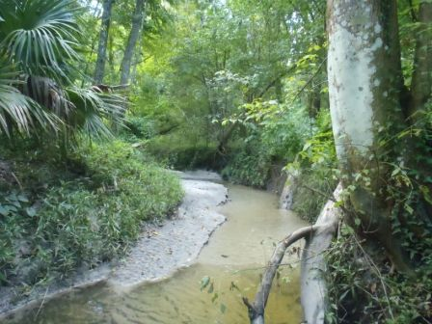
Looking for indication of untreated human waste sources using sucralose, MST human marker HF-183, and acetaminophen alongside fecal coliform and e-coli.

Hogtown Creek


Elizabeth Creek

Tumblin Creek

Sweetwater Branch

Rattlesnake Branch

Contents
Orange Creek BMAP Basins 1
Looking for indication of untreated human waste sources using sucralose, MST human marker HF-183, and acetaminophen alongside fecal coliform and e-coli. 1
Table of Figures 3
Summary of Results 5
Introduction 5
Indicator information and caveats of this study 5
Result summaries and action items responding to data 7
Rattlesnake Branch (WBID 2698) 7
Sweetwater Branch (2271) 8
Tumblin Creek (2718B) 10
Possum Creek (2696) 11
Elizabeth Creek (2698) 13
Hogtown Creek (2698) 14
Lab Data Results 17
Projecting Future Sampling Events: 18
Appendix A 19
Appendix B 34
Appendix C 35

Figure 1: View upstream at station RATUSHOG 7
Figure 2: View upstream at station RATNW8 7
Figure 3: View upstream at station RATNW18DS 7
Figure 4: View upstream at station SWBSE4AVE 8
Figure 5: View upstream at station SWBSE1 8
Figure 6: View upstream at station SWBSE8 8
Figure 7: View upstream at station ROSESE2 9
Figure 8: View upstream at station SWB331 9
Figure 9: View upstream at station ROSESE9 9
Figure 10: View upstream at station SWBSE4 9
Figure 11: View upstream at station TUM441 10
Figure 12: View upstream at station TUMSW9 10
Figure 17: View upstream at station POSPARK 11
Figure 16: View upstream at station POSNW36DR 11
Figure 15: View upstream at station POSNW34DS 11
Figure 13: View upstream at station POSNW8 11
Figure 14: View upstream at station POSNW39 11
Figure 18: View upstream at station ELIZARBOR 13
Figure 19: View upstream at station ELIZNW7 13
Figure 20: View upstream at station HOGNW45 14
Figure 21: View upstream at station SPSTNW13 14
Figure 22: View upstream at station HOGNW23 15
Figure 23: View upstream at station HOGNW29 15
Figure 24: View upstream at station HOGNW16 15
Figure 25: View upstream at station HOGUSRAT 15
Figure 26: View upstream at station HOGSW2 16
Figure 27: View upstream at station HOGNW30US 16
Figure 28: Lab results for source indicator monitoring. 17
Figure 29: August 2014 monitoring event of Tumblin Creek-documentation of conditions. 19
Figure 30: Tumblin Creek watershed seasonal info 20
Figure 31: August 2014 monitoring event of Sweetwater Branch-documentation of conditions. 21
Figure 32: Sweetwater Branch watershed seasonal info 22
Figure 33: August 2014 monitoring event of Rattlesnake Branch-documentation of conditions. 23
Figure 34: Rattlesnake Branch watershed seasonal info 24
Figure 35: August 2014 monitoring event of Hogtown Creek-documentation of conditions. 25
Figure 36: Hogtown Creek watershed seasonal info 26
Figure 37: August 2014 monitoring event of Elizabeth Creek-documentation of conditions. 27
Figure 38: Elizabeth Creek watershed seasonal info 28
Figure 39: August 2014 monitoring event of Possum Creek-documentation of conditions. 29
Figure 40: Possum Creek watershed seasonal info 30
Figure 41: October 2014 monitoring event of Possum Creek-documentation of conditions. 31
Figure 42: Gainesville Rainfall for 30days prior to monitoring event. 32
Figure 43: Stage for Hogtown Creek preceding sampling events. 33
Figure 44: Rainfall data for previous 12 months in Gainesville, FL. 33
Figure 45: Double click the image above to open Appendix B maps 34
Figure 46: Quick tips for navigating Adobe pdf mapsFigure 45: Double click the image above to open Appendix B maps 34
Figure 46: Quick tips for navigating Adobe pdf maps 34
Figure 47: Double click the image above to open Appendix C scanned field sheetsFigure 46: Quick tips for navigating Adobe pdf maps 34
Figure 47: Double click the image above to open Appendix C scanned field sheets 36
Figure 47: Double click the image above to open Appendix C scanned field sheets 36

Summary of Results

Introduction
In summer of 2014, Anita Nash worked with the Alachua County EPD to initiate a source ID study in association with the Orange Creek BMAP efforts and adoption of the 2014 Phase II BMAP document. The county preformed 2 source ID studies in these basins more than 5 years earlier with the assistance of Dr. Jody Harwood at UF. These studies included MST studies, the use of wildlife cameras, and extensive efforts to follow up on high indicator sample results. In summer of 2014, county staff provided a list recommended stations to FDEP. These stations will be referred to as “repeat” stations as they will be tested during various hydrologic conditions and potentially various landuse conditions. Additional stations will be tested as follow-up to any results suggesting human waste presence and their locations will be chosen to help zero in on source locations. The FDEP lab mailed sample kits to the county staff who went into the field and took samples and shipped them back to the FDEP lab for analysis. Parameters in the sample kits were chosen to help discover the potential for human waste in the ambient stream water. Analytes were: qPCR marker HF-183, sucralose, acetaminophen, E-coli, and fecal coliform.
DEP staff Anita Nash and Alachua County staff, Robin Hallbourg, Greg Owen, Chelsea Rivera, Coda Freeman discussed results from the August and October sampling events on Nov. 20. The dialogue included acknowledgement that there is a lot of sucralose in these systems but not a lot of reuse or treated wastewater disposal. Historical knowledge of the area and these results point toward leaking sanitary sewer conveyances, laterals, and leachate from septic tanks especially areas with no reuse but presence of sucralose especially so when acetaminophen and HF-183 are also present. Anita suggested follow up to the areas feeding stations with hits on all 3 parameters in hopes of identifying areas of contribution for further investigation.
When interpreting the results and possible sources it is helpful to keep in mind that these streams are cut the upper Unconfined Floridan aquifer. Baseflows of tributaries and the creeks are comprised of waters from this aquifer. The importance of this is its proximity to septic tank drainfield leachate zones, lateral sewer connections, and sanitary sewer conveyances. The immediate follow up sampling will include acetaminophen and sucralose to be analyzed at the FDEP lab, and Fecal Coli and E-Coli at the Alachua County lab. Follow-up sampling will occur again at the stations with great levels of indicators and new stations will be sampled which divide the upstream region into small segments for the purpose of drilling down to source locations. This study will likely provide information which can be used to help guide decision makers about prioritization of areas for future management actions meant to reduce loading of human waste to ambient waters.

Indicator information and caveats of this study
A few caveats about the analytes and reporting we are using are described this section. These are one way tests and represent only a snapshot in time. Please keep in mind, we are looking to answer the questions: do we see indication of human waste in the streams, and does the source appear to be raw sewage which is of greatest concern because it poses a great health risk and should be remediated immediately. The intention of this data review is to help managers determine if there is any immediate remediation needed, if resampling stations may lead to source identification which could lead to remediation efforts depending on the sources.
Acetaminophen is mostly removed during the wastewater treatment process, but may be a symptom of raw sewage from either failing septic tanks or failing sanitary sewer infrastructure for raw sewage. It persists in the environment for only a few days indicating a very recent source. Sucralose is present at 10-40 mg/l in treated effluent such as reuse as well as raw sewage. It persists in the environment for approximately 1-2 years. It builds up in lakes with slow water exchange, but will dilute over time. When comparing acetaminophen and sucralose in the same sample, remember that they exist at similar magnitudes in raw waste water. In treated effluent, acetaminophen is greatly reduced but sucralose is not. So if acetaminophen and sucralose are present but 2 or more orders of magnitude separate the results, it is quite possible the source is reuse water or treated effluent.
The DNA captured in the sample may be from live or dead cells. DNA may exist outside of a live cell but in the environment, it is most likely going to degrade within a couple of weeks of its initial release to the environment. In order for DNA from dead cells to persist a couple of weeks in the environment it would need to be sheltered from UV rays, bound to organic matter, in water that is not highly oxygenated, and in water that remains at cooler temperatures. Even with these conditions, DNA would not likely persist more than a couple of weeks at most. It is important to keep in mind that the data may reflect DNA from live or dead cells, but either way, presence indicates a recent (within 2 weeks) loading of human waste, treated or untreated. Where reuse water may be entering the stormwater drains and then the creeks, we could see some hits of HF-183 even though the cells are dead from treatment at waste water treatment facilities. That is why it is important to couple the HF-183 with other tests. A new test to be added to the DEP Lab is one that estimates the amount of a sample which is live vs dead. Other considerations for interpreting data is that really high qPCR samples need diluted. This called purification which results in increased detection limits. So when qualifiers relating to detection limits accompany reported values of varying counts, it may be a result of purification. A common dilution is 25 times the lowest detection value, thus increasing the reported value by 25 times. Freshly treated waste water can have values of HF-183 from 0 to in the thousands. DEP will learn more soon on this after a study of treated effluent from multiple waste water treatment facilities around the state.
Qualifier “I” means the parameter is present, but we aren’t sure of the exact number to report. For interpretation, if acetaminophen is present, that’s all we really need to know to suspect raw sewage loading. For qPCR, HF-183, a “U” qualifier means there was no amplification, therefore consider HF-183 not present, a non-detect. In other words, amplification was attempted up to the number reported, and no amplification occurred up to the number reported. “T” means something amplified, but not enough to “I” qualify it. “I” means it was present but between detection limit and quantification limits. The importance is that it was present at least the level being reported, and the true result may be higher than the number being reported. “T” qualifier is used to explain the replication was stopped bgefore the 30-35 run point because it is possible to get false positives if no presence showed before this number of runs.
Robin Hallbourg of Alachua County EPD compiled some historic and recent rainfall data as well as flow data for FDEP. This information was considered during the evaluation of lab results. Dave Whiting and Anita Nash reviewed the data results from the monitoring event in August and October of 2014. The following discussion contains brief notes and plans to move forward for each of the watersheds monitored. Lab data, maps of stations, and rainfall summaries can be found in the section of this report following the summaries section.

Result summaries and action items responding to data

Rattlesnake Branch (WBID 2698)
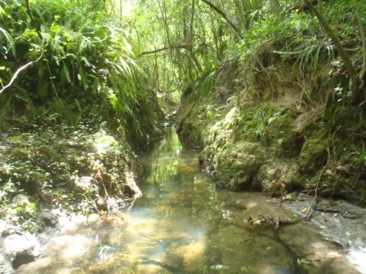
There were traces of acetaminophen and HF-183 through most of the system which indicates human waste is likely a source of elevated fecal coliforms. The upper most station and lower most station had the highest indication of waste. Sucralose results are strong in Rattlesnake, but there is no known reuse upstream of the 3 stations monitored. The middle station had lower results suggesting the creek has a tributary contributing water which diluted the higher concentrations from upstream. But since the lower station also had high results, it is possible there are two source areas to investigate. One above the upper most station, and one between the bottom two stations.
Figure 1: View upstream at station RATUSHOG

Immediate Actions Rattlesnake Branch:
Resample at the RATUSHOG station and move up into the watershed to determine if one particular area or many are contributing what results indicate may be untreated human waste.
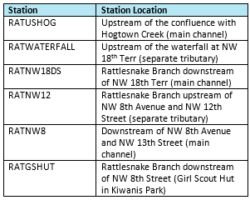

Figure 2: View upstream at station RATNW8

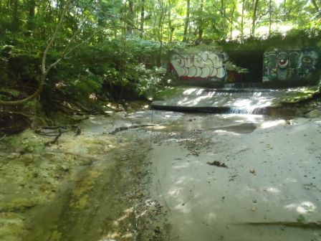
Figure 3: View upstream at station RATNW18DS

Sweetwater Branch (2271)
There were 2 hits for acetaminophen, it was present, but qualified with an “I” indicating we’re just not confident in the result. There was also presence of HF-183, sucralose, and acetaminophen at SWBSE4AVE which indicates a possible raw sewage source. SWBSE4 had no amplification of HF-183, but had presence of sucralose with a non-detect on acetaminophen. SWBSE4 could possibly be treated wastewater. Treated waste water is being used in this watershed on Depot Ave, upstream of SWB221 and 6 MGD is being discharged from the Main Street Water Reclamation Facility above SWB331 whose results look much like semi-diluted treated waste water.
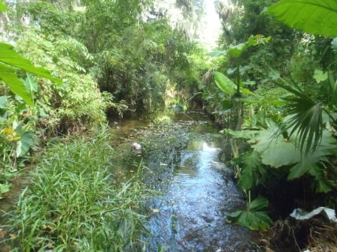
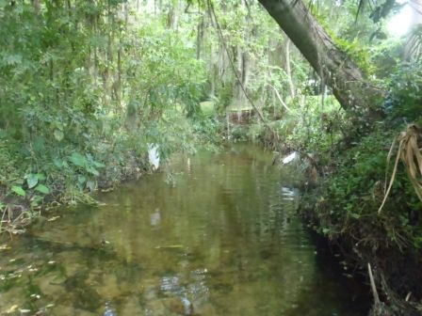
Figure 4: View upstream at station SWBSE4AVE
Figure 5: View upstream at station SWBSE1
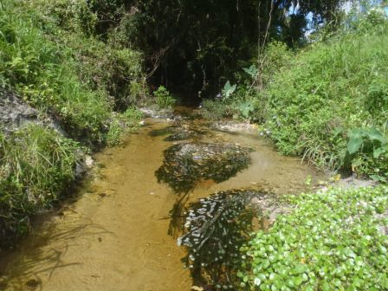

Immediate Actions Sweet Water Branch:
Resample at the SWBSE1 station and move up into the watershed to determine if one particular area or many are contributing what results indicate may be untreated human waste.
Rose Creek indicated potential leachate, so this should be followed up at a later time. For now, resources will focus on high levels at SWBSE1.
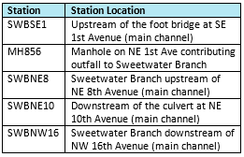

Figure 6: View upstream at station SWBSE8

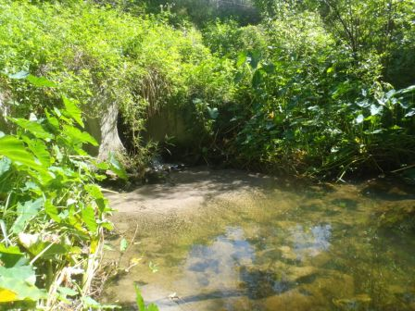
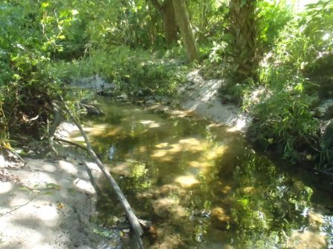
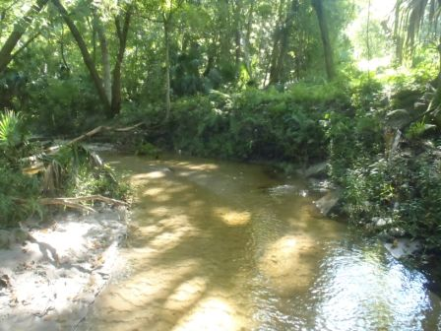
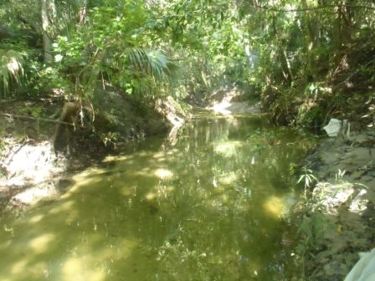
Figure 7: View upstream at station ROSESE2
Figure 8: View upstream at station SWB331
Figure 9: View upstream at station ROSESE9
Figure 10: View upstream at station SWBSE4

Tumblin Creek (2718B)
TUMSW9 looks like it might contain raw sewage that is being diluted because Acetaminophen and Sucralose are separated only by 1 magnitude, and fecal and e-coli bacteria are in the low thousands.

Immediate Actions Tumblin Creek:
Resample at the TUMSW9 station and move up into the watershed to determine if one particular area or many are contributing what results indicate may be untreated human waste.
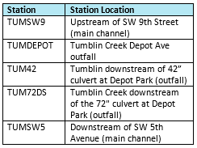
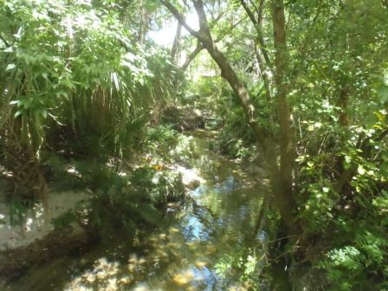
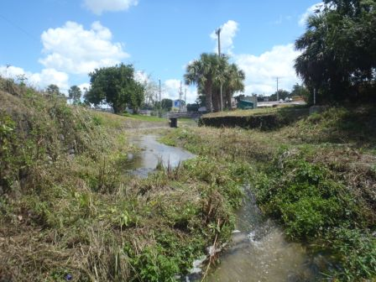
Figure 11: View upstream at station TUM441
Figure 12: View upstream at station TUMSW9

Possum Creek (2696)
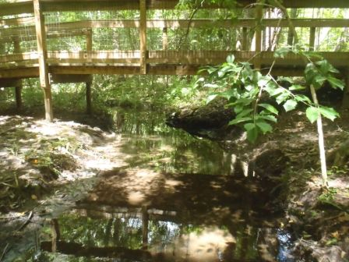
There is nothing here that is greatly concerning. No immediate resampling prescribed. The sucralose amount is so dilute, it would be hard to trace the source, especially because the other 2 indicators are not present. One note about the wet season sampling event in August 2014 is that the bottle for acetaminophen and sucralose tests which was sent to the lab for station POSNW16 was lost and resampled in October.
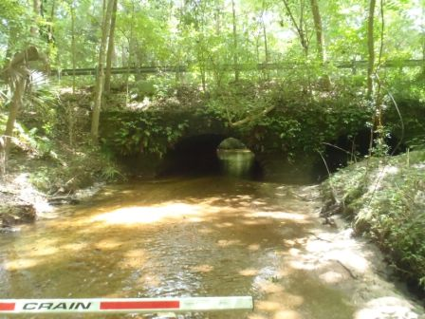
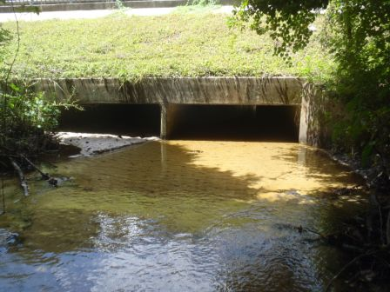
Perhaps sucralose is indicating septic drain field leachate or leaking laterals. This will be compared to results from dry weather sampling events in the spring.
Figure 17: View upstream at station POSPARK
Figure 16: View upstream at station POSNW36DR
Figure 15: View upstream at station POSNW34DS
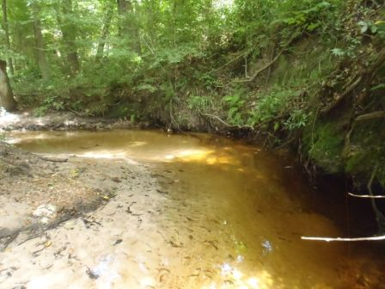
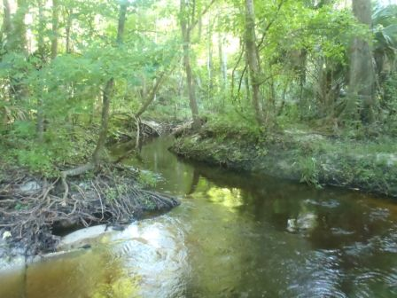
- Recommend county staff walk Possum to look for signs of failing drainfields or private infrastructure.
Figure 14: View upstream at station POSNW39
Figure 13: View upstream at station POSNW8

Elizabeth Creek (2698)
There is reuse being used to irrigate UF property which may drain directly to the creek. So, presence of sucralose and low levels of HF-183 may not be surprising. Upstream station ELIZNW7 was higher than the downstream station had presence of HF-183 but the downstream station did not. Also interesting was that sucralose was slightly higher downstream. Low concern since there is no acetaminophen and presence of possible reuse water upstream.
Potential indication of septic drain field leachate or leaking conveyances or laterals. This will be compared to results from dry weather sampling events in the spring.
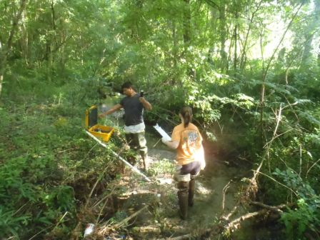

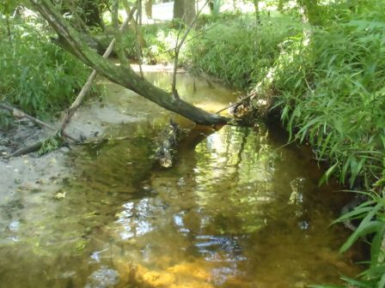
Figure 18: View upstream at station ELIZARBOR

Figure 19: View upstream at station ELIZNW7

Hogtown Creek (2698)
Sucralose is present all the way down the creek but no acetaminophen and very low HF-183, suggesting there is a very small source upstream of leachate or an unrealized reuse location. At site HOGMMFB, a small presence of HF-183 was detected. Determine if station is on the tributary or downstream of the tributary.
Potential indication of septic drain field leachate or leaking conveyances or laterals. This will be compared to results from dry weather sampling events in the spring.

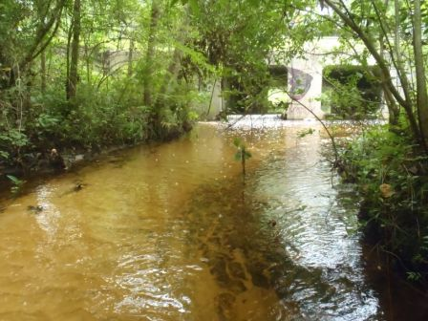
Figure 20: View upstream
at station HOGNW45

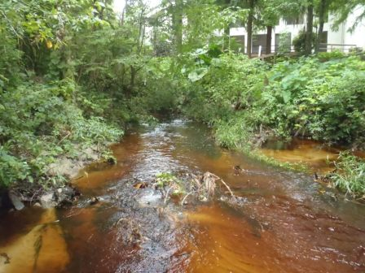

Figure 21: View upstream at station SPSTNW13

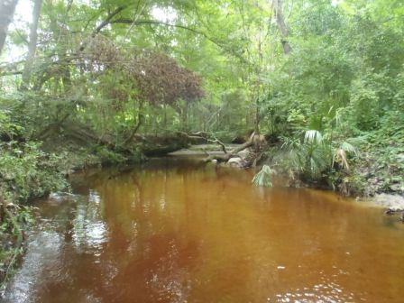
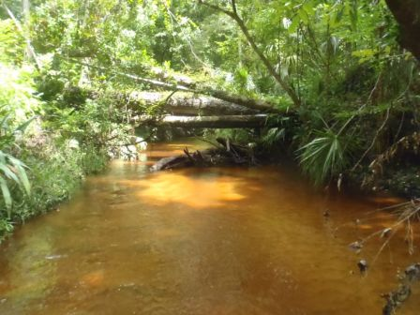
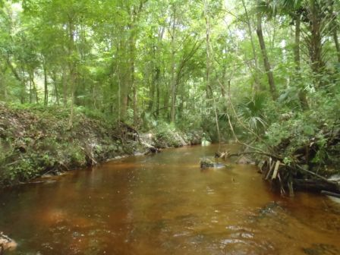
Figure 22: View upstream at station HOGNW23
Figure 23: View upstream at station HOGNW29
Figure 24: View upstream at station HOGNW16
Figure 25: View upstream at station HOGUSRAT
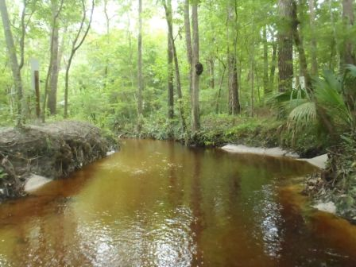

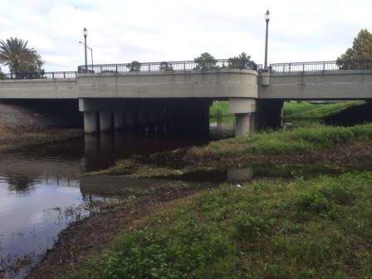

Figure 26: View upstream at station HOGSW2
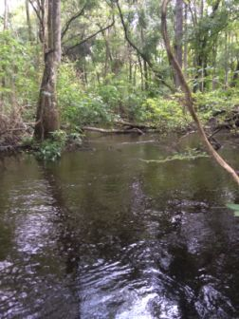

Figure 27: View upstream at station HOGNW30US

Lab Data Results
Figure 28: Lab results for source indicator monitoring.

Projecting Future Sampling Events:
The sampling events of August 2014 account for wet weather monitoring and as the highest seasonal human population time of year.
The only rookery-like area of these watersheds mentioned is in the Possum Creek vicinity, located in a wetland downstream of POSPARK and upstream of POSNW39. It is said to host 1-10 pairs of herons periodically. The sampling event of August and one sample in October account for the empty rookery season.

- Targeting dry season conditions means we will plan monitoring events for the beginning of May, 2015. Historically there are 2 dry periods each year, Oct.-Dec. and April & May. However, last year there were some winter storms that increased rainfall in November significantly above average. Historical wet seasons have been June through September
- Determine if the rookery will be full during May to compare bacteria levels to human waste indicators.
- Determine if additional monitoring dates should be planned to capture seasonal low in human population. Consider reserving this conversation for only areas with hot spots based on fecal coliform and e-coli bacteria results.

Appendix A
For each watershed and each sampling event in that watershed is an view of the ancillary data that helps us understand the saturation and flushing that occurred recent to the sampling event as well as assistance targeting the next best monitoring dates to capture other hydrologic seasons as appropriate. This data was provided by Alachua County EPD’s Robin Hallbourg.
Figure 29: August 2014 monitoring event of Tumblin Creek-documentation of conditions.
Figure 30: Tumblin Creek watershed seasonal info
Figure 31: August 2014 monitoring event of Sweetwater Branch-documentation of conditions.
Figure 32: Sweetwater Branch watershed seasonal info

Figure 33: August 2014 monitoring event of Rattlesnake Branch-documentation of conditions.

Figure 34: Rattlesnake Branch watershed seasonal info

Figure 35: August 2014 monitoring event of Hogtown Creek-documentation of conditions.
Figure 36: Hogtown Creek watershed seasonal info
Figure 37: August 2014 monitoring event of Elizabeth Creek-documentation of conditions.
Figure 38: Elizabeth Creek watershed seasonal info
Figure 39: August 2014 monitoring event of Possum Creek-documentation of conditions.

Figure 40: Possum Creek watershed seasonal info
Figure 41: October 2014 monitoring event of Possum Creek-documentation of conditions.

Figure 42: Gainesville Rainfall for 30days prior to monitoring event.
Figure 43: Stage for Hogtown Creek preceding sampling events.

Figure 44: Rainfall data for previous 12 months in Gainesville, FL.

Appendix B
Double click the image of a map (right) to open pdf maps of stations and data results to compare station locations and watershed attributes.
Once in the pdf, you can turn off the large balloon labels to see the graphic below by clicking the layers icon on the left bar in Adobe. Once open, expand the layers by clicking plus signs and turn layers on and off by clicking the eye symbols.
To quickly find a watershed map, press control key and the f key at the same time, type the name of the watershed or the WBID number and hit enter. Your view will move to the first instance of this number in the document. Scroll down to see the whole map. Hit enter a second time to find the next instance of the word or number you are searching for.
Save an electronic copy of the maps document to your computer by clicking file and save.
Figure 45: Double click the image above to open Appendix B maps

Figure 46: Quick tips for navigating Adobe pdf mapsFigure 45: Double click the image above to open Appendix B maps

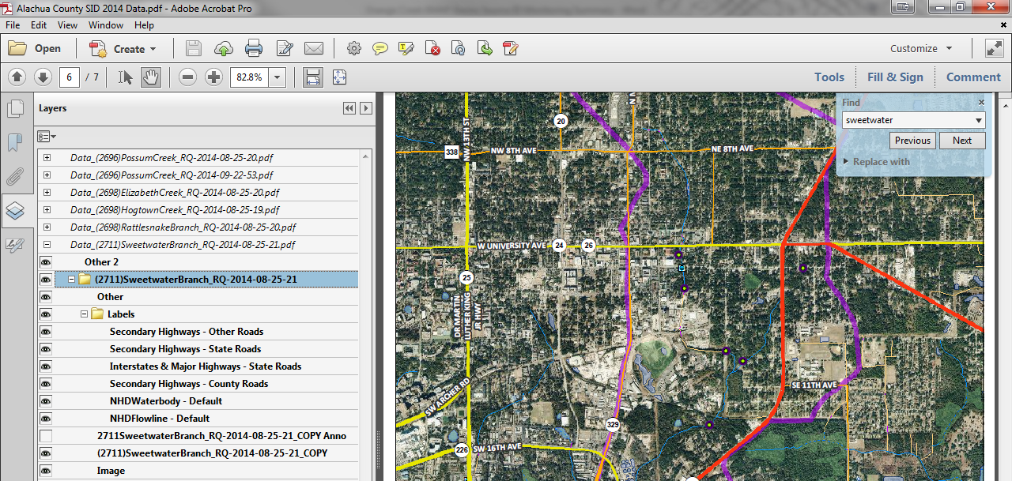
Figure 46: Quick tips for navigating Adobe pdf maps

Figure 47: Double click the image above to open Appendix C scanned field sheetsFigure 46: Quick tips for navigating Adobe pdf maps

Appendix C
Double click the field sheet icon (right) to open a pdf of the field sheets associated with the first round of sampling, August 2014 and October 2014.
Figure 47: Double click the image above to open Appendix C scanned field sheets

Figure 47: Double click the image above to open Appendix C scanned field sheets

To review FDEP Lab SOPs for acetaminophen and sucralose, please go to http://www.dep.state.fl.us/labs/cgi-bin/sop/sop1.asp?sect=CHEMISTRY&A1=Submit and review SOP ID: LC-001.

