Land Use Aggregation for Newnans Lake and Orange Lake
The Upper Ocklawaha Basin TMDL models were more detailed than Orange Creek Basin TMDLs and identified more categories of developed land uses. To simplify the calculations developed land uses in the Upper Ocklawaha were aggregated into three categories based on similar event mean concentrations and runoff coefficients used for modeling. Table 1 lists the land use aggregation scenarios used in the Upper Ocklawaha Basin. Two different levels of modeling were used in the basin. Lake Yale, the example given at the January 28 meeting, is part of the Harris Chain of Lakes. The apportioning of reductions to local entities is for urban stormwater loading.
Table 1: Land Use Categories Used for the Upper Ocklawaha Basin
Harris Chain Land Use Category | Description
Developed Land Use - High | High density residential, high density commercial, and industrial.
Developed Land Use - Medium | Medium density residential and low density commercial
Developed Land Use - Low | Low density residential, mining, sprayfields, and open land/recreation
Palatlakaha River Land Use Category | Description
Developed Land Use - High | High density residential
Developed Land Use - Medium | Medium density residential and transportation
Developed Land Use - Low | Urban open and low density residential

The Newnans Lake and Orange Lake models are simpler than the Harris Chain; there are only five developed land uses included in them. These land uses could be aggregated as:
- Developed Land Use – High which includes high density residential.
- Developed Land Use – Medium which includes medium density residential + communication/transportation.
- Developed Land Use – Low which includes low density residential + urban open.
Or, the non-aggregated approach where all five modeled land uses would be kept as separate developed land use categories (five categories instead of three). This is the recommended approach. The following developed land uses would be used for distributing loading:
- Urban Open
- Low Density Residential
- Medium Density Residential
- High Density Residential
- Communication and Transportation

Lake Basin Boundaries
Figure 1 and Figure 2 depict the individual lake basins delineated for TMDL development. The lower part of Newnans Lake basin was not included in the Newnans Lake TMDL (shaded in dark orange). That portion of Newnans Lake was considered part of the Orange Lake Basin for TMDL modeling purposes. The lake basin dividing line appears to be SR 20 with one excursion to the north. The Orange Lake delineation follows the basin boundary delineated by SJRWMD. There is a portion of the Camps Canal drainage as well as the northern portion of the Orange Lake Basin that were not explicitly modeled in the Orange Lake TMDL. Loading for this area was input directly from Camps Canal. This is the area shaded in dark orange. Lochloosa Lake sub-basin and basin boundary were delineated by SJRWMD and it is those delineations that were used by DEP for the Lochloosa Lake TMDL (Figure 2).
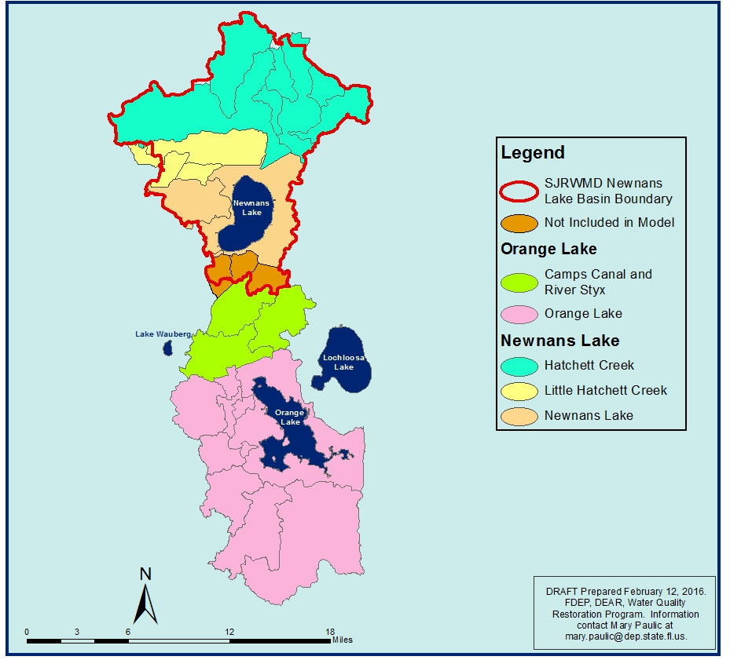
Figure 1: Newnans Lake and Orange Lake Basin Boundaries Used for TMDL Modeling
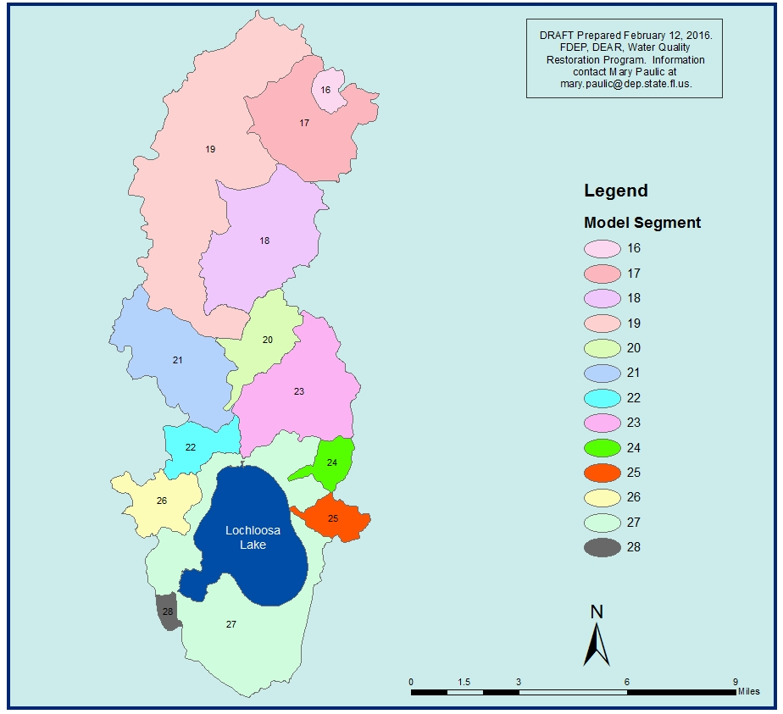
Figure 2: Lochloosa Lake Basin Boundary Used for TMDL Modeling
Overlaid on Figure 1 is the basin boundary used by SJRWMD for Newnans Lake. The DEP and SJRWMD basin delineations are close in area and location of boundary with the exception of the boundary with the Hogtown Creek Basin and Waldo Canals. The Newnans Lake Basin boundary delineated by SJRWMD is aligned with Lochloosa Lake and Orange Lake whereas the DEP delineated boundary leaves small gaps between Newnans Lake and Lochloosa Lake (Figure 3). This was most likely the result of different resolution maps used by the respective agency for defining the boundary. I recommend we use the SJRWMD boundary for apportioning of loading reductions, because it will allow the subsequent GIS work to be cleaner.

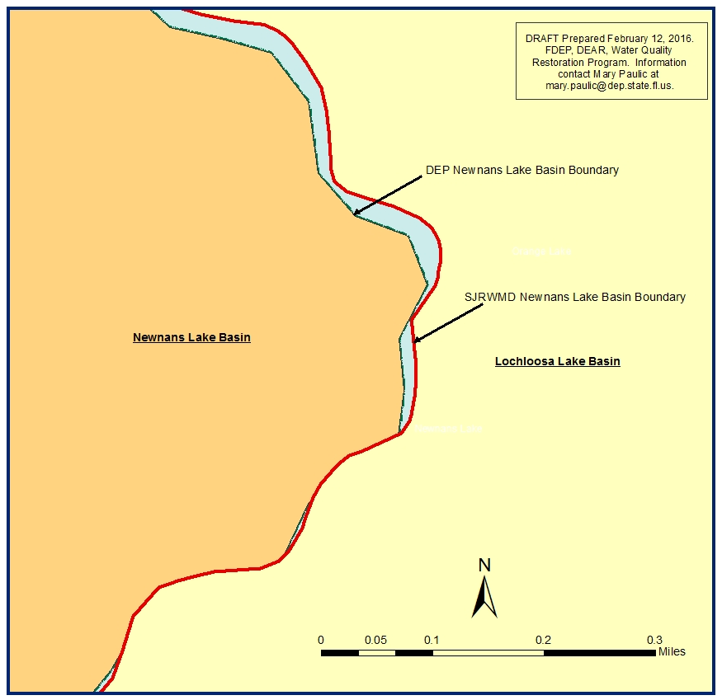
Figure 3: Example of mismatched Newnans Lake and Lochloosa Lake Boundary

