Appendix 8B-1:
WY2018 Supplemental Lake Okeechobee Watershed Phosphorus Concentration Data by Subwatershed
Danielle Medellin, Kristen Campos, and Steffany Olson
Contributor: Cordella Miessau

Introduction
The information provided in Figures 1 through 7 in this appendix is intended to supplement the data summaries provided in Chapter 8B. Section 373.4595(3)(a)2.a., Florida Statutes, requires the evaluation of all available existing water quality data concerning total phosphorus (TP) in the Lake Okeechobee Watershed (LOW). Surface water quality monitoring networks have been in place in the LOW since the early 1980s. The purpose of the networks has been to collect ambient data for the long term and track changes in water quality over time within the watershed.
The South Florida Water Management District (SFWMD or District) currently has monitoring networks that include sampling locations at two hydrologic levels within the LOW: Level 1, subwatershed and drainage basin level (basin monitoring sites for which flow and TP concentration data are collected and TP load is calculated), and Level 2, subbasin level (upstream ambient/tributary sites). The locations of the Level 1 sites are shown in figures within this appendix for reference only, while the Level 1 data can be found in Table 8B-3 of Chapter 8B of this volume. The Level 2 tributary sites in the figures indicate locations where grab samples are collected during flow conditions for analysis of TP concentrations. Definitions of project codes in figures can be found in the Acronyms, Abbreviations, and Units of Measurements for the 2019 South Florida Environmental Report.
This appendix presents TP data results for Water Year 2018 (WY2018; May 1, 2017–April 30, 2018) for the six subwatersheds north of Lake Okeechobee: Fisheating Creek, Indian Prairie, Lake Istokpoga, Upper Kissimmee, Lower Kissimmee, and Taylor Creek/Nubbin Slough basins S-191 and S-154/S-154C. TP concentrations presented in Figures 1 through 7 are not flow-weighted because flow measurements are not available at most sites. TP concentration ranges are grouped for reference in all figures. Box-and-whisker plots for each upstream monitoring site show the WY2018 average TP concentration compared to the distribution of TP concentrations for the most recent 10-year (WY2008–WY2017) period.
In WY2016, 20 sites were temporarily suspended and monitoring was discontinued; the timeline for reinstating those sites is unknown. Also in WY2016, the sampling frequency at the majority of the upstream ambient/tributary sites was temporarily reduced from biweekly to monthly. SFWMD will continue an analysis to determine the impact of the frequency reduction and consider the findings in future monitoring optimization efforts.
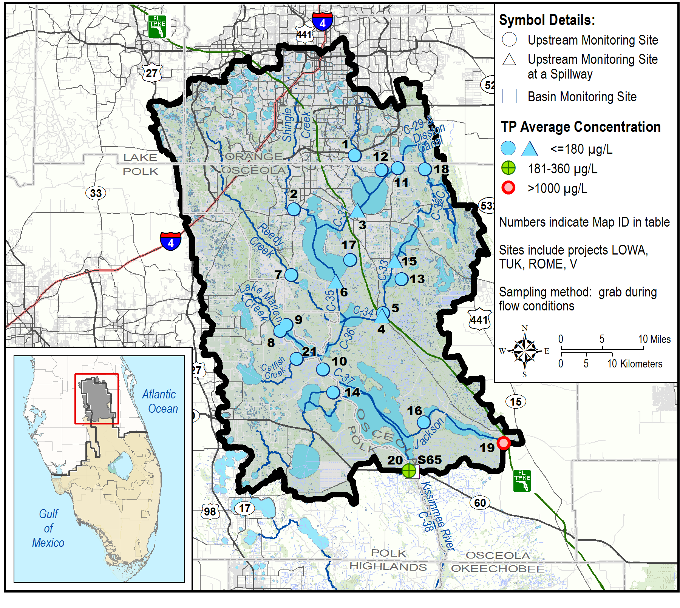
Figure 1a. Upper Kissimmee Subwatershed upstream tributary average TP concentrations for WY2018. (Note: µg/L – micrograms per liter.)
Upper Kissimmee |  | WY2018 |  |  |  | Number of Samples per Water Yearª
 |  | Number of Samples | TP Concentration (µg/L)
Map ID | Site | Number of Samples | Avg | Min | Max | 2008 | 2009 | 2010 | 2011 | 2012 | 2013 | 2014 | 2015 | 2016 | 2017
1 | ABOGGN | 8 | 61 | 24 | 197 | - | - | 4 | 12 | 12 | 12 | 11 | 11 | 9 | 4
2 | BNSHINGLE | 10 | 77 | 35 | 172 | 9 | 12 | 10 | 12 | 10 | 11 | 11 | 11 | 10 | 3
3 | BS-59 (S59) | 7 | 47 | 16 | 196 | 3 | 6 | 8 | 3 | 9 | 3 | 8 | 10 | 5 | 3
4 | CL06283111 (S63A) | 4 | 63 | 29 | 83 | - | - | - | - | 13 | 19 | 15 | 17 | 11 | 6
5 | CL06283112 | 2 | 70 | 56 | 84 | - | - | - | - | - | - | - | 3 | - | 1
6 | CL18273011 (S61) | 9 | 48 | 29 | 64 | - | - | - | - | 19 | 11 | 16 | 23 | 11 | 6
7 | CREEDYBR | 7 | 106 | 40 | 184 | 7 | 10 | 7 | 8 | 6 | 7 | 5 | 9 | 9 | 3
8 | DLMARNCR | 20^{b} | 65 | 26 | 158 | - | - | - | - | - | 19 | 26 | 25 | 19 | 10
9 | DLONDNCR | 10^{b} | 79 | 44 | 154 | - | - | - | - | - | 5 | 9 | 16 | 14 | 6
10 | EC-37 | 21^{b} | 78 | 41 | 173 | - | - | - | - | - | - | 1 | 19 | 15 | 8
11 | ET05253114 | 9 | 40 | 34 | 56 | 14 | 10 | 11 | 5 | 4 | 10 | 10 | 17 | 8 | 11
12 | ET06253113 | 9 | 173 | 40 | 979 | 21 | 19 | 15 | 20 | 20 | 23 | 26 | 24 | 20 | 9
13 | GENTRYDTCH | 12^{b} | 116 | 24 | 270 | - | - | - | - | - | 13 | 7 | 18 | 18 | 3
14 | KUB009 | 7^{b} | 95 | 44 | 175 | - | - | - | - | - | 12 | 8 | 6 | 19 | 6
15 | LG32263124 (S60) | 5 | 23 | 15 | 29 | - | - | - | - | 9 | 7 | 11 | 16 | 8 | 5
16 | LJACKDSCH | 8^{b} | 98 | 43 | 158 | - | - | - | - | - | 16 | 16 | 19 | 15 | 5
17 | LT32263013 | 7 | 92 | 52 | 171 | 12 | 15 | 14 | 11 | 7 | 3 | 7 | 7 | 6 | 2
18 | MJ01253123 | 5 | 20 | 17 | 22 | - | - | - | - | 7 | 8 | 8 | 16 | 7 | 5
19 | ML22303313 | 7 | 1551 | 789 | 2948 | - | - | - | - | - | - | - | 8 | 11 | 3
20 | PA10313112 | 10 | 188 | 41 | 965 | 12 | 14 | 17 | 18 | 14 | 12 | 11 | 13 | 11 | 7
21 | ROMCUT | 18^{b} | 73 | 38 | 159 | - | - | - | 2 | 2 | - | - | 1 | - | 1
a. During WY2016, the sampling frequency of the majority of the upstream ambient/tributary sites was reduced from biweekly to monthly because of SFWMD resource constraints.
b. These sites are visited biweekly, which may have resulted in a higher number of samples at the site.
Figure 1b. Upper Kissimmee Subwatershed upstream tributary average TP concentrations for WY2018 and sample count for the previous 10-year period. (Note: µg/L -micrograms per liter, Avg – average, ID – Identification, Max – maximum, and Min – minimum.)
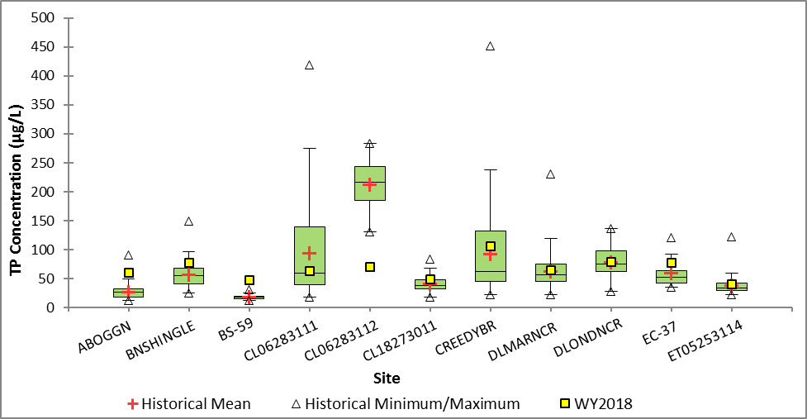
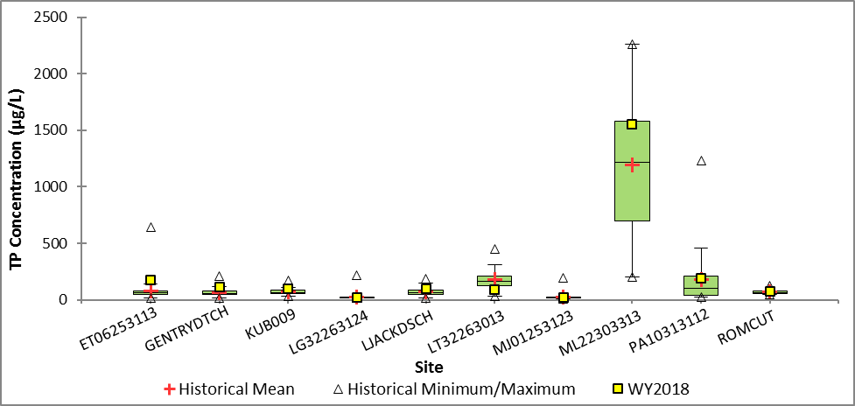
Figure 1c. Box-and-whisker plot of WY2018 average TP concentration compared to the TP concentration distribution for the previous 10-year period for the upstream monitoring sites in the Upper Kissimmee Subwatershed.
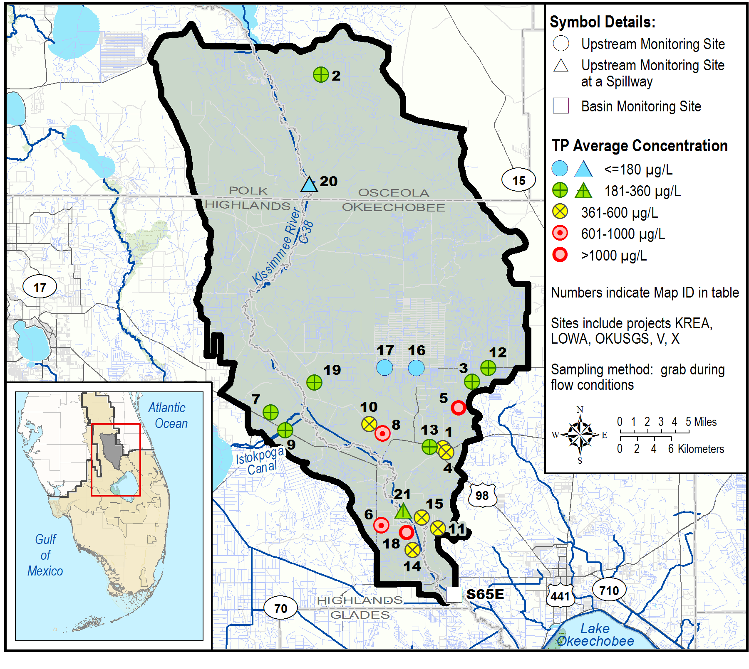
Figure 2a. Lower Kissimmee Subwatershed upstream tributary average TP concentrations for WY2018.
Lower Kissimmee |  | WY2018 |  |  |  | Number of Samples per Water Yearª
 |  | Number of Samples | TP Concentration (µg/L)
Map ID | Site | Number of Samples | Avg | Min | Max | 2008 | 2009 | 2010 | 2011 | 2012 | 2013 | 2014 | 2015 | 2016 | 2017
1 | 02272676 (KREA 06) | 5^{b} | 411 | 114 | 751 | - | 10 | 29 | 10 | 7 | 14 | 11 | 16 | 15 | 5
2 | BB16313214 | 3 | 185 | 131 | 250 | 11 | 7 | 13 | 8 | 6 | 5 | 1 | 3 | - | 4
3 | CY05353444 | 8 | 232 | 48 | 1040 | 23 | 24 | 22 | 22 | 24 | 25 | 17 | 21 | 16 | 4
4 | CY06363411 | 4 | 471 | 285 | 683 | 7 | 6 | 16 | 5 | 5 | 11 | 7 | 11 | 8 | 1
5 | CY17353413 (KREA 43A) | 4 | 4100 | 3159 | 4790 | 10 | 7 | 11 | 7 | 4 | 10 | 3 | 1 | 3 | 2
6 | KR05373311 (KREA 10D) | 9 | 621 | 148 | 1707 | 14 | 13 | 19 | 18 | 3 | 7 | 12 | 7 | 3 | 1
7 | KR24353114 | 4 | 266 | 97 | 524 | 10 | 10 | 17 | 12 | 8 | 11 | 15 | 18 | 13 | 6
8 | KR29353334 (KREA 08) | 2 | 720 | 114 | 1326 | 3 | 10 | 11 | 9 | 3 | 5 | 9 | 5 | 5 | 1
9 | KR30353214 | 5 | 191 | 67 | 612 | 25 | 13 | 15 | 12 | - | 3 | 2 | 1 | 1 | 3
10 | KR30353312 (KREA 07) | 1 | 386 | 386 | 386 | 3 | 5 | 13 | 10 | 4 | 9 | 2 | 6 | - | 2
11 | KR36363312 (KREA 16) | 4 | 416 | 156 | 820 | 10 | 14 | 19 | 10 | 2 | 5 | 5 | 5 | 3 | 2
12 | KREA 01 | 4 | 302 | 181 | 585 | 11 | 10 | 12 | 12 | 11 | 10 | 12 | 13 | 8 | 5
13 | KREA 04 | 7 | 312 | 103 | 661 | 9 | 7 | 11 | 6 | 10 | 13 | 13 | 15 | 15 | 4
14 | KREA 14 | 6 | 390 | 67 | 713 | 6 | 9 | 4 | 5 | 8 | 17 | 16 | 23 | 15 | -
15 | KREA 17A | 9 | 405 | 141 | 762 | 8 | 14 | 15 | 12 | 11 | 14 | 18 | 19 | 17 | 7
16 | KREA 22 | 9 | 125 | 52 | 350 | 10 | 8 | 17 | 22 | 17 | 14 | 17 | 22 | 17 | 5
17 | KREA 23 | 6 | 65 | 46 | 83 | 13 | 9 | 13 | 11 | 9 | 17 | 20 | 23 | 19 | 6
18 | KREA 41A | 2 | 1822 | 1703 | 1942 | 3 | 5 | 9 | 9 | 2 | 10 | 12 | 13 | 6 | 2
19 | OK09353212 | 9 | 211 | 89 | 361 | 9 | 19 | 14 | 10 | 8 | 8 | 15 | 22 | 14 | 7
20 | S65A | 26 | 79 | 41 | 176 | 17 | 23 | 26 | 23 | 23 | 26 | 25 | 27 | 20 | 13
21 | S65D | 17 | 192 | 65 | 541 | 15 | 31 | 24 | 22 | 26 | 24 | 25 | 26 | 19 | 6
a. During WY2016, the sampling frequency of the majority of the upstream ambient/tributary sites was reduced from biweekly to monthly because of SFWMD resource constraints.
b. This site is visited biweekly, which may have resulted in a higher number of samples at the site.
Figure 2b. Lower Kissimmee Subwatershed upstream tributary average TP concentrations for WY2018 and sample count for the previous 10-year period.
(Note: Alias name of site is in parenthesis.)
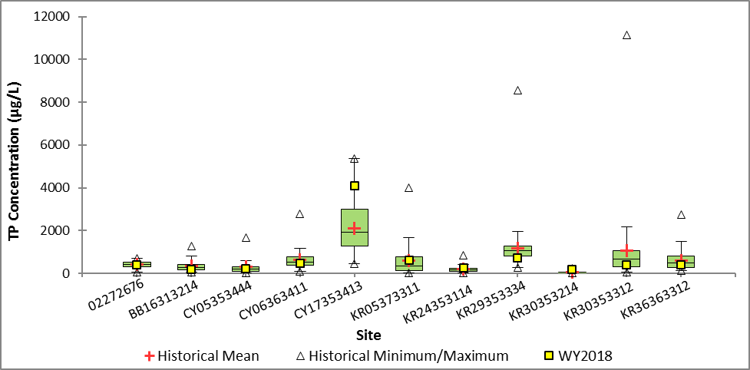
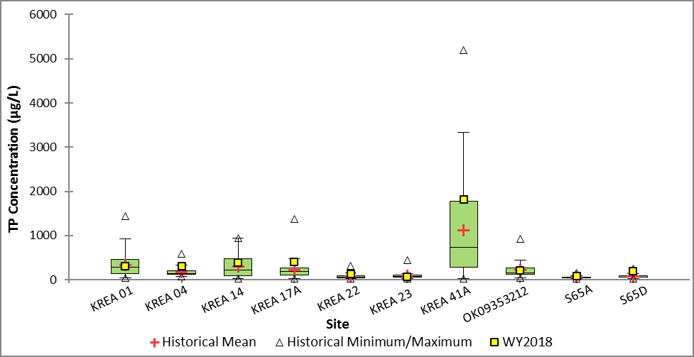
Figure 2c. Box-and-whisker plot of WY2018 average TP concentration compared to the TP concentration distribution for the previous 10-year period for the upstream monitoring sites in the Lower Kissimmee Subwatershed.
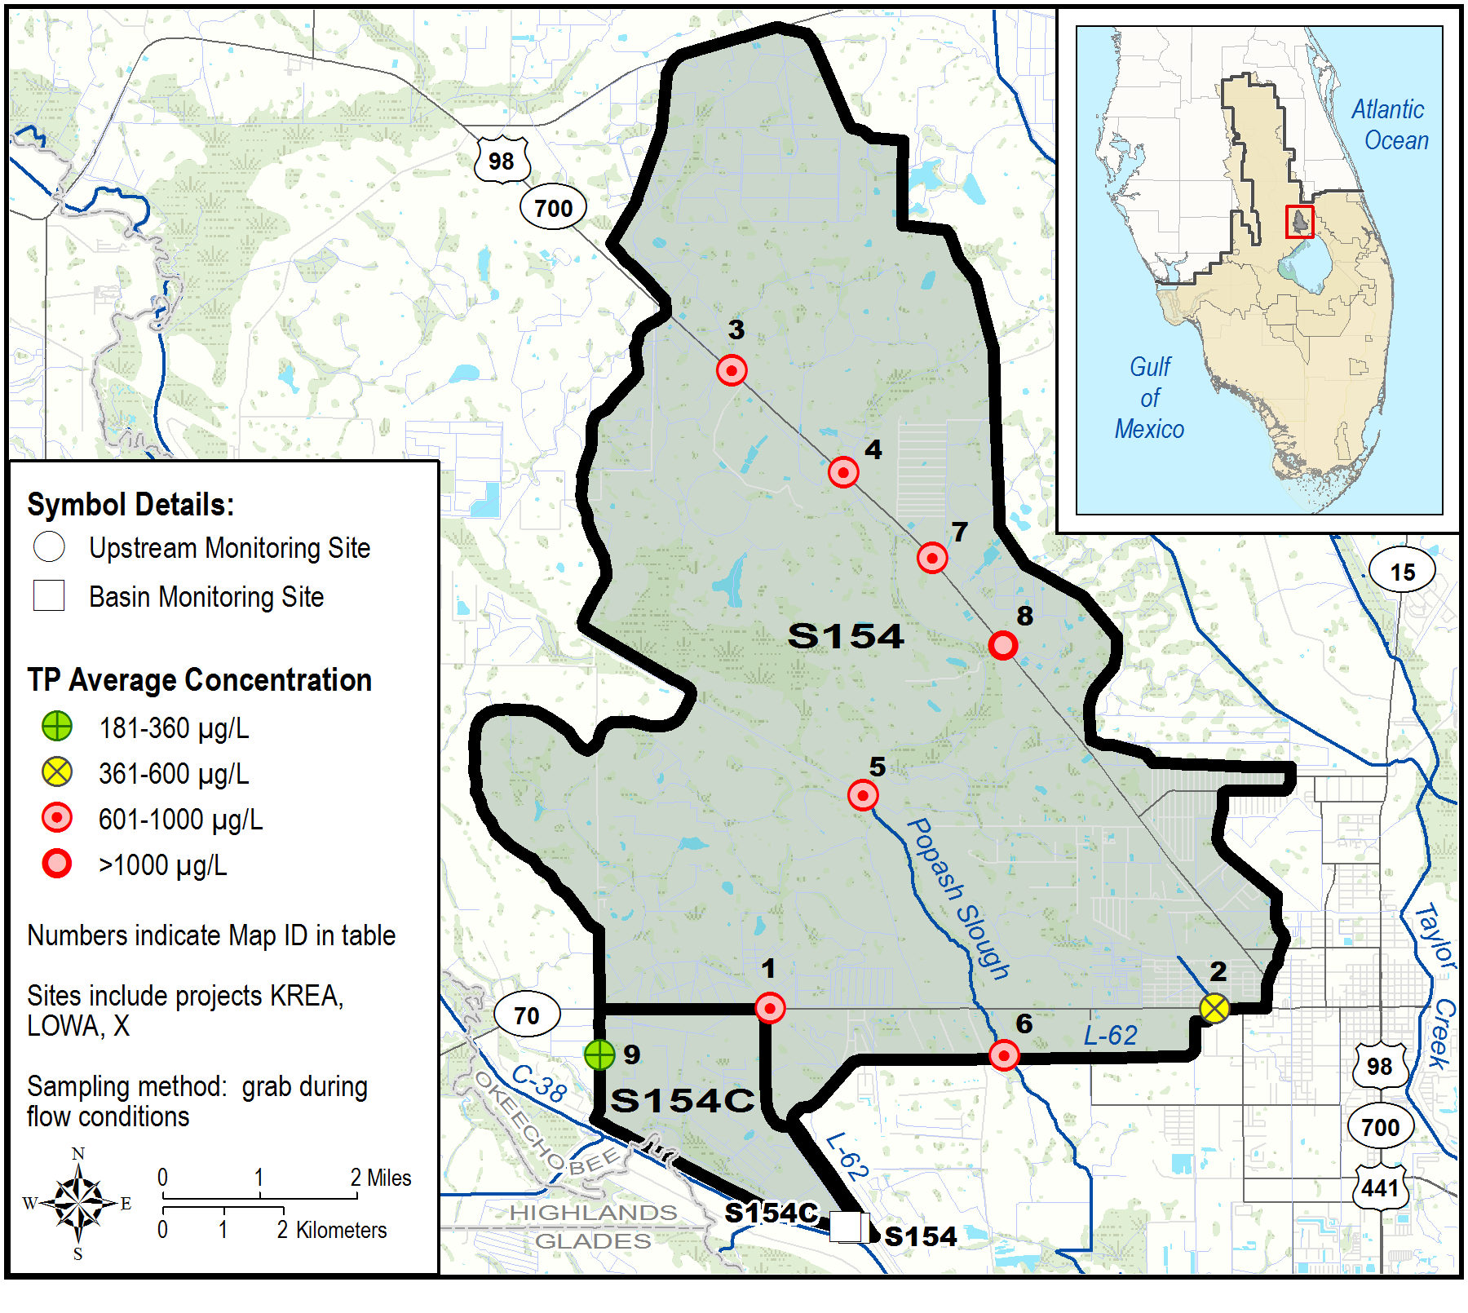
Figure 3a. Taylor Creek/Nubbin Slough Subwatershed, S-154 and S-154C Basins upstream tributary average TP concentrations for WY2018.
S154 & S154C |  | WY2018 |  |  |  | Number of Samples per Water Yearª
 |  | Number of Samples | TP Concentration (µg/L)
Map ID | Site | Number of Samples | Avg | Min | Max | 2008 | 2009 | 2010 | 2011 | 2012 | 2013 | 2014 | 2015 | 2016 | 2017
1 | KR16373414 | 7 | 686 | 107 | 1700 | 24 | 23 | 23 | 21 | 12 | 16 | 12 | 10 | 10 | 4
2 | KR17373513 (KREA 29) | 7 | 437 | 115 | 1147 | 24 | 25 | 24 | 22 | 18 | 16 | 14 | 13 | 8 | 2
3 | KREA 20 | 6 | 832 | 450 | 1272 | 2 | 5 | 1 | 5 | 4 | 8 | 8 | 13 | 7 | 2
4 | KREA 25 | 5 | 971 | 671 | 1299 | - | 5 | 1 | 7 | 2 | 4 | 7 | - | - | 1
5 | KREA 28 | 5 | 854 | 406 | 1197 | - | 11 | 7 | 5 | 4 | 9 | 9 | 7 | 12 | 5
6 | KREA 30A | 3 | 628 | 334 | 806 | 2 | 4 | 2 | 2 | 1 | 4 | 5 | 2 | 1 | 1
7 | TS26363411 (KREA 32) | 1 | 710 | 710 | 710 | 17 | 20 | 18 | 19 | 3 | 5 | 5 | 4 | 2 | 1
8 | TS36363411 (KREA 49) | 1 | 3577 | 3577 | 3577 | 16 | 10 | 9 | 17 | 5 | 4 | 5 | 6 | 3 | 1
9 | KR20373413 | 3 | 347 | 239 | 555 | 8 | 10 | 10 | 7 | 4 | 2 | 4 | 9 | 4 | 2
a. During WY2016, the sampling frequency of the majority of the upstream ambient/tributary sites was reduced from biweekly to monthly because of SFWMD resource constraints.
Figure 3b. Taylor Creek/Nubbin Slough Subwatershed, S-154 and S-154C Basins upstream tributary average TP concentrations for WY2018 and sample count for the previous 10-year period. (Note: Alias name of site is in parenthesis.)
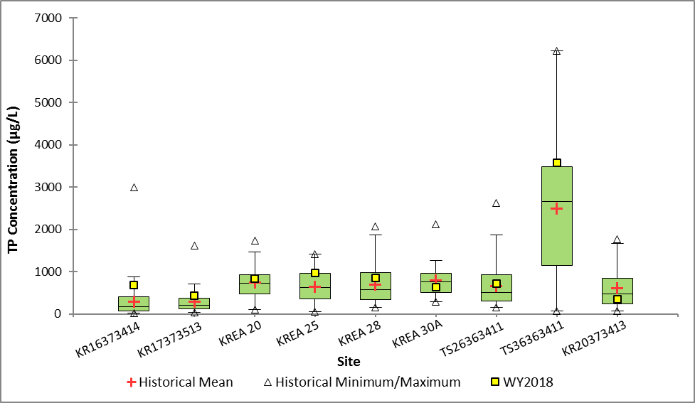
Figure 3c. Box-and-whisker plot of WY2018 average TP concentration compared to the TP concentration distribution for the previous 10-year period for the upstream monitoring sites in the Taylor Creek/Nubbin Slough Subwatershed, S-154 and S-154C Basins.
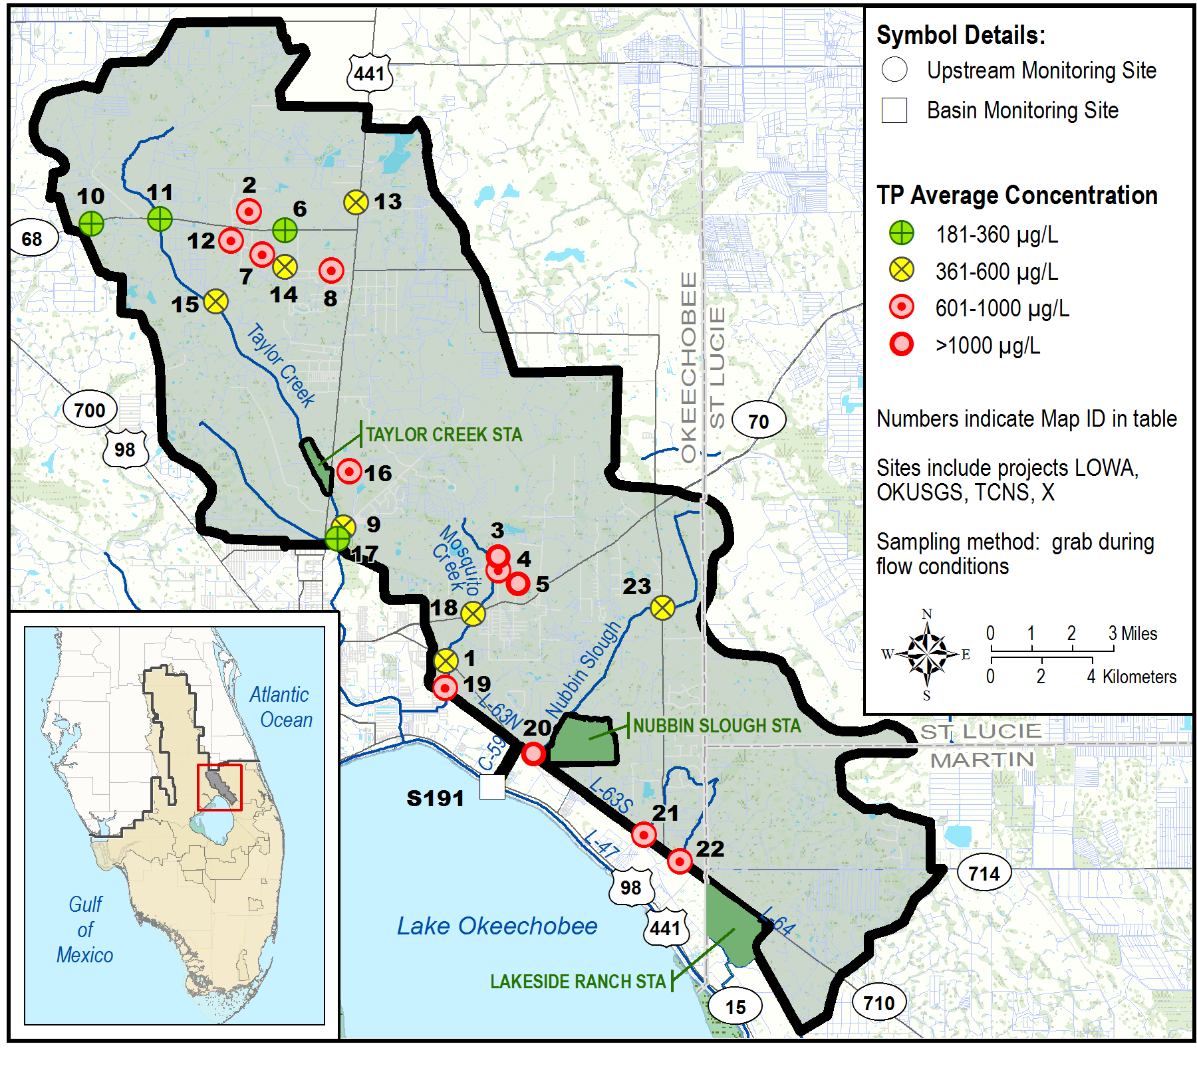
Figure 4a. Taylor Creek/Nubbin Slough Subwatershed, S-191 Basin upstream tributary average TP concentrations for WY2018.
(Note: STA – Stormwater Treatment Area.)
S191 |  | WY2018 |  |  |  | Number of Samples per Water Yearª
 |  | Number of Samples | TP Concentration (µg/L)
Map ID | Site | Number of Samples | Avg | Min | Max | 2008 | 2009 | 2010 | 2011 | 2012 | 2013 | 2014 | 2015 | 2016 | 2017
1 | 02275197 | 7^{b} | 523 | 190 | 1341 | - | 13 | 28 | 5 | 8 | 15 | 18 | 17 | 16 | 5
2 | LB29353513 (TCNS 265) | 9 | 783 | 230 | 3198 | 13 | 15 | 18 | 17 | 16 | 20 | 12 | 10 | 11 | 6
3 | MS05373613 (TCNS 263) | 5 | 1882 | 856 | 3120 | 5 | 15 | 10 | 21 | 8 | 5 | 2 | 1 | 2 | 1
4 | MS08373611 (TCNS 262) | 9 | 890 | 111 | 3005 | 16 | 18 | 19 | 16 | 2 | 13 | 8 | 11 | 3 | 5
5 | MS08373614 (TCNS 277) | 3 | 1839 | 1174 | 2579 | 13 | 11 | 12 | 6 | 3 | 5 | 2 | 2 | 2 | 1
6 | OT29353514 (TCNS 243) | 4 | 288 | 143 | 403 | 7 | 8 | 14 | 5 | 2 | 2 | 14 | 21 | 9 | 3
7 | OT32353511 (TCNS 210) | 7 | 716 | 245 | 1320 | 6 | 11 | 14 | 9 | 5 | 8 | 8 | 9 | 10 | 3
8 | OT34353513 (TCNS 211) | 4 | 725 | 147 | 2207 | 19 | 18 | 19 | 17 | 6 | 7 | 8 | 10 | 8 | 4
9 | TC03373511 | 5 | 571 | 200 | 1102 | 4 | 3 | 4 | 3 | 4 | 7 | 6 | 10 | 9 | 4
10 | TC27353413 | 6 | 356 | 256 | 444 | 1 | 2 | 2 | 1 | 7 | 7 | 6 | 10 | 7 | 1
11 | TCNS 201 | 8 | 293 | 123 | 608 | 7 | 5 | 9 | 3 | 6 | 3 | 6 | 8 | 7 | 2
12 | TCNS 204 | 7 | 788 | 303 | 1277 | 8 | 9 | 11 | 9 | 13 | 13 | 13 | 12 | 11 | 6
13 | TCNS 207 | 6 | 381 | 164 | 646 | 15 | 9 | 12 | 4 | 7 | 16 | 13 | 7 | 11 | 6
14 | TCNS 209 | 7 | 459 | 131 | 1108 | 4 | 14 | 8 | 5 | 13 | 13 | 8 | 7 | 5 | 3
15 | TCNS 213 | 6 | 434 | 211 | 639 | 20 | 16 | 16 | 18 | 21 | 23 | 10 | 16 | 15 | 6
16 | TCNS 214 | 4 | 856 | 600 | 1018 | 22 | 16 | 10 | 11 | 3 | 12 | 13 | 16 | 14 | 8
17 | TCNS 217 | 10 | 262 | 114 | 541 | 21 | 15 | 18 | 23 | 20 | 22 | 23 | 25 | 19 | 8
18 | TCNS 220 | 7 | 582 | 215 | 1249 | 4 | 9 | 12 | 8 | 12 | 11 | 12 | 18 | 8 | 5
19 | TCNS 222 | 5 | 617 | 189 | 1085 | 9 | 12 | 18 | 14 | 18 | 18 | 16 | 23 | 17 | 9
20 | TCNS 228 | 3 | 1063 | 894 | 1239 | 7 | 4 | 6 | 1 | 3 | 7 | 4 | 6 | 4 | 1
21 | TCNS 230 | 3 | 821 | 537 | 995 | 2 | 3 | 2 | - | 3 | 4 | 5 | 3 | 2 | 3
22 | TCNS 233 | 3 | 975 | 651 | 1158 | 12 | 6 | 7 | 1 | 6 | 8 | 11 | 8 | 5 | 4
23 | TCNS 249 | 3 | 442 | 91 | 640 | 5 | 5 | 10 | 4 | 1 | 6 | 4 | 18 | 9 | 3
a. During WY2016, the sampling frequency of the majority of the upstream ambient/tributary sites was reduced from biweekly to monthly because of SFWMD resource constraints.
b. This site is visited biweekly, which may have resulted in a higher number of samples at the site.
Figure 4b. Taylor Creek/Nubbin Slough Subwatershed, S-191 Basin upstream tributary average TP concentrations for WY2018 and sample count for the previous 10-year period. (Note: Alias name of site is in parenthesis.)
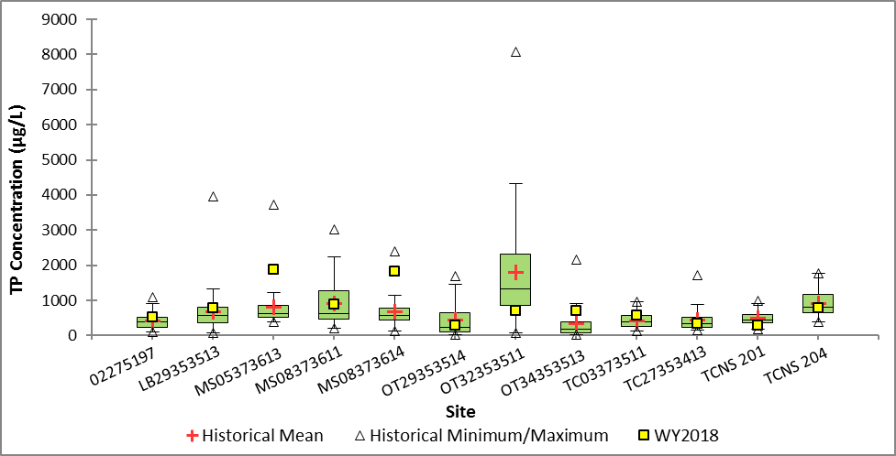
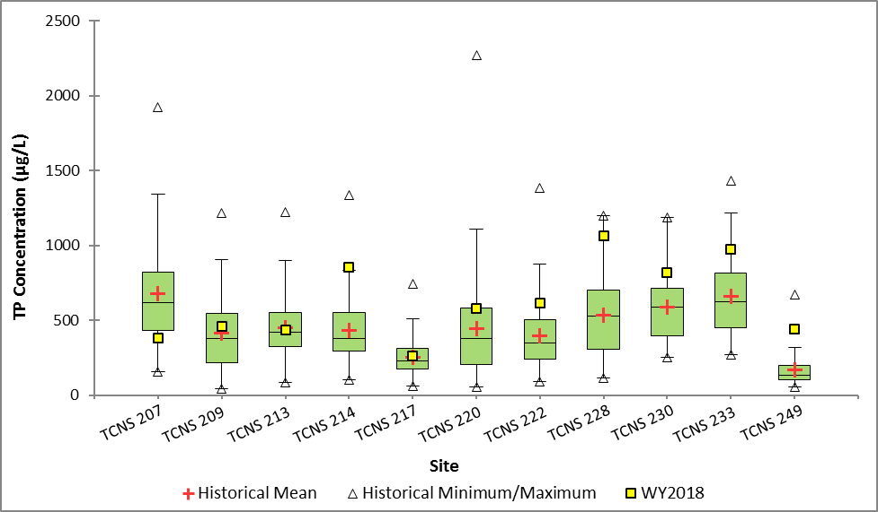
Figure 4c. Box-and-whisker plot of WY2018 average TP concentration compared to the TP concentration distribution for the previous 10-year period for the upstream monitoring sites in the Taylor Creek/Nubbin Slough Subwatershed, S-191 Basin.
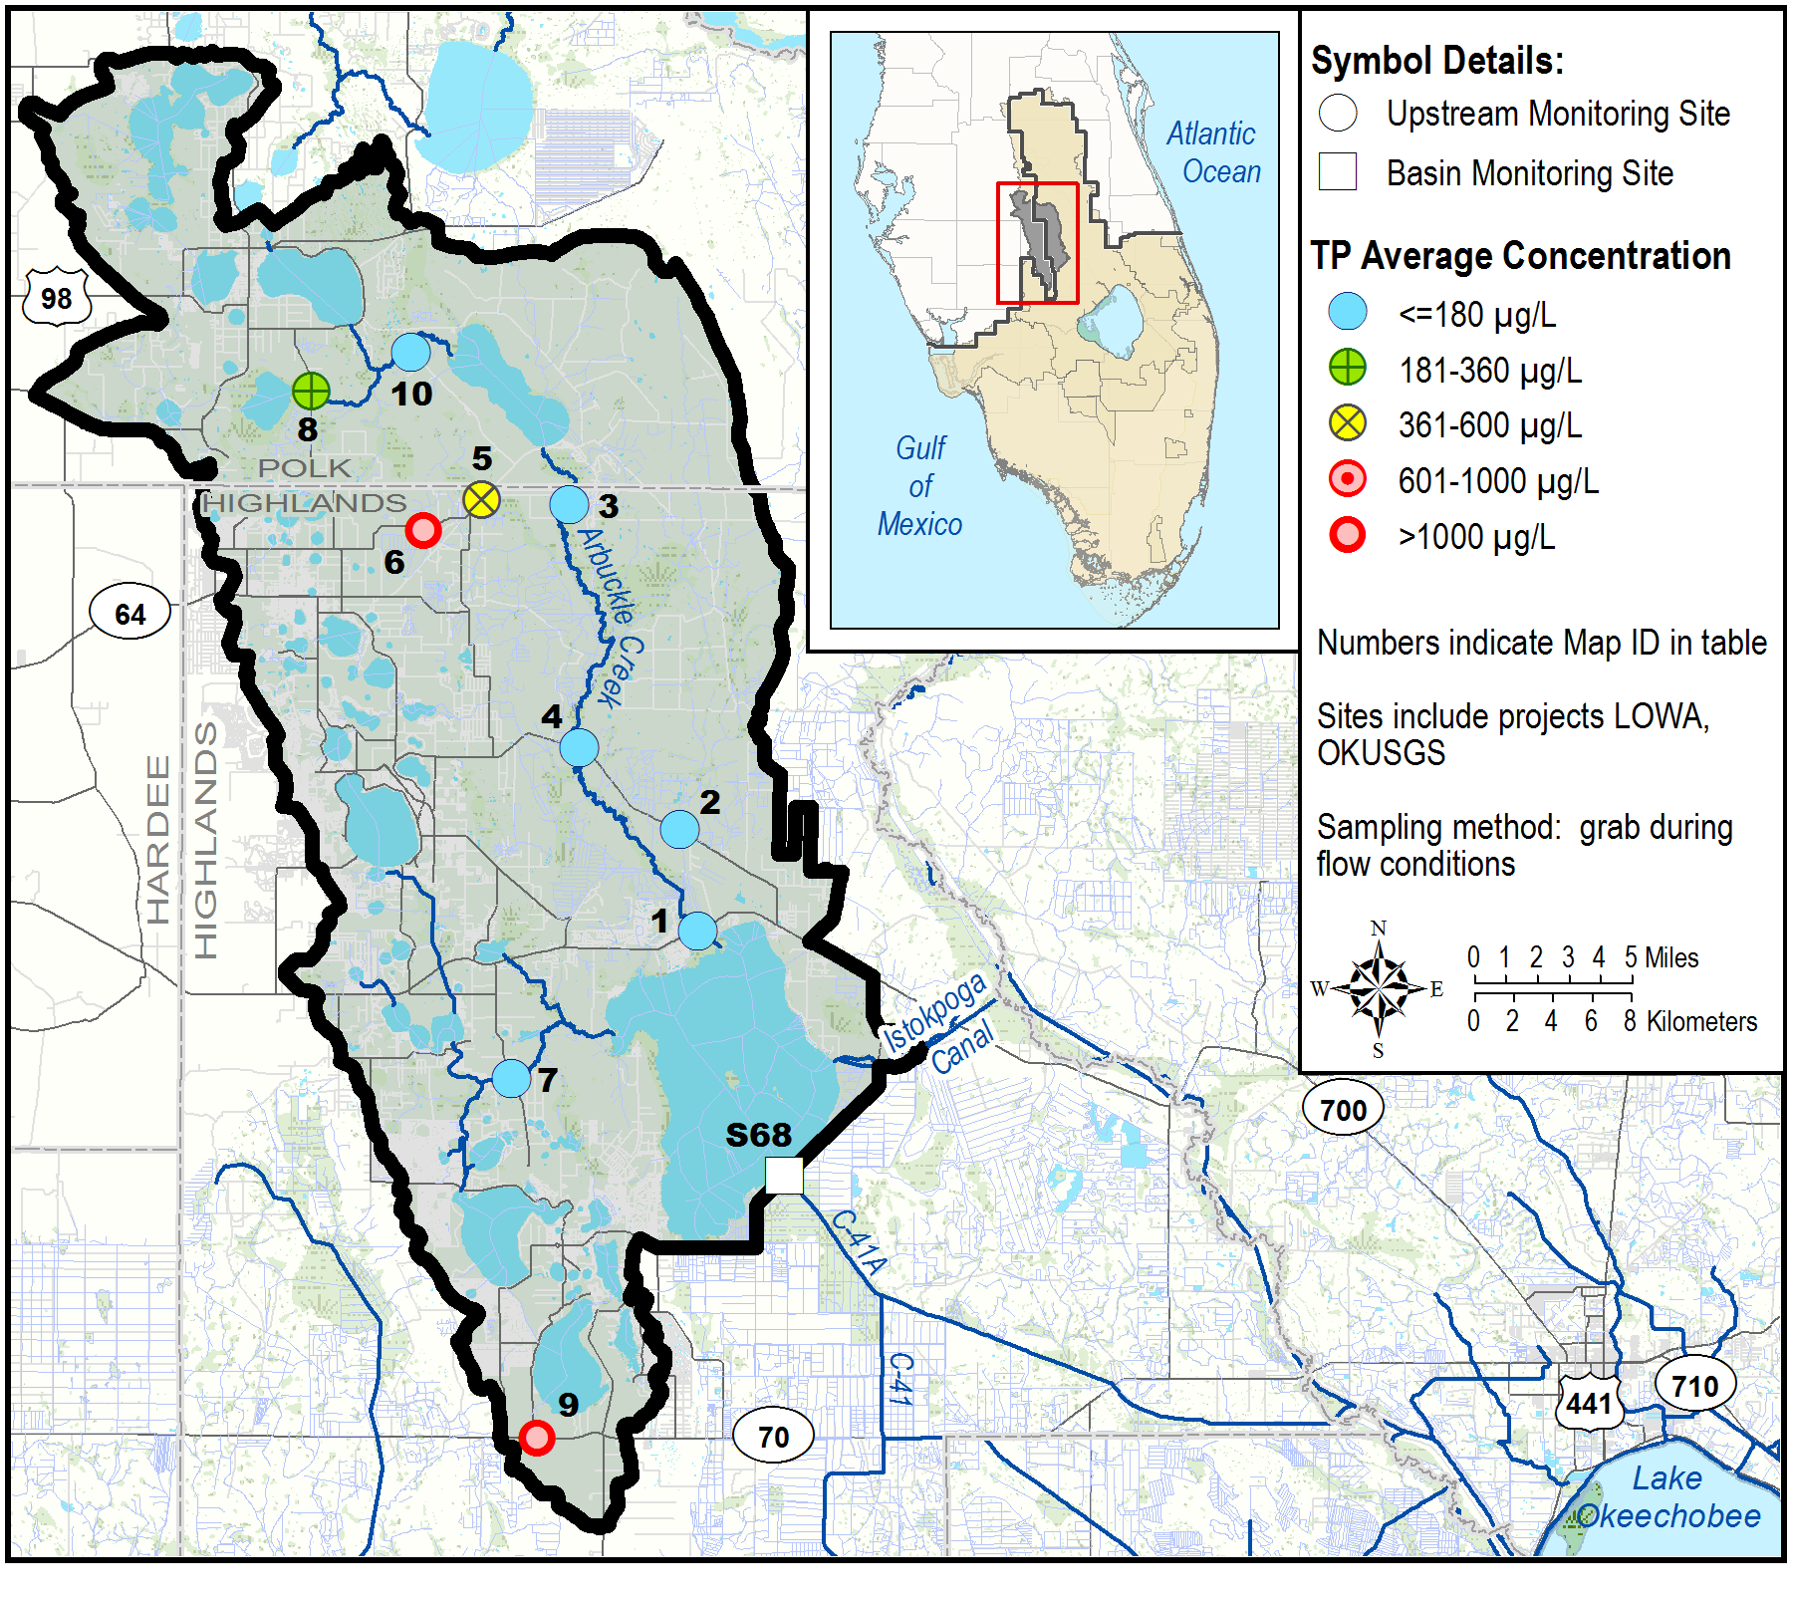
Figure 5a. Lake Istokpoga Subwatershed upstream tributary average TP concentrations for WY2018.
Lake Istokpoga |  | WY2018 |  |  |  | Number of Samples by Water Yearª
 |  | Number of Samples | TP Concentration (µg/L)
Map ID | Site | Number of Samples | Avg | Min | Max | 2008 | 2009 | 2010 | 2011 | 2012 | 2013 | 2014 | 2015 | 2016 | 2017
1 | 02270500 | 47^{b} | 153 | 70 | 559 | - | 17 | 33 | 12 | 25 | 45 | 47 | 52 | 51 | 44
2 | AB27343014 | 10 | 170 | 48 | 343 | 23 | 25 | 21 | 24 | 19 | 20 | 19 | 21 | 17 | 8
3 | AR06333013 | 11 | 99 | 54 | 146 | 22 | 23 | 21 | 24 | 23 | 26 | 26 | 25 | 19 | 12
4 | AR18343012 | 11 | 142 | 56 | 384 | 23 | 25 | 21 | 21 | 18 | 14 | 15 | 20 | 16 | 9
5 | BN03332911 | 12 | 577 | 130 | 886 | 25 | 26 | 25 | 25 | 23 | 25 | 26 | 26 | 19 | 12
6 | BN08332912 | 12 | 1276 | 131 | 3774 | 18 | 20 | 22 | 24 | 19 | 16 | 23 | 19 | 14 | 11
7 | LI02362923 | 12 | 67 | 49 | 117 | - | - | - | - | 22 | 26 | 26 | 27 | 20 | 10
8 | LV14322813 | 7 | 255 | 144 | 306 | 1 | 4 | 12 | 21 | 8 | 11 | 12 | 21 | 10 | 4
9 | PL01382911 | 8 | 1207 | 945 | 1707 | 13 | 20 | 23 | 24 | 24 | 19 | 21 | 22 | 18 | 7
10 | RD08322913 | 13 | 119 | 49 | 194 | 26 | 26 | 26 | 25 | 26 | 25 | 26 | 26 | 19 | 12
a. During WY2016, the sampling frequency of the majority of the upstream ambient/tributary sites was reduced from biweekly to monthly because of SFWMD resource constraints.
b. This site has an autosampler and is visited weekly for servicing, which resulted in the higher number of samples at the site. However, data in this table only represent grab samples.
Figure 5b. Lake Istokpoga Subwatershed upstream tributary average TP concentrations for WY2018 and sample count for the previous 10-year period.
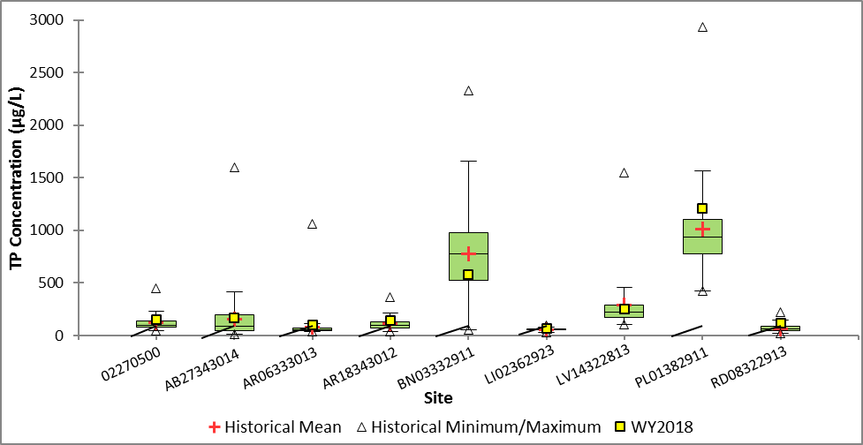
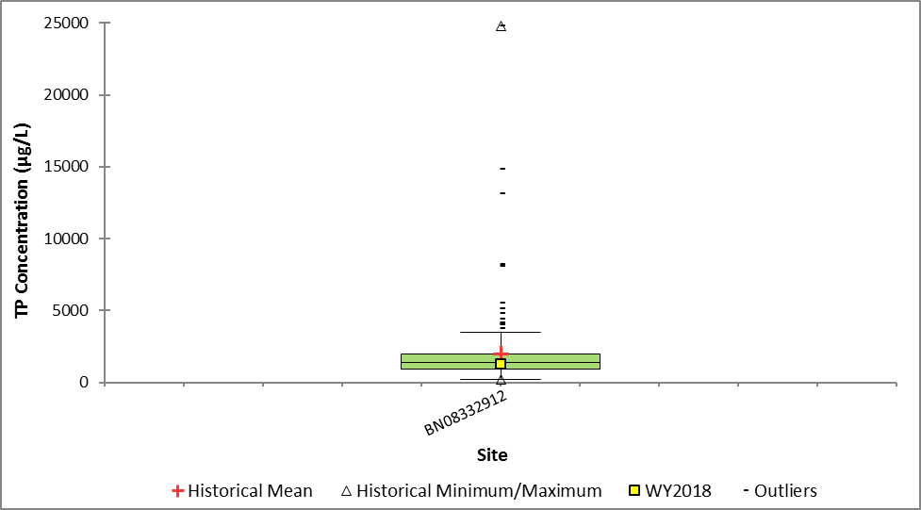
Figure 5c. Box-and-whisker plot of WY2018 average TP concentration compared to the TP concentration distribution for the previous 10-year period for the upstream monitoring sites in the Lake Istokpoga Subwatershed.
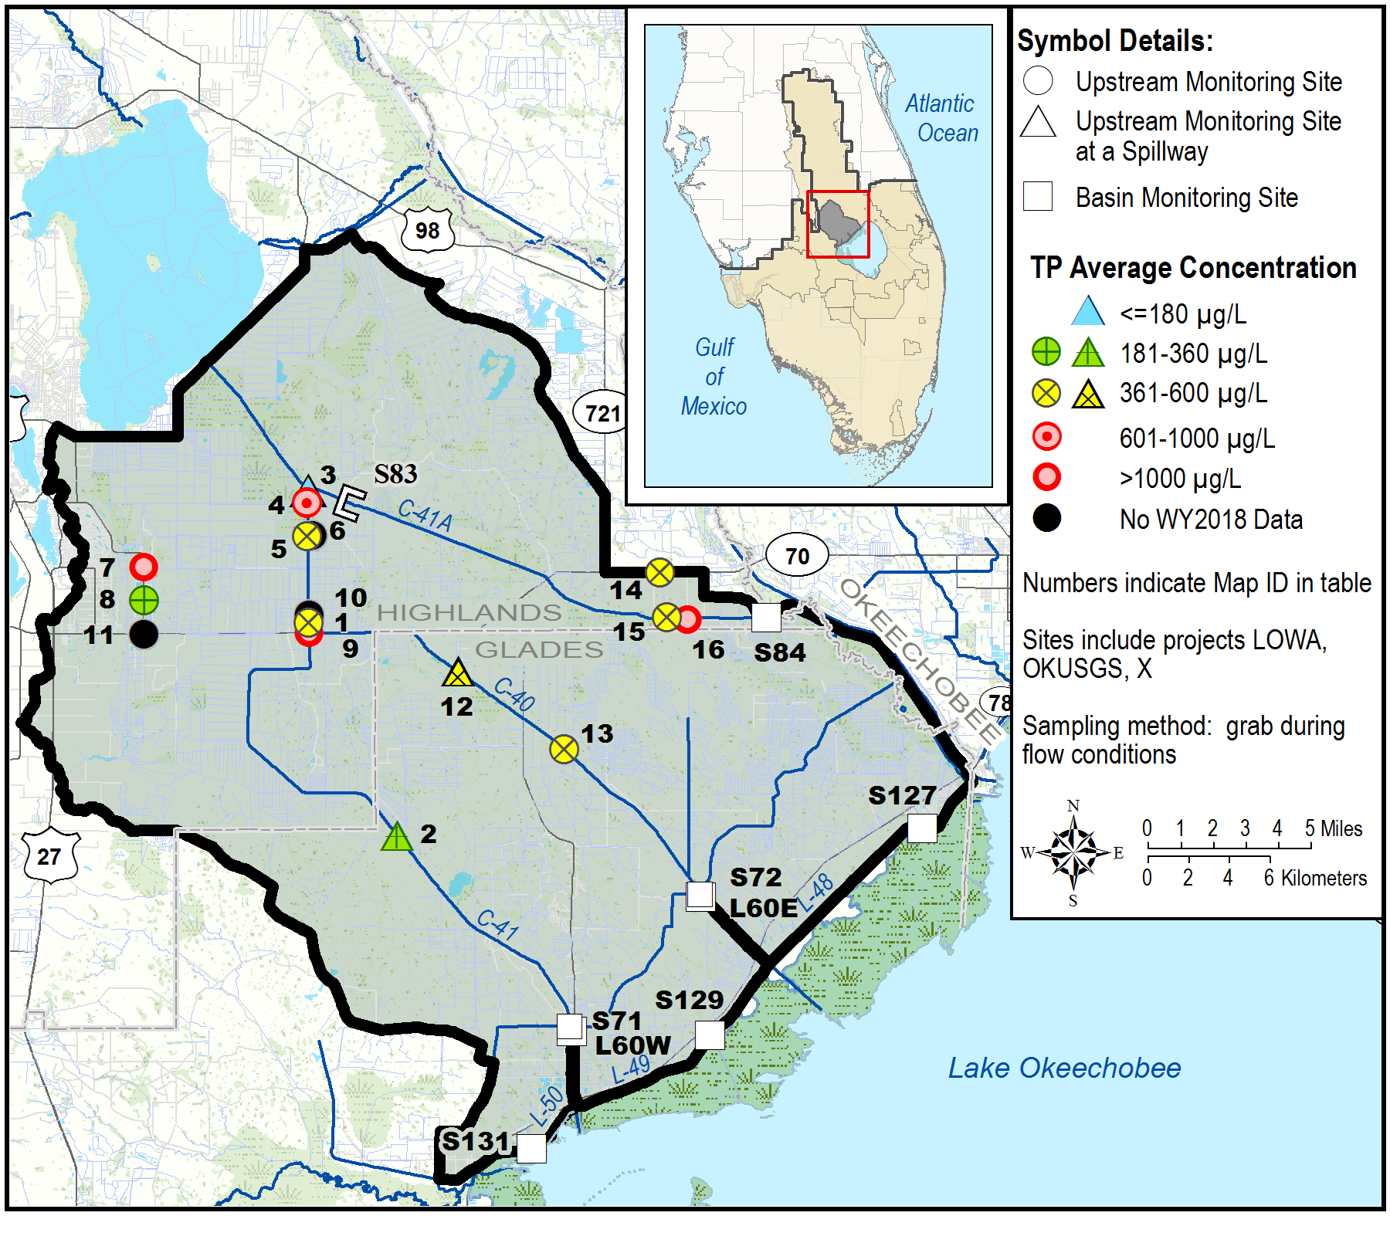
Figure 6a. Indian Prairie Subwatershed upstream tributary average TP concentrations for WY2018.
Indian Prairie |  | WY2018 |  |  |  | Number of Samples per Water Yearª
 |  | Number of Samples | TP Concentration (µg/L)
Map ID | Site | Number of Samples | Avg | Min | Max | 2008 | 2009 | 2010 | 2011 | 2012 | 2013 | 2014 | 2015 | 2016 | 2017
1 | 02273230 | 4^{b} | 372 | 215 | 604 | - | 3 | 8 | 2 | 6 | 14 | 12 | 15 | 14 | 7
2 | HP06393242 (S70) | 7 | 254 | 75 | 588 | 11 | - | - | - | 12 | 20 | 16 | 14 | 14 | 9
3 | HP11373132 (S82) | 2 | 88 | 60 | 116 | 12 | 4 | 4 | 7 | 17 | 16 | 12 | 10 | 8 | 2
4 | HP15373112 | 4 | 731 | 505 | 975 | 5 | 20 | 16 | 21 | 9 | 12 | 8 | 5 | 9 | 3
5 | HP22373112 | 5 | 399 | 329 | 465 | 13 | 18 | 21 | 13 | 10 | 14 | 11 | 9 | 9 | 3
6 | HP23373111 | - | - | - | - | 8 | 4 | 4 | 3 | 2 | 4 | 4 | 10 | 4 | 2
7 | HP24373013 | 3 | 1426 | 1071 | 1945 | 17 | 19 | 14 | 4 | 5 | 10 | 14 | 10 | 4 | 1
8 | HP25373013 | 10 | 221 | 118 | 554 | 26 | 26 | 26 | 25 | 25 | 26 | 24 | 24 | 20 | 8
9 | HP34373124 | 1 | 2204 | 2204 | 2204 | 4 | 12 | 7 | 7 | 4 | 8 | 7 | 2 | 1 | -
10 | HP35373113 | - | - | - | - | 3 | 4 | 5 | 3 | 3 | 6 | 1 | 3 | 1 | -
11 | HP36373013 | - | - | - | - | 15 | 24 | 25 | 16 | 1 | 6 | 9 | 4 | 4 | -
12 | IP09383232 (S75) | 6 | 375 | 111 | 1114 | 4 | - | - | - | 17 | 18 | 16 | 12 | 13 | 7
13 | IP24383214 | 1 | 470 | 470 | 470 | 13 | 5 | 9 | 2 | 5 | 2 | 5 | 6 | - | -
14 | SD28373312 | 3 | 418 | 334 | 492 | 13 | 13 | 16 | 18 | 7 | 2 | 7 | 5 | 3 | 1
15 | SD33373314 | 2 | 519 | 472 | 566 | 25 | 23 | 16 | 13 | 10 | 6 | 8 | 6 | 1 | 1
16 | SD34373313 | 2 | 1065 | 72 | 2058 | 7 | 2 | 6 | 2 | 2 | 1 | 4 | 7 | 2 | -
a. During WY2016, the sampling frequency of the majority of the upstream ambient/tributary sites was reduced from biweekly to monthly because of SFWMD resource constraints.
b. This site is visited biweekly, which may have resulted in a higher number of samples at the site.
Figure 6b. Indian Prairie Subwatershed upstream tributary average TP concentrations for WY2018 and sample count for the previous 10-year period.
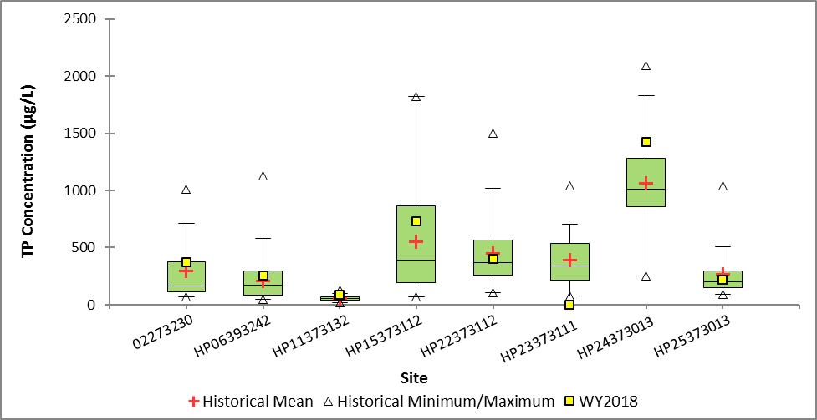
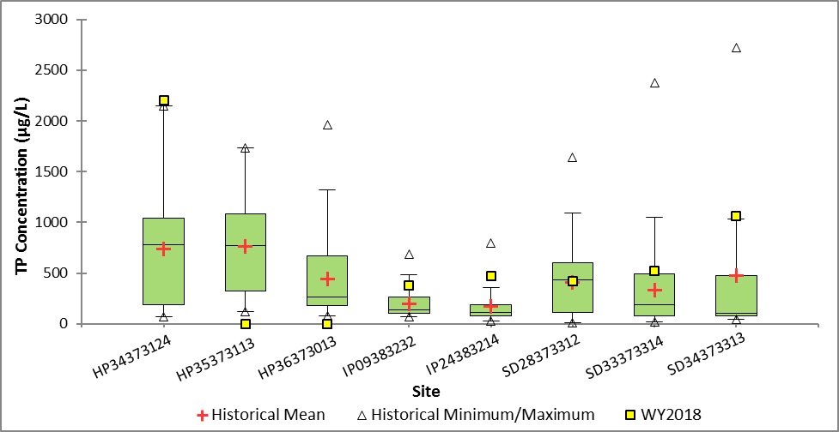
Figure 6c. Box-and-whisker plot of WY2018 average TP concentration compared to the TP concentration distribution for the previous 10-year period for the upstream monitoring sites in the Indian Prairie Subwatershed.
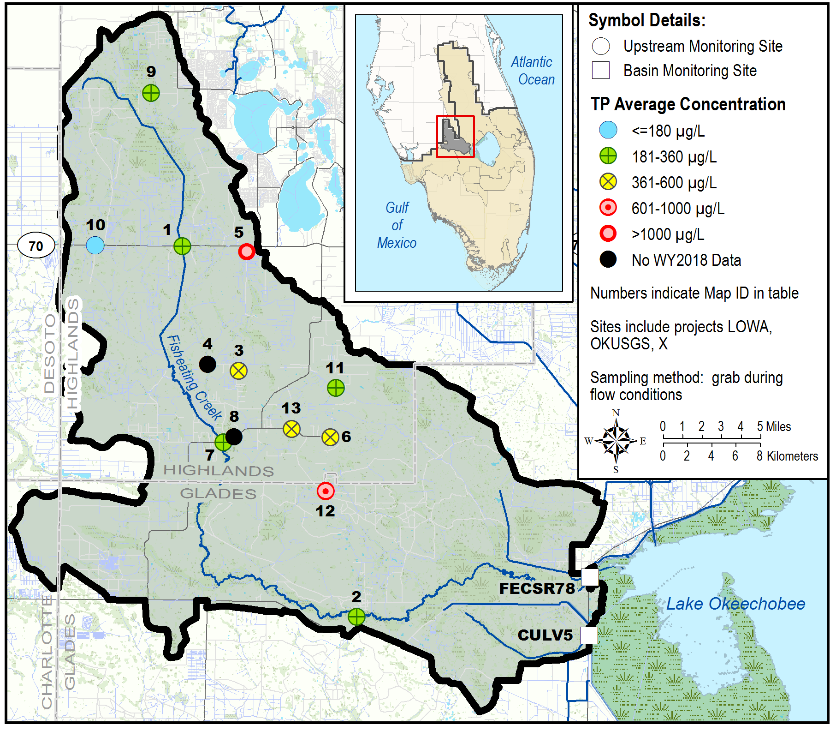
Figure 7a. Fisheating Creek Subwatershed upstream tributary average TP concentrations for WY2018.
Fisheating Creek |  | WY2018 |  |  |  | Number of Samples per Water Yearª
 |  | Number of Samples | TP Concentration (µg/L)
Map ID | Site | Number of Samples | Avg | Min | Max | 2008 | 2009 | 2010 | 2011 | 2012 | 2013 | 2014 | 2015 | 2016 | 2017
1 | 02255600 | 6^{b} | 223 | 158 | 325 | - | 11 | 24 | 5 | 4 | 13 | 11 | 12 | 14 | 3
2 | 02256500 | 5^{b} | 288 | 224 | 353 | - | 13 | 30 | 9 | 5 | 3 | 9 | 8 | 10 | 5
3 | BH04392912 | 4 | 393 | 238 | 664 | 22 | 18 | 19 | 20 | 12 | 10 | 11 | 17 | 17 | 5
4 | BH32382914 | - | - | - | - | 11 | 9 | 12 | 12 | 4 | 3 | 7 | 3 | 8 | -
5 | FE03382911 | 7 | 1090 | 913 | 1440 | 2 | 2 | 2 | 2 | 1 | 4 | 2 | 8 | 9 | 1
6 | FE20393013 | 2 | 489 | 427 | 550 | 22 | 18 | 18 | 20 | 24 | 7 | 10 | 4 | 6 | 1
7 | FE21392913 | 3 | 328 | 264 | 431 | 26 | 26 | 26 | 17 | 8 | 10 | 10 | 8 | 9 | 3
8 | FE21392914 | - | - | - | - | 10 | 10 | 21 | 12 | 7 | 4 | 8 | 4 | 11 | 1
9 | FE26362812 | 9 | 245 | 173 | 319 | 20 | 22 | 23 | 14 | 6 | 11 | 17 | 21 | 18 | 5
10 | FE32372814 | 4 | 163 | 84 | 349 | 23 | 16 | 22 | 16 | 8 | 5 | 11 | 4 | 7 | 2
11 | GA09393011 | 9 | 325 | 207 | 452 | 27 | 26 | 25 | 21 | 23 | 20 | 21 | 15 | 11 | 9
12 | GG05403011 | 2 | 859 | 723 | 995 | 10 | 11 | 18 | 10 | 4 | 3 | 8 | 5 | 7 | 2
13 | PB24392912 | 7 | 577 | 330 | 1220 | 21 | 19 | 18 | 21 | 23 | 23 | 24 | 24 | 18 | 9
a. During WY2016, the sampling frequency of the majority of the upstream ambient/tributary sites was reduced from biweekly to monthly because of SFWMD resource constraints.
b. These sites are visited biweekly, which may have resulted in a higher number of samples at the site.
Figure 7b. Fisheating Creek Subwatershed upstream tributary average TP concentrations for WY2018 and sample count for the previous 10-year period.
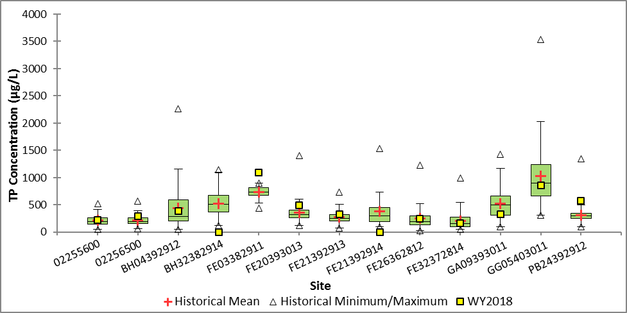
Figure 7c. Box-and-whisker plot of WY2018 average TP concentration compared to the TP concentration distribution for the previous 10-year period for the upstream monitoring sites in the Fisheating Creek Subwatershed.

The suspended sites included AJ33243122, AL11263113, AL24263113, AL34263113, CL19273123, CO35253112, HL08283014, BM15313111, IC35313112, KR23313113, KR32343214, LM29373514, TC09373513, AR21343013, RD01322813, HP09383151, HP27383124, HP36383112, IP29383313, and SD10373111.

