Appendix 8C-1:
Water Year 2018 Supplemental St. Lucie River Watershed Phosphorus and Nitrogen Concentration Data by Basin
Jodie Hutchins
Contributor: Cordella Miessau

Introduction
The information in Figures 1 through 4 in this appendix is intended to supplement the data summaries provided in Chapter 8C of this volume. Sections 373.4595(4)(c)2, Florida Statues (F.S.), requires the evaluation of all available existing water quality data concerning total phosphorus (TP) and total nitrogen (TN) in the St. Lucie River Watershed. The purpose of the networks has been to collect ambient data for the long term and track changes in water quality over time within the watershed.
The South Florida Water Management (SFWMD or District) has current monitoring networks that include sampling locations at two hydrologic levels within the St. Lucie River Watershed: Level 1, subwatershed and drainage basin level (basin monitoring sites for which flow and TP concentration data are collected and TP load is calculated), and Level 2, subbasin level (upstream ambient/tributary sites). The locations and data summaries of the Level 1 sites can be found in Chapter 8C. The Level 2 upstream tributary sites in figures within this appendix indicate locations where grab samples are collected bi-weekly during flow conditions for analysis of phosphorus and nitrogen concentrations. When reviewing the sample count information in Figures 1b, 2b, 3b, and 4b, a count of 26 would indicate that the site was flowing every time the grab collection event took place. Definitions of project codes in the figures can be found in the Acronyms, Abbreviations, and Units of Measurements for the 2019 South Florida Environmental Report.
This appendix presents TP and TN data results for Water Year 2018 (WY2018; May 1, 2017–April 30, 2018) for the St. Lucie Tributary (SLT) sites within the North Fork, North Mid-Estuary, Basin 4-5-6, South Fork, South Mid-Estuary, and South Coastal Basins. Note that the concentrations presented in Figures 1 through 4 are not flow-weighted because flow monitoring is not conducted at these sites. TP concentration ranges are grouped for reference in all figures. The ranges begin with the St. Lucie Estuary Total Maximum Daily Load (TMDL) for nutrients; 81 micrograms per liter (µg/L) for TP and 720 µg/L for TN (FDEP 2008). Box-and-whisker plots for each upstream monitoring site show the WY2018 average TP and TN concentration compared to the distribution of the TP and TN concentrations for the most recent 10-year (WY2008–WY2017) period.
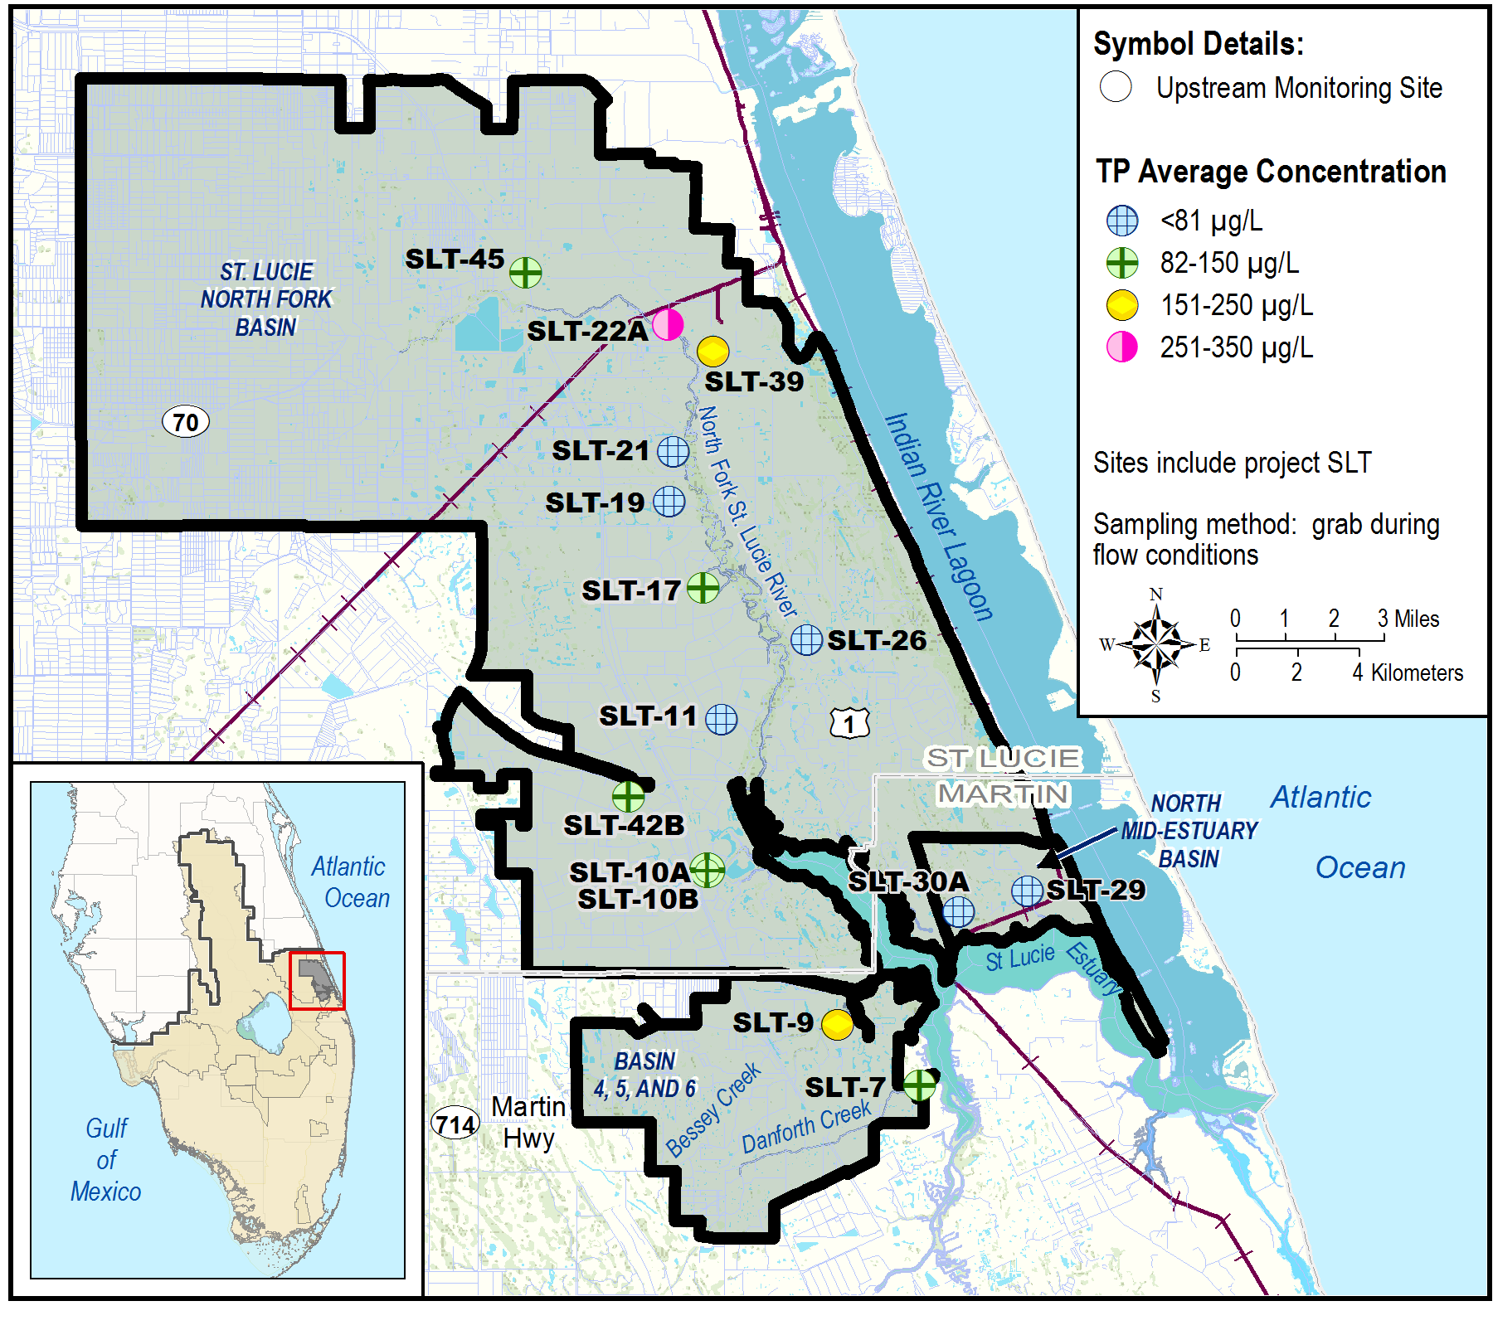
Figure 1a. North Fork, North Mid-Estuary, and Basin 4-5-6 Basins upstream tributary average TP concentrations for WY2018.
Site | WY2018 |  |  |  | Number of Samples per Water Year
Site | Number of Samples | TP Concentration (µg/L)
Site | Number of Samples | Avg | Min | Max | 2008 | 2009 | 2010 | 2011 | 2012 | 2013 | 2014 | 2015 | 2016 | 2017
SLT-7 | 9 | 145 | 64 | 234 | 1 | 15 | 8 | 11 | 3 | 16 | 9 | 17 | 16 | 11
SLT-9 | 5 | 197 | 129 | 280 | 7 | 10 | 2 | 6 | 1 | 1 | 11 | 3 | 6 | 10
SLT-10A | 26 | 86 | 56 | 129 |  |  |  |  |  |  | 26 | 26 | 24 | 26
SLT-10B | 15 | 103 | 84 | 132 |  |  |  |  |  |  | 22 | 13 | 11 | 13
SLT-11 | 26 | 80 | 43 | 148 | 24 | 26 | 26 | 26 | 13 | 26 | 26 | 26 | 25 | 25
SLT-17 | 25 | 88 | 37 | 273 | 8 | 22 | 23 | 8 | 10 | 25 | 26 | 26 | 25 | 26
SLT-19 | 22 | 60 | 20 | 209 | 24 | 25 | 25 | 24 | 10 | 21 | 26 | 26 | 25 | 21
SLT-21 | 6 | 52 | 26 | 92 | 25 | 25 | 21 | 14 | 9 | 25 | 26 | 26 | 24 | 18
SLT-22A | 7 | 331 | 148 | 976 | 7 | 19 | 16 | 12 | 6 | 19 | 15 | 17 | 13 | 11
SLT-26 | 26 | 76 | 34 | 272 | 14 | 20 | 17 | 21 | 7 | 17 | 25 | 26 | 25 | 26
SLT-29 | 23 | 21 | 11 | 50 | 15 | 18 | 14 | 15 | 1 | 23 | 26 | 25 | 22 | 20
SLT-30A | 1 | 29 | 29 | 29 |  |  |  |  |  |  | 10 | 1 | 6 | 2
SLT-39 | 4 | 209 | 161 | 266 | 4 | 16 | 14 | 14 | 6 | 20 | 25 | 26 | 25 | 16
SLT-42B | 15 | 114 | 58 | 176 |  |  |  |  |  |  | 26 | 25 | 24 | 22
SLT-45 | 26 | 96 | 34 | 327 |  |  |  |  |  |  | 26 | 26 | 25 | 26
Figure 1b. North Fork, North Mid-Estuary, and Basin 4-5-6 Basins upstream tributary average TP concentrations for WY2018 and sample count for the previous 10-year period.
(Note: Avg – Average; Max – Maximum, and Min – Minimum.)
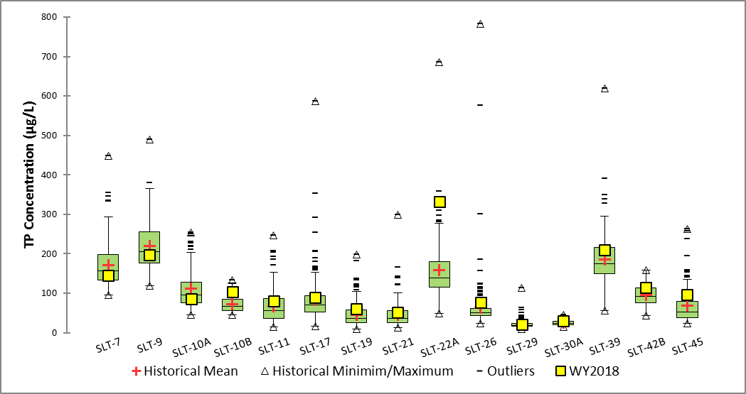
Figure 1c. Box-and-whisker plot of WY2018 average TP concentration compared to the TP concentration distribution for the previous 10-year period for the upstream monitoring sites in the North Fork, North Mid-Estuary, and Basin 4-5-6 Basins. (Note: the maximum historical TP concentration reported at SLT-22A and SLT-45 was 2,085 [WY2007] and 4,357 [WY2016] ug/L, respectively, and is off-scale.)

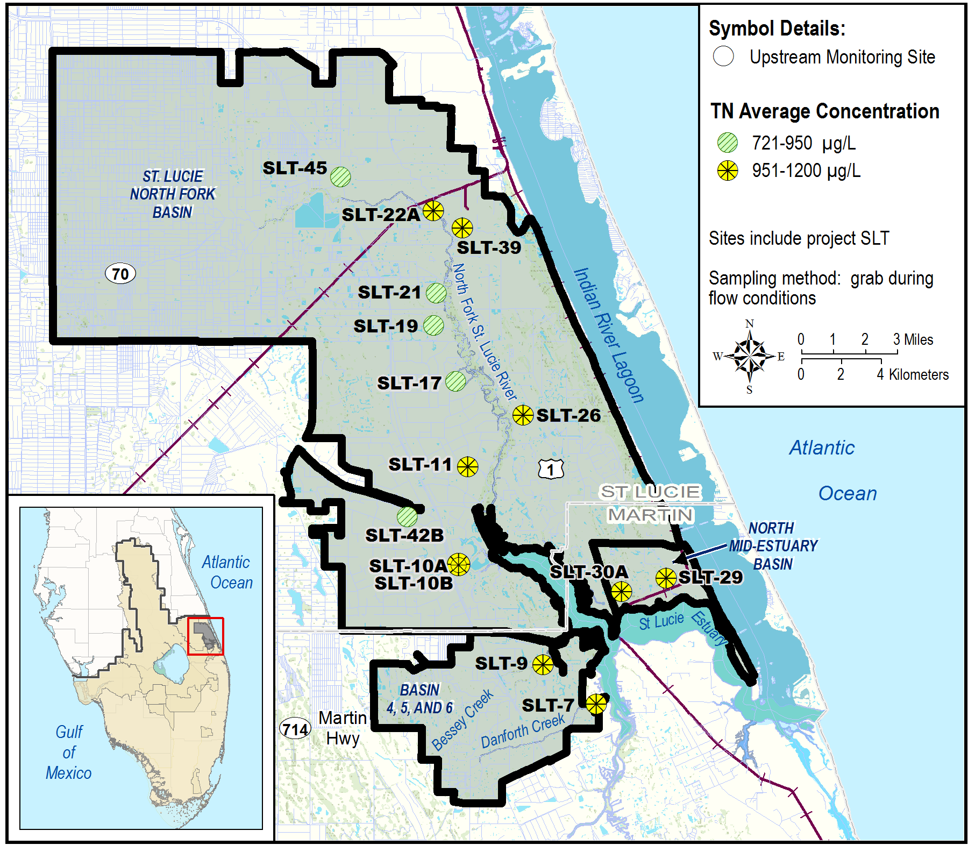
Figure 2a. North Fork, North Mid-Estuary, and Basin 4-5-6 Basins upstream tributary average TN concentrations for WY2018.
Site | WY2018 |  |  |  | Number of Samples per Water Year
Site | Number of Samples | TN Concentration (µg/L)
Site | Number of Samples | Avg | Min | Max | 2008 | 2009 | 2010 | 2011 | 2012 | 2013 | 2014 | 2015 | 2016 | 2017
SLT-7 | 9 | 1032 | 725 | 1530 | 1 | 15 | 8 | 11 | 3 | 16 | 9 | 17 | 16 | 11
SLT-9 | 5 | 1015 | 844 | 1310 | 7 | 10 | 2 | 6 | 1 | 1 | 11 | 3 | 6 | 10
SLT-10A | 26 | 953 | 758 | 1230 |  |  |  |  |  |  | 26 | 26 | 26 | 26
SLT-10B | 15 | 1024 | 849 | 1200 |  |  |  |  |  |  | 22 | 13 | 11 | 12
SLT-11 | 26 | 986 | 723 | 1220 | 24 | 26 | 26 | 26 | 13 | 26 | 26 | 26 | 26 | 24
SLT-17 | 25 | 802 | 526 | 1140 | 8 | 22 | 23 | 8 | 10 | 25 | 26 | 26 | 26 | 25
SLT-19 | 22 | 832 | 580 | 1200 | 24 | 25 | 25 | 24 | 10 | 21 | 26 | 26 | 26 | 20
SLT-21 | 6 | 893 | 595 | 1190 | 25 | 25 | 21 | 14 | 9 | 25 | 26 | 26 | 25 | 17
SLT-22A | 7 | 1177 | 858 | 1660 | 7 | 19 | 16 | 12 | 6 | 19 | 15 | 17 | 14 | 10
SLT-26 | 26 | 951 | 624 | 3520 | 14 | 20 | 17 | 21 | 7 | 17 | 25 | 26 | 26 | 26
SLT-29 | 23 | 1002 | 685 | 1980 | 15 | 18 | 14 | 15 | 1 | 23 | 26 | 26 | 23 | 19
SLT-30A | 1 | 1020 | 1020 | 1020 |  |  |  |  |  |  | 10 | 1 | 6 | 2
SLT-39 | 4 | 976 | 506 | 1380 | 4 | 16 | 14 | 14 | 5 | 20 | 25 | 26 | 26 | 16
SLT-42B | 15 | 921 | 675 | 1130 |  |  |  |  |  |  | 26 | 25 | 25 | 21
SLT-45 | 26 | 795 | 453 | 1390 |  |  |  |  |  |  | 26 | 26 | 26 | 25
Figure 2b. North Fork, North Mid-Estuary, and Basin 4-5-6 Basins upstream tributary average TN concentrations for WY2018 and sample count for the previous 10-year period.
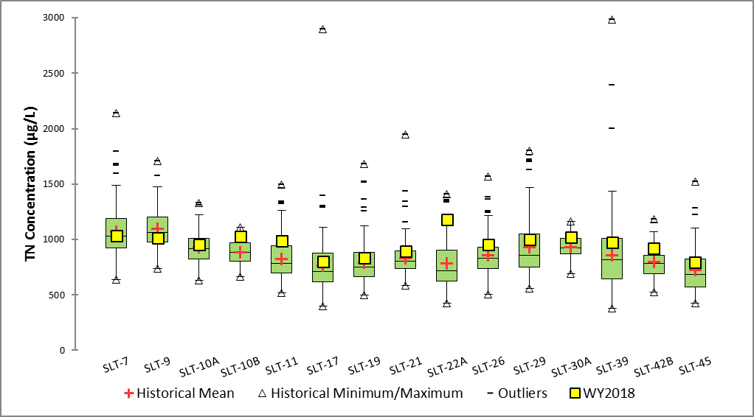
Figure 2c. Box-and-whisker plot of WY2018 average TN concentration compared to the TN concentration distribution for the previous 10-year period for the upstream monitoring sites in the North Fork, North Mid-Estuary, and Basin 4-5-6 Basins. (Note: Additional historical TP concentrations reported at SLT-22A was 6,916 ug/L [WY2010], at SLT-26 was 7,267 ug/L [WY2011] and 4,297 ug/L [WY2011], and at SLT-45 was 12,900 ug/L [WY2016] and are off-scale.)

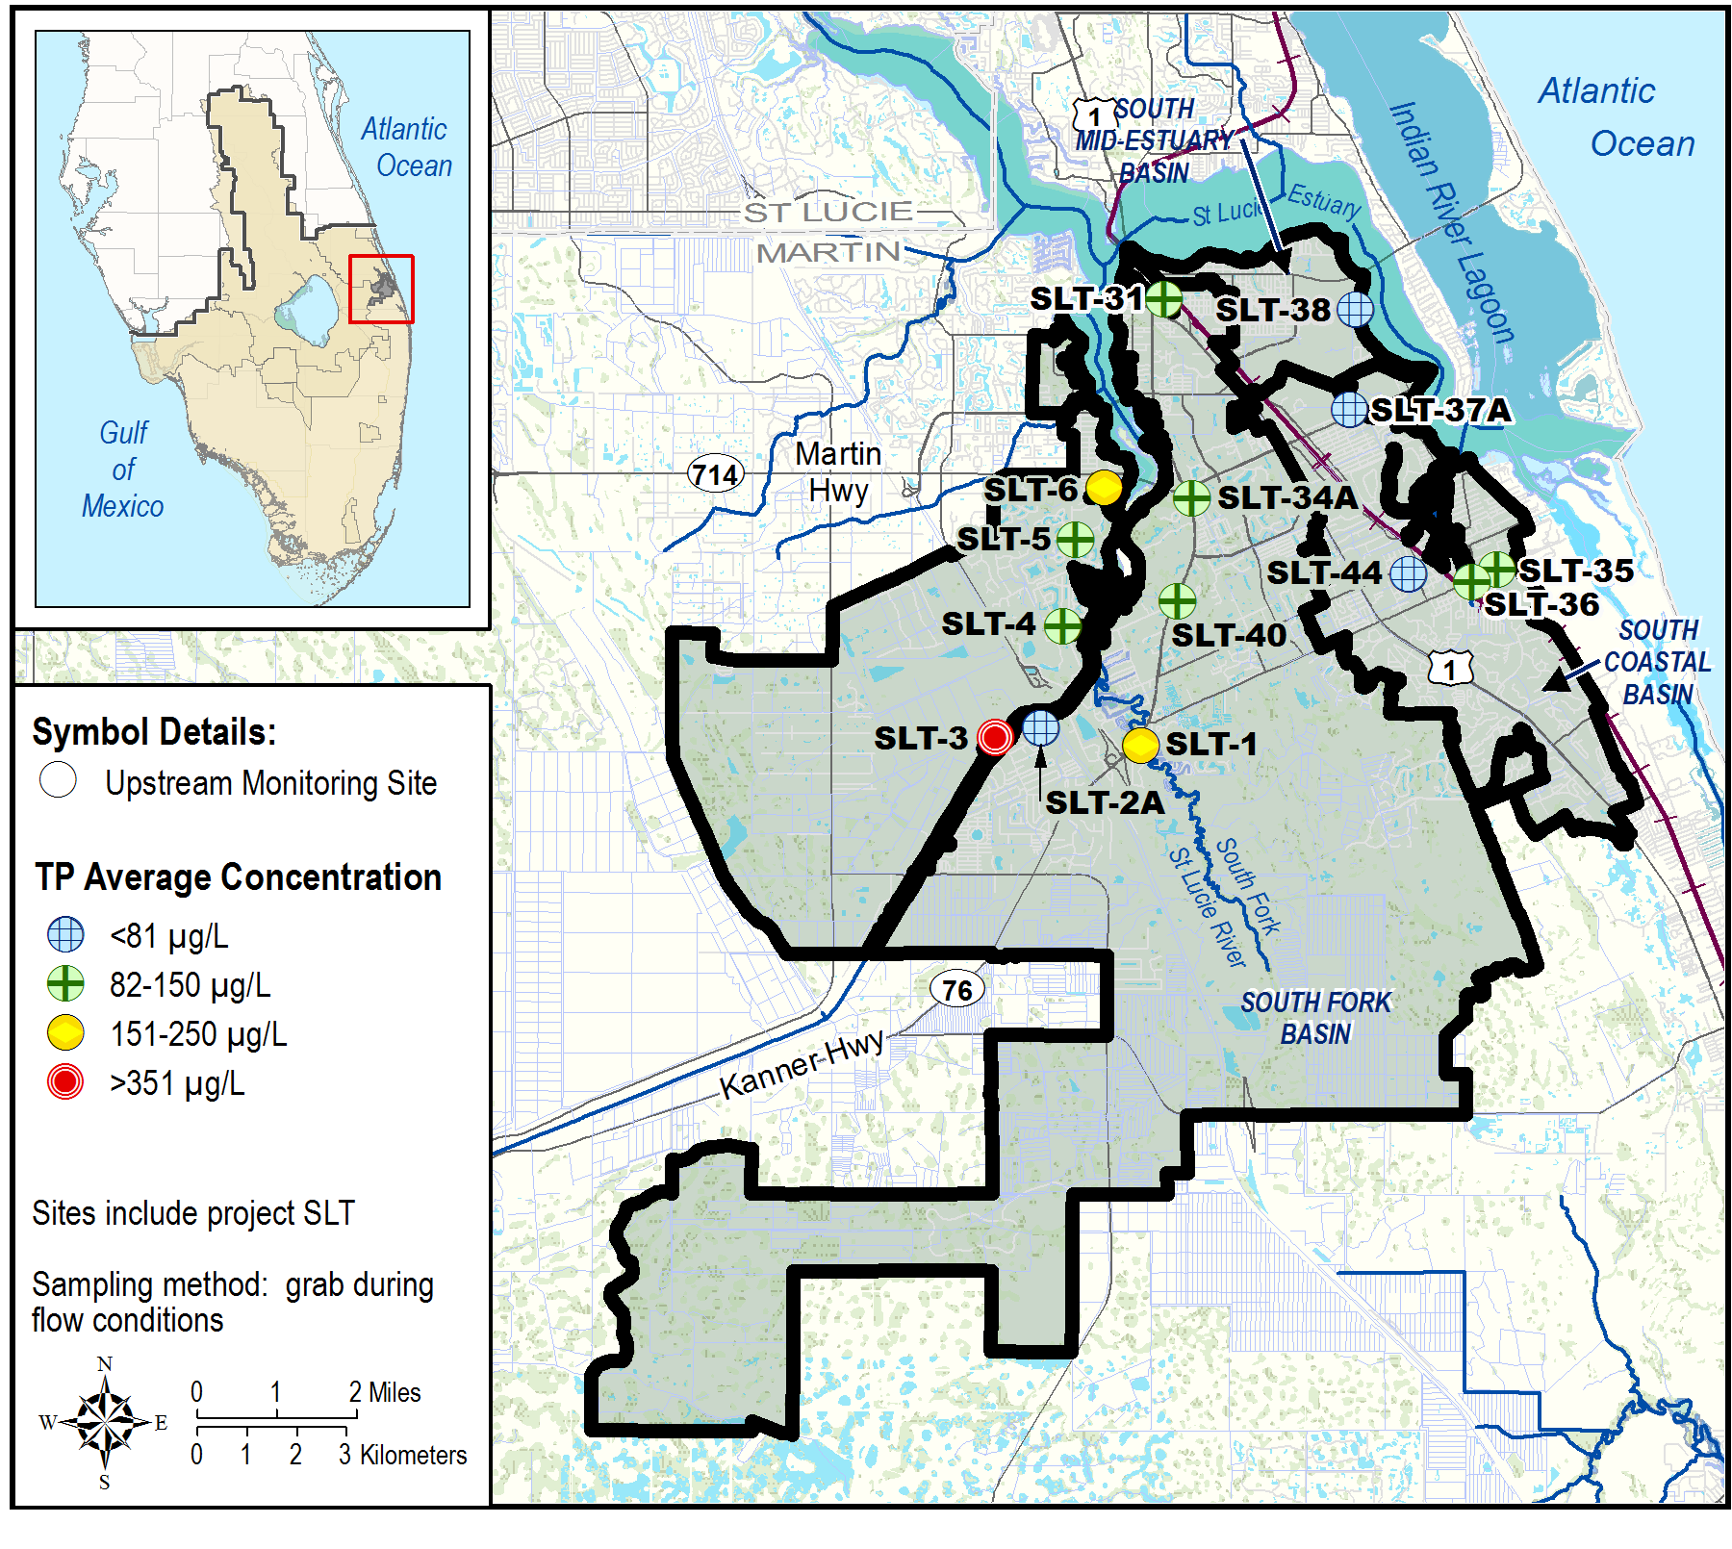
Figure 3a. South Fork, South Mid-Estuary, and South Coastal Basins upstream tributary average TP concentrations for WY2018.
Site | WY2018 |  |  |  | Number of Samples per Water Year
Site | Number of Samples | TP Concentration (µg/L)
Site | Number of Samples | Avg | Min | Max | 2008 | 2009 | 2010 | 2011 | 2012 | 2013 | 2014 | 2015 | 2016 | 2017
SLT-1 | 8 | 163 | 90 | 278 |  |  |  |  |  |  | 22 | 10 | 9 | 10
SLT-2A | 15 | 65 | 28 | 123 |  |  |  |  |  |  | 24 | 13 | 25 | 23
SLT-3 | 24 | 352 | 97 | 1610 |  |  |  |  |  |  | 26 | 26 | 26 | 26
SLT-4 | 6 | 145 | 102 | 188 |  |  |  |  |  |  | 7 | 9 | 3 | 4
SLT-5 | 6 | 110 | 101 | 126 |  |  |  |  |  |  | 22 | 13 | 15 | 7
SLT-6 | 6 | 176 | 88 | 306 |  |  |  |  |  |  | 20 | 9 | 6 | 6
SLT-31 | 18 | 98 | 55 | 195 | 19 | 21 | 22 | 14 | 6 | 18 | 24 | 19 | 16 | 20
SLT-34A | 26 | 125 | 76 | 242 | 22 | 26 | 26 | 25 | 11 | 25 | 26 | 24 | 26 | 25
SLT-35 | 25 | 94 | 58 | 137 |  |  |  |  |  |  | 25 | 24 | 23 | 25
SLT-36 | 5 | 142 | 133 | 146 | 1 | 12 | 10 | 11 | 2 | 9 | 12 | 7 | 4 | 4
SLT-37A | 26 | 24 | 11 | 51 | 25 | 26 | 26 | 26 | 8 | 25 | 26 | 26 | 26 | 26
SLT-38 | 28 | 32 | 19 | 93 | 5 | 8 | 3 | 4 |  | 25 | 32 | 28 | 28 | 30
SLT-40 | 26 | 90 | 40 | 218 | 3 | 19 | 7 | 6 | 3 | 26 | 41 | 30 | 36 | 31
SLT-44 | 26 | 57 | 32 | 108 | 22 | 25 | 25 | 26 | 7 | 24 | 26 | 26 | 26 | 26
Figure 3b. South Fork, South Mid-Estuary, and South Coastal Basins upstream tributary average TP concentrations for WY2018 and sample count for the previous 10-year period.
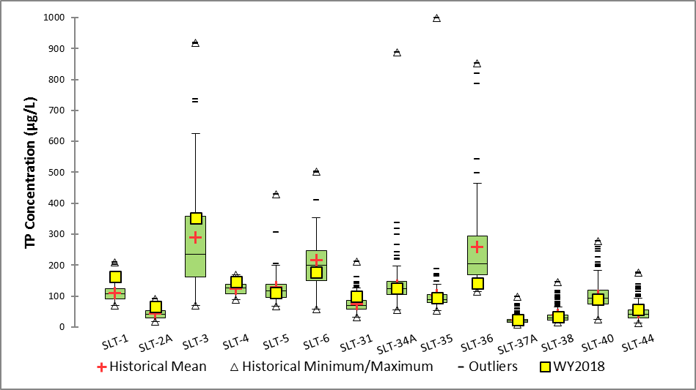
Figure 3c. Box-and-whisker plot of WY2018 average TP concentration compared to the TP concentration distribution for the previous 10-year period for the upstream monitoring sites in the South Fork, South Mid-Estuary, and South Coastal Basins. (Note: Additional historical TP concentrations reported at SLT-36 was 1,277 ug/L [WY2011] and 1,128 ug/L [WY2010], and at SLT-3 was 1,080 ug/L [WY2014]; these are off-scale.)
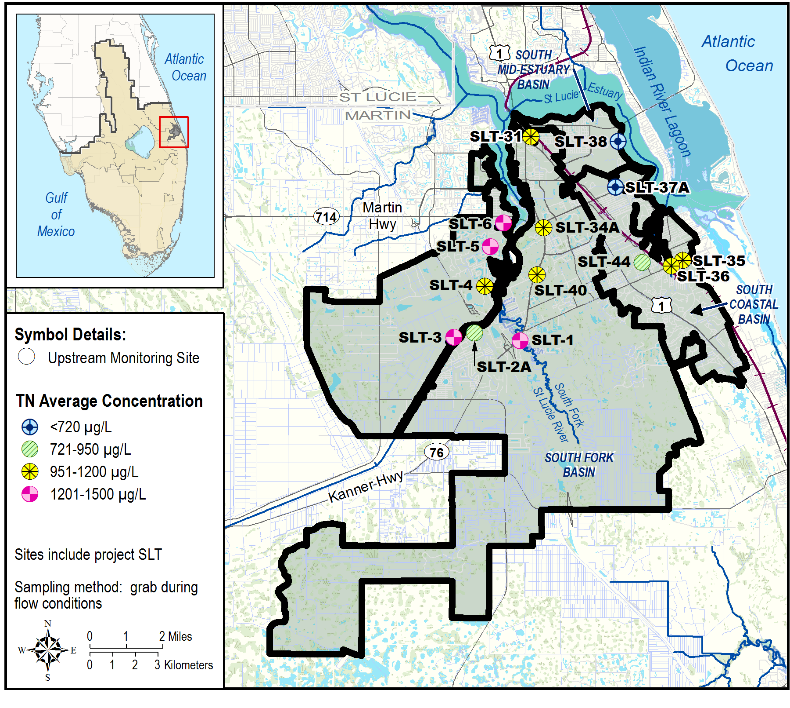
Figure 4a. South Fork, South Mid-Estuary, and South Coastal Basins upstream tributary average TN concentrations for WY2018.
Site | WY2018 |  |  |  | Number of Samples per Water Year
Site | Number of Samples | TN Concentration (µg/L)
Site | Number of Samples | Avg | Min | Max | 2008 | 2009 | 2010 | 2011 | 2012 | 2013 | 2014 | 2015 | 2016 | 2017
SLT-1 | 8 | 1209 | 844 | 1680 |  |  |  |  |  |  | 22 | 10 | 9 | 10
SLT-2A | 15 | 945 | 784 | 1100 |  |  |  |  |  |  | 24 | 13 | 25 | 23
SLT-3 | 24 | 1241 | 691 | 3070 |  |  |  |  |  |  | 26 | 26 | 26 | 26
SLT-4 | 6 | 1002 | 819 | 1230 |  |  |  |  |  |  | 7 | 9 | 3 | 4
SLT-5 | 6 | 1338 | 1210 | 1660 |  |  |  |  |  |  | 21 | 13 | 15 | 7
SLT-6 | 6 | 1498 | 928 | 2290 |  |  |  |  |  |  | 19 | 9 | 6 | 6
SLT-31 | 18 | 988 | 611 | 2140 | 19 | 21 | 22 | 14 | 6 | 18 | 24 | 19 | 17 | 20
SLT-34A | 26 | 1060 | 871 | 1390 | 22 | 26 | 26 | 25 | 9 | 25 | 26 | 23 | 26 | 25
SLT-35 | 25 | 961 | 417 | 1260 |  |  |  |  |  |  | 25 | 24 | 23 | 25
SLT-36 | 5 | 1023 | 974 | 1070 | 1 | 12 | 10 | 11 | 2 | 9 | 12 | 7 | 4 | 4
SLT-37A | 26 | 677 | 436 | 863 | 26 | 26 | 26 | 26 | 8 | 25 | 26 | 26 | 26 | 26
SLT-38 | 27 | 605 | 474 | 929 | 5 | 9 | 3 | 4 |  | 25 | 32 | 28 | 28 | 30
SLT-40 | 26 | 1018 | 800 | 1320 | 3 | 19 | 7 | 6 | 3 | 26 | 41 | 30 | 36 | 31
SLT-44 | 26 | 919 | 678 | 1570 | 22 | 25 | 25 | 26 | 7 | 24 | 26 | 26 | 26 | 26
Figure 4b. South Fork, South Mid-Estuary, and South Coastal Basins upstream tributary average TN concentrations for WY2018 and sample count for the previous 10-year period.
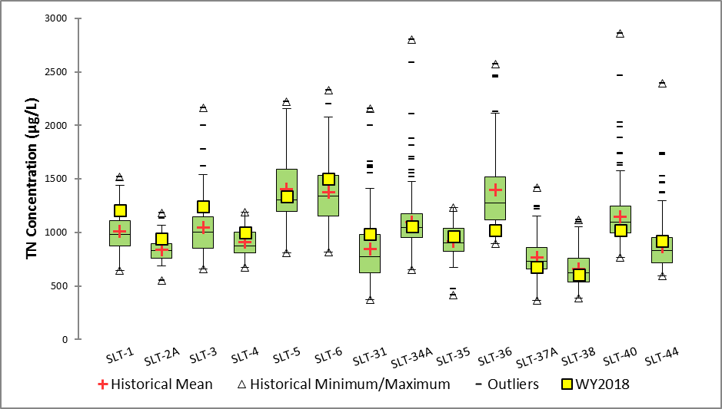
Figure 4c. Box-and-whisker plot of WY2018 average TN concentration compared to the TN concentration distribution for the previous 10-year period for the upstream monitoring sites in the South Fork, South Mid-Estuary, and South Coastal Basins. (Note: The maximum historical TP concentrations reported at SLT-34A, SLT-35, SLT-36, and SLT-40, were 3,453 ug/L (WY2011), 5,918 ug/L (WY2014), 3,753 ug/L (WY2010), and 3,070 ug/L (WY2012), respectively. These are off-scale.)

Literature Cited
FDEP 2008. TMDL Report: Nutrients and Dissolved Oxygen TMDL for the St. Lucie Basin. Florida Department of Environmental Protection, FL. October 2008.

