Chapter 8B:
Lake Okeechobee Watershed Annual Report
Zach Welch, Joyce Zhang, and Paul Jones
Contributors: Lucia Baldwin, Michael Baranski, Richard Botta, Patricia Burke, Therese East, Charles Hanlon, Steven Hill, Alyssa Jordan, and Cheol Mo

summary
Total phosphorus (TP) loads to the lake exceeded 1,080 metric tons (t) in WY2018, raising the most recent five-year average TP load to almost 500 t above the total maximum daily load (TMDL) target of 140 t. This may have been caused by an extremely wet September and October when inflows into the lake were unusually high (3.423 million ac-ft) due to Hurricane Irma landfall in September 2017. The smallest subwatershed, Taylor Creek/Nubbin Slough, contributed the highest unit annual load (UAL; 2.08 pounds per acre [lb/ac]), the highest TP flow-weighted mean (FWM) concentration (593 micrograms per liter [µg/L]) and the second highest TP load (186.5 t) in the Lake Okeechobee Watershed (LOW).
Among the 35 tributary monitoring stations studied, 13 stations had significantly higher TP concentrations during the post-Lake Okeechobee Protection Act (LOPA) period from 2002 to 2017 than during the previous eleven-year period (1991–2001), 10 stations had significantly lower TP concentrations, and the remaining 12 tributary stations exhibited no change in TP concentrations between the two periods. Analysis of the post-LOPA period reveals four of these 35 tributary stations and one of the 16 dairy monitoring stations exhibiting a decreasing trend in TP concentration.
The Lower Kissimmee Subwatershed had increased flows and TP concentrations, resulting in TP loads exceeding 300 metric tons (; over 3.5 times the previous five-water-year average). River restoration construction over the last two water years, which saw new flooding in many areas that had been drained since the 1970s, has coincided with consecutive increases in TP concentrations and loads from the subwatershed. Likewise, some of the monitored dairy and tributary sites of the Lower Kissimmee Subwatershed have had increasing concentrations over the last few years. As a result of Hurricane Irma, WY2018 was also one of two years since 2001 that flows exceeded 10,000 cubic feet per second (cfs) in the Kissimmee River. Such flows inundate the very highest parts of the floodplain, potentially mobilizing legacy phosphorus from rarely-flooded pastures and former pastures. The high TP loads from the Lower Kissimmee Subwatershed in WY2018 are likely a result of a combination of these three factors; restoration construction, increasing trends in some dairy and tributary TP concentrations, and unusually high flows.
The ecological health of Lake Okeechobee declined in Water Year 2018 (WY2018; May 1, 2017–April 30, 2018), as evidenced by the indicators discussed in this chapter. The WY2018 in-lake TP concentration of 203 µg/L was 35% higher than the previous water year and more than five times the target of 40 µg/L. Lake Okeechobee stage peaked at elevation 17.2 feet (ft; 5.3 meters [m]) National Geodetic Vertical Datum of 1929 (NGVD29) after Hurricane Irma in October 2017 and did not recede to the desired seasonal low target of 12.5 ft (3.8 m) NGVD29 before the onset of the 2018 wet season. There was also a dramatic reversal due to heavy rains in late May 2018, which marked an early end to most of the wading bird nesting on the lake and reduced wading bird foraging counts by 95%.
More than 15,000 acres (57%) of submerged aquatic vegetation (SAV) was lost immediately after Hurricane Irma. Moreover, additional losses due to prolonged adverse conditions (high water levels and low clarity) were expected after limited surveys in February and May 2018 found as little as 1 of 44 sites having SAV. Low water levels in the summer, or those below the bottom of the preferred ecological envelope (<12.5 ft NGVD29), promote SAV recovery by improving light penetration and encouraging reestablishment and growth. Considering the extensive losses of SAV coverage in WY2018, prolonged lower water levels would likely be required to provide sufficient light penetration in the water column for recovery of the SAV community.
Lake Okeechobee water levels have reached or exceeded 16.0 ft (4.9 m) NGVD29 in every water year since WY2012 and twice remained above the desired maximum summer stage (13.0 ft NGVD29) during the same seven-year period. These consecutive high water events, coupled with lack of seasonal low stages, have led to severe declines in SAV, pushing the nearshore region of the lake towards a phytoplankton/turbid water state. Lake stages must reach the lower end of the ecologically beneficial range (12.5 ft [3.8 m] NGVD29) in the peak of the growing season nearly every year to maintain robust SAV and emergent communities as higher lake stages and turbid water in the winter keeps light from penetrating to depths in the water column sufficient to support these communities. When the majority of the resilient SAV community is lost to consecutive years of high stages and hurricane effects, only lower-than average stages can repopulate these barren areas. Without sufficient recovery, long-term reductions in the production and recruitment of largemouth bass (Micropterus salmoides), bluegill (Lepomis macrochirus), and black crappie (Pomoxis nigromaculatus) may lead to major declines in sportfish abundance in the near future.
Fisheries in Lake Okeechobee during WY2018 also experienced declines in abundance, young-of-the-year, and juvenile fish; less than 2,000 pelagic region fish were collected, which was the fewest since 2005 and 2007, after major hurricanes and droughts. The loss of submerged and emergent littoral habitat reduced spawning habitat for mature nearshore fish, as well as refugia and foraging habitat for juvenile fish. Coupled with increases in pelagic turbidity and potential disruptions in food web links, these factors likely led to reductions in abundance of important sportfish.

Introduction
This chapter fulfills, in part, the reporting requirements of the Northern Everglades and Estuaries Protection Program (NEEPP), Section 373.4595, Florida Statutes (F.S.). As required, this annual report contains a summary of the conditions of the hydrology, water quality, and aquatic habitat of Lake Okeechobee and its watershed through WY2018.

Lake Okeechobee Watershed
Lake Okeechobee is a central part of the interconnected South Florida aquatic ecosystem and the United States Army Corps of Engineers (USACE) regional flood control project. The lake receives water mainly from four distinct tributary systems: Kissimmee River Valley, Lake Istokpoga–Indian Prairie, Fisheating Creek, and Taylor Creek/Nubbin Slough (Figure 8B-1). Except for Fisheating Creek, all major inflows to Lake Okeechobee are controlled by gravity-fed or pump-driven water control structures. These four major tributary systems, along with several minor tributaries, are generally bound by the drainage divides of the major water bodies and are further divisible into 69 drainage basins and grouped by nine subwatersheds based on hydrology and geography in the Lake Okeechobee Watershed (LOW). These subwatersheds are the Upper Kissimmee (above structure S-65), Lower Kissimmee (between structures S-65E and S-65), Taylor Creek/Nubbin Slough (S-191, S-133, S-135, S-154, and S-154C basins), Lake Istokpoga (above structure S-68), Indian Prairie (C-40, C-41AN, C-41AS, C-41N, C-41S, L-48, L-49, L-59E, L-59W, L-60E, L-60W, L-61E, and S-131 basins), Fisheating Creek (Fisheating Creek, L-61W, and Nicodemus Slough North basins), East Lake Okeechobee (Basin 8, C-44, S-153, and L-8 basins), West Lake Okeechobee (East Caloosahatchee, Hicpochee North, and Nicodemus Slough South), and South Lake Okeechobee, which includes the S-4 basin, and most basins in the Everglades Agricultural Area (EAA), as well as Chapter 298, F.S., Districts (Figure 8B-1).
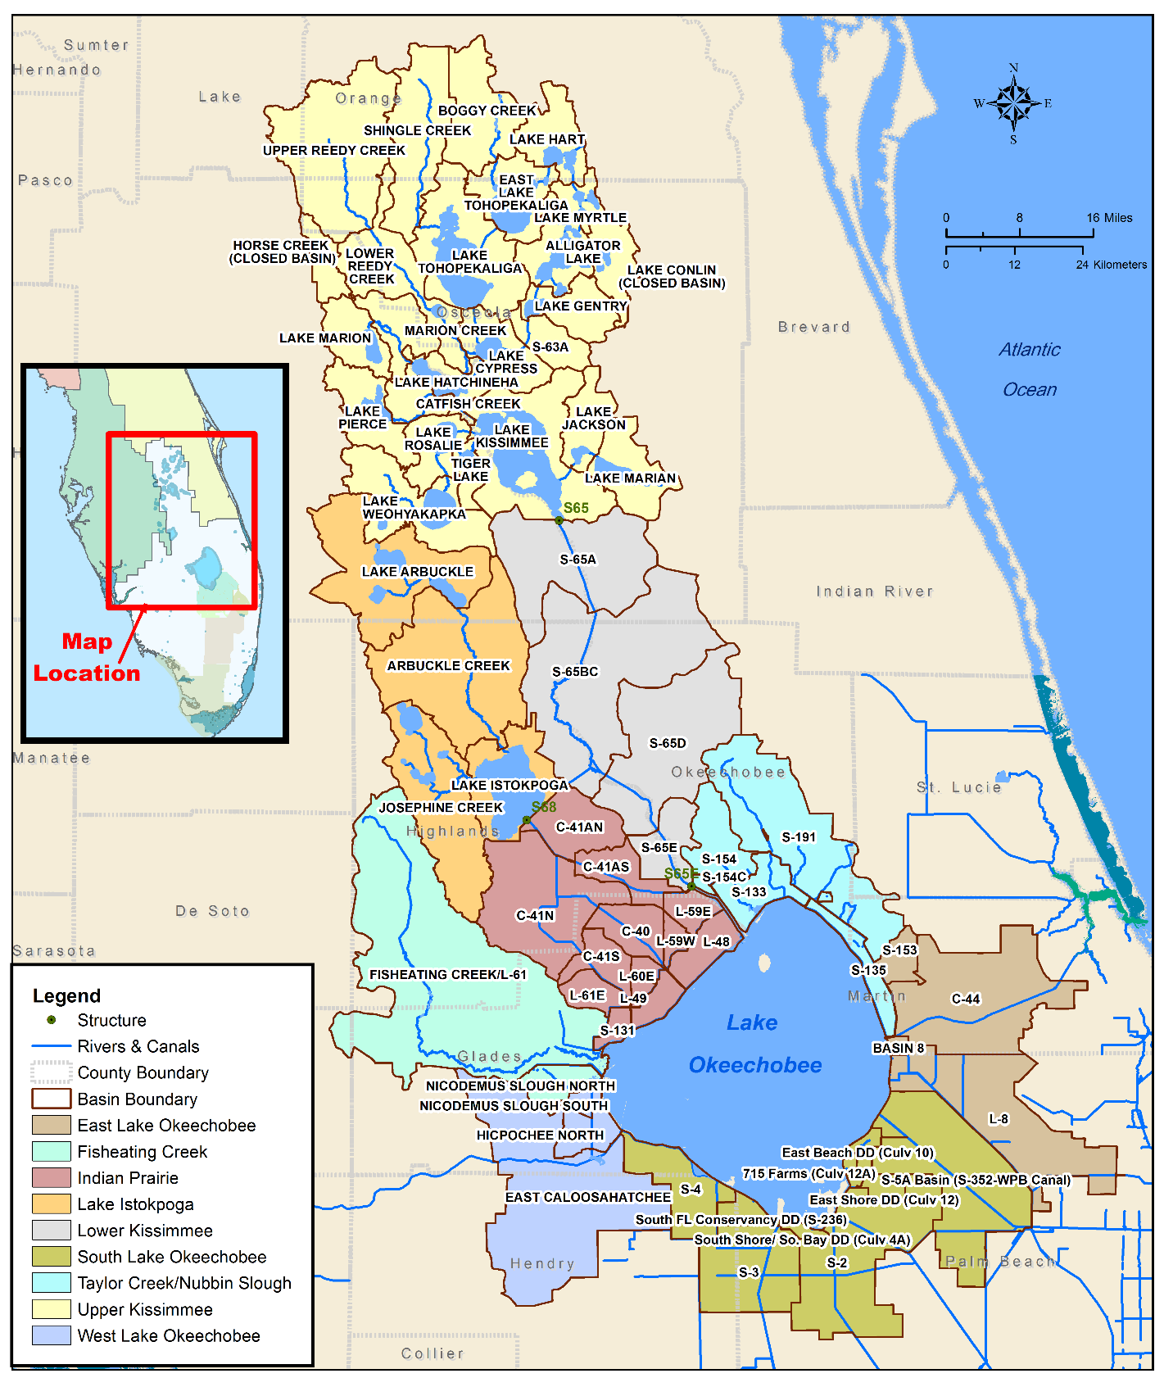
Figure 8B-1. Lake Okeechobee Watershed (LOW) detailing major hydrologic features, subwatersheds, drainage basins (black labels indicate basins).

Water Quality
As required by NEEPP (Section 373.4595(3)(a)2.a, F.S.), SFWMD monitors the water quality of inflows to and outflows from Lake Okeechobee at District-operated control structures and maintains a long-term water quality monitoring network within the LOW. This network is continuously reviewed for efficiency and to ensure all data collection objectives associated with legislatively mandated and permit required monitoring are being met. The District coordinates monitoring efforts with FDEP, FDACS, and United States Geological Survey (USGS) to leverage monitoring sites and reduce duplication of efforts. The current monitoring network is presented yearly in FDEP’s LOW BMAPs (FDEP 2014, 2016, 2017).
The District’s current monitoring network includes sample locations at two hydrologic levels within the LOW: (1) subwatershed and drainage basin level (basin loading stations), and (2) subbasin level (ambient/tributary stations that consist of multiple monitoring networks). A drainage basin may include one or more subbasins. Flow and nutrient concentration (TP and TN) are monitored at stations at the subwatershed and drainage basin levels and loads are calculated for basin loading stations (Figure 8B-2). In addition, the Lake Okeechobee Operating Permit issued by FDEP requires additional Class I water quality parameters be collected from 35 control structures with direct discharges into Lake Okeechobee. The subbasin-level TP and TN (where available) concentration monitoring is conducted at ambient/tributary monitoring stations throughout the LOW (Figure 8B-2). These monitoring networks are generally for collecting ambient data and tracking changes in water quality over time within the subbasin. The ambient/tributary long-term trend projects include the Kissimmee River Eutrophication Abatement (KREA); the Taylor Creek/Nubbin Slough project (TCNS); Tributaries of the Upper Kissimmee (TUK); sites formerly part of the subbasin loading project (OKUSGS); and the Lake Okeechobee Watershed Assessment (LOWA). Additionally, the OKUSGS project, under contract with FDACS, maintains flow data from several of these sites, which allows load to be calculated at those stations. Data from all these monitoring efforts reside in the District’s corporate environmental database, DBHYDRO, and are associated with the project names listed above in parentheses.
The trend analysis results for both TP and TN concentrations collected from the long-term upstream stations during 1991 to 2007 were presented by Zhang et al. (2011). This study extended the period of record for 10 years to 2017. Summary statistics and trend analyses are presented in the Tributary Water Quality Trend Analysis subsection. The TP concentration data from all upstream tributary monitoring sites shown in Figure 8B-2 for WY2018 are presented in Appendix 8B-1 of this chapter. This appended information is supplemental to the main chapter and it fulfills the NEEPP requirement to evaluate all available existing water quality data concerning TP in the LOW.
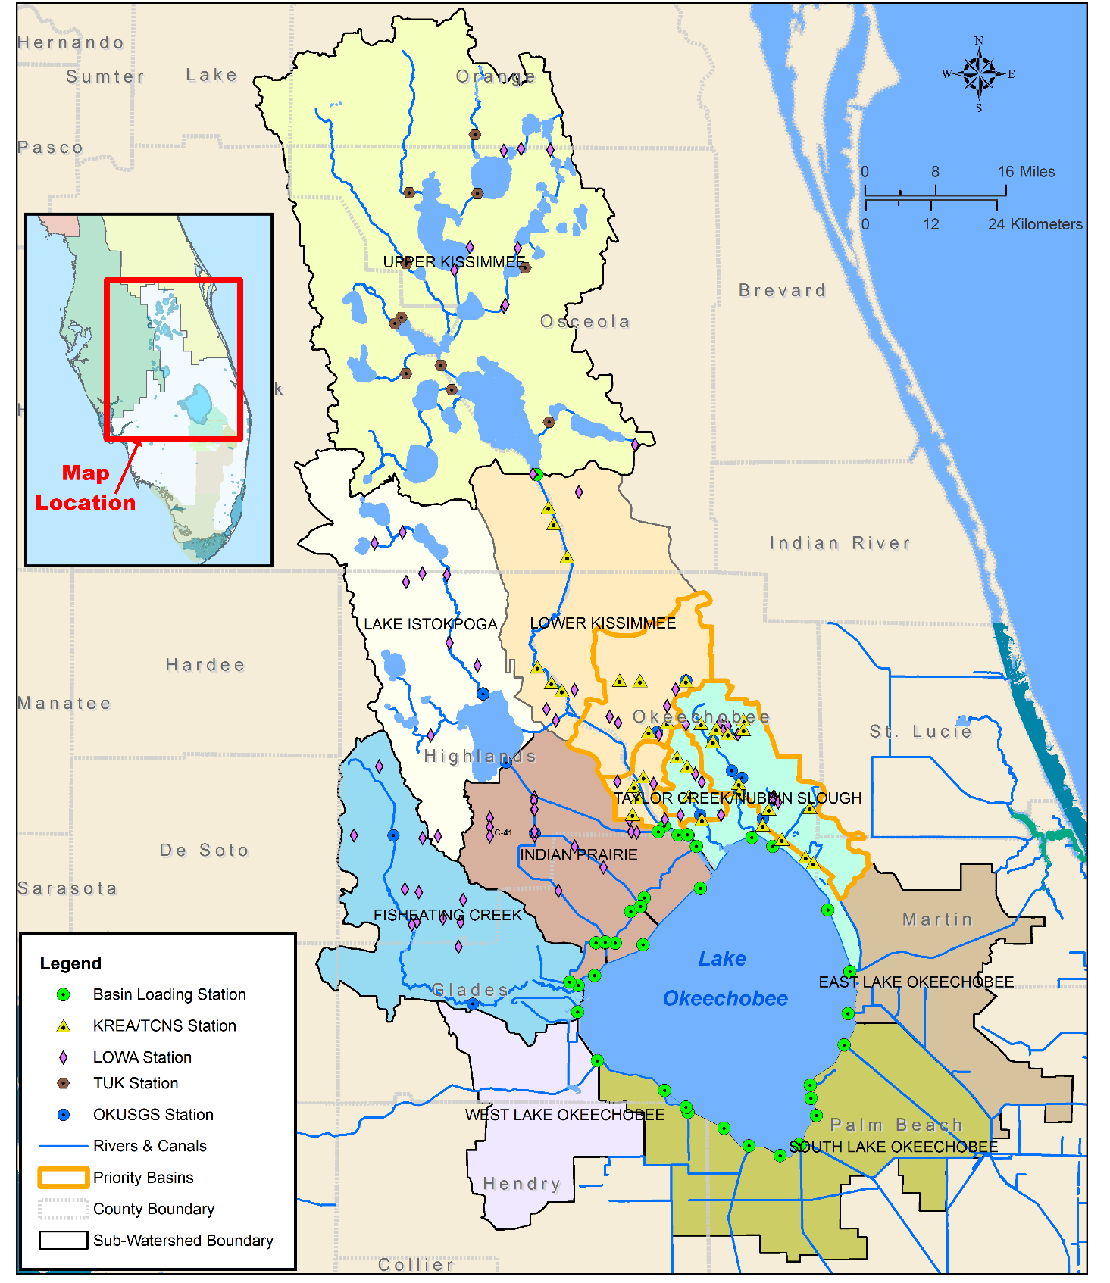
Figure 8B-2. Locations of WY2018 water quality sampling stations under the KREA, TCNS, LOWA, TUK, OKUSGS, and basin loading projects in the LOW.

TP and TN Loads to Lake Okeechobee
TP loading rates into Lake Okeechobee varied over time because of a combination of climatic conditions, land use changes, and changes in water management conditions (Tables 8B-1). TP loads to the lake from tributaries and atmospheric deposition (estimated as 35 t per year) totaled 1,081 t in WY2018 (Table 8B-1). This load was 123% (597 t) higher than the previous water year load of 484 t. It could be attributed to an extremely wet September and October when inflows were unusually high as a result of Hurricane Irma landfall in September 2017 (see Volume III, Appendix 4-1 of this year’s report). The highest TP loading rate was 1,189 t in WY1983, followed by the WY2018 TP load of 1,081 t and the WY2005 TP load of 960 t. The highest five-year average load was 714 t during the WY2002–WY2006 period of record (POR) mainly due to high discharges to the lake during and after the 2004 and 2005 hurricanes. The five-year average from WY2007 through WY2011 was the lowest average value (352 t) since 1981 and included three of the driest years (WY2007, WY2008, and WY2011) on record. The most recent five-year average load was 633 t for the period of WY2014–WY2018, which exceed the TMDL by 493 t (Table 8B-1). The target of 140 t of TP for Lake Okeechobee is the state’s TMDL, which is being implemented through the FDEP BMAP (FDEP 2014; https://floridadep.gov/sites/default/files/LakeOkeechobeeBMAP.pdf) as stated in Chapter 8A of this volume. This most recent five-year average was 102 t more than the previous five-year average of 531 t for WY2013–WY2017.
The WY2018 TN load was estimated at 8,745 t, which is an increase of 3,446 t (65%) compared to the previous water year load of 5,299 t (Table 8B-2). The most recent five-year rolling average (WY2014–WY2018) TN load averaged 6,772 t, a 470 t (7%) increase from the WY2013–WY2017 average of 6,302 t (Table 8B-2). From WY2000 through WY2018, the highest TN loading rate was 8,775 t in WY2005, followed by 8,745 t in WY2018, and 8,279 t in WY2003. The highest five-year rolling average load was 7,880 t during the WY2002–WY2006 period and mainly due to the high discharges to the lake during and after the 2004 and 2005 hurricanes. The five-year rolling average from WY2007 through WY2011 was the lowest average value (4,457 t) since 2004 because it included three of the driest years (WY2007, WY2008, and WY2011) on record.

WY2018 TP and TN Loading Data by Drainage Basin and Subwatershed
Surface water flow and TP and TN loads to the lake for WY2018 were calculated for the major drainage basins using data from the basin loading stations, as well as discharges from Lake Istokpoga and Lake Kissimmee. These lakes are the outfalls of subwatersheds that collect water flow and nutrient loads from smaller surrounding drainage basins (Figure 8B-2). Data are based on monitoring stations where flow is continuously monitored, and TP and TN samples are collected biweekly, based on flow, or monthly at a minimum.
As shown in Table 8B-3, the total discharge to the lake from all drainage basins was 3.423 million acre-feet (ac-ft; 4,221 million cubic meters [m³]) in WY2018. The watershed-wide averaged inflow TP concentration of 248 µg/L was about 22% higher than the in-lake TP concentration estimate of 203 µg/L, which exceeded the in-lake goal of 40 µg/L (discussed in the Lake Status section of this chapter). The two subwatersheds with higher TP concentrations relative to their flows were the Taylor Creek/Nubbin Slough Subwatershed, which contributed 7% of the flow and 18% of the TP load, as well as the Lower Kissimmee Subwatershed, which discharged 19% of the water and 29% of the TP load to the lake in WY2018 (Table 8B-3).
Table 8B-1. Annual flow and TP loads to Lake Okeechobee from WY1981 through WY2018.
a. Includes an atmospheric load of 35 t per year based on the Lake Okeechobee TMDL (FDEP 2001).
b. Target is the Lake Okeechobee TMDL of 140 t compared to the five-year moving average.
Table 8B-2. Annual TN loads to Lake Okeechobee from WY2000 through WY2018.
a. Includes atmospheric load of 1,233 t per year to account for atmospheric deposition.
Table 8B-3. WY2018 surface water inflows and TP loads, FWM concentrations, and UALs from the drainage basins to Lake Okeechobee. ª
a. Values shown in this table only account for contributions from the basins to Lake Okeechobee. It does not capture contributions from these basins to other basins or other surface waters.
b. Weighting factors: w1 = S-72/[(S-71)+(S-72)+(S-84)]; w2 = S-71/[(S-71)+(S-72)+(S-84)]; and w3 = S-84/[(S-71)+(S-72)+(S-84)].
The watershed-wide UAL of TP averaged 0.67 lb/ac (0.75 kilogram per hectare [kg/ha]) in WY2018 (Table 8B-3), a 131% increase comparing with the WY2017 value of 0.29 lb/ac (0.32 kg/ha; Zhang and Welch 2018). At the drainage basin level, the highest UAL of TP in WY2018 was from the S-154C basin (5.39 lb/ac or 6.04 kg/ha) in the Taylor Creek/Nubbin Slough Subwatershed, followed by the L-59W basin (2.82 lb/ac or 3.16 kg/ha) in the Indian Prairie Subwatershed, and S-191 (2.31 lb/ac or 2.59 kg/ha) basin in the Taylor Creek/Nubbin Slough Subwatershed. The East Beach Drainage District basin in the South Lake Okeechobee Subwatershed had the highest FWM TP concentration value (903 µg/L), followed by the S-154C (756 µg/L) and S-191 (684 µg/L) basins in the Taylor Creek/Nubbin Slough Subwatershed during WY2018. The East Beach Drainage District site contributed very low discharge and load into the lake, even though it had the highest FWM TP value.
A summary of data at the subwatershed level is provided in Table 8B-4. During WY2018, the largest surface water inflow was from the Upper Kissimmee Subwatershed (above structure S-65) (972 x 10³ ac-ft or 1,198 million m³), followed by the Lower Kissimmee Subwatershed (645 x 10³ ac-ft or 795 million m³) and Indian Prairie Subwatershed (430 x 10³ ac-ft or 530 million m³). The Upper Kissimmee Subwatershed covers about 30% of the drainage area in the LOW and contributed approximately 28% of total inflow and 11% of total TP loads during WY2018. The Lower Kissimmee Subwatershed covers 12% of the drainage area in the LOW and contributed about 19% of the total inflow and 29% of TP loads in WY2018. The Indian Prairie Subwatershed comprises 8% of the drainage area in the LOW and contributed about 13% of total inflow and 14% of TP loads during WY2018. The comparative values of discharges and TP loads to Lake Okeechobee from each subwatershed is shown in Figure 8B-3. The Taylor Creek/Nubbin Slough Subwatershed comprises about 6% of the drainage area in the LOW and contributed approximately 7% of total inflow and 18% of TP loads during WY2018. In contrast, the Lake Istokpoga Subwatershed comprises about 11% of the drainage area in the LOW and contributed approximately 12.5% of total inflow and 6% of TP loads during WY2018.
Table 8B-4. The average surface water inflows and TP loads, FWM concentration, and UALs from subwatersheds to Lake Okeechobee during WY2018. ª (Note: ac – acres.)
a. Values shown in this table only account for contributions from the basins to Lake Okeechobee. The East, West, and South Lake Okeechobee subwatersheds drain primarily to the east, west, and south, respectively. This table only represents the portion of runoff from these areas that are discharged to the lake. It does not capture contributions from these basins to other basins or other surface waters.
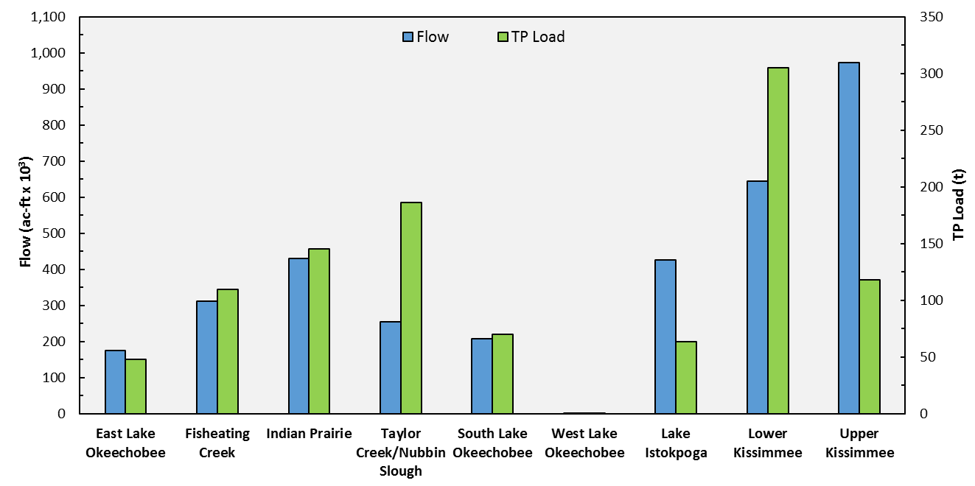
Figure 8B-3. The comparative values of discharge in 1,000 acre-feet (ac-ft x 10³) and TP load to Lake Okeechobee from the contributing subwatersheds in WY2018.
At the subwatershed level, the highest UAL of TP in WY2018 was from Taylor Creek/Nubbin Slough Subwatershed (2.08 lb/ac or 2.33 kg/ac), followed by the Lower Kissimmee Subwatershed (1.57 lb/ac or 1.76 kg/ha) and Indian Prairie Subwatershed (1.16 lb/ac or 1.30 kg/ha) and (Table 8B-4). In terms of FWM TP concentrations, the Taylor Creek/Nubbin Slough Subwatershed had the highest value (593 µg/L), followed by the Lower Kissimmee Subwatershed (383 µg/L) and Fisheating Creek Subwatershed (285 µg/L) during WY2018. Unlike the subwatersheds north of the lake, the discharges to the lake from the East, West, and South Lake Okeechobee subwatersheds are highly managed based on the hydrology and other factors. Moreover, the majority of runoff from these subwatersheds is typically directed away from the lake. The WY2018 average runoff for the watershed was 11.9 inches (30.2 cm). The highest surface runoff that reached the lake comes from the Indian Prairie Subwatershed (18.7 inches or 47.5 cm), followed by the Lower Kissimmee Subwatershed (18.0 inches or 45.7 cm) and Taylor Creek/Nubbin Slough Subwatershed (15.5 inches or 39.4 cm).
As shown in Table 8B-5, during WY2018, TN load to the lake from all drainage basins and atmospheric deposition (estimated as 1,233 t [James et al. 2005]) was 8,745 t, which is 3,446 t (65%) more than the last water year load of 5,299 t. The UAL of TN averaged 4.80 lb/ac (5.38 kg/ha) for the LOW. At the drainage basin level, the highest UAL of TN was from the C-41A basin (24.10 lb/ac or 26.99 kg/ha) in the Indian Prairie Subwatershed, followed by the Industrial Canal basin (21.46 lb/ac or 24.04 kg/ha) in the South Lake Okeechobee Subwatershed and the S-154C basin (17.73 lb/ac or 19.86 kg/ha) in the Taylor Creek/Nubbin Slough Subwatershed. The FWM TN concentration averaged 1.78 milligrams per liter (mg/L) for the LOW, which is 34% higher than the WY2017 FWM TN value (1.33 mg/L; Zhang and Welch 2018). The S-5A basin in the South Lake Okeechobee Subwatershed had the highest FWM TN concentration (9.40 mg/L), followed by the S-2 basin (5.04 mg/L) in the South Lake Okeechobee Subwatershed, and the C-41 basin (5.04 mg/L) in the Indian Prairie Subwatershed during WY2018.
Table 8B-5. WY2018 surface water inflows and TN loads, FWM concentrations, and UALs from the drainage basins to Lake Okeechobee. ª
a. Values shown in this table only account for contributions from the basins to Lake Okeechobee. It does not capture contributions from these basins to other basins or other surface waters.
b. Weighting factors: w1 = S-72/[(S-71)+(S-72)+(S-84)]; w2 = S-71/[(S-71)+(S-72)+(S-84)]; and w3 = S-84/[(S-71)+(S-72)+(S-84)].
At the subwatershed level, the highest TN loads were from the Upper Kissimmee Subwatershed (1,892 t), followed by the Indian Prairie Subwatershed (1,417 t) and South Lake Okeechobee Subwatershed (1,043 t) (Table 8B-6). The highest UAL was from the Indian Prairie Subwatershed (11.30 lb/ac or 12.66 kg/ha), followed by the Taylor Creek/Nubbin Slough Subwatershed (6.64 lb/ac or 7.44 kg/ha) and South Lake Okeechobee Subwatershed (6.33 lb/ac or 7.09 kg/ha). In terms of FWM TN concentrations from the subwatersheds, the South Lake Okeechobee subwatershed had the highest value (4.08 mg/L), followed by the West Lake Okeechobee Subwatershed (2.72 mg/L) and Indian Prairie Subwatershed (2.67 mg/L) during WY2018. Figure 8B-4 shows the comparative values of discharges and TN loads to Lake Okeechobee from each subwatershed in WY2018. The South Lake Okeechobee Subwatershed comprises about 10.5% of the drainage area in the LOW and contributed approximately 6% of total inflow and 14% of TN loads during WY2018.
Table 8B-6. The average surface water inflows and TN loads, FWM concentrations, and UALs from subwatersheds to Lake Okeechobee during WY2018. ª
a. Values shown in this table only account for contributions from the basins to Lake Okeechobee. The East, West, and South Lake Okeechobee subwatersheds drain primarily to the east, west, and south, respectively. This table only represents the portion of runoff from these areas that are discharged to the lake. It does not capture contributions from these basins to other basins or other surface waters.
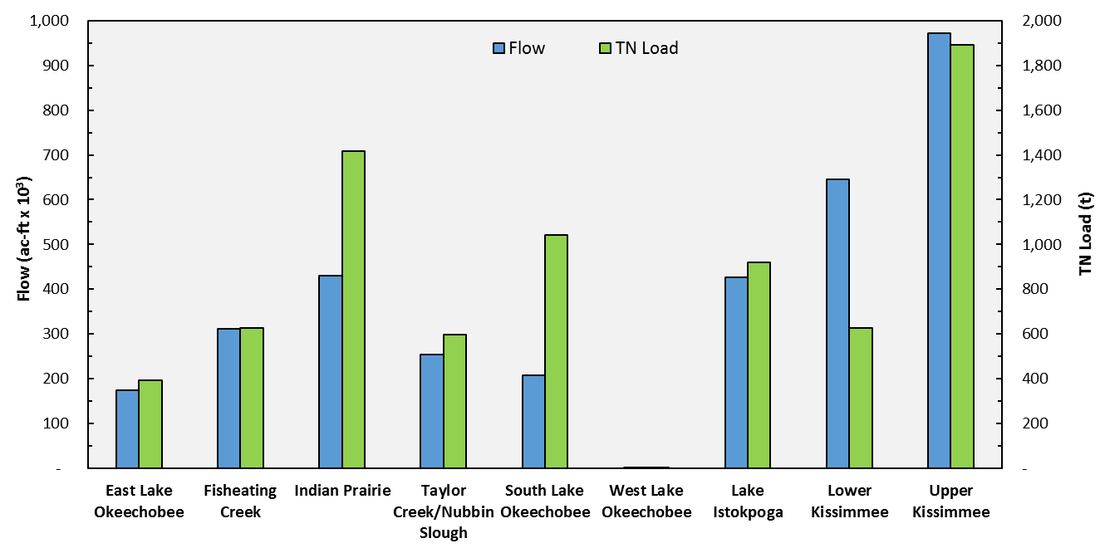
Figure 8B-4. The comparative values of discharge and TN load to Lake Okeechobee from the contributing subwatersheds in WY2018.

TP and TN Loading Data for the
Most Recent Five Years (WY2014 to WY2018)
The TP and TN loading rates into Lake Okeechobee changed annually due to various factors, mainly the climatic conditions (see Chapter 2 of this volume). To evaluate the annual changes when comparing with the long-term average values, the annual flow, TP load, and TP FWM concentration for the last five water years (WY2014–WY2018) from each of nine subwatersheds are presented in Table 8B-7. The highest FWM TP concentrations came from the Taylor Creek/Nubbin Slough Subwatershed in WY2018 (594 µg/) and the lowest FWM TP concentration was from the Upper Kissimmee Subwatershed in WY2015 (63.0 µg/). In terms of the UAL of TP, the Taylor Creek/Nubbin Slough Subwatershed had the highest value of 2.18 lb/ac or 2.44 kg/ha in WY2018 and the Upper Kissimmee Subwatershed had the lowest value of 0.16 lb/ac or 0.18 kg/ha in WY2014 and WY2017 (Table 8B-7).
During the most recent five-year period (WY2014–WY2018), the average annual TP load and discharge to the lake from all drainage basins and atmospheric deposition are presented in Table 8B-8. The average annual TP load to the lake for this five-year period was 633 t, the average annual discharge to the lake was 2.922 million ac-ft (3,603 million m³) and the watershed-wide FWM TP concentration to the lake was 166 µg/L (Table 8B-8). For the five-year period, the highest basin UAL of TP came from the L-59W basin (3.65 lb/ac or 4.09 kg/ha) in the Indian Prairie Subwatershed, followed by the S-154C (2.83 lb/ac or 3.17 kg/ha) and the S-191 basin (1.42 lb/ac or 1.59 kg/ha) in the Taylor Creek/Nubbin Slough Subwatershed (Table 8B-8). In terms of FWM TP concentrations from the drainage basins, the East Beach Drainage basin in the South Lake Okeechobee Subwatershed had the highest value of 776 µg/L, followed by the S-154C basin (709 µg/L) and the S-191 basin (616 µg/L) in the Taylor Creek/Nubbin Slough Subwatershed. The East Beach Drainage Basin had very limited flow and the load overall to the lake was not significant. The FWM TP concentration for the previous four water years was largely due to one value from WY2018.

Table 8B-7. Annual flow volumes and TP loads, UAL, and FWM concentrations by subwatershed for WY2014–WY2018.

Table 8B-8. Five-year average of surface water inflows and TP loads, FWM concentrations, and UALs from the drainage basins to Lake Okeechobee during WY2014–WY2018. ª
a. Values shown in this table only account for contributions from the basins to Lake Okeechobee. It does not capture contributions from these basins to other basins or other surface waters.
b. Weighting factors: w1 = S-72/[(S-71)+(S-72)+(S-84)]; w2 = S-71/[(S-71)+(S-72)+(S-84)]; and w3 = S-84/[(S-71)+(S-72)+(S-84)].
At the subwatershed level, the largest surface water inflow came from the Upper Kissimmee Subwatershed, followed by the Lower Kissimmee Subwatershed and Lake Istokpoga Subwatershed during this five-year period (Table 8B-9). The Lower Kissimmee Subwatershed contributed the largest TP loads to the lake (126 t), followed by Taylor Creek/Nubbin Slough Subwatershed (114 t) and Indian Prairie Subwatershed (103 t). During this five-year period, the Lower Kissimmee Subwatershed has 12% of the total drainage area, and it contributed 17% of flow and 21% of TP load to the lake. The Taylor Creek/Nubbin Slough Subwatershed has 6% of total drainage area, and it contributed 7% of flow and 19% of TP load to the lake. The Indian Prairie Subwatershed has 8% of total drainage area, and it contributed 13% of flow and 17% of TP load to the lake. In contrast, the Upper Kissimmee Subwatershed has 30% of the total drainage area, and it contributed about 32% of flow and 15% of TP load. The highest subwatershed UAL of TP came from the Taylor Creek/Nubbin Slough Subwatershed (1.27 lb/ac or 1.42 kg/ha), followed by the Indian Prairie Subwatershed (0.82 lb/ac or 0.92 kg/ha) and the Lower Kissimmee Subwatershed (0.65 lb/ac or 0.73 kg/ha; Table 8B-9). These subwatersheds have the highest level of dairy operation land use and intensive agricultural land use (Zhang and Welch 2018). The nutrient levels in surface water runoff are directly related to land use and land management practices (Hiscock et al. 2003). In terms of FWM TP concentrations from the subwatersheds, the Taylor Creek/Nubbin Slough Subwatershed had the highest value (470 µg/L), followed by the South Lake Okeechobee Subwatershed (266 µg/L) and the Indian Prairie Subwatershed (219 µg/L). The Taylor Creek/Nubbin Slough subwatershed continues to exhibit relatively low discharge but high unit area load, an indication of that high TP concentrations persists within the subwatershed.
Table 8B-9. Five-year average of surface water inflows and TP loads, FWM concentrations, and UALs from subwatersheds to Lake Okeechobee during WY2014–WY2018. ª.
a. Values shown in this table only account for contributions from the basins to Lake Okeechobee. The East, West, and South Lake Okeechobee subwatersheds drain primarily to the east, west, and south, respectively. This table only represents the portion of runoff from these areas that are discharged to the lake. It does not capture contributions from these basins to other basins or other surface waters.

The comparative values of discharges and TP loads to Lake Okeechobee from each subwatershed for the most recent five-year period (WY2014–WY2018) is shown in Figure 8B-5. There continues to be disproportionally high TP loads from Taylor Creek/Nubbin Slough, Lower Kissimmee, and Indian Prairie subwatersheds due to higher TP concentrations. The Upper Kissimmee and Lake Istokpoga subwatersheds have displayed low loads compared to flows due to lower TP concentrations. The assimilative capacity of Lake Kissimmee (as well as the Upper Chain of Lakes) and Lake Istokpoga may play a role in providing a sink for TP, keeping TP loads from those subwatersheds lower.
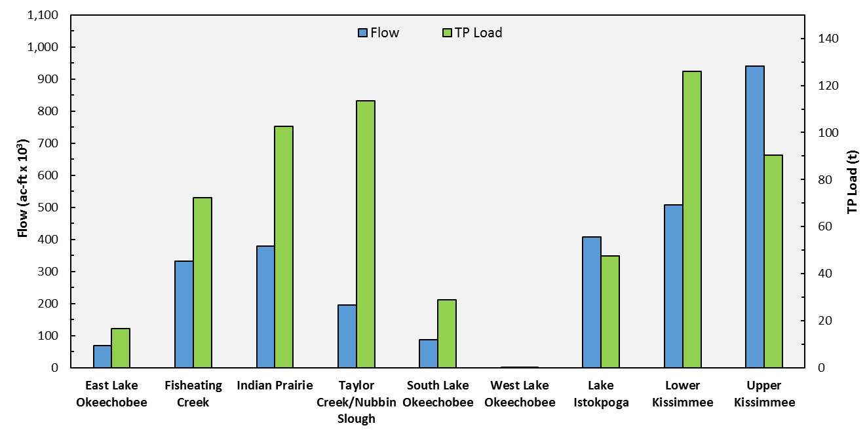
Figure 8B-5. The comparative five-year average values of discharge and TP load to Lake Okeechobee from the contributing subwatersheds during WY2014–WY2018.
The annual flow, TN load, UAL, and FWM TN concentration for the last five water years (WY2014–WY2018) from each of the nine subwatersheds are presented in Table 8B-10. The highest FWM TN concentrations came from the South Lake Okeechobee Subwatershed in WY2016 (5.39 mg/L) and the lowest FWM TN concentration was from the Upper Kissimmee Subwatershed in WY2016 and WY2017 (1.09 mg/L). In terms of the UAL of TN, the Indian Prairie Subwatershed had the highest value of 11.30 lb/ac or 12.66 kg/ha in WY2018 and the Upper Kissimmee Subwatershed had the lowest value of 2.46 lb/ac or 2.76 kg/ha in WY2017 (Table 8B-10). The UAL from the East, West, and South Lake Okeechobee subwatersheds were not ranked since these subwatersheds drain a small portion to the lake and deliver largely to the east, west, and south, respectively.
The average annual TN load and discharge to the lake for the most recent five-year period (WY2014–WY2018) from all drainage basins and atmospheric deposition was 6,772 t (Table 8B-11), which is 1,973 t (29%) less than the WY2018 value of 8,745 t. In terms of FWM TN concentrations from the drainage basins, the S-5A basin had the highest value (9.40 mg/L), followed by the S-2 basin (6.14 mg/L) and the S-3 basin (4.56 mg/L) (Table 8B-11). All three basins are in the South Lake Okeechobee Subwatershed.
The Upper Kissimmee Subwatershed contributed the largest subwatershed TN loads to Lake Okeechobee, followed by the Indian Prairie and Lake Istokpoga subwatersheds (Table 8B-12). The highest subwatershed UAL came from the Indian Prairie Subwatershed (8.23 lb/ac or 9.51 kg/ha), followed by the Taylor Creek/Nubbin Slough Subwatershed (5.00 lb/ac or 5.60 kg/ha) and Lake Istokpoga Subwatershed (4.30 lb/ac or 4.82 kg/ha). In terms of FWM TN concentrations from subwatersheds, the South Lake Okeechobee subwatershed had the highest value (4.05 mg/L), followed by the Indian Prairie Subwatershed (2.21 mg/L) and the East Lake Okeechobee Subwatershed (1.99 mg/L).
The comparative values of discharges and TN loads to Lake Okeechobee from each subwatershed for this five-year period (WY2014–WY2018) is shown in Figure 8B-6. During this five-year period, the South Lake Okeechobee Subwatershed has 10.5% of total drainage area, and it contributed 3% of flow and 8% of TN load to the lake. The Indian Prairie Subwatershed has 8% of total drainage area, and it contributed 13% of flow and 19% of TN load to the lake. In contrast, the Upper Kissimmee Subwatershed has 30% of the total drainage area, and it contributed about 32% of flow and 26% of TN load.

Table 8B-10. Annual flow volumes and TN loads, UAL and FWM concentrations by subwatershed for WY2014–WY2018.

Table 8B-11. Five-year average of surface water inflows and TN loads, FWM concentrations, and UALs from the drainage basins to Lake Okeechobee during WY2014–WY2018. ª
a. Values shown in this table only account for contributions from the basins to Lake Okeechobee. It does not capture contributions from these basins to other basins or other surface waters.
b. Weighting factors: w1 = S-72/[(S-71)+(S-72)+(S-84)]; w2 = S-71/[(S-71)+(S-72)+(S-84)]; and w3 = S-84/[(S-71)+(S-72)+(S-84)].
Table 8B-12. Five-year average of surface water inflows and TN loads, FWM concentrations, and UALs from subwatersheds to Lake Okeechobee during WY2014–WY2018. ª
a. Values shown in this table only account for contributions from the basins to Lake Okeechobee. The East, West, and South Lake Okeechobee subwatersheds drain primarily to the east, west, and south, respectively. This table only represents the portion of runoff from these areas that are discharged to the lake. It does not capture contributions from these basins to other basins or other surface waters.
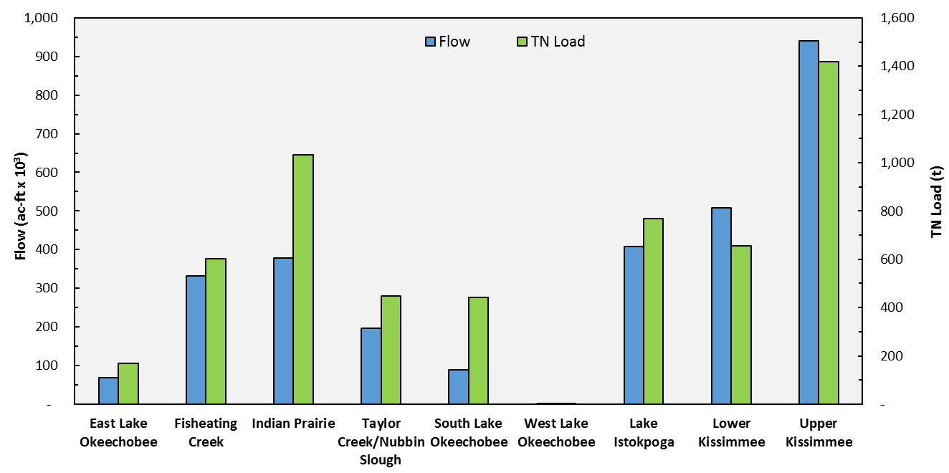
Figure 8B-6. The comparative five-year average values of discharge and TN load to Lake Okeechobee from the contributing subwatersheds during WY2014–WY2018.

Tributary Water Quality Trend Analysis
The S-154, S-191, S-65D, and S-65E drainage basins, make up the four priority basins in the LOW (Figure 8B-7). These were designated priority basins in 1989 due to their contributions to the overall loading to Lake Okeechobee and having the highest basin TP concentrations (SFWMD 1989). The tributary monitoring network is a long-term, ambient monitoring network in the LOW. The network consists of 27 sampling stations within the four priority basins and 8 sampling stations along the Kissimmee River within basins S-65A and S-65BC (Figure 8B-7) for both TP and TN concentrations. No flow data are available at these stations due to cost constraints and the logistics of installing reliable flow instrumentation in this type of topography and flow regime. The sampling frequency for the 27 tributary stations was bi-weekly. Grab samples were collected only during flow until December 2015. Since that time, the tributary monitoring frequency was reduced to monthly sampling, and collected only during flow. The 8 Kissimmee River stations are sampled monthly for both TP and TN concentrations. Only TP concentration data were collected at the 16 stations located at outfalls from the dairy operations; data was collected starting in 1986 in response to the implementation of the FDEP Dairy Rule. These land-use related monitoring data remain a critical tool in providing information to identify the most effective strategies for reducing phosphorus discharges from these operations. These dairy stations have continued to be sampled by leveraging the collections of other watershed sampling trips for TP concentrations only.

Basin Characteristics
The S-154 basin has a drainage area of 12,875 hectares (ha). The primary land use in this basin is agriculture, including improved and unimproved beef pastures; several dairy farms in the basin have ceased operation and have been converted to residential land use. The S-154 basin has four tributary monitoring stations and one dairy station. Due to its size (48,751 ha) and the numbers of monitoring stations, the S-191 basin is further divided into two subbasins: S-191 Taylor Creek (S-191TC) and S-191 Nubbin Slough (S-191NS). The S-191TC and S-191NS subbasins have drainage areas of 27,276 ha and 21,475 ha, respectively. The land use distribution is similar to the S-154 basin, but the majority of the dairy farms in these two subbasins remain in operation. Subbasin S-191TC contains 8 tributary stations and 4 dairy stations, while the S-191NS subbasin has 6 tributary stations and 6 dairy stations. The S-65E basin covers an area of 11,799 ha with major land uses including improved beef pasture, citrus grove, row crop, and dairy. The S-65E basin has four tributary monitoring stations and two dairy stations. The S-65D basin is the northernmost of the four priority basins in the LOW and covers an area of approximately 47,210 ha. Improved pasture is the primary land use in this basin, followed by citrus groves, row crops, and dairy. The S-65D basin contains five tributary monitoring stations and three dairy stations.
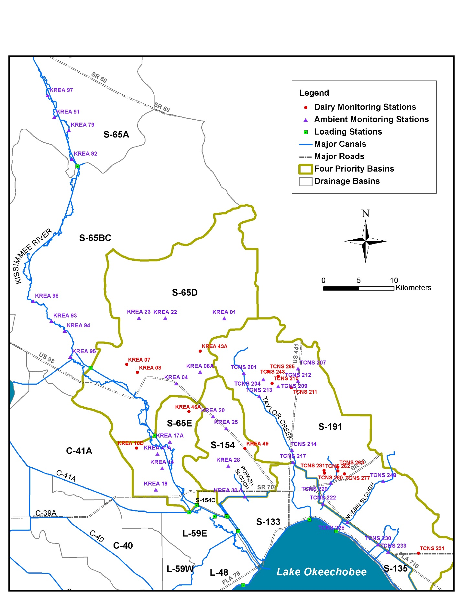
Figure 8B-7. Location of ambient water quality sampling sites where TP and TN were collected in the tributary basins that drain into Lake Okeechobee (purple triangles), sampling sites where TP data were collected at dairy outfalls (red dots), and the loading stations at the inflow structures (green squares).

Statistical Analyses
A previous trend analysis study defined two periods: (1) the baseline period from calendar year (CY) 1991 to CY2001 and (2) the period of Lake Okeechobee Protection Act (LOPA)-mandated best management practices (BMP) implementation from CY2002 to CY2007 (Zhang et al. 2011). The trend analysis study presented in this year’s chapter kept the same baseline period of 1991 to 2001 and extended the post-LOPA period for additional 10 years to 2017. Summary statistics included the number of samples, means, medians, minima, maxima, and standard deviations for each station. Monthly mean concentrations were used for all other statistical analyses. Notched box-and-whisker plots summarized selected statistical properties of the data sets for each study period and were used to test for statistical significance between data sets at roughly a 95% confidence interval and to detect changes in constituent concentration variability over time (McGill et al. 1978). These plots consist of the median, lower quartile (25th percentile), upper quartile (75th percentile), and smallest and largest values in the distribution of each set of data. The narrowest point of the notch represents the median of the data. A comparison of TP and TN concentrations measured during the baseline period (CY1991 to CY2001) and the LOPA BMP implementation period (CY2002 to CY2017) was performed using the Mann-Whitney test (a non-parametric equivalent of the 2-sample t-test) to determine if statistically significant differences existed between the two periods. A significance level (α) of 0.05 was used to identify statistical significance.
Seasonal Kendall Tau test was used to verify the statistical significance of trends in the two series of TP and TN concentrations from CY1991 to CY2001 and from CY2002 to CY2017, respectively. Seasonal Kendall Tau is a non-parametric test frequently used to detect trends for water quality time series data. It is a rank-order statistic that can be applied to time series data exhibiting seasonal cycles, missing and censored data, and indications of non-normality (Yu and Zou 1993). Non-parametric tests perform analyses based on the ranks of the data and are therefore not influenced by outliers or skewed data.
When data are collected over time, significant autocorrelation may exist between data values. Seasonal Kendall Tau provides an adjusted p-value for data that exhibit a significant level of dependence (Reckhow et al. 1992). To determine statistical significance, an alpha (α) level of 0.05 was selected. Results of the Seasonal Kendall Tau test indicate whether or not a statistically significant increase or decrease in concentrations is present at both the station and basin levels.

Summary Statistics with Data Collected at the Tributary Stations
Summary statistics of the TP and TN data collected from the 27 tributary monitoring stations within the four priority basins and 8 stations along the Kissimmee River within basins S-65A and S-65BC are presented in Tables 8B-13 and 8B-14, respectively. Among the 8 stations along the Kissimmee River, 4 stations exhibited higher median TP concentrations and 3 stations had higher median TN concentrations during the LOPA implementation period when compared to the baseline conditions (Tables 8B-13 and 8B-14). Among the 27 tributary stations located in the four priority basins, 16 stations had higher median TP concentrations and 22 stations exhibited higher median TN concentrations during the post-LOPA period (Tables 8B-13 and 8B-14). When examining the data at the basin monitoring stations, all the monitoring stations in the S-154 priority basin exhibited significant differences in median TP concentrations for the two monitoring periods. Significantly lower median TP concentrations (p < 0.05) were observed in the S-154 basin for the post-LOPA period (Table 8B-13). Median concentrations in this basin for the post-LOPA period were between 30% to 60% lower than the baseline period.

Table 8B-13. Summary statistics of TP data (in mg/L) collected during the baseline period of CY1991 through CY2001, and the post-LOPA period of CY2002 through CY2017. ª
a. Bolded and italicized rows indicate a statistically significance difference between the two sampling periods at α = 0.05, as indicated by the Mann Whitney Test results.
Table 8B-14. Summary statistics of TN data (in mg/L) collected during the baseline period of CY1991 through CY2001, and the post-LOPA period of CY2002 through CY2017. ª
a. Bolded and italicized rows indicate a statistically significance difference between the two sampling periods at α = 0.05, as indicated by the Mann Whitney Test results.
A graphical comparison of TP concentrations at each basin for the two monitoring periods is provided in Figure 8B-8. A distinct decrease of TP concentrations is observed for the S-154 basin during the post-LOPA period. The initial higher TP concentration values in this basin during the baseline period might play an important role for the relatively lower concentrations during the post-LOPA period (Figure 8B-9). Basins with higher initial TP values may respond better to BMP implementations, resulting in significant lower TP concentration values in the post-LOPA period. The most decreased median TP concentrations during these two periods occurred at stations KREA 20 (60%), TCNS 249 (52%), and KREA 28 (41%) (Table 8B-13), with two of these individual stations being in the S-154 basin. The highest increase of median TP concentrations during these two periods took place at stations KREA 23 (150%), KREA 01 (120%), and TCNS 233 (102%) respectively. Further evaluation of stations with significant changes in trend over time may yield useful information for identifying target areas where future restorative projects and practices may have the most impact and to evaluate which types of initiatives work best for certain land uses.
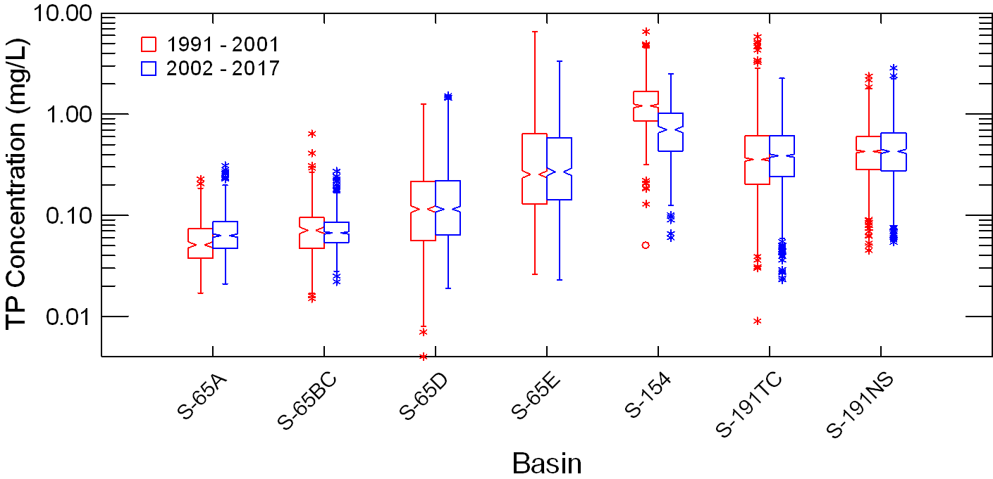
Figure 8B-8. Box-and-whisker plot of TP concentrations at the basin level for the baseline period of CY1991–2001 and the post-LOPA period of CY2002–2017.
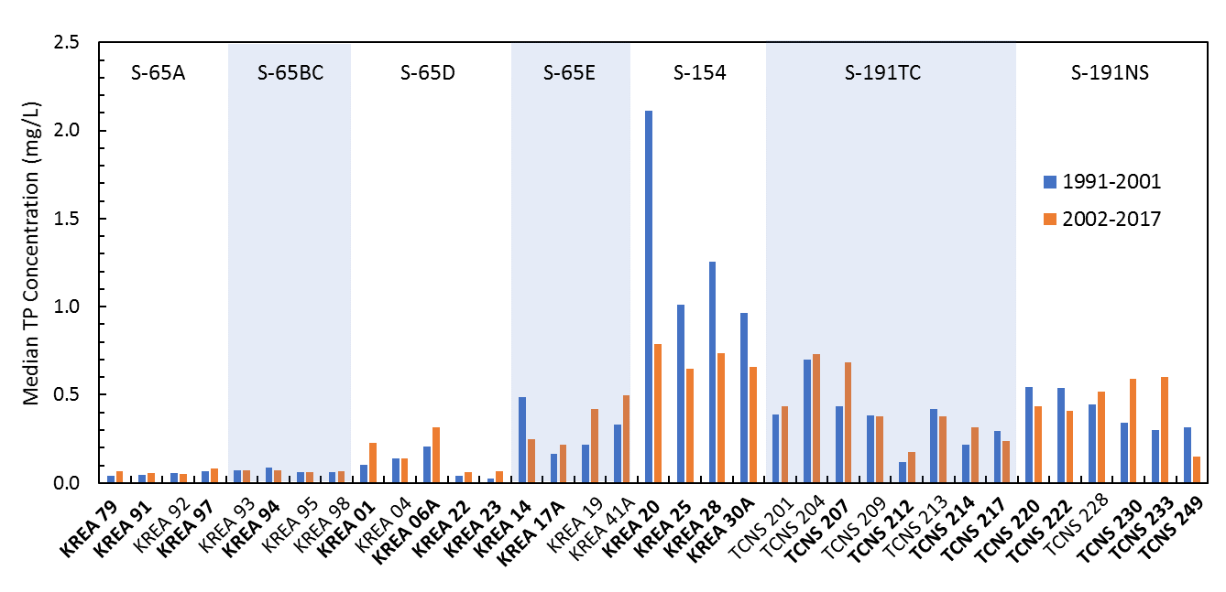
Figure 8B-9. The comparative median TP concentration values between the baseline period of CY1991–CY2001 and the post-LOPA period of CY2002–CY2017. Stations bolded indicate a statistically significance difference between the two sampling periods at α = 0.05 as indicated by the Mann Whitney Test results.

Summary Statistics with Data Collected at the Dairy Stations
During this study, it was discovered the data collected from October 2003 to September 2004 at these dairy stations were not included in the previous analysis (Zhang et al. 2011). These missing data were not loaded into the District’s DBHYDRO database but were found and retrieved from another District sub-database, so they could be included in this study. A graphical comparison of TP concentrations at each station for the two monitoring periods is provided in Figure 8B-10. TP concentrations averaged over the post-LOPA period were generally lower than those from the baseline period for the 16 dairy stations. The median TP concentrations in the post-LOPA period were lower than the baseline period for 10 out of 16 stations (Figure 8B-11 and Table 8B-15). These observations may be attributed to the intensive BMP implementation at the specific dairy stations, as well as the high initial concentrations that were greatly reduced over time.
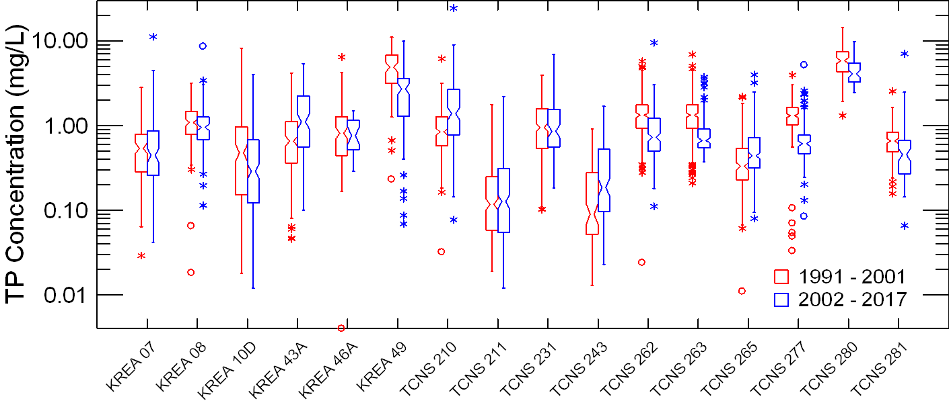
Figure 8B-10. Box-and-whisker plot of TP concentrations collected at the dairy stations for the baseline period of CY1991–CY2001 and the post-LOPA period of CY2002–CY2017.
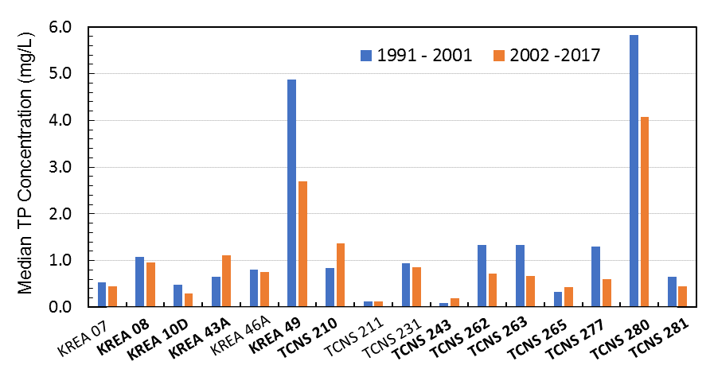
Figure 8B-11. The comparative median TP concentration values collected at the dairy stations between the baseline period of CY1991–CY2001 and the post-LOPA period of CY2002–CY2017. Stations bolded indicate a statistically significance difference between the two sampling periods at
α = 0.05 as indicated by the Mann Whitney Test results.
Table 8B-15. Summary of TP data (in mg/L) collected from the dairy stations during the baseline period of CY1991–CY2001, and the post-LOPA period of CY2002–CY2017. ª
a. Bolded and italicized rows indicate a statistically significance for the two sampling periods at α = 0.05.

Trend Analyses with Data Collected at the Tributary Stations
The trend analysis results including the Sen slope and p-value are shown in Table 8B-16 for TP and Table 8B-17 for TN concentrations. The Sen slope indicates the change in annual concentration for a constituent. While the presence of significant trends (Sen slope: + for increase or – for decrease) provides the most valuable management tool for determining how a station is reacting to restoration measures, other statistics represented in Tables 8B-16 and 8B-17 can be used to predict likely trends and help the coordinating agencies focus resources on the most efficient ways to achieve water quality improvements for the LOW. For instance, the Sen slope indicates the change in annual value for a constituent, which, taken into consideration the p-value, can indicate if a basin is more likely to continue to follow its current direction in the next few years and if these changes will be significant. Monitoring stations with highly negative or positive slopes where probability (p)-values are close to 0.05, though not showing a statistically significant trend, could still be targeted for in-depth investigations to help evaluate success stories or identify areas where more intense nutrient control measures need to be implemented.
Among the 8 stations within the Kissimmee River proper in the S-65A and S-65BC basins, 4 stations displayed a significant increasing trend in mean TP concentration for the baseline period (1991–2001) and 1 station had a significant decreasing trend in mean TP concentration for the post-LOPA period (2002–2007; Table 8B-16). In general, the Sen slope values in the post-LOPA period were smaller than the values during the baseline period indicating a reduction in the annual rate of change for TP concentrations during the post-LOPA period. Additional information relating to basin runoff is needed to determine if these trends are mainly the result of contributions from the Upper Kissimmee Basin and to determine to what degree, if any, changes in the water quality characteristics of the upland basin areas are contributing to these promising results.
TP concentrations exhibited a significant increasing trend at 4 stations in the S-65D basin during the baseline period (1991–2001) and 1 station had a significant increasing trend during the post-LOPA period (2002–2017; Table 8B-16). Station KREA 06A displayed a significant increasing trend for both periods with an increased Sen slope value of 0.008 mg/L per year for the baseline period to 0.024 mg/L per year for the post-LOPA period. Station KREA 17A in the S-65E basin exhibited significant increasing trends for TP concentrations during the baseline period. No significant trends were found for TP in the S-154 basin for the baseline period and a significant decreasing trend exhibited at one station during the post-LOPA period. TP concentrations at station KREA 20 in the S-154 basin had a Sen slope of -0.066 mg/L per year (Table 8B-16). The stations with more negative slopes can be targeted for in-depth investigations to help evaluate the success or effectiveness of TP reduction measures implemented so far. In the S-191TC subbasin, TP increased significantly at station TNCS 207 during the baseline period, as well as at stations TCNS 204 and TCNS 214 during the post-LOPA period (Table 8B-16). In the S-191NS subbasin, TP concentrations at stations TCNS 220 and TCNS 222 showed significantly decreasing trends. All stations in this subbasin had negative or zero Sen slopes values during the post-LOPA period.
Based on the Seasonal Kendall Tau analysis of data at the basin level, the S-65BC basin exhibited a statistically significant increasing trend during the baseline period (Figure 8B-12). Note that this basin had a short POR (1996–2001) for the baseline period. All basins had a negative or an improved Sen slope value during the post-LOPA period, indicating the overall improvement of decreasing TP concentrations at the basin level. The stations with high positive slope can be targeted for in-depth investigations to help evaluate the effectiveness of TP reduction measures or identify areas where more intense nutrient control measures need to be implemented.
A total of 13 stations displayed a significant trend for TN concentrations. Four stations displayed a significant increasing trend in mean TN concentration for the baseline period (1991–2001). For the post-LOPA period (2002–2017), 3 stations had a significant decreasing trend and 6 stations displayed a significant decreasing trend in mean TN concentration (Table 8B-17). Overall, the Sen slope values in the post-LOPA period were less than the values during the baseline period, indicating that improvement in the overall reduction of TN concentrations occurred during the post-LOPA period.
Table 8B-16. Seasonal Kendall Tau trend analysis of TP collected within the Kissimmee River and at all tributary stations for the baseline period (CY1991–CY2001) and post-LOPA period (CY2002–CY2017). ª
a. Bolded and italicized results indicate a significant change in concentration.
Table 8B-17. Seasonal Kendall Tau trend analysis of TN collected within the Kissimmee River and at all tributary stations for the baseline period (CY1991–CY2001) and the post-LOPA period (CY2002–CY2017). ª
a. Bolded and italicized results indicate significant difference between pre- and post-LOPA concentrations.
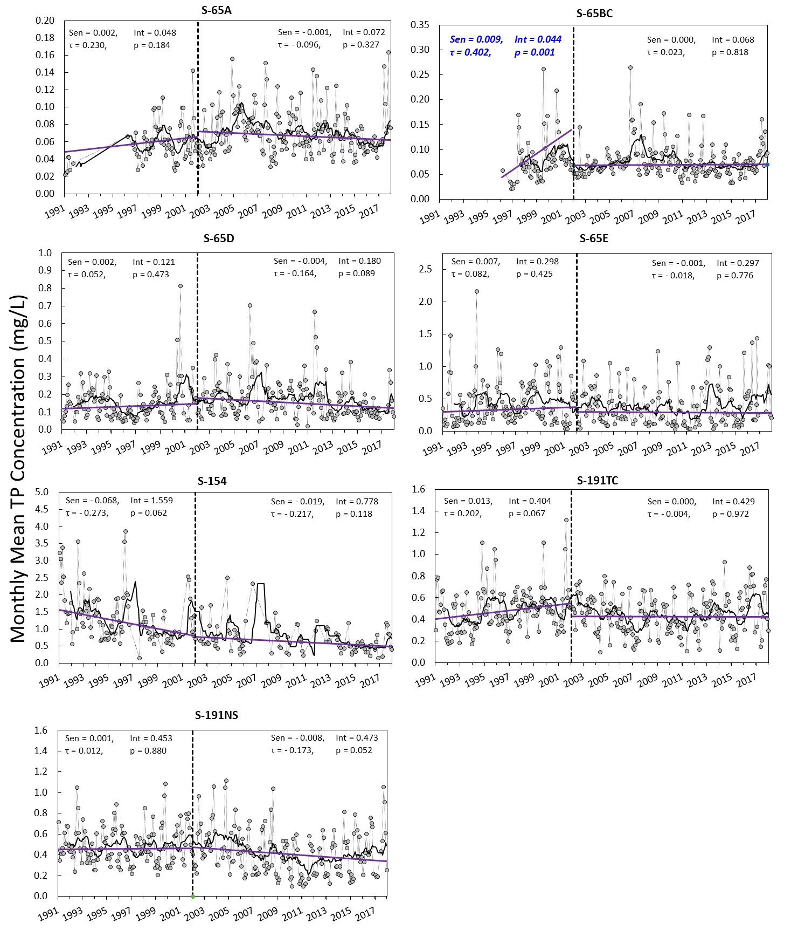
Figure 8B-12. Monthly mean TP concentrations for the baseline period (CY1991–CY2001) and post-LOPA period (CY2002–CY2017). Gray dots represent monthly values, black lines represent the 12-month moving average, and the purple lines represent the Seasonal Kendall Tau trend line. Statistically significant changes (p-value < 0.05, in blue text) were observed for the S-65BC basin.

Trend Analyses with Data Collected at the Dairy Stations
Among the 16 dairy stations analyzed, 9 stations revealed significant trends for 1 of the 2 periods and 1 station had a significant trend for both periods (Table 8B-18 and Figure 8B-13). Station KREA 43A displayed a significant increasing trend for TP concentrations during the post-LOPA period (2002–2017) and the Sen slope was increased from 0.019 mg/L per year to 0.213 mg/L per year. In contrast, station TCNS 231 showed a significant increasing trend for TP concentrations during the baseline period (1991–2001) and a significant decreasing trend for the post-LOPA period (2002–2017). This site was discontinued in 2012, so the analysis for the post-LOPA period only includes 10 years of data. During the baseline period, two stations displayed a statistically significant increasing trend in TP concentration and four stations showed a statistically significant decreasing trend in TP concentration (Table 8B-18). However, only one station displayed statistically significant decreasing trend in TP concentration and four stations had statistically significant increasing trend in TP concentration during the post-LOPA period. The stations with increasing trends may warrant additional investigation to determine what types of measures may work best to achieve reductions in TP concentrations.

Table 8B-18. Seasonal Kendall Tau trend analysis of TP at monitoring stations located on individual dairy farm for the baseline period (CY1991–CY2001) and the post-LOPA period (CY2002–CY2017).
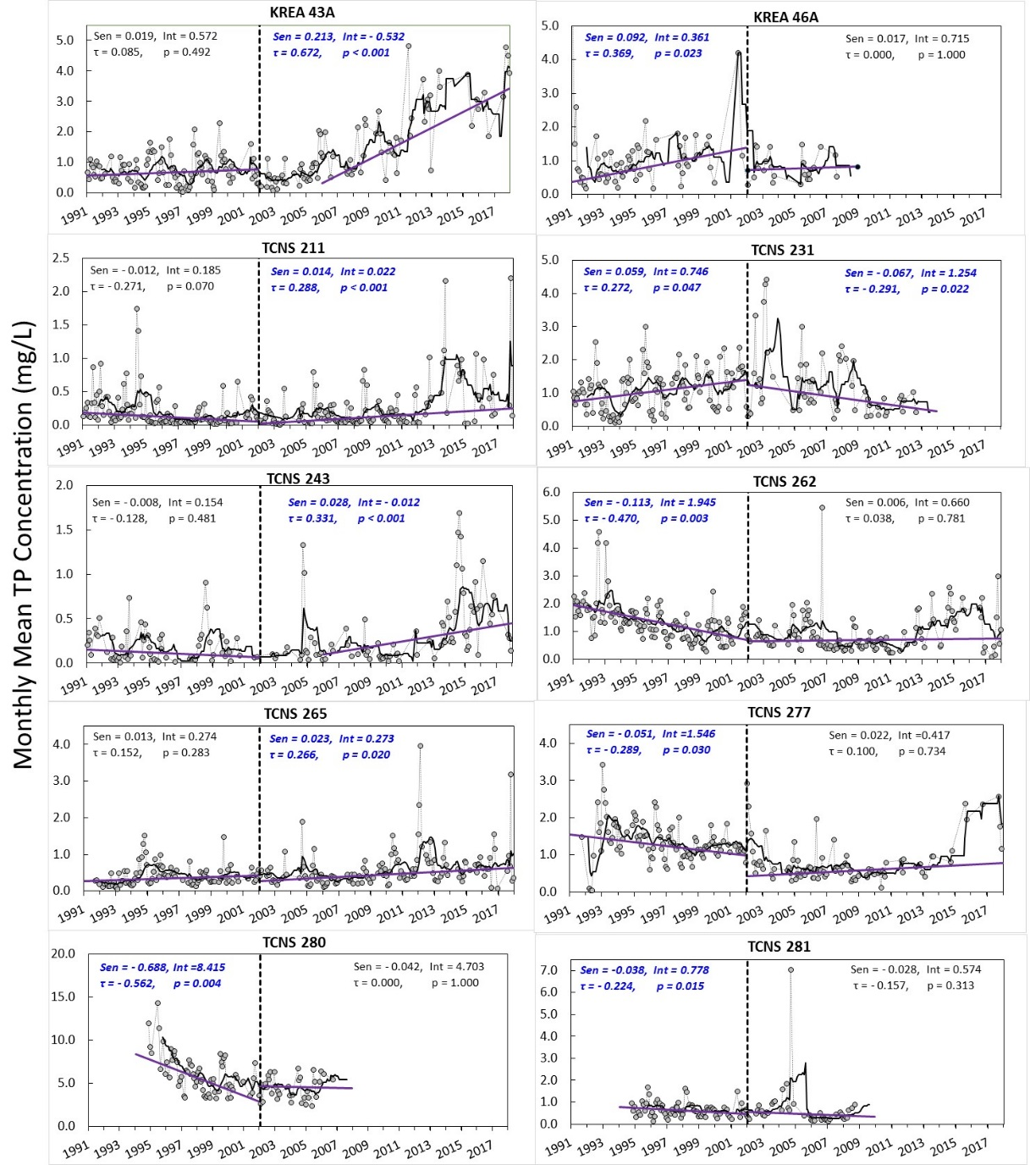
Figure 8B-13. Monthly mean TP concentrations for the baseline period (CY1991–CY2001) and the post-LOPA period (CY2002–CY2017). Gray dots represent monthly values, black lines represent 12-month moving averages, and purple lines represent the Seasonal Kendall Tau trend line. Statistically significant changes (p-value < 0.05, in blue text) were observed for these dairy stations.

Summary and Discussion
A broad array of state and federal projects is planned within the watershed to reduce TP loading to Lake Okeechobee. These nutrient reduction projects, along with on-site BMPs when fully implemented, will reduce P transport from uplands and capture water runoff during periods of high rainfall. Ongoing research and monitoring in the watershed are helping to guide the design of TP load reduction projects that will improve water quality and attenuate flows. The highly variable nature of the data from these basins and the influence of storm events on those data make continuous evaluations a critical management tool. Evaluations that show no significant trends over several years can also be useful in helping to determine if the system has stabilized and what measures need to be taken if the stabilized state is still not meeting target water quality goals. An ongoing assessment of water quality trends in the watershed is necessary to evaluate progress toward achieving the Lake Okeechobee TMDL goal of 140 t per year.
A total of 51 monitoring stations were studied: 35 long-term, ambient monitoring stations that included 27 stations in the 4 priority basins and 8 along the Kissimmee River within the S-65A and S-65BC basins; and 16 stations located at the outfalls of the dairy operations. Only TP data were collected at the 16 dairy stations. The baseline data and the post-LOPA period trend analyses for TP and TN concentrations were summarized at the station and basin levels using the data collected at the 35 long-term, ambient monitoring stations. Data collected in basin S-65BC displayed a significant increasing trend in terms of mean monthly TP concentrations during the baseline period (CY1991–CY2001). This basin had a relatively short POR from CY1996 to CY2002. All basins evaluated in this study had a negative or an improved Sen slope value during the post-LOPA period, indicating the overall improvement of TP concentrations at the basin level.
Among the 16 dairy stations, the median TP concentrations in the post LOPA period were lower than the baseline period for 10 out 16 stations. However, in terms of trend in TP concentrations, one station displayed a significant decreasing trend and four stations had a significant increasing trend during the post-LOPA period.
Although enrollment and implementation of BMPs is progressing, there was still nearly 50 percent of the watershed that needs BMP implementation as of April 30, 2018 (see Chapter 8A of this volume). The high levels of legacy TP in the soils may play a role in the delayed response of the watershed to show TP concentration reductions. The distance from the BMP implementation area to the actual tributary monitoring station, as well as nearby land use practices are also factors in the trends displayed at the sampling stations. In summary, the suite of nutrient control measures implemented since 1991 has made limited progress in the reduction of TP loads to the lake. The continued evaluation of the nutrient data within the watershed at the basin and upstream levels can assist with pinpointing areas to focus continued restoration efforts in order to meet the target water quality goals for Lake Okeechobee.

Lake Okeechobee
Lake Okeechobee is shallow, turbid, eutrophic, and a central component of the hydrology and environment of South Florida. The lake provides natural habitat for fish, wading birds, and other wildlife, but has been subject to three long-term stresses: (1) excessive TP loads, (2) extreme water level fluctuations, and (3) rapid spread of exotic and nuisance plants in the littoral zone. The following section provides a summary of the hydrology, water quality, and aquatic habitat conditions of Lake Okeechobee in WY2018.

Hurricane Irma
On September 10, 2017 (WY2018), the eye of Hurricane Irma passed about 60 miles west of the lake with sustained winds in the central portion of the lake between 50 and 60 miles per hour. These winds caused lake stages to increase over 6 feet in the north and west side of the lake, while dropping stages over 4 feet in the south and east side of the lake; causing a wind seiche of over 10 feet from east to west at its peak (Figure 8B-14). The wind and wave action resulted in a direct loss of roughly 5,200 acres (2,100 ha) of emergent vegetation along the outer shorelines of the marsh (Figure 8B-15). Inspections revealed most of the uprooted vegetation was cattail (Typha spp.), while more desirable grasses and bulrush species appeared less affected. However, the uprooted vegetation was deposited in long rows within or along the edge of the marsh, creating substrate for long-term floating islands of organic material that will be barriers to fish movement between the marsh and open water habitats.
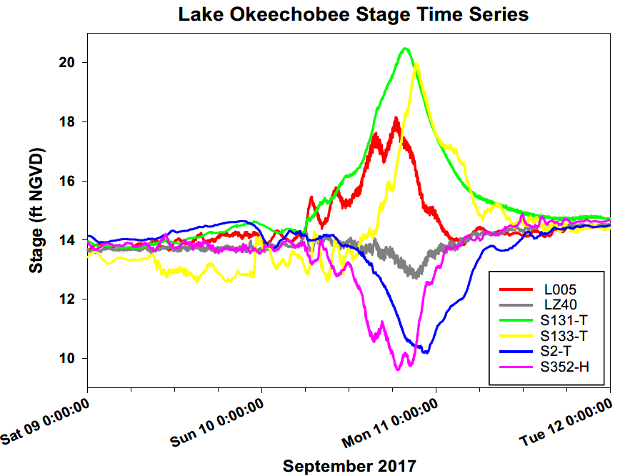
Figure 8B-14. Lake stage at different water level monitoring stations on Lake Okeechobee from September 9–12, 2017. S352-H and S2-T are located on the east and southeast shorelines, respectively, while S131-T and S133-T are located on the west and north shorelines, respectively.
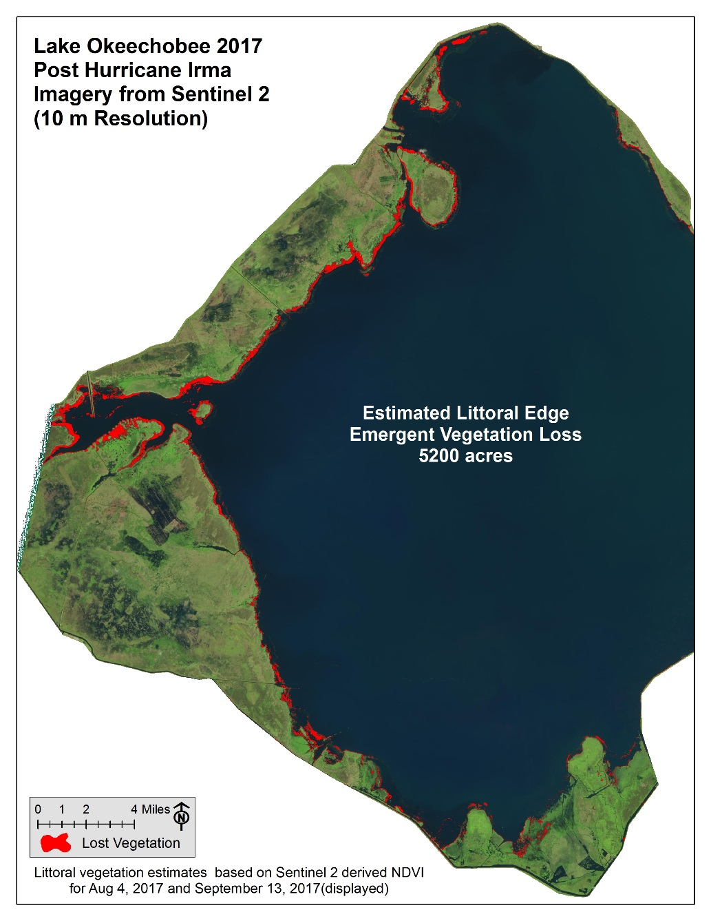
Figure 8B-15. Location and approximate quantity of emergent marsh vegetation uprooted and removed from the shorelines because of Hurricane Irma.
Due to the enormous rainfall associated with Hurricane Irma, runoff from the watershed and resuspension of the sediments after the storm resulted in a 1-week increase in the average measured TP concentrations of 223 µg/L in the nearshore zone (up to 388 µg/L post-storm) and 201 µg/L in the pelagic zone (up to 313 µg/L post-storm). Post-storm water clarity also markedly decreased, with average monthly turbidity rising from 7 to 74 nephelometric turbidity units (NTU) in the nearshore and from 13 to 86 NTU in pelagic areas (Figure 8B-16). Strong winds experienced in January 2018 caused even further sediment resuspension, causing the highest in-lake average pelagic turbidity levels (185 NTU) since the 2004–2005 hurricanes, and remaining elevated until April 2018 (Figure 8B-17). The combined physical effects of wave action and deep water, combined with poor water quality for months following the storm, reduce the prospect of improving ecological conditions in the near term.
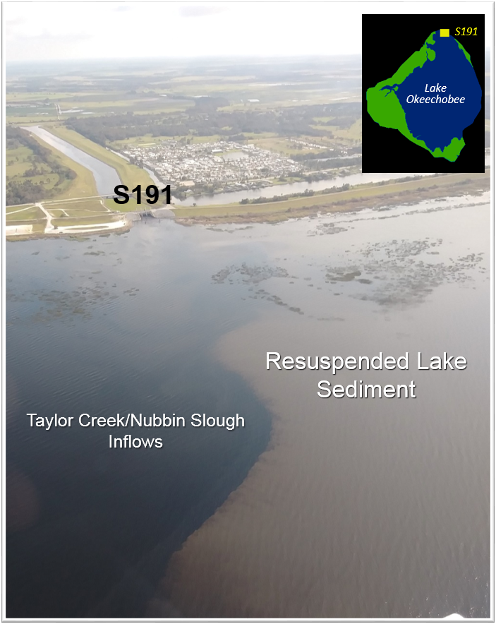
Figure 8B-16. Photograph showing the contrast between the inflows from the S-191 structure at Taylor Creek/Nubbin Slough and the turbid, resuspended sediment in the lake a week after Hurricane Irma.

Figure 8B-17. Turbidity values on Lake Okeechobee for WY2016–WY2018. The vertical red dashed line indicates when Hurricane Irma impacted Florida, which was just prior to the September sampling event.

Hydrology
Surface inflows to Lake Okeechobee were approximately 3.42 million ac-ft in WY2018 (Table 8B-4). This was a 38% increase from WY2017 (2.49 million ac-ft). The increased inflow could be attributed primarily to the extreme weather events during the 2017 wet season.
Lake Okeechobee stage elevation was 11.61 ft (3.54 m) NGVD29 on May 1, 2017, which placed water levels in the Beneficial Use Subband (Figure 8B-18). Water levels declined to the water year low of 10.93 ft (3.33 m) NGVD29 on June 2, 2017, and then increased steadily. Stage levels rose rapidly from 13.7 ft (4.17 m) on September 10, 2017, to 17.2 ft (5.24 m) NGVD29 on October 10, 2017. Water levels crossed into the High Lake Management Band on October 6, 2017, and remained there for 2 weeks. The dry season that followed from November 2017 through April 2018, along with regulatory and water supply water management releases, resulted in a decline in water levels by 4.8 ft (1.46 m) from November 1, 2017, to April 30, 2018, an average of 0.96 ft (0.30 m) per month. On April 30, 2018, the lake stage was at 13.16 ft (4.01 m) NGVD29, an increase of 1.55 ft (0.47 m) NGVD29 from the start of WY2018.
Figure 8B-18. Annotated Lake Okeechobee stage hydrograph.
(Note: cfs – cubic feet per second, max – maximum, and WS – water supply.)
Approximately 2.62 million ac-ft of water was released from the lake in WY2018, which was 2% lower than WY2017 (2.67 million ac-ft). Regulatory releases to the estuaries were made in WY2018 based on the current Lake Okeechobee regulation schedule, LORS2008. These releases occurred from September 5 to December 6, 2017. Pulse releases to the estuaries occurred from December 7, 2017 to January 4, 2018. Total releases to the estuaries were 1.96 million ac-ft or 75% of the total released from the lake. Releases totaling 593 thousand ac-ft of water were made south through the S-351, S-352, and S354 structures, and Culvert 10A; constituting 23% of the water discharged from the lake during WY2018 (Figure 8B-19). The capacity of discharging south was affected by a high water emergency declared by FDEP in 2017 for the Everglades Water Conservation Areas (WCAs) due to Hurricane Irma, which directed USACE and SFWMD to reduce inflows and maximize outflows from the WCAs.

Figure 8B-19. Water discharges from Lake Okeechobee to the Caloosahatchee River Estuary through S-77, the St. Lucie River Estuary through S-308, and south through S-351, S-352, S-354 and CULV-10A.

Water quality

Total Phosphorus Budget and Concentrations
TP loads to the lake from tributaries and atmospheric deposition (estimated as 35 metric tons per year [t/yr], FDEP 2001) totaled 1,081 t in WY2018 (Table 8B-19 and Figure 8B-20). This was a 123% increase from the previous year’s input of 484 t TP and the highest annual total since 1983. Much of this load increase may be attributed to extreme weather events, with two-thirds of the annual TP load entering the lake between September and October.
In-lake TP concentrations declined from a high of 233 µg/L in WY2005 to 93 µg/L in WY2012 (Figure 8B-21). In WY2018, the in-lake TP concentration was 203 µg/L, 35% higher than the WY2017 value of 150 µg/L. These in-lake TP concentration values exceed the TP in-lake goal of 40 µg/L. The current five-year (WY2014–WY2018) moving average TP concentration is 145 µg/L, which is higher than the pre-hurricane (pre-2004) range of 57 to 127 µg/L.
Mean lake TP mass in WY2018 was the highest it has been since WY2006 due to a combination of higher in-lake concentrations and extremely high TP loads into the lake (Table 8B-19). Loads out of the lake in WY2018 were 43% higher than in WY2017, despite total water discharges being 2% lower. Fifty-five percent of the WY2018 TP load discharged from the lake went into the Caloosahatchee and St. Lucie rivers from September through November 2017, while 22% was discharged south in the EAA from December 2017 through April 2018. As with the load into the lake, the net load (inputs minus outputs) in WY2018 was much higher than in WY2017, at 533 t, compared to 102 t. Based on the difference between net load and net change in lake phosphorus (P) content, there was an estimated 236 t of P that accumulated in the sediments in WY2018, which resulted in a net sedimentation coefficient (σ_{y}) of 0.26 (Table 8B-19 and Figure 8B-22). The σ_{y} of the P budget is the amount of TP that accumulates in the sediment per year divided by the average lake water TP mass. A low σ_{y} indicates that the lake absorbed less of the excess TP load from the watershed. The five-year moving average trend shows a steep decline in σ_{y} from the 1970s to the 1990s, but from the mid-1990s, this five-year average of σ_{y} has remained within the range of 0.25 and 0.5, suggesting the lake is close to capacity in terms of P absorption.
Table 8B-19. TP budget for Lake Okeechobee for the most recent 10 water years.
Water Year  May 1–April 30 | Mean Lake TP Mass  (t) | Change in Lake TP Mass (t) ª | TP Load In ^{b} (t) | TP Load Out  (t) | TP Net Load ^{c}  (t) | TP Accumulation in Sediment Accumulation ^{d} (t) | σ_{y}
2009 | 608 | -257 | 656 | 243 | 413 | 670 | 1.10
2010 | 500 | 283 | 481 | 79 | 402 | 119 | 0.24
2011 | 439 | -320 | 170 | 210 | -40 | 280 | 0.64
2012 | 318 | 11 | 373 | 88 | 285 | 274 | 0.86
2013 | 545 | 280 | 569 | 126 | 443 | 163 | 0.30
2014 | 542 | -34 | 609 | 332 | 277 | 311 | 0.57
2015 | 604 | -63 | 450 | 298 | 152 | 215 | 0.36
2016 | 520 | 188 | 543 | 357 | 187 | -1 | 0.00
2017 | 680 | -199 | 484 | 382 | 102 | 301 | 0.44
2018 | 918 | 297 | 1081 | 548 | 533 | 236 | 0.26
Average | 568 | 19 | 542 | 266 | 275 | 257 | 0.48
a. Net change of Lake Content based on the estimate of mass on the end date (April 30) subtracted by the estimate of mass on the start date (May 1) of each water year.
b. Includes 35 t/yr to account for atmospheric deposition.
c. Difference between load in and load out.
d. Difference between net change in lake P content and net load (positive value is accumulation in sediments).

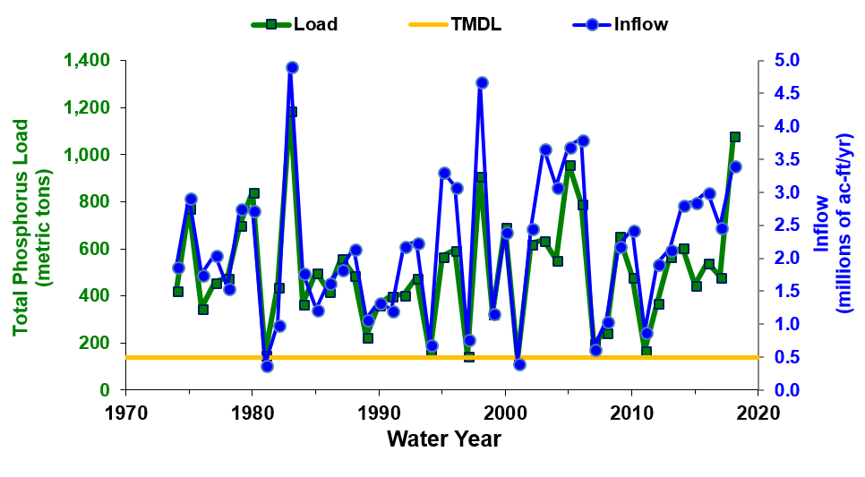
Figure 8B-20. Timelines of May–April water year TP load and inflow entering Lake Okeechobee from its tributaries calculated from the P budget of Lake Okeechobee.

Figure 8B-21. Timelines of inflow (flow-weighted mean) and average lake TP concentrations (five-year moving average trend lines) calculated from the P budget of Lake Okeechobee.
(Note: ppb – parts per billion, which is equivalent to μg/L.)
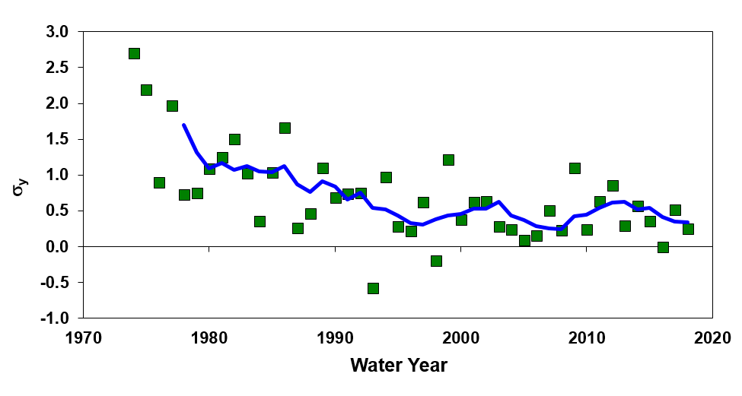
Figure 8B-22. Timeline of the net sedimentation coefficient (σ_{y}) calculated from the P budget of Lake Okeechobee. Negative values indicate a net release of P from the sediment. Trend line is a 5-year moving average.

Total Nitrogen Budget and Concentrations
TN loads to the lake from tributaries and atmospheric deposition (estimated as 1,233 t/yr) totaled 8,745 t in WY2018, which was 65% higher than the previous water year (Table 8B-20 and Figure 8B-23). As with TP, the majority (almost 60%) of the TN load entered the lake during September and October 2017. Despite higher loads in, discharge TN loads were 15% higher than the previous year (Table 8B-20 and Figure 8B-23) and the resultant net TN load was 3,296 t. The lake removed a smaller amount of nitrogen (N) compared to the previous water year, potentially due to the stormy conditions reducing the ability of the lake to remove TN by the usual physical (settling of organic material) and biological (N uptake and denitrification) processes that occur in the lake (James et al. 2011). With the higher loads entering the lake in WY2017, the in-lake TN concentration increased by 15%, from 1.45 mg/L in WY2017 to 1.67 mg/L in WY2018 (Figure 8B-24). The outflow concentrations also increased compared to the previous year, from 1.43 mg/L in WY2017 to 1.68 mg/L in WY2018.
Table 8B-20. N budget for Lake Okeechobee (WY2009–WY2018).
Water Year  May 1–April 30 | Mean Lake TN Mass | Change in Lake TN Mass ª | TN Load In ^{b} (t) | TN Load Out  (t) | TN Net Load ^{c}  (t) | TN Accumulation in Sediment ^{d}  (t) | σ_{y}
2009 | 6,566 | -1,075 | 6,689 | 2,841 | 3,848 | 4,923 | 0.75
2010 | 6,659 | 2,735 | 6,325 | 1,106 | 5,219 | 2,484 | 0.37
2011 | 5,762 | -3,402 | 2,913 | 3,018 | -105 | 3,297 | 0.57
2012 | 4,427 | 487 | 4,620 | 1,460 | 3,160 | 2,673 | 0.60
2013 | 6,178 | 1,705 | 6,397 | 1,879 | 4,518 | 2,813 | 0.46
2014 | 5,900 | -81 | 6,750 | 4,258 | 2,492 | 2,573 | 0.44
2015 | 6,159 | -1,021 | 6,191 | 3,311 | 2,879 | 3,901 | 0.63
2016 | 5,690 | 1,346 | 6,875 | 4,404 | 2,471 | 1,125 | 0.20
2017 | 6,285 | -1,622 | 5,299 | 4,707 | 592 | 2,214 | 0.35
2018 | 7,667 | 2,108 | 8,745 | 5,449 | 3,296 | 1,188 | 0.15
Average | 6,230 | 118 | 6,080 | 3,290 | 2,791 | 2,673 | 0.44
a. Net change of lake content is based on the estimate of mass on the end date (April 30) subtracted by the estimate of mass on the start date (May 1) of each water year.
b. Includes 1,233 t/yr to account for atmospheric deposition.
c. Difference between load in and load out.
d. Difference between net change in lake content and net load (positive value is adsorption from water column).
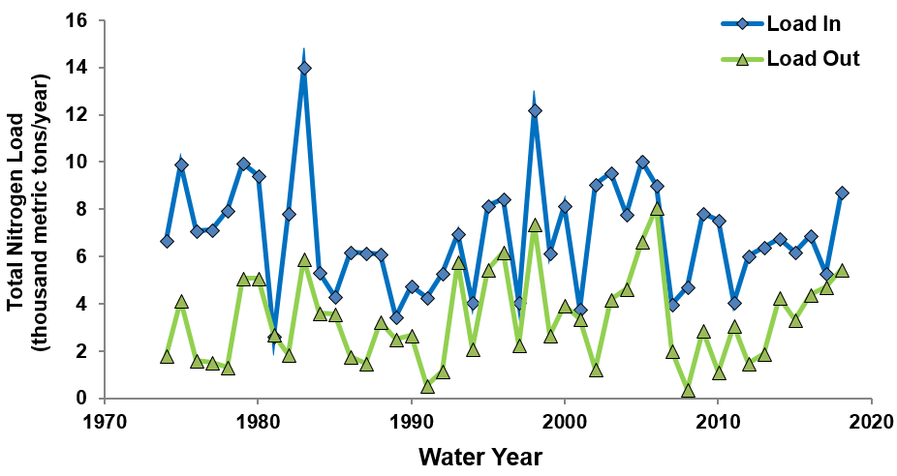
Figure 8B-23. Timelines of water year (May–April) inflow and outflow N load to and from Lake Okeechobee calculated from the lake N budget.
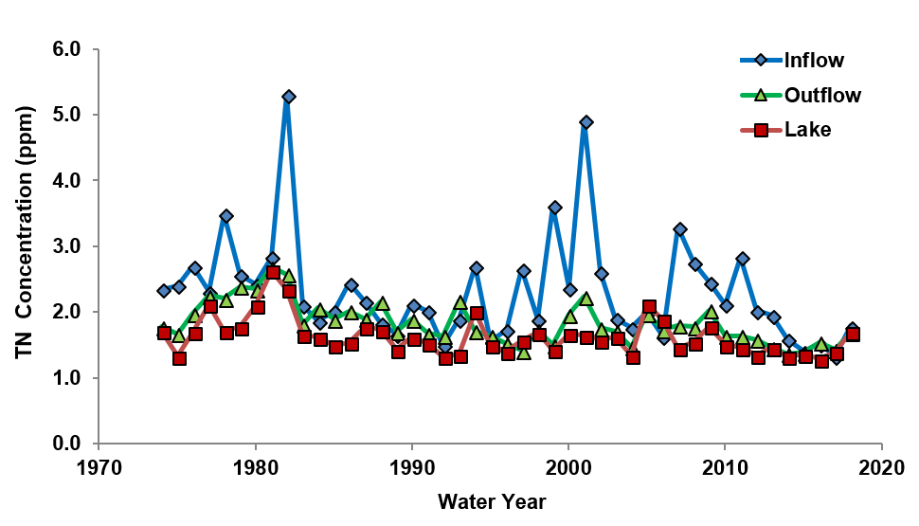
Figure 8B-24. Timelines of inflow, outflow, and lake average TN concentrations calculated from the lake N budget.

Algal Bloom Monitoring
The District collects chlorophyll a (Chla) samples monthly from 19 stations on Lake Okeechobee as part of its routine water quality monitoring activities. Six of these stations are also monitored for microcystin-LR (microcystin) and algal (phytoplankton) species composition monthly (Figure 8B-24). Together, the data can be used to obtain a rough estimate of the prevalence and distribution of cyanobacterial and algal blooms on the lake, as well as the composition of the phytoplankton community and presence of toxins. Results of these analyses are reported to FDEP, which may collect additional samples. The Florida Department of Health issues health advisories and posts warning signs when there is a health risk. Algal bloom proliferation is triggered by multiple factors, including but not limited to, light, temperature, nutrients, and hydrology. However, our understanding of bloom dynamics on the lake is still rudimentary. An overview of the most recent five-year (WY2014–WY2018) and past year (WY2018) monitoring results is presented in this subsection.
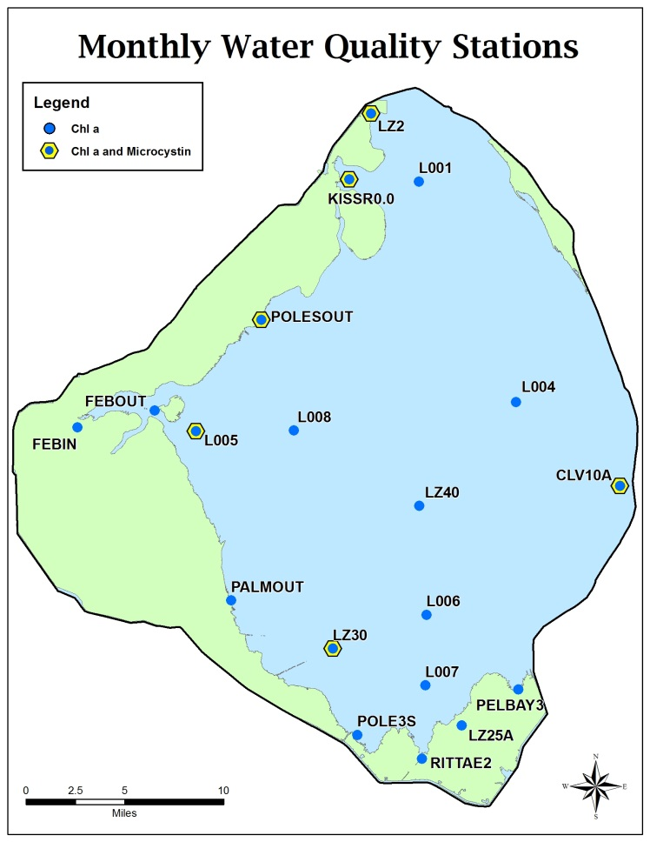
Figure 8B-25. Nineteen Chla and six microcystin-LR and phytoplankton (yellow outline) sampling locations in Lake Okeechobee.

Chlorophyll a
During WY2014–WY2018, there were a total of 1,102 Chla samples collected from 19 monthly sampling locations (between 208 and 228 sampling events per water year). About 13% of those, or 138 occurrences, reported algal blooms, defined by the District as a Chla concentration of 40 μg/L or greater (Walker and Havens 1995; Figure 8B-26). WY2018 had the fewest number of samples (14) where site specific Chla values exceeded 40 μg/L, while WY2014 had the highest (44). During WY2015, WY2016, and WY2017, site specific blooms occurred 33, 15, and 32 times, respectively.

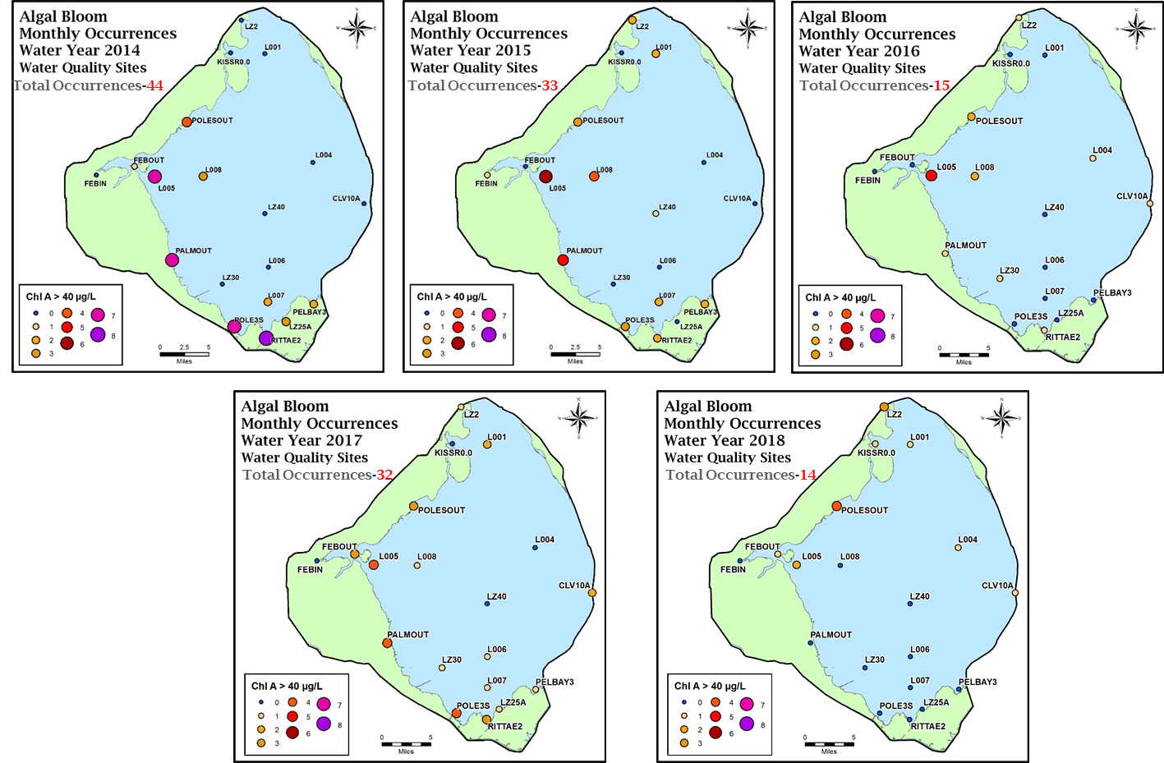
19%
15%
7%
7%
15%
Figure 8B-26. Frequency of blooms at the 19 sites in Lake Okeechobee from WY2014 to WY2018. A Chla concentration of 40 μg/L or greater indicates bloom conditions. Each site is sampled once a month for a maximum of 228 sampling events per water year (1,140 per 5 water years). The percent of samples that had bloom conditions present each WY are shown in red.

Over the 5 most recent water years, the highest frequency of blooms by site has occurred at the pelagic station L005 with 24 blooms, followed by the nearshore PALMOUT station with 17 blooms (Figure 8B-27). Of the 138 total blooms recorded from WY2014 through WY2018, 61% occurred at the nearshore sites and 39% occurred at the pelagic sites. In WY2014, when algal bloom occurrence peaked, 73% of the blooms occurred at nearshore sites while only 27% occurred at pelagic sites. Most of the blooms have occurred at southern and western sites, while a few have occurred at the northern sites; only within the last 3 water years have blooms been recorded at eastern sites. On a seasonal basis, bloom conditions occurred most frequently from May through October, peaking in August. The fewest blooms have occurred in February. Mean annual Chla concentrations were highest (25 ug/L) during WY2014 and lowest (13 ug/L) during WY2018. Three of the six highest Chla values were recorded at L005 (a pelagic site), the highest of which was 278 ug/L in WY2017. However, the mean annual concentrations were higher in the nearshore region than in the pelagic region over the past 5 water years.
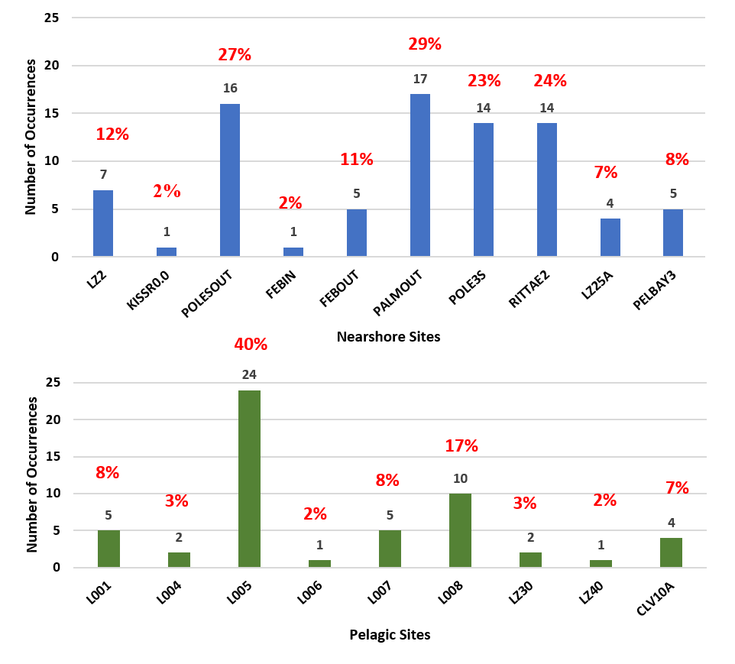
Figure 8B-27. Frequency of blooms (Chla concentrations of 40 μg/L or greater) for the 10 nearshore (top panel) and 9 pelagic (bottom panel) sites in Lake Okeechobee over the past 5 water years (WY2014 to WY2018). The percent of samples that had bloom conditions present each water year are shown in red.
In terms of bloom events, WY2018 was the least active over the past 5 water years. Previous analyses indicate that when the average May water level is above 14.0 ft NGVD29, the probability of summer cyanobacteria blooms is elevated (RECOVER 2009). Water levels in May WY2017 were not only above 14.0 ft but over a 3-week period during the last quarter of WY2016 (January and February), water levels increased by 1.63 ft to a water year high of 16.40 ft NGVD29 due to two consecutive storm events. Conversely, stage in May WY2018 was below 12.0 ft NGVD29 and below 14.0 ft NGVD from mid-January (WY2017) until September 2017 (WY2018), a week after Hurricane Irma. Higher lake stages are correlated with a suite of poor water quality parameters in the nearshore region including increased phytoplankton biomass, total suspended solids, TP, TN, and dissolved inorganic nitrogen (DIN); and reduced transparency ratio and TN:TP ratio; likely due to absence of SAV and epiphyton and reduced competition with phytoplankton for nutrients (James and Havens 2005).

Microcystin
There was a total of 73 occurrences out of 356 sampling events when microcystin concentrations were detected (analytical detection limit of 0.2 µg/L) over the past five water years (Figure 8B-28). Sixty-six percent occurred during WY2016 and WY2017 and only 10% occurred in WY2018. Average microcystin concentrations at the 6 monitoring sites steadily increased from a low of 0.20 µg/L in WY2014 to a high of 0.83 µg/L in WY2017 but declined to 0.23 µg/L this past water year. The northern KISSR0.0 site had 23 of the 73 elevated occurrences, 9 of which were in WY2016 (Figure 8B-29). Additionally, 64% of the occurrences were in the nearshore region, 19 of which were also in WY2016.
The two highest toxin values over the past 5 water years in Lake Okeechobee were reported in June 2016 (WY2017). The highest toxin value was reported at LZ30, the southernmost microcystin site, where toxin concentrations reached 18.0 µg/L. The concomitant Chla value at this site was also the highest value (278 µg/L), as noted above. The second highest toxin concentration (8.8 µg/L) was reported from the easternmost site (CLV10A), and although the toxin level was elevated, the concomitant Chla value was well below the bloom threshold value of 40 μg/L. The same situation occurred at KISSR0.0 where there were 23 instances of toxin detections but only 1 bloom occurrence (Figures 8B-27 and 8B-28). One reason for this dichotomy may be due to the fact toxins are released into the water column after algal cells rupture and die, not when algal cells are viable; so there can be a lag time between when bloom conditions are prevalent and when elevated toxin levels are detected. Therefore, the results above suggest that there were blooms comprised of toxin-producing species at sites prior to sampling, but the blooms had dissipated by the time the sampling event occurred, or that water circulation or wind patterns caused accumulations of post-bloom toxins but not the surface blooms themselves.

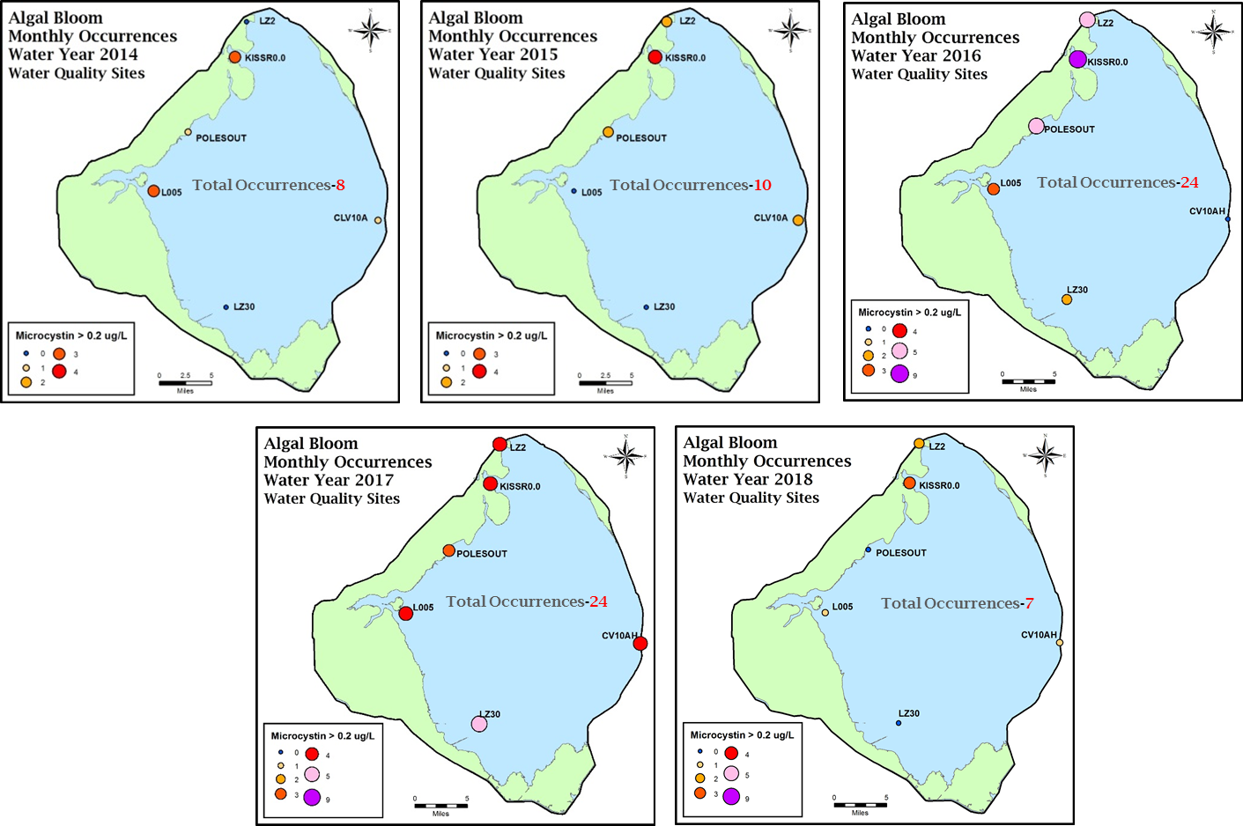
33%
14%
11%
10%
34%
Figure 8B-28. Frequency of microcystin detections (method detection limit of 0.2 µg/L) at the 6 monitoring sites for WY2014 to WY2018. Each site is sampled once a month for a maximum of 72 sampling events per water year (360 per 5 water years). The percent of samples that had bloom conditions present each water year are shown in red.
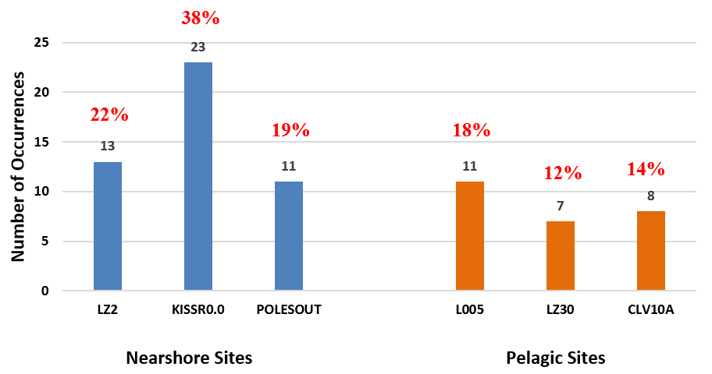
Figure 8B-29. Frequency of microcystin detections (method detection limit of 0.2 µg/L) for the three nearshore (blue bars) and three pelagic (orange bars) sites in Lake Okeechobee for WY2014 to WY2018. The percent of samples that had bloom conditions present each water year are shown in red.
The recreational guidance values for microcystin-LR are 20 µg/L for activities in direct contact with water, and 100 µg/L for activities having indirect contact with water (Chorus and Bartram 1999). Over the past 4 to 5 years, the toxin values during the summer months have been surprising low (and below these standards) given the relatively high Chla values, especially during isolated blooms. Others have reported that shallow, eutrophic, subtropical systems have low microcystin to chlorophyll ratios, which may explain the low toxin values (Bigham et al. 2009, Wu et al. 2006). Another possible explanation is that even though there are toxin producing species present in the plankton community the conditions may not be favorable for those species to produce toxins. Over the past five water years, the dominant cyanobacteria species include Cylindrospermopsis, Anabaena, Planktolyngbya, and Anaphanizomenon; all of which can produce microcystin as well as other toxins under the right conditions. It is not clear what factors influence microcystin production in Lake Okeechobee as there are only weak correlations with inflows, nutrients, and temperature. In other Florida subtropical lakes, temperature does influence microcystin concentrations, with the majority of concentrations ≥ 1.0 µg/L occurring from May to November (Bigham et al. 2009). This general pattern has been seen in Lake Okeechobee over the past 5 water years, with most concentrations of ≥ 0.2 µg/L (detection limit) occurring from June through September. Additionally, our present analytical method for Chla includes all types of phytoplankton but only certain species of cyanobacteria are microcystin–LR producers; so, elevated Chla concentrations may frequently occur when toxin producing species are not present.
It should be noted that because the Lake Okeechobee algal bloom monitoring program is based on a finite number of stations sampled once monthly, it is primarily useful for providing an estimate of seasonal or annual trends. Algal blooms tend to be transient and ephemeral; therefore, the algal bloom monitoring program does not represent a comprehensive assessment of bloom or toxin events on Lake Okeechobee. The data presented above should be interpreted with these limitations in mind.
A more frequent, less time consuming, and quicker determination of algal bloom conditions on Lake Okeechobee would allow for a more thorough understanding of bloom dynamics and might lead to information that would allow for the development of management strategies to prevent or disrupt the progress of ongoing blooms. The section below (Satellite Imagery for Algal Bloom Monitoring) describes a project that attempts to address this capability.

Satellite Imagery for Algal Bloom Monitoring
The District has partnered with the National Oceanic and Atmospheric Administration’s (NOAA’s) National Centers for Coastal Ocean Science (NCCOS) since 2014 to evaluate satellite imagery as a tool for frequently monitoring and forecasting algal blooms in Lake Okeechobee. NCCOS has developed a cyanobacteria index (CI) applied to satellite imagery that initially was being used to forecast blooms of the cyanobacterium Microcystis aeruginosa in western Lake Erie. CI is essentially a measure of the shape of the remote sensing reflectance curve centered at 681 nanometers (nm). A more negative shape (or decrease) at 681 nm indicates a higher concentration of cyanobacteria. CI algorithms were initially developed for the Medium Resolution Imaging Spectrometer (MERIS) onboard the European Space Agency’s Envisat satellite. In 2012, the Envisat satellite went out of commission and the CI was modified to use in conjunction with the Moderate Resolution Imaging Spectrometer (MODIS) sensor. Unfortunately, the MODIS sensor on the National Aeronautics and Space Administration’s (NASA’s) Terra and Aqua satellites had reduced spatial resolution (from 300 m to 1 kilometer) and suboptimal spectral bands available in the red and near infrared range that reduced the detection quality of reflectance at 681 nm.
Initial in-situ surface reflectance data collected at the 19 monthly water quality monitoring sites (see the Algal Bloom Monitoring section above) on Lake Okeechobee was compared with MODIS CI values in 2014 (details are presented in the 2017 SFER – Volume I, Chapter 8B, Sharfstein and Zhang 2017). These preliminary results showed promise, but the suboptimal spectral bands produced both false positives and false negatives reducing the reliability in detection. However, the MODIS product was still an important early detection tool available during the extensive cyanobacterial blooms that occurred during summer WY2017 by indicating increased bloom potential well before the largest expanse of the bloom. Additional limitations became evident as the nearshore sites were too close to the vegetated edge and outside of pixel range for a CI value to be produced.
A new satellite, Sentinel 3a, with an Ocean Land Colour Instrument (OLCI) sensor, was launched in February 2016 and began routine operations March 2017; NCCOS has since been processing CI imagery. This new sensor has spatial and spectral characteristics similar to MERIS. A second satellite, Sentinel 3b, was launched in April 2018 and should begin routine operations in late 2018, increasing satellite revisits to at least every other day. In addition, pre-operational Sentinel 3a OLCI data has been released coinciding with the blooms of WY2017. By examining conditions during the summer of WY2017 and WY2018, initial qualitative comparisons look positive for greatly improved performance of the OLCI product compared to the MODIS product. Visual comparison of CI products with in-situ monthly Chla concentration showed increased similarities in bloom extent with warmer colors indicating increased bloom potential (Figure 8B-30). The enhanced spatial resolution now allows detection at the nearshore sites where algal blooms have been documented during the monthly water quality collections. In addition, the OLCI bloom potential appears to parallel more closely with the in-situ Chla data than MODIS did. Cloud coverage also appears to be delineated correctly more often resulting in less false positives (Figure 8B-30, June 2017, gray color). Future efforts will include a more quantitative comparison between in-situ Chla and OLCI CI values once data from three or more years with multiple bloom events are available.
This technology, especially once both satellites are in operational orbit, has the potential to be a rapid, effective, and affordable option (free imagery) for monitoring blooms and their potential severity at a lakewide scale on a routine and near real-time basis. Depending on cloud cover, new images could be produced almost daily. Additional potential uses for the imagery include (1) linking to current and future models (e.g., Lake Okeechobee Ecological Model) to allow predictions of bloom movements as is currently being done with Great Lakes data, and (2) providing algal bloom data for other District water bodies that are large enough to be “seen” by the Sentinel 3 satellites (Lake Istokpoga, Kissimmee Chain of Lakes, St Lucie Estuary, and Caloosahatchee Estuary). With the satellite tool, the District could conduct targeted rather than hit-or-miss sampling of algal blooms.
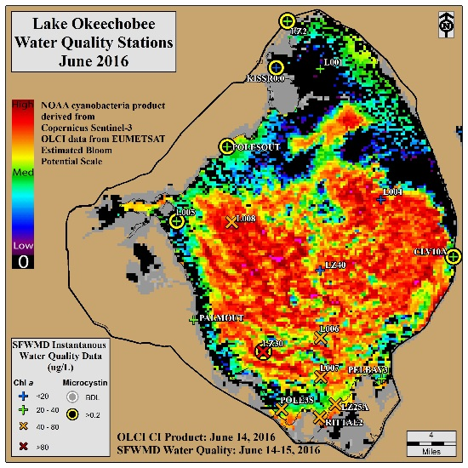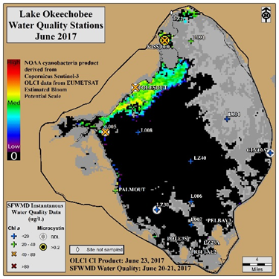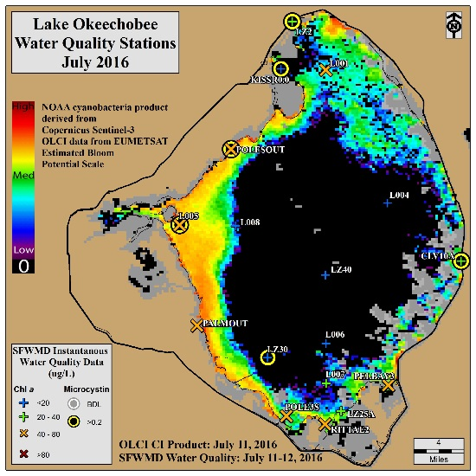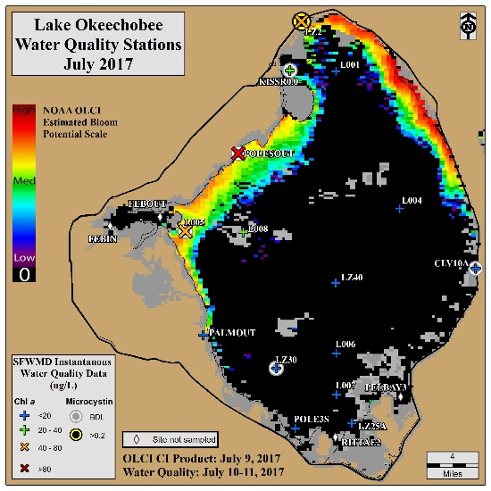
Figure 8B-30. Chla results at 17 of the monthly water quality sampling sites overlaid on OLCI CI image for June and July in WY2017 and WY2018. Values pair well and improved spatial resolution allowed for increased coverage along the nearshore and into smaller bays. Top right image shows cloud cover delineation (grey shading).

Phytoplankton
The phytoplankton community over the past 5 water years at the 6 sites where microcystin and phytoplankton samples were collected (LZ2, KISSR0.0, POLESOUT, L005, LZ30, and CLV10A) have been dominated by diatoms and cyanobacteria, collectively comprising between 79 to 88% of the total biovolume. The predominant diatom taxa have been Aulacoseira, Merismopedia and Planktolyngbya, while the predominant cyanobacteria taxa have been Cylindrospermopsis and Dolichospermum (Anabaena). A diatom to cyanobacteria ratio (D:C) of >1.5:1 is a performance measure target (Table 8B-21 in the Performance Measures section below) and indicates the phytoplankton community is dominated by the more desirable diatoms rather than the noxious bloom-forming and potentially toxin forming cyanobacteria species. This goal was met in three of the past five water years with WY2018 having the highest D:C ratio (2.4:1). WY2018 also had the fewest bloom events (Figure 8B-26). Generally, when Chla levels are high on the lake, cyanobacteria constitute a higher percent of the phytoplankton community. For example, the cyanobacteria at the individual monitoring stations when blooms were recorded (Chla ≥40 µg/L) averaged 55 to 84% of the algal community, as compared to less than 36% when blooms were not present (Figure 8B-31). It should be noted that the species analysis for the last two months of WY2018 was not complete at time of publication, but there were no bloom events at the end of the water year. Consequently, the final relative biovolume estimates for WY2018 may be lower.
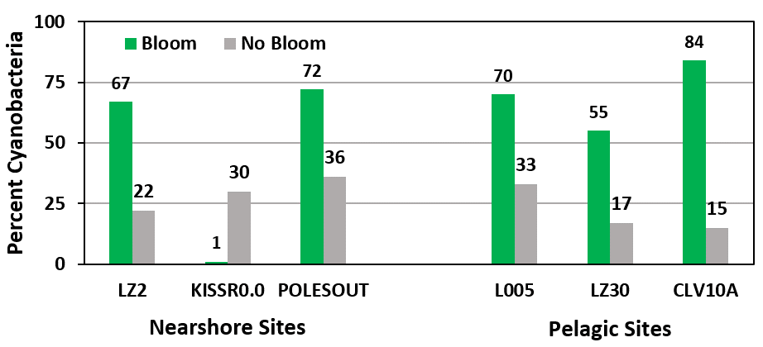
Figure 8B-31. Relative biovolume of cyanobacteria during bloom (Chla ≥ 40 μg/L) and non-bloom (Chla < 40 μg/L) conditions at the three nearshore and three pelagic sites where phytoplankton is collected in Lake Okeechobee from WY2014 to WY2018.

Aquatic Habitat
The following sections provide WY2017 updates on long-term in-lake monitoring projects that are used to track the ecological condition of the lake and its response to operational, climatological, and restoration activities. A number of these projects are components of the Comprehensive Everglades Restoration Plan (CERP) Restoration Coordination and Verification Program (RECOVER) CERP Monitoring and Assessment Plan (RECOVER 2009) and can be leveraged for use for plans under the NEEPP (see Table 8B-21 in the Performance Measures section below).

Aquatic Vegetation

Submerged Aquatic Vegetation
SAV abundance, a key indicator of the lake’s overall ecological health, has been routinely monitored using a standard grid cell size since WY2001. SAV is sampled in two ways that vary in temporal and spatial scales to provide information on plant responses and relative plant distribution. On a yearly basis, the entire nearshore (gridded area) of the lake is mapped to determine the spatial extent of each SAV species (Figure 8B-32). On a quarterly basis, SAV is sampled at a subset of these annual sites in the south, west, and north nearshore zones (Figure 8B-32, purple grid cells) to document changes on a shorter time scale. Further details of sampling methods and sites are presented in the 2012, 2013, and 2017 SFER – Volume I, Chapter 8 (Zhang and Sharfstein 2012, 2013, Sharfstein and Zhang 2017, respectively).
Over the past six water years, total areal coverage of SAV in the nearshore region, as measured in August of each year, ranged from a high of approximately 44,700 ac (18,089 ha) in WY2013 to a low of approximately 19,500 ac (7,891 ha) in WY2017 (Figure 8B-33). This is the lowest areal coverage since WY2007 when wind, wave, and high water from three successive hurricanes caused physical uprooting and extreme water column turbidity, reducing the spatial extent of SAV to less than 3,000 ac (1,200 ha). Total SAV coverage was relatively stable from WY2014 to WY2016, varying by less than about 2,200 ac (890 ha), but the coverage of vascular species declined steadily through that period and continued through WY2018. The vascular species are slower to respond to poor or optimal growing conditions, while the non-vascular species respond more quickly. For example, the large reduction in total SAV between WY2016 and WY2017 was primarily the non-vascular Chara spp. (muskgrass), a macroalgae, and was likely due to high summer water levels in early WY2017, which never fell below 13.5 ft NGVD29. Conversely, an increase of roughly 8,000 ac (3,240 ha) of Chara spp. in WY2018 was likely due to summer lows falling to 11 ft NGVD29 and remaining below 13 ft for the majority of the WY2018 growing season. The slower, vascular species also benefitted from these conditions and may have had higher coverage the next year were it not for rapid ascension rates in June (approximately 1 ft in 2 weeks) and then Hurricane Irma impacting the lake in September 2017. Vallisneria americana (tape grass) and Najas guadalupensis (southern naiad), both vascular species, were the only other species to increase in coverage in WY2018. Utricularia spp. (bladderwort) dominated the SAV community in WY2017 but had the largest decrease in total acreage in WY2018, followed by Hydrilla verticillata (hydrilla), Ceratophyllum spp. (coontail) and Potamogeton spp. (pondweed) (Figure 8B-34). Utricularia spp. tends to occur within sheltered areas with emergent plants, much of which was dried out during the low summer water levels in early WY2018, causing declines in coverage of this species.
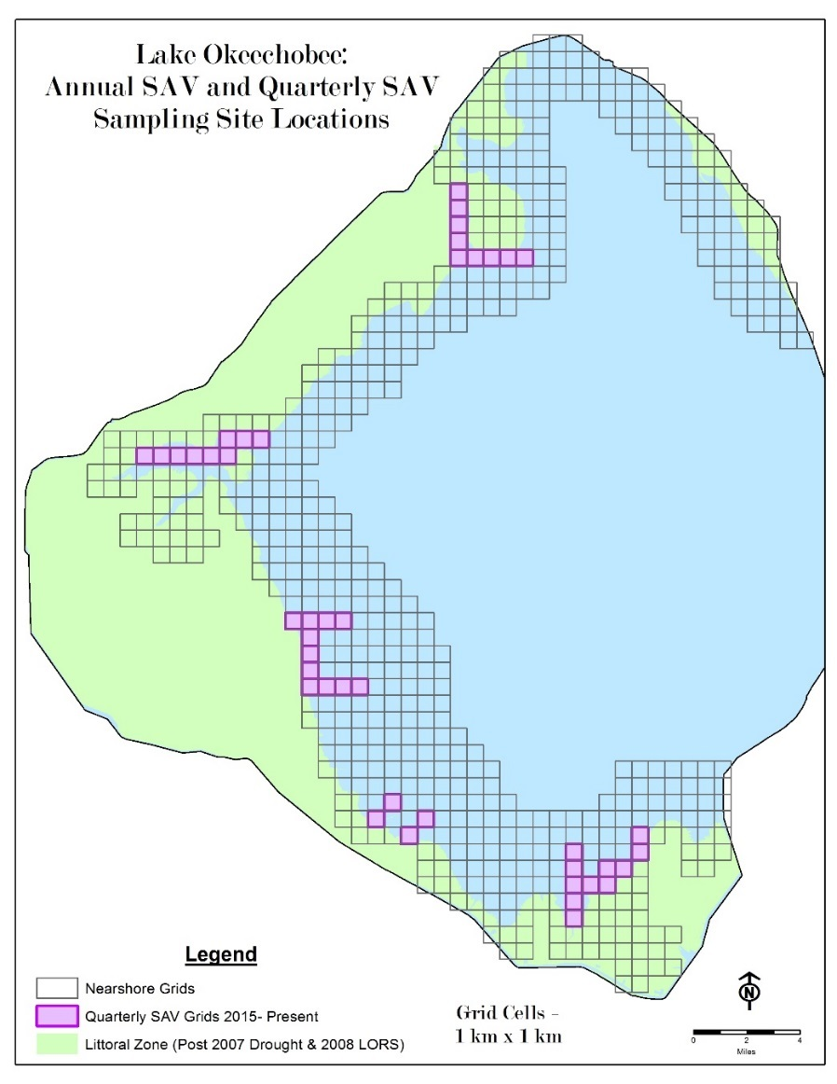
Figure 8B-32. Map showing the geographic area defined as nearshore SAV sites (631 grid cells) that are sampled every August. The 44 purple grid cells are a subset of annual grid cells sampled on a quarterly basis. Grid cell size = 1 square kilometer (km²).
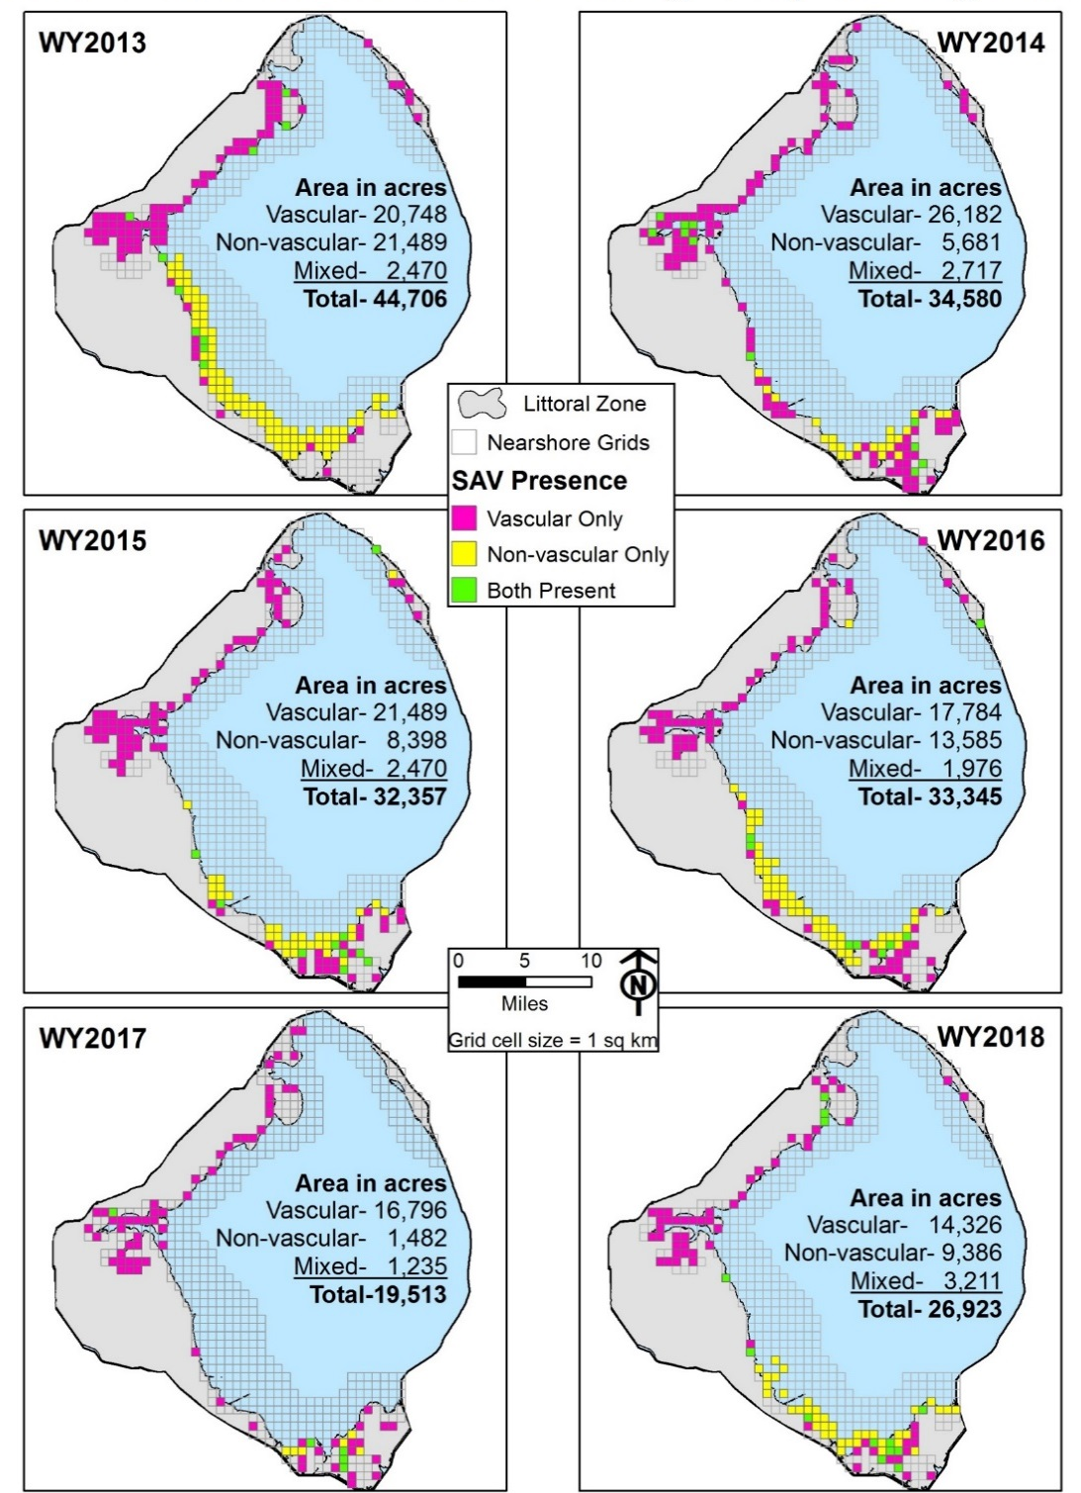
Figure 8B-33. Annual nearshore SAV mapping results for WY2013 to WY2018. Vascular species include Hydrilla verticillata, Utricularia spp., Ceratophyllum spp., Vallisneria americana, Potamogeton spp., and Najas guadalupensis, Chara spp., and Nitella spp. are the only non-vascular species. Mixed indicates the presence of both vascular and non-vascular species in the same grid cell. Sampling was conducted in August of each year.
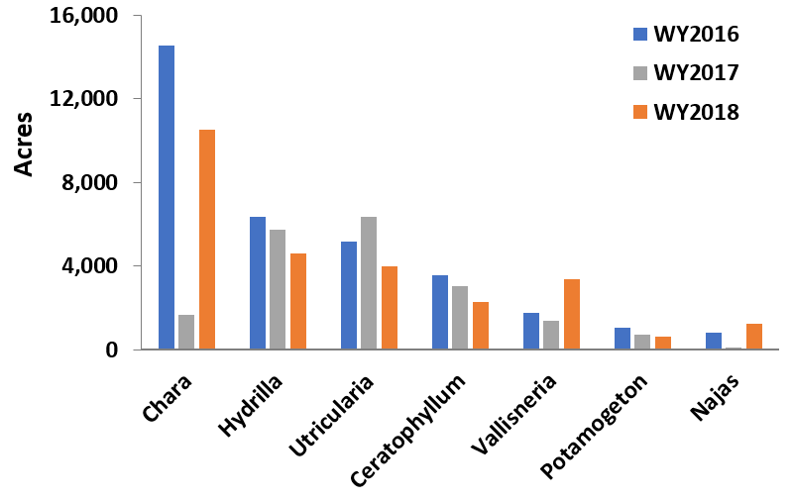
Figure 8B-34. Total nearshore acres for each SAV species for WY2016 and WY2017. Vascular species include Hydrilla verticillata, Utricularia spp., Ceratophyllum spp., Vallisneria americana, Potamogeton spp., and Najas guadalupensis. Chara spp. is the only non-vascular species reported herein although Nitella spp. was occasionally present in WY2017. Sampling was conducted in August of each year.
About three weeks after the WY2018 annual SAV mapping was completed, Hurricane Irma passed through South Florida and had dramatic impacts on lake water levels, water quality, and the outer edges of the marsh vegetation. SAV was immediately resampled to determine the direct impacts from the seiche, rapid water level rise, and combined wind and wave energy. All sites that had SAV present in the August WY2018 sampling event were revisited in September and early October. Out of the 26,923 ac (10,900 ha) of SAV that were present before Hurricane Irma, approximately 11,609 ac (4,700 ha) remained post assessment (Figure 8B-35). Hurricane Irma’s direct impacts may have caused a decline of roughly 15,314 ac (6,200 ha). Additionally, indications from the subsequent quarterly transect sampling revealed that even 8 months post-hurricane there was further loss of the SAV community, with only 1 of 44 grids having plants in May WY2019 (Figure 8B-36). Low water levels at the end of WY2017 promoted SAV recovery in WY2018, improving light penetration and encouraging reestablishment and growth. However, Hurricane Irma resulted in lakewide nutrient and suspended solids concentrations similar to those documented after the hurricanes of WY2005 and WY2006, wiping out any recovery of the already diminished SAV community.
The RECOVER SAV interim goal is to have at least 35% of the 100,000 ac (40,469 ha) of potentially colonizable area vegetated with vascular and non-vascular SAV during the peak summer growing season (July–August). Using these metrics, WY2018 was only 77% of the target, and the interim goal has only been achieved once in the past six water years (WY2013). Lake level and turbidity act as external forcing functions to drive changes from an SAV/clear water state to a phytoplankton/turbid water state. Thus, the nearshore zone switches between a SAV/clear water state when water levels and turbidity are low to a phytoplankton/turbid water state when there are periods of prolonged high water levels with accompanying sediment resuspension (Havens et al. 2001, 2004, James and Havens 2005). Water levels have been generally higher, reaching or exceeding 16.0 ft NGVD29 in every water year since WY2012, and twice having annual minimums of only roughly 13.5 ft NGVD29 or higher. Currently, the lake is experiencing a phytoplankton/turbid water state and frequent stages below the envelope may be required to promote SAV growth and development to shift back to an SAV/clear water state in the nearshore zone.

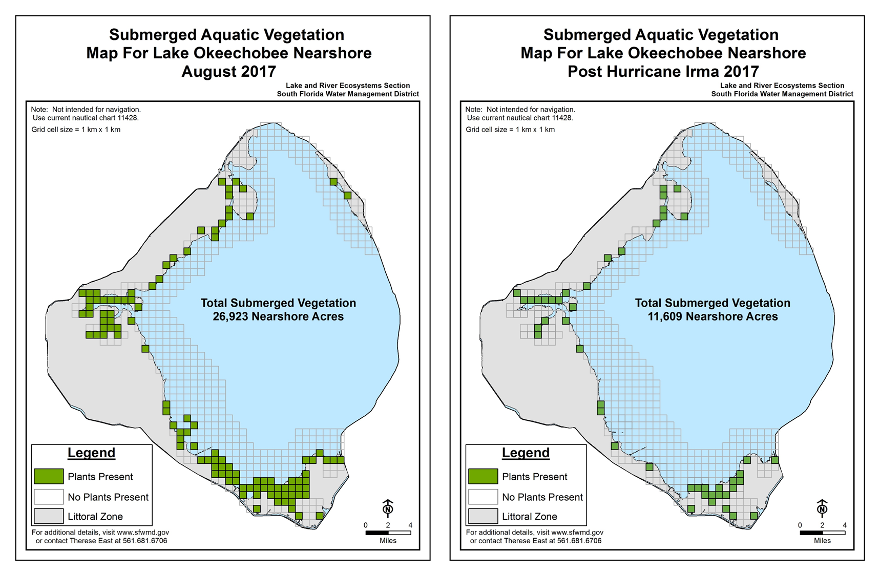
Figure 8B-35. Comparison of SAV spatial extent before (August WY2018) and after (September– October WY2018) Hurricane Irma.

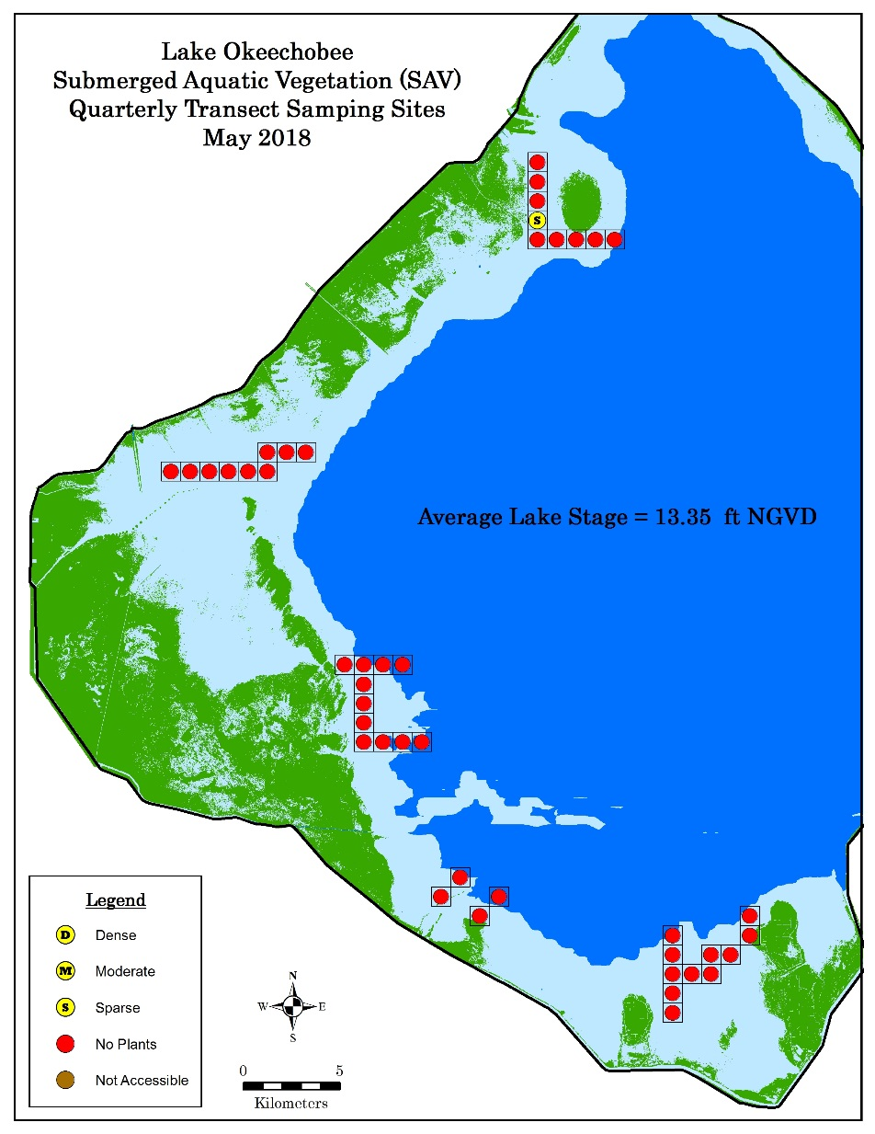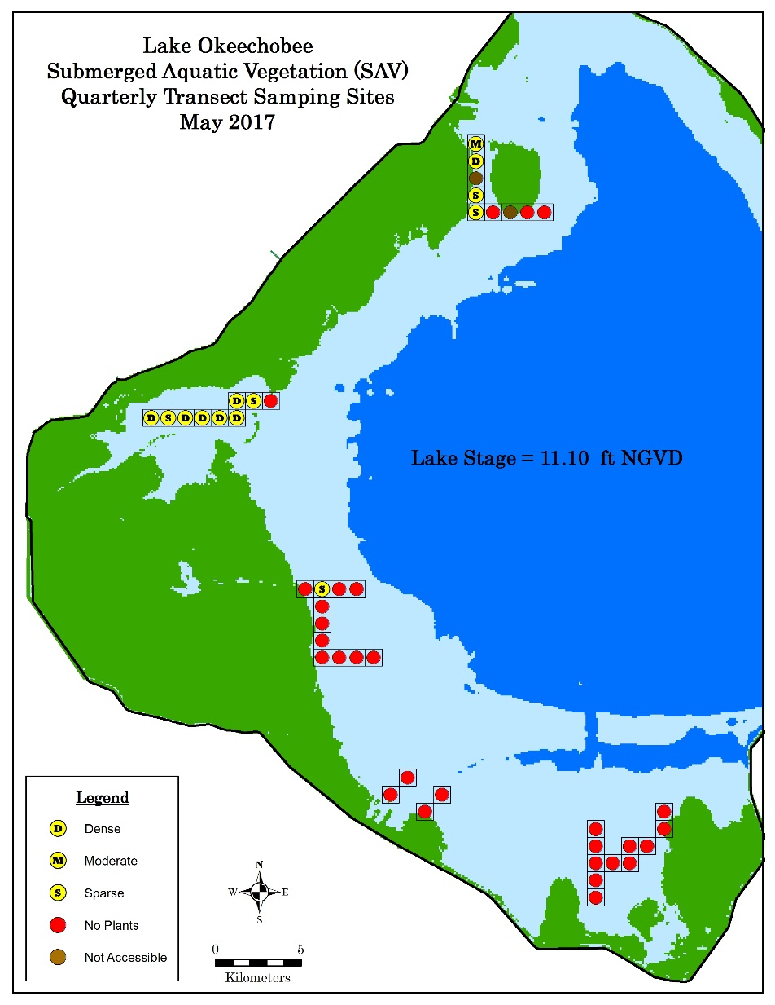
Figure 8B-36. Quarterly mapping results for August 2017 (WY2018) and May 2018 (WY2019). The August data were extracted from the annual mapping grid cells

Emergent Aquatic Vegetation
The emergent marsh in Lake Okeechobee provides important habitat for fish, wading birds, and other wildlife. The composition, distribution, and areal coverage of the plant communities in the marsh are strongly influenced by hydrologic conditions, vegetation management actions, and competition between species; especially when native habitats are impacted by invasive exotic plants. To document and quantify how Lake Okeechobee’s emergent marsh community responds to these variables, 23 sentinel monitoring locations are evaluated annually. The dominant and co-dominant plant communities within 50 individual 1-ha grids (100 m x 100 m) are recorded at each location. Sentinel site locations were selected to include a representative range of elevations that account for spatial differences in hydroperiod and flooding depths across the marsh (Figure 8B-37). The permanent location of the sentinel sites and accompanying grid cells allow us to evaluate and quantify temporal changes in plant communities (fish and wildlife habitat) that occur across the landscape in response to changing environmental conditions and/or management actions (e.g. herbicide treatments of exotic or invasive species, or prescribed burns).
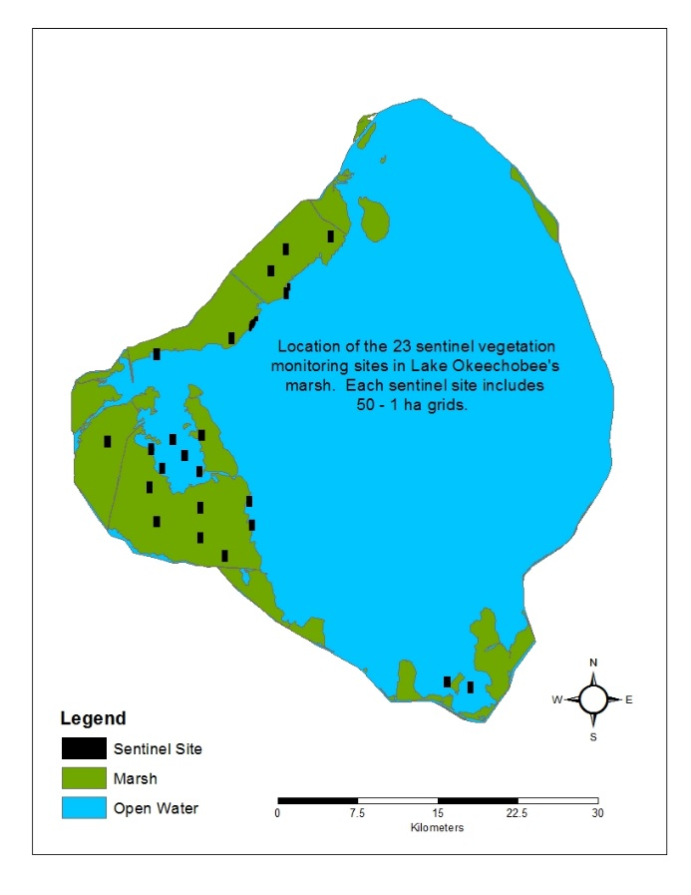
Lake Okeechobee
Figure 8B-37. Location of 23 sentinel sites used to monitor annual changes in emergent vegetation in Lake Okeechobee’s marsh. Each sentinel site consists of 50 individual 1-ha grid cells.
Although hydrologic conditions strongly influence plant community distribution and abundance, there often will be a lag in the plant community’s response to changing conditions. Thus, antecedent hydrologic conditions were evaluated for the 6-month periods that preceded the spring 2017 and 2018 sentinel site sampling events. The marsh was much wetter during most of the 6-month period prior to the 2018 sample compared to the 2017 sample. This was due mostly to direct rainfall and watershed runoff associated with Hurricane Irma. Lake stage was above 15 ft NGVD29 for 161 days (89% of the period) in the 6 months prior to the 2018 evaluation and was above 16 ft NGVD29 for 72 days (40% of the period). In contrast, the entire upper marsh (> 14 ft NGVD29) was dry for 104 of the 180 days (58% of the period) prior to the 2017 evaluation and lake stage exceeded 15 ft NGVD29 for only 18 days (10% of the period) (Figure 8B-38).
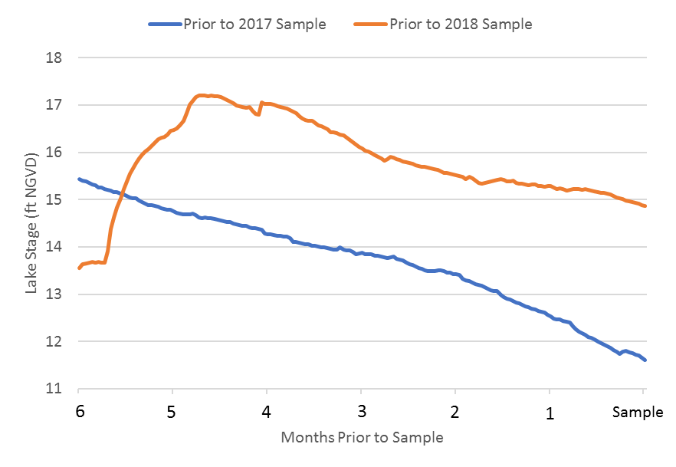
Figure 8B-38. Average daily lake stage during the 6-month periods (December 2016–April 2017 (blue) and October 2017–March 2018 (orange) prior to the 2017 and 2018 sampling trips.
Some of the most notable changes observed across the marsh landscape in 2018 compared to 2017 included an increase in open water, lily (Nymphaea spp.), American lotus (Nelumbo lutea), and willow habitat (Salix spp.), and a decline in the coverage of cattail (Typha spp.), woody shrubs, and torpedograss (Panicum repens).
In 2018, open water was dominant in 409 of the 1-ha sentinel grids, representing a fourfold increase in open water habitat compared to 2017. The coverage of water lily and American lotus also increased from 127 ha (2017) to 156 ha (2018) in response to greater flooding depths. There was also a 17-ha increase in willow coverage, which mostly occurred in areas where cattail had recently been treated in Moonshine Bay. Cattail coverage decreased from 434 ha to 232 ha, which was likely from a combination of vegetative management activity (Figure 8B-39A), increased flooding depth, and wind/wave impacts from Hurricane Irma and other winter storm events that uprooted thousands of hectares of vegetation along the outer edge of the marsh during the 6-month period prior to the 2018 sample. The areal coverage of woody shrubs also declined 66% in response to higher water levels observed in 2018. The decline in torpedograss coverage from 167 to 145 ha was attributed mostly to herbicide treatments that occurred in 2017 (Figure 8B-39B). Several communities, including sawgrass (Cladium jamaicense) and broadleaf marsh (Pontederia cordata and Sagittaria spp.) showed little change in coverage between 2017 and 2018. Sawgrass increased from 19 to 23 ha while the broadleaf community declined by 5 ha.
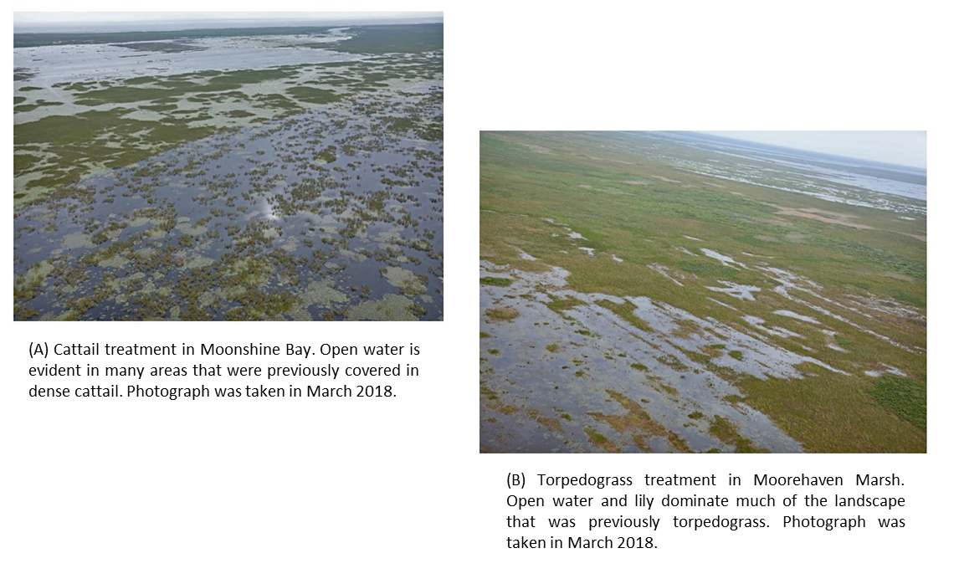
Figure 8B-39. (A) Cattail and (B) torpedograss treatments in Moonshine Bay and Moorehaven Marsh, respectively. Open water was dominant in much of the treated areas. The photographs were taken in March 2018.
Detailed monitoring results from three of the 23 sentinel locations discussed above are shown in Figure 8B-40. Site IP-2 (upper panels) is in the Indian Prairie marsh. In 2017, 25 of the 50 grids were dominated by torpedograss, and in 2018 only 12 grids were dominated by torpedograss while 36 grids were dominated by treated/dead torpedograss. The large number of treated sites indicates that torpedograss coverage increased at the sentinel location after the site was evaluated in 2017.
Site IP-Edge 1 (middle panel) is located on the outer edge of the marsh south of Indian Prairie canal. In 2017, lily and cattail were the dominant species in 26 and 21 of the grids, respectively, while 3 grids were dominated by open water. Following the damaging effects of Hurricane Irma in September 2017 and the extreme high lake stage that followed, most of the vegetation along the outside edge of the marsh disappeared. In 2018, open water was dominant in 43 grids of the 50 grids, cattail was dominant in just 4 grids, and no lily was observed.
Site MH-10 is in Moonshine Bay and located in an area where several thousand hectares of dense cattail were treated in 2016. In 2017, dead cattail was dominant in 36 grids followed by willow and Phragmites sp., each dominant in 6 grids. In 2018 willow was dominant in many of the areas previously occupied by dead cattail. The coverage of live cattail also increased from 1 grid in 2017 to 18 grids in 2018, suggesting additional cattail has expanded in the area and additional treatments may soon be necessary.
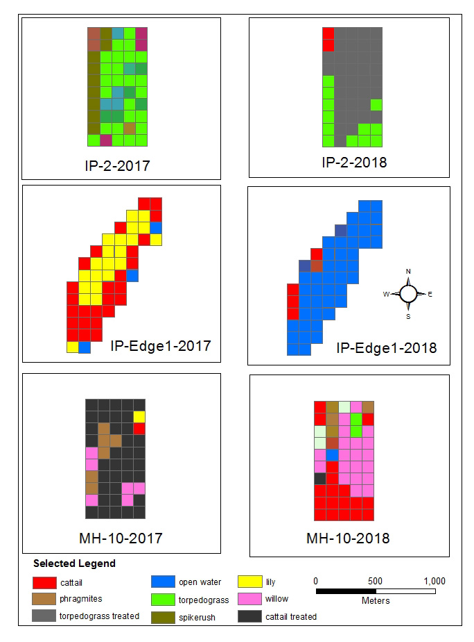
Figure 8B-40. Sentinel site data showing the change in dominant plant communities at three locations between 2017 and 2018. The dominant vegetation in each of the 50 1-ha grids was recorded at each location. The 2017 data is shown on the left and the 2018 data is on the right. Site IP-2 (upper panel) is in the Indian Prairie Marsh, site IP-Edge 1 (middle panel) is located on the outer edge of the marsh south of Indian Prairie Canal, and site MH-10 is in the Moorehaven Marsh.
The Florida Fish and Wildlife Conservation Commission and the District will continue to work together in 2018 to reduce cattail and torpedograss coverage and reestablish a mix of open water and desirable native plant habitat in Moonshine Bay and in other areas of the marsh. When properly managed, hydrologic variability and nuisance vegetation management can lead to and support the development of a healthy and productive marsh. Annual monitoring and mapping of the dominant plant communities provide a quantifiable method to evaluate temporal changes that occur across the marsh landscape.

Wildlife

Fishery
Lake Okeechobee’s fishery is monitored annually by the Florida Fish and Wildlife Conservation Commission. They use a standardized electrofishing protocol to monitor the nearshore fishery and a trawling protocol to monitor pelagic species.
Electrofishing Sampling. In October of each year, the fish community in Lake Okeechobee was sampled at 22 nearshore sites. Sites were sampled using electrofishing gear for a total of 990 minutes except in 2015 when sampling effort was reduced to 940 minutes. In October 2017 (WY2018), the lakewide electrofishing effort resulted in the capture of 11,389 fish comprised of 33 species with a combined biomass of 891.3 kilograms (kg). That was the third largest number of fish collected since 2010 but fish biomass was relatively low, indicating an abundance of small fish (Figure 8B-41). Threadfin shad (Dorosoma petenense) and gizzard shad (Dorosoma cepedianum) were the only species considered dominant (more than 5% of the composition) and collectively they comprised 82.5% of the catch by number (Figure 8B-42). Six dominant species comprised 82% of the catch by weight and are in order of total biomass: gizzard shad, largemouth bass (LMB; Micropterus salmoides), Florida gar (Lepisosteus platyrhincus), striped mullet (Mugil cephalus), bowfin (Amia calva), and bluegill (Lepomis macrochirus).
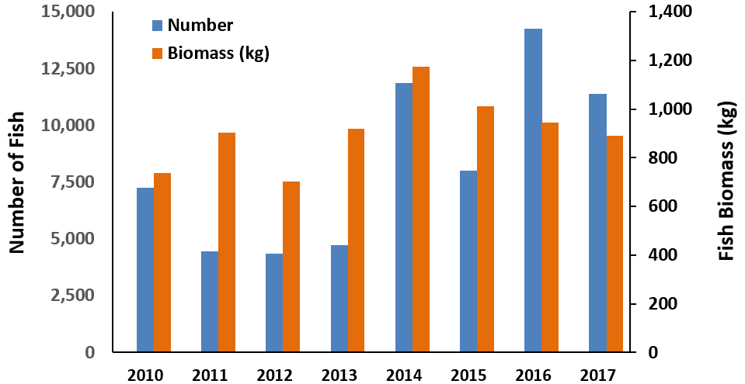
Figure 8B-41. Lakewide electrofishing data indicating the total number of fish (blue bars) and the total fish biomass (orange bars) collected during the fall from 2010 to 2017 (WY2011–WY2018). Annual sampling effort was 990 minutes except in 2015 when effort was reduced to 940 minutes.

In addition to relative fish abundance and biomass, the size and composition of the fish community can be evaluated using catch per unit effort (CPUE) data. The lakewide catch rate was > 1 fish/minute in 2014–2016 and ranged from 0.7 to 0.9 fish/minute in 2010–2013 and again in 2017. In years when fish abundance was greatest, there were large numbers of small forage fish: threadfin shad and eastern mosquitofish (Gambusia holbrooki) from 2014 to 2016, and threadfin shad and gizzard shad in 2017 (Figure 8B-42). Catch rates for sport fish, including LMB, bluegill, and redear sunfish, have declined the past three years and in 2017 were 62 to 83% less than the rates reported for these species in 2010 (Figure 8B-43). However, not all species have shown a recent decline in abundance. Relative abundance of threadfin shad has increased more than three-fold since 2015 and seven-fold since 2010, though electrofishing results for small forage species can vary significantly depending on whether a dense school is encountered. Trawl sampling results showed an opposite trend and may be more representative of this species, as the trawl sampling method is also done primarily in the pelagic zone.
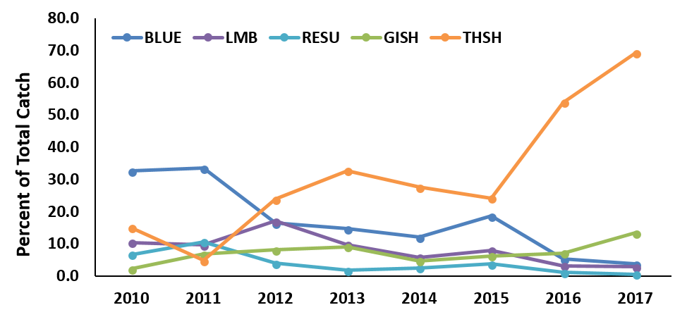
Figure 8B-42. Percent of total catch of selected prey species including gizzard shad (GISH) and threadfin shad (THSH) and selected sport fish including LMB, bluegill (BLUE) and redear sunfish (RESU) collected by electrofishing during October from 2010 to 2017 (WY2011-WY2018).
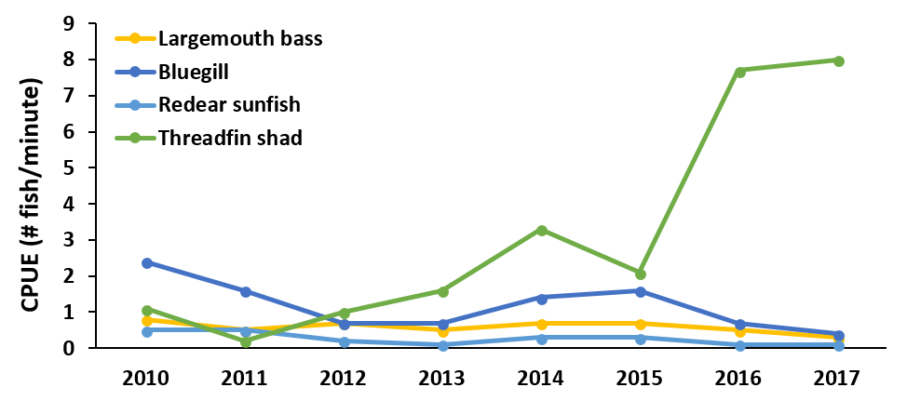
Figure 8B-43. Catch rates by year for selected sport and forage species collected by electrofishing during October from 2010 to 2017 (WY2011–WY2018).
Trawl Sampling. Lakewide trawl sampling at 27 pelagic sites during December 2017 (WY2018) resulted in the capture of 1,993 fish with a combined biomass of 187 kg (Figure 8B-44). This was the fewest number of fish and the lowest biomass collected since 2010, represented by fifteen species. Five dominant species collectively comprised 95% of the catch by number (in order of abundance): black crappie (Pomoxis nigromaculatus), white catfish (Ameiurus catus), threadfin shad, channel catfish (Ictalurus punctatus), and bluegill sunfish (Figure 8B-45). Four dominant species collectively comprised 85% of the catch by weight (in order of biomass): white catfish, black crappie, channel catfish, and Florida gar.
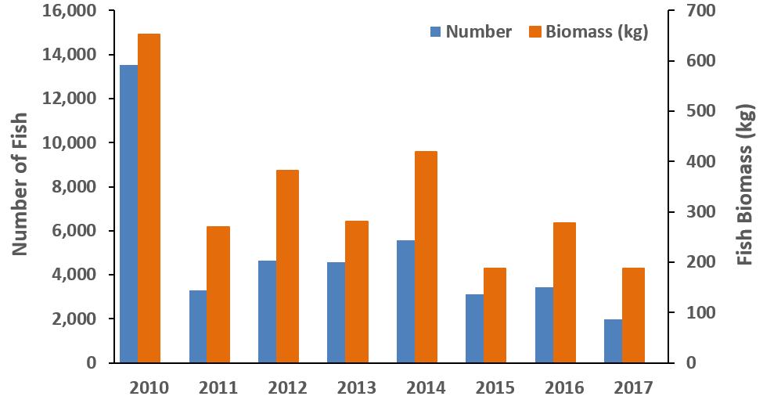
Figure 8B-44. Comparison of lakewide trawling data (27 pelagic sites) indicating the total number of fish (blue) and total biomass (orange) collected during December from 2010 to 2017 (WY2011–WY2018).
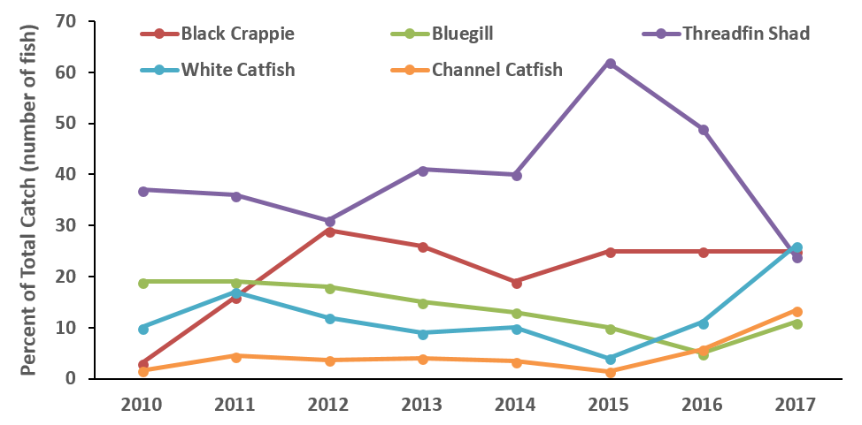
Figure 8B-45. Relative abundance of the five dominant species collected by trawl from 2010 to 2017 (WY2011-WY2018).
Threadfin shad was the most abundant pelagic species collected from 2010 to 2016 (2.2–9.2 fish/minute), based on CPUE (Figure 8B-46). However, in 2017 its catch rate dropped to 0.8 fish/minute, less than the rate reported for black crappie and white catfish. Threadfin are an important forage fish for adult black crappie and their decline is coincident with a decline in catch rate of black crappie. Black crappie abundance appeared lowest in 2010 and 2011 (< 1 fish/minute) before peaking in 2012 (2.5 fish/minute), though it has trended down since 2014 and was again < 1 fish/minute in 2017. Bluegill abundance was greatest in 2010 (4.9 fish/minute) before declining in 2011. The catch rate for pelagic bluegill remained greater than 1 fish/minute through 2014 but was less than 0.5 fish/minute the past three years.
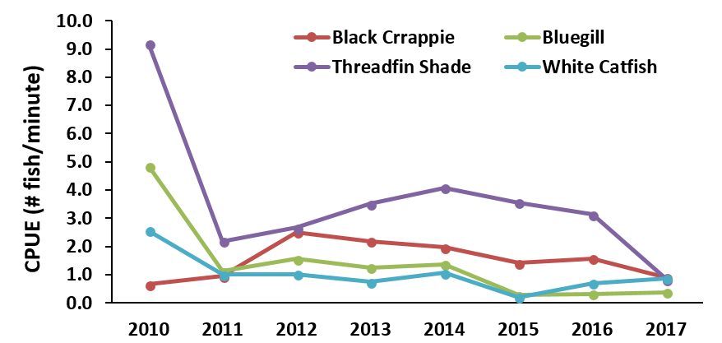
Figure 8B-46. Catch rate for selected pelagic sport and forage fish and white catfish collected by trawl during December from 2010 to 2017 (WY2011–WY2018).
Hurricane Irma Impacts. Previous hurricanes that passed over Lake Okeechobee in 2004 and 2005 destroyed important fish habitat, degraded water quality, and disrupted links in the food web. Collectively, the changes led to large-scale reductions in the production and recruitment of sport fish. While it is too early to determine the total impact that the recent Hurricane Irma had on Lake Okeechobee’s fishery, post-storm sampling suggested substantial effects; few young of the year and age 1 LMB (< 20 centimeters [cm]) were collected (Figure 8B-47), bluegill abundance was reduced by more than 40%, and the number of juveniles collected was less than 2016 (Figure 8B-48). In the pelagic region less than 2,000 fish were collected in 2017; the lowest since 2005 and 2007. Those years marked a period when the pelagic fishery was recovering from the damaging impacts of recent hurricanes and record droughts, drastically reducing the black crappie population. Following Hurricane Irma, the abundance of black crappie declined by more than 50% in 2017 compared to rates reported in 2012–2014 and by 40% compared to 2016. Most of the recent reduction in abundance was due to the loss of juvenile fish in the 14- to 16-cm size class and fish larger than 20 cm (Figure 8B-49).
The loss of submerged and emergent littoral habitat from Hurricane Irma reduced spawning habitat for mature nearshore fish, and refugia and foraging habitat for juvenile fish; and increases in pelagic turbidity and potential disruptions in food web links likely led to reductions in black crappie abundance. Unless key environmental conditions, including shallow inundation depths (low lake stage) and relatively clear water (low turbidity) are present, it will be difficult for these critically important littoral habitats to recover soon. Without sufficient recovery, long-term reductions in the production and recruitment of LMB, bluegill, and black crappie, or overall reductions in lakewide sport fish abundance are likely to occur.
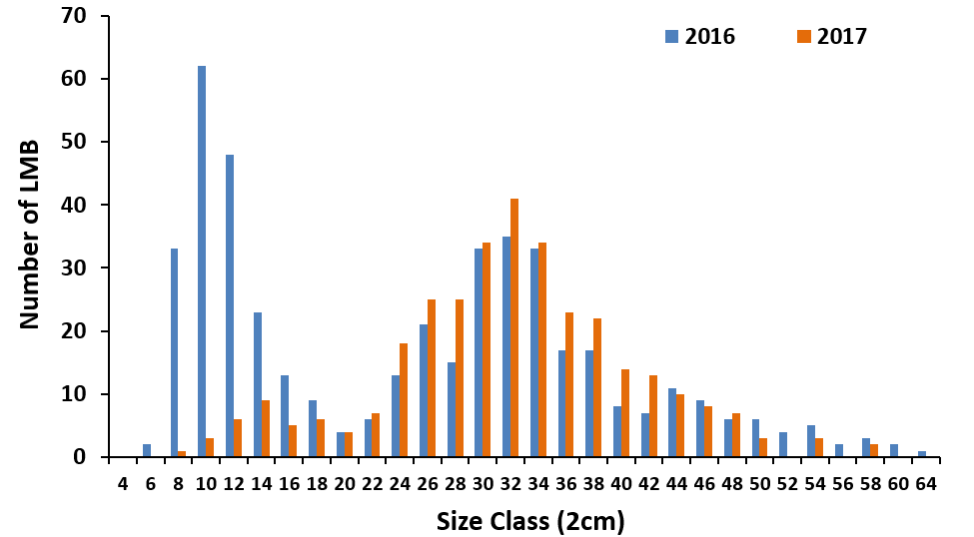
Figure 8B-47. Length frequency distribution of LMB collected in 2016 and 2017 (WY2017 and WY2018). Very few young of the year bass were collected in 2017 following Hurricane Irma.
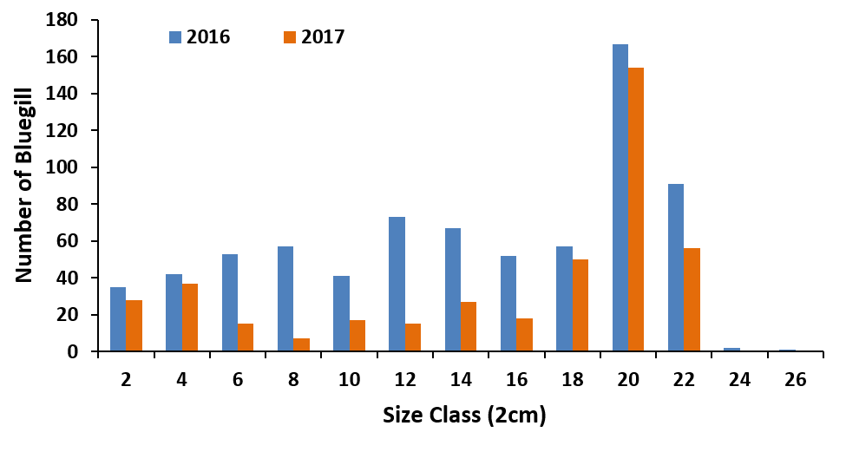
Figure 8B-48. Length frequency distribution of bluegill sunfish collected in 2016 and 2017 (WY2017 and WY2018). The number of juvenile fish collected in 2017 following Hurricane Irma was greatly reduced compared to 2016.
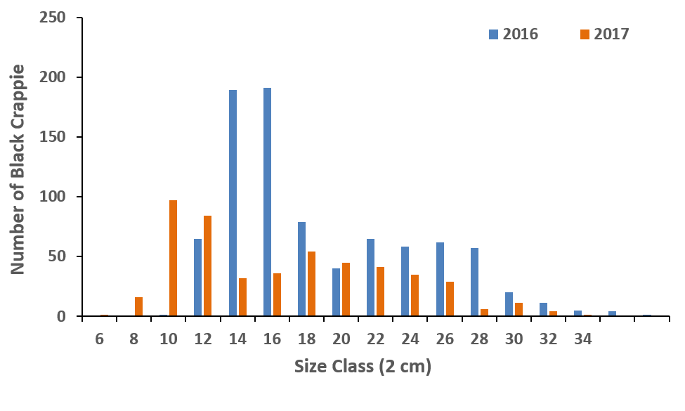
Figure 8B-49. Length frequency distribution of pelagic black crappie collected by trawl in December 2016 and 2017 (WY2017 and WY2018).

Wading Birds
Lake Okeechobee historically supported large numbers of nesting wading birds. Successful nesting requires a continuous supply of easily accessible prey resources from the period of nest initiation through fledging of offspring. Current foraging on the lake mainly occurs in the shallow littoral zone when lake stages recede throughout the spring, beginning when stage falls below 15.5 ft NGVD29, with peak activity occurring between 14.5 and 11.5 ft NGVD29. This drydown provides marsh depths across large areas that are suitable for foraging and concentrates prey so they become available to birds. In 1978, the Lake Okeechobee regulation schedule was altered such that lake stage was increased (as high as 17.5 ft NGVD29), which reduced the availability of prey and limited wading bird access to critical foraging habitat (David 1994). Wading bird nesting severely declined over the following decades.
In 2000, the regulation schedule was changed to better account for climatic variability and to improve ecological conditions on Lake Okeechobee. In 2008, the schedule was again modified out of concerns for the integrity of the Herbert Hoover Dike at extreme high stages. This new schedule is commonly referred to as LORS2008. It maintains the lake approximately a foot lower than the preceding schedule. Coincidentally, this also improves conditions for wading birds on the lake, providing more appropriate depths across a broader area of marsh. In 2010, the District initiated a wading bird foraging monitoring program in Lake Okeechobee’s littoral zone to better assess ecological conditions related to wading bird reproduction and use of the lake. The monitoring surveys are conducted every two weeks via helicopter from December through June along east-west transects established at 2-kilometer (km) intervals throughout the entire littoral zone of the lake. Further details regarding survey methods are described in the 2012 SFER – Volume I, Chapter 8 (Zhang and Sharfstein 2012).
This monitoring effort provides water managers with baseline information on wading bird use in relation to hydrology and other environmental drivers of nesting. These data are used to help understand the role of hydrology on birds and other trophic levels, which can be used to develop indicators of habitat quality, to predict habitat suitability and use based on climatic change, to make water management decisions, to assess effects of proposed restoration projects, and to assess overall ecological conditions within the lake. It also provides important data regarding whether nest colonies on the lake are being supported by habitats inside or outside of the dike. The wading bird nesting surveys are conducted by Florida Atlantic University for the CERP RECOVER program.
Hydrology. At the beginning of the survey season for WY2018, lake levels were at 16.08 ft NGVD29, 1.56 ft above the LORS2008 regulation schedule average (Figure 8B-50). Similar to WY2017, there was a nearly continuous recession of water levels from November throughout most of the dry season. Recession rates were within the one-week recommended range of 0.075–0.125 ft (0.3–0.5 ft/month) four times out of 16 weeks during peak nesting season (March–May) with an average of 0.2 ft per week (Figure 8B-51). The highest rates peaked at 0.26 ft, more than double the recommended range. The wet season started early with record level rain falling across the District in May, resulting in a large stage reversal on the lake over the last two weeks of the month. The reversal caused a dramatic rise in water levels of 1.39 ft in just over two weeks, with lake stage plateauing just above 14 ft NGVD29 and effectively ending wading bird foraging on the lake for the season.
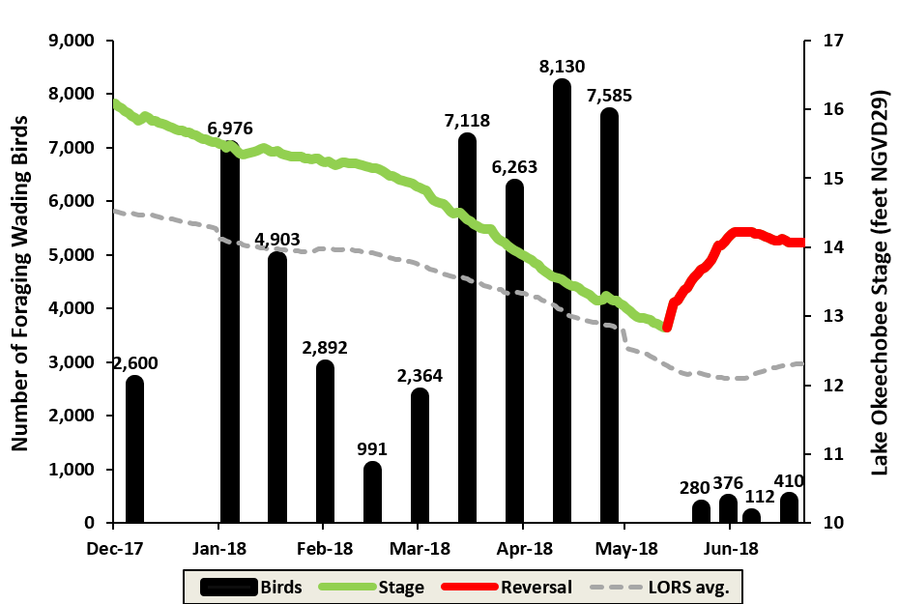
Figure 8B-50. Number of wading birds observed on approximate biweekly foraging surveys (black bars) for WY2018, overlaid with lake stage. Blanks represent no data, not zero wading birds. Red segments on the lake stage represent high water or reversal periods. The gray dashed line represents the average daily water levels during the period of LORS2008 operation (approximately WY2009–WY2018). (Note: avg. = average.)
Figure 8B-51. Seven-day recession (Recess or Rec.) rates during wading bird nesting season in WY2018. The green outlined area represents the preferred range of weekly recession rates.
Foraging. Lake Okeechobee continues to play a vital role in wading bird conservation independent of environmental conditions in the Everglades. The number of foraging birds observed in WY2018 was quite variable early in the season but as lake levels and foraging conditions improved, the number of flocks observed increased (Figure 8B-50). The number of foraging birds during the peak of the nesting season was considered normal, averaging 4,588 birds. That number is roughly half of what was observed in WY2017, but foraging conditions were ideal in the Everglades, which likely attracted many birds away from the lake, the opposite of WY2018 (Figure 8B-52). Peak foraging numbers during nesting were much higher prior to the heavy rains in May that caused a reversal, with an average of 6,292 birds observed per survey. After the reversal, the number fell to an average of just 328; a 95% decrease. While few birds were observed foraging on the lake after the reversal, some nesting activity continued near the levee. Nesting birds were observed foraging outside of the lake in flooded cattle pastures, agricultural canals, and short hydroperiod wetlands, affording the birds sufficient food to finish nesting in some of the colonies.
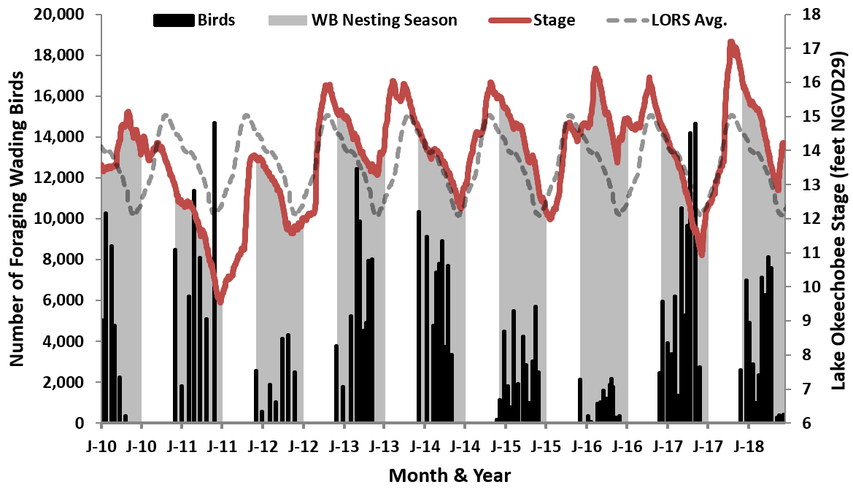
Figure 8B-52. A comparison of the total number of foraging birds surveyed each month from WY2010 to WY2018 in relation to lake stage. The shaded region of the graph represents the survey period, which coincides with the dry season. The red line is the actual stage hydrograph while the gray dashed line represents the average daily water levels during the period of LORS2008 (LORS) operation (approximately WY2009–WY2018). (Note: Avg. – Average, J – January, and WB – Wading Bird.)
Nesting. Nesting data for wading birds on Lake Okeechobee are collected by Florida Atlantic University as part of the CERP RECOVER baseline monitoring program. Nine species were found nesting in 16 colonies (two outside of the lake), including; great egret (Ardea alba), snowy egret (Egretta thula), great blue heron (Ardea herodias), white ibis (Eudocimus albus), tricolored heron (Egretta tricolor), little blue heron (Egretta caerulea), glossy ibis (Plegadis falcinellus), wood stork (Mycteria americana), and roseate spoonbill (Platalea ajaj). The WY2018 breeding season totaled approximately 5,617 nests, which is just below the average nesting effort since the implementation of LORS2008 (5,801) (Figure 8B-53). White ibis, snowy egret, and great egret accounted for 87% of the nesting effort with all three species near their LORS2008 average. All other species had above average nesting except for the glossy ibis (88% decline from average), which has all of its regional nesting located on the lake in some years. Although the white ibis had the highest number of nests, 25% were estimated to have abandoned from two different colonies. This was most likely caused by two events; rapid recession rates in April likely dried up foraging opportunities near a colony at higher elevation, and the major stage reversal in mid-May likely flooded out nests at a lower elevation colony and reduced foraging opportunities throughout the lake. Additional information on wading bird nesting is available in the South Florida Wading Bird Report, which is generally published by the District in January of each year.
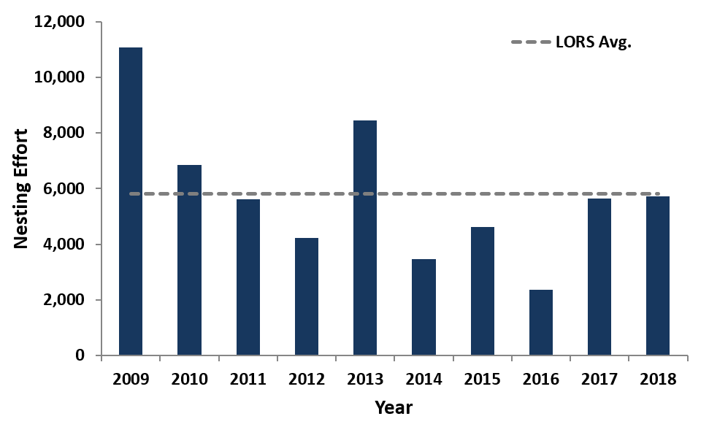
Figure 8B-53. A comparison of nesting effort from 2007 until 2018. Total number of nests include nine species: great egret, snowy egret, great blue heron, white ibis, tricolored heron, little blue heron, glossy ibis, wood stork, and roseate spoonbill.
(Note: LORS Avg. – LORS2008 nesting average.)

Performance Measures
Measurements of TP, Chla, phytoplankton, SAV, and water levels are used as quantitative in-lake performance measures. These measures describe the status of the ecosystem and its responses to implemented restoration programs. Measures are five-year averages to ensure consistency with TMDL reporting, reduce year-to-year variation due to climate and hydrology, and improve understanding of underlying trends. These values are compared to quantitative restoration goals (Table 8B-21). The Lake Okeechobee Protection Program, Lake Okeechobee Protection Plan report provides a technical foundation for these restoration goals (SFWMD et al. 2004). The WY2018 averaged observations document this year’s water quality and lake level conditions.
The 123% increase in TP loads and 65% increase in TN loads in WY2018 compared to WY2017 can be attributed primarily to highly elevated inflow from the LOW in September and October (see the Hydrology subsection above). Because of these increased loads, none of the nutrient performance measures improved in WY2018 as compared to WY2017 (Table 8B-21).
Table 8B-21. Summary of Lake Okeechobee rehabilitation performance measures, rehabilitation program goals, and lake conditions for the five-year average (WY2014–WY2018), WY2018, and WY2017.
Performance Measure | Goal | Five-Year Average | WY2018 | WY2017
Nutrient
TP load | 140 t/yr | 633 t/yr | 1,081 t/yr | 484 t/yr
N load | Not applicable | 6,772 t/yr | 8,745 t/yr | 5,299 t/yr
Pelagic TP | 40 μg/L | 146 μg/L | 203 μg/L | 150 μg/L
Pelagic TN | Not applicable | 1.39 mg/L | 1.68 mg/L | 1.45 mg/L
Pelagic SRP ª | Not applicable | 48 μg/L | 68 μg/L | 46 μg/L
Pelagic DIN | Not applicable | 217 μg/L | 381 μg/L | 255 μg/L
Pelagic TN:TP | > 22:1 | 9.5:1 | 8.3:1 | 9.7:1
Pelagic DIN:SRP | > 10:1 | 4.5:1 | 5.6:1 | 5.6:1
Nearshore TP | Below 40 μg/L | 111 μg/L | 183 μg/L | 105 μg/L
Biological
Diatom:cyanobacteria ratio | > 1.5 | 2.0:1 | 7.1:1 | 2.1:1
Algal bloom frequency | < 5% of sites Chla  exceeding 40 μg/L | 12.5% | 6.7% | 14.6%
SAV ^{b} | Total SAV > 40,000 acres | 29,344 | 26,923 | 19,513
SAV ^{b} | Vascular SAV > 50% of  total acres | 75% | 65% | 92%
Physical
Water clarity | Secchi disk visible on lake bottom at all nearshore SAV sampling locations from May to September | 29% | 35% | 3%
Hydrology
Extremes in low lake stage (current water year) | Maintain stages above 10 ft | Not applicable | Goal attained | Goal attained
Extremes in high lake stage (current water year) | Maintain stages below 17 ft; stage not exceeding 15 ft for more than 4 months | Not applicable | Goal attained | Goal not attained
Spring recession (January to June 2015) without reversals | Stage recession from near 15.5 ft in January to  near 12.5 ft in June | Not applicable | Goal attained | Goal not attained (reversals)
a. SRP – soluble reactive phosphorus.
b. Mean yearly acreages (from August 2012–2016 maps).

Three of the five biological performance measures showed improvement in WY2018 as compared to WY2017. The diatom to cyanobacteria ratio increased to 7.1:1, meeting the biological performance measure goal of > 1.5 (Table 8B-21). The five-year average also was above the performance goal at 2.0:1. The algal bloom frequency also improved from the prior year, with only 6.7% of sample stations recording bloom conditions over the water year; just above the goal of < 5%. While the total acreage of SAV increased in the summer of WY2018, Hurricane Irma reduced the extent to the lowest total since the hurricanes in 2004 and 2005. The percent of the SAV community consisting of vascular species declined from 92 to 65% because low water levels resulted in an increase in macroalgae, while higher water the year prior had reduced non-vascular coverage to very low levels.
Calculation of Secchi depth to total water depth ratio indicates the depth of light penetration in the water column. Generally, a Secchi depth to total depth ratio of 0.5 indicates that sufficient light is reaching the bottom to allow for the growth of SAV. However, a more stringent criterion of the Secchi depth, being visible on the bottom (a Secchi depth to total depth ratio of 1), was used for this performance measure. For WY2018, 35% of the samples met the criteria, a major increase from the previous year (Table 8B-21). This can be attributed to lower lake stage in May and August 2017 (average 11.35 and 13.29 ft [3.46 and 4.05 m, respectively] NGVD29) as compared to May and August 2016 (average 14.07 and 14.71 ft [4.29 and 4.48 m, respectively] NGVD29), which resulted in 26 of 74 measurements having a Secchi depth to total depth ratio of 1. For the five-year period, the average fell slightly to 29% from 32%.
Only one of the hydrology performance goals was met (Table 8B-21). Lake stage remained above the 10.0 ft (3.05 m) NGVD29 extreme low stage goal throughout WY2018 but was at or above the 17.0 ft (5.18 m) NGVD29 extreme high stage for 15 days, reaching a peak stage of 17.2 ft (5.24 m) NGVD29 on October 9, 2017. Further, lake stage exceeded 15.0 ft (4.57 m) NGVD29 in WY2018 for 161 days from September 14, 2017, to February 21, 2018. These prolonged high stages likely caused continued declines in SAV coverage throughout the winter and spring of 2018, as evidenced by quarterly sampling results. During the annual winter-spring recession, lake stage did decline steadily from 15.48 ft (4.72 m) NGVD29 on January 1, 2018, to 12.83 ft (3.91 m) NGVD29 on May 13, 2018, but then rose rapidly to 14.19 ft (4.32 m) NGVD29 by June 1. However, the 2.65 ft (0.81 m) reduction over a 5.5-month period averaged 0.60 ft per month or 0.18 m per month, which was within the 0.3 to 0.7 ft per month optimal range identified in the Adaptive Protocols for Lake Okeechobee Operations (SFWMD 2010). The decline in lake stage contributed to relatively good conditions for wading bird nesting and foraging, despite rapid increases in water levels in mid-May that halted the breeding season early (See subsection on Wading Birds above).

Literature Cited
Bigham, D.L., M.V. Hoyer and D.E. Canfield Jr. 2009. Survey of toxic algal (microcystin) distribution in Florida lakes. Lake and Reservoir Management 25:264-275.
Chorus, I. and J. Bartram (eds.). 1999. Toxic Cyanobacteria in Water: A Guide to Their Public Health Consequences, Monitoring, and Management. E & FN Spon Publishers, London, United Kingdom, and New York, NY. Published on behalf of the World Health Organization.
David, P. 1994. Wading bird nesting at Lake Okeechobee, Florida: An historic perspective. Colonial Waterbirds 17:69-77.
FDEP. 2001. Total Maximum Daily Load for Total Phosphorus Lake Okeechobee, Florida. Submitted by Florida Department of Environmental Protection, Tallahasee, FL, to United States Environmental Protection Agency Region IV, Atlanta, GA.
FDEP. 2014. Basin Management Action Plan for the Implementation of Total Maximum Daily Loads for Total Phosphorus by the Florida Department of Environmental Protection in Lake Okeechobee. Florida Department of Environmental Protection, Tallahassee, FL. December 2014.

FDEP. 2016. Final 2015 Progress Report for the Lake Okeechobee Basin Management Action Plan by the Florida Department of Environmental Protection in Lake Okeechobee (Annual Update). Florida Department of Environmental Protection, Tallahassee, FL. July 2016.
FDEP. 2017. Final 2016 Progress Report for the Lake Okeechobee Basin Management Action Plan by the Florida Department of Environmental Protection in Lake Okeechobee (Annual Update). Florida Department of Environmental Protection, Tallahassee, FL. June 2017.
Havens, K.E., K.R. Jin, A.J. Rodusky, B. Sharfstein, M.A. Brady, T.L. East, N. Iricanin, R.T. James, M.C. Harwell and A.D. Steinman. 2001. Hurricane effects on a shallow lake ecosystem and its response to a controlled manipulation of water level. The Scientific World Journal 1:44-70.
Havens, K.E., B. Sharfstein, M.A. Brady, T.L. East, M.C. Harwell, R.P. Maki and A.J. Rodusky. 2004. Recovery of sumberged plants from high water stress in a large subtropical lake in Florida, USA. Aquatic Botany 78:67-82.
Hiscock, J.G., C.S. Thourot and J. Zhang. 2003. Phosphorus budget-land use relationships for the northern Lake Okeechobee Watershed, Florida. Ecological Engineering, 21:63-74.
James, R.T. and K.E. Havens. 2005. Outcomes of extreme water levels on water quality of offshore and nearshore regions in a large shallow subtropical lake. Archiv fur Hydrobiologie 163(2):225-239.
James R.T., W. Gardner, M. McCarthy and S. Carini. 2011. Nitrogen dynamics in Lake Okeechobee: Forms, functions, and changes. Hydrobiologia 669(1):199-212.
McGill, R., J.W. Tukey and W.A. Larsen. 1978. Variations of box plots. The American Statistician 32(1):12-16.
Reckhow, K.H., K. Kepford and W. Warren-Hicks. 1992. Methods for the Analysis of Lake Water Quality Trends. School of the Environment, Duke University, Durham, NC.
RECOVER. 2009. CERP Monitoring and Assessment Plan. Restoration Coordination and Verification c/o United States Army Corps of Engineers, Jacksonville, FL; and South Florida Water Management District, West Palm Beach, FL.
Sharfstein, B.A. and J. Zhang. 2017. Chapter 8B: Lake Okeechobee Watershed Protection Program. In: 2017 South Florida Environmental Report – Volume I, South Florida Water Management District, West Palm Beach, FL.
SFWMD. 1989. Interim Surface Water Improvement and Management (SWIM) Plan for Lake Okeechobee. South Florida Water Management District, West Palm Beach, FL
SFMWD. 2010. Appendix A: Application of Regional Performance Measures. In: Final Adaptive Protocols for Lake Okeechobee Operations. South Florida Water Management District, West Palm Beach, FL.
SFWMD, FDEP and FDACS. 2004. Lake Okeechobee Protection Program, Lake Okeechobee Protection Plan. South Florida Water Management District, West Palm Beach, FL; Florida Department of Environmental Protection, Tallahassee, FL; and Florida Department of Agriculture and Consumer Services, Tallahassee, FL.
Walker, W.W. Jr. and K.E. Havens. 1995. Relating algal bloom frequencies to phosphorous concentrations in Lake Okeechobee. Lakes and Reservoir Management 11:77-83.
Wu, S.K., P. Xie, G.D. Liang, S.B. Wang and X.M. Liang. 2006. Relationships between microcystins and environmental parameters in 30 subtropical shallow lakes along the Yangtze River, China. Freshwater Biology 51:2309-2319.
Yu, Y.S. and S. Zou. 1993. Research trends of principal components to trends of water-quality constituents. Water Resources Bulletin 29(5):797-806.
Zhang, J., P. Burke, N. Iricanin, S. Hill, S. Gray and R. Budell. 2011. Long-term Water Quality Trends in the Lake Okeechobee Watershed, Florida. Journal of Critical Reviews in Environmental Science and Technology 41 (6):548-575.
Zhang, J. and B.A. Sharfstein. 2012. Chapter 8: Lake Okeechobee Watershed Protection Program. In: 2012 South Florida Environmental Report – Volume I, South Florida Water Management District, West Palm Beach, FL.
Zhang, J. and B.A. Sharfstein. 2013. Chapter 8: Lake Okeechobee Watershed Protection Program. In: 2013 South Florida Environmental Report – Volume I, South Florida Water Management District, West Palm Beach, FL.
Zhang, J. and Z. Welch. 2018. Chapter 8B: Lake Okeechobee Watershed Research and Water Quality Monitoring Results and Activities. In: 2018 South Florida Environmental Report – Volume I, South Florida Water Management District, West Palm Beach, FL.

Florida Fish and Wildlife Conservation Commission, Vero Beach, Florida.
The authors acknowledge Susan Gray, Seán Sculley, Stacey Ollis, Teresa Coley, Steffany Olson, Ximena Pernett, Ansley Marr, and staff from the Florida Department of Environmental Protection for providing valuable comments and suggestions to this document. Appreciation also is extended to Bonnie Ibsen for providing geographic information system (GIS) support.

