Chapter 8C:
St. Lucie and Caloosahatchee
River Watershed Research and
Water Quality Monitoring
Results and Activities
Cassondra Armstrong, Fawen Zheng, Anna Wachnicka, Amanda Khan, Zhiqiang Chen, and Lucia Baldwin

Summary
In 2007, the Northern Everglades and Estuaries Protection Program (NEEPP) was authorized under Section 373.4595, Florida Statutes (F.S.), in response to legislative findings that the Lake Okeechobee, Caloosahatchee River, and St. Lucie River basins are critical water resources that have been adversely affected by changes to hydrology and water quality. The NEEPP legislation specifically called for the development of the three northern watershed protection plans: Lake Okeechobee, St. Lucie River, and Caloosahatchee River. These plans aim to minimize the undesirable inflows and improve the quality of water delivered to the St. Lucie and Caloosahatchee river estuaries.
In accordance with NEEPP (which was amended in 2016), this chapter fulfills the Research and Water Quality Monitoring Program (RWQMP) annual progress report for the St. Lucie and Caloosahatchee river watersheds for the Water Year 2018 (WY2018; May 1, 2017–April 30, 2018) reporting period. In conjunction with Chapter 8A (NEEPP Annual Progress Report) and Chapter 8B (Lake Okeechobee Watershed Research and Water Quality Monitoring Results and Activities), this chapter fulfills the specific reporting requirements outlined in NEEPP for the annual progress report.

St. Lucie Estuary
WY2018 total annual rainfall across the Tier 1 Contributing Areas (Lake Okeechobee, St. Lucie Basin, and Tidal Basin) to the St. Lucie Estuary (SLE) was more than the long-term average from WY1997 through WY2018. Although 74% of the annual rainfall usually occurs in the wet season, this value increased to 80% in WY2018. The relatively high amount of wet season rain was the driver for increased discharge to the SLE. The total annual freshwater inflow to the SLE in WY2018 (1.6 million acre-feet [ac-ft]) was higher than the long-term average of 1.0 million ac-ft. The inflow and percent contribution from Lake Okeechobee in WY2018 (0.6 million ac-ft and 37%, respectively) were greater than the long-term averages (0.3 million ac-ft and 26%, respectively). Salinity at the US1 Roosevelt Bridge was within the adult oyster salinity envelope (10 to 26) 46% of the days in WY2018, which is greater than the previous year but less than the long-term average.
Total nitrogen (TN) loading to the SLE in WY2018 (3,135 metric tons [t]) was higher than that in WY2017 (1,376 t) and the long-term average from the WY1997–WY2018 period (1,779 t). The magnitude of TN supplied by the St. Lucie Basin in WY2018 (1,400 t and 45%, respectively) was more than the long-term average but the percentage was less (906 t and 51%, respectively). TN input and percent contribution from Lake Okeechobee in WY2018 increased to 1,346 t and 43%, respectively, compared to long-term averages of 572 t and 32%, respectively. TP loads in WY2018 (556 t) were 70% higher than the long-term average (327 t). TP loading from Lake Okeechobee in WY2018 was higher than the long-term average (161 t versus 60 t), and the relative contribution of the lake was also higher (29% versus 18%).
The average TN and TP concentrations at stations HR1 (North Fork), SE03 (Roosevelt Bridge), and SE11 (St. Lucie Inlet) in WY2018 were higher than the long-term values from the period WY1997–WY2018 for wet and dry seasons and locations, but most differences were well within the standard deviations. The WY2018 chlorophyll a (Chla) concentrations at HR1, SE03, and SE11 were 16.2, 9.0, and 4.0 micrograms per liter (µg/L), respectively, which were also higher but within the standard deviations of the long-term averages (WY1997–WY2018) for each station.
The estimated total submerged aquatic vegetation (SAV) coverage at the Willoughby Creek monitoring location, just upstream of the St. Lucie Inlet, ranged from approximately 5 to 25% between WY2013 and WY2017. However, in WY2018, average coverage was < 5% in the wet season due to a decrease in Halodule wrightii (shoal grass) cover. Halophila johnsonii (Johnson’s seagrass) has been increasing in coverage since WY2014. The total SAV coverage at the Boy Scout Island monitoring location, near the St. Lucie Inlet, has declined since November 2015. This decline largely is driven by a decrease in the relative cover of Syringodium filiforme (manatee grass) to < 5% cover. However, there was increased cover of H. wrightii and H. johnsonii, increasing total SAV cover compared to WY2017.
Adult live oyster density at the beginning of WY2018 wet season was 1,047 oysters per square meter (/m²), almost twice that of the previous two wet seasons. But following Hurricane Irma, live oyster density had declined to < 1 oyster/m². Larval recruitment was low both before and after the hurricane. The prevalence of the oyster marine parasite, Perkinsus marinus (Dermo), was comparatively low before the hurricane and unable to be measured after the hurricane due to lack of live oysters.

Caloosahatchee River Estuary
The total annual rainfall across the Tier 1 Contributing Areas (Lake Okeechobee, C-43 Basin, and Tidal Caloosahatchee Basin) to the Caloosahatchee River Estuary (CRE) was 17% higher than the long-term average from the period WY1997–WY2018.
Although 79% of the annual rainfall usually occurs in the wet season, this value increased to 91% in WY2018. The relatively high amount of rain during this time was the driver for increased discharge to the CRE. The total annual freshwater inflow to the CRE in WY2018 (3.1 million ac-ft) was greater than the long-term average (1.9 million ac-ft). The inflow and percent contribution from Lake Okeechobee in WY2018 (1.2 million ac-ft and 39%, respectively) were greater than the long-term values (0.62 million ac-ft and 33%, respectively). As rainfall declined leading into the dry season, inflow decreased considerably and salinity at the Ft. Myers monitoring station increased to > 10 rendering only 69% of the days in WY2018 below the salinity threshold of 10, the target range for Vallisneria americana (tape grass).
TN loading to the CRE in WY2018 (5,329 t) was more than the long-term average from the period WY1997–WY2018 (3,070 t). The magnitude of TN supplied by the C-43 Basin in WY2018 (2,641 t and 50%, respectively) was higher than the long-term average but the percentage was less (1,545 t and 50%, respectively). TN input and percent contribution from Lake Okeechobee in WY2018 increased to 2,115 t and 40%, respectively, compared to long-term averages of 1,091 t and 35%. TP loading from the C-43 Basin also increased from the long-term average of 177 t (WY1997–WY2018) to 373 t in WY2018. The magnitude and percent contribution of Lake Okeechobee to TP loading in WY2018 (195 t and 30%, respectively) were higher than the long-term averages (74 t and 24%, respectively).
The average concentrations of TN and total phosphorus (TP) at stations CES04, CES06, and CES08 in WY2018 were mostly higher than the long-term average from the period WY2000–WY2018, while Chla was mostly lower. However, Chla concentrations closer to the inlet increased in the wet season compared to the long-term average.
Based on Braun-Blanquet scores, total SAV coverage at Site 2 in the upper CRE declined in WY2018 from maximums reached in WY2016. SAV monitoring Site 8 in the lower CRE had a combination of H. wrightii and Thalassia testudinum (turtle grass). SAV cover at this location has stabilized since WY2017 since declining slightly in the wet seasons of WY2015 and WY2016.
Oyster density reached the maximum in the WY2013 dry season (~3,000 oysters/m²) before decreasing to ~2,000 oysters/m² in WY2015 and WY2016. There continued to be a decline in average live oyster density at Iona Cove in WY2018 (714 oysters/m²) and at Bird Island (587 oysters/m²). Larval recruitment was relatively low at Iona Cove in WY2018, but Bird Island experienced two months of relatively high recruitment in the wet season. The weighted prevalence for Dermo was relatively low in WY2018 at both Iona Cove and Bird Island, although there was a spike in prevalence in July. Dermo at Bird Island in the dry season was lower than in the previous dry season, and no oysters were available for assessment in Iona Cove due to Hurricane Irma.

Introduction
The St. Lucie and Caloosahatchee river watersheds and estuaries are located on the southern peninsula of Florida. Together with the Lake Okeechobee Watershed, they comprise a major overall region known as the Northern Everglades (see Figure 8A-1 in Chapter 8A of this volume). The St. Lucie River Watershed lies to the east of Lake Okeechobee and the Caloosahatchee River Watershed to the west. Overall, the Northern Everglades is a highly modified system as it is part of the larger Central and Southern Florida Flood Control Project (USACE and SFWMD 1999). Importantly, the western part of the St. Lucie River Watershed (C-44/S-153) and the eastern portion of the Caloosahatchee River Watershed (C-43 East) can drain either into Lake Okeechobee or into their respective estuaries.
In 2007, the NEEPP was authorized under Section 373.4595, F.S., in response to legislative findings that the Lake Okeechobee, Caloosahatchee River, and St. Lucie River watersheds are critical water resources that have been and continue to be adversely affected from changes to hydrology and water quality. The NEEPP legislation specifically called for the development of the three northern watershed protection plans: Lake Okeechobee, St. Lucie River, and Caloosahatchee River. In 2009, the St. Lucie River Watershed Protection Plan (SFWMD et al. 2009b) and the Caloosahatchee River Watershed Protection Plan (SFWMD et al. 2009a) were developed by the South Florida Water Management District (SFWMD or District), Florida Department of Environmental Protection (FDEP), and Florida Department of Agriculture and Consumer Services (FDACS), collectively known as the coordinating agencies, with extensive stakeholder input. These plans aim to minimize the undesirable flows and improve the quality of water delivered to the St. Lucie and Caloosahatchee river estuaries through implementation of the respective River Watershed Construction Projects and RWQMPs (Paragraphs 373.4595(4)(a) and (c), F.S. respectively). Key to these projects and programs are the FDEP basin management action plans (BMAPs), which are the blueprint to meet FDEP’s total maximum daily loads (TMDLs) and are the overarching water quality restoration plans for the Northern Everglades.
In addition to annual NEEPP reporting, three-year updates were previously submitted in 2012 and 2015 for both estuaries as part of the annual South Florida Environmental Report (SFER) – Volume I (Bertolotti and Balci 2012, Balci and Bertolotti 2012, Buzzelli et al. 2015) in accordance with NEEPP requirements at that time. The RWQMP annual progress report for the previous two water years (WY2016 and WY2017) are provided in the 2017 SFER (Zheng et al. 2017) and 2018 SFER (Buzzelli et al. 2018), respectively. In accordance with NEEPP, this chapter fulfills the RWQMP annual progress report for the WY2018 reporting period. In conjunction with Chapter 8A (NEEPP Annual Progress Report) and Chapter 8B (Lake Okeechobee Watershed Research and Water Quality Monitoring Results and Activities), this chapter fulfills the specific reporting requirements outlined in NEEPP for the annual progress report.
This report starts with a description of the estuaries and the river watersheds to set the stage for the rest of the chapter. This is followed by a summary of the conditions of the hydrology (rainfall and flow), water quality (salinity, phosphorus, nitrogen, and Chla), and aquatic habitat (oysters and SAV) based on results of the RWQMPs. Following the summary for each estuary, significant findings during the WY2018 reporting period are highlighted. In addition, the St. Lucie and Caloosahatchee river watersheds’ water quality monitoring results for total phosphorus (TP) and total nitrogen (TN) by basin are presented in Appendix 8C-1 of this volume as supplemental information.

Estuarine Habitats as Indicators of Inflow
Freshwater inflow and nutrient loading from the upstream watershed are the major external drivers of abiotic and biotic conditions in an estuary (Alber 2002). Knowledge of the causative mechanisms underlying the relationships between inflow patterns and estuarine condition plays a crucial scientific role in establishing freshwater inflow standards for better decision making and management of estuarine resources (Alber 2002, Doering et al. 2002, Wolanski et al. 2004, Adams et al. 2009, Volety et al. 2009). This concept is being applied particularly to water management in coastal Texas, Australia, South Africa, and South Florida.
Estuarine habitats, such as seagrass (SAV) meadows and oyster reefs, are widely used as indicators of ecosystem health (Tomasko et al. 1996, Duarte et al. 2008, Buzzelli et al. 2012) and to evaluate effects of freshwater inflows (Alber 2002, Flannery et al. 2002, Mattson 2002, Montagna et al. 2002). Different species of SAV have different tolerances for environmental variables including temperature, submarine light penetration, inorganic nutrient availability, and salinity (Short et al. 1993, Lirman and Cropper 2003, Duarte et al. 2007, Lee et al. 2007). While all these variables are important and interrelated, salinity is a useful explanatory tool (Lirman et al. 2008, Buzzelli et al. 2012). In the case of the CRE, the freshwater SAV, Vallisneria americana (tape grass), provides a good indicator of the habitat to help prescribe freshwater delivery through S-79 (Doering et al. 2002). Tape grass is very sensitive to both increased salinity and decreased submarine light availability (Bortone and Turpin 2000, French and Moore 2003).
Oysters are also sensitive to salinity and generally thrive best under salinity conditions between 10 and 26 (USACE and SFWMD 2004, Alleman, 2012). Oysters are important to estuarine health because they filter water and suspended solids, couple the water column to the benthos, and provide living aquatic habitat for other organisms (Peterson et al. 2003, Coen et al. 2007, Buzzelli et al. 2012).
To evaluate the ecological conditions of the St. Lucie Estuary (SLE) and CRE, SAV and oysters are routinely monitored by the Restoration Coordination and Verification Program (RECOVER) in support of the Comprehensive Everglades Restoration Plan (CERP).
To protect these valuable resources, critical salinity criteria have been established for each estuary. In the SLE, a target 7-day average salinity envelop of 10 to 26 at the US1 Roosevelt Bridge has been determined beneficial to oysters in the mid-estuary (USACE and SFMWD 2004, Alleman 2012). Systematic analyses of inflows determined that discharges ranging from approximately 350 to 2,000 cubic feet per second (cfs) can help maintain this salinity envelop (USACE and SFWMD 2004, Wilson et al. 2005). For the CRE, a maximum 30-day average salinity of 10 was established at Ft. Myers as part of the Caloosahatchee River Minimum Flows and Levels (MFL) Rule (SFWMD 2000, 2003). Additional salinity data at the I-75 Bridge supports implementation of the current Lake Okeechobee regulation schedule, LORS2008 (SFWMD 2010). At the estuary-scale, average monthly inflows of 400 to 2,800 cfs at the S-79 structure are conducive to tape grass and favorable for seagrass and oyster habitats in the polyhaline CRE (Chamberlain and Doering 1998, Doering et al. 2002, SFWMD 2003, Volety et al. 2009).

St. Lucie River Estuary and Watershed Condition

Background
Located in southeastern Florida in Martin and St. Lucie counties, the St. Lucie Estuary (SLE) comprises a major tributary to the Southern Indian River Lagoon (Sime 2005, Ji et al. 2007, Buzzelli et al. 2012; see Figure 8A-1 in Chapter 8A of this volume). Historically, the SLE was a freshwater system exposed to the coastal ocean only through ephemeral passes in the barrier islands. The St. Lucie Inlet was permanently opened in 1892 to provide a connection between the SLE and the coastal ocean. The C-44 canal linking Lake Okeechobee to the South Fork of the SLE was completed in 1924. The SLE is now a partially mixed micro-tidal estuary having a semi-diurnal tide with an amplitude of 1.25 feet (ft; 0.38 meters [m]). The SLE is geographically divided into four distinct segments: North Fork, South Fork, Middle Estuary, and Lower Estuary located near the St. Lucie Inlet. Total surface area of the estuary is 11.2 square miles (29.0 square kilometers or 7,168 acres [2,903 hectares]) with an average depth of 7.87 ft (2.4 m) (Buzzelli et al. 2013a). The flushing time of the SLE ranges from approximately 2 to 20 days (Ji et al. 2007, Buzzelli et al. 2013b).
To accommodate population growth and coastal development, the St. Lucie Basin has been highly altered from natural sloughs and wetlands into a system of eight subbasins. The SLE receives drainage from a comparatively large area, as the ratio between basin area and SLE surface area is approximately 100:1 (i.e., Tampa Bay has a ratio of 5.5:1). The primary land use type within the St. Lucie basin today is agricultural, comprising 52% of total land use. Urban land use comprises 19%, wetlands are 11%, with 7% upland forest, and 5% open water based on 2012 land use data (SFWMD et al. 2018).
The combination of basin modifications, channelized freshwater inflow, and increased coastal population density have created a hydrodynamically and ecologically complex estuary with variable water quality and benthic habitat attributes at seasonal, annual, and interannual scales (Cloern 2001, Buzzelli et al. 2013a, b). Previously documented water quality issues include allochthonous and autochthonous phytoplankton blooms, bottom water hypoxia, and increased prevalence of pathogens (Doering 1996, Millie et al. 2004, Phlips et al. 2011, LaPointe et al. 2012, Rosen et al. 2017). Changes in inflow and water quality can greatly influence the distribution, composition, and density of benthic habitats such as oyster beds and SAV (Wilson et al. 2005, Buzzelli et al. 2012, Parker et al. 2013).
The inputs of fresh water and nutrients were categorized into three Tier 1 basins consisting of Lake Okeechobee, the St. Lucie Basin, and the Tidal Basin (Table 8C-1). Each of these Tier 1 categories is composed of multiple Tier 2 basins. These include calculated inputs from Lake Okeechobee via the S-308 and S-80 structures; measured inflows and nutrient loads at the C-44/S-153, C-23, and C-24 structures; a combination of measured and modeled inputs from Ten Mile Creek (TMC) for inclusion in the St. Lucie Basin; and modeled inputs from the Tidal Basin through the North Fork, Basin 4,5,6, and the South Fork (Figure 8C-1).
Table 8C-1. Major contributing areas of the St. Lucie River Watershed.
Tier 1 Basins | Tier 2 Basins | Flow and Loads
Tidal Basin | North Fork | Modeled
Tidal Basin | Basin 4,5,6 | Modeled
Tidal Basin | South Fork | Modeled
St. Lucie Basin | C-44/S-153 | Measured
St. Lucie Basin | C-23 | Measured
St. Lucie Basin | C-24 | Measured
St. Lucie Basin | Ten Mile Creek | Measured and Modeled
Lake Okeechobee | S-80 and S-308 | Calculated

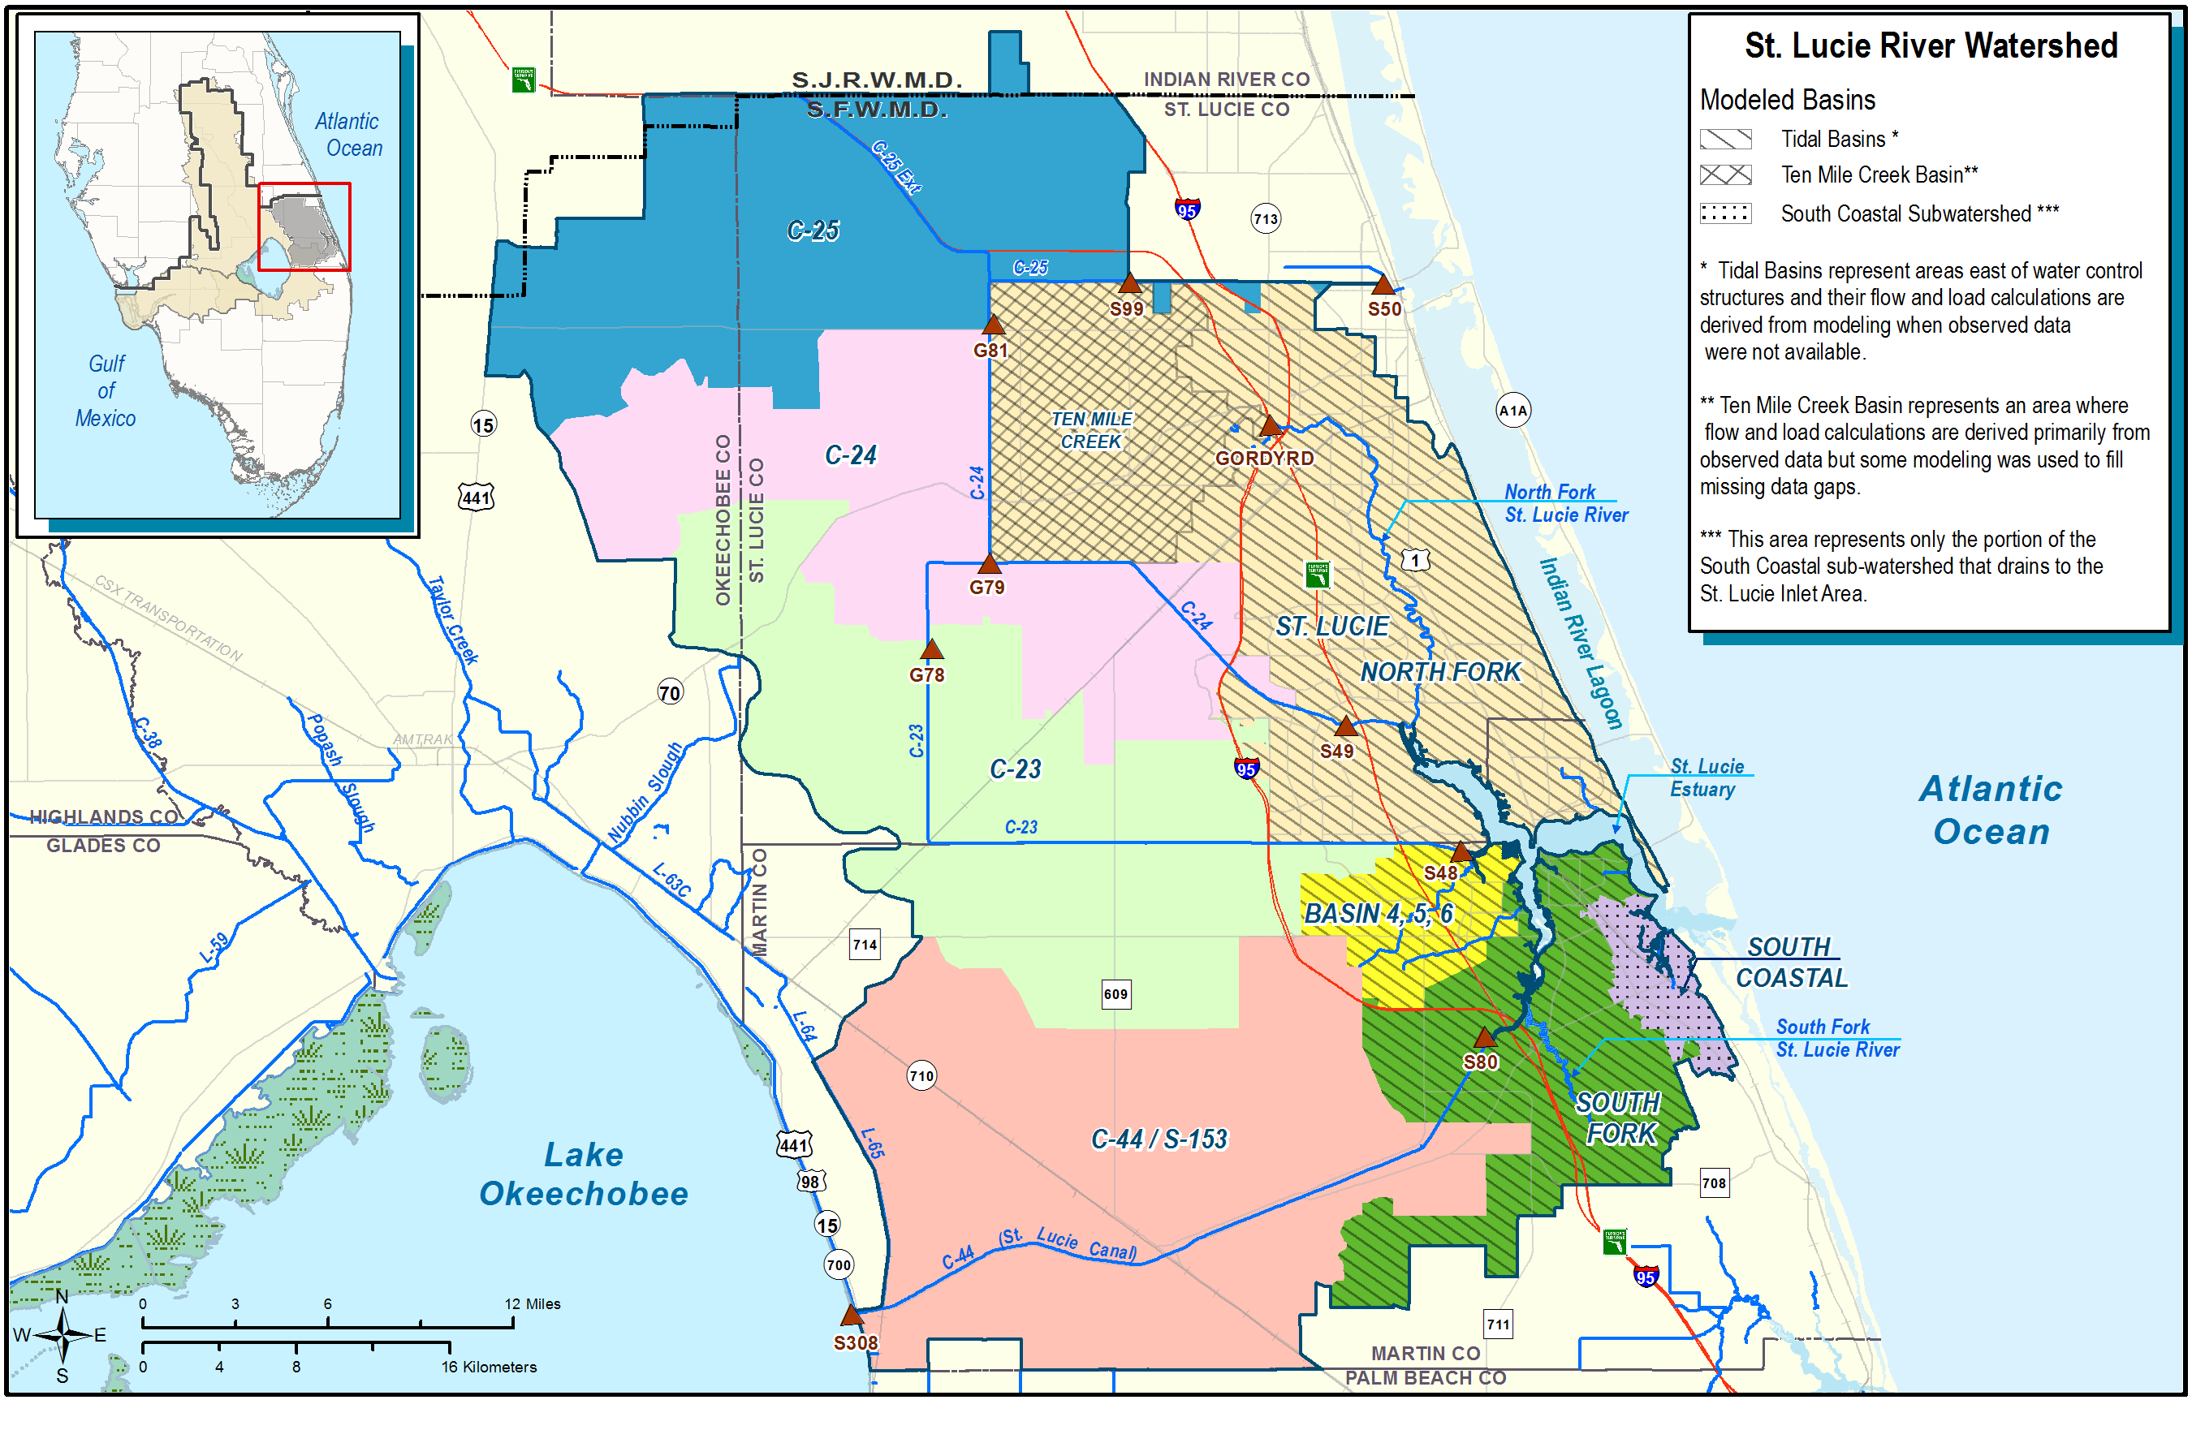
Figure 8C-1. The St. Lucie River Watershed with its basins and major water control structures.
Modeled basin areas are also depicted.

A suite of external drivers and ecological responses are monitored in the St. Lucie Basin and SLE (Figure 8C-2). These variables include rainfall, freshwater discharge, and nutrient loads as external drivers, and patterns of salinity, estuarine nutrient concentrations, oyster habitat status, and SAV community composition as the estuarine ecological responses. Salinity gradients are a conservative property of the water body and therefore are useful to connect the sources of freshwater inflow, circulation, and biological indicators (Wilber 1992, Jassby et al. 1995, Hagy and Murrell 2007, Pollack et al. 2011).

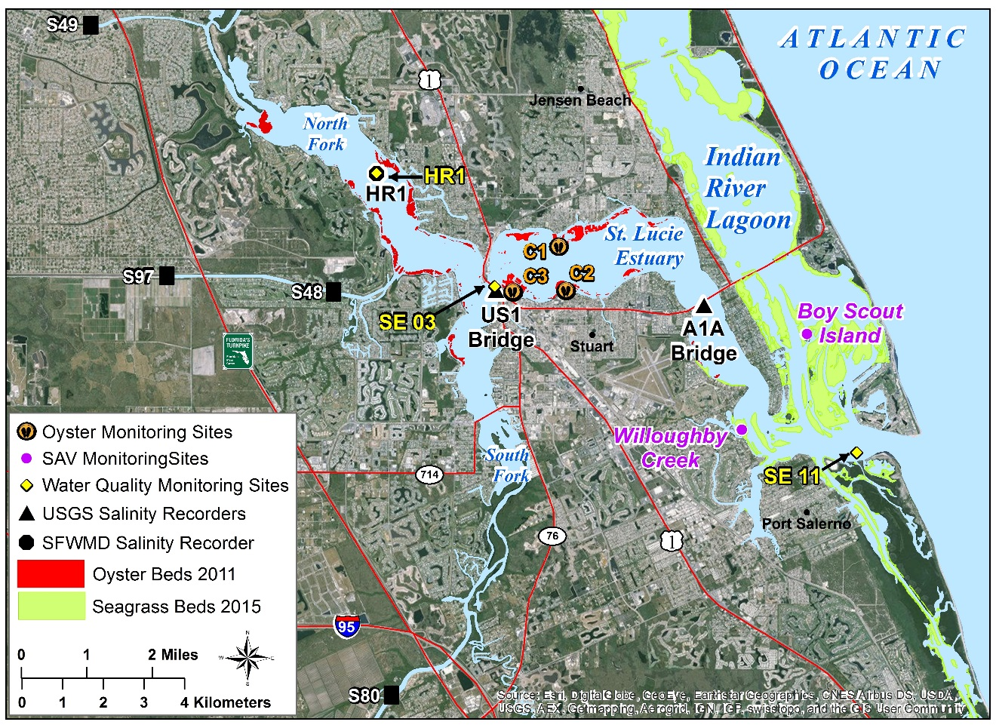
Figure 8C-2. Monitoring locations of salinity, water quality, and living aquatic habitat (oysters and SAV) for the SLE. The map also depicts distribution of SAV habitat in the St. Lucie Inlet and Southern Indian River Lagoon.

Hydrology

Rainfall
Daily next generation radar (NEXRAD) rainfall data from WY1997 to WY2018 for each subbasin of the St. Lucie Basin were downloaded from the District’s corporate environmental database, DBHYDRO, on the District’s website at http://my.sfwmd.gov/nexrad2/nrdmain.action. The cumulative amount of rainfall across the basin was computed using area-weighting, which accounts for the different sizes of the subbasins.
The daily rainfall over the past three water years (WY2016–WY2018) across the entire SLE Watershed is presented in Figure 8C-3. In WY2018, total rainfall to the St. Lucie River Watershed was 67.3 inches, with 80% in the wet season and 20% in the dry season (Figure 8C-4). This was 35% higher than the long-term annual average (WY1997–WY2018; 48.6 inches), 51% more than WY2017 (44.5 inches), and 24% more than WY2016 (54.1 inches). Due to the impact of Hurricane Irma and other tropical storms, WY2018 wet season rainfall (53.8 inches) was higher than in the wet seasons of the previous two years (37.2 inches in WY2017, 29.5 inches in WY2016) and the long-term wet-season average (WY1997–WY2018; 36.1 inches). The maximum daily rainfall (5.7 inches), occurred on September 10, 2017, when Hurricane Irma made landfall (Figure 8C-3), and was the second highest daily rainfall from WY1997 through WY2018. Rainfall was observed (> 0 inches) on 248 days (68%) in WY2018, with 14 days having rainfall greater than 1.0 inch. Spatially, the greatest rainfall in WY2018 occurred in the C-44/S-153 subbasin (71.0 inches) and the least in the C-24 subbasin (64.8 inches) (Figure 8C-5). This differed from the long-term (WY1997–WY2018) average rainfall pattern where the highest rainfall was over the Tidal Basin (50.0 inches) and the lowest was in the C-23 basin (47.2 inches) (Figure 8C-5).
Figure 8C-3. Time series of total daily rainfall to the St. Lucie River Watershed from WY2016 through WY2018.
Figure 8C-4. Total rainfall to the St. Lucie River Watershed by water year and season for the past three years and the long-term average (WY1997–WY2018). The numbers are the percentage of annual total rainfall for each season.
Figure 8C-5. Average annual rainfall by basin for the past three water years and the long-term average (WY1997–WY2018).

Freshwater Inflow and Salinity
Freshwater inflow to the SLE is measured at S-80 (C-44/S-153 basin), S-48 (C-23 basin), S-49 (C-24 basin), and the Gordy Road Structure (TMC Basin; Figure 8C-1 and Table 8C-1). These multiple inflows were assigned to one of three Tier 1 basins: Lake Okeechobee, the St. Lucie Basin, and the Tidal Basin. The drainage area downstream of these major structures comprises the SLE Tidal Basin. The Tidal Basin inflow and nutrient loads were simulated using the SLE Tidal Basin Lin-Res Model calibrated to the SLE Watershed Hydrology (WaSH) Model and data collected in the nearby basins (Wan and Konyha 2015). Total daily inflows during WY1997–WY2018 from Lake Okeechobee, the St. Lucie Basin, and the Tidal Basin were organized by month and used to quantify total inflow to the SLE each water year, evaluate intra- and interannual variations in inflow, and estimate the contributions of the Tier 1 basins from source to total inflow.
Surface and bottom salinity observations were recorded every 30 minutes at three stations: HR1, US1 at the Roosevelt Bridge, and the A1A Bridge (Figure 8C-2). Salinity was vertically averaged to produce a water-column average time series over the long-term period of record (POR; WY2001–WY2018; Instrumentation to measure salinity was not deployed until WY2001). The percentages of days for the oyster resource-based salinity criteria were calculated over the POR and for WY2016, WY2017, and WY2018.
Total freshwater inflow in WY2018 was 1.576 million ac-ft, of which 0.59 million ac-ft (37) was from Lake Okeechobee, 0.67 million ac-ft (43%) from St. Lucie Basin, and 0.32 million ac-ft (20%) from the Tidal Basin (Table 8C-2 and Figure 8C-6). WY2018 was a very wet year as total freshwater inflow was 56%, 29%, and 67% greater than the long-term average (WY1997–WY2018), WY2016, and WY2017, respectively. Annual inflow from three sources (Lake Okeechobee, St. Lucie Basin, and Tidal Basin) from WY1997 to WY2018 fluctuated, with the highest flow occurring in WY2006 followed by the lowest flow in WY2007 (Figure 8C-7).
Table 8C-2. Summary of freshwater inflow in million acre-feet per year (10⁶ ac-ft/yr) and TN loads and TP loads in metric tons per year (t/yr) from Lake Okeechobee, the St. Lucie Basin (C-23, C-24, C-44, and TMC) and the Tidal Basin (ungauged) to the SLE.
 |  | WY1997–W2018 | WY2016 | WY2017 | WY2018
Inflow  (10⁶ ac-ft/yr) | Total | 1.01 | 1.22 | 0.95 | 1.58
Inflow  (10⁶ ac-ft/yr) | Lake Okeechobee | 0.26 | 0.37 | 0.34 | 0.59
Inflow  (10⁶ ac-ft/yr) | St. Lucie Basin | 0.49 | 0.59 | 0.37 | 0.67
Inflow  (10⁶ ac-ft/yr) | Tidal Basin | 0.26 | 0.26 | 0.24 | 0.32
TN  (t/yr) | Total | 1,779 | 1,991 | 1,376 | 3,135
TN  (t/yr) | Lake Okeechobee | 572 | 717 | 621 | 1,346
TN  (t/yr) | St. Lucie Basin | 906 | 970 | 497 | 1,400
TN  (t/yr) | Tidal Basin | 301 | 304 | 258 | 390
TP  (t/yr) | Total | 327 | 333 | 230 | 556
TP  (t/yr) | Lake Okeechobee | 60 | 84 | 57 | 161
TP  (t/yr) | St. Lucie Basin | 222 | 219 | 144 | 350
TP  (t/yr) | Tidal Basin | 45 | 31 | 29 | 45

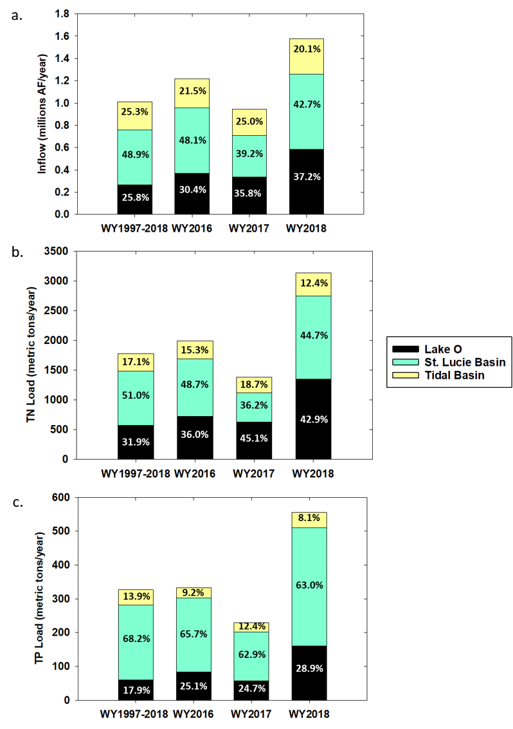
Figure 8C-6. Stacked bar chart for the (a) total freshwater inflow in million acre-feet per year (10⁶ ac-ft/yr) and (b) TN load and (c) TP loads in metric tons per year from each source.

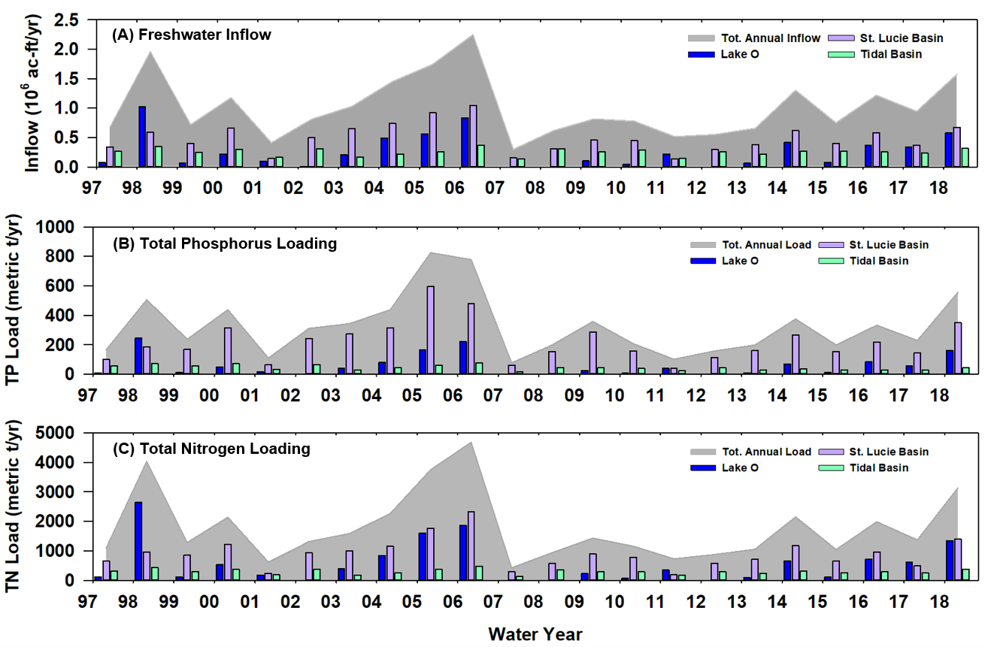
Figure 8C-6. Time series of (a) annual freshwater inflow in million acre-feet per year (10⁶ ac-ft/yr) and (b) TP load, and (c) TN load in metric tons per year (t/yr) into the SLE from different sources between WY1997–WY2018.

The seven-day moving average salinity at the US1 Roosevelt Bridge was calculated using average daily surface and bottom salinity data for the long-term average (WY2001–WY2018) and most recent three years. With the wetter-than-normal conditions, salinity fell in the preferred envelop for adult oyster (10 to 26) less frequently than the long-term average (Table 8C-3). However, conditions for oysters were more favorable than in WY2017. All the days with salinity above 26 occurred in the beginning of the water year (May 1 to June 6, 2017) and in the end of the water year (March 25 to April 30, 2018).
Table 8C-3. The percentage of days the 7-day moving average water column salinity at the US1 Roosevelt Bridge was categorized below, within, or above the preferred salinity envelope of 10 to 26 for adult eastern oysters.
Period | Days with  Salinity < 10  (%) | Days with  Salinity ≥ 10 and < 26 (%) | Days with  Salinity ≥ 26  (%)
WY2001–WY2018 | 30.3 | 60.6 | 9.1
WY2016 | 42.8 | 57.2 | 0.0
WY2017 | 42.4 | 34.3 | 23.3
WY2018 | 38.2 | 46.0 | 15.9

Water Quality

TN and TP Loads to the Estuary
The concentrations of TN and TP are monitored at the same locations as flow and salinity (Figure 8C-2). Water for TN analyses were from grab samples (SFWMD 2017, 2018). Water for the determination of TP concentration was obtained either using an autosampler or grab sample. Inflows and nutrient loads from TMC were simulated from WY1997 through WY1999 because the data set was incomplete. The daily loads of TN and TP were calculated as the product of the total daily inflow and the computed daily nutrient concentration.
The annual nutrient loading to the SLE fluctuated with total freshwater inflow during the period of WY1997–WY2018 (Figures 8C-6 and 8C-7). During this period, TN load averaged 1,779 tons per year (t/yr) and TP loads averaged 327 t/yr (Table 8C-2). In WY2018, total TN loading was 3,135 t, 45% of which was from the St. Lucie Basin (1,400 t), 12% was from the Tidal Basin (390 t), and 43% was from Lake Okeechobee (1,3446 t) (Figure 8C-7b). This TN loading was 57%, 128%, and 76% greater than WY2016, WY2017, and the long-term average loading (WY1997–WY2018), respectively. TP loading in WY2018 was 556 t (Table 8C-2) and was 67%, 142%, and 70% higher than WY2016, WY2017, and the long-term loading average (WY1997–WY2018), respectively. Most TP loading in WY2018 originated from the St. Lucie Basin (350 t or 63%), followed by Lake Okeechobee (161 t/yr or 29%), and the Tidal Basin (45 t/yr or 8%; Table 8C-2 and Figure 8C-7c).
The high overall nutrient loads in WY2018 compared to WY2016, WY2017, and long-term average (WY1997–WY2018) resulted from the higher inflow and flow-weighted mean nutrient concentrations from St. Lucie and Lake Okeechobee basins (Table 8C-2 and Figures 8C-6 and 8C-7). This high nutrient-rich freshwater inflow may have been attributed to the above average rainfall and Hurricane Irma (Figures 8C-3 and 8C-4).

TP and TN Loading Data for the Most Recent Five Years (WY2014–WY2018)
Table 8C-4 lists tributary basin annual flows, TP load, TP flow-weighted mean (FWM) concentration, total nitrogen (TN) load and TN FWM concentration for the last five water years—WY2014–WY2018—in the St. Lucie River Watershed. Tributary basins of the St. Lucie River Watershed include the C-44, C-23, C-24, Ten Mile Creek, and Tidal basins. Inflows from Lake Okeechobee to the watershed are also accounted for in Table 8C-4. Tributary basin runoff from the watershed accounted for 46% of total flow, 67% of TP load, and 48% of TN load to the St. Lucie Estuary from WY2014 through WY2018. Lake Okeechobee contributed 31% of total flow, 23% of TP load, and 36% of TN load during the same five-year period. Flow and nutrient loads from the Tidal Basin were estimated by modeled flow and measured grab sample data from within the basin.
Table 8C-4. St. Lucie River Watershed tributary basin annual flow volumes with TP and TN loads and FWM concentrations for WY2014–WY2018. (Note: mg/L – milligrams per liter.)
Water Year | Inflow from Lake Okeechobee | C-44 Basin | C-23 Basin | C-24 Basin | Ten Mile Creek Basin | Tidal Basin | Total
Flow (10³ acre-feet)
WY2014 | 418.6 | 257.1 | 169.4 | 107.7 | 84.3 | 267.8 | 1,305.0
WY2015 | 80.3 | 108.0 | 105.0 | 104.6 | 84.2 | 268.7 | 750.6
WY2016 | 369.8 | 188.6 | 106.7 | 176.6 | 114.4 | 262.6 | 1,218.7
WY2017 | 338.2 | 78.8 | 65.9 | 97.9 | 127.8 | 236.5 | 945.2
WY2018 | 585.6 | 79.8 | 219.7 | 221.1 | 152.9 | 316.9 | 1,576.0
TP Load (metric tons)
WY2014 | 71.0 | 106.2 | 93.2 | 44.3 | 22.5 | 37.9 | 375.0
WY2015 | 13.3 | 37.1 | 57.2 | 41.6 | 19.2 | 30.6 | 199.1
WY2016 | 83.6 | 63.7 | 53.5 | 59.9 | 41.9 | 30.6 | 333.2
WY2017 | 56.8 | 30.0 | 28.5 | 34.3 | 51.7 | 28.6 | 229.8
WY2018 | 160.5 | 68.2 | 100.0 | 111.4 | 70.3 | 45.3 | 555.8
TP FWM Concentration (mg/L)
WY2014 | 0.137 | 0.335 | 0.446 | 0.334 | 0.216 | 0.115 | 0.233
WY2015 | 0.135 | 0.279 | 0.442 | 0.323 | 0.185 | 0.092 | 0.215
WY2016 | 0.183 | 0.274 | 0.407 | 0.275 | 0.297 | 0.094 | 0.244
WY2017 | 0.136 | 0.309 | 0.351 | 0.284 | 0.328 | 0.098 | 0.197
WY2018 | 0.222 | 0.693 | 0.369 | 0.408 | 0.373 | 0.116 | 0.286
TN Load (metric tons)
WY2014 | 660.2 | 528.9 | 360.6 | 189.5 | 96.0 | 318.5 | 2,153.7
WY2015 | 124.7 | 174.7 | 201.6 | 189.8 | 93.0 | 265.4 | 1,049.2
WY2016 | 717.2 | 289.1 | 204.5 | 326.5 | 149.7 | 303.7 | 1,990.7
WY2017 | 621.3 | 62.2 | 114.0 | 162.1 | 159.3 | 257.5 | 1376.2
WY2018 | 1,345.5 | 256.6 | 457.5 | 457.2 | 228.7 | 389.7 | 3,135.2
TN FWM Concentration (mg/L)
WY2014 | 1.28 | 1.67 | 1.73 | 1.43 | 0.92 | 0.96 | 1.34
WY2015 | 1.26 | 1.31 | 1.56 | 1.47 | 0.90 | 0.80 | 1.13
WY2016 | 1.57 | 1.24 | 1.55 | 1.50 | 1.06 | 0.94 | 1.32
WY2017 | 1.49 | 0.64 | 1.40 | 1.34 | 1.01 | 0.88 | 1.18
WY2018 | 1.86 | 2.61 | 1.69 | 1.68 | 1.21 | 1.00 | 1.61

Estuary Water Quality
Water was sampled via grabs at mid-depth at 12 stations in the SLE at approximately monthly intervals at three stations: HR1 in the North Fork, SE03 in the Middle Estuary at the US1 Roosevelt Bridge, and SE11 near the St. Lucie Inlet (Figure 8C-2). Concentrations of TN, TP, and Chla during WY1997–WY2018 from each of the stations were included in the analyses. Water quality conditions within the estuary between WY1997 and WY2018 (Figure 8C-8). Long-term and seasonal averages and standard deviations were calculated for the long-term average (WY1997–WY2018) and the last three water years (WY2016, WY2017, and WY2018; Table 8C-5).
Chla concentrations were highly variable at all three stations with a range of 0.3 to 90 μg/L (Figure 8C-8). On average, concentration and variability decrease in the downstream direction (Table 8C-5). HR1, the most upstream site, averaged 12.9 ± 12.2 μg/L, followed by SE03 (8.7 ± 8.1 μg/L), and SE11 (3.6 ± 3.0 μg/L). This pattern held for the most recent water years as well. The wet season concentrations are usually higher than dry season. However, in WY2018, SE03 and SE11 had the opposite pattern, with Chla concentrations being higher in the dry season. This was likely do to dilution by freshwater inflow associated with Hurricane Irma.
TN concentrations at all three stations ranged from 0.06 to 2.89 milligrams per liter (mg/L) (Figure 8C-8). Long-term average TN concentrations and standard deviation were similar at the HR1 and SE03 stations (0.97 ± 0.40 mg/L and 0.96 ± 0.44 mg/L, respectively) and lowest at SE11 (0.51 ± 0.38 mg/L) (Table 8C-5). In WY2018, the wet season, dry season, and annual average concentrations at all three stations were higher than WY2016, WY2017, and the long-term average (WY1997–WY2018), except for the WY2016 dry season at HR1 and SE03. The WY2016 dry season was very wet and accounted for almost half the total rainfall for that water year (Figure 8C-4).
TP average concentrations at all three stations ranged from of 0.004 to 1.040 mg/L (Figure 8C-8). The long-term average concentrations and variability decreased in the downstream direction (Table 8C-5), with HR1 averaging 0.21 ± 0.11 mg/L, followed by SE03 (0.18 ± 0.09 mg/L), and then by SE11 (0.06 ± 0.06 mg/L). This pattern was also true for WY2018. Similar to TN concentration, all three stations had higher TP concentration in WY2018 than WY2016, WY2017, and long-term average (WY1997–WY2018). The average concentrations at all the three stations were higher during the wet season compared to the dry season.

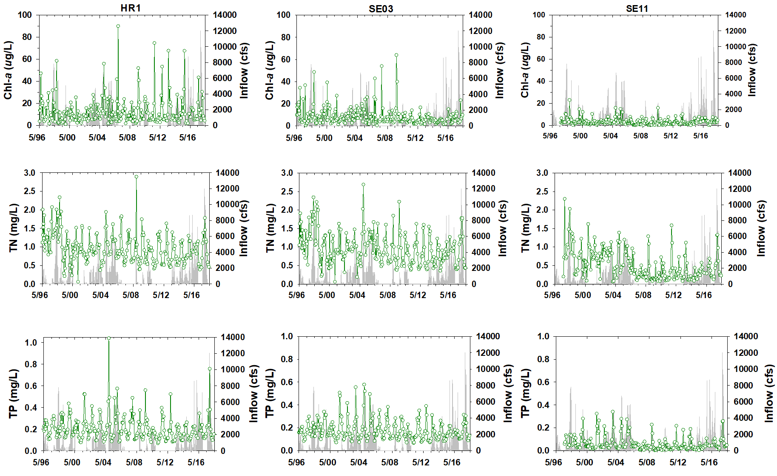
Figure 8C-8. Time series of Chla, TN, and TP (green line with open circles) and total gauged inflows (gray line) at stations HR1, SE03, and SE11 in the SLE.
Table 8C-5. Water column concentrations of Chla, TN, and TP at three stations (HR1, SE03, and SE11) in the SLE. The table includes dry season (November–April), wet season (May–October), and total annual averages (Avg) and standard deviations (SD) for WY1997–WY2018.
Chla  (μg/L) | HR1 |  |  |  |  |  | SE03 |  |  |  |  |  | SE11
Chla  (μg/L) | Dry |  | Wet |  | Total |  | Dry |  | Wet |  | Total |  | Dry |  | Wet |  | Total
Chla  (μg/L) | Avg | SD | Avg | SD | Avg | SD | Avg | SD | Avg | SD | Avg | SD | Avg | SD | Avg | SD | Avg | SD
WY1997–WY2018 | 9.45 | 7.49 | 16.08 | 14.57 | 12.91 | 12.17 | 6.36 | 4.21 | 10.87 | 10.13 | 8.73 | 8.19 | 2.91 | 2.31 | 4.17 | 3.37 | 3.57 | 2.98
WY2016 | 5.58 | 4.54 | 24.28 | 23.58 | 18.05 | 20.98 | 3.81 | 2.27 | 5.28 | 2.88 | 4.84 | 2.68 | 4.33 | 1.96 | 4.95 | 2.10 | 4.74 | 1.95
WY2017 | 6.24 | 1.20 | 13.34 | 3.28 | 9.47 | 4.33 | 5.78 | 3.23 | 8.48 | 4.76 | 7.01 | 4.03 | 2.40 | 1.54 | 5.26 | 1.48 | 3.70 | 2.07
WY2018 | 15.09 | 10.67 | 17.39 | 13.89 | 16.24 | 11.87 | 10.52 | 7.43 | 7.81 | 3.80 | 9.04 | 5.59 | 4.13 | 1.59 | 4.05 | 1.82 | 4.08 | 1.63
TP  (mg/L) | HR1 |  |  |  |  |  | SE03 |  |  |  |  |  | SE11
TP  (mg/L) | Dry |  | Wet |  | Total |  | Dry |  | Wet |  | Total |  | Dry |  | Wet |  | Total
TP  (mg/L) | Avg | SD | Avg | SD | Avg | SD | Avg | SD | Avg | SD | Avg | SD | Avg | SD | Avg | SD | Avg | SD
WY1997–WY2018 | 0.14 | 0.05 | 0.27 | 0.12 | 0.21 | 0.11 | 0.13 | 0.04 | 0.23 | 0.09 | 0.18 | 0.09 | 0.04 | 0.03 | 0.09 | 0.07 | 0.06 | 0.06
WY2016 | 0.14 | 0.03 | 0.19 | 0.04 | 0.17 | 0.04 | 0.14 | 0.02 | 0.17 | 0.04 | 0.16 | 0.04 | 0.05 | 0.00 | 0.06 | 0.03 | 0.06 | 0.02
WY2017 | 0.13 | 0.02 | 0.24 | 0.06 | 0.18 | 0.07 | 0.11 | 0.01 | 0.16 | 0.02 | 0.13 | 0.03 | 0.03 | 0.01 | 0.08 | 0.02 | 0.05 | 0.03
WY2018 | 0.14 | 0.03 | 0.37 | 0.21 | 0.25 | 0.18 | 0.14 | 0.06 | 0.25 | 0.06 | 0.19 | 0.08 | 0.06 | 0.02 | 0.14 | 0.10 | 0.10 | 0.08
TN  (mg/L) | HR1 |  |  |  |  |  | SE03 |  |  |  |  |  | SE11
TN  (mg/L) | Dry |  | Wet |  | Total |  | Dry |  | Wet |  | Total |  | Dry |  | Wet |  | Total
TN  (mg/L) | Avg | SD | Avg | SD | Avg | SD | Avg | SD | Avg | SD | Avg | SD | Avg | SD | Avg | SD | Avg | SD
WY1997–WY2018 | 0.76 | 0.32 | 1.15 | 0.38 | 0.97 | 0.40 | 0.78 | 0.40 | 1.13 | 0.41 | 0.96 | 0.44 | 0.40 | 0.34 | 0.62 | 0.38 | 0.51 | 0.38
WY2016 | 0.82 | 0.11 | 0.98 | 0.25 | 0.93 | 0.22 | 0.93 | 0.30 | 0.82 | 0.19 | 0.85 | 0.22 | 0.31 | 0.01 | 0.40 | 0.11 | 0.38 | 0.11
WY2017 | 0.58 | 0.29 | 0.99 | 0.13 | 0.76 | 0.31 | 0.56 | 0.29 | 0.97 | 0.08 | 0.74 | 0.30 | 0.22 | 0.08 | 0.51 | 0.15 | 0.35 | 0.19
WY2018 | 0.78 | 0.32 | 1.27 | 0.37 | 1.03 | 0.41 | 0.85 | 0.55 | 1.28 | 0.43 | 1.07 | 0.52 | 0.44 | 0.30 | 0.73 | 0.48 | 0.58 | 0.41

Aquatic Habitat

Submerged Aquatic Vegetation
SAV monitoring in the Southern Indian River Lagoon and SLE has been ongoing since 2012 as part of RECOVER’s monitoring and assessment program in support of CERP (RECOVER 2014). Results from monthly wet season (May–October) sampling events are presented for the Boy Scout Island and Willoughby Creek sites (Figure 8C-2) for the WY2014–WY2018 period. At each site, a ~2-acre (0.81-hectare) polygon was delineated and for each sampling event, 30 random points within the polygon were sampled, and a visual estimate of percent cover was recorded. Starting in 2017, the visual estimates were converted to Braun Blanquet cover and abundance (BBCA) scores and in-field measures of BBCA scores were recorded. BBCA assesses percent cover of the bottom by SAV using a scale ranging from 0 to 5 representing values of ~5 to 75 to 100% cover (Table 8C-6; Fourqurean et al. 2003).
Table 8C-6. BBCA values and corresponding percent cover interpretation.
BBCA | Cover interpretation
0 | Species absent from quadrat
0.1 | <5 %; species represented by a single shoot
0.5 | <5 %; a few solitary shoots
1 | <5 %; many shoots
2 | 5% -25%
3 | 25%- 50%
4 | 50% -75%
5 | 75% - 100%

SAV at the Willoughby Creek monitoring site (Figure 8C-2) in the SLE is comprised of Halophila johnsonii (Johnson’s seagrass) and Halodule wrightii (shoal grass). Both species tolerate a broad salinity range (Doering et al. 2002, Kahn et al. 2013), which commonly occurs at this site. An increase in total seagrass cover was observed from WY2014 through WY2017 to average values of 5 to 25% cover. However, in WY2018, average cover was < 5% in the wet season (Figure 8C-9A and Table 8C-6. Halophila johnsonii cover has tended to increase since WY2014.
Boy Scout Island, the seagrass site located north of the St. Lucie Inlet (Figure 8C-2) in the Southern Indian River Lagoon, is populated by Halophila johnsonii, Halodule wrightii, and Syringodium filiforme (manatee grass), the latter of which has a lower tolerance for hyposaline conditions (Lirman and Cropper 2003). Average cover of Syringodium filiforme declined annually from 5 to 25% in WY2014 to almost zero in WY2018 (Figure 8C-9B). While there was a distinct decline in total seagrass cover observed in all species from WY2016 to WY2017, there was some recovery of Halophila johnsonii and Halodule wrightii from WY2017 to WY2018 resulting in an increase in total seagrass cover from WY2017 to WY2018 (Figure 8C-9B)
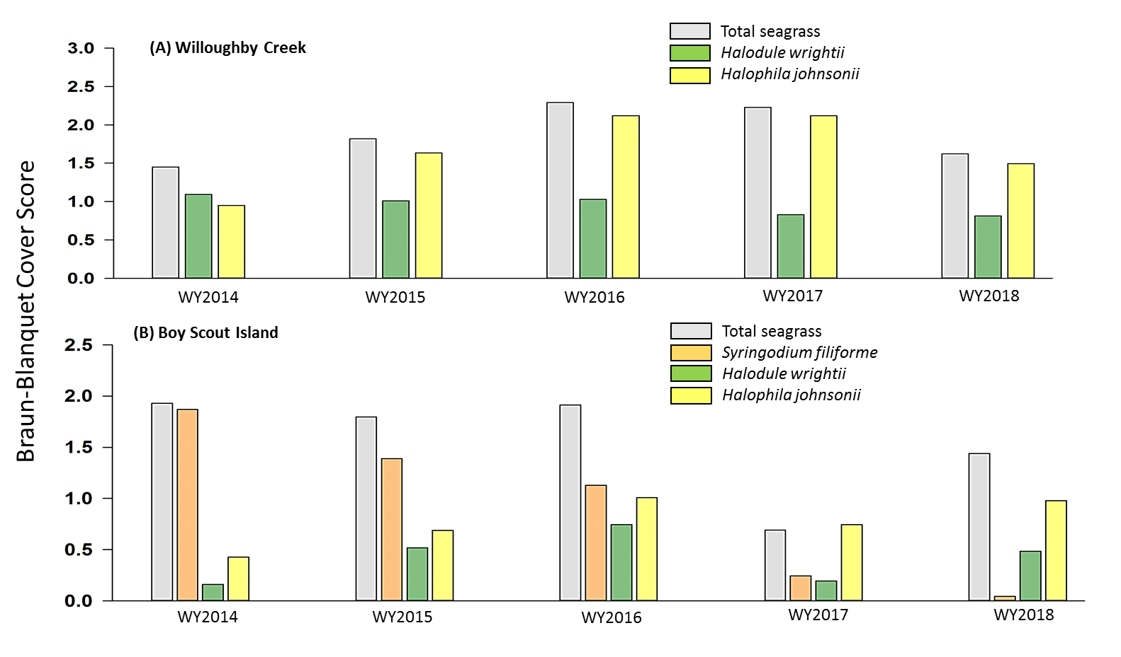
Figure 8C-9. BBCA for average wet season (May–October) monthly sampling events of SAV at (A) Willoughby Creek, and (B) Boy Scout Island from WY2014 through WY2018. Seasonal estimates provided for total SAV cover (grey fill) and individual species

Oyster Habitat
Oyster monitoring has been ongoing in three segments of the SLE (Mid-Estuary, South Fork, and North Fork) since WY2006 (Figure 8C-2) (Parker et al. 2013) by RECOVER in support of CERP (RECOVER 2014). At each site, three stations are sampled. The focus for this report will be on the St. Lucie Mid-estuary sampling site, as it is the most representative of ecosystem conditions for oysters. Oyster density (live/m²) was determined biannually, but began quarterly in 2018, using survey methodology based on that of Lenihan and Peterson (1998) and Grizzle et al. (2005). Recruitment was measured monthly from shells suspended on strings and calculated to spat/shell/month. Tissue from a subset of live adult oysters was collected monthly to determine prevalence (number infected/total collected) and intensity of the protozoan pathogen, Perkinsuss marinus (dermo) (Ray 1966).
In June 2017, average live adult oyster densities at the Mid-Estuary (Central) sites, C1, C2 and C3 (Figure 8C-2) were almost twice that of the previous two wet season sampling events, at 1,047 oysters/m². This density is similar to that of the WY2015 wet season (Table 8C-7). Following Hurricane Irma in September 2017, salinities at the US1 Roosevelt Bridge remained below 10 through December, and the March 2018 dry season sampling was < 1 live adult oyster/m². Larval recruitment at the sites is generally low, with the highest larval recruitment over the past five water years being 11.3 spat/shell in June 2016 (Figure 8C-10A). Wet season recruitment before Hurricane Irma was 0.4 spat/shell and the following dry season was 0.005 spat/shell, with 0 spat observed between December 2017 and March 2018. The prevalence of disease was relatively low, averaging ~20%, in WY2018 prior to Hurricane Irma (Figure 8C-10B). After the storm, no live adult oysters were present at the site for sampling through April 2018.

Table 8C-7. Average live adult oyster densities/m² from the Mid-Estuary (Central) SLE sites for WY2014–WY2018 and month sampled. The site was sampled twice in the WY2014 dry season.
Water Year | Season | Month Sampled | Density  (oysters per m²)
WY2014 | Dry | December | 31
WY2014 | Dry | March | 144
WY2015 | Wet | September | 1,123
WY2015 | Dry | March | 821
WY2016 | Wet | September | 590
WY2016 | Dry | April | 309
WY2017 | Wet | September | 634
WY2017 | Dry | March | 599
WY2018 | Wet | June | 1,047
WY2018 | Dry | March | < 1
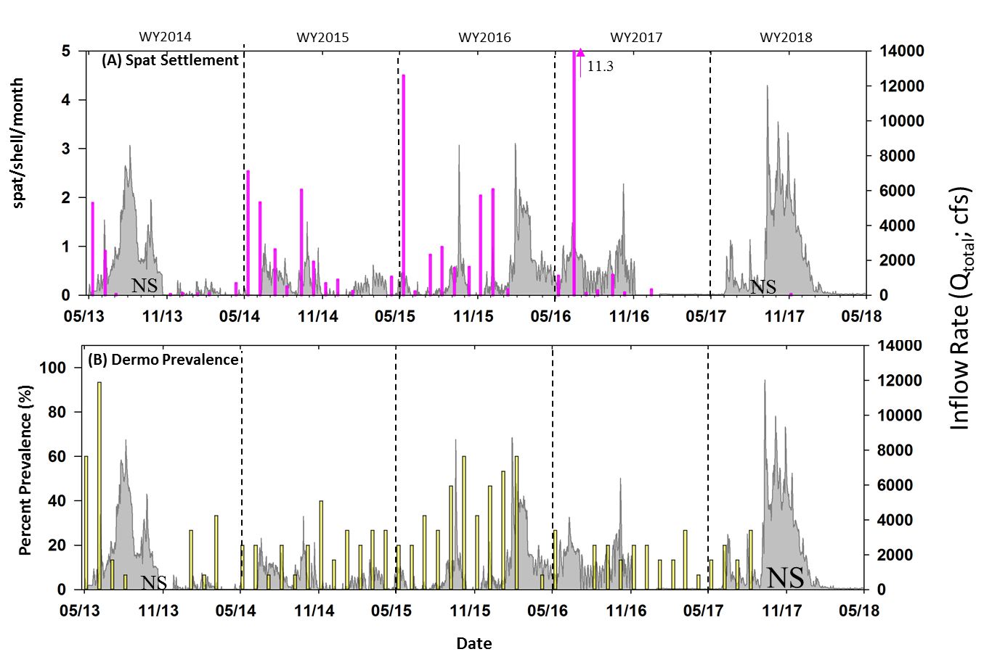
Figure 8C-10. Time series of oyster monitoring metrics from the Mid-Estuary of the SLE for WY2014–WY2018. (A) Monthly spat settlement rate (spat/shell/month) and (B) monthly percent Dermo prevalence. The right y-axis depicts daily freshwater total inflow rate to the SLE not including Tidal Basin flows (grey area fill). NS represents date not sampled or no living oysters present at the site for sampling at the time of sampling event.

Summary
- Rainfall across the St. Lucie Basin and Tidal Basin in WY2018 was 67.3 inches, with 80% occurring in the wet season and 20% in the dry season. This was 35% higher than the long-term annual average (WY1997–WY2018), 22.8 and 13.1 inches more than in WY2017 and WY2016, respectively.
- Total freshwater inflow to the SLE in WY2018 was 1.6 million ac-ft, of which 37% was from Lake Okeechobee and 63% from the St. Lucie Basin and Tidal Basin. Inflow to the estuary was 56% greater than the long-term average (WY1997–2018) and 67% greater than WY2017.
- Salinity was below the preferred envelop for adult oysters 38% and above the envelop 16% of the time during WY2018, which was lower than in WY2016 or WY2017.
- Nitrogen loading in WY2018 (3,135 t) was almost twice the long-term average (1,779 t) and was primarily from the St. Lucie Basin (1,400 t or 45% of the total).
- Phosphorus loading in WY2018 (556t) was 70 % higher than the long-term average (32.7 t), mostly from the St. Lucie Basin (350 t or 63% of the total).
- The average Chla concentrations in WY2018 were higher than the long-term average concentrations, but the impact of Hurricane Irma could be seen in the lower wet season concentrations at the US1 Roosevelt Bridge and the St. Lucie Inlet sites.
- Total seagrass cover declined at Willoughby Creek from WY2017 to WY2018 due to a decrease in Halodule wrightii cover. Although Syringodium filiforme cover declined to < 5% at Boy Scout Island, there was increased coverage of Halodule wrightii and Halophila johnsonii, increasing total seagrass cover.
- Adult live oyster density in the beginning of the WY2018 wet season was high (1,047/ m²). However, after Hurricane Irma, the March 2018 sampling average was <1 adult living oyster/m². Larval recruitment was very low in WY2018 before and after the hurricane. The prevalence of the oyster marine parasite, Dermo, was comparatively low in WY2018 before the hurricane and due to lack of live oysters could not be assessed thereafter.

Caloosahatchee River Estuary and Watershed Condition

Background
Historically, the Caloosahatchee River was sinuous as it originated near Lake Flirt ~2 miles (3.2 kilometers [km]) east of La Belle at Fort Thompson. Beginning in the 1880s, the river channel was straightened, deepened, and connected to Lake Okeechobee. This resulted in a loss of 76 river bends and 8.2 miles (13.2 km) of river length (Antonini et al. 2002). Dredging alterations continued and, by 1918, three combination lock and spillway structures had been constructed at Moore Haven, Citrus Center, and Fort Thompson (USACE 1957, Section 6.B.6). Flows within the historic Caloosahatchee River (now the C-43 canal) are controlled through the operation of multiple water control structures (S-77, S-78, and S-79. The final lock and dam structure (Franklin Lock and Dam or S-79) was completed in 1966 at Olga to assure freshwater supply and prevent upstream saltwater intrusion. Discharges from Lake Okeechobee and the Caloosahatchee River Watershed between the S-77 and S-79 structures are regulated by the United States Army Corps of Engineers (USACE). Presently, the C-43 canal spans 44 miles (70 km) from S-77 at Lake Okeechobee to S-79, while the CRE begins at S-79 and spans 26 miles (42 km) to Shell Point where it empties into San Carlos Bay.
The modern Caloosahatchee River Watershed is a series of linked regional subbasins and includes the S-4 basin adjacent to Lake Okeechobee, the East Caloosahatchee Basin, the West Caloosahatchee Basin, the Tidal Caloosahatchee Basin located downstream of S-79, and the Cape Coral Coastal Basin (referred to as the Coastal Basin in Figure 8C-11) to the north of the Caloosahatchee River Estuary (CRE; Figure 8C-11; Balci and Bertolotti 2012, Buzzelli et al. 2017). The primary land use type within the Caloosahatchee River Watershed today is agricultural, which comprises 44%. Urban land use comprises 14% and open water comprises 12% (Buzzelli et al. 2018). The surface area of the CRE is 21.6 square miles (55.9 square km) with an average depth of 8.9 ft (2.7 m) (Buzzelli et al. 2013a). The flushing time ranges from 2 to 30 days (Buzzelli et al. 2013b).
The Caloosahatchee basins are categorized into Tier 1 and 2 levels of organization (Table 8C-8). Tier 1 basins are the C-43 and Tidal Caloosahatchee basins and Lake Okeechobee. For the purposes of this report, the East Caloosahatchee basin and the S-4 basin were combined.
Table 8C-8. Major contributing areas of the Caloosahatchee River Watershed.
Tier 1 Basins | Tier 2 Basins | Flows and Loads
C-43 Basin | East Caloosahatchee/S-4 | Measured
C-43 Basin | West Caloosahatchee | Measured
Tidal Caloosahatchee Basin | Tidal Caloosahatchee Basin | Modeled
Lake Okeechobee | Lake Okeechobee via S-77 and S-79 | Measured

Fluctuations in freshwater inflows over time scales ranging from weeks to years have altered salinity regimes and impacted the ecology of the CRE (Chamberlain and Doering 1998, Barnes 2005). Changes in freshwater inflows and salinity have been shown to affect the distribution and dynamics of many taxa and communities including phytoplankton and zooplankton (Tolley et al. 2010, Radabaugh and Peebles 2012), SAV (Doering et al. 2001, 2002, Lauer et al. 2011), oysters and pathogens (La Peyre et al. 2003, Barnes et al. 2007, Volety et al. 2009), fauna inhabiting oyster reefs (Tolley et al. 2005, 2006), and fishes (Collins et al. 2008, Heupel and Simpfendorfer 2008, Simpfendorfer et al. 2011, Poulakis et al. 2013, Stevens et al. 2013).

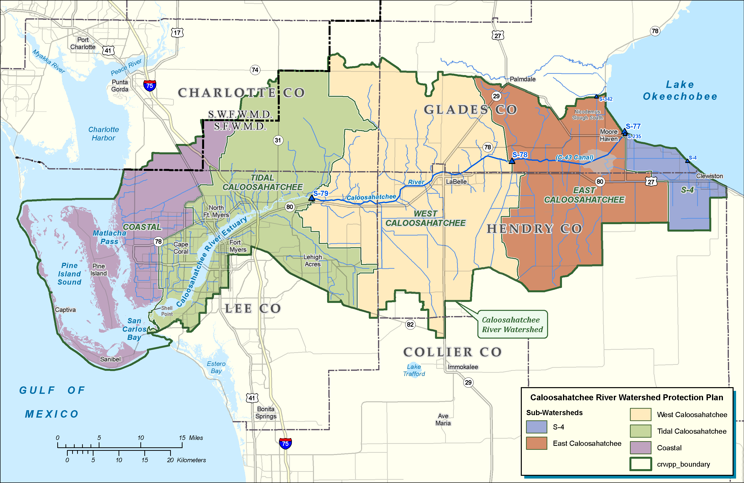
Figure 8C-11. The Caloosahatchee River Watershed with its basins and major water control structures.

A suite of external drivers and ecological responses are monitored in the Caloosahatchee River Watershed and CRE (Figure 8C-12). These variables include rainfall, freshwater discharge, and nutrient loads as external drivers, and patterns of salinity, estuarine nutrient concentrations, oyster habitat status, and SAV community composition as the estuarine ecological responses. Salinity gradients are a conservative property of the water body and therefore are useful to connect the sources of freshwater inflow, circulation, and biological indicators (Wilber 1992, Jassby et al. 1995, Hagy and Murrell 2007, Pollack et al. 2011).
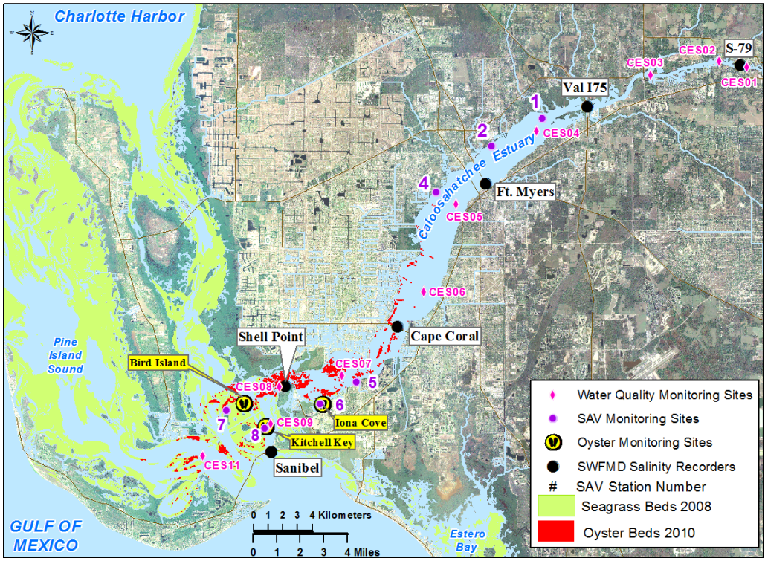
Figure 8C-12. Monitoring locations of salinity, water quality, and living aquatic habitat (oysters and SAV) for the CRE. The map includes a depiction of the distribution of SAV and oyster habitat in the CRE, Matchalas Pass, and Pine Island Sound.

Hydrology

Rainfall
Daily NEXRAD rainfall data for WY1997–WY2018 for each basin of the Caloosahatchee River Watershed were downloaded from the District’s corporate environmental database, DBHYDRO, on the District’s website at http://my.sfwmd.gov/nexrad2/nrdmain.action. The cumulative amount of rainfall across the watershed was computed using area-weighting, which accounts for the different sizes of the basins.
The daily rainfall for the past three water years (WY2016–WY2018) over the entire watershed was highly variable (Figure 8C-13). In WY2018, the total rainfall for the Caloosahatchee River Watershed was 63.0 inches, with 91% received during the wet season (Figure 8C-14). This was 17% higher than the long-term annual average (52.2 inches; WY1997–WY2018), 24% higher than WY2017 (48.1 inches), and comparable to WY2016 (62.3 inches). Total WY2018 wet season rainfall (57.2 inches) was remarkably higher than the previous two water year wet seasons (43.2 and 41.1 inches for WY2017 and WY2016, respectively) and the long-term wet season average (41.4 inches). The maximum daily rainfall (7.4 inches) occurred on September 10, 2017, when Hurricane Irma made landfall and was the highest daily rainfall for the long-term period, WY1997–WY2018 (Figure 8C-13). During WY2018, it rained 232 days (64 %), with 9 days having rainfall greater than 1.0 inches.
Spatial patterns of rainfall in WY2018 were similar to those observed in WY2016, with higher rainfall in the Coastal and Tidal Caloosahatchee basins and lower rainfall in the inland basins (East Caloosahatchee and S-4 basins) (Figure 8C-15). WY2017 and the long-term average (WY1997–WY2018) had higher rainfall in the Tidal and West Caloosahatchee basins and lower rainfall in the Coastal, East Caloosahatchee, and S-4 basins. In WY20108, the greatest rainfall was recorded in the Tidal Caloosahatchee Basin (68.8 inches) and the lowest in the East Caloosahatchee Basin (55.5 inches) (Figure 8C-15).
Figure 8C-13. Time series of total daily rainfall to the Caloosahatchee River Watershed for WY2016–WY2018.
Figure 8C-14. Total rainfall to the Caloosahatchee River Watershed by water year and season
including averages from the period WY1997–WY2018 and those for WY2016, WY2017, and WY2018. The numbers are percentage of annual total rainfall for dry versus wet seasons.
Figure 8C-15. Average annual rainfall to the Caloosahatchee River Watershed Tier 2 Contributing Areas, including the long-term average (WY1997–WY2018), and WY2016, WY2017, and WY2018. (Note: EC– East Caloosahatchee; S4 – S-4; TC – Tidal Caloosahatchee; and WC – West Caloosahatchee.)

Freshwater Inflow and Salinity
Surface and bottom salinity observations were recorded every 30 minutes at six stations in the CRE: S-79, Bridge 31, Ft. Myers, Cape Coral, Shell Point, and Sanibel Island Bridge (Figure 8C-12). The ValI75 station has been offline since WY2016 due to bridge construction. Daily surface and bottom salinity values were averaged together to assess average water column temporal variations. These data were used to calculate the percentage of days above or below a salinity of 10, the threshold criteria for Vallisneria americana (tape grass).
The Caloosahatchee River Watershed basins are categorized into Tier 1 and 2 levels of organization (Table 8C-8). Tier 1 basins are the C-43 and Tidal Caloosahatchee basins and Lake Okeechobee. All freshwater flows and nutrient loads are measured except those from the Tidal Caloosahatchee Basin where the WaSH model is used to simulate inputs (Wan and Konyha 2015). Freshwater discharge is monitored at S-77 at Lake Okeechobee, S-78 near the City of LaBelle, and S-79 at the upstream boundary of the CRE (Figure 8C-12). For the purposes of this report, the East Caloosahatchee Basin and the S-4 basin were combined.
Average daily inflows from WY1997 through WY2018 for S-79, S-78, S-77, and the Tidal Caloosahatchee Basin were used to evaluate intra- and interannual variations in inflow, quantify total inflow to the CRE, and estimate the contributions of the basins to total inflow. This included the relative volume contributions from the three Tier 1 basins. Total daily discharges and contributions were categorized by water year and season. The contribution of the Tidal Caloosahatchee Basin to freshwater inflow and nutrient loads was estimated using a linear reservoir modeling approach. Flows and loads from the Cape Coral Coastal Basin were not estimated as they do not discharge into the CRE.
The total freshwater inflow to the CRE in WY2018 was 3.063 million ac-ft (Table 8C-9), of which 39% was from Lake Okeechobee, 45% was from C-43 Basin, and 15% from Tidal Caloosahatchee Basin (Figure 8C-16a). The high total inflow in WY2018 resulting from high rainfall was 63%, 29%, and 31% more than long-term average (WY1997–WY2018), WY2016, and WY2017, respectively. The magnitude of each source (Lake Okeechobee, C-43 Basin, and Tidal Caloosahatchee Basin) contribution to inflow fluctuated greatly between WY1997 and WY2018 (Figure 8C-17a) reflecting drought and El Niño conditions.
Table 8C-9. Summary of freshwater inflow in million acre-feet per year (10⁶ ac-ft/yr) and TN loads and TP loads in metric tons per year (t/yr) from Lake Okeechobee, the C-43 Basin (C-23, C-24, C-44, and Ten Mile Creek) and the Tidal Caloosahatchee Basin (ungauged) to the SLE. Shown in the table are the long-term averages (WY1997–WY2018) and values for WY2016, WY2017 and WY2018.
 |  | WY1997-2018 | WY2016 | WY2017 | WY2018
Inflow (10⁶ ac-ft/yr) | Total | 1.88 | 2.38 | 2.33 | 3.06
Inflow (10⁶ ac-ft/yr) | Lake Okeechobee | 0.62 | 0.85 | 1.01 | 1.20
Inflow (10⁶ ac-ft/yr) | C-43 Basin | 0.88 | 0.96 | 0.93 | 1.39
Inflow (10⁶ ac-ft/yr) | Tidal Caloosahatchee Basin | 0.38 | 0.57 | 0.39 | 0.47
TN  (t/yr) | Total | 3,070 | 3,567 | 3,417 | 5,329
TN  (t/yr) | Lake Okeechobee | 1,091 | 1,590 | 1,559 | 2,115
TN  (t/yr) | C-43 Basin | 1,545 | 1,350 | 1,465 | 2,641
TN  (t/yr) | Tidal Caloosahatchee Basin | 434 | 627 | 393 | 573
TP  (t/yr) | Total | 297 | 302 | 317 | 643
TP  (t/yr) | Lake Okeechobee | 74 | 106 | 104 | 195
TP  (t/yr) | C-43 Basin | 177 | 140 | 175 | 373
TP  (t/yr) | Tidal Caloosahatchee Basin | 47 | 56 | 38 | 76
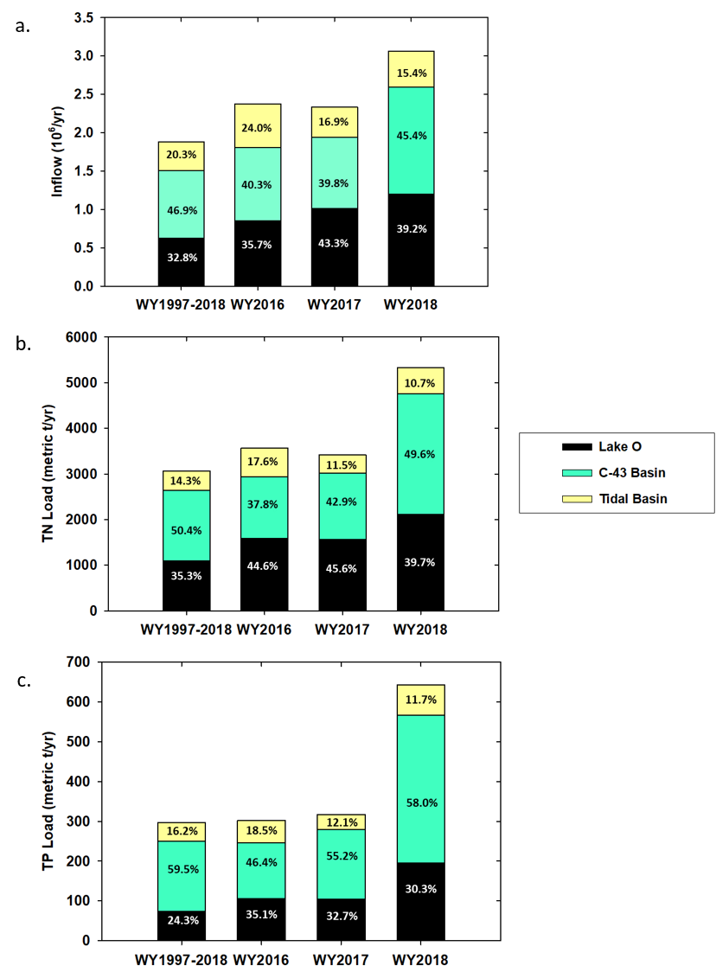
Figure 8C-16. Stacked bar chart for the (a) total freshwater inflow in million acre foot per year (10⁶/yr) and (b) TN loading and (c) TP loading in metric tons per year (metric t/yr) attributable to Lake Okeechobee, the C-43 Basin, and the Tidal Caloosahatchee Basin. Displayed are the long-term average for WY1997–WY2018, WY2016, WY2017, and WY2018.

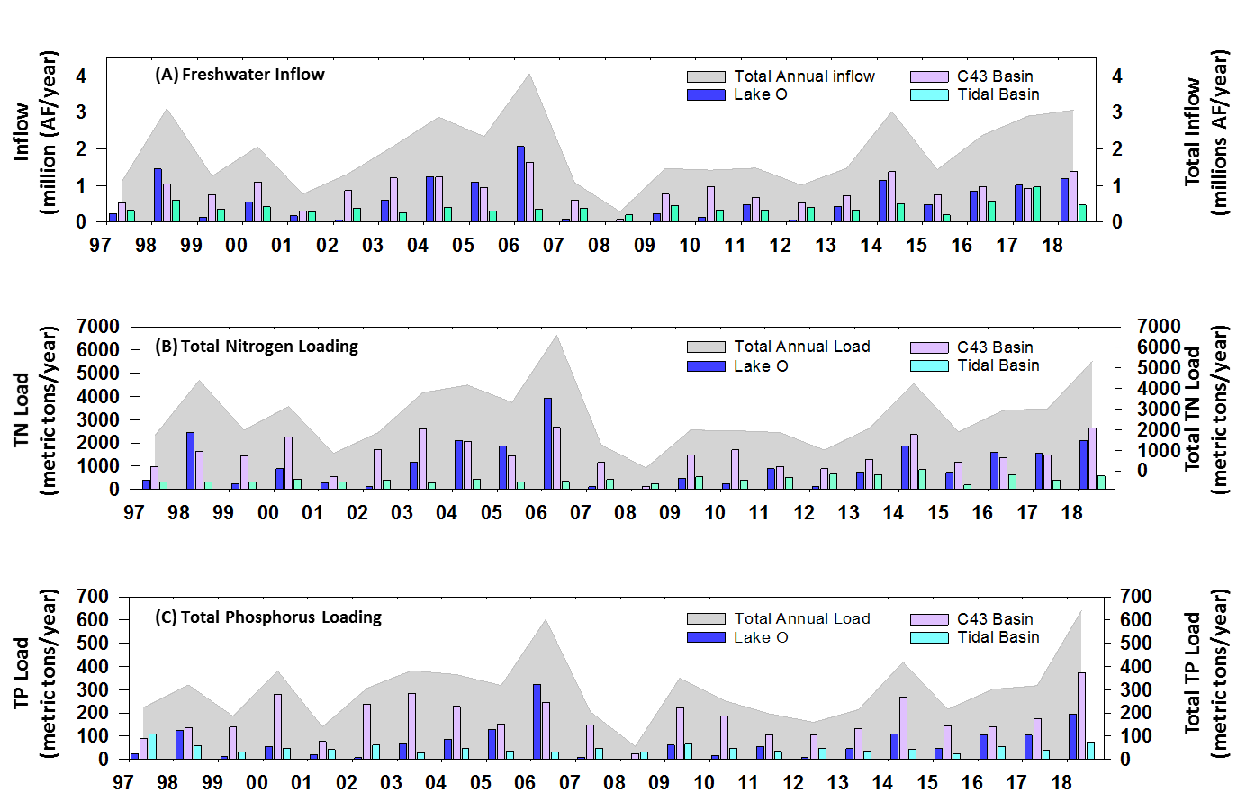
Figure 8C-17. Time series of (a) annual freshwater inflow in million acre-foot per year (million AF/year) and (b) TN loads and (c) TP loads in metric tons per year (metric tons/year) into the CRE for WY1997–WY2018.

The salinity criteria at the Ft. Myers station is a 30-day moving average of less than 10. This is designed to be protective of Vallisneria americana (tape grass) in the upper estuary. In WY2018, the criteria were exceeded 31% of the time, which was similar to the long-term average (WY2001–WY2018) (Table 8C-10). Daily salinity at Ft. Myers ranged from 0.12 on September 13, 2017, to 27.73 on May 30, 2008. The lowest daily average salinity was recorded after the passage of Hurricane Irma (September 10, 2017) (Figure 8C-13) resulting in high freshwater inflow into CRE.
Table 8C-10. Salinity criteria at the Ft. Myers station for WY2001–WY2018, WY2016, WY2017, and WY2018. At the Ft. Myers station, the daily average surface salinity goal is not to exceed the 30-day moving average surface salinity goal of 10 (Section 40E-8.221, Florida Administrative Code).
Period | Days (%) with 30-day Moving Average of Surface Salinity < 10 | Days (%) with 30-day Moving Average of Surface Salinity ≥ 10
WY2001–WY2018 | 72.1 | 27.9
WY16 | 100.0 | 0.0
WY17 | 75.1 | 24.9
WY18 | 69.1 | 30.9

Water Quality

TN and TP Loads to the Estuary
Daily TN and TP loads were calculated using measured daily inflows at S-79 and S-77, and TN and TP concentrations were determined from water samples collected approximately under conditions of flow at the structure. The contribution of the Tidal Caloosahatchee Basin to freshwater inflow and nutrient loads was estimated using a linear reservoir modeling approach. Lee County and City of Cape Coral monitor the concentrations of TN and TP in the tributaries of the CRE. These data are available from the Lee County Department of Natural Resources and City of Cape Coral. The monitoring data along with the estimated freshwater inflows from the Tidal Caloosahatchee Basin were used to derive monthly time series of TN and TP loading to the CRE for WY1997–WY2018. Flows and loads from the Cape Coral Coastal Basin were not estimated as they do not discharge into the CRE.
The annual nutrient loads to the CRE fluctuated with total freshwater inflow during the period from WY1997 to WY2018 (Figure 8C-17b and c). In WY2018, TN load was 5,329 t, which was 74%, 49%, and 56% greater than long-term average (WY1997-WY2018), WY2016, and WY2017, respectively (Table 8C-9). For TN loading, 50% was from C-43 Basin, 40% from Lake Okeechobee, and 11% from the Tidal Caloosahatchee Basin (Figure 8C-16b). The TN load from all three sources (Lake Okeechobee, C-43 Basin, and Tidal Caloosahatchee Basin) was significantly higher than the long-term average (WY1997–W2018), WY2016, and WY2017 possibly due to the impact of Hurricane Irma (Table 8C-9).
TP loading was 643 t in WY2018, of which 58% was from C-43 Basin, 30% from Lake Okeechobee, and 12% from the Tidal Caloosahatchee Basin (Figure 8C-16c). This TP load was significantly higher than long-term average (WY1997–WY2018), WY2016, and WY2018 possibly due to the impact of Hurricane Irma (Table 8C-9). Also, TP loading from each of three sources (Lake Okeechobee, C-43 Basin, and Tidal Caloosahatchee Basin) was higher than those of long-term average (WY1997–WY2018) and past two water years (WY2016 and WY2017) (Figure 8C-17c).

TP and TN Loading Data for the Most Recent Five Years (WY2014–WY2018)
Table 8-11 list tributary basin annual flows, TP load, TP FWM concentration, TN load and TN FWM concentration for the last five water years—WY2014–WY2018—in the Caloosahatchee River Watershed. Tributary basins of the Caloosahatchee River Watershed are the C-43 and S-4 basins combined and the Tidal Caloosahatchee Basin. Inflows from Lake Okeechobee to the watershed are also accounted for in Table 8-11. Tributary basin runoff in the watershed accounted for 44% of total flow, 58% of TP load, and 46% of TN load to the CRE from WY2014 through WY2018. Lake Okeechobee contributed 38% of total flow, 30% of TP load, and 40% of TN load during the same five-year period.
Table 8-11. Caloosahatchee River Watershed tributary basin annual flow volumes with TP and TN loads and FWM concentrations for WY2014–WY2018.
Water Year | Inflow from Lake Okeechobee | C-43 plus S-4 Basins | Tidal Caloosahatchee Basin | Total
Flow (10³ x acre-feet)
WY2014 | 1,145.7 | 1,377.1 | 499.8 | 3,022.6
WY2015 | 486.6 | 747.6 | 199.6 | 1,433.8
WY2016 | 849.6 | 956.7 | 570.5 | 2,376.7
WY2017 | 1,010.1 | 929.4 | 392.8 | 2,332.2
WY2018 | 1201.1 | 1391.9 | 474.4 | 3,067.3
TP Load (metric tons)
WY2014 | 108.0 | 268.8 | 41.8 | 418.5
WY2015 | 47.7 | 144.9 | 23.0 | 215.5
WY2016 | 105.9 | 140.0 | 55.8 | 301.7
WY2017 | 103.9 | 175.1 | 38.3 | 317.4
WY2018 | 194.7 | 372.8 | 75.6 | 643.1
TP FWM Concentration (mg/L)
WY2014 | 0.076 | 0.158 | 0.068 | 0.112
WY2015 | 0.080 | 0.157 | 0.093 | 0.122
WY2016 | 0.101 | 0.119 | 0.079 | 0.103
WY2017 | 0.083 | 0.153 | 0.079 | 0.089
WY2018 | 0.131 | 0.217 | 0.129 | 0.170
TN Load (metric tons)
WY2014 | 1,879.5 | 2,365.9 | 842.0 | 5,087.4
WY2015 | 725.2 | 1,171.2 | 182.5 | 2,078.9
WY2016 | 1,589.5 | 1,349.7 | 627.3 | 3,566.5
WY2017 | 1,559.2 | 1,464.7 | 392.9 | 3,416.9
WY2018 | 2,115.2 | 2,641.4 | 572.5 | 5,329.0
TN FWM Concentration (mg/L)
WY2014 | 1.33 | 1.39 | 1.37 | 1.37
WY2015 | 1.21 | 1.27 | 0.74 | 1.18
WY2016 | 1.52 | 1.14 | 0.89 | 1.22
WY2017 | 1.25 | 1.28 | 0.81 | 0.96
WY2018 | 1.43 | 1.54 | 0.98 | 1.41

Estuary Water Quality
Water column properties were determined from sampling at a depth of 0.5 m at 10 stations
in the CRE, San Carlos Bay, and Pine Island Sound at approximately monthly intervals (Figure 8C-12). Three stations (CES04, CES06, and CES08), with the most complete records, were selected to characterize estuarine water quality. Concentrations of TN, TP, and Chla for WY2001–WY2018 were assessed (Figure 8C-18). Long-term and seasonal averages and standard deviations were calculated for long-term average for the WY2000–WY2018 period and most recent three water years (WY2016, WY2017, and WY2018) (Table 8C-12).
Chla concentrations at the selected three stations varied from 0.25 to 106 μg/L (Figure 8C-18). The long-term average concentrations were highest at CES04 and decreased moving downstream from CES06 to CES08 (Table 8C-12). However, in WY2016 and WY2018, annual average Chla concentration was highest at CES06 (Table 8C-12). Dry and wet season average concentrations in WY2016 and WY2018 followed the same pattern. Chla concentrations at both CES04 and CES06 in WY2018 were higher than previous two water years but less than long-term average whereas CES08 had a higher value than either the long-term average or past two water years. All three stations generally had higher Chla concentrations during the wet season than the dry season with some exceptions (Table 8C-12).
TN concentrations were highly variable at all three stations and ranged from 0.03 to 4.97 mg/L (Figure 8C-18). The long-term average concentrations decreased in the downstream direction (Table 8C-12). TN concentration in WY2018 followed the same pattern as Chla with the highest concentration at CES04 and decreasing downstream. All three stations had higher concentrations than both the long-term average (WY2000–WY2018) and past two water years (WY2016 and WY2017). During WY2018 and WY2017, wet season average TN concentrations exceeded dry season concentrations at all three stations. The WY2018 wet season average concentrations at all the three stations were higher than in WY2016 and WY2017, and the long-term averages.
TP concentrations also were highly variable at all three stations and ranged from 0.016 to 0.689 mg/L (Figure 8C-18). The long-term average concentrations also decreased in the downstream direction (Table 8C-12). The average concentrations and the range of variations at all the three stations were higher during the wet seasons compared to the dry seasons. The WY2018 wet season average concentrations at all the three stations were higher than in WY2016 and WY2017, and the long-term averages.

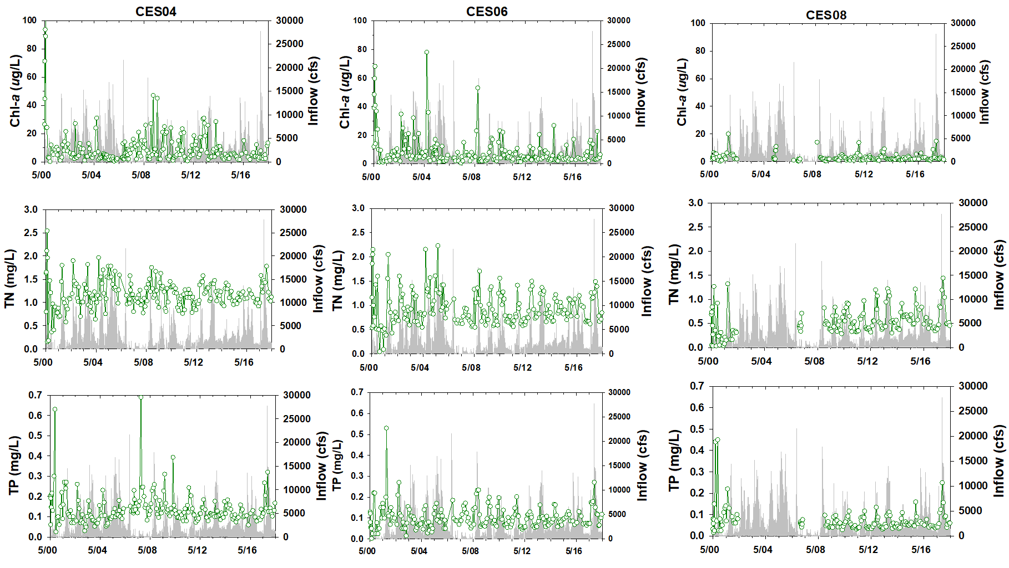
Figure 8C-18. Time series of Chla, TN, and TP (green line with open circles) and total gauged inflows (gray line) at stations CES04, CES06 and CES08 in the CRE.
Table 8C-12. Summary of water column concentrations of Chla in micrograms per liter (μg/L), and TN and TP in milligrams per liter (mg/L) at three stations (CES04, CES06 and CES08) in the CRE. The table includes dry season (November–April), wet season (May–October), and total averages (Avg) and standard deviations (SD) for the WY2000–WY2018 period, and for WY2016, WY2017, and WY2018.
Chla  (μg/L) | CES04 |  |  |  |  |  | CES06 |  |  |  |  |  | CES08
Chla  (μg/L) | Dry |  | Wet |  | Total |  | Dry |  | Wet |  | Total |  | Dry |  | Wet |  | Total
Chla  (μg/L) | Avg | SD | Avg | SD | Avg | SD | Avg | SD | Avg | SD | Avg | SD | Avg | SD | Avg | SD | Avg | SD
WY2000–WY2018 | 8.43 | 7.60 | 11.18 | 17.26 | 9.81 | 13.38 | 7.00 | 7.33 | 11.39 | 14.04 | 9.21 | 11.41 | 2.40 | 2.07 | 4.51 | 3.72 | 3.36 | 3.11
WY2016 | 2.97 | 2.20 | 4.95 | 0.99 | 4.20 | 1.73 | 7.74 | 8.10 | 5.14 | 4.48 | 6.12 | 5.66 | 3.00 | 2.12 | 2.68 | 0.97 | 2.80 | 1.36
WY2017 | 4.13 | 1.82 | 8.33 | 6.00 | 5.70 | 4.11 | 5.47 | 2.31 | 3.61 | 0.76 | 4.77 | 2.04 | 1.67 | 0.84 | 3.65 | 2.23 | 2.41 | 1.69
WY2018 | 6.40 | 4.75 | 5.19 | 3.98 | 5.79 | 4.23 | 7.18 | 7.71 | 9.75 | 6.21 | 8.46 | 6.81 | 2.26 | 0.59 | 5.60 | 5.16 | 3.93 | 3.91
TN  (mg/L) | CES04 |  |  |  |  |  | CES06 |  |  |  |  |  | CES08
TN  (mg/L) | Dry |  | Wet |  | Total |  | Dry |  | Wet |  | Total |  | Dry |  | Wet |  | Total
TN  (mg/L) | Avg | SD | Avg | SD | Avg | SD | Avg | SD | Avg | SD | Avg | SD | Avg | SD | Avg | SD | Avg | SD
WY2000–WY2018 | 1.17 | 0.49 | 1.27 | 0.30 | 1.22 | 0.41 | 0.75 | 0.27 | 1.02 | 0.36 | 0.89 | 0.35 | 0.52 | 0.17 | 0.69 | 0.30 | 0.60 | 0.26
WY2016 | 1.16 | 0.08 | 1.07 | 0.08 | 1.10 | 0.09 | 0.98 | 0.18 | 0.94 | 0.19 | 0.96 | 0.17 | 0.73 | 0.14 | 0.75 | 0.31 | 0.74 | 0.25
WY2017 | 1.01 | 0.07 | 1.18 | 0.09 | 1.08 | 0.11 | 0.73 | 0.13 | 0.99 | 0.21 | 0.83 | 0.20 | 0.42 | 0.07 | 0.50 | 0.11 | 0.45 | 0.09
WY2018 | 1.25 | 0.30 | 1.34 | 0.21 | 1.30 | 0.25 | 0.84 | 0.31 | 1.16 | 0.29 | 1.01 | 0.33 | 0.60 | 0.24 | 0.86 | 0.41 | 0.74 | 0.35
TP  (mg/L) | CES04 |  |  |  |  |  | CES06 |  |  |  |  |  | CES08
TP  (mg/L) | Dry |  | Wet |  | Total |  | Dry |  | Wet |  | Total |  | Dry |  | Wet |  | Total
TP  (mg/L) | Avg | SD | Avg | SD | Avg | SD | Avg | SD | Avg | SD | Avg | SD | Avg | SD | Avg | SD | Avg | SD
WY2000-WY2018 | 0.12 | 0.04 | 0.17 | 0.09 | 0.14 | 0.07 | 0.08 | 0.03 | 0.12 | 0.05 | 0.10 | 0.05 | 0.05 | 0.02 | 0.08 | 0.04 | 0.06 | 0.03
WY2016 | 0.09 | 0.03 | 0.12 | 0.03 | 0.11 | 0.03 | 0.08 | 0.01 | 0.11 | 0.01 | 0.10 | 0.02 | 0.06 | 0.01 | 0.08 | 0.05 | 0.07 | 0.04
WY2017 | 0.10 | 0.02 | 0.11 | 0.02 | 0.10 | 0.02 | 0.07 | 0.00 | 0.11 | 0.03 | 0.08 | 0.02 | 0.04 | 0.00 | 0.06 | 0.02 | 0.05 | 0.01
WY2018 | 0.11 | 0.02 | 0.20 | 0.08 | 0.15 | 0.07 | 0.08 | 0.03 | 0.17 | 0.06 | 0.13 | 0.06 | 0.06 | 0.02 | 0.12 | 0.07 | 0.09 | 0.06

Aquatic Habitat

Submerged Aquatic Vegetation
Submerged aquatic vegetation (SAV) monitoring in the CRE has been ongoing with the following methods since 2012 by RECOVER in support of CERP (RECOVER 2014). Presented here are results from two sites of monthly wet season (May–October) sampling events: CRE 2 and CRE 8 (Figure 8C-12; note that the labels on this figure do not contain “CRE” just the number) for WY2014–WY2018. At each site, a ~2-acre (0.81-hectare) polygon was delineated and for each sampling event, 30 random points within the polygon were sampled and a visual estimated percent cover was recorded. Starting in 2017, the visual estimates were converted to BBCA scores and in-field measures of BBCA scores were recorded. BBCA assesses percent cover of the bottom by the SAV using a scale ranging from 0 to 5 representing values of ~5 to 75 to 100% cover (Table 8C-6; Fourqurean et al. 2003).
SAV at the upper estuary, low salinity habitat of CRE 2 is comprised of Ruppia maritima (widgeon grass) and Vallisneria americana (tape grass). While widgeon grass prefers salinity 10 to 20 (Murphy et al. 2003, Strazisar et al. 2015), tape grass survival is impeded at salinity > 10 (Haller et al. 1974, Doering et al. 2001, 2002, French and Moore 2003, Boustany et al. 2010, Lauer et al. 2011). Total SAV cover declined from WY2014 to WY2015 and exhibited some recovery in WY2016 with increased cover of Ruppia maritima. Vallisneria americana cover increased from WY2015 to WY2017 but decreased in the WY2018 wet season (Figure 8C-19A).
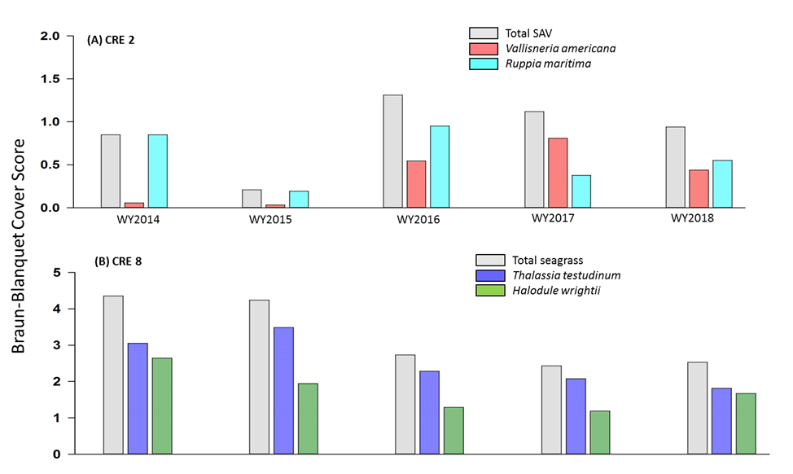
Figure 8C-19. BBCA score for average wet season (May–October) monthly sampling events of SAV at (A) Willoughby Creek (CRE 2) and (B) Boy Scout Island (CRE 8) for WY2014–WY2018.
Estimates are provided for total SAV cover (grey fill) and individual species.
The CRE 8 (Figure 8C-12) is higher salinity habitat and the dominant species are Halodule wrightii (shoal grass) and Thalassia testudinum (turtle grass), the latter of which prefers salinity between 30 and 40 (Zieman 1975, Doering and Chamberlain 2000). Total SAV cover declined from WY2015 through WY2016 and remained stable through WY2018. There was a slight change in relative species abundance with a decline in Thalassia testudinum relative to increased Halodule wrightii cover from WY2017 to WY2018 (Figure 8C-19B).

Oyster Habitat
Oyster monitoring has been ongoing at multiple sites in the lower CRE since WY2001 by RECOVER in support of CERP (RECOVER 2014). The assessment provided here utilized data from the Bird Island and Iona Cove sites (Figure 8-12) for WY2006–WY2018. At these sites, living oyster density was determined biannually using survey methodology based on that of Lenihan and Peterson (1998) and Grizzle et al. (2005) with quarterly sampling beginning in 2018. Recruitment was measured monthly from shells suspended on strings and calculated to spat/shell/month. Tissue from a subset of live adult oysters was collected monthly to determine prevalence (number infected/total collected) of the protozoan pathogen, Perkinsus marinus (dermo) (Ray 1966).
Adult live oyster average density at Iona Cove was moderate for this site at 714 oysters/m² in June 2017 (WY2018; Table 8C-13). The highest number over the last five years observed at Iona Cove was in the WY2016 dry season at 1,552 oysters/m². Bird Island had low adult oyster densities in WY2018 compared to previous years (Table 8C-13). The WY2018 wet season average density of 813 oysters/m² was more than two and a half times lower than the previous water year’s wet season (2,107 oysters/m²), though it followed a similar low average density observed in the WY2017 dry season sampling (809 oysters/m²; Table 8C-13). After Hurricane Irma in September 2017, average density at the Bird Island site was 587 oysters/m², while only 2 oysters/m² were observed at the Iona Cove site during the March 2018 sampling event (Table 8C-13). Salinity at Ft. Myers remained below 10 after Hurricane Irma through January 2018.
Table 8C-13 Time series of average live adult oyster densities from the CRE sites for WY2014–WY2018 and month sampled.
Water Year | Season | Month Sampled | Density  (oysters per m²)
Water Year | Season | Month Sampled | Iona Cove | Bird Island
WY2014 | Wet | August | 0 | 2,606
WY2014 | Dry | February | Not applicable | 2,139
WY2014 | Dry | March | 218 | Not applicable
WY2015 | Wet | July | 442 | 1,428
WY2015 | Dry | February | 690 | 1,388
WY2016 | Wet | September | 857 | 1,643
WY2016 | Dry | February | 1,552 | Not applicable
WY2016 | Dry | March | Not applicable | 1,934
WY2017 | Wet | August | 231 | 2,107
WY2017 | Dry | March | 430 | 809
WY2018 | Wet | June | 714 | 813
WY2018 | Dry | March | 2 | 587

Larval recruitment was relatively low throughout WY2018 at Iona Cove and average larval recruitment was 0.02 spat/shell in the months following Hurricane Irma, in a high flow, low salinity, environment (Figure 8C-20A). There was a peak at Bird Island in larval recruitment in August 2017 (WY2018) with an average of 34 spat/shell. Post-Hurricane Irma, October 2017 average recruitment was 23 spat/shell, which is relatively high for October at this particular site compared to the previous five years (Figure 8C-21A). Average recruitment for the WY2018 dry season was 1.25 spat/shell for Bird Island.
WY2018 dermo prevalence was moderately low at Iona Cove until a peak of 100% prevalence was observed in July 2017 followed by diminished prevalence in August (Figure 8C-20B). This pattern was also observed at Bird Island, whereby a consistent monthly pattern of 20% spiked to 60% in July and receded to 40% in August (Figure 8C-21B). Bird Island WY2018 dry season average dermo prevalence was 29%, which was lower than the previous dry season (41%). After Hurricane Irma, live adult oysters were not present the remainder of WY2018 at Iona Cove to sample for the assessment of dermo.
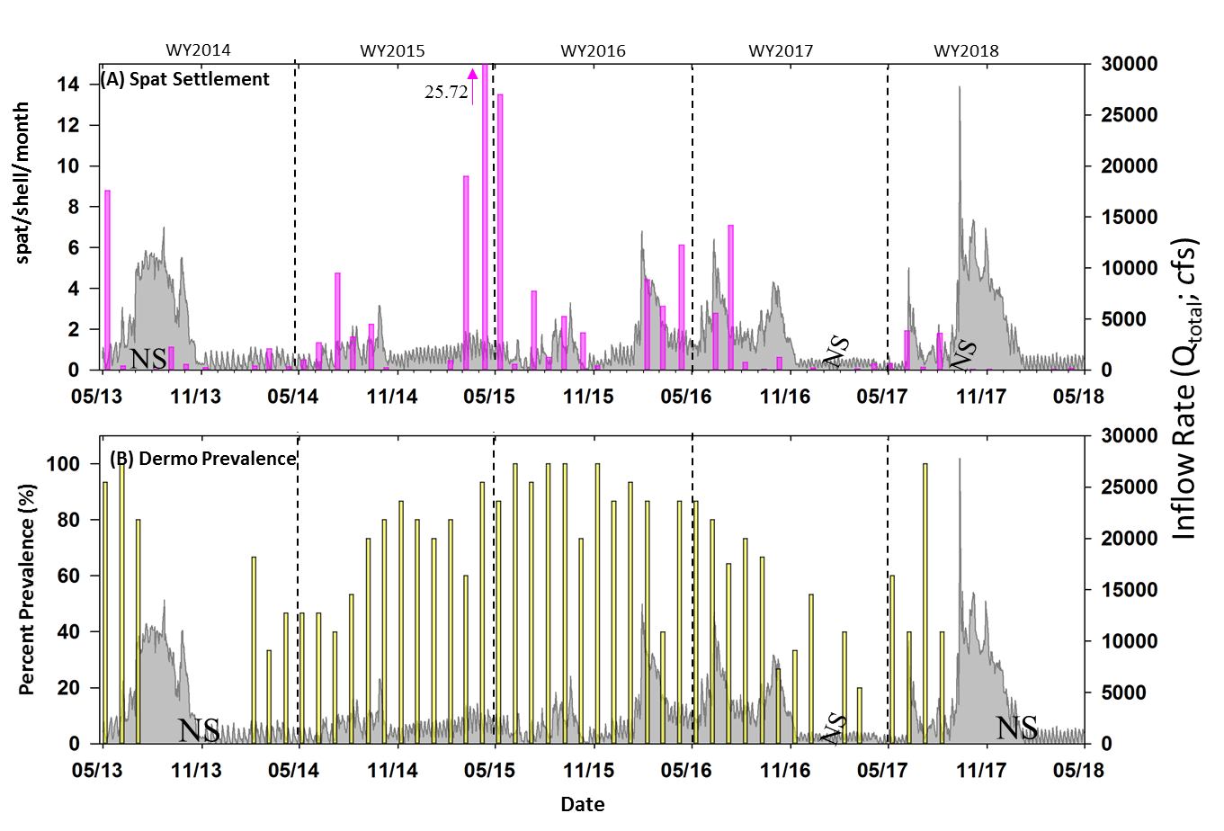
Figure 8C-20. Time series of oyster monitoring metrics from the Iona Cove site of the CRE for WY2014–WY2018. (A) Monthly spat settlement rate (spat/shell/month) and (B) monthly percent dermo prevalence. The right y-axis depicts daily freshwater inflow rate from S-79 to the CRE, not including Tidal Caloosahatchee Basin flows (grey area fill). NS represents date not sampled or no living oysters present at the site for sampling at the time of sampling event. Recruitment data for the CRE sites are not available for February 2017 since all stringers were replaced with new.
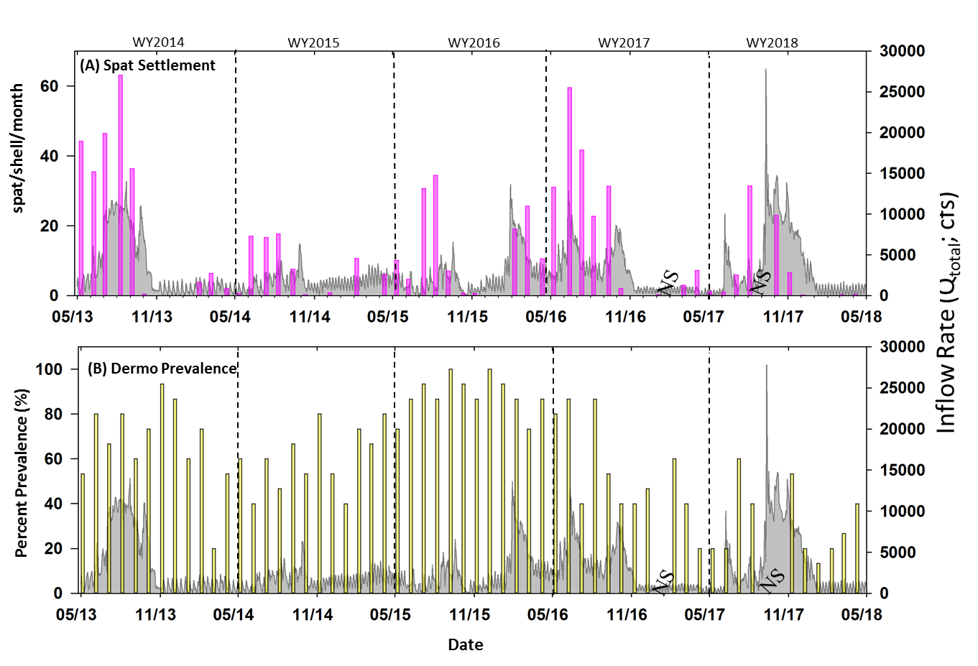
Figure 8C-21. Time series of oyster monitoring metrics from the Bird Island Site of the CRE for WY2014–WY2018. (A) Monthly spat settlement rate (spat/shell/month) and (B) monthly percent dermo prevalence. The right y-axis depicts daily freshwater inflow rate from S-79 to the CRE, not including Tidal Caloosahatchee Basin flows (grey area fill). NS represents date not sampled or no living oysters present at the site for sampling at the time of sampling event. Recruitment data for the CRE sites are not available for February 2017 since all stringers were replaced with new.

Summary
- Rainfall across the C-43 and Tidal Caloosahatchee basins in WY2018 was 63.0 inches, with 91% occurring in the wet season and 9% occurring in the dry season. Rainfall was 17% higher than the long-term annual average (WY1997–WY2018).
- The total freshwater inflow to the CRE in WY2018 was 3.063 million ac-ft, of which 39% was from Lake Okeechobee, 45% was from the C-43 Basin, and 15% from the Tidal Caloosahatchee Basin. Total inflow was 63% more than long-term average (WY1997–WY2018).
- The 30-day moving average surface salinity exceeded 10 at Ft. Myers 31% of the days in WY2018, similar to the long-term average.
- Nitrogen loading to the CRE in WY2018 was higher than the previous two years and the long-term average with the greatest source of loading from the C-43 Basin (2,641 t or 50% of the total).
- Phosphorus loading to the estuary was 116% higher in WY2018 (643 t) than the long-term average (WY1997–WY2018). The largest source was from the C-43 Basin (373 t or 58% of the total).
- Chla concentrations tended to be lower in WY2018 than the long-term average, except in the wet season in the lower estuary.
- Vallisneria americana cover declined at CRE 2, the upper estuary, low salinity site, from WY2017 to the WY2018 wet season. Total SAV cover remained stable at the more oceanic salinity site of CRE 8 in the lower estuary, with both Halodule wrightii and Thalassia testudinum present in an average of 5 to 25% cover in the WY2018 wet season.
- Average oyster density at Bird Island in the lower CRE was relatively low in WY2018 (813 oysters/m² pre-hurricane) and declined post-hurricane to 587 oysters/m². Oyster larval recruitment was less than 1 spat per shell in the dry season. Iona Cove was similarly impacted by the hurricane.

Literature Cited
Adams, A.J., R. Kirby-Wolfe and C.A. Layman. 2009. Preliminary examination of how human-driven freshwater inflow alteration affects trophic ecology of juvenile snook (Centropomus undecimalis) in estuarine creeks. Estuaries and Coasts 32:819-828.
Alber, M. 2002. A conceptual model of esturine freshwater inflow management. Estuaries (25)6B:1246-1261.
Allman, R. 2012. Proposal to Change the St. Lucie Estuary Salinity Envelope Ranges in the Weekly Estuarine Conditions Report. Technical Notes, South Florida Water Management District, West Palm Beach, FL. August 2012.
Antonini, G.A., D.A. Fann and P. Roat. 2002. A Historical Geography of Southwest Florida Waterways, Volume Two: Placida Harbor to Marco Island. National Seagrant College Program, Silver Spring, MD.
Balci, P. and L. Bertolotti L. 2012. Appendix 10-2: Caloosahatchee River Watershed Protection Plan 2012 Update. In: 2012 South Florida Environmental Report – Volume I, South Florida Water Management District, West Palm Beach, FL.
Barnes, T. 2005. Caloosahatchee Estuary Conceptual Ecological Model. Wetlands 25:884-897.
Barnes, T., A.K. Volety, K. Chartier, F.J. Mazzotti and L. Pearlstine. 2007. A habitat suitability index model for the eastern oyster (Crassostrea virginica), at tool for restoration of the Caloosahatchee Estuary, Florida. Journal of Shellfish Research 26(4):949-959.
Bertolotti, L. and P. Balci. 2012. Appendix 10-1: St. Lucie River Watershed Protection Plan 2012 Update. In: 2012 South Florida Environmental Report – Volume I, South Florida Water Management District, West Palm Beach, FL.
Bortone, S.A. and R.K. Turpin. 2000. Tape grass life history metrics associated with environmental variables in a controlled estuary. Pages 65–79 in: S.A. Bortone (ed.), Seagrasses: Monitoring, Ecology, Physiology, and Management, CRC Press, Boca Raton, FL.
Boustany, R.G., T.C. Michot and R.F. Moss. 2010. Effects of salinity and light on biomass and growth of Vallisneria americana from lower St. Johns River, FL, USA. Wetlands Ecology and Management 18:203-217.
Buzzelli, C., B. Robbins, P. Doering, Z. Chen, D. Sun, Y. Wan, B. Welch and A. Schwarzchild. 2012. Monitoring and modelling of Syringodium filiforme (manatee grass) in Southern Indian River Lagoon. Estuaries and Coasts 35:1401-1415.
Buzzelli, C., Z. Chen, T. Coley, P. Doering, R. Samimy, D. Schlesinger and B. Howes. 2013a. Dry season sediment-water exchanges of nutrients and oxygen in two Floridian estuaries: Patterns, comparisons, and internal loading. Florida Scientist 76(1)54-79.
Buzzelli, C., P. Doering, Y. Wan and J. Boyer. 2013b. Seasonal dissolved inorganic nitrogen
and phosphorus budgets for two sub-tropical estuaries in South Florida. Biogeosciences 10:6721-6736.
Buzzelli, C., K. Carter, L. Bertolotti and P. Doering. 2015. Chapter 10: St. Lucie and Caloosahatchee River Watershed Protection Program Annual and Three-year Updates. In: 2015 South Florida Environmental Report – Volume I, South Florida Water Management District, West Palm Beach, FL.
Buzzelli, C., P. Doering, Y. Wan, T. Coley, D. Sun, Z. Chen, C. Thomas, D. Medellin and T. Edwards. 2017. Assessment of the Responses of the Caloosahatchee River Estuary to Low Freshwater Inflow in the Dry Season. South Florida Water Management District, West Palm Beach, FL.
Buzzelli, C., A. Wachnicka, F. Zheng, Z. Chen, L. Baldwin and Amamda Kahn. 2018. Chapter 8C: St. Lucie and Caloosahatchee River Watershed Research and Water Quality Monitoring Results and Activities. In: 2018 South Florida Environmental Report – Volume I, South Florida Water Management District, West Palm Beach, FL.
Chamberlain, R.H. and P.H. Doering. 1998. Freshwater inflow to the Caloosahatchee Estuary and the Resource-based Method for Evaluation. Page 274 in: S.F. Treat (ed.), Proceedings of the Charlotte Harbor Public Conference and Technical Symposium, March 1997. Technical Report 98-02, South Florida Water Management District, West Palm Beach, FL.
Cloern, J.E. 2001. Our evolving conceptual model of the coastal eutrophication problem. Marine Ecology Progress Series 210:223-253.
Coen, L.D., R.D. Brumbaugh, D. Bushek, R.E. Grizzle, M.W. Luckenbach, M.H. Posey, S.P. Powers and S.G. Tolley. 2007. Ecosystem services related to oyster restoration. Marine Ecology Progress Series 341:303-307.
Collins, A.B., M.R. Heupel and C.A. Simpfendorfer. 2008. Spatial distribution and long-term movement patterns of cownose rays Rhinoptera bonasus within an estuarine river. Estuaries and Coasts 31(6):1174-1183.
Doering, P.H. 1996. Temporal variability of water quality in the St. Lucie Estuary, South Florida. Journal of the American Water Resources Association 32(6):1293-1306.
Doering, P.H. and R.H. Chamberlain. 2000. Experimental studies on the salinity tolerance of turtle grass, Thalassia testudinum. Pages 81–98 in: S.A. Bortone (ed.), Seagrasses: Monitoring Ecology, Physiology, and Management, CRC Press, Boca Raton, FL.
Doering, P.H., R.H. Chamberlain and J.M. McMunigal. 2001. Effects of simulated saltwater intrusions on the growth and survival of wild celery, Vallisneria americana, from the Caloosahatchee Estuary (South Florida). Estuaries and Coasts 24(6):894-903.
Doering, P.H., R.H. Chamberlain and D.E. Haunert. 2002. Using submerged aquatic vegetation to establish minimum and maximum freshwater inflows to the Caloosahatchee Estuary, Florida. Estuaries and Coasts 25(6):1343-1354.
Duarte, C.M., N. Marba, D. Krause-Jensen and M. Sanchez-Camacho. 2007. Testing the predictive power of seagrass depth limit models. Estuaries and Coasts 30:652-656.
Duarte, C.M., W.C. Dennison, R.J. W. Orth and T.J.B. Carruthers. 2008. The charisma of coastal ecosystems: Addressing the imbalance. Estuaries and Coasts 31:233-238.
Flannery, M.S., E.B. Peebles and R.T. Montgomery. 2002. A percent-of-inflow approach for managing reductions of freshwater inflows from unimpounded rivers to Southwest Florida estuaries. Estuaries 25(6B):1318-1332.
Fourqurean, J.W., J.N. Boyer, M.J. Durako, L.N. Hefty and B.J. Peterson. 2003. Forecasting responses of seagrass distributions to changing water quality using monitoring data. Ecological Applications 13:474-489.
French, G.T. and K.A. Moore. 2003. Interactive effects of light and salinity stress on the growth, reproduction, and photosynthetic capabilities of Vallisneria americana (wild celery). Estuaries 26:1255-1268.
Grizzle, R.E., L.G. Ward, J.R. Adams, S.J. Dijkstra and B. Smith. 2005. Mapping and characterizing subtidal oyster reefs using acoustic techniques, underwater videography, and quadrat counts. American Fisheries Society Symposium 41:153-159.
Hagy, J.D. and M. Murrell. 2007. Susceptibility of a northern Gulf of Mexico estuary to hypoxia: An analysis using box models. Estuarine, Coastal, and Shelf Science 74:239-253.
Haller, W.T., D.L. Sutton and W.C. Barlowe. 1974. Effects of salinity on growth of several aquatic macrophytes. Ecology 55:891-894.
Heupel, M.R. and C.A. Simpfendorfer. 2008. Movement and distribution of young bull sharks Carcharhinus leucas in a variable estuarine environment. Aquatic Biology 1:277-289.
Jassby, A.D., W.J. Kimmerer, S.G. Monismith, C. Armor, J.E. Cloern, T.M. Powell, J.R. Schubel and T.J. Vendlinski. 1995. Isohaline position as a habitat indicator for estuarine populations. Ecological Applications 5:272-289.
Ji, Z.G., G. Hu, J. Shen and Y. Wan. 2007. Three-dimensional modeling of hydrodynamics processes in the St. Lucie Estuary. Estuarine, Coastal, & Shelf Science 73:188-200.
Kahn, A.E., J.J. Beal and M.J. Durako. 2013. Diurnal and tidal variability in the photobiology of the seagrass Halophila johnsonii in a riverine versus marine habitat. Estuaries and Coasts 36:430-443.
La Peyre, M.K., A.D. Nickens, A.K. Volety, G. Tolley and J.F. La Peyre. 2003. Environmental significance of freshets in reducing Perkinsus marinus infection in eastern oysters Crassostrea virginica: Potential management applications. Marine Ecology Progress Series 248:165-176.
LaPoint, B.E., L.W. Herren and B.J. Bedford. 2012. Effects of hurricanes, land use, and water management on nutrient and microbial pollution: St. Lucie Estuary, southeast Florida. Journal of Coastal Research 28(6):1345-1361.
Lauer, N., M. Yeager, A.E. Kahn, D.R. Dobberfuhl and C. Ross. 2011. The effects of short term salinity exposure on the sublethal stress response of Vallisneria americana Michx. (Hydrocharitaceae). Aquatic Botany 95(3):207-213.
Lee, K.S., S.R. Park and Y.K. Kim. 2007. Effects of irradiance, temperature, and nutrients on growth dynamics of seagrasses: A review. Journal of Experimental Marine Biology and Ecology 350:144-175.
Lenihan, H.S. and C.H. Peterson. 1998. How habitat degradation through fishery disturbance enhances impacts of hypoxia on oyster reefs. Ecological Applications 8:128-140.
Lirman, D. and W.P. Cropper. 2003. The influence of salinity on seagrass growth, survivorship, and distribution within Biscayne Bay, Florida: Field, experimental, and modeling studies. Estuaries 26:131-141.
Lirman, D., G. Deangelo, J. Serafy, A. Hazra, D.S. Hazra, J. Herlan, J. Luo, S. Bellmund, J. Wang and R. Clausing. 2008. Seasonal changes in the abundance and distribution of submersed aquatic vegetation in a highly managed coastal lagoon. Hydrobiologia 596:105-120.
Mattson, R.A. 2002. A resourced-based framework for establishing freshwater inflow requirements for the Suwannee River Estuary. Estuaries 25(6B):1333-1342.
Millie, D.F., H.J. Carrick, P.H. Doering and K.A. Steidinger. 2004. Intra-annual variability of water quality and phytoplankton in the North Fork of the St. Lucie River Estuary, Florida (USA): A quantitative assessment. Estuarine, Coastal, and Shelf Science 1:137-149.
Montagna, P., M. Alber, P. Doering and M.S. Connor. 2002. Freshwater inflow: Science, policy, management. Estuaries 25(6B):1243-1245.
Murphy, L.R., S.T. Kinsey and M.J. Durako. 2003. Physiological effects of short-term salinity changes on Ruppia maritima. Aquatic Botany 75:293-309.
Parker, M., M.S. Arnold, S.P. Geiger, P. Gorman and E.H. Leone. 2013. Impacts of freshwater management activities on eastern oyster (Crassostrea virginica) density and recruitment: Recovery and long-term stability in seven Florida estuaries. Journal of Shellfish Research 32(3):695-708.
Peterson, C.H., J.H. Grabowski and S.P. Powers. 2003. Estimated enhancement of fish production resulting from restored oyster reef habitat: Quantitative valuation. Marine Ecology Progress Series 264:249-264.
Phlips, E.J., S. Badylak, J. Hart, D. Haunert, J. Lockwood, K. O'Donnell, D. Sun, P. Viveros and M. Yilmaz. 2011. Climatic influences on autochthonous and allochthonous phytoplankton biomass in a subtropical estuary, St. Lucie Estuary, Florida, USA. Estuaries and Coasts 35:335-352.
Pollack, J.B., H.C. Kim, E.K. Morgan and P.A. Montagna. 2011. Role of flood disturbance in natural oyster (Crassostrea virginica) population maintenance in an estuary in South Texas, USA. Estuaries and Coasts 34:187-197.
Poulakis, G R., P.W. Stevens, A.A. Timmers, C.J. Stafford and C.A. Simpfendorfer. 2013. Movements of juvenile endangered smalltooth sawfish, Pristis pectinata, in an estuarine river system: Use of non-main-stem river habitats and lagged responses to freshwater inflow-related changes. Environmental Biology of Fishes 96(6):763-778.
Radabaugh, K.R. and E.B. Peebles. 2012. Detection and classification of phytoplankton deposits along an estuarine gradient. Estuaries and Coasts 35(6):1361-1375.
Ray, S.M. 1966. A review of the culture method for detecting Dermocystidium marinum, with suggested modifications and precautions. Proceedings of the National Shellfisheries Association 54:55-69.
RECOVER. 2014. 2014 System Status Report. Restoration Coordination and Verification Program c/o United States Army Corps of Engineers, Jacksonville, FL, and South Florida Water Management District, West Palm Beach, FL. Available online at https://evergladesrestoration.gov/ssr/2014/ssr_full_2014.pdf.
Rosen, B.H., T.W. Davis, C.J. Gobler, B.J. Kramer and K.A. Loftin. 2017. Cyanobacteria of the 2016 Lake Okeechobee Waterway Harmful Algal Bloom. Open File Report 2017-1054, United States Geological Survey, Reston, VA. Available online at https://pubs.er.usgs.gov/publication/ofr20171054.
SFWMD. 2000. Draft Technical Documention to Support Development of Minimum Inflows and Levels for the Caloosahatchee River and Estuary. South Florida Water Management District, West Palm Beach, FL. September 6, 2000.
SFWMD. 2003. Technical Documentation to Support Development of a Minimum Inflows and Levels for the Caloosahatchee River and Estuary Draft 2003 Status Update Report. South Florida Water Management District, West Palm Beach, FL. February 3, 2003.
SFWMD. 2010. Final Adaptive Protocols for Lake Okeechobee Operations. South Florida Water Management District, West Palm Beach, FL.
SFWMD. 2017. Field Sampling Quality Manual. SFWMD-FIELD-QM-001-09, South Florida Water Management District, West Palm Beach, FL. Effective June 29, 2017.
SFWMD. 2018. 2018 Chemistry Laboratory Quality Manual. SFWMD-LAB-QM-2018-001, South Florida Water Management District, West Palm Beach, FL. Effective January 8, 2018.
SFWMD, FDEP and FDACS. 2009a. Caloosahatchee River Watershed Protection Plan. South Florida Water Management District, West Palm Beach, FL; Florida Department of Environmental Protection, Tallahassee, FL; and Florida Department of Agriculture and Consumer Services, Tallahasee, FL. January 2009. Available online at http://www.sfwmd.gov/northerneverglades.
SFWMD, FDEP and FDACS. 2009b. St. Lucie River Watershed Protection Plan.
South Florida Water Management District, West Palm Beach, FL; Florida Department of Environmental Protection, Tallahassee, FL; and Florida Department of Agriculture and Consumer Services, Tallahassee, FL. January 2009. Available online at http://www.sfwmd.gov/northerneverglades.
SFWMD, FDEP and Amec Foster Wheeler. 2018. Draft St. Lucie River and Estuary Watershed Hydrology and Water Quality Modeling for the St. Lucie River and Estuary Basin Management Action Plan. April 2018.
Short, F.T., J. Montgomery, C.F. Zimmerman and C.A. Short. 1993. Production and nutrient dynamics of a Syringodium filiforme Kutz. seagrass bed in Indian River Lagoon, Florida. Estuaries 16(2):323-334.
Sime, P. 2005. St. Lucie Estuary and Indian River Lagoon Conceptual Ecological Model. Wetlands 25:898-207.
Simpfendorfer, C.A., B.G.Yeiser, T.R. Wiley, G.R. Poulakis, P.W. Stevens and M.R. Heupel. 2011. Environmental influences on the spatial ecology of juvenile smalltooth sawfish (Pristis pectinata): Results from acoustic monitoring. PLoS One 6(2):e16918.
Stevens, P.W., M.F. Greenwood and D.A. Blewett. 2013. Fish assemblages in the oligohaline stretch of a southwest Florida river during periods of extreme freshwater inflow variation. Transactions of the American Fisheries Society 142(6):1644-1658.
Strazizar, T., M.S. Koch and C.J. Madden. 2015. Seagrass (Ruppia maritima L.) life history transitions in response to salinity dynamic along the Everglades-Florida Bay ecotone. Estuaries and Coasts 38:337-352.
Tolley, S.G. A.K. Volety and M. Savarese. 2005. Influence of salinity on the habitat use of oyster reefs in three Southwest Florida estuaries. Journal of Shellfish Research 24:127-137.
Tolley, S.G., A.K. Volety, M. Savarese, L.D. Walls, C. Linardich and E.M. Everham III. 2006. Impacts of salinity and freshwater inflow on oyster-reef communities in Southwest Florida. Aquatic Living Resources 19(4):371-387.
Tolley, S.G., D. Fugate, M.L. Parsons, S.E. Burghart and E.B. Peebles. 2010. The Responses of Turbidity, CDOM, Benthic Microalgae, Phytoplankton, and Zooplankton to Variation in Seasonal Freshwater Inflow to the Caloosahatchee Estuary. Submitted to South Florida Water Management District, West Palm Beach, FL, and United States Department of Education, Washington, DC.
Tomasko, D.A., C.J. Dawes and M.O. Hall. 1996. The effects of anthropogenic enrichment on turtle grass (Thalassia testudinum) in Sarasota Bay, Florida. Estuaries 19:448-456.
USACE. 1957. General Design Memorandum, Caloosahatchee River and Control Structures (Canal 43 Lock and Spillway Structures 77, 78, and 79), Part IV: Central and Southern Florida Project. Serial Number 36, Jacksonville District, United States Army Corps of Engineers, Jacksonville, FL.
USACE and SFWMD. 1999. Central and Southern Florida Project Comprehensive Review Study Final Integreted Feasibility Report and Programmatic Environmental Impact Statement. United States Army Corps of Engineers, Jacksonville, FL; and South Florida Water Management District, West Palm Beach, FL. April 1999.
USACE and SFWMD. 2004. Central and Southern Florida Project Indian River Lagoon – South Final Integrated Project Implementation Report and Environmental Impact Statement. United States Army Corps of Engineers, Jacksonville, FL; and South Florida Water Management District, West Palm Beach, FL. March 2004.
Volety, A.K., M. Savarese, S.G. Tolley, W.S. Arnold, P. Sime, P. Goodman, R.H. Chamberlain and P.H. Doering. 2009. Eastern oysters (Crassotrea virginica) as an indicator for restoration of Everglades ecosystems. Ecological Indicators 9:S120-S136.
Wan, Y. and K. Konyha. 2015. A simple hydrologic model for rapid prediction of runoff from ungauged coastal catchments, Journal of Hydrology 28:571-583.
Wilber, D. 1992. Associations between freshwater ininflows and oyster productivity in Apalachicola Bay, Florida. Estuarine, Coastal, and Shelf Science 35:179-190.
Wilson, C., L. Scotto, J. Scarpa, A. Volety, S. Laramore and D. Haunert. 2005. Survey of water quality, oyster reproduction, and oyster health status in the St. Lucie Estuary. Journal of Shellfish Research 24:157-165.
Wolanski, E., L.A. Boorman, L. Chicharo, E. Langlois-Saliou, R. Lara, A.J. Plater, R.J. Uncles and M. Zalewski. 2004. Ecohydrology as a new tool for sustainable management of estuaries and coastal waters. Wetland Ecology and Management 12:235-276.
Zheng, F., P. Doering, Z. Chen, L. Baldwin, B. Orlando, R. Robbins and B. Welch. 2017. Chapter 8C: St. Lucie and Caloosahatchee River Watershed Research and Water Quality Monitoring Results and Activities. In: 2017 South Florida Environmental Report – Volume I, South Florida Water Management District, West Palm Beach, FL.
Zieman, J.C., 1975. Seasonal variation of turtle grass, Thalassia testudinum König, with reference to temperature and salinity effects. Aquatic Botany 1:107-123.

