DRAFT

Focused Implementation of Best Management Practices in the Santa Fe River Basin

A Joint Document Prepared by:

Division of Environmental Assessment and Restoration
Florida Department of Environmental Protection
Tallahassee, FL

and

Office of Agricultural Water Policy
Florida Department of Agriculture and Consumer Services
Tallahassee, FL

August 2013



Table of Contents

Introduction 1
Criteria Considered in Establishing the Santa Fe River Basin RFA 2
Actions Completed To Attain Stakeholder Involvement in the RFA Effort 3
Agricultural and Urban Roles 3
Steps for Assessing Progress in the RFA 4
Step 1: Identify all potential sources and estimated inputs of nitrate in the RFA. 5
Step 2: Develop a formal written monitoring strategy. 5
Step 3A: Conduct ground water and springs monitoring to provide information on nitrogen concentrations and sources in the RFA. 5
Step 3B: Implement management actions. 5
Step 4: If needed, explore opportunities to further reduce nitrogen losses without economic impacts to stakeholders. 7
Appendix A: Monitoring Plan for the Santa Fe River Basin RFA 7

Introduction
The Santa Fe River Basin Management Action Plan includes a Best Management Practices (BMP)–based approach to achieve water quality improvements in the river. The BMAP was developed to help meet the water quality target for nitrate in the Santa Fe River that was set under the Florida Department of Environmental Protection’s Total Maximum Daily Load Program. The BMAP also provides for the identification of one or more Restoration Focus Areas (RFAs), where existing staff and financial resources will be concentrated on BMP implementation, and water quality monitoring will be conducted to evaluate and quantify related nutrient reductions. BMAP stakeholders can prioritize their efforts in implementing nitrate reduction strategies more completely and quickly in these areas. Consequently, it is anticipated that water quality improvements in an RFA could be assessed before changes might be observed in the impaired waterbodies.
However, the RFA effort is not a quick fix, and a reasonable time must be allotted for implementing practices and realizing the benefits to water quality. If after a reasonable time, the implementation of BMPs in these areas does not result in measurable water quality improvement, modifications to the practices or the introduction of other strategies may be warranted.
Eight areas in the basin were evaluated for the RFA pilot study according to the criteria listed below. A combination of factors led to the identification of the contributing areas for Ginnie and Gilchrist Blue Springs as the best candidate for the initial RFA. Among other things, these are both economically important springs to the region and have elevated nitrate concentrations.
This document includes information on the criteria used to select the Ginnie and Gilchrist Blue Springs contributing area for the RFA pilot study, the activities that are being conducted during the study, and the strategy for evaluating the effects of agricultural BMPs and other actions taken as part of BMAP implementation. The Monitoring Plan in Appendix A describes the monitoring strategy for the RFA and includes the following components: setting, monitoring objectives, monitoring design, water quality analytes and field records, quality assurance/quality control (QA/QC) protocols, data management and assessment, a reporting schedule, and evaluation.
BMPs for agricultural land uses are based on United States Department of Agriculture (USDA), university, and other research designed to help avoid or reduce impacts to water resources. Partial information on the urban component is included, although contributions from urban sources are still being assessed. More information will be added as it becomes available.

Criteria Considered in Establishing the Santa Fe River Basin RFA
The following criteria were considered in establishing the RFA in the Santa Fe Basin:
- Springs that are impaired or otherwise identified as having statewide or regional priority for restoration and protection. Additional consideration should be given to springs that contribute high loads of nutrients to surface water bodies.
- The availability of water-quality data (e.g. nitrate values from monitoring wells, springs, and river sites) from the Suwannee River Water Management District (SRWMD), the Department, and other providers.
- Opportunity for an increased level of BMP enrollment and implementation. Also, conditions that provide an opportunity to observe short-term improvements in water quality.
- The existence of the following information for the area or springshed:
  - Delineated springsheds and spring vent locations.
  - Preferred pathways/conduits
  - Identified vulnerable areas and areas within specific distances(s) from sensitive features (rivers, spring vents, etc.)
  - Agricultural commodities grown currently and historically within the area.
  - Types and locations of urban and agricultural land uses within the area.
  - Water resources identified as economically important on a state or local level.
- The availability of financial and staffing resources in the area to carry out RFA.

- The availability of water quality data (nitrate values from monitoring wells and springs) from the Suwannee River Water Management District (SRWMD), the Department, and other providers.
- Conditions that provide an opportunity to observe short-term improvements in water quality.
- The existence of the following:
  - Delineated springsheds and spring vent locations.
  - Preferred pathways/conduits.
  - Springs that are impaired or otherwise identified as having statewide or regional priority for restoration and protection. Additional consideration should be given to springs that contribute high loads to surface waterbodies.
  - Identified vulnerable areas and areas within specified distance(s) from sensitive natural features (rivers, springheads, etc.).
  - Water resources identified as economically important on a state or local level.
- The types and concentrations of urban and active agricultural land use in the area.
- Commodities being grown in the area.
- Opportunity for an increased level of BMP enrollment/implementation.
- The availability of financial and staffing resources in the area to carry out RFA activities.

Actions Completed To Attain Stakeholder Involvement in the RFA Effort

Agricultural and Urban Roles
Previous studies demonstrate that nonpoint sources of nitrate in the basin are primarily from inorganic fertilizer. Likewise, land use analyses show that agriculture is the primary land use in the RFA. For these reasons, restoration efforts in the RFA are more heavily focused on implementing agricultural BMPs. This will allow for the more efficient use of resources, maximizing water quality improvement in a shorter time.
Restoration activities, including the adoption and implementation of fertilizer ordinances, will also be implemented by county governments and municipalities in the RFA. Impacts to ground water by point sources such as wastewater and National Pollutant Discharge Elimination System (NPDES) facilities have not been accurately determined, and it is important to remember that these entities operate under authorized permits. While the results from isotopic analyses in the RFA may help to identify point sources of nitrate, reductions to these allowable discharges would likely require stakeholders to implement efforts above and beyond those required by their permits.
The following activities are helping to secure stakeholder involvement in the establishment and implementation of the RFA:
- Information on the RFA has been presented to stakeholders at public meetings held by the Department to discuss the Santa Fe River BMAP. Initially it was presented in a public meeting at Fort White in January 2012.
- The Department provides updates on the RFA in presentations at regular meetings of the Santa Fe Springs Working Group hosted by Alachua County. The first presentation on the RFA was given at the August 2012 meeting.
- Suwannee River Partnership (SRP) staff members attend a variety of meetings and workshops and provide regular updates on new concepts such as the RFA. As opportunities present themselves, staff will give presentations and hand out materials at meetings of agricultural stakeholders such as University of Florida–Institute of Food and Agricultural Sciences (UF–IFAS) workshops and agricultural industry meetings (i.e., county cattlemen meetings and county Farm Bureau meetings). Additionally, SRP staff members also have opportunities to discuss the RFA project at county commission, soil and water conservation district, and Santa Fe Springs Working Group meetings to help educate stakeholders regarding BMPs.
- SRP staff members will continue to identify opportunities to present information related to the BMAP and RFA in similar venues and will focus efforts on one-on-one contact with producers operating in the RFA.

Steps for Assessing Progress in the RFA
The activities conducted to evaluate progress in the RFA and a summary of the status of each step are as follows:

Step 1: Identify all potential sources and estimated inputs of nitrate in the RFA.
This step creates a baseline against which to measure change. Potential tools include the most current land use coverage, land use categories typically associated with nitrogen, and estimated nitrogen inputs from fertilizer use and animal operations, using published data from UF–IFAS and other sources. Periodically update changes in land use, such as conversion of pastureland to cropland.

Step 2: Develop a formal written monitoring strategy.
The strategy should identify strategic locations for ground water and springs sampling, including ground water monitoring network wells and private wells. Appendix A contains a Monitoring Plan.

Step 3A: Conduct ground water and springs monitoring to provide information on nitrogen concentrations and sources in the RFA.
This activity provides a water quality baseline against which changes due to management actions could be measured, and continued monitoring to evaluate changes in water quality over time. The monitoring network will allow for the evaluation of more regional changes, via the spring monitoring, and more localized changes from the monitoring wells, which are located close to potential sources in the RFA.

Step 3B: Implement management actions.
For agriculture, the implementation of management actions, at a minimum, includes obtaining a specified degree of landowner participation in the BMP Program (e.g., X % or X number of acres enrolled) and ensuring that the most current set of applicable BMPs is being implemented. This step also includes an evaluation of cost-share needs for implementing agricultural BMPs for nutrient reduction, and of the availability of cost-share funds. For urban stakeholders, implementing management actions will involve determining compliance with applicable permits and ordinances and ensuring that any projects that are included in the BMAP to address urban sources are completed and maintained.
Most of the efforts under the BMAP are focused on agriculture. Within the RFA, the following activities will be emphasized:
- Establish agricultural BMP enrollment/implementation targets for the RFA – To be determined, but essentially the targets are 100% enrollment for BMP implementation, focusing first on operations near areas of high nitrate levels.
- Enroll agricultural producers in appropriate manuals/practices – Efforts to expand BMP enrollment and implementation in the Santa Fe BMAP and RFA are under way, and a new conservation technician was hired in March 2013 to assist with these efforts. The technician who was hired has extensive knowledge of the BMAP area and agricultural producers within it, and this experience should prove beneficial to the SRP efforts in the basin. The technician position is administered through the Gilchrist County Soil and Water Conservation District (GSWCD) with immediate oversight by the SRP Coordinator.
- Review geographic information system (GIS) spatial data for BMP enrollment and land use data for potential enrollment opportunities – Although the data are preliminary, SRP staff have reviewed the first round of monitoring well sample results and correlated them to areas of potential BMP enrollment opportunities. SRP staff have already contacted some unenrolled agricultural landowners and operators in areas where monitoring well data appear to be elevated for nitrate concentrations. New agricultural acreage has been enrolled into FDACS BMP programs as appropriate, and SRP staff will continue to identify farm operations and seek out new BMP enrollment.
- Identify priority practices on which to focus cost-share and implementation assurance efforts – A list is being developed and will be circulated for review/input.
- Provide cost-share as needed – Insert text?
- Provide technical assistance as needed to ensure the appropriate implementation of BMPs – Insert text?
- Conduct Implementation Assurance site visits periodically to ensure that priority BMPs are being implemented (once a year?) – SRP staff have begun to conduct Implementation Assurance reviews with producers in the RFA and help with BMP implementation. Additionally, SRP staff are working with producers to identify potential cost-share opportunities to assist with BMP implementation.
- In urban areas, determine compliance with applicable ordinances and ensure that listed BMAP projects are completed and maintained – Reference specific ordinances, or plan/schedule to develop these?

Step 4: If needed, explore opportunities to further reduce nitrogen losses without economic impacts to stakeholders.
This may include the exploration of measures that are economically feasible without cost-share, measures that require cost-share, and/or publicly funded water quality improvement projects.

Appendix A:
Monitoring Plan for the Santa Fe River Basin RFA

Ground Water Management Section
Florida Department of Environmental Protection
Tallahassee, FL

August 2013

Acknowledgments
This Monitoring Plan was developed by the Ground Water Management Section of the Florida Department of Environmental Protection, Division of Environmental Assessment and Restoration, Watershed Evaluation and TMDL Program, with assistance from the Department’s Watershed Planning and Coordination Section, the Florida Department of Agriculture and Consumer Service’s Office of Agricultural Water Policy, and the Suwannee River Water Management District.
For more information about the Monitoring Plan, contact:
Brian Katz, Ph.D.
Ground Water Management Section
brian.katz@dep.state.fl.us

For more information about the Santa Fe River Basin Restoration Focus Area Program, contact:
Terry Hansen
Watershed Planning and Coordination Section
terry.hansen@dep.state.fl.us

Table of Contents
Introduction 10
1: Setting 11
2: Monitoring Objectives 14
3: Monitoring Design 14
Water Resources Monitored 14
Monitoring Site Selection 15
Sampling Methods and Frequency 19
4: Water Quality Analytes and Field Records 20
5: Quality Assurance/Quality Control (QA/QC) Protocols 23
6: Data Management and Assessment 23
7: Communications 25
8: Evaluation of Monitoring Plan Results 26
Definitions 27
References 29

List of Figures
Figure 1: Santa Fe Basin RFA and adjacent springsheds. 12
Figure 2: Land use in the Santa Fe Basin RFA and ground water monitoring locations. 13
Figure 3. Santa Fe Basin RFA spring and river monitoring stations. 18

List of Tables
Table 1. Summary information on monitoring wells used in the RFA pilot study. 17
Table 2: List of analytes in water samples from sites in the Santa Fe RFA monitoring network. 22
Table 3: List of field-measured physical and chemical indicators for sites in the Santa Fe RFA monitoring network. 23

Introduction
The Santa Fe River Basin Management Action Plan provides for a Best Management Practices (BMP)–based approach to achieve the water quality targets set as part of the Florida Department of Environmental Protection’s Total Maximum Daily Load Program. The BMAP also provides for the identification of one or more Restoration Focus Areas (RFAs), where existing staff and financial resources will be concentrated on BMP implementation, and water quality monitoring will be conducted to demonstrate related nutrient reductions. The Florida Department of Agriculture and Consumer Services (FDACS) and the Department selected the Ginnie and Gilchrist Blue springsheds in the Santa Fe Basin as a pilot area to evaluate the RFA concept for use in other BMAP areas around the state.
The Santa Fe Basin RFA shown in Figure 1 was created based on springshed maps from a 2009 ground water flow model developed by Geohydros, LLC (Kinkaid et al. 2009), and the generalized area is based on a composite of modeled low-flow (worst case) ground water capture areas (springsheds) for Ginnie and Gilchrist Blue Springs. It also includes the smaller Twin Spring springshed to the west, a small area between the Ginnie-Gilchrist Blue and Poe-Lily springsheds, and the major springs that discharge into the Santa Fe River west of Poe Spring from south of the river. This area is bounded to the north by the Santa Fe River, to the east by the springshed of Poe and Lily Springs, to the west by the Waccasassa Flats, and to the south by the southern boundary of the Santa Fe River ground water contributing area.
Monitoring in the Santa Fe Basin RFA will also support the Department’s effort to develop an understanding of the fate and transport of nutrients in other spring areas by providing baseline and ongoing water quality and flow information.
This Monitoring Plan provides information on the monitoring strategy for the RFA and includes the following components:
- Setting.
- Monitoring objectives.
- Monitoring design.
- Water quality analytes and field records.
- Quality assurance/quality control (QA/QC) protocols.
- Data management and assessment.
- Reporting schedule.
- Evaluation of Monitoring Plan.

1: Setting
The RFA includes approximately 185 square miles in Gilchrist and Alachua Counties. According to the most recent land use/land cover map of the Suwannee River Water Management District (SRWMD) (based on 2010 and 2011 aerial photographs), the major land uses/land cover in the area include forest land (44%), agriculture (29%), and urban/residential (about 12%, most of which is low-density residential). An initial step in beginning the RFA project was to update and ground verify the land uses in the RFA. Figure 2 is a map of the RFA that highlights land uses that may be nitrate sources, which were updated in a 2012 reconnaissance. Land use changes in the RFA that might influence the relationship between land use and nitrogen loading will be continuously monitored and documented.
The city of Newberry, the only incorporated area in the RFA, covers approximately 54.6 square miles. Newberry has its own wastewater treatment facility (WWTF), which serves the more densely developed portion of the city and has a design flow of approximately 0.415 million gallons per day (MGD). The remaining residents are on septic systems, also known as onsite treatment and disposal systems (OSTDS). Overall, there are approximately 3,500 OSTDS in the Santa Fe Basin RFA, most of them in the Newberry area (Hall and Clancy 2009).

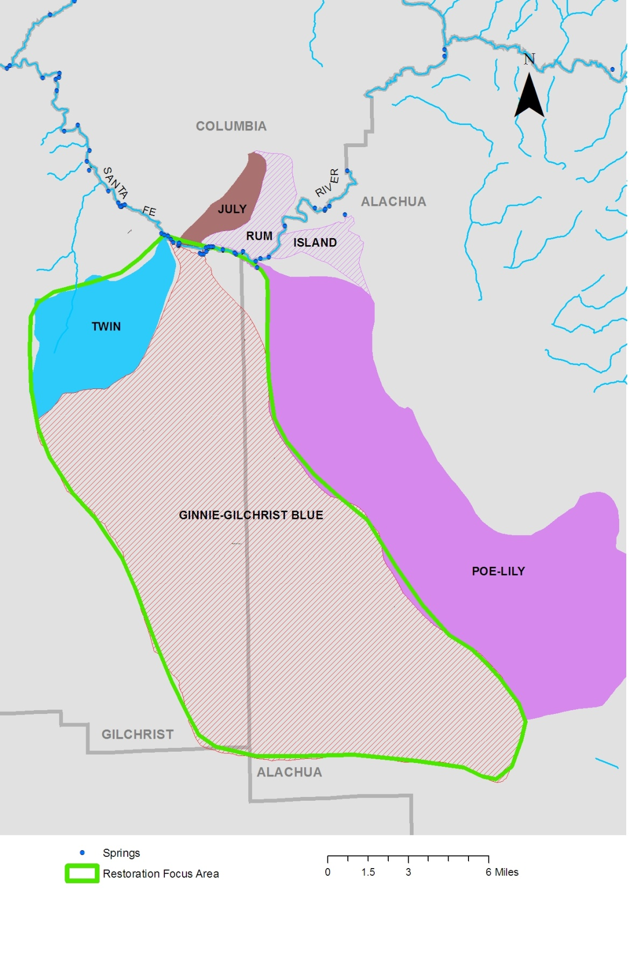

Figure 1: Santa Fe Basin RFA and adjacent springsheds.

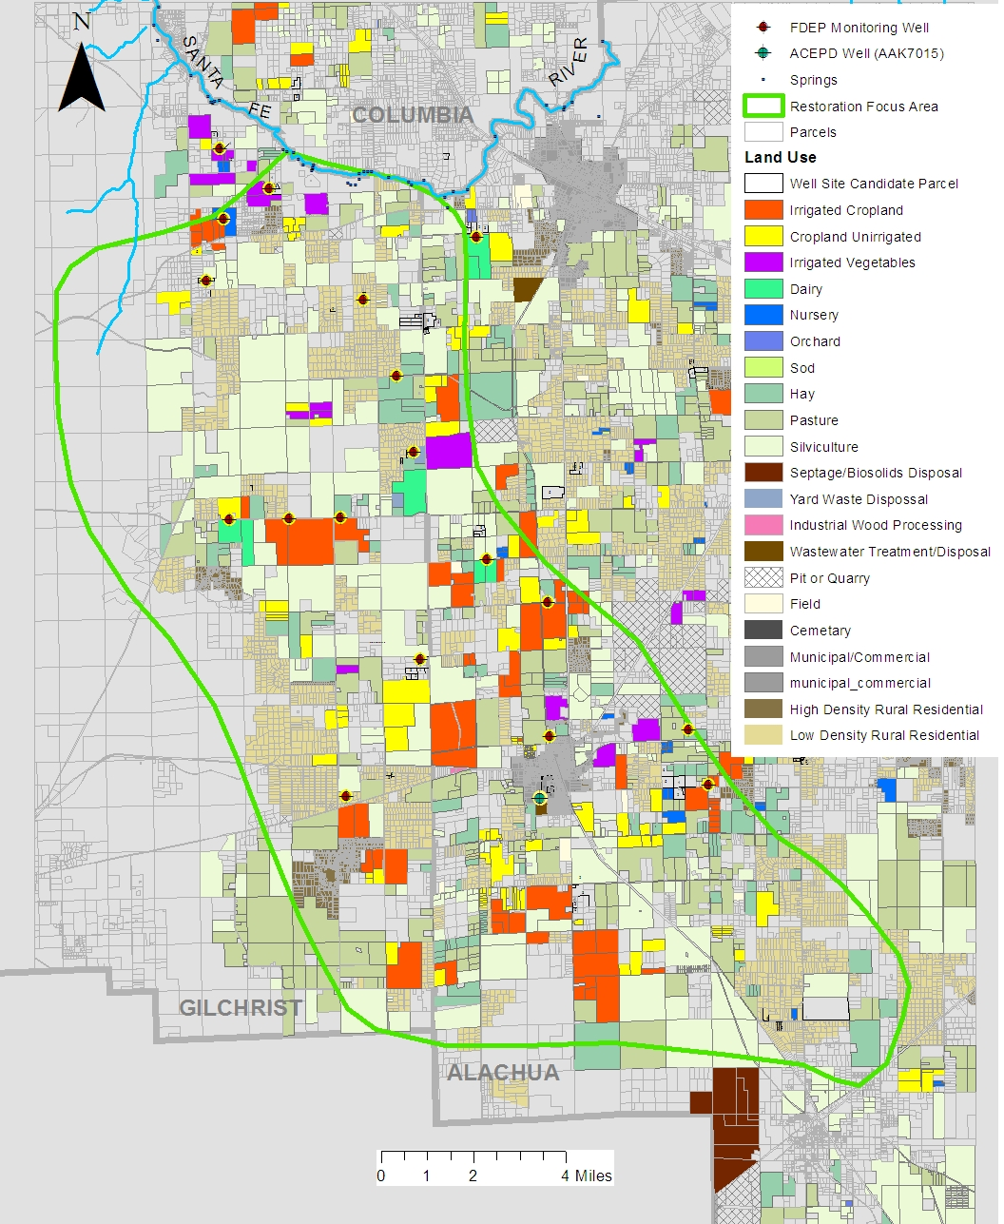

Figure 2: Land use in the Santa Fe Basin RFA and ground water monitoring locations.

2: Monitoring Objectives
The monitoring objectives for the RFA project are as follows:
- Assess ambient nitrogen concentrations and water quality in springs and in ground water at specific locations in the RFA.
- Monitor ground water quality at stations near potential nitrogen sources that are typical of the area (including farms, areas with septic tanks, the Newberry wastewater application site, and septage disposal) to evaluate their influence on ground water.
- Evaluate the effectiveness of real-time nitrate monitoring sensors and data sondes in evaluating the relation between rainfall and nutrient reduction activities to nitrate (NO₃) concentrations in sampled springs and ground water.
- Evaluate the temporal and spatial variability of water quality in springs and wells for the entire RFA relative to land use, nitrogen inputs over time, and nitrate transformation processes (such as denitrification).
- Evaluate water quality changes in springs and ground water related to the implementation of BMPs in the RFA.

3: Monitoring Design

Water Resources Monitored

Ground Water
The Upper Floridan Aquifer (UFA) is the sole source of potable ground water within the RFA (Col et al. 1997). It is also the source of water for agricultural irrigation wells and two water-bottling plants. Ground water levels and hydrochemical conditions in the UFA are highly dependent on recharge from precipitation in the springshed, which in turn is dependent on the degree of confinement of the aquifer (Upchurch et al. 2011). The UFA is unconfined within the northeastern portion of the Santa Fe River springshed (Upchurch et al. 2011). It is under semiconfined conditions within the southwestern portion of the Santa Fe River springshed based on data published in 1980 by the SRWMD. This means that ground water may be more readily impacted by human activities in areas where the UFA is less confined.
In the RFA, which is located in the southwestern part of the Santa Fe River Basin, shallow clay layers occur in part of the area that could potentially impede infiltrating water and create semiconfining conditions for the UFA. The sites selected for ground water monitoring in the RFA will provide information about land use influence in areas where the UFA is unconfined, as well as in semiconfined areas.

Surface Water and Springs
Water levels in the Santa Fe River and springs are also directly dependent on ground water contributions that are related to recharge in the springshed. The spring vents are aquifer discharge points into the Santa Fe River and can be used to evaluate conditions affecting ground water levels and quality in the springshed.
The RFA contains two main vents, Ginnie Spring and Blue Spring, both of which are second-magnitude springs (with average discharge between 10 and 100 cubic feet per second [cfs]). There is also Devil’s Ear Spring, which is part of a complex of three vents whose combined discharge make up a first-magnitude spring complex (greater than 100 cfs). Together, Ginnie and Blue Springs and the Devil’s Ear spring complex constitute a major input of flow to the Santa Fe River. Other small springs in or near the RFA include Twin Spring, Deer Spring, Dogwood Spring, Little Blue Spring, Johnson Spring, and Naked Spring (Scott et al. 2004).

Monitoring Site Selection

Ground Water
Alachua County Monitoring Network Wells – In 2011, the Department’s Ground Water Management Section (GWMS) and the Alachua County Environmental Protection Department (ACEPD) conducted a baseline ground water and spring monitoring study of the southern (mainly the Alachua County portion) of the Santa Fe River Basin (Department April 2012). This included ground water samples collected from four of the ACEPD’s routine monitoring stations in the RFA. One of these stations, a well used for irrigation at a cemetery adjacent to the city of Newberry wastewater sprayfield (AAK7015), will be included in the RFA monitoring network because this sprayfield is the most significant wastewater source (by volume) in the RFA.
Newly Constructed Monitoring Wells – The updated land use information for an area including the RFA and information on ground water flow pathways (Kinkaid et al. 2009) were used to identify potential locations to monitor the presence, fate, and transport of nitrate in the ground water near a variety of agricultural land uses, residential neighborhoods served by septic systems, and the more urban area of Newberry. Many of these wells were determined to be suitable as monitoring stations in the RFA. Information on the proposed wells was presented to FDACS, SRWMD, ACEPD, and other stakeholders in summer 2012, and later that year Department contractors worked with local landowners, county governments, and representatives of FDACS to secure access for drilling and establishing monitoring well sites. Between November 2012 and January 2013, all 20 monitoring wells were installed, developed, and surveyed.
These wells were sampled twice to assess baseline water quality conditions at each site prior to any activities under the RFA implementation plan. These sampling events occurred in January and May 2013, representing conditions during both the non-growing season and a more active period after the planting of agricultural sites. These data were used to begin to develop an understanding of the distribution of nitrate, seasonal trends in nutrient concentrations, and overall water quality throughout the RFA and at specific locations where management actions would be implemented.
Table 1 lists the 19 ground water monitoring stations selected for the RFA monitoring program, along with well construction information and land use settings. Figure 2 shows the ground water monitoring locations.

Table 1. Summary information on monitoring wells used in the RFA pilot study.
¹ Used in ACEPD quarterly monitoring program.
N/A = Not available or not applicable?
- = Empty cell/no data
Nutrient Fate Study ID | Well Screen Interval Depth | Adjacent  Land Use | Well Distance from  Land Use | Comments
MSFMW1 | 38-48 | Irrigated cropland | 40 | 1 year, previously scrub
MSFMW2 | 38-48 | Irrigated vegetables | 30 | 1 year, previously pasture
MSFMW3 | 21-31 | Irrigated vegetables | 430 | Vegetables since 2004 aerial, pasture before that
MSFMW4 | 58-68 | Irrigated cropland | 40 | Partially irrigated cropland since before 1994
MSFMW5 | 48-58 | Irrigated field crop supporting dairy | 75 | Dairy since before 1994, small
MFMW6 | 25-35 | Low-density residential |  | Potential septic tank influence
MSFMW7 | 48-58 | Irrigated field crop supporting dairy | 20 | Dairy since before 1994
MSFMW8 | 58-68 | Low density residential | N/A | Background
MSFMW9 | 44-54 | Pasture | 90 | Pasture or nonirrigated crops approximately 20 years +
MSFMW11 | 38-48 | Irrigated field crop and pasture supporting dairy | 40 | Dairy since before 1994
MSFMW12 | 68-78 | Residential, irrigated field crop supporting dairy | 35 | Dairy since early 2000s, residential developed in early 2000s
MSFMW13 | 51-61 | Irrigated cropland | 90 | Was pasture until approximately 2010
MSFMW14 | 48-58 | Hay | 20 | Hayfield or pasture since before 1994
MSFMW15 | 61-71 | Nonirrigated cropland | 2,300 | Multiple agricultural land uses in vicinity
MSFWMD16 | 58-68 | Pasture | 60 | No change in land use since before 1994
MSFMW17 | 35-45 | Urban | NA | In Newberry urban area
MSFMW18 | 55-65 | Irrigated cropland | 80 | Cropland since before 1994, not irrigated until possibly 2010
MSFMW20 | 58-68 | Irrigated cropland | 360 | Approximately 20 years +; irrigated in early 2000s
AAK7015¹ | - | Domestic wastewater sprayfield and cemetery | - | Adjacent to city of Newberry WWTP sprayfield

Surface Water and Springs
Spring samples will be collected quarterly from the two main vents, Ginnie Spring and Blue Spring, as well as Devil’s Ear Spring (to represent the Devil’s Ear spring complex input) and Twin Spring. Discharge from Ginnie Spring and Blue Spring will be measured with flow meters that will be established in the spring runs as part of the remote monitoring program described in a subsequent section. These springs represent the major contributions of discharge to the Santa Fe River from these two springsheds.
In addition to the springs, three stations on the Santa Fe River will be monitored. These include a station immediately upstream of the RFA boundary to determine water quality conditions from the upstream river system, a station immediately downstream from the cluster of springs within the RFA boundary, and an additional station farther downstream to evaluate water quality in the river after nitrate has been assimilated to some degree. These stations are located at Alachua County’s Poe Spring Park, just below the Poe Spring vent (upstream of the RFA); at the USGS Fort White staff gage (immediately downstream from the RFA); and at the State Road 47 bridge (farther downstream to evaluate nitrate assimilation). Santa Fe River discharge will be obtained from the U.S. Geological Survey (USGS). Figure 3 shows the spring and river monitoring locations. Change text in graphic below to Devil’s Ear Spring
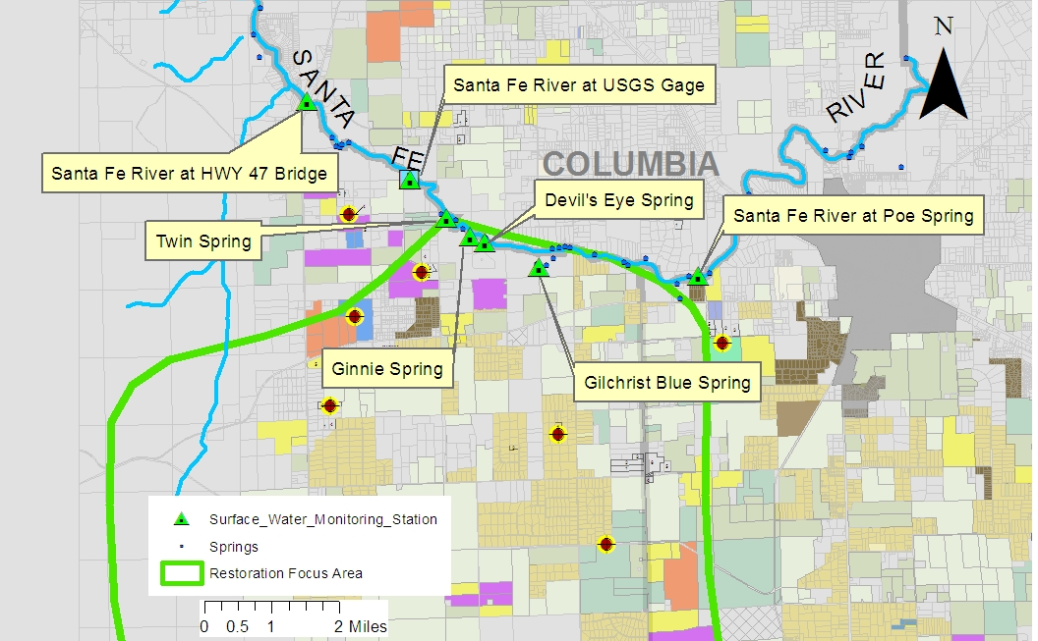

Figure 3. Santa Fe Basin RFA spring and river monitoring stations.

Sampling Methods and Frequency

Routine Water Chemistry
All routine sampling methods will comply with requirements outlined in Rule 62-160, Florida Administrative Code (F.A.C.) and the document titled Standard Operating Procedures for Field Activities (http://www.dep.state.fl.us/water/sas/sop/sops.htm). A study for validating nonstandard sampling and analytical methods (nitrate sensors) will also be conducted.
The monitoring network is designed to provide spatial and temporal information about ground water quality and potential changes from anthropogenic or natural influences, including extreme events (e.g., droughts and hurricanes). Monitoring network sampling was performed in January and May 2013 to establish baseline water quality in springs, ground water, and the Santa Fe River. Water samples were analyzed for the constituents listed in Tables 2 and 3. These samples represent conditions prior to the implementation of management actions. The water quality sampling of network wells, springs, and river water sites will continue on a quarterly schedule.

Continuous Monitoring Equipment
An evaluation of nonstandard sampling and analytical methods will also be conducted as part of the RFA monitoring project. Nitrate sensors, multiparameter data sondes (pH, temperature, specific conductance, and dissolved oxygen [DO]) and flow meters will be installed later in 2013 and will be maintained by an approved contractor in Ginnie Spring and Gilchrist Blue Spring. The Satlantic Submersible Ultraviolet Nitrate Analyzer (SUNA) V2 will be used for real-time continuous nitrate monitoring (Satlantic LP 2013). The SUNA is designed for long-term unattended continuous nitrate monitoring in a variety of fresh and saline waters (http://satlantic.com/suna; accessed 6/5/13). The GWMS is working with the Department Laboratory to develop a validation procedure for the nitrate sensor. Prior to installation in the field, each nitrate sensor will be checked for accuracy by the Department laboratory. In addition, the laboratory will measure the nitrate detection limit of each sensor and assess its precision.
After a one-year deployment in the field, the accuracy and precision of the nitrate sensor will be evaluated by the Department laboratory. Additional quality assurance information will be obtained from grab samples that will be collected at least quarterly from the selected springs and wells to compare laboratory nitrate measurements of the grab sample with the nitrate sensor data at the time of collection of the grab sample. The nitrate sensors will be programmed to measure nitrate concentrations every two to four hours in the springs and a yet-to-be-determined frequency in the selected wells. A rain gauge also will be installed at each well location for documenting precipitation and controlling data frequency collection in the wells. The actual measurement frequency will be adjusted based on measured and forecast weather events.
Data from the nitrate sensor, the multiparameter sonde, and rainfall gauge will be stored onsite in data loggers. A wireless telecommunication system and internet web link will be used to view the measurements remotely and download them. The nitrate sensor data will be used to detect short-term temporal changes in nitrate concentrations in ground water and spring waters. In addition, flow sensors will be installed at Ginnie and Gilchrist Blue Springs to provide high-frequency measurements of discharge to evaluate influence by river stage rise and increased recharge from rain events, as well as land use changes in the springshed.
Two of the monitoring wells (to be determined) will be equipped with pressure transducers to measure water level and with water-quality sensors to measure nitrate (SUNA), pH, specific conductance, and DO (YSI multiparameter sonde). These data will be collected continuously on a high-frequency basis by a data logger and made available real time via telemetry.
To better evaluate the influence of rainfall on the nutrient flux in the springshed, rain gauges with high-frequency sensors will be colocated with nitrate sensors and multiparameter sondes at Ginnie and Blue Springs and at two of the ground water monitoring stations with nitrate sensors and multiparameter sondes. The actual measurement frequency will be adjusted based on measured and forecast weather events.

4: Water Quality Analytes and Field Records
Water quality data includes chemical, physical, and biological measurements that provide scientific information about the condition of the affected water resources. The Department will sample chemical and physical indicators in order to achieve the monitoring objectives. Tables 2 and 3 provide the lists of laboratory analytes and field measurements to be included in the RFA monitoring. The Department will also collect rainfall data using rain gages and review Santa Fe River discharge data as provided by USGS National Water Information System (http://waterdata.usgs.gov/fl/nwis).
Field and laboratory records will include the following:
- Date, location, and time of sampling or measurements.
- Persons responsible for performing the sampling or measurements.
- Depth to ground water.
- Depth of pump during collection of samples.
- Weather conditions at time of sampling.
- Rainfall data.
- Adjacent land use information.
- Flow measurements, as applicable.
- Monthly flow data.
- Dates that analyses were performed or the appropriate code as required by Rule 62-160, F.A.C.
- Person responsible for performing the analyses.
- Analytical techniques or methods used, including Method Detection Limit (MDL).
- Results of such analyses, including appropriate data qualifiers.

Table 2: List of analytes in water samples from sites in the Santa Fe RFA monitoring network.
- = Empty cell/no data
Mg/L = Milligrams per liter
Mg N/L = Milligrams per liter of nitrogen
Mg N/P = Milligrams per liter of phosphorus
µg/L = Micrograms per liter
Chemical Indicators | Unit | Laboratory (L) or  Field (F) Analysis Method | Justification
Alkalinity | mg CaCO3/L | SM 2320 B (L) | Aquifer properties
Chloride | mg/L | Method 300 (L) | Source indicator
Fluoride | mg/L | SM 4500 F-C (L) | Confinement indicator
Sulfate | mg/L | Method 300 (L) | Source indicator
Total Dissolved Solids | mg/L | SM 2540 C (L) | Source indicator
Total Suspended Solids | mg/L | SM 2540 D (L) | Source indicator
Bromide | mg/L | - | Source indicator
Boron | mg/L | - | Source indicator
Calcium | mg/L | Method 200.7 (L) | Aquifer properties
Magnesium | mg/L | Method 200.7 (L) | Aquifer properties
Potassium | mg/L | Method 200.7 (L) | Source indicator
Sodium | mg/L | Method 200.7 (L) | Source indicator
Ammonia-N | mg N/L | Method 350.1 (L) | Source indicator/aquifer properties
Nitrate-Nitrite | mg N/L | Method 353.2 | Management action influence, source indicator/  nitrogen species transformation
Total Phosphorus | mg P/L | In-house based on  Method 365.4 (L) | Aquifer properties, Hawthorne influence
Total Kjeldahl Nitrogen | mg/L | In-house based on  Method 351.2 (L) | Source indicator/  nitrogen species transformation
Organic Carbon | mg/L | In-house based on  Method 415.1 (L) | Aquifer properties
Orthophosphate | mg/L | Method 365.1 (L) | Aquifer properties,  Hawthorne influence
Sucralose | µg/L | In-house | Source indicator
Nitrogen and Oxygen Isotopes (δ15N and δ18O in NO₃) | Per mil | Colorado Plateau Stable Isotope Laboratory | Nitrate source indicator, denitrification indictor

Table 3: List of field-measured physical and chemical indicators for sites in the Santa Fe RFA monitoring network.
- = Empty cell/no data
SU = Standard units
µs/cm = Micromohs per centimeter
NTU – Nephelometric Turbidity Units
PCU = Platinum cobalt units
Physical Indicators | Unit | Analysis Method | Justification
DO | Mg/L | DEP-SOP-001/01 FT 1500 (F) | Aquifer properties/  redox conditions
pH | SU | DEP-SOP-001/01 FT 1100 (F) | Aquifer properties
Specific Conductance | µS/cm | DEP-SOP-001/01 FT 1200 (F) | Aquifer properties
Turbidity | NTU | Method 180.1 (L) | Aquifer properties
Color | PCU | SM 2120 B (L) | Aquifer properties
Temperature | ° C. | DEP-SOP-001/01 FT 1400 (F) | Aquifer properties
Depth to Water (wells) | Feet | - | Recharge to aquifer
Spring Flow Measurement | Cfs | - | Load calculations

5: Quality Assurance/Quality Control (QA/QC) Protocols
All sample collection, shipping, and analytical test methods will be conducted in accordance with Rule 62-160, F.A.C., Quality Assurance, and specified in the Department document titled Standard Operating Procedures for Field Activities. All samples except for isotopes will be shipped to the Department’s Bureau of Laboratories in Tallahassee for analysis. The Department’s Bureau of Laboratories has SOPs for Laboratory Activities that address handling and analyzing samples, reporting precision, accuracy, and method detection limits, and other data reporting guidelines. Isotope samples will be analyzed at the University of Northern Arizona’s Colorado Plateau Stable Isotope Laboratory (CPSIL).
Sample collection and analysis methods not addressed in Rule 62-160, F.A.C., will be approved by the Department. Currently, the SUNA sensor is not a Department-approved sample collection and analysis method for nitrate, and therefore any data obtained by this method would only be used for planning purposes.

6: Data Management and Assessment
The Department’s Automated Data Management (ADM) Program will be used to track RFA water quality samples of springs, ground water, and the Santa Fe River from the field to the Department Laboratory. Analytical results will be transferred electronically from the Department Laboratory Information Management System (LIMS) to the Department GWMS, where they will be processed and merged with corresponding field data, and linked to the corresponding site data. Computerized accuracy and completeness checks will be automatically run, in addition to several other quality assurance checks. Data files will be manually checked using field sheets and results from the computerized reviews to identify random or systematic errors. After preliminary data review for a project is completed, a copy of the project file will be transferred to the field samplers for their review. Following completion of the reviews, the data will be considered “release quality” and will be ready to be made available to the general public.
Manual measurements of springs and river discharge will be collected by SRWMD and USGS staff using SOPs. Water samples with nitrate-N concentrations greater than 0.1 mg/L will be sent to CPSIL at Northern Arizona University for analyses of nitrogen and oxygen isotopes of nitrate. The data from CPSIL will be checked and reviewed prior this information is entered into a local database.
All field measurements and water quality data collected as part of the RFA study will be stored in the Department’s Oracle-based Generalized Water Information System (OGWIS). Data will be periodically uploaded from OGWIS to Florida STORET and also exported to Hydroport, a ground water quality data retrieval and analysis tool for GWMS.
Continuous water quality data from the SUNA sensors and the multiparameter sondes will be uploaded from the datalogger at each site and reviewed by the Department’s contractor for missing data, erratic measurements, instrument drift, and other problems. The accuracy of the nitrate concentrations from the SUNA sensors will be checked periodically with nitrate concentrations from grab samples that will be analyzed at the Department Laboratory. In addition, rainfall data and water velocity data also will be uploaded from the data logger and reviewed by the Department contractor. After the quality assurance checks are completed and problems resolved, these data will be stored in a time-series data management system provided by the contractor who will be maintaining the SUNA sensors and multiparameter data sondes. Both time-series data management systems will be accessible via an internet web link.
Nitrate data and other water quality information from wells, springs, and river sites will be analyzed using graphical, statistical, and GIS techniques to address the monitoring objectives listed earlier. These techniques will be used to evaluate relationships and trends between nitrate and other water quality data with several environmental variables. Variables may include (but are not limited to) distance from known nitrate sources (fertilized fields, manure, land application of wastewater, septic tanks), locations where BMPs are being implemented, depth of well, location along ground water flow paths to springs, data on nitrogen loading to ground water, fertilizer application information, and rainfall. Furthermore, water quality data from the laboratory and the field sensors will also be related to information on land use changes, agricultural practices, and estimates of nitrogen inputs before and after implementation of BMPs in the RFA.
Environmental chemical data seldom meet the requirement of normal distribution; therefore, nonparametric statistical tests will be run, such as the seasonal Kendall test, to determine if statistically significant changes have occurred for each indicator. The effect of seasonality (and variability of annual rainfall amounts) and drought/flood conditions can mask trends in water quality and will be accounted for in the analyses. If sufficient water quality data are present in the RFA, the analyst will conduct a test for trend on the “before BMP” data and then on the “after BMP” data. If the “before BMP” data do not show a trend, while the “after BMP” data do, this would provide compelling evidence that activities in the RFA are having a beneficial impact on water quality.
Continuous data on nitrate, pH, temperature, DO, and specific conductance will be statistically and graphically analyzed with rainfall data and information on agricultural practices (particularly farms that have enrolled in BMPs in the RFA). This information will be used to evaluate relationships between changes in nitrogen loading to nitrate trends in spring waters and ground water at selected sites.
The Department will coordinate with FDACS to compile detailed information on the number of acres enrolled in agricultural BMPs in the RFA during the next five years. This information will be used to statistically evaluate relations between increased acres enrolled in BMPs (and their associated reductions in nitrogen loading to ground water) and observed nitrate trends in springs, ground water along flow paths, and Santa Fe River water.

7: Communications
After each sampling event, monitoring results will be compiled and reviewed by the Department and informally shared with the RFA pilot project team (FDACS, SRWMD) for evaluating the network design and to determine if the objectives are being properly addressed.
A Santa Fe River Basin RFA web page will be created to provide information on the project. In addition to obtaining general information, users will able to obtain regular updates as the monitoring results become available, and to obtain information on real-time monitoring data. This web page will be available via the Department’s website at http://www.floridasprings.org/.
At the end of each year of monitoring, a progress report will be provided. The yearly report will include a summary of the status of BMP implementation in the RFA as well as information on water quality from the ground water, spring, and river monitoring stations. The annual report will also provide a discussion of the findings, recommended changes in the monitoring program, recommendations related to the restoration activities, and any new information that is pertinent. Annual reports will address each of the monitoring objectives and provide recommendations for management actions and any changes in the Monitoring Plan.
As opportunities present themselves, updates on the RFA project will also be provided by FDACS and Department staff at meetings of agricultural producers in the region, at the Santa Fe Springs Working Group, and other venues.

8: Evaluation of Monitoring Plan Results
Project team members from the Department, FDACS, and SRWMD will evaluate the monitoring data semiannually and make adjustments in sampling stations, parameters, and monitoring frequency as needed to meet the monitoring objectives. This adaptive management approach will ensure that the monitoring program is providing relevant data with respect to the restoration activities in the RFA.

Definitions
Basin Management Action Plan (BMAP) – The “blueprint” for restoring impaired waters by reducing pollutant loadings to meet the established Total Maximum Daily Load (TMDL). It represents a comprehensive set of strategies—permit limits on wastewater facilities, urban and agricultural best management practices, conservation programs, financial assistance and revenue generating activities, etc.—designed to implement the pollutant reductions established in the TMDL. These broad-based plans are developed with local stakeholders, so they rely on local input and local commitments. BMAPs are adopted by Secretarial Order to be enforceable (Section 403.067, Florida Statutes [F.S.]).
Best Management Practice (BMP) – A practice or combination of practices that is based on research, field-testing, and expert review, to currently be the most effective and practicable on-location means, including economic and technological considerations, for improving water quality in agricultural and urban discharges. BMPs for agricultural discharges shall reflect a balance between water quality improvements and agricultural productivity (Section 373.4595, F.S.).
Ground Water – Water beneath the surface of the ground within a zone of saturation, whether or not flowing through known and definite channels (Rule 62-520.200, Florida Administrative Code [F.A.C.]). For the purposes of this document, ground water specifically includes the subsurface saturated zone with the potential to impact surface waters.
Load – The mass of a pollutant reaching a target waterbody per unit of time, often calculated as the concentration of a pollutant multiplied by the flow rate for a given period.
Quality Assurance (QA)/Quality Control (QC) Protocol – The system of management activities and quality control procedures implemented to produce and evaluate reliable data according to pre-established data quality objectives.
Restoration Focus Area (RFA) –- A portion of a basin with an adopted BMAP, in which applicable water quality restoration and monitoring activities contained in the BMAP are implemented to the greatest practicable extent in a relatively short time. The purpose of an RFA is to concentrate limited financial and staff resources on implementation and monitoring in a priority area in order to expedite water quality improvements in that area.
Sonde – A multiparameter probe used for water quality monitoring that typically measures temperature, conductivity, dissolved oxygen, and pH.
Standard Operating Procedures (SOPs) – Procedures used for the collection and analyses of data. For the purposes of this document, nonpoint source dischargers shall use only Department-approved SOPs for monitoring, which are incorporated by reference into Rule 62-160, F.A.C., and are available online at http://www.dep.state.fl.us/water/sas/sop/sops.htm.
Surface Water – Water upon the surface of the earth, whether contained in bounds created naturally or artificially or diffused. Water from natural springs shall be classified as surface water when it exits from the spring onto the earth’s surface (Rule 62-302.200, F.A.C.). For the purposes of this document, surface water is intended to mean jurisdictional surface waters as delineated in Rule 62-302, F.A.C.
Total Maximum Daily Load (TMDL) – A scientific determination of the maximum amount of a given pollutant that a surface water can absorb and still meet the water quality standards that protect human health and aquatic life as required by Section 303(d) of the federal Clean Water Act (CWA).

References
Col, N., F. Rupert, and G. Horvath, 1997. Reappraisal of the geology and hydrogeology of Gilchrist County, Florida, with emphasis on the Waccasassa Flats. Florida Geological Survey Report of Investigations No. 99.
Hall, P., and S.J. Clancy. 2009. The Florida statewide inventory of onsite sewage treatment and disposal systems (OSTDS): A report on the status of knowledge of the number and locations of OSTDS in each county and best management practices for improving this knowledge. Florida Department of Health. U.S. Geological Survey Scientific Investigations Report 2012-5207.
Hicks, R., and K. Holland, April 2012. Well and spring sampling to evaluate nitrate sources in Alachua County portion of the Santa Fe BMAP area. Tallahassee, FL: Florida Department of Environmental Protection, Ground Water Management Section, Bureau of Watershed Restoration.
Kincaid, T.R., B.A. Meyer, and J. Radtke. 2009. Western Santa Fe River Basin Groundwater Resource Model, modeling results and methods. Presentation for the Suwannee River Water Management District, St. Johns River Water Management District, and U.S. Geological Survey at the CCDA Waters Bottling Facility in High Springs, FL, on August 3, 2009. GeoHydros, LLC, Reno, NV: www.geohydros.com/CCNA/ - last accessed 6/12/13.
Satlantic LP. 2013. SUNA Manual, Satlantic LP, SAT-DN-00596, Rev. D, 2013-01-07, Halifax, Nova Scotia, Canada.
Scott, T.M., G.H. Means, R.P. Meegan, R.C. Means, and S.B. Upchurch et al. 2004, Springs of Florida. Florida Geological Survey Bulletin 66.
Upchurch, S.B., J. Chen, and C.R. Cain. 2011. Springsheds of the Santa Fe River.

