Info and Observations on Lysimeter Monitoring,
Ichetucknee Experimental Drainfield (10-2-14)

General
- Drainfield went on line late March 2014. 3 rows of infiltrators approximately 30 ft long.
- Top of infiltrators 3 ft below land, bottom of infiltrator 4 ft below land, 18 inches of sand extends to 5 ½ feet below land, 10 inches of mulch extends to a little less than 6 ½ feet below land. Water table is about 24 feet below land.
- Data represent 4 sampling episodes. Results for September monitoring are pending.
Effluent Data
- Effluent samples are collected from a sampling port between the septic tank and drainfield. Concentrations generally fall within typical values for STE except for the most recent sampling event, which shows a much lower nitrogen concentration. Fluctuation is not unusual. Date with low value could have been laundry day.
- Only two residents are currently living in the residence and flow is probably less than typical because they do not have a dishwasher.
Lysimeter Data
- Lysimeters were installed immediately adjacent to infiltrators approximately 7 and 15 feet from the outfall in each of the lysimeter rows. Shallow (1 ft below bottom of infiltrators) and Deep (1 ft below bottom of mulch layer). FIGURE 1 shows the drainfield configuration and monitoring locations.
- Distribution of effluent water to the infiltrators is uneven. Most of the effluent goes to the North row of infiltrators and based on the lysimeter response, most is infiltrating less than 7 feet from the beginning of the row. This can be observed in the TN concentrations in the shallow lysimeters and frequency of no water found in lysimeters at many of the lysimeter locations (FIGURE 2) This condition is less than ideal because more uniform infiltration would provide better treatment as well as a more robust study. However, it is possible that over time the effluent discharge will begin to equalize.
- Treatment of effluent (nitrogen removal) by the mulch layer appears to be evident based on the comparison of Effluent, shallow lysimeter and deep lysimeter results. In the small area that most of the water is being loaded (monitored by lysimeter cluster L-1). Over the two quarters of monitoring there is a 61.5% difference between the deep lysimeter TN concentration and the effluent concentration. It is possible that the high loading in this small area could have caused some seepage down the edge of the deep lysimeter’s standpipe, which could be biasing the data (increasing the concentration) and the treatment by wood chips could be actually a good bit greater.
- In the other drainfield points being monitored by lysimeters, TN levels are somewhat lower than at L-1 and the differences between TN values for shallow and deep lysimeters are much greater (on the order of 90% or greater) when water is present in both shallow and deep zones.
- During the next month, the lysimeter network will be overhauled. An additional deep lysimeter will be installed near L-1D to help determine the acutual nitrogen levels in soil pore water beneath the mulch later and evaluate whether a cross connection is influencing TN concentrations in L-1D. In addition, lysimeter L-3D, which was damaged shortly after construction and has yielded no data, will be replaced as will lysimeter L-5S, which appears to have performance issues.
- We are also considering having the septic tank contractor re-level the distribution header that was apparently knocked out of plumb during the construction.
Ground Water Data
- Ground water samples are collected in two wells installed beneath the drainfield. Well screens straddle the water table and during the dry weather of August, both wells were dry.
- Well W-1 is closer to the active end of the drainfield and may be representative of the ground water quality being influenced by this drainfield. If so, influence is much lower than typical. The maximum TN concentration detected was 3.44 mg/L which is about 10 times lower than the typical concentration beneath drainfields. This well may also be influenced by the old drainfield. The screen interval for well W-2 intersected an organic silt layer and this well produces poorly and the water from it is dark brown in color. Elevated TN value in one sample from this well was from organic nitrogen (we collected samples for both TKN and ammonia, so that is verified), which occurs naturally in the geologic material at this particular location. The nitrate concentration in this well is low.
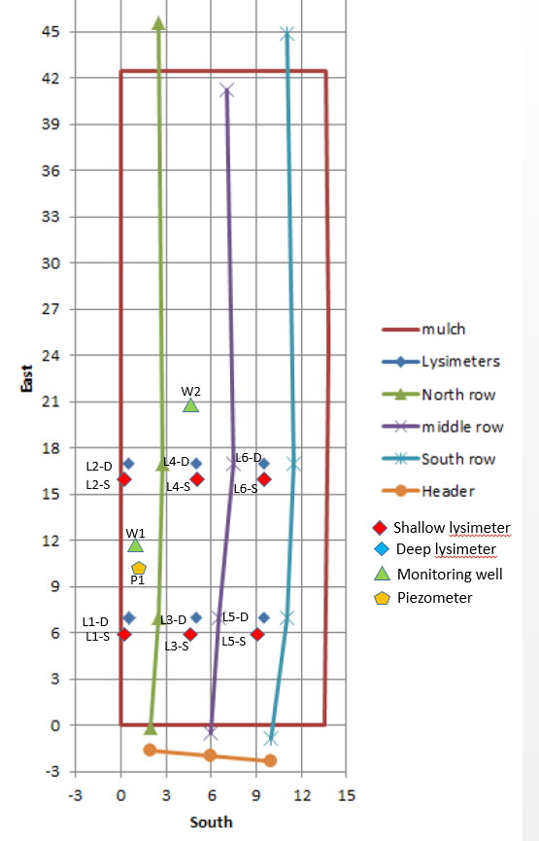
FIGURE 1-Construction diagram of drainfield and monitoring points

FIGURE 2-Comparison of TN concentrations in soil beneath lysimeter locations on drainfield

TN Concentrations in Lysimeters Compared against Effluent Concentrations
Ichetucknee Experimental Drainfield

FIGURE 3-TN in Lysimeter Cluster L-1

FIGURE 4-TN in Lysimeter Cluster L-2

FIGURE 5-TN in Lysimeter Cluster L-4

FIGURE 6-TN in Lysimeter Cluster L-5

FIGURE 7-TN in Lysimeter Cluster L-6

ICHETUCKNEE EXPERIMENTAL DRAINFIELD MONITORING DATA
 | Sample Date | Cl | TKN | NO3 | TN | TP
E-1 | 4/17/2014 | 93.00 | 89.00 | 0.01 | 89.01 | 9.90
 | 6/4/2014 | 160.00 | 100.00 | BDL | 100.00 | 13.00
 | 6/25/2014 | 130.00 | 100.00 | 0.01 | 100.01 | 13.00
 | 8/19/2014 | 54.00 | 65.00 | 0.01 | 65.01 | 7.70
L-1S | 4/17/2014 | 87.00 | 8.40 | 91.00 | 99.40 | 0.18
 | 6/4/2014 | 110.00 | 1.70 | 74.00 | 75.70 | 2.10
 | 6/25/2014 | 100.00 | 1.60 | 57.00 | 58.60 | 3.20
 | 8/19/2014 | 62.00 | 0.80 | 56.00 | 56.80 | 4.10
L-1D | 4/17/2014 | 94.00 | 15.00 | 9.00 | 24.00 | 0.26
 | 6/4/2014 | 120.00 | 2.00 | 36.00 | 38.00 | 0.18
 | 6/25/2014 | 140.00 | 1.60 | 37.00 | 38.60 | 0.16
 | 8/19/2014 | 64.00 | 1.70 | 34.00 | 35.70 | 0.17
L-2S | 4/17/2014 | 6.50 | 1.60 | 12.00 | 13.60 | 0.13
 | 6/4/2014 | 17.00 | 1.10 | 24.00 | 25.10 | 0.13
 | 6/25/2014 | 2.30 | 1.10 | 21.00 | 22.10 | 0.21
 | 8/19/2014 | 0.60 | 1.30 | 1.30 | 2.60 | 0.86
L-2D | 4/17/2014 | 13.00 | 0.43 | 0.18 | 0.61 | 0.18
 | 6/4/2014 | 66.00 | 1.50 | 0.21 | 1.71 | 0.29
 | 6/25/2014
 | 8/19/2014 |  | 4.20 | BDL | 4.20 | 0.41
L-3S | 4/17/2014 | 69.00 | 16.00 | 29.00 | 45.00 | 0.44
 | 6/4/2014 | 74.00 | 1.50 | 52.00 | 53.50 | 2.60
 | 6/25/2014 | 82.00 | 1.40 | 65.00 | 66.40 | 4.80
 | 8/19/2014
L-3D | 4/17/2014
 | 6/4/2014
 | 6/25/2014
 | 8/19/2014
L-4S | 4/17/2014 | 3.90 | 0.63 | 11.00 | 11.63 | 0.11
 | 6/4/2014 | 1.20 | 0.93 | 12.00 | 12.93 | 0.18
 | 6/25/2014 | 0.43 | 0.87 | 6.00 | 6.87 | 0.11
 | 8/19/2014 | 0.25 | 0.87 | 3.20 | 4.07 | 0.12
L-4D | 4/17/2014 | 12.00 | 0.70 | 0.09 | 0.79 | 0.02
 | 6/4/2014 |  | 2.50 | 0.31 | 2.81 | 0.15
 | 6/25/2014
 | 8/19/2014
L-5S | 4/17/2014
 | 6/4/2014 | 2.00 | 1.50 | 18.00 | 19.50 | 0.20
 | 6/25/2014
 | 8/19/2014 |  | 1.80 | 34.00 | 35.80 | 0.21
L-5D | 4/17/2014 | 16.00 | 2.20 | BDL | 2.20 | 0.48
 | 6/4/2014 | 79.00 | 1.40 | 0.30 | 1.70 | 0.55
 | 6/25/2014 | 140.00 | 1.20 | 0.36 | 1.56 | 0.54
 | 8/19/2014 | 110.00 | 1.10 | 0.36 | 1.46 | 0.64
L-6S | 4/17/2014 | 3.90 | 0.87 | 9.30 | 10.17 | 0.16
 | 6/4/2014 | 2.80 | 1.00 | 27.00 | 28.00 | 0.16
 | 6/25/2014
 | 8/19/2014 | 0.43 | 1.50 | 9.80 | 11.30 | 0.14
L-6D | 4/17/2014 | 17.00 | 1.00 | 0.00 | 1.00 | 0.34
 | 6/4/2014 | 21.00 | 2.00 | 0.49 | 2.49 | 0.53
 | 6/25/2014 | 23.00 | 1.40 | 0.15 | 1.55 | 0.34
 | 8/19/2014
W-1 | 4/17/2014 | 1.90 | 0.14 | 3.30 | 3.44 | 0.01
 | 6/4/2014 | 1.90 | 0.10 | 2.60 | 2.70 | 0.03
 | 6/25/2014 | 2.90 |  | 3.10 | 3.10 | 0.20
 | 8/19/2014
W-2 | 4/17/2014
 | 6/4/2014 | 1.80 | 2.50 | 0.18 | 2.68 | 0.62
 | 6/25/2014 |  | 12.00 | 0.11 | 12.11 | 3.60
 | 8/19/2014
NOTES: E=effluent sample; L= lysimeter sample; W=monitoring well sample
Blank fields indicate that there was no water available or, in the case of L-3D, the sampling device was damaged.

