First Quarterly Monitoring Report: Assessment of the Nitrogen Removal and Viability of a Reactive Layer with Liner under a Conventional Septic System Drainfield

Division of Environmental Assessment and Restoration

Florida Department of Environmental Protection

February 2017


Prepared by:
Florida Department of Environmental Protection
Division of Environmental Assessment and Restoration
Water Quality Evaluation and TMDL Program
Groundwater Management Section

For more information, contact:
Richard Hicks
DEP Groundwater Management Section
850-245-8229
richard.w.hicks@dep.state.fl.us

Introduction
According to our study plan under the Memorandum of Understanding between the Department of Environmental Protection (DEP) and the Department of Health (DOH), DEP would provide quarterly reports on the monitoring activities and results for the experimental lined drainfield study being conducted at a private residence located in Apopka, Florida. This reports serves as the first quarterly report of those events and findings, which is a compilation of the first 4 months of the system’s operations.
This project began with the construction of a new lined drainfield underlain by reactive media layer composed of hardwood mulch. A monitoring well was installed on July 6, 2016 to a depth of 39 feet. Construction of the new drainfield occurred the week of July 18, 2016, and began receiving septic tank effluent from the private citizen’s residence July 29, 2016. Two diversion valves were installed in-line between the septic tank and the drainfield distribution header to divert flow from the old drainfield, and allow the newly lined experimental drainfield to begin receiving effluent. At the time of construction, 6 horizontal monitoring wells were installed on top of the liner and below the four rows of infiltrators. On July 27, 2016, 6 deep suction lysimeters, 7 shallow lysimeters, and 3 piezometers were installed. Figures 1 and 2 show the layout of the drainfield and locations of the lysimeters, monitoring wells and piezometers. The monitoring stations are described in Table 1.

Table 1. Summary of monitoring stations included in study.
Station Identifier | Description | Monitoring Objective
STE-1 | Septic tank effluent from riser installed over septic tank inspection port | Measure “input” constituent concentrations before effluent goes to the drainfield
L1S through L6S | Shallow lysimeters installed at 6 locations adjacent to the infiltrator rows; bottom of lysimeters 0.5 ft above mulch layer | Monitor pore water quality between the drainfield and the reactive media layer (intermediate level of treatment) to evaluate nitrogen concentration and nitrification
L7S | Shallow lysimeter installed below the distribution header | Monitor for leakage of effluent at header
M1 through M6 | Horizontal well points on top of liner at 6 locations | Monitor water quality within saturated portion of mulch layer and beneath header
L1D through L6D | Deep lysimeters installed along outside edge of liner; bottom of lysimeters 1 ft below edge of liner | Monitor pore water quality in soil at edges of liner where water collected on liner discharges
MW1 | Monitoring well near edge of the drainfield | Measure ground water quality and ground water levels near edge of the drainfield
P1 through P3 | Piezometers installed inside lined area, below the drainfield and above the reactive media layer | Measure presence of and depth to water to assess mounding above the saturated zone on liner and evaluate gradient toward liner edges
Flow | Flow meter installed at supply well | Measure flow to the experimental drainfield from the septic tank

Figure 1. Aerial of monitoring stations
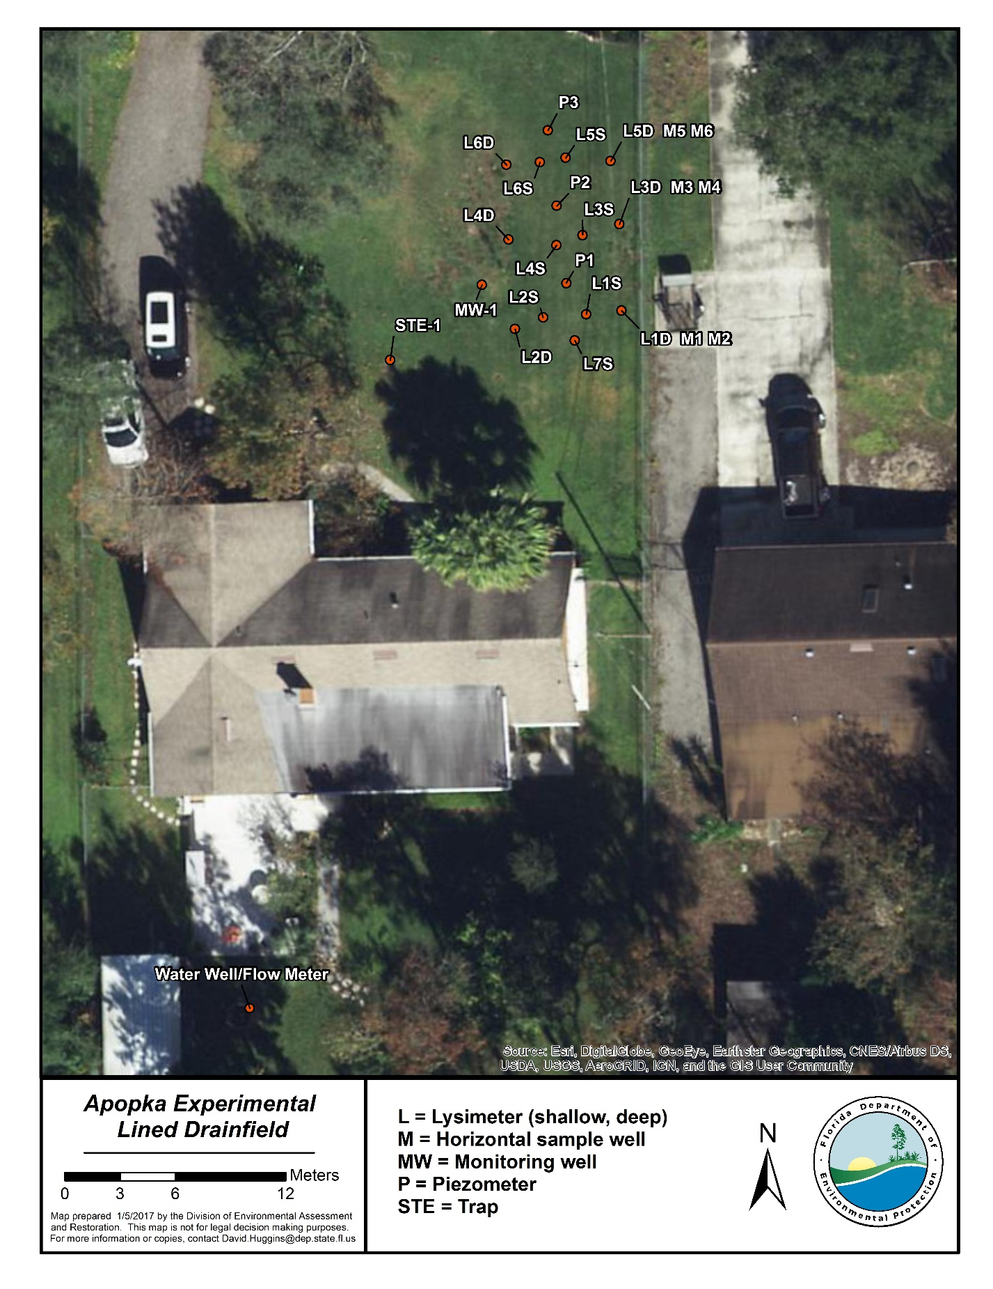
Figure 2. Plan view of monitoring locations at experimental drainfield.

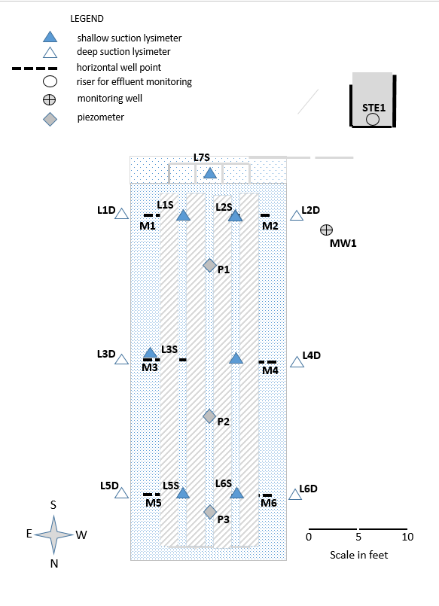

Monitoring Results
Water quality samples have been collected from the effluent, lysimeters, and monitoring wells on 4 occasions. These samples were analyzed by the DEP central laboratory. Table 2 presents the results to date for the major parameters of interest. The parameters list includes chloride (Cl), ammonium (NH4), total Kjeldahl nitrogen (TKN), nitrate+nitrite-nitrogen (NOX), and total phosphorous (TP).
Water level and flow measurements were also taken. Depths to water were measured in the 3 piezometers and the monitoring well, and flow was recorded from the flow meter during each site visit. These results are provided in Tables 3 and 4.
Table 2. Monitoring results for key parameters, Wekiva experimental lined drainfield study
Station | Sample Date | Cl (mg/L) | NH4 (mg/L) | TKN (mg/L) | Org N (mg/L) | NO3+NO2 (mg/L) | TN (mg/L) | TP (mg/L)
STE1 | 09/14/16 | 99 | 64 | 80 | 16.00 | BDL | 80 | 8.4
 | 10/12/16 | 70 | 42 | 45 | 3.00 | BDL | 45 | 5.2
 | 11/09/16 | 83 | 53 | 60 | 7.00 | BDL | 60 | 7.5
 | 12/08/16 | 75 | 57 | 65 | 8.00 | BDL | 65 | 7.3
MW1 | 09/14/16 | 31 | 0.008 | 2.60 | 2.59 | 3.6 | 6 | 92
 | 10/12/16 | 39 | 0.16 | 120 | 119.84 | 11.0 | 131 | 490
 | 11/09/16 | 29 | 0.80 | 64 | 63.20 | 3.5 | 68 | 200
 | 12/08/16 | 26 | 0.28 | 63 | 62.72 | 2.9 | 66 | 200
L1S | 09/14/16
 | 10/12/16
 | 11/09/16 | 77 | 34 | 33 | BDL | 6.1 | 39 | 4.7
 | 12/08/16
L1D | 09/14/16
 | 10/12/16 | 29 | 12 | 14.0 | 2.00 | BDL | 14 | 29
 | 11/09/16 | 73 | 0.46 | 4.7 | 4.24 | 41 | 46 | 0.1
 | 12/08/16
M1 | 09/14/16 | 100 | 51 | 57 | 6 | BDL | 57 | 2.8
 | 10/12/16 | 67 | 43 | 47 | 4 | 0.078 | 47 | 3.6
 | 11/09/16 | 77 | 42 | 46 | 4 | BDL | 46 | 6.7
 | 12/08/16 | 73 | 19 | 22 | 3 | 0.014 | 22 | 3.1
L2S | 09/14/16
 | 10/12/16 | 16 | 0.12 | 1.9 | 1.78 | 2.0 | 4 | 0.14
 | 11/09/16 |  | 0.036 | 2.6 | 2.56 | 29 | 32 | 0.11
 | 12/08/16
L2D | 09/14/16
 | 10/12/16 | 38 | 4.30 | 6.9 | 2.60 | 4.2 | 11 | 0.19
 | 11/09/16 | 69 | 0.55 | 2.3 | 1.75 | 22 | 24 | 0.13
 | 12/08/16
M2 | 09/14/16 | 100 | 51 | 61 | 10.00 | BDL | 61 | 2.5
 | 10/12/16 | 62 | 38 | 43 | 5.00 | BDL | 43 | 2.5
 | 11/09/16 | 75 | 43 | 45 | 2.00 | 0.066 | 45 | 4.5
 | 12/08/16 | 72 | 31 | 34 | 3.00 | 0.011 | 34 | 2.6
L3S | 09/14/16
 | 10/12/16 | 54 | 0.067 | 1.6 | 1.53 | 1.3 | 3 | 0.10
 | 11/09/16 | 27 | 0.10 | 2.4 | 2.30 | 11.0 | 13 | 0.10
 | 12/08/16
L3D | 09/14/16 | 110 | 0.012 | 3.9 | 3.89 | 4.20 | 8 | 0.43
 | 10/12/16 | 28 | 0.076 | 2.4 | 2.32 | 0.89 | 3 | 0.86
 | 11/09/16 | 30 | 0.044 | 2.7 | 2.66 | 7.70 | 10 | 0.26
 | 12/08/16
M3 | 09/14/16 | 91 | 18 | 50 | 32.00 | 0.015 | 50 | 34
 | 10/12/16 | 58 | 19 | 31 | 12.00 | BDL | 31 | 8.4
 | 11/09/16 | 71 | 16 | 23 | 7.00 | BDL | 23 | 2.0
 | 12/08/16 | 69 | 9 | 16 | 7.00 | BDL | 16 | 1.6
L4S | 09/14/16 | 79 | 0.022 | 3.2 | 3.18 | 8.50 | 12 | 0.14
 | 10/12/16 | 85 | 0.078 | 2.5 | 2.42 | 0.73 | 3 | 0.10
 | 11/09/16 | 24 | 0.023 | 3.0 | 2.98 | 5.40 | 8 | 0.10
 | 12/08/16
L4D | 09/14/16
 | 10/12/16 | 54 | 8.5 | 13 | 4.50 | BDL | 13 | 0.27
 | 110/9/16 | 53 | 6.3 | 11 | 4.70 | 0.017 | 11 | 0.06
 | 12/08/16
M4 | 09/14/16 | 96 | 19 | 64 | 45.00 | 0.047 | 64 | 54
 | 10/12/16 | 62 | 13 | 28 | 15.00 | BDL | 28 | 9.1
 | 11/09/16 | 73 | 15 | 21 | 6.00 | BDL | 21 | 2.2
 | 12/08/16 | 72 | 9.6 | 17 | 7.40 | BDL | 17 | 0.8
L5S | 09/14/16 | 25 | 0.062 | 2.9 | 2.84 | 0.31 | 3 | 0.23
 | 10/12/16 | 6 | 0.061 | 1.8 | 1.74 | 0.60 | 2 | 0.12
 | 11/09/16 | 9 | 0.063 | 2.1 | 2.04 | 5.50 | 8 | 0.06
 | 12/08/16
L5D | 09/14/16 | 43 | 0.16 | 3.0 | 2.84 | 1.10 | 4 | 0.13
 | 10/12/16 | 14 | 0.65 | 2.9 | 2.25 | BDL | 3 | 0.17
 | 11/09/16 | 30 | 2.20 | 4.5 | 2.30 | 0.56 | 5 | 0.04
 | 12/08/16
M5 | 09/14/16 | 89 | 7.5 | 40 | 32.50 | 0.018 | 40 | 60
 | 10/12/16 | 52 | 1.4 | 24 | 22.60 | BDL | 24 | 10
 | 11/09/16 | 43 | 0.6 | 16 | 15.39 | BDL | 16 | 8.3
 | 12/08/16 | 64 | 2.2 | 11 | 8.80 | BDL | 11 | 6.9
L6S | 09/14/16 | 16 | 0.21 | 2.50 | 2.29 | 0.022 | 3 | 0.31
 | 10/12/16 | 9 | 0.18 | 2.00 | 1.82 | BDL | 2 | 0.12
 | 11/09/16 | 13 | 0.610 | 2.80 | 2.19 | BDL | 3 | 0.06
 | 12/08/16
L6D | 09/14/16
 | 10/12/16 | 86 | 16 | 31 | 15.00 | BDL | 31 | 31
 | 11/09/16 | 62 | 22 | 27 | 5.00 | BDL | 27 | 20
 | 12/08/16
M6 | 09/14/16 | 98 | 6.9 | 38 | 31.10 | 0.018 | 38 | 49
 | 10/12/16 | 54 | 4.4 | 28 | 23.60 | BDL | 28 | 14
 | 11/09/16 | 52 | 2.8 | 21 | 18.20 | BDL | 21 | 12
 | 12/08/16 | 68 | 2.0 | 11 | 9.0 | BDL | 11 | 8.6
L7S | 09/14/16
 | 10/12/16 | 43 | 22 | 18 | BDL | 0.510 | 19 | 0.51
 | 11/09/16 | 68 | 10 | 13 | 3.00 | 0.036 | 13 | 0.83
 | 12/08/16
Notes: STE=Trap effluent sample; L= lysimeter sample; MW=monitoring well sample; P=piezometer; horizontal well
BDL=below detection limit, Reported concentrations are in milligrams per liter, Empty field indicates insufficient sample

Table 3. Water levels, Wekiva experimental lined drainfield study
Station | Date | Depth to Water (ft.) | Height of Water Above Liner (ft.)
MW1 | 09/13/16 | 29.05 | N/A
P1 | 09/13/16 | 5.47 | 0.53
P2 | 09/13/16 | 5.27 | 0.53
P3 | 09/13/16 | 5.22 | 0.48
MW1 | 10/12/16 | 27.90 | N/A
P1 | 10/12/16 | 5.40 | 0.60
P2 | 10/12/16 | 5.30 | 0.50
P3 | 10/12/16 | 5.35 | 0.35
MW1 | 11/09/16 | 26.75 | N/A
P1 | 11/09/16 | 5.55 | 0.45
P2 | 11/09/16 | 5.40 | 0.40
P3 | 11/09/16 | 5.35 | 0.35
MW1 | 12/08/16 | 27.90 | N/A
P1 | 12/08/16 | 5.55 | 0.45
P2 | 12/08/16 | 5.45 | 0.35
P3 | 12/08/16 | 5.45 | 0.25
Notes: Elevations are relative to septic tank outlet bottom, assigned Elevation
of 100.0 feet. MW1=monitoring well, P=piezometer, N/A=not applicable

Table 4. Flow measurements, Wekiva experimental lined drainfield study
Date | Meter Reading (gal.) | Daily Average (gal.) | Comments
7/28/2016 | 300 | ~ | Commence flow measurements to drainfield
9/13/2016 | 1700 | 30 | Homeowner on vacation
10/12/2016 | 2400 | 23 | Homeowner on vacation
11/9/2016 | 32700 | 1082 | Irrigation of newly installed sod
12/8/2016 | 42500 | 327 | Normal irrigation use
1/17/2017 | 54100 | 290 | Normal irrigation use
Note: Average daily flow includes irrigation and is based on flow since date of previous measurement

Results to Date
Operation of the experimental drainfield has proceeded since July 29, 2016. During this period, there have been several observations: Effluent concentrations have been variable, possibly due to intermittent use while the residents took vacations. Except for one occasion, TN values were within a typical range for septic tank effluent.
Recovery of water from suction lysimeters was poor, due in part to the dry season and in part to the uneven distribution of infiltrating water within the drainfield.
Shallow lysimeter (L1S) data indicate that there is very uneven distribution of infiltrating effluent and incomplete nitrification is occurring. The results from L1S may indicate that infiltrating effluent pools near the distribution header. However, at other shallow lysimeters with data nitrification appears to be occurring and nitrogen is being reduced in the upper layer.
The chloride and nitrogen data from horizontal wellpoints below the mulch layer seem to indicate that effluent is infiltrating into the mulch layer. Ammonia detections, particularly at two locations closest to the header (M1 and M2), could be consistent with the results at shallow lysimeter L1S. It is also possible that ammonia is being generated from conversion of organic nitrogen leached from the wood mulch. High organic nitrogen concentrations that were detected in the horizontal well points could only be from the mulch. Phosphorus appears to also be coming from the mulch based on a comparison of the effluent and horizontal wellpoint data.
The data from deep lysimeters installed along the edge of the liner appear to reflect water quality influence by residence within the liner. TN concentrations in all but one instance have been significantly lower than the effluent concentration. Nitrogen in some samples is a mixture of organic and ammonia nitrogen forms and in some samples, it is in the form of nitrate. It appears that these represent water quality influence by the effluent as well as the mulch material.
The monitor well adjacent to the drainfield is a small-diameter (3/4-inch diameter) micro-well that was installed by the DEP-owned direct push rig. Depth to groundwater at this site is greater than 30 feet, so this well must be purged and sampled using a method that results in a turbid sample. Sample turbidity does not bias the water quality results, but it could be responsible for anomalously high total phosphorus and TKN readings. In the future, samples will be filtered.
Piezometer readings indicate that water is pooling within the lined area and much of the wood mulch layer is saturated.
When the flow meter was installed, it was understood that it was being installed at a point where flow to the irrigation system would not be included. However, it was determined later that irrigation flow is also being measured. High water use measured during this period reflects irrigation of new sod during the dry season (Table 4). DEP is currently working with the homeowner on a way to separate irrigation use from water use by the household that discharges to the drainfield. Average weekly usage will be calculated based on frequency and duration of scheduled irrigation.
Concentrations in the shallow pore water samples (from above the mulch) generally correspond with the Cl results but nitrogen levels are considerably lower in all but one of the deeper lysimeters (L-1D). Lower nitrogen concentrations are most likely due to denitrification in the mulch layer. The data from L-1D are anomalous due to an apparent cross connection issue.
Phosphorus concentrations (as TP) are significantly higher in the effluent than they are in most of the lysimeter samples, which indicates that phosphorus is being adsorbed to the soil. In several of the lysimeter clusters, TP concentrations in soil pore water from below the mulch layer are greater than they are in corresponding locations above the media. This may suggest that the mulch is a minor source of phosphorus.
Next Steps
DEP staff will return to the site monthly to collect samples and record measurements of flow and water levels in the piezometers and monitoring well. After three months of monitoring data are collected and analyzed, the second quarterly report will be submitted. DEP believes that more time is needed to achieve stabilization of the mulch layer and equalization of flow within the drainfield. Any decisions on modifications to the monitoring system or treatment system must be based on a more consistent data set.

Table 5. Depths and Relative Elevations of Experimental Drainfield Components and Monitoring Devices
Point | Relative Elevation | Depth below land surface | Depth below outlet | Height above liner bottom | Height above liner edge
Average land surface at drainfield | 103.5 | 0.0 | -3.5 | 6.8 | 6.3
Septic tank outlet | 100.0 | 3.5 | 0.0 | 3.3 | 2.8
Header | 99.8 | 3.8 | 0.3 | 3.0 | 2.5
Infiltrator top | 100.3 | 3.3 | -0.3 | 3.5 | 3.0
Infiltrator base | 99.3 | 4.3 | 0.8 | 2.5 | 2.0
Liner bottom | 96.8 | 6.8 | 3.3 | 0.0 | -0.5
Liner edge | 97.3 | 6.3 | 2.8 | 0.5 | 0.0
Deep lysimeter bottom | 96.2 | 7.3 | 3.8 | -0.6 | -1.1
Shallow lysimeter bottom | 98.2 | 5.3 | 1.8 | 1.4 | 0.9
Horizontal well point mid | 97.1 | 6.4 | 2.9 | 0.4 | -0.1
P1 measuring point | 102.7 | 0.8 | -2.7 | 6.0 | 5.5
P1 bottom | 97.0 | 6.6 | 3.1 | 0.2 | -0.3
P2 measuring point | 102.5 | 1.0 | -2.5 | 5.8 | 5.3
P2 bottom | 97.0 | 6.6 | 3.1 | 0.2 | -0.3
P3 measuring point | 102.4 | 1.1 | -2.4 | 5.7 | 5.2
P3 bottom | 97.0 | 6.6 | 3.1 | 0.2 | -0.3
MW1 measuring point | 102.5 | 1.0 | -2.5 | 5.8 | 5.3
MW1 bottom | 60.5 | 61.5 | 58.0 | -54.8 | -54.2
Notes: Depths and elevations in feet. Elevations are relative to septic tank outlet bottom, assigned elevation of 100.0 feet. Land surface based on average across drainfield area.

