First Quarterly Monitoring Report:

Experimental Lined Drainfield, 1914 Orchard Drive, Apopka, FL

Division of Environmental Assessment and Restoration

Florida Department of Environmental Protection

February 2017


Prepared by:
Florida Department of Environmental Protection
Division of Environmental Assessment and Restoration
Water Quality Evaluation and TMDL Program
Groundwater Management Section

For more information, contact:
Richard Hicks
DEP Groundwater Management Section
850-245-8229
richard.w.hicks@dep.state.fl.us

or

Michael Dalsis
DEP Groundwater Management Section
850-245-8023
michael.dalsis@dep.state.fl.us

Introduction
According to our study plan under the Memorandum of Understanding between the Department of Environmental Protection (DEP) and the Department of Health (DOH), DEP would provide quarterly reports on the monitoring activities and results for the experimental lined drainfield at 1914 Orchard Drive in Apopka, Florida. This reports serves as the first quarterly report of those events and findings, which is a compilation from the first 5 months of the system’s operation.
This project began with the construction of a new lined drainfield underlain by reactive media layer composed of hardwood mulch. A monitoring well was installed on July 6, 2016 to a depth of 39 feet. Construction of the new lined drainfield occurred the week of July 18, 2016, and it began receiving septic tank effluent from the private citizen’s residence July 29, 2016. Two diversion valves were installed in-line between the septic tank and the drainfield distribution header to divert flow from the old drainfield, and allow the experimental drainfield to begin receiving effluent. At the time of construction, 6 horizontal monitoring wellpoints were installed on top of the liner and below the four rows of infiltrators, and 3 piezometers were installed with their screen intervals resting on top of the liner. On July 27-28, 2016, 6 deep suction lysimeters, 7 shallow lysimeters, and a flow meter were installed. Figures 1 and 2 show the layout of the drainfield and locations of the lysimeters, monitoring wells and piezometers. The monitoring stations are described in Table 1.

Table 1. Summary of information on monitoring stations included in study.
Station Identifier | Description | Monitoring Objective
STE-1 | Septic tank effluent from riser installed over septic tank inspection port | Measure “input” constituent concentrations before effluent goes to the drainfield
L1S through L6S | Shallow lysimeters installed at 6 locations adjacent to the infiltrator rows; bottom of lysimeters 0.5 ft above mulch layer | Monitor pore water quality between the drainfield and the reactive media layer (intermediate level of treatment) to evaluate nitrogen concentration and nitrification
L7S | Shallow lysimeter installed below the distribution header | Monitor for leakage of effluent from header
M1 through M6 | Horizontal well points on top of liner at 6 locations | Monitor water quality within saturated portion of mulch layer
L1D through L6D | Deep lysimeters installed along outside edge of liner; bottom of lysimeters 1 foot below edge of liner | Monitor pore water quality in soil at edges of liner where water collected on liner discharges
MW1 | Monitoring well near edge of the drainfield | Measure ground water quality and ground water levels near edge of the drainfield
P1 through P3 | Piezometers installed inside lined area, below the drainfield and above the reactive media layer | Measure presence of and depth to water to assess mounding above the saturated zone on liner and evaluate gradient toward liner edges
Flow | Flow meter installed at supply well | Measure flow to the septic system from the household
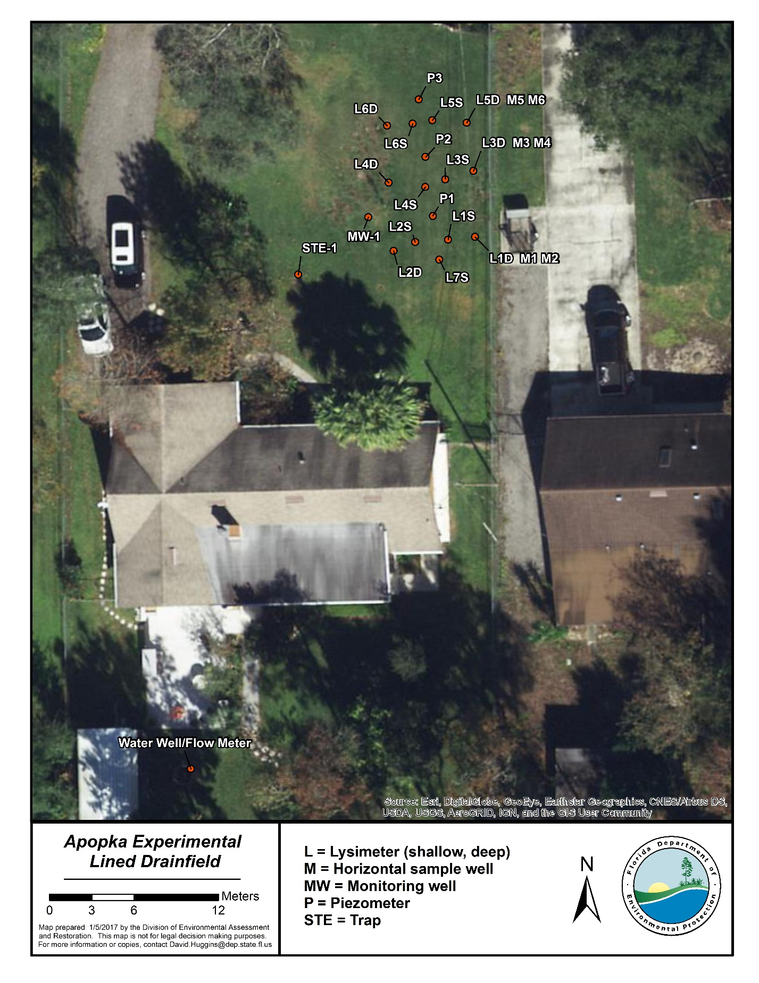Figure 1. Aerial photograph with monitoring station sampling points

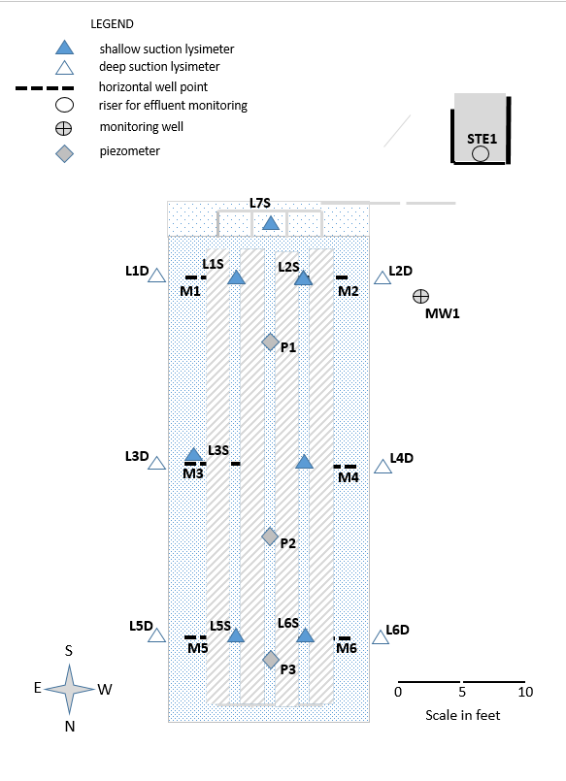
Figure 2. Plan view of monitoring device locations at experimental drainfield.
Monitoring Results
Water quality samples have been collected from the effluent, lysimeters, and monitoring wells on 5 occasions. These samples were analyzed by the DEP central laboratory. Table 2 presents the laboratory results to date for the major parameters of interest. The parameters include chloride (Cl), ammonium (NH4), total Kjeldahl nitrogen (TKN), nitrate+nitrite-nitrogen (NO3+NO2), and total phosphorous (TP).
Table 2. Monitoring results for key parameters, Wekiva experimental lined drainfield study
Station | Sample Date | Cl (mg/L) | NH4 (mg/L) | TKN (mg/L) | Org N (mg/L) | NO3+NO2 (mg/L) | TN (mg/L) | TP (mg/L)
STE1 | 09/14/16 | 99 | 64 | 80 | 16.00 | BDL | 80 | 8.4
 | 10/12/16 | 70 | 42 | 45 | 3.00 | BDL | 45 | 5.2
 | 11/09/16 | 83 | 53 | 60 | 7.00 | BDL | 60 | 7.5
 | 12/08/16 | 75 | 57 | 65 | 8.00 | BDL | 65 | 7.3
 | 01/18/17 | 79 | 53 | 61 | 8.00 | BDL | 61 | 6.9
MW1 | 09/14/16 | 31 | 0.008 | 2.60 | 2.59 | 3.6 | 6 | 92
 | 10/12/16 | 39 | 0.16 | 120 | 119.84 | 11.0 | 131 | 490
 | 11/09/16 | 29 | 0.80 | 64 | 63.20 | 3.5 | 68 | 200
 | 12/08/16 | 26 | 0.28 | 63 | 62.72 | 2.9 | 66 | 200
 | 01/18/17 | 27 | 0.049 | 27 | 26.95 | 3.1 | 30 | 200
L1S | 09/14/16
 | 10/12/16
 | 11/09/16 | 77 | 34 | 33 | BDL | 6.1 | 39 | 4.7
 | 12/08/16
 | 01/18/17 | 82 | 18 | 18 | 0 | 11 | 29 | 3.2
L1D | 09/14/16
 | 10/12/16 | 29 | 12 | 14.0 | 2.0 | BDL | 14 | 29
 | 11/09/16 | 73 | 0.46 | 4.7 | 4.24 | 41 | 46 | 0.1
 | 12/08/16
 | 01/18/16 | 71 | 0.36 | 1.7 | 1.34 | 11 | 13 | 0.04
M1 | 09/14/16 | 100 | 51 | 57 | 6.0 | BDL | 57 | 2.8
 | 10/12/16 | 67 | 43 | 47 | 4.0 | 0.078 | 47 | 3.6
 | 11/09/16 | 77 | 42 | 46 | 4.0 | BDL | 46 | 6.7
 | 12/08/16 | 73 | 19 | 22 | 3.0 | 0.014 | 22 | 3.1
 | 01/18/17 | 86 | 4.9 | 8 | 3.0 | BDL | 8 | 2.8
L2S | 09/14/16
 | 10/12/16 | 16 | 0.12 | 1.9 | 1.78 | 2.0 | 4 | 0.14
 | 11/09/16 |  | 0.036 | 2.6 | 2.56 | 29 | 32 | 0.11
L2S | 12/08/16
 | 01/18/17 |  | 0.035 | 2.5 | 2.47 | 23 | 26 | 0.13
L2D | 09/14/16
 | 10/12/16 | 38 | 4.30 | 6.9 | 2.60 | 4.2 | 11 | 0.19
 | 11/09/16 | 69 | 0.55 | 2.3 | 1.75 | 22 | 24 | 0.13
 | 12/08/16
 | 01/18/17 | 62 | 0.14 | 1.6 | 1.46 | 19 | 21 | 0.06
M2 | 09/14/16 | 100 | 51 | 61 | 10.0 | BDL | 61 | 2.5
 | 10/12/16 | 62 | 38 | 43 | 5.0 | BDL | 43 | 2.5
 | 11/09/16 | 75 | 43 | 45 | 2.0 | 0.066 | 45 | 4.5
 | 12/08/16 | 72 | 31 | 34 | 3.0 | 0.011 | 34 | 2.6
 | 01/18/17 | 87 | 26 | 27 | 1.0 | BDL | 27 | 3.3
L3S | 09/14/16
 | 10/12/16 | 54 | 0.067 | 1.6 | 1.53 | 1.3 | 3 | 0.10
 | 11/09/16 | 27 | 0.10 | 2.4 | 2.30 | 11.0 | 13 | 0.10
 | 12/08/16
 | 01/18/17 | 46 | 0.11 | 2.1 | 1.99 | 7.7 | 10 | 0.12
L3D | 09/14/16 | 110 | 0.012 | 3.9 | 3.89 | 4.20 | 8 | 0.43
 | 10/12/16 | 28 | 0.076 | 2.4 | 2.32 | 0.89 | 3 | 0.86
 | 11/09/16 | 30 | 0.044 | 2.7 | 2.66 | 7.70 | 10 | 0.26
 | 12/08/16
 | 01/18/17 | 59 | 0.053 | 2.0 | 1.95 | 7.6 | 10 | 0.16
M3 | 09/14/16 | 91 | 18 | 50 | 32.0 | 0.015 | 50 | 34
 | 10/12/16 | 58 | 19 | 31 | 12.0 | BDL | 31 | 8.4
 | 11/09/16 | 71 | 16 | 23 | 7.0 | BDL | 23 | 2.0
 | 12/08/16 | 69 | 9 | 16 | 7.0 | BDL | 16 | 1.6
 | 01/18/17 | 74 | 3 | 9 | 5.7 | BDL | 9 | 2.1
L4S | 09/14/16 | 79 | 0.022 | 3.2 | 3.18 | 8.50 | 12 | 0.14
 | 10/12/16 | 85 | 0.078 | 2.5 | 2.42 | 0.73 | 3 | 0.10
 | 11/09/16 | 24 | 0.023 | 3.0 | 2.98 | 5.40 | 8 | 0.10
 | 12/08/16
 | 01/18/17 | 73 | 1.1 | 2.7 | 1.60 | 9.90 | 13 | 0.13
L4D | 09/14/16
 | 10/12/16 | 54 | 8.5 | 13 | 4.50 | BDL | 13 | 0.27
 | 110/9/16 | 53 | 6.3 | 11 | 4.70 | 0.017 | 11 | 0.06
 | 12/08/16
 | 01/18/17 | 61 | 0.76 | 2.3 | 1.54 | 2.60 | 5 | 0.02
M4 | 09/14/16 | 96 | 19 | 64 | 45.0 | 0.047 | 64 | 54
 | 10/12/16 | 62 | 13 | 28 | 15.0 | BDL | 28 | 9.1
 | 11/09/16 | 73 | 15 | 21 | 6.0 | BDL | 21 | 2.2
M4 | 12/08/16 | 72 | 9.6 | 17 | 7.40 | BDL | 17 | 0.8
 | 01/18/17 | 72 | 1.5 | 9 | 7.10 | BDL | 9 | 1.7
L5S | 09/14/16 | 25 | 0.062 | 2.9 | 2.84 | 0.31 | 3 | 0.23
 | 10/12/16 | 6 | 0.061 | 1.8 | 1.74 | 0.60 | 2 | 0.12
 | 11/09/16 | 9 | 0.063 | 2.1 | 2.04 | 5.50 | 8 | 0.06
 | 12/08/16
 | 01/18/17 | 48 | 0.12 | 1.0 | 0.88 | 0.40 | 1 | 0.03
L5D | 09/14/16 | 43 | 0.16 | 3.0 | 2.84 | 1.10 | 4 | 0.13
 | 10/12/16 | 14 | 0.65 | 2.9 | 2.25 | BDL | 3 | 0.17
 | 11/09/16 | 30 | 2.20 | 4.5 | 2.30 | 0.56 | 5 | 0.04
 | 12/08/16
 | 01/18/17 | 45 | 0.2 | 1.4 | 1.23 | 0.79 | 2 | 0.03
M5 | 09/14/16 | 89 | 7.5 | 40 | 32.50 | 0.018 | 40 | 60
 | 10/12/16 | 52 | 1.4 | 24 | 22.60 | BDL | 24 | 10
 | 11/09/16 | 43 | 0.6 | 16 | 15.39 | BDL | 16 | 8.3
 | 12/08/16 | 64 | 2.2 | 11 | 8.80 | BDL | 11 | 6.9
 | 01/18/17 | 63 | 0.3 | 8 | 7.45 | BDL | 8 | 2.7
L6S | 09/14/16 | 16 | 0.21 | 2.50 | 2.29 | 0.022 | 3 | 0.31
 | 10/12/16 | 9 | 0.18 | 2.00 | 1.82 | BDL | 2 | 0.12
 | 11/09/16 | 13 | 0.610 | 2.80 | 2.19 | BDL | 3 | 0.06
 | 12/08/16
 | 01/18/17 | 44 | 0.33 | 1.50 | 1.17 | BDL | 1.5 | 0.03
L6D | 09/14/16
 | 10/12/16 | 86 | 16 | 31 | 15.00 | BDL | 31 | 31
 | 11/09/16 | 62 | 22 | 27 | 5.0 | BDL | 27 | 20
 | 12/08/16
 | 01/18/17 | 66 | 17 | 20 | 3.00 | BDL | 20 | 6.7
M6 | 09/14/16 | 98 | 6.9 | 38 | 31.10 | 0.018 | 38 | 49
 | 10/12/16 | 54 | 4.4 | 28 | 23.60 | BDL | 28 | 14
 | 11/09/16 | 52 | 2.8 | 21 | 18.20 | BDL | 21 | 12
 | 12/08/16 | 68 | 2.0 | 11 | 9.0 | BDL | 11 | 8.6
 | 01/18/17 | 68 | 0.3 | 10 | 9.2 | BDL | 10 | 2.9
L7S | 09/14/16
 | 10/12/16 | 43 | 22 | 18 | BDL | 0.510 | 19 | 0.51
 | 11/09/16 | 68 | 10 | 13 | 3.0 | 0.036 | 13 | 0.83
 | 12/08/16
 | 01/18/17 | 81 | 2.4 | 3.2 | 0.80 | 34 | 37 | 1.5
Notes: STE=septic tank effluent sample; L= lysimeter sample; MW=monitoring well sample; M=horizontal well sample
BDL=below detection limit, reported concentrations are in milligrams per liter, empty field indicates insufficient sample volume available for analysis

Water level and flow measurements were also taken. Depths to water were measured in the 3 piezometers and the monitoring well, and flow was recorded from the flow meter during each site visit. These results are provided in Tables 3 and 4.

Table 3. Water levels, Wekiva experimental lined drainfield study
Station | Date | Depth to Water (ft.) | Height of Water Above Bottom of Liner (ft.)
MW1 | 09/13/16 | 29.05 | N/A
P1 | 09/13/16 | 5.47 | 0.48
P2 | 09/13/16 | 5.27 | 0.48
P3 | 09/13/16 | 5.22 | 0.47
MW1 | 10/12/16 | 27.90 | N/A
P1 | 10/12/16 | 5.40 | 0.55
P2 | 10/12/16 | 5.30 | 0.45
P3 | 10/12/16 | 5.35 | 0.34
MW1 | 11/09/16 | 26.75 | N/A
P1 | 11/09/16 | 5.55 | 0.40
P2 | 11/09/16 | 5.40 | 0.35
P3 | 11/09/16 | 5.35 | 0.34
MW1 | 12/08/16 | 27.90 | N/A
P1 | 12/08/16 | 5.55 | 0.40
P2 | 12/08/16 | 5.45 | 0.30
P3 | 12/08/16 | 5.45 | 0.24
Notes: Elevations are relative to septic tank outlet bottom, assigned Elevation
of 100.0 feet. MW1=monitoring well, P=piezometer, N/A=not applicable

Table 4. Flow measurements, Wekiva experimental lined drainfield study
Date | Meter Reading (gal.) | Daily Average (gal.) | Comments
7/28/2016 | 300 | ~ | Commence flow measurements to drainfield
9/13/2016 | 1700 | 30 | Homeowner on vacation
10/12/2016 | 2400 | 23 | Homeowner on vacation
11/9/2016 | 32700 | 1082 | Irrigation of newly installed sod
12/8/2016 | 42500 | 327 | Normal irrigation use
1/17/2017 | 54100 | 290 | Normal irrigation use
Note: Average daily flow includes irrigation and is based on flow since date of previous measurement

Results to Date
Operation of the experimental drainfield has proceeded since July 29, 2016. The data collected during this period allow us to make the following observations:
- Effluent concentrations have been variable, possibly due to intermittent use while the residents took vacations. Except for one occasion, TN values were within a typical range for septic tank effluent.
- Recovery of water from suction lysimeters was poor, due in part to the dry season and in part to the uneven distribution of infiltrating water within the drainfield.
- Shallow lysimeter (L1S) data indicate that there is very uneven distribution of infiltrating effluent and incomplete nitrification is occurring. The results from L1S may indicate that infiltrating effluent pools near the distribution header. However, at other shallow lysimeter locations, high nitrate data indicate that nitrification appears to be occurring and nitrogen is being reduced in the upper layer.
- The chloride and nitrogen data from the horizontal wellpoints below the mulch layer seem to indicate that effluent is infiltrating into the mulch layer. Ammonia detections, particularly at two locations closest to the header (M1 and M2), could be consistent with the results at shallow lysimeter L1S. It is also possible that ammonia is being generated from conversion of organic nitrogen leached from the wood mulch. High organic nitrogen concentrations that were detected in the horizontal well points could only be from the mulch. Phosphorus appears to also be coming from the mulch based on a comparison of the effluent and horizontal wellpoint data.
- The data from deep lysimeters installed along the edge of the liner appear to reflect water quality influence by residence within the liner. TN concentrations in all but one instance have been significantly lower than the effluent concentration. Nitrogen in some samples is a mixture of organic and ammonia nitrogen forms and in some samples, it is in the form of nitrate. It appears that these represent water quality influence by the effluent as well as the mulch material.
- The monitor well adjacent to the drainfield is a small-diameter (3/4-inch diameter) micro-well that was installed by the DEP-owned direct push rig. Depth to groundwater at this site is almost 30 feet, so purging and sampling with a suction lift pump is not possible, and this well must be purged and sampled using a method that results in a turbid sample. Sample turbidity is biasing the quality results for phosphorus and possibly TKN/organic nitrogen results. In subsequent sampling trips, samples from the well will be filtered and a new monitoring well may be installed at a later date.
- Water levels in the piezometers indicate that water is pooling within the lined area and some of the wood mulch layer is saturated.
- When the flow meter was installed, it was understood that it was being installed at a point where flow to the irrigation system would not be included. However, it was determined later that irrigation flow is also being measured. High water use measured during some months reflects irrigation of new sod during the dry season (Table 4). DEP is currently working with the homeowner on a way to estimate irrigation use each month so that irrigation can then be subtracted from total flow.

Next Steps
DEP staff will continue monthly sample collection and measurements of flow and water levels in the piezometers and monitoring well. After three additional months of monitoring data are collected and analyzed, the second quarterly report will be submitted. DEP believes that more time is needed to achieve stabilization of the mulch layer and equalization of flow within the drainfield. Any decisions on modifications to the monitoring or treatment systems must be based on a more consistent data set.

