Final

Crystal River/Kings Bay
Basin Management Action Plan

Division of Environmental Assessment and Restoration
Water Quality Restoration Program
Florida Department of Environmental Protection

with participation from the
Crystal River/Kings Bay Stakeholders

May 2018



2600 Blair Stone Rd.
Tallahassee, FL 32399
www.dep.state.fl.us

Acknowledgments
The Florida Department of Environmental Protection adopted the Crystal River/Kings Bay Basin Management Action Plan by Secretarial Order as part of its statewide watershed management approach to restore and protect Florida's water quality. The plan was developed in coordination with stakeholders, identified below, with participation from affected local, regional, and state governmental interests; elected officials and citizens; and private interests.
Florida Department of Environmental Protection
Noah Valenstein, Secretary
Table A-1. Crystal River/Kings Bay stakeholders
Type of Entity | Name
Responsible Stakeholders | Citrus County  City of Crystal River  Agricultural producers  Golf courses
Responsible Agencies | Florida Department of Agriculture and Consumer Services  Florida Department of Environmental Protection  Florida Department of Health  Southwest Florida Water Management District
Other Interested Stakeholders | Citizens  Duke Energy  Florida Farm Bureau Federation  Florida Onsite Wastewater Association  Gulf Archeology Research Institute  Kings Bay Rotary  Kings Bay Springs Alliance  Save Crystal River  Save the Manatee Club  St. Martins Marsh Aquatic Preserve  University of Florida Institute of Food and Agricultural Sciences –  Citrus County Extension Service  U.S. Fish and Wildlife Service

See Appendix A for links to important sources referenced in this document. For additional information on total maximum daily loads and nutrient management strategies in the Crystal River/Kings Bay Basin, contact:
Terry Hansen, P.G., Basin Coordinator
Florida Department of Environmental Protection
Water Quality Restoration Program, Watershed Planning and Coordination Section
2600 Blair Stone Road, Mail Station 3565
Tallahassee, FL 32399-2400
Email: terry.hansen@dep.state.fl.us
Phone: (850) 245–8561

Table of Contents
Acknowledgments 2
Table of Contents 3
List of Figures 5
List of Tables 6
List of Acronyms and Abbreviations 7
Executive Summary 10
Section 1 : Background 14
1.1 Legislation 14
1.2 Water Quality Standards and Total Maximum Daily Loads (TMDLs) 14
1.3 BMAP Requirements 15
1.4 BMAP Area 15
1.5 PFA 15
1.6 Other Scientific and Historical Information 18
1.7 Stakeholder Involvement 18
1.8 Description of BMPs Adopted by Rule 19
Section 2 : Implementation to Achieve TMDLs 20
2.1 Allocation of Pollutant Loads 20
2.2 Prioritization of Management Strategies 25
2.3 Load Reduction Strategy 26
2.4 OSTDS Management Strategies 27
2.5 UTF Management Strategies 29
2.6 STF Management Strategies 30
2.7 Agricultural Sources Management Strategies 31
2.8 WWTF Management Strategies 34
2.9 Atmospheric Deposition Management Strategies 36
2.10 Future Growth Management Strategies 37
2.11 Protection of Surface Water and Groundwater Resources through Land Conservation 37
2.12 Commitment to Implementation 38
Section 3 : Monitoring and Reporting 39
3.1 Methods for Evaluating Progress 39
3.2 Adaptive Management Measures 39
3.3 Water Quality and Biological Monitoring 40
Appendices 44
Appendix A. Important Links 44
Appendix B. Projects to Reduce Nitrogen Sources 46
Appendix C. Crystal River/Kings Bay PFA Report 57
Appendix D. OSTDS Remediation Plan 58
Appendix E. Technical Support Information 67
Appendix F. Educational Activities to Implement the UTF Management Strategies 72
Appendix G. FDACS BMPs 75
Appendix H. Future Growth Strategies of Local Jurisdictions 85

List of Figures
Figure ES-1. Crystal River/Kings Bay BMAP area and PFA boundaries 10
Figure 1. Crystal River/Kings Bay BMAP area and PFA boundaries 16
Figure 2. Loading to groundwater by source in the Crystal River/Kings Bay BMAP area 24
Figure 3. OSTDS locations in the Crystal River/Kings Bay BMAP area 28
Figure 4. Locations of WWTFs in the Crystal River/Kings Bay BMAP area 35
Figure 5. Groundwater and surface water stations sampled in the Crystal River/Kings Bay Basin 42
Figure D-1. Locations of OSTDS in the PFA in the Crystal River/Kings Bay BMAP area 63
Figure G-1. Composite of agricultural lands in the Crystal River/Kings Bay Springshed 77
Figure G-2. BMP enrollment in the Crystal River/Kings Bay Springshed as of December 31, 2016 81

List of Tables
Table A-1. Crystal River/Kings Bay stakeholders 2
Table ES-1. WWTF effluent standards 12
Table 1. Restoration targets for the Kings Bay Spring Group 15
Table 2. BMPs and BMP manuals adopted by rule as of June 2017 19
Table 3. Estimated nitrogen load to groundwater by source in the BMAP area 22
Table 4. Total reduction required to meet the TMDLs 25
Table 5. Nitrogen reduction schedule (lb-N/yr) 25
Table 6. Summary of potential credits for the Crystal River/Kings Bay BMAP to meet the TMDLs 26
Table 7. Estimated individual OSTDS improvements to groundwater 29
Table 8. Current project credits to reduce UTF loading to groundwater 30
Table 9. Maximum UTF load reductions based on existing public education credit policies 30
Table 10. Maximum load reductions from STF improvements based on existing credit policies 31
Table 11. Potential for additional load reductions to groundwater 33
Table 12. Calculations for additional load reductions to groundwater 33
Table 13. Wastewater effluent standards for the BMAP area 36
Table 14. Stakeholder conservation land purchase 38
Table 15. Core water quality indicators 41
Table 16. Supplemental water quality indicators 41
Table 17. Anticipated resource responses from BMAP implementation 42
Table B-1. Stakeholder projects to reduce nitrogen sources 47
Table D-1. Estimated reduction credits for OSTDS enhancement or sewer* 62
Table D-2. Stakeholder educational activities to implement the OSTDS remediation plan 66
Table E-1. Range of environmental attenuation of nitrogen from a detailed literature review 70
Table F-1. Stakeholder education activities to implement UTF management strategies 73
Table G-1. Composite agricultural land use in the Crystal River/Kings Bay Springshed 76
Table G-2. Fertilized crop lands in the Crystal River/Kings Bay Springshed 76
Table G-3. Livestock lands in the Crystal River/Kings Bay Springshed 76
Table G-4. Key management and structural BMPs adopted by FDACS OAWP 79
Table G-5. Agricultural acreage and BMP enrollment in the Crystal River/Kings Bay Springshed as of December 31, 2016 82
Table G-6. Beyond BMP implementation 84
Table H-1. Future growth strategies of local jurisdictions 85

List of Acronyms and Abbreviations
Ac Acre
AWT Advanced Wastewater Treatment
ATU Aerobic Treatment Unit
BAF Biochemical Attenuation Factor
BMAP Basin Management Action Plan
BMPs Best Management Practices
CASTNET Clean Air Status and Trends Network
cfs Cubic Feet Per Second
CMAQ Community Multiscale Air Quality
C.R. County Road
CRF Controlled-Release Fertilizer
DEP Florida Department of Environmental Protection
DMR Discharge Monthly Report
DO Dissolved Oxygen
ERP Environmental Resource Permit
F.A.C. Florida Administrative Code
F.A.R. Florida Administrative Register
FARMS Facilitating Agricultural Resource Management Systems
FDACS Florida Department of Agriculture and Consumer Services
FDOH Florida Department of Health
FF Farm Fertilizer
FGS Florida Geological Survey
FLUCCS Florida Land Use Cover and Forms Classification System
FOWA Florida Onsite Wastewater Association
F.S. Florida Statutes
FSAID Florida Statewide Agriculture Irrigation Database
FY Fiscal Year
FYN Florida Yards and Neighborhoods
GIS Geographic Information System
gpd Gallons Per Day
HA Habitat Assessment
IA Implementation Assurance
IV Implementation Verification
in/yr Inch Per Year
lb Pound
lb-N/yr Pounds of Nitrogen Per Year
LF Linear Feet
LID Low-Impact Development
LVS Linear Vegetation Survey
LW Livestock Waste
MFL Minimum Flow and Level
mgd Million Gallons Per Day
mg/L Milligrams Per Liter
MIL Mobile Irrigation Lab
N Nitrogen
NA Not Applicable
NADP National Atmospheric Deposition Program
NELAC National Environmental Accreditation Conference
NELAP National Environmental Accreditation Program
NNC Numeric Nutrient Criteria
NOI Notice of Intent
NPDES National Pollutant Discharge and Elimination System
NSF National Sanitation Foundation
NSILT Nitrogen Source Inventory Loading Tool
NTN National Trends Network
OAWP Office of Agricultural Water Policy
OFS Outstanding Florida Spring
OFW Outstanding Florida Water
OSTDS Onsite Sewage Treatment and Disposal System
PBTS Performance-based Treatment System
PFA Priority Focus Area
PSA Public Service Announcement or Planned Service Area
QA/QC Quality Assurance/Quality Control
RIB Rapid Infiltration Basin
RPS Rapid Periphyton Survey
SBIO DEP Statewide Biological Database
SCI Stream Condition Index
SOP Standard Operating Procedure
STF Sports Turf Fertilizer
STORET Florida Storage and Retrieval Database
SWFWMD Southwest Florida Water Management District
SWIM Surface Water Improvement and Management
TDEP Total Atmospheric Deposition Model
TMDL Total Maximum Daily Load
TN Total Nitrogen
TP Total Phosphorus
TSS Total Suspended Solids
UFA Upper Floridan Aquifer
UF–IFAS University of Florida/Institute of Food and Agricultural Sciences
USDA U.S. Department of Agriculture
USGS U.S. Geological Survey
UTF Urban Turfgrass Fertilizer
WAFR Wastewater Facility Regulation (Database)
WBID Waterbody Identification (Number)
WIN Florida Watershed Information Network Database
WMD Water Management District
WWTF Wastewater Treatment Facility
WWTP Wastewater Treatment Plant
yr Year

Executive Summary
Crystal River/Kings Bay Basin
The Florida Springs and Aquifer Protection Act (Chapter 373, Part VIII, Florida Statutes [F.S.]), provides for the protection and restoration of Outstanding Florida Springs (OFS), which comprise 24 first magnitude springs, 6 additional named springs, and their associated spring runs. The Florida Department of Environmental Protection (DEP) has assessed water quality in each OFS and has determined that 24 of the 30 OFS are impaired for the nitrate form of nitrogen. The Kings Bay Spring Group is one of the impaired first magnitude OFS.
The Crystal River/Kings Bay Basin Management Action Plan (BMAP) area (Figure ES-1) consists of 178,753 acres located in Citrus County, Florida, adjacent to the City of Crystal River. The BMAP area contains the Crystal River/Kings Bay spring complex, which has more than 70 springs that account for 99 % of the fresh water entering the 600-acre Kings Bay.
Crystal River/Kings Bay Priority Focus Area (PFA)
The PFA boundary includes the majority of the BMAP area, with the exception of the water discharge area along the Gulf Coast and portions of the southern and eastern springshed that have lower recharge characteristics as well as fewer nitrogen sources (see Appendix C).
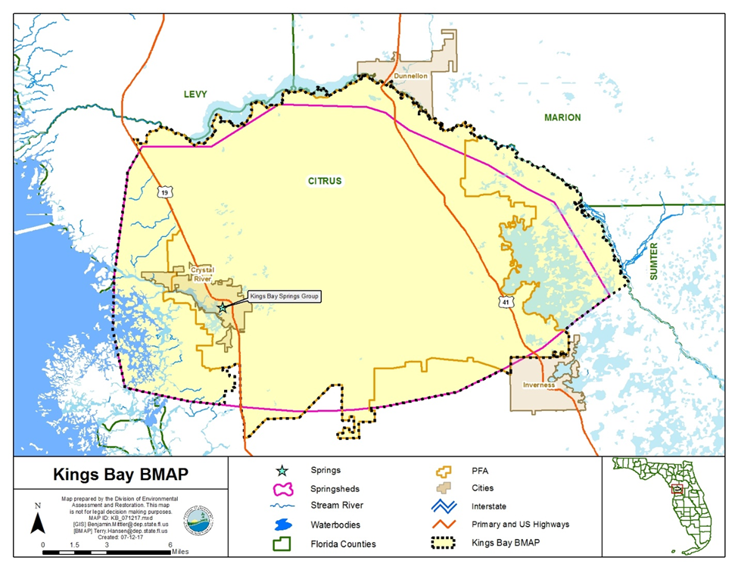
Figure ES-1. Crystal River/Kings Bay BMAP area and PFA boundaries
Nitrogen Source Identification, Required Reductions, and Options to Achieve Reductions
DEP set nitrate and orthophosphate water quality restoration targets for 5 springs in the Kings Bay Spring Group and total nitrogen (TN) and total phosphorus (TP) targets for Kings Bay. In 2014, DEP adopted total maximum daily loads (TMDLs) of 0.23 milligrams per liter (mg/L) of nitrate and 0.028 mg/L of orthophosphate at the 5 spring vents, and TMDLs of 0.28 mg/L of TN and 0.032 mg/L of TP for Kings Bay.
Onsite sewage treatment and disposal systems (OSTDS or septic systems; the terms are used interchangeably throughout this document) represent 42 % of the estimated nitrogen loading to groundwater, agriculture (including farm fertilizer [FF] and livestock waste [LW]) 17 %, and urban turfgrass fertilizer (UTF) 15 % of the total loading to groundwater based on DEP's analysis conducted using the Nitrogen Source Inventory Loading Tool (NSILT).
The total load reduction required to meet the TMDLs at the spring vents is 274,000 pounds of nitrogen per year (lb-N/yr). To measure progress towards achieving the necessary load reduction, DEP is establishing the following milestones:
- 82,200 lb-N/yr (30 %) within 5 years.
- 137,000 lb-N/yr (50 %) within 10 years.
- 54,800 lb-N/yr (20 %) within 15 years.
- Total of 274,000 lb-N/yr within 20 years.
The policies and submitted projects included within this BMAP are estimated to achieve a reduction of 201,007 to 299,021 lb-N/yr. The BMAP is designed to achieve 80 % of the effort within 10 years of adoption and 100 % within 15 years. Projects and strategies are designed to achieve nitrogen reductions throughout the Kings Bay Spring Group. Projects are designed for nitrogen removal, but are expected to achieve phosphorus reductions as well. DEP will evaluate progress towards these milestones and will report to the Governor and Florida Legislature. DEP will adjust management strategies to ensure the target concentrations are achieved. This may include expanding the area to which the OSTDS remediation policies apply; any such change, however, would be incorporated into an updated BMAP through a formal adoption process.
There are currently 51 projects to improve water quality (see Appendix B), of which 21 projects have estimated load reductions. Possible load reductions include projects resulting from policies for owner-implemented best management practices (BMPs) for FF, LW, and sports turfgrass fertilizer (STF); wastewater treatment facility (WWTF) upgrades; policies to reduce UTF application; and voluntary OSTDS enhancements or conversions to sewer.
Restoration Approaches
- New OSTDS – Upon BMAP adoption, the OSTDS remediation plan prohibits new systems on lots of less than 1 acre within the PFAs, unless the system includes enhanced treatment of nitrogen as defined by the OSTDS remediation plan, or unless the OSTDS permit applicant demonstrates that sewer connections will be available within 5 years. Local governments and utilities are encouraged to develop master wastewater treatment feasibility plans to identify specific areas to be sewered within 20 years of BMAP adoption. The OSTDS remediation plan is incorporated as Appendix D.
- Existing OSTDS – Upon completion of the feasibility plan, rulemaking, and funding milestones included in the OSTDS remediation plan, but no later than five years after BMAP adoption, modification or repair permits issued by FDOH for all OSTDS within the PFA on all lot sizes will require enhanced treatment of nitrogen, unless sewer connections will be available based on a BMAP-listed project. All OSTDS subject to the policy must include enhanced treatment of nitrogen no later than 20 years after BMAP adoption.
- WWTFs − The effluent standards listed in Table ES-1 will apply to all new and existing WWTFs in the BMAP area (inside and outside the PFA).
Table ES-1. WWTF effluent standards
gpd = Gallons per day
95% of the Permitted Capacity  (gpd) | Nitrogen Concentration Limits for Rapid Infiltration Basins (RIBs) and Absorption Fields  (mg/L) | Nitrogen Concentration Limits for All Other Land Disposal Methods, Including Reuse  (mg/L)
Greater than 100,000 | 3 | 3
20,000 to 100,000 | 3 | 6
Less than 20,000 | 6 | 6

- UTF – UTF sources can receive up to 6 % credit for DEP's approved suite of public education and source control ordinances. Entities have the option to collect and provide monitoring data to quantify reduction credits for additional measures.
- STF – STF sources include golf courses and other sporting facilities. Golf courses can receive up to 10 % credit for implementing the Golf Course BMP Manual. Other sports fields can receive up to 6 % credit for managing their fertilizer applications to minimize transport to groundwater.
- FF – All FF sources are required to implement BMPs or perform monitoring to demonstrate compliance with the TMDL. A 15 % reduction to groundwater is estimated for owner-implemented BMPs. Additional credits could be achieved through better documentation of reductions achieved through BMP implementation or implementation of additional agricultural projects or practices, such as precision irrigation, soil moisture probes, controlled-release fertilizer, and cover crops.
- LW – All LW sources are required to implement BMPs or perform monitoring. A 10 % reduction to groundwater is estimated for owner-implemented BMPs. Additional credits could be achieved through additional projects and practices if data are available.

: Background

Legislation
Chapter 373, Part VIII, Florida Statutes (F.S.), created the Florida Springs and Aquifer Protection Act to provide for the protection and restoration of Outstanding Florida Springs (OFS), which comprise 24 first magnitude springs, 6 additional named springs, and their associated spring runs. The Florida Department of Environmental Protection (DEP) has assessed water quality in each OFS and has determined that 24 of the 30 OFS are impaired for the nitrate form of nitrogen. The Kings Bay Spring Group is one of the impaired first magnitude OFS.
Development of the basin management action plan (BMAP) to meet the new requirements of the Florida Springs and Aquifer Protection Act for the Crystal River/Kings Bay Basin was initiated in 2016.

Water Quality Standards and Total Maximum Daily Loads (TMDLs)
A TMDL represents the maximum amount of a given pollutant that a waterbody can assimilate and still meet water quality criteria. Kings Bay and the impaired springs in the Kings Bay Spring Group addressed in this BMAP are Class III waterbodies with a designated use of recreation, propagation, and the maintenance of a healthy, well-balanced population of fish and wildlife. These waters are impaired by nutrients, which in excess has been demonstrated to adversely affect flora or fauna through the excessive growth of algae. Excessive algal growth results in ecological imbalances in the springs and can produce human health problems, foul beaches, inhibit navigation, and reduce the aesthetic value of the resources.
DEP adopted nutrient TMDLs for the Kings Bay Spring Group in 2014, including Kings Bay, Hunter Spring (also locally known as Hunters Spring), House Spring, Idiot's Delight Spring, Tarpon Spring (also known as Tarpon Hole Spring), and Black Spring (see Table 1). The TMDLs established an annual average nitrate target of 0.23 milligrams per liter (mg/L) and an annual average orthophosphate target of 0.028 mg/L at the 5 spring vents, and TMDLs of 0.28 mg/L of total nitrogen (TN) and 0.032 mg/L of total phosphorus (TP) for Kings Bay. The period of record for water quality data for the TMDLs was January 1, 2004 through June 30, 2011.

Table 1. Restoration targets for the Kings Bay Spring Group
Waterbody or  Spring Name | Waterbody Identification (WBID) Number | Parameter | TMDL  (mg/L)
Kings Bay | 1341 | TN, annual average | 0.28
Kings Bay | 1341 | TP, annual average | 0.032
Hunter Spring | 1341C | Nitrate, annual average | 0.23
Hunter Spring | 1341C | Orthophosphate, annual average | 0.028
House Spring | 1341D | Nitrate, annual average | 0.23
House Spring | 1341D | Orthophosphate, annual average | 0.028
Idiot's Delight Spring | 1341F | Nitrate, annual average | 0.23
Idiot's Delight Spring | 1341F | Orthophosphate, annual average | 0.028
Tarpon Spring | 1341G | Nitrate, annual average | 0.23
Tarpon Spring | 1341G | Orthophosphate, annual average | 0.028
Black Spring | 1341H | Nitrate, annual average | 0.23
Black Spring | 1341H | Orthophosphate, annual average | 0.028

BMAP Requirements
Section 403.067(7), F.S., provides DEP with the statutory authority for the BMAP Program. A BMAP is a comprehensive set of strategies to achieve the required pollutant load reductions. In addition to this authority, the Florida Springs and Aquifer Protection Act (Part VIII of Chapter 373, F.S.) describes additional requirements for 30 springs.

BMAP Area
The BMAP area (Figure 1) comprises 178,753 acres located in Citrus County, Florida, adjacent to the City of Crystal River. The BMAP area contains the Crystal River/Kings Bay spring complex, which has more than 70 springs that account for 99 % of the fresh water entering the 600-acre Kings Bay.
This area includes the surface water basin as well as the groundwater contributing areas for the springs (or springsheds). Springsheds for the OFS were delineated or reviewed by SWFWMD with input from the Florida Geological Survey (FGS). A springshed is the area of land that contributes water to a spring or group of springs, mainly via groundwater flow.

PFA
In compliance with the Florida Springs and Aquifer Protection Act, this BMAP delineates a PFA, defined as the area(s) of a basin where the Floridan aquifer is generally most vulnerable to pollutant inputs and where there is a known connectivity between groundwater pathways and an OFS. The PFA provides a guide for focusing restoration strategies where science suggests these efforts will most benefit the springs. The link to the PFA document is included in Appendix C.

Description
Nitrogen sources are more likely to influence groundwater quality under certain conditions. For example, where soils are sandy and well drained, less nitrogen is converted to gas and released into the atmosphere or taken up by plants, compared with other soil types. Therefore, local soil types play a role in how much nitrogen travels from the land surface to groundwater in a specific springshed. Also, the underlying geologic material influences the vulnerability of the underlying aquifers and the rate of lateral movement within the Floridan aquifer toward the springs. These conditions, and others, were considered in the delineation of the PFA (see Appendix C).
Following BMAP adoption, DEP will ensure that the GIS files associated with the PFA boundary are available to the public on the DEP Map Direct webpage.
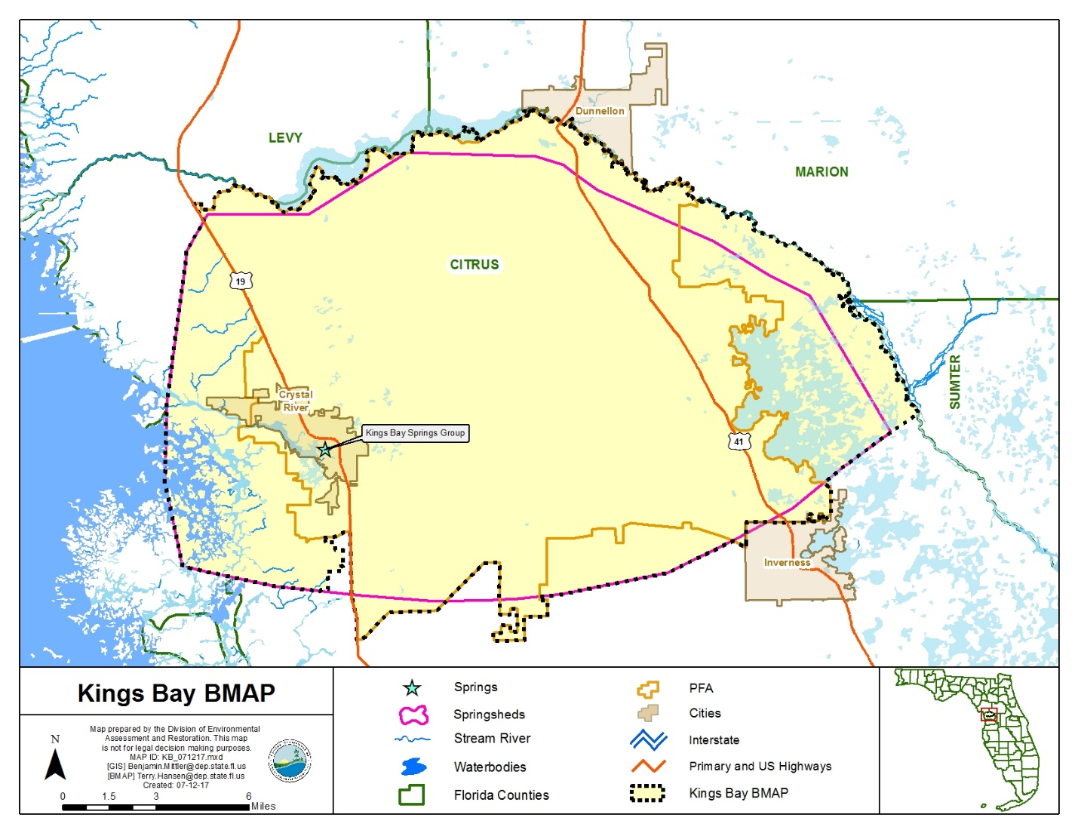
Figure 1. Crystal River/Kings Bay BMAP area and PFA boundaries

Additional Requirements
In accordance with Section 373.811, F.S., the following activities are prohibited in the PFA:
- New domestic wastewater disposal facilities, including rapid infiltration basins (RIBs), with permitted capacities of 100,000 gallons per day (gpd) or more, except for those facilities that meet an advanced wastewater treatment (AWT) standard of no more than 3 mg/L TN, on an annual permitted basis.
- New OSTDS on lots of less than once acre inside the PFA, unless additional nitrogen treatment is provided, as specified in the OSTDS remediation plan (see Appendix D for details).
- New facilities for the disposal of hazardous waste.
- The land application of Class A or Class B domestic wastewater biosolids not in accordance with a DEP-approved nutrient management plan establishing the rate at which all biosolids, soil amendments, and sources of nutrients at the land application site can be applied to the land for crop production, while minimizing the amount of pollutants and nutrients discharged to groundwater or waters of the state.
- New agricultural operations that do not implement BMPs, measures necessary to achieve pollution reduction levels established by DEP, or groundwater monitoring plans approved by a WMD or DEP.
1.5.2.1 Additional Requirements for Biosolids and Septage Application Sites
In the PFA, the aquifer contributing to the springs is highly vulnerable to contamination by nitrogen sources and soils have a high to moderate tendency to leach applied nitrogen. DEP previously documented elevated nitrate concentrations in groundwater beneath septage application zones in spring areas. To assure that nitrogen losses to groundwater are minimized from permitted application of biosolids and septage in the PFA, the following requirements apply to newly-permitted application sites and existing application sites upon permit renewal.
All permitted biosolids application sites that are agricultural operations must be enrolled in the FDACS BMP program or be within an agricultural operation enrolled in the FDACS BMP program for the applicable crop type. Implementation of applicable BMPs will be verified by FDACS in accordance with Chapter 5M-1, Florida Administrative Code (F.A.C.). Permitted biosolids application sites that are new agricultural operations must also comply with Subsection 373.811(5), F.S. Biosolids application sites must be certified as viable agricultural operations by an acknowledged agricultural professional such as an agricultural consultant or agricultural extension agent. Effective nutrient management practices must be ongoing at the application zones in the permit. Plant uptake and harvesting are vital components of the nutrient management plan to remove nitrogen and prevent it from leaching to groundwater. If DEP determines that the site is not a viable agricultural site implementing a nutrient management plan, corrective action will be required.

Groundwater monitoring for nitrate is required for all biosolids and septage land application sites in the PFA to assure compliance with nutrient management objectives in this BMAP. However, groundwater monitoring is not required if the site nutrient management plan limits biosolids application rates of TN with no adjustment for available nitrogen normally allowed by subsections 62-640.500(5) and (6), F.A.C. (e.g. for a recommended fertilizer rate of 160 pounds of nitrogen per acre, only 160 pounds of TN per acre shall be applied). For septage application, groundwater monitoring is not required if the site nutrient management plan limits application rates to 30,000 gallons per acre for sites accepting mixtures of septage and grease (food establishment sludge) or to 40,000 gallons per acre for sites accepting septage without grease. The permit renewal application will include a trend analysis for nitrate in groundwater monitoring wells during the previous permit cycle, and an evaluation of the potential for the facility to cause or contribute to exceedance of the TMDL.
Changes are proposed to the upcoming FDACS Cattle BMP Manual revision that will likely impact biosolid application. This will necessitate coordination between FDACS and DEP permitting staff.

Other Scientific and Historical Information
In preparing this BMAP, DEP collected and evaluated credible scientific information on the effect of nutrients, particularly forms of nitrogen, on springs and springs systems. Some of the information collected is specific to the Crystal River/Kings Bay Basin, while other references provide information on spring restoration topics, such as nitrogen-reducing technologies, the treatment performance of OSTDS, and runoff following fertilizer applications.

Stakeholder Involvement
Stakeholder involvement is critical to develop, gain support for, and secure commitments in a BMAP. The BMAP process engages stakeholders and promotes coordination and collaboration to address the pollutant load reductions necessary to achieve the TMDLs. DEP invites stakeholders to participate in the BMAP development process and encourages public participation and consensus to the greatest practicable extent. Table A-1 identifies the stakeholders participating in the development of this BMAP.
During the development of the Crystal River/Kings Bay BMAP, DEP held a series of meetings involving stakeholders and the general public. The purpose of these meetings was to consult with stakeholders to gather information, evaluate the best available science, develop an OSTDS remediation plan (including a public education plan), define management strategies and milestones, and establish monitoring requirements. All of the meetings were open to the public and noticed in the Florida Administrative Register (F.A.R.). Additionally, a public meeting on the current draft BMAP was held on September 25, 2017 and was noticed in the F.A.R. and in local newspapers.
Upon BMAP adoption, DEP intends to facilitate annual meetings with stakeholders to review progress towards achieving the TMDLs.

Description of BMPs Adopted by Rule
Table 2 identifies the adopted BMPs and BMP manuals relevant to this BMAP.
Table 2. BMPs and BMP manuals adopted by rule as of June 2017
Agency | F.A.C. Chapter | Chapter Title
FDACS Office of Agricultural Water Policy (OAWP) | 5M-6 | Florida Container Nursery BMP Guide
FDACS OAWP | 5M-8 | BMPs for Florida Vegetable and Agronomic Crops
FDACS OAWP | 5M-9 | BMPs for Florida Sod
FDACS OAWP | 5M-11 | BMPs for Florida Cow/Calf Operations
FDACS OAWP | 5M-12 | Conservation Plans for Specified Agricultural Operations
FDACS OAWP | 5M-13 | BMPs for Florida Specialty Fruit and Nut Crop Operations
FDACS OAWP | 5M-14 | BMPs for Florida Equine Operations
FDACS OAWP | 5M-16 | BMPs for Florida Citrus
FDACS OAWP | 5M-17 | BMPs for Florida Dairies
FDACS OAWP | 5M-18 | Florida Agriculture Wildlife BMPs
FDACS OAWP | 5M-19 | BMPs for Florida Poultry
FDACS Division of Agricultural Environmental Services | 5E-1 | Fertilizer
FDACS Division of Aquaculture | 5L-3 | Aquaculture BMPs
FDACS Florida Forest Service | 5I-6 | BMPs for Silviculture
FDACS Florida Forest Service | 5I-8 | Florida Forestry Wildlife BMPs for State Imperiled Species
SWFWMD | 40D-26 | Facilitating Agricultural Resource Management Systems (FARMS) Program
DEP | 62-330 | Environmental Resource Permitting

: Implementation to Achieve TMDLs

Allocation of Pollutant Loads
DEP collected and evaluated credible scientific information on the effect of nutrients, particularly forms of nitrogen, on the Kings Bay Spring Group, described below.

Nutrients in the Springs and Spring Systems
DEP developed the NSILT to provide information on the major sources of nitrogen in the groundwater contributing area. In addition, this tool is used to estimate nitrogen loads to groundwater from these sources in the spring contributing area. The NSILT is a GIS and spreadsheet-based tool that provides spatial estimates of the relative contribution of nitrogen from major nitrogen sources and accounts for the transport pathways and processes affecting the various forms of nitrogen as they move from the land surface through the soil and geologic strata.
The first major factor to consider in estimating the loading to groundwater in the NSILT is the attenuation of nitrogen as it moves from its source through the environment, before it reaches the Upper Floridan Aquifer (UFA). The movement of nitrogen from the land surface to groundwater is controlled by biological and chemical processes that occur as part of the nitrogen cycle, as well as hydrogeological processes. Many of these processes attenuate (impede or remove) the amount of nitrogen transported to groundwater. An understanding of how water moves through the subsurface and the processes that transform the different forms of nitrogen is essential for estimating nitrogen loading to groundwater from various sources.
A second major factor to consider in estimating the loading to groundwater are the geological features in the springshed and the related "recharge rate". Water movement between the shallow groundwater (surficial aquifer, where present) and the deeper aquifer (UFA) is slowed by a low-permeability layer of clay, silt, and fine sand that retards the vertical movement of infiltrating water from the surface. The UFA occurs in limestone that can be prone to dissolving and, over geologic time, the development of numerous karst features (sinkholes, caves, and conduits). These features allow water from the land surface to move directly and relatively rapidly into the aquifer and in some areas for groundwater in the aquifer to move rapidly to the springs.
Potential recharge rates from the surface to the UFA are affected by variations in the geologic materials and the presence of karst features. DEP estimated the recharge rate ranges and grouped them into three rate categories, which were applied to the NSILT:
- Low recharge (Less than 3 inches per year [in/yr]).
- Medium recharge (3 to 10 in/yr).
- High recharge (10 in/yr or greater).
In the NSILT, DEP applied different attenuation factors to different types of sources, so that various biological, chemical, and hydrogeological effects could be estimated. The attenuation that was applied means that the amount of nitrogen leaving a source (such as a livestock operation or a newly fertilized yard) reduces the amount of nitrogen predicted to reach the aquifer. In the NSILT estimates, the attenuation rates range from 90 % (for atmospheric deposition) to 25 % (for wastewater disposal in a RIB). Using these examples, only 10 % of nitrogen from atmospheric deposition is expected to reach the aquifer, while 75 % of nitrogen from a RIB is expected to reach groundwater, because the remainder is attenuated by various chemical and biological processes.
Phosphorus is naturally abundant in the geological material underlying much of Florida and is often present in high concentrations in surface water and groundwater. Measured orthophosphate concentrations in the Kings Bay Spring Group do not show an increasing trend over time. However, TP increases have been measured in the bay, suggesting that there are local sources such as stormwater runoff. Monitoring and evaluation of TP and orthophosphate and influences on the springs continue as the TMDLs are implemented.

Estimated Nitrogen Loads
Table 3 lists the nitrogen loads to groundwater by source. Note that urban stormwater loads are included in UTF estimates, while agricultural stormwater loads are included in farm fertilizer (FF) and livestock waste (LW) loading estimates. Nitrogen loading to surface water will be reduced through the activities and strategies for the sources identified in this chapter for groundwater loading.
Table 3. Estimated nitrogen load to groundwater by source in the BMAP area
Nitrogen Source | Total Nitrogen Load to Groundwater  (lb-N/yr) | % Contribution
OSTDS | 250,174 | 42
UTF | 90,148 | 15
Atmospheric Deposition | 79,541 | 13
FF | 70,694 | 12
STF | 49,727 | 8
LW | 30,793 | 5
WWTF | 20,453 | 3
Total | 591,530 | 100

Assumptions and Considerations
The NSILT calculations are based on the following assumptions and considerations:
- NSILT Nitrogen Inputs – The methods used to calculate nitrogen inputs for each pollutant source were based on a detailed synthesis of information, including direct water quality measurements, census data, surveys, WWTF permits, published scientific studies and reports, and information obtained in meetings with agricultural producers. For some pollutant source categories, nitrogen inputs were obtained using assumptions and extrapolations, and as a result, these inputs could be subject to further refinement if more detailed information becomes available.
OSTDS Load Contribution – A per capita contribution to an OSTDS of 9.012 lb-N/year was used to calculate loading from OSTDS. The average household contribution was estimated based on 2010 U.S. Census Bureau data on the average number of people per household (2.23 in Citrus County) and additional information on the amount of time spent away from home by the school-age population and labor force (adjusted to 1.95 effective persons per household). Nitrogen Attenuation Factors – Biological and chemical processes that occur as part of the nitrogen cycle, as well as hydrogeological processes, control the movement of nitrogen from the land surface to groundwater. To estimate the amount of nitrogen loading to the aquifer, DEP applied two nitrogen attenuation factors: (1) biochemical attenuation, to account for biochemical processes that convert or transform the different forms of nitrogen; and (2) hydrogeological attenuation, to account for spatial variations that affect the rate of water infiltrating through geological media to recharge the UFA. Given the relatively large range of literature-reported values of nitrogen attenuation for each source category, DEP used an average attenuation factor for each source based on land use practices and hydrogeological conditions in the contributing areas.
Other assumptions and considerations for BMAP implementation include the following:
- Unquantified Project Benefits – Nitrogen reductions for some of the projects and activities listed in this BMAP cannot currently be quantified. However, because of their positive impact, it is assumed that these actions will help reduce pollutant loads, and estimated loading reductions may be determined at a later date and assigned to these activities.
- Atmospheric Deposition – Atmospheric sources of nitrogen are local, national, and international. Atmospheric sources are generally of low nitrogen concentration compared with other sources and are further diminished through additional biological and chemical processes before they reach groundwater. Atmospheric deposition sources and trends will be reevaluated periodically.
- OSTDS Inventory and Loading Calculations – The total number of OSTDS in the basin is estimated based on local information and FDOH data. Future BMAPs and the associated OSTDS loading calculations may be adjusted based on improved data on the number and locations of existing septic systems and may include additional OSTDS installed since BMAP adoption.
- PFA – The PFA provides a guide for focusing strategies where science suggests efforts will best benefit the springs. The PFA boundary may be adjusted in the future if additional relevant information becomes available.
- Project Collection Period – The BMAP project collection period is limited to projects after a certain date, based on the data used to calculate the reductions needed. Reductions from older projects are already accounted for in the baseline loading. Projects completed in the springshed after July 1, 2011, were considered for inclusion in this BMAP.
- Legacy Sources – Land uses or management practices not currently ongoing in the basin may still be affecting the nitrate concentration of the springs. The movement of water from the land surface through the soil column to the UFA and through the UFA to the spring system varies both spatially and temporally and is influenced by local soil and aquifer conditions. As a result, there may be a lag between when nitrogen input to the UFA occurs and ultimately when that load arrives at the Kings Bay Spring Group. The impact of this delay is not fully known.
- Implementation Schedule – BMAP implementation is intended to be a 20-year process. This plan defines nitrogen reduction milestones for 5-year (30 %), 10-year (50 %), and 15-year (20 %) implementation, so that the TMDLs will be met no later than the 20-year goal (see Section 2.1.6 for further details). Further, the total reductions and the project credits may be adjusted under the adaptive management approach used for the BMAP. This approach requires regular follow-up to ensure that management strategies are carried out and that their incremental effects are assessed. The process acknowledges that there is some uncertainty associated with the outcomes of proposed management strategies and the estimated response in nitrogen concentration at the springs. As more information is gathered and progress towards each 5-year milestone is reviewed, additional management strategies to achieve the TMDLs will be developed or existing strategies refined to better address the sources of nitrogen loading.
- Changes in Spring Flows – The role of this BMAP is specifically to promote the implementation of projects that reduce the nitrogen load to groundwater while the minimum flows and levels (MFLs) established for specific springs address water flows and levels. To maximize efforts between the two programs, spring protection projects should provide both water quality and quantity benefits.

Loading by Source
Based on the NSILT results, the pie chart in Figure 2 depicts the estimated percentage of nitrogen loading to groundwater by source in the springshed. Septic systems represent 42 % of the total nitrogen loading to groundwater, agriculture (including FF and LW) 17 %, and UTF 15 %. Stormwater loading to groundwater is incorporated into the other source categories.
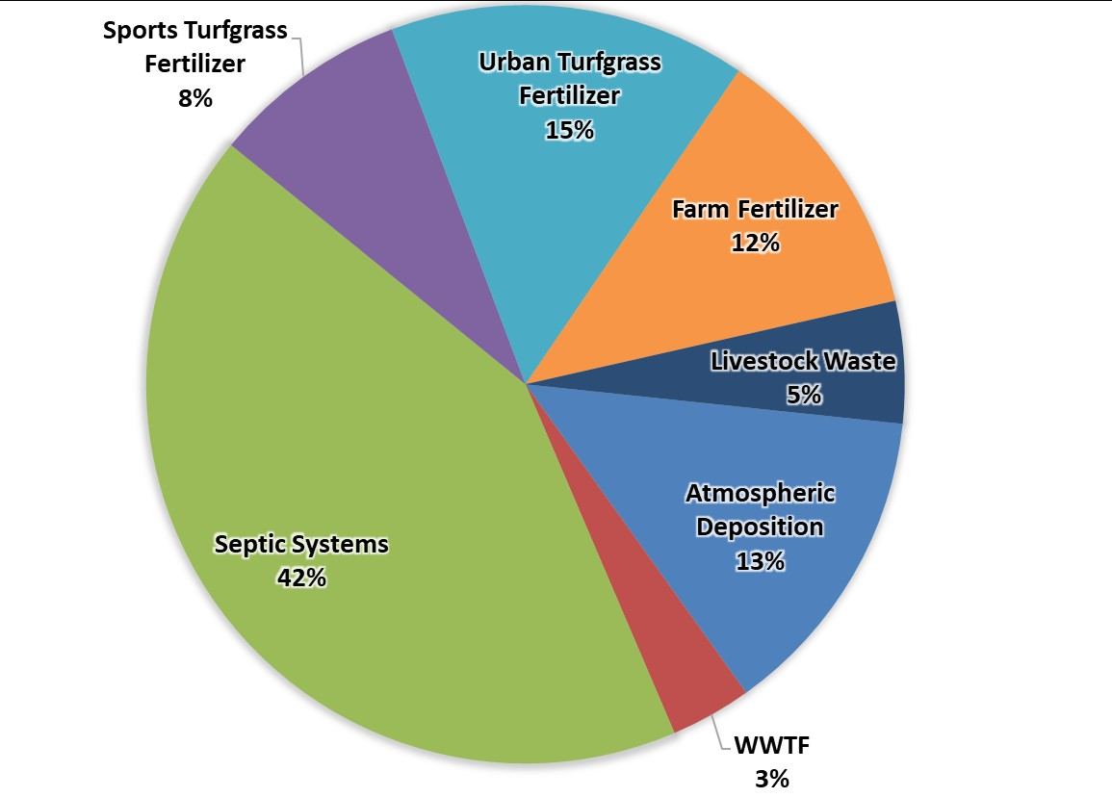
Figure 2. Loading to groundwater by source in the Crystal River/Kings Bay BMAP area

Loading Allocation
The nitrogen source reductions are based on the measured nitrate concentrations and flows at the vent, along with the TMDL target nitrate concentration. Table 4 lists the total nitrate (as nitrogen) loads at the spring vents compared with the TMDL loading based on a target nitrate concentration of 0.23 mg/L. The difference between the spring vent loading and the TMDL loading estimate is the required reduction to meet the TMDLs. The total load that is required to be reduced in the basin is being allocated to the entire basin.
Table 4. Total reduction required to meet the TMDLs
Description | Nitrogen Loads (lb-N/yr) | Notes Regarding Data Used
Total Load at Spring Vents | 487,000 | Upper 95 % confidence interval – nitrate data and flow data from 2010 to 2016 (470 cubic feet per second [cfs] and 0.526 mg/L)
TMDL Load | 213,000 | TMDL target is 0.23 mg/L and using the same flow data from 2010 to 2016
Required Reduction | 274,000

Description of 5-, 10-, and 15-year Milestones/Reduction Schedule
The overall load reduction targets are 30 % of the total within 5 years, 80 % of the total within 10 years, and 100 % of the total within 15 years. DEP will evaluate progress towards these milestones and will report to the Governor and Florida Legislature. DEP will adjust management strategies to ensure the target concentrations are achieved. This may include expanding the area to which the OSTDS remediation policies apply; any such change, however, would be incorporated into an updated BMAP through a formal adoption process.
Table 5 identifies the nitrogen reductions needed, by milestone. Progress will be tracked yearly and adjustments made as needed. At the five-year milestone, progress will be assessed and load reductions adjusted as necessary. Entities have flexibility in the types and locations of projects as long as they achieve the overall required load reductions. The monitoring of existing groundwater and springs sampling locations is essential. Section 2.3 describes detailed source reduction strategies.
Table 5. Nitrogen reduction schedule (lb-N/yr)
5-Year Milestone  (30 % of Total) | 10-Year Milestone  (50 % of Total) | 15-Year Milestone  (20 % of Total) | Total Nitrogen Reduction  (100 %)
82,200 | 137,000 | 54,800 | 274,000

Prioritization of Management Strategies
The management strategies listed in Appendix B, Appendix D, and Appendix F are ranked with a priority of high, medium, or low. In 2016, the Florida Legislature amended the Watershed Restoration Act (Section 403.067, F.S.), creating additional requirements for all new or revised BMAPs. BMAPs must now include planning-level details for each listed project, along with their priority ranking.
Project status was selected as the most appropriate indicator of a project’s priority ranking based primarily on need for funding. Projects with a "completed" status were assigned a low priority. Projects classified as "underway" were assigned a medium priority because some resources have been allocated to these projects, but additional assistance may be needed for the project to be completed. High priority was assigned to projects listed with the project status "planned" as well as certain "completed" projects that are ongoing each year (any project with one of these project types: "street sweeping," "catch basin inserts/inlet filter cleanout," "public education efforts," "fertilizer cessation," "fertilizer reduction," or "aquatic vegetation harvesting"), and select projects that are elevated because substantial, subsequent project(s) are reliant on their completion.

Load Reduction Strategy
The total load reduction to groundwater needed to meet the TMDL is 274,000 lb-N/yr. Based on the totals of all the credits from BMAP actions and policies, the range of total reductions to groundwater is between 201,007 and 299,021 lb-N/yr (see Table 6).
To achieve reductions outside the scope of the policies listed, additional project options are available to local entities but have not been planned. Other efforts could be pursued to further reduce the nitrogen load to groundwater in the Crystal River/Kings Bay BMAP area.
Table 6. Summary of potential credits for the Crystal River/Kings Bay BMAP to meet the TMDLs
Nitrogen Source | Credits to Load to Groundwater Based on Project Tables (lb-N/yr) | Description
OSTDS | 142,168 – 207,784 | Credits are based on lots inside the PFA being remediated by either enhancing an OSTDS or connecting to sewer. An estimated 218,447 lb-N/yr have been provided as OSTDS remediation projects which may be on these lots or in the larger BMAP area. Any projects outside the PFA would add additional reductions to the estimates listed.
UTF | 5,438 | DEP-approved credits (6 %) for public education activities as well as credits identified for stakeholder stormwater projects
STF | 4,886 | 6 % BMP credit for sports fields and 10 % BMP credit for golf courses on STF load to groundwater, assuming 100 % BMP implementation on golf courses and sports fields
FF | 10,604 | 15 % BMP credit on FF load to groundwater, assuming 100 % owner-implemented BMPs on all fertilized lands
LW | 3,079 | 10 % BMP credit on load to groundwater, assuming 100 %  owner-implemented BMPs at all livestock facilities
WWTF | 23,755 | Achieved by BMAP WWTF policy (achieving 3 or 6 mg/L)
Total Credits from BMAP Policies and Submitted Projects | 189,931 – 255,547
Advanced Agriculture BMPs | 11,076 – 43,474 | Pursue additional practices over the next 20 years, contingent on funding. Includes 10 % to 50 % reduction from 100 % of fertilized acres with a change in practice.
Total Credits | 201,007 – 299,021 | Estimated load reduction to meet the TMDL is 274,000 lb-N/yr

OSTDS Management Strategies
Overall, there are currently nearly 28,000 OSTDS in the PFA, based on FDOH estimates. This BMAP lists 6 specific projects (Appendix B) that reduce OSTDS loading by 218,447 lb-N/yr. Figure 3 shows the locations of OSTDS in the BMAP area and PFA.
In addition to the six listed projects, DEP assessed the overall OSTDS loading compared with other nitrogen sources in the PFA, as well as the relative loading in the wider BMAP area. Based on these assessments, OSTDS contribute more than 20 % of the nonpoint source nitrogen pollution to the OFS. Per the Crystal River/ Kings Bay NSILT, septic systems contribute 42 % of the pollutant loading in the springshed area and 39 % of the pollutant loading in the PFA. Cumulatively, nitrogen loading from OSTDS within this springshed result in the significant degradation of groundwater that impacts the Crystal River/Kings Bay BMAP area. Therefore, the comprehensive remediation of OSTDS, consistent with the requirements of this BMAP, is necessary to prevent associated groundwater and surface water contamination so that the TMDL can ultimately be achieved and so that increases in nitrogen loads from future growth are limited.
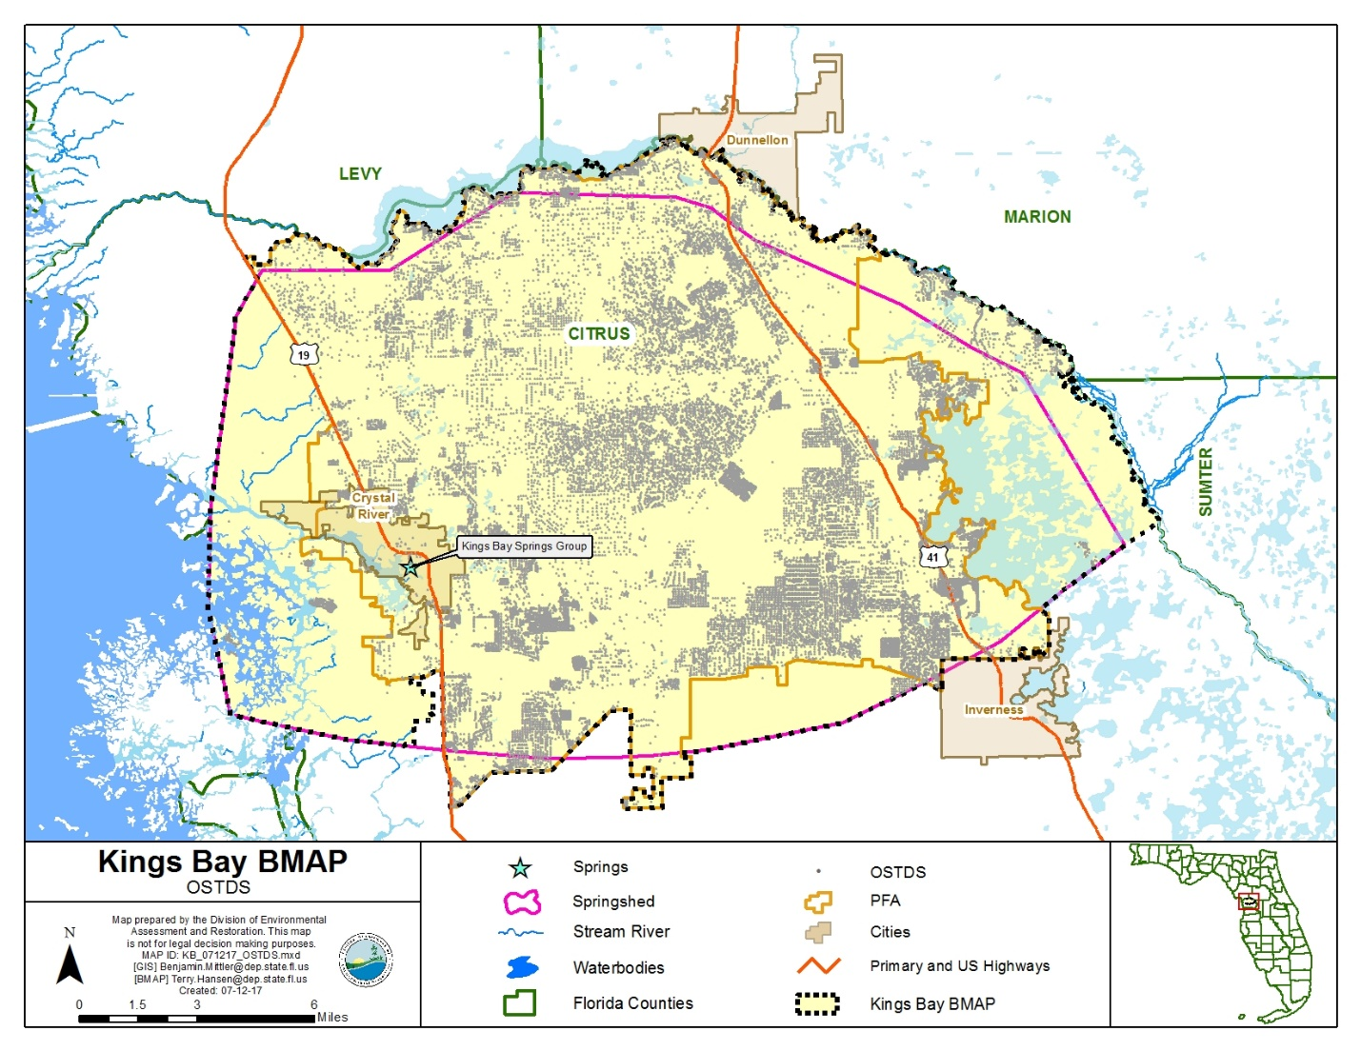
Figure 3. OSTDS locations in the Crystal River/Kings Bay BMAP area
In addition to the actions outlined in the OSTDS remediation plan (incorporated into this BMAP as Appendix D), remedial efforts on existing conventional OSTDS could achieve nitrogen reductions. Table 7 summarizes the nitrogen inputs, attenuation and recharge factors, and loads to groundwater for a conventional OSTDS. The conventional OSTDS nitrogen input is based on a per capita contribution of 9.012 lb-N/yr. This value is multiplied by the estimated number of people using the system (i.e., 2.23 persons per household in Citrus County, adjusted for time away from home to 1.95 effective persons per household). Percent reductions for enhanced or replaced systems are applied to the conventional OSTDS nitrogen groundwater loads to valuate possible improvements to groundwater. Enhanced OSTDS can achieve an estimated 65 % improvement in the load to groundwater compared to a conventional system. OSTDS replaced by sewer reduce the conventional nitrogen inputs by an estimated 95 %, assuming a sewer connection to a WWTF meeting AWT levels.
The results show an estimated nitrogen reduction (i.e., credit) of 5.1 in high recharge areas, 2.9 in medium recharge areas, and 0.6 in low recharge areas for each enhanced OSTDS and an estimated nitrogen reduction of 7.5 in high recharge areas, 4.2 in medium recharge areas, and 0.8 in low recharge areas for each replaced OSTDS. Estimated costs for retrofitting (onsite treatment improvements) or removing (sewering) OSTDS range from $10,000 to $20,000 per system, which would be anticipated to be offset by cost-share from state funds. These costs can be refined as projects are completed and detailed cost data are available.
Table 7. Estimated individual OSTDS improvements to groundwater
Recharge Category | Conventional OSTDS Load To Groundwater (lb-N/yr/OSTDS) | Reduction To Groundwater  (lb-N/yr/OSTDS)
Recharge Category | Conventional OSTDS Load To Groundwater (lb-N/yr/OSTDS) | Enhanced OSTDS | Replaced OSTDS
Nitrogen Input | 18 | ‒ | ‒
Attenuation (0.5) | 8.8 | ‒ | ‒
Low Recharge (0.1) | 0.9 | 0.6 | 0.8
Medium Recharge (0.5) | 4.4 | 2.9 | 4.2
High Recharge (0.9) | 7.9 | 5.1 | 7.5

UTF Management Strategies
UTFs are fertilizers applied to the turfgrass typically found in residential and urban areas (including residential lawns and public green spaces). They are applied by either the homeowner or a lawn service company on residential properties, while on nonresidential properties they may be applied by contractors or maintenance staff.

Fertilizer Ordinance Adoption
As required by the Florida Legislature, as described in Subsection 373.807(2), F.S., local governments with jurisdictional boundaries that include an OFS or any part of a springshed or delineated PFA of an OFS are required to develop, enact, and implement a fertilizer ordinance by July 1, 2017. The statutes require any ordinance to be based, at a minimum, on the DEP model ordinance for Florida-friendly fertilizer use on urban landscapes.

Prioritized Management Strategies and Milestones
Based on the fertilizer ordinances and public education activities in place at the time of BMAP adoption, the associated credits for UTF reductions to groundwater are 4,021 lb-N/yr (see Table 8). Counties and municipalities could be given credit for additional reductions if they implement other public education efforts and source control ordinances, as described in Section below.
Local stormwater projects that treat urban runoff, including nitrogen from urban fertilizer, are also in place (see Appendix B) for a total reduction to groundwater of 29 lb-N/yr.
Since there is uncertainty about the data used in the NSILT to calculate the UTF loading to groundwater, DEP will work toward collecting better data by documenting reductions with the stakeholders. Also, DEP will work with stakeholders to develop additional measures to reduce fertilizer application.
Table 8. Current project credits to reduce UTF loading to groundwater
Project Category | Project Credits (lb-N/yr) Based on Management Actions Listed in Appendix B
Fertilizer Ordinances and Public Education Activities | 4,021
Stormwater Improvements | 29
Total Project Credits | 4,050

Additional UTF Reduction Options
The anticipated reduction from UTF sources is currently limited to 6 % of the estimated load to groundwater. This reduction can be achieved through a 6 % total credit if each local government has an applicable fertilizer ordinance, landscape ordinance, irrigation ordinance, and pet waste ordinance; carries out public education activities; and implements the Florida Yards and Neighborhood (FYN) Program (see Table 9).
If all the local governments implement the full suite of public education measures, a 5,409 lb-N/yr reduction can be achieved. Currently, these credits total 4,021 lb-N/yr. Thus, an additional 1,388 lb-N/yr reduction could be achieved through public education and source control efforts.
Table 9. Maximum UTF load reductions based on existing public education credit policies
UTF Source Control Measures | Credit Based on Estimated Load to Groundwater  (%) | Possible Nitrogen Credits  (lb-N/yr)
Fertilizer Ordinance | 0.5 | 451
Pet Waste Ordinance | 0.5 | 451
Landscape Ordinance | 0.5 | 451
Irrigation Ordinance | 0.5 | 451
FYN Program | 3.0 | 2,704
Public Education Program | 1.0 | 901
 | 6.00 | 5,409

Appendix E contains technical support information that further explains the concepts presented in this section, including nitrogen loading by source category, reduction obligations, and management strategies.

STF Management Strategies
Sports turfgrass areas fall into two main categories that are evaluated separately: golf courses and sporting facilities (such as baseball, football, soccer, and other fields). There are 9 golf courses covering 2,174 acres in the Crystal River/Kings Bay BMAP area. The majority of the acreage (1,976 acres) is located in high recharge areas. There are also 183 acres of land associated with sports facilities or other fields, all of which are located in high recharge areas.

Prioritized Management Strategies and Milestones
DEP will work with sports field managers and golf course superintendents to ensure relevant BMP implementation and to estimate the reductions associated with these efforts. To improve the golf course loading estimate over a literature-based approach, DEP will also confer with golf course superintendents to identify the actual rate of fertilizer application to update the estimate of the golf course load to groundwater. Golf courses are expected to implement the BMPs described in DEP's BMP manual, Best Management Practices for the Enhancement of Environmental Quality on Florida Golf Courses, for an estimated 10 % reduction in loads to groundwater.
Managers of sports fields can assist by reducing fertilizer use, using products that reduce leaching, and more efficiently irrigating sports turf. The estimated credit for better management of nongolf sports turfgrass is 6 % of the starting load to groundwater. Based on these approaches, the initial reduction from STF sources is 4,886 lb-N/yr, as listed in Table 10.
Table 10. Maximum load reductions from STF improvements based on existing credit policies
STF Source  Control Measures | Credit Based on Estimated Load to Groundwater (%) | Possible Nitrogen Credits  (lb-N/yr)
Golf Course BMP Implementation | 10 | 4,757
Sports Fields BMPs | 6 | 129
Total Possible Credits |  | 4,886

Agricultural Sources Management Strategies
Based on data provided by FDACS, there are 17,470 acres in the basin: 15,715 acres are used for livestock and 673 acres for fertilized crops, and 1,082 acres are classified as both fertilized croplands and livestock lands.

FF Loading
Nitrogen in agricultural fertilizer is applied at varying rates, depending on the crop and individual farm practices. The NSILT estimated total nitrogen load to groundwater from farm fertilizer is 70,694 lb-N/year, or 12 % of the total nitrogen load to groundwater in the BMAP area. FF includes commercial inorganic fertilizer applied to row crops, field crops, pasture, and hay fields.

LW Loading
Agricultural practices specific to livestock management were obtained through meetings with agricultural producers and stakeholders. The NISLT estimated total nitrogen load from livestock waste to groundwater is 30,793 lb-N/year, or 5 % of the total nitrogen load to groundwater in the BMAP area.

Prioritized Management Strategies and Milestones
Subsection 403.067, F.S., requires agricultural nonpoint sources in a BMAP area either to submit to FDACS a notice of intent (NOI) and implement the applicable FDACS-adopted BMPs, which provides a presumption of compliance with water quality standards, or conduct water quality monitoring prescribed by DEP or the SWFWMD that demonstrates compliance with water quality standards.
Further, based on the Florida Springs and Aquifer Protection Act, Subsection 373.811(5), F.S., prohibits any new agricultural operations in BMAP areas that do not implement applicable FDACS BMPs upon the commencement of those operations, measures necessary to achieve pollution reduction levels established by DEP, or follow a WMD- or DEP-approved monitoring plan to demonstrate compliance with water quality standards. Failure to submit to FDACS an NOI and implement BMPs or conduct monitoring that demonstrates compliance may result in enforcement action by DEP.
FDACS will work with applicable producers within the BMAP area to ensure enrollment and, within the first five-year period, verify implementation of BMPs. In addition, FDACS will undertake projects such as precision irrigation, soil moisture probes, and planting of cover crops. As of December 31, 2016, there are NOIs covering 736 acres in the Crystal River/Kings Bay BMAP area. No producers are conducting water quality monitoring in lieu of implementing BMPs at this time. Appendix B lists project information. Appendix G provides detailed information on BMPs and agricultural practices in the BMAP area.
With crop-specific BMP enrollment or monitoring for FF areas, a 10,604 lb-N/yr reduction to groundwater can be achieved, based on an average reduction of 15 % in the nitrogen load to groundwater. While DEP has listed larger percentage reductions in nitrogen from agricultural BMPs in estimating benefits to surface waters, the best data available indicate a
15 % reduction in the load to groundwater, where owner-implemented BMPs are in place. This percentage could increase as more data are collected on the impact of BMPs to groundwater.
For livestock operations, owner-implemented BMPs are expected to achieve a reduction of 3,079 lb-N/yr, based on a 10 % reduction from owner-implemented BMP implementation.
Summarizing the reductions discussed above, the total reduction from BMP implementation of all agricultural sources is 13,683 lb-N/yr.

Additional Agricultural Reduction Options
Further reductions can be achieved through implementing additional agricultural projects or practices, including land acquisition and conservation easements. SWFWMD is implementing projects to encourage low input agriculture and water quality improvement technologies. Examples of these projects include providing incentives for producers to transition to less intensive cropping systems, changing land use to fallow or native landscape, or changing the type of cropping system. Other reductions associated with the implementation and modification of BMPs may be realized through ongoing studies and data collection. Basin-specific studies will be conducted to demonstrate the effectiveness of BMPs on a site-specific basis.
Additional reductions may also be achieved through implementing additional agricultural projects and practices. Table 11 lists these projects and practices with their estimated load reductions, based on existing crop types. FDACS supplied the acreages, load reductions associated with applicable practices, and estimated the costs of implementation.
Table 11. Potential for additional load reductions to groundwater
Action | Acreage | Reduction Credit  (lb-N/yr) for  High-Recharge Area | Reduction Credit  (lb-N/yr) for  Medium-Recharge Area | Cost
Precision Irrigation | 318 | 1,145 | 636 | $26,800
Controlled-Release Fertilizer | 114 | 4,104 | 2,052 | $21,000
Cover Crops | 55 | 2,475 | 1,238 | $2,500
Total | 487 |  |  | $50,330
The projects and practices listed in Table 11 are a component of the reductions to groundwater that could be achieved through changes in practices (Table 12). For example, a 75 % reduction of fertilizer loss to groundwater on 25 % of the fertilized lands would result in an estimated reduction of 13,406 lb-N/yr. Note that these estimates are averaged over the entire basin, and the recharge characteristics of a specific site and the fertilization practices for specific crops may change the estimated reduction for specific acres with a conservation easement or change in fertilization.
Table 12. Calculations for additional load reductions to groundwater
% of Fertilized Acres with a Change in Practice | Amount of Fertilized Acres with a Change in Practice | 100 %  Reduction in Load to Ground-water  (lb-N/yr reduced) | 75 % Reduction in Load to Ground-water  (lb-N/yr reduced) | 50 % Reduction in Load to Ground-water  (lb-N/yr reduced) | 25 % Reduction in Load to Ground-water  (lb-N/yr reduced) | 10 % Reduction in Load to Ground-water  (lb-N/yr reduced)
100 | 1,700 | 71,500 | 53,625 | 35,750 | 17,875 | 7,150
75 | 1,275 | 53,625 | 40,219 | 26,813 | 13,406 | 5,363
50 | 850 | 35,750 | 26,813 | 17,875 | 8,938 | 3,575
25 | 425 | 17,875 | 13,406 | 8,938 | 4,469 | 1,788
10 | 170 | 7,150 | 5,363 | 3,575 | 1,788 | 715
Beyond enrolling producers in the FDACS BMP Program and verifying implementation, FDACS will work with DEP to improve the data used to estimate agricultural land uses in the springshed. FDACS will also work with producers to implement a suite of agricultural projects and research agricultural technologies on properties where they are deemed technically feasible and if funding is made available. The acreages provided by FDACS are preliminary estimates of the maximum acreages and will be evaluated and refined over time. As presented here, these projects are based on planning-level information. Actual implementation would require funding as well as more detailed designs based on specific information, such as actual applicable acreages.

WWTF Management Strategies
WWTFs receive and treat domestic wastewater. In the Crystal River/Kings Bay BMAP area, treated effluent containing nitrogen is discharged to sprayfields, RIBs, and percolation ponds, and is reused for irrigation water. The estimated nitrogen load from WWTFs is 20,453 lb-N/year. The discharge location (such as proximity to the spring, highly permeable soils, etc.) and level of wastewater treatment are important factors to consider when calculating loadings to groundwater. Additionally, addressing the nitrogen loading from OSTDS could increase the volume of effluent treated and disposed of by WWTFs.

Summary of Facilities
There are 25 domestic WWTFs located in the Crystal River/Kings Bay BMAP area, including 6 WWTFs permitted to discharge more than 100,000 gallons of treated effluent per day (or 0.1 million gallons per day [mgd]). Figure 4 shows the locations of WWTFs in the Crystal River/Kings Bay Basin with discharges greater than 0.1 mgd and those with discharges less than 0.1 mgd.
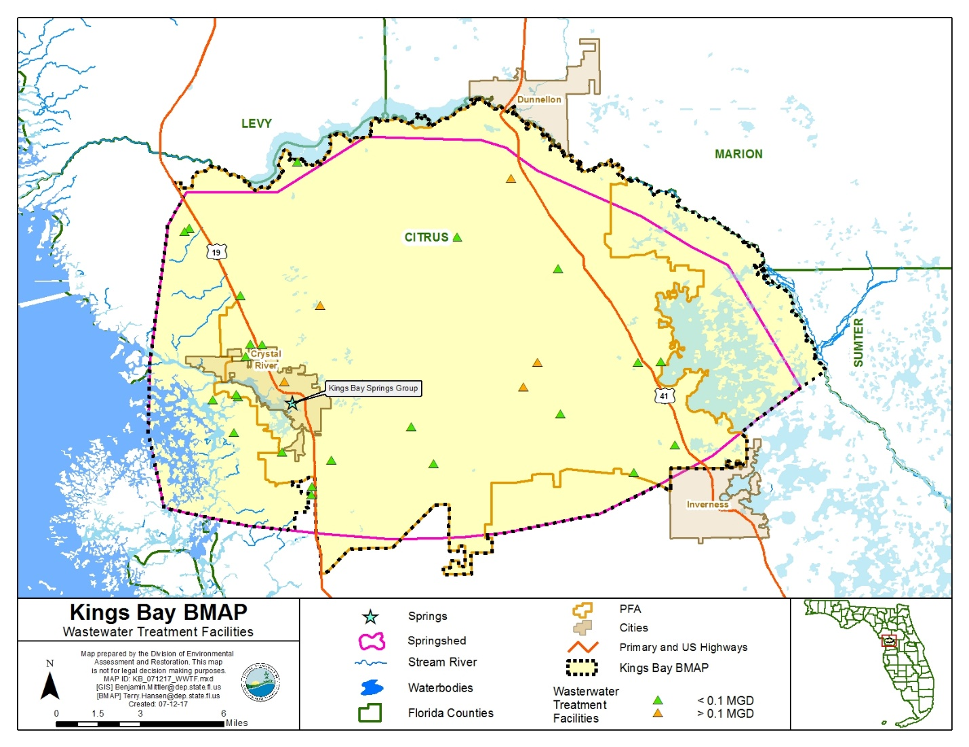
Figure 4. Locations of WWTFs in the Crystal River/Kings Bay BMAP area

Wastewater Management Standards and Reuse Management
The Florida Springs and Aquifer Protection Act prohibits new domestic wastewater disposal facilities in the PFA, including RIBs, with permitted capacities of 100,000 gpd or more, except for facilities that provide AWT that reduces total nitrogen in the effluent to 3 mg/L or lower, on an annual permitted basis.
To provide regulatory consistency in the BMAP area and to further improve wastewater management to protect the Crystal River/Kings Bay Basin, DEP requires the nitrogen effluent limits listed above in any new or existing wastewater permit, unless the utility/entity can demonstrate reasonable assurance that the reuse or land application of effluent would not cause or contribute to an exceedance of the nitrate concentrations established by the Kings Bay Spring Group TMDLs. To demonstrate reasonable assurance, the utility/entity shall provide relevant water quality data, physical circumstances, or other site-specific credible information needed to show their facility would not cause a nitrate concentration that would be greater than 0.23 mg/L at the spring vents. This demonstration may include factors such as dilution, site-specific geological conditions, research/studies, including dye tracer tests, and groundwater transport modeling. Should DEP concur with the reasonable assurance demonstration request, the TN effluent requirements established here may be modified for the applicant or waived.
The nitrogen effluent limits set forth in Table 13 will be applied as an annual average to all new and existing WWTFs with a DEP-permitted discharge. New effluent standards will take effect at the time of permit renewal or no later than five years after BMAP adoption, whichever is sooner.
Table 13. Wastewater effluent standards for the BMAP area
95% of the Permitted Capacity  (gpd) | TN Concentration Limits for RIBs and Absorption Fields  (mg/L) | TN Concentration Limits for All Other Land Disposal Methods, Including Reuse  (mg/L)
Greater than 100,000 | 3 | 3
20,000 to 100,000 | 3 | 6
Less than 20,000 | 6 | 6

Additionally, new or existing wastewater permits in the BMAP area must require at least quarterly sampling of the effluent discharge for TN and must report these sampling results in the discharge monitoring reports (DMRs) submitted to DEP.
DEP encourages the reuse of treated wastewater for irrigation as a water conservation measure. The expansion of reuse water for irrigation can reduce reliance on the Floridan aquifer for water supply. The nitrogen load to groundwater from reuse water is expected to be reduced through these WWTF policies, as improvements in reuse water quality will both reduce loads from this source and limit future increases in loading from reuse because of higher treatment levels.

Prioritized Management Strategies and Milestones
Based on the current volumes of discharge and effluent concentrations, the reductions to be achieved through the implementation of these revised wastewater standards are 9,445 lb-N/yr. Appendix B contains detailed information on projects that have been completed, are under way, or are planned to reduce nitrogen loading from WWTFs.

Atmospheric Deposition Management Strategies

Summary of Loading
Atmospheric deposition is largely a diffuse, albeit continual, source of nitrogen. Nitrogen species and other chemical constituents are measured in wet and dry deposition at discrete locations around the U.S. In 2014, Schwede and Lear developed a hybrid model for estimating the total atmospheric deposition of nitrogen and sulfur for the entire U.S., referred to as "TDEP." Deposition data from several monitoring networks—including Clean Air Status and Trends Network (CASTNET), the National Atmospheric Deposition Program (NADP) Ammonia Monitoring Network, the Southeastern Aerosol Research and Characterization Network, and modeled data from the Community Multiscale Air Quality (CMAQ) Modeling System—are combined in a multistep process with National Trends Network (NTN) wet deposition values to model total deposition. The TDEP model run used for the NSILT included data from 2011 to 2013.

Description of Approach
Atmospheric sources of nitrogen are local, national, and international. Atmospheric sources are generally of low nitrogen concentration compared with other sources and are further diminished through additional biological and chemical processes before they reach groundwater. Atmospheric deposition sources and trends will be re-evaluated periodically.

Future Growth Management Strategies
Local land development regulations, comprehensive plans, ordinances, incentives, BMPs, Environmental Resource Permit (ERP) requirements, and consumptive use permit limits provide mechanisms for protecting water resources and reducing the impact of new development and other land use changes as they occur. They are the primary mechanisms available to address additional nitrogen loadings from urban and agricultural growth. Future agricultural operations will be subject to the same requirements as existing operations with regard to the implementation of FDACS-adopted BMPs (Section 2.7).
The associated increased load from OSTDS to groundwater must also be addressed in addition to the current loads. Future development on lots less than one acre in the PFAs must connect to central sewer, if available, or include nitrogen-reducing OSTDS, as described in Appendix D. This BMAP recognizes the local protections described in Appendix H as important components of the BMAP and encourages local governments to further strengthen local watershed protection frameworks.

Protection of Surface Water and Groundwater Resources through Land Conservation
Maintaining land at lower intensity uses through land purchases or easements for conservation and recreational use is one strategy that can help reduce water quality impacts in the Crystal River/Kings Bay Basin. Table 14 identifies one land conservation purchase in the BMAP area since summer 2011, which is the last year of the period of record used for developing the TMDLs.

Table 14. Stakeholder conservation land purchase
Lead Entity | Name of Conservation Purchase | Description | Purchase Status | Cost | Acreage Acquired | Year Acquired
SWFWMD | Tsala Apopka Two-Mile Prairie Connector | Property is adjacent to SWFWMD and Florida's jointly owned Two-Mile Prairie lands (2,981 acres) to northwest and close to SWFWMD Potts Preserve property (9,378 acres). Primary purpose for acquisition is ability to provide significant water recharge and natural flood control. | Completed | $1,300,000 | 411 | 2015

Commitment to Implementation
Successful BMAP implementation requires commitment, dedicated state funding, and follow-up. Stakeholders have expressed their intention to carry out the plan, monitor its effects, and continue to coordinate within and across jurisdictions to achieve nutrient reduction goals. As the TMDLs must be achieved within 20 years, DEP, FDACS, and SWFWMD will implement management actions with a portion of the annual $50 million state appropriations to reduce nitrogen in the Crystal River/Kings Bay Basin.

: Monitoring and Reporting

Methods for Evaluating Progress
DEP will work with stakeholders to track project implementation and organize the monitoring data collected each year. The project and monitoring information will be presented in an annual update. Stakeholders have agreed to meet annually after the adoption of the BMAP to follow up on plan implementation, share new information, and continue to coordinate on TMDL restoration–related issues. The following activities may occur at annual meetings:
Implementation data and reporting:
- Collect project implementation information from stakeholders, including FDACS agricultural BMP enrollment and FDOH-issued permits, and compare with the BMAP schedule.
- Discuss the data collection process, including any concerns and possible improvements to the process.
- Review the monitoring plan implementation, as detailed in Section 3.3.
Sharing new information:
- Report on results from water quality monitoring and trend information.
- Provide updates on new management strategies in the basin that will help reduce nutrient loading.
- Identify and review new scientific developments on addressing nutrient loads and incorporate any new information into annual progress reports.
Coordinating TMDL restoration–related issues:
- Provide updates from DEP on the basin assessment cycle and activities related to any impairments, TMDLs, and BMAP.
- Obtain reports from other basins where tools or other information may be useful in implementing the Crystal River/Kings Bay Basin TMDLs.

Adaptive Management Measures
Adaptive management involves making adjustments in the BMAP when circumstances change or monitoring indicates the need for additional or more effective restoration strategies. Adaptive management measures may include the following:
- Implementing procedures to determine whether additional cooperative strategies are needed.
- Using criteria/processes for determining whether and when plan components need revision because of changes in costs, project effectiveness, social effects, watershed conditions, or other factors.
- Revising descriptions of stakeholders' roles during BMAP implementation and after BMAP completion.
- Updating information on corrective actions (and any supporting documentation) being implemented as data are gathered to refine project implementation schedules and performance expectations.
Key components of adaptive management are to share information and expertise and to track plan implementation, monitor water quality and pollutant loads, and holding periodic meetings.

Water Quality and Biological Monitoring

Objectives
Focused objectives are critical for a monitoring strategy to provide the information needed to evaluate implementation success. Since the BMAP implementation involves an iterative process, the monitoring efforts are related to primary and secondary objectives. The primary objectives focus on achieving water quality targets, while the secondary objectives focus on water quality parameters that can be used to provide information for future refinements of the BMAP. The monitoring strategy may be updated as necessary.
Primary objectives:
- Measure the water quality and biological response in the impaired springs, river, and/or groundwater at the beginning of the BMAP period and during implementation.
- Document nutrient trends in the Crystal River/Kings Bay Basin and associated springs and groundwater.
- Focus BMP efforts by using water quality results combined with appropriate project information and land use in conjunction with statistical and spatial analysis tools.
Secondary objectives:
- Identify areas where groundwater data and modeling might help in understanding the hydrodynamics of the system.
- Confirm and refine nutrient removal efficiencies of agricultural and/or urban BMPs.
- Identify and implement more effective nutrient reduction strategies.
- Use nitrogen isotope and tracer sampling for evaluating nitrogen contributions from organic and inorganic sources.

Water Quality Parameters, Frequency, and Network
To achieve the objectives listed above, the monitoring strategy focuses on two types of indicators to track improvements in water quality: core and supplemental (Tables 15 and 16, respectively). The core indicators are directly related to the parameters causing impairment in the river or associated springs. Supplemental indicators are monitored primarily to support the interpretation of core water quality parameters. The monitoring network is established for a variety of purposes.
For this BMAP, nitrate is considered to be the key core parameter measured, to track progress in decreasing nitrogen concentrations in groundwater and the water flowing from the spring vent. The other parameters are considered supplementary parameters for the BMAP, as they build information about groundwater and the spring but are not direct measurements of impairment.
At a minimum, the core parameters will be tracked to determine the progress made towards meeting the TMDLs and/or achieving the numeric nutrient criteria (NNC). Resource responses to BMAP implementation may also be tracked. A significant amount of time may be needed to observe changes in water chemistry.
Table 15. Core water quality indicators
Core Parameters
Chloride
Sulfate
Potassium
Ammonia as Nitrogen
Total Kjeldahl Nitrogen
Nitrate/Nitrite as Nitrogen

Table 16. Supplemental water quality indicators
Supplemental Parameters
Specific Conductance
Dissolved Oxygen (DO)
pH
Temperature
Total Suspended Solids (TSS)
Nitrate and Oxygen Isotopes
Initially, data from the ongoing sampling effort being conducted by SWFWMD will be used to meet the primary objectives. Surface water and groundwater monitoring network locations were selected to track changes in water quality and allow the annual evaluation of progress toward achieving the TMDL. Figure 5 shows the locations of the river and spring stations currently being sampled that will be used for BMAP monitoring in the Crystal River/Kings Bay Basin.

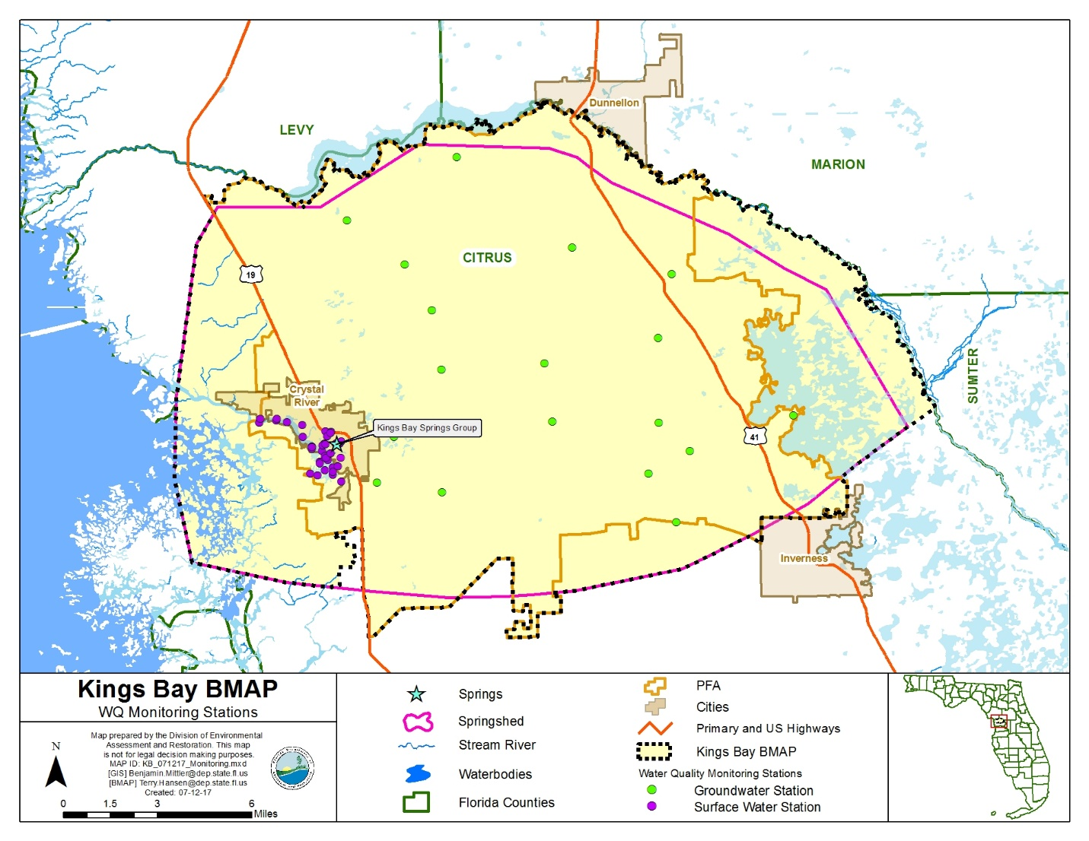
Figure 5. Groundwater and surface water stations sampled in the Crystal River/Kings Bay Basin

Biological Monitoring
Biological resource responses represent improvements in the overall ecological health of the Crystal River/Kings Bay Basin (see Table 17).
Table 17. Anticipated resource responses from BMAP implementation
Resource Responses
Chlorophyll a
Increase in Stream Condition Index (SCI) score
Increase in Linear Vegetation Survey (LVS) score
Increase in Rapid Periphyton Survey (RPS) score
Increase in key fish populations
An RPS will be conducted to assess the abundance and variety of algae in the river. An LVS will be conducted to assess the types and density of vegetation present in the river and to identify the native versus non-native species. An SCI will be conducted to measure the number of different organisms present in the river. In addition, habitat assessments (HAs) will be conducted to assess the river conditions and habitat present to support the SCI evaluation. Water quality samples will also be collected with the biological monitoring.

Data Management and Assessment
As of June 30, 2017, water quality data in Florida are entered by the entity collecting the data into the Florida Watershed Information Network (WIN) Database, which has replaced the Florida Storage and Retrieval System (STORET). DEP pulls water quality data directly from WIN for impaired waters evaluations and TMDL development. Data providers are required to upload their data regularly, so the information can be used as part of the water quality assessment process and for annual reporting. Data providers should upload their data to WIN upon completion of the appropriate quality assurance/quality control (QA/QC) checks. All data collected in the last quarter of the calendar year should be uploaded no later than April 1 of the following year.
Biological data are stored in the DEP Statewide Biological (SBIO) Database. Biological data collected by data providers should also be uploaded regularly, after the appropriate QA/QC checks. All biological data collected in the last quarter of the calendar year should be uploaded no later than April 1 of the following year. The water quality data will be analyzed during BMAP implementation to determine trends in water quality and the health of the biological community. A wide variety of statistical methods is available for the water quality trend analyses. The selection of an appropriate data analysis method depends on the frequency, spatial distribution, and period of record available from existing data. Specific statistical analyses were not identified during BMAP development.

QA/QC
Stakeholders participating in the monitoring plan must collect water quality data in a manner consistent with Chapter 62-160, F.A.C., and the DEP standard operating procedures (SOPs) for QA/QC required by rule. The most current version of these procedures is available on the DEP website. For BMAP-related data analyses, entities should use National Environmental Laboratory Accreditation Conference (NELAC) National Environmental Laboratory Accreditation Program (NELAP)–certified laboratories or other labs that meet the certification and other requirements outlined in the DEP SOPs.

Appendices

Appendix A. Important Links
The links below were correct at the time of document preparation. Over time, the locations may change and the links may no longer be accurate. None of these linked materials are adopted into this BMAP.
- DEP Website: http://www.floridadep.gov
- DEP Map Direct Webpage: https://ca.dep.state.fl.us/mapdirect/
- Florida Statutes: http://www.leg.state.fl.us/statutes
  - Florida Watershed Recovery Act (Section 403.067, F.S.)
  - Florida Springs and Aquifer Protection Act (Part VIII of Chapter 373, F.S.)
- DEP Model Ordinances: http://fyn.ifas.ufl.edu/fert_ordinances.html
- DEP Standard Operating Procedures for Water Quality Samples: https://floridadep.gov/dear/quality-assurance/content/dep-sops
- NELAC NELAP: https://fldeploc.dep.state.fl.us/aams/index.asp
- FDACS BMPs: https://www.freshfromflorida.com/Business-Services/Best-Management-Practices-BMPs/Agricultural-Best-Management-Practices
- FDACS BMP and Field Staff Contacts: http://www.freshfromflorida.com/Divisions-Offices/Agricultural-Water-Policy
- Florida Administrative Code (Florida Rules): https://www.flrules.org/
- SWFWMD 2015 Crystal River/Kings Bay Surface Water Improvement and Management (SWIM) Plan: http://www.swfwmd.state.fl.us/files/database/calendar/Exhibit_CRKB_SWIM_PLAN_FINAL.pdf
- Howard T. Odum Florida Springs Institute 2016 Crystal River/Kings Bay Restoration Plan: http://floridaspringsinstitute.org/resources/Pictures/Kings%20Bay%20RAP%20final.pdf
- SWFWMD Springs: http://www.swfwmd.state.fl.us/springs/
- SWFWMD Social Research: http://www.swfwmd.state.fl.us/projects/social_research/
- UF–IFAS Research: http://research.ifas.ufl.edu/

Appendix B. Projects to Reduce Nitrogen Sources
Prioritization of Management Strategies
The management strategies in Table B-1 are ranked with a priority of high, medium, or low. In 2016, the Florida Legislature amended the Watershed Restoration Act (Section 403.067, F.S.), creating additional requirements for all new or revised BMAPs. BMAPs must now include planning-level details for each listed project, along with their priority ranking.
Project status was selected as the most appropriate indicator of a project’s priority ranking based primarily on need for funding. Projects with a "completed" status were assigned a low priority. Projects classified as "underway" were assigned a medium priority because some resources have been allocated to these projects, but additional assistance may be needed for the project to be completed. High priority was assigned to projects listed with the project status "planned" as well as certain "completed" projects that are ongoing each year (any project with one of these project types: "street sweeping," "catch basin inserts/inlet filter cleanout," "public education efforts," "fertilizer cessation," "fertilizer reduction," or "aquatic vegetation harvesting"), and select projects that are elevated because substantial, subsequent project(s) are reliant on their completion.
Description of the Management Strategies
Responsible entities submitted these management strategies to the department with the understanding that the strategies would be included in the BMAP, thus requiring each entity to implement the proposed strategies in a timely way and achieve the assigned load reduction estimates. However, this list of strategies is meant to be flexible enough to allow for changes that may occur over time. Any change in listed management strategies, or the deadline to complete these actions, must first be approved by the department. Substituted strategies must result in equivalent or greater nutrient reductions than expected from the original strategies.
While the 20-year planning period for this BMAP is 2018−38, projects completed since January 2010 count toward the overall nitrogen reduction goals.
Estimated nitrogen reductions are subject to refinement based on DEP verification and/or on adjustment to calculations based on loading to groundwater rather than surface water. Agriculture load reductions (FDACS-01 and FDACS-02) assume 100 % enrollment and verification. Projects with a designation of TBD (to be determined) denotes information is not currently available but will be provided by the stakeholder when it is available. Projects with a designation of N/A (not applicable) indicates the information for that category is not relevant to that project. Projects with a designation of "Not Provided" denotes that information was requested by DEP but was not provided by the lead entity.
Table B-1. Stakeholder projects to reduce nitrogen sources
Lead Entity | Project Number | Project Name | Project Description | Project Type | Project Status | Start Date | Estimated Completion Date | Nitrogen Source Addressed by Project | Estimated Nitrogen Load Reduction (lb-N/yr) | Cost Estimate | Funding Source | Funding Amount
Citrus County | CC-01 | Public Education Activities | Fertilizer ordinance; implementation of Florida Yards & Neighborhood Program; and website, public service announcements, brochures, etc. | Public Education | Completed | 2016 | 2016 | UTF | 4,003 | Not Provided | County | Not Provided
Citrus County | CC-02 | Citrus Springs Force Main | Construction of a force main from the Citrus Springs Wastewater Treatment Plant (WWTP) to the Meadowcrest Wastewater Treatment Facility (WWTF). | Wastewater System Upgrade | Completed | 2015 | 2016 | WWTF | Not Provided | $2,300,000 | County | County: $2,300,000
Citrus County | CC-03 | Fort Island Trail Force Main | Constructed seven miles of eight-inch force main along Fort Island Trail corridor that connects to the Meadowcrest WWTF that will enable up to 250 septic systems to send flows once systems are connected to the force main. | Wastewater Service Area Expansion | Completed | 2013 | 2015 | OSTDS | 1,887 | $2,000,000 | County/ SWFWMD/ DEP | County: $1 million SWFWMD: $500,000 DEP: $500,000
Citrus County | CC-04 | Hunter Springs Water Quality | Expansion of an existing water quality treatment area at the intersection of NE 2nd Street and NE 3rd Avenue to reduce total nitrogen released into Kings Bay. | Wet Detention Pond | Completed | 2013 | 2015 | UTF | 29 | $350,000 | County/ SWFWMD | County: $175,000 SWFWMD: $175,000
Citrus County | CC-05 | Fort Island Trail Septic to Sewer (Monte-zuma, Crystal Shores, Dixie Shores) | Design and construction of gravity sewer lines, force mains, lift stations, and lateral connections to connect 250 septic systems to central sewer. | Wastewater Service Area Expansion | Underway | 2016 | 2018 | OSTDS | 1,924 | $2,950,000 | County/ DEP | DEP: $2,200,000 County: $750,000
Citrus County | CC-06 | Phase 1 Package Plant Intercon-nections | Provide connection of the Crystal Isle RV and River Cove Landing communities to central sewer and decommission the individual package plants. | Wastewater Treatment Facility Upgrade | Underway | 2016 | 2018 | WWTF | TBD | $570,000 | DEP | DEP: $570,000
Citrus County | CC-07 | Phase 2 Package Plant Intercon-nections | Provide connection of the Pelican Bay, Imperial Gardens, and Forest View communities to central sewer and decommission the individual package plants. | Wastewater Treatment Facility Upgrade | Underway | 2017 | 2019 | WWTF | TBD | $860,000 | DEP | DEP:  $860,000
Citrus County | CC-08 | Phase 3 Package Intercon-nections | Provide connection of the Belle Villa and Stonebrook communities to central sewer and decommission the individual package plants. | Wastewater Treatment Facility Upgrade | Underway | 2017 | 2019 | WWTF | TBD | $570,000 | DEP | DEP: $570,000
Citrus County | CC-09 | Duke Energy Reclaimed Water Intercon-nection, Phase 1 | Construction of a reclaimed water line from the Meadowcrest WWTF to the City of Crystal River's reclaimed line that provides reclaimed water to the Duke Energy complex. | Reclaimed Water | Underway | 2016 | 2019 | WWTF | Not Provided | $6,573,625 | DEP/ County | DEP: $4,290,000 County: $2,283,625
Citrus County | CC-10 | Duke Energy Reclaimed Water Interconnection, Phase 2 | Construction of a reclaimed water line connecting the Southwest Regional Water Reclamation Facility to the Phase 1 Duke Energy reclaimed water line. | Reclaimed Water | Planned | 2018 | 2019 | WWTF | TBD | $6,000,000 | DEP/ County | DEP: $3,000,000 County: $3,000,000
Citrus County | CC-11 | Duke Energy Re-claimed Water Intercon-nection, Phase 3 | Construction of a reclaimed water line connecting the Brentwood WWTF to the Phase 1 Duke Energy reclaimed water line. In FY 18, Brentwood WWTF will be updated to AWT with $754k cost share from DEP. | Reclaimed Water | Planned | 2018 | 2020 | WWTF | 13,698 | $5,600,000 | DEP/ County | DEP: $2,800,000 County: $2,800,000
Citrus County | CC-12 | North-west Quadrant Waste-water Extension | Construction of gravity sewer and force main to connect septic systems and private package plants to central sewer in the northwest quadrant of the county. | Wastewater Service Area Expansion | Planned | 2020 | 2021 | OSTDS | 85,000 | $6,000,000 | DEP/ County | DEP: $3,000,000 County: $3,000,000
Citrus County | CC-13 | C.R. 491 Regional Storm-water Project-Phase I | Phase I includes construction of regional stormwater drainage detention areas from Laurel Street to south of Audubon Park. | Dry Detention Pond | Underway | 2015 | 2018 | UTF | Not Provided | $7,083,000 | County/ FDOT | DEP: $4,290,000 County: $2,283,625
Citrus County | CC-14* | Center Ridge Water-shed Management Plan | Complete alternative analysis tasks including a stormwater level of service analysis, surface water resource assessment, and BMP alternative analysis. | Studies | Underway | 2016 | 2017 | Other | NA | $200,000 | County | County: $200,000
Citrus County | CC-15 | C.R. 491 Regional Storm-water Project-Phase II | Phase II includes construction of regional stormwater drainage detention areas from Audubon Park to west of Horace Allen Street. | Dry Detention Pond | Planned | 2019 | 2021 | UTF | TBD | $4,838,000 | County/ SWFWMD | County: $2,419,000 SWFWMD: $2,419,000
Citrus County | CC-16 | Septic to Sewer Conversion Study | Identify the best options for converting existing OSTDS and any non-municipal WWTFs to central collection. | Studies | Planned | 2020 | 2021 | OSTDS | NA | $200,000 | County/ DEP | DEP: $100,000 County: $100,000
Citrus County | CC-17 | C.R. 491 Regional Storm-water Project-Phase III | Implementation/installation of advanced water quality treatment elements in regional drainage detention areas. | Wet Detention Pond | Planned | 2022 | 2024 | Urban Turfgrass Fertilizer | TBD | $9,000,000 | County/ SWFWMD | County: $4,500,000 SWFWMD: $4,500,000
Citrus County | CC-18 | North of Crystal River Waste-water Project | Gravity sewer and force main to connect residential and commercial OSTDS to the Meadowcrest WWTF. Connect up to 400 OSTDS. | Wastewater Service Area Expansion | Planned | 2031 | 2036 | OSTDS | 3,005 | $24,198,695 | TBD | TBD
Citrus County | CC-19 | North-west Quadrant Septic to Sewer Conversion Project | Gravity sewer and force main to connect residential and commercial OSTDS to the Meadowcrest WWTF. Connect up to 2,800 OSTDS. | Wastewater Service Area Expansion | Planned | 2031 | 2036 | OSTDS | 21,035 | $70,000,000 | TBD | TBD
Citrus County | CC-20 | Central Utility Area Septic to Sewer Conversion, Phase 1 | Gravity sewer and force main to connect residential and commercial OSTDS to the Meadowcrest WWTF. Connect up to 5,021 OSTDS. | Wastewater Service Area Expansion | Planned | 2031 | 2036 | OSTDS | 37,721 | $125,525,000 | TBD | TBD
Citrus County | CC-21 | Central Utility Area Septic to Sewer Conversion, Phase 2 | Gravity sewer and force main to connect residential and commercial OSTDS to the Meadowcrest WWTF. Connect up to 2,555 OSTDS. | Wastewater Service Area Expansion | Planned | 2031 | 2036 | OSTDS | 19,195 | $63,875,000 | TBD | TBD
Citrus County | CC-22 | Northeast Septic to Sewer Conversion, Phase 1 | Gravity sewer and force main to connect residential and commercial OSTDS to the Meadowcrest WWTF. Connect up to 4,307 OSTDS. | Wastewater Service Area Expansion | Planned | 2031 | 2036 | OSTDS | 32,357 | $107,675,000 | TBD | TBD
Citrus County | CC-23⁺ | Meadow-crest WWTF | Construction of a new 2.0 mgd wastewater facility which produces reclaimed water for golf course irrigation. | Wastewater Treatment Facility Upgrade | Completed | 2008 | 2010 | WWTF | Not Provided | $16,231,926 | County/ DEP | Not Provided
City of Crystal River | CR-01 | Areas 112 and113 Central Sewer | Installation of central sewer to remove approximately 204 septic systems. | Wastewater Service Area Expansion | Completed | Prior to 2012 | 2012 | OSTDS | 4,513 | $3,776,508 | City/DEP | Not Provided
City of Crystal River | CR-02 | Harbor Isle Central Sewer | Installation of central sewer to remove approximately 18 septic systems. | Wastewater Service Area Expansion | Completed | Prior to 2012 | 2012 | OSTDS | 398 | $299,799 | City/DEP | Not Provided
City of Crystal River | CR-03 | Area 114 Central Sewer | Installation of central sewer to remove approximately 183 septic systems. | Wastewater Service Area Expansion | Completed | 2012 | 2014 | OSTDS | 4,048 | $4,153,932 | City/DEP | Not Provided
City of Crystal River | CR-04 | Duke Energy Re-claimed Water Project | Design and construction of transmission mains, 1.5 million gallon storage tank, filtration and pumping infrastructure to provide reclaimed water from the city to the Duke Energy complex. | Reclaimed Water | Completed | 2012 | 2015 | WWTF | Not Provided | $6,228,712 | City/ DEP/ SWFWMD | City:  $2,555,485 DEP:  $1,117742 SWFWMD: $2,555,485
City of Crystal River/  Save Crystal River, Inc. | CR-05 | Kings Bay Pilot Vacuum Dredge | Pilot project in two private canals in the Hunters Cove area of northeastern Kings Bay to remove accumulated sediment and revegetate with native eelgrass. | Muck Removal/ Restoration Dredging | Underway | 2016 | 2017 | UTF | Not Provided | $3,400,000 | DEP | DEP:  $3,400,000
City of Crystal River | CR-06 | Hunter Springs Park Living Shoreline | Pilot project that added wetland vegetation between the water and land to treat stormwater runoff inputs to the spring. | Filter Marsh | Completed | 2014 | 2016 | UTF | Not Provided | $600,000 | SWFWMD | SWFWMD: $600,000
City of Crystal River | CR-07 | Septic to Aerobic at Crystal River State Park and facilities off State Park Road | Design, permit, and remove existing septic systems and connect the state park to the city's sewer system. The project will have the capacity to add future septic systems from neighboring waterfront communities. | Wastewater Service Area Expansion | Underway | 2016 | 2019 | OSTDS | 100 | $850,000 | DEP | DEP: $850,000
City of Crystal River | CR-08 | Indian Waters Sewer  Expansion Phase I | Installation of central sewer to remove approximately 95 septic systems. | Wastewater Service Area Expansion | Underway | 2016 | 2018 | OSTDS | 1,870 | $1,097,000 | City/DEP | DEP: $997,000 City: $100,000
City of Crystal River | CR-09 | Storm-water Best Manage-ment Practices (BMPs) Alternatives Analysis | The city is conducting an alternatives analysis to determine the best site locations for the implementation of stormwater BMPs and for design and permitting of water quality improvements. | Studies | Underway | 2017 | 2017 | UTF | NA | $100,000 | City/ SWFWMD | SWFWMD: $50,000 City: $50,000
City of Crystal River | CR-10 | Kings Bay Restoration Project | Restoration of approximately 80 acres of canal waterways through the removal of invasive plants and organic material from the canal bottom. | Vegetation Harvesting | Underway | 2016 | 2018 | UTF | Not Provided | $5,061,980 | DEP | DEP: $2,061,980
City of Crystal River | CR-11 | Indian Waters Sewer  Expansion Phase II | Installation of central sewer to remove approximately 178 septic systems and one package plant which serves 84 single family and 54 condo units. | Wastewater Service Area Expansion | Underway | 2017 | 2018 | OSTDS | 5,303 | $4,000,000 | City/DEP | DEP: $3,600,000 City: $400,000
City of Crystal River | CR-12 | Public Education Activities | Adopt fertilizer ordinance in 2017; website, public service announcements, brochures, etc. | Public Education | Underway | 2017 | 2017 | UTF | 18 | Not Provided | City | Not Provided
City of Crystal River | CR-13 | WWTP Expansion | Expansion of the City's WWTP by 1 mgd based on expanded sewer capacity and results of the wastewater masterplan. | Wastewater Treatment Facility Upgrade | Planned | 2021 | 2023 | WWTF | TBD | $12,000,000 | City/DEP | TBD
City of Crystal River | CR-14 | Southern Sewer  Expansion | Design and construction of approximately 10,000 LF of gravity sewer and force main and associated lift stations to remove residential and commercial septic systems. | Wastewater Service Area Expansion | Planned | 2022 | 2024 | OSTDS | TBD | $5,000,000 | City/DEP | TBD
Florida Dept. of Ag. and Consumer Services (FDACS) | FDACS-01 | Agricultural BMPs - Farm Fertilizer | Implementation of existing BMPs on applicable acreage. Up to 15 % reduction in load to groundwater. | BMPs | Underway | Not Provided | Not Provided | FF | 10,604 | $61,000 | TBD | TBD
FDACS | FDACS-02 | Agricultural BMPs - Livestock Waste | Implementation of existing BMPs on applicable acreage. Up to 10 % reduction in load to groundwater. | BMPs | Underway | Not Provided | Not Provided | LW | 3,079 | $813,000 | TBD | TBD
Florida Dept. of Env. Protection Florida Park Service (FPS) | FPS-01 | Crystal River State Park Septic Upgrade | Removal of existing septic tanks and connect the park to the City of Crystal River’s sanitary sewer system. | Wastewater Service Area Expansion | Underway | 2017 | Not Provided | OSTDS | 100 | $200,000 | DEP | $200,000
Southwest Florida Water Manage-ment District (SWFWMD | SWF-01 | Crystal River/Kings Bay Surface Water Improvement and Manage-ment (SWIM) Plan | Implementation and periodic review and update of the CR/KB SWIM Plan. | Studies | Completed | 2013 | 2015 | Other | NA | $205,885 | SWFWMD | SWFWMD: $205,885
SWFWMD | SWF-02 | Three Sisters Springs Wetland Treatment Project | Design and construction of a stormwater treatment wetland that will intercept stormwater to improve water quality before discharge into Kings Bay. | Wetland Treatment | Underway | 2015 | 2017 | UTF | Not Provided | $643,099 | SWFWMD | SWFWMD: $643,009
SWFWMD | SWF-03 | Three Sister Springs Sediment Removal Feasibility Study | Dredging activities and underwater habitat restoration to remove sediment from spring vents which should lead to increased spring discharge and removal of nutrients contained within the sediments. | Dredging | Underway | 2016 | 2018 | UTF | Not Provided | $470,000 | SWFWMD | SWFWMD: $470,000
SWFWMD | SWF-04* | Facilitating Agricultural Resource Management Systems (FARMS) Program | The FARMS Program is an agricultural BMP cost-share program to promote improved water quality in spring systems through approved precision nutrient application technologies. | BMPs | Underway | Prior to 2012 | 2021 | FF | Not Provided | $6,000,000 | SWFWMD | SWFWMD: $6,000,000
SWFWMD | SWF-05* | Evaluation of Nitrogen Leaching from Re-claimed Water | This project will determine typical nitrogen leaching rates from reclaimed water application to lawns, spray fields, and rapid infiltration basins. This information can be used to refine estimates of nitrogen loading to the aquifer and springs, and identify the best reclaimed water disposal methods to minimize nitrogen loading to groundwater. | Studies | Underway | 2014 | 2018 | UTF | NA | $294,000 | SWFWMD | SWFWMD: $294,000
SWFWMD | SWF-06* | Springs Coast Waste-water Disposal Treatment Wetlands | This project will assess areas to determine sites appropriate for construction of wetlands to treat WWTF effluent. | Studies | Underway | 2014 | 2017 | WWTF | NA | $400,000 | SWFWMD | SWFWMD: $400,000
SWFWMD | SWF-07 | Citrus County Cambridge Greens Septic to Sewer | The project is for the design, permitting, and construction of a regional wastewater collection system necessary for connection of a existing residential homes in the Cambridge Greens area of the Crystal River/Kings Bay springshed. If constructed, a minimum of 240 existing septic systems will convert to County sanitary sewer. | Wastewater collection and treatment | Planned | 2018 | 2021 | OSTDS | 2,370 | $3,250,000 | SWFWMD | $1,625,000
SWFWMD | SWF-08 | Hunter Springs Stormwater Modification | Design, permitting and construction of a modification to an existing drainage retention area which will improve stormwater quality discharged to the Hunters Springs area of Kings Bay | Stormwater | Planned | 2018 | 2019 | Stormwater | 25 | $37,500 | SWFWMD | $18,750
SWFWMD | SWF-09 | Springs - Crystal River Indian Waters Septic to Sewer  Phase II | Design, permitting, and construction of a municipal sewer system including connection fees, plant demolition and tank abandonment, and necessary components. This project will allow for the connection of a private wastewater package plant and provide City central sewer to areas currently served by septic systems within the Kings Bay/Crystal River springshed. | Wastewater collection and treatment | Planned | 2018 | 2021 | WWTF | 2,860 | $2,250,000 | SWFWMD | $1,125,000
SWFWMD | SWF-10 | Crystal River Southern Septic to Sewer Project | The project is for the design, permitting, and construction of an extension of the City wastewater collection system necessary for connection of a minimum of 722 existing residential and commercial homes currently serviced by septic systems within the Kings Bay/Crystal River Priority Focus Area (PFA). | OSTDS | planned | 2018 | 2021 | OSTDS | 6815 | $3,250,000 | SWFWMD | $1,625,000
SWFWMD | SWF-11 | Pilot Nutrient/Water Recovery and Research | This project will design, permit and construct a pilot nutrient water recovery facility to process septage and eliminate ground application of septage at the Caterbury Trails wastewater treatment facility in Citrus County. | Wastewater collection and treatment | planned | 2018 | Not provided | Wastewater | 42,034 | $1,948,724 | SWFWMD | Not provided
SWFWMD | SWF-12 | OSTDS Remediation Plan Implementation | This project assists homeowners offset costs to replace septic tanks in OFS springsheds with individual systems that have enhanced nitrogen removal technology where conversion to sewer is not feasible. | OSTDS | Planned | 2018 | Not provided | OSTDS | Not provided | Not provided | SWFWMD | Not Provided
University SWFWMD of Florida Institute of Food and Agricultural Sciences (IFAS) | IFAS-01* | Development of Land-scape Fertilizer BMPs | The objective of this project is to verify the accuracy of the Florida Yards and Neighborhoods (FYN) and Florida Green Industries BMPs fertilizer recommendations. | Studies | Underway | 2012 | 2018 | UTF | NA | $274,429 | SWFWMD | SWFWMD: $274,429
IFAS | IFAS-02* | Com-posting at Animal Stock Facilities | Evaluate the nutrient removal efficiency from composting animal waste. The project will compare nutrient leaching efficiency for manure stockpiling and composting facilities. | Studies | Underway | 2016 | 2018 | LW | NA | $175,000 | SWFWMD | SWFWMD: $175,000
Golf Courses | GC-01 | Golf Course Reduction Credits | 6% BMP credit on golf course load to groundwater, assuming 100% BMP implementation by golf course owners. | BMPs | Planned | TBD | TBD | STF | 4,757 | TBD | TBD | TBD
Sports Fields | SF-01 | Sports Field Reduction Credits | 10% BMP credit on sports field load to groundwater, assuming 100% BMP implementation by sports field owners. | BMPs | Planned | TBD | TBD | STF | 129 | TBD | TBD | TBD
Waste-water Utilities | WU-01 | Wastewater Treatment Facility Reduction Credits | Achieved by WWTF policy if implemented BMAP-wide, achieving 3 or 6 mg/L. | Wastewater Treatment Facility Upgrade | Planned | TBD | TBD | WWTF | 9,454 | TBD | TBD | TBD

Appendix C. Crystal River/Kings Bay PFA Report
A PFA (Crystal River/Kings Bay, September 2016) is defined as the area(s) of a basin where the Floridan aquifer is generally most vulnerable to pollutant inputs and where there is a known connectivity between groundwater pathways and an OFS. As required by the Florida Springs and Aquifer Protection Act, DEP delineated a PFA for Crystal River/Kings Bay. The PFA for Crystal River/Kings Bay is adopted and incorporated by reference into this BMAP. Information on this and other springshed PFAs is available in report format at the following link:
http://publicfiles.dep.state.fl.us/DEAR/BMAP/Springs%20Coast/PFAs/crystal%20river%20kings%20bay/Methodology%20for%20Establishing%20Priority%20Focus%20Area_Kings%20Bay_Revised%209-1-16.pdf.

Appendix D. OSTDS Remediation Plan
The Florida Aquifer and Springs Protection Act specifies that if, during the development of a BMAP for an OFS, DEP identifies OSTDS as contributors of at least 20 % of nonpoint source nitrogen pollution in a PFA or if DEP determines remediation is necessary to achieve the TMDLs, the BMAP shall include an OSTDS remediation plan. Based on the Crystal River/Kings Bay NSILT estimates and GIS coverages, OSTDS contribute approximately 40 % pollutant loading in the PFA. Irrespective of the percent contribution from OSTDS, DEP has determined that an OSTDS remediation plan is necessary to achieve the TMDLs and to limit the increase in nitrogen loads from future growth.
D.1 Plan Elements
D.1.1 Permits for Installation of New OSTDS
Per statute, new OSTDS on lots of less than one acre are prohibited within the PFA, if the addition of the specific system conflicts with an OSTDS remediation plan incorporated into an OFS BMAP (see Section 373.811(2), F.S.). This OSTDS remediation plan prohibits installation of new conventional systems on lots of less than one acre within the PFA, unless the OSTDS includes enhanced treatment of nitrogen or unless the OSTDS permit applicant demonstrates that sewer connections will be available within 5 years. Local governments and utilities are encouraged to develop master wastewater treatment feasibility plans to identify specific areas to be sewered within 20 years of BMAP adoption. To aid in implementation, the DEP Map Direct webpage includes a detailed downloadable springs PFA boundary shapefile. DEP also maintains on its website an interactive map of the PFA and BMAP boundaries; the map can be easily searched for specific street address locations.
FDOH permits the installation of new OSTDS pursuant to Chapter 64E-6, F.A.C., which includes not only systems installed on a property where one has not previously been installed, but also systems installed to replace illegal systems, systems installed in addition to existing systems, and other new systems. FDOH permitting requirements with respect to the definition of "new" or "less than one acre" will be followed for this remediation plan. For FDOH to issue a permit for a new OSTDS on a lot of less than one acre within a PFA, the system must include at least one of the following nitrogen reducing enhancements:
- Features allowed pursuant to FDOH rule, such as in-ground nitrogen-reducing biofilters (media layer systems).
- Features consistent with and identified in the FDOH Florida Onsite System Nitrogen Removal Strategy Studies report, such as in-tank nitrogen-reducing biofilters.
- Other FDOH-approved treatment systems capable of meeting or exceeding the NSF Standard 245 nitrogen removal rate before disposing the wastewater in the drain field, such as aerobic treatment units (ATU) and performance-based treatment systems (PBTS). For FDOH-approved treatment systems that meet NSF 245, but do not meet or exceed the minimum treatment level expected from the in-ground nitrogen-reducing biofilters, the drain fields, at minimum, shall be installed with a 24-inch separation between the bottom of the drain field and the seasonal high-water table.
D.1.2 Permits for Modification or Repair of Existing OSTDS
Per statute, the OSTDS remediation plan must provide loading reductions consistent with achieving the TMDL within 20 years of plan adoption (see Section 373.807(1)(b)8., F.S.). This plan therefore establishes the following remediation policy for existing systems, based on (a) the potential for reducing nitrogen loads by converting existing OSTDS to enhanced nitrogen removing systems or by connecting homes to central sewer, (b) the total amount of nitrogen load that must be reduced to achieve the TMDL, and (c) the relative contribution of nitrogen load from existing OSTDS.
- Where does the remediation policy for existing systems apply? It applies to all existing OSTDS within the PFA on lots of all sizes.
- What is required by the remediation policy for existing systems? For FDOH to issue a modification or repair permit to an existing OSTDS in the area subject to the policy, the system must include at least one of the following nitrogen reduction enhancements, unless the OSTDS permit applicant demonstrates that sewer connections will be available within 5 years.
  - Enhanced treatment of nitrogen means inclusion of features allowed pursuant to FDOH rules, such as in-ground nitrogen-reducing biofilters (media layer systems); features consistent with and identified in the FDOH Florida Onsite System Nitrogen Removal Strategy Studies report, such as in-tank nitrogen-reducing biofilters; or other FDOH-approved treatment systems capable of meeting or exceeding the NSF Standard 245 nitrogen removal rate before disposing the wastewater in the drain field, such as ATUs and PBTSs. For FDOH-approved treatment systems that meet NSF 245, but do not meet or exceed the minimum treatment level expected from the in-ground nitrogen-reducing biofilters, the drain fields, at minimum, shall be installed with a 24-inch separation between the bottom of the drain field and the seasonal high-water table.
  - FDOH permitting requirements with respect to defining "modification," "repair," and lot size (i.e., acreage) will be followed for this remediation plan
- When is the remediation policy for existing systems effective? It begins following completion of the master wastewater treatment feasibility plans, rulemaking, and funding milestones included in Sections D.3 and D.4, but no later than five years after BMAP adoption.
D.1.3 Achieving Necessary Load Reductions
All conventional OSTDS in areas subject to the remediation policy for existing systems are required to adopt enhanced treatment of nitrogen no later than 20 years after BMAP adoption.
D.1.4 Other Plan Elements
Statutes also require that OSTDS remediation plans contain the following elements.
- An evaluation of credible scientific information on the effect of nutrients, particularly forms of nitrogen, on springs and spring systems. (See Section D.2.)
- Options for repair, upgrade, replacement, drain field modification, the addition of effective nitrogen-reducing features, connection to a central sewer system, or other action. (See Section D.3.)
- A public education plan to provide area residents with reliable, understandable information about OSTDS and springs. (See Section D.4.)
- Cost-effective and financially feasible projects necessary to reduce the nutrient impacts from OSTDS. (See Section 2 and Appendix B.)
- A priority ranking for each project for funding contingent on appropriations in the General Appropriations Act. (See Section 2 and Appendix B.)
The Florida Springs and Aquifer Protection Act defines an OSTDS as a system that contains a standard subsurface, filled, or mound drain field system; an aerobic treatment unit; a graywater system tank; a laundry wastewater system tank; a septic tank; a grease interceptor; a pump tank; a solids or effluent pump; a waterless, incinerating, or organic waste–composting toilet; or a sanitary pit privy that is installed or proposed to be installed beyond the building sewer on land of the owner or on other land on which the owner has the legal right to install such a system. The term includes any item placed within or intended to be used as a part of or in conjunction with, the system. The term does not include package sewage treatment facilities and other treatment works regulated under Chapter 403, F.S.
D.2 Collection and Evaluation of Credible Scientific Information
As discussed in Section 2, DEP developed the Crystal River/Kings Bay NSILT, a planning tool that provides estimation of nitrogen loading sources to groundwater based on the best available scientific data for a particular geographic area. The NSILT results were peer-reviewed by the SWFWMD, FDOH, and FDACS. Additional technical support information concerning the NSILT can be found in Appendix E.
DEP consulted the Crystal River/Kings Bay SWIM Plan adopted by the SWFWMD in December 2015 for science-related OSTDS actions and projects. At a public meeting on August 23, 2016, DEP presented and obtained concurrence from stakeholders for actions and projects that include the following (lead entities are listed in parentheses):
Monitoring and research:
- Improve understanding of the ecological responses to nutrient enrichment and reductions (DEP/SWFWMD/universities).
- Maintain and expand water quality monitoring programs (SWFWMD/DEP).
- Report annual status and trends (SWFWMD).
- Evaluate new and emerging technologies (SWFWMD).
- Research and develop advanced septic systems (FDOH/DEP/UF–IFAS).
Completed project:
- Florida Onsite Sewage Nitrogen Reduction Strategies Study (FDOH).
Ongoing projects:
- Quarterly springs water quality monitoring (SWFWMD).
- Stream water quality monitoring (SWFWMD).
- UFA nutrient modeling (SWFWMD).
- Springs Initiative modeling (SWFWMD).
- Project COAST (collect and analyze monthly surface water quality data at 50 fixed stations along the coasts of Hernando, Citrus, and Levy Counties) (SWFWMD/University of Florida).
- U.S. Geological Survey (USGS) Groundwater Data Collection (USGS/SWFWMD).
- USGS Surface Water Data Collection (USGS/SWFWMD).
Proposed projects:
- Nutrient hot-spot loading identification (DEP/SWFWMD).
- Groundwater quality monitoring for BMAP assessment (DEP/SWFWMD).
DEP developed calculation methods to estimate nitrogen reductions associated with septic system enhancement and replacement projects, WWTF projects, golf course BMPs, other sports turfgrass BMPs, and urban turfgrass BMPs. The calculations are based on extensive scientific research, documented in the bibliography in Appendix E.
D.3 Remediation Options
The NSILT estimates that OSTDS contribute approximately 40 % of the pollutant loading to groundwater in the PFA. Table D-1 identifies the number of existing OSTDS in the BMAP area since the PFA comprises most of the BMAP area and the estimated nitrogen reductions associated with enhancement connection to sewer. Figure D-1 shows the areas where OSTDS are located.
Table D-1. Estimated reduction credits for OSTDS enhancement or sewer*
*Estimated reductions are for either enhancement or sewer per parcel classification. Reductions cannot be combined for the same parcel classification but can be combined between the different classifications. For example, the sewer credit associated with parcels less than one acre in size can be combined with the sewer credit associated with parcels one acre or greater in size.
Recharge Area | OSTDS in PFA on Parcels Less Than One Acre in Size | Credit for Enhancement  (lb-N/yr) | Credit for Sewer  (lb-N/yr) | OSTDS in PFA on Parcels One Acre and Greater | Credit for Enhancement  (lb-N/yr) | Credit for Sewer  (lb-N/yr)
High | 15,854 | 81,493 | 119,105 | 11,804 | 60,675 | 88,679
Medium | - | 0 | 0 | 0 | 0 | 0
Total | 15,854 | 81,493 | 119,105 | 11,804 | 60,675 | 88,679
As required by statute, this OSTDS remediation plan identifies remediation options for existing OSTDS, including repair, upgrade, replacement, drain field modification, the addition of effective nitrogen-reducing features, connection to a central sewer system, or other action. More simply, remediation options can be classified as enhancement or replacement. Enhancement options consist of systems identified in either existing FDOH rules or existing and ongoing FDOH studies, or systems not otherwise prohibited by FDOH. Examples of enhancements include in-ground nitrogen-reducing biofilters (media layer systems); in-tank nitrogen-reducing biofilters; and ATU or PBTS capable of meeting or exceeding the NSF Standard 245 nitrogen removal rate before disposing wastewater in the drain field.
Nitrogen impacts from new development could also be reduced through prohibiting new conventional OSTDS on all lot sizes, throughout the BMAP area, or both. DEP, FDOH, and local governments will develop programs to provide funding to homeowners and individuals to upgrade existing OSTDS by adding nutrient reducing features. The funding program will be designed to prioritize OSTDS where it is most economical and efficient to add nutrient reducing features (i.e., systems needing a permit for a repair or modification, within the PFA, and on lots of less than one acre).
To facilitate incorporation of nitrogen reducing features at the time of a permit to repair or modify an existing OSTDS, FDOH will pursue regulatory solutions to accomplish the following objectives:
- Update OSTDS rule language regarding permits, variances, and waivers to include consideration of DEP-adopted OSTDS remediation plans.
- Update OSTDS rules to allow installation of passive remediation systems, including systems featuring liners, nitrogen reducing material, or both underneath the drain field.
Figure D-1. Locations of OSTDS in the PFA in the Crystal River/Kings Bay BMAP area

D.4 Public Education Plan
DEP and FDOH will develop and disseminate educational material focused on homeowners and guidance for builders and septic system contractors. The materials will identify the need for advanced, nitrogen reducing OSTDS along with the requirements for installing nitrogen reducing technologies under this OSTDS remediation plan. DEP will coordinate with industry groups such as Florida Home Builders Association and FOWA.
DEP hosted a brainstorming session on July 19, 2016, to gather local input on the primary facets of a public education plan, including key audiences, the identification of major themes for communication/education, and the identification of misconceptions about septic systems.
During the development of this BMAP, the following list of steps, target audiences, consideration of appropriate messaging, and preparation of materials/resources were identified.
- Step 1 – Understand the data and issues associated with OSTDS.
- Step 2 – Identify existing and short-term activities to address the issues.
- Step 3 – Undertake a pilot project outreach and social marketing campaign.
- Step 4 – Identify future actions for basinwide implementation.
Target Audiences
- Schools.
- Residents.
- Builders.
- Realtors.
- Developers.
- Community.
Messaging
- Convey cost of doing nothing.
- Preserving our waterways.
- Conventional septic systems provide minimal nitrogen treatment; septic system enhancement is needed.
Materials
- Public Service Announcements (PSAs).
- SWFWMD springs education webpage.
- Social media
The management strategies listed in Table D-2 are ranked with a priority of high, medium, or low. In 2016, the Florida Legislature amended the Watershed Restoration Act (Section 403.067, F.S.), creating additional requirements for all new or revised BMAPs. BMAPs must now include planning-level details for each listed project, along with their priority ranking.
Project status was selected as the most appropriate indicator of a project’s priority ranking based primarily on need for funding. Projects with a "completed" status were assigned a low priority. Projects classified as "underway" were assigned a medium priority because some resources have been allocated to these projects, but additional assistance may be needed for the project to be completed. High priority was assigned to projects listed with the project status "planned" as well as certain "completed" projects that are ongoing each year (any project with one of these project types: "street sweeping," "catch basin inserts/inlet filter cleanout," "public education efforts," "fertilizer cessation," "fertilizer reduction," or "aquatic vegetation harvesting"), and select projects that are elevated because substantial, subsequent project(s) are reliant on their completion.

Table D-2. Stakeholder educational activities to implement the OSTDS remediation plan
Notes:
* Denotes activity that is applicable in all Springs Coast BMAPs and will also be included in the Weeki Wachee BMAP and Homosassa/Chassahowitzka BMAP. The dollar amount is the total project amount (not split among the BMAPs).
Lead Entity | Priority Ranking | Activity Number | Activity Name | Description of Activity | Activity Status | Partners | Estimated Start Date | Estimated Completion Date | Cost Estimate | Funding Source | Funding Amount
City of Crystal River | Medium | CR-E-1 | Septic Systems in Our Watershed Campaign | Install signs in urban areas with septic systems informing citizens that lack of inspection and maintenance leads to nutrient pollution in Kings Bay. | Planned | Information not provided | 2019 | 2019 | $5,000 | Information not provided | Information not provided
UF–IFAS | High | IFAS-E-1* | OFS OSTDS Campaign, Phase 1 | Implement social marketing campaign that links septic systems to springs. | Planned | Information not provided | 2018 | 2020 | $30,000 | Information not provided | Information not provided
UF–IFAS | High | IFAS-E-2* | OFS OSTDS Campaign, Phase 2 | Create online clearinghouse of fact sheets, videos, PSAs, etc. | Planned | Information not provided | 2018 | 2018 | $7,000 | Information not provided | Information not provided
UF–IFAS | High | IFAS-E-3* | OFS OSTDS Campaign, Phase 3 | Presentations to realtors and distribution of information kits for home buyers. | Planned | Information not provided | 2018 | 2018 | $10,000 | Information not provided | Information not provided
UF–IFAS | High | IFAS-E-4* | OFS OSTDS Campaign, Phase 4 | Six to eight septic system workshops for elected officials. | Planned | Information not provided | 2018 | 2019 | $5,000 | Information not provided | Information not provided
UF–IFAS | High | IFAS-E-5* | OFS OSTDS Campaign, Phase 5 | Homeowner workshops with field demonstrations. | Planned | Information not provided | 2018 | 2020 | $25,000 | Information not provided | Information not provided

Appendix E. Technical Support Information
E.1 NSILT Data
An NSILT was completed on the BMAP area of the Kings Bay Spring. This technical support information identifies the data sources relied upon during NSILT development and documents all the major assumptions used by DEP when applying the NSILT approach to the Kings Bay Springs BMAP.
The general NSILT approach involves estimating the nitrogen load to the surface for various source categories based on land use. The NSILT subjects the surface loading to recharge and attenuation to derive the estimated load to groundwater at the top of the aquifer. The estimated load to groundwater determines the scope of reduction strategies needed in the BMAP for each source category. For additional information about the general NSILT approach, see any of the NSILT reports posted online at http://publicfiles.dep.state.fl.us/DEAR/NSILT/.
E.1.1 General Data Inputs
Hydrogeology and Aquifer Recharge
Information on recharge to the UFA is from a groundwater flow model that was developed in 2002 by the United States Geological Survey (USGS) based on well data from 1993 to 1994. The raster-based model was smoothed and classified into three recharge categories, discharge, medium recharge, and high recharge.
Land Use
Land use information is from SWFWMD based on the 2011 Florida Land Use Cover and Forms Classification System (FLUCCS) and 2014 Citrus County property appraiser data.
E.1.2 Land Surface Nitrogen Inputs
Atmospheric Deposition
Atmospheric deposition information is derived from the TDEP hybrid model that inputs wet and dry monitoring network data for the U.S. and calculates an estimated TN deposition load (Schwede and Lear 2014). The data set is comprised of data from 2011 to 2013.
WWTFs
The average annual input of nitrogen to the land surface was estimated for each effluent land application site in the BMAP area using TN concentration and discharge volume data available in the DEP Wastewater Facility Regulation (WAFR) database. Smaller WWTFs are not always required to monitor and report TN effluent concentrations, and therefore may not have data available in the WAFR database. For these, DEP estimated TN concentrations based on nitrate-N (NO3-N) data (assuming the NO3-N concentration was 38.5 % of the TN, based on a 2009 cooperative study with the Water Reuse Foundation of 40 domestic WWTFs across the state). The WWTF data were compiled for each facility and include the most recent complete year of data. The years of data vary with the individual facilities. However, the majority of the data ranges from 2013 to 2014.
OSTDS
The number of OSTDS was initially estimated from the 2009 FDOH model which was correlated with current property appraiser land use information (Hall and Clancy 2009). The results were corrected for parcels identified with more than one OSTDS and the proximity of sewer lines.
The population served by the OSTDS was estimated using the 2010 U.S. Census Bureau data for Citrus County. Data were used to estimate the effective population and OSTDS usage. This resulted in a per capita contribution of 9.012 lb-N/yr and 1.95 persons per household (U.S. Environmental Protection Agency [EPA] 2002; Toor et al. 2011; Viers et al. 2012).
UTF
The UTF application rate is estimated based on the results of a 2008 SWFWMD survey of fertilizer use in Marion and Citrus counties (Martin 2008). The results provide input data on percent of the population that fertilize, the applicator (i.e., landscape professional versus homeowner), and application rates.
The type of property where fertilizer is applied is estimated for nonresidential and residential parcels. The acreage receiving fertilizer is estimated the same for both parcel types by using county property appraiser data and zoning data. Impervious and pervious land areas are determined for each parcel.
Fertilizer application on commercial and public green spaces was assumed to be performed by lawn service professionals or trained staff using application rates and frequencies similar to those recommended in the Green Industries BMP Manual (DEP 2010). Nonresidential parcels are assumed to be fertilized by a commercial service provider at a rate of 21.78 lb-N/acre (ac). Residential parcels are evaluated by estimating the percentage of the property fertilized and the probability of fertilization. For residential parcels, these factors are determined by utilizing property values (higher valued properties fertilize more often and in greater amounts) and parcel type (single-family residences fertilize more frequently than other residence types).
STF
Sports turfgrass areas include golf courses and sporting facilities. To estimate the nitrogen input attributed to golf courses, surveys completed by golf course superintendents were used to provide basic information about fertilizer practices. Of those surveyed, responses were provided for 44% of the golf courses, with detailed information provided about their fertilizer use. The results indicate that the golf courses with information apply nitrogen fertilizer at a rate of 43.0 lb-N/ac/yr averaged over the entire golf course (including greens, tees, collars, fairways and rough). For the remaining golf courses in the area, a statewide annual average application rate of 141.1 lb-N/ac/yr (assuming 72 % of the course area is fertilized) was used (Sartain 2002; DEP 2007).

Sports facilities were assessed based on PA land use data. The parcel types likely to contain sports facilities were identified and evaluated based on aerial imagery. In total, 183 acres of land were associated with sports facilities in the high-recharge area. At the time of this analysis, no sports facilities were located in the medium-recharge area. It is assumed that turf areas at sports facilities are fertilized at rates applied by lawn service companies.
LW
Livestock operation practices are obtained through meetings with producers. For cow-calf operations, a stocking rate of 1 cow per 6 to 8 acres is used and the estimated quantity of pasture acreage is based on property appraiser data. For other livestock animals, populations are estimated from the U.S. Department of Agriculture (USDA) census of agriculture and SWFWMD land use coverage adjusted by percent of land use type in the BMAP area. The nitrogen waste factor for each animal type is based on published literature values (listed in the NSILT document) and subdivided into locations and recharge area.
FF
Agricultural fertilizer is applied at varying rates depending on crop type and farm practices. Estimated application rates are based on UF-IFAS recommendations and types of crops likely grown are estimated from the Citrus County property appraiser database.
Estimated Nitrogen Inputs to Land Surface
The estimated input from each source category above is summed and a relative percent calculated.
E.1.3 Attenuation and Groundwater Loading
The two types of attenuation that are evaluated are biochemical attenuation factors (BAFs) and hydrogeological attenuation (i.e., recharge).
BAFs and Uncertainty Factors
The BAFs used to account for the processes affecting the movement of nitrogen from each source category in the subsurface are based on literature review of studies in Florida and similar areas. The BAFs in Table E-1 are the result of this evaluation. The BAF is used to estimate what percent of the surface input could infiltrate to groundwater. For example, if 70 % of urban fertilizer is biologically attenuated, then the remaining 30 % could infiltrate to the groundwater.
The environmental attenuation of nitrogen from specific sources within the categories can vary substantially, both spatially and with depth in the subsurface, and will affect the amount of nitrogen leaching to groundwater and the relative contribution of nitrogen from each source category. The range in nitrogen attenuation can result from variability in soil properties, crop types, agricultural practices, nitrogen storage, volatilization of ammonia to the atmosphere, uptake by vegetation, denitrification, and other removal processes.
The potential range in nitrogen attenuation for each source is shown in Table E-1.
Table E-1. Range of environmental attenuation of nitrogen from a detailed literature review
N Source Category | Low-Level Attenuation (%) | Attenuation Used  for This Analysis (%) | High-Level Attenuation (%)
Atmospheric Deposition | 85 | 90 | 95
WWTFs-RIBs | 10 | 25 | 40
WWTFs-Sprayfields | 50 | 60 | 75
WWTF-Reuse | 50 | 75 | 85
Septic Systems | 40 | 50 | 75
Livestock Waste | 80 | 90 | 95
Farm Fertilizer | 50 | 80 | 85
Urban Fertilizer | 50 | 70 | 85
Hydrogeological Attenuation (i.e., Recharge)
The recharge rate for the area where the surface input is calculated is based on the composite USGS recharge map. To account for variations in recharge rates to the UFA, non-attenuated nitrogen inputs in high rate recharge areas are multiplied by a weighting factor of 0.9, while nitrogen inputs are multiplied by a weighting factor of 0.5 for medium rate recharge areas. Groundwater discharge areas were not included in the calculations of nitrogen loads to the groundwater contributing area, as these areas do not contribute nitrogen to the aquifer.
Estimated Nitrogen Loads to Groundwater
The surface inputs by source category are adjusted by applying the BAFs for the appropriate source category and location-based recharge factors to estimate the load to groundwater by source category.
It is important to note that this load is estimated for the top of the aquifer. As the load interacts with the aquifer, additional factors likely modify it prior to discharge at the spring vents.
E.2 References
Florida Department of Environmental Protection. 2007. Best management practices for the enhancement of environmental water quality on Florida golf courses. Tallahassee, FL.
Florida Department of Environmental Protection. 2010. Florida friendly best management practices for protection of water resources by the green industries. Tallahassee, FL.
Hall, P., and S.J. Clancy. 2009. The Florida statewide inventory of onsite sewage treatment and disposal systems (OSTDS): A report on the status of knowledge of the number and locations of OSTDS in each county and best management practices for improving this knowledge. Prepared for the Florida Department of Health, Bureau of Onsite Sewage Programs, by EarthSTEPS and GlobalMind.
Martin, T. 2008. Lawn care behavior, Crystal River/Weeki Wachee Spring and Rainbow River survey. Final report prepared for the Southwest Florida Water Management District.
Sartain, J.B. 2002. Recommendations for N, P, K and Mg for golf course and athletic field fertilization based on Mehlich III extractant. Document SL191. Gainesville, FL: University of Florida Institute of Food and Agricultural Sciences.
Schwede, D.B., and G.G. Lear. 2014. A novel hybrid approach for estimating total deposition in the United States. Atmospheric Environment 92: 207–220.
Toor, G.S., M. Lusk, and T. Obreza. 2011. Onsite sewage treatment and disposal systems: Nitrogen. SL 348. Gainesville, FL: University of Florida Institute of Food and Agricultural Sciences.
U.S. Department of Agriculture Census of Agriculture website: https://www.agcensus.usda.gov
U.S. Environmental Protection Agency. 2002. Onsite wastewater treatment systems manual. EPA/625/R-00/008. Washington, DC: Office of Water.
Viers, J.H, D. Liptzin, T.S. Rosenstock, W.B. Jensen, and A.D. Hollander et al. 2012. Nitrogen sources and loading to groundwater. Technical Report 2. California State Water Resources Control Board.
Water Reuse Foundation, 2009 “A Reconnaissance-Level Quantitative Comparison of Reclaimed Water, Surface Water and Groundwater,” Alexandria, Virginia.

Appendix F. Educational Activities to Implement the UTF Management Strategies
Prioritization of Management Strategies
The management strategies in Table F-1 are ranked with a priority of high, medium, or low. In 2016, the Florida Legislature amended the Watershed Restoration Act (Section 403.067, F.S.), creating additional requirements for all new or revised BMAPs. BMAPs must now include planning-level details for each listed project, along with their priority ranking.
Project status was selected as the most appropriate indicator of a project’s priority ranking based primarily on need for funding. Projects with a "completed" status were assigned a low priority. Projects classified as "underway" were assigned a medium priority because some resources have been allocated to these projects, but additional assistance may be needed for the project to be completed. High priority was assigned to projects listed with the project status "planned" as well as certain "completed" projects that are ongoing each year (any project with one of these project types: "street sweeping," "catch basin inserts/inlet filter cleanout," "public education efforts," "fertilizer cessation," "fertilizer reduction," or "aquatic vegetation harvesting"), and select projects that are elevated because substantial, subsequent project(s) are reliant on their completion.

Table F-1. Stakeholder education activities to implement UTF management strategies
Notes:
* Denotes activity that is applicable in all Springs Coast BMAPs and will also be included in the Weeki Wachee BMAP and Homosassa/Chassahowitzka BMAP. The dollar amount is the total project amount (not split among the BMAPs).
Lead Entity | Priority Ranking | Activity Number | Activity Name | Description of Activity | Activity Status | Partners | Estimated Start Date | Estimated Completion Date | Cost Estimate | Funding Source | Funding Amount
Citrus County | High | CC-E-1 | Fertilizer Education Outreach Campaign | Citrus County Board of County Commissioners intends to undertake comprehensive multiyear program to educate local citizens and professionals about role of fertilizer in health of aquatic systems. | Planned | UF–IFAS | 2018 | 2021 | Information not provided | County/  DEP | Information not provided
Citrus County | High | CC-E-2 | Public Education on Fertilizer Ordinance | Presentations to homeowner associations on county's adopted fertilizer ordinance. | Continuing | UF–IFAS | 2017 | 2017 | $300 | County | $300
Citrus County | High | CC-E-3 | Social Marketing Research | Determine public views/drivers/barriers to reduced use of fertilizer. | Planned | UF–IFAS | 2017 | 2017 | $50,000 | DEP | Information not provided
Citrus County | High | CC-E-4 | Education Materials | Create branded/themed education materials for public distribution. | Planned | UF–IFAS | 2018 | 2018 | $25,000 | DEP | Information not provided
Citrus County | High | CC-E-5 | Training on Green Industries BMPs | Train professionals and general public who seek exemption from fertilizer ordinance. | Continuing | UF–IFAS | 2015 | 2021 | In-kind | County/  UF–IFAS | In-kind
Citrus County | High | CC-E-6 | News Articles | Publish articles in Citrus County Chronicle regarding proper use of fertilizer. | Continuing | UF–IFAS | 2017 | 2021 | In-kind | County/  UF–IFAS | In-kind
Citrus County | High | CC-E-7 | Newsletters | Monthly Citrus County Link  e-newsletters and quarterly UF–IFAS newsletters that educate on fertilizer use. | Continuing | UF–IFAS | 2015 | 2021 | In-kind | County/  UF–IFAS | In-kind
Citrus County | High | CC-E-8 | Webpage – Phase I | Develop webpage geared toward youth with computer game showing impacts of impaired waters and various actions. | Planned | UF–IFAS | 2018 | 2019 | $25,000 | DEP | Information not provided
Citrus County | High | CC-E-9 | Webpage – Phase II | Develop webpage geared toward adults with content that is visually engaging, including video and social media links. | Planned | UF–IFAS | 2018 | 2019 | $35,000 | DEP | Information not provided
Citrus County | High | CC-E-10 | Signage | Post signage educating on fertilizer at parks and boat ramps. | Planned | UF–IFAS | 2019 | 2019 | $3,000 | DEP | Information not provided
Citrus County | High | CC-E-11 | Geocache Educational Tool | Create geocache trail and event with each cache containing educational messages and trinkets. | Planned | UF–IFAS | 2019 | 2020 | $3,000 | County | Information not provided
Citrus County | High | CC-E-12 | Evaluation Tools | Evaluate effectiveness of high-priority projects during first five years. | Planned | UF–IFAS | 2020 | 2021 | In-kind | County/  UF–IFAS | In-kind
Citrus County | High | CC-E-13 | School Events and Fairs | Engage youth with quick messages and hands-on activities. | Planned | UF–IFAS | 2020 | 2021 | In-kind | County/  UF–IFAS | In-kind
Citrus County | High | CC-E-14 | Promotional Materials | Procure collateral promotional items such as water bottles, sponges, etc., to hand out at festivals. | Planned | UF–IFAS | 2019 | 2020 | $10,000 | DEP/  County | Information not provided
Citrus County | High | CC-E-15 | Display | Banner, tablecloth, promotional material for education at local events. | Planned | UF–IFAS | 2018 | 2018 | $2,000 | DEP | Information not provided
Citrus County | Medium | CC-E-16 | Citrus 20/20 and Save our Waters Week Committee | Partner with advisory or environmental groups to use their educational programs | Planned | UF–IFAS | 2017 | 2021 | $1,500 | SWFWMD | Information not provided
Citrus County | Medium | CC-E-17 | Education of Boat Captains and Other Leisure Service Providers | Educate those making a living on or near water and ask them to be ambassadors. | Planned | UF–IFAS | 2018 | 2021 | In-kind | County/  UF–IFAS | In-kind
Citrus County | Medium | CC-E-18 | Train Volunteers | Train master gardeners and other volunteers about nonpoint source pollution from fertilizers. | Planned | UF–IFAS | 2019 | 2021 | In-kind | County/  UF–IFAS | In-kind
Citrus County | Low | CC-E-19 | Billboards | Place billboards near coast or rivers to educate on fertilizer. | Planned | UF–IFAS | 2019 | 2020 | $24,000 | DEP | Information not provided
Citrus County | Low | CC-E-20 | Mall Display | Decorate Crystal River Mall window display to educate visiting patrons. | Planned | UF–IFAS | 2020 | 2021 | $2,500 | DEP | Information not provided
Citrus County | Medium | CC-E-21 | PSAs | Create videos and short PSAs. | Planned | UF–IFAS | 2022 | 2023 | $5,000 | DEP | Information not provided
Citrus County | Medium | CC-E-22 | Electronic Model | Create stand-alone electronic model with lights, moving "water," and other elements to illustrate runoff and leached pollution. | Planned | UF–IFAS | 2022 | 2023 | $15,000 | DEP | Information not provided
Citrus County | Medium | CC-E-23 | Coloring Books | Engage youth and parents through educational messages in coloring book format. | Planned | UF–IFAS | 2022 | 2026 | $1,000 | DEP | Information not provided
Citrus County | Medium | CC-E-24 | Vehicle Wraps | Colorful, educational wraps for county vehicles. | Planned | UF–IFAS | 2022 | 2025 | $4,000 | DEP | Information not provided
SWFWMD | High | SWF-E-2* | Fertilizer Campaign | Fertilizer campaign is in place with existing communication products produced by District's Public Affairs Bureau. | Under way | Information not provided | Information not provided | Information not provided | $10,000 | SWFWMD | $10,000 (annual)
UF–IFAS | High | IFAS-E-6* | Social Marketing Campaign | Implement social marketing campaign to increase awareness of local fertilizer ordinances and to encourage good fertilizer practices. | Planned | Information not provided | 2017 | 2020 | $30,000 | Information not provided | Information not provided

Appendix G. FDACS BMPs
G.1 Implementation of Agricultural BMPs
Agricultural nonpoint sources in a BMAP area are required by state law (Subsection 403.067[7], F.S.) either to implement FDACS-adopted BMPs, which provides a presumption of compliance with water quality standards, or to conduct water quality monitoring prescribed by DEP or the SWFWMD. Failure either to implement BMPs or conduct monitoring may result in enforcement action by DEP or the SWFWMD.
Growers who implement BMPs may be eligible for cost-share funding from FDACS, the SWFWMD, or others to defray partially the costs of implementation. Through the OAWP, the Florida Forest Service, and the Division of Aquaculture, FDACS develops, adopts, and assists producers in implementing agricultural BMPs to improve water quality and water conservation.
FDACS identified potential land for enrollment in the FDACS BMP Program in the Crystal River/Kings Bay Springshed by creating a composite coverage based on land use data from the Crystal River/Kings Bay NSILT to estimate nitrogen loads for agricultural lands. Acreages for fertilized crops were estimated using the Citrus County property appraiser land use data and the Florida Statewide Agriculture Irrigation Demand (FSAID) IV database, which provides more detailed crop and associated irrigation system information. Acreages for cattle grazing lands were estimated using property appraiser land use data, and acreages for all other miscellaneous livestock lands were estimated using 2011 SWFWMD land use data.
Table G-1 summarizes the composite land use data for agriculture in the Crystal River/Kings Bay Springshed. The total agricultural lands in the springshed is 17,470 acres.
Table G-2 summarizes the agricultural land by crop type that was estimated to be fertilized and the corresponding acreages. The primary fertilized land use in the Crystal River/Kings Bay Springshed is cropland soil Class 1, per the NSILT, the an estimated crop type is hay with 67 % of the fertilized land use in the springshed.
Table G-3 summarizes the agricultural lands with livestock and distinguishes between lands used for cattle grazing, miscellaneous livestock, and lands containing both cattle grazing and miscellaneous livestock. It is important to note that some of the agricultural lands include more than one agricultural practice, resulting in some acreage being identified in both Tables G-2 and G-3.
Figure G-1 shows the approximate locations of these agricultural lands based on the composite land use data in the Crystal River/Kings Bay Springshed.
Table G-1. Composite agricultural land use in the Crystal River/Kings Bay Springshed
Agricultural Land Use Category | Acres
Crop Fertilizer Lands Only | 673
Livestock Lands Only | 15,715
Crop Fertilizer and Livestock Lands | 1,082
Total | 17,470

Table G-2. Fertilized crop lands in the Crystal River/Kings Bay Springshed
Crop Type | Data Source | Acres
Blueberries | FSAID IV | 8
Citrus | FSAID IV | 52
Cropland Soil Class 1 | Property Appraiser | 1,174
Cropland Soil Class 2 | Property Appraiser | 7
Cropland Soil Class 3 | Property Appraiser | 53
Field Nursery | FSAID IV | 23
Hay | FSAID IV | 242
Melons | FSAID IV | 55
Orchard Groves Citrus | Property Appraiser | 16
Ornamentals Miscellaneous Agriculture | Property Appraiser | 106
Pasture | FSAID IV | 21
Total |  | 1,755

Table G-3. Livestock lands in the Crystal River/Kings Bay Springshed
Livestock Category | Acres
Cattle Grazing Lands Only | 5,714
Miscellaneous Livestock Lands Only | 6,268
Cattle Grazing Lands and Miscellaneous Livestock Lands | 4,815
Total | 16,797

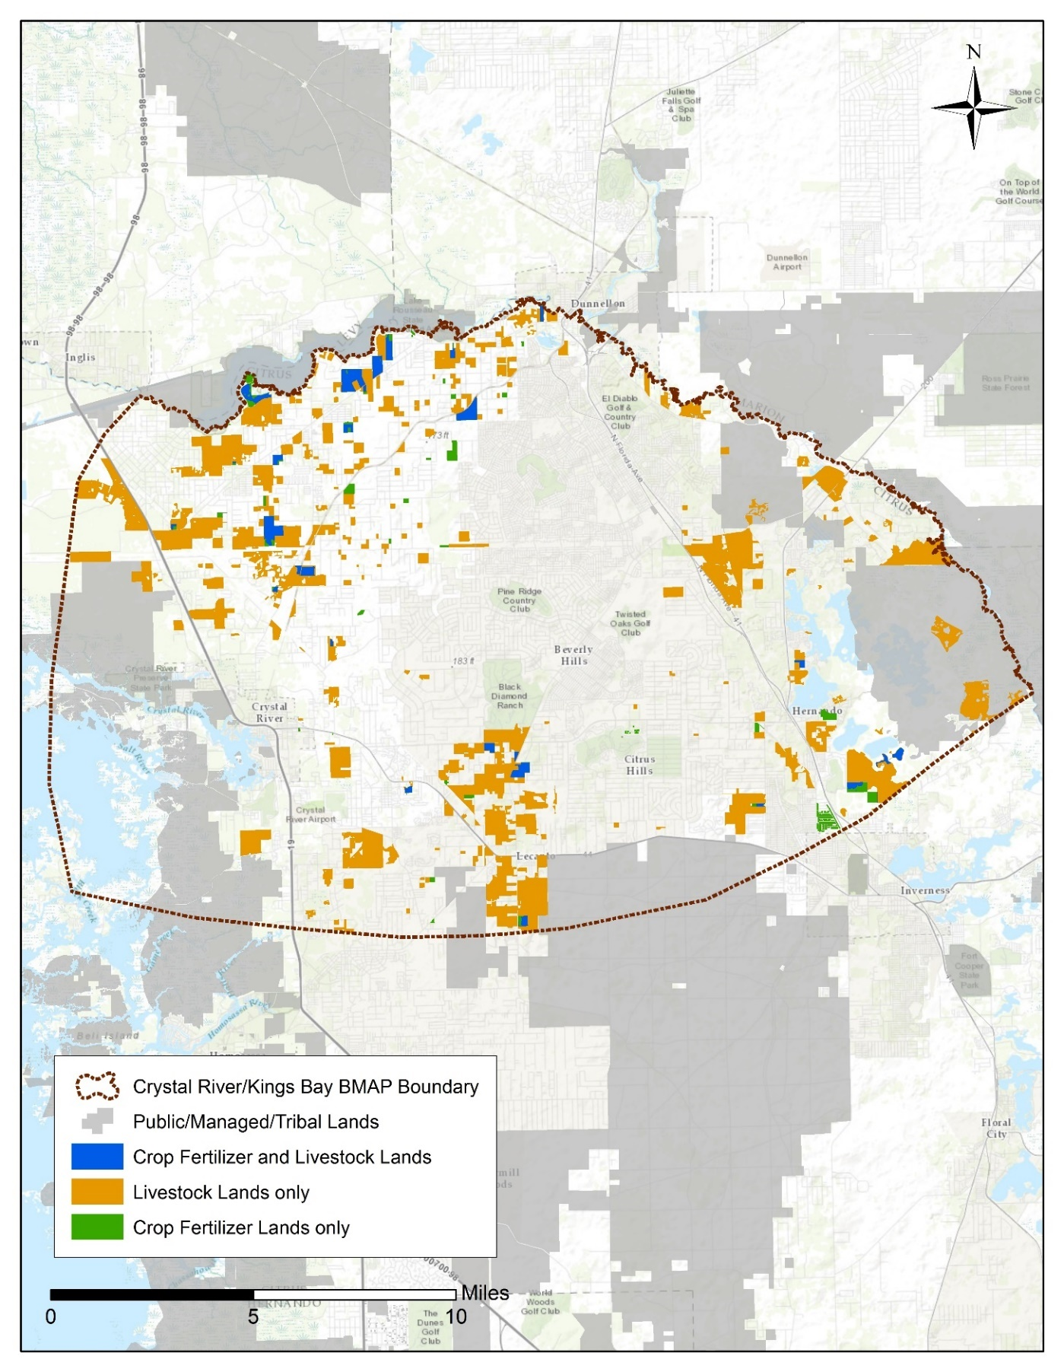
Figure G-1. Composite of agricultural lands in the Crystal River/Kings Bay Springshed

Agricultural land use data are critical for determining agricultural nonpoint source loads and developing strategies to reduce those loads in a BMAP area, but there are inherent limitations in the available data. The time of year when land use data are collected (through aerial photography) affects the accuracy of photo interpretation. Flights are often scheduled during the winter months because of weather conditions and reduced leaf canopies. While these are favorable conditions for capturing aerial imagery, they make photo interpretation for determining agricultural land use more difficult (e.g., more agricultural lands are fallow in the winter months) and can result in inappropriate analysis of the photo imagery.
There is also a significant variation in the frequency with which various sources of data are collected and compiled, and older data are less likely to capture the frequent changes that often typify agricultural land use. In addition, agricultural activity being conducted on the land is not always apparent. For example, acreage classified as improved pasture may be used for a cow-calf operation, consist of forage grass that is periodically harvested for hay, or simply be a fallow vegetable field awaiting planting. Finally, the classification method itself may be an issue. For example, property appraiser data assigns an agricultural land use designation to an entire parcel, although agricultural production may only be conducted on a portion of the parcel. Because of error in the collection and characterization of land use data and changes in land use over time, agricultural land use acreage estimates are subject to adjustment.
G.2 Agricultural BMPs
BMPs are individual or combined practices determined through research, field testing, and expert review to be effective and practicable means for improving water quality, considering economic and technological considerations. FDACS has authority for establishing agricultural BMPs through the Florida Forest Service (Silviculture BMP Program), the Division of Aquaculture (Aquaculture Certification Program), and the OAWP (all other agricultural BMP programs). As of February 2017, the OAWP has adopted manuals for cow-calf, statewide citrus, vegetable and agronomic crops, nurseries, equine operations, specialty fruit and nut, sod, dairy, and poultry operations. Development is under way for a small farms manual, and adoption is expected in 2017. The sod and cow-calf manuals are currently under review and revision.
The OAWP BMPs fall into two categories: structural and management. Structural BMPs (e.g., water control structures and fencing) involve the installation of structures or changes to the land and are usually costlier than management BMPs. Management BMPs, such as nutrient and irrigation management, comprise the majority of the practices and often are not readily observable. Nutrient management addresses fertilizer type, amount, placement, and application timing, and includes practices such as soil and tissue testing, application methods, correct fertilizer formulations, and setbacks from water resources. Irrigation management consists of maintenance, scheduling, and other measures that improve the overall efficiency rating of irrigation systems. FDACS-funded mobile irrigation labs (MILs) are available to evaluate irrigation system efficiency and provide recommendations to producers to improve efficiency. The implementation of these recommendations results in billions of gallons of water saved throughout the state and helps reduce nutrient runoff and leaching.
Table G-4 identifies key management and structural BMPs applicable to agricultural operations in the springshed. By definition, BMPs are developed to be technically and economically feasible. However, FDACS BMP manuals do contain some BMPs that may be affordable only with financial assistance through cost-share programs. The BMP checklists allow producers to indicate whether implementing a BMP requires financial assistance.
Information on the BMP manuals and field staff contact information can be obtained here: http://www.freshfromflorida.com/Divisions-Offices/Agricultural-Water-Policy. Printed BMP manuals can be obtained by contacting OAWP field staff.
Table G-4. Key management and structural BMPs adopted by FDACS OAWP
BMP Category | BMP | Description
Nutrient Need Determination | Soil and Tissue Testing | Used to base fertilizer applications on plant needs and available nutrients in soil; helps prevent the overapplication of fertilizer.
Nutrient Need Determination | Nutrient Budgeting | Adjustment of fertilizer regime to account for other nutrient sources, such as biosolids, legumes, manure, and nutrient-laden irrigation water; helps prevent the overapplication of fertilizer.
Nutrient Application Management | Precision Application of Nutrients | Use of specialized equipment for precise placement of nutrients on targeted areas at specified rates; reduces total amount used and prevents stray applications.
Nutrient Application Management | Equipment Calibration/Maintenance | Ensures proper functioning of equipment; prevents the misapplication or overapplication of fertilizer materials.
Nutrient Application Management | Split Fertilizer Applications | Multiple applications timed with optimal growth stages; allows plants to assimilate nutrients more efficiently; reduces nutrient loss in leaching and runoff.
Nutrient Application Management | Controlled-Release Fertilizer | Use of fertilizer formulations with controlled nutrient-release curve; reduces nutrient loss to leaching and runoff.
Nutrient Application Management | Fertilizer Application Setbacks from Waterbodies (e.g., wetlands, watercourses, sinks, springs, etc.) | Establishes zone where no fertilizer will be applied; reduces nutrient loadings to waterbodies.
Irrigation Management | Irrigation Scheduling | Planning when to irrigate to reduce water and nutrient losses, based on available soil moisture content, evapotranspiration levels, recent rainfall, and time of day.
Irrigation Management | Soil Moisture and Water Table Monitoring | Use of devices that measure water table level and amount of water in soil; is a key component of proper irrigation scheduling.
Treatment and Erosion Control | Filter Strips | Vegetated strips of land designed to reduce nutrients and sediments in surface water runoff from fields, pastures, and livestock high-intensity areas before it reaches downstream waterbodies.
Treatment and Erosion Control | Vegetative Buffers | Establishment of riparian and/or wetland buffers to attenuate and assimilate nutrient- or sediment-laden surface flows coming from cropped/grazed areas.
Treatment and Erosion Control | Ditch Maintenance and Retrofits | Use of rip rap, sediment traps, staging structures, and permanent vegetative bank cover to minimize erosion and transport of nutrient-laden sediments.
Livestock Management (Applicable to Cow/Calf and Equine Operations) | Manure Management | Appropriate storage and disposal of animal waste.
Livestock Management (Applicable to Cow/Calf and Equine Operations) | Alternative Water Sources | Use of upland livestock watering ponds and/or water troughs; minimizes manure deposition in waterbodies.
Livestock Management (Applicable to Cow/Calf and Equine Operations) | Rotational Grazing | Movement of cattle to different grazing areas on planned basis; prevents concentrated waste accumulations and denuding of pasture areas. May involve fencing.
Livestock Management (Applicable to Cow/Calf and Equine Operations) | High-Intensity Areas Location | Siting of cowpens, supplemental feed areas, etc., away from waterbodies to minimize nutrient loadings.
Operations Management | Fertilizer Storage | Proper location/storage of bulk fertilizer products to prevent nutrient loadings.
Operations Management | Fertilizer Mix/Load | Use of appropriate dedicated or temporary mix/load areas located away from waterbodies to prevent nutrient loading.
Operations Management | Employee Training | Training provided to farmworkers on how to implement BMPs.
Operations Management | Record Keeping | Proper record keeping provides accountability in implementation of BMPs and assists producers in making nutrient and irrigation management decisions.

G.3 BMP Enrollment
Figure G-2 shows the acres enrolled in the FDACS BMP Program in the Crystal River/Kings Bay Springshed as of December 31, 2016. Table G-5 lists the acres enrolled in the FDACS BMP Program by manual and the number of NOIs associated with those acres. Given that the enrolled acres where BMPs are implemented can contain nonproduction acres (such as buildings, parking lots, and fallow acres), only the enrollment for the land classified as agriculture based on the FSAID is included in Table G-5.
As of December 31, 2016, there are NOIs cover 736 acres in the Crystal River/Kings Bay Springshed. No producers are conducting water quality monitoring in lieu of implementing BMPs at this time.
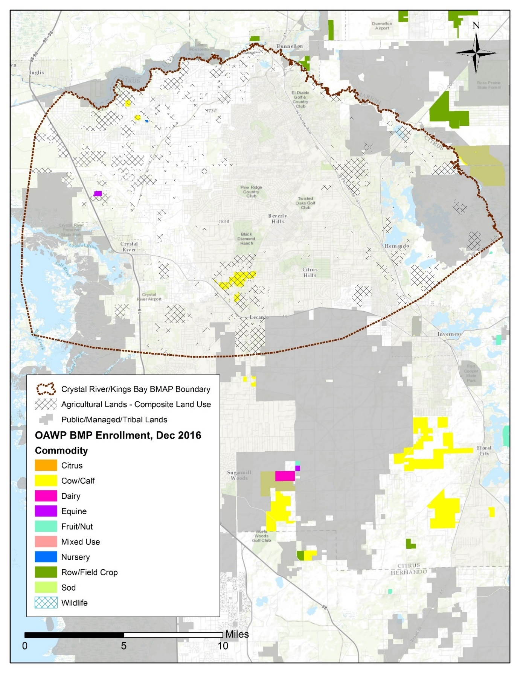
Figure G-2. BMP enrollment in the Crystal River/Kings Bay Springshed as of December 31, 2016

Table G-5. Agricultural acreage and BMP enrollment in the Crystal River/Kings Bay Springshed as of December 31, 2016
Related FDACS BMP Programs | NOI Acreage Enrolled | Composite Agricultural Land Use Acres within NOIs
Cow/Calf Operations | 663 | 639
Equine | 63 | .03
Nurseries | 9 | 7
Total | 736 | 646

G.4 Role of FDACS OAWP in BMP Implementation and Follow-Up
The OAWP works with producers to submit NOIs to implement the BMPs applicable to their operations, provides technical assistance to growers, and distributes cost-share funding, as available, to eligible producers for selected practices. The OAWP follows up with growers through site visits to evaluate the level of BMP implementation and record keeping, identify areas for improvement, if any, and discuss cost-share opportunities.
When DEP adopts a BMAP that includes agriculture, it is the agricultural producer's responsibility to implement BMPs adopted by FDACS to help achieve load reductions. If land use acreage corrections and BMP implementation do not fully account for the current agricultural load reduction allocation, it may be necessary to develop and implement cost-assisted field- or regional-level treatment options that remove nutrients from farms and other nonpoint sources. In that case, FDACS will work with DEP and the SWFWMD to identify appropriate options for achieving further agricultural load reductions.
Section 403.067, F.S., requires that, where water quality problems are demonstrated despite the proper implementation of adopted agricultural BMPs, FDACS must reevaluate the practices, in consultation with DEP, and modify them if necessary. Continuing water quality problems will be detected through the BMAP monitoring component and other DEP and SWFWMD activities. If a reevaluation of the BMPs is needed, FDACS will also include the SWFWMD and other partners in the process.
G.5 OAWP Implementation Assurance Program
The OAWP formally established its Implementation Assurance (IA) Program in 2005 in the Suwannee River Basin as part of the multi-agency/local stakeholder Suwannee River Partnership. In 2007, OAWP initiated the IA Program in the Lake Okeechobee Watershed and launched a standardized follow-up program for the remaining areas of the state in 2013, beginning with the Ridge Citrus and Indian River Citrus BMPs.
Because of program-specific needs, the follow up process for each of these three components was different. In early 2014, the OAWP began to streamline the IA Program to ensure consistency statewide and across commodities and BMP manuals. This effort resulted in a single IA site-visit form, which is currently used by OAWP staff.
The current IA Program is based on interactions with producers during a site visit by OAWP staff. Site visits are conducted by OAWP field staff and technicians as workload allows. For the visits, field staff and technicians use a standard form (not BMP specific) developed in 2014. This form focuses on nutrient management, irrigation management, and water resource protection BMPs common to all of the BMPs that have been adopted by rule. The paper forms are submitted to OAWP staff and compiled into a spreadsheet, and the data are reported annually.
From 2007 to2015, OAWP conducted 1,936 site visits. However, it is difficult to compare data collected prior to the implementation of the recently developed single IA site visit form because of regional differences (e.g., different forms and information requested) in the administration of the IA Program.
Additional emphasis was given to verifying the implementation of BMPs by enrolled producers with the enactment of Chapter 2016-1, Laws of Florida. That legislation directed the OAWP to formalize the Implementation Verification (IV) Program into rules. In December 2016, the OAWP published a notice of rule development. In July 2017, draft rule language has been distributed and presented at a public workshop. This draft language provided the structure for a statewide uniform implementation verification system, including assessments of the status of implementation, compliance assistance to aid producers in achieving full implementation, and referral to DEP for producers who are not implementing BMPs. The IV rule is final as of November 1, 2017, and can be found in Chapter 5M-1, F.A.C.
G.6 Beyond BMPs
Beyond enrolling producers in the FDACS BMP Program and verifying implementation, FDACS will work with DEP to improve the data used to estimate agricultural land uses in the springshed. FDACS will also work with producers to implement a suite of agricultural projects and research agricultural technologies on properties where they are deemed technically feasible and if funding is made available. Acreages provided by FDACS are preliminary estimates that are the maximum acreages that will be evaluated and refined over time.
As presented here, these projects are based on planning-level information. Actual implementation would require funding as well as more detailed design based on specific information, such as actual applicable acreages and willing landowners. Table G-6 summarizes these efforts. It is important to note that the research projects listed in the table are being conducted in the Suwannee River Basin. At some future point, the findings of these studies may be applicable to the Crystal River/Kings Bay Springshed.

Table G-6. Beyond BMP implementation
Category | Name | Description
Practices | Precision Irrigation | Deployment of equipment, procedures, and training to improve location, volume, and timing of irrigation to match crop needs more precisely.
Practices | Soil Moisture Probes | Deployment, training, technical support, and use of soil moisture probes to manage irrigation systems.
Practices | Cover Crops | Planting of cover crops between production cycles to increase soil organic content, improve nutrient retention, and reduce erosion.
Research | Bioreactors | Bioreactors/denitrification walls and onsite capture and reuse of high-N water.
Research | Rotational Production | Conversion of conventional production operations to planned rotational production incorporating grass and cover crops. May include cattle.
Research | Soil Moisture Sensor Deployment and Calibration | Installation, training, monitoring, and research on use of electronic soil moisture sensors, including correlations to nutrient movement through the root zone.
Research | Controlled Release Fertilizer (CRF) | Application of new and developing fertilizer products that become available to crops via dissolution over longer periods in the growing season.
Research | Reuse of High Nutrient Value Water Sources | Study of potential sources of high nutrient value water, potential beneficial reuse sites, legal and regulatory obstacles, and costs.

Appendix H. Future Growth Strategies of Local Jurisdictions
Table H-1. Future growth strategies of local jurisdictions
Local Jurisdiction | Strategy Name | Description | Strategy Type | Status
City of Crystal River | Springs Protection Zones/Overlays | Develop springs protection zones based on aquifer vulnerability and develop standards for new construction in these zones. | Regulation | Planned
Citrus County | Coastal, Lakes, River Management Policy 4.7.3 | To reduce the amount of untreated stormwater effluent, the county shall prepare a strategic plan to retrofit appropriate areas. | Comprehensive Plan | Completed
Citrus County | Infrastructure Element Policy 7.3.5 | All development must be served by a regional WWTF as soon as the service is available. | Comprehensive Plan | Completed
Citrus County | Infrastructure Element Policy 7.3.12 | The county shall eliminate and prevent the future discharge of inadequately treated wastewater into water and wetlands of the state by encouraging the use of spray irrigation and percolation ponds and by decreasing the number of illegal outfalls through code enforcement proceedings and/or capital facilities. The application of gray and treated wastewaters for use in irrigation is encouraged in upland areas and should be interpreted as a direct discharge. | Comprehensive Plan | Completed
Citrus County | Infrastructure Element Policy 7.3.15 | All existing central wastewater treatment systems shall be designed to achieve AWT standards upon expansion and include reuse capabilities. | Comprehensive Plan | Completed
Citrus County | Infrastructure Element Policy 7.3.16 | All new central wastewater treatment systems shall be designed to achieve AWT standards and include reuse capabilities. | Comprehensive Plan | Completed
Citrus County | Infrastructure Element Policy  7.4.4 | The county shall seek long term agreements with large users of groundwater to provide reclaimed water for the irrigation of horticultural or agricultural uses, golf courses, recreation and open space areas, and commercial and residential projects. | Comprehensive Plan | Completed
Citrus County | Infrastructure Element Policy  7.4.6 | Reclaimed water irrigation systems shall be designed and installed to prevent overspray or irrigation of any wetlands, waterbodies, sinkholes, or stormwater systems except for reclaimed water storage ponds. Buffers and BMPs shall be required to prevent reclaimed water runoff from entering sinks, wetlands, and waterbodies. | Comprehensive Plan | Completed
Citrus County | Future Land Use Element Policy 17.2.5 | New development locating in the Planned Service Area (PSA) shall be allowed only when central water and sewer are provided. For new residential land uses, this shall apply to developments of 4 units or greater per acre. Existing development must connect to central water and sewer systems when the services become available. Within the PSA, all new subdivision plats of 500 or more dwellings shall be required to connect to regional central water and regional central sewer | Comprehensive Plan | Completed
Citrus County | Future Land Use Element Policy 17.9.3 | All development and redevelopment shall be designed to minimize stormwater discharge and shall be designed to meet or exceed the requirements of Chapter 62-25, F.A.C. The county shall establish additional standards as needed to protect springs and their springsheds, spring run creeks, aquifer recharge, and Outstanding Florida Waters (OFWs) and their tributaries. | Comprehensive Plan | Completed
Citrus County | Future Land Use Element Policy 17.42.5 | The county shall encourage limited impervious cover and use green building techniques and LID strategies and technologies. | Comprehensive Plan | Completed
Citrus County | Future Land Use Element Policy 17.42.6 | The county shall encourage buffering requirements (water quality improvements) to provide pretreatment (filtering) of pollutants/contaminants from stormwater runoff that are detrimental to the long-term water quality of the county's natural resources. | Comprehensive Plan | Completed
Citrus County | Future Land Use Element Policy 17.45.3 | Design of infrastructure shall support development features and landscape vegetation that promote natural stormwater mitigation. | Comprehensive Plan | Completed

