Final

Homosassa and Chassahowitzka Springs Groups
Basin Management Action Plan

Division of Environmental Assessment and Restoration
Water Quality Restoration Program
Florida Department of Environmental Protection

with participation from the
Homosassa and Chassahowitzka Stakeholders

May 2018



2600 Blair Stone Rd.
Tallahassee, FL 32399
floridadep.gov

Acknowledgments
The Florida Department of Environmental Protection adopted the Homosassa and Chassahowitzka Springs Groups Basin Management Action Plan by Secretarial Order as part of its statewide watershed management approach to restore and protect Florida's water quality. The plan was developed in coordination with stakeholders, identified below, with participation from affected local, regional, and state governmental interests; elected officials and citizens; and private interests.
Florida Department of Environmental Protection
Noah Valenstein, Secretary
Table A-1. Homosassa and Chassahowitzka stakeholders
Type of Entity | Name
Responsible Stakeholders | Citrus County  City of Brooksville  City of Inverness  Hernando County  Agricultural producers  Golf courses
Responsible Agencies | Florida Department of Agriculture and Consumer Services  Florida Department of Environmental Protection  Florida Department of Health  Southwest Florida Water Management District
Other Interested Stakeholders | Citizens  Florida Farm Bureau  Florida Onsite Wastewater Association  Florida Springs Council  Hernando Beach Government Affairs Committee  Hernando County Port Authority  Hernando Environmental Land Protectors (HELP)  Homosassa River Alliance  Save the Manatee Club

See Appendix A for links to important sources referenced in this document. For additional information on the watershed management approach for the Homosassa and Chassahowitzka Springs Groups Basin, contact:
Terry Hansen, P.G., Basin Coordinator
Florida Department of Environmental Protection
Water Quality Restoration Program, Watershed Planning and Coordination Section
2600 Blair Stone Road, Mail Station 3565
Tallahassee, FL 32399-2400
Email: terry.hansen@dep.state.fl.us
Phone: (850) 245–8561
Fax: (850) 245–8434

Table of Contents
Acknowledgments 2
Table of Contents 4
List of Figures 6
List of Tables 7
Executive Summary 12
Section 1 : Background 16
1.1 Legislation 16
1.2 Water Quality Standards and Total Maximum Daily Loads (TMDLs) 16
1.3 BMAP Requirements 17
1.4 BMAP Area 17
1.5 PFA 18
1.6 Other Scientific and Historical Information 21
1.7 Stakeholder Involvement 21
1.8 Description of BMPs Adopted by Rule 21
Section 2 : Implementation to Achieve TMDLs 23
2.1 Allocation of Pollutant Loads 23
2.2 Prioritization of Management Strategies 29
2.3 Load Reduction Strategy 30
2.4 OSTDS Management Strategies 31
2.5 UTF Management Strategies 33
2.6 STF Management Strategies 35
2.7 Agricultural Sources Management Strategies 35
2.8 WWTF Management Strategies 38
2.9 Atmospheric Deposition Management Strategies 40
2.10 Future Growth Management Strategies 41
2.11 Protection of Surface Water and Groundwater Resources through Land Conservation 41
2.12 Commitment to Implementation 42
Section 3 : Monitoring and Reporting 43
3.1 Methods for Evaluating Progress 43
3.2 Adaptive Management Measures 43
3.3 Water Quality and Biological Monitoring 44
Appendices 49
Appendix A. Important Links 49
Appendix B. Projects to Reduce Nitrogen Sources 50
Appendix C. Priority Focus Area Report 61
Appendix D. OSTDS Remediation Plan 62
Appendix E. Technical Support Information 70
Appendix F. Educational Activities to Implement UTF Management Strategies 75
Appendix G. FDACS BMPs 80
Appendix H. Future Growth Strategies of Local Jurisdictions 92

List of Figures
Figure ES-1. Homosassa and Chassahowitzka Springs Groups BMAP and PFA boundary 13
Figure 1. Homosassa and Chassahowitzka Springs Groups BMAP and PFA boundaries 19
Figure 2. Loading to groundwater by source in the Homosassa Springshed 28
Figure 3. Loading to groundwater by source in the Chassahowitzka Springshed 28
Figure 4. OSTDS locations in the Homosassa and Chassahowitzka Springs Groups BMAP area 32
Figure 5. WWTF Locations in the Homosassa and Chassahowitzka Springs Groups BMAP Area 39
Figure 6. Groundwater and surface water stations sampled in the Homosassa and Chassahowitzka Springs Groups Basin 46
Figure D-1. Locations of OSTDS in the PFA in the Homosassa and Chassahowitzka Springs Groups BMAP 67
Figure G-1. Composite of agricultural lands in the combined springsheds 84
Figure G-2. BMP enrollment in the combined springsheds as of August 31, 2017 88

List of Tables
Table A-1. Homosassa and Chassahowitzka stakeholders 2
Table ES-1. WWTF effluent standards 15
Table 1. Restoration targets for the Homosassa Spring Group 16
Table 2. Restoration targets for the Chassahowitzka Spring Group 17
Table 3. Restoration target for the Chassahowitzka River 17
Table 4. BMPs and BMP manuals adopted by rule as of June 2017 21
Table 5. Estimated nitrogen load to groundwater by source in the Homosassa Springshed 24
Table 6. Estimated nitrogen load to groundwater by source in the Chassahowitzka Springshed 24
Table 7. Total reduction required to meet the TMDLs 28
Table 8. Nitrogen reduction schedule (lb-N/yr) 29
Table 9. Summary of potential credits for the Homosassa and Chassahowitzka Springs Groups BMAP 30
Table 10. Estimated individual OSTDS improvements to groundwater 33
Table 11. Current project credits to reduce UTF loading to groundwater 34
Table 12. Maximum UTF load reductions based on existing public education credit policies 34
Table 13. Maximum load reductions from STF improvements based on existing credit policies 35
Table 14. Estimated reductions for additional agricultural projects or practices in the Homosassa Springshed 37
Table 15. Estimated reductions for additional agricultural projects or practices in the Chassahowitzka Springshed 37
Table 16. Calculations for additional load reductions to groundwater 38
Table 17. Wastewater effluent standards for the BMAP area 40
Table 18. Stakeholder conservation land purchases 42
Table 19. Core water quality indicators 45
Table 20. Supplemental water quality indicators and field parameters 46
Table 21. Biological response measures 47
Table B-1. Stakeholder projects to reduce nitrogen sources 51
Table D-1. Estimated reduction credits for OSTDS enhancement or sewer in the PFA* 66
Table D-2. Prioritized target audiences, messaging, and materials/resources 68
Table D-3. Stakeholder educational activities to implement the OSTDS remediation plan 69
Table E-1. Range of environmental attenuation of nitrogen from a detailed literature review 73
Table F-1. Stakeholder educational activities to implement urban turfgrass fertilizer management strategies 76
Table G-1. Agricultural land use within the Homosassa Springshed 80
Table G-2. Agricultural land use within the Chassahowitzka Springshed 81
Table G-3. Fertilized crop lands within the Homosassa Springshed 81
Table G-4. Fertilized crop lands within the Chassahowitzka Springshed 82
Table G-5. Livestock lands within the Homosassa Springshed 82
Table G-6. Livestock lands within the Chassahowitzka Springshed 82
Table G-7. Key management and structural BMPs adopted by FDACS OAWP 85
Table G-8. Agricultural acreage and BMP enrollment in the Homosassa Springshed as of August 31, 2017 89
Table G-9. Agricultural acreage and BMP enrollment in the Chassahowitzka Springshed as of August 31, 2017 89
Table G-10. Beyond BMP implementation 91
Table H-1. Future growth strategies of local jurisdictions 92

List of Acronyms and Abbreviations
Ac Acre
AWT Advanced Wastewater Treatment
ATU Aerobic Treatment Unit
BAF Biochemical Attenuation Factor
BMAP Basin Management Action Plan
BMPs Best Management Practices
CASTNET Clean Air Status and Trends Network
cfs Cubic Feet Per Second
CMAQ Community Multiscale Air Quality
C.R. County Road
CRF Controlled Release Fertilizer
DEP Florida Department of Environmental Protection
DMR Discharge Monthly Report
DO Dissolved Oxygen
ERP Environmental Resource Permit
F.A.C. Florida Administrative Code
F.A.R. Florida Administrative Register
FARMS Facilitating Agricultural Resource Management Systems
FDACS Florida Department of Agriculture and Consumer Services
FDOH Florida Department of Health
FF Farm Fertilizer
FGS Florida Geological Survey
FLUCCS Florida Land Use Cover and Forms Classification System
FOWA Florida Onsite Wastewater Association
F.S. Florida Statutes
FSAID Florida Statewide Agriculture Irrigation Database
FY Fiscal Year
FYN Florida Yards and Neighborhoods
GIS Geographic Information System
gpd Gallons Per Day
HA Habitat Assessment
IA Implementation Assurance
IV Implementation Verification
in/yr Inch Per Year
lb Pound
lb-N/yr Pounds of Nitrogen Per Year
LF Linear Feet
LID Low Impact Development
LVS Linear Vegetation Survey
LW Livestock Waste
MFLs Minimum Flows and Levels
mgd Million Gallons Per Day
mg/L Milligrams Per Liter
MIL Mobile Irrigation Lab
N Nitrogen
N/A Not Applicable
NADP National Atmospheric Deposition Program
NELAC National Environmental Accreditation Conference
NELAP National Environmental Accreditation Program
NNC Numeric Nutrient Criteria
NOI Notice of Intent
NPDES National Pollutant Discharge and Elimination System
NSF NSF International (formerly National Sanitation Foundation)
NSILT Nitrogen Source Inventory Loading Tool
NTN National Trends Network
OAWP Office of Agricultural Water Policy
OFS Outstanding Florida Spring
OFW Outstanding Florida Water
OSTDS Onsite Sewage Treatment and Disposal System
PBTS Performance-based Treatment System
PFA Priority Focus Area
PSA Public Service Announcement or Planned Service Area
QA/QC Quality Assurance/Quality Control
RIB Rapid Infiltration Basin
RPS Rapid Periphyton Survey
SBIO DEP Statewide Biological Database
SCI Stream Condition Index
SOP Standard Operating Procedure
STF Sports Turf Fertilizer
STORET Florida Storage and Retrieval Database
SWFWMD Southwest Florida Water Management District
SWIM Surface Water Improvement and Management
TDEP Total Atmospheric Deposition Model
TMDL Total Maximum Daily Load
TN Total Nitrogen
TP Total Phosphorus
TSS Total Suspended Solids
UFA Upper Floridan Aquifer
UF–IFAS University of Florida/Institute of Food and Agricultural Sciences
USDA U.S. Department of Agriculture
USGS U.S. Geological Survey
UTF Urban Turfgrass Fertilizer
WAFR Wastewater Facility Regulation (Database)
WBID Waterbody Identification (Number)
WIN Florida Watershed Information Network Database
WMD Water Management District
WWTF Wastewater Treatment Facility
WWTP Wastewater Treatment Plant
yr Year

Executive Summary
Homosassa and Chassahowitzka Springs Groups Basin
The Florida Springs and Aquifer Protection Act (Chapter 373, Part VIII, Florida Statutes [F.S.]), provides for the protection and restoration of Outstanding Florida Springs (OFS), which comprise 24 first magnitude springs, 6 additional named springs, and their associated spring runs. The Florida Department of Environmental Protection (DEP) has assessed water quality in each OFS, and determined that 24 of the 30 OFS are impaired for the nitrate form of nitrogen. The Homosassa and Chassahowitzka Springs Groups are two of the impaired first magnitude OFS.
This basin management action plan (BMAP) comprises 340,609 acres located in southern Citrus County, including the City of Inverness, and northern Hernando County, including a portion of the City of Brooksville. The BMAP area (Figure ES-1) contains both the Homosassa Spring Group, comprised of numerous springs that are the source waters for the Homosassa River, and the Chassahowitzka Spring Group, comprised of six springs that make up the headwaters of the Chassahowitzka River (an impaired Outstanding Florida Water [OFW]), that discharges into the Gulf of Mexico.
Priority Focus Area (PFA)
The PFA (see Appendix C) comprises 77,732 acres and includes a region in the western part of the Homosassa Springshed (36,961 acres) and Chassahowitzka Springshed (40,771 acres) that are subareas within the BMAP boundary. The PFA represents the area in the basin where the aquifer is most vulnerable to inputs and where there are the most connections between groundwater and the springs.
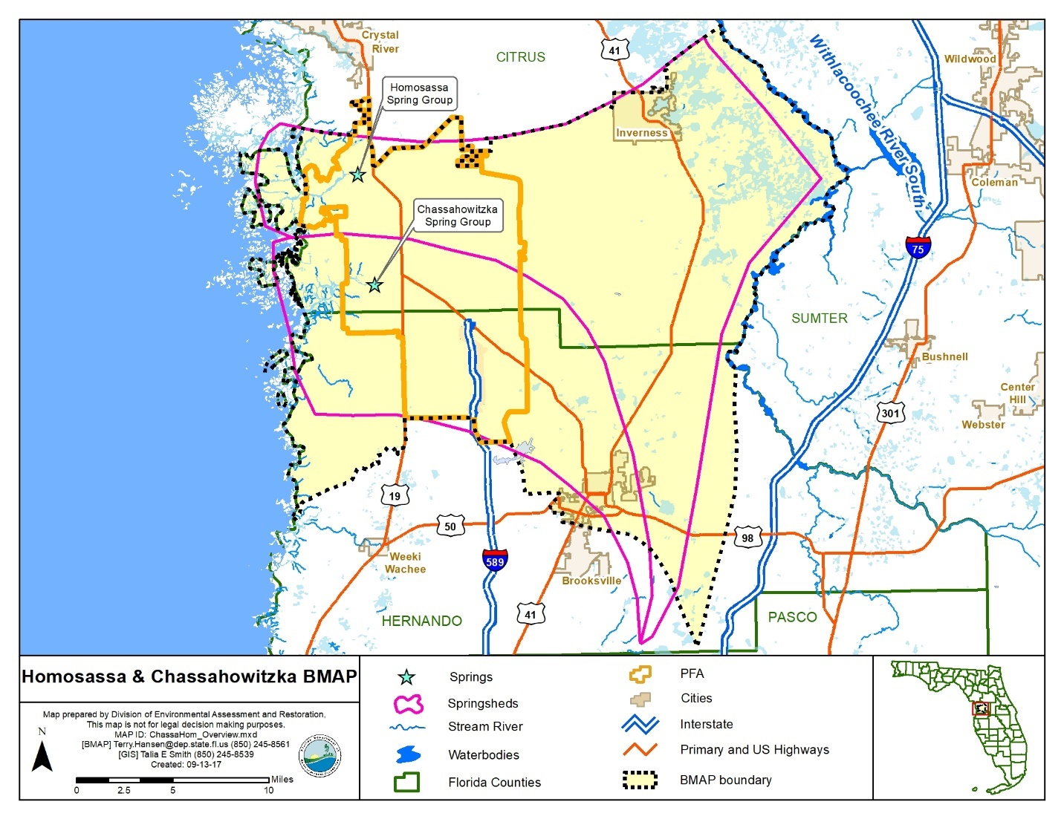
Figure ES-1. Homosassa and Chassahowitzka Springs Groups BMAP and PFA boundary

Nitrogen Source Identification, Required Reductions, and Options to Achieve Reductions
DEP adopted nutrient total maximum daily loads (TMDLs) for the Homosassa Spring Group, Chassahowitzka Spring Group, and Chassahowitzka River-Baird Creek in 2014. The TMDLs established a monthly average nitrate target of 0.23 milligrams per liter (mg/L) for Homosassa Spring Group and Chassahowitzka Spring Group and a total nitrogen (TN) water quality target of 0.25 mg/L for Chassahowitzka River-Baird Creek.
Agricultural sources in the BMAP area (farm fertilizer [FF] and livestock waste [LW]) represent 39 % of the nitrogen loading to groundwater, urban turfgrass fertilizer (UTF) represents 22 %, and onsite sewage treatment and disposal systems (OSTDS or septic systems; the terms are used interchangeably throughout this document) 16 % of the total loading to groundwater based on the DEP analysis conducted using the Nitrogen Source Inventory Loading Tool (NSILT).
The total load reduction required to meet the TMDLs at the spring vents is 272,833 pounds of nitrogen per year (lb-N/yr) − 157,132 lb-N/yr in the Homosassa Springshed and 115,701 lb-N/yr in the Chassahowitzka Springshed. To measure progress towards achieving the necessary load reduction, DEP is establishing the following milestones:
- 81,850 lb-N/yr (30 %) within 5 years.
- 136,417 lb-N/yr (50 %) within 10 years.
- 54,567 lb-N/yr (20 %) within 15 years.
- Total of 272,833 lb-N/yr within 20 years.

The policies and submitted projects included within this BMAP are estimated to achieve a reduction of 162,782 to 347,433 lb-N/yr. The BMAP is designed to achieve 80 % of the effort within 10 years of adoption and 100 % within 15 years. DEP will evaluate progress towards these milestones and will report to the Governor and Florida Legislature. DEP will adjust management strategies to ensure the target concentrations are achieved. This may include expanding the area to which the OSTDS remediation policies apply; any such change, however, would be incorporated into an updated BMAP through a formal adoption process.
There are currently 48 projects to improve water quality (see Appendix B), of which 20 projects have estimated load reductions. Included are owner-implemented best management practices (BMPs) for FF, LW, sports turfgrass (STF); wastewater treatment facility (WWTF) upgrades; projects to reduce UTF application; and OSTDS conversions to sewer.
Restoration Approaches
- New OSTDS – Upon BMAP adoption, the OSTDS remediation plan prohibits new systems on lots of less than 1 acre within the PFAs, unless the system includes enhanced treatment of nitrogen as defined by the OSTDS remediation plan, or unless the OSTDS permit applicant demonstrates that sewer connections will be available within 5 years. Local governments and utilities are encouraged to develop master wastewater treatment feasibility plans to identify specific areas to be sewered within 20 years of BMAP adoption. The OSTDS remediation plan is incorporated as Appendix D.
- Existing OSTDS – Upon completion of the feasibility plan, rulemaking, and funding milestones included in the OSTDS remediation plan, but no later than five years after BMAP adoption, modification or repair permits issued by FDOH for all OSTDS within the PFA on all lots will require enhanced treatment of nitrogen, unless sewer connections will be available based on a BMAP-listed project. All OSTDS subject to the policy must include enhanced treatment of nitrogen no later than 20 years after BMAP adoption.
- WWTFs − The effluent standards listed in Table ES-1 will apply to all new and existing WWTFs in the BMAP area (inside and outside the PFA).
Table ES-1. WWTF effluent standards
gpd = Gallons per day
95% of the Permitted Capacity (gpd) | Nitrogen Concentration Limits for Rapid Infiltration Basins (RIBs) and Absorption Fields (mg/L) | Nitrogen Concentration Limits for All Other Land Disposal Methods, Including Reuse (mg/L)
Greater than 100,000 | 3 | 3
20,000 to 100,000 | 3 | 6
Less than 20,000 | 6 | 6
- UTF – UTF sources can receive up to 6 % credit for the DEP-approved suite of public education and source control ordinances. Entities have the option to collect and provide monitoring data to quantify reduction credits for additional measures.
- STF – STF sources include golf courses and other sporting facilities. Golf courses can receive up to 10 % credit for implementing the Golf Course BMP Manual. Other sports fields can receive up to 6 % credit for managing their fertilizer applications to minimize transport to groundwater.

- FF – All FF sources are required to implement best management practices (BMPs) or perform monitoring to demonstrate compliance with the TMDL. A 15 % reduction to groundwater is estimated for owner-implemented BMPs. Additional credits could be achieved through better documentation of reductions achieved through BMP implementation or implementation of additional agricultural projects or practices, such as precision irrigation, soil moisture probes, controlled release fertilizer, and cover crops.
- LW – All LW sources are required to implement BMPs or perform monitoring. A 10 % reduction to groundwater is estimated for owner-implemented BMPs. Additional credits could be achieved through additional projects and practices if data are available.

: Background

Legislation
Chapter 373, Part VIII, Florida Statutes (F.S.), created the Florida Springs and Aquifer Protection Act to provide for the protection and restoration of Outstanding Florida Springs (OFS), which comprise 24 first magnitude springs, 6 additional named springs, and their associated spring runs. The Florida Department of Environmental Protection (DEP) has assessed water quality in each OFS and determined that 24 of the 30 OFS are impaired for the nitrate form of nitrogen. The Homosassa and Chassahowitzka Springs Groups are two of the impaired first magnitude OFS.
Development of the basin management action plan (BMAP) to meet the new requirements of the Florida Springs and Aquifer Protection Act for the Homosassa and Chassahowitzka Springs Groups Basin was initiated in 2016.

Water Quality Standards and Total Maximum Daily Loads (TMDLs)
A TMDL represents the maximum amount of a given pollutant that a waterbody can assimilate and still meet water quality criteria. The waters of the Homosassa and Chassahowitzka Springs Groups that are addressed in this BMAP are Class III waterbodies which have a designated use of recreation, propagation, and the maintenance of a healthy, well-balanced population of fish and wildlife. These waters are impaired by nitrate nitrogen, which in excess has been demonstrated to adversely affect flora or fauna through the excessive growth of algae. Excessive algal growth results in ecological imbalances in springs and rivers and can produce human health problems, foul beaches, inhibit navigation, and reduce the aesthetic value of the resources.
DEP adopted nutrient TMDLs for the Homosassa and Chassahowitzka Springs Groups and Chassahowitzka River in 2014 (see Table 1, Table 2, and Table 3). The TMDLs established a target of an annual average of 0.23 milligrams per liter (mg/L) of nitrate for the Homosassa and Chassahowitzka Springs Groups; a target of an annual average of 0.25 mg/L of TN for Chassahowitzka River-Baird Creek. The period of record for water quality data evaluated for the TMDLs was January 2004 through December 2013.
Table 1. Restoration targets for the Homosassa Spring Group
Waterbody or Spring Name | Waterbody Identification (WBID) Number | Parameter | TMDL  (mg/L)
Homosassa #1 Spring | 1345G | Nitrate, annual average | 0.23
Homosassa #2 Spring | 1345G | Nitrate, annual average | 0.23
Homosassa #3 Spring | 1345G | Nitrate, annual average | 0.23
Pumphouse Springs | 1345G | Nitrate, annual average | 0.23
Trotter Springs | 1345G | Nitrate, annual average | 0.23
Bluebird Springs | 1348A | Nitrate, annual average | 0.23
Hidden River Main Spring | 1348E | Nitrate, annual average | 0.23
Hidden River #2 Spring | 1348E | Nitrate, annual average | 0.23

Table 2. Restoration targets for the Chassahowitzka Spring Group
Waterbody or Spring Name | WBID Number | Parameter | TMDL  (mg/L)
Chassahowitzka Main Spring | 1348Z | Nitrate, annual average | 0.23
Chassahowitzka #1 Spring | 1348Z | Nitrate, annual average | 0.23
Crab Creek Spring | 1348Z | Nitrate, annual average | 0.23
Baird #1 Spring | 1348D | Nitrate, annual average | 0.23
Ruth Spring | 1348D | Nitrate, annual average | 0.23
Beteejay Spring | 1361B | Nitrate, annual average | 0.23

Table 3. Restoration target for the Chassahowitzka River
Waterbody or Spring Name | WBID Number | Parameter | TMDL  (mg/L)
Chassahowitzka River-Baird Creek | 1348D | TN, annual average | 0.25

BMAP Requirements
Section 403.067(7), F.S., provides DEP the statutory authority for the BMAP Program. A BMAP is a comprehensive set of strategies to achieve the required pollutant load reductions. In addition to this authority, the Florida Springs and Aquifer Protection Act (Part VIII of Chapter 373, F.S.) describes additional requirements for 30 springs.

BMAP Area
The BMAP area (see Figure 1) comprises 340,609 acres located in southern Citrus County, including the City of Inverness, and northern Hernando County, including a portion of the City of Brooksville. The BMAP area contains both the Homosassa Spring Group, comprised of numerous springs that are the source waters for the Homosassa River, and the Chassahowitzka Spring Group, comprised of six springs that make up the headwaters of the Chassahowitzka River (an impaired Outstanding Florida Water), that discharges into the Gulf of Mexico.
This area includes the surface water basin as well as the groundwater contributing areas for the springs (or springsheds). Springsheds for the OFS were delineated or reviewed by Southwest Florida Water Management District (SWFWMD) with input from the Florida Geological Survey (FGS). A springshed is the area of land that contributes water to a spring or group of springs, mainly via groundwater flow.

PFA
In compliance with the Florida Springs and Aquifer Protection Act, this BMAP delineates one PFA that includes portions of the Homosassa and Chassahowitzka springsheds. A PFA is defined as the area(s) of a basin where the Floridan aquifer is generally most vulnerable to pollutant inputs and where there is a known connectivity between groundwater pathways and an OFS. The PFA provides a guide for focusing restoration strategies where science suggests these efforts will most benefit the springs. The document describing the delineation process for the PFA is on the DEP website. The link to the PFA document is provided in Appendix C.

Description
Nitrogen sources are more likely to influence groundwater quality under certain conditions. For example, where soils are sandy and well drained, less nitrogen is converted to gas and released into the atmosphere or taken up by plants, compared with other soil types. Therefore, local soil types play a role in how much nitrogen travels from the land surface to groundwater in a specific springshed. Also, the underlying geologic material influences the vulnerability of the underlying aquifers and the rate of lateral movement within the Floridan aquifer toward the springs and river. These conditions, and others, were considered in the delineation of the PFA (see Appendix C).
Following BMAP adoption, DEP will ensure that the GIS files associated with the PFA boundary are available to the public on the DEP Map Direct webpage.
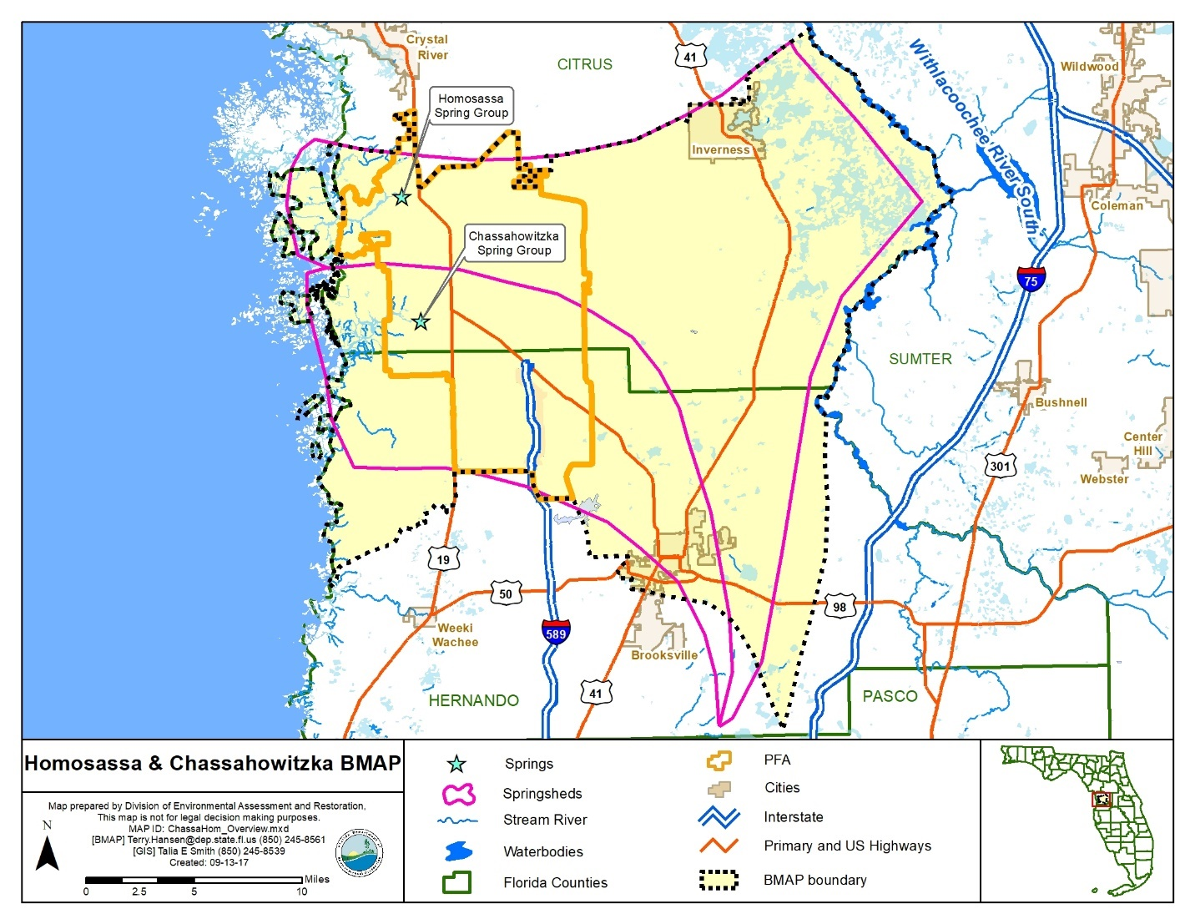
Figure 1. Homosassa and Chassahowitzka Springs Groups BMAP and PFA boundaries

Additional Requirements
In accordance with Section 373.811, F.S., the following activities are prohibited in the PFA:
- New domestic wastewater disposal facilities, including rapid infiltration basins (RIBs), with permitted capacities of 100,000 gpd or more, except for those facilities that meet an advanced wastewater treatment (AWT) standard of no more than 3 mg/L total nitrogen (TN) on an annual permitted basis.
- New OSTDS on lots of less than one acre inside the PFA unless additional nitrogen treatment is provided, as specified in the OSTDS remediation plan (see Appendix D for details).
- New facilities for the disposal of hazardous waste.
- The land application of Class A or Class B domestic wastewater biosolids not in accordance with a DEP-approved nutrient management plan establishing the rate at which all biosolids, soil amendments, and sources of nutrients at the land application site can be applied to the land for crop production while minimizing the amount of pollutants and nutrients discharged to groundwater or waters of the state.
- New agriculture operations that do not implement BMPs, measures necessary to achieve pollution reduction levels established by DEP, or groundwater monitoring plans approved by a WMD or DEP.

Biosolids and Septage Application Practices
In the PFA, the aquifer contributing to the springs is highly vulnerable to contamination by nitrogen sources and soils have a high to moderate tendency to leach applied nitrogen. DEP previously documented elevated nitrate concentrations in groundwater beneath septage application zones in spring areas. To assure that nitrogen losses to groundwater are minimized from permitted application of biosolids and septage in the PFA, the following requirements apply to newly-permitted application sites and existing application sites upon permit renewal.
All permitted biosolids application sites that are agricultural operations must be enrolled in the Florida Department of Agriculture and Consumer Services (FDACS) BMP Program or be within an agricultural operation enrolled in the FDACS BMP Program for the applicable crop type. Implementation of applicable BMPs will be verified by FDACS in accordance with Chapter 5M-1, Florida Administrative Code (F.A.C.). Permitted biosolids application sites that are new agricultural operations must also comply with Subsection 373.811(5), F.S. Biosolids application sites must be certified as viable agricultural operations by an acknowledged agricultural professional such as an agricultural consultant or agricultural extension agent. Effective nutrient management practices must be ongoing at the application zones in the permit. Plant uptake and harvesting are vital components of the nutrient management plan to remove nitrogen and prevent it from leaching to groundwater. If DEP determines that the site is not a viable agricultural site implementing a nutrient management plan, corrective action will be required.
Groundwater monitoring for nitrate is required for all biosolids and septage land application sites in the PFA to assure compliance with nutrient management objectives in this BMAP. However, groundwater monitoring is not required if the site nutrient management plan limits biosolids application rates to TN with no adjustment for available nitrogen normally allowed by subsections 62-640.500(5) and (6), F.A.C. (e.g. for a recommended fertilizer rate of 160 pounds of nitrogen per acre, only 160 pounds of TN per acre shall be applied). For septage application, groundwater monitoring is not required if the site nutrient management plan limits application rates to 30,000 gallons per acre for sites accepting mixtures of septage and grease (food establishment sludge) or to 40,000 gallons per acre for sites accepting septage without grease. The permit renewal application will include a trend analysis for nitrate in groundwater monitoring wells during the previous permit cycle, and an evaluation of the potential for the facility to cause or contribute to exceedance of the TMDL.
Changes are proposed to the upcoming FDACS Cattle BMP Manual revision that will likely impact biosolid application. This will necessitate coordination between FDACS and DEP permitting staff.

Other Scientific and Historical Information
In preparing this BMAP, DEP collected and evaluated credible scientific information on the effect of nutrients, particularly forms of nitrogen, on springs and springs systems. Some of the information collected is specific to the Homosassa and Chassahowitzka Springs Groups Basin, while other references provide information on related knowledge for restoring springs, such as nitrogen-reducing technologies, the treatment performance of OSTDS, and runoff following fertilizer applications.

Stakeholder Involvement
Stakeholder involvement is critical to develop, gain support for, and secure commitments in a BMAP. The BMAP process engages stakeholders and promotes coordination and collaboration to address the pollutant load reductions necessary to achieve the TMDLs. DEP invites stakeholders to participate in the BMAP development process and encourages public participation and consensus to the greatest practicable extent. Table A-1 identifies the stakeholders who participated in the development of this BMAP.
During development of this BMAP, DEP held a series of meetings involving stakeholders and the general public. The purpose of these meetings was to consult with stakeholders to gather information, evaluate the best available science, develop an OSTDS remediation plan (including a public education plan), define management strategies and milestones, and establish monitoring requirements. All of the meetings were open to the public and noticed in the Florida Administrative Register (F.A.R.). Additionally, a public meeting on the current draft BMAP was held on January 30, 2018, and was noticed in the F.A.R. and in local newspapers.
Upon BMAP adoption, DEP intends to facilitate annual meetings with stakeholders to review progress towards achieving the TMDLs.

Description of BMPs Adopted by Rule
Table 4 identifies the adopted BMPs and BMP manuals that are relevant to this BMAP.
Table 4. BMPs and BMP manuals adopted by rule as of June 2017
Agency | F.A.C. Chapter | Chapter Title
FDACS Office of Agricultural Water Policy (OAWP) | 5M-6 | Florida Container Nursery BMP Guide
FDACS OAWP | 5M-8 | BMPs for Florida Vegetable and Agronomic Crops
FDACS OAWP | 5M-9 | BMPs for Florida Sod
FDACS OAWP | 5M-11 | BMPs for Florida Cow/Calf Operations
FDACS OAWP | 5M-12 | Conservation Plans for Specified Agricultural Operations
FDACS OAWP | 5M-13 | BMPs for Florida Specialty Fruit and Nut Crop Operations
FDACS OAWP | 5M-14 | BMPs for Florida Equine Operations
FDACS OAWP | 5M-16 | BMPs for Florida Citrus
FDACS OAWP | 5M-17 | BMPs for Florida Dairies
FDACS OAWP | 5M-18 | Florida Agriculture Wildlife BMPs
FDACS OAWP | 5M-19 | BMPs for Florida Poultry
FDACS Division of Agricultural Environmental Services | 5E-1 | Fertilizer
FDACS Division of Aquaculture | 5L-3 | Aquaculture BMPs
FDACS Florida Forest Service | 5I-6 | BMPs for Silviculture
FDACS Florida Forest Service | 5I-8 | Florida Forestry Wildlife BMPs for State Imperiled Species
SWFWMD | 40D-26 | Facilitating Agricultural Resource Management Systems (FARMS) Program
DEP | 62-330 | Environmental Resource Permitting

: Implementation to Achieve TMDLs

Allocation of Pollutant Loads
DEP collected and evaluated credible scientific information on the effect of nutrients, particularly forms of nitrogen, on the Homosassa and Chassahowitzka Springs Groups as described below.

Nutrients in the Springs and Spring Systems
DEP developed the Nitrogen Source Inventory Loading Tool (NSILT) to provide information on the major sources of nitrogen in the groundwater contributing area and spring contributing area for the OFS. In addition, this tool is used to estimate nitrogen loads to groundwater from these sources in the spring contributing area. The NSILT is a GIS- and spreadsheet-based tool that provides spatial estimates of the relative contribution of nitrogen from major nitrogen sources and accounts for the transport pathways and processes affecting the various forms of nitrogen as they move through the land surface through soil and geologic strata.
The first major factor to consider in estimating the loading to groundwater in the NSILT is the attenuation of nitrogen as it moves from its source through the environment, before it reaches the Upper Floridan aquifer (UFA). The movement of nitrogen from the land surface to groundwater is controlled by biological and chemical processes that occur as part of the nitrogen cycle, as well as hydrogeological processes. Many of these processes attenuate (impede or remove) the amount of nitrogen transported to groundwater. An understanding of how water moves through the subsurface and the processes that transform the different forms of nitrogen is essential for estimating nitrogen loading to groundwater from various sources.
A second major factor to consider in estimating the loading to groundwater is the geologic features in the springshed and the related "recharge rate." Water movement between the shallow groundwater (surficial aquifer, where present) and the deeper aquifer (UFA) is slowed by a low permeability layer of clay, silt, and fine sand that retards the vertical movement of infiltrating water from the surface. The UFA occurs in limestone that can be prone to dissolving, and, over geologic time, the development of numerous karst features (sinkholes, caves, and conduits). These features allow water from the land surface to move directly and relatively rapidly into the aquifer and in some areas for groundwater in the aquifer to move rapidly to the springs.
Potential recharge rates from the surface to the UFA are affected by variations in the geologic materials and the presence of karst features. DEP estimated the recharge rate ranges and grouped them into three rate categories, which were applied in the NSILT:
- Low recharge (Less than 3 inches per year [in/yr]).
- Medium recharge (3 to 10 in/yr).
- High recharge (10 in/yr or greater).
In the NSILT, DEP applied different attenuation factors to different types of sources, so that various biological, chemical, and hydrogeological effects could be estimated. The attenuation that was applied means that the amount of nitrogen leaving a source (such as a livestock operation or a newly fertilized yard) reduces the amount of nitrogen predicted to reach the aquifer. In the NSILT, the attenuation rates ranged from 90 % (for atmospheric deposition) to 25 % (for wastewater disposal in a RIB). This means that, for these examples, only 10 % of nitrogen from atmospheric deposition is expected to reach the aquifer, while 75 % of nitrogen from a RIB is expected to reach groundwater, because the remainder is attenuated by various chemical and biological processes.
Phosphorus is naturally abundant in the geologic material underlying much of Florida and is often present in high concentrations in surface water and groundwater. Monitoring and evaluation of phosphorus and influences on the springs continues as the nitrate TMDLs are implemented.

Estimated Nitrogen Loads
Table 5 and Table 6 list the estimated nitrogen loads to groundwater by source by springshed. Note that urban stormwater loads are included in UTF estimates, while agricultural stormwater loads are included in FF and LW loading estimates. Nitrogen loading to surface water will be reduced through the activities and strategies for the sources identified in this chapter for groundwater loading.
Table 5. Estimated nitrogen load to groundwater by source in the Homosassa Springshed
Nitrogen Source | Estimated Total Nitrogen Load to Groundwater  (lb-N/yr) | % Contribution
OSTDS | 96,116 | 16
UTF | 137,637 | 24
Atmospheric Deposition | 83,152 | 14
FF | 107,844 | 18
STF | 14,786 | 3
LW | 136,880 | 24
WWTF | 5,662 | 1
Total | 582,077 | 100

Table 6. Estimated nitrogen load to groundwater by source in the Chassahowitzka Springshed
Nitrogen Source | Estimated Total Nitrogen Load to Groundwater  (lb-N/yr) | % Contribution
OSTDS | 58,357 | 15
UTF | 74,200 | 19
Atmospheric Deposition | 61,346 | 16
FF | 90,841 | 24
STF | 44,797 | 12
LW | 40,811 | 11
WWTF | 10,111 | 3
Total | 380,463 | 100

Assumptions and Considerations
The NSILT estimates are based on the following assumptions and considerations:
- NSILT Nitrogen Inputs – The methods used to estimate nitrogen inputs for each pollutant source were based on a detailed synthesis of information, including direct water quality measurements, census data, surveys, WWTF permits, published scientific studies and reports, and information obtained in meetings with agricultural producers. For some pollutant source categories, the calculation of nitrogen inputs was achieved using assumptions and extrapolations and, as a result, these estimated inputs could be subject to further refinement if more detailed information becomes available.
- OSTDS Load Contribution – A per capita contribution to an OSTDS of 9.012 pounds of nitrogen per year (lb-N/yr) was used to calculate loading from OSTDS. The average household contribution was estimated based on 2010 U.S. Census Bureau data on the average number of people per household by county (2.23 in Citrus County and 2.41 in Hernando) within the area and additional information on the amount of time spent away from home by the school-age population and labor force (adjusted to 1.95 effective persons per household).
- Nitrogen Attenuation Factors –To estimate the amount of nitrogen loading to the aquifer, DEP applied two nitrogen attenuation factors. Biological and chemical processes that occur as part of the nitrogen cycle, as well as hydrogeological processes, control the movement of nitrogen from the land surface to groundwater. Biochemical attenuation accounts for biochemical processes that convert or transform the different forms of nitrogen, while hydrogeological attenuation accounts for spatial variations that affect the rate of water infiltrating through geological media to recharge the UFA.
Given the relatively large range of literature-reported values of biochemical nitrogen attenuation for each source category, DEP used an average biochemical attenuation factor for each source based on land use practices and hydrogeological (i.e., recharge) conditions in the contributing areas.
Other assumptions and considerations for BMAP implementation include the following:
- Unquantified Project Benefits – Nitrogen reductions for some of the projects and activities listed in this BMAP cannot currently be quantified. However, because of their positive impact, it is assumed that these actions will help reduce pollutant loads, and estimated loading reductions may be determined at a later date and assigned to these activities.
- Atmospheric Deposition – Atomospheric sources of nitrogen are local, national, and international. Atmospheric sources are generally of low nitrogen concentration compared with other sources and are further diminished through additional biological and chemical processes before they reach groundwater. Atmospheric deposition sources and trends will be re-evaluated periodically.
- OSTDS Inventory and Loading Calculations – The total number of OSTDS in the basin is estimated based on local information and Florida Department of Health (FDOH) data. Future BMAPs and the associated OSTDS loading calculations may be adjusted based on improved data on the number and location of existing septic systems, and may include additional OSTDS installed since BMAP adoption.
- PFA – The PFA provides a guide for focusing strategies where science suggests efforts will best benefit the springs. The PFA boundary may be adjusted in the future if additional relevant information becomes available.
- Project Collection Period – The BMAP project collection period is limited to projects after a certain date, based on the data used to calculate the reductions needed. Reductions from older projects are already accounted for in the baseline loading. Projects completed in the springsheds after January 1, 2014, were considered for inclusion in this BMAP.
- Legacy Sources – Land uses or management practices not currently active in the basin may still be affecting the nitrate concentration of the springs. The movement of water from the land surface through the soil column to the UFA and through the UFA to the spring system varies both spatially and temporally and is influenced by local soil and aquifer conditions. As a result, there may be a lag between when nitrogen input to the UFA occurs and ultimately when that load arrives at the Homosassa and Chassahowitzka Springs Groups. The impact of this delay is not fully known.
- Implementation Schedule – BMAP implementation is intended to be a 20-year process. This plan defines nitrogen reduction milestones for 5-year (30 %), 10-year (50 %), and 15-year (20 %) implementation, so that the TMDLs will be met no later than the 20-year goal (see Section 2.1.6 for further details). Further, the total reductions and the project credits may be adjusted under the adaptive management approach used for the BMAP. This approach requires regular follow-up to ensure that management strategies are carried out and that their incremental effects are assessed. This process acknowledges that there is some uncertainty associated with the outcomes of proposed management strategies and the estimated response of concentration at the springs. As more information is gathered and progress towards each 5-year milestone is reviewed, additional management strategies to achieve the TMDLs will be developed or existing strategies refined to better address the sources of nitrogen loading.
- Changes in Spring Flows – The role of this BMAP is specifically to promote the implementation of projects that reduce nitrogen load to groundwater while the minimum flows and levels (MFLs) established for specific springs address water flows and levels. To maximize efforts between the two programs, spring protection projects should provide both water quality and quantity benefits.

Loading by Source
Based on the NSILT estimates, the pie charts in Figure 2 and Figure 3 depict the estimated percentage of nitrogen loading to groundwater by source in each springshed. Agricultural sources represent a 39 % of the nitrogen loading to groundwater, UTF 22 %, and septic systems 16 % of the total loading in the BMAP area (combined springsheds). Stormwater loading to groundwater is incorporated in the various source categories.
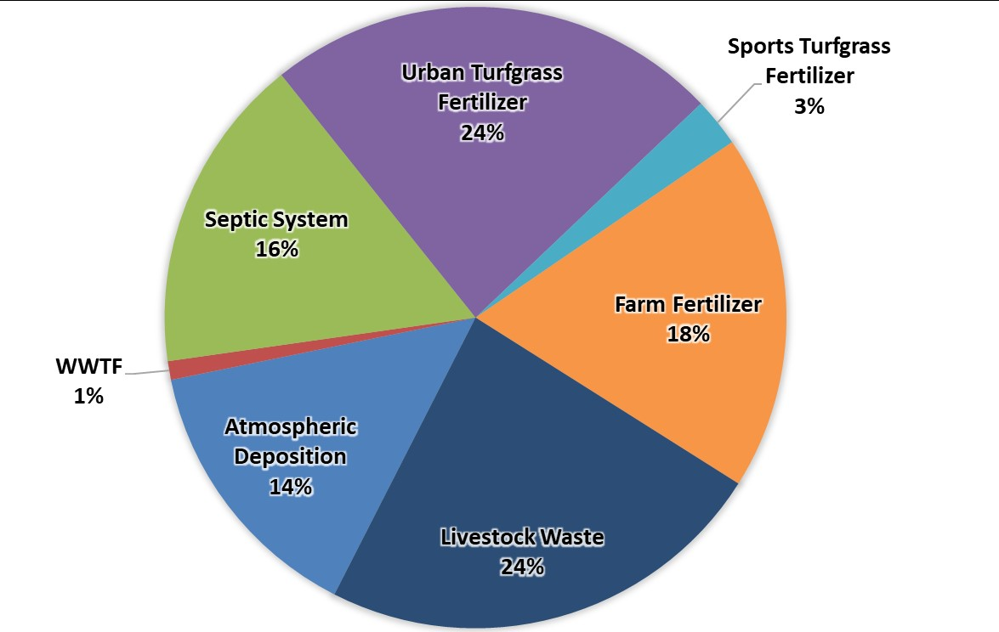
Figure 2. Loading to groundwater by source in the Homosassa Springshed
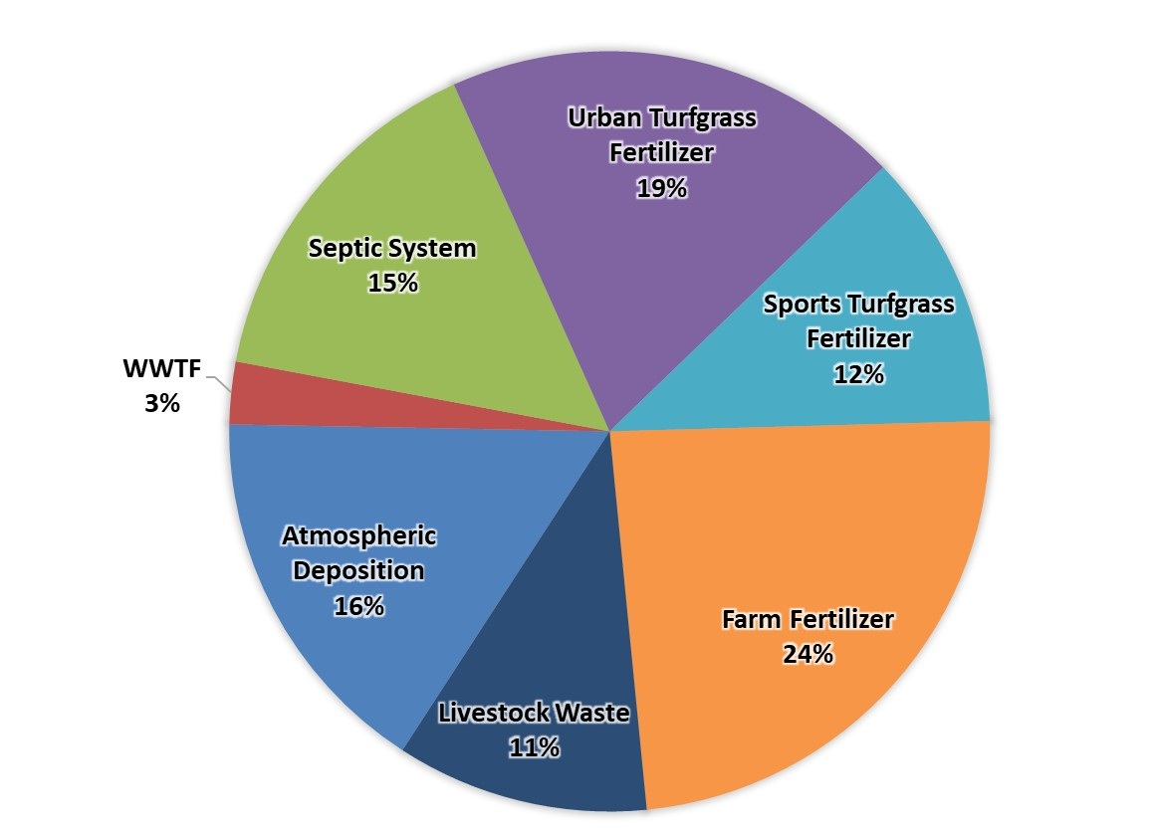
Figure 3. Loading to groundwater by source in the Chassahowitzka Springshed

Loading Allocation
The nitrogen source reductions are based on the measured nitrate concentrations and flows at the vents, along with the TMDL target nitrate concentrations. Table 7 lists the measured nitrate (as nitrogen) loads at the spring vents compared with the TMDL loading based on a target nitrate concentration of 0.23 mg/L. The difference between the spring vent loading and the TMDL loading estimates is the required reduction to meet the TMDLs. The total load that is required to be reduced in the basin is being allocated to the entire basin.
Table 7. Total reduction required to meet the TMDLs
Springshed | Total Load at Spring Vents  (lb-N/yr) | TMDL Load  (lb-N/yr) | Required Reduction to Meet TMDLs  (lb-N/yr) | Notes Regarding Data Used
Homosassa | 245,580 | 88,448 | 157,132 | Upper 95 % confidence interval – nitrate data from years 2012 to 2015 and flow data from years 2012 to 2017 (195 cubic feet per second [cfs])
Chassahowitzka | 197,454 | 81,753 | 115,701 | Upper 95% confidence interval – nitrate data from years 2010 to 2017 and flow data from years 1988 to 2017 (180.5 cfs)
Total | - | - | 272,833

Description of 5-, 10-, and 15-year Milestones/Reduction Schedule
The overall load reduction targets are 30 % of the total within 5 years, 80 % of the total within 10 years, and 100 % of the total within 15 years. DEP will evaluate progress towards these milestones and will report to the Governor and Florida Legislature. DEP will adjust management strategies to ensure the target concentrations are achieved. This may include expanding the area to which the OSTDS remediation policies apply; any such change, however, would be incorporated into an updated BMAP through a formal adoption process.
Table 8 lists the estimated nitrogen reductions needed, by milestone. Progress will be tracked yearly and adjustments made as needed. At the five-year milestone, progress will be assessed and load reductions adjusted as necessary. Entities have flexibility in the types and locations of projects as long as they achieve the overall required load reductions. The monitoring of existing groundwater and springs sampling locations is essential. Section 2.2 describes detailed source reduction strategies.
Table 8. Nitrogen reduction schedule (lb-N/yr)
5-Year Milestone  (30% of Total) | 10-Year Milestone  (50% of Total) | 15-Year Milestone  (20% of Total) | Total Nitrogen Reduction  (100%)
81,850 | 136,417 | 54,567 | 272,833

Prioritization of Management Strategies
The management strategies and projects listed in Appendix B, Appendix D, and Appendix F are ranked with a priority of high, medium, or low. In 2016, the Florida Legislature amended the Watershed Restoration Act (Section 403.067, F.S.), creating additional requirements for all new or revised BMAPs. BMAPs must now include planning-level details for each listed project, along with their priority ranking.
Project status was selected as the most appropriate indicator of a project’s priority ranking. Projects with a "completed" status were assigned a low priority. Projects classified as "underway" were assigned a medium priority because some resources have been allocated to these projects, but some work still needs to be completed. High priority was assigned to projects listed as "planned" as well as certain "completed" projects that are ongoing each year (any project with one of these project types: "street sweeping," "catch basin inserts/inlet filter cleanout," "public education efforts," "fertilizer cessation," "fertilizer reduction," or "aquatic vegetation harvesting"), and select projects that are elevated because substantial, subsequent project(s) are reliant on their completion.

Load Reduction Strategy
The total load reduction to groundwater needed to meet the TMDL is 272,833 lb-N/yr. Based on the totals of all the credits from BMAP actions and policies, the range of total reductions to groundwater is between 162,782 and 347,433 lb-N/yr (see Table 9).
To achieve reductions outside the scope of the policies listed, additional project options are available to local entities but have not been planned. Other efforts could be pursued to further reduce the nitrogen load to groundwater in the Homosassa and Chassahowitzka Springs Groups Basin.
Table 9. Summary of potential credits for the Homosassa and Chassahowitzka Springs Groups BMAP
Note: No reductions are estimated for atmospheric deposition sources.
Nitrogen Source | Credits to Load to Groundwater in Homosassa Springshed (lb-N/yr) | Credits to Load to Groundwater in Chassahowitzka Springshed (lb-N/yr) | Credits to Load to Groundwater (lb-N/yr) | Description
OSTDS | 31,112 – 45,471 | 8,470 – 12,380 | 39,582 – 57,851 | Credits are based on lots of all sizes inside the PFA being remediated by either enhancing onsite system or connecting to sewer. An estimated 10,929 lb-N/yr have been provided as OSTDS remediation projects which may be on these lots or in the larger BMAP area. Any projects outside the PFA would add additional reductions to the estimates listed.
UTF | - | - | 12,710 | DEP approved credits (6 %) for public education activities as well as credits identified for stakeholder stormwater projects.
STF | 1,431 | 4,708 | 17,769 | 6 % BMP credit for sports fields and 10 % BMP credit for golf courses on STF load to groundwater, assuming 100 % BMP implementation on golf courses and sports fields.
FF | 16,177 | 13,626 | 29,803 | 15 % BMP credit on FF load to groundwater, assuming 100 % owner-implemented BMPs on all fertilized lands
LW | 13,688 | 4,081 | 17,769 | 10 % BMP credit on load to groundwater, assuming 100 % owner-implemented BMPs at all livestock facilities.
WWTF |  |  |  | Achieved by BMAP WWTF policy for the BMAP area and projects in metrics workbooks.
Total Credits from BMAP Policies and Submitted Projects | 63,583 – 77,942 | 37,460 – 41,369 | 113,753 – 132,022
Advanced Agricultural Practices and Procedures | 26,867 – 111,939 | 22,163 – 103,472 | 49,029 – 215,411 | Pursue additional practices over the next 20 years, contingent on funding.
Total Credits | 90,450 – 189,881 | 59,622 – 144,841 | 162,782 – 347,433 | Estimated load reduction to meet the TMDL is 272,833 lb-N/yr.

OSTDS Management Strategies
Overall there are currently around 8,000 OSTDS in the PFA, based on FDOH estimates. This BMAP lists 10 specific projects (Appendix B) that reduce nitrogen loading from existing OSTDS on variably sized parcels by a total of 10,929 lb-N/yr. Figure 4 shows the locations of all OSTDS in the BMAP area.
In addition to the 10 listed projects, DEP assessed the overall OSTDS loading compared with other nitrogen sources in the PFA, as well as the relative loading in the wide BMAP area. Based on these assessments, DEP has determined that OSTDS contribute 17 % of the pollutant loading in the Homosassa Springshed and 15 % of the pollutant loading in the Chassahowitzka Springshed. In the PFA, 24 % of the pollutant load in the Homosassa Springshed and 12 % of the pollutant load in the Chassahowitzka Springshed are from OSTDS. An OSTDS remediation plan is required for the Homosassa Springshed. Cumulatively, nitrogen loading from OSTDS within this springshed result in the significant degradation of groundwater that impacts the Homosassa and Chassahowitzka BMAP area. Therefore, the comprehensive remediation of OSTDS, consistent with the requirements of this BMAP, is necessary to prevent associated groundwater and surface water contamination so that the TMDL can ultimately be achieved and so that increases in nitrogen loads from future growth are limited. The OSTDS remediation plan is incorporated as Appendix D.
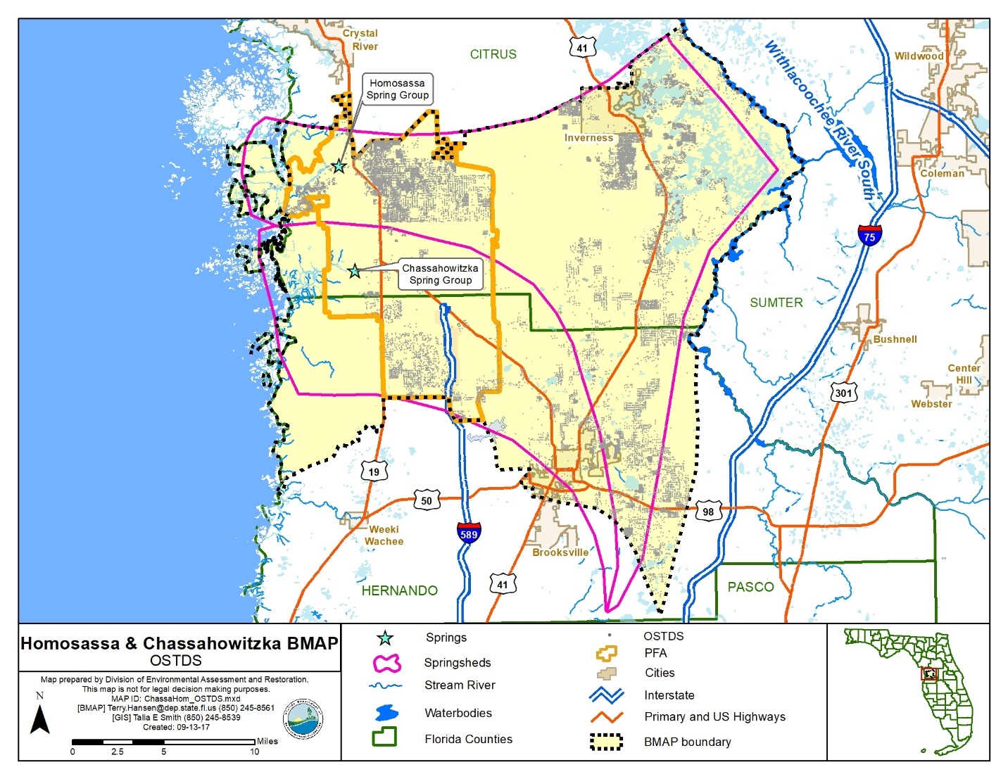
Figure 4. OSTDS locations in the Homosassa and Chassahowitzka Springs Groups BMAP area
In addition to the actions outlined in the OSTDS remediation plan (incorporated into this BMAP as Appendix D), remedial efforts on existing conventional OSTDS could achieve nitrogen reductions. Table 10 summarizes the nitrogen inputs, attenuation and recharge factors, and loads to groundwater for a conventional OSTDS. The conventional OSTDS nitrogen input is based on a per capita contribution of 9.012 lb-N/yr. This value is multiplied by the estimated number of people using the system (2.23 in Citrus County and 2.41 in Hernando) within the area and additional information on the amount of time spent away from home by the school-age population and labor force (adjusted to 1.95 effective persons per household). Percent reductions for enhanced or replaced systems are applied to the conventional OSTDS nitrogen groundwater loads to valuate possible improvements to groundwater. Enhanced OSTDS can achieve an estimated 65 % improvement in the load to groundwater compared to a conventional system. OSTDS replaced by sewer reduce the conventional nitrogen inputs by an estimated 95 %, assuming a sewer connection to a WWTF meeting AWT levels.
The results show an estimated nitrogen reduction (i.e., credit) of 5.1 in high recharge areas, 2.9 in medium recharge areas, and 0.6 in low recharge areas for each enhanced OSTDS and an estimated nitrogen reduction of 7.5 in high recharge areas, 4.2 in medium recharge areas, and 0.8 in low recharge areas for each replaced OSTDS. Estimated costs for retrofitting (onsite treatment improvements) or removing (sewering) OSTDS range from $10,000 to $20,000 per system, which would be anticipated to be offset somewhat by cost-share from state funds. These costs can be refined as projects are completed and detailed cost data are available.
Table 10. Estimated individual OSTDS improvements to groundwater
Recharge Category | Conventional OSTDS Load To Groundwater (lb-N/yr/OSTDS) | Reduction To Groundwater  (lb-N/yr/OSTDS)
Recharge Category | Conventional OSTDS Load To Groundwater (lb-N/yr/OSTDS) | Enhanced OSTDS | Replaced OSTDS
Nitrogen Input | 18 | ‒ | ‒
Attenuation (0.5) | 8.8 | ‒ | ‒
Low Recharge (0.1) | 0.9 | 0.6 | 0.8
Medium Recharge (0.5) | 4.4 | 2.9 | 4.2
High Recharge (0.9) | 7.9 | 5.1 | 7.5

UTF Management Strategies
UTF consists of fertilizers applied to the turfgrass typically found in residential and urban areas (including residential lawns and public green spaces). It is applied by either the homeowner or a lawn service company on residential properties, while on non-residential properties they may be applied by contractors or maintenance staff.

Fertilizer Ordinance Adoption
As required by the Florida Legislature, as described in Subsection 373.807(2), F.S., local governments with jurisdictional boundaries that include an OFS or any part of a springshed or delineated PFA of an OFS, are required to develop, enact, and implement a fertilizer ordinance by July 1, 2017. The statutes require any ordinance to be based, at a minimum, on the DEP model ordinance for Florida-friendly fertilizer use on urban landscapes.

Prioritized Management Strategies and Milestones
Based on the fertilizer ordinances and public education activities in place at the time of BMAP adoption, the associated credits for UTF reductions to groundwater in the BMAP area are 8,238 lb-N/yr (Table 11). Additional environmental benefits could be credited if the counties and municipalities implement other public education efforts and source control ordinances, as described in Section 2.11.3.
Local stormwater projects that treat urban runoff, including nitrogen from urban fertilizer are also in place (see Appendix B) with estimated reductions to groundwater to be determined.
Table 11. Current project credits to reduce UTF loading to groundwater
Project Category | Homosassa Springshed (lb-N/yr) | Chassahowitzka Springshed (lb-N/yr) | Total Project Credits in BMAP Area (lb-N/yr)
Fertilizer Ordinances and Public Education Activities | 7,246 | 992 | 8,238
Since there is uncertainty about the data used in the NSILT to calculate the UTF loading to groundwater, DEP will work toward collecting better data by documenting reductions with the stakeholders. Also, DEP will work with stakeholders to develop additional measures to reduce fertilizer application.

Additional UTF Reduction Options
The anticipated reduction from UTF sources is currently limited to 6 % of the estimated load to groundwater. This reduction can be achieved through a 6 % total credit if each local government has an applicable fertilizer ordinance, landscape ordinance, irrigation ordinance, and pet waste ordinance; carries out public education activities; and implements the Florida Yards and Neighborhood (FYN) Program (see Table 12).
If all the local governments implement the full suite of public education measures, a 12,710 lb-N/yr reduction can be achieved. Currently, local government public education credits total 8,238 lb-N/yr. Thus, an additional 4,472 lb-N/yr reduction could be achieved through public education and source control efforts.
Table 12. Maximum UTF load reductions based on existing public education credit policies
Urban Turfgrass Source Control Measures | Credit, Based on Estimated Load to Groundwater  (%) | Possible Nitrogen Credits (lb-N/yr)
Fertilizer Ordinance | 0.5 | 1,059
Pet Waste Ordinance | 0.5 | 1,059
Landscape Ordinance | 0.5 | 1,059
Irrigation Ordinance | 0.5 | 1,059
FYN Program | 3.0 | 6,355
Public Education Program | 1.0 | 2,118
Total Possible Credits | 6.00 | 12,710

Appendix E contains technical support information that further explains the concepts presented in this section, including nitrogen loading by source category, reduction obligations, and management strategies.

STF Management Strategies
Sports turfgrass areas fall into two main categories that are evaluated separately: golf courses and sporting facilities (such as baseball, football, soccer, and other fields). There are 10 golf courses covering 1,575 in the BMAP area. The majority of the golf course acreage is located in high recharge areas (1,408 acres). The majority of the sporting facility acreage is located in high recharge areas (138 acres).

Prioritized Management Strategies and Milestones
DEP will work with sports field managers and golf course superintendents to ensure relevant BMP implementation and to estimate reductions associated with these efforts. To improve the golf course loading estimate over a literature-based approach, DEP will also confer with golf course superintendents to identify the actual rate of fertilizer application to update the estimate of the golf course load to groundwater. Golf courses are expected to implement the BMPs described in the DEP BMP manual, Best Management Practices for the Enhancement of Environmental Quality on Florida Golf Courses, for an estimated 10 % reduction in loads to groundwater.
Managers of sports fields can assist by reducing fertilizer use, using products that reduce leaching, and more efficiently irrigating their sports turf. The estimated credit for better management of non-golf sports turfgrass is 6 % of the starting load to groundwater. Based on these approaches, the initial estimated reductions from STF sources in the BMAP area is 6,140 lb-N/yr, as listed in Table 13.
Table 13. Maximum load reductions from STF improvements based on existing credit policies
STF Source Control Measures | Credit Based on Estimated Load to Groundwater (%) | Possible Nitrogen Credits in Homosassa Springshed (lb-N/yr) | Possible Nitrogen Credits in Chassahowitzka Springshed  (lb-N/yr) | Total Possible Nitrogen Reduction Credits in BMAP Area
Golf Course BMP Implementation | 10 | 1,333 | 4,656 | 5,989
Sports Fields BMPs | 6 | 98 | 53 | 151
Total Possible Credits |  | 1,431 | 4,708 | 6,140

Agricultural Sources Management Strategies
Based on data provided by FDACS, there are 38,733 acres in the basin: 6,471 acres are used for livestock, 2,064 acres for fertilized crops, and 30,197 acres are classified as both fertilized croplands and livestock lands.

FF Loading
Nitrogen in agricultural fertilizer is applied at varying rates, depending on the crop and individual farm practices. The NSILT estimated total nitrogen load to groundwater in the BMAP area from FF is 198,685 lb-N/year, approximately 21 % of the total nitrogen load to groundwater in the BMAP area. FF includes commercial inorganic fertilizer applied to row crops, field crops, pasture, and hay fields.

LW Loading
Agricultural practices specific to this livestock management were obtained through meetings with University of Florida Institute of Food and Agricultural Sciences (UF-IFAS) extension staff, FDACS field representatives, agricultural producers, and stakeholders. The NSILT estimated total nitrogen load to groundwater in the BMAP area from LW is 177,691 lb-N/year, or 18 % of the total nitrogen load to groundwater.

Prioritized Management Strategies and Milestones
Subsection 403.067, F.S., requires agricultural nonpoint sources in a BMAP area either to implement the applicable FDACS-adopted BMPs, which provides a presumption of compliance with water quality standards, or conduct water quality monitoring prescribed by DEP or SWFWMD that demonstrates compliance with water quality standards.
Further, based on the Florida Springs and Aquifer Protection Act, Subsection 373.811(5), F.S., prohibits any new agricultural operations in BMAP areas that do not implement applicable FDACS BMPs upon the commencement of those operations, implement measures necessary to achieve pollution reduction levels established by DEP, or follow a water management district- or DEP-approved monitoring plan to demonstrate compliance with water quality standards. Failure to submit to FDACS an NOI and implement BMPs or conduct monitoring that demonstrates compliance may result in enforcement action by DEP. FDACS will work with applicable producers within the BMAP area to ensure enrollment and, within the first five-year period, verify implementation of BMPs. In addition, FDACS will undertake projects such as precision irrigation, soil moisture probes, and controlled release fertilizer. As of August 31, 2017, there were Notices of Intent (NOIs) to implement BMPs covering 11,664 acres in the springsheds. No producers are conducting water quality monitoring in lieu of implementing BMPs at this time. Appendix B lists project information. Appendix G provides detailed information on BMPs and agricultural practices in the BMAP area.
With crop-specific BMP enrollment or monitoring for FF areas, an estimated 29,803 lb-N/yr reduction to groundwater can be achieved, based on an average reduction of 15 % in the nitrogen load to groundwater. While DEP has listed larger percentage reductions in nitrogen from agricultural BMPs in estimating benefits to surface waters, the best data available indicate a 15 % reduction in the load to groundwater, where owner-implemented BMPs are in place. This number could increase as more data are collected on the impact of BMPs to groundwater.
For livestock operations, owner-implemented BMPs are expected to achieve a reduction of 17,769 lb-N/yr, using an estimated 10 % reduction in the load to groundwater from owner-implemented BMPs at livestock operations.
Summarizing the reductions discussed above, the total reduction from BMP implementation of all agricultural sources is 47,572 lb-N/yr.

Additional Agricultural Reduction Options
Further reductions can be achieved through implementing additional agricultural projects or practices, including land acquisition and conservation easements. SWFWMD is implementing projects to encourage low input agriculture and water quality improvement technologies. Examples of these projects include providing incentives for producers to transition to less intensive cropping systems, changing land use to fallow or native landscape, or changing the type of cropping system. Other reductions associated with the implementation and modification of BMPs may be realized through ongoing studies and data collection. Basin-specific studies are underway to evaluate and demonstrate the effectiveness of BMPs on a site-specific basis.
Additional reductions may also be achieved through implementing additional agricultural projects and practices. Table 14 and Table 15 list these projects and practices with their estimated load reductions, based on existing crop types. FDACS supplied the acreages, load reductions associated with applicable practices, and estimated the costs of implementation.
Table 14. Estimated reductions for additional agricultural projects or practices in the Homosassa Springshed
Action | Acreage | Estimated Reduction Credit in High Recharge Area (lb-N/yr) | Estimated Reduction Credit in Medium Recharge Area  (lb-N/yr) | Cost
Controlled Release Fertilizer | 493 | 1,331 | 740 | $8,874
Precision Fertilization | 774 | 4,263 | 2,368 | $90,500
Precision Irrigation | 758 | 422 | 235 | $338,211
Soil Moisture Probes | 1,042 | 6,580 | 3,656 | $54,250
Total | 3,067 |  |  | $491,835

Table 15. Estimated reductions for additional agricultural projects or practices in the Chassahowitzka Springshed
Action | Acreage | Estimated Reduction Credit in High Recharge Area (lb-N/yr) | Estimated Reduction Credit in Medium Recharge Area  (lb-N/yr) | Cost
Controlled Release Fertilizer | 163 | 439 | 244 | $2,928
Precision Fertilization | 244 | 1,447 | 804 | $28,551
Precision Irrigation | 586 | 251 | 140 | $261,383
Soil Moisture Probes | 277 | 1,992 | 1,107 | $28,000
Total | 1,270 |  |  | $320,862

The projects and practices listed in Table 14 and Table 15 are a component of the reductions to groundwater that could be achieved through changes in practices (Table 16). For example, a 75 % reduction of fertilizer loss to groundwater on 25 % of the fertilized lands would result in an estimated reduction of 37,253 lb-N/yr. Note that these estimates are averaged over the entire basin, and the recharge characteristics of a specific site and the fertilization practices for specific crops may change the estimated reduction for specific acres with a conservation easement or change in fertilization.
Table 16. Calculations for additional load reductions to groundwater
% of Fertilized Acres with a Change in Practice | Amount of Fertilized Acres with a Change in Practice | 100%  Reduction in Load to Ground-water  (lb-N/yr reduced) | 75% Reduction in Load to Ground-water  (lb-N/yr reduced) | 50% Reduction in Load to Ground-water  (lb-N/yr reduced) | 25% Reduction in Load to Ground-water  (lb-N/yr reduced) | 10% Reduction in Load to Ground-water  (lb-N/yr reduced)
100 | 32,262 | 198,685 | 149,014 | 99,343 | 49,671 | 19,869
75 | 24,197 | 149,014 | 111,760 | 74,507 | 37,253 | 14,901
50 | 16,131 | 99,343 | 74,507 | 49,671 | 24,836 | 9,934
25 | 8,066 | 49,671 | 37,253 | 24,836 | 12,418 | 4,967
10 | 3,226 | 19,869 | 14,901 | 9,934 | 4,967 | 1,987

Beyond enrolling producers in the FDACS BMP Program and verifying implementation, FDACS will work with DEP to improve the data used to estimate agricultural land uses in the springshed. FDACS will also work with producers to implement a suite of agricultural projects and research agricultural technologies on properties where they are deemed technically feasible and if funding is made available. The acreages provided by FDACS are preliminary estimates of the maximum acreages and will be evaluated and refined over time. As presented here, these projects are based on planning-level information. Actual implementation would require funding as well as more detailed designs based on specific information, such as actual applicable acreages and willing landowners.

WWTF Management Strategies
WWTFs receive and treat domestic wastewater. In the Homosassa and Chassahowitzka Springs Groups BMAP area, treated effluent containing nitrogen is discharged to sprayfields, RIBs, and percolation ponds, and is reused for irrigation water. The nitrogen load from WWTFs in the BMAP area is 15,773 lb-N/year. The discharge location (such as proximity to the spring, highly permeable soils, etc.) and level of wastewater treatment are important factors to consider when calculating loadings to groundwater. Additionally, addressing the nitrogen loading from OSTDS could increase the volume of effluent treated and disposed of by WWTFs.

Summary of Facilities
There are 26 domestic WWTFs located in the BMAP area, including 4 WWTFs permitted to discharge more than 100,000 gallons of treated effluent per day (or 0.1 million gallons per day [mgd]). Figure 5 shows the locations of WWTFs in the basin with discharges greater than 0.1 mgd and those with discharges less than 0.1 mgd.

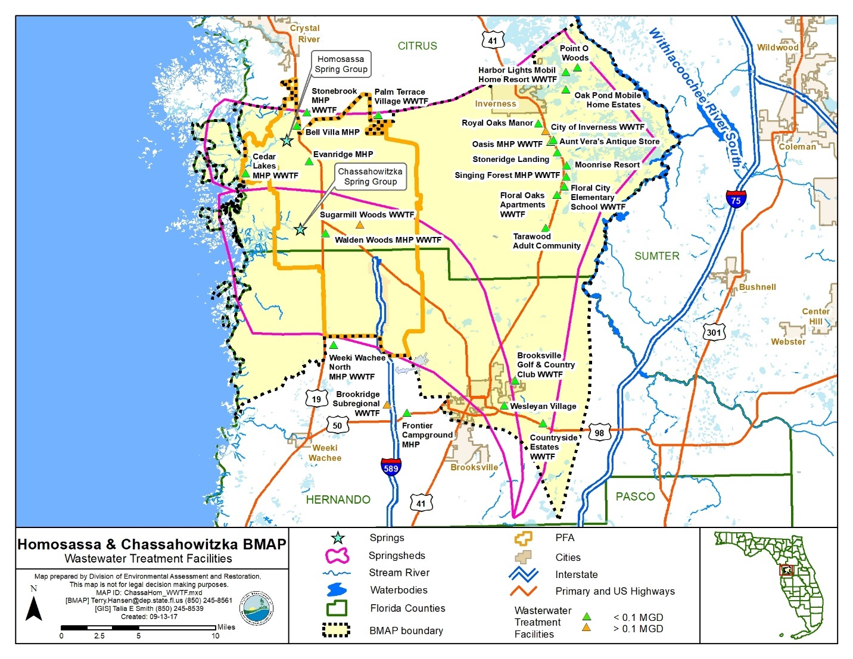
Figure 5. WWTF Locations in the Homosassa and Chassahowitzka Springs Groups BMAP Area

Wastewater Management Standards and Reuse Management
The Florida Springs and Aquifer Protection Act prohibits new domestic wastewater disposal facilities in the PFA, including RIBs, with permitted capacities of 100,000 gpd or more, except for those facilities that provide AWT that reduces total nitrogen in the effluent to 3 mg/L or lower, on an annual permitted basis.
To provide regulatory consistency in the BMAP area and to further improve wastewater management to protect the Homosassa and Chassahowitzka Springs Groups Basin, DEP requires the nitrogen effluent limits listed below in any new or existing wastewater permit, unless the utility/entity can demonstrate reasonable assurance that the reuse or land application of effluent would not cause or contribute to an exceedance of the nitrate concentrations established by the TMDLs. To demonstrate reasonable assurance, the utility/entity shall provide relevant water quality data, physical circumstances, or other site-specific credible information needed to show a nitrate concentration no greater than 0.23 mg/L at the spring vents. This demonstration may include factors such as dilution, site-specific geological conditions, research/studies, including dye tracer tests, and groundwater transport modeling. Should DEP concur with the reasonable assurance demonstration request, the TN effluent requirements established here may be modified for the applicant or waived.
The nitrogen effluent limits set forth in Table 17 will be applied as an annual average to all new and existing WWTFs with a DEP-permitted discharge. New effluent standards will take effect at the time of permit renewal or no later than five years after BMAP adoption, whichever is sooner.
Table 17. Wastewater effluent standards for the BMAP area
95% of the Permitted Capacity (gpd) | Nitrogen Concentration Limits for RIBs and Absorption Fields (mg/L) | Nitrogen Concentration Limits for All Other Land Disposal Methods, Including Reuse (mg/L)
Greater than 100,000 | 3 | 3
20,000 to 100,000 | 3 | 6
Less than 20,000 | 6 | 6
Additionally, new or existing wastewater permits in the BMAP area must require at least quarterly sampling of the effluent discharge for TN and report these sampling results in the discharge monitoring reports (DMRs) submitted to DEP.
DEP encourages the reuse of treated wastewater for irrigation as a water conservation measure. The expansion of reuse water for irrigation can reduce reliance on the Floridan aquifer for water supply. The nitrogen load to groundwater from reuse water is expected to be reduced through these WWTF standards, as improvements in reuse water quality will both reduce loads from this source and limit future increases in loading from reuse because of higher treatment levels.

Prioritized Management Strategies and Milestones
Based on the current volumes of discharge and effluent concentrations, the estimated reduction to be achieved through the implementation of these revised wastewater standards is 7,604 lb-N/yr. Appendix B contains detailed information on projects that have been completed, are underway, or are planned to reduce nitrogen loading from WWTFs.

Atmospheric Deposition Management Strategies

Summary of Loading
Atmospheric deposition is largely a diffuse, albeit continual, source of nitrogen. Nitrogen species and other chemical constituents are measured in wet and dry deposition at discrete locations around the U.S. In 2014, Schwede and Lear published a hybrid model for estimating the total atmospheric deposition of nitrogen and sulfur for the entire U.S., referred to as "TDEP." Deposition data from several monitoring networks—including the Clean Air Status and Trends Network (CASTNET), the National Atmospheric Deposition Program (NADP), Ammonia Monitoring Network, the Southeastern Aerosol Research and Characterization Network, and modeled data from the Community Multi-Scale Air Quality (CMAQ) Modeling System—are combined in a multistep process with National Trends Network (NTN) wet deposition values to model total deposition. The TDEP model run used for the NSILT included data from 2011 to 2013.

Description of Approach
Atmospheric sources of nitrogen are local, national, and international. Atmospheric sources are generally of low nitrogen concentration compared with other sources and are further diminished through additional biological and chemical processes before they reach groundwater. Atmospheric deposition sources and trends will be re-evaluated periodically.

Future Growth Management Strategies
Local land development regulations, comprehensive plans, ordinances, incentives, BMPs, environmental resource permit requirements, and consumptive use permit limits provide mechanisms for protecting water resources and reducing the impact of new development and other land use changes as they occur. They are the primary mechanisms available to address additional nitrogen loadings from urban and agricultural growth. Future agricultural operations will be subject to the same requirements as existing operations with regard to the implementation of FDACS-adopted BMPs and potentially other measures (Section 2.7).
The associated increased load from OSTDS to groundwater must also be addressed in addition to the current loads. Future development on lots less than one acre in the PFA must connect to central sewer, if available, or include nitrogen-reducing OSTDS as described in Appendix D. This BMAP recognizes local protections described in Appendix H as important components of the BMAP and encourages local governments to further strengthen local watershed protection frameworks.

Protection of Surface Water and Groundwater Resources through Land Conservation
Maintaining land at lower intensity uses through land purchases or easements for conservation and recreational use is one strategy for reducing water quality impacts in the Homosassa and Chassahowitzka Springs Groups Basin. Table 18 identifies one pending conservation land purchase and several planned purchases; there have been no land conservation purchases in the BMAP area since 2013, the last year of the period of record used when setting the TMDLs.
Table 18. Stakeholder conservation land purchases
TBD = To be determined
Lead Entity | Name of Conservation Purchase | Description | Purchase Status | Cost | Acreage Acquired | Year Acquired
Citrus County | Old Homosassa Heritage Waterfront Park | Shoreline and habitat preservation on the Homosassa River that will include a passive recreation area and the TL Rogers Maritime Fishing and Commercial Heritage Museum. $850,000 appropriated to DEP in FY 17/18 budget for acquisition. | Pending | $1,450,000 | 2 | 2018 (anticipated)
SWFWMD | Dylan Kramer Property | Located immediately southeast and in close proximity to the Southeast Fork of the Homosassa headsprings and Homosassa River. | Planned | TBD | 57 | TBD
SWFWMD | Joseph Moody Property | Property with 1,200 feet of undisturbed shoreline on the south bank of the Homosassa River. | Planned | TBD | 47 | TBD
SWFWMD | Parkway Towne Properties LLC | Located immediately adjacent to the Homosassa River; currently contains a mobile home park with canal and boat slips connected directly to the river. | Planned | TBD | 10 | TBD
SWFWMD | Yates Bleachery Property | Forested riverfront with 400 feet of shoreline on the south bank of the Homosassa River. | Planned | TBD | 33 | TBD
SWFWMD | Annutteliga Hammock | 8,036 acres remaining to be acquired of a 19,424-acre tract. It is one of the largest longleaf pine forest tracts remaining and would conserve fragments between the Withlacoochee State Forest and Chassahowitzka Wildlife Management Area. | Planned | TBD | 8,036 | TBD
SWFWMD | Chassahowitzka River and Coastal Swamps Property Acquisition, Martha Blanche Yandle Trustee | Forested wetlands adjacent to the Chassahowitzka River. | Planned | TBD | 25 | TBD
SWFWMD | Jere Hooker (formerly David Roberts Trustee) | Forested wetlands adjacent to the Chassahowitzka River including 400 feet of shoreline adjacent to Chassahowitzka Spring #1. | Planned | TBD | 0.41 | TBD
SWFWMD | Donald Stephens Trustee | Two parcels that are adjacent to the Crab Creek Springs Group. | Planned | TBD | 27.59 | TBD

Commitment to Implementation
Successful BMAP implementation requires commitment, dedicated state funding, and follow-up. Stakeholders have expressed their intention to carry out the plan, monitor its effects, and continue to coordinate within and across jurisdictions to achieve nutrient reduction goals. As the TMDLs must be achieved within 20 years, DEP, FDACS, and SWFWMD will implement management actions with a portion of the annual $50 million state appropriations to reduce nitrogen in the Homosassa and Chassahowitzka Springs Groups Basin. The cost estimates for implementing advanced nitrogen reducing technologies and implementing voluntary land acquisition or conservation easements is well within state appropriations.

: Monitoring and Reporting

Methods for Evaluating Progress
DEP will work with stakeholders to track project implementation and organize the monitoring data collected each year. The project and monitoring information will be presented in an annual update. Stakeholders have agreed to meet annually after the adoption of the BMAP to follow up on plan implementation, share new information, and continue to coordinate on TMDL restoration related issues. The following activities may occur at annual meetings:
Implementation data and reporting:
- Collect project implementation information from stakeholders, including FDACS agricultural BMP enrollment and FDOH-issued permits, and compare with the BMAP schedule.
- Discuss the data collection process, including any concerns and possible improvements to the process.
- Review the monitoring plan implementation, as detailed in Section 3.3.
Sharing new information:
- Report on results from water quality monitoring and trend information.
- Provide updates on new management strategies in the basin that will help reduce nutrient loading.
- Identify and review new scientific developments on addressing nutrient loads and incorporate any new information into annual progress reports.
Coordinating on TMDL restoration-related issues:
- Provide updates from DEP on the basin assessment cycle and activities related to any impairments, TMDLs, and BMAP.
- Obtain reports from other basins where tools or other information may be applicable to the Homosassa and Chassahowitzka Springs Groups.

Adaptive Management Measures
Adaptive management involves making adjustments in the BMAP when circumstances change or monitoring indicates the need for additional or more effective restoration strategies. Adaptive management measures may include the following:
- Implementing procedures to determine whether additional cooperative strategies are needed.
- Using criteria/processes for determining whether and when plan components need revision because of changes in costs, project effectiveness, social effects, watershed conditions, or other factors.
- Revising descriptions of stakeholders' roles during BMAP implementation and after BMAP completion.
- Updating information on corrective actions (and any supporting documentation) being implemented as data are gathered to refine project implementation schedules and performance expectations.
Key components of adaptive management to share information and expertise are tracking plan implementation, monitoring water quality and pollutant loads, and holding periodic meetings.

Water Quality and Biological Monitoring

Objectives
Focused objectives are critical for a monitoring strategy to provide the information needed to evaluate implementation success. Since the BMAP implementation involves an iterative process, the monitoring efforts are related to primary and secondary objectives. The primary objectives focus on achieving water quality targets, while the secondary objectives focus on water quality parameters that can be used to provide information for future refinements of the BMAP. The monitoring strategy may be updated as necessary.
Primary objectives:
- Measure the water quality and biological response in the impaired springs and/or groundwater at the beginning of the BMAP period and during implementation.
- Document nutrient trends in the Homosassa and Chassahowitzka Springs Groups and associated springs and groundwater.
- Focus BMP efforts by using water quality results combined with appropriate project information and land use in conjunction with statistical and spatial analysis tools.
Secondary objectives:
- Identify areas where groundwater data and modeling might help in understanding the hydrodynamics of the system.
- Confirm and refine nutrient removal efficiencies of agricultural and/or urban BMPs.
- Identify and implement more effective nutrient reduction strategies.
- Use nitrogen isotope and tracer sampling for evaluating nitrogen contributions from organic and inorganic sources.

Water Quality Parameters, Frequency, and Network
To achieve the objectives listed above, the monitoring strategy focuses on two types of indicators to track improvements in water quality: core and supplemental (Table 19 and Table 20, respectively). The core indicators are directly related to the parameters causing impairment in the river or associated springs. Supplemental indicators are monitored primarily to support the interpretation of core water quality parameters. The monitoring network is established for a variety of purposes.
For this BMAP, nitrate is considered to be the key core parameter measured, to track progress in decreasing nitrogen concentrations in groundwater and the water flowing from the spring vent. The other parameters are considered supplementary parameters for the BMAP, as they build information about groundwater and the spring, but are not direct measurements of impairment.
At a minimum, the core parameters will be tracked to determine the progress made towards meeting the TMDLs and/or achieving NNC. Resource responses to BMAP implementation may also be tracked. A significant amount of time may be needed to observe changes in water chemistry.
Table 19. Core water quality indicators
Core Parameters
Chloride
Sulfate
Potassium
Ammonia as Nitrogen
Total Kjeldahl Nitrogen
Nitrate/Nitrite as Nitrogen

Table 20. Supplemental water quality indicators and field parameters
Supplemental Parameters
Specific conductance
DO
pH
Temperature
Total Suspended Solids (TSS)
Nitrate and Oxygen Isotopes

Initially, data from the ongoing sampling effort being conducted by SWFWMD will be used to meet the primary objectives. Surface water and groundwater monitoring network locations were selected to track changes in water quality and allow the annual evaluation of progress toward achieving the TMDL. Figure 6 shows the location of the river and spring stations currently being sampled that will be used for the BMAP monitoring in the Homosassa and Chassahowitzka Springs Groups Basin.
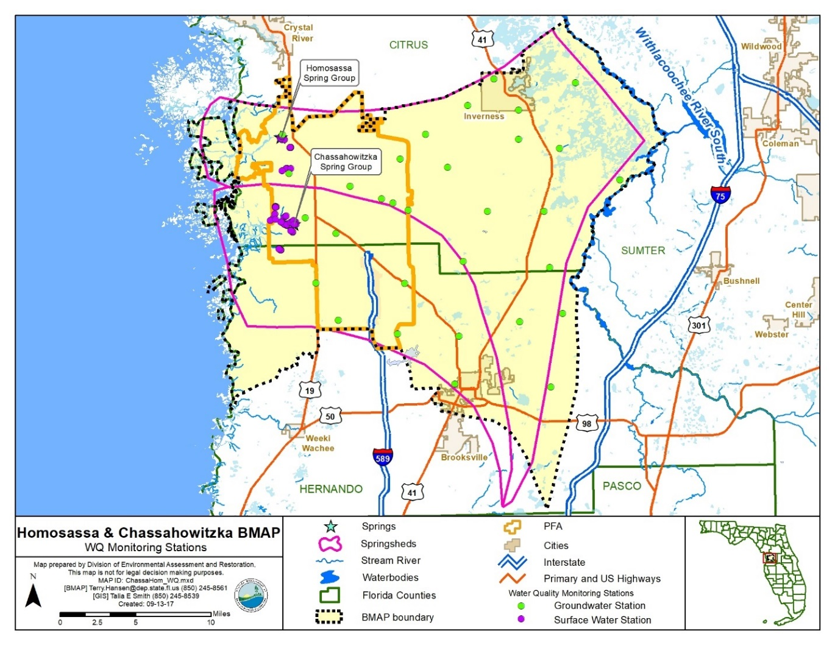
Figure 6. Groundwater and surface water stations sampled in the Homosassa and Chassahowitzka Springs Groups Basin

Biological Monitoring
Biological resource responses represent improvements in the overall ecological health of the Upper Wakulla River and Wakulla Spring Basin (see Table 21).
Table 21. Biological response measures
Biological Response Measures
Chlorophyll a
Stream Condition Index (SCI) score
Linear Vegetation Survey (LVS) score
Rapid Periphyton Survey (RPS) score
Key fish populations

An RPS will be conducted to assess the abundance and variety of algae in the river. An LVS will be conducted to assess the types and density of vegetation present in the river and to identify the native versus non-native species. An SCI will be conducted to measure the number of different organisms present in the river. In addition, habitat assessments (HAs) will be conducted to assess the river conditions and habitat present to support the SCI evaluation. Water quality samples will also be collected with the biological monitoring.

Data Management and Assessment
As of June 30, 2017, water quality data in Florida are entered by the entity collecting the data into the Florida Watershed Information Network (WIN) Database, which has replaced the Florida Storage and Retrieval System (STORET). DEP pulls water quality data directly from WIN for impaired waters evaluations and TMDL development. Data providers are required to upload their data regularly, so the information can be used as part of the water quality assessment process and for annual reporting. Data providers should upload their data to WIN, upon completion of the appropriate quality assurance/quality control (QA/QC) checks. All data collected in the last quarter of the calendar year should be uploaded no later than April 1st of the following year.
Biological data are stored in the DEP Statewide Biological (SBIO) Database. Biological data collected by data providers should also be uploaded regularly, after the appropriate QA/QC checks. All biological data collected in the last quarter of the calendar year should be uploaded no later than April 1 of the following year.
The water quality will be analyzed during BMAP implementation to determine trends in water quality and the health of the biological community. A wide variety of statistical methods are available for the water quality trend analyses. The selection of an appropriate data analysis method depends on the frequency, spatial distribution, and period of record available from existing data. Specific statistical analyses were not identified during BMAP development.

QA/QC
Stakeholders participating in the monitoring plan must collect water quality data in a manner consistent with Chapter 62-160, F.A.C., and the DEP standard operating procedures (SOPs) for QA/QC required by rule. The most current version of these procedures is available on the DEP website. For BMAP-related data analyses, entities should use National Environmental Laboratory Accreditation Conference (NELAC) National Environmental Laboratory Accreditation Program (NELAP)–certified laboratories or other labs that meet the certification and other requirements outlined in the SOPs.

Appendices

Appendix A. Important Links
The links below were correct at the time of document preparation. Over time, the locations may change and the links may no longer be accurate. None of these linked materials are adopted into this BMAP.
- DEP Website: http://www.floridadep.gov
- DEP Map Direct Webpage: https://ca.dep.state.fl.us/mapdirect/
- Searchable online version of PFA maps: https://www.floridadep.gov/pfamap
- Florida Statutes: http://www.leg.state.fl.us/statutes
  - Florida Watershed Recovery Act (Section 403.067, F.S.)
  - Florida Springs and Aquifer Protection Act (Part VIII of Chapter 373, F.S.)
- DEP Model Ordinances: http://fyn.ifas.ufl.edu/fert_ordinances.html
- DEP Standard Operating Procedures for Water Quality Samples: https://floridadep.gov/dear/quality-assurance/content/dep-sops
- NELAC NELAP: https://fldeploc.dep.state.fl.us/aams/index.asp
- FDACS BMPs: https://www.freshfromflorida.com/Business-Services/Best-Management-Practices-BMPs/Agricultural-Best-Management-Practices
- FDACS BMP and Field Staff Contacts: http://www.freshfromflorida.com/Divisions-Offices/Agricultural-Water-Policy
- Florida Administrative Code (Florida Rules): https://www.flrules.org/
- SWFWMD 2017 Homosassa River and Chassahowitzka River Surface Water Improvement Plan (SWIM) Plans: http://www.swfwmd.state.fl.us/projects/swim/
- SWFWMD Springs: http://www.swfwmd.state.fl.us/springs/
- SWFWMD Social Research: http://www.swfwmd.state.fl.us/projects/social_research/
- UF-IFAS Research: http://research.ifas.ufl.edu/

Appendix B. Projects to Reduce Nitrogen Sources
Prioritization of Management Strategies
The management strategies in Table B-1 are ranked with a priority of high, medium, or low. In 2016, the Florida Legislature amended the Watershed Restoration Act (Section 403.067, F.S.), creating additional requirements for all new or revised BMAPs. BMAPs must now include planning-level details for each listed project, along with their priority ranking.
Project status was selected as the most appropriate indicator of a project’s priority ranking based primarily on need for funding. Projects with a "completed" status were assigned a low priority. Projects classified as "underway" were assigned a medium priority because some resources have been allocated to these projects, but additional assistance may be needed for the project to be completed. High priority was assigned to projects listed with the project status "planned" as well as certain "completed" projects that are ongoing each year (any project with one of these project types: "street sweeping," "catch basin inserts/inlet filter cleanout," "public education efforts," "fertilizer cessation," "fertilizer reduction," or "aquatic vegetation harvesting"), and select projects that are elevated because substantial, subsequent project(s) are reliant on their completion.
Description of the Management Strategies
Responsible entities submitted these management strategies to the department with the understanding that the strategies would be included in the BMAP, thus requiring each entity to implement the proposed strategies in a timely way and achieve the assigned load reduction estimates. However, this list of strategies is meant to be flexible enough to allow for changes that may occur over time. Any change in listed management strategies, or the deadline to complete these actions, must first be approved by the department. Substituted strategies must result in equivalent or greater nutrient reductions than expected from the original strategies.
While the 20-year planning period for this BMAP is 2018 to 2038, projects completed since January 1, 2014, count toward the overall nitrogen reduction goals.
Estimated nitrogen reductions are subject to refinement based on DEP verification and/or on adjustment to calculations based on loading to groundwater rather than surface water. Agriculture load reductions (FDACS-01 and FDACS-02) assume 100 % enrollment and verification. Projects with a designation of TBD (to be determined) denotes information is not currently available, but will be provided by the stakeholder when it is available. Projects with a designation of N/A (not applicable) indicates the information for that category is not relevant to that project. Projects with a designation of "Not Provided" denotes that information was requested by DEP but was not provided by the lead entity.

Table B-1. Stakeholder projects to reduce nitrogen sources
*Denotes project that is applicable in another Springs Coast BMAP. The dollar amount is the total project amount (not split among the BMAPs).
Lead Entity | Location (Springshed) | Project Number | Project Name | Project Description | Project Type | Status | Start Date | Estimated Completion Date | Nitrogen Source Addressed by Project | Estimated Nitrogen Load Reduction (lb-N/yr) | Cost Estimate | Funding Source | Funding Amount
City of Brooksville | Chassa-howitzka | COB-01 | Public Education Activities | Adopt fertilizer ordinance in 2017; website, public service announcements, brochures, etc. | Education Efforts | Underway | 2017 | 2018 | UTF | 38 | TBD | City | TBD
City of Inverness | Homosassa | COI-01 | Public Education Activities | Implementation of Florida Yards & Neighborhood (FYN) Program; and website, public service announcements, brochures, etc. | Education Efforts | Planned | 2018 | 2018 | UTF | 194 | TBD | City | TBD
Citrus County | Homosassa | CC-01 | Public Education Activities | Fertilizer ordinance; implementation of FYN Program; and website, public service announcements, brochures, etc. | Education Efforts | Completed | Not Provided | 2017 | UTF | 7,052 | Not Provided | County | Not Provided
Citrus County | Homosassa | CC-02 | Southwest Regional Water Reclamation Facility (SWRWRF) | 1.5 MGD advanced wastewater treatment facility that will reduce nutrients in effluent and create disposal capacity for flow coming from septic system elimination. | Wastewater System Upgrade | Underway | Not Provided | 2021 | WWTF | TBD | $23,000,000 | County/  DEP | County: $6,6000,000 DEP: $16,400,000
Citrus County | Homosassa | CC-03 | Garcia Point Septic to Sewer Project | Connection of 68 residents to centralized sewer and elimination of septic tanks along the Homosassa River. | Wastewater Service Area Expansion | Underway | Not Provided | 2020 | OSTDS | 2,174 | $1,250,000 | County/  DEP | County: $300,000 DEP: $950,000
Citrus County | Chassa-howitzka | CC-04 | Chassahowitzka to SWRWRF Force Main | New force main interconnection that will collect wastewater flows from the south side of the Homosassa River by redirecting flow from the Meadowcrest WWTP to the SWRWRF. | Wastewater System Upgrade | Not Provided | Not Provided | 2021 | WWTF | TBD | $1,200,000 | TBD | TBD: $1,200,000
Citrus County | Chassa-howitzka | CC-05 | Sugarmill Woods Residential Reclaimed Water | Distribute reclaimed water to the residential area of Oak Village in the Sugarmill Woods development. | Reclaimed Water | Underway | Not Provided | 2021 | WWTF | TBD | $12,000,000 | County/  DEP/  SWFWMD | County: $6,000,000 DEP: $4,000,000 SWFWMD: $2,000,000
Citrus County | Chassa-howitzka | CC-06 | Sugarmill Woods Golf and Country Club Reclaimed Water Project | Reclaimed water line from the SWRWRF to the golf course for irrigation. | Reclaimed Water | Planned | TBD | 2021 | WWTF | TBD | $4,000,000 | County/  TBD | County: $2,000,000 TBD: $2,000,000
Citrus County | Homosassa | CC-07 | Septic to Sewer Conversion Study | Perform a study to identify the best options for converting existing lots with OSTDS and any non-municipal WWTFs within the study area to central collection. | Study | Planned | TBD | 2021 | OSTDS | N/A | $200,000 | County/  TBD | County: $100,000 TBD: $100,000
Citrus County | Homosassa | CC-08 | Homosassa South Fork Water Quality Improvement Phase I - Pond 2 | Water quality treatment of stormwater runoff prior to entering Pepper Creek and the South Fork of the Homosassa River from the directly connected areas north of CR 490A. | BMP Treatment Train | Underway | 2014 | 2018 | UTF | Not Provided | $1,903,000 | County/  DEP/ SWFWMD | County: $703,000 DEP: $200,000 SWFWMD: $1,000,000
Citrus County | Homosassa | CC-09 | Cardinal Lane Watershed Management Plan | Complete alternative analysis tasks including a stormwater level of service analysis, surface water resource assessment, and BMP alternative analysis. | Study | Underway | 2016 | 2017 | Other | N/A | $200,000 | County/ SWFWMD | County: $100,000 SWFWMD: $100,000
Citrus County | Homosassa | CC-10 | Floral City Collection System | Construct a sanitary gravity collector system along east Orange Ave and Old Floral City Road to connect facilities to central sewer. | Wastewater Service Area Expansion | Underway | 2015 | 2020 | OSTDS | Not Provided | $1,200,000 | County | County: $1,200,000
Citrus County | Homosassa | CC-11 | Mason Creek Private Package Plant | Connect the private package plant to the county's central sewer. | WWTF Upgrade | Underway | 2016 | 2019 | WWTF | Not Provided | $925,000 | County | County: $925,000
Citrus County | Homosassa | CC-12 | Homosassa Downtown West Septic to Sewer | Gravity sewer and force main to connect 122 residents and businesses to the SWRWRF; including septic system abandonment. | Wastewater Service Area Expansion | Planned | TBD | 2025 | OSTDS | 940 | $4,108,210 | County/  DEP/ SWFWMD | County: $1,027,053 DEP: $2,054,105 SWFWMD: $1,027,053
Citrus County | Homosassa | CC-13 | Homosassa Downtown East Septic to Sewer | Gravity sewer and force main to connect 232 residents and businesses to the SWRWRF; including septic system abandonment. | Wastewater Service Area Expansion | Planned | TBD | 2025 | OSTDS | 1,785 | $10,805,685 | TBD | TBD: $10,805,685
Citrus County | Homosassa | CC-14 | Homosassa Downtown North Septic to Sewer | Gravity sewer and force main to connect 129 residents and businesses to the SWRWRF; including septic system abandonment. | Wastewater Service Area Expansion | Planned | TBD | 2025 | OSTDS | 995 | $7,424,625 | TBD | TBD: $7,424,625
Citrus County | Homosassa | CC-15 | Homosassa Park Septic to Sewer | Gravity sewer and force main to connect 89 residents and businesses to the SWRWRF; including septic system abandonment. | Wastewater Service Area Expansion | Planned | TBD | 2025 | OSTDS | 685 | $3,561,705 | TBD | TBD: $3,561,705
Citrus County | Homosassa | CC-16 | Homosassa Rooks Septic to Sewer | Gravity sewer and force main to connect 163 residents and businesses to the SWRWRF; including septic system abandonment. | Wastewater Service Area Expansion | Planned | TBD | 2025 | OSTDS | 1,255 | $5,607,305 | TBD | TBD: $5,607,305
Citrus County | Chassa-howitzka | CC-17 | SWRWRF Dewatering Facility | Construct a sludge dewatering facility at the SWRWRF. | Wastewater System Upgrade | Planned | TBD | 2025 | WWTF | Not Provided | $2,500,000 | TBD | TBD: $2,500,000
Citrus County | Homosassa | CC-18 | Homosassa Retreats Septic to Sewer | Gravity sewer and force main to connect 104 residents and businesses to the SWRWRF; including septic system abandonment. | Wastewater Service Area Expansion | Planned | TBD | 2030 | OSTDS | 800 | $4,591,845 | TBD | TBD: $4,591,845
Citrus County | Homosassa | CC-19 | Homosassa Cedars Septic to Sewer | Gravity sewer and force main to connect 23 residents and businesses to the SWRWRF; including septic system abandonment. | Wastewater Service Area Expansion | Planned | TBD | 2030 | OSTDS | 175 | $2,177,090 | TBD | TBD: $2,177,090
Citrus County | Homosassa | CC-20 | Mason Creek Septic to Sewer | Gravity sewer and force main to connect 160 residents and businesses to the SWRWRF; including septic system abandonment. | Wastewater Service Area Expansion | Planned | TBD | 2030 | OSTDS | 1,235 | $6,008,235 | TBD | TBD: $6,008,235
Citrus County | Homosassa | CC-21 | Homosassa Phase 5 Septic to Sewer | Gravity sewer and force main to connect 115 residents and businesses to the SWRWRF; including septic system abandonment. | Wastewater Service Area Expansion | Planned | TBD | 2030 | OSTDS | 885 | $4,421,525 | TBD | TBD: $4,421,525
Hernando County | Chassa-howitzka | HC-01 | Public Education Activities | Adopted fertilizer ordinance; pet waste ordinance; website, brochures, public service announcements, etc. | Education Efforts | Completed | 2013 | 2013 | UTF | 954 | $20,000 | County | County: $20,000
Hernando County | Chassa-howitzka | HC-02* | BMAP Manager | Proposed position to be filled by a high level staff person to lead all aspects of BMAP implementation for Hernando County. This position will be responsible for intergovernmental coordination with agencies to fulfill BMAP requirements. | Other | Planned | 2017 | 2031 | Other | N/A | $150,000 | TBD | TBD: $150,000
Hernando County | Chassa-howitzka | HC-03 | Eastern Hernando Withlacoochee Watershed Resource Assessment and BMP Development Plan | Comprehensive engineering analysis, water quality assessment, watershed model development and conceptual BMP designs. | Study | Completed | 2014 | 2016 | Other | N/A | $200,000 | County/ SWFWMD | County: $100,000 SWFWMD: $100,000
Hernando County | Chassa-howitzka | HC-04 | Bystre Lake Resource Assessment and BMP Development Plan | Comprehensive engineering analysis, water quality assessment, watershed model development and conceptual BMP designs. | Study | Underway | 2015 | 2017 | Other | N/A | $200,000 | County/ SWFWMD | County: $100,000 SWFWMD: $100,000
Hernando County | Chassa-howitzka | HC-05 | Blue Sink Watershed Resource Assessment and BMP Development Plan | Comprehensive engineering analysis, water quality assessment, watershed model development and conceptual BMP designs. | Study | Completed | 2013 | 2015 | Other | N/A | $200,000 | County/ SWFWMD | County: $100,000 SWFWMD: $100,000
Hernando County | Chassa-howitzka | HC-06 | Little Withla-coochee River Watershed Resource Assessment and BMP Development Plan | Comprehensive engineering analysis, water quality assessment, watershed model development and conceptual BMP designs. | Study | Completed | 2014 | 2015 | Other | N/A | $100,000 | County/ SWFWMD | County: $50,000 SWFWMD: $50,000
Hernando County | Chassa-howitzka | HC-07 | Blue Sink Stormwater Quality Improvement Project | Construction of stormwater BMP treatment train providing water quality pre-treatment of surface discharges to Blue Sink using enhanced nitrogen removal technology. | BMP Treatment Train | Planned | TBD | TBD | UTF | TBD | $750,000 | TBD | TBD
Hernando County | Chassa-howitzka | HC-08* | Reclaimed Water Master Plan Revision | Revision to current reclaimed water plan to identify future growth and needed interconnections. The increased use of reclaimed water will reduce fertilizer application. | Study | Underway | 2016 | 2018 | UTF | N/A | $150,000 | County/ SWFWMD | SWFWMD: $75,000 County: $75,000
Hernando County | Chassa-howitzka | HC-09 | Countryside Estates | Connect package plant at existing mobile home community to county sewer system via new force main and lift station. | WWTF Upgrade | Underway | 2016 | 2018 | WWTF | 146 | $1,001,300 | County | County: $1,001,300
FDACS | Basin-wide | FDACS-01 | Agricultural BMPs - Farm Fertilizer | Implementation of existing BMPs on applicable acreage. Up to 15 % reduction in load to groundwater. | BMPs | Underway | Underway | TBD | FF | 29,803 | TBD | TBD | TBD
FDACS | Basin-wide | FDACS-02 | Agricultural BMPs - Livestock Waste | Implementation of existing BMPs on applicable acreage. Up to 10 % reduction in load to groundwater. | BMPs | Underway | Underway | TBD | LW | 17,769 | TBD | TBD | TBD
SWFWMD | Homosassa | SWF-01 | Homosassa River SWIM Plan | Implementation and periodic review and update of the Homosassa SWIM Plan. | Study | Completed | 2015 | 2017 | Other | N/A | $51,500 | SWFWMD | SWFWMD: $51,500
SWFWMD | Chassa-howitzka | SWF-02 | Chassa-howitzka River SWIM Plan | Implementation and periodic review and update of the Chassahowitzka SWIM Plan. | Study | Completed | 2015 | 2017 | Other | N/A | $51,500 | SWFWMD | SWFWMD: $51,500
SWFWMD | Basin-wide | SWF-03* | Facilitating Agricultural Resource Management Systems (FARMS) Program | The FARMS Program is an agricultural BMP cost-share program to promote improved water quality in spring systems through approved precision nutrient application technologies. | BMPs | Underway | Prior to 2014 | 2021 | FF | Not Provided | $6,000,000 | SWFWMD | SWFWMD: $6,000,000
SWFWMD | Basin-wide | SWF-04* | Evaluation of Nitrogen Leaching from Reclaimed Water | This project will determine typical nitrogen leaching rates from reclaimed water application to lawns, spray fields, and rapid infiltration basins. This information can be used to refine estimates of nitrogen loading to the aquifer and springs, and identify the best reclaimed water disposal methods to minimize nitrogen loading to groundwater. | Study | Underway | 2014 | 2018 | UTF | N/A | $294,000 | SWFWMD | SWFWMD: $294,000
SWFWMD | Basin-wide | SWF-05* | Springs Coast Wastewater Disposal Treatment Wetlands | This project will assess areas to determine sites appropriate for construction of wetlands to treat WWTF effluent. | Study | Underway | 2014 | 2017 | WWTF | N/A | $400,000 | SWFWMD | SWFWMD: $400,000
SWFWMD | Homosassa | SWF-08 | Homosassa Habitat Enhancement | Install, monitor, and maintain a floating wetland system in the Homosassa River within the Ellie Schiller Homosassa Wildlife State Park to evaluate the water quality and aquatic habitat benefits. | Floating Islands/ Managed Aquatic Plant Systems | Underway | 2016 | 2017 | UTF | TBD | $128,471 | SWFWMD | SWFWMD: $128,471
SWFWMD | Chassa-howitzka | SWF-09 | Chassa-howitzka Spring Sediment Removal | Removal and disposal of 3,800 cubic yards of organic sediments and sand from the Chassahowitzka Headspring. This will increase water column visibility, reduce nutrient resuspension, and improve recreation. | Muck Removal/ Restoration Dredging | Completed | Prior to 2014 | 2014 | UTF | Not Provided | $875,000 | SWFWMD | SWFWMD: $875,000
SWFWMD | Basin-wide | SWF-10 | Update FDOH Drinking Water Source and Wastewater Source Inventory | Update FDOH GIS map of drinking water service and wastewater disposal areas of concern to determine impacts from onsite wastewater. | Study | Planned | 2018 | 2021 | OSTDS | N/A | $245,000 | SWFWMD | SWFWMD: $245,000
SWFWMD | Basin-wide | SWF-11 | Model Springs Fertilizer Ordinance | Develop a Springs Coast model fertilizer ordinance that provides better fertilizer guidance in spring systems. | Ordinance | Planned | 2018 | 2021 | UTF | N/A | TBD | SWFWMD | SWFWMD: TBD
SWFWMD | Basin-wide | SWF-12 | Mason Creek Force Main Project | Construct 4,500 lf of 8-inch force main along Mason Creek Road for the purpose of transporting wastewater flows from the Old Homosassa residential area for future septic to sewer projects as they are implemented over the next ten years. This force main will help compel up to 2,300 septic tanks in Old Homosassa into the county's' wastewater collection system. | Wastewater collection and treatment | Planned | 2018 | 2020 | WWTF | 50,000 | $600,000 | Not Provided | TBD
SWFWMD | Basin-wide | SWF-13 | Springs - Citrus County Old Homosassa West Septic to Sewer Project | The project is for the design, permitting, and construction of a regional wastewater collection system necessary for connection of existing residential homes in the Old Homosassa area of the Homosassa springshed. If constructed, a minimum of 95 existing septic systems will convert to County sanitary sewer. | Wastewater collection and treatment | Planned | 2018 | 2021 | WWTF | 904 | $3,000,000 | SWFWMD | $1,500,000
SWFWMD | Basin-wide | SWF-14 | OSTDS Remediation Plan Implementation | This project assists homeowners offset costs to replace septic tanks in OFS springsheds with individual systems that have enhanced nitrogen removal technology where conversion to sewer is not feasible. | Wastewater collection and treatment | Planned | 2018 | 2021 | WWTF | Not Provided | Not Provided | Not Provided | Not Provided
UF-IFAS | Basin-wide | IFAS-01* | Development of Landscape Fertilizer BMPs | The objective of this project is to verify the accuracy of the FYN and Florida Green Industries BMPs fertilizer recommendations. | Study | Underway | 2012 | 2018 | UTF | N/A | $274,429 | SWFWMD | SWFWMD: $274,429
IFAS | Basin-wide | IFAS-02* | Composting at Animal Stock Facilities | Evaluate the nutrient removal efficiency from composting animal waste. The project will compare nutrient leaching efficiency for manure stockpiling and composting facilities. | Study | Underway | 2016 | 2018 | LW | N/A | $175,000 | SWFWMD | SWFWMD: $175,000
Golf Courses | Basin-wide | GC-01 | Golf Course Reduction Credits | 6% BMP credit on golf course load to groundwater, assuming 100% BMP implementation by golf course owners. | BMPs | Planned | TBD | TBD | STF | 5,989 | TBD | TBD | TBD
Sports Fields | Basin-wide | SF-01 | Sports Field Reduction Credits | 10% BMP credit on sports field load to groundwater, assuming 100% BMP implementation by sports field owners. | BMPs | Planned | TBD | TBD | STF | 151 | TBD | TBD | TBD
Wastewater Utilities | Basin-wide | WU-01 | Wastewater Treatment Facility Reduction Credits | Achieved by WWTF policy if implemented BMAP-wide, achieving 3 or 6 mg/L. | WWTF Upgrade | Planned | TBD | TBD | WWTF | 7,604 | TBD | TBD | TBD

Appendix C. Priority Focus Area Report
A PFA (Homosassa and Chassahowitzka Springs Groups, January 2017) is defined as the area(s) of a basin where the Floridan aquifer is generally most vulnerable to pollutant inputs and where there is a known connectivity between groundwater pathways and an OFS. As required by the Florida Springs and Aquifer Protection Act, DEP delineated a PFA for the Homosassa and Chassahowitzka Springs Groups. This PFA is adopted and incorporated by reference into this BMAP. Detailed information on the PFA is available in report format at the following link:
http://publicfiles.dep.state.fl.us/DEAR/BMAP/Adopted%20BMAPs/Chaz%20Hom/PFA%20and%20GIS%20FIles/Methodology%20for%20Establishing%20Priority%20Focus%20Area_Chassahowitzka&Homosassa_11-2016.pdf

Appendix D. OSTDS Remediation Plan
The Florida Aquifer and Springs Protection Act specifies that if during the development of a BMAP for an OFS, DEP identifies OSTDS as contributors of at least 20 % of nonpoint source nitrogen pollution in a PFA or if DEP determines remediation is necessary to achieve the TMDLs, the BMAP shall include an OSTDS remediation plan. Based on the Homosassa and Chassahowitzka Springs Groups NSILT and GIS coverages, OSTDS contribute approximately 24 % of the pollutant load in the Homosassa portion of the PFA and 12 % of the pollutant load in the Chassahowitzka portion of the PFA. Irrespective of the percent contribution from OSTDS, DEP has determined that an OSTDS remediation plan is necessary to achieve the TMDLs and to limit the increase in nitrogen loads from future growth.
D.1 Plan Elements
D.1.1 Permits for Installation of New OSTDS
Per statute, new OSTDS on lots of less than one acre are prohibited within PFAs, if the addition of the specific systems conflicts with an OSTDS remediation plan incorporated into an OFS BMAP (see Section 373.811(2), F.S.). This OSTDS remediation plan prohibits installation of new conventional systems on lots of less than one acre within the PFA, unless the OSTDS includes enhanced treatment of nitrogen or unless the OSTDS permit applicant demonstrates that sewer connections will be available within 5 years. Local governments and utilities are encouraged to develop master wastewater treatment feasibility plans to identify specific areas to be sewered within 20 years of BMAP adoption.. To aid in implementation, the DEP Map Direct webpage includes a detailed downloadable springs PFA boundary shapefile. DEP also maintains on its website an interactive map of the PFA and BMAP boundaries; the map can be easily searched for specific street address locations.
FDOH permits the installation of new OSTDS pursuant to Chapter 64E-6, F.A.C., which includes not only systems installed on a property where one has not previously been installed, but also systems installed to replace illegal systems, systems installed in addition to existing systems, and other new systems. FDOH permitting requirements with respect to the definition of "new" or "less than one acre" will be followed for this remediation plan. For FDOH to issue a permit for a new OSTDS on a lot of less than one acre within a PFA, the system must include at least one of the following nitrogen reducing options:
- Features allowed pursuant to FDOH rule, such as in-ground nitrogen-reducing biofilters (media layer systems).
- Features consistent with and identified in the FDOH Florida Onsite System Nitrogen Removal Strategy Studies report, such as in-tank nitrogen-reducing biofilters.
- Other FDOH-approved treatment systems capable of meeting or exceeding the NSF Standard 245 nitrogen removal rate before disposing the wastewater in the drain field, such as aerobic treatment units (ATU) and performance-based treatment systems (PBTS). For FDOH-approved treatment systems that meet NSF 245, but do not meet or exceed the minimum treatment level expected from the in-ground nitrogen-reducing biofilters, the drain fields, at minimum, shall be installed with a 24-inch separation between the bottom of the drain field and the seasonal high-water table.
D.1.2 Permits for Modification or Repair of Existing OSTDS
Per statute, the OSTDS remediation plan must provide loading reductions consistent with achieving the TMDL within 20 years of plan adoption (see Section 373.807(1)(b)8., F.S.). This plan therefore establishes the following remediation policy for existing systems, based on (a) the potential for reducing nitrogen loads by converting existing OSTDS to enhanced nitrogen removing systems or by connecting homes to central sewer, (b) the total amount of nitrogen load that must be reduced to achieve the TMDL, and (c) the relative contribution of nitrogen load from existing OSTDS.
- Where does the remediation policy for existing systems apply? It applies to all existing OSTDS within the PFA on lots of all sizes.
- What is required by the remediation policy for existing systems? For FDOH to issue a modification or repair permit to an existing OSTDS in the area subject to the policy, the system must include at least one of the following nitrogen reduction enhancements, unless the OSTDS permit applicant demonstrates that sewer connections will be available within 5 years.
  - Enhanced treatment of nitrogen means inclusion of features allowed pursuant to FDOH rules, such as in-ground nitrogen-reducing biofilters (media layer systems); features consistent with and identified in the FDOH Florida Onsite System Nitrogen Removal Strategy Studies report, such as in-tank nitrogen-reducing biofilters; or other FDOH-approved treatment systems capable of meeting or exceeding the NSF Standard 245 nitrogen removal rate before disposing the wastewater in the drain field, such as ATUs and PBTSs. For FDOH-approved treatment systems that meet NSF 245, but do not meet or exceed the minimum treatment level expected from the in-ground nitrogen-reducing biofilters, the drain fields, at minimum, shall be installed with a 24-inch separation between the bottom of the drain field and the seasonal high-water table.
  - FDOH permitting requirements with respect to defining "modification," "repair," and lot size (i.e., acreage) will be followed for this remediation plan
- When is the remediation policy for existing systems effective? It begins following completion of the master wastewater treatment feasibility plans, rulemaking, and funding milestones included in Sections D.3 and D.4, but no later than five years after BMAP adoption.
D.1.3 Achieving Necessary Load Reductions
All conventional OSTDS in areas subject to the remediation policy for existing systems are required to adopt enhanced treatment of nitrogen no later than 20 years after BMAP adoption.
D.1.4 Other Plan Elements
Statutes also require that OSTDS remediation plans contain the following elements.
- An evaluation of credible scientific information on the effect of nutrients, particularly forms of nitrogen, on springs and spring systems. (See Section D.2.)
- Options for repair, upgrade, replacement, drain field modification, the addition of effective nitrogen-reducing features, connection to a central sewer system, or other action. (See Section D.3.)
- A public education plan to provide area residents with reliable, understandable information about OSTDS and springs. (See Section D.4.)
- Cost-effective and financially feasible projects necessary to reduce the nutrient impacts from OSTDS. (See Section 2 and Appendix B.)
- A priority ranking for each project for funding contingent on appropriations in the General Appropriations Act. (See Section 2 and Appendix B.)
The Florida Springs and Aquifer Protection Act defines an OSTDS as a system that contains a standard subsurface, filled, or mound drain field system; an aerobic treatment unit; a graywater system tank; a laundry wastewater system tank; a septic tank; a grease interceptor; a pump tank; a solids or effluent pump; a waterless, incinerating, or organic waste–composting toilet; or a sanitary pit privy that is installed or proposed to be installed beyond the building sewer on land of the owner or on other land on which the owner has the legal right to install such a system. The term includes any item placed within, or intended to be used as a part of or in conjunction with, the system. The term does not include package sewage treatment facilities and other treatment works regulated under Chapter 403, F.S.
D.2 Collection and Evaluation of Credible Scientific Information
As discussed at Section 2, DEP created the Homosassa and Chassahowitzka Springs Groups NSILT, a planning tool that provides estimation of nitrogen loading sources to groundwater based on best available scientific data at the time the tool is used for a particular geographic area. The NSILT results were peer-reviewed by SWFWMD, FDOH, and FDACS. Additional technical support information concerning the NSILT can be found in Appendix E.
Monitoring and research:
- Improve understanding of the ecological responses to nutrient enrichment and reductions (DEP/SWFWMD/universities).
- Maintain and expand water quality monitoring programs (SWFWMD/DEP).
- Report annual status and trends (SWFWMD).
- Evaluate new and emerging technologies (SWFWMD).
- Research and develop advanced septic systems (FDOH/DEP/UF-IFAS).
Completed project:
- Florida Onsite Sewage Nitrogen Reduction Strategies Study (FDOH).
Ongoing projects:
- Quarterly springs water quality monitoring (SWFWMD).
- Stream water quality monitoring (SWFWMD).
- UFA nutrient modeling (SWFWMD).
- Springs Initiative modeling (SWFWMD).
- Project COAST (collect and analyze monthly surface water quality data at 50 fixed stations along the coasts of Hernando, Citrus, and Levy Counties) (SWFWMD/UF).
- USGS Groundwater Data Collection (USGS/SWFWMD).
- USGS Surface Water Data Collection (USGS/SWFWMD).

Proposed projects:
- Nutrient hot spot loading identification (DEP/SWFWMD).
- Groundwater quality monitoring for BMAP assessment (DEP/SWFWMD).
DEP developed calculation methods to estimate nitrogen reductions associated with septic system enhancement and replacement projects, WWTF projects, golf course BMPs, other sports turfgrass BMPs, and urban turfgrass BMPs.
D.2 Remediation Options
The NSILT estimates that OSTDS contribute approximately 24 % of the pollutant load in the Homosassa portion of the PFA and 12 % of the pollutant load in the Chassahowitzka portion of the PFA. Table D-1 lists the number of existing OSTDS in the PFA and the estimated nitrogen reductions associated with enhancement or connection to sewer. Figure D-1 shows the areas where OSTDS are located.
Table D-1. Estimated reduction credits for OSTDS enhancement or sewer in the PFA*
*Estimated reductions are for either enhancement or sewer per parcel classification. Reductions cannot be combined for the same parcel classification, but can be combined between the different classifications. For example, the sewer credit associated with parcels less than one acre in size can be combined with the sewer credit associated with parcels one acre or greater in size.
Recharge Area | OSTDS Parcels Less Than One Acre in PFA | Credit for Enhancement (lb-N/yr) | Credit for Sewer (lb-N/yr) | OSTDS Parcels One Acre and Greater in PFA | Credit for Enhancement (lb-N/yr)) | Credit for Sewer (lb-N/yr)
High | 3,942 | 20,263 | 29,615 | 3,310 | 17,014 | 24,867
Medium | 617 | 1,762 | 2,575 | 143 | 408 | 597
Low | 156 | 89 | 130 | 80 | 46 | 67
Total | 4,715 | 22,114 | 32,320 | 3,533 | 17,468 | 25,530
As required by statute, this OSTDS remediation plan identifies remediation options for existing OSTDS, including repair, upgrade, replacement, drain field modification, the addition of effective nitrogen-reducing features, connection to a central sewer system, or other action. More simply, remediation options can be classified as enhancement or replacement. Enhancement options consist of systems identified in either existing FDOH rules or existing and ongoing FDOH studies, or systems not otherwise prohibited by FDOH. Examples of enhancements include in-ground nitrogen-reducing biofilters (media layer systems); in-tank nitrogen-reducing biofilters; and ATU or PBTS capable of meeting or exceeding the NSF Standard 245 nitrogen removal rate before disposing wastewater in the drain field.
Nitrogen impacts from new development could also be reduced through prohibiting new conventional OSTDS throughout the BMAP area.
DEP, FDOH, and local governments will develop programs to provide funding to homeowners and individuals to upgrade existing OSTDS by adding nutrient reducing features. The funding program will be designed to prioritize OSTDS where it is most economical and efficient to add nutrient reducing features (i.e., systems needing a permit for a repair or modification, within the PFA, and on lots of less than one acre).
To facilitate incorporation of nitrogen reducing features at the time of a permit to repair or modify an existing OSTDS, FDOH will pursue regulatory solutions to accomplish the following objectives:
- Update OSTDS rule language regarding permits, variances, and waivers to include consideration of DEP-adopted OSTDS remediation plans.
- Update OSTDS rules to allow installation of passive remediation systems, including systems featuring liners, nitrogen reducing material, or both underneath the drain field.
Figure D-1. Locations of OSTDS in the PFA in the Homosassa and Chassahowitzka Springs Groups BMAP

D.4 Public Education Plan
DEP and FDOH will develop and disseminate educational material focused on homeowners and guidance for builders and septic system contractors. The materials will identify the need for advanced, nitrogen reducing OSTDS along with the requirements for installing nitrogen reducing technologies under this OSTDS remediation plan. DEP will coordinate with industry groups such as Florida Home Builders Association and FOWA.
DEP hosted a brainstorming session on July 19, 2016 to gather local input on the primary facets of a public education plan, including key audiences, the identification of major themes for communication/education, and the identification of misconceptions about septic systems.
Based on this discussion and one-on-one coordination with local governments and other stakeholders with interest in public education, prioritized target audiences, messaging, and materials/resources (see Table D-2) were presented at a public meeting on November 16, 2016.
- Step 1 – Understand the data and issues associated with OSTDS.
- Step 2 – Identify existing and short-term activities to address the issues.
- Step 3 – Undertake a pilot project outreach and social marketing campaign.
- Step 4 – Identify future actions for basin-wide implementation.
Table D-2. Prioritized target audiences, messaging, and materials/resources
Audience | Messaging | Materials/Resources
Schools | Convey cost of doing nothing | Public service announcements
Residents | Preserving our waterways | SWFWMD springs education webpage
Builders/realtors/developers/business community | Conventional septic systems provide minimal nitrogen treatment; septic system enhancement is needed | Social media

The management strategies listed in Table D-3 are ranked with a priority of high, medium, or low. In 2016, the Florida Legislature amended the Watershed Restoration Act (Section 403.067, F.S.), creating additional requirements for all new or revised BMAPs. BMAPs must now include planning-level details for each listed project, along with their priority ranking.

Project status was selected as the most appropriate indicator of a project’s priority ranking based primarily on need for funding. Projects with a "completed" status were assigned a low priority. Projects classified as "underway" were assigned a medium priority because some resources have been allocated to these projects, but additional assistance may be needed for the project to be completed. High priority was assigned to projects listed with the project status "planned" as well as certain "completed" projects that are ongoing each year (any project with one of these project types: "street sweeping," "catch basin inserts/inlet filter cleanout," "public education efforts," "fertilizer cessation," "fertilizer reduction," or "aquatic vegetation harvesting"), and select projects that are elevated because substantial, subsequent project(s) are reliant on their completion.

Table D-3. Stakeholder educational activities to implement the OSTDS remediation plan

*Denotes activity that is applicable in all Springs Coast BMAPs. The dollar amount is the total project amount (not split among the BMAPs).
Lead Entity | Activity Number | Activity Name | Description of Activity | Activity Status | Partners | Estimated Start Date | Estimated Completion Date | Cost Estimate | Funding Source | Funding Amount
City of Brooksville | COB-E-1 | Public Service Announcements (PSAs) | Include FDOH PSAs in septic system utility bills twice per year. | Planned | N/A | 2017 | 2018 | $5,000 | City | $5,000
City of Brooksville | COB-E-2 | Think About Personal Pollution (TAPP) Program | Transfer or deploy City of Tallahassee TAPP Program in Brooksville. | Planned | N/A | 2018 | 2020 | $5,000 | City | $5,000
City of Brooksville | COB-E-3 | City Website | Post springs-related and OSTDS-related information on city website. | Planned | N/A | 2018 | 2018 | $5,000 | City | $5,000
Hernando County | HC-E-1 | OSTDS Enhancement Education Campaign | Develop education campaign in conjunction with identified partners on OSTDS enhancement options. | Planned | Not Provided | 2018 | 2021 | $50,000 | Not Provided | Not Provided
Hernando County | HC-E-8 | Drain Field Enhancement Demonstration Project | Implement drain field enhancement demonstration project on public property. | Planned | N/A | 2022 | 2025 | $250,000 | Not Provided | Not Provided
Hernando County | HC-E-10 | Training on Septic Drain Field Enhancements | Conduct training for local government permitting staff on the availability and permitting process for septic system drain field enhancements. | Planned | N/A | 2022 | 2022 | $1,000 | County | $1,000
UF-IFAS | IFAS-E-1* | OFS OSTDS Campaign, Phase 1 | Implement social marketing campaign that links septic systems to springs. | Planned | N/A | 2018 | 2020 | $30,000 | TBD | TBD
UF-IFAS | IFAS-E-2* | OFS OSTDS Campaign, Phase 2 | Create on-line clearinghouse of fact sheets, videos, public service announcements, etc. | Planned | N/A | 2018 | 2018 | $7,000 | TBD | TBD
UF-IFAS | IFAS-E-3* | OFS OSTDS Campaign, Phase 3 | Presentations to realtors and distribution of information kits for home buyers. | Planned | N/A | 2018 | 2018 | $10,000 | TBD | TBD
UF-IFAS | IFAS-E-4* | OFS OSTDS Campaign, Phase 4 | Six to eight septic system workshops for elected officials. | Planned | N/A | 2018 | 2019 | $5,000 | TBD | TBD
UF-IFAS | IFAS-E-5* | OFS OSTDS Campaign, Phase 5 | Homeowner workshops with field demonstrations. | Planned | N/A | 2018 | 2020 | $25,000 | TBD | TBD

Appendix E. Technical Support Information
E.1 NSILT Data
An NSILT was completed on the contributing areas of the Homosassa Spring Group and Chassahowitzka Spring Group for this BMAP. This technical support information identifies the data sources relied upon during NSILT development and documents all the major assumptions used by DEP when applying the NSILT approach to the Homosassa and Chassahowitzka Springs Groups BMAP.
The general NSILT approach involves estimating the nitrogen load to the surface for various source categories based on land use. The NSILT subjects the surface loading to recharge and attenuation to derive the estimated load to groundwater at the top of the aquifer. The estimated load to groundwater determines the scope of reduction strategies needed in the BMAP for each source category. For additional information about the general NSILT approach, see any of the NSILT reports posted online at http://publicfiles.dep.state.fl.us/DEAR/NSILT/
E.1.1 General Data Inputs
Hydrogeology and Aquifer Recharge
Information on recharge to the UFA is from a groundwater flow model that was developed in 2013 by HydroGeoLogic, Inc., based on the existing Northern District Model.
Land Use
Land use information is from SWFWMD based on the 2011 Florida Land Use Cover and Forms Classification System (FLUCCS) and 2014 Hernando County and Citrus County property appraiser data.
E.1.2 Land Surface Nitrogen Inputs
Atmospheric Deposition
Atmospheric deposition information is derived from the TDEP hybrid model that inputs wet and dry monitoring network data for the U.S. and calculates an estimated TN deposition load (Schwede and Lear 2014). The data set is comprised of data from 2011 to 2013.
WWTFs
The average annual input of nitrogen to the land surface was estimated for each effluent land application site in the BMAP area using TN concentration and discharge volume data available in the DEP Wastewater Facility Regulation (WAFR) database. Smaller WWTFs are not always required to monitor and report TN effluent concentrations, and therefore may not have data available in the WAFR database. For these, DEP estimated TN concentrations based on nitrate-N (NO3-N) data (assuming the NO3-N concentration was 38.5 % of the TN, based on a 2009 cooperative study with the Water Reuse Foundation of 40 domestic WWTFs across the state). The range of years for which data were available varied with the individual WWTFs; however, the majority of the data are from November 2014 to October 2015 for the Homosassa contributing area and April 2015 to March 2016 for the Chassahowitzka contributing area.
OSTDS
In 2014, FDOH began the Florida Water Management Inventory (FLWMI), a statewide project to develop geographic information system (GIS) mapping attributes for water use and wastewater treatment method for all parcels by county. The results of this inventory can be obtained from FDOH.
Results from the 2016 release of the FLWMI were used to estimate the total number of septic systems within the BMAP area boundary. ArcGIS files provided the locations of both known and estimated septic systems.
The population served by the OSTDS was estimated using the 2010 U.S. Census Bureau data for Hernando and Citrus counties. Data were used to estimate the effective population and OSTDS usage. The 2010 persons per household (adjusted for time spent away from home) for Hernando and Citrus Counties were 2.08 and 1.95, respectively. Several literature sources have reported a per capita contribution of 9.012 lb-N/yr, and this value was multiplied by the number of people using septic tanks within the different regions of the BMAP area (U.S. Environmental Protection Agency [EPA] 2002; Toor et al. 2011; Viers et al. 2012).
UTF
The UTF application rate is estimated based on the results of a 2008 SWFWMD study (Martin 2008). The results provide input data on percent of the population that fertilize, the applicator (i.e., landscape professional versus homeowner), and application rates.
The type of property where fertilizer is applied is estimated for nonresidential and residential parcels. The acreage receiving fertilizer is estimated the same for both parcel types by using county property appraiser data and zoning data. Impervious and pervious land areas are determined for each parcel.
Fertilizer application on commercial and public green spaces was assumed to be performed by lawn service professionals or trained staff using application rates and frequencies similar to those recommended in the Green Industries BMP Manual (DEP 2010). Nonresidential parcels are assumed to be fertilized by a commercial service provider at a rate of 21.78 lb-N/acre (ac). Residential parcels are evaluated by estimating the percentage of the property fertilized and the probability of fertilization. For residential parcels, these factors are determined by utilizing property values (higher valued properties fertilize more often and in greater amounts) and parcel type (single-family residences fertilize more frequently than other residence types).
STF
Sports turfgrass areas include golf courses and sporting facilities. STF estimates are based on the statewide annual average application rate of 141.1 lb-N/ac/yr (Sartain 2002, DEP 2007). Some golf courses span both contributing areas, and the nitrogen input is estimated based on the land area within each boundary.
Sports facilities are assessed based on feedback from county parks departments and school boards that provide detailed information on annual fertilization rates as well as the locations where the fertilizers are applied.

LW
Livestock operation practices are obtained through meetings with producers. For cow-calf operations, a stocking rate of 1 cow per 6 to 8 acres is used and the estimated quantity of pasture acreage is based on property appraiser data. For other livestock animals, populations are estimated from the U.S. Department of Agriculture (USDA) census of agriculture and SWFWMD land use coverage adjusted by percent of land use type in the BMAP area. The nitrogen waste factor for each animal type is based on published literature values (listed in NSILT reports) and subdivided into locations and recharge area.
FF
Agricultural fertilizer is applied at varying rates depending on crop type and farm practices. Estimated application rates are based on UF-IFAS recommendations, and types of crops likely grown are estimated from the county property appraiser database.
Estimated Nitrogen Inputs to Land Surface
The estimated input from each source category above is summed and a relative percent calculated.
E.1.3 Attenuation and Groundwater Loading (NSILT Section 3.0)
The two types of attenuation that are evaluated are biochemical attenuation factors (BAFs) and hydrogeological attenuation (i.e., recharge).
BAFs and Uncertainty Factors
The BAFs used to account for the processes affecting the movement of nitrogen from each source category in the subsurface are based on literature review of studies in Florida and similar areas. The BAFs in Table E-1 are the result of this evaluation. The BAF is used to estimate what percent of the surface input could infiltrate to groundwater. For example, if 70 % of urban fertilizer is biologically attenuated, then the remaining 30 % could infiltrate to the groundwater.
The environmental attenuation of nitrogen from specific sources within the categories can vary substantially, both spatially and with depth in the subsurface, and will affect the amount of nitrogen leaching to groundwater and the relative contribution of nitrogen from each source category. The range in nitrogen attenuation can result from variability in soil properties, crop types, agricultural practices, nitrogen storage, volatilization of ammonia to the atmosphere, uptake by vegetation, denitrification, and other removal processes.
The potential range in nitrogen attenuation for each source is shown in Table E-1.
Table E-1. Range of environmental attenuation of nitrogen from a detailed literature review
N Source Category | Low-Level Attenuation (%) | Attenuation Used  for This Analysis (%) | High-Level Attenuation (%)
Atmospheric Deposition | 85 | 90 | 95
WWTFs-RIBs | 10 | 25 | 40
WWTFs-Sprayfields | 50 | 60 | 75
WWTF-Reuse | 50 | 75 | 85
Septic Systems | 40 | 50 | 75
Livestock Waste-Nondairy | 80 | 90 | 95
Livestock Waste-Dairy | 40 | 50 | 70
Farm Fertilizer | 50 | 80 | 85
Urban Fertilizer | 50 | 70 | 85

Hydrogeological Attenuation (i.e., Recharge)
The recharge rate for the area where the surface input is calculated is based on the composite U.S. Geological Survey recharge map. To account for variations in recharge rates to the UFA, non-attenuated nitrogen inputs in high rate recharge areas are multiplied by a weighting factor of 0.9, while nitrogen inputs are multiplied by a weighting factor of 0.5 for medium rate recharge areas and 0.1 for low. Groundwater discharge areas were not included in the calculations of nitrogen loads to the groundwater contributing area, as these areas do not contribute nitrogen to the aquifer.
Estimated Nitrogen Loads to Groundwater
The surface inputs by source category are adjusted by applying the BAFs for the appropriate source category and location-based recharge factors to estimate the load to groundwater by source category.
It is important to note that this load is estimated for the top of the aquifer. As the load interacts with the aquifer, additional factors likely modify it prior to discharge at the spring vents.
E.2 References
Florida Department of Environmental Protection. 2007. Best management practices for the enhancement of environmental water quality on Florida golf courses. Tallahassee, FL.
Florida Department of Environmental Protection. 2010. Florida friendly best management practices for protection of water resources by the green industries. Tallahassee, FL.
HydroGeoLogic Inc. 2013. Northern District Groundwater Flow Model: Version 4.0. Reston, Virginia.
Martin, T. 2008. Lawn care behavior, Crystal River/Weeki Wachee Spring and Rainbow River survey. Final report prepared for the Southwest Florida Water Management District.
Sartain, J.B. 2002. Recommendations for N, P, K and Mg for golf course and athletic field fertilization based on Mehlich III extractant. Document SL191. Gainesville, FL: University of Florida Institute of Food and Agricultural Sciences.
Schwede, D.B., and G.G. Lear. 2014. A novel hybrid approach for estimating total deposition in the United States. Atmospheric Environment 92: 207–220.
Toor, G.S., M. Lusk, and T. Obreza. 2011. Onsite sewage treatment and disposal systems: Nitrogen. SL 348. Gainesville, FL: University of Florida Institute of Food and Agricultural Sciences.
U.S. Department of Agriculture Census of Agriculture website: https://www.agcensus.usda.gov
U.S. Environmental Protection Agency. 2002. Onsite wastewater treatment systems manual. EPA/625/R-00/008. Washington, DC: Office of Water.
Viers, J.H, D. Liptzin, T.S. Rosenstock, W.B. Jensen, and A.D. Hollander et al. 2012. Nitrogen sources and loading to groundwater. Technical Report 2. California State Water Resources Control Board.
Water Reuse Foundation, 2009. A Reconnaissance-Level Quantitative Comparison of Reclaimed Water, Surface Water and Groundwater. Alexandria, Virginia.

Appendix F. Educational Activities to Implement UTF Management Strategies
Prioritization of Management Strategies
The management strategies in Table F-1 are ranked with a priority of high, medium, or low. In 2016, the Florida Legislature amended the Watershed Restoration Act (Section 403.067, F.S.), creating additional requirements for all new or revised BMAPs. BMAPs must now include planning-level details for each listed project, along with their priority ranking.
Project status was selected as the most appropriate indicator of a project’s priority ranking based primarily on need for funding. Projects with a "completed" status were assigned a low priority. Projects classified as "underway" were assigned a medium priority because some resources have been allocated to these projects, but additional assistance may be needed for the project to be completed. High priority was assigned to projects listed with the project status "planned" as well as certain "completed" projects that are ongoing each year (any project with one of these project types: "street sweeping," "catch basin inserts/inlet filter cleanout," "public education efforts," "fertilizer cessation," "fertilizer reduction," or "aquatic vegetation harvesting"), and select projects that are elevated because substantial, subsequent project(s) are reliant on their completion.

Table F-1. Stakeholder educational activities to implement urban turfgrass fertilizer management strategies

*Denotes activity that is applicable in all Springs Coast BMAPs. The dollar amount is the total project amount (not split among the BMAPs).
Lead Entity | Activity Number | Activity Name | Description of Activity | Activity Status | Partners | Estimated Start Date | Estimated Completion Date | Cost Estimate | Funding Source | Funding Amount
Citrus County | CC-E-1 | Fertilizer Education Outreach Campaign | Citrus County Board of County Commissioners intends to undertake comprehensive multiyear program to educate local citizens and professionals about role of fertilizer in health of aquatic systems. | Planned | UF–IFAS | 2018 | 2021 | Not Provided | County/  DEP | Not Provided
Citrus County | CC-E-2 | Public Education on Fertilizer Ordinance | Presentations to homeowner associations on county's adopted fertilizer ordinance. | Underway | UF–IFAS | 2017 | 2018 | $300 | County | $300
Citrus County | CC-E-3 | Social Marketing Research | Determine public views/drivers/barriers to reduced use of fertilizer. | Planned | UF–IFAS | 2018 | 2018 | $50,000 | DEP | Not Provided
Citrus County | CC-E-4 | Education Materials | Create branded/themed education materials for public distribution. | Planned | UF–IFAS | 2018 | 2018 | $25,000 | DEP | Not Provided
Citrus County | CC-E-5 | Training on Green Industries BMPs | Train professionals and general public who seek exemption from fertilizer ordinance. | Underway | UF–IFAS | 2015 | 2021 | In-kind | County/  UF–IFAS | In-kind
Citrus County | CC-E-6 | News Articles | Publish articles in Citrus County Chronicle regarding proper use of fertilizer. | Underway | UF–IFAS | 2017 | 2021 | In-kind | County/  UF–IFAS | In-kind
Citrus County | CC-E-7 | Newsletters | Monthly Citrus County Link  e-newsletters and quarterly UF–IFAS newsletters that educate on fertilizer use. | Underway | UF–IFAS | 2015 | 2021 | In-kind | County/  UF–IFAS | In-kind
Citrus County | CC-E-8 | Webpage – Phase I | Develop webpage geared toward youth with computer game showing impacts of impaired waters and various actions. | Planned | UF–IFAS | 2018 | 2019 | $25,000 | DEP | Not Provided
Citrus County | CC-E-9 | Webpage – Phase II | Develop webpage geared toward adults with content that is visually engaging, including video and social media links. | Planned | UF–IFAS | 2018 | 2019 | $35,000 | DEP | Not Provided
Citrus County | CC-E-10 | Signage | Post signage educating on fertilizer at parks and boat ramps. | Planned | UF–IFAS | 2019 | 2019 | $3,000 | DEP | Not Provided
Citrus County | CC-E-11 | Geocache Educational Tool | Create geocache trail and event with each cache containing educational messages and trinkets. | Planned | UF–IFAS | 2019 | 2020 | $3,000 | County | Not Provided
Citrus County | CC-E-12 | Evaluation Tools | Evaluate effectiveness of high-priority projects during first five years. | Planned | UF–IFAS | 2020 | 2021 | In-kind | County/  UF–IFAS | In-kind
Citrus County | CC-E-13 | School Events and Fairs | Engage youth with quick messages and hands-on activities. | Planned | UF–IFAS | 2020 | 2021 | In-kind | County/  UF–IFAS | In-kind
Citrus County | CC-E-14 | Promotional Materials | Procure collateral promotional items such as water bottles, sponges, etc., to hand out at festivals. | Planned | UF–IFAS | 2019 | 2020 | $10,000 | DEP/  County | Not Provided
Citrus County | CC-E-15 | Display | Banner, tablecloth, promotional material for education at local events. | Planned | UF–IFAS | 2018 | 2018 | $2,000 | DEP | Not Provided
Citrus County | CC-E-16 | Citrus 20/20 and Save our Waters Week Committee | Partner with advisory or environmental groups to use their educational programs | Planned | UF–IFAS | 2018 | 2021 | $1,500 | SWFWMD | Not Provided
Citrus County | CC-E-17 | Education of Boat Captains and Other Leisure Service Providers | Educate those making a living on or near water and ask them to be ambassadors. | Planned | UF–IFAS | 2018 | 2021 | In-kind | County/  UF–IFAS | In-kind
Citrus County | CC-E-18 | Train Volunteers | Train master gardeners and other volunteers about nonpoint source pollution from fertilizers. | Planned | UF–IFAS | 2019 | 2021 | In-kind | County/  UF–IFAS | In-kind
Citrus County | CC-E-19 | Billboards | Place billboards near coast or rivers to educate on fertilizer. | Planned | UF–IFAS | 2019 | 2020 | $24,000 | DEP | Not Provided
Citrus County | CC-E-20 | Mall Display | Decorate Crystal River Mall window display to educate visiting patrons. | Planned | UF–IFAS | 2020 | 2021 | $2,500 | DEP | Not Provided
Citrus County | CC-E-21 | PSAs | Create videos and short PSAs. | Planned | UF–IFAS | 2022 | 2023 | $5,000 | DEP | Not Provided
Citrus County | CC-E-22 | Electronic Model | Create stand-alone electronic model with lights, moving "water," and other elements to illustrate runoff and leached pollution. | Planned | UF–IFAS | 2022 | 2023 | $15,000 | DEP | Not Provided
Citrus County | CC-E-23 | Coloring Books | Engage youth and parents through educational messages in coloring book format. | Planned | UF–IFAS | 2022 | 2026 | $1,000 | DEP | Not Provided
Citrus County | CC-E-24 | Vehicle Wraps | Colorful, educational wraps for county vehicles. | Planned | UF–IFAS | 2022 | 2025 | $4,000 | DEP | Not Provided
City of Brooksville | COB-E-4 | PSAs | Include PSAs on fertilizer use on utility bills twice per year. | Planned | N/A | 2018 | 2018 | $5,000 | City | $5,000
City of Brooksville | COB-E-5 | City Website | Post springs-related and fertilizer-related information on city website. | Planned | N/A | 2018 | 2018 | $5,000 | City | $5,000
Hernando County | HC-E-2 | Fertilizer Survey | Mass mailing to single family residences with request to take on-line survey regarding fertilizer ordinance and activities. | Completed | N/A | 2016 | 2017 | $16,844 | Fish & Wildlife Foundation/County | Foundation: $14,511 County: $2,333
Hernando County | HC-E-4 | Stormwater Nutrient Reduction Education | Stormwater education per NPDES permit requirements. | Underway | N/A | Prior to 2012 | 2031 | $15,000/yr | FDOT/  County | $15,000/yr
Hernando County | HC-E-5 | Hernando County Groundwater Guardians | Annual public workshop on water quality and water resources. | Underway | N/A | 2017 | 2021 | $2,000/yr | County | $2,000/yr
Hernando County | HC-E-6 | Fertilizer Ordinance Education | Public education campaign on existing fertilizer ordinance. | Underway | UF-IFAS | 2012 | 2021 | $30,000 | Not Provided | Not Provided
Hernando County | HC-E-7 | Public Outreach on Fertilizer Use | Outreach by county extension staff on the Florida-Friendly Landscaping Program. | Planned | UF-IFAS | 2018 | 2021 | Not Provided | Not Provided | Not Provided
Hernando County | HC-E-9 | Update "Water's Journey" Public Education Campaign | Potential multi-partner and multi-jurisdiction effort to update the existing "Water's Journey" campaign. | Planned | Not Provided | 2022 | 2026 | $100,000 | Not Provided | Not Provided
Hernando County | HC-E-11 | Training on Green Industries BMPs | Train professionals and master gardener volunteers on exemptions from the fertilizer ordinance. | Underway | UF-IFAS | 2013 | 2021 | Not Provided | Not Provided | Not Provided
Hernando County | HC-E-12 | Expert Lawn Care and Landscaping Course | Conduct classes to homeowners on a variety of topics including irrigation and fertilization. | Underway | UF-IFAS | 2016 | 2021 | Not Provided | Not Provided | Not Provided
Hernando County | HC-E-13 | Social Media Awareness Campaign | Education for residents on urban turfgrass fertilizer through a variety of social media platforms. | Planned | UF-IFAS | 2018 | 2018 | $5,000 | Not Provided | Not Provided
Hernando County | HC-E-14 | Hernando County Water Watch | Citizen-science water quality program that would be part of a statewide coastal water watch program to complement LAKEWATCH. | Planned | Florida Sea Grant Program/  UF-IFAS | 2018 | 2031 | Not Provided | Not Provided | Not Provided
Hernando County | HC-E-15 | Florida Master Naturalist Program (FMNP) in Hernando County | The mission of the FMNP is to promote awareness, understanding, and respect of Florida's natural world among Florida's citizens and visitors. | Underway | Florida Sea Grant Program/  UF-IFAS | 2017 | 2031 | $5,000 | Not Provided | Not Provided
Hernando County | HC-E-16 | Florida-Friendly Landscaping Annual Workshop | Conduct annual workshop for residents. | Underway | UF-IFAS | 2017 | 2030 | $3,000 | County/  DEP/  SWFWMD | $3,000
Hernando County | HC-E-17 | Community Event Education Booth | Sponsor education booth at various community events that focus on fertilizer BMPs. | Underway | UF-IFAS | 2017 | 2031 | $3,000 | County/  DEP/  SWFWMD | $3,000
Hernando County | HC-E-18 | Springs Workshop | Biannual workshop for local government leaders on springs protection and BMPs. | Underway | UF-IFAS | Prior to 2012 | 2031 | $5,000 | County/  DEP/  SWFWMD | $5,000
Hernando County | HC-E-19 | Direct Mail Fertilizer Education Brochures | Insert in Hernando County Utility Department customer bill three times per year. | Underway | N/A | Prior to 2012 | 2031 | $9,500 | County/  WRWSA | $9,500
Hernando County | HC-E-20 | Presentations to Homeowner Associations (HOAs) | On-site presentations to HOAs on BMPs. | Underway | UF-IFAS | Prior to 2012 | 2031 | $2,000 | County/  WRWSA | $2,000
SWFWMD | SWF-E-2* | Fertilizer Campaign | Fertilizer campaign is in place with existing communication products produced by the District's Public Affairs Bureau. | Underway | Not Provided | Not Provided | Not Provided | $10,000 | SWFWMD | $10,000 (annual)
UF-IFAS | IFAS-E-6* | Social Marketing Campaign | Implement social marketing campaign to increase awareness of local fertilizer ordinances and to encourage good fertilizer practices. | Planned | Not Provided | 2017 | 2020 | $30,000 | Not Provided | Not Provided

Appendix G. FDACS BMPs
G.1 Implementation of Agricultural BMPs
Agricultural nonpoint sources in a BMAP area are required by state law (Subsection 403.067(7), F.S.) either to implement FDACS-adopted BMPs, which provides a presumption of compliance with water quality standards, or to conduct water quality monitoring prescribed by DEP or SWFWMD. Failure either to implement BMPs or conduct monitoring may result in enforcement action by DEP.
Growers who implement BMPs may be eligible for cost-share funding from FDACS, SWFWMD, or others to defray partially the costs of implementation. Through OAWP, the Florida Forest Service, and the Division of Aquaculture, FDACS develops, adopts, and assists producers in implementing agricultural BMPs to improve water quality and water conservation.
FDACS identified potential land that could be enrolled in the FDACS BMP Program within the Chassahowitzka and Homosassa Springs Groups BMAP area using the Florida Statewide Agriculture Irrigation Demand (FSAID) IV geodatabase.
Table G-1 and Table G-2 summarize the land use data for agriculture in the springsheds. Based on the FSAID IV geodatabase, the total agricultural lands within the combined Chassahowitzka and Homosassa springsheds is 38,733 acres. Table G-3 and Table G-4 summarize the agricultural land by crop type that was estimated to be fertilized and the corresponding acreages. The primary fertilized agricultural land use in both springsheds is cropland and pastureland which comprises 93 % of the fertilized land use. Table G-5 and Table G-6 summarize the agricultural lands with livestock. It is important to note that some of the agricultural lands include more than one agricultural practice.
Figure G-1 shows the approximate location of the agricultural lands based on the FSAID IV geodatabase.
Table G-1. Agricultural land use within the Homosassa Springshed
Agricultural Nitrogen Loading Category | Acres
Crop Fertilizer Lands only | 788
Livestock Lands only | 4,226
Crop Fertilizer and Livestock Lands | 9,913
Total | 14,928

Table G-2. Agricultural land use within the Chassahowitzka Springshed
Agricultural Nitrogen Loading Category | Acres
Crop Fertilizer Lands only | 1,276
Livestock Lands only | 2,245
Crop Fertilizer and Livestock Lands | 20,284
Total | 23,805

Table G-3. Fertilized crop lands within the Homosassa Springshed
Crop Type | Application Rate (lbs/acre) | Acres
Blueberries | 50 | 229
Citrus | 200 | 307
Cropland and Pastureland | 30 | 20,264
Field Nursery | 90 | 81
Grass/Pasture | 60 | 2
Hay | 240 | 268
Improved Pasture | 60 | 19
Melons | 175 | 176
Other Groves | 150 | 10
Sod | 200 | 9
TomatoesSpring_DryBeans | 50 | 62
Tree Crops | 240 | 92
Tree Plantations | 150 | 41
Total |  | 21,560

Table G-4. Fertilized crop lands within the Chassahowitzka Springshed
Crop Type | Application Rate (lbs/acre) | Acres
Blueberries | 50 | 30
Citrus | 200 | 132
Cropland and Pastureland | 30 | 9,913
Field Nursery | 90 | 391
Grass/Pasture | 60 | 18
Hay | 240 | 114
Tree Crops | 150 | 91
Tree Plantations | 60 | 12
Total |  | 10,702

Table G-5. Livestock lands within the Homosassa Springshed
Livestock Category | Acres
Cropland and Pastureland | 20,264
Feeding Operations | 101
Improved Pasture | 19
Other Open Lands (Rural) | 1,866
Specialty Farms | 267
Total | 22,517

Table G-6. Livestock lands within the Chassahowitzka Springshed
Livestock Category | Acres
Cropland and Pastureland | 9,913
Feeding Operations | 290
Other Open Lands (Rural) | 2,955
Specialty Farms | 981
Total | 14,140

Agricultural land use data are critical for determining agricultural nonpoint source loads and developing strategies to reduce those loads in a BMAP area, but there are inherent limitations in the available data. The time of year when land use data are collected (through aerial photography) affects the accuracy of photo interpretation. Flights are often scheduled during the winter months due to weather conditions and reduced leaf canopies, and while these are favorable conditions for capturing aerial imagery, they make photo interpretation for determining agricultural land use more difficult (e.g., more agricultural lands are fallow in the winter months) and can result in inappropriate analysis of the photo imagery. There is also a significant variation in the frequency with which various sources of data are collected and compiled, and older data are less likely to capture the frequent changes that often typify agricultural land use. In addition, agricultural activity being conducted on the land is not always apparent, for example, acreage classified as improved pasture may be used for a cow-calf operation, consist of forage grass that is periodically harvested for hay, or simply be a fallow vegetable field awaiting planting. Finally, the classification method itself may be an issue, for example, property appraiser data assigns an agricultural land use designation to an entire parcel, although agricultural production may only be conducted on a portion of the parcel. Because of error in the collection and characterization of land use data and changes in land use over time, agricultural land use acreage estimates are subject to adjustment.
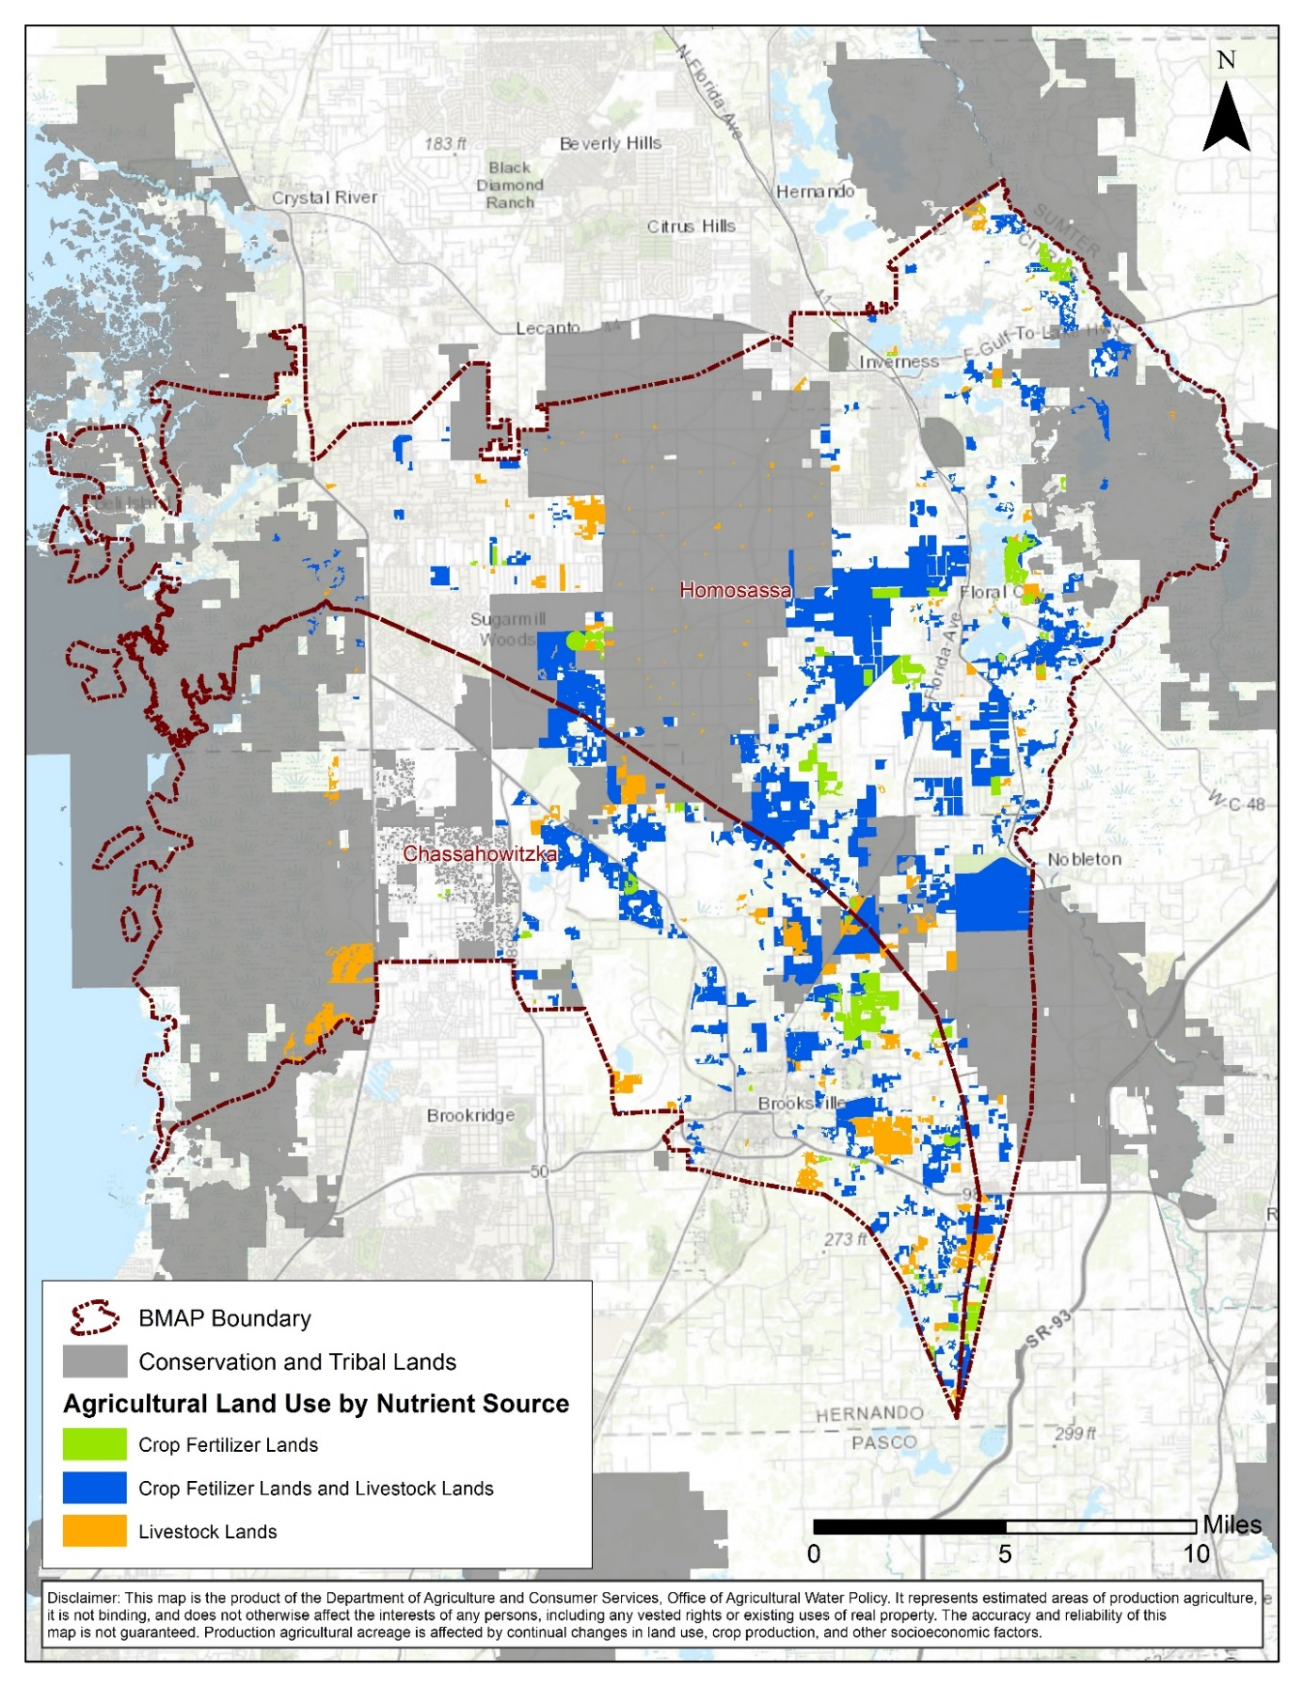
Figure G-1. Composite of agricultural lands in the combined springsheds

G.2 Agricultural BMPs
BMPs are individual or combined practices determined through research, field-testing, and expert review to be effective and practicable means for improving water quality, considering economic and technological feasibility. FDACS has authority for establishing agricultural BMPs through the Florida Forest Service (Silviculture BMP Program), Division of Aquaculture (Aquaculture Certification Program), and OAWP (all other agricultural BMP programs). As of January 2018, OAWP has adopted manuals for cow-calf, statewide citrus, vegetable and agronomic crops, nurseries, equine operations, specialty fruit and nut, sod, dairy, and poultry operations. A small farms manual is under development and adoption is expected in 2018. The sod and cow-calf manuals are currently under review and revision.
The OAWP BMPs fall into two categories: structural and management. Structural BMPs, e.g., water-control structures and fencing, involve the installation of structures or changes to the land and are usually costlier than management BMPs. Management BMPs, such as nutrient and irrigation management, comprise the majority of the practices and often are not readily observable. Nutrient management addresses fertilizer type, amount, placement, and application timing, and it includes practices such as soil and tissue testing, application methods, correct fertilizer formulations, and setbacks from water resources. Irrigation management is maintenance, scheduling, and other measures that improve the overall efficiency of irrigation systems. FDACS-funded mobile irrigation labs (MILs) are available to evaluate irrigation system efficiency and provide recommendations to producers to improve efficiency. The implementation of these recommendations results in billions of gallons of water saved throughout the state and helps reduce nutrient runoff and leaching.
Table G-7 identifies key management and structural BMPs applicable to agricultural operations in the springsheds. By definition, BMPs are developed to be technically and economically feasible. However, FDACS BMP manuals do contain some BMPs that may be affordable only with financial assistance through cost-share programs. The BMP checklists allow producers to indicate whether implementing a BMP requires financial assistance.
Information on the BMP manuals and field staff contact information can be obtained here: http://www.freshfromflorida.com/Divisions-Offices/Agricultural-Water-Policy. Printed BMP manuals can be obtained by contacting OAWP field staff.
Table G-7. Key management and structural BMPs adopted by FDACS OAWP
BMP Category | BMP | Description
Nutrient Management (Right Source) | Use of Correct Formulations | Use of fertilizer formulations that are appropriate for the environmental conditions. Includes enhanced efficiency fertilizers, as warranted.
Nutrient Management (Right Rate) | Soil and Tissue Testing  Nutrient Budgeting | Used to base fertilizer applications on plant needs and available nutrients in the soil; helps prevent the over application of fertilizer.  Consideration of all nutrient sources, such as commercial fertilizers, biosolids, legumes, manure, and nutrient-laden irrigation water to ensure that fertilization meets crop nutrient requirements.
Nutrient Management (Right Placement) | Precision Application of Nutrients | Use of specialized equipment for precise placement of nutrients on targeted areas at specified rates; reduces total amount used and prevents stray applications.
Nutrient Management (Right Timing) | Split Fertilizer Applications | Multiple applications timed with optimal growth stages; allows plants to assimilate nutrients more efficiently; reduces nutrient loss in leaching and runoff.
Nutrient Management (Special Fertilization Practices) | Special Fertilization Practices | Commodity specific fertilization practices to address nuances on a case-by-case basis.
Nutrient Management (Fertilizer Storage and Handling) | Fertilizer Storage and Handling | Proper location/storage of bulk fertilizer products to prevent nutrient loadings.  Use of appropriate dedicated or temporary mix/load areas located away from waterbodies to prevent nutrient loading.
Irrigation and Water Table Management | Irrigation Scheduling | Planning when to irrigate to reduce water and nutrient losses, based on available soil moisture content, evapotranspiration levels, recent rainfall, and time of day.
Irrigation and Water Table Management | Irrigation System Maintenance | Use of MILs to identify efficiency issues, maintenance, and incorporation of potential upgrades to irrigation system.
Irrigation and Water Table Management | Wellhead Protection | Establishing safe practices around irrigation and drinking water wells.
Water Resource Protection | Buffers and Setbacks | Fertilizer application setbacks from waterbodies (e.g., wetlands, watercourses, sinks, springs, etc.) and use of appropriate buffers around water resource features.
Water Resource Protection | Ditch Maintenance and Water Control Structures | Use of rip rap, sediment traps, staging structures, and permanent vegetative bank cover to minimize erosion and transport of nutrient-laden sediments.
Water Resource Protection | Erosion Control | Vegetated strips of land designed to reduce nutrients and sediments in surface water runoff from fields, pastures, and livestock high-intensity areas before it reaches downstream waterbodies.
Livestock Management | Manure Management | Appropriate storage and disposal of animal waste.
Livestock Management | Water Requirements and Sources | Use of upland livestock watering ponds and/or water troughs; minimizes manure deposition in waterbodies.
Livestock Management | Forage, Pasture and Grazing Management | Movement of cattle to different grazing areas on a planned basis; prevents concentrated waste accumulations and denuding of pasture areas. May involve fencing.  Also involves siting of cowpens, supplemental feed areas, etc., away from waterbodies to minimize nutrient loadings.
Livestock Management | Use Exclusion | Used when stream banks have significant rill or gully erosion because of cattle trampling.

G.3 BMP Enrollment
Figure G-2 shows the acres enrolled in the FDACS BMP Program in the combined springsheds as of August 31, 2017. Table G-8 and Table G-9 list the acres enrolled in the FDACS BMP Program by manual. Given that the enrolled acres on which BMPs are implemented can contain nonproduction acres (such as buildings, parking lots, and fallow acres), only the enrollment for the land classified as agriculture based on the FSAID is included in the table.
As of August 31, 2017, NOIs cover 11,664 acres in the combined springsheds. No producers are conducting water quality monitoring in lieu of implementing BMPs at this time.

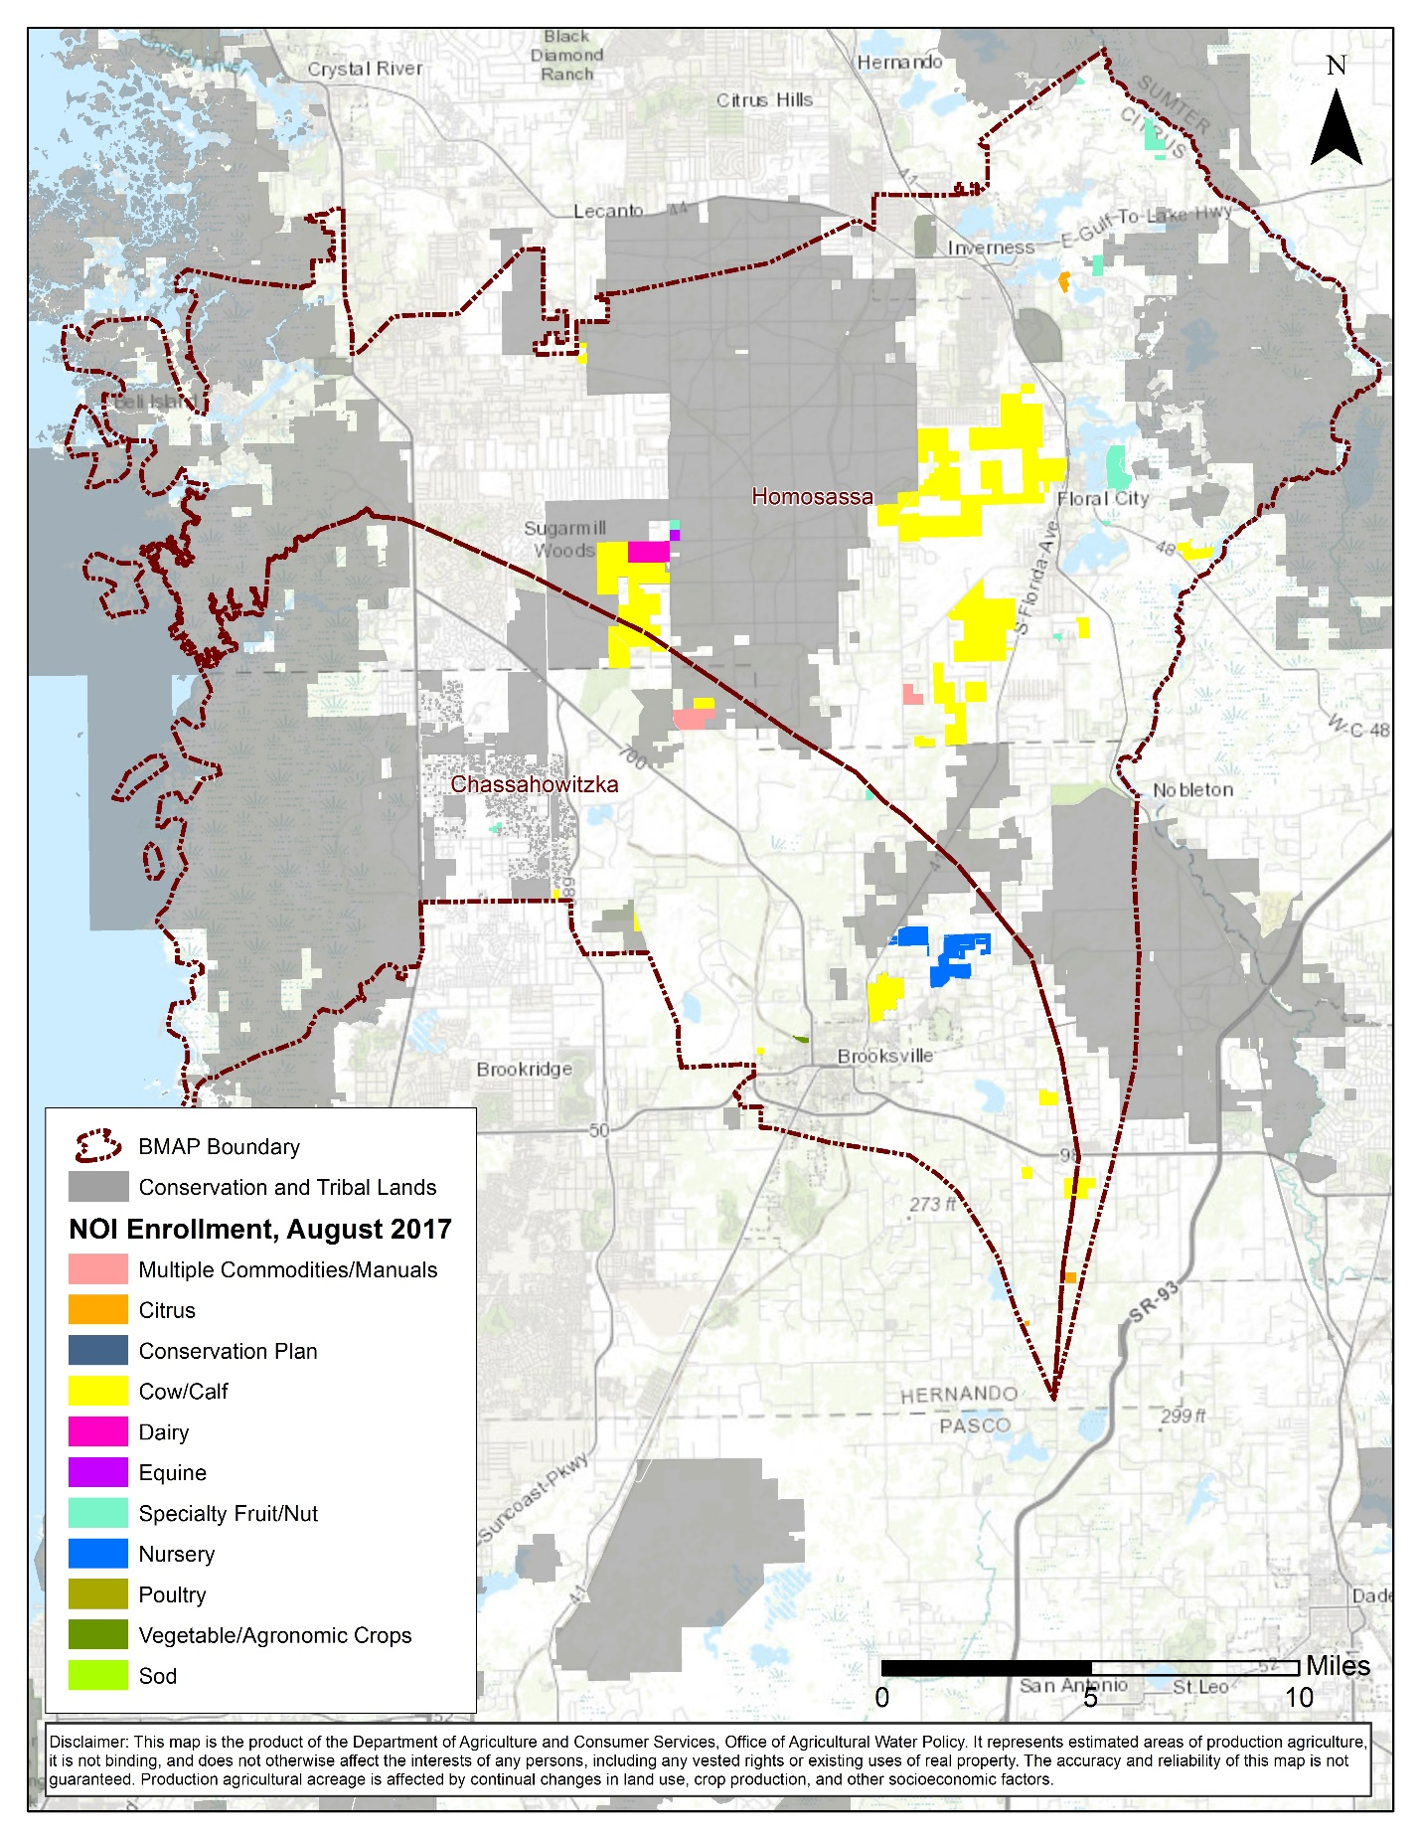
Figure G-2. BMP enrollment in the combined springsheds as of August 31, 2017
Table G-8. Agricultural acreage and BMP enrollment in the Homosassa Springshed as of August 31, 2017
Related FDACS BMP Programs | NOI Acreage Enrolled | Agricultural Land Use Acres within NOIs
Citrus | 98 | 82
Cow/Calf | 7,896 | 4,365
Dairy | 323 | 305
Equine | 42 | 20
Multiple Commodities/Manuals | 115 | 111
Specialty Fruit/Nut | 649 | 575
Total | 9,122 | 5,458

Table G-9. Agricultural acreage and BMP enrollment in the Chassahowitzka Springshed as of August 31, 2017
Related FDACS BMP Programs | NOI Acreage Enrolled | Agricultural Land Use Acres within NOIs
Citrus | 10 | 10
Cow/Calf | 1,323 | 1,156
Multiple Commodities/Manuals | 272 | 270
Nursery | 860 | 826
Specialty Fruit/Nut | 53 | 30
Vegetable and Agronomic Crops | 25 | 20
Total | 2,543 | 2,312

G.4 FDACS OAWP Role in BMP Implementation and Follow-Up
OAWP works with producers to submit NOIs to implement the BMPs applicable to their operations, provides technical assistance to growers, and distributes cost-share funding, as available, to eligible producers for selected practices. OAWP follows up with growers through site visits to evaluate the level of BMP implementation and record keeping, identify areas for improvement, if any, and discuss cost-share opportunities.
When DEP adopts a BMAP that includes agriculture, it is the agricultural producer’s responsibility to implement BMPs adopted by FDACS to help achieve load reductions. If land use acreage corrections and BMP implementation do not fully account for the current agricultural load reduction allocation, it may be necessary to develop and implement additional projects and practices that reduce nutrients from agricultural nonpoint sources. In that case, FDACS will work with DEP and SWFWMD to identify appropriate options for achieving further agricultural load reductions.
Section 403.067, F.S. requires that, where water quality problems are demonstrated despite the proper implementation of adopted agricultural BMPs, FDACS must reevaluate the practices, in consultation with DEP, and modify them if necessary. Continuing water quality problems will be detected through the BMAP monitoring component and other DEP and SWFWMD activities. If a reevaluation of the BMPs is needed, FDACS will also include SWFWMD and other partners in the process.
G.5 OAWP Implementation Assurance Program
OAWP formally established its Implementation Assurance (IA) Program in 2005 in the Suwannee River Basin as part of the multi-agency/local stakeholder Suwannee River Partnership. In 2007, OAWP initiated the IA Program in the Lake Okeechobee Watershed and launched a standardized follow-up program for the remaining areas of the state in 2013, beginning with the Ridge Citrus and Indian River Citrus BMPs. Because of program-specific needs, the follow up process for each of these three components was different. In early 2014, OAWP began to streamline the IA Program to ensure consistency statewide and across commodities and BMP manuals. This effort resulted in a single IA site-visit form, which is currently used by OAWP staff.
The current IA Program is based on interactions with producers during a site visit by OAWP staff. Site visits are conducted by OAWP field staff and technicians as workload allows. For the visits, field staff and technicians use a standard form (not BMP specific) developed in 2014. This form focuses on nutrient management, irrigation management, and water resource protection BMPs that are common to all of the BMPs that have been adopted by rule. The paper forms are submitted to OAWP staff and compiled into a spreadsheet, and the data are reported annually. From 2007 to 2015, OAWP conducted 1,936 site visits. However, it is difficult to compare data collected prior to the implementation of the recently developed single IA site visit form because of regional differences (e.g., different forms and information requested) in the administration of the IA Program.
Additional emphasis was given to verifying implementation of BMPs by enrolled producers with the enactment of Chapter 2016-1, Laws of Florida. That legislation directed OAWP to formalize the Implementation Verification Program into rules. In December 2016, OAWP published a notice of rule development. In July 2017, draft rule language was distributed and presented at a public workshop. This draft language provided the structure for a statewide uniform implementation verification system, including assessments of the status of implementation, compliance assistance to aid producers in achieving full implementation, and referral to DEP for producers who are not implementing BMPs. The IV rule was final as of November 1, 2017 (Chapter 5M-1, F.A.C.).
G.6 Beyond BMPs
Beyond enrolling producers in the FDACS BMP Program and verifying implementation, FDACS will work with DEP to improve the data used to estimate agricultural land uses in the springshed. FDACS will also work with producers to implement a suite of agricultural projects and research agricultural technologies on properties where they are deemed technically feasible and if funding is made available. Acreages provided by FDACS are preliminary estimates that are the maximum acreages that will be evaluated and refined over time.
As presented here, these projects are based on planning-level information. Actual implementation would require funding as well as more detailed designed based upon information, such as actual applicable acreages and willing landowners. These efforts are summarized in Table G-10. It is important to note that the research projects listed in Table G-6 are being conducted in the Suwannee River Basin. At some point in the future, the findings of these studies may be applicable to the Homosassa and Chassahowitzka Springsheds.
Table G-10. Beyond BMP implementation
Category | Name | Description
Practices | Soil Moisture Probes | Deployment, training, technical support, and use of soil moisture probes to manage irrigation systems.
Practices | Precision Fertilization | Deployment of equipment, procedures, and training to improve formulations, delivery methods, and timing to match fertilization more precisely to crop needs. Cost is a one-time capital expenditure.
Practices | Precision Irrigation | Deployment of equipment, procedures, and training to improve location, volume, and timing of irrigation to match crop needs more precisely. Cost is a one-time capital expenditure.
Practices | Cover Crops | Planting of cover crops in between production cycles to increase soil organic content, improve nutrient retention, and reduce erosion.
Practices | Controlled Release Fertilizer (CRF) | Application of new and developing fertilizer products which become available to crops via dissolution over longer periods of time in the growing season.
Research | Rotational Production | Conversion of conventional production operations to planned rotational production incorporating grass and cover crops. May include cattle.
Research | Soil Moisture Sensor Deployment and Calibration | Installation, training, monitoring, and research on use of electronic soil moisture sensors, including correlations to nutrient movement through the root zone.
Research | BMP Effectiveness on CRF | Focused research on the effects of BMP implementation on water quality and water conservation.
Research | Reuse of High Nutrient Value Water Sources | Study of potential sources of high nutrient value water, potential beneficial reuse sites, legal and regulatory obstacles, and costs.

Appendix H. Future Growth Strategies of Local Jurisdictions
Table H-1. Future growth strategies of local jurisdictions
Local Jurisdiction | Strategy Name | Description | Strategy Type | Status
Citrus County | Coastal, Lakes, River Management Policy 4.7.3 | To reduce the amount of untreated stormwater effluent, the county shall prepare a strategic plan to retrofit appropriate areas. | Comprehensive Plan |  | Completed
Citrus County | Infrastructure Element Policy 7.3.5 | All development must be served by a regional WWTF as soon as the service is available. | Comprehensive Plan |  | Completed
Citrus County | Infrastructure Element Policy 7.3.12 | The county shall eliminate and prevent the future discharge of inadequately treated wastewater into water and wetlands of the state by encouraging the use of spray irrigation and percolation ponds and by decreasing the number of illegal outfalls through code enforcement proceedings and/or capital facilities. The application of gray and treated wastewaters for use in irrigation is encouraged in upland areas and should be interpreted as a direct discharge. | Comprehensive Plan |  | Completed
Citrus County | Infrastructure Element Policy 7.3.15 | All existing central wastewater treatment systems shall be designed to achieve AWT standards upon expansion and include reuse capabilities. | Comprehensive Plan |  | Completed
Citrus County | Infrastructure Element Policy 7.3.16 | All new central wastewater treatment systems shall be designed to achieve AWT standards and include reuse capabilities. | Comprehensive Plan |  | Completed
Citrus County | Infrastructure Element Policy  7.4.4 | The county shall seek long term agreements with large users of groundwater to provide reclaimed water for the irrigation of horticultural or agricultural uses, golf courses, recreation and open space areas, and commercial and residential projects. | Comprehensive Plan |  | Completed
Citrus County | Infrastructure Element Policy  7.4.6 | Reclaimed water irrigation systems shall be designed and installed to prevent overspray or irrigation of any wetlands, waterbodies, sinkholes, or stormwater systems except for reclaimed water storage ponds. Buffers and BMPs shall be required to prevent reclaimed water runoff from entering sinks, wetlands, and waterbodies. | Comprehensive Plan |  | Completed
Citrus County | Future Land Use Element Policy 17.2.5 | New development locating in the Planned Service Area (PSA) shall be allowed only when central water and sewer are provided. For new residential land uses, this shall apply to developments of 4 units or greater per acre. Existing development must connect to central water and sewer systems when the services become available. Within the PSA, all new subdivision plats of 500 or more dwellings shall be required to connect to regional central water and regional central sewer | Comprehensive Plan |  | Completed
Citrus County | Future Land Use Element Policy 17.9.3 | All development and redevelopment shall be designed to minimize stormwater discharge and shall be designed to meet or exceed the requirements of Chapter 62-25, F.A.C. The county shall establish additional standards as needed to protect springs and their springsheds, spring run creeks, aquifer recharge, and Outstanding Florida Waters (OFWs) and their tributaries. | Comprehensive Plan |  | Completed
Citrus County | Future Land Use Element Policy 17.42.5 | The county shall encourage limited impervious cover and use green building techniques and LID strategies and technologies. | Comprehensive Plan |  | Completed
Citrus County | Future Land Use Element Policy 17.42.6 | The county shall encourage buffering requirements (water quality improvements) to provide pretreatment (filtering) of pollutants/contaminants from stormwater runoff that are detrimental to the long-term water quality of the county's natural resources. | Comprehensive Plan |  | Completed
Citrus County | Future Land Use Element Policy 17.45.3 | Design of infrastructure shall support development features and landscape vegetation that promote natural stormwater mitigation. | Comprehensive Plan |  | Completed
City of Brooksville | Stormwater Management  Ordinance | The City will establish and implement BMPs for all activities, operations, and/or facilities within the city which may cause or contribute to pollution or contamination of storm water, the storm drainage system, or waters of the U.S. | Ordinance |  | Completed
City of Brooksville | Conservation Element Policy 2-2 | The City shall consider entering into agreement with Hernando County to establish BMPs for the protection of surface and groundwater quality of water basins within Peck Sink, Blue Sink, and Byster Lake. | Comprehensive Plan |  | Planned
City of Brooksville | Conservation Element Policy 3-1 | Require all development in the city connect to city sewer service, where and when available. | Comprehensive Plan |  | Completed
City of Brooksville | Future Land Use Element Policy 2-4 | High density and intensity growth shall not be permitted in conservation areas, or those areas best suited for continued low density and intensity development. | Comprehensive Plan |  | Completed
City of Brooksville | Future Land Use Element Policy 2-9 | Require central sewer and sewer systems for new urban developments, which are designed to be compatible with future public utility systems. | Comprehensive Plan |  | Completed
City of Inverness | Conservation Element Policy 4.1.2.2 | The City shall continue to enforce a comprehensive stormwater management ordinance. | Comprehensive Plan |  | Completed
City of Inverness | Conservation Element Policy 4.1.2.11 | The City shall prohibit the discharge of inadequately treated stormwater into waters of the state. | Comprehensive Plan |  | Completed
City of Inverness | Conservation Element Policy 4.1.2.12 | The City shall protect surface waters and water quality by restricting activities and land uses known to adversely affect the quality and quantity of identified water sources; including natural groundwater recharge areas, wellhead protection areas and surface waters used as a source of public water supply. | Comprehensive Plan |  | Completed
City of Inverness | Conservation Element Policy 4.1.3.3 | The City shall continue to coordinate with Citrus County to provide adequate sewer facilities in the lake areas in order to eliminate septic tank usage in this critical area. | Comprehensive Plan |  | Completed
City of Inverness | Comprehensive Element Policy 4.1.3.6 | The City shall require all new developments within statutory proximity to sewer lines to connect to City sewer services. | Comprehensive Plan |  | Completed
City of Inverness | Comprehensive Element Policy 4.1.6.7 | The City shall encourage conservation and protection of natural functions of existing soils, fisheries, wildlife habitats, rivers, bays, lakes, floodplains, harbors, wetlands including estuarine marshes, freshwater beaches and shores and marine habitats. | Comprehensive Plan |  | Completed
City of Inverness | Infrastructure Element Policy 5.2.2.1 | Effluent and sludge from all City owned treatment plants shall meet all biological and chemical standards of the applicable regulatory authority(s). | Comprehensive Plan |  | Completed
City of Inverness | Infrastructure Element Policy 5.2.4.2 | The City shall negotiate or enter into an interlocal agreement with Citrus County to require that any development in the urban fringe or planning area that will be served by package treatment plants shall be such that the plants shall either be interim in nature or can eventually be linked as a regional system and be publicly owned and operated. | Comprehensive Plan |  | Completed
City of Inverness | Infrastructure Element Policy 5.2.5.1 | Package treatment plants and septic tanks will not be allowed for new development if existing sanitary sewer system facility capacity is available to maximize the use of existing facility and to discourage urban sprawl. | Comprehensive Plan |  | Completed
City of Inverness | Infrastructure Element Policy 5.2.6.1 | Consistent with environmental need, the City shall designate a portion of its operation and capital improvements budgets for use in connecting residences and businesses using septic tanks to the sanitary sewer system. | Comprehensive Plan |  | Completed
City of Inverness | Infrastructure Element Policy 5.2.6.2 | The City shall prohibit the creation of new septic systems or the use of existing septic systems in areas where sewer systems are available. | Comprehensive Plan |  | Completed
City of Inverness | Infrastructure Element Policy 5.4.2.5 | By the end of the planning period, the City shall evaluate the water quality treatment capacity for each sub-basin in the City for use in developing water quality level of service standards. As part of the evaluation, the City shall identify point sources of pollution and quantify impacts to receiving waters. The City shall develop and implement water quality level of service standards in an effort to meet water quality goals of maintaining the water quality of local water bodies. | Comprehensive Plan |  | Completed
City of Inverness | Infrastructure Element Policy 5.4.4.1 | Basins, swales, and culverts shall be designed to protect groundwater and surface water quality as well as accommodate stormwater flows in all new developments. | Comprehensive Plan |  | Completed
City of Inverness | Infrastructure Element Policy 5.5.1.1 | The City, as part of its Land Development Regulations, will continue to emphasize the proper use of structural drainage techniques, such as swales, that allow natural vegetation to absorb pollutants and allow percolation of clean water into the aquifer recharge area. | Comprehensive Plan |  | Completed
City of Inverness | Infrastructure Element Policy 5.5.1.7 | The city shall regulate land use and development to protect the functions of natural drainage features and natural groundwater aquifer recharge areas. | Comprehensive Plan |  | Completed
City of Inverness | Intergovernmental Coordination Element Policy 7.1.1.7 | The City and Citrus County shall coordinate to ensure verification of adequate provision of wastewater treatment in all utility service areas prior to issuance of local development orders. | Comprehensive Plan |  | Completed
City of Inverness | Intergovernmental Coordination Element Policy 7.1.1.13 | The City shall participate in a coordinated management of bays, estuaries and harbors that fall under the jurisdiction of more than one local government. | Comprehensive Plan |  | Completed
Hernando County | Riverine Buffer Ordinance | Regulates land use within 75 feet of rivers, streams, and wetlands. Addresses septic systems, wastewater treatment systems, petroleum products, solid waste, and agricultural waste | Ordinance |  | Completed
Hernando County | Low Impact Drainage | New strategies for low impact drainage standards and initiatives. | Comprehensive Plan |  | Planned
Hernando County | Ecological Linkages | New strategies for prioritizing ecological linkage conservation as one means of recharge and groundwater conservation. | Comprehensive Plan |  | Planned
Hernando County | Aquifer Recharge | Update strategies to protect high recharge areas and karst areas. | Comprehensive Plan |  | Planned
Hernando County | Aquifer Protection | Update strategies to protect groundwater through appropriate design of stormwater, sewage treatment, golf course facilities, and landscaping. | Comprehensive Plan |  | Planned
Hernando County | Aquifer Protection | New strategies for coordination on minimum flows and levels for springs and surface waters. | Comprehensive Plan |  | Planned
Hernando County | Surface Water Protection | Update strategies to continue the County's riverine ordinance. | Comprehensive Plan |  | Planned
Hernando County | Erosion Control | Update strategies for erosion control and minimization of sedimentation. | Comprehensive Plan |  | Planned
Hernando County | Habitat Mitigation | New strategies that require mitigation of loss of large natural communities. | Comprehensive Plan |  | Planned
Hernando County | Future Land Use Element Policy 1.01T(6) | Water and sewer planning conducted by the County will utilize a public participation process. | Comprehensive Plan |  | Completed
Hernando County | Sanitary Sewer Element Policy 4.01A(6) | Wastewater service plans developed and updated hereunder, along with the adopted Capital Improvement Plan, shall be utilized to guide the location and timing of land development requiring wastewater service. | Comprehensive Plan |  | Completed
Hernando County | Sanitary Sewer Element Policy 4.01A(7) | Wastewater facility and service planning conducted by the County will utilize a public participation process. | Comprehensive Plan |  | Completed
Hernando County | Sanitary Sewer Element Policy 4.01B(2) | As part of the Wastewater Service Plan, establish standards to determine when commercial and industrial septic tanks will be required to connect to central services. | Comprehensive Plan |  | Completed
Hernando County | Sanitary Sewer Element Policy 4.03A(4) | Advanced secondary and tertiary treatment should be considered for future permanent sewage treatment plants, particularly those which are located near water bodies or in soils which do not have a defined impermeable clay lens or significantly thick sand layers between the surface and the Floridan aquifer. | Comprehensive Plan |  | Completed
Hernando County | Sanitary Sewer Element Policy 4.03B(3) | Where possible, provide flexibility in public or private facility design to allow for development of reuse systems. | Comprehensive Plan |  | Completed
Hernando County | Drainage & Natural Groundwater Aquifer Recharge Element Policy 4.10A(1) | Develop an aquifer protection program including public education, coordination with appropriate agencies, provision of adequate collection, and disposal facilities in order to limit the amount of contaminants reaching the surficial or Floridan aquifers. | Comprehensive Plan |  | Completed
Hernando County | Potable Water Element Policy 4.15B(1) | Implement a strategy to encourage replacement of potable water use with reclaimed water for irrigation purposes of at least 4.3 MGD by the year 2019. | Comprehensive Plan |  | Completed
Hernando County | Conservation Element Policy 6.01G(8) | Provide for an east-west corridor connecting the Chassahowitzka Preserve to the Green Swamp and a north south coastal corridor west of US Highway 19 connecting to Pasco County as strategic wildlife corridors, and require future development to accommodate wildlife habitat corridors through the use of designated open space, conservation easements, clustering, or other acceptable planning technique. | Comprehensive Plan |  | Completed
Hernando County | Conservation Element Policy 6.02A(9) | The County shall require all new golf courses be designed and maintained using the principles developed by the Institute of Food and Agricultural Sciences (IFAS) for Best Management Practices for Florida Golf Courses. | Comprehensive Plan |  | Completed
Hernando County | Conservation Element Policy 6.02A(10) | The County shall establish guidelines for managing existing and future turf and landscapes at all County owned facilities utilizing the educational guidelines of the University of Florida Extension’s Florida Yards & Neighborhoods Program and Best Management Practices. It is the intent of this policy that the County reduce nutrient/pollutant infiltration into ground and surface waters and to encourage best management practices through public education | Comprehensive Plan |  | Completed
Hernando County | Conservation Element Policy 6.02C(2) | Evaluate any development proposal for its effect on the quantity and quality of surface waters which flow into the Gulf of Mexico, including stormwater runoff, erosion and sedimentation, and septic tank discharge. | Comprehensive Plan |  | Completed
Hernando County | Conservation Element Policy 6.08A(1) | Minimum lot sizes for septic fields may be further restricted from the minimum ½ acre in prime aquifer recharge areas, sinkhole areas, areas adjacent to lakes or rivers or areas where soils have severe limitations. | Comprehensive Plan |  | Completed
Hernando County | Conservation Element Policy 6.08A(11) | Development of property shall adhere to green industries Best Management Practices (BMPs), including Integrated Pest Management (IPM) (FDEP & FDEO, 2002. Protecting Florida Springs - Land Use Planning Strategies & Best Management Practices). Florida Yards & Neighborhoods (FYN) education shall be provided for individual lot owners. | Comprehensive Plan |  | Completed

