Wakulla River Progress Report - Biological Monitoring

2013 - 2020

The Upper Wakulla River (WBID 1006) was verified as impaired for biology and was included on the Verified List of impaired waters for the St. Marks Basin that was adopted by Secretarial Order by the Florida Department of Environmental Protection (Department) in June 2008. The Department of Environmental Protection (DEP or the Department) established a Total Maximum Daily Load (TMDL) for the allowable concentration of nitrate to the Upper Wakulla River that would restore the waterbody. A Basin Management Action Plan (BMAP) is currently being developed to recommend strategies and limits to achieve pollution reduction.
Beginning in October 2013, the Department, in collaboration with the Northwest Florida Water Management District (NWFWMD), collected quarterly water chemistry and biological samples at two locations in the Wakulla River to monitor and measure the effects of current and future reductions in nutrients on the biological communities in the Wakulla River (Figure 1). The upstream station is located at the Boat Tram inside the Wakulla Springs State Park, approximately 0.5 miles downstream from the spring boil (Figure 1) and the second station is approximately 3.0 miles downstream of the spring boil, just outside the state park boundary at County Road 365. This report summarizes all available biological data collected between October 2013 and July 2020 at these two locations. It is being provided for informational purposes to interested Department staff and stakeholders.
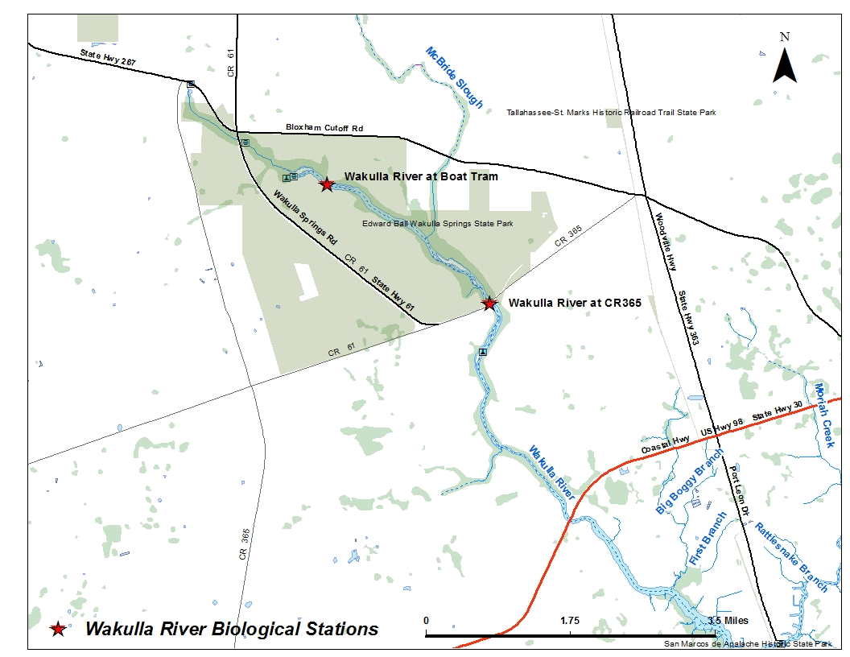
Figure 1. Wakulla River Biological Monitoring Stations.

Stream Condition Index
The Stream Condition Index (SCI) is a biological assessment procedure that measures the degree to which flowing fresh waters support a healthy, well-balanced biological community, as indicated by benthic macroinvertebrates. A balanced faunal community is achieved if the average score of at least two temporally independent SCIs is 40 or higher, with neither of the two most recent SCI scores less than 35.
When the SCI bioregions were initially developed in 1992, there were relatively little data available for some of the bioregions, particularly the eastern portion of the Panhandle region. DEP has subsequently collected thousands of new SCIs throughout the state. In addition, better Geographic Information System (GIS) tools now available allow more accurate spatial resolution. In 2012, the Department undertook a re-analysis of the SCI regions to better define the macroinvertebrate expectations across the State. The re-analysis of the SCI regionalization indicated that the Panhandle bioregion should be divided into the Panhandle West and Big Bend bioregions because they have significantly different taxa at reference sites (Figure 2). During the SCI re-evaluation, the bioregion boundaries were also redrawn to be consistent with watershed boundaries. The original bioregion boundaries bisected watersheds which meant that the biological expectation in some streams changed upstream or downstream of an imaginary line across the stream. Greater detail concerning the re-analysis of the SCI bioregions and the results of that evaluation are provided in Appendix B of the Technical Support Document: DEP-SAS-001/13. As part of the re-assessment, the SCI equations were also updated and SCI scores were recalculated. The original listing of the Wakulla River was based on earlier versions of the SCI. This report uses the revised regions and equations for what is now referred to as the SCI-2012 (Figure 2).
Figure 2. Comparison of the SCI 2007 bioregions with the new 2012 bioregions.
Figure 3 shows the average annual SCI scores collected from the biological monitoring stations from October 2013 through January 2020. The average SCI score from 2013 through 2020 (n = 24) at the upstream Boat Tram site is 35 and the average of the two most recent samples is 46. The average SCI score for the same period at the CR 365 site is 49 (n = 22), and the average of the two most recent samples is 56. The overall average SCI score for the WBID is 42 and passes the average minimum impairment threshold of 40. While these results suggest an increasing trend in scores at both locations, there are still occasional excursions below the minimum acceptable score of 35 at the Boat Tram site. It may be that natural factors associated with spring systems (e.g., lower dissolved oxygen, higher specific conductance) will continue to limit the invertebrate community such that it will not consistently pass the SCI threshold.
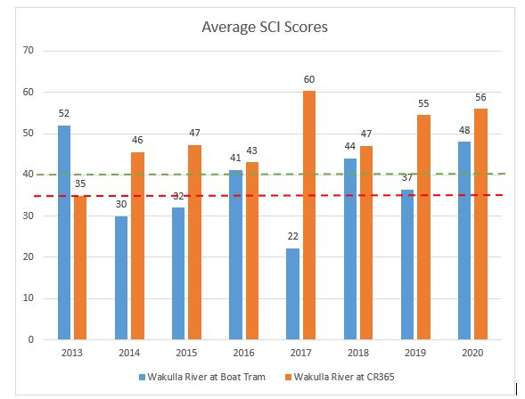
Figure 3. Average annual SCI results for the Wakulla River from 2013 through 2020. Dashed lines show the evidentiary thresholds for the single sample minimum (35) and two-sample average (40).

Floral Measures
The Department derived the floral thresholds that are used as part of the streams nutrient standard using a distribution of a population of minimally disturbed Benchmark streams. The thresholds summarized in Table 1 can be used when developing evidence supporting a Department conclusion regarding the balance of the floral community in streams. If all floral measures are achieved, a stream meets the floral component of a healthy, well balanced aquatic system, because it is within the range of condition for minimally disturbed Benchmark streams. However, if any one of these floral measures indicates an imbalance, then the stream does not attain the Numeric Nutrient Criteria (NNC, Rule 62-302.531, Florida Administrative Code).

Table 1. Floral measures summary. Values are based on the distribution of a population of minimally disturbed benchmark sites sampled by the Department as part of NNC development.
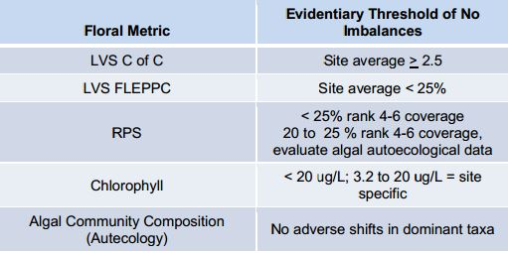

Linear Vegetation Survey
The Linear Vegetation Survey (LVS) is a rapid assessment tool for evaluating the ecological condition of streams based on vascular plants, conducted per DEP SOP FS 7320. The Department evaluated LVS data from reference streams and found that if a site’s average Coefficient of Conservatism (C of C) score is greater than or equal to 2.5 and the frequency of occurrence of Florida Exotic Plant Pest Council (FLEPPC) exotic taxa is less than 25% of the total plant occurrences, the plant community composition may be part of the reference site distribution and does not represent an imbalance of flora. Because of the inherent variability in aquatic plant communities, two temporally independent assessments are required (at least 3 months apart). For all sampling events, both LVS metrics met the evidentiary thresholds as seen in Figures 4 and 5.
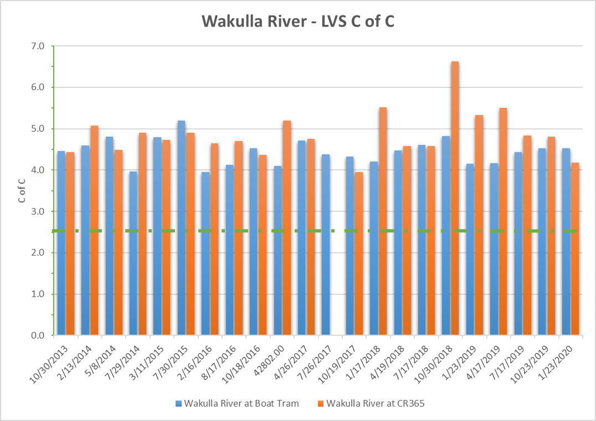
Figure 4. Coefficient of Conservatism (C of C) for samples collected between 2013 and 2020. Dashed line shows the evidentiary threshold for balanced flora of 2.5.
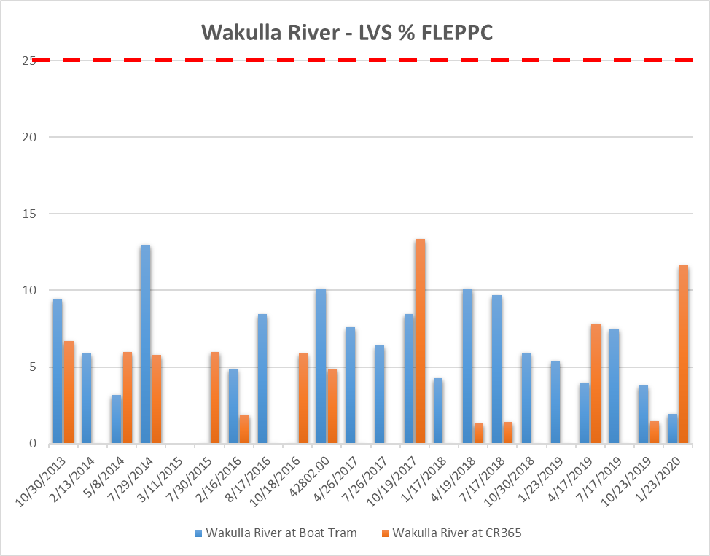
Figure 5. Percent FLEPPC for samples collected between 2013 and 2020. Dashed line shows the evidentiary threshold for balanced flora of ≤25%.
The average C of C for the two most recent samples at the Boat Tram and County Road 365 sites were both 4.5, which is above the minimum threshold of 2.5. Similarly, the % FLEPPC taxa was less than the 25% maximum threshold at both locations, 3% and 7%, at the Boat Tram and CR 365 site, respectively.

Rapid Periphyton Survey
The Rapid Periphyton Survey (RPS) is used to quantify the extent and abundance of attached algae, and is conducted per DEP SOP FS 7230. The Department compares RPS results from a stream to the RPS results compiled from the population of minimally disturbed and healthy sites that was sampled by the Department as part of NNC development. RPS rank 4-6 coverage (Rank 4-6 represent algae mat lengths of >6 mm) at these streams ranged from 0% to 66%, with a mean value of 6% and a 90th percentile value of 25%. Therefore, if a stream exhibits a percent coverage for RPS ranks 4-6 of 25% or less in both samples, the RPS results indicate evidence of no imbalance of flora. If a stream segment exceeds an RPS 4-6 coverage of >25% during two consecutive, temporally independent samplings (at least 3 months apart), the Department considers this as evidence that the NNC is not achieved.
RPS samples collected from 2013 through 2020 in the Wakulla River indicate an imbalance in the floral community (Figure 6) based on the abundance of excessive algal growth. There appears to be a decreasing trend in the abundance of algae at the downstream station at County Road 365, but algae inside the park at the Boat Tram continues to be extremely abundant. The averages of all samples since October 2013 at the Boat Tram and CR 365, were 65% and 45%, respectively. Station averages for two most recent sampling events were slightly below these longer-term averages at 59% and 35%.
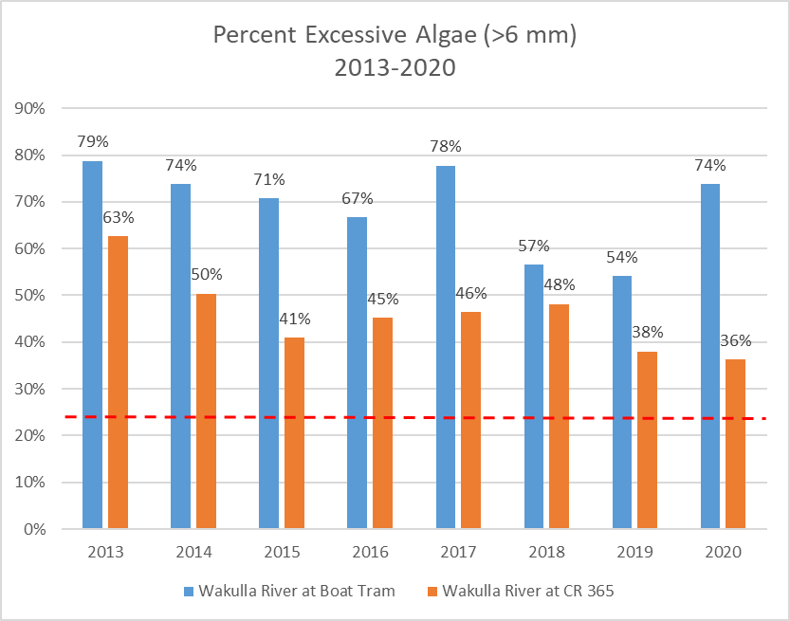
Figure 6. Annual average abundance of RPS Ranks 4-6 (>6 mm) in the Wakulla River. Dashed line shows the evidentiary threshold for balanced flora, <25% of 6 mm.

Chlorophyll-a
There is a wide range of stream chlorophyll a values that are considered “healthy” due to a variety of site specific factors, such as system morphology and water residence time. If a stream exhibits annual geometric mean (AGM) chlorophyll a concentrations below the 90th percentile values (3.2-3.5 µg/L) observed at minimally disturbed and healthy sites, that chlorophyll a concentration shows no imbalance of flora. It should be noted that chlorophyll a concentrations shown in Table 2 represent individual sample results or arithmetic means depending on the number of samples collected. There were only two years where there was enough data to calculate AGMs, as noted in the table. No years indicate an imbalance in the floral communities. A sample collected at the Boat Tram site on April 17, 2019 was elevated (23 µg/L) although when it was averaged with the other samples collected that year it did not exceed the AGM threshold. It appears to be an anomaly given all the other sample results, however, since there were no comments or qualifiers to suggest an error, it was included in the calculation.
Table 2. Average annual chlorophyll-a values in the Wakulla River.
Year | Chlorophyll-a, Corrected (µg/L)
Year | Wakulla River at Boat Tram | Wakulla River at CR365
2013 | 1.1 I | 0.55 U
2014 | 1.4 I | 1.8
2015 | 0.74 I | 0.73 I
2016 | 1.33 I | 0.62 I
2017 | 0.55 U | 0.71 I
2018 | 0.62 U | 0.68 *
2019 | 1.99 * | 0.55 U
2020 | 1.10 I | 0.55 U
I - substance measured between the method detection limit and the practical quantitation limit.
U - Indicates that the compound was analyzed for but not detected.
* Annual Geometric Mean

Florida Department of Environmental Protection Technical Support Document: Derivation of Dissolved Oxygen Criteria to Protect Aquatic Life in Florida’s Fresh and Marine Waters. DEP-SAS-001/13. March 2013.

