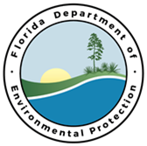

Fall Springs Outreach Campaigns
Draft Agenda
October 20, 2020, 9 a.m.
Microsoft Teams link: https://tinyurl.com/yxlqvbvg

Welcome and Introductions (Tiffany Busby)

FDEP Activities and Updates (Mary Paulic and Emily Brown)
- Final Compost Amendment BMP
- LID or Green Stormwater Infrastructure
- NPS Tool Development

Presentations
- Alachua County Outreach Projects Sampler Platter (Stacie Greco)
- Recharging Outreach – Promoting and Preparing Education at the Ocala Wetland Recharge Park (Rachel Slocumb)
- Volusia County Updates (Katrina Locke)

Update of agency activities
- Other DEP agency activities
- Local government activities

Wrap-Up and Next Steps

