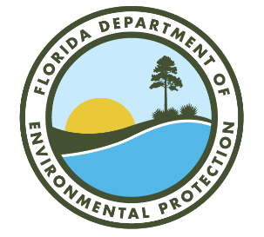

Springs Education Campaigns
Florida Department of Environmental Protection (DEP)

February 10, 2022 at 9:30 AM
Microsoft Teams link: Click here to join the meeting
For audio only call 469-305-1028, Phone Conference ID: 159 489 19#

Agenda

Welcome and Introductions (Tiffany Busby/Lauren Campbell)

DEP Basin Management Action Program (BMAP) Activities and Updates
- Statewide Annual Report (STAR) 2021 project collection
- BMAP review and updates

Presentations
- University of Florida-Institute of Food and Agricultural Sciences (UF-IFAS)- “Low Impact Development and Green Stormwater Infrastructure (LID+GSI) Tool and Resource Development” (Dr. Eban Bean)
  - Home - Florida GSI (floridadep.gov)
- DEP- “DEP Nonpoint Source (NPS) Management GSI Initiatives” (Nathan Jagoda)
  - NPS Publication Tool – Brought to you by the Florida Department of Environmental Protection (npspublications.com)

Discussion
- GSI/LID initiatives discussion

Update of Agency Activities
- Local government activities
- Agency activities

Wrap-Up and Next Steps
- Request for future meeting ideas
- Future meeting topic- “Three years later, where are we now?”

