Draft

5-Year Review for the
St. Lucie River and Estuary
Basin Management Action Plan

Division of Environmental Assessment and Restoration
Water Quality Restoration Program
Florida Department of Environmental Protection

with participation from the
St. Lucie River and Estuary Stakeholders

June 2018



2600 Blair Stone Rd.
Tallahassee, FL 32399
www.floridadep.gov

Acknowledgments
The St. Lucie River and Estuary Basin Management Action Plan, adopted in June 2013, was prepared as part of a statewide watershed management approach to restore and protect Florida's water quality. This 2018 5-Year Review for the St. Lucie River and Estuary Basin Management Action Plan was prepared in partial fulfilment of Paragraph 373.4595(4)(d), Florida Statutes. Both documents were prepared by the Florida Department of Environmental Protection with participation from the St. Lucie River and Estuary stakeholders identified below.



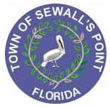


Hobe St. Lucie Conservancy District
Pal Mar Water Control District
Troup-Indiantown Water Control District
Copper Creek Community Development District
Tradition Community Development District
Verano Community Development District

For additional information on the watershed management approach in the St. Lucie River and Estuary Basin, contact:
Breanna Crowell
Florida Department of Environmental Protection
Watershed Restoration Program, Watershed Planning and Coordination Section
2600 Blair Stone Road, Mail Station 3565
Tallahassee, FL 32399-2400
Email: Breanna.Crowell@dep.state.fl.us
Phone: (850) 245–8521

Table of Contents

Acknowledgments 2
List of Acronyms and Abbreviations 9
Executive Summary 12
Chapter 1: Background Information 15
1.1 Water Quality Standards and Total Maximum Daily Loads (TMDLs) 15
1.1.1 St. Lucie River and Estuary TMDLs 15
1.2 St. Lucie River and Estuary Basin Management Action Plan (BMAP) 20
1.2.1 St. Lucie River and Estuary BMAP Pollutant Reduction and Discharge Allocations 20
Chapter 2: Assessing Progress 22
2.1 Projects to Achieve the TMDLs 22
2.2 Other Coordinating Agency Efforts 24
2.2.1 Agriculture/FDACS 24
2.2.2 SFWMD 24
2.3 Water Quality Monitoring and Evaluation 25
2.3.1 Ambient Water Quality Monitoring. 26
2.3.2 Biological Monitoring 27
2.3.3 Water Quality Evaluation 27
Chapter 3: Recommendations 38
3.1 Milestones 38
3.2 BMAP Boundary Change 40
3.2.1 Addition of South Coastal Subbasin 41
3.2.2 Fort Pierce Stormwater Master Plan and Boundary Revisions 41
3.3 BMAP Modeling 43
3.3.1 WaSh Modeling Revisions 43
3.3.2 Baseline Condition Scenario 43
3.3.3 WaSh Alternative Condition Scenarios 44
3.4 Revised Allocations 44
3.3.1 Methodology 44
3.3.2 Results 47
3.3.3 Entity Status Summary 49
3.5 Water Quality Monitoring Revisions 49
3.5.1 Recommended Revisions 49
3.5.2 New Recommended Tiered Monitoring Network 51
3.5.3 TMDL Compliance Methodology 51
Appendices 53
Appendix A: BMAP Projects 53
Appendix B: Future BMAP Projects 81
Appendix C: Agricultural Enrollment and Reductions 83
Appendix D: BMAP Monitoring Network and Recommended Revisions 92
Appendix E: St. Lucie Water Quality Data Processing and Analysis Methods 105
Appendix F: Revised Allocation Methodology 111
Appendix G: St. Lucie River Sub-Watershed Boundary Improvements Technical Memorandum 113

List of Figures
Figure ES-1. Estimated progress towards meeting the TN TMDL allocated to the St. Lucie River and Estuary Basin. Reductions are associated with projects completed through December 31, 2017. 13
Figure ES-2. Estimated progress towards meeting the TP TMDL allocated to the St. Lucie River and Estuary Basin. Reductions are associated with projects completed through December 31, 2017. 14
Figure 1. St. Lucie River and Estuary Basin 17
Figure 2. WBIDs with adopted TMDLs in the St. Lucie River and Estuary Basin 19
Figure 3. Trends stations used in the water quality evaluation for the St. Lucie 5-Year Review 28
Figure 4. Seasonal Kendall trend analysis results for TN concentrations 31
Figure 5. Seasonal Kendall trend analysis results for TP concentrations 33
Figure 6. Seasonal Kendall trend analysis results for TN loads 35
Figure 7. Seasonal Kendall trend analysis results for TP loads 37
Figure 8. Estimated progress towards the St. Lucie River and Estuary BMAP TN milestones 40
Figure 9. Estimated progress towards the St. Lucie River and Estuary BMAP TP milestones 40
Figure 10. Proposed St. Lucie River and Estuary BMAP boundary changes 42
Figure 11. Draft allocation areas associated with entities 46
Figure C-1. BMP enrollment in the St. Lucie Estuary as of December 31, 2017 87
Figure C-2. Enrolled acres used to estimate TN and TP reductions as of December 31, 2017 88
Figure D-1. Water quality monitoring network for the southern part of the St. Lucie River and Estuary 96
Figure D-2. Water quality monitoring network for the northern part of the St. Lucie River and Estuary 97
Figure D-3. Revised Tier 1 St. Lucie River and Estuary BMAP stations 102
Figure D-4. Revised Tier 2 and 3 St. Lucie River and Estuary BMAP stations 103

List of Tables
Table 1. Designated use attainment categories for Florida surface waters 15
Table 2. St. Lucie River and Estuary TMDLs 18
Table 3. Required load reductions by entity 21
Table 4. Projects submitted by year 22
Table 5. Projects to achieve the TMDL 23
Table 6. Reductions towards the TMDL 23
Table 7: Seasonal Kendall trend analysis results for TN concentrations 30
Table 8: Seasonal Kendall trend analysis results for TP concentrations 32
Table 9. Seasonal Kendall trend analysis results for TN FWMs 34
Table 10. Seasonal Kendall trend analysis results for TP FWMs 34
Table 11. Seasonal Kendall trend analysis results for TN loads 34
Table 12. Seasonal Kendall trend analysis results for TP loads 36
Table 13. Percent of total TN load per subbasin by entity 47
Table 14. Percent of total TP load per subbasin by entity 48
Table 15. Percent required reductions for TN and TP load per subbasin 49
Table 16. City of Port St. Lucie monitoring changes 50
Table A-1. City of Fort Pierce projects 54
Table A-2. City of Port St. Lucie projects 56
Table A-3. City of Stuart projects 59
Table A-4. FDOT District 4 projects 63
Table A-5. Hobe St. Lucie Conservancy District projects 68
Table A-6. Martin County projects 68
Table A-7. North St. Lucie River WCD projects 72
Table A-8. Pal Mar WCD projects 73
Table A-9. St. Lucie County MS4 projects 74
Table A-10. St. Lucie County Non-MS4 projects 75
Table A-11. Town of Sewall's Point projects 76
Table A-12. Troup-Indiantown WCD projects 79
Table A-13. Turnpike projects 80
Table B-1. Future BMAP projects for planning and funding purposes 82
Table C-1. Agricultural land use acreage (2013 adopted St. Lucie BMAP) 84
Table C-2. FDACS BMP enrollment as of December 31, 2017, by program and acreage 85
Table C-3. Enrolled acreage used to estimate TN and TP reductions as of December 31, 2017 86
Table C-4. Agricultural acreage in the St. Lucie Estuary Basin in 2012 89
Table C-5. BMP enrollment for the St. Lucie Estuary Basin as of December 31, 2017 90
Table D-1. BMAP monitoring network 92
Table D-2. Revised BMAP monitoring network 98
Table D-3. St. Lucie River and Estuary biological monitoring 104
Table E-1. POR for monthly nutrient data series 108
Table E-2. Complete Seasonal Kendall trend analysis results for TN concentrations 109
Table E-3. Complete Seasonal Kendall trend analysis results for TP concentrations 109
Table E-4. Salinity trends analysis at estuary stations 110

List of Acronyms and Abbreviations
µg/L Micrograms Per Liter
ACF Autocorrelation Function
ac-ft Acre-Feet
BMAP Basin Management Action Plan
BMP Best Management Practice
BOD Biochemical Oxygen Demand
CDD Community Development District
CDS Continuous Deflective Separation
CERP Comprehensive Everglades Restoration Program
cfs Cubic Feet Per Second
CIRL Central Indian River Lagoon
CR County Road
DEP Florida Department of Environmental Protection
DO Dissolved Oxygen
DWM Dispersed Water Management
EPA U.S. Environmental Protection Agency
F.A.C. Florida Administrative Code
FCT Florida Community Trust
FDACS Florida Department of Agriculture and Consumer Services
FDOT Florida Department of Transportation
FEMA Federal Emergency Management Agency
FIND Florida Inland Navigation District
FPL Florida Power and Light
F.S. Florida Statutes
FSAID Florida Statewide Agriculture Irrigation Demand (Database
FWC Florida Fish and Wildlife Conservation Commission
FWM Flow Weighted Mean
FWRA Florida Watershed Restoration Act
FY Fiscal Year
FYN Florida Yards and Neighborhoods (Program)
GIS Geographic Information System
LA Load Allocation
HOA Homeowner Association
HWTT Hybrid Wetland Treatment Technology
IA Implementation Assurance
IDS Integrated Delivery Schedule
IRL Indian River Lagoon
kg Kilogram
lbs/yr Pounds Per Year
LF Linear Feet
LID Low-Impact Development
MAPS Managed Aquatic Plant System
mg/L Milligrams Per Liter
MS4 Municipal Separate Storm Sewer System
N/A Not ApplicableNEEPP Northern Everglades and Estuaries Protection Program
NFSLR North Fork of the St. Lucie River
NOI Notice of Intent
NPDES National Pollutant Discharge Elimination System
NRCS Natural Resources Conservation Service
NSLRWCD North St. Lucie River Water Control District
O&M Operations and Maintenance
OAWP Office of Agricultural Water Policy
POR Period of Record
PSA Public Service Announcement
PUD Planned Unit Development
QA Quality Assurance
QC Quality Control
SFER South Florida Environmental Report
SFWMD South Florida Water Management District
SLC St. Lucie County
SLREW St. Lucie River and Estuary Watershed
SLRIT St. Lucie River Issues Team
SLRWCD St. Lucie River Water Control District
SLRWPP St. Lucie River Watershed Protection Plan
SLWSD St. Lucie West Services District
SR State Road
STA Stormwater Treatment Area
STORET STOrage and RETrieval (Database)
TBD To Be Determined
TIF Tax-Increment Financing
TIWCD Troup-Indiantown Water Control District
TKN Total Kjeldahl Nitrogen
TMDL Total Maximum Daily Load
TN Total Nitrogen
TOSP Town of Sewall's Point
TP Total Phosphorus
TSS Total Suspended Solids
USACE U.S. Army Corps of Engineers
USDA U.S. Department of Agriculture
USGS U.S. Geological Survey
WaSh Watershed Water Quality Simulation Model
WBID Waterbody Identification (Number)
WCD Water Control District
WCS Water Control Structure
WIN Watershed Information Network (Database)
WLA Wasteload Allocation
WPA Water Preserve Area
WWTF Wastewater Treatment Facility
WY Water Year
yr Year

Executive Summary
Background
The Florida Department of Environmental Protection (DEP) identified the St. Lucie River and Estuary as impaired by nutrients (chlorophyll a) in 2004. In March 2009, DEP adopted total maximum daily loads (TMDLs) for nitrogen and phosphorus in the St. Lucie Basin as targets for restoration of the river and estuary.
DEP adopted the St. Lucie River and Estuary Basin Management Action Plan (BMAP) in June 2013 to implement the total nitrogen (TN) and total phosphorus (TP) TMDLs in the watershed. The BMAP is implemented in a phased approach to allow for adaptive management. At the end of each 5-year phase, a review is completed. This first 5-Year Review was prepared to update the status of implementation at the end of the first phase and provide recommendations for future phases of the BMAP.
Summary of Load Reductions
Management actions including projects, programs, and activities were required by the original BMAP to address nutrient loads and had to meet several criteria to be considered eligible for credit. Through December 31, 2017, 221 projects have been completed and an additional 26 underway or planned projects have been added to the BMAP. The activities completed to date, including those finished and credited since 2000, are estimated to achieve total reductions of 535,197 pounds per year (lbs/yr) of TN and 141,477 lbs/yr of TP, or 51 % and 35 %, respectively, of the reductions needed to meet the TMDL. Figure ES-1 shows progress towards the TN TMDL load reductions, and Figure ES-2 shows progress towards the TP TMDL load reductions.
Water Quality and Biological Monitoring
The existing St. Lucie River and Estuary BMAP monitoring network consists of 44 stations monitored by local entities, 4 stations monitored by the U.S. Geological Survey (USGS), and 46 stations monitored by the South Florida Water Management District (SFWMD). The SFWMD monitors water quality (TN and TP) data at Roosevelt Bridge (Station SE 03), which is the compliance point for the TMDL. The stations where this monitoring occurs are not specifically BMAP stations—i.e., they are designed for other purposes—but some of the data collected at these sites are used to monitor the effectiveness of the BMAP projects. As part of the 5-Year Review, a water quality evaluation was completed using data available as of December 31, 2017. Trend analyses were conducted to track changes at freshwater structures and estuarine stations in the watershed.
In addition to water quality monitoring, the SFWMD conducts biological sampling for oysters and seagrass to assess the overall health of the St. Lucie River and Estuary.
Recommendations for Future Implementation
The BMAP implements phased TN and TP reductions, according to Subparagraph 403.067(7)(a)1., Florida Statutes (F.S.), for the portion of loading generated in the St. Lucie River and Estuary Watershed. The purpose of this 5-Year Review is to evaluate implementation activities that have taken place during the first 5-year phase and make recommendations for future implementation activities that may be incorporated into a revised BMAP.
This first phase included significant restoration efforts by stakeholders, and the implementation process will continue in order to help achieve the TMDL. This 5-Year Review recommends implementation milestones as required in Subparagraph 403.067(7)(a)6., F.S., and describes progress towards the first 5-year milestone. The milestones are established in 5-year increments in collaboration with stakeholders through the submission of project information, and with the goal of achieving the TMDL in 20 years (Paragraph 373.4595[4][d], F.S). DEP will adopt the implementation schedule into a revised BMAP and will continue to review the implementation status every 5 years to determine whether progress is being made towards these milestones.
DEP has refined the water quality model and recommends a revision of the assigned allocations to reflect the updated results. Additionally, the expansion of the model extent allows for the refinement of the BMAP boundary, with the inclusion of the South Coastal Subbasin and other areas found to drain to the St. Lucie Estuary.
Finally, DEP and participating stakeholders are recommending revising the BMAP monitoring network to help prioritize monitoring resources, to improve the way progress is tracked, and to reorganize the network into a tiered system.
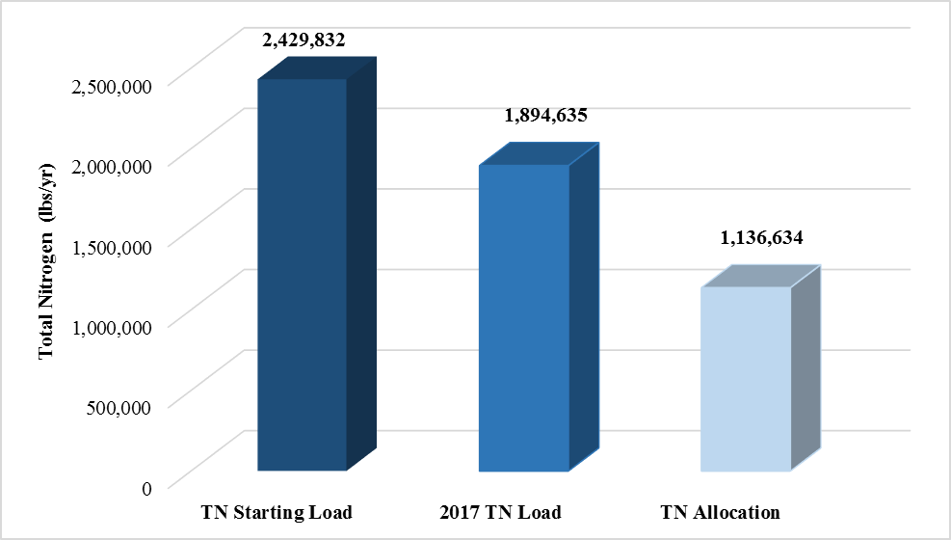
Figure ES-1. Estimated progress towards meeting the TN TMDL allocated to the St. Lucie River and Estuary Basin. Reductions are associated with projects completed through December 31, 2017.
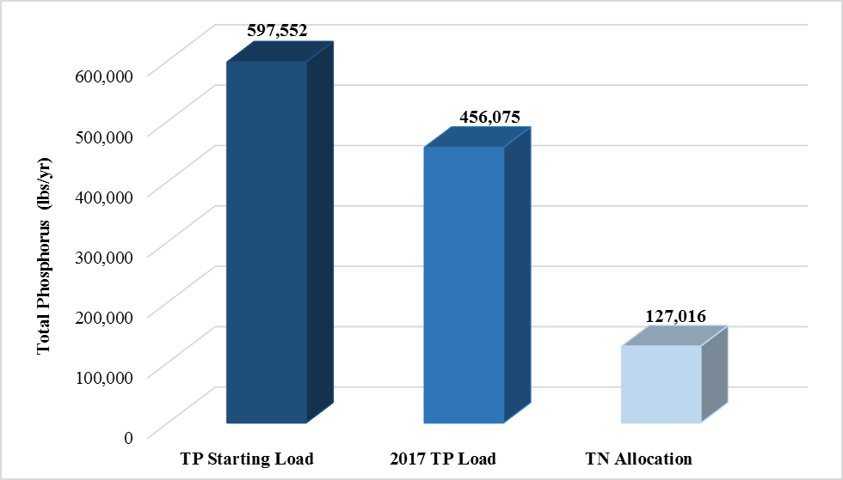
Figure ES-2. Estimated progress towards meeting the TP TMDL allocated to the St. Lucie River and Estuary Basin. Reductions are associated with projects completed through December 31, 2017.

Chapter 1: Background Information

Water Quality Standards and Total Maximum Daily Loads (TMDLs)
Florida's water quality standards are designed to ensure that surface waters fully support their designated uses, such as drinking water, aquatic life, recreation, and agriculture. Currently, most surface waters in Florida, including those in the St. Lucie River and Estuary, are categorized as Class III waters, meaning they must be suitable for recreation and must support fish consumption and the propagation and maintenance of a healthy, well-balanced population of fish and wildlife. Table 1 lists all designated use classifications for Florida surface waters.
Table 1. Designated use attainment categories for Florida surface waters
¹ Class I, I-Treated, and II waters additionally include all Class III uses.
² The Class I-Treated classification was approved by the Environmental Regulation Commission on July 26, 2016. However, the classification has not yet been approved by the U.S. Environmental Protection Agency (EPA) and is therefore not currently in effect for Clean Water Act purposes.
Classification | Description
Class I¹ | Potable water supplies
Class I-Treated^{1,2} | Treated potable water supplies
Class II¹ | Shellfish propagation or harvesting
Class III | Fish consumption; recreation, propagation and maintenance of a healthy,  well-balanced population of fish and wildlife
Class III-Limited | Fish consumption, recreation or limited recreation, and/or propagation and maintenance of a limited population of fish and wildlife
Class IV | Agricultural water supplies
Class V | Navigation, utility, and industrial use (no current Class V designations)

Section 303(d) of the federal Clean Water Act requires that every two years each state must identify its "impaired" waters, including estuaries, lakes, rivers, and streams, that do not meet their designated uses. Florida Department of Environmental Protection (DEP) staff in the Division of Environmental Assessment and Restoration are responsible for assessing Florida's waters for inclusion on the Verified List of Impaired Waters and Study List, which is then provided to the EPA as an annual update to the state "303(d) list." In 2004, DEP identified the St. Lucie River and Estuary as impaired for dissolved oxygen (DO) and nutrients.

St. Lucie River and Estuary TMDLs
DEP develops and adopts TMDLs for the waterbody segments it identifies as impaired. A TMDL is the maximum amount of a specific pollutant that a waterbody can assimilate while maintaining its designated uses. In March 2009, DEP adopted the St. Lucie River and Estuary TMDLs for total nitrogen (TN) and total phosphorus (TP), which are linked to high chlorophyll a concentrations in portions of the St. Lucie River and Estuary. The TMDLs include segments with waterbody identification (WBID) numbers 3193 (St. Lucie Estuary), 3194 (North Fork St. Lucie River), 3194B (North Fork St. Lucie Estuary), 3197 (C-24 Canal), 3200 (C-23 Canal), 3210 (South Fork St. Lucie Estuary), 3210A (South Fork St. Lucie River), 3211 (Bessey Creek), and 3218 (C-44 Canal).
TMDLs must establish reasonable and equitable allocations that will alone, or in conjunction with other management and restoration activities, attain the TMDLs. Allocations may be to individual sources, source categories, or basins that discharge to the impaired waterbody. The allocations identify either the amount of pollutant discharge (such as pounds per year [lbs/yr]) or the percent of its loading the source designation must reduce (reduction allocation). The TMDL allocation categories are as follows:
- Wasteload Allocation (WLA) is the allocation to point sources permitted through the National Pollutant Discharge Elimination System (NPDES) Program, including the following:
- Wastewater Allocation is the allocation to industrial and domestic wastewater facilities.
- NPDES Stormwater Allocation is the allocation to NPDES stormwater permittees that operate municipal separate storm sewer systems (MS4s). These permittees are treated as point sources under the TMDL Program.
- Load Allocation (LA) is the allocation to nonpoint sources, including agricultural sources and stormwater from areas not included in an MS4 permit.
The 15 permitted NPDES wastewater facilities in the St. Lucie River and Estuary Basin discharge only during a 25-year, 72-hour storm event, and therefore constitute a minimal and highly irregular impact on nutrient discharges. Facilities with permitted discharges above this level are cooling or dewatering processes that effectively discharge ambient water. Since the TMDLs are based on ambient conditions in the watershed, the infrequent discharge from these facilities was not assigned a wasteload allocation. If conditions change in the future, an allocation may be assigned.
During the development of the St. Lucie River and Estuary (Figure 1) BMAP, various stakeholders in the basin raised questions about the BMAP model and required reductions. DEP agreed to refine the BMAP model during this first 5-year iteration. Therefore, DEP requested that the stakeholders provide information on activities and projects that would reduce a portion of the nutrient loading identified in the model. In this first BMAP phase, the activities identified were not expected to fully achieve the TMDLs. Rather, the BMAP called for projects and activities necessary to achieve 30 % of the TMDL-required reductions by the end of the first 5-year phase. After the first phase of BMAP implementation, DEP and the stakeholders agreed to evaluate progress and adjust using adaptive management, as needed, to meet the remainder of the reductions to achieve the TMDLs.

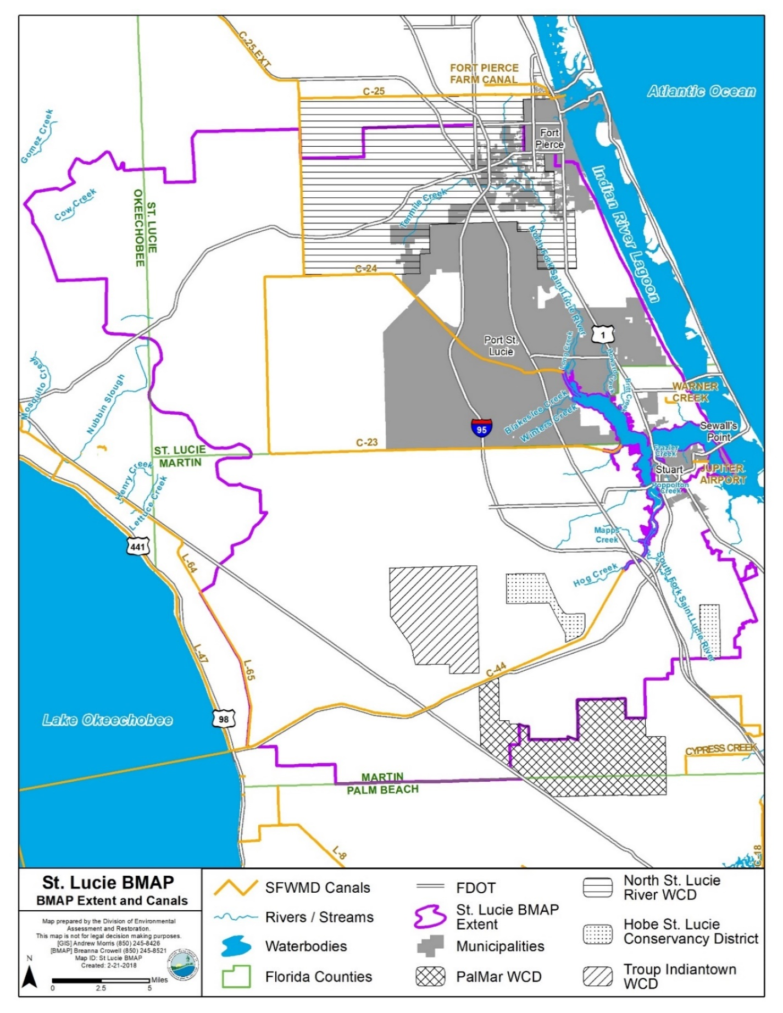
Figure 1. St. Lucie River and Estuary Basin

Table 2 lists the TMDLs and pollutant load allocations implemented by rule (Rule 62-304.705, Florida Administrative Code [F.A.C.], effective March 26, 2009) for the St. Lucie River and Estuary Basin (based on updates to the watershed loading effective May 14, 2012). TMDL loads in upstream WBIDs were calculated based on achieving the same target concentrations (0.72 milligrams per liter [mg/L] for TN and 0.081 mg/L for TP) as in the St. Lucie Estuary. The TMDLs were used as the basis for the BMAP targets and allocation calculations. Figure 2 shows the locations of the WBIDs with TMDLs.
Table 2. St. Lucie River and Estuary TMDLs
BOD = Biochemical oxygen demand.
WBID | Waterbody | Parameter | Annual TMDL Target | NPDES  Stormwater  (% Reduction) | Load  Allocation  (% Reduction)
3193 | St. Lucie Estuary | TN | 0.720 mg/L | 21.4 | 21.4
3193 | St. Lucie Estuary | TP | 0.081 mg/L | 41.3 | 41.3
3194 | North Fork | TN | 140,134 lbs | 25.0 | 25.0
3194 | North Fork | TP | 15,765 lbs | 42.2 | 42.2
3194 | North Fork | BOD | 2.0 mg/L | 74.0 | 74.0
3194B | North Fork | TN | 103,747 lbs | 28.8 | 28.8
3194B | North Fork | TP | 11,672 lbs | 58.1 | 58.1
3197 | C-24 Canal | TN | 348,957 lbs | 51.8 | 51.8
3197 | C-24 Canal | TP | 39,258 lbs | 72.2 | 72.2
3197 | C-24 Canal | BOD | 2.0 mg/L | 33.3 | 33.3
3200 | C-23 Canal | TN | 242,202 lbs | 51.7 | 51.7
3200 | C-23 Canal | TP | 27,248 lbs | 78.6 | 78.6
3210 | South Fork | TN | 24,463 lbs | 38.4 | 38.4
3210 | South Fork | TP | 2,752 lbs | 57.2 | 57.2
3210A | South Fork | TN | 90,471 lbs | 47.1 | 47.1
3210A | South Fork | TP | 10,178 lbs | 61.8 | 61.8
3211 | Bessey Creek | TN | 29,981 lbs | 23.9 | 23.9
3211 | Bessey Creek | TP | 3,373 lbs | 51.2 | 51.2
3218 | C-44 Canal | TN | 242,929 lbs | 51.2 | 51.2
3218 | C-44 Canal | TP | 27,330 lbs | 55.0 | 55.0
3218 | C-44 Canal | BOD | 2.0 mg/L | 69.7 | 69.7

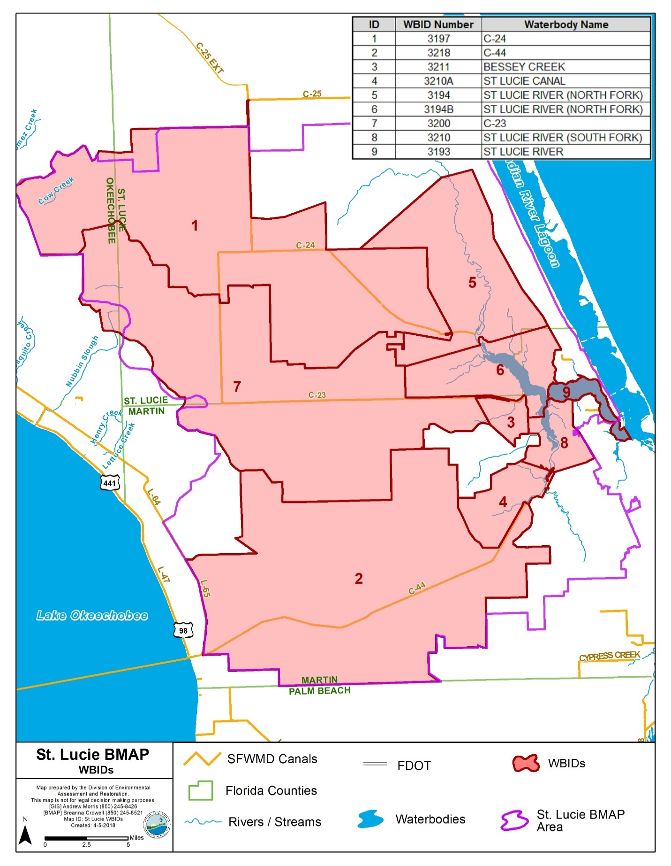
Figure 2. WBIDs with adopted TMDLs in the St. Lucie River and Estuary Basin

St. Lucie River and Estuary Basin Management Action Plan (BMAP)
DEP implements TMDLs through permits and BMAPs, the latter of which contain strategies to reduce and prevent pollutant discharges through various cost-effective means. During the TMDL process, DEP and the affected stakeholders jointly develop BMAPs or other implementation approaches. Stakeholder involvement is critical to the success of the TMDL Program and varies with each phase of implementation to achieve different purposes. The BMAP development process is structured to achieve cooperation and consensus among a broad range of interested parties, including: the South Florida Water Management District (SFWMD), the Florida Department of Agriculture and Consumer Services (FDACS), and stakeholders representing other agencies, governments, and interested parties.

St. Lucie River and Estuary BMAP Pollutant Reduction and Discharge Allocations
Under Section 403.067, F.S. (the Florida Watershed Restoration Act, or FWRA), the TMDL allocation adopted by rule may be an "initial" allocation among point and nonpoint sources. In such cases, the "detailed" allocation to specific point sources and specific categories of nonpoint sources must be established in the BMAP. Both initial and detailed allocations must be determined based on several factors listed in the FWRA, including cost-benefit, technical and environmental feasibility, implementation time frames, and others. The TMDL analysis did not include detailed allocations for the wastewater treatment facilities (WWTFs) in the basin. Therefore, the BMAP only assigned detailed allocations for the nonpoint sources in the St. Lucie River and Estuary Basin.
During the initial stages of BMAP development, DEP worked with the stakeholders to disaggregate the total TN and TP load by entity. The acreage and loading information for each stakeholder were calculated using output from the WaSh model. Geographic information system (GIS) coverage was then used to help determine detailed allocations (i.e., portion of the total loads). The load reduction was allocated based on a stakeholder's percentage of the developed load. More information on detailed allocations is available in the 2013 BMAP. Table 3 lists the allocation of the load reductions for entities in the St. Lucie River and Estuary BMAP area.
The management actions and adaptive management approach described in the BMAP will address TN and TP reductions until the TMDLs are attained. The phased BMAP approach allows for the implementation of projects over multiple years designed to achieve incremental reductions, while simultaneously monitoring and conducting studies to better understand the water quality dynamics (sources and response variables) in the watershed.

Table 3. Required load reductions by entity
Entity | TN Starting Load  (lbs/yr) | Total TN Required Reduction  (lbs/yr) | TP Starting Load  (lbs/yr) | Total TP  Required Reduction  (lbs/yr)
Agriculture | 1,563,122 | 812,924 | 390,312 | 307,059
FDOT District 4 | 12,514 | 5,106 | 2,542 | 1,709
Fort Pierce MS4 | 17,041 | 6,479 | 3,879 | 2,693
Hobe St. Lucie Conservancy District | 24,193 | 9,462 | 5,252 | 3,520
Martin County MS4 | 100,813 | 32,158 | 22,369 | 14,590
North St. Lucie River Water Control District (NSLRWCD) | 197,403 | 87,846 | 45,884 | 33,634
Port St. Lucie MS4 | 156,481 | 53,101 | 35,016 | 23,431
St. Lucie County MS4 | 18,114 | 6,728 | 4,127 | 2,849
St. Lucie County Non-MS4 | 23,760 | 9,756 | 6,072 | 4,500
Stuart MS4 | 13,998 | 3,106 | 3,106 | 2,062
Troup-Indiantown WCD | 62,219 | 25,094 | 2,542 | 8,119
Entities without required reductions | 23,993 | 0 | 5,272 | 0
Totals | 2,429,832 | 1,053,414 | 597,552 | 404,166

Some entities were not given a reduction responsibility because of their relatively low contribution to the overall load, but this does not prevent these entities from having reduction requirements in future BMAPs. Any actions taken by these entities during the first BMAP iteration that has resulted in TN and/or TP reductions can be used by those entities for credit against any reduction requirements allocated in subsequent BMAP iterations.
Additional details about the sources, modeling development process, and implementation assumptions and considerations are provided in the 2009 TMDL report and 2013 BMAP.

Chapter 2: Assessing Progress
  - Projects to Achieve the TMDLs
DEP annually reviews each entity's progress towards completing projects listed in the BMAP and achieving the assigned allocations based on the details described in the current TMDLs and BMAP. These details may be refined as part of the modeling that is currently being updated. Table 4 depicts the annual project totals by entity as of December 31, 2017. Table 5 outlines the number of projects that each entity has committed to in the BMAP and annual progress reports, along with the status of those projects as of December 31, 2017. Table 6 summarizes the allocations and reductions achieved by each entity in the BMAP as of December 31, 2017.
Table 4. Projects submitted by year
* The Florida Department of Agriculture and Consumer Services (FDACS) projects are the Best Management Practice (BMP) Enrollment Program, and agricultural land use changes between the 2004 SFWMD land use coverage and land use at the time of BMAP adoption. FDACS submits enrollment updates to DEP annually. FDACS identified these differences using aerial imagery and local field staff knowledge; they include acres that are fallow or out of production, or that were converted to urban/nonagricultural use in the basin.
FDOT = Florida Department of Transportation.
Lead Entity | 2013 | 2014 | 2015 | 2016 | 2017 | Total Projects
Agriculture/FDACS* | 2 | * | * | * | * | 2
City of Fort Pierce | 6 | 0 | 0 | 5 | 2 | 13
City of Port St. Lucie | 26 | 4 | 0 | 3 | 0 | 33
City of Stuart | 15 | 5 | 0 | 3 | 1 | 24
FDOT | 40 | 4 | 1 | 12 | 2 | 59
Hobe St. Lucie Conservancy District | 3 | 0 | 0 | 0 | 0 | 3
Martin County | 28 | 2 | 4 | 4 | 4 | 42
North St. Lucie River WCD | 8 | 0 | 0 | 0 | 4 | 12
Pal Mar WCD | 1 | 0 | 0 | 0 | 0 | 1
St. Lucie County MS4 | 8 | 0 | 1 | 0 | 0 | 9
St. Lucie County Non-MS4 | 6 | 0 | 1 | 1 | 0 | 8
Town of Sewall's Point | 29 | 1 | 1 | 1 | 0 | 32
Troup-Indiantown WCD | 2 | 0 | 0 | 0 | 3 | 5
Turnpike Authority | 3 | 0 | 0 | 0 | 2 | 5
Total | 177 | 16 | 8 | 29 | 18 | 248

Table 5. Projects to achieve the TMDL
* The FDACS projects are the BMP Enrollment Program and agricultural land use changes accounted for in the original adopted BMAP.
Entity | Total Projects | Completed | Underway | Planned | Cancelled
Agriculture/FDACS* | 2 | 2 | 0 | 0 | 0
City of Fort Pierce | 13 | 13 | 0 | 0 | 0
City of Port St. Lucie | 33 | 30 | 2 | 0 | 1
City of Stuart | 24 | 22 | 2 | 0 | 0
FDOT | 59 | 48 | 11 | 0 | 0
Hobe St. Lucie Conservancy District | 3 | 3 | 0 | 0 | 0
Martin County | 42 | 38 | 2 | 2 | 0
North St. Lucie River WCD | 12 | 12 | 0 | 0 | 0
Pal Mar WCD | 1 | 1 | 0 | 0 | 0
St. Lucie County MS4 | 9 | 9 | 0 | 0 | 0
St. Lucie County Non-MS4 | 8 | 6 | 2 | 0 | 0
Town of Sewall's Point | 32 | 29 | 2 | 1 | 0
Troup-Indiantown WCD | 5 | 3 | 2 | 0 | 0
Turnpike Authority | 5 | 5 | 0 | 0 | 0
Total | 248 | 221 | 23 | 3 | 1

Table 6. Reductions towards the TMDL
* Reductions to date include TN and TP reductions associated with projects completed as of the end of the reporting period (December 31, 2017).
** The entity was not given a reduction responsibility in the first phase of the BMAP due to their relatively low contribution to the overall load.
Entity | TN Reduction to Date*  (lbs/yr) | % of Total TN Reduction Achieved | TP Reduction to Date*  (lbs/yr) | % of Total TP Reduction Achieved
Agriculture/FDACS | 305,569 | 38 | 85,102 | 28
City of Fort Pierce | 2,300 | 36 | 1,384 | 51
City of Port St. Lucie | 60,180 | 113 | 9,329 | 40
City of Stuart | 6,735 | 141 | 2,038 | 99
FDOT District 4 | 2,113 | 41 | 1,093 | 64
Florida Turnpike** | 167 |  | 13
Hobe St. Lucie Conservancy District | 10,288 | 109 | 3,302 | 94
Martin County | 42,768 | 133 | 8,351 | 57
North St. Lucie River WCD | 69,366 | 79 | 19,134 | 57
Pal Mar WCD** | 926 |  | 92
St. Lucie County MS4 | 5,277 | 78 | 2,032 | 71
St. Lucie County Non-MS4 | 4,175 | 43 | 1,484 | 33
Town of Sewall's Point** | 277 |  | 179
Troup-Indiantown WCD | 25,055 | 100 | 7,943 | 98
Total | 535,197 | 51 | 141,477 | 35

  - Other Coordinating Agency Efforts
FDACS and the SFWMD have coordinated efforts with DEP to focus on achieving the TMDLs and maintaining compliance with state water quality standards. Those efforts are briefly summarized below.

Agriculture/FDACS
Beyond enrolling producers in the FDACS BMP Program and verifying implementation, FDACS is working with DEP to improve the data used to estimate agricultural land uses in the watershed. FDACS is also working with producers to identify and implement a suite of agricultural projects and research agricultural technologies on properties where they are deemed technically feasible and where funding can be made available. The implementation of these projects would require funding as well as more detailed design based on site-specific information, such as applicable acreages and willing landowners.
As of December 31, 2017, FDACS Office of Agricultural Water Policy (OAWP) provided $1.1 million in cost-share assistance for nutrient management, irrigation management, and water resource protection projects. Appendix D contains more detailed information on agricultural enrollment, nutrient reductions, and activities in the basin.

SFWMD
State-appropriated funds coupled with SFWMD resources were used to advance numerous restoration activities in the St. Lucie River and Estuary Watershed (SLREW) during the BMAP reporting period. Highlights of advancements made in key SFWMD-involved projects in the basin during the BMAP reporting period (through December 31, 2017) are summarized below. While these regional projects provide both water storage and water quality benefits, they have not been included in the estimates of TN and TP reductions for this BMAP.
Comprehensive Everglades Restoration Program (CERP) Indian River Lagoon-South (IRL-S) Project
The CERP IRL-S authorized plan includes a variety of storage features (reservoirs, stormwater treatment areas [STAs], and natural land restoration) intended to capture water from the primary basins (C-23, C-24, C-25, and C-44) that discharge to the St. Lucie River and southern IRL. Additional diversion features and the removal of muck from the estuary are also included. Together, these features will improve the quantity, quality, timing, and distribution of flows to the river and estuary, as follows:
- C-44 Reservoir and STA. The construction of the C-44 STA and inflow pump station continued, with completion expected in late 2018. The U.S. Army Corps of Engineers (USACE) is continuing the construction of the reservoir, currently scheduled for completion in 2020. An interim pumping facility will be constructed to inflow water into the STA cells, thus allowing vegetation to grow ahead of the completion of the reservoir component of the project. Additionally, the SFWMD has completed the construction of the communications tower and the system discharge canal and spillway associated with the C-44 project, and the USACE has completed the construction of the project Intake Canal (C-400) and external drainage canals (C-133 and C-133N).
- C-23/24 North and South Reservoirs and STA. To date, 86 % of the land required for the construction of the C-23/24 components of the IRL-S plan has been acquired. The USACE has initiated preliminary design activities for the C-23/24 North Reservoir. Consistent with the USACE Integrated Delivery Schedule (IDS), the design of the South Reservoir will commence in 2020, while the design of the STA is scheduled to start in 2026. Design efforts are expected to be completed after 4 years, with the construction of the first component (North Reservoir) to begin in 2022.
- Allapattah Complex Natural Storage and Water Quality Area. The portion of the Allapattah Complex located immediately north of the C-44 Reservoir and STA, is being restored by the SFWMD, in cooperation with the U.S. Department of Agriculture (USDA) Natural Resources Conservation Service (NRCS). The restoration of this area will provide additional freshwater storage, contribute to water quality improvements, increase natural wetlands and upland habitat for wildlife, and recharge the surficial aquifer. Restoration construction activities were initiated with the onset of the 2016–17 dry season and are planned to continue in 2018.
Ten Mile Creek Project
The purpose of the Ten Mile Creek Water Preserve Area (WPA) Critical Project is to improve the quantity and timing of water deliveries to the North Fork of the St. Lucie River (NFSLR) by capturing and storing stormwater originating in the Ten Mile Creek Subbasin. Additional benefits to the St. Lucie River and Estuary should result because of the reductions in sediment load, concentration of suspended solids, and nutrients. The Ten Mile Creek WPA consists of a 2-stage detention system, including a 526-acre reservoir, a 132-acre polishing cell, and an intake pump station (S-382).
During the BMAP reporting period, the design of a remediation project to allow the reservoir to hold up to four feet of water was completed. A construction contract for the remediation project was awarded in July 2016. Substantial completion of that contract was achieved in June 2017, and both the reservoir and STA were put into operation during the 2017 wet season (mid-May through mid-October).
  - Water Quality Monitoring and Evaluation
The St. Lucie River and Estuary BMAP monitoring plan was designed to enhance the understanding of basin loads, identify areas with high nutrient concentrations, and track water quality trends. The information gathered through the monitoring plan measures progress toward achieving the TMDLs and provides a better understanding of watershed loading. The BMAP monitoring plan consists of ambient water quality sampling and biological monitoring.

2.3.1 Ambient Water Quality Monitoring.
Focused objectives are critical for a monitoring strategy to provide the information needed to evaluate implementation success. The primary objective of the monitoring strategy for the St. Lucie River and Estuary, described below, is to evaluate the success of the BMAP, help interpret the data collected, and provide information for potential future refinements of the BMAP.
All BMAP data providers have agreed to upload ambient water quality data at least once every six months upon completion of the appropriate quality assurance/quality control (QA/QC) checks. The STOrage and RETrieval (STORET) Database served as the primary repository of ambient water quality data for the state until DEP transitioned to the Watershed Information Network (WIN) in 2017. Data providers have begun uploading data to WIN instead of STORET.
Primary Objective
- Track trends in TN and TP loads in the major canals and tributaries, as well as the St. Lucie River and Estuary.
To achieve the objective above, the monitoring strategy focuses on the following suggested parameters:
- TP.
- Orthophosphate as P.
- Nitrate/nitrite as N.
- N, ammonia.
- Total Kjeldahl nitrogen (TKN).
- DO.
- BOD.
- Chlorophyll a.
- pH.
- Temperature.
- Specific conductance.
- Total suspended solids (TSS).
- Turbidity.
- Alkalinity.
During the first phase of BMAP implementation, the SFWMD continued monitoring at 46 stations in the BMAP area, and the monitoring data for the reporting period were uploaded to WIN in June 2017 (this monitoring and associated data results are described in the 2017 South Florida Environmental Report [SFER] – Volume I, Chapter 8C, available on the SFWMD website). Appendix D lists the stations in the BMAP monitoring network for reference.

2.3.2 Biological Monitoring
Biological sampling for oysters and seagrass is routinely conducted in the St. Lucie River and Estuary (see Table D-3). The stations are not specifically BMAP stations—i.e., they are designed for other purposes—but the data collected at these sites are submitted to DEP and may be used to monitor the effectiveness of the BMAP.

2.3.3 Water Quality Evaluation
A water quality evaluation was completed to assist in tracking progress in the St. Lucie Estuary and tributaries. Monitoring stations were evaluated for data availability and sampling frequency. Only stations with the best data availability and sampling frequencies were used in the analyses (Figure 3). The remaining stations may be used in future analyses, provided more data become available and they can meet the data quality requirements. The majority of nitrogen and phosphorus data for this analysis was retrieved from STORET, and the most recent data were downloaded from WIN.
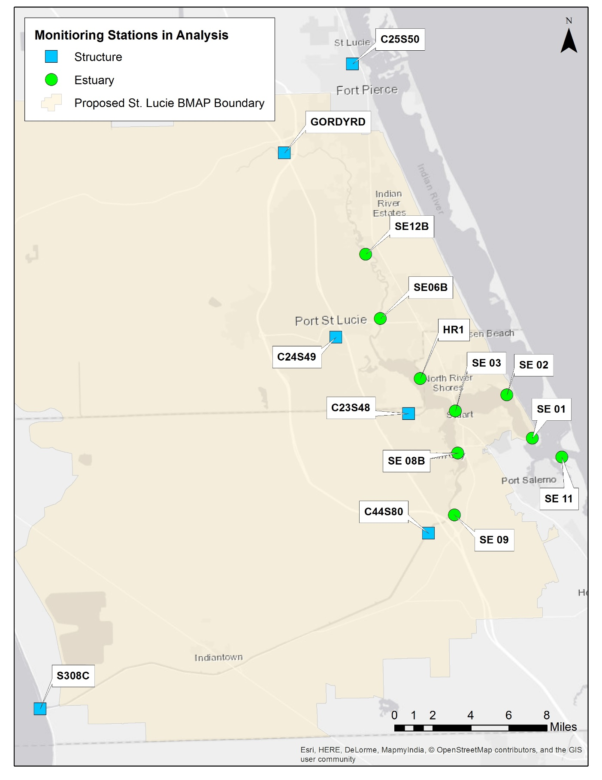
Figure 3. Trends stations used in the water quality evaluation for the St. Lucie 5-Year Review
The period of record (POR) for this analysis was May 1, 2007, to April 30, 2017 (Water Year [WY] 2008 to WY 2017) to ensure a sufficient data period for trend analysis and also include a period prior to the BMAP that could be used to track progress in the implementation of a number of load reduction projects. Evaluating data based on water year is a standard practice among other coordinating agencies in the basin and allows for consistent reporting and evaluation.
To track possible changes in nutrient concentrations in the St. Lucie Estuary, trend analyses were conducted on the individual stations within the estuary and at SFWMD-managed structures. In addition, nutrient flow-weighted mean (FWM) and load data provided by the SFWMD were also assessed for trends at the structure stations, since the estuarine stations do not have the flow and/or volume data necessary to calculate FWMs and loads. The results of the trend analyses are summarized below, and Appendix E provides details of the methods used to retrieve, process, and perform the analysis.
Seasonal Kendall Trend Results
The nonparametric Seasonal Kendall test was used to identify monotonic trends in the nutrient data for each station. Tables 7 and 8 summarize the results for the Seasonal Kendall trend analysis for TN and TP concentrations, respectively. The effects of seasonal patterns and serial correlation in the data series were taken into account in the analysis to avoid false positive or false negative indications of trend significance. It should also be noted that while the trends may be statistically significant, they may not be ecologically significant, which would pertain to ecological response variables (i.e. chlorophyll a, algal community composition, etc.). A trend slope near 0 likely will not show a measurable effect within a reasonable time frame (i.e., years to decades).
Out of the nine estuarine stations, three stations (HR1, SE06, and SE12) showed statistically significant decreasing trends for TN concentration, two stations (SE06 and SE12) showed statistically significant decreasing trends for TP concentration, and one station (SE11) showed a statistically significant increasing trend for TP concentration (Figures 4 and 5). None of the six structure stations showed statistically significant trends for TN or TP concentrations; this corroborated with the FWM results, which showed no statistically significant trends for TN or TP FWMs (Tables 9 and 10). However, differences in trend results across the type of unit measured (concentration vs. FWM vs. load) were found when evaluating nutrient loads for structure stations. None of the stations showed statistically significant trends for TN load (Table 11; Figure 6). However, the station at the inflow structure from Lake Okeechobee to the St. Lucie Watershed (S308C) showed a statistically significant increasing trend for TP load (Table 12; Figure 7).

Table 7: Seasonal Kendall trend analysis results for TN concentrations
Note: P-values listed in bold indicate statistical significance (p<0.05).
TN measured in mg/L.
¹ Even if the p-value is determined to be statistically significant, the result may not be ecologically significant. For example, if a trend is statistically significantly declining (negative trend) but the slope is near 0, then it may not be realistic to assume that an improvement in water quality by reductions in TN or TP may positively impact the ecological system in a measurable way.
² Series with serial correlation (per autocorrelation analysis results) used the P-value adjusted for serial correlation.
³ If the p-value is less than 0.05, then a decreasing trend may suggest an improvement in water quality, and an increasing trend may suggest a decline in water quality.
* Stations SE 06 and SE 12 include data from SE06B and SE12B, respectively.
Station | Station Type | Tau | Slope¹ | Selected  P-Value² | Statistical Trend Interpretation³
C23S48 | Structure | -0.017 | -0.00133 | 0.913 | No significant trend
C24S49 | Structure | -0.125 | -0.00825 | 0.260 | No significant trend
C25S50 | Structure | 0.024 | 0.00175 | 0.852 | No significant trend
C44S80 | Structure | -0.061 | -0.00567 | 0.616 | No significant trend
GORDYRD | Structure | -0.141 | -0.01486 | 0.279 | No significant trend
S308C | Structure | -0.209 | -0.03583 | 0.114 | No significant trend
HR1 | Estuary | -0.165 | -0.01229 | 0.043 | Significant decreasing trend
SE 01 | Estuary | 0.046 | 0.00392 | 0.658 | No significant trend
SE 02 | Estuary | -0.014 | -0.00088 | 0.899 | No significant trend
SE 03 | Estuary | -0.161 | -0.01232 | 0.089 | No significant trend
SE 08B | Estuary | -0.050 | -0.00525 | 0.578 | No significant trend
SE 09 | Estuary | -0.088 | -0.00735 | 0.273 | No significant trend
SE 11 | Estuary | 0.162 | 0.00917 | 0.170 | No significant trend
*SE 06 | Estuary | -0.226 | -0.01667 | 0.017 | Significant decreasing trend
*SE 12 | Estuary | -0.298 | -0.02375 | 0.021 | Significant decreasing trend

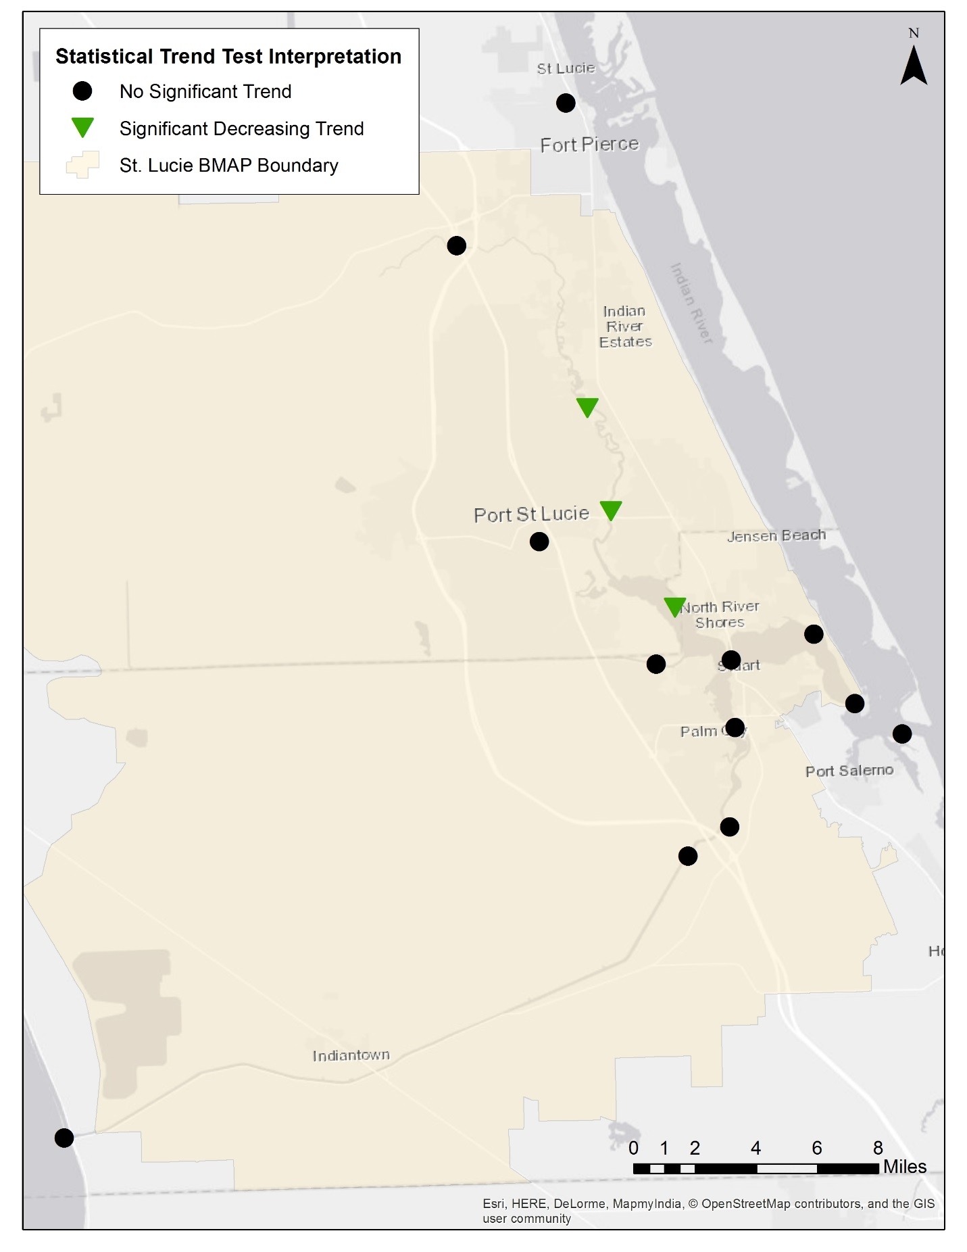
Figure 4. Seasonal Kendall trend analysis results for TN concentrations

Table 8: Seasonal Kendall trend analysis results for TP concentrations
Note: P-values listed in bold indicate statistical significance (p<0.05).
TP measured in mg/L.
¹ Even if the p-value is determined to be statistically significant, the result may not be ecologically significant. For example, if a trend is statistically significantly declining (negative trend) but the slope is near 0, then it may not be realistic to assume that an improvement in water quality by reductions in TN or TP may positively impact the ecological system in a measurable way.
² Series with serial correlation (as per autocorrelation analysis results) used the P-value adjusted for serial correlation.
³ If the p-value is less than 0.05, then a decreasing trend may suggest an improvement in water quality, and an increasing trend may suggest a decline in water quality.
* Stations SE 06 and SE 12 include data from SE06B and SE12B, respectively.
Station | Station Type | Tau | Slope¹ | Selected  P-Value² | Statistical Trend Interpretation³
C23S48 | Structure | 0.068 | 0.00200 | 0.571 | No significant trend
C24S49 | Structure | 0.083 | 0.00260 | 0.467 | No significant trend
C25S50 | Structure | -0.018 | -0.00040 | 0.897 | No significant trend
C44S80 | Structure | -0.050 | -0.00092 | 0.672 | No significant trend
GORDYRD | Structure | -0.066 | -0.00200 | 0.601 | No significant trend
S308C | Structure | -0.105 | -0.00367 | 0.151 | No significant trend
HR1 | Estuary | -0.154 | -0.00214 | 0.194 | No significant trend
SE 01 | Estuary | 0.101 | 0.00150 | 0.214 | No significant trend
SE 02 | Estuary | 0.008 | 0.00020 | 0.930 | No significant trend
SE 03 | Estuary | -0.172 | -0.00400 | 0.078 | No significant trend
SE 08B | Estuary | -0.119 | -0.00217 | 0.187 | No significant trend
SE 09 | Estuary | -0.045 | -0.00100 | 0.479 | No significant trend
SE 11 | Estuary | 0.175 | 0.00175 | 0.020 | Significant increasing trend
*SE 06 | Estuary | -0.255 | -0.00550 | 0.024 | Significant decreasing trend
*SE 12 | Estuary | -0.266 | -0.00600 | 0.031 | Significant decreasing trend

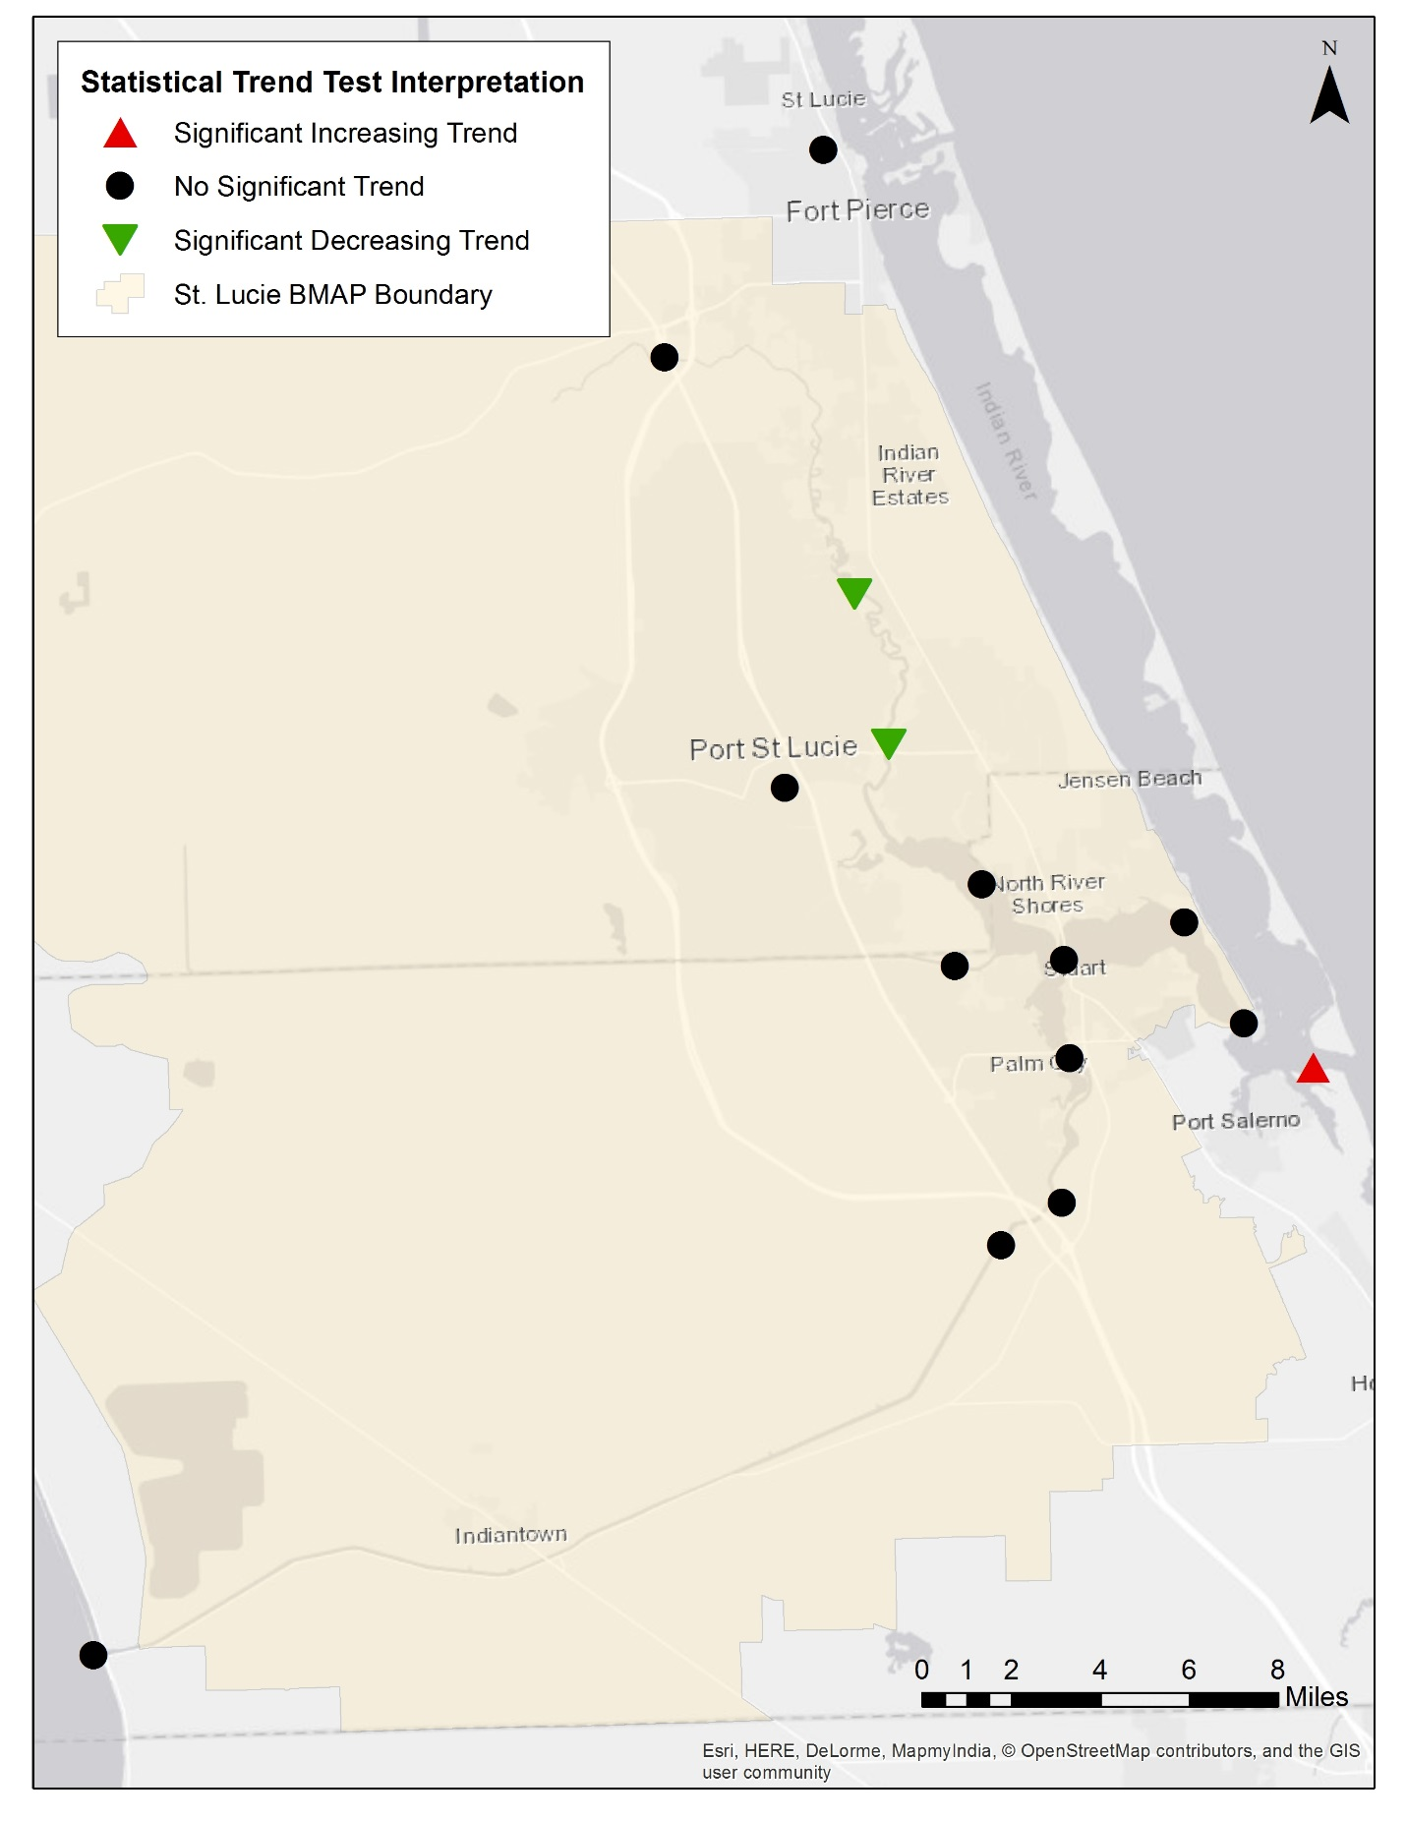
Figure 5. Seasonal Kendall trend analysis results for TP concentrations
Table 9. Seasonal Kendall trend analysis results for TN FWMs
Note: TN measured in mg/L.
¹ Series with serial correlation (as per autocorrelation analysis results) used the P-value adjusted for serial correlation.
Station | Tau | Slope | Selected P-Value¹ | Statistical Trend Interpretation
C23S48 | -0.036 | -0.00467 | 0.758 | No significant trend
C24S49 | -0.235 | -0.02258 | 0.069 | No significant trend
C25S50 | -0.062 | -0.00920 | 0.493 | No significant trend
C44S80 | -0.228 | -0.02275 | 0.144 | No significant trend
GORDYRD | -0.176 | -0.02096 | 0.191 | No significant trend
S308C into SLREW | -0.183 | -0.02175 | 0.200 | No significant trend

Table 10. Seasonal Kendall trend analysis results for TP FWMs
Note: TP measured in mg/L.
¹ Series with serial correlation (as per autocorrelation analysis results) used the P-value adjusted for serial correlation.
Station | Tau | Slope | Selected P-Value¹ | Statistical Trend Interpretation
C23S48 | 0.102 | 0.00314 | 0.383 | No significant trend
C24S49 | -0.003 | -0.00013 | 1.000 | No significant trend
C25S50 | 0.062 | 0.00150 | 0.632 | No significant trend
C44S80 | -0.108 | -0.00492 | 0.344 | No significant trend
GORDYRD | -0.092 | -0.00334 | 0.517 | No significant trend
S308C into SLREW | -0.008 | 0.00000 | 0.933 | No significant trend

Table 11. Seasonal Kendall trend analysis results for TN loads
Note: P-values listed in bold indicate statistical significance (p<0.05).
Total Nitrogen measured in lbs/yr.
¹ Series with serial correlation (as per autocorrelation analysis results) used the P-value adjusted for serial correlation.
Station | Tau | Slope | Selected P-Value¹ | Statistical Trend Interpretation
C23S48 | -0.013 | -0.00920 | 0.930 | No significant trend
C24S49 | -0.005 | -0.00621 | 0.973 | No significant trend
C25S50 | 0.035 | 0.05736 | 0.789 | No significant trend
C44S80 | 0.000 | -0.02250 | 1.000 | No significant trend
GORDYRD | 0.023 | 0.04437 | 0.771 | No significant trend
S308C into SLREW | 0.133 | 0.56120 | 0.079 | No significant trend

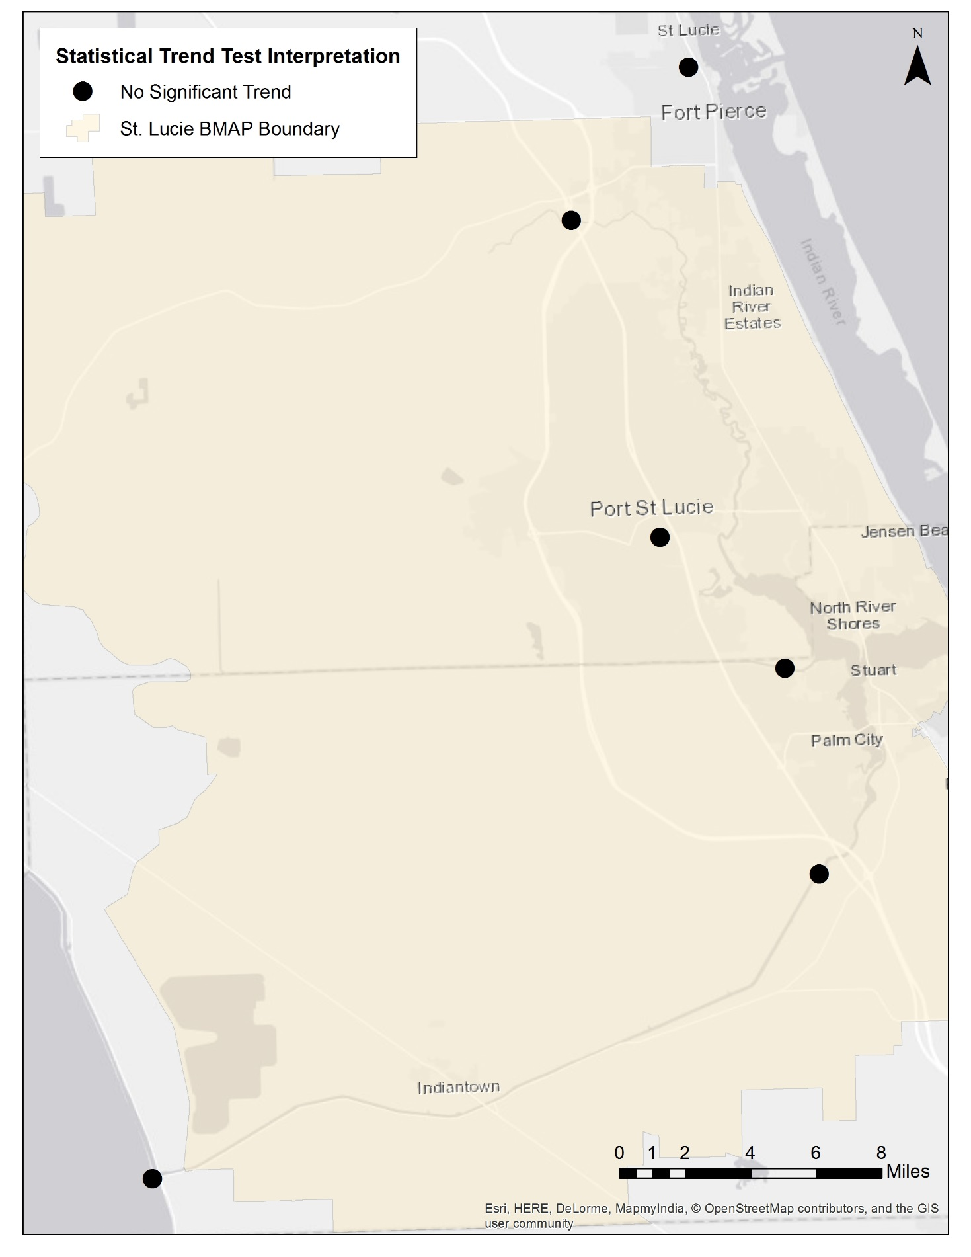
Figure 6. Seasonal Kendall trend analysis results for TN loads
Table 12. Seasonal Kendall trend analysis results for TP loads
Note: P-values listed in bold indicate statistical significance (p<0.05).
TP measured in lbs/yr.
¹ Even if the p-value is determined to be statistically significant, the result may not be ecologically significant. For example, if a trend is statistically significantly declining (negative trend) but the slope is near 0, then it may not be realistic to assume that an improvement in water quality by reductions in TN or TP may positively impact the ecological system in a measurable way.
² Series with serial correlation (as per autocorrelation analysis results) used the P-value adjusted for serial correlation.
³ A decreasing trend may suggest an improvement in water quality. An increasing trend may suggest a decline in water quality.
Station | Tau | Slope¹ | Selected P-Value² | Statistical Trend Interpretation³
C23S48 | -0.006 | -0.00125 | 0.977 | No significant trend
C24S49 | -0.037 | -0.01619 | 0.688 | No significant trend
C25S50 | 0.063 | 0.00575 | 0.608 | No significant trend
C44S80 | 0.013 | 0.02538 | 0.955 | No significant trend
GORDYRD | 0.050 | 0.01054 | 0.509 | No significant trend
S308C into SLREW | 0.171 | 0.06542 | 0.024 | Significant increasing trend
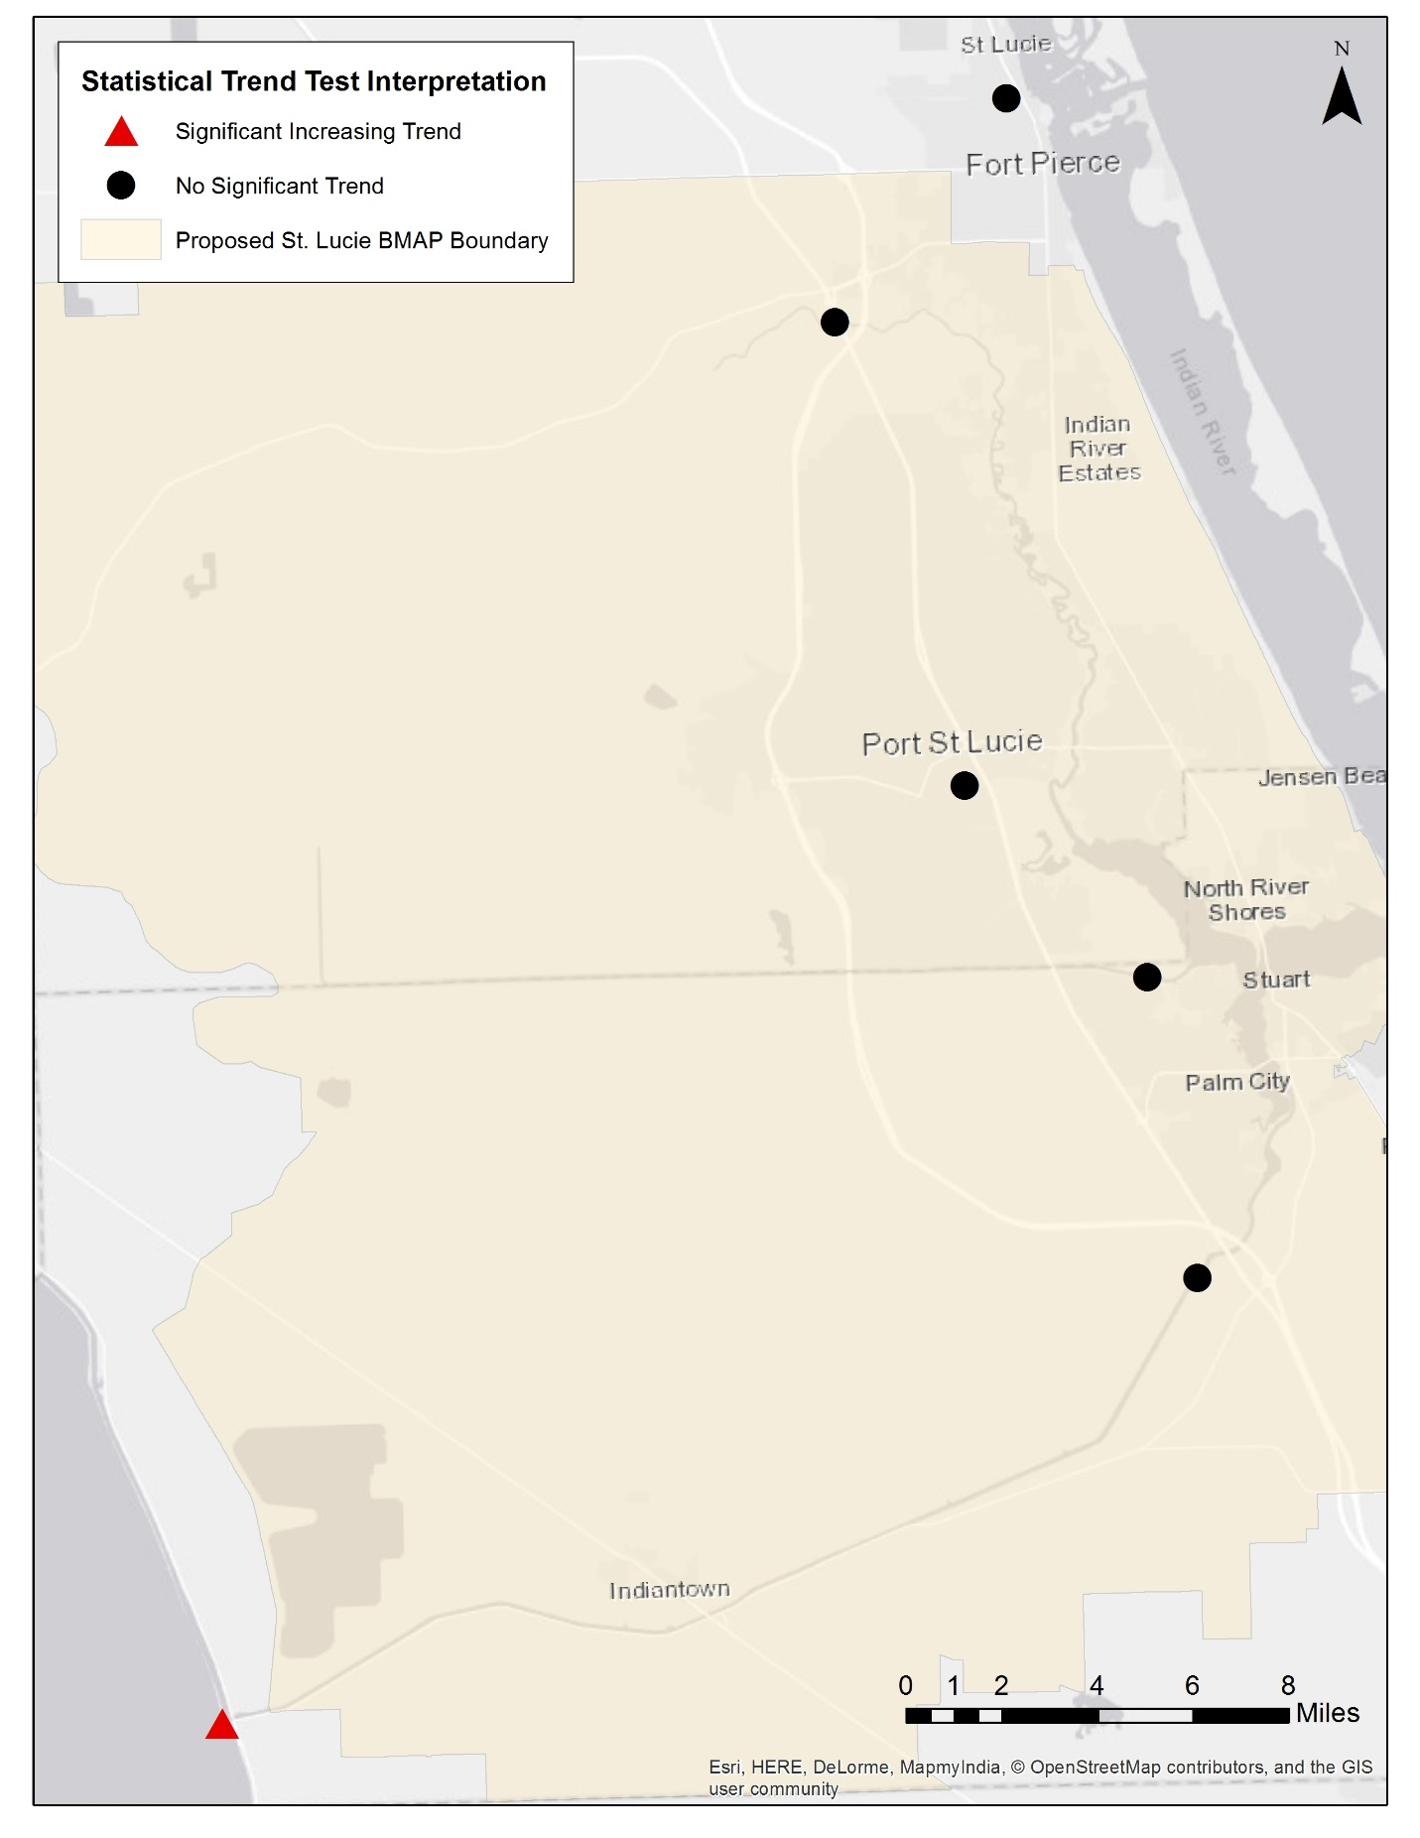
Figure 7. Seasonal Kendall trend analysis results for TP loads

Chapter 3: Recommendations
The BMAP implements phased TN and TP reductions according to Subparagraph 403.067(7)(a)1., F.S., for the loading generated in the St. Lucie River and Estuary Basin. The purpose of this 5-Year Review is to evaluate implementation activities that have taken place during the first 5-year phase. The recommendations included here are for future implementation activities that may be incorporated into a revised BMAP and adopted by Secretarial Order.
This first phase included significant restoration efforts by stakeholders, and the implementation process will continue in order to help meet the TMDLs. The projects and other activities, collected through stakeholder participation, are estimated to achieve TN reductions of 535,197 lbs/yr (or 51 %) and TP reductions of 141,477 lbs/yr (or 35 %) by the end of the first 5-year phase. The milestones described here were developed in collaboration with stakeholders through the submission of project information.
DEP recommends revising the assigned allocations to reflect the results from updated BMAP modeling. Additionally, the expansion of the model extent allows the BMAP boundary to be expanded to include the South Coastal Subbasin. DEP and participating stakeholders also recommend revising the BMAP monitoring network to help prioritize monitoring resources and improve how progress is tracked.
  - Milestones
The St. Lucie River and Estuary BMAP is governed by Section 373.4595, F.S., as a part of the Northern Everglades and Estuaries Protection Program (NEEPP). Paragraph 373.4595(4)(d), F.S., states:
"The department shall develop an implementation schedule establishing 5-year, 10-year, and 15-year measurable milestones and targets to achieve the total maximum daily load no more than 20 years after adoption of the plan. The initial implementation schedule shall be used to provide guidance for planning and funding purposes and is exempt from chapter 120. Upon the first 5-Year Review, the implementation schedule shall be adopted as part of the plans. If achieving the total maximum daily load within 20 years is not practicable, the implementation schedule must contain an explanation of the constraints that prevent achievement of the total maximum daily load within 20 years, an estimate of the time needed to achieve the total maximum daily load, and additional 5-year measurable milestones, as necessary."
The 5-Year Review documents progress and allows for stakeholder involvement in the methods of assessing progress and revising the BMAP as appropriate. The projects and activities in the BMAP are key to reducing TN and TP in the estuary. The estimated benefits of these implemented activities should be tracked to show stakeholder efforts by determining a percentage towards the total required reductions to be achieved at each milestone. Stakeholders in the St. Lucie BMAP aim to meet 100 % of the required reductions within 15 years of BMAP adoption. The following percent reduction goals are proposed for each milestone:
- 5-year milestone (Years 1 to 5, including projects completed after January 1, 2000): 30 % or 316,024 lbs/yr TN and 121,250 lbs/yr TP.
- 10-year milestone (Years 6 to 10): 75 % or 790,061 lbs/yr TN and 65 % or 277,446 lbs/yr TP.
- 15-year milestone (Years 11 to 15): 100 % or 1,053,414 lbs/yr TN and 404,166 lbs/yr TP.
Of the 248 projects submitted towards the 5-year milestone, 221 have been completed, for a total estimated reduction of 535,197 lbs/yr TN and 141,477 lbs/yr TP (Figures 8 and 9). 25 projects were submitted for completion by the 10-year milestone for the St. Lucie BMAP. Of those submitted projects, 12 were quantified, with reductions totaling 2,990 lbs/yr TN (a cumulative 10-year total of 538,187 or 51 %) and 1,018 lbs/yr TP (a cumulative 10-year total of 142,495 or 35%). DEP will re-estimate project credit prior to updating the St. Lucie BMAP, but it is likely that more projects will be needed to reach the 10- and 15-year milestones.
8 projects were submitted for completion by the 15-year milestone. Sufficient information regarding the estimated reductions for these projects has not been identified but will be included in future reports. During the annual review of BMAP implementation efforts, project-specific information may be revised and updated, resulting in changes to the reductions for those projects. The revisions may increase or decrease reductions, and DEP will work with stakeholders to address revisions as they are identified. Appendix B contains more information on the funding status of these future projects.
Projects included in this review are necessary components for restoration in the basin. Section 3.2 discusses the efforts made to update the WaSh model and how the application of the model in the basin may lead to future revisions of the detailed stakeholder allocations. Many projects are not far enough along in their development to quantify TN and TP reductions or to have obtained full funding at the time this review was published. DEP anticipates that it is practicable to achieve reductions sufficient to meet the TMDLs within 20 years and will review additional projects submitted prior to the 2023 5-Year Review to confirm whether this is supported.

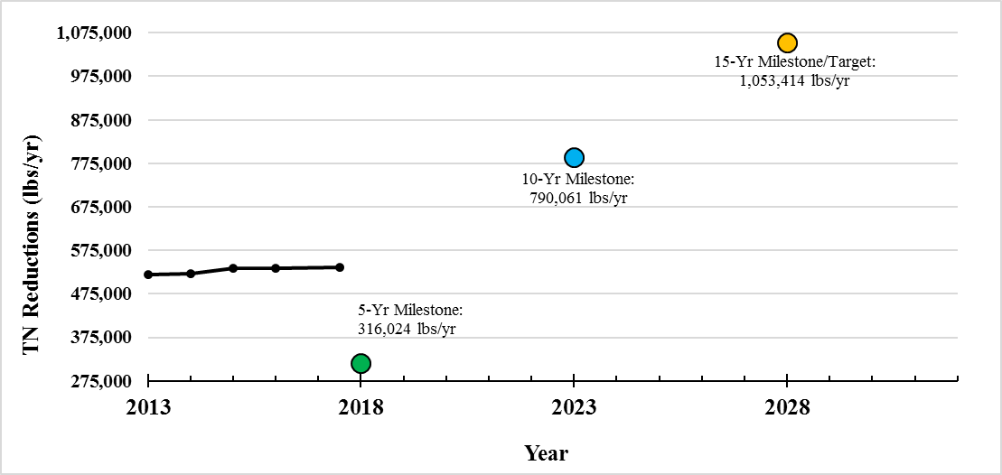
Figure 8. Estimated progress towards the St. Lucie River and Estuary BMAP TN milestones

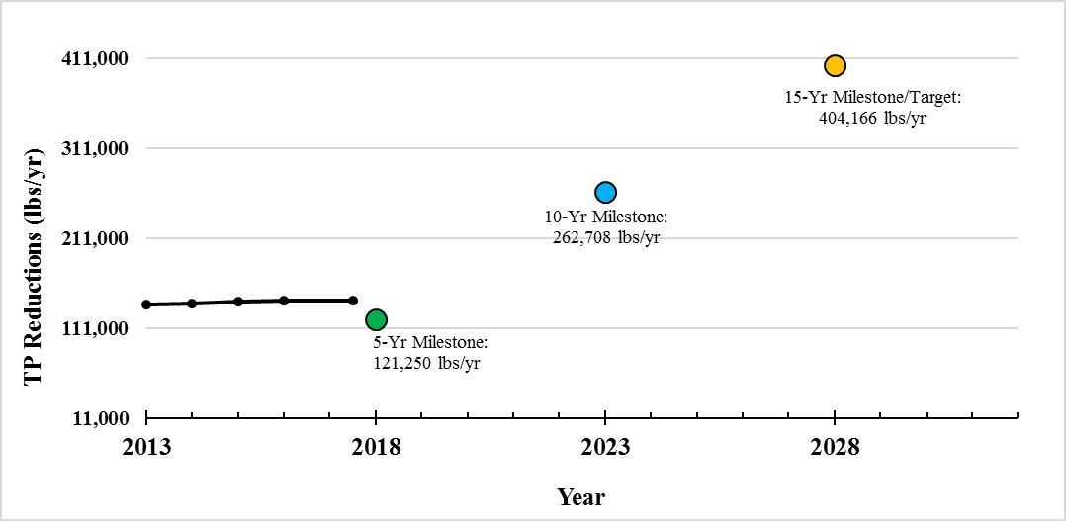
Figure 9. Estimated progress towards the St. Lucie River and Estuary BMAP TP milestones

  - BMAP Boundary Change
The BMAP area was originally divided into six subbasins, which were also used in the water quality analysis for the SFWMD's St. Lucie River Watershed Protection Plan (SLRWPP). As both the SLRWPP and the BMAP are requirements of the NEEPP, the BMAP boundary was based on the SLRWPP to align the BMAP process with the SLRWPP and take a holistic watershed approach.
Since the adoption of the BMAP in June 2013, the subbasin boundaries have been updated based on the hydrologic evaluation of tributaries in the St. Lucie River Watershed. This evaluation involved conversations with local entities, aerial surveys, and the investigation of areas where discrepancies were noted in the SFWMD's ArcHydro Database. Based on the results, each subbasin boundary was refined to more accurately reflect drainage conditions, and the changes in acreage were documented. Appendix G provides a more detailed description of these changes. Subsequent to the information summarized in Appendix G, the boundary was also affected by redelineation efforts for the North Palm Beach–area watersheds as part of the Loxahatchee River Restoration Project and the other changes listed below.
Figure 10 shows the existing and recommended revised boundary. Overall, 22,252 acres would be added to the BMAP area and 3,427 acres removed, resulting in a net addition of 18,825 acres. This recommended change is pending further discussion with the SFWMD, and a decision will be made prior to the adoption of the revised BMAP following the 5-Year Review.
    - Addition of South Coastal Subbasin
The South Coastal Subbasin was not included within the original BMAP boundary because of a lack of nutrient loading data for the area. Tidal stage data have since become available at the St. Lucie Inlet in the northern portion of the South Coastal Subbasin that drains to the lower St. Lucie Estuary. As a result, the WaSh model revisions included the expansion of the model domain to include the remainder of the South Mid-Estuary Subbasin, the South Coastal Subbasin, and the Lower St. Lucie Estuary.
    - Fort Pierce Stormwater Master Plan and Boundary Revisions
The northeastern portion of the St. Lucie BMAP boundary was refined based on a stormwater master plan completed by the City of Fort Pierce. Proposed changes to the boundary were made in two of the city's drainage basins: Virginia Ave. Canal East and Virginia Ave. Canal West. The southern portion of the boundary was also refined to follow the northern portion of the city's Cortez NSLRWCD Canal drainage basin.
The boundary changes allowed City of Fort Pierce projects and reductions to be more accurately divided between the St. Lucie BMAP and the Central IRL BMAP, in which the city is also a stakeholder. Citywide projects (street sweeping, catch basin cleanouts, and education) were credited based on the percentage of city area within the BMAP boundary. Additionally, the Indian Hills Recreation Area Stormwater Improvements Phase II (FP-11) Project is located within the updated boundary, and credits will be estimated accordingly in the future.

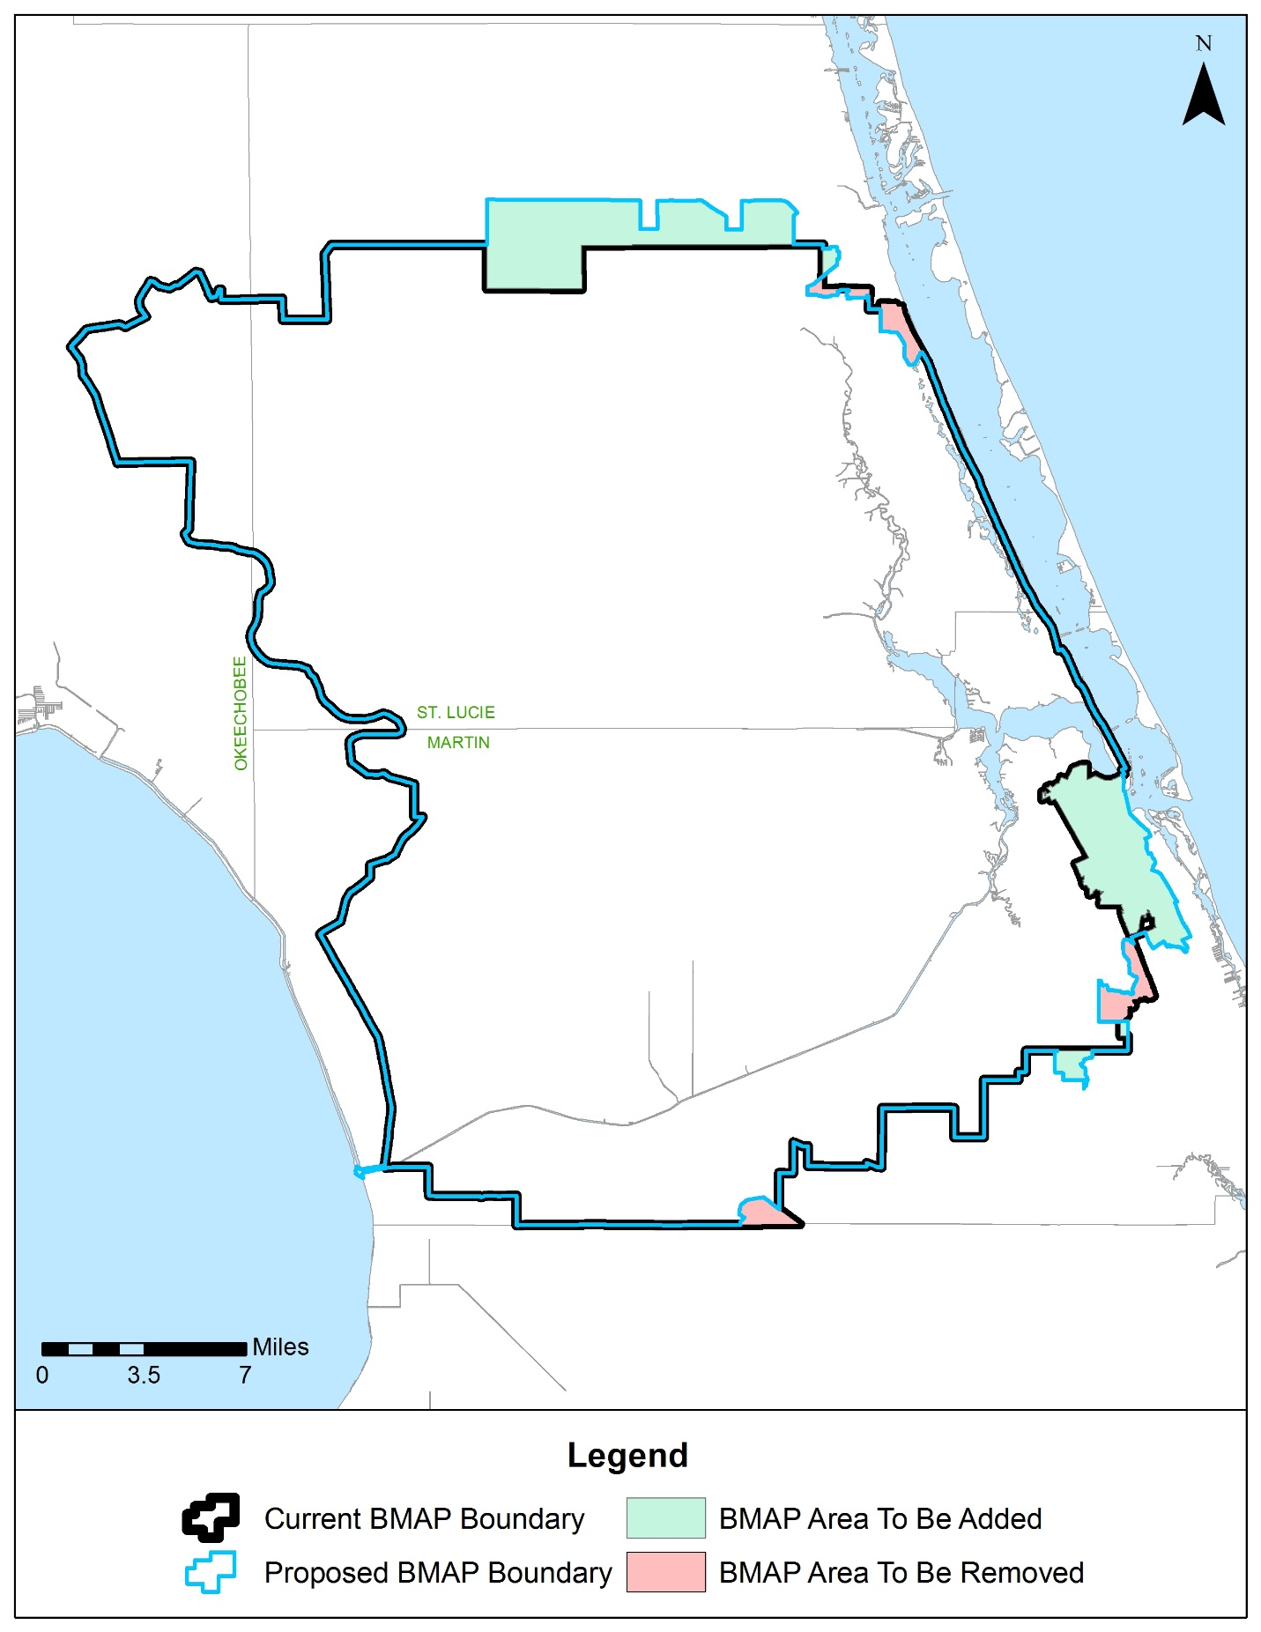
Figure 10. Proposed St. Lucie River and Estuary BMAP boundary changes

  - BMAP Modeling
The St. Lucie Estuary WaSh model was updated and revised as part of this 5-Year Review. The revisions and scenarios are summarized below, and a separate modeling report provides additional descriptions of model functionality, data sources, calibration and verification results, and alternative scenario outcomes (SFWMD et al., 2018).
    - WaSh Modeling Revisions
The WaSh model—a hydrologic, hydrodynamic, and water quality model—was developed for the SLREW. The model domain covers the C-23, C-24, C-44/S-153, Ten Mile Creek, North Fork, South Fork, and South Coastal Subbasins, and Basins 4/5/6. The model was originally developed for the unique hydrologic conditions in South Florida (URS, 2008) and was adapted during the first phase of implementation to better suit the planning purposes of the BMAP.
DEP coordinated with the SFWMD to revise, enhance, and update the model, first by simulating the baseline scenario. The baseline scenario POR is 1994 to 2016, and the model uses 2004, 2008, and 2012 land use data. The model was calibrated using available SFWMD data from 2001 to 2006 and verified with available SFWMD data from 1995 to 2000.
The draft report for the WaSh baseline scenario (SFWMD, 2017) was made available to stakeholders for review and preliminary modeling results were presented at the BMAP public meeting in January 2018. Stakeholder comments were incorporated into an updated model report (SFWMD et al, 2018) which was available for stakeholder review in April 2018.
The results of this modeling effort were used to draft the revised nutrient load allocations recommended in Section 3.3.
    - Baseline Condition Scenario
The baseline WaSh model was calibrated using the following measured data: flow (cubic feet per second [cfs]), ammonia nitrogen (mg/L), nitrate nitrogen (mg/L), organic nitrogen (mg/L), chlorophyll a (micrograms per liter [µg/L]), inorganic phosphorus (mg/L), organic phosphorus (mg/L), and DO (mg/L). Annual and monthly TN and TP loads were calculated (in lbs/yr) based on model output (flows and nutrient concentrations). The locations for model calibration/ verification of flow included S-80, S-97, and S-49; and for water quality included S-80, S-48,
S-49, HR1, SE01, SE02, SE03 SE06, SE08/SE08B, and SE11.
Overall, the model was well calibrated and verified within the periods chosen for the baseline scenario. The comparison of simulated and measured time series plots for both flow and water quality data were generally in good agreement. The comparison plots and evaluation statistics indicate that the model can predict annual TN and TP loads well. Generally, the comparison of simulated and measured data indicates that the model closely reproduces the patterns of flow and captures the variation of nutrient dynamics.

    - WaSh Alternative Condition Scenarios
Two alternative condition scenarios from 2007 to 2016 were ran and are currently being evaluated using the WaSh model: (1) the impact of select large-scale BMAP projects; and (2) the impact of septic tank removal. The results of these scenarios may be expanded in the future and used to support restoration activities in the BMAP. Information about the set-up and results of these scenarios can be found in the draft modeling report (SFWMD 2018).
  - Revised Allocations
The updates and enhancements to the WaSh model made it possible to revise the allocation process from the original BMAP and recalculate allocations and required reductions. The process and the numbers are proposed, and conversation is ongoing with stakeholders about the revisions. Upon acceptance of the changes, it is recommended that the enhanced model and new process be used to calculate new allocations when the BMAP is readopted following the 5-Year Review.

3.3.1 Methodology
The revised WaSh model can produce polygon outputs with loading data included. Through a series of GIS steps, polygons were generated for each stakeholder. GIS data were used to clip the area within the BMAP boundary associated with each entity. The clipping was done sequentially, as follows:
- Water (Florida Power and Light [FPL] Pond, Dispersed Water Management [DWM] and CERP projects [construction or design status]).
- Roads (FDOT and Florida's Turnpike Enterprise).
- WCDs and other special districts.
- Natural lands (land use codes 3000 [not including 3300], 4000, 5000, and 6000).
- Agriculture (land use codes 2000 and 3300).
- Community development districts (CDDs), each to its own boundary.
- Municipalities.
- Remaining area assigned to each county.
These stakeholder polygons allow the generation of model outputs with loading information covering 2007 through 2016. Allocations can be set based on each stakeholder's percentage of the total loading. Figure 11 shows the polygons for the stakeholders used to calculate new proposed allocations. For additional details on how entities were incorporated into the processing, see Appendix F.
Assumptions
The following assumptions were used during the allocation process:
- Natural and Water Management Areas – The allocations do not include required load reductions from areas identified as natural land use areas in the 2012 SFWMD land use coverage. Water management areas such as large regional projects, dikes and levees, and reservoirs are also excluded from the allocations. These loads are considered uncontrollable, background sources, and the stakeholders are not required to make reductions on these lands.
- Land Uses – The loading estimates in the BMAP are based on land uses at a particular point in time, allowing the model to be validated and calibrated. The loading estimates for these allocations were based on 2012 land use data.
- Basin Boundaries – The BMAP boundary recommended in Section 3.2 is used for the allocations. The boundary change will be finalized once adopted into a revised BMAP.
- Subbasins – The adopted BMAP divided starting loads into 6 subbasins, while this analysis used 9 subbasins. The 3 additional subbasins used in the revised allocation calculations were the North Mid-Estuary subbasin, Ten Mile Creek subbasin, and the combined South Mid-Estuary and South Coastal subbasins.
- Basins 4, 5, and 6 – Two reach outputs capture the model output from Basins 4, 5, and 6, so the modeled results were averaged to obtain one percent reduction for the entire basin.

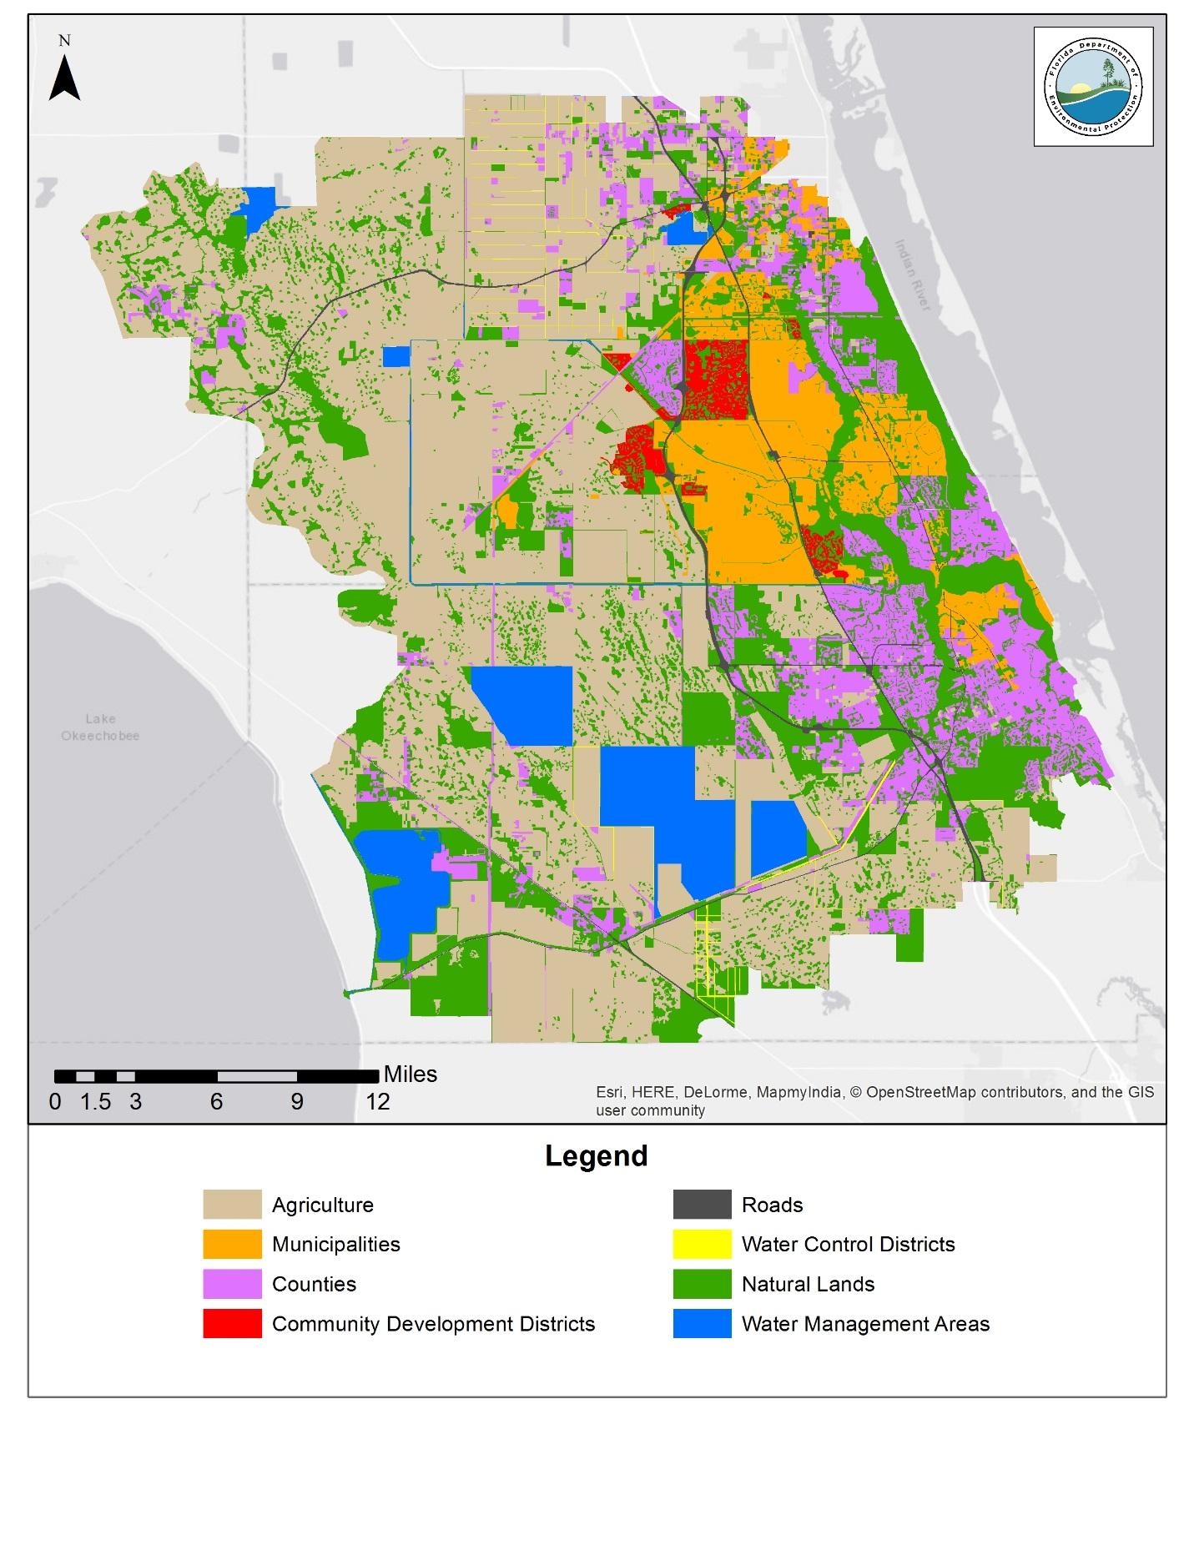
Figure 11. Draft allocation areas associated with entities

3.3.2 Results
Based on the updated allocation methodology and revised model output, the percent TN and TP load for each entity (by subbasin) was calculated (Tables 13 and 14) and those percentages will be applied to the total output load for the BMAP (proposed boundary). This will result in starting loads by entity and by sub-basin.
Table 13. Percent of total TN load per subbasin by entity
Entity | Basins 4,5,6 | C-23 | C-24 | C-44, S-153 | North Fork | North Mid-Estuary | South Fork | South Mid-Estuary/ South Coastal | Ten Mile Creek | Total
Agriculture | 0.69% | 17.39% | 14.79% | 17.57% | 1.56% |  | 4.88% | 0.01% | 6.46% | 63.35%
City of Fort Pierce |  |  |  |  | 1.33% |  |  |  | 0.00% | 1.33%
City of Port St. Lucie |  | 0.23% | 0.52% |  | 11.17% |  |  |  | 0.02% | 11.94%
City of Stuart |  |  |  |  | 0.03% | 0.08% | 0.55% | 0.43% |  | 1.09%
Copper Creek CDD |  |  | 0.08% |  |  |  |  |  |  | 0.08%
Creekside CDD |  |  |  |  |  |  |  |  | 0.05% | 0.05%
FDOT District 4 | 0.09% | 0.24% | 0.11% | 0.21% | 0.37% | 0.02% | 0.22% | 0.01% | 0.07% | 1.34%
FDOT District 5 |  | 0.03% |  |  |  |  |  |  |  | 0.03%
Martin County | 2.62% | 0.46% |  | 1.41% | 0.76% | 0.74% | 3.66% | 2.55% |  | 12.20%
Okeechobee County |  | 0.23% | 0.18% |  |  |  |  |  |  | 0.40%
Portofino Isles CDD |  | 0.06% |  |  | 0.00% |  |  |  |  | 0.06%
River Place CDD |  |  |  |  | 0.03% |  |  |  |  | 0.03%
St. Lucie County |  | 0.19% | 0.94% |  | 3.46% |  |  |  | 1.00% | 5.59%
St. Lucie West Service District |  |  |  |  | 1.20% |  |  |  |  | 1.20%
Tesoro CDD |  |  |  |  | 0.23% |  |  |  |  | 0.23%
Town of Sewall's Point |  |  |  |  |  | 0.14% |  |  |  | 0.14%
Tradition CDD |  | 0.00% | 0.43% |  | 0.01% |  |  |  |  | 0.43%
Turnpike | 0.05% | 0.00% |  |  | 0.28% |  | 0.07% |  | 0.00% | 0.41%
Veranda CDD |  |  |  |  | 0.02% |  |  |  |  | 0.02%
Verano CDD |  |  | 0.05% |  |  |  |  |  |  | 0.05%
Villa Vizcaya CDD |  |  |  |  | 0.01% |  |  |  |  | 0.01%
Total | 3.46% | 18.84% | 17.09% | 19.20% | 20.46% | 0.99% | 9.37% | 3.00% | 7.60% | 100.00%
Table 14. Percent of total TP load per subbasin by entity
Entity | Basins 4,5,6 | C-23 | C-24 | C-44, S-153 | North Fork | North Mid-Estuary | South Fork | South Mid-Estuary/ South Coastal | Ten Mile Creek | Total
Agriculture | 0.69% | 17.39% | 14.79% | 17.57% | 1.56% |  | 4.88% | 0.01% | 6.46% | 63.35%
City of Fort Pierce |  |  |  |  | 1.33% |  |  |  | 0.00% | 1.33%
City of Port St. Lucie |  | 0.23% | 0.52% |  | 11.17% |  |  |  | 0.02% | 11.94%
City of Stuart |  |  |  |  | 0.03% | 0.08% | 0.55% | 0.43% |  | 1.09%
Copper Creek CDD |  |  | 0.08% |  |  |  |  |  |  | 0.08%
Creekside CDD |  |  |  |  |  |  |  |  | 0.05% | 0.05%
FDOT District 4 | 0.09% | 0.24% | 0.11% | 0.21% | 0.37% | 0.02% | 0.22% | 0.01% | 0.07% | 1.34%
FDOT District 5 |  | 0.03% |  |  |  |  |  |  |  | 0.03%
Martin County | 2.62% | 0.46% |  | 1.41% | 0.76% | 0.74% | 3.66% | 2.55% |  | 12.20%
Okeechobee County |  | 0.23% | 0.18% |  |  |  |  |  |  | 0.40%
Portofino Isles CDD |  | 0.06% |  |  | 0.00% |  |  |  |  | 0.06%
River Place CDD |  |  |  |  | 0.03% |  |  |  |  | 0.03%
St. Lucie County |  | 0.19% | 0.94% |  | 3.46% |  |  |  | 1.00% | 5.59%
St. Lucie West Service District |  |  |  |  | 1.20% |  |  |  |  | 1.20%
Tesoro CDD |  |  |  |  | 0.23% |  |  |  |  | 0.23%
Town of Sewall's Point |  |  |  |  |  | 0.14% |  |  |  | 0.14%
Tradition CDD |  | 0.00% | 0.43% |  | 0.01% |  |  |  |  | 0.43%
Turnpike | 0.05% | 0.00% |  |  | 0.28% |  | 0.07% |  | 0.00% | 0.41%
Veranda CDD |  |  |  |  | 0.02% |  |  |  |  | 0.02%
Verano CDD |  |  | 0.05% |  |  |  |  |  |  | 0.05%
Villa Vizcaya CDD |  |  |  |  | 0.01% |  |  |  |  | 0.01%
Total | 3.46% | 18.84% | 17.09% | 19.20% | 20.46% | 0.99% | 9.37% | 3.00% | 7.60% | 100.00%

10-year average (2007 to 2016) TN and TP concentrations were calculated from model reach outputs corresponding to subbasin discharge points. Following the same process used during BMAP development, these concentrations were compared to the target concentrations at SE 03 to determine required percent reductions for TN and TP in each sub-basin (Table 15). These percent reductions will be applied to each entity’s starting load by subbasin, and the results for each entity will be summed to obtain total required reductions.
Table 15. Percent required reductions for TN and TP load per subbasin
Category | Basins 4,5,6 | C-23 | C-24 | C-44, S-153 | North Fork | North Mid-Estuary | South Fork | South Mid-Estuary/ South Coastal | Ten Mile Creek
TN Current Concentration (mg/L) | 0.92 | 1.71 | 1.69 | 1.08 | 1.18 | 0.95 | 1.06 | 0.69 | 1.00
TN Target Concentration (mg/L) | 0.72 | 0.72 | 0.72 | 0.72 | 0.72 | 0.72 | 0.72 | 0.72 | 0.72
TN Reduction Required (%) | 22% | 58% | 57% | 33% | 39% | 24% | 32% | 0% | 28%
TP Current Concentration (mg/L) | 0.192 | 0.350 | 0.279 | 0.153 | 0.231 | 0.187 | 0.195 | 0.120 | 0.201
TP Target Concentration (mg/L) | 0.081 | 0.081 | 0.081 | 0.081 | 0.081 | 0.081 | 0.081 | 0.081 | 0.081
TP Reduction Required (%) | 58% | 77% | 71% | 47% | 65% | 57% | 58% | 33% | 60%

3.3.3 Entity Status Summary
Using the output from the revised WaSh model, project reductions will also be recalculated to correspond with the updated allocations. Once this work is complete, each entity's progress towards meeting the required reductions will be re-evaluated.
  - Water Quality Monitoring Revisions
The 5-Year Review of the St. Lucie River and Estuary BMAP provides an opportunity to improve key components of the plan and make further progress to achieve the TMDLs. DEP and participating stakeholders recommend revising the BMAP monitoring network to help prioritize monitoring and track BMAP progress. Recommendations for the monitoring network include implementing a new tiered system for the sampling stations and removing some stations from the network. The proposed changes will go into effect after BMAP revision and official adoption by the DEP Secretary.
    - Recommended Revisions
During the first phase of the BMAP, an initial scientific and statistically-based evaluation was conducted to group the stations into tiers, and this evaluation was recently refined based on data quality to determine the final list of stations. If the recommended revisions to the BMAP monitoring network are implemented, sampling will be performed by the SFWMD, City of Port St. Lucie, and USGS at 61 stations.
Port St. Lucie Station Modification
The city has worked with DEP to modify the location and frequency of monitoring stations, with the goal of narrowing down sample sites so that certain locations can be sampled more frequently (Table 16). Both the Sagamore and Degan wastewater sites were removed because low- or no-flow conditions were frequently observed throughout the year. The Burrow site was also removed, as it did not measure any flows into the Port St. Lucie MS4 system. The farthest southwest subbasin contains Horseshoe Canal, which drains most of the basin and passes through Structure A18; thus a new station located near the A18 structure will allow that portion of the drainage area to be monitored. The farthest southeast subbasin mostly drains to Structure A22, which will also be sampled as part of the recommended BMAP network. In addition to the city's stations in the monitoring network, Stations A24, B-95-3, and B-33 will be sampled periodically if time and other resources allow. The new sampling plan began in January 2018.
Table 16. City of Port St. Lucie monitoring changes
 | Original | Revised
Sampling Frequency | 1 or 2 times/year | Every other month
Number of Monitoring Stations | 21 | 9 core sites, 3 optional sites
Parameters | TN, TP | TKN, TN, TP, DO, pH, conductivity, temperature, turbidity, N (ammonia), TSS, BOD, orthophosphate as P, alkalinity, and chlorophyll a

Stations Recommended for Removal from the Network
Based on the low frequency of sampling and overall need for the BMAP, the following stations are recommended for removal from the BMAP monitoring network:
- Hobe St. Lucie Conservancy District: Data at four stations are collected too infrequently to be used as a part of the dataset when conducting trend analysis for BMAP purposes.
- North St. Lucie River WCD (NSLRWCD): Because of issues with uploading data to STORET, the district provides data for seven stations by hand at annual meetings. It will continue to submit data directly to the BMAP coordinator until they can be uploaded to WIN.
- St. Lucie County (SLC): Data are collected at four stations—inflows and outflows for project areas—and are not needed to monitor inflows into the estuary.
- St. Lucie West Services District (SLWSD): Data at eight stations are collected too infrequently to be used as a part of the dataset when conducting trend analyses for BMAP purposes. Additionally, the data are forwarded from the processing lab to the City of Port St. Lucie and are not uploaded into WIN.

    - New Recommended Tiered Monitoring Network
To help prioritize monitoring and track BMAP progress over the long term, DEP and stakeholders recommend a new tiered system for the sampling stations, as follows:
- Tier 1 stations will be used in periodic water quality analyses to help track water quality trends in the basin. Tier 1 stations include both estuary and structure ambient monitoring stations, which are all sampled by the SFWMD at least monthly. Several of these stations have autosamplers with more frequent data collection, and the stations at the structures also have flow data.
- Tier 2 stations will provide secondary information that can be used to help focus and adaptively manage implementation efforts.
- Tier 3 consists of USGS gages where flow and/or stage are monitored.
Appendix D contains a table listing the revised monitoring network.
    - TMDL Compliance Methodology
The development of an appropriate compliance methodology for the TMDL targets in the BMAP is underway and will be discussed with stakeholders upon revision and re-adoption of the BMAP.
References
SFWMD, FDEP and Amec Foster Wheeler. 2018. Draft Report: St. Lucie River and Estuary Watershed Water Quality Modeling for the St. Lucie River and Estuary Basin Management Action Plan. Prepared by South Florida Water Management District, Florida Department of Environmental Protection, and Amec Foster Wheeler. April 2018.

SFWMD. 2017. Draft Report: St. Lucie River and Estuary Watershed Water Quality Modeling. Part I: Model Calibration and Verification of Baseline Scenario for the St. Lucie River and Estuary Basin Management Action Plan. Prepared by the South Florida Water Management District, West Palm Beach, FL. December 2017.

URS, Inc. 2008. WaSh model configuration, calibration, and validation for the St. Lucie Estuary Watershed. Prepared for Florida Department of Environmental Protection. December 2008.

Appendices

Appendix A: BMAP Projects
The tables in this appendix list the implementation status of the BMAP projects as of December 31, 2017. The tables list the nitrogen and phosphorus reduction (in lbs/yr) attributable to each individual project. These projects were submitted to provide reasonable assurance to DEP that each entity has a plan on how to meet its allocation. However, the list of projects is meant to be flexible enough to allow for changes that may occur over time. During the annual review of BMAP implementation efforts, project-specific information may be revised and updated, resulting in changes to the estimated reductions for those projects. The revisions may increase or decrease estimated reductions, and DEP will work with stakeholders to address revisions as they are identified.
The project status column is standardized into the following four categories:
- Canceled: Project or activity that was planned but will no longer take place. This includes the cessation of ongoing activities.
- Completed: Project, activity, or task that is finished. This includes fully implemented activities (i.e., ongoing activities) that must continue indefinitely to maintain assigned credits (such as street sweeping, BMP cleanout, catch basin cleanout, public education, fertilizer cessation/reduction, and vegetation harvesting).
- Planned: Project or activity that is conceptual or proposed.
- Underway: Project or activity that has commenced or initiated but is not completed and is not yet reducing nutrient loads from the treated area.
Prior to reporting project information, DEP contacts each lead entity to gather new information on projects and confirm previously reported information. The terms used throughout the project tables are defined as follows:
- Not provided: Denotes that information was requested by DEP but was not provided by the lead entity.
- TBD: To be determined. Denotes that information is not currently available but will be provided by the stakeholder when it is available.
- N/A: Not applicable. Denotes that information for that category is not relevant to that project.
- 0: Zero. Denotes the numeric value for that category as zero.
- O&M: Operations and maintenance.
These project tables are based on current information, and project details may be updated as further information becomes available.

Table A-1. City of Fort Pierce projects
¹The City of Fort Pierce worked with DEP to determine how to best represent its projects in the St. Lucie BMAP because the city boundary also includes the Central IRL BMAP and a portion of land outside any BMAP boundary. The changes resulting from that conversation are reflected in this project table.
Lead Entity | Partners | Project Number | Project Name | Project Description | Project Type | Project Status | Estimated Completion Date | TN Reduction (lbs/yr) | TP Reduction (lbs/yr) | Location | Acres Treated | Cost Estimate | Cost Annual O&M | Funding Source | Funding Amount | DEP Contract Agreement Number
City of Fort Pierce | DEP | FP-01 | Indian Hills Recreation Area Stormwater Improvements Phase I (also known as Heathcote Botanical Gardens Treatment Train) | Treatment train of 6 different BMPs are joined together to improve water quality of stormwater runoff discharging into IRL | BMP Treatment Train | Completed | 2015 | N/A | N/A | Outside BMAP Boundary | 1,242 | $3,000,000 | $113,000 | DEP | $1,410,000 | SO579
City of Fort Pierce | N/A | FP-02 | Moore's Creek Retrofit – Phases 3 and 4 | Not provided | Wet Detention Pond | Completed | 2008 | N/A | N/A | Outside BMAP Boundary | 72 | $825,000 | Not provided | Not provided | Not provided | N/A
City of Fort Pierce | N/A | FP-03 | Street Sweeping | City removed 6,599 cubic yards of debris. | Street Sweeping | Completed | 2013 | 2,020 | 1,295 | Primary BMAP Area | N/A | Not provided | Not provided | Not provided | Not provided | N/A
City of Fort Pierce | N/A | FP-04 | Inlet Cleaning | City cleans storm inlets citywide and disposes of waste (194 cubic yards). | Catch Basin Inserts/Inlet Filter Cleanout | Completed | 2013 | 65 | 40 | Primary BMAP Area | N/A | Not provided | Not provided | Not provided | Not provided | N/A
City of Fort Pierce | N/A | FP-05 | Education Program | City delivers educational programs to public, either through trade associations, homeowner associations (HOAs), or other means. City educates on hazards associated with illicit discharge, fertilizer use, importance of water quality, and stormwater pollution protection. City has web page devoted to NPDES permits, DEP, and stormwater education. | Education Efforts | Completed | 2013 | 215 | 49 | Primary BMAP Area | N/A | Not provided | Not provided | Not provided | Not provided | N/A
City of Fort Pierce | N/A | FP-06 | Virginia Ave. Outfall Canal | Stabilization of eroded canal banks as result of Tropical Storm Fay using rock rip-rap and gabion basket wall construction. | Shoreline Stabilization | Completed | 2008 | N/A | N/A | Outside BMAP Boundary | 161 | $3,462,572 | $1,500 | Not provided | Not provided | N/A
City of Fort Pierce | N/A | FP-07 | Moore's Creek Retrofit Phase 2 | Not provided | Baffle Boxes – 1st Generation (hydrodynamic separator) | Completed | 2008 | N/A | N/A | Outside BMAP Boundary | 1,680 | $1,480,437 | Not provided | Not provided | Not provided | N/A
City of Fort Pierce | N/A | FP-08 | South Beach Baffle Boxes | Not provided | Baffle Boxes – 1st Generation (hydrodynamic separator) | Completed | 2005 | N/A | N/A | Outside BMAP Boundary | 128 | $557,003 | Not provided | Not provided | Not provided | N/A
City of Fort Pierce | DEP | FP-09 | Veterans Park Stormwater Improvements | Improvements to existing stormwater facility to incorporate BMPs along with pervious parking, lake construction, and bioswales. | BMP Treatment Train | Completed | 2016 | N/A | N/A | Outside BMAP Boundary | 44 | $2,367,000 | Not provided | DEP | $807,500 | SO696  G0417
City of Fort Pierce | N/A | FP-10 | North 2nd St. (Seaway Dr. north to Taylor Creek Marina) | Project entails complete reconstruction of 2nd St., including drainage conveyance/storage, utility upgrades and replacement, roadway widening and reconstruction, sidewalk on west side, and landscaping and lighting improvements. | Wet Detention Pond | Completed | 2017 | N/A | N/A | Outside BMAP Boundary | Not provided | $1,909,176 | Not provided | Not provided | Not provided | N/A
City of Fort Pierce | DEP | FP-11 | Indian Hills Recreation Area Stormwater Improvements  Phase II | Re-establishment of wetlands and pervious paver parking areas. | Wetland Restoration | Completed | 2016 | TBD | TBD | Primary BMAP Area | 61 | $2,337,485 | Not provided | DEP | $1,410,000 | S0579
City of Fort Pierce | N/A | FP-12 | Ave. F (US 1 to 6th St.) | Drainage improvements along Ave. F will include curb inlets, 100 linear feet (LF) of exfiltration trench, complete curb replacement, and roadway resurfacing. | Exfiltration Trench | Completed | 2017 | N/A | N/A | Outside BMAP Boundary | Not provided | $186,327 | Not provided | Not provided | Not provided | N/A
City of Fort Pierce | N/A | FP-13 | Mechanical removal of water lettuce at Moore's Creek between N 10th St. and N 13th St. | One-time mechanical removal of water lettuce at Moore's Creek between N 10th St. and N 13th St. | Aquatic Vegetation Harvesting | Completed | 2016 | N/A | N/A | Outside BMAP Boundary | 0.04 | $10,740 | N/A | Not provided | Not provided | N/A

Total TN Project Reduction = 2,300 lbs/yr Total TP Project Reduction = 1,384 lbs/yr
Total TN Reduction Required = 6,479 lbs/yr Total TP Reduction Required = 2,693 lbs/yr

Table A-2. City of Port St. Lucie projects
Lead Entity | Partners | Project Number | Project Name | Project Description | Project Type | Project Status | Estimated Completion Date | TN Reduction (lbs/yr) | TP Reduction (lbs/yr) | Location | Acres Treated | Cost Estimate | Cost Annual O&M | Funding Source | Funding Amount | DEP Contract Agreement Number
City of Port St. Lucie | DEP/ SFWMD/ SLC/ American Greenways/ Tax-increment financing (TIF) | PSL-01 | Woodstork Trail Design Districts 7, 8, and 9 | 4.6 acres of new filter marsh, 7.21 acres of new uplands, and installation of baffle box. | BMP Treatment Train | Completed | 2007 | 4 | 4 | Primary BMAP Area | 229 | $3,300,000 | $386,000 (Annual budget to maintain drainage rights-of-way)  $736,000 (Annual budget for aquatic spraying) | DEP/ SFWMD/ SLC / American Greenways/ TIF | Not provided | G0140
City of Port St. Lucie | DEP/ City Center Special Assessments | PSL-02 | Wood Stork Trail Design District 6 | 7.74-acre wet detention area, .62-acres STA, and 3 baffle boxes. | BMP Treatment Train | Completed | 2008 | 3 | 2 | Primary BMAP Area | 81 | $825,500 | See PSL-01 and PSL-14 | DEP/ City Center Special Assessments | Not provided | G0178
City of Port St. Lucie | DEP/SFWMD | PSL-03 | Howard Creek STA | Construction of weir, 45-acre STA, littoral shelves, and new plantings. | BMP Treatment Train | Completed | 2010 | 523 | 212 | Primary BMAP Area | 436 | Included in PSL-4 | See PSL-01 and PSL-05 | DEP/  SFWMD | Not provided | S0507
City of Port St. Lucie | N/A | PSL-04 | Eastern Watershed Improvement Project | Flood control, water quality, environmental restoration project consisting of 27 acres of wet detention ponds, littoral shelves, and created wetlands. | BMP Treatment Train | Completed | 2011 | 618 | 361 | Primary BMAP Area | 850 | $36,000,000 | See PSL-01 (aquatic spraying) and PSL-05 | City | Not provided | N/A
City of Port St. Lucie | NRCS/ SFWMD | PSL-05 | B-1 and B-2 Water Control Structures (WCS) | WCS B-1, B-2, and B-3 protected NFSLR from receiving uncontrolled E-8 Canal discharges. System will stage appropriate discharge levels based on volume, retaining maximum flows. | Control Structure | Completed | 2007 | 2,527 | 994 | Primary BMAP Area | 1,748 | $1,800,000 | $621,000 (Annual right-of-way, bridge, and WCS maintenance) | City/ NRCS/ SFWMD | Not provided | N/A
City of Port St. Lucie | NRCS/ SFWMD | PSL-06 | B-3 WCS | Not provided | Control Structure | Completed | 2007 | 2,372 | 932 | Primary BMAP Area | 1,641 | Included in PSL-5 | See PSL-05 | City/ NRCS/ SFWMD | Not provided | N/A
City of Port St. Lucie | DEP | PSL-07 | E-8 Waterway Phase 1 Water Quality Retrofit | Control structure improvements, weirs, sediment removal, and construction of 2 STAs totaling 24.36 acres. Improvements will enhance stormwater drainage and flood protection capacity, improve water quality, and restore native vegetation and habitat. | BMP Treatment Train | Completed | 2010 | 764 | 664 | Primary BMAP Area | 1,610 | $400,000 | See PSL-01 and PSL-05 | DEP | Not provided | S0239
City of Port St. Lucie | SFWMD | PSL-08 | E-17 Canal WCS | New WCS added to retain maximum flows. | Control Structure | Completed | 2008 | 181 | 0 | Primary BMAP Area | 984 | $437,000 | See PSL-05 | City | Not provided | N/A
City of Port St. Lucie | N/A | PSL-09 | Water and Wastewater Expansion | Multiple phase-outs of septic tanks from 2013 through 2017. | Septic Tank Phase Out | Completed | 2017 | 34,183 | N/A | Primary BMAP Area | N/A | $91,075,666 | $3,700,000 Renewal and Replacement Fund (438) | City | N/A | N/A
City of Port St. Lucie | N/A | PSL-10 | Street Sweeping | Not provided | Street Sweeping | Completed | Prior to 2013 | 676 | 434 | Primary BMAP Area | N/A | Not provided | $448,000 (Annual Street Division budget) | City | Not provided | N/A
City of Port St. Lucie | N/A | PSL-11 | Swale Maintenance | Not provided | BMP Cleanout | Completed | Prior to 2013 | 7,649 | 3,097 | Primary BMAP Area | N/A | Not provided | $780,000 | City | Not provided | N/A
City of Port St. Lucie | N/A | PSL-12 | Catch Basin Cleaning | Not provided | Catch Basin Inserts/Inlet Filter Cleanout | Completed | Prior to 2013 | 21 | 13 | Primary BMAP Area | N/A | Not provided | See PSL-10 | City | Not provided | N/A
City of Port St. Lucie | N/A | PSL-13 | Education Program | Florida Yards and Neighborhoods (FYN) Program; fertilizer, landscape, irrigation, and pet waste ordinances; public service announcements (PSAs); stormwater educational shows; website; outreach programs; Stencil Program; and stormwater pollution hotline. | Education Efforts | Completed | Prior to 2013 | 9,389 | 2,101 | Primary BMAP Area | N/A | Not provided | Not provided | City | Not provided | N/A
City of Port St. Lucie | N/A | PSL-14 | Tiffany Channel | Landscape irrigation is drawn from stormwater in channel. | Stormwater Reuse | Completed | Prior to 2013 | 33 | 8 | Primary BMAP Area | N/A | Included in PSL-003 and PSL-004 Costs | $1,900,000 (Annual Drainage Division budget) | City | Not provided | N/A
City of Port St. Lucie | N/A | PSL-15 | Patio STA | Landscape irrigation is drawn from stormwater in channel. | Stormwater Reuse | Completed | Prior to 2013 | 11 | 3 | Primary BMAP Area | N/A | Included in PSL-003 and PSL-004 Costs | See PSL-14 | City | Not provided | N/A
City of Port St. Lucie | N/A | PSL-16 | Mary STA | Landscape irrigation is drawn from stormwater in channel. | Stormwater Reuse | Completed | Prior to 2013 | 8 | 2 | Primary BMAP Area | N/A | Included in PSL-003 and PSL-004 Costs | See PSL-14 | City | Not provided | N/A
City of Port St. Lucie | N/A | PSL-17 | Leithgow STA | Landscape irrigation is drawn from stormwater in channel. | Stormwater Reuse | Completed | Prior to 2013 | 7 | 2 | Primary BMAP Area | N/A | Included in PSL-003 and PSL-004 Costs | See PSL-14 | City | Not provided | N/A
City of Port St. Lucie | N/A | PSL-18 | Cane Slough 1/  Elks STA | Landscape irrigation is drawn from stormwater in channel. | Stormwater Reuse | Completed | Prior to 2013 | 33 | 7 | Primary BMAP Area | N/A | Included in PSL-003 and PSL-004 Costs | See PSL-14 | City | Not provided | N/A
City of Port St. Lucie | N/A | PSL-19 | Cane Slough 2/  Azzi STA | Landscape irrigation is drawn from stormwater in channel. | Stormwater Reuse | Completed | Prior to 2013 | 24 | 6 | Primary BMAP Area | N/A | Included in PSL-003 and PSL-004 Costs | See PSL-14 | City | Not provided | N/A
City of Port St. Lucie | N/A | PSL-20 | Loutus STA | Landscape irrigation is drawn from stormwater in channel. | Stormwater Reuse | Completed | Prior to 2013 | 23 | 5 | Primary BMAP Area | N/A | Included in PSL-003 and PSL-004 Costs | See PSL-14 | City | Not provided | N/A
City of Port St. Lucie | N/A | PSL-21 | Howard Creek STA | Landscape irrigation is drawn from stormwater in channel. | Stormwater Reuse | Completed | Prior to 2013 | 34 | 7 | Primary BMAP Area | N/A | Included in PSL-003 and PSL-004 Costs | See PSL-14 | City | Not provided | N/A
City of Port St. Lucie | N/A | PSL-22 | Bur St, STA | Landscape irrigation is drawn from stormwater in channel. | Stormwater Reuse | Completed | Prior to 2013 | 1 | 0 | Primary BMAP Area | N/A | Included in PSL-003 and PSL-004 Costs | See PSL-14 | City | Not provided | N/A
City of Port St. Lucie | N/A | PSL-23 | SLWSD Aquatic Harvesting | Not provided | Aquatic Vegetation Harvesting | Canceled | N/A | N/A | N/A | N/A | N/A | N/A | N/A | N/A | N/A | N/A
City of Port St. Lucie | SLWSD | PSL-24 | SLWSD Catch Basin Cleaning | Not provided | Catch Basin Inserts/Inlet Filter Cleanout | Completed | Prior to 2013 | 84 | 52 | Primary BMAP Area | N/A | $185,600 | $10,450 | SLWSD | Not provided | N/A
City of Port St. Lucie | N/A | PSL-25 | Atlantis Basin | Installation of 2nd-generation baffle box. | Baffle Boxes – 2nd Generation | Completed | 2015 | 91 | 17 | Primary BMAP Area | 116 | $628,000 | See PSL-14 | City | Not provided | N/A
City of Port St. Lucie | N/A | PSL-26 | Evergreen Basin | Installation of 2nd-generation baffle box. | Baffle Boxes –2nd Generation | Completed | 2015 | 190 | 35 | Primary BMAP Area | 241 | Included in PSL-25 cost | See PSL-14 | City | Not provided | N/A
City of Port St. Lucie | N/A | PSL-27 | Lansdown Basin | Installation of 2nd-generation baffle box. | Baffle Boxes – 2nd Generation | Completed | 2015 | 90 | 16 | Primary BMAP Area | 189 | Included in PSL-25 cost | See PSL-14 | City | Not provided | N/A
City of Port St. Lucie | N/A | PSL-28 | Streamlet/Manth Basin | Installation of 2nd-generation baffle box. | Baffle Boxes – 2nd Generation | Completed | 2015 | 33 | 6 | Primary BMAP Area | 89 | Included in PSL-25 cost | See PSL-14 | City | Not provided | N/A
City of Port St. Lucie | N/A | PSL-29 | Walters Basin | Installation of 2nd-generation baffle box. | Baffle Boxes – 2nd Generation | Completed | 2015 | 140 | 25 | Primary BMAP Area | 32 | Included in PSL-25 cost | See PSL-14 | City | Not provided | N/A
City of Port St. Lucie | DEP/SLWSD | PSL-30 | SLWSD Water Management Improvement Project | Increase storage of existing wetland. | Wet Detention Pond | Completed | 2016 | 454 | 326 | Primary BMAP Area | 140 | $360,704 | $8,200 | DEP/SLWSD | DEP: $159,658  SLWSD: $201,046 | S0812
City of Port St. Lucie | DEP/SFWMD | PSL-31 | McCarty Ranch Extension Phases 1 – VI | Water Farming Project - Pumps water from SFWMD C-23 Canal onto property for storage and retains rainfall on multiple phases of project. | Dispersed Water Management | Underway | 2023 | TBD | TBD | Primary BMAP Area | TBD | $3,663,383 | $147,640; Covered in final build-out cost ($180,640) | City/ DEP/ SFWMD | Not provided | NF028
City of Port St. Lucie | N/A | PSL-32 | Veterans Memorial Water Quality Retrofit | Installing control structures, digging ponds, and increasing storage. | BMP Treatment Train | Underway | 2022 | 2,961 | 1,005 | Primary BMAP Area | 1,065 | $3,834,193 | See PSL-01 and PSL-05 | City/SFWMD | SFWMD: $125,000 | N/A
City of Port St. Lucie | SLWSD | PSL-33 | Lake Harvey | Construction of 4.41-acre wetland area and 2.25-acre flow-way to enhance water quality, storage, and hydraulic connectivity in SLWSD Basin 4E. | Hydrologic Restoration | Completed | 2017 | TBD | TBD | Primary BMAP Area | 333 | $534,000 | $15,500 | SLWSD | Not provided | N/A

Total TN Project Reduction = 60,180 lbs/yr Total TP Project Reduction = 9,329 lbs/yr
Total TN Reduction Required = 53,101 lbs/yr Total TP Reduction Required = 23,431 lbs/yr

Table A-3. City of Stuart projects
Lead Entity | Partners | Project Number | Project Name | Project Description | Project Type | Project Status | Estimated Completion Date | TN Reduction (lbs/yr) | TP Reduction (lbs/yr) | Location | Acres Treated | Cost Estimate | Cost Annual O&M | Funding Source | Funding Amount | DEP Contract Agreement Number
City of Stuart | DEP/ SFWMD/ Healthy Rivers/ Florida Community Trust (FCT) | S-01 | Poppleton Creek – Phase II and III | Muck sediment removal, creation of 6.5-acre retention pond and 160-foot weir to stage up groundwater in basin. Habitat reconstruction (removal of exotics and replanting of native vegetation); passive recreational improvements (nature trails, educational signage, public access/trailhead) north of Central Parkway. Additional BMPs include 4 continuous deflective separation (CDS) baffle box units and street sweeping in basin. | BMP Treatment Train, Education Efforts, Muck Removal/ Restoration Dredging, and Exotic Vegetation Removal | Completed | 2008 | 1,299 | 576 | Primary BMAP Area | 629 | $4,371,250 | Not provided | DEP/ SFWMD/ Healthy Rivers/ FCT | Not provided | S0278, G0083
City of Stuart | SFWMD/ Federal Emergency Management Agency (FEMA)/ Martin County | S-02 | Airport Ditch Project | Conversion of 2 uncontrolled drainage ditches to tie into retention/detention facilities controlled by "v" notch weirs. | Online Retention BMPs | Completed | 2003 | 900 | 532 | Primary BMAP Area | 894 | $766,756 | Not provided | SFWMD/ FEMA/ Martin County | Not provided | N/A
City of Stuart | SFWMD | S-03 | Crescent Basin Project | Stormwater retention through 3 1st-generation baffle boxes. | Online Retention BMPs | Completed | 2003 | 198 | 42 | Primary BMAP Area | 59 | $180,000 | Not provided | City/ SFWMD | Not provided | N/A
City of Stuart | DEP/ SFWMD | S-04 | Krueger Creek Project | Removal of "ooze" sediments and installation of 4 baffle boxes plus 2 CDS units in 2010. | Baffle Boxes–1st Generation (hydrodynamic separator) | Completed | 2001 | 7 | 7 | Primary BMAP Area | 310 | $432,000 | Not provided | City/ SFWMD/ DEP | Not provided | WAP015, G0083
City of Stuart | N/A | S-05 | Street Sweeping | Pavement cleaning by sweeping, vacuum, or washing. | Street Sweeping | Completed | 2013 | 111 | 71 | Primary BMAP Area | N/A | $33,000 | Not provided | City | Not provided | N/A
City of Stuart | N/A | S-06 | Sediment Removal from Storm Systems | Removal and proper disposal of sediment captured by catch basin inserts. | Catch Basin Inserts/Inlet Filter Cleanout | Completed | 2013 | 97 | 59 | Primary BMAP Area | N/A | N/A | $75,000 | City | Not provided | N/A
City of Stuart | N/A | S-07 | Education Program | FYN Program. City ordinances for landscaping, irrigation, fertilizer, and pet waste management. Doggie Pot Stations provided in all city parks. City stormwater website. Stormwater calendars mailed to residents and businesses every odd calendar year. Neighborhood Cleanup Program. Pollution prevention information posted on electronic billboards 365 days/year from 12 PM to 1 PM. | Education Efforts | Completed | 2013 | 840 | 186 | Primary BMAP Area | N/A | Total Cost: $30,150 (FYN agreement –$16,550; calendars –$8,400; dog stations – $5,200) | Not provided | City | Not provided | N/A
City of Stuart | SFWMD/ Healthy Rivers | S-08 | North Point CRA Drainage Basin | There is 1 existing 1st-generation baffle box and street sweeping in basin, existing FDOT swale along basin's east boundary, and 2 FDOT retention/detention ponds near Roosevelt Bridge. | Baffle Boxes – 1st Generation (hydrodynamic separator) | Completed | 2002 | 24 | 23 | Primary BMAP Area | 1,084 | $1,339,000 | Not provided | City/ SFWMD/ Healthy Rivers | Not provided | N/A
City of Stuart | DEP/ Florida Inland Navigation District (FIND)/ Healthy Rivers | S-09 | Anchorage Drainage Basin | There is 1 existing 1st-generation baffle box and 3 FDOT dry detention ponds in basin. Ponds receive runoff from roadways and portion of Roosevelt Bridge. There is also street sweeping in basin. | Baffle Boxes – 1st Generation (hydrodynamic separator) | Completed | 2002 | 1 | 0 | Primary BMAP Area | 21 | $766,500 | Not provided | City/ DEP/ FIND/ Healthy Rivers | Not provided | Not provided
City of Stuart | DEP | S-10 | Downtown Drainage Basin | Drainage basin contains 4 1st-generation baffle boxes and 4 CDS units installed between 2000 and 2012; 3 catch basin filter baskets installed in 2010–11. Streets swept 12 times per month. | Baffle Boxes – 1st Generation (hydrodynamic separator) | Completed | 2002 | 2 | 2 | Primary BMAP Area | 117 | $275,000 | Not provided | City/DEP | Not provided | G0083
City of Stuart | DEP | S-11 | Hildebrad Basin | 1 CDS unit and 7 catch basin filter baskets installed in 2010–11; includes street sweeping in basin. | CDS Unit | Completed | 2009 | 0 | 6 | Primary BMAP Area | 67 | $388,480 | Not provided | City/DEP | Not provided | G0083
City of Stuart | N/A | S-12 | Landfill Basin | Landfill closed, ongoing groundwater monitoring, zero discharge. Closed basin with no outfall. | 100% Onsite Retention | Completed | 2013 | 167 | 26 | Primary BMAP Area | 71 | $29,144 | Not provided | City | Not provided | N/A
City of Stuart | N/A | S-13 | South Fork Drainage Basin | There are 2 1st-generation baffle boxes in northwest portion of basin and 1 unimproved ditch along south side of SE Ruhnkee St. that flows to wooded area on west side of basin boundary within city jurisdiction. | Baffle Boxes – 1st Generation (hydrodynamic separator) | Completed | 2002 | 16 | 16 | Primary BMAP Area | 663 | Not provided | Not provided | City | Not provided | N/A
City of Stuart | DEP | S-14 | Neighborhood Initiated Sewer Expansion Program | Sewer expansion program to phase out septic tanks by expanding sewer service into areas of city using low pressure sewer system piping along road rights-of-way and individual residential grinder pump station at each home. | Septic Tank Phase Out | Completed | 2013 | 1,341 | N/A | Primary BMAP Area | N/A | $3,200,000 | Not provided | City/DEP | Not provided | S0793, S0821
City of Stuart | N/A | S-15 | Eldorado Heights | Area of land within the south-central area of Stuart city limits that does not discharge to surface waterbody or adjacent basin. | Closed Basin | Completed | 2012 | 134 | 27 | Primary BMAP Area | 30 | $779,000 | Not provided | City | Not provided | N/A
City of Stuart | Martin Memorial Health Systems/ SFWMD | S-16 | Amerigo Ave. Drainage Improvements | Construction of dry retention areas to eliminate street flooding, provide water quality treatment and TMDL reductions. | Dry Detention Pond | Completed | 2014 | 37 | 7 | Primary BMAP Area | 10 | $679,557 | Not provided | City/ Martin Memorial Health Systems/ SFWMD | Not provided | SFWMD No. 4600002954
City of Stuart | Martin County/ Healthy Rivers/ FCT/ DEP | S-17 | Haney Creek  Project – Phase I–IV | Creation of flow-through marsh and multiple wetlands and control structures to address stormwater quality, environmental restoration and preservation, greenways, passive recreation, and environmental education. | Filter Marsh | Completed | 2016 | 513 | 207 | Primary BMAP Area | 626 | $4,831,411 | $9,600 | Martin County/ Healthy Rivers/ FCT/ DEP | Not provided | WAP-031
City of Stuart | N/A | S-18 | Nondischarge Areas | Area of land within eastern city limits with no stormwater infrastructure and no outfalls discharging to adjacent basin. | Noncontributing Basin | Completed | 2014 | 1,038 | 233 | Primary BMAP Area | 218 | See S-12 | N/A | City | Not provided | N/A
City of Stuart | DEP | S-19 | Baffle Boxes (22) Throughout City | Concrete structures containing series of sediment settling chambers separated by baffles. Boxes are vacuum cleaned base on sediment depth inspection by city stormwater staff. | Baffle Boxes – 1st Generation (hydrodynamic separator) | Completed | 2014 | 11 | 11 | Primary BMAP Area | 475 | Included in Project S-10 cost | Not provided | City/DEP | Not provided | G0083
City of Stuart | DEP | S-20 | CDS Units Throughout City | Hydrodynamic separators that capture, sediment, trap debris, and separate floating oils from runoff. CDS units are vacuum cleaned based on sediment depth inspections by city stormwater staff. | CDS Unit | Completed | 2014 | 0 | 6 | Primary BMAP Area | 66 | Included in Project S-11 cost | Not provided | City/DEP | Not provided | G0083
City of Stuart | N/A | S-21 | SW South Carolina Dr. Drainage Project | Installation of stormwater conveyance system and 1st-generation baffle box in residential area to eliminate unrestricted sheet flow to St. Lucie River. | Stormwater System Rehabilitation | Completed | 2016 | TBD | TBD | Primary BMAP Area | 3 | $100,936 | Not provided | City | Not provided | N/A
City of Stuart | DEP | S-22 | Poppleton Creek Tidal Wetlands Creation and Restoration Project | Construct tidal red mangrove wetlands on 4.3 acres of city-owned property south of and adjacent to Poppleton Creek east of Palm City Rd. Project will clear exotic vegetation and create tidal wetlands, then direct tidal flows through created red mangrove wetlands and into existing red mangrove wetlands. Goal is to provide functional treatment of impaired waters with every tidal exchange. | Wetland Restoration | Underway | 2018 | TBD | TBD | Primary BMAP Area | 525 | $270,200 | TBD | City/DEP | Not provided | G0363
City of Stuart | DEP | S-23 | East Heart of Haney Creek Wetlands Restoration | Restore eastern third of Heart of Haney Creek to wetlands by creating system of berms and weirs within 6 acres of exotic cleared area. Currently, open ditch directs stormwater to tide. Restored wetlands will replace ditch and thus provide stormwater treatment and nutrient removal before discharge to tidal St. Lucie River. | Wetland Restoration | Underway | 2019 | TBD | TBD | Primary BMAP Area | 395 | $220,000 | TBD | City/DEP | DEP: $90,000  City: $110,000 | S0891
City of Stuart | DEP, Healthy Rivers | S-24 | Frazier Creek Pond | Construction of wet detention pond to eliminate unrestricted flow from ditch to tide. | Wet Detention Pond | Completed | 2002 | TBD | TBD | Primary BMAP Area | 379 | $1,702,000 | Not provided | City/DEP/ Healthy Rivers | Not provided | WAP016

Total TN Project Reduction = 6,735 lbs/yr Total TP Project Reduction = 2,038 lbs/yr
Total TN Reduction Required = 4,760 lbs/yr Total TP Reduction Required = 2,062 lbs/yr

Table A-4. FDOT District 4 projects
¹ Projects located in the 'Special Project BMAP Area' are projects that are located in the South Coastal or Mid-Coastal Subbasins, which are outside of the current BMAP boundary. However, they may be considered for credit in the next BMAP iteration.
Lead Entity | Partners | Project Number | Project Name | Project Description | Project Type | Project Status | Estimated Completion Date | TN Reduction (lbs/yr) | TP Reduction (lbs/yr) | Location | Acres Treated | Cost Estimate | Cost Annual O&M | Funding Source | Funding Amount | DEP Contract Agreement Number
FDOT | N/A | FDOT-01 | FM# 230108-1  (Ponds 2 and 3) | Widening and new late construction on State Road (SR) 68 from SR 9 to east of County Road (CR) 607A (40 % credit, remaining 60 % to the Central Indian River Lagoon [CIRL]). | Wet Detention Pond | Completed | 2013 | 1 | 0 | Primary BMAP Area | 18 | Not provided | Not provided | Florida Legislature | Not provided | N/A
FDOT | N/A | FDOT-02 | FM# 230108-1 | Combined with FDOT-01. | Wet Detention Pond | Completed | 2013 | N/A | N/A | Primary BMAP Area | 18 | Not provided | Not provided | Florida Legislature | Not provided | N/A
FDOT | N/A | FDOT-03 | FM# 230262-4 | Road widening of SR 70 from west of Rim Ditch Canal to west of Header Canal. | Dry Detention Pond | Completed | 2008 | 69 | 18 | Primary BMAP Area | 102 | Not provided | Not provided | Florida Legislature | Not provided | N/A
FDOT | N/A | FDOT-04 | FM# 230262-5 | Road widening of SR 70 from Turnpike to Berman Rd. | Dry Detention Pond | Completed | 2010 | 60 | 15 | Primary BMAP Area | 124 | Not provided | Not provided | Florida Legislature | Not provided | N/A
FDOT | N/A | FDOT-05 | FM# 230262-3 | Road widening of SR 70 from Okeechobee County line, east 10.2 miles. | Dry Detention Pond | Completed | 2012 | 168 | 38 | Primary BMAP Area | 195 | Not provided | Not provided | Florida Legislature | Not provided | N/A
FDOT | N/A | FDOT-06 | FM# 230262-2 | Road widening of SR 70 from Okeechobee County line, east 10.2 miles. | Dry Detention Pond | Completed | 2015 | 110 | 36 | Primary BMAP Area | 238 | Not provided | Not provided | Florida Legislature | Not provided | N/A
FDOT | N/A | FDOT-07 | FM# 230295-1 | Road widening of SR 716 from Westmoreland Br to  SR 5. | Dry Detention Pond | Completed | 2003 | 9 | 2 | Primary BMAP Area | 17 | Not provided | Not provided | Florida Legislature | Not provided | N/A
FDOT | N/A | FDOT-08 | SPN 99004-1585 | Road widening of SR 5 from Jensen Beach Blvd. to Port St. Lucie Blvd. | Dry Detention Pond | Completed | 2003 | 16 | 3 | Primary BMAP Area | 31 | Not provided | Not provided | Florida Legislature | Not provided | N/A
FDOT | N/A | FDOT-09 | SPN 99004-1585  (Lake 3) | Road widening of SR A1A from Sewalls Point Rd. to west of MacArthur Blvd. | Wet Detention Pond | Completed | 2003 | 14 | 5 | Primary BMAP Area | 13 | Not provided | Not provided | Florida Legislature | Not provided | N/A
FDOT | N/A | FDOT-10 | FM# 228819-1  (Basin A and B) | SR A1A Ernest Lyons Bridge Replacement | Wet Detention Pond | Completed | 2007 | 0.2 | 0.1 | Primary BMAP Area | 0 | Not provided | Not provided | Florida Legislature | Not provided | N/A
FDOT | N/A | FDOT-11 | FM# 228821-1  (West 1 A) | SR A1A Evans Crary Senior Bridge Replacement | Exfiltration Trench | Completed | 2001 | 5 | 1 | Primary BMAP Area | 2 | Not provided | Not provided | Florida Legislature | Not provided | N/A
FDOT | N/A | FDOT-12 | FM# 228821-1 (East) | SR A1A Evans Crary Senior Bridge Replacement | Exfiltration Trench | Completed | 2001 | 2 | 0 | Primary BMAP Area | 1 | Not provided | Not provided | Florida Legislature | Not provided | N/A
FDOT | N/A | FDOT-13 | FM# 228831-1 | Bridge replacement at SR 714 crossing over Florida's Turnpike. | Dry Detention Pond | Completed | 2000 | 3 | 1 | Primary BMAP Area | 9 | Not provided | Not provided | Florida Legislature | Not provided | N/A
FDOT | N/A | FDOT-14 | FM# 228801-1 | Road widening of SR 5 from Seabranch Blvd. to north of Salerno Rd. | Dry Detention Pond | Completed | 2003 | 1 | 0 | Primary BMAP Area | 2 | Not provided | Not provided | Florida Legislature | Not provided | N/A
FDOT | N/A | FDOT-15 | FM# 405504-1 | SR 9 rest area improvements | Dry Detention Pond | Completed | 2005 | 24 | 5 | Primary BMAP Area | 54 | Not provided | Not provided | Florida Legislature | Not provided | N/A
FDOT | N/A | FDOT-16 | FM# 230288-2 | Road widening of SR 5 from Rio Mar Dr. to Midway Rd. | Wet Detention Pond | Completed | 2009 | 63 | 22 | Primary BMAP Area | 44 | Not provided | Not provided | Florida Legislature | Not provided | N/A
FDOT | City of Port St. Lucie | FDOT-17 | FM# 419890-1 | Construction of interchange at SR 9 and Becker Rd. | BMP Treatment Train | Completed | 2010 | 2 | 2 | Primary BMAP Area | 42 | Not provided | Not provided | Florida Legislature | Not provided | N/A
FDOT | N/A | FDOT-18 | Street Sweeping | Not provided | Street Sweeping | Completed | 2013 | 1,419 | 910 | Primary BMAP Area | N/A | Not provided | Not provided | Florida Legislature | Not provided | N/A
FDOT | N/A | FDOT-19 | Public Education | Pamphlets | Education Efforts | Completed | 2013 | 31 | 6 | Primary BMAP Area | N/A | Not provided | Not provided | Florida Legislature | Not provided | N/A
FDOT | Martin County | FDOT-20 | FM# 230978-1 Indian St. Bridge (Pond East) | New bridge crossing on CR 714 from west of Mapp Rd. to east of SR 76 on Indian St. | Dry Detention Pond | Completed | 2014 | 2 | 0 | Primary BMAP Area | 21 | Not provided | Not provided | Florida Legislature | Not provided | N/A
FDOT | N/A | FDOT-21 | FM# 230978-1 Indian St. Bridge (Pond West) | New bridge crossing on CR 714 from west of Mapp Rd. to east of SR 76 on Indian St. | Wet Detention Pond | Completed | 2014 | 0.1 | 0.0 | Primary BMAP Area | 34 | Not provided | Not provided | Florida Legislature | Not provided | N/A
FDOT | N/A | FDOT-22 | SR 615 Midway Rd. to Edwards Rd.  (Basin B-1) | Not provided | Wet Detention Pond | Completed | 2009 | 5 | 2 | Primary BMAP Area | 8 | Not provided | Not provided | Florida Legislature | Not provided | N/A
FDOT | N/A | FDOT-23 | SR 615 Midway Rd. to Edwards Rd. (Basin E) | Not provided | Wet Detention Pond | Completed | 2009 | 6 | 2 | Primary BMAP Area | 9 | Not provided | Not provided | Florida Legislature | Not provided | N/A
FDOT | N/A | FDOT-24 | FM# 410717-1 SR 70 Widening Kings Highway to Jenkins Rd. (West Basin) | Road widening on SR 70 from Kings Highway to Jenkins Rd. | Dry Detention Pond | Completed | 2012 | 3 | 1 | Primary BMAP Area | 6 | Not provided | Not provided | Florida Legislature | Not provided | N/A
FDOT | N/A | FDOT-25 | SR 713 (King's Highway) Turn Lanes | Not provided | Grass swales without swale blocks or raised culverts | Completed | 2013 | 0 | 0 | Primary BMAP Area | 1 | Not provided | Not provided | Florida Legislature | Not provided | N/A
FDOT | N/A | FDOT-26 | Johnson Honda of Stuart Turn Lane  (Basin A and B) | Not provided | Exfiltration Trench | Completed | 2010 | 0.1 | 0.0 | Primary BMAP Area | 0 | Not provided | Not provided | Florida Legislature | Not provided | N/A
FDOT | N/A | FDOT-27 | FM# 228852-1 SR 76 Drainage Improvements at Cabana Point  (Pond 9A) | SR 76 drainage improvements at Cabana Point. | Wet Detention Pond | Completed | 2006 | 10 | 3 | Primary BMAP Area | 5 | Not provided | Not provided | Florida Legislature | Not provided | N/A
FDOT | N/A | FDOT-28 | FM# 228852-1 Osprey Ridge Planned Unit Development (PUD) – SR 76 Improvements | SR 76 Osprey Ridge PUD drainage improvements. | Exfiltration Trench | Completed | 2007 | 0.1 | 0.0 | Primary BMAP Area | 0 | Not provided | Not provided | Florida Legislature | Not provided | N/A
FDOT | N/A | FDOT-29 | FM# 228852-1 SR 76 Improvements – Kanner Professional Center | SR 76 Improvements –Kanner Professional Center | Exfiltration Trench | Completed | 2009 | 0.2 | 0.0 | Primary BMAP Area | 0 | Not provided | Not provided | Florida Legislature | Not provided | N/A
FDOT | N/A | FDOT-30 | FM# 228851-1  (Basin A) | Resurfacing of SR 5 from just north of Bridge Rd. to just north of SE Dharyls St. | Dry Detention Pond | Completed | 2004 | TBD | TBD | Special Project BMAP Area | 14 | Not provided | Not provided | Florida Legislature | Not provided | N/A
FDOT | N/A | FDOT-31 | FM# 228851-1 | Resurfacing of SR 5 from just north of Bridge Rd. to just north of SE Dharyls St. | Dry Detention Pond | Completed | 2004 | TBD | TBD | Special Project BMAP Area | 26 | Not provided | Not provided | Florida Legislature | Not provided | N/A
FDOT | N/A | FDOT-32 | FM# 230132-1  (System No. 1) | Road widening of SR 615 between Ave. Q and Industrial Ave. | Dry Detention Pond | Completed | 2001 | TBD | TBD | Special Project BMAP Area | 3 | Not provided | Not provided | Florida Legislature | Not provided | N/A
FDOT | N/A | FDOT-33 | FM# 228758-1 | SR 732 bridge replacement over Intracoastal Waterway. | Dry Detention Pond | Completed | 2006 | TBD | TBD | Special Project BMAP Area | 19 | Not provided | Not provided | Florida Legislature | Not provided | N/A
FDOT | N/A | FDOT-34 | FM# 228819-1  (Basin C) | Road reconstruction and construction of 2 new bridges on SR A1A from Sewall's Point Rd. to west of MacArthur Blvd. | Dry Detention Pond | Completed | 2007 | TBD | TBD | Special Project BMAP Area | 16 | Not provided | Not provided | Florida Legislature | Not provided | N/A
FDOT | N/A | FDOT-35 | FM# 228819-1  (Basin D) | Road reconstruction and construction of 2 new bridges on SR A1A from Sewall's Point Rd. to west of MacArthur Blvd. | Exfiltration Trench | Completed | 2007 | TBD | TBD | Special Project BMAP Area | 4 | Not provided | Not provided | Florida Legislature | Not provided | N/A
FDOT | N/A | FDOT-36 | FM# 228819-1  (Basin E) | Road reconstruction and construction of 2 new bridges on SR A1A from Sewall's Point Rd to west of MacArthur Blvd. | Exfiltration Trench | Completed | 2007 | TBD | TBD | Special Project BMAP Area | 5 | Not provided | Not provided | Florida Legislature | Not provided | N/A
FDOT | N/A | FDOT-37 | FM# 405167-1 | Resurfacing of SR A1A from Hutchinson House West North to Martin County. | Online Retention BMPs | Completed | 2005 | TBD | TBD | Special Project BMAP Area | 30 | Not provided | Not provided | Florida Legislature | Not provided | N/A
FDOT | N/A | FDOT-38 | FM# 230296-1 | Shoulder widening and drainage improvements on SR A1A from C-1 Intake Canal to Fort Pierce city limits. | Grass swales without swale blocks or raised culverts | Completed | 2009 | TBD | TBD | Special Project BMAP Area | 89 | Not provided | Not provided | Florida Legislature | Not provided | N/A
FDOT | N/A | FDOT-39 | FM# 230297-1 SR A1A Roadway Improvements Phase 3 | Roadway improvements on SR A1A from Blue Heron Blvd. to Gulfstream Ave. | Exfiltration Trench | Completed | 2010 | TBD | TBD | Special Project BMAP Area | 6 | Not provided | Not provided | Florida Legislature | Not provided | N/A
FDOT | N/A | FDOT-40 | FM# 228758-1 SR 702 Jensen Beach Causeway | New roadway construction on SR 702 from Indian River Dr. to SR A1A. | Dry Detention Pond | Completed | 2008 | TBD | TBD | Special Project BMAP Area | 34 | Not provided | Not provided | Florida Legislature | Not provided | N/A
FDOT | N/A | FDOT-41 | FM# 419250-2 SR 710 Bridge Replacement – 100A, 100B, and 200 | Big John Monahon Bridge replacement on SR 710 from SW Trail Dr. to east of SR 76 connector ramps. | Dry Detention Pond | Completed | 2015 | 3 | 0 | Primary BMAP Area | 17 | Not provided | Not provided | Florida Legislature | Not provided | N/A
FDOT | N/A | FDOT-42 | FM# 419250-2 SR 710 Bridge Replacement – 300 and 500 | Big John Monahon Bridge replacement on SR 710 from SW Trail Dr. to east of SR 76 connector ramps. | Dry Detention Pond | Completed | 2015 | 7 | 1 | Primary BMAP Area | 28 | Not provided | Not provided | Florida Legislature | Not provided | N/A
FDOT | N/A | FDOT-43 | FM# 413046-1 SR 9 Widening | Road widening on SR 9 from Okeechobee Rd. to south of Indrio Rd. | Online Retention BMPs | Completed | 2015 | 75 | 14 | Primary BMAP Area | 152 | Not provided | Not provided | Florida Legislature | Not provided | N/A
FDOT | N/A | FDOT-44 | FM# 423022-1 CR 68 Orange Ave. | County to provide GIS data for county road; proposed split of 25 % to FDOT and 75 % to St. Lucie County. | Dry Detention Pond | Completed | 2015 | TBD | TBD | Primary BMAP Area | 6 | Not provided | Not provided | Florida Legislature | Not provided | N/A
FDOT | N/A | FDOT-45 | FM# 230108-1 SR 68 Orange Ave. (40 % credit) | Combined with FDOT-1. | Wet Detention Pond | Completed | 2005 | N/A | N/A | Primary BMAP Area | 18 | Not provided | Not provided | Florida Legislature | Not provided | N/A
FDOT | SLC | FDOT-46 | 231440-2 Midway Rd. Widening, 25th St. to US 1 (Pond 1 and 2) | Road widening on Midway Rd. from SR 68 to SR 5. | Wet Detention Pond | Underway | Not provided | 0.2 | 0.4 | Primary BMAP Area | 17 | Not provided | Not provided | Florida Legislature | Not provided | N/A
FDOT | SLC | FDOT-47 | 231440-2 Midway Rd. Widening, 25th St to US 1 (Pond 3 and 4) | Road widening on Midway Rd. from SR 68 to SR 5. | Wet Detention Pond | Underway | Not provided | 0.2 | 0.5 | Primary BMAP Area | 14 | Not provided | Not provided | Florida Legislature | Not provided | N/A
FDOT | SLC | FDOT-48 | 231440-2 Midway Rd. Widening, 25th St. to US 1 (Pond 5) | Road widening on Midway Rd from SR 68 to SR 5. | Wet Detention Pond | Underway | Not provided | 0.2 | 0.6 | Primary BMAP Area | 11 | Not provided | Not provided | Florida Legislature | Not provided | N/A
FDOT | N/A | FDOT-49 | 230978-2 CR 714 Martin Highway Widening – Danforth Basin | Road widening on CR 714 (Martin Highway) from east of Turnpike to just west of Mapp Rd. | Wet Detention Pond | Completed | 2016 | 3 | 4 | Primary BMAP Area | 17 | Not provided | Not provided | Florida Legislature | Not provided | N/A
FDOT | N/A | FDOT-50 | 230978-2 CR 714 Martin Highway Widening – Wetlands Basin | Road widening on CR 714 (Martin Highway) from east of Turnpike to just west of Mapp Rd. | Wet Detention Pond | Completed | 2016 | 2 | 2 | Primary BMAP Area | 12 | Not provided | Not provided | Florida Legislature | Not provided | N/A
FDOT | N/A | FDOT-51 | 422641-3 SR 76 Widening from I-95 to Monterey Rd. Pond 1 | Road widening on SR 76 from I-95 to Monterey Rd. | Dry Detention Pond | Underway | 2018 | 2 | 1 | Primary BMAP Area | 5 | Not provided | Not provided | Florida Legislature | Not provided | N/A
FDOT | N/A | FDOT-52 | 422641-3 SR 76 Widening from I-95 to Monterey Rd. Pond 2A | Road widening on SR 76 from I-95 to Monterey Rd. | Wet Detention Pond | Underway | 2018 | 2 | 1 | Primary BMAP Area | 7 | Not provided | Not provided | Florida Legislature | Not provided | N/A
FDOT | N/A | FDOT-53 | 422641-3 SR 76 Widening from I-95 to Monterey Rd. Pond 2B | Road widening on SR 76 from I-95 to Monterey Rd. | Wet Detention Pond | Underway | 2018 | 3 | 1 | Primary BMAP Area | 15 | Not provided | Not provided | Florida Legislature | Not provided | N/A
FDOT | N/A | FDOT-54 | 422641-3 SR 76 Widening from I-95 to Monterey Rd. Pond 3 | Road widening on SR 76 from I-95 to Monterey Rd. | Wet Detention Pond | Underway | 2018 | 5 | 4 | Primary BMAP Area | 25 | Not provided | Not provided | Florida Legislature | Not provided | N/A
FDOT | N/A | FDOT-55 | 422641-3 SR 76 Widening from I-95 to Monterey Rd. Pond 4 | Road widening on SR 76 from I-95 to Monterey Rd. | Wet Detention Pond | Underway | 2018 | 3 | 2 | Primary BMAP Area | 12 | Not provided | Not provided | Florida Legislature | Not provided | N/A
FDOT | N/A | FDOT-56 | 422641-3 SR 76 Widening from I-95 to Monterey Rd. Pond 8 | Road widening on SR 76 from I-95 to Monterey Rd. | Wet Detention Pond | Underway | 2018 | 3 | 2 | Primary BMAP Area | 11 | Not provided | Not provided | Florida Legislature | Not provided | N/A
FDOT | N/A | FDOT-57 | Fertilizer Application Cessation | Not provided | Fertilizer Cessation | Completed | 2016 | TBD | TBD | Primary BMAP Area | N/A | Not provided | Not provided | Florida Legislature | Not provided | N/A
FDOT | N/A | FDOT-58 | FM# 432705-1 | Road widening of SR 710 from north of Indiantown Rd. to just south of bridge over C-44 Canal. | Grass Swales without Swale Blocks or Raised Culverts | Underway | 2020 | 8 | 0 | Primary BMAP Area | 121 | Not provided | Not provided | Florida Legislature | Not provided | N/A
FDOT | N/A | FDOT-59 | FM# 432705-1 | Road widening of SR 710 from north of Indiantown Rd. to just south of bridge over C-44 Canal. | Grass Swales without Swale Blocks or Raised Culverts | Underway | 2020 | 3 | 1 | Primary BMAP Area | 38 | Not provided | Not provided | Florida Legislature | Not provided | N/A

Total TN Project Reduction = 9,644 lbs/yr Total TP Project Reduction = 2,976 lbs/yr
Total TN Reduction Required = 7,408 lbs/yr Total TP Reduction Required = 3,520 lbs/yr

Table A-5. Hobe St. Lucie Conservancy District projects
Lead Entity | Partners | Project Number | Project Name | Project Description | Project Type | Project Status | Estimated Completion Date | TN Reduction (lbs/yr) | TP Reduction (lbs/yr) | Location | Acres Treated | Cost Estimate | Cost Annual O&M | Funding Source | Funding Amount | DEP Contract Agreement Number
Hobe St. Lucie Conservancy District | Not provided | HSL-01 | Hobe Sound Polo Club | Not provided | BMP Treatment Train | Completed | 2013 | 3,097 | 1,014 | Primary BMAP Area | 1,736 | Not provided | Not provided | Not provided | Not provided | N/A
Hobe St. Lucie Conservancy District | Not provided | HSL-02 | Changes in Agricultural Land Uses | Not provided | Land Use Change | Completed | 2013 | 7,000 | 2,259 | Primary BMAP Area | N/A | Not provided | Not provided | Not provided | Not provided | N/A
Hobe St. Lucie Conservancy District | Not provided | HSL-03 | 90 % Implementation Agricultural BMPs | Not provided | Agricultural BMPs | Completed | 2013 | 191 | 30 | Primary BMAP Area | N/A | Not provided | Not provided | Not provided | Not provided | N/A

Total TN Project Reduction = 10,288 lbs/yr Total TP Project Reduction = 3,302 lbs/yr
Total TN Reduction Required = 9,462 lbs/yr Total TP Reduction Required = 3,520 lbs/yr

Table A-6. Martin County projects
¹ Projects located in the 'Special Project BMAP Area' are projects that are located in the South Coastal sub-basin which is outside of the current BMAP boundary. However, they may be considered for credit in the next BMAP iteration.
Lead Entity | Partners | Project Number | Project Name | Project Description | Project Type | Project Status | Estimated Completion Date | TN Reduction (lbs/yr) | TP Reduction (lbs/yr) | Location | Acres Treated | Cost Estimate | Cost Annual O&M | Funding Source | Funding Amount | DEP Contract Agreement Number
Martin County | SFWMD – DEP | MC-01 | Cedar Point Water Quality Retrofit | 1.7 acre-feet (ac-ft) of water quality treatment (0.36 inches). | BMP Treatment Train | Completed | 2004 | 72 | 34 | Primary BMAP Area | 31 | $398,027 | Not provided | DEP | $127,000 | SO101
Martin County | SFWMD – DEP | MC-02 | Indian River Dr. Baffle Boxes | Not provided | Baffle Boxes – 2nd Generation | Completed | 2010 | 31 | 6 | Primary BMAP Area | 39 | $741,827 | Not provided | DEP/SFWMD | SFWMD: $187,000  DEP: $208,137 | SO363
Martin County | SFWMD – DEP | MC-03 | Warner Creek/Leilani Heights Water Quality Retrofit Phase I | 8.0 ac-ft of water quality treatment (0.14 inches). | BMP Treatment Train | Completed | 2011 | 230 | 49 | Primary BMAP Area | 70 | $541,854 | Not provided | DEP/SFWMD | DEP: $558,625  SFWMD: $825,000  SFWMD: $704,375 | G0264
Martin County | SFWMD – DEP | MC-04 | Warner Creek Phase II | Not provided | Dry Detention Pond | Completed | 2012 | 6 | 1 | Primary BMAP Area | 15 | $1,750,338 | Not provided | Florida Legislature | Not provided | N/A
Martin County | SFWMD – DEP | MC-05 | Warner Creek Phase III – Beacon 21 | Not provided | Wet Detention Pond | Completed | 2012 | 1,291 | 597 | Primary BMAP Area | 1,354 | $2,122,935 | Not provided | Florida Legislature | Not provided | N/A
Martin County | SFWMD – DEP | MC-06 | Manatee Creek Water Quality Retrofit Phases I, II, and III | 30.4 ac-ft of water quality treatment (0.44 inches). | BMP Treatment Train | Completed | 2012 | 6 | 4 | Primary BMAP Area | 16 | $7,026,439 | Not provided | DEP/SFWMD | DEP: $1,833,992  SFWMD: $2,591,205 | OT040740  SO0257
Martin County | SFWMD – DEP | MC-07 | Rio/St. Lucie – Water Quality Retrofit –  Phase 1 | 3.0 ac-ft of water quality treatment (0.35 inches). | BMP Treatment Train | Completed | 2006 | 41 | 11 | Primary BMAP Area | 8 | $354,161 | Not provided | DEP | $300,179 | SO100
Martin County | SFWMD – DEP | MC-08 | Rio/St. Lucie – Water Quality Retrofit –  Phase 2 | Not provided | BMP Treatment Train | Completed | 2008 | 190 | 74 | Primary BMAP Area | 120 | $998,170 | Not provided | DEP | $776,170 | OT050685
Martin County | SFWMD – DEP | MC-09 | Salerno Creek Water Quality Retrofit | 54.5 ac-ft of water quality treatment - 1.03 inches | BMP Treatment Train | Completed | 2003 | 408 | 134 | Primary BMAP Area | 208 | $4,715,074 | Not provided | DEP | $1,541,568 | OT060149  WAP068  WM800  SP379
Martin County | SFWMD – DEP | MC-10 | Coral Gardens Water Quality Retrofit | 8.5 ac-ft of water quality treatment (0.05 inches). | BMP Treatment Train | Completed | 2005 | 1,376 | 936 | Primary BMAP Area | 2,008 | $2,321,860 | Not provided | DEP | $2,009,741 | OT040741  SO116
Martin County | SFWMD – DEP | MC-11 | Fern Creek Water Quality Retrofit | 29.8 ac-ft of water quality treatment (0.81 inches). | BMP Treatment Train | Completed | 2005 | 685 | 258 | Primary BMAP Area | 607 | $2,660,200 | Not provided | DEP | $761,141 | SO078  WAP027
Martin County | SFWMD – DEP – FEMA | MC-12 | Old Palm City Water Quality Retrofit Phases I, II, and III | 8.1 ac-ft of water quality treatment (0.51 inches). | BMP Treatment Train | Completed | 2004 | 244 | 96 | Primary BMAP Area | 141 | $4,576,473 | Not provided | DEP/ SFWMD/ FEMA | DEP: $851,156  SFWMD: $1,200,000  FEMA: $593,553 | G0034  OT060148
Martin County | SFWMD – DEP | MC-13 | North River Shores Baffle Boxes | Not provided | Baffle Boxes–1st Generation (hydrodynamic separator) | Completed | 2002 | 4 | 4 | Primary BMAP Area | 187 | $1,310,000 | Not provided | DEP | $500,000 | SP557
Martin County | SFWMD – DEP | MC-14 | Palm Lake Park Water Quality Retrofit | 7.7 ac-ft of water quality treatment (1.16 inches). | BMP Treatment Train | Completed | 2003 | 108 | 42 | Primary BMAP Area | 80 | $1,741,098 | Not provided | DEP | $1,480,936 | WAP026
Martin County | SFWMD – DEP | MC-15 | Tropical Farms Water Quality Retrofit | 43.2 ac-ft of water quality treatment (1.11 inches). | BMP Treatment Train | Completed | 2010 | 945 | 309 | Primary BMAP Area | 470 | $4,047,219 | Not provided | DEP/SFWMD | SFWMD: $1,412,000  DEP: $1,180,589 | OT060152  SO361
Martin County | N/A | MC-16 | Septic to Central Sewer Conversions | 1,121 single-family and multifamily residential and commercial units in 5 neighborhoods. | Septic Tank Phase-Out | Completed | 2014 | 15,386 | N/A | Primary BMAP Area | N/A | $28,678,946 | Not provided | NEEP - North River Shores neighbor-hood | Not provided | N/A
Martin County | SFWMD | MC-17 | Danforth Creek –  Phase 1 | Not provided | Wet Detention Pond | Completed | 2014 | 2,435 | 1,011 | Primary BMAP Area | 2,459 | $1,869,255 | Not provided | SFWMD | $1,035,515 | N/A
Martin County | N/A | MC-18 | Street Sweeping | Not provided | Street Sweeping | Completed | 2013 | 108 | 69 | Primary BMAP Area | N/A | Not provided | Not provided | Not provided | Not provided | N/A
Martin County | N/A | MC-19 | Baffle Box and Structure Cleanout | Not provided | Catch Basin Inserts/Inlet Filter Cleanout | Completed | 2013 | 397 | 161 | Primary BMAP Area | N/A | Not provided | Not provided | Not provided | Not provided | N/A
Martin County | N/A | MC-20 | Education Program | FYN; landscaping, irrigation, fertilizer, and pet waste ordinances; PSAs, pamphlets, website, illicit discharge program | Education Efforts | Completed | 2013 | 6,049 | 1,342 | Primary BMAP Area | N/A | Not provided | Not provided | County | $60,000 | N/A
Martin County | FDOT | MC-21 | FM# 230978-1 Indian St. Bridge (Pond East) | Not provided | Dry Detention Pond | Completed | 2014 | 5 | 1 | Primary BMAP Area | 21 | Not provided | Not provided | Not provided | Not provided | N/A
Martin County | FDOT | MC-22 | FM# 230978-1 Indian St. Bridge (Pond West) | Not provided | Wet Detention Pond | Completed | 2014 | 0 | 0 | Primary BMAP Area | 34 | Not provided | Not provided | Not provided | Not provided | N/A
Martin County | DEP | MC-23 | Golden Gate Water Quality Retrofit Phases I, II | Not provided | Dry Detention Pond | Completed | 2003 | TBD | TBD | Special Project BMAP Area | 202 | $2,046,145 | Not provided | DEP | $1,322,772 | WAP030  G0012
Martin County | DEP | MC-24 | Golden Gate Water Quality Retrofit Phase III | Not provided | BMP Treatment Train | Completed | 2004 | TBD | TBD | Special Project BMAP Area | 27 | $584,371 | Not provided | DEP | $313,060 | SO105
Martin County | DEP | MC-25 | Hibiscus Park Water Quality Retrofit Phases I and II | Not provided | Wet Detention Pond | Completed | 2007 | TBD | TBD | Special Project BMAP Area | 5 | $1,390,574 | Not provided | DEP | $687,715 | OT050696
Martin County | DEP | MC-26 | Poinciana Gardens Water Quality Retrofit Phases I and II | Not provided | Wet Detention Pond | Completed | 2003 | TBD | TBD | Special Project BMAP Area | 188 | $2,960,547 | Not provided | DEP | $2,235,091 | WAP025
Martin County | N/A | MC-27 | Willoughby Creek Muck Dredging | Not provided | Muck Removal/ Restoration Dredging | Completed | 2012 | TBD | TBD | Special Project BMAP Area | N/A | $13,200,000 | Not provided | Not provided | Not provided | N/A
Martin County | N/A | MC-28 | Manatee Pocket Dredging | Not provided | Muck Removal/ Restoration Dredging | Completed | 2012 | TBD | TBD | Special Project BMAP Area | N/A | $1,000,000 | Not provided | Not provided | Not provided | N/A
Martin County | DEP/  SFWMD | MC-29 | Rio Water Quality Retrofit | Not provided | BMP Treatment Train | Completed | 2014 | 162 | 36 | Primary BMAP Area | 45 | $696,800 | Not provided | DEP/ SFWMD | DEP: $240,000  SFWMD: $310,000 | SO642
Martin County | N/A | MC-30 | Old Palm City Beemats | Not provided | Floating Islands/Managed Aquatic Plant Systems (MAPS) | Completed | 2013 | TBD | TBD | Primary BMAP Area | N/A | $21, 996 | Not provided | Not provided | Not provided | N/A
Martin County | FDACS | MC-31 | Bessey Creek Hybrid Wetland Treatment Technology (HWTT) | Not provided | HWTT | Completed | 2015 | 6,081 | 1,473 | Primary BMAP Area | 2,675 | $3,000,000 | Not provided | FDACS | $3,000,000 | N/A
Martin County | FDACS | MC-32 | Danforth Creek HWTT | Not provided | HWTT | Completed | 2016 | 5,274 | 1,281 | Primary BMAP Area | 2,419 | $3,000,000 | Not provided | FDACS | $3,000,000 | N/A
Martin County | N/A | MC-33 | Hoke Library Rain Garden | Not provided | LID – Rain Gardens | Completed | 2015 | Not provided | Not provided | Primary BMAP Area | Not provided | $4,372 | Not provided | Not provided | Not provided | N/A
Martin County | N/A | MC-34 | Halpatiokee Park Rain Garden | Not provided | LID – Rain Gardens | Completed | 2015 | Not provided | Not provided | Primary BMAP Area | Not provided | $1,500 | Not provided | Not provided | Not provided | N/A
Martin County | DEP | MC-35 | Manatee Pocket SW Prong Baffle Box | Not provided | Baffle Boxes – 2nd Generation | Completed | 2016 | TBD | TBD | Primary BMAP Area | 207 | $232,505 | Not provided | DEP | $100,000 | S0759
Martin County | DEP | MC-36 | Martin County Golf Course Water Quality | Not provided | Wet Detention Pond | Completed | 2016 | TBD | TBD | Primary BMAP Area | 207 | $156,255 | Not provided | DEP | $50,000 | S0765
Martin County | DEP | MC-37 | All American Ditch | Not provided | Wet Detention Pond | Completed | 2016 | TBD | TBD | Primary BMAP Area | 268 | $5,165,376 | Not provided | DEP | $3,000,000 | S0758  G0414
Martin County | SFWMD | MC-38 | Hilltop St. Exfiltration Trench | Not provided | BMP Treatment Train | Completed | 2016 | TBD | TBD | Primary BMAP Area | 15 | $264,774 | Not provided | SFWMD | $100,000 | N/A
Martin County | N/A | MC-39 | Willoughby Creek STA | Not provided | BMP Treatment Train | Underway | 2019 | TBD | TBD | Primary BMAP Area | TBD | Not provided | Not provided | Not provided | Not provided | N/A
Martin County | N/A | MC-40 | Savannah Rd. Exfiltration Trench | Not provided | BMP Treatment Train | Underway | 2020 | TBD | TBD | Primary BMAP Area | TBD | Not provided | Not provided | Not provided | Not provided | N/A
Martin County | N/A | MC-41 | Old Palm City Phase IV | Not provided | BMP Treatment Train | Planned | 2021 | TBD | TBD | Primary BMAP Area | TBD | TBD | TBD | N/A | N/A | N/A
Martin County | N/A | MC-42 | South Savannas Weir | Not provided | Control Structure | Planned | 2020 | TBD | TBD | Primary BMAP Area | TBD | TBD | TBD | TBD | TBD | N/A

Total TN Project Reduction = 42,768 lbs/yr Total TP Project Reduction = 8,351 lbs/yr
Total TN Reduction Required = 32,158 lbs/yr Total TP Reduction Required = 14,590 lbs/yr

Table A-7. North St. Lucie River WCD projects
Lead Entity | Partners | Project Number | Project Name | Project Description | Project Type | Project Status | Estimated Completion Date | TN Reduction (lbs/yr) | TP Reduction (lbs/yr) | Location | Acres Treated | Cost Estimate | Cost Annual O&M | Funding Source | Funding Amount | DEP Contract Agreement Number
NSLRWCD | St. Lucie River Issues Team (SLRIT) | NSLRWCD-01 | SLRIT Grant 2000–2001: Vegetation Control and Bank Restoration | Installation of C-25 diversion structure, which regulates flow from NSLRWCD C-44/North Emergency Relief Canal to SFWMD C-25. In addition, installation of 3 risers with adjustable gates. These 4 control structures, at different locations, provide better water quality and more efficient management of water levels. | Control Structure | Completed | 2003 | 983 | 0 | Primary BMAP Area | 4,173 | $929,000 | Not provided | NSLRWCD/ SLRIT 50/50 contribution match | Not provided | N/A
NSLRWCD | SLRIT | NSLRWCD-02 | SLRIT Grant 2007–2008: Water Control Structure Retrofits | Installation of adjustable gates on water control structures to improve efficiency of water levels and better manage sediment transport downstream. | Control Structure | Completed | 2010 | 1,372 | 0 | Primary BMAP Area | 4,701 | $77,000 | Not provided | NSLRWCD/ SLRIT 50/50 contribution match | Not provided | N/A
NSLRWCD | SLC, FDOT | NSLRWCD-03 | Canals 23 and 28 Retrofit for Stormwater Treatment and Attenuation | Construction of ponds and installation of water control structures for area retrofit. Inclusion of district canals into pond footprints. | Control Structure | Completed | 2009 | 11 | 0 | Primary BMAP Area | 44 | Not provided | Not provided | Primarily funded by FDOT; SLC, NSLRWCD | Not provided | N/A
NSLRWCD | N/A | NSLRWCD-04 | Canal Maintenance Program | Maintenance program on over 200 miles of canal. | Aquatic Vegetation Harvesting | Completed | 2013 | Not provided | Not provided | Primary BMAP Area | 66,225 | $4,200,000 | Not provided | NSLRWCD | Not provided | N/A
NSLRWCD | N/A | NSLRWCD-05 | Changes in Agricultural Land Uses | Not provided | Land Use Change | Completed | 2013 | 45,621 | 14,445 | Primary BMAP Area | 1,055 | N/A | N/A | N/A | N/A | N/A
NSLRWCD | N/A | NSLRWCD-06 | 90 % Implementation Agricultural BMPs | Not provided | Agricultural BMPs | Completed | 2013 | 19,972 | 4,308 | Primary BMAP Area | N/A | N/A | N/A | N/A | N/A | N/A
NSLRWCD | N/A | NSLRWCD-07 | Change from Agricultural to Urban | Not provided | Land Use Change | Completed | 2013 | 839 | 208 | Primary BMAP Area | N/A | N/A | N/A | N/A | N/A | N/A
NSLRWCD | N/A | NSLRWCD-08 | Ideal Grove HWTT | Not provided | HWTT | Completed | 2013 | 330 | 127 | Primary BMAP Area | 238 | $217,929 | Not provided | Not provided | Not provided | N/A
NSLRWCD | Not provided | NSLRWCD-09 | Structure 81-1-2 | Installation of new control structure, which was part of Okeechobee Rd. improvements project. | Control Structure | Completed | 2010 | 124 | 24 | Primary BMAP Area | 2,582 | Not provided | Not provided | Not provided | Not provided | N/A
NSLRWCD | Not provided | NSLRWCD-10 | Structure 82-2-2 | Installation of new control structure, which was part of Okeechobee Rd. improvements project. | Control Structure | Completed | 2010 | 23 | 5 | Primary BMAP Area | 674 | Not provided | Not provided | Not provided | Not provided | N/A
NSLRWCD | Not provided | NSLRWCD-11 | Structure 83-2-2 | Installation of new control structure, which was part of Okeechobee Rd. improvements project. | Control Structure | Completed | 2010 | 27 | 5 | Primary BMAP Area | 484 | Not provided | Not provided | Not provided | Not provided | N/A
NSLRWCD | Not provided | NSLRWCD-12 | Structure 85-1-2 | Installation of new control structure, which was part of Okeechobee Rd. improvements project. | Control Structure | Completed | 2010 | 64 | 12 | Primary BMAP Area | 961 | Not provided | Not provided | Not provided | Not provided | N/A

Total TN Project Reduction = 69,366 lbs/yr Total TP Project Reduction = 19,134 lbs/yr
Total TN Reduction Required = 87,846 lbs/yr Total TP Reduction Required = 33,634 lbs/yr

Table A-8. Pal Mar WCD projects
Lead Entity | Partners | Project Number | Project Name | Project Description | Project Type | Project Status | Estimated Completion Date | TN Reduction (lbs/yr) | TP Reduction (lbs/yr) | Location | Acres Treated | Cost Estimate | Cost Annual O&M | Funding Source | Funding Amount | DEP Contract Agreement Number
Pal Mar WCD | Not provided | PM-01 | 90 % Implementation Agricultural BMPs | Not provided | Agricultural BMPs | Completed | 2013 | 926 | 92 | Primary BMAP Area | N/A | N/A | N/A | N/A | N/A | N/A
Total TN Project Reduction = 926 lbs/yr Total TP Project Reduction = 92 lbs/yr
Total TN Reduction Required = N/A Total TP Reduction Required = N/A

Table A-9. St. Lucie County MS4 projects
Lead Entity | Partners | Project Number | Project Name | Project Description | Project Type | Project Status | Estimated Completion Date | TN Reduction (lbs/yr) | TP Reduction (lbs/yr) | Location | Acres Treated | Cost Estimate | Cost Annual O&M | Funding Source | Funding Amount | DEP Contract Agreement Number
SLC MS4 | N/A | SLC-01 | Platt's Creek STA | Wet detention with alum injection. | Wet Detention Pond | Completed | 2008 | 676 | 306 | Primary BMAP Area | 311 | $3,539,475 | Not provided | County | Not provided | N/A
SLC MS4 | N/A | SLC-02 | Indian River Estates Stormwater Improvements (Phase I and II) | Wet detention with alum injection. | Wet Detention Pond | Completed | 2009 | 1,841 | 707 | Primary BMAP Area | 1,004 | $4,471,114 | Not provided | County | Not provided | N/A
SLC MS4 | N/A | SLC-03 | Prima Vista | Not provided | Baffle Boxes – 2nd Generation | Completed | 2006 | 76 | 14 | Primary BMAP Area | 97 | $323,483 | Not provided | Not provided | Not provided | N/A
SLC MS4 | N/A | SLC-04 | Bay Street | Not provided | Baffle Boxes – 2nd Generation | Completed | 2006 | 35 | 6 | Primary BMAP Area | 44 | Included in SLC-3 | Not provided | Not provided | Not provided | N/A
SLC MS4 | N/A | SLC-05 | Education Program | FYN; pet waste, landscape, irrigation, and fertilizer ordinances; PSAs; website; Illicit Discharge Program, Eco-Center, Clean Stormwater – Clean River Program | Education Efforts | Completed | 2013 | 1,087 | 248 | Primary BMAP Area | N/A | Not provided | Not provided | Not provided | Not provided | N/A
SLC MS4 | N/A | SLC-06 | Street Sweeping | Not provided | Street Sweeping | Completed | 2013 | 211 | 135 | Primary BMAP Area | N/A | Not provided | Not provided | Not provided | Not provided | N/A
SLC MS4 | N/A | SLC-07 | Catch Basin Cleanout | Not provided | Catch Basin Inserts/Inlet Filter Cleanout | Completed | 2013 | 170 | 105 | Primary BMAP Area | N/A | Not provided | Not provided | Not provided | Not provided | N/A
SLC MS4 | N/A | SLC-08 | Platt's Creek Sump Cleanout | Not provided | BMP Cleanout | Completed | 2013 | 1,182 | 512 | Primary BMAP Area | N/A | Not provided | Not provided | Not provided | Not provided | N/A
SLC MS4 | City of Port St. Lucie | SLC-14 | Platt's Creek Compensatory Mitigation Project | Not provided | Floodplain Restoration | Completed | 2015 | Not provided | Not provided | Primary BMAP Area | 311 | $2,600,000 | Not provided | Not provided | Not provided | N/A

Total TN Project Reduction = 5,277 lbs/yr Total TP Project Reduction = 2,032 lbs/yr
Total TN Reduction Required = 6,728 lbs/yr Total TP Reduction Required = 2,849 lbs/yr

Table A-10. St. Lucie County Non-MS4 projects
Lead Entity | Partners | Project Number | Project Name | Project Description | Project Type | Project Status | Estimated Completion Date | TN Reduction (lbs/yr) | TP Reduction (lbs/yr) | Location | Acres Treated | Cost Estimate | Cost Annual O&M | Funding Source | Funding Amount | DEP Contract Agreement Number
SLC Non-MS4 | N/A | SLC-01 | Platt's Creek STA | Not provided | Wet Detention Pond | Completed | 2008 | 907 | 365 | Primary BMAP Area | 564 | Included in SLC-01 MS4 table | Not provided | Not provided | Not provided | N/A
SLC Non-MS4 | DEP | SLC-09 | White City – Citrus/Seager Stormwater Improvement | Wet detention with polyacrylamide logs. | Wet Detention Pond | Completed | 2016 | 71 | 26 | Primary BMAP Area | 39 | $1,862,859 | Not provided | DEP/ County | Not provided | G0382
SLC Non-MS4 | N/A | SLC-10 | Education Program | FYN; pet waste, landscape, irrigation, and fertilizer ordinances; PSAs; website; Illicit Discharge Program, Eco-Center, Clean Stormwater – Clean River Program | Education Efforts | Completed | 2003 | 1,426 | 364 | Primary BMAP Area | N/A | Not provided | Not provided | Not provided | Not provided | N/A
SLC Non-MS4 | N/A | SLC-11 | Street Sweeping | Not provided | Street Sweeping | Completed | 2003 | 113 | 73 | Primary BMAP Area | N/A | Not provided | Not provided | Not provided | Not provided | N/A
SLC Non-MS4 | N/A | SLC-12 | Catch Basin Cleanout | Not provided | BMP Cleanout | Completed | 2003 | 92 | 56 | Primary BMAP Area | N/A | Not provided | Not provided | Not provided | Not provided | N/A
SLC Non-MS4 | N/A | SLC-13 | Platt's Creek Sump Cleanout | Not provided | BMP Cleanout | Completed | 2013 | 1,566 | 601 | Primary BMAP Area | N/A | Not provided | Not provided | Not provided | Not provided | N/A
SLC Non-MS4 | N/A | SLC-15 | IRL South C23/C24 CERP Buffer – Teague Preserve Rewatering Project | Not provided | Hydrologic Restoration | Underway | Not provided | TBD | TBD | Primary BMAP Area | TBD | $400,000 | TBD | Not provided | Not provided | N/A
SLC Non-MS4 | N/A | SLC-16 | Melville Rd. Master Drainage Plan | Not provided | Stormwater System Rehabilitation | Underway | 2025 | TBD | TBD | Primary BMAP Area | 175 | $5,000,000 | TBD | County | Not provided | N/A

Total TN Project Reduction = 4,175 lbs/yr Total TP Project Reduction = 1,484 lbs/yr
Total TN Reduction Required = 9,756 lbs/yr Total TP Reduction Required = 4,500 lbs/yr

Table A-11. Town of Sewall's Point projects
¹ Projects located in the 'Special Project BMAP Area' are projects located in the Mid-Coastal Subbasin, which is outside the current BMAP boundary. However, they may be considered for credit in the next BMAP iteration.
Lead Entity | Partners | Project Number | Project Name | Project Description | Project Type | Project Status | Estimated Completion Date | TN Reduction (lbs/yr) | TP Reduction (lbs/yr) | Location | Acres Treated | Cost Estimate | Cost Annual O&M | Funding Source | Funding Amount | DEP Contract Agreement Number
Town of Sewall's Point (TOSP) | SFWMD | SP-01 | Ridgeland Court Retrofit | Installation of exfiltration/baffle box. | Baffle Boxes–1st Generation (hydrodynamic separator) | Completed | 2002 | 0 | 0 | Primary BMAP Area | 6 | Not provided | $300,000 annual stormwater maintenance budget | Town/ SFWMD | Not provided | N/A
TOSP | SFWMD | SP-02 | Palm Court/Knowles | Installation of baffle box. | Baffle Boxes–1st Generation (hydrodynamic separator) | Completed | 2000 | 0 | 0 | Primary BMAP Area | 13 | Not provided | See SP-01 | Town/ SFWMD | Not provided | N/A
TOSP | SFWMD | SP-03 | Captain Cove | Installation of baffle box. | Baffle Boxes–1st Generation (hydrodynamic separator) | Completed | 2000 | 0 | 0 | Primary BMAP Area | 5 | Not provided | See SP-02 | Town/ SFWMD | Not provided | N/A
TOSP | SFWMD | SP-04 | Quail Run Park | Installation of direct link to detention area prior to discharge to Indian River. | Dry Detention Pond | Completed | 2000 | 0 | 0 | Primary BMAP Area | 0 | Not provided | See SP-03 | Town/ SFWMD | Not provided | N/A
TOSP | N/A | SP-05 | Heritage Park | Installation of stormwater retrofit area in developed subdivision. | Stormwater System Rehabilitation | Completed | 2000 | 7 | 2 | Primary BMAP Area | 5 | Not provided | See SP-04 | Town | Not provided | N/A
TOSP | SFWMD | SP-06 | Via Lucindia | Installation of exfiltration pipe. | Exfiltration Trench | Completed | 2000 | 8 | 2 | Primary BMAP Area | 3 | Not provided | See SP-05 | Town/ SFWMD | Not provided | N/A
TOSP | SFWMD | SP-07 | Rio Vista Park | Installation of baffle boxes/erosion control for outfall to Indian River. | Baffle Boxes–1st Generation (hydrodynamic separator) | Completed | 2002 | 1 | 1 | Primary BMAP Area | 24 | Not provided | See SP-06 | Town/ SFWMD | Not provided | N/A
TOSP | N/A | SP-08 | India Lucie | Installation of retrofit of weir/retention area with 2 baffle boxes in old subdivision without retention to directly discharge to Indian River. | Stormwater System Rehabilitation | Completed | 2003 | 44 | 18 | Primary BMAP Area | 31 | Not provided | See SP-07 | Martin County | Not provided | N/A
TOSP | FEMA | SP-09 | India Lucie | Installation of retrofit of weir/retention area with 2 baffle boxes in old subdivision without retention to directly discharge to Indian River. | Stormwater System Rehabilitation | Completed | 2006 | 0 | 0 | Primary BMAP Area | 6 | Not provided | See SP-08 | Town/ FEMA | Not provided | N/A
TOSP | SFWMD | SP-10 | Periwinkle | Installation of baffle box. | Baffle Boxes–1st Generation (hydrodynamic separator) | Completed | 2000 | 0 | 0 | Primary BMAP Area | 16 | Not provided | See SP-09 | Town/ SFWMD | Not provided | N/A
TOSP | N/A | SP-11 | Palm Rd. | Installation of grass swales. | Grass swales without swale blocks or raised culverts | Completed | 2008 | 1 | 0 | Primary BMAP Area | 1 | Not provided | See SP-10 | Town | Not provided | N/A
TOSP | SFWMD | SP-12 | Riverview | Installation of baffle box. | Baffle Boxes–1st Generation (hydrodynamic separator) | Completed | 2002 | 0 | 0 | Primary BMAP Area | 10 | Not provided | See SP-11 | Town/ SFWMD | Not provided | N/A
TOSP | N/A | SP-13 | Pineapple Lane | Installation of outfall exfiltration. | Exfiltration Trench | Completed | 2002 | 0 | 0 | Primary BMAP Area | 6 | Not provided | See SP-12 | Town | Not provided | N/A
TOSP | TOSP | SP-14 | Copaire | Installation of baffle box. | Baffle Boxes–1st Generation (hydrodynamic separator) | Completed | 2002 | 0 | 0 | Primary BMAP Area | 2 | Not provided | See SP-13 | Town/ SFWMD | Not provided | N/A
TOSP | TOSP | SP-15 | Homewood Park/ South Sewall's Point Rd. | Installation of retention area with pervious Flexi-Pave and exfiltration pipe. | Online Retention BMPs | Completed | 2009 | 46 | 10 | Primary BMAP Area | 14 | Not provided | See SP-14 | Town/ SFWMD | Not provided | N/A
TOSP | DEP/SFWMD | SP-16 | Pedway/Greenway | Installation of exfiltration/pervious paver sidewalk. | BMP Treatment Train | Completed | 2014 | 6 | 1 | Primary BMAP Area | 2 | Not provided | See SP-15 | Town/ DEP/ SFWMD | Not provided | G0333
TOSP | FDOT | SP-17 | SR A1A | Installation of outfall exfiltration. | Exfiltration Trench | Completed | 2012 | 52 | 10 | Primary BMAP Area | 12 | Not provided | See SP-16 | FDOT | Not provided | N/A
TOSP | N/A | SP-18 | Education Program | Fertilizer ordinance. | Education Efforts | Completed | 2013 | 9 | 2 | Primary BMAP Area | N/A | N/A | See SP-17 | Town | N/A | N/A
TOSP | N/A | SP-19 | Street Sweeping | 19 cubic yards of debris collected through street sweeping. | Street Sweeping | Completed | 2013 | 25 | 16 | Primary BMAP Area | N/A | Not provided | See SP-18 | Town | N/A | N/A
TOSP | N/A | SP-20 | Delano Lane | Installation of exfiltration system. | Exfiltration Trench | Completed | 2000 | TBD | TBD | Special Project BMAP Area | 1 | Not provided | See SP-19 | Town | Not provided | N/A
TOSP | N/A | SP-21 | Town Commons Park | Installation of water quality treatment/dry detention. | Dry Detention Pond | Completed | 2002 | TBD | TBD | Special Project BMAP Area | 1 | Not provided | See SP-20 | Town | Not provided | N/A
TOSP | N/A | SP-22 | Island Rd. | Installation of exfiltration pipe with baffle box. | Baffle Boxes–1st Generation (hydrodynamic separator) | Completed | 2002 | TBD | TBD | Special Project BMAP Area | 5 | Not provided | See SP-21 | Town | Not provided | N/A
TOSP | SFWMD | SP-23 | Highpoint West | Installation of baffle box. | Baffle Boxes–1st Generation (hydrodynamic separator) | Completed | 2000 | TBD | TBD | Special Project BMAP Area | 8 | Not provided | See SP-22 | Town/ SFWMD | Not provided | N/A
TOSP | SFWMD | SP-24 | Mandalay (Marguerita) | Installation of baffle box. | Baffle Boxes–1st Generation (hydrodynamic separator) | Completed | 2000 | TBD | TBD | Special Project BMAP Area | 15 | Not provided | See SP-23 | Town/ SFWMD | Not provided | N/A
TOSP | SFWMD | SP-25 | Highpoint East | Installation of baffle box. | Baffle Boxes–1st Generation (hydrodynamic separator) | Completed | 2000 | TBD | TBD | Special Project BMAP Area | 16 | Not provided | See SP-24 | Town/ SFWMD | Not provided | N/A
TOSP | SFWMD | SP-26 | High Point Exfiltration | Installation of exfiltration/swales. | BMP Treatment Train | Completed | 2014 | TBD | TBD | Special Project BMAP Area | 6 | Not provided | See SP-25 | Town/ SFWMD | Not provided | N/A
TOSP | N/A | SP-27 | Extend Pedway/Greenway | Extension of existing pervious pedway by 9,000 LF to include pervious pavers and exfiltration. | BMP Treatment Train | Completed | 2016 | 16 | 109 | Special Project BMAP Area | 28 | $201,483 | See SP-26 | Town | Not provided | N/A
TOSP | DEP/  SFWMD | SP-28 | Mandalay (Marguerita) | Installation of exfiltration system/baffle boxes and STA. | Dry Detention Pond | Underway | Not provided | TBD | TBD | Special Project BMAP Area | 15 | $1,200,000 | See SP-27 | Town/ DEP/ SFWMD | Town: $600,000  DEP: $600,000 | NS029
TOSP | N/A | SP-29 | Baffle Boxes | Installation of baffle boxes in various locations. | Baffle Boxes–1st Generation (hydrodynamic separator) | Underway | Not provided | TBD | TBD | Special Project BMAP Area | 18 | Not provided | See SP-28 | Town | Not provided | N/A
TOSP | N/A | SP-30 | Indialucie | Installation of exfiltration system in wet retention area. | Exfiltration Trench | Completed | 2014 | 62 | 8 | Primary BMAP Area | 31 | Not provided | See SP-29 | Town | Not provided | N/A
TOSP | N/A | SP-31 | Quail Run Subdivision | Installation of exfiltration/swales. | BMP Treatment Train | Completed | 2015 | Not provided | Not provided | Primary BMAP Area | 4 | Not provided | See SP-30 | Town | Not provided | N/A
TOSP | N/A | SP-32 | Septic Tank Elimination -  Phase I | Conversion of existing septic tanks to sanitary sewer. | Septic Tank Phase-Out | Planned | TBD | TBD | N/A | Primary BMAP Area | 17 | $500,000 | See SP-31 | Town/ Florida Legislature | Not provided | N/A

Total TN Project Reduction = 4,175 lbs/yr Total TP Project Reduction = 1,484 lbs/yr
Total TN Reduction Required = 9,756 lbs/yr Total TP Reduction Required = 4,500 lbs/yr

Table A-12. Troup-Indiantown WCD projects
Lead Entity | Partners | Project Number | Project Name | Project Description | Project Type | Project Status | Estimated Completion Date | TN Reduction (lbs/yr) | TP Reduction (lbs/yr) | Location | Acres Treated | Cost Estimate | Cost Annual O&M | Funding Source | Funding Amount | DEP Contract Agreement Number
Troup-Indiantown WCD (TIWCD) | N/A | -01 | C-44 Conservation Area | Not provided | Land Preservation | Completed | 2013 | 23,199 | 7,497 | Primary BMAP Area | 9,135 | N/A | N/A | Not provided | Not provided | N/A
TIWCD | N/A | TI-02 | 90 % Implementation Agricultural BMPs | Not provided | Agricultural BMPs | Completed | 2013 | 1,856 | 446 | Primary BMAP Area | N/A | N/A | N/A | Not provided | Not provided | N/A
TIWCD | N/A | TI-03 | Removal of Drainage Areas | Minute Maid Rd. drainage improvements. | 100 % Onsite Retention | Completed | 2013 | TBD | TBD | Primary BMAP Area | 73 | $124,000 | N/A | TIWCD | Not provided | N/A
TIWCD | SFWMD/ USACE | TI-04 | C-44 Reservoir Area | Converting from conservation area to reservoir. | Land Use Change | Underway | 2018 | N/A | N/A | Primary BMAP Area | 3,485 | N/A | N/A | USACE | Not provided | N/A
TIWCD | SFWMD/ USACE | TI-05 | C-44 STA Area | Converting from conservation area to STA. | Land Use Change | Underway | 2018 | N/A | N/A | Primary BMAP Area | 6,100 | N/A | N/A | SFMWD | Not provided | N/A

Total TN Project Reduction = 25,055 lbs/yr Total TP Project Reduction = 7,943 lbs/yr
Total TN Reduction Required = 25,094 lbs/yr Total TP Reduction Required = 8,119 lbs/yr

Table A-13. Turnpike projects
Lead Entity | Partners | Project Number | Project Name | Project Description | Project Type | Project Status | Estimated Completion Date | TN Reduction (lbs/yr) | TP Reduction (lbs/yr) | Location | Acres Treated | Cost Estimate | Cost Annual O&M | Funding Source | Funding Amount | DEP Contract Agreement Number
Turnpike Authority | N/A | T-01 | Project 420735-1 Port St. Lucie Interchange Pond A | Not provided | Dry Detention Pond | Completed | 2013 | 2 | 0 | Primary BMAP Area | 4 | Not provided | N/A | Not provided | Not provided | N/A
Turnpike Authority | N/A | T-02 | Project 420735-1 Port St. Lucie Interchange Pond B | Not provided | Wet Detention Pond | Completed | 2013 | 16 | 2 | Primary BMAP Area | 21 | Not provided | N/A | Not provided | Not provided | N/A
Turnpike Authority | N/A | T-03 | Thomas B. Manuel Bridge North Pond | Not provided | Dry Detention Pond | Completed | 2013 | 5 | 1 | Primary BMAP Area | 10 | Not provided | N/A | Not provided | Not provided | N/A
Turnpike Authority | N/A | T-04 | Education Program | No fertilizer on rights-of-way, educational signage, illicit discharge training | Education Efforts | Completed | N/A | TBD | TBD | Primary BMAP Area | N/A | Not provided | N/A | Not provided | Not provided | N/A
Turnpike Authority | N/A | T-05 | Street Sweeping | 1,944 lane miles swept and 28,323 lbs (or 12,847 kilograms [kg]) of debris collected. | Street Sweeping | Completed | N/A | 144 | 10 | Primary BMAP Area | N/A | Not provided | N/A | Not provided | Not provided | N/A

Total TN Project Reduction = 167 lbs/yr Total TP Project Reduction = 13 lbs/yr
Total TN Reduction Required = N/A Total TP Reduction Required = N/A

Appendix B: Future BMAP Projects
In accordance with Chapter 2016-1, Laws of Florida, every new and revised BMAP is required to include more detailed project information than was previously included in BMAPs and annual progress reports. Chapter 403.067, F.S., directs new and revised BMAPs to include the following:
- A ranked list of projects with a planning-level cost estimate and estimated date of completion for each project.
- The source and amount of financial assistance to be made available by DEP, a water management district, or other entity for each project, if applicable.
- A planning-level estimate of each project's expected load reduction, if applicable.
The BMAP requires stakeholders to implement their projects to achieve reductions as soon as practicable. However, the full implementation of the BMAP will be a long-term process. While some of the projects and activities contained in the BMAP were recently completed or are currently ongoing, several projects (Table B-1) require more time to design, secure funding, and construct. Unlike projects listed in Appendix A, these projects are not yet considered commitments of the entities but rather intended for future BMAP credit, pending funding and other resources.
Since BMAP implementation is a long-term process, the TMDL established for this basin will not be achieved in the next five years. It is understood that all waterbodies can respond differently to the implementation of reduced loadings to meet applicable water quality standards. Continued coordination and communication by the stakeholders will be essential to ensure that management strategies continue to meet the implementation milestones.
As a first step towards compiling the lists of projects that will be required in a revised St. Lucie River and Estuary BMAP, DEP requested information from stakeholders on future projects that have the potential for additional load reductions in the basin. Funding has not yet been identified for many of these future projects (listed in Table B-1), and the continual funding of projects is a key part of meeting reductions required to achieve the TMDL. This list will be updated as project collection and verification efforts are refined.
The terms used in Table B-1 are defined as follows:
- TBD: To be determined. Denotes that information is not currently available but will be provided by the stakeholder when it is available.
- O&M: Operations and maintenance.

Table B-1. Future BMAP projects for planning and funding purposes
Lead Entity | Project Number | Project Name | Description | Project Type | Project Status | Acres Treated | TN Reduction (lbs/yr) | TP Reduction (lbs/yr) | Cost Estimate | Cost Annual O&M | Funding Source | Funding Status
St. Lucie County | F-01 | Sunland Gardens Neighborhood Improvement Project | This project will include the construction of a stormwater collection system to include roadside swales, dry detention areas, and paved roadways for an older unimproved subdivision currently with outfalls directly to the waterways. | Dry Detention Pond | Future | 423 | TBD | TBD | $25,000,000 | TBD | TBD | Unfunded
City of Stuart | F-02 | West Heart of Haney | Wetland restoration to improve water quality of stormwater discharging into St. Lucie River | Wetland Restoration/Filter Marsh | Future | TBD | TBD | TBD | TBD | TBD | TBD | Unfunded
City of Port St. Lucie | F-03 | McCarty Ranch Future Phase | Water Farming Project – Pumps water from SFWMD C-23 Canal onto property for storage and retains rainfall in future phases. | Online Retention BMPs | Future | 7,641 ac-ft | 35,320 | 7,272 | $1,476,111 | See cost above | Utility Operating Budget | Unfunded
City of Port St. Lucie | F-04 | Veterans Memorial Water Quality Retrofit Project 6 | Digging ponds, increasing storage. | Wet Detention Pond | Designed | 1,065 for all 6 projects | See PSL-32 | See PSL-32 | $1,600,000 | TBD | Stormwater Utility | Proposed for FY 2024–25 Budget
City of Port St. Lucie | F-05 | Sagamore Basin STA East | Design and construct STA with control structure and associated piping. | Wet Detention Pond | 60 % Designed | TBD | TBD | TBD | $1,100,000 | TBD | Stormwater Utility | Proposed for FY 2023–24 Budget
City of Port St. Lucie | F-06 | Sagamore Basin STA West | Design and construct STA with control structure and associated piping. | Wet Detention Pond | 60 % Designed | TBD | TBD | TBD | $1,200,000 | TBD | Stormwater Utility | Proposed for FY 2025–26 Budget
City of Fort Pierce | F-07 | Georgia Avenue Basin Water Quality Improvements | The construction of a control structure and two nutrient separating baffle boxes are proposed for this stormwater outfall which is currently uncontrolled and discharging directly in to the Indian River Lagoon. | Baffle Boxes - Second Generation | Future | 217 | N/A | N/A | $980,000 | TBD | TBD | Unfunded
City of Fort Pierce | F-08 | Moore's Creek Linear Park - Phase 2 | The continuation of the linear park concept from 15th Street west to 29th Street. Project includes canal enlargement as a continued effort to provide better water quality to the Indian River Lagoon. | TBD | Future | TBD | N/A | N/A | $9,813,800 | TBD | TBD | Unfunded

Appendix C: Agricultural Enrollment and Reductions
All agricultural nonpoint sources in the St. Lucie River and Estuary BMAP area are statutorily required either to implement FDACS-adopted BMPs or to conduct water quality monitoring prescribed by DEP or the applicable water management district that demonstrates compliance with water quality standards (Paragraph 403.067[7][b], F.S.). Under Paragraph 403.067(7)(c), F.S., the implementation of FDACS-adopted, DEP-verified BMPs in accordance with FDACS rules provides a presumption of compliance with state water quality standards.
FDACS Office of Agricultural Water Policy (OAWP) Role in BMP Implementation and Follow-Up
The OAWP works with producers to submit notices of intent (NOIs) to implement the BMPs applicable to their operations, provides technical assistance to growers, and distributes cost-share, as available, to eligible producers for selected practices. The OAWP follows up with growers through site visits to evaluate the level of BMP implementation and record keeping, identify areas for improvement, if any, and discuss cost-share opportunities.
When DEP adopts a BMAP that includes agriculture, it is the agricultural producer's responsibility to implement BMPs adopted by FDACS to help achieve load reductions. To date, FDACS has BMP manuals. for cow/calf, citrus, vegetable and agronomic crops, nurseries, equine, sod, dairy, poultry, and specialty fruit and nut operations. In 2017, FDACS began work on a small farms manual.
If land use acreage corrections and BMP implementation do not fully account for the current agricultural load reduction allocation, it may be necessary to develop and implement cost-assisted field- or regional-level treatment options that remove nutrients from farms and other nonpoint sources. In that case, FDACS will work with DEP and the SFWMD to identify appropriate options for achieving further agricultural load reductions. As of December 31, 2017, FDACS OAWP provided $1.1 million in cost share assistance for nutrient management, irrigation management and water resource protection projects.
Section 403.067, F.S. requires that, where water quality problems are demonstrated despite the proper implementation of adopted agricultural BMPs, FDACS must re-evaluate the practices, in consultation with DEP, and modify them if necessary. Continuing water quality problems will be detected through the BMAP monitoring component and other DEP and SFWMD activities. If a re-evaluation of the BMPs is needed, FDACS will also include the SFWMD and other partners in the process.

Adopted BMAP Agricultural Land Use and Enrollment
The St. Lucie River and Estuary BMAP adopted in 2013 uses land use data from the 2004 SFWMD coverage, and the land uses in Table C-1 were considered agriculture for the purposes of this BMAP. The table also lists the FDACS commodity associated with each land use. Land use data are helpful as a starting point for estimating agricultural acreage and developing BMP implementation strategies. However, DEP relies on local stakeholder knowledge and coordination with FDACS to verify agricultural activities and achieve BMP implementation.
Table C-1. Agricultural land use acreage (2013 adopted St. Lucie BMAP)
2004 SFWMD Land Use | 2004 Acres | FDACS-Adjusted Acres¹ | Related FDACS BMP Programs
Pasture and Mixed Rangeland | 152,299.6 | 151,232.9 | Cow/Calf; Vegetable and Agronomic Crops (Hay)
Row/Field/Mixed Crops | 16,368.8 | 16,219.1 | Vegetable/Agronomic Crops
Sod Farms | 294.1 | 294.1 | Statewide Sod
Horse Farm | 784.4 | 814.2 | Equine
Citrus | 113,672.8 | 43,694.6 | Statewide Citrus
Fruit Orchards/Other Groves | 60.5 | 51.3 | Specialty Fruit and Nut
Tree Nurseries | 480.1 | 480.1 | Statewide Nursery;  Specialty Fruit and Nut
Ornamentals | 1,252.1 | 1,251.7 | Statewide Nursery
Specialty Farms | 132.6 | 132.6 | Conservation Plan Rule
Dairies | 404.5 | 404.5 | Lake Okeechobee Protection Program
Cattle Feeding Operations | 100.9 | 100.9 | Conservation Plan Rule
Poultry Feeding Operations | 106.8 | 106.8 | Conservation Plan Rule
Total | 285,957.2 | 214,782.8

FDACS BMP enrollments are done according to parcels and based on NOIs signed by landowners. Agricultural BMPs may or may not be implemented on all these acres because the NOIs may include nonproduction acres, such as buildings, parking lots, and fallow acres. Furthermore, this enrollment acreage includes NOIs on lands not classified as agriculture, because they are part of a larger parcel with some agricultural lands. Table C-2 lists the acreages enrolled under the various combinations of FDACS BMP Programs based on the acreage of the enrolled parcels. As of December 31, 2017, 191,018 acres of the St. Lucie Estuary Basin are covered by NOIs issued by the OAWP.

Table C-2. FDACS BMP enrollment as of December 31, 2017, by program and acreage
Related FDACS BMP Programs | Acreage Enrolled
Citrus | 25,898
Citrus; Cow/Calf | 959
Citrus; Cow/Calf; Wildlife | 667
Citrus; Nursery | 918
Citrus; Row/Field Crops | 635
Citrus; Row/Field Crops; Sod | 1,206
Conservation Plan Rule | 1,316
Cow/Calf | 98,839
Cow/Calf; Lake Okeechobee Protection Program | 1,082
Cow/Calf; Nursery | 1,186
Cow/Calf; Row/Field Crops | 973
Cow/Calf; Wildlife | 14,489
Dairy | 8
Dairy; Lake Okeechobee Protection Program | 43
Equine | 2
Equine; Row/Field Crops | 1
Fruit and Nut | 5
Lake Okeechobee Protection Program | 9,802
Nursery | 1,051
Nursery; Lake Okeechobee Protection Program | 551
Nursery; Row/Field Crops | 5
Row/Field Crops | 28,907
Row/Field Crops; Sod | 1,200
Sod | 1,275
Total | 191,018

For the St. Lucie River and Estuary BMAP, agricultural land uses in the 2004 SFWMD land use coverage are considered when estimating TN and TP reductions related to FDACS BMP Program enrollment. Nutrient reduction efficiencies for agricultural BMPs were developed through extensive literature review, modeling projects, and observed data, considering factors such as soil type, land use, rainfall, and commodity-specific management practices (SWET 2008). Table C-3 lists the enrolled acreages used to estimate TN and TP reductions, based on the 2004 SFWMD land uses considered as agriculture in the adopted BMAP.

Table C-3. Enrolled acreage used to estimate TN and TP reductions as of December 31, 2017
2004 SFWMD Land Use | 2004 Acres | Enrolled Acres
Pasture and Mixed Rangeland | 152,299.6 | 83,030.9
Row/Field/Mixed Crops | 16,368.8 | 10,096.4
Sod Farms | 294.1 | 54.0
Horse Farm | 784.4 | 29.2
Citrus | 113,672.8 | 59,151.2
Fruit Orchards/Other Groves | 60.5 | 21.9
Tree Nurseries | 480.1 | 47.7
Ornamentals | 1,252.1 | 156.0
Specialty Farms | 132.6 | 7.7
Dairies | 404.5 | 387.9
Cattle Feeding Operations | 100.9 | 99.6
Poultry Feeding Operations | 106.8 | 2.6
Total | 285,957.2 | 153,085.0

Figure C-1 shows the parcels enrolled in OAWP BMP Programs as of December 31, 2017, and Figure C-2 shows the enrolled acres used to estimate TN and TP reductions for the St. Lucie River and Estuary Basin.

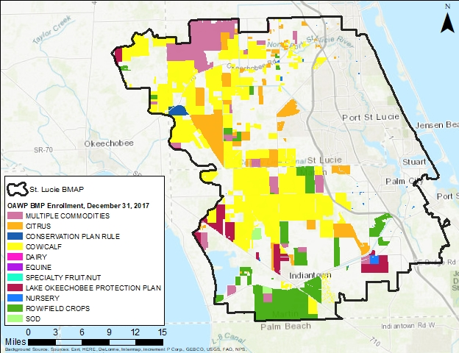
Figure C-1. BMP enrollment in the St. Lucie Estuary as of December 31, 2017

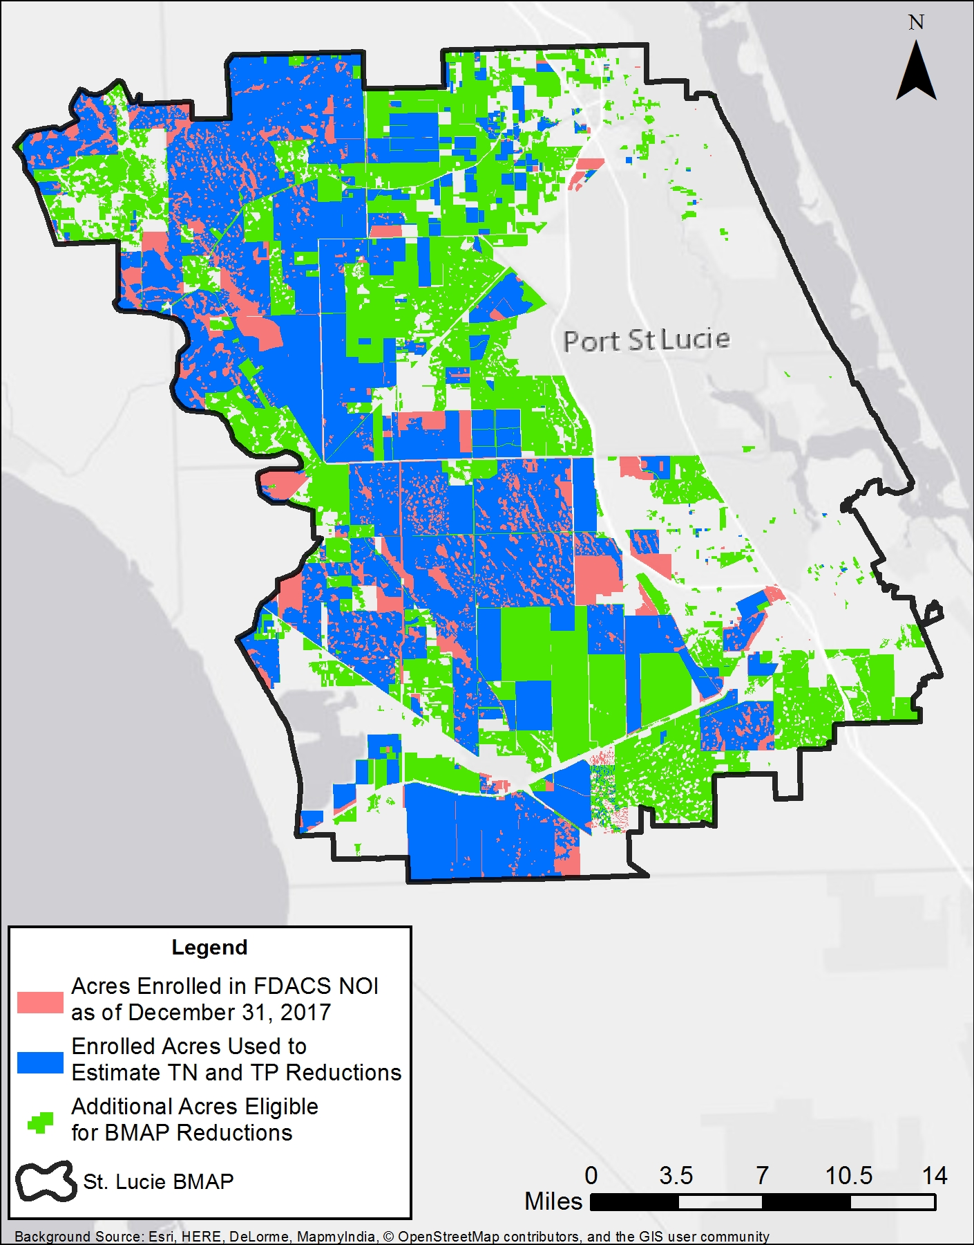
Figure C-2. Enrolled acres used to estimate TN and TP reductions as of December 31, 2017

Recommended Updates to Land Use and Enrollment
As part of the 5-Year Review, the WaSh modeling was updated to include the 2009 and 2012 SFWMD land use coverages. Table C-4 lists the 2012 SFWMD land use acres considered as agriculture for the purposes of the revised allocations described in Section 3.3 and Appendix F. FDACS used the Florida Statewide Agriculture Irrigation Demand (FSAID) IV Geodatabase to estimate agricultural acreages throughout the state, including the acreage in the St. Lucie Estuary Basin.
Table C-4 lists the FDACS-adjusted acres for each agricultural land use type, based on the FSAID Geodatabase. FDACS is currently developing a new FSAID version, and DEP and FDACS are discussing approaches for using the information in BMAPs throughout the state.
Per the FSAID land use, there are 179,695 agricultural acres, of which 132,312 are enrolled in the FDACS BMP Program. This equates to 74 % enrollment of the agricultural acreage in the St. Lucie Estuary Basin covered by the FDACS BMP Program. Table C-5 lists the BMPs and the acreage covered by NOIs.
Table C-4. Agricultural acreage in the St. Lucie Estuary Basin in 2012
¹ FDACS staff-adjusted acreage for purposes of enrollment is based on a review of more recent aerial imagery in the basin and local staff observations.
Land Use | 2012 SFWMD Acres | FDACS Adjusted Acres¹
Pasture (2100, 2110, 2120, 2130) | 153,433 | 159,282
Row/Field/Mixed Crops | 20,158 | 14,905
Fallow Cropland | 42,812
Horse Farm | 1,022 | 112
Citrus | 32,479 | 134
Abandoned Groves | 19,379
Fruit Orchards/Other Groves | 704 | 10
Tree Nurseries | 1,491 | 1,965
Ornamentals | 1,941 | 588
Specialty Farms | 226 | 85
Dairies | 578 | 43
Poultry Feeding Operations | 75 | 74
Sod Farms | 379 | 1,628
Aquaculture | 133 | 611
Hay |  | 181
Cattle Feed Operations |  | 2
Other Open Lands (Rural) |  | 51
Sugarcane |  | 16,649
Total | 274,063 | 179,695

Table C-5. BMP enrollment for the St. Lucie Estuary Basin as of December 31, 2017
Related FDACS BMP Programs | Acreage Enrolled | FSAID 4 Agricultural Land Use Acres within NOIs
Citrus | 25,898 | 12,850
Citrus; Cow/Calf | 959 | 252
Citrus; Cow/Calf; Wildlife | 667 | 656
Citrus; Nursery | 918 | 65
Citrus; Row/Field Crops | 635 | 626
Citrus; Row/Field Crops; Sod | 1,206 | 1,170
Conservation Plan Rule | 1,316 | 1,207
Cow/Calf | 98,839 | 64,644
Cow/Calf; Lake Okeechobee Protection Program | 1,082 | 921
Cow/Calf; Nursery | 1,186 | 104
Cow/Calf; Row/Field Crops | 973 | 469
Cow/Calf; Wildlife | 14,489 | 14,216
Dairy | 8 | 6
Dairy; Lake Okeechobee Protection Program | 43 | 40
Equine | 2 | 1
Equine; Row/Field Crops | 1 | 1
Fruit and Nut | 5
Lake Okeechobee Protection Program | 9,802 | 8,406
Nursery | 1,051 | 872
Nursery; Lake Okeechobee Protection Program | 551 | 456
Nursery; Row/Field Crops | 5
Row/Field Crops | 28,907 | 23,299
Row/Field Crops; Sod | 1,200 | 884
Sod | 1,275 | 1,257
Total | 191,018 | 132,312

FDACS OAWP Implementation Assurance (IA) Program
The OAWP formally established its IA Program in 2005 in the Suwannee River Basin as part of the multiagency/local stakeholder Suwannee River Partnership. In 2007, OAWP initiated the IA Program in the Lake Okeechobee Watershed and launched a standardized follow-up program for the remaining areas of the state in 2013, beginning with the Ridge Citrus and Indian River Citrus BMPs. Because of program-specific needs, the follow-up process for each of these three components was different. In early 2014, OAWP began to streamline the IA Program to ensure consistency statewide and across commodities and BMP manuals.
The IA Program is based on interactions with producers during a site visit by OAWP staff. Site visits are conducted by OAWP field staff and technicians as workload allows. For the visits, field staff and technicians use a standard form (not BMP specific) developed in 2014. This form focuses on nutrient management, irrigation management, and water resource protection BMPs common to all the BMPs adopted by rule. The paper forms are submitted to OAWP staff and compiled into a spreadsheet, and the data are reported annually.
Additional emphasis was given to verifying the implementation of BMPs by enrolled producers with the enactment of Chapter 2016-1, Laws of Florida. That legislation directed OAWP to formalize an Implementation Verification (IV) Program into rules. The IV rule, effective on November 1, 2017, provides the structure for a statewide uniform implementation verification system, including assessments of the status of implementation, compliance assistance to aid producers in achieving full implementation, and referral to DEP for producers who are not implementing BMPs (Chapter 5M-1, F.A.C.).
Beyond BMPs
Beyond enrolling producers in the FDACS BMP Program and verifying implementation, FDACS will work with DEP to improve the data used to estimate agricultural land uses in the watershed. FDACS will also work with producers to identify and implement a suite of agricultural projects and research agricultural technologies on properties where they are deemed technically feasible and if funding is made available. The implementation of projects would require funding as well as more detailed design based on site-specific information, such as actual applicable acreages and willing landowners.

Appendix D: BMAP Monitoring Network and Recommended Revisions
The St. Lucie River and Estuary BMAP monitoring plan was designed to enhance the understanding of basin loads, identify areas with high nutrient concentrations, and track water quality trends. The BMAP monitoring plan currently consists of the ambient water quality sampling described below.
Currently, TN and TP concentrations are monitored at 90 stations and flow is monitored at 4 stations in the adopted BMAP monitoring network. The network of stations is listed in Table
D-1 and shown in Figures D-1 and D-2.
Table D-1. BMAP monitoring network
Sampling Entity | Station ID | Station Name | Station Type | Frequency | Site Established
Hobe St. Lucie Conservancy District | Sample III | III | Grab | Annual | 1974
Hobe St. Lucie Conservancy District | Sample 6 | 6 | Grab | Annual | 1974
Hobe St. Lucie Conservancy District | Sample 7 | 7 | Grab | Annual | 1974
Hobe St. Lucie Conservancy District | Sample 8 | 8 | Grab | Annual | 1974
NSLRWCD | 1 | Structure 23-1 Sager and Oleander | Grab | Quarterly | 01/2011
NSLRWCD | 2 | North Fork St. Lucie River at Midway Rd. – White City Park pier | Grab | Quarterly | 01/2011
NSLRWCD | 3 | Five Mile Creek at Edwards Rd. – Bridge at Kirby Loop Rd. | Grab | Quarterly | 01/2011
NSLRWCD | 6 | South of Riser 40-1-2 NW corner Okeechobee Rd. and Kings Highway | Grab | Quarterly | 01/2011
NSLRWCD | 7 | Structure 71-1-4 Ten Mile Creek and C-96 (bridge on Gordy Rd.) | Grab | Quarterly | 01/2011
NSLRWCD | 8 | McCarty Rd. and Ten Mile Creek | Grab | Quarterly | 01/2011
NSLRWCD | 9 | McCarty Rd. and Stetson Rd. | Grab | Quarterly | 01/2011
Port St. Lucie | C-106 | C-106 | Grab | 1 or 2 times/year (yr) | 02/2004
Port St. Lucie | C-107 | C-107 | Grab | 1 or 2 times/yr | 06/2004
Port St. Lucie | C-108 | C-108 | Grab | 1 or 2 times/yr | 02/2004
Port St. Lucie | Sagamore WW | Sagamore WW | Grab | 1 or 2 times/yr | 02/2004
Port St. Lucie | Degan WW | Degan WW | Grab | 1 or 2 times/yr | 10/2004
Port St. Lucie | D-14 | D-14 | Grab | 1 or 2 times/yr | 02/2004
Port St. Lucie | D-21 | D-21 | Grab | 1 or 2 times/yr | 02/2004
Port St. Lucie | Elcam In | Elcam In | Grab | 1 or 2 times/yr | 02/2004
Port St. Lucie | Elcam Spillway | Elcam Spillway | Grab | 1 or 2 times/yr | 02/2004
Port St. Lucie | Kingsway WW | Kingsway WW | Grab | 1 or 2 times/yr | 02/2004
Port St. Lucie | A23 | A23 | Grab | 1 or 2 times/yr | 02/2004
Port St. Lucie | A24 | A24 | Grab | 1 or 2 times/yr | 02/2004
Port St. Lucie | A25 | A25 | Grab | 1 or 2 times/yr | 02/2004
Port St. Lucie | Burrow | Burrow | Grab | 1 or 2 times/yr | 02/2004
Port St. Lucie | E8 | E8 | Grab | 1 or 2 times/yr | 02/2004
Port St. Lucie | Monterrey WW | Monterrey WW | Grab | 1 or 2 times/yr | 02/2004
Port St. Lucie | U16-D016 | U16-D016 | Grab | 1 or 2 times/yr | 02/2004
Port St. Lucie | H-16 | H-16 | Grab | 1 or 2 times/yr | 02/2004
Port St. Lucie | Blackwell Pump Station | Blackwell Pump Station | Grab | 1 or 2 times/yr | 02/2004
Port St. Lucie | B-33 | B-33 | Grab | 1 or 2 times/yr | 03/2005
Port St. Lucie | B-95-3 | B-95-3 | Grab | 1 or 2 times/yr | 03/2005
SFWMD | C23S48 | WQM | Grab | Weekly | 01/1979
SFWMD | C23S48 | WQM | Autosampler | Weekly | 10/1996
SFWMD | C24S49 | WQM | Grab | Weekly | 01/1979
SFWMD | C24S49 | WQM | Autosampler | Weekly | 09/1997
SFWMD | C44S80 | WQM | Grab | Weekly | 01/1979
SFWMD | C44S80 | WQM | Autosampler | Weekly | 04/1999
SFWMD | G81 | WQM | Grab | Biweekly | 07/2012
SFWMD | GORDYRD | WQM | Grab | Weekly | 08/1999
SFWMD | GORDYRD | WQM | Autosampler | Weekly | 08/1999
SFWMD | SLT-1 | SLT | Grab | Biweekly | 11/2001
SFWMD | SLT-10A | SLT | Grab | Biweekly | 11/2001
SFWMD | SLT-10B | SLT | Grab | Biweekly | 11/2001
SFWMD | SLT-11 | SLT | Grab | Biweekly | 11/2001
SFWMD | SLT-17 | SLT | Grab | Biweekly | 11/2001
SFWMD | SLT-19 | SLT | Grab | Biweekly | 11/2001
SFWMD | SLT-21 | SLT | Grab | Biweekly | 11/2001
SFWMD | SLT-22A | SLT | Grab | Biweekly | 05/2012
SFWMD | SLT-26 | SLT | Grab | Biweekly | 11/2001
SFWMD | SLT-29 | SLT | Grab | Biweekly | 11/2001
SFWMD | SLT-2A | SLT | Grab | Biweekly | 05/2013
SFWMD | SLT-3 | SLT | Grab | Biweekly | 11/2001
SFWMD | SLT-30A | SLT | Grab | Biweekly | 11/2001
SFWMD | SLT-31 | SLT | Grab | Biweekly | 11/2001
SFWMD | SLT-34A | SLT | Grab | Biweekly | 05/2007
SFWMD | SLT-35 | SLT | Grab | Biweekly | 11/2001
SFWMD | SLT-36 | SLT | Grab | Biweekly | 11/2001
SFWMD | SLT-37A | SLT | Grab | Biweekly | 01/2003
SFWMD | SLT-38 | SLT | Grab | Biweekly | 11/2001
SFWMD | SLT-38A | SLT | Grab | Biweekly | 05/2012
SFWMD | SLT-39 | SLT | Grab | Biweekly | 02/2003
SFWMD | SLT-4 | SLT | Grab | Biweekly | 11/2001
SFWMD | SLT-40 | SLT | Grab | Biweekly | 01/2003
SFWMD | SLT-40A | SLT | Grab | Biweekly | 05/2012
SFWMD | SLT-42B | SLT | Grab | Biweekly | 11/2001
SFWMD | SLT-44 | SLT | Grab | Biweekly | 05/2007
SFWMD | SLT-45 | SLT | Grab | Biweekly | 05/2013
SFWMD | SLT-5 | SLT | Grab | Biweekly | 11/2001
SFWMD | SLT-6 | SLT | Grab | Biweekly | 11/2001
SFWMD | SLT-7 | SLT | Grab | Biweekly | 11/2001
SFWMD | SLT-9 | SLT | Grab | Biweekly | 11/2001
SFWMD | HR1 | SE | Grab | Monthly | 06/1994
SFWMD | SE 01 | SE | Grab | Monthly | 10/1990
SFWMD | SE 02 | SE | Grab | Monthly | 10/1990
SFWMD | SE 03 | SE | Grab | Monthly | 10/1990
SFWMD | SE 08B | SE | Grab | Monthly | 12/2003
SFWMD | SE 09 | SE | Grab | Monthly | 10/1990
SFWMD | SE 11 | SE | Grab | Monthly | 06/1997
SFWMD | SE06B | SE | Grab | Monthly | 10/1990
SFWMD | SE12B | SE | Grab | Monthly | 07/2003
SFWMD | SE13B | SE | Grab | Monthly | 07/2003
SLC | Platt's Creek Influent | Platt's Creek Influent | Grab | Triweekly | 01/2008
SLC | Platt's Creek Effluent | Platt's Creek Effluent | Grab | Triweekly | 01/2008
SLC | Indian River Estates Influent | Indian River Estates Influent | Grab | Triweekly | 03/2009
SLC | Indian River Estates Effluent | Indian River Estates Effluent | Grab | Triweekly | 03/2009
SLWSD | Gate 7 | 7B | Outfall structure |  | 08/2011
SLWSD | Gate 8 | 7A | Outfall structure |  | 08/2011
SLWSD | Gate 6 | 6B | Outfall structure |  | 08/2011
SLWSD | Gate 4 | 4E | Outfall structure |  | 08/2011
SLWSD | Gate 3 | 3B | Outfall structure |  | 08/2011
SLWSD | Gate 2 | 2C | Outfall structure |  | 08/2011
SLWSD | Gate 1 | 1E | Outfall structure |  | 08/2011
SLWSD | Gate 5 | 5 | Outfall structure |  | 08/2011
USGS | 2277100 | St Lucie River at Speedy Point, Stuart, FL | Flow gage | Daily | 08/1997
USGS | 2277110 | St Lucie River at A1A (Steele Point), Stuart, FL | Flow gage | Daily | 08/1997
USGS | 2276870 | St Lucie Canal at Lake Okeechobee | Flow gage | Daily | 03/1941
USGS | 272524080221800 | Five Mile Canal above S-29-1-4 near Ft. Pierce | Flow gage | Daily | 12/2002

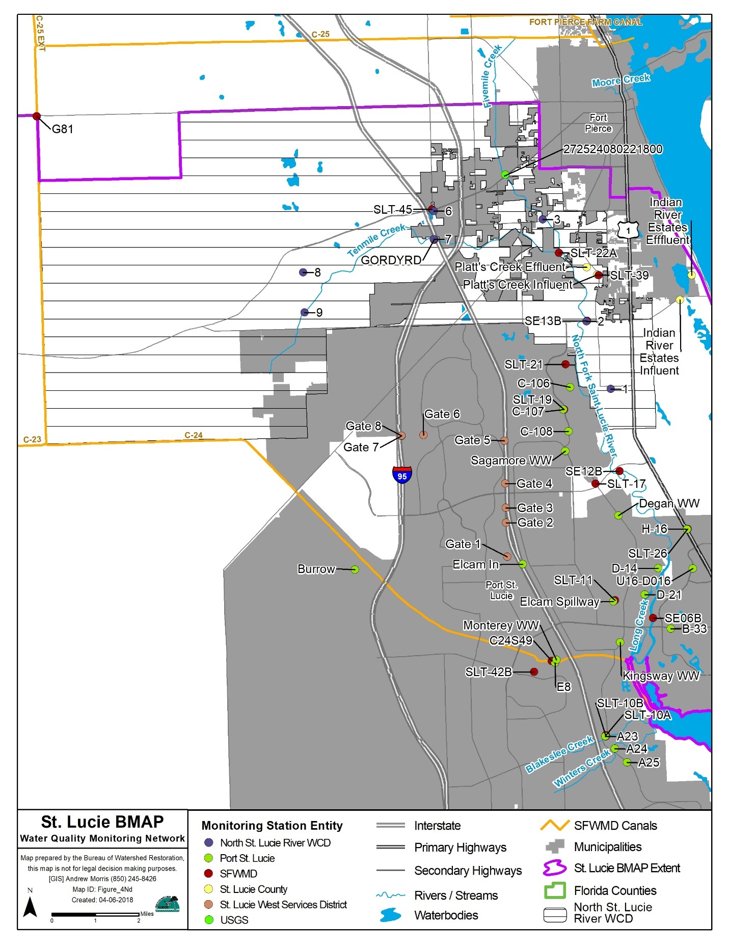
Figure D-1. Water quality monitoring network for the southern part of the St. Lucie River and Estuary

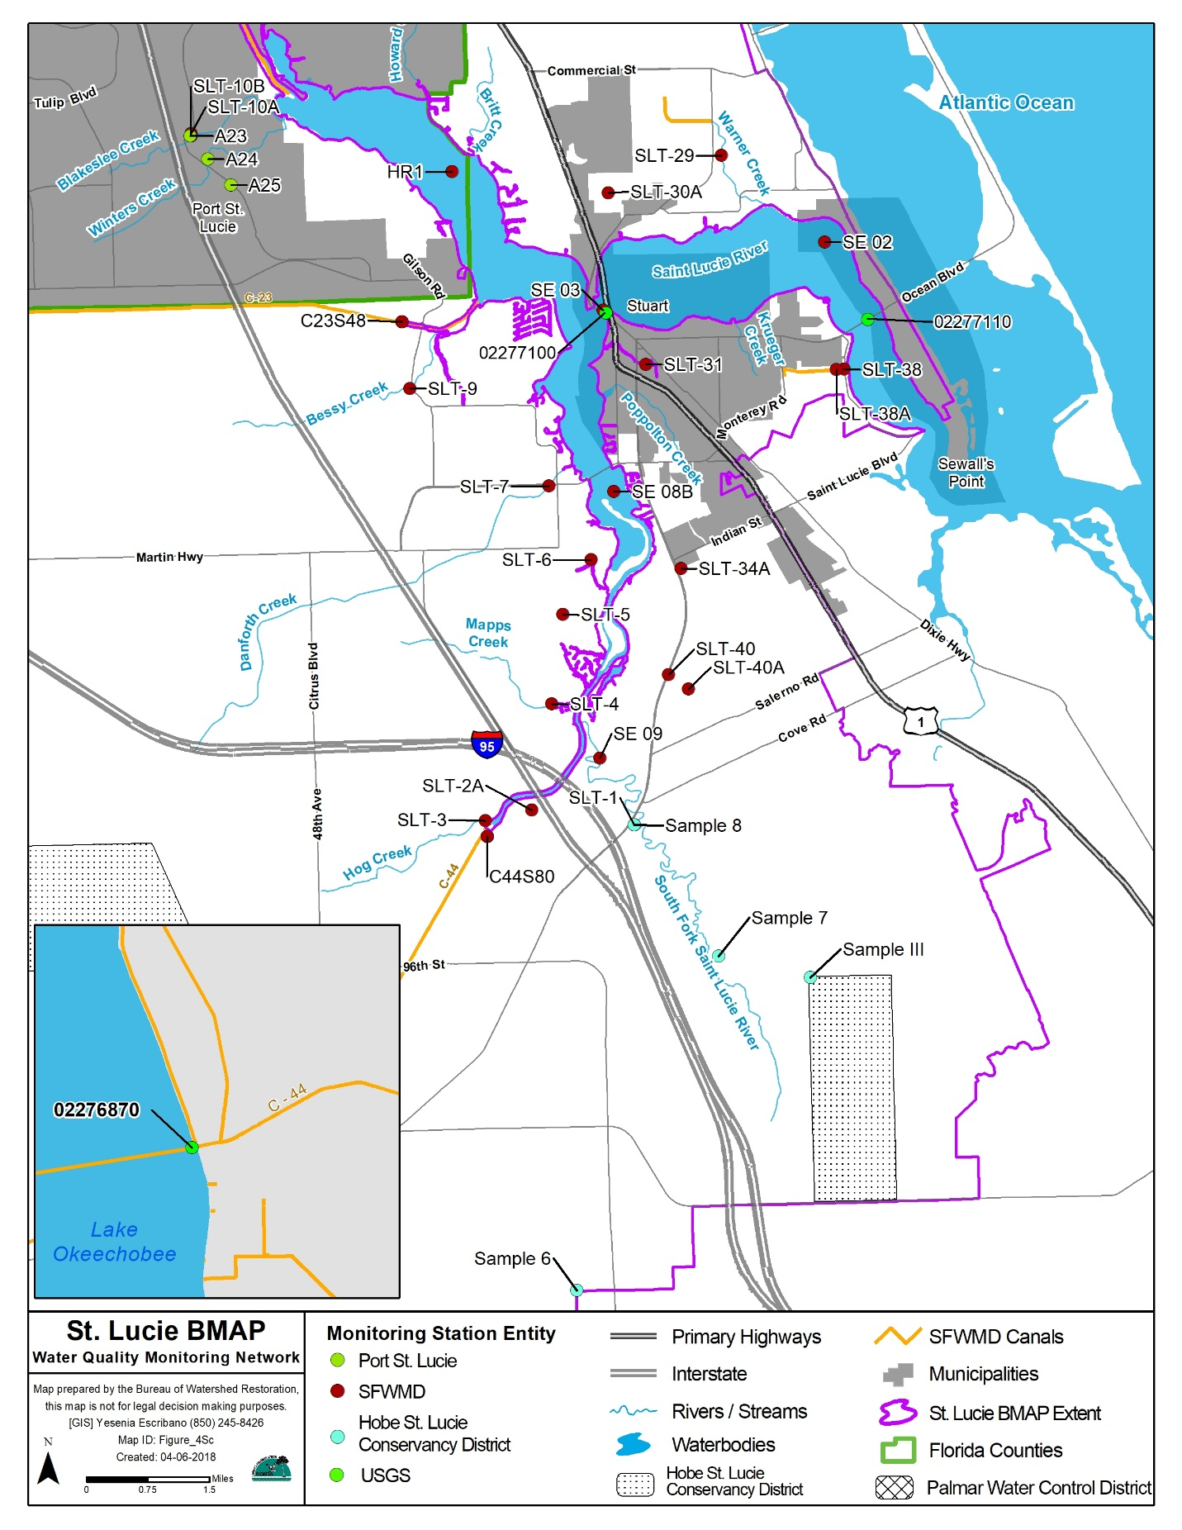
Figure D-2. Water quality monitoring network for the northern part of the St. Lucie River and Estuary

Recommended Revisions
For future implementation phases, one recommendation is to reorganize the ambient water quality monitoring stations into a tiered system, as follows:
- Tier 1: Stations that will be the primary/priority stations used to track BMAP progress over the long term. If at any point it is necessary to reduce efforts in the basin, these stations should be the last stations impacted.
- Tier 2: Stations that can be used for regional analyses or other secondary analyses.
- Tier 3: USGS gages where flow and/or stage are monitored.
Several additional sites monitored in the basin are not included in the BMAP network, as the ability to sample is resource dependent. Data from these sites may be reviewed when appropriate. If the recommended revisions to the BMAP monitoring network are implemented, TN and TP concentrations will be monitored at 57 stations and flow will be monitored at 4 stations. The revised network of stations is listed in Table D-2 and shown in Figures D-3 and
D-4.
Table D-2. Revised BMAP monitoring network
¹ Previously listed as "B" station, which was active from July 16, 2012, to February 12, 2015. The station was moved back to the original location and no data are available after 2/12/2015.
Notes: N/A = Not applicable. Remove = Recommended that station be excluded from revised network. Bold denotes a station that is newly added to the network.
Sampling Entity | Station | Station Type | Tier Recommendation | Structure, Estuary, or Tributary
Hobe St. Lucie Conservancy District | Sample III | Grab | Remove | N/A
Hobe St. Lucie Conservancy District | Sample 6 | Grab | Remove | N/A
Hobe St. Lucie Conservancy District | Sample 7 | Grab | Remove | N/A
Hobe St. Lucie Conservancy District | Sample 8 | Grab | Remove | N/A
NSLRWCD | 1 (Structure 23-1 Sager and Oleander) | Grab | Remove | N/A
NSLRWCD | 2 (North Fork St. Lucie River at Midway Rd. – White City Park Pier) | Grab | Remove | N/A
NSLRWCD | 3 (Five Mile Creek at Edwards Rd. – Bridge at Kirby Loop Rd.) | Grab | Remove | N/A
NSLRWCD | 6 (South of Riser 40-1-2 NW corner Okeechobee Rd. and Kings Highway | Grab | Remove | N/A
NSLRWCD | 7 (Structure 71-1-4 Ten Mile Creek and C-96 [bridge on Gordy Rd.]) | Grab | Remove | N/A
NSLRWCD | 8 (McCarty Rd. and Ten Mile Creek) | Grab | Remove | N/A
NSLRWCD | 9 (McCarty Rd. and Stetson Rd.) | Grab | Remove | N/A
Port St. Lucie | C-106 | Grab | Remove | N/A
Port St. Lucie | C-107 | Grab | 2 | Tributary
Port St. Lucie | C-108 | Grab | Remove | N/A
Port St. Lucie | Sagamore WW | Grab | Remove | N/A
Port St. Lucie | Degan WW | Grab | Remove | N/A
Port St. Lucie | D-14 | Grab | Remove | N/A
Port St. Lucie | D-21 | Grab | Remove | N/A
Port St. Lucie | Elcam In | Grab | Remove | N/A
Port St. Lucie | Elcam Spillway | Grab | 2 | Tributary
Port St. Lucie | Kingsway WW | Grab | 2 | Tributary
Port St. Lucie | A18 | Grab | 2 | Tributary
Port St. Lucie | A22 | Grab | 2 | Tributary
Port St. Lucie | A23 | Grab | Remove | N/A
Port St. Lucie | A24 | Grab | Remove | Tributary
Port St. Lucie | A25 | Grab | Remove | N/A
Port St. Lucie | Burrow | Grab | Remove | N/A
Port St. Lucie | E8 | Grab | 2 | Tributary
Port St. Lucie | Monterrey WW | Grab | 2 | Tributary
Port St. Lucie | U16-D016 | Grab | 2 | Tributary
Port St. Lucie | H-16 | Grab | 2 | Tributary
Port St. Lucie | Blackwell Pump Station | Grab | Remove | N/A
Port St. Lucie | B-33 | Grab | Remove | Tributary
Port St. Lucie | B-95-3 | Grab | Remove | Tributary
SFWMD | C23S48 | Grab | 1 | Structure
SFWMD | C23S48 | Autosampler | 1 | Structure
SFWMD | C24S49 | Grab | 1 | Structure
SFWMD | C24S49 | Autosampler | 1 | Structure
SFWMD | C25S50 | Grab | 1 | Structure
SFWMD | C44S80 | Grab | 1 | Structure
SFWMD | C44S80 | Autosampler | 1 | Structure
SFWMD | G81 | Grab | 2 | Structure
SFWMD | GORDYRD | Grab | 1 | Structure
SFWMD | GORDYRD | Autosampler | 1 | Structure
SFWMD | S308C | Grab | 1 | Structure
SFWMD | SLT-1 | Grab | 2 | Tributary
SFWMD | SLT-10A | Grab | 2 | Tributary
SFWMD | SLT-10B | Grab | 2 | Tributary
SFWMD | SLT-11 | Grab | 2 | Tributary
SFWMD | SLT-17 | Grab | 2 | Tributary
SFWMD | SLT-19 | Grab | 2 | Tributary
SFWMD | SLT-21 | Grab | 2 | Tributary
SFWMD | SLT-22A | Grab | 2 | Tributary
SFWMD | SLT-26 | Grab | 2 | Tributary
SFWMD | SLT-29 | Grab | 2 | Tributary
SFWMD | SLT-2A | Grab | 2 | Tributary
SFWMD | SLT-3 | Grab | 2 | Tributary
SFWMD | SLT-30A | Grab | 2 | Tributary
SFWMD | SLT-31 | Grab | 2 | Tributary
SFWMD | SLT-34A | Grab | 2 | Tributary
SFWMD | SLT-35 | Grab | 2 | Tributary
SFWMD | SLT-36 | Grab | 2 | Tributary
SFWMD | SLT-37A | Grab | 2 | Tributary
SFWMD | SLT-38 | Grab | 2 | Tributary
SFWMD | SLT-38A | Grab | 2 | Tributary
SFWMD | SLT-39 | Grab | 2 | Tributary
SFWMD | SLT-4 | Grab | 2 | Tributary
SFWMD | SLT-40 | Grab | 2 | Tributary
SFWMD | SLT-40A | Grab | 2 | Tributary
SFWMD | SLT-42B | Grab | 2 | Tributary
SFWMD | SLT-44 | Grab | 2 | Tributary
SFWMD | SLT-45 | Grab | 2 | Tributary
SFWMD | SLT-5 | Grab | 2 | Tributary
SFWMD | SLT-6 | Grab | 2 | Tributary
SFWMD | SLT-7 | Grab | 2 | Tributary
SFWMD | SLT-9 | Grab | 2 | Tributary
SFWMD | HR1 | Grab | 1 | Tributary
SFWMD | SE 01 | Grab | 1 | Estuary
SFWMD | SE 02 | Grab | 1 | Estuary
SFWMD | SE 03 | Grab | 1 | Estuary
SFWMD | SE 08B | Grab | 1 | Estuary
SFWMD | SE 09 | Grab | 1 | Estuary
SFWMD | SE 11 | Grab | 1 | Estuary
SFWMD | SE06B¹ | Grab | 1 | Estuary
SFWMD | SE12B¹ | Grab | 1 | Estuary
SFWMD | SE13B¹ | Grab | 2 | Estuary
SLC | Platt's Creek Influent | Grab | Remove | N/A
SLC | Platt's Creek Effluent | Grab | Remove | N/A
SLC | Indian River Estates Influent | Grab | Remove | N/A
SLC | Indian River Estates Effluent | Grab | Remove | N/A
SLWSD | Gate 7 | Outfall structure | Remove | N/A
SLWSD | Gate 8 | Outfall structure | Remove | N/A
SLWSD | Gate 6 | Outfall structure | Remove | N/A
SLWSD | Gate 4 | Outfall structure | Remove | N/A
SLWSD | Gate 3 | Outfall structure | Remove | N/A
SLWSD | Gate 2 | Outfall structure | Remove | N/A
SLWSD | Gate 1 | Outfall structure | Remove | N/A
SLWSD | Gate 5 | Outfall structure | Remove | N/A
USGS | 2277100 (St. Lucie River at Speedy Point, Stuart, FL) | Flow gage | 3 | Estuary
USGS | 2277110 (St. Lucie River at A1A [Steele Point], Stuart, FL) | Flow gage | 3 | Estuary
USGS | 2276870 (St. Lucie Canal at Lake Okeechobee) | Flow gage | 3 | Structure
USGS | 272524080221800 (Five Mile Canal above S-29-1-4 near Ft. Pierce) | Flow gage | 3 | Tributary

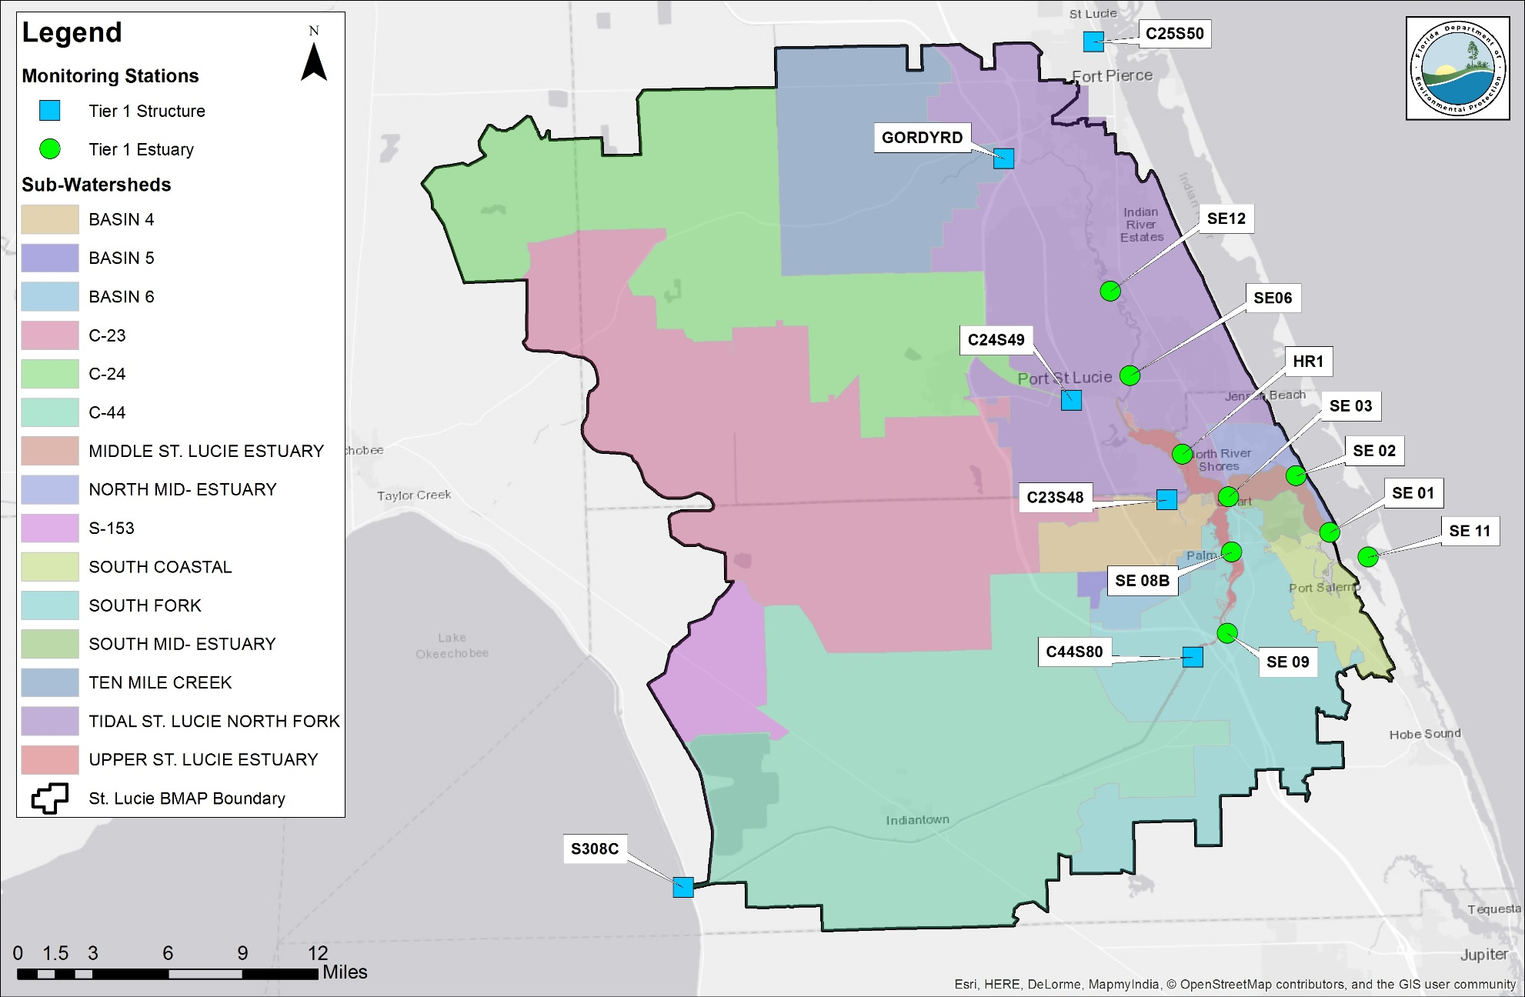
Figure D-3. Revised Tier 1 St. Lucie River and Estuary BMAP stations

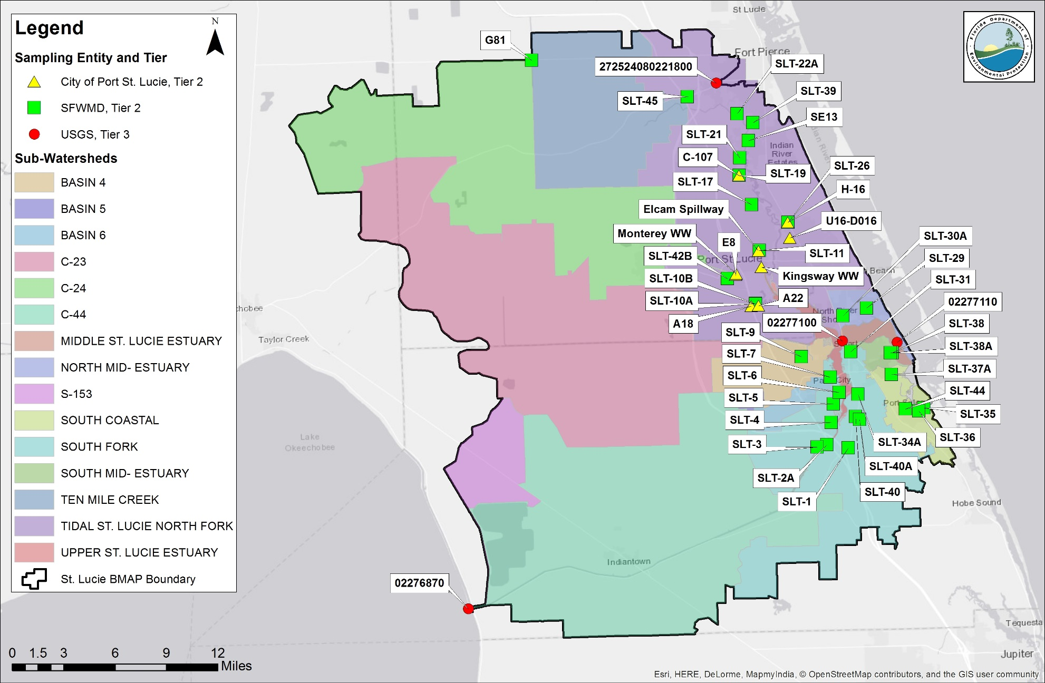
Figure D-4. Revised Tier 2 and 3 St. Lucie River and Estuary BMAP stations

Biological Monitoring
In addition to the monitoring of water quality parameters, biological monitoring is carried out to assess the overall health of the St. Lucie River and Estuary. This monitoring includes the evaluation of seagrass and oysters, as summarized in Table D-3. These stations are not specifically BMAP stations—i.e., they are designed for other purposes—but the data collected are submitted to DEP and may be used to monitor the effectiveness of BMAP projects.
Table D-3. St. Lucie River and Estuary biological monitoring
FWC = Florida Fish and Wildlife Conservation Commission
Sampling Entity | Project | Number of Stations | Location | Parameter(s) | Frequency | Project Start Date
SFWMD/ DEP | Seagrass Monitoring and Mapping | 20 | Transects in all lagoon segments | Species-specific percent cover, shoot density, canopy height, length of seagrass bed, epiphyte cover, macroalgae | Semiannually | 1994
SFWMD/ DEP | Seagrass Monitoring  and Mapping | Lagoonwide maps | Entire lagoon from St. Lucie Estuary upstream to Roosevelt Bridge (US 1) | Continuous or patchy seagrass cover map | Every 2 to 5 years | 1986
SFWMD | Seagrass Monitoring  and Mapping | 7 | Indian River Lagoon -South | Species-specific presence/absence 2008-12, percent cover starting 2012, canopy height of dominant species | Quarterly to bimonthly (2 sites near St. Lucie Estuary monitored monthly during summer) | 2008
SFWMD/ FWC | Oyster Monitoring  and Mapping | 9 | St. Lucie Estuary | Spat recruitment and disease prevalence (monthly); live/dead density (semiannually) | Monthly; Semiannually | 2005

Appendix E: St. Lucie Water Quality Data Processing and Analysis Methods
For this 5-Year Review of the St. Lucie Estuary BMAP, trend analyses were conducted on available data from appropriate estuary and structure stations for the period from May 1, 2007, to April 30, 2017. Data were provided primarily by STORET and WIN and processed according to the procedure outlined in the next section. The nonparametric Seasonal Kendall test was used to identify monotonic trends in the data. This statistical technique was chosen because data are not required to conform to a particular distribution and because nonparametric techniques are robust against outliers and gaps in the data record. The results of the Seasonal Kendall analysis are summarized in Section 2.3.3 in the report, and details of the techniques are provided below.
Data Management and Processing
The working POR for this analysis was May 1, 2007, to April 30, 2017, to allow a sufficient data record for trend analysis including periods before and after BMAP adoption in May 2013. Additionally, by using water year, the evaluation will remain consistent with the established water year in the region (May 1 to April 30).
The parameters used in the analysis included TN (including all nitrogen species required to calculate TN) and TP. TN and TP data were retrieved from STORET and WIN for the 15 SFWMD stations determined to be appropriate for the analysis. Data from Stations SE06 and SE12 were combined with data from SE06B and SE12B, respectively, as the stations are in the same locations but were renamed. Additionally, STORET and WIN had no data for SE06 and SE12 before July 2012, and so data were retrieved from the SFWMD DBHYDRO Database for the period from May 2007 to July 2012. Following the completion of data analyses and this report, SFWMD uploaded data from these stations to WIN for inclusion in the DEP database.
Table A-1 lists the POR, data availability, and retrieval database for the monthly series of nutrient data for each station. All data were subject to processing with industry standard quality control (QC) checks and statistical diagnostics, which addressed the review of sample collection methods, the removal of data flagged with fatal qualifier codes, the assessment of temporal independence, and serial correlation. After QC processing was completed, monthly medians were calculated for each month with more than one sampling date. The monthly median series were the final data series used in statistical and trend analysis. The following sections describe specific data processing steps and methodology.
Statistical Analyses
The Seasonal Kendall test was used to identify monotonic trends in the nutrient concentration data for each station. Nonparametric tests such as Seasonal Kendall are robust against outliers and large data gaps, and data are not required to conform to a particular distribution for nonparametric analyses. The USGS Fortran code for the Seasonal Kendall test was used to compute a tau, raw p-value, and slope for each parameter series using months as "seasons." The program also provides a p-value adjusted for covariance caused by serial correlation.
Autocorrelation function (ACF) analysis was conducted on the monthly TN and TP series for each station to identify seasonality and serial correlation. If a series showed significant autocorrelation at the 12-month lag, it was considered to exhibit serial correlation, and the adjusted p-value was selected as the representative p-value for the series. If no serial correlation was detected, then the raw p-value was reported. Trends in the data series were considered significant if the appropriate p-value was less than 0.05, with a positive Sen slope indicating an increasing trend, and a negative Sen slope indicating a decreasing trend.
Data Download
- TN and TP data from WIN and STORET:
  - Structure stations used in analysis: C44S80, C23S48, C24S49, GORDYRD, C25S50, S308C.
  - Estuary stations used in analysis: HR1, SE01, SE02, SE03, SE06, SE08B, SE09, SE11, and SE12:
    - Stations SE06B and SE12B were combined with Stations SE06 and SE12 respectively, as they are in the same location, but were renamed.
- Station data were provided by DEP (from STORET and WIN) to assess nutrient concentrations for all stations, and by SFWMD (DBHYDRO) to assess nutrient FWMs and loads at structure stations for the designated POR:
  - Overall POR was May 1, 2007, through April 30, 2017.

Data Processing (in order of operation)
- Data Qualifiers:
  - Data with result qualifiers of "G," "H," "K," "L," "N," "O," "Q," "V," "Y," or "?" were not used in the analysis, as per Table 1, Data Qualifier Codes, in Rule 62-160.700, F.A.C., Quality Assurance, and recent decisions of DEP.
  - Only grab samples were used in the analysis of concentration data.
  - Both grab and automatic composite samples were used in the analysis of FWM and load data (as calculated and provided by SFWMD from flow and concentration data).
  - Comments associated with data with a result qualifier of "J" were reviewed, however none indicated that the data should be excluded from the analyses.
  - Data with a result qualifier of "U" were reviewed:
    - If not already present, a result qualifier of "U" was assigned to any data with a result value of "*Non-Detect."
    - Data with a result value of "*Not Reported" were deleted unless they also had a value qualifier of "U."
    - Data with a result qualifier of "U" were processed in accordance with Subsection 62-303.320(12), F.A.C., Aquatic Life-Based Water Quality Criteria Assessment. Results reported by a laboratory with the "U" data qualifier code were assessed as half the reported result or half the criterion (whichever was lower).
- Sample Depth:
  - Samples were not filtered by sample depth.
- Nutrient Characteristic Selection:
  - TP: "Phosphorus as P," "Phosphorus - Total."
  - TN (in order of priority):
    - "Nitrogen - Total", or "Nitrogen ion."
    - TKN + (NO₂ + NO₃).
    - TKN + NO₂ + NO₃
    - TKN*Adjustment Factor:
      - Adjustment Factor = Median (TN/TKN) for the entire POR.
- Accounting for Duplicate Samples:
  - If samples were found to share the same station, characteristic, date, and time, they were flagged and reviewed.
  - The median of the duplicate samples was used as the reported value.
- Temporal Processing:
  - Monthly Time Series: If multiple data points existed within a month, the monthly median was calculated for each month.
- Processing for Statistical Tests:
  - Data were processed according to the needs of each statistical test (ACF or trend) and formatted for use in the R statistical program or USGS Fortran code.
  - Sampling Frequency:
    - Monthly data series were used for analysis.
    - If a series had at least 5 years of data (without large data gaps), it was used for trend analysis.
      - The STORET/WIN series for Stations SE06 and SE12 were missing data from May 1, 2007, to July 1, 2012, and so the gap was filled using DBHYDRO data. The DBHYDRO data during that period were later submitted to WIN after the completion of this report.

Trend Analysis
- Autocorrelation function (ACF):
    - Autocorrelation function was conducted to evaluate seasonal patterns or serial correlation (using monthly seasons).
    - For purposes of Seasonal Kendall analysis, statistically significant correlation on the 12th month lag was considered to be representative of serial correlation.
  - Seasonal Kendall Tau Test:
    - Statistical Test Description: A nonparametric statistical test that does not require data to conform to a specific distribution and is not sensitive to outliers or data gaps:
      - Identifies monotonic trends in the datasets.
      - Yields statistical significance value and direction of trend (increasing or decreasing).
      - Accounts for seasonal data patterns (using months as seasons).
    - Use in Trend Analysis:
      - Serial correlation was identified with ACFs prior to trend analysis.
      - USGS Fortran code for Seasonal Kendall Tau Test was used to produce tau, p-value, adjusted p-value, and Sen slope:
        - Raw P-value used for series with no serial correlation detected.
        - Adjusted p-value used if serial correlation was identified.
        - Tables E-2 and E-3 provide complete results for trend analysis, including raw and adjusted p-values and selected p-values.
      - Tau, p-value, and slope were used to interpret significance and direction of monotonic trend.

Table E-1. POR for monthly nutrient data series
* DBHYDRO data were used to fill gaps in the STORET/WIN dataset from May 2007 to July 2012. All data were processed and reviewed with the same procedures.
Data Source | Station | TP  Start Date | TP  End Date | TP  Count | TN  Start Date | TN  End Date | TN  Count
STORET/WIN | C23S48 | May-2007 | April-2017 | 119 | May-2007 | April-2017 | 119
STORET/WIN | C24S49 | May-2007 | April-2017 | 115 | May-2007 | April-2017 | 115
STORET/WIN | C25S50 | May-2007 | June-2016 | 110 | May-2007 | June-2016 | 110
STORET/WIN | C44S80 | May-2007 | April-2017 | 118 | May-2007 | April-2017 | 118
STORET/WIN | S308C | May-2007 | April-2017 | 119 | May-2007 | April-2017 | 119
STORET/WIN | GORDYRD | May-2007 | April-2017 | 119 | May-2007 | April-2017 | 119
STORET/WIN | HR1 | May-2007 | April-2017 | 115 | May-2007 | April-2017 | 116
STORET/WIN | SE 01 | May-2007 | April-2017 | 114 | May-2007 | April-2017 | 115
STORET/WIN | SE 02 | May-2007 | April-2017 | 113 | May-2007 | April-2017 | 113
STORET/WIN | SE 03 | May-2007 | April-2017 | 115 | May-2007 | April-2017 | 116
STORET/WIN | SE 08B | May-2007 | April-2017 | 115 | May-2007 | April-2017 | 116
STORET/WIN | SE 09 | May-2007 | April-2017 | 114 | May-2007 | April-2017 | 114
STORET/WIN | SE 11 | May-2007 | April-2017 | 114 | May-2007 | April-2017 | 114
STORET/WIN | *SE 06 | July-2012 | April-2017 | 53 | July-2012 | April-2017 | 53
STORET/WIN | *SE 12 | July-2012 | April-2017 | 54 | July-2012 | April-2017 | 54
DBHYDRO | *SE 06 | May-2007 | July-2012 | 84 | May-2007 | July-2012 | 84
DBHYDRO | *SE 12 | May-2007 | July-2012 | 84 | May-2007 | July-2012 | 84

Table E-2. Complete Seasonal Kendall trend analysis results for TN concentrations
Note: P-values listed in bold indicate statistical significance (p<0.05).
TN measured in mg/L.
¹ Even if the p-value is determined to be statistically significant, the result may not be ecologically significant. For example, if a trend is statistically significantly declining (negative trend) but the slope is near 0, then it may not be realistic to assume that an improvement in water quality by reductions in TN or TP may positively impact the ecological system in a measurable way.
² Series with serial correlation (marked with X, as per autocorrelation analysis results) used the P-value adjusted for serial correlation.
* Stations SE06 and SE12 include data from SE06B and SE12B, respectively.
Station | Station Type | Tau | Raw  P-Value | P-Adjusted | Slope¹ | Serial Correlation | Selected P-Value²
C23S48 | Structure | -0.017 | 0.835 | 0.913 | -0.00133 | X | 0.913
C24S49 | Structure | -0.125 | 0.095 | 0.260 | -0.00825 | X | 0.260
C25S50 | Structure | 0.024 | 0.770 | 0.852 | 0.00175 | X | 0.852
C44S80 | Structure | -0.061 | 0.413 | 0.616 | -0.00567 | X | 0.616
GORDYRD | Structure | -0.141 | 0.053 | 0.279 | -0.01486 | X | 0.279
S308C | Structure | -0.209 | 0.004 | 0.114 | -0.03583 | X | 0.114
HR1 | Estuary | -0.165 | 0.027 | 0.043 | -0.01229 | X | 0.043
SE 01 | Estuary | 0.046 | 0.556 | 0.658 | 0.00392 | X | 0.658
SE 02 | Estuary | -0.014 | 0.870 | 0.899 | -0.00088 | X | 0.899
SE 03 | Estuary | -0.161 | 0.031 | 0.089 | -0.01232 | X | 0.089
SE 08B | Estuary | -0.050 | 0.516 | 0.578 | -0.00525 | X | 0.578
SE 09 | Estuary | -0.088 | 0.251 | 0.273 | -0.00735 | X | 0.273
SE 11 | Estuary | 0.162 | 0.030 | 0.170 | 0.00917 | X | 0.170
*SE 06 | Estuary | -0.226 | 0.002 | 0.017 | -0.01667 | X | 0.017
*SE 12 | Estuary | -0.298 | 0.000 | 0.021 | -0.02375 | X | 0.021

Table E-3. Complete Seasonal Kendall trend analysis results for TP concentrations
Note: P-values listed in bold indicate statistical significance (p<0.05).
TP measured in mg/L..
¹ Even if the p-value is determined to be statistically significant, the result may not be ecologically significant. For example, if a trend is statistically significantly declining (negative trend) but the slope is near 0, then it may not be realistic to assume that an improvement in water quality by reductions in TN or TP may positively impact the ecological system in a measurable way.
² Series with serial correlation (marked with X, as per autocorrelation analysis results) used the P-value adjusted for serial correlation.
* Stations SE06 and SE12 include data from SE06B and SE12B, respectively.
Station | Station Type | Tau | Raw  P-Value | P-Adjusted | Slope¹ | Serial Correlation | Selected P-Value²
C23S48 | Structure | 0.068 | 0.361 | 0.571 | 0.00200 | X | 0.571
C24S49 | Structure | 0.083 | 0.274 | 0.467 | 0.00260 | X | 0.467
C25S50 | Structure | -0.018 | 0.838 | 0.897 | -0.00040 | X | 0.897
C44S80 | Structure | -0.050 | 0.509 | 0.672 | -0.00092 | X | 0.672
GORDYRD | Structure | -0.066 | 0.375 | 0.601 | -0.00200 | X | 0.601
S308C | Structure | -0.105 | 0.151 | 0.442 | -0.00367 |  | 0.151
HR1 | Estuary | -0.154 | 0.040 | 0.194 | -0.00214 | X | 0.194
SE 01 | Estuary | 0.101 | 0.184 | 0.214 | 0.00150 | X | 0.214
SE 02 | Estuary | 0.008 | 0.933 | 0.930 | 0.00020 | X | 0.930
SE 03 | Estuary | -0.172 | 0.021 | 0.078 | -0.00400 | X | 0.078
SE 08B | Estuary | -0.119 | 0.112 | 0.187 | -0.00217 | X | 0.187
SE 09 | Estuary | -0.045 | 0.561 | 0.479 | -0.00100 | X | 0.479
SE 11 | Estuary | 0.175 | 0.020 | 0.130 | 0.00175 |  | 0.020
*SE 06 | Estuary | -0.255 | 0.001 | 0.024 | -0.00550 | X | 0.024
*SE 12 | Estuary | -0.266 | 0.000 | 0.031 | -0.00600 | X | 0.031

The trends in salinity at estuary stations were also evaluated (Table E-4).
Table E-4. Salinity trends analysis at estuary stations
¹ Even if the p-value is determined to be statistically significant, the result may not be ecologically significant. For example, if a trend is statistically significantly declining (negative trend) but the slope is near 0, then it may not be realistic to assume that an improvement in water quality by reductions in TN or TP may positively impact the ecological system in a measurable way.
* Stations SE06 and SE12 include data from SE06B and SE12B, respectively.
Station | Station Type | Tau | P-Adjusted | Slope¹ | Statistical Trend Interpretation
HR1 | Estuary | -0.056 | 0.6797 | -0.1493 | No significant trend
SE 01 | Estuary | -0.141 | 0.581 | -0.3583 | No significant trend
SE 02 | Estuary | -0.155 | 0.0374 | -0.6063 | Significant decreasing trend
SE 03 | Estuary | -0.071 | 0.6067 | -0.2000 | No significant trend
SE 08B | Estuary | -0.101 | 0.4154 | -0.1439 | No significant trend
SE 09 | Estuary | -0.097 | 0.1991 | -0.02292 | No significant trend
SE 11 | Estuary | 0.153 | 0.0389 | -0.200 | Significant decreasing trend
*SE 06 | Estuary | -0.162 | 0.2440 | -0.09333 | No significant trend
*SE 12 | Estuary | -0.002 | 1.0000 | 0.000 | No significant trend

Only two stations, SE02 and SE11, had any significant trends and both were decreasing. Salinity, the measurement of total dissolved solids in the water, is commonly indicative of saline waters, ionic-rich carbonate aquifers, and waste products.

Appendix F: Revised Allocation Methodology
Certain land uses and types of entities were re-evaluated and incorporated into the allocation methodology in a different manner than the original approach. The changes proposed in the methodology aim to best represent the existing responsibility of each stakeholder and to ensure that any load is allocated as accurately as possible.
Water Management Areas
As in the original BMAP, the acreage and loading associated with the FPL cooling pond were set aside in the allocations. FPL withdraws water from the C-44 Canal for facility cooling processes, and the water is then discharged to the cooling pond for circulation and reuse. The cooling pond is directly discharged to the C-44 Canal only when necessary after excessive rain events and twice per year during the spillway gate tests. Additional nutrient reductions are not required in the cooling pond.
Portions of the St. Lucie BMAP area also contain large-scale DWM projects and projects that are part of CERP that cannot be assigned to any stakeholder. The projects that were removed were selected based on status—either 'Construction' or 'Design/Permitting'—and, as a result, the acreage and loading of six projects was set aside in the allocations.
WCDs and Other Special Districts
The way in which the WCDs were incorporated into the allocation processing was a change from the previous allocation methodology. Previously, the entire WCD boundary was used to estimate each district's allocation. Since WCDs only have jurisdiction over the canals and rights-of-way within their boundaries, the remainder of WCD lands was removed from the allocation process. Instead of having a set required reduction, each WCD will follow certain canal and right-of-way BMPs. This will also simplify the reporting of agricultural BMP enrollment in the basin. The districts impacted by this change were Hobe St. Lucie Conservancy District, North St. Lucie River WCD, Pal Mar WCD, and Troup-Indiantown WCD.
CDDs
The CDDs in the St. Lucie BMAP area were reassessed to determine whether each should be included or excluded from the allocation process. The CDDs were included if they met all three of the following criteria: they are developed (i.e., have roads and infrastructure), they discharge to city or county MS4, and they receive money from stormwater fee collection. These criteria were verified with representatives of each CDD identified in the BMAP area. The draft list of CDDs that meet all three criteria is as follows:
- Copper Creek.
- Creekside.
- Portofino Isles.
- River Place on St. Lucie.
- St. Lucie West Services.
- Tesoro.
- Tradition.
- Veranda.
- Verano/Verano Center.
- Villa Vizcaya.

Appendix G: St. Lucie River Sub-Watershed Boundary Improvements Technical Memorandum
ADA Engineering, Inc. completed a study for the SFWMD in 2012 that led to a revision of watershed boundaries in February 2013. These modifications were not adopted in time to be included in the original BMAP but were subsequently presented in the 2015 St. Lucie Watershed Protection Plan Update and used in other planning and modeling efforts. The Technical Memorandum included in this appendix describes the boundary refinement in detail, in addition to the changes previously discussed in Section 3.4 and shown in Figure 6.

T E C H N I C A L M E M O R A N D U M

To: Archydro Developers, Coordinating Agencies, and Stakeholders From: Jodie Hansing, Everglades Regulation Bureau, SFWMD
Date: February 06, 2013
Subject: St. Lucie River Sub-watershed Boundary Improvements Background:
The St. Lucie River Watershed tributary boundaries were documented within the St. Lucie River Watershed Protection Plan (2009), coordinated among agencies, and adopted to the District’s ArcHydro Database. Drainage basin delineations within the watershed are used for multiple purposes including FDEPs Basin Management Action Plan and other planning and modeling efforts. The South Florida Water Management District (District), as part of source control program development in this area, has made further efforts to refine these boundaries.

Under a contract managed by the District’s Everglades Regulation Bureau, a study conducted by ADA Engineering, Inc. to evaluate the hydrologic network for tributaries with questionable drainage area was completed in October 2012, (ADA, 2012). Follow-up activities included interviews with local entities, aerial inspections, and investigations of areas where differences were identified in the AHED database. The following items summarize sub-watershed boundary modifications resulting from this study and these activities. These modifications will be presented in the 2015 Protection Plan Update and may be adopted by the coordinating agencies ensuring consistency in project reporting and restoration efforts.

North Fork Sub-Watershed:

Figure 1 depicts the added and removed acreages from the St. Lucie North Fork Sub-watershed as described below.

Areas added:

- 12,619 acres within the NSLRWCD that is in the C25 sub-watershed was found to drain to the North Fork under most conditions.
- 4,415 acres within the NSLRWCD that is in the C24 sub-watershed was found to drain to the North Fork under most conditions.
- 716 acres within the City of Ft. Peirce, Mid-Coastal sub-watershed, was found to drain to the North Fork.

Areas removed:

- 863 acres of the northern savannas were found to drain to the Indian River Lagoon (IRL), therefore removed from the North Fork and from the SLRW.

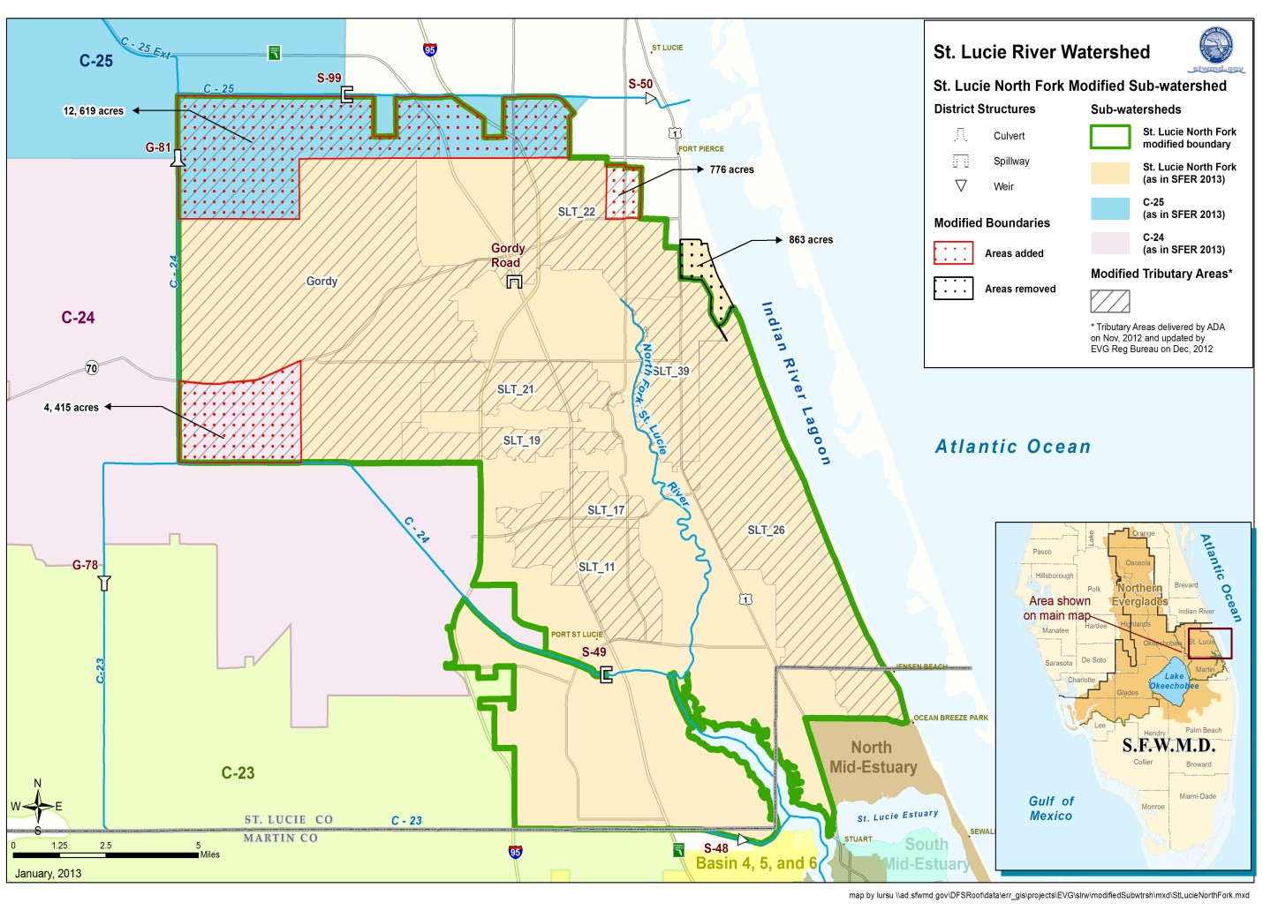
Figure 1. St. Lucie North Fork Modified Sub-watershed

C25/C25E Sub-Watershed:

Figure 2 depicts the added and removed acreages from the C25/C25E Sub-watershed as described below.

Areas added:

- 256 acres was added to include acreage from the C25 conveyance canal up to the sub- watershed monitoring station, S50.
- 476 acres was found to drain to the C-25 as shown by the AHED database. This change is to update the shapefiles produced by the Everglades Regulation Bureau as the AHED database already reflects this area as part of the C-25.

Areas removed:

- 12,619 acres within the NLSRWCD were found to drain to the North Fork under most conditions, therefore removed from the C25/C25E sub-watershed.

- 3,296 acres was found to drain to the SJRWMD C52 Canal per findings from Ken Konyha and SJRWMD staff, therefore removed from the C25 sub-watershed.

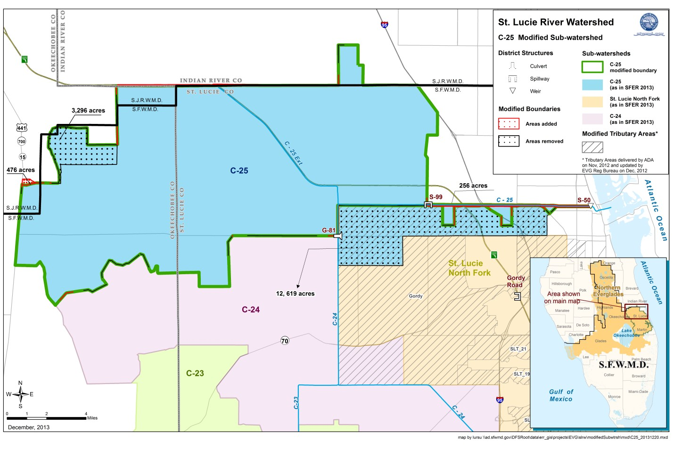
Figure 2. C25/C25E Modified Sub-watershed

C24 Sub-Watershed:

Figure 3 depicts the added and removed acreages from the C24 Sub-watershed as described below.

Areas added:

- None.

Areas removed:

- 4,415 acres within the NLSRWCD were found to drain to the North Fork under most conditions, therefore removed from the C24 sub-watershed.

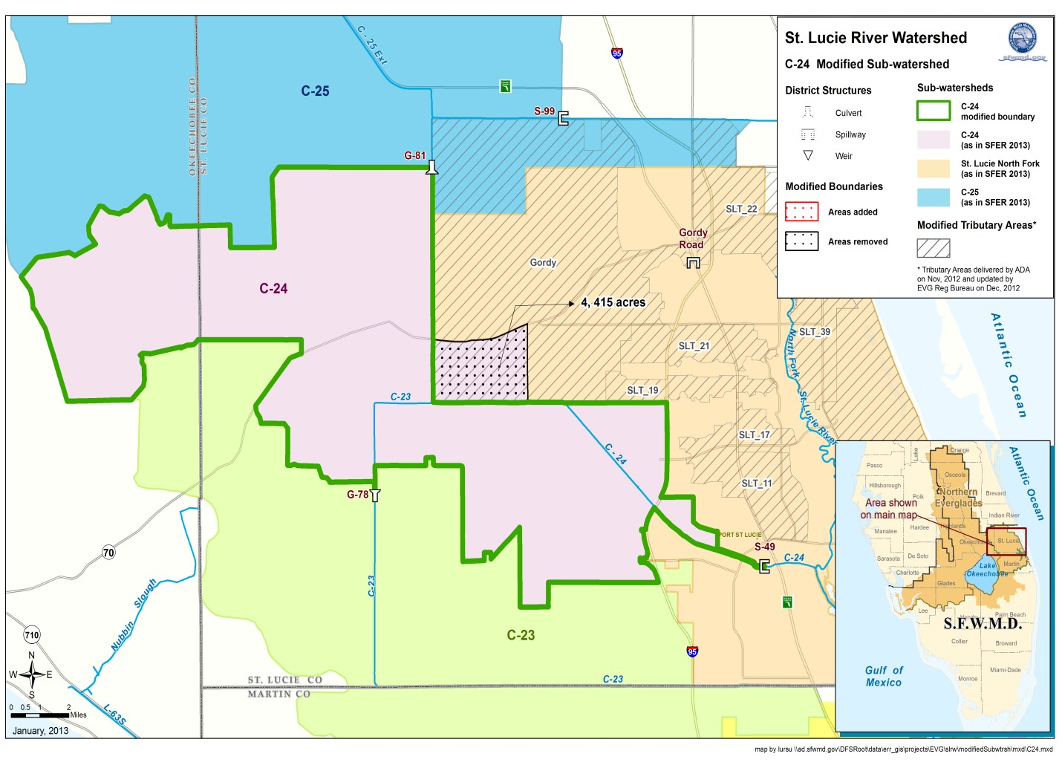
Figure 3. C24 Modified Sub-watershed

C23 Sub-Watershed:

Figure 4 depicts the added and removed acreages from the C23 Sub-watershed as described below.

Areas added:

- 81 acres were added to include acreage from the C23 conveyance canal up to the sub- watershed monitoring station, S48. Currently in the AHED database the C23 sub- watershed stops at station S97.

Areas removed:

- 1,301 acres that are within the C23 sub-watershed were found to drain to Bessey Creek, (monitoring station SLT-09). Because Bessey Creek is in the Basin 4-5-6 sub-watershed, this acreage was removed from the C23 sub-watershed.

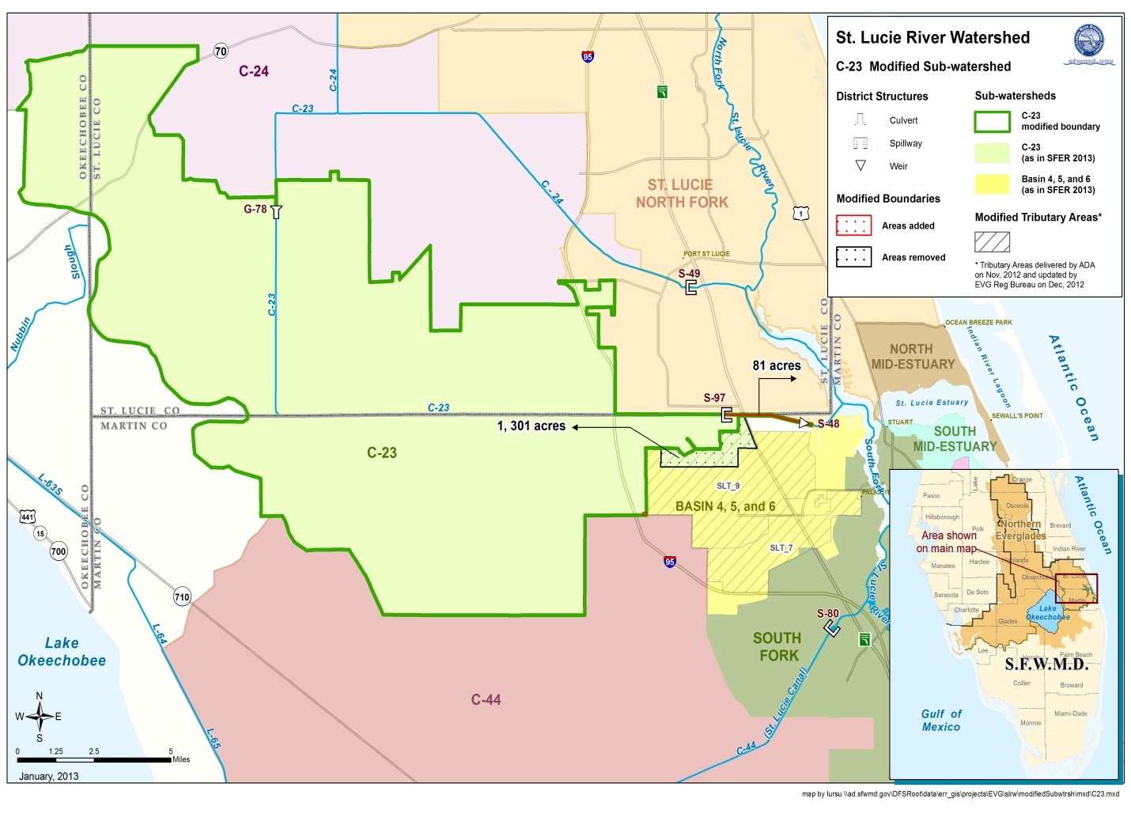
Figure 4. C23 Modified Sub-watershed

Basin 4-5-6 Sub-Watershed:

Figure 5 depicts the added and removed acreages from the Basin 4-5-6 Sub-watershed as described below.

Areas added:

- 1,301 acres that are within the C23 sub-watershed were found to drain to Bessey Creek, (monitoring station SLT-09). Because Bessey Creek is in the Basin 4-5-6 sub-watershed, this acreage was removed from the C23 sub-watershed and added to Basin 4-5-6 sub- watershed.
- 521 acres (Evergreen Club), was not tied to any sub-watershed. As shown by the SWM permit 43-00069-S, this area drains downstream of the C23 monitoring station, S48. This area was added to the Basin 4-5-6 sub-watershed because of its land use similarity. This area is already part of the Basin 4-5-6 sub-watershed in the AHED database. The change described here is to update the shapefiles produced by the Everglades Regulation Bureau.
- 42 acres (31 acres and 11 acres shown in Figure 5), that are within the South Fork sub- watershed were found to drain to Danforth Creek, (monitoring station SLT-07). Because

Danforth Creek is in the Basin 4-5-6 sub-watershed, this acreage was removed from the South Fork and added to Basin 4-5-6 sub-watershed.

Areas removed:

- 981 acres (724 acres, 238 acres, and 19 acres shown by Figure 5), on the south and eastern boundary of Basin 4-5-6 were found to drain to the South Fork based on the modified boundary of Danforth Creek. Areas were investigated due to remaining acreage in Basin 4-5-6 after the Danforth Creek boundary was modified. Review of available permits showed these areas to drain to the South Fork.

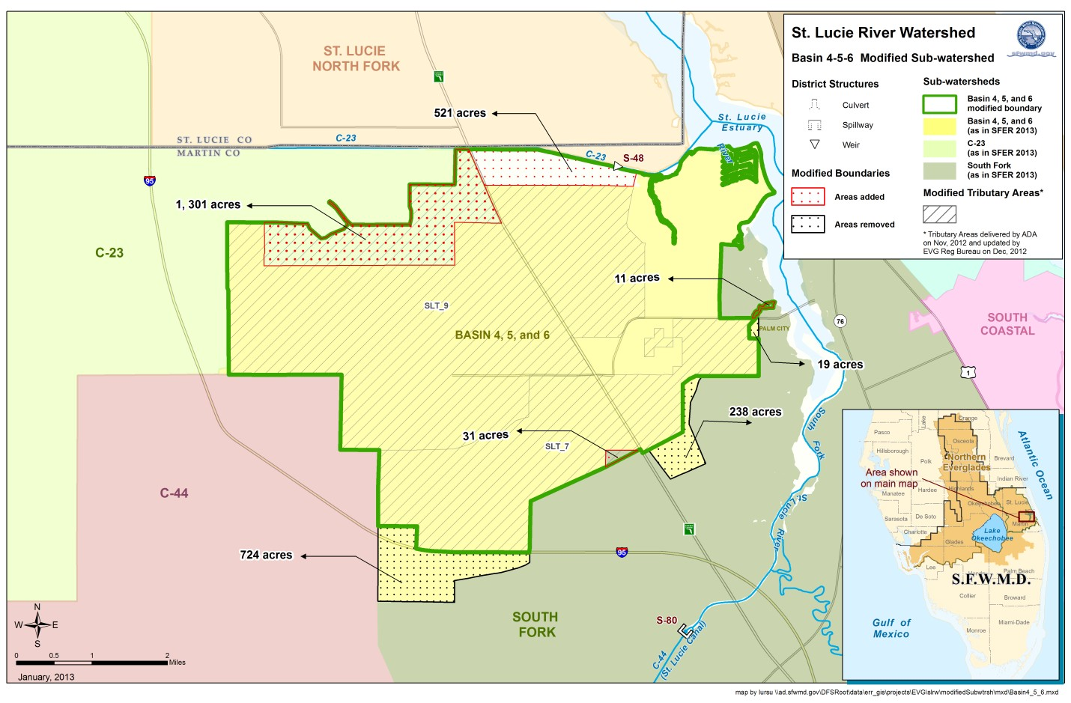
Figure 5. Basin 4-5-6 Modified Sub-watershed

C44 Sub-Watershed:

Figure 6 depicts the added and removed acreages from the C44 Sub-watershed as described below.

Areas added:

- 134 acres was added to include acreage from the C44 conveyance canal up to the sub- watershed monitoring station, S80.

Areas removed:

- None.

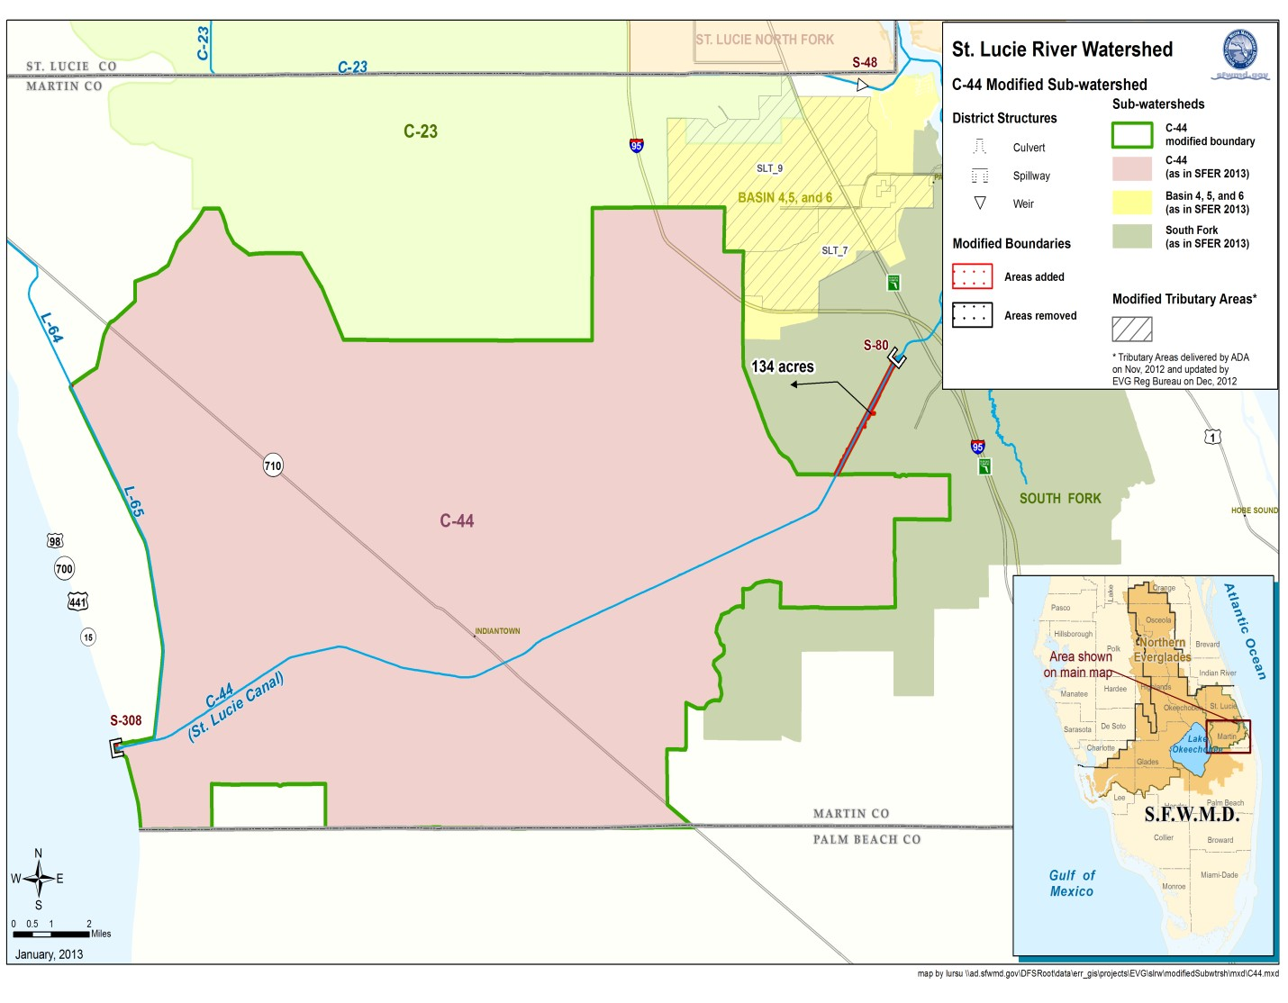
Figure 6. C44 Modified Sub-watershed

North Mid-Estuary Sub-Watershed:

The St. Lucie River Watershed hydrologic evaluation study resulted in no change to the North Mid Estuary Sub-watershed, (Figure 7).

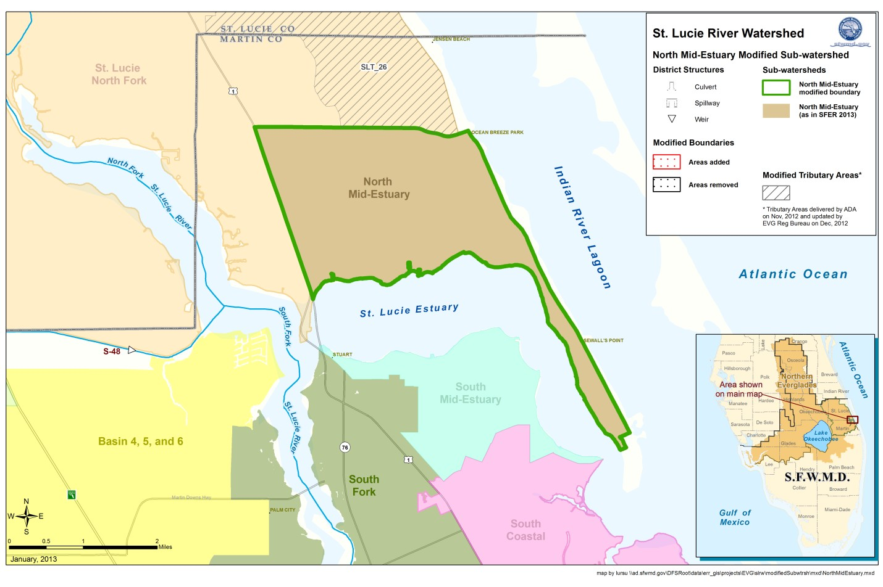
Figure 7. North Mid Estuary Sub-watershed

South Mid-Estuary Sub-Watershed:

Figure 8 depicts the added and removed acreages from the South Mid Estuary Sub-watershed as described below.

Areas added:

- 215 acres that are within the South Coastal sub-watershed were found to drain to North Airport Ditch, (monitoring station SLT-38). Because North Airport Ditch is in the South Mid-Estuary sub-watershed, this acreage was removed from the South Coastal sub- watershed.
- 42 acres that are within the South Fork sub-watershed were found to drain to North Airport Ditch, (monitoring station SLT38). Because North Airport Ditch is in the South Mid-Estuary sub-watershed, this acreage was removed from the South Fork sub- watershed.

Areas removed:

- No removal of acreage

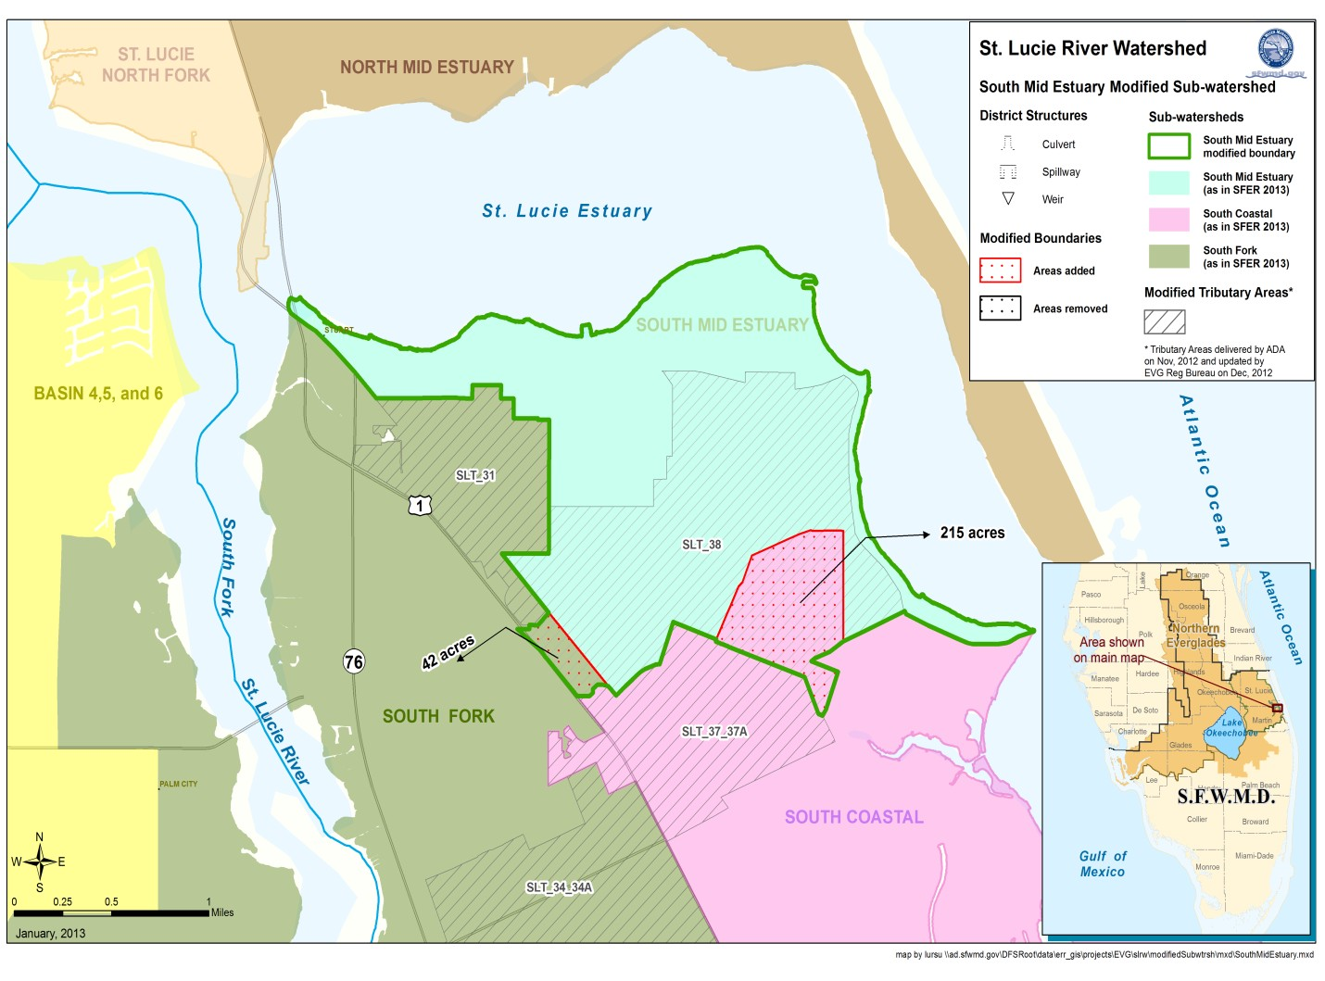
Figure 8. South Mid Estuary Modified Sub-watershed

South Coastal Sub-Watershed:

Figure 9 depicts the added and removed acreages from the South Mid Estuary Sub-watershed as described below.

Areas added:

- 163 acres (82 and 81 acres shown in Figure 9), that are within the South Fork were found to drain to Salerno Creek, (monitoring station SLT-44). Because Salerno Creek is within the South Coastal sub-watershed, this acreage was removed from the South Fork sub-watershed.
- 109 acres located along the eastern boundary of the South Fork sub-watershed were found to be unmonitored by the adjacent modified tributary boundaries, (SLT-34 and SLT-40) in the South Fork. This area is also located along the South Coastal sub- watershed boundary. Because this area was found not to drain to Coral Gardens Ditch SLT-34 nor Fern Creek SLT-40, it was removed from the South Fork and brought into the South Coastal sub-watershed based on review of available permits.

- 1,274 acres south of the South Coastal sub-watershed was found to drain to Manatee Pocket which is within the South Coastal sub-watershed.

Areas removed:

- 215 acres that are within the South Coastal sub-watershed were found to drain to North Airport Ditch, (monitoring station SLT-38). Because North Airport Ditch is in the South Mid-Estuary sub-watershed, this acreage was removed from the South Coastal sub- watershed.
- 1,249 acres located along the eastern boundary of the South Coastal sub-watershed was found to drain directly to the IRL, therefore removed from the South Coastal sub- watershed and from the SLRW.

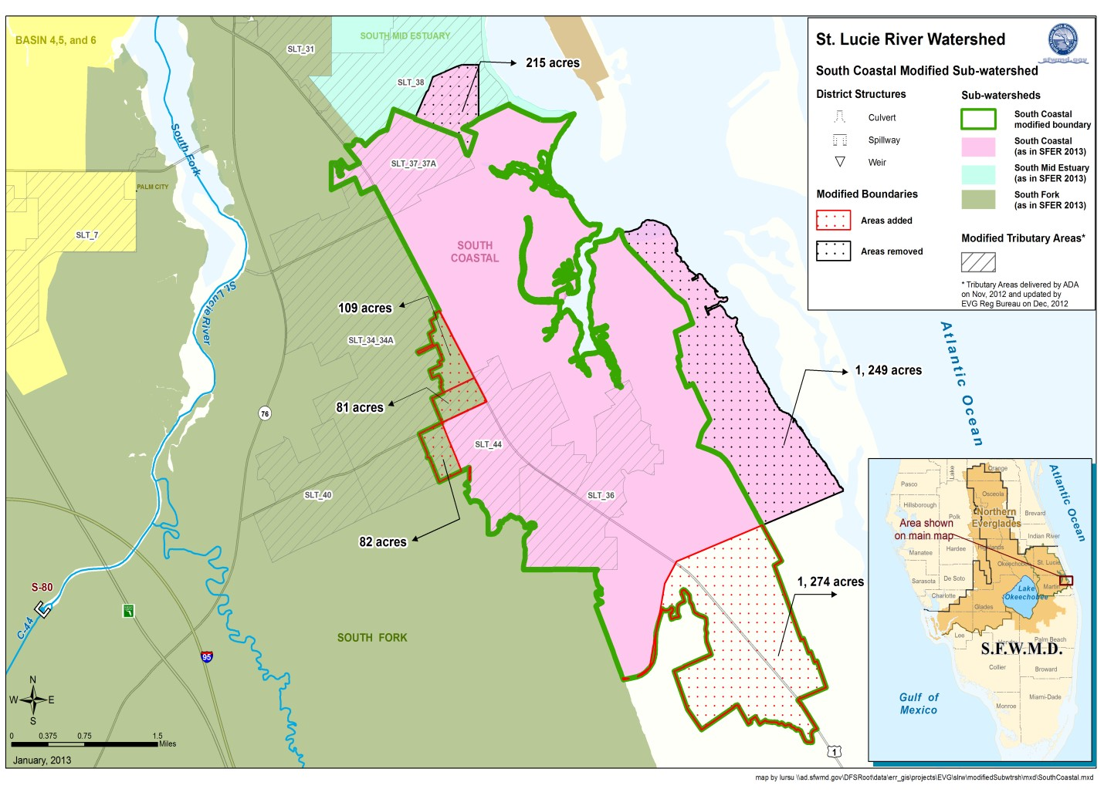
Figure 9. South Coastal Modified Sub-watershed

South Fork Sub-Watershed:

Figure 10 depicts the added and removed acreages from the South Fork Sub-watershed as described below.

Areas added:

- 981 acres (724 acres, 238 acres, and 19 acres shown by Figure 10), on the north western boundary of the South Fork are part of the Basin 4-5-6 sub-watershed, however found to drain to the South Fork based on the modified boundary of Danforth Creek, (monitoring station SLT-07). Areas were investigated due to remaining acreage in Basin 4-5-6 after the Danforth Creek boundary was modified. Review of available permits showed these areas to drain to the South Fork.
- 210 acres was found to drain to the South Fork as shown by the AHED database. This was confirmed based on the SWM permit 43-00355-S-05 for this area. The change described here is to update the shapefiles produced by the Everglades Regulation Bureau as the AHED database already reflects this area as part of the South Fork.

Areas removed:

- 42 acres that are within the South Fork sub-watershed were found to drain to North Airport Ditch, (monitoring station SLT38). Because North Airport Ditch is in the South Mid-Estuary sub-watershed, this acreage was removed from the South Fork sub- watershed.
- 163 acres (82 and 81 acres shown in Figure 10), that are within the South Fork were found to drain to Salerno Creek, (monitoring station SLT-44). Because Salerno Creek is within the South Coastal sub-watershed, this acreage was removed from the South Fork sub-watershed.
- 109 acres located along the eastern boundary of the South Fork sub-watershed were found to be unmonitored by the adjacent modified tributary boundaries, (SLT-34 and SLT-40) in the South Fork. This area is also located along the South Coastal sub- watershed boundary. Because this area was found not to drain to Coral Gardens Ditch SLT-34 nor Fern Creek SLT-40, it was removed from the South Fork and brought into the South Coastal sub-watershed based on review of available permits.
- 42 acres (31 acres and 11 acres shown in Figure 10), that are within the South Fork sub- watershed were found to drain to Danforth Creek, (monitoring station SLT-07). Because Danforth Creek is in the Basin 4-5-6 sub-watershed, this acreage was removed from the South Fork and added to Basin 4-5-6 sub-watershed.
- 134 acres was removed from the South Fork and added to the C44 sub-watershed to include acreage from the C44 conveyance canal up to the C44 sub-watershed monitoring station, S80.

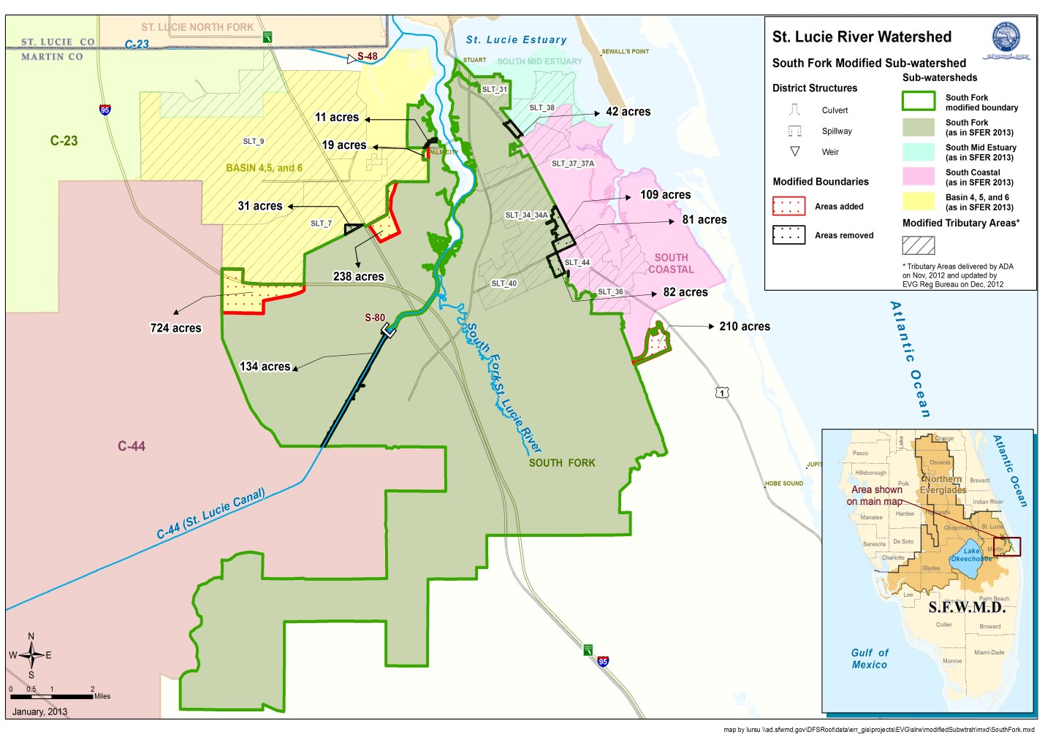
Figure 10. South Fork Modified Sub-watershed

Final Sub-watershed Acreages:

Sub-watershed | Old Acreage, (2013 SFER) | Acres Added | Acres Removed | New Acreage*
North Fork | 114,909 | 17,810 | 863 | 131,856
C25/C25E | 114,907 | 732 | 15,915 | 99,724
C24 | 87,770 | - | 4,415 | 83,359
C23 | 112,094 | 81 | 1,301 | 110,872
Basin 4-5-6 | 15,055 | 1,864 | 981 | 15,935
C44 | 132,571 | 134 | - | 132,705
North Mid-Estuary | 4,196 | - | - | 4,196
South Mid-Estuary | 1,823 | 257 | - | 2,080
South Coastal | 7,914 | 1,546 | 1,464 | 7,991
South Fork | 48,089 | 1,191 | 490 | 48,792
SLRW Total | 639,328 | 23,615 | 25,429 | 637,514
* Acreage represents the GIS modified sub-watershed polygon. The net change is acreage based on changes
described in this document may not match 100 percent due minor modifications not described in this document to align sub-watershed edges to sub-watershed polygons in the AHED database.

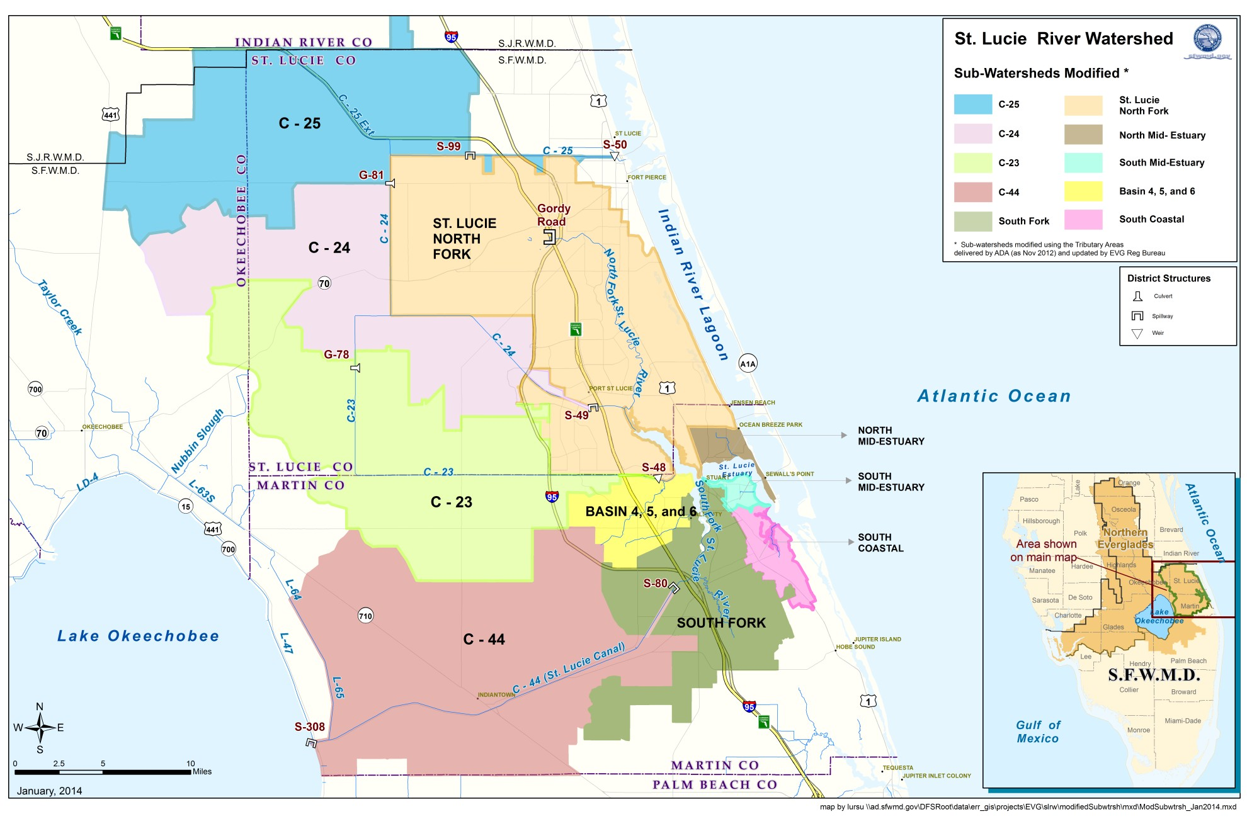
Figure 11. SLRW Modified Sub-watersheds

References:

ADA Engineering, Inc. 2012. FINAL – St. Lucie River Watershed Source Control Hydrologic Evaluations. Deliverable 4.2b – Final Field Verification Report. West Palm Beach, FL.

South Florida Water Management District, 2013. Review of revised watershed boundaries for the Southern St. Lucie River Basin. Response from Ken Konyha, HESM on the proposed boundary changes by Everglades Regulation.

South Florida Water Management District. 2013. FINAL – 2013 South Florida Environmental Report. West Palm Beach, FL.

http://www.freshfromflorida.com/Divisions-Offices/Agricultural-Water-Policy/Enroll-in-BMPs/BMP-Rules-Manuals-and-Other-Documents.

