Draft
St. Lucie River and Estuary
Basin Management Action Plan

Division of Environmental Assessment and Restoration
Water Quality Restoration Program
Florida Department of Environmental Protection

with participation from the
St. Lucie River and Estuary Stakeholders

January 2020



2600 Blair Stone Road
Tallahassee, FL 32399-2400
https://floridadep.gov/

Acknowledgments
The St. Lucie River and Estuary Basin Management Action Plan was prepared as part of a statewide watershed management approach to restore and protect Florida's water quality. It was prepared by the Florida Department of Environmental Protection with participation from the St. Lucie River and Estuary stakeholders identified below.
Type of Governmental or  Private Entity | Participant
Local Governments | Martin County  Okeechobee County  St. Lucie County  City of Fort Pierce  City of Port St. Lucie  City of Stuart  Town of Sewall's Point
Community Development Districts | Copper Creek  Creekside  Portofino Isles  River Place  St. Lucie West Service District  Tesoro  Tradition  Veranda  Verano  Villa Vizcaya
Special Districts | Hobe St. Lucie Conservancy District  North St. Lucie River Water Control District  Pal Mar Water Control District  Troup-Indiantown Water Control District
Regional and State Agencies | Florida Department of Agriculture and Consumer Services  Florida Department of Environmental Protection  Florida Department of Transportation District 4  Florida Department of Transportation District 1  Florida Turnpike Enterprise  South Florida Water Management District

Table of Contents
Acknowledgments 2
List of Acronyms and Abbreviations 11
Executive Summary 14
Chapter 1. Background Information 20
Water Quality Standards and Total Maximum Daily Loads (TMDLs) 20
1.1.1. St. Lucie River and Estuary TMDLs 20
1.2 St. Lucie River and Estuary Basin Management Action Plan (BMAP) 22
1.2.1. Five-Year Review 25
1.2.2. Pollutant Sources 25
1.2.3. Assumptions 35
1.2.4. Considerations 35
Chapter 2. Modeling, Load Estimates, and Restoration Approach 41
2.1 BMAP Modeling 41
2.1.1. WaSh Modeling Revisions 41
2.1.2. WaSh Baseline Condition Scenario 41
2.1.3. WaSh Alternative Condition Scenarios 42
2.1.4. Use of Model for Allocations 42
2.1.5. Use of Model for Project Estimates 43
2.2 Calculation of Starting Loads and Allocations 43
2.2.1. Starting Loads 43
2.2.2. Allocation of Load Reductions 46
2.3. Basinwide Sources Approach 51
2.3.1. Agriculture 51
2.3.2. Septic Systems 52
2.3.3. Stormwater 53
2.3.4. Wastewater Treatment 53
2.4 TRA Approach 55
2.4.1. Overview 55
2.4.2. Evaluation 57
2.5 Water Quality Monitoring Plan 58
2.5.1. Objectives and Parameters 58
2.5.2. Monitoring Network 59
2.5.3. Data Management and Quality Assurance/Quality Control (QA/QC) 60
Chapter 3. Basins 62
3.1. North Fork Basin 62
3.1.1. Water Quality Monitoring 63
3.1.2. Basin Evaluation Results 65
3.1.3. Projects 66
3.2. Ten Mile Creek Basin 78
3.2.1. Water Quality Monitoring 78
3.2.2. Basin Evaluation Results 80
3.2.3. Projects 81
3.3. C-24 Basin 84
3.3.1. Water Quality Monitoring 84
3.3.2. Basin Evaluation Results 86
3.3.3. Projects 87
3.4. C-23 Basin 91
3.4.1. Water Quality Monitoring 91
3.4.2. Basin Evaluation Results 93
3.4.3. Projects 94
3.5 C-44/S-153 Basin 99
3.5.1. Water Quality Monitoring 99
3.5.2. Basin Evaluation Results 101
3.5.3. Projects 102
3.6. Basin 4/5 105
3.6.1. Water Quality Monitoring 105
3.6.2. Basin Evaluation Results 107
3.6.3. Projects 108
3.7. Basin 6 110
3.7.1. Water Quality Monitoring 110
3.7.2. Basin Evaluation Results 112
3.7.3. Projects 113
3.8. South Fork Basin 116
3.8.1. Water Quality Monitoring 116
3.8.2. Basin Evaluation Results 118
3.8.3. Projects 119
3.9. South Coastal Basin 127
3.9.1. Water Quality Monitoring 127
3.9.2. Basin Evaluation Results 129
3.9.3. Projects 130
3.10. South Mid-Estuary Basin 134
3.10.1. Water Quality Monitoring 134
3.10.2. Basin Evaluation Results 136
3.10.3. Projects 137
3.11. North Mid-Estuary Basin 141
3.11.1. Water Quality Monitoring 141
3.11.2. Basin Evaluation Results 143
3.11.3. Projects 144
Chapter 4. Summary 152
4.1. TRA Evaluation Results 152
4.2. RFI Responses 152
4.3. Future Growth 153
4.4. Compliance 153
Chapter 5. References 154
Appendices 155
Appendix A. BMAP Projects Supporting Information 155
Appendix B. Agricultural Enrollment and Reductions 157
Appendix C. WCDs and Other Special Districts 195
Appendix D. RFI Responses 211

List of Figures
Figure ES-1. St. Lucie River and Estuary BMAP area and basins 18
Figure ES-2. Estimated progress towards meeting the TN TMDL allocated to the St. Lucie River and Estuary Watershed with projects completed through June 30, 2019 19
Figure ES-3. Estimated progress towards meeting the TP TMDL allocated to the St. Lucie River and Estuary Watershed with projects completed through June 30, 2019 19
Figure 1. St. Lucie River and Estuary BMAP area 23
Figure 2. Estimated progress towards meeting the TN TMDL allocated to the SLREW with projects completed through June 30, 2019 24
Figure 3. Estimated progress towards meeting the TP TMDL allocated to the SLREW with projects completed through June 30, 2019 24
Figure 4. Location of septic systems in the SLREW 33
Figure 5. 2013 BMAP area boundary and 2020 BMAP area boundary 39
Figure 6. Proposed BMAP area basin boundaries 40
Figure 7. Summary of the TRA prioritization process 58
Figure 8. St. Lucie River and Estuary BMAP monitoring stations 61
Figure 9. North Fork Basin monitoring stations 64
Figure 10. Ten Mile Creek Basin monitoring stations 79
Figure 11. C-24 Basin monitoring stations 85
Figure 12. C-23 Basin monitoring stations 92
Figure 13. C-44/S-153 Basin monitoring stations 100
Figure 14. Basin 4/5 monitoring stations 106
Figure 15. Basin 6 monitoring stations 111
Figure 16. South Fork Basin monitoring stations 117
Figure 17. South Coastal Basin monitoring stations 128
Figure 18. South Mid-Estuary Basin monitoring stations 135
Figure 19. North Mid-Estuary Basin monitoring stations 142
Figure B-1. BMP enrollment in the St. Lucie River and Estuary BMAP area as of June 2019 164
Figure B-2. GIS example of a sliver 167
Figure B-3. Distribution of agricultural acreage on parcels with potential agricultural activity, St. Lucie River and Estuary BMAP area 169
Figure B-4. Agricultural land uses on parcels with 50 acres of agriculture and greater, St. Lucie River and Estuary BMAP area 169
Figure B-5. Agricultural land uses on parcels with less than 50 acres of agriculture, St. Lucie River and Estuary BMAP area 170
Figure B-6. Number of parcels with 50 acres of agriculture and greater, St. Lucie River and Estuary BMAP area 171
Figure B-7. Number of parcels with less than 50 acres of agriculture, St. Lucie River and Estuary BMAP area 171
Figure B-8. Distribution of agricultural acreage on parcels with potential agricultural activity, North Fork Basin 172
Figure B-9. Land use type and distribution of agricultural acreage, North Fork Basin 173
Figure B-10. Distribution of agricultural acreage on parcels with potential agricultural activity, Ten Mile Creek Basin 174
Figure B-11. Land use type and distribution of agricultural acreage by parcel size, Ten Mile Creek Basin 175
Figure B-12. Distribution of agricultural acreage on parcels with potential agricultural activity, C-24 Basin 176
Figure B-13. Land use type and distribution of agricultural acreage by parcel size, C-24 Basin 177
Figure B-14. Distribution of agricultural acreage on parcels with potential agricultural activity, C-23 Basin 178
Figure B-15. Land use type and distribution of agricultural acreage by parcel size, C-23 Basin 179
Figure B-16. Distribution of agricultural acreage on parcels with potential agricultural activity, C-44/S-153 Basin 180
Figure B-17. Land use type and distribution of agricultural acreage by parcel size, C-44/ S-153 Basin 181
Figure B-18. Distribution of agricultural acreage on parcels with potential agricultural activity, Basin 4/5 182
Figure B-19. Land use type and distribution of agricultural acreage by parcel size, Basin 4/5 183
Figure B-20. Distribution of agricultural acreage on parcels with potential agricultural activity, Basin 6 184
Figure B-21. Land use type and distribution of agricultural acreage by parcel size, Basin 6 185
Figure B-22. Distribution of agricultural acreage on parcels with potential agricultural activity, South Fork Basin 186
Figure B-23. Land use type and distribution of agricultural acreage by parcel size, South Fork Basin 187
Figure B-24. Distribution of agricultural acreage on parcels with potential agricultural activity, South Coastal Basin 188
Figure B-25. Land use type and distribution of agricultural acreage by parcel size, South Coastal Basin 189
Figure B-26. Distribution of agricultural acreage on parcels with potential agricultural activity, North Mid-Estuary Basin 190
Figure B-27. Land use type and distribution of agricultural acreage by parcel size, North Mid-Estuary Basin 191

List of Tables
Table 1. Designated use attainment categories for Florida surface waters 20
Table 2. St. Lucie River and Estuary TMDLs 21
Table 3. Summary of TN and TP loads by WaSh land use category by basin 26
Table 4. Summary of agricultural land use acreage enrolled in the BMP Program in the St. Lucie River and Estuary BMAP area 28
Table 5. Agricultural land use acreage enrolled in the BMP Program in the St. Lucie River and Estuary BMAP by basin 28
Table 6. Summary of unenrolled agricultural land use acreage in the St. Lucie River and Estuary BMAP area 29
Table 7. Entities in the SLREW designated as Phase II MS4s as of October 2019 32
Table 8. Septic system counts by basin 34
Table 9. Urban nonpoint sources in the SLREW 34
Table 10. TN required reductions by basin 43
Table 11. TP required reductions by basin 43
Table 12. TN starting loads by entity (lbs/year) 44
Table 13. TP starting loads by entity (lbs/year) 45
Table 14. Entity contributions to total TN starting load with low priority ranking cutoff 47
Table 15. Entity contributions to total TP starting load with low priority ranking cutoff 48
Table 16. TN load required reductions by entity (lbs/yr) 49
Table 17. TP load required reductions by entity (lbs/yr) 50
Table 18. Septic system counts by basin, and estimated effluent loads 53
Table 19. TN effluent limits 55
Table 20. TP effluent limits 55
Table 21. Summary of land uses in the North Fork Basin 62
Table 22. Water quality monitoring stations in the North Fork Basin 63
Table 23. Basin evaluation results for the North Fork Basin 65
Table 24. TRA evaluation results for the North Fork Basin 65
Table 25. Existing and planned projects in the North Fork Basin 66
Table 26. Future projects in the North Fork Basin 77
Table 27. Summary of land uses in the Ten Mile Creek Basin 78
Table 28. Water quality monitoring stations in the Ten Mile Creek Basin 78
Table 29. Basin evaluation results for the Ten Mile Creek Basin 80
Table 30. TRA evaluation results for the Ten Mile Creek Basin 80
Table 31. Existing and planned projects in the Ten Mile Creek Basin 81
Table 32. Summary of land uses in the C-24 Basin 84
Table 33. Water quality monitoring stations in the C-24 Basin 84
Table 34. Basin evaluation results for the C-24 Basin 86
Table 35. TRA evaluation results for the C-24 Basin 86
Table 36. Existing and planned projects in the C-24 Basin 87
Table 37. Summary of land uses in the C-23 Basin 91
Table 38. Water quality monitoring stations in the C-23 Basin 91
Table 39. Basin evaluation results for the C-23 Basin 93
Table 40. TRA evaluation results for the C-23 Basin 93
Table 41. Existing and planned projects in the C-23 Basin 94
Table 42. Future projects in the C-23 Basin 98
Table 43. Summary of land uses in the C-44/S-153 Basin 99
Table 44. Water quality monitoring stations in the C-44/S-153 Basin 99
Table 45. Basin evaluation results for the C-44/S-153 Basin 101
Table 46. TRA evaluation results for the C-44/S-153 Basin 101
Table 47. Existing and planned projects in the C-44/S-153 Basin 102
Table 48. Summary of land uses in Basin 4/5 105
Table 49. Water quality monitoring stations in Basin 4/5 105
Table 50. Basin evaluation results for Basin 4/5 107
Table 51. TRA evaluation results for Basin 4/5 107
Table 52. Existing and planned projects in the Basin 4/5 Basin 108
Table 53. Summary of land uses in Basin 6 110
Table 54. Water quality monitoring stations in Basin 6 110
Table 55. Basin evaluation results for Basin 6 112
Table 56. TRA evaluation results for Basin 6 112
Table 57. Existing and planned projects in Basin 6 113
Table 58. Summary of land uses in the South Fork Basin 116
Table 59. Water quality monitoring stations in the South Fork Basin 116
Table 60. Basin evaluation results for the South Fork Basin 118
Table 61. TRA evaluation results for the South Fork Basin 118
Table 62. Existing and planned projects in the South Fork Basin 119
Table 63. Future projects in the South Fork Basin 126
Table 64. Summary of land uses in the South Coastal Basin 127
Table 65. Water quality monitoring stations in the South Coastal Basin 127
Table 66. Basin evaluation results for the South Coastal Basin 129
Table 67. TRA evaluation results for the South Coastal Basin 129
Table 68. Existing and planned projects in the South Coastal Basin 130
Table 69. Future projects in the South Coastal Basin 133
Table 70. Summary of land uses in the South Mid-Estuary Basin 134
Table 71. Water quality monitoring stations in the South Mid-Estuary Basin 134
Table 72. Basin evaluation results for the South Mid-Estuary Basin 136
Table 73. TRA evaluation results for the South Mid-Estuary Basin 136
Table 74. Existing and planned projects in the South Mid-Estuary Basin 137
Table 75. Summary of land uses in the North Mid-Estuary Basin 141
Table 76. Water quality monitoring stations in the North Mid-Estuary Basin 141
Table 77. Basin evaluation results for the North Mid-Estuary Basin 143
Table 78. TRA evaluation results for the North Mid-Estuary Basin 143
Table 79. Existing and planned projects in the North Mid-Estuary Basin 144
Table 80. Future projects in the North Mid-Estuary Basin 151
Table B-1. Agricultural land use acreage enrolled summary in the BMP Program in the St. Lucie River and Estuary BMAP area as of June 2019 159
Table B-2. Agricultural land use acreage enrolled in the BMP Program in the St. Lucie River and Estuary BMAP area by basin 160
Table B-3. Agricultural land use acreage enrolled in the St. Lucie River and Estuary BMAP area by BMP Program 161
Table B-4. Agricultural land use acreage enrolled in the BMP Program in the North Fork Basin 161
Table B-5. Agricultural land use acreage enrolled in the BMP Program in the Ten Mile Creek Basin 161
Table B-6. Agricultural land use acreage enrolled in the BMP Program in the C-24 Basin 162
Table B-7. Agricultural land use acreage enrolled in the BMP Program in the C-23 Basin 162
Table B-8. Agricultural land use acreage enrolled in the BMP Program in the C-44/S-153 Basin 162
Table B-9. Agricultural land use acreage enrolled in the BMP Program in Basin 4/5 163
Table B-10. Agricultural land use acreage enrolled in the BMP Program in Basin 6 163
Table B-11. Agricultural land use acreage enrolled in the BMP Program in the South Fork Basin 163
Table B-12. Summary of unenrolled agricultural land use acreage in the St. Lucie River and Estuary BMAP area 170
Table B-13. Agricultural land use change by basin 193
Table B-14. Cost-share project types and associated nutrient reductions recommended by OAWP 194
Table D-1. Summary of responses received for RFI 2020018 211

List of Acronyms and Abbreviations
µg/L Micrograms Per Liter
ac-ft Acre-Feet
BMAP Basin Management Action Plan
BMP Best Management Practice
BOD Biochemical Oxygen Demand
CDD Community Development District
CDS Continuous Deflection Separation
CEPP Central Everglades Planning Project
CERP Comprehensive Everglades Restoration Plan
CIRL Central Indian River Lagoon
CMAC Continuous Monitoring and Adaptive Control
CR County Road
CWA Clean Water Act
DEP Florida Department of Environmental Protection
DO Dissolved Oxygen
DOR Florida Department of Revenue
DWM Dispersed Water Management
EAA Everglades Agricultural Area
EBD Environmental Balance Device
EPA U.S. Environmental Protection Agency
F.A.C. Florida Administrative Code
FCT Florida Communities Trust
FDACS Florida Department of Agriculture and Consumer Services
FDOH Florida Department of Health
FDOT Florida Department of Transportation
FEMA Federal Emergency Management Agency
FIND Florida Inland Navigation District
FPL Florida Power and Light
F.S. Florida Statutes
FSAID Florida Statewide Agricultural Irrigation Demand (geodatabase)
FWM Flow Weighted Mean Concentration
FWRA Florida Watershed Restoration Act
FYN Florida Yards and Neighborhoods
GIS Geographic Information System
HOA Homeowner Association
HWTT Hybrid Wetland Treatment Technology
IRL Indian River Lagoon
IRL-S Indian River Lagoon-South
lbs Pounds
lbs/ac Pounds Per Acre
lbs/yr Pounds Per Year
LID Low Impact Development
LOPP Lake Okeechobee Protection Plan
MAPS Managed Aquatic Plant System
mgd Million Gallons Per Day
mg/L Milligrams Per Liter
MS4 Municipal Separate Storm Sewer System
mt/yr Metric Tons Per Year
N/A Not Applicable
NEEPP Northern Everglades and Estuaries Protection Program
NFSLR North Fork St. Lucie River
NIRS Nutrient Inceptor Removal System
NOI Notice of Intent
NPDES National Pollutant Discharge Elimination System
NRCS Natural Resources Conservation Service
NSLRWCD North St. Lucie River Water Control District
O&M Operations and Maintenance
OAWP Office of Agricultural Water Policy
ONE Organic Nitrogen Elimination
OSTDS Onsite Sewage Treatment and Disposal System
PSA Public Service Announcement
PUD Planned Unit Development
QA/QC Quality Assurance/Quality Control
RFI Request for Information
RIB Rapid Infiltration Basin
RRLA Rapid Rate Land Application
SFER South Florida Environmental Report
SFWMD South Florida Water Management District
SLC St. Lucie County
SLREW St. Lucie River and Estuary Watershed
SLRIT St. Lucie River Issues Team
SLRWPP St. Lucie River Watershed Protection Plan
SLWSD St. Lucie West Services District
SR State Road
STA Stormwater Treatment Area
STORET STOrage and RETrieval (Database)
SWIG Sustainable Water Investment Group
SWMP Stormwater Master Plan
TIF Tax-Increment Financing
TMDL Total Maximum Daily Load
TN Total Nitrogen
TOSP Town of Sewall's Point
TP Total Phosphorus
TRA Targeted Restoration Area
UAL Unit Area Load
USACE U.S. Army Corps of Engineers
USGS U.S. Geological Survey
WaSh Watershed Water Quality Simulation (Model)
WBID Waterbody Identification (number)
WCD Water Control District
WCS Water Control Structure
WIN Watershed Information Network (Database)
WMA Water Management Area
WMD Water Management District
WWTF Wastewater Treatment Facility
WY Water Year

Executive Summary
Background
The St. Lucie River and Estuary Watershed (SLREW) is located in southeast Florida in Martin, St. Lucie, and Okeechobee Counties. It consists of 11 basins (see Figure ES-1). The 2013 St. Lucie River and Estuary Basin Management Action Plan (BMAP) area covered 13 basins; however, some of these basins were merged to align with monitoring and other priorities. The St. Lucie Estuary is a major tributary to the Southern Indian River Lagoon, and this watershed is an economically important area.
The St. Lucie River and Estuary and its associated watershed have been subjected to hydrologic, land use, and other anthropogenic modifications over the past century that have degraded its water quality. To help address the nutrient impairment, the Florida Department of Environmental Protection (DEP) adopted total maximum daily loads (TMDLs) for total nitrogen (TN) and total phosphorus (TP) in the watershed. This BMAP represents the joint efforts of multiple stakeholders to identify where nutrients, both nitrogen and phosphorus, can be reduced through regulatory programs, nonregulatory programs, incentive-based programs, and implementing projects that will ultimately achieve the TN and TP TMDLs in the watershed.
In 2018, DEP and the local stakeholders completed the 5-Year Review to evaluate implementation activities that took place during the first 5-year phase and make recommendations for future implementation activities. The information gathered as part of the 5-Year Review was used to develop this report.
In January 2019, Executive Order 19-12 (Item C) included a requirement to update and secure all restoration plans, within one year, for waterbodies impacting south Florida communities, including the St. Lucie River and Estuary BMAP area. This 2020 BMAP provides information on changes since the 2013 BMAP was adopted, including updates to the modeling, updated allocations of load reductions to the responsible stakeholders, management actions to achieve nutrient reductions, and a revised monitoring plan to continue to track trends in water quality. This update sets a deadline for achieving load reductions no later than 2028, which is 15 years after the initial BMAP adoption and the original timeline from the 2013 BMAP. The reductions are split into milestones, with at least 75 % of the TN required reductions and 65 % of the TP required reductions occurring by 2023 (10 years after the initial BMAP adoption) and the remaining reductions occurring by 2028.
TMDLs
TMDLs are water quality targets designed to address verified impairments for specific pollutants, such as TN and TP. DEP identified the St. Lucie River and Estuary as impaired by nutrients (chlorophyll a) in 2004. In March 2009, DEP adopted TMDLs for TN and TP in the St. Lucie Watershed as targets for the restoration of the river and estuary.
The attainment of the TMDL will be calculated using a 5-year rolling average (the latest 5 water years [WYs], which span two calendar years from May 1st through April 30th) of TN and TP concentration data from the Roosevelt Bridge (SE 03) compliance point.
St. Lucie River and Estuary BMAP
DEP first adopted the St. Lucie River and Estuary BMAP in June 2013 to implement the TN and TP TMDLs in the SLREW. BMAPs are designed to be implemented in a phased approach and, at the end of each five-year phase, a review is completed and submitted to the Legislature and Governor. In June 2018, the first 5-Year Review was prepared to update the status of implementation at the end of the first phase, and it contained recommendations for future phases of the BMAP.
Summary of Load Reductions
DEP asked the stakeholders to provide information on management actions, including projects, programs, and activities, that would reduce nutrient loads from the SLREW. Management actions were required by the original BMAP to address nutrient loads and had to meet several criteria to be considered eligible for credit. Through June 30, 2019, 221 projects were completed, and an additional 39 projects were underway or planned. A Request for Information (RFI) was released in October 2019 to solicit additional projects from public and private entities in the SLREW. The completed activities in the SLREW are estimated to achieve total reductions of 811,389 pounds per year (lbs/yr) of TN, which is 65 % of the reductions needed to meet the TN TMDL. The activities completed to date are estimated to achieve total reductions of 190,377 lbs/yr of TP, which is 47 % of the reductions needed to meet the TP TMDL. Figure ES-2 shows progress towards the TN TMDL load reductions, and Figure ES-3 shows progress towards the TP TMDL load reductions, both based on projects completed through June 30, 2019.
To achieve the TMDL in 15 years, stakeholders must identify and submit additional local projects and the Coordinating Agencies (DEP, Florida Department of Agriculture and Consumer Services [FDACS], and South Florida Water Management District [SFWMD]) must identify additional regional projects as well as determine the significant funding that will be necessary. Enhancements to programs addressing basinwide sources will also be required. In addition, the legacy phosphorus contribution in the watershed must be addressed through further studies and projects targeted at this source. Once this additional information is provided, the Coordinating Agencies will address these constraints and estimate the time needed to achieve the TMDLs in a future BMAP update.
Source Requirements
This BMAP sets TN and TP effluent limits in the SLREW for individually permitted point source discharges from domestic wastewater facilities, their associated Rapid Rate Land Application effluent disposal systems (RRLA) and reuse activities, unless the owner or operator can demonstrate reasonable assurance that the discharge, associated RRLA or reuse activity would not cause or contribute to an exceedance of the TN or TP TMDLs for the St. Lucie River and Estuary. In U.S. Census–designated urbanized areas and urban clusters, local governments and utilities are also directed to develop master wastewater treatment feasibility analyses to identify specific areas to be sewered within 15 years of BMAP adoption. In areas not targeted for sewering, local governments should identify alternative methods to address loads from septic systems. Sources of funding to address nutrient loading from septic systems should also be identified.
FDACS will verify that all eligible landowners are enrolled in appropriate best management practice (BMP) programs and are implementing BMPs as intended, and within one year of the adoption of this BMAP will provide to DEP a list of all unenrolled landowners in the SLREW. At least every two years, FDACS will perform an onsite inspection of each agricultural operation enrolled in a BMP program to ensure that such practices are being properly implemented. Further reductions beyond the implementation of required agricultural owner–implemented BMPs will be necessary to achieve the TMDLs. As such, FDACS will reevaluate existing owner-implemented BMPs and update existing BMP manuals and rules as necessary within five years of adoption of this BMAP.
Further reductions can also be achieved through the implementation of additional agricultural projects or activities. The Coordinating Agencies (DEP, FDACS, and SFWMD) will work together to identify cost-share practices and other projects that can be undertaken to achieve these nutrient reductions and identify and implement additional projects and activities in priority targeted restoration areas (TRAs). These additional projects and activities are to be implemented in conjunction with the BMP Program, which needs to achieve full enrollment with verification to ensure that the BMAP goals are achieved. FDACS will also collect fertilization and nutrient records during implementation verification visits from each agricultural producer enrolled in BMPs that address nutrients and provide an annual summary to DEP and SFWMD of fertilizer use in the BMAP area.
FDACS will also collect fertilization and nutrient records from each agricultural producer enrolled in BMPs that address nutrients and provide an annual summary to DEP and SFWMD of fertilizer use in the BMAP area.
Within five years of the adoption of this BMAP, DEP will evaluate any entity located within the BMAP area that serves a minimum resident population of at least 1,000 individuals that are not currently covered by a municipal separate storm sewer system (MS4) permit and designate eligible entities as regulated MS4s, in accordance with Chapter 62-624, F.A.C. DEP and the water management districts are planning to update the stormwater design and operation requirements in Environmental Resource Permit rules and incorporate the most recent scientific information available to improve nutrient reduction benefits.
Water Quality Monitoring
The existing St. Lucie River and Estuary BMAP monitoring network (Figure 8) consists of 9 stations monitored by local entities (e.g., Port St. Lucie) and 63 stations monitored by SFWMD. Of the 63 SFWMD stations, 15 are new or proposed stations since the adoption of the 2013 BMAP. The monitoring network was revised into tiers as follows: (1) Tier 1 stations are the primary/priority stations used in periodic water quality analyses to track BMAP progress and water quality trends over the long term in the basin, (2) Tier 2 stations will provide secondary information that can be used to help focus and adaptively manage implementation efforts. The monitoring stations are not specifically BMAP stations—i.e., they are designed for other purposes—but some of the data collected at these sites are used to monitor the effectiveness of BMAP implementation.
BMAP Cost
The project costs provided for the BMAP may include capital costs as well as those associated with construction and routine operations and maintenance and monitoring. Many BMAP projects were built to achieve multiple objectives and not just nutrient reductions. Funds for some projects have already been spent, others have been obligated to ongoing projects, and the remainder are yet to be appropriated.
The funding sources for the projects range from local public and private contributions to state and federal legislative appropriations. DEP will continue to work with stakeholders to explore new opportunities for funding assistance to ensure that the activities listed in this BMAP can be maintained at the necessary level of effort and that additional projects can be constructed.

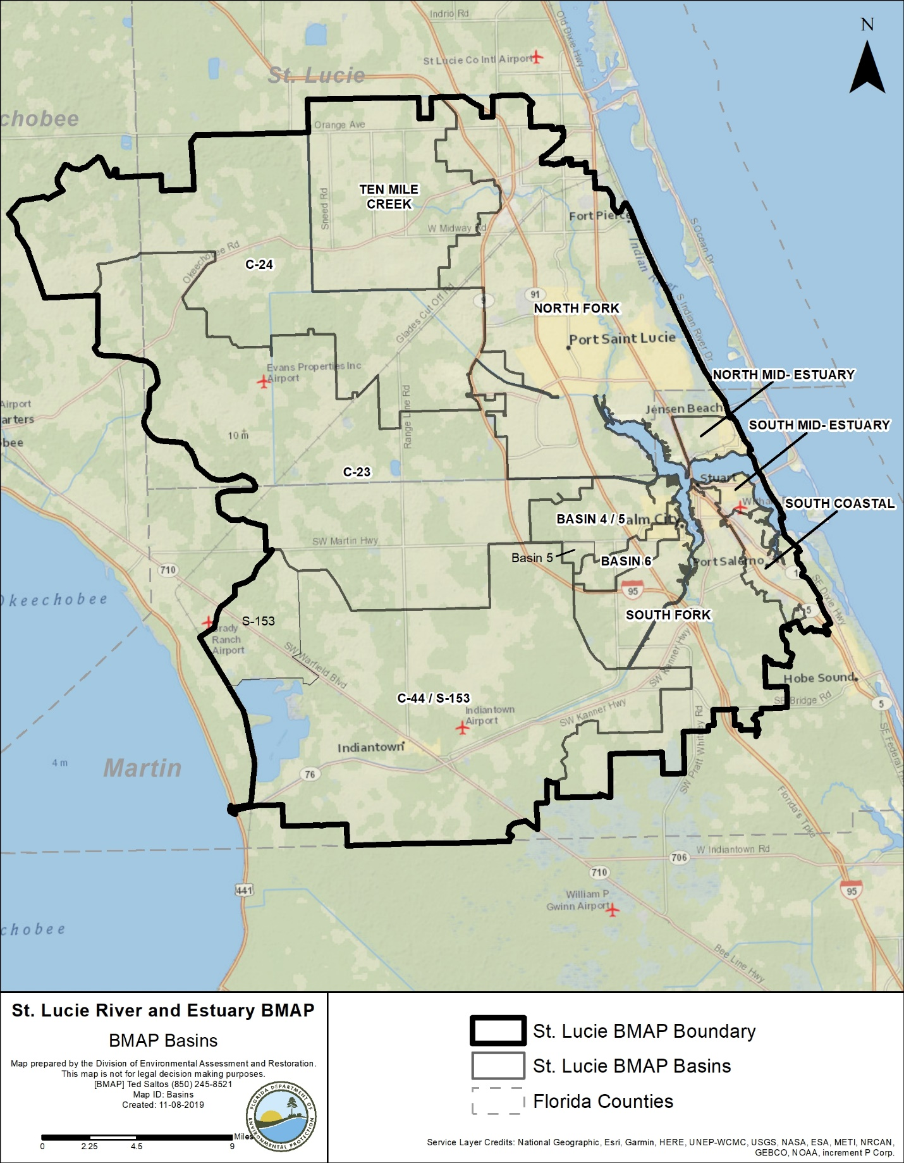
Figure ES-1. St. Lucie River and Estuary BMAP area and basins

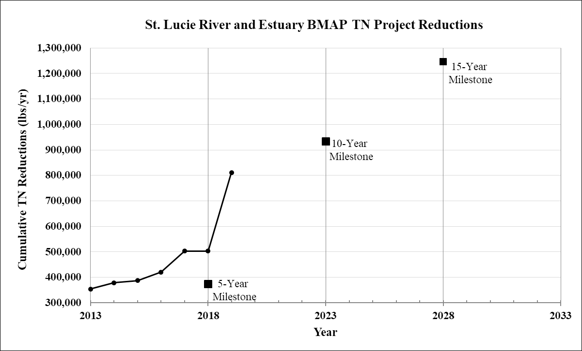
Figure ES-2. Estimated progress towards meeting the TN TMDL allocated to the St. Lucie River and Estuary Watershed with projects completed through June 30, 2019

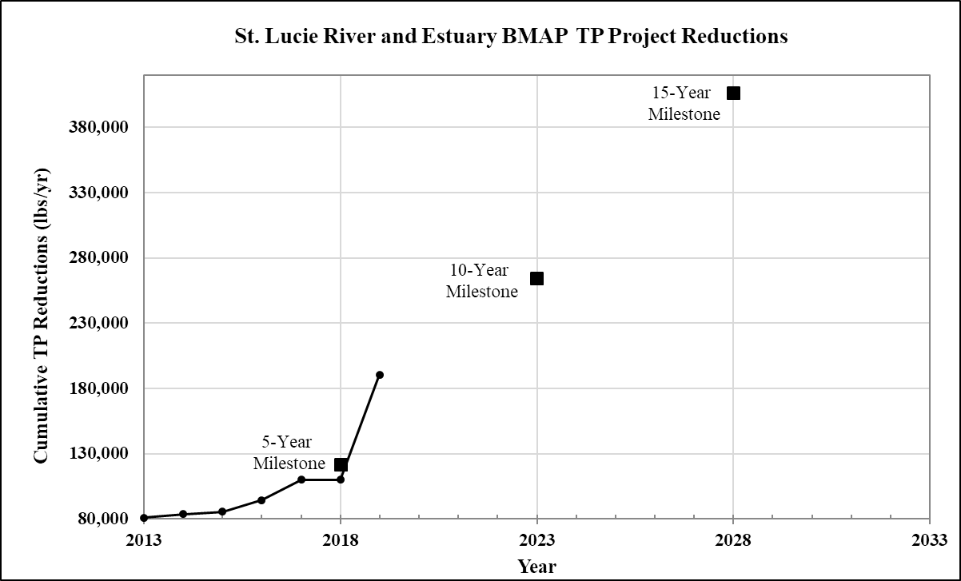
Figure ES-3. Estimated progress towards meeting the TP TMDL allocated to the St. Lucie River and Estuary Watershed with projects completed through June 30, 2019

Chapter 1. Background Information

Water Quality Standards and Total Maximum Daily Loads (TMDLs)
Florida's water quality standards are designed to ensure that surface waters fully support their designated uses, such as drinking water, aquatic life, recreation, and agriculture. Currently, most surface waters in Florida, including those in the St. Lucie River and Estuary, are categorized as Class III waters, meaning they must be suitable for recreation and must support fish consumption and the propagation and maintenance of a healthy, well-balanced population of fish and wildlife. Table 1 lists all designated use classifications for Florida surface waters.
Table 1. Designated use attainment categories for Florida surface waters
¹ Class I, I-Treated, and II waters additionally include all Class III uses.
Classification | Description
Class I¹ | Potable water supplies
Class I-Treated¹ | Treated potable water supplies
Class II¹ | Shellfish propagation or harvesting
Class III | Fish consumption; recreation, propagation and maintenance of a healthy,  well-balanced population of fish and wildlife
Class III-Limited | Fish consumption, recreation or limited recreation, and/or propagation and maintenance of a limited population of fish and wildlife
Class IV | Agricultural water supplies
Class V | Navigation, utility, and industrial use (no current Class V designations)

Section 303(d) of the federal Clean Water Act (CWA) requires that every two years each state must identify its "impaired" waters, including estuaries, lakes, rivers, and streams, that do not meet their designated uses. Florida Department of Environmental Protection (DEP) staff in the Division of Environmental Assessment and Restoration are responsible for assessing Florida's waters for inclusion on the Verified List of Impaired Waters (when a causative pollutant for the impairment has been identified) and Study List (when a causative pollutant for the impairment has not been identified and additional study is needed). These lists are then provided to the U.S. Environmental Protection Agency (EPA) as an annual update to the state "303(d) list." In 2004, DEP identified the St. Lucie River and Estuary as impaired for dissolved oxygen (DO) and nutrients.

St. Lucie River and Estuary TMDLs
A TMDL is the maximum amount of a specific pollutant that a waterbody can assimilate while maintaining its designated uses. The St. Lucie River and Estuary nutrient TMDL was adopted in 2009 for total nitrogen (TN) and total phosphorus (TP), which are linked to high chlorophyll a concentrations in portions of the St. Lucie River and Estuary. The TMDLs include segments with waterbody identification (WBID) numbers 3193 (St. Lucie Estuary), 3194 (North Fork St. Lucie River), 3194B (North Fork St. Lucie Estuary), 3197 (C-24 Canal), 3200 (C-23 Canal), 3210 (South Fork St. Lucie Estuary), 3210A (South Fork St. Lucie River), 3211 (Bessey Creek), and 3218 (C-44 Canal).
Table 2 lists the TMDLs and pollutant load allocations implemented by rule (Rule 62-304.705, Florida Administrative Code [F.A.C.], effective March 26, 2009) for the St. Lucie River and Estuary Watershed (SLREW) (based on updates to the watershed loading effective May 14, 2012). TMDL loads (in pounds [lbs]) in upstream WBIDs were calculated based on achieving the same target concentrations (0.72 milligrams per liter [mg/L] for TN and 0.081 mg/L for TP) as in the St. Lucie Estuary. The TMDLs were used as the basis for the BMAP targets and allocation calculations.
The attainment of the TMDL will be calculated using a five-year rolling average (the latest five water years [WYs]) of TN and TP concentration data from the Roosevelt Bridge (SE 03) compliance point.
Table 2. St. Lucie River and Estuary TMDLs
BOD = Biochemical oxygen demand.
NPDES = National Pollutant Discharge Elimination System.
WBID | Waterbody | Parameter | Annual TMDL Target | NPDES  Stormwater  (% Reduction) | Load  Allocation  (% Reduction)
3193 | St. Lucie Estuary | TN | 0.720 mg/L | 21.4 | 21.4
3193 | St. Lucie Estuary | TP | 0.081 mg/L | 41.3 | 41.3
3194 | North Fork | TN | 140,134 lbs | 25.0 | 25.0
3194 | North Fork | TP | 15,765 lbs | 42.2 | 42.2
3194 | North Fork | BOD | 2.0 mg/L | 74.0 | 74.0
3194B | North Fork | TN | 103,747 lbs | 28.8 | 28.8
3194B | North Fork | TP | 11,672 lbs | 58.1 | 58.1
3197 | C-24 Canal | TN | 348,957 lbs | 51.8 | 51.8
3197 | C-24 Canal | TP | 39,258 lbs | 72.2 | 72.2
3197 | C-24 Canal | BOD | 2.0 mg/L | 33.3 | 33.3
3200 | C-23 Canal | TN | 242,202 lbs | 51.7 | 51.7
3200 | C-23 Canal | TP | 27,248 lbs | 78.6 | 78.6
3210 | South Fork | TN | 24,463 lbs | 38.4 | 38.4
3210 | South Fork | TP | 2,752 lbs | 57.2 | 57.2
3210A | South Fork | TN | 90,471 lbs | 47.1 | 47.1
3210A | South Fork | TP | 10,178 lbs | 61.8 | 61.8
3211 | Bessey Creek | TN | 29,981 lbs | 23.9 | 23.9
3211 | Bessey Creek | TP | 3,373 lbs | 51.2 | 51.2
3218 | C-44 Canal | TN | 242,929 lbs | 51.2 | 51.2
3218 | C-44 Canal | TP | 27,330 lbs | 55.0 | 55.0
3218 | C-44 Canal | BOD | 2.0 mg/L | 69.7 | 69.7

1.2 St. Lucie River and Estuary Basin Management Action Plan (BMAP)
DEP implements TMDLs through permits and BMAPs; the latter contain strategies to reduce and prevent pollutant discharges through various cost-effective means. The Florida Watershed Restoration Act (FWRA), Subparagraph 403.067(7)(a)1., Florida Statutes (F.S.) establishes an adaptive management process for BMAPs that continues until the TMDLs are met. This approach allows for incrementally reducing loadings through the implementation of projects and programs, while simultaneously monitoring and conducting studies to better understand water quality dynamics (sources and response variables) in each impaired waterbody. This adaptive management process will continue until the TMDLs are met.
During the watershed restoration process, DEP and the affected stakeholders jointly develop BMAPs or other implementation approaches. Stakeholder involvement is critical to the success of the watershed restoration program and varies with each phase of implementation to achieve different purposes. The BMAP development process is structured to achieve cooperation and consensus among a broad range of interested parties, including the SFWMD, FDACS, and stakeholders representing other agencies, governments, and interested parties. The original St. Lucie River and Estuary BMAP was adopted in June 2013, and the 5-Year Update was completed in June 2018. (Section 373.4595, F.S., calls for a review of the BMAP to be completed and submitted to the Legislature and Governor every 5 years.)
In January 2019, Executive Order 19-12 (Item C) included a requirement to update and secure all restoration plans, within one year, for waterbodies impacting south Florida communities, including the St. Lucie River and Estuary BMAP. This document serves as an update to the 2013 BMAP based on recommendations from the 5-Year Review. Figure 1 shows the St. Lucie River and Estuary BMAP area. Figure 2 shows the estimated progress toward meeting the St. Lucie River and Estuary TN TMDLs as of June 2019. Figure 3 shows the estimated progress toward meeting the St. Lucie River and Estuary TP TMDLs as of June 2019. Through June 30, 2019, 221 projects were completed, and an additional 39 projects were underway or planned.
A Request for Information (RFI) was released in October 2019 to solicit additional projects from public and private entities in the SLREW. The completed activities are estimated to achieve total reductions of 811,389 pounds per year (lbs/yr) of TN, which is 65 % of the reductions needed to meet the TN TMDL. The activities completed to date are estimated to achieve total reductions of 190,377 lbs/yr of TP, which is 47 % of the reductions needed to meet the TP TMDL.
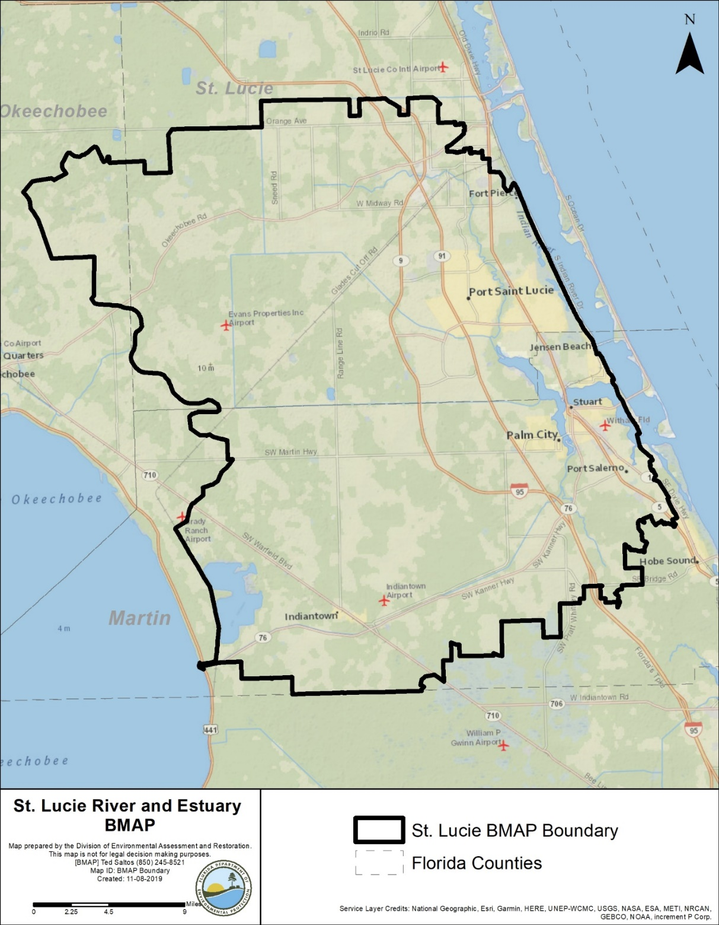
Subsection 373.4595(4)(d), F.S., requires DEP to set an implementation schedule for achieving the full load reductions of the BMAP. To meet this requirement, DEP establishes a set of five-year milestones by which a certain percentage of the full load reductions must be met. Additionally, stakeholders need to provide DEP with reasonable assurance that they have enough project credits to achieve their full required reductions within the period established by the BMAP. The next 5-year milestone is in 2023 (10 years after the initial BMAP adoption), by which at least 75 % of the TN required reductions and 65 % of the TP required reductions must be met. The deadline established by this BMAP for achieving the full load reductions is 2028, which is 15 years after the initial BMAP adoption and the original timeline from the 2013 BMAP.

Figure 1. St. Lucie River and Estuary BMAP area

Figure 2. Estimated progress towards meeting the TN TMDL allocated to the SLREW with projects completed through June 30, 2019

Figure 3. Estimated progress towards meeting the TP TMDL allocated to the SLREW with projects completed through June 30, 2019

1.2.1. Five-Year Review
The 5-Year Review, completed in June 2018, provided recommendations for improving the health of the St. Lucie River and Estuary, and these recommendations are included throughout this 2020 BMAP. The 5-Year Review also included a water quality trend analysis to track trends in TN and TP concentrations in the St. Lucie River and Estuary and its basins. The results of this trend analysis are used in the TRA approach described in Section 2.4.
The 5-Year Review mentioned the ongoing large-scale restoration efforts in south Florida, including the Central Everglades Planning Project (CEPP), a component of the Comprehensive Everglades Restoration Plan (CERP). CEPP sets the foundation for restoring the central portion of the Everglades ecosystem and sending additional water south. The implementation of the CEPP as well as the CERP projects (C-44 Reservoir and Stormwater Treatment Area [STA]) will significantly improve water quality in the St. Lucie River and Estuary by cleaning local basin runoff and discharges from Lake Okeechobee. In addition to the projects included in CERP and CEPP, the Everglades Agricultural Area (EAA) Storage Reservoir project will benefit the St. Lucie River and Estuary by redirecting the additional flows from Lake Okeechobee south to the Restoration Strategies complex and ultimately to the Everglades with the completion of CEPP features. The goal of the Restoration Strategies is to improve water quality and flow to the Everglades.
The 5-Year Review also recommended the refinement of the water quality model and revision of the assigned allocations to reflect updated results. The model was expanded to allow for the refinement of the BMAP boundary, with the inclusion of the South Coastal Basin and other areas draining to the St. Lucie Estuary. The update also recommended revising the BMAP monitoring network to help prioritize monitoring resources, improve how progress is tracked, and reorganize the network into a tiered system. Updates to the BMAP monitoring network are described in Section 2.5.

1.2.2. Pollutant Sources
There are various sources of pollution in the SLREW. Nonpoint (i.e., diffuse) sources in the watershed contribute the majority of the TN and TP loads to the SLREW and include urban and agricultural stormwater runoff. Lake Okeechobee loading is being addressed through the Lake Okeechobee BMAP. Several reports (SFWMD; DEP; FDACS; periodic St. Lucie River Watershed Protection Plan [SLRWPP] updates) document more detailed information regarding TN and TP inputs from the SLREW.
Table 3 summarizes the TN and TP load contributions to the St. Lucie River and Estuary by land use category in each basin, based on the percent contribution from each land use category as determined by the 2012 land use coverage from the Watershed Water Quality Simulation (WaSh) model and load estimation shapefile discussed in Section 2.1. The subsections below discuss the sources included in this BMAP in more detail.

Table 3. Summary of TN and TP loads by WaSh land use category by basin
Basin | Land Use Category | TN Load  (% Basin Total) | TP Load  (% Basin Total)
Basin 4/5 | Urban | 62 | 60
Basin 4/5 | Agriculture | 19 | 23
Basin 4/5 | Natural | 19 | 17
Basin 6 | Urban | 73 | 72
Basin 6 | Agriculture | 12 | 14
Basin 6 | Natural | 15 | 14
C-23 | Urban | 5 | 4
C-23 | Agriculture | 79 | 80
C-23 | Natural | 16 | 16
C-24 | Urban | 11 | 9
C-24 | Agriculture | 75 | 78
C-24 | Natural | 14 | 13
C-44/S-153 | Urban | 6 | 5
C-44/S-153 | Agriculture | 74 | 75
C-44/S-153 | Natural | 21 | 20
North Fork | Urban | 75 | 75
North Fork | Agriculture | 6 | 7
North Fork | Natural | 19 | 18
North Mid-Estuary | Urban | 82 | 81
North Mid-Estuary | Agriculture | 0 | 0
North Mid-Estuary | Natural | 18 | 19
South Coastal | Urban | 87 | 87
South Coastal | Agriculture | 0 | 0
South Coastal | Natural | 13 | 13
South Mid-Estuary | Urban | 92 | 93
South Mid-Estuary | Agriculture | 0 | 0
South Mid-Estuary | Natural | 8 | 7
South Fork | Urban | 35 | 32
South Fork | Agriculture | 38 | 44
South Fork | Natural | 26 | 24
Ten Mile Creek | Urban | 16 | 15
Ten Mile Creek | Agriculture | 76 | 78
Ten Mile Creek | Natural | 8 | 7

1.2.2.1. Agricultural Nonpoint Sources
The primary agricultural land uses in the SLREW are cow/calf operations (pasture), row/field crops, and citrus. Other agricultural land uses include nurseries and horse farms/specialty farms. Most of the horse farms are small, noncommercial hobby farms, concentrated in Martin County. Because of urban encroachment, citrus health issues (freeze/disease), and the downturn in the economy, many citrus operations have been destroyed or abandoned, have significantly lowered their production acreage, or have transitioned to another commodity. In recent years, some of this acreage may have shifted to nonagricultural/urban uses.
Per Section 403.067, F.S., when DEP adopts a BMAP that includes agriculture, it is the agricultural landowner's responsibility to implement best management practices (BMPs) adopted by FDACS to help achieve load reductions or demonstrate through monitoring, per Chapter 62-307, F.A.C., that water quality standards are already being met. To date, FDACS' Office of Agricultural Water Policy (OAWP) has adopted BMP manuals by rule for cow/calf, citrus, vegetable and agronomic crops, nurseries, equine, sod, dairy, poultry, and specialty fruit and nut operations.
To enroll in the BMP Program, landowners must submit to OAWP a Notice of Intent (NOI) to implement the BMPs on the BMP checklist from the applicable BMP manual. The landowner may meet with OAWP to determine the BMPs applicable to that individual operation. Because many agricultural operations are diverse and are engaged in the production of multiple commodities, a landowner may be required to sign multiple NOIs for a single parcel.
OAWP is required to verify that landowners are implementing the BMPs identified in their NOIs. Rule 5M-1.008, F.A.C., outlines the procedures used to verify the implementation of agricultural BMPs. BMP implementation is verified through annual surveys submitted by producers enrolled in the BMP Program and site visits by OAWP staff. Producers not implementing BMPs according to the process outlined in Chapter 5M-1, F.A.C., are referred to DEP for enforcement action after attempts at remedial action are exhausted.
FDACS staff conduct site visits to verify that all BMPs are being implemented correctly and to review nutrient and irrigation management records. In addition, OAWP verifies that cost-share items are being implemented correctly. Site visits are prioritized based on the date the NOI was signed, the date of the last BMP verification site visit, whether a survey was completed by the producer or not for the most recent year, and whether the operation has received cost-share funding. FDACS is to conduct an onsite inspection of each producer implementing BMPs at least every two years and provide information it obtains to DEP, subject to any confidentiality restrictions.
Section 403.067, F.S., requires that, where water quality problems persist despite the proper implementation of adopted agricultural BMPs, FDACS must reevaluate the practices, in consultation with DEP, and modify them if necessary. Continuing water quality problems may be detected through the monitoring component of the BMAP and other DEP and SFWMD activities. If a reevaluation of the BMPs is needed, FDACS will also include SFWMD and other partners in the process. Section 2.3.1 provides further details on the need for reevaluation of existing practices.
For the BMAP, the implementation of agricultural BMPs will be documented based on participation in FDACS' BMP Program. The program rules provide the presumption of compliance to those landowners.
Table 4 and Table 5 summarize the agricultural land use enrolled in BMP programs for the entire SLREW and by basin, respectively. Enrollment is as of June 30, 2019, and the agricultural acreage in each basin is based on the Florida Statewide Agricultural Irrigation Demand (FSAID) VI geodatabase. Appendix B provides more information on agricultural activities in the SLREW. As new BMAPs are developed or existing BMAP areas are expanded, overlap among BMAPs is increasing. In the St. Lucie River and Estuary BMAP area, 81,661 agricultural acres are also included in the Lake Okeechobee BMAP. While calculations, allocations, and projects are specific to each BMAP, the number of acres from the individual BMAP reports, if added, exceeds the total acres in the two BMAP areas. Appendix B provides more information on agricultural activities in the SLREW.
Table 4. Summary of agricultural land use acreage enrolled in the BMP Program in the St. Lucie River and Estuary BMAP area
Category | Acres
FSAID VI agricultural acres in the BMAP | 283,609
Total agricultural acres enrolled | 173,448
% of FSAID VI agricultural acres enrolled | 61 %

Table 5. Agricultural land use acreage enrolled in the BMP Program in the St. Lucie River and Estuary BMAP by basin
Basin | Total FSAID VI Agricultural Acres | Agricultural Acres Enrolled | % of Agricultural Acreage Enrolled
North Fork | 7,161 | 1,928 | 27
Ten Mile Creek | 33,271 | 11,877 | 36
C-24 | 59,804 | 42,785 | 72
C-23 | 81,466 | 60,127 | 74
C-44/S-153 | 81,660 | 48,083 | 59
Basin 4/5 | 1,949 | 78 | 4
Basin 6 | 454 | 19 | 4
South Fork | 17,814 | 8,550 | 48
South Coastal | 28 | 0 | 0
South Mid-Estuary | 0 | 0 | N/A
North Mid-Estuary | 2 | 0 | 0
Total | 283,609 | 173,448 | 61

Unenrolled Agricultural Acreage
Agricultural land use designation is not always indicative of current agricultural activity and consequently presents challenges to estimating load allocations accurately as well as enrolling every agricultural acre in an appropriate BMP manual. To characterize unenrolled agricultural acres, OAWP identified FSAID VI features outside the BMP enrollment areas using geographic information system (GIS) software (see Appendix B for details). Table 6 summarizes the results of that analysis.

Table 6. Summary of unenrolled agricultural land use acreage in the St. Lucie River and Estuary BMAP area
Note: Because of geometric variations between shapefiles used in the unenrolled agricultural lands analysis performed by OAWP, the unenrolled agricultural acres differ from the subtraction of the FSAID VI agricultural acres in the BMAP and the total agricultural acres enrolled referenced in Table 5.
Category | Acres
Unenrolled agricultural acres | 110,195
Acres identified within slivers of unenrolled agricultural areas | 3,227
Lands without enrollable agricultural activity (e.g., tribal lands, residential development, and parcels with Department of Revenue (DOR) use codes 70-98) | 25,533
Total lands with potentially enrollable agricultural activities | 81,435

As of June 30, 2019, OAWP has enrolled 173,448 agricultural acres in BMPs. Considering the results of the analysis shown in Table 6, the total acreage with the potential to have agricultural activities that can be enrolled in FDACS' BMP Program in the watershed is 254,849 acres. Using this adjusted agricultural acreage, 68 % of agricultural acres have been enrolled.
Analyzing land use data and parcel data is a valuable first step in identifying the agricultural areas that provide the greatest net benefits to water resources for enrollment in FDACS' BMP Program, as well as prioritize implementation verification visits in a given basin. OAWP will continue to enroll agricultural lands in the BMP Program, focusing on intensive operations, including irrigated acreage, dairies and nurseries, parcels greater than 50 acres in size, and agricultural parcels adjacent to waterways.
The next step to help prioritize the enrollment efforts could use the parcel loading information derived from the WaSh model. This effort could help FDACS identify specific parcels with the highest modeled nutrient loading. These parcels could then be targeted for enrollment and the implementation of BMPs, as well as the verification of BMP implementation.
Aquaculture
Under the CWA, aquaculture activities are defined as a point source. Starting in 1992, DEP and/or the water management districts regulated all aquaculture facilities through a general fish farm permit authorized by Rule 403.814, F.S. In 1999, the Florida Legislature amended Chapter 597, F.S., Florida Aquaculture Policy Act, to create a program within FDACS requiring Floridians who sell aquatic species to annually acquire an Aquaculture Certificate of Registration and implement Chapter 5L-3, F.A.C., Aquaculture BMPs. Permit holders must be certified every year.
However, as with agricultural land use in Florida, aquaculture facilities are frequently in and out of production. The facilities for which acreages were provided in the original BMAP may no longer be in operation and there may be new companies in different parts of the basin. In the SLREW, 198 acres of aquaculture are under certification with FDACS' Division of Aquaculture as of September 2019. For purposes of the BMAP, OAWP delineated the aquaculture facilities using parcel data. Since the acreages were not delineated to just the tank, pond, or pool areas, in most cases these calculations overestimate the acreages of aquaculture activity.

1.2.2.2. Municipal Separate Storm Sewer Systems (MS4s)
Many of the municipalities in the watershed are regulated by the Florida NPDES Stormwater Program. An MS4 is a conveyance or system of conveyances, such as roads with stormwater systems, municipal streets, catch basins, curbs, gutters, ditches, constructed channels, or storm drains.
If an MS4 permittee is identified as a contributor in the BMAP, the permitted MS4 must undertake projects specified in the BMAP. The BMAP projects required to be undertaken by MS4s are detailed for each basin in Chapter 3. Phase I and Phase II MS4s are required to implement stormwater management programs to reduce pollutants to the maximum extent practicable and address applicable TMDL allocations. Phase I MS4 permits include assessment practices to determine the effectiveness of stormwater management programs (SWMPs), which can include water quality monitoring. Both Phase I and Phase II MS4 permits include provisions for the modification of SWMP activities for consistency with the assumptions and requirements of the adopted BMAP. There are no Phase I permittees in the SLREW as of October 2019.
Phase II MS4 Stormwater Permit Requirements
Table 7 lists the Phase II MS4s in the SLREW as of October 2019. Under a generic permit, the operators of regulated Phase II MS4s must develop an SWMP that includes BMPs with measurable goals and a schedule for implementation to meet the following six minimum control measures:
- Public Education and Outreach – Implement a public education program to distribute educational materials to the community or conduct equivalent outreach activities about the impacts of stormwater discharges on waterbodies and the steps that the public can take to reduce pollutants in stormwater runoff.
- Implement a public participation/involvement program that complies with state and local public notice requirements.
- Illicit Discharge Detection and Elimination – Subsection 62-624.200(2), F.A.C., defines an illicit discharge as "…any discharge to an MS4 that is not composed entirely of stormwater…," except discharges under an NPDES permit, or those listed in rule that do not cause a violation of water quality standards. Illicit discharges can include septic/sanitary sewer discharge, car wash wastewater, laundry wastewater, the improper disposal of auto and household toxics, and spills from roadway accidents.
- Develop, if not already completed, a storm sewer system map showing the location of all outfalls, and the names and location of all surface waters of the state that receive discharges from those outfalls.
- To the extent allowable under state or local law, effectively prohibit, through ordinance or other regulatory mechanism, nonstormwater discharges into the storm sewer system and implement appropriate enforcement procedures and actions.
- Develop and implement a plan to detect and address nonstormwater discharges, including illegal dumping, to the storm sewer system.
- Inform public employees, businesses, and the general public of hazards associated with illegal discharges and improper waste disposal.
- Construction Site Runoff Control –
- Implement a regulatory mechanism to require erosion and sediment controls, as well as sanctions to ensure compliance, to reduce pollutants in any stormwater runoff to the Phase II MS4 from construction activity that results in a land disturbance greater than or equal to an acre. Construction activity disturbing less than one acre must also be included if that construction activity is part of a larger common plan of development or sale that would disturb one acre or more.
- Develop and implement requirements for construction site operators to implement appropriate erosion and sediment control BMPs.
- Implement requirements for construction site operators to control waste such as discarded building materials, concrete truck washout, chemicals, litter, and sanitary waste at the construction site that may cause adverse impacts to water quality.
- Develop and implement procedures for site plan review that incorporate the consideration of potential water quality impacts.
- Develop and implement procedures for receiving and considering information submitted by the public.
- Develop and implement procedures for site inspection and the enforcement of control measures.
- Postconstruction Runoff Control – Implement and enforce a program to address the discharges of postconstruction stormwater runoff from areas with new development and redevelopment. (Note: In Florida, Environmental Resource Permits issued by water management districts typically serve as a Qualifying Alternative Program for purposes of this minimum control measure.)
- Pollution Prevention/Good Housekeeping – Implement an operations and maintenance program that has the ultimate goal of preventing or reducing pollutant runoff from MS4 operator activities, such as park and open space maintenance, fleet and building maintenance, new construction and land disturbances, stormwater system maintenance, and staff training in pollution prevention.
The "NPDES Generic Permit for Discharge of Stormwater from Phase II MS4s," Paragraph 62-621.300(7)(a), F.A.C., also requires that if the permittee discharges stormwater to a waterbody with an adopted TMDL pursuant to Chapter 62-304, F.A.C., then the permittee must revise its SWMP to address the assigned wasteload in the TMDL. Additionally, in accordance with Section 403.067, F.S., if an MS4 permittee is identified in an area with an adopted BMAP or a BMAP in development, the permittee must comply with the adopted provisions of the BMAP that specify activities to be undertaken by the permittee.
DEP can designate an entity as a regulated Phase II MS4 if its discharges meet the requirements of the rule and are determined to be a significant contributor of pollutants to surface waters of the state in accordance with Rule 62-624.800, F.A.C. A Phase II MS4 can be designated for regulation when a TMDL has been adopted for a waterbody or segment into which the MS4 discharges the pollutant(s) of concern. If an MS4 is designated as a regulated Phase II MS4, it is subject to the conditions of the "NPDES Generic Permit for Stormwater Discharges from Phase II MS4s."
Table 7. Entities in the SLREW designated as Phase II MS4s as of October 2019
Permittee | Permit Number
Martin County | FLR04E013
Okeechobee County | FLR04E140
St. Lucie County | FLR04E029
City of Fort Pierce | FLR04E065
City of Stuart | FLR04E031
City of Port St. Lucie | FLR04E001
FDOT District 4 | FLR04E083
Florida Turnpike | FLR04E049
Town of Sewall's Point | FLR04E044

1.2.2.3. Septic Systems
Based on 2019 data from the Florida Department of Health (FDOH), there are 46,269 known or likely septic systems located throughout the SLREW (Figure 4). Table 8 summarizes the number of septic systems by basin.
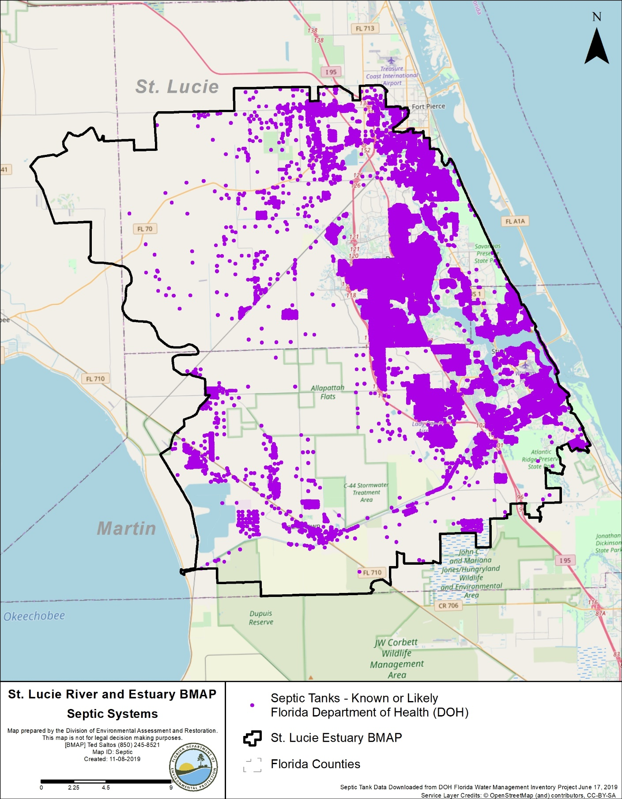
Figure 4. Location of septic systems in the SLREW

Table 8. Septic system counts by basin
Basin | Number of  Septic Systems
North Fork | 26,350
Ten Mile Creek | 823
C-24 | 1,320
C-23 | 737
C-44/S-153 | 900
Basin 4/5 | 1,815
Basin 6 | 679
South Fork | 4,739
South Coastal | 5,071
South Mid-Estuary | 1,124
North Mid-Estuary | 2,711
Total | 46,269

1.2.2.4. Urban Nonpoint Sources
Subsubparagraph 403.067(7)(b)2.f., F.S., prescribes the pollutant reduction actions required for nonagricultural pollutant sources that are not subject to NPDES permitting. ″Non-MS4 sources‶ must also implement the pollutant reduction requirements detailed in a BMAP and are subject to enforcement action by DEP or a water management district if they fail to implement their responsibilities under the BMAP. Table 9 lists the nonpoint sources in the SLREW.
Table 9. Urban nonpoint sources in the SLREW
Type of Entity | Participant
Government Entities and Special Districts | Copper Creek Community Development District (CDD)  Hobe St. Lucie Conservancy District  North St. Lucie River Water Control District (NSLRWCD)  Pal Mar Water Control District (WCD)  Pal Mar WCD  Tradition CDD  Troup-Indiantown WCD  Verano CDD

1.2.2.5. Wastewater Treatment Facilities (WWTFs)
The TMDL analysis identified 15 permitted NPDES WWTFs in the SLREW. All these facilities were only permitted to discharge during a 25-year, 72-hour storm eventresulting in minimal and highly irregular impacts on nutrient discharges in the SLREW. Facilities with permitted discharges above this level are for cooling or dewatering, which effectively discharge ambient water. As of December 2019, there were 37 individually permitted industrial and domestic WWTFs in the SLREW. Of these, 7 hold NPDES permits and therefore are authorized, within the limitations of their permits, to discharge directly to surface waters within the LOW. The remaining 30 do not have authorization to discharge directly to surface waters.

1.2.3. Assumptions
The water quality impacts of BMAP implementation are based on several fundamental assumptions about the pollutants targeted by the TMDLs, modeling approaches, waterbody response, and natural processes. The following assumptions were used during the BMAP process:
- Certain BMPs were assigned provisional nutrient reduction benefits for load reductions in this BMAP iteration while additional monitoring and research are conducted to quantify their effectiveness. These estimated reductions may change in future BMAP iterations as additional information becomes available.
- Nutrient reduction benefits of the stakeholders' projects were calculated using the best available methodologies. Project-specific monitoring, where available, will be used to verify calculations, and reduction benefits may be adjusted as necessary.
- Reductions in TN and TP loading to the St. Lucie River and Estuary will increase DO concentrations and reduce chlorophyll a concentrations to improve the water quality conditions in these waterbodies.
- The allocations do not include required load reductions from areas identified as natural land use areas in the 2012 SFWMD land use coverage. These loads are considered uncontrollable, background sources, and the stakeholders are not required to make reductions on natural lands. The focus of the BMAP allocations is on urban and agricultural stormwater sources and septic tanks in the watershed.
- Achieving the St. Lucie River and Estuary TMDLs is contingent on reductions from the Lake Okeechobee Watershed, and in the St. Lucie River and Estuary TMDLs it was assumed that the Lake Okeechobee TMDL had been met. A separate BMAP is adopted for the Lake Okeechobee Watershed.

1.2.4. Considerations
This BMAP requires stakeholders to implement their projects to achieve reductions within the specified period. However, the full implementation of this BMAP will be a long-term, adaptively managed process. While some of the BMAP projects and activities were recently completed or are currently ongoing, several projects require more time to design, secure funding, and construct. Regular followup and continued coordination and communication by the stakeholders will be essential to ensure the implementation of management strategies and assessment of incremental effects.
During the BMAP process, a number of items were identified that should be addressed in future watershed management cycles to ensure that future BMAPs use the most accurate information:
- Land Uses – The loading estimates in the BMAP are based on land uses at a point in time, allowing the model to be validated and calibrated. The loading estimates for this BMAP iteration were based on 2012 land use data.
- Basin Boundaries – During BMAP development, DEP and SFWMD worked closely in consultation with the stakeholders to identify an appropriate basin boundary for both the BMAP and SLRWPP. The BMAP area was originally divided into six basins, which were also used in the water quality analysis for the SLRWPP (SFWMD et al. 2009). As both the SLRWPP and BMAP are requirements of the Northern Everglades and Estuaries Protection Program (NEEPP), the BMAP boundary was based on the SLRWPP to align the BMAP process with the SLRWPP.
Since the 2013 BMAP adoption, the basin boundaries have been updated based on the hydrologic evaluation of tributaries in the SLREW. This evaluation involved conversations with local entities, aerial surveys, and the investigation of areas where discrepancies were noted in the SFWMD ArcHydro Database. Each basin boundary was refined to more accurately reflect drainage conditions, and the changes in acreage were documented. The boundary was also affected by redelineation efforts for the watersheds in the northern part of Palm Beach County as part of the Loxahatchee River Restoration Project.
The South Coastal Basin was not included within the original BMAP boundary because of a lack of nutrient loading data for the area. Tidal stage data have since become available at the St. Lucie Inlet in the northern portion of the South Coastal Basin that drains to the lower St. Lucie Estuary. As a result, the WaSh model revisions expanded the model domain to include the remainder of the South Mid-Estuary Basin, South Coastal Basin, and Lower St. Lucie Estuary.
In addition, the northeastern portion of the St. Lucie BMAP boundary was refined based on a stormwater master plan completed by the City of Fort Pierce (Kimley-Horn and Associates, Inc. 2010). Proposed changes to the boundary were made in two of the city's drainage basins—Virginia Avenue Canal East and Virginia Avenue Canal West. The southern portion of the boundary was also refined to follow the northern portion of the city's Cortez NSLRWCD Canal Drainage Basin.
The North Mid-Estuary Basin boundary was revised based on the results of a hydrology study commissioned by SFWMD. The boundary originally extended east close to the Indian River Lagoon (IRL) and included most of the Town of Sewall's Point; however, the boundary was moved west towards St. Lucie Estuary to follow the ridge line and more accurately reflect drainage into the St. Lucie Estuary.
The St. Lucie River and Estuary BMAP area is now divided into 11 basins. The 2013 BMAP area included 13 basins; however, some of these basins were merged to better align with the monitoring network and updated BMAP approach. The C-44 Basin was merged with the S-153 Basin, and Basin 4 was merged with Basin 5.
Figure 5 shows the previous and updated BMAP boundary. Overall, 22,443 acres were added to the BMAP area and 3,922 acres removed, resulting in a net addition of 18,521 acres. Figure 6 displays the proposed BMAP basin boundaries.
- Jurisdictional Boundaries – Entities may experience shifts in their jurisdictional boundaries over time that require allocation adjustments. Changes to the boundaries and/or allocations for these stakeholders may be made as necessary and reflected in future BMAP iterations.
- CDD Responsibilities –DEP has had several conversations with the City of Port St. Lucie and the numerous CDDs located in the city. CDDs were assigned allocations only if three criteria were met: (1) there is development—i.e., roads and infrastructure—in the CDD area; (2) the CDD does not discharge to the City of Port St. Lucie's MS4; and (3) the CDD pays a stormwater fee and receives a refund of this fee. As further details are provided (e.g., discharge locations from these CDDs), revisions to the city's allocations and boundaries will be made in future BMAP iterations. Furthermore, some of the CDDs that did not receive an allocation in this BMAP iteration may receive allocations in future BMAP iterations.
- Chapter 40E-61, F.A.C. – SFWMD has initiated rulemaking to revise Chapter 40E-61, F.A.C., to ensure objectives are consistent with Sections 373.4595 and 403.067, F.S.
- WCDs – In the 2013 BMAP, WCDs and other special districts were assigned allocations, which included all agricultural and urban lands within their jurisdictional boundaries that were not part of an MS4. During the development of the BMAP, there were concerns with this approach, because FDACS is the only entity that can enroll agricultural producers in BMPs, but the WCDs were responsible for loading from the agricultural areas. In addition, the urban lands within the districts were permitted by the city or county and not under the district's control. Therefore, this 2020 BMAP only assigns the canals and rights-of-way to the special districts, as the districts have control over these portions of their jurisdictions. The districts are required to implement specific canal and right-of-way BMPs to be compliant with the BMAP.
- Complexity of Problem – DEP acknowledges the complexity of the dynamics that affect the water quality of the SLREW; therefore, this BMAP is designed to encompass a wide variety of projects that will cumulatively act to significantly reduce nutrient loads. In October 2019, DEP released an RFI to obtain new proposals for restoration projects and technologies to be implemented in the SLREW. Appendix D describes the projects and technologies submitted through the RFI for each of the 11 basins. Resources will be needed to implement these projects throughout the watershed.
- Legacy Phosphorus – DEP recognizes that legacy phosphorus is present in the St. Lucie River and Estuary and in the watershed as a result of past anthropogenic activities, and this watershed load has the potential to be transported to the St. Lucie River and Estuary. The Coordinating Agencies (DEP, FDACS, and SFWMD) and stakeholders will identify projects and management strategies that will address the legacy load.
- Previous Restoration Efforts – DEP recognizes that stakeholders throughout the watershed have implemented stormwater management projects prior to the implementation of the TMDLs and that these efforts have benefited water quality. Projects completed in 2000 or later are considered for credits and inclusion in the BMAP.
- Lake Okeechobee BMAP Overlap – Portions of the Lake Okeechobee Watershed overlap with the SLREW. The projects in these overlap areas are included in both this BMAP and the Lake Okeechobee BMAP. The benefits of these projects will vary by BMAP as the reductions are calculated for the waterbody that is the focus of the BMAP.

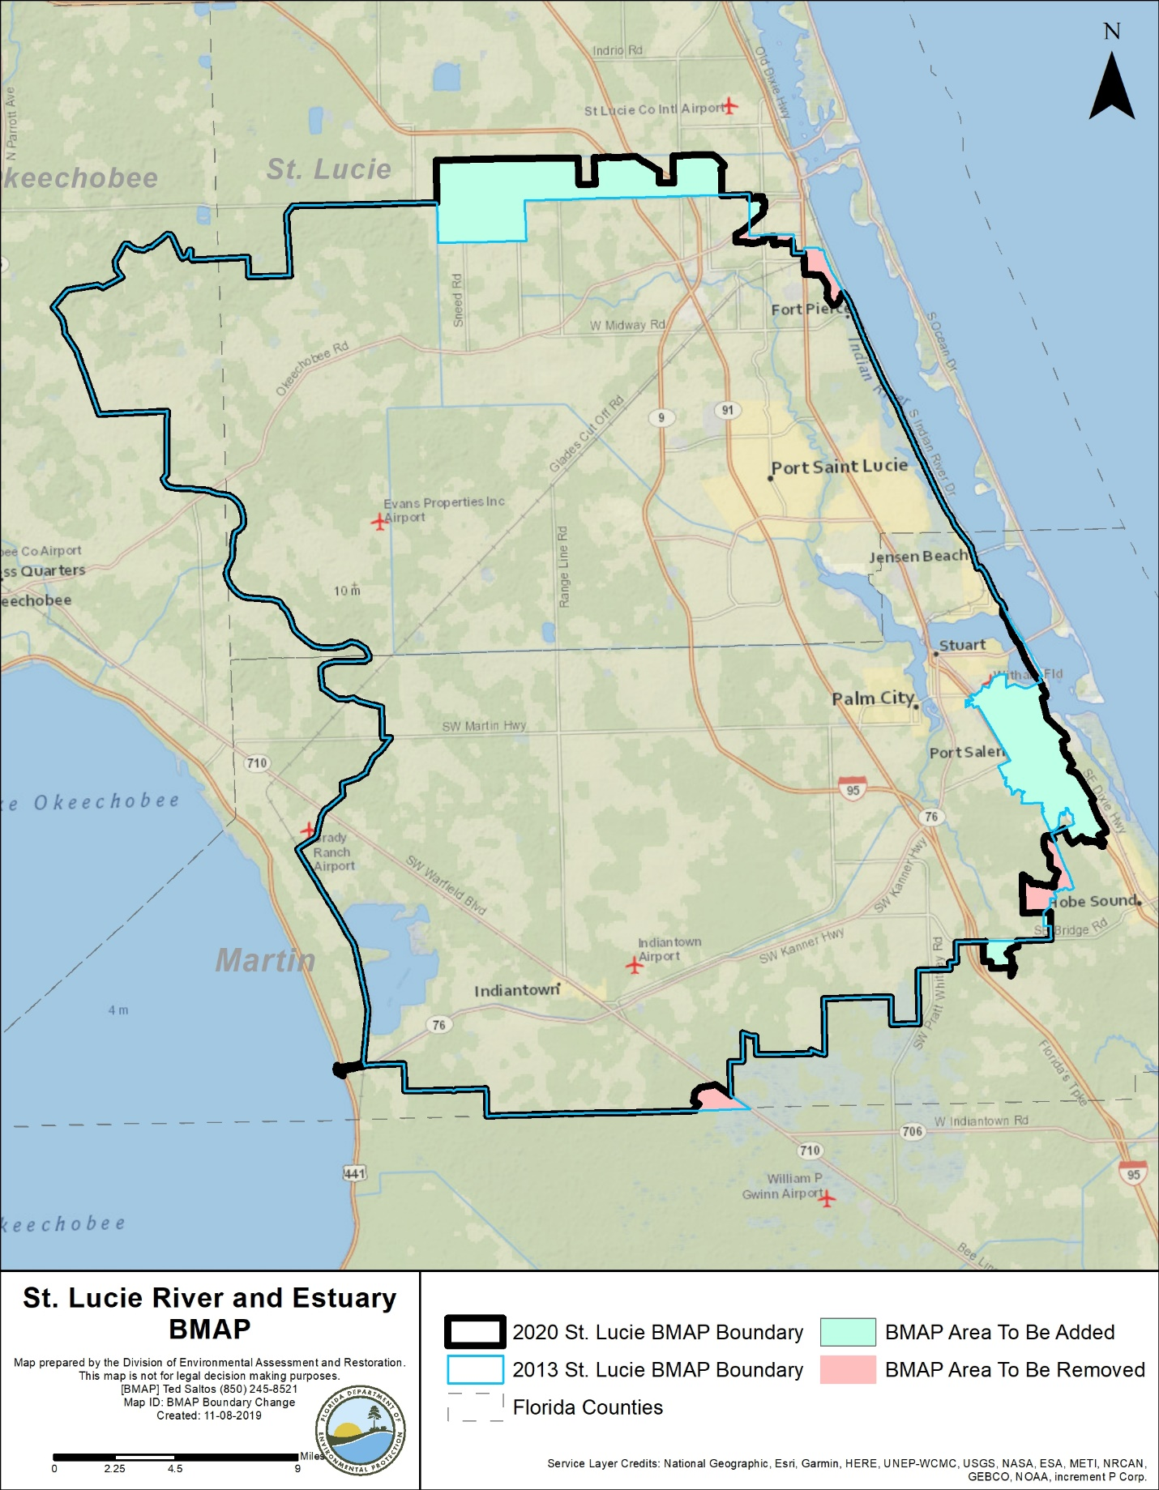
Figure 5. 2013 BMAP area boundary and 2020 BMAP area boundary

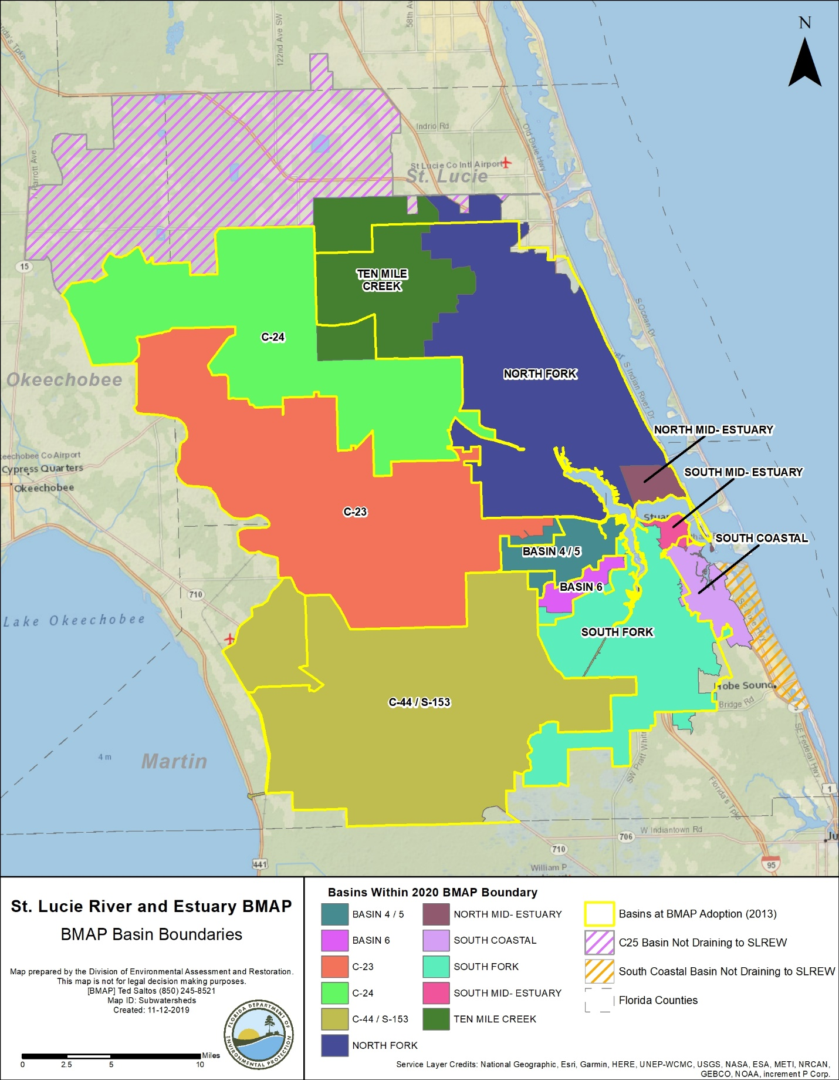
Figure 6. Proposed BMAP area basin boundaries

Chapter 2. Modeling, Load Estimates, and Restoration Approach
The St. Lucie Estuary WaSh model was updated and revised as part of the 5-Year Review. The revisions and scenarios are summarized below, and a separate modeling report provides additional descriptions of model functionality, data sources, calibration and verification results, and alternative scenario outcomes (SFWMD et al. 2018).

BMAP Modeling

2.1.1. WaSh Modeling Revisions
The WaSh model is a hydrologic, hydrodynamic, and water quality model that was developed for the SLREW. The model domain covers the C-23, C-24, C-44/S-153, Ten Mile Creek, North Fork, South Fork, and South Coastal Basins and Basins 4/5/6. The model was originally developed for the unique hydrologic conditions in south Florida (URS 2008) and was adapted during the first phase of implementation to better suit the planning purposes of the BMAP.
DEP coordinated with SFWMD to revise, enhance, and update the model, first by simulating the baseline scenario. The baseline scenario period of record is 1994 to 2016, and the model uses 2004, 2008, and 2012 land use data. The model was calibrated using available SFWMD data from 2001 to 2006 and verified with available SFWMD data from 1995 to 2000.
The draft report for the WaSh baseline scenario (SFWMD 2017) was made available to stakeholders for review, and preliminary modeling results were presented at the BMAP public meeting in January 2018. Stakeholder comments were incorporated into an updated model report (SFWMD et al. 2018), which was further revised based on additional work and made available for stakeholder review in May 2018.
The results of this modeling effort were used as inputs for the revised nutrient load allocation methodology.

2.1.2. WaSh Baseline Condition Scenario
The baseline WaSh model was calibrated using the following measured data: flow (cubic feet per second), ammonia nitrogen (mg/L), nitrate nitrogen (mg/L), organic nitrogen (mg/L), chlorophyll a (micrograms per liter [µg/L]), inorganic phosphorus (mg/L), organic phosphorus (mg/L), and DO (mg/L). Annual and monthly TN and TP loads (lbs/yr) were calculated based on model output (flows and nutrient concentrations). The locations for model calibration and verification of flow included S-80, S-97, and S-49, and for water quality included S-80, S-48, S-49, HR1, SE 01, SE 02, SE 03 SE 06, SE 08/SE 08B, and SE 11.
Overall, the model was well calibrated and verified within the periods chosen for the baseline scenario. The comparison of simulated and measured time series plots for both flow and water quality data were generally in good agreement. The comparison plots and evaluation statistics indicate that the model can predict annual TN and TP loads well. Generally, the comparison of simulated and measured data indicates that the model closely reproduces the patterns of flow and captures the variation of nutrient dynamics.
Under the baseline condition scenario, Lake Okeechobee is meeting its TMDL; therefore, the S-308 input is set to the TMDL as well. The S-308 structure allows water from Lake Okeechobee to be released into the C-44 canal to the St. Lucie River. This scenario was used so that stakeholders were not asked to reduce loads from the lake, for which they are not responsible.

2.1.3. WaSh Alternative Condition Scenarios
Two alternative condition scenarios from 2007 to 2016 were run using the WaSh model: (1) the impact of select large-scale BMAP projects, and (2) the impact of septic system removal. The results of these scenarios are not currently being used to draft new allocations, but the model may be expanded in the future and used to support restoration activities in the BMAP. More detailed information about the setup, data, and assumptions used as well as the results of these scenarios can be found in the draft modeling report (SFWMD et al. 2018).

2.1.4. Use of Model for Allocations
The revised WaSh model can produce polygon outputs with loading data included. Through a series of GIS steps, polygons were generated for each stakeholder. GIS data were used to clip the area within the BMAP boundary associated with each entity's jurisdictional boundary or the codes from SFWMD 2012 land use data related to the natural lands and agriculture categories. The clipping was done sequentially, as follows:
- Water Management Areas (Florida Power and Light [FPL] Pond, Dispersed Water Management [DWM], and CERP projects in construction or design).
- Roads (Florida Department of Transportation [FDOT] and Florida's Turnpike Enterprise).
- WCDs and other special district canals and rights-of-way.
- Natural lands (land use codes 3000 [not including 3300], 4000, 5000, and 6000).
- Agriculture (land use codes 2000 and 3300).
- CDDs.
- Municipalities.
- Remaining area assigned to each county.
The loads associated with water and natural lands were not assigned to any stakeholder as the TMDLs focus on loads from anthropogenic (urban and agricultural) sources and does not require reductions from natural lands. In addition, the WCDs and other special districts were not assigned an allocation and were instead asked to implement specific BMPs as discussed in Appendix C.

2.1.5. Use of Model for Project Estimates
The polygon output feature of the updated WaSh model could also be used to obtain load per acre values for each land use type on a basin basis. This information was linked with the 2012 land use shapefile to create a load estimation shapefile that could be manipulated to calculate updated baseloads from all existing project treatment areas in the BMAP.

2.2 Calculation of Starting Loads and Allocations
This section describes the process to calculate the load reductions needed to achieve the TMDL loads and to allocate the load reduction requirements to the responsible stakeholders.

2.2.1. Starting Loads
The current concentrations were estimated by the model for each basin and compared with the TMDL target concentration to calculate the percent required reduction needed in each basin to achieve the TMDL loads. The current and target TN concentrations as well as the required reduction by basin are shown in Table 10, and the current and target TP concentrations as well as the required reduction by basin are listed in Table 11. The starting loads (lbs/yr) of TN and TP by entity are listed, respectively, in Table 12 and Table 13.
Table 10. TN required reductions by basin
Category | Basins 4,5,6 | C-23 | C-24 | C-44, S-153 | North Fork | North Mid-Estuary | South Fork | South Mid-Estuary/ South Coastal | Ten Mile Creek
TN current concentration (mg/L) | 0.86 | 1.74 | 1.71 | 0.92 | 1.08 | 0.92 | 0.99 | 0.68 | 1.00
TN target concentration (mg/L) | 0.72 | 0.72 | 0.72 | 0.72 | 0.72 | 0.72 | 0.72 | 0.72 | 0.72
TN reduction required (%) | 16% | 59% | 58% | 22% | 33% | 22% | 27% | 0% | 28%

Table 11. TP required reductions by basin
Category | Basins 4,5,6 | C-23 | C-24 | C-44, S-153 | North Fork | North Mid-Estuary | South Fork | South Mid-Estuary/ South Coastal | Ten Mile Creek
TP current concentration (mg/L) | 0.180 | 0.352 | 0.279 | 0.111 | 0.233 | 0.178 | 0.167 | 0.117 | 0.201
TP target concentration (mg/L) | 0.081 | 0.081 | 0.081 | 0.081 | 0.081 | 0.081 | 0.081 | 0.081 | 0.081
TP reduction required (%) | 55% | 77% | 71% | 27% | 65% | 54% | 51% | 31% | 60%

Table 12. TN starting loads by entity (lbs/year)
Entity | Basins  4, 5, 6 | C-23 | C-24 | C-44, S-153 | North Fork | North Mid-Estuary | South Fork | South Mid-Estuary/ South Coastal | Ten Mile Creek | Total
Agriculture | 23,272 | 586,882 | 492,844 | 592,295 | 51,513 |  | 165,321 | 386 | 216,175 | 2,128,687
City of Fort Pierce | N/A | N/A | N/A | N/A | 48,611 | N/A | N/A | N/A | 7 | 48,617
City of Port St. Lucie | N/A | 7,806 | 17,585 | N/A | 375,955 | N/A | N/A | N/A | 583 | 401,929
City of Stuart | N/A | N/A | N/A | N/A | 911 | 2,836 | 18,635 | 14,511 | N/A | 36,893
Copper Creek CDD | N/A | N/A | 2,591 | N/A | N/A | N/A | N/A | N/A | N/A | 2,591
Creekside CDD | N/A | N/A | N/A | N/A | N/A | N/A | N/A | N/A | 1,695 | 1,695
FDOT District 4 | 1,799 | 8,172 | 3,774 | 6,808 | 13,542 | 464 | 6,906 | 583 | 2,355 | 44,404
FDOT District 1 | N/A | 1,013 | N/A | N/A | N/A | N/A | N/A | N/A | N/A | 1,013
Martin County | 88,436 | 12,022 | N/A | 46,586 | 25,425 | 25,113 | 122,195 | 85,420 | N/A | 405,198
Okeechobee County | N/A | 7,701 | 5,934 | N/A | N/A | N/A | N/A | N/A | N/A | 13,635
Portofino Isles CDD | N/A | 2,143 | N/A | N/A | 44 | N/A | N/A | N/A | N/A | 2,186
River Place CDD | N/A | N/A | N/A | N/A | 1,166 | N/A | N/A | N/A | N/A | 1,166
St. Lucie County | N/A | 6,436 | 31,092 | N/A | 110,015 | N/A | N/A | N/A | 32,978 | 180,521
St. Lucie West Service District | N/A | N/A | N/A | N/A | 40,406 | N/A | N/A | N/A | N/A | 40,406
Tesoro CDD | N/A | N/A | N/A | N/A | 7,756 | N/A | N/A | N/A | N/A | 7,756
Town of Sewall's Point | N/A | N/A | N/A | N/A | N/A | 1,919 | N/A | N/A | N/A | 1,919
Tradition CDD | N/A | 2 | 14,340 | N/A | 279 | N/A | N/A | N/A | N/A | 14,621
Turnpike | 1,808 | 19 | N/A | N/A | 9,594 | N/A | 2,382 | N/A | 37 | 13,839
Veranda CDD | N/A | N/A | N/A | N/A | 558 | N/A | N/A | N/A | N/A | 558
Verano CDD | N/A | N/A | 1,778 | N/A | N/A | N/A | N/A | N/A | N/A | 1,778
Villa Vizcaya CDD | N/A | N/A | N/A | N/A | 357 | N/A | N/A | N/A | N/A | 357
Natural Lands | 29,016 | 127,211 | 101,061 | 191,269 | 187,259 | 7,683 | 120,195 | 16,535 | 17,933 | 798,161
WCD Canals | N/A | N/A | 5 | 7,836 | 5,422 | N/A | 869 | N/A | 9,357 | 23,489
Total | 144,331 | 759,407 | 671,004 | 844,794 | 878,811 | 38,015 | 436,502 | 117,436 | 281,120 | 4,171,420

Table 13. TP starting loads by entity (lbs/year)
Entity | Basins  4, 5, 6 | C-23 | C-24 | C-44, S-153 | North Fork | North Mid-Estuary | South Fork | South Mid-Estuary/ South Coastal | Ten Mile Creek | Total
Agriculture | 4,971 | 158,997 | 109,204 | 106,968 | 10,842 | N/A | 35,890 | 65 | 45,486 | 472,423
City of Fort Pierce | N/A | N/A | N/A | N/A | 8,071 | N/A | N/A | N/A | 1 | 8,071
City of Port St. Lucie | N/A | 1,331 | 3,073 | N/A | 63,694 | N/A | N/A | N/A | 93 | 68,190
City of Stuart | N/A | N/A | N/A | N/A | 151 | 450 | 3,140 | 2,402 | N/A | 6,142
Copper Creek CDD | N/A | N/A | 431 | N/A | N/A | N/A | N/A | N/A | N/A | 431
Creekside CDD | N/A | N/A | N/A | N/A | N/A | N/A | N/A | N/A | 293 | 293
FDOT District 4 | 308 | 1,929 | 714 | 1,239 | 2,169 | 71 | 1,056 | 95 | 466 | 8,047
FDOT District 1 | N/A | 283 | N/A | N/A | N/A | N/A | N/A | N/A | N/A | 283
Martin County | 15,100 | 2,351 | N/A | 7,954 | 4,088 | 4,197 | 21,071 | 14,521 | N/A | 69,281
Okeechobee County | N/A | 1,661 | 968 | N/A | N/A | N/A | N/A | N/A | N/A | 2,629
Portofino Isles CDD | N/A | 363 | N/A | N/A | 7 | N/A | N/A | N/A | N/A | 371
River Place CDD | N/A | N/A | N/A | N/A | 195 | N/A | N/A | N/A | N/A | 195
St. Lucie County | N/A | 1,353 | 5,502 | N/A | 19,417 | N/A | N/A | N/A | 6,340 | 32,612
St. Lucie West Service District | N/A | N/A | N/A | N/A | 6,967 | N/A | N/A | N/A | N/A | 6,967
Tesoro CDD | N/A | N/A | N/A | N/A | 1,271 | N/A | N/A | N/A | N/A | 1,271
Town of Sewall's Point | N/A | N/A | N/A | N/A | N/A | 319 | N/A | N/A | N/A | 319
Tradition CDD | N/A | 1 | 2,517 | N/A | 44 | N/A | N/A | N/A | N/A | 2,562
Turnpike | 306 | 4 | N/A | N/A | 1,564 | N/A | 399 | N/A | 8 | 2,281
Veranda CDD | N/A | N/A | N/A | N/A | 63 | N/A | N/A | N/A | N/A | 63
Verano CDD | N/A | N/A | 366 | N/A | N/A | N/A | N/A | N/A | N/A | 366
Villa Vizcaya CDD | N/A | N/A | N/A | N/A | 60 | N/A | N/A | N/A | N/A | 60
Natural Lands | 4,645 | 33,213 | 20,736 | 33,657 | 30,977 | 1,204 | 20,931 | 2,800 | 3,715 | 151,878
WCD Canals | N/A | N/A | 1 | 1,315 | 966 | N/A | 164 | N/A | 1,944 | 4,389
Total | 25,329 | 201,487 | 143,513 | 151,132 | 150,546 | 6,242 | 82,650 | 19,881 | 58,345 | 839,126

2.2.2. Allocation of Load Reductions
The allocation boundary for each entity is divided into each basin where the entity is located, so that starting loads for each entity by basin can be calculated. The required load reduction needed to meet the TMDLs was calculated by multiplying the TN and TP starting loads for each entity in each basin (Table 12 and Table 13) by the percent required reduction for TN and TP by basin (Table 10 and Table 11). If a stakeholder is located in more than one basin, the required load reductions by basin were summed to determine one total load reduction for TN and TP. The required TN and TP reductions (lbs/yr) for TN and TP by entity and within each basin are listed in Table 16 for TN and Table 17 for TP.
Low Priority Ranking Determination
Several stakeholders contribute less than 0.1 % of both the TN and TP loading from the watershed to the St. Lucie River and Estuary. The contribution to the overall nutrient loading from these stakeholders is low enough that reductions from these areas would have essentially no impact on the required reductions for the BMAP at this time; therefore, these entities are currently considered a low priority for implementing reductions.
Table 14 and Table 15 summarize the priority evaluation, and those stakeholders meeting the classification requirements for low priority are highlighted in grey. Stakeholders that met the low-priority classification include the Town of Sewall's Point, Copper Creek CDD, Portofino Isles CDD, Verano CDD, Creekside CDD, River Place CDD, FDOT District 1, Veranda CDD, and Villa Vizcaya CDD. These entities are not required to meet the 10-year reduction target for TN and TP but must continue to adhere to all requirements of their MS4 permit or other permits.
BMAP progress will be reviewed over time, and reduction requirements, including for those stakeholders with this low-priority status, will be updated in a future BMAP update as needed. TN and TP reductions may be needed from the low-priority entities in the future. Therefore, although they do not currently have a reduction responsibility, this does not exempt these stakeholders from such requirements in future BMAP updates. Any actions taken by these entities that result in TN and TP reductions will be documented for credit against any reduction requirements allocated in subsequent BMAP updates.

Table 14. Entity contributions to total TN starting load with low priority ranking cutoff
Note: Grey highlighting and boldface type indicate jurisdictions meeting the classification requirements for low priority.
Entity | TN Starting Load (lbs/yr) | % of Total TN Starting Load
Agriculture | 2,128,687 | 63.55
City of Port St. Lucie | 401,929 | 12.00
Martin County | 388,638 | 11.60
St. Lucie County | 180,521 | 5.39
City of Fort Pierce | 48,617 | 1.45
FDOT District 4 | 44,404 | 1.33
St. Lucie West Service District | 40,406 | 1.21
City of Stuart | 36,893 | 1.10
Village of Indiantown | 16,560 | 0.49
Tradition CDD | 14,621 | 0.44
Turnpike | 13,839 | 0.41
Okeechobee County | 13,635 | 0.41
Tesoro CDD | 7,756 | 0.23
Copper Creek CDD | 2,591 | 0.08
Portofino Isles CDD | 2,186 | 0.07
Town of Sewall's Point | 1,919 | 0.06
Verano CDD | 1,778 | 0.05
Creekside CDD | 1,695 | 0.05
River Place CDD | 1,166 | 0.03
FDOT District 1 | 1,013 | 0.03
Veranda CDD | 558 | 0.02
Villa Vizcaya CDD | 357 | 0.01
Total for Allocated Entities | 3,349,770 | 100.0
Natural Lands | 798,161 | N/A
WCD Canals | 23,489 | N/A
Total | 4,171,420 | N/A

Table 15. Entity contributions to total TP starting load with low priority ranking cutoff
Note: Grey highlighting and boldface type indicate jurisdictions meeting the classification requirements for low priority.
Entity | TP Starting Load  (lbs/yr) | % of Total Starting TP Load
Agriculture | 472,423 | 69.18
City of Port St. Lucie | 68,190 | 9.99
Martin County | 66,501 | 9.74
St. Lucie County | 32,612 | 4.78
FDOT District 4 | 8,047 | 1.18
City of Fort Pierce | 8,071 | 1.18
St. Lucie West Service District | 6,967 | 1.02
City of Stuart | 6,142 | 0.90
Village of Indiantown | 2,780 | 0.41
Okeechobee County | 2,629 | 0.39
Tradition CDD | 2,562 | 0.38
Turnpike | 2,281 | 0.33
Tesoro CDD | 1,271 | 0.19
Copper Creek CDD | 431 | 0.06
Portofino Isles CDD | 371 | 0.05
Verano CDD | 366 | 0.05
Town of Sewall's Point | 319 | 0.05
Creekside CDD | 293 | 0.04
FDOT District 1 | 283 | 0.04
River Place CDD | 195 | 0.03
Veranda CDD | 63 | 0.01
Villa Vizcaya CDD | 60 | 0.01
Total for Allocated Entities | 682,858 | 100.0
Natural Lands | 151,878 | N/A
WCD Canals | 4,389 | N/A
Total | 839,126 | N/A

Table 16. TN load required reductions by entity (lbs/yr)
Entity | Basins 4,5,6 | C-23 | C-24 | C-44,  S-153 | North Fork | North Mid-Estuary | South Fork | South Mid-Estuary/ South Coastal | Ten Mile Creek | Total
Agriculture | 3,789 | 344,034 | 285,331 | 128,760 | 17,171 | 0 | 45,088 | 0 | 60,529 | 884,700
City of Fort Pierce | 0 | 0 | 0 | 0 | 16,204 | 0 | 0 | 0 | 2 | 16,205
City of Port St. Lucie | 0 | 4,576 | 10,181 | 0 | 125,318 | 0 | 0 | 0 | 163 | 140,239
City of Stuart | 0 | 0 | 0 | 0 | 304 | 617 | 5,082 | 0 | 0 | 6,003
Copper Creek CDD | 0 | 0 | 1,500 | 0 | 0 | 0 | 0 | 0 | 0 | 1,500
Creekside CDD | 0 | 0 | 0 | 0 | 0 | 0 | 0 | 0 | 475 | 475
FDOT District 4 | 293 | 4,791 | 2,185 | 1,480 | 4,514 | 101 | 1,883 | 0 | 660 | 15,907
FDOT District 1 | 0 | 594 | 0 | 0 | 0 | 0 | 0 | 0 | 0 | 594
Martin County | 14,397 | 7,047 | 0 | 10,127 | 8,475 | 5,459 | 33,326 | 0 | 0 | 78,831
Okeechobee County | 0 | 4,515 | 3,435 | 0 | 0 | 0 | 0 | 0 | 0 | 7,950
Portofino Isles CDD | 0 | 1,256 | 0 | 0 | 15 | 0 | 0 | 0 | 0 | 1,271
River Place CDD | 0 | 0 | 0 | 0 | 389 | 0 | 0 | 0 | 0 | 389
St. Lucie County | 0 | 3,773 | 18,001 | 0 | 36,672 | 0 | 0 | 0 | 9,234 | 67,679
St. Lucie West Service District | 0 | 0 | 0 | 0 | 13,469 | 0 | 0 | 0 | 0 | 13,469
Tesoro CDD | 0 | 0 | 0 | 0 | 2,585 | 0 | 0 | 0 | 0 | 2,585
Town of Sewall's Point | 0 | 0 | 0 | 0 | 0 | 417 | 0 | 0 | 0 | 417
Tradition CDD | 0 | 1 | 8,302 | 0 | 93 | 0 | 0 | 0 | 0 | 8,396
Turnpike | 294 | 11 | 0 | 0 | 3,198 | 0 | 650 | 0 | 10 | 4,163
Veranda CDD | 0 | 0 | 0 | 0 | 186 | 0 | 0 | 0 | 0 | 186
Verano CDD | 0 | 0 | 1,030 | 0 | 0 | 0 | 0 | 0 | 0 | 1,030
Villa Vizcaya CDD | 0 | 0 | 0 | 0 | 119 | 0 | 0 | 0 | 0 | 119
Total | 18,772 | 370,598 | 329,964 | 140,367 | 228,710 | 6,594 | 86,029 | 0 | 71,072 | 1,252,107

Table 17. TP load required reductions by entity (lbs/yr)
Entity | Basins 4,5,6 | C-23 | C-24 | C-44,  S-153 | North Fork | North Mid-Estuary | South Fork | South Mid-Estuary/ South Coastal | Ten Mile Creek | Total
Agriculture | 2,734 | 122,410 | 77,500 | 28,910 | 7,073 | 0 | 18,482 | 20 | 27,156 | 284,285
City of Fort Pierce | 0 | 0 | 0 | 0 | 5,265 | 0 | 0 | 0 | 1 | 5,266
City of Port St. Lucie | 0 | 1,024 | 2,181 | 0 | 41,551 | 0 | 0 | 0 | 55 | 44,812
City of Stuart | 0 | 0 | 0 | 0 | 98 | 245 | 1,617 | 739 | 0 | 2,700
Copper Creek CDD | 0 | 0 | 306 | 0 | 0 | 0 | 0 | 0 | 0 | 306
Creekside CDD | 0 | 0 | 0 | 0 | 0 | 0 | 0 | 0 | 175 | 175
FDOT District 4 | 169 | 1,485 | 507 | 335 | 1,415 | 39 | 544 | 29 | 278 | 4,801
FDOT District 1 | 0 | 218 | 0 | 0 | 0 | 0 | 0 | 0 | 0 | 218
Martin County | 8,305 | 1,810 | 0 | 2,150 | 2,667 | 2,287 | 10,851 | 4,468 | 0 | 32,537
Okeechobee County | 0 | 1,279 | 687 | 0 | 0 | 0 | 0 | 0 | 0 | 1,966
Portofino Isles CDD | 0 | 280 | 0 | 0 | 5 | 0 | 0 | 0 | 0 | 285
River Place CDD | 0 | 0 | 0 | 0 | 127 | 0 | 0 | 0 | 0 | 127
St. Lucie County | 0 | 1,041 | 3,905 | 0 | 12,667 | 0 | 0 | 0 | 3,785 | 21,398
St. Lucie West Service District | 0 | 0 | 0 | 0 | 4,545 | 0 | 0 | 0 | 0 | 4,545
Tesoro CDD | 0 | 0 | 0 | 0 | 829 | 0 | 0 | 0 | 0 | 829
Town of Sewall's Point | 0 | 0 | 0 | 0 | 0 | 174 | 0 | 0 | 0 | 174
Tradition CDD | 0 | 0 | 1,786 | 0 | 29 | 0 | 0 | 0 | 0 | 1,815
Turnpike | 168 | 3 | 0 | 0 | 1,020 | 0 | 205 | 0 | 5 | 1,402
Veranda CDD | 0 | 0 | 0 | 0 | 41 | 0 | 0 | 0 | 0 | 41
Verano CDD | 0 | 0 | 260 | 0 | 0 | 0 | 0 | 0 | 0 | 260
Villa Vizcaya CDD | 0 | 0 | 0 | 0 | 39 | 0 | 0 | 0 | 0 | 39
Total | 11,376 | 129,551 | 87,131 | 31,395 | 77,372 | 2,745 | 31,699 | 5,256 | 31,455 | 407,980

2.3. Basinwide Sources Approach

2.3.1. Agriculture
When DEP adopts a BMAP that includes agriculture, it is the agricultural landowner's responsibility to implement BMPs adopted by FDACS to help achieve load reductions or demonstrate through monitoring that they are already meeting water quality standards. FDACS will verify that all eligible landowners are enrolled in appropriate BMP programs and are implementing BMPs as intended to achieve maximum environmental benefit, and within one year of adoption of this BMAP will provide to DEP a list of all unenrolled landowners in the SLREW. At least every two years, FDACS will perform an onsite inspection of each agricultural operation enrolled in a BMP program to ensure that these practices are being properly implemented.
Although it is anticipated that additional enrollment in agricultural BMPs, along with more frequent implementation verification site visits by FDACS, will increase nutrient reductions from agricultural nonpoint sources, it is also recognized that further reductions, beyond the implementation of required owner-implemented BMPs, will be necessary to achieve the TMDLs. As such, FDACS will reevaluate existing owner-implemented BMPs and update existing BMP manuals and rules as necessary within five years of the adoption of this BMAP.
Further nutrient reductions can be achieved through the implementation of additional agricultural projects or activities. The Coordinating Agencies will continue to collaborate to identify cost-share practices and other projects that can be undertaken to achieve these nutrient reductions and identify and implement additional projects and activities in priority targeted restoration areas (TRAs).
SFWMD is implementing projects that encourage low-input agriculture and water quality improvement technologies. FDACS also provides funding to some agricultural operations to add other practices beyond owner-implemented BMPs. Examples include drainage improvements, fencing, water control structures, precision agriculture technology, and fertigation. The Coordinating Agencies will also investigate the possibility of implementing incentive-based programs—such as providing incentives for producers to transition to less-intensive crops, changing land use to fallow or native landscape, or changing the type of cropping system–that would reduce nutrient loading in the BMAP area.
Other reductions associated with the implementation and modification of BMPs may be realized through ongoing studies, data collection, and water management district initiatives. These additional projects and practices are to be implemented in conjunction with the BMP Program, which needs to achieve full enrollment with verification to ensure that the BMAP goals are achieved.
FDACS will also collect fertilization and nutrient records from each agricultural producer enrolled in BMPs that address nutrients during implementation verification visits. FDACS will provide DEP and SFWMD with an annual summary of aggregated fertilizer use in the BMAP area, quantifying total applications and providing information on application reductions by basin.

2.3.2. Septic Systems
In U.S. Census–designated urbanized areas and urban clusters, local governments and utilities will develop master wastewater treatment feasibility analyses that include provisions to address loads from existing and new septic systems (e.g., sewering, advanced septic system retrofits, prohibiting the installation of new conventional septic systems). The analyses must identify specific areas to be sewered within 15 years of BMAP adoption. The analyses will also identify sources of funding to address nutrient loading from septic systems. The feasibility analyses will be completed and submitted to DEP within 3 years of the adoption of this BMAP, so that they can inform the selection of management strategies and projects as part of future BMAP updates.
Based on data from FDOH, there are 46,269 known and likely septic systems located throughout the SLREW. Of these, 39,859 are located in U.S. Census–designated urbanized areas or urban clusters. Table 18 summarizes the TN and TP estimated loads from septic systems in urbanized areas. These loads were calculated based on 2018 U.S. Census Bureau data for the average number of people per household for each county in the SLREW, with an estimated wastewater flow of 70 gallons per day per person and TN and TP nutrient concentrations in the effluent from the EPA Onsite Wastewater Treatment Systems Manual (2002). This resulted in an average effluent load leaving the septic system of 15 lbs/yr of TN and 1.5 lbs/yr of TP per septic system.
The reductions from addressing these septic systems will be less than the estimated load depending on how they are addressed (i.e., connecting to central sewer sends the wastewater to a treatment facility, which does not remove 100 % of the nutrient load). This effluent load will also attenuate as it travels through the watershed to the St. Lucie River and Estuary; thus the benefits in the estuary from addressing these septic systems will be based on attenuated loads, which have not been calculated. Furthermore, stakeholders will submit projects describing how septic loads are addressed as part of BMAP reporting.

Table 18. Septic system counts by basin, and estimated effluent loads
Basin | Total Number of  Septic Systems | Number of Septic Systems in the Urbanized Areas and Urban Clusters | Estimated TN Load from Urbanized Septic Systems  (lbs/yr) | Estimated TP Load from Urbanized Septic Systems  (lbs/yr)
North Fork | 26,350 | 25,193 | 371,356 | 35,914
Ten Mile Creek | 823 | 0 | 0 | 0
C-24 | 1,320 | 1,093 | 16,217 | 1,568
C-23 | 737 | 5 | 74 | 7
C-44/S-153 | 900 | 108 | 1,424 | 138
Basin 4/5 | 1,815 | 1,392 | 18,350 | 1,775
Basin 6 | 679 | 335 | 4,416 | 427
South Fork | 4,739 | 3,869 | 51,003 | 4,933
South Coastal | 5,071 | 4,803 | 63,315 | 6,123
South Mid-Estuary | 1,124 | 921 | 12,141 | 1,174
North Mid-Estuary | 2,711 | 2,140 | 28,210 | 2,728
Total | 46,269 | 39,859 | 566,505 | 54,788

2.3.3. Stormwater
Stormwater from urban areas is a considerable source of the nutrient loading to the St. Lucie River and Estuary, and many of these areas are already regulated under the NPDES Stormwater Program. MS4 permittees are required to develop and implement a stormwater management program. Urban areas located in the BMAP area that are not currently covered by an MS4 permit also significantly contribute, individually or in aggregate, to nutrient loading. Therefore, the NPDES Stormwater Program will, within 5 years of BMAP adoption, evaluate any entity located in the BMAP area that serves a minimum resident population of at least 1,000 individuals that are not currently covered by an MS4 permit and designate eligible entities as regulated MS4s, in accordance with Chapter 62-624, F.A.C.
DEP and the water management districts are planning to update the stormwater design and operation requirements in Environmental Resource Permit rules. These revisions will incorporate the most recent scientific information available to increase nutrient reduction benefits.

2.3.4. Wastewater Treatment
DEP issues permits for facilities and activities to discharge wastewater to surface water and groundwater of the state. It is authorized by the EPA to issue permits for discharges to surface waters under the NPDES Program. DEP issues permits for discharges to groundwater under state statutes and rules. These wastewater discharge permits establish specific limitations and requirements based on the location and type of facility or activity releasing industrial or domestic wastewater from a point source. Historically, the term "point source" means discharges to surface waters that typically have a continuous flow via a discernable, confined, and discrete conveyance, such as a pipe, ditch, channel or conduit. This term does not include agricultural stormwater discharges and return flows from irrigated agriculture.
New and existing point source facilities, such as domestic wastewater facilities, their associated RRLAs, and reuse activities must meet the stringent nutrient wastewater limitations set forth in this BMAP, as implemented pursuant to rules of the Department. Any such new facilities, their RRLAs, and reuse activities (those commencing after the adoption of this BMAP) must be capable of meeting the requirements of the BMAP at the time of permit issuance. For existing point source facilities, their associated RRLAs, and reuse activities, DEP will modify the permit limitations and requirements to be consistent with the BMAP at the time of the next permit renewal, as authorized by Department rule. In some cases, the owner or operator may require additional time to meet the modified limitations in the renewed permit, in which case, the permit will also establish a compliance schedule not to exceed four and half years after the effective date of the permit.
In areas where there is anticipated growth in human population, adequate treatment capacity of domestic wastewater is essential. Domestic wastewater is treated through either WWTFs or onsite sewage treatment and disposal systems (OSTDS), commonly referred to as septic systems. Where sewer lines are available, Florida law (Rule 381.00655, F.S.) requires a development or property owner to abandon the use of OSTDS and connect to sanitary sewer lines.
This BMAP requires all individually permitted domestic wastewater point source facilities, their associated RRLAs, and reuse activities to meet the effluent limits listed in Table 19 and Table 20, unless the owner or operator can demonstrate reasonable assurance that the effluent would not cause or contribute to an exceedance of the TN or TP TMDLs for the St. Lucie River and Estuary. To demonstrate reasonable assurance, the owner or operator must provide relevant water quality data, physical circumstances, location, or other site-specific credible information needed to show that the facility would not cause or contribute to the nitrogen or phosphorus loading to the BMAP area. This demonstration may include factors such as dilution; site-specific geological conditions; research/studies, including dye tracer tests; and modeling. Should DEP concur with the reasonable assurance demonstration request, the TN and TP effluent requirements established here may be modified for the owner or operator or waived. New effluent standards will take effect at the time of permit issuance.
Table 19 and Table 20 list the TN and TP effluent limits, respectively, adopted for this BMAP that apply to domestic wastewater point source facilities, their RRLAs, and reuse activities, unless the owner or operator can demonstrate reasonable assurance as listed above. The limits for direct surface discharges apply to individually NPDES-permitted facilities. The limits for RRLA effluent disposal systems apply at the compliance well located at the edge of the zone of discharge for domestic wastewater facilities, RRLAs, or reuse activities having sites such as rapid infiltration basins (RIBs) and absorption fields. These limits are applied as an annual average.
Short-term or intermittent discharges are not significant sources of TN or TP in the SLREW and are not subject to the limits in Table 19 and Table 20. Intermittent, rainfall-driven, diffuse overflow releases of wastewater from ponds or basins designed to hold precipitation from a 25-year, 24-hour rainfall event or less frequent rainfall event or that infrequently reaches surface waters are considered insignificant sources of TN and TP. The owners or operators of cooling pond reservoirs must operate each spillway gate either during regular operation or on a test basis to protect the structural integrity of the reservoir. Because of the short duration and low volume of wastewater released during spillway gate testing, releases either on an annual or semi-annual basis are considered insignificant sources of TN and TP.
As of December 2019, there are 37 individually permitted industrial and domestic WWTFs in the SLREW. Of these facilities, 7 have NPDES permits, and 30 do not have NPDES permits. Additionally, new or renewed point source discharge wastewater permits in the BMAP area must require at least quarterly sampling of the effluent discharge at the point of discharge or edge of mixing zone and compliance wells for TN and TP and the reporting of sampling results in the discharge monitoring reports submitted to DEP.
Table 19. TN effluent limits
mgd = Million gallons per day
Designed Average Daily Flow (mgd) | TN Concentration Limits for Direct Surface Discharge (mg/L) | TN Concentration Limits for RRLA Effluent Disposal System  (mg/L) | TN Concentration Limits for Reuse Activities (mg/L)
Greater than or equal to 0.5 | 3 | 3 | 10
Less than 0.5 and greater than or equal to 0.01 | 3 | 6 | 10
Less than 0.01 | 10 | 10 | 10

Table 20. TP effluent limits
Designed Average Daily Flow (mgd) | TP Concentration Limits for Direct Surface Discharge (mg/L) | TP Concentration Limits for RRLA Effluent Disposal System  (mg/L) | TP Concentration Limits for Reuse Activities (mg/L)
Greater than or equal to 0.5 | 1 | 1 | 6
Less than 0.5 and greater than or equal to 0.01 | 1 | 3 | 6
Less than 0.01 | 6 | 6 | 6

2.4 TRA Approach

2.4.1. Overview
To better prioritize and focus resources to most efficiently achieve restoration in the SLREW, DEP developed the TRA approach. This approach used measured data collected throughout the watershed to evaluate TN and TP concentrations in each of the SLREW basins. Flow data currently exist at the four structure stations; however, the TRA approach does not currently include an assessment of water quantity since a flow evaluation has not yet been completed. Once a complete flow evaluation is available, it will be reviewed for inclusion in future BMAP annual updates. The measured nutrient concentrations were compared with selected benchmarks to identify those basins that should be the highest priority for restoration. The benchmarks are not intended to measure progress towards restoration; they were only used to prioritize resources. The overall approach implemented the following steps:
- Identify smaller areas (e.g., basins) for focused restoration.
- Delineate each area and locate relevant water quality stations:
  - Obtain existing data for TN, TP, and flow.
  - Recommend additional monitoring where data are lacking.
  - Supplement with information from water quality models where appropriate.
- Determine benchmarks for evaluating water quality and water storage:
- Consider the applicable TMDL target (e.g., TN or TP), and consult the SLRWPP for indications of water quality and/or flow issues.
- Rely on existing SFWMD information for water storage needs.
- Review measured data:
- Calculate most recent 5-year average TN and TP concentrations (using available data from WY2014–WY2018).
- Compare concentrations with established benchmarks.
- Consult flow weighted mean (FWM) concentrations and unit area loads (UALs), where available, to better understand conditions.
- Identify criteria for implementation and funding, and describe restoration types (e.g., water quality, flow) recommended for each TRA:
- Calculate expected reductions from existing and recommended projects using measured data wherever possible.
- Identify where additional projects are necessary.
- Prioritize areas where new projects would have the most impact to overall restoration:
- Use water quality (TN and TP) and flow data (where available).
- Compare with benchmarks for each basin.
- Publish an RFI to solicit additional projects and evaluate responses based on benchmarks established for each TRA.
Chapter 3 includes the results of the TRA approach for each of the SLREW basins. Table D-1 in Appendix D lists the projects received from the RFI.
Future steps in this approach include the following:
- Evaluate progress in TRAs annually by comparing measured data with benchmarks and TMDL targets for the basins.
- Use responses from RFIs and existing project lists, combined with the prioritized areas and recommended restoration needs, to inform future budget requests for DEP.
- Update existing water quality models based on expanded monitoring efforts.

2.4.2. Evaluation
Chapter 3 summarizes the results of the TRA evaluation process for the basins in the SLREW. For each basin, a priority was assigned based on the TN concentration, TP concentration, and flows (where available). These priorities were set to help focus resources and projects in the basins most in need of improvement. Basins were assessed and prioritized as follows (Figure 7):
- Assess the five-year average concentration at representative stations and compare with the TMDL benchmark:
- Priority 1: Concentration is two times greater than the TMDL benchmark.
- Priority 2: Concentration is greater than the TMDL benchmark but less than two times the TMDL benchmark.
- Priority 3: Concentration is less than or equal to the TMDL benchmark.
- Assess the five-year average FWM concentration and compare with the TMDL benchmark. This step is weighted above Step 1; therefore, the results for the FWM concentrations would supersede the priorities from Step 1.
- Priority 1: FWM concentration is greater than twice TMDL benchmark.
- Priority 2: FWM concentration is greater than TMDL benchmark, but less than twice TMDL benchmark.
- Priority 3: FWM concentration is equal to or less than TMDL benchmark.
- Assess the attenuated UAL, which is the average load per acre in each basin from the WaSh model. Compare with the basin UAL target calculated with loading data from the SFWMD 2019 South Florida Environmental Report (SFER). This step is weighted above Step 2 where data are available; therefore, results would increase or decrease the priority accordingly:
- Priority increases: UAL is greater than 50 % above the basin target UAL.
- Priority decreases: UAL is less than the basin target UAL.
- Priority remains unchanged: UAL is above the basin target UAL, but less than 50 %.
- Assess the water quality trends from the SLRWPP for statistical significance (as described in the 5-Year Review). This step is weighted above Step 3 where data are available; therefore, results would increase or decrease the priority accordingly:
- Priority increases: Trend is significantly increasing.
- Priority decreases: Trend is significantly decreasing.
- Priority remains unchanged: No significant trend detected.

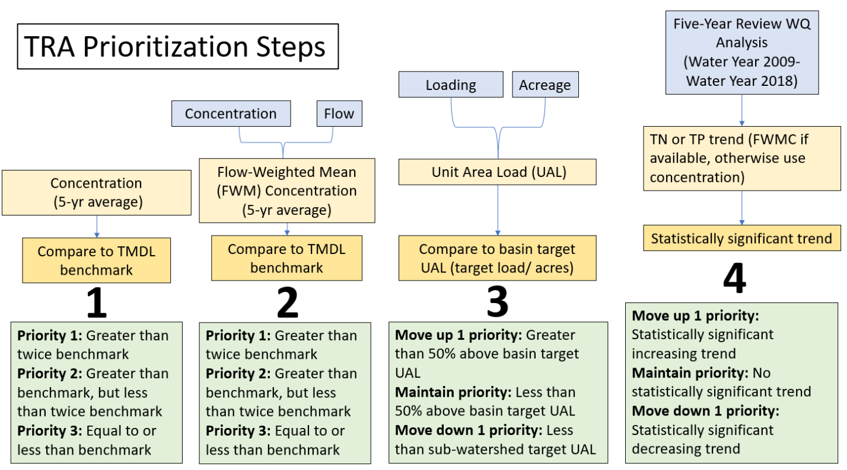
Figure 7. Summary of the TRA prioritization process

2.5 Water Quality Monitoring Plan
To help prioritize monitoring and track BMAP progress, the BMAP monitoring network is being revised, as discussed below, to implement a new tiered system for the sampling stations, remove some stations from the network, and add new monitoring locations.

2.5.1. Objectives and Parameters
The St. Lucie River and Estuary BMAP monitoring plan was designed to enhance the understanding of basin loads, identify areas with high nutrient concentrations, and track water quality trends. The information gathered through the monitoring plan measures progress toward achieving the TMDLs and provides a better understanding of watershed loading. The BMAP monitoring plan consists of ambient water quality sampling, sampling at discharge structures, and flow monitoring. In addition, information on water quality throughout the watershed and within the estuary can be found in the latest South Florida Environmental Report, published annually by SFWMD.
Focused objectives are critical for a monitoring strategy to provide the information needed to evaluate implementation success. The primary objective of the monitoring strategy for the SLREW, described below, is to evaluate the success of the BMAP, help interpret the data collected, and provide information for potential future refinements of the BMAP.
Primary Objective
- To track trends in TN and TP loads in the major canals and tributaries, as well as the St. Lucie River and Estuary.
To achieve this objective, the monitoring strategy focuses on the following parameters:

- Alkalinity.
- Ammonia (N).
- BOD.
- Carbon – organic.
- Carbon – Total.
- Chlorophyll a.
- Color.
- DO.
- DO Saturation.
- Flow.
- Nitrate/Nitrite (N).
- Nitrogen – Total Kjeldahl.
- Nitrogen – total.
- Orthophosphate (P)
- pH.
- Phosphorus –T otal.
- Specific conductance/Salinity.
- Temperature, Water.
- Total suspended solids.
- Turbidity.

2.5.2. Monitoring Network
The monitoring network comprises a tiered system for the sampling stations, as follows:
- Tier 1 stations are the primary/priority stations used in periodic water quality analyses to track BMAP progress and water quality trends over the long term in the basin. Tier 1 stations include both estuary and structure ambient monitoring stations. Several of these stations have autosamplers with more frequent data collection. Structure stations also have flow data, while the estuary stations do not collect flow data. If at any point it is necessary to reduce efforts in the basin, these stations should be the last stations impacted.
- Tier 2 stations will provide secondary information that can be used to help focus and adaptively manage implementation efforts. 15 proposed stations will provide additional information about concentrations in previously unmonitored basin areas.
Figure 8 shows the stations included in each of these tiers. Chapter 3 includes additional information about the BMAP monitoring network and stations used in the TRA process.

2.5.3. Data Management and Quality Assurance/Quality Control (QA/QC)
The STOrage and RETrieval (STORET) Database served as the primary repository of ambient water quality data for the state until DEP transitioned to the Watershed Information Network (WIN) in 2017. BMAP data providers have agreed to upload ambient water quality data at least once every six months on the completion of the appropriate QA/QC checks and have begun uploading data to WIN instead of STORET. Data must be collected following DEP standard operating procedures, and the results must be analyzed by a National Environmental Laboratory Accreditation Program–certified laboratory.
In addition to ambient water quality data, flow data (where available) is used to track loading trends for the BMAP. Data collected by the USGS are available through their website, and some flow data are also available through the SFWMD corporate environmental database, DBHYDRO.

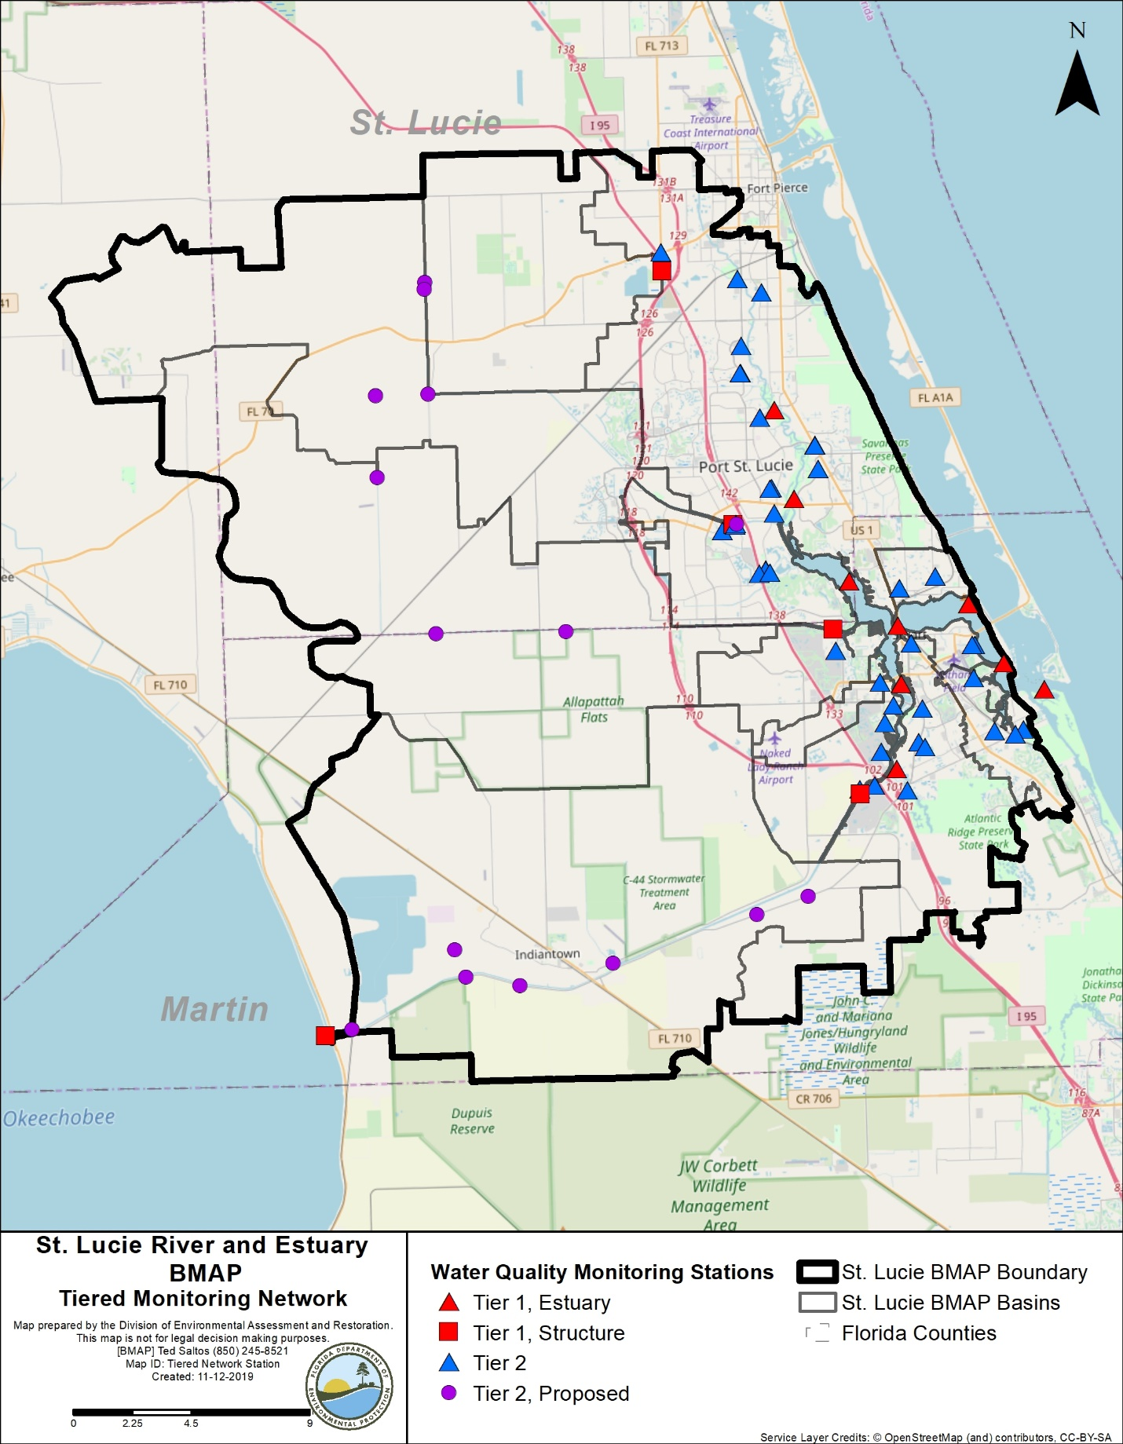
Figure 8. St. Lucie River and Estuary BMAP monitoring stations

Chapter 3. Basins
Section 3.1 through Section 3.11 provide specific information on the 11 basins in the SLREW. The land use summaries are based on 2012 land use, and Appendix B provides additional details on agricultural land uses. Monitoring network stations in the basin are provided, along with designations for the basin where the station is located, monitoring entity, BMAP monitoring network tier, whether the station is a representative site for the TRA approach discussed in Section 2.4, and whether additional data are needed for the TRA approach in that basin or at that station. The TN, TP, and flow priority results of the TRA evaluation are provided for basins.
Finally, all projects identified as part of this BMAP are listed by basin. For projects that treat lands in multiple basins (indicated in the "Basin" column), the nutrient reductions provided in the table are the total estimated for the project and not applicable to a specific basin. The table of existing and planned projects lists those projects submitted by stakeholders to help meet their obligations under the BMAP. Stakeholders have identified future projects to help achieve the remaining reductions needed; however, many of these projects are conceptual or in early design stages, or have not been fully funded. Information in the tables was provided by the lead entity and is subject to change as the project develops and more information becomes available. Appendix D lists projects and technologies submitted as part of the RFI.

3.1. North Fork Basin
The North Fork Basin covers 89,902 acres of the St. Lucie River and Estuary Watershed. As shown in Table 21, the most common land uses in this basin are urban and built-up as well as upland forests. Stakeholders in the basin include FDOT, City of Fort Pierce, Martin County, North St. Lucie River WCD, City of Stuart, and St. Lucie County.
Table 21. Summary of land uses in the North Fork Basin
Level 1 Land Use Code | Land Use Description | Acres | % Total
1000 | Urban and Built-Up | 52,893 | 58.8
2000 | Agriculture | 6,502 | 7.2
3000 | Upland Nonforested | 3,485 | 3.9
4000 | Upland Forests | 10,743 | 11.9
5000 | Water | 4,164 | 4.6
6000 | Wetlands | 7,921 | 8.8
7000 | Barren Land | 257 | 0.3
8000 | Transportation, Communication, and Utilities | 3,937 | 4.4
 | Total | 89,902 | 100

3.1.1. Water Quality Monitoring
Table 22 summarizes the water quality monitoring stations in the North Fork Basin, and Figure 9 shows the station locations. The SLT-27, SLT-28, SLT-41, SLT-43, and SLT-New stations are new or proposed and are intended to provide better resolution of water quality trends in the North Fork Basin.
Table 22. Water quality monitoring stations in the North Fork Basin
* Stations denoted by an asterisk are proposed/new stations.
Basin | Representative Site? | Entity | Station ID | Tier
North Fork | Yes | SFWMD | SLT-10A | 2
North Fork | Yes | SFWMD | SLT-10B | 2
North Fork | Yes | SFWMD | SLT-11 | 2
North Fork | Yes | SFWMD | SLT-17 | 2
North Fork | Yes | SFWMD | SLT-19 | 2
North Fork | Yes | SFWMD | SLT-21 | 2
North Fork | Yes | SFWMD | SLT-22A | 2
North Fork | Yes | SFWMD | SLT-26 | 2
North Fork | Yes | SFWMD | SLT-39 | 2
North Fork | Yes | SFWMD | SLT-42B | 2
North Fork | N/A | SFWMD | SLT-41* | 2
North Fork | No | SFWMD | SE-06 | 1
North Fork | No | SFWMD | SE-12 | 1
North Fork | No | SFWMD | HR1 | 1
North Fork | No | Port St. Lucie | C-107 | 2
North Fork | No | Port St. Lucie | Elcam Spillway | 2
North Fork | No | Port St. Lucie | Kingsway WW | 2
North Fork | No | Port St. Lucie | E8 | 2
North Fork | No | Port St. Lucie | Monterey WW | 2
North Fork | No | Port St. Lucie | U16-D016 | 2
North Fork | No | Port St. Lucie | H-16 | 2
North Fork | No | Port St. Lucie | A18 | 2
North Fork | No | Port St. Lucie | A-22 | 2

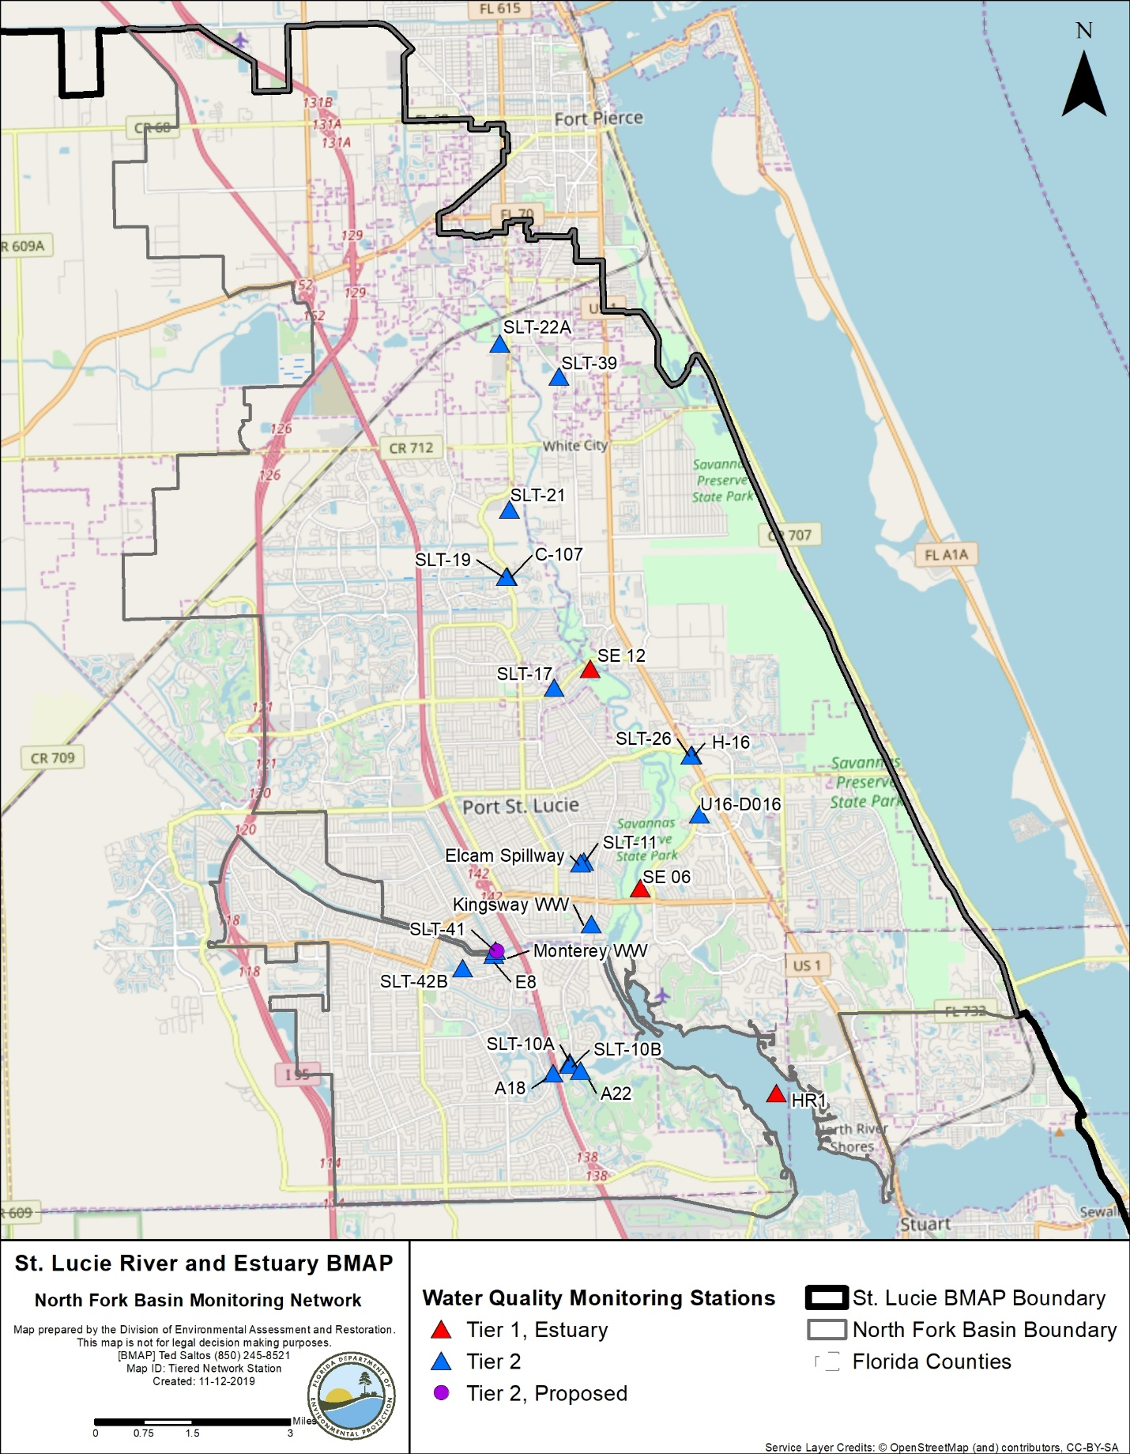
Figure 9. North Fork Basin monitoring stations

3.1.2. Basin Evaluation Results
Table 23 summarizes the basin evaluation results based on data from WY2014–WY2018 for the North Fork Basin. The current TN concentration is 0.86 mg/L, which is above the benchmark of 0.72 mg/L required to meet the TMDL. The current TP concentration is 0.101 mg/L, which is below the benchmark of 0.081 mg/L required to meet the TMDL. Significant decreasing trends were observed for both TN and TP.
The TRA prioritization results for the North Fork Basin are shown in Table 24, with 1 the highest priority, 2 the next highest priority, and 3 a priority as resources allow.
Table 23. Basin evaluation results for the North Fork Basin
TRA ID | Basin Name | TN  (mg/L)  (Benchmark – 0.72) | TN FWM Concentration (mg/L) | TN UAL, pounds per acre (lbs/ac)] | TN Trend Analysis | TP  (mg/L)  (Benchmark – 0.081) | TP FWM Concentration (mg/L) | TP UAL (lbs/ac) | TP Trend Analysis
1 | North Fork | 0.86 | N/A | N/A | Significant decreasing trend | 0.101 | N/A | N/A | Significant decreasing trend

Table 24. TRA evaluation results for the North Fork Basin
Basin | Stations | TN Priority | TP Priority
North Fork | SLT-10A, SLT-10B, SLT-11, SLT-17, SLT-19, SLT-21, SLT-22A, SLT-26, SLT-39, SLT-42B | 3 | 3

3.1.3. Projects
The tables below summarize the existing and planned and future projects for the North Fork Basin that were provided for the BMAP. The existing and planned projects are a BMAP requirement, while future projects will be implemented as funding becomes available for project implementation. Appendix A provides additional details about the projects and the terms used in these tables.

3.1.3.1 Existing and Planned Projects
Table 25 summarizes the existing and planned projects provided by the stakeholders for the North Fork Basin.
Table 25. Existing and planned projects in the North Fork Basin
Notes: For projects with multiple basins listed in the "Basin" column, the nutrient reductions provided in the table are the total estimated for the project and not applicable to a specific basin.
Projects FDOT-32, FDOT-33, FDOT-34, FDOT-35, FDOT-36, FDOT-37, FDOT-38, FDOT-39, FDOT-40, FP-01, FP-02, FP-06, FP-07, FP-08, FP-09, FP-10, FP-12, and FP-13 no longer fall within the BMAP area because of drainage evaluations and/or boundary changes.
Lead Entity | Partners | Project Number | Project Name | Project Description | Project Type | Project Status | Estimated Completion Date | TN Reduction (lbs/yr) | TP Reduction (lbs/yr) | Basin | Acres Treated | Cost Estimate | Cost Annual O&M | Funding Source | Funding Amount | DEP Contract Agreement Number
FDACS | Agricultural Producers | FDACS-01 | BMP Implementation and Verification | Enrollment and verification of BMPs by agricultural producers. Reductions based on WaSh model. Acres treated based on FDACS OAWP June 2019 Enrollment and FSAID VI. | Agricultural BMPs | Completed | N/A | 3,513 | 800 | North Fork | 1,928 | TBD | TBD | FDACS | TBD | N/A
FDACS | Agricultural Producers | FDACS-09 | Cost-share Projects | Cost-share projects paid for by FDACS. Acres treated based on FDACS OAWP June 2019 Enrollment. Reductions based on WaSh model. | Agricultural BMPs | Completed | N/A | 52 | 19 | North Fork | 45 | TBD | TBD | FDACS | TBD | N/A
FDACS | N/A | FDACS-15 | Credit for Changes in Land Use | Acreages and reductions based on a portion of differences between modeled agricultural land use coverage identified in Table B-13. DEP will estimate final numbers by next BMAP update. | Land Use Change | Completed | N/A | 439 | 88 | North Fork | 58 | N/A | N/A | N/A | N/A | N/A
FDOT District 4 | N/A | FDOT-01 | FM# 230108-1 (Ponds 2 & 3) | Widening and new late construction on State Road (SR) 68 from SR 9 to east of County Road (CR)-607A (40 % credit, remaining 60 % to Central Indian River Lagoon (CIRL). | Wet Detention Pond | Completed | 2013 | MC | 0 | North Fork | 18 | Not provided | Not provided | Florida Legislature | Not provided | N/A
FDOT District 4 | N/A | FDOT-02 | FM# 230108-1 | Combined with FDOT-01. | Wet Detention Pond | Completed | 2013 | N/A | N/A | North Fork | 18 | Not provided | Not provided | Florida Legislature | Not provided | N/A
FDOT District 4 | N/A | FDOT-07 | FM# 230295-1 | Road widening of SR 716 from Westmoreland Bridge to SR 5. | Dry Detention Pond | Completed | 2003 | 17 | 3 | North Fork | 17 | Not provided | Not provided | Florida Legislature | Not provided | N/A
FDOT District 4 | N/A | FDOT-08 | SPN 99004-1585 | Road widening of SR 5 from Jensen Beach Blvd. to Port St. Lucie Blvd. | Dry Detention Pond | Completed | 2003 | 30 | 5 | North Fork | 31 | Not provided | Not provided | Florida Legislature | Not provided | N/A
FDOT District 4 | N/A | FDOT-09 | SPN 99004-1585 (Lake 3) | Road widening of SR A1A from Sewall's Point Rd. to west of MacArthur Blvd. | Wet Detention Pond | Completed | 2003 | 34 | 10 | North Fork | 13 | Not provided | Not provided | Florida Legislature | Not provided | N/A
FDOT District 4 | N/A | FDOT-16 | FM# 230288-2 | Road widening of SR 5 from Rio Mar Dr. to Midway Rd. | Wet Detention Pond | Completed | 2009 | 123 | 38 | North Fork | 44 | Not provided | Not provided | Florida Legislature | Not provided | N/A
FDOT District 4 | City of Port St. Lucie | FDOT-17 | FM# 419890-1 | Construction of interchange at SR 9 and Becker Rd. | BMP Treatment Train | Completed | 2010 | 3 | 2 | North Fork, C-23 | 42 | Not provided | Not provided | Florida Legislature | Not provided | N/A
FDOT District 4 | N/A | FDOT-18 | Street Sweeping | Not provided. | Street Sweeping | Completed | N/A | 1,419 | 910 | North Fork, Ten Mile Creek,  C-24, C-23,  C-44/S-153, Basin 4/5, Basin 6, South Fork, South Coastal, South Mid-Estuary, North Mid-Estuary | N/A | Not provided | Not provided | Florida Legislature | Not provided | N/A
FDOT District 4 | N/A | FDOT-19 | Public Education | Pamphlets. | Education Efforts | Completed | N/A | 109 | 20 | North Fork, Ten Mile Creek,  C-24, C-23,  C-44/S-153, Basin 4/5, Basin 6, South Fork, South Coastal, South Mid-Estuary, North Mid-Estuary | N/A | Not provided | Not provided | Florida Legislature | Not provided | N/A
FDOT District 4 | N/A | FDOT-22 | State Road 615 Midway Rd. to Edwards Rd. (Basin B-1) | Not provided. | Wet Detention Pond | Completed | 2009 | 15 | 4 | North Fork | 8 | Not provided | Not provided | Florida Legislature | Not provided | N/A
FDOT District 4 | N/A | FDOT-23 | State Road 615 Midway Rd. to Edwards Rd. (Basin E) | Not provided. | Wet Detention Pond | Completed | 2009 | 20 | 6 | North Fork | 9 | Not provided | Not provided | Florida Legislature | Not provided | N/A
FDOT District 4 | N/A | FDOT-24 | FM# 410717-1 SR 70 Widening Kings Highway (Hwy.) to Jenkins Rd. (West Basin) | Road widening on SR 70 from Kings Hwy. to Jenkins Rd. | Dry Detention Pond | Completed | 2012 | 6 | 1 | North Fork | 6 | Not provided | Not provided | Florida Legislature | Not provided | N/A
FDOT District 4 | N/A | FDOT-25 | SR 713 (King's Hwy.) Turn Lanes | Not provided. | Grass Swales without Swale Blocks or Raised Culverts | Completed | 2013 | 0 | 0 | North Fork | 1 | Not provided | Not provided | Florida Legislature | Not provided | N/A
FDOT District 4 | N/A | FDOT-43 | FM# 413046-1 SR 9 Widening | Road widening on SR 9 from Okeechobee Rd. to south of Indrio Rd. | Online Retention BMPs | Completed | 2015 | 145 | 24 | North Fork | 152 | Not provided | Not provided | Florida Legislature | Not provided | N/A
FDOT District 4 | N/A | FDOT-44 | FM# 423022-1 CR 68 Orange Ave. | County to provide GIS data for county road; proposed split of 25 % to FDOT and 75 % to St. Lucie County. | Dry Detention Pond | Completed | 2015 | TBD | TBD | North Fork | 6 | Not provided | Not provided | Florida Legislature | Not provided | N/A
FDOT District 4 | N/A | FDOT-45 | FM# 230108-1 SR 68 Orange Ave. (40 % credit) | Combined with FDOT-1. | Wet Detention Pond | Completed | 2005 | N/A | N/A | North Fork | 18 | Not provided | Not provided | Florida Legislature | Not provided | N/A
FDOT District 4 | St. Lucie County | FDOT-46 | 231440-2 Midway Rd. Widening, 25th St. to US 1 (Pond 1 and 2) | Road widening on Midway Rd. from SR 68 to SR 5. | Wet Detention Pond | Underway | 2020 | 1.3 | 1.3 | North Fork | 17 | Not provided | Not provided | Florida Legislature | Not provided | N/A
FDOT District 4 | St. Lucie County | FDOT-47 | 231440-2 Midway Rd. Widening, 25th St. to US 1 (Pond 3 and 4) | Road widening on Midway Rd. from SR 68 to SR 5. | Wet Detention Pond | Underway | 2020 | 1.1 | 5.1 | North Fork | 14 | Not provided | Not provided | Florida Legislature | Not provided | N/A
FDOT District 4 | St. Lucie County | FDOT-48 | 231440-2 Midway Rd. Widening, 25th St. to US 1 (Pond 5) | Road widening on Midway Rd. from SR 68 to SR 5. | Wet Detention Pond | Underway | 2020 | 0.8 | 2.5 | North Fork | 11 | Not provided | Not provided | Florida Legislature | Not provided | N/A
FDOT District 4 | N/A | FDOT-57 | Fertilizer Application Cessation | No longer routinely applying fertilizer. | Fertilizer Cessation | Completed | 2016 | 23,881 | 5,970 | North Fork, Ten Mile Creek,  C-24, C-23,  C-44/S-153, Basin 4/5, Basin 6, South Fork, South Coastal, South Mid-Estuary, North Mid-Estuary | N/A | Not provided | Not provided | Florida Legislature | Not provided | N/A
FDOT District 4 | N/A | FDOT-61 | FM# 230256-6 | Road widening of King's Hwy.; Phase I South | Wet Detention Pond | Underway | 2021 | 0 | 0 | North Fork | 39 | Not provided | Not provided | Florida Legislature | Not provided | N/A
FDOT District 4 | N/A | FDOT-62 | FM# 230256-7 | Road widening of King's Hwy.; Phase II | Wet Detention Pond | Underway | 2022 | 0 | 0 | North Fork | 25 | Not provided | Not provided | Florida Legislature | Not provided | N/A
City of Fort Pierce | N/A | FP-03 | Street Sweeping | City removes cubic yards of debris by street sweeping activities. | Street Sweeping | Completed | N/A | 2,020 | 1,295 | North Fork | N/A | Not provided | $89,617 | City's stormwater utility | Not provided | N/A
City of Fort Pierce | N/A | FP-04 | Inlet Cleaning | City cleans storm inlets citywide and disposes of waste. | Catch Basin Inserts/Inlet Filter Cleanout | Completed | N/A | 65 | 40 | North Fork | N/A | Not provided | Not provided | Not provided | Not provided | N/A
City of Fort Pierce | N/A | FP-05 | Education Program | City delivers educational programs to public through trade associations, homeowner associations (HOAs), or other means. Educates on hazards associated with illicit discharge, fertilizer use, the importance of water quality, and stormwater pollution protection. | Education Efforts | Completed | N/A | 1,804 | 304 | North Fork | N/A | Not provided | Not provided | Not provided | Not provided | N/A
City of Fort Pierce | DEP | FP-11 | Indian Hills Recreation Area (Phase II) Stormwater Improvements | Reestablishment of wetlands and pervious paver parking areas. | Wetland Restoration | Completed | 2016 | TBD | TBD | North Fork | 61 | $2,337,485 | Not provided | DEP | $1,410,000 | S0579
Martin County | SFWMD/ DEP | MC-13 | North River Shores Baffle Boxes | Installation of +20 baffle boxes | Baffle Boxes – First Generation (hydrodynamic separator) | Completed | 2002 | 11 | 9 | North Fork | 187 | $1,310,000 | Not provided | DEP | $500,000 | SP557
Martin County | SFWMD/ DEP | MC – 14 | Palm Lake Park Water Quality Retrofit | 7.7 ac-ft of water quality treatment (1.16 inches). | BMP Treatment Train | Completed | 2003 | 387 | 117 | North Fork | 80 | $1,741,098 | Not provided | DEP | $1,480,936 | WAP026
Martin County | N/A | MC-16 | Septic to Central Sewer Conversions | 1,121 single-family and multifamily residential and commercial units in 5 neighborhoods. | OSTDS Phase Out | Completed | 2014 | 15,386 | N/A | North Fork, Basin 4/5, North Mid-Estuary | N/A | $28,678,946 | Not provided | NEEPP – North River Shores neighborhood | Not provided | N/A
Martin County | N/A | MC-18 | Street Sweeping | Not provided. | Street Sweeping | Completed | N/A | 108 | 69 | North Fork,  C-23, C-44/S-153, Basin 4/5, Basin 6, South Fork, South Coastal, South Mid-Estuary, North Mid-Estuary | N/A | Not provided | Not provided | Not provided | Not provided | N/A
Martin County | N/A | MC-20 | Education Program | Florida Yards and Neighborhoods (FYN); landscaping, irrigation, fertilizer, and pet waste ordinances; public service announcements (PSAs), pamphlets, website, illicit discharge program. | Education Efforts | Completed | N/A | 16,644 | 2,831 | North Fork,  C-23, C-44/  S-153, Basin 4/5, Basin 6, South Fork, South Coastal, South Mid-Estuary, North Mid-Estuary | N/A | Not provided | Not provided | County | $60,000 | N/A
Martin County | N/A | MC-33 | Hoke Library Rain Garden | Not provided. | Low Impact Development (LID) – Rain Gardens | Completed | 2015 | Not provided | Not provided | North Fork | Not provided | $4,372 | Not provided | Not provided | Not provided | N/A
Martin County | N/A | MC-42 | South Savannas Weir | Not provided. | Control Structure | Planned | 2020 | TBD | TBD | North Fork | TBD | TBD | TBD | TBD | TBD | N/A
North St. Lucie River WCD | St. Lucie River Issues Team (SLRIT) | NSLRWCD-01 | SLRIT Grant 2000–2001: Vegetation Control & Bank Restoration | Installation of C-25 diversion structure, which regulates flow from NSLRWCD C-44/ North Emergency Relief Canal to SFWMD C-25. In addition, installation of 3 risers with adjustable gates. | Control Structure | Completed | 2003 | 1,548 | 0 | North Fork, Ten Mile Creek | 4,173 | $929,000 | Not provided | NSLRWCD/ SLRIT 50/50 contribution match | Not provided | N/A
North St. Lucie River WCD | St. Lucie County/ FDOT | NSLRWCD-03 | Canals 23 and 28 Retrofit for Stormwater Treatment and Attenuation | Construction of ponds and installation of water control structure (WCS) for area retrofit. Inclusion of water management district canals into pond footprints. | Control Structure | Completed | 2009 | 22 | 0 | North Fork | 44 | Not provided | Not provided | FDOT/ St. Lucie County/ NSLRWCD | Not provided | N/A
North St. Lucie River WCD | N/A | NSLRWCD-04 | Canal Maintenance Program | Maintenance program on over 200 miles of canal, now included in NSLRWCD water quality activities. | Aquatic Vegetation Harvesting | Canceled | 2013 | N/A | N/A | North Fork, Ten Mile Creek | 66,225 | $4,200,000 | Not provided | NSLRWCD | Not provided | N/A
North St. Lucie River WCD | N/A | NSLRWCD-05 | Changes in Agricultural Land Uses | All land uses updated with new model. | Land Use Change | Canceled | 2013 | N/A | N/A | North Fork, Ten Mile Creek | 1,055 | N/A | N/A | N/A | N/A | N/A
North St. Lucie River WCD | N/A | NSLRWCD-06 | 90% Implementation Agricultural BMPs | All agricultural BMP enrollment now included in FDACS-01. | Agricultural BMPs | Canceled | N/A | N/A | N/A | North Fork, Ten Mile Creek | N/A | N/A | N/A | N/A | N/A | N/A
North St. Lucie River WCD | N/A | NSLRWCD-07 | Change from Agricultural to Urban | All land uses updated with new model. | Land Use Change | Canceled | N/A | N/A | N/A | North Fork, Ten Mile Creek | N/A | N/A | N/A | N/A | N/A | N/A
City of Port St. Lucie | DEP/ SFWMD/ St. Lucie County (SLC)/ American Greenways/ Tax-Increment Financing (TIF) | PSL-01 | Woodstork Trail Design Districts 7, 8, and 9 | 4.6 acres of new filter marsh, 7.21 acres of new uplands, and installation of baffle box. | BMP Treatment Train | Completed | 2007 | 12 | 10 | North Fork | 229 | $3,300,000 | $1,122,000 | DEP/ SFWMD/ SLC/ American Greenways/ TIF | Not provided | G0140
City of Port St. Lucie | DEP/ City Center Special Assess-ments | PSL-02 | Wood Stork Trail Design District 6 | 7.74-acre wet detention area, 62-acre STA, and 3 baffle boxes. | BMP Treatment Train | Completed | 2008 | 4 | 3 | North Fork | 81 | $825,500 | N/A | DEP/ City Center Special Assessments | Not provided | G0178
City of Port St. Lucie | DEP/ SFWMD | PSL-03 | Howard Creek STA | Construction of weir,  45-acre STA, littoral shelves, and new plantings. | BMP Treatment Train | Completed | 2010 | 1,266 | 439 | North Fork | 436 | N/A | N/A | DEP/ SFWMD | Not provided | S0507
City of Port St. Lucie | N/A | PSL-04 | Eastern Watershed Improvement Project | Flood control, water quality, environmental restoration project consisting of 27 acres of wet detention ponds, littoral shelves, and created wetlands. | BMP Treatment Train | Completed | 2011 | 1,378 | 795 | North Fork | 850 | $36,000,000 | N/A | City | Not provided | N/A
City of Port St. Lucie | Natural Resources Conserva-tion Service (NRCS)/ SFWMD | PSL-05 | B-1 and B-2 WCS | WCS B-1 and B-2 protected North Fork of St. Lucie River (NFSLR) from receiving uncontrolled E-8 Canal discharges. System will stage appropriate discharge levels based on volume, retaining maximum flows. | Control Structure | Completed | 2007 | 6,737 | 2,088 | North Fork, C-24, C-23 | 1,748 | $1,800,000 | $621,000 | City/ NRCS/ SFWMD | Not provided | N/A
City of Port St. Lucie | NRCS/ SFWMD | PSL-06 | B-3 WCS | B-3 protected NFSLR from receiving uncontrolled E-8 Canal discharges. System will stage appropriate discharge levels based on volume, retaining maximum flows. | Control Structure | Completed | 2007 | 7,027 | 2,177 | North Fork | 1,641 | N/A | N/A | City/ NRCS/ SFWMD | Not provided | N/A
City of Port St. Lucie | DEP | PSL-07 | E-8 Waterway Phase 1 Water Quality Retrofit | Control structure improvements, weirs, sediment removal, and construction of 2 STAs totaling 24.36 acres. Improvements will enhance stormwater drainage and flood protection capacity, improve water quality, and restore native vegetation and habitat. | BMP Treatment Train | Completed | 2010 | 1,532 | 1,513 | North Fork | 1,610 | $400,000 | N/A | DEP | Not provided | S0239
City of Port St. Lucie | SFWMD | PSL-08 | E-17 Canal WCS | New WCS added to retain maximum flows in emergencies only. | Control Structure | Completed | 2008 | N/A | N/A | North Fork | 984 | $437,000 | N/A | City | Not provided | N/A
City of Port St. Lucie | N/A | PSL-09 | Water and Wastewater Expansion | Multiple phase outs of septic tanks from 2013 to 2019. | OSTDS Phase Out | Completed | 2019 | 44,921 | N/A | North Fork, C-24, C-23 | N/A | $91,075,666 | $3,700,000 | City | N/A | N/A
City of Port St. Lucie | N/A | PSL-10 | Street Sweeping | Materials are collected from roadways and the gutters using street sweeper truck. | Street Sweeping | Completed | N/A | 676 | 434 | North Fork | N/A | Not provided | $448,000 | City | Not provided | N/A
City of Port St. Lucie | N/A | PSL-11 | Swale Maintenance | Removal and proper disposal of sediment captured in swale liner. | BMP Cleanout | Completed | N/A | 7,649 | 3,097 | North Fork | N/A | Not provided | $780,000 | City | Not provided | N/A
City of Port St. Lucie | N/A | PSL-12 | Catch Basin Cleaning | Removal and proper disposal of sediment captured by catch basins. | Catch Basin Inserts/Inlet Filter Cleanout | Completed | N/A | 21 | 13 | North Fork | N/A | Not provided | N/A | City | Not provided | N/A
City of Port St. Lucie | N/A | PSL-13 | Education Program | FYN Program; fertilizer, landscape, irrigation, and pet waste ordinances; PSAs; stormwater educational shows; website; outreach programs; Stencil Program; and stormwater pollution hotline. | Education Efforts | Completed | N/A | 21,978 | 3,722 | North Fork, C-24, C-23 | N/A | Not provided | Not provided | City | Not provided | N/A
City of Port St. Lucie | N/A | PSL-14 | Tiffany Channel | Landscape irrigation is drawn from stormwater in channel. | Stormwater Reuse | Completed | Prior to 2013 | 56 | 10 | North Fork | N/A | N/A | $1,900,000 | City | Not provided | N/A
City of Port St. Lucie | N/A | PSL-15 | Patio STA | Landscape irrigation is drawn from stormwater in channel. | Stormwater Reuse | Completed | Prior to 2013 | 19 | 3 | North Fork | N/A | N/A | N/A | City | Not provided | N/A
City of Port St. Lucie | N/A | PSL-16 | Mary STA | Landscape irrigation is drawn from stormwater in channel. | Stormwater Reuse | Completed | Prior to 2013 | 13 | 2 | North Fork | N/A | N/A | N/A | City | Not provided | N/A
City of Port St. Lucie | N/A | PSL-17 | Leithgow STA | Landscape irrigation is drawn from stormwater in channel. | Stormwater Reuse | Completed | Prior to 2013 | 13 | 2 | North Fork | N/A | N/A | N/A | City | Not provided | N/A
City of Port St. Lucie | N/A | PSL-18 | Cane Slough 1/ Elks STA | Landscape irrigation is drawn from stormwater in channel. | Stormwater Reuse | Completed | Prior to 2013 | 61 | 11 | North Fork | N/A | N/A | N/A | City | Not provided | N/A
City of Port St. Lucie | N/A | PSL-19 | Cane Slough 2/ Azzi STA | Landscape irrigation is drawn from stormwater in channel. | Stormwater Reuse | Completed | Prior to 2013 | 45 | 8 | North Fork | N/A | N/A | N/A | City | Not provided | N/A
City of Port St. Lucie | N/A | PSL-20 | Loutus STA | Landscape irrigation is drawn from stormwater in channel. | Stormwater Reuse | Completed | Prior to 2013 | 41 | 7 | North Fork | N/A | N/A | N/A | City | Not provided | N/A
City of Port St. Lucie | N/A | PSL-21 | Howard Creek STA | Landscape irrigation is drawn from stormwater in channel. | Stormwater Reuse | Completed | Prior to 2013 | 65 | 11 | North Fork | N/A | N/A | N/A | City | Not provided | N/A
City of Port St. Lucie | N/A | PSL-22 | Bur St. STA | Landscape irrigation is drawn from stormwater in channel. | Stormwater Reuse | Completed | Prior to 2013 | 0 | 0 | North Fork | N/A | N/A | N/A | City | Not provided | N/A
St. Lucie West Services District | N/A | PSL-23 | St. Lucie West Services District (SLWSD) Aquatic Harvesting | Project moved to new entity (SLWSD) | Aquatic Vegetation Harvesting | Canceled | N/A | N/A | N/A | North Fork | N/A | N/A | N/A | N/A | N/A | N/A
St. Lucie West Services District | SLWSD | PSL-24 | SLWSD Catch Basin Cleaning | Project moved to new entity (SLWSD) | Catch Basin Inserts/Inlet Filter Cleanout | Canceled | N/A | N/A | N/A | North Fork | N/A | N/A | N/A | N/A | N/A | N/A
City of Port St. Lucie | N/A | PSL-25 | Atlantis Basin | Installation of 2nd-generation baffle box. | Baffle Boxes – Second Generation | Completed | 2015 | 259 | 36 | North Fork | 116 | $628,000 | N/A | City | Not provided | N/A
City of Port St. Lucie | N/A | PSL-26 | Evergreen Basin | Installation of 2nd-generation baffle box. | Baffle Boxes – Second Generation | Completed | 2015 | 539 | 74 | North Fork | 241 | N/A | N/A | City | Not provided | N/A
City of Port St. Lucie | N/A | PSL-27 | Lansdown Basin | Installation of 2nd-generation baffle box. | Baffle Boxes – Second Generation | Completed | 2015 | 254 | 35 | North Fork | 189 | N/A | N/A | City | Not provided | N/A
City of Port St. Lucie | N/A | PSL-28 | Streamlet/ Manth Basin | Installation of 2nd-generation baffle box. | Baffle Boxes – Second Generation | Completed | 2015 | 94 | 13 | North Fork | 89 | N/A | N/A | City | Not provided | N/A
City of Port St. Lucie | N/A | PSL-29 | Walters Basin | Installation of 2nd-generation baffle box. | Baffle Boxes – Second Generation | Completed | 2015 | 404 | 56 | North Fork | 32 | N/A | N/A | City | Not provided | N/A
St. Lucie West Services District | DEP/ SLWSD | PSL-30 | SLWSD Water Management Improvement Project | Project moved to new entity (SLWSD). | Wet Detention Pond | Canceled | 2016 | N/A | N/A | North Fork | N/A | N/A | N/A | N/A | N/A | N/A
City of Port St. Lucie | N/A | PSL-32 | Veterans Memorial Water Quality Retrofit. Project 1 and 2 out of 6. | Installing control structures, digging ponds, and increasing storage. | BMP Treatment Train | Underway | 2025 | 5,087 | 1,556 | North Fork | 1,065 | $3,834,193 | N/A | City/ SFWMD | SFWMD – $125,000 | N/A
St. Lucie West Services District | SLWSD | PSL-33 | Lake Harvey | Project moved to new entity (SLWSD). | Hydrologic Restoration | Canceled | 2017 | N/A | N/A | North Fork | N/A | N/A | N/A | N/A | N/A | N/A
City of Stuart | N/A | S-05 | Street Sweeping | Pavement cleaning by sweeping, vacuum, or washing. | Street Sweeping | Completed | N/A | 275 | 176 | North Fork, South Fork, South Coastal, South Mid-Estuary, North Mid-Estuary | N/A | $33,000 | Not provided | City | Not provided | N/A
City of Stuart | N/A | S-06 | Sediment Removal from Storm Systems | Removal and proper disposal of sediment captured by catch basin inserts. | Catch Basin Inserts/Inlet Filter Cleanout | Completed | N/A | 54 | 33 | North Fork, South Fork, South Coastal, South Mid-Estuary, North Mid-Estuary | N/A | N/A | $75,000 | City | Not provided | N/A
City of Stuart | N/A | S-07 | Education Program | FYN Program. City ordinances for landscaping, irrigation, fertilizer, and pet waste management. City stormwater website. Stormwater calendars. Pollution prevention information posted on electronic billboards 365 days/yrr from 12 PM to 1 PM. | Education Efforts | Completed | N/A | 2,202 | 371 | North Fork, South Fork, South Coastal, South Mid-Estuary, North Mid-Estuary | N/A | $30,150 | Not provided | City | Not provided | N/A
City of Stuart | SFWMD/ Healthy Rivers | S-08 | North Point CRA Drainage Basin | There is 1 existing 1st-generation baffle box and street sweeping in basin, existing FDOT swale along basin's east boundary, and 2 FDOT retention/detention ponds near Roosevelt Bridge. | Baffle Boxes – First Generation (hydrodynamic separator) | Completed | 2002 | 4 | 3 | North Fork, North Mid-Estuary | 1,084 | $1,339,000 | Not provided | City/ SFWMD/ Healthy Rivers | Not provided | N/A
City of Stuart | DEP | S-19 | Baffle Boxes (22) throughout City | Concrete structures containing series of sediment settling chambers separated by baffles. Boxes are vacuum cleaned base on sediment depth inspection by city stormwater staff. | Baffle Boxes – First Generation (hydrodynamic separator) | Completed | 2014 | 27 | 21 | North Fork, South Fork, South Mid-Estuary, North Mid-Estuary | 475 | N/A | Not provided | City/ DEP | Not provided | G0083
St. Lucie County | N/A | SLC-001a | Platt's Creek Stormwater Treatment Facility | Wet detention with alum injection. | Wet Detention Pond | Completed | 2008 | 1,655 | 537 | North Fork | 311 | $3,539,475 | Not provided | County | Not provided | N/A
St. Lucie County | N/A | SLC-001b | Platt's Creek Stormwater Treatment Facility | Not provided. | Wet Detention Pond | Completed | 2008 | 2,808 | 875 | North Fork | 564 | N/A | Not provided | Not provided | Not provided | N/A
St. Lucie County | N/A | SLC-002 | Indian River Estates Stormwater Improvements (Phases I and II) | Wet detention with alum injection. | Wet Detention Pond | Completed | 2009 | 5,585 | 1,689 | North Fork | 1,004 | $4,471,114 | Not provided | County | Not provided | N/A
St. Lucie County | N/A | SLC-003 | Prima Vista | Not provided. | Baffle Boxes – Second Generation | Completed | 2006 | 218 | 30 | North Fork | 97 | $323,483 | Not provided | Not provided | Not provided | N/A
St. Lucie County | N/A | SLC-004 | Bay Street | Not provided. | Baffle Boxes – Second Generation | Completed | 2006 | 100 | 14 | North Fork | 44 | N/A | Not provided | Not provided | Not provided | N/A
St. Lucie County | N/A | SLC-005 | Education Program | FYN; pet waste, landscape, irrigation, and fertilizer ordinances; PSAs; website; Illicit Discharge Program, Eco-Center, Clean Stormwater–Clean River Program. St. Lucie Water Champions. | Education Efforts | Completed | N/A | 2,597 | 454 | North Fork,  C-24, C-23 | N/A | Not provided | Not provided | Not provided | Not provided | N/A
St. Lucie County | N/A | SLC-006 | Street Sweeping | Materials are collected from roadways and gutters using street sweeper truck. | Street Sweeping | Completed | N/A | 211 | 135 | North Fork, Ten Mile Creek,  C-24, C-23 | N/A | Not provided | Not provided | Not provided | Not provided | N/A
St. Lucie County | N/A | SLC-007 | Catch Basin Cleanout | Catch basins are cleaned out on rotational basis using vactruck. | Catch Basin Inserts/Inlet Filter Cleanout | Completed | N/A | 170 | 105 | North Fork, Ten Mile Creek, C-23 | N/A | Not provided | Not provided | Not provided | Not provided | N/A
St. Lucie County | N/A | SLC-008 | Platt's Creek Sump Cleanout | Not provided. | BMP Cleanout | Completed | N/A | 1,182 | 512 | North Fork | N/A | Not provided | Not provided | Not provided | Not provided | N/A
St. Lucie County | DEP | SLC-009 | White City – Citrus/Seager Stormwater Improvement | Wet detention with polyacrylamide logs. | Wet Detention Pond | Completed | 2016 | 180 | 56 | North Fork | 39 | $1,862,859 | Not provided | DEP/ County | Not provided | G0382
St. Lucie County | N/A | SLC-010 | Education Program | FYN; pet waste, landscape, irrigation, and fertilizer ordinances; PSAs; website; Illicit Discharge Program, Eco-Center, Clean Stormwater–Clean River Program, St. Lucie Water Champions. | Education Efforts | Completed | N/A | 8,821 | 1,594 | North Fork, Ten Mile Creek,  C-24, C-23 | N/A | Not provided | Not provided | Not provided | Not provided | N/A
St. Lucie County | N/A | SLC-011 | Street Sweeping | Materials are collected from roadways and the gutters using street sweeper truck. | Street Sweeping | Completed | N/A | 113 | 73 | North Fork, Ten Mile Creek,  C-24, C-23 | N/A | Not provided | Not provided | Not provided | Not provided | N/A
St. Lucie County | N/A | SLC-012 | Catch Basin Cleanout | Catch basins are cleaned out on rotational basis using vactruck. | BMP Cleanout | Completed | N/A | 92 | 56 | North Fork, Ten Mile Creek, C-24 | N/A | Not provided | Not provided | Not provided | Not provided | N/A
St. Lucie County | N/A | SLC-013 | Platt's Creek Sump Cleanout | Not provided. | BMP Cleanout | Completed | N/A | 1,566 | 601 | North Fork | N/A | Not provided | Not provided | Not provided | Not provided | N/A
St. Lucie County | City of Port St. Lucie | SLC-014 | Platt's Creek Compensatory Mitigation Project | Not provided. | Floodplain Restoration | Completed | 2015 | Not provided | Not provided | North Fork | 311 | $2,600,000 | Not provided | Not provided | Not provided | N/A
St. Lucie County | N/A | SLC-015 | IRL South C23/C24 CERP Buffer – Teague Preserve Re-watering Project | Not provided. | Hydrologic Restoration | Underway | Not provided | TBD | TBD | North Fork, C-24, C-23 | TBD | $400,000 | TBD | Not provided | Not provided | N/A
St. Lucie County | N/A | SLC-016 | Melville Rd. Master Drainage Plan | Not provided. | Stormwater System Rehabilitation | Underway | 2024 | TBD | TBD | North Fork | 175 | $5,000,000 | TBD | County | Not provided | N/A
St. Lucie County | N/A | SLC-017 | Swales Material Collection | Roadside swale cleanout and retrofitting in MS4 area and non-MS4 area. | BMP Cleanout | Completed | N/A | TBD | TBD | North Fork, Ten Mile Creek, C-23 | Not provided | Not provided | Not provided | Not provided | Not provided | N/A
St. Lucie County | N/A | SLC-018 | Swales Material Collection | Roadside swale cleanout and retrofitting. Project rolled into SLC-017. | BMP Cleanout | Canceled | N/A | TBD | TBD | North Fork, Ten Mile Creek, C-23 | Not provided | Not provided | Not provided | Not provided | Not provided | N/A
St. Lucie County | N/A | SLC-019 | Becker Preserve Ten-Mile Creek Oxbow Reconnection | Oxbow reconnection with muck dredging. | Floodplain Restoration | Underway | Not provided | TBD | TBD | North Fork | TBD | Not provided | Not provided | Not provided | Not provided | N/A
Turnpike Enterprise | N/A | T-01 | Project 420735-1 Port St. Lucie Interchange Pond A | Not provided. | Dry Detention Pond | Completed | 2013 | 4 | 1 | North Fork | 4 | Not provided | N/A | Not provided | Not provided | N/A
Turnpike Enterprise | N/A | T-02 | Project 420735-1 Port St. Lucie Interchange Pond B | Not provided. | Wet Detention Pond | Completed | 2013 | 33 | 4 | North Fork | 21 | Not provided | N/A | Not provided | Not provided | N/A
Turnpike Enterprise | N/A | T-04 | Education Program | No fertilizer on rights-of-way, educational signage, illicit discharge training. | Education Efforts | Completed | N/A | 268 | 45 | North Fork, Basin 4/5, South Fork | N/A | Not provided | N/A | Not provided | Not provided | N/A
Turnpike Enterprise | N/A | T-05 | Street Sweeping | 1,944 lane miles swept and 28,323 lbs (or 12,847 kg) of debris collected. | Street Sweeping | Completed | N/A | 144 | 10 | North Fork, Basin 4/5, South Fork | N/A | Not provided | N/A | Not provided | Not provided | N/A
St. Lucie West Services District | N/A | SLWSD-01 | SLWSD Aquatic Harvesting | Not provided. | Aquatic Vegetation Harvesting | Canceled | N/A | N/A | N/A | North Fork | N/A | N/A | N/A | N/A | N/A | N/A
St. Lucie West Services District | SLWSD | SLWSD-02 | SLWSD Catch Basin Cleaning | Not provided. | Catch Basin Inserts/Inlet Filter Cleanout | Completed | N/A | 84 | 52 | North Fork | N/A | $185,600 | $10,450 | SLWSD | Not provided | N/A
St. Lucie West Services District | DEP/ SLWSD | SLWSD-03 | SLWSD Water Management Improvement Project | Increase storage of existing wetland. | Wet Detention Pond | Completed | 2016 | 1,196 | 695 | North Fork | 140 | $360,704 | $8,200 | DEP/ SLWSD | DEP – $159,658/ SLWSD – $201,046 | S0812
St. Lucie West Services District | SLWSD | SLWSD-04 | Lake Harvey | Construction of 4.41-acre wetland area and 2.25-acre flow-way to enhance water quality, storage, and hydraulic connectivity in SLWSD Basin 4E. | Hydrologic Restoration | Completed | 2017 | 726 | 269 | North Fork | 333 | $534,000 | $15,500 | SLWSD | Not provided | N/A
Coordinating Agency | N/A | CA-01 | Ten Mile Creek Water Preserve Area | Control quantity and timing of water delivery to NFSLR by capturing and storing stormwater flows that originated in Ten Mile Creek Basin. | Hydrologic Restoration | Completed | 2017 | TBD | 8,789 | North Fork, Ten Mile Creek | 658

3.1.3.2. Future Projects
Table 26 lists the future projects provided by the stakeholders for the North Fork Basin.
Table 26. Future projects in the North Fork Basin
Lead Entity | Partners | Project Number | Project Name | Project Description | Project Type | Project Status | Acres Treated | TN Reduction (lbs/yr) | TP Reduction (lbs/yr) | Basin | Cost Estimate | Cost Annual O&M
St. Lucie County | N/A | F-01 | Sunland Gardens Neighborhood Improvement Project | Project will include construction of stormwater collection system to include roadside swales, dry detention areas, and paved roadways for older unimproved subdivision currently with outfalls directly to waterways. | Dry Detention Pond | Future | 423 | TBD | TBD | North Fork | $25,000,000 | TBD
City of Port St. Lucie | N/A | F-04 | Veterans Memorial Water Quality Retrofit Projects 3-6 | Digging ponds, increasing storage. | Wet Detention Pond | Designed | 1,065 for all 6 projects | See PSL-32 | See PSL-32 | North Fork | $1,600,000 | TBD
City of Port St. Lucie | N/A | F-05 | Sagamore Basin STA East | Design and construct STA with control structure and associated piping. | STA | 100 % Designed | TBD | TBD | TBD | North Fork | $1,100,000 | TBD
City of Port St. Lucie | N/A | F-06 | Sagamore Basin STA West | Design and construct STA with control structure and associated piping. | STA | 100 % Designed | TBD | TBD | TBD | North Fork | $1,200,000 | TBD
City of Fort Pierce | N/A | F-07 | Georgia Avenue Basin Water Quality Improvements | Construction of control structure and 2 nutrient separating baffle boxes are proposed for this stormwater outfall, which is currently uncontrolled and discharging directly into IRL. | Baffle Boxes – Second Generation | Future | 217 | N/A | N/A | North Fork | $980,000 | TBD
City of Fort Pierce | N/A | F-08 | Moore's Creek Linear Park – Phase 2 | Continuation of linear park concept from 15th St. west to 29th St. Project includes canal enlargement as continued effort to provide better water quality to IRL. | TBD | Future | TBD | N/A | N/A | North Fork | $9,813,800 | TBD

3.2. Ten Mile Creek Basin
The Ten Mile Creek Basin covers 41,736 acres of the St. Lucie River and Estuary Watershed. As shown in Table 27, the predominant land use in this basin is agriculture, which accounts for 79 % of land use. Stakeholders in the basin include FDOT, NSLRWCD, and St. Lucie County.
Table 27. Summary of land uses in the Ten Mile Creek Basin
Level 1 Land Use Code | Land Use Description | Acres | % Total
1000 | Urban and Built-Up | 4,736 | 11.3
2000 | Agriculture | 32,966 | 79.0
3000 | Upland Nonforested | 1,533 | 3.7
4000 | Upland Forests | 528 | 1.3
5000 | Water | 525 | 1.3
6000 | Wetlands | 710 | 1.7
7000 | Barren Land | 210 | 0.5
8000 | Transportation, Communication, and Utilities | 528 | 1.3
 | Total | 41,736 | 100

3.2.1. Water Quality Monitoring
Table 28 summarizes the water quality monitoring stations in the Ten Mile Creek Basin, and Figure 10 shows the station locations.
Table 28. Water quality monitoring stations in the Ten Mile Creek Basin
Basin | Representative Site? | Entity | Station ID | Tier
Ten Mile Creek | Yes | SFWMD | Gordy | 1

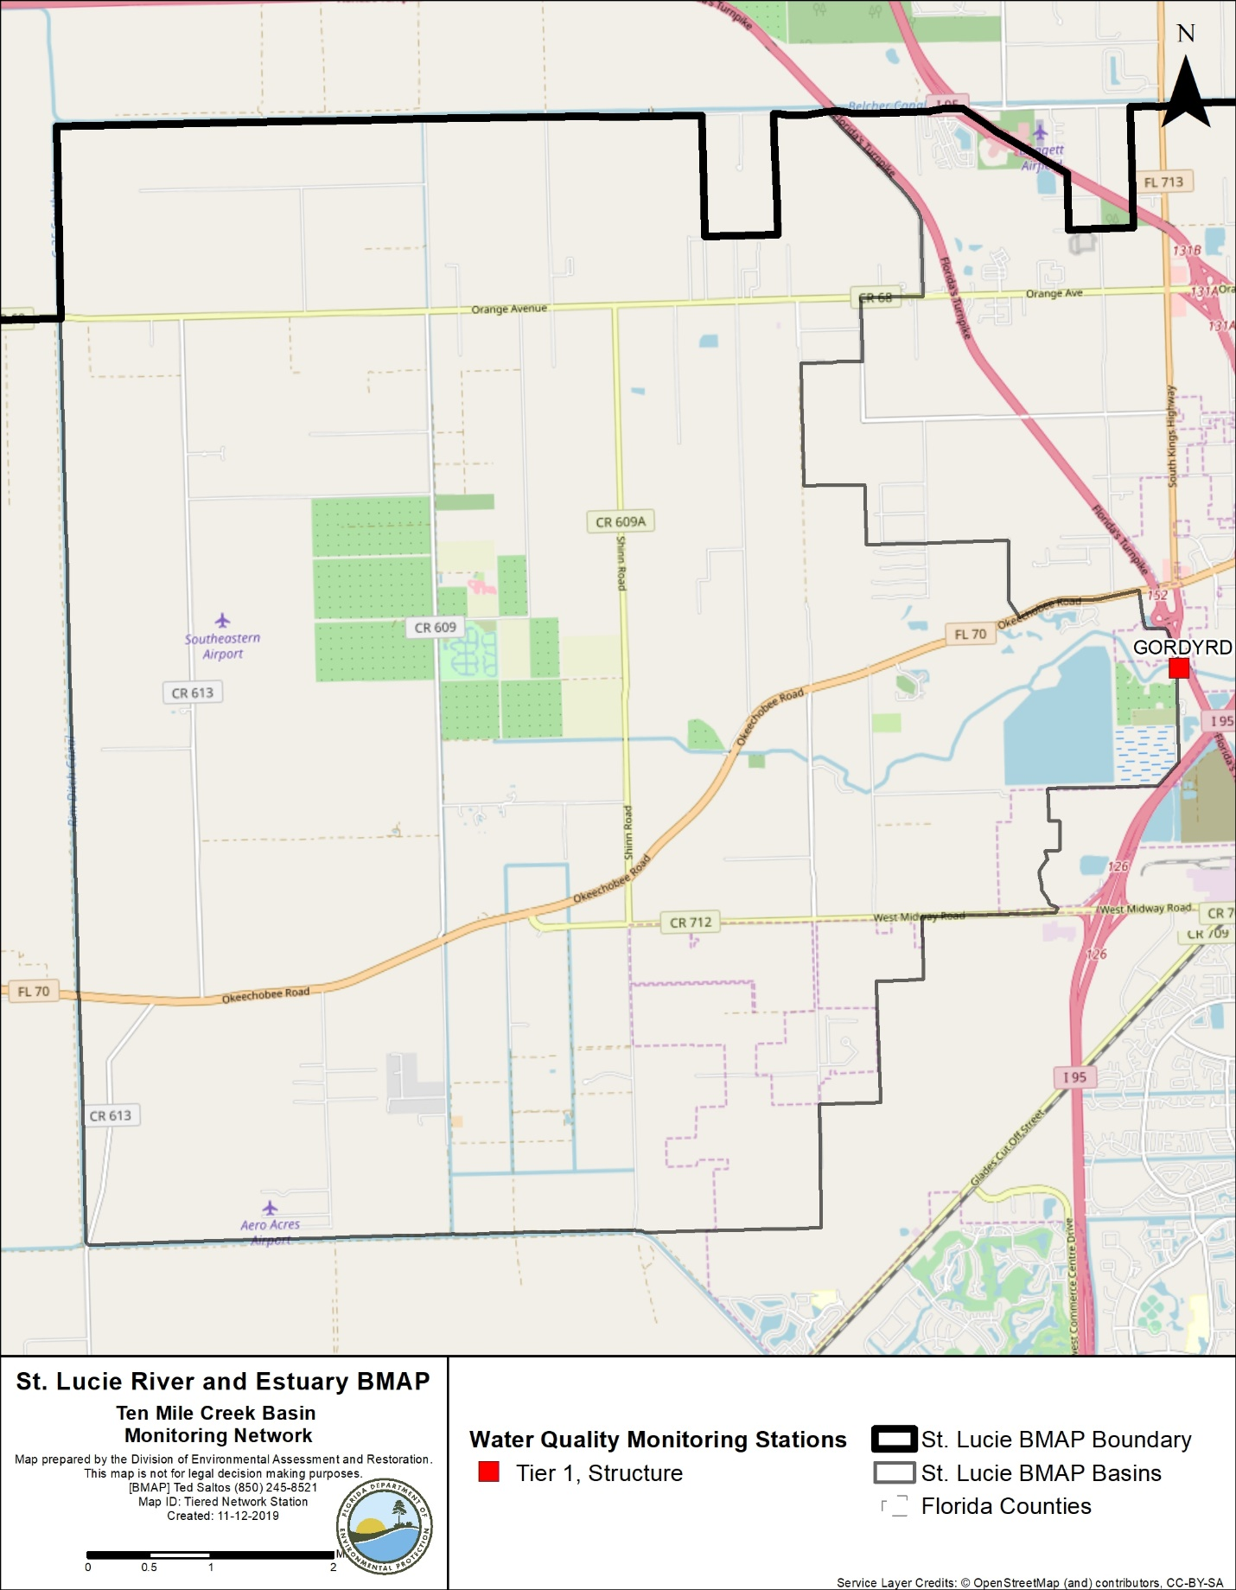
Figure 10. Ten Mile Creek Basin monitoring stations

3.2.2. Basin Evaluation Results
Table 29 summarizes the basin evaluation results based on data from WY2014–WY2018 for the Ten Mile Creek Basin. The current TN concentration is 0.88 mg/L, which is above the benchmark of 0.72 mg/L required to meet the TMDL. The current TP concentration is 0.218 mg/L, which is above the benchmark of 0.081 mg/L required to meet the TMDL. The FWM concentrations are 0.92 mg/L and 0.23 mg/L for TN and TP, respectively.
For these assessments, FWM concentrations were used because flow data were available at the Gordy structure. The TN UAL is 8.24 lbs/ac, which is 47 % above the target UAL of 5.61 lbs/ac, and the TP UAL is 2.33 lbs/ac, which is 269 % above the target UAL of 0.63 lbs/ac. No significant trend was observed for TN or TP.
The TRA prioritization results for the Ten Mile Creek Basin are shown in Table 30, with 1 the highest priority, 2 the next highest priority, and 3 a priority as resources allow.
Table 29. Basin evaluation results for the Ten Mile Creek Basin
TRA ID | Basin Name | TN (mg/L)  (Benchmark – 0.72) | TN FWM Concentration (mg/L) | TN UAL (lbs/ac) | TN Trend Analysis | TP (mg/L)  (Benchmark – 0.081) | TP FWM Concentration (mg/L) | TP UAL (lbs/ac) | TP Trend Analysis
2 | Ten Mile Creek | 0.88 | 0.92 | 8.24 | No significant trend | 0.218 | 0.23 | 2.33 | No significant trend

Table 30. TRA evaluation results for the Ten Mile Creek Basin
Basin | Station | TN Priority | TP Priority
Ten Mile Creek | Gordy | 1 | 1

3.2.3. Projects
The tables below summarize the existing and planned and future projects for the Ten Mile Creek Basin that were provided for the BMAP. The existing and planned projects are a BMAP requirement, while future projects will be implemented as funding becomes available for project implementation. Appendix A provides additional details about the projects and the terms used in these tables.

3.2.3.1. Existing Projects
Table 31 summarizes the existing and planned projects provided by the stakeholders for the Ten Mile Creek Basin.
Table 31. Existing and planned projects in the Ten Mile Creek Basin
Notes: For projects with multiple basins listed in the "Basin" column, the nutrient reductions provided in the table are the total estimated for the project and not applicable to a specific basin.
Lead  Entity | Partners | Project Number | Project Name | Project Description | Project Type | Project Status | Estimated Completion Date | TN Reduction (lbs/yr) | TP Reduction (lbs/yr) | Basin | Acres Treated | Cost Estimate | Cost Annual O&M | Funding Source | Funding Amount | DEP Contract Agreement Number
FDACS | Agricultural Producers | FDACS-02 | BMP Implementation and Verification | Enrollment and verification of BMPs by agricultural producers. Reductions based on WaSh model. Acres treated based on FDACS OAWP June 2019 Enrollment and FSAID VI. | Agricultural BMPs | Completed | N/A | 8,397 | 1,436 | Ten Mile Creek | 11,877 | TBD | TBD | FDACS | TBD | N/A
FDACS | Agricultural Producers | FDACS-10 | Cost-share Projects | Cost-share projects paid for by FDACS. Acres treated based on FDACS OAWP June 2019 Enrollment. Reductions based on WaSh model. | Agricultural BMPs | Completed | N/A | 525 | 146 | Ten Mile Creek | 955 | TBD | TBD | FDACS | TBD | N/A
FDACS | N/A | FDACS-16 | Credit for Changes in Land Use | Acreages and reductions based on a portion of differences between modeled agricultural land use coverage identified in Table B-13. DEP will estimate final numbers by next BMAP update. | Land Use Change | Completed | N/A | 501 | 101 | Ten Mile Creek | 74 | N/A | N/A | N/A | N/A | N/A
FDOT District 4 | N/A | FDOT-03 | FM# 230262-4 | Road widening of SR 70 from west of Rim Ditch Canal to west of Header Canal. | Dry Detention Pond | Completed | 2008 | 77 | 15 | Ten Mile Creek,  C-24 | 102 | Not provided | Not provided | Florida Legislature | Not provided | N/A
FDOT District 4 | N/A | FDOT-04 | FM# 230262-5 | Road widening of SR 70 from Turnpike to Berman Rd. | Dry Detention Pond | Completed | 2010 | 92 | 18 | Ten Mile Creek | 124 | Not provided | Not provided | Florida Legislature | Not provided | N/A
FDOT District 4 | N/A | FDOT-18 | Street Sweeping | Not provided. | Street Sweeping | Completed | N/A | 1,419 | 910 | North Fork, Ten Mile Creek, C-24, C-23, C-44/S-153, Basin 4/5, Basin 6, South Fork, South Coastal, South Mid-Estuary, North Mid-Estuary | N/A | Not provided | Not provided | Florida Legislature | Not provided | N/A
FDOT District 4 | N/A | FDOT-19 | Public Education | Pamphlets. | Education Efforts | Completed | N/A | 109 | 20 | North Fork, Ten Mile Creek, C-24, C-23, C-44/S-153, Basin 4/5, Basin 6, South Fork, South Coastal, South Mid-Estuary, North Mid-Estuary | N/A | Not provided | Not provided | Florida Legislature | Not provided | N/A
FDOT District 4 | N/A | FDOT-57 | Fertilizer Application Cessation | No longer routinely applying fertilizer.. | Fertilizer Cessation | Completed | 2016 | 23,881 | 5,970 | North Fork, Ten Mile Creek, C-24, C-23, C-44/S-153, Basin 4/5, Basin 6, South Fork, South Coastal, South Mid-Estuary, North Mid-Estuary | N/A | Not provided | Not provided | Florida Legislature | Not provided | N/A
North St. Lucie River WCD | SLRIT | NSLRWCD-01 | SLRIT Grant 2000–2001: Vegetation Control & Bank Restoration | Installation of C-25 diversion structure, which regulates flow from NSLRWCD C-44/ North Emergency Relief Canal to SFWMD C-25. In addition, installation of 3 risers with adjustable gates. | Control Structure | Completed | 2003 | 1,548 | 0 | North Fork, Ten Mile Creek | 4,173 | $929,000 | Not provided | NSLRWCD/ SLRIT 50/50 contribution match | Not provided | N/A
North St. Lucie River WCD | SLRIT | NSLRWCD-02 | SLRIT Grant 2007–2008: WCS Retrofits | Installation of adjustable gates on WCS to improve efficiency of water levels and better manage sediment transport downstream. | Control Structure | Completed | 2010 | 1,558 | 0 | Ten Mile Creek, C-24 | 4,701 | $77,000 | Not provided | NSLRWCD/ SLRIT 50/50 contribution match | Not provided | N/A
North St. Lucie River WCD | N/A | NSLRWCD-04 | Canal Maintenance Program | Maintenance program on over 200 miles of canal, now included in NSLRWCD water quality activities. | Aquatic Vegetation Harvesting | Canceled | 2013 | N/A | N/A | North Fork, Ten Mile Creek | 66,225 | $4,200,000 | Not provided | NSLRWCD | Not provided | N/A
North St. Lucie River WCD | N/A | NSLRWCD-05 | Changes in Agricultural Land Uses | All land uses updated with new model. | Land Use Change | Canceled | 2013 | N/A | N/A | North Fork, Ten Mile Creek | 1,055 | N/A | N/A | N/A | N/A | N/A
North St. Lucie River WCD | N/A | NSLRWCD-06 | 90% Implementation Agricultural BMPs | All agricultural BMP enrollment now included in FDACS-01. | Agricultural BMPs | Canceled | N/A | N/A | N/A | North Fork, Ten Mile Creek | N/A | N/A | N/A | N/A | N/A | N/A
North St. Lucie River WCD | N/A | NSLRWCD-07 | Change from Agricultural to Urban | All land uses updated with new model. | Land Use Change | Canceled | N/A | N/A | N/A | North Fork, Ten Mile Creek | N/A | N/A | N/A | N/A | N/A | N/A
North St. Lucie River WCD | N/A | NSLRWCD-08 | Ideal Grove Hybrid Wetland Treatment Technology (HWTT) | Not provided. | HWTT | Completed | 2013 | 433 | 132 | Ten Mile Creek, C-24 | 238 | $217,929 | Not provided | Not provided | Not provided | N/A
North St. Lucie River WCD | Not provided | NSLRWCD-09 | Structure 81-1-2 | Installation of new control structure as part of Okeechobee Rd. improvements project. | Control Structure | Completed | 2010 | 124 | 124 | Ten Mile Creek | 2,582 | Not provided | Not provided | Not provided | Not provided | N/A
North St. Lucie River WCD | Not provided | NSLRWCD-10 | Structure 82-2-2 | Installation of new control structure as part of Okeechobee Rd. improvements project. | Control Structure | Completed | 2010 | 23 | 23 | Ten Mile Creek | 674 | Not provided | Not provided | Not provided | Not provided | N/A
North St. Lucie River WCD | Not provided | NSLRWCD-11 | Structure 83-2-2 | Installation of new control structure as part of Okeechobee Rd. improvements project. | Control Structure | Completed | 2010 | 27 | 27 | Ten Mile Creek | 484 | Not provided | Not provided | Not provided | Not provided | N/A
North St. Lucie River WCD | Not provided | NSLRWCD-12 | Structure 85-1-2 | Installation of new control structure as part of Okeechobee Rd. improvements project. | Control Structure | Completed | 2010 | 64 | 64 | Ten Mile Creek | 961 | Not provided | Not provided | Not provided | Not provided | N/A
St. Lucie County | N/A | SLC-006 | Street Sweeping | Materials are collected from roadways and gutters using street sweeper truck. | Street Sweeping | Completed | N/A | 211 | 135 | North Fork, Ten Mile Creek, C-24, C-23 | N/A | Not provided | Not provided | Not provided | Not provided | N/A
St. Lucie County | N/A | SLC-007 | Catch Basin Cleanout | Catch basins are cleaned out on rotational basis using vactruck. | Catch Basin Inserts/Inlet Filter Cleanout | Completed | N/A | 170 | 105 | North Fork, Ten Mile Creek, C-23 | N/A | Not provided | Not provided | Not provided | Not provided | N/A
St. Lucie County | N/A | SLC-010 | Education Program | FYN; pet waste, landscape, irrigation, and fertilizer ordinances; PSAs; website; Illicit Discharge Program, Eco-Center, Clean Stormwater–Clean River Program, St. Lucie Water Champions. | Education Efforts | Completed | N/A | 8,821 | 1,594 | North Fork, Ten Mile Creek, C-24, C-23 | N/A | Not provided | Not provided | Not provided | Not provided | N/A
St. Lucie County | N/A | SLC-011 | Street Sweeping | Materials are collected from roadways and gutters using street sweeper truck. | Street Sweeping | Completed | N/A | 113 | 73 | North Fork, Ten Mile Creek, C-24, C-23 | N/A | Not provided | Not provided | Not provided | Not provided | N/A
St. Lucie County | N/A | SLC-012 | Catch Basin Cleanout | Catch basins are cleaned out on rotational basis using a vactruck.. | BMP Cleanout | Completed | N/A | 92 | 56 | North Fork, Ten Mile Creek, C-24 | N/A | Not provided | Not provided | Not provided | Not provided | N/A
St. Lucie County | N/A | SLC-017 | Swales Material Collection | Roadside swale cleanout and retrofitting in MS4 area and non-MS4 area. | BMP Cleanout | Completed | N/A | TBD | TBD | North Fork, Ten Mile Creek, C-23 | Not provided | Not provided | Not provided | Not provided | Not provided | N/A
St. Lucie County | N/A | SLC-018 | Swales Material Collection | Roadside swale cleanout and retrofitting. Project rolled into SLC-017. | BMP Cleanout | Canceled | N/A | TBD | TBD | North Fork, Ten Mile Creek, C-23 | Not provided | Not provided | Not provided | Not provided | Not provided | N/A
Coordinating Agency | N/A | CA-01 | Ten Mile Creek Water Preserve Area | Control quantity and timing of water delivery to NFSLR by capturing and storing stormwater flows that originated in Ten Mile Creek Basin. | Hydrologic Restoration | Completed | 2017 | TBD | 8,789 | North Fork, Ten Mile Creek | 658
Coordinating Agency | N/A | CA-02 | IRL-South | C-44 Reservoir/STA will capture, store and treat runoff from C-44/S-153 Basin prior to discharge to estuary. Reservoir will provide 50,600 ac-ft of water storage. Two reservoirs and STA in C-23/C-24 Basins also planned to treat 92,000 ac-ft of runoff. The STA will be completed in 2020, and the reservoir in 2022. | Regional Stormwater Treatment | Underway | 2022 | 187,393 | 74,957 | Ten Mile Creek,  C-24, C-23, C-44/S-153 | 10,700

3.2.3.2. Future Projects
No future projects were provided by the stakeholders for the Ten Mile Creek Basin.

3.3. C-24 Basin
The C-24 Basin covers 83,300 acres of the St. Lucie River and Estuary Watershed. As shown in Table 32, agriculture is the primary land use, comprising 73.6 % of the basin. Stakeholders in the basin include FDOT, NSLRWCD, Port St. Lucie, and St. Lucie County.
Table 32. Summary of land uses in the C-24 Basin
Level 1 Land Use Code | Land Use Description | Acres | % Total
1000 | Urban and Built-Up | 6,253 | 7.5
2000 | Agriculture and 3300 (Rangeland) | 61,352 | 73.6
3000 | Upland Nonforested | 1,252 | 1.5
4000 | Upland Forests | 936 | 1.1
5000 | Water | 1,339 | 1.6
6000 | Wetlands | 11,062 | 13.3
7000 | Barren Land | 363 | 0.4
8000 | Transportation, Communication, and Utilities | 821 | 1.0
 | Total | 83,378 | 100

3.3.1. Water Quality Monitoring
Table 33 summarizes the water quality monitoring stations in the C-24 Basin, and Figure 11 shows the station locations. Four new stations were added in the C-24 Basin: G79, PC38C24, PC39C24, and PC54C23. These stations were added to increase data collection in this basin.
Table 33. Water quality monitoring stations in the C-24 Basin
*Stations denoted by an asterisk are proposed/new stations.
Basin | Representative Site? | Entity | Station ID | Tier
C-24 | Yes | SFWMD | S-49 | 1
C-24 | N/A | SFWMD | G79* | 2
C-24 | N/A | SFWMD | PC38C24* | 2
C-24 | N/A | SFWMD | PC39C24* | 2
C-24 | N/A | SFWMD | PC54C23* | 2

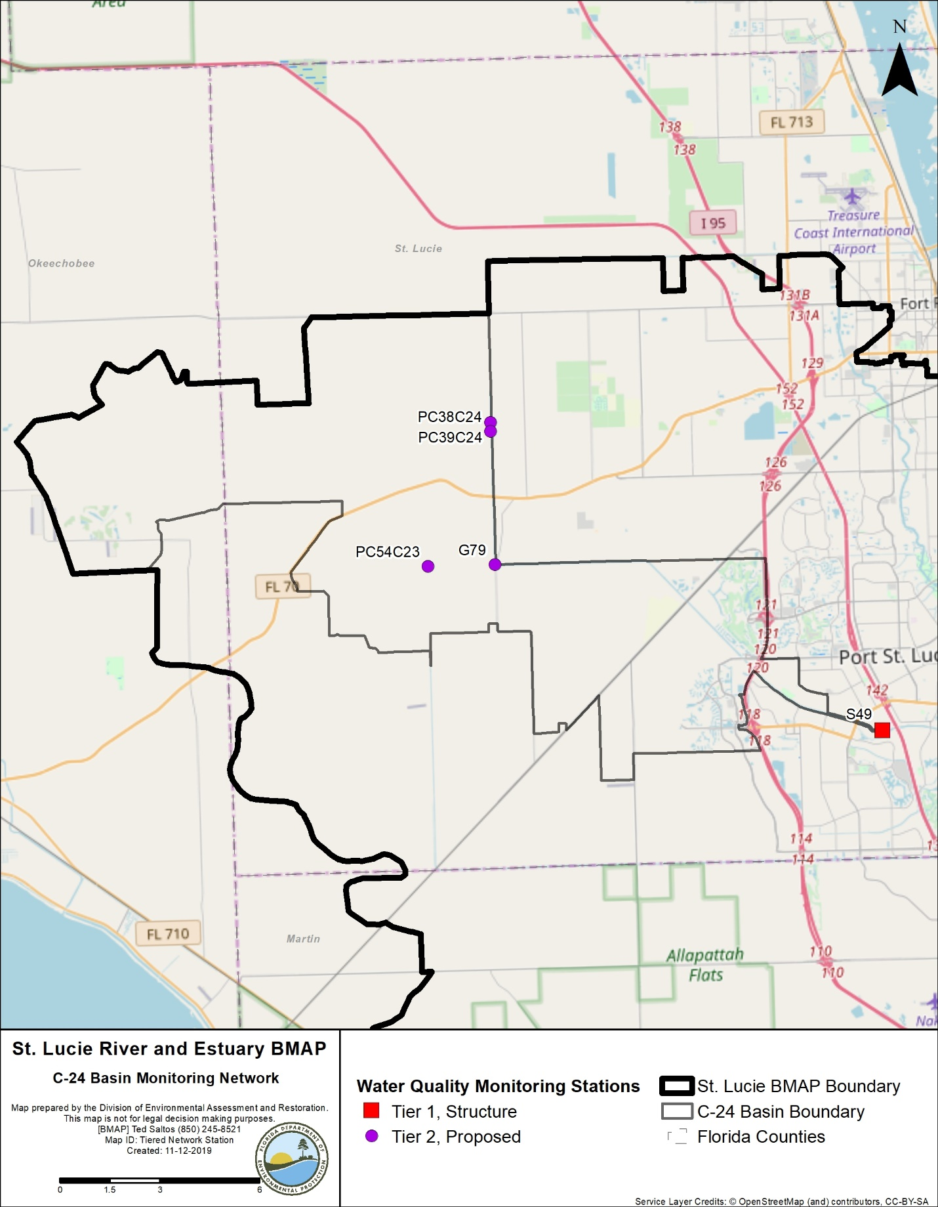
Figure 11. C-24 Basin monitoring stations

3.3.2. Basin Evaluation Results
Table 34 summarizes the basin evaluation results based on data from WY2014–-2018 for the C-24 Basin. The current TN concentration is 1.30 mg/L, which is above the benchmark of 0.72 mg/L required to meet the TMDL. The current TP concentration is 0.237 mg/L, which is above the benchmark of 0.081 mg/L required to meet the TMDL. The FWM concentrations are 1.33 and 0.25 mg/L for TN and TP, respectively. For these assessments, FWM concentrations were used because flow data were available at the S-49 structure. The TN UAL is 6.84 lbs/ac, which is 110 % above the target UAL of 3.25 lbs/ac, and the TP UAL is 1.51 lbs/ac, which is 314 % above the target UAL of 0.37 lbs/ac. No significant trends were observed for either TN or TP.
The TRA prioritization results for the C-24 Basin are shown in Table 35, with 1 as the highest priority, 2 as the next highest priority, and 3 a priority as resources allow.
Table 34. Basin evaluation results for the C-24 Basin
TRA ID | Basin Name | TN (mg/L)  (Benchmark – 0.72) | TN FWM Concentration (mg/L) | TN UAL (lbs/ac) | TN Trend Analysis | TP (mg/L)  (Benchmark – 0.081) | TP FWM Concentration (mg/L) | TP UAL (lbs/ac) | TP Trend Analysis
3 | C-24 | 1.30 | 1.33 | 6.84 | No significant trend | 0.237 | 0.25 | 1.51 | No significant trend

Table 35. TRA evaluation results for the C-24 Basin
Basin | Station | TN Priority | TP Priority
C-24 | S-49 | 1 | 1

3.3.3. Projects
The tables below summarize the existing and planned and future projects for the C-24 Basin that were provided for the BMAP. The existing and planned projects are a BMAP requirement, while future projects will be implemented as funding becomes available for project implementation. Appendix A provides additional details about the projects and the terms used in these tables.

3.3.3.1. Existing and Planned Projects
Table 36 summarizes the existing and planned projects provided by the stakeholders for the C-24 Basin.
Table 36. Existing and planned projects in the C-24 Basin
Notes: For projects with multiple basins listed in the "Basin" column, the nutrient reductions provided in the table are the total estimated for the project and not applicable to a specific basin.
Lead Entity | Partners | Project Number | Project Name | Project Description | Project Type | Project Status | Estimated Completion Date | TN Reduction (lbs/yr) | TP Reduction (lbs/yr) | Basin | Acres Treated | Cost Estimate | Cost Annual O&M | Funding Source | Funding Amount | DEP Contract Agreement Number
FDACS | Agricultural Producers | FDACS-03 | BMP Implementation and Verification | Enrollment and verification of BMPs by agricultural producers. Reductions based on WaSh model. Acres treated based on FDACS OAWP June 2019 Enrollment and FSAID VI. | Agricultural BMPs | Completed | N/A | 50,877 | 8,218 | C-24 | 42,785 | TBD | TBD | FDACS | TBD | N/A
FDACS | Agricultural Producers | FDACS-11 | Cost-share Projects | Cost-share projects paid for by FDACS. Acres treated based on FDACS OAWP June 2019 Enrollment. Reductions based on WaSh model. | Agricultural BMPs | Completed | N/A | 89,627 | 26,668 | C-24 | 3,062 | TBD | TBD | FDACS | TBD | N/A
FDACS | N/A | FDACS-17 | Credit for Changes in Land Use | Acreages and reductions based on a portion of differences between modeled agricultural land use coverage identified in Table B-13. DEP will estimate final numbers by next BMAP update. | Land Use Change | Completed | N/A | TBD | TBD | C-24 | TBD | N/A | N/A | N/A | N/A | N/A
FDOT District 4 | N/A | FDOT-03 | FM# 230262-4 | Road widening of SR 70 from west of Rim Ditch Canal to west of Header Canal | Dry Detention Pond | Completed | 2008 | 77 | 15 | Ten Mile Creek, C-24 | 102 | Not provided | Not provided | Florida Legislature | Not provided | N/A
FDOT District 4 | N/A | FDOT-05 | FM# 230262-3 | Road widening of SR 70 from Okeechobee County line, east 10.2 miles. | Dry Detention Pond | Completed | 2012 | 160 | 36 | C-24 | 195 | Not provided | Not provided | Florida Legislature | Not provided | N/A
FDOT District 4 | N/A | FDOT-06 | FM# 230262-2 | Road widening of SR 70 from Okeechobee County line, east 10.2 miles. | Dry Detention Pond | Completed | 2012 | 160 | 36 | C-24 | 195 | Not provided | Not provided | Florida Legislature | Not provided | N/A
FDOT District 4 | N/A | FDOT-18 | Street Sweeping | Not provided. | Street Sweeping | Completed | N/A | 1,419 | 910 | North Fork, Ten Mile Creek,  C-24, C-23,  C-44/S-153, Basin 4/5, Basin 6, South Fork, South Coastal, South Mid-Estuary, North Mid-Estuary | N/A | Not provided | Not provided | Florida Legislature | Not provided | N/A
FDOT District 4 | N/A | FDOT-19 | Public Education | Pamphlets. | Education Efforts | Completed | N/A | 109 | 20 | North Fork, Ten Mile Creek,  C-24, C-23,  C-44/S-153, Basin 4/5, Basin 6, South Fork, South Coastal, South Mid-Estuary, North Mid-Estuary | N/A | Not provided | Not provided | Florida Legislature | Not provided | N/A
FDOT District 4 | N/A | FDOT-57 | Fertilizer Application Cessation | No longer routinely applying fertilizer. | Fertilizer Cessation | Completed | 2016 | 23,881 | 5,970 | North Fork, Ten Mile Creek,  C-24, C-23,  C-44/S-153, Basin 4/5, Basin 6, South Fork, South Coastal, South Mid-Estuary, North Mid-Estuary | N/A | Not provided | Not provided | Florida Legislature | Not provided | N/A
North St. Lucie River WCD | SLRIT | NSLRWCD-02 | SLRIT Grant 2007-2008: WCS Retrofits | Installation of adjustable gates on WCS to improve efficiency of water levels and better manage sediment transport downstream. | Control Structure | Completed | 2010 | 1,558 | 0 | Ten Mile Creek, C-24 | 4,701 | $77,000 | Not provided | NSLRWCD/SLRIT 50/50 contribution match | Not provided | N/A
North St. Lucie River WCD | N/A | NSLRWCD-08 | Ideal Grove HWTT | Not provided. | HWTT | Completed | 2013 | 433 | 132 | Ten Mile Creek, C-24 | 238 | $217,929 | Not provided | Not provided | Not provided | N/A
City of Port St. Lucie | NRCS/ SFWMD | PSL-05 | B-1 and B-2 WCS | WCS B-1 and B-2 protected NFSLR from receiving uncontrolled E-8 Canal discharges. System will stage appropriate discharge levels based on volume, retaining maximum flows. | Control Structure | Completed | 2007 | 6,737 | 2,088 | North Fork,  C-24, C-23 | 1,748 | $1,800,000 | $621,000 | City/ NRCS/ SFWMD | Not provided | N/A
City of Port St. Lucie | NRCS/ SFWMD | PSL-06 | B-3 WCS | B-3 protected NFSLR from receiving uncontrolled E-8 Canal discharges. System will stage appropriate discharge levels based on volume, retaining maximum flows. | Control Structure | Completed | 2007 | 7,027 | 2,177 | North Fork | 1,641 | N/A | N/A | City/ NRCS/ SFWMD | Not provided | N/A
City of Port St. Lucie | N/A | PSL-09 | Water and Wastewater Expansion | Multiple phase-outs of septic tanks from 2013 to 2019. | OSTDS Phase Out | Completed | 2019 | 44,921 | N/A | North Fork,  C-24, C-23 | N/A | $91,075,666 | $3,700,000 | City | N/A | N/A
City of Port St. Lucie | N/A | PSL-13 | Education Program | FYN Program; fertilizer, landscape, irrigation, and pet waste ordinances; PSAs; stormwater educational shows; website; outreach programs; Stencil Program; and stormwater pollution hotline. | Education Efforts | Completed | N/A | 21,978 | 3,722 | North Fork,  C-24, C-23 | N/A | Not provided | Not provided | City | Not provided | N/A
St. Lucie County | N/A | SLC-005 | Education Program | FYN; pet waste, landscape, irrigation, and fertilizer ordinances; PSAs; website; Illicit Discharge Program, Eco-Center, Clean Stormwater–Clean River Program. St. Lucie Water Champions. | Education Efforts | Completed | N/A | 2,597 | 454 | North Fork,  C-24, C-23 | N/A | Not provided | Not provided | Not provided | Not provided | N/A
St. Lucie County | N/A | SLC-006 | Street Sweeping | Materials are collected from roadways and gutters using street sweeper truck. | Street Sweeping | Completed | N/A | 211 | 135 | North Fork, Ten Mile Creek,  C-24, C-23 | N/A | Not provided | Not provided | Not provided | Not provided | N/A
St. Lucie County | N/A | SLC-010 | Education Program | FYN; pet waste, landscape, irrigation, and fertilizer ordinances; PSAs; website; Illicit Discharge Program, Eco-Center, Clean Stormwater–Clean River Program, St. Lucie Water Champions. | Education Efforts | Completed | N/A | 8,821 | 1,594 | North Fork, Ten Mile Creek,  C-24, C-23 | N/A | Not provided | Not provided | Not provided | Not provided | N/A
St. Lucie County | N/A | SLC-011 | Street Sweeping | Materials are collected from roadways and gutters using street sweeper truck. | Street Sweeping | Completed | N/A | 113 | 73 | North Fork, Ten Mile Creek,  C-24, C-23 | N/A | Not provided | Not provided | Not provided | Not provided | N/A
St. Lucie County | N/A | SLC-012 | Catch Basin Cleanout | Catch basins are cleaned out on rotational basis using vactruck. | BMP Cleanout | Completed | N/A | 92 | 56 | North Fork, Ten Mile Creek,  C-24 | N/A | Not provided | Not provided | Not provided | Not provided | N/A
St. Lucie County | N/A | SLC-015 | IRL-South C-23/C-24 CERP Buffer – Teague Preserve Re-watering Project | Not provided. | Hydrologic Restoration | Underway | Not provided | TBD | TBD | North Fork,  C-24, C-23 | TBD | $400,000 | TBD | Not provided | Not provided | N/A
Coordinating Agency | N/A | CA-02 | IRL-South | C-44 Reservoir/STA will capture, store and treat runoff from C-44/S-153 Basin prior to discharge to estuary. Reservoir will provide 50,600 ac-ft of water storage. Two reservoirs and an STA in C-23/C-24 Basins also planned to treat 92,000 ac-ft of runoff. The STA will be completed in 2020, and the reservoir in 2022. | Regional Stormwater Treatment | Underway | 2022 | 187,393 | 74,957 | Ten Mile Creek,  C-24, C-23, C-44/S-153 | 10,700
Coordinating Agency | N/A | CA-03 | Adams-Russakis Ranch Water Management Area (WMA) | 1,000-acre project area, which has estimated water storage benefit of 536 ac-ft/yr. | DWM | Underway | 2020 | N/A | N/A | C-24 | 1,000
Coordinating Agency | N/A | CA-04 | C-23/24 Interim Storage Section C Water Farm | 297-acre project area, which has estimated water storage benefit of 2,958 ac-ft/yr. | DWM | Completed | 2017 | N/A | N/A | C-24 | 297
Coordinating Agency | N/A | CA-09 | Alderman-Deloney Ranch | 170-acre project area, which has estimated water storage benefit of 147 ac-ft/yr. | DWM | Completed | 2012 | N/A | N/A | C-24 | 170
Coordinating Agency | N/A | CA-10 | C-23/24 Interim Storage Parcel B | 320-acre project area to provide shallow storage in C-24 Basin. | DWM | Planned | TBD | N/A | N/A | C-24 | 320

3.3.3.2. Future Projects
No future projects were provided by stakeholders in the C-24 Basin.

3.4. C-23 Basin
The C-23 Basin covers 110,883 acres of the St. Lucie River and Estuary Watershed. As shown in Table 37, the most common land use is agriculture, which comprises 74.2 % of the basin. Stakeholders in the basin include FDOT, Martin County, Port St. Lucie, and St. Lucie County.
Table 37. Summary of land uses in the C-23 Basin
Level 1 Land Use Code | Land Use Description | Acres | % Total
1000 | Urban and Built-Up | 3,237 | 2.9
2000 | Agriculture | 82,273 | 74.2
3000 | Upland Nonforested | 2,157 | 1.9
4000 | Upland Forests | 2,710 | 2.4
5000 | Water | 1,554 | 1.4
6000 | Wetlands | 15,967 | 14.4
7000 | Barren Land | 1,201 | 1.1
8000 | Transportation, Communication, and Utilities | 1,784 | 1.6
 | Total | 110,883 | 100

3.4.1. Water Quality Monitoring
Table 38 summarizes the water quality monitoring stations in the C-23 Basin, and Figure 12 shows the station locations. Three new stations were added in the C-23 Basin: ACRA1, PC32C23, and PC49C23. Data collected at these stations will allow for a better understanding of water quality trends in the basin.
Table 38. Water quality monitoring stations in the C-23 Basin
* Stations denoted by an asterisk are proposed/new stations.
Basin | Representative Site? | Entity | Station ID | Tier
C-23 | Yes | SFWMD | S-48 | 1
C-23 | Yes | SFWMD | ACRA1* | 2
C-23 | Yes | SFWMD | PC32C23* | 2
C-23 | Yes | SFWMD | PC49C23* | 2

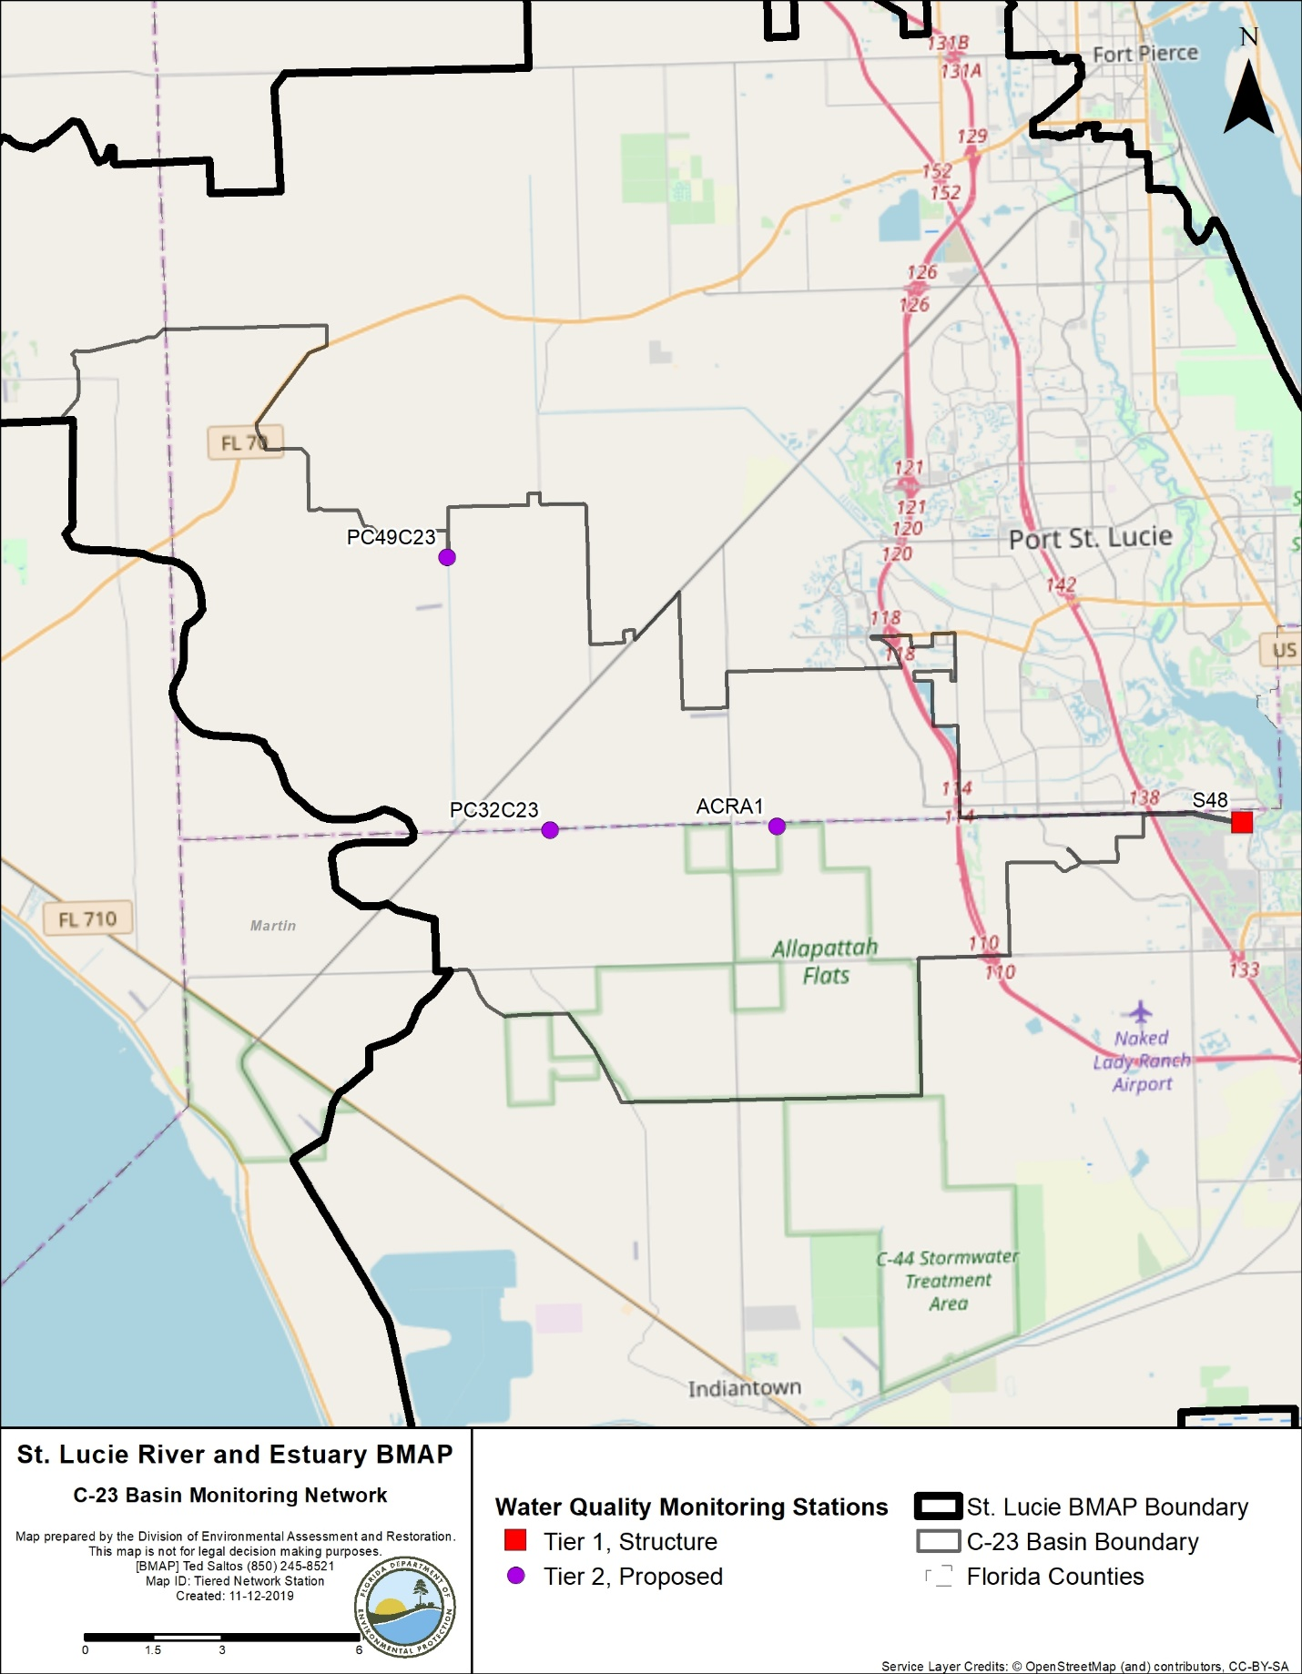
Figure 12. C-23 Basin monitoring stations

3.4.2. Basin Evaluation Results
Table 39 summarizes the basin evaluation results based on data from WY2014–WY2018 for the C-23 Basin. The current TN concentration is 1.36 mg/L, which is above the benchmark of 0.72 mg/L required to meet the TMDL. The current TP concentration is 0.326 mg/L, which is below the benchmark of 0.081 mg/L required to meet the TMDL. The FWM concentrations are 1.50 and 0.37 mg/L for TN and TP, respectively. For these assessments, FWM concentrations were used because flow data were available at the S-48 structure. The TN UAL is 5.57 lbs/ac, which is 136 % above the target UAL of 2.35 lbs/ac, and the TP UAL is 1.46 lbs/ac, which is 449 % above the target UAL of 0.26 lbs/ac. No significant trends were observed for either TN or TP.
Table 40 lists the TRA prioritization results for the C-23 Basin, with 1 the highest priority, 2 the next highest priority, and 3 a priority as resources allow.
Table 39. Basin evaluation results for the C-23 Basin
TRA ID | Basin Name | TN (mg/L)  (Benchmark – 0.72) | TN FWM Concentration (mg/L) | TN UAL (lbs/ac) | TN Trend Analysis | TP (mg/L)  (Benchmark – 0.081) | TP FWM Concentration (mg/L) | TP UAL (lbs/ac) | TP Trend Analysis
4 | C-23 | 1.36 | 1.50 | 5.57 | No significant trend | 0.326 | 0.37 | 1.46 | No significant trend

Table 40. TRA evaluation results for the C-23 Basin
Basin | Station | TN Priority | TP Priority
C-23 | S-48 | 1 | 1

3.4.3. Projects
The tables below summarize the existing and planned and future projects for the C-23 Basin that were provided for the BMAP. The existing and planned projects are a BMAP requirement, while future projects will be implemented as funding becomes available for project implementation. Appendix A provides additional details about the projects and the terms used in these tables.

3.4.3.1. Existing Projects
Table 41 summarizes the existing and planned projects provided by the stakeholders for the C-23 Basin.
Table 41. Existing and planned projects in the C-23 Basin
Notes: For projects with multiple basins listed in the "Basin" column, the nutrient reductions provided in the table are the total estimated for the project and not applicable to a specific basin.
Lead Entity | Partners | Project Number | Project Name | Project Description | Project Type | Project Status | Estimated Completion Date | TN Reduction (lbs/yr) | TP Reduction (lbs/yr) | Basin | Acres Treated | Cost Estimate | Cost Annual O&M | Funding Source | Funding Amount | DEP Contract Agreement Number
FDACS | Agricultural Producers | FDACS-04 | BMP Implementation and Verification | Enrollment and verification of BMPs by agricultural producers. Reductions based on WaSh model. Acres treated based on FDACS OAWP June 2019 Enrollment and FSAID VI. | Agricultural BMPs | Completed | N/A | 68,159 | 12,479 | C-23 | 60,127 | TBD | TBD | FDACS | TBD | N/A
FDACS | Agricultural Producers | FDACS-12 | Cost-share Projects | Cost-share projects paid for by FDACS. Acres treated based on FDACS OAWP June 2019 Enrollment. Reductions based on WaSh model. | Agricultural BMPs | Completed | N/A | 65,137 | 29,777 | C-23 | 17,563 | TBD | TBD | FDACS | TBD | N/A
FDACS | N/A | FDACS-18 | Credit for Changes in Land Use | Acreages and reductions based on a portion of differences between modeled agricultural land use coverage identified in Table B-13. DEP will estimate final numbers by next BMAP update. | Land Use Change | Completed | N/A | 2,428 | 521 | C-23 | 475 | N/A | N/A | N/A | N/A | N/A
FDOT District 4 | N/A | FDOT-06 | FM# 230262-2 | Road widening of SR 70 from Okeechobee County line, east 10.2 miles. | Dry Detention Pond | Completed | 2015 | 317 | 91 | C-24, C-23 | 238 | Not provided | Not provided | Florida Legislature | Not provided | N/A
FDOT District 4 | City of Port St. Lucie | FDOT-17 | FM# 419890-1 | Construction of interchange at SR 9 and Becker Rd. | BMP Treatment Train | Completed | 2010 | 3 | 2 | North Fork, C-23 | 42 | Not provided | Not provided | Florida Legislature | Not provided | N/A
FDOT District 4 | N/A | FDOT-18 | Street Sweeping | Not provided. | Street Sweeping | Completed | N/A | 1,419 | 910 | North Fork, Ten Mile Creek, C-24, C-23, C-44/S-153, Basin 4/5, Basin 6, South Fork, South Coastal, South Mid-Estuary, North Mid-Estuary | N/A | Not provided | Not provided | Florida Legislature | Not provided | N/A
FDOT District 4 | N/A | FDOT-19 | Public Education | Pamphlets. | Education Efforts | Completed | N/A | 109 | 20 | North Fork, Ten Mile Creek, C-24, C-23, C-44/  S-153, Basin 4/5, Basin 6, South Fork, South Coastal, South Mid-Estuary, North Mid-Estuary | N/A | Not provided | Not provided | Florida Legislature | Not provided | N/A
FDOT District 4 | N/A | FDOT-57 | Fertilizer Application Cessation | No longer routinely applying fertilizer. | Fertilizer Cessation | Completed | 2016 | 23,881 | 5,970 | North Fork, Ten Mile Creek, C-24, C-23, C-44/S-153, Basin 4/5, Basin 6, South Fork, South Coastal, South Mid-Estuary, North Mid-Estuary | N/A | Not provided | Not provided | Florida Legislature | Not provided | N/A
Martin County | N/A | MC-18 | Street Sweeping | Not provided. | Street Sweeping | Completed | N/A | 108 | 69 | North Fork, C-23, C-44/S-153, Basin 4/5, Basin 6, South Fork, South Coastal, South Mid-Estuary, North Mid-Estuary | N/A | Not provided | Not provided | Not provided | Not provided | N/A
Martin County | N/A | MC-20 | Education Program | FYN; landscaping, irrigation, fertilizer, and pet waste ordinances; PSAs, pamphlets, website, illicit discharge program. | Education Efforts | Completed | N/A | 16,644 | 2,831 | North Fork, C-23, C-44/S-153, Basin 4/5, Basin 6, South Fork, South Coastal, South Mid-Estuary, North Mid-Estuary | N/A | Not provided | Not provided | County | $60,000 | N/A
Martin County | FDACS | MC-31 | Bessey Creek HWTT | Not provided. | HWTT | Completed | 2015 | 6,081 | 1,473 | C-23, Basin 4/5 | 2,675 | $3,000,000 | Not provided | FDACS | $3,000,000 | N/A
City of Port St. Lucie | N/A | PSL-09 | Water and Wastewater Expansion | Multiple phase-outs of septic tanks from 2013 to 2019. | OSTDS Phase-Out | Completed | 2019 | 44,921 | N/A | North Fork, C-24, C-23 | N/A | $91,075,666 | $3,700,000 | City | N/A | N/A
City of Port St. Lucie | N/A | PSL-13 | Education Program | FYN Program; fertilizer, landscape, irrigation, and pet waste ordinances; PSAs; stormwater educational shows; website; outreach programs; Stencil Program; and stormwater pollution hotline. | Education Efforts | Completed | N/A | 21,978 | 3,722 | North Fork, C-24, C-23 | N/A | Not provided | Not provided | City | Not provided | N/A
City of Port St. Lucie | DEP/ SFWMD | PSL-31 | St. Lucie River/C-23 Water Quality ProjectPhases I – VI | Water Farming Project – Pumps water from SFWMD C-23 Canal onto property for storage and retains rainfall on multiple phases of project. | DWM | Underway | 2023 | TBD | TBD | C-23 | TBD | $3,663,383 | $180,640 | City/ DEP/ SFWMD | Not provided | NF028
St. Lucie County | N/A | SLC-005 | Education Program | FYN; pet waste, landscape, irrigation, and fertilizer ordinances; PSAs; website; Illicit Discharge Program, Eco-Center, Clean Stormwater–Clean River Program. St. Lucie Water Champions. | Education Efforts | Completed | N/A | 2,597 | 454 | North Fork, C-24, C-23 | N/A | Not provided | Not provided | Not provided | Not provided | N/A
St. Lucie County | N/A | SLC-006 | Street Sweeping | Materials are collected from roadways and gutters using street sweeper truck. | Street Sweeping | Completed | N/A | 211 | 135 | North Fork, Ten Mile Creek, C-24, C-23 | N/A | Not provided | Not provided | Not provided | Not provided | N/A
St. Lucie County | N/A | SLC-007 | Catch Basin Cleanout | Catch basins are cleaned out on rotational basis using vactruck. | Catch Basin Inserts/Inlet Filter Cleanout | Completed | N/A | 170 | 105 | North Fork, Ten Mile Creek, C-23 | N/A | Not provided | Not provided | Not provided | Not provided | N/A
St. Lucie County | N/A | SLC-010 | Education Program | FYN; pet waste, landscape, irrigation, and fertilizer ordinances; PSAs; website; Illicit Discharge Program, Eco-Center, Clean Stormwater–Clean River Program, St. Lucie Water Champions. | Education Efforts | Completed | N/A | 8,821 | 1,594 | North Fork, Ten Mile Creek, C-24, C-23 | N/A | Not provided | Not provided | Not provided | Not provided | N/A
St. Lucie County | N/A | SLC-011 | Street Sweeping | Materials are collected from roadways and gutters using street sweeper truck. | Street Sweeping | Completed | N/A | 113 | 73 | North Fork, Ten Mile Creek, C-24, C-23 | N/A | Not provided | Not provided | Not provided | Not provided | N/A
St. Lucie County | N/A | SLC-015 | IRL-South C-23/C-24 CERP Buffer – Teague Preserve Rewatering Project | Not provided. | Hydrologic Restoration | Underway | Not provided | TBD | TBD | North Fork, C-24, C-23 | TBD | $400,000 | TBD | Not provided | Not provided | N/A
St. Lucie County | N/A | SLC-017 | Swales Material Collection | Roadside swale cleanout and retrofitting in MS4 area and non-MS4 area. | BMP Cleanout | Completed | N/A | TBD | TBD | North Fork, Ten Mile Creek, C-23 | Not provided | Not provided | Not provided | Not provided | Not provided | N/A
St. Lucie County | N/A | SLC-018 | Swales Material Collection | Roadside swale cleanout and retrofitting. Project rolled into SLC-017. | BMP Cleanout | Canceled | N/A | TBD | TBD | North Fork, Ten Mile Creek, C-23 | Not provided | Not provided | Not provided | Not provided | Not provided | N/A
Coordinating Agency | N/A | CA-02 | IRL-South | C-44 Reservoir/STA will capture, store and treat runoff from C-44/S-153 Basin prior to discharge to estuary. Reservoir will provide 50,600 ac-ft of water storage. Two reservoirs and an STA in C-23/C-24 Basins also planned to treat 92,000 ac-ft of runoff. The STA will be completed in 2020, and the reservoir in 2022. | Regional Stormwater Treatment | Underway | 2022 | 187,393 | 74,957 | Ten Mile Creek,  C-24, C-23, C-44/S-153 | 10,700
Coordinating Agency | N/A | CA-05 | Bluefield Grove Water Farm | A Public-private partnership project actively stores local stormwater runoff on 6,100 acres in C-23 Basin in St. Lucie County. Project is estimated to provide net annual average water storage benefit of 28,360 ac-ft/yr. | DWM | Underway | 2020 | 26,896‬ | 6,173‬ | C-23 | 6,100
Coordinating Agency | N/A | CA-06 | Bull Hammock Ranch WMA | 608-acre project area, which has estimated water storage benefit of 285 ac-ft/yr. | DWM | Completed | 2015 | N/A | N/A | C-23 | 608
Coordinating Agency | N/A | CA-07 | Spur Land and Cattle Water Farm | 210-acre project area, which has estimated water storage benefit of 1,500 ac-ft/yr. | DWM | Completed | 2014 | N/A | N/A | C-23 | 210

3.4.3.2. Future Projects
Table 42 lists the future projects provided by the stakeholders for the C-23 Basin.
Table 42. Future projects in the C-23 Basin
Lead Entity | Partners | Project Number | Project Name | Project Description | Project Type | Project Status | Acres Treated | TN Reduction (lbs/yr) | TP Reduction (lbs/yr) | Basin | Cost Estimate | Cost Annual O&M
City of Port St. Lucie | N/A | F-03 | St. Lucie River/C-23 Water Quality Project Future Phase | Water Farming Project – Pumps water from SFWMD C-23 Canal onto property for storage and retains rainfall in future phases. | Online Retention BMPs | Future | 7,641 ac-ft | 35,320 | 7,272 | C-23 | $1,476,111 | $180,640
Martin County | N/A | F-15 | AgTEC Regional STA | Design and construct 1,300-acre STA on 1,700-acre property adjacent to C-23 Canal. | STA | Future | 1,300 | TBD | 39,683 | C-23 | TBD | TBD

3.5 C-44/S-153 Basin
The C-44/S-153 Basin covers 129,301 acres of the St. Lucie River and Estuary Watershed. As shown in Table 43, agriculture is the primary land use, comprising 63.5 % of the basin followed by wetlands (10.5 %). Stakeholders in the basin include FDOT, Hobe St. Lucie Conservancy District, Martin County, Pal Mar WCD, and Troup-Indiantown WCD.
Table 43. Summary of land uses in the C-44/S-153 Basin
Level 1 Land Use Code | Land Use Description | Acres | % Total
1000 | Urban and Built-Up | 4,001 | 3.1
2000 | Agriculture | 82,059 | 63.5
3000 | Upland Nonforested | 6,958 | 5.4
4000 | Upland Forests | 11,301 | 8.7
5000 | Water | 8,077 | 6.2
6000 | Wetlands | 13,538 | 10.5
7000 | Barren Land | 1,036 | 0.8
8000 | Transportation, Communication, and Utilities | 2,331 | 1.8
 | Total | 129,301 | 100

3.5.1. Water Quality Monitoring
Table 44 summarizes the water quality monitoring stations in the C-44/S-153 Basin, and Figure 13 shows the station locations. Seven stations were added to the basin: C44SC14, S-153, C44SC19, C44SC23, C44SC24, C44SC5, and C44SC2. Data collected from these stations will be used to better understand water quality trends in the C-44/S-153 Basin.
Table 44. Water quality monitoring stations in the C-44/S-153 Basin
* Stations denoted by an asterisk are proposed/new stations.
Basin | Representative Site? | Entity | Station ID | Tier
C-44/S-153 | Yes | SFWMD | S-80 | 1
C-44/S-153 | N/A | SFWMD | C44SC2* | 2
C-44/S-153 | N/A | SFWMD | C44SC5* | 2
C-44/S-153 | N/A | SFWMD | C44SC14* | 2
C-44/S-153 | N/A | SFWMD | S-308C | 1
C-44/S-153 | N/A | SFWMD | S-153* | 2
C-44/S-153 | N/A | SFWMD | C44SC19* | 2
C-44/S-153 | N/A | SFWMD | C44SC23* | 2
C-44/S-153 | N/A | SFWMD | C44SC24* | 2

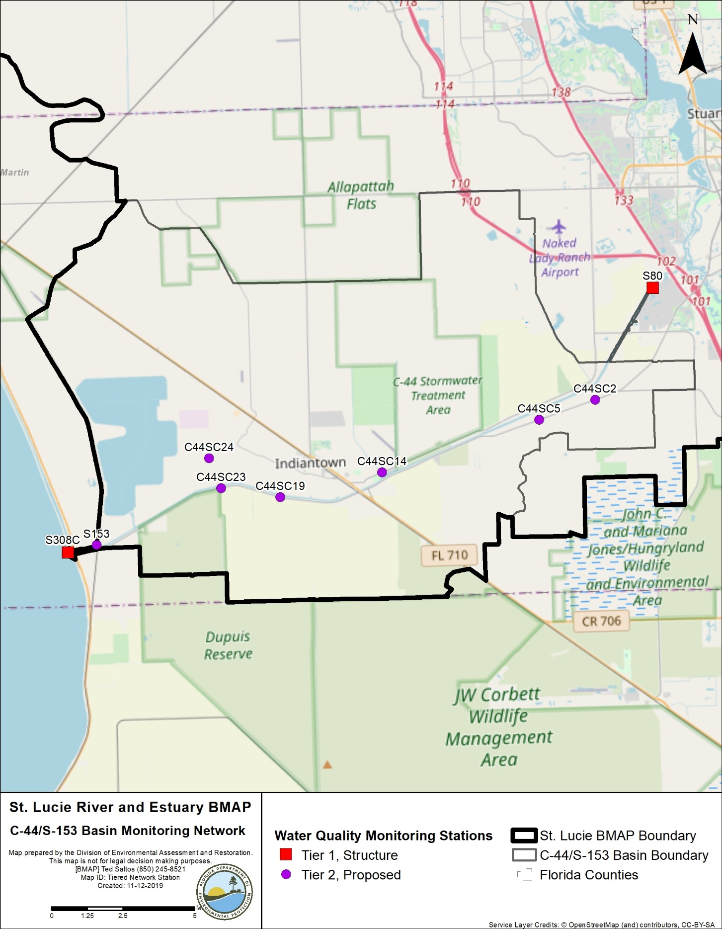
Figure 13. C-44/S-153 Basin monitoring stations

3.5.2. Basin Evaluation Results
Table 45 summarizes the basin evaluation results based on data from WY2014–WY2018 for the C-44/S-153 Basin. The current TN concentration is 1.432 mg/L, which is above the benchmark of 0.72 mg/L required to meet the TMDL. The current TP concentration is 0.214 mg/L, which is below the benchmark of 0.081 mg/L required to meet the TMDL. For these assessments, FWM concentrations were used because flow data were available at the S-80 structure. The FWM concentrations are 1.57 and 0.25 mg/L for TN and TP, respectively. The TN UAL is 16.74 lbs/ac, which is 122 % above the target UAL of 7.55 lbs/ac, and the TP UAL is 2.34 lbs/ac, which is 176 % above the target UAL of 0.85 lbs/ac. No significant trend was observed for TN or TP.
Table 46 lists the TRA prioritization results for the C-44/S-153 Basin, with 1 the highest priority, 2 the next highest priority, and 3 a priority as resources allow.
Table 45. Basin evaluation results for the C-44/S-153 Basin
Note: TN and TP loads from Lake Okeechobee are included as part of the evaluation for the C-44/S-153 basin.
TRA ID | Basin Name | TN (mg/L)  (Benchmark – 0.72) | TN FWM Concentration (mg/L) | TN UAL (lbs/ac) | TN Trend Analysis | TP (mg/L)  (Benchmark – 0.081) | TP FWM Concentration (mg/L) | TP UAL (lbs/ac) | TP Trend Analysis
5 | C-44/  S-153 | 1.432 | 1.57 | 16.74 | No significant trend | 0.214 | 0.25 | 2.34 | No significant trend

Table 46. TRA evaluation results for the C-44/S-153 Basin
Basin | Station | TN Priority | TP Priority
C-44/S-153 | S-80 | 1 | 1

3.5.3. Projects
The tables below summarize the existing and planned and future projects for the C-44/S-153 Basin that were provided for the BMAP. The existing and planned projects are a BMAP requirement, while future projects will be implemented as funding becomes available for project implementation. Appendix A provides additional details about the projects and the terms used in these tables.

3.5.3.1. Existing and Planned Projects
Table 47 summarizes the existing and planned projects provided by the stakeholders for the C-44/S-153 Basin.
Table 47. Existing and planned projects in the C-44/S-153 Basin
Notes: For projects with multiple basins listed in the "Basin" column, the nutrient reductions provided in the table are the total estimated for the project and not applicable to a specific basin.
Lead Entity | Partners | Project Number | Project Name | Project Description | Project Type | Project Status | Estimated Completion Date | TN Reduction (lbs/yr) | TP Reduction (lbs/yr) | Basin | Acres Treated | Cost Estimate | Cost Annual O&M | Funding Source | Funding Amount | DEP Contract Agreement Number
FDACS | Agricultural Producers | FDACS-05 | BMP Implementation and Verification | Enrollment and verification of BMPs by agricultural producers. Reductions based on WaSh model. Acres treated based on FDACS OAWP June 2019 Enrollment and FSAID VI. | Agricultural BMPs | Completed | N/A | 60,076 | 11,994 | C-44/S-153 | 48,803 | TBD | TBD | FDACS | TBD | N/A
FDACS | Agricultural Producers | FDACS-13 | Cost-share Projects | Cost-share projects paid for by FDACS. Acres treated based on FDACS OAWP June 2019 Enrollment. Reductions based on WaSh model. | Agricultural BMPs | Completed | N/A | 47,585 | 9,641 | C-44/S-153 | 9,017 | TBD | TBD | FDACS | TBD | N/A
FDACS | N/A | FDACS-19 | Credit for Changes in Land Use | Acreages and reductions based on a portion of differences between modeled agricultural land use coverage identified in Table B-13. DEP will estimate final numbers by next BMAP update. | Land Use Change | Completed | N/A | 188 | 1,106 | C-44/S-153 | 138 | N/A | N/A | N/A | N/A | N/A
FDOT District 4 | N/A | FDOT-18 | Street Sweeping | Not provided. | Street Sweeping | Completed | N/A | 1,419 | 910 | North Fork, Ten Mile Creek, C-24, C-23,  C-44/S-153, Basin 4/5, Basin 6, South Fork, South Coastal, South Mid-Estuary, North Mid-Estuary | N/A | Not provided | Not provided | Florida Legislature | Not provided | N/A
FDOT District 4 | N/A | FDOT-19 | Public Education | Pamphlets. | Education Efforts | Completed | N/A | 109 | 20 | North Fork, Ten Mile Creek, C-24, C-23,  C-44/S-153, Basin 4/5, Basin 6, South Fork, South Coastal, South Mid-Estuary, North Mid-Estuary | N/A | Not provided | Not provided | Florida Legislature | Not provided | N/A
FDOT District 4 | N/A | FDOT-41 | FM# 419250-2 SR 710 Bridge Replacement – 100A, 100B, and 200 | Big John Monahan Bridge replacement on SR 710 from SW Trail Dr. to east of SR 76 connector ramps. | Dry Detention Pond | Completed | 2015 | 8 | 1 | C-44/S-153 | 17 | Not provided | Not provided | Florida Legislature | Not provided | N/A
FDOT District 4 | N/A | FDOT-42 | FM# 419250-2 SR 710 Bridge Replacement – 300 and 500 | Big John Monahan Bridge replacement on SR 710 from SW Trail Dr. to east of SR 76 connector ramps. | Dry Detention Pond | Completed | 2015 | 16 | 3 | C-44/S-153 | 28 | Not provided | Not provided | Florida Legislature | Not provided | N/A
FDOT District 4 | N/A | FDOT-57 | Fertilizer Application Cessation | No longer routinely applying fertilizer. | Fertilizer Cessation | Completed | 2016 | 23,881 | 5,970 | North Fork, Ten Mile Creek, C-24, C-23,  C-44/S-153, Basin 4/5, Basin 6, South Fork, South Coastal, South Mid-Estuary, North Mid-Estuary | N/A | Not provided | Not provided | Florida Legislature | Not provided | N/A
FDOT District 4 | N/A | FDOT-58 | FM# 432705-1 | Road widening of SR 710 from north of Indiantown Rd to just south of bridge over C-44 Canal. | Grass swales without swale blocks or raised culverts | Underway | 2020 | 8 | 0 | C-44/S-153 | 121 | Not provided | Not provided | Florida Legislature | Not provided | N/A
FDOT District 4 | N/A | FDOT-59 | FM# 432705-1 | Road widening of SR 710 from north of Indiantown Rd to just south of C-44 Canal bridge. | Grass swales without swale blocks or raised culverts | Underway | 2020 | 3 | 1 | C-44/S-153 | 38 | Not provided | Not provided | Florida Legislature | Not provided | N/A
Hobe St. Lucie Conservancy District | Not provided | HSL-02 | Changes in Agricultural Land Uses | All land uses updated with new model. | Land Use Change | Canceled | 2013 | N/A | N/A | C-44/S-153, South Fork | N/A | N/A | N/A | N/A | N/A | N/A
Hobe St. Lucie Conservancy District | Not provided | HSL-03 | 90% Implementation Agricultural BMPs | All agricultural BMP enrollment now included in FDACS-01. | Agricultural BMPs | Canceled | 2013 | N/A | N/A | C-44/S-153, South Fork | N/A | N/A | N/A | N/A | N/A | N/A
Martin County | SFWMD | MC-17 | Danforth Creek – Phase 1 | 8.1-acre wet detention pond with littoral plantings and control structure. | Regional Stormwater Treatment | Completed | 2014 | 6,132 | 2,266 | C-44/S-153, Basin 4/5, Basin 6, South Fork | 2,459 | $1,869,255 | Not provided | SFWMD | $1,035,515 | N/A
Martin County | N/A | MC-18 | Street Sweeping | Not provided. | Street Sweeping | Completed | N/A | 108 | 69 | North Fork, C-23,  C-44/S-153, Basin 4/5, Basin 6, South Fork, South Coastal, South Mid-Estuary, North Mid-Estuary | N/A | Not provided | Not provided | Not provided | Not provided | N/A
Martin County | N/A | MC-20 | Education Program | FYN; landscaping, irrigation, fertilizer, and pet waste ordinances; PSAs, pamphlets, website, illicit discharge program. | Education Efforts | Completed | N/A | 16,644 | 2,831 | North Fork, C-23,  C-44/S-153, Basin 4/5, Basin 6, South Fork, South Coastal, South Mid-Estuary, North Mid-Estuary | N/A | Not provided | Not provided | County | $60,000 | N/A
Martin County | FDACS | MC-32 | Danforth Creek HWTT | Not provided. | HWTT | Completed | 2016 | 5,312 | 1,287 | C-44/S-153, Basin 4/5, Basin 6, South Fork | 2,419 | $3,000,000 | Not provided | FDACS | $3,000,000 | N/A
Pal Mar WCD | Not provided | PM-01 | 90% Implementation Agricultural BMPs | All agricultural BMP enrollment now included in FDACS-01. | Agricultural BMPs | Canceled | N/A | N/A | N/A | C-44/S-153 | N/A | N/A | N/A | N/A | N/A | N/A
Troup-Indiantown WCD | N/A | TI-01 | C-44 Conservation Area | Not provided. | Land Preservation | Completed | 2013 | 23,199 | 7,497 | C-44/S-153 | 9,135 | N/A | N/A | Not provided | Not provided | N/A
Troup-Indiantown WCD | N/A | TI-02 | 90% Implementation Agricultural BMPs | All agricultural BMP enrollment now included in FDACS-01. | Agricultural BMPs | Canceled | 2013 | N/A | N/A | C-44/S-153 | N/A | N/A | N/A | N/A | N/A | N/A
Troup-Indiantown WCD | N/A | TI-03 | Removal of Drainage Areas | Minute Maid Rd. drainage improvements. | 100% On-Site Retention | Completed | 2013 | TBD | TBD | C-44/S-153 | 73 | $124,000 | N/A | WCD | Not provided | N/A
Troup-Indiantown WCD | SFWMD/ USACE | TI-04 | C-44 Reservoir Area | Converting from conservation area to reservoir. | Land Use Change | Underway | 2018 | N/A | N/A | C-44/S-153, Basin 4/5, Basin 6 | 3,485 | N/A | N/A | USACE | Not provided | N/A
Troup-Indiantown WCD | SFWMD/ USACE | TI-05 | C-44 STA Area | Converting from conservation area to STA. | Land Use Change | Underway | 2018 | N/A | N/A | C-44/S-153, Basin 4/5, Basin 6 | 6,100 | N/A | N/A | SFMWD | Not provided | N/A
Coordinating Agency | N/A | CA-02 | IRL-South | C-44 Reservoir/STA will capture, store and treat runoff from C-44/S-153 Basin prior to discharge to estuary. Reservoir will provide 50,600 ac-ft of water storage. Two reservoirs and STA in C-23/C-24 Basins also planned to treat 92,000 ac-ft of runoff. The STA will be completed in 2020, and the reservoir in 2022. | Regional Stormwater Treatment | Underway | 2022 | 187,393 | 74,957 | Ten Mile Creek,  C-24, C-23, C-44/S-153 | 10,700
Coordinating Agency | N/A | CA-08 | Caulkins Water Farm Expansion | Public-private partnership that actively stores local stormwater runoff as well as water from Lake Okeechobee regulatory releases on 3,275 acres of privately owned land along C-44 Canal. Project is estimated to provide net annual average water storage benefit of 60,000 ac-ft/yr. | DWM | Completed | 2017 | 123,238 | 16,755 | C-44/S-153 | 3,275

3.5.3.2. Future Projects
No future projects were provided by the stakeholders for the C-44/S-153 Basin.

3.6. Basin 4/5
Basin 4/5 covers 12,009 acres of the St. Lucie River and Estuary Watershed. As shown in Table 48, urban and built up land uses are the primary land use in the basin, comprising 48.6 % of the land, followed by agriculture, which represents 18.2 % of the basin. Stakeholders in the basin include FDOT, Martin County, and Florida Turnpike Authority.
Table 48. Summary of land uses in Basin 4/5
Level 1 Land Use Code | Land Use Description | Acres | % Total
1000 | Urban and Built-Up | 5,834 | 48.6
2000 | Agriculture | 2,190 | 18.2
3000 | Upland Nonforested | 239 | 2.0
4000 | Upland Forests | 1,794 | 14.9
5000 | Water | 394 | 3.3
6000 | Wetlands | 1,066 | 8.9
7000 | Barren Land | 47 | 0.4%
8000 | Transportation, Communication, and Utilities | 445 | 3.7
 | Total | 12,009 | 100

3.6.1. Water Quality Monitoring
Table 49 summarizes the water quality monitoring stations in Basin 4/5, and Figure 1 shows the station locations.
Table 49. Water quality monitoring stations in Basin 4/5
Basin | Representative Site? | Entity | Station ID | Tier
Basin 4/5 | Yes | SFWMD | SLT-9 | 2

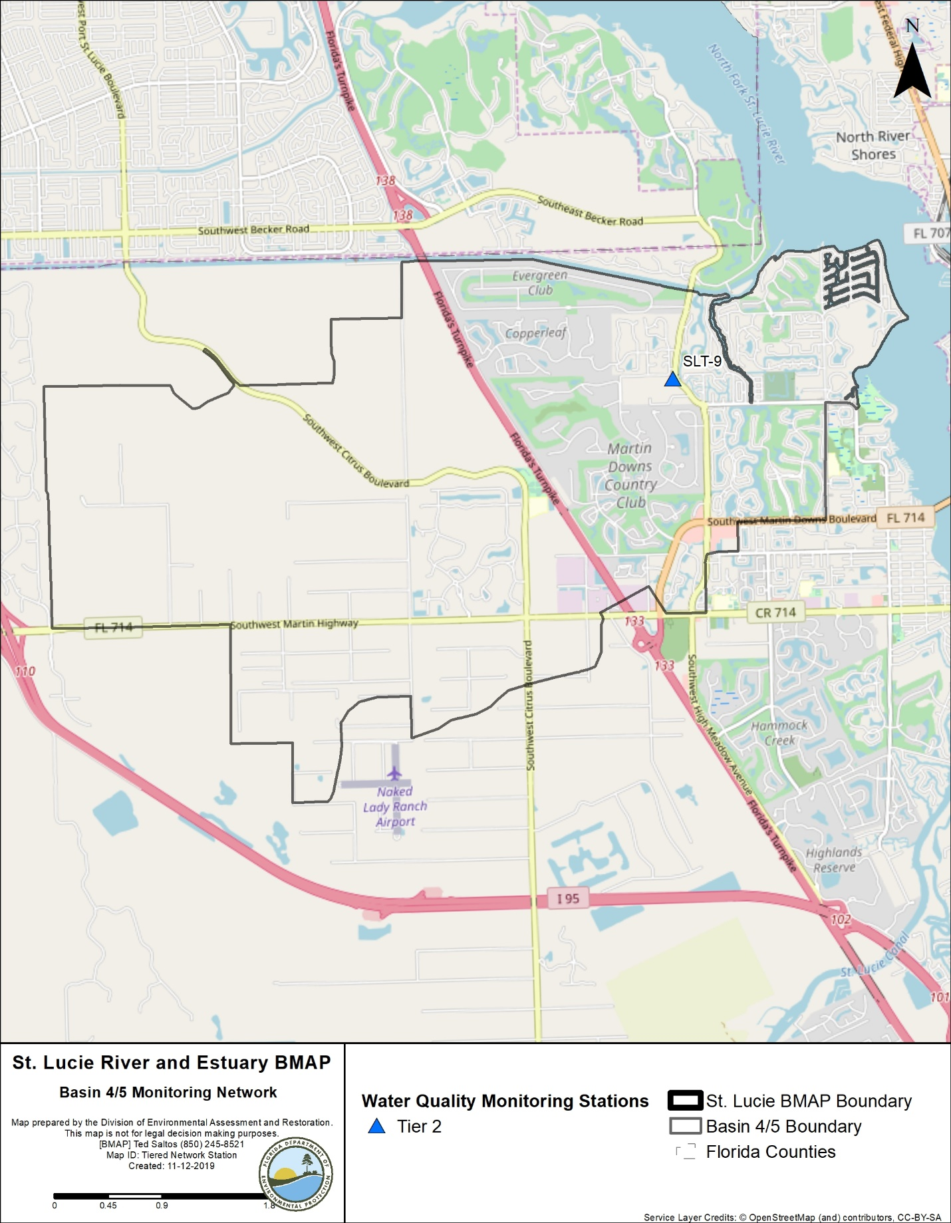
Figure 14. Basin 4/5 monitoring stations

3.6.2. Basin Evaluation Results
Table 50 summarizes the basin evaluation results based on data from WY2014–WY2018 for Basin 4/5. The current TN concentration is 1.02 mg/L, which is above the benchmark of 0.72 mg/L required to meet the TMDL. The current TP concentration is 0.197 mg/L, which is below the benchmark of 0.081 mg/L required to meet the TMDL. No FWM concentrations were calculated for this basin. No significant trend was detected for TN or TP concentration changes over time.
Table 51 lists the TRA prioritization results for Basin 4/5, with 1 the highest priority, 2 the next highest priority, and 3 a priority as resources allow.
Table 50. Basin evaluation results for Basin 4/5
TRA ID | Basin Name | TN (mg/L)  (Benchmark – 0.72) | TN FWM Concentration (mg/L) | TN UAL (lbs/ac) | TN Trend Analysis | TP (mg/L)  (Benchmark – 0.081) | TP FWM Concentration (mg/L) | TP UAL (lbs/ac) | TP Trend Analysis
6 | Basin 4/5 | 1.02 | N/A | N/A | No significant trend | 0.197 | N/A | N/A | No significant trend

Table 51. TRA evaluation results for Basin 4/5
Basin | Station | TN Priority | TP Priority
Basin 4/5 | SLT-9 | 2 | 1

3.6.3. Projects
The tables below summarize the existing and planned and future projects for Basin 4/5 that were provided for the BMAP. The existing and planned projects are a BMAP requirement, while future projects will be implemented as funding becomes available for project implementation. Appendix A provides additional details about the projects and the terms used in these tables.

3.6.3.1. Existing and Planned Projects
Table 52 summarizes the existing and planned projects provided by the stakeholders for Basin 4/5.
Table 52. Existing and planned projects in the Basin 4/5 Basin
Notes: For projects with multiple basins listed in the "Basin" column, the nutrient reductions provided in the table are the total estimated for the project and not applicable to a specific basin.
Lead Entity | Partners | Project Number | Project Name | Project Description | Project Type | Project Status | Estimated Completion Date | TN Reduction (lbs/yr) | TP Reduction (lbs/yr) | Basin | Acres Treated | Cost Estimate | Cost Annual O&M | Funding Source | Funding Amount | DEP Contract Agreement Number
FDACS | Agricultural Producers | FDACS-06 | BMP Implementation and Verification | Enrollment and verification of BMPs by agricultural producers. Reductions based on WaSh model. Acres treated based on FDACS OAWP June 2019 Enrollment and FSAID VI. | Agricultural BMPs | Completed | N/A | 159 | 40 | Basin 4/5 | 78 | TBD | TBD | FDACS | TBD | N/A
FDOT District 4 | N/A | FDOT-13 | FM# 228831-1 | Bridge replacement at SR 714 crossing over Florida's Turnpike. | Dry Detention Pond | Completed | 2000 | 7 | 1 | Basin 4/5, Basin 6 | 9 | Not provided | Not provided | Florida Legislature | Not provided | N/A
FDOT District 4 | N/A | FDOT-18 | Street Sweeping | Not provided. | Street Sweeping | Completed | N/A | 1,419 | 910 | North Fork, Ten Mile Creek, C-24, C-23,  C-44/S-153, Basin 4/5, Basin 6, South Fork, South Coastal, South Mid-Estuary, North Mid-Estuary | N/A | Not provided | Not provided | Florida Legislature | Not provided | N/A
FDOT District 4 | N/A | FDOT-19 | Public Education | Pamphlets. | Education Efforts | Completed | N/A | 109 | 20 | North Fork, Ten Mile Creek, C-24, C-23,  C-44/S-153, Basin 4/5, Basin 6, South Fork, South Coastal, South Mid-Estuary, North Mid-Estuary | N/A | Not provided | Not provided | Florida Legislature | Not provided | N/A
FDOT District 4 | N/A | FDOT-49 | 230978-2 CR 714 Martin Highway Widening – Danforth Basin | Road widening on CR 714 (Martin Hwy.) from east of Turnpike to just west of Mapp Rd. | Wet Detention Pond | Completed | 2016 | 15 | 5 | Basin 4/5, Basin 6 | 17 | Not provided | Not provided | Florida Legislature | Not provided | N/A
FDOT District 4 | N/A | FDOT-57 | Fertilizer Application Cessation | No longer routinely applying fertilizer. | Fertilizer Cessation | Completed | 2016 | 23,881 | 5,970 | North Fork, Ten Mile Creek, C-24, C-23,  C-44/S-153, Basin 4/5, Basin 6, South Fork, South Coastal, South Mid-Estuary, North Mid-Estuary | N/A | Not provided | Not provided | Florida Legislature | Not provided | N/A
Martin County | N/A | MC-16 | Septic to Central Sewer Conversions | 1,121 single-family and multifamily residential and commercial units in 5 neighborhoods. | OSTDS Phase Out | Completed | 2014 | 15,386 | N/A | North Fork, Basin 4/5, North Mid-Estuary | N/A | $28,678,946 | Not provided | NEEPP – North River Shores neighborhood | Not provided | N/A
Martin County | SFWMD | MC-17 | Danforth Creek – Phase 1 | 8.1-acre wet detention pond with littoral plantings and control structure. | Regional Stormwater Treatment | Completed | 2014 | 6,132 | 2,266 | C-44/S-153, Basin 4/5, Basin 6, South Fork | 2,459 | $1,869,255 | Not provided | SFWMD | $1,035,515 | N/A
Martin County | N/A | MC-18 | Street Sweeping | Not provided. | Street Sweeping | Completed | N/A | 108 | 69 | North Fork, C-23,  C-44/S-153, Basin 4/5, Basin 6, South Fork, South Coastal, South Mid-Estuary, North Mid-Estuary | N/A | Not provided | Not provided | Not provided | Not provided | N/A
Martin County | N/A | MC-19 | Baffle Box and Structure Cleanout | Not provided. | Catch Basin Inserts/Inlet Filter Cleanout | Completed | N/A | 397 | 161 | Basin 4/5, Basin 6, South Fork, South Coastal, South Mid-Estuary, North Mid-Estuary | N/A | Not provided | Not provided | Not provided | Not provided | N/A
Martin County | N/A | MC-20 | Education Program | FYN; landscaping, irrigation, fertilizer, and pet waste ordinances; PSAs, pamphlets, website, illicit discharge program. | Education Efforts | Completed | N/A | 16,644 | 2,831 | North Fork, C-23,  C-44/S-153, Basin 4/5, Basin 6, South Fork, South Coastal, South Mid-Estuary, North Mid-Estuary | N/A | Not provided | Not provided | County | $60,000 | N/A
Martin County | N/A | MC-30 | Old Palm City Beemats | Not provided. | Floating Islands/ Managed Aquatic Plant System (MAPS) | Completed | 2013 | TBD | TBD | Basin 4/5, Basin 6, South Fork, South Coastal, South Mid-Estuary, North Mid-Estuary | N/A | $21,996 | Not provided | Not provided | Not provided | N/A
Martin County | FDACS | MC-31 | Bessey Creek HWTT | Not provided. | HWTT | Completed | 2015 | 6,081 | 1,473 | C-23, Basin 4/5 | 2,675 | $3,000,000 | Not provided | FDACS | $3,000,000 | N/A
Martin County | FDACS | MC-32 | Danforth Creek HWTT | Not provided. | HWTT | Completed | 2016 | 5,312 | 1,287 | C-44/S-153, Basin 4/5, Basin 6, South Fork | 2,419 | $3,000,000 | Not provided | FDACS | $3,000,000 | N/A
Turnpike Enterprise | N/A | T-04 | Education Program | No fertilizer on rights-of-way, educational signage, illicit discharge training. | Education Efforts | Completed | N/A | 268 | 45 | North Fork, Basin 4/5, South Fork | N/A | Not provided | N/A | Not provided | Not provided | N/A
Turnpike Enterprise | N/A | T-05 | Street Sweeping | 1,944 lane miles swept and 28,323 lbs (or 12,847 kg) of debris collected. | Street Sweeping | Completed | N/A | 144 | 10 | North Fork, Basin 4/5, South Fork | N/A | Not provided | N/A | Not provided | Not provided | N/A
Troup-Indiantown WCD | SFWMD/ USACE | TI-04 | C-44 Reservoir Area | Converting from conservation area to reservoir. | Land Use Change | Underway | 2018 | N/A | N/A | C-44/S-153, Basin 4/5, Basin 6 | 3,485 | N/A | N/A | USACE | Not provided | N/A
Troup-Indiantown WCD | SFWMD/ USACE | TI-05 | C-44 STA Area | Converting from conservation area to STA. | Land Use Change | Underway | 2018 | N/A | N/A | C-44/S-153, Basin 4/5, Basin 6 | 6,100 | N/A | N/A | SFMWD | Not provided | N/A

3.6.3.2. Future Projects
No future projects were provided by the stakeholders for Basin 4/5.

3.7. Basin 6
Basin 6 covers 3,927 acres of the St. Lucie River and Estuary Watershed. Most of the basin is urban and built-up land, followed by urban forest and agriculture. As shown in Table 53, urban and built-up land uses make up much of the acreage in the basin. Stakeholders in the basin include FDOT, Martin County, and Florida Turnpike Authority.
Table 53. Summary of land uses in Basin 6
Level 1 Land Use Code | Land Use Description | Acres | % Total
1000 | Urban and Built-Up | 2,540 | 64.7
2000 | Agriculture | 456 | 11.6
3000 | Upland Nonforested | 47 | 1.2
4000 | Upland Forests | 512 | 13.0
5000 | Water | 34 | 0.9
6000 | Wetlands | 184 | 4.7
7000 | Barren Land | 12 | 0.3
8000 | Transportation, Communication, and Utilities | 142 | 3.6
 | Total | 3,927 | 100

3.7.1. Water Quality Monitoring
Table 54 summarizes the water quality monitoring stations in Basin 6, and Figure 15 shows the station locations.
Table 54. Water quality monitoring stations in Basin 6
Basin | Representative Site? | Entity | Station ID | Tier
Basin 6 | Yes | SFWMD | SLT-7 | 2

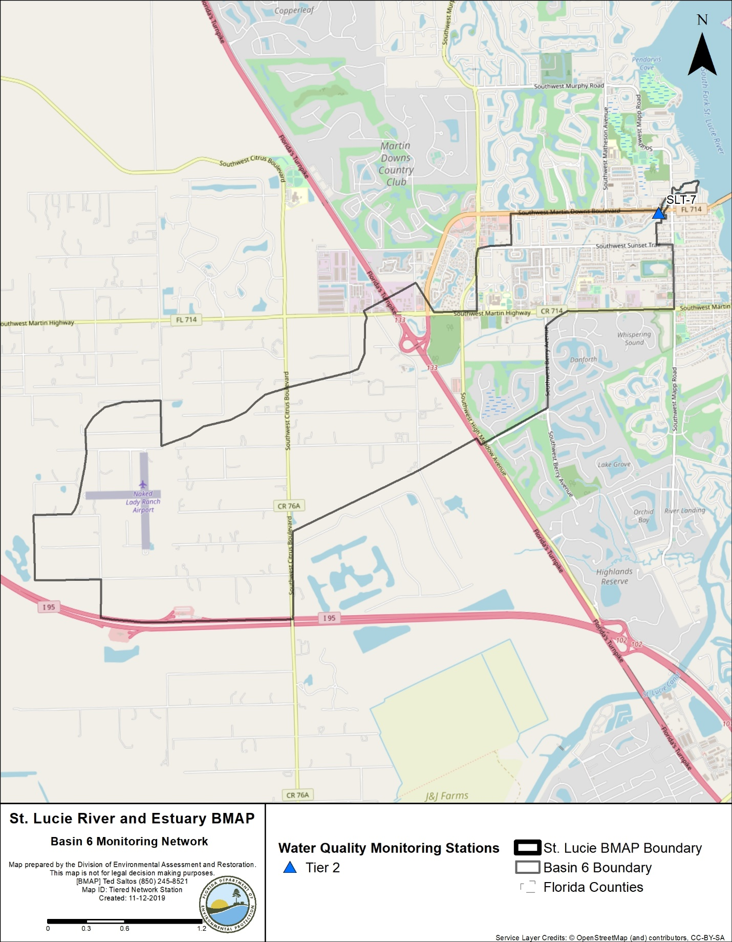
Figure 15. Basin 6 monitoring stations

3.7.2. Basin Evaluation Results
Table 55 summarizes the basin evaluation results based on data from WY2014–WY2018 for Basin 6. The current TN concentration is 1.02 mg/L, which is above the benchmark of 0.72 mg/L required to meet the TMDL. The current TP concentration is 0.151 mg/L, which is below the benchmark of 0.081 mg/L required to meet the TMDL. No FWM concentrations were calculated for this basin. No significant trend was detected for changes in TN or TP concentrations over time.
Table 56 lists the TRA prioritization results for Basin 6, with 1 the highest priority, 2 the next highest priority, and 3 a priority as resources allow.
Table 55. Basin evaluation results for Basin 6
TRA ID | Basin Name | TN (mg/L)  (Benchmark – 0.72) | TN FWM Concentration (mg/L) | TN UAL (lbs/ac) | TN Trend Analysis | TP (mg/L)  (Benchmark – 0.081) | TP FWM Concentration (mg/L) | TP UAL (lbs/ac) | TP Trend Analysis
7 | Basin 6 | 1.02 | N/A | N/A | No significant trend | 0.151 | N/A | N/A | No significant trend

Table 56. TRA evaluation results for Basin 6
Basin | Station | TN Priority | TP Priority
Basin 6 | SLT-7 | 2 | 2

3.7.3. Projects
The tables below summarize the existing and planned and future projects for Basin 6 that were provided for the BMAP. The existing and planned projects are a BMAP requirement, while future projects will be implemented as funding becomes available for project implementation. Appendix A provides additional details about the projects and the terms used in these tables.

3.7.3.1 Existing and Planned Projects
Table 57 summarizes the existing and planned projects provided by the stakeholders for Basin 6.
Table 57. Existing and planned projects in Basin 6
Notes: For projects with multiple basins listed in the "Basin" column, the nutrient reductions provided in the table are the total estimated for the project and not applicable to a specific basin.
Lead Entity | Partners | Project Number | Project Name | Project Description | Project Type | Project Status | Estimated Completion Date | TN Reduction (lbs/yr) | TP Reduction (lbs/yr) | Basin | Acres Treated | Cost Estimate | Cost Annual O&M | Funding Source | Funding Amount | DEP Contract Agreement Number
FDACS | Agricultural Producers | FDACS-07 | BMP Implementation and Verification | Enrollment and verification of BMPs by agricultural producers. Reductions based on WaSh model. Acres treated based on FDACS OAWP June 2019 Enrollment and FSAID VI. | Agricultural BMPs | Completed | N/A | 10 | 3 | Basin 6 | 19 | TBD | TBD | FDACS | TBD | N/A
FDOT | N/A | FDOT-13 | FM# 228831-1 | Bridge replacement at SR 714 crossing over Florida's Turnpike. | Dry Detention Pond | Completed | 2000 | 3.0 | 1.0 | Basin 4/5, Basin 6 | 9.00 | Not provided | Not provided | Florida Legislature | Not provided | N/A
FDOT | N/A | FDOT-15 | FM# 405504-1 | SR 9 rest area improvements. | Dry Detention Pond | Completed | 2005 | 24.0 | 5.0 | Basin 6, South Fork | 54.00 | Not provided | Not provided | Florida Legislature | Not provided | N/A
FDOT | N/A | FDOT-18 | Street Sweeping | Not provided. | Street Sweeping | Completed | N/A | 1,419.0 | 910.0 | North Fork, Ten Mile Creek, C-24, C-23, C-44/  S-153, Basin 4/5, Basin 6, South Fork, South Coastal, South Mid-Estuary, North Mid-Estuary | N/A | Not provided | Not provided | Florida Legislature | Not provided | N/A
FDOT | N/A | FDOT-19 | Public Education | Pamphlets. | Education Efforts | Completed | N/A | 31.0 | 6.0 | North Fork, Ten Mile Creek, C-24, C-23, C-44/  S-153, Basin 4/5, Basin 6, South Fork, South Coastal, South Mid-Estuary, North Mid-Estuary | N/A | Not provided | Not provided | Florida Legislature | Not provided | N/A
FDOT | N/A | FDOT-21 | FM# 230978-1 Indian St. Bridge (Pond West) | New bridge crossing on CR 714 from west of Mapp Rd. to east of SR 76 on Indian St. | Wet Detention Pond | Completed | 2014 | 0.1 |  | Basin 6, South Fork | 34.00 | Not provided | Not provided | Florida Legislature | Not provided | N/A
FDOT | N/A | FDOT-49 | 230978-2 CR 714 Martin Highway Widening – Danforth Basin | Road widening on CR 714 (Martin Hwy.) from east of Turnpike to just west of Mapp Rd. | Wet Detention Pond | Completed | 2016 | 3.0 | 4.0 | Basin 4/5, Basin 6 | 17.00 | Not provided | Not provided | Florida Legislature | Not provided | N/A
FDOT | N/A | FDOT-50 | 230978-2 CR 714 Martin Hwy. Widening – Wetlands Basin | Road widening on CR 714 (Martin Hwy.) from east of Turnpike to just west of Mapp Rd. | Wet Detention Pond | Completed | 2016 | 2.0 | 2.0 | Basin 6, South Fork | 12.00 | Not provided | Not provided | Florida Legislature | Not provided | N/A
FDOT | N/A | FDOT-57 | Fertilizer Application Cessation | No longer routinely applying fertilizer. | Fertilizer Cessation | Completed | 2016 | TBD | TBD | North Fork, Ten Mile Creek, C-24, C-23, C-44/  S-153, Basin 4/5, Basin 6, South Fork, South Coastal, South Mid-Estuary, North Mid-Estuary | N/A | Not provided | Not provided | Florida Legislature | Not provided | N/A
Martin County | SFWMD/ DEP/ FEMA | MC-12 | Old Palm City Water Quality Retrofit Phases I, II, and III | 8.1 ac-ft of water quality treatment (0.51 inches). | BMP Treatment Train | Completed | 2004 | 244.0 | 96.0 | Basin 6, South Fork | 141.00 | $4,576,473.00 | Not provided | DEP/ SFWMD/ FEMA | DEP – $851,156/ SFWMD – $1,200,000/ FEMA – $593,553 | G0034/ OT060148
Martin County | SFWMD | MC-17 | Danforth Creek – Phase 1 | 8.1-acre wet detention pond with littoral plantings and control structure. | Regional Stormwater Treatment | Completed | 2014 | 2,435.0 | 1,011.0 | C-44/S-153, Basin 4/5, Basin 6, South Fork | 2,459.00 | $1,869,255.00 | Not provided | SFWMD | $1,035,515 | N/A
Martin County | N/A | MC-18 | Street Sweeping | Not provided. | Street Sweeping | Completed | N/A | 119.0 | 76.0 | North Fork, C-23, C-44/  S-153, Basin 4/5, Basin 6, South Fork, South Coastal, South Mid-Estuary, North Mid-Estuary | N/A | Not provided | Not provided | Not provided | Not provided | N/A
Martin County | N/A | MC-19 | Baffle Box and Structure Cleanout | Not provided. | Catch Basin Inserts/Inlet Filter Cleanout | Completed | N/A | 266.0 | 163.0 | Basin 4/5, Basin 6, South Fork, South Coastal, South Mid-Estuary | N/A | Not provided | Not provided | Not provided | Not provided | N/A
Martin County | N/A | MC-20 | Education Program | FYN; landscaping, irrigation, fertilizer, and pet waste ordinances; PSAs, pamphlets, website, illicit discharge program. | Education Efforts | Completed | N/A | 6,049.0 | 1,342.0 | North Fork, C-23, C-44/S-153, Basin 4/5, Basin 6, South Fork, South Coastal, South Mid-Estuary, North Mid-Estuary | N/A | Not provided | Not provided | County | $60,000 | N/A
Martin County | FDOT | MC-22 | FM# 230978-1 Indian St. Bridge (Pond West) | Not provided. | Wet Detention Pond | Completed | 2014 | TBD | TBD | Basin 6, South Fork | 34.00 | Not provided | Not provided | Not provided | Not provided | N/A
Martin County | N/A | MC-30 | Old Palm City Beemats | Not provided. | MAPS | Completed | 2013 | TBD | TBD | Basin 4/5, Basin 6, South Fork, South Coastal, South Mid-Estuary, North Mid-Estuary | N/A | $21,996.00 | Not provided | Not provided | Not provided | N/A
Martin County | FDACS | MC-32 | Danforth Creek HWTT | Not provided. | HWTT | Completed | 2016 | 5,274.0 | 1,281.0 | C-44/S-153, Basin 4/5, Basin 6, South Fork | 2,419.00 | $3,000,000.00 | Not provided | FDACS | $3,000,000 | N/A
Martin County | DEP | MC-37 | All American Ditch | Not provided. | Regional Stormwater Treatment | Completed | 2016 | 428.0 | 169.3 | Basin 6, South Fork | 268.00 | $5,165,376.00 | Not provided | DEP | $3,000,000 | S0758/ G0414
Turnpike Authority | N/A | T-04 | Education Program | No fertilizer on rights-of-way, educational signage, illicit discharge training. | Education Efforts | Completed | N/A | TBD | TBD | North Fork, C-44/S-153, Basin 4/5, Basin 6 | N/A | Not provided | N/A | Not provided | Not provided | N/A
Turnpike Authority | N/A | T-05 | Street Sweeping | 1,944 lane miles swept and 28,323 lbs (or 12,847 kg) of debris collected. | Street Sweeping | Completed | N/A | 144.0 | 10.0 | North Fork, C-44/S-153, Basin 4/5, Basin 6 | N/A | Not provided | N/A | Not provided | Not provided | N/A

3.7.3.2. Future Projects
No future projects were provided by the stakeholders for Basin 6.

3.8. South Fork Basin
The South Fork Basin covers 48,155 acres of the St. Lucie River and Estuary Watershed. As shown in Table 58, most of the land use comprises urban and built-up as well as agriculture. Stakeholders in the basin include FDOT, Hobe St. Lucie Conservancy District, Martin County, City of Stuart, and Florida Turnpike Authority.
Table 58. Summary of land uses in the South Fork Basin
Level 1 Land Use Code | Land Use Description | Acres | % Total
1000 | Urban and Built-Up | 12,857 | 26.7
2000 | Agriculture | 16,826 | 34.9
3000 | Upland Nonforested | 2,003 | 4.2
4000 | Upland Forests | 7,550 | 15.7
5000 | Water | 1,333 | 2.8
6000 | Wetlands | 6,360 | 13.2
7000 | Barren Land | 153 | 0.3
8000 | Transportation, Communication, and Utilities | 1,073 | 2.2
 | Total | 48,155 | 100

3.8.1. Water Quality Monitoring
Table 59 summarizes the water quality monitoring stations in the South Fork Basin, and Figure 16 shows the station locations.
Table 59. Water quality monitoring stations in the South Fork Basin
Basin | Representative Site? | Entity | Station ID | Tier
South Fork | Yes | SFWMD | SLT-31 | 2
South Fork | Yes | SFWMD | SLT-34A | 2
South Fork | Yes | SFWMD | SLT-6 | 2
South Fork | Yes | SFWMD | SLT-5 | 2
South Fork | Yes | SFWMD | SLT-4 | 2
South Fork | Yes | SFWMD | SLT-3 | 2
South Fork | Yes | SFWMD | SLT-40, 40A | 2
South Fork | Yes | SFWMD | SLT-2A | 2
South Fork | Yes | SFWMD | SLT-1 | 2
South Fork | No | SFWMD | SE-08B | 1
South Fork | No | SFWMD | SE-09 | 1

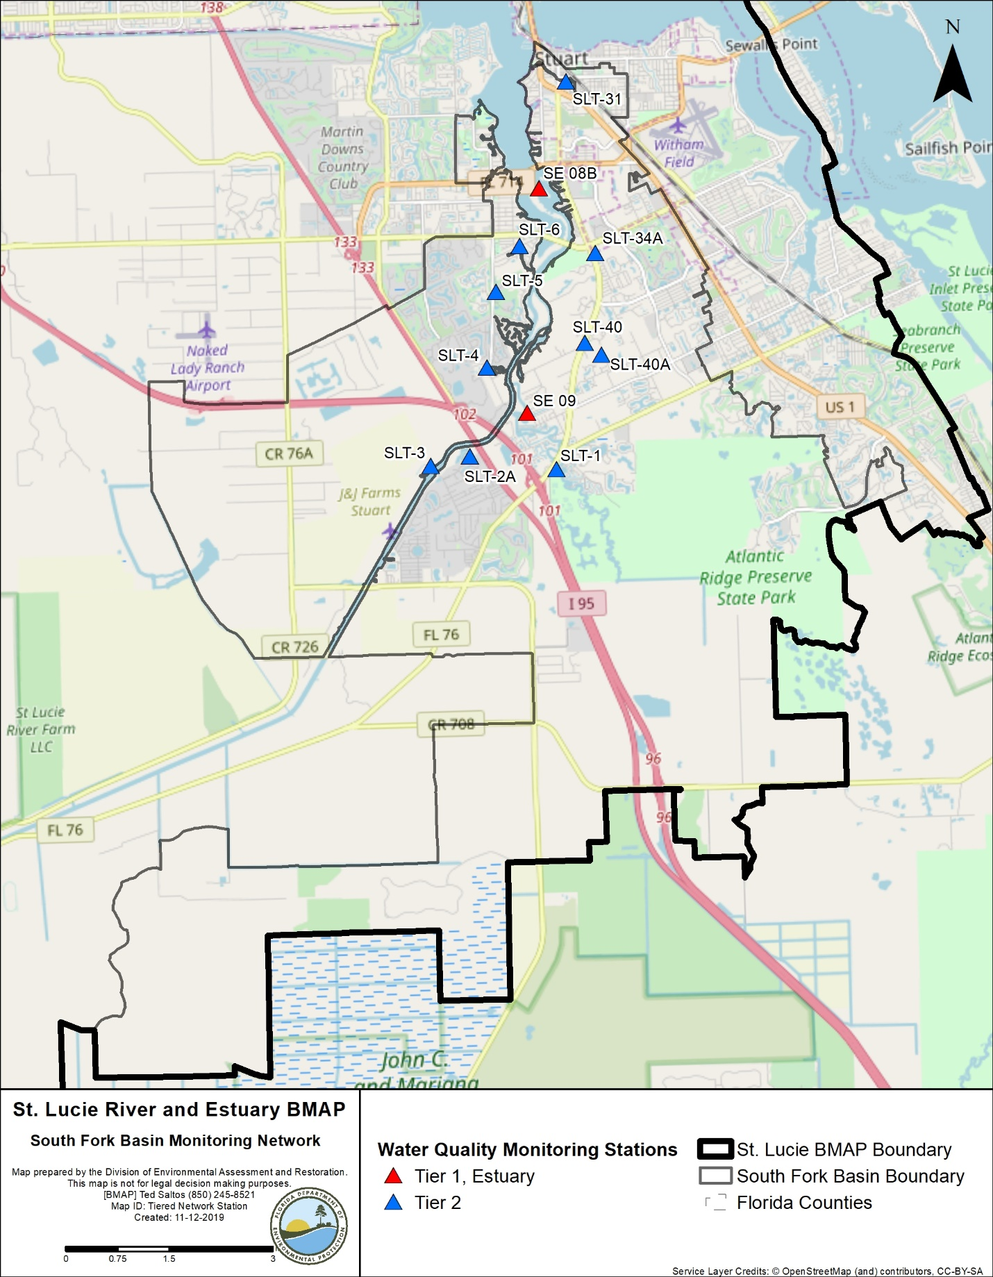
Figure 16. South Fork Basin monitoring stations

3.8.2. Basin Evaluation Results
Table 60 summarizes the basin evaluation results based on data from WY2014–WY2018 for the South Fork Basin. The current TN concentration is 1.07 mg/L, which is above the benchmark of 0.72 mg/L required to meet the TMDL. The current TP concentration is 0.131 mg/L, which is below the benchmark of 0.081 mg/L required to meet the TMDL. No FWM concentrations were calculated for this basin. No significant trend was detected for TN or TP concentration changes over time.
Table 61 lists the TRA prioritization results for the South Fork Basin, with 1 the highest priority, 2 the next highest priority, and 3 a priority as resources allow.
Table 60. Basin evaluation results for the South Fork Basin
TRA ID | Basin Name | TN (mg/L)  (Benchmark – 0.72) | TN FWM Concentration (mg/L) | TN UAL (lbs/ac) | TN Trend Analysis | TP (mg/L)  (Benchmark – 0.081) | TP FWM Concentration (mg/L) | TP UAL (lbs/ac) | TP Trend Analysis
8 | South Fork | 1.07 | N/A | N/A | No significant trend | 0.131 | N/A | N/A | No significant trend

Table 61. TRA evaluation results for the South Fork Basin
Basin | Stations | TN Priority | TP Priority
South Fork | SLT-1, SLT-2A, SLT-3, SLT-4, SLT-5, SLT-6, SLT-31, SLT-34A, SLT-40, SLT-40A | 2 | 2

3.8.3. Projects
The tables below summarize the existing and planned and future projects for South Fork Basin that were provided for the BMAP. The existing and planned projects are a BMAP requirement, while future projects will be implemented as funding becomes available for project implementation. Appendix A provides additional details about the projects and the terms used in these tables.

3.8.3.1 Existing and Planned Projects
Table 62 summarizes the existing and planned projects provided by the stakeholders for the South Fork Basin.
Table 62. Existing and planned projects in the South Fork Basin
Notes: For projects with multiple basins listed in the "Basin" column, the nutrient reductions provided in the table are the total estimated for the project and not applicable to a specific basin.
Lead Entity | Partners | Project Number | Project Name | Project Description | Project Type | Project Status | Estimated Completion Date | TN Reduction (lbs/yr) | TP Reduction (lbs/yr) | Basin | Acres Treated | Cost Estimate | Cost Annual O&M | Funding Source | Funding Amount | DEP Contract Agreement Number
FDACS | Agricultural Producers | FDACS-08 | BMP Implementation and Verification | Enrollment and verification of BMPs by agricultural producers. Reductions based on WaSh model. Acres treated based on FDACS OAWP June 2019 enrollment and FSAID VI. | Agricultural BMPs | Completed | N/A | 10,839 | 2,057 | South Fork | 8,550 | TBD | TBD | FDACS | TBD | N/A
FDACS | Agricultural Producers | FDACS-14 | Cost-share Projects | Cost-share projects paid for by FDACS. Acres treated based on FDACS OAWP June 2019 Enrollment. Reductions based on WaSh model. | Agricultural BMPs | Completed | N/A | 11,934 | 2,678 | South Fork | 1,947 | TBD | TBD | FDACS | TBD | N/A
FDACS | N/A | FDACS-20 | Credit for Changes in Land Use | Acreages and reductions based on a portion of differences between modeled agricultural land use coverage identified in Table B-13. DEP will estimate final numbers by next BMAP update. | Land Use Change | Completed | N/A | 1,827 | 346 | South Fork | 294 | N/A | N/A | N/A | N/A | N/A
FDOT District 4 | N/A | FDOT-15 | FM# 405504-1 | SR 9 rest area improvements. | Dry Detention Pond | Completed | 2005 | 40 | 6 | Basin 6, South Fork | 54 | Not provided | Not provided | Florida Legislature | Not provided | N/A
FDOT District 4 | N/A | FDOT-18 | Street Sweeping | Not provided. | Street Sweeping | Completed | N/A | 1,419 | 910 | North Fork, Ten Mile Creek, C-24, C-23,  C-44/S-153, Basin 4/5, Basin 6, South Fork, South Coastal, South Mid-Estuary, North Mid-Estuary | N/A | Not provided | Not provided | Florida Legislature | Not provided | N/A
FDOT District 4 | N/A | FDOT-19 | Public Education | Pamphlets. | Education Efforts | Completed | N/A | 109 | 20 | North Fork, Ten Mile Creek, C-24, C-23,  C-44/S-153, Basin 4/5, Basin 6, South Fork, South Coastal, South Mid-Estuary, North Mid-Estuary | N/A | Not provided | Not provided | Florida Legislature | Not provided | N/A
FDOT District 4 | Martin County | FDOT-20 | FM# 230978-1 Indian St. Bridge (Pond East) | New bridge crossing on CR 714 from west of Mapp Rd. to east of SR 76 on Indian St. | Dry Detention Pond | Completed | 2014 | 4 | 1 | South Fork | 21 | Not provided | Not provided | Florida Legislature | Not provided | N/A
FDOT District 4 | N/A | FDOT-21 | FM# 230978-1 Indian St. Bridge (Pond West) | New bridge crossing on CR 714 from west of Mapp Rd. to east of SR 76 on Indian St. | Wet Detention Pond | Completed | 2014 | 0.2 | 0.0 | Basin 6, South Fork | 34 | Not provided | Not provided | Florida Legislature | Not provided | N/A
FDOT District 4 | N/A | FDOT-26 | Johnson Honda of Stuart Turn Lane (Basin A and B) | Not provided. | Exfiltration Trench | Completed | 2010 | 0.2 | 0.0 | South Fork | 0 | Not provided | Not provided | Florida Legislature | Not provided | N/A
FDOT District 4 | N/A | FDOT-27 | FM# 228852-1 SR 76 Drainage Improvements at Cabana Point (Pond 9A) | SR 76 drainage improvements at Cabana Point. | Wet Detention Pond | Completed | 2006 | 14 | 4 | South Fork | 5 | Not provided | Not provided | Florida Legislature | Not provided | N/A
FDOT District 4 | N/A | FDOT-28 | FM# 228852-1 Osprey Ridge Planned Unit Development (PUD) – SR 76 Improvements | SR 76 Osprey Ridge PUD drainage improvements. | Exfiltration Trench | Completed | 2007 | 0.1 | 0.0 | South Fork | 0 | Not provided | Not provided | Florida Legislature | Not provided | N/A
FDOT District 4 | N/A | FDOT-29 | FM# 228852-1 SR 76 Improvements – Kanner Professional Center. | SR 76 improvements – Kanner Professional Center. | Exfiltration Trench | Completed | 2009 | 0.5 | 0.1 | South Fork | 0 | Not provided | Not provided | Florida Legislature | Not provided | N/A
FDOT District 4 | N/A | FDOT-50 | 230978-2 CR 714 Martin Hwy. widening – Wetlands Basin | Road widening on CR 714 (Martin Hwy.) from east of Turnpike to just west of Mapp Rd. | Wet Detention Pond | Completed | 2016 | 9 | 3 | Basin 6, South Fork | 12 | Not provided | Not provided | Florida Legislature | Not provided | N/A
FDOT District 4 | N/A | FDOT-51 | 422641-3 SR 76 widening from I-95 to Monterey Rd. Pond 1 | Road widening on SR 76 from I-95 to Monterey Rd. | Dry Detention Pond | Underway | 2019 | 4 | 1 | South Fork | 5 | Not provided | Not provided | Florida Legislature | Not provided | N/A
FDOT District 4 | N/A | FDOT-52 | 422641-3 SR 76 widening from I-95 to Monterey Rd. Pond 2A | Road widening on SR 76 from I-95 to Monterey Rd. | Wet Detention Pond | Underway | 2019 | 5 | 1 | South Fork | 7 | Not provided | Not provided | Florida Legislature | Not provided | N/A
FDOT District 4 | N/A | FDOT-53 | 422641-3 SR 76 widening from I-95 to Monterey Rd. Pond 2B | Road widening on SR 76 from I-95 to Monterey Rd. | Wet Detention Pond | Underway | 2019 | 9 | 2 | South Fork | 15 | Not provided | Not provided | Florida Legislature | Not provided | N/A
FDOT District 4 | N/A | FDOT-54 | 422641-3 SR 76 widening from I-95 to Monterey Rd. Pond 3 | Road widening on SR 76 from I-95 to Monterey Rd. | Wet Detention Pond | Underway | 2019 | 16 | 4 | South Fork | 25 | Not provided | Not provided | Florida Legislature | Not provided | N/A
FDOT District 4 | N/A | FDOT-55 | 422641-3 SR 76 widening from I-95 to Monterey Rd. Pond 4 | Road widening on SR 76 from I-95 to Monterey Rd. | Wet Detention Pond | Underway | 2019 | 8 | 2 | South Fork | 12 | Not provided | Not provided | Florida Legislature | Not provided | N/A
FDOT District 4 | N/A | FDOT-56 | 422641-3 SR 76 widening from I-95 to Monterey Rd. Pond 8 | Road widening on SR 76 from I-95 to Monterey Rd. | Wet Detention Pond | Underway | 2019 | 8 | 2 | South Fork | 11 | Not provided | Not provided | Florida Legislature | Not provided | N/A
FDOT District 4 | N/A | FDOT-57 | Fertilizer Application Cessation | No longer routinely applying fertilizer. | Fertilizer Cessation | Completed | 2016 | 23,881 | 5,970 | North Fork, Ten Mile Creek, C-24, C-23,  C-44/S-153, Basin 4/5, Basin 6, South Fork, South Coastal, South Mid-Estuary, North Mid-Estuary | N/A | Not provided | Not provided | Florida Legislature | Not provided | N/A
FDOT District 4 | N/A | FDOT-60 | FM# 422641-2 | Road widening on SR 76 from I-95 to Monterey Rd. | BMP Treatment Train | Underway | 2019 | 1 | 0 | South Fork | 40 | Not provided | Not provided | Florida Legislature | Not provided | N/A
Hobe St. Lucie Conservancy District | Not provided | HSL-01 | Hobe Sound Polo Club | Not provided. | BMP Treatment Train | Completed | 2013 | 2,915 | 718 | South Fork | 1,736 | Not provided | Not provided | Not provided | Not provided | N/A
Hobe St. Lucie Conservancy District | Not provided | HSL-02 | Changes in Agricultural Land Uses | All land uses updated with new model. | Land Use Change | Canceled | 2013 | N/A | N/A | C-44/S-153, South Fork | N/A | N/A | N/A | N/A | N/A | N/A
Hobe St. Lucie Conservancy District | Not provided | HSL-03 | 90 % Implementation Agricultural BMPs | All agricultural BMP enrollment now included in FDACS-01. | Agricultural BMPs | Canceled | 2013 | N/A | N/A | C-44/S-153, South Fork | N/A | N/A | N/A | N/A | N/A | N/A
Martin County | SFWMD/ DEP | MC-06 | Manatee Creek Water Quality Retrofit Phases I, II, and III | 30.4 ac-ft of water quality treatment (0.44 inches). | BMP Treatment Train | Completed | 2012 | 54 | 21 | South Fork, South Coastal | 16 | $7,026,439 | Not provided | DEP/ SFWMD | DEP – $1,833,992/ SFWMD – $2,591,205 | OT040740/ SO0257
Martin County | SFWMD/ DEP | MC-09 | Salerno Creek Water Quality Retrofit | 54.5 ac-ft of water quality treatment (1.03 inches). | BMP Treatment Train | Completed | 2003 | 1,110 | 338 | South Fork, South Coastal | 208 | $4,715,074 | Not provided | DEP | $1,541,568 | OT060149/ WAP068/ WM800/ SP379
Martin County | SFWMD/ DEP | MC-10 | Coral Gardens Water Quality Retrofit | 8.5 ac-ft of water quality treatment (0.05 inches). | BMP Treatment Train | Completed | 2005 | 2,512 | 1,725 | South Fork, South Coastal | 2,008 | $2,321,860 | Not provided | DEP | $2,009,741 | OT040741/ SO116
Martin County | SFWMD/ DEP | MC-11 | Fern Creek Water Quality Retrofit | 29.8 ac-ft of water quality treatment (0.81 inches). | BMP Treatment Train | Completed | 2005 | 1,828 | 590 | South Fork | 607 | $2,660,200 | Not provided | DEP | $761,141 | SO078/ WAP027
Martin County | SFWMD/ DEP/ Federal Emergency Management Agency (FEMA) | MC-12 | Old Palm City Water Quality Retrofit Phases I, II, and III | 8.1 ac-ft of water quality treatment (0.51 inches). | BMP Treatment Train | Completed | 2004 | 597 | 177 | Basin 6, South Fork | 141 | $4,576,473 | Not provided | DEP/ SFWMD/ FEMA | DEP – $851,156/ SFWMD – $1,200,000/ FEMA – $593,553 | G0034/ OT060148
Martin County | SFWMD/ DEP | MC-15 | Tropical Farms Water Quality Retrofit | 43.2 ac-ft of water quality treatment (1.11 inches). | BMP Treatment Train | Completed | 2010 | 2,845 | 826 | South Fork | 470 | $4,047,219 | Not provided | DEP/ SFWMD | SFWMD – $1,412,000/ DEP – $1,180,589 | OT060152/ SO361
Martin County | SFWMD | MC-17 | Danforth Creek – Phase 1 | 8.1-acre wet detention pond with littoral plantings and control structure. | Regional Stormwater Treatment | Completed | 2014 | 6,132 | 2,266 | C-44/S-153, Basin 4/5, Basin 6, South Fork | 2,459 | $1,869,255 | Not provided | SFWMD | $1,035,515 | N/A
Martin County | N/A | MC-18 | Street Sweeping | Not provided. | Street Sweeping | Completed | N/A | 108 | 69 | North Fork, C-23,  C-44/S-153, Basin 4/5, Basin 6, South Fork, South Coastal, South Mid-Estuary, North Mid-Estuary | N/A | Not provided | Not provided | Not provided | Not provided | N/A
Martin County | N/A | MC-19 | Baffle Box and Structure Cleanout | Not provided. | Catch Basin Inserts/Inlet Filter Cleanout | Completed | N/A | 397 | 161 | Basin 4/5, Basin 6, South Fork, South Coastal, South Mid-Estuary, North Mid-Estuary | N/A | Not provided | Not provided | Not provided | Not provided | N/A
Martin County | N/A | MC-20 | Education Program | FYN; landscaping, irrigation, fertilizer, and pet waste ordinances; PSAs, pamphlets, website, illicit discharge program. | Education Efforts | Completed | N/A | 16,644 | 2,831 | North Fork, C-23,  C-44/S-153, Basin 4/5, Basin 6, South Fork, South Coastal, South Mid-Estuary, North Mid-Estuary | N/A | Not provided | Not provided | County | $60,000 | N/A
Martin County | FDOT | MC-21 | FM# 230978-1 Indian St. Bridge (Pond East) | Not provided. | Dry Detention Pond | Completed | 2014 | 12 | 2 | South Fork | 21 | Not provided | Not provided | Not provided | Not provided | N/A
Martin County | FDOT | MC-22 | FM# 230978-1 Indian St. Bridge (Pond West) | Not provided. | Wet Detention Pond | Completed | 2014 | 109 | 33 | Basin 6, South Fork | 34 | Not provided | Not provided | Not provided | Not provided | N/A
Martin County | DEP | MC-26 | Poinciana Gardens Water Quality Retrofit Phases I and II | Treatment train system, 87.36 ac-ft of wet detention and baffle box. | BMP Treatment Train | Completed | 2003 | 983.8 | 284.4 | South Fork, South Coastal | 188 | $2,960,547 | Not provided | DEP | $2,235,091 | WAP025
Martin County | N/A | MC-30 | Old Palm City Beemats | Not provided. | Floating Islands/ MAPS | Completed | 2013 | TBD | TBD | Basin 4/5, Basin 6, South Fork, South Coastal, South Mid-Estuary, North Mid-Estuary | N/A | $21,996 | Not provided | Not provided | Not provided | N/A
Martin County | FDACS | MC-32 | Danforth Creek HWTT | Not provided. | HWTT | Completed | 2016 | 5,312 | 1,287 | C-44/S-153, Basin 4/5, Basin 6, South Fork | 2,419 | $3,000,000 | Not provided | FDACS | $3,000,000 | N/A
Martin County | N/A | MC-34 | Halpatiokee Park Rain Garden | Not provided. | LID- Rain Gardens | Completed | 2015 | Not provided | Not provided | South Fork | Not provided | $1,500 | Not provided | Not provided | Not provided | N/A
Martin County | DEP | MC-37 | All American Ditch | Not provided. | Regional Stormwater Treatment | Completed | 2016 | 980 | 298 | Basin 6, South Fork | 268 | $5,165,376 | Not provided | DEP | $3,000,000 | S0758/ G0414
Martin County | N/A | MC-41 | Old Palm City Phase IV | Not provided. | BMP Treatment Train | Planned | 2021 | 80 | 29 | South Fork | TBD | TBD | TBD | N/A | N/A | N/A
Martin County | DEP | MC-43 | East Fork Creek STA | 700-foot-long STA and 1,500-foot-long lake in unopened right-of-way and FDOT Lateral Ditch to provide stormwater treatment. | Regional Stormwater Treatment | Planned | 2021 | TBD | TBD | South Fork, South Coastal | TBD | TBD | TBD | DEP | $1,200,000 | LPQ0004
City of Stuart | DEP/ SFWMD/ Healthy Rivers/ FCT | S-01 | Poppleton Creek – Phase II and III | Muck sediment removal, creation of 6.5-acre retention pond, and 160-foot weir. Habitat reconstruction; passive recreational improvements. 4 continuous deflective separation (CDS) baffle box units and street sweeping in basin. | BMP Treatment Train | Completed | 2008 | 2,184 | 748 | South Fork, South Coastal, South Mid-Estuary | 629 | $4,371,250 | Not provided | DEP/ SFWMD/ Healthy Rivers/ FCT | Not provided | S0278/ G0083
City of Stuart | SFWMD/ FEMA/Martin County | S-02 | Airport Ditch Project | Conversion of 2 uncontrolled drainage ditches to tide into retention/detention facilities controlled by "v" notch weirs. | Online Retention BMPs | Completed | 2003 | 815 | 421 | South Fork, South Mid-Estuary | 894 | $766,756 | Not provided | SFWMD/ FEMA/ Martin County | Not provided | N/A
City of Stuart | SFWMD | S-03 | Crescent Basin Project | Stormwater retention through 3 first-generation baffle boxes. | Online Retention BMPs | Completed | 2003 | 502 | 83 | South Fork | 59 | $180,000 | Not provided | City/ SFWMD | Not provided | N/A
City of Stuart | DEP/ SFWMD | S-04 | Krueger Creek Project | Removal of "ooze" sediments and installation of 4 baffle boxes plus 2 CDS units in 2010. | Baffle Boxes- First Generation (hydrodynamic separator) | Completed | 2001 | 18 | 14 | South Fork, South Mid-Estuary | 310 | $432,000 | Not provided | City/ SFWMD/ DEP | Not provided | WAP015/ G0083
City of Stuart | N/A | S-05 | Street Sweeping | Pavement cleaning by sweeping, vacuum, or washing. | Street Sweeping | Completed | N/A | 275 | 176 | North Fork, South Fork, South Coastal, South Mid-Estuary, North Mid-Estuary | N/A | $33,000 | Not provided | City | Not provided | N/A
City of Stuart | N/A | S-06 | Sediment Removal from Storm Systems | Removal and proper disposal of sediment captured by catch basin inserts. | Catch Basin Inserts/Inlet Filter Cleanout | Completed | N/A | 54 | 33 | North Fork, South Fork, South Coastal, South Mid-Estuary, North Mid-Estuary | N/A | N/A | $75,000 | City | Not provided | N/A
City of Stuart | N/A | S-07 | Education Program | FYN Program. City ordinances for landscaping, irrigation, fertilizer, and pet waste management. City stormwater website. Stormwater calendars. Pollution prevention information posted on electronic billboards 365 days/yr from 12 PM to 1 PM. | Education Efforts | Completed | N/A | 2,202 | 371 | North Fork, South Fork, South Coastal, South Mid-Estuary, North Mid-Estuary | N/A | $30,150 | Not provided | City | Not provided | N/A
City of Stuart | DEP/ Florida Inland Navigation District (FIND)/ Healthy Rivers | S-09 | Anchorage Drainage Basin | There is 1 existing first-generation baffle box and 3 FDOT dry detention ponds in basin. Ponds receive runoff from roadways and portion of Roosevelt Bridge. Street swept in basin. | Baffle Boxes- First Generation (hydrodynamic separator) | Completed | 2002 | 1 | 1 | South Fork, South Mid-Estuary | 21 | $766,500 | Not provided | City/ DEP/ FIND/ Healthy Rivers | Not provided | Not provided
City of Stuart | DEP | S-10 | Downtown Drainage Basin | Drainage basin contains 4 first-generation baffle boxes and 4 CDS units installed between 2000 and 2012; 3 catch basin filter baskets installed in 2010–11. Streets swept 12 times per month. | Baffle Boxes – First Generation (hydrodynamic separator) | Completed | 2002 | 7 | 5 | South Fork, South Mid-Estuary | 117 | $275,000 | Not provided | City/ DEP | Not provided | G0083
City of Stuart | N/A | S-12 | Landfill Basin | Landfill closed; ongoing groundwater monitoring, zero discharge. Closed basin with no outfall. | 100% On-site Retention | Completed | 2013 | 539 | 95 | South Fork | 71 | $29,144 | Not provided | City | Not provided | N/A
City of Stuart | N/A | S-13 | South Fork Drainage Basin | There are 2 first-generation baffle boxes in northwest portion of basin and 1 unimproved ditch along south side of SE Ruhnke St. that flows to wooded area on west side of basin boundary within city jurisdiction. | Baffle Boxes – First Generation (hydrodynamic separator) | Completed | 2002 | 15 | 12 | South Fork | 663 | Not provided | Not provided | City | Not provided | N/A
City of Stuart | DEP | S-14 | Neighborhood Initiated Sewer Expansion Program | Sewer expansion program to phase out septic tanks by expanding sewer service into areas of city using low pressure sewer system piping along road rights-of-way and individual residential grinder pump station at each home. | OSTDS Phase Out | Completed | 2013 | 1,341 | N/A | South Fork, South Mid-Estuary | N/A | $3,200,000 | Not provided | City/ DEP | Not provided | S0793/ S0821
City of Stuart | N/A | S-15 | Eldorado Heights | Area of land within south-central area of Stuart city limits that does not discharge to surface waterbody or adjacent basin. | Closed Basin | Completed | 2012 | 342 | 59 | South Fork | 30 | $779,000 | Not provided | City | Not provided | N/A
City of Stuart | N/A | S-18 | Nondischarge Areas | Area within eastern city limits with no stormwater infrastructure and no outfalls discharging to adjacent basin. | Noncontributing Basin | Completed | 2014 | 2,386 | 412 | South Fork, South Mid-Estuary | 218 | N/A | N/A | City | Not provided | N/A
City of Stuart | DEP | S-19 | Baffle Boxes (22) Throughout City | Concrete structures containing series of sediment settling chambers separated by baffles. Boxes are vacuum cleaned base on sediment depth inspection by city stormwater staff. | Baffle Boxes – First Generation (hydrodynamic separator) | Completed | 2014 | 27 | 21 | North Fork, South Fork, South Mid-Estuary, North Mid-Estuary | 475 | N/A | Not provided | City/ DEP | Not provided | G0083
City of Stuart | DEP | S-20 | CDS Units Throughout City | Hydrodynamic separators that capture, sediment, trap debris, and separate floating oils from runoff. CDS units are vacuum cleaned based on sediment depth inspections by city stormwater staff. | Hydrodynamic Separators | Completed | 2014 | 0 | 13 | South Fork, South Mid-Estuary | 66 | N/A | Not provided | City/ DEP | Not provided | G0083
City of Stuart | N/A | S-21 | SW South Carolina Dr. Drainage Project | Installation of stormwater conveyance system and first-generation baffle box in residential area to eliminate unrestricted sheet flow to St. Lucie River. | Stormwater System Rehabilitation | Completed | 2016 | 0 | 0 | South Fork | 3 | $100,936 | Not provided | City | Not provided | N/A
City of Stuart | DEP | S-22 | Poppleton Creek Tidal Wetlands Creation and Restoration | Construct tidal red mangrove wetlands on 4.3 acres of city-owned property south of and adjacent to Poppleton Creek east of Palm City Rd. Project will clear exotic vegetation and create tidal wetlands. | Wetland Restoration | Completed | 2018 | 152 | 0 | South Fork | 500 | $270,200 | TBD | City/ DEP | Not provided | G0363
City of Stuart | DEP/ Healthy Rivers | S-24 | Frazier Creek Pond | Construction of wet detention pond to eliminate unrestricted flow from ditch to tide. | Wet Detention Pond | Completed | 2002 | 898 | 377 | South Fork, South Mid-Estuary | 379 | $1,702,000 | Not provided | City/ DEP/ Healthy Rivers | Not provided | WAP016
Turnpike Enterprise | N/A | T-03 | Thomas B. Manuel Bridge North Pond | Not provided. | Dry Detention Pond | Completed | 2013 | 8 | 1 | South Fork | 10 | Not provided | N/A | Not provided | Not provided | N/A
Turnpike Enterprise | N/A | T-04 | Education Program | No fertilizer on rights-of-way, educational signage, illicit discharge training. | Education Efforts | Completed | N/A | 268 | 45 | North Fork, Basin 4/5, South Fork | N/A | Not provided | N/A | Not provided | Not provided | N/A
Turnpike Enterprise | N/A | T-05 | Street Sweeping | 1,944 lane miles swept and 28,323 lbs (or 12,847 kg) of debris collected. | Street Sweeping | Completed | N/A | 144 | 10 | North Fork, Basin 4/5, South Fork | N/A | Not provided | N/A | Not provided | Not provided | N/A

3.8.3.2. Future Projects
Table 63 lists the future projects provided by the stakeholders for the South Fork Basin.
Table 63. Future projects in the South Fork Basin
Lead Entity | Partners | Project Number | Project Name | Project Description | Project Type | Project Status | Acres Treated | TN Reduction (lbs/yr) | TP Reduction (lbs/yr) | Basin | Cost Estimate | Cost Annual O&M
Martin County | N/A | F-09 | East Fork Creek STA | Design and construct STA with control structure and associated piping. | Wet Detention Pond | Future | TBD | TBD | TBD | South Fork, South Coastal | $2,350,000 | TBD
Martin County | N/A | F-10 | East Hansen Grant Retrofit-Phase III | Design and construct retention/detention facilities to treat water from commercial/ industrial area of Stuart. | TBD | Future | TBD | TBD | TBD | South Fork | $2,275,000 | TBD

3.9. South Coastal Basin
The South Coastal Basin covers 7,992 acres of the St. Lucie River and Estuary Watershed. As shown in Table 64, the primary land use is urban and built-up. Stakeholders in the basin include FDOT, Martin County, and the City of Stuart.
Table 64. Summary of land uses in the South Coastal Basin
Level 1 Land Use Code | Land Use Description | Acres | % Total
1000 | Urban and Built-Up | 6,053 | 75.7
2000 | Agriculture | 29 | 0.4
3000 | Upland Nonforested | 142 | 1.8
4000 | Upland Forests | 804 | 10.1
5000 | Water | 229 | 2.9
6000 | Wetlands | 273 | 3.4
7000 | Barren Land | 9 | 0.1
8000 | Transportation, Communication, and Utilities | 453 | 5.7
 | Total | 7,992 | 100

3.9.1. Water Quality Monitoring
Table 65 summarizes the water quality monitoring stations in the South Coastal Basin, and Figure 17 shows the station locations.
Table 65. Water quality monitoring stations in the South Coastal Basin
Basin | Representative Site? | Entity | Station ID | Tier
South Coastal | Yes | SFWMD | SLT-37A | 2
South Coastal | Yes | SFWMD | SLT-44 | 2
South Coastal | Yes | SFWMD | SLT-36 | 2
South Coastal | Yes | SFWMD | SLT-35 | 2
South Coastal | No | SFWMD | SLE-11 | 1

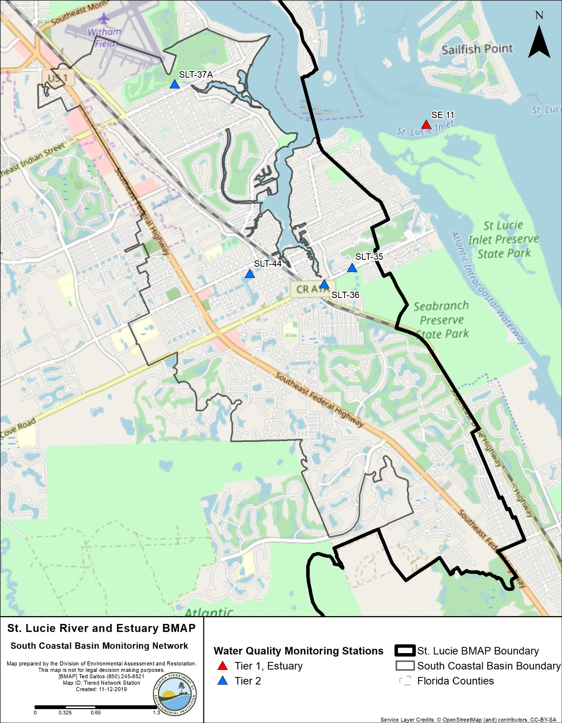
Figure 17. South Coastal Basin monitoring stations

3.9.2. Basin Evaluation Results
Table 66 summarizes the basin evaluation results based on data from WY2014–WY2018 for the South Coastal Basin. The current TN concentration is 0.96 mg/L, which is above the benchmark of 0.72 mg/L required to meet the TMDL. The current TP concentration is 0.096 mg/L, which is below the benchmark of 0.081 mg/L required to meet the TMDL. No FWM concentrations were calculated for this basin. No significant trend was detected for TN or TP concentration changes over time.
Table 67 lists the TRA prioritization results for the South Coastal Basin, with 1 the highest priority, 2 the next highest priority, and 3 a priority as resources allow.
Table 66. Basin evaluation results for the South Coastal Basin
TRA ID | Basin Name | TN (mg/L)  (Benchmark – 0.72) | TN FWM Concentration (mg/L) | TN UAL (lbs/ac) | TN Trend Analysis | TP (mg/L)  (Benchmark – 0.081) | TP FWM Concentration (mg/L) | TP UAL (lbs/ac) | TP Trend Analysis
9 | South Coastal | 0.96 | N/A | N/A | No significant trend | 0.096 | N/A | N/A | No significant trend

Table 67. TRA evaluation results for the South Coastal Basin
Basin | Stations | TN Priority | TP Priority
South Coastal | SLT-37A, SLT-35, SLT-36, SLT-44 | 2 | 2

3.9.3. Projects
The tables below summarize the existing and planned and future projects for the South Coastal Basin that were provided for the BMAP. The existing and planned projects are a BMAP requirement, while future projects will be implemented as funding becomes available for project implementation. Appendix A provides additional details about the projects and the terms used in these tables.

3.9.3.1. Existing and Planned Projects
Table 68 summarizes the existing and planned projects provided by the stakeholders for the South Coastal Basin.
Table 68. Existing and planned projects in the South Coastal Basin
Notes: For projects with multiple basins listed in the "Basin" column, the nutrient reductions provided in the table are the total estimated for the project and not applicable to a specific basin.
Lead Entity | Partners | Project Number | Project Name | Project Description | Project Type | Project Status | Estimated Completion Date | TN Reduction (lbs/yr) | TP Reduction (lbs/yr) | Basin | Acres Treated | Cost Estimate | Cost Annual O&M | Funding Source | Funding Amount | DEP Contract Agreement Number
FDOT | N/A | FDOT-14 | FM# 228801-1 | Road widening of SR 5 from Seabranch Blvd to north of Salerno Rd. | Dry Detention Pond | Completed | 2003 | 1 |  | South Coastal | 2.00 | Not provided | Not provided | Florida Legislature | Not provided | N/A
FDOT | N/A | FDOT-18 | Street Sweeping | Not provided. | Street Sweeping | Completed | N/A | 1,419 | 910 | North Fork, Ten Mile Creek, C-24, C-23,  C-44/S-153, Basin 4/5, Basin 6, South Fork, South Coastal, South Mid-Estuary, North Mid-Estuary | N/A | Not provided | Not provided | Florida Legislature | Not provided | N/A
FDOT | N/A | FDOT-19 | Public Education | Pamphlets. | Education Efforts | Completed | N/A | 31 | 6 | North Fork, Ten Mile Creek, C-24, C-23,  C-44/S-153, Basin 4/5, Basin 6, South Fork, South Coastal, South Mid-Estuary, North Mid-Estuary | N/A | Not provided | Not provided | Florida Legislature | Not provided | N/A
FDOT | N/A | FDOT-57 | Fertilizer Application Cessation | No longer routinely applying fertilizer. | Fertilizer Cessation | Completed | 2016 | TBD | TBD | North Fork, Ten Mile Creek, C-24, C-23,  C-44/S-153, Basin 4/5, Basin 6, South Fork, South Coastal, South Mid-Estuary, North Mid-Estuary | N/A | Not provided | Not provided | Florida Legislature | Not provided | N/A
Martin County | SFWMD/ DEP | MC-06 | Manatee Creek Water Quality Retrofit Phases I, II, and III | 30.4 ac-ft of water quality treatment (0.44 inches). | BMP Treatment Train | Completed | 2012 | 6 | 4 | South Fork, South Coastal | 16.00 | $7,026,439.00 | Not provided | DEP/ SFWMD | DEP – $1,833,992/ SFWMD – $2,591,205 | OT040740/ SO0257
Martin County | SFWMD/ DEP | MC-09 | Salerno Creek Water Quality Retrofit | 54.5 ac-ft of water quality treatment (1.03 inches). | BMP Treatment Train | Completed | 2003 | 408 | 134 | South Fork, South Coastal | 208.00 | $4,715,074.00 | Not provided | DEP | $1,541,568 | OT060149/ WAP068/ WM800/ SP379
Martin County | SFWMD/ DEP | MC-10 | Coral Gardens Water Quality Retrofit | 8.5 ac-ft of water quality treatment (0.05 inches). | BMP Treatment Train | Completed | 2005 | 1,376 | 936 | South Fork, South Coastal | 2,008.00 | $2,321,860.00 | Not provided | DEP | $2,009,741 | OT040741/ SO116
Martin County | N/A | MC-18 | Street Sweeping | Not provided. | Street Sweeping | Completed | N/A | 119 | 76 | North Fork, C-23, C-44/S-153, Basin 4/5, Basin 6, South Fork, South Coastal, South Mid-Estuary, North Mid-Estuary | N/A | Not provided | Not provided | Not provided | Not provided | N/A
Martin County | N/A | MC-19 | Baffle Box and Structure Cleanout | Not provided. | Catch Basin Inserts/Inlet Filter Cleanout | Completed | N/A | 266 | 163 | Basin 4/5, Basin 6, South Fork, South Coastal, South Mid-Estuary | N/A | Not provided | Not provided | Not provided | Not provided | N/A
Martin County | N/A | MC-20 | Education Program | FYN; landscaping, irrigation, fertilizer, and pet waste ordinances; PSAs, pamphlets, website, illicit discharge program. | Education Efforts | Completed | N/A | 6,049 | 1,342 | North Fork, C-23, C-44/S-153, Basin 4/5, Basin 6, South Fork, South Coastal, South Mid-Estuary, North Mid-Estuary | N/A | Not provided | Not provided | County | $60,000 | N/A
Martin County | DEP | MC-23 | Golden Gate Water Quality Retrofit Phases I, II | Treatment train system, baffle boxes, dry detention, and 5.61 ac-ft of wet detention. | BMP Treatment Train | Completed | 2003 | 1,150 | 280 | South Coastal | 202.00 | $2,046,145.00 | Not provided | DEP | $1,322,772 | WAP030/ G0012
Martin County | DEP | MC-24 | Golden Gate Water Quality Retrofit Phase III | Treatment train system, baffle boxes, and 2.26 ac-ft of wet detention | BMP Treatment Train | Completed | 2004 | 123 | 37 | South Coastal | 27.00 | $584,371.00 | Not provided | DEP | $313,060 | SO105
Martin County | DEP | MC-25 | Hibiscus Park Water Quality Retrofit Phases I and II | 1.24 ac-ft of wet detention volume. | Wet Detention Pond | Completed | 2007 | 24 | 7 | South Coastal | 5.00 | $1,390,574.00 | Not provided | DEP | $687,715 | OT050696
Martin County | DEP | MC-26 | Poinciana Gardens Water Quality Retrofit Phases I and II | Treatment train system, 87.36 ac-ft of wet detention and baffle box. | BMP Treatment Train | Completed | 2003 | TBD | TBD | South Fork, South Coastal | 188.00 | $2,960,547.00 | Not provided | DEP | $2,235,091 | WAP025
Martin County | N/A | MC-27 | Willoughby Creek Muck Dredging | Not provided. | Muck Removal/ Restoration Dredging | Completed | 2012 | TBD | TBD | South Coastal | N/A | $13,200,000.00 | Not provided | Not provided | Not provided | N/A
Martin County | N/A | MC-28 | Manatee Pocket Dredging | Not provided. | Muck Removal/Restoration Dredging | Completed | 2012 | TBD | TBD | South Coastal | N/A | $1,000,000.00 | Not provided | Not provided | Not provided | N/A
Martin County | N/A | MC-30 | Old Palm City Beemats | Not provided. | Floating Islands/ MAPS | Completed | 2013 | TBD | TBD | Basin 4/5, Basin 6, South Fork, South Coastal, South Mid-Estuary, North Mid-Estuary | N/A | $ 21,996.00 | Not provided | Not provided | Not provided | N/A
Martin County | DEP | MC-35 | Manatee Pocket SW Prong Baffle Box | Not provided. | Baffle Boxes – Second Generation | Completed | 2016 | 255 | 46 | South Coastal | 236.00 | $232,505.00 | Not provided | DEP | $100,000 | S0759
Martin County | DEP | MC-36 | Martin County Golf Course WQ | Not provided. | Wet Detention Pond | Completed | 2016 | 548 | 205 | South Coastal, South Mid-Estuary | 207.00 | $156,255.00 | Not provided | DEP | $50,000 | S0765
Martin County | N/A | MC-39 | Willoughby Creek STA | Not provided. | BMP Treatment Train | Underway | 2019 | 1,554 | 411 | South Coastal | TBD | Not provided | Not provided | Not provided | Not provided | N/A
City of Stuart | DEP/ SFWMD/ Healthy Rivers/ FCT | S-01 | Poppleton Creek – Phase II and III | Muck sediment removal, creation of 6.5-acre retention pond, and 160-foot weir. Habitat reconstruction; passive recreational improvements. 4 CDS baffle box units and street sweeping in basin. | BMP Treatment Train | Completed | 2008 | 1,299 | 576 | South Fork, South Coastal, South Mid-Estuary | 629.00 | $4,371,250.00 | Not provided | DEP/ SFWMD/ Healthy Rivers/ FCT | Not provided | S0278/ G0083
City of Stuart | N/A | S-05 | Street Sweeping | Pavement cleaning by sweeping, vacuum, or washing. | Street Sweeping | Completed | N/A | 111 | 71 | North Fork, South Fork, South Coastal, South Mid-Estuary, North Mid-Estuary | N/A | $33,000.00 | Not provided | City | Not provided | N/A
City of Stuart | N/A | S-06 | Sediment Removal from Storm Systems | Removal and proper disposal of sediment captured by catch basin inserts. | Catch Basin Inserts/Inlet Filter Cleanout | Completed | N/A | 97 | 59 | North Fork, South Fork, South Coastal, South Mid-Estuary, North Mid-Estuary | N/A | N/A | $75,000.00 | City | Not provided | N/A
City of Stuart | N/A | S-07 | Education Program | FYN Program. City ordinances for landscaping, irrigation, fertilizer, and pet waste management. City stormwater website. Stormwater calendars. Pollution prevention information posted on electronic billboards 365 days/yr from 12 PM to 1 PM. | Education Efforts | Completed | N/A | 840 | 186 | North Fork, South Fork, South Coastal, South Mid-Estuary, North Mid-Estuary | N/A | $30,150.00 | Not provided | City | Not provided | N/A

3.9.3.2. Future Projects
Table 69 lists the future projects provided by the stakeholders for the South Coastal Basin.

Table 69. Future projects in the South Coastal Basin
Lead Entity | Partners | Project Number | Project Name | Project Description | Project Type | Project Status | Acres Treated | TN Reduction (lbs/yr) | TP Reduction (lbs/yr) | Basin | Cost Estimate | Cost Annual O&M
Martin County | N/A | F-09 | East Fork Creek STA | Design and construct STA with control structure and associated piping. | Wet Detention Pond | Future | TBD | TBD | TBD | South Fork, South Coastal | $2,350,000 | TBD
Martin County | N/A | F-11 | Horseshoe Point Road Exfiltration | Design and construct exfiltration trenches and roadway swales. | Exfiltration | Future | TBD | TBD | TBD | South Coastal | $250,000 | TBD
Martin County | N/A | F-12 | Manatee Pocket SW Prong STA | Design and construct STA with control structure and associated piping. | Wet Detention Pond | Future | TBD | TBD | TBD | South Coastal | $1,725,000 | TBD
Martin County | N/A | F-13 | Rocky Point Exfiltration and Baffle Boxes | Design and construct exfiltration trenches, roadway swales, and baffle boxes. | Exfiltration and Baffle Boxes | Future | TBD | TBD | TBD | South Coastal | $1,000,000 | TBD
Martin County | N/A | F-14 | Golden Gate Rehabilitation | Design and construct deep-water lake in STA and recontour entire facility. | Wet Detention Pond | Planning | TBD | TBD | TBD | South Coastal | $1,000.000 | TBD

3.10. South Mid-Estuary Basin
The South Mid-Estuary Basin covers 2,080 acres of the St. Lucie River and Estuary Watershed. As shown in Table 70, urban and built-up is the largest land use category in the basin. Stakeholders in the basin include FDOT, Martin County, and the City of Stuart.
Table 70. Summary of land uses in the South Mid-Estuary Basin
Level 1 Land Use Code | Land Use Description | Acres | % Total
1000 | Urban and Built-Up | 1,417 | 68.1
2000 | Agriculture | - | -
3000 | Upland Nonforested | 7 | 0.3
4000 | Upland Forests | 212 | 10.2
5000 | Water | 33 | 1.6
6000 | Wetlands | - | -
7000 | Barren Land | - | -
8000 | Transportation, Communication, and Utilities | 411 | 19.8
 | Total | 2,080 | 100

3.10.1. Water Quality Monitoring
Table 71 summarizes the water quality monitoring stations in the South Mid-Estuary Basin, and Figure 18 shows the station locations.
Table 71. Water quality monitoring stations in the South Mid-Estuary Basin
Basin | Representative Site? | Entity | Station ID | Tier
South Mid-Estuary | Yes | SFWMD | SLT-38, 38A | 2
South Mid-Estuary | No | SFWMD | SE-01 | 1

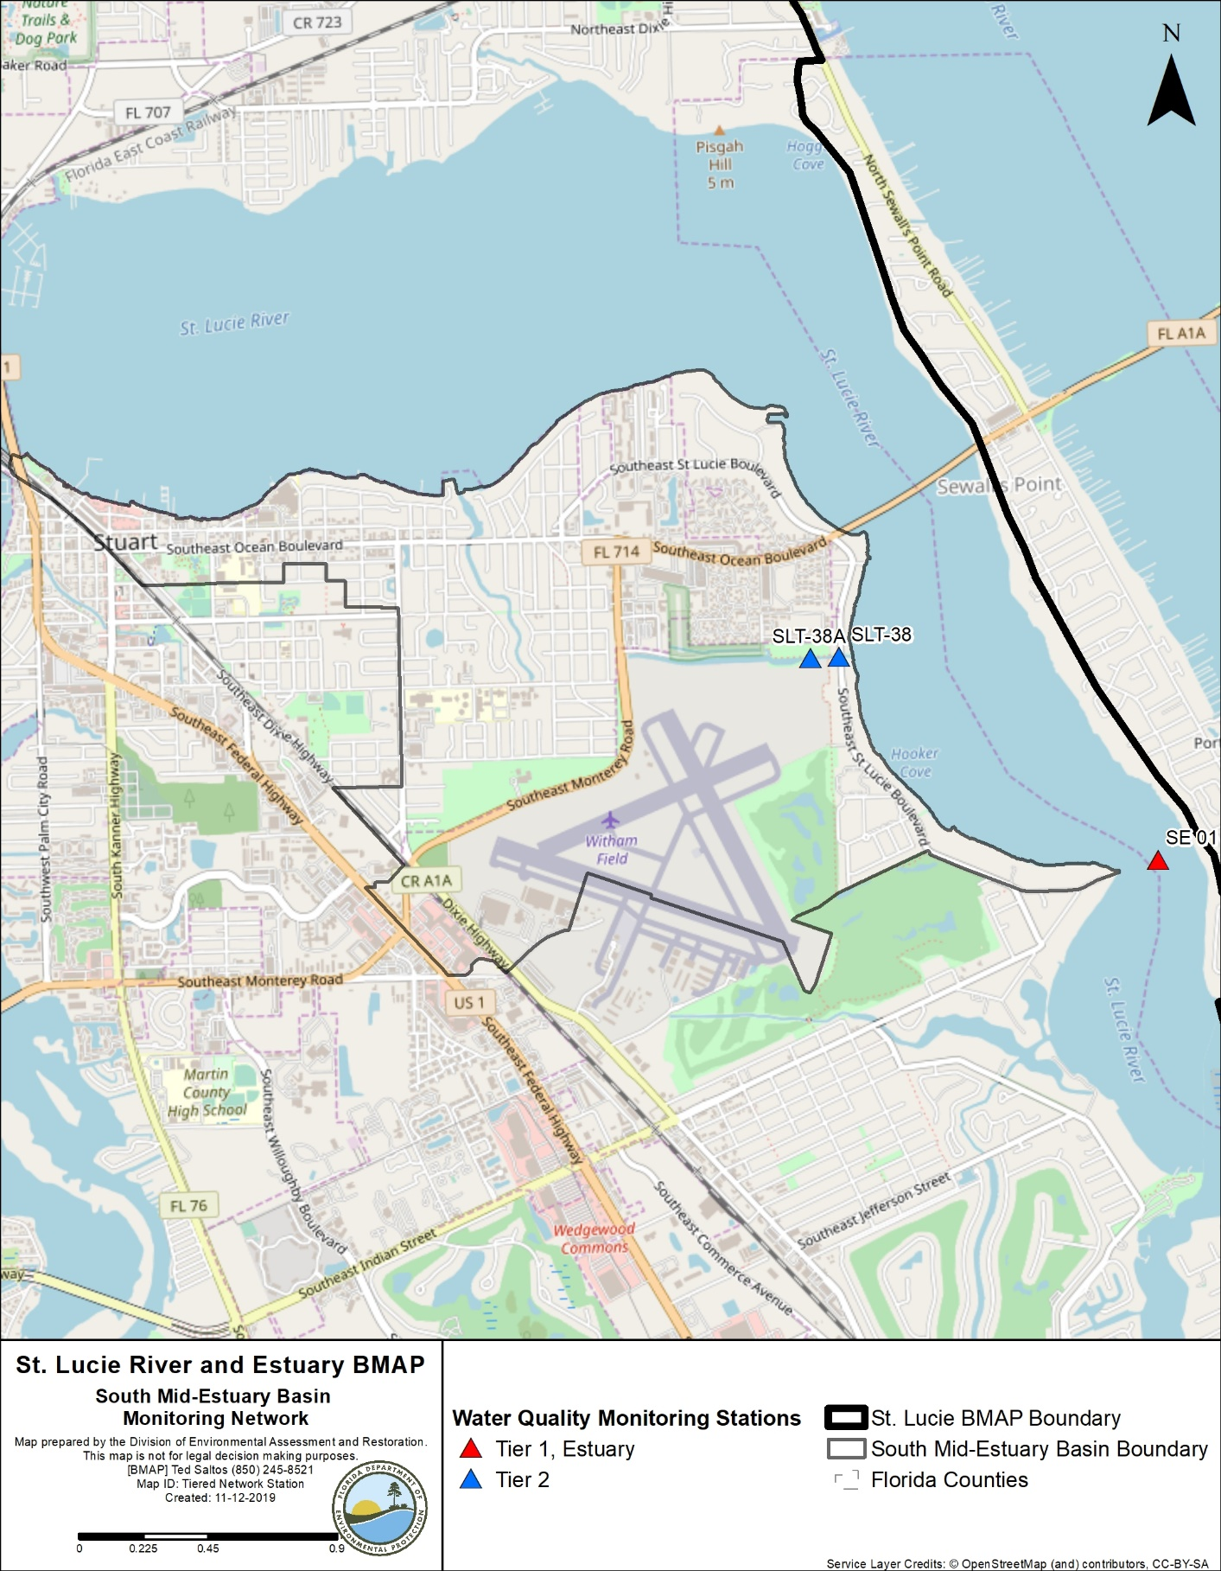
Figure 18. South Mid-Estuary Basin monitoring stations

3.10.2. Basin Evaluation Results
Table 72 summarizes the basin evaluation results based on data from WY2014–WY2018 for the South Mid-Estuary Basin. The current TN concentration is 0.62 mg/L, which is below the benchmark of 0.72 mg/L required to meet the TMDL. The current TP concentration is 0.032 mg/L, which is below the benchmark of 0.081 mg/L required to meet the TMDL. No FWM concentrations were calculated for this basin. No significant trend was detected for TN or TP concentration changes over time.
Table 73 lists the TRA prioritization results for the South Mid-Estuary Basin, with 1 the highest priority, 2 the next highest priority, and 3 a priority as resources allow.
Table 72. Basin evaluation results for the South Mid-Estuary Basin
TRA ID | Basin Name | TN (mg/L)  (Benchmark – 0.72) | TN FWM Concentration (mg/L) | TN UAL (lbs/ac) | TN Trend Analysis | TP (mg/L)  (Benchmark – 0.081) | TP FWM Concentration (mg/L) | TP UAL (lbs/ac) | TP Trend Analysis
10 | South Mid-Estuary | 0.62 | N/A | N/A | No significant trend | 0.032 | N/A | N/A | No significant trend

Table 73. TRA evaluation results for the South Mid-Estuary Basin
Basin | Station | TN Priority | TP Priority
South Mid-Estuary | SLT-38, SLT-38A | 3 | 3

3.10.3. Projects
The tables below summarize the existing and planned and future projects for the South Mid-Estuary Basin that were provided for the BMAP. The existing and planned projects are a BMAP requirement, while future projects will be implemented as funding becomes available for project implementation. Appendix A provides additional details about the projects and the terms used in these tables.

3.10.3.1. Existing and Planned Projects
Table 74 summarizes the existing and planned projects provided by the stakeholders for the South Mid-Estuary Basin.
Table 74. Existing and planned projects in the South Mid-Estuary Basin
Notes: For projects with multiple basins listed in the "Basin" column, the nutrient reductions provided in the table are the total estimated for the project and not applicable to a specific basin.
Lead Entity | Partners | Project Number | Project Name | Project Description | Project Type | Project Status | Estimated Completion Date | TN Reduction (lbs/yr) | TP Reduction (lbs/yr) | Basin | Acres Treated | Cost Estimate | Cost Annual O&M | Funding Source | Funding Amount | DEP Contract Agreement Number
FDOT District 4 | N/A | FDOT-11 | FM# 228821-1 (West 1 A) | SR A1A Evans Crary Senior Bridge replacement. | Exfiltration Trench | Completed | 2001 | 11 | 2 | South Mid-Estuary | 2 | Not provided | Not provided | Florida Legislature | Not provided | N/A
FDOT District 4 | N/A | FDOT-18 | Street Sweeping | Not provided. | Street Sweeping | Completed | N/A | 1,419 | 910 | North Fork, Ten Mile Creek, C-24, C-23, C-44/S-153, Basin 4/5, Basin 6, South Fork, South Coastal, South Mid-Estuary, North Mid-Estuary | N/A | Not provided | Not provided | Florida Legislature | Not provided | N/A
FDOT District 4 | N/A | FDOT-19 | Public Education | Pamphlets. | Education Efforts | Completed | N/A | 109 | 20 | North Fork, Ten Mile Creek, C-24, C-23, C-44/S-153, Basin 4/5, Basin 6, South Fork, South Coastal, South Mid-Estuary, North Mid-Estuary | N/A | Not provided | Not provided | Florida Legislature | Not provided | N/A
FDOT District 4 | N/A | FDOT-57 | Fertilizer Application Cessation | No longer routinely applying fertilizer. | Fertilizer Cessation | Completed | 2016 | 23,881 | 5,970 | North Fork, Ten Mile Creek, C-24, C-23, C-44/S-153, Basin 4/5, Basin 6, South Fork, South Coastal, South Mid-Estuary, North Mid-Estuary | N/A | Not provided | Not provided | Florida Legislature | Not provided | N/A
Martin County | SFWMD/ DEP | MC-01 | Cedar Point Water Quality Retrofit | 1.7 ac-ft of water quality treatment (0.36 inches). | BMP Treatment Train | Completed | 2004 | 106 | 39 | South Mid-Estuary | 31 | $398,027 | Not provided | DEP | $127,000 | SO101
Martin County | N/A | MC-18 | Street Sweeping | Not provided. | Street Sweeping | Completed | N/A | 108 | 69 | North Fork, C-23, C-44/S-153, Basin 4/5, Basin 6, South Fork, South Coastal, South Mid-Estuary, North Mid-Estuary | N/A | Not provided | Not provided | Not provided | Not provided | N/A
Martin County | N/A | MC-19 | Baffle Box and Structure Cleanout | Not provided. | Catch Basin Inserts/Inlet Filter Cleanout | Completed | N/A | 397 | 161 | Basin 4/5, Basin 6, South Fork, South Coastal, South Mid-Estuary, North Mid-Estuary | N/A | Not provided | Not provided | Not provided | Not provided | N/A
Martin County | N/A | MC-20 | Education Program | FYN; landscaping, irrigation, fertilizer, and pet waste ordinances; PSAs, pamphlets, website, illicit discharge program. | Education Efforts | Completed | N/A | 16,644 | 2,831 | North Fork, C-23, C-44/S-153, Basin 4/5, Basin 6, South Fork, South Coastal, South Mid-Estuary, North Mid-Estuary | N/A | Not provided | Not provided | County | $60,000 | N/A
Martin County | N/A | MC-30 | Old Palm City Beemats | Not provided. | Floating Islands/ MAPS | Completed | 2013 | TBD | TBD | Basin 4/5, Basin 6, South Fork, South Coastal, South Mid-Estuary, North Mid-Estuary | N/A | $21,996 | Not provided | Not provided | Not provided | N/A
Martin County | DEP | MC-36 | Martin County Golf Course WQ | Not provided. | Wet Detention Pond | Completed | 2016 | 873 | 253 | South Coastal, South Mid-Estuary | 207 | $156,255 | Not provided | DEP | $50,000 | S0765
City of Stuart | DEP/ SFWMD/ Healthy Rivers/ FCT | S-01 | Poppleton Creek – Phase II and III | Muck sediment removal, creation of 6.5-acre retention pond and 160-foot weir. Habitat reconstruction; passive recreational improvements. 4 CDS baffle box units and street sweeping in basin. | BMP Treatment Train | Completed | 2008 | 2,184 | 748 | South Fork, South Coastal, South Mid-Estuary | 629 | $4,371,250 | Not provided | DEP/ SFWMD/ Healthy Rivers/ FCT | Not provided | S0278/ G0083
City of Stuart | SFWMD/ FEMA/Martin County | S-02 | Airport Ditch Project | Conversion of 2 uncontrolled drainage ditches to tide into retention/detention facilities controlled by "v" notch weirs. | On-line Retention BMPs | Completed | 2003 | 815 | 421 | South Fork, South Mid-Estuary | 894 | $766,756 | Not provided | SFWMD/ FEMA/ Martin County | Not provided | N/A
City of Stuart | DEP/ SFWMD | S-04 | Krueger Creek Project | Removal of "ooze" sediments and installation of 4 baffle boxes plus 2 CDS units in 2010. | Baffle Boxes – First Generation (hydrodynamic separator) | Completed | 2001 | 18 | 14 | South Fork, South Mid-Estuary | 310 | $432,000 | Not provided | City/ SFWMD/ DEP | Not provided | WAP015/ G0083
City of Stuart | N/A | S-05 | Street Sweeping | Pavement cleaning by sweeping, vacuum, or washing. | Street Sweeping | Completed | N/A | 275 | 176 | North Fork, South Fork, South Coastal, South Mid-Estuary, North Mid-Estuary | N/A | $33,000 | Not provided | City | Not provided | N/A
City of Stuart | N/A | S-06 | Sediment Removal from Storm Systems | Removal and proper disposal of sediment captured by catch basin inserts. | Catch Basin Inserts/Inlet Filter Cleanout | Completed | N/A | 54 | 33 | North Fork, South Fork, South Coastal, South Mid-Estuary, North Mid-Estuary | N/A | N/A | $75,000 | City | Not provided | N/A
City of Stuart | N/A | S-07 | Education Program | FYN Program. City ordinances for landscaping, irrigation, fertilizer, and pet waste management. City stormwater website. Stormwater calendars. Pollution prevention information posted on electronic billboards 365 days/yr from 12 PM to 1 PM. | Education Efforts | Completed | N/A | 2,202 | 371 | North Fork, South Fork, South Coastal, South Mid-Estuary, North Mid-Estuary | N/A | $30,150 | Not provided | City | Not provided | N/A
City of Stuart | DEP/ FIND/ Healthy Rivers | S-09 | Anchorage Drainage Basin | There is 1 existing first-generation baffle box and 3 FDOT dry detention ponds in basin. Ponds receive runoff from roadways and portion of Roosevelt Bridge. Street swept in basin. | Baffle Boxes- First Generation (hydrodynamic separator) | Completed | 2002 | 1 | 1 | South Fork, South Mid-Estuary | 21 | $766,500 | Not provided | City/ DEP/ FIND/ Healthy Rivers | Not provided | Not provided
City of Stuart | DEP | S-10 | Downtown Drainage Basin | Drainage basin contains 4 first-generation baffle boxes and 4 CDS units installed between 2000 and 2012; 3 catch basin filter baskets installed in 2010–11. Streets swept 12 times per month. | Baffle Boxes- First Generation (hydrodynamic separator) | Completed | 2002 | 7 | 5 | South Fork, South Mid-Estuary | 117 | $275,000 | Not provided | City/ DEP | Not provided | G0083
City of Stuart | DEP | S-11 | Hildebrad Basin | 1 CDS unit and 7 catch basin filter baskets installed in 2010–11; includes street sweeping in basin. | Hydrodynamic Separators | Completed | 2009 | 0 | 13 | South Mid-Estuary | 67 | $388,480 | Not provided | City/ DEP | Not provided | G0083
City of Stuart | DEP | S-14 | Neighborhood Initiated Sewer Expansion Program | Sewer expansion program to phase out septic tanks by expanding sewer service into areas of city using low pressure sewer system piping along road rights-of-way, and individual residential grinder pump station at each home. | OSTDS Phase Out | Completed | 2013 | 1,341 | N/A | South Fork, South Mid-Estuary | N/A | $3,200,000 | Not provided | City/ DEP | Not provided | S0793/ S0821
City of Stuart | Martin Memorial Health Systems/ SFWMD | S-16 | Amerigo Avenue Drainage Improvements | Construction of dry retention areas to eliminate street flooding, provide water quality treatment, and TMDL reductions. | Dry Detention Pond | Completed | 2014 | 70 | 11 | South Mid-Estuary | 10 | $679,557 | Not provided | City/ Martin Memorial Health Systems/ SFWMD | Not provided | N/A
City of Stuart | N/A | S-18 | Nondischarge Areas | Area within eastern city limits with no stormwater infrastructure and no outfalls discharging to adjacent basin. | Non-contributing Basin | Completed | 2014 | 2,386 | 412 | South Fork, South Mid-Estuary | 218 | N/A | N/A | City | Not provided | N/A
City of Stuart | DEP | S-19 | Baffle Boxes (22) Throughout City | Concrete structures containing series of sediment settling chambers separated by baffles. Boxes are vacuum cleaned base on sediment depth inspection by city stormwater staff. | Baffle Boxes – First Generation (hydrodynamic separator) | Completed | 2014 | 27 | 21 | North Fork, South Fork, South Mid-Estuary, North Mid-Estuary | 475 | N/A | Not provided | City/ DEP | Not provided | G0083
City of Stuart | DEP | S-20 | CDS Units Throughout City | Hydrodynamic separators that capture, sediment, trap debris, and separate floating oils from runoff. CDS units are vacuum cleaned based on sediment depth inspections by city stormwater staff. | Hydrodynamic Separators | Completed | 2014 | 0 | 13 | South Fork, South Mid-Estuary | 66 | N/A | Not provided | City/ DEP | Not provided | G0083
City of Stuart | DEP/ Healthy Rivers | S-24 | Frazier Creek Pond | Construction of wet detention pond to eliminate unrestricted flow from ditch to tide. | Wet Detention Pond | Completed | 2002 | 898 | 377 | South Fork, South Mid-Estuary | 379 | $1,702,000 | Not provided | City/ DEP/ Healthy Rivers | Not provided | WAP016

3.10.3.2. Future Projects
No future projects were provided by the stakeholders for the South Mid-Estuary Basin.

3.11. North Mid-Estuary Basin
The North Mid-Estuary Basin covers 3,957 acres of the St. Lucie River and Estuary Watershed. As shown in Table 75, the major land use is urban and built-up. Stakeholders in the basin include FDOT, Martin County, City of Stuart, and Town of Sewall's Point.
Table 75. Summary of land uses in the North Mid-Estuary Basin
Level 1 Land Use Code | Land Use Description | Acres | % Total
1000 | Urban and Built-Up | 2,861 | 72.3
2000 | Agriculture | - | -
3000 | Upland Nonforested | 193 | 4.9
4000 | Upland Forests | 473 | 12.0
5000 | Water | 111 | 2.8
6000 | Wetlands | 249 | 6.3
7000 | Barren Land | - | -
8000 | Transportation, Communication, and Utilities | 70 | 1.8
 | Total | 3,957 | 100

3.11.1. Water Quality Monitoring
Table 76 summarizes the water quality monitoring stations in the North Mid-Estuary Basin, and Figure 19 shows the station locations.
Table 76. Water quality monitoring stations in the North Mid-Estuary Basin
Basin | Representative Site? | Entity | Station ID | Tier
North Mid-Estuary | Yes | SFWMD | SLT-30A | 2
North Mid-Estuary | Yes | SFWMD | SLT-29 | 2
North Mid-Estuary | No | SFWMD | SE-02 | 1

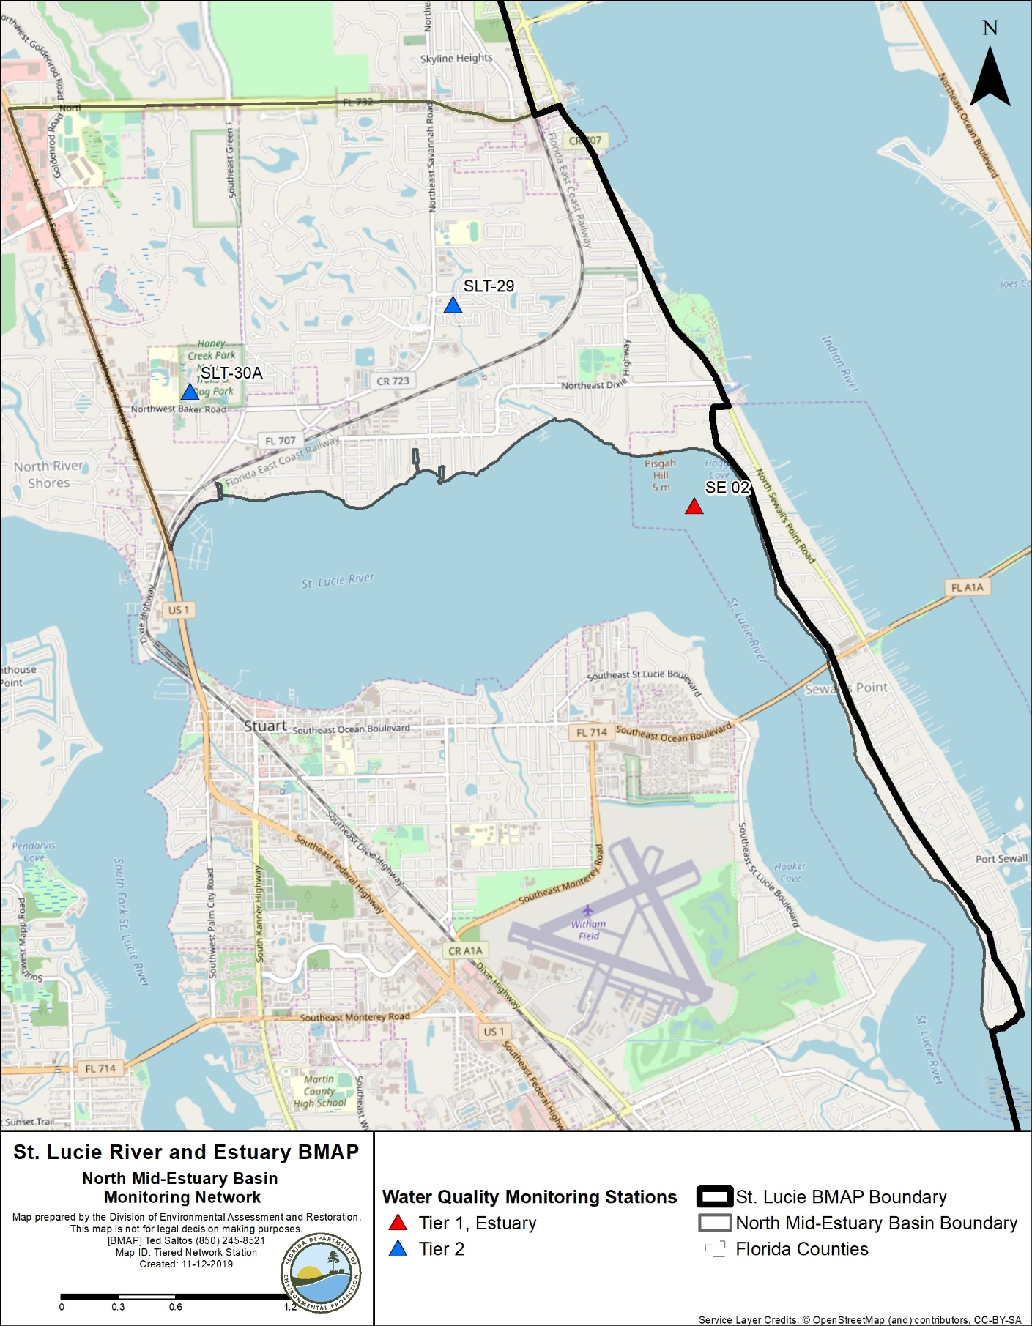
Figure 19. North Mid-Estuary Basin monitoring stations

3.11.2. Basin Evaluation Results
Table 77 summarizes the basin evaluation results based on data from WY2014–WY2018 for the North Mid-Estuary Basin. The current TN concentration is 0.93 mg/L, which is above the benchmark of 0.72 mg/L required to meet the TMDL. The current TP concentration is 0.023 mg/L, which is below the benchmark of 0.081 mg/L required to meet the TMDL. No FWM concentrations were calculated for this basin. No significant trend was detected for TN or TP concentration changes over time.
Table 78 lists the TRA prioritization results for the North Mid-Estuary Basin, with 1 the highest priority, 2 the next highest priority, and 3 a priority as resources allow.
Table 77. Basin evaluation results for the North Mid-Estuary Basin
TRA ID | Basin Name | TN (mg/L)  (Benchmark – 0.72) | TN FWM Concentration (mg/L) | TN UAL (lbs/ac) | TN Trend Analysis | TP (mg/L)  (Benchmark – 0.081) | TP FWM Concentration (mg/L) | TP UAL (lbs/ac) | Trend Analysis
11 | North Mid-Estuary | 0.93 | N/A | N/A | No significant trend | 0.023 | N/A | N/A | No significant trend

Table 78. TRA evaluation results for the North Mid-Estuary Basin
Basin | Stations | TN Priority | TP Priority
North Mid-Estuary | SLT-29, SLT-30A | 2 | 3

3.11.3. Projects
The tables below summarize the existing and planned and future projects for the North Mid-Estuary Basin that were provided for the BMAP. The existing and planned projects are a BMAP requirement, while future projects will be implemented as funding becomes available for project implementation. Appendix A provides additional details about the projects and the terms used in these tables.

3.11.3.1. Existing and Planned Projects
Table 79 summarizes the existing and planned projects provided by the stakeholders for the North Mid-Estuary Basin.
Table 79. Existing and planned projects in the North Mid-Estuary Basin
Notes: For projects with multiple basins listed in the "Basin" column, the nutrient reductions provided in the table are the total estimated for the project and not applicable to a specific basin.
Projects SP-03, SP-04, SP-06, SP-11, SP-14, SP-15, SP-16, SP-20, SP-21, SP-22, SP-23, SP-24, SP-25, SP-26, SP-27, SP-28, SP-29, and SP-31 no longer fall within the BMAP area because of drainage evaluations and/or boundary changes.
Lead Entity | Partners | Project Number | Project Name | Project Description | Project Type | Project Status | Estimated Completion Date | TN Reduction (lbs/yr) | TP Reduction (lbs/yr) | Basin | Acres Treated | Cost Estimate | Cost Annual O&M | Funding Source | Funding Amount | DEP Contract Agreement Number
FDOT District 4 | N/A | FDOT-10 | FM# 228819-1 (Basin A and B) | SR A1A Ernest Lyons Bridge replacement. | Wet Detention Pond | Completed | 2007 | 0.4 | 0.1 | North Mid-Estuary | 0 | Not provided | Not provided | Florida Legislature | Not provided | N/A
FDOT District 4 | N/A | FDOT-12 | FM# 228821-1 (East) | SR A1A Evans Crary Senior Bridge replacement. | Exfiltration Trench | Completed | 2001 | 5 | 1 | North Mid-Estuary | 1 | Not provided | Not provided | Florida Legislature | Not provided | N/A
FDOT District 4 | N/A | FDOT-18 | Street Sweeping | Not provided. | Street Sweeping | Completed | N/A | 1,419 | 910 | North Fork, Ten Mile Creek, C-24, C-23,  C-44/S-153, Basin 4/5, Basin 6, South Fork, South Coastal, South Mid-Estuary, North Mid-Estuary | N/A | Not provided | Not provided | Florida Legislature | Not provided | N/A
FDOT District 4 | N/A | FDOT-19 | Public Education | Pamphlets. | Education Efforts | Completed | N/A | 109 | 20 | North Fork, Ten Mile Creek, C-24, C-23,  C-44/S-153, Basin 4/5, Basin 6, South Fork, South Coastal, South Mid-Estuary, North Mid-Estuary | N/A | Not provided | Not provided | Florida Legislature | Not provided | N/A
FDOT District 4 | N/A | FDOT-57 | Fertilizer Application Cessation | No longer routinely applying fertilizer. | Fertilizer Cessation | Completed | 2016 | 23,881 | 5,970 | North Fork, Ten Mile Creek, C-24, C-23,  C-44/S-153, Basin 4/5, Basin 6, South Fork, South Coastal, South Mid-Estuary, North Mid-Estuary | N/A | Not provided | Not provided | Florida Legislature | Not provided | N/A
Martin County | SFWMD/ DEP | MC-02 | Indian River Drive Baffle Boxes | 6 second-generation baffle boxes. | Baffle Boxes – Second Generation | Completed | 2010 | 77 | 11 | North Mid-Estuary | 39 | $741,827 | Not provided | DEP/ SFWMD | SFWMD – $187,000/  DEP – $208,137 | SO363
Martin County | SFWMD/ DEP | MC-03 | Warner Creek/Leilani Heights Water Quality Retrofit Phase I | 8.0 ac-ft of water quality treatment (0.14 inches). | BMP Treatment Train | Completed | 2011 | 539 | 90 | North Mid-Estuary | 70 | $541,854 | Not provided | DEP/ SFWMD | DEP – $558,625/ SFWMD – $825,000/ SFWMD – $704,375 | G0264
Martin County | SFWMD/ DEP | MC-04 | Warner Creek Phase II | 0.36-acre dry detention area with control structure | Dry Detention Pond | Completed | 2012 | 16 | 3 | North Mid-Estuary | 15 | $1,750,338 | Not provided | DEP/ SFWMD | N/A | G0265
Martin County | SFWMD/ DEP | MC-05 | Warner Creek Phase III –Beacon 21 | 2.96-acre wet detention area with control structure weir. | Wet Detention Pond | Completed | 2012 | 3,103 | 1,218 | North Mid-Estuary | 1,354 | $2,122,935 | Not provided | DEP/ SFWMD | N/A | G0266
Martin County | SFWMD/ DEP | MC-07 | Rio/St. Lucie – Water Quality Retrofit -Phase 1 | 3.0 ac-ft of water quality treatment (0.35 inches). | BMP Treatment Train | Completed | 2006 | 71 | 12 | North Mid-Estuary | 8 | $354,161 | Not provided | DEP | $300,179 | SO100
Martin County | SFWMD/ DEP | MC-08 | Rio/St. Lucie – Water Quality Retrofit -Phase 2 | 5.1 ac-ft of additional water quality treatment and control structures on existing lakes (0.7 inches). | Wet Detention Pond | Completed | 2008 | 428 | 124 | North Mid-Estuary | 120 | $998,170 | Not provided | DEP | $776,170 | OT050685
Martin County | N/A | MC-16 | Septic to Central Sewer Conversions | 1,121 single-family and multifamily residential and commercial units in 5 neighborhoods. | OSTDS Phase Out | Completed | 2014 | 15,386 | N/A | North Fork, Basin 4/5, North Mid-Estuary | N/A | $28,678,946 | Not provided | NEEPP – North River Shores neighborhood | Not provided | N/A
Martin County | N/A | MC-18 | Street Sweeping | Not provided. | Street Sweeping | Completed | N/A | 108 | 69 | North Fork, C-23,  C-44/S-153, Basin 4/5, Basin 6, South Fork, South Coastal, South Mid-Estuary, North Mid-Estuary | N/A | Not provided | Not provided | Not provided | Not provided | N/A
Martin County | N/A | MC-19 | Baffle Box and Structure Cleanout | Not provided. | Catch Basin Inserts/Inlet Filter Cleanout | Completed | N/A | 397 | 161 | Basin 4/5, Basin 6, South Fork, South Coastal, South Mid-Estuary, North Mid-Estuary | N/A | Not provided | Not provided | Not provided | Not provided | N/A
Martin County | N/A | MC-20 | Education Program | FYN; landscaping, irrigation, fertilizer, and pet waste ordinances; PSAs, pamphlets, website, illicit discharge program. | Education Efforts | Completed | N/A | 16,644 | 2,831 | North Fork, C-23, C-44/S-153, Basin 4/5, Basin 6, South Fork, South Coastal, South Mid-Estuary, North Mid-Estuary | N/A | Not provided | Not provided | County | $60,000 | N/A
Martin County | SFWMD/ DEP | MC-29 | Rio Water Quality Retrofit | Exfiltration trenches and baffle boxes | BMP Treatment Train | Completed | 2014 | 420 | 69 | North Mid-Estuary | 50 | $696,800 | Not provided | DEP/ SFWMD | DEP – $240,000/ SFWMD – $310,000 | SO642
Martin County | N/A | MC-30 | Old Palm City Beemats | Not provided. | Floating Islands/ MAPS | Completed | 2013 | TBD | TBD | Basin 4/5, Basin 6, South Fork, South Coastal, South Mid-Estuary, North Mid-Estuary | N/A | $21,996 | Not provided | Not provided | Not provided | N/A
Martin County | SFWMD | MC-38 | Hilltop Street Exfiltration Trench | Not provided. | Exfiltration Trench | Completed | 2016 | 123 | 20 | North Mid-Estuary | 15 | $264,774 | Not provided | SFWMD | $100,000 | N/A
Martin County | N/A | MC-40 | Savannah Road Exfiltration Trench | N/A | BMP Treatment Train | Canceled | N/A | N/A | N/A | North Mid-Estuary | N/A | N/A | N/A | N/A | N/A | N/A
City of Stuart | N/A | S-05 | Street Sweeping | Pavement cleaning by sweeping, vacuuming, or washing. | Street Sweeping | Completed | N/A | 275 | 176 | North Fork, South Fork, South Coastal, South Mid-Estuary, North Mid-Estuary | N/A | $33,000 | Not provided | City | Not provided | N/A
City of Stuart | N/A | S-06 | Sediment Removal from Storm Systems | Removal and proper disposal of sediment captured by catch basin inserts. | Catch Basin Inserts/Inlet Filter Cleanout | Completed | N/A | 54 | 33 | North Fork, South Fork, South Coastal, South Mid-Estuary, North Mid-Estuary | N/A | N/A | $75,000 | City | Not provided | N/A
City of Stuart | N/A | S-07 | Education Program | FYN Program. City ordinances for landscaping, irrigation, fertilizer, and pet waste management. City stormwater website. Stormwater calendars. Pollution prevention information posted on electronic billboards 365 days/yr from 12 PM to 1 PM. | Education Efforts | Completed | N/A | 2,202 | 371 | North Fork, South Fork, South Coastal, South Mid-Estuary, North Mid-Estuary | N/A | $30,150 | Not provided | City | Not provided | N/A
City of Stuart | SFWMD/ Healthy Rivers | S-08 | North Point CRA Drainage Basin | There is 1 existing first-generation baffle box and street sweeping in basin, existing FDOT swale along basin's east boundary, and 2 FDOT retention/ detention ponds near Roosevelt Bridge. | Baffle Boxes – First Generation (hydrodynamic separator) | Completed | 2002 | 4 | 3 | North Fork, North Mid-Estuary | 1,084 | $1,339,000 | Not provided | City/ SFWMD/ Healthy Rivers | Not provided | N/A
City of Stuart | Martin County/ Healthy Rivers/ FCT/ DEP | S-17 | Haney Creek Project – Phase I – IV | Creation of flow-through marsh and multiple wetlands and control structures to address stormwater quality, environmental restoration and preservation, greenways, passive recreation, and environmental education. | Filter Marsh | Completed | 2016 | 737 | 224 | North Mid-Estuary | 626 | $4,831,411 | $9,600 | Martin County/ Healthy Rivers/ FCT/ DEP | Not provided | WAP031
City of Stuart | DEP | S-19 | Baffle Boxes (22) Throughout City | Concrete structures containing series of sediment settling chambers separated by baffles. Boxes are vacuum cleaned base on sediment depth inspection by city stormwater staff. | Baffle Boxes – First-Generation (hydrodynamic separator) | Completed | 2014 | 27 | 21 | North Fork, South Fork, South Mid-Estuary, North Mid-Estuary | 475 | N/A | Not provided | City/ DEP | Not provided | G0083
City of Stuart | DEP | S-23 | East Heart of Haney Creek Wetlands Restoration | Restore eastern third of Heart of Haney Creek to wetlands by creating system of berms and weirs within 6 acres of exotic cleared area. | Wetland Restoration | Underway | 2019 | TBD | TBD | North Mid-Estuary | 395 | $220,000 | TBD | City/ DEP | DEP – $90,000/ City – $110,000 | S0891
Town of Sewall's Point | SFWMD | SP-01 | Ridgeland Court Retrofit | Installation of exfiltration/baffle box. | Baffle Boxes – First Generation (hydrodynamic separator) | Completed | 2002 | 0 | 0 | North Mid-Estuary | 6 | Not provided | $300,000 | Town/ SFWMD | Not provided | N/A
Town of Sewall's Point | SFWMD | SP-02 | Palm Court/Knowles | Installation of baffle box. | Baffle Boxes – First Generation (hydrodynamic separator) | Completed | 2000 | 0 | 0 | North Mid-Estuary | 13 | Not provided | N/A | Town/ SFWMD | Not provided | N/A
Town of Sewall's Point | SFWMD | SP-03 | Captain Cove | Installation of baffle box. | Baffle Boxes – First Generation (hydrodynamic separator) | Completed | 2000 | N/A | N/A | North Mid-Estuary (no longer in BMAP area) | 5 | Not provided | N/A | Town /SFWMD | Not provided | N/A
Town of Sewall's Point | SFWMD | SP-04 | Quail Run Park | Installation of direct link to detention area prior to discharge to Indian River. | Dry Detention Pond | Completed | 2000 | N/A | N/A | North Mid-Estuary (no longer in BMAP area) | 0 | Not provided | N/A | Town/ SFWMD | Not provided | N/A
Town of Sewall's Point | N/A | SP-05 | Heritage Park | Installation of stormwater retrofit area in developed subdivision. | Stormwater System Rehabilitation | Completed | 2000 | 0 | 0 | North Mid-Estuary | 5 | Not provided | N/A | Town | Not provided | N/A
Town of Sewall's Point | SFWMD | SP-06 | Via Lucindia | Installation of exfiltration pipe. | Exfiltration Trench | Completed | 2000 | N/A | N/A | North Mid-Estuary (no longer in BMAP area) | 3 | Not provided | N/A | Town/ SFWMD | Not provided | N/A
Town of Sewall's Point | SFWMD | SP-07 | Rio Vista Park | Installation of baffle boxes/ erosion control for outfall to Indian River. | Baffle Boxes – First Generation (hydrodynamic separator) | Completed | 2002 | 0 | 0 | North Mid-Estuary | 24 | Not provided | N/A | Town/ SFWMD | Not provided | N/A
Town of Sewall's Point | N/A | SP-08 | India Lucie | Installation of retrofit of weir/ retention area with 2 baffle boxes in old subdivision without retention to directly discharge to Indian River. | Stormwater System Rehabilitation | Completed | 2003 | 5 | 2 | North Mid-Estuary | 31 | Not provided | N/A | Martin County | Not provided | N/A
Town of Sewall's Point | FEMA | SP-09 | India Lucie | Installation of retrofit of weir/ retention area with 2 baffle boxes in old subdivision without retention to directly discharge to Indian River. | Stormwater System Rehabilitation | Completed | 2006 | 0 | 0 | North Mid-Estuary | 6 | Not provided | N/A | Town/ FEMA | Not provided | N/A
Town of Sewall's Point | SFWMD | SP-10 | Periwinkle | Installation of baffle box. | Baffle Boxes – First-Generation (hydrodynamic separator) | Completed | 2000 | 0 | 0 | North Mid-Estuary | 16 | Not provided | N/A | Town/ SFWMD | Not provided | N/A
Town of Sewall's Point | N/A | SP-11 | Palm Road | Installation of grass swales. | Grass swales without swale blocks or raised culverts | Completed | 2008 | N/A | N/A | North Mid-Estuary (no longer in BMAP area) | 1 | Not provided | N/A | Town | Not provided | N/A
Town of Sewall's Point | SFWMD | SP-12 | Riverview | Installation of baffle box. | Baffle Boxes – First-Generation (hydrodynamic separator) | Completed | 2002 | 1 | 0 | North Mid-Estuary | 10 | Not provided | N/A | Town/ SFWMD | Not provided | N/A
Town of Sewall's Point | N/A | SP-13 | Pineapple Lane | Installation of outfall exfiltration. | Exfiltration Trench | Completed | 2002 | 0 | 0 | North Mid-Estuary | 6 | Not provided | N/A | Town | Not provided | N/A
Town of Sewall's Point | Town of Sewall's Point (TOSP) | SP-14 | Copaire | Installation of baffle box. | Baffle Boxes – First-Generation (hydrodynamic separator) | Completed | 2002 | N/A | N/A | North Mid-Estuary (no longer in BMAP area) | 2 | Not provided | N/A | Town/ SFWMD | Not provided | N/A
Town of Sewall's Point | TOSP | SP-15 | Homewood Park/South Sewall's Point Road | Installation of retention area with pervious Flexi-Pave and exfiltration pipe. | Online Retention BMPs | Completed | 2009 | N/A | N/A | North Mid-Estuary (no longer in BMAP area) | 14 | Not provided | N/A | Town/ SFWMD | Not provided | N/A
Town of Sewall's Point | DEP/ SFWMD | SP-16 | Pedway/ Greenway | Installation of exfiltration/ pervious paver sidewalk. | BMP Treatment Train | Completed | 2014 | N/A | N/A | North Mid-Estuary (no longer in BMAP area) | 2 | Not provided | N/A | Town/ DEP/ SFWMD | Not provided | G0333
Town of Sewall's Point | FDOT | SP-17 | State Road A1A | Installation of outfall exfiltration. | Exfiltration Trench | Completed | 2012 | 102 | 15 | North Mid-Estuary | 12 | Not provided | N/A | FDOT | Not provided | N/A
Town of Sewall's Point | N/A | SP-18 | Education Program | Fertilizer ordinance. | Education Efforts | Completed | N/A | 24 | 4 | North Mid-Estuary | N/A | N/A | N/A | Town | N/A | N/A
Town of Sewall's Point | N/A | SP-19 | Street Sweeping | 19 cubic yards of debris collected through street sweeping. | Street Sweeping | Completed | N/A | 25 | 16 | North Mid-Estuary | N/A | Not provided | N/A | Town | N/A | N/A
Town of Sewall's Point | N/A | SP-20 | Delano Lane | Installation of exfiltration system. | Exfiltration Trench | Completed | 2000 | N/A | N/A | North Mid-Estuary (no longer in BMAP area) | 1 | Not provided | N/A | Town | Not provided | N/A
Town of Sewall's Point | N/A | SP-21 | Town Commons Park | Installation of water quality treatment/dry detention. | Dry Detention Pond | Completed | 2002 | N/A | N/A | North Mid-Estuary (no longer in BMAP area) | 1 | Not provided | N/A | Town | Not provided | N/A
Town of Sewall's Point | N/A | SP-22 | Island Road | Installation of exfiltration pipe with baffle box. | Baffle Boxes – First Generation (hydrodynamic separator) | Completed | 2002 | N/A | N/A | North Mid-Estuary (no longer in BMAP area) | 5 | Not provided | N/A | Town | Not provided | N/A
Town of Sewall's Point | SFWMD | SP-23 | Highpoint West | Installation of baffle box. | Baffle Boxes – First Generation (hydrodynamic separator) | Completed | 2000 | N/A | N/A | North Mid-Estuary (no longer in BMAP area) | 8 | Not provided | N/A | Town/ SFWMD | Not provided | N/A
Town of Sewall's Point | SFWMD | SP-24 | Mandalay (Marguerita) | Installation of baffle box. | Baffle Boxes – First Generation (hydrodynamic separator) | Completed | 2000 | N/A | N/A | North Mid-Estuary (no longer in BMAP area) | 15 | Not provided | N/A | Town/ SFWMD | Not provided | N/A
Town of Sewall's Point | SFWMD | SP-25 | Highpoint East | Installation of baffle box. | Baffle Boxes – First Generation (hydrodynamic separator) | Completed | 2000 | N/A | N/A | North Mid-Estuary (no longer in BMAP area) | 16 | Not provided | N/A | Town/ SFWMD | Not provided | N/A
Town of Sewall's Point | SFWMD | SP-26 | High Point Exfiltration | Installation of exfiltration/swale. | BMP Treatment Train | Completed | 2014 | N/A | N/A | North Mid-Estuary (no longer in BMAP area) | 6 | Not provided | N/A | Town/ SFWMD | Not provided | N/A
Town of Sewall's Point | N/A | SP-27 | Extend Pedway/Greenway | Extension of existing pervious pedway by 9,000 linear feet to include pervious pavers and exfiltration. | BMP Treatment Train | Completed | 2016 | N/A | N/A | North Mid-Estuary (no longer in BMAP area) | 28 | $201,483 | N/A | Town | Not provided | N/A
Town of Sewall's Point | DEP/ SFWMD | SP-28 | South Sewell's Point Road – Phase 1  Mandalay (Marguerita) | Installation of exfiltration system/baffle boxes and STA. | BMP Treatment Train | Underway | TBD | N/A | N/A | North Mid-Estuary (no longer in BMAP area) | 21 | $2,000,000 | N/A | Town/ DEP/ SFWMD | Town – $1,400,000/ DEP – $600,000 | NS029
Town of Sewall's Point | N/A | SP-29 | Baffle Boxes | Installation of baffle boxes in various locations. | Baffle Boxes – First Generation (hydrodynamic separator) | Underway | TBD | N/A | N/A | North Mid-Estuary (no longer in BMAP area) | 18 | $315,000 | N/A | Town | TBD | N/A
Town of Sewall's Point | N/A | SP-30 | Indialucie | Installation of exfiltration system in wet retention area. | Exfiltration Trench | Completed | 2014 | 11 | 2 | North Mid-Estuary | 31 | Not provided | N/A | Town | Not provided | N/A
Town of Sewall's Point | N/A | SP-31 | Quail Run Subdivision | Installation of exfiltration/swale. | BMP Treatment Train | Completed | 2015 | N/A | N/A | North Mid-Estuary (no longer in BMAP area) | 4 | Not provided | N/A | Town | Not provided | N/A
Town of Sewall's Point | N/A | SP-32 | Septic Tank Elimination – Phase I | Conversion of existing septic tanks to sanitary sewer. | OSTDS Phase Out | Planned | TBD | TBD | N/A | North Mid-Estuary | 17 | $500,000 | N/A | Town/ Florida Legislature | Not provided | N/A
Town of Sewall's Point | TBD | SP-33 | Outfall Control Structures | Add control structures | Stormwater System Rehabilitation | Underway | TBD | TBD | TBD | North Mid-Estuary | TBD | $500,000 | N/A | Town | TBD | TBD
Town of Sewall's Point | TBD | SP-34 | South Sewall's Point Road – Phase 2 | Installation of exfiltration system/baffle boxes and STA. | BMP Treatment Train | Planned | TBD | TBD | TBD | North Mid-Estuary | 64 | TBD | N/A | Town | TBD | TBD
Town of Sewall's Point | TBD | SP-35 | South Sewall's Point Road – Phase 3 | Installation of exfiltration system/baffle boxes and STA. | BMP Treatment Train | Planned | TBD | TBD | TBD | North Mid-Estuary | TBD | TBD | N/A | Town | TBD | TBD
Town of Sewall's Point | TBD | SP-36 | South Sewall's Point Road – Phase 4 | Installation of exfiltration system/baffle boxes and STA. | BMP Treatment Train | Planned | TBD | TBD | TBD | North Mid-Estuary | TBD | TBD | N/A | Town | TBD | TBD

3.11.3.2. Future Projects
Table 80 lists the future projects provided by the stakeholders for the North Mid-Estuary Basin.
Table 80. Future projects in the North Mid-Estuary Basin
Lead Entity | Partners | Project Number | Project Name | Project Description | Project Type | Project Status | Acres Treated | TN Reduction (lbs/yr) | TP Reduction (lbs/yr) | Basin | Cost Estimate | Cost Annual O&M
City of Stuart | N/A | F-02 | West Heart of Haney | Wetland restoration to improve water quality of stormwater discharging into St. Lucie River. | Wetland Restoration/ Filter Marsh | Future | TBD | TBD | North Mid-Estuary | TBD | TBD | TBD

Chapter 4. Summary

4.1. TRA Evaluation Results
Table 81 summarizes the results of the TRA evaluation process presented by basin in Chapter 3 for the basins in the SLREW. For each basin, a priority was assigned based on the TN and TP concentrations. The TRA evaluation does not currently include an assessment of water quantity since a flow evaluation has not yet been completed. Once a complete flow evaluation is available, it will be reviewed for inclusion in future BMAP annual updates.
These priorities were set to help focus resources and projects in the basins that are in most need of improvement. Priorities were set, with 1 the highest priority, 2 the next highest priority, and 3 a priority as resources allow.
Table 81. Summary of the TRA evaluation results
*SFWMD determined that additional investigations are needed regarding whether water quantity is an issue.
Basin | TN Priority | TP Priority
North Fork | 3 | 3
Ten Mile Creek | 2 | 1
C-24 | 1 | 1
C-23 | 1 | 1
C-44/S-153 | 1 | 1
Basin 4/5 | 2 | 1
Basin 6 | 2 | 2
South Fork | 2 | 2
South Coastal | 2 | 2
South Mid-Estuary | 3 | 3
North Mid-Estuary | 2 | 3

4.2. RFI Responses
To further identify restoration projects for this BMAP, DEP implemented an RFI to generate additional restoration projects or activities from both the public and private sectors. The effort was open to any interested parties who could propose a viable project for restoration and could be considered for inclusion in the final St. Lucie River and Estuary BMAP for funding consideration.
Overall, the RFI process generated 37 responses, mainly from the private sector. Submittals ranged from structural projects to new and emerging technologies. After reviewing all submittals, 8 projects were sufficiently complete, and Appendix D provides a summary of the submittals. Resources will be needed to implement any of these projects throughout the watershed, and they are being considered for DEP funding. Additional details on all responses are on file with DEP.

4.3. Future Growth
To ensure that this BMAP effort can achieve and ultimately maintain the goal of meeting TMDL requirements, the overall restoration strategy must include actions and planning for future growth and development. New development primarily falls into two general source categories: (1) new and (2) agriculture. Nutrient impacts from new development are addressed through a variety of mechanisms as well as other provisions of Florida law.
While the majority of the restoration projects and programs listed in this BMAP address current loading, the need to plan and implement sound management strategies to address additional population growth in the BMAP area must be considered. DEP has included in this BMAP specific elements to address all current and future WWTF effluent, septic systems, and stormwater sources. Broader laws—such as local land development regulations, comprehensive plans, ordinances, incentives, Environmental Resource Permit requirements, and consumptive use permit requirements—all provide additional mechanisms and avenues for protecting water resources and reducing the impact of new development and other land use changes as they occur.
The recommendations presented in Chapter 2 should be considered by local governments during master planning and land use decision-making efforts. At the time of BMAP development and adoption, many of these recommendations are not required by statute, but it is anticipated that some, if not all, of the recommendations may be a part of future legislative mandates and future BMAP iterations.
It should also be noted that any additional loading, such as from land use changes from low to high density, or any increase in intensity of use (that may include additional nutrient loadings), will be evaluated during future BMAP review efforts. If an increase in loading has occurred, additional restoration actions will be required to remediate impacts. DEP recommends that all local governments revise their planning and land use ordinance(s) to adequately address all future growth, and consider limitations on growth in sensitive areas, such as lands with direct hydrologic connection to impaired waterbodies, wetland areas, or coastal areas.

4.4. Compliance
The TMDL sets a TN concentration target of 0.72 mg/L and a TP concentration target of 0.081 mg/L, as measured at the Roosevelt Bridge (SE 03) compliance point. The TMDL also includes a BOD target of 2.0 mg/L. The TMDL does not address a compliance calculation; however, for the purposes of this BMAP, compliance with the TMDL will be assessed by a 5-year rolling average of concentration values measured on a monthly basis at the SE 03 monitoring station. The 5-year rolling average will use data from the latest five WYs.
The TMDL is attained when the 5-year rolling average concentration at the SE 03 monitoring station is less than the TMDL target concentration.

Chapter 5. References
Florida Department of Environmental Protection. 2008. TMDL report. Nutrient and dissolved oxygen TMDL for the St. Lucie Basin. Tallahassee, FL: Division of Water Resource Management, Bureau of Watershed Management.
Florida Stormwater Association. 2012. Methodology for calculating nutrient load reductions using the FSA assessment tool.
Kimley-Horn and Associates, Inc. 2010. City of Ft. Pierce citywide stormwater master plan. Prepared for the City of Fort Pierce, FL.
South Florida Water Management District. Buzzelli, Christopher, Wachnicka, Anna, Zheng, Fawen, Chen, Zhiqiang, Baldwin, Lucia, and Kahn-Dickens, Amanda. Chapter 8C: St. Lucie and Caloosahatchee River watershed research and water quality monitoring results and activities. 2019 South Florida Environmental Report.
South Florida Water Management District. 2017. Draft report. St. Lucie River and Estuary Watershed water quality modeling. Part I: Model calibration and verification of baseline scenario for the St. Lucie River and Estuary Basin Management Action Plan. West Palm Beach, FL.
South Florida Water Management District, Florida Department of Environmental Protection, and Florida Department of Agriculture and Consumer Services. 2009. St. Lucie River Watershed Protection Plan.
South Florida Water Management District, Florida Department of Environmental Protection, and Amec Foster Wheeler. 2018. Draft report. St. Lucie River and Estuary Watershed water quality modeling for the St. Lucie River and Estuary Basin Management Action Plan.
Soil and Water Engineering Technology (SWET), Inc. 2008. Legacy phosphorus abatement plan for project entitled "Technical assistance in review and analysis of existing data for evaluation of legacy phosphorus in the Lake Okeechobee Watershed." West Palm Beach, FL: South Florida Water Management District.
URS, Inc. 2008. WaSh model configuration, calibration, and validation for the St. Lucie Estuary Watershed. Prepared for the Florida Department of Environmental Protection.

Appendices

Appendix A. BMAP Projects Supporting Information
The project tables in this BMAP list the implementation status of the BMAP projects as of June 30, 2019. The tables list the TN and TP reductions in lbs/yr attributable to each individual project. These projects were submitted to DEP by responsible entities with the understanding that the projects and activities would be included in the BMAP, thus setting the expectation of each entity to implement the proposed projects and activities to achieve the assigned load reduction estimates in the specified time.
However, the list of projects is meant to be flexible enough to allow for changes that may occur over time. During the annual review of BMAP implementation efforts, project-specific information may be revised and updated, resulting in changes to the estimated reductions for those projects. The revisions may increase or decrease estimated reductions, and DEP will work with stakeholders to address revisions as they are identified.
The project status column is standardized into the following four categories:
- Canceled: Project or activity that was planned but will no longer take place. This includes the cessation of ongoing activities.
- Completed: Project, activity, or task that is finished. This category includes fully implemented activities (i.e., ongoing activities) that must continue to maintain assigned credits indefinitely (such as street sweeping, best management practice [BMP] cleanout, catch basin cleanout, public education, fertilizer cessation/reduction, and vegetation harvesting).
- Planned: Project or activity that is conceptual or proposed.
- Underway: Project or activity that has commenced or initiated but is not completed and is not yet reducing nutrient loads from the treated area.
Prior to reporting project information, DEP contacts each lead entity to gather new information on projects and confirm previously reported information. The terms used throughout the project tables are defined as follows:
- Not provided: Denotes that information was requested by DEP but was not provided by the lead entity.
- TBD: To be determined. Denotes that information is not currently available but will be provided by the stakeholder when it is available.
- N/A: Not applicable. Denotes that information for that category is not relevant to that project.
- 0: Zero. Denotes the numeric value for that category as zero.
The project tables are based on current information, and project details may be updated as further information becomes available.
This BMAP requires stakeholders to implement their projects to achieve reductions as soon as practicable. However, the full implementation of the BMAP will be a long-term process. While some of the projects and activities contained in the BMAP were recently completed or are currently ongoing, several projects require more time to design, secure funding, and construct. Unlike the existing and planned projects, these future projects are not yet considered commitments of the entities but rather are intended for future BMAP credit, pending the availability of funding and other resources.
Although BMAP implementation is a long-term process, the goal of this BMAP is to achieve the TMDLs within 15 years from BMAP adoption. It is understood that all waterbodies can respond differently to the implementation of reduced loadings to meet applicable water quality standards. Continued coordination and communication by the stakeholders will be essential to ensure that management strategies continue to meet the implementation milestones.
DEP requested information from stakeholders on future projects and released an RFI to obtain proposals for restoration projects and technologies with the potential for additional load reductions in the basin. Funding has not yet been identified for many of these future projects and RFI projects, and the additional funding of projects is a key part of making reductions required to achieve the TMDLs. The future project tables in Chapter 3 will be updated as project details are refined and funding is obtained.

Appendix B. Agricultural Enrollment and Reductions
(Language in this appendix was provided by FDACS.)
All agricultural nonpoint sources in the St. Lucie River and Estuary BMAP area are statutorily required either to implement FDACS-adopted BMPs or to conduct water quality monitoring prescribed by DEP or the applicable water management district. Under Paragraph 403.067(7)(c), F.S., the implementation of FDACS-adopted, DEP-verified BMPs, in accordance with FDACS rules, provides a presumption of compliance with state water quality standards for the pollutants addressed by the BMPs.
FDACS’ Role in BMP Implementation and Followup
When DEP adopts a BMAP that includes agriculture, it is the agricultural landowner's responsibility to implement BMPs adopted by FDACS to help achieve load reductions. To date, FDACS OAWP has adopted BMP manuals by rule for cow/calf, citrus, vegetable and agronomic crops, nurseries, equine, sod, dairy, poultry, and specialty fruit and nut operations. All OAWP BMP manuals are periodically revised, updated, and subsequently reviewed and preliminarily verified by DEP before readoption. OAWP intends to update BMP manuals every five years.
To enroll in the BMP Program, landowners must meet with OAWP to determine the BMPs that are applicable to their operation. The landowner must submit an NOI to implement the BMPs on the BMP checklist from the applicable BMP manual to OAWP. Because many agricultural operations are diverse and are engaged in the production of multiple commodities, a landowner may sign multiple NOIs for a single parcel.
OAWP is required to verify that landowners are implementing BMPs identified in their NOIs. Procedures used to verify the implementation of agricultural BMPs are outlined in Rule 5M-1.008, F.A.C. BMP implementation is verified using annual surveys submitted by producers enrolled in the BMP program and site visits by OAWP. Producers not implementing BMPs according to the process outlined in Title 5M-1, F.A.C., are referred to DEP for enforcement action after attempts at remedial action are exhausted.
BMP verification site visits are conducted to verify that all BMPs are being implemented correctly and to review nutrient and irrigation management records. In addition, OAWP verifies that cost-share items are being implemented correctly. Site visits are prioritized based on the date the NOI was signed, the date of the last BMP verification site visit, whether a status report was completed by the producer or not for the most recent year, and whether the operation has received cost-share funding. FDACS is to conduct an onsite inspection of each producer implementing BMPs at least every two years and provide information it obtains to DEP, subject to any confidentiality restrictions.
Section 403.067, F.S., requires that, where water quality problems persist despite the proper implementation of adopted agricultural BMPs, FDACS must reevaluate the practices, in consultation with DEP, and modify them if necessary. Continuing water quality problems will be detected through the monitoring component of the BMAP and other DEP and SFWMD activities. If a reevaluation of the BMPs is needed, FDACS will also include the SFWMD and other partners in the process.
Adopted BMAP Agricultural Land Use and Enrollment
Land use data are helpful as a starting point for estimating agricultural acreage, determining agricultural nonpoint source loads, and developing strategies to reduce those loads in a BMAP area, but there are inherent limitations in the available data. The time of year when land use data are collected (through aerial photography) affects the accuracy of photo interpretation. Flights are often scheduled during the winter months because of weather conditions and reduced leaf canopies, and while these are favorable conditions for capturing aerial imagery, they make photo interpretation for determining agricultural land use more difficult. Agricultural lands are often fallow in the winter months and can lead to inappropriate analysis of the photo imagery.
There is also a significant variation in the frequency with which various sources of data are collected and compiled, and older data are less likely to capture the frequent changes that often typify agricultural land use. In addition, it is not always apparent that an agricultural activity is being conducted on the land. Consequently, DEP relies on local stakeholder knowledge and coordination with FDACS to verify agricultural acreage and BMP implementation.
FDACS uses the FSAID Geodatabase to estimate agricultural acreages statewide. FSAID is derived from water management district land use data, and is refined using county property appraiser data, OAWP BMP enrollment data, U.S. Department of Agriculture data for agriculture, such as the Cropland Data Layer and Census of Agriculture, FDACS Department of Plant Industry citrus data, water management district water use and permitting data, as well as field verification performed by the U.S. Geological Survey, the water management districts, and OAWP. Ongoing mapping and ground-truthing efforts of the FSAID dataset provide the best available data on the status of irrigated and nonirrigated agricultural lands in Florida.
In terms of NOIs, enrolled acreage fluctuates when parcels are sold, when leases end or change hands, or when production areas downsize or production ceases, among other reasons. When crop types on a specific parcel change, additional NOIs may be required for any new commodities being produced on the parcel, which could result in a reduction in enrolled acreage. OAWP BMP enrollments are delineated in GIS using county property appraiser parcels. Nonproduction areas such as forest, roads, urban structures, and water features are often included within the parcel boundaries. Conversely, agricultural lands in the FSAID only include areas identified as agriculture. To estimate the agricultural acres enrolled in the BMP Program, OAWP overlays FSAID and BMP enrollment data within GIS to calculate the acres of agricultural land in an enrolled parcel.
To address the greatest resource concerns, OAWP prioritizes the enrollment of agricultural land uses. The highest priority parcels comprise all intensive operations, including dairies and nurseries, parcels greater than 50 acres in size, and agricultural parcels adjacent to waterways. In the St. Lucie River and Estuary BMAP area, there are approximately 60,000 acres (FSAID VI) of fallow citrus, some of which has been, or is going to be, converted to water farms. Projects to convert 3,655 acres have been constructed and are operational. Projects comprising another 15,000 acres are under construction or design/permitting.
When considering agricultural land uses and associated nonpoint source loads, it is important to note that the St. Lucie River and Estuary BMAP boundary overlaps portions of the Lake Okeechobee BMAP area. The total agricultural area represented by the overlap between watersheds is 81,661 acres, which comprises 29 % of the agricultural acreage in the St. Lucie River and Estuary BMAP. Table B-1 and Table B-2 list the agricultural acreage based on FSAID VI that is enrolled in each OAWP BMP Program commodity or in Lake Okeechobee Protection Plan (LOPP) enrollments. LOPP enrollments were made before OAWP adopted commodity-specific BMP manuals. LOPP enrollments are being reincorporated over time under the appropriate manuals—mostly cow/calf. Table B-3 shows the agricultural acreage enrolled in the various BMP Programs in the SLREW. Tables B-4 through B-11 show the agricultural land use acreage enrolled in the BMP Program by basin. The South Coastal Basin, South Mid-Estuary Basin, and North Mid-Estuary Basin do not have individual tables because no agricultural land use acres are enrolled in the BMP Program. Figure B-1 shows the parcels enrolled in the BMP Program by commodity in the St. Lucie River and Estuary BMAP area.
Table B-1. Agricultural land use acreage enrolled summary in the BMP Program in the St. Lucie River and Estuary BMAP area as of June 2019
Category | Acres
FSAID VI agricultural acres in the BMAP area | 283,609
Total agricultural acres enrolled | 173,448
% of FSAID VI agricultural acres enrolled | 61%

Table B-2. Agricultural land use acreage enrolled in the BMP Program in the St. Lucie River and Estuary BMAP area by basin
Basin | Total Agricultural Acres | Agricultural Acres Enrolled | % of Agricultural Acreage Enrolled
North Fork | 7,161 | 1,928 | 27
Ten Mile Creek | 33,271 | 11,877 | 36
C-24 | 59,804 | 42,785 | 72
C-23 | 81,466 | 60,127 | 74
C-44/S-153 | 81,660 | 48,083 | 59
Basin 4/5 | 1,949 | 78 | 4
Basin 6 | 454 | 19 | 4
South Fork | 17,814 | 8,550 | 48
South Coastal | 28 | 0 | 0
South Mid-Estuary | 0 | 0 | N/A
North Mid-Estuary | 2 | 0 | 0
Total | 283,725 | 173,449 | 61

Table B-3. Agricultural land use acreage enrolled in the St. Lucie River and Estuary BMAP area by BMP Program
Related OAWP BMP Programs | Agricultural Acres Enrolled
Citrus | 20,292
Conservation Plan | 522
Cow/Calf | 96,673
Dairy | 4
Equine | 117
LOPP | 2,896
Multiple Commodities | 21,606
Nursery | 416
Poultry | 39
Row/Field Crop | 29,288
Specialty Fruit and Nut | 43
Sod | 1,554
Total | 173,448

Table B-4. Agricultural land use acreage enrolled in the BMP Program in the North Fork Basin
Related OAWP BMP Programs | Agricultural Acres Enrolled
Citrus | 170
Cow/Calf | 665
Multiple Commodities | <1
Nursery | 42
Row/Field Crops | 1,052
Total | 1,928

Table B-5. Agricultural land use acreage enrolled in the BMP Program in the Ten Mile Creek Basin
Related OAWP BMP Programs | Agricultural Acres Enrolled
Citrus | 2,914
Cow/Calf | 7,343
Multiple Commodities | 1,049
Nursery | 265
Row/Field Crops | 268
Specialty Fruit and Nut | 39
Total | 11,877

Table B-6. Agricultural land use acreage enrolled in the BMP Program in the C-24 Basin
Related OAWP BMP Programs | Agricultural Acres Enrolled
Citrus | 5,172
Cow/Calf | 21,257
LOPP | 686
Multiple Commodities | 15,232
Poultry | 39
Row/Field Crops | 401
Total | 42,785

Table B-7. Agricultural land use acreage enrolled in the BMP Program in the C-23 Basin
Related OAWP BMP Programs | Agricultural Acres Enrolled
Citrus | 10,257
Conservation Plan | 522
Cow/Calf | 41,806
Dairy | 4
LOPP | 2
Multiple Commodities | 2,766
Row/Field Crops | 4,270
Sod | 501
Total | 60,128

Table B-8. Agricultural land use acreage enrolled in the BMP Program in the C-44/S-153 Basin
Related OAWP BMP Programs | Agricultural Acres Enrolled
Citrus | 1,022
Cow/Calf | 20,356
Equine | 117
LOPP | 2,208
Multiple Commodities | 2,228
Nursery | 35
Row/Field Crops | 21,065
Sod | 1,052
Total | 48,083

Table B-9. Agricultural land use acreage enrolled in the BMP Program in Basin 4/5
Related OAWP BMP Programs | Agricultural Acres Enrolled
Cow/Calf | 29
Nursery | 5
Specialty Fruit and Nut | 45
Total | 78

Table B-10. Agricultural land use acreage enrolled in the BMP Program in Basin 6
Related OAWP BMP Programs | Agricultural Acres Enrolled
Nursery | 19
Total | 19

Table B-11. Agricultural land use acreage enrolled in the BMP Program in the South Fork Basin
Related OAWP BMP Programs | Agricultural Acres Enrolled
Citrus | 757
Cow/Calf | 5,218
Multiple Commodities | 331
Nursery | 11
Row/Field Crops | 2,233
Total | 8,550

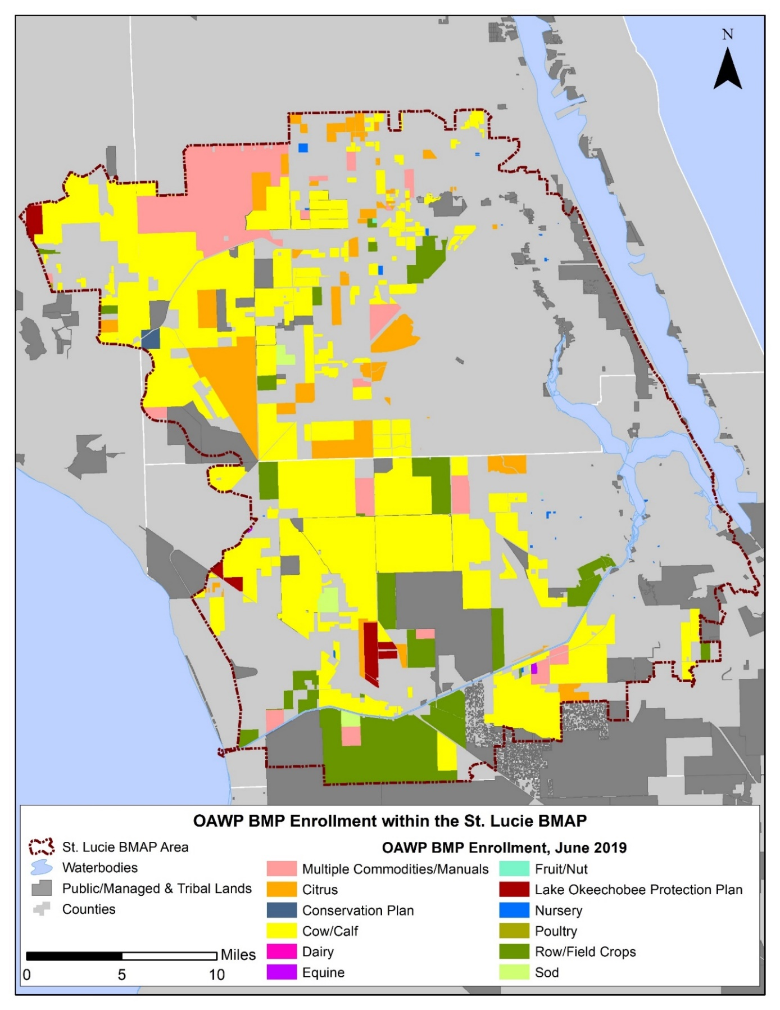
Figure B-1. BMP enrollment in the St. Lucie River and Estuary BMAP area as of June 2019

Unenrolled Agricultural Acreage
Since the adoption of NEEPP, FDACS’ goal has been to enroll 100 % of the agricultural acres in the BMP Program. As of June 2019, 61 % of the agricultural acres in the St. Lucie River and Estuary BMAP area are enrolled in FDACS' BMP Program and are implementing practices designed to improve water quality. While achieving 100 % enrollment is a laudable goal, the analysis of various land use databases has identified land uses classified as agriculture that are difficult to enroll or where there is a limit to the BMPs that can effectively be implemented onsite. This has required the prioritization and specific identification of agricultural lands that can be enrolled in FDACS' BMP Program.
To address the greatest resource concerns, OAWP has prioritized BMP enrollment by focusing on more intensive operations, including irrigated acreage, dairies and nurseries, parcels greater than 50 acres in size, and agricultural parcels adjacent to waterways. As of June 2019, 81 % of irrigated agricultural acres in the St. Lucie River and Estuary BMAP area were enrolled in FDACS' BMP Program.
As these priorities are met, OAWP has identified additional enrollment priorities, typically comprising smaller irrigated agricultural operations ranging from 30 to 50 acres and other targeted areas. Those larger, more intensive operations that have not enrolled are being referred to DEP to either develop individual monitoring plans pursuant to Chapter 62-307, F.A.C., or be subject to enforcement actions under DEP's regulatory authority.
General Considerations
As new BMAPs are developed or existing BMAP areas are expanded, overlap among BMAPs is increasing. In the St. Lucie River and Estuary BMAP area, 29 % of the agricultural acres are also included in the Lake Okeechobee BMAP area. While calculations, allocations, and projects are specific to each BMAP, it should be noted that the number of acres from the individual BMAP reports, if added, exceeds the total acres in the three BMAP areas. The St. Lucie River and Estuary BMAP boundary encompasses 81,661 acres of agricultural land use that are also contained in the Lake Okeechobee BMAP area. Of the unenrolled agriculture identified in this BMAP, 19,632 acres are also identified in the Lake Okeechobee BMAP.
Although land use data have been used as the basis for prioritizing FDACS enrollment efforts, many land use issues not captured by these databases affect FDACS enrollment efforts. Many areas within the St. Lucie River and Estuary BMAP boundaries experience rapid land use changes, especially at the urban/rural boundary. Agricultural lands are regularly converted to residential, industrial, commercial, or multiuse properties, but still appear in various databases as pasture or other rural lands. While these lands are likely to be developed in the near future, the agricultural land use classifications require these properties to comply with the BMP enrollment requirements.
Additionally, the counties' methods of classifying small acreages as agricultural lands can affect the BMP enrollment process. Along with these changes, there are also large agricultural parcels being subdivided but remaining classified as "agriculture." This "urban agriculture"—also called residential agriculture, rural residential, rural estates, equine communities, ranchettes, rural homesteads, and other descriptive names for homes with some acreage and agricultural zoning—present a particular challenge for FDACS, since the BMP manuals are not designed for the enrollment of these properties in BMPs targeted for bona fide agricultural production areas.
Further, thousands of acres of open land, scrubland, unimproved pasture, and grazing land exist without a readily identifiable agricultural production activity that will fit within the framework of existing FDACS BMP manuals. Also, these types of parcels are usually controlled by many different individuals. The increasing number of these smaller parcels with nontraditional agricultural production represents a growing component of unenrolled acreage. It will be necessary to develop a suite of options to apply to these properties or develop a new classification that may subject these types of areas to alternative methods to ensure their nutrient loading contribution is being appropriately identified and reduced.
Another challenging area includes those agricultural lands that are inactive or fallow—i.e., lands that, on the day the FDACS representative visits, display no enrollable agricultural activity. These lands may be part of a rotation implemented by a landowner, scheduled for development, listed for sale, etc. The land use information FDACS receives is consistently improving the classification of these areas, but policy options remain limited in scope to ensure the implementation of practices aimed at reducing nutrient inputs from these areas.
Characterization of Unenrolled Agricultural Lands
To characterize unenrolled agricultural acres, OAWP identified FSAID VI features outside the BMP enrollment areas within GIS. As previously mentioned, OAWP BMP enrollments are initially delineated based on county property appraiser parcel data, even if the entire parcel is not agriculture, to allow BMPs to be tied to the specific parcels where agricultural activities are occurring. FSAID agricultural lands are delineated based on land use features identified as agriculture and represent a more refined analysis of those areas actually in agricultural production.
Because of differences in their spatial geometries when they are combined or compared, the boundaries often do not align precisely, creating "slivers." Slivers are not enrollable because they are an artifact of the geospatial analysis and do not represent lands with active agricultural practices. For example, a sliver can represent the area between the boundary of a parcel and the beginning of a road, canal, easement, etc. Slivers are often associated with previously enrolled agricultural operations but because of the delineation differences, these slivers are not captured within the enrolled parcel during geoprocessing. When characterizing unenrolled agricultural lands, slivers are excluded. Figure B-2 shows an example of a sliver created when performing geospatial analysis.

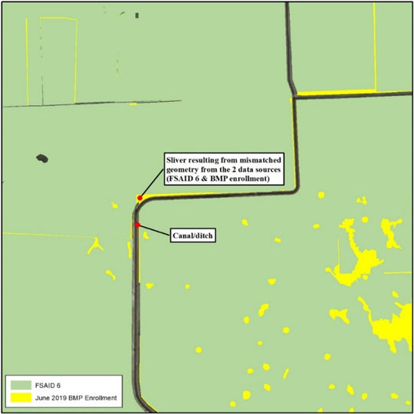
Figure B-2. GIS example of a sliver

OAWP used property appraiser data and manually reviewed aerial imagery to characterize unenrolled lands in the BMAP area. Lands under tribal ownership are not subject to the requirements of Section 403.067, F.S.; yet areas within the sovereign lands of the Seminole Tribe of Florida are identified as unenrolled agricultural lands. Other large areas that are identified as agricultural land use but are unlikely to have enrollable agricultural activities include lands owned by the state (Board of Trustees of the Internal Improvement Trust Fund) and SFWMD. It is possible that these lands, in whole or in part, may be leased to other entities that conduct agricultural activities, but such leasing is infrequent. If leasing occurs, the leasing entity will be required to enroll in the BMP Program. Ongoing coordination between FDACS, DEP's Division of State Lands, and SFWMD is needed to ensure that any public lands that are leased for the purposes of agricultural activities are required to implement and enroll in FDACS' BMP Program as a condition of the lease. Other lands that may be classified as agriculture but are unlikely to have enrollable agricultural activities include lands that may be part of a SFWMD restoration project or water storage project. Future analysis and coordination with the SFWMD will be needed to identify which areas may have enrollable agriculture within the areas identified for restoration and water storage projects.
Other smaller parcels that have been identified as nonagricultural, but have features that cause them to be identified as agricultural lands in various databases, include those lands associated with utilities, telecommunication companies, churches, FDOT rights-of-way, and airports. The Florida Department of Revenue (DOR) uses code numbers 70 through 98 to identify these types of lands.
Those agricultural lands that have been identified as "fallow," "former [ag]," and "abandoned," as well as brushland/scrubland/open land, comprise 38 % of the total unenrolled agricultural acres in the St. Lucie River and Estuary BMAP area. These acres are still classified as agricultural land for the purposes of the BMAP nutrient load assessment. There are a variety of potential options to capture some of these lands, such as enrollment as "temporarily inactive" operations—particularly those that were previously enrolled and are planned to resume production. Another option may be to note the inactive acres at the time of a field visit and perform periodic reassessment on a cyclical basis. The possibility for DEP and FDACS to calculate nutrient reduction credits or adjust nutrient loading rates may also provide opportunities to present more accurate estimates and establish priorities.
Another factor considered in the prioritization of BMP enrollment is the number of agricultural acres on the parcel. Analyzing the number of agricultural acreages on the parcel and commodity type can give an idea of the efforts that are needed to enroll these areas in FDACS' BMP Program and also identify the areas most in need of enrollment. Figure B-3 summarizes the agricultural acres distributed by agricultural acreage found on each parcel.
Further analysis was done to characterize the parcels containing 50 acres of agriculture or greater and those parcels with less than 50 acres of agriculture; 58,017 acres of the 81,435 acres of land identified as having potential agricultural activity are found on parcels containing 50 acres of agriculture or greater. Figure B-4 shows the types of agricultural land use based on FSAID VI found on parcels that contain 50 acres of agriculture or greater. Grazing land comprises 40 % of this acreage.
Of the land identified as agriculture, 23,257 acres are found on parcels with less than 50 acres of agriculture. Figure B-5 shows the types of agricultural land use found on parcels with less than 50 acres of agriculture. Grazing land comprises 54 % of this acreage. For these parcels, OAWP will prioritize the more intensive agricultural operations, such as sugarcane, citrus, and other row crops, for enrollment.

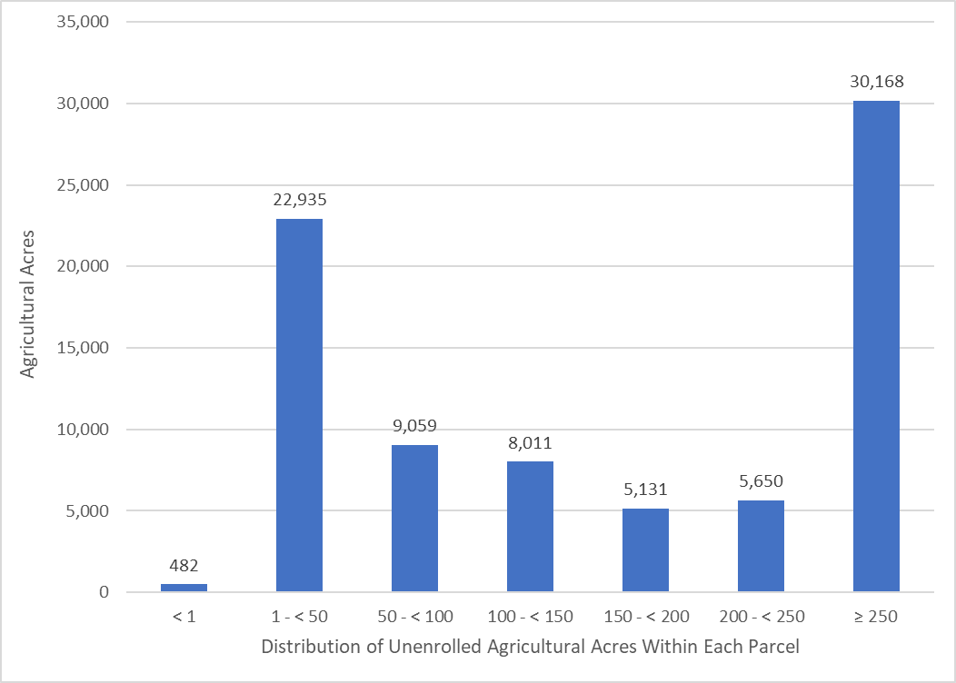
Figure B-3. Distribution of agricultural acreage on parcels with potential agricultural activity, St. Lucie River and Estuary BMAP area

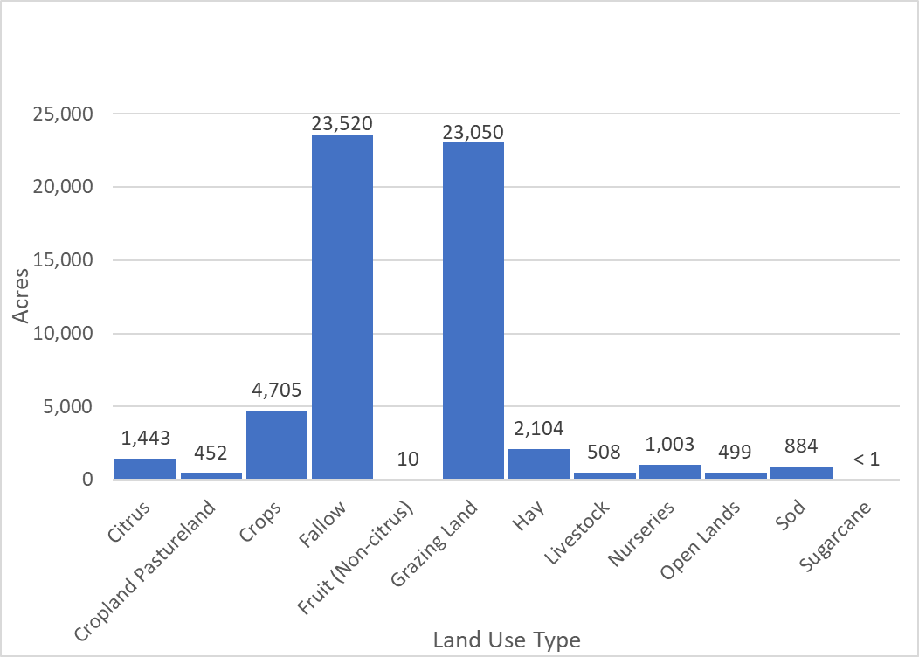
Figure B-4. Agricultural land uses on parcels with 50 acres of agriculture and greater, St. Lucie River and Estuary BMAP area

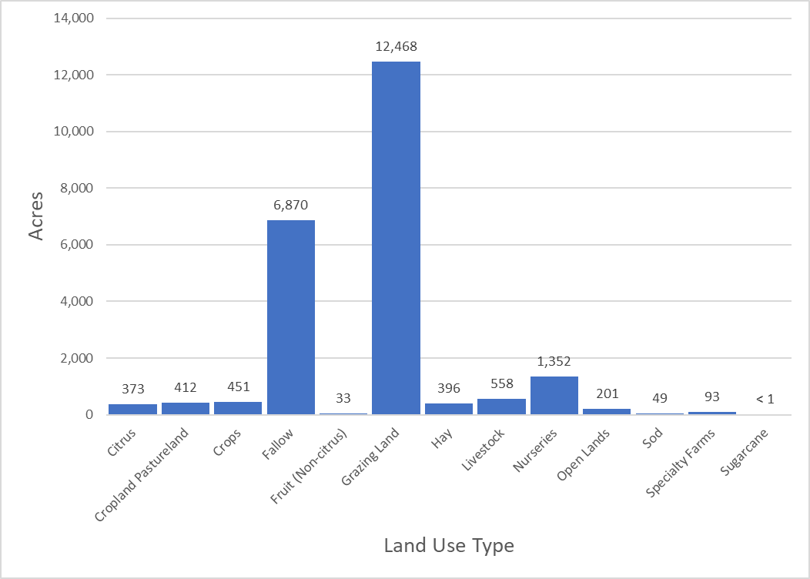
Figure B-5. Agricultural land uses on parcels with less than 50 acres of agriculture, St. Lucie River and Estuary BMAP area

Table B-12 lists the total acreage associated with the identified slivers and the lands that are not likely to have enrollable agricultural activities, along with the remaining total of unenrolled agricultural acres in the BMAP area. Figure B-6 and Figure B-7 summarize the unenrolled agricultural acres in the St. Lucie River and Estuary BMAP area by acres of agriculture within the parcels. However, they do not include acreages or parcels associated with slivers or lands that are not likely to have enrollable agricultural activities.
Table B-12. Summary of unenrolled agricultural land use acreage in the St. Lucie River and Estuary BMAP area
Note: Because of geometric variations between shapefiles used in the unenrolled agricultural lands analysis performed by OAWP, the unenrolled agricultural acres differ from subtraction of the FSAID VI Agricultural Acres in the BMAP and the Total Agricultural Acres Enrolled referenced in Table B-2.
Category | Acres
Unenrolled agricultural acres | 110,195
Acres identified within slivers of unenrolled agricultural areas | 3,227
Lands without enrollable agricultural activity (e.g., tribal lands, residential development, and parcels with DOR use codes 70-98) | 25,533
Total lands with potentially enrollable agricultural activities | 81,435

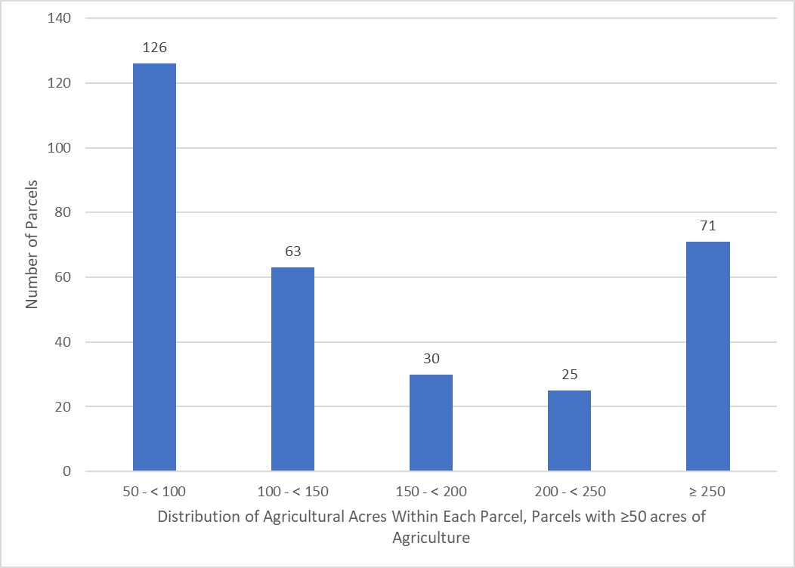
Figure B-6. Number of parcels with 50 acres of agriculture and greater, St. Lucie River and Estuary BMAP area

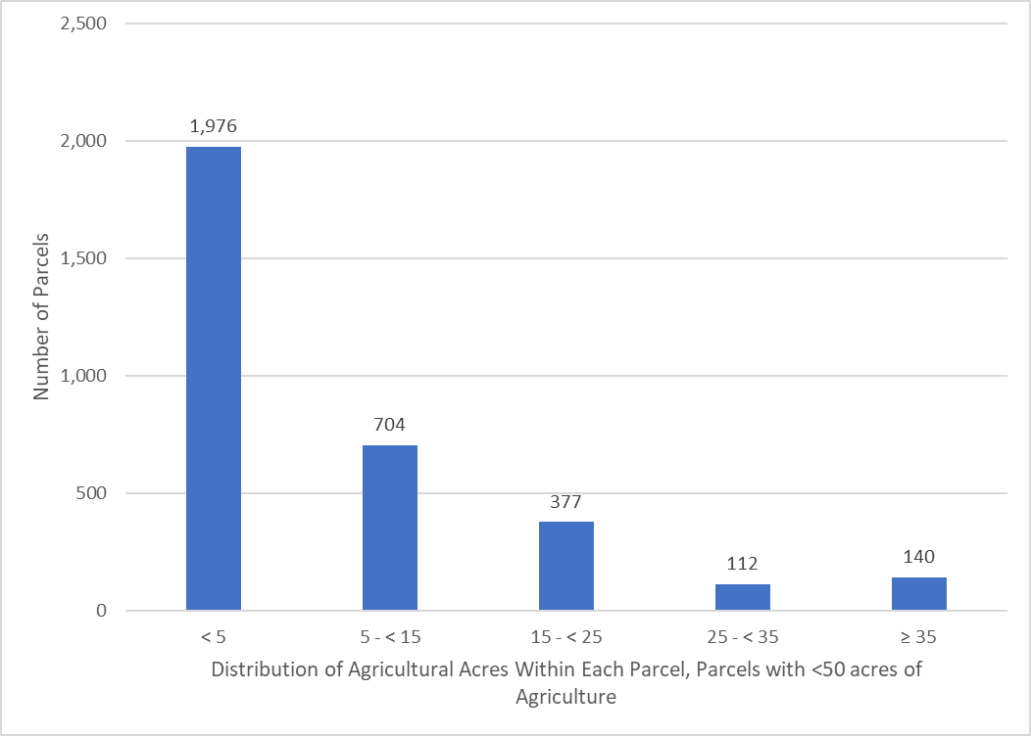
Figure B-7. Number of parcels with less than 50 acres of agriculture, St. Lucie River and Estuary BMAP area

Unenrolled agriculture characterization information for each individual basin, including the distribution of agricultural acres within each parcel and land use type, is presented in Figure B-8 through Figure B-27.

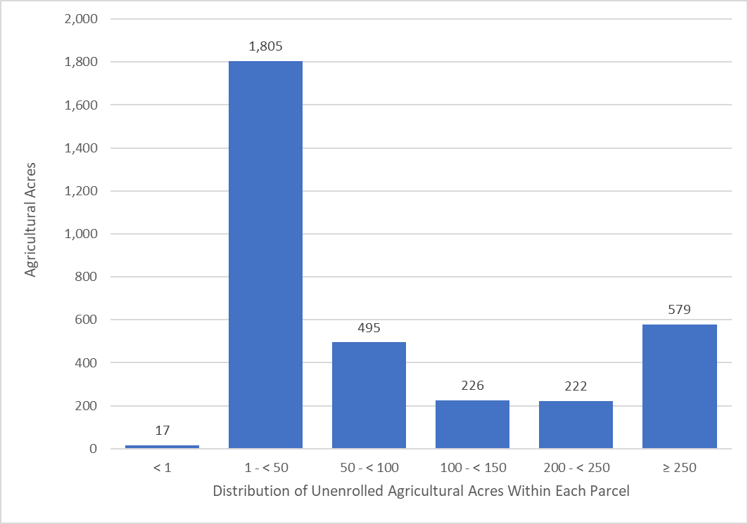
Figure B-8. Distribution of agricultural acreage on parcels with potential agricultural activity, North Fork Basin

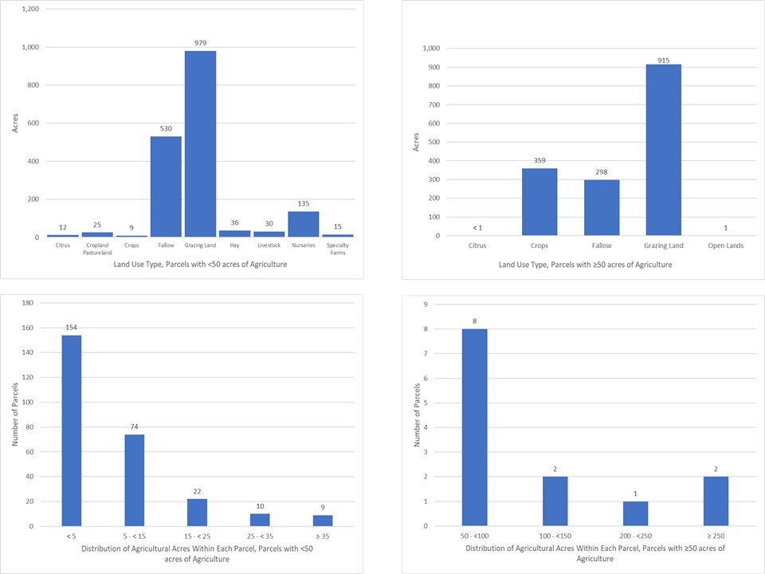
Figure B-9. Land use type and distribution of agricultural acreage, North Fork Basin

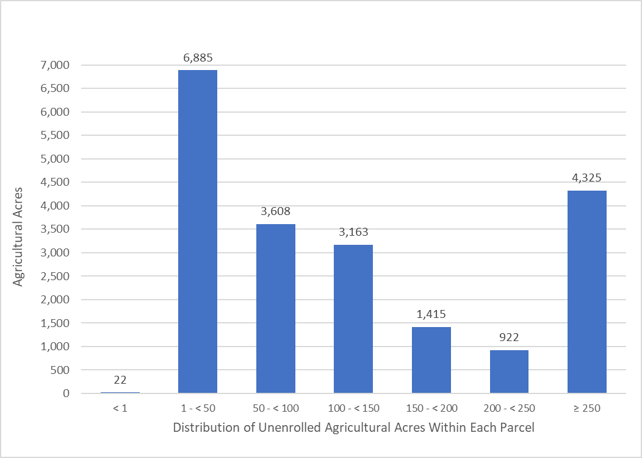
Figure B-10. Distribution of agricultural acreage on parcels with potential agricultural activity, Ten Mile Creek Basin

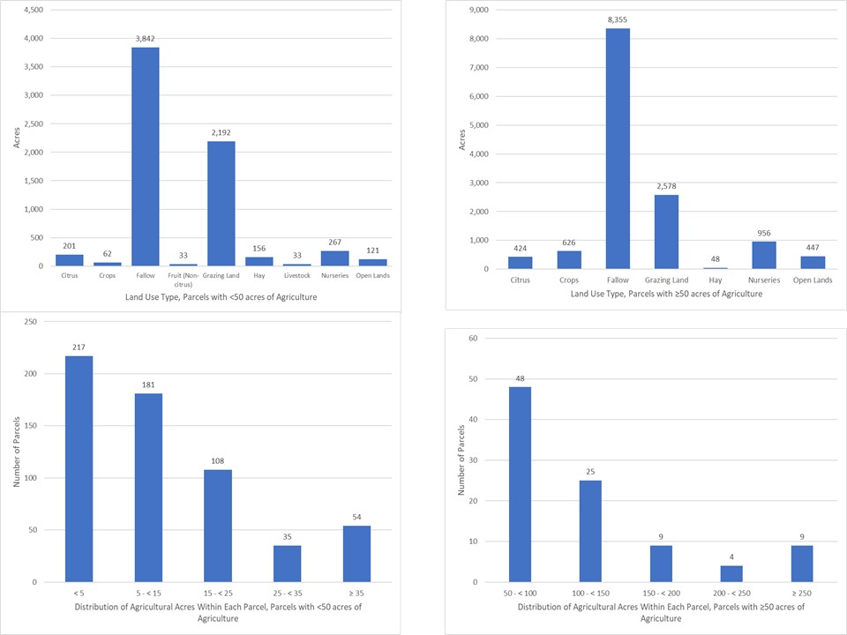
Figure B-11. Land use type and distribution of agricultural acreage by parcel size, Ten Mile Creek Basin

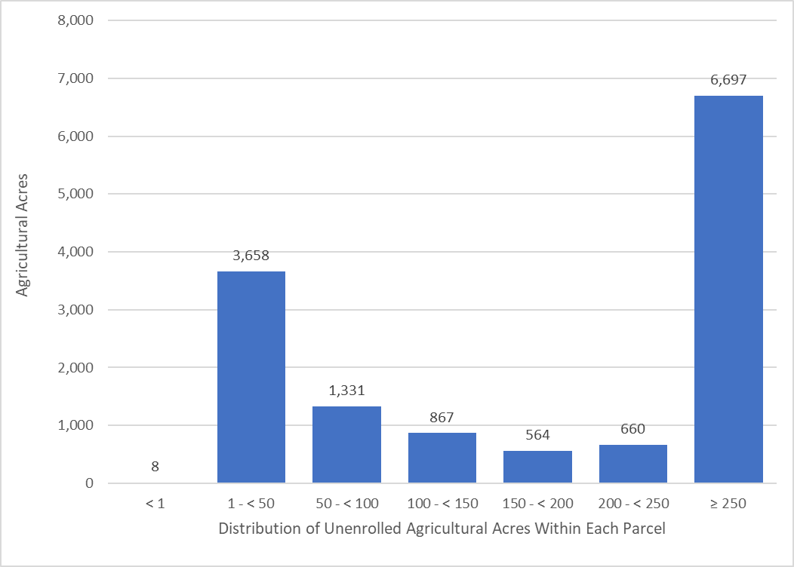
Figure B-12. Distribution of agricultural acreage on parcels with potential agricultural activity, C-24 Basin

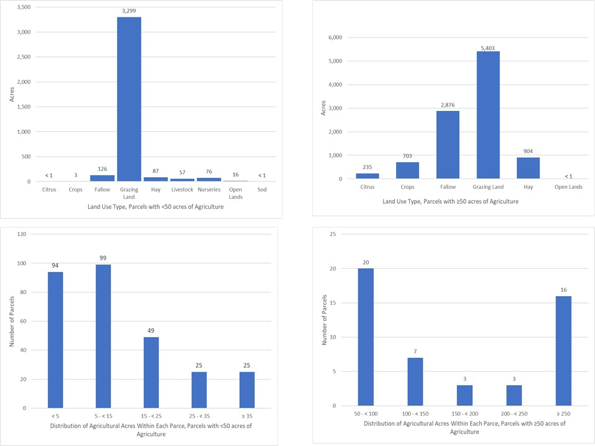
Figure B-13. Land use type and distribution of agricultural acreage by parcel size, C-24 Basin

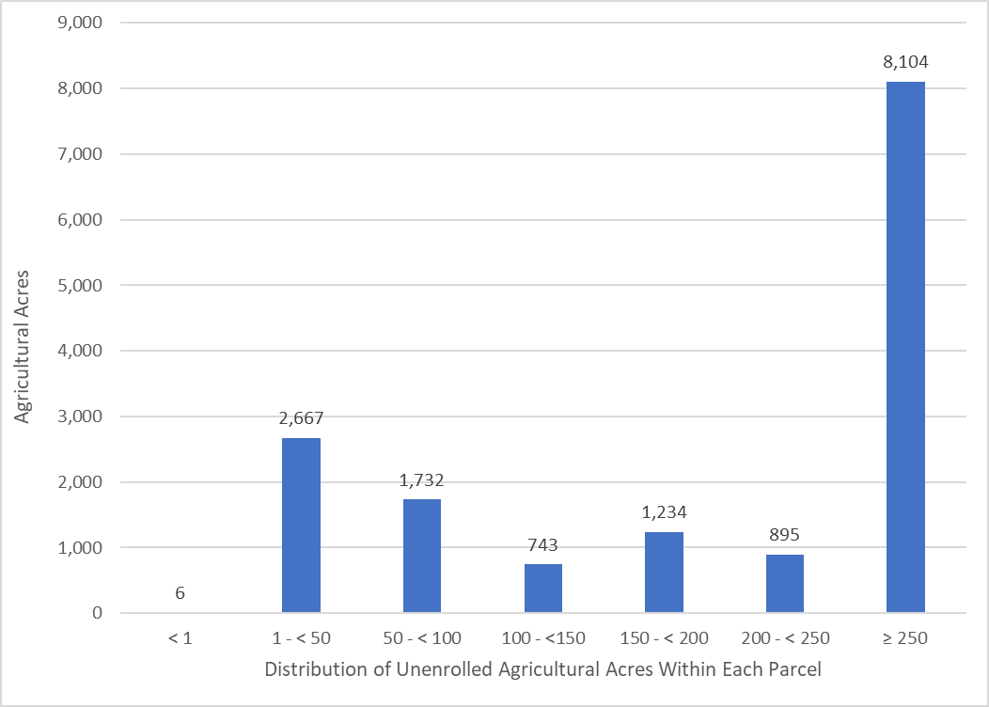
Figure B-14. Distribution of agricultural acreage on parcels with potential agricultural activity, C-23 Basin

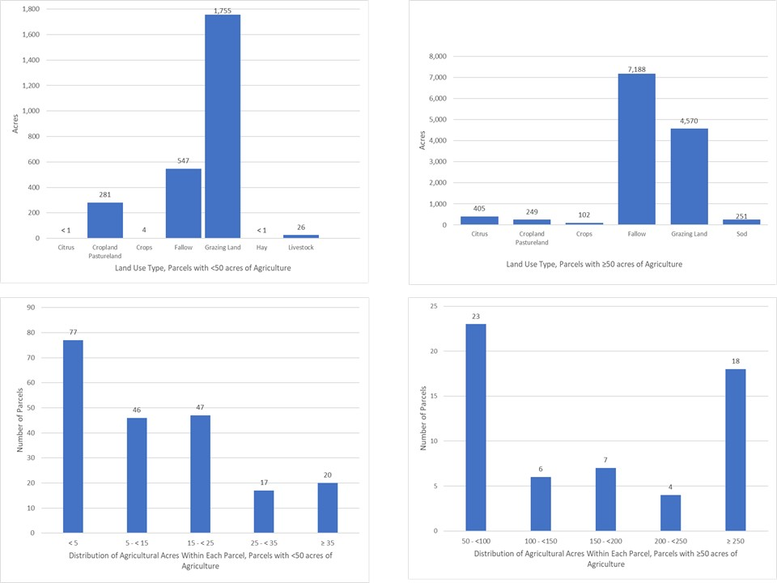
Figure B-15. Land use type and distribution of agricultural acreage by parcel size, C-23 Basin

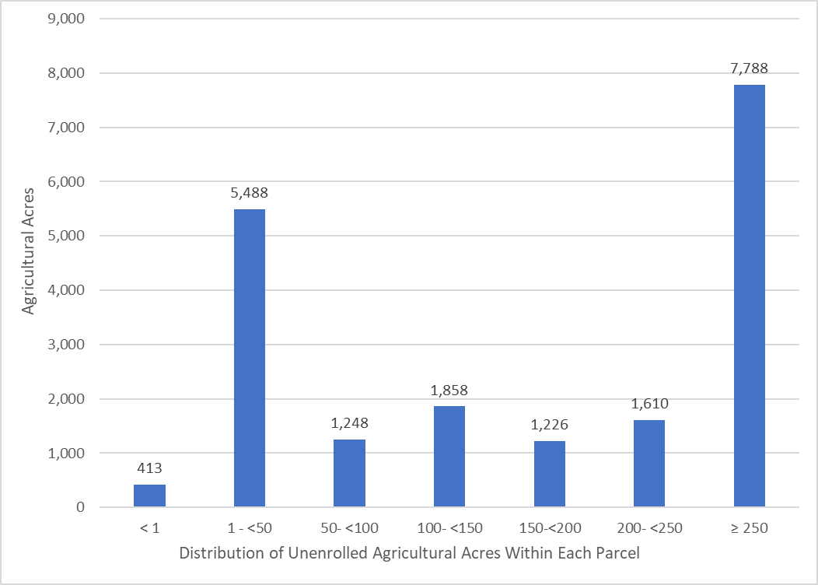
Figure B-16. Distribution of agricultural acreage on parcels with potential agricultural activity, C-44/S-153 Basin

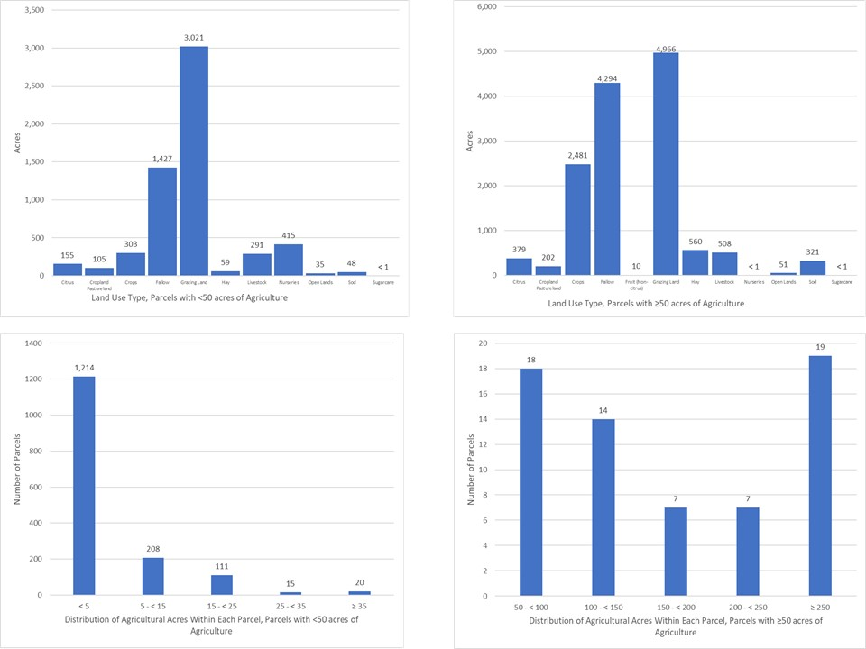
Figure B-17. Land use type and distribution of agricultural acreage by parcel size, C-44/
S-153 Basin

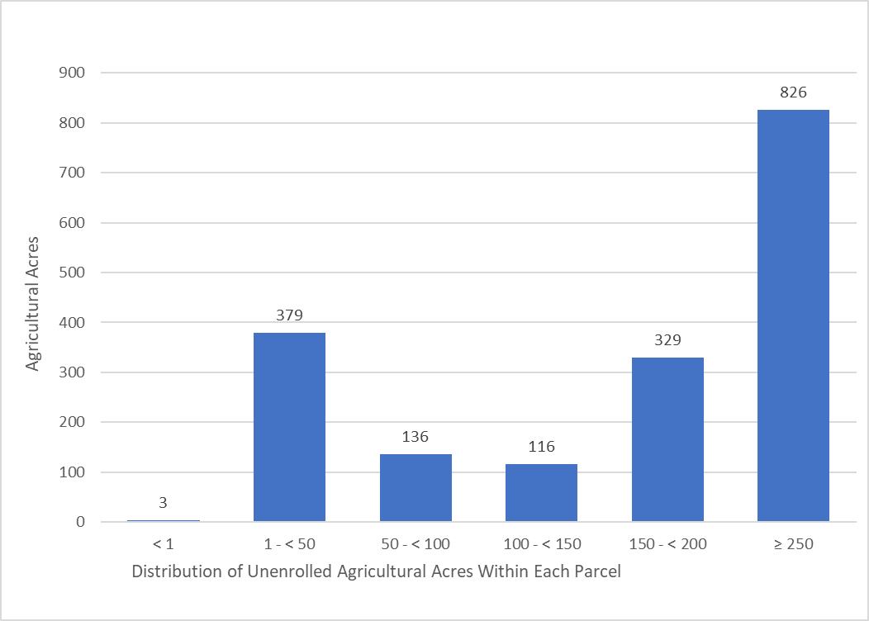
Figure B-18. Distribution of agricultural acreage on parcels with potential agricultural activity, Basin 4/5

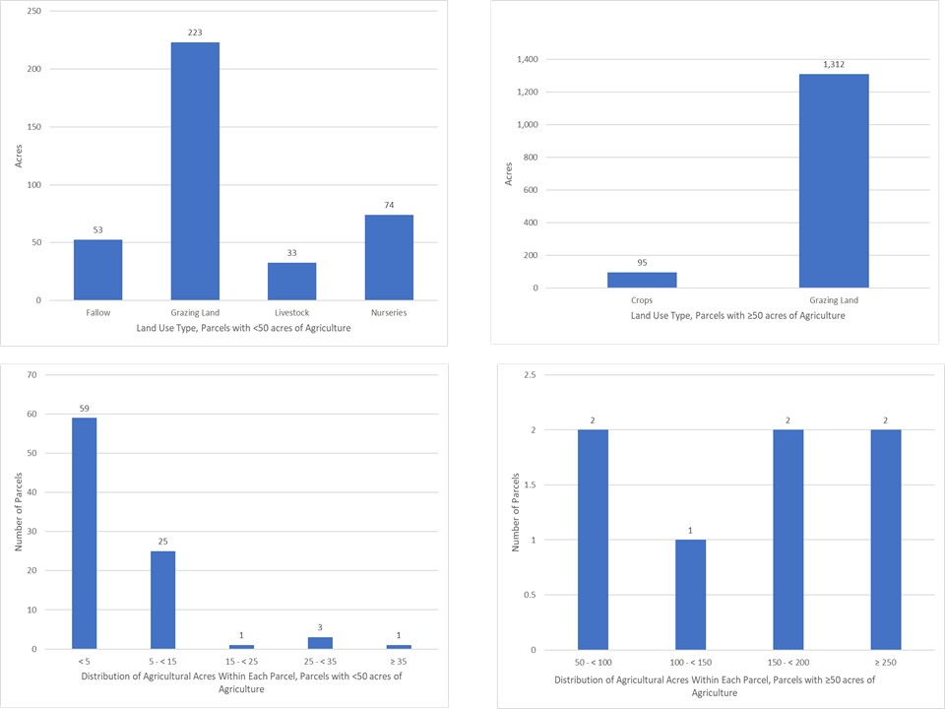
Figure B-19. Land use type and distribution of agricultural acreage by parcel size, Basin 4/5

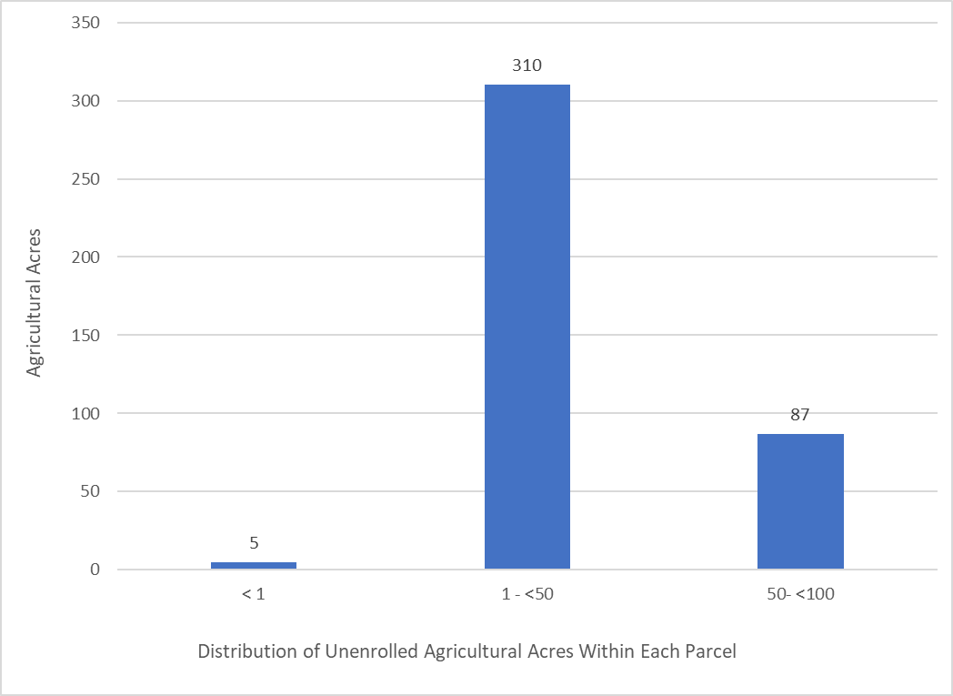
Figure B-20. Distribution of agricultural acreage on parcels with potential agricultural activity, Basin 6

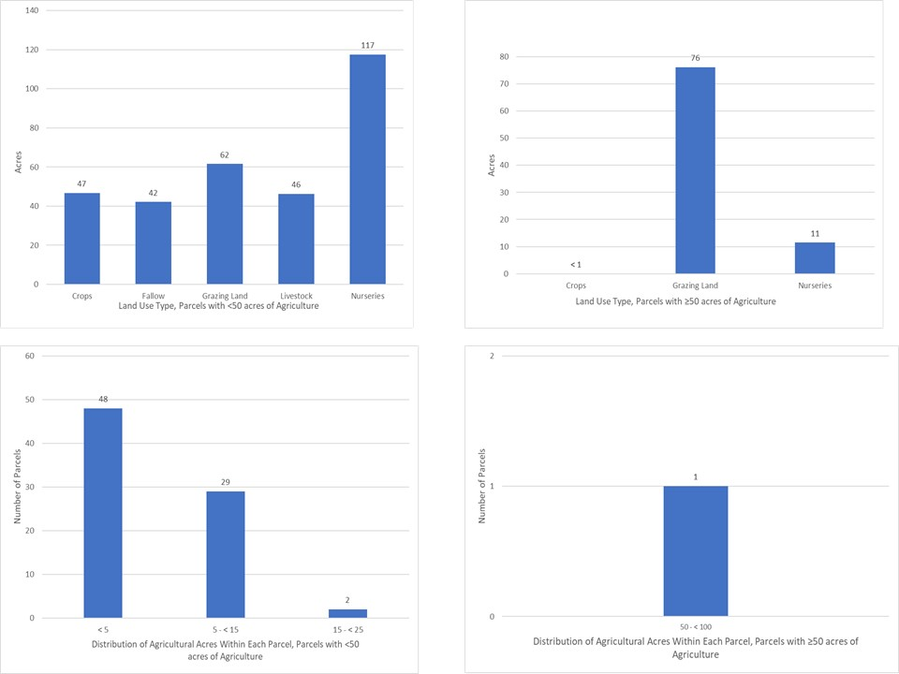
Figure B-21. Land use type and distribution of agricultural acreage by parcel size, Basin 6

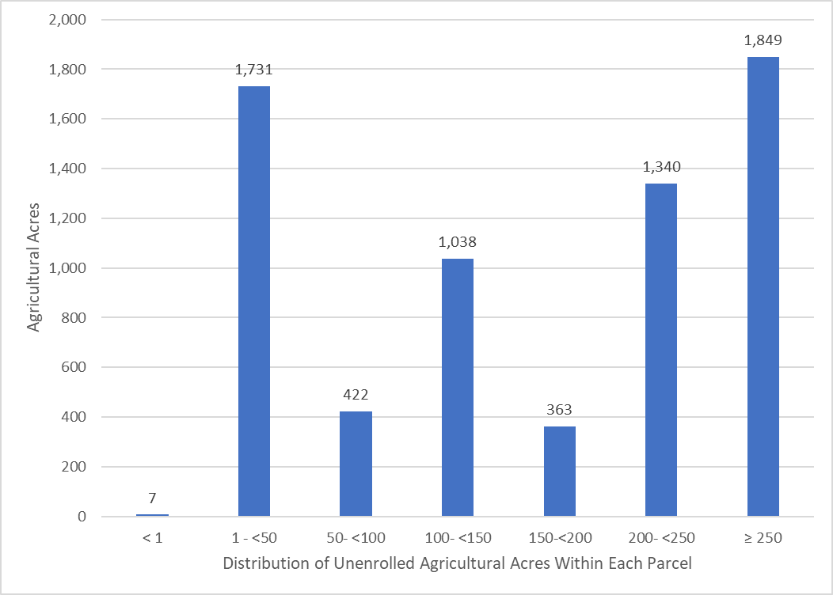
Figure B-22. Distribution of agricultural acreage on parcels with potential agricultural activity, South Fork Basin

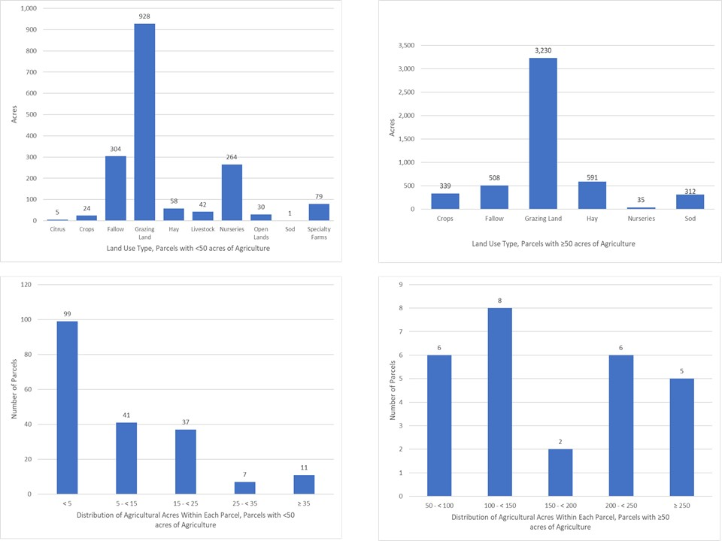
Figure B-23. Land use type and distribution of agricultural acreage by parcel size, South Fork Basin

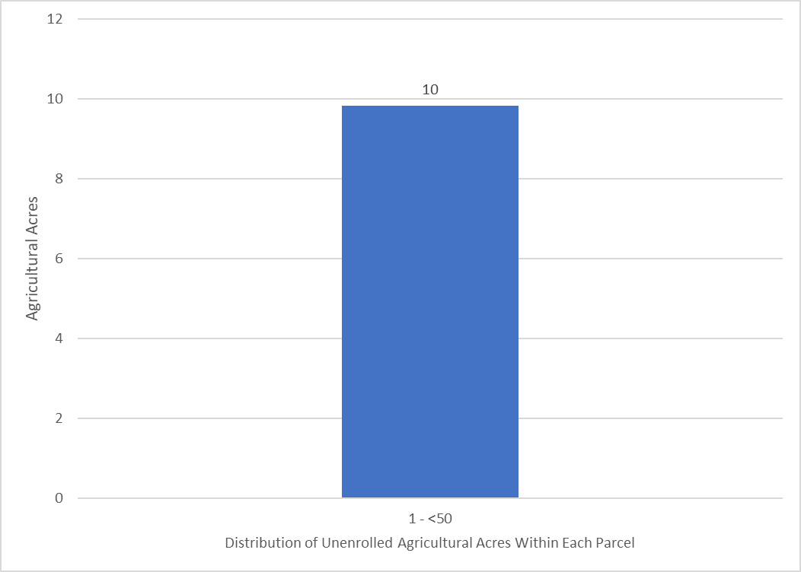
Figure B-24. Distribution of agricultural acreage on parcels with potential agricultural activity, South Coastal Basin

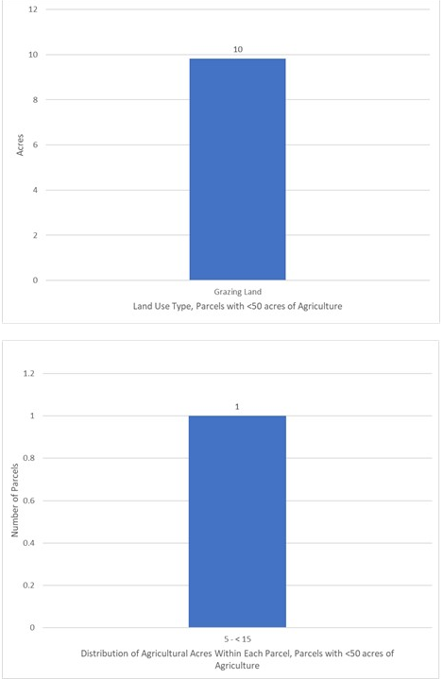
Figure B-25. Land use type and distribution of agricultural acreage by parcel size, South Coastal Basin

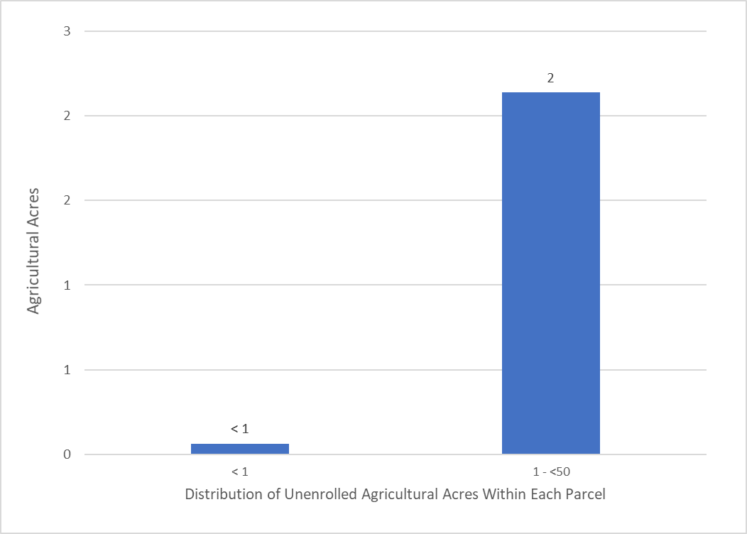
Figure B-26. Distribution of agricultural acreage on parcels with potential agricultural activity, North Mid-Estuary Basin

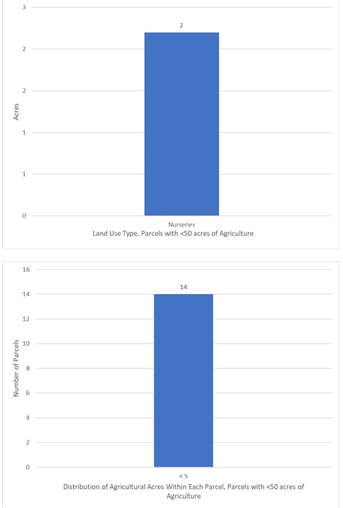
Figure B-27. Land use type and distribution of agricultural acreage by parcel size, North Mid-Estuary Basin
Future Efforts
BMAP loads and allocations, as well as water supply projections, are based primarily on land use data. Maintaining the most accurate agricultural land use dataset is critical to planning and policy decisions. Although crop changes, technology advances, and land ownership/lessee changes related to agricultural operations create dynamic environments and difficulties in estimating impacts from specific operations, FDACS and DEP continue to coordinate and develop ways to improve accuracy.
Additional characterizations of the agricultural land uses need to be conducted for each of the basin in the St. Lucie River and Estuary BMAP area. As the DEP analysis identifies the nutrient loading estimates for each associated basin, FDACS will be able to better focus enrollment and cost-share efforts on those basins with the highest estimated loads and characterize the land uses with agricultural production that are consistent with FDACS' BMP Program.
Analyzing land use data and parcel data is a valuable first step in identifying the agricultural areas that provide the greatest net benefits to water resources for enrollment in FDACS’ BMP Program, as well as to prioritize implementation verification visits in a given basin. The next step to refine the enrollment efforts will have the parcel loading information derived from the WaSh converted to a format that can easily be analyzed with the land use and parcel geodatabases. This effort will help FDACS identify specific parcels with the highest modeled nutrient loading. These parcels would then be prioritized for the enrollment and implementation of BMPs, as well as site visits to verify BMP implementation.
Additional Factors Related to Agricultural Lands and Measuring Progress
Legacy loading, including loading as a result of the operation of the regional water management system and associated infrastructure, can present an additional challenge to measuring progress in many of areas of Florida with adopted BMAPs. Based on research, initial verification by DEP, and long-term trends in water quality in the BMAP area, it is expected that current efforts, such as BMP implementation, will continue to provide improvements in overall water quality despite the impacts from legacy loads. Recognition that there is naturally occurring nitrogen and phosphorus in the system is important when evaluating solutions, as the ubiquity of the source, limitations for treatment, and uncertainty of proportion compared with anthropogenic sources may mask or overwhelm gains achieved through BMP implementation and other site-specific efforts.
While the implementation of BMPs will improve the water quality in the basin, it is not reasonable to assume that BMP implementation alone can overcome the issues of legacy loads, conversion to more urban environments, and the effects of intense weather events. BMP implementation is one of several complex and integrated components in managing the water resources of a watershed. Additional regional projects, precisely located and operated, will be needed to achieve the TMDLs for the SLREW.
Collaboration between DEP, the water management districts, and other state agencies, as well as local governments, federal partners, and agricultural producers, is critical in identifying projects and programs, as well as locating funding opportunities to achieve allocations provided for under this BMAP. To improve water quality while retaining the benefits agricultural production provides to local communities, wildlife enhancement, and the preservation of natural areas requires a commitment from all stakeholders to implementing protective measures in a way that maintain the viability of agricultural operations.
Recommended Updates to Land Use
DEP and OAWP have identified land use–related issues that consistently occur during BMAP development and/or updates. One of these issues is the differentiation between what is classified as agricultural land use in the TMDL or BMAP model and what is no longer agricultural land use.
OAWP has developed a methodology to identify agricultural land use changes. Using GIS, OAWP compared the 2012 SFWMD land use with the latest FSAID land use and OAWP BMP enrollment data. OAWP identified areas classified as agriculture by the BMAP modeled land use that do not overlap with the latest FSAID or OAWP BMP enrollment data. OAWP reviewed the output of this overlay analysis by using county appraiser data and aerial imagery to determine if the nonoverlapping areas were still in production. OAWP identified 2,310 acres, classified as agriculture in the 2012 SFWMD land use, that are now other land use types such as residential, industrial, or commercial (see Table B-13). DEP will evaluate the land use changes identified by OAWP and apportion the associated acres and loads to the appropriate entities after a discussion with each entity. Following these determinations, the reallocated loads will be credited to FDACS as reductions. Land use change credits that have not yet been evaluated as of BMAP adoption will be reflected in the next BMAP update.
Often the analyses show changes that have occurred more rapidly than any land use data can capture, such as the transition to residential development. The land use changes are provided to DEP as a GIS shapefile with a description of the information in the county property appraiser database and aerial imagery reflected for the refinement of the acreage and loading allocated to agriculture in a BMAP area.
In addition to identifying land use changes in the BMAP area modeled land use, OAWP regularly reviews FSAID data, at times daily or weekly, as it performs other job functions. Any edits or changes are reviewed and considered for inclusion in the next iteration of the FSAID.
Table B-13. Agricultural land use change by basin
Basin | Acres
North Fork | 149
Ten Mile Creek | 146
C-24 | 345
C-23 | 642
C-44/S-153 | 734
South Fork | 294
Total | 2,310

Potential Site-Specific Nutrient Management Measures in Addition to BMPs
Beyond enrolling producers in the OAWP BMP Program and verifying implementation, OAWP will also work with producers to identify a suite of agricultural projects and research agricultural technologies that could be implemented on properties where they are deemed technically feasible and if funding is made available. FDACS executes contracts with Soil and Water Conservation Districts and other partners to administer cost-share funds and provide technical and administrative support for these districts and other partners. Cost-share funding is being used to implement higher level BMPs, innovative technologies, and regional projects to provide the next added increment of improving and protecting water quality.
Table B-14 identifies the agricultural technologies that received cost-share assistance in the St. Lucie River and Estuary BMAP area and the associated nutrient reductions based on the 2016 Soil and Water Engineering Technology (SWET) report. Using the nutrient reductions from the report, OAWP developed a methodology to estimate nutrient reductions for NOIs that have received cost-share funding. The NOI boundary, based on property appraiser parcel data, was considered the area treated by the cost-shared agricultural technology or project. For parcels with more than one cost-share project, OAWP identified the order of treatment to determine the reductions for the multiple projects and created a workbook that provided the cost-share agricultural technologies and the formulas to estimate the nutrient reductions.
Table B-14. Cost-share project types and associated nutrient reductions recommended by OAWP
¹ Reductions for this measure not incorporated as part of this exercise
² Reductions for this measure are from Table 5. Estimated Edge of Farm Nutrient Load Reductions for the FDACS Okeechobee BMP Program in the 2016 SWET Report (Bottcher 2016) and is represented in pounds per year per unit (each project is 1 unit)
Project Types | TN Reductions  (%) | TP Reductions  (%)
Chemigation/fertigation | 20 | 20
Composting and/or storage project | N/A | N/A
Crop implements | N/A | N/A
Dairy work | 50 | 50
Drainage improvements, mole drain, ditch cleaning | 10 | 15
Engineering, surveying, planning, modeling | N/A | N/A
Fence | 10 | 10
Irrigation improvements, automation | 20 | 20
Precision agriculture technology | 30 | 10
Retention, detention, tailwater recovery, berms (vegetable and agronomic crops, citrus) | 64 | 70
Retention, detention, tailwater recovery, berms (cow/calf) | 25 | 18
Structure for water control/culvert | 17 | 29
Weather station¹ | 20 | 5
Well, pipeline, trough, pond, heavy use protection² | 50 | 50

Appendix C. WCDs and Other Special Districts
In the 2013 BMAP, WCDs and other special districts were assigned numeric allocations, which included all agricultural and urban lands within their jurisdictional boundaries that were not part of an MS4. During the development of the BMAP, there were concerns with this approach, because FDACS is the only entity that can enroll growers in BMPs, but the districts were responsible for loading from the agricultural areas.
In addition, the urban lands within the districts were permitted by cities or counties and not under each district's control. Therefore, this 2020 BMAP only assigns the canals and rights-of-way to the special districts, as the districts have control over these portions of their jurisdictions. The districts are required to implement specific canal and right-of-way BMPs to be compliant with the BMAP, as summarized below.
Hobe St. Lucie Conservancy District
- Remove sediment on a regular basis from the canals. When removing the sediment, care should be taken to avoid creating steep banks that will continue to erode and add sediments into the canals. Bank stabilization should be used where needed. Sediments removed must be disposed of in a location where they will not reenter the canal.
- Report: Regular maintenance activities, including dates when sediment removal activities occurred, volume of sediment removed, and sediment disposal location.
- Create a canal buffer or filter strip to help reduce loading from stormwater runoff to the canals. This can be done by not mowing canal banks within a minimum of 10 feet of the canal, or by using alternative mechanisms that accomplish the same goal. Mowing and maintenance activities should be done in such a way to prevent grass clippings from getting into the canals, where they can decompose and add nutrients.
- Report: Width and locations of vegetated buffer strip (or percentage of canal banks that include a buffer strip). Type and location of any alternative methods of canal buffer or filter strips.
- Assist FDACS, where needed, with identifying and contacting producers within the district boundaries for the purposes of participating in the relevant FDACS' BMP Program.
- Report: Number of landowners contacted to assist FDACS, and the names of landowners.
- Maintain the Hobe Sound Polo Club BMP treatment train.
- Report: O&M that occurred.
North St. Lucie River WCD
- Harvest aquatic vegetation in the canals using mechanical processes instead of herbicide treatment. Vegetation removed from the canals must be disposed of in a location where the material will not reenter the canal. Vegetation harvesting should consider the DEP guidelines in the document, Removal of Aquatic Vegetation for Nutrient Credits in the Indian River Lagoon (IRL) Basin (September 2012).
- Report: Dates when harvesting occurred and disposal location. Report any herbicide treatments and justification for the nonmechanical removal of vegetation.
- Create a canal buffer or filter strip to help reduce loading from stormwater runoff to the canals. This can be done by not mowing canal banks within a minimum of 10 feet of the canal, or by using alternative mechanisms that accomplish the same goal. Mowing and maintenance activities should be done in such a way to prevent grass clippings from getting into the canals where they can decompose and add nutrients.
- Report: Width and locations of vegetated buffer strip (or percentage of canal banks that include a buffer strip). Type and location of any alternative methods of canal buffer or filter strips.
- Assist FDACS, where needed, with identifying and contacting producers within the district boundaries for purposes of participating in the relevant FDACS' BMP Program.
- Report: Number of landowners contacted to assist FDACS, and the names of landowners.
- Maintain existing water control structures, including the C-25 diversion structure; adjustable gates on structures; Canals 23 and 28 ponds and structures; and 81-1-2, 82-2-2, 83-2-2, and 85-1-2 control structures.
- Report: Structure type, location (shapefile), and operation.

Pal Mar WCD
- Maintain the lands within the district as natural and undeveloped to prevent nutrient loading.
- Report: Status of lands in the district and any changes to the land use types.
- Create a canal buffer or filter strip to help reduce loading from stormwater runoff to the canals. This can be done by not mowing canal banks within a minimum of 10 feet of the canal, or by using alternative mechanisms that accomplish the same goal. Mowing and maintenance activities should be done in such a way to prevent grass clippings from getting into the canals where they can decompose and add nutrients.
- Report: Width and locations of vegetated buffer strip (or percentage of canal banks that include a buffer strip). Type and location of any alternative methods of canal buffer or filter strips.

Troup-Indiantown WCD
- Remove sediment periodically from the canals and/or stabilize the banks of the canals. When removing the sediment, care should be taken to avoid creating steep banks that will continue to erode and add sediments into the canals. Bank stabilization should be used, where needed. Sediments removed must be disposed in a location where they will not reenter the canal.
- Report: Regular maintenance activities, including dates when bank stabilization/sediment removal activities occurred, the linear feet of stabilization/volume of sediment removed, and sediment disposal location. Sediment removal projects, including dates when activities occurred, project area, volume of sediment removed, and sediment disposal location.
- Create a canal buffer or filter strip to help reduce loading from stormwater runoff to the canals. This can be done by not mowing canal banks within a minimum of 10 feet of the canal, or by using alternative mechanisms that accomplish the same goal. Mowing and maintenance activities should be done in such a way to prevent grass clippings from getting into the canals where they can decompose and add nutrients.
- Report: Width and locations of vegetated buffer strip (or percentage of canal banks that include a buffer strip). Type and location of any alternative methods of canal buffer or filter strips.
- Assist FDACS, where needed, with identifying and contacting producers within the district boundaries for purposes of participating in the relevant FDACS' BMP Program.
- Report: Number of landowners contacted to assist FDACS, and the names of landowners.
- Maintain existing water control structures and the Minute Maid Road drainage improvements project.
- Report: Structure type, location (shapefile), and operation. O&M for the Minute Maid Road project.
Troup0-

Appendix D. RFI Responses
To further identify restoration projects for this BMAP, DEP released an RFI to generate additional restoration projects or activities from both the public and private sectors. The effort was open to any interested parties who could propose a viable project for restoration and could be considered for inclusion in the final St. Lucie River and Estuary BMAP for funding consideration.
Overall, the RFI process generated 37 responses, mainly from the private sector. Submittals ranged from structural projects to new and emerging technologies. All submittals were reviewed; Table D-1 summarizes the submittals. The TRA IDs and basin names reference the maps for each basin in Chapter 3. Resources will be needed to implement any of these projects throughout the watershed., and they are being considered for DEP funding. Additional details on all responses are on file with DEP.
Table D-1. Summary of responses received for RFI 2020018
Location Information | Submitted by | Project Name | Project Type
TRA IDs: 1,2,3,4,5 | AECOM Technical Services, Inc. | Nutrient Inceptor Removal System (NIRS) | Algae-harvesting technology
TRA ID: 3 | AquaFiber Technologies Corporation | AquaLutions | Algae-harvesting technology
TRA IDs: 1,2,3,4,5,6,7,8,9,10,11 | Aquatic Vegetation Control, Inc. | Bio-Zyme | Technology
TRA IDs: 8,9,10,11 | Beta Analytic, Inc. | Dissolved Nitrate Isotopic Monitoring | Monitoring
TRA IDs: 1,2,3,4,5,6,7,8,9,10,11 | C.B. Smith Company, Inc. | ADS Canal/River Treatment | Technology
TRA ID: 5 | Caulkin s-Troup Water Farm | Water Storage | Storage/STA
TRA ID: 1,2,3 | City of Port St. Lucie – Septic2Sewer | Utility Expansion Project | Septic to Sewer
TRA ID: 4 | Cypress Creek – Ru-Mar Inc. Bluefield Ranch | Rehydration of Cypress Creek | Structure
TRA IDs: 1-27 | Eco Librium | Water Cleanser | Technology
TRA IDs: 1-11 | ECS | Bold & Gold Filtration Media | Biosorption activated media
Not provided | Equilibrium Sciences, LLC | ExtraGro_{TM} | Bioremediation/land application technology
TRA IDs: 1,2,3,4,5,6,7,8,9,10,11 | Ferrate Solutions, Inc. | Ferrate Treatment Systems | Technology
Not provided | Freytech | Environmental Balance Device (EBD) | Technology
Not provided | Galene Water Treatment LLC | OSTDs Septic to Sewer | Septic to Sewer
TRA IDs: 1,5 | Green Water Solutions, LLC | NBOT Technology | Technology
TRA IDs: 1,2,3,4,5,6,7,8,9,10,11 | Higgins | A-Pod | Technology
TRA IDs: 1-11 | LatAm Services | LatAm Services Technology | Bioremediation/land application technology
Not provided | Liventa | LWT, PWC, SOS and Soil-Pro | Bioremediation and Land Application
TRA IDs: 1,2,3,4,5,6,7,8,9,10,11 | Aquamon | Water Quality Monitoring Station Construction and Deployment | Monitoring
Not provided | McDonald International Consulting Corporation | Bioremediation Treatment Technology | STA structure
TRA IDs: 1,2,3,4,5,6,7,8,9,10,11 | Nanopure, Tech. | NanoBOT N50 | STA/DWM structure
TRA IDs:1-11 | OnSyte Performance, LLC | Septic to Sewer Program | Technology
TRA IDs: 1,2,3,4,5,6,7,8,9,10,11 | OptiRTC, Inc. | Continuous Monitoring and Adaptive Control (CMAC) | Monitoring
TRA IDs: 1,2,3,4,5,6,7,8,9,10,11 | Peace USA | Nualgi | Algae-harvesting technology
TRA IDs: 2,3,4 | Phosphorus Free | Phosphorus Free Water Solutions | Technology
TRA IDs: 1,2 | South Florida Engineering and Consulting | Performance Improvement of Ten Mile Creek Water Preserve Area | Storage
TRA ID 8 (South Fork Basin) | Sustainable Water Investment Group, LLC (SWIG) | Organic Nitrogen Elimination (ONE) System | Storage/STA
TRA IDs: 2,3,4,5 | Soil and Water Engineering Tech Inc. | Stormwater Retention and Reuse with Chemical Treatment System | STA/Storage
TRA ID: 5 | The Caulkins-Greenridge Water Farm | Water Storage | Storage/STA
TRA ID: 8 | The MilCor Group, Inc. – Winemiller Water Farm | Winemiller Water Farm | Storage/STA
TRA ID: 11 | Town of Sewalls Point – Septic2Sewer | Septic to Sewer Program | Storage
TRA IDs: 1,2,3,4,5,6,7,8,9,10,11 | UltraTech International, Inc. | Ultra-Archaea and Ultra-PhosFilter | Technology
TRA IDs: 1,2,3,4,5,6,7,8,9,10,11 | Universal Engineering Sciences, Inc. | Universal Engineering Sciences Bioremediation | Technology
TRA IDs: 1,2,3,4,5,6,7,8,9,10,11 | Water Warriors | PoseidonTM Carbonate Pellets | Technology

Includes the Village of Indiantown, which is a new entity in the 2020 BMAP. The Village of Indiantown's allocations are grouped with Martin County's allocations but may be separated in a future iteration of the BMAP.
The Village of Indiantown's starting loads are grouped with Martin County's loads but may be separated in a future phase of the BMAP.
The Village of Indiantown's starting loads are grouped with Martin County's loads but may be separated in a future phase of the BMAP.
The Village of Indiantown's reductions are grouped with Martin County's reductions but may be separated in a future phase of the BMAP.
The Village of Indiantown's reductions are grouped with Martin County's reductions but may be separated in a future phase of the BMAP.
https://www.fdacs.gov/Agriculture-Industry/Water/Agricultural-Best-Management-Practices

