ATTACHMENT A-1
DRAFT GRANT WORK PLAN

PROJECT TITLE: Manatee Pocket Southwest Prong Water Quality Retrofit Project

PROJECT LOCATION: The Project is located within Port Salerno, in eastern Martin County, Florida. More specifically, the Project site is located at the GPS coordinates of N 27.141930°, W 80.193358°, north of Cove Road, west of SE Dixie Highway, south of SE Broward Street and east of the County’s Salerno Creek Retrofit project. The watershed served by this project is approximately 281-acres and consists primarily of platted single-family and multi-family residential lots, with some high- and low-intensity commercial properties, a cemetery, middle school, a shopping center and some undeveloped properties.

The attached Figure 1 depicts the general location of the project within the state of Florida. The site location is further shown in the Site Vicinity Map within the attached Figure 2.

PROJECT BACKGROUND: A Total Maximum Daily Load (TMDL) for the St. Lucie River and Estuary Basin was adopted for nutrients and dissolved oxygen in October 2008, and a Basin Management Action Plan (BMAP) to implement the TMDL was adopted in May 2013. Martin County annually updates the comprehensive Stormwater Needs Assessment (SNA) plan first developed in 2013, to prioritize areas within the County that are deficient in water quality treatment and to eliminate or reduce nutrient runoff to the St. Lucie River and Estuary. The Southwest Prong of Manatee Pocket was identified as a priority watershed to address in this plan.
The Southwest Prong Basin, upstream of the proposed project, is comprised of highly impervious land uses, including commercial properties along U.S. Highway 1, medium- and high-density residential developments, a local middle school, cemetery and some undeveloped lands. Most all of the basin upstream of the proposed project was developed prior to today’s design standards for water quality treatment and has been identified as a major contributor of high concentrations of nitrogen, phosphorus and sediments.
The Project is expected to achieve high levels of load reductions by maximizing storage capacity, attenuation and residence time for physical settling of the suspended solids. Vegetation planted in the treatment wetlands will provide additional water quality treatment through biological uptake. The Project will provide ground water recharge and improve timing of fresh water discharges to the St. Lucie Estuary.

PROJECT DESCRIPTION: The Project proposes to construct approximately 2.48-acre shallow treatment wetlands and a deep, wet detention lake configured in a treatment train system, and install a water quality treatment control structure prior to discharging into the Manatee Pocket. The purpose of the treatment train system is to reduce the velocities, and maximize storage capacity, attenuation and residence time in order to achieve the most possible pollutant load reductions within the deep, wet detention lakes, by physical settling of the suspended solids. The treatment wetlands will be planted with native herbaceous, emergent and submergent plants for further polishing of the stormwater through the biological uptake of nutrients by the plants. The purpose of the water quality control structure will be to maximize attenuation and residence time, allowing for ground water recharge, and improve timing of freshwater discharges to the estuary.
The primary objective of the Project is to treat non-point source runoff and provide water quality benefits by reducing the nutrient loads of TN by an estimated 31.6% (451 lbs/year), TP by 60.3% (188 lbs/year) and sediments to the St Lucie River and Estuary, a nutrient impaired water body with an adopted TMDL and BMAP. The project will be designed to provide ground water recharge and improve timing of fresh water discharges to the St. Lucie Estuary.

TASKS and DELIVERABLES:
Task #1: Construction

DESCRIPTION: This task pertains to the work associated with all aspects construction. The work associated with this task will include site clearing, grubbing and stripping, demolition, excavation, embankment and filling, site grading, and re-grading, maintenance of drainage, dewatering, placing sod, installation of all plants and trees, and other associated miscellaneous pertinent items associated with the project. The Grantee will construct the proposed Water Control Structures, including a pipe system between the Lake and treatment wetlands and the grading of the water quality swales and ditches. The work will consist of the construction, surveying, dewatering, excavation, installation of the water quality control structures, pipe and catch basins, backfilling and compaction, and grading of water quality swales and ditches, in accordance with the final design, required permits and construction plans and specifications. The Grantee's Division Manager will assist, advise and review construction on a limited basis of an estimated 2 hours per week; the Grantee's Project Manager will manage and inspect the construction an estimated two hours per day and the Grantee's Administrative Specialist will provide office support and assist the Project Manager an estimated one hour per day.

DELIVERABLES: The deliverables will be a certification letter from the project's engineer, stating that all construction work performed, in which reimbursement is being requested, is in compliance with all permits, drawings and specifications for the project; photographs documenting progress of construction will be provided.

PERFORMANCE STANDARD: The Department's Grant Manager will review the dated photographs, certification letter from the project's engineer stating that all work performed is in compliance with all permits, drawings and specifications for the project and verify that they meet the specifications in the grant work plan and this task description.

TASK 2: Education and Outreach

DESCRIPTION: The work associated with this task will include installation of three educational signs on an educational trail and a kiosk with signage. Martin County will utilize social media and our Martin County Television (MCTV), to the extent possible, to share information with residents regarding our efforts to maximize treatment efficiency within the watershed to achieve water quality results. County staff will participate in a community event to provide educational information regarding stormwater runoff, which will include a specific display associated with this project. A student volunteer group will be organized to install placards that read, “Dump No Waste, Drains to the River” on catch basins within the upstream contributing neighborhoods.
DELIVERABLES: The deliverables will be a certification letter from the project's engineer, stating that the educational and outreach work performed, in which reimbursement is being requested, is in compliance with all permits, drawings and specifications for the project; photographs documenting progress of construction will be provided.

PERFORMANCE STANDARD: The Department's Grant Manager will review the dated photographs, certification letter from the project's engineer stating that the education and outreach work performed is in compliance with all permits, drawings and specifications for the project and verify that they meet the specifications in the grant work plan and this task description.

TASK 3: Water Quality Monitoring

DESCRIPTION: The work associated witht this task includes implementation of a water quality monitoring program that will develop a complete hydrologic budget, comprised of rainfall, evaporation, ground water inputs and losses, flow metering, and continuous flow-weighted composite sampling for a minimum of one year. The monitoring program will be developed to evaluate the performance efficiency of each BMP of the project. A Quality Assurance Project Plan (QAPP) will be prepared in cooperation with FDEP. The monitoring plan will specify the sampling locations by GPS, sampling instruments, and parameters to be sampled. The parameters shall include, but are not limited to: TN (lbs/yr), TP (lbs/yr), TSS (lbs/yr), Cu, NO2/NO3, TKN, NH3, Orthophosphate, oil/grease, fecal coliform, rainfall and flow. The monitoring shall include a sampling location at each inflow and outflow point, as well as upstream and downstream of each wet detention lake and each treatment wetland in order to evaluate the effectiveness of the treatment train. A Water Quality Monitoring Final Report will be prepared and submitted for review and acceptance by FDEP. The Water Quality Final Report will include an explanation of the system design, field and laboratory activities, results and an overall summary. The report will include characteristics of the monitored inputs and outputs, the performance and mass removal efficiencies and pollutant removal costs.
DELIVERABLES: The deliverables will be a certification letter from the project's engineer, stating that the water quality monitoring work performed, in which reimbursement is being requested, is in compliance with all permits, drawings and specifications for the project; photographs documenting progress of construction; and a final Water Quality Monitoring Report will be provided.

PERFORMANCE STANDARD: The Department's Grant Manager will review the dated photographs, certification letter from the project's engineer stating that the water quality monitoring work performed is in compliance with all permits, drawings and specifications for the project and verify that they meet the specifications in the grant work plan and this task description.

Payment Request Schedule: Grantee may submit a payment request for cost reimbursement upon completion of the task and Department approval of all associated task deliverables.

Final Deliverable Due Date: September 30, 2023, All task related work must be completed by, and all deliverables must be received by, the task end date.

PROJECT FUNDING AND TIMELINE: The tasks must be completed by the corresponding task end date and all deliverables must be received by the designated due date.

Description | Grant Funding | Match Funding | Number of Months To Complete Task
Design, Permitting | N/A (not eligible for grant funds) | $0 | Currently in process
BMP Construction | $530,000 | $330,000 | Month 3 to Month 18
Education | $10,000 | $10,000 | Month 1 to Month 36
Monitoring | $60,000 | $55,000 | Month 18 to Month 33
Reporting | $0 | $5,000 | Month 1 to Month 36
Totals | $600,000 | 400,000
Totals | 60.0% | 40.0%

Figure 1.

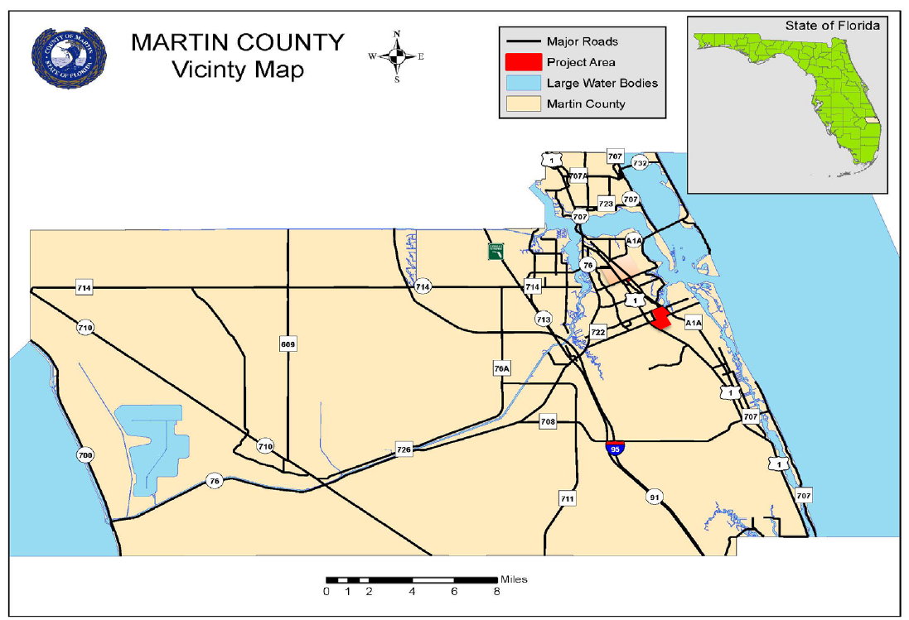

Figure 2.
