Operating System Requirements
The WaSh Model is accessed and operated through a Graphical User’s Interface (GUI) that functions within ArcMap 10.0 or 10.1 as a toolbar. ArcMap must be installed prior to installation and operation of the WaSh Model.
Basic system requirements for ArcMap 10.0 and 10.1 are:
- CPU: 2.2 Ghz
- Memory: 2 GB Minimum
- Disk Space: 2.4 GB Minimum
- Spatial Analyst is also required for certain features to function properly, such as the topographic processing using elevation raster files
The Wash GUI extension is not supported in earlier versions of ArcGIS.

Self-Extracting Executable
The WaSh Model GUI and Model Code are typically delivered as an ESRI Addin and a zip file that contains all supporting files. To begin installation, run WashGUI_ArcMap10.esriAddIn. The window shown in Figure # will appear and the user should click the “Install Add-In” button.
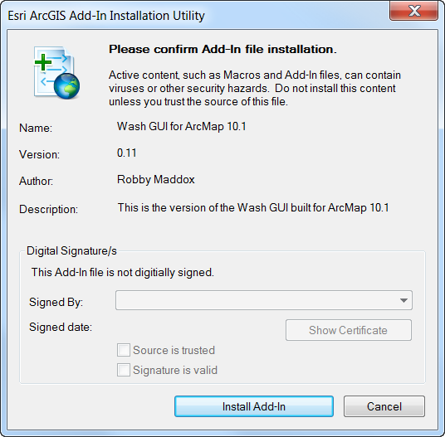
After the Add-In installation is complete, a new folder needs to be created and named C:\WashGUI_Seed. All files contained in WashGUI_Seed.zip will need to be extracted to C:\WashGUI_Seed, as these files are vital to the operation of the Wash GUI. Files with the .lyr extension control how different features are displayed on the map. The WashGUI.config file contains several settings. The SeedTables.mdb file contains default values for many of the Wash Model parameters. It is recommended that you do not change these files’ names.

Initializing WaSh Toolbar
After installing the Wash GUI and opening an ArcMap session, the WaSh GUI toolbar should be visible and appear as:
 2.1
The toolbar can be removed from the center of the layout by adding it to the toolbars along the frame of the ArcMap screen.
If the Wash GUI toolbar is not visible, the list of available toolbars can be accessed by right clicking anywhere in the toolbar area. Activate the Wash GUI toolbar by checking the associated box next to the " Wash GUI Toolbar" on the toolbar list.
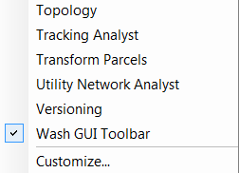 2.2

2.2

