DRAFT

Basin Management Action Plan

for the Implementation of
Total Maximum Daily Loads for Nutrients
Dissolved Oxygen and Fecal Coliforms by
the Florida Department of Environmental Protection
in the
Alafia River Basin

developed by the
Alafia River Stakeholders

in cooperation with the
Division of Environmental Assessment and Restoration
Bureau of Watershed Restoration
Florida Department of Environmental Protection
Tallahassee, FL 32399

February 2014

Acknowledgments: The Alafia River Basin Management Action Plan was prepared as part of a statewide watershed management approach to restore and protect Florida’s water quality. It was developed by the Alafia River stakeholders, identified below, with participation from affected local, regional, and state governmental interests; elected officials and citizens; and private interests. Additional input was received from members of the Tampa Bay Estuary Program and Tampa Bay Nutrient Management Consortium who are not specifically mentioned below.
Alafia River Basin Participants

Entity
Environmental Protection Commission of Hillsborough County
Hillsborough County Public Works
Tampa Bay Water
CSX
Florida Department of Agriculture and Consumer Services
TECO Energy
City of Lakeland
Plant City
Polk County
Southwest Florida Water Management District
The Mosaic Company
Kinder Morgan
Tampa Bay Estuary Program
Florida Department of Transportation
CF Industries
Florida Department of Health and
Hillsborough County Health Department
Tampa Bay Regional Planning Council
Coronet Industries
Sierra Club

For additional information on Total Maximum Daily Loads and the watershed management approach in the Alafia River Basin, contact:

Terry Hansen, P.G., Basin Coordinator
Florida Department of Environmental Protection
Bureau of Watershed Restoration, Watershed Planning and Coordination Section
2600 Blair Stone Road, Mail Station 3565
Tallahassee, FL 32399-2400
Email: terry.hansen@dep.state.fl.us
Phone: (850) 245–8561

Table of Contents

Executive Summary x
Chapter 1 : Context, Purpose, and Scope of the Plan 1
1.1 Water Quality Standards and Total Maximum Daily Loads 1
1.2 TMDL Implementation 2
1.3 The Alafia River BMAP 3
1.3.1 Stakeholder Involvement 3
1.3.2 Plan Purpose and Scope 3
1.3.3 Pollutant Reduction and Discharge Allocations 4
1.3.4 Alafia River Basin TMDLs 6
1.4 Assumptions and Considerations Regarding TMDL Implementation 6
1.4.1 Assumptions 7
1.4.2 Considerations 7
1.5 Future Growth in the Watershed 8
Chapter 2 : Alafia River Basin Setting 10
2.1 Jurisdictions, Population, and Land Uses 10
2.2 Physiography and Geology 10
2.3 Water Quality Trends 14
2.3.1 WBID 1621G (Alafia River Tidal Reach) 14
2.3.2 WBID 1592C (Mustang Ranch Creek) 18
2.3.3 WBID 1639 (Thirtymile Creek) 21
2.4 WBIDs with Fecal Coliform TMDLs 25
Chapter 3 : Pollutant Sources, Anticipated Outcomes, and Management Actions 35
3.1 Summary of Sources in the TMDLs 35
3.1.1 Point Source Facilities 35
3.1.2 Municipal Separate Storm Sewer Systems 36
3.1.3 Extractive Land Use 40
3.2 Anticipated Outcomes of BMAP Implementation 41
3.3 Management Strategies 41
3.3.1 Types of Management Strategies 42
3.4 Addressing Agricultural Nonpoint Pollution 42
3.4.1 Agricultural BMPs 43
3.4.2 FDACS’ OAWP Role in BMP Implementation and Follow-Up 45
3.4.3 BMP Enrollment Goals and Load Reduction Estimates 46
3.5 Funding Elements 49
Chapter 4 : Assessing Progress and Making Changes 50
4.1 Tracking Implementation 50
4.2 Water Quality Monitoring 51
4.2.1 Water Quality Monitoring Objectives 51
4.2.2 Water Quality Indicators and Resource Responses 52
4.2.3 Monitoring Network 53
4.2.4 Quality Assurance/Quality Control 54
4.2.5 Data Management and Assessment 54
4.3 Adaptive Management Measures 56
Chapter 5 : Commitment to Plan Implementation 57
APPENDICES 58
Appendix A: TMDL Basin Rotation Schedule 59
Appendix B: Alafia River Basin Stakeholder Involvement in BMAP Development 60
Appendix C: Summary of EPA-Recommended Elements of a Comprehensive Watershed Plan 61
Appendix D: Projects To Achieve the TMDLs 66
Appendix E: Glossary of Terms 81
Appendix F: Potential Funding Sources 87
Appendix G: Water Quality Monitoring Stations in the Alafia River Basin 92
Appendix H: Bibliography of Key References and Websites 94

List of Figures

Figure 1. Alafia River Basin showing the WBIDs addressed in this BMAP 5
Figure 2. Land uses in the Alafia River Basin in 2009 11
Figure 3. Alafia River Basin regional setting 13
Figure 4. Long-term trends in annual geometric mean TN concentrations at EPCHC Stations 74 (top panel) and 153 (bottom panel) in the lower Alafia River (WBID 1621G), 1980–2011 15
Figure 5. Annual percentages of monthly DO observations falling below the 4.0 mg/L DO threshold at EPCHC Stations 74 (top panel) and 153 (bottom panel) in the lower Alafia River (WBID 1621G) 16
Figure 6. Annual geometric mean TN and TP concentrations (top and bottom panels, respectively) at EPCHC Station 542 in WBID 1592C (Mustang Ranch Creek), a tributary to Medard Reservoir and the Little Alafia River, 2006–11 19
Figure 7. Annual mean cchla concentrations (top panel) and percentages of monthly DO observations falling below the 5.0 mg/L freshwater DO threshold (bottom panel) at EPCHC Station 542 in WBID 1592C (Mustang Ranch Creek), a tributary to Medard Reservoir and the Little Alafia River, 2006–11 20
Figure 8. Annual geometric mean TN and TP concentrations (top and bottom panels, respectively) at SWFWMD Station 17975 in WBID 1639 (Thirtymile Creek), a tributary to the North Prong of the Alafia River, 2000–11 23
Figure 9. Annual mean cchla concentrations (top panel) and percentages of monthly DO observations falling below the 5.0 mg/L freshwater DO threshold (bottom panel) at SWFWMD Station 17975 in WBID 1639 (Thirtymile Creek), a tributary to the North Prong of the Alafia River, 2000–11 24
Figure 10. WBID 1578B, Turkey Creek: Time-series of annual geometric mean fecal coliform counts (CFU/100mL) (top panel) and 3-year MWQA scores (bottom panel) for EPCHC Station 111 (SR 60) 28
Figure 11. WBID 1578B, Turkey Creek: Time-series of annual geometric mean fecal coliform counts (CFU/100 mL) (top panel) and 3-year MWQA scores (bottom panel) for EPCHC Station 151 (Durant Road) 29
Figure 12. WBID 1592C, Mustang Ranch Creek: Time-series of annual geometric mean fecal coliform counts (CFU/100 mL) (top panel) and 3-year MWQA scores (bottom panel) for EPCHC Station 542 (SR 60) 30
Figure 13. WBID 1552, English Creek: Time-series of annual geometric mean fecal coliform counts (CFU/100mL) (top panel) and 3-year MWQA scores (bottom panel) for EPCHC Station 154 (SR 60) 31
Figure 14. WBID 1583, Poley Creek: Time-series of annual geometric mean fecal coliform counts (CFU/100 mL) (top panel) and 3-year MWQA scores (bottom panel) for Polk County Station POLCRN1 (Pipkin Road) 32
Figure 15. WBID 1583, Poley Creek: Time-series of annual geometric mean fecal coliform counts (CFU/100mL) (top panel) and 3-year MWQA scores (bottom panel) for Polk County Station POLCRS2 (SR 60) 33
Figure 16. Agricultural land use based on 2008 SWFWMD data in the Alafia River Basin 47
Figure 17. BMP enrollment as of March 31, 2013, in the Alafia River Basin 49
Figure 18. Water quality monitoring stations in the Alafia River Basin 55

List of Tables
Table 1. Designated use attainment categories for Florida surface waters 1
Table 2. Phases of the watershed management cycle 2
Table 3. Alafia River TMDLs 6
Table 4. Land uses in the Alafia River Basin BMAP area in 2009 10
Table 5. Required reductions in the Alafia River Basin 35
Table 6. NPDES point sources in the Alafia River Basin 37
Table 7. Alafia River Basin MS4 permit holders 38
Table 8. Summary of Alafia River BMAP projects 42
Table 9. Key management and structural BMPs adopted by FDACS’ OAWP¹ 44
Table 10. Agricultural acreage, BMP enrollment, and future enrollment goals in the Alafia River Basin 48
Table 11a. Core water quality indicators and anticipated trends 53
Table 11b. Supplemental water quality indicators and anticipated trends 53
Table 12. Anticipated resource responses from BMAP implementation 53
Table A-1. Major hydrologic basins by group and Department District Office 59
Table H-1. Local and regional stormwater and water quality protection websites 96
Table H-2. State stormwater and water quality protection websites 96
Table H-3. National stormwater and water quality protection websites 96

List of Acronyms and Abbreviations

Acronym/Abbreviation | Explanation
µg/L | Micrograms Per Liter
ARTF | Alafia River Task Force
BMAP | Basin Management Action Plan
BMP | Best Management Practice
CCMP | Comprehensive Conservation and Management Plan
CDBG | Community Development Block Grant
CDS | Continuous Deflective Separation
C.F.R. | Code of Federal Regulations
CFU | Colony-Forming Units
Chla | Chlorophyll a
Department | Florida Department of Environmental Protection
DMR | Discharge Monitoring Report
DO | Dissolved Oxygen
EE | Environmental Education
EPA | U.S. Environmental Protection Agency
EPCHC | Environmental Protection Commission of Hillsborough County
ERP | Environmental Resource Permit
F.A.C. | Florida Administrative Code
FAR | Florida Administrative Register
FDACS | Florida Department of Agriculture and Consumer Services
FDOH | Florida Department of Health
FDOT | Florida Department of Transportation
FGD | Flue Gas Desulfurization
F.S. | Florida Statutes
FWRA | Florida Watershed Restoration Act
IO | Indicator Organisms
IWR | Impaired Surface Waters Rule
LA | Load Allocation
LID | Low-Impact Development
MEP | Maximum Extent Practicable
MGD | Million Gallons Per Day
mg/L | Milligrams Per Liter
MIL | Mobile Irrigation Lab
mL | Milliliter
MS4 | Municipal Separate Storm Sewer System
MWQA | Microbial Water Quality Assessment
NMC | Tampa Bay Nitrogen Management Consortium
NNC | Numeric Nutrient Criterion
NOI | Notice of Intent
NOx | Nitrogen Oxide
NPDES | National Pollutant Discharge Elimination System
NPS | Nonpoint Source
OAWP | Office of Agricultural Water Policy
OSTDS | On-Site Sewage Treatment and Disposal System
POTW | Publicly Owned Treatment Works
PSU | Practical Salinity Units
QA/QC | Quality Assurance/Quality Control
RA | Reasonable Assurance
RO | Reverse Osmosis
RUS | Rural Utilities Service
SCI | Stream Condition Index
SCR | Selective Catalytic Reduction
SOP | Standard Operating Procedure
SRF | State Revolving Fund
SSO | Sanitary Sewer Overflow
SWFWMD | Southwest Florida Water Management District
SWIM | Surface Water Improvement and Management
SWMP | Stormwater Management Program
TBEP | Tampa Bay Estuary Program
TBRPC | Tampa Bay Regional Planning Council
TKN | Total Kjeldahl Nitrogen
TMDL | Total Maximum Daily Load
TN | Total Nitrogen
TP | Total Phosphorus
TSI | Trophic State Index
TSS | Total Suspended Solids
UF–IFAS | University of Florida–Institute of Food and Agricultural Sciences
WBID | Waterbody Identification
WLA | Wasteload Allocation
WWTF | Wastewater Treatment Facility
WWTP | Wastewater Treatment Plant

Executive Summary

Alafia River Basin
The Alafia River Basin (Figure 1) covers an area of more than 410 square miles in Hillsborough and Polk Counties. The river originates in west-central Polk County and flows westward to Hillsborough Bay. It is bounded to the north by the Hillsborough River Basin, to the east by the Peace River Basin, and to the south by the Little Manatee River Basin. Major tributaries include the North Prong, South Prong, Little Alafia River, and Turkey Creek. The river is tidally influenced to Bell Shoals Road, approximately 11 river miles upstream from the mouth. During the dry season much of the freshwater inflow to the tidal reach is contributed by ground water inflows, notably from Lithia Springs and Buckhorn Springs, which are located southeast of Bloomingdale approximately14 river miles upstream from the mouth.
The watershed contains few natural lakes, but numerous man-made lakes (such as Medard Reservoir) have been created as a result of phosphate-mining and other earth-moving activities.
Mining, agriculture, and urban development are predominant land uses, with suburban, commercial, and industrial uses common in the northern and western portions; agriculture and (increasingly) suburban uses common in the southern portion; and mining-related uses dominating the eastern portion.
This BMAP covers the following impaired segments with waterbody identification (WBID) numbers in the Alafia River Basin:
WBID 1621G, Alafia River Tidal Reach above Hillsborough Bay.
WBID 1578B, Turkey Creek.
WBID 1592C, Mustang Ranch Creek.
WBID 1552, English Creek.
WBID 1639, Thirtymile Creek.
WBID 1583, Poley Creek.

Additionally, unimpaired WBIDs 1621 A, 1621B, 1621C, and 1621D are covered in this BMAP, as they are located immediately upstream of WBID 1621G.
Total Maximum Daily Loads
TMDLs are water quality targets, based on state water quality standards, for specific pollutants (such as excessive nitrogen and phosphorus). The Florida Department of Environmental Protection verified that the Alafia River was impaired by nutrients (chlorophyll-a [chla]), dissolved oxygen (DO), and fecal coliforms.
In September 2013, the U.S. Environmental Protection Agency (EPA) approved revisions to Florida's criteria for dissolved oxygen (DO) in Rules 62-302 and 62-303, Florida Administrative Code (F.A.C.). The revised DO criteria are now in effect and apply to both fresh and marine waters. These revisions are not evaluated in this BMAP.
This BMAP addresses four fecal coliform TMDLs (WBIDs 1578B, 1592C, 1552, and 1583) and three DO and nutrient TMDLs (WBIDs 1621G, 1592C, and 1639).
The Alafia River BMAP
The Alafia River BMAP was developed in collaboration with areawide stakeholders with the assistance of the Tampa Bay Estuary Program (TBEP) and the Tampa Bay Nitrogen Management Consortium (NMC). The TBEP has been successful in coordinating a plan to reduce nutrient inputs to Tampa Bay by working with NMC members to assess the actual loads generated, implement actions to reduce nitrogen loadings, and then monitor improvements in seagrass throughout the bay.
Anticipated Outcomes of BMAP Implementation
Through the implementation of projects, activities, and additional source assessment in this BMAP, stakeholders expect the following outcomes:
Continued improvements in water quality trends in the Alafia River.
Decreased loading of the target pollutant (TN).
Identification of potential sources of fecal coliform impairments.
Increased coordination between state BMAP efforts and TBEP and NMC members in problem solving for surface water quality restoration.
Determination of effective projects through the stakeholder decision-making and priority-setting processes.

BMAP Cost
Alafia River Basin BMAP projects are summarized in Table 8 and Appendix D. The approximate total cost of the projects listed is more than $170 million.
BMAP Follow-Up
The Department will work with the Tampa Bay Estuary Program (TBEP) and technical stakeholders to organize the monitoring data and track project implementation. The results will be used to evaluate whether the plan is effective in continuing to reduce nutrient loads and fecal coliform sources in the watershed. The technical stakeholders will meet periodically as needed after the adoption of the BMAP to follow up on plan implementation, share new information, and continue to coordinate on TMDL-related issues.
Commitment to BMAP Implementation
In coordinating the Tampa Bay Reasonable Assurance Plan (RA Plan), the TBEP has received letters of commitment or resolutions of support to ensure that as staff and board members change over time, the entity has a way to show support for the water quality improvements in Tampa Bay. This BMAP incorporates those efforts.

: Context, Purpose, and Scope of the Plan

Water Quality Standards and Total Maximum Daily Loads
Florida's water quality standards are designed to ensure that surface waters can be used for their designated purposes, such as drinking water, recreation, wildlife habitat, and agriculture. Currently, most surface waters in Florida, including those in the Alafia River Basin, are categorized as Class III waters, meaning that they must be suitable for recreation and must support the propagation and maintenance of a healthy, well-balanced population of fish and wildlife. Table 1 shows all designated use categories.
Under Section 303(d) of the federal Clean Water Act, every two years each state must identify its “impaired” waters, including estuaries, lakes, rivers, and streams, that do not meet their designated uses and are not expected to improve before the next 303(d) list is prepared for the basin. The Florida Department of Environmental Protection is responsible for developing this “303(d) list” of impaired waters in Florida.
Table 1. Designated use attainment categories for Florida surface waters

* Class I and II waters include the uses of the classifications listed below them.
Category | Description
Class I* | Potable water supplies
Class II* | Shellfish propagation or harvesting
Class III | Recreation, propagation, and maintenance of a healthy, well-balanced population  of fish and wildlife
Class IV | Agricultural water supplies
Class V | Navigation, utility, and industrial use (no current Class V designations)

Florida's 303(d) list identifies hundreds of waterbody segments that fall short of water quality standards. The three most common water quality concerns are fecal coliform, nutrients, and oxygen-demanding substances. The listed waterbody segments are candidates for more detailed assessments of water quality to determine whether they are impaired according to state statutory and rule criteria. The Department develops and adopts Total Maximum Daily Loads for the waterbody segments it identifies as impaired. A TMDL is the maximum amount of a specific pollutant that a waterbody can assimilate while maintaining its designated uses.
The water quality evaluation and decision-making processes for listing impaired waters and establishing TMDLs are authorized by Section 403.067, Florida Statutes (F.S.), known as the Florida Watershed Restoration Act (FWRA), and contained in Florida’s Identification of Impaired Surface Waters Rule (IWR), Rule 62-303, Florida Administrative Code (F.A.C.). The impaired waters in the Alafia River Basin addressed in this plan are all Class III waters. TMDLs have been established for these waters, identifying the amount of nutrients and other pollutants they can receive and still maintain Class III designated uses.
TMDLs are developed and implemented as part of a watershed management cycle that rotates through the state’s 52 river basins every 5 years (see Appendix A) to evaluate waters, determine impairments, and develop and implement management strategies to restore impaired waters to their designated uses. Table 2 summarizes the five phases of the watershed management cycle.
Table 2. Phases of the watershed management cycle
Phase | Activity
Phase 1 | Preliminary evaluation of water quality
Phase 2 | Strategic monitoring and assessment to verify water quality impairments
Phase 3 | Development and adoption of TMDL(s) for waters verified as impaired
Phase 4 | Development of management strategies to achieve the TMDL(s)
Phase 5 | Implementation of TMDL(s), including monitoring and assessment

TMDL Implementation
Rule-adopted TMDLs may be implemented through Basin Management Action Plans, which contain strategies to reduce and prevent pollutant discharges through various cost-effective means. During Phase 4 of the TMDL process, the Department and the affected stakeholders in the various basins jointly develop BMAPs or other implementation approaches. A basin may have more than one BMAP, based on practical considerations. The FWRA contains provisions that guide the development of BMAPs and other TMDL implementation approaches.
Stakeholder involvement is critical to the success of the TMDL Program, and varies with each phase of implementation to achieve different purposes. The BMAP development process is structured to achieve cooperation and consensus among a broad range of interested parties. Under statute, the Department invites stakeholders to participate in the BMAP development process and encourages public participation to the greatest practicable extent. The Department must hold at least one noticed public meeting in the basin to discuss and receive comments during the planning process.

The Alafia River BMAP

Stakeholder Involvement
Stakeholder involvement with the Tampa Bay Estuary Program (TBEP) and Tampa Bay Nutrient Management Consortium (NMC) was a key component in developing the Alafia River BMAP. The BMAP process engages local stakeholders and promotes coordination and collaboration to address the total nitrogen (TN) and total phosphorus (TP) reductions needed to achieve the nutrient TMDL, as well as identifying fecal coliform sources for the fecal coliform TMDL.
Starting in June 2011, the Department initiated the BMAP development process and held a series of technical meetings involving key stakeholders and the general public. Technical meetings were open to the public and noticed in the Florida Administrative Register (FAR). The purpose of these meetings was to consult with key stakeholders to gather information on the impaired segments with waterbody identification (WBID) numbers and their contributing areas, in order to aid in the development of the BMAP and identify specific management actions that would reduce TN and TP loading and identify fecal coliform sources. Since 2011, six technical meetings have been held to gather information; identify potential sources; conduct field reconnaissance; define programs, projects, and actions currently under way; and develop the BMAP contents and actions that will reduce TN and TP with the ultimate goal of achieving the TMDL target reductions. The technical meetings also served to plan the “Walk the Waterbody” process for the WBIDs impaired for fecal coliform. Stakeholder involvement is essential to develop, gain support for, and secure commitments to implement the BMAP.
In addition to technical meetings, the Department also met with stakeholders in one-on-one meetings. The purpose of these meetings was to discuss project-specific information with stakeholders.
Except as specifically noted in subsequent sections, this BMAP document reflects the input of the stakeholders, along with public input from workshops and meetings held to discuss key aspects of TMDL and BMAP development. Appendix C provides further details.

Plan Purpose and Scope
The purpose of this BMAP is to implement load reductions to achieve the nutrient and dissolved oxygen (DO) TMDLs for the Alafia River Basin and develop a process for identifying and abating fecal coliform sources in the impaired WBIDs. This plan outlines specific projects that will achieve load reductions and a schedule for the implementation of those projects. The document details a monitoring approach to measure progress toward meeting load reductions and to report on how the TMDLs are being accomplished.
The impaired WBIDs addressed in this BMAP include the river’s tidal reach (WBID 1621G), located along the southeastern shoreline of Hillsborough Bay, and several freshwater tributary streams located in the upper reaches of the watershed. Turkey Creek (WBID 1578B) is located between Valrico and Plant City in eastern Hillsborough County, discharging to the Little Alafia River. Mustang Ranch Creek (WBID 1592C) is located to the east of Turkey Creek in the Little Alafia River watershed, discharging to the Medard Reservoir. The catchments of English Creek (WBID 1552) and Thirty Mile Creek (WBID 1639) straddle the Hillsborough/Polk County line, and Poley Creek (WBID 1583) in Polk County discharges to the North Prong of the Alafia River. Figure 1 shows the locations of these WBIDs.

Pollutant Reduction and Discharge Allocations

Categories for Rule Allocations
The rules adopting TMDLs must establish reasonable and equitable allocations that will alone, or in conjunction with other management and restoration activities, attain the TMDLs. Allocations may be to individual sources, source categories, or basins that discharge to the impaired waterbody. The allocations identify either how much pollutant discharge each source designation may continue to contribute (discharge allocation), or the percent of its loading the source designation must reduce (reduction allocation). Currently, the TMDL allocation categories are as follows:
Wasteload Allocation (WLA) – The allocation to point sources permitted under the National Pollutant Discharge Elimination System (NPDES) Program:
  - Wastewater Allocation is the allocation to industrial and domestic wastewater facilities.
  - NPDES Stormwater Allocation is the allocation to NPDES stormwater permittees that operate municipal separate storm sewer systems (MS4s). These permittees are treated as point sources under the TMDL Program.
Load Allocation (LA) – The allocation to nonpoint sources, including agricultural runoff and stormwater from areas that are not covered by an MS4.

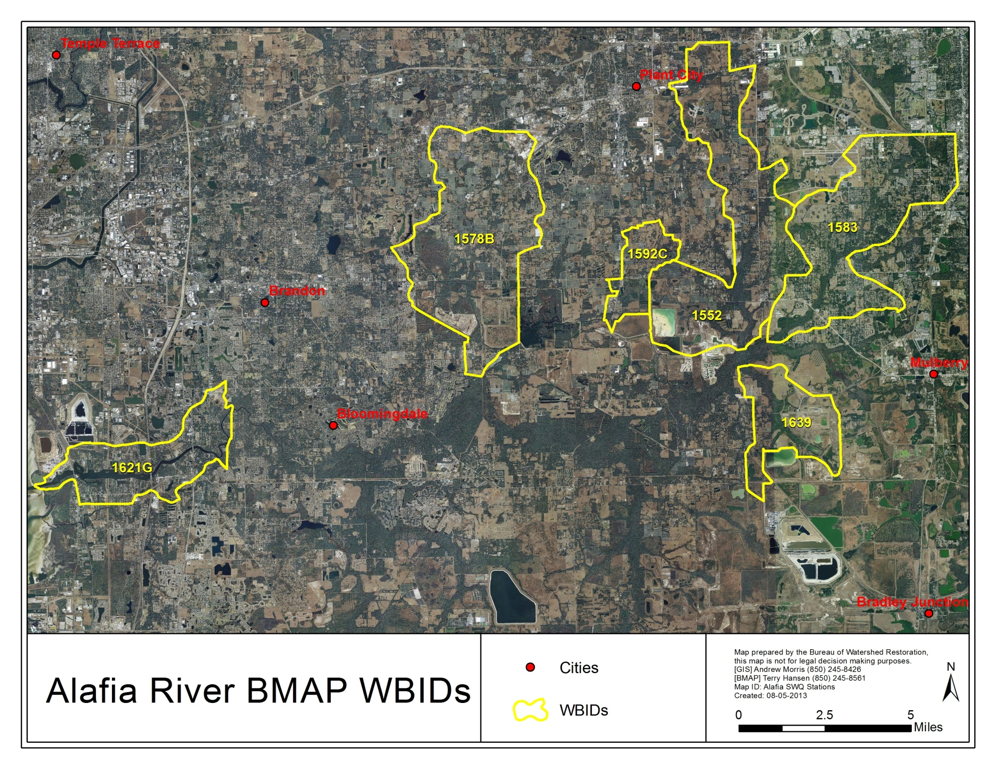

Figure 1. Alafia River Basin showing the WBIDs addressed in this BMAP

Allocations
Under the FWRA, the TMDL allocation adopted by rule must include an allocation among point and nonpoint sources. In the Alafia BMAP, this TMDL allocation is applied to the entire basin. Allocations must be determined based on a number of factors listed in the FWRA, including cost-benefit, technical and environmental feasibility, implementation time frames, and others.

Alafia River Basin TMDLs
The Department adopted fecal, nutrient, and DO TMDLs (Table 3), for the Alafia River Basin in 2005 for Thirtymile Creek (WBID 1639) and in 2009 for the remainder of the WBIDs.
Table 3. Alafia River TMDLs
WBID Number | Waterbody Name | TMDL Components
1621G | Alafia River above Hillsborough Bay  (Tidal Segment) | TN concentration (target = 0.65 milligrams per liter [mg/L])  - WLA (NPDES stormwater) = 54% reduction  - WLA (NPDES wastewater) = 14.3 lbs/day  - LA = 54% reduction
1578B | Turkey Creek | Fecal coliform concentration (% reduction)  - WLA (NPDES stormwater) = 64% reduction  - WLA (NPDES wastewater) = must meet permit limits  - LA = 64% reduction
1592C | Mustang Ranch Creek | TN concentration (% reduction)  - WLA (NPDES stormwater) = 50%  - LA = 50%  TP concentration (% reduction)  - WLA (NPDES stormwater) = 45%  - LA = 45%
1592C | Mustang Ranch Creek | Fecal coliform concentration (% reduction)  - WLA (NPDES stormwater) = 88% reduction  - LA = 88% reduction
1552 | English Creek | Fecal coliform concentration (% reduction)  - WLA (NPDES stormwater) = 40% reduction  - LA = 40% reduction
1639 | Thirtymile Creek | TN concentration (target = 3.0 mg/L)  - WLA = 3.0 mg TN/L (monthly average)  - LA = 1.6 mg TN/L (annual average)
1583 | Poley Creek | Fecal coliform concentration (% reduction)  - WLA (NPDES stormwater) = 67% reduction  - LA = 67% reduction

Assumptions and Considerations Regarding TMDL Implementation
The water quality impacts of BMAP implementation are based on several fundamental assumptions about the pollutants targeted by the TMDLs, modeling approaches, waterbody response, and natural processes. In addition, there are important considerations to keep in mind about the nature of the BMAP and its long-term implementation.

Assumptions
The following assumptions were used during the BMAP process:
The TBEP and NMC are successfully implementing nutrient reduction projects.
The Tampa Bay Reasonable Assurance Plan (RA Plan) provides a good basis for existing projects.
Seagrass in Tampa Bay is rebounding, demonstrating the results of water quality improvements.
Existing and ongoing stakeholder efforts need to be recognized and incorporated into the BMAP.
Additional projects need to be coordinated with the TBEP to eliminate redundant efforts by stakeholders.
WBIDs with fecal coliform impairments will undergo a “Walk the Waterbody” process to identify potential sources that can be addressed through source reduction projects.

Considerations
This BMAP requires that all stakeholders in the basin implement their projects set forth in this document within the first five-year BMAP cycle. However, the full attainment of the TMDL targets will be a long-term process. While many of the projects and activities contained in the BMAP are recently completed or currently ongoing, many projects will require time to design, secure funding, and construct. Funding limitations do not impact the requirement that each entity must implement the activities committed to in this BMAP. However, funding was considered, to the extent practicable, when determining the schedule for meeting BMAP requirements.
Many of the TMDLs established for this basin are close to being achieved through the ongoing efforts of NMC members. Given that it may take even longer for the river to respond to the reduced loading and fully meet applicable water quality standards, regular follow-up and continued coordination and communication by the stakeholders will be essential to ensuring that management strategies are being carried out and that their incremental effects are assessed. Any additional management actions required to achieve TMDLs, if the TMDLs are not met, will be developed as part of BMAP follow-up.
During the BMAP process, several items were identified, as follows, that should be addressed in future watershed management cycles to ensure the most accurate information is utilized for future iterations:
Given the mix of industrial and rural land uses that are present in the Thirtymile Creek watershed (WBID 1639), it appears that future BMAP efforts should focus on coordinating with the phosphate industry on NPDES permit compliance issues, and on working with the Florida Department of Agriculture and Consumer Services (FDACS) and local agricultural operations to implement nutrient-related best management practices (BMPs).
Phosphorus loads in Thirtymile Creek (WBID 1639) should be monitored to determine if the anthropogenic phosphorus loads are resulting in TN/TP ratios that inaccurately reflect water quality impairments.
In the Mustang Ranch Creek watershed (WBID 1592), the absence of NPDES wastewater facilities, and the presence of a mix of rural, urban, and roadway-related land uses in the area, will likely require a combination of nutrient-related stormwater BMPs to provide the most cost-effective approach for achieving load reductions.
In the Alafia River Tidal Reach (WBID 1621G), an investigation of other environmental variables—in addition to annual geometric mean TN concentration—that affect DO dynamics appears to be needed.
The September 2013 adoption of DO criteria will require an evaluation of the appropriate data and the possible revision of impairments.

Future Growth in the Watershed
The FWRA requires that BMAPs “identify the mechanisms by which potential future increases in pollutant loading will be addressed.” To meet this requirement, the BMAP will utilize the efforts of the TBEP and NMC to address future loading through the Tampa Bay RA Plan. The current RA Plan and supporting information are available at: http://www.tbeptech.org/
index.php?searchword=reasonable+assurance&ordering=&searchphrase=all&Itemid=1&option=com_search. Additionally, existing comprehensive plans, land development regulations, additional or ongoing ordinances, and Environmental Resource Permits (ERPs) may be utilized to manage future loads. As additional projects are identified and implemented, they will be included in the project database and tracked.

: Alafia River Basin Setting

Jurisdictions, Population, and Land Uses
Table 4 identifies land use in the Alafia River BMAP area in 2009. The primary land use in the BMAP WBIDs is urban and built-up. The area has undergone development and is transitioning from mining and agriculture to more urban uses. Although much of the recently mined land has been restored per existing regulations, land mined prior to required restoration efforts remains largely unreclaimed. Figure 2 shows 2009 land uses in the BMAP area.
Table 4. Land uses in the Alafia River Basin BMAP area in 2009
Land Use | Acres
Urban and Built-Up | 18,198
Extractive (ongoing and depleted) | 9,019
Agriculture | 9,950
Rangeland | 351
Upland Forest | 2,193
Water | 1,425
Wetland | 5,097
Barren Land | 30
Transportation, Communication, and Utilities | 942
Total | 47,198

Physiography and Geology
The Alafia River lies within the Southwestern Florida Flatwoods subregion of the Southern Coastal Plain ecoregion (denoted as Ecoregion 75b by Griffith et al. 1994). This region is characterized by Gulf coastal lowlands and valleys, as well as higher elevation areas, including the Bone Valley Upland. The area includes fairly recent sedimentary deposits of marine origin, and certain marine clays (e.g., the Hawthorne Formation) and limestone formations that lie near the surface are extremely high in phosphorus. Some of these phosphatic deposits are mined, making Florida one of the largest producers of phosphate in the world (Florida produces approximately 25% of the phosphate used globally). Two geologic formations, the Peace River Formation and the Bone Valley Member, comprise this naturally high-phosphate area, which includes portions of Hillsborough, Polk, Hardee, Manatee, DeSoto, and Sarasota Counties.

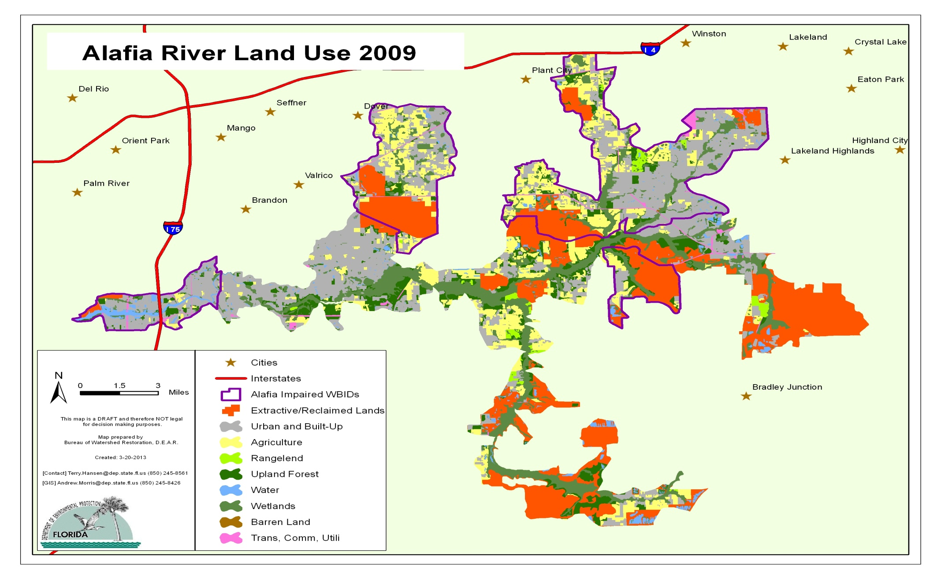
Figure 2. Land uses in the Alafia River Basin in 2009

The Peace River Formation crops out or lies beneath a thin overburden on the southern part of the Ocala Platform extending into the Okeechobee Basin (Figure 3). These sediments were mapped from Hillsborough County southward to Charlotte County. Within this area, the Peace River Formation is composed of interbedded sands, clays, and carbonates. The sands are generally light gray to olive gray, poorly consolidated, clayey, variably dolomitic, very fine to medium grained, and phosphatic. The clays are yellowish gray to olive gray, poorly to moderately consolidated, sandy, silty, phosphatic, and dolomitic. The carbonates are usually dolostone in the outcrop area. The dolostones are light gray to yellowish gray, poorly to well indurated, variably sandy and clayey, and phosphatic. Opaline chert is often found in these sediments. The phosphate content of the Peace River Formation sands is frequently high enough to be economically mined. Naturally occurring phosphorus pebbles are frequently observed in streams within this formation.
The Bone Valley Member and the Peace River Formation occur in a limited area on the southern part of the Ocala Platform in Hillsborough, Polk, and Hardee Counties (Figure 3). Throughout its extent, the Bone Valley Member is a clastic unit consisting of sand-sized and larger phosphate grains in a matrix of quartz sand, silt, and clay. The lithology is highly variable, ranging from sandy, silty, phosphatic clays and relatively pure clays to clayey, phosphatic sands to sandy, clayey phosphorites. In general, consolidation is poor, and colors range from white, light brown, and yellowish gray to olive gray and blue green. Mollusks are found as reworked, often phosphatized casts. Vertebrate fossils occur in many of the beds within the Bone Valley Member. Sharks’ teeth are often abundant. Silicified corals and wood are occasionally present as well. The Bone Valley Member is an extremely important, unique phosphate deposit that has been the source for much of the phosphate production in the United States during the 20th century. Phosphate mining in the outcrop area began in 1888 and continues to the present.
The Department and the U.S. Environmental Protection Agency (EPA) have previously used the geographic distribution of the Peace River Formation and Bone Valley Member to delineate a homogeneous nutrient region known as the West Central (formally Bone Valley) Region.
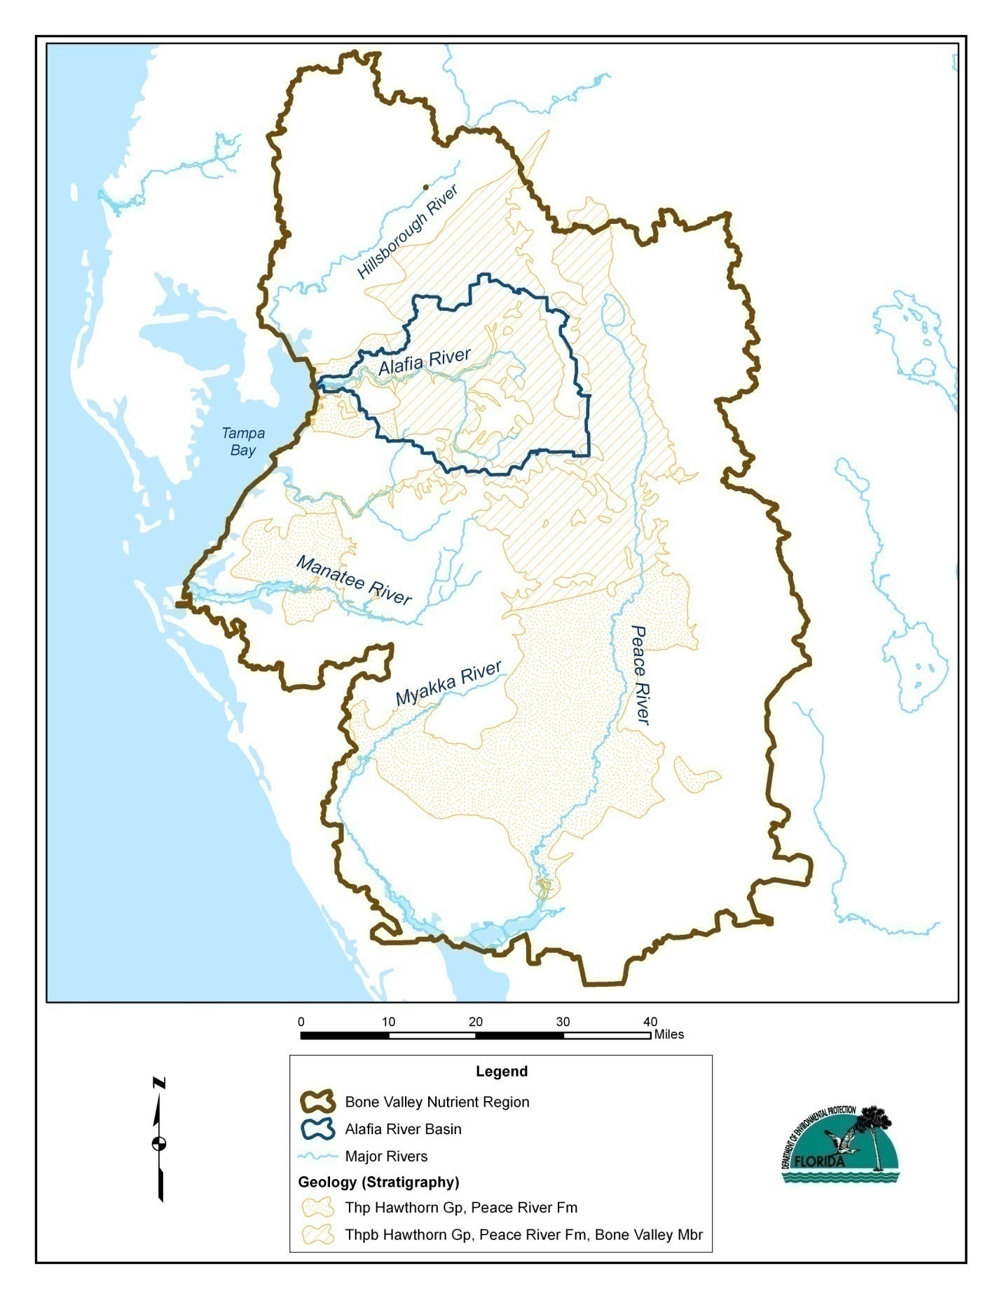
Figure 3. Alafia River Basin regional setting

Water Quality Trends

WBID 1621G (Alafia River Tidal Reach)
The TMDL for this WBID seeks to bring the waterbody into compliance with the existing DO criterion, which for tidal waters requires that no more than 10% of the measured DO concentrations should fall below the estuarine threshold of 4.0 mg/L (Petrus and Laskis 2009).
Two long-term monitoring stations are present in the WBID, both of which are sampled monthly by the Environmental Protection Commission of Hillsborough County (EPCHC). Station 74 is located in the downstream portion of the WBID, at the U.S. Highway 41 bridge. Station 153 is located farther upstream, at the U.S. Highway 301 bridge. Nutrient, chlorophyll a (chla), and DO data are available from Station 74 for 1981 through 2011, and from Station 153 for 2000 through 2011.
TN concentrations declined at both stations during these monitoring periods. Annual geometric mean TN concentrations fell by roughly 50% at Station 74 between 1981 and 2011, and have remained consistently below 1 mg/L at this station since 2005 (Figure 4). During 2010 and 2011, the annual geometric mean TN concentration was less than the 0.65 mg/L value proposed as the TMDL target. Annual geometric means declined by roughly 20% at Station 153 between 2000 and 2011, and have fluctuated around 1.5 mg/L since 2007 (Figure 4). Although higher than the 0.65 mg/L target level proposed in the TMDL, the concentrations observed at Station 153 in recent years are comparable to the numeric nutrient criterion (NNC) value recently proposed by the Department for streams in the west-central Florida region.
The reductions in TN concentrations in WBID 1621G are the result of a larger, stakeholder-driven watershed management effort that has been in place since the late 1970s. Its goals are to reduce the overall nitrogen loads entering Tampa Bay, in order to meet management targets that have been established to restore and protect seagrasses and other living resources in the bay ecosystem (TBEP 2006; Yates et al. 2011).
Despite the large reductions in annual geometric mean TN concentrations that have occurred in recent decades, improved compliance with the 4.0 mg/L DO criterion has not been observed in WBID 1621G (Figure 5). At multiannual and decadal time scales, the percentage of DO observations falling below the 4.0 mg/L threshold does not appear to be responding to changes in ambient TN concentrations, and at these time scales DO appears to be fluctuating independently of changes in TN.

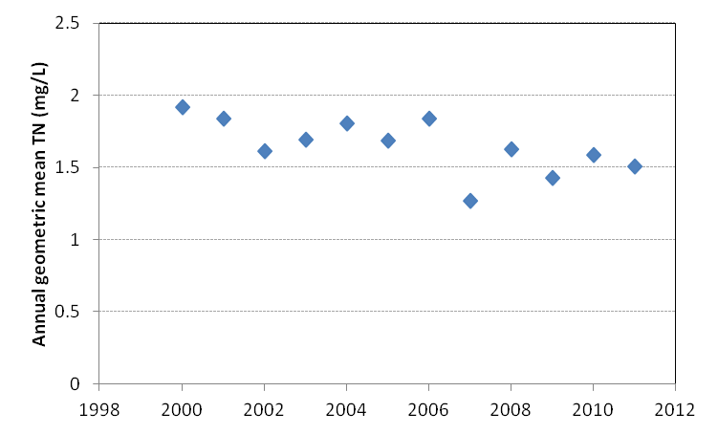
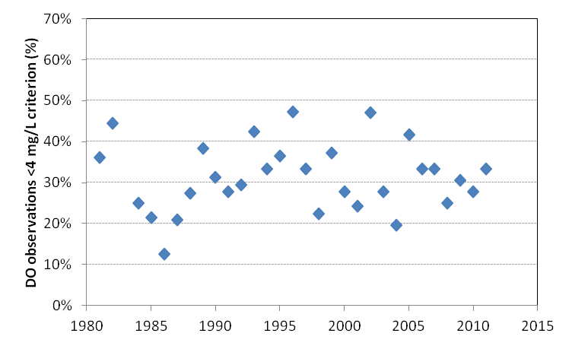
Figure 4. Long-term trends in annual geometric mean TN concentrations at EPCHC Stations 74 (top panel) and 153 (bottom panel) in the lower Alafia River (WBID 1621G), 1980–2011

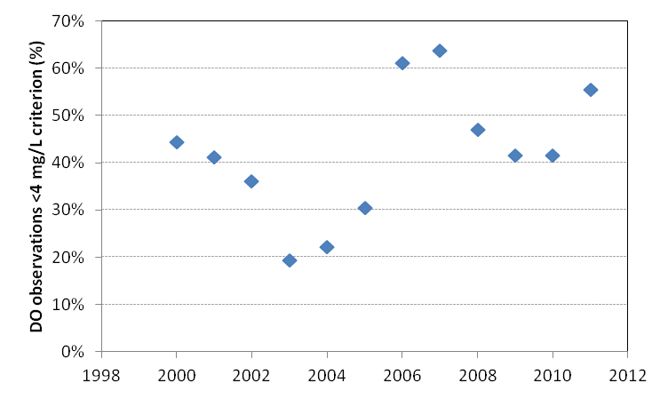
Figure 5. Annual percentages of monthly DO observations falling below the 4.0 mg/L DO threshold at EPCHC Stations 74 (top panel) and 153 (bottom panel) in the lower Alafia River (WBID 1621G)
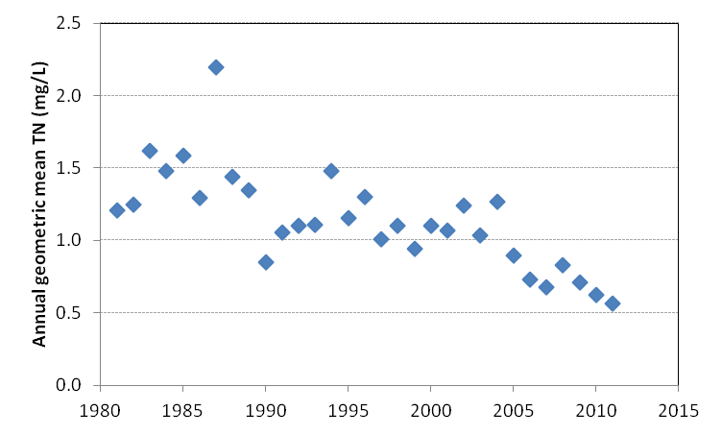
On a baywide basis, Tampa Bay currently appears to be on track in terms of meeting its TN, chla, water clarity and seagrass restoration goals (TBEP 2006; Yates et al. 2011). As a result, future watershed management actions will presumably focus on the TBEP’s “hold-the-line” strategy (as implemented through limits on all NPDES TN loading permits in the Tampa Bay watershed) , seeking to compensate for ongoing population growth, and prevent TN loads from increasing as the human population of the watershed continues to expand. If those management efforts are successful, TN concentrations in the tidal reach of the Alafia River in future years are likely to be comparable to those observed today.
For the BMAP Program, the most appropriate course of action may be to investigate other environmental variables—in addition to the annual geometric mean TN concentration—that affect DO dynamics in WBID 1621G. Physical factors that determine circulation, flushing, and reaeration rates could be playing critical roles. If so, the BMAP Program may wish to focus on examining those factors, their interactions with each other and with ambient nutrient levels, and the effects of those interactions on ambient DO concentrations. The information could be used to develop a strategy for achieving compliance with existing DO criteria or developing site-specific alternative criteria (SSAC) consistent with the physical characteristics of the waterbody.
As examples of physical factors that could be examined, nonparametric correlation analysis suggests that the most important physical factor affecting monthly variations in DO at the downstream EPCHC station (Station 74) may be water temperature (Kendall tau = -0.66, p < 0.0001), while the dominant physical factors at the upstream station (Station 153) appear to be a combination of temperature (tau =
-0.44, p < 0.0001) and mid-depth salinity (tau = -0.35, p < 0.0001).
Salinity regimes at these stations also differ, with the downstream station averaging 20.2 practical salinity units (PSU) and ranging between 0.09 and 33 PSU, and the upstream station averaging 8.5 and ranging between 0.09 and 24 PSU. Given that water temperature and salinity directly affect oxygen solubility and waterbody flushing characteristics, which in turn affect DO dynamics, a more detailed understanding of the relationships between these physical factors and DO levels in WBID 1621G could help to guide future water quality management efforts.

WBID 1592C (Mustang Ranch Creek)
The nutrient-related TMDL for this WBID seeks to reduce ambient nutrient (TN and TP) concentrations by 45% to 50% to comply with the existing DO criterion (5.0 mg/L) for freshwater streams (Petrus and Kurisko 2009).
Data from the WBID are limited. One station (Station 542) is sampled quarterly by the EPCHC. Station 542 is located near the midpoint of the WBID, where Mustang Ranch Creek crosses State Road (SR) 60. Nutrient (N and P forms), chla, and DO data are available from the site for the period from 2006 through 2011.
TN and TP concentrations at Station 542 were elevated during the 2006–11 sampling period. This was particularly true during 2010 and 2011, when annual geometric mean TN concentrations exceeded 2.5 mg/L, and TP concentrations exceeded 0.6 mg/L (Figure 6). Annual mean chla concentrations (corrected for pheophytin [cchla]) exhibited a steadily increasing pattern throughout the period but did not exceed 10 micrograms per liter (µg/L) (Figure 7). The percentage of DO samples that failed to meet the 5.0 mg/L freshwater criterion was elevated throughout the period, never falling below 20% and reaching as high as 100% (based on 4 quarterly sampling events) in 2006 (Figure 7). Stakeholders may wish to increase the frequency of water quality monitoring in the WBID from quarterly to monthly to provide more detailed information on nutrient, chlorophyll, and DO dynamics.
The TMDL document for Mustang Ranch Creek (Petrus and Kurisko 2009) notes that the predominant land uses in the WBID are agricultural, comprising over 58% of the watershed area. These mainly consist of cropland and pastureland (684 acres) and tree crops (479 acres). Urban and built-up land uses make up about 21% of the area, with low-density residential (282 acres) making up the majority of the urban land. Wetlands comprise about 8% of the area, followed by rangeland and forest, which cover about 6%.
The TMDL document reported no NPDES-permitted wastewater facilities with discharges to the surface waters in the WBID. Stormwater collection systems owned and operated by Hillsborough County and co-permittee (Florida Department of Transportation [FDOT] District 7) are covered by a Phase I NPDES MS4 permit (FLS000006). No Phase II MS4 permits were identified in the TMDL document.

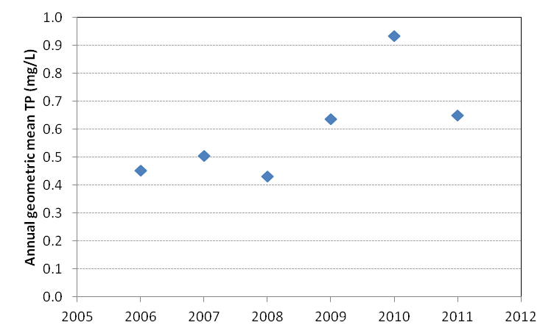
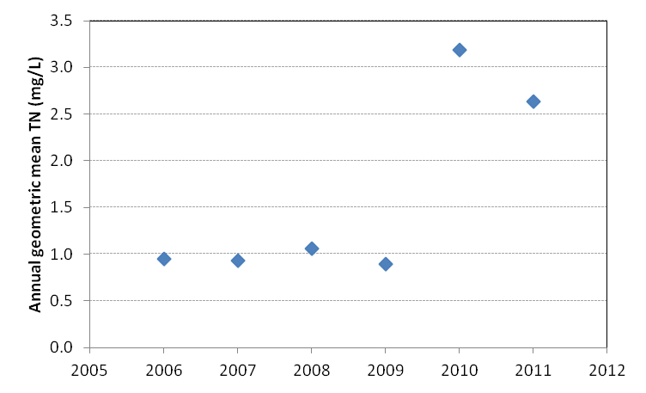
Figure 6. Annual geometric mean TN and TP concentrations (top and bottom panels, respectively) at EPCHC Station 542 in WBID 1592C (Mustang Ranch Creek), a tributary to Medard Reservoir and the Little Alafia River, 2006–11

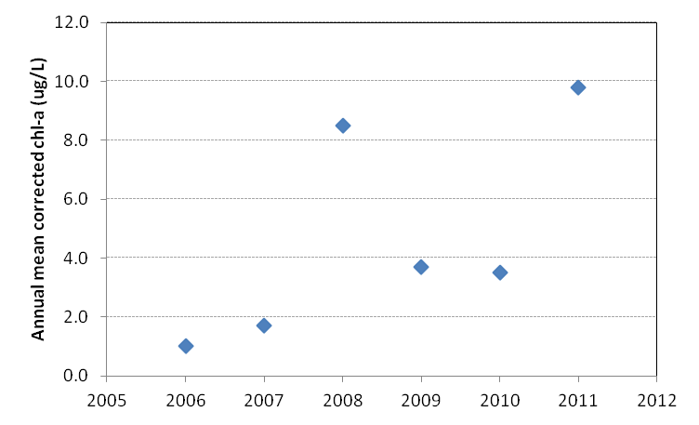
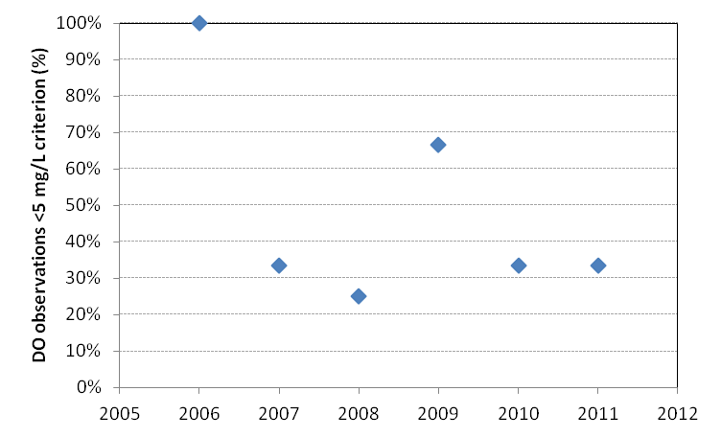
Figure 7. Annual mean cchla concentrations (top panel) and percentages of monthly DO observations falling below the 5.0 mg/L freshwater DO threshold (bottom panel) at EPCHC Station 542 in WBID 1592C (Mustang Ranch Creek), a tributary to Medard Reservoir and the Little Alafia River, 2006–11

Additional watershed management actions may be needed in future BMAPs to further reduce anthropogenic nutrient loadings. If such actions prove necessary, the BMAP process will offer the Department an opportunity to work with other state agencies (e.g., FDACS, Florida Department of Health [FDOH], FDOT), local governmental organizations (e.g., Hillsborough County Public Works, Hillsborough County Health Department, EPCHC), and landowners and other private sector interests to implement load reduction projects. Due to the absence of NPDES wastewater facilities and the presence of a mix of rural, urban, and roadway-related land uses in the area, it appears that a combination of nutrient-related stormwater BMPs would offer the most cost-effective approach for achieving load reductions.

WBID 1639 (Thirtymile Creek)
The TMDL for this WBID, which was developed in 2004, seeks to reduce ambient nutrient TN concentrations to a target level of 3.0 mg/L in order to maintain annual mean chla concentrations at or below 20 μg/L and achieve compliance with the existing DO criterion (5.0 mg/L) for freshwater streams (Wainwright 2004).
Although water quality data from several short-term monitoring sites are available from the WBID and were used to develop the TMDL, long-term data are limited to a single Southwest Florida Water Management District (SWFWMD) site (Station 17975) that has been monitored monthly since 2000. The site is located near the midpoint of the WBID, where Thirtymile Creek crosses Nichols Road.
Annual geometric mean TN concentrations at Station 17975 were elevated (2 to 5 mg/L) from 2000 through 2004, but declined sharply in 2005 and remained at roughly 1 mg/L from 2006 through 2011 (Figure 8). Geometric mean TP concentrations were elevated throughout the 2000–11 monitoring period, fluctuating between 0.6 and 2.1 mg/L. Annual mean cchla concentrations were relatively low, not exceeding 10 µg/L in most years. During 2002, however, chla concentrations were elevated (ranging from 27 to 85 µg/L) from June through November, and the annual mean concentration for that year was 28.5 µg/L (Figure 8). Department staff have indicated that it is possible that the WBID may be designated as “not impaired” for nutrients during its next assessment period.
The percentage of DO samples failing to meet the 5.0 mg/L freshwater criterion showed large year-to-year fluctuations from 2000 through 2011 (Figure 9). Nonparametric (Kendall tau) correlation analysis indicates that these year-to-year changes in DO criterion exceedances were positively associated with changes in annual geometric mean TP concentrations (tau = 0.52, p < 0.02) and negatively associated with changes in annual mean fluoride concentrations (tau = -0.49, p < 0.03). The relationship between DO exceedances and annual geometric mean TN concentrations was weaker and on the borderline of statistical significance (tau = 0.40, p = 0.07).
The TMDL report for Thirtymile Creek (Wainwright 2004) notes that phosphate mining and processing are the dominant land uses in WBID 1639, comprising 61% (2,565 acres) of the land surface. The TMDL requires that TN concentrations discharged from two NPDES-permitted phosphate industry outfalls located upstream of Nichols Road not exceed 3.0 mg/L as a monthly average, and recommends that an additional outfall located downstream from Nichols Road also meet this condition.
Agriculture (including pastureland, crops, and tree crops) is the second largest land use category in the WBID, at 15.9%. The TMDL load allocation for nonpoint source discharges from these areas is 1.6 mg/L of TN as an annual average.
The TMDL report notes that there is little urban land use in the WBID. Low-density residential land use (with fewer than 2 dwelling units per acre) makes up approximately 6%, and commercial land use comprises approximately 0.01% of the land area. The remainder consists primarily of wetlands and forested areas containing mixed hardwoods. Due to the rural nature of the watershed, MS4 loadings and allocations were not considered in the development of the TMDL (Wainwright 2004).
Given the mix of industrial and rural land uses in the WBID, it appears likely that future BMAP efforts will focus on coordinating with the phosphate industry on NPDES permit compliance issues, and working with FDACS and local agricultural operations to implement nutrient-related BMPs.
While the existing TMDL emphasizes the need for nitrogen load reductions, the BMAP Program may also wish to focus on managing future phosphorus loads. Numerous technical studies have demonstrated the importance of managing both N and P loads in freshwater catchments that discharge to coastal waters (Howarth and Paerl 2008; Schindler et al. 2008). Due to their phosphorus-rich geology and land use, Thirtymile Creek and other streams in the Alafia River Basin have a long history of receiving TP loads that would be considered unusually large in other, less phosphorus-rich geographic regions. These large background TP loads skew standard metrics, such as TN/TP ratios, that are typically used to assign priorities to TN or TP load reduction efforts. Unless they are counterbalanced by very large anthropogenic TN loads, the very large background TP loads that occur in areas such as

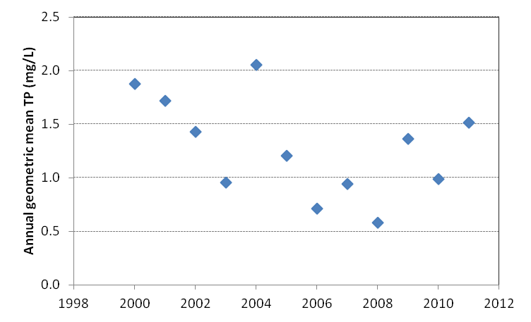
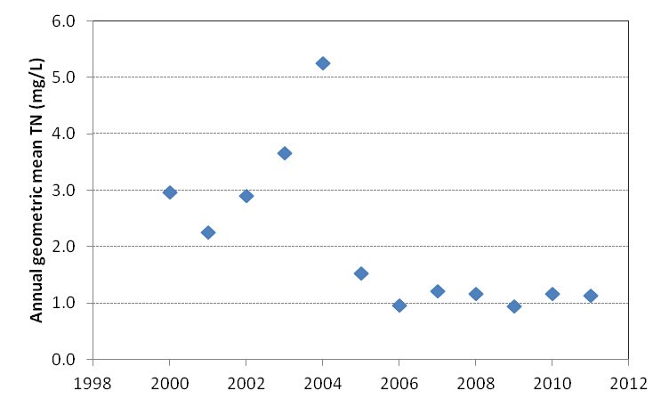
Figure 8. Annual geometric mean TN and TP concentrations (top and bottom panels, respectively) at SWFWMD Station 17975 in WBID 1639 (Thirtymile Creek), a tributary to the North Prong of the Alafia River, 2000–11

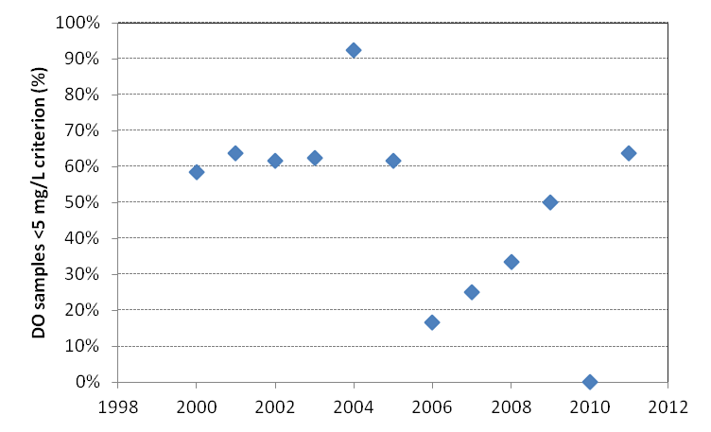
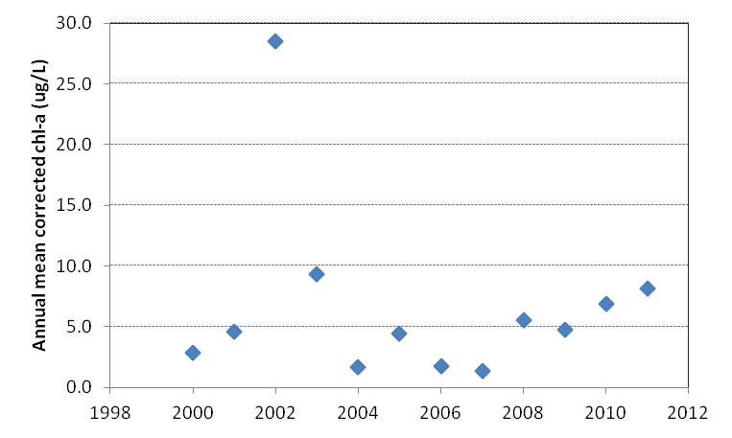
Figure 9. Annual mean cchla concentrations (top panel) and percentages of monthly DO observations falling below the 5.0 mg/L freshwater DO threshold (bottom panel) at SWFWMD Station 17975 in WBID 1639 (Thirtymile Creek), a tributary to the North Prong of the Alafia River, 2000–11

Thirtymile Creek tend to produce low TN/TP ratios in the water column of the receiving stream. These low ratios can lead managers to conclude that a waterbody is “nitrogen limited” and that efforts to control TP loads are unnecessary. In practice, however, efforts to control anthropogenic TP loads are often critically important in such situations (Howarth and Paerl 2008; Schindler et al. 2008).

WBIDs with Fecal Coliform TMDLs
Under the federal Clean Water Act, Florida has adopted water quality criteria for fecal coliform bacteria in order to reduce human health risks in cases where waterborne pathogens could potentially be present in waterbodies that are used for recreation, shellfish harvesting, or potable water supply. For Class III (recreational) and Class I (potable supply) waters, a criterion of 400 colony-forming units per 100 mL (CFU/100mL) sample is typically used to identify fecal coliform impairments. Waterbodies in which >10% of samples exceed the 400 CFU/100mL criterion are designated as impaired and require TMDL development.
In most cases, however, the fecal coliform bacteria that are detected in surface water samples are not human pathogens. Instead, they are indicator organisms (IO) that are used as a surrogate to indicate that water may have been contaminated by fecal material (from humans or other warm-blooded vertebrates) and may therefore contain disease-causing organisms that pose a risk to public health.
Several issues impact the use of fecal coliforms and other IO as water quality indicators in tropical and subtropical climates. Rose et al. (2001), in a recent study conducted in the Tampa Bay area, provided the following summary of this issue:
Risks to swimmers using polluted beaches have been a major issue associated with the setting of ambient water quality standards and discharge limits to recreational sites. Public health concerns in recreational waters in the tropics and subtropics differ from those of cooler waters. Prevention of disease depends on the use of appropriate fecal indicators. However, the finding that the most widely used fecal contamination indicator, fecal coliforms and more specifically E. coli, grow naturally on vegetation in warm climates clearly brings into question whether these or other indicators developed for temperate climates are applicable in Florida and other southeastern areas… In recent years, total and fecal coliform bacterial indicators have not been able to consistently indicate the persistence of pathogens, especially viruses in surface waters.

In recognition of these and other points, the Department (2011) has developed a guidance document that provides recommendations for stakeholders on steps that can be taken to implement fecal coliform TMDLs. Among other actions, the recommended steps include the following:
Compiling and evaluating available data.
Identifying and assembling watershed stakeholders.
Identifying potential sources of fecal contamination.
Identifying appropriate management actions to address those sources.
Developing and implementing a management plan.
Carrying out monitoring to track plan effectiveness.
The information provided in this report addresses only the first of these steps: the compilation and analysis of available water quality data. Several other steps are being addressed by local stakeholders working directly with Department staff, and information on these activities will be summarized in other documents.
As noted in Figure 3, the following WBIDs with fecal coliform impairments are addressed in this BMAP:
1578B (Turkey Creek).
1592C (Mustang Ranch Creek).
1552 (English Creek).
1639 (Thirtymile Creek).
1583 (Poley Creek).
Figure 10 through Figure 15 summarize information on annual geometric mean fecal coliform counts and microbial water quality assessment (MWQA) scores for these WBIDs. The MWQA scores are expressed as letter grades (A through E) reflecting how frequently the state’s fecal coliform criterion of 400 CFU/100mL is exceeded at a given monitoring site. Scores of A indicate that 10% or less of samples exceed the criterion, while scores of E indicate that >75% of samples exceed the criterion. Previous studies have shown that sites with higher frequencies of exceedances also exhibit higher overall concentrations of fecal coliforms and other indicator bacteria (Morrison et al. 2010), so that MWQA Categories A through E also provide working estimates of progressively higher IO concentrations and increasing levels of potential human health risk. Because fecal coliform counts can be highly variable from month to month and year to year, the MWQA scores shown in Figure 10 through Figure 15 are based on 3 years of monitoring data to provide a multiyear summary of bacterial water quality conditions at each monitoring station.
Fecal coliform counts at the two monitoring sites on Turkey Creek (EPCHC Stations 111 and 151) show very different temporal patterns. At the upstream site (Station 111, located at SR 60) although annual geometric means declined dramatically between 1980 and 1992, they remained quite elevated (e.g., 500 to 1,500 CFU/100mL) from 1993 through 2011 (Figure 10). Three-year MWQA scores at the site have fluctuated between C and D throughout the period of record. Depending on the specific types of fecal sources present in the watershed and the risks they pose to humans, MWQA scores in this range frequently indicate the presence of moderate to moderately high health risks. Over the most recent 10-year period, monthly fecal coliform counts have been positively correlated with TP (Kendall tau = 0.18, p < 0.01) and turbidity (tau = 0.25, p < 0.001), and negatively correlated with conductivity (tau = -0.21, p = 0.01). This suggests the presence of an IO source that is associated with turbid surface water discharges containing elevated TP concentrations.
At the downstream site (Station 151, located at Durant Road), fecal coliform counts were quite elevated in 1991–92, declined sharply in 1993, and showed a significant increasing trend (tau = 0.20, p < 0.0001) between 1993 and 2011 (Figure 11). Three-year MWQA scores have ranged from A to B since 1993. Over the past 10 years, as at Station 111, monthly fecal coliform counts have been positively correlated with nutrient concentrations and turbidity, and negatively correlated with conductivity.
Long-term fecal coliform data are not available from the Mustang Ranch Creek WBID. The monitoring station with the longest period of record is EPCHC Station 542, located at SR 60. Annual data from this station cover only 2006 through 2011. During that period, annual geometric mean fecal coliform counts ranged between 159 and 2,563 CFU/100mL, and 3-year MWQA scores ranged between C and D, suggesting a moderate to moderately high potential for human health risk (Figure 12). No correlations were evident between the monthly IO counts and other water quality variables, perhaps due to the relatively small amount of available data.
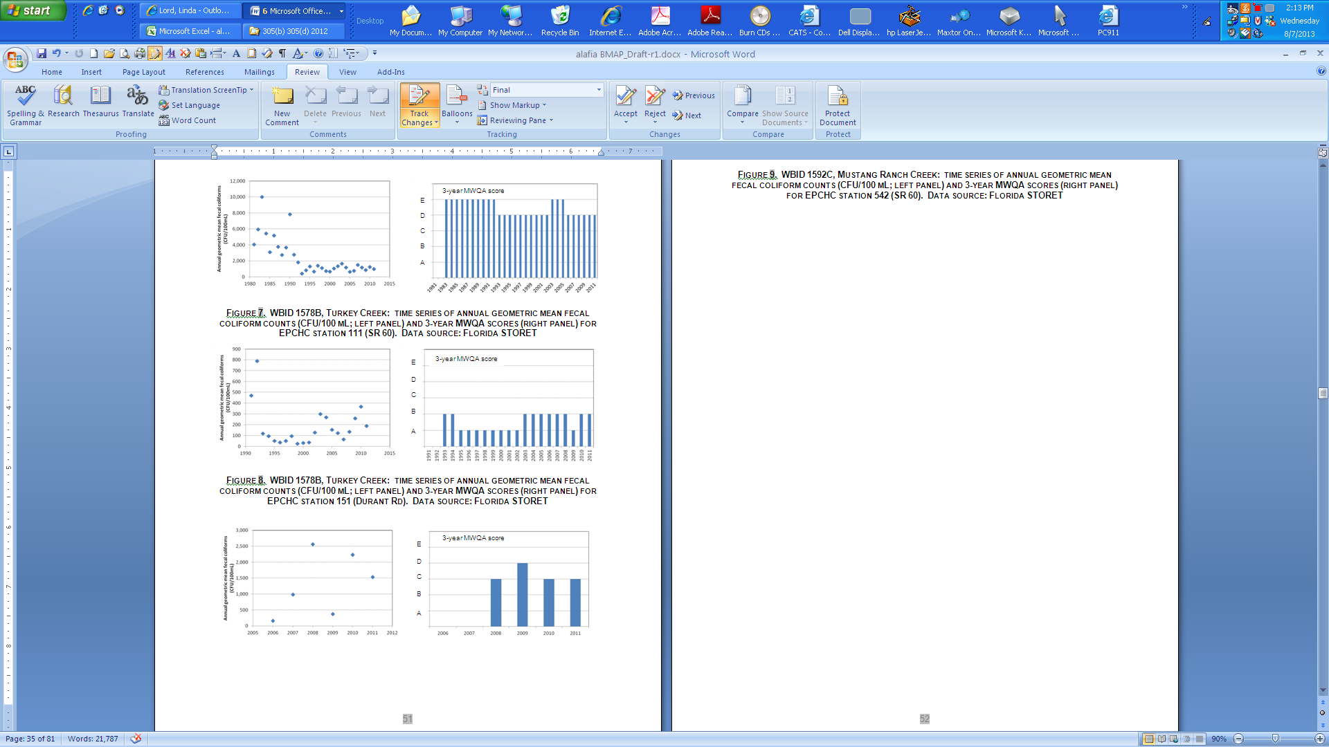

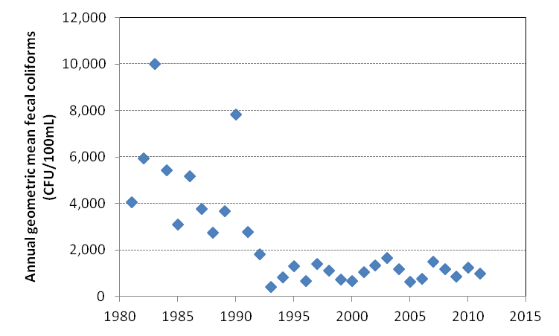
Figure 10. WBID 1578B, Turkey Creek: Time-series of annual geometric mean fecal coliform counts (CFU/100mL) (top panel) and 3-year MWQA scores (bottom panel) for EPCHC Station 111 (SR 60)

Data source: Florida STORET

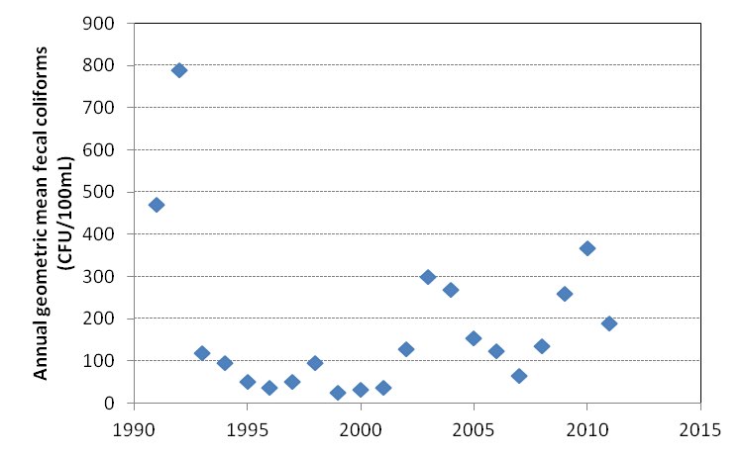
Figure 11. WBID 1578B, Turkey Creek: Time-series of annual geometric mean fecal coliform counts (CFU/100 mL) (top panel) and 3-year MWQA scores (bottom panel) for EPCHC Station 151 (Durant Road)

Data source: Florida STORET

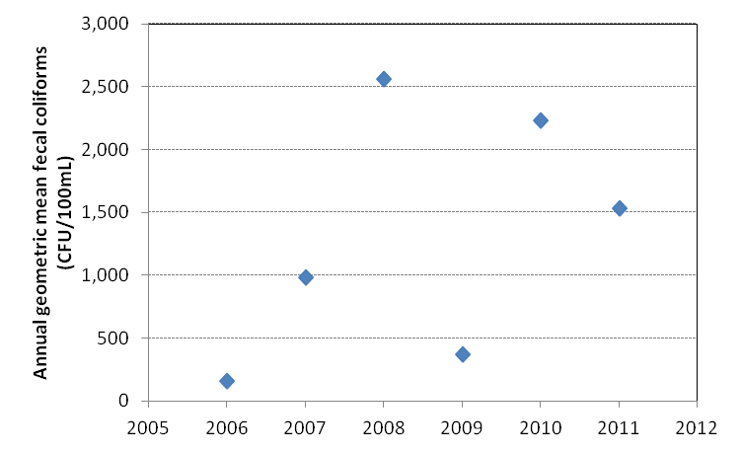
Figure 12. WBID 1592C, Mustang Ranch Creek: Time-series of annual geometric mean fecal coliform counts (CFU/100 mL) (top panel) and 3-year MWQA scores (bottom panel) for EPCHC Station 542 (SR 60)

Data source: Florida STORET

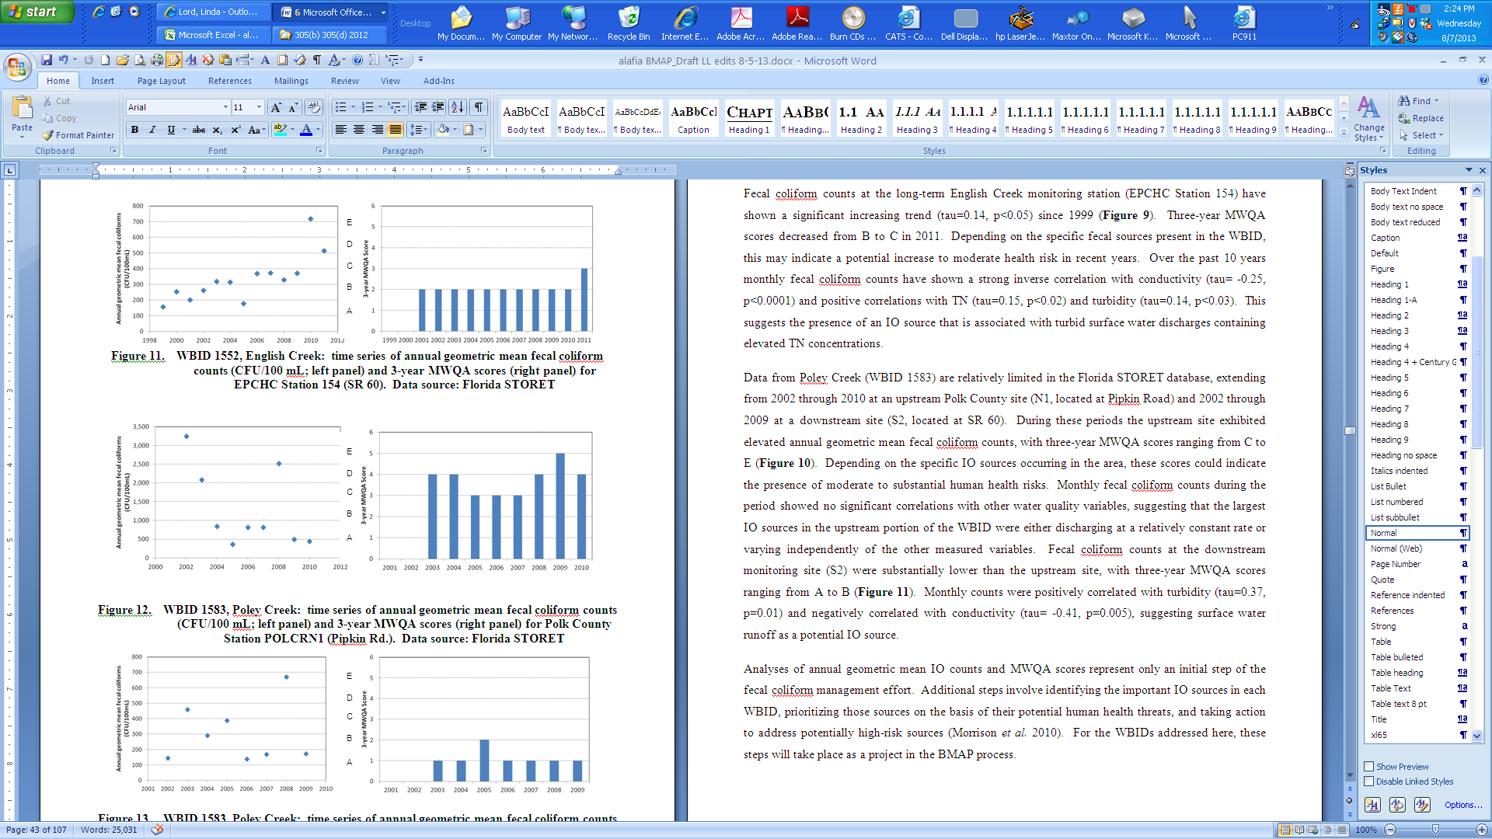
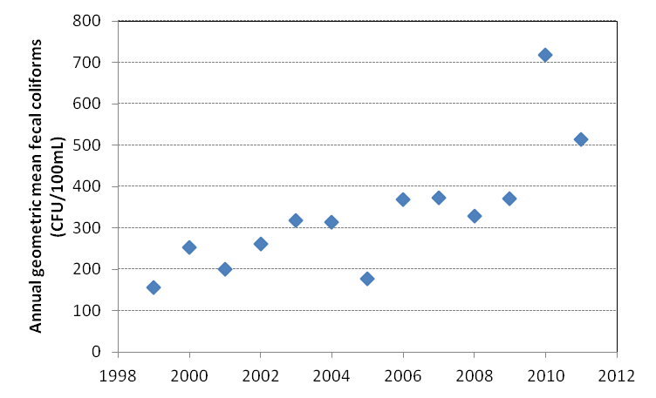
Figure 13. WBID 1552, English Creek: Time-series of annual geometric mean fecal coliform counts (CFU/100mL) (top panel) and 3-year MWQA scores (bottom panel) for EPCHC Station 154 (SR 60)

Data source: Florida STORET

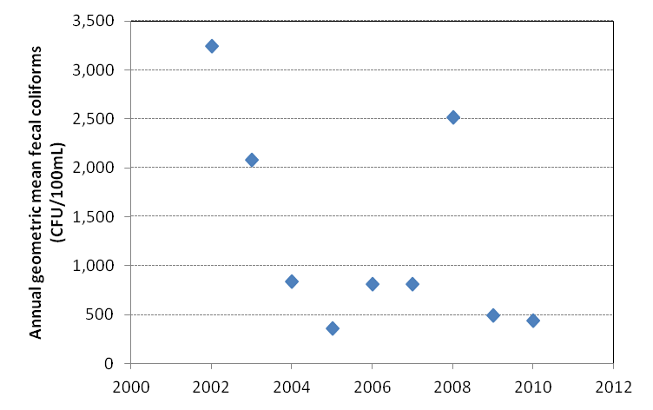
Figure 14. WBID 1583, Poley Creek: Time-series of annual geometric mean fecal coliform counts (CFU/100 mL) (top panel) and 3-year MWQA scores (bottom panel) for Polk County Station POLCRN1 (Pipkin Road)

Data source: Florida STORET

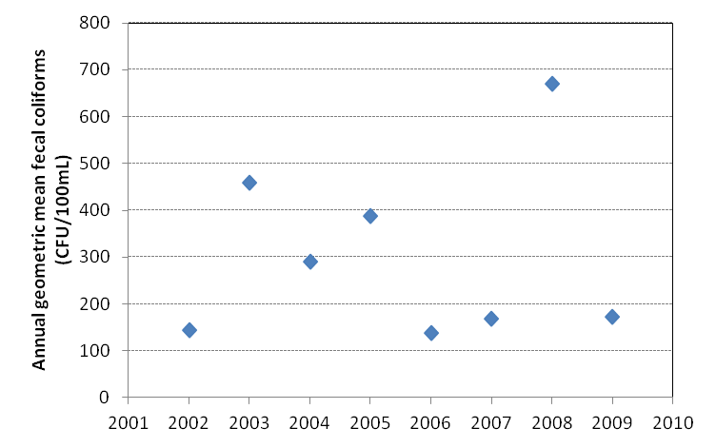
Figure 15. WBID 1583, Poley Creek: Time-series of annual geometric mean fecal coliform counts (CFU/100mL) (top panel) and 3-year MWQA scores (bottom panel) for Polk County Station POLCRS2 (SR 60)

Data source: Florida STORET

Fecal coliform counts at the long-term English Creek monitoring station (EPCHC Station 154) have shown a significant increasing trend (tau = 0.14, p < 0.05) since 1999 (Figure 13). Three-year MWQA scores decreased from B to C in 2011. Depending on the specific fecal sources present in the WBID, this may indicate a potential increase to moderate health risk in recent years. Over the past 10 years monthly fecal coliform counts have shown a strong inverse correlation with conductivity (tau = -0.25, p < 0.0001) and positive correlations with TN (tau = 0.15, p < 0.02) and turbidity (tau = 0.14, p < 0.03). This suggests the presence of an IO source that is associated with turbid surface water discharges containing elevated TN concentrations.
Data from Poley Creek (WBID 1583) are relatively limited in the Florida STORET database, extending from 2002 through 2010 at an upstream Polk County site (N1, located at Pipkin Road) and 2002 through 2009 at a downstream site (S2, located at SR 60). During these periods the upstream site exhibited elevated annual geometric mean fecal coliform counts, with 3-year MWQA scores ranging from C to E (Figure 14). Depending on the specific IO sources in the area, these scores could indicate the presence of moderate to substantial human health risks. Monthly fecal coliform counts during the period showed no significant correlations with other water quality variables, suggesting that the largest IO sources in the upstream portion of the WBID were either discharging at a relatively constant rate or varying independently of the other measured variables. Fecal coliform counts at the downstream monitoring site (S2) were substantially lower than at the upstream site, with 3-year MWQA scores ranging from A to B (Figure 15). Monthly counts were positively correlated with turbidity (tau = 0.37, p = 0.01) and negatively correlated with conductivity (tau = -0.41, p = 0.005), suggesting surface water runoff as a potential IO source.
Analyses of annual geometric mean IO counts and MWQA scores represent only an initial step in the fecal coliform management effort. Additional steps involve identifying the important IO sources in each WBID, prioritizing those sources on the basis of their potential human health threats, and taking action to address potentially high-risk sources (Morrison et al. 2010). For the WBIDs addressed here, these steps will take place as projects in the BMAP process.

: Pollutant Sources, Anticipated Outcomes, and Management Actions

Summary of Sources in the TMDLs
The TMDLs include estimates of TN/TP loading and fecal coliform exceedances in the Alafia River Basin WBIDs from Phase 1 MS4s and nonpoint watershed stormwater sources, point source facilities, and nonpoint source land use inputs (agricultural and urban septic tanks). Table 5 shows the existing loads and required reductions in the TMDL. Additional details about the sources that are included in this BMAP are provided in the subsections below.
Table 5. Required reductions in the Alafia River Basin
NA = Not applicable
- = Empty cell/no data
Alafia River  Basin WBID | TMDL Target Concentration TP/TN  (mg/L) | Domestic Wastewater Treatment Plant (WWTP) Point Sources  (% reduction) | Stormwater Runoff Load  (% reduction) | Fecal Coliform  (% reduction)
1621G | NA/0.65 | 54% TN | 54% TN | NA
1578B | NA | NA | NA | 64%
1592C | 0.415/1.73 | NA | 50% TN/45% TP | 88%
1552 | NA | NA | NA | 40%
1583 | NA | NA | NA | 67 %
1639 | NA/3.0 | - | - | NA

Point Source Facilities
Point sources include both domestic and industrial WWTFs. Rule 62-620, F.A.C., defines domestic wastewater facilities as those facilities that are principally designed “to collect and treat sanitary wastewater or sewage from dwellings or homes, business buildings, institutions, and the like.” This rule defines industrial wastewater as “process and non-process wastewater from manufacturing, commercial, mining, and silvicultural facilities or activities, including the runoff and leachate from areas that receive pollutants associated with industrial or commercial storage, handling or processing, and all other wastewater not otherwise defined as domestic wastewater.”
In 1995, the EPA authorized the Department to implement the NPDES Program to permit wastewater discharges, including industrial and domestic wastewater facilities, to state surface waters. Permits are issued under the applicable provisions of Chapter 403, F.S., and appropriate rules in Rule 62-600, F.A.C., with applicable sections of 40 Code of Federal Regulations (C.F.R.) incorporated by reference. These regulations, rules, and statutes give the Department the authority to regulate domestic and industrial wastewater facilities.
There are 23 active NPDES-permitted discharges in the Alafia River Basin (Table 6). Permits issued to all existing point source discharges in the basin are currently designed to achieve Class III water quality standards. The facilities listed in Table 6 that do not have a design capacity have permits for emergency discharge only. The largest discharge is the city of Lakeland domestic wastewater facility with a design capacity of 20 million gallons per day (MGD). This facility is located outside the Alafia River Basin but has an outfall to a tributary of the North Prong. The majority of the industrial wastewater facilities are owned by the Mosaic Company. Coronet Industries, Inc. is an animal feed operations facility that closed in 2004 but still has an active status until the holding ponds are mitigated.

Municipal Separate Storm Sewer Systems
Many of the municipalities in the basin are regulated by the Florida NPDES Stormwater Program because these municipalities discharge stormwater and qualify as MS4s. An MS4 refers to a conveyance or system of conveyances—such as roads with stormwater systems, municipal streets, catch basins, curbs, gutters, ditches, constructed channels, or storm drains—that has the following characteristics:
Is owned or operated by a state, city, town, county, special district, association, or other public body (created by or under state law) having jurisdiction over the management and discharge of stormwater and that discharges to surface waters of the state.
Is designed or used for collecting or conveying stormwater.
Is not a combined sewer.
Is not part of a Publicly Owned Treatment Works (POTW). POTW means any device or system used in the treatment of municipal sewage or industrial wastes of a liquid nature which is owned by a “state” or “municipality.” This definition includes sewers, pipes, or other conveyances only if they convey wastewater to a POTW providing treatment.

Table 6. NPDES point sources in the Alafia River Basin
Watershed | Facility ID | Facility Name | Facility Type | Design Capacity  (MGD)
South Prong | FL0033332 | Mosaic Phosphates Company - Lonesome Mine | Industrial Wastewater | 0.00
South Prong | FL0132381 | Cytec Industries, Inc. – Brewster Plant | Industrial Wastewater | 0.00
South Prong | FL0000370 | Mosaic Phosphates Company –  South Pierce Concentrates Plant | Industrial Wastewater | 0.00
South Prong | FL0033294 | Mosaic Fertilizer, LLC – Hookers Prairie Mine | Industrial Wastewater | 0.00
South Prong | FL0160083 | Estech, Inc. – Agricola Plant | Industrial Wastewater | 0.00
South Prong | FL0036421 | Mosaic Fertilizer, LLC –  New Wales Concentrates Complex | Industrial Wastewater | 0.00
North Prong | FL0000752 | Mosaic Fertilizer, LLC – Green Bay Chemical Plant | Industrial Wastewater | 0.00
Alafia River | FL0122076 | Rice Creek Utility Company | Domestic Wastewater | 0.30
North Prong | FL0178527 | Mosaic Phosphates Company –  New Wales Closed Gypsum Stack | Industrial Wastewater | 0.00
Alafia River | FL0000761 | Mosaic Fertilizer LLC – Riverview Facility | Industrial Wastewater | 0.00
Alafia River | FL0030139 | Mosaic Fertilizer LLC – Nicols Facility | Industrial Wastewater | 0.00
North Prong | FL0039772 | Lakeland, City of – Glendale WRF | Domestic Wastewater | 20.00
North Prong | FL0000523 | CF Industries, Inc – Bartow Chemical Plant | Industrial Wastewater | 0.00
North Prong | FL0675032 | Kinder Morgan Central Florida Terminal | Industrial Wastewater | 0.00
North Prong | FL0334944 | MPI Mulberry Phosphogypsum Stack System Closure | Industrial Wastewater | 0.00
North Prong | FL0000671 | Mosaic Fertilizer, LLC – Mulberry Chemical Plant | Industrial Wastewater | 0.00
North Prong | FL0020338 | Mulberry, City of | Domestic Wastewater | 0.75
North Prong | FLG110205 | CEMEX LLC – Mulberry CBP | Concrete Batch GP | 0.00
North Prong | FLG110168 | Hicks CBP | Concrete Batch GP | 0.00
South Prong | FL0000256 | Mosaic Fertilizer, LLC – Kingsford Mine | Industrial Wastewater | 0.00
North Prong | FL0001589 | Mosaic Fertilizer, LLC – Bartow Chemical Plant | Industrial Wastewater | 0.00
North Prong | FL0032590 | Mosaic Phosphates Company – Hopewell Mine | Industrial Wastewater | 0.00
North Prong | FL0034657 | Coronet Industries Inc | Industrial Wastewater | 0.00
North Prong | FLG110671 | Tarmac America LLC – Plant City Plant | Concrete Batch GP | 0.00

The basic requirements of the MS4 program serve as a foundation for the stormwater management efforts of these communities. The EPA developed the federal NPDES stormwater permitting program in two phases. Phase I, which began in 1990, addresses large and medium MS4s located in incorporated areas and counties with populations of 100,000 or more, as well as specific industrial activities. Phase II, which started in 1999, addresses small MS4s that are designated according to population and other criteria established in federal and state rules. Small MS4s include those that serve a population of 1,000 or more and are located within an urbanized area.
In October 2000, the EPA authorized the Department to implement the NPDES stormwater permitting program in the state. This permitting has remained separate from state Stormwater/ ERP Programs and local stormwater/water quality programs, which have their own regulations and permitting requirements. Florida's rules for MS4s can be found in Rules 62-4, 62-620, 62-621, and 62-624, F.A.C. Table 7 lists the entities that are currently designated as MS4 permittees in the Alafia River Basin. Both of these Phase 1 permits have multiple co-permittees.
Table 7. Alafia River Basin MS4 permit holders
MS4 Type | Permittee | Permit Number
Phase I | Hillsborough County | FLS000006
Phase I | FDOT District 7 | FLS000006
Phase I | City of Plant City | FLS000006
Phase I | Polk County | FLS000015

Phase I MS4 Stormwater Permit Requirements
Hillsborough County and its co-permittees, and Polk County and its co-permittees, currently hold Phase I MS4 permits. Phase I MS4 permittees were subject to a two-part permit application process requiring the development of a proposed stormwater management program (SWMP) that would meet the standard of reducing (discharged) pollutants to the Maximum Extent Practicable (MEP), and the incorporation of the SWMP into an individual permit issued to the MS4 operator. The SWMPs for Phase I MS4s include, but are not limited to, the following measures:
Identify major outfalls and pollutant loadings.
Detect and eliminate nonstormwater discharges (illicit discharges) to the system.
Reduce pollutants in runoff from industrial, commercial, and residential areas.
Control stormwater discharges from new development and redevelopment areas.
Implement a monitoring program.
To avoid the need for reopening MS4 permits each time a TMDL or BMAP is adopted, the following language included in the Phase I MS4 permits automatically requires the implementation of any stormwater requirements in an adopted BMAP, during the permit cycle following BMAP adoption. This “TMDL clause” states: “In accordance with Section 403.067, F.S., NPDES permits must be consistent with the requirements of adopted TMDLs. Therefore, when a Basin Management Action Plan (BMAP) and/or an implementation plan for a TMDL for a water body into which the permitted MS4 discharges the pollutant of concern is adopted pursuant to Section 403.067(7), F.S., the MS4 operator must comply with the adopted provisions of the BMAP and/or implementation plan that specify activities to be undertaken by the permittee during the permit cycle.” Also, according to Paragraph 403.067(7)(a)4, F.S., the BMAP is adopted by Secretarial Order under Chapter 120, F.S.

Phase II MS4 Stormwater Permit Requirements
There are no current Phase II MS4 permits in the Alafia River Basin. Under a generic permit, operators of regulated Phase II MS4s must develop an SWMP that includes BMPs, with measurable goals, to effectively implement the following six minimum control measures:
Public Education and Outreach – Perform educational outreach regarding the harmful impacts of polluted stormwater runoff.
Public Participation/Involvement – Comply with state and local public notice requirements and encourage other avenues for citizen involvement.
Illicit Discharge Detection and Elimination – Implement a plan to detect and eliminate any nonstormwater discharges to the MS4, and create a system map showing outfall locations. Subsection 62-624.200(2), F.A.C., defines an illicit discharge as “…any discharge to an MS4 that is not composed entirely of stormwater…,” except discharges under a NPDES permit, or those listed in rule that do not cause a violation of water quality standards. Illicit discharges can include septic/sanitary sewer discharge, car wash wastewater, laundry wastewater, improper disposal of auto and household toxics, and spills from roadway accidents.
Construction Site Runoff Control – Implement and enforce an erosion and sediment control program for construction activities.
Postconstruction Runoff Control – Implement and enforce a program to address discharges of postconstruction stormwater runoff from new development and redevelopment areas. (Note: This minimum control is generally met through state stormwater permitting requirements under Part IV, Chapter 373, F.S., as a qualifying alternative program.)
Pollution Prevention/Good Housekeeping – Implement a program to reduce pollutant runoff from municipal operations and property and perform staff pollution prevention training.
The Phase II generic permit (Paragraph 62-621.300[7][a], F.A.C.) also has a self-implementing clause that compels a permittee to implement its stormwater pollutant load responsibilities within an adopted BMAP. It states: “If a TMDL is approved for any water body into which the Phase II MS4 discharges, and the TMDL includes requirements for control of stormwater discharges, the operator must review its stormwater management program for consistency with the TMDL allocation. If the Phase II MS4 is not meeting its TMDL allocation, the operator must modify its stormwater management program to comply with the provisions of the TMDL Implementation Plan applicable to the operator in accordance with the schedule in the Implementation Plan.”

Extractive Land Use
The entire Alafia River Basin (BMAP area and other WBIDs) consists of approximately 270,129 acres, with approximately 36% of the land having undergone extractive mining for phosphate. This former land use will continue to influence water quality in all the Alafia River Basin WBIDs.
The upper reaches of the North Prong of the Alafia were mined in the early 1900s, and the area now consists of a large herbaceous wetland. This wetland greatly influences the DO regime of the system. Based on site observations and on comparisons with other wetland-dominated systems (e.g., the Everglades, where similarly low DO levels are observed at TP concentrations of less than 10 µg/L), the low DO that is commonly observed in the upper reaches of the Alafia results from the system morphology and wetland conditions. The Department is currently gathering additional DO data to establish a DO SSAC for the wetland and upper portions of the North Prong. The North Prong of the Alafia River has been physically altered (dredged and channelized), and habitat suitable for the colonization of stream organisms is generally not observed until downstream of English Creek near the Alafia River Reserve. The South Prong watershed has been heavily mined, but the in-stream habitat has been far less physically altered than in the North Prong.

Anticipated Outcomes of BMAP Implementation
With the implementation of the projects outlined in this BMAP, continued reductions in nutrient loads and the identification and remediation of fecal coliform sources in the impaired WBIDs are expected to decrease the contribution of nutrients and fecal coliforms to these WBIDs. As noted previously, most of the projects identified are a result of the previous work accomplished by the TBEP and the NMC for the ongoing Tampa Bay RA Plan. The following outcomes are expected from BMAP implementation:
Continued improvement in water quality trends in the watershed and Tampa Bay.
Decreased loading of the target pollutants (TN and TP).
Identification of potential fecal coliform sources.
Corrective action on anthropogenic sources of fecal coliforms.
Continuing coordination between state and local governments and within divisions of local governments in problem solving for surface water quality restoration.
Determination of effective projects through the stakeholder decision-making and priority-setting processes and incorporation of the projects into the existing TBEP database.
Enhanced public awareness of pollutant sources, pollutant impacts on water quality, and corresponding corrective actions.
Enhanced understanding of basin hydrology, water quality, and pollutant sources.

Management Strategies
The Tampa Bay Action Plan Database (available: http://apdb.tbeptech.org/) currently lists 62 stakeholder projects that have been or are being implemented to improve and protect water quality in the Alafia River Basin. This BMAP also requires the implementation of these projects by the assigned entities. An additional 8 projects have been identified in the BMAP, through discussions with stakeholders. These projects will be added the Action Plan Database in the near future. Information on this group of 70 projects is included in the spreadsheet in Appendix D. Because the tidal reach of the Alafia River (WBID 1621G) receives discharges from throughout the basin, all of these projects are relevant to water quality conditions in at least one of the WBIDs addressed in this report.
The TBEP in early 2013 received approval for the Tampa Bay RA Plan update. The Action Plan Database contains a continually updated summary of stakeholder projects that will be used in the next cycle of the Tampa Bay RA process.
The WBIDs impaired for fecal coliforms are undergoing source identification through the “Walk the Waterbody” process. The information gained and projects generated from these activities will be added to the BMAP in the future.

Types of Management Strategies
The TBEP Action Plan Database contains the Alafia River BMAP projects and is regularly updated. The types and quantities of projects listed in Table 8 are current through the beginning of 2013, and details are included in Appendix D. The reclamation of mined lands and other restoration activities play major roles in restoring and protecting water quality in the Alafia River Basin.
Table 8. Summary of Alafia River BMAP projects

- = Empty cell/no data
Category | Quantity | Total Estimated Cost
Restoration, land acquisition, and water quality improvement | 22 | $85,000,000
Stormwater management | 16 | $86,000,000
Public education and outreach | 2 | $75,000
Agricultural BMPs | Basinwide (60) | -
Wastewater infrastructure management | 3 | $250,000 estimated
Regulations, ordinances, guidelines | 2 | -
Other (includes “Walk the Waterbody”) | 7 | $1,200,000

Addressing Agricultural Nonpoint Pollution
Paragraph 403.067(7)(b), F.S., requires that nonpoint pollutant sources (such as agriculture) included in a BMAP demonstrate compliance with pollutant reductions needed to meet a TMDL, either by implementing appropriate BMPs (adopted by FDACS or the Department, as applicable), or conducting water quality monitoring, prescribed by the Department or the applicable water management district, that demonstrates compliance with water quality standards. If pollutant sources do not either implement BMPs or conduct monitoring, they may be subject to enforcement by the Department or the applicable water management district.
Under Paragraph 403.067(7)(c), F.S., the implementation of FDACS-adopted, Department-verified BMPs in accordance with FDACS rule provides a presumption of compliance with state water quality standards. In addition, producers who implement BMPs may be eligible for cost-share funding from the water management district, FDACS, or others. The Department of Agriculture and Consumer Services will assist existing growers in selecting the applicable best management practices and entering notice of intents to confirm their usage. Among other things, the BMPs emphasize nutrient management, irrigation management, sediment/erosion control, stormwater management, and record keeping. During the initial five-year implementation period, FDACS will contact producers associated with at least 60% of the commercial agricultural acreage within the basin, to offer them assistance with BMPs. FDACS will report annually to FDEP on its progress in contacting and enrolling producers, including number of operations and acres enrolled. In conducting outreach to producers, FDACS will work with the soil and water conservation districts, resource conservation and development councils, county Extension staff, and others to convey the statutory imperative for agriculture to implement BMPs, as well as their benefits to the environment and the producers.

Agricultural BMPs
BMPs are individual or combined practices determined through research, field testing, and expert review to be the most effective and practicable means for improving water quality, taking into account economic and technological considerations.
FDACS’ BMPs fall into two categories: structural and management. Structural BMPs involve the installation of structures or changes to the land, usually are more costly, and often require cost-share to be economically feasible. They include water control structures, fencing, and tailwater recovery systems. Management BMPs, such as nutrient and irrigation management, comprise the majority of the practices and often are not readily observable. Nutrient management addresses fertilizer type, amount, placement, and application timing, and includes practices such as soil and tissue testing to determine crop nutrient needs, application methods, and setbacks from water resources. Irrigation management is the maintenance, scheduling, and overall efficiency rating of irrigation systems. In several areas of the state, FDACS-funded Mobile Irrigation Labs (MILs) identify and demonstrate irrigation efficiency techniques to producers. The implementation of these recommendations saves billions of gallons of water throughout the state and helps reduce nutrient runoff and leaching.
Table 9 identifies key management and structural BMPs that most likely would be applicable to agricultural operations in the basin. By definition, BMPs are technically and economically feasible. However, FDACS’ BMP manuals contain some BMPs that may be affordable only with financial assistance. The BMP checklists allow producers to indicate whether a BMP is not economically feasible, on a case-by-case basis. As BMP cost-share becomes available to the basin, FDACS will work with producers to implement applicable key BMPs that otherwise are not affordable.

Table 9. Key management and structural BMPs adopted by FDACS’ OAWP¹

¹ Many practices contained in the cow/calf and equine BMP manuals help reduce the potential for fecal contamination, as well as nutrient loading.
Key OAWP Management and Structural BMPs
Determining Nutrient Needs
Soil and Tissue Testing: Used to base fertilizer applications on plant needs and available nutrients in soil; helps prevent overapplication of fertilizer.
Nutrient Budgeting: Adjustment of fertilizer regime to account for other nutrient sources, such as biosolids, legumes, manure, and nutrient-laden irrigation water; helps prevent overapplication of fertilizer.
Managing Nutrient Application
Precision Application of Nutrients: Use of specialized equipment for precise placement of nutrients on targeted areas at specified rates; reduces total amount used and prevents stray applications.
Equipment Calibration/Maintenance: Ensures proper functioning of equipment; prevents misapplication or overapplication of fertilizer materials.
Split Fertilizer Applications: Multiple applications timed with optimal growth stages; allows plants to assimilate nutrients more efficiently; reduces nutrient loss in leaching and runoff.
Fertigation: Application of fertilizer through irrigation water; allows for direct nutrient application to crop root zone and more efficient assimilation by plants, reducing nutrient loss in leaching and runoff.
Controlled-Release Fertilizer: Use of fertilizer formulations with controlled nutrient release curve; reduces nutrient loss to leaching and runoff.
Fertilizer Application Setbacks from Waterbodies (wetlands, watercourses, sinks, springs, etc.): Establishes zone where no fertilizer will be applied; reduces nutrient loadings to waterbodies.
Managing Irrigation Water and Stormwater
Irrigation Scheduling: Planning when to irrigate to reduce water and nutrient losses, based on available soil moisture content, evapotranspiration levels, recent rainfall, and time of day.
Monitoring Soil Moisture and Water Table: Use of devices that measure water table level and amount of water in soil; is key component of proper irrigation scheduling.
Tailwater Recovery: Use of downgradient catchment ponds to trap irrigation tailwater to be reused on cropland; reduces offsite transport of nutrients and conserves water.
Water Control Structures: Used to slow and/or direct flow of stormwater.
Retention/Detention Ponds: Used to capture and filter or otherwise treat stormwater onsite.
Filter Strips: Vegetated strips of land designed to reduce nutrients and sediments in surface water runoff from fields, pastures, and livestock high-intensity areas before it reaches downstream waterbodies.
Vegetative Buffers: Establishment of riparian and/or wetland buffers to attenuate and assimilate nutrient- or sediment-laden surface flows coming from cropped/grazed areas.
Ditch Maintenance and Retrofits: Use of rip rap, sediment traps, staging structures, and permanent vegetative bank cover to minimize erosion and transport of nutrient-laden sediments.
Livestock Management (applicable to cow/calf and equine operations)
Alternative Water Sources: Use of upland livestock watering ponds and/or water troughs; minimizes manure deposition in waterbodies.
Rotational Grazing: Movement of cattle to different grazing areas on planned basis; prevents concentrated waste accumulations and denuding of pasture areas; may involve fencing.
High-Intensity Areas Location: Siting of cowpens, supplemental feed areas, etc., away from waterbodies to minimize nutrient loadings.
Operations Management
Fertilizer Storage: Proper location/storage of bulk fertilizer products to prevent nutrient loadings.
Fertilizer Mix/Load: Use of appropriate dedicated or temporary mix/load areas located away from waterbodies to prevent nutrient loading.
Employee Training: Training provided to farm workers on how to implement BMPs.
Record Keeping: Proper record keeping provides accountability in implementing BMPs and assists producers in making nutrient and irrigation management decisions.

OAWP BMPs and staff contact information are available at: http://www.floridaagwaterpolicy.com. Printed BMP manuals can be obtained in the local Extension Office at county Agricultural Extension Service Centers, or by contacting OAWP field staff.

FDACS’ OAWP Role in BMP Implementation and Follow-Up
The OAWP assists agricultural producers enrolled in its programs in implementing BMPs. It employs field staff and has contracts with service providers to work with producers to submit Notices of Intent (NOIs) to implement the BMPs appropriate for their operations. Depending on the region of the state, these providers include the soil and water conservation districts, University of Florida–Institute of Food and Agricultural Sciences (UF–IFAS), and natural resource development and conservation councils. They also give technical assistance to producers and, as funding allows, help implement cost-share programs that leverage regional, state, and federal funds.
The OAWP will assist producers in the Alafia River Basin in enrolling in adopted BMP programs applicable to their operations. OAWP staff and contractors will identify existing growers, to the greatest extent possible, with the help of grower associations, information on county agricultural exemptions, field staff knowledge, and other means. Staff/contractors will assist producers in selecting the appropriate BMPs, with emphasis on nutrient management, irrigation management, sediment/erosion control, stormwater management, and record keeping.
In addition to enrolling targeted operations in the relevant BMP programs, the OAWP will do the following:
Document the submitted NOIs, which will include a list of the BMPs to be implemented.
Document the amount of total agricultural acreage covered by the NOIs.
Assist growers in understanding and implementing BMPs properly.
On a rotating basis by program, mail written surveys to all operations in the Alafia River Basin under an active FDACS’ NOI, to evaluate BMP implementation and update information on ownership, land use, acreage, etc.
Through regional field staff and contractors, follow up on identified areas/operations of particular concern.
Participate in annual BMAP reporting on enrollment efforts and estimated load reductions, new manuals adopted, and any new efforts planned.

The FWRA requires that, where water quality problems are demonstrated despite the proper implementation of adopted agricultural BMPs, FDACS must re-evaluate the practices, in consultation with the Department, and modify them if necessary. Continuing water quality problems will be detected through the BMAP monitoring component and other Department and SWFWMD activities. If a re-evaluation of the BMPs is needed, FDACS will include SWFWMD and other partners in the process.
The FWRA states that nonpoint source dischargers who fail either to implement the appropriate BMPs or conduct water quality monitoring prescribed by the Department or a water management district that demonstrates compliance with water quality standards may be subject to enforcement action by either of those agencies.

BMP Enrollment Goals and Load Reduction Estimates
Figure 16 shows agricultural land use within the Alafia River BMAP area. Table 10 summarizes the land use data, the number of acres enrolled in BMP programs, and the goal for enrolling additional acres in the basin. The acreage used to calculate the starting point agricultural nutrient load is based on 2008 land use information from the SWFWMD.
It is important to understand that, even if all targeted agricultural operations are enrolled, not all of the acreage listed as agriculture in Table 10 will be included in enrollment figures. The NOIs will document the estimated total number of acres on which applicable BMPs are implemented, not the entire parcel acreage. This is because land use data can contain nonproduction acres (such as buildings, parking lots, and fallow acres) that will not be counted on the NOIs submitted to FDACS. There also may be significant amounts of acreage that do not need to be enrolled, such as lands that are not actively involved in commercial agriculture (operations conducted as a business). These areas are often low-density residential uses on large parcels of grassed land, or land that was but is no longer in commercial agricultural production. This information is impossible to discern in the photo interpretation process used to generate land use data. Local governmental, SWFWMD, or Department BMPs may address these noncommercial sources.

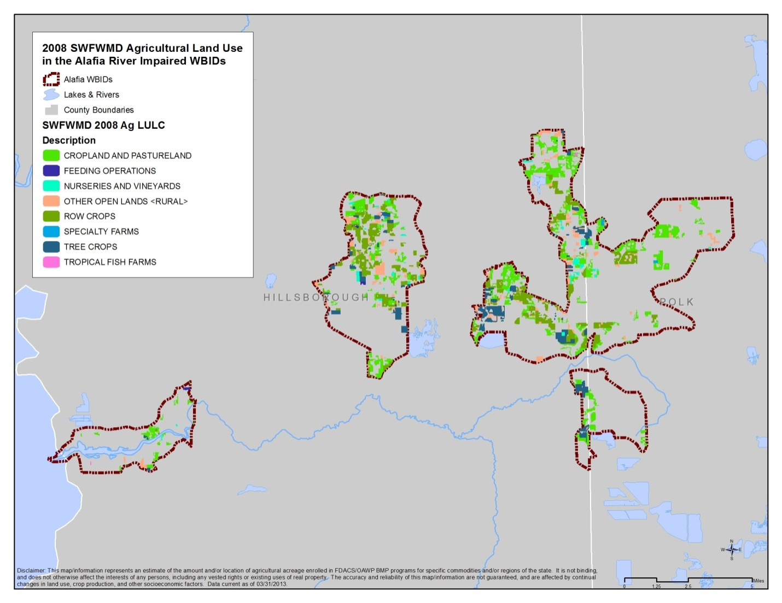
Figure 16. Agricultural land use based on 2008 SWFWMD data in the Alafia River Basin

Based on aerial imagery and field staff observation, FDACS adjusted these figures to reflect the current agricultural land use acreage more accurately. The FDACS-adjusted acreage shows approximately 8.8% less total acreage than indicated in the 2008 figures, due to nonproduction land that would not need to be enrolled but is included in agricultural land use and classified as “other open lands – rural.” In addition, some acreage may have ceased production since 2008 and also would not need to be enrolled in BMPs.
All agricultural nonpoint sources in the BMAP area are statutorily required either to implement FDACS-adopted BMPs or to conduct water quality monitoring that demonstrates compliance with state water quality standards. Figure 17 shows the acres enrolled in BMPs as of March 31, 2013. Initial priority will be given to enrolling operations in the Thirtymile Creek watershed (WBID 1639), particularly in collaboration with major landowners and their leaseholders.
Table 10. Agricultural acreage, BMP enrollment, and future enrollment goals in the Alafia River Basin

¹ FDACS-adjusted acreage for purposes of enrollment is based on a review of more recent aerial imagery in the basin and local staff observations.
- = Empty cell/no data
NA = Not applicable
2008 SWFWMD Land Use | 2008 Acres | FDACS-Adjusted Acres for Enrollment¹ | Related FDACS’  BMP Programs | Acreage Enrolled¹ | Related NOIs/  Certification
Pastureland and Rangeland | 4,396.3 | 4,396.3 | Cow/Calf  Future (hay) | 742.4 | 1  1
Row/Field/  Mixed Crops | 3,033.3 | 3,033.3 | Vegetable/  Agronomic Crops | 2,279.4 | 39
Tree Crops | 1,452.2 | 142.2 | Specialty Fruit and Nut  Citrus | 54.6  154.7 | 7  3
Nurseries and Vineyards | 343.2 | 343.2 | Container Nursery | 297.4 | 10
Specialty Farms | 40.0 | 40 | Equine | 0 | 0
Feeding Operations | 42.9 | 42.9 | Conservation Plan Rule | 0 | 0
Other Open Land – Rural | 1,183.7 | 0 | No Enrollment Needed | NA | NA
Aquaculture | 12.9 | 12.9 | FDACS Aquaculture |  | -
Total | 10,554.4 | 9,370.7 | - | 3,528.5 | 60
Enrolled Acreage  (March 31, 2013) | - | 3,528.5 | - | - | -

Due to the inaccuracies in land use information and changes in land use since 2008, agricultural loadings may be less than indicated in the TMDL. The region is expected to continue the shift from agricultural to residential/urban land uses, further reducing agricultural load. More precise information will be incorporated into the next iteration of the BMAP, and the estimated agricultural load will be adjusted to reflect the updated acreage figure. The potential refinement of a basin- and commodity-specific agricultural loading/reduction model should be considered during the first BMAP cycle.

Figure 17. BMP enrollment as of March 31, 2013, in the Alafia River Basin

Funding Elements
A BMAP must identify feasible funding strategies for implementing the management strategies presented. Appendix D lists potential funding sources and contact information. As contact information for these programs can change, it is recommended that the appropriate website be visited to obtain the most up-to-date information.

: Assessing Progress and Making Changes
Successful BMAP implementation requires commitment and follow-up. Stakeholders have committed and are required to implement the assigned projects and activities within the first five-year phase of this BMAP. The FWRA requires that an assessment be conducted every five years to determine whether there is reasonable progress in achieving pollutant load reductions. This chapter contains the water quality monitoring component sufficient to make this evaluation.

Tracking Implementation
The Department, in conjunction with the TBEP, has constructed an updated, web-enabled database where summary information on stakeholders’ water quality protection and restoration projects can be managed and stored. That database, which includes information on projects throughout the Tampa Bay watershed, is being maintained by the TBEP as a means of tracking projects that are carried out to implement the Tampa Bay RA Plan and Action Plans identified in the Tampa Bay Comprehensive Conservation and Management Plan (CCMP), which was developed by TBEP in 2006. The Action Plan Database may be accessed through the web-based portal at: http://apdb.tbeptech.org/.
The Department will work with stakeholders to organize the monitoring data and track project implementation. This information will be presented in a periodic update report. The stakeholders have agreed to meet periodically after the adoption of the BMAP to follow up on plan implementation, share new information, and continue to coordinate on TMDL-related issues. The following types of activities may occur at these meetings:
Implementation data and reporting:
  - Collect project implementation information from the stakeholders and MS4 permit reporting and compare with the BMAP schedule. Appendix D provides the information that will be required for BMAP project implementation (to be completed by the entities). This information will need to be modified to be compatible with the existing TBEP Action Plan Database.
  - Discuss the data collection process, including any concerns and possible improvements to the process.
  - Review the monitoring plan implementation, as detailed in Section 4.2.

Sharing new information:
  - Report on results from water quality monitoring and trend information.
  - Provide updates on new projects and programs in the basin that will help reduce nutrient loading.
  - Identify and review new scientific developments on addressing nutrient loads and incorporate any new information into annual progress reports.

Coordinating TMDL-related issues:
  - Provide updates from the Department on the basin cycle and activities related to any impairments, TMDLs, and BMAP.
  - Obtain reports from other basins where tools or other information may be applicable to the Alafia River TMDLs.

Covering all of these topics is not required for these meetings, but the list above provides examples of the types of information that should be considered for the agenda to assist with BMAP implementation and improve coordination among the agencies and stakeholders.

Water Quality Monitoring

Water Quality Monitoring Objectives
Focused objectives are critical for a monitoring strategy to provide the information needed to evaluate implementation success. The primary and secondary objectives of the monitoring strategy for the tributaries, described below, will be used to evaluate the success of the BMAP, help interpret the data collected, and provide information for potential future refinements of the BMAP.
4.2.1.1 Primary Objective
On a baywide basis, Tampa Bay currently appears to be on track in terms of meeting its TN, chla, water clarity, and seagrass restoration goals (TBEP 2006; Yates et al. 2011; Sherwood 2013). As a result, future watershed management actions will presumably focus on the TBEP’s “hold-the-line” strategy, seeking to compensate for ongoing population growth and prevent TN loads from increasing as the human population of the watershed continues to expand. If those management efforts are successful, TN concentrations in the Alafia River Tidal Reach in future years are likely to be comparable to those observed today.
4.2.1.2 Secondary Objective
Tidally influenced WBID 1621G potentially needs specialized monitoring efforts due to its historical DO values. The most appropriate course of action may be to investigate other environmental variables—in addition to the annual geometric mean TN concentration—that affect DO dynamics in the WBID. Physical factors that determine circulation, flushing, and reaeration rates could be playing critical roles. If so, the BMAP Program may wish to focus on examining those factors, their interactions with each other and with ambient nutrient levels, and the effects of those interactions on ambient DO concentrations. That information could be used to develop a strategy for achieving compliance with existing DO criteria or developing SSAC that are consistent with the waterbody’s physical characteristics.
As examples of physical factors that could be examined, nonparametric correlation analysis suggests that the most important physical factor affecting monthly variations in DO at the downstream EPCHC station (Station 74) may be water temperature (Kendall tau = -0.66, p < 0.0001), while the dominant physical factors at the upstream station (Station 153) appear to be a combination of temperature
(tau = -0.44, p < 0.0001) and mid-depth salinity (tau = -0.35, p < 0.0001).
Salinity regimes at these stations also differ, with the downstream station averaging 20.2 and ranging between 0.09 and 33 PSU, and the upstream station averaging 8.5 and ranging between 0.09 and 24 PSU. Given that water temperature and salinity have direct effects on oxygen solubility and on waterbody flushing characteristics, which in turn affect DO dynamics, a more detailed understanding of the relationships that exist between these physical factors and DO levels in WBID 1621G could help to guide future water quality management efforts.

Water Quality Indicators and Resource Responses
To achieve the objectives above, the monitoring strategy focuses on two types of indicators to track water quality trends: core and supplemental (Table 11a and Table 11b). The core indicators are directly related to the parameters causing impairment in the river. Supplemental indicators are monitored primarily to support the interpretation of core water quality parameters. At a minimum, the core parameters will be tracked to determine progress towards meeting the TMDL. In addition, resource responses to BMAP implementation will also be tracked (Table 12). Changes in water chemistry are expected to occur within a relatively short period, depending on the actual rate of project implementation and rainfall conditions. A significant amount of time may be needed for the changes in water chemistry to be observed in the resource responses. However, resource responses represent improvements in the overall ecological health of the Alafia River.
Table 11a. Core water quality indicators and anticipated trends
Core Parameters | Anticipated Trend
Chla (corrected) | Decrease in concentration
TP (as P) | Decrease in concentration
Orthophosphate as P | Decrease in concentration
Ammonia as N | Decrease in concentration
Nitrate/nitrite as N | Decrease in concentration
Total Kjeldahl nitrogen (TKN) | Decrease in concentration

Table 11b. Supplemental water quality indicators and anticipated trends
Supplemental Parameters | Anticipated Trend
Specific Conductance | Monitored to support interpretation of core indicators
DO | Monitored to support interpretation of core indicators
pH | Monitored to support interpretation of core indicators
Temperature | Monitored to support interpretation of core indicators
Total Suspended Solids (TSS) | Monitored to support interpretation of core indicators

Table 12. Anticipated resource responses from BMAP implementation
Resource Responses
Reduction in Trophic State Index (TSI) score
Increase in Stream Condition Index (SCI) score
Increase in Shannon-Wiener Diversity Index score
Increase in key fish populations

Monitoring Network
The water quality stations listed in Appendix G and shown in Figure 18 have been historically sampled by EPCHC, the Department, or another governmental agency. Data from these stations or their replacements will be utilized as the monitoring network for the Alafia River BMAP WBIDs.

Quality Assurance/Quality Control
Through cooperation on TMDL-related data collection, the Department and stakeholders have consistently used similar standard operating procedures (SOPs) for field sampling and lab analyses. This consistency will continue into the future to ensure that data can be used not only for tracking BMAP progress but also for future TMDL evaluations and other purposes. Water quality data will be collected in a manner consistent with the Department’s SOPs for quality assurance/quality control (QA/QC). The most current version of these procedures is available at http://www.dep.state.fl.us/water/sas/sop/index.htm. The data collected by the EPCHC and other stakeholders in support of the BMAP will follow these SOPs.

Data Management and Assessment
Data collected as part of this monitoring plan will need to be tracked, compiled, and analyzed for it to be useful in support of the BMAP by the Department or the stakeholder group. The Florida STORET database or its replacement will serve as the primary resource for storing ambient data and providing access for all stakeholders, in accordance with Section 62-40.540, F.S. Stakeholders have agreed to upload data to STORET in a timely manner, after the appropriate QA/QC checks have been completed. All applicable data collected by the entities responsible for monitoring will be uploaded to STORET regularly, but at least quarterly. The Department will be responsible for data storage and retrieval from the STORET database.
STORET uploads are only appropriate for data that represent ambient conditions. Other data will be maintained by the entity that collected the samples. Stakeholders agree to provide this data to other BMAP partners on request and when appropriate for inclusion in BMAP data analyses and adaptive management evaluations.

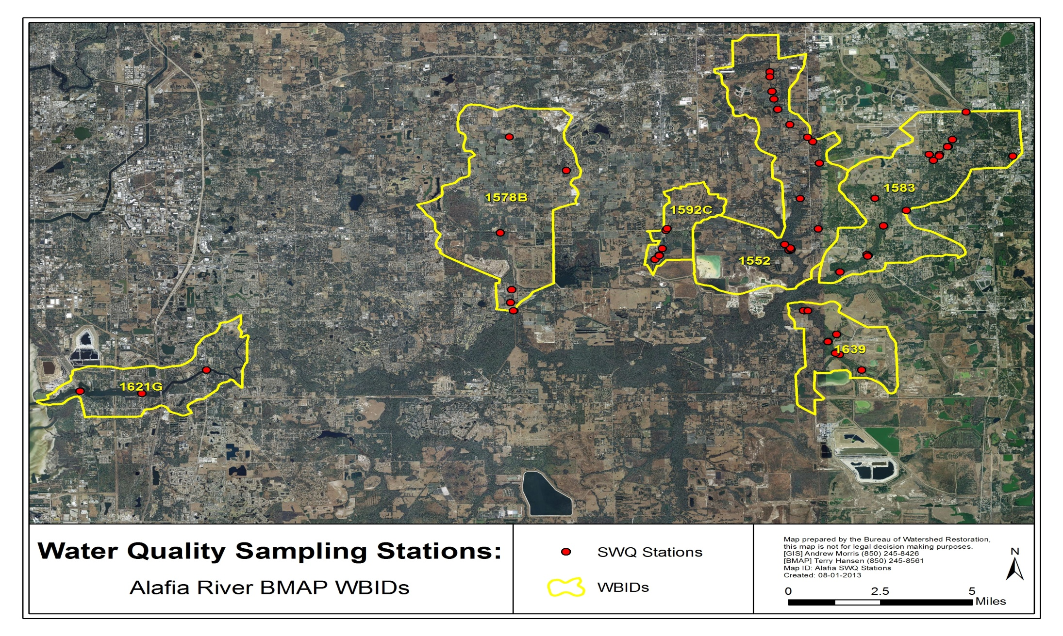
Figure 18. Water quality monitoring stations in the Alafia River Basin

Adaptive Management Measures
Adaptive management involves setting up a mechanism for making adjustments in the BMAP when circumstances change or feedback indicates the need for a more effective strategy. Adaptive management measures include the following:
Procedures to determine whether additional cooperative strategies are needed.
Criteria/processes for determining whether and when plan components need revision due to changes in costs, environmental impacts, social effects, watershed conditions, or other factors.
Descriptions of the stakeholders’ roles after BMAP completion.
Key components of adaptive management to share information and expertise are tracking plan implementation, monitoring water quality and pollutant loads, and holding periodic meetings.
BMAP execution will be a long-term process. The stakeholders will track implementation efforts and monitor water quality to measure effectiveness and ensure BMAP compliance. The stakeholders will meet periodically to discuss implementation issues, consider new information, and, if the watershed is not projected to meet the TMDLs, determine additional corrective actions. Project implementation as well as program and activity status will be collected annually from the participating entities. The stakeholders will review these reports to assess progress towards meeting the BMAP’s goals.

: Commitment to Plan Implementation
Subsection 403.067(7), F.S., lays out the mechanisms for BMAP implementation. While the BMAP is linked by statute to permitting and other enforcement processes that target individual entities, successful implementation mandates that local stakeholders willingly and consistently work together to attain adopted TMDLs. This collaboration fosters the sharing of ideas, information, and resources. The stakeholders have demonstrated their willingness to confer with and support each other in their efforts through the adoption of this document and continuing support of the efforts of the TBEP through the NMC.

APPENDICES

Appendix A: TMDL Basin Rotation Schedule
TMDLs are developed, allocated, and implemented through a watershed management approach (managing water resources within their natural boundaries) that addresses the state’s 52 major hydrologic basins in 5 groups, on a rotating schedule. Table A-1 shows the hydrologic basins within each of the five groups, with the Department’s District Office of jurisdiction.
Table A-1. Major hydrologic basins by group and Department District Office
Department  District  Office | Group 1  Basins | Group 2  Basins | Group 3  Basins | Group 4  Basins | Group 5  Basins
Northwest | Ochlockonee–  St. Marks | Apalachicola–  Chipola | Choctawhatchee–  St. Andrews Bay | Pensacola Bay | Perdido Bay
Northeast | Suwannee–Santa Fe | Lower St. Johns | Not applicable | Nassau–St. Marys | Upper East Coast
Central | Ocklawaha | Middle St. Johns | Upper St. Johns | Kissimmee | Indian River  Lagoon
Southwest | Tampa Bay | Tampa Bay  Tributaries | Sarasota Bay–  Peace–Myakka | Withlacoochee | Springs Coast
South | Everglades  West Coast | Charlotte Harbor | Caloosahatchee | Fisheating Creek | Florida Keys
Southeast | Lake  Okeechobee | St. Lucie–  Loxahatchee | Lake Worth Lagoon–  Palm Beach Coast | Southeast Coast–Biscayne Bay | Everglades

Each group will undergo a cycle of five phases on a rotating schedule, as follows:
Phase 1: Preliminary evaluation of water quality.
Phase 2: Strategic monitoring and assessment to verify water quality impairments.
Phase 3: Development and adoption of TMDL(s) for waters verified as impaired.
Phase 4: Development of BMAP to achieve the TMDL(s).
Phase 5: Implementation of the BMAP and monitoring of results.

The Alafia River Basin is a Group 1 basin. As such, the Cycle 1 list of verified impaired waters was developed in 2002, and the Cycle 2 list was developed in 2009. Subsequent TMDL and BMAP development is occurring on a schedule driven by the 1998 303(d) list (see http://www.dep.state.fl.us/water/tmdl/ for more information) and Department staff resource availability. The Department will re-evaluate impaired waters every five years to determine whether improvements are being achieved, and to refine loading estimates and TMDL allocations using new data. If any changes in a TMDL are required, the applicable TMDL rule may be revised. Changes to a TMDL would prompt revisions to the applicable BMAP, which will be revisited at least every five years and modified as necessary, regardless of whether the TMDL is modified.

Appendix B: Alafia River Basin Stakeholder Involvement in BMAP Development

Public Participation in Meetings
Six technical meetings were held in 2011 and 2012. All technical meetings were open to the public and noticed in the Florida Administrative Register (FAR). Technical meetings were open to anyone interested in participating in the technical discussions. In addition, public meetings were held on the Verified List, the adoption of the TMDLs, and the BMAP document.
Governmental Agency Participation in Meetings
Appropriate city and county local governmental staff attended stakeholder meetings and submitted input and project information. The TBEP coordinated project input with the stakeholders.
Public Meeting(s)
Public meetings on the proposed Verified List and the Alafia River Basin TMDLs were held before each was adopted. In addition, a public workshop on the BMAP was held on September 13, 2013.

Appendix C: Summary of EPA-Recommended Elements of a Comprehensive Watershed Plan
The following is an excerpt on the nine elements of a watershed plan from the EPA’s Draft Handbook for Developing Watershed Plans to Restore and Protect Our Waters.
Nine Minimum Elements to Be Included in a Watershed Plan for Impaired Waters Funded Using Incremental Section 319 Funds

Although many different components may be included in a watershed plan, the EPA has identified a minimum of nine elements that are critical for achieving improvements in water quality. The EPA requires that these nine elements be addressed for watershed plans funded using incremental Section 319 funds and strongly recommends that they be included in all other watershed plans that are intended to remediate water quality impairments.
The nine elements are provided below, listed in the order in which they appear in the guidelines. Although they are listed as a through i, they do not necessarily take place sequentially. For example, Element d asks for a description of the technical and financial assistance that will be needed to implement the watershed plan, but this can be done only after you have addressed Elements e and i.
Explanations are provided with each element to show you what to include in your watershed plan.
Nine Elements

1. Identification of causes of impairment and pollutant sources or groups of similar sources that need to be controlled to achieve needed load reductions, and any other goals identified in the watershed plan. Sources that need to be controlled should be identified at the significant subcategory level along with estimates of the extent to which they are present in the watershed (e.g., X number of dairy cattle feedlots needing upgrading, including a rough estimate of the number of cattle per facility; Y acres of row crops needing improved nutrient management or sediment control; or Z linear miles of eroded streambank needing remediation).

What does this mean?
Your watershed plan should include a map of the watershed that locates the major sources and causes of impairment. Based on these impairments, you will set goals that will include (at a minimum) meeting the appropriate water quality standards for pollutants that threaten or impair the physical, chemical, or biological integrity of the watershed covered in the plan.

2. An estimate of the load reductions expected from management measures.

What does this mean?
You will first quantify the pollutant loads for the watershed. Based on these pollutant loads, you’ll determine the reductions needed to meet the water quality standards.
You will then identify various management measures (see element c below) that will help to reduce the pollutant loads and estimate the load reductions expected as a result of these management measures to be implemented, recognizing the difficulty in precisely predicting the performance of management measures over time.
Estimates should be provided at the same level as that required in the scale and scope component in paragraph a (e.g., the total load reduction expected for dairy cattle feedlots, row crops, or eroded streambanks). For waters for which EPA has approved or established TMDLs, the plan should identify and incorporate the TMDLs.
Applicable loads for downstream waters should be included so that water delivered to a downstream or adjacent segment does not exceed the water quality standards for the pollutant of concern at the water segment boundary. The estimate should account for reductions in pollutant loads from point and nonpoint sources identified in the TMDL as necessary to attain the applicable water quality standards.
3. A description of the nonpoint source management measures that will need to be implemented to achieve load reductions in paragraph 2, and a description of the critical areas in which those measures will be needed to implement this plan.

What does this mean?
The plan should describe the management measures that need to be implemented to achieve the load reductions estimated under element b, as well as to achieve any additional pollution prevention goals called out in the watershed plan. It should also identify the critical areas in which those measures will be needed to implement the plan. This can be done by using a map or a description.

4. Estimate of the amounts of technical and financial assistance needed, associated costs, and/or the sources and authorities that will be relied upon to implement this plan.

What does this mean?
You should estimate the financial and technical assistance needed to implement the entire plan. This includes implementation and long-term operation and maintenance of management measures, I/E activities, monitoring, and evaluation activities. You should also document which relevant authorities might play a role in implementing the plan. Plan sponsors should consider the use of federal, state, local, and private funds or resources that might be available to assist in implementing the plan. Shortfalls between needs and available resources should be identified and addressed in the plan.

5. An information and education component used to enhance public understanding of the project and encourage their early and continued participation in selecting, designing, and implementing the nonpoint source management measures that will be implemented.

What does this mean?
The plan should include an I/E component that identifies the education and outreach activities or actions that will be used to implement the plan. These I/E activities may support the adoption and long-term operation and maintenance of management practices and support stakeholder involvement efforts.
6. Schedule for implementing the nonpoint source management measures identified in this plan that is reasonably expeditious.

What does this mean?
You need to include a schedule for implementing the management measures outlined in your watershed plan. The schedule should reflect the milestones you develop in 7.

7. A description of interim measurable milestones for determining whether nonpoint source management measures or other control actions are being implemented.

What does this mean?
You’ll develop interim, measurable milestones to measure progress in implementing the management measures for your watershed plan. These milestones will measure the implementation of the management measures, such as whether they are being implemented on schedule, whereas element h (see below) will measure the effectiveness of the management measures, for example, by documenting improvements in water quality.

8. A set of criteria that can be used to determine whether loading reductions are being achieved over time and substantial progress is being made toward attaining water quality standards.

What does this mean?
Using the milestones you developed above, you’ll develop a set of criteria (or indicators) with interim target values to be used to determine whether progress is being made toward reducing pollutant loads. These interim targets can be direct measurements (e.g., fecal coliform concentrations) or indirect indicators of load reduction (e.g., number of beach closings). You must also indicate how you’ll determine whether the watershed plan needs to be revised if interim targets are not met and what process will be used to revise the existing management approach. Where a nonpoint source TMDL has been established, interim targets are also needed to determine whether the TMDL needs to be revised.
9. A monitoring component to evaluate the effectiveness of the implementation efforts over time, measured against the criteria established under item h immediately above.

What does this mean?
The watershed plan must include a monitoring component to determine whether progress is being made toward attainment or maintenance of the applicable water quality standards. The monitoring program must be fully integrated with the established schedule and interim milestone criteria identified above. The monitoring component should be designed to determine whether loading reductions are being achieved over time and substantial progress in meeting water quality standards is being made. Watershed-scale monitoring can be used to measure the effects of multiple programs, projects, and trends over time. Instream monitoring does not have to be conducted for individual BMPs unless that type of monitoring is particularly relevant to the project.

Appendix D: Projects To Achieve the TMDLs
The table below sets forth the projects and activities, and the time frames for implementation of those projects and activities, required in this BMAP. Additional reductions are expected to be necessary in future BMAP phases to meet the loads specified in the TMDLs. The BMAP projects and activities represent a considerable local, regional, and state investment in a multifaceted approach to water quality protection and restoration within the Manatee River system. Responsible entities submitted these projects and activities to the Department with the understanding that the projects and activities would be included in the BMAP, thus requiring each entity to implement the proposed projects and activities and achieve the assigned load reduction estimates in a timely way. However, this list of projects and activities is meant to be flexible enough to allow for changes that may occur over time. Any change in listed projects and activities, or the deadline to complete these actions, must first be approved by the Department. Substitute projects and activities must result in equivalent or greater nutrient reductions than expected from the original projects and activities.

- = Empty cell/no data
NA = Not applicable
Note: Projects shown in boldface type and yellow highlighting are not yet entered into the Action Plan Database.
Project Number | Major Drainage Basin/Bay Segment | WBID | Project Name | Management Category | Lead Entity/  Project Partner | Completed or Ongoing (Date) | Estimated Cost/Source of Funding | General Location/  Project Description and Benefits
8 | Alafia River | - | Delany Creek Wetland Restoration Project | - | Hillsborough County | 1997 | - | Completed project in RA Plan.
14 | Alafia River | - | Palma Ceia Area Stormwater Pond | - | City of Tampa | 2001 | - | Completed project in RA Plan.
27 | Alafia River | - | Alafia River Corridor Land Acquisition | Restoration, Land Acquisition, and Water Quality Improvement | SWFWMD | Completed (1995) | - | Alafia River corridor land acquisition.
34 | Alafia River | - | IMC – Agrico Company Termination of Ammonia in Flot Plants–Alafia River | Restoration, Land Acquisition, and Water Quality Improvement | IMC – Phosphate | Completed (1995) | - | Average discharge from mining to Alafia River and Little Manatee River (1992–97) is 46 MGD. Effective drop in nitrogen concentrations with termination of use of ammonia in flot plants is 0.3 mg/L (staff determination based on NPDES Discharge Monitoring Report [DMR] forms).
254 | Alafia River | - | Bell Creek Preserve – Land Acquisition | Restoration, Land Acquisition, and Water Quality Improvement | Hillsborough County | Completed (1997) | $2,788,117 | Future use – multifamily residential.
256 | Alafia River | - | Boy Scout –  Land Acquisition | Restoration, Land Acquisition, and Water Quality Improvement | Hillsborough County | Completed (1999) | $51,355 | Future use – medium-density residential.
269 | Alafia River | - | Rhodine Scrub (formerly known as Rhodine Road) Land Acquisition | Restoration, Land Acquisition, and Water Quality Improvement | Hillsborough County | Completed (1997) | $70,006 | Future use – medium-density residential.
273 | Alafia River | - | Alafia River Corridor – Land Acquisition | Restoration, Land Acquisition, and Water Quality Improvement | Hillsborough County | Completed (1999) | $13,491,310 | Future uses;  923.4 = single family;  77.8 = medium density;  2,091 = single family;  929 = single family.
411 | Alafia River | - | Alafia River Task Force (ARTF) | Restoration, Land Acquisition, and Water Quality Improvement | Department | Completed | - | In May 1992, Department convened ARTF to make recommendations for point and nonpoint source nutrient and pollutant load reductions and proactive river restoration projects.
461 | Alafia River | - | Tampa Bay Water Regional Surface Water Treatment Plant | Stormwater Management Program | Tampa Bay Water | Completed (2003) | $84,000,000 | Stormwater treatment for RA Plan.
762 | Alafia River | - | Repowering Gannon Power Plant – Bayside Facility | Restoration, Land Acquisition, and Water Quality Improvement | TECO | Completed (2003) | - | Reduction calculations for TECO repowering Gannon Power Plant (renamed Bayside Facility). Completed in 2003. Conversion of coal-fired plant to natural gas, with approximately 95% reduction in nitrogen oxide (NOx) emissions.
772 | Alafia River | - | Big Bend Power Plant Improvements | Restoration, Land Acquisition, and Water Quality Improvement | TECO | Completed (2004) | - | Big Bend Power Plant improvements include use of flue gas desulfurization (FGD) system or scrubber, which removes sulfur dioxide produced when coal is burned in Units 1, 2, 3, and 4.
782 | Alafia River | - | Big Bend Power Plant Improvements | Restoration, Land Acquisition, and Water Quality Improvement | TECO | Completed (2005) | - | Big Bend Power Plant improvements include use of flue gas desulfurization (FGD) system or scrubber which removes sulfur dioxide produced when coal is burned in Units 1, 2, 3, and 4.
792 | Alafia River | - | Hookers Point Facility – Shut Down | Restoration, Land Acquisition, and Water Quality Improvement | TECO | Completed (2002) | - | Reductions calculated due to shutdown of facility–based on calculations for Big Bend and Gannon plants.
805 | Alafia River | - | Gibsonton on the Bay | Stormwater Management Program | SWFWMD | Completed (2005) | $806,247/ Hillsborough County/ SWFWMD | Project involves design and construction of drainage system and installation of continuous deflective separation (CDS) unit, Stormceptor, or baffle box to enhance water quality.
843 | Alafia River | - | Mosaic Riverview, Modifications to Outfall Automation and Monitoring | Restoration, Land Acquisition, and Water Quality Improvement | Mosaic | Completed (2003) | - | Installation of complex automated system at facility's main stormwater outfall (005), including redundant pH meters interlocked to shut down discharge in event of excursions or elevated nutrient loads.
844 | Alafia River | - | Mosaic Riverview, Enhanced Housekeeping and Street Sweeping | Restoration, Land Acquisition, and Water Quality Improvement | Mosaic | - | - | Water quality improvement through better operations management-
845 | Alafia River | - | Mosaic Riverview, Improved Drainage in Phosphoric Acid Production Areas | Restoration, Land Acquisition, and Water Quality Improvement | Mosaic | 2005 | - | Water quality improvement through better operations management.
846 | Alafia River | - | Mosaic Mulberry, Transfer of Mulberry Phosphates Process Water | Restoration, Land Acquisition, and Water Quality Improvement | Mosaic | - | - | Water quality improvement through better operations management.
847 | Alafia River | - | Mosaic Mulberry, Transfer of Mulberry Phosphates Process Water | Restoration, Land Acquisition, and Water Quality Improvement | Mosaic | Completed (2005) | -- | Implemented transfer process water from Mulberry Facility to Bartow Facility to discharge into Peace River Basin rather than Alafia River.
848 | Alafia River | - | Bartow Phosphate Complex, Enhanced Process Water Evaporation, Nutrient Load Prevention Project – 2001 | Restoration, Land Acquisition, and Water Quality Improvement | CF Industries, Inc. | Completed (2001) | $400,000 | Development and implementation of large-scale treated and untreated process water evaporation systems to reduce surface water discharge loadings through closure.
849 | Alafia River | - | Bartow Phosphate Complex, Enhanced Process Water Evaporation, Nutrient Load Prevention Project | Restoration, Land Acquisition, and Water Quality Improvement | CF Industries, Inc. | Completed (2006) | $0.00 | Same as Project ID# 848; different period. TN reduction for 2001–05 is 6,600 lbs/yr; for 2006, reduction is 16,600 lbs/yr.
854 | Alafia River | - | Bartow Phosphate Complex Phosphogypsum Stack Closure | Restoration, Land Acquisition, and Water Quality Improvement | CF Industries, Inc. | - | $60,000,000 | Closure of 900-acre phosphogypsum stack system. Eliminates treated process water discharges containing elevated nitrogen and phosphorus by 2010; significant reductions beginning 2007 to 2008. Also represents permanent closure of former operating plant.
855 | Alafia River | - | Mulberry Reverse Osmosis (RO) Process Water Treatment, Prevention Project | Restoration, Land Acquisition, and Water Quality Improvement | Mosaic | Completed | - | Implementation of RO treatment of process wastewater from Mulberry plant to minimize overall nutrient loading.
856 | Alafia River | - | Mulberry/Bartow Regional Process Water Storage Pond and RO Treatment | Restoration, Land Acquisition, and Water Quality Improvement | Mosaic | Completed | - | Construct regional lined process water storage impoundment and RO treatment system for avoidance of treated process water discharges, but providing for high-quality effluent if discharges are required. Details in November 2005.
857 | Alafia River | - | Mulberry, Closure of Mulberry Phosphogypsum Stack | Restoration, Land Acquisition, and Water Quality Improvement | Mosaic | Completed | -/  Department | Water quality improvement through better operations management.
870 | Alafia River | - | Hillsborough County Citrus | Agricultural BMPs | Hillsborough County | Completed (1995) | - | NPS load reductions.
871 | Alafia River | - | Citrus Conversion to Micro-Irrigation | Agricultural BMPs | Hillsborough County | Completed (1995) | - | NPS load reductions.
877 | Alafia River | - | Field and Row Crop Conversion to Micro-Irrigation | Agricultural BMPs | Hillsborough County | Completed (1995) | - | NPS load reductions.
878 | Alafia River | - | Field and Row Crop Conversion to Micro-Irrigation | Agricultural BMPs | Hillsborough County | Completed (2000) | - | NPS load reductions.
889 | Alafia River | - | Strawberry Conversion to Micro-Irrigation | Agricultural BMPs | Hillsborough County | Completed (1995) | - | NPS load reductions.
980 | Alafia River | - | Marine Gang Educational Performance Troupe | Public Education and Outreach | Tampa Bay Regional Planning Council (TBRPC) | Completed (2005) | $70,377 | Educational performances to children in schools and summer programs and for public at festivals.
997 | Alafia River | - | Bartow Phosphate Complex, Enhanced Process Water Evaporation, Nutrient Load Prevention Project – 2005 | Restoration, Land Acquisition, and Water Quality Improvement | CF Industries, Inc. | Completed (2005) | - | Same as ID# 848;  different period.
1003 | Alafia River | - | Bartow Phosphate Complex, Enhanced Process Water Evaporation, Nutrient Load Prevention Project | Restoration, Land Acquisition, and Water Quality Improvement | CF Industries, Inc. | Completed (2006) | $0.00 | Same as ID# 848;  different period.
1018 | Alafia River | - | Hurley Tailwater Pond | Stormwater Management Program | Hillsborough County | Completed (2006) | $250,000 | Project converted 3 agricultural ponds to accept tailwater from row crop land that was impacting highway. Ponds capture, treat and reuse tailwater for irrigation. Overflow from treatment train leads to Bullfrog Creek.
1023 | Alafia River | - | Bayview Park | Restoration, Land Acquisition, and Water Quality Improvement | City of Clearwater | - | - | Park development to reduce runoff into river.
1057 | Alafia River | - | Lakeland Methane to Energy Project –  Phase II | Other | City of Lakeland | - | $950,000 | Offset energy production using fossil fuels with renewal (digester gas) fuel. No new emissions will be generated as fuel is being burned without energy recovery already.
1058 | Alafia River | - | Lakeland Selective Catalytic Reduction (SCR) Project | Other | City of Lakeland | - | - | Reduction of atmospheric deposition of nitrogen by installation of SCR equipment at McIntosh Power Production site. Anticipated amount is qualified but dispersion is under study.
1059 | Alafia River | - | Lakeland Hi-Efficiency Burners | Other | City of Lakeland | Completed | - | Reduction of atmospheric deposition of nitrogen by installation of high-efficiency burners at McIntosh Power Production site. Amount is quantified but dispersion is under study.
1060 | Alafia River | - | Lakeland Water to TECO | Wastewater Infrastructure Management (Sewer and/or Septic Systems) | City of Lakeland | Completed | $50K-100K/ TECO/  SWFWMD/  City of Lakeland | Remove current Lakeland discharge from Alafia River for utilization as cooling water at TECO Polk Power Station. 30-year project.
1061 | Alafia River | - | Lakeland Methane to Energy Project –  Phase I | Other | City of Lakeland | Completed | $150,000 | Offset energy production using fossil fuels with renewable (digester gas) fuel.
1067 | Alafia River | - | Tampa Bay Regional Surface Water Treatment Plant Expansion | Stormwater Management Program | Tampa Bay Water | Completed (2010) | $133,000,000/ Tampa Bay Water/  SWFWMD | Tampa Bay Water’s Surface Water Treatment Plant withdraws and treats water from Alafia River and Tampa Bypass Canal’s Lower-Middle Pools (includes Hillsborough River).
1070 | Alafia River | - | Tampa Bay Water Regional Surface Water Treatment Plant | Stormwater Management Program | Tampa Bay Water | Completed (2004) | - | Tampa Bay Water’s Surface Water Treatment Plant withdraws and treats water from Alafia River and Tampa Bypass Canal’s Lower-Middle Pools (includes Hillsborough River.
1072 | Alafia River | - | Tampa Bay Water Regional Surface Water Treatment Plant | Stormwater Management Program | Tampa Bay Water | Completed (2005) | - | Tampa Bay Water’s Surface Water Treatment Plant withdraws and treats water from Alafia River and Tampa Bypass Canal’s Lower-Middle Pools (includes Hillsborough River.
1074 | Alafia River | - | Tampa Bay Water Regional Surface Water Treatment Plant | Stormwater Management Program | Tampa Bay Water | Completed (2006) | - | Tampa Bay Water’s Surface Water Treatment Plant withdraws and treats water from Alafia River and Tampa Bypass Canal’s Lower-Middle Pools (includes Hillsborough River.
1076 | Alafia River | - | Tampa Bay Water Regional Surface Water Treatment Plant | Stormwater Management Program | Tampa Bay Water | Completed (2007) | - | Tampa Bay Water’s Surface Water Treatment Plant withdraws and treats water from Alafia River and Tampa Bypass Canal’s Lower-Middle Pools (includes Hillsborough River .
1079 | Alafia River | - | Tampa Bay Regional Surface Water Treatment Plant Expansion | Stormwater Management Program | Tampa Bay Water | Completed (2008) | - | Same as ID# 1067;  Basin.
1082 | Alafia River | - | Septic Tank Abandonment or Connection to Sanitary Sewer | Wastewater Infrastructure Management (Sewer and/or Septic Systems) | City of Lakeland | Completed | - | Identification and quantification of nutrient reductions achieved by eliminating septic tanks in city of Lakeland and surrounding areas.
1159 | Alafia River | - | Illicit Discharge Complaint Investigation | Stormwater Management Program | Polk County | - | - | Illicit discharge investigations are part of NPDES permit requirements in which county investigates and performs corrective actions on any illicit discharges affecting MS4.
1160 | Alafia River | 1583 | Creative Drive Outfall Project | Stormwater Management Program | Polk County | Completed (2006) | $218,225 | 3,138-foot drainage ditch (occupying 2,760 acres) in south Lakeland. Drains to WBID 1583 (Poley Creek). Project entailed stabilization of ditch with concrete rip-rap to improve hydraulic function.
1164 | Alafia River | - | Dog Waste Signs | Stormwater Management Program | City of Plant City | - | $300/yr | Ongoing program that involves installation of signs that say “Dog Waste Transmits Disease and Contaminates Our Water: Leash and Pick Up After Your Dog” in public areas where dog waste has become a problem.
1182 | Alafia River | - | Agricultural BMPs | Agricultural BMPs | Department/  FDACS | Completed (2012) | - | Nonpoint source nutrient reductions.
1184 | Alafia River | - | Agricultural BMPs | Agricultural BMPs | Department/FDACS | Completed (2012) | - | Agricultural BMPs are practical, cost-effective actions that agricultural producers can take to reduce amount of pesticides, fertilizers, animal waste, and other pollutants entering water resources, and to increase water use efficiencies.
1187 | Alafia River | - | Agricultural BMPs | Agricultural BMPs | Department/FDACS | - | - | Agricultural BMPs are practical, cost-effective actions that agricultural producers can take to reduce amount of pesticides, fertilizers, animal waste, and other pollutants entering water resources, and to increase water use efficiencies.  4,396.32 acres pasture,  1,155.65 treated acres
1189 | Alafia River | - | Agricultural BMPs | Agricultural BMPs | Department/  FDACS | - | - | Agricultural BMPs are practical, cost-effective actions that agricultural producers can take to reduce amount of pesticides, fertilizers, animal waste, and other pollutants entering water resources, and to increase water use efficiencies.  4,396.32 acres pasture,  1,155.65 treated acres
1190 | Alafia River | - | Agricultural BMPs | Agricultural BMPs | Department/  FDACS | - | - | Agricultural BMPs are practical, cost-effective actions that agricultural producers can take to reduce amount of pesticides, fertilizers, animal waste, and other pollutants entering water resources, and to increase water use efficiencies.  1,452.22 acres citrus,  203.81 treated acres
1192 | Alafia River | - | Agricultural BMPs | Agricultural BMPs | Department/  FDACS | - | - | Agricultural BMPs are practical, cost-effective actions that agricultural producers can take to reduce amount of pesticides, fertilizers, animal waste, and other pollutants entering water resources, and to increase water use efficiencies.  343.2 acres nursery,  326.33 treated acres
1225 | Alafia River | - | Alafia River Corridor – North Prong | Restoration, Land Acquisition, and Water Quality Improvement | Hillsborough County | Completed (2006) | $8,264,400 | Map of vegetative communities.
1233 | Alafia River | - | Green Bay Discharge Diversion to Progress Energy | Other | Mosaic | - | - | Redirection of discharge water from bay to reuse.
1314 | Alafia River | 1578B | Plant City Street Sweeping Program | Stormwater Management Program | - | - | $70,000 annually | Ongoing program that employs services of contractor operating vacuum street sweeper to remove debris and potential stormwater contaminants from city-maintained roads, bridges, and parking lots. Streets are swept daily. Secondary roads are swept during day, and primary roadways are swept at night. Contractor is responsible for disposal of all debris. Approximately 100 tons are collected and disposed of annually.
1275 | Alafia River | 1578B | Plant City Environmental Education (EE) Program | Public Education and Outreach | - | - | $250 | City of Plant City’s website will feature brochures that teach about grease management and proper disposal in EE Program section. Public may easily download brochures and will be directed to city’s Public Used Oil Collection Center for motor oil and kitchen grease disposal. Brochures also include phone number for public to report illegal dumping so that city can take corrective action.
NA | Alafia River | 1578B | Plant City Lift Station Telemetry Program | Wastewater Infrastructure Management (Sewer and/or Septic Systems) | - | - | To be determined | Ongoing program provides radio telemetry remote control and monitoring at sanitary sewer lift stations. Currently all 42 city lift stations are provided with radio telemetry systems that send information to city’s Operation Center at Water Reclamation Facility. Operations at lift stations can be monitored and controlled from here.
1284 | Alafia River | 1578B | Plant City Stormwater Inlet Marking Program | Wastewater Infrastructure Management (Sewer and/or Septic Systems) | - | Ongoing | To be determined | Ongoing program involves application of plaques to stormwater inlets. Plaques state in English and Spanish: “DO NOT POLLUTE THE WATER. DUMP NO WASTE. IT’S THE LAW.” Printed environmental education pamphlets are distributed to residents in areas where plaques are applied and problems exist. These materials stress importance of pollution prevention and indicate BMPs that can be utilized to prevent pollution.
1285 | Alafia River | 1578B | Plant City Lift Station Auxiliary Power Program | Wastewater Infrastructure Management (Sewer and/or Septic Systems) | - | Ongoing | $96K + $14K yearly | Ongoing program provides auxiliary power generators at sanitary sewer lift stations. Currently (2013) 18 of 42 stations are provided with permanent on-site generators;  8 portable generators are also available for use as needed.
1286 | Alafia River | 1578B | Plant City Lift Station Maintenance Program | Wastewater Infrastructure Management (Sewer and/or Septic Systems) | - | Ongoing | $1.1M | Ongoing program involves maintenance and repair of city’s wastewater treatment plant (WWTP) and 42 lift stations in sanitary sewer collection system. Program helps to prevent sanitary sewer overflows (SSOs) from occurring at lift stations in collection system and ensures that WWTP is able to operate at highest efficiency.
1287 | Alafia River | 1578B | Plant City Lift Station Security Program | Wastewater Infrastructure Management (Sewer and/or Septic Systems) | - | Ongoing | $10K | Ongoing program provides basic security (fences, gates, locks) for sanitary sewer lift stations. Currently 28 of 42 stations are secured in this fashion.
1288 | Alafia River | 1578B | Plant City Grease Management Program | Wastewater Infrastructure Management (Sewer and/or Septic Systems) | - | Ongoing | $50K yearly | Ongoing program involves inspection and monitoring of commercial, industrial, and residential sites that generate and dispose of cooking grease and oils. Program also provides education to representatives of these sites on proper grease management practices. Program provides location for residents to recycle household cooking grease and oils.
1289 | Alafia River | 1578B | Plant City Inflow and Infiltration (I&I) Program | Wastewater Infrastructure Management (Sewer and/or Septic System) | - | Ongoing | $600K yearly | Ongoing program involves cleaning, smoke testing, video inspection, and grouting of sanitary sewer lines and manholes. Program helps prevent both infiltration/inflow of ground water to collection system and exfiltration of wastewater and SSOs to ground and surface water.
1291 | Alafia River | 1578B | Plant City Spill Prevention and Response Program | Wastewater Infrastructure Management (Sewer and/or Septic System) | - | Ongoing | $50K | Ongoing program to prevent introduction of spill-related pollutants to environment. Program includes educational components to provide associated city employees with instruction on BMPs for spill prevention/spill response. Detailed SOPs (SSO Response Plan) have been established to specifically address SSOs and proper remediation of these incidents.
1292 | Alafia River | 1578B | Plant City Sewer Line Maintenance Program | Wastewater Infrastructure Management (Sewer and/or Septic System) | - | Ongoing | $1M | Ongoing program involves maintenance and repair of over 150 miles of sanitary sewer lines. Includes repair of all associated manholes and connection of new service laterals to main collection lines. Program helps to lower probabilities of SSOs due to structure failure.
To be added | Alafia River | 1621G | Road BMPs | Stormwater Management Program | FDOT | Ongoing | - | I-75 (10075), U.S. Highway 301 (10010), and U.S. Highway 41 (10060) street sweeping (typically monthly cycle) for curb and gutter sections.
To be added | Alafia River | 1621G | U.S. Highway 301 Underdrain Pond Reconstruction | Stormwater Management Program | FDOT | Completed (2013) | - | Reconstruction of underdrain pond on U.S. Highway 301 that discharges to Alafia River.
To be added | Alafia River | 1592C | Road BMPs | Stormwater Management Program | FDOT | Ongoing | - | SR 60 and SR 39 street sweeping for curb section.
To be added | Alafia River | 1578B | Walk the Waterbody | Other | Hillsborough County | Completed (2012) |  | “Walk the Waterbody” exercise for Turkey Creek to identify potential issues in watershed.
To be added | Alafia River | - | Fertilizer Ordinance | Regulations, Ordinances, and Guidelines | Hillsborough County | Completed (2013) | - | Ongoing and future source reduction.
To be added | - | - | Monitoring for Pollutant Loading Estimate Project | Special Studies, Planning, Monitoring, and Assessment | EPCHC/FDOT | Ongoing | - | Collection of additional water quality information.
To be added | Alafia River | 1583 | Walk the Waterbody | Other | Polk County | Completed (2012) | - | “Walk the Waterbody” exercise for Poley Creek to identify potential issues in watershed.
To be added | Alafia River | - | Fertilizer Ordinance | Regulations, Ordinances, and Guidelines | Polk County | Completed (2013) | - | Public awareness, nutrient reduction from surface water runoff.

Alafia Annual Project Table and Information
Data must be entered into the TBEP database at: http://apdb.tbeptech.org/. Database tabs needing information include the following:
Contact information – name, phone number, and email
BMAP project name, Project description and location.
Project schedule.
Costs.
Nonpoint source and/or point source treatment information.
Example Annual Report Update Project table
- = Empty cell
Description of Project Phase or Milestone | Start Date of Project Phase or Milestone | Completion Date of Projecct Phase or Milestone | For Street Sweeping only, Weight of Material Collected (kg/yr) | For Catch Basins only, Weight of Material Collected (kg/yr) | For Street Sweeping and Catch Basins only (total material or dry weight of material) | For Retention BMPs only, On-Line or Off-Line | For Retention BMPs only, Inches of Retetention | For Wet Detention Ponds only, Residence Time (days) | Associated Permit #, if applicable | Description of Additional Treatment Provided Beyond Permit Requirements, if applicable
- | - | - | - | - | - | - | - | - | - | -
- | - | - | - | - | - | - | - | - | - | -

Description of Additional Treatment Provided Beyond Permit Requirements, if applicable | Project Footprint (acres) | Treated Acres | Part of Treatment Train (yes/no) | Associated Projects in Treatment Train, if applicable | Project Cost | Annual Operations and Maintenance Cost | Funding Source(s) | Project Area Map (GIS, CAD, Google Map, or hard copy) | Name of Project Area Map file (if providing electronically)
- | - | - | - | - | - | - | - | - | -
- | - | - | - | - | - | - | - | - | -

Appendix E: Glossary of Terms

303(d) List: The list of Florida's waterbodies that do not meet or are not expected to meet applicable water quality standards with technology-based controls alone.
305(b) Report: Section 305(b) of the federal Clean Water Act requires states to report biennially to the EPA on the quality of the waters in the state.
Allocation Technical Advisory Committee (ATAC): The Watershed Restoration Act of 1999 required the Department to form a Technical Advisory Committee to address issues relating to the allocation of load reductions among point source and nonpoint source contributors. The ATAC was thus formed to develop recommendations for a report to the legislature on the process for allocating TMDLs.
Background: The condition of waters in the absence of human-induced alterations.
Baffle Box: An underground stormwater management device that uses barriers (or baffles) to slow the flow of untreated stormwater, allowing particulates to settle out in the box before the stormwater is released into the environment.
Baseline Period: A period of time used as a basis for later comparison.
Baseline Loading: The quantity of pollutants in a waterbody, used as a basis for later comparison.
Basin Management Action Plan (BMAP): The document that describes how a specific TMDL will be implemented; the plan describes the specific load and wasteload allocations as well as the stakeholder efforts that will be undertaken to achieve an adopted TMDL.
Basin Status Report: This report, developed for each river basin in the state, documents the water quality issues, waterbody segments under consideration for a TMDL, and data needs in the basin.
Best Available Technology (BAT) Economically Achievable: As defined by 40 CFR, §125.3, outlines technology-based treatment requirements in permits.
Best Management Practices (BMPs): Methods that have been determined to be the most effective, practical means of preventing or reducing pollution from nonpoint sources.
Coliforms: Bacteria that live in the intestines (including the colon) of humans and other animals, used as a measure of the presence of feces in water or soil.
Clean Water Act (CWA): The Clean Water Act is a 1977 amendment to the Federal Water Pollution Control Act of 1972, which set the basic structure for regulating discharges of pollutants to waters of the United States.
Continuous Deflective Separation (CDS) Unit: A patented stormwater management device that uses the available energy of the storm flow to create a vortex to cause a separation of solids from fluids. Pollutants are captured inside the separation chamber, while the water passes out through the separation screen.
Designated Use: Uses specified in the state’s water quality standards for each waterbody or segment (such as drinking water, swimmable, fishable).
Detention Pond: A stormwater system that delays the downstream progress of stormwater runoff in a controlled manner, typically by using temporary storage areas and a metered outlet device.
Domestic Wastewater: Wastewater derived principally from dwellings, business buildings, institutions, and the like; sanitary wastewater; sewage.
Dry Season: The dry part of the year when rainfall is low; the dry season is defined as November through May.
Effluent: Wastewater that flows into a receiving stream by way of a domestic or industrial discharge point.
Environmental Protection Agency (EPA): The agency was created in December 1970 to address the nation's urgent environmental problems and to protect the public health. The majority of the Department’s regulatory programs have counterparts at the EPA or are delegated from the EPA.
Event mean concentration: The flow-weighted mean concentration of an urban runoff pollutant measured during a storm event.
Exfiltration: Loss of water from a drainage system as the result of percolation or absorption into the surrounding soil.
External Loading: Pollutants originating from outside a waterbody that contribute to the pollutant load of the waterbody.
Flocculent: A liquid that contains loosely aggregated, suspended particles.
Florida Department of Environmental Protection (Department): The Department is Florida's principal environmental and natural resources agency. The Florida Department of Natural Resources and the Florida Department of Environmental Regulation were merged to create the Department effective July 1, 1993.
Ground Water or Groundwater: Water below the land surface in the zone of saturation where water is at or above atmospheric pressure.
Impairment: The condition of a waterbody that does not achieve water quality standards (designated use) due to pollutants or an unknown cause.
Load Allocations (LA): The portions of a receiving water's loading capacity that are allocated to one of its existing or future nonpoint sources of pollution.
Load Capacity: The highest amount of loading that a waterbody can receive without violating water quality standards.
Loading: The total quantity of pollutants in stormwater runoff that contributes to the water quality impairment.
Margin of Safety (MOS): An explicit or implicit assumption used in the calculation of a TMDL, which takes into account any lack of knowledge concerning the relationship between effluent limitations and water quality. An explicit MOS is typically a percentage of the assimilative capacity or some other specific amount of pollutant loading (e.g., the loading from an out-of-state source). Most Department-adopted TMDLs include an implicit MOS based on the fact that the predictive model runs incorporate a variety of conservative assumptions (they examine worst-case ambient flow conditions, worst-case temperature, and assume that all permitted point sources discharge at their maximum permittable amount).
National Pollutant Discharge Elimination System (NPDES): The permitting process by which technology based and water quality–based controls are implemented.
Nonpoint Source (NPS): Diffuse runoff without a single point of origin that flows over the surface of the ground by stormwater and is then introduced to surface or ground water. It includes atmospheric deposition and runoff or leaching from agricultural lands, urban areas, unvegetated lands, on-site sewage treatment and disposal systems (OSTDS), and construction sites.
Nonpoint Source Pollution: Nonpoint source pollution is created by the flushing of pollutants from the landscape by rainfall and the resulting stormwater runoff, or by the leaching of pollutants through the soils into the ground water.
Organic Matter: Carbonaceous waste contained in plant or animal matter and originating from domestic or industrial sources.
Outfall: The place where a sewer, drain, or stream discharges.
Particulate: A minute separate particle, as of a granular substance or powder.
Pollutant Load Reduction Goals (PLRGs): The estimated numeric reductions in pollutant loadings needed to preserve or restore designated uses of receiving waterbodies and maintain water quality consistent with applicable state water quality standards. PLRGs are developed by the water management districts.
Point Source: An identifiable and confined discharge point for one or more water pollutants, such as a pipe, channel, vessel, or ditch.
Pollutant: Generally any substance, such as a chemical or waste product, introduced into the environment that adversely affects the usefulness of a resource.
Pollution: An undesirable change in the physical, chemical, or biological characteristics of air, water, soil, or food that can adversely affect the health, survival, or activities of humans or other living organisms.
Removal Efficiency: A description of how much of a given substance (metals, sediment, etc.) has been extracted from another substance.
Retention Pond: A stormwater management structure whose primary purpose is to permanently store a given volume of stormwater runoff, releasing it by infiltration and /or evaporation.
Reuse: The deliberate application of reclaimed water for a beneficial purpose. Criteria used to classify projects as “reuse” or “effluent disposal” are contained in Section 62-610.810, F.A.C.
Runoff Curve: A calculated number representing the percentage of rainfall that becomes runoff for a given area.
Quality Assurance (QA): An integrated system of management activities involving planning, implementation, documentation, assessment, reporting, and quality improvement to ensure that a process, product, or service meets defined standards of quality.
Quality Control (QC): The overall system of technical activities that measures the attributes and performance of a process, product, or service against defined standards to verify that they meet the established data quality objectives.
Septic Tank: A watertight receptacle constructed to promote the separation of solid and liquid components of wastewater, to provide the limited digestion of organic matter, to store solids, and to allow clarified liquid to discharge for further treatment and disposal in a soil absorption system.
STORET: The EPA's STOrage and RETrieval database, used nationally for water quality data storage.
Stormwater: Water that results from a rainfall event.
Stormwater Runoff: The portion of rainfall that hits the ground and is not evaporated, percolated, or transpired into vegetation, but rather flows over the land surface seeking a receiving waterbody.
Submersed: Growing or remaining under water.
Surface Water: Water on the surface of the earth, whether contained in bounds created naturally or artificially or diffused. Water from natural springs is classified as surface water when it exits the spring onto the earth’s surface.
Total Maximum Daily Load (TMDL): The sum of the individual wasteload allocations for point sources and the load allocations for nonpoint sources and natural background. Prior to determining individual wasteload allocations and load allocations, the maximum amount of a pollutant that a waterbody or waterbody segment can assimilate from all sources while still maintaining its designated use must first be calculated. TMDLs are based on the relationship between pollutants and instream water quality conditions.
Wasteload Allocations (WLAs): Pollutant loads allotted to existing and future point sources, such as discharges from industry and sewage facilities.
Wastewater: The combination of liquid and pollutants from residences, commercial buildings, industrial plants, and institutions, together with any ground water, surface runoff, or leachate that may be present.
Waterbody Identification (WBID) Numbers: WBIDs are numbers assigned to hydrologically based drainage areas in a river basin.
Water Column: The water within a waterbody between the surface and sediments.
Water Quality Index: Determines the quality of Florida's streams, blackwaters, and springs. Categories include water clarity, DO, oxygen-demanding substances, nutrients, bacteria, and macroinvertebrate diversity.
Water Quality Standards (WQSs): (1) Standards that comprise the designated most beneficial uses (classification of water), the numeric and narrative criteria applied to the specific water use or classification, the Florida Anti-Degradation Policy, and the moderating provisions contained in Rules 62-302 and 62-4, F.A.C. (2) State-adopted and EPA-approved ambient standards for waterbodies. The standards prescribe the use of the waterbody (such as drinking, fishing and swimming, and shellfish harvesting) and establish the water quality criteria that must be met to protect designated uses.
Watershed: Topographic area that contributes or may contribute runoff to specific surface waters or an area of recharge.
Watershed Management Approach: The process of addressing water quality concerns within their natural boundaries, rather than political or regulatory boundaries. The process draws together all the participants and stakeholders in each basin to decide what problems affect the water quality in the basin, which are most important, and how they will be addressed.
Wet Season: The rainy part of the year; the wet season is defined as June through October.

Appendix F: Potential Funding Sources

A BMAP must identify feasible funding strategies for implementing the management strategies presented. This appendix provides a list of potential funding sources and contact information. As contact information for these programs can change, it is recommended that the appropriate website be visited to obtain the most up-to-date information.



Water Resource Funding in Florida - February 2013

The Florida Department of Environmental Protection provides financial assistance to local governments and certain other entities to upgrade, expand or build wastewater, stormwater, and drinking water facilities or implement various other water quality improvement projects.
The Clean Water State Revolving Fund (SRF) loan program provides low-interest loans to local governments to plan, design, and build or upgrade wastewater, stormwater, and nonpoint source pollution prevention projects. Certain agricultural best management practices may also qualify for funding. Discounted assistance for small communities is available. Interest rates on loans are below market rates and vary based on the economic wherewithal of the community. The Clean Water SRF is Florida’s largest financial assistance program for water infrastructure. More information is available at www.dep.state.fl.us/water/wff/cwsrf, or contact Tim Banks at timothy.banks@dep.state.fl.us or 850.245.8360.
The Drinking Water SRF loan program provides low-interest loans to local governments and certain private utilities to plan, design, and build or upgrade drinking water systems. Discounted assistance for small communities may be available. Interest rates on loans are typically 40% below market rates. More information is available at www.dep.state.fl.us/water/wff/dwsrf, or contact Paul Brandl at paul.brandl@dep.state.fl.us or 850.245.8373.
The Small Community Wastewater Facilities Grants Program provides grants to fund the construction of wastewater facilities in municipalities with 10,000 or fewer people and per capita income levels below Florida’s average per capita income. A local match is required. The program is linked to the Clean Water SRF loan program outlined above, and is highly competitive. More information is available at www.dep.state.fl.us/water/wff/cwsrf/smalcwgp.htm, or contact Tim Banks at timothy.banks@dep.state.fl.us or 850.245.8358.
Florida’s Section 319 grant program administers funds received from EPA to implement projects or programs that reduce nonpoint sources of pollution. Projects or programs must benefit Florida’s priority watersheds (“impaired waters”), and local sponsors must provide at least a 40% match or in-kind contribution. Eligible activities include demonstration and evaluation of urban and agricultural stormwater BMPs, stormwater retrofits, and public education. More information is available at www.dep.state.fl.us/water/nonpoint/319h.htm, or contact Kathryn Brackett at Kathryn.Brackett@dep.state.fl.us or 850.245.8682.
Funding for projects related to the implementation of Total Maximum Daily Load determinations may be available through periodic legislative appropriations to the Department. When funds are available, the program prioritizes stormwater retrofit projects to benefit impaired waters, somewhat along the lines of the Section 319 grant program listed above. More information is available at www.dep.state.fl.us/water/watersheds/tmdl_grant.htm, or contact Kathryn Brackett at Kathryn.Brackett@dep.state.fl.us or 850.245.8682.
The Florida Legislature may solicit applications directly for Community Budget Issue Request projects, including water projects, in anticipation of upcoming legislative sessions. This process is an opportunity to secure legislative sponsorship of project funding through the state budget. The Legislature may coordinate applications with the Department. In other years, the Legislature will not solicit projects but may include them in the budget in any event. You are advised to contact your local legislative delegation to determine whether there are opportunities available to fund your project. Information on contacting Senators and Representatives is available at www.leg.state.fl.us.

There are a number of other programs at both the state and federal levels that offer the possibility of water infrastructure funding. These include:
Florida Department of Economic Opportunity Small Cities Community Development Block Grant (CDBG) Program – Funds are available annually for water and sewer projects that benefit low- and moderate-income persons. Monies also may be available for water and sewer projects that serve a specific “job-creating entity” as long as most of the jobs created are for people with low or moderate incomes. For more information, visit http://www.floridajobs.org/community-planning-and-development/assistance-for-governments-and-organizations/florida-small-cities-community-development-block-grant-program, or contact Roger Doherty at roger.doherty@deo.myflorida.com or 850.717.8417.
Florida Rural Water Association Loan Program – This program provides low-interest bond or bank financing for community utility projects in coordination with the Department’s SRF programs discussed above. Other financial assistance may also be available. For more information, visit www.frwa.net/ and look for the links to “Funding” and “Long-Term Financing,” or contact Gary Williams at gary.williams@frwa.net or 850.668.2746.
Enterprise Florida – Enterprise Florida’s program is a resource for a variety of public and private projects and activities, including those in rural communities, to facilitate the creation, capital investment, and strengthening and diversification of local economies by promoting tourism, trade and economic development. The various Enterprise Florida programs and financial incentives are intended, among other things, to provide additional financial assistance to enable communities to better access other infrastructure funding programs. For more information, visit www.eflorida.com/; contact information is available from the “Contact Us” link at the top of the page.
Florida’s five regional water management districts also offer financial assistance for a variety of water-related projects, for water supply development, water resource development, and surface water restoration. Assistance may be provided from ad valorem tax revenues or from periodic legislative appropriations for Alternative Water Supply Development and Surface Water Improvement and Management (SWIM) projects. The amount of funding available, matching requirements, and types of assistance may vary from year to year. For information on funding opportunities, contact the water management district with jurisdiction in your area—see www.dep.state.fl.us/secretary/watman for a map and links to each of the districts.
U.S. Department of Commerce Economic Development Administration (EDA) Public Works and Development Facilities Program – The program provides funding to help distressed communities in economic decline revitalize, expand, and upgrade their physical infrastructure to attract new industry, encourage business expansion, diversify local economies, and generate or retain long-term, private sector jobs and investment. The program focuses on redeveloping existing infrastructure. For more information, visit www.eda.gov/investmentPriorities.htm, or contact Jonathan Corso at jonathan.corso@eda.gov or 404.730.3023.
U.S. Department of Agriculture Rural Development Rural Utilities Service (RUS) Guaranteed and Direct Loans and Grants – This program provides a combination of loans and grants for water, wastewater, and solid waste projects to rural communities and small incorporated municipalities. Some nonprofit entities also may be eligible. For more information, visit http://www.rurdev.usda.gov/UWEP_HomePage.html, or contact Michael Langston at michael.langston@fl.usda.gov or 352.338.3485.
Congress’s State and Tribal Assistance Grant Program provides the opportunity to secure Congressional sponsorship of project funding, including water project funding, through the annual federal budget process. The program’s stated purpose is to strengthen state, local governments, and tribal abilities to address environmental and public health threats while furthering environmental compliance. You may want to consider contacting your Representatives or Senators for assistance in pursuing funding; see http://thomas.loc.gov/links/.
You may also want to review the following:
Grants.gov at http://www.grants.gov/, which is the official federal website for information on more than 1,000 federal grant programs. The site includes an automatic email notification system for keeping apprised of federal grant opportunities.
Catalog of Federal Domestic Assistance at http://www.cfda.gov/, which provides a database of all federal programs available to state and local governments; public, quasi- public, and private profit and nonprofit organizations and institutions; specialized groups; and individuals. There are a variety of sources of niche funding that may be appropriate to your situation. There are also private funding sources (endowments, private trusts, etc.) that may, on occasion, fund water-related projects; a variety of sources to investigate these opportunities are available on the web.
The Florida Resource Directory at http://redi.state.fl.us/ provides a searchable directory of information about and links to many state and federal programs with resources available to help local communities. Funding for water-related projects is just one of many types of assistance identified here.
If you are interested in disaster relief, your first contacts should be to Florida’s Division of Emergency Management at http://www.floridadisaster.org/ or your county emergency management agency (see www.floridadisaster.org/fl_county_em.asp); and the Federal Emergency Management Agency at 1.800.621.FEMA (3362), or visit www.fema.gov/government/grant/pa/index.shtm, where the process for securing disaster-related infrastructure assistance begins.
If you have general questions about financial assistance unrelated to any particular program, please contact Tom Shiflett with the Florida Department of Environmental Protection at tom.shiflett@dep.state.fl.us or 850.245.8339.

Appendix G: Water Quality Monitoring Stations in the Alafia River Basin
WBID | Station ID | Station Name
1653 | 112WRD 02301300 | ALAFIA RIVER (SOUTH PRONG)
1653 | 21FLHILL116 | ALAFIA RIVER (SOUTH PRONG)
1653 | 21FLHILL139 | ALAFIA RIVER (SOUTH PRONG)
1653 | 21FLHILL548 | ALAFIA RIVER (SOUTH PRONG)
1653 | 21FLTPA 24020059 | ALAFIA RIVER (SOUTH PRONG)
1653 | 21FLTPA 24020079 | ALAFIA RIVER (SOUTH PRONG)
1653 | 21FLTPA 24020080 | ALAFIA RIVER (SOUTH PRONG)
1653 | 275055348206565 | ALAFIA RIVER (SOUTH PRONG)
1621E | 21FLPOLKALAFIA1N | ALAFIA RIVER (NORTH PRONG) UPPER SEGMENT
1621E | 21FLPOLKALAFIA2N | ALAFIA RIVER (NORTH PRONG) UPPER SEGMENT
1621D | 112WRD 02301000 | ALAFIA RIVER (NORTH PRONG) LOWER SEGMENT
1621D | 21FLHILL115 | ALAFIA RIVER (NORTH PRONG) LOWER SEGMENT
1621D | 2754208820345 | ALAFIA RIVER (NORTH PRONG) LOWER SEGMENT
1621C | 275145682082817 | ALAFIA RIVER ABOVE TURKEY CREEK
1621B | 21FLGW 3554 | ALAFIA RIVER ABOVE FLINT HAWK
1621B | 21FLHILL166 | ALAFIA RIVER ABOVE FLINT HAWK
1621A | 21FLHILL114 | ALAFIA RIVER ABOVE HILLSBOROUGH BAY
1621A | 21FLGW 36998 | ALAFIA RIVER ABOVE HILLSBOROUGH BAY
1621A | 21FLGW 37939 | ALAFIA RIVER ABOVE HILLSBOROUGH BAY
1621A | 21FLTBW AR100164 | ALAFIA RIVER ABOVE HILLSBOROUGH BAY
1621A | 21FLTBW AR612232 | ALAFIA RIVER ABOVE HILLSBOROUGH BAY
1621A | 21FLTBW AR612266 | ALAFIA RIVER ABOVE HILLSBOROUGH BAY
1621A | 21FLTBW AR612670 | ALAFIA RIVER ABOVE HILLSBOROUGH BAY
1621A | 21FLTBW AR612779 | ALAFIA RIVER ABOVE HILLSBOROUGH BAY
1621A | 21FLTBW AR612811 | ALAFIA RIVER ABOVE HILLSBOROUGH BAY
1621A | 21FLTBW AR612840 | ALAFIA RIVER ABOVE HILLSBOROUGH BAY
1621A | 21FLTBW AR613277 | ALAFIA RIVER ABOVE HILLSBOROUGH BAY
1621A | 21FLTBW AR613323 | ALAFIA RIVER ABOVE HILLSBOROUGH BAY
1621A | 21FLTBW AR613406 | ALAFIA RIVER ABOVE HILLSBOROUGH BAY
1621A | 21FLTBW AR613470 | ALAFIA RIVER ABOVE HILLSBOROUGH BAY
1621A | 21FLTBW AR613591 | ALAFIA RIVER ABOVE HILLSBOROUGH BAY
1621A | 21FLTBW AR613680 | ALAFIA RIVER ABOVE HILLSBOROUGH BAY
1621A | 21FLTBW AR613882 | ALAFIA RIVER ABOVE HILLSBOROUGH BAY
1621A | 21FLTBW AR613941 | ALAFIA RIVER ABOVE HILLSBOROUGH BAY
1621A | 21FLTBW AR613993 | ALAFIA RIVER ABOVE HILLSBOROUGH BAY
1621A | 21FLTBW AR714006 | ALAFIA RIVER ABOVE HILLSBOROUGH BAY
1621A | 21FLTBW AR714021 | ALAFIA RIVER ABOVE HILLSBOROUGH BAY
1621A | 21FLTBW AR714062 | ALAFIA RIVER ABOVE HILLSBOROUGH BAY
1621A | 21FLTBW AR714357 | ALAFIA RIVER ABOVE HILLSBOROUGH BAY
1621A | 21FLTBW AR714500 | ALAFIA RIVER ABOVE HILLSBOROUGH BAY
1621A | 21FLTBW AR714850 | ALAFIA RIVER ABOVE HILLSBOROUGH BAY
1621A | 21FLTBW AR714928 | ALAFIA RIVER ABOVE HILLSBOROUGH BAY
1621A | 21FLTBW AR714973 | ALAFIA RIVER ABOVE HILLSBOROUGH BAY
1621A | 21FLTBW AR715046 | ALAFIA RIVER ABOVE HILLSBOROUGH BAY
1621A | 21FLTBW AR715046 | ALAFIA RIVER ABOVE HILLSBOROUGH BAY
1621A | 21FLTBW AR715094 | ALAFIA RIVER ABOVE HILLSBOROUGH BAY
1621A | 21FLTBW AR715180 | ALAFIA RIVER ABOVE HILLSBOROUGH BAY
1621A | 21FLTBW AR715361 | ALAFIA RIVER ABOVE HILLSBOROUGH BAY
1621A | 21FLTBW AR715382 | ALAFIA RIVER ABOVE HILLSBOROUGH BAY
1621A | 21FLTBW AR715470 | ALAFIA RIVER ABOVE HILLSBOROUGH BAY
1621A | 21FLTBW AR715633 | ALAFIA RIVER ABOVE HILLSBOROUGH BAY
1621A | 21FLTBW AR715739 | ALAFIA RIVER ABOVE HILLSBOROUGH BAY
1621A | 21FLTBW AR715793 | ALAFIA RIVER ABOVE HILLSBOROUGH BAY
1621A | 21FLTBW AR716032 | ALAFIA RIVER ABOVE HILLSBOROUGH BAY
1621A | 21FLTBW AR716153 | ALAFIA RIVER ABOVE HILLSBOROUGH BAY
1621A | 21FLTBW AR716548 | ALAFIA RIVER ABOVE HILLSBOROUGH BAY
1621A | 21FLTBW AR716566 | ALAFIA RIVER ABOVE HILLSBOROUGH BAY
1621A | 21FLTBW AR716943 | ALAFIA RIVER ABOVE HILLSBOROUGH BAY
1621A | 21FLTBW AR717052 | ALAFIA RIVER ABOVE HILLSBOROUGH BAY
1621A | 21FLTBW AR717104 | ALAFIA RIVER ABOVE HILLSBOROUGH BAY
1621A | 21FLTBW AR717328 | ALAFIA RIVER ABOVE HILLSBOROUGH BAY
1621A | 21FLTBW AR717382 | ALAFIA RIVER ABOVE HILLSBOROUGH BAY
1621A | 21FLTBW AR718162 | ALAFIA RIVER ABOVE HILLSBOROUGH BAY
1621A | 21FLTBW AR718233 | ALAFIA RIVER ABOVE HILLSBOROUGH BAY
1621A | 21FLTBW AR718401 | ALAFIA RIVER ABOVE HILLSBOROUGH BAY
1621A | 21FLTBW AR718422 | ALAFIA RIVER ABOVE HILLSBOROUGH BAY
1621A | 21FLTBW AR718491 | ALAFIA RIVER ABOVE HILLSBOROUGH BAY

Appendix H: Bibliography of Key References and Websites
Key References:
Florida Department of Environmental Protection. 2001. Water quality status report: Tampa Bay Tributaries. Tallahassee, FL: Bureau of Watershed Management. Available: http://www.dep.state.fl.us/water/basin411/tbtribs/status.htm.
———. 2003. Water quality assessment report: Tampa Bay Tributaries. Tallahassee, FL: Bureau of Watershed Management. Available: http://www.dep.state.fl.us/water/basin411/tbtribs/assessment.htm.
———. 2011. Implementation guidance for the fecal coliform Total Daily Maximum Loads adopted by the Florida Department of Environmental Protection. Tallahassee, FL.
———. 2013. Standard operating procedures. Tallahassee, FL: Bureau of Laboratories. Available: http://www.dep.state.fl.us/water/sas/sop/index.htm.
Griffith, G.E., J.M. Omernik, C.M. Rohm, and S.M. Pierson. 1994. Florida regionalization project. Corvallis, OR: Environmental Research Laboratory, U.S. Environmental Protection Agency.
Howarth, R.W., and H.W. Paerl. 2008. Coastal marine eutrophication: Control of both nitrogen and phosphorus is necessary. Proc Natl Acad Sci USA 105:E103.
Morrison, G., H.N. Swanson, V.J. Harwood, C.M. Wapnick, T. Hansen, and H.S. Greening. 2010. Using a ‘decision matrix’ approach to develop a fecal coliform BMAP for impaired waters in the Hillsborough River watershed. In Proceedings, Tampa Bay Area Scientific Information Symposium (S.T. Cooper, Ed.), BASIS 5: 20–23 October 2009 (St. Petersburg, FL: Tampa Bay Estuary Program and Tampa Bay Regional Planning Council, pp. 402–419).
Petrus, K., and P. Kurisko. September 16, 2009. Dissolved oxygen and nutrient TMDL for Mustang Ranch Creek (WBID 1592C). TMDL report. Tallahassee, FL: Florida Department of Environmental Protection, Bureau of Watershed Restoration. Available: http://www.epa.gov/waters/tmdldocs/37513_mustangranchcrk_WBID1592C_DO&Nuts.pdf.
Petrus, K., and K. Laskis. September 16, 2009. Dissolved oxygen and nutrient TMDL for the Alafia River above Hillsborough Bay – Tidal Segment (WBID 1621G). TMDL report. Tallahassee, FL: Florida Department of Environmental Protection, Bureau of Watershed Restoration. Available: http://www.epa.gov/waters/tmdldocs/37512_alatidal_WBID1621G_DO_Nuts.pdf.
Rose, J.B., J.H. Paul, M.R. McLaughlin, V.J. Harwood, and S.Farrah et al. 2001. Healthy beaches Tampa Bay: Microbiological monitoring of water quality conditions and public health impacts. Tampa Bay Estuary Program Technical Report #03-01. St. Petersburg, FL.
Schindler, D.W. et al. 2008. Eutrophication of lakes cannot be controlled by reducing nitrogen input: Results of a 37-year whole-ecosystem experiment. Proc Natl Acad Sci USA 105:11254–11258.
Tampa Bay Estuary Program. 2006. Charting the course: The comprehensive conservation and management plan for Tampa Bay. St. Petersburg, FL.
U.S. Environmental Protection Agency. March 2008. Draft handbook for developing watershed plans to restore and protect our waters. Washington, DC: Office of Water. Available: http://water.epa.gov/polwaste/nps/handbook_index.cfm.
Wainwright, D. September 17, 2004. Nutrient and dissolved oxygen TMDL for Thirty Mile Creek, Polk County, Florida, WBID 1639. TMDL report. Tallahassee, FL: Florida Department of Environmental Protection, Bureau of Watershed Management. Available: http://www.dep.state.fl.us/water/tmdl/docs/tmdls/final/gp3/ThirtyMileCreekDOTMDL.pdf.
Yates, K.K., H.S. Greening, and G. Morrison. 2011. Integrating science and resource management in Tampa Bay, Florida. U.S. Geological Survey Circular 1348. St. Petersburg, FL.

Stormwater and Water Quality Protection Websites:

Table H-1. Local and regional stormwater and water quality protection websites
Entity/Program | Website Link
Hillsborough County | http://www.hillsboroughcounty.org/
Polk County | http://www.polk-county.net/index.aspx
TBEP | http://www.tbep.org/
Hillsborough County Water Atlas | http://www.hillsborough.wateratlas.usf.edu/
SWFWMD | http://www.swfwmd.state.fl.us/
EPCHC | http://www.epchc.org/

Table H-2. State stormwater and water quality protection websites
Entity/Program | Website Link
General Portal for Florida | http://www.myflorida.com
Department | http://www.dep.state.fl.us/
Watershed Management | http://www.dep.state.fl.us/water/watersheds/index.htm
TMDL Program | http://www.dep.state.fl.us/water/tmdl/index.htm
BMPs, Public Information | http://www.dep.state.fl.us/water/nonpoint/pubs.htm
NPDES Stormwater Program | http://www.dep.state.fl.us/water/stormwater/npdes/index.htm
Nonpoint Source (NPS) Funding Assistance | http://www.dep.state.fl.us/water/nonpoint/319h.htm
Surface Water Quality Standards | http://www.dep.state.fl.us/legal/Rules/shared/62-302/62-302.pdf
Water Quality Assessment Report:  Tampa Bay Tributaries | http://www.dep.state.fl.us/water/basin411/tbtribs/assessment.htm
FDOH | http://www.doh.state.fl.us
Standards for OSTDS | http://www.doh.state.fl.us/environment/ostds/pdfiles/forms/64e620070924.pdf

Table H-3. National stormwater and water quality protection websites
Entity/Program | Website Link
Center for Watershed Protection | http://www.cwp.org/
EPA Office of Water | http://www.epa.gov/water
EPA Region 4 (Southeast United States) | http://www.epa.gov/region4
EPA SSO Fact Sheet | http://water.epa.gov/infrastructure/greeninfrastructure/upload/EPA-Green-Infrastructure-Factsheet-3-061512-PJ.pdf

