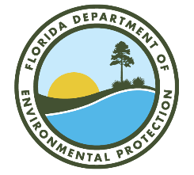

Manatee River Basin Management Action Plan (BMAP) Annual Meeting

Lakewood Ranch Library
16410 Rangeland Parkway
Lakewood Ranch, FL 34211

November 13, 2024
2:00 PM

Agenda

- Manatee River Management Action Plan (BMAP) Background.

- Statute Overview.

- 2025 BMAP Update—Additional BMAP Provisions.

Please note the FTP site for documents pertaining to the Lower St. Johns River Main Stem BMAP:
https://publicfiles.dep.state.fl.us/DEAR/BMAP/Tampa_Bay_Tributaries/Manatee_BMAP/Public_Meetings/2024NOV13/
For more information on the Manatee River BMAP, contact: Anita Stine, 850-245-8545,
Anita.Stine@FloridaDEP.gov

