DRAFT

Basin Management Action Plan

for the Implementation of
Total Maximum Daily Loads for
Nutrients and Fecal Coliforms Adopted by
the Florida Department of Environmental Protection
in the Manatee River Basin

developed by the
Manatee River Basin Stakeholders

in cooperation with the
Division of Environmental Assessment and Restoration
Bureau of Watershed Restoration
Florida Department of Environmental Protection
Tallahassee, FL 32399

February 2014

Acknowledgments: The Manatee River Basin Management Action Plan was prepared as part of a statewide watershed management approach to restore and protect Florida’s water quality. It was developed by the Manatee River stakeholders, identified below, with participation from affected local, regional, and state governmental interests; elected officials and citizens; and private interests.

Manatee River Basin Participants

Entity
Manatee County
Florida Department of Agriculture and Consumer Services
Florida Department of Transportation
Florida Power and Light
City of Palmetto
SMR Farms
CSX
Tampa Bay Regional Planning Council
Southwest Florida Water Management District
Tampa Bay Estuary Program
Sierra Club
The Mosaic Company
Lakewood Ranch
City of Bradenton
CF Industries
Schroeder-Manatee Ranch
Braden River Utilities
Florida Department of Health

For additional information on Total Maximum Daily Loads and the watershed management approach in the Manatee River Basin, contact:
Terry Hansen, P.G., Basin Coordinator
Florida Department of Environmental Protection
Bureau of Watershed Restoration, Watershed Planning and Coordination Section
2600 Blair Stone Road, Mail Station 3565
Tallahassee, FL 32399-2400
Email: Terry.Hansen@dep.state.fl.us
Phone: (850) 245–8561
Table of Contents

List of Acronyms and Abbreviations viii
Executive Summary x
Chapter 1 : Context, Purpose, and Scope of the Plan 1
1.1 Water Quality Standards and Total Maximum Daily Loads 1
1.2 TMDL Implementation 2
1.3 The Manatee River BMAP 3
1.3.1 Stakeholder Involvement 3
1.3.2 Plan Purpose and Scope 3
1.3.3 Pollutant Reduction and Discharge Allocations 4
1.3.4 Manatee River Basin TMDLs 6
1.4 Assumptions and Considerations Regarding TMDL Implementation 6
1.4.1 Assumptions 7
1.4.2 Considerations 7
1.5 Future Growth in the Watershed 8
Chapter 2 : Manatee River Basin Setting 10
2.1 Jurisdictions, Population, and Land Uses 10
2.2 Physiography and Geology 10
2.3 Water Quality Trends 14
2.3.1 WBID 1923 (Rattlesnake Slough) 14
2.3.2 WBID 1913 (Nonsense Creek) 17
2.4 WBIDs with Fecal Coliform TMDLs 21
Chapter 3 : Pollutant Sources, Anticipated Outcomes, and Management Actions 29
3.1 Summary of Sources in the TMDLs 29
3.1.1 Point Source facilities 29
3.1.2 Municipal Separate Storm Sewer Systems 30
3.2 Anticipated Outcomes of BMAP Implementation 33
3.3 Management Actions 34
3.3.1 Types of Management Strategies 34
3.4 Addressing Agricultural Nonpoint Pollution 35
3.4.1 Agricultural BMPs 35
3.4.2 FDACS’ OAWP Role in BMP Implementation and Follow-Up 36
3.4.3 BMP Enrollment Goals and Load Reduction Estimates 39
3.5 Funding Elements 42
Chapter 4 : Assessing Progress and Making Changes 43
4.1 Tracking Implementation 43
4.2 Water Quality Monitoring 44
4.2.1 Water Quality Monitoring Objectives 44
4.2.2 Water Quality Indicators and Resource Responses 45
4.2.3 Monitoring Network 46
4.2.4 Quality Assurance/Quality Control 46
4.2.5 Data Management and Assessment 48
4.3 Adaptive Management Measures 48
Chapter 5 : Commitment to Plan Implementation 50
APPENDICES 51
Appendix A: TMDL Basin Rotation Schedule 52
Appendix B: Manatee River Basin Stakeholder Involvement in BMAP Development 53
Appendix C: Summary of EPA-Recommended Elements of a Comprehensive Watershed Plan 54
Appendix D: Projects To Achieve the TMDLs 58
Appendix E: Glossary of Terms 68
Appendix F: Potential Funding Sources 74
Appendix G: Water Quality Monitoring Stations in the Manatee River Basin 79
Appendix H: Bibliography of Key References and Websites 80

List of Figures

Figure 1. Manatee River BMAP WBIDs 5
Figure 2. Land cover in the Manatee River BMAP area in 2009 11
Figure 3. Manatee River Basin regional setting 13
Figure 4. Annual geometric mean DO concentrations (top panel), and percentages of monthly DO observations falling below the 5.0 mg/L freshwater DO threshold (bottom panel) at Station TS1 in WBID 1923 (Rattlesnake Slough) 15
Figure 5. Annual geometric mean TN and TP concentrations (upper and lower panels, respectively) at Station TS1 in WBID 1923 (Rattlesnake Slough) 16
Figure 6. Annual geometric mean DO concentrations (top panel), and percentages of monthly DO observations falling below the 5.0 mg/L freshwater DO threshold (bottom panel) at Station TS7 in WBID 1913 (Nonsense Creek) 19
Figure 7. Annual geometric mean TN and TP concentrations (upper and lower panels, respectively) at Station TS7 in WBID 1913 (Nonsense Creek) 20
Figure 8. WBID 1923, Rattlesnake Slough: Time-series of annual geometric mean fecal coliform counts (CFU/100mL) (top panel) and 3-year MWQA scores (bottom panel) for Station TS1. Data source: Florida STORET. 25
Figure 9. WBID 1926, Cedar Creek: Time-series of annual geometric mean fecal coliform counts (CFU/100mL) (top panel) and 3-year MWQA scores (bottom panel) for Station TS2. Data source: Florida STORET. 26
Figure 10. WBID 1913, Nonsense Creek: Time-series of annual geometric mean fecal coliform counts (CFU/100mL) (top panel) and 3-year MWQA scores (bottom panel) for Station TS7. Data source: Florida STORET. 27
Figure 11. WBID 1914, Braden River above Evers Reservoir: Time-series of annual geometric mean fecal coliform counts (CFU/100mL) (top panel) and 3-year MWQA scores (bottom panel) for Station TS6. Data source: Florida STORET. 28
Figure 12. Agricultural land use based on 2008 SWFWMD data in the Manatee River BMAP WBIDs 39
Figure 13. BMP enrollment as of March 31, 2013, in the Manatee River Basin 41
Figure 14. Water quality monitoring stations in the Manatee River BMAP WBIDs 47

List of Tables

Table 1. Designated use attainment categories for Florida surface waters 1
Table 2. Phases of the watershed management cycle 2
Table 3. Manatee River Basin TMDLs 6
Table 4. Land cover in the Manatee River BMAP area in 2009 10
Table 5. Required reductions in the Manatee River Basin 29
Table 6. Manatee River Basin MS4 permit holders 31
Table 7. Summary of Manatee River BMAP projects 34
Table 8. Key management and structural BMPs adopted by FDACS’ OAWP¹ 37
Table 9. Agricultural acreage, BMP enrollment, and future enrollment goals in the Manatee River Basin 40
Table 10a. Core parameters and anticipated trends 45
Table 10b. Supplemental parameters and anticipated trends 46
Table 11. Anticipated resource responses from BMAP implementation 46
Table A-1. Major hydrologic basins by group and Department District Office 52
Table H-1. Local stormwater and water quality protection websites 82
Table H-2. State stormwater and water quality protection websites 82
Table H-3. National stormwater and water quality protection websites 82

List of Acronyms and Abbreviations

Acronym/Abbreviation | Explanation
µg/L | Micrograms Per Liter
ACOE | U.S. Army Corps of Engineers
ASR | Aquifer Storage and Recovery
BMAP | Basin Management Action Plan
BMP | Best Management Practice
BOD | Biochemical Oxygen Demand
BOD₅ | Five-Day Biochemical Oxygen Demand
BRASWA | Braden River Area Surface Water Assessment
CBDG | Community Development Block Grant
CCMP | Comprehensive Conservation and Management Plan
CDS | Continuous Deflective Separation
CES | Cooperative Extension Service
C.F.R. | Code of Federal Regulations
CFU | Colony-Forming Units
Chla | Chlorophyll a
Department | Florida Department of Environmental Protection
DO | Dissolved Oxygen
EPA | U.S. Environmental Protection Agency
ERP | Environmental Resource Permit
F.A.C. | Florida Administrative Code
FAR | Florida Administrative Register
FDACS | Florida Department of Agriculture and Consumer Services
FDOH | Florida Department of Health
FDOT | Florida Department of Transportation
FGD | Flue Gas Desulfurization
F.S. | Florida Statutes
FWRA | Florida Watershed Restoration Act
I | Interstate
IO | Indicator Organism
IWR | Impaired Surface Waters Rule
LA | Load Allocation
MEP | Maximum Extent Practicable
MGD | Million Gallons Per Day
mg/L | Milligrams Per Liter
MIL | Mobile Irrigation Lab
mL | Milliliter
MOS | Margin of Safety
MS4 | Municipal Separate Storm Sewer System
MWQA | Microbial Water Quality Assessment
NMC | Tampa Bay Nitrogen Management Consortium
NNC | Numeric Nutrient Criterion
NOI | Notice of Intent
NOx | Nitrogen Oxide
NPDES | National Pollutant Discharge Elimination System
NPS | Nonpoint Source
OAWP | Office of Agricultural Water Policy
OFW | Outstanding Florida Water
OSTDS | Onsite Sewage Treatment and Disposal System
POTW | Publicly Owned Treatment Works
QA/QC | Quality Assurance/Quality Control
RA | Reasonable Assurance
RUS | Rural Utilities Service
SCI | Stream Condition Index
SOP | Standard Operating Procedure
SR | State Road
SRF | State Revolving Fund
SSO | Sanitary Sewer Overflow
SWFWMD | Southwest Florida Water Management District
SWIM | Surface Water Improvement and Management
SWMP | Stormwater Management Program
SWRA | Surface Water Resource Assessment
TBEP | Tampa Bay Estuary Program
TBRPC | Tampa Bay Regional Planning Council
TKN | Total Kjeldahl Nitrogen
TMDL | Total Maximum Daily Load
TN | Total Nitrogen
TP | Total Phosphorus
TSI | Trophic State Index
TSS | Total Suspended Solids
UF–IFAS | University of Florida–Institute of Food and Agricultural Sciences
WBID | Waterbody Identification
WLA | Wasteload Allocation
WWTF | Wastewater Treatment Facility
WWTP | Wastewater Treatment Plant

Executive Summary

Manatee River Basin

The headwaters of the Manatee River are located in northeastern Manatee County, near the Four Corners area. The river drains an area of 360 square miles, flowing 45 miles westward and discharging to Lower Tampa Bay (Figure 1). Major tributaries include Gilley Creek, Gamble Creek, and the Braden River. The watershed includes two run-of-the-river water supply reservoirs: Lake Manatee on the Manatee River provides potable water supply to Manatee County, and the Bill Evers Reservoir (also known as Ward Lake) on the Braden River supplies the city of Bradenton.
The upper Manatee River and Gilley Creek are major tributaries to the Lake Manatee Reservoir. Tributaries of the Evers Reservoir include the upper Braden River, Rattlesnake Slough, Cedar Creek, Nonsense Creek, and several other streams. The Manatee River is a tidal, estuarine waterbody downstream of the Lake Manatee Dam, as is the Braden River downstream of the Evers Reservoir (Wolfe and Drew 1990; Southwest Florida Water Management District [SWFWMD] 2001).
Total Maximum Daily Load

Total Maximum Daily Loads (TMDLs) are water quality targets, based on state water quality standards, for specific pollutants (such as excessive nitrogen and phosphorus). The Florida Department of Environmental Protection identified the Manatee River to be impaired by nutrients (chlorophyll a [chla]), dissolved oxygen (DO), and fecal coliforms.
In September 2013, the U.S. Environmental Protection Agency (EPA) approved the revisions to Florida's criteria for dissolved oxygen (DO) in Rules 62-302 and 62-303, Florida Administrative Code (F.A.C.). The revised DO criteria are now in effect and apply to both fresh and marine waters. These revisions are not evaluated in this BMAP.
This Basin Management Action Plan (BMAP) addresses four fecal coliform TMDLs (WBIDs 1923, 1926, 1913, 1914) and two DO and nutrient TMDLs (WBIDS 1913 and 1914).
The Manatee River BMAP

The Manatee River BMAP was developed with areawide stakeholders, the assistance of the Tampa Bay Estuary Program (TBEP) and the Tampa Bay Nitrogen Management Consortium (NMC). The TBEP has been successful in reducing nutrient inputs to Tampa Bay by working with NMC members to assess actual loads generated and then monitor improvements in seagrass throughout the bay.

Anticipated Outcomes of BMAP Implementation

Through the implementation of projects, activities, and additional source assessment in this BMAP, stakeholders expect the following outcomes:
- Continued improvements in water quality trends in the Manatee River.
- Decreased loading of the target pollutant (total nitrogen [TN]).
- Identification of potential sources of fecal coliform impairments.
- Increased coordination between state BMAP efforts and the TBEP and NMC members in problem solving for surface water quality restoration.
- Determination of effective projects through the stakeholder decision-making and priority-setting processes.

BMAP Cost

Manatee River BMAP projects are summarized in Table 7 and listed in Appendix C. The total cost of projects listed is approximately $50 million.
BMAP Follow-Up

The Department will work with the TBEP and technical stakeholders to organize the monitoring data and track project implementation. The results will be used to evaluate whether the plan is effective in continuing to reduce nutrient loads in the watershed. The technical stakeholders will meet periodically as needed after the adoption of the BMAP to follow up on plan implementation, share new information, and continue to coordinate on TMDL-related issues.
Commitment to BMAP Implementation

In coordinating the Tampa Bay Reasonable Assurance Plan (RA Plan) for Tampa Bay, the TBEP has received letters of commitment or resolutions of support to ensure that as staff and board members change over time, the entity has a way to show support for the water quality improvements in Tampa Bay. This BMAP incorporates those efforts.

: Context, Purpose, and Scope of the Plan

Water Quality Standards and Total Maximum Daily Loads
Florida's water quality standards are designed to ensure that surface waters can be used for their designated purposes, such as drinking water, recreation, and agriculture. Currently, most surface waters in Florida, including those in the Manatee River Basin, are categorized as Class III waters, meaning that they must be suitable for recreation and must support the propagation and maintenance of a healthy, well-balanced population of fish and wildlife. Table 1 shows all designated use categories.
Under Section 303(d) of the federal Clean Water Act, every two years each state must identify its “impaired” waters, including estuaries, lakes, rivers, and streams, that do not meet their designated uses and are not expected to improve within the subsequent two years. The Florida Department of Environmental Protection is responsible for developing this “303(d) list” of impaired waters.

Table 1. Designated use attainment categories for Florida surface waters

* Class I and II waters include the uses of the classifications listed below them.
Category | Description
Class I* | Potable water supplies
Class II* | Shellfish propagation or harvesting
Class III | Recreation, propagation and maintenance of a healthy, well-balanced population of fish and wildlife
Class IV | Agricultural water supplies
Class V | Navigation, utility, and industrial use (no current Class V designations)

Florida's 303(d) list identifies hundreds of waterbody segments that fall short of water quality standards. The three most common water quality concerns are fecal coliform, nutrients, and oxygen-demanding substances. The listed waterbody segments are candidates for more detailed assessments of water quality to determine whether they are impaired according to state statutory and rule criteria. The Department develops and adopts Total Maximum Daily Loads for the waterbody segments it identifies as impaired. A TMDL is the maximum amount of a specific pollutant that a waterbody can assimilate while maintaining its designated uses.
The water quality evaluation and decision-making processes for listing impaired waters and establishing TMDLs are authorized by Section 403.067, Florida Statutes (F.S.), known as the Florida Watershed Restoration Act (FWRA), and contained in Florida’s Identification of Impaired Surface Waters Rule (IWR), Rule 62-303, Florida Administrative Code (F.A.C.). The impaired waters in the Manatee River Basin addressed in this plan are all Class III waters. TMDLs have been established for these waters, identifying the amount of nutrients and other pollutants they can receive and still maintain Class III designated uses.
TMDLs are developed and implemented as part of a watershed management cycle that rotates through the state’s 52 river basins every 5 years (see Appendix A) to evaluate waters, determine impairments, and develop and implement management strategies to restore impaired waters to their designated uses. Table 2 summarizes the five phases of the watershed management cycle.

Table 2. Phases of the watershed management cycle

Phase | Activity
Phase 1 | Preliminary evaluation of water quality
Phase 2 | Strategic monitoring and assessment to verify water quality impairments
Phase 3 | Development and adoption of TMDL(s) for waters verified as impaired
Phase 4 | Development of management strategies to achieve the TMDL(s)
Phase 5 | Implementation of TMDL(s), including monitoring and assessment

TMDL Implementation
Rule-adopted TMDLs are typically implemented through Basin Management Action Plans, which contain strategies to reduce and prevent pollutant discharges through various cost-effective means. During Phase 4 of the TMDL process, the Department and the affected stakeholders in the various basins jointly develop BMAPs or other implementation approaches. A basin may have more than one BMAP, based on practical considerations. The FWRA contains provisions that guide the development of BMAPs and other TMDL implementation approaches.
Stakeholder involvement is critical to the success of the TMDL Program, and varies with each phase of implementation to achieve different purposes. The BMAP development process is structured to achieve cooperation and consensus among a broad range of interested parties. Under statute, the Department invites stakeholders to participate in the BMAP development process and encourages public participation to the greatest practicable extent. The Department must hold at least one noticed public meeting in the basin to discuss and receive comments during the planning process. Stakeholder involvement is essential to develop, gain support for, and secure commitments to implement the BMAP.

The Manatee River BMAP

Stakeholder Involvement
Stakeholder involvement with the Tampa Bay Estuary Program (TBEP) and Nitrogen Management Consortium (NMC) was a key component in developing the Manatee River BMAP. The BMAP process engages local stakeholders and promotes coordination and collaboration to address the total nitrogen (TN) and total phosphorus (TP) reductions needed to achieve the nutrient TMDL, as well as identifying fecal coliform sources for the fecal TMDL.
Starting in June 2011, the Department initiated the BMAP development process and held a series of technical meetings involving key stakeholders and the general public. Technical meetings were open to the public and noticed in the Florida Administrative Register (FAR). The purpose of these meetings was to consult with key stakeholders to gather information on the impaired WBIDs and their contributing areas, in order to aid in the development of the BMAP and identify specific management actions that would reduce TN and TP loading and identify fecal coliform sources. Since 2011, six technical meetings have been held to gather information; identify potential sources; conduct field reconnaissance; define programs, projects, and actions currently under way; and develop the BMAP contents and actions that will result in a reduction of TN and TP with the ultimate goal of achieving the TMDL target reductions. The technical meetings also served to plan the “Walk the Waterbody” process for the WBIDs impaired for fecal coliform.
In addition to technical meetings, the Department also met with stakeholders in one-on-one meetings. The purpose of these meetings was to discuss project-specific information with stakeholders.
Except as specifically noted in subsequent sections, this BMAP document reflects the input of the stakeholders, along with public input from workshops and meetings held to discuss key aspects of the TMDL and BMAP development. Appendix B provides further details.

Plan Purpose and Scope
The purpose of this BMAP is to implement load reductions to achieve the nutrient and dissolved oxygen (DO) TMDLs for the Manatee River Basin and develop a process for identifying and abating fecal coliform sources in the impacted WBIDs. This plan outlines specific projects that will achieve load reductions and a schedule for implementation. The document details a monitoring approach to measure progress toward meeting load reductions and to report on how the TMDL is being accomplished. The BMAP is an adaptive process and if water quality standards change or the WBIDs are determined to no longer be impaired, the appropriate information will be included in the report updates.
This BMAP covers the following impaired segments with waterbody identification (WBID) numbers in the Manatee River Basin: WBID 1923, Rattlesnake Slough; WBID 1926, Cedar Creek; WBID 1913, Nonsense Creek; and WBID 1914, Braden River above Evers Reservoir. Figure 1 shows the WBIDs addressed in this report.

Pollutant Reduction and Discharge Allocations

1.3.3.1 Categories for Rule Allocations
The rules adopting TMDLs must establish reasonable and equitable allocations that will alone, or in conjunction with other management and restoration activities, attain the TMDLs. Allocations may be to individual sources, source categories, or basins that discharge to the impaired waterbody. The allocations identify either how much pollutant discharge per day each source designation may continue to contribute (discharge allocation), or the percentage of its loading the source designation must reduce (reduction allocation). Currently, the TMDL allocation categories are as follows:
- Wasteload Allocation (WLA) – The allocation to point sources permitted under the National Pollutant Discharge Elimination System (NPDES) Program includes the following:
  - Wastewater Allocation is the allocation to industrial and domestic wastewater facilities.
  - NPDES Stormwater Allocation is the allocation to NPDES stormwater permittees that operate municipal separate storm sewer systems (MS4s). These permittees are treated as point sources under the TMDL Program.
- Load Allocation – The allocation to nonpoint sources, including agricultural runoff and stormwater from areas that are not covered by an MS4.

1.3.3.2 Allocations
Under the FWRA, the TMDL allocation adopted by rule must include an allocation among point and nonpoint sources. In the Manatee BMAP this TMDL allocation is applied to the entire basin. Allocations must be determined based on a number of factors listed in the FWRA, including cost-benefit, technical and environmental feasibility, implementation time frames, and others.

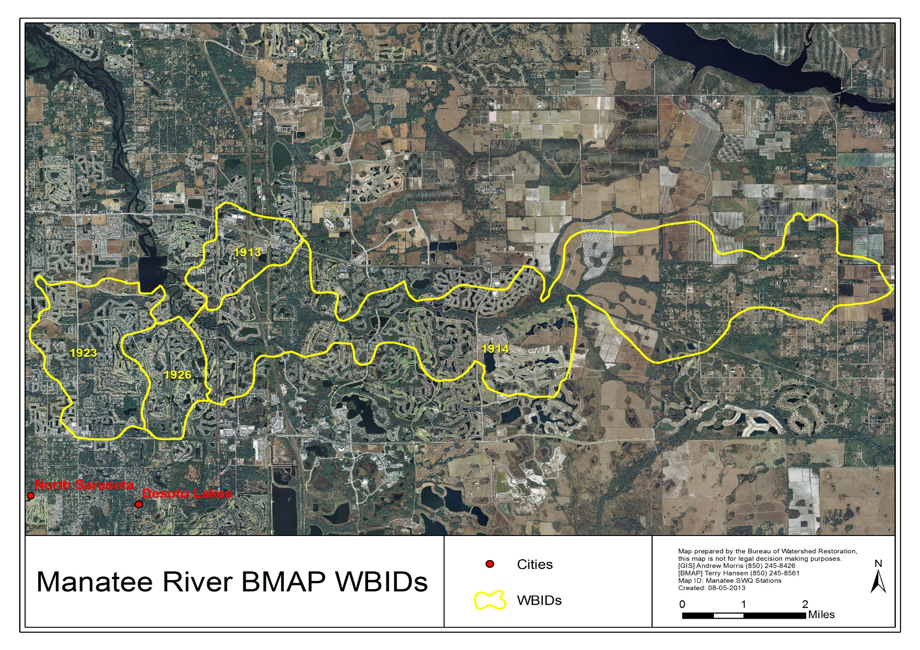
Figure 1. Manatee River BMAP WBIDs

Manatee River Basin TMDLs
In 2009, the Department adopted fecal, nutrient, and DO TMDLs for the Manatee River Basin for the WBIDs listed in Table 3.

Table 3. Manatee River Basin TMDLs

BOD₅ = Five-day biochemical oxygen demand
WBID Number | Name | TMDL Components
1923 | Rattlesnake Slough | TP (% load reduction)  – WLA (NPDES stormwater) = 21%  – LA = 21%  TN (% load reduction)  – WLA (NPDES stormwater) = 30% reduction  – LA = 30% reduction  BOD₅ (% load reduction)  – WLA (NPDES stormwater) = 31% reduction  – LA = 31% reduction
1923 | Rattlesnake Slough | Fecal coliform concentration (% reduction)  – WLA (NPDES stormwater) = 43% reduction  – LA = 43% reduction
1926 | Cedar Creek | Fecal coliform concentration (% reduction)  – WLA (NPDES stormwater) = 61% reduction  – LA = 61% reduction
1913 | Nonsense Creek | Fecal coliform concentration (% reduction)  – WLA (NPDES stormwater) = 57% reduction  – LA = 57% reduction
1913 | Nonsense Creek | TN (% load reduction)  – WLA (NPDES stormwater) = 27% reduction  – LA = 27% reduction  BOD₅ (% load reduction)  – WLA (NPDES stormwater) = 36 % reduction  – LA = 36% reduction
1914 | Braden River above Evers Reservoir | Fecal coliform concentration (% reduction)  – WLA (NPDES stormwater) = 43% reduction  – LA = 43% reduction

Assumptions and Considerations Regarding TMDL Implementation
The water quality impacts of BMAP implementation are based on several fundamental assumptions about the pollutants targeted by the TMDLs, modeling approaches, waterbody response, and natural processes. In addition, there are important considerations to keep in mind about the nature of the BMAP and its long-term implementation.

Assumptions
The following assumptions were used during the BMAP process:
- The TBEP and NMC are successfully implementing nutrient reduction projects.
- The Reasonable Assurance Plan (RA Plan) for Tampa Bay provides a good basis for existing projects.
- Seagrass in Tampa Bay is rebounding, demonstrating the results of water quality improvements.
- Existing and ongoing stakeholder efforts need to be recognized and incorporated into the BMAP.
- Additional projects need to be coordinated with the TBEP to eliminate redundant efforts by stakeholders.
- WBIDs impaired for fecal coliform will undergo a “Walk the Waterbody” process to identify potential sources that can be addressed through source reduction projects.

Considerations
This BMAP requires that all stakeholders in the basin implement their projects set forth in this document within the first five-year BMAP cycle. However, the full attainment of the TMDL targets will be a long-term process. While many of the projects and activities contained in the BMAP are recently completed or currently ongoing, many projects will require time to design, secure funding, and construct. Funding limitations do not impact the requirement that each entity must implement the activities committed to in this BMAP. However, funding was considered, to the extent practicable, when determining the schedule for meeting BMAP requirements.
Many of the TMDLs established for this basin are close to being achieved through the ongoing efforts of NMC members. Given that it may take even longer for these WBIDs to respond to the reduced loading and fully meet applicable water quality standards, regular follow-up and continued coordination and communication by the stakeholders will be essential to ensuring that management strategies are being carried out and that their incremental effects are assessed. Any additional management actions required to achieve a TMDL, if the TMDL is not met, will be developed as part of BMAP follow-up.
During the BMAP process, items were identified for each WBID that should be addressed in future watershed management cycles to ensure the most accurate information is utilized for future iterations:
- Rattlesnake Slough – Future nutrient-related BMAP activities need to focus on tracking ongoing water quality trends, assessing the biological integrity of the stream using Stream Condition Index (SCI) evaluations, and developing a clearer understanding of the physical factors (e.g., stream flow, stream shading) and the interactions between physical factors and nutrient concentrations that affect DO levels in the WBID. Improved understanding of those factors and interactions could prove helpful in guiding future water quality management actions.
- Nonsense Creek – Future nutrient-related BMAP activities in this WBID should focus on tracking ongoing water quality trends, assessing the biological integrity of the stream using SCI evaluations, and developing a clearer understanding of the physical factors (e.g., stream flow, stream shading) and the interactions between physical factors and nutrient concentrations that affect DO levels in the waterbody.
- WBIDs with fecal coliform TMDLs – When using the “Annapolis protocol” approach to manage fecal coliform exceedances, analyses of annual geometric mean indicator organism (IO) counts and microbial water quality assessment (MWQA) scores represent only an initial step in the management effort. Additional steps involve identifying the important IO sources in each WBID, prioritizing those sources on the basis of their potential human health threats, and taking action to address potentially high-risk sources (Morrison et al. 2010). For these WBIDs, these steps are taking place as part of the BMAP project process.
- The September 2013 adoption of DO criteria will require an evaluation of the appropriate data and possible revision of the impairment determinations.

Future Growth in the Watershed
The FWRA requires that BMAPs “identify the mechanisms by which potential future increases in pollutant loading will be addressed.” To meet this requirement, the BMAP will utilize the efforts of the TBEP and NMC to address future loading through the Tampa Bay RA Plan. The current RA Plan and supporting information are available at: http://www.tbeptech.org/index.php?searchword=reasonable+assurance&ordering=&searchphrase=all&Itemid=1&option=com_search. Additionally, existing comprehensive plans, land development regulations, additional or ongoing ordinances and Environmental Resource Permits (ERPs) may be utilized to manage future loads. As additional projects are identified and implemented, they will be included in the project database and tracked.

: Manatee River Basin Setting

Jurisdictions, Population, and Land Uses
Table 4 identifies 2009 land use in the Manatee River BMAP area. The primary land use in the BMAP WBIDs is urban and built-up. The area has undergone development, transitioning from rural and agricultural to more urban. Figure 2 shows land use in 2009.

Table 4. Land cover in the Manatee River BMAP area in 2009

Land Cover | Acres
Urban and Built-Up | 8,524
Agriculture | 2395
Rangeland | 270
Upland Forest | 1,269
Water | 1,172
Wetland | 1888
Barren Land | 35
Transportation, Communication, and Utilities | 474
Total | 16,027

Physiography and Geology
The headwaters of the Manatee River are located in northeastern Manatee County, near the Four Corners area. The river drains an area of 360 square miles, flowing 45 miles westward and discharging to Lower Tampa Bay (Figure 3). Major tributaries include Gilley Creek, Gamble Creek, and the Braden River. The watershed includes two run-of-the-river water supply reservoirs: Lake Manatee on the Manatee River, which provides potable water supply to Manatee County, and the Bill Evers Reservoir (also known as Ward Lake) on the Braden River, which supplies the city of Bradenton. The upper Manatee River and Gilley Creek are major tributaries to the Lake Manatee Reservoir. Tributaries of the Evers Reservoir include the upper Braden River, Rattlesnake Slough, Cedar Creek, Nonsense Creek, and several other streams. The Manatee River is a tidal, estuarine waterbody downstream of the Lake Manatee Dam, as is the Braden River downstream of the Evers Reservoir (Wolfe and Drew 1990).

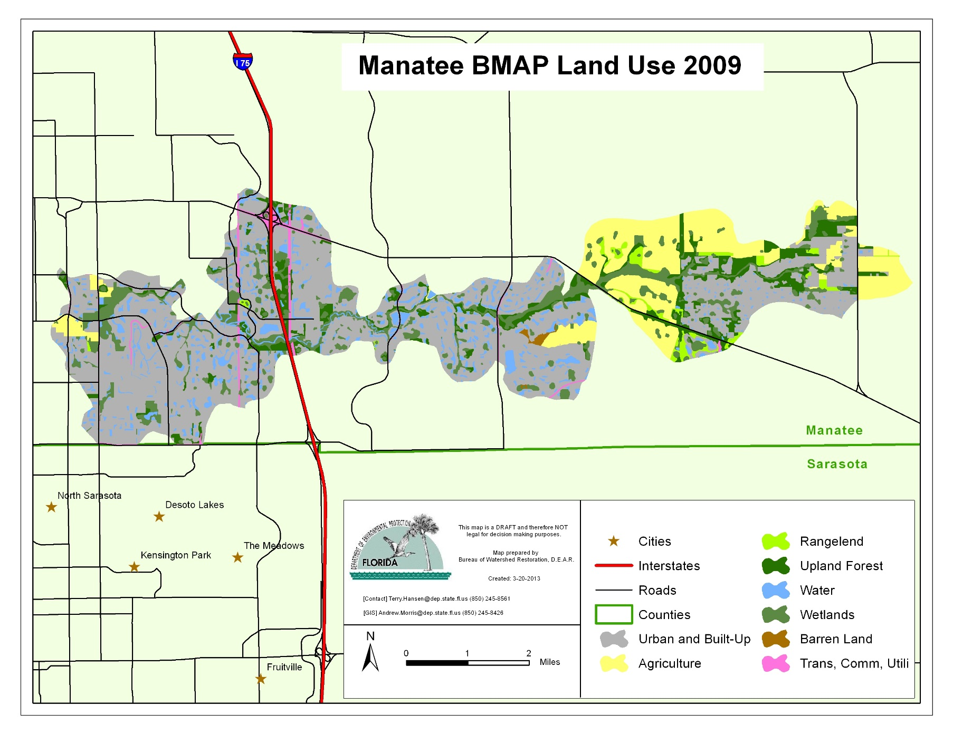
Figure 2. Land cover in the Manatee River BMAP area in 2009

The Manatee River lies within the Southwestern Florida Flatwoods subregion of the Southern Coastal Plain ecoregion (denoted as Ecoregion 75b by Griffith et al. 1994). This region is characterized by Gulf coastal lowlands and valleys, as well as higher elevation areas, including the Bone Valley Upland. The area includes fairly recent sedimentary deposits of marine origin, and certain marine clays (e.g., the Hawthorne Formation) and limestone formations that lie near the surface are extremely high in phosphorus. Some of these phosphatic deposits are mined, making Florida one of the largest producers of phosphate in the world (Florida produces approximately 25% of phosphate used globally). Two geologic formations, known as the Peace River Formation and the Bone Valley Member, comprise this naturally high-phosphate area, which includes portions of Hillsborough, Polk, Hardee, Manatee, DeSoto, and Sarasota Counties.
The Peace River Formation crops out or lies beneath a thin overburden on the southern part of the Ocala Platform extending into the Okeechobee Basin (Figure 3). These sediments were mapped from Hillsborough County southward to Charlotte County. In this area, the Peace River Formation is composed of interbedded sands, clays, and carbonates. The sands are generally light gray to olive gray, poorly consolidated, clayey, variably dolomitic, very fine to medium grained, and phosphatic. The clays are yellowish gray to olive gray, poorly to moderately consolidated, sandy, silty, phosphatic, and dolomitic. The carbonates are usually dolostone in the outcrop area. The dolostones are light gray to yellowish gray, poorly to well indurated, variably sandy and clayey, and phosphatic. Opaline chert is often found in these sediments. The phosphate content of the Peace River Formation sands is frequently high enough to be economically mined. Naturally occurring phosphorus pebbles are frequently observed in streams in this formation.
The Department and U.S. Environmental Protection Agency (EPA) have previously used the geographic distribution of the Peace River Formation and Bone Valley Member to delineate a homogeneous nutrient region known as the West Central (formally Bone Valley) region.
The cities of Bradenton and Palmetto, located near the mouth of the Manatee River, are the only incorporated municipalities in the basin. Unincorporated communities include Ellenton and Parrish near the Interstate 75 corridor and Duette in northeastern Manatee County. The western portion of the watershed (from the I-75 corridor west to Tampa Bay) is heavily urbanized, while the central portion (from I-75 east to Rye Road) is a mix of suburban and rural land uses, and the eastern portion (east of Rye Road) is predominantly rural. In 2010 predominant land uses included intensive agriculture (32%), rangeland (12%), urban (26%), wetlands and water (20%), and upland forest (8%) (Figure 2).
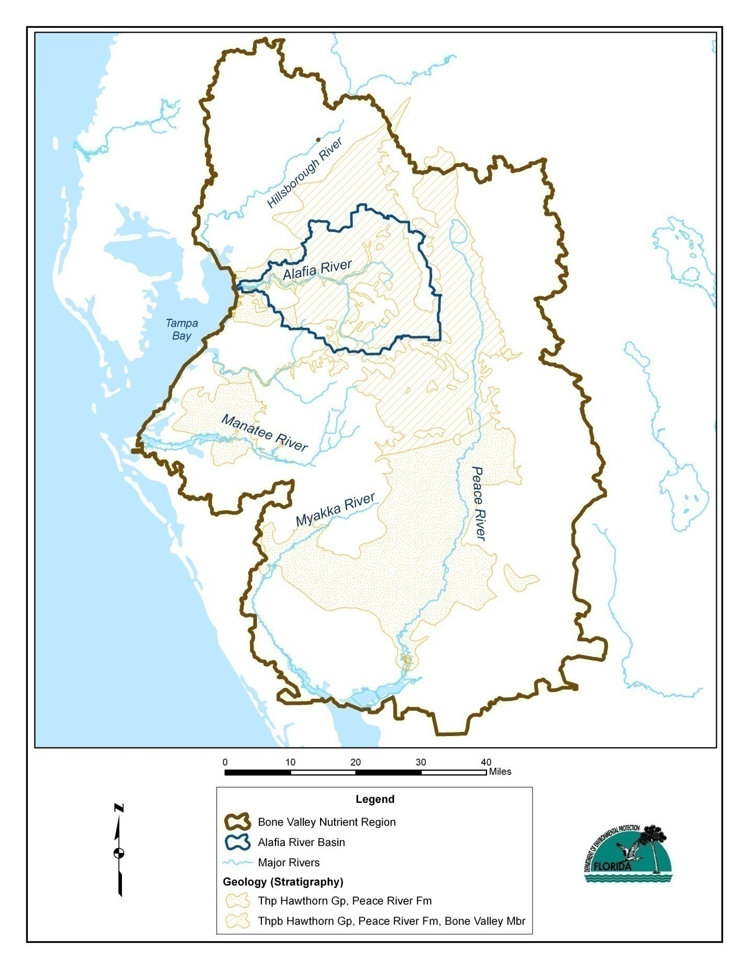
Figure 3. Manatee River Basin regional setting

Water Quality Trends
The September 2013 adoption of the state of Florida DO criteria by the EPA will require the WBIDs in this BMAP to be evaluated against new DO criteria. As this evaluation is completed and data gaps are identified, changes in water quality trends are likely to be identified. This information will be included in BMAP updates.

WBID 1923 (Rattlesnake Slough)
The TMDL for this WBID is aimed at bringing the waterbody into compliance with existing DO criterion by reducing loads of TP, TN, and BOD₅. For freshwater streams, the criterion requires that no more than 10% of DO observations fall below 5.0 milligrams per liter (mg/L) on an annual basis.
The single long-term monitoring station in the WBID is sampled monthly by the Manatee County Natural Resources Department. Station TS1 is located in the downstream portion of the WBID, approximately one mile upstream from its confluence with the Braden River. Nutrient, chlorophyll a (chla), and DO data are available from the site for 1990 through 2011.
The annual percentage of DO observations at Station TS1 that failed to meet the 5.0 mg/L criterion declined significantly (Kendall tau = -0.43, p<0.01) between 1990 and 2011, and the annual geometric mean DO concentration increased significantly (tau = 0.32, p<0.05) over the same period (Figure 4).
Annual geometric mean TN concentrations did not show a significant trend (tau = 0.18, p=0.25) from 1990 through 2011. During the past 10 years, the annual geometric mean TN concentration has not exceeded the 1.65 mg/L target recently proposed as a numeric nutrient criterion (NNC) by the Department for streams in the west-central Florida region (Figure 5).
Annual geometric mean TP concentrations fell sharply between 1990 and 1991, and fluctuated between 0.25 and 0.5 mg/L from 1992 to 2011. During the past 10 years, annual geometric mean TP concentrations have not exceeded the 0.49 mg/L NNC recently proposed by the Department for the region (Figure 5).

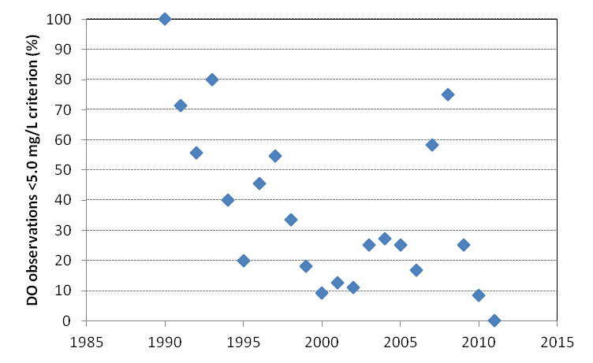
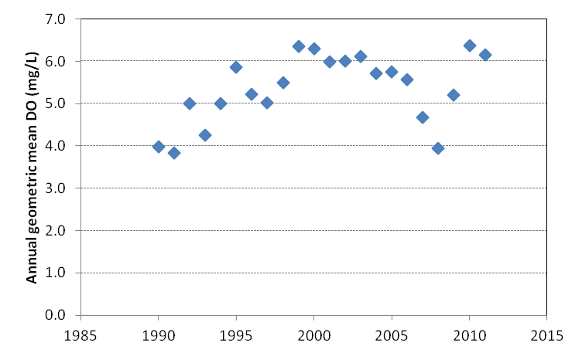
Figure 4. Annual geometric mean DO concentrations (top panel), and percentages of monthly DO observations falling below the 5.0 mg/L freshwater DO threshold (bottom panel) at Station TS1 in WBID 1923 (Rattlesnake Slough)

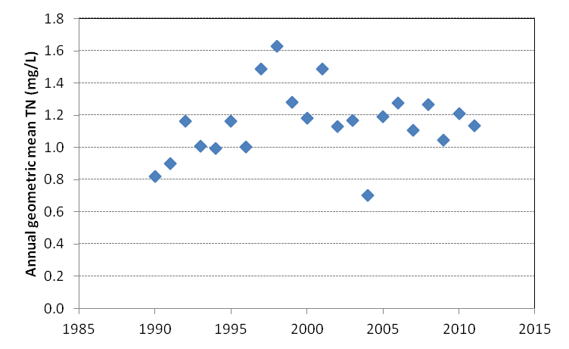
Figure 5. Annual geometric mean TN and TP concentrations (upper and lower panels, respectively) at Station TS1 in WBID 1923 (Rattlesnake Slough)
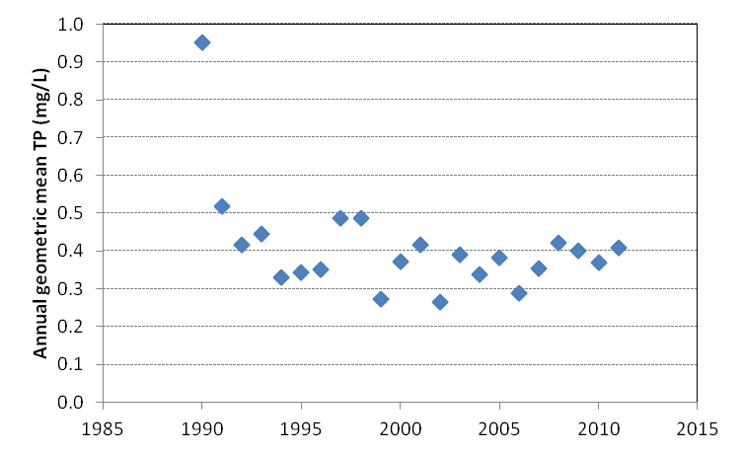
From 1990 through 2011, the annual percentage of DO observations failing to meet the 5.0 mg/L criterion was positively correlated (tau = 0.39, p=0.01) with the annual geometric mean TP concentration. Annual geometric mean DO concentrations were negatively correlated (tau = -0.38, p<0.02) with annual geometric mean TP concentrations. Similar relationships occurred between DO and TN, but were weaker and only marginally significant (0.10>p>0.05).
The usefulness of BOD as an indicator of DO dynamics appears limited in this WBID. At Station TS1, between 1990 and 2008 annual geometric mean BOD values exhibited an increasing trend (tau = 0.50, p<0.005). Annual geometric mean DO concentrations also increased significantly over that period, as did the percentage of DO observations meeting the 5.0 mg/L criterion (Figure 4). On a monthly time step, between 1990 and 2008 BOD and DO values were uncorrelated (tau = 0.05, p=0.33). BOD records from Station TS1 in the Florida STORET database end in 2008.
The available data indicate that DO levels in this WBID are showing improving trends, and nutrient concentrations do not appear elevated relative to the proposed NNC. Department staff have indicated that, as a result of low (<20 micrograms per liter [µg/L]) chla concentrations observed in recent years, it is possible that the WBID may be designated as “not impaired” for nutrients during its next assessment period.
The WBID is located in the Evers Reservoir Watershed Overlay District, a potable supply watershed. Section 604 of the Manatee County Land Development Code includes requirements that are designed to protect water quality in such areas. Stormwater systems in the overlay district must meet Outstanding Florida Waters (OFW) design criteria, and septic tank locations are subject to additional setback criteria. In addition, a countywide fertilizer ordinance is in place that should help to reduce fertilizer runoff from areas with residential and commercial landscaping.

WBID 1913 (Nonsense Creek)
The TMDL for this WBID (Department 2009e) also seeks to achieve compliance with the existing freshwater DO criterion of 5.0 mg/L by reducing TN and BOD₅ loadings.
The single long-term monitoring station in the WBID is sampled monthly by the Manatee County Natural Resources Department. Station TS7 is located in the downstream portion of the WBID, approximately 0.8 miles upstream from the Evers Reservoir. Nutrient, chla, and DO data are available from the site for 1990 through 2011. BOD data are available for 1990 through 2008.
The annual percentage of DO observations at Station TS7 that failed to meet the 5.0 mg/L criterion showed no significant trend from 1990 through 2011 (Figure 6). Annual geometric mean DO concentrations showed a marginally significant increase (tau = 0.27; 0.10>p>0.05) over the period.
Annual geometric mean TN concentrations also showed a marginally significant increasing trend (tau = 0.27; 0.10>p>0.05) from 1990 through 2011, but did not exceed the 1.65 mg/L regional NNC for TN that was recently proposed by the Department during any of those years (Figure 7).
Annual geometric mean TP concentrations fell significantly (tau = -0.58, p=0.0002) between 1990 and 2011, and did not exceed the 0.49 mg/L NNC recently proposed by the Department for the region during any year (Figure 7).
On a monthly time step, DO concentrations were negatively correlated with TP (tau = -0.27, p<0.0001) and uncorrelated (p>0.25) with both TN and BOD.
As with Rattlesnake Slough, Department staff have indicated that, as a result of low (<20 µg/L) chla concentrations observed in recent years, it is possible that this WBID may be designated as “not impaired” for nutrients during its next assessment period.
Nonsense Creek is located in the Evers Reservoir Watershed Overlay District and, as noted above, Section 604 of the Manatee County Land Development Code includes requirements that are designed to protect water quality in this potable supply watershed. Stormwater systems in the overlay district are required to meet OFW design criteria, and septic tank locations are subject to additional setback criteria. In addition, a countywide fertilizer ordinance is in place that should help to reduce fertilizer runoff from areas with residential and commercial landscaping.

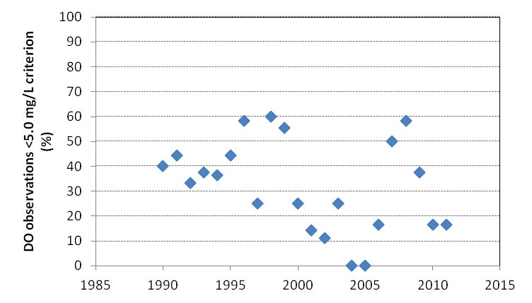
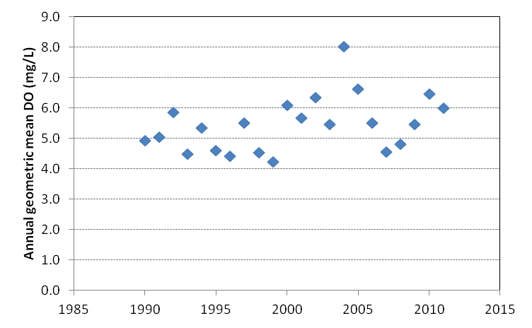

Figure 6. Annual geometric mean DO concentrations (top panel), and percentages of monthly DO observations falling below the 5.0 mg/L freshwater DO threshold (bottom panel) at Station TS7 in WBID 1913 (Nonsense Creek)

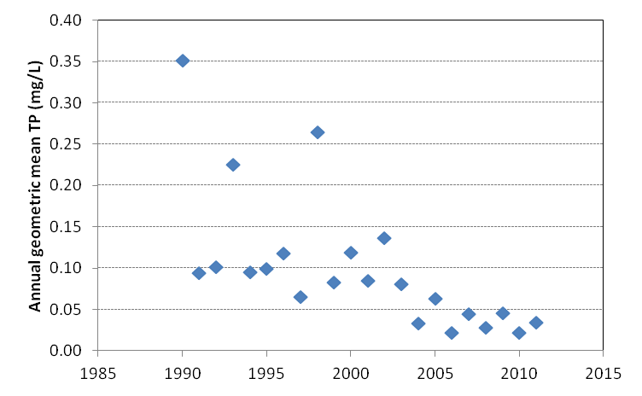
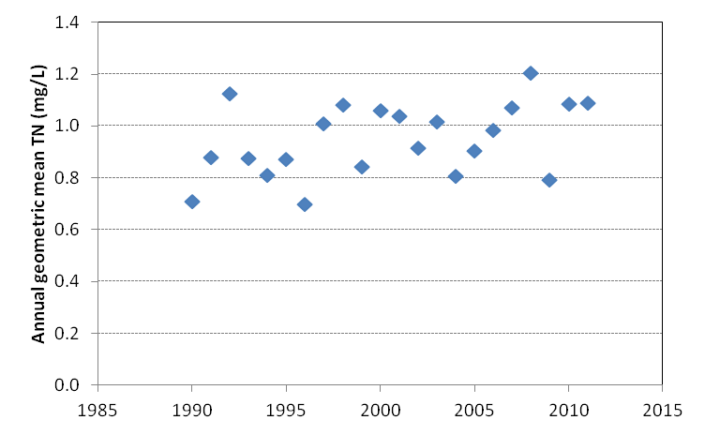

Figure 7. Annual geometric mean TN and TP concentrations (upper and lower panels, respectively) at Station TS7 in WBID 1913 (Nonsense Creek)

WBIDs with Fecal Coliform TMDLs
Under the federal Clean Water Act, Florida has adopted water quality criteria for fecal coliform bacteria in order to reduce human health risks in cases where waterborne pathogens could potentially be present in waterbodies that are used for recreation, shellfish harvesting, or potable water supply. For Class III (recreational) and Class I (potable supply) waters, a criterion of 400 colony-forming units per 100 milliliters (CFU/100mL) sample is typically used to identify fecal coliform impairments. Waterbodies in which more than 10% of samples exceed the 400 CFU/100mL criterion are designated as impaired and are subject to TMDL development.
In most cases, however, the fecal coliform bacteria that are detected in surface water samples are not human pathogens. Instead, they are IO that are used as a surrogate to indicate that water may have been contaminated by fecal material (from humans or other warm-blooded vertebrates), and may therefore contain disease-causing organisms that pose a risk to public health.
Several issues impact the use of fecal coliforms and other IO as water quality indicators in tropical and subtropical climates. Rose et al. (2001), in a recent study conducted in the Tampa Bay area, provided the following summary of this issue:
Risks to swimmers using polluted beaches have been a major issue associated with the setting of ambient water quality standards and discharge limits to recreational sites. Public health concerns in recreational waters in the tropics and subtropics differ from those of cooler waters. Prevention of disease depends on the use of appropriate fecal indicators. However, the finding that the most widely used fecal contamination indicator, fecal coliforms and more specifically E. coli, grow naturally on vegetation in warm climates clearly brings into question whether these or other indicators developed for temperate climates are applicable in Florida and other southeastern areas… In recent years, total and fecal coliform bacterial indicators have not been able to consistently indicate the persistence of pathogens, especially viruses in surface waters.
In recognition of these and other points, the Department (2011) has developed a guidance document that provides recommendations for stakeholders on steps that can be taken to implement fecal coliform TMDLs. Among other actions, the recommended steps include the following:
- Compiling and evaluating available data.
- Identifying and assembling watershed stakeholders.
- Identifying potential sources of fecal contamination.
- Identifying appropriate management actions to address those sources.
- Developing and implementing a management plan.
- Monitoring to track plan effectiveness.

The information provided in this report addresses only the first of these steps: the compilation and analysis of available water quality data. Several other steps are being addressed by local stakeholders working directly with Department staff, and will be summarized in other documents.
As noted in Table 1, this report addresses the following WBIDs with fecal coliform impairments:
- WBID 1923 (Rattlesnake Slough).
- WBID 1926 (Cedar Creek).
- WBID 1913 (Nonsense Creek).
- WBID 1914 (Braden River above Evers Reservoir).

Figure 8 through Figure 11 summarize information on annual geometric mean fecal coliform counts and MWQA scores for these WBIDs. The MWQA scores are symbolized as letter grades (A through E) reflecting how frequently the state’s fecal coliform criterion of 400 CFU/100mL is exceeded at a given monitoring site. Scores of A indicate that 10% or less of samples exceed the criterion, while scores of E indicate that >75% of samples exceed the criterion.
Previous studies have shown that sites with higher frequencies of criterion exceedances also tend to exhibit higher overall concentrations of fecal coliforms and other indicator bacteria (Morrison et al. 2010); thus MWQA Categories A through E also provide working estimates of progressively higher indicator organism concentrations and increasing levels of potential human health risk. Because fecal coliform counts can be highly variable from month to month and year to year, the MWQA scores shown in Figure 8 through Figure 11 are based on three years of monitoring data to provide a multiyear summary of bacterial water quality conditions at each monitoring station.
In WBID 1923 (Rattlesnake Slough), fecal coliform data are available from Manatee County Station TS1 for calendar years 1995 through 2011. Annual geometric means fluctuated between <100 and >500 CFU/100mL during that period (Figure 8), showing no significant upward or downward trend. Three-year MWQA scores ranged between A and C (Figure 8). Depending on the specific fecal sources present in the watershed, these scores suggest low to moderate potential health risks. Monthly fecal coliform counts were positively correlated with turbidity (tau = 0.21, p<0.0001), BOD (tau = 0.18, p=0.003), chla (tau = 0.13, p=0.02), TN (tau = 0.12, p=0.02), and color (tau = 0.11, p=0.04), suggesting an IO source associated with turbid, nitrogen-enriched surface runoff.
At Manatee County Station TS2 on Cedar Creek (WBID 1926), which is located approximately 0.5 miles upstream from the Braden River and 2 miles upstream from the Evers Reservoir Dam, annual geometric mean fecal coliform counts showed a significant increasing trend (tau = 0.43, p=0.02) from 1995 through 2011, as did the 3-year MWQA scores (tau = 0.61, p=0.004) (Figure 9). MWQA scores have ranged from C to D since 2005. Depending on the specific types of fecal sources present in the area, these could represent moderate to moderately high human health risks. On a monthly time step, fecal coliform counts were positively correlated with fluoride (tau = 0.17, p=0.002) and conductivity (tau = 0.10, p=0.04), possibly suggesting an IO source associated with ground water inputs or one that is diluted by surface runoff.
Annual geometric mean fecal coliform counts at Manatee County Station TS7 on Nonsense Creek (WBID 1913) showed a marginally significant (tau = 0.20, p=0.10) increasing trend from 1995 through 2011. Three-year MWQA scores increased significantly (tau = 0.61, p=0.006) during the period, with scores of C persisting in 2009 through 2011 (
Figure 10). On a monthly time step, fecal coliform counts were negatively correlated with conductivity (tau = -0.13, p=0.01), possibly suggesting an IO source that is associated with surface runoff or is diluted by ground water discharges.
Several long-term Manatee County monitoring stations are located in WBID 1914 (Braden River above Evers Reservoir), providing fecal coliform data for 1995 through 2011. Station BR1 is located less than 0.1 mile upstream from the reservoir, while Station BR2 is located approximately 1.2 miles upstream near 68th Drive East. Station LL1 is located east of I-75, approximately 2.5 miles upstream from the reservoir, near Linger Lodge. Station TS6 is located approximately 5 miles upstream from the reservoir, between Lakewood Ranch and State Road (SR) 70.
With the exception of Station TS6, statistical analysis indicates that the percentage of samples exceeding the 400 CFU/100mL fecal coliform criterion at these monitoring sites was ≤10% (i.e., a MWQA score of A) during each year between 1995 and 2011. At Station TS6, however, 3-year MWQA scores ranged from B to D during that period, with no consistent upward or downward trend (Figure 11). Annual geometric mean fecal coliform counts ranged from 130 to 708 CFU/100mL and showed a significant downward trend (tau = -0.38, p=0.04) between 1995 and 2011. The largest annual geometric means (>600 CFU/100mL) were observed in 1999 and 2000, with progressively smaller values occurring in subsequent years (Figure 11). On a monthly basis, fecal coliform counts at Station TS6 were positively correlated with turbidity (tau = 0.13, p< 0.01), which in turn was positively correlated with color (tau = 0.25, p<0.0001) and negatively correlated with conductivity (tau = -0.22, p<0.0001). This set of relationships suggests an IO source associated with surface runoff.
As noted earlier, when using the “Annapolis protocol” approach to manage fecal coliform exceedances, analyses of annual geometric mean IO counts and MWQA scores represent only an initial step of the management effort. Additional steps involve identifying the important IO sources in each WBID, prioritizing those sources on the basis of their potential human health threats, and taking action to address potentially high-risk sources (Morrison et al. 2010). For these WBIDs, the “Walk the Waterbody” process and application of the “Annapolis protocol” will take place as a BMAP project, with the results presented in the first BMAP progress report.

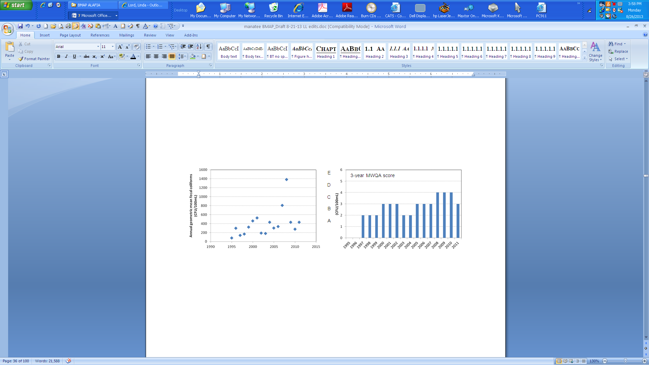
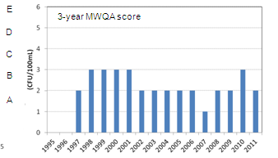

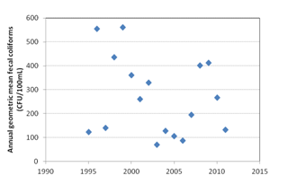
Figure 8. WBID 1923, Rattlesnake Slough: Time-series of annual geometric mean fecal coliform counts (CFU/100mL) (top panel) and 3-year MWQA scores (bottom panel) for Station TS1. Data source: Florida STORET.

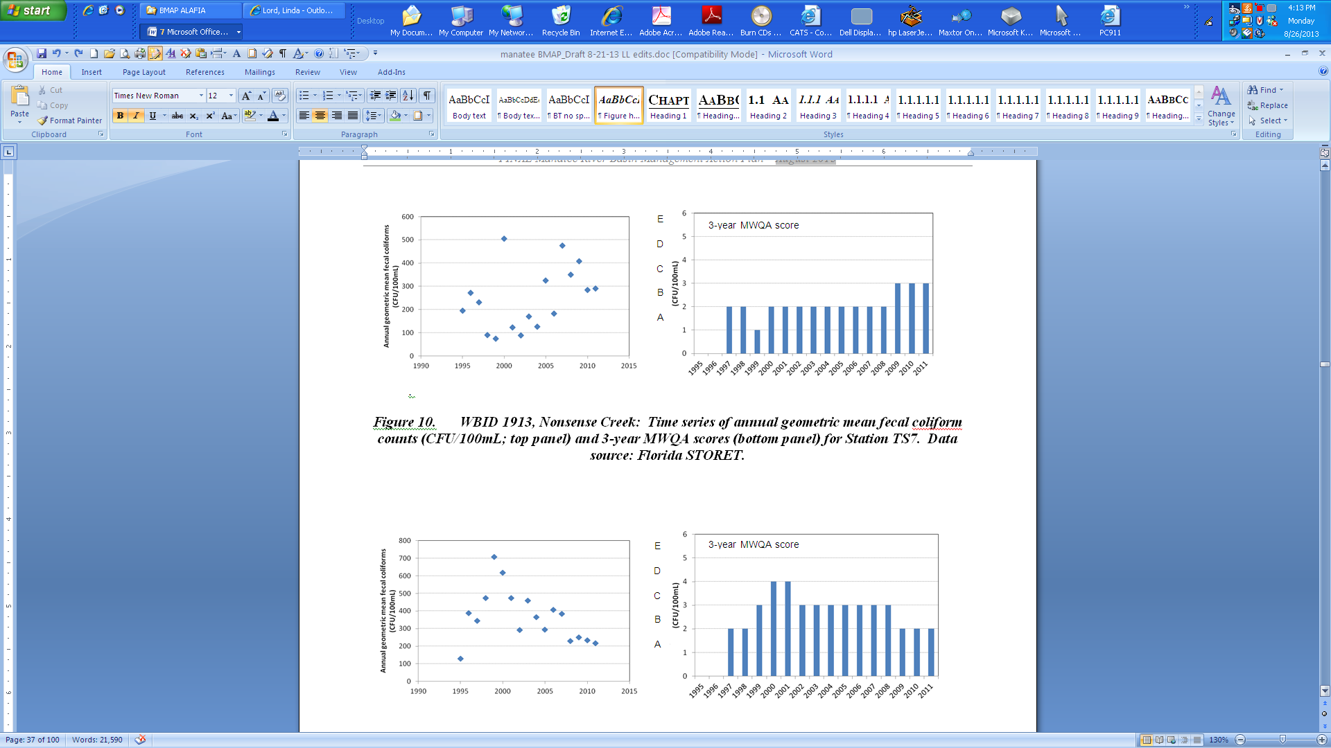

Figure 9. WBID 1926, Cedar Creek: Time-series of annual geometric mean fecal coliform counts (CFU/100mL) (top panel) and 3-year MWQA scores (bottom panel) for Station TS2. Data source: Florida STORET.
3-year MWQA score Score

Figure 10. WBID 1913, Nonsense Creek: Time-series of annual geometric mean fecal coliform counts (CFU/100mL) (top panel) and 3-year MWQA scores (bottom panel) for Station TS7. Data source: Florida STORET.

Figure 11. WBID 1914, Braden River above Evers Reservoir: Time-series of annual geometric mean fecal coliform counts (CFU/100mL) (top panel) and 3-year MWQA scores (bottom panel) for Station TS6. Data source: Florida STORET.

: Pollutant Sources, Anticipated Outcomes, and Management Actions

Summary of Sources in the TMDLs
The TMDLs include estimates of TN and TP loading and fecal coliform exceedances in the Manatee River Basin WBIDs from Phase 1 MS4s and nonpoint watershed stormwater sources, point source facilities, and nonpoint source land use inputs (agricultural and urban septic tanks). Table 5 shows the existing loads and required reductions in the TMDLs. The subsections below provide additional details about the sources included in this BMAP.

Table 5. Required reductions in the Manatee River Basin

NA = Not applicable
Manatee River  Basin WBID | TMDL Target Concentration (mg/L) | Domestic Wastewater Treatment Plant (WWTP) Point Sources  (% reduction) | Stormwater Runoff Load  (% reduction) | Fecal Coliform  (% reduction)
1923 | TN=0.84  TP=0.48  BOD=2.4 | NA | TN=30%  TP=21%  BOD=31%  FC=48% | 48%
1926 | NA | NA | FC=61% | 61%
1913 | TN=0.89  BOD=2.0 | NA | TN=27%  BOD=36%  FC=57% | 57%
1914 | NA | NA | FC=43% | 43%

Point Source facilities
Point sources include both domestic and industrial wastewater treatment facilities. Rule 62-620, F.A.C., defines domestic wastewater facilities as those facilities that are principally designed “to collect and treat sanitary wastewater or sewage from dwellings or homes, business buildings, institutions, and the like.” This rule defines industrial wastewater as “process and non-process wastewater from manufacturing, commercial, mining, and silvicultural facilities or activities, including the runoff and leachate from areas that receive pollutants associated with industrial or commercial storage, handling or processing, and all other wastewater not otherwise defined as domestic wastewater.”
In 1995, the EPA authorized the Department to implement the NPDES Program to permit wastewater discharges to state surface water, including industrial and domestic wastewater facilities. Permits are issued under the applicable provisions of Chapter 403, F.S., and appropriate rules in Rule 62-600, F.A.C., with applicable sections of 40 Code of Federal Regulations (C.F.R.) incorporated by reference. These regulations, rules, and statutes give the Department the authority to regulate domestic and industrial wastewater facilities.
There are no active NPDES-permitted facilities discharging in the Manatee River Basin.

Municipal Separate Storm Sewer Systems
Many of the municipalities in the basin are regulated by the Florida NPDES Stormwater Program because these municipalities discharge stormwater and qualify as a municipal separate storm sewer system (MS4). MS4 means a conveyance or system of conveyances such as roads with stormwater systems, municipal streets, catch basins, curbs, gutters, ditches, constructed channels, or storm drains that has the following characteristics:
- Is owned or operated by a state, city, town, county, special district, association, or other public body (created by or under state law) having jurisdiction over the management and discharge of stormwater and that discharges to surface waters of the state.
- Is designed or used for collecting or conveying stormwater.
- Is not a combined sewer.
- Is not part of a Publicly Owned Treatment Works (POTW). POTW means any device or system used in the treatment of municipal sewage or industrial wastes of a liquid nature that is owned by a “state” or “municipality.” This definition includes sewers, pipes, or other conveyances only if they convey wastewater to a POTW providing treatment.

The basic requirements of this program serve as a foundation for the stormwater management efforts of these communities. The EPA developed the federal NPDES stormwater permitting program in two phases. Phase I, which began in 1990, addresses large and medium MS4s located in incorporated areas and counties with populations of 100,000 or more, as well as specific industrial activities. Phase II, which started in 1999, addresses small MS4s that are designated according to population and other criteria established in federal and state rules. Small MS4s include MS4s that serve a population of 1,000 or more and are located in an urbanized area.
In October 2000, the EPA authorized the Department to implement the NPDES stormwater permitting program in the state. This permitting has remained separate from state Stormwater/Environmental Resource Permit (ERP) Programs and local stormwater/water quality programs, which have their own regulations and permitting requirements. Florida's rules for MS4s can be found in Rules 62-4, 62-620, 62-621, and 62-624, F.A.C. Table 6 lists the entities that are currently designated as MS4 permittees in the Manatee River Basin.

Table 6. Manatee River Basin MS4 permit holders

MS4 Type | Permittee | Permit Number
Phase I | Manatee County and Co-Permittees  (Florida Department of Transportation [FDOT] District 1) | FLS000036

3.1.2.1 Phase I MS4 Stormwater Permit Requirements
Manatee County and its co-permittees currently hold a Phase I MS4 permit. Phase I MS4 permittees are subject to a two-part permit application process requiring the development of a proposed stormwater management program (SWMP) that will meet the standard of reducing (discharged) pollutants to the Maximum Extent Practicable (MEP), and the incorporation of the SWMP into an individual permit issued to the MS4 operator. The SWMPs for Phase I MS4s include, but are not limited to, the following measures:
- Identify major outfalls and pollutant loadings.
- Detect and eliminate nonstormwater discharges (illicit discharges) to the system.
- Reduce pollutants in runoff from industrial, commercial, and residential areas.
- Control stormwater discharges from new development and redevelopment areas.
- Implement a monitoring program.

To avoid the need for reopening MS4 permits each time a TMDL or BMAP is adopted, the following language included in the Phase I MS4 permits automatically requires the implementation of any stormwater requirements in an adopted BMAP. This “TMDL clause” states: “In accordance with Section 403.067, F.S., NPDES permits must be consistent with the requirements of adopted TMDLs. Therefore, when a Basin Management Action Plan (BMAP) and/or an implementation plan for a TMDL for a water body into which the permitted MS4 discharges the pollutant of concern is adopted pursuant to Section 403.067(7), F.S., the MS4 operator must comply with the adopted provisions of the BMAP and/or implementation plan that specify activities to be undertaken by the permittee during the permit cycle.” Also, according to Paragraph 403.067(7)(a)4, F.S., the BMAP is adopted by Secretarial Order under Chapter 120.

3.1.2.2 Phase II MS4 Stormwater Permit Requirements
There is one current Phase II MS4 permit in the Manatee River Basin: Lakewood Ranch Community Development Center in WBID 1914. Under a generic permit, the operators of regulated Phase II MS4s must develop a SWMP that includes best management practices (BMPs), with measurable goals, to effectively implement the following six minimum control measures:
- Public Education and Outreach – Perform educational outreach regarding the harmful impacts of polluted stormwater runoff.
- Public Participation/Involvement – Comply with state and local public notice requirements and encourage other avenues for citizen involvement.
- Illicit Discharge Detection and Elimination – Implement a plan to detect and eliminate any nonstormwater discharges to the MS4 and create a system map showing outfall locations. Subsection 62-624.200(2), F.A.C., defines an illicit discharge as “…any discharge to an MS4 that is not composed entirely of stormwater…,” except discharges under an NPDES permit, or those listed in rule that do not cause a violation of water quality standards. Illicit discharges can include septic/sanitary sewer discharge, car wash wastewater, laundry wastewater, the improper disposal of auto and household toxics, and spills from roadway accidents.
- Construction Site Runoff Control – Implement and enforce an erosion and sediment control program for construction activities.
- Postconstruction Runoff Control – Implement and enforce a program to address discharges of postconstruction stormwater runoff from new development and redevelopment areas. (Note: This minimum control is generally met through state stormwater permitting requirements under Part IV, Chapter 373, F.S., as a qualifying alternative program.)
- Pollution Prevention/Good Housekeeping – Implement a program to reduce pollutant runoff from municipal operations and property and train staff in pollution prevention.
The Phase II generic permit (Paragraph 62-621.300[7][a], F.A.C.) also has a self-implementing clause that compels a permittee to implement its stormwater pollutant load responsibilities within an adopted BMAP. It states: “If a TMDL is approved for any water body into which the Phase II MS4 discharges, and the TMDL includes requirements for control of stormwater discharges, the operator must review its stormwater management program for consistency with the TMDL allocation. If the Phase II MS4 is not meeting its TMDL allocation, the operator must modify its stormwater management program to comply with the provisions of the TMDL Implementation Plan applicable to the operator in accordance with the schedule in the Implementation Plan.”

Anticipated Outcomes of BMAP Implementation
With the implementation of the projects outlined in this BMAP, continued reductions in the nutrient loads and the identification and remediation of fecal coliform sources in the impaired WBIDs are expected to decrease the contribution of nutrients and fecal coliforms to these WBIDs. As noted previously, most of the projects identified are a result of the previous work accomplished by the TBEP and the NMC for the ongoing Tampa Bay RA Plan. The following outcomes are expected from BMAP implementation:
- Continued improvement in water quality trends in the watershed and Tampa Bay.
- Decreased loading of the target pollutants (TN and TP).
- Identification of potential fecal coliform sources.
- Corrective action for human sources of fecal coliforms.
- Continued coordination between state and local governments and within divisions of local governments in problem solving for surface water quality restoration.
- Determination of effective projects through the stakeholder decision-making and priority-setting processes and incorporation of the projects into the existing TBEP database.
- Enhanced public awareness of pollutant sources, pollutant impacts on water quality, and corresponding corrective actions.
- Enhanced understanding of basin hydrology, water quality, and pollutant sources.

Management Actions
The Tampa Bay RA Plan Database (available: http://apdb.tbeptech.org/) currently lists 52 stakeholder projects that have been or are being implemented to improve and protect water quality in the Manatee River Basin. An additional 10 projects identified through discussions with stakeholders are listed and will be added to the action plan database in the near future. The spreadsheet in Appendix D includes information on this group of 62 projects. Additional geographic analysis will be needed to identify the projects that are relevant to the specific WBIDs addressed in this report.
In early 2013 the TBEP received approval for the Tampa Bay RA Plan update. The RA database contains a continually updated summary of stakeholder projects that will be used in the next cycle of the Tampa Bay RA process.
The WBIDs impaired for fecal coliforms are undergoing source identification through the “Walk the Waterbody” process. The information gained and projects generated from these activities will be included as an appendix to this document or as update report(s). In August 2013 the “Walk the Waterbody” process was completed for Rattlesnake Slough, WBID 1923, and Braden River, WBID 1914. The first BMAP update will include the summary reports for these efforts.

Types of Management Strategies
The TBEP database contains information on the Manatee River BMAP projects and is regularly updated. The project types and quantities listed in Table 7 are current through the beginning of 2013, and Appendix D provides details of these projects. Manatee County has implemented stormwater management ordinances that provide for a high level of treatment.

Table 7. Summary of Manatee River BMAP projects

- = Empty cell/no data
Category | Number | Total Estimated Cost
Restoration, Land Acquisition, and  Water Quality Improvement | 18 | $33,000,000
Stormwater Management | 4 | $10,000,000
Public Education and Outreach | 2 | $75,000
Agricultural BMPs | Basinwide | -
Wastewater Infrastructure Management | 3 | $3,000,000
Regulations, Ordinances, Guidelines | 5 | $10,000
Other (includes “Walk the Waterbody”) | 10 | $1,200,000

Addressing Agricultural Nonpoint Pollution
Paragraph 403.067(7)(b), F.S., requires that nonpoint pollutant sources (such as agriculture) included in a BMAP demonstrate compliance with pollutant reductions needed to meet a TMDL, either by implementing appropriate BMPs (adopted by FDACS or the Department, as applicable), or conducting water quality monitoring prescribed by the Department or the applicable water management district that demonstrates compliance with water quality standards. If pollutant sources do not either implement BMPs or conduct monitoring, they may be subject to enforcement by the Department or the applicable water management district.
Under Paragraph 403.067(7)(c), F.S., the implementation of FDACS-adopted, Department-verified BMPs in accordance with FDACS rule provides a presumption of compliance with state water quality standards. In addition, producers who implement BMPs may be eligible for cost-share funding from the water management district, FDACS, or others. The Department of Agriculture and Consumer Services will assist existing growers in selecting the applicable best management practices and entering notice of intents to confirm their usage. Among other things, the BMPs emphasize nutrient management, irrigation management, sediment/erosion control, stormwater management, and record keeping. During the initial five-year implementation period, FDACS will contact producers associated with 100% of the commercial agricultural acreage within the basin, to offer them assistance with enrolling in BMPs. FDACS will report annually to FDEP on its progress in contacting and enrolling producers, including number of operations and acres enrolled. In conducting outreach to producers, FDACS will work with the soil and water conservation districts, resource conservation and development councils, county Extension staff, and others to convey the statutory imperative for agriculture to implement BMPs, as well as their benefits to the environment and the producers.

Agricultural BMPs
BMPs are individual or combined practices determined through research, field testing, and expert review to be the most effective and practicable means for improving water quality, taking into account economic and technological considerations.
FDACS’ BMPs fall into two categories: structural and management. Structural BMPs involve the installation of structures or changes to the land, usually are more costly, and often require cost-share to be economically feasible. They include water control structures, fencing, and tailwater recovery systems, among other things. Management BMPs, such as nutrient and irrigation management, comprise the majority of BMPs and often are not readily observable. Nutrient management addresses fertilizer type, amount, placement, and application timing, and includes practices such as soil and tissue testing to determine crop nutrient needs, application methods, setbacks from water resources, etc. Irrigation management is the maintenance, scheduling, and overall efficiency rating of irrigation systems. In several areas of the state, FDACS-funded Mobile Irrigation Labs (MILs) identify and demonstrate irrigation efficiency techniques to producers. The implementation of these recommendations saves billions of gallons of water throughout the state and helps reduce nutrient runoff and leaching.
Table 8 identifies key management and structural BMPs that most likely would be applicable to agricultural operations in the basin. By definition, BMPs are technically and economically feasible. However, FDACS’ BMP manuals contain some BMPs that may be affordable only with financial assistance. The BMP checklists allow producers to indicate whether a BMP is not economically feasible, on a case-by-case basis. As BMP cost-share becomes available to the basin, FDACS will work with producers to implement applicable key BMPs that otherwise are not affordable.
OAWP BMPs and staff contact information are available at: http://www.floridaagwaterpolicy.com. Printed BMP manuals can be obtained in the local Extension Office at County Agricultural Extension Centers, or by contacting OAWP field staff.

FDACS’ OAWP Role in BMP Implementation and Follow-Up
The OAWP assists agricultural producers enrolled in its programs in implementing BMPs. It employs field staff and has contracts with service providers to work with producers to submit Notices of Intent (NOIs) to implement the BMPs appropriate for their operations. Depending on the region of the state, these providers include the soil and water conservation districts, University of Florida–Institute of Food and Agricultural Sciences (UF–IFAS), and natural resource development and conservation councils. They also provide technical assistance to producers and, as funding allows, help implement cost-share programs that leverage regional, state, and federal funds.

Table 8. Key management and structural BMPs adopted by FDACS’ OAWP¹

¹ Many practices contained in the cow/calf and equine BMP manuals help reduce the potential for fecal contamination, as well as nutrient loading.
Key OAWP Management and Structural BMPs
Determining Nutrient Needs
Soil and Tissue Testing: Used to base fertilizer applications on plant needs and available nutrients in soil; helps prevent overapplication of fertilizer.
Nutrient Budgeting: Adjustment of fertilizer regime to account for other nutrient sources, such as biosolids, legumes, manure, and nutrient-laden irrigation water; helps prevent overapplication of fertilizer.
Managing Nutrient Application
Precision Application of Nutrients: Use of specialized equipment for precise placement of nutrients on targeted areas at specified rates; reduces total amount used and prevents stray applications.
Equipment Calibration/Maintenance: Ensures proper functioning of equipment; prevents misapplication or overapplication of fertilizer materials.
Split Fertilizer Applications: Multiple applications timed with optimal growth stages; allows plants to assimilate nutrients more efficiently; reduces nutrient loss in leaching and runoff.
Fertigation: Application of fertilizer through irrigation water; allows for direct nutrient application to crop root zone and more efficient assimilation by plants, reducing nutrient loss in leaching and runoff.
Controlled-Release Fertilizer: Use of fertilizer formulations with controlled nutrient release curve; reduces nutrient loss to leaching and runoff.
Fertilizer Application Setbacks from Waterbodies (wetlands, watercourses, sinks, springs, etc.): Establishes zone where no fertilizer will be applied; reduces nutrient loadings to waterbodies.
Managing Irrigation Water and Stormwater
Irrigation Scheduling: Planning when to irrigate to reduce water and nutrient losses, based on available soil moisture content, evapotranspiration levels, recent rainfall, and time of day.
Monitoring Soil Moisture and Water Table: Use of devices that measure water table level and amount of water in soil; is key component of proper irrigation scheduling.
Tailwater Recovery: Use of downgradient catchment ponds to trap irrigation tailwater to be reused on cropland; reduces offsite transport of nutrients and conserves water.
Water Control Structures: Used to slow and/or direct flow of stormwater.
Retention/Detention Ponds: Used to capture and filter or otherwise treat stormwater onsite.
Filter Strips: Vegetated strips of land designed to reduce nutrients and sediments in surface water runoff from fields, pastures, and livestock high-intensity areas before it reaches downstream waterbodies.
Vegetative Buffers: Establishment of riparian and/or wetland buffers to attenuate and assimilate nutrient- or sediment-laden surface flows coming from cropped/grazed areas.
Ditch Maintenance and Retrofits: Use of rip rap, sediment traps, staging structures, and permanent vegetative bank cover to minimize erosion and transport of nutrient-laden sediments.
Livestock Management (Applicable to Cow/Calf and Equine Operations)
Alternative Water Sources: Use of upland livestock watering ponds and/or water troughs; minimizes manure deposition in waterbodies.
Rotational Grazing: Movement of cattle to different grazing areas on planned basis; prevents concentrated waste accumulations and denuding of pasture areas; may involve fencing.
High-Intensity Areas Location: Siting of cow pens, supplemental feed areas, etc., away from waterbodies to minimize nutrient loadings.
Operations Management
Fertilizer Storage: Proper location/storage of bulk fertilizer products to prevent nutrient loadings.
Fertilizer Mix/Load: Use of appropriate dedicated or temporary mix/load areas located away from waterbodies to prevent nutrient loading.
Employee Training: Training provided to farm workers on how to implement BMPs.
Record Keeping: Proper record keeping provides accountability in implementing BMPs and assists producers in making nutrient and irrigation management decisions.

The OAWP will assist producers in the Manatee River Basin in enrolling in adopted BMP programs applicable to their operations. OAWP staff and contractors will identify existing growers, to the greatest extent possible, with the help of grower associations, information on county agricultural exemptions, field staff knowledge, and other means. Staff/contractors will assist producers in selecting the appropriate BMPs, with emphasis on nutrient management, irrigation management, sediment/erosion control, stormwater management, and record keeping.
In addition to enrolling targeted operations in the relevant BMP programs, the OAWP will do the following:
- Document the submitted NOIs, which will include a list of the BMPs to be implemented.
- Document the amount of total agricultural acreage covered by the NOIs.
- Assist growers in understanding and implementing BMPs properly.
- On a rotating basis by program, mail written surveys to all operations in the Manatee River Basin under an active FDACS’ NOI, to evaluate BMP implementation and update information on ownership, land use, acreage, etc.
- Through regional field staff and contractors, follow up on identified areas/operations of particular concern.
- Participate in annual BMAP reporting on enrollment efforts and estimated load reductions, new manuals adopted, and any new efforts planned.

The FWRA requires that, where water quality problems are demonstrated despite the proper implementation of adopted agricultural BMPs, FDACS must re-evaluate the practices, in consultation with the Department, and modify them if necessary. Continuing water quality problems will be detected through the BMAP monitoring component and other Department and Southwest Florida Water Management District (SWFWMD) activities. If a re-evaluation of the BMPs is needed, FDACS will include SWFWMD and other partners in the process.
The FWRA states that nonpoint source dischargers who fail either to implement the appropriate BMPs or conduct water quality monitoring prescribed by the Department or a water management district may be subject to enforcement action by either of those agencies.

BMP Enrollment Goals and Load Reduction Estimates
Figure 12 shows the agricultural land use in the Manatee River BMAP area. Table 9 summarizes the land use data, the number of acres enrolled in BMP programs, and the goal for enrolling additional acres in the basin. The acreage used to calculate the starting point agricultural nutrient load is based on 2008 land use information from the SWFWMD.
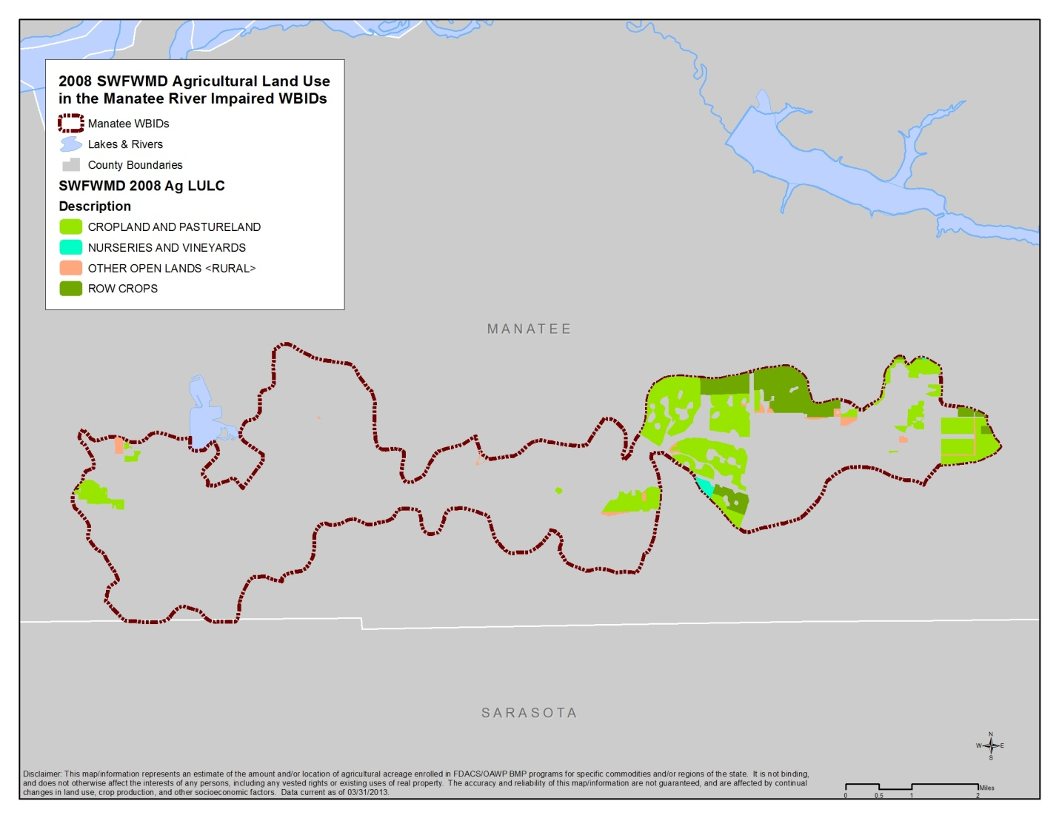
Figure 12. Agricultural land use based on 2008 SWFWMD data in the Manatee River BMAP WBIDs

It is important to understand that, even if all targeted agricultural operations are enrolled, not all of the acreage listed as agriculture in Error! Not a valid bookmark self-reference. will be included in enrollment figures. The NOIs will document the estimated total number of acres on which applicable BMPs are implemented, not the entire parcel acreage. This is because land use data can contain nonproduction acres (such as buildings, parking lots, and fallow acres) that will not be counted on the NOIs submitted to FDACS. There also may be significant amounts of acreage that do not need to be enrolled, such as lands that are not actively involved in commercial agriculture (operations conducted as a business). These areas are often low-density residential uses on large parcels of grassed land, or land that was but is no longer in commercial agricultural production. This information is impossible to discern in the photo interpretation process used to generate land use data. Local governmental, SWFWMD, or Department BMPs may address these noncommercial sources.

Table 9. Agricultural acreage, BMP enrollment, and future enrollment goals in the Manatee River Basin

¹ FDACS-adjusted acreage for purposes of enrollment is based on a review of more recent aerial imagery in the basin and local staff observations.
- = Empty cell/no data
NA = Not applicable
2008 SWFWMD Land Use | 2008 Acres | FDACS-Adjusted Acres for Enrollment¹ | Related FDACS BMP Programs | Acreage Enrolled¹ | Related NOIs/  Certification
Pastureland and Rangeland | 1,945.2 | 1,945.2 | Cow/Calf  Sod | 1,018.2  412.5 | 1  1
Row/Field/Mixed Crops | 604.7 | 604.7 | Vegetable/  Agronomic Crops | 524.4 | 2
Nurseries and Vineyards | 1.0 | 1.0 | Container Nursery | 0 | 0
Other Open Land - Rural | 114.6 | 0 | No Enrollment Needed | NA | NA
TOTAL | 2,665.5 | 2,550.9 | - | 1,958.1 | 4
Enrolled Acreage  (March 31, 2013) | - | 1,958.1 | - | - | -

Based on aerial imagery and field staff observation, FDACS adjusted these figures to reflect current agricultural land use acreage more accurately. The FDACS-adjusted acreage shows approximately 8.8% less total acreage than indicated in the 2008 figures, due to nonproduction land that would not need to be enrolled but that is included in agricultural land use and classified as “other open lands – rural.” In addition, some acreage may have ceased production since 2008 and also would not need to be enrolled in BMPs.
All agricultural nonpoint sources in the BMAP area are statutorily required either to implement FDACS-adopted BMPs or to conduct water quality monitoring that demonstrates compliance with state water quality standards.
Figure 13 shows the acres enrolled in BMPs as of March 31, 2013. The initial focus will be to work with the city of Bradenton, which leases 300 acres to a private cow/calf operation. The enrollment of these acres in FDACS BMPs is under way.
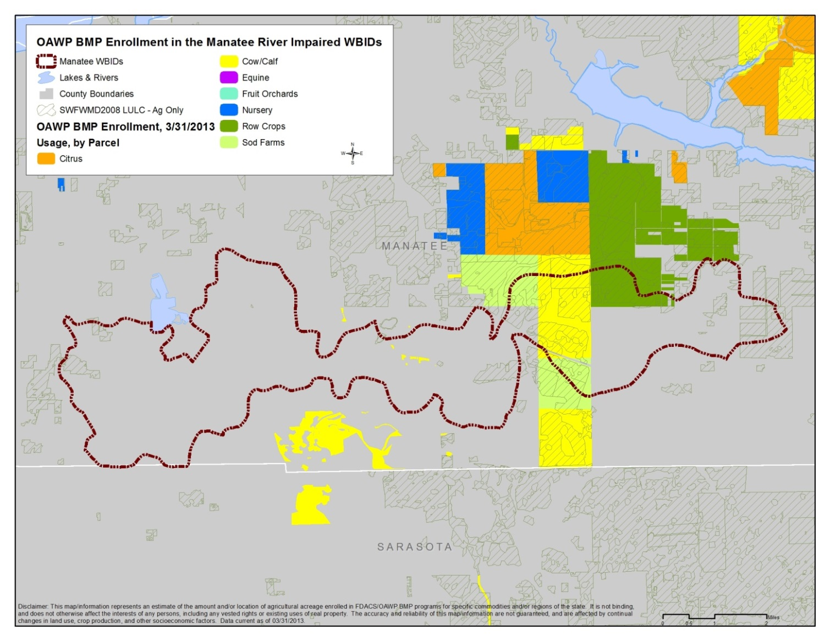
Figure 13. BMP enrollment as of March 31, 2013, in the Manatee River Basin

Due to inaccuracies in land use information and changes in land use since 2008, agricultural loadings may be less than indicated in the TMDLs. The region is expected to continue the shift from agricultural to residential/urban land uses, further reducing agricultural loading. More precise information will be incorporated into the next iteration of the TMDLs, and the estimated agricultural load will be adjusted to reflect the updated acreage figure. The potential refinement of a basin- and commodity-specific agricultural loading/reduction model should be considered during the first BMAP cycle.

Funding Elements
A BMAP must identify feasible funding strategies for implementing the management strategies presented. Appendix F lists potential funding sources and contact information. As contact information for these programs can change, it is recommended that the appropriate website be visited to obtain the most up-to-date information.

: Assessing Progress and Making Changes

Successful BMAP implementation requires commitment and follow-up. Stakeholders have committed and are required to implement the assigned projects and activities within the first five-year phase of this BMAP. The FWRA requires that an assessment be conducted every five years to determine whether there is reasonable progress in implementing the BMAP and achieving pollutant load reductions. This chapter contains the water quality monitoring component sufficient to make this evaluation.

Tracking Implementation
The Department, in conjunction with the TBEP, has constructed an updated, web-enabled database where summary information on stakeholders’ water quality protection and restoration projects can be managed and stored. That database, which includes information on projects throughout the Tampa Bay watershed, is being maintained by the TBEP as a means of tracking projects carried out to implement the Action Plans identified in the Tampa Bay Comprehensive Conservation and Management Plan (CCMP) developed by TBEP in 2006. The Action Plan Database may be accessed through its web-based portal at http://apdb.tbeptech.org/.
The Department will work with the stakeholders to organize the monitoring data and track project implementation. This information will be presented in a periodic update report. The stakeholders have agreed to meet periodically after the adoption of the BMAP to follow up on plan implementation, share new information, and continue to coordinate on TMDL-related issues. The following types of activities may occur at these meetings:
- Implementation data and reporting:
  - Collect project implementation information from the stakeholders and MS4 permit reporting and compare with the BMAP schedule. Appendix D contains the information a stakeholder will need to upload information into the existing TBEP project information database.
  - Discuss the data collection process, including any concerns and possible improvements to the process.
  - Review the monitoring plan implementation, as detailed in Section 4.2.

- Sharing new information:
  - Report on results from water quality monitoring and trend information.
  - Provide updates on new projects and programs in the watershed that will help reduce nutrient loading.
  - Identify and review new scientific developments in addressing nutrient loads and incorporate any new information into annual progress reports.

- Coordinating TMDL-related issues:
  - Provide updates from the Department on the basin cycle and activities related to any impairments, TMDLs, and BMAP.
  - Obtain reports from other basins where tools or other information may be applicable to the Manatee River TMDLs.

Covering all of these topics is not required for these meetings, but the list above provides examples of the types of information that should be considered for the agenda to assist with BMAP implementation and improve coordination among agencies and stakeholders.

Water Quality Monitoring

Water Quality Monitoring Objectives
Focused objectives are critical for a monitoring strategy to provide the information needed to evaluate implementation success. The primary and secondary objectives of the monitoring strategy for the tributaries, described below, will be used to evaluate the success of the BMAP, help interpret the data collected, and provide information for potential future refinements of the BMAP.
4.2.1.1 Primary Objective
On a baywide basis, Tampa Bay currently appears to be on track in terms of meeting its TN, chla, water clarity, and seagrass restoration goals (TBEP 2006; Yates et al. 2011). As a result, future watershed management actions will presumably focus on the TBEP’s “hold-the-line” strategy, seeking to compensate for ongoing population growth and prevent TN and TP loads from increasing as the human population of the watershed continues to expand. For those WBIDs with fecal coliform impairments, after the “Walk the Waterbody” process has identified likely sources, improvements in water quality will be documented.
4.2.1.2 Secondary Objective
Rattlesnake Slough and Nonsense Creek are located in the Evers Reservoir Watershed Overlay District. Section 604 of the Manatee County Land Development Code includes requirements that are designed to protect water quality in this potable supply watershed. Stormwater systems in the overlay district are required to meet OFW design criteria, and septic tank locations are subject to additional setback criteria. In addition, a countywide fertilizer ordinance is in place that should help to reduce fertilizer runoff from areas with residential and commercial landscaping. Water quality monitoring should be helpful in documenting the success of these activities.

Water Quality Indicators and Resource Responses
To achieve the objectives above, the monitoring strategy focuses on two types of indicators to track water quality trends: core and supplemental (Table 10a and Table 10b). The core indicators are directly related to the parameters causing impairment in the river. Supplemental indicators are monitored primarily to support the interpretation of core water quality parameters. At a minimum, the core parameters will be tracked to determine progress towards meeting the TMDLs.
Resource responses to BMAP implementation will also be tracked (Table 11). Changes in water chemistry are expected to occur within a relatively short period, depending on the actual rate of project implementation and rainfall conditions. A significant amount of time may be needed for the changes in water chemistry to be observed in the resource responses. However, resource responses represent improvements in the overall ecological health of the Manatee River.

Table 10a. Core parameters and anticipated trends

Core Parameters | Anticipated Trend
Chla (corrected) | Decrease in concentration
TP (as P) | Decrease in concentration
Orthophosphate as P | Decrease in concentration
Ammonia as N | Decrease in concentration
Nitrate/nitrite as N | Decrease in concentration
Total Kjeldahl nitrogen (TKN) | Decrease in concentration

Table 10b. Supplemental parameters and anticipated trends

Supplemental Parameters | Anticipated Trend
Specific Conductance | Monitored to support interpretation of core indicators
DO | Monitored to support interpretation of core indicators
pH | Monitored to support interpretation of core indicators
Temperature | Monitored to support interpretation of core indicators
Total Suspended Solids (TSS) | Monitored to support interpretation of core indicators

Table 11. Anticipated resource responses from BMAP implementation

Resource Responses
Reduction in Trophic State Index (TSI) score
Increase in Stream Condition Index (SCI) score
Increase in Shannon-Weaver diversity index score
Increase in key fish populations

Monitoring Network
The water quality stations listed in Appendix G and shown in Figure 14 have been historically sampled by the Department or another government agency. Data from these stations or their replacements will be utilized as the monitoring network for the Manatee BMAP WBIDs.

Quality Assurance/Quality Control
Through cooperation on TMDL-related data collection, the Department and stakeholders have consistently used similar standard operating procedures (SOPs) for field sampling and lab analyses. This consistency will continue into the future to ensure that data can be used not only for tracking BMAP progress but also for future TMDL evaluations and other purposes. The collection of water quality data will be conducted in a manner consistent with the Department’s SOPs for quality assurance/quality control (QA/QC). The most current version of these procedures is available at: http://www.dep.state.fl.us/water/sas/sop/. All stakeholders contributing data in support of the BMAP agree to follow these SOPs.

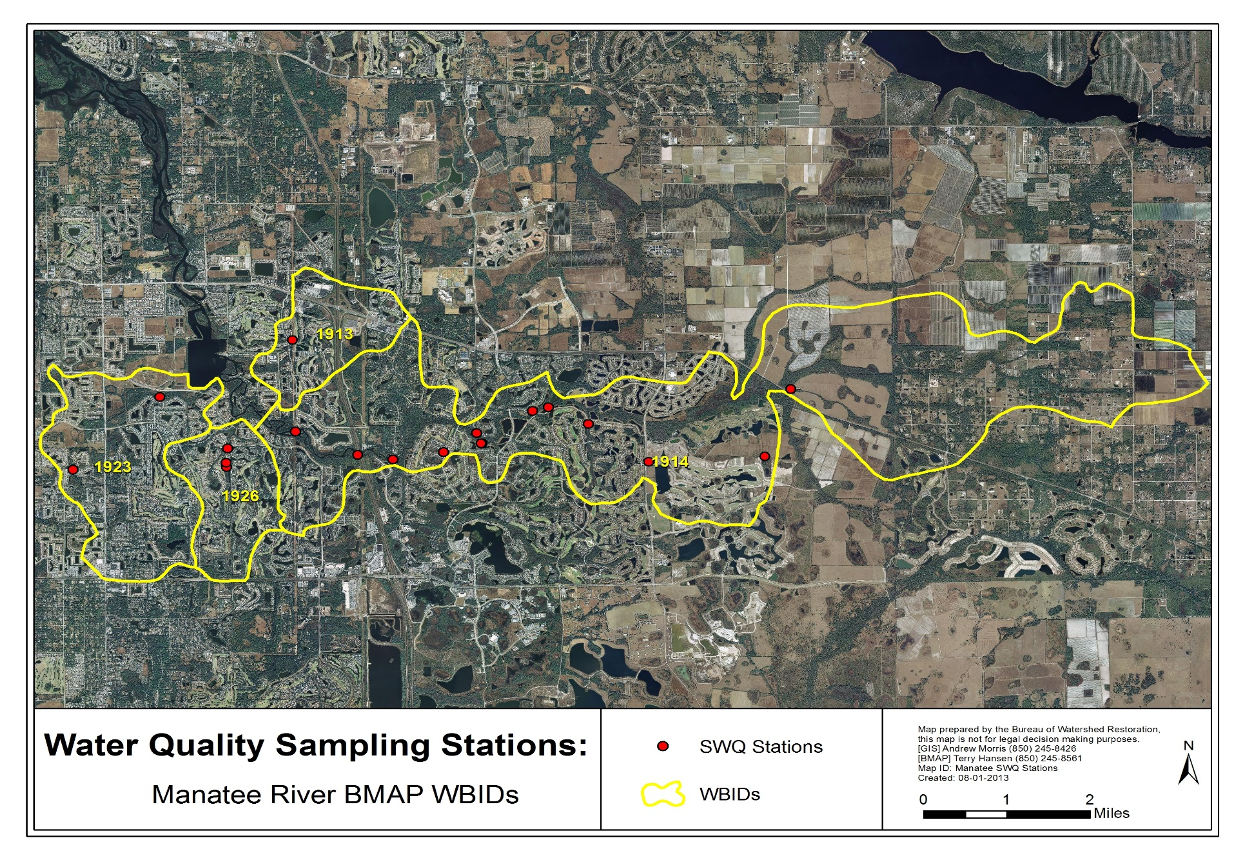
Figure 14. Water quality monitoring stations in the Manatee River BMAP WBIDs

Data Management and Assessment
Data collected as part of this monitoring plan will need to be tracked, compiled, and analyzed for it to be useful in support of the BMAP. The Florida STORET database or its replacement will serve as the primary resource for storing ambient data and providing access for all stakeholders, in accordance with Section 62-40.540, F.S. Stakeholders have agreed to upload data to STORET in a timely manner, after the appropriate QA/QC checks have been completed. All applicable data collected by the entities responsible for monitoring will be uploaded to STORET regularly, but at least quarterly. The Department will be responsible for data storage and retrieval from the STORET database.
STORET uploads are only appropriate for data that represent ambient conditions. Other data will be maintained by the entity collecting the samples. Stakeholders agree to provide this data to other BMAP partners on request and when appropriate for inclusion in BMAP data analyses and adaptive management evaluations.

Adaptive Management Measures
Adaptive management involves setting up a mechanism for making adjustments in the BMAP when circumstances change or feedback indicates the need for a more effective strategy. Adaptive management measures include the following:
- Procedures to determine whether additional cooperative strategies are needed.
- Criteria/processes for determining whether and when plan components need revision due to changes in costs, environmental impacts, social effects, watershed conditions, or other factors.
- Descriptions of the stakeholders’ role after BMAP completion.

Key components of adaptive management to share information and expertise are tracking plan implementation, monitoring water quality and pollutant loads, and holding periodic meetings.
BMAP execution will be a long-term process. The stakeholders will track implementation efforts and monitor water quality to measure effectiveness and ensure BMAP compliance. They will meet periodically to discuss implementation issues, consider new information, and, if the impaired WBIDs are not projected to meet the TMDLs, determine additional corrective actions. Project implementation as well as program and activity status will be collected annually from the participating entities. The stakeholders will review these reports to assess progress towards meeting the BMAP’s goals.
Examples of future potential actions for each WBID are as follows:
- WBID 1923 (Rattlesnake Slough) – If needed, stakeholders may wish to focus future nutrient-related BMAP activities on tracking ongoing water quality trends, assessing the biological integrity of Rattlesnake Slough, and developing a clearer understanding of the physical factors (e.g., stream flow, stream shading) and the interactions between physical factors and nutrient concentrations that affect DO levels in this WBID. An improved understanding of those factors and interactions could prove helpful in guiding future water quality management actions.
- WBID 1913 (Nonsense Creek) – If needed, stakeholders may wish to focus future nutrient-related BMAP activities in this WBID on tracking ongoing water quality trends, assessing the biological integrity of the stream using SCI evaluations, and developing a clearer understanding of the physical factors (e.g., stream flow, stream shading) and the interactions between physical factors and nutrient concentrations that affect DO levels in the waterbody.

: Commitment to Plan Implementation

Section 403.067(7), F.S., lays out the mechanisms for BMAP implementation (see Appendix B). While the BMAP is linked by statute to permitting and other enforcement processes that target individual entities, successful implementation mandates that local stakeholders willingly and consistently work together to attain adopted TMDLs. This collaboration fosters the sharing of ideas, information, and resources. The stakeholders have demonstrated their willingness to confer with and support each other in their efforts through the adoption of this document and continuing support of the efforts of the TBEP through the NMC, other estuary programs in the area, the SWFWMD, and other local groups.

APPENDICES

Appendix A: TMDL Basin Rotation Schedule

TMDLs are developed, allocated, and implemented through a watershed management approach (managing water resources within their natural boundaries) that addresses the state’s 52 major hydrologic basins in 5 groups, on a rotating schedule. Table A-1 shows the hydrologic basins within each of the five groups, with the Department District office of jurisdiction.

Table A-1. Major hydrologic basins by group and Department District Office

Depart-ment  District | Group 1  Basins | Group 2  Basins | Group 3  Basins | Group 4  Basins | Group 5  Basins
Northwest | Ochlockonee–  St. Marks | Apalachicola–  Chipola | Choctawhatchee–  St. Andrews Bay | Pensacola Bay | Perdido Bay
Northeast | Santa Fe | Lower St. Johns | Not applicable | Nassau–St. Marys | Upper East Coast
Central | Ocklawaha | Middle St. Johns | Upper St. Johns | Kissimmee | Indian River  Lagoon
Southwest | Tampa Bay | Tampa Bay  Tributaries | Sarasota Bay–  Peace–Myakka | Withlacoochee | Springs Coast
South | Everglades  West Coast | Charlotte Harbor | Caloosahatchee | Fisheating Creek | Florida Keys
Southeast | Lake  Okeechobee | St. Lucie–  Loxahatchee | Lake Worth Lagoon–  Palm Beach Coast | Southeast Coast–Biscayne Bay | Everglades

Each group will undergo a cycle of five phases on a rotating schedule:
Phase 1: Preliminary evaluation of water quality
Phase 2: Strategic monitoring and assessment to verify water quality impairments
Phase 3: Development and adoption of TMDL(s) for waters verified as impaired
Phase 4: Development of BMAP to achieve the TMDL(s)
Phase 5: Implementation of the BMAP and monitoring of results

The Manatee River Basin is a Group 1 basin. As such, the Cycle 1 list of verified impaired waters was developed in 2002, and the Cycle 2 list was developed in 2009. Subsequent TMDL and BMAP development is occurring on a schedule driven by the 1998 303(d) list (see http://www.dep.state.fl.us/water/tmdl/ for more information) and Department staff resource availability. The Department will re-evaluate impaired waters every five years to determine whether improvements are being achieved, and to refine loading estimates and TMDL allocations using new data. If any changes in a TMDL are required, the applicable TMDL rule may be revised. Changes to a TMDL would prompt revisions to the applicable BMAP, which will be revisited at least every five years and modified as necessary, regardless of whether the TMDL is modified.

Appendix B: Manatee River Basin Stakeholder Involvement in BMAP Development

Public Participation in Meetings

Six technical meetings were held during 2011 and 2012. All technical meetings were open to the public and noticed in the Florida Administrative Register (FAR). Technical meetings were open to anyone interested in participating in the technical discussions. In addition, public meetings were held on the Verified Lists, the adoption of the TMDLs, and the BMAP document.
Governmental Agency Participation in Meetings

Appropriate city and county local governmental staff attended stakeholder meetings and submitted input and project information. The TBEP coordinated project input with the stakeholders.
Public Meeting(s)

Public meetings on the proposed Verified List and the Manatee River TMDLs were held before each was adopted. In addition, a public workshop on the BMAP was held on October 23, 2013.

Appendix C: Summary of EPA-Recommended Elements of a Comprehensive Watershed Plan

The following is an excerpt on the nine elements of a watershed plan from the EPA’s Draft Handbook for Developing Watershed Plans To Restore and Protect Our Waters. Additional information regarding these elements can be found in the full version of the handbook located online at: http://water.epa.gov/polwaste/nps/handbook_index.cfm.
Nine Minimum Elements to Be Included in a Watershed Plan for Impaired Waters Funded Using Incremental Section 319 Funds
Although many different components may be included in a watershed plan, EPA has identified a minimum of nine elements that are critical for achieving improvements in water quality. EPA requires that these nine elements be addressed for watershed plans funded using incremental Section 319 funds and strongly recommends that they be included in all other watershed plans that are intended to remediate water quality impairments.
The nine elements are provided below, listed in the order in which they appear in the guidelines. Although they are listed as a through i, they do not necessarily take place sequentially. For example, element d asks for a description of the technical and financial assistance that will be needed to implement the watershed plan, but this can be done only after you have addressed elements e and i.
Explanations are provided with each element to show you what to include in your watershed plan.
Nine Elements

a. Identification of causes of impairment and pollutant sources or groups of similar sources that need to be controlled to achieve needed load reductions, and any other goals identified in the watershed plan. Sources that need to be controlled should be identified at the significant subcategory level along with estimates of the extent to which they are present in the watershed (e.g., X number of dairy cattle feedlots needing upgrading, including a rough estimate of the number of cattle per facility; Y acres of row crops needing improved nutrient management or sediment control; or Z linear miles of eroded streambank needing remediation).
What does this mean?
Your watershed plan should include a map of the watershed that locates the major sources and causes of impairment. Based on these impairments, you will set goals that will include (at a minimum) meeting the appropriate water quality standards for pollutants that threaten or impair the physical, chemical, or biological integrity of the watershed covered in the plan.
b. An estimate of the load reductions expected from management measures.
What does this mean?
You will first quantify the pollutant loads for the watershed. Based on these pollutant loads, you’ll determine the reductions needed to meet the water quality standards.
You will then identify various management measures (see element c below) that will help to reduce the pollutant loads and estimate the load reductions expected as a result of these management measures to be implemented, recognizing the difficulty in precisely predicting the performance of management measures over time.
Estimates should be provided at the same level as that required in the scale and scope component in paragraph a (e.g., the total load reduction expected for dairy cattle feedlots, row crops, or eroded streambanks). For waters for which EPA has approved or established TMDLs, the plan should identify and incorporate the TMDLs.
Applicable loads for downstream waters should be included so that water delivered to a downstream or adjacent segment does not exceed the water quality standards for the pollutant of concern at the water segment boundary. The estimate should account for reductions in pollutant loads from point and nonpoint sources identified in the TMDL as necessary to attain the applicable water quality standards.
c. A description of the management measures that will need to be implemented to achieve load reductions in paragraph 2, and a description of the critical areas in which those measures will be needed to implement this plan.
What does this mean?
The plan should describe the management measures that need to be implemented to achieve the load reductions estimated under element b, as well as to achieve any additional pollution prevention goals called out in the watershed plan. It should also identify the critical areas in which those measures will be needed to implement the plan. This can be done by using a map or a description.
d. Estimate of the amounts of technical and financial assistance needed, associated costs, and/or the sources and authorities that will be relied upon to implement this plan.
What does this mean?
You should estimate the financial and technical assistance needed to implement the entire plan. This includes implementation and long-term operation and maintenance of management measures, information and education (I/E) activities, monitoring, and evaluation activities. You should also document which relevant authorities might play a role in implementing the plan. Plan sponsors should consider the use of federal, state, local, and private funds or resources that might be available to assist in implementing the plan. Shortfalls between needs and available resources should be identified and addressed in the plan.
e. An information and education (I/E) component used to enhance public understanding of the project and encourage their early and continued participation in selecting, designing, and implementing the nonpoint source management measures that will be implemented.
What does this mean?
The plan should include an I/E component that identifies the education and outreach activities or actions that will be used to implement the plan. These I/E activities may support the adoption and long-term operation and maintenance of management practices and support stakeholder involvement efforts.
f. Schedule for implementing the management measures identified in this plan that is reasonably expeditious.
What does this mean?
You need to include a schedule for implementing the management measures outlined in your watershed plan. The schedule should reflect the milestones you develop in g.
g. A description of interim measurable milestones for determining whether management measures or other control actions are being implemented.
What does this mean?
You’ll develop interim, measurable milestones to measure progress in implementing the management measures for your watershed plan. These milestones will measure the implementation of the management measures, such as whether they are being implemented on schedule, whereas element h (see below) will measure the effectiveness of the management measures, for example, by documenting improvements in water quality.
h. A set of criteria that can be used to determine whether loading reductions are being achieved over time and substantial progress is being made toward attaining water quality standards.
What does this mean?
Using the milestones you developed above, you’ll develop a set of criteria (or indicators) with interim target values to be used to determine whether progress is being made toward reducing pollutant loads. These interim targets can be direct measurements (e.g., fecal coliform concentrations) or indirect indicators of load reduction (e.g., number of beach closings). You must also indicate how you’ll determine whether the watershed plan needs to be revised if interim targets are not met and what process will be used to revise the existing management approach. Where a nonpoint source TMDL has been established, interim targets are also needed to determine whether the TMDL needs to be revised.
i. A monitoring component to evaluate the effectiveness of the implementation efforts over time, measured against the criteria established under item h immediately above.
What does this mean?
The watershed plan must include a monitoring component to determine whether progress is being made toward attainment or maintenance of the applicable water quality standards. The monitoring program must be fully integrated with the established schedule and interim milestone criteria identified above. The monitoring component should be designed to determine whether loading reductions are being achieved over time and substantial progress in meeting water quality standards is being made. Watershed-scale monitoring can be used to measure the effects of multiple programs, projects, and trends over time. In stream monitoring does not have to be conducted for individual BMPs unless that type of monitoring is particularly relevant to the project.

Appendix D: Projects To Achieve the TMDLs

The table below sets forth the projects and activities, and the time frames for implementation of those projects and activities, required in this BMAP. Additional reductions are expected to be necessary in future BMAP phases to meet the loads specified in the TMDLs. The BMAP projects and activities represent a considerable local, regional, and state investment in a multifaceted approach to water quality protection and restoration within the Manatee River system. Responsible entities submitted these projects and activities to the Department with the understanding that the projects and activities would be included in the BMAP, thus requiring each entity to implement the proposed projects and activities and achieve the assigned load reduction estimates in a timely way. However, this list of projects and activities is meant to be flexible enough to allow for changes that may occur over time. Any change in listed projects and activities, or the deadline to complete these actions, must first be approved by the Department. Substitute projects and activities must result in equivalent or greater nutrient reductions than expected from the original projects and activities.
- = Empty cell/no data
Note: Projects shown in boldface type and yellow highlighting have not yet been entered into the Action Plan Database.
Project Name | Management  Category |  | Lead Entity/  Project Partner | Completed or  Ongoing  (Date) | Estimated Cost/  Source of Funding | General Location/  Project Description and Benefits
Overlay District Projects – Development | Stormwater Management Program |  | Manatee County | Completed (2000) | - | Manatee County has created special overlay districts to protect its potable water supplies. Lake Manatee Overlay District (WO-M) is approximately 82,240 acres, and Braden River/Evers Reservoir Overlay District (WO-E) is approximately 32,800 acres. Allowed activities in overlay districts are significantly more restrictive than in other areas of county and require stormwater treatment in overlay districts to meet OFW standards. Additionally, all tributaries in overlay districts must have minimum 50-foot buffer, and all agricultural activities are required to implement BMPs, with documentation of such management practices in Conservation Plans approved by Manatee River Soil and Water Conservation District.
Overlay District Projects – Agriculture | Agricultural BMPs |  | Manatee County | Completed (2000) | - | Manatee County has created special overlay districts to protect its potable water supplies. Lake Manatee Overlay District (WO-M) is approximately 82,240 acres, and Braden River/Evers Reservoir Overlay District (WO-E) is approximately 32,800 acres. Allowed activities in overlay districts are significantly more restrictive than in other areas of county and require stormwater treatment in overlay districts to meet OFW standards. Additionally, all tributaries in overlay districts must have minimum 50-foot buffer, and all agricultural activities are required to implement BMPs, with documentation of such management practices in Conservation Plans approved by Manatee River Soil and Water Conservation District.
Central Sewer Hook-up – Manatee County | Wastewater Infrastructure Management (Sewer and/or Septic Systems) |  | Manatee County | Completed (2003) | $3,180,026 | From 1995 to 1997, 312 units were removed from septic systems.
Tropicana Point Discharge To Deep Well Injection | Restoration, Land Acquisition, and Water Quality Improvement |  | Manatee County | Completed (2003) | $500,000 – $1,000,000/ Tropicana | Tropicana currently discharges approximately 60 pounds of nitrogen each day into Manatee River. Tropicana is investigating feasibility of removing discharge from river and disposing of its effluent via deep well injection. Funded by Tropicana.
Palmetto Estuary Preserve Habitat Restoration (Phase I) | Restoration, Land Acquisition, and Water Quality Improvement |  | SWFWMD | ongoing | - | Land acquisition for water quality improvement
Bradenton Reclaimed | Wastewater Infrastructure Management (Sewer and/or Septic Systems) |  | City of Bradenton | Completed (2000) | - | Bradenton – Mr. J. Cumming, August 2000. Inclusion of Tropicana Products as major user of reclaimed water (1.2 million gallons per day [MGD]). Other industrial users have begun discussions regarding use of 2 to 4 MGD of reclaimed water.
Ware's Creek Flood Reduction | Restoration, Land Acquisition, and Water Quality Improvement |  | Manatee County | Completed | $4,600,000/ SWFWMD | Project involves replacing four bridges and improving existing stormwater management systems at three locations.
Repowering Gannon Power Plant – Bayside Facility | Restoration, Land Acquisition, and Water Quality Improvement |  | TECO | Completed (2003) | - | Reduction calculations for TECO repowering Gannon Power Plant (renamed Bayside Facility). Completed in 2003. Conversion of coal-fired plant to natural gas, with approximately 95% reduction in nitrogen oxide (NOx) emissions.
Big Bend Power Plant Improvements | Restoration, Land Acquisition, and Water Quality Improvement |  | TECO | Completed (2004) | - | Big Bend Power Plant improvements include use of flue gas desulfurization (FGD) system or scrubber that removes sulfur dioxide produced when coal is burned in Units One, Two, Three, and Four.
Big Bend Power Plant Improvements | Restoration, Land Acquisition, and Water Quality Improvement |  | TECO | Completed (2005) | - | Big Bend Power Plant improvements include use of FGD system or scrubber that removes sulfur dioxide produced when coal is burned in Units One, Two, Three, and Four.
Hookers Point Facility –  Shut Down | Restoration, Land Acquisition, and Water Quality Improvement |  | TECO | Completed (2002) | - | Reductions calculated due to shutdown of facility – based on calculations for Big Bend and Gannon plants.
Citrus Conversion to Microirrigation | Agricultural BMPs |  | Manatee County (Cooperative Extension Service [CES]) | Completed (1995) | - | Reduction in water consumption.
Citrus Conversion to Microirrigation | Agricultural BMPs |  | Manatee County (CES) | Completed (2000) | - | Reduction in water consumption.
Field and Row Crop Conversion to Microirrigation | Agricultural BMPs |  | Manatee County (CES) | Completed (1995) | - | Reduction in water consumption.
Field and Row Crop Conversion to Microirrigation | Agricultural BMPs |  | Manatee County (CES) | Completed (2000) | - | Reduction in water consumption.
Strawberry Crop Conversion to Microirrigation | Agricultural BMPs |  | Manatee County (CES) | Completed (1995) | - | Reduction in water consumption.
Robinsons Preserve | - |  | Manatee County | Ongoing | - | Land acquisition for watershed restoration.
Pine Island | Restoration, Land Acquisition, and Water Quality Improvement |  | Manatee County | Completed (2003) | $750,000 | 78 acres of land lying in Braden River purchased for preservation.
Parrish Life Estate | Restoration, Land Acquisition, and Water Quality Improvement |  | Manatee County | Completed (2006) | $88,000 | Acquisition of approximately 500 acres contiguous with north side of Duette Park (i.e., headwaters of Manatee River) for preservation and habitat restoration.
Manatee River Headwaters Wetlands Restoration | Restoration, Land Acquisition, and Water Quality Improvement |  | Manatee County | Completed (2005) | $88,000 | Restore and rehydrate approximately 4,000 acres of wetlands impacted by historical agricultural operations in headwaters of Manatee River near Duette.
Mining Mitigation Parcel | Restoration, Land Acquisition, and Water Quality Improvement |  | Manatee County | Completed (2006) | - | As mitigation for phosphate mining activities in northwest corner of county, Mosaic Co. is preserving property located near Manatee County wellfield for wildlife habitat.
Hidden Harbour | Restoration, Land Acquisition, and Water Quality Improvement |  | Manatee County | Completed (2004) | $12,500,000 | 229 acres of land purchased for preservation.
Gulfstream Pipeline Mitigation | Restoration, Land Acquisition, and Water Quality Improvement |  | Manatee County | Completed (2008) | $1,000,000 – $3,000,000 | Gulfstream Gas Co. purchased land as part of mitigation for gas pipeline construction activities. Land will be handed over to county for management by 2008.
Neal Preserve | Restoration, Land Acquisition, and Water Quality Improvement |  | Manatee County | Completed (2005) | $9,000,000 | 114 acres of land purchased for preservation.
Duette Land Acquisition |  | Restoration, Land Acquisition, and Water Quality Improvement | Manatee County | Ongoing | - | Land acquisition for watershed restoration.
Future Land Acquisition at Duette Park |  | Restoration, Land Acquisition, and Water Quality Improvement | Manatee County | Ongoing | - | Land acquisition for watershed restoration.
Conservatory |  | Restoration, Land Acquisition, and Water Quality Improvement | Manatee County | Completed (2004) | $3,200,000 | 50 acres of land purchased for preservation.
East County Transit Route |  | Other | Manatee County | Completed | $1,800,000/ FDOT | Extending Manatee County public transportation to eastern portions of county. Coverage area includes east to Lakewood Ranch Blvd. and north to SR 64. Recommended calculating NOx reduction using Caltrans/Air Resource Board report submitted.
Artificial Reef Ball Program |  | - | Manatee County | Completed | $37,000 | Manatee County obtained grant to promote installation of small reef balls at permitted locations throughout waters adjacent to Manatee County. Using grant funds from 2001 for construction and placement of reef balls.
Gladiolus/North Shore Basin Project |  | - | Manatee County | Ongoing | - | Watershed restoration project.
Grassy Point Project |  | - | Manatee County | Ongoing | - | Watershed restoration project.
Blueways Guide |  | Public Education and Outreach | Manatee County | Completed | $20,000 | Has distributed over 10,000 copies of this public education brochure describing kayak/canoe paddling routes through waterways in and around county. Brochure also includes descriptions of commonly observed wildlife and habitats.
Prairie Schooner at Duette Park |  | Public Education and Outreach | Manatee County | Ongoing | - | Educational efforts on watersheds.
Visitors Center at Emerson Point Park |  | Public Education and Outreach | Manatee County | Ongoing | - | Educational efforts on watersheds.
Wares Creek Dredging |  | - | Manatee County | Completed (2008) | >$10,000,000/ U.S. Army Corps of Engineers (ACOE)/  Manatee County | 250,000 cubic yards of material to be dredged from Wares Creek. Material will be used to backfill borrow pits in Manatee River to restore natural depth contours.
Regatta Point Clean Marina |  | - | Manatee County | Ongoing | - | Water quality improvement.
Perico Harbor Clean Marina |  | - | Manatee County | Ongoing | - | Water quality improvement.
Jeff's Cowpen Creek Dredge and Silt Box Project |  | - | Manatee County | Completed (2003) | $400,000 | Dredge project removed approximately 9,000 cubic yards of dredge materials from Jeff’s Cowpen Creek, tributary to Braden River.
Flow Reductions within Select Watersheds |  | Stormwater Management Program | Manatee County | Completed (2005) | - | Land development cost and stormwater management design authorizes up to 50% reduction of allowable discharge rate from any new development in floodprone area.
Aquifer Storage and Recovery – North WWTP |  | Restoration, Land Acquisition, and Water Quality Improvement | Manatee County | Completed | - | Installation and use of Aquifer Storage and Recovery (ASR) wells at county's North WWTP, near Buffalo Canal. ASR wells will be used to store reclaimed water, which can then be distributed more efficiently.
Seagrass Protection Ordinance  04-72 |  | Regulations, Ordinances, and Guidelines | Manatee County | Ongoing | - | Continuing water quality project.
Irrigation Requirements for Developments |  | Regulations, Ordinances, and Guidelines | Manatee County | Completed (1999) | <$5,000 | In 2001 Manatee County Comprehensive Plan was changed to implement policy that would require all new development to use lowest quality water available for irrigation.
Clean Marina Requirement |  | Regulations, Ordinances, and Guidelines | Manatee County | Ongoing | - | Water quality improvement.
Additional Wetland Buffers for Larger Developments |  | Regulations, Ordinances, and Guidelines | Manatee County | Completed | <$5,000 | Manatee County Planning Department has begun requesting larger-than-required wetland buffers in large planned development communities located north of Manatee River.
Waterfront Initiatives –  Diamond Habitat Awards |  | Regulations, Ordinances, and Guidelines | Gus Muench (Commercial Crabber) | Completed (2005) | $600 | Three homeowners received awards for seawall/shore enhancement.
Willow/Gulf Dr./Pine Ave. |  | Stormwater Management Program | City of Anna Maria | Ongoing | - | Water quality improvement project.
Buffalo Canal Watershed Management Program |  | - | Manatee County | Ongoing | - | Watershed restoration project.
Gamble Creek Watershed Management Program |  | - | Manatee County | Ongoing | - | Watershed restoration project.
Braden River Area Surface Water Assessment |  | - | Manatee County | Completed (2012) | $300,000/ SWFWMD/  City of Bradenton | Surface Water Resource Assessment (SWRA)  for Braden River watershed.
201032-2 I-75  at SR 70 Interchange |  | Stormwater Management Program | FDOT | - | >$10,000,000 | FPID 201032-2 will improve I-75 and SR 70 interchange in Manatee County, including stormwater treatment facilities.
Agricultural BMPs |  | Agricultural BMPs | Department/  FDACS | - | - | Agricultural BMPs are practical, cost-effective actions that agricultural producers can take to reduce amount of pesticides, fertilizers, animal waste, and other pollutants entering water resources, and to increase water use efficiencies.
Agricultural BMPs |  | Agricultural BMPs | Department/  FDACS | - | - | Agricultural BMPs are practical, cost-effective actions that agricultural producers can take to reduce amount of pesticides, fertilizers, animal waste, and other pollutants entering water resources, and to increase water use efficiencies.
Reclaimed Water |  | Wastewater Infrastructure Management (Sewer and/or Septic Systems) | Braden River Utilities | Ongoing | - | Water use reduction and quality improvement.
Walk the Waterbody |  | Other | Manatee County | Completed (2012) | - | “Walk the Waterbody” exercise for Rattlesnake Slough to identify potential issues in watershed.
Walk the Waterbody |  | Other | Manatee County | ongoing | - | “Walk the Waterbody” exercise for Cedar Creek to identify potential issues in watershed.
Fertilizer Ordinance |  | Regulations, Ordinances, and Guidelines | Manatee County | Completed (2011) | - | Water quality improvement ordinance.
2010 Love Our Lake Campaign |  | - | River Club Homeowners Association | - | $2,800  (grant from SWFWMD) | Educate residents on benefits of reducing fertilizer use, provide handouts in English and Spanish, become model for other associations, measure behavioral changes with pre- and post-survey.
2011 Volunteer Water Quality Education Program |  | - | River Club Homeowners Association | - | $4,429.23 (grant from SWFWMD) | Educate residents on how to collect and test water quality samples, demonstrate how ponds treat stormwater, reduce fertilizer use June to September, Manatee County Ordinance passed June 2011 effective June 2012.
2012 Project To Reduce Nutrient Runoff in Stormwater Ponds |  | - | River Club Homeowners Association | - | - | Build on existing community initiatives, utilize community-based social marketing techniques, educate homeowners on Manatee County fertilizer ordinance, monitor effectiveness of blackout period in ordinance, monitor homeowner awareness of ordinance, test homeowners support for BMPs.
Additional Projects |  | - | River Club Homeowners Association | - | - | Flow-way maintenance projects, cooperative maintenance projects with golf course, floating tussock removal projects, shoreline restoration projects.
Agricultural BMPs  (Citrus, Cow/Calf,  Container Nurseries, Sod) |  | Agricultural BMPs | Schroeder-Manatee Ranch | - | - | Reduction in agricultural fertilizer usage.
Water Quality Monitoring |  | Special Studies, Planning, Monitoring, and Assessment | Schroeder-Manatee Ranch | - | - | Water quality improvement verification.

Manatee Annual Project Table and Information

Data must be entered into the TBEP database at: http://apdb.tbeptech.org/. Database tabs needing information include the following:
- Contact information – name, phone number, and email
- BMAP project name, Project description and location.
- Project schedule.
- Costs.
- Nonpoint source and/or point source treatment information.

Example Annual Report Update Project Table
- = Empty cell
Description of Project Phase or Milestone | Start Date of Project Phase or Milestone | Completion Date of Projecct Phase or Milestone | For Street Sweeping only, Weight of Material Collected (kg/yr) | For Catch Basins only, Weight of Material Collected (kg/yr) | For Street Sweeping and Catch Basins only (total material or dry weight of material) | For Retention BMPs only, On-Line or Off-Line | For Retention BMPs only, Inches of Retetention | For Wet Detention Ponds only, Residence Time (days) | Associated Permit #, if applicable | Description of Additional Treatment Provided Beyond Permit Requirements, if applicable
- | - | - | - | - | - | - | - | - | - | -
- | - | - | - | - | - | - | - | - | - | -

Description of Additional Treatment Provided Beyond Permit Requirements, if applicable | Project Footprint (acres) | Treated Acres | Part of Treatment Train (yes/no) | Associated Projects in Treatment Train, if applicable | Project Cost | Annual Operations and Maintenance Cost | Funding Source(s) | Project Area Map (GIS, CAD, Google Map, or hard copy) | Name of Project Area Map file (if providing electronically)
- | - | - | - | - | - | - | - | - | -
- | - | - | - | - | - | - | - | - | -

Appendix E: Glossary of Terms

303(d) List: The list of Florida's waterbodies that do not meet or are not expected to meet applicable water quality standards with technology-based controls alone.
305(b) Report: Section 305(b) of the federal Clean Water Act requires states to report biennially to the EPA on the quality of the waters in the state.
Allocation Technical Advisory Committee (ATAC): The Watershed Restoration Act of 1999 required the Department to form a Technical Advisory Committee to address issues relating to the allocation of load reductions among point source and nonpoint source contributors. The ATAC was therefore formed in order to develop recommendations for a report to the legislature on the process for allocating TMDLs.
Background: The condition of waters in the absence of human-induced alterations.
Baffle Box: An underground stormwater management device that uses barriers (or baffles) to slow the flow of untreated stormwater, allowing particulates to settle out in the box before the stormwater is released into the environment.
Baseline Period: A period of time used as a basis for later comparison.
Baseline Loading: The quantity of pollutants in a waterbody, used as a basis for later comparison.
Basin Management Action Plan (BMAP): The document that describes how a specific TMDL will be implemented; the plan describes the specific load and wasteload allocations as well as the stakeholder efforts that will be undertaken to achieve an adopted TMDL.
Basin Status Report: For the Pensacola Basin, this document was published in 2004 by the Department. The report documents the water quality issues, list of water segments under consideration for a TMDL and data needs in the basin.
Best Available Technology (BAT) Economically Achievable: As defined by 40 CFR, §125.3, outlines technology-based treatment requirements in permits.
Best Management Practices (BMPs): Methods that have been determined to be the most effective, practical means of preventing or reducing pollution from nonpoint sources.
Coliforms: Bacteria that live in the intestines (including the colon) of humans and other animals, used as a measure of the presence of feces in water or soil.
Clean Water Act (CWA): The Clean Water Act is a 1977 amendment to the Federal Water Pollution Control Act of 1972, which set the basic structure for regulating discharges of pollutants to waters of the United States.
Continuous Deflective Separation (CDS) Unit: A patented stormwater management device that uses the available energy of the storm flow to create a vortex to cause a separation of solids from fluids. Pollutants are captured inside the separation chamber, while the water passes out through the separation screen.
Designated Use: Uses specified in water quality standards for each waterbody or segment (such as drinking water, swimmable, fishable).
Detention Pond: A stormwater system that delays the downstream progress of stormwater runoff in a controlled manner, typically by using temporary storage areas and a metered outlet device.
Domestic Wastewater: Wastewater derived principally from dwellings, business buildings, institutions and the like; sanitary wastewater; sewage.
Dry Season: The dry part of the year when rainfall is low; the dry season is defined as November through May.
Effluent: Wastewater that flows into a receiving stream by way of a domestic or industrial discharge point.
Environmental Protection Agency (EPA): The agency was created in December 1970 to address the nation's urgent environmental problems and to protect the public health. The majority of the Department’s regulatory programs has counterparts at the EPA or is delegated from the EPA.
Event Mean Concentration: The flow-weighted mean concentration of an urban runoff pollutant measured during a storm event.
Exfiltration: Loss of water from a drainage system as the result of percolation or absorption into the surrounding soil.
External loading: Pollutants originating from outside a waterbody that contribute to the pollutant load of the waterbody.
Flocculent: A liquid that contains loosely aggregated, suspended particles.
Florida Department of Environmental Protection (Department): The Department is Florida's principal environmental and natural resources agency. The Florida Department of Natural Resources and the Florida Department of Environmental Regulation were merged together to create the Department effective July 1, 1993.
Ground Water or Groundwater: Water below the land surface in the zone of saturation where water is at or above atmospheric pressure.
Impairment: The condition of a waterbody that does not achieve water quality standards (designated use) due to pollutants or an unknown cause.
Load Allocations (LA): The portions of a receiving water's loading capacity that are allocated to one of its existing or future nonpoint sources of pollution.
Load Capacity: The greatest amount of loading that a waterbody can receive without violating water quality standards.
Loading: The total quantity of pollutants in stormwater runoff that contributes to the water quality impairment.
Margin of Safety (MOS): An explicit or implicit assumption used in the calculation of a TMDL, which takes into account any lack of knowledge concerning the relationship between effluent limitations and water quality. An explicit MOS is typically a percentage of the assimilative capacity or some other specific amount of pollutant loading (e.g., the loading from an out-of-state source). Most Department-adopted TMDLs include an implicit MOS based on the fact that the predictive model runs incorporate a variety of conservative assumptions (they examine worst-case ambient flow conditions, worst-case temperature, and assume that all permitted point sources discharge at their maximum permittable amount).
National Pollutant Discharge Elimination System (NPDES): The permitting process by which technology based and water quality–based controls are implemented.
Nonpoint Source (NPS): Diffuse runoff without a single point of origin that flows over the surface of the ground by stormwater and is then introduced to surface or ground water. NPS includes atmospheric deposition and runoff or leaching from agricultural lands, urban areas, unvegetated lands, OSTDS, and construction sites.
Nonpoint Source Pollution: Nonpoint source pollution is created by the flushing of pollutants from the landscape by rainfall and the resulting stormwater runoff, or by the leaching of pollutants through the soils into the ground water.
Organic Matter: Carbonaceous waste contained in plant or animal matter and originating from domestic or industrial sources.
Outfall: The place where a sewer, drain, or stream discharges.
Particulate: A minute separate particle, as of a granular substance or powder.
Pollutant Load Reduction Goals (PLRGs): PLRGs are defined as the estimated numeric reductions in pollutant loadings needed to preserve or restore designated uses of receiving waterbodies and maintain water quality consistent with applicable state water quality standards. PLRGs are developed by the water management districts.
Point Source: An identifiable and confined discharge point for one or more water pollutants, such as a pipe, channel, vessel, or ditch.
Pollutant: Generally any substance, such as a chemical or waste product, introduced into the environment that adversely affects the usefulness of a resource.
Pollution: An undesirable change in the physical, chemical, or biological characteristics of air, water, soil, or food that can adversely affect the health, survival, or activities of humans or other living organisms.
Removal efficiency: A description of how much of a given substance (metals, sediment, etc.) has been extracted from another substance.
Retention Pond: A stormwater management structure whose primary purpose is to permanently store a given volume of stormwater runoff, releasing it by infiltration and /or evaporation.
Reuse: The deliberate application of reclaimed water for a beneficial purpose. Criteria used to classify projects as “reuse” or “effluent disposal” are contained in Subsection 62-610.810, F.A.C.
Runoff Curve: A calculated number representing the percentage of rainfall that becomes runoff for a given area.
Quality Assurance (QA): An integrated system of management activities involving planning, implementation, documentation, assessment, reporting, and quality improvement to ensure that a process, product, or service meets defined standards of quality.
Quality Control (QC): The overall system of technical activities that measures the attributes and performance of a process, product, or service against defined standards to verify that they meet the established data quality objectives.
Septic Tank: A watertight receptacle constructed to promote the separation of solid and liquid components of wastewater, to provide the limited digestion of organic matter, to store solids, and to allow clarified liquid to discharge for further treatment and disposal in a soil absorption system.
STORET: The EPA's STOrage and RETrieval database, used nationally for water quality data storage.
Stormwater: Water that results from a rainfall event.
Stormwater Runoff: The portion of rainfall that hits the ground and is not evaporated, percolated, or transpired into vegetation, but rather flows over the ground surface seeking a receiving water body.
Submersed: Growing or remaining under water.
Surface Water: Water on the surface of the earth, whether contained in bounds created naturally or artificially or diffused. Water from natural springs is classified as surface water when it exits the spring onto the earth’s surface.
Total Maximum Daily Load (TMDL): The sum of the individual wasteload allocations for point sources and the load allocations for nonpoint sources and natural background. Prior to determining individual wasteload allocations and load allocations, the maximum amount of a pollutant that a waterbody or waterbody segment can assimilate from all sources while still maintaining its designated use must first be calculated. TMDLs are based on the relationship between pollutants and instream water quality conditions.
Wasteload Allocations (WLAs): Pollutant loads allotted to existing and future point sources, such as discharges from industry and sewage facilities.
Wastewater: The combination of liquid and pollutants from residences, commercial buildings, industrial plants, and institutions, together with any ground water, surface runoff, or leachate that may be present.
Waterbody Identification (WBID) Numbers: WBIDs are numbers assigned to hydrologically based drainage areas in a River basin.
Water column: The water within a waterbody between the surface and sediments.
Water Quality Index: Determines the quality of Florida's streams, blackwaters, and springs. Categories include water clarity, dissolved oxygen, oxygen-demanding substances, nutrients, bacteria, and macroinvertebrate diversity.
Water Quality Standards (WQSs): (1) Standards that comprise the designated most beneficial uses (classification of water), the numeric and narrative criteria applied to the specific water use or classification, the Florida Anti-degradation Policy, and the moderating provisions contained in Rules 62-302 and 62-4, F.A.C. (2) State-adopted and EPA-approved ambient standards for waterbodies. The standards prescribe the use of the waterbody (such as drinking, fishing and swimming, and shellfish harvesting) and establish the water quality criteria that must be met to protect designated uses.
Watershed: Topographic area that contributes or may contribute runoff to specific surface waters or an area of recharge.
Watershed Management Approach: The process of addressing water quality concerns within their natural boundaries, rather than political or regulatory boundaries. The process draws together all the participants and stakeholders in each basin to decide what problems affect the water quality in the basin, which are most important, and how they will be addressed.
Wet Season: The rainy part of the year; the wet season is defined as June through October.

Appendix F: Potential Funding Sources

A BMAP must identify feasible funding strategies for implementing the management strategies presented. This appendix provides a list of potential funding sources and contact information. As contact information for these programs can change, it is recommended that the appropriate website be visited to obtain the most up-to-date information.

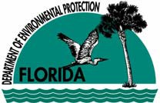

Water Resource Funding in Florida - February 2013

The Florida Department of Environmental Protection provides financial assistance to local governments and certain other entities to upgrade, expand or build wastewater, stormwater, and drinking water facilities or implement various other water quality improvement projects.
- The Clean Water State Revolving Fund (SRF) loan program provides low-interest loans to local governments to plan, design, and build or upgrade wastewater, stormwater, and nonpoint source pollution prevention projects. Certain agricultural best management practices may also qualify for funding. Discounted assistance for small communities is available. Interest rates on loans are below market rates and vary based on the economic wherewithal of the community. The Clean Water SRF is Florida’s largest financial assistance program for water infrastructure. More information is available at www.dep.state.fl.us/water/wff/cwsrf, or contact Tim Banks at timothy.banks@dep.state.fl.us or 850.245.8360.
- The Drinking Water SRF loan program provides low-interest loans to local governments and certain private utilities to plan, design, and build or upgrade drinking water systems. Discounted assistance for small communities may be available. Interest rates on loans are typically 40% below market rates. More information is available at www.dep.state.fl.us/water/wff/dwsrf, or contact Paul Brandl at paul.brandl@dep.state.fl.us or 850.245.8373.
- The Small Community Wastewater Facilities Grants Program provides grants to fund the construction of wastewater facilities in municipalities with 10,000 or fewer people and per capita income levels below Florida’s average per capita income. A local match is required. The program is linked to the Clean Water SRF loan program outlined above, and is highly competitive. More information is available at www.dep.state.fl.us/water/wff/cwsrf/smalcwgp.htm, or contact Tim Banks at timothy.banks@dep.state.fl.us or 850.245.8358.
- Florida’s Section 319 grant program administers funds received from EPA to implement projects or programs that reduce nonpoint sources of pollution. Projects or programs must benefit Florida’s priority watersheds (“impaired waters”), and local sponsors must provide at least a 40% match or in-kind contribution. Eligible activities include demonstration and evaluation of urban and agricultural stormwater BMPs, stormwater retrofits, and public education. More information is available at www.dep.state.fl.us/water/nonpoint/319h.htm, or contact Kathryn Brackett at Kathryn.Brackett@dep.state.fl.us or 850.245.8682.
- Funding for projects related to the implementation of Total Maximum Daily Load (TMDL) determinations may be available through periodic legislative appropriations to the Department. When funds are available, the program prioritizes stormwater retrofit projects to benefit impaired waters, somewhat along the lines of the Section 319 grant program listed above. More information is available at www.dep.state.fl.us/water/watersheds/tmdl_grant.htm, or contact Kathryn Brackett at Kathryn.Brackett@dep.state.fl.us or 850.245.8682.
- The Florida Legislature may solicit applications directly for Community Budget Issue Request projects, including water projects, in anticipation of upcoming legislative sessions. This process is an opportunity to secure legislative sponsorship of project funding through the state budget. The Legislature may coordinate applications with the Department. In other years, the Legislature will not solicit projects but may include them in the budget in any event. You are advised to contact your local legislative delegation to determine whether there are opportunities available to fund your project. Information on contacting Senators and Representatives is available at www.leg.state.fl.us.

There are a number of other programs at both the state and federal levels that offer the possibility of water infrastructure funding. These include:
- Florida Department of Economic Opportunity Small Cities Community Development Block Grant (CDBG) Program – Funds are available annually for water and sewer projects that benefit low- and moderate-income persons. Monies also may be available for water and sewer projects that serve a specific “job-creating entity” as long as most of the jobs created are for people with low or moderate incomes. For more information, visit http://www.floridajobs.org/community-planning-and-development/assistance-for-governments-and-organizations/florida-small-cities-community-development-block-grant-program, or contact Roger Doherty at roger.doherty@deo.myflorida.com or 850.717.8417.
- Florida Rural Water Association Loan Program – This program provides low-interest bond or bank financing for community utility projects in coordination with the Department’s SRF programs discussed above. Other financial assistance may also be available. For more information, visit www.frwa.net/ and look for the links to “Funding” and “Long-Term Financing,” or contact Gary Williams at gary.williams@frwa.net or 850.668.2746.
- Enterprise Florida – Enterprise Florida’s program is a resource for a variety of public and private projects and activities, including those in rural communities, to facilitate the creation, capital investment, and strengthening and diversification of local economies by promoting tourism, trade and economic development. The various Enterprise Florida programs and financial incentives are intended, among other things, to provide additional financial assistance to enable communities to better access other infrastructure funding programs. For more information, visit www.eflorida.com/; contact information is available from the “Contact Us” link at the top of the page.
- Florida’s five regional water management districts also offer financial assistance for a variety of water-related projects, for water supply development, water resource development, and surface water restoration. Assistance may be provided from ad valorem tax revenues or from periodic legislative appropriations for Alternative Water Supply Development and Surface Water Improvement and Management (SWIM) projects. The amount of funding available, matching requirements, and types of assistance may vary from year to year. For information on funding opportunities, contact the water management district with jurisdiction in your area—see www.dep.state.fl.us/secretary/watman for a map and links to each of the districts.
- U.S. Department of Commerce Economic Development Administration (EDA) Public Works and Development Facilities Program – The program provides funding to help distressed communities in economic decline revitalize, expand, and upgrade their physical infrastructure to attract new industry, encourage business expansion, diversify local economies, and generate or retain long-term, private sector jobs and investment. The program focuses on redeveloping existing infrastructure. For more information, visit www.eda.gov/investmentPriorities.htm, or contact Jonathan Corso at jonathan.corso@eda.gov or 404.730.3023.
- U.S. Department of Agriculture Rural Development Rural Utilities Service (RUS) Guaranteed and Direct Loans and Grants – This program provides a combination of loans and grants for water, wastewater, and solid waste projects to rural communities and small incorporated municipalities. Some nonprofit entities also may be eligible. For more information, visit http://www.rurdev.usda.gov/UWEP_HomePage.html, or contact Michael Langston at michael.langston@fl.usda.gov or 352.338.3485.
- Congress’s State and Tribal Assistance Grant Program provides the opportunity to secure Congressional sponsorship of project funding, including water project funding, through the annual federal budget process. The program’s stated purpose is to strengthen state, local governments, and tribal abilities to address environmental and public health threats while furthering environmental compliance. You may want to consider contacting your Representatives or Senators for assistance in pursuing funding; see http://thomas.loc.gov/links/.

You may also want to review the following:
- Grants.gov at http://www.grants.gov/, which is the official federal website for information on more than 1,000 federal grant programs. The site includes an automatic email notification system for keeping apprised of federal grant opportunities.
- Catalog of Federal Domestic Assistance at http://www.cfda.gov/, which provides a database of all federal programs available to state and local governments; public, quasi- public, and private profit and nonprofit organizations and institutions; specialized groups; and individuals. There are a variety of sources of niche funding that may be appropriate to your situation. There are also private funding sources (endowments, private trusts, etc.) that may, on occasion, fund water-related projects; a variety of sources to investigate these opportunities are available on the web.
- The Florida Resource Directory at http://redi.state.fl.us/ provides a searchable directory of information about and links to many state and federal programs with resources available to help local communities. Funding for water-related projects is just one of many types of assistance identified here.

If you are interested in disaster relief, your first contacts should be to Florida’s Division of Emergency Management at http://www.floridadisaster.org/ or your county emergency management agency (see www.floridadisaster.org/fl_county_em.asp); and the Federal Emergency Management Agency at 1.800.621.FEMA (3362), or visit www.fema.gov/government/grant/pa/index.shtm, where the process for securing disaster-related infrastructure assistance begins.
If you have general questions about financial assistance unrelated to any particular program, please contact Tom Shiflett with the Florida Department of Environmental Protection at tom.shiflett@dep.state.fl.us or 850.245.8339.

Appendix G: Water Quality Monitoring Stations in the Manatee River Basin

WBID | Station ID | Station Name
1923 | 21FLMANATS1 | RATTLESNAKE SLOUGH
1923 | 112WRD 023000038 | RATTLESNAKE SLOUGH NEAR SARASOTA FL
1923 | 21FLTPA 240100073 | TP114 RATTLESNAKE SLOUGH
1913 | 21FLAMANATS7 | NONSENSE CREEK
1913 | 112WRD023000039 | NONSENSE CREEK NEAR BRADENTON FL
1914 | 21FLGW 26894 | BRADEN RIVER AWL
1914 | 21FLGW 11197 | BRADEN RIVER AWL
1914 | 21FLMANATABR2 | BRADEN RIVER AWL
1914 | 21FLMANABR3 | BRADEN RIVER AWL
1914 | 21FLMANALL1 | BRADEN RIVER AWL
1914 | 21FLMANATS6 | BRADEN RIVER AWL
1926 | 21FLGW26911 | CEDAR CREEK
1926 | 21FLMANATS2 | CEDAR CREEK

Appendix H: Bibliography of Key References and Websites

Key References:
Florida Department of Environmental Protection. 2001. Water quality status report: Tampa Bay Tributaries. Tallahassee, FL: Bureau of Watershed Management. Available: http://www.dep.state.fl.us/water/basin411/tbtribs/status.htm.
———. 2003. Water quality assessment report: Tampa Bay Tributaries. Tallahassee, FL: Bureau of Watershed Management. Available: http://www.dep.state.fl.us/water/basin411/tbtribs/assessment.htm.
———. 2011. Implementation guidance for the fecal coliform Total Daily Maximum Loads adopted by the Florida Department of Environmental Protection. Tallahassee, FL.
———. 2013. Standard operating procedures. Tallahassee, FL: Bureau of Laboratories. Available: http://www.dep.state.fl.us/water/sas/sop/index.htm.
Griffith, G.E., J.M. Omernik, C.M. Rohm, and S.M. Pierson. 1994. Florida regionalization project. Corvallis, OR: Environmental Research Laboratory, U.S. Environmental Protection Agency.
Howarth, R.W., and H.W. Paerl. 2008. Coastal marine eutrophication: Control of both nitrogen and phosphorus is necessary. Proc Natl Acad Sci USA 105:E103.
Morrison, G., H.N. Swanson, V.J. Harwood, C.M. Wapnick, T. Hansen, and H.S. Greening. 2010. Using a “decision matrix” approach to develop a fecal coliform BMAP for impaired waters in the Hillsborough River watershed. In Proceedings, Tampa Bay Area Scientific Information Symposium (S.T. Cooper, Ed.), BASIS 5: 20–23 October 2009 (St. Petersburg, FL: Tampa Bay Estuary Program and Tampa Bay Regional Planning Council, pp. 402–419).
Petrus, K., and P. Kurisko. September 16, 2009. Dissolved oxygen and nutrient TMDL for Mustang Ranch Creek (WBID 1592C). TMDL report. Tallahassee, FL: Florida Department of Environmental Protection, Bureau of Watershed Restoration. Available: http://www.epa.gov/waters/tmdldocs/37513_mustangranchcrk_WBID1592C_DO&Nuts.pdf.
Petrus, K., and K. Laskis. September 16, 2009. Dissolved oxygen and nutrient TMDL for the Alafia River above Hillsborough Bay – Tidal Segment (WBID 1621G). TMDL report. Tallahassee, FL: Florida Department of Environmental Protection, Bureau of Watershed Restoration. Available: http://www.epa.gov/waters/tmdldocs/37512_alatidal_WBID1621G_DO_Nuts.pdf.
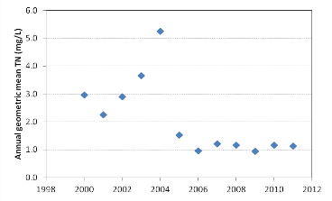
Rose, J.B., J.H. Paul, M.R. McLaughlin, V.J. Harwood, and S.Farrah et al. 2001. Healthy beaches Tampa Bay: Microbiological monitoring of water quality conditions and public health impacts. Tampa Bay Estuary Program Technical Report #03-01. St. Petersburg, FL.
Schindler, D.W. et al. 2008. Eutrophication of lakes cannot be controlled by reducing nitrogen input: Results of a 37-year whole-ecosystem experiment. Proc Natl Acad Sci USA 105:11254–11258.
Southwest Florida Water Management District. April 26, 2001. Manatee River comprehensive watershed management plan. Available: http://www.swfwmd.state.fl.us/documents/plans/cwm/cwm-manateeriver.pdf.
Tampa Bay Estuary Program. 2006. Charting the course: The comprehensive conservation and management plan for Tampa Bay. St. Petersburg, FL.
U.S. Environmental Protection Agency. March 2008. Draft handbook for developing watershed plans to restore and protect our waters. Washington, DC: Office of Water. Available: http://water.epa.gov/polwaste/nps/handbook_index.cfm.
Wainwright, D. September 17, 2004. Nutrient and dissolved oxygen TMDL for Thirty Mile Creek, Polk County, Florida, WBID 1639. TMDL report. Tallahassee, FL: Florida Department of Environmental Protection, Bureau of Watershed Management. Available: http://www.dep.state.fl.us/water/tmdl/docs/tmdls/final/gp3/ThirtyMileCreekDOTMDL.pdf.
Yates, K.K., H.S. Greening, and G. Morrison. 2011. Integrating science and resource management in Tampa Bay, Florida. U.S. Geological Survey Circular 1348. St. Petersburg, FL.

Stormwater and Water Quality Protection Websites:

Table H-1. Local stormwater and water quality protection websites
Entity/Program | Website Link
Manatee County | http://www.mymanatee.org
Tampa Bay Estuary Program | http://www.tbep.org/
Manatee County Water Atlas | http://www.manatee.wateratlas.usf.edu/
Southwest Florida Water Management District | http://www.swfwmd.state.fl.us/

Table H-2. State stormwater and water quality protection websites
Entity/Program | Website Link
General Portal for Florida | http://www.myflorida.com
Department | http://www.dep.state.fl.us/
Watershed Management | http://www.dep.state.fl.us/water/watersheds/index.htm
TMDL Program | http://www.dep.state.fl.us/water/tmdl/index.htm
BMPs, Public Information | http://www.dep.state.fl.us/water/nonpoint/pubs.htm
NPDES Stormwater Program | http://www.dep.state.fl.us/water/stormwater/npdes/index.htm
Nonpoint Source (NPS) Funding Assistance | http://www.dep.state.fl.us/water/nonpoint/319h.htm
Surface Water Quality Standards | http://www.dep.state.fl.us/legal/Rules/shared/62-302/62-302.pdf
Water Quality Status Report:  Tampa Bay Tributaries | http://www.dep.state.fl.us/water/basin411/tbtribs/status.htm
Water Quality Assessment Report:  Tampa Bay Tributaries | http://www.dep.state.fl.us/water/basin411/tbtribs/assessment.htm
Florida Department of Health | http://www.doh.state.fl.us
Standards for Onsite Sewage Treatment and Disposal Systems (OSTDS) | http://www.doh.state.fl.us/environment/ostds/pdfiles/forms/64e620070924.pdf

Table H-3. National stormwater and water quality protection websites
Entity/Program | Website Link
Center for Watershed Protection | http://www.cwp.org/
EPA Office of Water | http://www.epa.gov/water
EPA Region 4 (Southeast United States) | http://www.epa.gov/region4
EPA Sanitary Sewer Overflow (SSO) Fact Sheet | http://water.epa.gov/infrastructure/greeninfrastructure/upload/EPA-Green-Infrastructure-Factsheet-3-061512-PJ.pdf

