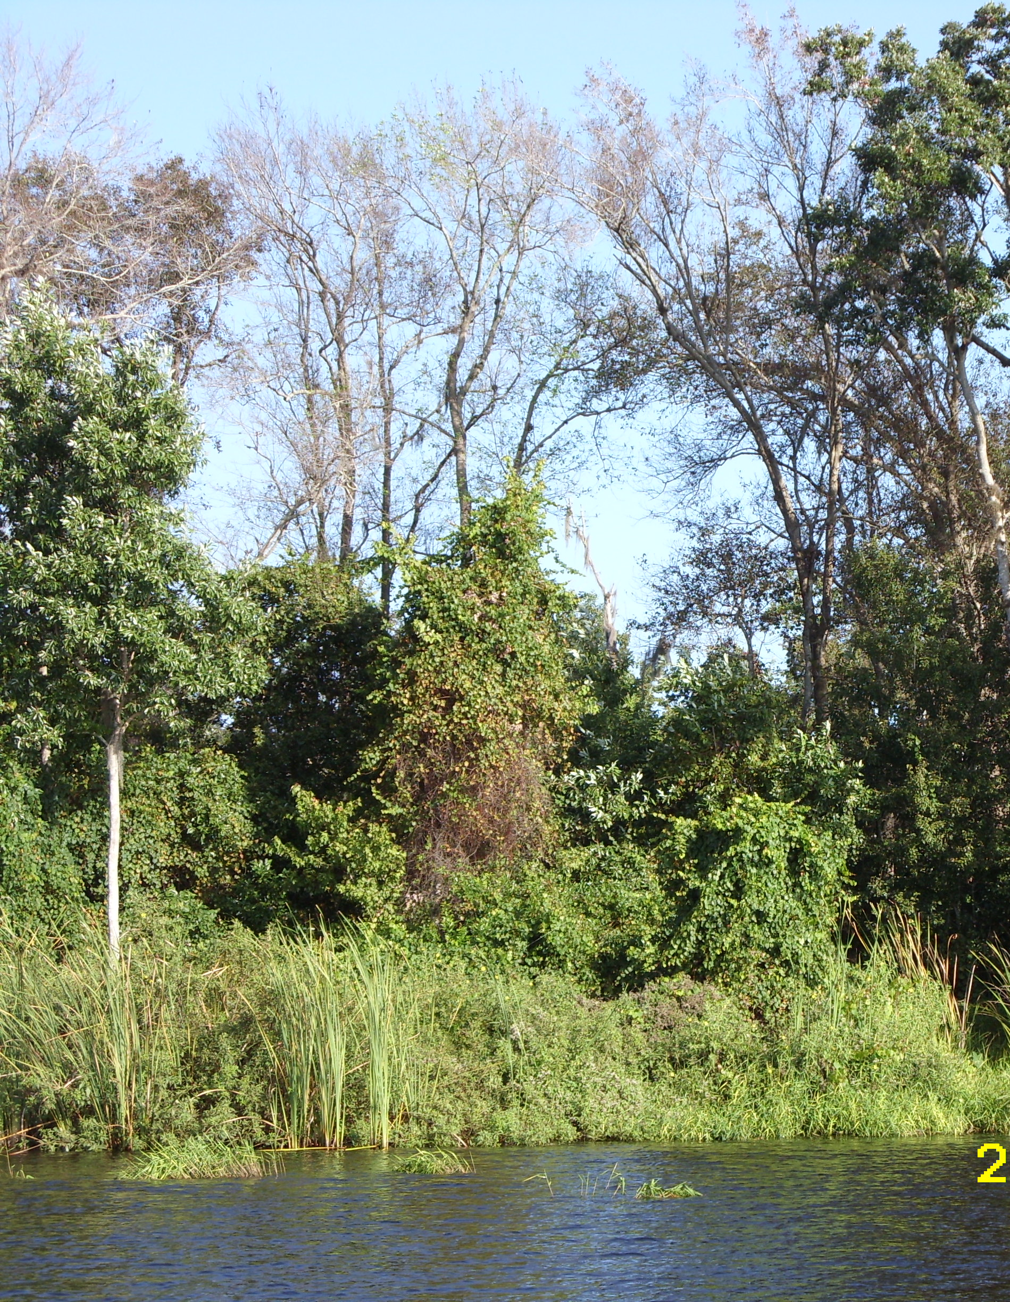

Winter Haven Chain of Lakes
Water Quality Management Plan
Revised Summary Report –Task II
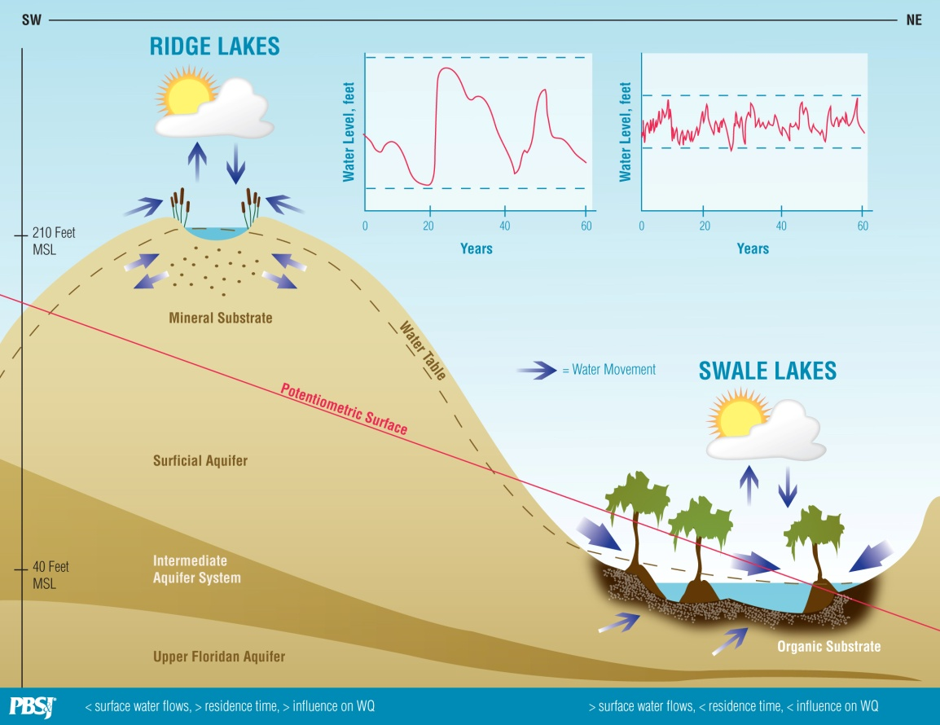
VALLEY LAKES

Submitted to :

Prepared by:
4030 West Boy Scout Boulevard Suite 700
Tampa, Florida 33607

May 2010

VALLEY LAKES
Table of Contents
Table of Contents i
1.0 Introduction 1-1
1.1. Project Objective 1-1
1.2. Project Area 1-2
2.0 Establishment of Criteria for Best Management Practices 2-1
2.1. Background on Water Quality Goals and TMDLs 2-1
2.2. Development of Appropriate Water Quality Criteria 2-2
2.3. Influence of Factors Other than Nutrients on Levels of Chlorophyll-a 2-10
2.4. Historical Trends in Lake Levels 2-15
2.5. Long-term Variations in Rainfall Patterns 2-22
2.6. Rainfall and Variations in Lake Levels 2-25
2.7. Relationships between Rainfall Patterns and Lake Levels 2-27
2.8. Influence of Forested Wetlands on Water Quality in Valley Lakes 2-31
3.0 Review of Lake Management Practices 3-1
4.0 Conclusions 4-1
5.0 Recommendations 5-1
6.0 Literature Cited 6-1

List of Figures:
Figure 1 Winter Haven Chain of Lakes physical setting (map from SWFWMD, 1998). 1-3
Figure 2 Conceptual model of Ridge and Valley lakes within the WHCL 2-3
Figure 3 EPA Numeric nutrient criteria guidance for high color lakes. 2-4
Figure 4 EPA Numeric nutrient criteria guidance for low color lakes. 2-5
Figure 5 EPA Numeric nutrient criteria guidance for low color lakes. 2-7
Figure 6 Relationship between lake level, in feet (NGVD) and chlorophyll-a (µg / liter) for Lake Blue 2-11
Figure 7 Lake level, in feet (NGVD 1929) over time for Lake Cannon 2-15
Figure 8 Lake level, in feet (NGVD 1929) over time for Lake Eloise 2-16
Figure 9 Lake level, in feet (NGVD 1929) over time for Lake Fannie 2-16
Figure 10 Lake level, in feet (NGVD 1929) over time for Lake Hamilton 2-17
Figure 11 Lake level, in feet (NGVD 1929) over time for Lake Howard 2-17
Figure 12 Lake level, in feet (NGVD 1929) over time for Lake Lulu 2-19
Figure 13 Lake level, in feet (NGVD 1929) over time for Lake Smart 2-19
Figure 14 Average monthly Polk Count rainfall (1940-2008). 2-22
Figure 15 Long-term and five-year moving average rainfall patterns for Polk County for monthly rainfall, annual rainfall, wet-season rainfall, and dry-season rainfall. 2-24
Figure 16 Comparisons of lake levels and rainfall patterns for Lakes Fannie, Hamilton, Howard, and Smart. 2-26
Figure 17 Comparisons of lake levels and rainfall patterns for selected model terms 2-28
Figure 18 An example of how data were overlaid in GIS to obtain elevation data around historic and existing lake edges. 2-30
Figure 19 Comparison of lake level elevations in historical (1850s) and current times. Elevations in feet (NGVD 1929). 2-31
Figure 20 Relationship between TP (mg / liter) and chlorophyll-a (µg / liter) in Lakes Henry and Lulu. 2-32
Figure 21 Concentrations of chlorophyll-a (µg / liter), TN (mg / liter x 10), TP (mg / liter x 100) and Color (PCU / 10) in Lakes Henry and Lulu. Data are median values from 1997 to 2007. 2-33
Figure 22 Water clarity (Secchi disk depth in feet) for Lake Howard. Line is three-point moving average. Shaded area denotes approximate time of stormwater retrofit project. 3-1
Figure 23 Water clarity (Secchi disk depth in feet) for Lake May. Line is three-point moving average. Shaded area denotes approximate time of stormwater retrofit project. 3-2
Figure 24 Water clarity (Secchi disk depth in feet) for Lake Lulu. Line is three-point moving average. Shaded area denotes approximate time of stormwater retrofit project. 3-2
Figure 25 Chlorophyll-a (µg / liter) for Lake Howard. Line is three-point moving average. Shaded area denotes approximate time of stormwater retrofit project. 3-3
Figure 26 Chlorophyll-a (µg / liter) for Lake May. Line is three-point moving average. Shaded area denotes approximate time of stormwater retrofit project. 3-3
Figure 27 Chlorophyll-a (µg / liter) for Lake Lulu. Line is three-point moving average. Shaded area denotes approximate time of stormwater retrofit project. 3-4
Figure 28 Total phosphorus (mg TP / liter) for Lake Howard. Line is three-point moving average. Shaded area denotes approximate time of stormwater retrofit project. 3-5
Figure 29 Total phosphorus (mg TP / liter) for Lake May. Line is three-point moving average. Shaded area denotes approximate time of stormwater retrofit project. 3-5
Figure 30 Total phosphorus (mg TP / liter) for Lake Lulu. Line is three-point moving average. Shaded area denotes approximate time of stormwater retrofit project. 3-6
Figure 31 Water clarity (Secchi disk depths in feet) for Lakes Conine and Parker. Line is three-point moving average. Shaded area denotes approximate time of whole-lake alum treatment for Lake Conine. 3-7
Figure 32 Chlorophyll-a (µg / liter) for Lakes Conine and Parker. Line is three-point moving average. Shaded area denotes approximate time of whole-lake alum treatment for Lake Conine. 3-7
Figure 33 Total phosphorous (mg TP / liter) for Lakes Conine and Parker. Line is three-point moving average. Shaded area denotes approximate time of whole-lake alum treatment for Lake Conine. 3-8
Figure 34 Water clarity (Secchi disk depths in feet) for Banana Lake and Lake Parker. Line is three-point moving average. Shaded area denotes approximate time of sediment dredging project for Banana Lake. 3-9
Figure 35 Water clarity (Secchi disk depths in feet) for Lake Hollingsworth and Lake Parker. Line is three-point moving average. Green shaded area denotes approximate time of sediment removal project for Lake Hollingsworth. Orange shaded area denotes approximate time of whole-lake alum project for Lake Hollingsworth. 3-9
Figure 36 Chlorophyll-a (µg / liter) for Banana Lake and Lake Parker. Line is three-point moving average. Shaded area denotes approximate time of sediment dredging project for Banana Lake. 3-10
Figure 37 Chlorophyll-a (µg / liter) for Lake Hollingsworth and Lake Parker. Line is three-point moving average. Green shaded area denotes approximate time of sediment removal project for Lake Hollingsworth. Orange shaded area denotes approximate time of whole-lake alum project for Lake Hollingsworth. 3-10
Figure 38 Total phosphorus (mg / liter) for Banana Lake and Lake Parker. Line is three-point moving average. Shaded area denotes approximate time of sediment dredging project for Banana Lake. 3-11
Figure 39 Total phosphorus (mg / liter) for Lake Hollingsworth and Lake Parker. Line is three-point moving average. Green shaded area denotes approximate time of sediment removal project for Lake Hollingsworth. Orange shaded area denotes approximate time of whole-lake alum project for Lake Hollingsworth. 3-11
Figure 40 Chlorophyll-a in Lake Trafford. Line is three-point moving average. Shaded area denotes approximate time of sediment removal project. 3-13

List of Tables:
Table 1 Classification of lakes of the WHCL into Ridge or Valley, Clear or Colored, and Acidic or Alkaline Categories. Ridge vs. Valley classifications from PBS&J (2008). All other classifications use criteria outlined in Weaver and Hendrickson (2009) and EPA (2010). NA = not applicable. 2-6
Table 2 Target and median values (1997 to 2007) for chlorophyll-a (µg/liter) for WHCL using methodology outlined in EPA (2010) and modified using locally-derived specific conductance threshold values for alkalinity. 2-8
Table 3 Target and median values (1997 to 2007) for total phosphorus (mg TP/liter) and total nitrogen (mg TN/liter) for WHCL using methodology outlined in EPA (2010) and modified using locally-derived specific conductance threshold values for alkalinity 2-9
Table 4 Regression analysis of lake levels and chlorophyll-a, total nitrogen and total phosphorus (data from PBS&J 2008). 2-12
Table 5 Summary of available information on point source discharge history of various WHCL lakes (compiled from various sources). 2-14
Table 6 Summary of trends over time in lake levels in Polk County. Data from Spechler and Kroening (2006). 2-21
Table 7 Summary of Best-Fit Models of Lake Level and Preceding Rainfall 2-28
Table 8 Mean and median values for chlorophyll-a (µg / liter), TP (mg / liter) and TN (mg / liter) for lakes with color levels < 50 PCU compared to lakes with > 50 PCU. Data are from 1997 to 2007. 2-32
Table 9 Summary of water quality proposed interim water quality targets and restoration project types proposed for the WHCL. 5-2

Introduction

Project Objective
The objective of this project is to develop a Water Quality Management Plan (WQMP) for the Northern and Southern Winter Haven Chain of Lakes (WHCL). The WQMP is intended to give specific project recommendations that could be used to meet the requirements of the Florida Department of Environmental Protection’s (FDEP) Total Maximum Daily Load (TMDL) program, to describe expected water quality improvements with the proposed projects, to provide cost estimates for the recommended projects, and to develop a list of recommended funding sources and potential cooperators for project implementation. This project is consistent with the Winter Haven Chain of Lakes Surface Water Improvement and Management (SWIM) Plan, as well as the WHCL Pre-BMAP (Basin Management Action Plan) Assessment report (PBS&J 2008) prepared for the FDEP.
The WQMP for the WHCL has four deliverables.
- Task I, which has already been completed, involved the development of a data collection plan and a summary report.
- Task II, which is the topic of this report, involves the establishment of criteria for Best Management Practices (BMP) so that appropriate BMPs can be designed for individual lakes.
- Task III, which is yet to be completed, involves the development of conceptual restoration plans for each lake, if the data support a lake by lake conceptual plan. This task will involve the development of project alternatives and lake-specific BMPs as well as descriptions of individual proposed projects including alternatives and budgets.
- Task IV, yet to be started, involves the preparation of a WQMP with recommendations as to project prioritization, more refined cost estimates of selected lake restoration projects, a cost: benefit estimate of the value of proposed projects, and a plan for future data collection efforts to ensure that lake restoration projects are providing their expected benefits.
This Summary Report for Task II is the second deliverable of the WQMP. The original scope of work for this WQMP was placed on hold to give the FDEP time to complete their pre-BMAP effort (PBS&J 2008) which involved an assessment of the loading models, water quality goals, and lake restoration projects suggested for implementation in the WHCL TMDL report (FDEP 2007). The intent of this WQMP is to take information from the SWIM Plan (SWFWMD 1998), the TMDL report (FDEP 2007) and the pre-BMAP report (PBS&J 2008) and move forward in creating a master plan for implementation. This Summary Report establishes criteria for BMPs and proposed projects for restoring water quality in the WHCL; it is based in large part on FDEP’s Pre-BMAP report (PBS&J 2008).

Project Area

The WHCL is a priority waterbody of the Southwest Florida Water Management District’s (SWFWMD) SWIM program and consists of 19 interconnected lakes divided into a Southern and Northern Chain (Figure 1).
The WHCL is generally divided into the Northern Chain, consisting of 5 lakes, and the Southern Chain, consisting of 16 lakes. The Northern Chain lakes include Conine, Rochelle, Haines, Smart and Fannie. The Southern Chain lakes consist of Winterset, Eloise, Summit, Lulu, Roy, Shipp, May, Howard, Cannon, Blue, Mirror, Spring, Idylwild, Jessie, Mariana, and Hartridge. Lakes Blue and Mariana connect to the other lakes in the Southern Chain only when water levels reach set lake operational levels. The watershed of the WHCL is approximate 32 square miles in size (FDEP 2007).
Many of these lakes have been negatively impacted through historical point and non-point sources of pollution and many have been listed as impaired. The development of this WQMP involves incorporating existing information, obtaining additional data (where needed), and using previously developed nutrient budget and water quality studies to develop water quality management plans for the WHCL. The additional information will be used to evaluate alternatives and BMPs that could be used to improve water quality in the WHCL. The intent of the City of Winter Haven is to incorporate the findings of the WQMP into the TMDL BMAP process and in the upcoming revision of the SWFWMD’s SWIM Plan for the WHCL.

Figure 1
Winter Haven Chain of Lakes physical setting (map from SWFWMD, 1998).

Establishment of Criteria for Best Management Practices

Background on Water Quality Goals and TMDLs
In January of 2010, the US Environmental Protection Agency (EPA) produced proposed rules to establish water quality standards for Florida waters, including lakes such as those in the WHCL system (EPA 2010). EPA (2010) concluded that numeric nutrient criteria (NNC) are necessary for the State of Florida to meets the requirements outlined in section 303(c) of the Federal Clean Water Act. While EPA (2010) remarked upon the considerable progress made by FDEP and its stakeholder partners to diagnose and control nutrient-induced water degradation, it concluded that water quality standards “…in the form of numeric nutrient water quality criteria are necessary to meet the requirements of the CWA in the State of Florida.” In Florida, EPA (2010) has developed water quality standards for lakes based on levels of “color” (i.e., tannins) and alkalinity. While this recent involvement of EPA into the lake management process in Florida could have been problematic, the proposed NNC from EPA (2010) share many of the features of the independently derived nutrient-chlorophyll relationships previously derived for the WHCL system, as outlined in FDEP’s pre-BMAP report for the WHCL (PBS&J 2008). However, there is at least one major modification that needs to be incorporated, the division between clear, acidic lakes and clear, alkaline lakes needs to be adjusted for local conditions. This topic will be discussed in greater detail below in Section 2.2
Prior efforts by FDEP have resulted in the conclusion that numerous impairments exist for the WHCL system, based on FDEP’s prior use of the Trophic State Index (TSI), using guidance outlined in FDEP’s Impaired Water Rule (IWR). The IWR methodology had two TSI thresholds, depending upon the levels of color (i.e., “tannins”) as quantified via platinum cobalt units (PCU), similar to the NNC developed by EPA (2010). Lakes in which the mean annual color is greater than 40 PCU were placed on the Verified List if the annual mean TSI value for the lake exceeded 60. Where levels of color were less than or equal to 40 PCU, lakes were placed on the Verified List if annual mean TSI value exceeded 40. Lakes with high levels of tannins were considered to be more “tolerant” of elevated nutrient availability than lakes with lower levels of tannins.
In its TMDL report for the WHCL, FDEP (2007) used a TSI threshold of 60 to develop nutrient TMDLs for listed lakes, even though most lakes in the WHCL system had PCU levels less than 40. This approach was considered to be appropriate, as prior investigations of the paleolimnology of the lakes indicated that WHCL lakes most likely had pre-development TSI values higher than 40, as pre-development chlorophyll-a concentrations were likely in excess of 5 µg / liter (the chlorophyll-a concentration equivalent to a TSI_{chla} value of 40; Whitmore and Brenner 1995).
The original Draft Verified List produced by FDEP included Lakes Winterset, Eloise, Hartridge, and Fannie. The annual average TSI values from these lakes exceeded the original default TSI value of 40. These four lakes were subsequently removed from the Verified List, as they did not exceed the revised and site-specific TSI threshold of 60 (equivalent to a TSI_{chla} value of 20 µg / liter) based on the findings of Whitmore and Brenner (1995).
Within this context, a system-wide TSI goal of 60 was selected by the SWFWMD in its Pollutant Load Reduction Goal (PLRG) report (USF 2005). This PLRG was then used by FDEP in its TMDL calculations (FDEP 2007). This PLRG might be overly protective in some lakes, and not fully protective in others. For example, the paleolimnological work conducted on the WHCL used to develop the alternative TSI goal of 60 was limited to five lakes (Lakes Conine, Haines, Hartridge, Howard, and May). The conclusion of the paleolimnological study (Whitmore and Brenner 1995) was that these five lakes were historically mesotrophic to eutrophic, which led the authors to conclude that these lakes would have had pre-development TSI values in the range of 50 to 60. Therefore, the TSI goal of 60 for the WHCL is based on not exceeding the upper end of the range of historical water quality conditions derived from a subset of 5 lakes, out of a total of 21 lakes in the WHCL.
An additional topic related to TMDLs and BMAPs for the WHCL is the role of tannins in moderating algal growth. For Wolf Lake in Highlands County, elevated levels of total nitrogen (mean value of 1.30 mg TN /liter ) and total phosphorus (mean value of 0.24 mg TP / liter) are not expressed as elevated chlorophyll-a concentrations (mean value of 15.5 µg / liter), perhaps due to the high levels of tannins in the lake (mean value of 346 PCU). Highlands County has summarized Wolf Lake’s water quality issues as, “Despite the high nutrient levels, algae populations, as estimated by the chlorophyll-a concentration in the water, are low in this lake. This may be due to heavy natural staining of the water that reduces light penetration needed for algal growth.”

Development of Appropriate Water Quality Criteria
FDEP’s Pre-BMAP report (PBS&J 2008) contained the conclusion that lakes within the WHCL system tend to fit within two major class variables – “Ridge” lakes and “Valley” lakes. Ridge lakes are those that are found in higher elevations, where soil types are typically well-drained, mineral-rich and low in organic contents. Ridge lakes roughly correspond to the “low color” lakes described by EPA (2010). Valley lakes are those found in lower elevations, where soil types are typically moderately to poorly drained, and where the organic content is higher and the mineral content is lower. Valley lakes roughly correspond to the “high color” lakes described by EPA (2010). Figure 2 illustrates a conceptual model of these two lake types.

Figure 2
Conceptual model of Ridge and Valley lakes within the WHCL
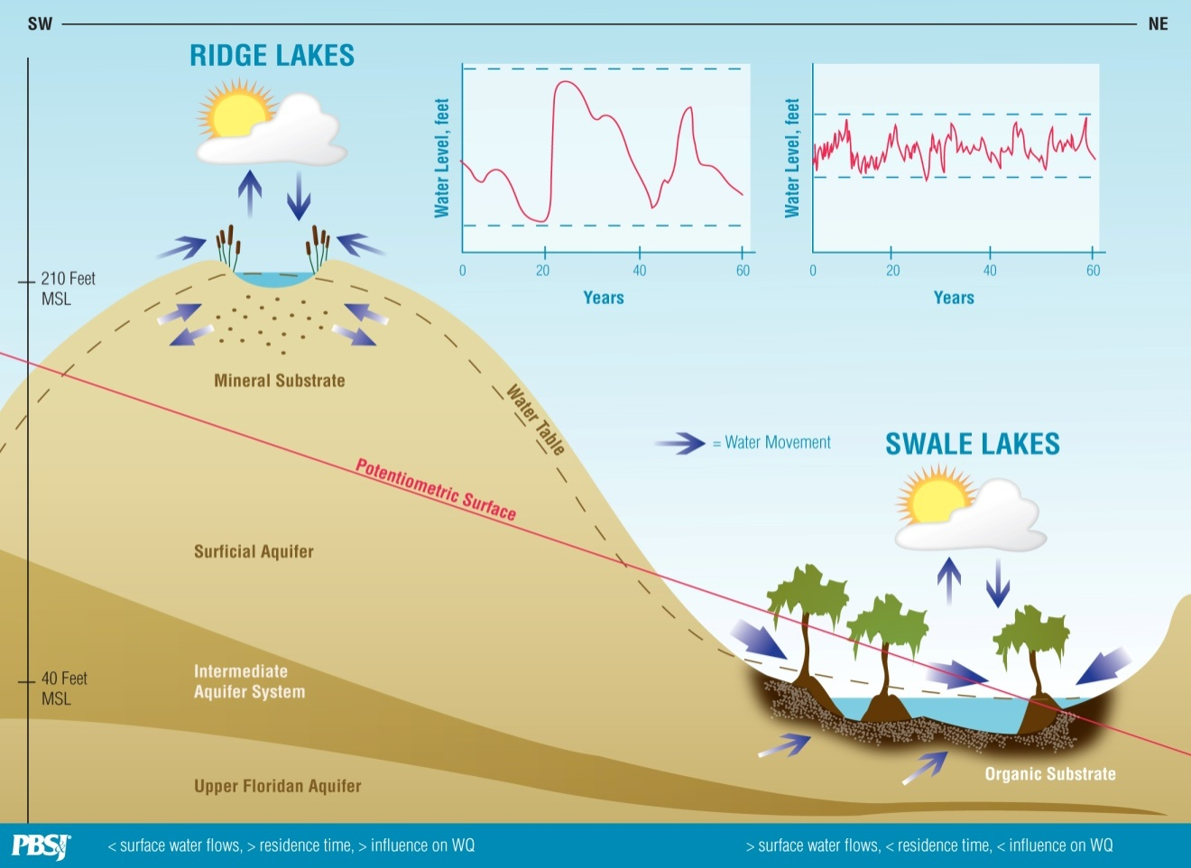
Valley Lakes

Based on a combination of physiographic regions, the digital elevation model (DEM)-derived elevations, and soil types, the lakes of the WHCL were classified as either Ridge lakes or Valley lakes. These lakes were also categorized in terms of their levels of color and probable alkalinity, as outlined in EPA (2010).
Over the past decade, FDEP has been developing numeric nutrient criteria to replace the current narrative criteria and the reliance on TSI. These efforts by FDEP were superseded in January of 2010 when EPA signed a proposed rule, “Water Quality Standards for the State of Florida’s Lakes and Flowing Waters” in response to a 2008 lawsuit against EPA. The lawsuit concluded that FDEP’s existing narrative nutrient criteria were insufficient and that FDEP’s timeline to develop proposed numeric nutrient criteria was too long. The newly proposed nutrient standards comply with the terms of a January 2009 EPA determination under the Clean Water Act that numeric nutrient standards are needed in Florida, as well as an August 2009 consent decree between EPA and the Florida Wildlife Federation. The determination included EPA’s intent to propose numeric nutrient standards for Florida lakes and flowing waters, and for estuaries and coastal waters, within 12 and 24 months of the determination, respectively. As previously noted, FDEP has been developing numeric criteria over the past decade, collecting all of the science based data necessary to establish the appropriate criteria for Florida waters.
The EPA (2010) report has three lake “types”: 1) colored lakes with mean values in excess of 40 PCU, 2) clear and alkaline lakes with mean color less than 40 PCU and alkalinity greater than 50 mg CaCO₃ / liter, and 3) clear and acidic lakes with mean color less than 40 PCU and alkalinity less than or equal to 50 mg CaCO₃ / liter.
Figures 3 and 4 illustrate the decision-tree pathways to be followed using EPA’s methodology (EPA 2010) for developing numeric nutrient targets for the three lake types in Florida (colored, clear and acidic, and clear and alkaline).

Figure 3
EPA Numeric nutrient criteria guidance for high color lakes.
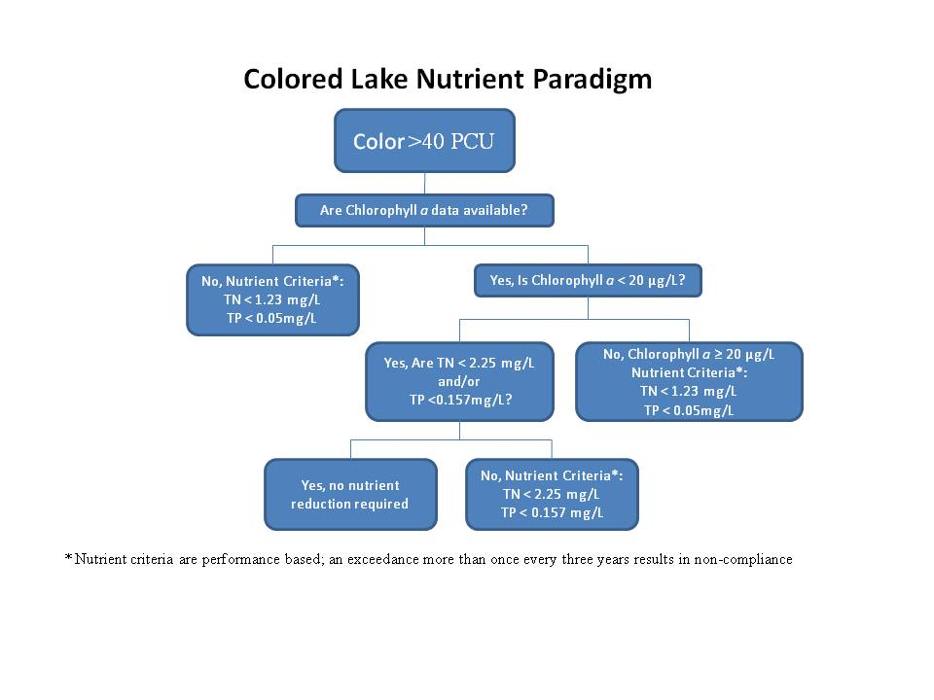

Figure 4
EPA Numeric nutrient criteria guidance for low color lakes.
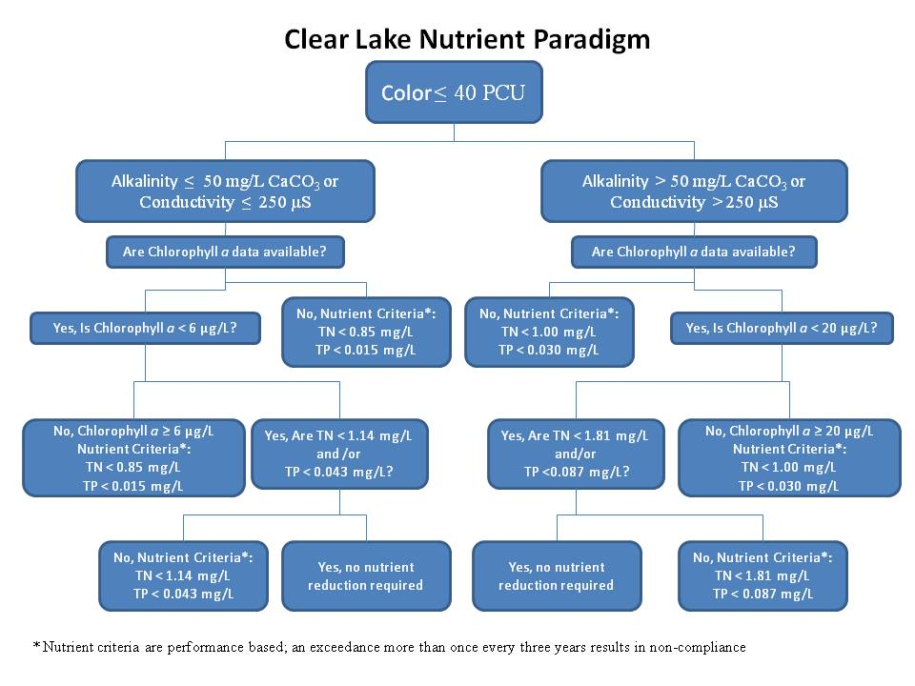

Unfortunately, most Florida lakes do not have detailed, multi-year data sets for alkalinity. Because of this, Weaver and Hendrickson (2009) have suggested that a specific conductance value of 250 µmhos/cm be used as a surrogate for an alkalinity level of 50 mg CaCO₃/liter; this technique is also allowed by EPA (2010). Using the guidance outlined above, lakes within the WHCL were then classified as to Ridge vs. Valley, clear vs. colored, and “alkaline” vs. “acidic” (using specific conductance data if alkalinity values were absent or limited) with the results shown in Table 1. Water chemistry data are based on median values used in FDEP’s pre-BMAP report (PBS&J, 2008).

Table 1
Classification of lakes of the WHCL into Ridge or Valley, Clear or Colored, and Acidic or Alkaline Categories. Ridge vs. Valley classifications from PBS&J (2008). All other classifications use criteria outlined in Weaver and Hendrickson (2009) and EPA (2010). NA = not applicable.
Lake | Chain | Type | Clear or Colored | Acidic or Alkaline
Blue | Southern | Ridge | Clear | Acidic
Cannon | Southern | Ridge | Clear | Acidic
Conine | Northern | Ridge | Clear | Acidic
Eloise | Southern | Ridge | Clear | Alkaline
Fannie | Northern | Valley | Colored | NA
Haines | Northern | Valley | Colored | NA
Hamilton | Northern | Valley | Colored | NA
Hartridge | Southern | Ridge | Clear | Acidic
Henry | Southern | Valley | Colored | NA
Howard | Southern | Ridge | Clear | Acidic
Idylwild | Southern | Ridge | Clear | Acidic
Jessie | Southern | Ridge | Clear | Acidic
Little Hamilton | Northern | Valley | Clear | Acidic
Lulu | Southern | Valley | Clear | Acidic
Mariana | Southern | Ridge | Clear | Acidic
May | Southern | Ridge | Clear | Acidic
Mid. Hamilton | Northern | Valley | Colored | NA
Mirror | Southern | Ridge | Clear | Acidic
Rochelle | Northern | Valley | Clear | Acidic
Roy | Southern | Ridge | Clear | Alkaline
Shipp | Southern | Ridge | Clear | Acidic
Smart | Northern | Valley | Colored | NA
Spring | Southern | Ridge | Clear | Acidic
Summit | Southern | Ridge | Clear | Alkaline
Winterset | Southern | Ridge | Clear | Alkaline

Using techniques outlined in EPA (2010), the majority of lakes in the WHCL system have water quality that supports their initial designation in the FDEP Pre-BMAP report (PBS&J 2008) as Ridge or Valley lakes. The exceptions are Little Hamilton Lake and Lakes Lulu and Rochelle, which were all classified as a Valley-type lakes yet have color levels too low to be classified as Colored lakes. Little Hamilton had a long-term median color level of 38 PCU, so it straddles the border between being a Clear or Colored lake. Both Lake Lulu and Lake Rochelle have lower levels of color than would be expected, based on their elevations and shorelines; these may represent lakes that have “lost” the water quality influence of their surrounding swamp shorelines, resulting in lower levels of tannins than in their historical conditions. All lakes in the WHCL are comfortably within the range of being categorized as acidic lakes, using the 250 µmhos/cm threshold proposed by both Weaver and Hendrickson (2009) and EPA (2010). In contrast, a prior state-wide lake assessment report authored by researchers from EPA, FDEP, and the University of Florida (Griffith et al. 1997) does not support the designation of the WHCL’s clear lakes as being acidic. Instead, Griffith et al. (1997) concluded that “The lakes can be characterized as alkaline, moderately hardwater lakes of relatively high mineral content, and are eutrophic.” In addition, lakes within the WHCL system match the water quality characteristics of clear and alkaline lakes described by Shannon and Brezonik (1972), not the clear and “softwater” lake category they used to reflect the clear and acidic category of Weaver and Hendrickson (2009) and EPA (2010).
The discrepancy over whether WHCL’s clear lakes are appropriately categorized as acidic or alkaline is not a trivial matter, as the chlorophyll-a and nutrient targets for clear acidic lakes are much lower than those for clear alkaline lakes (see Figure 4). In the absence of data on alkalinity for the WHCL system, the use of specific conductance to categorize lakes as acidic or alkaline could be problematic if the relationship between conductance and alkalinity is such that the threshold values for conductance do not necessarily match up with the threshold values for alkalinity. A search of data bases on the Polk County WaterAtlas found that the largest data base where both alkalinity and conductance were both collected is from the City of Lakeland. The plot of specific conductance vs. alkalinity for lake data from the City of Lakeland is shown in Figure 5.

Figure 5
EPA Numeric nutrient criteria guidance for low color lakes.

As can be seen in Figure 5, an extensive data set from a nearby location (City of Lakeland) illustrates the finding that many lakes with alkalinity values greater than 50 mg CaCO₃/liter would be inappropriately labeled as acidic due to having specific conductance values less than 250 µmhos/cm. Using this local data set, the specific conductance value that equates to an alkalinity value of 50 mg CaCO₃/liter is 190 µmhos/cm. The specific conductance threshold of 250 µmhos/cm proposed by Weaver and Hendrickson (2009) and EPA (2010) results in too many truly alkaline lakes (i.e., > 50 mg CaCO₃/liter) being classified as acidic. Using this locally-derived alkaline-lake threshold value of 190 µmhos/cm, the lakes of the WHCL system were reclassified. This modification does not change the number of lakes categorized as clear or colored, but it changes most clear and acidic lakes to clear and alkaline. The only clear lakes that would continue to be categorized as clear and acidic are Lake Blue and Lake Hartridge; all other clear lakes would shift to being categorized as alkaline, consistent with the prior characterizations of both Griffith et al. (1997) and Shannon and Brezonik (1972).
These classifications were then used to compare long-term median values (1997 to 2007) for chlorophyll-a against the target values derived from EPA (2010) for the specific lake type (Colored vs. Clear, Acid vs. Alkaline). Results are shown in Table 2, along with the percent reduction required (if any) for lakes to meet their appropriate chlorophyll-a targets.
Table 2
Target and median values (1997 to 2007) for chlorophyll-a (µg/liter) for WHCL using methodology outlined in EPA (2010) and modified using locally-derived specific conductance threshold values for alkalinity.

Lake | Chl-a Target  (µg / liter) | Median Chl-a  (µg / liter) | Percent Chl-a  Reduction Required
Blue | 6 | 79 | 92
Cannon | 20 | 28 | 29
Conine | 20 | 39 | 49
Eloise | 20 | 31 | 36
Fannie | 20 | 14 | 0
Haines | 20 | 50 | 60
Hamilton | 20 | 5 | 0
Hartridge | 6 | 16 | 63
Henry | 20 | 5 | 0
Howard | 20 | 32 | 38
Idylwild | 20 | 28 | 29
Jessie | 20 | 27 | 26
Lit. Hamilton | 20 | 15 | 0
Lulu | 20 | 42 | 52
Mariana | 20 | 23 | 14
May | 20 | 46 | 57
Mid. Hamilton | 20 | 27 | 26
Mirror | 20 | 32 | 38
Rochelle | 20 | 30 | 33
Roy | 20 | 15 | 0
Shipp | 20 | 61 | 67
Smart | 20 | 26 | 23
Spring | 20 | 21 | 5
Summit | 20 | 14 | 0
Winterset | 20 | 15 | 0
Nutrient data were then compared to relevant nutrient targets, using the proposed revisions to EPA’s methodology (EPA 2010) using an alkaline lake threshold specific conductance value of190 µmhos/cm (Table 3).

Table 3
Target and median values (1997 to 2007) for total phosphorus (mg TP/liter) and total nitrogen (mg TN/liter) for WHCL using methodology outlined in EPA (2010) and modified using locally-derived specific conductance threshold values for alkalinity

Lake | TP Target  (mg/liter) | Median TP  (mg/liter) | TP  Reduction  Required (%) | TN Target  (mg/liter) | Median TN  (mg/liter) | TN  Reduction  Required (%)
Blue | 0.015 | 0.101 | 85 | 0.85 | 2.35 | 64
Cannon | 0.030 | 0.043 | 30 | 1.00 | 1.08 | 7
Conine | 0.030 | 0.073 | 59 | 1.00 | 1.33 | 25
Eloise | 0.030 | 0.038 | 21 | 1.00 | 1.32 | 24
Fannie | 0.157 | 0.029 | 0 | 2.25 | 0.84 | 0
Haines | 0.050 | 0.066 | 24 | 1.23 | 1.32 | 7
Hamilton | 0.157 | 0.100 | 0 | 2.25 | 1.09 | 0
Hartridge | 0.015 | 0.027 | 44 | 0.85 | 0.75 | 0
Henry | 0.157 | 0.116 | 0 | 2.25 | 1.00 | 0
Howard | 0.030 | 0.041 | 27 | 1.00 | 1.41 | 29
Idylwild | 0.030 | 0.041 | 27 | 1.00 | 0.93 | 0
Jessie | 0.030 | 0.061 | 51 | 1.00 | 1.02 | 2
Lit. Hamilton | 0.030 | 0.035 | 14 | 1.00 | 1.11 | 10
Lulu | 0.030 | 0.050 | 40 | 1.00 | 1.22 | 18
Mariana | 0.030 | 0.034 | 12 | 1.00 | 1.09 | 8
May | 0.030 | 0.058 | 48 | 1.00 | 1.41 | 29
Mid. Hamilton | 0.050 | 0.070 | 29 | 1.23 | 1.56 | 21
Mirror | 0.030 | 0.040 | 25 | 1.00 | 1.41 | 29
Rochelle | 0.030 | 0.050 | 40 | 1.00 | 1.07 | 7
Roy | 0.030 | 0.028 | 0 | 1.00 | 0.94 | 0
Shipp | 0.030 | 0.049 | 39 | 1.00 | 1.64 | 39
Smart | 0.050 | 0.055 | 9 | 1.23 | 1.36 | 10
Spring | 0.030 | 0.039 | 23 | 1.00 | 0.94 | 0
Summit | 0.030 | 0.028 | 0 | 1.00 | 0.84 | 0
Winterset | 0.030 | 0.021 | 0 | 1.00 | 0.80 | 0

Results from Table 2 show that a median chlorophyll-a reduction of 28 percent is needed to get lakes within the WHCL system to meet the revised EPA NNC criteria outlined above. Lakes Fannie, Hamilton, Henry, Idylwild, Little Hamilton, Roy, Summit and Winterset have median chlorophyll-a levels (1997 to 2007) below their relevant thresholds. However, they may exceed their target values in particular years; “impairment” is established when lakes fail to meet criteria more than once in three years.
The median reduction in TP concentrations shown in Table 3 is 25 percent, which compares favorably to the median TP concentration reduction of 31 percent calculated in the pre-BMAP report conducted for FDEP (PBS&J 2008). The median TN reduction shown in Table 3 is 7 percent, although there is quite a bit of support for the contention that levels of phosphorus are more important to control for the WHCL than levels of nitrogen (FDEP 2005).
With the proposed modification of using 190 µmhos/cm as the threshold specific conductance value for a lake to be classified as clear-alkaline, the proposed numeric nutrient criteria of EPA (2010) give similar guidance as to nutrient concentrations as does FDEP’s pre-BMAP report (PBS&J 2008).
The next section of this report will address what types of projects are likely to aid in reaching these target values.

Influence of Factors Other than Nutrients on Levels of Chlorophyll-a
This report summarizes results of an investigation of the effects, if any, of water levels on water quality. As described in the pre-BMAP report for FDEP (PBS&J 2008) lake level data were queried to determine if there were any apparent relationships between lake levels and water quality. The relationship between lake levels and water quality was evaluated for those lakes where there was at least ten (10) continuous years of both lake level data and water quality data, to be consistent with the other water quality analyses described both here and in the pre-BMAP Assessment report (PBS&J 2008). Further, it was assumed for this effort (Mike Britt, personal communication) that lake levels in Lakes Mirror, Shipp and Lulu would be the same as those reported for Lake Shipp.
As an example of the results from this assessment, Figure 6 illustrates the relationships found between lake levels and chlorophyll-a for Lake Blue.

Figure 6
Relationship between lake level, in feet (NGVD) and chlorophyll-a (µg / liter)
for Lake Blue
For Lake Blue, Figure 6 displays an inverse and statistically significant relationship between lake levels and chlorophyll-a. That is, the highest levels of chlorophyll-a are usually associated with low lake levels, and vice versa.
The relationships between lake levels and chlorophyll-a, total nitrogen, and total phosphorus were examined for all lakes where sufficient data existed for both lake levels and water quality. Data were tested for statistically significant relationships using linear regression of non-transformed data, with significance set at p < 0.05. The results of these analyses are summarized in Table 4.

Table 4
Regression analysis of lake levels and chlorophyll-a, total nitrogen
and total phosphorus (data from PBS&J 2008).
Lake | Chl-a | TP | TN
Blue | NEG | NONE | NEG*
Cannon | ID | ID | ID
Conine | POS | POS | NONE
Eloise | ID | ID | ID
Fannie | ID | ID | ID
Haines | NONE | POS | POS
Hamilton | NONE | NONE | NONE
Hartridge | ID | ID | ID
Henry | NEG | POS | NONE
Howard | NEG | NONE | NEG*
Idylwild | ID | ID | ID
Jessie | ID | ID | ID
Lulu | NONE | NEG | NEG
Mariana | ID | ID | ID
May | NONE | NEG | NEG
Mirror | NONE | NONE | NONE
Rochelle | NONE | NONE | NONE
Roy | ID | ID | ID
Smart | NONE | POS | NONE
Shipp | NEG | NEG | NEG
Spring | ID | ID | ID
Summit | ID | ID | ID
Winterset | ID | ID | ID
“NEG” = inverse relationship found. “NEG*” = inverse relationship found with evidence of nitrogen fixation. “POS” = positive relationship found. “NONE” = no significant relationship found. “ID” = insufficient data for analysis
These results show that insufficient data exist for most lakes to determine the relationships, if any, between lake levels and water quality. For those lakes where sufficient data exist for both lake levels and water quality, the pattern of relationships between lake level and water quality are summarized below. A point worth noting is that while results are shown only where statistically significant (p < 0.05) linear relationships were found between chlorophyll-a and lake levels or nutrient concentrations and lake levels, the strength of these relationships was not particularly high. For example, the highest r² value for a chlorophyll-a : lake level relationship was 0.354 for Lake Shipp; 35 percent of the variation in chlorophyll-a levels in Lake Shipp could be explained by variation in lake levels. In contrast, even though such a relationship was statistically significant (and therefore not likely due to chance alone) only 7 percent of the variation in levels of chlorophyll-a in Lake Conine was explained by variation in lake levels. The relationships between lake levels and water quality should therefore be considered appropriate for guidance as to general influences on water quality, rather than relationships worthy of inclusion in empirically-derived goal-setting equations.

Findings are summarized below:
For chlorophyll-a, twelve lakes had sufficient data to examine these relationships. Seven of these twelve lakes showed no relationship between lake levels and chlorophyll-a, while four lakes had negative relationships.
Lake Conine was unique as the only lake to exhibit a trend of higher levels of chlorophyll-a with higher lake levels. In contrast, Lakes Blue, Henry, Howard and Shipp had trends of higher chlorophyll-a with lower lake levels.
For phosphorus, twelve lakes had sufficient data to examine these relationships. Five of these twelve lakes showed no relationship between lake levels and phosphorus, while three lakes had negative relationships. Four lakes had positive relationships between lake levels and phosphorus. Three of the four lakes with positive relationships were Valley lakes (Lakes Haines, Henry and Smart).
For nitrogen, twelve lakes had sufficient data to examine these relationships. Six of these twelve lakes showed no relationship between lake levels and nitrogen, while five lakes had negative relationships. Only one lake, the Valley lake of Lake Haines, had a positive relationship between lake levels and nitrogen.
High lake levels reflect recent inflow events and thus elevated quantities of stormwater runoff in the recent and not-so-recent past. Despite this link with stormwater runoff (and by extension, the TMDL program) only Lake Conine had a pattern of higher levels of chlorophyll-a at higher lake levels. In contrast, four lakes - Lakes Blue, Henry, Howard and Shipp – had trends of higher levels of chlorophyll-a at lower lake levels. For these four lakes, it seems likely that internal processes such as sediment resuspension and re-mineralization are more important influences on phytoplankton production than external nutrient loads.
The basis for the influence of lake levels on water quality is not entirely known, but it could be related to the impact of nutrient-rich bottom sediments and the importance of internal, vs. external loads on water quality. Many of the lakes in the WHCL system have received effluent from either or both domestic and industrial discharges, sometimes for many decades (Table 5). Although the WHCL TMDL report (FDEP 2006) states that there are currently no wastewater discharges to any lakes within the WHCL system, the concern here is that there are likely “legacy effects” of these prior discharges that could preclude improvements in water quality until and unless accumulated sediments are appropriately addressed.

Table 5
Summary of available information on point source discharge history of various WHCL lakes (compiled from various sources).
Lake | Status | Discharge Source | Comments
Eloise | diverted in June 1975 | Cypress Gardens WWTP | 9.5 m3/d, 30kg P/yr; 85 kg TN/yr
Haines | ended in 1992 | Lake Alfred WWTP | 77% lake TP load; 1,515 kg P/yr; 2,230 kg TN/yr, 0.3 MGD
Howard | discharge until 1977, capable of overflow until 1980 | Jan-Phyl Village WWTP | ~1,500 lbs TP / yr
Conine | discharges ended | Birds Eye
Conine | discharges ended | Pipping Packing Co.
Conine | discharges ended | Florida Citrus Salads
Conine | ended in 1992 | City of Winter Haven (CWH) WWTP
Lulu | ended in 1977 | CWH WWTP | 90% lake TP load, domestic secondary effluent, 1.8 mgd in 1976
Lulu | discharges ended | Bordo's citrus processing plant
Lulu | discharges ended | Snively plant
Lulu | discharges ended | Swift Fertilizer plant
Shipp | discharges ended | Robert Brothers vegetable processing | Sewer discharge until connected to CWH, then sludge from tankers
Shipp | discharges ended | Bordo's citrus processing plant
May | closed in 1949 | Imhoff Plant
May | discharges ended | Citrus
May | discharges ended | Velda
Jessie | discharges ended | Wastewater treatment plant effluent

While direct discharges to these lakes have stopped, the nutrient loads, particularly for phosphorus, have been left behind in the lakes’ sediments to various degrees. Nutrient-enriched sediments from past point source impacts would be expected to be problematic especially during times of low water due to two factors: there would be a smaller volume of water to dilute impacts of these internal loads (which are not dependent upon rain events to exert their influence) and low lake levels would allow for a greater impact from wind-induced bottom resuspension. For example, the Lake Dynamic Ratio concept originally developed for Florida lakes by Bachman et al. (2000) was used to determine that a 4 ½ foot increase in water levels in Lake Hancock would result in the frequency of whole-lake bottom resuspension dropping from once a week to once every two weeks (Tomasko et al. 2009). In that study, Tomasko et al. (2009) concluded that “…it would seem reasonable to conclude that increases in effective water depth of Lake Hancock would likely bring about an improvement in water quality, due in part to conditions being less favorable for resuspension of bottom sediments.” For Lakes May, Shipp and Lulu, ERD (2009) reported that “… windy conditions caused an increase in TSS of approximately 37% in Lake May, 33% in Lake Shipp, and 53% in Lake Lulu.” These results further support the contention that bottom sediments can be stirred up into the water column during windy conditions. Resuspension of bottom sediments can also increase the supply of nutrients into the water column, as was found for Lake Hancock (Tomasko et al. 2009) and in Lakes May, Shipp and Lulu (ERD 2009). Although the impacts on water quality, if any, of bottom sediments is not addressed in the WHCL TMDL (FDEP 2006), bottom sediments will need to be a part of lake restoration strategies in the WHCL system, as will be discussed in greater detail in later parts of this report.

Historical Trends in Lake Levels
Longer term patterns in lake levels were examined by compiling lake level data from all available sources of information (i.e., SWFWMD, USGS, etc.). These datasets were assembled to create a period of record (POR) dataset, in some cases going back to the 1940s. The results, shown for Lakes Cannon, Eloise, Fannie, Hamilton, Lulu and Smart, are shown in Figures 7 to 13, respectively.
Figure 7
Lake level, in feet (NGVD 1929) over time for Lake Cannon
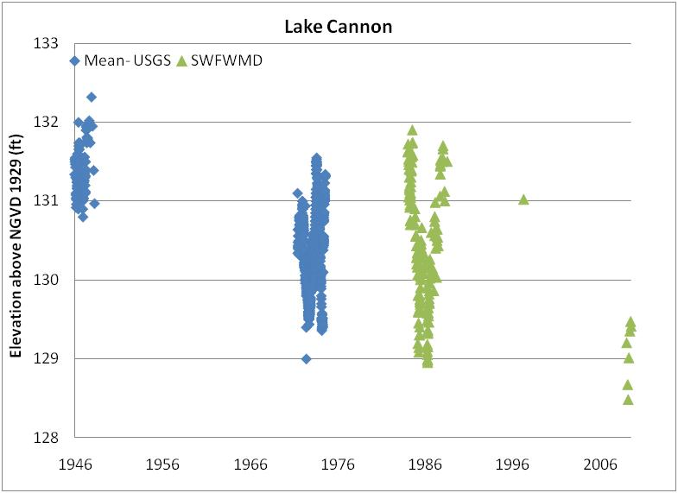
Figure 8
Lake level, in feet (NGVD 1929) over time for Lake Eloise
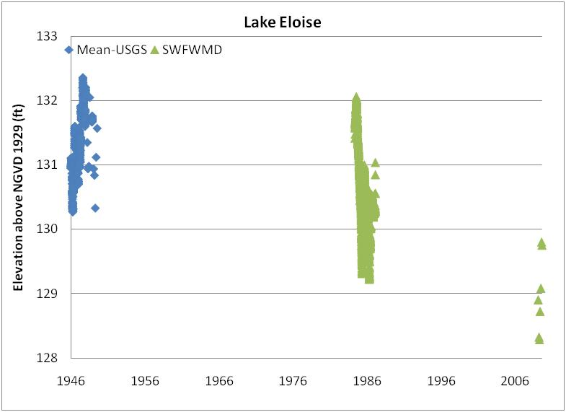
Figure 9
Lake level, in feet (NGVD 1929) over time for Lake Fannie
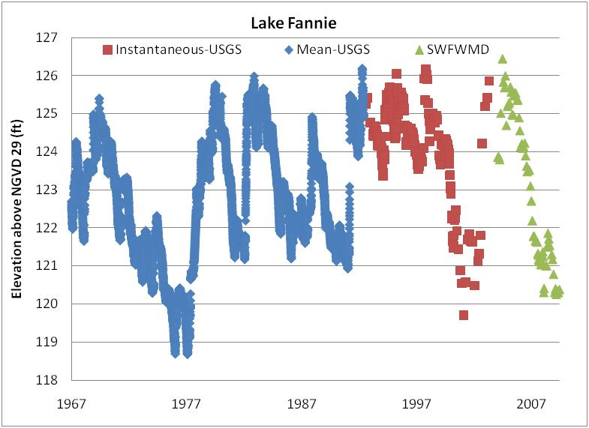
Figure 10
Lake level, in feet (NGVD 1929) over time for Lake Hamilton
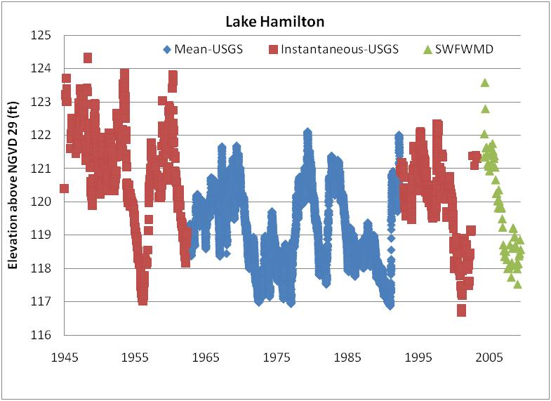
Figure 11
Lake level, in feet (NGVD 1929) over time for Lake Howard
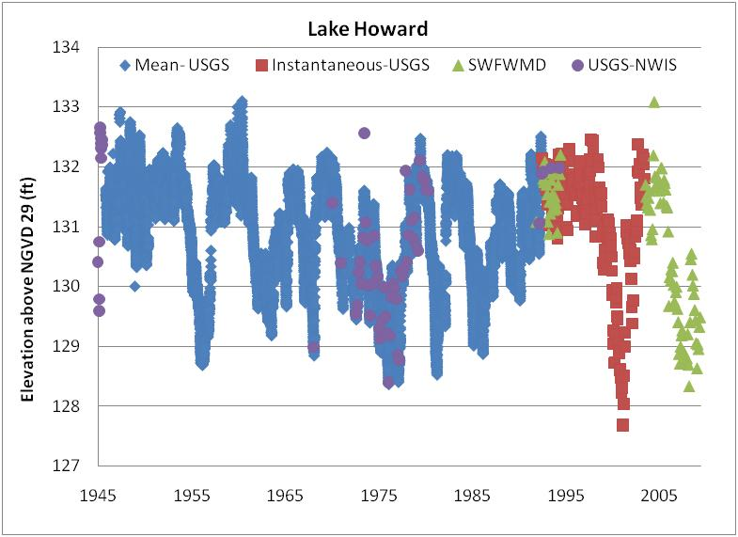
Figure 12
Lake level, in feet (NGVD 1929) over time for Lake Lulu
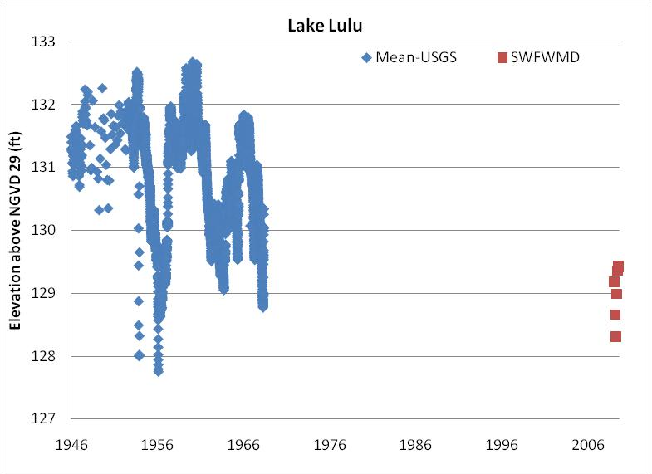
Figure 13
Lake level, in feet (NGVD 1929) over time for Lake Smart
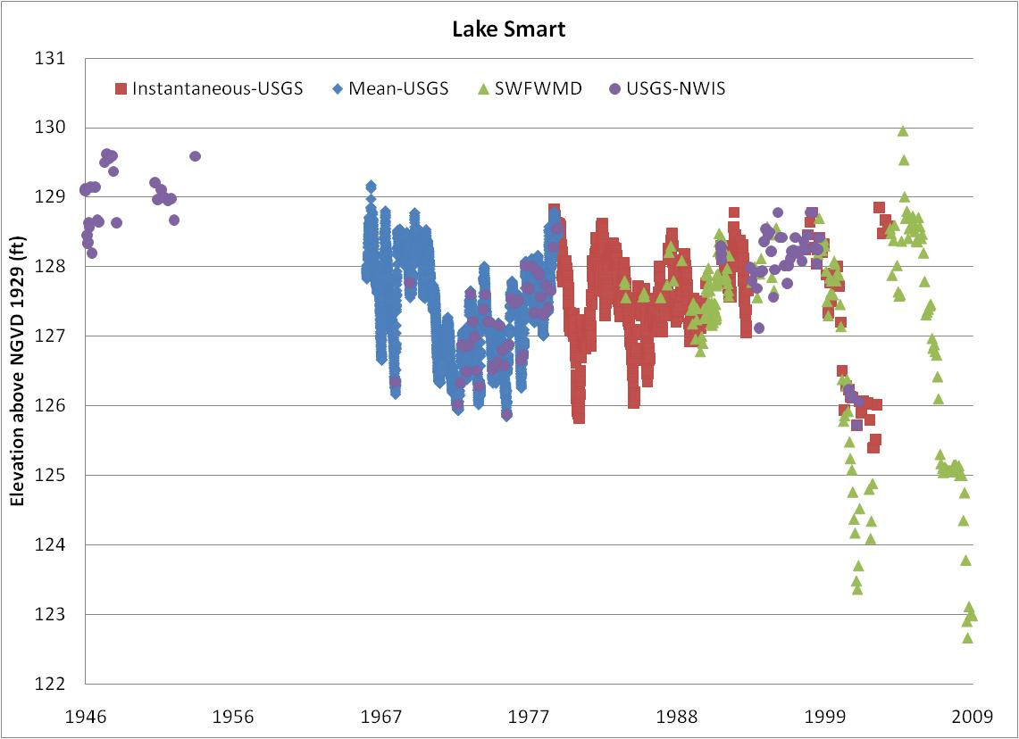
For Lakes Cannon, Eloise, Hamilton, Howard, Lulu and Smart, which all have lake level data back to the 1940s; the available information suggests that these lakes are lower than they were 50 to 60 years ago. This finding is consistent with earlier literature by Heath (1961) who noted that Polk County lake levels had likely been affected by both water withdrawals for public supply, agriculture, and/or phosphate mining, as well as by drainage. Heath (1961) concluded that “…The construction of a canal to remove water from what previously had been a landlocked lake, for example, would change the stage characteristics…” which is of particular relevance for the Winter Haven Chain of Lakes, which are presently connected to each other by a series of canals; in their historical condition they did not have such a high degree of interconnectedness.
Further, Kaufman (1967) concluded that “Pumpage from the Floridan aquifer has increased the hydraulic gradient between the lake surfaces and the piezometric surface and may be responsible in part for lowered lake levels in this area.”
These conclusions, and the data shown in Figures 7 to 13, appear to be different than the conclusions reached by Spechler and Kroening (2006) who found little evidence of recent declines in lake levels in Polk County (see Table 6).
Table 6
Summary of trends over time in lake levels in Polk County. Data from Spechler and Kroening (2006).
Lake name | Period of record analyzed | Kendall’s tau | p-value
Lake Clinch | 1960-2003 | -0.2812 | 0.0071
Lake Parker | 1960-2003 | .1501 | .1509
Crooked Lake | 1960-2003 | -.4017 | .0001
Lake Hamilton | 1960-2002 | .0122 | .9084
Scott Lake | 1960-2002 | .2918 | .0052
Mountain Lake | 1960-1986, 1989-1999,  2000-2003 | -.5282 | .0000
Lake Hancock | 1960-2002 | .0808 | .4449
Lake Howard | 1960-2003 | .1067 | .3070
Lake Mariana | 1960-2003 | .9784 | .0003
Lake Deeson | 1960, 1965-2003 | .1667 | .1299
Lake Otis | 1960-2003 | -.0761 | .4665
Reedy Lake | 1960-2003 | .0878 | .4187
Lake Marion | 1960-1993, 1998, 2001-2003 | -.2319 | .0404
Lake Wales | 1960-2003 | -.2902 | .0075
Of the 14 Polk County lakes examined by Spechler and Kroening (2006) only half showed any evidence of a change in lake levels over the period of 1960 to 2003, and two of those with trends (Scott Lake and Lake Mariana) had significant increases in lake levels during that time. However, with the exception of Lake Smart, most of the lake level data displayed in Figures 7 to 13 suggest that the major modifications to lake levels had mostly occurred during the 1940s and the 1950s. The graphs displayed here are mostly consistent with the findings of Spechler and Kroenig (2006) in that lake levels appear to have been widely variable over the past 20 to 30 years, but they have not displayed an overall trend of continued declines over the past two to three decades. Nonetheless it does appear that most lakes in the WHCL are at lower levels than they were in the 1950s or earlier, with the notable exception of Lake Howard.

Long-term Variations in Rainfall Patterns
The primary objective of these analyses was to assess similarities and potential relationships between long-term seasonal rainfall patterns and lake levels. The following describes the graphical and statistical methods utilized to make these comparisons.
An initial series of graphical analyses were conducted to assess long-term patterns in monthly, annual and seasonal Polk County rainfall.
Monthly total regional total rainfall patterns were then graphically compared with historical monthly mean water levels for those lakes with sufficient long-term data.
Finally average monthly lake and rainfall levels were statistically compared in order to evaluate interactions over both shorter and extended monthly intervals.
Monthly average Polk County rainfall totals (based on area-weighted average values) for 1915-2008 period of record were obtained from the SWFWMDs hydrologic data. Wet and dry-season periods were based on long-term monthly averages (Figure 14), using the total for the months June through September as the wet period and the annual total for the remaining eight months as the dry. Figure 15 displays time series plots over the 1940-2008 time interval of: 1) monthly rainfall; 2) annual rainfall; 3) total wet-season rainfall; and 4) dry-season rainfall, as well as five-year moving averages for SWFWMD estimated Polk County rainfall.
Figure 14
Average monthly Polk Count rainfall (1940-2008).

Figure 15
Long-term and five-year moving average rainfall patterns for Polk County for monthly rainfall, annual rainfall, wet-season rainfall, and dry-season rainfall.
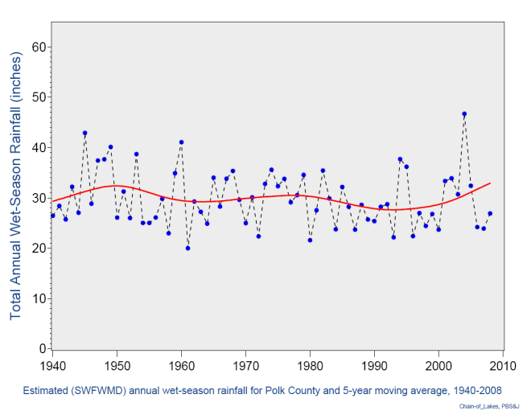
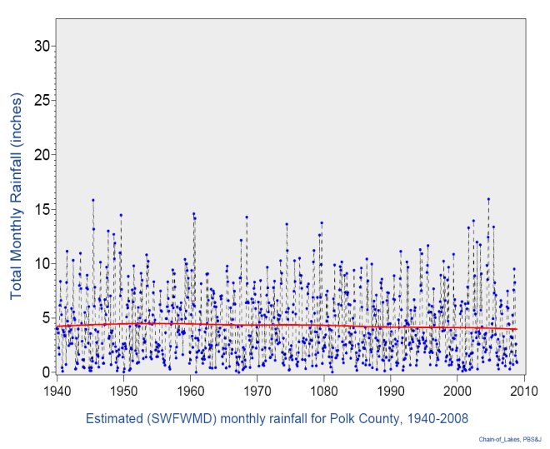
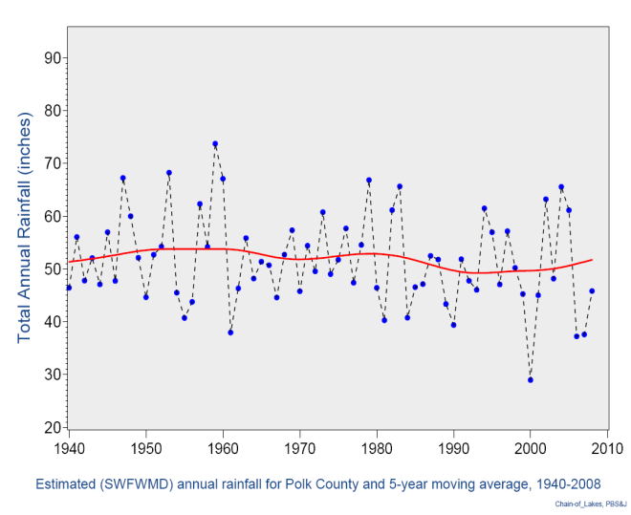

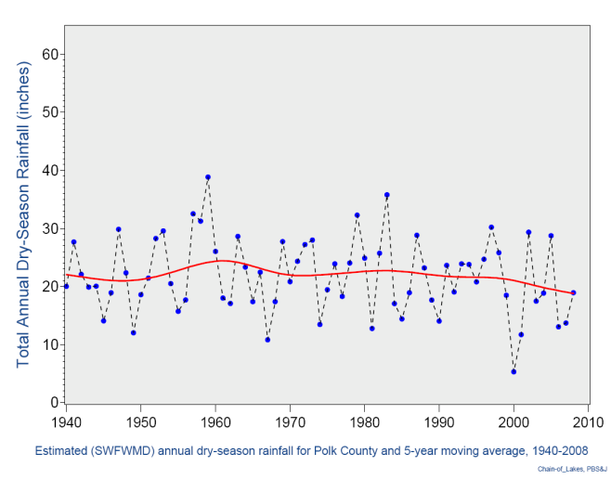
The graphics in Figure 15 depict the following patterns:
Monthly rainfall totals exhibit such high degrees of variability that when plotted over 1940-2008 both short and longer term patterns are difficult to discern.
When the data are plotted as annual totals distinct patterns depicting occasional series of wetter and drier intervals become apparent.
The 1950s were characterized by extended periods of wetter than average conditions.
Two of the driest periods in the last 70 years occurred during the 1999-2001 and 2006-2008 time intervals.
The plots of annual total wet and dry-season rainfall indicated that both recent droughts were due to low rainfall levels during both seasons, with dry-season rainfall totals in both 2001 and 2002 being the two lowest during the last 70 years.

Rainfall and Variations in Lake Levels
Historic lake level data were obtained (as available) from SWFWMD and United States Geological Survey (USGS) for the series of lakes in the Polk County Chain of Lakes system. Of these, sufficient data were available to determine long-term monthly mean water levels for the following four lakes:
- Lake Fannie
- Lake Hamilton
- Lake Howard
- Lake Smart
Figure 16 provides graphical comparisons of monthly mean Polk County rainfall and lake levels for the periods of available water level data for each of these four lakes. The graphics depict both mean monthly total rainfall and mean lake levels as fitted, smoothed lines (calculated using the Statistical Analysis Software (SAS) cubic-spline method that minimizes the linear combination of the sums of squares of the residuals of the fit as well as the integral of the square of the second derivative).
These graphics clearly indicate distinct differences in the relative degree of interactions between regional rainfall and gaged lake levels among the four lakes. Each system further shows characteristic lags between periods of both increasing and decreasing rainfall and corresponding responses in lake levels. It should be noted when making such comparisons that lake levels responding to increasing rainfall are truncated by outflow from the lake.

Figure 16
Comparisons of lake levels and rainfall patterns for Lakes Fannie,
Hamilton, Howard, and Smart.
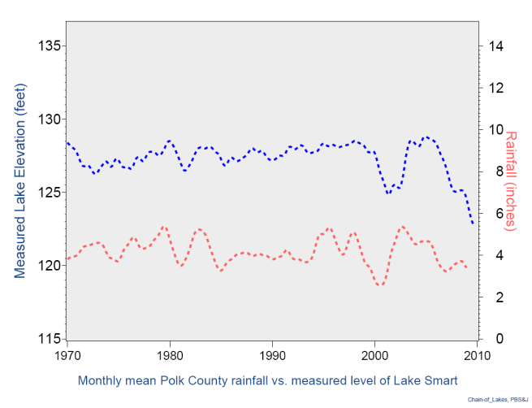
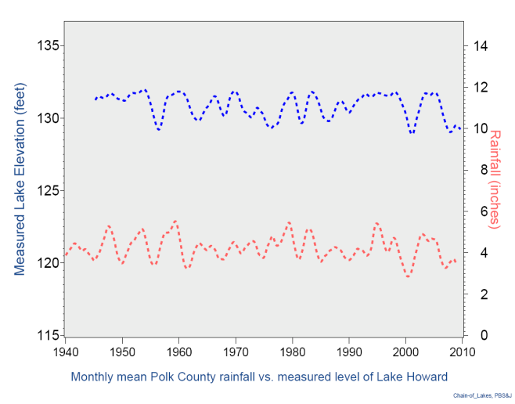
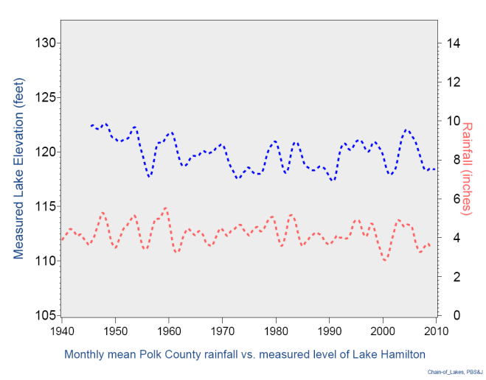
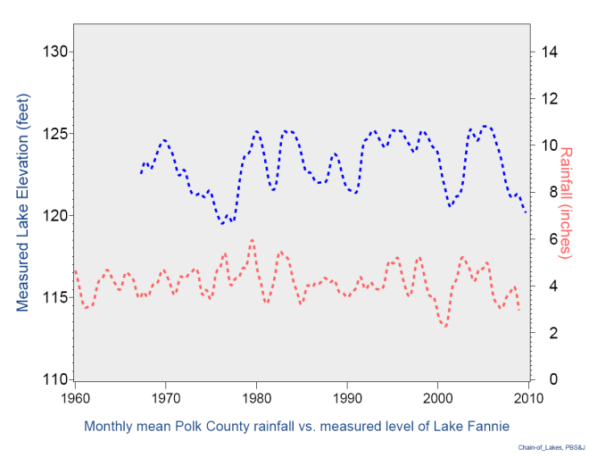

Relationships between Rainfall Patterns and Lake Levels
In order to make comparisons and contrast the statistical relationships between patterns in regional rainfall and water levels among the four lakes, data over a standardized period (1985-2008) were selected for the following series of analyses made using the SAS.
- The Univariate Procedure was used to test for the degree of normality of both untransformed and transformed terms for all variables subsequently used.
- The Correlation Procedure was then used to test for and contrast correlations between gaged lake levels and average rainfall over a range of preceding intervals (1-36 months).
- The forward, best-fit, stepwise regression was next used to assess potential terms (or groups of terms) to determine the relationships between gage lake levels and preceding rainfall.
- The General Linear Model (GLM) procedure was then applied in developing final best-fit models for the water level/rainfall relationships for each of the four lakes. (All terms applied being statistically significant at p < 0.05).
These GLM models followed the generalized form:
where:
= specific intercept
= slope for “short-term (i.e., 3 months)” rainfall (linear and/or non-linear)
= slope “long-term (i.e., 12 months)” rainfall (linear and/or non-linear)
= slope “longer-term (i.e., 21 to 24 months)” rainfall (linear and/or non-linear)
Table 8 provides an overview and comparison of the resulting best-fit models for each of the four lakes. Models explaining approximately 60 percent of the observed variation in monthly Lake Fannie and Lake Hamilton water elevations could be developed using a single term for short- term preceding rainfall (3 months) and a second longer-term of about two years. Similar r² values were obtained for models of Lakes Howard and Smart by further applying a third term for rainfall over the preceding 12 months.

Table 7
Summary of Best-Fit Models of Lake Level and Preceding Rainfall
Lake Level | Terms for Preceding Periods of Rainfall |  |  | r² Value
Lake Fannie | 3 month | 21 month |  | 0.60
Lake Hamilton | 3 month | 24 month |  | 0.57
Lake Howard | 3 month | 12 month | 24 month | 0.58
Lake Smart | 3 month | 12 month | 24 month | 0.61
Figure 17 illustrates and contrasts the relative relationships between gaged lake levels and preceding rainfall over longer-term intervals (21-24 months). As shown, there is a relatively high degree of fit with almost all the observations falling within the expected 95 percent prediction limits.
Figure 17
Comparisons of lake levels and rainfall patterns for selected model terms
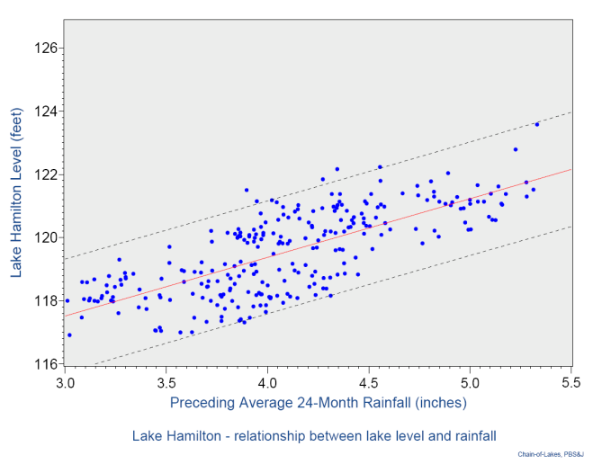
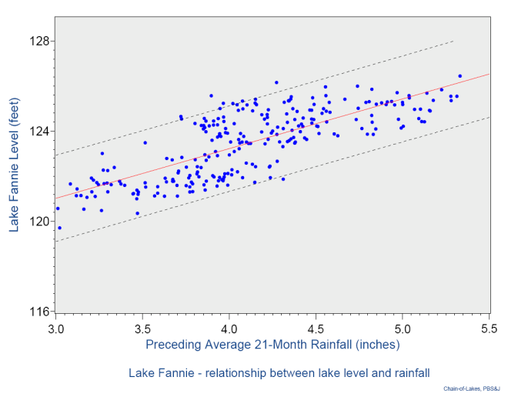
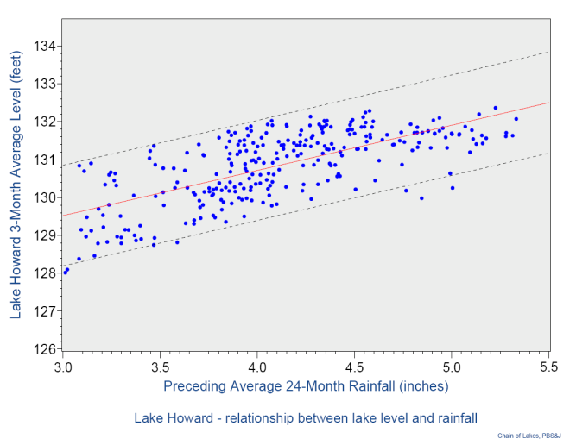
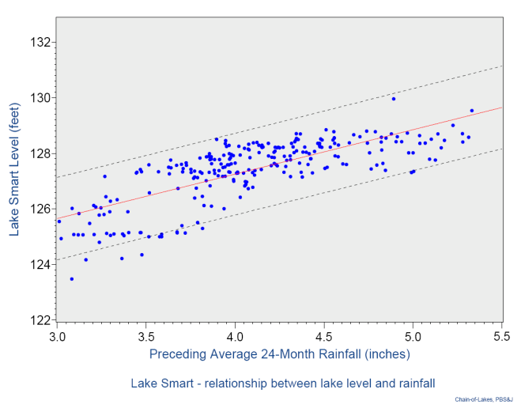
Combined, these results show that annual and dry-season rainfall amounts were extremely low during recent (post-1999) droughts. Those recent droughts were characterized by annual rainfall amounts so low that they comprise three of the driest five years for annual rainfall since 1918. The dry season rainfall total during 2000 was the driest on record for the Bartow region, dating back to 1918. In contrast, the wet-season rainfall amount in 2004 was the highest recorded over the period of record, the same year when Central Florida was affected by Hurricanes Charley, Frances, and Jeanne, all within a period of six weeks. For the WHCL system, it appears that approximately 60 percent of the variation in lake levels appears to be related to rainfall amounts during the past 3 to 24 months. This information supports the contention that high or low lake levels are not normally brought about by the most recent rainfall amounts, but instead they reflect longer term responses. These results suggest that groundwater influences on lake levels are potentially very significant, as discharge of groundwater from the surficial aquifer may be more important than recent rainfall as an influence on water levels, particularly during the dry season. Activities that maximize the opportunities to recharge the surficial aquifer could therefore not only affect lake levels, they could also improve water quality through the general finding of degraded water quality during the times of lowest lake levels.
As a final assessment on the influences of lake levels on water quality, an assessment of historical lake levels was made, in an attempt to gain information on lake levels for periods prior to modern record keeping, and for lakes without a long record of lake level data.
Geographic Information System techniques (GIS) were used to obtain elevation data around historic and existing lake edges. Pre-settlement maps, surveyors’ notes, elevation data, current aerial photographs, and existing land use data were overlaid in GIS. Figure 18 shows an example of how data were overlaid.

Figure 18
An example of how data were overlaid in GIS to obtain elevation data around
historic and existing lake edges.

Light Detection and Ranging (LIDAR) data were processed to create a 3D raster image based on topography. This digital elevation model (DEM) was used to interpolate topographic data at historic and existing lake edges.
Historic lake edges were obtained from the General Land Office Survey (GLOS) maps and GLOS data points. GLOS maps were downloaded from the FDEP, Bureau of Survey and Mapping (BSM), Land Boundary Information System (LABINS) website. Historic GLOS data points were created from surveyors’ notes and obtained from SWFWMD. Notes indicate that the GLOS maps and data points were generated circa 1850. Data points with associated notes indicating lake edges were selected and used for this analysis.
Existing lake edges were established by referencing SWFWMD 2006 land use data and 2008 aerial photographs. Using this approach, an assessment was made of the historical and current lake level elevations for lakes of the WHCL system. Results of this analysis are shown in Figure 19.
Figure 19
Comparison of lake level elevations in historical (1850s) and current times. Elevations in feet (NGVD 1929).

Using this approach, the majority of lakes in the WHCL system (14 of 16) appear to be at lower elevations than their estimated historical condition, a finding supported by anecdotal observations from various sources (e.g., Stokes 1999). The average reduction in lake level elevations, from estimated historical conditions, is approximately five (5) feet.
Reductions in lake levels from estimated historical conditions can be problematic for a variety of reasons. For Ridge lakes, particularly those with a record of point source discharges, lowered lake levels make them more likely to experience water quality impacts from nutrient-enriched bottom sediments. For Valley lakes, lowered lake levels can functionally “disconnect” them from their historical swamp shorelines, reducing the beneficial impacts of wetland-derived tannins as moderators of nutrient stimulation of phytoplankton growth. This last issue is the topic of the following section of this report.

Influence of Forested Wetlands on Water Quality in Valley Lakes
As it was shown in the Pre-BMAP report for the WHCL (PBS&J 2008) it appears that in Valley lakes the levels of tannins help to moderate the transformation of nutrients into phytoplankton.
Table 8 displays results where median values of color, chlorophyll-a, TN and TP were examined for two groups of lakes: those with median color levels less than 50 PCU, and those with median color levels greater than 50 PCU.

Table 8
Mean and median values for chlorophyll-a (µg / liter), TP (mg / liter) and TN (mg / liter) for lakes with color levels < 50 PCU compared to lakes with > 50 PCU.
Data are from 1997 to 2007.
 | Chlorophyll-a (µg / liter) |  | TP (mg / liter) |  | TN (mg / liter)
 | PCU < 50 | PCU > 50 | PCU < 50 | PCU > 50 | PCU < 50 | PCU > 50
mean | 31.0 | 20.2 | 0.046 | 0.076 | 1.201 | 1.161
median | 28.0 | 13.6 | 0.041 | 0.070 | 1.103 | 1.089
Lakes within the WHCL system with color levels less than 50 PCU tended to have substantially elevated levels of phytoplankton biomass, even though they had, on average, substantially lower levels of TP. Levels of TN did not vary significantly between low and high color lakes. These results are further support for the contention raised in the Pre-BMAP report (PBS&J 2008) that at least for Valley lakes, phytoplankton biomass is more strongly influenced by levels of color (i.e., tannins) than by the availability of nutrients such as phosphorus.
As a further example of this phenomenon, Figure 20 plots the relationship between phosphorus levels and phytoplankton abundance for Lakes Henry and Lulu.
Figure 20
Relationship between TP (mg / liter) and chlorophyll-a (µg / liter) in Lakes Henry and Lulu.
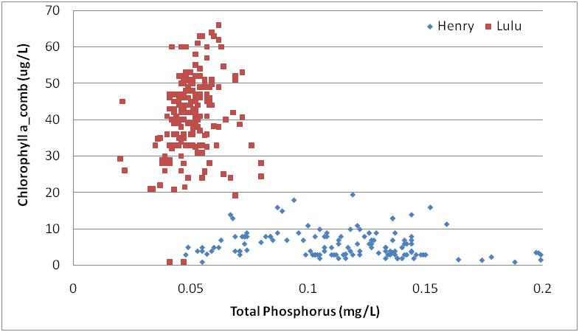
For Lake Henry, an overall higher level of TP than Lake Lulu does not translate into higher levels of chlorophyll-a. Instead, factors other than nutrient levels alone appear to be more important in keeping phytoplankton biomass under control.
Comparing the two lakes against each other, it is apparent the most likely factor involved in moderating chlorophyll-a concentrations in Lake Henry is the elevated levels of color (i.e., tannins), as was originally documented in FDEP’s Pre-BMAP report for the WHCL (i.e., data shown in Figure 21).
Figure 21
Concentrations of chlorophyll-a (µg / liter), TN (mg / liter x 10), TP (mg / liter x 100) and Color (PCU / 10) in Lakes Henry and Lulu. Data are median values from 1997 to 2007.
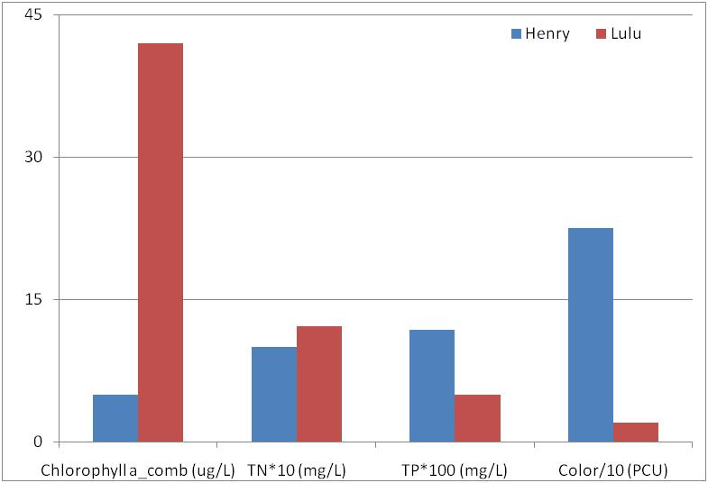
As an assessment of the sources of color for lakes within the WHCL system, PBS&J (2008) examined the relationships between lake chemistry and landscape features. From this analysis, it was found that the factor that explained the greatest amount of variability in levels of color within lakes was the amount of the immediate shoreline (within 500 feet of the lake edge) as forested wetlands.
The greater the amount of a lake’s shoreline as a swamp, the greater (on average) the level of color within that lake. Based on the data summarized in Table 8, a preliminary and minimum target for color levels of 50 platinum-cobalt units or higher is proposed for Valley lakes of the WHCL system, to allow for sufficient levels of “tannins” to moderate the transformation of nutrients into phytoplankton by reducing the depth of the photic zone.
The empirically-derived relationships shown by PBS&J (2008) indicate the approximate amount of nearshore (within 500 feet of the water) landscape in the category of swamps that would be required to allow for 50 PCU color levels is on the order of 10 to 20 percent.
Therefore, a preliminary target for Valley lakes is to restore or maintain a minimum of 10 to 20 percent of their nearshore watershed as a functional swamp shoreline. This management goal may be more important in controlling phytoplankton levels than the “traditional” activity of reducing nutrient loading via large regional stormwater treatment systems, even though such stormwater retrofits are necessary to reduce external nutrient loads. This last conclusion is discussed in greater detail below.

Review of Lake Management Practices
The “traditional” approach to lake management in the WHCL system is based on the premise that reducing stormwater loads will result in improved water quality. Within the WHCL system, the City of Winter Haven and its funding partners have completed a series of large regional stormwater treatment projects for Lakes Howard, May, Lulu and Hartridge. Lakes Howard, May and Lulu are “verified impaired” for high levels of nutrients.
As outlined in PBS&J (2008) the combined projects for Lakes Howard, May and Lulu all exceed the amount of TP load reduction called for in the TMDL report for the WHCL (FDEP 2007). Therefore, the expectation would be that lakes with fully implemented TMDL load reductions (such as Lakes Howard, May and Lulu) would show levels of improvement in water quality sufficient to make them no longer “impaired.” As a test of whether or not such responses occurred, water quality in Lakes Howard, May and Lulu was examined for trends over time, if any, in water clarity, chlorophyll-a, and TP concentrations. Results for water clarity are shown in Figures 22 to 24.
Figure 22
Water clarity (Secchi disk depth in feet) for Lake Howard. Line is three-point moving average. Shaded area denotes approximate time of stormwater retrofit project.
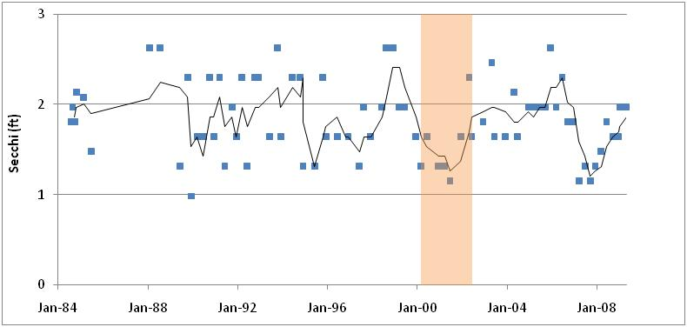

Figure 23
Water clarity (Secchi disk depth in feet) for Lake May. Line is three-point moving average. Shaded area denotes approximate time of stormwater retrofit project.
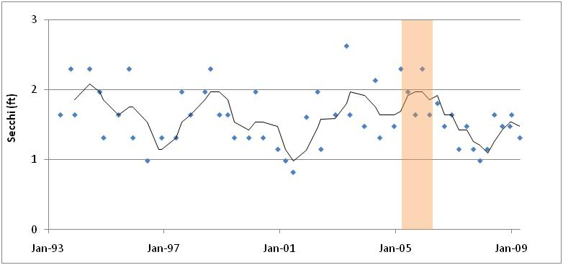
Figure 24
Water clarity (Secchi disk depth in feet) for Lake Lulu. Line is three-point moving average. Shaded area denotes approximate time of stormwater retrofit project.
These results show a lack of a clear and sustained response of water clarity to the completion of these stormwater retrofit projects, even though they were sufficient in magnitude to exceed the TMDL report’s (FDEP 2007) recommended TP load reduction goals (PBS&J 2008). Results were compared for the period after completion of the regional stormwater treatment projects to an equal amount of time prior to project initiation. As the data did not meet requirements of normality and homogeneity of variance, the non-parametric Kruskal-Wallis test was used to compare data for pre vs. post project time frames. There was no evidence of a sustained improvement in water clarity in any of the three lakes, based on this test (p > 0.05).
Results for chlorophyll-a are shown in Figures 25 to 27.
Figure 25
Chlorophyll-a (µg / liter) for Lake Howard. Line is three-point moving average. Shaded area denotes approximate time of stormwater retrofit project.
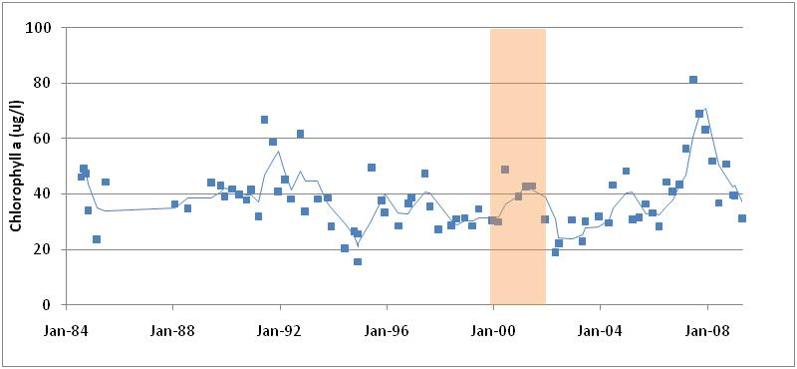
Figure 26
Chlorophyll-a (µg / liter) for Lake May. Line is three-point moving average. Shaded area denotes approximate time of stormwater retrofit project.
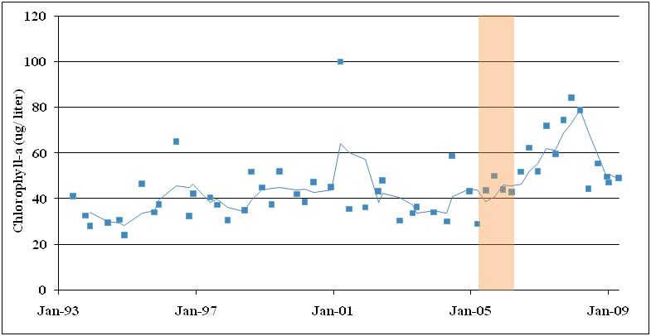
Figure 27
Chlorophyll-a (µg / liter) for Lake Lulu. Line is three-point moving average. Shaded area denotes approximate time of stormwater retrofit project.
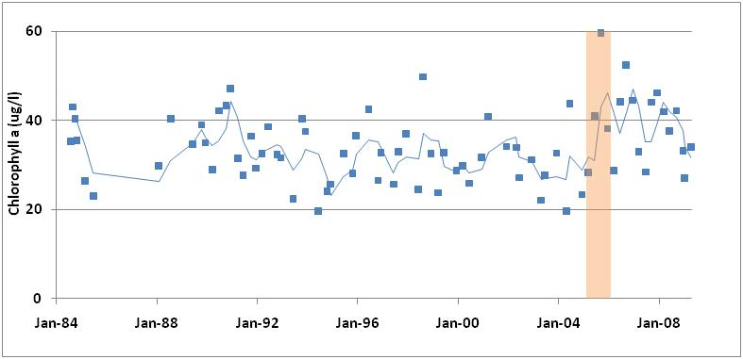
As with water clarity, there is no evidence of a sustained improvement in levels of chlorophyll-a in response to the completion of these stormwater retrofit projects, even though they were sufficient in magnitude to exceed the TMDL report’s (FDEP 2007) recommended TP load reduction goals (PBS&J 2008). Levels of chlorophyll-a were compared for the period after completion of the regional stormwater treatment projects to an equal amount of time prior to project initiation. As the data did not meet requirements of normality and homogeneity of variance, the non-parametric Kruskal-Wallis test was used to compare data for pre vs. post project time frames. There was no evidence of an improvement in levels of chlorophyll-a in any lake, based on this test (p > 0.05) although there was evidence of increased levels of chlorophyll-a in both Lake May and Lake Lulu during the post-project completion time period, as compared to an equal amount of time prior to project initiation (p < 0.05).
Results for TP are shown in Figures 28 to 30.

Figure 28
Total phosphorus (mg TP / liter) for Lake Howard. Line is three-point moving average. Shaded area denotes approximate time of stormwater retrofit project.
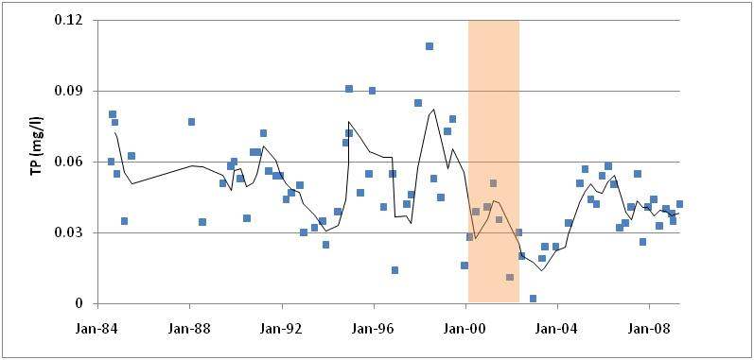
Figure 29
Total phosphorus (mg TP / liter) for Lake May. Line is three-point moving average. Shaded area denotes approximate time of stormwater retrofit project.
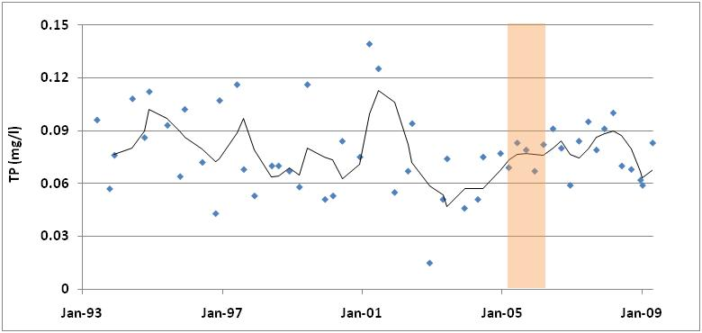

Figure 30
Total phosphorus (mg TP / liter) for Lake Lulu. Line is three-point moving average. Shaded area denotes approximate time of stormwater retrofit project.
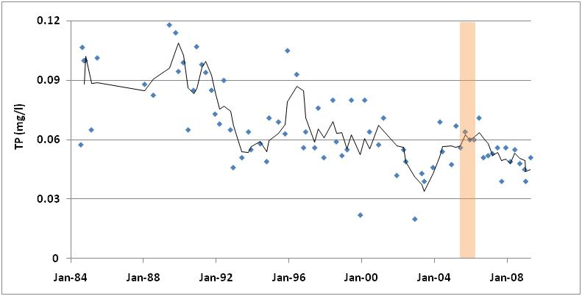
There is no evidence of a sustained improvement in levels of TP in response to the completion of these stormwater retrofit projects for any of the lakes, although there was an initial reduction in TP in Lake Howard (explained in greater detail later in this report). Even though Lakes Howard, May and Lulu all had experienced TP load reductions sufficient in magnitude to exceed the TMDL report’s (FDEP 2007) target load reductions (PBS&J 2008) there was no evidence of a sustained improvement in levels of TP in any of the lakes (Kruskal-Wallis test; p > 0.05).
Combined, these results suggest that large regional stormwater retrofit projects alone, even those substantial enough to exceed expected TP load reduction targets for their TMDLs, do not appear to be adequate, by themselves, for managing water quality in the WHCL system.
In response to these findings, alternative lake restoration techniques were examined. These approaches included whole-lake alum injection, sediment removal, lake aeration, and the benefits of properly managing for submerged aquatic plants. Where possible, the water quality in lakes that experienced these types of management actions were compared to similar lakes in the same general region without such activities. For whole-lake alum treatment, water quality responses of Lake Conine were compared to trends in nearby and similarly hypereutrophic Lake Parker.
For sediment removal, water quality responses of Banana Lake and Lake Hollingsworth were compared to Lake Parker as well. An additional assessment of the responses to sediment removal was made for Lake Trafford in Collier County. However, there was no similarly located lake to compare to Lake Trafford.
For whole-lake aeration, the best documented local assessment was that conducted by the SWFWMD for Lake Persimmon in Highlands County.
Figures 31 to 33 show the responses of water clarity, chlorophyll-a and TP to a whole-lake alum treatment, which was completed for Lake Conine in the mid-1990s.
Figure 31
Water clarity (Secchi disk depths in feet) for Lakes Conine and Parker. Line is three-point moving average. Shaded area denotes approximate time of whole-lake alum treatment for Lake Conine.
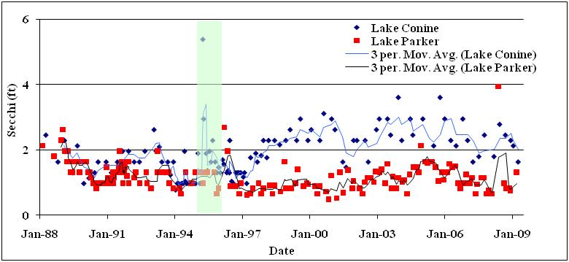
Figure 32
Chlorophyll-a (µg / liter) for Lakes Conine and Parker. Line is three-point moving average. Shaded area denotes approximate time of whole-lake alum
treatment for Lake Conine.
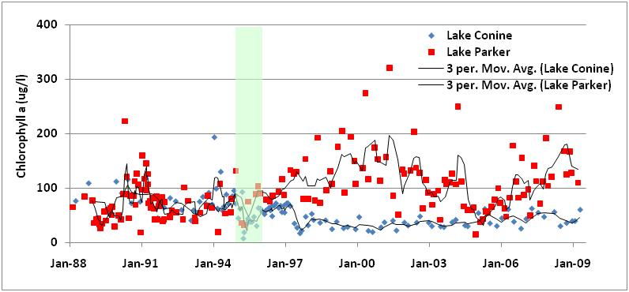
Figure 33
Total phosphorous (mg TP / liter) for Lakes Conine and Parker. Line is three-point moving average. Shaded area denotes approximate time of whole-lake alum treatment for Lake Conine.
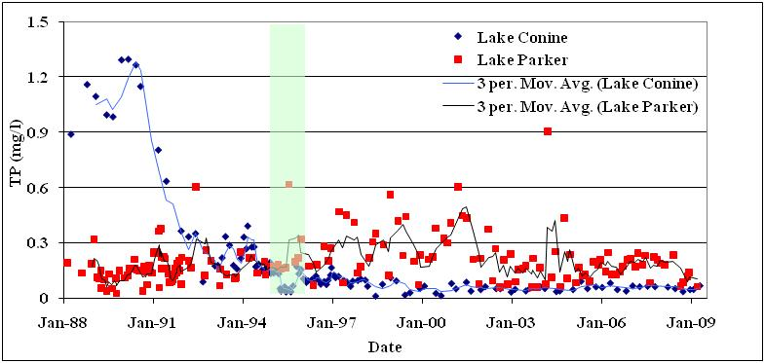
The available data show that water clarity increased and chlorophyll-a levels decreased in Lake Conine in the years after the whole-lake alum treatment, as opposed to a lack of a trend in water clarity, and an increase in chlorophyll-a in Lake Parker during the same time period. These differences were statistically significant (Kruskal-Wallis; p < 0.05). For TP, whole-lake alum brought about a decrease in Lake Conine, while Lake Parker actually experienced an increase in TP over the same time period. Also evident is the substantial reduction in TP levels in Lake Conine associated with the diversion, in the 1980s, of an earlier point source discharge from a domestic wastewater treatment plant.
Combined, these data clearly support the contention that a properly designed and implemented whole-lake alum treatment, similar to that done for Lake Conine, can improve water quality for lakes within the WHCL system.
To assess the effectiveness of sediment removal as a lake management technique, water quality responses of Banana Lake and Lake Hollingsworth were compared against trends over the same time period for Lake Parker, a nearby and similarly hypereutrophic lake. Trends in water clarity, chlorophyll-a and TP were examined, with Banana Lake’s responses compared to Lake Parker for each parameter, and then Lake Hollingsworth’s response similarly compared to Lake Parker for the same parameters.
Water clarity data are presented in Figures 34 and 35, with trends over time of chlorophyll-a shown in Figures 36 and 37, and TP trends shown in Figures 38 and 39.

Figure 34
Water clarity (Secchi disk depths in feet) for Banana Lake and Lake Parker. Line is three-point moving average. Shaded area denotes approximate time of sediment dredging project for Banana Lake.
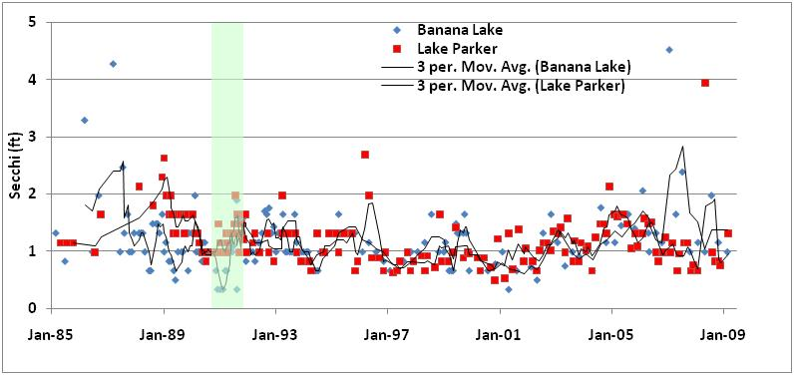
Figure 35
Water clarity (Secchi disk depths in feet) for Lake Hollingsworth and Lake Parker. Line is three-point moving average. Green shaded area denotes approximate time of sediment removal project for Lake Hollingsworth. Orange shaded area denotes approximate time of whole-lake alum project for Lake Hollingsworth.
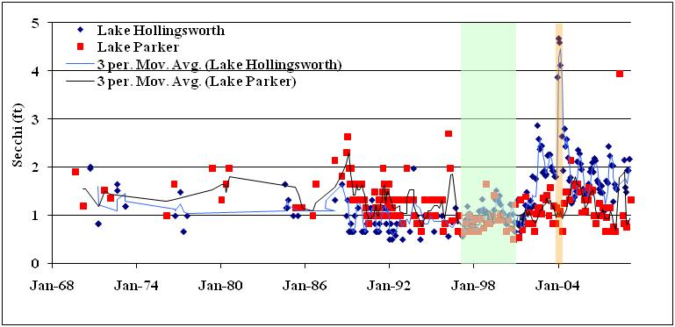

Figure 36
Chlorophyll-a (µg / liter) for Banana Lake and Lake Parker. Line is three-point moving average. Shaded area denotes approximate time of sediment dredging project for Banana Lake.
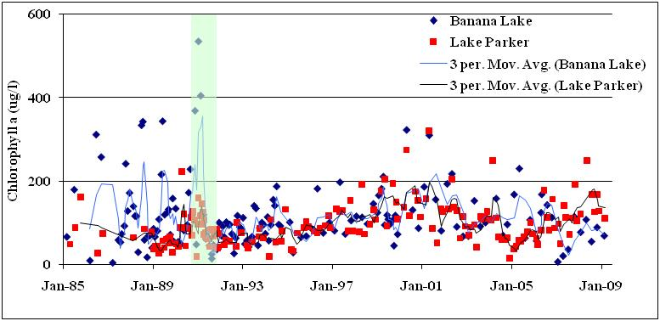
Figure 37
Chlorophyll-a (µg / liter) for Lake Hollingsworth and Lake Parker. Line is three-point moving average. Green shaded area denotes approximate time of sediment removal project for Lake Hollingsworth. Orange shaded area denotes approximate time of whole-lake alum project for Lake Hollingsworth.
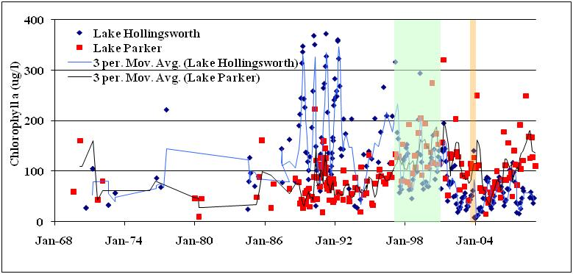

Figure 38
Total phosphorus (mg / liter) for Banana Lake and Lake Parker. Line is three-point moving average. Shaded area denotes approximate time of sediment dredging project for Banana Lake.
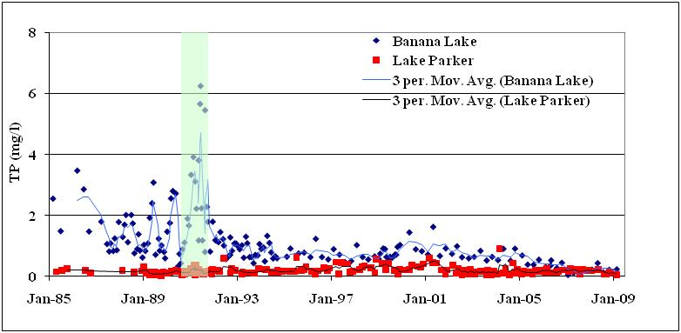
Figure 39
Total phosphorus (mg / liter) for Lake Hollingsworth and Lake Parker. Line is three-point moving average. Green shaded area denotes approximate time of sediment removal project for Lake Hollingsworth. Orange shaded area denotes approximate time of whole-lake alum project for Lake Hollingsworth.
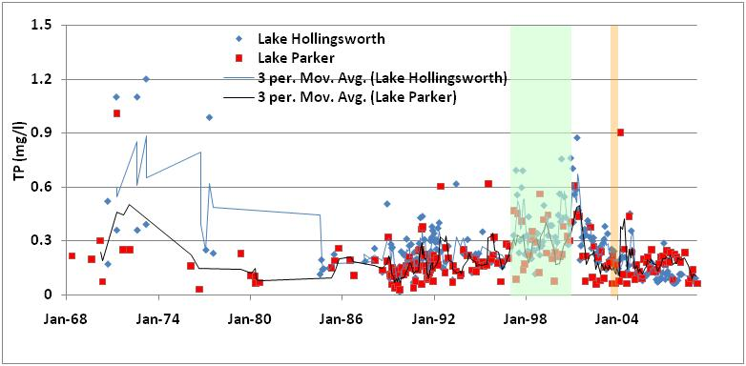
There is no evidence of an improvement in water clarity in Banana Lake as a result of sediment removal activities in the early 1990s, as Secchi disk depth values before and after sediment removal are not significantly different (Kruskal-Wallis; p > 0.05). In contrast, Lake Hollingsworth experienced a statistically-significant improvement in water clarity in the years after sediment removal (Kruskal-Wallis; p < 0.05). During the same time period, there was no difference in water clarity in Lake Parker. A later and short-term spike in water clarity in Lake Hollingsworth is due to a later whole-lake alum treatment. Even prior to the alum treatment, water clarity had already improved in Lake Hollingsworth.
Data on chlorophyll-a and TP also show patterns of improvement in Lake Hollingsworth after sediment removal, with complicating effects of a later whole-lake alum treatment. Chlorophyll-a levels in Lake Hollingsworth decreased in the years after sediment removal (Kruskal-Wallis; p < 0.05). There also appeared to be an initial increase in TP levels after sediment removal, with a later decline after whole-lake alum. Overall, there were statistically significant increases in water clarity and decreases in chlorophyll-a levels in Lake Hollingsworth in response to the combined effects of sediment removal and whole-lake alum treatment, with no such changes seen in Lake Parker.
In contrast to the overall positive responses seen in Lake Hollingsworth, there was a more mixed response to sediment removal in Banana Lake. Sediment removal was associated with a significant decrease in levels of TP in Banana Lake (Kruskal-Wallis; p < 0.01) compared to an increase in TP levels during the same time period in Lake Parker. However, there is no evidence of an improvement in either water clarity or chlorophyll-a when comparing water quality in Banana Lake in pre vs. post sediment removal time periods (Kruskal-Wallis; p > 0.05). These results suggest that sediment removal may have reduced TP levels in Banana Lake, but not enough to have resulted in a biological response of reduced levels of phytoplankton biomass, and thus not enough to have improved water clarity.
Similar to Lake Hollingsworth, but in contrast to Banana Lake, there is clear evidence of a reduction in chlorophyll-a levels in Lake Trafford in Collier County in response to a large-scale sediment removal project (Figure 40).

Figure 40
Chlorophyll-a in Lake Trafford. Line is three-point moving average. Shaded area denotes approximate time of sediment removal project.
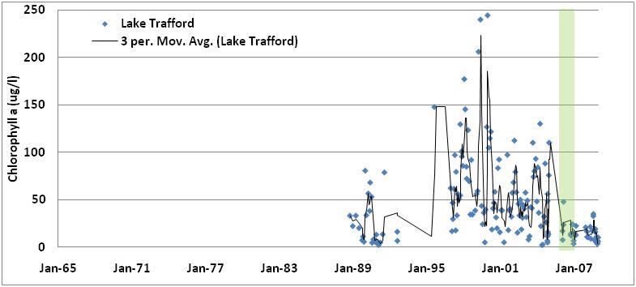
However, the period of record for post-sediment removal in Lake Trafford, and the lack of a similar but unaffected nearby reference lake makes the conclusion that sediment removal improved the water quality in Lake Trafford a tentative one. In their assessment of the water quality responses of Lake Tohopekaliga to sediment removal efforts, Hoyer et al. (2008) came to a similarly guarded conclusion that there was indeed a benefit, at least in the short term.
An additional lake management activity which was examined was that of whole-lake aeration. While there are examples in the literature reporting on improvements in water quality in response to lake aeration, many of these claims appear to be made without sufficient rigor in terms of reference lakes and experimental design. However, a whole-lake aeration system was installed in Lake Persimmon, a hypereutrophic lake in Highlands County, and the lake’s response to that effort was documented by scientists with the SWFWMD. In their review of water quality responses to this treatment, Kolasa and Kang (2005) concluded that “…several parameters have shown improvements including the reduction of ammonia and also chlorophyll.” While nitrate loads to the lake were not reduced by the aeration system, the lake itself has improved to a degree that local homeowners have noted the changes.
In summary, “traditional” large regional stormwater retrofit projects have not shown themselves capable of improving water quality in the WHCL system, even when these projects were sufficiently robust to have exceeded TP load reductions called for in the TMDL report for the WHCL (FDEP 2007). In contrast, whole-lake alum application clearly improved water quality in Lake Conine, as well as having downstream benefits to Lake Smart (PBS&J 2008). Sediment removal appears to have benefited water quality in Lake Hollingsworth, as well as in Collier County’s Lake Trafford. However, while TP levels decreased in response to sediment removal in Banana Lake, there was no concurrent improvement in either chlorophyll-a or water clarity. Based on results in Lake Persimmon, whole-lake aeration appears to be capable of improving water quality, although results might not be transferable to some of the larger lakes in the WHCL.
An additional finding of particular interest to management of the WHCL system is the noted increase in TP levels in Lake Howard after an initial decrease in the months after completion of the stormwater treatment projects (see Figure 28). This increase in TP is concurrent with the completion of an extensive Hydrilla eradication project, which used chemical treatment to kill off Hydrilla over an area of approximately half of Lake Howard (Polk County, personal communication). It appears that Hydrilla eradication efforts in Lake Howard compromised or offset some of the potential benefits, at least to chlorophyll-a concentrations and TP levels, of the prior regional stormwater treatment projects.
The conclusion that the abundance of submerged aquatic vegetation is inversely related to phytoplankton levels has been previously made for Florida lakes by Canfield et al. (1984). Increased levels of TP and chlorophyll-a, and decreased water clarity, occurred in Lake Baldwin (near Orlando) in response to Hydrilla eradication efforts (Shireman et al., 1985). At a minimum, Hydrilla control efforts should be coordinated with other lake management efforts such that the benefits of one project (i.e., Hydrilla control) do not offset the benefits of other projects (i.e., water quality improvement projects). An optimal course of action would be for Hydrilla control to be focused on the possibility of physical removal and replanting efforts as a means of substituting the water quality benefits of “bad” submerged aquatic vegetation with potential water quality benefits of “good” submerged aquatic vegetation. Although Hoyer and Canfield (1996) did not find a relationship between the amount of lake bottom covered by aquatic vegeataion and the abundance of targeted recreational fish, they did not discount that submerged aquatic vegetation were important to lake health. As such, it is recommened here a reasonable lake restoration goal for the WHCL system should be the that the threshold value of 30% proposed by the Florida Fish and Wildlife Conservation Commission (Anonymous, 1994).

Conclusions
A holistic lake management strategy for the WHCL system should account for the following findings:
- Much of the WHCL watershed is urbanized and much of that urbanization occurred in the years before modern stormwater treatment rules were in place.
- Development of the watershed has been accompanied by paving over of much of the recharge areas for the surficial aquifer.
- Most of the WHCL lakes are lower in elevation (by about five feet) than historical data indicate.
- For Ridge lakes, lowered lake levels in the dry-season can be associated with degraded water quality, perhaps due to increased resuspension of nutrient-enriched sediments.
- For Valley lakes, lowered lake levels in the wet season can be associated with a hydrologic disconnect between the lakes and their adjacent swamp shoreline.
- For Valley lakes, levels of tannins may be more important than nutrient availability, in terms of their influence on levels of chlorophyll-a.
- Traditional large-scale stormwater retrofit projects have not demonstrated clear and sustained water quality benefits within the WHCL, even when the projects were large enough to have met or exceeded TMDL targets for load reductions (although such projects may have been compromised by Hydrilla control efforts in some locations).
- Whole-lake alum treatment appears to be a possible means of benefiting lakes within the WHCL system.
- Sediment removal projects have been able to improve water quality in some lakes (Hollingsworth and Trafford) but this technique may not work for extremely hypereutrophic lakes (e.g., Banana Lake).
- Whole-lake aeration may be a useful tool for water quality improvement, at least in smaller lakes within the WHCL.
- Submerged aquatic vegetation, including Hydrilla, can improve water quality in lakes within the WHCL.
- Hydrilla eradication efforts can have unintended and adverse impacts to water quality.

Recommendations
These findings have given rise to the following recommendations:
Ridge and Valley Lakes recommendations:
Adopt the EPA (2010) proposed numeric nutrient criteria for both high and low color lakes, with the revision that a more locally-appropriate threshold value for clear alkaline lakes is that of a specific conductance value higher than 190 µmhos / cm.
Attempts to maximize native submerged aquatic vegetation communities should be undertaken, in coordination with efforts to control infestation by Hydrilla and maintain native submerged aquatic vegetation coverage of 30 percent of the lake bottom.
Ridge Lake recommendations:
Appropriate targets for TP and TN can be calculated using the EPA (2010) guidance, after reclassifying most low color lakes into their appropriate category of clear and alkaline based on the use of a 190 µmhos / cm threshold for specific conductance.
Sediment inactivation or sediment removal projects appear to be appropriate approaches to minimizing internal nutrient loads for those lakes with documented prior point source impacts.
Efforts should be undertaken to maximize recharge of the surficial aquifer through techniques such as rain gardens and decreasing the amount of directly connected impervious areas, to increase the amount of groundwater storage and maximize dry-season lake levels via groundwater discharge to the lakes.
Valley Lake recommendations:
Appropriate targets for TP and TN can be calculated using the EPA (2010) guidance
A target “tannin” level of 50 platinum-cobalt units or higher (for lakes with levels higher than 50 already) appears appropriate.
Increasing the hydrologic connection between lakes and their swamp shoreline, such that a minimum of 10 to 20% of their shoreline is functioning in the wet season as a tannin source.
Proposed interim water quality targets, and the proposed lake management projects, by lake, for the WHCL are listed in Table 9. More detailed analysis of the costs of such projects, and project details, will be developed in later stages of this Water Quality Management Plan effort.

Table 9
Summary of water quality proposed interim water quality targets and restoration project types proposed for the WHCL.
Lake | TMDL  Required? | Lake  Type | Target TP  (mg / l) | Target TN  (mg / l) | Target Color  (PCU) | Sediment Removal or Inactivation? | Swamp Shoreline Rehydration Goal  (% shoreline) | Lake Aeration?
Blue | N | Ridge | 0.15 | 0.85 | NA | N | NA | Y
Cannon | Y | Ridge | 0.03 | 1.00 | NA | N | NA | N
Conine | Y | Ridge | 0.03 | 1.00 | NA | Y* | NA | N
Eloise | N | Ridge | 0.03 | 1.00 | NA | Y | NA | N
Fannie | N | Valley | 0.157 | 2.25 | > 50 | N | 20 | N
Haines | Y | Valley | 0.050 | 1.23 | > 50 | Y | 20 | N
Hamilton | N | Valley | 0.157 | 2.25 | > 50 | N | 20 | N
Hartridge | N | Ridge | 0.015 | 0.85 | NA | N | NA | N
Henry | N | Valley | 0.157 | 2.25 | > 50 | N | 20 | N
Howard | Y | Ridge | 0.03 | 1.00 | NA | Y | NA | N
Idylwild | Y | Ridge | 0.03 | 1.00 | NA | N | NA | N
Jessie | Y | Ridge | 0.03 | 1.00 | NA | Y | NA | N
Little Hamilton | N | Valley | 0.03 | 1.00 | > 50 | N | NA | N
Lulu | Y | Valley | 0.03 | 1.00 | > 50 | Y | 20 | N
Mariana | N | Ridge | 0.03 | 1.00 | NA | N | NA | N
May | Y | Ridge | 0.03 | 1.00 | NA | Y | NA | Y
Mid. Hamilton | N | Valley | 0.05 | 1.23 | > 50 | N | 20 | N
Mirror | Y | Ridge | 0.03 | 1.00 | NA | N | NA | N
Rochelle | Y | Valley | 0.03 | 1.00 | > 50 | N | 20 | N
Roy | N | Ridge | 0.03 | 1.00 | NA | N | NA | Y
Shipp | Y | Ridge | 0.03 | 1.00 | NA | Y | NA | N
Smart | Y | Valley | 0.05 | 1.23 | > 50 | N | 20 | N
Spring | N | Ridge | 0.03 | 1.00 | NA | N | NA | Y
Summit | N | Ridge | 0.03 | 1.00 | NA | N | NA | Y
Winterset | N | Ridge | 0.03 | 1.00 | NA | N | NA | N
NA = not applicable. Y = yes. N = no. * = activity already completed.
The project types listed in Table 9 would be in addition to efforts to minimize stormwater runoff and maximize groundwater recharge, as outlined in the Sustainable Water Resources Management Plan for the Peace Creek Watershed and City of Winter Haven (PBS&J 2009). Projects to infiltrate runoff into the surficial aquifer would have the dual benefits of increasing lake levels in the dry-season via infiltration and eventual discharge from the surficial aquifer, and also reduction in stormwater loads of various pollutants via treatment processes of a typical dry retention pond. These types of scattered stormwater BMPs should replace the prior emphasis placed on large, regional stormwater treatment systems.
Sediment inactivation and/or removal projects would focus on lakes with documented prior point source impacts; such prior impacts appear to be capable of severely impacting water quality via internal loading processes.
Additionally, it is recommended that Hydrilla control efforts be better coordinated with other ongoing and/or planned lake management activities, to minimize the potential of projects being at cross purposes to each other. For all lakes, particularly low color ones, an interim goal of maintaining at least 30 percent coverage of the lake bottom with desirable submerged aquatic vegetation would be appropriate.
Lake aeration projects would focus on the smallest lakes within the WHCL, with emphasis placed on monitoring system responses both in terms of water quality and also monitoring of sediment composition.
For all projects, the continuation of long-term and multi-parameter water quality monitoring programs is essential. While water quality monitoring programs may not receive the amount of publicity and public awareness of large restoration projects, they are the only sources of information that can be relied upon to determine whether or not various restoration projects have performed, and whether more such projects should be considered.

Literature Cited
Anonymous (1996). Triploid grass carp. Fact sheet. Florida Game and Fresh Water Fish Commission, Eustis, Florida.
Brenner, M. T.J., Whitmore, M.S., Flannery, and M. Binford. 1993. Paleolimnological methods for defining target conditions in lake restoration: Florida case studies. Lake and Reservoir Management, 7(2): 209-217.
Bachmann, R.W., M.V. Hoyer, and D. Canfield. 2000. The potential for wave disturbance in shallow Florida lakes. Lake and Reservoir Management 16 (4): 281-291.
Canfield, D.E., Jr, J.V. Shireman, D.E. Colle, W.T. Haller, C.E. Watkins, II., and M.J. Maceina. 1984. Predication of Chlorophyll a concentrations in Florida lakes: Importance of Aquatic Macrophytes. Can. J. Fish. Aquat.Sci. 41: 497-501.
Canfield, D.E., E. Philips, and M. Duarte. 1989. Factors influencing the abundance of blue-green algae in Florida lakes. Can. J. Fish. Aquat. Sci. 46: 1232-1237.
EPA. 2010. Water Quality Standards for the State of Florida's Lakes and Flowing Waters. Federal Register: January 26th, 2010
FDEP. 1996. 1996 Water-Quality Assessment for the State of Florida. Section 305(b). Main Report. Florida Department of Environmental Protection.
FDEP, 2007. TMDL Report: Nutrient TMDL for the Winter Haven Southern Chain of lakes (WBIDs 1521, 1521D, 1521E, 1521F, 1521G, 1521H, 1521J, 1521K). Division of Water Resource Management, Bureau of Watershed Management, Tallahassee, Florida.
FFWCC, 2001. Florida Freshwater Fishing Values.
Heath, R. 1961. Surface water resources of Polk County, Florida. Prepared by USGS and FGS. Information circular No.25.
Hoyer, M., R. Bachmann and D. Canfield. 2008. Lake management (muck removal) and hurricane impacts on the trophic state of Lake Tohopekaliga, Florida. Lake and Reservoir Management 24: 57-68.
Hoyer, M., C. Brown and D. Canfield. 2004. Relations between water chemistry and water quality as defined by lake users in Florida. Lake and Reservoir Managements 20(3): 240-248.
Hoyer, M. and D. Canfield. 1996. Largemouth Bass abundance and aquatic vegetation in Florida lakes: an Empirical Analysis. J. Aquat. Plant. Manage. 34: 23-32.
Kaufman, M.I. 1967. Hydrologic effects of ground-water pumpage in the Peace and Alafia River Basins, Florida, 1934-1965. Report of Investigations No. 49.
Kautz, E.S. 1980. Effects of eutrophication on the fish communities of Florida lakes. Proc. Annu. Conf. Southeast. Assoc. Fish. Wildl. Agencies, 34:67-80.
Kolasa, K. and W. Kang. 2005. Aeration of subtropical hypertrophic lake- a band-aid approach that’s working. 69th Annual Meeting of the Florida Academy of Sciences. University of South Florida, Tampa, Fl. March 2005.
Larkin, P.A. and T.G. Northcote. 1969. Fish as indices of eutrophication. In Eutrophication, causes, consequences, correctives. Proceedings of a symposium, June 11-15, 1967. Madison, Wis National Academy of Sciences, Washington D.C., pp 256-273.
Lee, G. F., P.E. Jones and R.A. Jones. 1991. Effects of eutrophication on fisheries. Rev. Aquat. Sci. 5: 287-305.
PBS&J, 2008. Winter Haven Chain of Lakes Pre-BMAP Assessment: An Interpretative Synthesis of Existing Information. Final Report to the Florida Department of Environmental Protection.
Persson, L., G. Andersson, S.F. Hamrin and L. Johansson. 1988. Predator regulation and primary production along the productivity gradient of temperate lake ecosystems. In Complex interactions in freshwater ecosystems. Edited by S.R. Carpenter. Elsevier, Amsterdam. Pp 45-65.
Raschke, R. 1993. Guideline for assessing and predicting eutrophication status of small southeastern piedmont impoundments. Proceedings of the 1993 Georgia Water Resources Conference. The University of Georgia, Athens, Georgia.
Reidinger-Whitmore, M.A., T. Whitmore, J. Smoak, M. Brenner, A. Moore, J. Curtis, and C. Schelske. 2005. Cyanobacterial proliferation is a recent response to eutrophication in many Florida lakes: a paleolimnological assessment. Lake and Reservoir Management 21(4): 232-435.
Shireman, J.V., M.Hoyer, M. Maceina, and D. Canfield. 1985. The water quality and fishery of Lake Baldwin, Florida: 4 years after macrophyte removal by grass carp. Proceedings of the Fourth Annual Conference and International Symposium. North American Lake Management Society. McAfee, New Jersey. 201-206.
Southwest Florida Water Management District. 1998. Winter Haven Chain of Lakes Surface Water Improvement and Management Plan. Brooksville, Florida.
Spechler, R.M., and S.E. Kroening. 2006. Hydrology of Polk County, Florida: U.S. Geological Survey Scientific Investigations Report 2006-5320. 114 p
Stokes, S. 1999. The water table in Northeast Polk County a Century Ago. Polk County Historical Quarterly. Pg 4.
Tomasko, D.A., E. Keenan, L. DeBrabandere, J. Montoya and T. Frazer. 2009. Experimental studies on the effects of nutrient loading and sediment removal on water quality in Lake Hancock. Florida Scientist 72(4) 346-366.
University of South Florida. 2005. Winter Haven Chain of Lakes PLRG Study. Final Report to: Surface Water Improvement and Management (SWIM) Program, Southwest Florida Water Management District, Tampa, FL.
Weaver, K. 2009. Presentation on Numeric Nutrient Criteria. FDEP, Tallahassee, Fl.
Whitmore, T.J. 1989. Florida diatom assemblages as indicators of trophic state and pH. Limnology and Oceanography 34:882-895.
Whitmore, T.J. and M. Brenner. 1995. Historic water quality assessment of selected lakes in the Winter Haven Chain of Lakes. Final Report to the Southwest Florida Water Management District. Gainesville, Florida: University of Florida, Department of Fisheries and Aquatic Sciences.
Whitmore, T.J. and M. Brenner. 2002. Final Report: Paleolimnological Characterization of Pre-disturbance Water Quality Conditions in EPA-Defined Florida Lake Regions. Submitted to the Florida Department of Environmental Protection. March 2002.

