Draft
Basin Management Action Plan

for the Implementation of the
Total Maximum Daily Load for Nutrient (Biology)
by the Florida Department of Environmental Protection
in the Upper Wakulla River and Wakulla Springs Basin
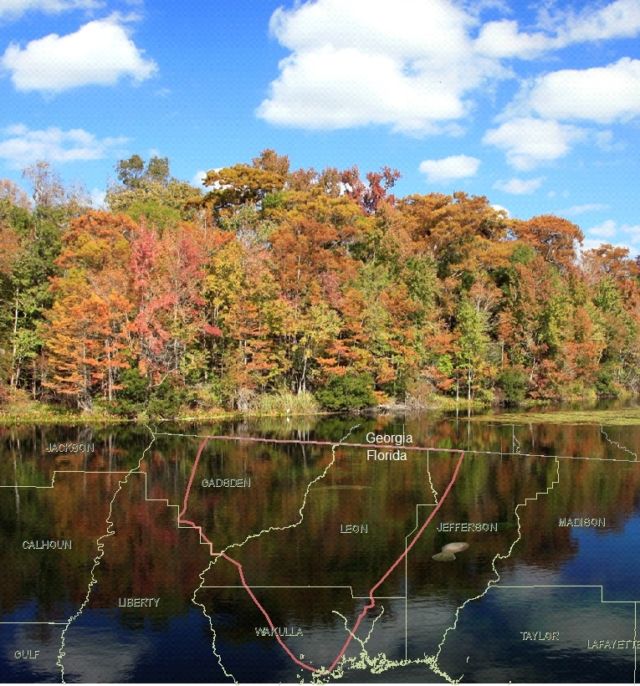
prepared by the
Division of Environmental Assessment and Restoration
Watershed Restoration Program
Florida Department of Environmental Protection
Tallahassee, FL 32399

in cooperation with the
Upper Wakulla River and Wakulla Springs Basin Technical Stakeholders

September 2013

Acknowledgments
The Florida Department of Environmental Protection adopted the Upper Wakulla River and Wakulla Springs Basin Management Action Plan by Secretarial Order as part of its statewide watershed management approach to restore and protect Florida’s water quality. The plan was developed in cooperation with the Upper Wakulla River and Wakulla Springs Basin stakeholders, identified below, with participation from affected local, regional, and state governmental interests; elected officials and citizens; and private interests.

Florida Department of Environmental Protection
Hershel T. Vineyard Jr., Secretary
Drew Bartlett, Deputy Secretary for Water Policy and Ecosystem Restoration
Tom Frick, Director of the Division of Environmental Assessment and Restoration
Trina Vielhauer, Deputy Director of the Division of Environmental Assessment and Restoration
Beth Alvi, Program Administrator for the Watershed Restoration Program
Charles Gauthier, Environmental Administrator for the Watershed Planning and Coordination Section

Upper Wakulla River and Wakulla Springs Basin Participants
- = Empty cell/no data
Responsible Stakeholders | Responsible Agencies | Other Interested Stakeholders
Agricultural Producers | Florida Department of Agriculture and Consumer Services | Center for Earth Jurisprudence
Leon County | Florida Department of Environmental Protection, including Wakulla Springs State Park | Citizens
Wakulla County | Florida Department of Health | Florida Department of Economic Opportunity
City of Tallahassee | Leon County Health Department | Friends of Wakulla Springs
Florida Department of Transportation District 3 | Northwest Florida Water Management District | Wakulla Springs Alliance
Gadsden County | Wakulla County Health Department | -
Jefferson County | - | -
City of Gretna | - | -
City of Midway | - | -
City of Quincy | - | -
Town of Havana | - | -
Federal Correctional Institution, Tallahassee | - | -
Florida Agricultural and Mechanical University | - | -
Florida State University | - | -
Tallahassee Community College | - | -
Talquin Electric Cooperative | - | -
For additional information on Total Maximum Daily Loads and the watershed management approach in the Upper Wakulla River and Wakulla Springs Basin, contact:

Stephen Cioccia, Basin Coordinator
Florida Department of Environmental Protection
Watershed Restoration Program, Watershed Planning and Coordination Section
2600 Blair Stone Road, Mail Station 3565
Tallahassee, FL 32399-2400
Email: Stephen.Cioccia@dep.state.fl.us
Phone: (850) 245–8513

Table of Contents
List of Acronyms and Abbreviations vii
Summary viii
Chapter 1 : Context, Purpose, and Scope of the Plan 1
1.1 Water Quality Standards and TMDLs 1
1.2 TMDL Implementation 3
1.3 Upper Wakulla River and Wakulla Springs BMAP 3
1.3.1 Plan Purpose and Scope 3
1.3.2 Stakeholder Involvement 6
1.3.3 BMAP Approach 8
1.3.4 Onsite Sewage Treatment and Disposal Systems (OSTDS) Initiative 9
1.3.5 Pollutant Reduction and Discharge Allocations 15
1.3.6 Upper Wakulla River TMDL 16
1.4 Assumptions and Considerations Regarding TMDL Implementation 16
1.4.1 Assumptions 16
1.4.2 Considerations 17
1.5 Future Growth in the Watershed 19
Chapter 2 : Upper Wakulla River and Wakulla Springs Basin Setting 22
2.1 Land Use Coverage 22
2.2 Hydrology 25
2.3 Water Quality and Biological Community Trends 26
2.4 The Impact of Nitrate on Water Quality and the Biological Community 31
Chapter 3 : Pollutant Sources and Anticipated Outcomes 33
3.1 Summary of Sources in the Basin 33
3.1.1 WWTFs 33
3.1.2 OSTDS 35
3.1.3 Residential Fertilizer 37
3.1.4 Agricultural Fertilizer and Livestock 37
3.1.5 Stormwater 39
3.2 Anticipated Outcomes of BMAP Implementation 41
Chapter 4 : Management Strategies within the PFAs 42
4.1 Sufficiency of Effort Evaluation 42
4.1.1 WWTFs Sufficiency 42
4.1.2 OSTDS Sufficiency 44
4.1.3 Residential Fertilizer Sufficiency 45
4.1.4 Agricultural Fertilizer and Livestock Sufficiency 46
4.1.5 Stormwater Sufficiency 46
4.1.6 Other Strategies 47
4.2 Stakeholder Management Strategies Tables 49
Chapter 5 : Management Strategies Outside of the PFAs 60
5.1 Agriculture 60
5.2 City of Gretna Management Strategies 62
5.3 City of Quincy Management Strategies 62
5.4 FAMU Management Strategies 62
5.5 Federal Correctional Institution, Tallahassee Management Strategies 63
5.6 FSU Management Strategies 63
5.7 Gadsden County Management Strategies 64
5.8 Talquin Electric Cooperative Management Strategies 64
5.9 TCC Management Strategies 65
5.10 Town of Havana Management Strategies 66
Chapter 6 : Assessing Progress and Making Changes 67
6.1 Tracking Implementation 67
6.2 Adaptive Management Measures 68
6.3 Water Quality Monitoring 69
6.3.1 Monitoring Objectives 69
6.3.2 Water Quality Monitoring Parameters, Frequency, and Network 69
6.3.3 Biological Monitoring 73
6.3.4 Data Management and Assessment 73
6.3.5 QA/QC 74
6.4 Research Studies 74
6.5 Commitment to Plan Implementation 75
APPENDICES 76
Appendix A: TMDL Basin Rotation Schedule 77
Appendix B: Summary of Statutory Provisions Guiding BMAP Development and Implementation 78
Appendix C: Rule 62-304(2), F.A.C., the Upper Wakulla River TMDL 82
Appendix D: City of Tallahassee Stormwater Treatment Projects in the Upper Wakulla River and Wakulla Springs Basin 83
Appendix E: Glossary of Terms 86
Appendix F: Bibliography of Key References and Websites 92

List of Figures
Figure ES-1: Upper Wakulla River and Wakulla Springs Basin ix
Figure ES-2: Water Quality Trends in the Wakulla River and Wakulla Spring Vent xi
Figure 1: Upper Wakulla River and Wakulla Springs Basin 5
Figure 2: Protection Measures for Future Growth 21
Figure 3: 2004 Land Cover in the Upper Wakulla River and Wakulla Springs Basin 24
Figure 4: Locations of the Main Wakulla Springs Tunnels 28
Figure 5: Water Quality Trends in the Wakulla River and Wakulla Spring Vent 29
Figure 6: Water Quality Trends in the Wakulla Springs Tunnels 29
Figure 7: Schematic of Sources, Reservoirs, and Pathways of Nitrogen in the Unconfined Portion of the Wakulla Springshed 32
Figure 8: Domestic Wastewater Treatment Plants and Facilities in the PFAs 34
Figure 9: Current Locations of OSTDS in the PFAs 36
Figure 10: 2009 Agricultural Lands in the Upper Wakulla River and Wakulla Springs BMAP 38
Figure 11: Agricultural Lands Enrolled in BMPs in the PFAs, as of June 2013 59
Figure 12: Agricultural Lands Enrolled in BMPs Outside of the PFAs, as of June 2013 61
Figure 13: Monitoring Network for the Upper Wakulla River and Wakulla Springs 72
Figure D-1: Location of the City of Tallahassee’s Stormwater Treatment Projects 85

List of Tables
Table ES-1: Upper Wakulla River TMDL x
Table 1: Designated Use Attainment Categories for Florida Surface Waters 2
Table 2: Phases of the Watershed Management Cycle 3
Table 3: Upper Wakulla River TMDL 16
Table 4: Leon County Strategies to Address Sources in Georgia 18
Table 5: 2009 Land Cover in the Upper Wakulla River and Wakulla Springs Basin 22
Table 6: 2009 Land Cover in PFA1 22
Table 7: 2009 Land Cover in PFA2 23
Table 8: 2009 Land Cover in the Basin Outside of the PFAs 23
Table 9: Local Governments in the Upper Wakulla River and Wakulla Springs BMAP Basin Designated as MS4s 39
Table 10: Florida Department of Environmental Protection Management Strategies 49
Table 11: FDOT District 3 Management Strategies 49
Table 12: Wakulla Springs State Park Management Strategies 49
Table 13: City of Tallahassee Management Strategies 50
Table 14: Leon County Management Strategies 52
Table 15: Wakulla County Management Strategies 56
Table 16: Agricultural Land Uses and BMP Enrollment in the PFAs as of March 31, 2013 58
Table 17: Agricultural Land Use Acreage BMAP Enrollment Outside of the PFAs as of March 31, 2013 60
Table 18: City of Gretna Management Strategies Outside of the PFAs 62
Table 19: City of Quincy Management Strategies Outside of the PFAs 62
Table 20: FAMU Management Strategies Outside of the PFAs 63
Table 21: Federal Correctional Institution, Tallahassee Management Strategies Outside of the PFAs 63
Table 22: FSU Management Strategies Outside of the PFAs 64
Table 23: Gadsden County Management Strategies Outside of the PFAs 64
Table 24: Talquin Electric Cooperative Management Strategies Outside of the PFAs 65
Table 25: TCC Management Strategies Outside of the PFAs 66
Table 26: Town of Havana Management Strategies Outside of the PFAs 66
Table 27: Water Quality Monitoring Parameters for the River Sites 69
Table 28: Water Quality Monitoring Parameters for the Spring Vent and Conduit Sites 70
Table 29: BMAP Water Quality Monitoring Network 70
Table 30: Biological Monitoring 73
Table A-1: Major Hydrologic Basins by Group and Department District Office 77
Table D-1: Summary of the City of Tallahassee Stormwater Treatment Projects 83
Table F-1: Local and Regional Stormwater and Water Quality Protection Websites 94
Table F-2: State Stormwater and Water Quality Protection Websites 94
Table F-3: National Stormwater and Water Quality Protection Websites 94

List of Acronyms and Abbreviations
AVA Aquifer Vulnerability Assessment
AWT Advanced Waste Treatment
BMAP Basin Management Action Plan
BMP Best Management Practice
C.F.R. Code of Federal Regulations
Department Florida Department of Environmental Protection
EPA U.S. Environmental Protection Agency
F.A.C. Florida Administrative Code
FAMU Florida Agricultural and Mechanical University
FDACS Florida Department of Agriculture and Consumer Services
FDOH Florida Department of Health
FDOT Florida Department of Transportation
FGS Florida Geological Survey
F.S. Florida Statutes
FSU Florida State University
FWRA Florida Watershed Restoration Act
FYN Florida Yards and Neighborhoods
GIS Geographic Information Systems
HA Habitat Assessment
kg/yr Kilograms Per Year
LA Load Allocation
LIDAR Light Detecting and Ranging
LVS Linear Vegetation Survey
mg/L Milligrams Per Liter
MS4 Municipal Separate Storm Sewer System
NELAC National Environmental Laboratory Accreditation Conference
NELAP National Environmental Laboratory Accreditation Program
NPDES National Pollutant Discharge Elimination System
NWFWMD Northwest Florida Water Management District
OSTDS Onsite Treatment and Disposal Systems
PFA Priority Focus Area
ppb Parts Per Billion
PSPZ Primary Springs Protection Zone
QA/QC Quality Assurance/Quality Control
RPS Rapid Periphyton Survey
SCI Stream Condition Index
SESF Southeast Spray Field
STORET STOrage and RETrieval (Database)
TCC Tallahassee Community College
TIF Tax Increment Financing (District)
TMDL Total Maximum Daily Load
TN Total Nitrogen
USGS U.S. Geological Survey
WBID Waterbody Identification (Number)
WLA Wasteload Allocation
WWTP Wastewater Treatment Plant
WWTF Wastewater Treatment Facility

Summary
Upper Wakulla River and Wakulla Springs Basin
The Wakulla River watershed and Wakulla Springs springshed are located within portions of southern Georgia, and Gadsden, Jefferson, Leon, and Wakulla Counties in Florida. The focus for the Upper Wakulla River and Wakulla Springs Basin Management Action Plan (BMAP) is on the portion of the springshed located in Florida (see Figure ES-1). The BMAP basin encompasses an area of approximately 848,445 acres or 1,325 square miles.
Wakulla Springs is the primary source of water to the Wakulla River. Within the Wakulla River watershed, the Cody Scarp generally separates the semi-confined geologic features to the north (soils characterized with lower potential for ground water impacts) and areas of unconfined geologic features to the south (highly permeable karst areas with a high potential for ground water impacts). The Wakulla River is about nine miles long, starting near Camp Indian Springs and joining the St. Marks River near Fort San Marcos. However, the BMAP extent of the Upper Wakulla River ends at the Highway 98 bridge. Major centers of population within the basin include the City of Tallahassee, Woodville, and Crawfordville (Department 2012a). As reported by Kincaid (2010), the efforts of numerous underwater cave explorers and scientists have identified a complex system of ground water conduits that interconnect many of the sinking streams in the watershed, as well as the City of Tallahassee Southeast Spray Field (SESF) to the Wakulla River and Wakulla Springs.
Within the Upper Wakulla River and Wakulla Springs Basin, two Priority Focus Areas (PFAs) were identified to focus management strategies for the first BMAP iteration (see Figure ES-1). These PFAs represent the areas in the basin where the aquifer is most vulnerable to inputs and where there are the most connections between the ground water and Wakulla Springs.
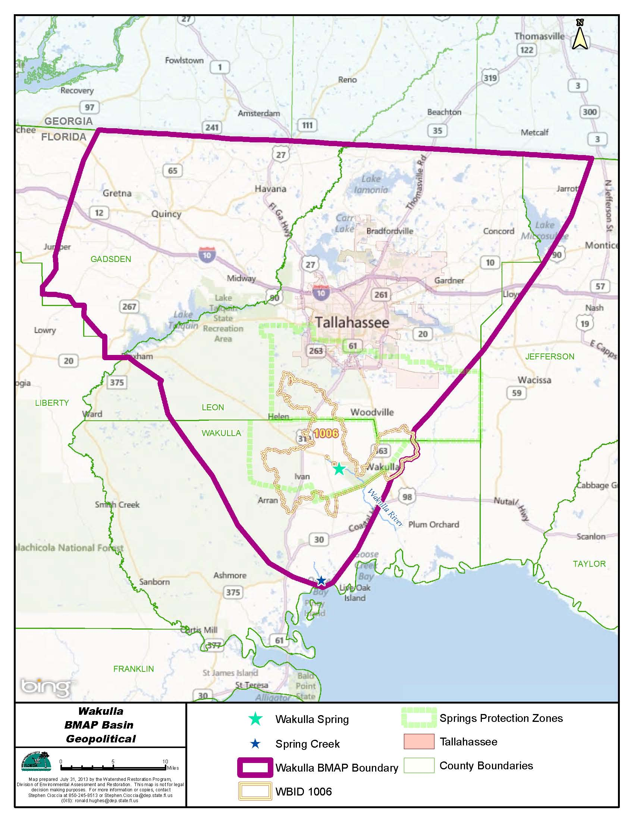
Figure ES-1: Upper Wakulla River and Wakulla Springs Basin

Total Maximum Daily Loads (TMDLs)
TMDLs are water quality targets that are based on state water quality standards for specific pollutants, such as excessive nitrate. The Department determined that the Upper Wakulla River waterbody identification (WBID) number 1006 was impaired by nitrate, which was defined in the TMDL as nitrate + nitrite, using data from January 1, 2000 through June 30, 2007. This determination was made based on stream condition index (SCI) surveys that indicated healthy biological community conditions in the Upper Wakulla River in only 7 of 27 sampling events. The biological community in the river is affected by excessive algal mats that were linked to elevated nitrate concentrations from anthropogenic sources (Department 2012a). Table ES-1 lists the TMDLs and pollutant load allocations adopted by rule for the Upper Wakulla River WBID.

Table ES-1: Upper Wakulla River TMDL
¹ There are no National Pollutant Discharge Elimination System (NPDES) wastewater facilities that discharge directly into the Upper Wakulla River.
² None of the NPDES municipal separate storm sewer systems (MS4s) discharges directly into the Upper Wakulla River.
WBID | Parameter | TMDL (mg/L) | TMDL % Reduction | Wasteload Allocation for Wastewater | Wasteload Allocation for NPDES Stormwater (% Reduction) | Load Allocation  (% Reduction)
1006 | Nitrate, as monthly average | 0.35 | 56.2% | N/A¹ | N/A² | 56.2%

Upper Wakulla River and Wakulla Springs BMAP
Paragraph 403.067(7)(a)1, Florida Statutes (F.S.), authorizes the Department to adopt BMAPs that provide for phased implementation of the strategies necessary to ultimately achieve the associated TMDLs. This approach allows stakeholders to establish management strategies and incrementally plan, budget, and execute projects while simultaneously monitoring and conducting studies to better understand the water quality dynamics (sources and response variables) in the basin. This BMAP is the first iteration for the Upper Wakulla River and Wakulla Springs Basin and it covers a five-year period.
Since the TMDL period, the largest source of loading to the Upper Wakulla River and Wakulla Springs, the City of Tallahassee’s wastewater treatment facility (WWTF) has been upgraded to reduce nitrate concentrations by approximately 75%. Further reductions in nitrate concentrations are expected in the river and springs due to the completed actions (see Figure ES-2). Given the need for further monitoring to determine to what extent additional reductions are needed, this BMAP used a sufficiency of effort evaluation based on source categories to move forward with reductions in the first five-year implementation period.
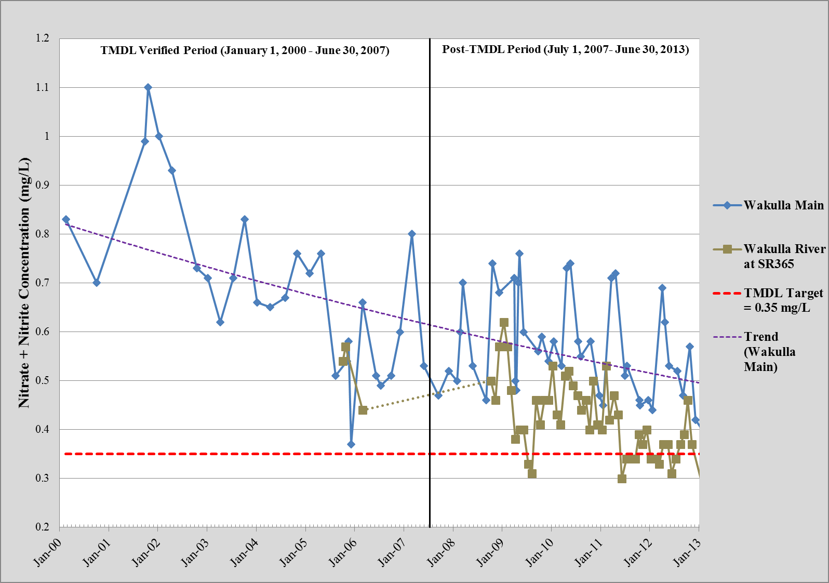
Figure ES-2: Water Quality Trends in the Wakulla River and Wakulla Spring Vent

Using information on sources in the basin, the stakeholders within the PFAs were asked to submit management strategies to reduce nitrate loading from the sources they are responsible for managing. The Department then compared the strategies provided to the sources within each PFA to evaluate whether each of the existing sources was sufficiently addressed for the first BMAP iteration and whether strategies were in place or would be put into place to reduce nitrate sources. Where needed, the Department requested additional details and strategies from the responsible stakeholders to assess sufficiency for the first BMAP iteration.
To ensure sufficiency for addressing onsite sewage treatment and disposal systems (OSTDS), the Department is undertaking an OSTDS Initiative, in cooperation with the Florida Department of Health (FDOH), City of Tallahassee, Leon and Wakulla Counties, and other interested parties. The objectives of the OSTDS Initiative are to identify effective, feasible strategies to reduce nutrient loads from OSTDS sources; establish stakeholder responsibilities and a schedule for implementation; and ensure implementation through stakeholder commitments and BMAP authority. During the first BMAP implementation period, the Department, FDOH, the City of Tallahassee, Leon and Wakulla Counties, and others will discuss options for addressing OSTDS loading, identify effective strategies for the Upper Wakulla River and Springs Basin, establish homeowner and local government council/commission education and outreach programs, determine responsibilities, and identify funding sources to implement the strategies. The Department will prepare an agency report that outlines the strategies appropriate to the basin, prioritizes the importance and sequencing of strategies, and identifies stakeholder responsibilities. The agency report may serve as a comprehensive wastewater management plan for the area encompassed by the PFAs. The responsible stakeholders will propose management strategies suggested for their jurisdiction necessary to meet the reduction targets.
For the first five years of BMAP implementation, collectively the management strategies included in the BMAP are sufficient and reasonable to address nitrate loading in the PFAs to the Upper Wakulla River and Wakulla Springs Basin. Additional management strategies may be required in the next BMAP iteration unless more current water quality data indicate that the TMDL has been achieved.
For point sources, both WWTFs and municipal separate storm sewer systems (MS4s), the BMAP and required TMDL reductions are enforceable through National Pollutant Discharge Elimination System (NPDES) or state permits. For non-MS4 sources, the BMAP requirements and TMDL reductions are enforceable under Section 403.067, F.S. Furthermore, an agricultural nonpoint source discharger included in a BMAP must demonstrate compliance with required reductions by either implementing the appropriate best management practices (BMPs) or conducting water quality monitoring prescribed by the Department or a water management district.
Key Elements of the BMAP
This BMAP addresses the key elements required by the Florida Watershed Restoration Act (FWRA), Chapter 403.067, F.S., including the following:
- Document how the public and other stakeholders were encouraged to participate or participated in developing the BMAP (Section 1.3.1).
- Equitably allocate pollutant reductions in the basin (Sections 1.3.3, 1.3.4, and 1.3.5.2).
- Identify the mechanisms by which potential future increases in pollutant loading will be addressed (Section 1.5).
- Document management strategies to achieve the TMDLs (Chapter 4 and Chapter 5).
- Document the implementation schedule, funding, responsibilities, and milestones (Chapter 4 and Chapter 5).
- Identify monitoring, evaluation, and a reporting strategy to evaluate reasonable progress over time (Section 6.3).
Anticipated Outcomes of BMAP Implementation
Through the implementation of management strategies and additional source assessment in this BMAP, stakeholders expect the following outcomes:
- Improvements in water quality trends in the Upper Wakulla River and Wakulla Springs.
- Decreased loading of the target pollutant (nitrate).
- Increased coordination, such as through the OSTDS Initiative and annual meetings, among state and local governments and within divisions of local governments in problem solving for water quality restoration.
- Determination of effective management strategies through the stakeholder decision-making and priority-setting processes.
- Enhanced public awareness of pollutant sources, pollutant impacts on water quality, and corresponding corrective actions.
- Enhanced understanding of basin hydrology, water quality, and pollutant sources.
BMAP Cost
Costs were provided for 28.8% of the management strategies identified in the PFAs. For those strategies with provided costs, the estimated total cost is more than $425.4 million. Of this total, $241,013,000 has been spent on projects completed since 2004, $78,832,989 has been spent on completed projects, and $105,567,100 could be spent on planned or proposed projects. In addition, costs were provided for 26.7% of the strategies identified outside of the PFAs, with an estimated total cost of almost $1.4 million. Of this cost, $1,190,000 has been spent on completed projects and $200,000 could be spent on proposed projects. Some of these cost estimates may include operations and maintenance for structural projects.
The funding sources for the management strategies range from local contributions to legislative appropriations. Stakeholders will continue to explore new opportunities for funding assistance to ensure that the strategies listed in this BMAP can be maintained at the necessary level of effort.
BMAP Follow-Up and Commitment to Implementation
The Department will work with the stakeholders to organize the monitoring data and track project implementation. The results of these efforts will be used to evaluate whether the BMAP is effective in reducing nitrate concentrations and loads in the basin. In addition to activities for the OSTDS Initiative, the Upper Wakulla River and Wakulla Springs stakeholders will meet approximately every 12 months after BMAP adoption to follow up on plan implementation, share new information, and continue to coordinate on TMDL-related issues. More frequent meetings may be held, if needed.
The stakeholders have committed to implementing the management strategies included in this BMAP and to work together to attain the Upper Wakulla River TMDL.

: Context, Purpose, and Scope of the Plan
The Upper Wakulla River and Wakulla Springs Basin is located in the Big Bend area of Florida in Gadsden, Jefferson, Leon, and Wakulla Counties. The Upper Wakulla River and Wakulla Springs are designated as Outstanding Florida Waters, and are important resources that have been affected by nitrate loading from anthropogenic sources in the basin. To address the nitrate impacts to the aquatic biological community in this impaired water, the Florida Department of Environmental Protection adopted a total maximum daily load (TMDL) to reduce the nitrate inputs to the river and springs. The greatest source of water to the Wakulla River is Wakulla Springs, which is a very dynamic ground water and surface water fed system.
This Basin Management Action Plan (BMAP) represents the joint efforts of multiple stakeholders to prepare strategies for water quality restoration for the Upper Wakulla River and Wakulla Springs to work towards achieving the adopted TMDL. The BMAP includes management strategies to reduce nitrate concentrations in the Upper Wakulla River, targeted at restoring the natural aquatic biological community, along with a monitoring plan to guide effective long-term restoration efforts. The BMAP was developed as part of Florida’s TMDL Program. Stakeholder involvement is critical to the success of the TMDL Program.
Stakeholder involvement is particularly essential to develop, gain support for, and secure commitments in a BMAP. The Department invited all interested stakeholders to participate in the Upper Wakulla River and Wakulla Springs BMAP development and facilitated participation to ensure that all voices were heard and opinions considered. This approach resulted in the use of a phased implementation process to achieve the TMDL target. The first five-year BMAP iteration is expected to achieve discernible results through the actions outlined in this document.
This chapter describes the TMDL Program, stakeholder involvement in BMAP development, BMAP purpose and scope, BMAP approach, TMDL addressed, assumptions and considerations identified during BMAP development, and future growth in the basin.

Water Quality Standards and TMDLs
Florida’s water quality standards are designed to ensure that surface waters can be used for their designated purposes, such as drinking water, recreation, wildlife, habitat, and agriculture. Currently, most surface waters in Florida, including those in the Upper Wakulla River Basin, are categorized as Class III waters, which means they must be suitable for recreation and must support the propagation and maintenance of a healthy, well-balanced population of fish and wildlife. Table 1 shows all designated use categories.

Table 1: Designated Use Attainment Categories for Florida Surface Waters
* Class I and II waters include the uses of the classifications listed below them.
** Surface water classification for waters in the Upper Wakulla River Basin.
Category | Description
Class I* | Potable water supplies
Class II* | Shellfish propagation or harvesting
Class III** | Recreation, propagation and maintenance of a healthy, well-balanced population of fish and wildlife
Class III-Limited | Fish consumption, recreation or limited recreation, and/or propagation and maintenance of a limited population of fish and wildlife
Class IV | Agricultural water supplies
Class V | Navigation, utility, and industrial use (no current Class V designations)

Under Section 303(d) of the federal Clean Water Act, every two years each state must identify its “impaired” waters, including estuaries, lakes, rivers, and streams, that do not meet their designated uses and are not expected to improve within the subsequent two years. The Department is responsible for developing this “303(d) list” of impaired waters.
Florida’s 303(d) list identifies waterbody segments that do not meet the state’s water quality standards and are thus considered impaired. In Florida, the four most common water quality concerns are nutrients, oxygen-demanding substances, mercury, and fecal coliforms. The 303(d)-listed waterbody segments are candidates for more detailed assessments of water quality to determine whether they are impaired according to state statutory and rule criteria. The Department develops and adopts TMDLs for the waterbody segments it identifies as impaired and for which a causative pollutant has been identified. A TMDL is the maximum amount of a specific pollutant that a waterbody can assimilate while maintaining its designated uses.
The water quality evaluation and decision-making processes for listing impaired waters and establishing TMDLs are authorized by Section 403.067, Florida Statutes (F.S.), known as the Florida Watershed Restoration Act (FWRA), and contained in Florida’s Identification of Impaired Surface Waters Rule (Rule 62-303, Florida Administrative Code [F.A.C.]). The impaired waterbody, the Upper Wakulla River, addressed in this BMAP is a Class III water. The TMDL for the Upper Wakulla River has been established and addresses the nitrate + nitrite concentration target required for this waterbody to maintain a healthy aquatic biological community per the Class III designated use.
TMDLs are developed and implemented as part of a watershed management cycle that rotates through the state’s 52 river basins every five years (see Appendix A) to evaluate waters, determine impairments, and develop and implement management strategies to restore impaired waters to their designated uses. Table 2 summarizes the five phases of the watershed management cycle.

Table 2: Phases of the Watershed Management Cycle
Phase | Activity
Phase 1 | Preliminary evaluation of water quality.
Phase 2 | Strategic monitoring and assessment to verify water quality impairments.
Phase 3 | Development and adoption of TMDLs for waters verified as impaired.
Phase 4 | Development of management strategies to achieve the TMDL(s).
Phase 5 | Implementation of TMDL(s), including monitoring and assessment.

TMDL Implementation
Rule-adopted TMDLs may be implemented through BMAPs, which contain strategies to reduce and prevent pollutant discharges into impaired waterbodies through various cost-effective means. During Phase 4 of the watershed management cycle, the Department and the affected stakeholders in the various basins jointly develop BMAPs or other implementation approaches. Based on practical considerations, a basin may have more than one BMAP. The FWRA contains provisions that guide the development of BMAPs and other TMDL implementation approaches. Appendix B summarizes the statutory provisions related to BMAP development.
Stakeholder involvement is critical to the success of the TMDL Program and varies with each phase of implementation to achieve different purposes. The BMAP development process is structured to achieve cooperation and consensus among a broad range of interested parties. As indicated in statute, the Department invites stakeholders to participate in the BMAP development process and encourages public participation and consensus to the greatest practicable extent. The Department must hold at least one noticed public meeting in the basin to discuss and receive public comments during the planning process. Stakeholder involvement is essential to develop, gain support for, and secure commitments to implement the BMAP.

Upper Wakulla River and Wakulla Springs BMAP

Plan Purpose and Scope
The purpose of this BMAP is to implement nitrate reductions to achieve the Upper Wakulla River TMDL. This plan outlines management strategies that have provided or will provide nitrate reductions and a schedule for implementation for the first five-year BMAP iteration. The BMAP also details a monitoring approach to measure progress towards the nitrate target concentration and improvement in the river’s biological community. The stakeholders will meet approximately annually to review progress made towards achieving the TMDLs.
In 2009, the Department adopted a nutrient TMDL for the Upper Wakulla River, which is waterbody identification (WBID) number 1006. Based on potentiometric maps of ground water levels, the Wakulla Springs springshed is located within portions of southern Georgia, and Gadsden, Jefferson, Leon, and Wakulla Counties in Florida. Based on topographic maps and surficial water features, the Upper Wakulla River surface watershed extends into Leon and Wakulla Counties. The focus for the Upper Wakulla River and Wakulla Springs BMAP is on the portion of the springshed located in Florida (see Figure 1). The BMAP basin encompasses an area of approximately 848,445 acres or 1,325 square miles, which is larger than the basin area included in the TMDL. The BMAP basin boundary was extended based on information from studies in the basin, potentiometric surface maps, and feedback from the stakeholders.

Priority Focus Areas
Within the Upper Wakulla River and Wakulla Springs Basin, two Priority Focus Areas (PFAs) were identified to focus management strategies for the first BMAP iteration (see Figure 1). These PFAs represent the areas in the basin where the aquifer is most vulnerable to pollutant inputs, where there are the fastest ground water travel times, and where there is a known connectivity between ground water pathways and Wakulla Springs. The PFAs were identified using information on the areas classified as “most” and “more” vulnerable from the Leon County Aquifer Vulnerability Assessment (AVA) (Baker 2007) and Wakulla County AVA (Baker 2009). Development of the PFA boundaries did not take surface features or land use activities into account. The PFAs are intended to provide a guide for focusing strategies where the science suggests these efforts will best benefit the spring.
PFA1 is the primary level of concern for sources contributing to the nitrate impairment. This area has either documented evidence or the highest probability to regularly contribute loading to the ground water flows to Wakulla Springs. PFA1 has the highest probability for surficial infiltration and contribution to the ground water based on information in the AVA reports. This area is also characterized with the most direct and fastest ground water travel times to Wakulla Springs, based on dye trace studies conducted in the basin.
PFA2 is the secondary level of concern for sources contributing to the nitrate impairment. This area also has a high probability for surficial infiltration to the ground water and contribution to Wakulla Springs, based on the AVA reports. However, this area has a more intermittent contribution to the ground water flows to the springs based on the dye trace studies for the basin.
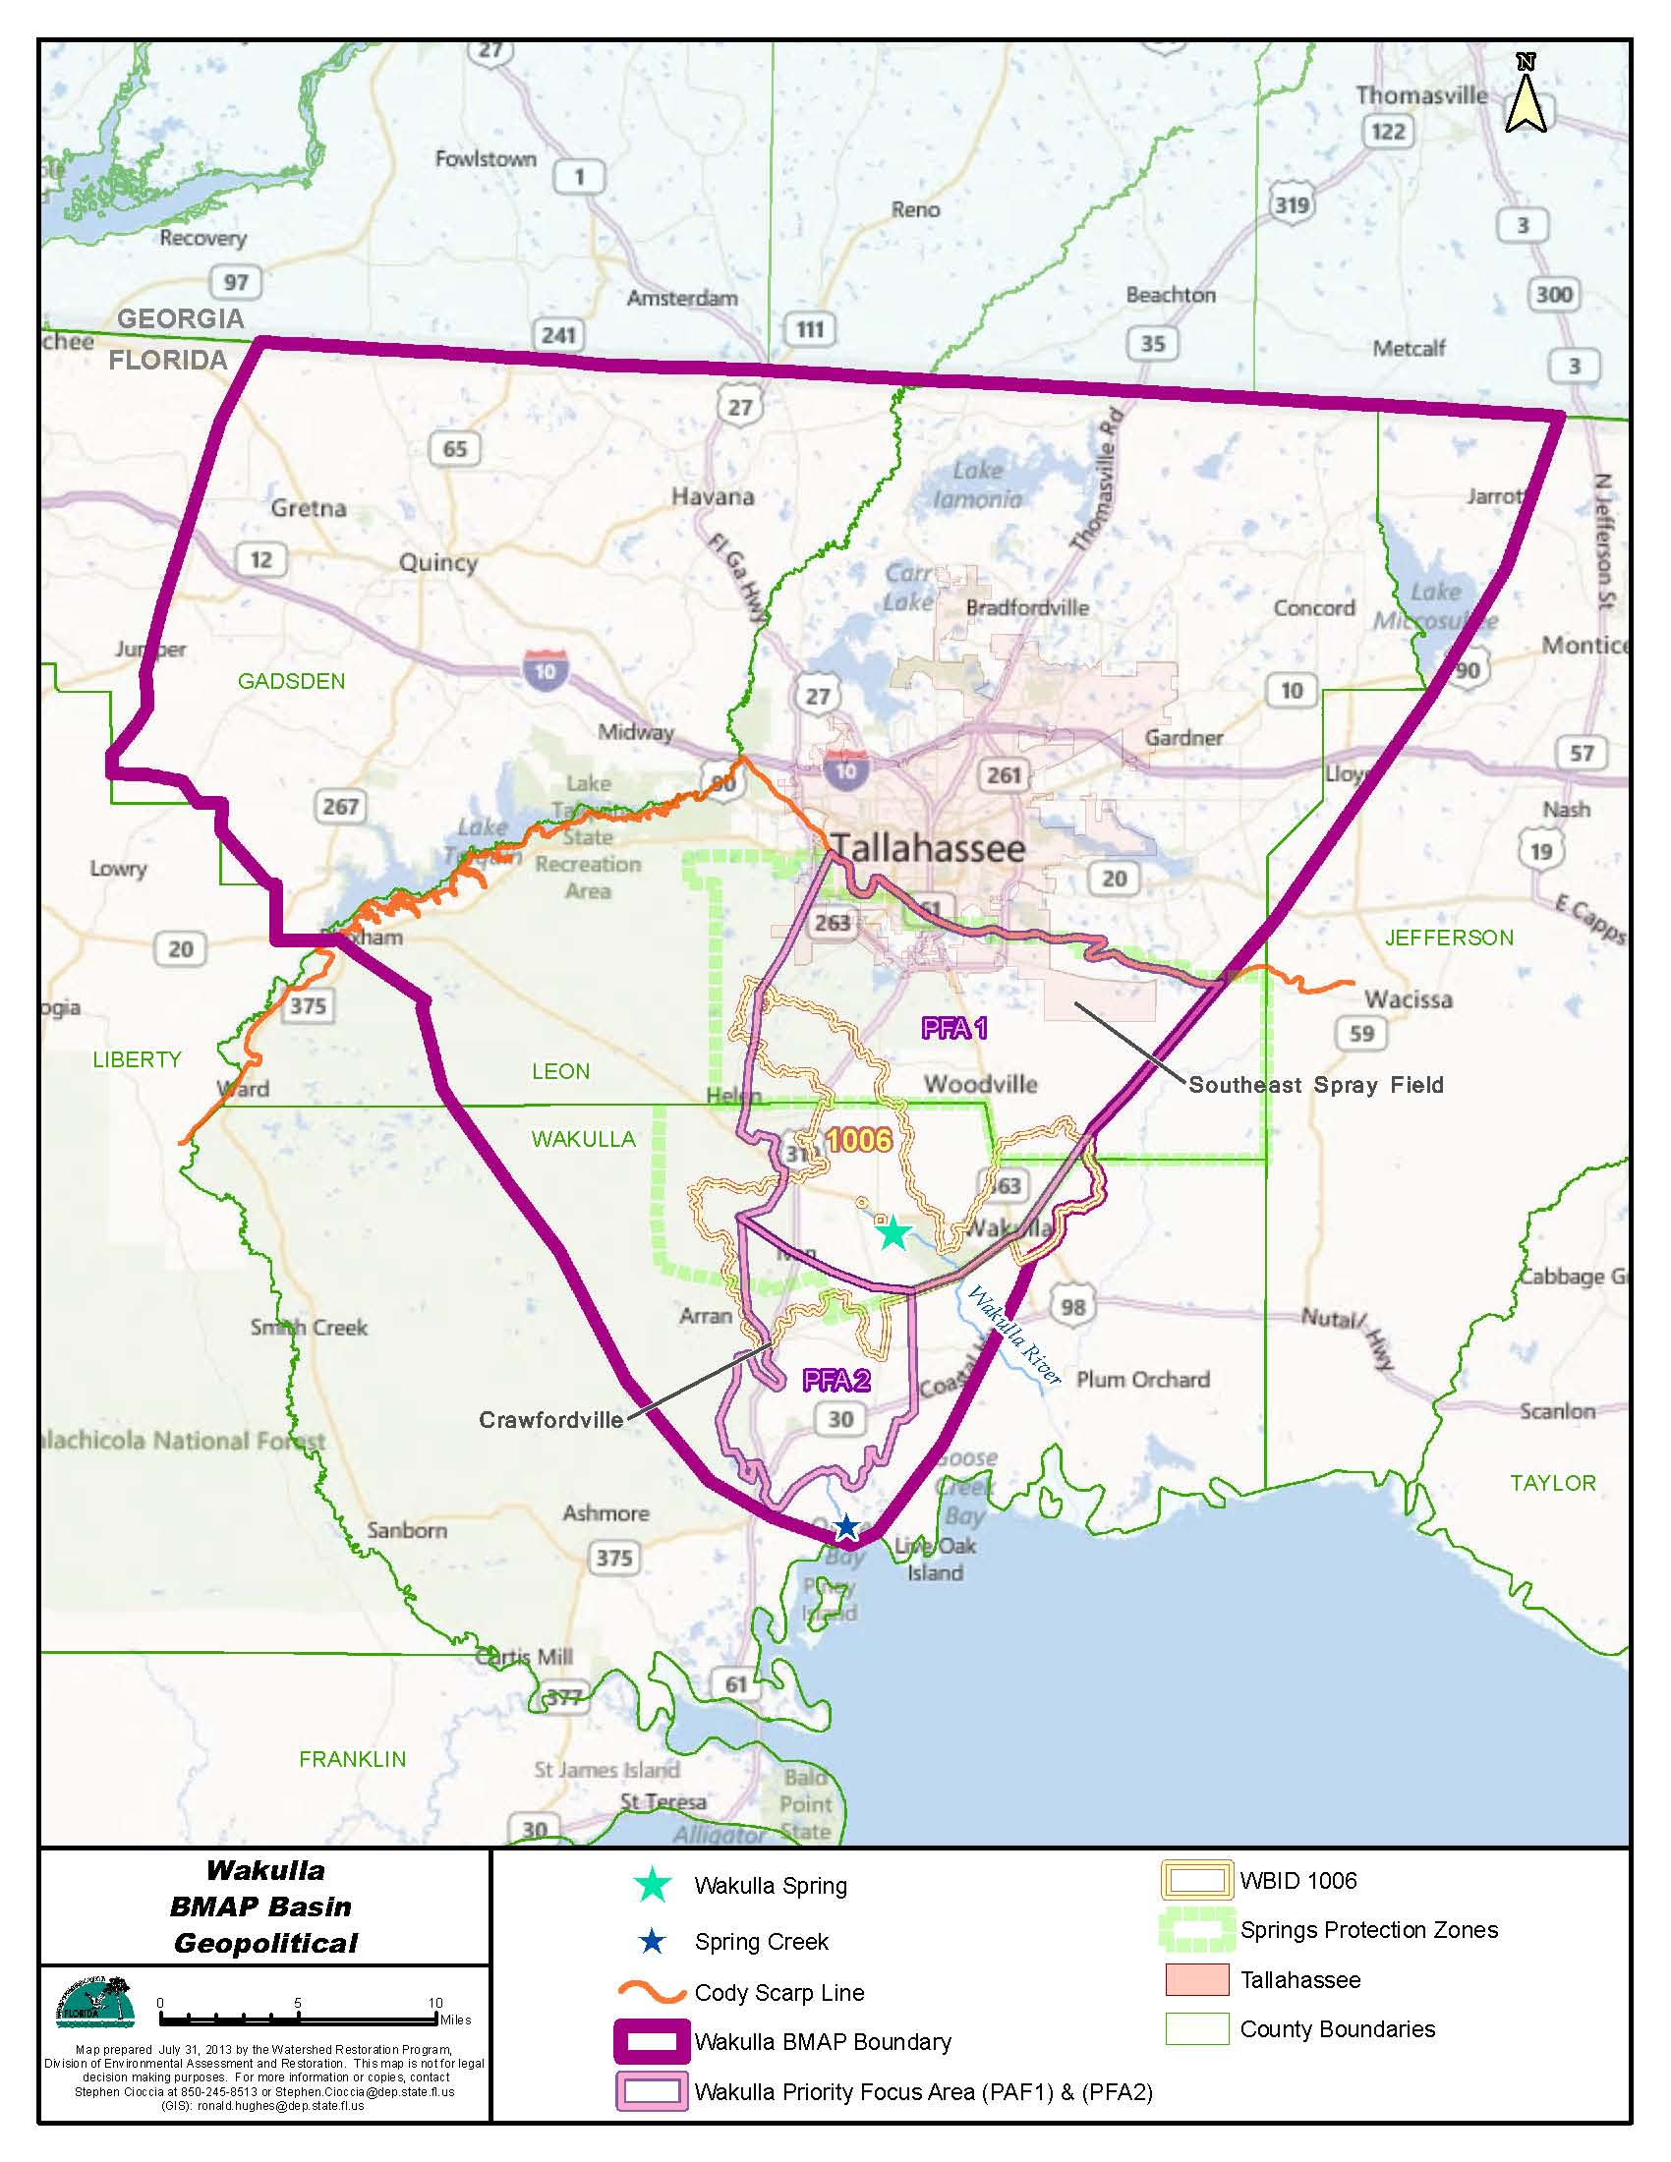
Figure 1: Upper Wakulla River and Wakulla Springs Basin

Stakeholder Involvement
The BMAP process engages local stakeholders and promotes coordination and collaboration to address the nitrate reductions to achieve the Upper Wakulla River TMDL. The following entities are the key stakeholders that are responsible for load reductions and monitoring within the PFAs:
- Agriculture.
- City of Tallahassee.
- Florida Department of Agriculture and Consumer Services (FDACS).
- Florida Department of Environmental Protection, including Wakulla Springs State Park.
- Florida Department of Health (FDOH).
- Florida Department of Transportation (FDOT) District 3.
- Leon County.
- Leon County Health Department.
- Northwest Florida Water Management District (NWFWMD).
- Wakulla County.
- Wakulla County Health Department.

In addition, the following entities are responsible for load reductions within the basin but outside of the PFAs:
- City of Gretna.
- City of Midway.
- City of Quincy.
- Federal Correctional Institution, Tallahassee.
- Florida Agricultural and Mechanical University (FAMU).
- Florida State University (FSU).
- Gadsden County.
- Jefferson County.
- Tallahassee Community College (TCC).
- Talquin Electric Cooperative.
- Town of Havana.

In addition to the responsible stakeholders above, several other interested parties and entities participated in the Upper Wakulla River and Wakulla Springs BMAP meetings, as follows:
- Center for Earth Jurisprudence.
- Citizens.
- Florida Department of Economic Opportunity.
- Friends of Wakulla Springs.
- Wakulla Springs Alliance.

In January 2013, the Department initiated the BMAP development process and held a series of technical meetings involving key stakeholders and the general public. The purpose of these meetings was to consult with key stakeholders to gather information about the basin and identify specific management strategies that would reduce nitrate loading. Technical meetings were held to gather information, identify potential sources, define management strategies currently underway or planned, and develop the BMAP contents and actions that will reduce nitrate loading with the ultimate goal of achieving the TMDL target. All technical meetings were open to the public and noticed in the Florida Administrative Register. Technical meetings were held regularly throughout the BMAP development process on the following dates:
- January 18, 2013.
- February 22, 2013.
- March 28, 2013.
- April 18, 2013.
- May 16, 2013.
- June 25, 2013.
- August 15, 2013.
- September 19, 2013.
- October 17, 2013.

In addition to technical meetings, the Department also met with stakeholders in one-on-one meetings. The purpose of these meetings was to discuss different aspects of the BMAP, such as management strategies, with the responsible stakeholders. Stakeholders were also encouraged to contact Department staff via phone and email to participate in forming the plan. A public workshop on the BMAP was also held on October 17, 2013.
Except as specifically noted in subsequent sections, this BMAP document reflects the Department’s approach to achieving the TMDL based upon its research and input of the stakeholders, along with public input from workshops and meetings held to discuss key aspects of the TMDL and BMAP development.

BMAP Approach
The BMAP provides for phased implementation under Paragraph 403.067(7)(a)1, F.S. The management actions and adaptive management approach described in the BMAP will address nitrate reductions, and the process will continue until the TMDL target is attained. The phased BMAP approach allows for the implementation of management strategies designed to achieve incremental reductions, while simultaneously monitoring and conducting studies to better understand the water quality dynamics in the basin. The total reductions to achieve the Upper Wakulla River TMDL will be addressed in five-year increments.
Since the TMDL period, the largest sources of loading to the Upper Wakulla River and Wakulla Springs, the City of Tallahassee’s wastewater treatment facility (WWTF) and Southeast Spray Field (SESF), have been upgraded to reduce nitrate concentrations applied to the land’s surface by about 75% (refer to Sections 3.1.1 and 4.1.1 for more details). Further reductions in nitrate concentrations are expected in the river and springs due to the completed actions. Given the progress in load reductions made to date and the need for further monitoring to determine to what extent additional reductions are needed, this BMAP used a sufficiency of effort evaluation rather than detailed allocations to move forward with reductions in the first five-year iteration.
Using information on sources in the basin (refer to Section 3.1), the stakeholders within the PFAs were asked to submit management strategies to reduce nitrate loading from the sources they are responsible for managing. The Department then compared the strategies provided to the sources within each PFA to evaluate whether each of the existing sources were sufficiently addressed for the first BMAP iteration and whether strategies were in place or would be put into place to reduce future nitrate sources. Where needed, the Department requested additional details and strategies from the responsible stakeholders to ensure sufficiency for the first BMAP iteration.
Collectively, the management strategies included in the BMAP are sufficient to address nitrate loading in the PFAs to the Upper Wakulla River and Wakulla Springs Basin over the next five years. These strategies are described in Chapter 4. Management strategies were also provided by the stakeholders located outside of the PFAs, and these strategies are described in Chapter 5. After year four of BMAP implementation, the Department will evaluate available water quality data to determine progress towards the nitrate target. Discussions will then be held with the responsible stakeholders to identify additional strategies for the next BMAP iteration, as needed.

Onsite Sewage Treatment and Disposal Systems (OSTDS) Initiative
With the major reductions made in wastewater loading in the basin, OSTDS are now the largest source of nitrate loading. However, activities to abate or remove OSTDS contributions are both expensive and require coordination with individual property owners and, therefore, require considerable planning to implement. To help address this source of loading, the Department, FDOH, the City of Tallahassee, Leon County, Wakulla County, and other parties will participate in the OSTDS Initiative.
The objectives of the OSTDS Initiative are to identify effective, feasible strategies to reduce nutrient loads from OSTDS sources; establish stakeholder responsibilities and a schedule for implementation; and ensure implementation through stakeholder commitments and BMAP authority. During the first BMAP iteration, the Department, FDOH, the City of Tallahassee, Leon County, Wakulla County, and others will discuss options for addressing OSTDS loading, identify effective strategies for the Upper Wakulla River and Springs Basin, establish homeowner and local government council/commission education and outreach programs, determine responsibilities, and identify funding sources to implement the strategies. The Department will prepare an agency report that outlines the strategies appropriate to the basin, prioritizes the importance and sequencing of strategies, and identifies stakeholder responsibilities. The agency report may serve as a comprehensive wastewater management plan for the area encompassed by the PFAs. The responsible stakeholders will then propose management strategies suggested for their jurisdiction necessary to meet the reduction targets. The management strategies, phasing, and milestones to be evaluated for implementation through the OSTDS Initiative process are detailed below.

General Direction for the OSTDS Initiative
This BMAP includes those management strategies ready for inclusion as an enforceable responsibility, in addition to a commitment to participate in the OSTDS Initiative where details for additional strategies will be established for subsequent adoption. A BMAP post-adoption schedule will be developed to include stakeholder responsibilities for preparing and reaching agreement on an overall coordinated septic tank strategy to be implemented in the second five-year BMAP implementation period. This schedule would need to be timed to take into account and respond to contingencies for the potential extension of central wastewater treatment under a Leon County sales tax extension, the potential use of RESTORE Act funding for expansion of Wakulla County wastewater capabilities, and the completion of the FDOH OSTDS nutrient reduction study. Based on water quality status and implementation experience, identification of additional OSTDS load reduction strategies may be required.
Commitment from the responsible stakeholders is essential to the OSTDS Initiative. As part of this BMAP, good faith commitments to participate in the process to further refine responsibilities and strategies are included, and continued participation would become a legal responsibility specified in the BMAP (refer to Section 4.2). When appropriate management strategies and responsible parties are identified, those would be included in the next BMAP implementation phase, and these will then be binding commitments based on the nitrate + nitrite reduction targets and schedule provided. The OSTDS Initiative includes four major phases.
Phase I – During BMAP Development, Estimate Impacts from OSTDS and Identify and Evaluate Potential Management Strategies
This phase will involve scoping and understanding of the following items:
- Identify the existing number and geographic distribution of OSTDS within the PFAs, using the existing FDOH model to determine probable numbers and locations.
- Calculate the best estimation of nitrate + nitrite loads from OSTDS to the Upper Wakulla River and Wakulla Springs within the PFAs.
- Obtain commitments by responsible stakeholders for continued participation in the implementation of the OSTDS Initiative.
Phase II – Within 24 Months Post BMAP Adoption, Select, Develop, and Prioritize Management Strategies
This phase will involve verifying the most current information:
- Verify the existing number and geographic distribution of OSTDS within the PFAs using the best available method to determine probable numbers and locations of existing OSTDS, and to note the older systems (as possible) that do not meet current FDOH standards.
- Project future growth and distribution of OSTDS through at least the first five-year BMAP implementation period within the PFAs.
- Estimate future nitrate + nitrite loads from OSTDS to the Upper Wakulla River and Wakulla Springs within the PFAs.
- Identify additional potential management strategies through the initiative process.
Potential management strategies will be evaluated including:
- Evaluate current OSTDS ordinances and other planning requirements; identify needed modifications or new ordinances and other planning requirements to reduce nitrate loading to ground water.
- Evaluate formation of a Regional Management Entity (RME) including the authority allowed for a RME, purpose and tasks within the RME authority, process for development of a RME, RME authority and goals, and limitations of a RME in achieving the OSTDS Initiative’s goals.
- Use of central wastewater treatment and collection strategies.
- Determine the availability of central wastewater collection system locations and relationship to areas of dense OSTDS concentrations.
- Assess the feasibility of expanding the existing wastewater treatment plants’ central wastewater collection systems and extending service to areas of dense OSTDS concentrations (e.g. Woodville, Oak Ridge/Lake Munson and Crawfordville vicinities).
- Evaluate the creation of localized central wastewater collection systems (smaller capacity of less than 1.0 million gallons per day) with no discharge of nitrate + nitrite effluent to ground water (e.g. wetland treatment ponds for effluent) and extending service to areas of dense OSTDS concentrations.
- Assess the pros and cons of cluster systems to centralize OSTDS drainfields and determine effluent impacts to ground water, and assess options where effluent concentrations are reduced to eliminate nitrate + nitrite contributions to ground water.
- Review septic system commitments in the comprehensive plans, land development regulations, and elsewhere.
- Evaluate the pros and cons of implementing a requirement for regular inspection, regular maintenance, and replacement of malfunctioning OSTDS.
- Determine if there is a need for regulatory requirements to connect to an available central wastewater system if an OSTDS is malfunctioning or in need of repair.
- Review existing requirements for new development to be served by central wastewater service at a comprehensive plan, zoning, or subdivision level to determine enforcement actions and incentives for sewer connections.
- Determine education strategies for homeowners to illuminate the water quality threats posed by OSTDS, benefits of good maintenance practices, enhanced nutrient removal accomplished by performance based treatment systems or passive OSTDS systems, and advantages of central wastewater service. Identify outreach opportunities and frequency needed such as through festivals, newspaper articles, public service announcements, tax bill/utility bill mailer, brochures, and presentations.
- Determine education strategies for local government decision-makers to illuminate the water quality threats posed by OSTDS, as well as the benefits of strategic placement and central wastewater service. Hold presentations synchronized with BMAP adoption, BMAP annual reports, and after the release of the FDOH study in 2015. Hold additional presentations as identified by the BMAP OSTDS Initiative and its milestones.
- Consider creation of an umbrella wastewater strategy that coordinates OSTDS responsible stakeholder responsibilities.
- Review probable repeal of House Bill 1263- 381.0065, F.S., restricting requirement for performance based treatment systems (expected July 2014), and evaluate opportunities for OSTDS treatment upgrade requirements allowed by this repeal.
- Evaluate recommendations from the FDOH study and use of passive, nitrate + nitrite-reducing OSTDS. Consider requirement of and appropriate application of passive systems, alternative technologies, AWT-level OSTDS, or other options recommended by the FDOH study.
- Identify other strategies, not listed above, as appropriate to the basin.
- Identify barriers such as absence of central wastewater service in areas where OSTDS reductions are needed; financial impediments to extension of central wastewater service areas including implementation delay and uncertainty of sewering strategies dependent on Blueprint 2000 sales tax extension approval and/or RESTORE Act funding, potential incurrence of unwanted debt, and difficulty in qualifying for additional grants; distribution of OSTDS and practicality of connection to central wastewater service; financial impact on homeowners of connection fees and utility bills; practicality of cluster onsite systems; and administrative and financial needs for a RME.
Ideas from other parts of the state should be reviewed to learn from experience:
- Identify model strategies and success stories for reduction of OSTDS loading.
- Identify funding opportunities to help alleviate financial impediments for strategy implementation.
Stakeholders will be engaged in discussions of appropriate effort and placement of management strategies within the first 30 months after BMAP adoption.
Phase III – Within 30 Months Post BMAP Adoption, Develop and Schedule Management Strategies
During this phase, the following activities would occur:
- Continue to evaluate OSTDS contributions and track ongoing reduction activities by responsible stakeholders.
- Review monitoring results.
- Determine the proposed target reductions to be achieved within the second BMAP implementation period.
- Consider potential future loading prevention policy strategies such as enforcement of Florida statutory requirement (F.S. 381.00655[1][a])for connection of existing OSTDS in areas where central wastewater service becomes available; use of passive nutrient reducing septic tank technology when new OSTDS are installed; and requirement that development areas authorized by comprehensive plan amendments, rezonings and subdivisions be supported by central wastewater service if feasible or nutrient reduction be required for new OSTDS installations.
- Present OSTDS Initiative findings or policy statements to capture the preferred overall direction to be taken on OSTDS concerns, in terms of clear and powerful statements that capture the consensus on central wastewater treatment and septic systems, and help give direction to future decision making.
- Prepare a Department agency report on management strategies (proposed completion 30 months post initial BMAP adoption) to describe the management strategies selected through the assessments process in Phase I (including stakeholder/public comment); prioritize the importance and sequencing of individual strategies and identify stakeholder responsibilities; and identify the relative responsibilities for nitrate + nitrite contributions from individual stakeholders, including commitments for strategy implementation and target reductions, to be accomplished by their management strategies to be contained within the second BMAP implementation period.
Phase IV – Implementation of OSTDS Management Strategies
Based on the Department agency report, the responsible stakeholders would be required to prepare detailed implementation plans that apply the selected management strategies to their areas of responsibility with a schedule of implementation. The implementation plans would be presented to the Department, evaluated to ensure they address responsibilities for OSTDS contributions, and included in the second BMAP implementation period.

Pollutant Reduction and Discharge Allocations

Categories for Rule Allocations
The rules adopting TMDLs must establish reasonable and equitable allocations that will alone, or in conjunction with other management and restoration activities, attain the TMDLs. Allocations may be to individual sources, source categories, or basins that discharge to the impaired waterbody. The allocations in rule identify either how much pollutant discharge each source designation may continue to contribute (discharge allocation), or the load or percentage of its loading the source designation must reduce (reduction allocation). Currently, the TMDL allocation categories are as follows:
- Wasteload Allocation (WLA) is the allocation to point sources permitted under the National Pollutant Discharge Elimination System (NPDES) Program. It includes the following:
  - Wastewater Allocation is the discharge allocation to industrial and domestic WWTFs.
  - NPDES Stormwater Allocation is the allocation to NPDES stormwater permittees that operate municipal separate storm sewer systems (MS4s). These permittees are treated as point sources under the TMDL Program.
- Load Allocation (LA) is the allocation to nonpoint sources, including agricultural runoff and stormwater from areas that are not included in an MS4 permit.

The TMDL did not specify WLAs to NPDES WWTFs or MS4s because there are no WWTFs and MS4s with discharges into the Upper Wakulla River WBID (Department 2012a). However, there are WWTFs and MS4s discharges within the Upper Wakulla River and Wakulla Springs Basin, which are included in this BMAP.

Allocations Implemented by the BMAP
The FWRA, Section 403.067, F.S., states that the BMAP must equitably allocate pollutant reductions to individual basins, as a whole to all basins, or to each identified point source or category of nonpoint sources, as appropriate. Allocations are determined based on a number of factors listed in the FWRA, including cost-benefits, technical and environmental feasibility, implementation time frames, and others (see Appendix B). The adopted TMDL (see Section 1.3.6) sets the allocations, as a percent reduction, to the nonpoint source category (LA) in order to achieve the target concentration of 0.35 milligrams per liter (mg/L) of nitrate + nitrite in the Upper Wakulla River. This BMAP implements the TMDL allocations for the nonpoint sources. More detailed allocations may be developed, if needed, for the next BMAP iteration.
The main sources of loading to the Upper Wakulla River come from the surrounding springshed, and the 0.35 mg/L nitrate + nitrite target concentration is also the criterion for springs. Therefore, the reductions associated with the strategies in this BMAP will improve the quality of both the Upper Wakulla River and Wakulla Springs.

Upper Wakulla River TMDL
The Department adopted the Nutrient (Biology) TMDL for the Upper Wakulla River (WBID 1006) in March 2012 through Rule 62-304.300[2], F.A.C. (refer to Appendix C). The Department determined that the Upper Wakulla River (WBID 1006) was impaired by nitrate based on stream condition index (SCI) surveys that indicated healthy biological community conditions in only 7 of 27 sampling events. The biological community in the river is affected by excessive algal mats that were linked to elevated nitrate concentrations from anthropogenic sources (Department 2012a). The TMDL defined the nitrate target as composed of both the nitrate and nitrite constituents. Table 3 lists the TMDL and pollutant load allocations adopted by rule for the Upper Wakulla River.

Table 3: Upper Wakulla River TMDL
¹ There are no NPDES wastewater facilities that discharge directly into the Upper Wakulla River.
² None of the NPDES MS4s discharges directly into the Upper Wakulla River.
WBID | Parameter | TMDL (mg/L) | TMDL % Reduction | WLA for Wastewater | WLA for NPDES Stormwater (% Reduction) | LA  (% Reduction)
1006 | Nitrate, as monthly average | 0.35 | 56.2% | N/A¹ | N/A² | 56.2%

Assumptions and Considerations Regarding TMDL Implementation
The water quality impacts of BMAP implementation are based on several fundamental assumptions about the pollutant targeted by the TMDL, waterbody response, and natural processes. In addition, there are important considerations about the nature of the BMAP and its long-term implementation. These assumptions and considerations are discussed below.

Assumptions
The following assumptions were used during the BMAP process:
- Reductions in nitrate concentrations in the Upper Wakulla River and Wakulla Springs will result in improved biological communities, including a reduction in the amount of algae present in the river.
- The greatest source of nitrate loading to the Upper Wakulla River is through Wakulla Springs. Therefore, management strategies that reduce nitrate loading to the ground water were the priority for this BMAP iteration.
- The scope of the TMDL did not include the adjacent Wakulla Springs vent area (WBID1006X) and, therefore, these waters are not applicable for determining achievement of the restoration targets. Although the TMDL did not include the upstream Wakulla Springs vent area, the BMAP incorporates Wakulla Springs and its contributing springshed within the BMAP area. This is based on the integral role of the springshed as the primary source of water inflow to the Upper Wakulla River.
- The BMAP focuses on reductions and management strategies within two PFAs. The PFAs were identified using best available information on the most vulnerable aquifer areas and ground water pathways to determine where management strategies would be most beneficial to improving the water quality of the Upper Wakulla River and Wakulla Springs. Pollutant loads contributed within the PFAs are considered to result in the largest magnitude and most immediate impacts to the Upper Wakulla River. In future iterations, the PFAs may be refined using the latest data.

Considerations
This BMAP requires stakeholders to implement management strategies to achieve nitrate reductions within the five-year period of this BMAP. However, the full implementation of this BMAP will be a long-term process, adaptively managed in five-year cycles. While some of the management strategies contained in the BMAP were recently completed or are currently ongoing, several strategies require more time to design, secure funding, and implement. Although strategies funding can be problematic, funding limitations do not affect the requirement that each entity within the PFAs must implement the management strategies listed in the BMAP in order to cumulatively achieve water quality standards.
Since BMAP implementation is a long-term process, the TMDL established for this basin will likely not be achieved in the first five-year iteration. It is understood that waterbodies can respond differently to the reduced concentrations and loading. Regular follow-up and continued coordination and communication by the stakeholders will be essential to ensure the implementation of management strategies and assessment of effects. Additional management strategies required to achieve the TMDL will, if necessary, be developed as part of the second BMAP iteration.
During the BMAP process, several items were identified that could be addressed in future watershed management cycles to ensure that future BMAPs use the most accurate information:
- Water Quality Standards – Since the Department adopted the Upper Wakulla River TMDL, numeric nutrient criteria were established for both streams and springs. For future evaluations to determine whether the Upper Wakulla River and Wakulla Springs Basin is meeting water quality standards, the Department will use these numeric nutrient criteria. The BMAP monitoring plan (refer to Section 6.3) was designed to collect the data necessary for these new evaluations.
- Basin Boundary – The BMAP boundary was determined using information from studies in the basin that delineated boundaries based on potentiometric surface data, water level measurements, and dye trace studies. The available boundaries were compiled by the Department, and the BMAP boundary was identified with input from the stakeholders. In future iterations of the BMAP, the basin extent may be modified based on new evidence and better science.
- Georgia Sources – The BMAP focuses on the Upper Wakulla River and Wakulla Springs Basin within Florida, as the Department only has authority to address nutrient loading within the state. However, a portion of the Wakulla Springs springshed extends into Georgia. Available data indicate that the greatest nutrient loading sources are in Florida. However, if significant sources within Georgia are identified, addressing these sources should be considered in the next BMAP iteration. Leon County has already begun efforts to address some of the nutrient loading from Georgia, as summarized in Table 4.

Table 4: Leon County Strategies to Address Sources in Georgia
Name | Description | Completion Date | Status
Cities of Thomasville and Moultrie | Based on proactive challenges by Leon County with Georgia Environmental Protection Division, the cities of Thomasville and Moultrie were required to conduct water quality monitoring and upgrades when their plants are expanded. | 04/2007 | Completed
City of Cairo Georgia | Based on proactive challenges by Leon County with Georgia Environmental Protection Division, Cairo, Georgia closed its sewage land application and built a new treatment facility with additional capacity and capabilities to reduce nitrogen and fecal coliform discharge levels to the Ochlocknee River. | 2005 | Completed
BASF Corporation Plant in Attapulgus | Leon County is challenging the renewal of the plant’s permit to prevent the direct discharge of approximately one million pounds of nitrate per year into the Little River, which flows to Lake Talquin. | Expected by 2018 | Ongoing

- OSTDS – Based on evaluations of loading in the basin, OSTDS are now the largest contributor of nitrate in the Upper Wakulla River and Wakulla Springs Basin (refer to Section 3.1). However, the management strategies that can be implemented at this time to address OSTDS are limited. FDOH is currently conducting a multi-year study to determine the best systems to attenuate nitrate loading. This study is scheduled to be completed in January 2015, and the study results will then be brought to the Legislature for consideration. The results of this study will help to guide OSTDS management strategies in the basin. In the meantime, the Department will work with the responsible local stakeholders and FDOH in the OSTDS Initiative (refer to Section 1.3.4) to identify appropriate management strategies and funding sources to address OSTDS loading.
- Authority to Address OSTDS – In order to successfully implement the strategies that will be identified through the OSTDS Initiative, some stakeholders have expressed a need for the authority for local governments to address OSTDS loading, and this authority will need to come from the Florida Legislature. During the first BMAP iteration, proposed legislation may be drafted by the local stakeholders, in collaboration with interested parties, such as the Wakulla Springs Alliance.
- Lake Swallets – There are several lakes within the basin that have known sinkholes that drain to ground water. In the next BMAP iteration, if data are available, the nitrate loads from these lakes could be considered and management strategies to address the loading identified, as needed.

Future Growth in the Watershed
The FWRA (Paragraph 403.067[7][a][2], F.S.) requires that BMAPs “identify the mechanisms by which potential future increases in pollutant loading will be addressed.” Since the TMDL reductions are based on decreasing loads from past development, it is important that loads from new development are well controlled. Although future development may be meeting state and local standards, the development may still add a nutrient load to the Upper Wakulla River and Wakulla Springs Basin. To ensure that future growth does not add to the degradation of these waterbodies, the local governments must be proactive in controlling loads from future growth.
This BMAP does not include a specific allocation for new development; instead, it relies on strategies from the stakeholders that help to minimize loading from future sources. The City of Tallahassee and Leon County have enacted ordinances to establish the Primary Springs Protection Zone (PSPZ), which reduce the development in the urban fringe in the PSPZ and allow development in the urban area only to the extent permitted by the future land use map. Wakulla County has a similar ordinance, which establishes the Wakulla Springs Special Planning Area (refer to Figure 2). Wakulla County has a comprehensive plan policy that requires advanced waste treatment (AWT) for any WWTF or spray field located within the special planning area. Leon County has a proposed amendment to its code of laws to require AWT within the PSPZ for any WWTF.
The City of Tallahassee, Leon County, and Wakulla County each have fertilizer use ordinances. The City of Tallahassee and Leon County have existing education and outreach programs to educate the public about fertilizer use, and Wakulla County will be adding public outreach activities. The City of Tallahassee and Leon County also have pet waste management ordinances to help reduce impacts from pet waste in the basin. Leon County adopted land development regulations that exceed state stormwater standards, and the county is also planning to create a low impact development ordinance to further address loads from new development. Wakulla County has comprehensive land use policies for certain future developments in the county, such as the Northeast Wakulla Sustainable Community, which require higher stormwater treatment levels and a no net increase in nutrients (refer to Table 15 for additional details). FDOT has a program to avoid mapped karst caves when constructing stormwater treatment ponds, which will help to reduce loading to the ground water from future projects. Wakulla Springs State Park also has education and outreach programs to educate the public about the importance of the river and springs.
In addition to the items that will be developed through the OSTDS Initiative (see Section 1.3.4), Leon County has a proposed effort to sewer within the PSPZ, if funding becomes available. The county is also proposing to modify its code of laws for OSTDS, as needed, based on the results of the FDOH study. Wakulla County has an adopted comprehensive plan policy requiring advanced nitrogen reducing onsite systems on parcels of certain sizes. The county is also proposing to sewer three historical neighborhoods, if funding becomes available, which would remove approximately 2,251 OSTDS that could occur through future development, in addition to the 1,330 OSTDS already in use.
The strategies listed above would help to reduce nitrate loading from future development for a variety of sources. The sufficiency of this BMAP relies on these management strategies.
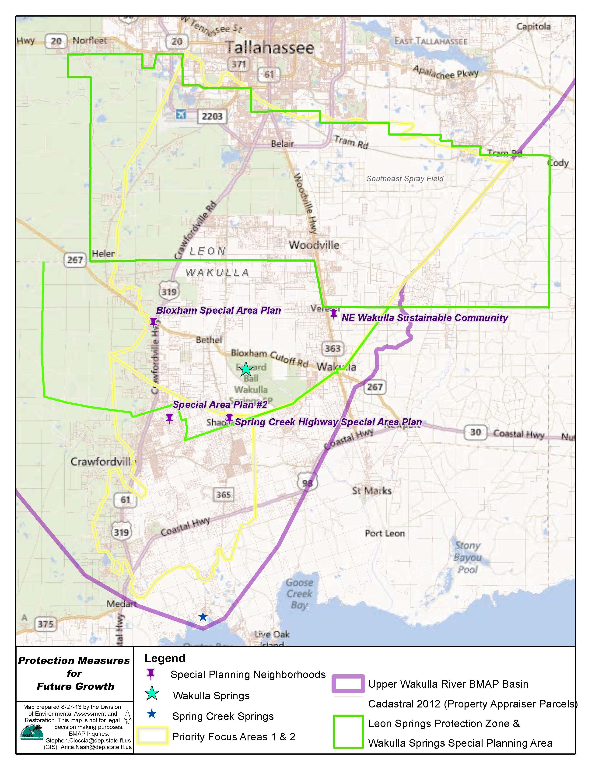
Figure 2: Protection Measures for Future Growth

: Upper Wakulla River and Wakulla Springs Basin Setting

Land Use Coverage
Land cover categories for the Upper Wakulla River and Wakulla Springs Basin were aggregated using the simplified Level 1 codes, which are shown in Table 5. Natural lands including upland nonforested, upland forests, water, and wetlands make up 84.1% of the acreage in the basin. Urban land uses including urban and built-up; barren land; and transportation, communication, and utilities makes up 9.1% of the basin. The remaining 6.7% of the basin is agricultural land uses. Figure 3 shows the distribution of land uses in the Upper Wakulla River and Wakulla Springs Basin.

Table 5: 2009 Land Cover in the Upper Wakulla River and Wakulla Springs Basin
- = Empty cell/no data
Level 1 Land Cover Code | Land Cover Description | Acres | % Total
1000 | Urban and Built-Up | 66,045.6 | 7.8%
2000 | Agriculture | 57,104.6 | 6.7%
3000 | Upland Nonforested | 51,268.7 | 6.0%
4000 | Upland Forests | 449,514.1 | 53.0%
5000 | Water | 19,838.4 | 2.3%
6000 | Wetlands | 193,611.3 | 22.8%
7000 | Barren Land | 806.5 | 0.1%
8000 | Transportation, Communication, and Utilities | 10,255.3 | 1.2%
- | Total | 848,444.5 | 100.0%

Within PFA1, 88.8% of this area is natural lands, 7.9% is urban lands, and 3.4% is agricultural lands, as shown in Table 6.

Table 6: 2009 Land Cover in PFA1
- = Empty cell/no data
Level 1 Land Cover Code | Land Cover Description | Acres | % Total
1000 | Urban and Built-Up | 5,435.0 | 5.3%
2000 | Agriculture | 3,508.6 | 3.4%
3000 | Upland Nonforested | 9,294.4 | 9.0%
4000 | Upland Forests | 73,194.9 | 70.8%
5000 | Water | 918.9 | 0.9%
6000 | Wetlands | 8,318.7 | 8.1%
7000 | Barren Land | 179.9 | 0.2%
8000 | Transportation, Communication, and Utilities | 2,476.9 | 2.4%
- | Total | 103,327.3 | 100.0%

Within PFA2, 77.6% of this area is natural lands, 15.3% is urban lands, and 7.0% is agricultural lands as shown in Table 7.

Table 7: 2009 Land Cover in PFA2
- = Empty cell/no data
Level 1 Land Cover Code | Land Cover Description | Acres | % Total
1000 | Urban and Built-Up | 4,285.7 | 14.4%
2000 | Agriculture | 2,095.9 | 7.0%
3000 | Upland Nonforested | 2,477.1 | 8.3%
4000 | Upland Forests | 17,510.1 | 58.9%
5000 | Water | 161.1 | 0.5%
6000 | Wetlands | 2,956.2 | 9.9%
7000 | Barren Land | 47.3 | 0.2%
8000 | Transportation, Communication, and Utilities | 207.6 | 0.7%
- | Total | 29,741.0 | 100.0%

For the portion of the basin outside of the PFAs, 83.8% is natural lands, 9.1% is urban lands, and 7.2% is agricultural lands as shown in Table 8.

Table 8: 2009 Land Cover in the Basin Outside of the PFAs
- = Empty cell/no data
Level 1 Land Cover Code | Land Cover Description | Acres | % Total
1000 | Urban and Built-Up | 56,325.0 | 7.9%
2000 | Agriculture | 51,501.1 | 7.2%
3000 | Upland Nonforested | 39,498.7 | 5.5%
4000 | Upland Forests | 358,816.9 | 50.2%
5000 | Water | 18,758.5 | 2.6%
6000 | Wetlands | 182,338.1 | 25.5%
7000 | Barren Land | 579.3 | 0.1%
8000 | Transportation, Communication, and Utilities | 7,570.7 | 1.1%
- | Total | 715,388.3 | 100.0%

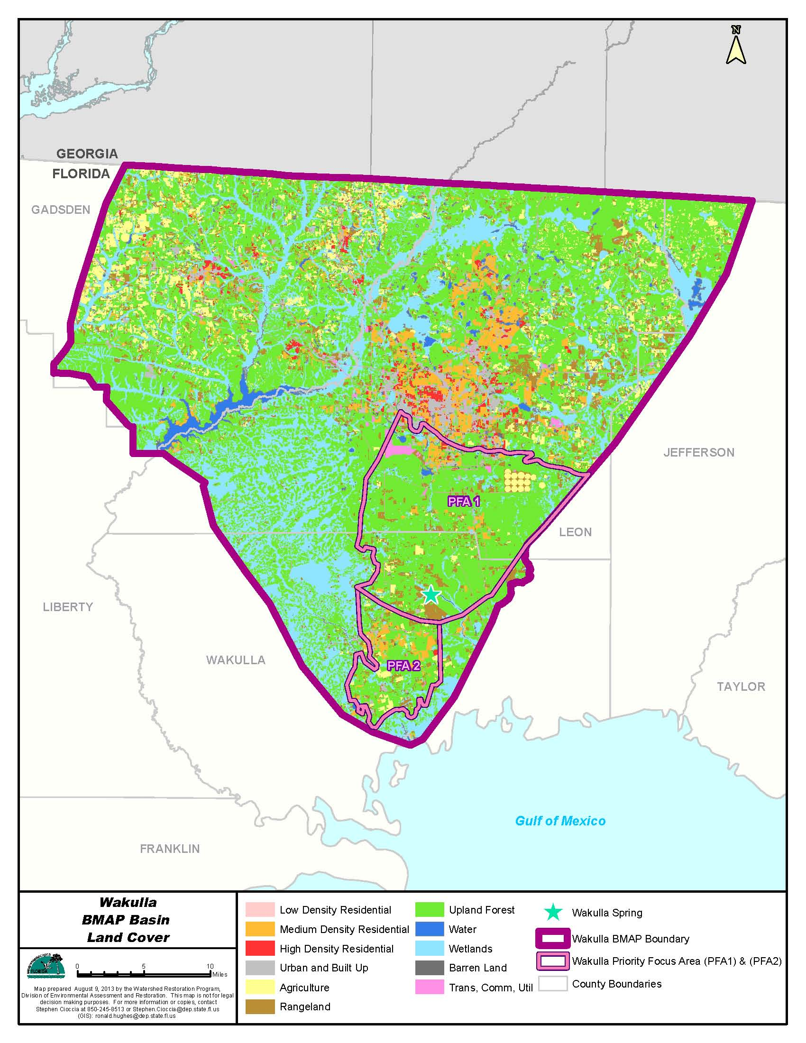
Figure 3: 2004 Land Cover in the Upper Wakulla River and Wakulla Springs Basin

Hydrology
In the Wakulla springshed, ground water occurs primarily in the Floridan aquifer, which is a vast carbonate aquifer system that is present throughout virtually all of Florida, as well as southern parts of Alabama and Georgia. The Floridan is the source of water for potable supply, irrigation, and industrial uses throughout most of the region. Wakulla Springs, located within the Ocala Karst District of the Woodville Karst Plain, is the primary source of the Wakulla River. Within the Wakulla River watershed, the Cody Scarp generally separates the semi-confined and unconfined geologic areas. In the most northern portion of the Wakulla springshed, the Floridan aquifer is confined by a thick overburden of sediment and/or clay that helps to protect against contamination. Moving southward, breaches are present in the confining layer, mainly sinkholes, which provide pathways for recharge and the introduction of contaminants. The unconfined or poorly confined regions of the Floridan aquifer (regions with less than 25 feet of sediment cover) extend slightly north of the Cody Scarp into the southern part of the City of Tallahassee urban area and southward towards the Gulf Coast.
This southern portion of the springshed is within the Woodville Karst Plain, which is part of the Gulf Coastal Lowland physiographic region. It extends from the southern edge of the City of Tallahassee to the Gulf of Mexico, in southeastern Leon County and eastern Wakulla County. Its northern border, the Cody Scarp, formed about 100,000 years when ocean levels rose. Capped by less than 20 feet of quartz sands, the Woodville Karst Plain gently slopes toward the Gulf. The porous sands allow water to move rapidly to the underlying soluble carbonates (limestone) that are present at or near the land surface, recharging the Floridan aquifer in the area. Over time, this acidic water has dissolved the limestone, resulting in karst terrain characterized by abundant springs, sinks, sinking streams, karst windows (collapsed segments of underground streams), swallets (caves or holes that swallow a stream), and dolines (collapsed caves), as well as a well-developed system of tunnels or conduits.
These features result in areas where the ground water has direct access from the surface (sinkholes) and surface waters whose pathways often flow beneath the sand and limestone surface layer (sinking streams) merging with the ground water. The karst sub-surface is also characterized by expansive areas of extremely porous formations, due to this limestone surface layer dissolution. This results in a large and extensive cave system and tunnel/conduit network which provides direct pathways and allows short travel times of surface runoff through ground water to the spring vent at the headwaters of the Wakulla River (Peer Review Committee 2005). As reported by Kincaid (2010), the efforts of numerous underwater cave explorers and scientists have identified a complex system of ground water conduits that interconnect many of the sinking streams in the watershed, as well as the City of Tallahassee SESF to the Wakulla River and Wakulla Springs. The BMAP PFAs represent the areas in the basin where the aquifer is most vulnerable to pollutant inputs, where there are the fastest ground water travel times, and where there is a known connectivity between ground water pathways and Wakulla Springs (refer to Section 1.3.1.1).
The Floridan aquifer generally flows in a southerly direction under the watershed to outflow from Wakulla Springs, Spring Creek Springs, the Lower St. Marks River, and the Gulf of Mexico. Ground water flow is increased by contributions from local rainfall and sinking streams. Data from potentiometric maps indicate that the steepest hydraulic gradient is just below the Cody Scarp and slowly declines towards the Gulf of Mexico. Wakulla Springs sits in the center of a zone of high hydraulic movement with lowered potentiometric surface that funnels water to Wakulla Springs. Therefore, small increases in the local hydraulic head resulting from short-term, intensive rainfall events should result in a significant increase in spring discharge.
Springs provide the majority of the flow in the Wakulla River. The Wakulla River is about nine miles long, starting near Camp Indian Springs and joining the St. Marks River near Fort San Marcos. Major centers of population within the basin include the City of Tallahassee, Woodville, and Crawfordville. The Wakulla River from Wakulla Springs downstream is tidally affected. The potential for saltwater intrusion into the ground water system exists, as the Floridan aquifer is directly connected to the Gulf of Mexico (Department 2012a).

Water Quality and Biological Community Trends
The Upper Wakulla River was determined to be impaired based on failing SCI scores between February 2000 and May 2007. The poor biological community scores were due to the fact that sensitive taxa was affected by the smothering of substrate by hydrilla, occasional low dissolved oxygen, and slightly elevated conductivity. The water quality data collected during this time found that ammonia levels (mostly below detection) and phosphorus levels (averaging 0.03 mg/L) generally represent excellent conditions, while nitrate concentrations are elevated from anthropogenic sources. Therefore, the Upper Wakulla River was determined to be impaired for nitrates, as evidenced by an aquatic biological community impacted by excessive hydrilla growth and algal mats (Department 2012a).
The highest nitrate concentration is found at the spring vent, and the nitrate concentration decreases as the water moves down river. When comparing the data from the TMDL verified period (2000-2007) to more recent data (2008-2012), the nitrate concentrations at the vent are declining. In the ground water conduits that feed Wakulla Spring, the nitrate concentrations appear to be higher in the B- and C-Tunnels than in the Main Tunnel, which indicates that there are other sources of flow to the springs that are diluting the concentrations observed at the spring vent. The data from K-Tunnel indicate lower nitrate levels and may be diluting flows from the other tunnels. The B-, C-, D-, and K-Tunnels continue to show mean nitrate + nitrite concentrations above the target concentration of 0.35 mg/L. The B-, C-, and D-Tunnels are the major contributors, with the highest mean nitrate concentration in B-Tunnel. These tunnels bring contributing flows from the SESF and Ames Sink to the Upper Wakulla River and Wakulla Springs. However, there are declining trends in nitrate concentrations in the B-, C-, and D-Tunnels. The K-Tunnel nitrate concentrations are unchanged, but are lower overall than the other tunnels (Department 2013d).
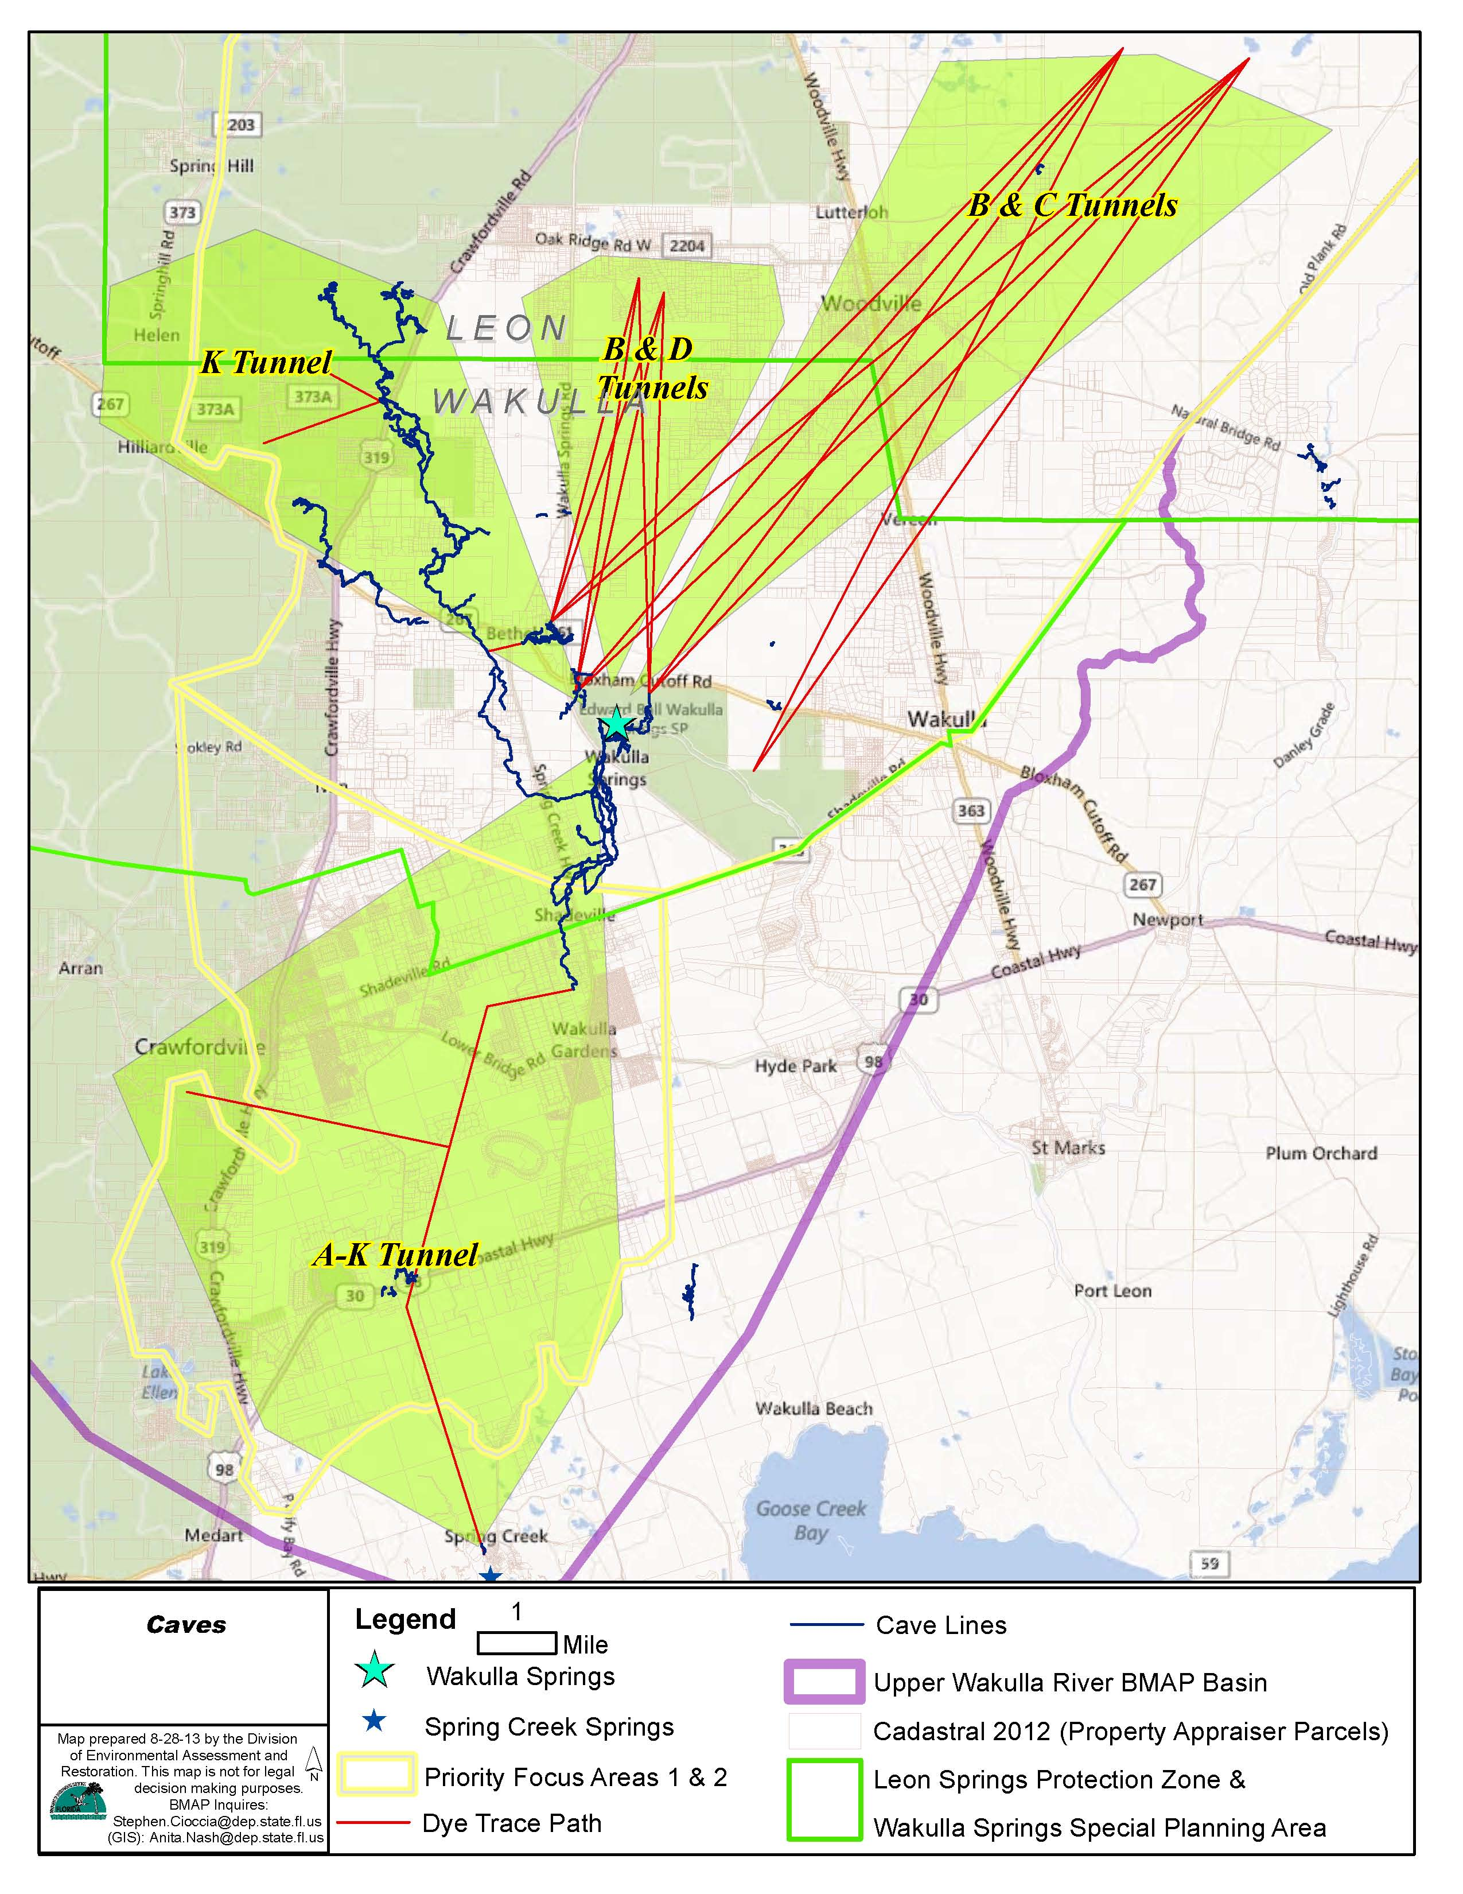
Figure 4: Locations of the Main Wakulla Springs Tunnels

Figure 5: Water Quality Trends in the Wakulla River and Wakulla Spring Vent

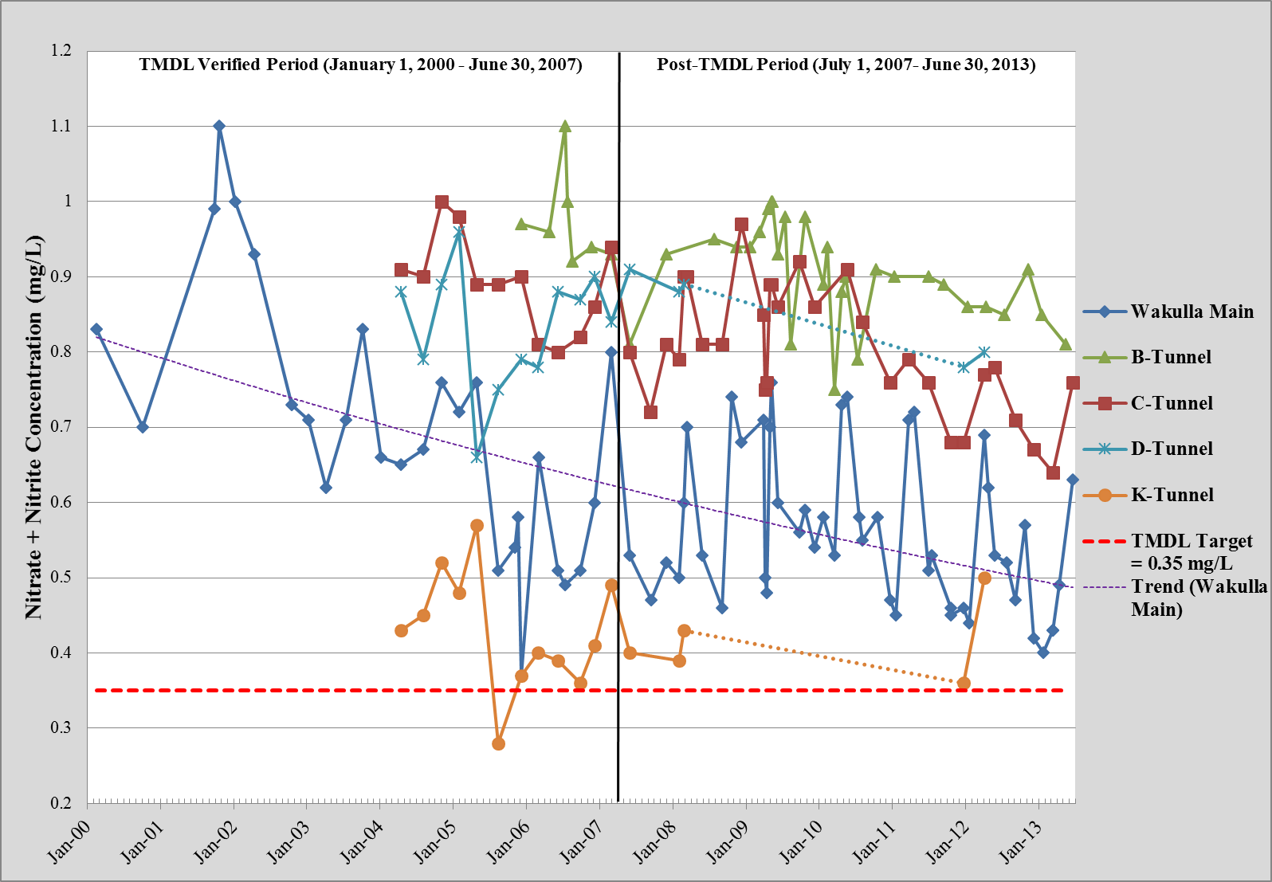
Figure 6: Water Quality Trends in the Wakulla Springs Tunnels

The SCI evaluation that occurred in 2004 in the Upper Wakulla River had score that was categorized as “very poor.” In 2007, the SCI score was categorized as “poor.” While there seems to be a slight improving trend in biological conditions, the overall quality is still poor. In April 2012, a rapid periphyton survey (RPS) was conducted in the Upper Wakulla River. This survey found that 75% of the points assessed had a rank of greater than four for algal coverage, which indicates visible filamentous algae. Additional samples are needed to confirm the results of this survey. There was also a RPS sample from below Highway 98, which was collected on April 2012; however, this site is located in the extreme downstream portion of the Wakulla River. The results of this RPS were that 40% of the points assessed had a rank of four or higher, which indicates visible filamentous algae (Department 2013b).
To determine the source of the nitrate loading in the basin, the Department collected data in March through December 2011 from the different tunnels around Wakulla Springs and from the springs themselves. Using information on nitrogen isotopes to correlate to sources, the data indicated that A-K- and K-Tunnels in the south and west have a much lower wastewater signature than the B-, C-, and D-Tunnels in the north and east. The springs are also showing a significant wastewater nitrate signature. These data had a nitrogen isotope signature in the wastewater/manure signature field (Department 2013c).
To determine if the nitrate is coming from humans or livestock, another tracer is needed. The Department uses sucralose as a tracer for human sources. Sucralose is the main ingredient in Splenda, and studies from around the world have detected sucralose in ground water with human wastewater influences. Sucralose is very stable, passes through the wastewater treatment into the final effluent, and is not affected by chlorination or tertiary-grade treatment. Sucralose has the added advantage that it is never used in animal feed and is therefore not expected to be present in the byproducts of animal waste. The median sucralose levels in the tunnels, based on data from 2011-2012, the A-K- and K-Tunnels were only slightly above the detection limit, which is 0.1 parts per billion (ppb). The and B-, C-, and D-Tunnels had a sucralose concentrations between 0.033 ppb and 0.035 ppb, which indicates a human influence coming from the north and east. This is consistent with findings from other studies in the basin that show that effluent applied at the City of Tallahassee’s SESF travels to the springs (Department 2013c).

The Impact of Nitrate on Water Quality and the Biological Community
It appears that nitrate is the crucial nutrient feeding the growth of algae and hydrilla in the Upper Wakulla Springs and Wakulla River. Nitrate is a common form of combined nitrogen in most natural surface freshwaters and some ground water in Florida. Nitrate occurs naturally but is also produced by human activities. Most plants cannot directly use nitrogen in its molecular form, but instead use nitrogen in the form of either nitrate or ammonium. The primary natural sources of nitrate on the earth’s surface include volcanic activity, lightning, and biological fixation. In biological fixation, molecular nitrogen is fixed by a special bacterium associated with certain plants, most notably legumes, sugarcane, and some ferns, and may be further oxidized to nitrate by other bacteria. Nitrate is also produced from the breakdown of animal manure and dead plants.
Human activities are greatly increasing the amount of nitrogen cycling between the living world and the soil, water, and atmosphere. In fact, humans have already doubled the rate of nitrogen entering the land-based nitrogen cycle, and that rate is continuing to climb. Elevated concentrations of nitrate in ground water commonly result from agricultural and urban land use practices in ground water recharge areas. The proximity of these areas to points of discharge (i.e., springs) can result in elevated nitrate levels in surface waters. Nitrate ions are mobile in ground water and surface water. There are essentially no solubility constraints on the amounts found in ground water because the nitrate ion does not sorb to soils or rock, and thus nitrate can move freely through the soil and the ground water system. In surface waters, nitrate acts as a fertilizer for aquatic plants. Nitrate levels much less than 1 mg/L can cause a significant shift in the balance of springs’ ecological communities. With an overly abundant supply of nutrients, aquatic plants and algae grow rapidly, filling the water with thick masses of green vegetation. Oxygen in the water is used up, leading to negative impacts to the aquatic community.
Nitrate does not naturally occur in Florida’s ground water at concentrations higher than 0.1 mg/L. Increasing nitrate levels in the Floridan aquifer in the Woodville Karst Plain in Leon and Wakulla Counties, as well as in water emanating from Wakulla Springs, are a significant ecological concern. Because a spring is a discharge point, the quality of spring water can be considered characteristic of a large cross-section of the aquifer. An increase in nitrate concentration in Wakulla Springs can be interpreted either as a widespread increase in nitrate concentration in the ground water from a large area of the aquifer (resulting, for example, from septic tanks) or as a significant increase in one or a few specific inputs (such as a WWTF). Nitrate sources for Wakulla Springs appear to be a combination of both types. Figure 7 illustrates the sources, reservoirs, and pathways of nitrogen in the unconfined portion of the Wakulla springshed. Under a thin veneer of sand, is a limestone matrix, the voids of which are saturated with ground water below the water table. The horizontal striping indicates the water-filled conduit that conveys water and pollutants to Wakulla Springs. The large checkered arrow denotes stormwater and sinking streams. Inputs of nitrate consist of atmospheric deposition, fertilizers, septic systems, land spraying, and residuals. Reservoirs consist of soils, vegetation, and livestock. Sinks of nitrogen (not illustrated) include the harvesting and decay of vegetation and removal of livestock. The nitrogen that enters groundwater finds its way to Wakulla Springs (Peer Review Committee 2005).
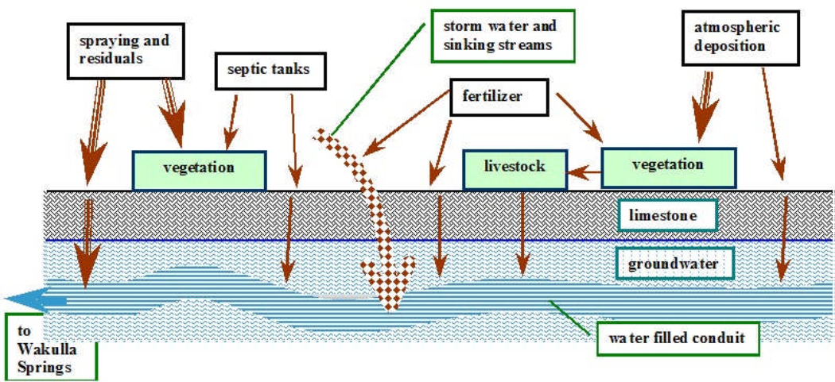
Figure 7: Schematic of Sources, Reservoirs, and Pathways of Nitrogen in the Unconfined Portion of the Wakulla Springshed

: Pollutant Sources and Anticipated Outcomes

Summary of Sources in the Basin
The TMDL includes estimates of nitrate loading in the Upper Wakulla River and Wakulla Springs Basin from WWTFs, OSTDS, fertilizer, livestock, atmospheric deposition, sinking streams, and stormwater. Atmospheric deposition is considered a background, uncontrollable source; therefore, the TMDL did not require reductions from this source. The contributions from sinking streams, including Munson Slough, Fisher Creek, Black Creek, and Lost Creek, were minimal and thought to be temporary in response to large rainfall events (Chelette et al. 2002). Therefore, the BMAP focuses on addressing nitrate loading from WWTFs, OSTDS, fertilizer, livestock, and stormwater. Additional details about the sources included in this BMAP are provided in the subsections below.

WWTFs
During the TMDL period, the largest WWTF load was the City of Tallahassee’s T.P. Smith Water Reclamation Facility and spray field, which are located within PFA1. In November 2012, the City of Tallahassee completed an upgrade to the WWTF, which resulted in large reductions of total nitrogen (TN) from the effluent applied to the land’s surface at the spray field (refer to Section 4.1.1 for additional details). In addition, the city removed biosolids application in the basin (see Section 4.1.1), which further reduced the impacts of the WWTF in the basin.
Located within the PFAs are four, smaller WWTFs. The Department reviewed the permits for these facilities and three of them had very small discharges and low TN concentrations. The largest of these smaller capacity plants, which is within PFA1, is Winco Utilities, Inc. (Department permit number FLA016544) located in Wakulla County. This plant has a permitted discharge of 0.495 million gallons per day, with the effluent land applied to a spray field. During the first BMAP iteration, the Department will work with existing WWTFs in the PFAs to determine if any reductions are needed to help address the Upper Wakulla River impairment (refer to Section 4.1.1 for more details).
In 1995, the U.S. Environmental Protection Agency (EPA) authorized the Department to implement the NPDES Program to permit wastewater discharges to state surface water, including industrial and domestic wastewater facilities. Permits are issued under the applicable provisions of Chapter 403, F.S., and appropriate rules in Chapter 62-600, F.A.C., with applicable sections of 40 Code of Federal Regulations (C.F.R.) incorporated by reference. These regulations, rules, and statutes give the Department the authority to regulate domestic and industrial wastewater facilities. For those entities that have WWTF strategies within the PFAs, if they fail to implement their approved list of strategies in the BMAP they will be subject to the appropriate enforcement actions as outlined in 40 C.F.R. 123.45, as well as Sections 403.061, 403.121, and 403.161, F.S., and Rule 62-650.300(4), F.A.C.
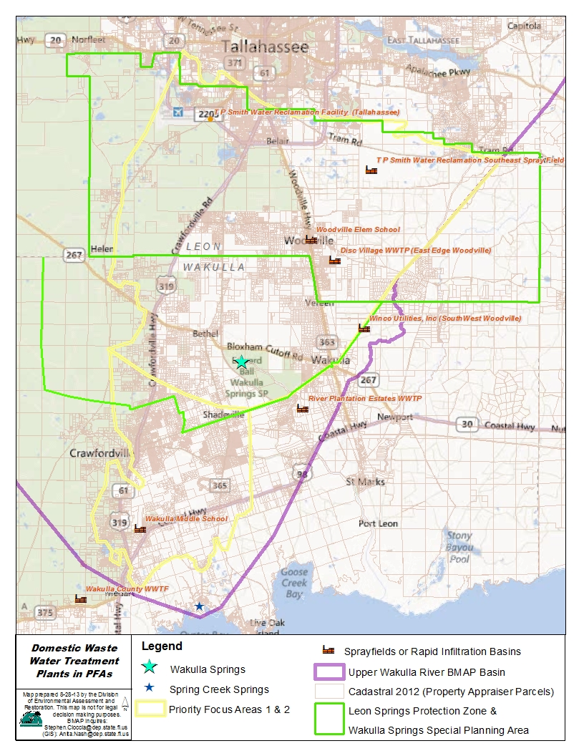
Figure 8: Domestic Wastewater Treatment Plants and Facilities in the PFAs

OSTDS
OSTDS, including septic tanks, are commonly used where providing central sewer is not cost-effective or practical. When properly sited, designed, constructed, maintained, and operated, OSTDS are a safe means of disposing of domestic waste (Department 2012a). However, in karst areas, such as the PFAs in the Upper Wakulla River and Wakulla Springs Basin, the nitrate contributions from OSTDS to ground water can be significant. A septic tank study was conducted by FSU’s Department of Earth, Ocean, and Atmospheric Science in the Woodville area, which is located in southern Leon County and northern Wakulla County (Harden et al. 2010). FSU researchers injected a dye into two shallow wells, and then samples were collected at several springs and Wakulla tunnels. Dye was recovered in Wakulla Spring, Sally Ward Spring, Indian Springs, and the six tunnels. Based on the distances from the two wells (5.2 and 6.0 miles) to Wakulla Springs, the dye traveled at a rate of about 327 feet (100 meters) per day (Department 2012b).
Based on the most recent FDOH coverage of OSTDS, there are approximately 7,484 septic tanks in PFA1 and 4,092 septic tanks in PFA2 (see Figure 9). In addition, 40,846 septic tanks are located within the basin, but outside of the PFAs. With the reduction in loading from the City of Tallahassee WWTF, OSTDS are now the largest source of nitrates to the ground water contributing more than one-third of the estimated loading (Department 2013a).
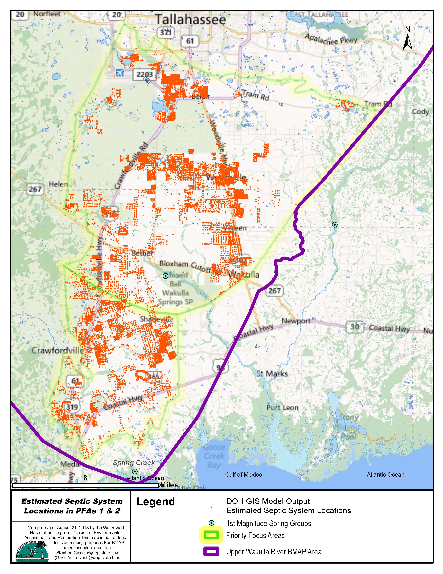
Figure 9: Current Locations of OSTDS in the PFAs

Residential Fertilizer
Fertilizer used on lawns and landscaping in residential areas can contribute to the nitrate loading in the ground water if over applied. It is estimated that residential fertilizer contributes about 7% of the nitrate loading in the basin (Department 2013a). Leon County, Wakulla County, and City of Tallahassee have fertilizer ordinances and education programs to help address this source (refer to Chapter 4 for more details).

Agricultural Fertilizer and Livestock
Based on the 2009 land cover, agriculture makes up about 4% of the acreage within the PFAs (see Figure 10). The majority of the agriculture within the PFAs is made up of pasture and rangeland, followed by hay fields and field crops. There are also smaller amount of horse farms, row crops, other grove types, nurseries and vineyards, ornamentals, and tree nurseries. Outside of the PFAs, agriculture is about 7% of the acreage with pasture and rangeland making up the majority of the agricultural lands. Hay fields and row, field, and mixed crops are the next most common types of agriculture. FDACS is working with the producers in the basin to enroll them in the appropriate BMP programs. During this process, FDACS determines if agricultural activities fit the criteria for the BMP programs. If land is not being used for commercial production, an update to the FDACS records will reflect that this acreage is not in commercial agriculture and, therefore, will not need a notice of intent to participate in BMPs. The total agricultural acreages estimated for the BMAP basin will decrease by those acres and will be reflected during annual updates.
Agricultural enforcement for BMAP actions is based on the FWRA, which states that nonpoint source dischargers who fail either to implement the appropriate BMPs or conduct water quality monitoring prescribed by the Department or a water management district may be subject to enforcement action by either of those agencies.
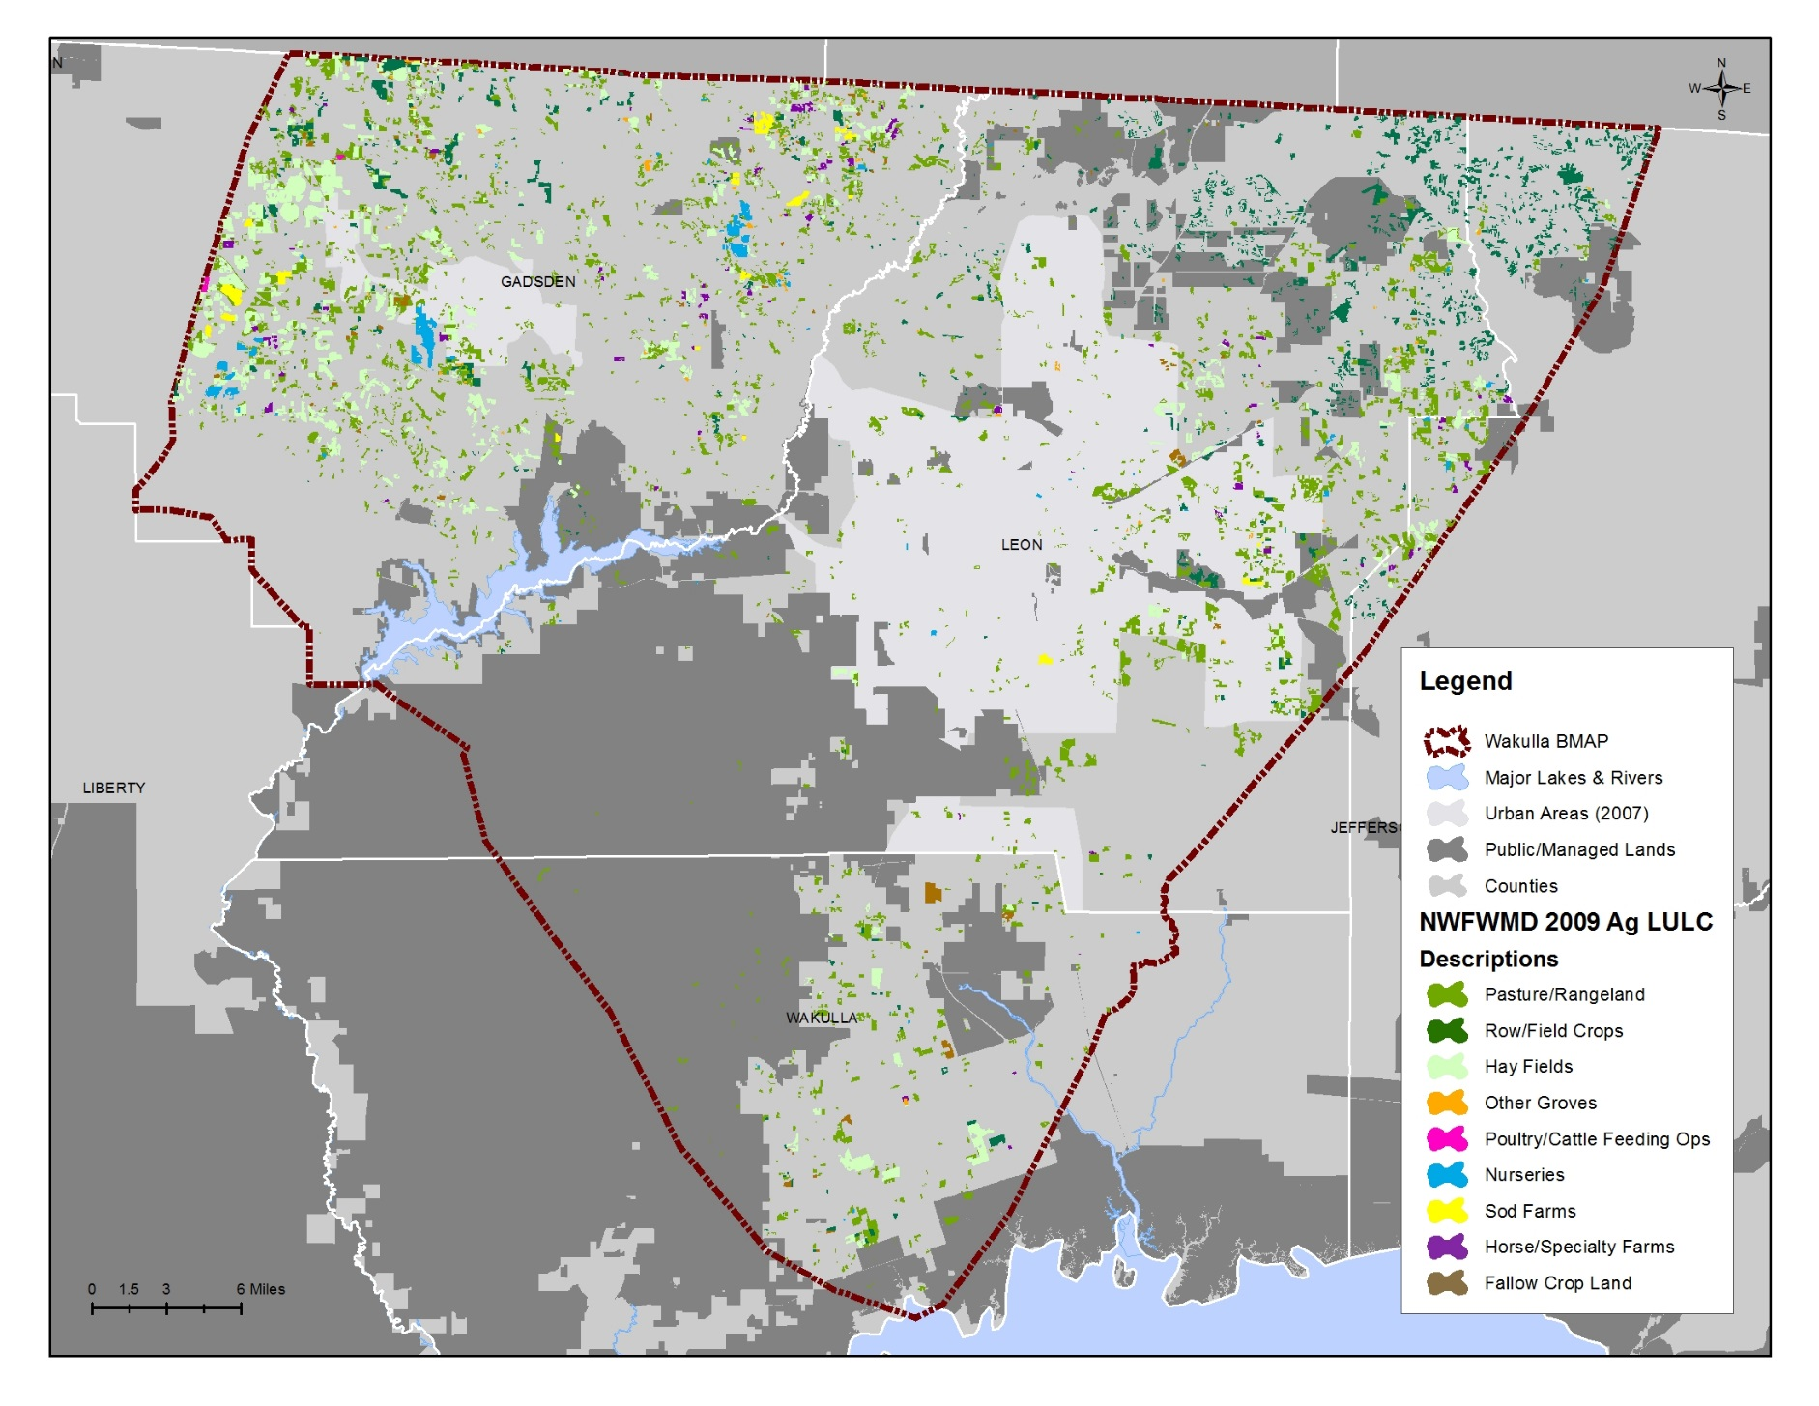
Figure 10: 2009 Agricultural Lands in the Upper Wakulla River and Wakulla Springs BMAP

Stormwater
Stormwater runoff is the responsibility of MS4s and urban nonpoint sources, and these entities are described in detail in the subsections below.

MS4s
Several of the stakeholders in the basin are regulated by the Florida NPDES stormwater program because they discharge stormwater and qualify as an MS4. An MS4 is a conveyance or system of conveyances such as roads with stormwater systems, municipal streets, catch basins, curbs, gutters, ditches, constructed channels, or storm drains that that is designed or used for collecting or conveying stormwater. An MS4 can be operated by municipalities, counties, drainage districts, colleges, military bases, or prisons, to name a few examples. By definition, the components of an MS4 system do not include waters of the state of Florida or of the United States. Instead, the MS4 ultimately discharges into such waters.
The basic requirements of the program serve as a foundation for the stormwater management efforts of these communities. EPA developed the federal NPDES stormwater permitting program in two phases. Phase I, which began in 1990, addresses large and medium MS4s located in incorporated areas and counties with populations of 100,000 or more, as well as specific industrial activities. Phase II, which started in 1999, addresses small MS4s that are designated according to population and other criteria established in federal and state rules. Small MS4s include MS4s located in an urbanized area that have a population of at least 50,000 people and/or serve a population of 1,000 or more people per square mile.
In October 2000, EPA authorized the Department to implement the NPDES stormwater permitting program in the state. This permitting has remained separate from state stormwater/Environmental Resource Permit programs and local stormwater/water quality programs, which have their own regulations and permitting requirements. Florida’s rules for MS4s can be found in Rules 62-4, 62-620, 62-621 and 62-624, F.A.C.
Entities in the Upper Wakulla River and Wakulla Springs Basin that are currently designated as MS4s are listed in Table 9.

Table 9: Local Governments in the Upper Wakulla River and Wakulla Springs BMAP Basin Designated as MS4s
MS4 Permit Phase | Permittee | Permit Number
I | Leon County | FLS000033
I | FDOT District 3 | FLS000033
I | City of Tallahassee | FLS000034
II | FSU | FLR04E051
II | FAMU | FLR04E095
II | Federal Correctional Institution, Tallahassee | FLR04E096

All NPDES permits, including MS4 permits, must be consistent with the requirements of adopted TMDLs. Paragraph 403.067(7)(b), F.S., prescribes the criteria for TMDL implementation. In accordance with this section, the implementation of a TMDL or BMAP for holders of NPDES MS4 permits must be achieved to the maximum extent practicable, through the use of best management practices (BMPs) or other management strategies. The implementation of BMPs consistent with the provisions of the stormwater management program required under an MS4 permit constitutes compliance with the standard of reducing pollutants to the maximum extent practicable for discharges to unimpaired waters. However, MS4s must also continue to assess and adjust their list of approved management strategies to achieve the greatest reduction of pollutants practicable to protect receiving waters in accordance with an adopted TMDL or BMAP.
Entities that fail to implement their list of approved strategies in order to reduce pollutants to the maximum extent practicable standard will be subject to enforcement action in accordance with Sections 403.061, 403.121, and 403.161, F.S., and Subsection 62-650.300(4), F.A.C. In addition, both Phase I and Phase II MS4 permits include provisions for revising the effluent limitations, monitoring requirements, and stormwater management programs to meet applicable TMDL allocations that are consistent with the assumptions and requirements of the adopted BMAP.

Urban Nonpoint Sources
Reductions in loads carried by stormwater that are separate from discharges by a permitted MS4 were established in the “load allocation” component of the TMDL. Paragraph 403.067(7)(b)2.f, F.S., prescribes the pollutant reduction actions required for nonagricultural pollutant sources that are not subject to NPDES permitting. These “non-MS4” sources must also implement the pollutant reduction requirements detailed in a BMAP. The nonpoint sources in the Upper Wakulla River and Wakulla Springs Basin are as follows:
- Gadsden County.
- Jefferson County.
- Wakulla County.
- City of Gretna.
- City of Midway.
- City of Quincy.
- Town of Havana.
Failure by a nonpoint source to reduce loadings, as required in a BMAP, can result in enforcement action by the Department under Paragraph 403.067(7)(b)2(h), F.S. The Department can designate an entity as a regulated Phase II MS4 if its discharges are determined to be a significant contributor of pollutants to surface waters of the state in accordance with Section 62-624.800, F.A.C. The designation of an entity as a Phase II MS4 can occur when a TMDL has been adopted for a waterbody or segment into which the entity discharges the pollutant(s) of concern. If an entity is designated as a regulated Phase II MS4, it is subject to the conditions of the Phase II MS4 Generic Permit.

Anticipated Outcomes of BMAP Implementation
With the implementation of the management strategies outlined in this BMAP, reductions in the nutrient loads to the Upper Wakulla River and Wakulla Springs Basin are expected to decrease the contribution of nitrate to the river and springs. The following outcomes are expected from BMAP implementation:
- Improvements in water quality trends in the Upper Wakulla River and Wakulla Springs.
- Decreased loading of the target pollutant (nitrate).
- Increased coordination, such as through the OSTDS Initiative and annual meetings, among state and local governments and within divisions of local governments in problem solving for water quality restoration.
- Determination of effective management strategies through the stakeholder decision-making and priority-setting processes.
- Enhanced public awareness of pollutant sources, pollutant impacts on water quality, and corresponding corrective actions.
- Enhanced understanding of basin hydrology, water quality, and pollutant sources.

: Management Strategies within the PFAs
“Management strategies” refer to the suite of activities that the responsible Upper Wakulla River and Wakulla Spring BMAP entities will be conducting to achieve nitrate reductions. These strategies include structural and nonstructural activities. The stakeholders submitted strategies that have been completed since January 1, 2004 and are planned within the first five-year BMAP iteration. January 1, 2004 was selected as a starting point for the BMAP strategies because it is the mid-point of the verified period used to determine the impairment in the Upper Wakulla River TMDL. Since the Upper Wakulla River and Wakulla Springs Basin is a ground water driven system, the Department reasoned that due to the delay between reduction strategies and detection of the results that the full benefits of the management strategies completed during the TMDL verified period were not seen in the water quality data. Therefore, these projects have provided additional benefits during the latter portion of the verified period to the Upper Wakulla River and Wakulla Springs and should be listed in the BMAP.
The management strategies were submitted to provide reasonable assurance to the Department that each responsible entity has a plan on how to reduce nitrate concentrations. The sections below outline the strategies submitted by the stakeholders within the PFAs.

Sufficiency of Effort Evaluation
The tables in Section 4.2 list the management strategies to reduce nitrate concentrations within the PFAs. The nitrate load reduction strategies outlined in the project tables, including the activities highlighted below, are expected to reduce nitrate concentrations and improve water quality in the Upper Wakulla River and Wakulla Springs. As water quality improves as a result of these strategies and more data are collected to show the nitrate concentrations and health of the biological community in the Upper Wakulla River and Wakulla Springs, future BMAP iterations may recommend different or additional strategies. For this BMAP iteration, the full implementation of the management strategies listed in the above tables for the PFAs is sufficient to significantly reduce nitrate concentrations and make substantial progress towards meeting the TMDL target. The sufficiency of this BMAP relies on these management strategies; by inclusion in the BMAP, it is required that they remain in effect without substantial revision, as determined by the Department.

WWTFs Sufficiency
The Department determined that WWTFs with a design capacity of 100,000 gallons per day (0.1 million gallons per day) or greater, which have an effluent discharge or disposal site within the PFA1 boundary area are subject to a requirement to achieve a final effluent TN concentration of 3.0 mg/L to protect ground water quality and prevent contribution to the impairment in the Upper Wakulla River. The level of 3.0 mg/L was selected based on statutory requirements for the Tampa Bay area, Florida Keys, and Wekiva River and as an appropriate level of nitrogen reduction. The 100,000 gallons per day threshold is based on consideration of “Evaluation of Nitrogen and Phosphorus Removal Technologies for Small Wastewater Treatment Plans”, October 1998, and “A Strategy for Water Quality Protection: Wastewater Treatment in the Wekiva Study Area”, December 2004. This requirement shall apply to all new WWTFs in PFA1.
Subsequent to BMAP adoption, the Department will evaluate existing WWTFs to determine which fall under the requirements above. The owners of existing facilities shall be given an opportunity to demonstrate a reasonable assurance there is not a contribution to the water quality violation at the Upper Wakulla River. Should the Department concur, the existing facility will not be subject to the 3.0 mg/L TN requirement noted above.
Decreasing the impacts of nitrate to the Wakulla Springs system will require reducing nitrogen loads to the landscape within the springshed, and particularly within the PFAs. Technologies that provide for denitrification should be encouraged, particularly south of the Cody Scarp and in the Wakulla Springs contributory area. Denitrification of effluent is an important strategy for reducing nitrates to the Wakulla springshed, and is particularly critical in those cases where elevated concentrations of nitrate in WWTF effluent is transmitted to land surface at significant flows or loadings. The fate of nitrogen introduced to ground water from land application sites is not fully understood, particularly within areas of high aquifer vulnerability such as the PFAs.
The current ground water quality standard of 10 mg/L of nitrate was developed to protect drinking water supplies. This is typically the permit standard for WWTFs with land application of effluent. However, this ground water standard for nitrate does not address the connectivity of ground water and surface water in many areas of Florida. The level of nitrate concentrations that is safe for human consumption can be detrimental to the ecological health of receiving surface waterbodies. These factors result in the need for close scrutiny of potential negative impacts from the land application of effluent with high nitrate levels. Important aspects in determining the potential for significant nitrate contributions to ground water from WWTFs are the fate and ground water transport pathway of nitrogen originating at these facilities’ effluent disposal sites and the potential to contribute to the nitrate impairment exhibited at the Upper Wakulla River and Wakulla Springs.
The largest point source facility identified in the TMDL was the City of Tallahassee’s T.P Smith Water Reclamation Facility and spray field. In 2008, the city began to upgrade the WWTF to meet AWT standards. This upgrade was completed ahead of schedule in November 2012, and resulted in a reduction in TN from about 12 mg/L to less than 3 mg/L in the effluent. Therefore, this facility has met the requirement to achieve the 3.0 mg/L effluent TN concentration. The change in TN concentration resulted in approximately 214,939 kilograms per year (kg/yr) of TN removed from application at the spray field. The city also removed its WWTF biosolids application from the basin, which resulted in a reduction of 169,347 kg/yr of TN that was previously applied to the land in the basin. In addition, the city has a program to assess and rehabilitate the sewer collection system in the older parts of the system. Of the total 895 miles of sewer system, 356 miles are part of the older system. Approximately 7% of the older system sewer lines are within PFA1. The assessment of the older system will be completed by the end of 2014 and the rehabilitation of the system will be completed by 2021.
Leon County is proposing an amendment to the county’s code of laws to require AWT for new wastewater systems within the PSPZ. The proposed amendment would apply only to WWTFs and not to OSTDS, at this time due to the current legislative statute that limits strategies for OSTDS.
Wakulla County has an adopted comprehensive plan policy that requires AWT for any WWTF or spray field located within the Wakulla Springs Special Planning Area. The county conducts routine inspections and maintenance of the sewer collection system throughout the county. Wakulla County is proposing to upgrade its WWTF for improved treatment and to connect OSTDS within PFA2. The current WWTF has secondary treatment and the proposed upgrade would be to AWT. The county is also looking at options to pump municipal wastewater to the City of Tallahassee WWTF for treatment.
For the first BMAP iteration, since the largest source of WWTFs loading has been addressed and the responsible entities have plans to improve the sewer collection systems and prevent loading in the future from WWTFs, the Department determined that these strategies sufficiently address nitrate loading from the WWTFs within the PFAs.

OSTDS Sufficiency
Leon County is proposing to prepare a Geographic Information Systems (GIS) inventory of the OSTDS located within the county, revise its septic tank ordinance to require greater separation between the drainfield and seasonal high water table to reduce the amount of nitrate that enters the ground water, and add educational kiosks about septic systems at the Woodville Community Center. The county has also committed to reviewing the results of the FDOH study on performance based OSTDS to determine if its code of laws should be modified. In addition, the county is proposing to sewer within the PSPZ to remove OSTDS, dependent on project and funding approval through the county’s sales tax process. This strategy would remove approximately 15,187 kg/yr of TN, if the sewering and connections occur.
Wakulla County has an adopted comprehensive plan policy that requires advanced nitrogen reducing OSTDS on parcels smaller than five acres in the Wakulla Springs Special Planning Area; within 150 feet of surface water, swallet, or other karst feature, or within 300 feet of a 1st or 2nd magnitude spring; and on all parcels less than 0.229 acres in size. The county is pursuing funding for planned sewer in Greiner's Addition, Magnolia Gardens, and Wakulla Gardens, which could remove the existing 1,330 septic systems, and an estimated potential for 2,251 additional systems in the future. The county is seeking funding to inspect and repair old, damaged, and failing OSTDS in the Wakulla Springs Basin. The county is also looking to form a tax increment financing (TIF) district for the Crawfordville area to fund improvements, including basic infrastructure.
Wakulla Springs State Park sewered its property in 1992, which removed all OSTDS within the Park except for one septic tank that serves the gatehouse. This septic tank is a performance based treatment system, which has a high nitrate removal efficiency.
In addition, the Department, FDOH, City of Tallahassee, Leon County, and Wakulla County will work together through the OSTDS Initiative to identify effective management strategies for the basin, determine funding sources, and develop strategies implementation plans. By the end of the first, five-year BMAP iteration, the responsible stakeholders will have already begun to implement or will be ready to implement additional OSTDS reduction strategies.
With the continuation of adopted measures and implementation of the OSTDS Initiative (refer to Section 1.3.4 for more details), OSTDS sources will be sufficiently addressed in the first BMAP iteration. Depending on water quality trends, substantial additional efforts may be needed in future BMAP iterations to address OSTDS sources.

Residential Fertilizer Sufficiency
The City of Tallahassee has a fertilizer use ordinance and an education program. Based on surveys conducted after the ordinance was adopted and the education efforts began, the city determined that the number of households that applied fertilizer decreased by 49% between 2007 and 2012. In addition, for those households that still apply fertilizer, the amount applied per household decreased by 27%.
FDOT District 3 has eliminated fertilizer use for turf maintenance along the roadways within the basin and is, therefore, no longer a source of fertilizer, except during the establishment of new turf grass. This fertilizer cessation resulted in a removal of about 4,640 kg/yr of TN applied to the land’s surface.
Leon County has a fertilizer ordinance for commercial applicators and it is considering a modification to the ordinance to reduce the nitrogen application rates in areas south of the Cody Scarp, if allowable by Florida law. The county also has an education and outreach program that provides the public with information about fertilizer use through the Florida Yards and Neighborhoods (FYN) Program, distribution of pamphlets, presentations, and workshops.
Wakulla County has an adopted fertilizer use ordinance that adopts the model ordinance on Florida-friendly fertilizer use on urban landscapes. The county is also planning to add fertilizer management education and outreach efforts.
The responsible stakeholders have strategies in place to reduce/remove fertilizer use; therefore, these strategies are collectively sufficient to address sources of residential fertilizer during the first BMAP iteration.

Agricultural Fertilizer and Livestock Sufficiency
In 2007, the City of Tallahassee eliminated the fertilizer application on the SESF where hay is grown. This resulted in a reduction of 61,500 kg/yr of TN that was previously applied on the land.
Within the PFAs, there is approximately 5,766.52 acres of agricultural land uses, of which 1,308.85 acres or 22.7% are enrolled in FDACS BMP programs as of March 31, 2013. During the first BMAP iteration, FDACS plans to enroll additional producers in BMPs so that the total enrollment within the PFAs is 90% of the agricultural acres. Adjustments may be made to the total agricultural acreage within the PFAs as FDACS assesses the current uses of those areas identified as agricultural land uses.
With the implementation of these strategies, agricultural fertilizer and livestock nitrate loading within the PFAs will be sufficiently addressed for the first BMAP iteration.

Stormwater Sufficiency
The City of Tallahassee has a pet waste ordinance and an education program that reaches out to the public about pet waste management. Since the adoption of the ordinance and the implementation of the education efforts, the city found that 34% of dog owners began picking up after their pets. In addition, the city has constructed various stormwater treatment projects throughout the city (see Appendix D).
FDOT District 3 has street sweeping of its curb and gutter roads within urbanized areas through contracts with Leon County and the City of Tallahassee. FDOT District 3 is also working with the Department to investigate the use of innovative nitrogen removal technologies for future projects within the PFAs.
Leon County enacted a pet waste ordinance in 2011, which includes an education program to promote the cleanup of pet waste. The county also adopted irrigation and landscaping ordinances. The county participates in the FYN Program, which provides education and outreach to the public. The county adopted land development regulations in 2012, including minimum environmental regulations countywide that exceed state stormwater standards. The county also adopted comprehensive plan amendments that reduced the allowable development in the urban fringe areas to focus development in the urban areas. In addition, the county is proposing to develop a low impact development program that would provide incentives to reduce nitrogen loading to surface and ground waters.
Leon County has also completed several stormwater improvement projects. The county constructed two stormwater retrofit ponds in Harbinwood Estates and planted/stabilized 1,200 linear feet of channel. The county constructed the 10-acre Fuller Road Regional Facility as a stormwater retrofit project at Interstate-10 and U.S. 27. The county removed a 15-acre nutrient sediment dam and stabilized Munson Slough as part of the Lake Munson erosion and flood protection upgrades. The county also maintains the stormwater system in accordance with the MS4 permit and street sweeps 762 miles of roads annually, removing approximately 51.3 kg/yr of TN.
Wakulla County has adopted comprehensive plan policies that establish special area plans for three projects within the Wakulla Springs Basin. These policies require nitrate loading analyses for development and establish standards for stormwater, karst feature protections, landscaping, and open space.
These strategies together will sufficiently address stormwater nitrate loading for the first BMAP iteration.

Other Strategies
The stakeholders have also implemented or are planning to implement studies, protection measures, and source control efforts that will help improve water quality in the Upper Wakulla River and Wakulla Springs Basin.
The City of Tallahassee and Leon County have an ordinance that identifies the PSPZ. The City of Tallahassee adopted comprehensive plan amendments that reduced the allowed development in the urban fringe areas inside the PSPZ and requires a no net increase in dwelling units from the future land use map within the PSPZ.
FDOT District 3 implements a protection measure in which it avoids constructing stormwater treatment ponds directly over mapped karst caves. A 300 foot buffer is provided around these known karst caves.
Leon County conducts water quality sampling at 73 sites and uses these data in annual water quality reports to help prioritize water quality project needs. The county completed a study on Woodville recharge aquifer protection using a grant from EPA, and the county is planning to create annual Wakulla Springs status reports for the Board of County Commissioners. Leon County has purchased land to protect sinks within the basin, and it has an adopted aquifer wellhead protection ordinance. The county also has a litter control program and Adopt-A-Road program.
Leon County and Wakulla County prepared AVA reports to determine the most vulnerable areas in each county. The City of Tallahassee, Leon County, and Wakulla County funded the Lombardo study to identify options for addressing OSTDS loading. Wakulla County has a springs protection ordinance that identifies the Wakulla Springs Special Planning Area, and the county is considering the expansion of this area based on geologic vulnerability. The county has ordinances that requires karst buffers, ground water extraction limitations, and wetlands protection. Wakulla County has comprehensive plan policies that set standards for the Northeast Wakulla Sustainable Community; develop solutions to restore the health of Wakulla Springs; protect the functions of ground water recharge areas, springs, and springsheds; and encourage development in Crawfordville with connection to sewer service. The county also has a litter control ordinance that prohibits litter and dumping along roadways and waterways.
In addition, the Wakulla Springs State Park conducts several education and outreach programs to educate the public about the Wakulla River and Wakulla Springs. The Learning in Florida’s Environment Program occurs annually with middle school students. The Project Learning Tree Program also occurs annually and involves nature activities with elementary school students. The Green Guide Class is an environmental education program to train Green Guides to conduct river wildlife surveys, aquatic studies on the river, and tree identification. The Park also participates in the annual Wakulla Wildlife Festival, and hosts a variety of Park Ranger programs.

Stakeholder Management Strategies Tables
The following tables summarize the management strategies provided by each of the stakeholders within the PFAs.

Table 10: Florida Department of Environmental Protection Management Strategies
Number | Name | Description | Status | Category
FDEP-1 | Requirement for 3.0 mg/L of TN from WWTFs in the PFAs | Update permits for WWTFs within PFA1 with a design capacity of greater than 100,000 gallons per day to require a final TN effluent concentration of 3.0 mg/L | Ongoing | Wastewater

Table 11: FDOT District 3 Management Strategies
N/A = Not applicable
* The estimated reductions are based on the amount of TN applied to the land surface and do not represent the nitrate loading to ground water.
Number | Name | Description | Status | Estimated Reductions (kg/yr of TN)* | Category
FDOT-1 | Fertilizer Cessation | Eliminated fertilizer use for ongoing turf maintenance within the basin. | Ongoing | 4,640 | Residential Fertilizer
FDOT-2 | Street Sweeping | Contract for street sweeping of FDOT curb and gutter roads within the urbanized areas of Leon County and City of Tallahassee. | Ongoing | Not quantified | Stormwater
FDOT-3 | Innovative Nitrogen Removal Technologies | Investigating the use of innovative nitrogen removal technologies as part of the present work program within the PFAs. | Planned | Not quantified | Stormwater
FDOT-4 | Avoidance of Mapped Karst Caves | Avoid constructing ponds directly over mapped karst caves by providing a 300 foot buffer. | Ongoing | Not quantified | Protection Measure
Total | N/A | N/A | N/A | 4,640 | N/A

Table 12: Wakulla Springs State Park Management Strategies
Number | Name | Description | Cost | Status | Category
WP-1 | Learning in Florida's Environment | Annual environmental education program with three outdoor field activities to investigate biodiversity of park wildlife: (1) river wildlife survey to observe and record wildlife on the river, (2) aquatic study of the Wakulla River to collect macroinvertebrates and others, and (3) aquatic study of Cypress Dome to collect macroinvertebrates and others. Students develop hypotheses related to habitat to investigate diversity of park aquatic wildlife. A total of 180 6th grade middle school students participated over four field trip days (45 students per day). | 17 staffing days | Ongoing | Education
WP-2 | Project Learning Tree | Annual environmental education program with three participatory nature activities involving 320 elementary school students. | 2 staffing days | Ongoing | Education
WP-3 | Green Guide Class | Annual environmental education program with 24 Green Guides in training. Four outdoor field activities to investigate biodiversity of park wildlife: (1) river wildlife survey to observe and record wildlife on the river, (2) aquatic study of Wakulla River to collect macroinvertebrates and others, (3) aquatic study of Cypress Dome collect macroinvertebrates and others, and (4) tree identification workshop. Occurs over two field trip days. | 3 staffing days | Ongoing | Education
WP-4 | Wakulla Wildlife Festival | Annual environmental education program with bird of prey and reptile shows, over 25 nature related exhibits, seven nature field trips, and over 2,500 Park visitors of all ages. All day event to promote environmental awareness and nature appreciation. | 24 staffing days | Ongoing | Education
WP-5 | Park Ranger Programs | Monthly morning nature walks, annual songbird walk, annual photographers tour, annual medicinal plant walk, and annual Swift Night Out! | 3.5 staffing days | Ongoing | Education

Table 13: City of Tallahassee Management Strategies
N/A = Not applicable
* The estimated reductions are based on the amount of TN applied to the land surface and do not represent the nitrate loading to ground water.
Number | Name | Description | Estimated Cost | Start Date | Completion Date | Status | Estimated Reductions (kg/yr of TN)* | Category
COT-1 | Wastewater Treatment Facility Upgrade to AWT | Upgrade to AWT to reduce the nitrogen concentration by 75% at the spray field near Tram Road and improve the quality of reuse. | $227,000,000 | 2008 | 11/2012 | Completed | 214,939 | Wastewater
COT-2 | Biosolids Application Elimination | Eliminated biosolids disposal in the springshed. | N/A | 2001 | 2006 | Completed | 169,347 | Wastewater
COT-3 | Assessment and Rehabilitation of the Sewer Collection System | Project consisting of an assessment and rehabilitation of the sewer collection system. The “older systems,” constructed of vitrified clay pipe, consist of 356 miles of the 895 total miles in the system. Of the 356 miles of “old system,” approximately 26 miles (7%) are in the PFA1. The rehabilitation of the sewer system is prioritized based upon level of severity or in conjunction with other planned projects, such as the repaving of a roadway. Completion of assessment expected by 12/31/2014 and completion of rehabilitation by 2021. | $10,000,000 | 2011 | 2021 | Ongoing | Not quantified | Wastewater
COT-4 | OSTDS Initiative Participant | Commitment to participate in the OSTDS Initiative and work collaboratively with the Department and stakeholders to identify effective, feasible strategies to reduce nutrient loads from OSTDS; provide recommendations to the Department in the establishment of responsibilities and a schedule for implementation of strategies to reduce nitrate loads based on identified targets; and pursue funding to plan and implement future management strategies and projects identified in the Initiative and subsequently adopted in the BMAP. | N/A | 01/2014 | 12/2018 | Ongoing | Not quantified | OSTDS
COT-5 | Fertilizer Use Ordinance | Households that applied fertilizer (2007 vs. 2012) decreased 49%, level of nitrogen applied per household decreased 27%. | N/A | 2009 | Ongoing | Ongoing | Not quantified | Residential Fertilizer
COT-6 | Public Education for Stormwater, Fertilizer, and Pet Waste | Public education using various media resources to promote behavioral changes for individuals and businesses to conserve water and reduce or eliminate pollution impacts to surface water and ground water. | $1,700,000 (since 2006) | 2006 | Ongoing | Ongoing | Not quantified | Residential Fertilizer
COT-7 | Spray Field Fertilizer Application | Eliminated fertilizer application on the spray field (in the springshed). | N/A | 2007 | 2007 | Completed | 61,500 | Farm Fertilizer
COT-8 | Pet Waste Ordinance | 34% of dog owners began picking up after their pets. | N/A | 06/2008 | Ongoing | Ongoing | Not quantified | Stormwater
COT-9 | Stormwater Treatment Projects | 74 stormwater projects city-wide completed since 2004, examples include Call-Cadiz, Frenchtown Pond, and Emory Court projects. | $66,195,489 | 2000 | 2012 | Ongoing | Not quantified | Stormwater
COT-10 | PSPZ Ordinance | Identifies the PSPZ. | N/A | 04/2009 | Ongoing | Ongoing | N/A | Protection Measure
COT-11 | Comprehensive Plan Provisions | Reduced allowed development in the urban fringe inside the PSPZ; created transfer of development units system that allows no net increase in dwelling units in the PSPZ; and allows transfer of development rights from rural to urban fringe areas into Woodville. | N/A | 2009 | Ongoing | Ongoing | N/A | Protection Measure
Total | N/A | N/A | $304,895,489 | N/A | N/A | N/A | 445,786 | N/A

Table 14: Leon County Management Strategies
N/A = Not applicable
* The estimated reductions are based on the amount of TN applied to the land surface and do not represent the nitrate loading to ground water.
Number | Name | Description | Estimated Cost | Start Date | Completion Date | Status | Estimated Reductions  (kg/yr of TN)* | Category
LC-1 | Amendment to Code of Laws for Wastewater Treatment Facilities | Establish AWT standard for new wastewater treatment systems for new development within the PSPZ, with means for managing such new wastewater treatment systems not on central sewer, to the extent such wastewater treatment systems will be regulated by the Department under Chapter 403, F.S., and not regulated by FDOH and to the extent that such proposed amendment is consistent with the laws of the State of Florida and the rules of the Department. | Staff time | 2013 | 2014 | Proposed | Not quantified | Wastewater
LC-2 | Sewering within the PSPZ | While all capital projects are subject to annual budget and appropriations, the county commits to this sewer system project under two conditions precedent, those being: (1) this project is on the final proposed project list for the one cent infrastructure sales tax extension; and (2) the successful passage of the necessary referendum to approve the proposed one cent infrastructure sales tax extension. | $57,900,000 | 2020 | 2025 | Proposed | 15,187 | OSTDS
LC-3 | Septic Tank Inventory | Preparation of a GIS inventory of all the septic systems in Leon County, pending budget approval. | $50,000 | 2013 | 2014 | Proposed | N/A | OSTDS
LC-4 | Septic Tank Repairs | Proposed revision to the septic tank ordinance to require repairs to have a minimum of 24 inch separation between drainfield and seasonal high water table. | Staff time | 2013 | 2014 | Proposed | Not quantified | OSTDS
LC-5 | Septic Tank Nitrogen Removal Requirements | Pending the results of FDOH evaluation of passive systems as referenced in Section 381.0065(4)(x), F.S, the county shall: (1) review the results of this Florida study of nitrogen reducing, performance based OSTDS, including passive systems; (2) identify passive systems regulated under Section 381.0065, F.S., that are approved by the State of Florida for permitting and appropriate for use within Leon County; (3) evaluate factors such as cost and operational feasibility of such passive systems; and (4) develop a proposed amendment to the code of laws requiring the use of appropriate systems for new construction within the PSPZ. | Staff time | 2015 | 2017 | Proposed | Not quantified | OSTDS
LC-6 | Septic Tank Education | Add educational kiosks at the Woodville Community Center to explain how septic systems work. | $2,500 | 2014 | 2015 | Proposed | Not quantified | OSTDS
LC-7 | OSTDS Initiative Participant | Commitment to participate in the OSTDS Initiative and work collaboratively with the Department and stakeholders to identify effective, feasible strategies to reduce nutrient loads from OSTDS; provide recommendations to the Department in the establishment of responsibilities and a schedule for implementation of strategies to reduce nitrate loads based on identified targets; and pursue funding to plan and implement future management strategies and projects identified in the Initiative and subsequently adopted in the BMAP. | N/A | 01/2014 | 12/2018 | Ongoing | Not quantified | OSTDS
LC-8 | Enacted Comprehensive Fertilizer Ordinance | Requires commercial applicators to follow a set of BMPs for the application of fertilizers. | Staff time | 2009 | 2009 | Completed | Not quantified | Residential Fertilizer
LC-9 | Fertilizer Ordinance Modification | Consider modification to the fertilizer ordinance to reduce nitrogen application rates below the Cody Scarp, if allowable by Florida law. | Staff time | 2014 | 2014 | Proposed | Not quantified | Residential Fertilizer
LC-10 | Education and Outreach | Outreach through FYN, illicit discharge program, pamphlets, presentations, workshops, and special events. | Staff time | N/A | Ongoing | Ongoing | Not quantified | Residential Fertilizer, Stormwater
LC-11 | Enacted a Pet Waste Ordinance | Education program to promote cleanup of pet waste as a contributor to surface water pollution. | Staff time | N/A | 08/2011 | Completed | Not quantified | Stormwater
LC-12 | Land Development Regulations | Adopted new minimum countywide environmental regulations that exceed state stormwater standards. | Staff time | 2011 | 2012 | Completed | Not quantified | Stormwater
LC-13 | Comprehensive Plan Provisions | Reduced allowable development in the urban fringe down from up to 1 unit per acre to 1 unit per 3 acres. Transfer of density with no net increase in dwelling units as allowed on the future land use map permitted. | Staff time | 01/2008 | 04/2009 | Completed | Not quantified | Stormwater
LC-14 | Lake Munson Erosion and Flood Protection Upgrades | Removed 15-acre nutrient sediment dam in 2002, stabilized Munson Slough to reduce erosion, and repaired the dam for stabilization of lake hydroperiod. | $7,200,000 | 1996 | 2012 | Completed | Not quantified | Stormwater
LC-15 | Harbinwood Estates Ponds | Constructed two stormwater retrofit ponds and planted/stabilized 1,200 linear feet of channel. | $2,980,000 | N/A | 06/2008 | Completed | Not quantified | Stormwater
LC-16 | Fuller Road Regional Facility | Constructed 10-acre stormwater retrofit facility at Interstate-10 and US 27. | $800,000 | N/A | 03/2010 | Completed | Not quantified | Stormwater
LC-17 | Low Impact Development | Develop low impact development incentives to reduce nitrogen loading to surface waters and ground water. | Staff time | 2013 | 2014 | Proposed | Not quantified | Stormwater
LC-18 | Street Sweeping | Contract for 762 miles of street sweeping annually; collects 106.81 tons/yr. | $ 67,500/yr | N/A | Ongoing | Ongoing | 51.3 | Stormwater
LC-19 | FYN Program | Participation in the FYN Program through the Cooperative Extension Service. | $55,000/yr | N/A | Ongoing | Ongoing | Not quantified | Stormwater
LC-20 | Irrigation Ordinance | Irrigation Ordinance. | N/A | N/A | Ongoing | Ongoing | Not quantified | Stormwater
LC-21 | Landscaping Ordinance | Landscaping Ordinance. | N/A | N/A | Ongoing | Ongoing | Not quantified | Stormwater
LC-22 | Stormwater System Maintenance | Stormwater system maintenance in compliance with the MS4 permit. | N/A | N/A | Ongoing | Ongoing | Not quantified | Stormwater
LC-23 | Aquifer Vulnerability Assessment | Study to determine the areas with the most direct connections to Wakulla Springs. Study ignored sinks within surface waters in its assessment. | $73,000 | 2006 | 10/2007 | Completed | N/A | Study
LC-24 | Lombardo Report | In conjunction with City of Tallahassee and Wakulla County, report to compile previous studies identifying nitrogen loading to Wakulla Springs, and to identify treatment and management options, where central sewer is not available, for the purpose of reducing nitrate loading to Wakulla Springs from septic systems located within the geographic area of Leon and Wakulla Counties. | $60,000 | 04/2010 | 02/2013 | Completed | N/A | Study
LC-25 | Water Quality Sampling | Sample 73 sites in 13 lakes, 27 streams, and 2 rivers. | $250,000 | N/A | Continuous | Ongoing | N/A | Study
LC-26 | Preparation of Annual Water Quality Report | Preparation and publishing an annual water quality report to document the health of our natural systems and utilize for prioritization of water quality project needs. | $15,000/yr | N/A | Available in summer of each year | Ongoing | N/A | Study
LC-27 | Woodville Recharge Aquifer Protection Study | EPA grant to study the 60 square mile Woodville Recharge Basin for flooding, water quality, and aquifer protection. | $300,000 | 2005 | 2007 | Completed | N/A | Study
LC-28 | Annual Wakulla Springs Status Report | Commitment to developing an annual status report on Wakulla Springs for the Board of County Commissioners. | Staff time | 01/2014 | 01/2018 | Ongoing | N/A | Study
LC-29 | Established the Primary Springs Protection Zone | Enacted to establish a defined area for enforcement for additional water quality protections within this zone. | Staff time | 2006 | 03/2009 | Completed | N/A | Protection Measure
LC-30 | Fred George Basin Acquisition | Acquisition of 166 acres which includes Fred George Sink for preservation/protection of the sink. | $2,600,000 | 2012 | 2012 | Completed | N/A | Protection Measure
LC-31 | Fred George Basin Wetland Rehydration | Wetland rehydration planned for enhanced water quality treatment of runoff prior to entering the sink. Survey, wetland delineation, Uniform Mitigation Assessment Method scoring, and design modeling are funded. Construction funding needs to be programmed once the design scope is complete. | $200,000 (survey), $800,000 (construction) | 06/2013 | 2017 | Planned | N/A | Protection Measure
LC-32 | Eight Mile Pond | Acquisition of 132 acres immediately upstream of Ames Sink to preserve/protect the sink. Property acquired through environmental permitting as mitigation for Florida Gas Transmission Line linear impacts. | Staff time | 2009 | 07/2010 | Completed | N/A | Protection Measure
LC-33 | Aquifer Wellhead Protection Ordinance | Includes Aquifer Protection Program. | Staff time | N/A | 07/2007 | Completed | N/A | Protection Measure
LC-34 | Litter Control Program | Maintain 2,316 miles of right-of-way, collecting 78.4 tons of waste. | Staff time | N/A | Ongoing | Ongoing | Not quantified | Other Source Control
LC-35 | Adopt-A-Road Program | Maintain 112 miles of right-of-way, collecting 2.11 tons of trash. | N/A | N/A | Ongoing | Ongoing | Not quantified | Other Source Control
Total | N/A | N/A | $73,903,000 | N/A | N/A | N/A | 15,238 | N/A

Table 15: Wakulla County Management Strategies
N/A = Not applicable
Number | Name | Description | Estimated Cost | Start Date | Completion Date | Status | Category
WC-1 | Comprehensive Plan Infrastructure Policy 1.3.6 | Requires AWT for any WWTF or spray field located in the Wakulla Springs Special Planning Area. | N/A | 2012 | Ongoing | Ongoing | Wastewater
WC-2 | Wakulla County WWTF Upgrade and Expansion | Proposed upgrades and expansion to include contributing systems within PFA2 to the WWTF for improved treatment. The current WWTF is secondary treatment and the proposed expansion will provide AWT. | $1,000,000 | 10/15/2012 | N/A | Advanced planning, seeking funding | Wastewater
WC-3 | Pumping Wastewater to City of Tallahassee | Planned pumping of municipal wastewater from Wakulla County to City of Tallahassee WWTF. | $8,054,000 | 10/15/2012 | N/A | Advanced planning, seeking funding | Wastewater
WC-4 | Inspections of the Collection System | Routine inspections and maintenance are done on the sewer systems throughout the county. | Staff time | N/A | Ongoing | Ongoing | Wastewater
WC-5 | Public Education on OSTDS | Provide citizens and officials with the best available information for decision making regarding the use of OSTDS and decentralized wastewater systems to reduce nutrients in ground water to the springs. | N/A | 2007 | 2007 | Completed | OSTDS
WC-6 | Comprehensive Plan Infrastructure Policy 1.3.7 | Requires nitrogen reducing septic systems on parcels smaller than five acres in the Wakulla Springs Special Planning Area; within 150 feet of surface water, swallet, or other karst feature, or within 300 feet of a 1st or 2nd magnitude spring; and on all parcels less than 0.229 acres in size. | N/A | 2012 | Ongoing | Ongoing | OSTDS
WC-7 | Historical Neighborhood Sewer and Stormwater | Planned sewer and stormwater treatment for Greiner's Addition, Magnolia Gardens, and Wakulla Gardens. Among the three subdivisions, there are approximately 1,330 existing septic systems and the county estimates there are potentially 2,251 additional systems that could be installed. | $36,180,300 | 10/15/2012 | N/A | Advanced planning, seeking funding, possible TIF project | OSTDS
WC-8 | Wakulla Springs Watershed | Inspection and repair of old, damaged, and failing systems in the Wakulla Springs watershed area. | 1,380,300 | 10/15/2012 | N/A | Advanced planning, seeking funding | OSTDS
WC-9 | Crawfordville TIF District | TIF District for Crawfordville area to fund improvements including basic infrastructure. | N/A | 11/5/2012 | Ongoing | Ongoing | OSTDS
WC-10 | OSTDS Initiative Participant | Commitment to participate in the OSTDS Initiative and work collaboratively with the Department and stakeholders to identify effective, feasible strategies to reduce nutrient loads from OSTDS; provide recommendations to the Department in the establishment of responsibilities and a schedule for implementation of strategies to reduce nitrate loads based on identified targets; and pursue funding to plan and implement future management strategies and projects identified in the Initiative and subsequently adopted in the BMAP. | N/A | 01/2014 | 12/2018 | Ongoing | OSTDS
WC-11 | Fertilizer Use Ordinance 2010-1 | Adopts model ordinance on Florida-friendly fertilizer use on urban landscapes. | N/A | 2/4/2010 | N/A | Ongoing | Residential Fertilizer
WC-12 | Fertilizer Management Education | Education and outreach to the public about fertilizer management. | N/A | 2014 | 2014 | Proposed | Residential Fertilizer
WC-13 | Comprehensive Plan Future Land Use Policies 1.2.10, 1.2.10.2, and 1.2.10.3 - Special Area Plans | Establishes special area plans for the Bloxham Special Area Plan, Special Area Plan #2, and Spring Creek Highway Special Area Plan within the Wakulla Springs Basin. Requires nitrate loading analyses for development. Establish standards for stormwater, karst feature protections, landscaping, and open space. | N/A | 2004 | Ongoing | Ongoing | Stormwater
WC-14 | Wakulla County Aquifer Vulnerability Assessment | Modeling effort to identify the most vulnerable areas in the county. | N/A | 2007 | 09/2009 | Completed | Study
WC-15 | Wakulla Springs Protection Ordinance | Identifies the Wakulla Springs Special Planning Area. | N/A | 1994 | Ongoing | Ongoing | Protection Measure
WC-16 | Comprehensive Plan Future Land Use Policy 1.2.9.1 - Northeast Wakulla Sustainable Community | Establishes standards for 606 acre site within the Wakulla Springs Basin. Requires no net increase in nutrients or phosphorous loading to ground water. Sustainable community standards established for stormwater, ground water, open space, and BMPs. Requires AWT standards for sanitary sewer service to the site. | N/A | 2003 | Ongoing | Ongoing | Protection Measure
WC-17 | Ordinance 2006-58 (Comprehensive Plan Conservation Policy 13.1 and Future Land Use Objective 13) | Add karst buffers; require a nitrate loading study for proposed development greater than one acre; incorporate FYN practices and landscaping standards that promote native vegetation for new subdivisions; reduce nitrates from public facilities; and address stormwater, water conservation, wastewater facilities, treated wastewater reuse, and natural water flows. | N/A | 2006 | Ongoing | Ongoing | Protection Measure
WC-18 | Comprehensive Plan Conservation Objective 12.0 | Develop solutions to restore the health of Wakulla Springs by reducing pollutants in the ground water, and implementing policies for the Wakulla Springs Special Planning Area. | N/A | 2010 | Ongoing | Ongoing | Protection Measure
WC-19 | Comprehensive Plan Conservation Policy 2.3 | Establishes a 75 foot setback from wetlands and surface waters. Direct discharge to wetlands prohibited. | N/A | 1995 | Ongoing | Ongoing | Protection Measure
WC-20 | Comprehensive Plan Conservation Policy 12.1 | Establishes a transfer of development rights policy to encourage development in Crawfordville with connection to sewer service, “no net increase in dwelling units” allowed by the future land use map in the Wakulla Springs Special Planning Area, fertilizer restrictions based on FYN Program. | N/A | 2010 | Ongoing | Ongoing | Protection Measure
WC-21 | Comprehensive Plan Conservation Policy 12.2 | County shall consider expanding the Wakulla Springs Special Planning Area based on geologic vulnerability. | N/A | 2010 | Ongoing | Ongoing | Protection Measure
WC-22 | Comprehensive Plan Infrastructure Objective 2.5 | To protect the functions of ground water recharge areas, springs, and springsheds. | N/A | 1995 | Ongoing | Ongoing | Protection Measure
WC-23 | Ground Water Extraction Ordinance | Requests the NWFWMD establish minimum flows and levels for Wakulla Springs and requests NWFWMD deny permits to transport water from the Wakulla Springs springshed and the Ochlockonee and St. Marks Rivers. | N/A | N/A | 6/18/2012 | Ongoing | Protection Measure
WC-24 | Wetlands Protection. Code of Ordinances Chapter 32 | Establishes 75 foot setback from wetlands and surface waters. | N/A | 7/2/1995 | Ongoing | Ongoing | Protection Measure
WC-25 | Litter Regulations. Code of Ordinances Section 27.049 | Prohibits litter and dumping along roadways and waterways, and establishes penalties. | N/A | 1992 | Ongoing | Ongoing | Other Source Control
Total | N/A | N/A | $46,614,600 | N/A | N/A | N/A | N/A

Table 16: Agricultural Land Uses and BMP Enrollment in the PFAs as of March 31, 2013
Note: The acreage identified as agricultural in the land use may not all be in active commercial production and, therefore, may not be targeted for enrollment.
2009 NWFWMD Land Use | Acres | Related FDACS BMP Programs | Enrolled Acres | Related Notices of Intent
Pasture and Rangeland | 3,762.36 | Cow/Calf | 1,308.85 | 6
Row/Field/Mixed Crops | 288.48 | Vegetable/Agronomic Crops | 0.00 | N/A
Hay Fields | 1,163.58 | Vegetable/Agronomic Crops Revision (Future) | 0.00 | N/A
Fallow Crop Land | 472.66 | N/A | 0.00 | N/A
Horse Farms | 37.29 | Equine | 0.00 | N/A
Other Groves | 19.24 | Specialty Fruit and Nut | 0.00 | N/A
Nurseries and Vineyards | 15.36 | Future Nursery, Specialty Fruit and Nut | 0.00 | N/A
Tree Nurseries | 2.77 | Future Nursery, Specialty Fruit and Nut | 0.00 | N/A
Ornamentals | 14.78 | Container Nursery | 0.00 | N/A
Total | 5,776.52 | N/A | 1,308.85 | 6

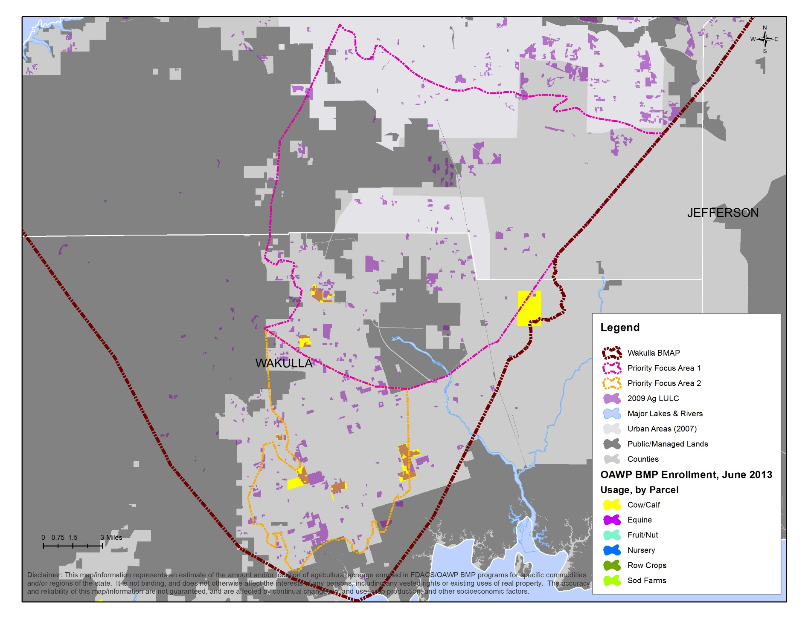
Figure 11: Agricultural Lands Enrolled in BMPs in the PFAs, as of June 2013

: Management Strategies Outside of the PFAs
In addition to the management strategies implemented by the stakeholders in the PFAs that are listed in Chapter 4, strategies are also being implemented or are planned for outside of the PFAs by the stakeholders listed below. These strategies will also help to reduce the nitrate loading to the Upper Wakulla River and Wakulla Springs.

Agriculture
In the portion of the Upper Wakulla River and Wakulla Springs Basin located outside of the PFAs, there is approximately 58,468.32 acres of agricultural land uses, of which 5,898.71 acres or 10.1% are enrolled in FDACS BMP programs as of March 31, 2013 (see Table 17 and Figure 12). During the first BMAP iteration, FDACS will continue to enroll additional producers in BMPs, to the extent possible.

Table 17: Agricultural Land Use Acreage BMAP Enrollment Outside of the PFAs as of March 31, 2013
N/A = Not applicable
¹ Enrollment numbers will depend on the ability of field staff to identify and locate producers, and whether producers choose to implement BMPs or monitor their water quality. Also, specific agricultural land uses and number of agricultural operations may changes from year to year. Progress on enrollment, based on the best available information, will be included in the BMAP annual progress reports.
2009 NWFWMD Land use | Acres¹ | Related FDACS BMP Programs | Acreage Enrolled | Related Notices of Intent
Pasture and Rangeland | 26,894.80 | Cow/Calf | 1,679.57 | 6
Row/Field/Mixed Crops | 11,775.52 | Vegetable/Agronomic Crops | 1,467.30 | 3
Hay Fields | 13,926.93 | Vegetable/Agronomic Crops Revision (Future) | N/A | N/A
Fallow Crop Land | 821.32 | N/A | N/A | N/A
Horse Farm | 1,298.26 | Equine | 0.00 | N/A
Other Groves | 475.53 | Specialty Fruit and Nut | 0.00 | N/A
Nurseries and Vineyards | 102.96 | Future Nursery, Specialty Fruit and Nut | 0.00 | N/A
Tree Nurseries | 155.11 | Future Nursery, Specialty Fruit and Nut | 0.00 | N/A
Ornamentals | 1,629.87 | Container Nursery | 2,751.84 | 6
Sod Farms | 1,260.62 | Statewide Sod | 0.00 | N/A
Specialty Farms | 48.67 | Conservation Plan Rule | 0.00 | N/A
Cattle Feeding | 55.15 | Conservation Plan Rule | 0.00 | N/A
Poultry Feeding | 23.58 | Conservation Plan Rule | 0.00 | N/A
TOTAL | 58,468.32 | N/A | 5,898.71 | 15

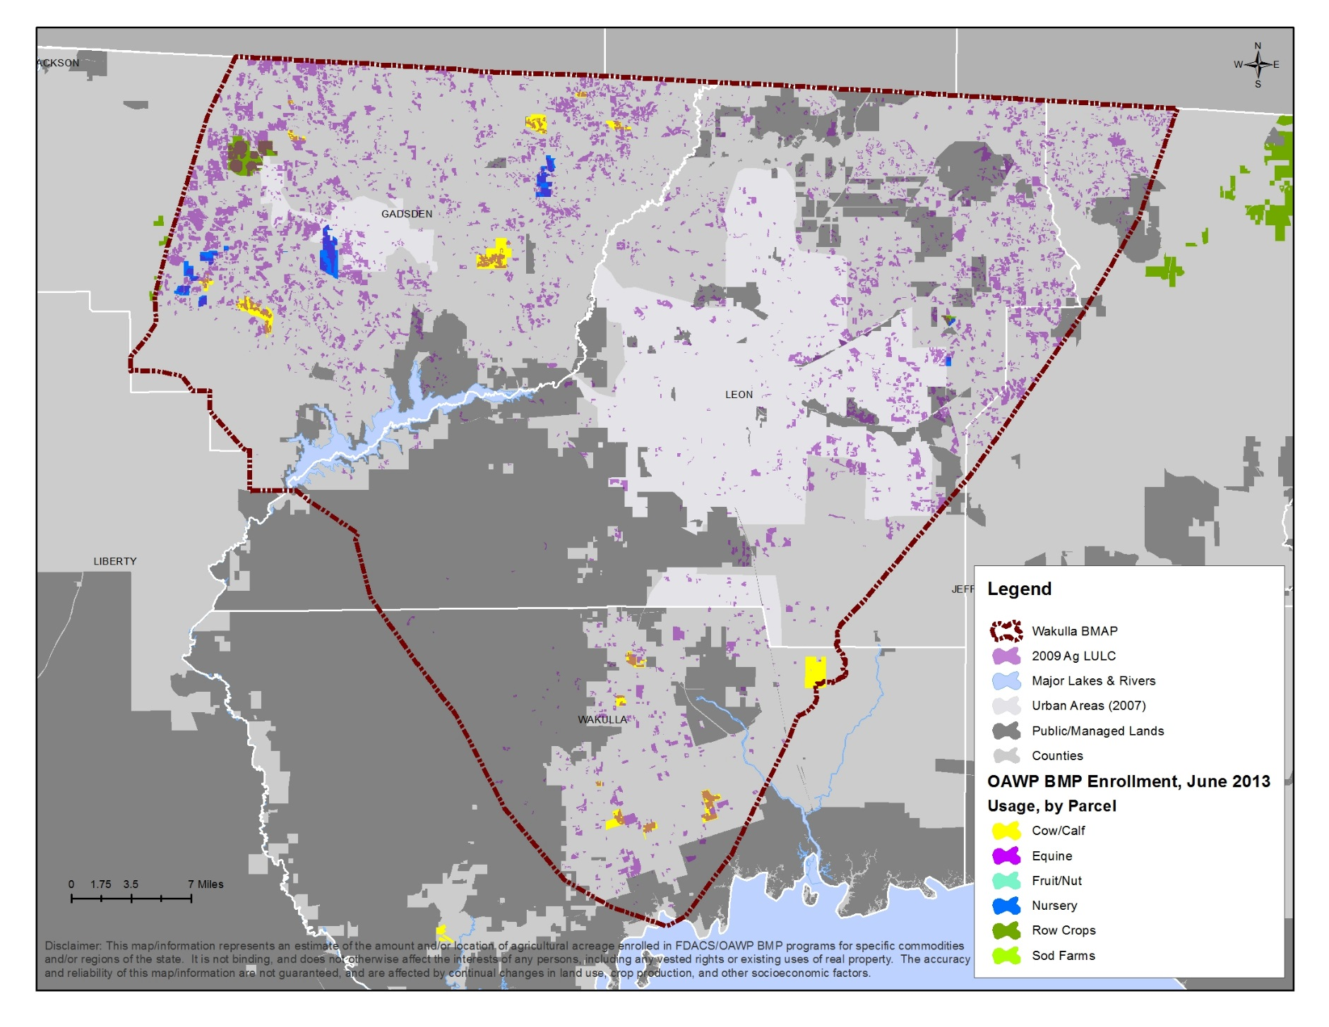
Figure 12: Agricultural Lands Enrolled in BMPs Outside of the PFAs, as of June 2013

City of Gretna Management Strategies
The City of Gretna does not apply fertilizer on any city-owned property. The city’s management strategies are summarized in Table 18.

Table 18: City of Gretna Management Strategies Outside of the PFAs
Number | Name | Description | Status | Category
CG-1 | No Fertilizer Use | Fertilizer is not applied on any city-owned property. | Ongoing | Residential Fertilizer

City of Quincy Management Strategies
The City of Quincy’s WWTF is at AWT. The city has an ordinance that requires minimum stormwater treatment levels and the use of BMPs, including slow release fertilizers. In addition, the city conducts street sweeping on a weekly basis.

Table 19: City of Quincy Management Strategies Outside of the PFAs
Number | Name | Description | Status | Category
CQ-1 | City of Quincy WWTF | AWT at the WWTF. | Completed | WWTF
CQ-2 | Land Development Code – Watershed Conservation Measures | Ordinance that requires minimum stormwater treatment levels and use of BMPs including slow release fertilizers. | Ongoing | Residential Fertilizer/ Stormwater
CQ-3 | Street Sweeping | Sweeping the streets in the south side of the city one week and the north side the next week. | Ongoing | Stormwater

FAMU Management Strategies
As part of FAMU’s MS4 activities, the school implements several management strategies to address stormwater including:
- Campus-wide letter to all students and staff on stormwater practices.
- Website about stormwater activities.
- Public service announcements on the FAMU public radio station about the effects of illicit discharges and illegal disposal of waste.
- Education about stormwater practices at athletic events and student activities.
- Stormwater system mapping.
- Illicit discharge screening.
- Stormwater system inspections and maintenance.
- Street sweeping.
FAMU’s management strategies are summarized in Table 20.

Table 20: FAMU Management Strategies Outside of the PFAs
Number | Name | Description | Status | Category
FAMU-1 | NPDES MS4 Permit | Stormwater system maintenance and education. | Ongoing | Stormwater

Federal Correctional Institution, Tallahassee Management Strategies
The Federal Correctional Institution, Tallahassee maintains approximately 255 catch basins/stormwater drains that make up the MS4 system. These catch basins/stormwater drains are inspected quarterly. In addition, no fertilizer is applied on the facility grounds. The Federal Correctional Institution, Tallahassee’s management strategies are summarized in Table 21.

Table 21: Federal Correctional Institution, Tallahassee Management Strategies Outside of the PFAs
Number | Name | Description | Status | Category
FCI-1 | NPDES MS4 Permit | Stormwater system inspection and maintenance. | Ongoing | Stormwater
FCI-2 | No Fertilizer Use | Fertilizer is not applied on facility grounds. | Ongoing | Fertilizer

FSU Management Strategies
FSU has a fertilizer rule in its University Master Plan that requires the use of slow release fertilizers and/or carefully managed fertilizer application times to minimize leaching of nutrients to the ground water. Dehydrated cow manure with a 2-1-2 analysis is used when planting, and a 15-0-15 mix with half the nitrogen water insoluble is used twice a year on the turf grass in high priority areas, such as athletic fields.
Through the MS4 permit, FSU also implements several management strategies to address stormwater including:
- Newsletter distributed several times per year to all faculty and staff through the mail and also available electronically.
- Website about stormwater activities: http://www.safety.fsu.edu/environmental.html.
- On-campus public service announcements.
- Base map of the entire campus stormwater drainage system.
- Illicit discharge policies.
- Stormwater hotline for faculty, staff, students, and visitors to report potential violations.
- Litter control and grounds maintenance.
FSU’s management strategies are summarized in Table 22.

Table 22: FSU Management Strategies Outside of the PFAs
Number | Name | Description | Start Date | Status | Category
FSU-1 | Fertilizer Rule in the University Master Plan | Use slow release fertilizers and/or carefully managed fertilizer applications time to ensure maximum root uptake and minimal surface water runoff or leaching to ground water. | 2008 | Ongoing | Fertilizer
FSU-2 | NPDES MS4 Permit | Stormwater system maintenance and education. | Not applicable | Ongoing | Stormwater

Gadsden County Management Strategies
Gadsden County has a comprehensive policy that requires a 100 foot setback for OSTDS from surface waters, which helps to minimize loading from OSTDS to surface waterbodies. The county also has a policy that requires water and sewer connection for any new development that occurs within 0.25 miles of available service, which will assist reducing the number of OSTDS that will be installed in the future in the areas of central sewer connection. The county also has a requirement to provide 1.5 times the normal treatment to reduce stormwater loading. In addition, the county has a policy that requires a 50 foot natural buffer around jurisdictional wetlands. Gadsden County’s management strategies are summarized in Table 23.

Table 23: Gadsden County Management Strategies Outside of the PFAs
Number | Name | Description | Status | Category
GC-1 | Comprehensive Plan Policy 4.5.1 and 5.2.11 in the Infrastructure and Conservation Element | Requires 100 foot setback for OSTDS from wetlands, creeks, streams, lakes, etc. | Ongoing | OSTDS
GC-2 | Comprehensive Plan Policy 5.2.4 and 5.2.11in the Conservation Element | Requires 50 foot natural buffer around all jurisdictional wetlands. | Ongoing | Protection Measure
GC-3 | Comprehensive Plan Infrastructure Element | Water and sewer connection required for new development within 0.25 miles of available service. | Ongoing | Wastewater
GC-4 | Section 3.4 Special Drainage Basins - Water Quality (Pollution Abatement) in the Stormwater Policies and Procedures Manual | Requires 1.5 times normal treatment requirement. | Ongoing | Stormwater

Talquin Electric Cooperative Management Strategies
Talquin Electric Cooperative completed a project on Highway 267 to add central sewer, which eliminated OSTDS for an existing motel and two future hotels. Talquin also added a sewer system along Beech Ridge Trail in Leon County, which removed 12 homes from OSTDS. Talquin is currently in the process of abandoning the Oyster Bay WWTP to remove this plant’s discharge from the coastal area. The sewer collection system that is associated with this WWTP will be connected to Wakulla County’s WWTF. Talquin is also looking to obtain funding to upgrade the Gadsden East WWTP to add a treatment wetland, which would result in zero effluent discharge from this facility. Talquin’s management strategies are summarized in Table 24.

Table 24: Talquin Electric Cooperative Management Strategies Outside of the PFAs
* The estimated reductions are based on the amount of TN applied to the land surface and do not represent the nitrate loading to ground water.
Number | Name | Description | Estimated Cost | Completion Date | Status | Estimated TN Reduction* | Category
TEC-1 | Oyster Bay WWTP abandonment | Decommissioned to connect coastal area sewer system to Wakulla County's sewer system in effort to move WWTP away from coastal areas. | $750,000 | 9/1/2013 | Construction | 100% | Wastewater
TEC-2 | Gadsden East WWTP | Construct a treatment wetland by retrofitting three existing rapid infiltration basins and building additional treatment cells, so the wetland has zero effluent discharge. The wetland's nitrogen reduction will be achieved through the natural wetland process and will require very little energy for operation and maintenance. | $200,000 | 12/31/2013 | Planned; seeking funding | 98% | Wastewater
TEC-3 | Highway 267 Sewer | Partnership with Gadsden County, and City of Quincy to provide a central sewer system to the Highway 267/I-10 interchange for existing motel and two future hotels eliminating OSTDS. | $400,000 | 06/2008 | Completed | 80% | Wastewater
TEC-4 | Beech Ridge Trail Sewer | Sewer system along Beech Ridge Trail to remove approximately 12 homes from OSTDS. | $40,000 | 12/2004 | Completed | 80% | Wastewater
Total | N/A | N/A | $1,390,000 | N/A | N/A | N/A | N/A

TCC Management Strategies
In spring 2012, TCC stopped applying fertilizer on the main campus. The previous applications were between 2,000 and 2,400 pounds of 18-0-18 fertilizer to the centipede sod throughout the campus each spring. In addition, TCC cut the amount of fertilizer used on the athletic fields in half. The new application rate is 300 pounds of fertilizer on the baseball field and 100 pounds of fertilizer on the softball and intramural fields, which is applied three times per year. TCC will continue this reduction in fertilizer application on the main campus and athletic fields. TCC’s management strategies are summarized in Table 25.

Table 25: TCC Management Strategies Outside of the PFAs
Number | Name | Description | Start Date | Status | Category
TCC-1 | Fertilizer Cessation | Cessation of fertilizer application on the main campus and reduction of application on the athletic fields by half. | 12/2012 | Ongoing | Residential Fertilizer

Town of Havana Management Strategies
The Town of Havana conducts quarterly sweeping of all the streets within the town limits, which helps to reduce the amount of pollutants that runoff from the roads. The Town of Havana’s management strategies are summarized in Table 26.

Table 26: Town of Havana Management Strategies Outside of the PFAs
Number | Name | Description | Status | Category
TH-1 | Street Sweeping | Quarterly street sweeping of all town roads. | Ongoing | Stormwater

: Assessing Progress and Making Changes
Successful BMAP implementation requires commitment and follow-up. In the commitment to plan implementation (see Section 6.5), stakeholders have expressed their intention to carry out the plan, monitor its effect, and continue to coordinate within and across jurisdictions to achieve water quality targets. The FWRA requires that an assessment be conducted every five years to determine whether there is reasonable progress in implementing the BMAP and achieving pollutant load reductions. This chapter contains the water quality monitoring component sufficient to make this evaluation.

Tracking Implementation
The Department will work with the stakeholders to track project implementation and organize the monitoring data collected each year. The project and monitoring information will be presented in an annual report. In addition to activities for the OSTDS Initiative, the Upper Wakulla River and Wakulla Springs stakeholders have agreed to meet approximately every 12 months after the adoption of the BMAP to follow up on plan implementation, share new information, and continue to coordinate on TMDL-related issues. The following types of activities may occur at annual meetings:
- Implementation Data and Reporting –
  - Collect project implementation information from the stakeholders and MS4 permit reporting and compare with the BMAP schedule.
  - Discuss the data collection process, including any concerns and possible improvements to the process.
  - Review the monitoring plan implementation, as detailed in Section 6.3.

- Sharing New Information –
  - Report on results from water quality and biological monitoring and trend information.
  - Provide updates on new management strategies in the basin that will help reduce nutrient loading.
  - Identify and review new scientific developments on addressing nutrient loads and incorporate any new information into annual progress reports.
- Coordinating TMDL-Related Issues –
  - Provide updates from the Department on the basin cycle and activities related to any impairments, TMDLs, and BMAP.
  - Obtain reports from other basins where tools or other information may be applicable to the Upper Wakulla River and Wakulla Springs TMDL.

Covering all of these topics is not required for the annual meetings, but this list provides examples of the types of information that should be considered for the agenda to assist with BMAP implementation and improve coordination among the agencies and stakeholders.

Adaptive Management Measures
Adaptive management involves setting up a mechanism for making adjustments in the BMAP when circumstances change or feedback indicates the need for a more effective strategy. Adaptive management measures include the following:
- Procedures to determine whether additional cooperative strategies are needed.
- Criteria/processes for determining whether and when plan components need revision due to changes in costs, environmental impacts, social effects, watershed conditions, or other factors.
- Descriptions of the stakeholders’ role after BMAP completion.

Key components of adaptive management to share information and expertise are tracking plan implementation, monitoring water quality and pollutant loads, and holding periodic meetings. BMAP execution will be a long-term process, and some projects will extend beyond the first BMAP phase. For example, during the first iteration, the OSTDS Initiative will be implemented to identify what strategies are most applicable to the basin to reduce nitrate loading, determine a timeline for future strategies, and identify which stakeholders are responsible for implementing the necessary strategies in the next BMAP iteration.
The Department and the stakeholders will track implementation efforts and monitor water quality to measure effectiveness and ensure BMAP compliance. The stakeholders will meet approximately every 12 months to discuss implementation issues, consider new information, and, if the basin is not projected to meet the TMDL, determine additional corrective actions. Information on management strategies implementation will be collected annually from the participating entities and organized into reports. The stakeholders will review these reports to assess progress towards meeting the BMAP goals.

Water Quality Monitoring

Monitoring Objectives
Focused objectives are critical for a monitoring strategy to provide the information needed to evaluate implementation success. The primary objectives of the monitoring strategy for the Upper Wakulla River and Wakulla Springs Basin are described below, and will be used to evaluate the success of the BMAP:
- Track trends in nitrate concentrations and loads in the Upper Wakulla River and Wakulla Springs.
- Track trends in the biological communities in the Upper Wakulla River.

Water Quality Monitoring Parameters, Frequency, and Network
To achieve the first objective above, the monitoring strategy focuses on collecting the suggested parameters included in Table 27 for the river sites and Table 28 for the spring vent and conduit sites. The core parameters are directly related to the impairment in the Upper Wakulla River and Wakulla Springs Basin. Supplemental parameters and field parameters are monitored primarily to support the interpretation of core water quality parameters. At a minimum, the core parameters will be tracked to determine progress towards meeting the TMDL.

Table 27: Water Quality Monitoring Parameters for the River Sites
- = Empty cell/no data
Core Parameters | Supplemental Parameters | Field Parameters
Nitrate + Nitrite (as N) | Chlorophyll-a | Water Temperature
Ammonia (as N) | Total Organic Carbon | pH
Kjeldahl Nitrogen | Total Phosphorous | Specific Conductance
- | Chloride | Dissolved Oxygen
- | Sulfate | Sample Depth
- | Fluoride | Secchi Depth
- | Calcium | -
- | Magnesium | -
- | Sodium | -
- | Potassium | -
- | Alkalinity | -
- | Hardness | -
- | Turbidity (lab) | -
- | Specific conductance (lab) | -
- | Color (true) | -
- | Total Suspended Solids | -
- | Total Dissolved Solids | -

Table 28: Water Quality Monitoring Parameters for the Spring Vent and Conduit Sites
- = Empty cell/no data
Core Parameters | Supplemental Parameters | Field Parameters
Nitrate + Nitrite (as N) | Sucralose | Water Temperature
Ammonia (as N) | Nitrogen Isotopes | pH
Kjeldahl Nitrogen | Oxygen Isotopes | Specific Conductance
- | Total Phosphorous | Dissolved Oxygen
- | Ortho-Phosphate (as P) | Sample Depth
- | Organic Carbon | -
- | Dissolved Solids | -
- | Suspended Solids | -
- | Turbidity | -
- | Color (true) | -
- | Boron | -
- | Calcium | -
- | Magnesium | -
- | Sodium | -
- | Potassium | -
- | Chloride | -
- | Sulfate | -
- | Fluoride | -
- | Alkalinity | -

Table 29 lists the water quality stations that are included in the BMAP monitoring network, which are sampled by NWFWMD and the Department. The water quality monitoring will be conducted in accordance with the frequencies below.
In addition, flow stations are listed in Table 29 to help determine loads to the river to achieve the first objective. These flow stations are maintained by the U.S. Geological Survey (UGGS) and Florida Geological Survey (FGS). The flow stations in the monitoring network are also shown in Figure 13. The Spring Creek flow station is included in the BMAP monitoring plan because it will be helpful in understanding the movement of water in the aquifer. This gage will provide the ability to create a correlation between Spring Creek Springs flow volumes and periods of reverse flows at Spring Creek to flows and water chemistry at the Wakulla Springs vent, which could help the stakeholders determine where to place management strategies in the future. The gage will also provide information expected to support NWFWMD in setting the minimum flows and levels for the Wakulla River.

Table 29: BMAP Water Quality Monitoring Network
Sampling Entity | Station ID | Station Name | Station Type | Frequency | Site Established
NWFWMD | S587 | Spring Vent | Recorder – discharge | 15-minute | 05/1997
NWFWMD | S587 | Spring Vent | Water quality vent | Quarterly | 04/2000
NWFWMD | S266 | Upper Bridge | Water quality river | Monthly | 08/2009
NWFWMD | S556 | Recreation Area Boat Dock | Water quality river | Monthly | 10/2013
NWFWMD | S556 | Recreation Area Boat Dock | Recorder – temperature, conductance | Hourly | 03/1999
NWFWMD | S98 | Boat Maintenance Tram | Recorder – stage | 5-minute | 12/1987
Department | 9695 | Spring Vent | Water quality vent | Quarterly | 09/2001
Department | 20383 | B-Tunnel | Water quality conduit | Quarterly | 04/2004
Department | 20385 | C-Tunnel | Water quality conduit | Quarterly | 04/2004
Department | 20387 | D-Tunnel | Water quality conduit | Quarterly | 04/2004
Department | 20388 | AD-Tunnel | Water quality conduit | Quarterly | 04/2004
Department | 20340 | K-Tunnel | Water quality conduit | Quarterly | 04/2004
Department | 20381 | AK-Tunnel | Water quality conduit | Quarterly | 04/2004
Department | S556 | Recreation Area Boat Dock | Nitrate Meter | Continuous | 12/2013 (projected)
USGS | 02327022 | Wakulla River Near Crawfordville, FL | Flow | Continuous | 10/2004
FGS | B_TUNNEL | B-Tunnel | Flow | 15-Minute | 12/2003
FGS | C_TUNNEL | C-Tunnel | Flow | 15-Minute | 12/2003
FGS | D_TUNNEL | D-Tunnel | Flow | 15-Minute | 02/2004
FGS | AD_TUNNEL | AD-Tunnel | Flow | 15-Minute | 02/2004
FGS | K_TUNNEL | K-Tunnel | Flow | 15-Minute | 02/2004
FGS | AK_TUNNEL | AK-Tunnel | Flow | 15-Minute | 02/2004
USGS | 02327031 | Spring Creek Gage | Flow | Continuous | 10/2013

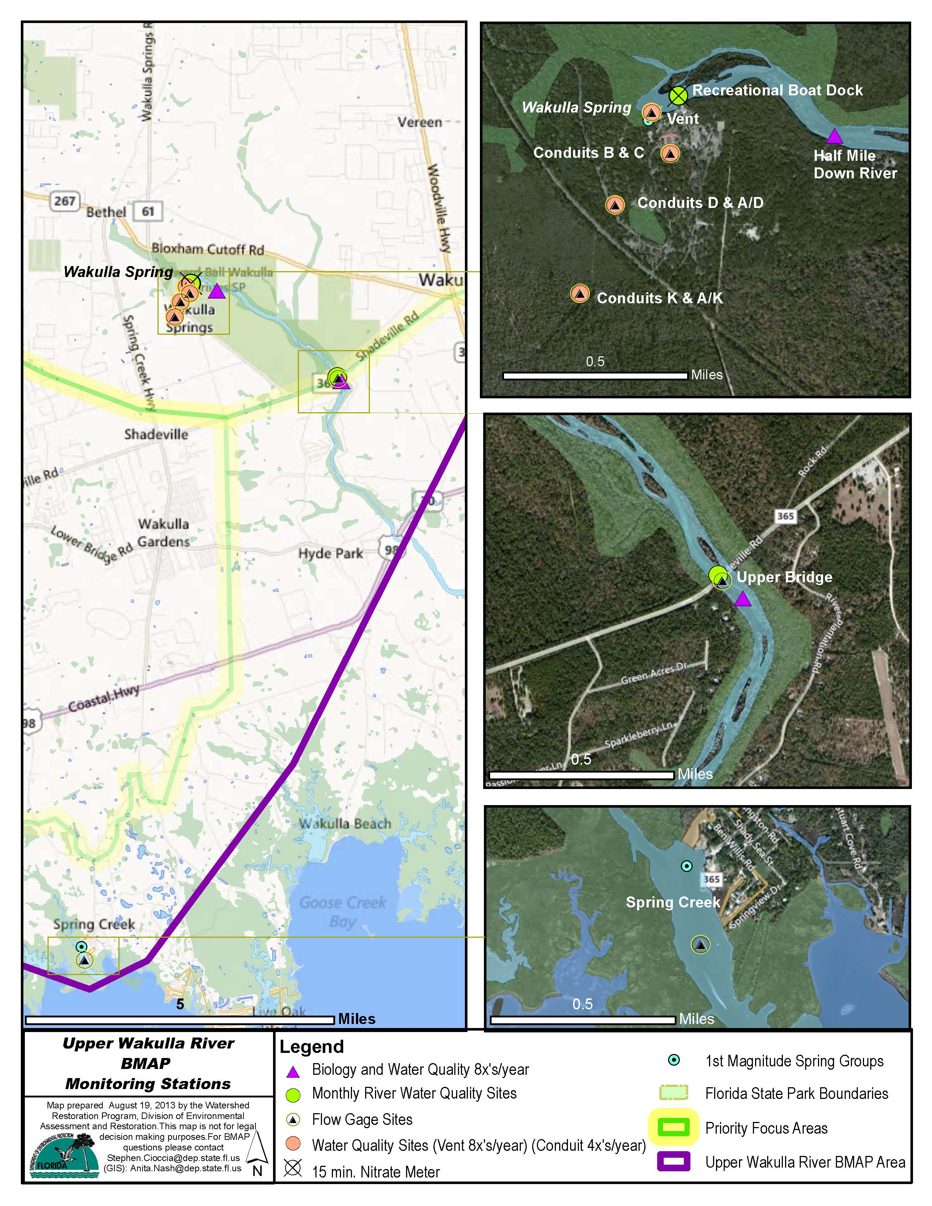
Figure 13: Monitoring Network for the Upper Wakulla River and Wakulla Springs

Biological Monitoring
To meet the second monitoring plan objective, several types of biological monitoring will occur to assess the health of the Upper Wakulla River. RPS will be conducted to assess the abundance and variety of algae in the river. The linear vegetation survey (LVS) will be conducted to assess the types and density of vegetation present in the river and to identify the native versus non-native species. SCI will be conducted to measure the number of different organisms present in the river. In addition, habitat assessments (HA) will be conducted to assess the river conditions and habitat present to support the SCI evaluation. Water quality samples will also be collected with the biological monitoring. The biological monitoring is summarized in Table 30 and the locations for this sampling are shown in Figure 13.

Table 30: Biological Monitoring
Sampling Entity | Type of Monitoring | Location | Frequency | Start Date
NWFWMD | RPS | 200 meters Downstream of Upper Bridge | Twice per year | 10/2013
NWFWMD | LVS | 200 meters Downstream of Upper Bridge | Twice per year | 10/2013
NWFWMD | SCI | 200 meters Downstream of Upper Bridge | Twice per year | 10/2013
NWFWMD | HA | 200 meters Downstream of Upper Bridge | Twice per year | 10/2013
Department | RPS | 200 meters Downstream of Upper Bridge | Twice per year | 01/2014
Department | LVS | 200 meters Downstream of Upper Bridge | Twice per year | 01/2014
Department | SCI | 200 meters Downstream of Upper Bridge | Twice per year | 01/2014
Department | HA | 200 meters Downstream of Upper Bridge | Twice per year | 01/2014
NWFWMD | RPS | Half Mile Downstream of Spring Vent | Twice per year | 10/2013
NWFWMD | LVS | Half Mile Downstream of Spring Vent | Twice per year | 10/2013
NWFWMD | SCI | Half Mile Downstream of Spring Vent | Twice per year | 10/2013
NWFWMD | HA | Half Mile Downstream of Spring Vent | Twice per year | 10/2013
Department | RPS | Half Mile Downstream of Spring Vent | Twice per year | 01/2014
Department | LVS | Half Mile Downstream of Spring Vent | Twice per year | 01/2014
Department | SCI | Half Mile Downstream of Spring Vent | Twice per year | 01/2014
Department | HA | Half Mile Downstream of Spring Vent | Twice per year | 01/2014

Data Management and Assessment
The Florida STORET database serves as the primary repository of ambient water quality data for the state of Florida. The Department pulls water quality data used for impaired water evaluations and TMDL development directly from the STORET database. Ambient water quality data collected as part of the BMAP will be uploaded into STORET for long-term storage and availability. Water quality data will be uploaded to STORET at least once every six months, upon completion of the appropriate quality assurance/quality control (QA/QC) checks.
The biological data will be stored in SBIO, which is also a Department database. The biological data will be uploaded at least once every six months, after the appropriate QA/QC checks.
The water quality and biological data will be analyzed during BMAP implementation to determine trends in water quality and the health of the biological community. A wide variety of statistical methods is available for the water quality trend analyses. The selection of an appropriate data analysis method depends on the frequency, spatial distribution, and period of record available from existing data. Specific statistical analyses were not identified during BMAP development; however, commonly accepted methods of data analysis will be used that are consistent with the TMDL model.

QA/QC
Stakeholders participating in the monitoring plan must collect water quality data in a manner consistent with the Department’s standard operating procedures for QA/QC. The most current version of these procedures can be downloaded from http://www.dep.state.fl.us/water/sas/sop/sops.htm. For BMAP-related data analyses, entities should use National Environmental Laboratory Accreditation Conference (NELAC) National Environmental Laboratory Accreditation Program (NELAP)–certified laboratories (http://www.dep.state.fl.us/labs/cgi-bin/aams/index.asp) or other labs that meet the certification and other requirements outlined in the standard operating procedures.

Research Studies
During the BMAP process, the stakeholders identified several research items they would like to pursue, if funding becomes available. These research topics include the following:
- Determine the nitrate contributions to Wakulla Springs during the reverse flow scenario where portions of the Spring Creek springshed flow to Wakulla Springs using data collected by NWFWMD and by potentially increasing the frequency of monitoring in the conduits that reverse flow.
- Conduct a dye trace study in Crawfordville to determine the contributions from septic tanks during the reverse flow scenario where portions of the Spring Creek springshed flow to Wakulla Springs.
- Evaluate the drinking water well data to identify wells with high nitrate concentrations and conduct further research to determine the source(s) of these high concentrations.
- Expand the Department’s Wakulla Springs Basin Nitrogen Sourcing Inventory to include the entire BMAP basin.
- Update the potentiometric surface data for the basin to better define the boundary, which will likely be performed for NWFWMD’s minimum flows and levels modeling.
- Run the AVA model for the entire BMAP basin, and incorporate the Light Detecting and Ranging (LIDAR) data from Wakulla County.
- Verify the effectiveness of agricultural BMPs in the Upper Wakulla River and Wakulla Springs Basin.
- Monitor before and after project implementation, as desired, to determine the nitrate reduction benefits of the projects.
- Add nitrate data loggers to the river water quality sampling locations (upper bridge and recreation area boat dock) to obtain better information about how nitrate concentrations change in the river.
- Develop a water budget and nutrient transport model for the Upper Wakulla River and Wakulla Springs Basin.
- Determine the effects of saltwater intrusion and sea level rise on the biological community in the Upper Wakulla River and Wakulla Springs.
- Measure color, using ultraviolet-visible light absorption spectrophotometry, in the Upper Wakulla River to determine the effects on water quality and the biological community.
- Create an Aquifer Watch program for the Upper Wakulla River and Wakulla Springs Basin to gather additional water quality data for ground water in the basin.
- Assess the nitrate contributions to ground water from sinkholes in the basin.

Commitment to Plan Implementation
Paragraph 403.067(7), F.S., lays out the mechanisms for BMAP implementation (see Appendix B). While the BMAP is linked by statute to permitting and other enforcement processes that target individual entities, successful implementation mandates that local stakeholders willingly and consistently work together to attain adopted TMDLs. This collaboration fosters the sharing of ideas, information, and resources. The stakeholders have demonstrated their willingness to confer with and support each other in their efforts.

APPENDICES

Appendix A: TMDL Basin Rotation Schedule
TMDLs are developed, allocated, and implemented through a watershed management approach (managing water resources within their natural boundaries) that addresses the state’s 52 major hydrologic basins in five groups on a rotating schedule. Table A-1 shows the hydrologic basins within each of the five groups, with the Department District office of jurisdiction.

Table A-1: Major Hydrologic Basins by Group and Department District Office
Department  District | Group 1  Basins | Group 2  Basins | Group 3  Basins | Group 4  Basins | Group 5  Basins
NW | Ochlockonee–  St. Marks | Apalachicola–  Chipola | Choctawhatchee–  St. Andrews Bay | Pensacola Bay | Perdido Bay
NE | Suwannee | Lower St. Johns | Not applicable | Nassau–St. Marys | Upper East Coast
Central | Ocklawaha | Middle St. Johns | Upper St. Johns | Kissimmee | Indian River  Lagoon
SW | Tampa Bay | Tampa Bay  Tributaries | Sarasota Bay–  Peace–Myakka | Withlacoochee | Springs Coast
S | Everglades  West Coast | Charlotte Harbor | Caloosahatchee | Fisheating Creek | Florida Keys
SE | Lake  Okeechobee | St. Lucie–  Loxahatchee | Lake Worth Lagoon–  Palm Beach Coast | Southeast Coast–Biscayne Bay | Everglades

Each group will undergo a cycle of five phases on a rotating schedule:
Phase 1: Preliminary evaluation of water quality.
Phase 2: Strategic monitoring and assessment to verify water quality impairments.
Phase 3: Development and adoption of TMDLs for waters verified as impaired.
Phase 4: Development of BMAP to achieve the TMDL.
Phase 5: Implementation of the BMAP and monitoring of results.

The Ochlockonee – St. Marks Basin is a Group 1 basin. As such, the Cycle 1 list of verified impaired waters was developed in 2002, the Cycle 2 list was developed in 2009, and the Cycle 3 list was developed in 2013. The Department will reevaluate impaired waters every five years to determine whether improvements are being achieved and to refine loading estimates and TMDL allocations using new data. If any changes in a TMDL are required, the applicable TMDL rule may be revised. Changes to a TMDL would prompt revisions to the applicable BMAP, which will be revisited at least every five years and modified as necessary, regardless of whether the TMDL is modified.

Appendix B: Summary of Statutory Provisions Guiding BMAP Development and Implementation
Sections 403.067(6) and (7), Florida Statutes – Summary of Excerpts
General Implementation
- DEP is the lead agency in coordinating TMDL implementation, through existing water quality protection programs.
- Application of a TMDL by a water management district does not require WMD adoption of the TMDL.
- TMDL implementation may include, but is not limited to:
  - Permitting and other existing regulatory programs.
  - Non-regulatory and incentive-based programs.
  - Other water quality management and restoration activities, such as Surface Water Improvement and Management (SWIM) plans or basin management action plans.
  - Pollutant trading or other equitable economically based agreements.
  - Public works.
  - Land acquisition.
Basin Management Action Plan Development
- The Department may develop a BMAP that addresses some or all of the watersheds and basins tributary to a TMDL waterbody.
- A BMAP shall:
  - Integrate appropriate management strategies available to the state through existing water quality protection programs.
  - Equitably allocate pollutant reductions to individual basins, all basins, each identified point source, or category of nonpoint sources, as appropriate.
  - Identify the mechanisms by which potential future increases in pollutant loading will be addressed.
  - Specify that for nonpoint sources for which BMPs have been adopted, the initial requirement shall be BMPs developed pursuant to paragraph I.
  - Establish an implementation schedule.
  - Establish a basis for evaluating plan effectiveness.
  - Identify feasible funding strategies.
  - Identify milestones for implementation and water quality improvement, and an associated water quality monitoring component to evaluate reasonable progress over time.
  - Be adopted in whole or in part by Department Secretarial Order, subject to chapter 120.
- A BMAP may:
  - Give load reduction credits to dischargers that have implemented load reduction strategies (including BMPs) prior to the development of the BMAP. (Note: this assumes the related reductions were not factored into the applicable TMDL.)
  - Include regional treatment systems or other public works as management strategies.
  - Provide for phased implementation to promote timely, cost-effective actions.
- An assessment of progress in achieving milestones shall be conducted every five years and the BMAP revised, as appropriate, in cooperation with basin stakeholders, and adopted by secretarial order.
- The Department shall assure that key stakeholders are invited to participate in the BMAP development process, holding at least one noticed public meeting in the basin to receive comments, and otherwise encouraging public participation to the greatest practicable extent.
- A BMAP shall not supplant or alter any water quality assessment, TMDL calculation, or initial allocation.
Basin Management Action Plan Implementation
- NPDES Permits
  - Management strategies related to a discharger subject to NPDES permitting shall be included in subsequent applicable NPDES permits or permit modifications when the permit expires (is renewed), the discharge is modified (revised), or the permit is reopened pursuant to an adopted BMAP.
  - Absent a detailed allocation, TMDLs shall be implemented through NPDES permit conditions that include a compliance schedule. The permit shall allow for issuance of an order adopting the BMAP within five years. (Note: Intended to apply to individual wastewater permits – not MS4s)
  - Once the BMAP is adopted, the permit shall be reopened, as necessary, and permit conditions consistent with the BMAP shall be established.
  - Upon request by a NPDES permittee, the Department may establish individual allocations prior to the adoption of a BMAP, as part of a permit issuance, renewal, or modification (revision).
  - To the maximum extent practicable, MS4s shall implement a TMDL or BMAP through the use of BMPs or other management measures.
  - A BMAP does not take the place of NPDES permits or permit requirements.
  - Management strategies to be implemented by a Department permittee shall be completed according to the BMAP schedule, which may extend beyond the five-year term of an NPDES permit.
  - Management strategies are not subject to challenge under chapter 120 when they are incorporated in identical form into a NPDES permit or permit modification (revision).
- Management strategies assigned to nonagricultural, non-NPDES permittees (state, regional, or local) shall be implemented as part of the applicable permitting programs.
- Nonpoint source dischargers (e.g., agriculture) included in a BMAP shall demonstrate compliance with the applicable TMDLs by either implementing appropriate BMPs established under paragraph 7I, or conducting water quality monitoring prescribed by Department or a WMD. (Note: this is not applicable to MS4s, as they are considered point sources under the federal Clean Water Act and TMDL Program.)
- Failure to implement BMPs or prescribed water quality monitoring may be subject to Department or WMD enforcement action.
- Responsible parties who are implementing applicable BMAP strategies shall not be required to implement additional pollutant load reduction strategies, and shall be deemed in compliance with this section. However, this does not limit DEP’s authority to amend a BMAP.
Best Management Practices
- The Department, in cooperation with WMDs and other interested parties, may develop interim measures, BMPs, or other measures for non-agricultural nonpoint sources to achieve their load reduction allocations.
- These measures may be adopted by Department or WMD rule. If adopted, they shall be implemented by those responsible for non-agricultural nonpoint source pollution.
- DACS may develop and adopt by rule interim measure, BMPs, or other measures necessary for agricultural pollutant sources to achieve their load reduction allocations.
  - These measures may be implemented by those responsible for agricultural pollutant sources. The Department, the WMDs, and FDACS shall assist with implementation.
  - In developing and adopting these measures, FDACS shall consult with the Department, Florida Department of Health, the WMDs, representatives of affected farming groups, and environmental group representatives.
  - The rules shall provide for a notice of intent to implement the practices and a system to ensure implementation, including recordkeeping.
- Verification of Effectiveness and Presumption of Compliance –
  - The Department shall, at representative sites, verify the effectiveness of BMPs and other measures adopted by rule in achieving load reduction allocations.
  - The Department shall use best professional judgment in making the initial verification of effectiveness, and shall notify FDACS and the appropriate WMD of the initial verification prior to the adoption of a rule proposed pursuant to this paragraph.
  - Implementation of rule-adopted BMPs or other measures initially verified by the Department to be effective, or verified to be effective by monitoring at representative sites, provides a presumption of compliance with state water quality standards for those pollutants addressed by the practices.
- Reevaluation –
  - Where water quality problems are demonstrated despite implementation, operation, and maintenance of rule-adopted BMPs and other measures, the Department, a WMD, or FDACS, in consultation with the Department, shall reevaluate the measures. If the practices require modification, the revised rule shall specify a reasonable time period for implementation.

Appendix C: Rule 62-304(2), F.A.C., the Upper Wakulla River TMDL
(2) Upper Wakulla River. The nitrate TMDL to address the biological impairment is an in-stream monthly mean concentration of 0.35 mg/L and is allocated as follows:
(a) The WLA for wastewater sources is not applicable.
(b) The WLA for discharges subject to the Department’s NPDES Municipal Stormwater Permitting Program is not applicable.
(c) The LAs for nonpoint sources are to address anthropogenic sources in the basin such that in-stream nitrate concentrations meet the TMDL target, which, based on the mean concentrations from the 2002-2007 period, will require a 56.2 percent reduction of nitrate at sources contributing to the observed biological impairment.
(d) The Margin of Safety is implicit.
(e) While the WLA and LAs for nitrate have been expressed as the concentration and percent reduction needed to attain the applicable Class III biology criterion, it is the combined reductions from both anthropogenic point and nonpoint sources that will result in the required reduction of in-stream nitrate concentrations. However, it is not the intent of the TMDL to abate natural background conditions.

Appendix D: City of Tallahassee Stormwater Treatment Projects in the Upper Wakulla River and Wakulla Springs Basin

Table D-1: Summary of the City of Tallahassee Stormwater Treatment Projects
Project Name | Status | Project Type | Map Label
Campus Circle | Complete | Wet detention with storm drain improvements | C2
Park Avenue Tributary #1 Stormwater Improvements | Active | Wet detention and channel stabilization | C3
Upper Lake Lafayette Nutrient Reduction Project | Active | Alum | C4
Pickett Court Area Stormwater | Complete | Not applicable | C5
Ford Street Drainage Improvements | Complete | Storm drain improvements | C6
Karen Lane Drainage Improvements | Complete | Storm drain improvements | C7
Emory Court And Dupont Drive Stormwater Improvements | Active | Channel stabilization | C8
Wilson Ridge Flood Relief | Complete | Storm drain improvements | C9
Killarney Way and Shamrock West Drainage Improvements | Active | Wet detention with storm drain improvements | C10
Northeast Ditch At Lonnbladh Road | Complete | Channel stabilization | C11
Chapel Drive Stormwater Improvements | Complete | Storm drain improvements | C13
Concord Road Stormwater Improvements | Active | Wet detention with storm drain improvements | C14
Frenchtown Stormwater Improvements Master Plan | Active | Wet detention with storm drain improvements | C15
Lafayette Park Outfall Phase II | Active | Storm drain improvements | C16
Lafayette Park Outfall Phase I | Complete | Dry detention | C17
East Georgia At Meridian Flood Mitigation | Complete | Storm drain improvements | C18
Lower Community Development District Erosion Control | Active | Channel stabilization | C20
Eastgate Flood Relief Project | Active | Channel stabilization with storm drain improvements | C21
Inglewood Stormwater Improvements | Active | Storm drain improvements | C22
Upper West Ditch Stormwater Facility | Active | To be determined | C23
Greenwood Stormwater Management Facility (part of Frenchtown Master Plan) | Active | Wet detention | C24
Royal Oaks Creek | Active | Channel stabilization | C25
Connie Drive Flooding | Active | Channel stabilization with storm drain improvements | C26
Call Street and Cadiz Stormwater Improvements | Active | Dry detention with storm drain improvements | C27
Meginnis Creek at Sharer Road | Active | Channel stabilization | C28
1046 Copper Creek Lane | Active | Conveyance Improvement | S1
1102 Tanner | Complete | Conveyance Improvement | S2
1103 Bonnie Drive | Complete | Conveyance Improvement | S3
1425 Devils Dip | Active | Conveyance Improvement | S5
1503 Spruce Avenue | Complete | Conveyance Improvement | S6
1829 Ivan Drive | Active | Conveyance Improvement | S7
2212 Eastgate Way | Complete | Conveyance Improvement | S9
2713 Bedford Way | Complete | Conveyance Improvement | S14
2764 Faringdon Drive | Complete | Conveyance Improvement | S15
2925 Edenderry Drive | Complete | Conveyance Improvement | S16
2945 Edenderry Drive (at Brandon Hill Drive) | Complete | Conveyance Improvement | S18
3015 Shamrock North | Active | Conveyance Improvement | S20
3068 O’Brien Drive | Complete | Conveyance Improvement | S22
3224 Baldwin Drive | Active | Conveyance Improvement | S23
3244 Shannon Lakes | Active | Conveyance Improvement | S24
3449 Mahoney Drive | Complete | Conveyance Improvement | S25
3933 Runnymede | Complete | Conveyance Improvement | S27
4052 Roscrea Drive | Active | Conveyance Improvement | S28
903 Beard Street | Active | Conveyance Improvement | S31
926 Millard Street | Complete | Conveyance Improvement | S32
Big Oak Street | Complete | Conveyance Improvement | S33
O’Brien and Grey Abbey Court | Complete | Conveyance Improvement | S34
Sandhurst Drive | Complete | Conveyance Improvement | S35
Shamrock North at Edenderry Drive | Complete | Conveyance Improvement | S36
Villages of Killearn/Kinsail | Complete | Conveyance Improvement | S38
Royal Oaks Phase I B | Complete | Conveyance Improvement | S39
2830 Cline Street | Complete | Conveyance Improvement | S40
314 Teal Lane | Complete | Conveyance Improvement | S41
4036 Brandon Hill Drive (Edenderry Drive) | Complete | Conveyance Improvement | S42
3703 Mockingbird Drive | Complete | Conveyance Improvement | S43
2407 Winthrop Road | Complete | Conveyance Improvement | S44
Trapnell Street (2818 McElroy) | Complete | Conveyance Improvement | S45
708 East Jefferson | Complete | Conveyance Improvement | S46
1543 Coleman | Complete | Conveyance Improvement | S47
3742 Shamrock | Complete | Conveyance Improvement | S48
4029 Brandon Hill | Complete | Conveyance Improvement | S49
Salmon Drive Ditch Lining (across 1706) | Complete | Conveyance Improvement | S51
Cypress Lake | Complete | Conveyance Improvement | S53
Ravine Drive | Complete | Conveyance Improvement | S54
Bay Shore Drive Stormwater Outfall | Complete | Conveyance Improvement | S55
551 Stonehouse Road | Complete | Conveyance Improvement | S56
Woodbern Lane | Complete | Conveyance Improvement | S57
Armistead Road | Complete | Conveyance Improvement | S58
519 Short Street | Active | Conveyance Improvement | S59
Limerick Drive Stormwater Outfall Improvements | Active | Conveyance Improvement | S60
Richardson Road | Active | Conveyance Improvement | S61
3907 Roswell Drive | Complete | Conveyance Improvement | S65
McGuire Pond | Complete | Pond Grading | S66
Bradford Road Stormwater Outfall | Active | Conveyance Improvement | S67
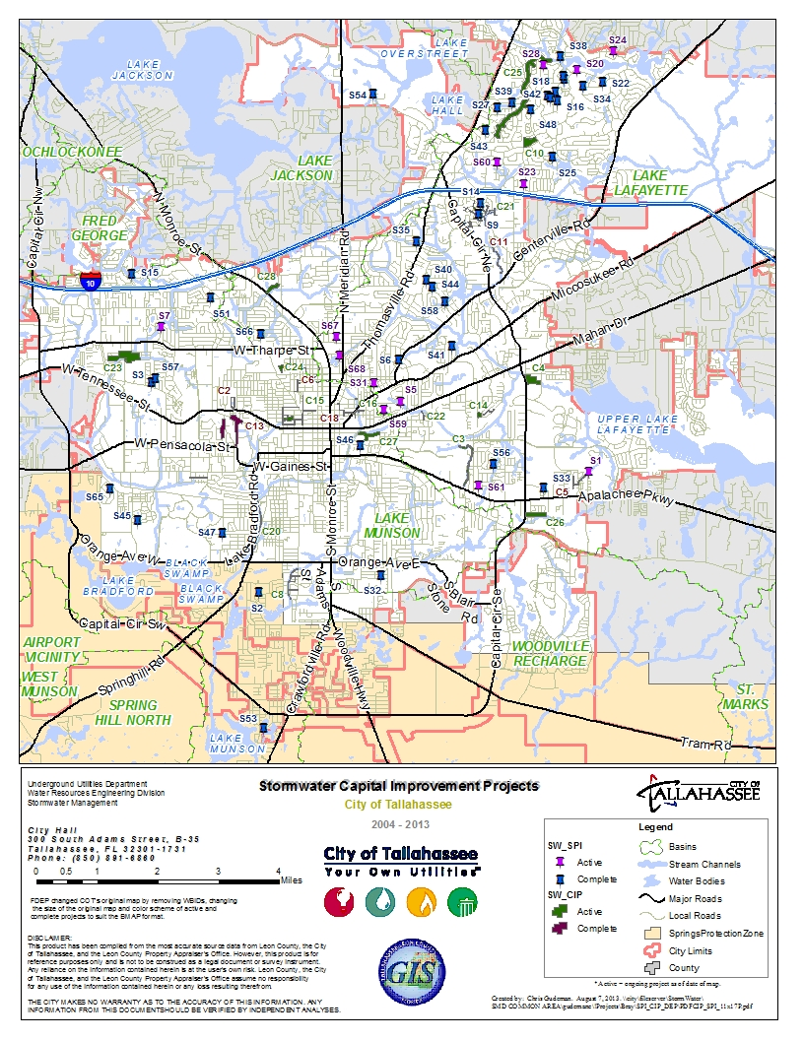
Figure D-1: Location of the City of Tallahassee’s Stormwater Treatment Projects

Appendix E: Glossary of Terms
303(d) List: The list of Florida’s waterbodies that do not meet or are not expected to meet applicable water quality standards with technology-based controls alone.
305(b) Report: Section 305(b) of the federal Clean Water Act requires states to report biennially to the EPA on the quality of the waters in the state.
Background: The condition of waters in the absence of human-induced alterations.
Baffle Box: An underground stormwater management device that uses barriers (or baffles) to slow the flow of untreated stormwater, allowing particulates to settle out in the box before the stormwater is released into the environment.
Baseline Loading: The quantity of pollutants in a waterbody, used as a basis for later comparison.
Basin Management Action Plan (BMAP): The document that describes how a specific TMDL will be implemented; the plan describes the specific load and wasteload allocations as well as the stakeholder efforts that will be undertaken to achieve an adopted TMDL.
Basin Status Report: For the Ochlockonee-St. Marks Basin, this document was published in 2001 by the Department. The report documents the water quality issues, list of water segments under consideration for a TMDL and data needs in the basin.
Best Management Practices (BMPs): Methods that have been determined to be the most effective, practical means of preventing or reducing pollution from nonpoint sources.
Coliforms: Bacteria that live in the intestines (including the colon) of humans and other animals, used as a measure of the presence of feces in water or soil.
Clean Water Act (CWA): The Clean Water Act is a 1977 amendment to the Federal Water Pollution Control Act of 1972, which set the basic structure for regulating discharges of pollutants to waters of the United States.
Continuous Deflective Separation (CDS) Unit: A patented stormwater management device that uses the available energy of the storm flow to create a vortex to cause a separation of solids from fluids. Pollutants are captured inside the separation chamber, while the water passes out through the separation screen.
Designated Use: Uses specified in water quality standards for each waterbody or segment (such as drinking water, swimmable, fishable).
Detention Pond: A stormwater system that delays the downstream progress of stormwater runoff in a controlled manner, typically by using temporary storage areas and a metered outlet device.
Domestic Wastewater: Wastewater derived principally from dwellings, business buildings, institutions and the like; sanitary wastewater; sewage.
Effluent: Wastewater that flows into a receiving stream by way of a domestic or industrial discharge point.
Environmental Protection Agency (EPA): The agency was created in December 1970 to address the nation’s environmental problems and to protect the public health. The majority of the Department’s regulatory programs has counterparts at the EPA or is delegated from the EPA.
Event Mean Concentration (EMC): The flow-weighted mean concentration of an urban runoff pollutant measured during a storm event.
Exfiltration: Loss of water from a drainage system as the result of percolation or absorption into the surrounding soil.
External Loading: Pollutants originating from outside a waterbody that contribute to the pollutant load of the waterbody.
Florida Department of Environmental Protection (Department): The Department is Florida’s principal environmental and natural resources agency. The Florida Department of Natural Resources and the Florida Department of Environmental Regulation were merged together to create the Department effective July 1, 1993.
Ground Water or Groundwater: Water below the land surface in the zone of saturation where water is at or above atmospheric pressure.
Impairment: The condition of a waterbody that does not achieve water quality standards (designated use) due to pollutants or an unknown cause.
Load Allocations (LA): The portions of a receiving water’s loading capacity that are allocated to one of its existing or future nonpoint sources of pollution.
Load Capacity: The greatest amount of loading that a waterbody can receive without violating water quality standards.
Loading: The total quantity of pollutants in stormwater runoff that contributes to the water quality impairment.
Margin of Safety (MOS): An explicit or implicit assumption used in the calculation of a TMDL, which takes into account any lack of knowledge concerning the relationship between effluent limitations and water quality. An explicit MOS is typically a percentage of the assimilative capacity or some other specific amount of pollutant loading (e.g., the loading from an out-of-state source). Most Department-adopted TMDLs include an implicit MOS based on the fact that the predictive model runs incorporate a variety of conservative assumptions (they examine worst-case ambient flow conditions, worst-case temperature, and assume that all permitted point sources discharge at their maximum permittable amount).
National Pollutant Discharge Elimination System (NPDES): The permitting process by which technology based and water quality–based controls are implemented.
Nonpoint Source (NPS): Diffuse runoff without a single point of origin that flows over the surface of the ground by stormwater and is then introduced to surface or ground water. NPS includes atmospheric deposition and runoff or leaching from agricultural lands, urban areas, unvegetated lands, onsite treatment disposal systems (OSTDS), and construction sites.
Nonpoint Source Pollution: Nonpoint source pollution is created by the flushing of pollutants from the landscape by rainfall and the resulting stormwater runoff, or by the leaching of pollutants through the soils into the ground water.
Organic Matter: Carbonaceous waste contained in plant or animal matter and originating from domestic or industrial sources.
Outfall (general): The place where a sewer, drain, or stream discharges.
Outfall (MS4): A point source at the location where a MS4 discharges to water of the state and does not include open conveyances connecting two municipal separate storm sewers, or pipes, tunnels, or other conveyances which connect segments of the same stream or other waters of the state and are used to convey waters of the state.
Point Source: An identifiable and confined discharge point for one or more water pollutants, such as a pipe, channel, vessel, or ditch.
Pollutant: Generally any substance, such as a chemical or waste product, introduced into the environment that adversely affects the usefulness of a resource.
Pollution: An undesirable change in the physical, chemical, or biological characteristics of air, water, soil, or food that can adversely affect the health, survival, or activities of humans or other living organisms.
Removal Efficiency: A description of how much of a given substance (metals, sediment, etc.) has been extracted from another substance.
Retention Pond: A stormwater management structure whose primary purpose is to permanently store a given volume of stormwater runoff, releasing it by infiltration and /or evaporation.
Reuse: The deliberate application of reclaimed water for a beneficial purpose. Criteria used to classify projects as “reuse” or “effluent disposal” are contained in Subsection 62-610.810, F.A.C.
Quality Assurance (QA): An integrated system of management activities involving planning, implementation, documentation, assessment, reporting, and quality improvement to ensure that a process, product, or service meets defined standards of quality.
Quality Control (QC): The overall system of technical activities that measures the attributes and performance of a process, product, or service against defined standards to verify that they meet the established data quality objectives.
Septic Tank: A watertight receptacle constructed to promote the separation of solid and liquid components of wastewater, to provide the limited digestion of organic matter, to store solids, and to allow clarified liquid to discharge for further treatment and disposal in a soil absorption system.
STORET: The EPA’s STOrage and RETrieval database, used nationally for water quality data storage.
Stormwater Runoff: The portion of rainfall that hits the ground and is not evaporated, percolated, or transpired into vegetation, but rather flows over the ground surface seeking a receiving waterbody.
Surface Water: Water on the surface of the earth, whether contained in bounds created naturally or artificially or diffused. Water from natural springs is classified as surface water when it exits the spring onto the earth’s surface.
Total Maximum Daily Load (TMDL): The sum of the individual wasteload allocations for point sources and the load allocations for nonpoint sources and natural background. Prior to determining individual wasteload allocations and load allocations, the maximum amount of a pollutant that a waterbody or waterbody segment can assimilate from all sources while still maintaining its designated use must first be calculated. TMDLs are based on the relationship between pollutants and instream water quality conditions.
Wasteload Allocations (WLAs): Pollutant loads allotted to existing and future point sources, such as discharges from industry and sewage facilities.
Wastewater: The combination of liquid and pollutants from residences, commercial buildings, industrial plants, and institutions, together with any ground water, surface runoff, or leachate that may be present.
Waterbody Identification (WBID) Numbers: WBIDs are numbers assigned to hydrologically based drainage areas in a river basin.
Water Quality Standards (WQSs): (1) Standards that comprise the designated most beneficial uses (classification of water), the numeric and narrative criteria applied to the specific water use or classification, the Florida Anti-degradation Policy, and the moderating provisions contained in Rules 62-302 and 62-4, F.A.C. (2) State-adopted and EPA-approved ambient standards for waterbodies. The standards prescribe the use of the waterbody (such as drinking, fishing and swimming, and shellfish harvesting) and establish the water quality criteria that must be met to protect designated uses.
Watershed: Topographic area that contributes or may contribute runoff to specific surface waters or an area of recharge.
Watershed Management Approach: The process of addressing water quality concerns within their natural boundaries, rather than political or regulatory boundaries. The process draws together all the participants and stakeholders in each basin to decide what problems affect the water quality in the basin, which are most important, and how they will be addressed.

Appendix F: Bibliography of Key References and Websites
Key References
Florida Department of Environmental Protection:
— 2001. Basin status report: Ochlockonee and St. Marks. Tallahassee, FL: Watershed Planning and Coordination Section, Bureau of Watershed Management.
— 2012a. TMDL report: Nutrient (Biology) TMDL for the Upper Wakulla River (WBID 1006). Tallahassee, FL: Division of Water Resource Management, Bureau of Watershed Management.
— 2012b. Kincaid, Todd, Gareth Davies, Christopher Werner, and Rodney DeHan. Demonstrating interconnection between a wastewater application facility and a first magnitude spring in a karstic watershed: Tracer study of the Southeast Farm Wastewater Reuse Facility, Tallahassee, Florida. Tallahassee, FL: Florida Geological Survey.
—2013a. Eller, Kirstin, Brian Katz, and Richard Hicks. Wakulla Springs Basin Nitrogen Sourcing Inventory. Tallahassee, FL: Ground Water Management Section. PowerPoint from: http://publicfiles.dep.state.fl.us/DEAR/BMAP/Upper%20Wakulla/04-Tech-Meeting_April-18-2013/Wakulla%20Nitrogen%20Project-K.ELLER.pdf.
—2013b. Jackson, Joy. Wakulla River Biological Assessments. Tallahassee, FL: Standards and Assessment Section. PowerPoint from: http://publicfiles.dep.state.fl.us/DEAR/BMAP/Upper%20Wakulla/03-Tech-Meeting_March-28-2013/Wakulla%20River%20Biological%20Results_BMAP%20Meeting%20-%20Joy%20Jackson.pdf.
—2013c. Katz, Brian. Using Nitrogen Isotopes to Identify Sources of Nitrogen in the Wakulla Springs Basin. Tallahassee, FL: Ground Water Management Section. PowerPoint from: http://publicfiles.dep.state.fl.us/DEAR/BMAP/Upper%20Wakulla/04-Tech-Meeting_April-18-2013/N-isotope-BK2_Wakulla-BMAP_B.KATZ.pdf.
—2013d. Maddox, Gary. Summary of Water Quality Data and the Existing Monitoring Network: Current & Recent Nitrate Trends in Wakulla Springs and River. Tallahassee, FL: Ground Water Management Section. PowerPoint from: http://publicfiles.dep.state.fl.us/DEAR/BMAP/Upper%20Wakulla/03-Tech-Meeting_March-28-2013/GM%20Wakulla%20Nutrient%20Trends%20SHORT.pdf.

Baker, Alan E., Alex R. Wood, James R. Cichon, and Jay L. Johnson. July 2007. The Leon County Aquifer Vulnerability Assessment. Prepared for the Leon County Board of County Commissioners in fulfillment of Leon County Project No. BC-06-21-06-53.

Baker, Alan E., Alex R. Wood, and James R. Cichon. September 2009. The Wakulla County Aquifer Vulnerability Assessment. Prepared for the Florida Department of Environmental Protection as part of the Florida Aquifer Vulnerability Assessment (FAVA) Phase II Project, Contract No. RM059.

Chelette, A., T.R. Pratt, and B.G. Katz. April 2002. Nitrate loading as an indicator of nonpoint source pollution in the Lower St. Marks-Wakulla Rivers watershed. Water Resources Special Report 02-1. Northwest Florida Water Management District.

Harden H., Katz B., Griffin D., McMahon P., Wade, E., Hicks R., and Chanton J. Fate of Effluent-Borne Contaminants Beneath Septic Tank Drainfields Overlying a Karst Aquifer, Journal of Environmental Quality, March 18, 2010.

Kincaid 2010. Understanding Florida’s Karst Results & Lessons Learned from the Woodville Karst Plain Research. PowerPoint from: http://geohydros.com/images/Pubs/geohydros_wswg_update_101115.pdf.

Lombardo Associates, Inc. November 2011. Onsite Sewage Treatment and Disposal and Management Options – Final Report for Wakulla Springs, Leon County, Wakulla County & City of Tallahassee, FL.
Peer Review Committee. December 2005. Degradation of Water Quality at Wakulla Springs, Florida: Assessment and Recommendations. Report of the Peer Review Committee on the Workshop Solving Water Pollution Problems in the Wakulla Springshed of North Florida May 12-13, 2005. Tallahassee, Florida.

Stormwater and Water Quality Protection Websites

Table F-1: Local and Regional Stormwater and Water Quality Protection Websites
Site | Website Link
NWFWMD | http://www.nwfwmd.state.fl.us/

Table F-2: State Stormwater and Water Quality Protection Websites
Site | Website Link
General Portal for Florida | http://www.myflorida.com
Department | http://www.dep.state.fl.us/
Watershed Management | http://www.dep.state.fl.us/water/watersheds/index.htm
TMDL Program | http://www.dep.state.fl.us/water/tmdl/index.htm
BMPs, Public Information | http://www.dep.state.fl.us/water/nonpoint/pubs.htm
NPDES Stormwater Program | http://www.dep.state.fl.us/water/stormwater/npdes/index.htm
Nonpoint Source Funding Assistance | http://www.dep.state.fl.us/water/nonpoint/319h.htm
Surface Water Quality Standards | http://www.dep.state.fl.us/legal/Rules/shared/62-302/62-302.pdf
Identification of Impaired Surface Waters Rule | http://www.dep.state.fl.us/legal/Rules/shared/62-303/62-303.pdf
Ochlockonee and St. Marks Basin Assessment Report | http://www.dep.state.fl.us/water/basin411/stmarks/assessment.htm
STORET Program | http://www.dep.state.fl.us/water/storet/index.htm
Criteria for Surface Water Quality Classifications | http://www.dep.state.fl.us/water/wqssp/classes.htm
FDACS Office of Agricultural Water Policy | http://www.floridaagwaterpolicy.com/
FDACS Adopted Agricultural BMPs | http://www.floridaagwaterpolicy.com/BestManagementPractices.html
City of Tallahassee and Leon County Comprehensive Plan | http://www.talgov.com/planning/planning-compln-comp-plan.aspx
Wakulla County Comprehensive Plan | http://www.mywakulla.com/departments/planning_and_zoning/document_center.php#revize_document_center_rz1019

Table F-3: National Stormwater and Water Quality Protection Websites
Site | Website Link
Center for Watershed Protection | http://www.cwp.org/
EPA Office of Water | http://www.epa.gov/water
EPA Region 4 (Southeast United States) | http://www.epa.gov/region4
Clean Water Act History | http://www.epa.gov/lawsregs/laws/cwahistory.html
USGS: Florida Waters | http://sofia.usgs.gov/publications/reports/floridawaters/#options

