DRAFT
2016 Progress Report for the Upper Wakulla River and Wakulla Springs Basin Management Action Plan

Division of Environmental Assessment and Restoration
Florida Department of Environmental Protection
May, 2017


2600 Blair Stone Road
Tallahassee, FL 32399
www.dep.state.fl.us

Acknowledgments
This Upper Wakulla River and Wakulla Springs Basin Management Action Plan Progress Report was prepared as part of a statewide watershed management approach to restore and protect Florida’s water quality. It was prepared by the Florida Department of Environmental Protection with information from the following Upper Wakulla River and Wakulla Springs Basin stakeholders:
Upper Wakulla River and Wakulla Springs Basin Participants
Agricultural Producers | Tallahassee Community College
Leon County | Talquin Electric Cooperative
Wakulla County | Florida Department of Agriculture and Consumer Services
City of Tallahassee | Florida Department of Environmental Protection, including Wakulla Springs State Park
Florida Department of Transportation District 3 | Florida Department of Health
Gadsden County | Leon County Health Department
Jefferson County | Northwest Florida Water Management District
City of Gretna | Wakulla County Health Department
City of Midway | 1000 Friends of Florida
City of Quincy | Citizens
Town of Havana | Florida Department of Economic Opportunity
Federal Correctional Institution, Tallahassee | Friends of Wakulla Springs
Florida Agricultural and Mechanical University | Wakulla Springs Alliance
Florida State University

For additional information on the watershed management approach in the Upper Wakulla River and Wakulla Springs Basin, contact:
Moira Homann, Environmental Consultant
Florida Department of Environmental Protection
Water Quality Restoration Program
2600 Blair Stone Road, Mail Station 3565
Tallahassee, FL 32399-2400
Email: moira.homann@dep.state.fl.us
Phone: (850) 245–8460
Fax: (850) 245–8434

Table of Contents
Section 1: Project Updates 8
1.1 Purpose of the Report 8
1.2 Agriculture 8
1.3 Activities by Entity 12
Section 2: Compliance 14
Section 3: Water Quality Assessment 15
3.1 Water Quality and Biological Community Trends 15
Section 4: Summary 27
Appendices 28
Appendix A: Bibliography of Key References and Websites 28
Appendix B: Stakeholder Projects Inside the PFAs 29
Appendix C: Stakeholder Projects Outside the PFAs 43

List of Figures
Figure 1: Agricultural lands enrolled in BMPs in the Wakulla PFAs, September 30, 2016 9
Figure 2: Agricultural lands enrolled in BMPs outside the PFAs, September 30, 2016 10
Figure 3: Nitrate-Nitrite water quality trends in the Wakulla River and Wakulla Spring vent 16
Figure 4: Nitrate-Nitrite water quality trends in the Wakulla Springs tunnels 16
Figure 5: Locations of the main Wakulla Springs tunnels 17
Figure 6: Estimated contributing areas to Wakulla Springs 18
Figure 7: Wakulla River biological monitoring stations 19
Figure 8: Comparison of the SCI 2007 bioregions with the new 2012 bioregions 20
Figure 9: SCI results for two sites on the Wakulla River from October 30, 2013 through October 18, 2016 21
Figure 10: C of C metric for samples collected between October 13, 2013 and August 17, 2016 23
Figure 11: Percent FLEPPC metric for samples collected between October 13, 2013 and August 17, 2016 23
Figure 12: Percent abundance of RPS Ranks 4 through 6 (> 6 mm) at two locations in the Wakulla River 25

List of Tables

Table 1: Agricultural acreage and BMP enrollment in the PFA of the Upper Wakulla River and Springs Basin as of September 30, 2016 9
Table 2: Agricultural acreage and BMP enrollment outside the PFAs of the Upper Wakulla River and Springs Basin as of September 30, 2016 11
Table 3: Summary of completed projects identified in the BMAP by entity 14
Table 4: Floral measures summary 22
Table 5: Individual LVS results for two stations on the Wakulla River between October 13, 2013 and August 17, 2016 24
Table 6: Chlorophyll-a values in the Wakulla River at two sampling locations 25
Table B-1. DEP management strategies 29
Table B-2. FDOT District Three management strategies 29
Table B-3. Wakulla Springs State Park management strategies 30
Table B-4. City of Tallahassee management strategies 30
Table B-5. Leon County management strategies 33
Table B-6. Wakulla County management strategies 38
Table C-1. City of Gretna management strategies 43
Table C-2. City of Quincy management strategies 43
Table C-3. FAMU management strategies 43
Table C-4. Federal Correctional Institution management strategies 44
Table C-5. FSU management strategies 44
Table C-6. Gadsden County management strategies 44
Table C-7. Talquin Electric Cooperative management strategies 45
Table C-8. Tallahassee Community College management strategies 45
Table C-9. Town of Havana management strategies 46
Table C-10. Leon County management strategies 46
Table C-11. City of Tallahassee management strategies 46

List of Acronyms and Abbreviations
µg/L Micrograms Per Liter
AGM Annual Geometric Mean
AWT Advanced Wastewater Treatment
BMAP Basin Management Action Plan
BMP Best Management Practice
C of C Coefficient of Conservativism
CDC Community Development Corporation
CR County Road
DEP Florida Department of Environmental Protection
DO Dissolved Oxygen
EPA Environmental Protection Agency
FAMU Florida Agricultural and Mechanical University
FDACS Florida Department of Agriculture and Consumer Services
FDOT Florida Department of Transportation
FCI Florida Correctional Institute
FLEPPC Florida Exotic Plant Pest Council
FSU Florida State University
FYN Florida Yards and Neighborhoods
GIS Geographic Information System
I Interstate
IA Implementation Assistance
kg/yr Kilograms per Year
LVS Linear Vegetation Survey
mg/L Milligrams Per Liter
mm Millimeter
MS4 Municipal Separate Storm Sewer System
NNC Numeric Nutrient Criteria
NOI Notice of Intent
NPDES National Pollutant Discharge Elimination System
NSILT Nitrogen Source Inventory Loading Tool
NWFWMD Northwest Florida Water Management District
OAWP Office of Agricultural Water Policy
OSTDS Onsite Sewage Treatment and Disposal System
PFA Priority Focus Area
PSPZ Primary Spring Protection Zone
RPS Rapid Periphyton Survey
SCI Stream Condition Index
SESF Southeast Spray Field
SOP Standard Operating Procedure
TCC Tallahassee Community College
TEC Talquin Electric Cooperative
TIF Tax Increment Financing
TMDL Total Maximum Daily Load
TN Total Nitrogen
WBID Waterbody Identification
WWTF Wastewater Treatment Facility
WWTP Wastewater Treatment Plant

Section 1: Project Updates

1.1 Purpose of the Report
The Florida Department of Environmental Protection (DEP) determined that the Upper Wakulla River segment with waterbody identification (WBID) number 1006 was impaired by nitrates using data from January 1, 2000, through June 30, 2007. To address nitrate impacts to the aquatic biological community in this impaired water, DEP adopted a total maximum daily load (TMDL) in 2009. TMDLs and pollutant load allocations adopted by rule for the watershed can be found at the DEP final TMDL webpage. The Upper Wakulla River and Wakulla Springs Basin Management Action Plan (BMAP) represents the joint efforts of multiple stakeholders to prepare strategies for water quality restoration for the Upper Wakulla River and Wakulla Springs to work towards achieving the adopted TMDL. A nitrogen source inventory and loading tool (NSILT) was developed in support of the BMAP decision-making process. The NSILT is intended to assist stakeholders and DEP in identifying locations where future projects will have the greatest impact in reducing nitrogen loads.
This is the first annual report for the Upper Wakulla River and Wakulla Springs BMAP. Section 1 describes the major accomplishments during the reporting period of November 1, 2015, through October 31, 2016. Section 2 provides a compliance overview. Section 3 provides water quality assessment during the reporting period, and Section 4 includes a summary of efforts. Appendix A provides a list of useful websites referenced in the report. Individual project tables are included in Appendix B. The stakeholders continued their public education and outreach efforts, maintenance programs, structural projects, and water quality monitoring during the reporting period.

1.2 Agriculture

Agriculture Best Management Practices
Agricultural BMPs may or may not be implemented on all acres reported because the notices of intent (NOIs) may include non-production acres, such as buildings, parking lots, and fallow acres. Furthermore, this enrollment figure includes NOIs on lands not classified as agriculture; however, the land use in this BMAP (2009) is outdated and may not accurately reflect agricultural land uses in the basin today. To estimate the actual agricultural acreage in the Wakulla River and Springs PFAs covered by the FDACS BMPs, FDACS used the 2009 NWFWMD agricultural land uses.

Inside the Priority Focus Areas (PFAs)
As of September 30, 2016, 1,465.49 acres of the Wakulla River and Springs PFAs are covered by 12 agricultural best management practices (BMP) notices of intent (NOIs) issued by FDACS OAWP (Figure 1). Per these land uses, there are 708.24 agricultural acres enrolled in the FDACS BMP Program. This figure equates to 12.2 % enrollment of the agricultural acreage based on the 2009 NWFWMD land use in the Wakulla River and Springs PFAs covered by the FDACS BMP Program. Table 1 lists the BMPs and the acreage covered by NOIs.
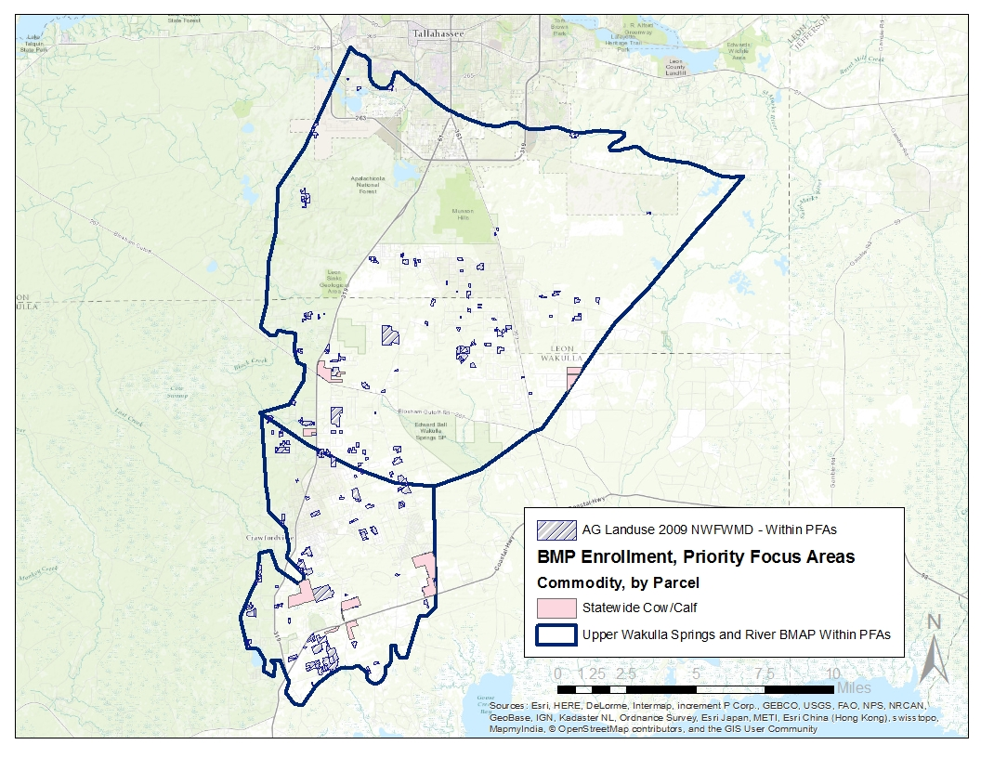
Figure 1: Agricultural lands enrolled in BMPs in the Wakulla PFAs, September 30, 2016
Table 1: Agricultural acreage and BMP enrollment in the PFA of the Upper Wakulla River and Springs Basin as of September 30, 2016
N/A – Not applicable
2009 NWFWMD Land Use | Acres | Related FDACS BMP Programs | Enrolled Acres | Related NOIs
Pasture and Rangeland | 3,761.48 | Cow/Calf | 1,465.49 | 5
Row Crops | 33.65 | Vegetable/Agronomic Crops | 0 | -
Field Crops | 254.80 | Vegetable/Agronomic Crops | 0 | -
Hay Fields | 1,162.58 | Vegetable/Agronomic Crops Revision (Future) | 0 | -
Other Groves | 19.24 | Specialty Fruit and Nut | 0 | -
Nurseries and Vineyards | 18.11 | Future Nursery, Specialty Fruit and Nut | 0 | -
Ornamentals | 14.78 | Container Nursery | 0 | -
Horse Farms | 37.29 | Equine | 0 | -
Aquaculture | 1.52 | N/A | 0
Other Open Lands | 33.12 | N/A | 0
Fallow Cropland | 472.61 | N/A | 0 | -
Total | 5,809.18 | N/A | 1,465.49 | 5

Outside the PFAs
As of September 30, 2016, 35,514.68 acres of the Wakulla River and Springs area outside of the PFAs are covered by 57 agricultural BMP NOIs issued by FDACS OAWP (Figure 2). Per these land uses, there are 9,075.85 agricultural acres enrolled in the FDACS BMP Program. This figure equates to 15.5 % enrollment of the agricultural acreage based on the 2009 NWFWMD land use in the Wakulla River and Springs PFAs covered by the FDACS BMP Program. Table 2 lists the BMPs and the acreage covered by NOIs.
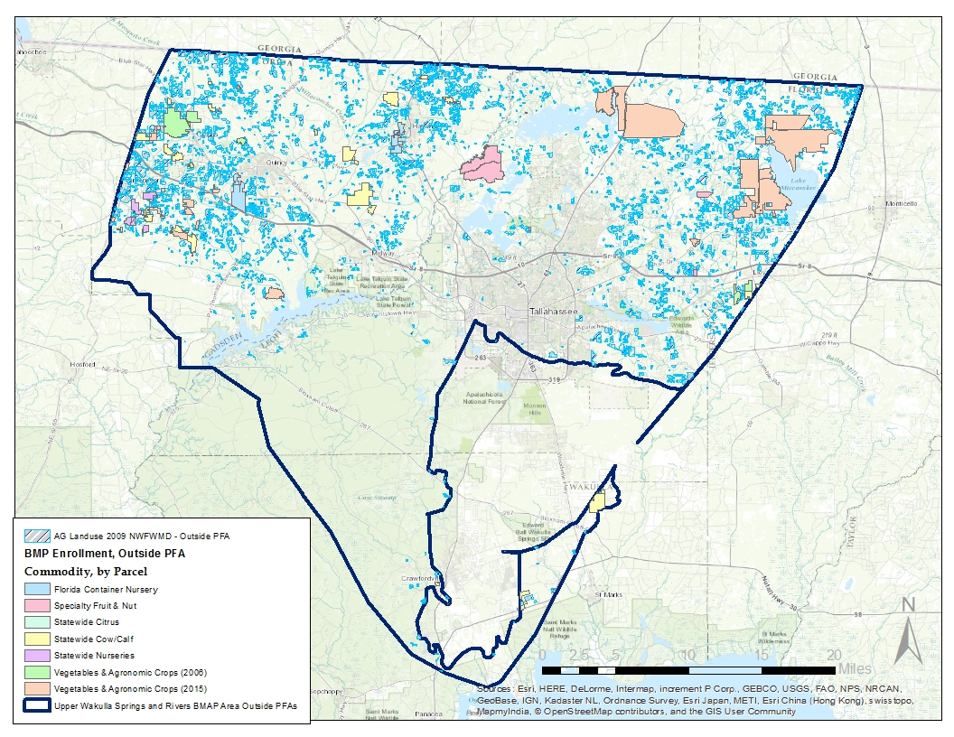
Figure 2: Agricultural lands enrolled in BMPs outside the PFAs, September 30, 2016
Table 2: Agricultural acreage and BMP enrollment outside the PFAs of the Upper Wakulla River and Springs Basin as of September 30, 2016
N/A – Not applicable
2009 NWFWMD Land Use | Acres | Related FDACS BMP Programs | Enrolled Acres | Related NOIs
Pasture and Rangeland | 26,893.79 | Cow/Calf | 5,398.14 | 19
Row/Field/Mixed Crops | 11,775.01 | Vegetable/Agronomic Crops and Citrus | 23,206 | 23
Hay Fields | 13,927.11 | Vegetable/Agronomic Crops and Citrus | 23,206 | 23
Fallow Cropland | 821.28 | - | - | -
Horse Farms | 1,298.19 | Equine | 0 | -
Other Groves | 476.50 | Specialty Fruit and Nut | 3,196.10 | 3
Nurseries and Vineyards | 258.08 | Specialty Fruit and Nut | 3,196.10 | 3
Ornamentals | 1,629.78 | Nursery | 3,714.44 | 12
Sod Farms | 1,260.56 | Statewide Sod | 0 | -
Specialty Farms | 48.67 | Conservation Plan Rule | 0 | -
Cattle Feeding | 55.15 | Conservation Plan Rule | 0 | -
Poultry Feeding | 23.58 | Conservation Plan Rule | 0 | -
Aquaculture | 10.20 | N/A | - | -
Other Open Lands | 62.41 | N/A | - | -
Total | 58,540.31 | - | 35,514.68 | 57

FDACS BMP Manuals
In 2015, the Florida Department of Agriculture and Consumer Services (FDACS) Office of Agricultural Water Policy (OAWP) adopted a revised vegetable and agronomic crop manual that includes specific nutrient and irrigation management best management practices (BMPs) for plastic mulch, bare ground, sugar cane, hay/silage, and greenhouse production systems. In early 2016, FDACS adopted a dairy manual that targets dairies that do not have DEP-issued National Pollutant Discharge Elimination System (NPDES) permits. In June 2016, a poultry manual was adopted. To date, FDACS has BMP manuals for cow/calf, citrus, vegetable and agronomic crops, nurseries, equine, sod, dairy, poultry, and specialty fruit and nut operations.

FDACS OAWP Implementation Assurance (IA) Program
FDACS OAWP formally established its IA Program in 2005. The IA Program to date has included two key components—mail-out surveys and site visits. Additional emphasis was given to implementation assurance in Chapter 2016-1, Laws of Florida. Among its provisions, this law requires enhancement and formalization of OAWP implementation assurance policies and procedures through rulemaking. Rulemaking was initiated prior to January 1, 2017. Once rulemaking is completed, the FDACS will implement the enhanced IA Program and more detailed reporting, as prescribed by the legislation, on site visits and surveys will be provided on an annual basis.
The enhanced IA Program, as a component of the FDACS BMP Program, will be designed to:
- Provide accurate and timely information on the status of BMP enrollments.
- Provide accurate and timely information on the extent of BMP implementation.
- Provide the information from which reports on BMP enrollment and implementation can be made to BMAP stakeholders and to the annual report required by Section 403.0675, Florida Statutes.
- Inform educational, research, and technical assistance efforts targeted to strengthen BMP implementation and effectiveness.
- Guide review and potential revision of BMP manuals.
Within the reporting period (November 1, 2015-October 31, 2016), FDACS field staff has conducted four implementation assurance visits within the Wakulla BMAP area.

FDACS Cost-share and Outreach
During the reporting period, FDACS started two new cost-share projects within the Wakulla Springs BMAP area at a total cost of $16,706.25. These projects are crop tools that will reduce the application of herbicides and fertilizer; reduce herbicide, pesticide, and nutrient leaching into the ground water or running off into adjacent surface waters including wetlands; and decrease soil compaction which will improve soil percolation and reduce run-off.
The following educational outreach events were completed during the reporting period: Lake Tallavana TMDL Meeting (January 2016); Envirothon at Torreya State Park (March 2016); Gadsden County Cattlemen’s Association (May 2016); Wakulla Springs Alliance Meeting (May 2016); Tri-State Climate Workshop (August 2016); Leon Agricultural Producers Workshops (August 2016); and Gadsden Agricultural Producers Workshop (September 2016). Attendees learned about FDACS BMP program and cost-share opportunities.

Activities by Entity

1.3.1 DEP
DEP continues to update permits as needed to incorporate new requirements for facilities within the PFA.

1.3.2 City of Tallahassee
During the reporting period, the City of Tallahassee completed an interlocal agreement with Leon County for the provision of sewer service to the Woodside Heights subdivision. The city also distributed the Wakulla Nitrate Video through the local television station, WCOT, and through social media. The city applied for several grant awards and secured federal 319h grant funding for septic to sewer outreach. The city also secured a related septic to sewer connection grant from 2016 legislative funds for 130 connections within PFA one.

Leon County
During the reporting period, Leon County prioritized areas within the BMAP - area for septic to sewer conversions for Fiscal Year 2017 legislative funding requests.

Wakulla County
During the reporting period, Wakulla County began construction on the Otter Creek Wastewater Treatment Plant (WWTP) upgrades which expands capacity at the plant. The county also secured funds and intends to begin construction this summer on the Magnolia Gardens Central Sewer Installation Project for an estimated 270 properties.

Talquin Electric Cooperative (TEC)
TEC completed the abandonment of the Oyster Bay WWTP that resulted in a load reduction of 830 kilograms per year (kg/yr) total nitrogen (TN). In addition, TEC completed the Gadsden East WWTP project. This project included construction of a treatment wetland by retrofitting existing rapid infiltration basins and building additional treatment cells. The load reduction associated with this project is 700 kg/yr TN.

Section 2: Compliance
Table 3 shows the number of projects that each entity committed to in the 2015 BMAP and the status of those projects. Nitrogen reductions from completed projects total 611,014 kg/yr.

Table 3: Summary of completed projects identified in the BMAP by entity
Entity | Projects Listed in 2015 BMAP | Completed | Cancelled | Underway
DEP | 1 | 1 | 0 | 0
Florida Department of Transportation (FDOT) District Three | 4 | 3 | 0 | 1
Wakulla Springs State Park | 5 | 5 | 0 | 0
City of Tallahassee | 13 | 12 | 0 | 1
Leon County | 33 | 27 | 0 | 6
Wakulla County | 22 | 17 | 0 | 5
City of Gretna | 1 | 1 | 0 | 0
City of Quincy | 3 | 3 | 0 | 0
Florida Agricultural and Mechanical University (FAMU) | 1 | 1 | 0 | 0
Florida Correctional Institute (FCI) | 2 | 2 | 0 | 0
Florida State University (FSU) | 2 | 2 | 0 | 0
Gadsden County | 4 | 4 | 0 | 0
TEC | 4 | 4 | 0 | 0
Tallahassee Community College (TCC) | 1 | 1 | 0 | 0
Town of Havana | 1 | 1 | 0 | 0
Total | 97 | 84 | 0 | 13

Section 3: Water Quality Assessment

3.1 Water Quality and Biological Community Trends

3.1.1 Water Quality Trends
The Upper Wakulla River was found to be impaired based on failing Stream Condition Index (SCI) scores between February 2000 and May 2007. The poor biological community scores reflect that sensitive taxa were affected by the smothering of substrate by hydrilla, occasional low dissolved oxygen (DO), and slightly elevated conductivity. The water quality data collected during this time indicated that ammonia levels (mostly below detection) and phosphorus levels (averaging 0.03 milligrams per liter [mg/L]) generally represented excellent conditions, while nitrate concentrations were elevated from anthropogenic sources. Therefore, the Upper Wakulla River was found to be impaired for nitrates, as evidenced by an aquatic biological community impacted by excessive hydrilla growth and algal mats (DEP 2012a).
The highest nitrate concentration is found at the spring vent, and the nitrate concentration decreases as the water moves downriver (Figure 3). When comparing the data from the verified period (2000–07) (yellow shaded area in Figure 3) with more recent data (2008–16), nitrate concentrations at the vent are declining. In the ground water caves and tunnels that feed Wakulla Spring, nitrate concentrations were higher in B-, C-, and D-Tunnels than in the Main Tunnel, indicating that other sources of flow to the springs are diluting the concentrations observed at the spring vent (Figure 4). The data from K-Tunnel (see the location in Error! Reference source not found.) indicate lower nitrate levels; this tunnel may be diluting flows from the other tunnels. B-, C-, and D -Tunnels continue to show mean nitrate + nitrite concentrations above the target concentration of 0.35 mg/L, and are the major contributors (Figure 4), with the highest mean nitrate concentration in B-Tunnel. These tunnels bring contributing flows from the Southeast Spray Field (SESF) and Ames Sink to the Upper Wakulla River and Wakulla Springs. However, there are declining trends in nitrate concentrations in B-, C-, and D-Tunnels. The K-Tunnel nitrate concentrations reached levels below the target concentration of 0.35 mg/L in 2014 and early 2015 (see Figure 5). Figure 6 shows the contributing area to Wakulla Springs in Florida.
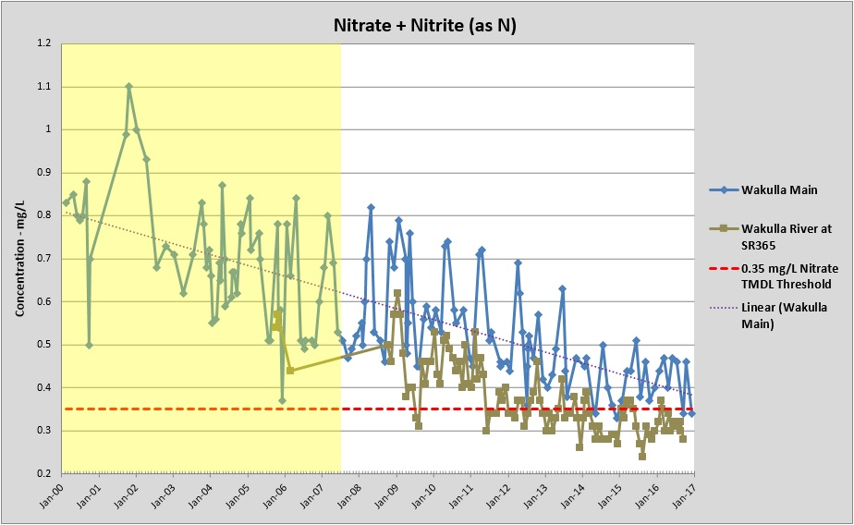
Figure 3: Nitrate-Nitrite water quality trends in the Wakulla River and Wakulla Spring vent
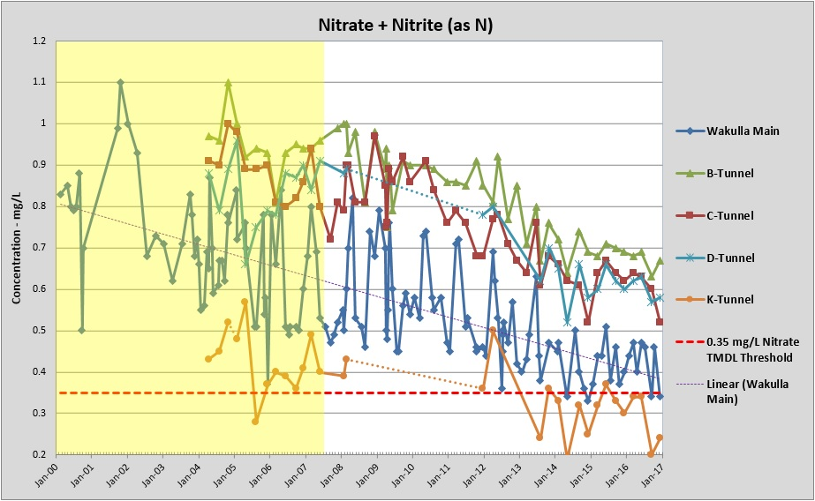
Figure 4: Nitrate-Nitrite water quality trends in the Wakulla Springs tunnels
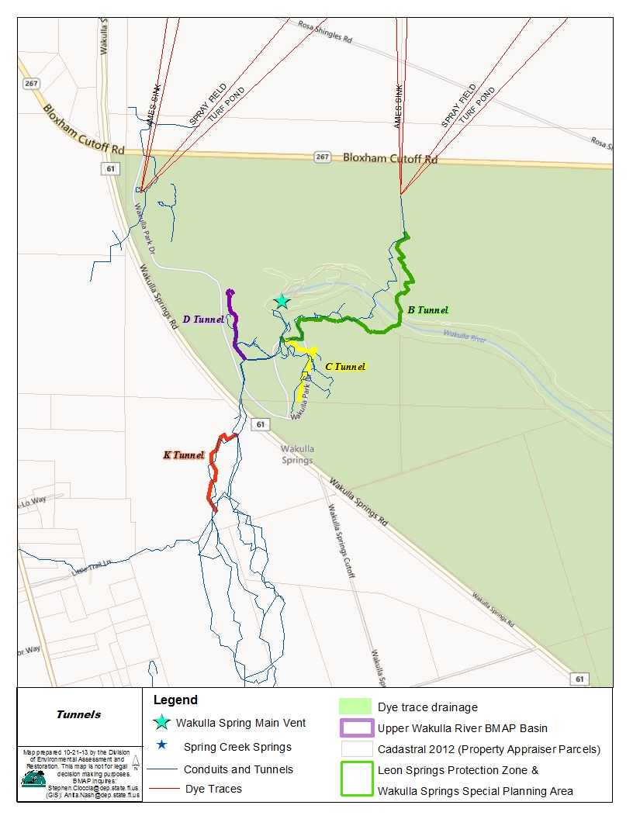
Figure 5: Locations of the main Wakulla Springs tunnels
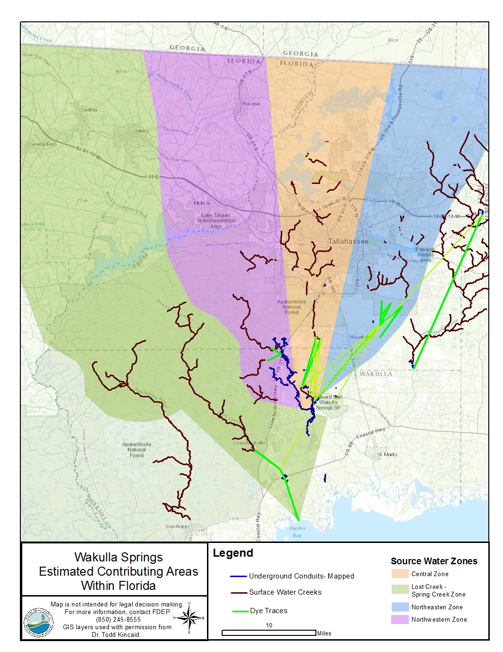
Figure 6: Estimated contributing areas to Wakulla Springs

Biological Community Trends
Beginning in October 2013, DEP, in collaboration with NWFWMD, collected quarterly water chemistry and biological samples at two locations in the Wakulla River to monitor and measure the effects of current and future reductions in nutrients on the biological communities in the Wakulla River (Figure 7). The upstream station is located at the Boat Tram inside the Wakulla Springs State Park, approximately 0.5 miles downstream from the spring boil (Figure 7) and the second station is approximately 3.0 miles downstream of the spring boil and just outside the state park boundary at County Road (CR) 365. This report summarizes biological data collected between October 2013 and October 2016 at these two locations and is being provided for informational purposes to interested DEP staff and stakeholders.
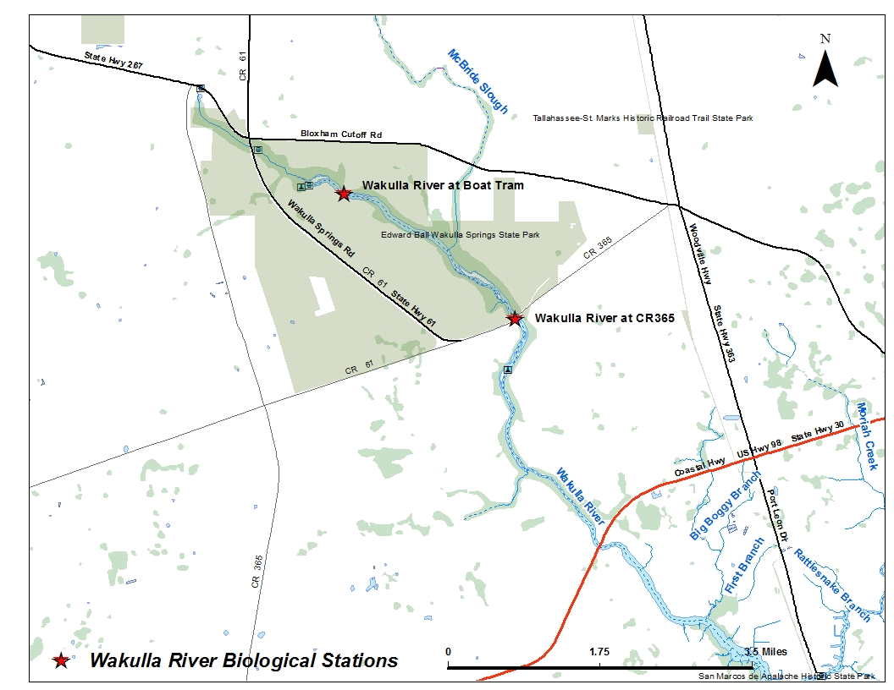
Figure 7: Wakulla River biological monitoring stations

SCI
The SCI is a biological assessment procedure that measures the degree to which flowing fresh waters support a healthy, well-balanced biological community, as indicated by benthic macroinvertebrates. A balanced faunal community is achieved if the average score of at least two temporally independent SCIs is 40 or higher, with neither of the two most recent SCI scores less than 35.
When the SCI bioregions were initially developed in 1992, there were relatively little data available for some of the bioregions, particularly the eastern portion of the Panhandle region. DEP has subsequently collected thousands of new SCIs throughout the state. In addition, better geographic information system (GIS) tools are now available allow more accurate spatial resolution. In 2012, DEP undertook a reanalysis of the SCI regions to better define the macroinvertebrate expectations across the state. The reanalysis of the SCI regionalization indicated that the Panhandle bioregion should be divided into the Panhandle West and Big Bend bioregions because they have significantly different taxa at reference sites (Figure 8). During the SCI reevaluation, the bioregion boundaries were also redrawn to be consistent with watershed boundaries. The original bioregion boundaries bisected watersheds which meant that the biological expectation in some streams changed upstream or downstream of an imaginary line across the stream. Greater detail concerning the reanalysis of the SCI bioregions and the results of that evaluation are provided in Appendix B of the Technical Support Document: DEP-SAS-001/13. As part of the reassessment, the SCI equations were also updated and SCI scores were recalculated. The original listing of the Wakulla River was based on earlier versions of the SCI. This report uses the revised regions and equations for what is now referred to as the SCI-2012 (Figure 8).
Figure 8: Comparison of the SCI 2007 bioregions with the new 2012 bioregions
Figure 9 shows the SCI results collected from the biological monitoring stations from October 2013 through October 2016. The average of the last 13 samples at the upstream Boat Tram site is 36 (up from 34 points reported in the 2015 summary) and the average of the two most recent samples is 41 (up 9 points from 32). The sample collected on August 17, 2016 (33) was below the single sample impairment threshold of 35 (red dotted line in Figure 9).. The average SCI score for the most recent 12 samples at the CR 365 site is 45 (compared to 47 in the 2015 summary), and the average of the two most recent samples is 44 (compared to 55 in 2015). A sample was not collected during the third quarter of 2016 at the CR 365 site due to inclement weather. Thus, when these sampling events are taken together, the overall average SCI score for the Wakulla River remains unchanged at 40 points, from 2013 through 2015 and 2013 through 2016.

Figure 9: SCI results for two sites on the Wakulla River from October 30, 2013 through October 18, 2016

Floral Measures
DEP derived the floral thresholds that are used as part of the streams nutrient standard using a distribution of a population of minimally disturbed benchmark streams sampled by DEP as part of the numeric nutrient criteria (NNC) development. The thresholds summarized in Table 4 can be used when developing evidence supporting a DEP conclusion regarding the balance of the floral community in streams. If all floral measures are achieved, a stream meets the floral component of a healthy, well balanced aquatic system, because it is within the range of condition for minimally disturbed benchmark streams. However, if any one of these floral measures indicates an imbalance, then the stream does not attain the NNC (Rule 62-302.531, Florida Administrative Code).
Table 4: Floral measures summary
Floral Metric | Evidentiary Threshold of No Imbalances
Linear Vegetation Survey (LVS) Coefficient of Conservativism (C of C) | Site average ≥ 2.5
LVS Florida Exotic Plant Pest Council (FLEPPC) | Site average < 25 %
Rapid Periphyton Survey (RPS) | < 25 % rank 4-6 coverage  20 to 25 % rank 4-6 coverage,  Evaluate algal autecological data
Chlorophyll-a | < 20 micrograms per liter (µg/L); 3.2 to 20 µg/L = site specific
Algal Community Composition (Autecology) | No adverse shifts in dominant taxa

LVS
The LVS is a rapid assessment tool for evaluating the ecological condition of streams based on vascular plants, conducted per DEP Standard Operating Procedure (SOP) FS 7320. DEP evaluated LVS data from reference streams and found that if a site’s average C of C score is greater than or equal to 2.5 and the frequency of occurrence of FLEPPC exotic taxa is less than 25 % of the total plant occurrences, the plant community composition may be part of the reference site distribution and does not represent an imbalance of flora. Because of the inherent variability in aquatic plant communities, two temporally independent assessments are required (at least three months apart). All samples from October 30, 2013 through August 17, 2016 met the evidentiary thresholds as seen in Figure 10 and Figure 11 and Table 5. The LVS results from the third quarter (October) 2016 sampling were not available as of this update. In Figure 10 the dashed line shows the evidentiary threshold for balanced flora of ≥ 2.5. In Figure 11 the dashed line shows the evidentiary threshold for balanced flora of ≤ 25 %.
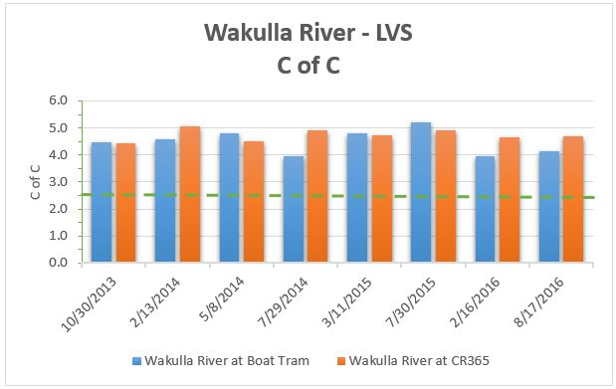
Figure 10: C of C metric for samples collected between October 13, 2013 and August 17, 2016
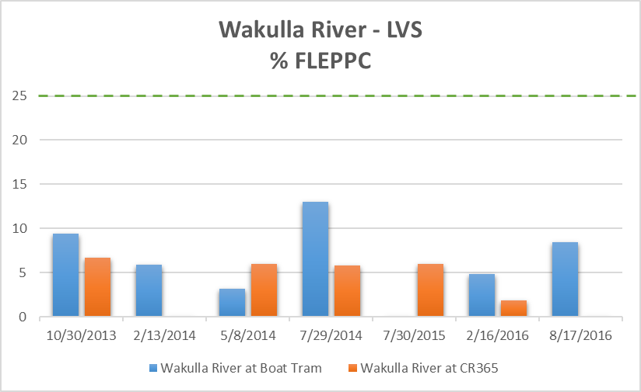
Figure 11: Percent FLEPPC metric for samples collected between October 13, 2013 and August 17, 2016
The average of the two most recent samples for C of C for the Wakulla River at Boat Tram and CR 365 were 4.0 and 4.7, respectively; both exceeded the minimum threshold. Similarly, the percent FLEPPC taxa was less than the 25 % maximum threshold at both locations, 8 % and 0 %, respectively.
Table 5: Individual LVS results for two stations on the Wakulla River between October 13, 2013 and August 17, 2016
Date Sampled | Wakulla River at Boat Tram |  | Wakulla River at CR 365
Date Sampled | Average  C of C | % FLEPPC | Average  C of C | % FLEPPC
10/30/2013 | 4.5 | 9 | 4.4 | 7
2/13/2014 | 4.6 | 6 | 5.1 | 0
5/8/2014 | 4.8 | 3 | 4.5 | 6
7/29/2014 | 4.0 | 13 | 4.9 | 6
3/11/2015 | 4.8 | 0 | 4.7 | 0
7/30/2015 | 5.2 | 0 | 4.9 | 6
2/16/2016 | 3.95 | 5 | 4.7 | 5
8/17/2016 | 4.13 | 8 | 1.9 | 0

RPS
The RPS is used to quantify the extent and abundance of attached algae, and is conducted per DEP SOP FS 7230. DEP compares RPS results from a stream to the RPS results compiled from the population of minimally disturbed and healthy sites that was sampled by DEP as part of NNC development. RPS rank 4 through 6 coverage (Rank 4 through 6 represent algae mat lengths of > 6 millimeters [mm]) at these streams ranged from 0 % to 66 %, with a mean value of 6 % and a 90th percentile value of 25 %. Therefore, if a stream exhibits a percent coverage for RPS ranks 4 through 6 of 25 % or less in both samples, the RPS results indicate evidence of no imbalance of flora. If a stream segment exceeds an RPS 4 to 6 coverage of > 25 % during two consecutive, temporally independent samplings (at least three months apart), DEP considers this as evidence that the NNC is not achieved.
The results of the RPS samples collected between October 30, 2013 and August 17, 2016 at the two locations in the Wakulla River indicate an imbalance in the floral community (Figure 12). Although there appears to be some temporal variability at the CR 365 location, the average ranks greatly exceeded the 25 % maximum threshold in all samples at both locations. The averages of the samples since October 2013 through August 2016 at the Boat Tram site and the CR 365 site were 68 and 49, respectively. Station means for two most recent sampling events were slightly below these longer-term averages at 61 % and 46 % at the Boat Tram and CR 265 sites, respectively. In Figure 12 the dashed line shows the evidentiary threshold for balanced flora, < 25 % 6 mm or greater.

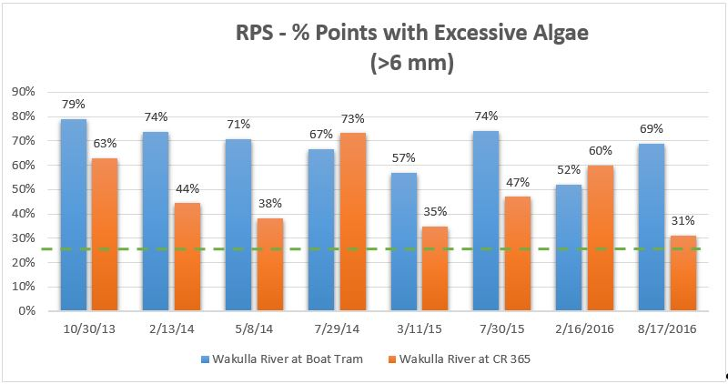
Figure 12: Percent abundance of RPS Ranks 4 through 6 (> 6 mm) at two locations in the Wakulla River

Chlorophyll-a
There is a wide range of stream chlorophyll-a values that are considered “healthy” due to a variety of site specific factors, such as system morphology and water residence time. The presence of lentic taxa may indicate a healthy aquatic stream in a natural transition from a lotic to lentic system during the period studied. If a stream exhibits annual geometric mean (AGM) chlorophyll-a concentrations below the 90th percentile values (3.2-3.5 µg/L) observed at minimally disturbed and healthy sites, that chlorophyll a concentration shows no imbalance of flora. The chlorophyll-a concentrations measured in this study represent individual samples and not AGMs; however, these values suggest no imbalance in the floral communities (Table 6).
Table 6: Chlorophyll-a values in the Wakulla River at two sampling locations
I - substance measured between the method detection limit and the practical quantitation limit.
NA – Not available at the time of reporting.
U - Indicates that the compound was analyzed for but not detected.
Date Sampled | Chlorophyll-a, Corrected for Phaeophytin
Date Sampled | Wakulla River at Boat Tram | Wakulla River at CR 365
10/30/2013 | 1.1 I | 0.55 U
2/13/2014 | 0.56 I | 0.88 I
5/8/2014 | 0.55 I | 0.55 U
7/29/2014 | 1.8 | 1.4 I
10/29/2014 | 0.55 I | 0.97 I
3/11/2015 | 0.55 I | 0.71 I
7/30/2015 | 0.92 I | 0.9 I
2/16/2016 | 0.55 U | 0.55 U
8/17/2016 | NA | 2.1

Section 4: Summary
The first year of BMAP implementation has been successful. The total BMAP project reductions, including those shown as completed in the BMAP and the projects completed during the first year of implementation is 611,014 kg/yr. Stakeholders identified nine new projects within the basin. In addition, water quality monitoring indicate that nitrate concentrations at the vent are declining. The overall average SCI score for the Wakulla River remains unchanged at 40 points, from 2013 through 2015 and 2013 through 2016. All samples from October 30, 2013 through August 17, 2016 met the evidentiary thresholds for the LVI. The results of the RPS samples collected between October 30, 2013 and August 17, 2016 at two locations in the Wakulla River indicate an imbalance in the floral community. The chlorophyll-a concentrations suggest no imbalance in the floral communities.

Appendices

Appendix A: Bibliography of Key References and Websites

References
Florida Department of Environmental Protection:
———. 2012a. TMDL report: Nutrient (biology) TMDL for the Upper Wakulla River (WBID 1006). Tallahassee, FL: Division of Water Resource Management, Bureau of Watershed Management.

Websites
- DEP homepage: http://www.dep.state.fl.us.
- DEP TMDL webpage: http://www.dep.state.fl.us/water/tmdl/final_tmdl.htm.
- Upper Wakulla River and Wakulla Springs BMAP: http://www.dep.state.fl.us/water/watersheds/bmap.htm.
- Nitrogen Source Inventory and Loading Tool: http://fdep.maps.arcgis.com/home/item.html?id=e71ecaa35bdd4caaba7a0c411691dfa7.
- FDACS BMP Manuals: http://www.freshfromflorida.com/Divisions-Offices/Agricultural-Water-Policy/Enroll-in-BMPs/BMP-Rules-Manuals-and-Other-Documents.
- Florida Department of Environmental Protection Technical Support Document: Derivation of Dissolved Oxygen Criteria to Protect Aquatic Life in Florida’s Fresh and Marine Waters. DEP-SAS-001/13. March 2013: https://www.dep.state.fl.us/water/tmdl/docs/tsd-do-criteria-aquatic-life.pdf.

Appendix B: Stakeholder Projects Inside the PFAs
Table B-1. DEP management strategies
Project Number | Project Name | Project Description | Project Type | Status | TN Reduction (kg/yr) | TP Reduction (kg/yr) | Cost | Cost Annual O&M | Partners | Start Date
FDEP-1 | TN Requirements for Wastewater Treatment Facilities (WWTFs) in PFA1 | Update permits, as needed, to incorporate new requirements to WWTFs. | Permit updates | Ongoing | 0 | 0 | $ - | $ - | - | -

Table B-2. FDOT District Three management strategies
Project Number | Project Name | Project Description | Project Type | Status | TN Reduction (kg/yr) | TP Reduction (kg/yr) | Cost | Cost Annual O&M | Partners | Start Date
FDOT-1 | Fertilizer Cessation | Eliminated fertilizer use for ongoing turf maintenance within the entire basin, including areas outside the PFAs. | Residential Fertilizer | Completed | 4,640 | 0 | $ - | $ - | - | -
FDOT-2 | Street Sweeping | Contract for street sweeping of FDOT curb and gutter roads within the urbanized areas of Leon County and City of Tallahassee. | Stormwater | Ongoing | 285 | 0 | $ - | $ - | - | -
FDOT-3 | Innovative Nitrogen Removal Technologies | Investigating the use of innovative nitrogen removal technologies as part of the present work program within the PFAs. | Stormwater | Planned | 0 | 0 | $ - | $ - | - | -
FDOT-4 | Avoidance of Mapped Karst Caves | Avoid constructing ponds directly over mapped karst caves by providing a 300-foot buffer. | Protection measure | Ongoing | 0 | 0 | $ - | $ - | - | -

Table B-3. Wakulla Springs State Park management strategies
Project Number | Project Name | Project Description | Project Type | Status | TN Reduction (kg/yr) | TP Reduction (kg/yr) | Cost | Cost Annual O&M | Partners | Start Date
WP-1 | Learning in Florida's Environment | Annual environmental education program. | Public education and outreach | Ongoing | 0 | 0 | $ - | $ - | - | -
WP-2 | Project Learning Tree | Annual environmental education program. | Public education and outreach | Ongoing | 0 | 0 | $ - | $ - | - | -
WP-3 | Green Guide Class | Annual environmental education program. | Public education and outreach | Ongoing | 0 | 0 | $ - | $ - | - | -
WP-4 | Wakulla Wildlife Festival | Annual environmental education program. | Public education and outreach | Ongoing | 0 | 0 | $ - | $ - | - | -

Table B-4. City of Tallahassee management strategies
Project Number | Project Name | Project Description | Project Type | Status | TN Reduction (kg/yr) | TP Reduction (kg/yr) | Cost | Cost Annual O&M | Partners | Start Date
COT-1 | Wastewater Treatment Facility Upgrade to Advanced Wastewater Treatment (AWT) | Upgrade to AWT to reduce the nitrogen concentration by 75 % at the spray field near Tram Road and improve the quality of reuse. | Wastewater | Completed | 214,939 | 0 | $ - | $ - | - | 2008
COT-2 | Biosolids Application Elimination | Eliminated biosolids disposal in the springshed. | Wastewater | Completed | 169,347 | 0 | $ - | $ - | - | 2001
COT-3 | Assessment and Rehabilitation of the Sewer Collection System | Project consisting of an assessment and rehabilitation of the sewer collection system. | Wastewater | Ongoing | 0 | 0 | $ - | $ - | - | 2011
COT-4 | Fertilizer Use Ordinance (08-072AA) | Households that applied fertilizer (2007 vs. 2012) decreased 49 %, level of nitrogen applied per household decreased 27 %. | Regulation or ordinance | Ongoing | 129 | 0 | $ - | $ - | - | 2009
COT-5 | Public Education for Stormwater, Fertilizer, and Pet Waste | Public education using various media resources to promote behavioral changes for individuals and businesses to conserve water and reduce or eliminate pollution impacts to surface water and ground water. | Public education and outreach | Ongoing | 47 | 0 | $ - | $ - | - | 2006
COT-6 | Spray Field Fertilizer Application | Eliminated fertilizer application on the spray field (in the springshed). | Farm fertilizer | Completed | 61,500 | 0 | $ - | $ - | - | 2007
COT-7 | Pet Waste Ordinance (Number 10-0-15AA) | 34 % of dog owners began picking up after their pets. | Regulation or ordinance | Ongoing | 29 | 0 | $ - | $ - | - | 06/2008
COT-8 | Stormwater Improvement Projects | Conveyance improvements. | Stormwater | Completed | 14 | 0 | $ - | $ - | - | 2004
COT-9 | Primary Spring Protection Zone (PSPZ) Ordinance (Number 08-0-68AA) | Identifies the PSPZ where development has to meet more stringent requirements. | Regulation or ordinance | Ongoing | 0 | 0 | $ - | $ - | - | 04/2009
COT-10 | Comprehensive Plan Provisions (Conservation Element Policy 4.2.5) | Reduced allowed development in the urban fringe inside the PSPZ. | Regulation or ordinance | Ongoing | 0 | 0 | $ - | $ - | - | 2009
COT-11/LC-29 | Alternatives to Sewer Solutions Study | Study and develop preferred options for management alternatives to traditional Onsite Sewage Treatment and Disposal System (OSTDS) in unincorporated areas of Leon County, including PSPZ; identify preferred options for responsible management entities, including recommendations for financing and management structure for identified preferred options; identify other issues related to sewage treatment and disposal system financing. | OSTDS | Planned | 0 | 0 | $ - | $ - | - | 2018
COT-14 | Public Education-Wakulla Springs Nitrate Video | Five-minute video educates homeowners on the local ground water system and explains the need to address septic systems to restore Wakulla Springs. Shared via social media and WCOT television. | Public education | Completed | - | - | $27,000 | $ - | City of Tallahassee | -
COT-15 | Septic Connection to Existing Sewer in the Wakulla BMAP Area | Facilitating the connection of approximately 130 properties currently on OSTDS to existing central sewer in the Wakulla BMAP PFA1. | Septic tank phase out | Started | 2,526 | 2,526 | $637,000 (Grant), $1,950,000 (Match) | $ - | DEP-Legislative Projects Grant/ City of Tallahassee | Early 2017
COT-16 | OSTDS Reduction Outreach Initiative - Outreach for the City of Tallahassee’s Connect Septic to Sewer Project | During 2017–2019 the City of Tallahassee will produce and distribute educational public service announcements, billboards, and other media, to encourage the City residents who are on septic systems within the PFA1, to connect to existing central sewer. | Public education | Started | - | - | $100,000 (Grant), $70,000 (Match) | $ - | DEP-FY2015-319/City of Tallahassee | Early 2017
COT-17 | 2017-2020 Development and Implementation of Education Plan | Development and implementation of plan to educate residents about septic to sewer and impact on Wakulla Springs - including public service announcements. | Public education | Envisioned, but Not Funded | - | - | $25,000 (Grant), $25,000 (Match) | $ - | DEP FY2017-2020 | Early 2017
COT-18 | Interlocal Agreement for the Provision of Sewer Service to Woodside Heights Subdivision | Interlocal agreement for the provision of sewer service to the Woodside Heights subdivision. | Septic tank phase out | Planned and Funded | 0 | 0 | $ - | $ - | City of Tallahassee/Leon County | -

Table B-5. Leon County management strategies
Project Number | Project Name | Project Description | Project Type | Status | TN Reduction (kg/yr) | TP Reduction (kg/yr) | Cost | Cost Annual O&M | Partners | Start Date
LC-1 | Sewering in PSPZ | The county had identified this project both in its adopted sewer master plan and the water and sewer interlocal agreement with the city as a targeted area for sewer. Funds for the project are available through the county’s share of the Blueprint Water Quality Funding supported by the local infrastructure sales tax, subject to annual budget and appropriation. | OSTDS | Ongoing (Woodside Heights) | 0 | 0 | $24,500,000 | $ - | NWFWMD | 2020
LC-2 | Septic Tank Inventory | Preparation of a GIS inventory of all the septic systems in Leon County. | OSTDS | Completed | 0 | 0 | $50,000 | $ - | - | 2013
LC-3 | Septic Tank Repairs | Proposed revision to the septic tank ordinance to require repairs to have a minimum of 24-inch separation between drainfield and seasonal high water table. | Regulation or ordinance | Completed | 0 | 0 | Staff Time | $ - | - | 2015
LC-4 | Septic Tank Nitrogen Removal Requirements | Pending the results of FDOH evaluation of passive systems as referenced in Section 38165(4)(x), F.S, the county shall: (1) review the results of this Florida study of nitrogen reducing, performance-based OSTDS, including passive systems; (2) identify passive systems regulated under Section 38165, F.S., that are approved by the State of Florida for permitting and appropriate for use within Leon County; (3) evaluate factors such as cost and operational feasibility of such passive systems; and (4) develop a proposed amendment to the code of laws requiring the use of appropriate systems for new construction within the PSPZ. | OSTDS | Ongoing | 0 | 0 | Staff Time | $ - | NWFWMD | 2015
LC-5 | Septic Tank Education | Add educational kiosks at the Woodville Community Center to explain how septic systems work. | Public education and outreach | Proposed | 22 | 0 | $ 2,500 | $ - | - | 2015
LC-6 | Enacted Comprehensive Fertilizer Ordinance (Number 09-34) | Requires commercial applicators to follow a set of BMPs for the application of fertilizers. | Regulation or ordinance | Completed | 12 | 0 | Staff Time | $ - | - | 2009
LC-7 | Fertilizer Ordinance Modification | Consider modification to the fertilizer ordinance to reduce nitrogen application rates below the Cody Scarp, if allowable by Florida law. | Regulation or ordinance | Proposed | 0 | 0 | Staff Time | $ - | - | 2014
LC-8 | Education and Outreach | Outreach through Florida Yards and Neighborhoods (FYN), illicit discharge program, pamphlets, presentations, workshops, and special events. | Public education and outreach | Ongoing | 25 | 0 | Staff Time | $ - | - | -
LC-9 | Enacted Pet Waste Ordinance (Number 11-21) | Education program to promote cleanup of pet waste as a contributor to surface water pollution. | Public education and outreach | Completed | 16 | 0 | Staff Time | $ - | - | -
LC-10 | Land Development Regulations | Adopted new minimum countywide environmental regulations that exceed state stormwater standards. | Regulation or ordinance | Completed | 0 | 0 | Staff Time | $ - | - | 2011
LC-11 | Comprehensive Plan Provisions (Conservation Element Policy 4.2.5) | Reduced allowable development in the urban fringe from up to 1 unit per acre to 1 unit per 3 acres. Transfer of density with no net increase in dwelling units as allowed on the future land use map permitted. | Regulation or ordinance | Completed | 0 | 0 | Staff Time | $ - | - | 01/2008
LC-12 | Lake Munson Erosion and Flood Protection Upgrades | Removed 15-acre nutrient sediment dam in 2002, stabilized Munson Slough to reduce erosion, and repaired the dam for stabilization of lake hydroperiod. | Stormwater | Completed | 157,068 | 0 | $7,200,000 | $ - | - | 1996
LC-13 | Low Impact Development | Develop low impact development incentives to reduce nitrogen loading to surface waters and ground water. | Stormwater | Completed | 0 | 0 | Staff Time | $ - | - | 2013
LC-14 | Street Sweeping | Contract for 821 miles of street sweeping annually; collects 124.75 tons/yr. | Stormwater | Ongoing | 51 | 0 | $ - | $75,000 | - | -
LC-15 | FYN Program | Participation in the FYN Program through the Cooperative Extension Service. | Stormwater | Ongoing | 74 | 0 | $ - | $55,000 | - | -
LC-16 | Irrigation Ordinance | Irrigation ordinance. | Regulation or ordinance | Ongoing | 12 | 0 | $ - | $ - | - | -
LC-17 | Landscaping Ordinance | Landscaping ordinance. | Regulation or ordinance | Ongoing | 12 | 0 | $ - | $ - | - | -
LC-18 | Aquifer Vulnerability Assessment | Study to determine the areas with the most direct connections to Wakulla Springs. | Study | Completed | 0 | 0 | $73,000 | $ - | - | 2006
LC-19 | Lombardo Report | In conjunction with City of Tallahassee and Wakulla County, compiled previous studies identifying nitrogen loading to Wakulla Springs, and identified treatment and management options, where central sewer is not available, for the purpose of reducing nitrate loading to Wakulla Springs from septic systems located within the geographic area of Leon and Wakulla counties. | Study | Completed | 0 | 0 | $60,000 | $ - | - | 04/2010
LC-20 | Water Quality Sampling | Sampled 73 sites in 13 lakes, 27 streams, and two rivers. | Study | Ongoing | 0 | 0 | $250,000 | $ - | - | -
LC-21 | Preparation of Annual Water Quality Report | Preparation and publishing an annual water quality report to document the health of our natural systems and utilize for prioritization of water quality project needs. | Study | Ongoing | 0 | 0 | $ - | $15,000 | - | -
LC-22 | Woodville Recharge Aquifer Protection Study | U.S. Environmental Protection Agency (EPA) grant to study the 60- square mile Woodville Recharge Basin for flooding, water quality, and aquifer protection. | Study | Completed | 0 | 0 | $300,000 | $ - | - | 2005
LC-23 | Annual Wakulla Springs Status Report | Commitment to develop an annual status report on Wakulla Springs for the Board of County Commissioners. | Study | Ongoing | 0 | 0 | Staff Time | $ - | - | 01/2014
LC-24 | Established PSPZ (Number 09-12) | Enacted to establish a defined area for enforcement for additional water quality protections within this zone. | Regulation or ordinance | Completed | 0 | 0 | Staff Time | $ - | - | 2006
LC-25 | Eight Mile Pond | Acquisition of 132 acres immediately upstream of Ames Sink to preserve/protect the sink. | Land acquisition | Completed | 0 | 0 | Staff Time | $ - | - | 2009
LC-26 | Aquifer Wellhead Protection Ordinance (Number 07-20) | Includes Aquifer Protection Program. | Regulation or ordinance | Completed | 0 | 0 | Staff Time | $ - | - | -
LC-27 | Litter Control Program | Maintain 2,316 miles of right-of-way, collecting 78.4 tons of waste. | Other Source Control | Ongoing | 0 | 0 | Staff Time | $ - | - | -
LC-28 | Adopt-A-Road Program | Maintain 112 miles of right-of-way, collecting 2.11 tons of trash. | Other Source Control | Ongoing | 0 | 0 | Volunteers | $ - | - | -
LC-29 | Harbinwood Estates Ponds | Constructed two stormwater retrofit ponds and planted/stabilized 1,200 linear feet of channel. | Stormwater | Completed | 108 | 0 | $2,980,000 | $ - | - | -
LC-29/COT-11 | Alternatives to Sewer Solutions Study | Study and develop preferred options for management alternatives to traditional OSTDS in unincorporated areas of Leon County, including PSPZ; identify preferred options for responsible management entities, including recommendations for financing and management structure for identified preferred options; identify other issues related to sewage treatment and disposal system financing. | OSTDS | Planned | 0 | 0 |  | $ - | - | 2018

Table B-6. Wakulla County management strategies
* - Project location has not been verified within the PFA.
Project Number | Project Name | Project Description | Project Type | Status | TN Reduction (kg/yr) | TP Reduction (kg/yr) | Cost | Cost Annual O&M | Partners | Start Date
WC-1 | Comprehensive Plan Infrastructure Policy 1.3.6 | Requires AWT for any WWTF or spray field located in the Wakulla Springs Special Planning Area. | Regulation or ordinance | Ongoing | 0 | 0 | $ - | $ - | - | 2006
WC-2 | Otter Creek WWTP Upgrade and Capacity Expansion | Proposed upgrades and expansion to include contributing systems within PFA2 to the WWTF for improved treatment. | Wastewater | Funded and Under construction | 0 | 0 | $12,000,000 | $ - | - | 2015
WC-3 | Public Education on OSTDS | Provide citizens and officials with the best available information for decision making regarding the use of OSTDS and decentralized wastewater systems to reduce nutrients in ground water to the springs. | Public education and outreach | Completed | 0 | 0 | $ - | $ - | - | 2007
WC-4 | Comprehensive Plan Infrastructure Policy 1.3.7 | Requires nitrogen reducing septic systems on parcels smaller than five acres in the Wakulla Springs Special Planning Area; within 150 feet of surface water, swallet, or other karst feature, or within 300 feet of a 1st or 2nd magnitude spring; and on all parcels less than 0.229 acres in size. | Regulation or ordinance | Ongoing | 0 | 0 | $ - | $ - | - | 2012
WC-5 | Magnolia Gardens Central Sewer Installation - Phase I | Planned central sewer installation for Magnolia Gardens Phase I. | OSTDS | Funded and construction anticipated Summer 2017 | 0 | 0 | $4,300,000 | $ - | - | -
WC-6 | Wakulla Gardens Central Sewer Installation - Phase I | Planned central sewer installation for Wakulla Gardens Phase I. There are potentially 90existing septic system connections projected. Conceptual planning for Phases II and III is ongoing. | OSTDS | Funded and construction anticipated Summer 2017 | 0 | 0 | $4,300,000 | $ - | - | -
WC-7 | Greiner's Addition Central Sewer Installation | Planned central sewer installation for the Greiner's Addition neighborhood. | OSTDS | Not yet funded | 0 | 0 | $ - | $ - | - | -
WC-8 | Wakulla County WWTF - Plantation River Estates | Wakulla County will assume ownership and management of the River Plantation Estates WWTP sewer system and wastewater treatment facility. Project includes removal and replacement of existing facility. | Wastewater | Ongoing | 0 | 0 | $4,900,000 | $ - | - | -
WC-9 | Wakulla Springs Watershed | Inspection and repair of old, damaged, and failing systems in the Wakulla Springs watershed area. | OSTDS | Advanced planning, seeking funding | 0 | 0 | $1,380,300 | $ - | - | 10/15/2012
WC-10 | Crawfordville Tax Increment Financing (TIF) District | TIF District for Crawfordville area to fund improvements including basic infrastructure. | OSTDS | Ongoing | 0 | 0 | $ - | $ - | - | 11/5/2012
WC-11 | Fertilizer Use Ordinance 2010-1 | Adopts model ordinance on Florida-friendly fertilizer use on urban landscapes. | Regulation or ordinance | Ongoing | 0 | 0 | $ - | $ - | - | 2/4/2010
WC-12 | Fertilizer Management Education | Education and outreach to the public about fertilizer management. | Public education and outreach | Proposed | 0 | 0 | $ - | $ - | - | 2014
WC-13 | Comprehensive Plan Future Land Use Policies 1.2.10, 1.2.10.3, Special Area Plans | Establishes special area plans for the Bloxham Special Area Plan, Special Area Plan #2, and Spring Creek Highway Special Area Plan within the Wakulla Springs Basin. Requires nitrate loading analyses for development. Establish standards for stormwater, karst feature protections, landscaping, and open space. | Regulation or ordinance | Ongoing | 22 | 0 | $ - | $ - | - | 2004
WC-14 | Wakulla County Aquifer Vulnerability Assessment | Modeling effort to identify the most vulnerable areas in the county. | Study | Completed | Part of WC-11 | 0 | $ - | $ - | - | 2007
WC-15 | Comprehensive Plan Future Land Use Polity 1.2.9.1 - Northeast Wakulla Sustainable Community | Establishes standards for 606 acres within the Wakulla Springs Basin. Requires no net increase in nutrients or phosphorous loading to ground water. Sustainable community standards established for stormwater, ground water, open space, and BMPs. Requires AWT standards for sanitary sewer service to the site. | Regulation or ordinance | Ongoing | 0 | 0 | $ - | $ - | - | 2003
WC-16 | Ordinance 2006-58 (Multiple Objectives and Policies in Comprehensive Plan Conservation and Future Land Use Elements) | Add karst buffers; require a nitrate loading study for proposed development greater than one acre; incorporate FYN practices and landscaping standards that promote native vegetation for new subdivisions; reduce nitrates from public facilities; and address stormwater, water conservation, wastewater facilities, treated wastewater reuse, and natural water flows. | Regulation or ordinance | Ongoing | 0 | 0 | $ - | $ - | - | 2006
WC-17 | Comprehensive Plan Conservation Objective 12.0 | Develop solutions to restore the health of Wakulla Springs by reducing pollutants in the ground water, and implementing policies for the Wakulla Springs Special Planning Area. | Regulation or ordinance | Ongoing | 0 | 0 | $ - | $ - | - | 2010
WC-18 | Comprehensive Plan Conservation Objective 12.1 | Establishes a transfer of development rights policy to encourage development in Crawfordville with connection to sewer service, “no net increase in dwelling units” allowed by the future land use map in the Wakulla Springs Special Planning Area, fertilizer restrictions based on FYN Program. | Regulation or ordinance | Ongoing | 0 | 0 | $ - | $ - | - | 2010
WC-19 | Comprehensive Plan Conservation Objective 12.2 | County shall consider expanding the Wakulla Springs Special Planning Area based on geologic vulnerability. | Regulation or ordinance | Ongoing | 0 | 0 | $ - | $ - | - | 2010
WC-20 | Comprehensive Plan Infrastructure Objective 2.5 | To protect the functions of ground water recharge areas, springs, and springsheds. | Regulation or ordinance | Ongoing | 0 | 0 | $ - | $ - | - | 1995
WC-21 | Ground Water Extraction Ordinance | Requests NWFWMD establish minimum flows and levels for Wakulla Springs and requests NWFWMD deny permits to transport water from the Wakulla Springs springshed and the Ochlocknee and St. Marks Rivers. | Protection measure | Ongoing | 0 | 0 | $ - | $ - | - | -
WC-22 | Litter Regulations. Code of Ordinances Section 27.049 | Prohibits litter and dumping along roadways and waterways, and establishes penalties. | Other Source Control | Ongoing | 0 | 0 | $ - | $ - | - | 1992
WC-23* | Nitrogen reduction – Wakulla Gardens Phase I | Planned central sewer installation for Wakulla Gardens Phase I. Estimated 326 properties. | Septic tank phase out | Planned and Funded | 0 | 0 | $4.3 million | $ - | NWFWMD | Design and permitting in process
WC-24* | Nitrogen reduction – Magnolia Gardens Phase II | Planned central sewer installation for Magnolia Gardens Phase II, Estimated 120 properties. | Septic tank phase out | Planned and Funded | 0 | 0 | $1.5 million | $ - | NWFWMD | Design and permitting in process
WC-25* | Nitrogen reduction – Wakulla Gardens Phase I | Planned central sewer installation for Wakulla Gardens Phase I. Estimated 2,500 +/- properties. | Septic tank phase out | Envisioned, but Not Funded | 0 | 0 | $ - | $ - | NWFWMD | -
WC-26* | WINCO WWTP Purchase | Nitrogen reduction – Northeast Wakulla County. | Septic tank phase out | Envisioned, but Not Funded | 0 | 0 | $ - | $ - | NWFWMD | -

Appendix C: Stakeholder Projects Outside the PFAs
Table C-1. City of Gretna management strategies
Project Number | Project Name | Project Description | Project Type | Status | TN Reduction (kg/yr) | TP Reduction (kg/yr) | Cost | Cost Annual O&M | Partners | Start Date
CG-1 | No Fertilizer Use | Fertilizer is not applied on any city-owned property. | Residential fertilizer | Ongoing | 0 | 0 | $ - | $ - | - | -

Table C-2. City of Quincy management strategies
Project Number | Project Name | Project Description | Project Type | Status | TN Reduction (kg/yr) | TP Reduction (kg/yr) | Cost | Cost Annual O&M | Partners | Start Date
CQ-1 | City of Quincy WWTF | AWT at the WWTF. | WWTF | Completed | 0 | 0 | $ - | $ - | - | -
CQ-2 | Land Development Code - Watershed Conservation Measures | Ordinance that requires minimum stormwater treatment levels and use of BMPs including slow release fertilizers. | Regulation or ordinance | Ongoing | 0 | 0 | $ - | $ - | - | -
CQ-3 | Street Sweeping | Sweeping the streets in the south side of the city one week and the north side the next week. | Stormwater | Ongoing | 0 | 0 | $ - | $ - | - | -

Table C-3. FAMU management strategies
Project Number | Project Name | Project Description | Project Type | Status | TN Reduction (kg/yr) | TP Reduction (kg/yr) | Cost | Cost Annual O&M | Partners | Start Date
FAMU-1 | NPDES Municipal Separate Storm Sewer (MS4) Permit | NPDES MS4 Permit. | Stormwater | Ongoing | 0 | 0 | $ - | $ - | - | -

Table C-4. Federal Correctional Institution management strategies
Project Number | Project Name | Project Description | Project Type | Status | TN Reduction (kg/yr) | TP Reduction (kg/yr) | Cost | Cost Annual O&M | Partners | Start Date
FCI-1 | NPDES MS4 Permit | Stormwater system inspection and maintenance. | Stormwater | Ongoing | 0 | 0 | $ - | $ - | - | -
FCI-2 | No Fertilizer Use | Fertilizer is not applied on facility grounds. | Fertilizer | Ongoing | 0 | 0 | $ - | $ - | - | -

Table C-5. FSU management strategies
Project Number | Project Name | Project Description | Project Type | Status | TN Reduction (kg/yr) | TP Reduction (kg/yr) | Cost | Cost Annual O&M | Partners | Start Date
FSU-1 | Fertilizer Rule in University Master Plan | Fertilizer Rule in the University Master Plan. | Fertilizer | Ongoing | 0 | 0 | $ - | $ - | - | 2008
FSU-2 | NPDES MS4 Permit | NPDES MS4 Permit. | Stormwater | Ongoing | 0 | 0 | $ - | $ - | - | -

Table C-6. Gadsden County management strategies
Project Number | Project Name | Project Description | Project Type | Status | TN Reduction (kg/yr) | TP Reduction (kg/yr) | Cost | Cost Annual O&M | Partners | Start Date
GC-1 | Comprehensive Plan Policy 4.5.1 and 5.2.11 | Comprehensive Plan Policy 4.5.1 and 5.2.11 in the Infrastructure and Conservation Element. | Regulation or ordinance | Ongoing | 0 | 0 | $ - | $ - | - | -
GC-2 | Comprehensive Plan Policy 5.2.4 and 5.2.11 | Comprehensive Plan Policy 5.2.4 and 5.2.11in the Conservation Element. | Regulation or ordinance | Ongoing | 0 | 0 | $ - | $ - | - | -
GC-3 | Comprehensive Plan Infrastructure Element | Comprehensive Plan Infrastructure Element. | Regulation or ordinance | Ongoing | 0 | 0 | $ - | $ - | - | -
GC-4 | Section 3.4 Special Drainage Basins | Section 3.4 Special Drainage Basins - Water Quality (Pollution Abatement) in the Stormwater Policies and Procedures Manual. | Stormwater | Ongoing | 0 | 0 | $ - | $ - | - | -

Table C-7. Talquin Electric Cooperative management strategies
Project Number | Project Name | Project Description | Project Type | Status | TN Reduction (kg/yr) | TP Reduction (kg/yr) | Cost | Cost Annual O&M | Partners | Start Date
TEC-1 | Oyster Bay WWTP Abandonment | Oyster Bay WWTP abandonment. | Wastewater | Completed | 830 | 0 | $750,000 | $ - | - | -
TEC-2 | Gadsden East WWTP | Gadsden East WWTP (construct a treatment wetland by retrofitting three existing rapid infiltration basins and building additional treatment cells). | Wastewater | Completed | 700 | 0 | $200,000 | $ - | - | -
TEC-3 | Highway 267 Sewer | Highway 267 Sewer. | Wastewater | Completed | 1 | 0 | $400,000 | $ - | - | -
TEC-4 | Beech Ridge Trail Sewer | Beech Ridge Trail Sewer. | Wastewater | Completed | 1 | 0 | $40,000 | $ - | - | -

Table C-8. Tallahassee Community College management strategies
Project Number | Project Name | Project Description | Project Type | Status | TN Reduction (kg/yr) | TP Reduction (kg/yr) | Cost | Cost Annual O&M | Partners | Start Date
TCC-1 | Fertilizer Cessation | Fertilizer Cessation. | Residential fertilizer | Ongoing | 1 | 0 | $ - | $ - | - | 12/2012

Table C-9. Town of Havana management strategies
Project Number | Project Name | Project Description | Project Type | Status | TN Reduction (kg/yr) | TP Reduction (kg/yr) | Cost | Cost Annual O&M | Partners | Start Date
TH-1 | Street Sweeping | Street Sweeping. | Stormwater | Ongoing | 1 | 0 | $ - | $ - | - | -

Table C-10. Leon County management strategies
Project Number | Project Name | Project Description | Project Type | Status | TN Reduction (kg/yr) | TP Reduction (kg/yr) | Cost | Cost Annual O&M | Partners | Start Date
LC-30 | Fuller Road Regional Facility | Constructed 10-acre stormwater retrofit facility at Interstate (I)-10 and US 27. | Stormwater | Completed | 208 | 0 | $800,000 | $ - | - | -
LC-31 | Fred George Basin Acquisition | Acquisition of 166 acres which includes Fred George Sink for preservation/protection of the sink. | Land acquisition | Completed | 0 | 0 | $2,600,000 | $ - | - | -
LC-32 | Fred George Basin Wetland Rehydration | Wetland rehydration through grade restoration and construction of trash racks at the inflow points are planned to improve water quality prior to runoff entering the Fred George Sink. | Protection measure | Planned | 0 | 0 | $1,000,000 | $ - | - | -

Table C-11. City of Tallahassee management strategies
Project Number | Project Name | Project Description | Project Type | Status | TN Reduction (kg/yr) | TP Reduction (kg/yr) | Cost | Cost Annual O&M | Partners | Start Date
COT-12 | Stormwater Treatment Projects | 81 stormwater projects city-wide (outside of PFA1) completed since 2004, examples include Lower Community Development Corporation (CDC), Frenchtown Pond, and Emory Court, Weems Pond projects. | Stormwater | Ongoing | 0 | 0 | $82,303,740 | $ - | - | -
COT-13 | Street Sweeping | City-wide street sweeping annually collects and estimated 2,000 tons of material and 2,000 pounds (942 kg) of total nitrogen removed | Stormwater | Ongoing | 942 | 0 | $1,500,000 | $ - | - | -

