NUTRIENT TESTING OF GRASS CLIPPINGS
By
Gordon England, P.E., D.WRE
Stormwater Solutions, Inc.
and
Daniel P Smith, P.E., Ph.D., DEE
Applied Environmental Technology
October, 2008

Background
Stormwater pollution has historically been assessed by measuring the concentration of pollutants in the water column. For example, the pollutant removal performance of structural BMPs has been extensively characterized using flow weighted pollutant concentrations (EMCs) in inlet and outlet water column samples. Over the last few years, it has been recognized that “gross pollutants” such as larger size sediment, organic debris, manmade debris, and grass and leaves could also be significant sources of pollutants. The recently completed “ASCE Guideline for Monitoring Stormwater Gross Solids” (EWRI, 2009) gives recommendations for monitoring and testing of the gross solids components to determine their pollutant content.

With TMDLs being set for nutrients in many Florida waterbodies, interest has been created in preventing nutrients bound in organic materials from entering waterbodies. What is lacking is a method to quantify the nutrient reduction benefit from BMPS that trap gross solids.

Previous Studies
The rate at which nutrients would leach from a mixture of green grass and dried oak leaves when submerged in water over extended time was examined by Strynchuk, Royal, and England (2001). The purpose of the testing was to simulate conditions in which leaves and grass were trapped in a water filled vault box such as a baffle box or CDS Unit. Known masses of the grass and leaf solids were placed into batch leaching bottles filled with water from a drainage canal and incubated for up to 180 days in a dark building open to the air. Samples of the solid material and leachate were periodically removed and analyzed for TKN, NOx, TN, TP, BOD, and Chlorophyll A.

Figures 1 and 2 show how TKN and TP concentrations fluctuated with time for the solids and liquid phases. In Figure 1, TKN was reduced in solids in the first 24 hours, with an according increase in liquid TKN. In the first 30 days, levels of TKN fluctuated and then stabilized at about the initial dry level as the nitrification cycle progresses. Figure 2 showed a drop in the first day for solids TP levels and an increase in leachate TP levels from 1.9 to 1100 g/kg. After the first day, TP concentrations stabilized and remained fairly constant for the remainder of the testing period. These figures indicated that organic debris stored in a water filled BMP would rapidly release small amounts of TKN and large amounts of Total Phosphorus to the water, which could be subsequently be flushed out with the next rainfall event. The conclusion of the report was that use of water filled BMPs resulted in little nutrient removal benefit from trapping and storing organic debris in a wet state.

Testing of oak leaves, McCann and Michael (1998), showed similar results of rapid release of nutrients in water.

Figure 1
Grass Clipping and Leaf Wet Decomposition
Mixed Leaves and Grass TKN Concentration

Figure 2
Grass Clipping and Leaf Wet Decomposition
Mixed Leaves and Grass Total Phosphorus Concentration

Objective
The objective of this study was to examine the potential of dry storage to reduce the leaching of Nitrogen and Phosphorus from grass clippings. The hypothesis was that storing green grass clippings in a dry state would enable a nutrient reducing decomposition process to occur. The hypothesis was tested using fresh clippings of St Augustine and Bahia grass collected from four locations in Brevard County, Florida. The grass clippings were initially characterized for wet and dry mass, Total Nitrogen (TN), Total Kjeldahl Nitrogen (TKN), Total Oxidized Nitrogen (NO_{x}) and Total Phosphorus (TP), allowed to dry for 30 days, and retested for the same parameters.

Methods
A sampling and testing regime was developed to simulate an inlet trap BMP which would filter grass clippings washed into an inlet and allow the grass clippings to dry before being removed from the inlet. Inlet traps are typically cleaned two to three times annually, but seldom at intervals less than 30 days. A 30-day drying time was used in this study.

Two samples of St. Augustine grass and two samples of Bahia grass were collected by a landscaping contractor in Brevard County on a random basis from locations he maintained (Table 1). For each of the two grass types, one sample was taken from a location where the grass had never been fertilized and one sample was taken from a nearby location where the grass had been fertilized and irrigated regularly. Fertilization of the two samples took place on a semi annual basis with 6-14-8 fertilizer.

Table 1
Grass Sample Types and Location
Sample No. | Location | Sample Information | Date Sampled
SANF | Levanto Subdivision, Viera | St. Augustine with No Fertilizer and No Irrigation | 7-31-08
SAF | Levanto Subdivision, Viera | St. Augustine with 6-14-8 Fertilizer and Regular Irrigation | 7-31-08
BNF | Sterling Forest Subdivision, Titusville | Bahia with No Fertilizer and No Irrigation | 7-31-08
BF | Village Square Shopping Center, Titusville | Bahia with 6-14-8 Fertilizer and Regular Irrigation | 7-31-08

All grass samples were taken on July 31, 2008 during Florida’s wet season, with the most recent antecedent rainfall occurring on July 24, 2008. At each sample location, two samples of freshly cut green grass from a lawnmower bag were taken from different parts of the site. The two samples from each location were thoroughly mixed and washed with tap water to simulate a rainfall that washed grass clippings into an inlet. For each of the four combined samples, a subsample was removed, placed on ice, and sent to a NELAC-certified analytical lab.

The samples were analyzed for solids, water, and nutrient content. Test procedures for solid organic tissues, rather than standard aqueous test procedures, were used as shown in Table 2. Nutrient concentrations in grass samples were reported on a dry weight basis.

The remaining grass materials were kept in separate open baskets in a warm, dry, dark building for 30 days and allowed to dry with no more exposure to water, simulating being trapped in an underground inlet filter that had no subsequent rain events which would leach out nutrients. Each of the sub-samples was then sent to the laboratory for a second analysis.

Results
Lab results are shown in Table 2. Fresh cut green grass had an average TN concentration of 18,250 mg/kg, while air dried grass had an average TN concentration of 4,173 mg/kg. The drying process for the four grass samples gave TN reductions ranging from 58% to 96%, with an average 80% removal. See Figure 1. TN is the sum of TKN and NO_{x}. TKN levels were consistently orders of magnitude higher than NO_{x} levels, with TN and TKN values being the same in most cases.

Figure 2 shows that TP reductions from the drying process were not as high nor as variable as TN reductions. Initial TP average concentrations were 3,175 mg/kg. After drying 30 days the average TP concentration dropped to 2,118 mg/kg. TP reduction ranged from 23.1% to 49%, with an average reduction of 35%.

Table 2
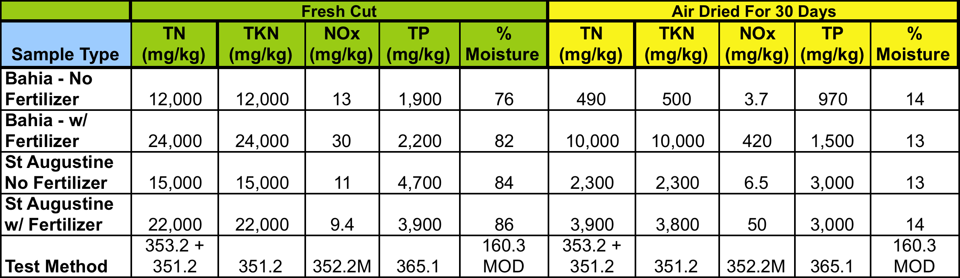Nutrient and Moisture Content of Fresh Cut and Air Dried Grass Samples

Figure 1 TN Concentrations in Fresh Cut and Air Dried Grass Samples

Figure 2 TP Concentrations in Fresh Cut and Air Dried Grass samples

Conclusions
In both Bahia and St. Augustine grass samples, air-drying resulted in significant reductions of TN concentrations and moderate reductions in TP concentrations. This study provides a starting point for estimating the reduction of nutrient loading to receiving waters that can be achieved by BMPs that capture grass in stormwater runoff, or by ordinances that prevent grass clippings from being deposited onto roads and into stormdrains. Therefore, air drying of grass samples in a manner that simulates dry storage in an inlet trap BMP serves as a type of “treatment process” that reduces nutrient masses reaching receiving waters.

BMPs such as inlet traps that filter grass clippings and keep them dry will allow the treatment process of decomposition to occur, and should be more effective at reducing nutrient loads from gross organic solids than BMPs that trap organic debris and keep them in a water filled chamber.

A practical method of using the information from this report would be to track the mass of grass clippings collected in inlet traps and compute the annual mass of grass removed. Obtaining a lab analysis of representative grass samples to determine TN and TP concentrations would give end condition concentrations and masses. Working backwards with the above reduction factors would give beginning condition masses, which would be the mass of nutrients removed from the system.

References
Environmental Water Resources Institute, Urban Water Resources Research Council, Gross Solids Technical Committee (October 2008). “ASCE Guideline for Monitoring Stormwater Gross Solids”

McCann, K. and Michael, J. (1998) “Nutrient Content and Release Rate In Water of Oak Leaves”. City of Orland Stormwater Utility Bureau.

Strynchuk, J., Royal, J., and England, G. (2001). “Decomposition Study of Grass and Leaves”. Brevard County Stormwater Utility.

