Summary of Results

Walk the WBID Exercise for
Wagner Creek (WBID 3288A)

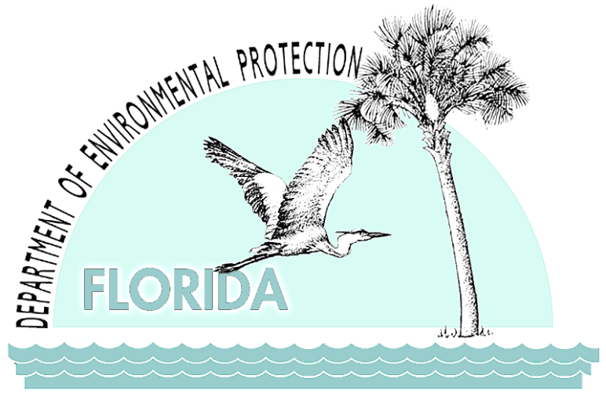

September 2011

Contents
Purpose and Contents 1
Background 2
Description of the Wagner Creek Watershed 2
Fecal Coliform Impairment of Wagner Creek 4
Walk the WBID Exercise 5
Participants 5
Costs 6
Initial Steps 6
Maps on the Table Session 7
Field Event 7
Results 9
Additional Post-Field Event Inspections 59
VA Hospital Tour 59
Boat Tour Area 2 68
Boat Tour Area 1 76
Next Steps and Follow-up Actions 84

List of Tables
Table 1. Next steps and follow-up actions for reducing fecal coliform in Wagner Creek 84

List of Figures
Figure 1. Aerial photo showing the boundary of the Wagner Creek watershed and major hydrologic features in the area. 2
Figure 2. Aerial photo showing the headwaters of Wagner Creek in Juan Pablo Duarte Park and the watershed boundary in this area. 10
Figure 3. Trash and debris in a stormwater manhole thought to be at the headwaters. 11
Figure 4. Water quality sampling results (for trash only) in a stormwater drain in the headwaters area showed fecal coliform concentrations of 300 CFU/100mL on November 18, 2010. 12
Figure 5. View of stagnant water and trash buildup in the stormwater conveyance that flows underground to the 20th Street Bridge; the accumulation may be caused by a blockage and should be investigated. This may be where the perennial portion of Wagner Creek now begins. 13
Figure 6. Water quality sampling results in the stormwater conveyance that flows underground to the 20th Street Bridge showed fecal coliform concentrations of 40 CFU/100mL. 14
Figure 7. Map of stormwater infrastructure in the headwaters and Allapattah Produce Market areas. 15
Figure 8. Map of wastewater infrastructure in the headwaters and Allapattah Produce Market areas. 16
Figure 9. Trash and debris along the street at the Allapattah Produce Market. 17
Figure 10. Fruit and trash collected on a storm drain at the Allapattah Produce Market. 18
Figure 11. Box of rotting fruit outside a warehouse at the Allapattah Produce Market. 18
Figure 12. Unsecured lids on a dumpster at the Allapattah Produce Market. The field team made observations at 1265 NW 21st Terrace. 19
Figure 13. 20th Street Bridge, where Wagner Creek re-emerges from the underground conveyance. 20
Figure 14. Aerial photo showing the location of Station WC04, in Wagner Creek–Seybold Canal. Popeye’s Chicken is located on the north side of NW 20th Street near where Wagner Creek first emerges from the underground culvert. A storm drain belonging to the Popeye’s Chicken parking lot was observed to be completely full of debris. 21
Figure 15. Results of annual sampling for Station WCO4, 2005–10. An SSO that occurred on May 1, 2007, resulted in fecal coliform levels of 20,000 CFU/100mL; a second SSO took place on January 6, 2008, resulting in levels of 700 CFU/100mL. 22
Figure 16. Sample results for 21FLWPB 28040446, March–October 2009, were as follows: 3/25/2009 = 660 CFU/100mL; 5/20/2009 = 26,000 CFU/100mL; 10/28/2009 = 7,800 CFU/100mL; 3/25/2009 = 660 CFU/100mL; 5/20/2009 = 26,000 CFU/100mL; and 10/28/2009 = 7,800 CFU/100mL. 23
Figure 17. A Walk the WBID team member collecting an oil and grease sample downstream of the 20th Street Bridge. 24
Figure 18. The results of the sampling on November 18, 2010, were below detection limits, indicating that oil and grease are not a problem in this part of the creek. 25
Figure 19. Broken storm drain covers at NW 20th Street belonging to Miami–Dade County; the openings allow trash and other materials to enter the underground conveyance directly and provide a breeding ground for fecal coliform. 26
Figure 20. A storm drain on NW 15th Avenue south of NW 20th Street is filled with trash and not draining properly; any flooding that results could cause a failure of the wastewater system, and trash can provide a breeding ground for fecal coliform. 27
Figure 21. Dog feces were observed near a stormwater drain at 20th Street; both sides of Wagner Creek near the 20th Street Bridge are popular areas for dog walking, and rainfall could wash fecal coliform from these areas into the creek. 28
Figure 22. Free-range chickens and a rooster were observed along the creek downstream of the 20th Street Bridge; their feces could wash into the creek, causing fecal coliform contamination. 29
Figure 23. Aerial photo showing the location of Station 21FLWPB 42009025 along Wagner Creek–Seybold Canal. Note the apartment properties along the waterway. Additional research is needed to determine whether any of the apartments have a direct connection to Wagner Creek. The follow-up boat tour revealed several direct connections from the apartment complex to Wagner Creek. 30
Figure 24. Sampling results for the 14th Avenue Bridge, March–October 2009, are as follows: March 2009 = 530 CFU/100mL; May 2009 = 23,000 CFU/100mL; August 2009 = 22,000 CFU/100mL; and October 2009 = 2,900 CFU/100mL. 31
Figure 25. View of a partially blocked stormwater drain at 1501 to 1511 NW 13th Court; any flooding that results could lead to the failure of septic and wastewater infrastructure. 32
Figure 26. Team members and law enforcement personnel investigating potential septic system failures and PICs at NW 13th Court. 33
Figure 27. Aerial photo showing the locations of PICs along NW 13th Court. 34
Figure 28. Apartments along the creek at 1310 NW 16th Street, with private storm drain outlets that discharge directly to the creek; this is a gated community, with no access for an inspection. 35
Figure 29. PIC 1 at NW 13th Court consisted of a pipe sticking out of the ground. 36
Figure 30. PIC 3 consisted of an unknown pipe sticking out of the ground. 37
Figure 31. PIC 4 was thought to be a pipe but was confirmed to be a log. 38
Figure 32. Solids and oils floating on surface water at a stormwater outfall from the VA Hospital building. 39
Figure 33. Walk the WBID team members carrying out water quality sampling at one of the VA Hospital outfalls. 40
Figure 34. Water quality sampling results at the VA Hospital outfall showed levels of 50 CFU/100mL on November 18, 2010. 41
Figure 35. A channelized Wagner Creek flowing past the University of Miami Medical Center, showing dumpsters and trucks right next to the creek, with no berm to prevent untreated stormwater runoff from entering the water. 42
Figure 36. Aerial photo showing the location of Station 21FLWPB 42009026 along Wagner Creek–Seybold Canal, just to the north of the University of Miami Medical Center. Sylvester Comprehensive Cancer Center is visible on the east side of NW 12th Avenue. 43
Figure 37. Sampling results at the University of Miami Medical Center, March–October 2009, were as follows: 3/25/2009 = 490 CFU/100mL; 5/20/2009 = 39,000 CFU/100mL; 8/19/2009 = 12,000 CFU/100mL; and 10/28/2009 = 820 CFU/100mL. 44
Figure 38. Wagner Creek is channelized next to the University of Miami Medical Center. When the hospital was built, the creek was rerouted to make a 90-degree turn so that there would be enough space on the existing lot to place the hospital building. 45
Figure 39. Abandoned sewer line crossing the creek north of the NW 17th Street Bridge. 46
Figure 40. Muscovy ducks in the creek at NW 14th Avenue; waterfowl can be a source of high fecal coliform bacteria in surface waters. 47
Figure 41. Access to Wagner Creek after the NW 14th Avenue Bridge is limited, and the team was not able to carry out its inspection because a boat is needed to inspect this area. 48
Figure 42. Litter, debris, and trash in a stormwater drain inside the Miami–Dade Transit Culmer Metrorail Station in the Highland Park area. 49
Figure 43. Aerial photo showing the location of Station WCO3 along Wagner Creek–Seybold Canal, adjacent to State Road 836, which is maintained by the Miami–Dade Expressway Authority. Note the drainage swales adjacent to the roadway. These may discharge to Wagner Creek, especially during high-flow conditions. The Winn-Dixie Supermarket, visible in the southwestern corner of the photograph, may have a direct connection to Wagner Creek. 50
Figure 44. Sampling results for Station WC03, January 2005–January 2010. 51
Figure 45. Team members inspecting the City of Miami Overtown stormwater pump station, where construction upgrades are incomplete. 52
Figure 46. A PIC at the City of Miami Overtown stormwater pump station consists of those portions of the incomplete upgrades that allow foreign objects to enter the stormwater system. 53
Figure 47. Aerial photo showing the location of Station WCO2 along Wagner Creek–Seybold Canal. A portion of the Miami–Dade County Water and Sewer Department Water Distribution Facility is visible adjacent to Wagner Creek in the westernmost portion of the photo (at far left) to the south of the Metrorail tracks. 54
Figure 48. Sampling results for Station WC02, January 2005–January 2010. 55
Figure 49. Sampling results for Station 21FLWPB 28040445, March–October 2009. Results were as follows: March 2009 = 150 CFU/100mL; May 2009 = 28,000 CFU/100mL; August 2009 = 6,700 CFU/100mL; and October 2009 = 3,400 CFU/100mL. 56
Figure 50. Aerial photo showing the location of Station MRO3, just downstream of where Wagner Creek–Seybold Canal merges with the Miami River. The City of Miami’s Point Park is visible at the confluence of Seybold Canal and the Miami River. A portion of NW 7th Avenue and its bridge that crosses the Miami River are visible on the easternmost portion of the photo (at far right). 57
Figure 51. Sampling results for Station MRO3, January 2007–November 2008. 58
Figure 52. Aerial photo of the VA Hospital. 60
Figure 53. View of a portion of the VA Hospital site, near the western parking lot. On the way in to inspect the sanitary lift stations, the team observed closed biomedical waste bins upstream of the curb opening inlet (circled in red at top right). One of the team members observed some small holes in the bins. In the same area, a roll-off container was observed upslope of a drop inlet (at left). 61
Figure 54. View of the first VA Hospital sanitary lift station, located inside one of the buildings. The VA staff stated that the pump station was “open” rather than “sealed” because it is located in an area where there is a continuous flow of air from outside. Harold Moesch from FDEP entered the pump station for a closer investigation. No unusual conditions were observed. There was a noticeable mercaptan odor at this location. 62
Figure 55. Views of the second VA Hospital sanitary lift station, also located inside one of the buildings. A noticeable sewage odor with ammonia prevailed. The pump station is sealed. 63
Figure 56. Views of the VA Hospital sanitary lift station located outside between Buildings 8 and 9. The pump station appeared relatively clean. No grease was observed. 64
Figure 57. Views of the storm sewer manhole located around the corner from the VA Hospital’s third pump station near the Endocrine, Polypeptide, and Cancer Institute. Upon inspection, no sanitary sewage impact was observed at this manhole. 65
Figure 58. View of the fourth VA Hospital sanitary lift station near NW 17th Street, close to the newly completed Fisher House. The Wagner Creek guardrail is just visible in the upper left corner of the photo. This is a new lift station that had not yet completed the DERM permitting process at the time of inspection. Scott Olsen of the VA Hospital opened the pump station. Debris and some globules were observed. Allen Cox from DERM suggested pumping out the new station. 66
Figure 59. Interior of the new lift station. 67
Figure 60. Close-up view of slowly leaking backflow preventer at the lift station. 67
Figure 61. Aerial photo of Boat Tour Area 2, located between NW 19th Terrace and NW 14th Avenue. After leaving the VA Hospital, the field team entered this portion of the creek at NW 19th Terrace and NW 15th Avenue and surveyed it from north to south. An odor of dead fish was detected approximately midway through the tour, but no dead fish were observed. 68
Figure 62. Aerial photo of Creek Club Apartments, 1434 NW 19th Terrace. The team observed several PICs connected to the apartment complex. 69
Figure 63. The first PIC was an 8-inch-diameter concrete pipe with a headwall. GPS coordinates are 25 47’ 37.142” N, 80 13’ 15.892” W. 70
Figure 64. Farther south, two 2-inch diameter metal pipes extended from the same apartment complex. The pipes were within 10 feet of each other. GPS coordinates are 25 47’ 36.699” N, 80 13’ 15.300” W. 71
Figure 65. Another 8-inch diameter concrete pipe, without a headwall, was located farther to the south and appeared to belong to the same apartment complex. The outfall was full of sediment. GPS coordinates are 25 47’ 36.299” N, 80 13’ 14.842” W. 72
Figure 66. Farther to the south, a fully submerged outfall with a headwall also appeared to belong to the same apartment complex. GPS coordinates are 25 47’ 35.516” N, 80 13’ 13.977” W. 73
Figure 67. A polyvinyl chloride (PVC) pipe approximately 2 inches in diameter located near the southern boundary of the property could be a PIC or an irrigation line. GPS coordinates are 25 47’ 35.028” N, 80 13’ 13.741” W. 74
Figure 68. A submerged outfall that appears to be from the public storm sewer system is located across the street from NW 19th Terrace near the put-in point. 75
Figure 69. Due to the topography near the put-in point, surface runoff was also observed to be a potential source of fecal coliform bacteria. 75
Figure 70. Aerial photo of Boat Tour Area 1. The field team entered this area from Miami’s Point Park at the confluence of the Miami River and Seybold Canal and surveyed the area from south to north. A manatee was seen in the southern portion of the creek, but the team was not able to take a photo. 76
Figure 71. PIC observed at Campeones Boatyard, 600 NW 7th Avenue. GPS coordinates are 25 46’ 45.720” N, 80 12’ 25.987” W. 77
Figure 72. Additional PICs observed at Campeones Boatyard. The lower outfall appears to be either full of sand or abandoned and filled with concrete. The upper outfall still appears active. Also note the small-diameter pipe that extends from the screen and then runs along the top of the seawall. The GPS coordinates of these outfalls and PICs are 25 46’ 49.231” N, 80 12’ 25.968” W. 78
Figure 73. A PIC or electrical connection located a few feet north of the two Campeones Boatyard outfalls. GPS coordinates are still 25 46’ 49.231” N, 80 12’ 25.968” W. 79
Figure 74. A sealed outfall with a manatee grate at NW 7th Avenue and NW 7th Street. No GPS coordinates were taken. 79
Figure 75. At 732 NW 7th Avenue, the team observed a concrete structure that may be a submerged outfall. The structure could not be observed in its entirety. GPS coordinates are 25 46’ 50.661” N, 80 12’ 26.025” W. 80
Figure 76. A 1.5-inch PVC pipe originating from Florida Precision at 800 NW 7th Avenue. GPS coordinates are 25 46’ 52.232” N, 80 12’ 25.917” W. 80
Figure 77. Three 4-inch rusted pipes protruding from Popeye Marine at 810 NW 8th Street. GPS coordinates are 25 46’ 52.232” N, 80 12’ 26.621” W. 81
Figure 78. A 2-inch diameter PVC pipe protruding from a private residence. The approximate address is 922 or 938 NW 8th Street. GPS coordinates are 25 46’ 57.121” N, 80 12’ 29.900” W. 81
Figure 79. A capped lateral (possibly sanitary) at what appeared to be an apartment house. The approximate address is 938-942 NW 8th Street. GPS coordinates are 25 46’ 57.495” N, 80 12’ 31.280” W. 82
Figure 80. A family of ibises on the south shore of Seybold Canal. No GPS coordinates were taken. 82
Figure 81. At 727 NW 7th Street, the team observed a 4-inch white PVC pipe running from the property line at Seybold Canal towards the front of the property. 83

Purpose and Contents
This report summarizes the results of the Walk the WBID exercise for the Wagner Creek watershed (WBID 3288A), located in the northwestern portion of the City of Miami, on November 18, 2010. (WBID is the abbreviation for WaterBody IDentification number, which is very similar to a watershed.) This field reconnaissance and source elimination effort was carried out to gain a better understanding of conditions within the watershed, including the hydrology of the creek and its contributing ditches and branches, flood-prone areas, the location of sewer and stormwater infrastructure, and potential sources that are contributing fecal coliform bacteria to the creek.
Basin Management Action Plans (BMAPs) to address sources may be appropriate for some watersheds; however, they are both time and resource intensive. The Walk the WBID exercise is a low-cost, effective alternative to begin addressing fecal coliform pollution in Wagner Creek and allow the waterbody to comply with state water quality standards. This common-sense first step allows stakeholders to identify the location of suspected sources, establish a sampling plan to fill in knowledge gaps, carry out easy-to-implement management actions for the creek using existing programs and ongoing activities, and follow up on those actions to assess the degree of success and the additional effort needed. The exercise enables stakeholders to identify uncertainties and future options for more effective adaptive management. It also contributes to improved communication between and within agencies, and provides opportunities to increase public awareness.
The lead entity for the Walk the WBID exercise is the Miami River Commission (MRC); other participants include state and county agencies, the City of Miami, the MRC Stormwater Subcommittee (SSC), and other stakeholders.
This report includes the following information:
Identification of the WBID;
Results of any preliminary investigation or issues identified;
- List of entities and staff participating in the field efforts or other operations;
Sources and potential sources observed;
Immediate next steps and follow-up actions taken;
Follow-up actions still needed;
Sources eliminated or investigated;
Water quality results from samples taken in the field;
Monitoring sites identified or proposed; and
Any other pertinent information.

Background

Description of the Wagner Creek Watershed
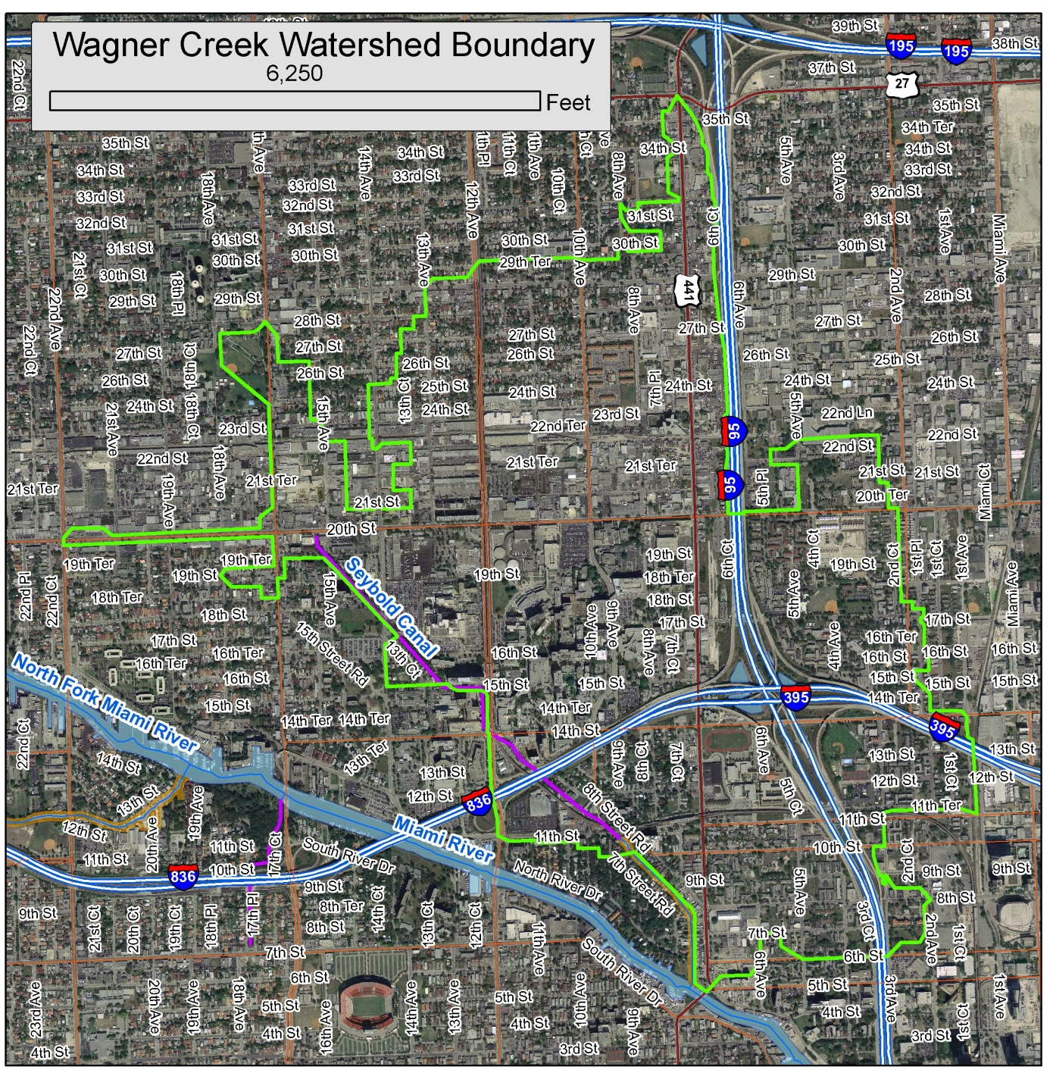
Wagner Creek is located in the northwestern quadrant of the City of Miami in North Miami–Dade County, within the Southeast Coast–Biscayne Bay Basin. A tributary to the Miami River, the creek flows into the river from the north (Figure 1).

Figure 1. Aerial photo showing the boundary of the Wagner Creek watershed and major hydrologic features in the area.

The Miami River comprises the basin’s downstream (and southern) boundary, while the upstream, northern boundary parallels NW 36th Street. The eastern boundary is irregular but generally extends several blocks east of Interstate 95. The irregular western boundary is located mainly east of NW 17th Avenue, but extends as far west as NW 22nd Avenue at its westernmost point.
Wagner Creek has its headwaters in Juan Pablo Duarte Park (formerly known as Allapattah Comstock Park, located at NW 26th Street and NW 17th Avenue). Approximately the first half-mile of the “creek” is culverted and comprises storm sewers and French drains that connect to a double culvert box, which opens into the creek immediately south of NW 20th Street. The creek then extends southeast from NW 20th Street to the Miami River. The only potential area of open water in the upper portion of the watershed is an approximately 700-foot-long drainage swale located within the park. It should be noted that this area is free from “open” water throughout much of the year. Water from the swale enters the double-box culvert in the southeastern corner of the park and re-emerges at the NW 20th Street Bridge. Based on a communication with a long-time city resident that was further corroborated by City of Miami documents, the swale used to be a permanently flowing portion of Wagner Creek. Later changes to the hydrology caused this historical portion of the creek to flow only during wet weather conditions.
The Allapattah Produce Market, a collection of independent produce vendors, distributors, and processors, is situated between the headwaters and the NW 20th Street Bridge. There are many stormwater drains in this highly developed area that drain into the culverted section of the creek, creating opportunities for the stormwater system to convey rainfall-flushed decaying organic matter and animal wastes along the street and into the creek.
In the segment between NW 20th and NW 16th Streets (the open-water portion of the creek’s upstream boundary), the creek has a vegetated shoreline. From NW 16th Street to NW 12th Avenue, the shoreline is hardened, having both banks reinforced with seawalls and a natural hardpan beneath the sediments at varying elevations. It flows east and southeast as an urban drainage feature with vegetated portions of shoreline up to the corner of NW 11th Street and NW 12th Avenue, at the southeast corner of the University of Miami (formerly Cedars of Lebanon) Medical Center.
While the term Wagner Creek is sometimes used interchangeably with Seybold Canal, Seybold Canal is the designation of the approximately 2,000-foot-long portion of the creek that is navigable, downstream from NW 11th Street. The canal merges with the Miami River just west of where NW 7th Avenue crosses the river.
Wagner Creek is tidally influenced throughout its length. Manatees have been observed as far upstream as NW 16th Street, which is more than a mile upstream from the Miami River.
The watershed is densely developed and dominated by commercial, industrial, and residential land uses, as well as highways, roads, and parking lots. There is heavy traffic in the area, including large numbers of tractor-trailers and trucks that service the watershed’s many businesses. Major land uses in and adjacent to the Wagner Creek WBID are as follows:
- Garment manufacturing activities in the NW 20th Street merchant’s corridor, between NW 22nd and 17th Avenues;
- The Allapattah Produce Market, a collection of independent produce vendors, distributors, and processors;
- Medical facilities such as the Bascom Palmer Eye Institute, Ryder Trauma Center, University of Miami (formerly Cedars of Lebanon) Hospital, Jackson Memorial Medical Center Hospital, and Miami Veterans Administration (VA) Hospital;
- The Civic Center area, Dade Criminal Justice Building, Miami–Dade County Pre-Trial Detention Center, and the state of Florida’s Miami–Dade County Health Department;
- Educational facilities, including the Lindsey Hopkins Adult Education Center, Miami Dade School of Medicine, Booker T. Washington Senior High School, and Frederick Douglass Elementary School;
- The largest industrial area in the city, containing clothing manufacturers, auto repair shops, paint and body shops, and carpentry and upholstery shops; and
- Several shipyards, marinas, and dry docks located along the banks of the Miami River.

Fecal Coliform Impairment of Wagner Creek
Florida’s Water Quality Standard for Fecal Coliform
For determining impairment for fecal coliform bacteria, the IWR states that the most probable number (MPN) or membrane filter (MF) counts (colony-forming units [CFU]) per 100 milliliters (mL) of fecal coliform bacteria shall not exceed a monthly average of 200, nor exceed 400 in 10% of the samples, nor exceed 800 on any one day. The criterion states that monthly averages shall be expressed as geometric means based on a minimum of 10 samples taken over a 30-day period. However, there were insufficient data (fewer than 10 samples in a given month) available to evaluate the geometric mean criterion for fecal coliform bacteria. Therefore, the criterion selected for the TMDLs was not to exceed 400 CFU/100mL in more than 10% of the samples.
Wagner Creek was verified impaired for fecal coliform bacteria in May 2006, based on the state’s Impaired Surface Waters Rule (IWR) (see box), and Total Maximum Daily Loads (TMDLs) were adopted for both fecal and total coliform in June 2006. However, the TMDL is now only applicable to fecal coliform, since total coliform is no longer a water quality standard regulated by the state.
A TMDL represents the maximum amount of a given pollutant that a waterbody can assimilate and still meet water quality standards, including its applicable water quality criteria and its designated uses. TMDLs are developed for waterbodies that are verified as not meeting their water quality standards. They are a critical step in the watershed restoration process because they provide the targets for measuring progress in subsequent water quality restoration efforts.
The fecal coliform TMDL calls for an 86% reduction in in-stream concentrations for Wagner Creek to meet state water quality standards. Currently, no point sources are permitted to discharge into the creek. Wasteload allocations have been assigned to two municipal separate storm sewer system (MS4) permittees: the City of Miami and Florida Department of Transportation (FDOT) District 6.
Other National Pollutant Discharge Elimination System (NPDES) stormwater permits in the watershed include the following:
- Miami–Dade County, on whose MS4 permit FDOT District 6 is a co-permittee;
- Miami–Dade County Expressway Authority, another co-permittee on Miami-Dade County’s NPDES MS4 Permit;
- Miami Waste Paper, 2120 NW 14th Avenue, Multi-Sector General Permit (MSGP);
- National Pallets, 2160 NW 8th Avenue, MSGP;
- Waste Management of Dade County, 2125 NW 10th Court, MSGP; and
- Cemex LLC, Midtown, 1590 NW 21st Street, Concrete Batch General Permit (GP).

It is possible that other businesses in the watershed that meet the criteria for NPDES permitting have not applied for permits. The American Society for Microbiology, in the April 2006 issue of Microbe, notes that “several genera of bacteria that are common contaminants of nonfecal sources (e.g., plant materials and pulp or paper mill effluents)” will produce a positive result in the fecal coliform assay. The article goes on to say, “Examples include Klebsiella, Enterobacter, and Citrobacter species. Moreover, these bacteria, which are false-positive indicators of fecal contamination, can grow under appropriate conditions in nonfecal niches such as water, food, and waste.” Citrobacter, in particular, is known for its role in the decomposition of citrus fruits.
While the Cemex facility, a concrete batch plant, would not usually be associated with fecal coliform, concrete batch plants habitually overapply the water used to control dust from their sand piles, sometimes to such an extent that plants grow on top of the piles and a microbial slime is visible on the retaining wall holding the piles. The sand is often piled so high that the sprinklers wash it over the wall, onto the sidewalk, and into the gutter. Even if there are no fecal coliform growing in the piles themselves, the sediment that enters the gutter and the storm drains helps to create an environment in which the microbes will thrive.

Walk the WBID Exercise

Participants
All agencies with jurisdictional authority collaborated before, during, and after the event. Team members included representatives from the City of Miami, Miami–Dade County Water and Sewer Department (WASD), City of Miami Public Works, Miami-Dade County Public Works, Miami–Dade County Department of Environmental Resources Management (DERM), Florida Department of Transportation (FDOT), Miami–Dade (Florida) Department of Health (FDOH), Florida Department of Environmental Protection (FDEP), Miami River Commission (MRC), South Florida Water Management District (SFWMD), and Florida Department of Law Enforcement (FDLE).

Costs
When the Walk the WBID exercise was suggested as an option for implementing the TMDL was suggested, stakeholders liked the idea, but at that time there were not enough funds to support the necessary water quality sampling. Subsequently, the MRC was able to secure funding through a request to its Board of Directors. The only costs to the participants in the Walk the WBID exercise were staff time and potentially management actions. The MRC was able to secure the funding necessary to process water quality samples associated with this effort, and DERM agreed to assist in collecting and processing the samples through its lower-cost contract laboratory.
Future management actions associated with existing city and county programs will require scheduling, coordination, and follow-up on behalf of the participating agencies. Examples of follow-up activities that may result in additional costs include system maintenance, repair, and investigation; however, it is important to note that these activities generally correspond with jurisdictional missions and already-established ongoing programs.

Initial Steps
After the establishment of the Wagner Creek fecal coliform TMDL in 2006, the MRC’s SSC served as the general coordination and information exchange venue for the Wagner Creek TMDL. Through discussions at meetings with participating stakeholders, the Walk the WBID exercise was suggested as an option for implementing the TMDL. The process was reviewed and the stakeholders agreed to use this approach to address the TMDL. Before going into the field (e.g., conducting the Walk the WBID), data and information needs were identified, and the stakeholders were tasked with collating and submitting needed data and information within their jurisdiction and purview. These included information and data on facility compliance with existing permit conditions; location, status, condition, and maintenance records of infrastructure (septic, sewer, stormwater systems); permitted facilities; records of regulatory violations; nonpermitted sewage discharges; illicit connections (to or between stormwater and sewer systems); and other information deemed pertinent as possible or potential sources of wastes and or bacteria. Before going into the field, the stakeholders assembled at the MRC meetings, including the City of Miami Public Works Department, Miami–Dade County DERM, Miami–Dade Department of Health, FDOT, FDEP, and other responsible entities. The information that was collected and assimilated included the following:
- Geographic information system (GIS) data;
- Stormwater infrastructure maps showing inlets and outfalls, ponds, ditches, and underground conveyances;
- Stormwater Best Management Practices (BMPs) being implemented;
- Maps of private and public sanitary sewer infrastructure showing the locations of pump and lift stations and force and gravity mains, as well as associated repair and maintenance records and other relevant information on the sewer collection system;
- Location and number of SSOs within the WBID, with an emphasis on areas with repeated releases;
- Septic tank locations and repair permits issued;
- Water quality sampling information such as sampling stations, frequency, and results;
- Hydrology, including wetlands, streams, and ponds; and
- Issues or areas of special concern such as homeless populations, dog parks, landfills, and transfer stations.

Each entity provided requested and available information in and around Wagner Creek–Seybold Canal to FDEP. FDEP, in turn, collated and summarized the information in a GIS database. The information was then presented back to the stakeholders in multiple large-format maps, depicting the various classes of information submitted. These maps would be the focus of a “pre-walk” tabletop exercise to better identify potential problem areas, and/or possible sources or contributing factors to level of fecal coliform in the creek.

Maps on the Table Session
With a representative present from each participating agency, team members held the “Maps on the Table” session at the South Florida Water Management District Miami Field Station on October 21st 2010, to identify areas of concern to visit during the Walk the WBID event, based on field knowledge from staff and a synthesis of the available information. The team members, facilitated by FDEP, reviewed the information on the maps for completeness, discussed concerns in specific areas, identified problematic and/or potential contributory facilities and activities, and marked the areas of concern on the maps. These would further serve as a reference, and as a guide, for the field team during the field exercise.
A final element of the “Maps on the Table” session was the selection of representatives to conduct the actual Walk the WBID. Due to logistical considerations, the field team was restricted in size. Therefore, the agencies identified field representatives who had the appropriate access, knowledge, and experience with the facilities; infrastructure sampling equipment; and protocols to conduct the actual Walk the WBID.
Subsequently, FDEP carried out a preliminary field reconnaissance to identify areas of focus, determine appropriate routes for the participants, and identify any access issues and safety concerns requiring coordination with local law enforcement.

Field Event
The Walk the WBID team used the large-format maps while conducting the field investigations. A documentation team was designated, with a team member assigned to record global positioning system (GPS) points with the coordinates of potential sources, another person to take pictures, and a primary note taker to record the information. Water quality sampling supplies and were used to collect water quality information about potential sources identified in the field via the “grab sample” method.
The team explored the waterbody while in the field, referring to the maps to follow the creek above and below ground. Team members looked at the creek’s banks and in the vicinity of the creek for potential sources. With the exception of the drainage swales along State Road 836, the team also walked the canals/ditches that intersected the waterbody to ensure that the waterbody and its associated branches were all included within the WBID boundary. A portion of the waterbody could not be explored on foot, and so a follow-up event was planned to explore this portion via boat. Care was taken to ensure that only appropriate entity representatives accessed private property, unless the property owner had granted access to the entire team. Potential sources that were investigated included the following:
- Potential illicit connections (PICs) or discharges;
- Public and private sanitary sewer infrastructure (such as manholes and pump stations);
- Package plants (small treatment facilities used to treat wastewater in small communities or on individual properties.);
- Signs of recent SSOs, or areas with multiple SSOs;
- Wastewater infrastructure located close to surface waters and/or stormwater inlets, including pump stations, manholes, and air release valves (ARVs);
- Septic tanks located close to surface waters and/or stormwater inlets;
- Failing septic tanks (as indicated by ponding and a strong smell of sewage);
- Evidence of homeless populations;
- MS4 conveyances requiring cleaning;
- Accumulated trash and debris on streets and parking lots;
- Accumulated trash and debris near to or inside stormwater drains and catch basins;
- Clogged or broken stormwater grates;
- Stormwater drains undergoing repairs;
- Stormwater outfalls discharging from underground conveyances or into ponds;
- Sewage smell from stormwater drains, indicating possible cross-connections;
- Unusual odors;
- Evidence of illegal dumping or discharge of liquids;
- Signs of oil and grease;
- Excessive sediments and signs of erosion or wash out;
- Stagnant water;
- Debris in inlets, or inlets located near wastewater infrastructure;
- Exposed pipes of unknown origin;
- Flood-prone areas;
- Pet waste or evidence of high-traffic pet areas;
- Evidence of wildlife such as raccoons and waterfowl;
- Evidence of chickens or other hobby animals; and
- Areas with heavy tree cover and vegetated ditches preventing ultraviolet (UV) light penetration.

Any discharges that were observed were sampled both downstream and upstream. Potential sources or other issues identified while in the field were reported to the proper jurisdiction and cataloged while in the field. A record was kept of major findings, including observations about the waterbody, potential sources, follow-up items and the responsible entity, and any areas that should be added to the monitoring plan or that required additional investigation.

Results
Figures 2 through 51 show the locations of monitoring stations and the areas inspected, summarize the water quality issues and potential fecal coliform sources that the team observed during the Walk the WBID exercise on November 18, 2010, and describe the results of the water quality sampling that was carried out from the headwaters to the NW 14th Avenue Bridge. The notes below the field observations contain information provided by team members after the field event.

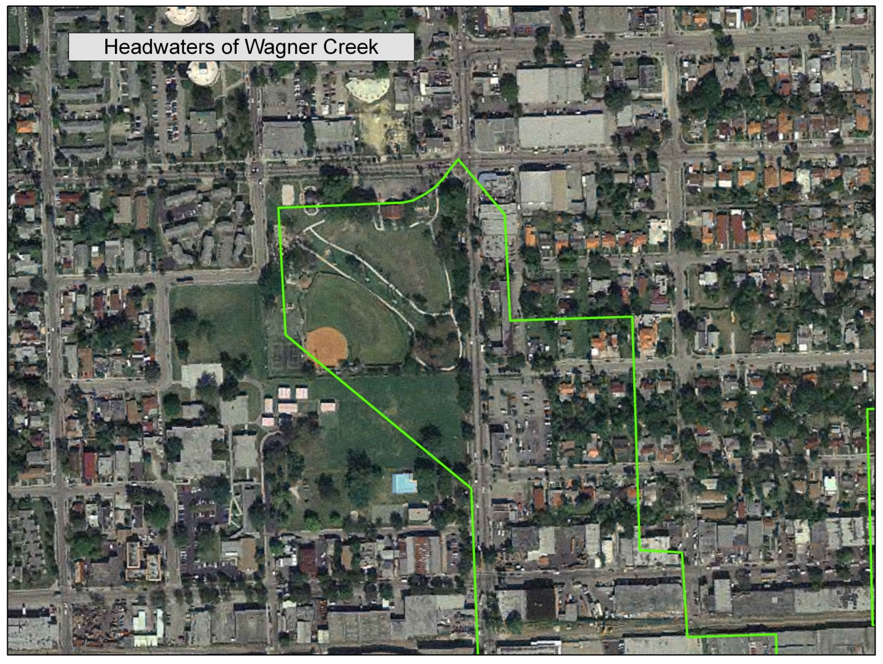
Figure 2. Aerial photo showing the headwaters of Wagner Creek in Juan Pablo Duarte Park and the watershed boundary in this area.

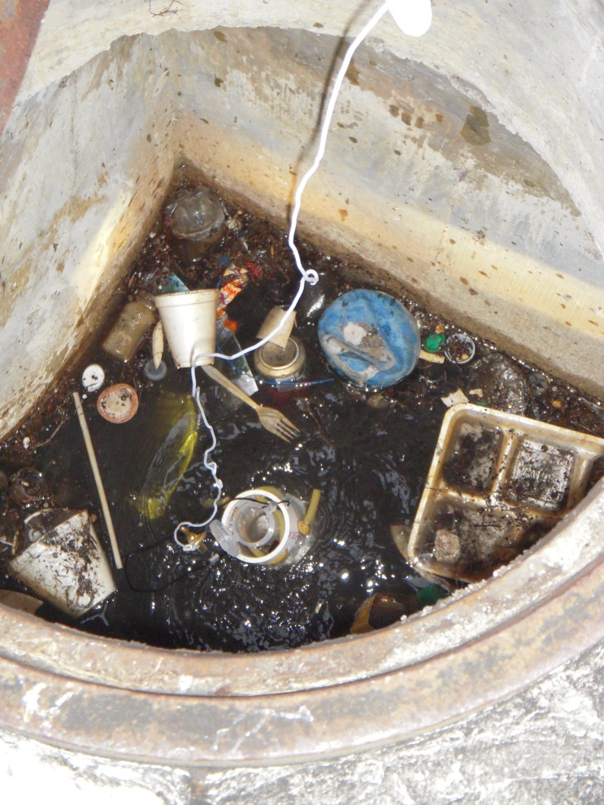
Figure 3. Trash and debris in a stormwater manhole thought to be at the headwaters.
POST-FIELD EVENT NOTE: The stormwater flows into a French drain system to the west and does not discharge into Wagner Creek.

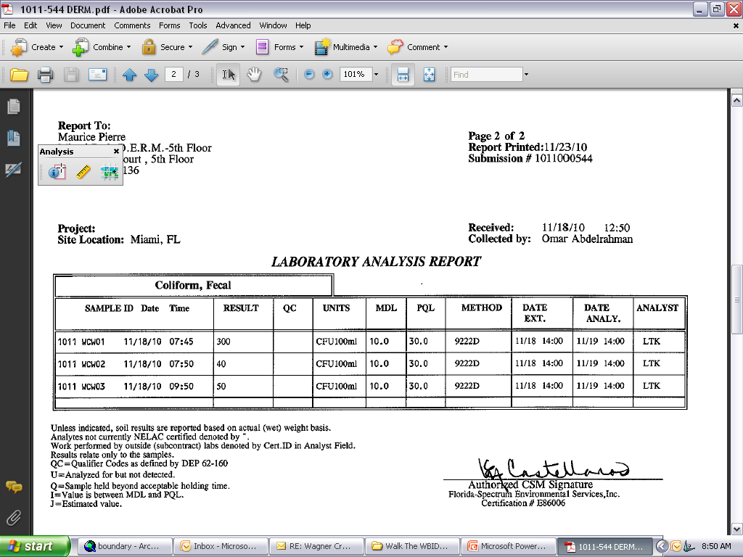
Figure 4. Water quality sampling results (for trash only) in a stormwater drain in the headwaters area showed fecal coliform concentrations of 300 CFU/100mL on November 18, 2010.

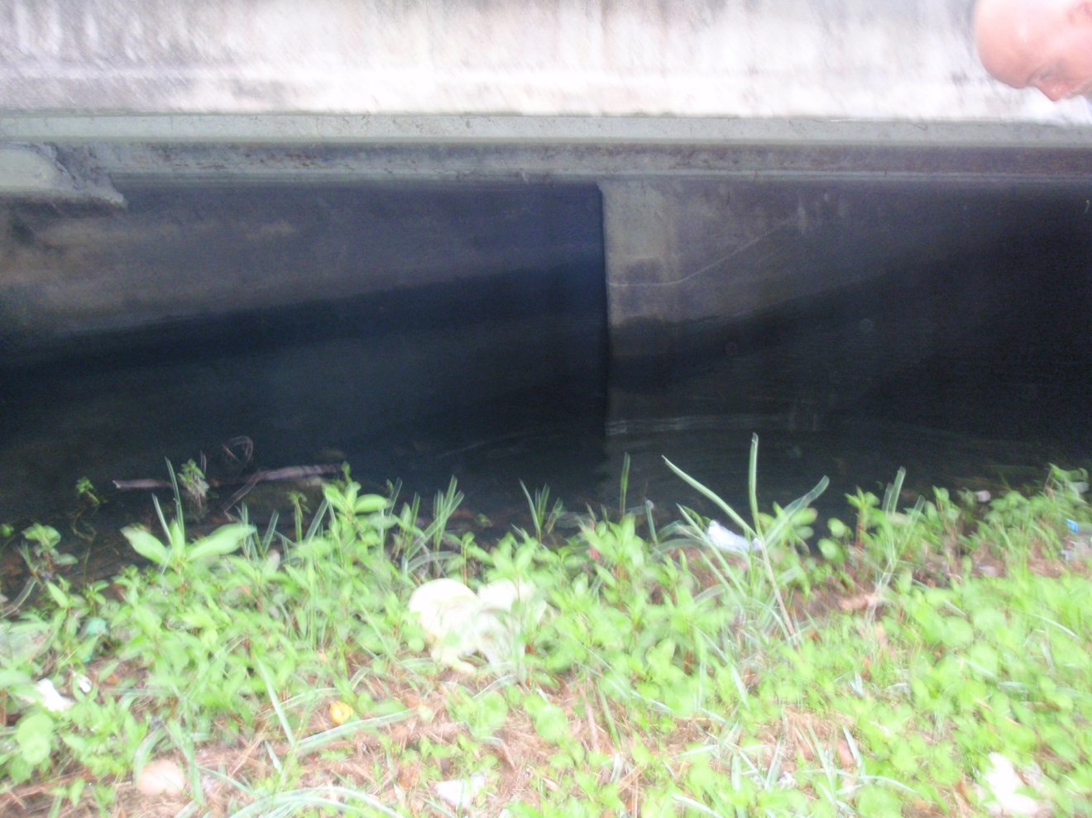
Figure 5. View of stagnant water and trash buildup in the stormwater conveyance that flows underground to the 20th Street Bridge; the accumulation may be caused by a blockage and should be investigated. This may be where the perennial portion of Wagner Creek now begins.

Figure 6. Water quality sampling results in the stormwater conveyance that flows underground to the 20th Street Bridge showed fecal coliform concentrations of 40 CFU/100mL.

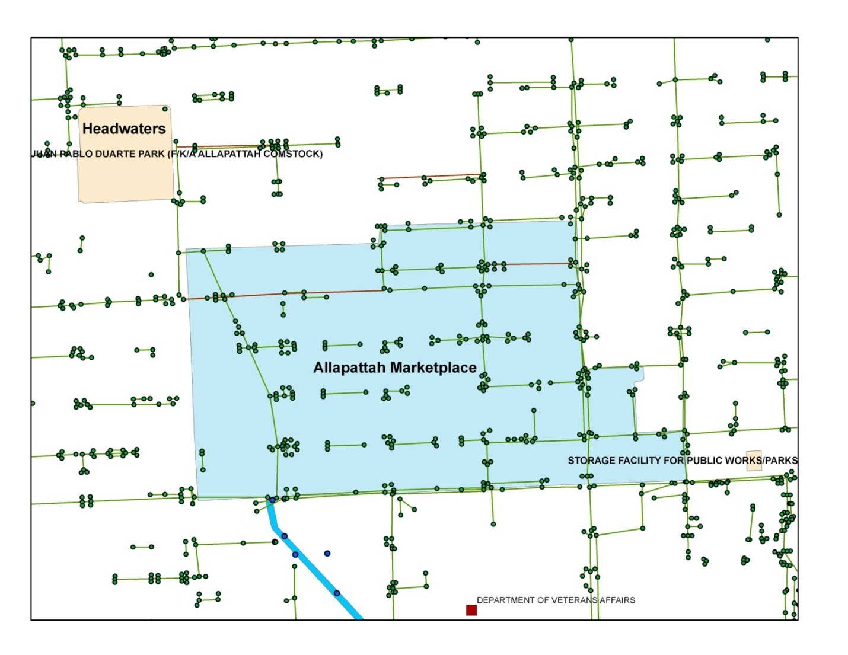
Figure 7. Map of stormwater infrastructure in the headwaters and Allapattah Produce Market areas.

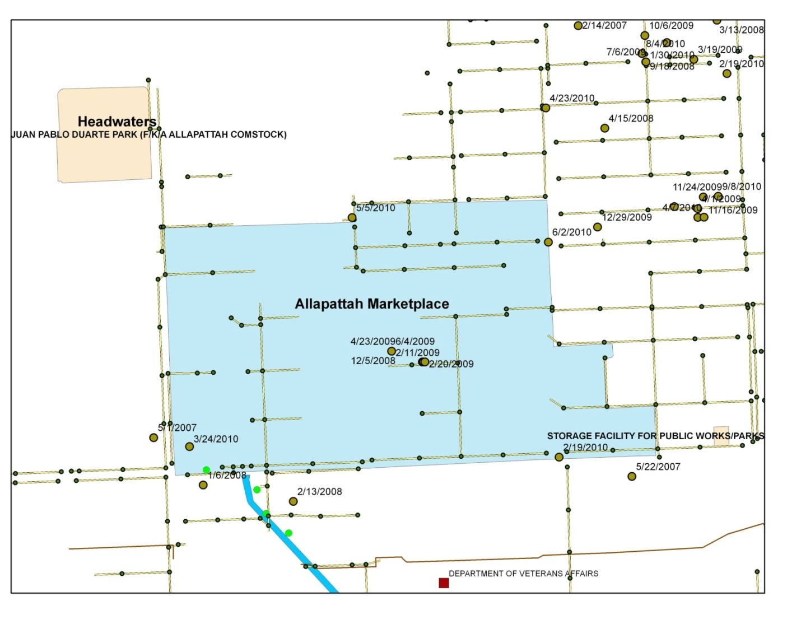
Figure 8. Map of wastewater infrastructure in the headwaters and Allapattah Produce Market areas.

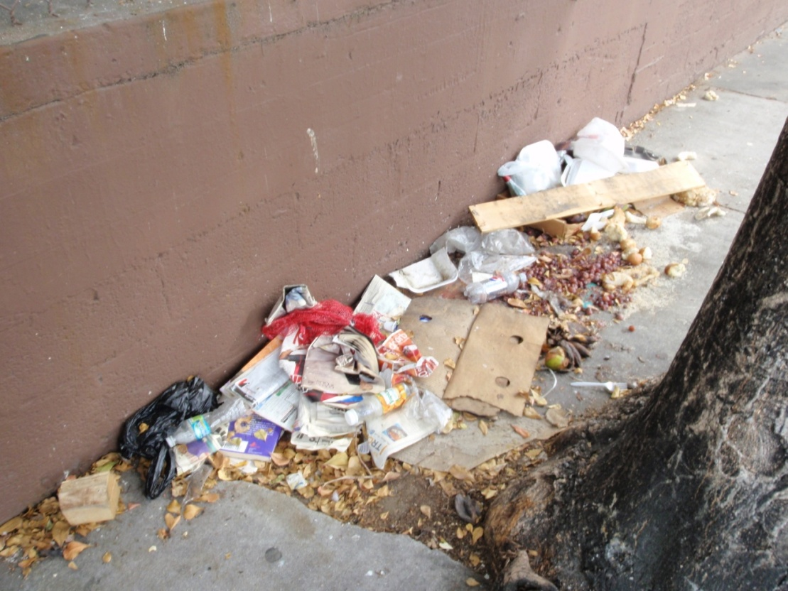

Figure 9. Trash and debris along the street at the Allapattah Produce Market.

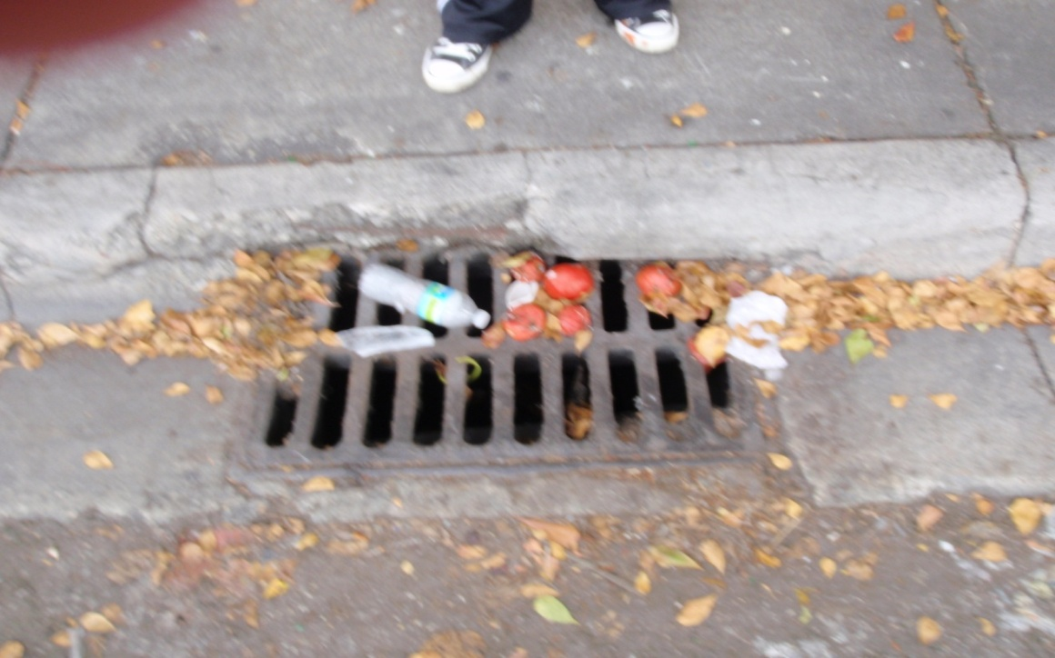
Figure 10. Fruit and trash collected on a storm drain at the Allapattah Produce Market.

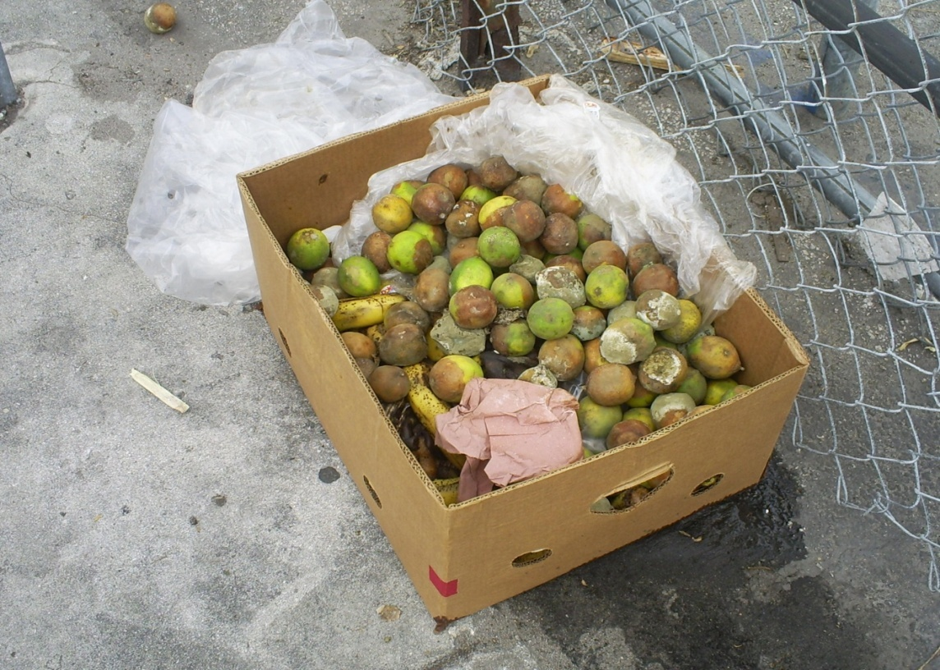

Figure 11. Box of rotting fruit outside a warehouse at the Allapattah Produce Market.

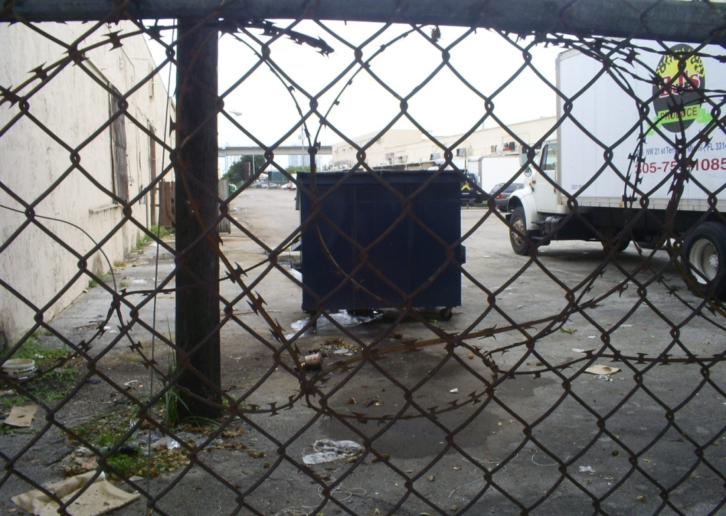
Figure 12. Unsecured lids on a dumpster at the Allapattah Produce Market. The field team made observations at 1265 NW 21st Terrace.

POST-FIELD EVENT NOTE: Subsequent research revealed that this portion of NW 21st Terrace is a private road whose drainage system connects to the public storm sewer system that discharges to Wagner Creek. The Miami–Dade County Property Appraiser lists the owner as Tavilla Realty Associates and the address as 2140 NW 12th Avenue. According to the plat, there is a 30-foot-wide utility easement along the northern portion of NW 21st Terrace on the property. Additional research is needed to determine whether the drainage system is located within the utility easement or solely within the area for which the private property owner bears maintenance responsibility.

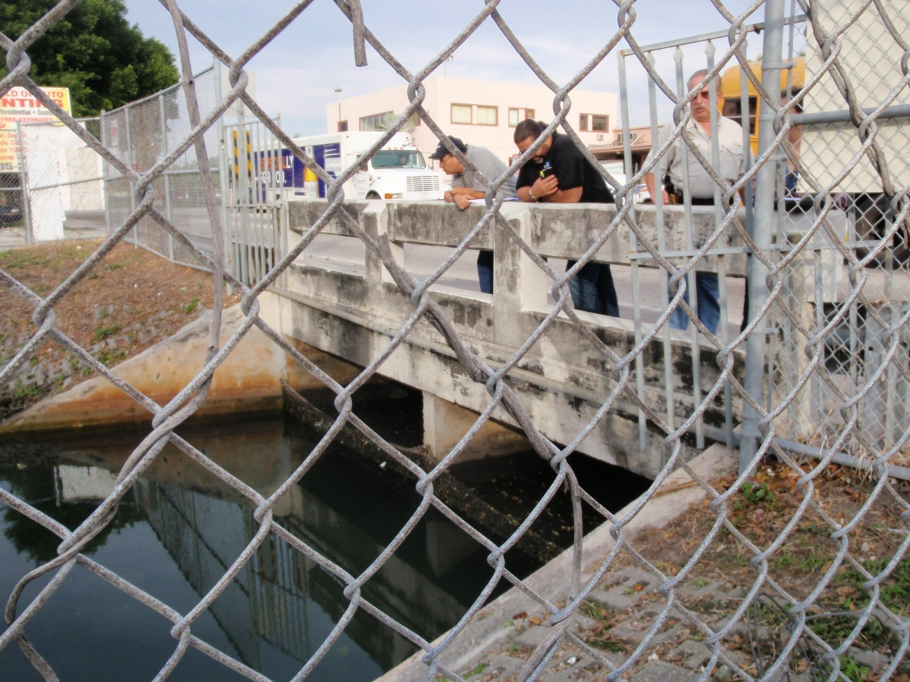
Figure 13. 20th Street Bridge, where Wagner Creek re-emerges from the underground conveyance.

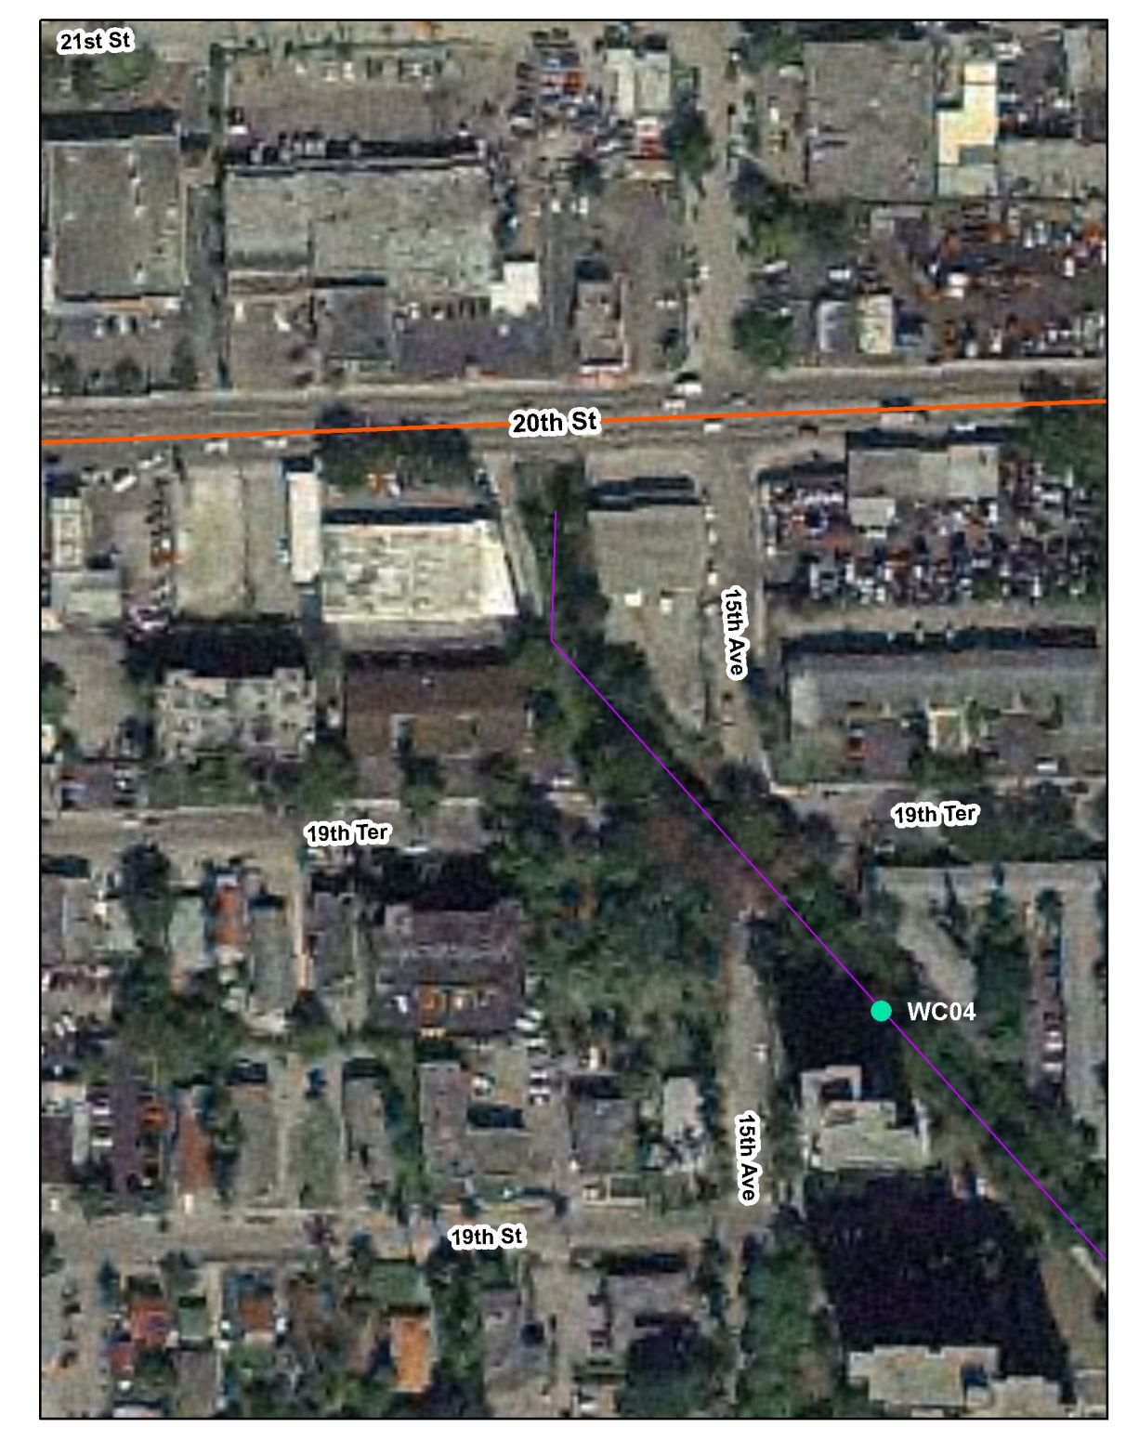
Figure 14. Aerial photo showing the location of Station DADEWC04, in Wagner Creek–Seybold Canal. Popeye’s Chicken is located on the north side of NW 20th Street near where Wagner Creek first emerges from the underground culvert. A storm drain belonging to the Popeye’s Chicken parking lot was observed to be completely full of debris.
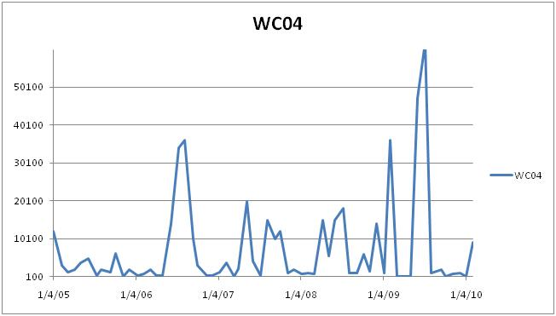

Figure 15. Results of annual sampling for Station WCO4, 2005–10. An SSO that occurred on May 1, 2007, resulted in fecal coliform levels of 20,000 CFU/100mL; a second SSO took place on January 6, 2008, resulting in levels of 700 CFU/100mL.

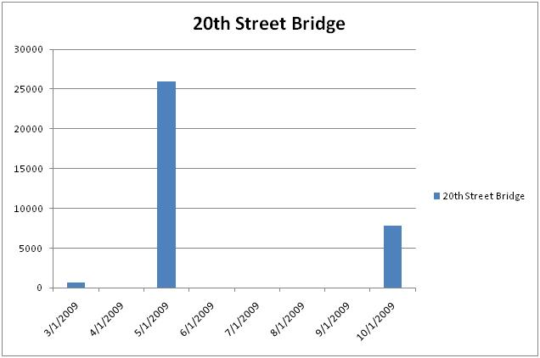

Figure 16. Sample results for 21FLWPB 28040446, March–October 2009, were as follows: 3/25/2009 = 660 CFU/100mL; 5/20/2009 = 26,000 CFU/100mL; 10/28/2009 = 7,800 CFU/100mL; 3/25/2009 = 660 CFU/100mL; 5/20/2009 = 26,000 CFU/100mL; and 10/28/2009 = 7,800 CFU/100mL.

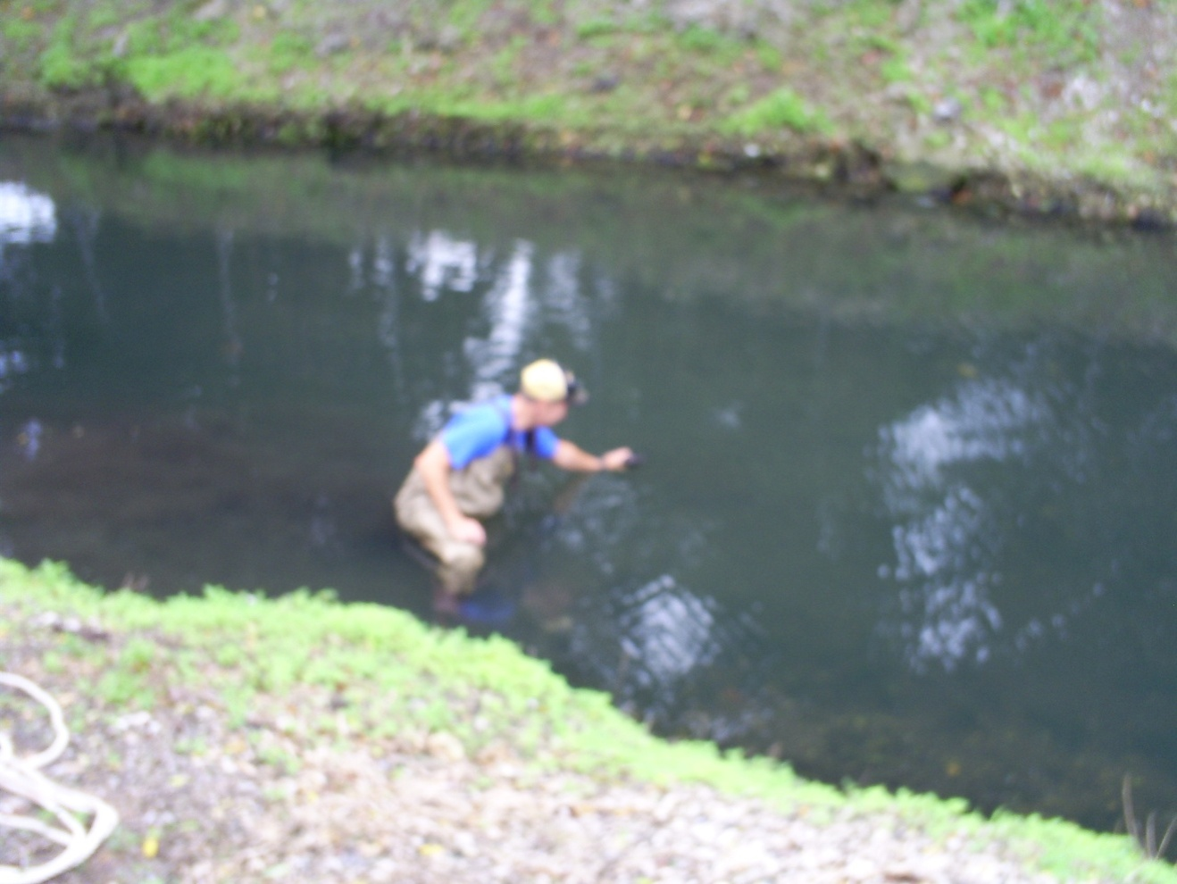
Figure 17. A Walk the WBID team member collecting an oil and grease sample downstream of the 20th Street Bridge.

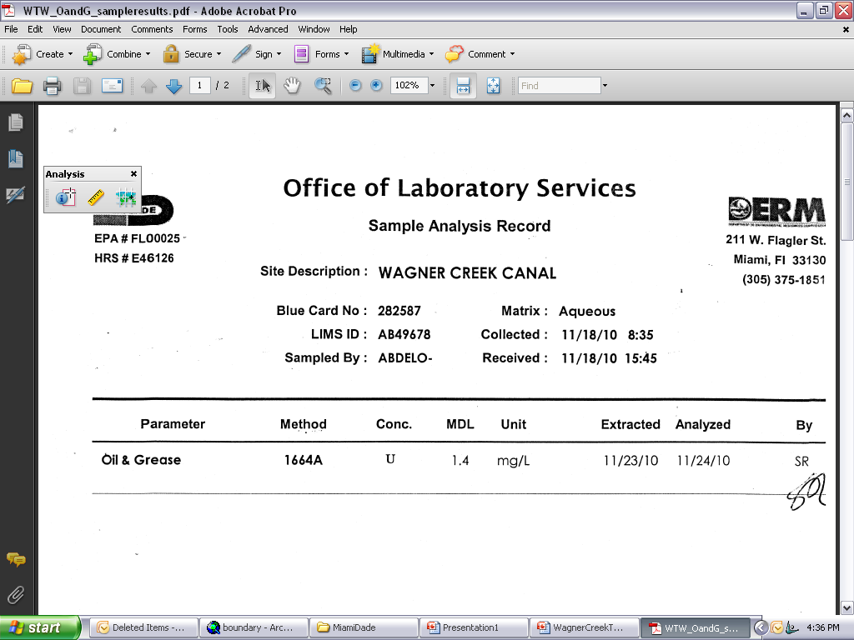
Figure 18. The results of the sampling on November 18, 2010, were below detection limits, indicating that oil and grease are not a problem in this part of the creek.

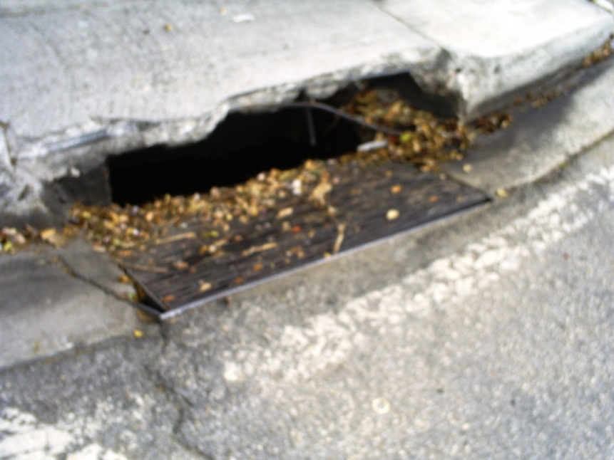
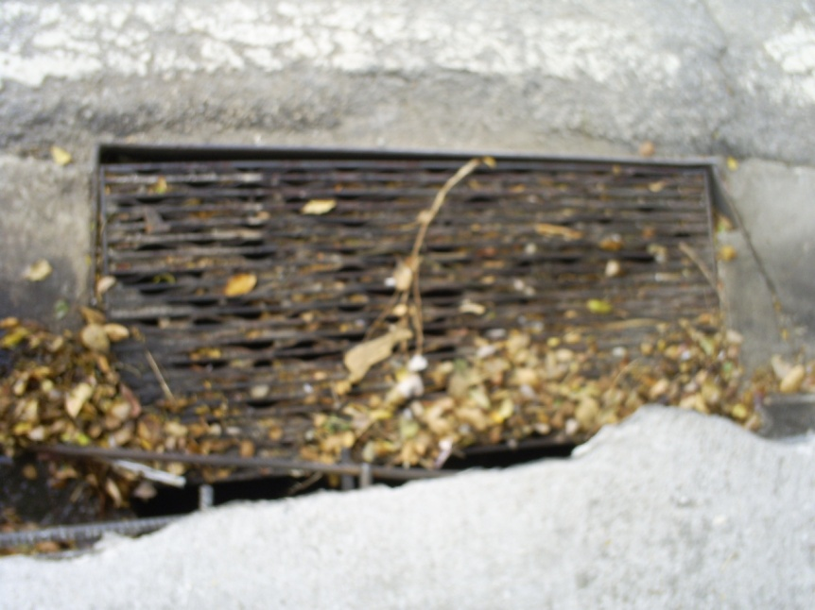
Figure 19. Broken storm drain covers at NW 20th Street belonging to Miami–Dade County; the openings allow trash and other materials to enter the underground conveyance directly and provide a breeding ground for fecal coliform.

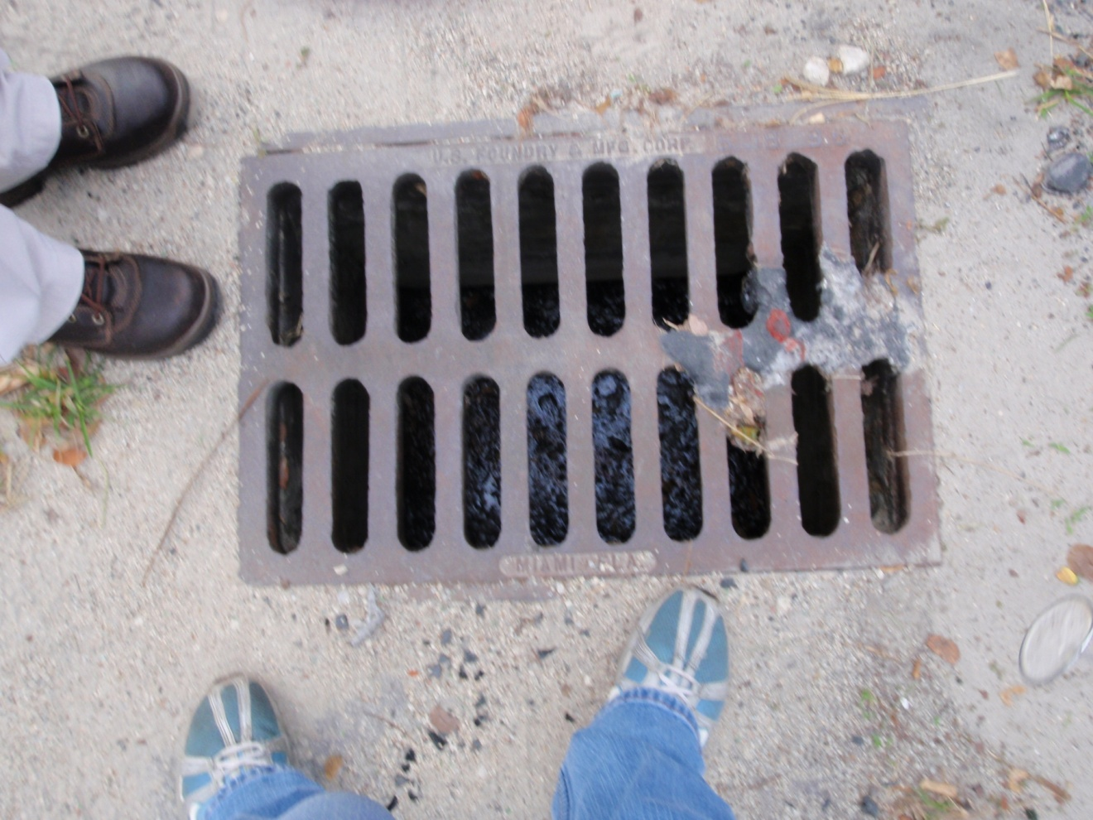
Figure 20. A storm drain on NW 15th Avenue south of NW 20th Street is filled with trash and not draining properly; any flooding that results could cause a failure of the wastewater system, and trash can provide a breeding ground for fecal coliform.

POST-FIELD EVENT NOTE: According to City of Miami records, this inlet connects to a French drain system with a baffle box and does not have a direct connection to Wagner Creek.

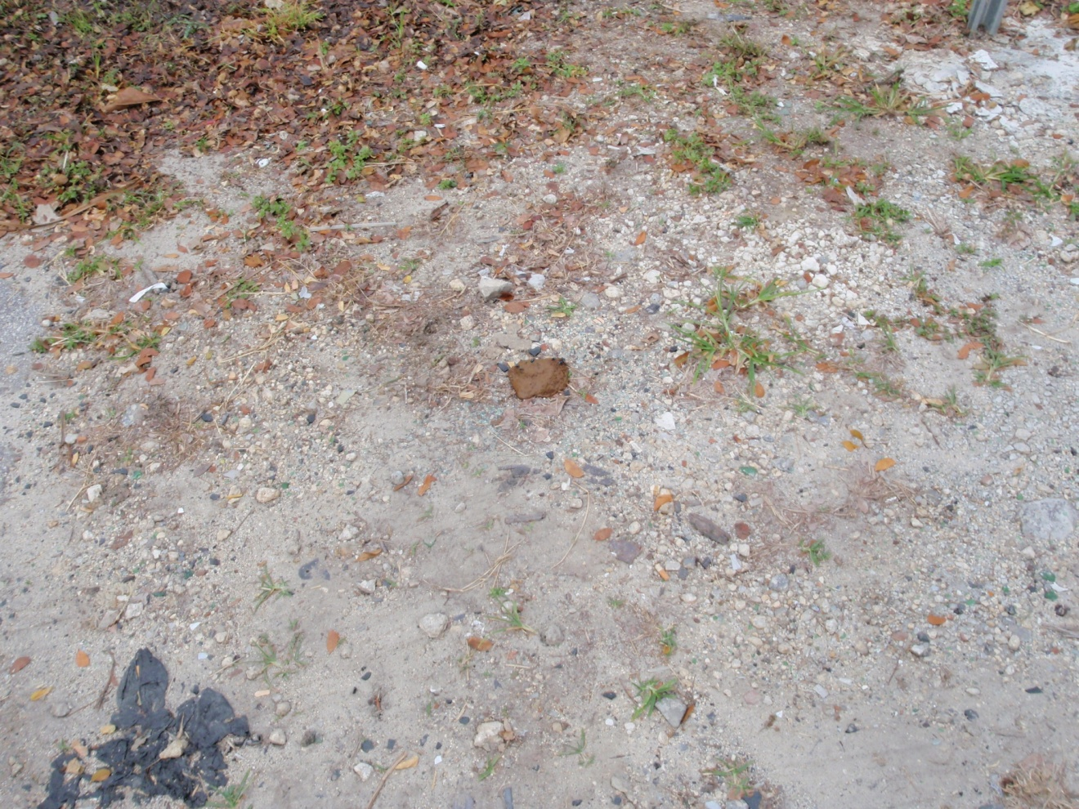
Figure 21. Dog feces were observed near a stormwater drain at 20th Street; both sides of Wagner Creek near the 20th Street Bridge are popular areas for dog walking, and rainfall could wash fecal coliform from these areas into the creek.

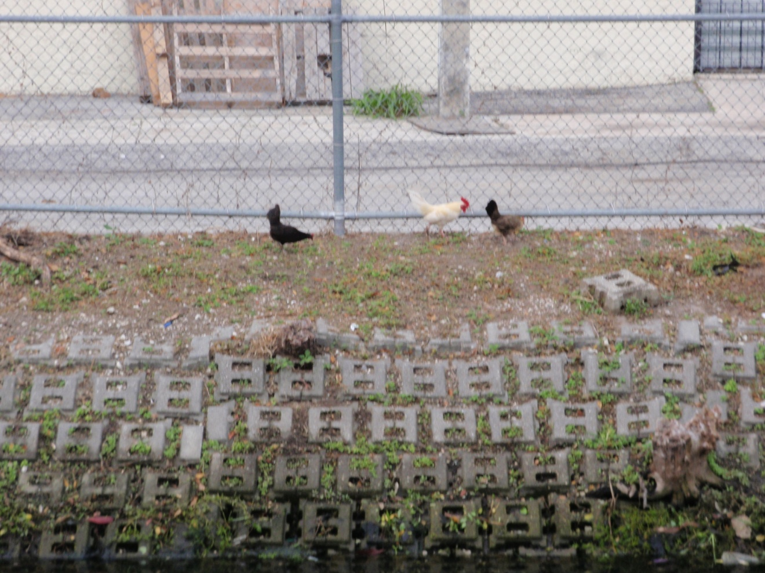
Figure 22. Free-range chickens and a rooster were observed along the creek downstream of the 20th Street Bridge; their feces could wash into the creek, causing fecal coliform contamination.

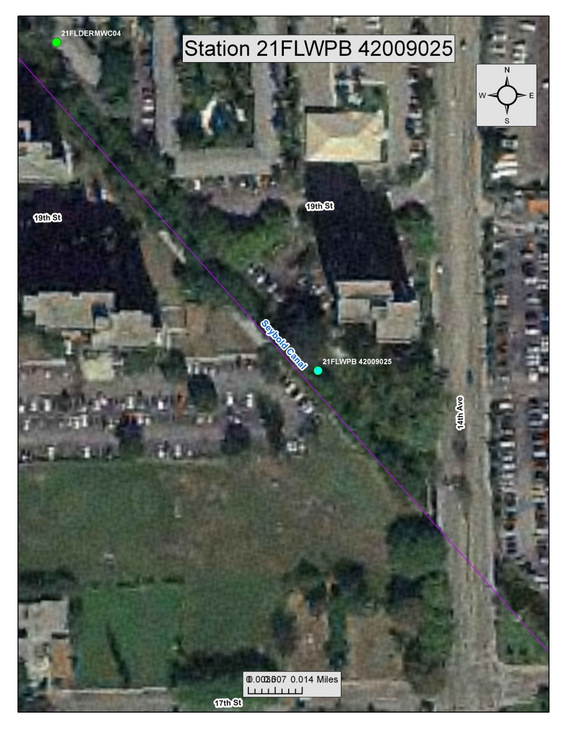
Figure 23. Aerial photo showing the location of Station 21FLWPB 42009025 along Wagner Creek–Seybold Canal. Note the apartment properties along the waterway. Additional research is needed to determine whether any of the apartments have a direct connection to Wagner Creek. The follow-up boat tour revealed several direct connections from the apartment complex to Wagner Creek.
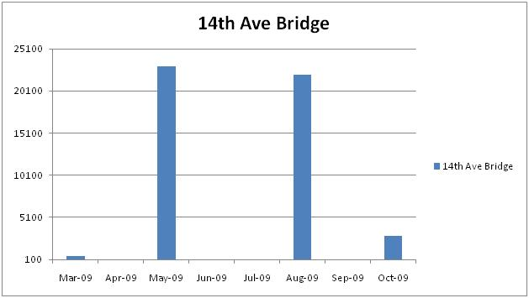
Figure 24. Sampling results for the 14th Avenue Bridge, March–October 2009, are as follows: March 2009 = 530 CFU/100mL; May 2009 = 23,000 CFU/100mL; August 2009 = 22,000 CFU/100mL; and October 2009 = 2,900 CFU/100mL.

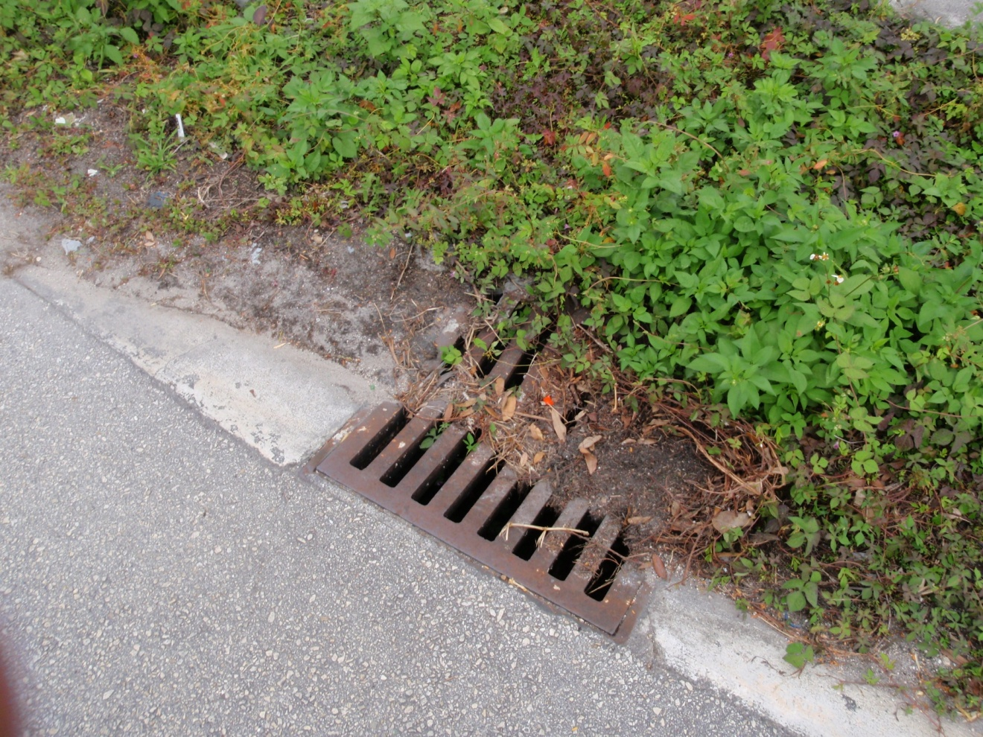
Figure 25. View of a partially blocked stormwater drain at 1501 to 1511 NW 13th Court; any flooding that results could lead to the failure of septic and wastewater infrastructure.

POST-FIELD EVENT NOTE: The City of Miami’s records indicate that this inlet discharges via an outfall to Wagner Creek and that there have not been any flooding complaints at this location for the past two and a half years. Only two flooding complaints were found for NW 13th Court between NW 15th and NW 16th Streets from November 2006, to March 30th, 2011. This inlet is maintained by the City of Miami Public Works Department.

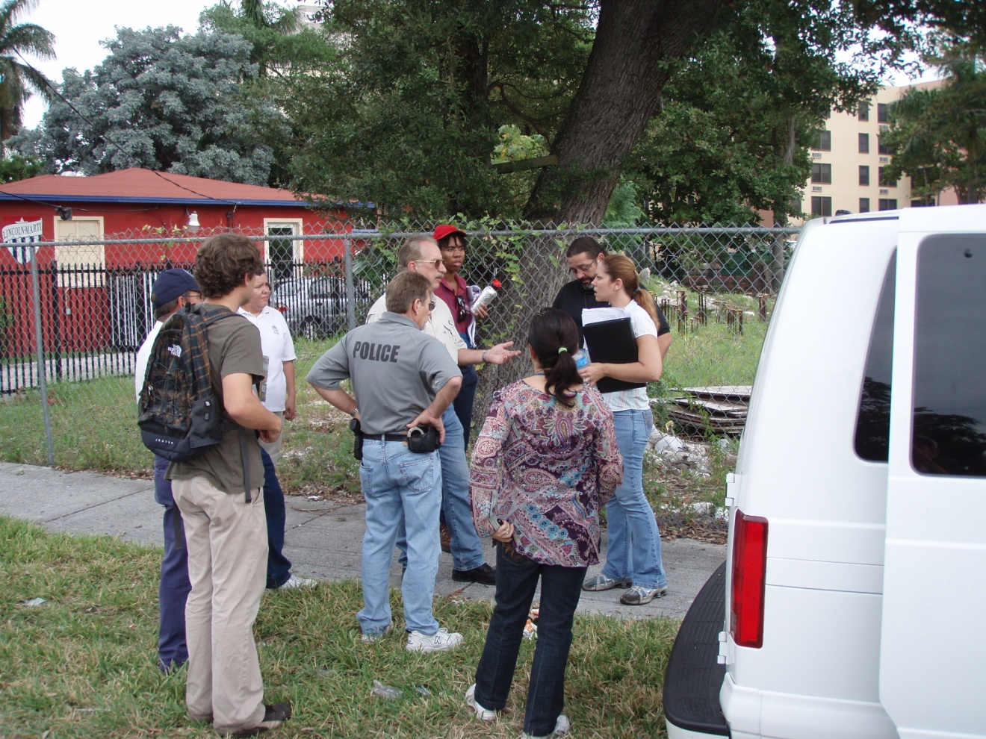
Figure 26. Team members and law enforcement personnel investigating potential septic system failures and PICs at NW 13th Court.

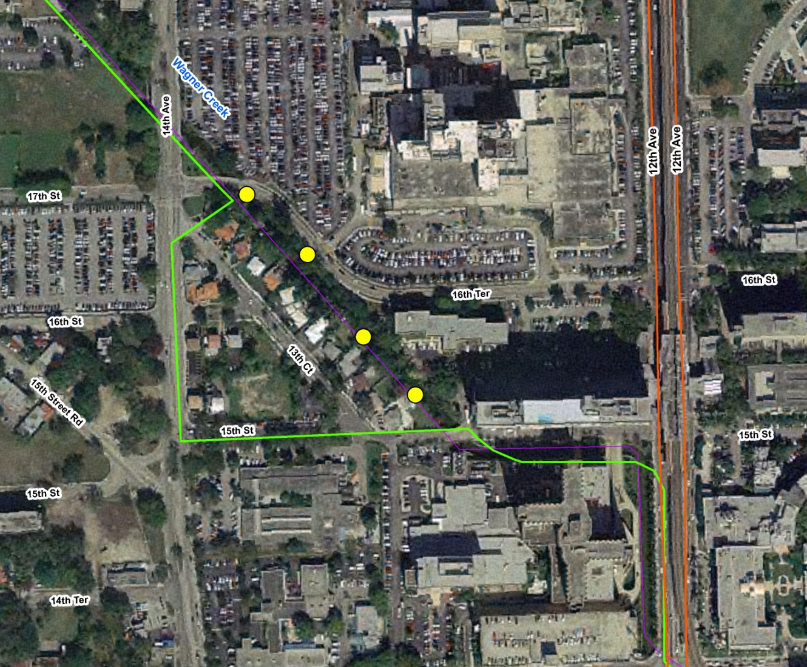
PICs along NW 13th Court
Figure 27. Aerial photo showing the locations of PICs along NW 13th Court.

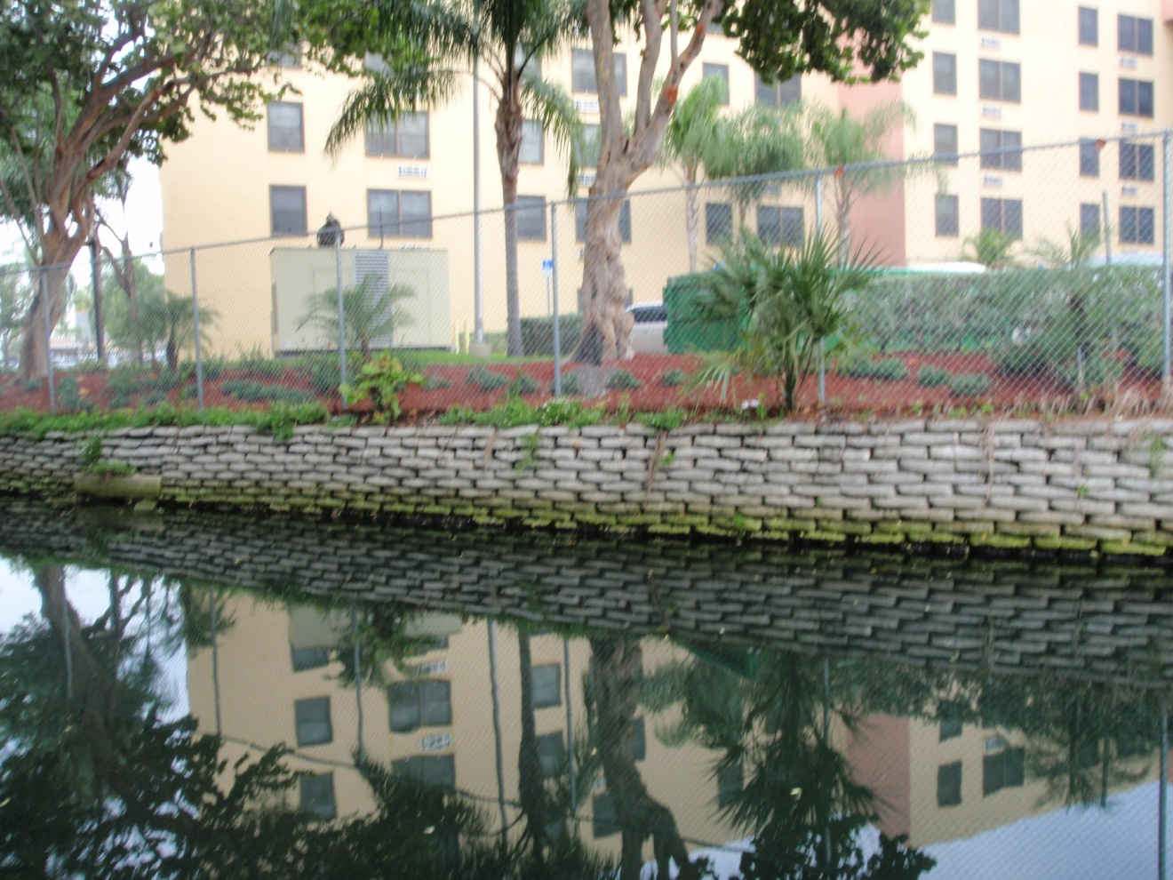
Figure 28. Apartments along the creek at 1310 NW 16th Street, with private storm drain outlets that discharge directly to the creek; this is a gated community, with no access for an inspection.

POST-FIELD EVENT NOTE: The Miami–Dade Property Appraiser lists this address as being owned by Miami–Dade County. According to publicly available GIS layers, the apartments at 1310 NW 16th Street are owned by the Miami–Dade County Housing Authority.

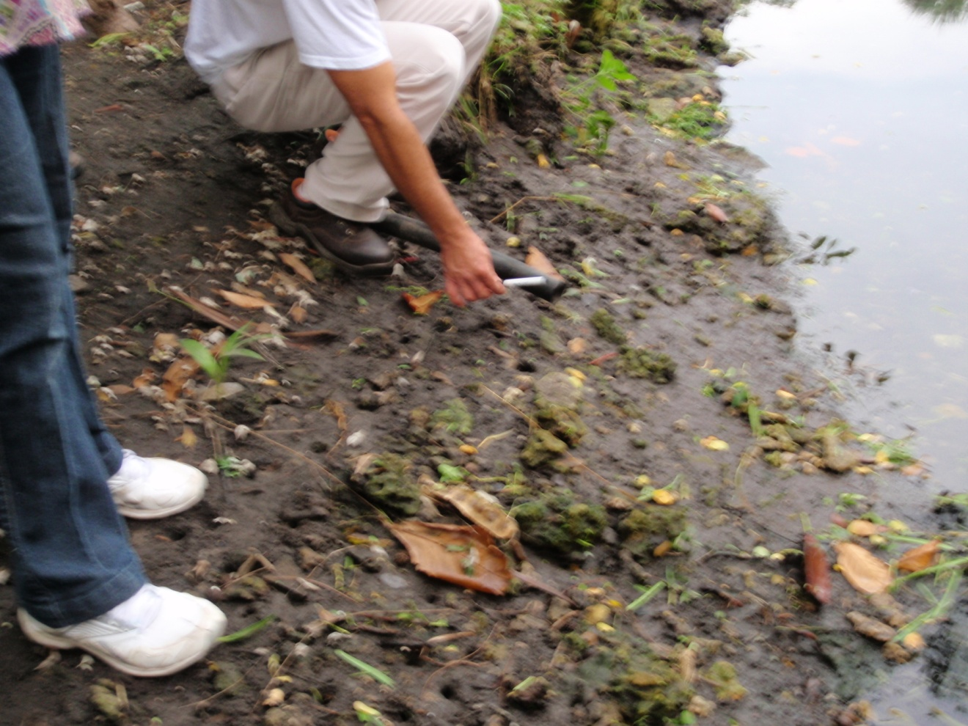
Figure 29. PIC 1 at NW 13th Court consisted of a pipe sticking out of the ground.

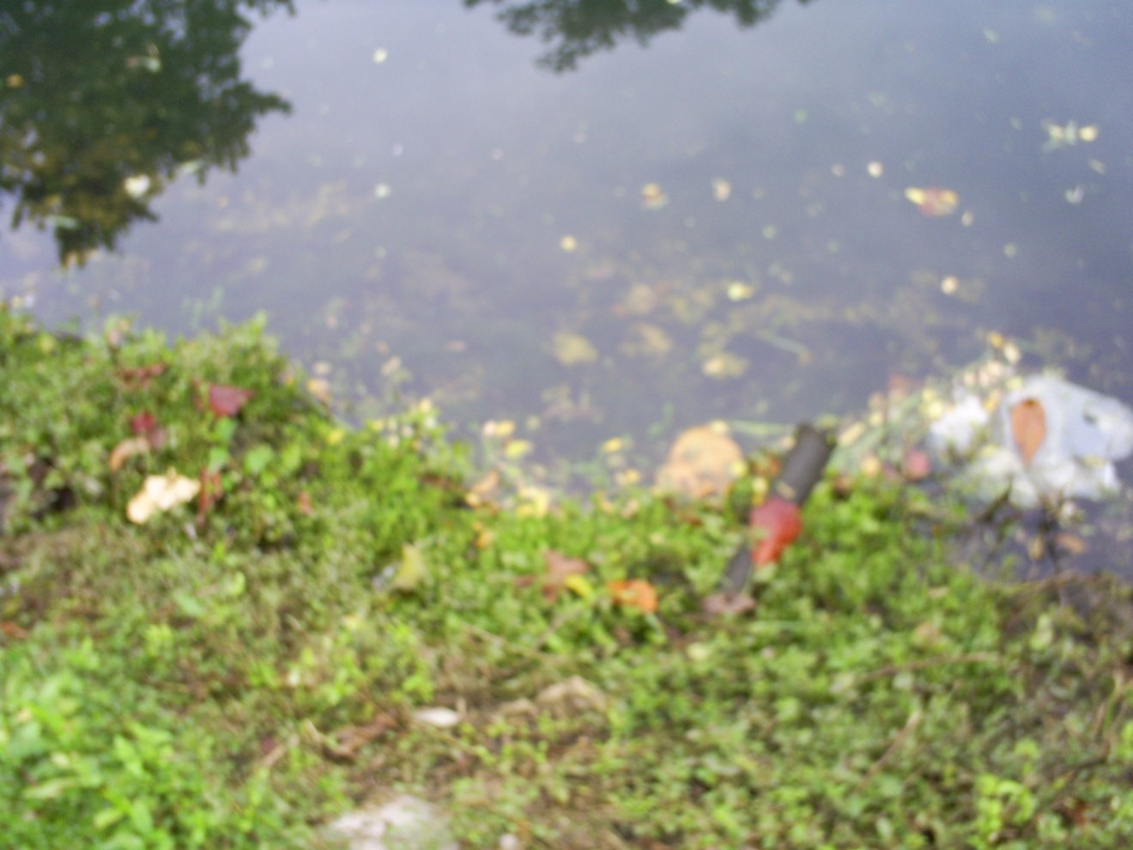
Figure 30. PIC 3 consisted of an unknown pipe sticking out of the ground.

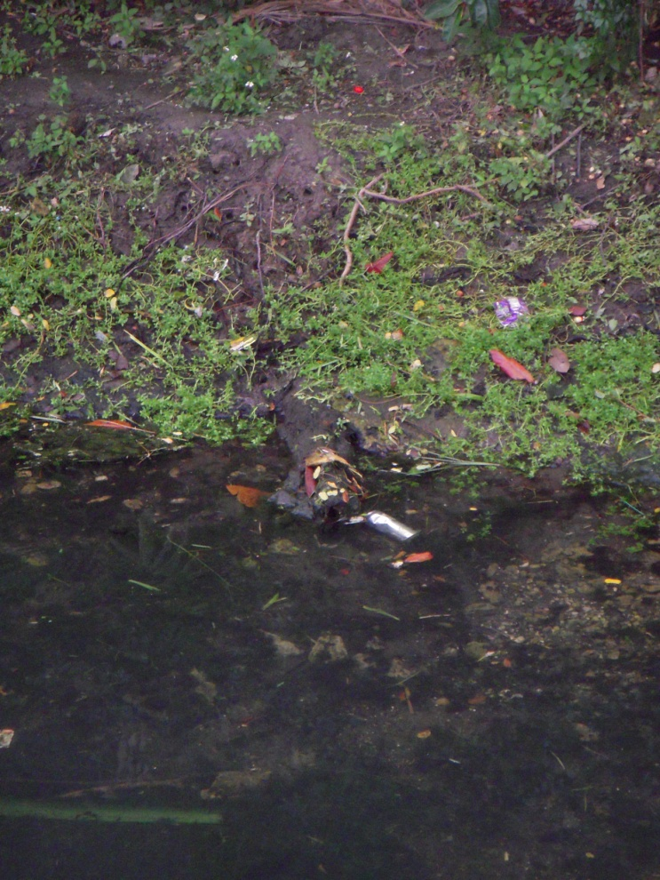
Figure 31. PIC 4 was thought to be a pipe but was confirmed to be a log.

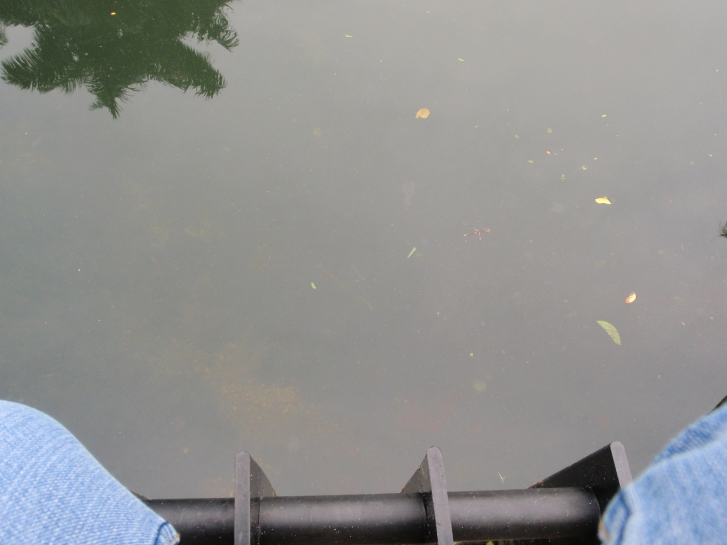
Figure 32. Solids and oils floating on surface water at a stormwater outfall from the VA Hospital building.

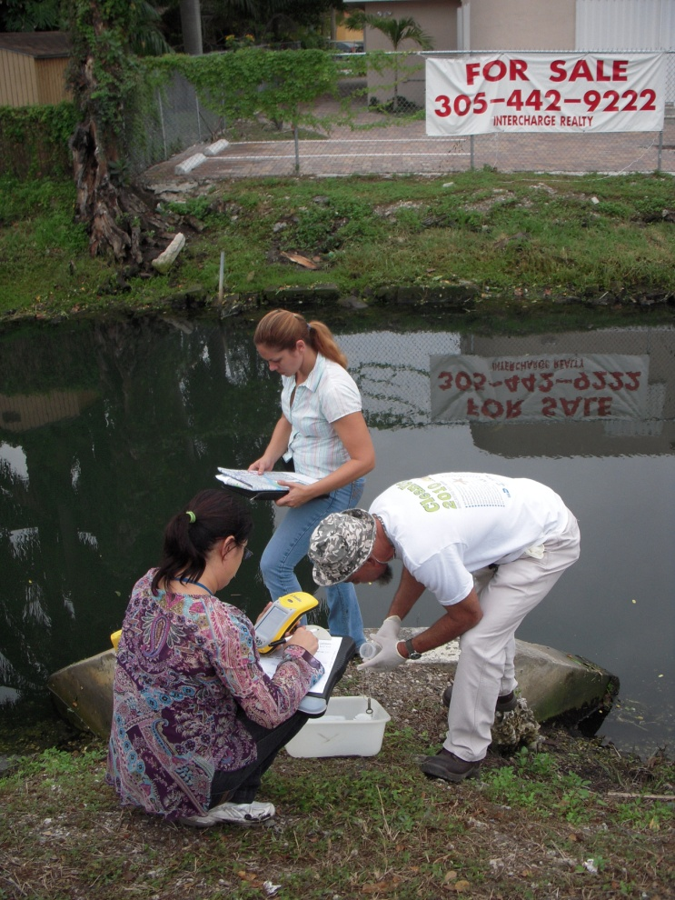
Figure 33. Walk the WBID team members carrying out water quality sampling at one of the VA Hospital outfalls.

Figure 34. Water quality sampling results at the VA Hospital outfall showed levels of 50 CFU/100mL on November 18, 2010.

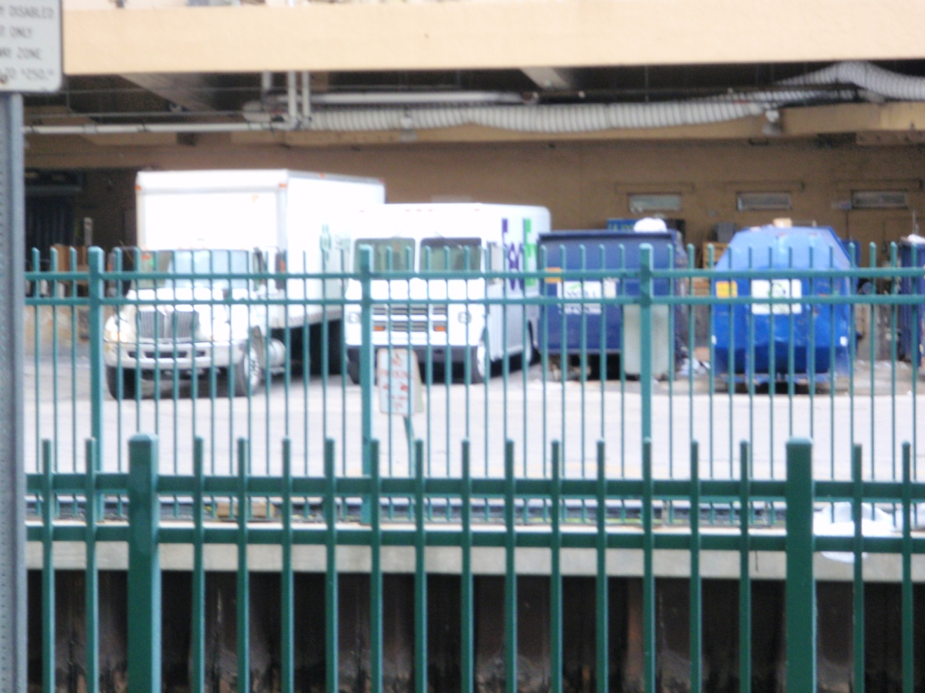
Figure 35. A channelized Wagner Creek flowing past the University of Miami Medical Center, showing dumpsters and trucks right next to the creek, with no berm to prevent untreated stormwater runoff from entering the water.

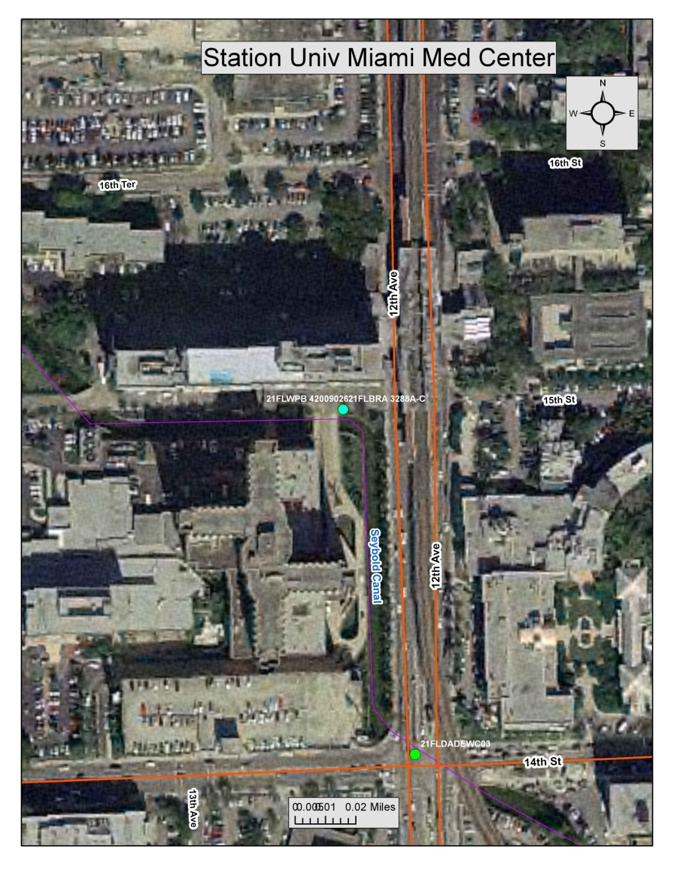
Figure 36. Aerial photo showing the location of Station 21FLWPB 42009026 along Wagner Creek–Seybold Canal, just to the north of the University of Miami Medical Center. Sylvester Comprehensive Cancer Center is visible on the east side of NW 12th Avenue.

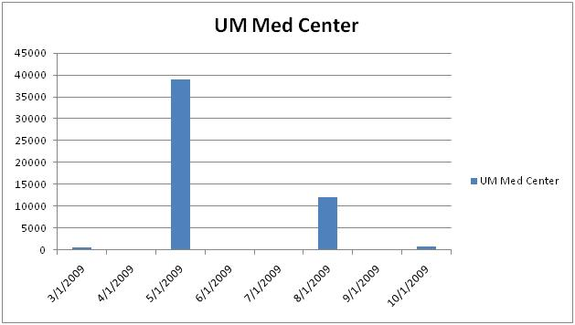
Figure 37. Sampling results at the University of Miami Medical Center, March–October 2009, were as follows: 3/25/2009 = 490 CFU/100mL; 5/20/2009 = 39,000 CFU/100mL; 8/19/2009 = 12,000 CFU/100mL; and 10/28/2009 = 820 CFU/100mL.

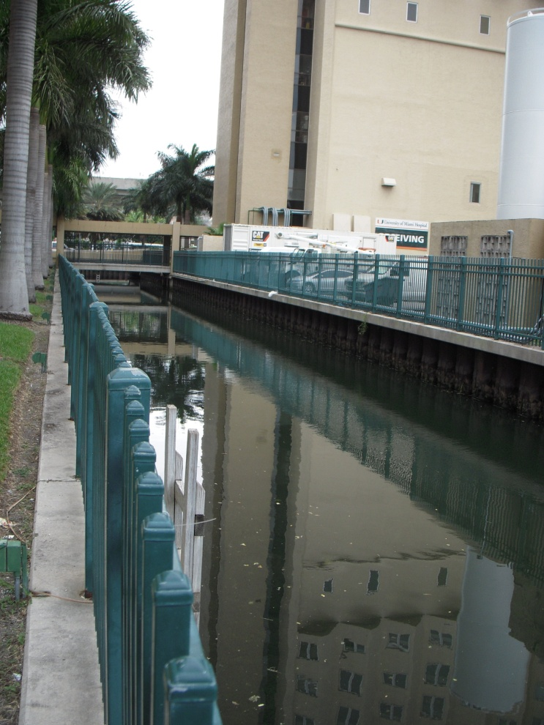
Figure 38. Wagner Creek is channelized next to the University of Miami Medical Center. When the hospital was built, the creek was rerouted to make a 90-degree turn so that there would be enough space on the existing lot to place the hospital building.
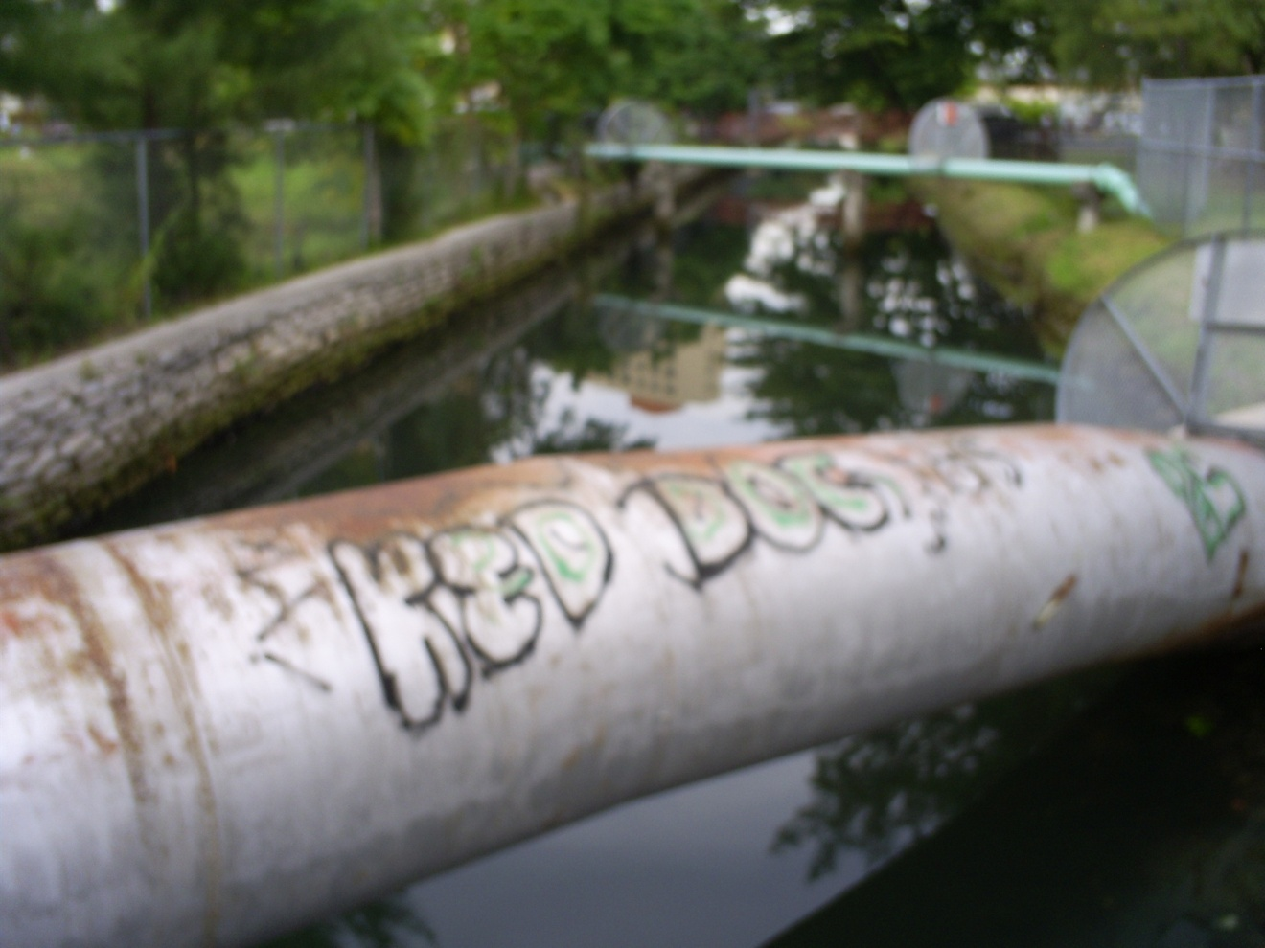
Figure 39. Abandoned sewer line crossing the creek north of the NW 17th Street Bridge.

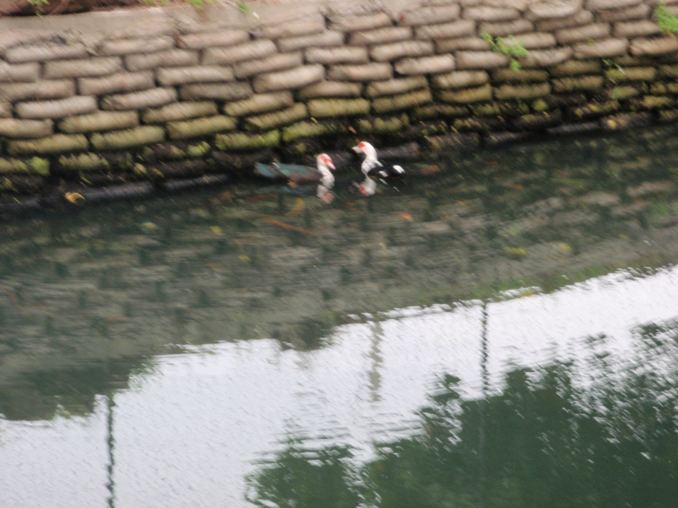
Figure 40. Muscovy ducks in the creek at NW 14th Avenue; waterfowl can be a source of high fecal coliform bacteria in surface waters.

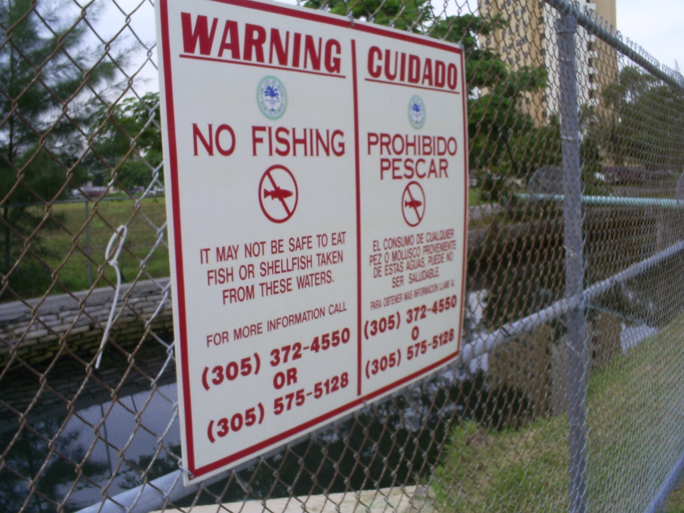
Figure 41. Access to Wagner Creek after the NW 14th Avenue Bridge is limited, and the team was not able to carry out its inspection because a boat is needed to inspect this area.

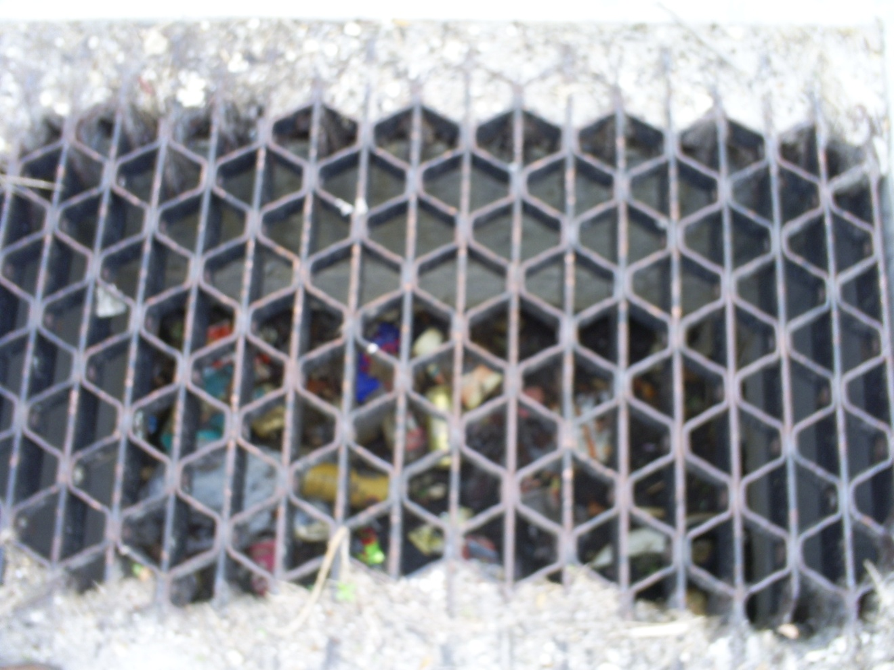
Figure 42. Litter, debris, and trash in a stormwater drain inside the Miami–Dade Transit Culmer Metrorail Station in the Highland Park area.

POST-FIELD EVENT NOTE: Frequently the Metrorail station drainage systems connect to the public right-of-way drainage systems.

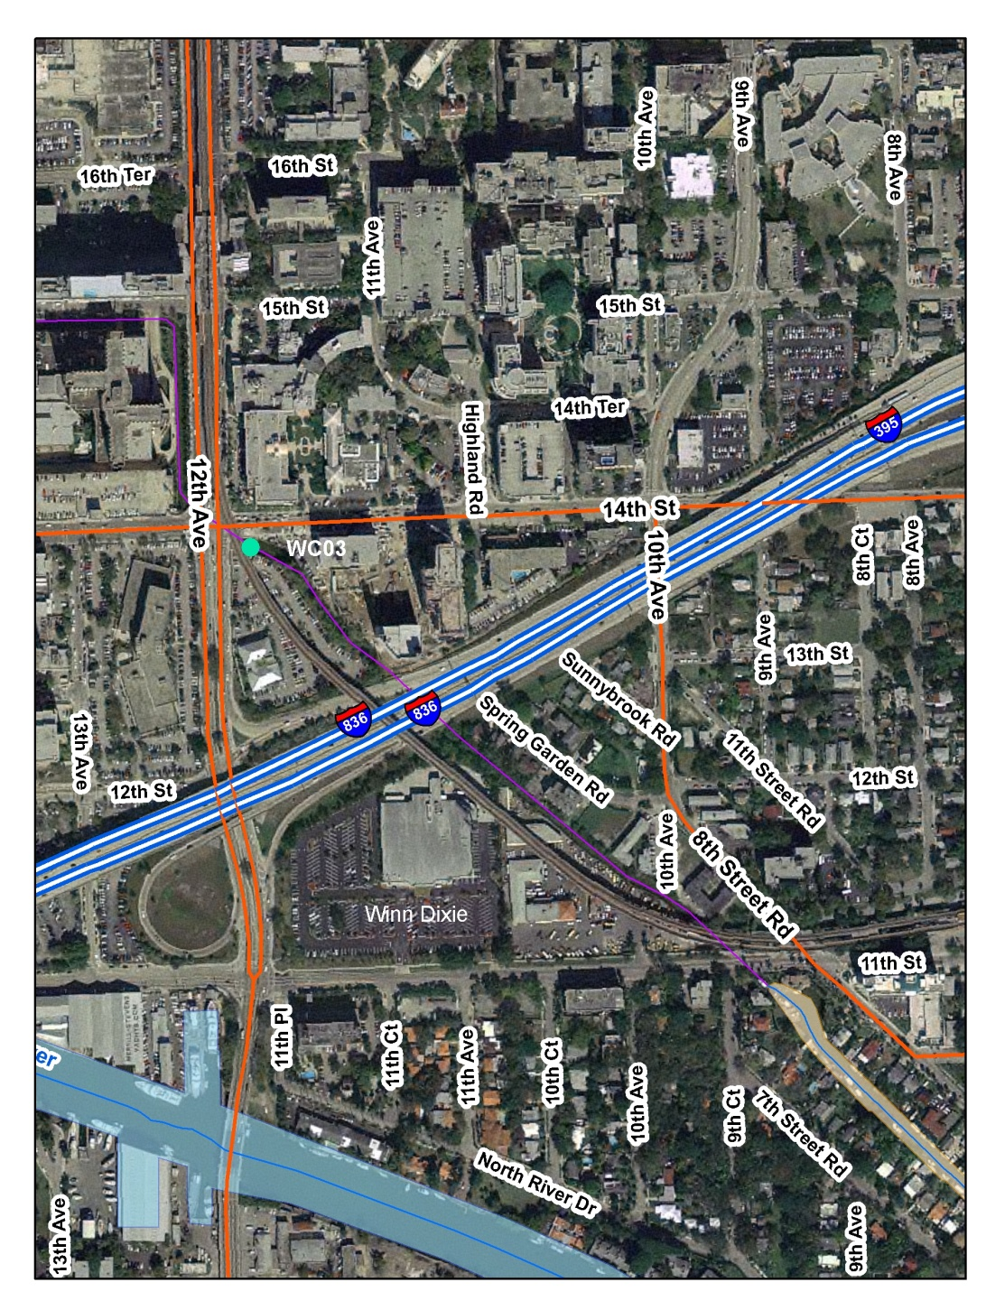
Figure 43. Aerial photo showing the location of Station WCO3 along Wagner Creek–Seybold Canal, adjacent to State Road 836, which is maintained by the Miami–Dade Expressway Authority. Note the drainage swales adjacent to the roadway. These may discharge to Wagner Creek, especially during high-flow conditions. The Winn-Dixie Supermarket, visible in the southwestern corner of the photograph, may have a direct connection to Wagner Creek.

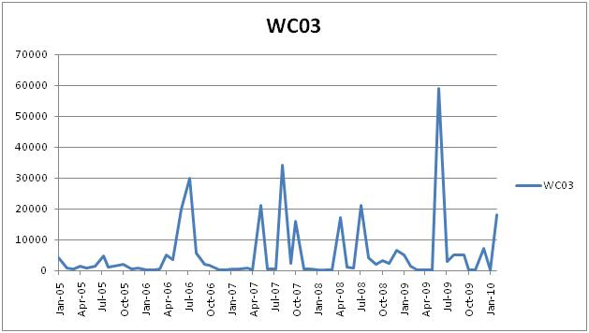
Figure 44. Sampling results for Station WC03, January 2005–January 2010.

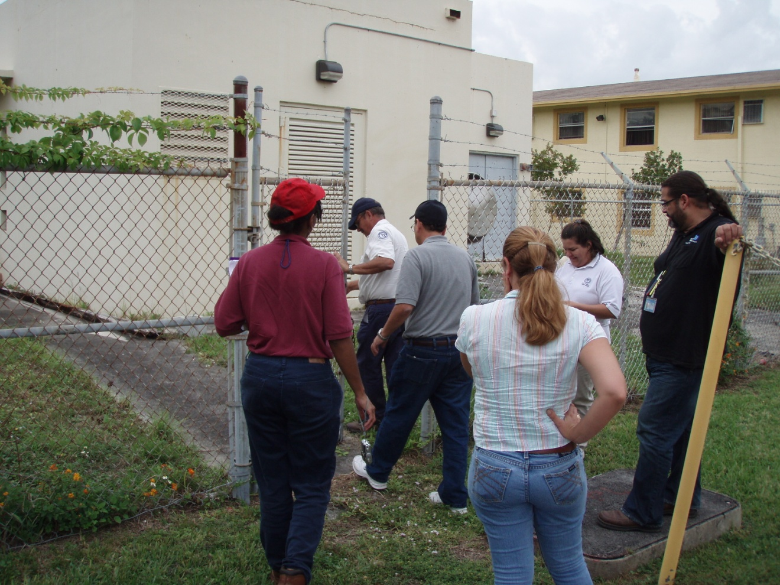
Figure 45. Team members inspecting the City of Miami Overtown stormwater pump station, where construction upgrades are incomplete.

POST-FIELD EVENT NOTE: The City of Miami is currently in litigation with the contractor who was supposed to complete the upgrades. The station has been inoperable for four years, and there is passive gravity flow to the creek from ponds. Documents are not available, and FDOT is checking on the hydrology of the area. The City of Miami obtained the project drawings that show how the Overtown Pump Station connects to Seybold Canal. The information is contained in three separate projects. Drawings for two of the projects were in the City of Miami records, and drawings for the third project had to be requested from FDOT archives. The records indicate that FDOT built the existing Overtown Pump Station as a replacement for a pump station constructed by the City of Miami that had to be removed due to FDOT’s Midtown Interchange Project, which routed Interstate 95 and State Road 836/Interstate 395 through the Overtown neighborhood. The project plans confirmed the connection between the Overtown Stormwater Pump Station, the FDOT ponds, and Seybold Canal.

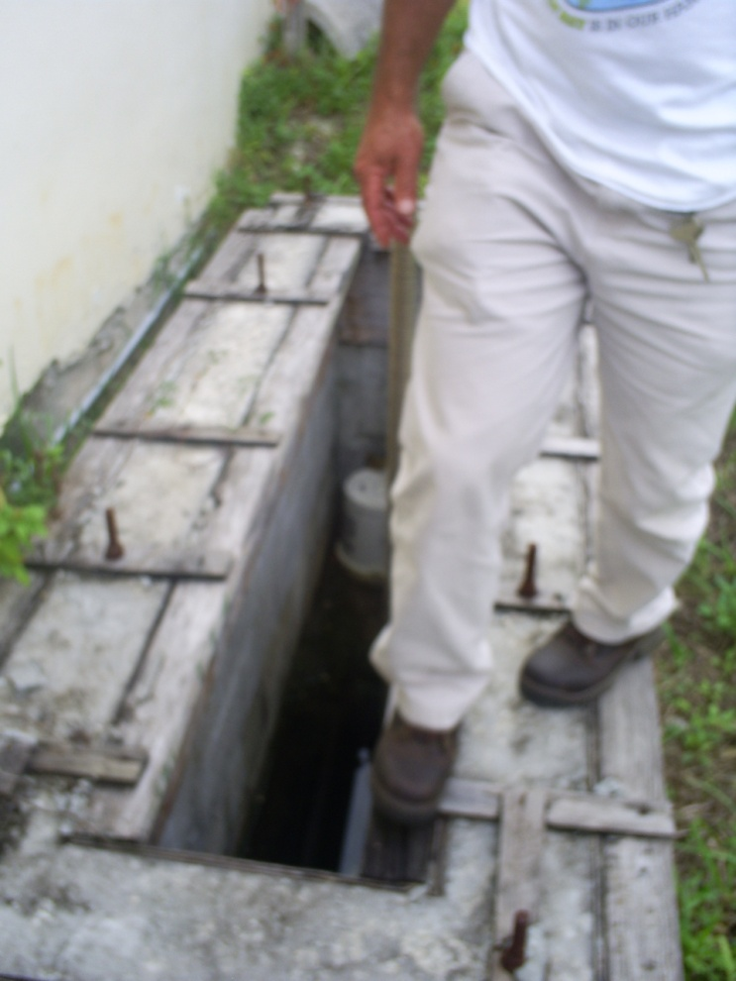
Figure 46. A PIC at the City of Miami Overtown stormwater pump station consists of those portions of the incomplete upgrades that allow foreign objects to enter the stormwater system.

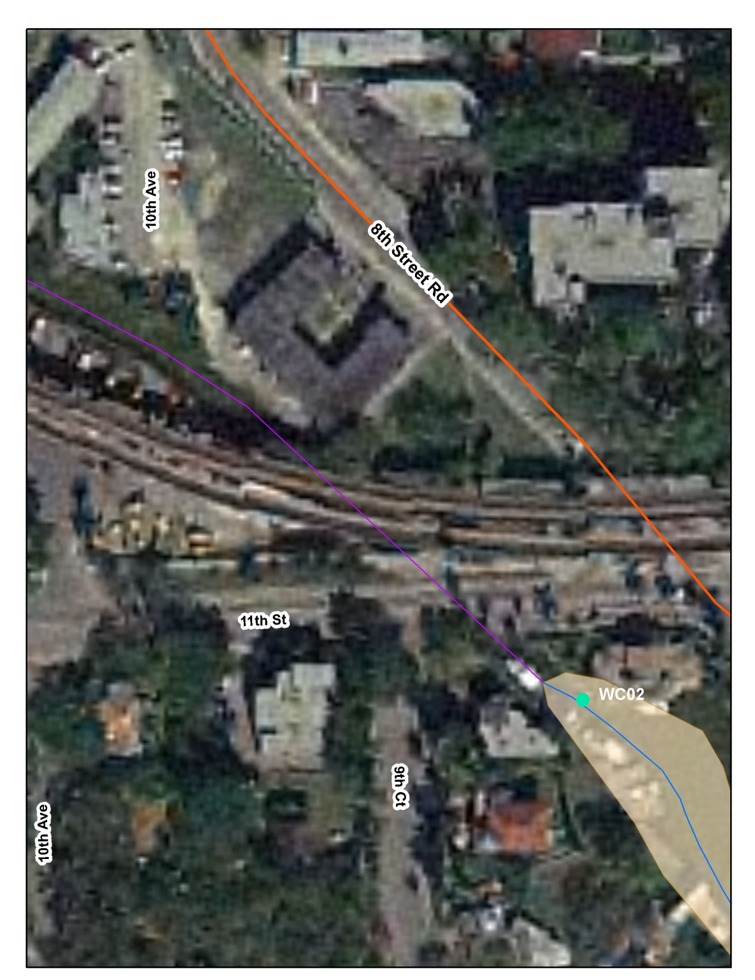
Figure 47. Aerial photo showing the location of Station WCO2 along Wagner Creek–Seybold Canal. A portion of the Miami–Dade County Water and Sewer Department Water Distribution Facility is visible adjacent to Wagner Creek in the westernmost portion of the photo (at far left) to the south of the Metrorail tracks.

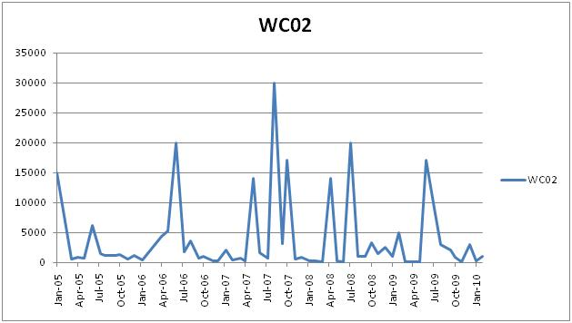
Figure 48. Sampling results for Station WC02, January 2005–January 2010.

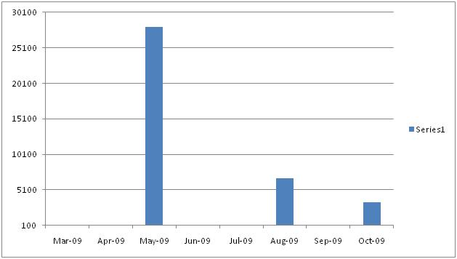
Figure 49. Sampling results for Station 21FLWPB 28040445, March–October 2009. Results were as follows: March 2009 = 150 CFU/100mL; May 2009 = 28,000 CFU/100mL; August 2009 = 6,700 CFU/100mL; and October 2009 = 3,400 CFU/100mL.

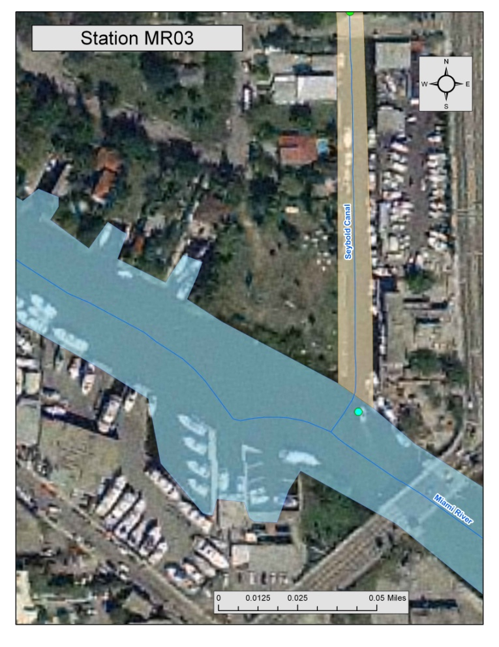
Figure 50. Aerial photo showing the location of Station MRO3, just downstream of where Wagner Creek–Seybold Canal merges with the Miami River. The City of Miami’s Point Park is visible at the confluence of Seybold Canal and the Miami River. A portion of NW 7th Avenue and its bridge that crosses the Miami River are visible on the easternmost portion of the photo (at far right).

POST-FIELD EVENT NOTE: City of Miami records indicate that there are 2 outfalls in the northernmost part of this photo (at top) at the NW 7th Street Bridge. One is a 72-inch line that city records indicate carries the discharge from the Overtown Pump Station. The City of Miami is listed as the owner, and FDOT is listed as the entity with permanent maintenance responsibility for this outfall. The other outfall is a 60-inch by 48-inch box that City of Miami records indicate is owned by FDOT.

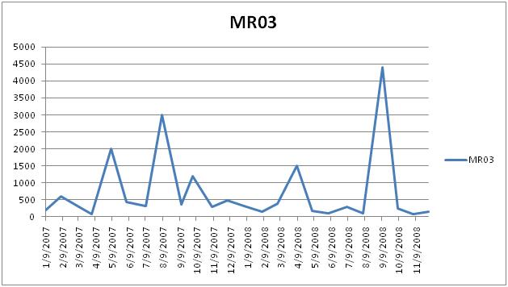
Figure 51. Sampling results for Station MRO3, January 2007–November 2008.

Additional Post-Field Event Inspections
Subsequent to the original Walk the WBID event, a post-field event inspection was carried out of several additional areas that were not walked on November 18, 2010. On June 9, 2011, another field team inspected the VA Hospital facility and then took a boat tour of two portions of Wagner Creek that were not accessible by land.
The VA Hospital is located at 1201 NW 16th Street. Boat Tour Area 2 was situated between NW 19th Terrace and NW 14th Avenue. Boat Tour Area 1 was located between NW 11th Street and Seybold Canal’s terminus at the Miami River. Representatives from the City of Miami, Miami–Dade County DERM, FDEP, and the VA Hospital participated in the inspection. Figures 52 through 81 show the locations that were inspected and the water quality issues and potential fecal coliform sources that the team observed.

VA Hospital Tour
The VA Hospital is an extensive facility, extending from NW 12th Avenue on the east to NW 14th Avenue on the west, and from NW 16th Street on the south to NW 19th Street on the north (Figure 52).
The field team met at the hospital, where Odniel (O.J.) Carlo of the VA Hospital met the other team members onsite. The team met with VA engineering and health and safety staff and reviewed available plans. The most recent plans available had been drawn in 1996 and so did not show the current configuration of the hospital. VA Hospital staff stated that they were waiting for a consultant to complete as-built plans of the facility. Smoke and/or dye testing of the drainage system are planned for the future.
The team then observed the sanitary lift stations onsite. According to available records, the VA has three outfalls that discharge directly to Wagner Creek.

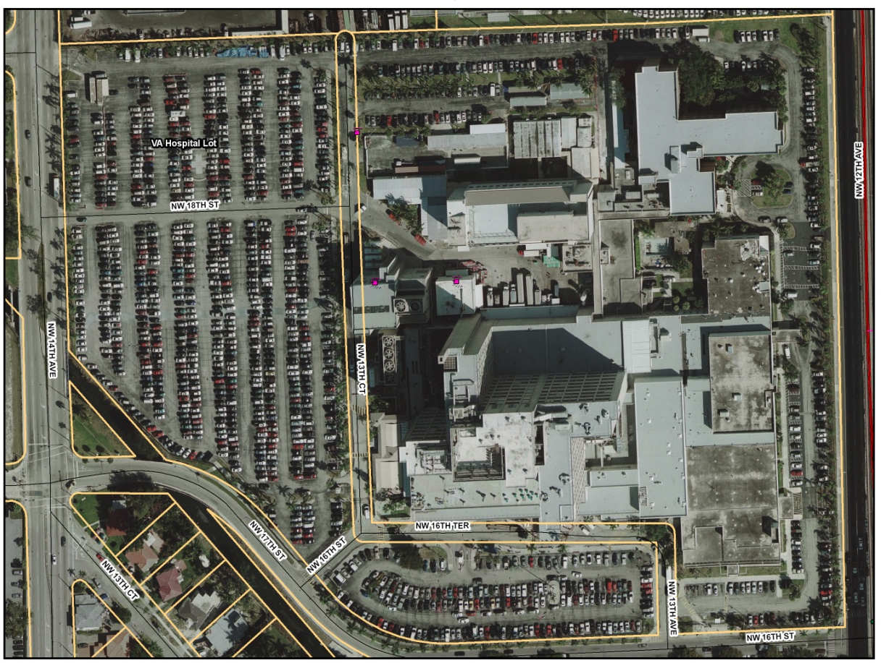
Figure 52. Aerial photo of the VA Hospital.

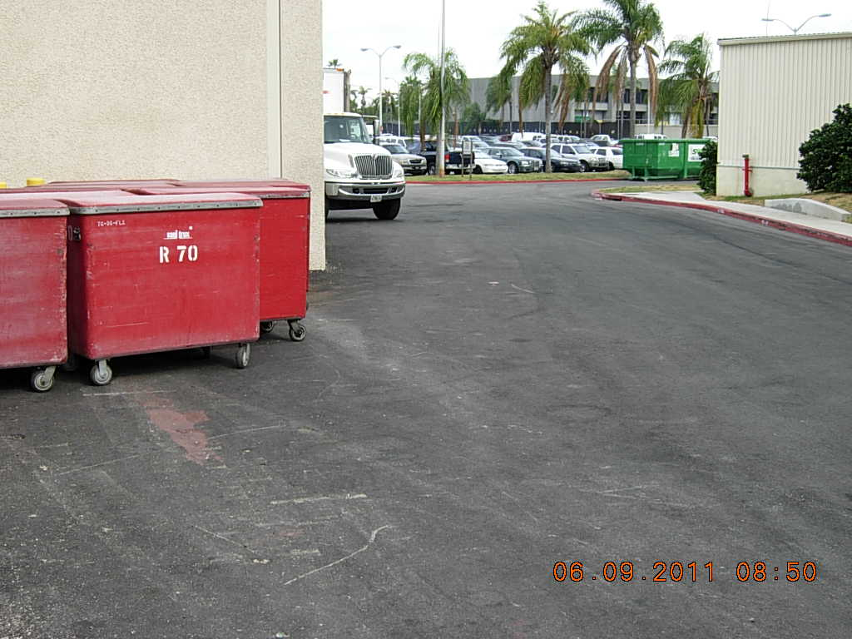
Inlet
Figure 53. View of a portion of the VA Hospital site, near the western parking lot. On the way in to inspect the sanitary lift stations, the team observed closed biomedical waste bins upstream of the curb opening inlet (circled in red at top right). One of the team members observed some small holes in the bins. In the same area, a roll-off container was observed upslope of a drop inlet (at left).

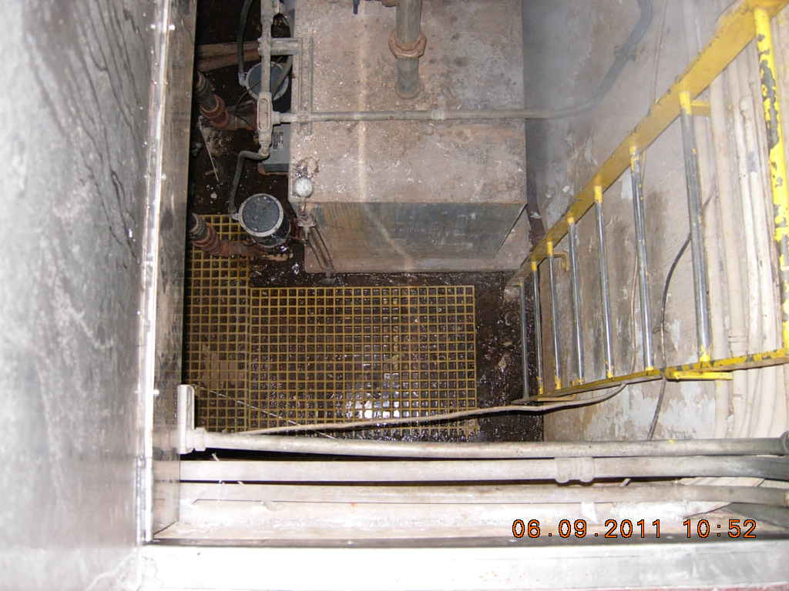
Figure 54. View of the first VA Hospital sanitary lift station, located inside one of the buildings. The VA staff stated that the pump station was “open” rather than “sealed” because it is located in an area where there is a continuous flow of air from outside. Harold Moesch from FDEP entered the pump station for a closer investigation. No unusual conditions were observed. There was a noticeable mercaptan odor at this location.

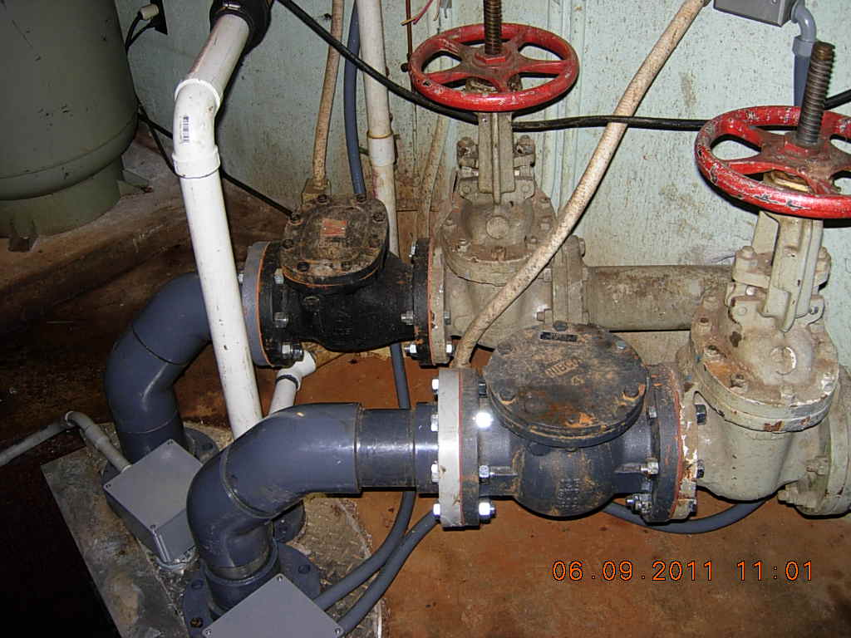
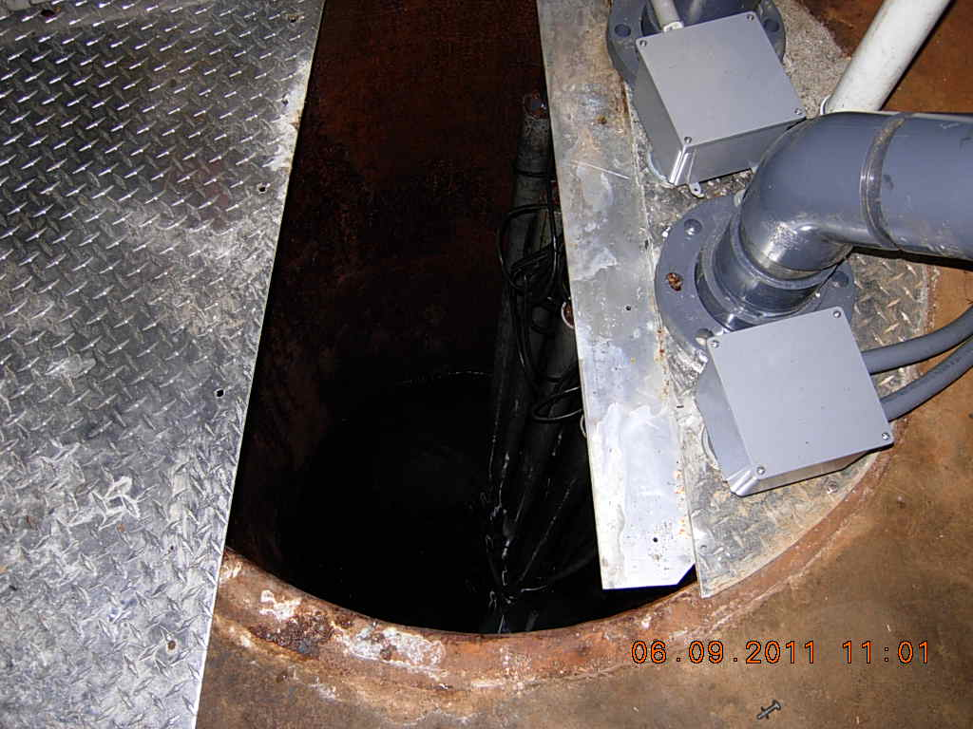
Figure 55. Views of the second VA Hospital sanitary lift station, also located inside one of the buildings. A noticeable sewage odor with ammonia prevailed. The pump station is sealed.

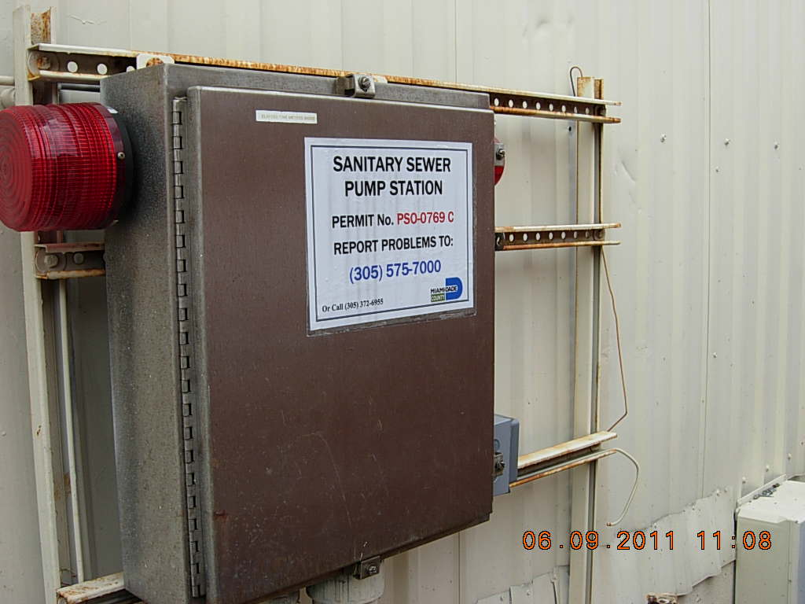
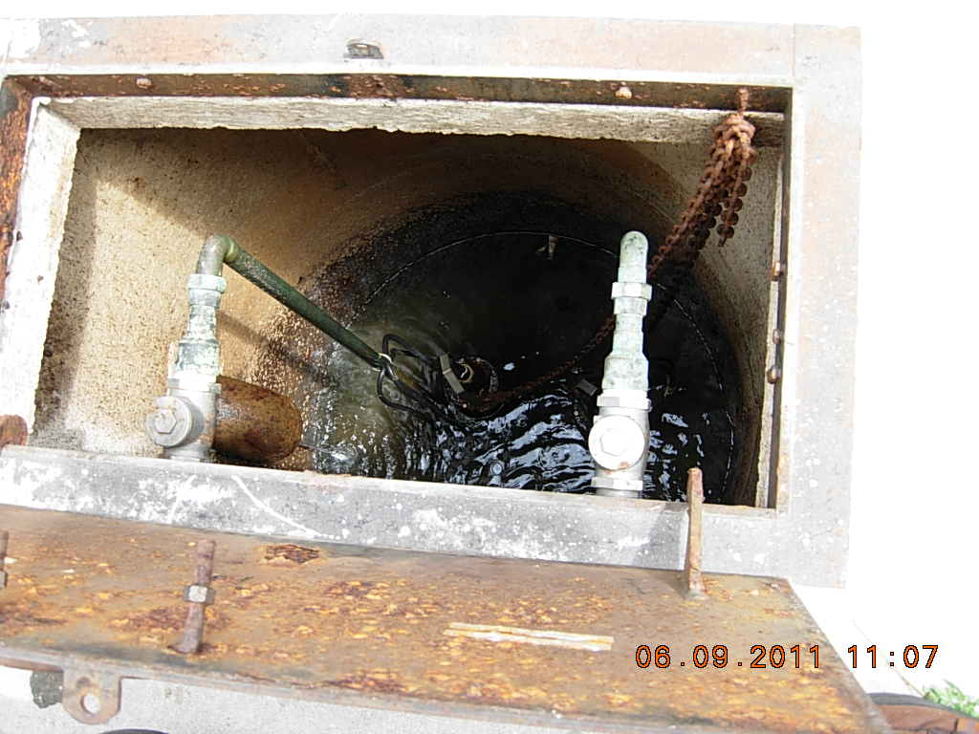
Figure 56. Views of the VA Hospital sanitary lift station located outside between Buildings 8 and 9. The pump station appeared relatively clean. No grease was observed.

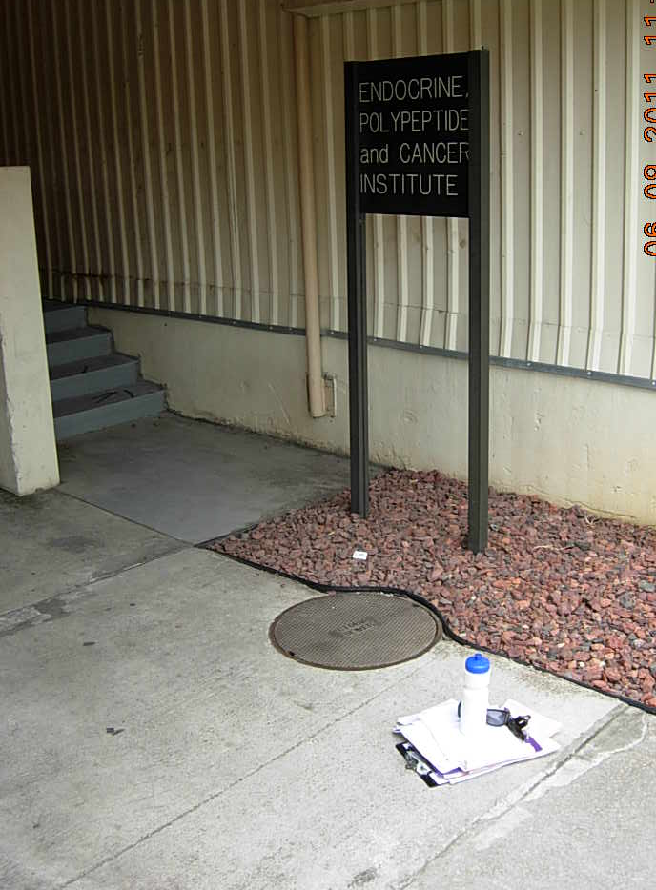
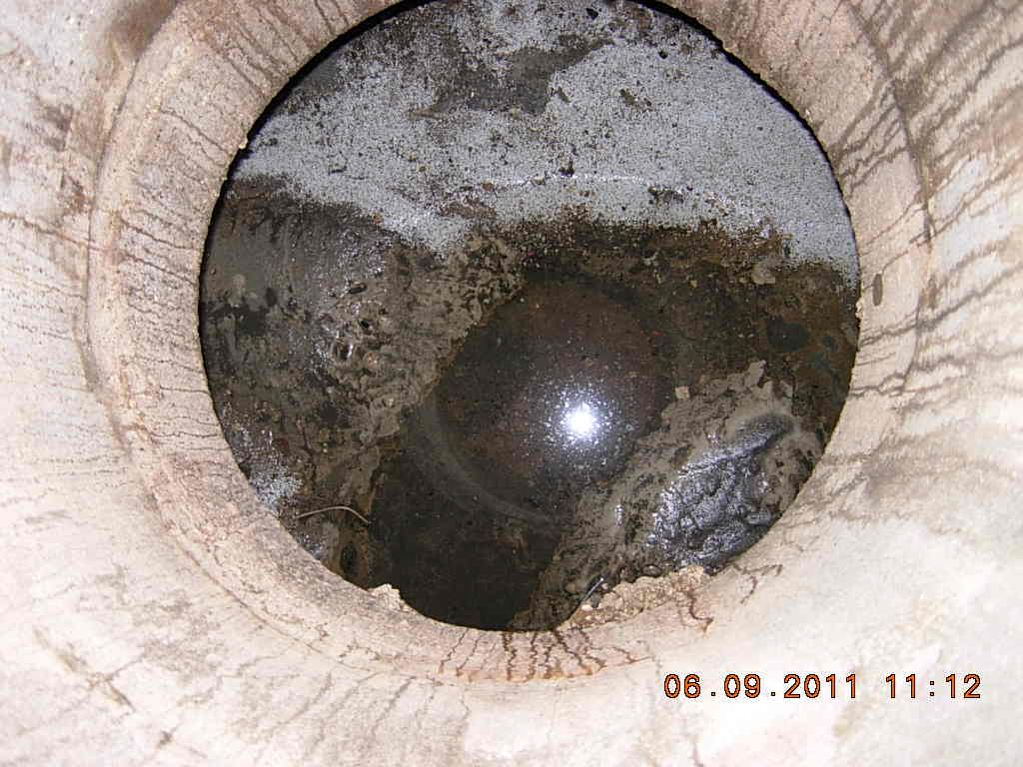
Figure 57. Views of the storm sewer manhole located around the corner from the VA Hospital’s third pump station near the Endocrine, Polypeptide, and Cancer Institute. Upon inspection, no sanitary sewage impact was observed at this manhole.

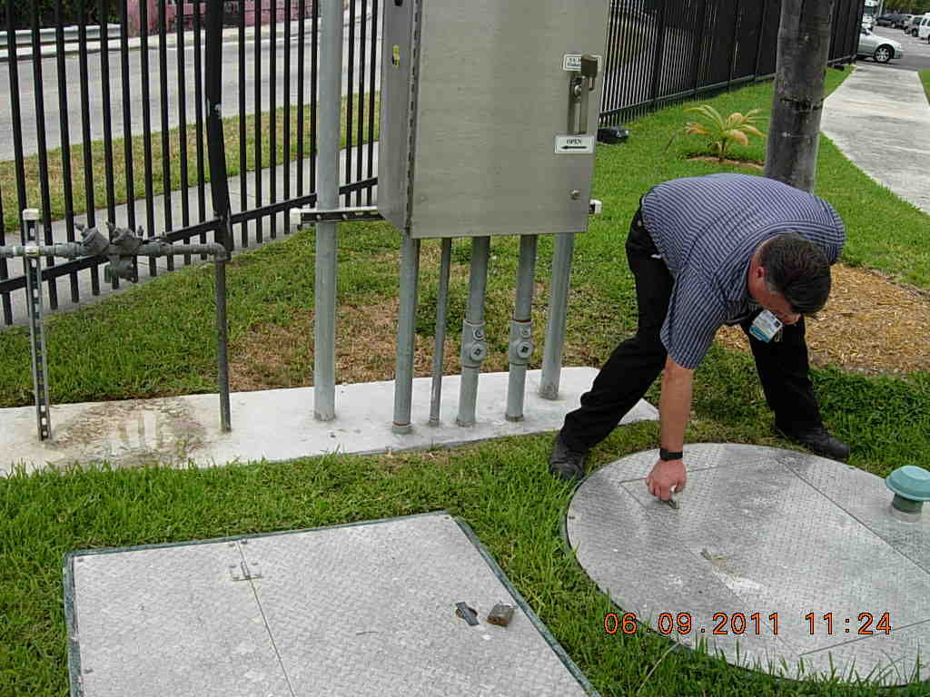
Figure 58. View of the fourth VA Hospital sanitary lift station near NW 17th Street, close to the newly completed Fisher House. The Wagner Creek guardrail is just visible in the upper left corner of the photo. This is a new lift station that had not yet completed the DERM permitting process at the time of inspection. Scott Olsen of the VA Hospital opened the pump station. Debris and some globules were observed. Allen Cox from DERM suggested pumping out the new station.

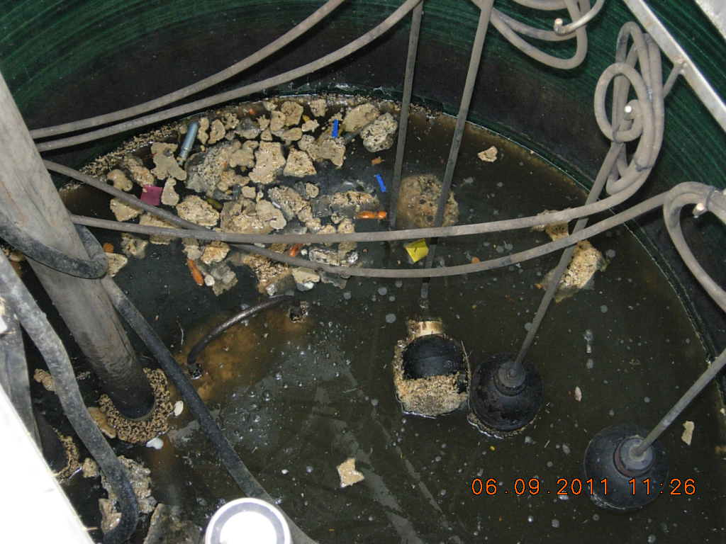
Figure 59. Interior of the new lift station.
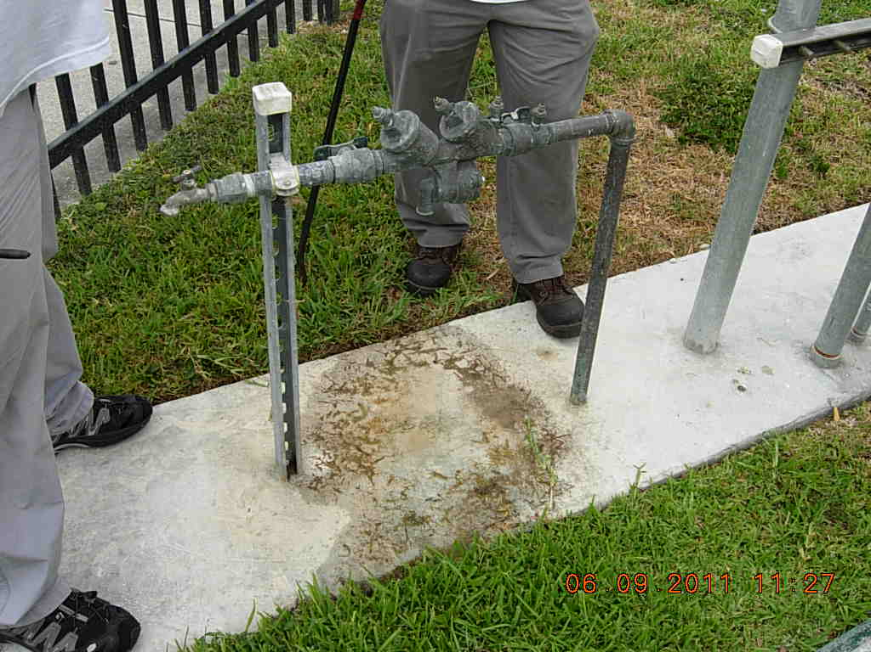
Figure 60. Close-up view of slowly leaking backflow preventer at the lift station.

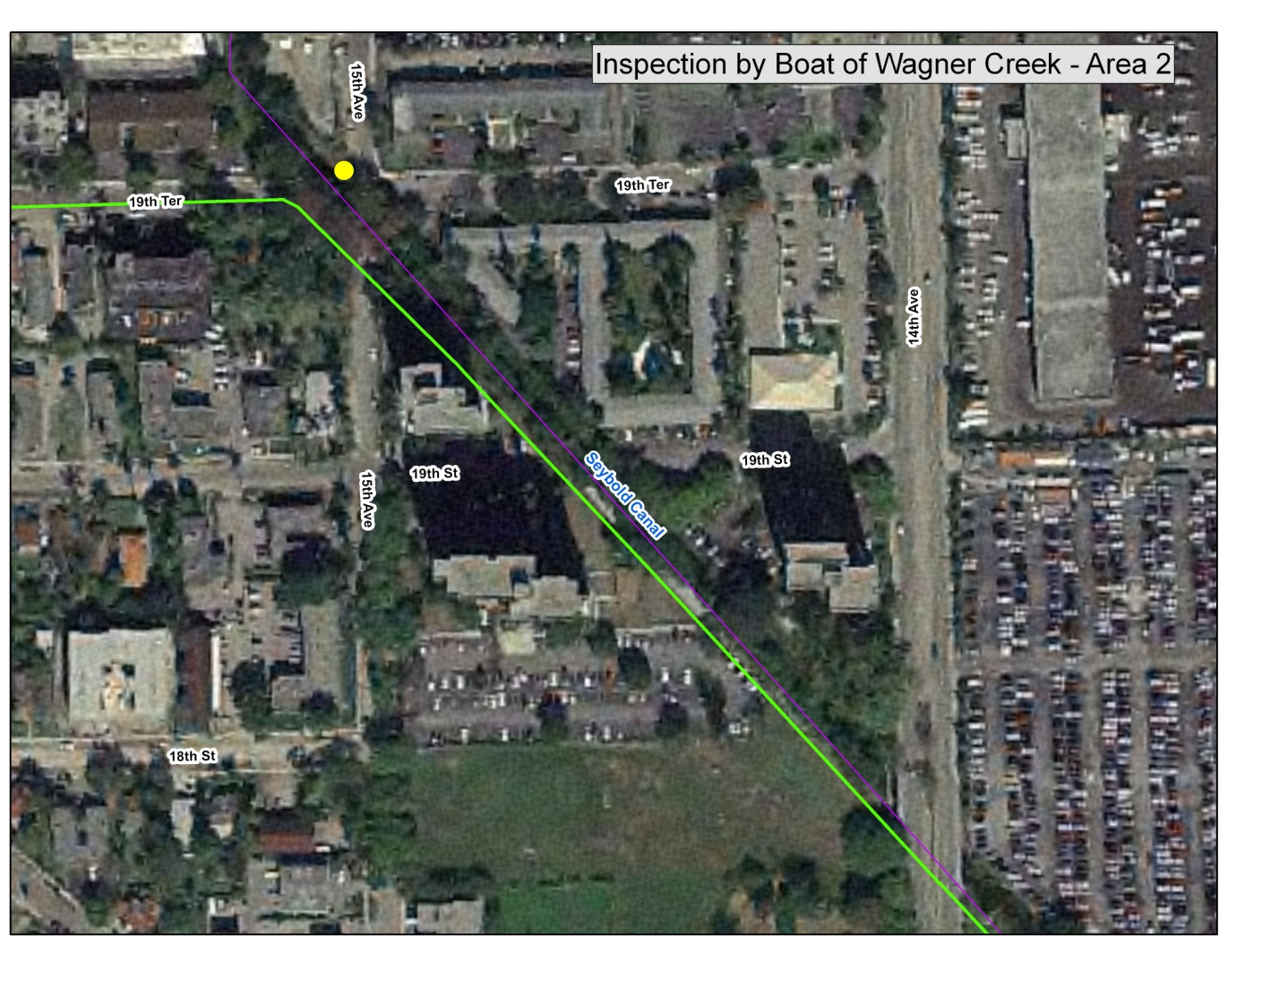
Boat Tour Area 2

Figure 61. Aerial photo of Boat Tour Area 2, located between NW 19th Terrace and NW 14th Avenue. After leaving the VA Hospital, the field team entered this portion of the creek at NW 19th Terrace and NW 15th Avenue and surveyed it from north to south. An odor of dead fish was detected approximately midway through the tour, but no dead fish were observed.

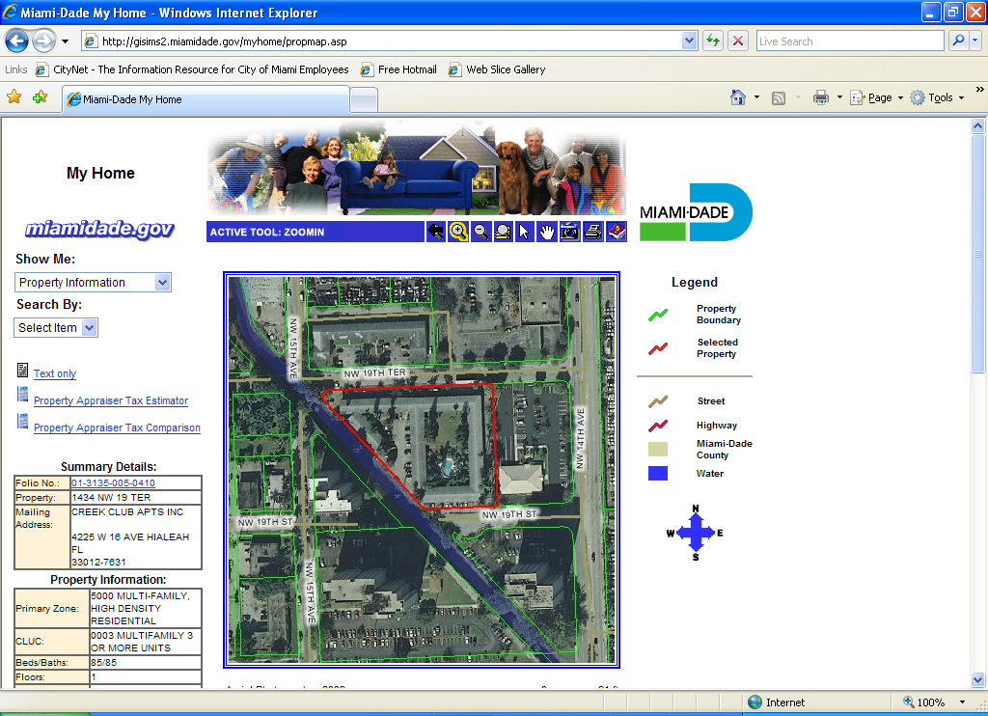
Figure 62. Aerial photo of Creek Club Apartments, 1434 NW 19th Terrace. The team observed several PICs connected to the apartment complex.
POST-BOAT TOUR NOTE: None of the connections observed appear in any of the City of Miami’s Public Works records.

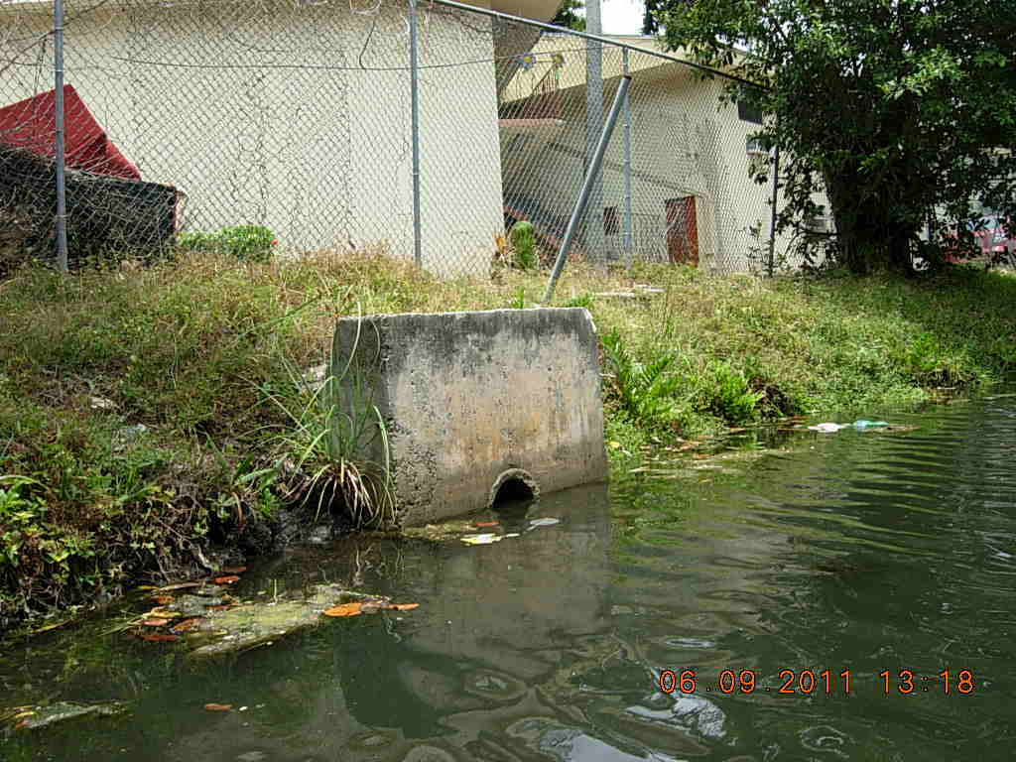
Figure 63. The first PIC was an 8-inch-diameter concrete pipe with a headwall. GPS coordinates are 25 47’ 37.142” N, 80 13’ 15.892” W.

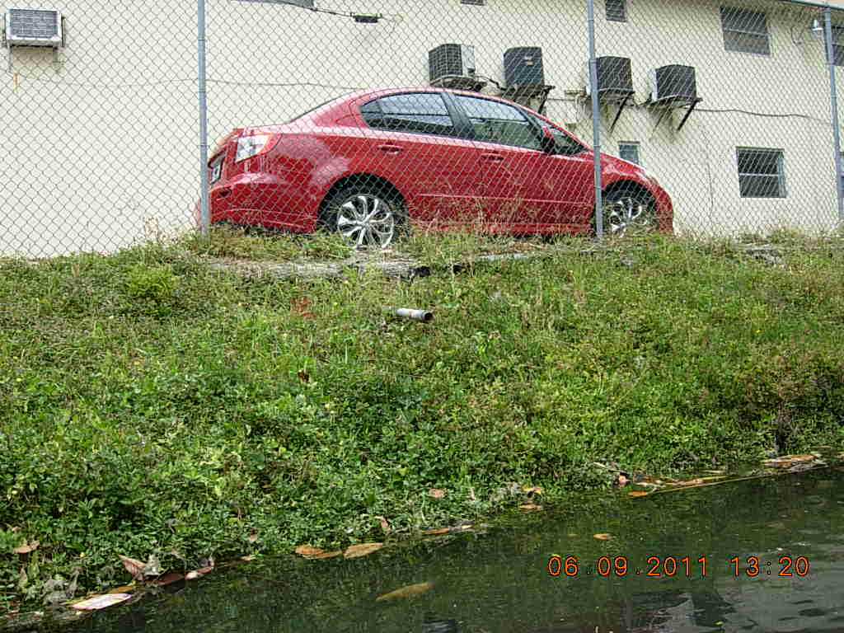
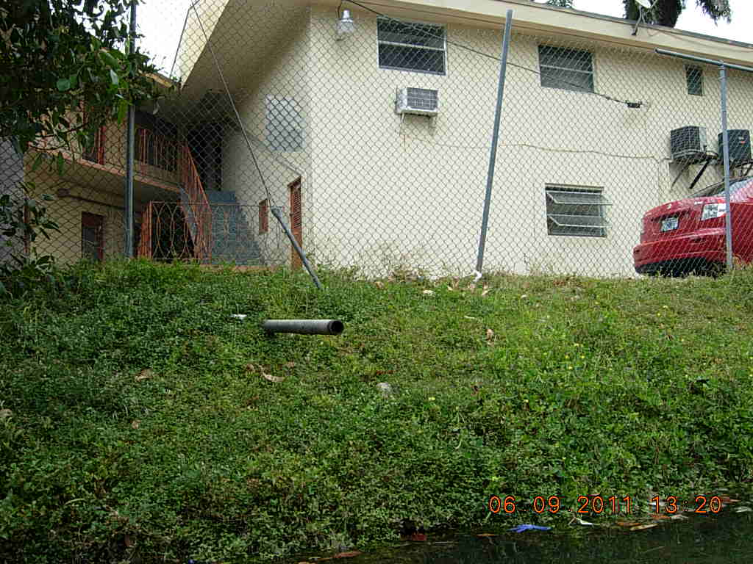

Figure 64. Farther south, two 2-inch diameter metal pipes extended from the same apartment complex. The pipes were within 10 feet of each other. GPS coordinates are 25 47’ 36.699” N, 80 13’ 15.300” W.

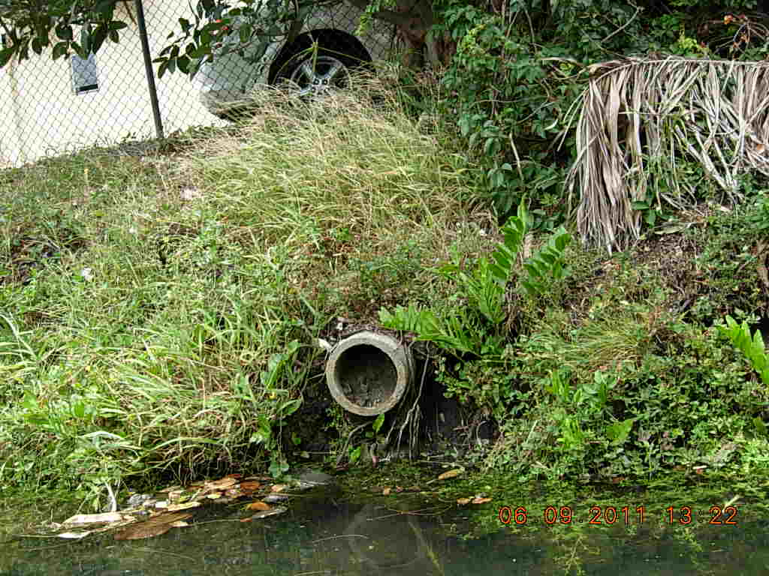
Figure 65. Another 8-inch diameter concrete pipe, without a headwall, was located farther to the south and appeared to belong to the same apartment complex. The outfall was full of sediment. GPS coordinates are 25 47’ 36.299” N, 80 13’ 14.842” W.

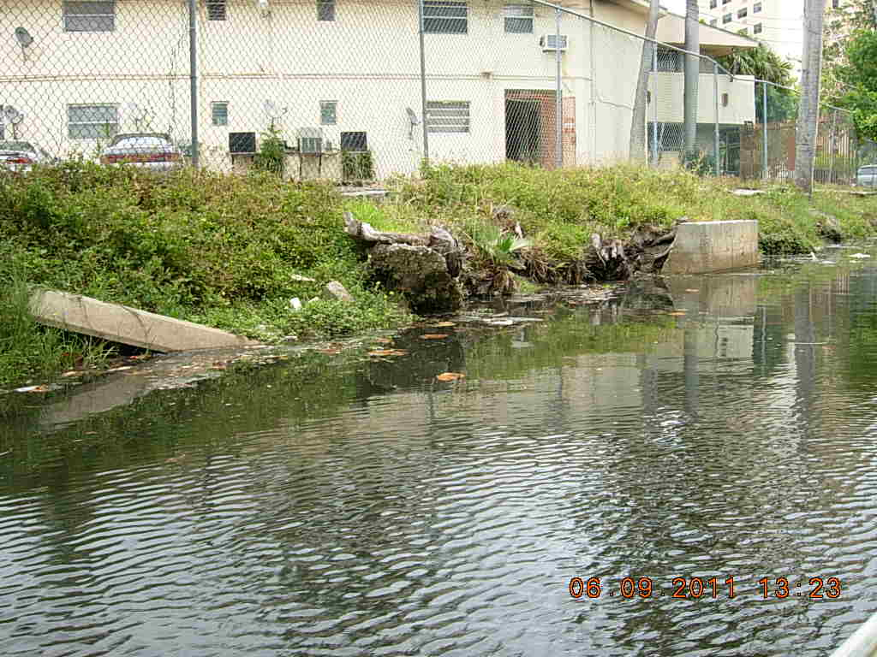
Outfall headwall

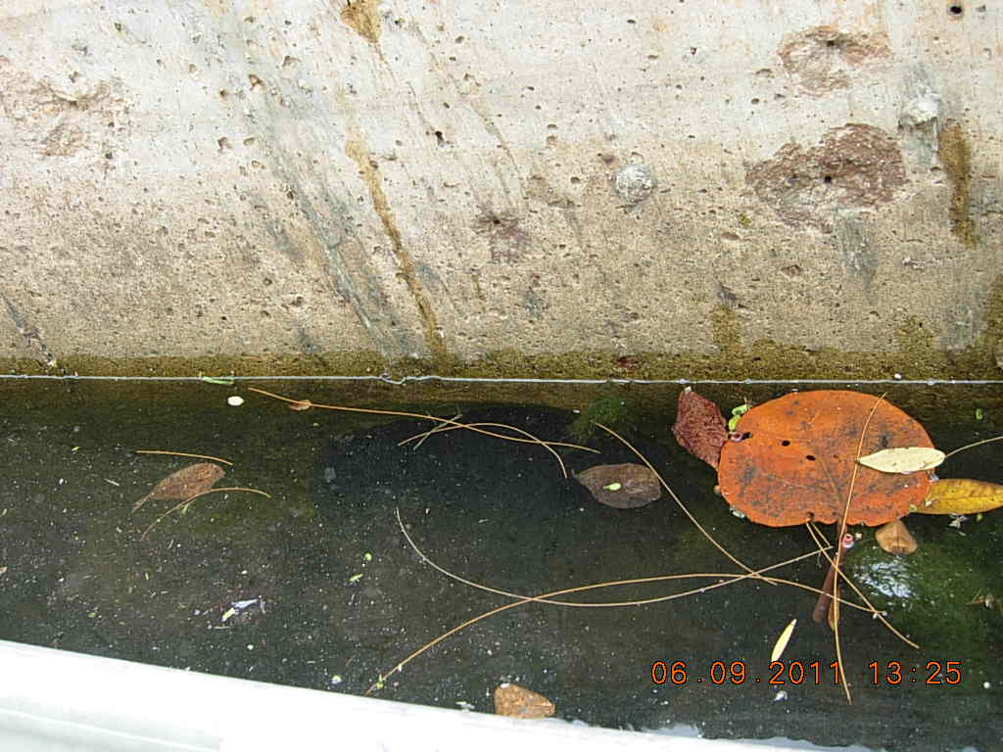
Submerged outfall
Figure 66. Farther to the south, a fully submerged outfall with a headwall also appeared to belong to the same apartment complex. GPS coordinates are 25 47’ 35.516” N, 80 13’ 13.977” W.

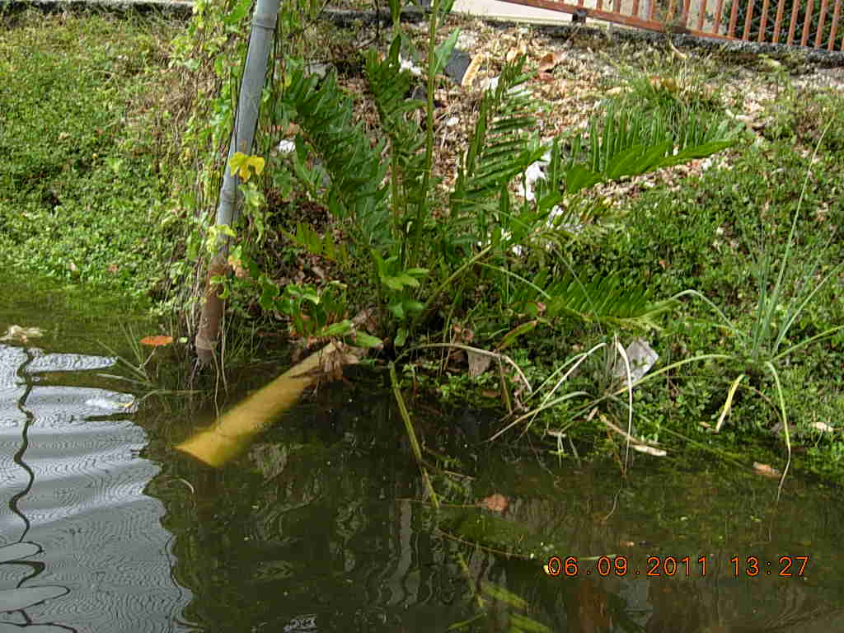
Figure 67. A polyvinyl chloride (PVC) pipe approximately 2 inches in diameter located near the southern boundary of the property could be a PIC or an irrigation line. GPS coordinates are 25 47’ 35.028” N, 80 13’ 13.741” W.

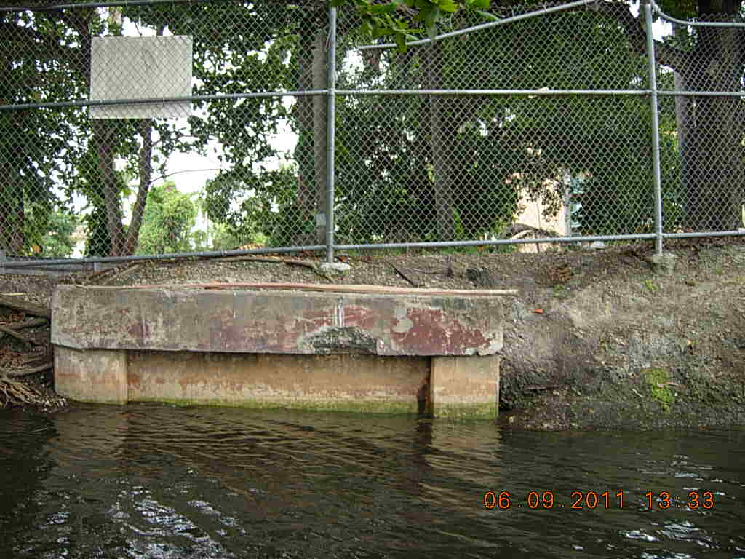
Figure 68. A submerged outfall that appears to be from the public storm sewer system is located across the street from NW 19th Terrace near the put-in point.
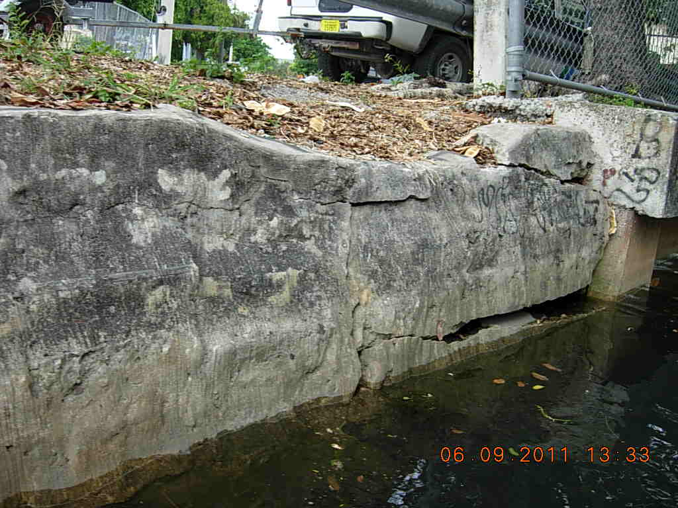
Figure 69. Due to the topography near the put-in point, surface runoff was also observed to be a potential source of fecal coliform bacteria.

Boat Tour Area 1
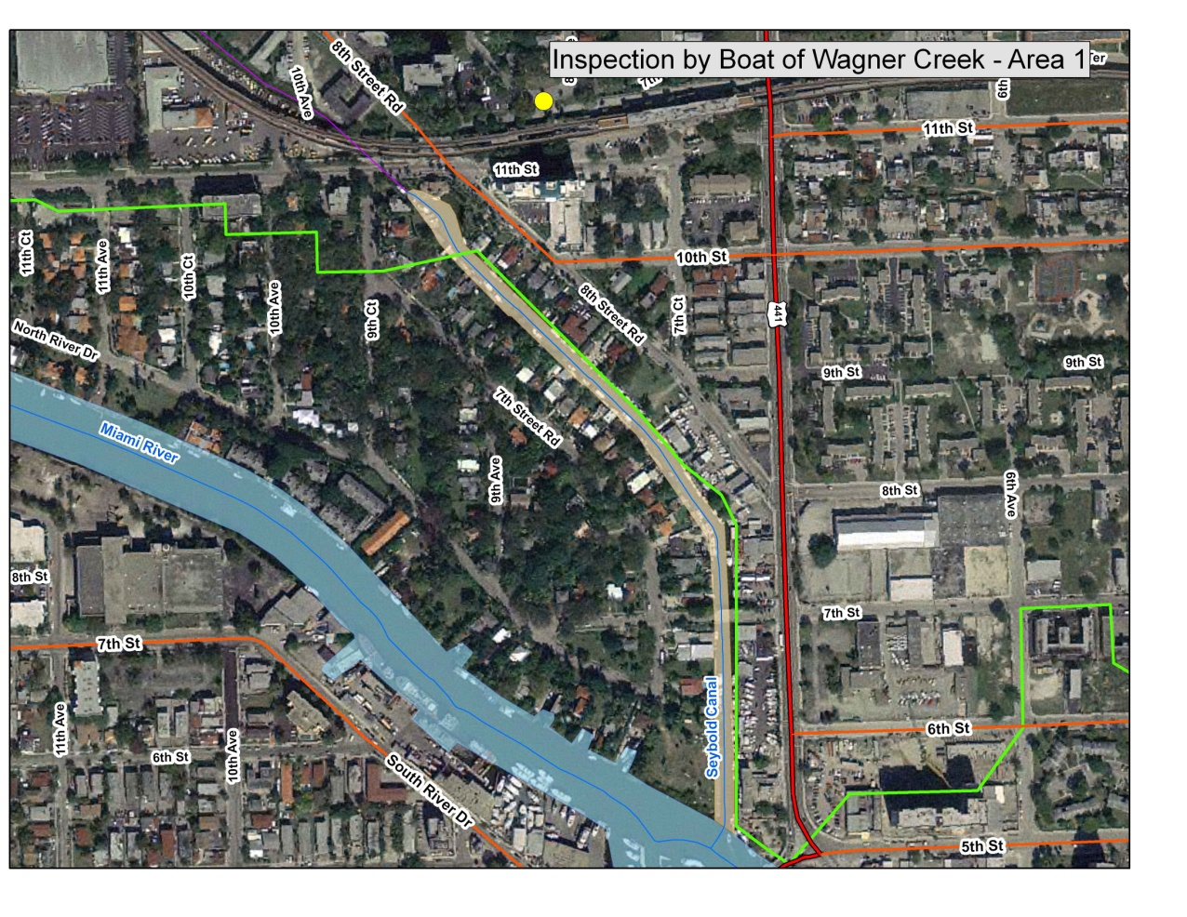
Figure 70. Aerial photo of Boat Tour Area 1. The field team entered this area from Miami’s Point Park at the confluence of the Miami River and Seybold Canal and surveyed the area from south to north. A manatee was seen in the southern portion of the creek, but the team was not able to take a photo.

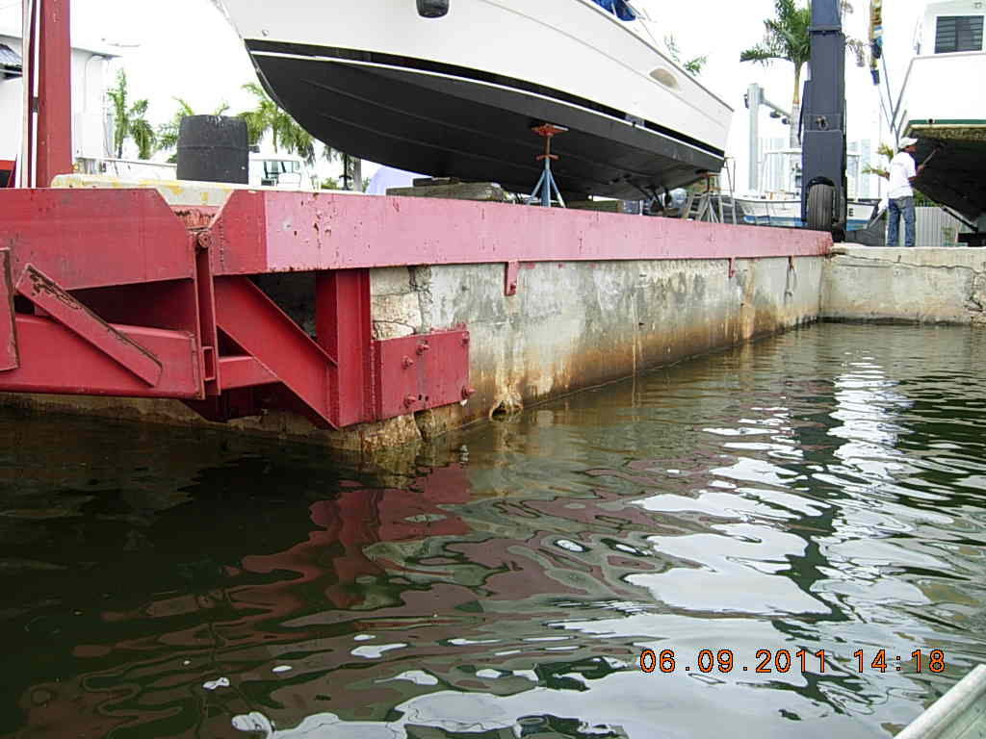
PIC
Figure 71. PIC observed at Campeones Boatyard, 600 NW 7th Avenue. GPS coordinates are 25 46’ 45.720” N, 80 12’ 25.987” W.

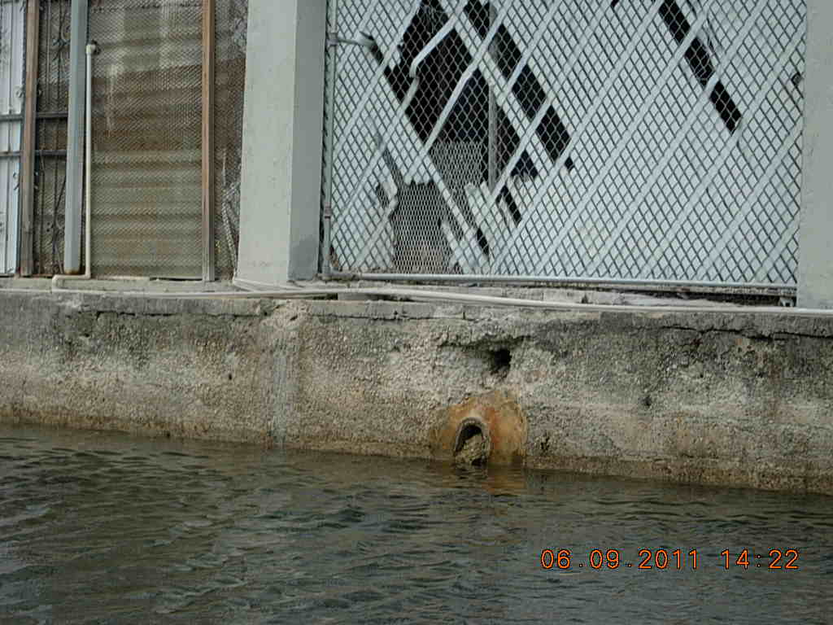
Sealed outfall
Open outfall
1-inch pipe
Figure 72. Additional PICs observed at Campeones Boatyard. The lower outfall appears to be either full of sand or abandoned and filled with concrete. The upper outfall still appears active. Also note the small-diameter pipe that extends from the screen and then runs along the top of the seawall. The GPS coordinates of these outfalls and PICs are 25 46’ 49.231” N, 80 12’ 25.968” W.

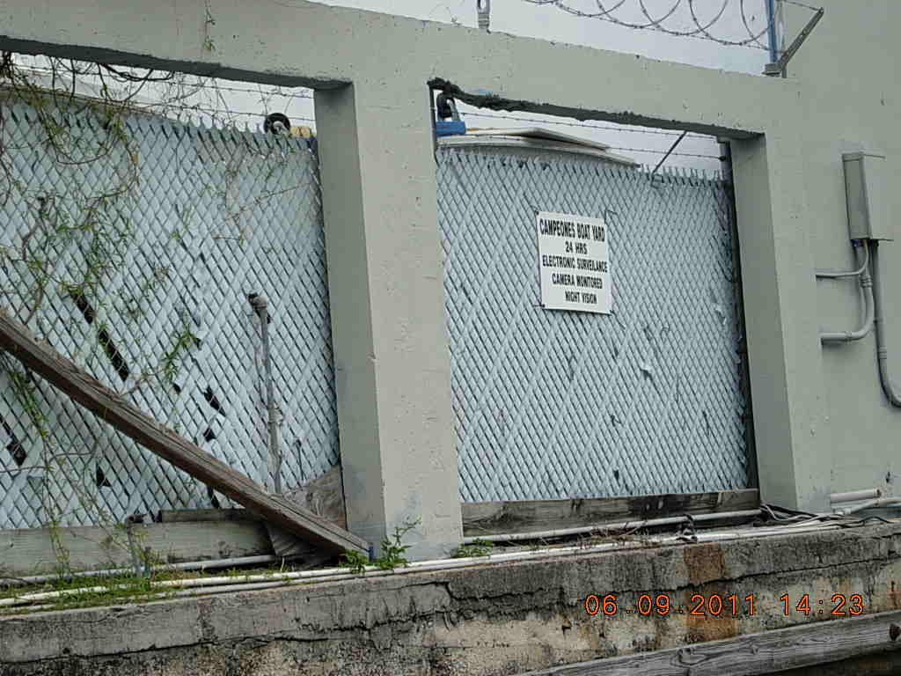
Figure 73. A PIC or electrical connection located a few feet north of the two Campeones Boatyard outfalls. GPS coordinates are still 25 46’ 49.231” N, 80 12’ 25.968” W.

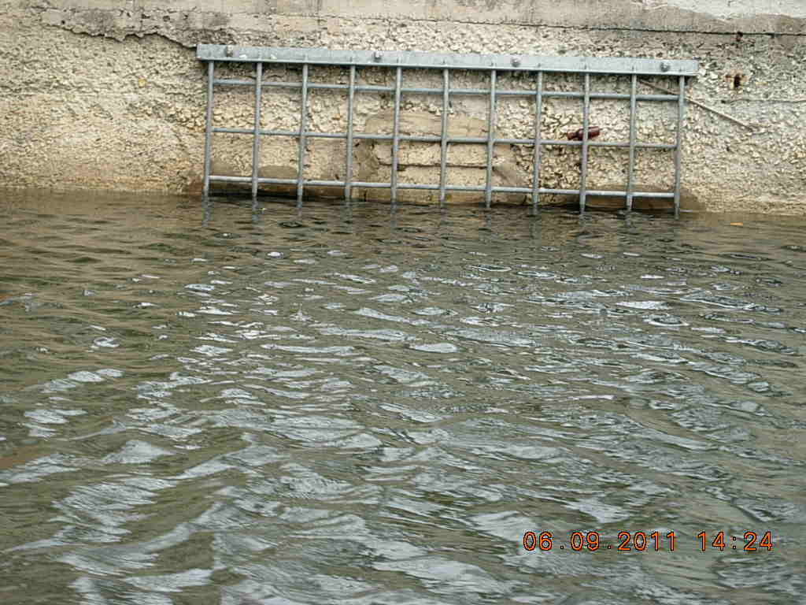
Figure 74. A sealed outfall with a manatee grate at NW 7th Avenue and NW 7th Street. No GPS coordinates were taken.

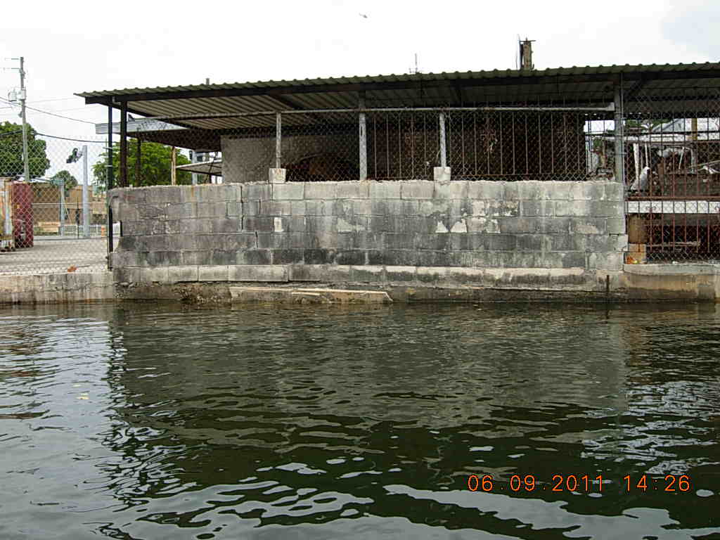
Figure 75. At 732 NW 7th Avenue, the team observed a concrete structure that may be a submerged outfall. The structure could not be observed in its entirety. GPS coordinates are 25 46’ 50.661” N, 80 12’ 26.025” W.

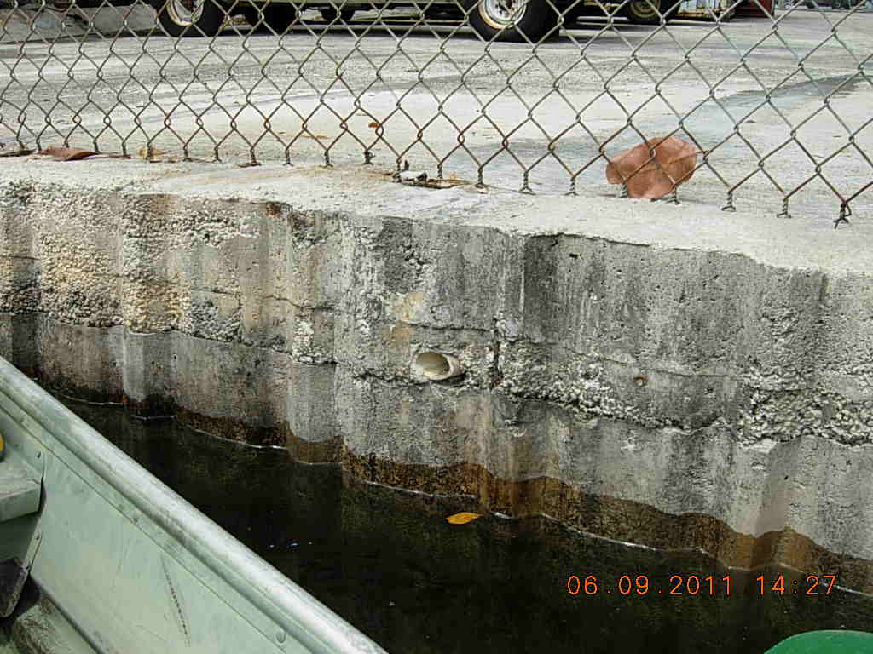
Figure 76. A 1.5-inch PVC pipe originating from Florida Precision at 800 NW 7th Avenue. GPS coordinates are 25 46’ 52.232” N, 80 12’ 25.917” W.

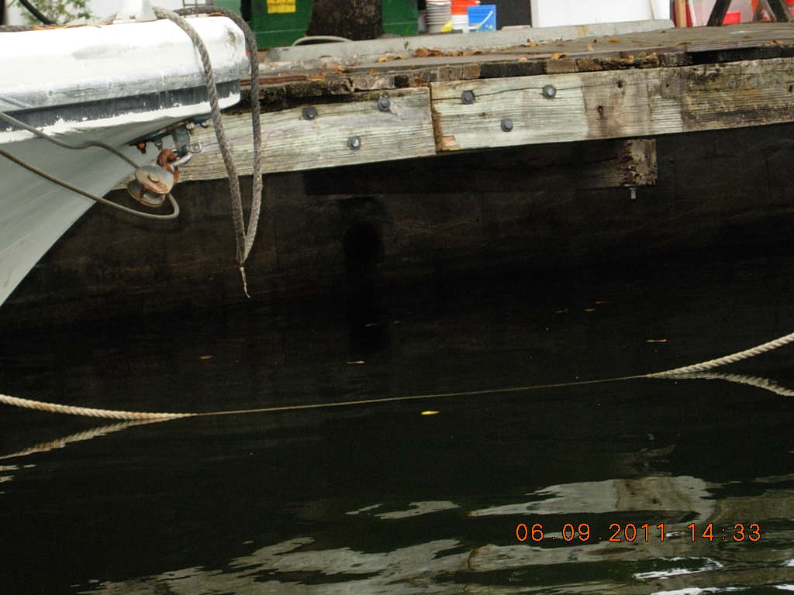
Figure 77. Three 4-inch rusted pipes protruding from Popeye Marine at 810 NW 8th Street. GPS coordinates are 25 46’ 52.232” N, 80 12’ 26.621” W.
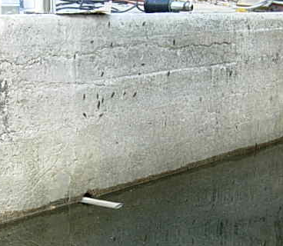
Figure 78. A 2-inch diameter PVC pipe protruding from a private residence. The approximate address is 922 or 938 NW 8th Street. GPS coordinates are 25 46’ 57.121” N, 80 12’ 29.900” W.
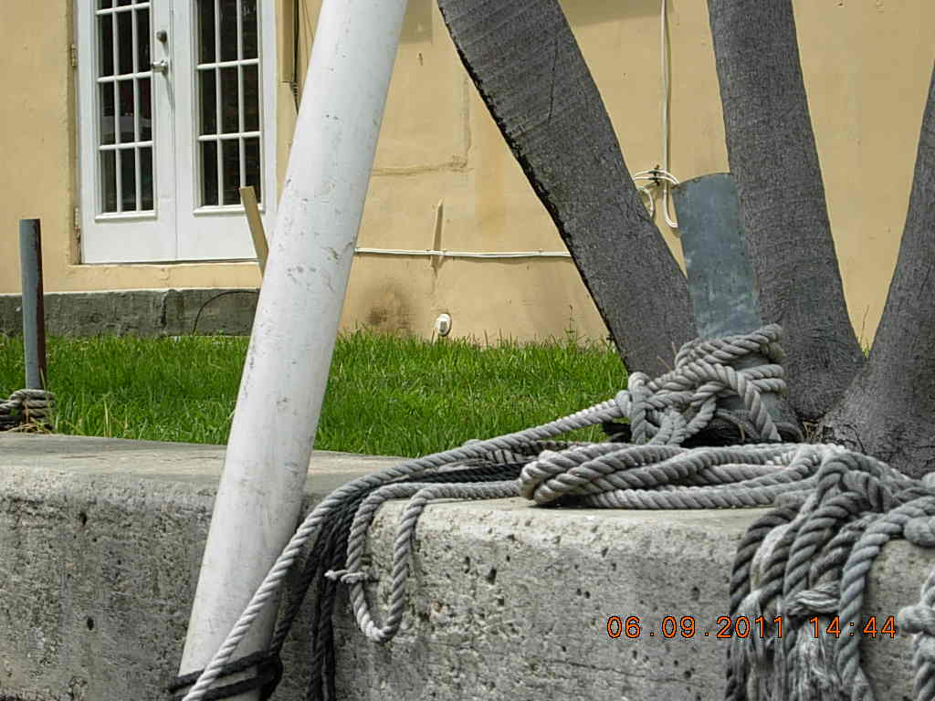
Figure 79. A capped lateral (possibly sanitary) at what appeared to be an apartment house. The approximate address is 938-942 NW 8th Street. GPS coordinates are 25 46’ 57.495” N, 80 12’ 31.280” W.
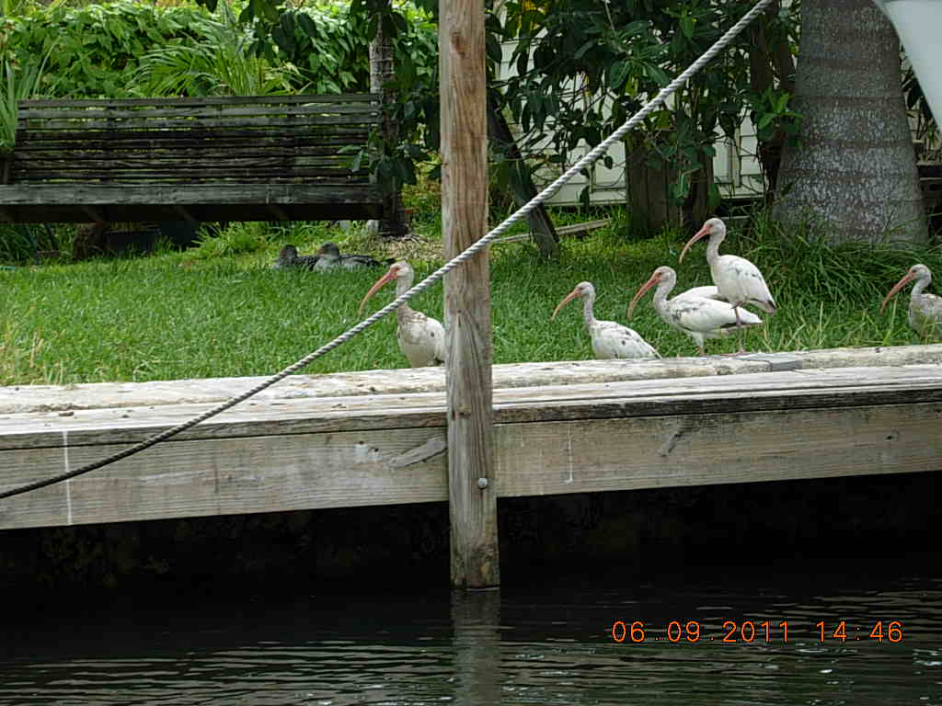
Figure 80. A family of ibises on the south shore of Seybold Canal. No GPS coordinates were taken.

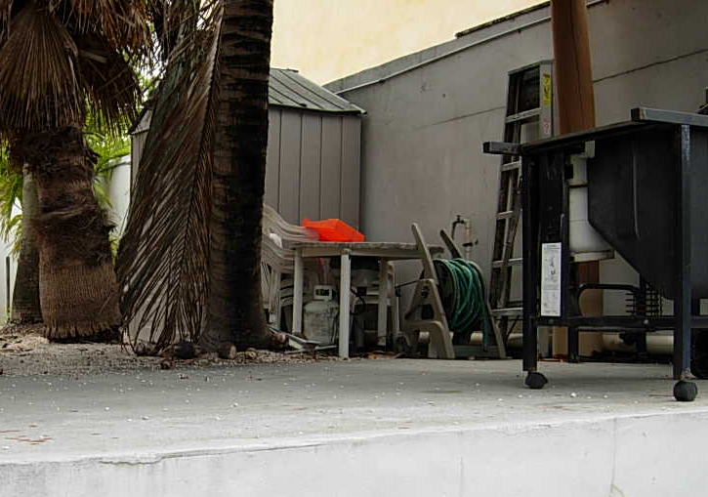
PVC pipe

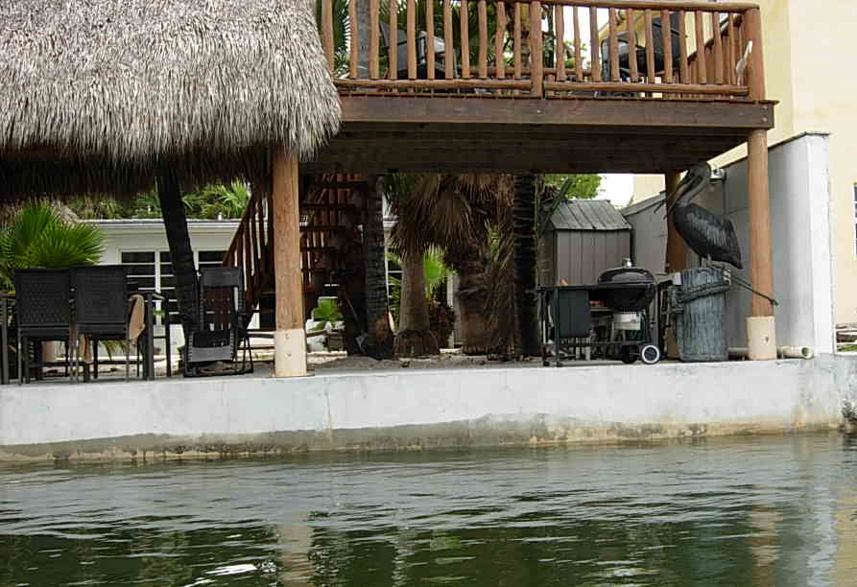
PVC pipe
Figure 81. At 727 NW 7th Street, the team observed a 4-inch white PVC pipe running from the property line at Seybold Canal towards the front of the property.

Next Steps and Follow-up Actions
Table 1 lists each follow-up action to be taken to reduce fecal coliform levels in Wagner Creek, the related figure, the entity carrying out the activity, the date of completion or initiation, and the action that was taken. The table serves as a checklist to ensure that all the necessary follow-up actions are taken.
Table 1. Next steps and follow-up actions for reducing fecal coliform in Wagner Creek
Related Figure(s) | Action Item | Entity | Date Completed/Initiated | Outcome
5, 9, 10, 19, 25, 42 | A:Increase the frequency of stormwater trap cleaning throughout the watershed.  B:Each specific point noted by figures to the left to be verified to be on schedules of the respective entity. | Watershed wide, each entity is responsible for their respectively owned stormwater systems: COM, FDOT, MDC, Miami Dade Express Way Authority, VA Hospital | A: Increased frequency: initiated by COM pre 9/2011. B: Verification related figures are on the schedule: initiated by COM 9/8/11, not yet verified.
4, 6, 15, 16, 24, 34, 37, 44, 48, 49, 51 | Carry out additional monitoring of storm drain system discharging to Wagner Creek–Seybold Canal. | COM | NTP issued May 2nd, 2011. Plan is in process as of Sept 2011. Anticipate the plan to be completed within a year. Additional monitoring may be needed. Outfall monitoring planned to take place during the next rainy season following the completion of the strategy plan. | The City of Miami has issued a notice to proceed to a consultant to create a monitoring plan to identify more precisely the source of fecal coliform loading to Seybold Canal and Wagner Creek.
4, 14, 23, 36, 43, 47, 50 | After a high sampling result at any of the sampling stations, go into the field within 24 hours and if possible sample just upstream and downstream of the location to identify the source. | DERM samples monthly, and can cooperate with others to let them know when a follow up sample must be taken. Follow up sampling person TBD | To be initiated no later than March 7, 2012.
4, 5, 6 | From Juan Pablo Duarte Park to the NW 20th Street Bridge, inspect underground stormwater pipes and ensure they are not clogged. | MDCPW | Completed January 31, 2011 | Miami–Dade County Public Works cleaned the county storm sewer system along NW 20th Street between NW 15th Avenue and Wagner Creek.
4, 5, 6 | From Juan Pablo Duarte Park to NW 20th Street Bridge, inspect underground stormwater pipes and ensure they are not clogged. | COMPW | Completed February 14, 2011 | City of Miami–maintained rights-of- way in this area fall into Public Works Maintenance Grid No. 38. Public Works Operations started cleaning this grid.
None | Inspect wastewater infrastructure from NW 17th Avenue to 20th Street; multiple SSOs have occurred in this area, and the underground stormwater conveyance is close to the creek and inlets. | WASD | To be initiated no later than March 7, 2012.
9, 10 | A: At the Allapattah Produce Market, increase the frequency of stormwater trap maintenance.  B: Each specific point noted by figures to the left to be verified to be on schedules of the respective entity. | Watershed wide, each entity is responsible for their respectively owned stormwater systems: COM, FDOT, MDC | A to be initiated no later than March 7, 2012.  B to be verified no later than March 7, 2012.
9, 10 | A: At the Allapattah Produce Market, carry out regular street sweeping.  B: Each specific point noted by figures to the left to be verified to be on schedules of the respective entity. | Watershed wide, each entity is responsible for their respectively owned stormwater systems: COM, FDOT, MDC | A to be initiated no later than March 7, 2012.  B to be verified no later than March 7, 2012.
9, 10, 11 | At the Allapattah Produce Market, implement public education campaign for businesses in area on stormwater contamination. | NET, Team Metro of MDC, COM MS4 and potentially DERM also. | Choosing flier & passing out fliers to be initiated no later than March 7, 2012.
10, 11, 12 | Increase enforcement of waste disposal codes in Allapattah Produce Market area. | COM, MDC | To be initiated no later than March 7, 2012.
11, 12 | At the Allapattah Produce Market, increase and enhance homeless services to reduce the number of homeless in the area who are retrieving fruit from unsecured dumpsters, or obtaining fruit to sell from local merchants who are seeking to avoid disposal costs using less environmentally responsible methods. | COM’s Homeless Assistance Program, “Green Shirts” | To be initiated no later than March 7, 2012.
12 | At the Allapattah Produce Market, determine whether the drainage system at 1265 NW 21st Terrace is located within the 30-foot-wide utility easement or only within the area where the property owner bears maintenance responsibility. | COM/MDC will determine who’s responsibility it is for maintenance of the road. | Determination to be made no later than March 7, 2012.
12 | At the Allapattah Produce Market, encourage local businesses to install locks or otherwise secure dumpsters to prevent the removal of fruit. | COM Solid Waste /MDC Solid waste could include in a letter. | To be initiated no later than March 7, 2012.
17 | Sample the sheen observed on the water’s surface downstream of the 20th Street Bridge. | Walk the WBID team | Sampled November 18, 2010 | The results showed that oil and grease are not a problem at this location.
19 | Fix broken storm drain covers at NW 20th Street. | MDCPW | Around March of 2012 expected completed. | Storm drain covers will be repaired under proposed project, NW 20St & NW 15 Ave. Drainage Improvement Project
20 | Investigate and resolve the cause of the trash buildup in the storm drain at NW 15th Avenue south of NW 2oth Street. | NA | NA | Plans show that this is a French drain, and is believed not to be contributing to Wagner Creek.  The city has a regular maintenance program in place to clean out the storm drains.
21 | In the area near the 20th Street Bridge, carry out a campaign to educate the public about pet waste. | Team Metro of MDC. MDC owns 20th Street. | To be initiated no later than March 7, 2012.
21 | Install pet waste stations in the area along NW 19th Terrace and NW 19th Street. | COM Solid Waste/ MDC Solid Waste | Discussion to be initiated no later than March 7, 2012.
21 | Increase public education concerning “scoop the poop” campaign. | COM & MDC | To be initiated no later than March 7, 2012.
21, 22 | Identify the owners of the free-ranging chickens or remove free-range chickens from the area. Ask COM Code Enforcement to address the issue of free-roaming pets. Ask County Animal Services to pick up stray chickens. | COM Code Enforcement & MDC Animal Services | Communication between WTW members and animals services to be initiated no later than March 7, 2012.
23 | Investigate whether the apartments located just south of 19th Street have a direct connection to Wagner Creek. | COM, MDC, and FDEP | Boat Tour June 9, 2011 | Boat tour revealed several pipes connecting directly to Wagner Creek from these parcels.
24 | Increase sampling frequency at NW 14th Avenue. | DERM | Discussion and planning to be initiated no later than March 7, 2012.
25 | Clean the partially blocked stormwater drain at 1501 to 1511 NW 13th Court. | COMPW | 5/19/2011 | A service request for storm drain cleaning at 1511 NW 13th Court was sent to Public Works Operations under SR # 11-00103962. The city has cleaned the inlet.
28 | Investigate the storm drain outlets that discharge directly to the creek from apartments at 1310 NW 16th Street. | MDHA | To be initiated no later than March 7, 2012.
29 | Investigate PIC #1 on NW 13th Court. | COMPW contractor | Completed November 19, 2010 | The city has removed the pipe sticking out of ground.
32, 33, 41, 44 | Investigate solids and oils floating on surface water at the stormwater outfall from the VA Hospital building. | Walk the WBID team | Sampled November 18, 2010 | The results showed fecal coliform levels of 50 CFU/100mL.
33, 34 | Inspect the VA Hospital stormwater outfalls and wastewater pump stations. | COM, FDEP, and DERM, VA Hospital Reps. | June 9, 2011 | Wastewater pump stations were inspected with no obvious issues found. Due to the time constraints of the boat tour, only part of the VA stormwater infrastructure was inspected.
35 | Sample just past the dumpsters at the University of Miami Medical Center after a rain event. | MRC approved up to $1700 in water quality samples (DERM’s contracted private lab-100 samples at $17 each) for this WBID. Leading this action item is COM and DERM, if necessary, ask for trained students from a university to volunteer time to grab samples. | Discussion to be initiated no later than March 7, 2012.
36, 37 | Sample at NW 15th Street upstream of the University of Miami Medical Center. | MRC approved up to $1700 in water quality samples (DERM’s contracted private lab-100 samples at $17 each) for this WBID. Leading this action item is COM and DERM, if necessary, ask for trained student from a university to volunteer time to grab samples. | Discussion to be initiated no later than March 7, 2012.
41 | Launch a boat downstream from NW 14th Avenue to complete the inspection of the creek. | DERM, FDEP, and COM | Completed June 9, 2011 | Results reflected in this report.
None | Determine whether Jackson Memorial Hospital has a direct connection to the public storm sewer system that connects to Wagner Creek. | 12th Ave is a DOT road, and FDOT’s storm sewer. | To be initiated no later than March 7, 2012.
42 | Verify the connections between the Metrorail drainage systems to the storm sewer system that leads to Wagner Creek–Seybold Canal, and increase cleaning of Metrorail drainage if connections are verified. | MDCPW and MDT | To be initiated no later than March 7, 2012.
42 | Contact the Miami–Dade County General Services Administration to ask them to clean up litter, debris, and trash in the stormwater drain inside the Miami–Dade Transit Culmer Metrorail Station in the Highland Park area. | MDCPW and MDT | Discussions to be initiated no later than March 7, 2012.
42 | Obtain plans from Miami–Dade County Public Works or Miami–Dade County Transit, or perform a field test to verify connections to the creek from the stormwater drain inside the Miami–Dade Transit Culmer Metrorail Station in the Highland Park area. | MDT and Miami Dade GSA | Planning to be initiated no later than March 7, 2012.
42 | Walk the ditch along State Road 836 to look for potential sources such as PICs, etc. | MDT and Miami Dade GSA | Discussions and planning to be initiated no later than March 7, 2012.
42 | Ask the Miami–Dade Expressway Authority whether the drainage swales adjacent to State Road 836 discharge to Wagner Creek. Field testing may be necessary. | DERM (Marcia Steelman), MDX (MS4 co-permittees) | Discussions and planning to be initiated no later than March 7, 2012.
43 | Ask the City of Miami Building Department whether the Winn-Dixie Supermarket in this area is directly connected to Wagner Creek. Field testing may be necessary. | COM | March, 2011 | Plans show French drains only, no discharges to creek.
45, 46, 50 | Investigate the hydrology of the area around the City of Miami Overtown stormwater pump station. | FDOT | Aug. 2011 | FDOT is investigating.
None | Ensure that the gate valve at the City of Miami Solid Waste Yard is still properly functioning. | COM GSA & COM Solid Waste | Information pursuit to be initiated no later than March 7, 2012.
None | Ensure that solid waste from the City of Miami Solid Waste vehicles is not entering the French drain system at the Solid Waste Yard. | COM GSA & COM Solid Waste | Information pursuit to be initiated no later than March 7, 2012.
None | Ensure that the sanitary/storm sewer cross-connection (discovered before the walk the waterbody exercise) at the Miami–Dade County Solid Waste Transfer Station has been corrected. | MDC Solid Waste | Information pursuit to be initiated no later than March 7, 2012.
None | Verify whether the storm sewer system at the Miami–Dade County Solid Waste Transfer Station connects to the public system that discharges to Wagner Creek. | FDOT- NW 12 Ave, MDC-NW 20th | Information pursuit to be initiated no later than March 7, 2012.
None | Ensure that solid waste leachate from the storage area and trucks at the Miami–Dade County Solid Waste Transfer Station is not entering the storm drain system. | FDOT- NW 12 Ave, MDC-NW 20th | Information pursuit to be initiated no later than March 7, 2012.
None | Implement increased sediment control at the Cemex concrete plant to lessen sedimentation into ditches and waterbodies. | DERM, COM | Information pursuit to be initiated no later than March 7, 2012.
53 | At the VA Hospital, ensure that there is no contamination from biomedical waste bins and roll-off containers entering the curb opening inlet. | VA Hospital, DERM, and COM Code Enforcement.  Maybe DOH. | Information pursuit to be initiated no later than March 7, 2012.
58 | Ensure that the pump station near the VA Hospital’s Fisher House is pumped out and the slow leak from the backflow preventer is fixed. | DERM | Information pursuit to be initiated no later than March 7, 2012.
62, 63, 64, 65, 66, 67 | Investigate whether the PICs at Creek Club Apartments are discharging to the creek. | DERM and potentially COM Building Department | Information pursuit to be initiated no later than March 7, 2012.
68, 69 | Investigate whether the outfalls near the NW 19th Terrace put-in point is discharging to the creek. | COM | Information pursuit to be initiated no later than March 7, 2012.
71, 72, 73, 74 | Investigate whether the PICs at Campeones Boatyard are discharging to the creek. | DERM, potentially COM Building Department, and FDOT | Information pursuit to be initiated no later than March 7, 2012.
75 | Investigate whether the submerged outfall at 732 NW 7th Avenue is discharging to the creek. | FDOT owns 7th AVE, DERM and potentially COM Building Department | Information pursuit to be initiated no later than March 7, 2012.
76 | Investigate whether the PVC pipe at Florida Precision, 800 NW 7th Avenue, is discharging to the creek. | DERM and potentially COM Building Department, FDOT | Information pursuit to be initiated no later than March 7, 2012.
77 | Investigate whether the three rusted pipes at Popeye Marine, 810 NW 8th Street, are discharging to the creek. | DERM and potentially COM Building Department, FDOT | Information pursuit to be initiated no later than March 7, 2012.
78 | Investigate whether the PVC pipe protruding from a private residence at 922 or 938 NW 8th Street is discharging to the creek. | DERM and potentially COM Building Department, FDOT | Information pursuit to be initiated no later than March 7, 2012.
79 | Inspect the history of the capped lateral at the apartment building at 938-942 NW 8th Street to determione if it was a source of fecal coliform to the creek. | COM Building Department | Information pursuit to be initiated no later than March 7, 2012.
81 | Investigate whether the white PVC pipe at 727 NW 7th Street is discharging to the creek. | DERM and potentially COM Building Department, FDOT | Information pursuit to be initiated no later than March 7, 2012.

Acronyms used in the table above:
COM- City of Miami
PW-Public Works
NET- COM Neighborhood Enhancement Team

MDC-Miami Dade County
PW-Public Works
DERM-Department of Environmental Resources Management
GSA-Miami Dade General Services Administration
MDT- Miami Dade Transit
WASD-Miami Dade Water and Sewer Department
MDHA-Miami Dade Housing Authority
MDX-Miami Dade Expressway

FDEP-Florida Department of Environmental Protection
FDOT-Florida Department of Transportation
DOH- Department of Health
VA-Veterans Affairs Hospital
UM-University of Miami

NTP-Notice to Proceed
TBD-To be determined

We extend our appreciation to all who have participated and will participate in the future of this pollution elimination effort.

