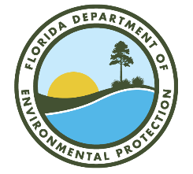

Outstanding Florida Springs Basin Management Action Plan

Updates

Via Webinar
January 23, 2024
10:00 AM

Webinar Registration Link:
https://attendee.gotowebinar.com/register/240858353506612832

Agenda

- Basin Management Action Plan (BMAP) Overview.​

- Nitrogen Source Inventory Loading Tool (NSILT) Updates.​

- Spring Vent Load Analysis.​

- Next Steps - BMAP Updates.

Please note the FTP site for documents pertaining to the various BMAPs:
publicfiles.dep.state.fl.us - /DEAR/BMAP/Outstanding Florida Springs BMAPs/
For more information on Outstanding Florida Spring BMAPs, contact: Lauren Campbell (850) 245-8083 Lauren.Campbell@FloridaDEP.gov

