2025 LVI Gap Lake

Long: -85.576426 W
±
Lat: 30.557995 N
Long: -85.582144 W 1
Lat: 30.556057 N

Long: -85.570954 W
2 Lat: 30.554408 N
12 Long: -85.565674 W
Lat: 30.551544 N

Long: -85.560228 W
Lat: 30.553362 N

11

Long: -85.58214 W
Lat: 30.549992 N
3
4
&

10 5
9

Long: -85.559063 W
Lat: 30.547988 N

Long: -85.57849 W
Lat: 30.546487 N

Long: -85.572279 W Lat: 30.546775 N
Long: -85.566252 W 8
Lat: 30.54761 N
Long: -85.565466 W
Lat: 30.543812 N 7

6

Long: -85.55940 W
Lat: 30.54347 N

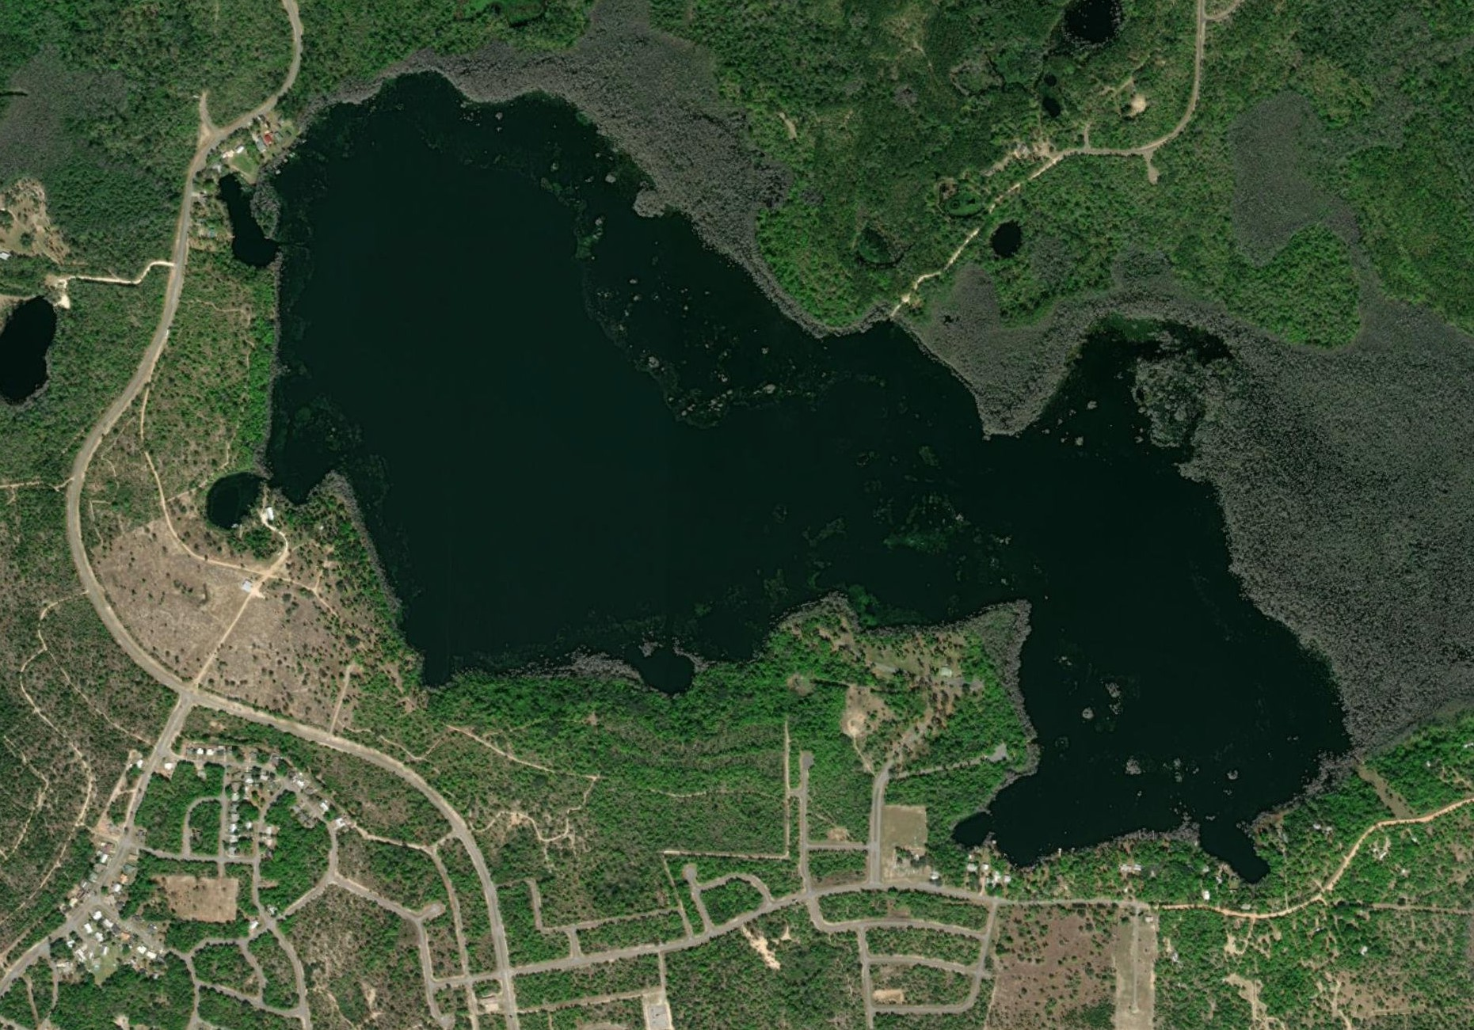


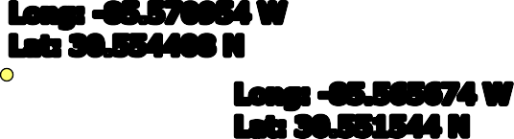








0 125
250 500 Meters
Map made for the WQSP

