2025 LVI Lake Gentry

Long: -81.252606 W
Lat: 28.151693 N

Long: -81.243131 W
Lat: 28.152096 N

Long: -81.235258 W
Lat: 28.151276 N
Long: -81.226449 W
Lat: 28.153372 N
±

Long: -81.258854 W
Lat: 28.144704 N
1
12 2

11 3

10 4

Long: -81.225833 W
Lat: 28.145349 N

Long: -81.260076 W
Lat: 28.135893 N

9 5

8 7 6
Long: -81.230226 W
Lat: 28.138322 N

Long: -81.235063 W
Lat: 28.131801 N

Long: -81.258816 W
Lat: 28.127213 N

Long: -81.252127 W
Lat: 28.12901 N
Long: -81.244021 W
Lat: 28.13005 N

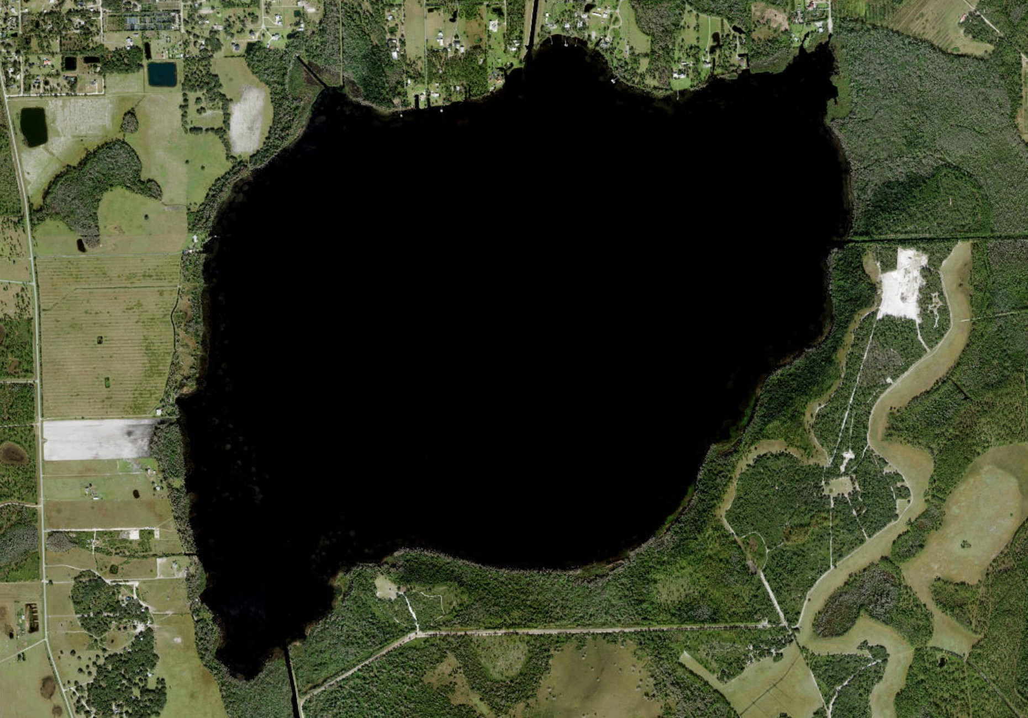












0 195
390 780 Meters
Map made for the WQSP

